Micro-simulation analysis of social protection interventions in Solomon Islands
Key points
> A combined package of high benefits to children under 5 and older people over 65, costing 2.6% of GDP, would reduce Solomon Islands’ poverty gap by 21%.
> A low value combined benefits package to all children under 5 and all older people over 65 (costing 0.8% of GDP) would have greater pro-poor impact and poverty-reducing efficiency than either a child benefit or a social pension alone.

Introduction
Micro-simulation models are tools for evidence-based analysis of social policy interventions. Rooted in representative household surveys of a country’s population, the models paint a picture of a country’s income, expenditure and poverty levels. They enable researchers to simulate the impact of existing and potential new social policy interventions. This brief summarises the results of a baseline micro-simulation analysis for Solomon Islands, analysing the impact of various social protection interventions on income levels, poverty headcounts and poverty gaps, nationally and by demographic group (Samson 2012). The models employ Household Income and Expenditure Survey (HIES) data from Solomon Islands’ 2006 HIES.
Social protection: costs and impacts on poverty
The models analyse variations on demographically targeted cash transfers to young children and older people (see Figure 1). The least expensive package—providing a benefit equal to 10% of the poverty line to all children under 5 and 25% of the poverty line to all older people over 65—costs 0.8% of GDP, or 1.8% of government expenditure, in Solomon Islands. Overall, this least expensive social protection package reduces Solomon Islands’ poverty gap by 7%, the poverty gap for households with young children by 10% and the poverty gap for households with older people by 15%.
Figure 1. Cost and impact on poverty of five different social protection packages
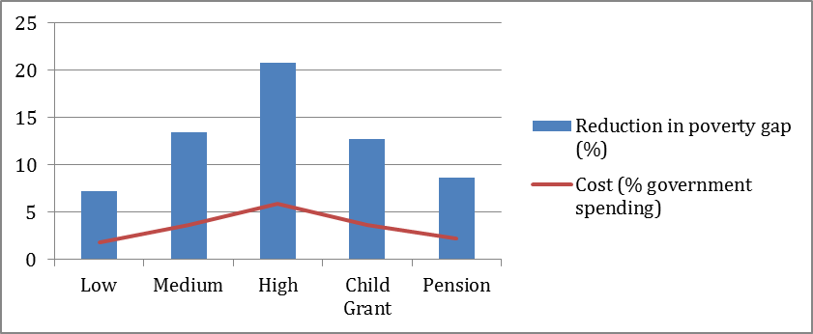

Doubling the benefits package—to 20% of the poverty line for children and 50% of the poverty line for older people—doubles the costs, but only at most to 1.6% of GDP (which falls in the lower half of the range for developing country spending on social assistance). Tripling the package to 30% of the poverty line for young children and 100% of the poverty line for older people leads to roughly proportional increases in costs and poverty reducing impacts. The cost is 2.6% of GDP in Solomon Islands, but this would reduce the poverty gap by 20%. The micro-simulation exercise thus demonstrates the feasibility of starting with a small but affordable package of benefits and scaling up as resources and political support will allow.
The micro-simulation exercise also separately tested two singular cash transfer benefits in Solomon Islands: a child benefit equal to 30% of the poverty line for all children under 5 years of age; and a social pension equal to 100% of the poverty line for all people 65 years of age and older. The child benefit costs around 1.6% of GDP and the stand-alone social pension around 1% of GDP; correspondingly the poverty gap reduction from the child benefit alone (12.8%) is greater than the impact of a social pension on its own (8.7%). However, it is notable that the social pension would reduce the poverty gap of those households with over-65s by an impressive 38%.
Comparing poverty reduction efficiency and impact
Poverty reducing efficiency and pro-poor indexing measure the efficiency and impact of social protection interventions. Poverty reducing efficiency looks at how much the poverty gap is reduced per unit of social protection expenditure. Pro-poor impact can be indexed by dividing poverty-reducing efficiency by the national household poverty rate. A benefit to everyone will have a neutral index value of 100%. The more the index value exceeds 100%, the greater the pro-poor impact.
As Figure 2 shows, the poverty-reducing efficiency of the combined packages falls slightly as their value increases, since the grants are now large enough to lift more people out of poverty. In fact, in the Solomon Islands (unlike in the other Pacific countries modelled), the large size of the benefits in the high-value combined package exhausts the pro-poor bias—a more efficient package for poverty reduction would distribute smaller benefits more broadly.
Figure 2. Poverty reducing efficiency and pro-poor impact
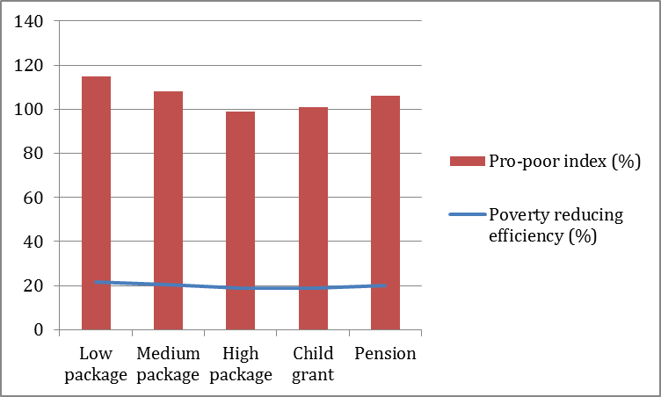
These categorical benefits, while not directly targeting the poor, reach poor households proportionally more than the distribution of poor households in the population because households with young children or with older people tend to be poorer than other households. The social pension has a greater pro-poor impact, and its poverty-reducing efficiency is higher than those of the child benefit; but its poverty-reducing efficiency and impact are still lower than those of the low and medium combined packages.

References:
Samson, M 2012, ‘Micro-simulation analysis of social protection interventions in the Pacific’, AusAID, Canberra, Australia

