Micro-simulation analysis of social protection interventions in Samoa
Key points
> A combined package of benefits to children under 5 and older people over 65, costing 2% of GDP, would reduce Samoa’s poverty gap by 20%.
> A high value child benefit (costing 1.5% of GDP) would have the greatest pro-poor impact and poverty-reducing efficiency of all the modelled interventions in Samoa.
> A categorical cash transfer (targeted to everyone in a particular age-group, such as older people or young children) can reduce poverty more efficiently than a poverty-targeted transfer.
> The efficiency of categorical versus poverty-targeted approaches depends on trade-offs between targeting costs and errors.

Introduction
Micro-simulation models are tools for evidence-based analysis of social policy interventions. Rooted in representative household surveys of a country’s population, the models paint a picture of a country’s income, expenditure and poverty levels. They enable researchers to simulate the impact of existing and potential new social policy interventions. This brief summarises the results of a baseline micro-simulation analysis for Samoa, analysing the impact of various social protection interventions on income levels, poverty headcounts and poverty gaps, nationally and by demographic group (Samson 2012). The models employ Household Income and Expenditure Survey (HIES) data from Samoa’s 2008 HIES.

Social protection: costs and impacts on poverty
The models analyse variations on categorically targeted cash transfers to children and older people¹ (see Figure 1). The least expensive package—providing a benefit equal to 10% of the poverty line to all children under 5 and 25% of the poverty line to all older people over 65—costs 1% of GDP, or 3% of government expenditure, in Samoa. Overall, this least expensive social protection package reduces Samoa’s poverty gap by 10%, the poverty gap for households with young children by 11% and the poverty gap for households with older people by 15%.
Figure 1. Cost and poverty impact of five different social protection packages
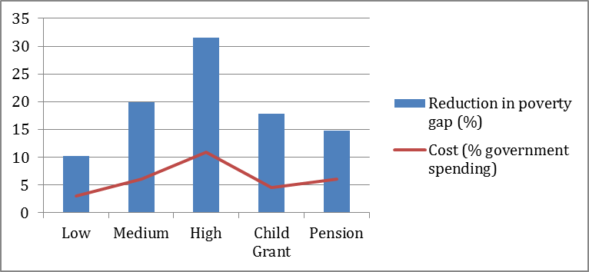

Doubling the benefits package—to 20% of the poverty line for young children and 50% of the poverty line for older people—doubles the costs, but only at most to 2% of GDP (which falls in the upper half of the range for developing country spending on social assistance). Tripling the package to 30% of the poverty line for young children and 100% of the poverty line for older people leads to roughly proportional increases in costs and poverty reducing impacts. The cost is nearly 4% of GDP in Samoa, but this would reduce the poverty gap by nearly a third. The micro-simulation exercise thus demonstrates the feasibility of starting with a small but affordable package of benefits and scaling up as resources and political support will allow.
The micro-simulation exercise also separately tested two singular cash transfer benefits in Samoa: a child benefit equal to 30% of the poverty line for all children under 5 years of age; and a social pension equal to 100% of the poverty line (i.e. double Samoa’s current SCBS) for all people 65 years of age and older. The child benefit costs around 1.5% of GDP and the stand-alone social pension around 2% of GDP; but the poverty gap reduction from the social pension alone (15%) is less than the impact of a child benefit on its own (18%).
Comparing poverty reduction efficiency and impact
Poverty reducing efficiency and pro-poor indexing measure the efficiency and impact of social protection interventions. Poverty reducing efficiency looks at how much the poverty gap is reduced per unit of social protection expenditure. Pro-poor impact can be indexed by dividing poverty-reducing efficiency by the national household poverty rate. A benefit to everyone will have a neutral index value of 100%. The more the index value exceeds 100%, the greater the pro-poor impact.
As Figure 2 shows, the poverty-reducing efficiency of the combined packages falls slightly as their value increases, since the grants are now large enough to lift more people out of poverty, but the packages remain strongly pro-poor. In each case, the poverty reduction impact is much larger than would be the case with a benefit to everyone.

Figure 2. Poverty reducing efficiency and pro-poor impact
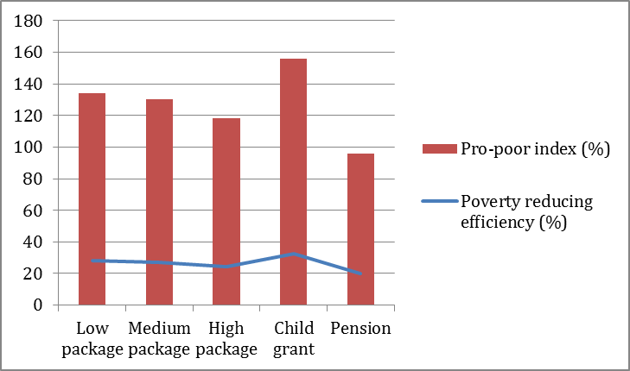

These categorical benefits, while not directly targeting the poor, reach poor households proportionally more than the distribution of poor households in the population because households with young children, in particular, are much poorer than other households. For this reason the child benefit alone has the greatest pro-poor impact, and its poverty-reducing efficiency is more than the efficiency of the combined packages. On the other hand, the poverty-reducing efficiency and impact of the social pension are lower than any of the other interventions because households with people over 65 are only slightly poorer than other households and less represented overall in the population.
Categorical or poverty-targeted?
The micro-simulation analysis also evaluated two types of poverty-targeted cash transfers for Samoa, testing different assumptions about targeting costs and errors (see Figure 3):
> Package 1: benefits equal to 50% of the poverty line targeted to the poorest 20% of households; and
> Package 2: benefits targeted to children (30% of the poverty line) and older people (100% of the poverty line) in the poorest 30% of households
Figure 3. Per cent reduction in the poverty gap of different targeting options and packages²
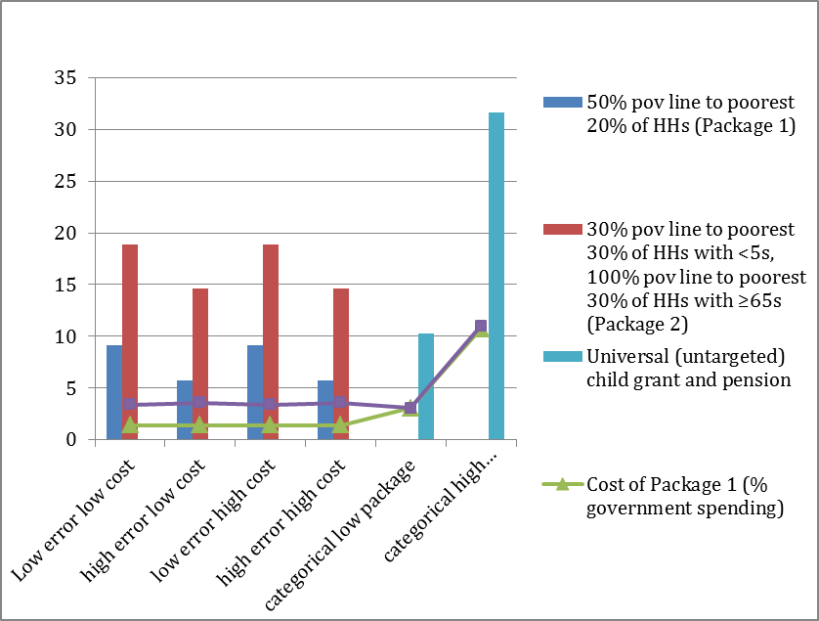

Not surprisingly, effective targeting with low costs and low errors yielded the highest possible efficiency in poverty reduction. However, this is an overly optimistic scenario—minimising targeting errors of inclusion and exclusion requires an expensive mechanism with a range of costs, including administrative, individual, social, political, economic and others.
A more realistic trade-off involves choosing between a low-cost targeting mechanism that yields relatively high targeting errors and a higher-cost mechanism that minimises errors. In this context, a purely categorical package of benefits reduces poverty more efficiently than in at least one of these ‘realistic’ scenarios, which demonstrates that a categorical cash transfer may reduce poverty in a country more efficiently than a poverty-targeted transfer. The critical determining factors are targeting effectiveness (measured by inclusion and exclusion errors) and the full costs of targeting. The fourth option—targeting with high costs and high errors—not surprisingly performed the worst.
In the absence of credible evidence on targeting costs and likely errors—evidence that does not exist for Pacific countries—it is not possible to precisely identify which targeting approach will be most effective and efficient in Samoa. However, this analysis underscores the importance of paying attention to targeting costs and errors, because they determine the relative efficiency of categorical versus poverty-targeted approaches.

References:
Samson, M 2012, ‘Micro-simulation analysis of social protection interventions in the Pacific’, AusAID, Canberra, Australia
Endnotes:
1 Samoa already provides a social pension (the Senior Citizens Benefit Scheme or SCBS) to all citizens over the age of 65. The SCBS value is roughly equivalent to the value of the pension modelled in the second scenario of this paper (50% of the poverty line). Since the Samoa micro-simulation is part of a larger multi-country study, to enable comparisons across countries the SCBS was removed from the original survey data prior to running the micro-simulation.
2 Poverty gap reductions do not reflect differences in administrative costs because the costs shown in all cases are those of the actual benefits, and administrative costs are treated as a separate layer. This means the poverty gap is reduced by the same amount in high cost and low cost scenarios: what changes is the poverty reducing efficiency.

