Micro-simulation analysis of social protection interventions in Pacific Islands
Key points
> The exercise demonstrates the feasibility of starting with a small but affordable package of benefits and scaling up as resources and political support allow
> A categorical cash transfer (targeted to everyone in a particular age-group, such as older people or young children) can reduce poverty more efficiently than a poverty targeted transfer
> Categorical benefits, while not directly targeting the poor, proportionally reach more poor households than represented in the population
> The efficiency of categorical versus poverty-targeted approaches depends on trade-offs between targeting costs and errors.

Introduction
Micro-simulation models are tools for evidence-based analysis of social policy interventions. Rooted in representative household surveys of a country’s population, the models paint a picture of a country’s income, expenditure and poverty levels. They enable researchers to simulate the impact of existing and potential new social policy interventions. This brief summarises the results of a baseline micro-simulation analysis for four Pacific Island countries: Kiribati, Samoa, Solomon Islands and Vanuatu, analysing the impact of various social protection interventions on poverty headcounts and poverty gaps, nationally and by demographic group (Samson 2012). The models employ Household Income and Expenditure Survey (HIES) data from the most recently available surveys (2006 or 2008).

Social protection: costs and impacts on poverty
The models analyse variations on categorically targeted cash transfers to children and older people (see Figure 1). The least expensive package—providing a benefit equal to 10% of the poverty line for children under 5 and 25% of the poverty line for older people over 65—costs the most in Kiribati (1.1% of GDP in the survey year) and Samoa (1.0%), moderately lower in Solomon Islands (0.8%) and much lower in Vanuatu (0.4%), mainly because the relatively low poverty line in Vanuatu leads to a low modelled benefit level. As a percentage of government expenditure, the fiscal burden for Samoa is the greatest at 3%, followed by Vanuatu at 2%, with Kiribati and Solomon Islands a little more than 1%. Vanuatu’s lower ratio of government spending to GDP accounts for this reversal in ranking.
Figure 1. Per cent reduction in poverty gap, and costs as per cent of government spending, of five different social protection packages
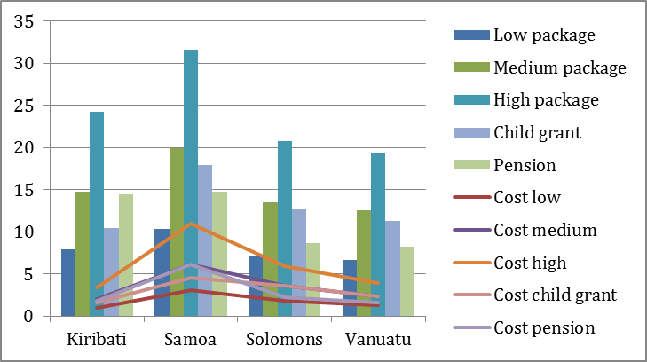
These categorical benefits, while not directly targeting the poor, reach poor households proportionally more than the representation of poor households in the population. This is particularly true for Samoa, because households with young children are poorer than average. Overall, the least expensive social protection package reduces each country’s poverty gap by approximately 7% to 10%, the poverty gap for households with young children by 10% to 11% and the poverty gap for households with older people by 15% to 17%.
Doubling the least expensive benefits package—to 20% of the poverty line for young children and 50% of the poverty line for older people—doubles the costs, but only at most to an arguably affordable 2% of GDP (which is towards the upper end of the range for developing country spending on social assistance). Poverty-reducing efficiency¹ falls slightly, since the grants are now large enough to lift more people out of poverty, but all packages remain strongly pro-poor. Across all countries the poverty gap falls between 13% and 20%—between 18% and 21% for households with young children and between 27% and 32% for households with older people.
Tripling the least expensive benefits package to 30% of the poverty line for young children and 100% of the poverty line for older people leads to roughly proportional increases in costs and poverty reducing impacts. The cost is greatest in Kiribati, at nearly 4% of GDP, and just a little less in Samoa. The impacts on the poverty gap are significantly larger elsewhere—reducing it by nearly a third in Samoa, a quarter in Kiribati and by nearly half in all countries for households with older people. The large size of the benefits exhausts the pro-poor bias in Solomon Islands—a more efficient package for poverty reduction would distribute smaller benefits more broadly.

Starting small and scaling up
The micro-simulation exercise demonstrates the feasibility of starting with a small but affordable package of benefits and scaling up as resources and political support will allow. In Kiribati, Samoa and Vanuatu, the pro-poor impact persists even as benefit levels rise to fairly generous levels. Countries are likely to encounter fiscal constraints before exhausting the potential of the categorical benefits to efficiently reduce poverty.
The micro-simulation exercise also separately tested two singular cash transfer benefits:
> a child benefit equal to 30% of the poverty line for all children under 5 years of age; and
> a social pension equal to 100% of the poverty line for all people 65 years of age and older.
The child benefit costs less than 2% of national income in Kiribati, Samoa and Solomon Islands and just 0.7% of GDP in Vanuatu. In Samoa, Solomon Islands and Vanuatu the poverty-reducing efficiency of this child benefit alone is more than the efficiency of the combined packages discussed above. The situation is reversed in Kiribati, where the combined packages are more efficient in reducing poverty than the child benefit. This is consistent with the relative poverty analysis of the two countries: Samoa reports the highest relative poverty for young children and Kiribati reports the highest relative poverty for older people.
The child benefit also has a significant impact on poverty for older people. Even in Kiribati the child benefit alone results in a 10.6% reduction in the poverty rate among households with people 65 and older. This reduction is the result of benefits reaching households with both children under the age of 5 and persons 65 years and older. However, the pairing of the child benefit with a generous social pension (100% of the poverty line) results in poverty rate reductions among these older people households ranging from 3.6 (Kiribati) to 8 (Samoa and Solomon Islands) and to nearly 15 (Vanuatu) times greater than the reductions resulting from the child benefit alone.
The stand-alone social pension (equal to 100% of the poverty line) costs less when expressed as percentage of GDP than the child benefit in Solomon Islands and Vanuatu but more in Kiribati and Samoa. In Samoa, Solomon Islands and Vanuatu the poverty gap reduction from the social pension alone is less than the impact of a child benefit on its own. The situation is reversed in Kiribati with a 14.4% reduction in the poverty gap with the social pension compared to a 10.4% reduction with the child benefit.
Categorical or poverty-targeted?
The micro-simulation analysis also evaluated two types of poverty-targeted cash transfers
in Samoa and Vanuatu, testing different assumptions about targeting costs and errors (see Figure 2):
> Package 1: benefits equal to 50% of the poverty line targeted to the poorest 20% of households; and
> Package 2: benefits targeted to children (30% of the poverty line) and older people (100% of the poverty line) in the poorest 30% of households.

Figure 2. Per cent reduction in the poverty gap of different targeting options and packages²
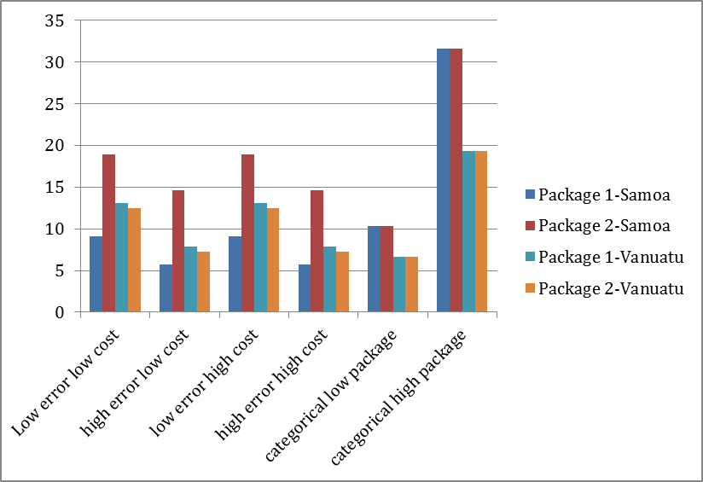

Not surprisingly, effective targeting with low costs and low errors yielded the highest possible efficiency in poverty reduction. However, this is an overly optimistic scenario—minimising targeting errors of inclusion and exclusion requires an expensive mechanism with a range of costs, including administrative, individual, social, political, economic and others.
A more realistic trade-off involves choosing between a low-cost targeting mechanism that yields relatively high targeting errors and a higher-cost mechanism minimising errors. In each country and for each targeting approach, a purely categorical package of benefits reduced poverty more efficiently than in at least one of these ‘realistic’ scenarios. These results demonstrate that a categorical cash transfer may reduce poverty in a country more efficiently than a poverty targeted transfer. The critical determining factors are targeting effectiveness (measured by inclusion and exclusion errors) and the full cost of targeting. The fourth option—targeting with high costs and high errors—not surprisingly performed the worst.
In the absence of credible evidence on targeting costs and likely errors—evidence that does not exist for Pacific countries—it is not possible to precisely identify which targeting approach will be most effective and efficient in Pacific Island countries. However, this analysis underscores the importance of paying attention to targeting costs and errors, because they determine the relative efficiency of categorical versus poverty targeted approaches.

References:
Samson, M 2012, ‘Micro-simulation analysis of social protection interventions in the Pacific’, AusAID, Canberra, Australia
Endnotes:
1 Poverty-reducing efficiency is calculated by dividing the reduction in the poverty gap by the total costs of the intervention, measured as the money cost of the transfers plus assumed targeting costs. For high-cost scenarios targeting costs are assumed to be 80% of the transfers; for low-cost scenarios it is 40%; and for purely categorical scenarios it is 20%.Exclusion and inclusion errors are assumed to be 50% for low-error scenarios and 70% for high-error scenarios.
2 Poverty gap reductions do not reflect differences in administrative costs because the costs shown in all cases are those of the actual benefits, and administrative costs are treated as a separate layer. This means the poverty gap is reduced by the same amount in high cost and low cost scenarios: what changes is the poverty reducing efficiency.

