Micro-simulation analysis of social protection interventions in Kiribati
Key points
> A combined package of benefits to children under 5 and older people over 65, costing 2% of government expenditure, would reduce Kiribati’s poverty gap by 15%.
> A high value social pension to all those over 65 years (costing 2% of GDP) would have greater pro-poor impact and poverty-reducing efficiency than a child benefit or any of the combined child grant and social pension packages modelled for Kiribati.

Introduction
Micro-simulation models are tools for evidence-based analysis of social policy interventions. Rooted in representative household surveys of a country’s population, the models paint a picture of a country’s income, expenditure and poverty levels. They enable researchers to simulate the impact of existing and potential new social policy interventions. This brief summarises the results of a baseline micro-simulation analysis for Kiribati, analysing the impact of various social protection interventions on income levels, poverty headcounts and poverty gaps, nationally and by demographic group (Samson 2012). The models employ Household Income and Expenditure Survey (HIES) data from Kiribati’s 2006 HIES.
Social protection: costs and impacts on poverty
The models analyse variations on demographically targeted cash transfers to children and older people¹ (see Figure 1). The least expensive package—a benefit equal to 10% of the poverty line to all children under 5 and 25% of the poverty line to all older people over 65—costs 1.1% of GDP, or 1.0% of government expenditure² in Kiribati. Overall, this least expensive social protection package reduces Kiribati’s poverty gap by 8%, the poverty gap for households with young children by 11% and the poverty gap for households with older people by 15%.
Figure 1. Cost and poverty impact of five different social protection packages
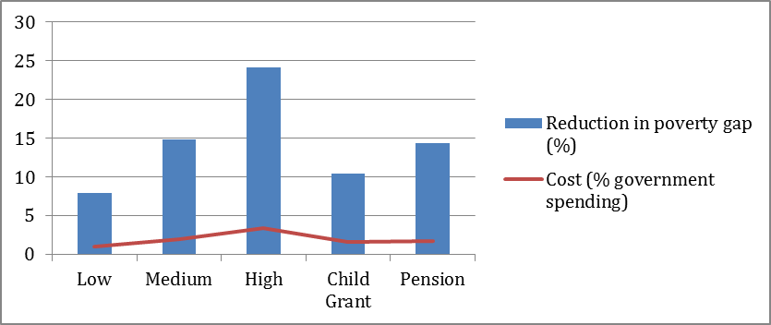

Doubling the benefits package—to 20% of the poverty line for children and 50% of the poverty line for older people—doubles the costs, but only to 2.2% of GDP (which falls in the upper half of the range for developing country spending on social assistance). Tripling the package to 30% of the poverty line for children and 100% of the poverty line for older people leads to roughly proportional increases in costs and poverty reducing impacts. The cost is nearly 4% of Kiribati’s GDP, but this would reduce the poverty gap by a quarter. The micro-simulation exercise thus demonstrates the feasibility of starting with a small but affordable package of benefits and scaling up as resources and political support will allow.
The micro-simulation exercise also separately tested two singular cash transfer benefits in Kiribati: a child benefit equal to 30% of the poverty line for all children under 5 years of age; and a social pension equal to 100% of the poverty line (i.e. double Kiribati’s current social pension) for all people over 65 years of age (rather than 67 years at present). The child benefit costs around 1.8% of GDP and the stand-alone social pension around 2% of GDP; but the poverty gap reduction from the social pension alone (14.4%) is greater than the impact of a child benefit on its own (10.4%), suggesting that Kiribati has made a good choice in starting with a social pension. The higher social pension would reduce the poverty gap of households with over-65s by an impressive 42%.
Comparing poverty reduction efficiency and impact
Poverty reducing efficiency and pro-poor indexing measure the efficiency and impact of social protection interventions. Poverty reducing efficiency looks at how much the poverty gap is reduced per unit of social protection expenditure. Pro-poor impact can be indexed by dividing poverty-reducing efficiency by the national household poverty rate. A benefit to everyone will have a neutral index value of 100%. The more the index value exceeds 100%, the greater the pro-poor impact.
As Figure 2 shows, the poverty-reducing efficiency of the combined packages falls slightly as their value increases, since the grants are now large enough to lift more people out of poverty, but the packages remain strongly pro-poor. In each case, the poverty reduction impact is much larger than the case of a benefit to everyone.
Figure 2. Poverty reducing efficiency and pro-poor impact
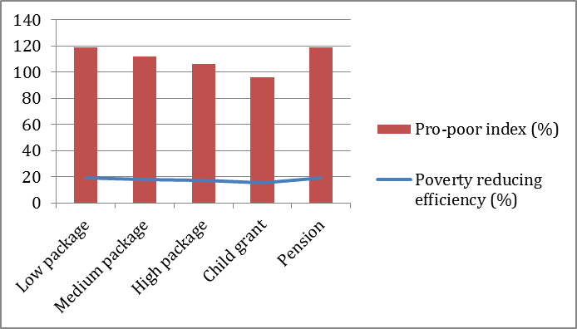
The social pension, while not directly targeting the poor, reaches poor households proportionally more than their distribution in the population because households with older people, in particular, are much poorer than other households. For this reason the social pension alone has the greatest pro-poor impact, and its poverty-reducing efficiency is more than the efficiency of any of the combined packages. On the other hand, the poverty-reducing efficiency and impact of the child benefit are lower than any of the other interventions because households with young children generally are not poorer than other households.

References:
Samson, M 2012, ‘Micro-simulation analysis of social protection interventions in the Pacific’, AusAID, Canberra, Australia
Endnotes:
1 Kiribati already provides a social pension to all citizens over the age of 67 with a value roughly equivalent to the one modelled in this paper (i.e. 50% of the poverty line). Since the Kiribati micro-simulation is part of a larger study, to enable comparisons across countries the existing pension was removed from the original data prior to running the simulation.
2 Kiribati is unusual in that its government expenditure exceeds its GDP. As Kiribati’s ‘National Development Strategies’ explains, this is because “changes in the national income of Kiribati are determined more by earnings from abroad than by domestic production of goods and services.” For more see http://www.sprep.org/att/IRC/eCOPIES/Countries/Kiribati/12.pdf.

