The Australia-Mekong NGO Engagement Platform (AMNEP)
Factsheet
September 2013

Supporting the work of NGOs in the Mekong
The Australia-Mekong NGO Engagement Platform (AMNEP) supports the work of AusAID and non-government organisations (NGOs) to deliver effective on-the-ground support for those most in need.
NGOs operate in some of the most challenging environments and poorest communities in the Mekong region. In response to a request from NGO partners for support to make their on-the-ground work more effective, we worked together to develop AMNEP. In addition to country-based AusAID funding, AMNEP brings high-quality technical expertise, access to policy dialogue and learning opportunities, and resources for better monitoring, evaluation and risk management to our partnerships with NGOs.
AMNEP’s role is to work with AusAID programs in the Mekong to provide these additional elements, which will ensure our work with NGO partners is delivered more efficiently and effectively, for greater impact on the lives of the poorest people in the Mekong region. Based in the Mekong Hub in Hanoi, Vietnam, it supports NGO work within bilateral and regional programs in Cambodia, Laos, Myanmar, Vietnam and regionally through a range of expertise and services.

The approach
AMNEP is not a traditional NGO funding program. AMNEP will primarily provide AusAID programs in the region with technical support and administrative services to help improve the effectiveness of our programs that have an NGO delivery component. This will involve developing common approaches to partner selection and contracting, monitoring, learning and engaging with risk. AM-NEP will also support more collaborative partnership arrangements between AusAID and NGOs. This will include setting up mechanisms that enable NGOs to bring programming evidence and experience to policy dialogue, program strategies (especially country and delivery strategies), program design and program implementation.
AM-NEP will provide support in a range of ways.
- Program implementation support to improve program quality and streamline processes
e.g. capacity building support; program learning; advice on the design of an NGO selection process; technical and administrative support for the selection and contracting of NGO partners; strategic advisory support for programs (for example on beneficiary targeting; child protection; disability inclusiveness); program coordination and review methodologies.
- Expertise to strengthen the role of NGOs in strategy and activity designs
e.g. advice on where to engage NGOs in the design process; approaches to NGO effectiveness, due diligence and risk; technical assistance to the design team (including: design scoping workshops, design standards advice, partner dialogue, partner NGO capacity building strategies, terms of reference input, partnership agreement advice); comments on strategy and design documents; and advice on appraisal and feedback processes involving NGOs.
- Value for money and achieving results
e.g. providing high quality, responsive, locally based advice and services; meet demand for program quality anf effectiveness services; linking AusAID-NGO partnership work into overall strategic objectives; improving reporting and monitoring; creating new opportunities to link AusAID’s work to impact on the ground.
- New opportunities for AusAID and NGOs to discuss regional, sectoral and program issues
e.g. regional policy dialogues; advice on the design of a consultation with local or international NGOs; consultation facilitation; action research, knowledge management and sharing.
- Guidance to assist good practice program monitoring, evaluation and lesson sharing
e.g. development of generic good practice guidance on M&E (monitoring and evaluation), and support for the development of specific M&E frameworks appropriate to the NGO partnership; documenting and participating in M&E, reviews, monitoring missions and reflection workshops; providing administrative support to an AM-NEP M&E and lesson sharing process.

Operation and management arrangements

AM-NEP strategy, operations and scope will be guided by an AusAID-NGO Reference Group. AM-NEP operations are managed by the AM-NEP Coordinator (Regional Civil Society Specialist) based in the Mekong Regional Hub. The Coordinator is supported by an Administrative Services Unit (ASU) which manages the assistance to posts on contracting, sourcing of expertise and managing events. The ASU has established a Performance and Quality Resources Group (PQRG) to ensure posts have access to vetted experts on demand.
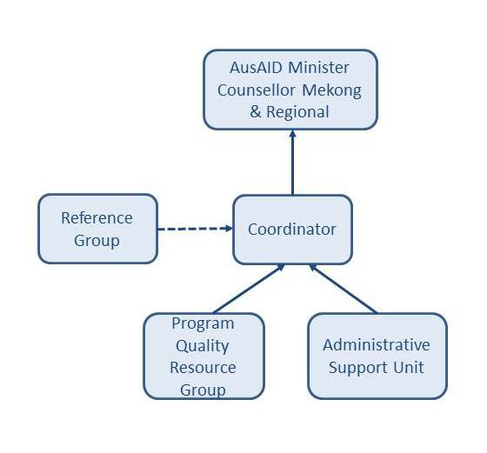
Fig 1: AMNEP Governance Structure

AMNEP in action
AMNEP is working to build effective partnerships with NGOs and civil society organisations across AusAID’s work in the Mekong – from supporting the Myanmar peacebuilding process, to working in the Cambodian health sector, to engaging with the dynamic Vietnam program.
Six NGOs are working with the Vietnam Climate Change program utilising global fast start funding. The program illustrates AM-NEP principles through its partnership approach – starting from design. Six NGO partners were selected through a competitive process based on their capacity and concept proposals. After selection, competitive conditions were removed and the NGO partners were funded to take their proposals to design.
Selected NGOs participated in an AusAID-led design workshop with an external facilitator with NGO and design experience to agree on the design and appraisal approach. The design process took six months with NGOs less experienced with AusAID requirements requiring more intensive assistance.
Through this collaborative design approach, each partner developed an understanding of their respective comparative advantage, and the potential contribution of each activity to the overall program (and sector) objectives. For example, one NGO volunteered to take the lead in coordinating across the adaptation climate change grants in the development of measurable indicators against which activity progress would be commonly monitored and reported.
The willingness of the NGO partners to continue working together after contracting and commit to joint responsibility for meeting program performance indicators signals a new way of working for AusAID and NGOs.
AM-NEP’s future involvement will centre on supporting the partnership through the remainder of the program cycle. Administrative and technical support, arranged through the AusAID AM-NEP Coordinator and contracted Administrative Support Unit (ASU),could range from support for partnership meetings to input into program evaluations. Identified areas for ASU support services include:
- A cluster-evaluation of the 6 NGO activities planned for mid-2014 will require AM-NEP support in agreeing on a shared methodology with NGO partners, developing a terms of reference, and helping identify suitable consultants;
- Support to the identification and running of knowledge-sharing events and workshops to help bring the lessons and approaches applied at the community level into national dialogue with a broad range of stakeholders;
- Sourcing of AM-NEP technical expertise if a need emerges to supplement the program M&E system or to stimulate cross-program learning.

