**Lessons Learnt Documentation of the MED Model Promoted by MEDEP/MEDPA in Nepal**

*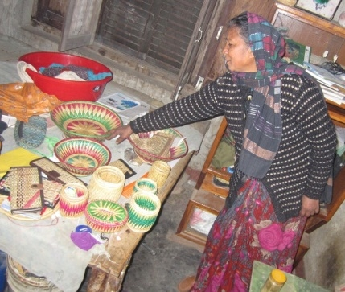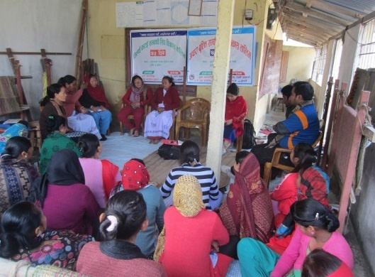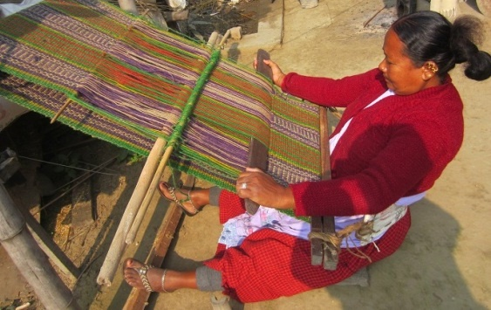*

*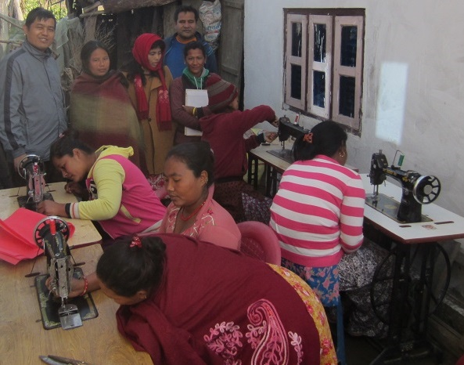*

|  |  |
| --- | --- |
| **Submitted to:**  **United Nations Development Programme (UNDP)** UN House, Pulchowk, Lalitpur, Nepal  and MEDEP/MEDPA |  |

**May, 2018**

**Title of the report:**

**Lessons Learnt Documentation of the MED Model Promoted by MEDEP/MEDPA in Nepal**

**Prepared by:**

Jailab Kumar Rai (Team leader)

Suhrid Prasad Chapagain (Team member)

Anita Shrestha (Team member)

**Submitted to:**

United Nations Development Programme, UN House, Pulchowk, Lalitpur, Nepal

**May, 2018**

Contents

[Acknowledgements **Error! Bookmark not defined.**](#_Toc515659322)

[List of tables v](#_Toc515659323)

[List of figures vii](#_Toc515659324)

[Abbreviations ix](#_Toc515659325)

[Executive summary xii](#_Toc515659326)

[Chapter 1: Introduction 1](#_Toc515659327)

[1.1 Background of the lessons learnt documentation 1](#_Toc515659328)

[1.2 Objective and rationale of the lessons learnt documentation 3](#_Toc515659329)

[1.3 TOR of the lessons learnt documentation 3](#_Toc515659330)

[1.4 Analytical framework 6](#_Toc515659331)

[1.4.1 Contextualizing MED model into SDGs and Nepal's HDI 6](#_Toc515659332)

[1.4.2 Conceptual framework: micro enterprise ecosystem 7](#_Toc515659333)

[1.4.3 Documentation framework 10](#_Toc515659334)

[1.5 Organization of the report 11](#_Toc515659335)

[Chapter 2: Methodology 12](#_Toc515659336)

[2.1 Introduction 12](#_Toc515659337)

[2.2 Selection of sites for primary information 12](#_Toc515659338)

[2.3 Collection of information from primary sources 13](#_Toc515659339)

[2.4 Collection of information from secondary sources 15](#_Toc515659340)

[2.5 Limitations of the lessons learnt documentation 16](#_Toc515659341)

[Chapter 3: Lessons learned from the MED model promoted by MEDEP and MEDPA in Nepal 17](#_Toc515659342)

[3.1 Effectiveness of MED Model 21](#_Toc515659343)

[3.2 Economic empowerment of hardcore poor through MED model 29](#_Toc515659344)

[3.3 Economic empowerment of hardcore poor through CFC 44](#_Toc515659345)

[3.4 Access to finance (A2F) in MED model 51](#_Toc515659346)

[3.5 Pro-poor public-private partnership (PPP) in MED model 61](#_Toc515659347)

[3.6 Result based sub-contracting to MEDSPs for MED services 69](#_Toc515659348)

[3.7 Human resource development and capacity building of MED stakeholders 77](#_Toc515659349)

[3.8 Socio-political and economic changes brought by MED model through GESI approach 90](#_Toc515659350)

[3.9 M&E and use of GESI-MIS in MED model 101](#_Toc515659351)

[3.10 Internalization and institutionalization of MED model before federalism 107](#_Toc515659352)

[3.11. Internalization and institutionalization of MED model after federalism 122](#_Toc515659353)

[Chapter 4: Summary and conclusion 132](#_Toc515659354)

[4.1 Introduction of the summary and conclusion 132](#_Toc515659355)

[4.2 Key thematic lessons learned 132](#_Toc515659356)

[4.3 Conclusion 135](#_Toc515659357)

[4.3.1 Major lessons learned from MED model 135](#_Toc515659358)

[4.3.2 Future prospects of MED model 137](#_Toc515659359)

[4.3.3 Concluding remarks 138](#_Toc515659360)

[References 140](#_Toc515659361)

[Annexes 142](#_Toc515659362)

[Annex 1: Successful case stories of MED model implementation 142](#_Toc515659363)

[Case A: River-bed farming lifting people out of poverty in Nepal 142](#_Toc515659364)

[Case B: Kick-starting a new life - Kari Ram's story 143](#_Toc515659365)

[Case C: Wider horizons - a story of Sunti Purja 143](#_Toc515659366)

[Case D: A life sweetened with honey - a story of Tikaram Timilsena 143](#_Toc515659367)

[Case E: When dreams come true 144](#_Toc515659368)

[Case F: Creating employment in villages 144](#_Toc515659369)

[Annex 2: List of respondents for KII 146](#_Toc515659370)

[Annex 3: List of participants for FGD 148](#_Toc515659371)

[Annex 4: Participants in the inception and draft report sharing meeting 156](#_Toc515659372)

[Annex 5: Detail ToR for the lessons learnt documentation work 157](#_Toc515659373)

# List of tables

[Table 1: Activities and responsible actors for portfolio approach of MED Model 3](#_Toc515659223)

[Table 2: Eleven themes mentioned in TOR 5](#_Toc515659224)

[Table 3: Flow and contents of the eleven themes after rearrangement 5](#_Toc515659225)

[Table 4: Selected SDGs (including targets) and HDI related with achievements of MED model 6](#_Toc515659226)

[Table 5: Nepal's HDI trends based on consistent time series data 7](#_Toc515659227)

[Table 6: Respondents of the study as sources of primary information 13](#_Toc515659228)

[Table 7: Districts covered by different phases of the MEDEP activities 17](#_Toc515659229)

[Table 8: Major milestones of MEDEP and MEDPA implementation 18](#_Toc515659230)

[Table 9: Internalization of MEDPA through functions of MED system players 19](#_Toc515659231)

[Table 10: Internalization of MEDPA through functions of MED system players 26](#_Toc515659232)

[Table 11: Employment generated and labor utilized from 998 MEs and their micro enterprises 30](#_Toc515659233)

[Table 12: Number of MEs created during MEDEP and projected during MEDPA through MED model 38](#_Toc515659234)

[Table 13: Survival rate of MEDEP and MEDPA supported MEs over time 39](#_Toc515659235)

[Table 14: Some of the examples of PAR and product development during MEDEP 41](#_Toc515659236)

[Table 15: Number of CFCs and affiliated MEs 45](#_Toc515659237)

[Table 16: Loan received by women entrepreneurs from WEDF in 2017 57](#_Toc515659238)

[Table 17: Total number of MEs received loan from different sources in 2017 57](#_Toc515659239)

[Table 18: Amount and sources of wholesale loan during MEDPA (as of December 2017) 58](#_Toc515659240)

[Table 19:MEDPA targets in terms of PPP 66](#_Toc515659241)

[Table 20:Progressive trends in MEDSPs biding and providing services to MEDPA (2015-2018) 72](#_Toc515659242)

[Table 21: GESI disaggregated information of certified EDFs 80](#_Toc515659243)

[Table 22: Participants in MED model capacity building training (in 2017) 81](#_Toc515659244)

[Table 23: Capacity building events (in 2017) 82](#_Toc515659245)

[Table 24: Some of the capacity development activities and participants (in 2017) 82](#_Toc515659246)

[Table 25: Status of MEAs in terms of capacity growth (up to December 2017) 84](#_Toc515659247)

[Table 26: Progressive trends in MEDSP bidding and providing services to MEDPA 85](#_Toc515659248)

[Table 27: Levels of EDFs introduced in CTEVT courses 87](#_Toc515659249)

[Table 28: Phase wise ME creation with GESI disaggregated database 92](#_Toc515659250)

[Table 29: Representation of target groups in MEA's association (in %) 95](#_Toc515659251)

[Table 30: HR targets for capacity building in order to ease MEDPA implementation 102](#_Toc515659252)

[Table 31: Policies and regulations related to the institutionalization of MED model 108](#_Toc515659253)

[Table 32: Staff requirements at the government agencies for MEDPA implementation 110](#_Toc515659254)

[Table 33: Resources projection by three agencies for MEDPA implementation (in NRs '000) 112](#_Toc515659255)

[Table 34: Resource projection for six activities of MEDPA implementation (in %) 113](#_Toc515659256)

[Table 35: Structures of project management committees for MEDPA implementation 115](#_Toc515659257)

[Table 36: Number of MEDSPs for MED delivery in two fiscal years 116](#_Toc515659258)

[Table 37: Number of MEs targets to be associated with MEAs during MEDPA period 118](#_Toc515659259)

[Table 38: Selected policies related to the institutionalization of MED model 123](#_Toc515659260)

[Table 39: Selected regulations related to the institutionalization of MED model 124](#_Toc515659261)

[Table 40: Institutional setups for the internalization and institutionalization of MED model 124](#_Toc515659262)

[Table 41: Efforts for institutionalization of MED model in demo LGs 125](#_Toc515659263)

# List of figures

[*Figure 1: Inter-connectedness of MSMEs within broader national economic ecosystem* 8](#_Toc515659264)

[*Figure 2: Inter-connectedness of actors within micro-enterprise ecosystem* 9](#_Toc515659265)

[*Figure 3: MEDEP intervention processes and documentation framework* 11](#_Toc515659266)

[*Figure 4: Districts visited for consultation meetings* 12](#_Toc515659267)

[*Figure 5: MEDEP and MEDPA's integration of six steps as MED model* 22](#_Toc515659268)

[*Figure 6: Stages of micro enterprise development through MED model* 23](#_Toc515659269)

[*Figure 7: MEDEP and MEDPA's demand driven framework* 24](#_Toc515659270)

[*Figure 8: Average labor utilization by MEs of 20 sub-sectors* 30](#_Toc515659271)

[*Figure 9: The steps of the SIYB training package* 31](#_Toc515659272)

[*Figure 10: Status of active, seasonally active and inactive micro enterprises* 31](#_Toc515659273)

[*Figure 11: Phase wise ME creation through MED model* 33](#_Toc515659274)

[*Figure 12: ME survival (combination of active and semi-active MEs) over time (1998-2015)* 34](#_Toc515659275)

[*Figure 13: Condition of food security before and after MED promoted MEs* 35](#_Toc515659276)

[*Figure 14: Projected number of MEs for graduation support during MEDPA period* 37](#_Toc515659277)

[Figure 15: Key domains of CFC 46](#_Toc515659278)

[Figure 16: Enterprise and financial service nexus in perspective of MED model 53](#_Toc515659279)

[Figure 17: Wholesale loan disaggregated by GESI target groups 58](#_Toc515659280)

[Figure 18: Key domains of PPP perspective 62](#_Toc515659281)

[Figure 19: Key attributes of MEDSPs within MED implementation framework 70](#_Toc515659282)

[*Figure 20: Projection of the number of EDFs developed and utilized for MED model* 77](#_Toc515659283)

[*Figure 21: Projected number of government staffs and officials for MED model capacity building* 78](#_Toc515659284)

[*Figure 22: EDF development trend* 79](#_Toc515659285)

[*Figure 23: Chapter model structure of MEAs* 84](#_Toc515659286)

[*Figure 24: ME creation by target and achievements for target groups (between 1998 and Dec. 2017)* 92](#_Toc515659287)

[*Figure 25: Saving status of HHs before and after MEDEP by caste ethnicity and gender (in %)* 93](#_Toc515659288)

[*Figure 26: MEs (in %) with profits above and below 21168 NRs* 93](#_Toc515659289)

[*Figure 27: Average net earnings per month from MEs (in NRs)* 94](#_Toc515659290)

[*Figure 28: Condition of food security before and after becoming MEDEP/MEDPA supported MEs* 94](#_Toc515659291)

[*Figure 29: Representation of target groups in DMEGA* 95](#_Toc515659292)

[*Figure 30: Representation of target groups in NMEFEN* 96](#_Toc515659293)

[*Figure 31: MEDEP and MEDPA supported MEs elected in the local election held in 2017* 97](#_Toc515659294)

[*Figure 32: GESI-MIS establishment projection during MEDPA period* 101](#_Toc515659295)

[*Figure 33: Resource projection by three agencies for MEDPA implementation (in %)* 113](#_Toc515659296)

[*Figure 34: Institutional structure of MEAs before federalism* 117](#_Toc515659297)

[*Figure 35: Major activities of MEAs for their members* 118](#_Toc515659298)

[*Figure 36: GESI disaggregated information of certified EDFs* 126](#_Toc515659299)

[*Figure 37: MED model orientation for LG representatives* 127](#_Toc515659300)

# Abbreviations

|  |  |
| --- | --- |
| A2F | Access to Finance |
| ADB | Asian Development Bank |
| APR | Annual Progress Report |
| AusAid | Australian Agency for International Development |
| B2B | Business to business linkages |
| BDSPO | Business Development Service Providing Organization |
| BMO | Business Member Organization |
| CEDAW | Convention on the Elimination of All Forms of Discrimination Against Women |
| CERD | Convention on the Elimination of All Forms of Racial Discrimination |
| CFC | Common Facility Center |
| CGF | Chaudhary Group Foundation |
| CIDA | Canadian International Development Agency |
| CPLD | Convention on the Rights of Persons with Disabilities |
| CRC | Convention of the Rights of the Child |
| CSIDB | Cottage and Small Industries Development Board |
| CTEVT | Council for Technical Education and Vocational Training |
| DADO | District Agriculture Development Office |
| DBA | Database Assistant |
| DCC | District Coordination Committee |
| DCC | Development Consultancy Center |
| DCCU | District Coffee Cooperatives Union |
| DCSI | Department of Cottage and Small Industries |
| DDC | District Development Committees |
| DEDC | District Enterprise Development Committee |
| DFAT | Department of Foreign Affairs and Trade |
| DMEGA | District Micro Entrepreneur's Group Association |
| DRTC | Development Resources and Training Center |
| EDC | Enterprise Development Committee |
| EDF | Enterprise Development Facilitators |
| EIC | Enterprise Information Centre |
| FECOFUN | Federation of Community Forest Users Group Nepal |
| FGD | Focus Group Discussions |
| FNCCI | Federation of Nepal Chambers of Commerce and Industries |
| FNCSI | Federation of Nepal Cottage and Small Industries |
| FSP | Financial Service Providers |
| FTG | Fair Trade Group |
| GBC | Gandaki Bee Concern |
| GESI | Gender Equality and Social Inclusion |
| GESI-MIS | Gender Equality and Social Inclusion-Management Information System |
| GIDC | Government Integrated Data Centre |
| GoN | Government of Nepal  GNI Gross National Income |
| HD | Human Development |
| HDI | Human Development Index |
| HR | Human Resource |
| IDS | Industry Development Section |
| ILO | International Labor Organization |
| IT | Information Technology |
| JTA | Junior Technical Assistant |
| KII | Key Informant Interview |
| LDTF | Local Development Trust Fund |
| LG | Local Government |
| LLD | Lessons Learned Documentation |
| MBA | Master in Business and Accounting |
| ME | Micro Entrepreneurs |
| MEA | Micro Entrepreneurs' Associations |
| MECD | Micro Enterprise Creation and Development |
| MED | Micro-Enterprise Development |
| MEDEP | Micro Enterprise Development Program |
| MEDF | Micro Enterprise Development Funds |
| MEDPA | Micro-Enterprise Development for Poverty Alleviation |
| MEDSP | Micro-Enterprise Development Service Providers |
| MEGA | Micro Entrepreneurs' Group Association |
| MoAD | Ministry of Agriculture Development |
| MoCPA | Ministry of Cooperatives and Poverty Alleviation |
| MoFALD | Ministry of Federal Affairs and Local Development |
| MoFSC | Ministry of Forest and Soil Conservation |
| MoI | Ministry of Industry |
| MSME | Micro, Small and Medium Enterprises |
| MTE | Mid Term Evaluation |
| NASC | National Administrative Staff College |
| NEDC | National Entrepreneurship Development Center |
| NMEFEN | National Micro Enterprise Federation Nepal |
| NPC | National Planning Commission |
| NPSO | National Program Support Office |
| NSTB | National Skill Testing Board |
| PAF | Poverty Alleviation Fund |
| PAR | Participatory Action Research |
| PDDP | Participatory District Development Programme |
| PEARL | Performance Evaluation and Reporting Logics |
| PPP | Pro-Poor Public-Private Partnership |
| PRA | Participatory Rural Appraisal |
| PSC | Public Service Commission |
| QIPSI | Quick Impact for Peace Support Initiative |
| RBM | Result Based Monitoring |
| RBSC | Result Based Sub-Contracting |
| RELRP | Rapid Enterprise and Livelihood Recovery Project |
| RMDC | Rural Microfinance Development Centre |
| SDG | Sustainable Development Goals |
| SIYB | Start and Improve Your Business |
| SME | Small and Medium Enterprise |
| SMLE | Small, Medium and Large Enterprises |
| TE | Trading Entrepreneurs |
| TOEE | Training of Existing Entrepreneurs |
| TOGE | Training of Graduated Entrepreneurs |
| TOPE | Training of Potential Enterprise |
| ToR | Term of References |
| TOSE | Training of Selected Entrepreneurs |
| TSLC | Technical Skill Leaving Certificate |
| UNDG | United Nations Development Group |
| UNDP | United Nations Development Programme |
| UNSCR | United Nations Security Council Resolution  VDC Village Development Committee |
| VEDC | Village Enterprise Development Committee |

# Executive summary

Reducing poverty in Nepal has become a major development challenge and one of the proven means to contribute to reducing levels of poverty is by increasing the income of the rural populations by creating employment opportunities. The Government of Nepal (GoN) sees high potentials of poverty reduction through employment creations, and hence successive National Development Plans after the Ninth Five Year Development Plan (1997-2002) have given due priority to this. Micro-Enterprise Development (MED) has gradually been recognized as an important means to contribute to creating employment opportunities in Nepal and hence several government and externally assisted projects have included MED activity as an important component of development intervention.

Nepal's economic growth has averaged four per cent over the last decade and absolute poverty has decreased to 23.8 per cent in 2015. However, there are large disputes with regard to the rates of poverty by gender, social group and geographical area (NPC, 2015 cited in UNDP, 2016, p. 15) which still demands implementation of target based development interventions. Micro Enterprise Development Program (MEDEP) is one of the interventions adopted by the GoN focusing on reducing the poverty of targeted peoples through Micro-Enterprises.

MEDEP, started in 10 districts in 1998 as first phase (1998-2003), has now been expanded to all over the country (77 districts) as Micro Enterprise Development for Poverty Alleviation (MEDPA). Many agencies including the Canadian International Development Agency (CIDA) and the Department of Foreign Affairs and Trade (DFAT) Australia have financially assisted to implement this program.

Integration of the demand-driven approach, six-step MED strategies, Gender Equality and Social Inclusion (GESI) target approach, and service delivery through Micro-Enterprise Development Service Providers (MEDSP) are unique features of the MED model implementation. The documentation of the lessons learnt from the MED model promoted by MEDEP and MEDPA in Nepal, therefore, has been carried out in the purview of these unique features. The documentation work has been focused on the diagnosis of the effectiveness of MED model under 11 themes (see discussions on 11 themes).

MEDEP transformed into MEDPA, continued for almost two decades, has lots of lessons to be identified and documented. One of the significances of the lessons learnt documentation of 20 years of experiences would be to have its institutional memory, while the other would be to draw lessons for future interventions. This document features both of these purposes. Therefore, the objective of the lessons learned documentation (LLD) study has been undertaken to document the lessons learnt/identified from the implementation of MED model and its internalization and institutionalization into the government system in order to provide technical advice to the GoN and other agencies interested to implement similar programs. The specific objectives of the lessons learnt documentation study are: (i) to document important lessons learnt through analysis of the processes, approaches and methods of implementing MED model promoted by MEDEP and MEDPA; and (ii) to produce lessons learnt document as “knowledge management” and “institutional memory” of MEDEP and MEDPA in order to improve the future program implementation.

This document draws lessons from both primary and secondary sources. However, the documentation primarily is based on the information from secondary sources. Relevant reports and project documents being collected/received from MEDEP, MEDSPs, District Micro Entrepreneur's Group Association (DMEGA), and other agencies were reviewed to identify relevant evidences or data/information to draw lessons learnt from the implementation of MED model. The information collected from the primary sources has been used as the complementary to the secondary information as well as methodological triangulation and validation. The primary information was obtained in the form of opinions, perceptions and experiences of the respondents. Primary data were collected through Focus Group Discussions (FGD) and Key Informant Interview (KII) with staffs, officials, and key individuals of the MEDPA stakeholders in 18 districts.

**Key lessons learned on 11 themes of the MED model**

The findings of the lessons learned documentation, noted along the 11 themes, are given below.

***1) Effectiveness of the MED model***

* MED model is a package of services that changes mindsets of the hardcore poor;
* Integration of six components enhances a holistic knowledge on micro enterprise;
* Entrepreneurship skills are potential to be expanded beyond a particular enterprise or product;
* Effectiveness of the MED services varied amongst the MEs;
* Proper sequencing as well as flexibility of the six components of the MED model is important for effective results;
* MED model is a blending of both demand side of the MEs and supply side of the service providers;
* Proper implementation of MED model is constrained by the availability of resources and time;
* The role of Enterprise Development Facilitators (EDFs) is one of the determinants of the effectiveness of MED model and hence their capacity building and motivation is highly required.

**2) Economic empowerment of the hardcore poor through the MED model**

* MED model has become means of triggering latent entrepreneurship skills of hardcore poor;
* MED model has transformed the latent entrepreneur skills of hardcore poor into the action;
* MED model provides spectrum of knowledge required for micro entrepreneurs;
* Entrepreneurship knowledge and skills are transformed to the inter-generations and intra-generations of MEs;
* Non-resilient MEs require timely interval graduation supports for their economic empowerments.

**3) Economic empowerment of the hardcore poor through Common Facility Center (CFC)**

* CFC is growing as an incubation of multiple service provision for the hardcore poor;
* CFC provides space for innovation, co-creation and dissemination of knowledge;
* CFC is a provision for the co-creation of leadership skills;
* CFC plays intermediary role for facilitating the banking services to the hardcore poor;
* Lack of state's clear policy provisions and guidelines is creating a problem for the legal recognition as well as ownership of the CFC properties;
* Management of the internal social dynamics of CFCs requires specialized institutional services.

**4) Access to finance (A2F) in the MED model**

* Better utilization of fund and a large number of members accessing loan is the uniqueness of MEs led cooperative;
* Inclusive governance is a unique endeavor of MED promoted cooperatives;
* Provision for the start-up capital is highly required for those MEs, who are not able to start their enterprise without it;
* Policy provisions for access to finance for MEs is yet to be effectively translated into practices;
* Constant capacity building of MEs led cooperatives is required for their sustainability.

**5) Pro-poor public-private partnership (PPP) in the MED model**

* MEs are important supply chain actors to the enterprise ecosystem;
* MEs can contribute to develop economically vibrant community at margin;
* MEAs are strongly positioned BMO to carry out policy advocacy on behalf of the MEs;
* Establishment of parallel and independent MEAs is leading towards institutional sustainability;
* MEAs akin to independent and sustained BMO are potential to thrive in the federal context;
* Regularity and predictability of production are highly desirable for the success of PPP model.

**6) Result based sub-contracting (RBSC) system in the MED model**

* RBSC is a paradigm shift in the government's development approach which has increased the outreach of the government's development efforts;
* RBSC mechanism is significantly contributing to maintaining transparency of the MED implementation;
* RBSC is a unique approach to implementing development project but the single year contracting system is creating problem to quality ME creation;
* Time consuming nature of MEDSP selection processes demands timely innovation;
* Types of MEDSP (i.e., local or outsiders) are important determinants for the effective implementation of MED activities;
* Effectiveness of RBSC mechanism can be ensured through engagement of multiple actors at the local levels.

**7) Human resources development and capacity building of the MED model stakeholders**

* EDFs are sustainable business service providers for enterprise development through MED model and beyond;
* Increased number of certified EDFs in the open market is crowding in MED service providers all over the country;
* Constant and continued efforts for the capacity building of MEDPA stakeholders are required for the effective implementation of MED activities;
* HR placement within the government system is complex and time consuming; hence, it should be done in time for the effective implementation of MED activities;
* Frequent transfer of the government officials is affecting the effective implementation of MED model; hence a policy of ‘no-transfer’ or ‘transfer within the same program’ is highly recommended for MED implementation;
* HR placement and capacity building of MED stakeholders should be done as per the needs and demands of the markets and market dynamics.

**8) Socio-political and economic changes brought by the MED model through GESI approach**

* GESI target approach ensures the greater reach of the benefits to the hard to reach people;
* Economic changes through GESI target approach significantly contribute to the socio-political changes of the hardcore poor;
* GESI target approach of MED model has multidimensional impacts on the hardcore poor;
* GESI target approach sometimes lead MED service providers to focus more on numeric achievements (i.e., ME creation), and focus less on quality services which demand frequent monitoring activities.

**9) Use of M&E and GESI-MIS system in the MED model**

* Gender Equality and Social Inclusion-Management Information System (GESI-MIS) is an IT- based evolving decision-making tool for ME creation and promotion;
* GESI-MIS is gradually developing the concept of the importance of e-governance within the MEDPA led-government institutions;
* Proper functioning of the GESI-MIS requires stable HR placements within the existing government institutions;
* Proper functioning of the GESI-MIS within the government institutions requires user-friendly systems and appropriate data variable;
* A constant stakeholder discussion is highly recommended for the constructive use of GESI-MIS (such as decision making, M&E, e-governance etc.);
* Technically sound and committed HR placement should be done at different tiers of the government institutions.

**10) Internalization and institutionalization of the MED model before federalism**

* MEs are well recognized in the policy frameworks and which have developed the importance of promoting MEs for the better functioning of national enterprise ecosystem;
* Structural institutional set-ups envisioned for the implementation of MEDPA requires continued technical facilitation supports;
* Internalization and institutionalization of MED model into government system is ensured through GON's co-funding mechanism;
* Internalization and institutionalization of MED model into existing government institutions in terms of HR placement and their capacity building requires continuous reinforcement and orientation;
* MEDPA stakeholders are interconnected through MED model implementation mechanisms and this has created a platform for cross-learning and cross-sharing - leading towards methodological innovations;
* Sustainability of MED model is strengthened through the spectrum of contributions by MEDPA stakeholders but providing an enabling environment for their proactive roles is highly desirable;
* Wider replication of MED model is possible through providing choices in MED service provisions.

**11) Internalization and institutionalization of the MED model after federalism**

* MED model provides a unique opportunity for LGs to reach the hard to reach people;
* Furthering the effective implementation of MED model is possible through the leadership of LGs but it requires external technical facilitation supports in terms of developing policy framework, planning of the program and its proper implementation;
* MED model implementation mechanisms are the sources of knowledge for LGs to foster partnership and collaborations among the different actors, agencies, institutions and stakeholders;
* Constant policy advocacy and lobby is highly required in order to orient LGs towards the integration of MED model into the highly demanded tangible development targets***;***
* Constant capacity building of MEAs is highly required in order to ensure effective policy lobby and advocacy from the local to national levels;
* Federalism has increased the reputational risk for the internalization and institutionalization of MED model;
* A technical facilitation support from external agencies is highly required at least until MED model is internalized and institutionalized into the federal government system.

**General lessons learnt from the implementation of MED model**

MED model as a key tool for economic empowerment, leading towards socio-political and economic changes of the people below the poverty line can be seen from global (Sustainable Development Goal-SDG) to national (Human Development Index-HDI) frameworks of change. The broader lessons learned from the MED model are as follows.

1. ***MED achievements, contributing towards achieving SDG targets as universal agreement to end poverty and inequality, have great potentials to further the contribution:*** Of the 17 SDGs and their underlying targets, achievements so far made in poverty reduction through ME creation, employment generation and women's socio-political and economic empowerment are significant contribution to meet the SDG targets, particularly target number *SDG-1: No Poverty* (end poverty in all its forms everywhere), *SDG-5: Gender Equality* (achieve gender equality and empower all women and girls), and *SDG-8: Decent Work and Economic Growth* (promote sustained, inclusive and sustainable economic growth, full and productive employment and decent work for all). Achievements of MED model activities have contributed to at least two each targets of SDG 1 (target number 1.1 and 1.2) and 5 (target number 5.1 and 5.a), and three targets of SDG 8 (target number 8.3, 8.6 and 8.10). The number of MEs creation (131,680 as of December 2017), number of MEs operated throughout the whole year (52.4%), increased cash saving (41.6 to 58.4% MEs), the number of MEs moved out of the poverty (53.9% of the MEs households) are the examples of MED achievements towards meeting (DRTC, 2015). To be specific, achievements regarding socio-political empowerments (75% LG elected leaders) and access to finance (70% wholesale loan is accessed by women) for women MEs are examples of how MED achievements have contributed towards meeting the targets of SDG-5. These evidences clearly indicate that implementation of MED model has great potential to further the contribution of MED model towards achieving SDGs targets as universal agreement to poverty reduction.
2. ***MED achievements contributing towards improving HD indicators of target groups in Nepal:*** Of the three major dimensions of Human Development Indicators (HDI) (life expectancy-*health*; mean years of schooling-*education*; and per capita income-*economy*), achievements so far made in increasing the income of supported MEs can be linked with contribution towards economic dimensions of HDI in Nepal. In addition to the figures presented in the previous/above point, the example in line with the contribution to HDI is that a total of 13 per cent MEs supported through MED model earned annual net profits more than NRs. 100,000 while 59.7 per cent earned more than NRs. 50,000 (CEDN, 2018: copied from presentation slides). This clearly indicates that implementation of MED model has potential to link with furthering contribution towards the improvements of Nepal's HDI.
3. ***MEs positioning as important actors in enterprise ecosystem is fostering rural-urban linkages:*** MED efforts leading towards recognition of MEs as a category of the enterprise not only opened up the opportunity to develop business to business linkages (B2B) between MEs and other forms of enterprises but also became means to fostering rural and urban linkages, since the MEs from rural areas positioned as supply chain node and other enterprises (namely small and medium) in urban areas as demand node actor.
4. ***Implementation of MED model has provided strategic platforms as well as opportunities to foster collaboration and partnership among multiple actors at local and national levels***: Multiple stakeholders (7 ministries and 12 other departments and institutions including MEAs, MEDSPs, private sectors, federations, FIs) have become strategic partners for MEDPA implementation. They have become part of MEDPA implementation through different mechanisms (different committees). They have shared a common platform to formulate necessary policy and regulatory frameworks for MEDPA implementation. Similarly, the MEDPA implementation processes such as selection processes of the MEDSPs, involvement of multi-stakeholders in the monitoring activities, required institutional setups, government's regular budgetary allocation for MED implementation, MEA's positioning, and HR placements have become important platform of fostering collaboration and partnership among the stakeholders. These processes have provided ample opportunities to the MEDPA stakeholders in developing innovative use of MED model in order to ensure internalization and institutionalization of MED model. The whole of the MEDPA processes have become an example of fostering enabling environment for stakeholder's collaboration and partnership.
5. ***Opportunities for innovative contextualization of MED model into federal LGs:*** MED model as a proven and tested model during last 20 years is a very effective tool for LGs to ensure the government's reach to the hard to reach. By ensuring valuing of the principle methodological approaches namely GESI target approach, demand-driven approach, and required business services (six component MED strategies), the LGs as lead implementing agencies in federal government can innovate the use of MED model to be contextualized into the aspirations of LGs and the people within their constituencies.

**Potential areas for the implementation of MED model**

MED model, continued for the last two decades, has set an example in terms of projects' lengths and institutionalization process into the government system in Nepal's development history. MEDEP and MEDPA genesis and ongoing knowledge clearly shows the MED model as a proven tool for transforming the hardcore poor into entrepreneurs. This requires deepening as well as broadening of the understanding of the importance of the MED model in the Nepal's present socio-political context. Some of the perspectives, as potential areas for the MED model, synthesized after interacting with various stakeholders are as below.

1. ***Mainstreaming MSMEs by conceptualizing MEs as supply chain node actor:*** Understanding the national economic contribution of MEs in isolation from SMEs is difficult and impossible. So, it requires mainstreaming of MEs within the broader enterprise ecosystem framework (discussed in this report) i.e. locating the Micro, Small and Medium Enterprises (MSMEs) within national economic ecosystem functions, in which the PPP approach comes into purview where B2B has to be further innovated in order to position MEs as quality led supply chain node actors. So, one of the potential area of MED model is to locate MEs within the larger framework of national economic ecosystem contributed by MSMEs.
2. ***Employment opportunities beyond the livelihood improvements of the hardcore poor:*** MED model until now could not go beyond economic empowerment of the people below poverty line. So, one of the potential opportunities of MED model could be creating employment opportunities for target population by expanding the intervention areas such as supporting small and medium enterprises (SMEs).
3. ***Potential economic growth through sectoral approach of ME creation:*** The implementation of MED model, principally, is based on the portfolio approach (combination of social projection approach and market-led approach) in which capacity of the stakeholders is built in order to ensure their contribution to deliver required MED services (MoI/GoN, 2013, p. 23-24). The future intervention of MED model can expand its horizon by mainstreaming MED model in a number of potential sectors such as agriculture, forest, tourism, handicraft making, service sectors etc.
4. ***Expanding the use of MED model into existing informal MEs:*** As we see that thousands of informal MEs exist in different situations (progressing, declining, seeking for the service), types (women, men, youths, etc.), domains (agriculture, tourism, etc.), and places (urban, rural, etc.) in the country. Many of those MEs could have benefitted from the use of MED services. Their identification and providing MED service delivery as per their market needs could add important value to the application of the MED model and economic growth through improved enterprise.
5. ***Catering productive usage of remittances:*** The characteristic of potential MEs restricts multiple choices for enterprise promotion. The effort on productive usage of remittance and women entrepreneurship development requires a focus program so that it can speculate in future about the involvement of youths working abroad to strengthen the existing women-led businesses. This practice has been noticed in cases of MEDEP and MEDPA interventions and hence development of further specific programs could be an important opportunity of MED model.
6. ***Providing choices in six components:*** Enterprises have varied choices to access to business services which primarily depend on the existing status of the enterprises. The engagement of the youth in enterprise requires some of the MED model components as pertinent rather than the entire component deemed as always necessary. So, the MED model has potential to expand the services to MEs and beyond as per the requirement or needs of particular entrepreneurs.
7. ***Mainstreaming climate change mitigation, green enterprises and disaster risk management:*** MED model implementation through MEDEP and MEDPA initiatives, as seen in the field, has promoted green enterprises including Rapid Enterprise and Livelihood Recovery Project (RERLP), Quick Impact for Peace Support Initiative (QIPSI) and disaster risk management by providing business solutions to the hardcore poor. However, inclusion of climate change, green enterprise and disaster risk management are found to be less documented as these have not been mainstreamed into the MED model. So, the MED model can be expanded towards these missing issues so that a variety of knowledge and experience could be gained to revise and devise the contents and strategies of the MED model.
8. ***Co-learning and bringing synergy:*** There has been a huge effort in learning from the MED model in existing activities of the Department of Cottage and Small Industries (DCSI) and Cottage and Small Industries Development Board (CSIDB). Further co-learning and finding best fit in ongoing activities of CSIDB and DSCI are deemed to be of importance. There are specific learning from MEDPA and other initiatives of DCSI and CSIDB for the promotion of SMEs. A concrete understanding of SMEs is the required versatility of the MED model towards envisioning of MSMEs model through which existing learning can pave forward clarity in MSMEs promotion by related stakeholders.
9. ***Involvement of the multiple actors for commercially viable business service provision:*** Envisioning of the implementation of MEDEP and MEDPA activities is primarily based on the service procurement for MEs through MEDSPs. Definitely, subsidized services are important for transforming the hardcore poor into entrepreneurs but the basis of business services and commercial viability is a must to be foreseen. The engagement of existing local institutions for the delivery of appropriate business services for MEs is one of the potential areas of the MED model.
10. ***Institutionalizing incubation services:*** CFC institutionalization as incubation center can be seen in many of the CFCs. The lesson learnt in CFC and its own presence/importance is very unique. Each wards' aspiration for a commercially viable CFC in federal structure is pertinent for enabling micro enterprises promotion and one-step solution for business service delivery.

**Concluding remarks**

MED model, implemented through MEDEP and MEDPA activities in Nepal, has remained a unique endeavor. The approaches, methods and strategies envisioned and adopted have made it much appreciated for the enterprise stakeholders in the country. A constant implementation of the MED model has produced encouraging outcomes/outputs. For example, the number of MEs created (a total of 131,680 as of December 2017 against the targeted number of 145,370 by July 2018) and their contribution to the socio-political (such as 389 MEs with 75% female participated and emerged victorious in local level elections; and 64% female in MEAs executive committee and 61.5% in decision making positions) and economic changes of MEs (such as family annual income increased from NRs. 86,581 to NRs. 137,161) are encouraging outcomes of the MED model.

The rationale behind the continuity of MED model for almost 20 years is seen in the GoN's commitments and efforts for the internalization and institutionalization of this model into the government system. However, this process is facing reputational risk in the federalized government system. The risks are seen mainly in two aspects: (i) policies; and (ii) institutional setups. At the policy level, a major risk is whether and to what extent the LGs will adapt to the existing policy provisions for the recognition and promotion of micro enterprises. At the institutional levels, establishing required institutional setups in 753 LG units, required HR placement, their capacity building, and continue smooth functioning of the committees or mechanism promoted for MED implementation such as MEDPA Steering Committee, MEDPA implementation Committee, MED units at CSIDB and DCSI, and MED section at Ministry of Industry (MoI). However, the establishment of Industry Development Section (IDS) in a total 102 LGs (as of December 2018) is a good start. In addition, the budgetary allocation, as one of the important components of MED model internalization and institutionalization, is encouraging that a total of NRs. 398 million by 186 LGs (as of December 2017) have already approved for enterprise development work.

The achievements of MED model, at the level of economic empowerment leading towards socio-political and economic changes can be linked with 3 goals (goal number 1, 5 and 8) of the 17 SDGs in order to link its contribution towards SDG's bold universal agreement to end poverty in all its dimensions, and HDI of Nepal in terms of two components (women's participation and economic empowerment of the hardcore poor). Therefore, the achievements so far made through the implementation of MED model have further potentials to contribute towards SDG targets as well as for the improvement of Nepal's HD indicators. MED model, further, can be taken as a platform for the GoN to fostering collaboration and partnership among/between line agencies including stakeholders. Moreover, there are great potentials for the innovative contextualization of MED model by LGs in federalized government system for economic improvement of the hardcore poor. However, for this, a constant technical input is highly required.

# Chapter 1: Introduction

## 1.1 Background of thelessons learnt documentation

Nepal is ranked among the poorest countries in Asia and hence reducing the level of poverty in the country has become major development challenges.One of the proven means to contribute to reducing levels of poverty in Nepal is creation of employment opportunities and increase income of the rural populations. The Government of Nepal (GoN) sees high potentials of poverty reduction through employment creations and hence successive national development plans after the Ninth Five Year Development Plan (1997-2002) have given due priority to this sector.

Micro-Enterprise Development (MED) has gradually been recognized as important means to contribute in creating employment opportunities in Nepal and hence several government and externally assisted projects have included MED activity as an important component of development intervention.

Nepal's economic growth has averaged four per cent over the last decade, and absolute poverty has decreased to 23.8% in 2015. However, there are disputes in the rates of poverty by gender, social group and geographical area (NPC, 2015 cited in UNDP, 2016, p. 15) which still demands implementation of the target-based development interventions. Micro Enterprise Development Program (MEDEP) is one of GoN’s interventions that focus on reducing poverty of targeted people through micro-enterprises.

MEDEP was implemented as per the interest of the GoN under the financial and technical assistance of United Nations Development Program (UNDP). The program started in 1998 and was implemented in 10 districts in the first phase (1998-2003). It was expanded to 25 districts in the second phase (2004-2008) and 38 districts in the third phase (2008-2013). During the third phase, the Australian Agency for International Development (AusAid), Canadian International Development Agency (CIDA) and Himal Power provided the financial assistance. The fourth phase of MEDEP is being transformed into Micro Enterprise Development for Poverty Alleviation (MEDPA) and has planned to expand to 75 districts of the country. The Department of Foreign Affairs and Trade (DFAT), Australiais a major donor of MEDPA implementation.

Over the 14 years (1998-2013), MEDEP's coverage was extended to a total of 38 districts, 989 Village Development Committees (VDCs), 27 municipalities, and 482 rural markets centers. Although the primary target group of MEDEP was those living below the national poverty line, the program prioritized women, unemployed youth and individuals from socially excluded groups like Dalits, disadvantaged Indigenous Nationalities (IN) and Madhesis. Over its life, MEDEP provided social mobilizations, entrepreneurship development training, technical skills, access to finance (A2F), testing and transfer of appropriate technologies, business counseling and market linkages to over 60,585 micro entrepreneurs (29% Dalits, 38% indigenous nationalities, 74% women, and 62% youths). The program also successfully provided policy advocacy for the promotion of micro and small enterprises, and support to draft appropriate policies, acts, regulations, and guidelines.

Over 14 years, MEDEP was able to develop a successful approach, known as MED model, in Nepal. During the initial stages, MEDEP carried out a resources/market potential study to determine the most feasible entrepreneurship activities in a local area, determine potential market demand, and local resources availability. Subsequently, MEDEP's approach supported potential micro entrepreneurs through six key components that offered a mix of training and service provisions in four stages. The package of these components is called six-step MED strategies, commonly called as MED model.

MEDEP has conceptualized six components as the integrated approach of micro entrepreneurs (ME) creation. The entrepreneurs being created through the integrated approach go through two stages: facilitate/support to develop start-up enterprises; and facilitate/support to graduate them into profitable businesses and resilient entrepreneurs.

In MEDEP's experience, an entrepreneur needs an average of 12 months to start-up a business. However, it was experienced that this time-window is not sufficient to guarantee their resilience. Considering this, MEDEP provided them with targeted technical supports in the forms of higher levels of entrepreneurship training, linkage with financial service providers and markets, business counseling, product branding and packaging, and other required services. In line with this, MEDEP conceptualized that a start-up takes up to a maximum of 2 years to graduate, for which a maximum of three-years time from the start to the end is projected to become a profitable business.

Implementation of MEDEP also resulted in some important policy outcomes. A study on micro and small enterprises policies in Nepal undertaked in 2003 by the International Labor Organization (ILO) in collaboration with GoN and UNDP/MEDEP suggested the GoN to formulate Micro Enterprise policy since the existing policies did not address the key issues of Micro Enterprises. Almost four years after the release of this study and eight years after the initiation of MEDEP, the GoN formulated the Micro Enterprise Development Policy 2007. The Industrial Policy 2010 further refined the policy arrangement related to micro enterprises (refined the definition of Micro Enterprise classifying industries on the basis of investment and outcomes). Industrial Policy 2010 also outlined incentives, facilities and supports to be accorded to the Micro Enterprise sector. So, the contribution of MEDEP remained substantial not only to the development of the MEs but also to the policy provisions.

Since 2007, the Ministry of Industry (MoI) and UNDP/MEDEP had pushed their views that MED model should be internalized into GoN's regular program. Based on MEDEP’s success in developing MEs, the GoN, since 2010, has started to mainstream MEDEP's approach (six-step MED strategies) into the new program called Micro Enterprise Development for Poverty Alleviation (MEDPA), which is also called MEDEP Phase IV. In order to succeed in these efforts, the GoN requested the UNDP to extend the MEDEP program by an additional five years, with the aim of building institutional capacity of the Ministry of Industry (MoI) and its partners in the delivery of MED. It is envisioned that MEDEP will completely exit by the end of MEDPA (in July 2018) and that the GoN internalizes and institutionalizes MEDPA and becomes capable to implement the program.

Internalizing MEDEP means institutional consolidation of MED model into MEDPA, in which concerned ministries, departments, offices, and local bodies implement MEDPA by integrating processes and systems followed by MEDEP. In other words, MEDPA's internalization brings managerial responsibilities to government departments, agencies, and local bodies along with the adequate resources allocations. The objectives of the internalization processes are:

a) To support the GoN’s takeover of the delivery of MED activities through MEDPA program;

b) To build the capacity of GoN and the private sector including NGOs (MED service providers) to sustainably deliver MED; and

c) To strengthen the capacity of ME's associations to sustainably provide members with a number of business development services such as access to market, access to finance, improved technologies, and advocacy.

The expected outputs of the five years long MEDPA implementation was the creation of 73,000 new MEs (with more than 60,000 resilient) and sustainable business services to those MEs. The implementation of MEDPA has used portfolio approach in which required services for ME creation and scale up are done through capacity development of GoN, MED service providers (MEDSP) and Micro Entrepreneurs' Association (MEA). This approach is also called combination of social protection approach and market-led approach.

Table 1: Activities and responsible actors for portfolio approach of MED Model

|  |  |
| --- | --- |
| **Activities (six steps)** | **Responsible actors** |
| Step 1: Social mobilization for enterprise | MEDPA, MED SP, NMFEN, DMEGA |
| Step 2: Entrepreneurship through SIYB, MECD | MEDPA, MED SP |
| Step 3: Technical skill development | MEDPA, MED SP |
| Step 4: Access to finance services | MEDPA, MED SP, NMEFEN, DMEGA |
| Step 5: Appropriate technology testing and transfer | MEDPA, MED SP, NMEFEN, DMEGA |
| Step 6: Market linkage and business | MEDPA, MED SP, NMEFEN, DMEGA, |

Source: UNDP/MEDPA, 2013, p. 24.

## 1.2 Objective and rationale of the lessons learnt documentation

The general objective of this lessons-learnt documentation (LLD) work is to record the lessons learnt/identified from the implementation of MED model and its internalization and institutionalization processes into the government system in order to guide the GoN and other agencies interested to implement similar programs. The specific objectives are:

1. To document important lessons learnt through experience in MED model promoted by MEDEP/MEDPA; and
2. To produce lessons learnt document as “knowledge management” and “institutional memory” of MEDEP and MEDPA in order to improve future program implementation.

MEDEP has been working since 1998, and its results and impacts on poverty reduction, creating employment opportunities and overall livelihoods improvement of the “primary focus groups” has been reported as positive and encouraging. The contribution of the project through MED model to poverty reduction in the last two decades is a tangible and viable model that can be showcased for wider demonstration and optimum internalization by the GoN and other stakeholders. The Project is in its final year of the IV phase and it is imperative to analyze its contribution to the socio-political and economic development/empowerment of the MEs, including those representing women and excluded groups, during its life.

Documentation of MED model itself and achievements (both in terms of policies and ME creation) so far made through the implementation of MED model during the last 19 years is important for the future interventions to this line. In addition, usefulness and relevance of MED model in Nepal's recently changed political contexts (federalism) also requires in-depth understanding of this model so as to develop knowledge synergies for exploring possible avenues in mainstreaming this model into future development processes.

The LLD work, therefore, identifies important lessons that has been learned and possesses the potential to become “lessons learnt documents" in order to guide the GoN and other agencies interested to implement similar programs in the future. So, this documentation work contains documents with micro as well as macro evidences for future replications.

## 1.3 TOR of the lessons learnt documentation

The Term of References (ToR) of the LLD study includes documentation of MED model promoted by MEDEP and MEDPA in Nepal in a total of 11 products (referred to as themes hereafter). The themes for the LLD team are themes or issues related to the implementation and outcome of the MED model.

Table 2: Eleven themes mentioned in TOR

|  |  |
| --- | --- |
| **Theme No.** | **Issues of the products** |
|  | The effectiveness of the MED model and its internalization |
|  | Internalization and institutionalization of MED into GoN system before and after federalism |
|  | Result based sub-contracting/ MED delivery through MEDSPs |
|  | Economic empowerment of the hardcore poor through CFC (Common Facility Center) approach |
|  | The social- political and economic changes brought by MED through GESI approach (approach, effectiveness and end results) |
|  | Human resource development and building capacity of MED model stakeholders (empowerment, enhancement of knowledge, skills and mind-set/temperament change, networking, partnership, and collaboration towards sustainability) |
|  | Access to finance (A2F scenario/ mapping, access, typology, transaction costs and consequences for MEs/ MEAs) |
|  | M& E and GESI-MIS (data, information, process, systems, reporting and use) |
|  | Pro-poor public-private partnership (empowerment, capacity, effectiveness, synergy and partnership) |
|  | Internalization of MED model in the context of federalism - local, provincial and state government levels |
|  | The role and effectiveness of EDF training institutes, CTEVT and NSTB for developing human resources |

According to the original TOR, a total of 57 sub-issues were identified and mentioned as guiding questions for the LLD. The LLD team has rearranged the flow of the 11 themes and related sub-issues. Important rearrangements of the themes to be noted are that theme number 11 (as per the original TOR) was rearranged as sub-theme into number 6, while theme number 4 is conceptualized into two themes (themes 2 and 3).

Table 3: Flow and contents of the eleven themes after rearrangement

|  |  |
| --- | --- |
| **Theme No.** | **Issues of the products (previous serial number)** |
| 1 | The effectiveness of the MED model (1) |
| 2 | Economic empowerment of the hardcore poor through MED model (new) (4) |
| 3 | Economic empowerment of the hardcore poor through CFC approach (4) |
| 4 | Access to finance (A2F scenario/ mapping, access, typology, transaction costs and consequences for MEs/ MEAs) (7) |
| 5 | Pro-poor public-private partnership (empowerment, capacity, effectiveness, synergy and partnership) (9) |
| 6 | Result based sub-contracting/ MED delivery through BDSPOs (3) |
| 7 | Human resource development and building capacity of MED model stakeholders (empowerment, enhancement of knowledge, skills and mind-set/temperament change, networking, partnership, and collaboration towards sustainability) (6) |
| 8 | The social- political and economic changes brought by MED through GESI approach(approach, effectiveness and end results) (5) |
| 9 | M& E and GESI-MIS (data, information, process, systems, reporting and use) (8) |
| 10 | Internalization and institutionalization of MED model into government system before federalism (10) |
| 11 | Internalization and institutionalization of MED model into GoN system after federalism (2) |

The LLD team also re-titled the given themes into appropriate headings in order to make them clear and coherent. The LLD team also re-clustered the sub-themes into appropriate headings/themes. Rearrangement of the themes and re-clustering of the sub-themes are based on the coherence of MED model implementation processes.

## 1.4 Analytical framework

### 1.4.1 Contextualizing MED model into SDGs and Nepal's HDI

The global figure on unemployment is quite discouraging; it increased from 170 million in 2007 to nearly 202 million in 2012, of which about 75 million are youths. The figure also says that a total of 470 million jobs are needed globally for new entrants to the labor market between 2016 and 2030.

The Sustainable Development Goals (SDGs) are a universal call to action to end poverty, protect the planet and ensure that all people enjoy peace and prosperity. The achievements of MED model can also be linked with some of the SDGs, particularly some of the targets of Goal 5 (target number 5.5 and 5.a) and Goal 8 (target number 8.3, 8.6 and 8.10). It seems that two targets of Goal 5 and three targets of Goal 8 are very relevant for the nature of efforts and achievements made so far through the implementation of MED model.

Table 4: Selected SDGs (including targets) and HDI related with achievements of MED model

|  |  |
| --- | --- |
| **SDGs** | **Targets** |
| ***Goal 1: No Poverty***  (end poverty in all its forms everywhere) | * (1.1) By 2030, eradicate extreme poverty for all people everywhere, currently measured as people living on less than $1.25 a day; * (1.2) By 2030, reduce at least by half the proportion of men, women and children of all ages living in poverty in all its dimensions according to national definitions; |
| ***Goal 5: Gender Equality*** (achieve gender equality and empower all women and girls) | * (5.5) Ensure women’s full and effective participation and equal opportunities for leadership at all levels of decision making in political, economic and public life; * (5.a) Undertake reforms to give women equal rights to economic resources, as well as access to ownership and control over land and other forms of property, financial services, inheritance and natural resources, in accordance with national laws; |
| ***Goal 8: Decent Work and Economic Growth*** (promote sustained, inclusive and sustainable economic growth, full and productive employment and decent work for all) | * (8.3) Promote development-oriented policies that support productive activities, decent job creation, entrepreneurship, creativity and innovation, and encourage the formalization and growth of micro-, small- and medium-sized enterprises, including through access to financial services; * (8.6) By 2020, substantially reduce the proportion of youth not in employment, education or training; * (8.10) Strengthen the capacity of domestic financial institutions to encourage and expand access to banking, insurance and financial services for all; |

The United Nations Development Program (UNDP) supports the implementation of the 2030 agenda for SDGs. It has worked with the United Nations Development Group (UNDG) in developing a strategy for effective and coherent implementation support of the SDG agenda on mainstreaming, acceleration, and policy support. These services, as outlined in the prospectus, cover a wide range of areas: poverty reduction, inclusive growth and productive employment, gender equality and the empowerment of women, HIV and health, access to water and sanitation, climate change adaptation, access to sustainable energy, sustainable management of terrestrial ecosystems, oceans governance, and promotion of peaceful and inclusive societies.

In this context, MED model being a unique endeavor to economic empowerment of the hardcore poor can be liked with the contribution towards SDG targets on Goal 5 and Goal 8. The contribution is conceptualized in the Conclusion section of this report.

Nepal's Human Development Index (HDI) value for 2015 was 0.558, which put the country in the medium human development category, positioning it at 144 out of 188 countries and territories. Between 1990 and 2015, Nepal’s HDI value increased from 0.378 to 0.558, an increase by 47.7 per cent. Nepal has progressed in each HD indicator during the last 15 years. For example, between 1990 and 2015, Nepal’s life expectancy at birth increased by 15.7 years, mean years of schooling increased by 2.1 years and expected years of schooling increased by 4.7 years. Nepal’s Gross National Income (GNI) per capita is increased by double between1990 and 2015. The number of ME creation and their economic growth can be linked with Nepal's increased HD indicators. Its conceptualization is presented in the Conclusion section of this report.

Table 5: Nepal's HDI trends based on consistent time series data

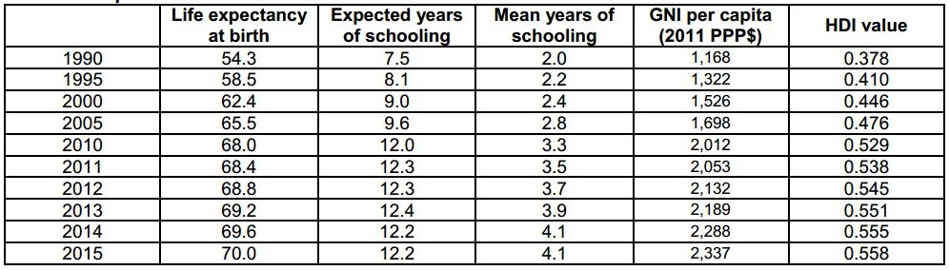

Source: (UNDP, 2016, p. 3)

### 1.4.2 Conceptual framework: micro enterprise ecosystem

MED model being carried out in limited districts (38 in total) by MEDEP in three phases has been expanded into 75 districts through institutionalization and internalization into the government system. The experiential learning from MEDEP has tremendously helped MEDPA to reduce the learning curve and extend MEDPA as a program for strengthening MEs acknowledged as one of the pillars for enterprise development in Nepal.

Bringing the hardcore poor and socially marginalized people to enterprise-related activities thereby contributing towards poverty reduction is a uniquely featured development endeavor in Nepal. The contribution of MED model towards this unique endeavor can also be viewed from economic positioning within economic ecosystem and enterprise ecosystems. The LLD considered the national economic ecosystem as a place for positioning MEs in relation to their contribution to the national economy. This conception clearly locates MEs within enterprise ecosystem. Which means that the economic contribution of MEs within national economy comes in relation to their positioning in other layers of enterprises ecosystem.

*Figure 1: Inter-connectedness of MSMEs within broader national economic ecosystem*

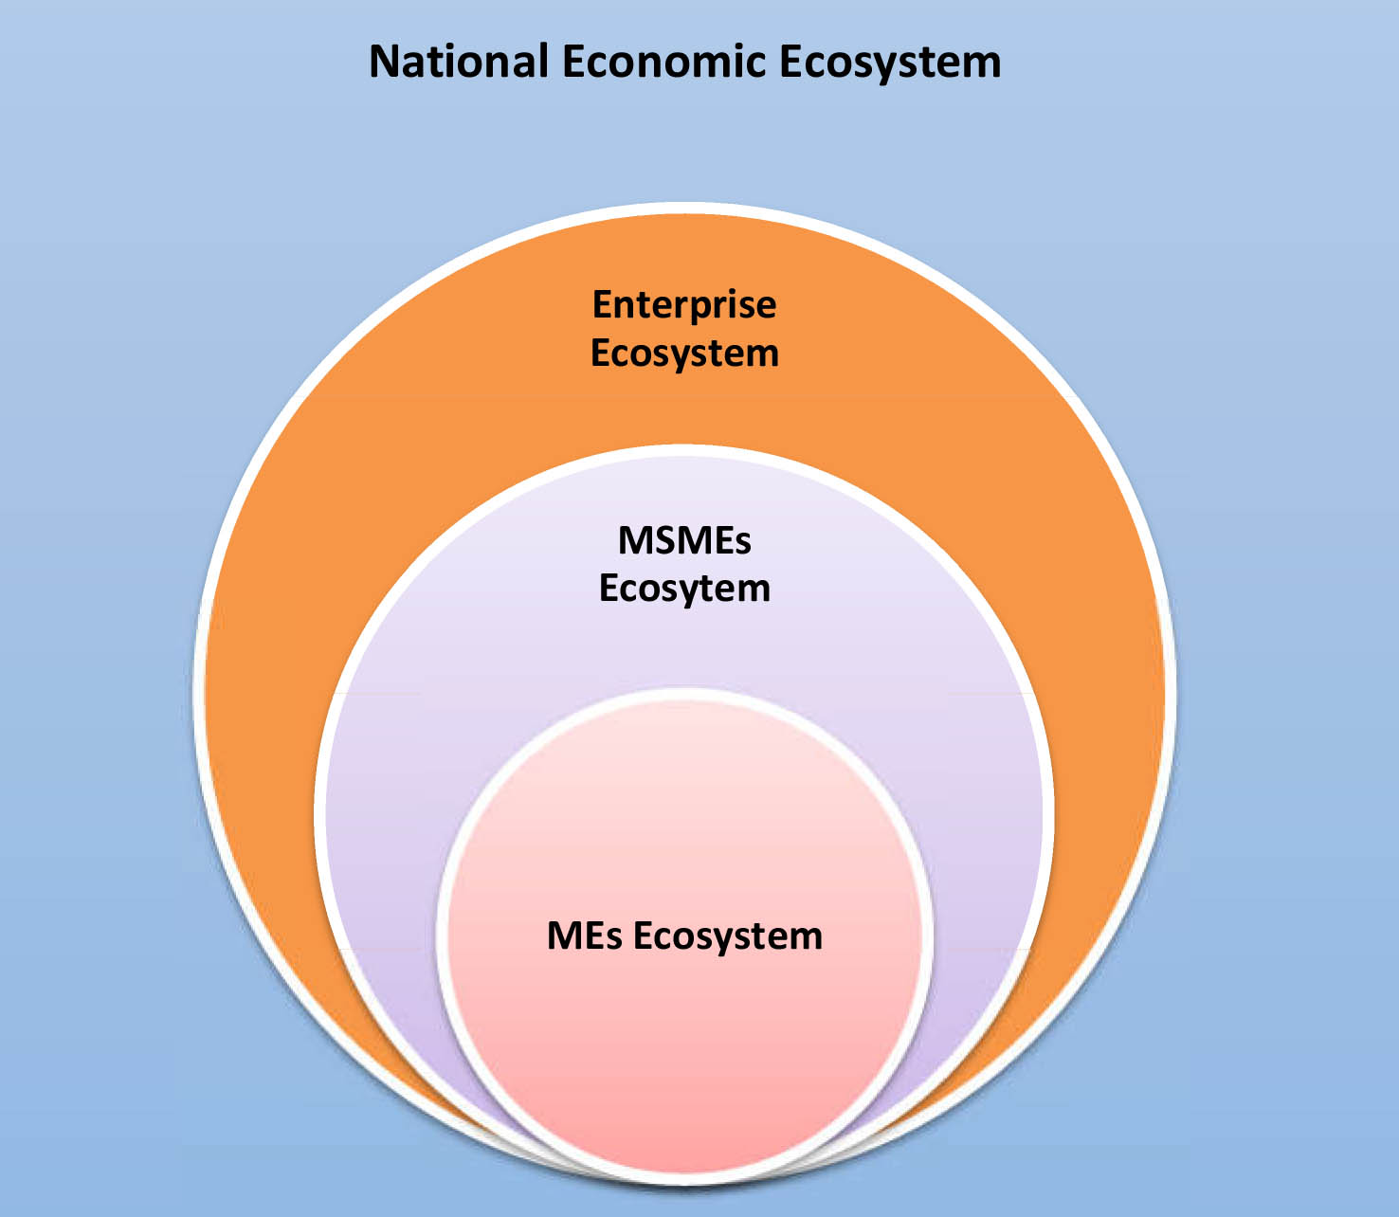

The LLD extends MED model's relation towards wider stakeholder by positioning MEs within Enterprise Ecosystem, which earlier was more focused on aspiration of Small, Medium and Large Enterprise (SMLE). The strong focus on ME promotion through MEDPA by MoI has enabled MEs to be recognized as a part of MSMEs ecosystem. This tremendous knowledge and insights inducted and practiced with MSMEs ecosystem has also led to the acknowledgement of MEs as one of the actors in enterprise ecosystem (including large enterprises) national economic ecosystem.

The literatures depict that there is strong positioning of MEs within enterprise and MSMEs ecosystem, whereas contribution of MEs in Nepal's economic ecosystem remains still unanswered. This demands innovating an approach that can position MEs within the national economic framework thereby producing avenues to foresee its results for continuous improvement of MEDPA programs in coming times.

*Figure 2: Inter-connectedness of actors within micro-enterprise ecosystem*

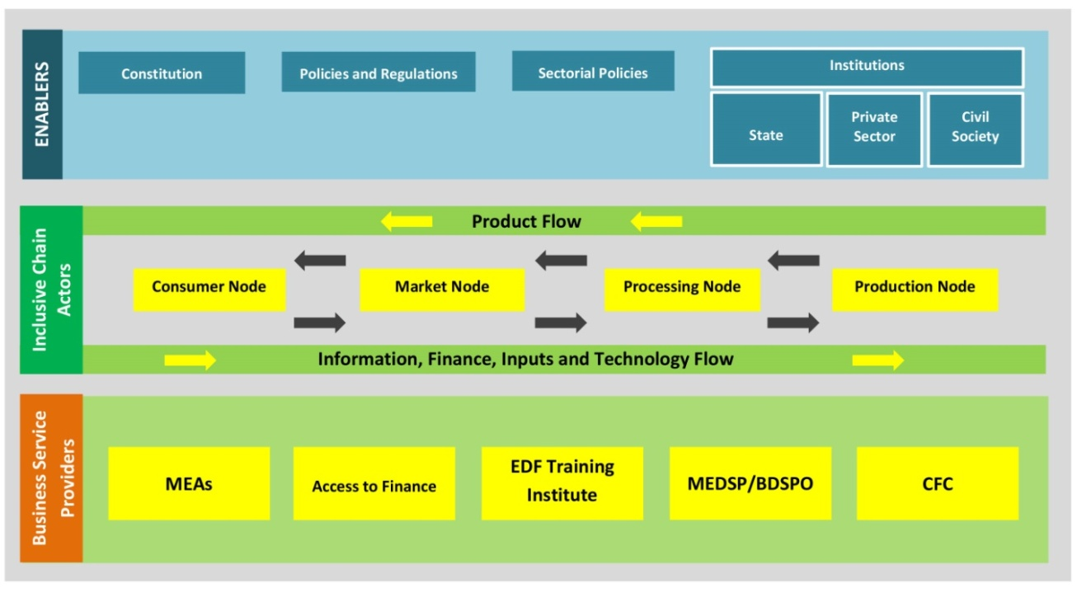

The enterprise ecosystem consists of three different layers:

1. ***Enablers:*** The enablers in Micro Enterprise Ecosystem include policies and actors that provide or produce an enabling policy environment to an enterprise; for instance, constitutions and constitutional provisions, related policies and regulations, and institutions such as ministerial line agencies, departments, private sectors, and civil society organizations. The state/government and its line agencies are considered as main enablers. However, private sector-led enablers, such as Federation of Nepalese Chambers of Commerce and Industries (FNCCI), Federation of Nepal Cottage and Small Industries (FNCSI), and National Micro Enterprise Federation Nepal (NMEFEN), civil society based enablers such as federation like Federation of Community Forest Users Group Nepal (FECOFUN) are also present as other enablers. Similarly, financial institutions are also considered as enablers in a micro enterprise ecosystem.
2. ***Inclusive Chain Actors:*** These consist of MEs, informal MEs, Small, Medium and Large Enterprises (SMLEs), consumers and various value chain actors. These actors carry out different value added functions for product/service transaction to reach final consumers, and even until and after the state of product disposal. They are positioned in four nodes: consumer node, market node, processing node, and production node. They are interconnected through two ways, i.e., back and forth. The information, finance, inputs and technology flow from consumer node to production node, while the products flow from production node to consumer.
3. ***Business Service Providers:*** Regarding MEs promoted by MED model, the business service providers include MEAs, Access to Finance (A2F), EDF training institutes, MEDSPs, and CFC. They cater the services that are required by value chain actors for effective functioning. This segment may include business service provision for MED delivery, pertinent business services, service provision by MEA, and technical training service provision. Given the enterprise ecosystem thrives when multiple opportunities for business, services like technology transfer, A2F, and other business service delivery are accessible as commercially viable options. In the case of MEs ecosystem, initial commercial viability might not be possible and subsidized service delivery may be needed for majority of business services.

The inter-connectedness of three actors shown in the figure above creates the micro enterprise ecosystem. MEs become cross-cutting actors in micro enterprise ecosystem. Mainstreaming and positioning MEs in different layers and thereby, signifying its importance in enterprise ecosystem requires high effort on capacity building, human resource development, and monitoring and evaluation mechanism. The above three important layers of enterprise ecosystem along with MEs as cross cutting layers enable holistic knowledge on MEDEP and MEDPA program and its positioning within enterprise ecosystem.

### 1.4.3 Documentation framework

The documentation of lessons learned from the implementation of MED model promoted by MEDEP and MEDPA is focused on 11 themes. These themes are major components of MED Model implementation that comprises of the processes adopted and achievements made. Therefore, the documentation work has been guided mainly by three principal approaches: demand-driven approach, six component MED strategies, and GESI target approach.

*Figure 3: MEDEP intervention processes and documentation framework*

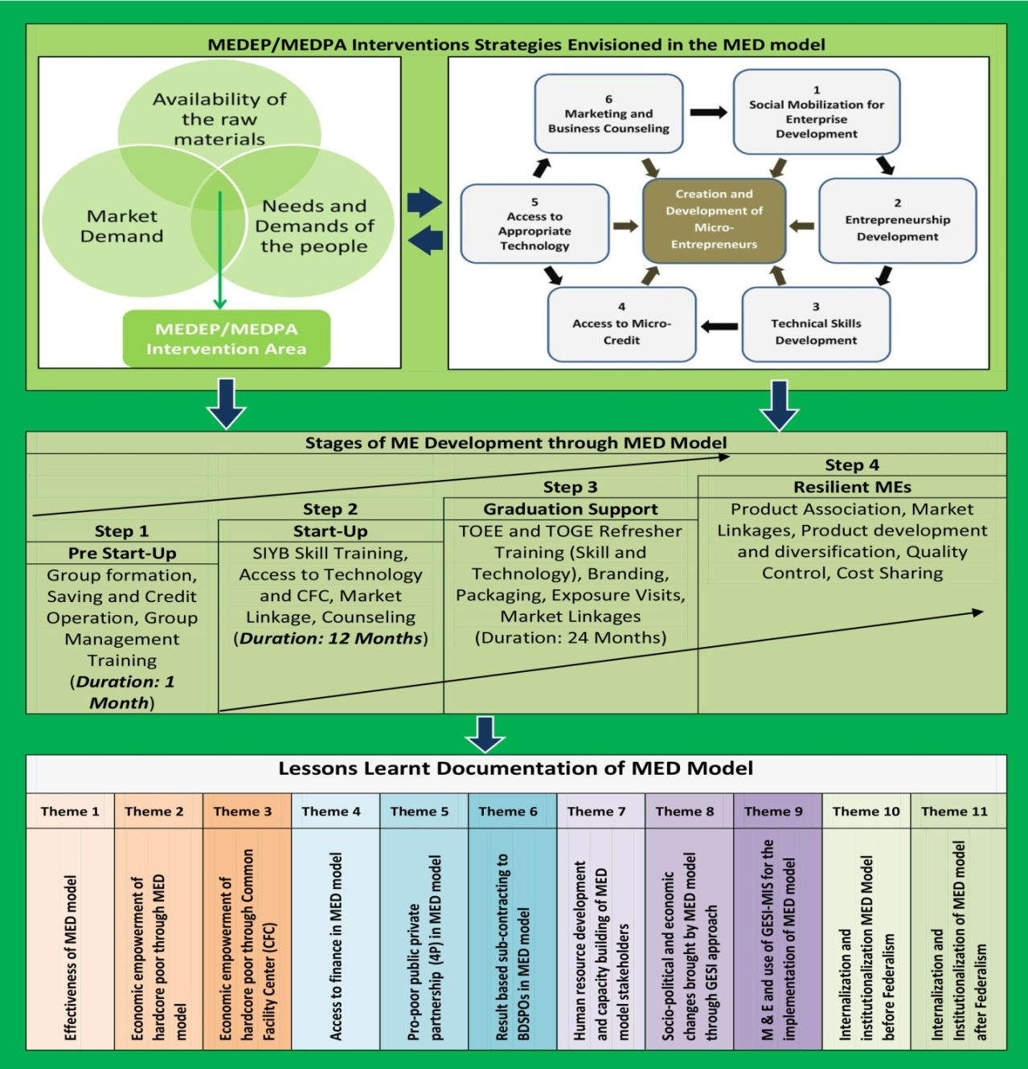

## 1.5 Organization of the report

This document is organized into 4 chapters.

First: Introduction (background, objective and rationale, ToR, and conceptual framework)

Second: Study methodology

Third: Lessons learnt documentation in 11 themes

Forth: Summary and conclusion

# Chapter 2: Methodology

## 2.1 Introduction

This document draws lessons from both primary and secondary information. However, the LLD is primarily based on the information from secondary sources. The primary information was taken as complementary to the information obtained from the secondary sources. The primary sources include opinions, perceptions, and experiences of the respondents; while secondary sources include relevant documents and reports. In terms of the nature of data, this LLD is primarily based on the qualitative nature of data; however relevant quantitative data have also been used to complement the qualitative data.

## 2.2 Selection of sites for primary information

Primary data collection was carried out in 18 districts, namely, Kaski, Parbat, Makawanpur, Mahottari, Dhanusa, Udayapur, Sunsari, Morang, Jhapa, Siraha, Khotang, Solukhumbu, Dolakha, Surkhet, Jajarkot, Dang, Kathmandu, and Lalitpur.The study districts were purposively selected since the study is primarily based on qualitative information.

*Figure 4: Districts visited for consultation meetings*

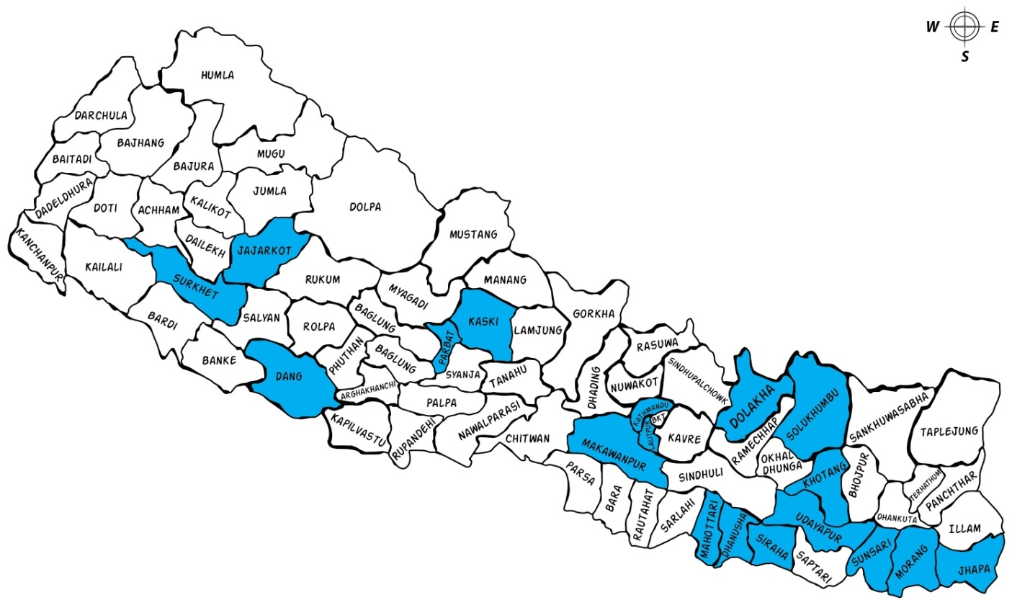

The LLD attempted to cover both MEDEP and MEDPA districts from ecologically diverse regions (Terai, hill and mountain). Originally (as per the finalized inception report), the study had planned to visit MEDEP's 6 APSOs (Pokhara, Makawanpur, Udayapur, Kathmandu, Dang, Surkhet including NPSO) and 11 constituent districts (Kaski, Makawanpur, Udayapur, Siraha, Khotang, Solukhumbu, Dolakha, Surkhet, Dang, Kathmandu, and Lalitpur). However, the study increased its field coverage districts for two main reasons. First, during the field visits, the staffs in proposed 2 APSOs (Pokhara and Makawanpur) were not available in the offices. Hence, the study team decided to visit Biratnagar APSO in order to increase the coverage. Second, the study team purposively decided to visit some more but easily accessible and possible neighboring districts to bring diverse lessons from MEDEP and MEDPA activities.

Visit to Parbat district was done as per the recommendation of Pokhara APSO team, and to Mahottari and Sarlahidistricts as per the recommendation of Makawanpur APSO team. Sunsari and Jhapa districts were visited through on-the-spot decision in order to observe ongoing industrial exhibitions in Dharan of Sunsari and Damak of Jhapa. Similarly, Jajarkot was visited through random decision of the LLD team in order to access additional information.

## 2.3 Collection of information from primary sources

Three types of respondents were visited and interviewed. They were primary stakeholders, secondary stakeholders and beneficiaries of the MEDEP and MEDPA activities. The primary stakeholders comprised of staffs of the MED Service Providers (MEDSP) or Business Development Service Providing Organizations (BDSPO), staffs of MEDPA implementing partner organizations namely Department of Cottage and Small Industries (DCSI) and Cottage and Small Industry Development Board (CSIDB), members of the Micro Entrepreneurs' Association (MEA), and Micro Entrepreneurs (MEs). The secondary stakeholders constituted of district level stakeholders such as District Coordination Committee (DCC) members, locally elected leaders, District chapters of Federation of Nepalese Chambers of Commerce and Industries (FNCCI), and local entrepreneurs. Beneficiaries for this LLD work were the entrepreneurs created and supported by MEDPA and MEDEP.

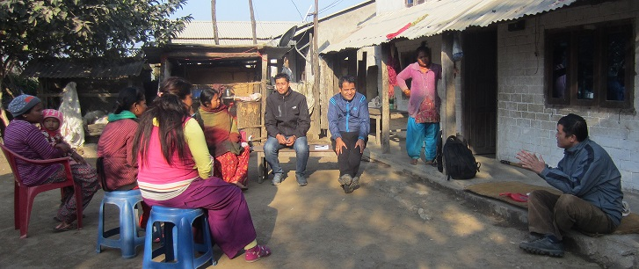

*(Participants of FGD with the members of Unnatiseel Mahila Laghu Udyami Samuha in Manahara 6, Makwanpur)*

Table 6: Respondents of the study as sources of primary information

|  |  |
| --- | --- |
| ***Categories of Respondents*** | ***Institutions/Organizations/Committees*** |
| National | * Ministry of Industries (MoI) * MEDPA Steering Committee * MEDPA Implementation Committee * MEDEP's National Program Support Office (NPSO) * National Micro-Entrepreneurs' Federation Nepal (NMEFEN) * National Entrepreneurs Development Center (NEDC) * Federation of Nepalese Cottage and Small Industries (FNCSI) * Federation of Nepalese Chambers of Commerce and Industries (FNCCI) * Department of Foreign Affairs and Trade (DFAT) * United Nations Development Program (UNDP) * Department of Cottage and Small Industries (DCSI) * Cottage and Small Industries Development Board (CSIDB) * Council for Technical Education and Vocational Training (CTEVT) |
| District and Regional | * MEDEP's Area Program Support Office (NPSO) * District Micro Entrepreneurs' Group Association (DMEGA) * Micro Enterprise Development Service Providers (MEDSP) or Business Development Service Providing Organization (BDSPO) * District Federation of Nepalese Chambers of Commerce and Industries (FNCCI) * District Department of Cottage and Small Industries Office (DCSIO) * District Cottage and Small Industries Development Board (CSIDB) * District Enterprise Development and Implementation Committee (DEDIC) * District Enterprise Development Committee (DEDC) * District Coordination Committee (DCC) |
| Local | * Micro Entrepreneurs (ME) * Micro Entrepreneurs' Group Association (MEGA) * Community Facility Centers (CFC) * Municipality Office * Rural Municipality Office * MEDEP promoted Cooperatives * Village Enterprise Development Committee (VEDC) |

Two methods/tools were used to generate required primary information: Focus Group Discussion (FGD) and Key Informant Interview (KII). Concerned officials/staffs and focal persons of the visited national, regional, district, and local level organizations/institutions were requested to speak about the processes, methods, approaches, outcomes/outputs, including strengths and gaps of the MEDEP and MEDPA activities so as to assess the effectiveness of the MED model and services provided through MEDPA and MEDEP implementation. The status/condition of the visited enterprises at the local levels were observed, and the concerned MEs were asked to speak about their experiences, problems, challenges, supports received, and supports needed in order to assess the effectiveness of MED model and services provided under MEDEP and MEDPA implementation. In addition, some of the key individuals (respondents) were also contacted through the telephone calls.

The prime objective of generating required primary information was to understand the effectiveness of the approaches and methods of implementing MED model and its outcomes/outputs. For this, interaction sessions with respondents at different levels (national, regional, district, and local) were conducted to ensure methodological triangulations for realistic information. In addition, community visits were carried out without any prior information so as to ensure observation of realistic picture of the visited enterprises and MEs.

## D:\ERI\Proposal\redesign\31_32_2_.JPG

*(Consultation meeting with MEDEP team in Kathmandu)*

## 2.4 Collection of information from secondary sources

Relevant reports and project documents were collected/received from MEDEP, BDSPOs, DMEGAs, and concerned agencies. The collected documents and reports, then, were reviewed to identify relevant evidences or data/information to substantiate the lessons learnt from the implementation of MED model. Some of the major documents collected and reviewed included the following:

* MEDPA five years strategy plan;
* MEDEP’s four phases documents;
* MEDEP/MEDPA's Mid Term Review (MTR) document;
* GESI study;
* GESI strategy;
* Mass Impact Study;
* MED Policy Compilation;
* Assessment reports of MEDSP, MEA and Financial Service Providers (FSPs);
* Data/Report of CFCs;
* M&E Reports;
* Annual Reports of MEDEP;
* GESI-MIS data reports;

## 2.5 Limitations of the lessons learnt documentation

Documentation of lessons learnt from the implementation of MED model during the last two decades within a very limited time frame of three months was very difficult and challenging. Therefore, one of the major limitations of this LLD was time constraint, due to which the LLD team could not get enough time to have rigorous consultation and discussion with MED stakeholders, MEDEP and MEDPA staffs, and other stakeholders. Similarly, review of all the relevant project documents, related policies, and literatures within the limited time period itself was also a challenge.

# Chapter 3: Lessons learned from the MED model promoted by MEDEP and MEDPA in Nepal

Availability of human and natural resources in Nepal has great potential to achieve poverty reduction and employment generation through micro enterprise development. It is evidenced that the experiences of many other low-income developing countries like India, Bangladesh, Indonesia, Thailand etc. (GoN/MoI, 2013 [July], p. 2) have adequate examples of economic growth and poverty reduction through micro-enterprise. Therefore, some Asian countries including Nepal are promoting micro-enterprise development for income generation and employment creation by targeting low income groups. In the context of Nepal, there is a constantly high relevance and potential of micro enterprise in many sectors that include: (a) high-value agriculture products, (b) sustainable and high utilization of agriculture, (c) promotion of tourism sector, (d) forest resources, (e) medicinal and aromatic plants, (f) cultural arts and handicrafts and many more others.

In view of above potential sectors for developing MEs in Nepal, a regional study sponsored by the Asian Development Bank (ADB) in 1996 recommended the GoN to formulate a micro enterprise development policy. The report noted that until a clear-cut definition of micro-enterprise existed within the Industrial Enterprise Act 1992, the Micro Enterprise sector would remain beyond the reach of the government fiscal incentives and other supporting facilities. In line with the conceptualization of micro enterprise development in Nepal as one of the means to poverty reduction, the GoN and UNDP initiated a joint initiative of piloting MEDEP in 10 districts in 1998. This piloting initiative was designed for 5 years (1998-2003). The overall purpose of this initiative was to improve the socio-economic conditions of low-income and socially deprived households. The specific objectives of the piloting initiative of MEDEP were: a) To improve the living standard of poor people who are below the poverty line, women, Dalits, indigenous nationalities, and deprived communities by establishing them as micro entrepreneurs; b) To create employment opportunities; and c) To encourage maximum utilization of local resources, means, technologies, and skills through the improvements, modernization, and diversification in the traditional occupation areas.

The Ninth Five Year Plan (1998-2002) in Nepal was remarkable as it aimed to promote the MEs, but no substantial progress was made until the start of MEDEP in 1998. Since then, MEDEP became one of the exemplary programs in Nepal which continued for almost two decades and had been implemented in four phases. Another characteristic feature of MEDEP as an exemplary program in Nepal is that it started in 10 districts in its first phase and was gradually expanded into 15 districts in second phase, 13 districts in third phase and rest of the other 37 districts in its fourth phase.

Table 7: Districts covered by different phases of the MEDEP activities

|  |  |  |
| --- | --- | --- |
| ***MEDEP Phases*** | ***Name of districts*** | ***No. of Districts*** |
| Phase I (1998-2003) | Terahthum, Sunsari, Dhanusa, Nuwakot, Nawalparasi, Parbat, Dang, Pyuthan, Dadeldhura, Baitadi | 10 |
| Phase II (2004-2008) | Saptari, Udayapur, Siraha, Sindhuli, Sarlahi, Ramechap, Kavrepalanchok, Sindhupalchok, Rasuwa, Kapilvastu, Myagdi, Banke, Bardiya, Kailali, Darchula, | 15 |
| Phase III (2008-2013) | Jhapa, Morang, Mahottari, Rautahat, Dolakha, Baglung, Rukum, Rolpa, Salyan, Surkhet, Dailekh, Kalikot, Jumla | 13 |
| Phase IV (2013-2018) | All remaining districts | 37 |
|  | **Total** | **75** |

Source: UNDP/MEDEP, 2013 p. 12

The fourth phase of the MEDEP program is remarkable in that one of the objectives was to support the GoN to take over the delivery of MED activities through Micro Enterprise Development for Poverty Alleviation (MEDPA) program with a primary goal to contribute to poverty reduction and employment generation in Nepal. This means, implementation of MEDPA was in line with GoN's efforts to reduce poverty through employment creation as outlined in the Three Years Interim Plans (2007/8-2009/10 and 2010/11-2012/13) and Thirteenth Plan (2013/14-2015/16), the Micro-Enterprise Policy 2007, Industrial Policy 2010 and the Government's MEDPA document that plan to deliver MED in 75 districts by 2017/18 creating about 73,000 MEs (GoN/MoI/UNDP, 2013 [July], p. 19).

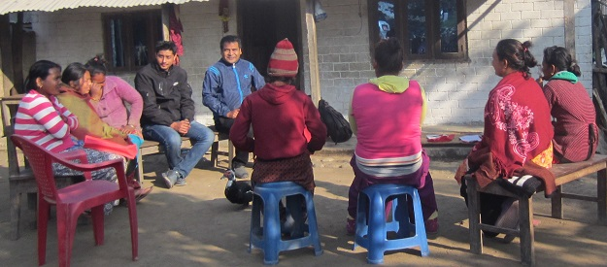

*(Participants of FGD with the members of Unnatiseel Mahila Laghu Udyami Samuha in Manahara 6, Makwanpur)*

The implementation of MED activities under different phases of the MEDEP is guided by a long term visionary framework, termed as "demand driven approach" that combines three aspects of enterprise development, i.e. availability of raw materials, demands of the micro entrepreneurs, and market demands in order to develop MEs from among the target groups. The demand-driven approach is central to the implementation of MED model where all program activities are embedded in the interest and potential of the community/participants to acquire the skills for enterprise development, demand or needs of the target groups, market opportunity based on location or district's potential, and resource potential that includes natural, financial, skills, etc.

The policy advocacy for the recognition and development of MEs has also remained one of the important components of MED model implementation. Therefore, implementation of MED model significantly contributed in creating an enabling policy environment for the development of MEs in Nepal. This means that a number of policies and guidelines related to the MEs have been formulated that have eased the implementation of MED model on the one hand, while MEs have been mainstreamed into government's development initiatives, on the other hand.

Table 8: Major milestones of MEDEP and MEDPA implementation

|  |  |
| --- | --- |
| ***Years*** | ***Major activities/milestones/events*** |
| 1998 | Inception of MEDEP |
| 2002 | Tenth Five Year Plan (2002-2007) that provisioned support to MEs in Nepal |
| 2004 | MEDEP II phase started |
| 2004 | The concept and practice of BDSPO was started |
| 2006 | MEA named NMEFEN was established |
| 2006 | NEDC as federation of BDSPOs was established |
| 2007 | Micro Enterprise Development Policy 2007 formulated |
| 2007 | TSLC-EDF course was approved by CTEVT for EDF production |
| 2008 | MEDEP III phase started |
| 2008 | District Enterprise Development Program Implementation Procedure, 2008 |
| 2008 | MED Fund Operation Guideline, 2008 |
| 2008 | Village Enterprise Plan Formulation Procedure and Implementation Guideline, 2009 |
| 2009 | Commercial policy 2009 |
| 2011 | Industrial policy 2011 formulated that has recognized ME as a category |
| 2012 | District enterprise development strategic plan preparation guideline, 2012 |
| 2013 | MEDEP IV phase started |
| 2013 | Monetary policy, 2013 |
| 2014 | MEDPA Operation Guideline, 2014 |

During 15 years of experience of direct implementation, MEDEP gained a strong understanding of the effectiveness of the MED model (six components) as a successful approach for developing MEs. The performance of MEDEP, since its inception in 1998, is also reported as encouraging. UNDP/Nepal, therefore has acknowledged the implementation of MED model as one of its most successful programs in Nepal. In line with this, MEDEP phase IV has been transformed into Micro Enterprise Development for Poverty Alleviation (MEDPA) which mainly aimed towards the internalization and institutionalization of the MED model into the government system. For this, handover of the MEDPA program to the GoN has remained an important milestone of the implementation of MED model. It is projected that the MEDPA will be completely handed over to the GoN by the end of MEDEP phase IV i.e. by August 2018.

Table 9: Internalization of MEDPA through functions of MED system players

|  |  |  |  |  |
| --- | --- | --- | --- | --- |
| **Program** | **Before MEDPA** | | **After MEDPA** | |
| **Responsible parties** | **Source of funds** | **Responsible parties** | **Source of funds** |
| Identification of program location and market centers | MEDEP and MED service providers (MED SP) | MEDEP | DDC and MED service providers | DDC (DEDIC using the DEDF) |
| Targeting and PRA | MEDSP | MEDEP | MEDSP | MEDPA and local government through MEDF |
| Resource survey and market survey | MEDSP | MEDEP | MEDSP | MEDPA and local government through MEDF |
| Pre-qualification/screening of SP | UNDP | UNDP | MoI | MEDPA and local government through MEDF |
| Contracting of MED SP and contract management | MEDEP | MEDEP | MoI and DDCs | MoI and DDCs through pooled funding |
| Social mobilization | DMEGA | MEDEP | MEDSP | MEDPA, DMEGA, beneficiaries |
| SIYB training | MEDSP | MEDEP | MEDSP | MEDPA and local government through MEDF |
| Technical and skill training | MEDSP | MEDEP | MEDSP, NMeFEN, DMEGA | MEDPA, DMEGA, beneficiaries (NMEFEN/ DMEGA members) |
| Financial linkage | BDSPOs, DMEGA | MEDEP | MED SP, NMeFEN, DMEGA | MEDPA, N/DMEGA, Financial Institutions (FI), beneficiaries (NMEFEN/DMEGA members) |

Source: UNDP/MEDEP, 2013, p. 23.

In line with the internalization and institutionalization of the MED model into the government system, strengthening the capacity of MEDPA implementers, namely DEDIC, DCSI, CSIDB, MEAs and MEDSPs/BDSPOs have remained important components of MEDPA activities. In line with this, the roles of MEDEP have been shifted from implementer to the technical facilitation for the implementation of MED model so as to let MEDPA take the lead. This means, MEDEP had to shift from being an implementer of MED model to supporting the GoN to set necessary system for MED delivery. This LLD work, therefore, is focused towards the analysis of the effectiveness of the MED model including processes of its internalization and institutionalization into the government system.

## 3.1 Effectiveness of MED Model

The unique feature of MEDEP and MEDPA activities is its processes-oriented ME creation through six steps MED strategy. This strategy is popularly known as MEDEP's MED model, which primarily focuses on the development of latent entrepreneurship skills of the target population, i.e. people below poverty line with special priority to socially marginalized communities that include women, Dalits, indigenous nationalities, Madhesis, and unemployed youths with special care/focus to the economically poor (hardcore poor).

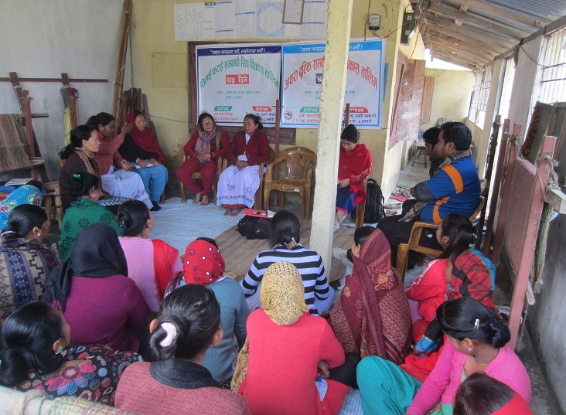

*(Participants of FGD in Jutjhalla CFC in Tutaha, Duhbi in Sunsari district)*

**Effectiveness of the six steps MED strategy**

The six steps MED strategies are the core of MEDEP and MEDPA interventions that offer a mix of training and service provisions. These steps are also known as six components of the MED model. The second and third steps or components, primarily, consist of providing training to enhance entrepreneurship skills, while others are the service provisions (UNDP/MEDEP, 2013, p. 14).

*Component 1 (Social Mobilization):* Use of Participatory Rural Appraisal (PRA) for identification of target candidates, formation of micro entrepreneur group to provide basic support to entrepreneurs, socialization of ideas and basis for impact measurement.

*Component 2 (Entrepreneurship Training):* Provision of Start and Improve Your Business (SIYB) and Micro Enterprise Creation and Development (MECD) training.

*Component 3 (Technical Skills Development):* Provision of basic technical training according to the type of enterprise that the candidate intends to start.

*Component 4 (Access to Financial Services):* Establishment of linkages between financial institutions (MFI, Cooperatives) and start up enterprise.

*Component 5 (Access to Appropriate Technology):* Provision of low-cost technology to start a business through the so called Common Facility Centers (CFC).

*Component 6 (Market Linkages and Business Counseling):* Consolidation of production by micro-entrepreneurs and linkages with wholesale buyers and markets.

*Figure 5: MEDEP and MEDPA's integration of six steps as MED model*

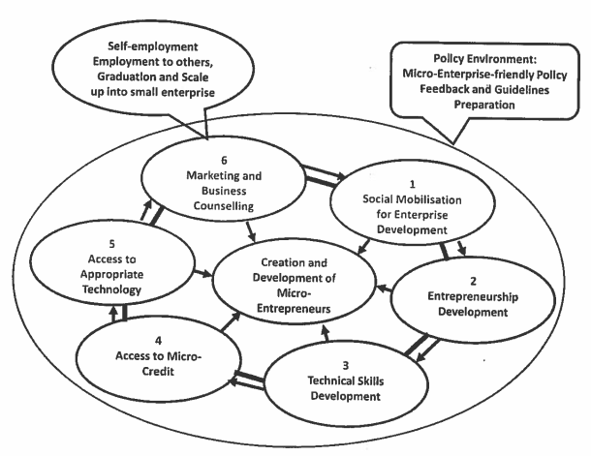

Source: UNDP/MEDEP, 2013, p. 14; GoN, 2013, p. 14

In MEDEP and MEDPA's experience, an entrepreneur needs, on average, 12 months to start-up a business; however, 12 months is not sufficient to guarantee its resilience as most start-ups require further support to access input such as access to finance and markets to become profitable. MED model has, therefore, supported an entrepreneur from start-up to graduate and then into profitable business by providing them with targeted technical support in the form of higher levels of entrepreneurship training, linkage with financial service providers, linkages with markets, business counseling, branding, and other required services. In MEDEP and MEDPA's experience, start-ups take up to a maximum of 2 years to graduate, for a total of a maximum of 3 years from the start to end of the process (UNDP/MEDEP, 2013, p. 15).

*Figure 6: Stages of micro enterprise development through MED model*

|  |  |  |  |
| --- | --- | --- | --- |
|  |  |  | **Stage 4** |
|  |  | **Stage 3** | **Resilient MEs** |
|  | **Stage 2** | **Graduation Support** | Product Association, Market Linkages, Product development and diversification, Quality Control, Cost Sharing |
| **Stage 1** | **Start-Up** | TOEE and TOGE Refresher Training (Skill and Technology), Branding, Packaging, Exposure Visits, Market Linkages  (***Duration: 24 Months***) |
| **Pre Start-Up** | SIYB, Skill Training, Access to Technology and CFC, Market Linkage, Counseling  (***Duration: 12 Months***) |
| Group formation, Saving and Credit Operation, Group Management Training  (***Duration: 1 Month***) |

Source: UNDP/MEDEP, 2013, p. 15

MEs developed by integrated approach of MED model go through four stages. The final goal of MEDEP and MEDPA is to develop resilient enterprises or MEs that are sufficiently connected to services and output markets to be able to grow their businesses and overcome economic shocks. Resilient entrepreneurs, for MED model, are those entrepreneurs who are still in business at least two years after graduation from MEDEP or MEDPA's supports (UNDP/MEDEP, 2013, p. 15). The resilient MEs, therefore, is one of the important indicators of MED model.

The six steps MED strategy consists of two important features. The first is the continued support and facilitation to the entrepreneurs; while the second one is the provision of multiple services to the MEs. So, it can be concluded that six steps MED strategy is a useful tool to develop a number of sectors in countries like Nepal, where the industrial base is low and level of poverty is high. For instance, ME development can play a relevant role in agriculture, forestry, tourism service and handicraft industries. However, implementation of six steps MED strategies is very difficult in terms of time as well as human and financial resources. This means that the MED model requires plenty of time alongside mobilization of experienced/skilled human resources.

The lessons learned from this case is that transforming target population into entrepreneurs is possible through effective implementation of MED model but requires constant support and facilitation for at least up to three years.

***Use of demand-driven mechanism in MED model***

Demand-driven mechanism is one of the important features of the MED model. The use of this approach is that the MED services are provided on the basis of the diagnosis from three aspects: demand of the micro entrepreneurs; market demand; and availability of raw materials. This means all program activities are embedded within the framework of the potential and needs of MEs and their markets. Therefore, the starting point of MED activities is thus based on the demand of the low income families to improve their sources of income and the demand of market for their products; this means the entry point of the MED model is based on the resource potential, people's need and market demand for products and services.

*Figure 7: MEDEP and MEDPA's demand driven framework*

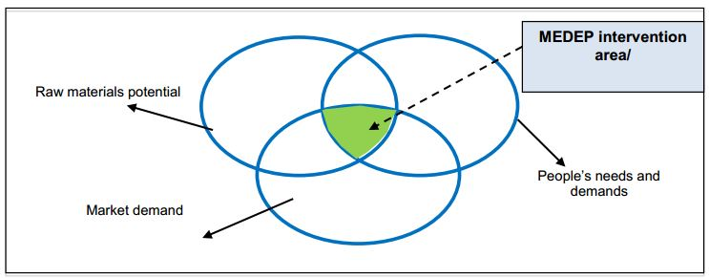

Source: GoN/MoI, 2013, p. 14

The demand-driven approach of the MED model is very important and effective to identity and select target population and to assess the potential of developing entrepreneurs. This approach is also very useful in exploring the partnership between different agencies for specific purposes such as technology transfer. However, applications of this approach on the ground primarily rely on the expertise of Enterprise Development Facilitators (EDF).

**Participant selection in MED training programs**

Participant selection process is one of the important features of the MED model. In this process, four steps of activities are carried out in order to ensure selection of the target population (women, Dalits, Indigenous Nationalities, Madhesis, and unemployed youths); which is aimed at identifying potential entrepreneurs from among the target groups so as to ensure maximum utilization of the limited resources. The four steps participant selection processes comprised of the following (GoN/UNDP, 2010, p. 5).

*Step 1:* Mapping of the poverty scenario in selected program locations (areas) through the use of PRA tool and identify poor and vulnerable households.

*Step 2:* Household (HH) survey through socio-economic baseline survey. The purpose of this survey is to collate basic demographic profile, employment details, sources of income, ownership status of land and other livelihood assets/capitals, source and level of income, management of food supplies, etc. (using form A).

*Step 3:* Administration of survey questionnaire to the unemployed and potential entrepreneur members of the HHs. Having identified unemployed members in the HHs through HH survey (form A), the next questionnaire (form B and form C) is administered to them. This questionnaire focuses on the educational status, knowledge, skills, interest/priorities, economic sources, entrepreneurship backgrounds, family backgrounds, membership in other groups and associations.

S*tep 4*: Selection of potential entrepreneurs within the selected households through participatory discussions and interactions among the concerned HHs.

The above discussed four steps are a package of participant selection processes of MED model implementation. The use of these steps is to ensure the selection of the individuals who are amongst the poorest of the poor. During these steps, the hardcore poor are prioritized as first, while women, Dalit, and indigenous nationality are considered as second order. Keeping in mind that unemployment problem could be addressed through targeting people aged between 16 to 30 years, the selection processes considered this age category of people as the third priority. It is also conceptualized that the risk bearing capacity, interest, commitment, availability of the time, and the possibility of physical mobility are also highly consideredfor participant’s selection. Finally, the socio-economic details of the individuals (as possible entrepreneurs) are entered in the GESI-MIS software and analyzed using the above criteria. The potential entrepreneurs are then selected as participants in the MED model activities.

In conclusion, it can be claimed that the participant selection processes under MED model is scientific as it goes through rigorous processes in identifying potential candidates. The MED model processes, particularly participant selection, therefore, has aided the poor and vulnerable people in being economically empowered.

The available data shows that a total of 72,370 individuals belonging to these categories have been economically empowered during three phases of MEDEP period (1998-2012) alone and 73,000 have been projected to be identified and supported during MEDPA period (2013-2018) (GoN/MoI, 2013 [July], p. 21). However, it is reported that its transformation into the real practice have some challenges such as political pressure, government's procurement policy (single year contracting during MEDPA period), and lengthy selection processes (resulting in shorter time for service delivery), and capacity and honesty of the EDF or staff, who conduct these processes.

Some measures could be adopted to mitigate problems/challenges mentioned above. The first problem could be resolved through the use of government's database (such as identification card provided by the government, area declared as prone zone by the government agency, etc.). The second is by revising the government procurement policies such as either by adopting pre-selection of BDSPOs so that the activities could start with the beginning of fiscal year or multi-year contracting (at least three years). The third problem could be resolved by regular monitoring and capacity development of EDFs or staffs those involved in these processes.

**Relevance and fit of the MED model in Nepal**

Nepal is a country of diversity. Diversity exists in terms of caste ethnic groups (125 caste/ethnic groups), religious groups (10 types of religions), and languages (123 languages are spoken as mother tongue) (GoN/CBS, 2011). It is a fact that some of the social groups such as women, Dalits, Indigenous Nationalities, Madhesis, and unemployed youths, are socially marginalized, economically vulnerable and politically excluded. In this case, development priority with special care to marginalized groups is of utmost importance to uplift the social, economic and political status of these groups. In line with this, MEDEP and MEDPA activities, through the implementation of MED model, have been providing special care to the hardcore poor of excluded groups. The special care comprises of service provisions in the form of the integration of six components of MED model. MED model, therefore, is very relevant and fit for Nepal's diverse socio-cultural, economic, and political context, since it provides continued support to the selected target population and seeks sustainable partnership between service providers and the MEs.

It can be concluded that some of the characteristics of MED model has made it relevant and fit in Nepal. They are: (a) people below poverty line as prioritized beneficiary; b) special focus and care to the hardcore poor; (c) setting the target in terms of selecting the beneficiary (women - 70%, Dalits - 30%, Indigenous Nationalities - 40%, Madhesis - 30%, unemployed youths age between 16 to 40 - 60%); (d) integrated service provision that includes six step/components of MED strategy; (e) continued supports and facilitation, at least up to three years to the selected beneficiary or ME; and (f) providing an integrated service package based on the demand-driven approach that consists of combined assessment of the availability of raw materials or natural resources, people's needs and demands, and market demands.

**Sustainability of the MED model**

Sustainability of the MED model depends on the institutional arrangements for its implementation. Looking at this, the implementation of the MED model changed over the time. It started from MEDEP itself as the service provider which was then transformed into MEDEP selected MEDSP/BDSPOs and then to the MEDPA selected BDSPOs. During this period, four tiers of MEAs (MEG, MEGA, DMEGA, and NMEGA/NMEFEN), MEDSP/BDSPO and their national association (named as National Enterprise Development Centers-NEDC) including national to district and village level multi stakeholder committees (namely MEDPA Steering Committee, MEDPA Implementation Committee at the national levels; DEDC and DEDIC at the district levels; and VEDC at the village level) have been formed to institutionalize the implementation of MED model.

In line with the sustainability of the MED model, capacity development of three stakeholders (MEDSPs, MEAs and MEDPA) has become one of the priority activities of MEDPA implementation. For this, MEDPA has adopted a portfolio approach to maximize the opportunities of each step of the integrated approach of MED model (GoN/MoI/UNDP, 2013 [July], p. 24) for which combination of social protection approach and a market-led approach has been adopted for the implementation of MED model.

Table 10: Internalization of MEDPA through functions of MED system players

|  |  |  |
| --- | --- | --- |
| **Steps** | **Activities** | **Responsible parties** |
| Step 1 | Social mobilization for enterprise | MEDPA, MED SP, NMEFEN, DMEGA |
| Step 2 | Entrepreneurship through SIYB/MECD training | MEDPA, MED SP |
| Step 3 | Technical skill development | MEDPA, MED SP |
| Step 4 | Access to financial services | MEDPA, MED SP, NMEFEN, DMEGA |
| Step 5 | Appropriate technology testing and transfer | MEDPA, MED SP, NMEFEN, DMEGA |
| Step 6 | Market linkages and business counseling | MEDPA, MED SP, NMEFEN, DMEGA |

Source: GoN/MoI/UNDP, 2013, p. 24

The MEDEP and MEDPA have facilitated to form the associations of MEs at local (as MEG and MEGA and recently i.e. after the federalism, it is LMEGA), district (DMEGA), and national levels (NMEFEN), commonly known as MEAs. However, members of the MEAs are from economically poor and socially excluded and marginalized section of society, and hence their institutional sustainability is always challenging in terms of leadership capacity and generating sustainable resources.

MEDPA is conceptually understood as internalized and institutionalized into the government system. In line with this, institutional set ups at the government levels (establishment of MED section at the MoI and MED unit at DCSI and CSIDB) and regular financial resources allocation from government's regular budget for the implementation of MED model is important indicators of the sustainability of MED model.

MED model is a platform for the service providers (MEDSP/BDSPOs) to enhance their institutional capacities. This has also developed institutional relations between MEDSPs and MEs. However, "*the issue is how to sustain them working in the MED sector so that the interest, expertise and number of active organizations do not decline because of the lack of adequate business opportunities in the market*" (DECC, 2016 [May], p. 54).

To conclude, the implementation of the MED model has encouraged engagement of multiple actors including the private sector, government line agencies, MEAs, and service providers, which is an evidence of its sustainability. However, the question in the present political context is how this mechanism can be transformed into Nepal's federal context, i.e. at the local to national government units.

**Success and challenges in implementing MED model**

MED model is a package of service provisions delivered through the service providers. This package of services is very effective in developing internal entrepreneurship skills of target population. This model is recognized as one of the best methods as well as successful program in Nepal in terms of economic empowerment of the people below poverty line. However, its time consuming nature is challenging when it is viewed from the perspective of the demands or expectation of quick impacts of interventions.

**Key lessons learnt from the effectiveness of the MED model**

1. ***MED model is a package of services that changes mindsets of the hardcore poor:*** As discussed earlier,the MED model is an integration of the package of services that includes six components delivered in sequential orders. It is reported as well as observed that the effective implementation of MED model or delivery of the six component/step services changes the mindsets of the participants that people who never thought of being entrepreneurs start thinking, planning and doing micro enterprises.
2. ***Integration of six components enhances holistic knowledge on micro enterprise:*** The six steps of MED model service provision is a process of enhancing complete knowledge on micro enterprise to the selected beneficiary. The service provisions include group formation, enterprise establishments, technical skill development, access to finance, access to technology, and marketing which enhances complete knowledge of a micro enterprise.
3. ***Entrepreneurship skills are potential to be expanded beyond aparticular enterprise or product:*** In some cases, many of the MED model participants or beneficiaries either could not establish the enterprise even after the receiving MED services or could not continue with the operation of established enterprises. However, in these cases, the skill and knowledge gained from the MED services have become very useful in their socio-economic lives beyond the particular enterprises. For example, in many cases, the participants have used received entrepreneurship knowledge and skills into other forms of economic activities including establishing and operating other enterprises. In such cases, technical and occasional refreshment trainingare necessary from the perspective of such MEs in order to ensure further progress in their enterprises.
4. ***The effectiveness of the MED services is different amongst the MEs:*** Outcomes of the MED services are different amongst the MEs. Some of the participants have become very successful MEs, while others have either dropped out or failed in their endeavors to establishing and running an enterprise. The successful cases are mainly due to the combination of MED services and the personal situation of the participants (i.e. interest, inner skills, socio-economic conditions etc.). In the case of failures, constant follow up support is required in order to make them resilient.
5. ***Proper sequencing as well as flexibility of the six components of the MED model is important for effective results:*** The six components of MED model are not required uniformly to all the participants or entrepreneurs. This is same as the types of students in a class in which some may need more care/effort/investments/time, while some other need less. The lesson from this is that the six components of the MED model need to have proper sequencing in terms of the investments of the efforts, focus and time to the different participants. In many cases, all levels of services may not be required to all participants, and in such cases flexibility in providing the choices for MED services is very effective.
6. ***MED model is a blending of both demand side of the MEs and supply side of the service providers:*** In principle, the MED modelis based on a demand-driven approach; which means that ME creation is often based on the demands of participants and the demands of markets by considering the availability of natural resources. In practice,the implementation of MED model has become a blending of the demands of the MEs and supply of the service providers.
7. ***Proper implementation of MED model is constrained by the availability of resources and the time:*** As discussed in the previous point that the implementation of MED model, in practice, is based on the balance between demand side and supply side. This is mainly because of the time and resource constraints of MEDSPs that prior-confirmed financial resources and time (to the MEDSPs) do neither allow MEDSPs to act according to the needs and demands of the particular MEs nor the requirements of the MED model. So, the proper implementation of MED model requires sufficient time and resources.
8. ***The role of EDF is determinants of the effectiveness of MED model and hence their capacity building and motivation is highly required***: In practice, EDFs work as close friends of the MEs. Hence they know conditions of the respective MEs (i.e., the MEs with whom they work) and support/facilitate as per the needs of the MEs. Therefore, effective implementation of the MED model primarily depends upon the knowledge, skills and roles of the EDFs. The lesson learnt from this situation is that enabling an environment for the EDFs including their capacity building and motivation are highly desirable for effective implementation of the MED model.

**Conclusion of the Effectiveness of the MED model**

MED model, aligned with contributing to poverty reduction, as effective and proven tool for the development of MEs in Nepal is due to its unique approaches (commonly known as MED model: demand-driven service provisions, integrated service provisions [six components of MED strategies], GESI target approach, and continued support and facilitation). A holistic service package of MED model does not only orient the participants' mindsets towards becoming a resilient entrepreneur but also enhances skills for becoming innovative users of the business service provisions. Therefore, MED model being a compact of service provisions requires innovations for sequential ordering and situational choices for expanding its effectiveness. For example, the impacts of MED services on different MEs (such as successful and failures or resilient and non-resilient) demands the situational choices of MED services. Providing an enabling environment for EDFs furthers the effectiveness of the MED services.

## 3.2 Economic empowerment of hardcore poor through MED model

As stated earlier, the target population of the MEDEP and MEDPA activities through implementation of MED model are the people living below the poverty line with priority to the socially marginalized groups and special care to the hardcore poor. The socially marginalized people include women, Dalits, indigenous nationalities, Madhesis, and unemployed youths from remote and less accessible VDCs of Nepal. In line with this, the economic empowerment of hardcore poor of the socially marginalized people has become one of the achievements of the implementation of MED model promoted by MEDEP and MEDPA in Nepal.

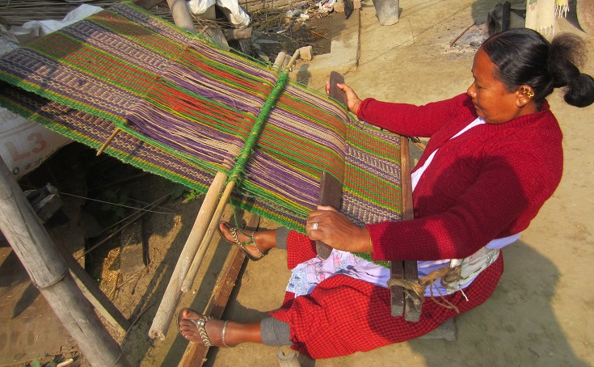

*(A member of Jutjhalla CFC in Tutaha, Duhbi in Sunsari district weaving Jutjhalla)*

In principle, the implementation of MED model intended to produce entrepreneurial choices for the hardcore poor. With the conceptualization of the term ‘empowerment’ as self-motivation for change, MED model provided choices for the development of the capacity of MEs by establishing enterprises of their choice. So, empowerment of hardcore poor can be accessed on the basis of the number of MEs, employment generation and the incomes earned from the micro enterprises.

Until December 2017, a total of 1,31,680 MEs (which is 104% compared to the total target number of 136,279) have been created through MED model and of which proportion of the target groups (Women - 74%, Dalits - 25%, IN - 38%, Madhesis - 21% and youths - 84%) is significantly high in number in comparison to the target (GoN/MoI/UNDP, 2018, p. 19). When ME creation is considered as an indicator of economic empowerment, this data clearly shows that MED model is successful in achieving this objective.

A study commissioned by Development Resources and Training Center (DRTC) in 2015 identified 20 types of enterprises. This study reported that a total of 138,833 person days of employment have been generated from the enterprises established by 998 MEs, which is significantly high in terms of the number of persons (DRTC, 2015, p. 42). This study summarized that the per capita income of the MED model supported household ranges from a minimum of NRs 5,205 to NRs 165,251 due to which 53.9% of the households (299 MEs out of the 555 MEs) have moved out of the poverty (DRTC, 2015, p. 50).

Table 11: Employment generated and labor utilized from 998 MEs and their micro enterprises

|  |  |  |  |  |  |  |  |
| --- | --- | --- | --- | --- | --- | --- | --- |
| **Product/services** | **Number of sub-sectors** | **Total employment generated** | | | **Average labor utilized** | | |
| **HH labor** | **Hired labor** | **Total** | **HH labor** | **Hired labor** | **Total** |
| Agro-based | 6 | 45397 | 8344 | **53741** | 93 | 22 | **116** |
| Forest-based | 7 | 26337 | 4169 | **30506** | 97 | 16 | **113** |
| Artisan-based | 5 | 18253 | 10810 | **29063** | 184 | 86 | **269** |
| Service-based | 2 | 19365 | 6158 | **25523** | 260 | 63 | **323** |
| **Total** | **20** | **109351** | **29481** | **138833** | **134** | **40** | **174** |

Source: DRTC, 2015, p. 42

The number of employment generated and the average labor utilized by 998 MEs presented in the table above is the finding of a study from 7.8% of sample MEs (a total of 1,169 out of 14,929 MEs) from 11 sample study districts. The main objective of this study was to explain the products and services that have emerged as important to generate employment and income, and alleviate poverty. This data is an example of the economic empowerment of MEs through establishment of micro enterprises.

*Figure 8: Average labor utilization by MEs of 20 sub-sectors*

Source: DRTC, 2015, p. 42

The establishment of micro enterprises itself is a part of economic empowerment since they create employment opportunities, while they also improve their family income there by aiding to move out of the poverty level. If the average calculation of this study is extrapolated to the total MEs created during MED model implementation (131,680 as of December 2017) then the number of households may become significantly high. The simple implication of this calculation is that MEs, created from the implementation of MED model, have great potentials for economic growth and empowerment.

**Effectiveness of SIYB training in MED model**

One of the important components of the economic empowerment of target population of the MED model is through providing a package of skill development training, called Start and Improve Your Business (SIYB). This training package contains both theoretical and practical skills as well as knowledge for the establishment and functioning of the micro enterprise. The training are delivered in 4 steps called Training of Potential Enterprise (TOPE), Training of Selected Entrepreneurs (TOSE), Training of Existing Entrepreneurs (TOEE), and Training of Graduated Entrepreneurs (TOGE). The objective of the SIYB training is to develop capacity and skills to start a business from the supported entrepreneurs. The package of these training makes the participants enlightened about the whole cycles of becoming an entrepreneur.

*Figure 9: The steps of the SIYB training package*

|  |  |  |  |
| --- | --- | --- | --- |
|  |  |  | **5 Participants** |
|  |  | **10 participants** | TOGE |
|  | **15 participants** | TOEE | Entrepreneurs who are operating enterprises and are interested to expand their enterprise |
| **25 participants** | TOSE | Training to the entrepreneurs who have started operating enterprise |
| TOPE | Training to the Potential entrepreneurs selected from TOPE or through other means |
| Training to the persons interested to start enterprise |

Source: GoN/UNDP, 2010, p. 6

SIYB training has become an entry point for poor and vulnerable people to develop personal knowledge and skills to become an entrepreneur. The peculiarity of this training package is systematic delivery of knowledge and skills considering the potential, needs and demands of the participants. So, this training package is effective in developing latent entrepreneur skills and knowledge of the target population. However, one time SIYB training is not enough for the economically poor and socially marginalized people. For this, provisions of demand-based refreshment training are highly desired for further growth of the entrepreneurs. This provision makes MED model further effective in order to enhance economic empowerment of the hardcore poor.

It is reported that nominal amount of daily allowances (as of reported during the field visit was NRs. 100 per day per person in 2017/18) during MEDPA implementation is provided to the participants for SIYB training. The practicality of this amount became problematic since this was not sufficient to manage hand-to-mouth problems of the participants when they had to devote whole day during the training period. As a result (as was reported), it increased the dropout rates of the trainees (during the training) on the one hand, and it affected the delivery of quality training due to low turnout and participation on the other. For this, providing reasonable amount of financial incentives to the participants is highly desirable for making SIYB training more effective.

*Figure 10: Status of active, seasonally active and inactive micro enterprises*

Source: GoN/MoI/UNDP, 2014, p. 29

The quality of service delivery has also been reported as one of the important aspects of SIYB training. Many of the cases, observed and reported, was that majority of the MEs after the completion of the SIYB training did not become entrepreneurs. However, the impact study commissioned by MEDPA (GoN/MoI/UNDP, 2014) has reported that 63.68 per cent of the MEs are active and 14.78 per cent are semi-active, while only 21.58 are inactive.This is quite exciting in terms of the success of SIYB training. However, it was frequently reported that government's procurement policy (single year contracting system) and processes (lengthy process that compelled the service providers to deliver the stated services within 3-6 months of a year) have created problems in developing quality MEs.

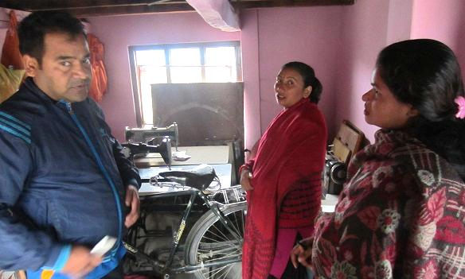

*(MED supported women entrepreneur in Badelkhadi of Bardibas 2 in Mahottari district showing her working station)*

Principally, delivery of the SYIB training, based on demand-driven approach of SIYB training, is very challenging because training are provided based on the needs and demands of the participants. However, it is reported to be difficult to translate this into practice due to time and resources constraints. For this, flexibility in terms of financial resources (at least provision of post-planning for re-budgeting) and time-frame (at least providing enough time for service deliveries; for example, continue the same services for the next year) is highly desirable for the effectiveness of SIYB training package.

**Use of EDFs for enterprise development**

Enterprise Development Facilitators (EDF) is conceptualized as a technical facilitator for the implementation of the six components of the MED model. Its conceptualization was the same like Junior Technical Assistant (JTA) in the agriculture field who plays technical facilitating roles for the development and growth of MEs. Therefore, delivery of all the activities under the six components of MED model is the responsibility of EDFs, and hence the success and failures of the enterprise development depend upon the roles of the EDFs. This means one of the indicators of the use of EDFs is number of MEs created from the implementation of MED model.

*Figure 11: Phase wise ME creation through MED model*

Source: GoN/MoI/UNDP, 2018, p. 19

A total of 131,680 MEs have already been created by December 2017 which is more than the target of 126,279 MEs (GoN/MoI/UNDP, 2018, p. 19). The comparison between the targets and progress or achievements in terms of the number of MEs during four phases of the MED model implementation clearly indicates a satisfactory progress for EDFs’ roles and contribution in ME creation. Therefore, use of EDFs has become one of the very effective approaches. Regular capacity development, including refreshment training to update with recent knowledge paradigms and innovation of new approaches/methods within the MED model, is highly desirable for furthering the effective mobilization of EDFs.

The roles of EDFs in many cases, in the recent phase (i.e. MEDPA), have become like accomplishment of events rather than following rigorous processes primarily due to the time and resources constraints as discussed earlier. However, the MED model has become an important platform for the EDFs to test, re-test, and improve their capacities and skills for the development of micro enterprises.

***Performance of entrepreneurs withSIYB/MECD training***

SIYB and Micro Enterprise Creation and Development (MECD) training are provided to enhance skills and knowledge required to become MEs. These include skills and knowledge related to the market situation (by identifying potential markets/buyers and prepare a potential list of products to decide what to produce), selection of appropriate enterprises to start, and preparation of a business plan to the participants so that they can visualize their enterprise themselves and establish accordingly.

The performance of the participants having SIYB/MECD training is measured in different aspects, and one of them is the business survival rate assessed in terms of active and resilient MEs. According to the MTE study of MEDPA, the ME survival rate found to be increasing in the later years which reached up to 99.94 per cent in 2015, while it was only 12.5 percent in the first year (1998) of MED model implementation (DCC, 2016, p. appendix A, table 7). One of the main reasons of high survival rate in later years, perhaps, is due to the impact of enterprise development training. A study, based on the study of 583 sample micro enterprise, found that 17 per cent of micro enterprises in the first phase (1998-2003), 77 per cent in second phase (2004-2008), and 26 per cent in third phase (2008-2013) were closed. The higher number of micro enterprises closing in the second phase was due to the political insurgency in the country (GoN/MoI/UNDP, 2014, pp. 42-43).

*Figure 12: ME survival (combination of active and semi-active MEs) over time (1998-2015)*

Source: DCC, 2016, p. Appendix A, table 7 (e)

However, when the ME survival rate found by the study of MTE is compared with the number of resilient MEs, we find some gaps. MEDEP defines resilient MEs as those still in businesses at least 2 years after graduation support, i.e., MEs active even after the MEDEP support. A study carried out by Institute for Policy Research and Development in 2014 concluded that only 8 per cent of MEs were resilient while 42 per cent had potential to be resilient. This would imply that longer term sustainability of 92 per cent of the MEs is doubtful. This data indicated that half of the MEs do survive for 10 years or more (DCC, 2016, p. 45). Similarly, a study commissioned in 2018 for economic analysis of MEs promoted by MEDEP and MEDPA (with sample size of 993 from 10 districts) found that a total of 50.2 per cent of MEs operate throughout the whole year and 51.2 per cent are viable (CEDN, 2018: copied from presentation slides).

The amount of profits earned by the MEs is one of the important indicators of assessing their performance. The MEDEP (1998-2013) impact study commissioned in 2014 has found that a total of 42.01 per cent of MEs earned profitsworth more than NRs. 21,168, while 48.23 per cent earned less than this (GoN/MoI/UNDP, 2014, p. 32). This study further found that saving status of MEs increased from 42 per cent (before implementation of MED model) to 58 per cent (after MED model implementation)(GoN/MoI/UNDP, 2014, p. 47). It was also found that the condition of food security has also increased for MED model supported MEs (NPC/NC, 2015 [Magh 2072 BS], pp. 37-39). The average income per month of MEs is recorded as NRs. 5,965 (GoN/MoI/UNDP, 2014, p. 61), which is an important indicator of the performance of MEs created through MED model. These findings clearly indicate good performance of MEs created through the MED model.

*Figure 13: Condition of food security before and after MED promoted MEs*

Source: Narma Consultancy Pct. Ltd., 2072 (NPC/NC, 2015), p. 39

The data presented and discussed above indicate the performance of MEs after establishing micro enterprise. Based on these, it can be concluded that the performance of MEs having SIYB/MECD training is effective in the sense that they have been economically empowered and have performed better resulting in their economic growth. This means the performances of MEs have become diversified with multiple impacts after receiving packages of skill development training. However, many of these MEs are forcefully created and hence their performance is always at high risk. There may be higher chances of dropouts when external supports are stopped.

**Challenges faced by entrepreneurs to expand their enterprises**

The main objective of the economic empowerment of hardcore poor is to enhance entrepreneurial knowledge and skills of the target population so that they may come out of the poverty line. However, establishing and becoming resilient MEs is always a challenge for the target population for many reasons. It is reported as well as observed that one of the common problems faced by the MEs is financial investment to expand their enterprise. Keeping this in mind, MED model provisioned graduation support to the needy but selected entrepreneurs.

Effort made to develop entrepreneurship skills for the hardcore poor itself was challenging in Nepal's socio-economic contexts. It is a big achievement of the MED model that the MEs developed during MEDPA comprised of 74 per cent women, 25 per cent Dalits, 38 per cent indigenous nationalities, 21 per cent Madhesis, and 84 per cent youths (GoN/MoI/UNDP, 2018, p. 19). However, the question is how many of them are resilient and whether they have become able to expand their businesses. The second issue for the expansion of their enterprise is having to solve their hand-to-mouth problem withwhatever income they earned from their enterprise. As a result, the incomes thus made could not go for further expansion of their enterprises.

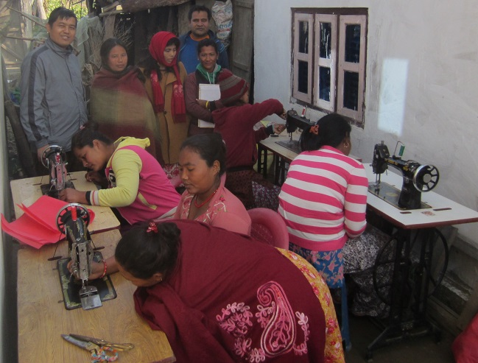

*(Members of women entrepreneurs associated with Unnatiseel Mahila Laghu Udyami Samuha in Manahara 6 of Makwanpur being ready for their group work)*

One-time training is not sufficient for MEs to expand their enterprise. Instead, they need repeated training in certain time intervals as refreshment and for self-reflection upon personal performances. However, such services are expensive in comparison to their economic condition (in terms of their affordability) and social network (in terms of their access to service providers). In this case, networking with potential service providers is one of the most important aspects in order to expand their enterprise.

In an informal group meeting in Hetauda of Makawanpur district, an industry owner said "*people do not buy things but they often buy story of the products*". He meant to say that branding and packaging of the product is very important for markets.This is very challenging for MEs since they need creative ideas as well as big investment which, in general,is beyond the capacity of MEs.

**Contribution of graduation support**

The objective of ‘graduation support’ is related to the sustainability of MEs. The graduation support, therefore, is an important component of MED model through which continued support and facilitation to the MEs is provisioned. The graduation support under MED model can also be considered as a practice of demand based approach that identify practical needs of the MEs and deliver the services accordingly. This component of MED model has constantly been considered as important activities since its inception to now. Under this package, MEs are provided with upscaling support to expand their enterprises.

*Figure 14: Projected number of MEs for graduation support during MEDPA period*

Source: GoN/MoI, 2013, p. 36

Before MEDPA, a total of 9,020 MEs were provided with the graduation support. During MEDPA, a total of 39,020 MEs were supported with the graduation support package (GoN/MoI 2013, p. 36). Thus, the cumulative number of MED model then becomes 48,040 during the entire MEDEP and MEDPA periods. According to the UNDP/MEDEP's annual report 2016, a total of 3,871 MEs have already been provided with the graduation support (GoN/MoI/UNDP, 2016).

Graduation support is a form of demand-driven approach of the MED model in which feasibility study is carried out to identify needy entrepreneurs. The information (condition of studied entrepreneurs) generated from the feasibility study are further analyzed in order to identify the needy and potential entrepreneurs. The processes followed and the embedded objectives are very important for the expansion of ME's enterprises. This step of the MED model also helps to further build the resilience capacity of the MEs. However, in many cases, it was observed and reported that these components have been accomplished as independent events and that in some cases, the provided support (particularly, technology) was out of the needs and demands of the particular MEs. For this, a careful market diagnosis is required so that the component could be linked with market demands and ME's needs.

Graduation support has become important means to expand the outreach of government agencies particularly through the direct engagement of the district chapters of DCSI and CSIDB in delivering services of this component. In addition, this also became means to assess and monitor the quality of services provided by Business Development Service Providing Organizations (BDSPOs) since graduation support targeted the recently (preceding year) created MEs.

Graduation support has become means of motivation to the MEs since support agencies (particularly, the EDFs) make repeated visits, undertake assessments and studies to diagnose the prevailing problems and provide available supports accordingly. In addition, this is also a means for maintaining and continuing relation between EDFs and the MEs. However, in some cases, it became a process of making the entrepreneurs further dependent on the external support agencies thereby hindering the development of risk bearing capacities among entrepreneurs.

Some portion of graduation support is implemented by district chapters of DCSI and CSIDB and in this case, there is a possibility of complication in terms of ME selection in the future. It is because of the provision of the registration of non-MEDEP/MEDPA MEs. Many of these MES may meet the basic criteria (i.e. below poverty line and socially marginalized) and claim for the graduation supports. If this happens then the number of MEs will become too big and in this case, lack of financial and human resources may be a big problem for implementing agencies. However, this will further the outreach of the program.

**Quality of MEs created through MED model**

ME creation is one of the important outputs of the implementation of MED model. As discussed earlier, MEs are created through the six steps MED strategy (that contains six components of services for MEs) in which activities and training packages are provided in four steps. The first two steps consist of the identification of potential participants, while later two steps consist of the processes of entrepreneurship development and their graduation supports. A total of 72,370 MEs were created during 15 years of MEDEP implementation and a total of 73,000 are projected to be created during MEDPA phase (2013-2018).

Table 12: Number of MEs created during MEDEP and projected during MEDPA through MED model

|  |  |  |  |  |  |  |  |
| --- | --- | --- | --- | --- | --- | --- | --- |
| **Agencies** | **Baseline data(during MEDEP)** | **MEDPA implementation years** | | | | |  |
| **2013/14** | **2014/15** | **2015/16** | **2016/17** | **2017/18** | **Total** |
| **DCSI** | ***5125*** | 2200 | 3300 | 2700 | 2700 | 2700 | **18725** |
| **CSIDB** | ***4245*** | 2800 | 3000 | 3600 | 4200 | 4800 | **22645** |
| **Local body** | ***7000*** | 1000 | 2000 | 3000 | 3000 | 2000 | **18000** |
| **MEDEP** | ***56000*** | 2500 | 7500 | 7500 | 7500 | 5000 | **86000** |
| **Total** | **72370** | **8500** | **15800** | **16800** | **17400** | **14500** | **145370** |

Source: GoN/MoI, 2013, pp. 35-36

The above table shows that projected numbers of MEs are created by the efforts of four actors. Of the four actors, large number of MEs is projected by MEDEP. This clearly shows the importance of the roles of MEDSPs/BDSPOs. This is because the ME creation for MEDEP is done through the services deliveries by MEDSPs/BDSPOs. According to the Annual Progress Report 2017, a total of 131,680 MEs have already been created until December 2017; this figure is more than the projected number (GoN/MoI/UNDP, 2018, p. 19).

The MTE study commissioned in 2016 reported that the business survival rate of MEs created and supported by MEDEP and MEDPA during the last 18 years (1998 to 2015) ranged from 12 to 99 per cent. For us, this is significantly high and satisfactory. The interesting thing is that the survival rate increased in the latter years. The higher rates in the latter years do not necessarily reflect an increase in effectiveness and impact, but rather MEs created recently are more likely to be still in business, while with the passing of time, more failures could be expected (DCC, 2016 [May], p.45).

Table 13: Survival rate of MEDEPand MEDPA supported MEs over time

|  |  |  |  |  |  |  |
| --- | --- | --- | --- | --- | --- | --- |
| **SN** | **Year** | **ExistingME** | **ActiveME** | **SemiActive ME** | **Business SurvivalIn terms of ActiveME** | **Business survival rate interms of (Active + Semiactive) ME** |
| 1 | 1998 | 16 | 2 | - | 12.50 | 12.50 |
| 2 | 1999 | 382 | 170 | 32 | 44.50 | 52.88 |
| 3 | 2000 | 921 | 438 | 133 | 47.56 | 62.00 |
| 4 | 2001 | 1,047 | 576 | 109 | 55.01 | 65.43 |
| 5 | 2002 | 1,938 | 891 | 404 | 45.98 | 66.82 |
| 6 | 2003 | 427 | 288 | 37 | 67.45 | 76.11 |
| 7 | 2004 | 796 | 409 | 133 | 51.38 | 68.09 |
| 8 | 2005 | 3,886 | 1,962 | 687 | 50.49 | 68.17 |
| 9 | 2006 | 3,890 | 1,750 | 762 | 44.99 | 64.58 |
| 10 | 2007 | 5,544 | 2,684 | 1,049 | 48.41 | 67.33 |
| 11 | 2008 | 6,493 | 2,993 | 1,519 | 46.10 | 69.49 |
| 12 | 2009 | 6,225 | 3,121 | 1,216 | 50.14 | 69.67 |
| 13 | 2010 | 4,821 | 3,103 | 466 | 64.36 | 74.03 |
| 14 | 2011 | 1,742 | 1,509 | 86 | 86.62 | 91.56 |
| 15 | 2012 | 4,260 | 3,370 | 359 | 79.11 | 87.54 |
| 16 | 2013 | 8,017 | 7,387 | 252 | 92.14 | 95.29 |
| 17 | 2014 | 4,344 | 4,277 | 21 | 98.46 | 98.94 |
| 18 | 2015 | 4,807 | 4,797 | 7 | 99.79 | 99.94 |
| **Total/average** | | **59556** | **39727** | **7272** | **60.2** | **71.3** |

Source: Prepared by MEDEP, cited in DCC, 2016 [May], p. appendix e.

The data in table 13 shows more than 60 per cent of MEs having status of business survival which clearly indicates the contribution of MED model as significantly high in terms of the creation of active MEs. However, many of the training have become meaningless in terms of active ME creation. For example, during the field visits of this study in January 2018, it was reported and observed that SIYB training related to handloom and sewing in Basantatar of Dharan municipality in Sunsari district about 3 years ago (by MEDPA) and same type of training in Gauradaha of Jhapa district in the same year were failures, in the sense that none of the trainees became entrepreneurs. This is mainly due to two reasons: First was the lack of choices for the types of training that were provided, i.e., participants were forced to take the training which was not of their interest, and second was the lack of startup business support and absence of regular follow-up support to the trained MEs.

MEDEP and MEDPA interventions were on track in ME creation; however, quality ME has become a challenging issue as only about 8 per cent of supported MEs are reported as being resilient and 42 per cent have the potential to be resilient (IPRD, 2014, cited in DCC, 2016, p. 45). It seems that more than 50 per cent of the MEs supported are out of track. To be more critical, 92 per cent of the supported MEs may have dropped out from being entrepreneurs. The field visits and observation during the field work for this study in February 2018 also clearly indicated the higher rates of ME dropouts. This has created a challenge to the projected MEDPA targets to create 60,000 resilient MEs (i.e. 82 %) out of a total of 73,000. Therefore, one of the big challenges of the MEDEP and MEDPA implementation is focusing on quantitative achievement of ME creation; thus suggesting a need for balancing between quantity and quality of MEs.

Quality of MEs during MEDEP and MEDPA intervention is determined by mainly two factors: (a) geographical locations of the supported MEs [i.e., the supported MEs are scattered over larger geographical areas and due to which access to potential markets and required business services have become very difficult]; (b) government's procurement policy (single year contracting to MEDSPs/BDSPOs) including lengthy selection processes of MEDSPs/BDSPOs. In addition, the capacity of selected BDSPOs in order to ensure effective delivery of the MED services also remained equally important factors. These scenarios have demanded either timely revision or innovation for the MED service providing mechanism (also suggested by MTE and other studies). The lesson learned from these issues is that the implementation of MED model, as efforts for the economic empowerment of the hardcore poor, requires rethinking and revision as per the changing time and context.

**Organization of MEAs in informal sector**

Thousands of informal MEs exist in different forms in the informal sectors. They are self-motivated and have created their own businesses. They do not receive the support and facilities such as the services delivered through MED model. In this context, Micro Entrepreneurs' Associations (MEAs), promoted during MED model, could be an important platform to help them to be more organized and access possible services. MEA is promoted at different local to national levels such as MEG at the community level, MEGA at the market center levels (now LMEGA), DMEGA at the district levels, and NMEFEN/NMEGA at the national level. The context is that the government has the policy to encourage such informal MEs to be registered with the CSIDB/DCSI. In this case, organization of MEAs could be one of the processes and means to organize and empower the hardcore poor.

Presently, MEA is limited to the MEDEP and MEDPA supported MEs. So, going beyond MEDEP and MEDPA supported MEs have great potential for the expansion of MEAs. This will also become important for the sustainability of MEAs through expansion the membership outreach. In addition, this also expands the government outreach in terms of MEs for its service delivery. However, in many cases, bringing informal MEAs under the jurisdiction of the government (or formal processes) may create additional burdens to the MEs, i.e., registration processes at the beginning and annual renew processes.

**The role of participatory action research (PAR) in MED model**

Participatory Action Research (PAR) is a methodology concerned with discovering and testing the effectiveness of concepts or tools in order to bring about desired social, economic and technical changes. It is the combination of the research and action undertaken as a temporary task to find “locally compatible solution” to the identified problems. This is also defined as a form of self-reflective enquiry undertaken by the participants collaboratively, sometimes in cooperation with outsiders. The major objectives of the application of PAR processes in MED model include:

* To transfer and disseminate adopted technology or new marketing strategies;
* To evaluate the appropriateness/effectiveness of existing and adopted technology or marketing strategies;
* To start new product development;
* To select appropriate technology or new marketing strategies; and
* To standardize the products and services;

PAR, for MEDEP and MEDPA, was learning by doing process for the innovation of new ideas or testing of the existing ideas/practices on micro enterprise. It was conducted with the participation of beneficiaries of certain location. For this, the formats of data collection were developed, information or data were generated and properly recorded, then analyzed and reports were prepared. The results and findings of the PAR, then, were shared with the beneficiaries, while the decision making authorities for the acceptance or rejection for PAR activities were given to the beneficiaries. After the PAR result (failure or success), beneficiaries were given rights to verify or re-test or replicate the practice or dropout from the practice. Some success stories and major achievements of PAR during MEDEP were:

Table 14: Some of the examples of PAR and product development during MEDEP

|  |  |  |  |  |  |
| --- | --- | --- | --- | --- | --- |
| S. N. | **Type of PAR** | **Main objective** | **Major Outcome** | **Actions Taken** | **No. of Beneficiaries** |
| 1 | Solar drier for ginger and other vegetable products (in Nawalparasi District) | Introduction of renewable energy technology reducing the negative environmental impact | Adaptation of solar drier for drying ginger | Disseminated and adapted solar drier for the production of dried ginger | 58 (Female 38, Male 20) |
| 2 | Promotion and dissemination of improved ghatta (water mill) (in Nuwakot district) | Set up improved water mills in strategic locations in rural village and use it as a demonstration ground for technology transfer, promotion, extension and training | Seven units of improved ghatta installed generating a total of 10.5 KW of power | Disseminated and adapted improved ghatta | 10 ghatta entrepreneurs and the local community |
| 3 | Bee Keeping (in Pyuthan, Baitadi and Dadeldhura districts) | Test the performance of Apis mellifera sp. bees in local environmental conditions | It was known that honey yield from melifera bees were ten times higher than the cerana bees in the same environmental conditions | Disseminated and adapted Apis mellifera breeds of bee in the community | 150 bee keeping entrepreneurs from three districts |
| 4 | Paper products from patter (Elephant grass) (in Nawalparasi district) | Testing of patter for paper making | High quality paper can be made from patter; Patter can be used in making various types of paper products (eg by blending with other raw materials like lokta, banana, recycled paper, etc.) | Informationdissemination of possibility of paper making from patter and test marketing |  |
| 5 | Fabrication of bamboo splitting tools (in Dhanusha and Nawalparasi Districts) | Fabrication of different tools for splitting and cutting bamboo which is the main time consuming operation for bamboo based enterprise | Four types of tools were fabricated; and Two tools (bamboo splitter and sizer) were found to be effective | Disseminatedtwo effective tools and further modification of other tools | 30 bamboo based micro-entrepreneurs from Dhanusha and Nawalparasi districts |

Source: Concept note of PAR model prepared by MEDEP

It was reported that most of the PAR activities listed in the table above were adopted by the MEs and their results were encouraging. It is to summarize that the experiences of PAR implementation became one of the best tools for the innovation as well as testing of the practicability of knowledge, practices and technology for ME promotion in Nepal. It is reported that many of the PAR were successful in producing the results. For example, adaptation of new technology for agriculture implements making enterprise (Aran in local language) by Biswakarma families in Dolakha district, replacement of traditional oil making machine (coal) by modified technology (converted into Chiuri oil production machine) in Ramechhap district were expanded to Baglung and Surkhet districts; success of Shitake mushroom production in Sindhupalchowk district was expanded to other areas; expansion of honey and ginger production in many districts (namely Dadehldhura, Baitadi, Nawalparasi, Dang and Parbat); and expansion of bio-briquette programs in many of the Terai districts are reported as success of PAR in MED model implementation. However, proper study and documentation of these efforts are noted as inadequate in MEDEP and MEDPA interventions.

**Key lessons learnt from the economic empowerment of hardcore poor through MED model**

1. ***MED model has become means of triggering latent entrepreneurship skills of hardcore poor:*** Implementation of MED model has sparked off latent entrepreneurship skills of the hardcore poor through cross-learning and cross-sharing with the EDFs and among the participants. On the one hand, the MED model motivate the hardcore poor to become micro entrepreneurs, while it enhances practical capacities and skills for establishing and operating micro enterprises on the other hand. Therefore, the whole process of implementing MED model is a means to activate latent entrepreneurship skills of the participants.
2. ***MED model has transformed the latent entrepreneur skills of hardcore poor into the action:*** The whole process of MED model transformed the latent entrepreneur skills of participants into actualization. This means that the hardcore poor as participants or beneficiary of the MED services have ended with the preparing of own micro enterprise development plan (Plan-P), implement prepared plan (Do-D), self-monitor of the performance (Check-C), and then act as per the needs of the market in order to improve the performance of the enterprise (Act-A) which conceptually can be called "actualization of PDCA".
3. ***MED model provides spectrum of knowledge required for micro entrepreneurs:*** Empowerment of hardcore poor through MED model is a provision of the spectrum of knowledge and skills required for the hardcore poor for the establishment and promotion of micro enterprises. The spectrum of knowledge and skills ranges from theoretical orientation on micro enterprises to the establishment of micro enterprise, access to finance, knowledge and access to technology, market, resources availability, and product branding and packaging.
4. ***Entrepreneurship knowledge and skills are transformed to the inter-generations and intra-generations of MEs:*** It is reported, observed and acknowledged that MED model has multiple social impacts. The entrepreneurship skills developed or enhanced to a particular entrepreneur is gradually transformed to others such as neighbours, colleagues, relatives, family members and the off-springs. In addition, the package of SIYB training consists of the participation of family members, particularly the male member or husband of the person, who is selected for the training so as to orient non-participants of the participant's family towards providing supporting environment for the establishment and operation of micro enterprises. To sum up, the economic improvement of hardcore poor through establishment and operation of micro enterprises has created innumerable positive societal impacts.
5. ***Non-resilient MEs requiretimely interval graduation supports for their economic empowerments:*** One time graduation support for skill and knowledge development training is not adequate for some of the MEs to become resilient. Rather, they require (as well as demand) frequent facilitation supports for access to finance, market demands, refreshment training, and skill development training. This means there is a need of constant support, facilitation and trainingare highly required as well as desirable for the economic empowerment of MEs, who are non-resilient even after one time MED services.

**Conclusion of the economic empowerment of hardcore poor in MED model**

Different activities and approaches of MED model have become means for the economic empowerment of the hardcore poor in Nepal. Targeting the hardcore poor from among socially excluded groups such as women, Dalits, indigenous nationalities, Madhesis, and unemployed youths from remote and less accessible areas is a unique approach of MED model to ensure benefits reach to the people hard to reach (i.e., socially marginalized and hardcore poor). The number of MEs created and supported through MED model itself is an important achievement. However, ensuring the business continuity of the created MEs is always a challenge. The important lessons learnt from the economic empowerment of hardcore poor through MED model is that the latent entrepreneur skills of the target people are triggered and actualized through a spectrum of MED services. Another lesson learnt is that economic empowerment of hardcore poor has multiple societal impacts and it can be furthered through support and skill training in timely intervals to those who are non-resilient.

## 3.3 Economic empowerment of hardcore poor through CFC

Common Facility Center (CFC) is one of the unique endeavors carried out by key stakeholders of MED model. It is a result of the reflection of working with hard core poor and the importance identified from this. CFC is a small infrastructure (commonly a building) where physical space and technology is provided through MEDEP (earlier) and MEDPA (presently) support. There is a guideline for CFC operation, which asks for land availability from the community which can be either private land or community based organization land. CFC is operated by MEG at the local level and support for capacity building is additionally sought from VDC, municipality, district development committee, CSIDB/DCSI as appropriate.

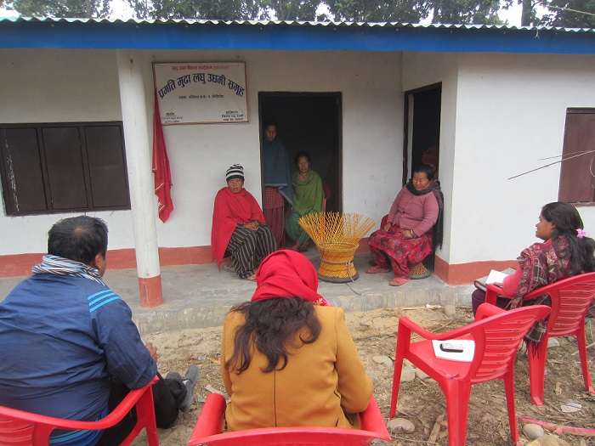

*(Participants for FGD with CFC members of Pragati Mudha Laghu Udhyami Samuha in Gauridanda of Bardibas-4 in Mahottari district)*

The deliberation of CFC establishment, operation and handover to community is carried out as per the Handbook for the implementation of CFCs, 2067 B.S. CFC’s realization and its pertinence are identified by gauging different attributes required for hard core poor to enable them to work together in a common place (a structure: either Masonry, Reinforced concrete, or truss). The pertinent attributes of the CFCs are:

* Importance of safe and secure place for hardcore poor to engage in entrepreneur activities;
* A place where learning, unlearning and relearning can be done by hardcore poor in relation with the other CFC members;
* Ability for bulk input marketing and output marketing;
* Build back better principle.

The importance of CFCs is highly acknowledged and its contribution to the GESI aspect is highly appreciated by MED stakeholders. This is internalized in MEDPA as DCSI and CSIDB have this component in their planning with budgeting from their own resources. During MEDEP, a higher focus was placed on increasing the numbers of CFC; whereas, in MEDPA, CFC initiatives are more focused on quality CFCs.

A total of 1,174 CFCs was the target of whole MEDEP and MEDPA period. With a total of 628 CFCs as baseline (CFCs before MEDPA), MEDPA alone had 536 CFCs targets (88 in first year, 84 in second year, 89 in third year, 106 in forth year, and 169 in fifth year) for five years (GoN/MoI, 2013 [July], p. 36). There is no question that the concept and efforts made so far in terms of CFC has remained an important endeavor in achieving set outcomes of the MED model. But the number of CFC targets became problematic because the focus was towards meeting the given numerical targets.

Table 15: Number of CFCs and affiliated MEs

|  |  |  |  |
| --- | --- | --- | --- |
| **SN** | **APSO** | **Number of CFCs** | **Number of MEs** |
| 1 | Biratnagar | 38 | 481 |
| 2 | Gaighat | 27 | 555 |
| 3 | Hetauda | 52 | 1220 |
| 4 | Kathmandu | 100 | 1941 |
| 5 | Pokhara | 48 | 190 |
| 6 | Ghorahi | 73 | 2100 |
| 7 | Surkhet | 64 | 904 |
| 8 | Kailali | 50 | 881 |
|  | **Total** | **452** | **8172** |

Source: DRS, 2017

The report on the visual assessment of CFCs mentioned a total of 452 CFC across the country with a total of 8172 affiliated MEs (DRS, 2017). Worth mentioning is an effort for reviving MEs and CFCs after the earthquake in April and May 2015. With the technical support to quick impact livelihood programs like RELRP, LSER and INTEL, 11,826 MEs in seven districts were revived and 2,986 new MEs were created, while 139 CFCs were repaired and rebuilt applying the build back better principle (GoN/MoI/UNDP, 2016).

During phase IV MEDEP facilitation, the establishment of 34 productive CFCs was carried out benefiting a total of 471 MEs. MEDEP invested NRs. 8,161,455, whilst VDCs shared the costs (equivalent to NRs. 290,000) of three CFCs (GoN/MoI/UNDP, 2016).

**Context for lesson learnt documentation (LLD)**

The LLD of MEDEM and MEDPA interventions can be carried out through multiple perspectives. The available documents on MEDPA and MEDEP supplemented by the field visits to CFCs in different geospatial regions have helped in the framing of a context of CFC where best lessons can be derived for various stakeholders.

CFC visual assessment deemed it as a structure. This common structure provides ample opportunities for socio-economic empowerment of hardcore poor. The base of CFC which provides attributes for sustainable operation includes locations of CFCs; registration/legal status; effective management and leadership; and continuous improvement and value addition. The sustainable CFCs promoted by MEDEP and MEDPA have three important pillars that require equal importance: Knowledge sharing/ empowerment; and market focus and business continuity management. CFC strategic positioning can be foreseen as an organic structure for hardcore poor acting as incubation and multiple service provision systems.

Figure 15: Key domains of CFC

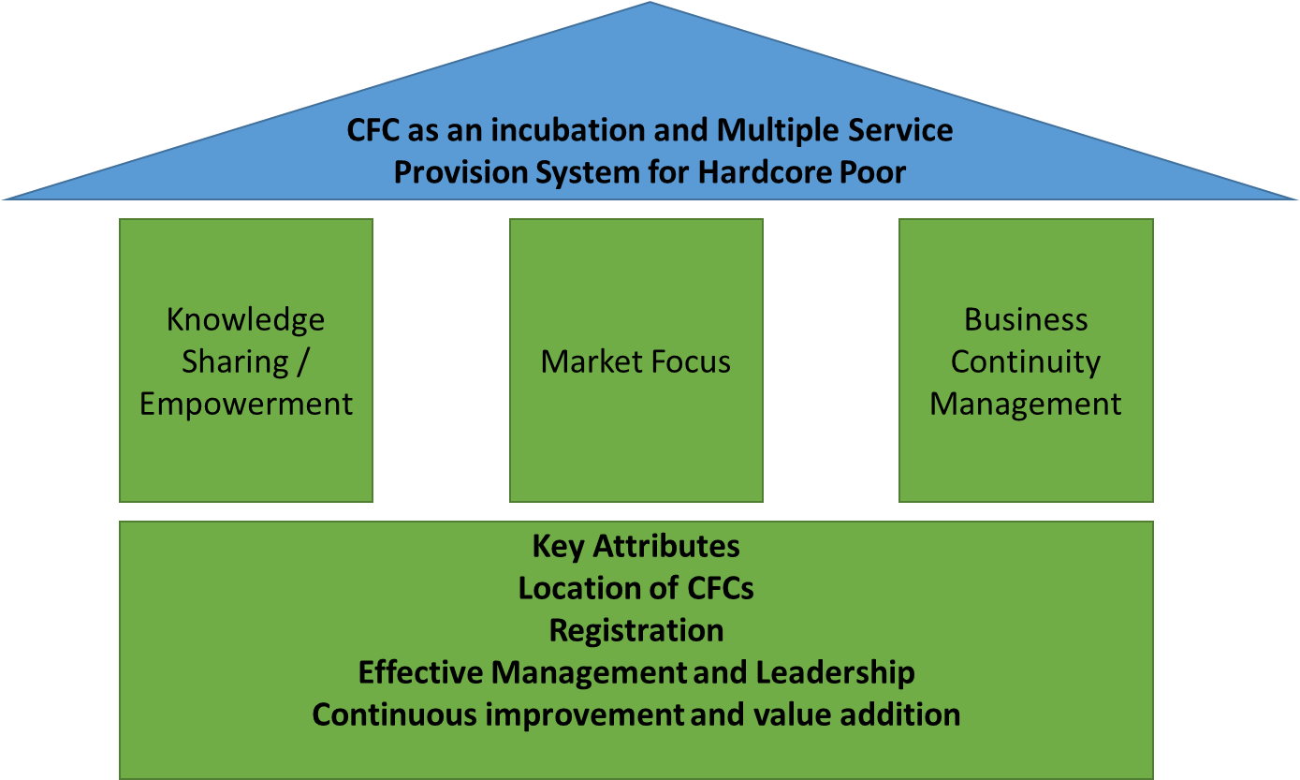

A closer look at existing CFCs both from the reports and field visits depict gaps which require further efforts for improvement mainly in registration/legal status, business continuity management practices, and effective leadership. Further exploration of the existing gaps is carried out through the scenario analysis of CFCs.

**Scenario analysis of CFCs**

There are various learning from CFCs. These are further gauged with 5[[1]](#footnote-1) different scenarios observed during the field visits.

1. Scenario 1: CFC best suited for initial engagement of hardcore poor
2. Scenario 2: CFC being utilized appropriately as per changing space time continuum
3. Scenario 3: CFC underutilization creating difficulties for the hard core poor
4. Scenario 5: CFC life cycle and phases
5. Scenario 4: CFC growing as an institution

Available reports do not provide enough evidence to compare survival rates of MEs in and out CFCs; but findings indicate that, overall, they are functioning well and that the entrepreneurs consider them important to their success (DCC, 2016 [May]).

***a) CFC best suited for initial engagement of hardcore poor:***

The MED model application for paving hardcore poor towards entrepreneurship has a strong base on group engagement. This feature can also be seen in the formation of MEG corresponding to market centers. The group formation seen in different other initiation is more focused on saving/credit, meetings and other pertinent activities regarding social mobilization. Individual MEs working independently on particular enterprise within MEG are more benefitted to accelerate learning from working in CFCs. This provides a space for re-learning, social engagement, safety, division of work and ability to cater to market demand.

Certain enterprises require a division of work and appropriate technology in order to compete in the local market. A *Duna-tapari* CFC in Surkhet reckons hardcore poor engagement in CFCs and such engagement as MEs has provided more security initially when much needed. CFCs can definitely be termed as an enabler for hardcore poor for initial engagement and increased learning curve on skill, technology usage, marketing intelligence etc. Further, CFCs on one hand seem to be effective in helping MEs improve their productivity and quality, but, on other hand, they do not meet the basic standards in relation to water and sanitation facilities, e.g., enough storage and working space, and child care facilities in the CFC, (DECC, 2016 [May]).

***b) CFC being utilized appropriately as per changing space time continuum:***

CFC establishment is supported by MEDPA, MEDEP and other organizations. Inclusive participation of hardcore poor as its member from among the concerned MEGs is an important characteristic of the CFCs. The members are involved in CFC establishments through contribution of local materials, engaging in construction and being in decision making positions in CFC management. This effort and ownership of CFC has made hardcore poor highly engaged in CFC. After the initial phase of high engagement, CFC is more often seen to be the center for specialized working function. Incense-stick based CFC in Dhanusha reckons that after experiencing rapid learning (in terms of skills, market intelligence, technology adaptation etc.), MEs are graduallybecoming independent in doing their business. This has led to utilization of some CFCs more appropriately than earlier. MEs are able to buy appropriate technology and work at their own home to cater to independent market. More often, in these instances, CFC is appropriately utilized for the functions that are less safe to operate at home, producing in bulk and marketing, common branding, etc. It was found that the technologies provided to them are underutilized in some of the CFCs for the reason that they either purchase similar technology or adopt newer and efficient technology or null the use of the technology. The types of these usages have to be seen positively, and lessons learnt from maximum utilization of CFC in a cyclic manner for bringing on new hardcore MEs can be exercised. The Jute CFC in Sunsari reckons that the maximum utilization of CFC is possible if it can adopt technology as per market demand and continue inclusion of hardcore poor when graduation of MEs takes place.

***c) CFC underutilization creatingdifficulties for the hard core poor:***

The CFCs which are under the category of Damage Grade (DG3-5) are struggling for smooth operation due to damage or renovation of their infrastructure, whereas CFC's smooth operation also includes important factors like the management of CFC, marketing of products, technology purchase, distance and location of CFCs. The perspective of reviving the CFCs is of utmost importance as it has made some of the hardcore poor searching for the alternatives (such as Mushroom CFC renovation in Lamahi, Dang). CFC has been pertinent as enabler for the hardcore poor to get engaged in enterprises. The importance of engaging hardcore poor associated with CFC has to be re-visited and appropriate solutions have to be provided so that hardcore poor are positively engaged again.

***d) CFC Life cycle and phases:***

The field observation and review of the reports help devise various phases of CFC. This can be augmented into:

1. Initial phase: High engagement and ownership of hardcore poor and community;
2. Short term phase: High utilization of CFC;
3. Mid-term phase: Optimum utilization of CFC or underutilization of CFC; and
4. Long-term phase: CFC growing as an institution or non- function of CFC.

The most pertinent factor to consider and reckoned by Dhaka CFC in Parbat district is the management of CFC. In most cases, the leadership drives the functioning of CFC and positive directions are taken by those who play active roles. In few cases, CFC has involved the mixed composition of HHs that also includes those rated as middle income level (such as *Duna-Tapari* CFC in Surkhet). The engagement of different composition (with high percentile of hardcore poor in CFC management) has shown a positive direction in the functioning of CFC.

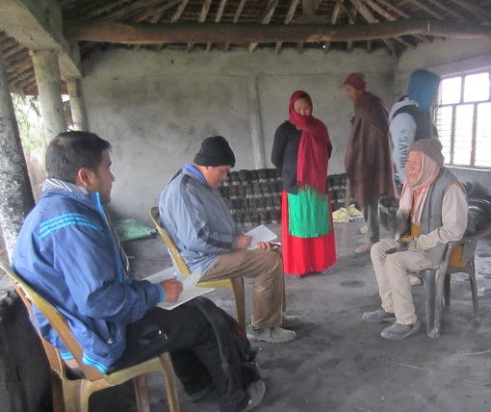

*(Interview with Agarbatti entrepreneurs in Rmaulitar in Dhanusa district)*

***e) CFC growing as an institution:***

The uniqueness of CFC in some of the A and B categories are worth mentioning as they help to pave pertinent lessons to be learnt so that CFC positioning can be depicted in the enterprise ecosystem. CFCs in some cases are strongly managed with the initially allocated fund. The funds are utilized for maintenance, taxation and business up-scaling (an example was found in *Duna-Tapari* CFC in Surkhet). The uniqueness of CFC also featured an equal share of benefits among members (the examples are found for *Muda* making CFC in Mahottari). Another important milestone achieved by some CFCs are additional functioning by making CFC space as one-door enterprise support systems like cooperative, training venue or upscale business (the example was found in *Jute-making* CFC in Sunsari). The cooperative and CFC nexus along with other possible services has been found effective for sustainability, up-scaling and access to business services (the example was found in Allo-making CFC in Dang).

In few cases, micro enterprises have formed informal groups and are working together by renting in spaces (an example was found among CFC in Gauradahaof Jhapa). This is due to market demand and the requirement for working together to cater as per market requirement. Thus, innovation in practice demands working space for MEs in order to work together in alignment with market demand and able leadership.

Another innovation through the effort of MEDEP and in partnership with engineering graduates of Pulchowk Engineering College of Tribhuvan University in Kathmandu has led to the development of technology to process yarn from Allo (Himalayan Nettle). This technology (machine) was able to enhance the Allo processing capacities (debarking, beating, spinning and hackling to retrieve yarn) five to 15 times more. The Ministry of Industry (MoI) has announced that it will invest NRs. 26 million in Allo technology in 10 districts and replicate it in 22 districts (GoN/MoI/UNDP, 2016). CFCs in two districts have successfully used this technology (GoN/MoI/UNDP, 2018). Based on all these, it can be claimed that CFCs are strongly positioned as a node for innovation, and from these CFCs multi- stakeholder efforts on technology development can be disseminated for the wider benefit of the community.

**Key lessons learnt from the economic empowerment of hardcore poor from CFC**

1. ***CFC is growing as incubation of multiple service provision for hardcore poor:*** The MED model’s uniqueness is further strengthened by CFC establishment. Even though in MEDPA there are limited CFC being supported, yet each CFC has the potential to engage hardcore poor and has been acting as an incubation space for early entrepreneurs. This has resulted in rapid learning of entrepreneur skills, technology and market, and thereby making micro enterprises more capable to cater market demand, work in a group, and understand group dynamics. Thus, intervention designed for higher engagement of hardcore poor as envisioned by various organizations can gauge deeper on CFC approach and tailor-made incubation services required for early stage entrepreneurs (micro and small enterprises).
2. ***CFC provides space for innovation, co-creation and dissemination of knowledge:*** Entrepreneurs are characterized by continuous innovation on given context. The CFC promotion has provided opportunities for innovation, co-creation and dissemination of knowledge and skills among its members. An example was seen in Gauradaha of Jhapa district where registered micro entrepreneurs of bag making, shoemaking and tailoring have come together and started working in a rented-in common office space. The able leadership coupled with management and learning perspectives has led them to be identified as promising women-led enterprise venture in the local market.
3. ***CFC is a provision for the co-creation of leadership skills:*** CFC is a space, where MEs as group entrepreneurs get opportunities for cross-sharing and cross-learning for innovation, diffusion, dissemination, and co-creation of knowledge and experiences in order to expand their entrepreneurial skills and enterprises. Members with spectrum of knowledge, experiences, expertise use common space for co-creation of the knowledge leading towards the development of leadership skills. It provides a common platform where the members become able to develop social cohesion for entrepreneurial initiation. For example, members with different ages, culture, and education cohabit for enterprise development in order to contribute in personal economy thereby contributing to enhance leadership skills and community management skills. These all begin with the start-up support to the CFC members.
4. ***CFC intermediates for the banking services to hardcore poor:*** CFC practice is a form of group work with group ownership upon the physical properties. Access to finance is one of the biggest challenges for hardcore poor when they want to establish and operate micro enterprise. In this context, the CFCs function as a cooperative or collateral for FIs requirement.
5. ***Lack of state's clear policy provisions and guidelines is creating problem for the legal recognition as well as ownership of the CFC properties:*** CFC, in practice is group enterprising, and so its ownership goes to the members of MEG. However, registration of the group based enterprise has not been provisioned in the Industrial Act. So, as per the existing legal provisions, the CFC registration is possible either in a single proprietorship or partnership of two persons based registration. This demands a clear policy provisions for the group registration so that CFC members can find group ownership and equal decision making mechanism.
6. ***Management of the internal social dynamics of CFCs requires specialized institutional services:*** The CFCs have different forms of their own internal social dynamics such as age, gender/sex, caste/ethnicity, entrepreneurship skills, access to finance, capacity of investment (in terms of time and finance) for the growth and management of their CFCs. These internal dynamics are properties of the CFCs on the one hand (e.g. as discussed in previous points that these characteristics nurture cross-learning and cross-sharing of the knowledge and skills); and on the other hand, these are also the challenges for CFC management (i.e. due to the different interest, unequal contribution in terms of time and resources, etc). So, a specialized institutional service such as cooperatives, microfinance institutions, municipalities, private sectors is highly required for proper management as well as further growth and development of the CFCs.

**Conclusion of economic empowerment of hardcore poor through CFC**

CFC is a platform for incubation services for the entrepreneurship development of hardcore poor. CFC practices have also provided an enabling environment for the economic empowerment of hardcore poor. This has strong positioning in enterprise ecosystem, where MEs can work together for common learning and catering to market demand. The phases of the growth of CFC reflected in the form of legal recognition, CFC property ownership and complication in the management of internal social dynamics demands the need of the services of specialized institutions from the very beginning of the CFCs. One of the important lessons learnt is that the federal structure and the present economic envisioning of the municipality/rural municipality for employment and enterprise promotion can look forward to tailor made CFC at each ward levels.

## 3.4 Access to finance (A2F) in MED model

Finance is the most pertinent business service requirement to entrepreneurs. Any entrepreneur's financial plan contains different financial mechanism including own investment and from financial service providers. In the case of microentrepreneurs, they have low financial capacity and so they need group based financing mechanism, subsidized financial mechanism, market actor led pre-paid mechanism, and loans from financial service providers.

MED model has highly prioritized Access to Finance (A2F) component for creation and promotion of enterprises. Continuous efforts have been carried out including earlier work with Asian Development Bank (ADB) and other financial institutions. However, financial service provision always remains a challenging component. The MEDPA and MEDEP has highly prioritized on the efforts for provisioning the sustainable access to credit, particularly through financial service providers and cooperatives and a number successful efforts are functional and delivering important benefits to MEs. However, it's sustainable functioning after MEDPA seems questionable (DCC, 2016 [May]).

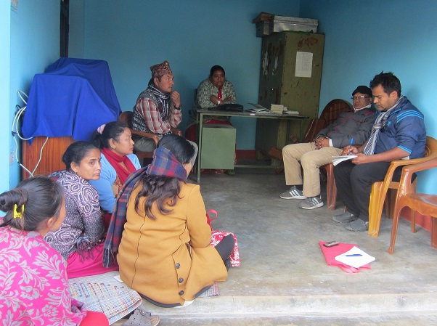

*(Participants for FGD with members of Krishi Adhar Laghu Udham Sahakari in Udayapur)*

In MEDPA's working modality, both CSIDB and DCSI have been strongly working for the innovation of the possibilities of easing the availability of financial services to entrepreneurs. Potential women entrepreneurs who meet the eligibility criteria can access fund up to NRs. 0.5 million from Women Entrepreneurship Development Fund (WEDF). This facility is available in 77 districts of Nepal. In 2017, altogether 131 MEs have received loans amounting NRs. 26.9 million for scaling up in twelve districts (GoN/MoI/UNDP, 2018).

The overall financial ecosystem provides collateral to financial institutions but this negates financial service provision to micro enterprises. This is because on the one hand they do not have necessary collateral and on the other hand they are located in some remote parts. The high interest rate (12-22% annual) of existing micro finance and cooperative mechanism also indicates needs for the provision to access to wholesale lending with institutions like Rural Micro Finance Development Center (RMDC), National Cooperative Bank and Nepal Rastra Bank for subsidized and low interest rate (DCC, 2016). The cooperatives and micro financial institutions in different parts of the country are providing A2F services to MEs. However, these institutions do not exist in some of the remote parts of the country. The efforts to address this problem have been highly prioritized in later time of MED model (i.e., in phase IV) and cumulative progress of MEs accessing A2F or receiving loans till December 2016 is 17,606 against the total targets (30,000) and which is 59% of the total targets(GoN/MoI/UNDP, 2016).

MED model consists of high degree of business service provision to MEs. Given the nature of the MED model, focus was more on access to finance or linkages to financial institutions. Whereas, the available financial institution's role and its positioning for poverty alleviation is a domain where best knowledge from relation between business service providers and financial service providers has to be extracted. Interaction with MEDSPs revealed a null partnership between two unique yet complementary service provisions. It is of utmost importance to explore synergy between two major actors: financial service providers and MEDSPs in coming times to work together for addressing various financial requirements of MEs from the startup.

Financial service provision also includes insurance services. There has been an institutional initiation at later phase in tandem with the existing GoN system enabling private sectors to reach even remote areas with insurance services. Insurance products orientation and its launching have already linked 419 MEs showing a positive result to be expanded in upcoming times.

Importantly, the control group research carried out by MEDEP depicts high percentage of MEs as borrower in comparison with other having focused on saving. An interaction (by LLD team) held with MEs led cooperative in Sunsari provided insights on more than 80% of members as borrowers and generic comparison with other FIs in vicinity (mainly cooperative) suggested very limited number of borrowers and members focusing more on savings.

**Context for lesson learnt document**

A2F, particularly in the micro enterprise context, is one of the most debatable, yet pertinent themes nationally and globally. There has been relentless effort on devising best tools and processes for catering financial services to different spectrum of clients (geo-spatial variation, outreach, value chain financing, wholesale lending, FIs, etc). Related project documents and consultation meeting with wider stakeholder still indicate demands for contextualizing A2F and utilizing best available financial mechanism. This statement best serves for the LLD team to further gauge specific context and derive lesson learnt based on review of the related documents and field visits.

Figure 16: Enterprise and financial service nexus in perspective of MED model

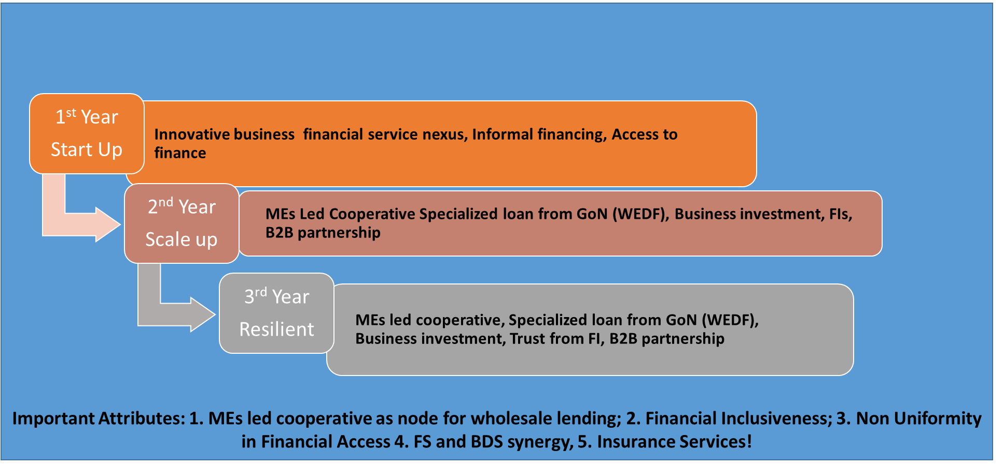

A2F of MED model promoted MEs make more sense when looked from three important phases (Start up, Up-scaling and Resilient). The financial requirement in different growth phases are often based on the services that MEs are receiving. Innovation is duly carried out by MED model by providing access to various business services (like entrepreneurship training, skill based training, technology transfer, mentoring services by EDFs and resource person) and financial services (A2F, insurance, advance payment from buyers, PPP partnership, etc.). There is cost involved even in business service delivery, which has been innovated as mainly public service provision along with contribution of MEs (for example technology purchase in 80:20 ratios between MEDPA and MEs). This situation demands for mainstreaming of the financial service provision within business service delivery (which for this document is termed as "innovative business financial service nexus"). The LLD study team, based on the review of the relevant project documents and field visits, has used scenario analysis for documenting A2F of MED model.

**A2F scenarios in MED model**

The A2F interventions of MED model can be looked from following 5 different scenarios.

1. Scenario 1: Access to finance in areas where financial intermediaries are absent;
2. Scenario 2: Access to finance in areas where there is presence of cooperatives and/or microfinance;
3. Scenario 3: Financial institutions lead by micro-entrepreneurs;
4. Scenario 4: Wholesale lending to financial institutions and utilization for micro-enterprise promotion;and
5. Scenario 5: Innovation on micro-enterprise funding.

These scenarios are further explained to gauge deeper comparative access across the target groups and geographic regions of MEs.

***a) Access to finance in areas where financial intermediaries are absent:***

This is a typical case that exists mostly in remote areas of Nepal. In such areas, there exist no financial intermediaries, and wherever they exist are in nascent stage. The MED model, which includes A2F as a specific component, has an important scoping of financial institutions initially in the first component “Social Mobilization” of the six components of MED strategy. This component of the MED strategy results in the identification of all possible financial institutions that can render services to micro enterprises in that area. The initiation for the establishment of MEG is carried out in order to develop foundation for the establishment of group level saving and credit mechanism by possible MEGs. However, such group level saving and credit mechanism are not able to meet the requirements for accessing financial services from other FIs. In this scenario, different financial requirement like skills training, technology purchase, raw material purchase, etc. for some of the MEs are managed effectively within MED components. Skills training is provided to the participants as innovative business-financial service nexus approach with minimum expense . Technology transfer is based on 80 per cent amount from MEDPA and 20 per cent from MEs. APSOs and MEDSPs reported that high level of efforts is made for developing possible A2F mechanism in remote areas of the country. Possible networking with village development committees and other development projects were also made as part of effort for maximizing A2F for micro enterprises. But, sustainable mechanism for A2F is still a daunting challenge in these geo-spatial locations.

***b) Access to finance in areas where there is presence of cooperatives and/or microfinance:***

The financial institutions scoping carried out during social mobilization component of MED model can pave further possibilities for micro entrepreneurs to render financial services. The major requirements for MEs at present are found to be start-up cost (apart from skill training and technology). The start-up cost for raw materials, human resource, and marketing cost are found to be much difficult at initial stage and MEs have to wait for support from organizations. At present, MEs are linked with available financial institutions as mandatory provision for MEs, and this has created an enabling environment for proper utilization of loans in the enterprise sector. However, the worst cases as reported during the field visits were the use of the financial service for household management. The interaction with different financial institutions has revealed it to be highly positive for MEs to best utilize loans for specific enterprise activities. The financial service providers have branches in 69 MEDPA program districts, and loans provided by these banking institutions are ensured according to the insurance provisions of the financial institutions (GoN/MoI/UNDP, 2016). Financial institutions are very strict in providing loans to non-members; this indicates the needs for non-members to become members before accessing loans. In line with this, the social mobilization component of MED strategy carried out this issue as an important activity. The objective of this activity is to ease the availability of “micro lending” to MEs without collateral from either cooperatives or microfinance institutions. Some formal agreements and interaction between financial institutions, MEDSPs, DMEGA and MEDPA have been carried out in order to cater best financial service to MEs. In few cases, the interest rate for MEs is lessened in comparison to other members. The results are that there has already been signing of the MoU between 20 national level commercial and microfinance banks (12 in 2015) and NMEFEN for MEs to access financial services. Similarly, a total of 16,554 MEs have accessed loans worth NRs. 398 million from these institutions by the end of December, 2016.

***c) Financial institutions lead by MEs:***

The provision of saving and credit and continuous growth of MEs from MEGs, and the needs for further financial service have led the MEs to establish their own cooperatives. Members involved in cooperatives are entrepreneurs who not only mobilize their savings but also seek outside fund to scale up their enterprises. The features of cooperatives promoted by MEs under MED model include: operating as inclusive business activities; functioning as social enterprise initiatives; and as part of larger inclusive business company (GoN/MoI/UNDP, 2016). There are mainly two distinct types of MEs-led financial institutions. First is a type which has only MEs as cooperative members, and the second one includes those members who are interested in or are operating enterprises at micro or small level (but not part of MEG/MEGA). The first type has significantly positive attributes in terms of: inclusion, loan usage, MED approach promotion and partnership with organization. However, due to the limited number of its members, these types of cooperatives are not able to increase share capital and saving thereby becoming unable to manage staffing for proper management. The second type of cooperative, which includes other members too, has more positive cash flow management and also able to partner with multiple organizations. Indeed, MED approach (in terms of A2F for provisioning investment in micro enterprises) is still highly practiced in both types of cooperatives. The important factor that can be summarized from MEs involved in financial institutions are: investment in enterprises and social inclusion of members.

***d) Wholesale lending to financial institutions and utilization for micro enterprise creation and promotion:***

It is aparant that limited number of cooperatives led by MEs are able to avail wholesale lending from financial institutions. A total of 39 cooperatives, of those existing, have gained skills and knowledge on cooperative management, account keeping, financial governance and cooperative management. Altogether 13 cooperatives received wholesale lending of NRs. 55.6 million (from Rural Self Reliance Fund, Yuva Swarojgar Kosh/Youth Self Employment Fund, RMDC, etc.) and 1,308 MEs have been benefitted (GoN/MoI/UNDP, 2018). The positive aspects of these cooperatives are the best utilization of fund i.e., use for enterprises requirement. This possibility has to be looked specifically by Performance Evaluation and Reporting Logics (PEARL) analysis, and a few of the cooperatives have shown a high requirement for improving cooperative indicators to match the readiness for wholesale lending. There is limited number of MEs promoted cooperatives engaged in wholesale lending, and the initial results show effectiveness of lending focusing on funding to enterprise/productive sector. MEG, DMEGA, MEDSPO and MEDPA are strongly focusing and monitoring to help ensure the best utilization of loans in productive sectors (i.e., enterprise).

***e) Innovation on microenterprise funding:***

Reiterating again, A2F services to micro enterprises has been the most challenging issue for stakeholder engagement in MED approach. There are innovations like: 1) Establishment of CFC to minimize enterprise cost for technology, input purchase and marketing cost; 2) Pro-Poor Public-Private Partnership (PPP) to bring investment from multiple stakeholders and pro-poor HHs becoming owner and also getting employment in the enterprises; 3) B2B partnership where forward linkage actors support MEs with advance and early payment; 4)FIs scoping and synergy for supporting MEs in local context; 5) Productive usage of remittances amount for enterprise activities. These innovations are ongoing and MEs are trying their best to manage cash flow through alternative sources like family, friends and relatives.

**Status of A2F progress and achievements in MED model**

A2F service for MEs has always remained as one of the challenging aspects for MED implementation. Facilitation of easy access to financial services for MEDEP and MEDPA created MEs (a total as of December 2017 is 131,680) was one of the important aspects of MED model. Realizing the importance for an effective collaborative relationship between the MEs/MEAs and financial service providers, the project has made significant efforts in this line. They include the following (GoN/MoI/UNDP, 2018, pp. 51-52):

1. Facilitate MEs to be federated in groups (named as MEG) with savings mobilization as required by the financial service providers (FSPs) in order to access deprived sector lending from the financial service providers.
2. Facilitate MEGs to deposit and mobilize savings to meet their initial investment requirements and build up financial strengths.
3. Facilitate MEGs (including CFCs) to operate enterprise that gradually become bankable and capable to absorb loan and payback the installment in time and MEs become potential borrowers of FSP and gradually become potential market for the FSPs.
4. Facilitation resulted into the establishment of a total of 330 cooperatives (54% are located in hills, 10% in the mountains and the rest 36% in the Tarai) with amount NRs. 230 million savings and mobilized to meet their financial needs including investment into micro-enterprises.
5. Facilitate MEs to access funds from wholesale lending organizations through cooperative; while the MEs' products are marketed collectively from their cooperatives as local community based production centers.
6. Facilitate, owing to MEAs’ partnership with FSPs, to establish collaboration with the Central Bank and national level financial service providers, financial institutions and local banks so that they recognize MEGs, CFCs, MEGAs as reliable credit worthy groups.
7. Facilitate in line with monetary policies issued annually by the Central Bank for giving priority to MEs promoted cooperatives to receive wholesale loan from the Nepal Rastra Bank.
8. Result is that the financial institutions including Central Bank has also recognized micro-enterprise loan for entrepreneurs.
9. A total of 13 cooperatives received wholesale loan amount NRs. 55.6 mil and 1,308 MEs have been benefitted from this (Rural Self Reliance Fund-RSRF, Yuba Swarojgar Kosh/Youth Self Employment Fund-YSEF, and other wholesale funds, i.e.,  Rural Microfinance Development Centre, First Microfinance Development Bank, Sana Kisan Bikas Bank, National Cooperative Bank are the organizations from where MEs cooperatives are getting along with capacity development training to capacitate them in receiving fund from them).
10. Launching awareness campaigns on insurance policy to MED promoted MEs to protect their enterprises from unseen financial and economic shocks and hazards (a total of 419 MEs: 67%-women, 19%-Dalit, 41%-IN, 40%-BCTS and 15%-Madhesi benefitted from the insurance services with increment in the number of MEs receiving loan from financial institutions).
11. Institutional arrangement among Bank, MEDPA and DMEGA, Ministry of Industry has established. Women Entrepreneurship Development Fund (WEDF) to provide loan for micro and small enterprises through Rastriya Banijya Bank (in 2017, altogether 131 micro-entrepreneurs amounting NRs 26.9 million have received loans to scale up their micro-enterprises in 12 districts).

In order to provide financial services to MEs, various avenues for A2F services through different sources have been mapped and identified. This effort is meant to link MEs to obtain loan from banking institutions, cooperatives and the micro-entrepreneurs’ groups. MEDEP has provided technical support to NMEFEN/DMEGAs to develop partnership linkages with different financial institutions[[2]](#footnote-2). As a result, there have already been nine partnerships at the central level (7 between NMEFEN and FSPs, and 2 between MoI and NRB/Rastriya Banijya Bank) and 25 at district level between DMEGAs and FSPs.

Table 16: Loan received by women entrepreneurs from WEDF in 2017

| **S.N.** | **District** | **MEs** | **Loan** | **GESI Target Groups** | | |
| --- | --- | --- | --- | --- | --- | --- |
| **Dalit** | **IN** | **BCTS** |
| 1 | Udaypur | 19 | 4,700,000 | 1 | 6 | 12 |
| 2 | Saptari | 18 | 862,000 | 5 | 13 | 0 |
| 3 | Dhanusha | 3 | 500,000 | 1 | 1 | 1 |
| 4 | Sindhuli | 8 | 1,300,000 |  | 5 | 3 |
| 5 | Kavre | 1 | 150,000 | 1 |  |  |
| 6 | Sindhulpalchwok | 10 | 1,750,000 | 1 | 5 | 4 |
| 7 | Nuwakot | 27 | 6,550,000 | 2 | 7 | 18 |
| 8 | Nawalparasi | 8 | 1,600,000 | 1 | 5 | 2 |
| 9 | Pyuthan | 13 | 3,052,000 | 1 | 8 | 4 |
| 10 | Rolpa | 17 | 3,955,000 | 0 | 12 | 5 |
| 11 | Banke | 1 | 300,000 |  |  | 1 |
| 12 | Dang | 6 | 2,150,000 | 0 | 5 | 1 |
|  | **Total** | **131** | **26,869,000** | **13** | **67** | **51** |
|  | GESI (%) |  |  | 10 | 51 | 39 |

Source: APSO Reports on A2F, MEDEP 2017, cited in GoN/MoI/UNDP, 2018, p. 52-53

Recommendation is needed from DMEGA for MEs to access loan from WEDF as a requirement under the tripartite institutional arrangement made among banks, CSIO/CSIDBO and MEAs. DMEGAs are recommending CSIO/CSIDB on behalf of MEs in accessing loan from WEDF which has resulted to a total of 131 MEs receiving a total of NRs. 26,869,000 worth of loans under this provision.

Facilitation is being carried out to MEAs and MoI to provide policy level inputs to create conducive environment for accessing apex funds such as Rural Self Reliance Fund (RSSF), fund from Rural Microfinance Development Centre (RMDC) and National Cooperative Bank at different levels by MEs. Facilitation also continued to MEs’ associations (i.e., MEG, MEGA, DMEGA, NMEFEN, cooperatives) to establish institutional linkages with financial service providers for continued access to financial services so that the service could be continued. With several efforts made by MoI, DCSI/CSIDB, MEAs establishing institutional linkages with financial service providers at different levels MEs are gradually increasing access to loan from FSPs. As a result, a total of 10, 239 MEs in 2017 have received loan amounting NRs. 195 million from financial service providers (GoN/MoI/UNDP, 2018, p. 53).

Table 17: Total number of MEs received loan from different sources in 2017

|  |  |  |  |  |  |  |
| --- | --- | --- | --- | --- | --- | --- |
| **Sources** | Dalit | IN | BCTS | Total | Madhesi | Women |
| Bank | 448 | 916 | 434 | 1,798 | 310 | 1,347 |
| Cooperative | 1,328 | 2,425 | 1,801 | 5,554 | 403 | 3,976 |
| MEGs/MEGAs | 97 | 193 | 130 | 420 | 44 | 272 |
| Relatives/NGOs/Other Groups | 675 | 983 | 809 | 2467 | 198 | 1,677 |
| **Total** | **2,548** | **4,517** | **3,174** | **10,239** | **955** | **7,272** |
| Percentage | 25 | 44 | 31 | 100 | 9 | 71 |
| **Loan** | | | | **19,53,02,437** | | |
| **Average Loan** | | | | **19,074** | | |

Source: APSO Reports on A2F, MEDEP 2017, cited in GoN/MoI/UNDP, 2018, p. 53

There was five-year broad agreement between the Nepal Rastra Bank and the MoI to support MEDEP and MEDPA promoted cooperatives in accessing wholesale loans. As a result, as of December 2017, a total of 13 cooperatives received wholesale loan worth NRs. 55.6 million from different sources (GoN/MoI/UNDP, 2018, p. 53).

Table 18: Amount and sources of wholesale loan during MEDPA (as of December 2017)

|  |  |  |  |  |
| --- | --- | --- | --- | --- |
| **S.N.** | **No. of Cooperatives** | **No. of MEs** | **Total Amount**  **(NRs)** | **Source** |
| 1 | 5 | 776 | 78,62,000 | Rural Self Reliance Fund |
| 2 | 2 | 115 | 51,00,000 | National Cooperative Bank |
| 3 | 3 | 125 | 87,65,000 | Youth Self Employment Fund |
| 4 | 1 | 29 | 25,00,000 | RSDC *Lagubitta*Sanstha |
| 5 | 1 | 132 | 45,00,000 | Rural Microfinance Development Centre |
| 6 | 1 | 131 | 26,86,9000 | Women Entrepreneurship Development Fund through RastriyaBanijya Bank |
|  | **13** | **1,308** | **55,596,000** |  |

Source: APSO Reports on A2F, MEDEP 2017, cited in GoN/MoI/UNDP, 2018, p. 53

The wholesale loan distribution in terms of GESI target group shows that significant number of women have accessed the loan service. A total of 70 per cent women, 48 per cent indigenous nationalities, 37 per cent of BCTS and 14 per cent of Dalits have accessed wholesale loan.

Figure 17: Wholesale loan disaggregated by GESI target groups

Source: APSO Reports on A2F, MEDEP 2017, cited in GoN/MoI/UNDP, 2018, p. 53

Despite these progresses, some challenges in terms of A2F service for MEs have been identified. They include low presence of FSPs in remote areas, FSPs’ reluctance to work in remote areas (where MED promoted MEs exist) due to high transaction cost, high interest rate charged by FSP for deprived sectors lending in micro-finance service (13-20%), other community lending funds like PAF are outside MED promoted MEs, and ME's less access to GoN's employment funds at central levels. However, opportunities can also be seen in the MEDPA phase II, which has priority to facilitate for the mobilization of central level funds to MEs, priority of the Constitution of Nepal - 2015 to cooperative activities at local levels, and well-positioned MEAs and their possible roles to garner partnership between MEs and FIs.

**Key lessons learnt from access to finance**

1. ***Better utilization of fund and larger number of members accessing loan is uniqueness of MEs led cooperative:*** One of the best lessons learnt from micro enterprise led cooperatives are investment of fund in enterprise sector and inclusiveness of members in cooperatives. The cooperatives are providing loans as per the requirement of micro enterprise by virtue of knowing them well and its better utilization so that recovery of loan is satisfactory. The micro enterprise led cooperative as per Type 1 (discussed earlier) has only MEs as members, whereas Type 2 has wider membership. The interaction with cooperatives (e.g., in Udayapur and Sunsari districts) have provided insights on inability of Type 1 cooperatives to expand membership as they find it riskier to provide loans to members who might utilize loans for non-productive sector. The definition of Micro Enterprise in Industrial Act - 2073 has paved forward possibilities of increasing membership for registered MEs thereby developing self-sustaining MEs led cooperatives in coming times.
2. ***Inclusive governanceis a unique endeavor of MED promoted cooperatives:*** The governance of the MED promoted cooperatives are based on the GESI approach according to which not only the management of the cooperative is inclusive in terms of its structure but special priority is given to the hardcore poor in terms of the access to loan and membership.
3. ***Provision for the start-up capitalis highly required for those MEs who cannot start their enterprise without it:*** Even though all possibilities for developing linkages between MEs and financial institutions (as available) were attempted during the MEDEP and MEDPA implementation, the management of the amount required for most of the MEs at initial phase is still an unresolved problem. A specific package for fulfilling startup capital requirement for needy MEs has to be explored in coming times so that micro enterprise ecosystem can be triggered for more employment and competiveness in the market (in reference to the GoN’s existing provisions of loan in the Agriculture sector).
4. ***Policy provisions for access to finance for MEs is yet to be effectively translated into practices:*** It is reported and found that a number of agreements between various cooperatives at local level and microfinance institutions at national and regional levels have taken place in order to provide access to finance for MEs. These agreements including the existing mechanism of partnership between FIs and local level cooperatives have provided ample opportunities to enhance better relation between the FIs and MEs so as to increase investment of the funds in productive sectors. There are few examples (as discussed in previous sections of this theme) where FIs have provided special priority to MEs (such as reduced interest rate, value chain based financing mechanism, etc). The effort made so far at the level of MED model implementation is satisfactory in providing enabling policy environments for MEs. However, the effective translation of these policy provisions into practice is not adequate yet in the sense that all the needy MEs (promoted through MED model) are not in a position to access financial services as per their need or requirement to operate their enterprises.
5. ***Constant capacity building of MEs led cooperatives is required for their sustainability:*** Even though the MED promoted cooperatives are based on the GESI approach in its governance (composition of committee members, access to loan, membership, special care to the hardcore poor, etc.), they face some challenges in its successful functioning. Hardcore poor and socially excluded MEs are the members of these cooperatives. This means that lack of management and leadership capacity is obviously a problem of these cooperatives. These characteristics have been creating increased risk for their institutional sustainability and effective service provisioning. Hence, capacity building of these cooperatives is highly desirable for the sustainability of these institutions.

**Concluding lessons learnt from access to finance (A2F) in MED model**

Constant efforts have been made for providing A2F services to the MED model promoted MEs. A number of practices have been localized and replicated in larger scale. For example, efforts for the establishment and functioning of MEs led cooperative, MEG group level fund mobilization, buy-back guarantee, B2B partnership linkages, CFC practices and investment from community organizations can be seen in MED model implemented communities/regions. However, startup capital funding mechanism has remained an unresolved problem for most of the MED model promoted MEs. So, it is important to initiate three things at this point: 1) to devise startup capital financing from initial stage through MEDPA; 2) develop synergy between business service provider and financial service provider for joint initiation to have easy and institutional A2F for MEs from the starting of MED implementation; and 3) policy framework for coupling efforts of MED approach and financial service delivery approach.

## 3.5 Pro-poor public-private partnership (PPP) in MED model

MED model primarily has three key stakeholders: MEDPA, MEDSP/BDSPOs and MEAs (NMEFEN, DMEGA, MEGA/LMEGA, MEG). The relentless effort of key stakeholders along with technical service rendered by MEDEP team has seen MED model outreach expanded to various institutions along with innovation in bringing multi-stakeholders together for MEs’ promotion. The exemplary initiation and work, at the level of MEAs, has been carried out by NMEFEN (at national level) and DMEGA (at district level) to position MEs akin to well-functioning SMEs in Nepal. The key stakeholders’ engagement resulted in the formulation of micro enterprise friendly laws, policies, guidelines and their revisions.

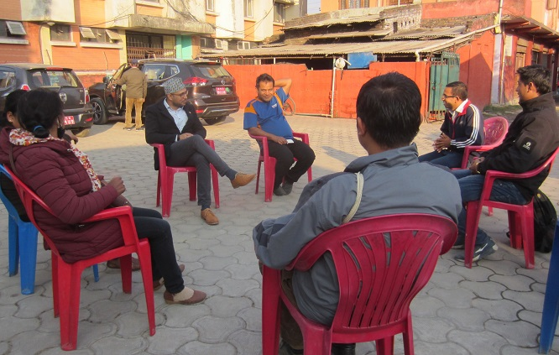

*(Interaction participants from MED stakeholders including private sectors in Hetauda, Makawanpur)*

Enterprise ecosystem in Nepal was focused on the promotion of SMEs, and during earlier phases only MEDEP was dedicated to micro enterprises. The realization of the importance of MEs in enterprise ecosystem led to the identification of its importance and replication of various components of MED model by other organizations; this started along with MED implementation (reflection from field visits, 2018).

**Context for lesson learnt documentation**

The establishment of MEAs and its positioning in enterprise ecosystem requires an analysis of the context where MED model is being carried out from Pro-Poor Public-Private Partnership (PPP) perspective. PPP perspective in itself is multi-dimensional and the study team, after reviewing existing MEDPA and MEDEP's relevant documents along with field visits, has concentrated on the context shown in the figure below.

Figure 18: Key domains of PPP perspective

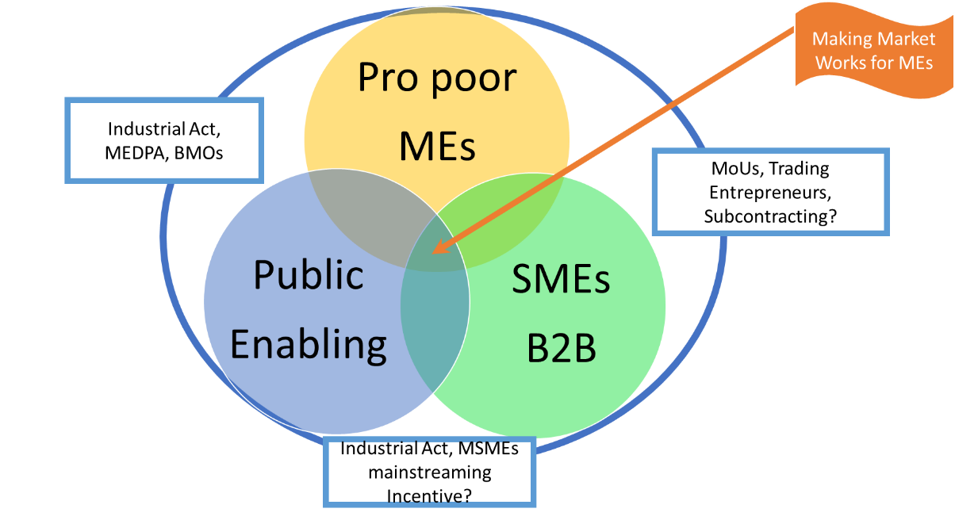

The above figure shows the contextualization of three stakeholders for the effort of positioning of MEs in enterprises ecosystem so that market works for the poor.

* Government of Nepal, particularly under the leadership of MoI and the technical support of MEDEP , has been instrumental in positioning of MEs, mainly in Industrial Policy 2011 along with various policy frameworks.
* MEAs comprising of MEs is acting as buyers of raw materials from production node (farmers/HHs) and acting as exporter of the goods to the market is also focusing on B2B linkages. This has led SMEs to identify MEs as supply chain nodes (considered by NMEFEN and study team’s interaction with CG Foundation, Mahaguthi, etc.).
* SMEs, prioritizing partnership with MoU and B2B linkages (interaction with UN Global compact team Nepal) through PPP approach, are working together with MEs.
* The missing link between MEs and SMEs for B2B linkages has been duly acknowledged and innovation has been carried out by promoting Trading Entrepreneurs (TE). A MEDEP (unpublished) report on TEs status depicts 50 TEs have already contracted with 1,449 MEs, and semi-annual sales of those TEs have been recorded to amount about NRs 20.12 million.

This engagement of public and private actors with larger enterprise ecosystem is a unique approach in MED model. Further, existing explanation on PPP perspective is explained through analyzing three important perspectives.

**Deriving analysis of MEs positioning in enterprise ecosystem**

Review of the relevant project documents and reports along with the field visits by study team was carried out to derive important analysis in the following sphere:

1. MSMEs mainstreaming;
2. Positioning of MEAs as Business Membership Organization (BMO) akin to other BMOs;
3. MEAs advocacy for micro enterprise ecosystem.

***a) MSMEs mainstreaming:***

Enterprise Ecosystem consists of different types of enterprises such as large, medium, small and micro enterprise as its pillars. From the context of micro enterprise ecosystem, the engagement of multiple actors is most required for engaging MEs in business partnership. MEDEP introduced a milestone approach known as Pro-Poor Public-private Partnership (PPP) as a form of mainstreaming micro enterprise into other categories of enterprises. The examples are seen in the case of Veneer, Juice and Nepali Paper enterprises in different parts of the country. The pro-poor MEs' engagement as business partners with private sectors and cooperatives is conceptualized as private limited company. The dual benefit of being a shareholder and also getting employment is unique in itself. Further, engaging the public for facilitation and devising proportionate representation in shareholder members has made r a good platform for pro-poor MEs in decision making level in the private limited companies. MEs have expertise with regard to production and processing nodes, whereas the private sector has more expertise on the marketing node. This exemplification has unique learning both in the case of MSMEs engagement and vertical integration in value chain nodes.

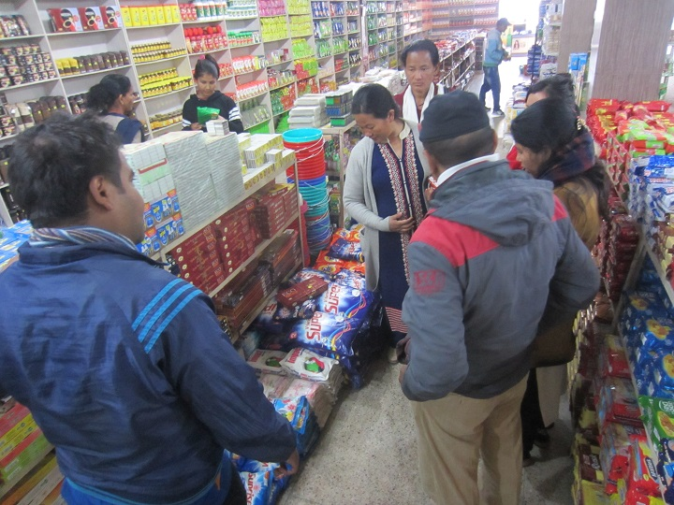

*(The EDF in Udayapur showing MED promoted entrepreneurs' product kept in the local supermarket)*

Business to Business (B2B) partnership with SMEs like Gandaki Bee Concern, Mahaguthi Craft, and Formation Carpet by signing MoU through the proactive engagement of NMEFEN has led to strengthening of the MEs as supply chain actors, catering B2B linkages. This has seen a new avenue of other private sector associations like Fair Trade Group (FTG), Carpet Association of Nepal, etc. Further, inclusion of MEs and their positioning in the enterprise ecosystem is pertinent for developing a realization of MEs as sustainable supply chain and business partner (Schmitt-Degenhardt, et al., 2016).

The establishment and strengthening of marketing outlets, known as “Koseli Ghar”, focusing on MEs products has wider success, and hence it has been replicated in different places. This has helped in promoting locally made products to different market segments. There are 40 outlets in operation along with Saugat-Griha in Kathmandu which have been acting as market hub point.

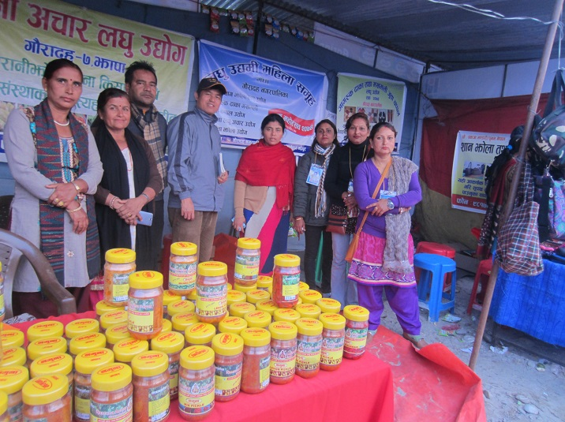

*(Women entrepreneurs displaying their products in their common stall in industrial trade-fair in Damak, Jhapa)*

Purchase of raw materials by MEs for further value addition has increased the household income of the people in the area and vicinity. Field level interaction with community, such as incense stick CFC in Dhanusha and Jute CFC in Sunsari, revealed the importance of nearby market for household products (agriculture, livestock product, and forest based product). The local raw materials and value addition to it through MEs have been supporting to increase rural income (products like Lapsi, Kaulo, Rithha, etc. not utilized for income generation before intervention). These processes are also providing recognition of local communities through value addition (e.g., Dhanusha known for incense stick, Dang for Allo, etc.) This recognition has further made it easier for SMEs to identify supply chain node.

***b) Positioning of MEAs as BMOs akin to other BMOs:***

Enabling environment for enterprise and economic promotion was led by Business Membership Organizations (BMO) like FNCCI, FNSCI, CNI, FHAN, etc. The issues concerning various value chain node actors were advocated by these organizations in different forums locally, regionally, nationally and even internationally. Micro enterprises are unique and characterized by relentless efforts of poor households towards enterprising journey (interaction with NMEFEN). It can be considered as first platform for poor households thereby graduating towards becoming SMEs. The context of Nepal, mainly for MEs, requires continuous effort for their sustainable functioning. EDF's engagement and support through various institutions for at least three years provides a platform from where MEs can thrive in SMEs ecosystem (interaction with EDF training institutes in Surkhet). However, it requires specific advocacy for MEs and formation of MEG, MEGA, DMEGA, NMEFEN in different nodes to get the things to function well. This conceptualization has provided a favorable environment for MEAs to carry out advocacy.

One of the most important achievements, in this line, is policy recognition of MEs in the Industrial Act - 2073. Mainstreaming MEs importance in other different policies and regulatory frameworks and ME being recognized in MEDPA's different committees, locally and nationally, has also resulted in developing the realization of the importance of MEs in national economy and entrepreneurship development.

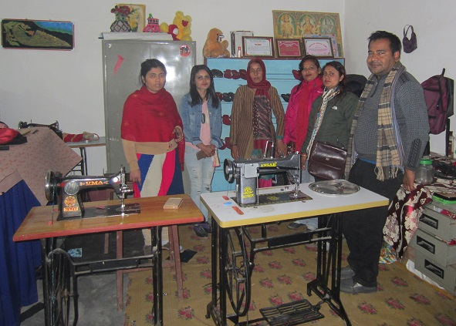

*(Women entrepreneurs in inside their common working stations in Gauradah, Jhapa)*

Further, MEA's engagement with other BMOs in the form of associate member (such as in FNCSI) is a positive sign. However, establishment of MEAs (i.e., NMEFEN) as a parallel private sector representative structure to existing ones, such as FNCCI, FNCSI, is a challenge (Schmitt-Degenhardt et al., 2016). But MEAs can be viewed as unique and a new lesson from the perspective of institutional development and organizational strengthening akin to BMOs in Nepal (interaction with FNCCI and FNCSI revealed uniqueness). This has developed a strong and sustainable positioning of MEAs akin to other BMOs and it possibly may open a platform for integration of different BMOs in coming times.

***c) MEAs advocacy for micro enterprise ecosystem:***

The relentless effort of NMEFEN, MEDEP, MoI, MEDSP and concerned stakeholders has become able to position MEs within Enterprise ecosystem. As a result, the generally established term SMEs has been redefined as MSMEs. The mainstream action for MSMEs through PPP approach and B2B linkages has already shown importance of MEs as unique supply chain actor for forward linkage buyers. There are various enabling tools required for MSMEs mainstreaming, importantly sub-contracting system which are presently being highly advocated and in the process of final decision making.

Acknowledging the MEs definition and potential increase in number of MEs (apart from MEDPA and MEDEP promoted), NMEFEN and DMEGA are opening up membership to cover larger number of MEs. Formal MEs (registered) are less in number and present Micro Enterprise ecosystem provides free registration facility to MEs. At present, MEAs are advocating for this and there is possibility that it will add new dimension to MEAs thereby pushing the trend towards positive direction of mainstreaming MEs within MSMEs ecosystem. MEDPA program, particularly with GESI target approach, will become capable to increase registered MEs to its association through mainstreaming informal MEs. A wider plan for supporting MEs needs to be formulated, including plan to incorporate new data in GESI-MIS.

**Targets and achievements of PPP during the implementation of MED model**

MEDEP and MEDPA have made significant efforts for PPP during the implementation of MED model. The implementation of MEDEP phase IV itself had a number of targets in terms of PPP promotion for MED model promoted MEs.

Table 19:MEDPA targets in terms of PPP

|  |  |  |  |  |  |  |  |
| --- | --- | --- | --- | --- | --- | --- | --- |
| **Verifiable indicators** | **Baseline** | **MEDPA implementation years** | | | | | **Total** |
| **2013/14** | **2014/15** | **2015/16** | **2016/17** | **2017/18** | **Total** |
| Number of sum-contracts for MEs | ***1000*** | 2000 | 4000 | 4000 | 4600 | 3000 | **18600** |
| Number of market outlets (Saugat Griha, Koseli Griha) | ***30*** | 21 | 4 | 9 | 6 | 6 | **76** |
| Share of ME's products at local markets (in %) | ***10*** | 10 | 15 | 20 | 25 | 25 | **25** |
| Share of ME's products in foreign markets (in %) | ***5*** | 5 | 5 | 5 | 10 | 10 | 10 |

Source: GoN/MoI, 2013 (July), p. 37

MEDEP and MEDPA have made efforts to establish partnership between MED model promoted MEs and private sectors at village, district, national and international levels. In line with these, MED model facilitated the signing of an MoU between NMEFEN and Chaudhary Group Foundation (CG) for a partnership agreement for the promotion of merchandise produced by MEs that has potential in the national and international market (GoN/MoI/UNDP, 2016, p. 40). Assistance from CG was sought especially for product identification, design, production, packaging, labeling, branding, and marketing organic agro products and fabric such as Allo, Dhaka, and Pashmina. Some of these products were sent to USA, UK, India, Thailand and EU countries as samples.

A couple of business to business (B2B) partnerships have been made during MEDEP and MEDPA implementation. For example, MEDEP and MEDPA promoted Honey micro-entrepreneurs worked together to forge business partnership with Gandaki Bee Concern Pvt. Ltd. (GBC) in 2017. The 8 districts selected for this purpose included Nawalparasi, Kapilvastu, Dang, Bardiya, Pyuthan, Kailali, Dadeldhura and Ramechhap. Altogether, 500 honey entrepreneurs were trained in beekeeping skills by GBC and signed the buy-back guarantee agreements to buy honey from the entrepreneurs. The MoUs were signed with individual entrepreneurs resulting in 500 honey entrepreneurs promoted by MEDEP, MEDPA and RELRP (Ramechhap), and linked with GBC. As per GBC, it has procured approximately 50,000 kg of honey from the entrepreneurs. The total amount of transaction is approximately NRs. 17.5 million (US $ 173,270 approx.). The beekeepers are organized into production and marketing/procurement groups in order to supply honey to the market through GBC. A group of five lead honey entrepreneurs collect honey and supply it to the GBC in bulk quantity. This has created a self-sustained sub-contracting mechanism in honey business. Currently, such B2B partnership has expanded. The partnership arrangement between CG Foundation and NMEFEN has continued in 2017. They have increased their support to MEs by accessing products to new outlets as well. For instance, MEs products are now being promoted through *Swaswot Dham* outlets in Nawalparasi district and CG digital outlet at *Bhatbhateni supermarket, in Baluwatar* of Kathmandu. As a result, MEs are able to sell goods worth NRs. 200,000 from these two sales avenues. Likewise, the partnership agreement between *Mahaguthi* and NMEFEN has been continued in 2017. On an average, MEs are able to sell goods worth NRs. 100,000 each month through the *Mahaguthi* Shop in Lalitpur (GoN/MoI/UNDP, 2017, pp. 70-71).

**Key lessons learnt from pro-poor public-private partnership(PPP) in MED Model:**

1. ***MEs are important supply chain actors to the enterprise ecosystem:*** MSMEs ecosystem in Nepal lack conceptualization of MEs as supply chain actors to the whole enterprise ecosystem. In practice, medium and large enterprises are out sourcing products globally, whereas small enterprises are operating on their own. Some SMEs are vertically integrating to carry out different functions like production, processing and marketing. MEDPA and MEDEP promoted MEs can play roles as supply chain actors to the small and medium enterprises. This is a tremendous effort being recognized by value chain actors. This can pave way forward for a concrete way out (aligning to policy instrument like sub- contracting) for Micro Enterprise as supply chain nodes (production, processing, semi-processing, trading nodes).
2. ***MEs can contribute to develop economically vibrant community at margin:*** The positioning of MEs as supply chain actors is important in contributing to develop conceptual understanding for the equitable benefit sharing amongst value chain actors. In line with these, the international market segment like Fair Trade, Ethical Trade, Responsible Business penetration, etc. are effective tools for promoting B2B partnership with MEs. These can pave way forward for enhancing economic vibration among the MEs at the margin through MEs as local business point (processing, trading and other value addition) such as MEs engaged in different enterprises like Lapsi, Rithha, Allo, Kaulo, etc. Importantly, Trading Entrepreneurs (TE) approach has been adopted to further strengthen the positioning of MEs. TEs have become part of MED approach and in coming times MEs can see the constraints of negating the markets for possible business opportunities in trade (APR, 2016).
3. ***MEAs are strongly positioned BMO to carry out policy advocacy on behalf of the MEs:*** MEs are organized in their associations from local to the national level (i.e., MEG, MEGA/LMEGA, DMEGA, NMEFEN). Their associations established at different layers are strongly positioned to carry out policy advocacy as well as to facilitate required business services for its members.
4. ***Establishment of parallel and independent MEAs is leading towards institutional sustainability:*** One of the important means of institutional sustainability of any organizations including Business Membership Organizations (BMOs) is the number of its members. It’s direct relation is due to the potentials to generate membership fees. A few BMOs are operating through sales of products by its members. NMEFEN facilitation for B2B linkages with provision of 3 to 5 per cent as incentive for partnership is duly documented (GoN/MoI/UNDP, 2016). NMEFEN as national association of MEs is finding difficulties in managing operating cost. At present, NMEFEN is focusing on re-structuring its institution in federal structure and following chapter model of BMOs establishment. The increasing number of MEs and priority for their affiliation to MEAs with membership fee can provide a sustainable resource generation for MEAs.
5. ***MEAs akin to independent and sustained BMO are potential to thrive in federal context:*** The Municipality/Rural Municipality of the federal government system can pave way forward for the constructive use of MEAs for the promotion of micro enterprise sectors in their governing constituencies. For example, the MEs elected as people's representatives at local government (a total of 389) can play influencing roles for incorporating MED model in the local development planning processes. This means, the elected MEs may become strong catalyst for policy advocacy for MED model from local to the national level forums.
6. ***Regularity and predictability of production is highly desirable for the success of PPP model:*** It was reported as well as observed that the production of the goods by MED promoted MEs is mostly irregular and unpredictable. Due to which sustainability of the implementation of PPP model become highly challenging to the fact that SMEs often demand regularity and predictability of the supply of goods for the sustainability of PPP model.

**Conclusion of PPP in MED model**

MEs positioning in enterprise ecosystem is well highlighted through various innovation within MEDEP and MEDPA activities. The Ministry of Industry (MoI), being the lead institution for the implementation of MEDPA, is a right institution for enabling enterprise ecosystem and mainstreaming MSMEs into broader national economic ecosystem. It is right to say that MoI has played encouraging roles to establish MEs as an important component of micro enterprise ecosystem framework. It has potentials to deliver proactive roles to further its visibility. The lesson learnt from MEDPA and MEDEs' achievements of positioning MEs as quality supply chain node is the beginning of furthering the importance of MEs to wider enterprise ecosystem in Nepal. A tailor-made program is required to work explicitly on mainstreaming MEs within enterprise ecosystem, for which predictability and regularity of the supply of goods and services is highly desired.

## 3.6 Result based sub-contracting to MEDSPs for MED services

Result based subcontracting is a unique and a paradigm shifting approach being implemented by MEDPA. This has become strength for MEDPA implementation as expansion of MEDPA in all 75 (77) districts in short period of time became possible through this approach. MEDEP as direct implementer of the MED model has gradually been transformed into technical facilitation. There was some confusion when MEDEP was also implementing MEDPA activities (until the strong recommendation of Mid Term Evaluation-MTE came out in 2016). Recently, there is more clarity on the importance of MEDSPs as MED service providers. Further the comparative assessment of procurement system also made strong suggestion to provide enabling environment that could provide sufficient time to MEDSPs for delivering the MED services (as reported that MEDSPS, in general, had to accomplish the MED services within 3-6 months).

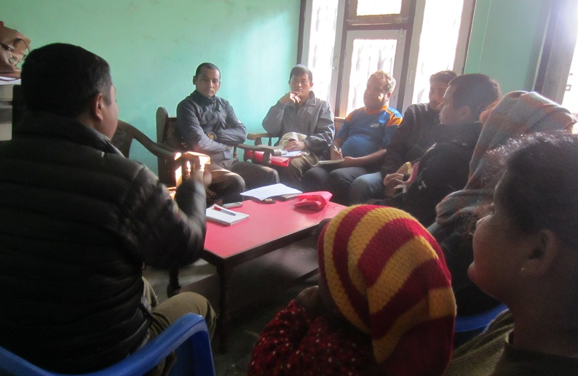

*(MEDSP staffs participating in FGD in Hetauda, Makawanpur)*

MEDEP program garnered spectrum of insights from working with Business Development Service Providers (MEDSP). This has resulted in clarity in defining the roles and responsibilities of three major MED stakeholder, viz. MEDPA, MEDSP and MEGA through devising required guidelines and strategies. For example, the crowding in approach has been successful as 403 applications from MEDSPs were received and out of which 214 became eligible in 2016 alone (GoN/MoI/UNDP, 2016).

Result based subcontracting is a unique system adopted for the implementation of MED model in which the service providers are contracted with targets outputs for a year. Their performance is systematically entered into the online database system, known as GESI-MIS. This is prepared by the service providers (MEDSPs), particularly by EDFs, on the basis of step by step activities as per six component of MED strategy. Result based sub-contracting, therefore, is a performance based contracting to the service providers which has resulted into the problems of delayed selection of MEDSPs thereby affecting the service delivery to MEs. For this, the Mid Term Evaluation (MTE) report in 2016 made strong suggestions to improve MEDSP selection procurement policy (adopt multiyear contracting system). In line with this, the Project is providing technical support to the MoI to incorporate multi-year subcontracting procurement system in MEDPA II Strategy Document.

**Contextualizing RBSC system of MED model**

Result based sub-contracting (RBSC) system is a paradigm shift of government led development program in Nepal. In order to understand RBSC system, as a part of MED model, it needs to be contextualized within underlying interconnectedness of MED stakeholders, MED model implementation processes, and inherent attributes of MEDSPs itself.

Figure 19: Key attributes of MEDSPs within MED implementation framework

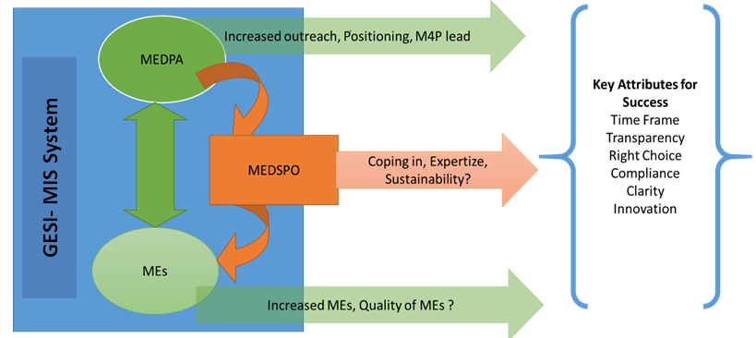

Key attributes of the MEDSPs, as listed in the framework above, bounds RBSC system within other two key MED stakeholders that determine the quality of MED services translated in the forms of number and quality of MEs. In other words, this framework locates MEDSPs within the purview of the MED implementation processes and outcomes. It puts MEDSPs within strategic, operational, and outcome based thinking that provides explicit ideas for lesson learnt documentation of MED model implementation. This contextualization of RBSC, as shown in the figure above, also postulates MEDSPs within a platform of possible hindrances (such as timeframe: sub-contracting for single year) and innovations (such as needs of multi-year sub-contracting) thereof.

**Multiple perspectives on RBSC**

Pertinently, the learning journey of RBSC needs to be further measured through multiple actor perspectives in order to draw important lessons learnt. The study team, based on the review of existing relevant project documents and reflections from the field visits, has tried to see the RBSC system from four key perspectives.

1. Perspective of MEs;
2. Perspective of DMEGA and NMEFEN ;
3. Perspective of MEDSP;
4. Perspective of DCSI/ CSIDB.

***a) Perspective of MEs:***

Micro Enterprises being promoted through MEDEP and MEDPA are characterized as members of the households with limited access to various opportunities and service provisions. This is primarily due tothe fact that they are located in the distanced and remote locations with higher poverty and high engagement in daily wages. In this context, the realization is that the effort of reaching to such people as the hardcore poor (as per inclusive and targeted people as MEDPA guideline) requires a concentrated effort from MED stakeholders. The provision of RBSC system and utilization of MEDSP has shown encouraging results in reaching the hardcore poor. The MEs creation and up-scaling activities presently being carried out through MEDSPs has been seen univocally important and relevant for GoN and others stakeholder's perspective. This has resulted in widening of the outreach of the MoI and its line agencies, namely DCSI and CSIDB in the districts. The services, in principles, are provisioned through mobilizations of EDFsfor mentorship and continuous support throughout the year. However, during MEDPA implementation, the engagement of EDFshave been mostly limited into certain period of time (minimum 2 months to maximum six months), due to the problem created from the government procurement policy (single year contracting and delayed selected processes). This has been seen reducing the quality of MED approach and its effectiveness in MEs promotion. This demands continued MED services through EDFs to be ensured at least for three years or until they become resilient.

***b) Perspective of DMEGA and NMEFEN:***

There has been univocal depiction by DMEGA and NMEFEN regarding the necessity of competition for acquiring subcontracting for MED delivery. DMEGA and NMEFEN as umbrella organizations of MEs have priority for advocating the rights of MEs in different forum. This has been helping them to make a strong presence in different MEDPA committees and forums. However, their presence in the MEDPA governing bodies (presence in MEDPA committees) has disqualified them from being a competitor for MED model delivery or being MEDSPs. MEDEP in early fourth phase was strongly involved in DMEGA implementation for different activities like up-scaling of enterprises, data base management and other possible frontiers. At present, with very limited support from MEDEP and some provision of support from MEDPA, DMEGA along with NMEFEN are striving for innovation so that voices of MEs can be represented and raised in various forums. DMEGA and NMEFEN are very positive about RBSC but restricting it to fewer organizations (i.e., MEDSP) has become a serious issue for them that they claim as being one of the potential actors for MEDPA implementation. This has created a problem in policy framing that whether MEAs can become MEDSPs or need to be restricted within policy advocacy.

***c) Perspective of MEDSP:***

MEDSP are recognized as specialized organization on MED delivery that is well acquainted with different tools, techniques and HR availability, particularly of having strong presence of EDFs at their disposal. MEDSPs' bigger concern, particularly during the implementation of MEDPA, was lack of availability of sufficient time to deliver the MED services in order to create quality MEs. MED model's genesis of working with MEs shows the characteristics of RBSC system as having continued engagement with MEs (up to three years) through ensured enabling environment for the delivery of six steps of MED strategies. This principally demanded situation for MEDPA implementation, from the perspective of MEDSPs, in general, have not been ensured in most of the cases/districts which have compelled MEDSPs to deliver/complete MED services within 2 to 6 months time period (which is not enough). Moreover, MEDSPs have to go through the selection processes every year as per the government's procurement policy which has created uncertainty among the MEDSPs. The fulfillment of technical requirements became much priority of the MED stakeholders thereby negating the possible innovations. MEDSP, by principles, is conceptualized as an organization having sustained informal networks with MEs even beyond the MED delivery timeline. But principally expected situations (relation between MEDSPs particularly with EDFs) could not happen and more shivering cases were reported and observed where selected MEDSPs have come from other districts. Much of the stakeholder aforementioned including MEDPA are univocally raising serious concern on single year sub-contracting and recommending for multi-year subcontracting with continuous quality control mechanism.

***d) Perspective of CSIDB and DCSI:***

The perspective of CSIDB and DCSI is highly guided and determined by the government's existing policy provisions and guidelines. There is spectrum of practical insights provided by the office bearers regarding the RBSC mechanism. Majority of office bearers are outlining the importance of RBSC disregarding their previous rigid thoughts that was against subcontracting mechanism (looking from the perspective that program can be State-run and State-implemented). The enrollments of EDFs and EDOs and database management personnel (mostly database assistant) within DCSI and CSIDB have eased their performance in terms of monitoring, evaluation and guidance for effective MED delivery through BDSPOs. The short duration for MED delivery through MEDSP has been a critical concern to CSIDB and DCSI as the MEs created during MEDPA are focused towards meeting the quantitative targets but quality of created MEs remained always a matter of critical concerns. The available HR and their capacity including infrastructure (physical space) of CSIDB and DCSI made them unable to ensure their presence to MED supported MEs. In some cases, it was reported that there were unintended political influences on MEDSP selection and making strict rules in this regard has always been a challenge (GoN/MoI/UNDP, 2016). The perspective deciphered has to be decoded further for making right choices at right time so that quality MEs is ensured in MED model.

**Acceptance of results based sub-contracting system**

RBSC system is considered as an effective method in achieving expected outputs and financial progress of the MEDPA interventions. The expected outputs of the MEDPA within 5 years time was to create at least 73,000 new micro entrepreneurs (40,000 by MEDPA and 30,000 by MEDEP in 38 MEDEP working districts) from across the country and of which 60,000 as resilient (GoN/MoI, 2013 [July], p. 21). Among them (new MEs), by gender group women - 70% and men - 30%; by caste ethnicity Dalits - 30%, Indigenous Nationalities - 40%, and other castes groups - 30%; unemployed youths 60% (16 - 40 years of age as per government policy), unemployed youth - 40% (16-30 years of age) targeting those who go abroad for job, and Madheshis - 40%.

Table 20:Progressive trends in MEDSPs biding and providing services to MEDPA (2015-2018)

|  |  |  |  |  |  |  |  |
| --- | --- | --- | --- | --- | --- | --- | --- |
| **FY** | **DCSI** | | **CSIDB** | | **Total DCSI & CSIDB** | | ***Number of Districts*** |
| ***Number of MED SP bidders*** | ***Number of eligible MEDSPs*** | ***Number of MED SP bidders*** | ***Number of eligible MEDSPs*** | ***Number of MED SP bidders*** | ***Number of eligible MEDSPs*** |
| 2015/16 | 144 | 67 | 133 | 95 | 277 | 162 | 63 |
| 2016/17 | 199 | 99 | 204 | 149 | 403 | 248 | 69 |
| 2017/18 | 200 | 108 | 237 | 177 | 437 | 285 | 75 |

Source: GoN/MoI/UNDP, 2018, p. 58

In summary, MEDSPs numbering 437 applied as eligible bidders to DCSI and CSIDB for the MED model implementation under MEDPA in calendar year 2017. Out of those who applied, only 285 were eligible for competitive bidding.

According to the RBSC system, the performance of MEDSPs is assessed on the basis of their performances as per their plan. The performance is assessed through online data monitoring system where following step by step activities and entering the details of the activities and MEs are mandatory for the service providers. This method has become an effective tool for achieving expected targets of the MEDPA interventions.

This method has been well accepted by MEDPA stakeholders. However, it has some unintended impacts at its outcome levels, as observed and reported, is that the service providers prioritize much on meeting numerical targets instead of focusing on quality services for ME creation.

MED model’s six components in present space time continuum have to be decoded to avoid duplication where other organizations have a mandate or specialization on. The activities within six components of MED model such as identifying hardcore poor can be in line with government organizations working with poverty (social mobilization component). The A2F component is much suited for FIs so that owning the component they have better options for MEs promotion. MED model and its delivery through single institutions like MEDSPs have to be critically looked forward to see possibilities of self-sustaining business operating organizations at the local level. A partnership between MEDSP and Financial Service providers from the start up can pave a new and viable direction where even EDFs can be hired as a part of larger financial institution ecosystem.

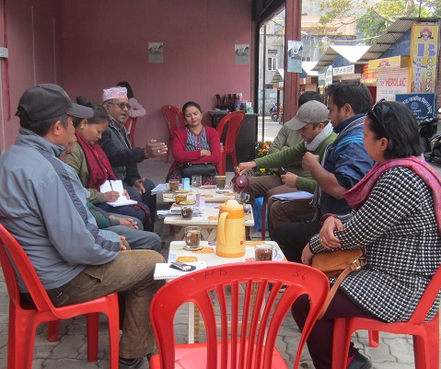

*(FGD participants in Dharan, Sunsari)*

There is also a pertinent requirement to position MEs from value chain perspective. Delivery of value chain development services also needs to be included in the capacity building activities of MEDSPs and EDFs, thereby creating opportunities for clarifying their role in addition to ME creation (Schmitt- Degenhardt et. al., 2016).

**Relevance of MEDSPs**

The objective of outsourcing MED services was to mobilize private sectors (outside expertise) for the successful implementation of six step MED models with the conceptualization that private sectors have skilled human resources and their utilization is most required for the success of MED model. Multiple stakeholders including different government line agencies are involved in the selection of BDSPOs. Therefore, outsourcing of MED services has two lessons: first, it provides ample opportunities to nourish collaboration and partnership between multiple agencies including government line agencies/ministries and private sectors; and the next is that it mobilizes private sector's skills/expertise to the effective implementation of MED model.

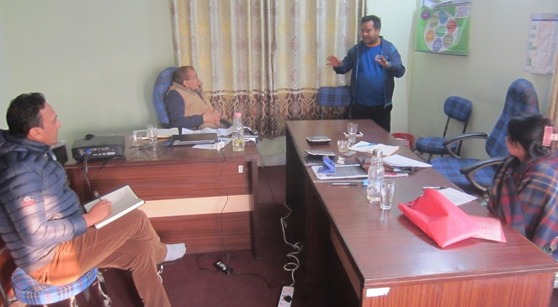

*(Discussion with APSO staffs in Biratnagar, Morang)*

However, the GoN’s procurement act does not allow multi-year contract to a particular service provider which has direct implication to the outcome of MED model implying that a single year is not enough to rigorously implement the six steps MED model. The lesson learnt from outsourcing of MED services is that it mobilizes multiple expertise through coordination of multiple actors to implement MED model but that had required an innovation for effective deliveries to address the challenges.

Entry of private sector MEDSPs into competitions should be explored and promoted further as the current NGO mode of the most of the MEDSPs creates some threat for sustainability (Schmitt-Degenhardt et al., 2016). There are various organizations like cooperatives, financial institutions, anchor firms, lead firms which might have more innovation for engaging either for increasing income of their member base through entrepreneurship (cooperative and FIs), or strengthening the supply chain, production node, and processing node by anchor or lead firms.

Therefore, outsourcing MED services has been very instrumental to mobilize outside expertise and enhance partnership among government line agencies, private sectors and stakeholders. It also enhanced capacity/expertise, especially of the EDFs with skills and knowledge to work with MEs, of private sector and made easily available in the market. It is also a means to receive multiple services from service providers as well as develop social networks with outside domains for the MEs. This has also increased government’s programmatic outreach.

**Key lessons learnt from the result based subcontracting to BDSPOs for MED service**

1. ***RBSC is a paradigm shift in the government's development approach which has increased the outreach of the government's development efforts:*** Respecting the earlier concern about Government’s direct involvement or sub-contracting mechanism debate, the recent perspective of MED model stakeholders preferred sub-contracting as this enables wider reach and working with specialized organization. This has enabled GoN to work for enabling environment, monitoring and evaluation and increase outreach to remote parts through entrepreneurship approach. The result based monitoring vis-à-vis coupled with GESI-MIS is an appreciated effort subjected to validity of data entered and full proof.
2. ***RBSC mechanism is significantly contributing in maintaining transparency of the MED implementation:*** As discussed earlier, the performance of the service providers (MEDSPs) in MED model is monitored through online information system (called GESI-MIS), generated by the EDFs and maintained by DBA. This has automatically helped to develop a systematized way of monitoring the performance of MEDSPs thereby contributing to the development of transparency and good governance.
3. ***RBSC is a unique approach of implementingdevelopment project but the single year contracting system is creating problem in quality ME creation:*** The implementation of RBSC system itself is a unique approach practiced by the government led development project in Nepal. The implementation of this system has become successful in creating targeted number of MEs. However, MEDSPs are subcontracted for a year and compelled to deliver stated MED services within the limited time period. A single year contracting itself is a problem in crating quality MEs, to that fact that development of resilient MEs may take at least three years' constant follow up supports. Moreover, the selected MEDSPs are compelled to deliver MED services within very limited time period (as it was reported that selected MEDSPs are compelled to deliver the services within 3 to 6 months since the rest of the months are invested for the selection processes). The important lessons learnt is that there must be an innovation in the selection processes as well as contracting periods to develop an enabling environment for quality ME creation.
4. ***Time consuming nature of MEDSP selection processes demands timely innovation***: The role of the government as lead of the MEDPA implementation has established strong positioning of the government in the processes. However, it was observed and reported that the whole process of the implementation of MED model have been gradually affected by the bureaucratic MEDSP selection processes. This is because the MEDSP selection processes as per the MEDPA guideline is very complicated and time consuming. The effects of the time consuming nature of MEDSP selection processes are resulted in the quality of ME creation. The problem aroused in this process was suggested with two alternatives (multiyear contracting or timely contracting). This gives a reflection that replication of RBSC system requires innovation for its effectiveness in the time continuum, particularly very important for the federal government system.
5. ***Types of MEDSP (i.e. local or outsiders) are important determinants for the effective implementation of MED activities:*** It was reported as well as observed that many of the selected MEDSPs (for example in Makwanpur in 2016/17 and in Solukhumbu in 2017/18) working for the implementation of MED model have come from other districts. Different issues related to the implementation of MED model such as effective implementation of MED activities, accountability for the implemented project activities, easy availability of the project staffs after the completion of MED activities, and coordination with district level stakeholders are determined by the types of MEDSPs. It was reported and observed that implementation of MED activities through local MEDSPs is more effective and hence future MEDPA should have an innovation in MEDSP selection processes which highly prioritize local organizations.
6. ***Effectiveness of RBSC mechanism can be ensured through engagement of multiple actors at the local levels:*** As it was observed and reported, one of the biggest challenges faced during the implementation of MEDPA implementation was quality of MED services to the MEs. In practice, a selected MEDSPs (mainly an organization as MEDSP) is responsible to deliver all types of services to the MEs. In this case, further innovation can be done through selection of multiple institutions with specialized functions (such as FIs for access to finance private sectors for marketing etc). This is more relevant in the context of federal government.

**Concluding the result based sub-contracting system in MED model**

RBSC approach is a paradigm shift and its application has increased programmatic outreach of the government programs. However, this approach needs to be revised so as to make it open for the competition by wider stakeholder (along with educating the possibilities) including local community groups in order to ensure sustained MED service deliveries, particularly in the context of federalized government system. The efforts made for the continuous supports to MEs for at least three years with constant engagement of EDFsis very effective which also demands provision for the engagement of multiple as well as local actors so as to ensure innovations on MED service delivery in coming times.

## 3.7 Human resource development and capacity building of MED stakeholders

Human resource development and capacity building of MED stakeholders is considered as one of the important activities of MED model implementation. It seems that human resources development is primarily important for the implementation of MED model while capacity building of MED stakeholders is primarily related with the internalization and institutionalization of MED model into the government system.

Since the inception of MED model, the development of EDFs through institutional linkages with CTEVT and affiliated training institutes has remained one of the important aspects of human resource development. It was projected that a total of 708 EDFs have to be developed (a total of 1283 with 575 developed during three phases of MEDEP and 708 during MEDPA) and utilized for MED implementation during MEDPA period (GoN/MoI, 2013, p. 35). Of these, a total of 1,234 EDFs have been already developed (as of December 2017) and the simple calculation indicates that a total of about 2,500 EDFs are needed for the implementation of MED model in 753 LGs.

*Figure 20: Projection of the number of EDFs developed and utilized for MED model*

Source: GoN/MoI, 2013, p. 35

MEDSPs as MED service providers, MEAs as beneficiaries, MoI and related government line agencies namely Micro-Enterprise Unit (MEU) of MOI, Cottage and Small Industry Development Board (CSIDB), Department of Cottage and Small Industry (DCSI), District Enterprise Development Committee [DEDC]) as government institutions are considered as MED stakeholders. The capacity development of these institutions and their staffs/officials was focused in order to ease the implementation of MED model.

*Figure 21: Projected number of government staffs and officials for MED model capacity building*

Source: GoN/MoI, 2013, p. 34-35

Capacity building of MED model stakeholders is carried out at both individual and institutional levels. At the individual levels, different forms of capacity development activities (that were included with the provision of training to enhance required skills and exposure/field visits) of the staffs of MED model implementing institutions were adopted. The institutional capacity buildings were included with facilitation to the institutional development of MEAs, MEDSPs, including establishment of required institutions at relevant government line agencies, departments, sections, and units. The institutional capacity building of MED stakeholders was expected through the following major activities (GoN/MoI, 2013, p. 33-35):

1. Establishment of Micro Enterprise Section at MoI;
2. Establishment of Micro Enterprise Units at DCSI and CSIDB;
3. Establishment of Result Based Monitoring System (RBMS) in all districts (75 districts);
4. Establishment of a Micro Enterprise knowledge management center at MoI;
5. Establishment of MEAs (75 DMEGAs from MEGs and MEGAs) with association of 84,600 MEs;
6. Establishment and strengthening of 5 EDF training institutes (2 established before MEDPA and other 3 during MEDPA);
7. Capacity building of the staffs and officials at MoI, CSIDB, DCSI, Ministry of Federal Affairs and Local Development (MoFALD), Ministry of Forest and soil Conservation (MoFSC), Ministry of Agriculture Development (MoAD), Ministry of Cooperatives and Poverty Alleviation (MoCPA), Poverty Alleviation Fund (PAF), and District Enterprise Development Committee (DEDC).

**EDF development through NSTB skill test and TSLC course under CTEVT for MED model**

The main objective of the development of the EDFs through National Skill Testing Board (NSTB) skill test and Technical Skill Leaving Certificate (TSLC) course under CTEVT is to produce formally recognized technical facilitators for the implementation of MED model in Nepal. EDF development was started along with the inception of MEDEP in 1998; however their status were not formally recognized until CTEVT institutionalized it into its formal system.

Initially, MEDEP provided a number of training and opportunity to the potential EDFs to practice in the field so that they become experienced facilitators for the implementation of MEDEP activities. Later, it was realized that formal recognition of the skills, knowledge, and experiences of the EDFs is most important for its sustainability. In line with this, MEDEP carried out lobby for the formal recognition of EDFs and as a result the concept of NSTB skill test and TSLC course under CTEVT was innovated.

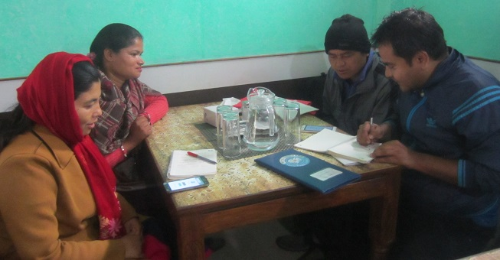

*(Interview with an EDF in Bardibas, Mahottari)*

*Figure 22: EDF development trend*

Source: CTEVT and NSTB, cited in GoN/MoI/UNDP, 2018, p. 60

Two methods were innovated for the formal institutionalization of the knowledge and skills of EDFs: the first was NSTB skill test in which individual having working experiences in the ME sectors appear in the exam for the certification of her/his skills; and the second was enrolment and certification from a total of 18 months’ formal classes (12 months theoretical classes and 6 months practical knowledge in the field). A total of 26 private training institutes, affiliated with CTEVT, have been established and contributing to train and produce EDFs in the market. As of December 2017, a total of 1,234 EDF have been developed and entered into the job market (GoN/MoI/UNDP, 2018, p. 60).

Table 21: GESI disaggregated information of certified EDFs

|  |  |  |  |  |  |  |  |  |  |  |  |
| --- | --- | --- | --- | --- | --- | --- | --- | --- | --- | --- | --- |
| Level | Dalit | | IN | | BCTS | | Madhesi | | Total | | |
| Women | Men | Women | Men | Women | Men | Women | Men | Women | Men | Total |
| II | 17 | 71 | 141 | 98 | 198 | 166 | 21 | 53 | 356 | 335 | 691 |
| III | 33 | 20 | 48 | 42 | 51 | 72 | 4 | 16 | 132 | 134 | 266 |
| TSLC | 40 | 3 | 116 | 31 | 56 | 31 | 5 | 17 | 212 | 65 | 277 |
| **Total** | **90** | **94** | **305** | **171** | **305** | **269** | **30** | **86** | **700** | **534** | **1234** |
| **%** | **48.9** | **51.1** | **64.1** | **35.9** | **53.1** | **46.9** | **25.9** | **74.1** | **56.7** | **43.3** | **100.0** |

Source: NSTB and CTEVT, cited in GoN/MoI/UNDP, 2018, p. 59

The production of EDFs through formal courses and skill test systems under CTEVT has institutionalized the contribution of MED model in producing skilled human resources for micro enterprise development in Nepal. However, increased number of private training institutes has also created the risk of low quality human resources production in the market. In addition, institutionalization of EDF production through CTEVT became narrower in the sense that EDFs are trained only for micro enterprise development. Broadening the horizon of the knowledge and skills of these EDF towards Small, Medium and Large Enterprises (SMLEs) is a great opportunity to compliment wider area of enterprises in Nepal. This means that this level of knowledge can help EDFs to understand and link MEs towards enterprise ecosystem.

Productions of EDFs through formal institutions have eased the implementation of MED model throughout the country as the EDF required for MED implementation have become available in the market. However, expansion of MED model throughout the country (in all 75/77 districts) has created a kind of complication for many of the potential local MEDSPs. The complication is that many of the potential local MEDSPs did not have certified EDFs and due to which MEDSPs for the delivery of MED services in the districts came from other districts. This has created some problems in service deliveries and program monitoring.

**Capacity enhancement of partners for advocacy and lobbying from local to national levels**

The main objective of the capacity enhancement of partners for advocacy and lobbying from local to national levels was to produce enabling policy environment for the implementation of MED model. For this, orientation meetings and workshops with the local government units (municipality and rural municipality) are being intensively carried out in order to develop understanding about approaches and methods adopted for the implementation of MED model. In addition, the orientation meetings were intended to orient local government units and stakeholders towards institutionalization of MED model in their constituencies.

Table 22: Participants in MED model capacity building training (in 2017)

|  |  |  |
| --- | --- | --- |
| **SN** | **Training** | **Total** |
| 1 | Facilitation for Institutionalisation workshop for MEDEP | 70 |
| 2 | MED model orientation to elected representatives | 12,945 |
| 3 | MED model orientation to new MEDPA districts (6) | 291 |
| 4 | Orientation on MED model and advocacy to elected MEs | 311 |
| 5 | ToT training of GESIMIS/RBM system to GoN staff and MISAs | 22 |
| 6 | GISMIS/RBM training to LG staff (computer operators & M &E focal persons) | 144 |
| 7 | Orientation on MEDSPs procurement systems | 332 |
| 8 | National workshop on MED model and programme planning (Balthali) | 29 |
| 9 | Orientation to non-demo LGs on GESIMIS | 328 |
| 10 | Capacity development of MEDSP on MED model | 405 |
| 11 | Training on GESIMIS to DBA of MEDSPs, CSIDB and CSIO | 46 |
|  | **Total** | **14,923** |

Source: GoN/MoI/UNDP, 2017, p. 69

The capacity building supports includes: training, logistic support, exposure visit, regular mentoring and coaching, joint planning/monitoring/review, feedback in policy review/development at both central and local levels. MEDEP supported DCSI/CSIDB and their district offices in procurement process of MEDSP selection and third party evaluation. Further, MEDEP is supporting MoI to set up enterprise information centre to establish GESIMIS and to provide information on entrepreneurship development. Similarly, MEDEP has been supporting to MEDSP, MEAs and other private sectors for MED development. Orientation program on MED model have also been carried out in most of the districts and continuing in remaining districts (GoN/MoI/UNDP, 2018, p. 68).

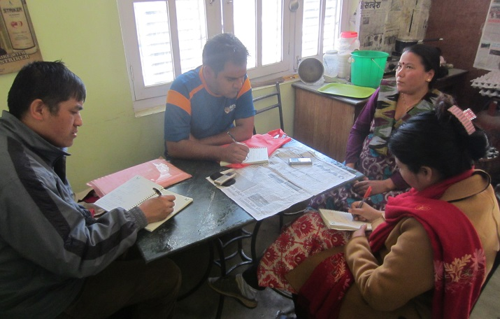

*(Interview with DMEGA chair in Makawanpur)*

Table 23: Capacity building events (in 2017)

|  |  |  |
| --- | --- | --- |
| **SN** | **Events** | **Total** |
| 1 | Project board meeting | 4 |
| 2 | MEDPA implementation committee meeting | 6 |
| 3 | Technical working group meeting | 6 |
| 4 | Orientation workshop on procurement process to CSIDB/DCSI at central to district level | 8 |
| 5 | Orientation on MED model to elected representatives in Local Governments (LG) | 550 |
| 6 | Orientation on MED model to new expanded districts | 75 |
| 7 | Capacity building training on MED model to MEDSPs | 69 |
|  | **Total** | **718** |

Source: GoN/MoI/UNDP, 2018, p. 84-85

The capacity enhancement of partners for local to national level lobby and policy advocacy was highly prioritized after the successful completion of local government elections in 2017. The capacity building training have been considered as important efforts for communicating the knowledge about MED approaches and its relevance to economic development of people below poverty line in the changing political contexts in Nepal. It was observed that MoI as a lead institution of MEDPA implementation fully acknowledges the effectiveness of MED model and is highly confident of institutionalizing MED model in federal government system. The secretary of MoI, during the consultation meeting for this study in February 2018, said "*the working modality and funding modality of the MEDPA is very effective and relevant in Nepali context and MoI will play proactive roles to internalize and institutionalize this model in federal government*". The working modality, as the secretary of MoI indicated was MED service through MEDSPs and funding modality was government’s regular budget allocation for the implementation of MEDPA implementation.

**Capacity growth and development of MEDPA staff**

The capacity growth of the MEDPA staffs was one of the priority programs during MEDPA implementation. The output number 2 of the MEDPA Five Year Strategic Plan (2013-2018) was to strengthen institutional capacity for MEPDA implementation which was included with different activities as discussed in the earlier part of this chapter.

Table 24: Some of the capacity development activities and participants (in 2017)

|  |  |  |
| --- | --- | --- |
| **SN** | **Events** | **Total** |
| 1 | ToT training of GESIMIS/RBM system to GoN staff | 22 |
| 2 | GISMIS/RBM training to LG staff (computer operators and M &E focal persons) | 144 |
| 3 | Orientation on MEDSPs procurement systems | 332 |
| 4 | National workshop on MED model and programme planning (Balthali) | 29 |
| 5 | Orientation workshop on procurement process to CSIDB/DCSI at central to district level | 332 |
| 6 | Training on GESI-MIS/RBM&E to government staffs and stakeholders | 1056 |
|  | **Total** | **1915** |

Source: GoN/MoI/UNDP, 2018, p. 83-85

Different training and orientation meetings for/on the MED model are considered as capacity development of MEDPA staffs. These have contributed to the capacity development at national (i.e., MoI) to local levels (district chapters of the CSIDB and DCSI) that have developed knowledge and confident about the processes and approaches of MED model of MEDPA activities. However, frequent transfer of the government staff, and recently the institutional placement/displacement of the district chapters of CSIDB and DCSI in federal system have been creating challenges in capacity development of MEDPA staffs.

One of the important aspects of capacity growth of the MEDPA staffs is National Administrative Staff College (NASC) agreed to incorporate the MED model in fiscal year 2075/76 pre course training session to the newly appointed government civil service officials (GoN/MoI/UNDP, 2018, p. 8 6).

**Capacity growth and development of MEAs**

The main objective of the capacity growth and development of MEAs is to develop sustainable business service to the MEs as well as to contribute in providing enabling policy environment for the implementation of MED model. In order to fulfill this objective, institutional strengthening of MEAs was projected through different activities. For this, an effort for increasing the number of ME's affiliation with MEAs was one of the primary efforts. The MEDPA Five Year Strategic Plan projected that a total of 84,600 MEs are to be affiliated with DMEGAs.

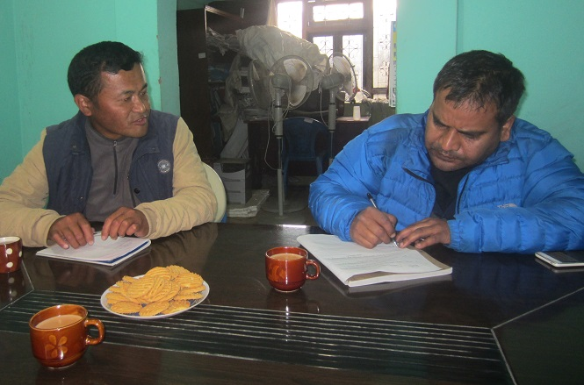

*(NMEFEN chair discussing about MEAs)*

Empowerment and building capacity of MEAs was an important aspect of MED model implementation and in order for the MEAs to function effectively in the new federal structure and play their effective advocacy and lobby as right holders needed to be functional and capable. Currently, MEAs have decided to go for the chapter model to ensure continuous improvement in the quality of services from Government and MEDSPs level. This has led to a stronger policy advocacy and business planning role for NMEFEN and DMEGAs. Provided the continued support from MEDPA/MoI, MEAs federations at various levels has the potential to create awareness, advocate and lobby and ensure quality of the MED model, vis-a-vis, MEDPA and MEDSPs. For FY 2073/74, the government has allocated budget amounting to NRs. 100,000 for each DMEGA’s structural and capacity development support (GoN/MoI, 2018, p. 22-23).

*Figure 23: Chapter model structure of MEAs*

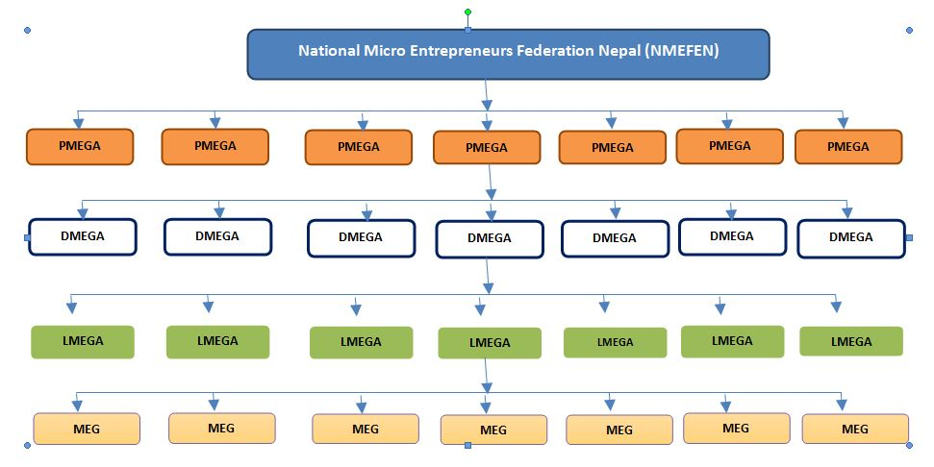

Source: GoN/MoI, 2018, p. 23

The affiliation of MEs with MEAs itself is also a part of capacity development as larger the number of MEs are to be affiliated; higher the chances of sustainability of MEAs thereby producing strong advocacy for the importance of MED model.

Table 25: Status of MEAs in terms of capacity growth (up to December 2017)

|  |  |  |
| --- | --- | --- |
| **SN** | **Characteristics** | **Total** |
| 1 | Funds raised from membership package (in NRs) | 8,500,000 |
| 2 | Proposal submitted to development partners and district level stakeholders (number) | 117 |
| 3 | Membership to MEAs (number of members) | 54,781 |
| 4 | Revision of MEA's statute (number) | 38 |
| 5 | Administrative and financial guideline developed and implemented (number of guideline) | 23 |
| 6 | Development of fee based service package (number of service package) | 38 |
| 7 | Number of dialogues and representation at LGs (number of dialogues) | 77 |
| 8 | Prepared strategy/business plan prepared (number of business plan) | 70 |
| 9 | Enterprise registration (number of ME registered) | 11714 |

Source: GoN/MoI, 2017, p. 82-83

The capacity growth and development of MEAs is measured in terms of the amount collected from the membership fees, proactive presence in the public spheres such as efforts to access funding, number of ME's affiliation to MEAs, institutional strengthening such as revision of MEA statutes, internal governance such as development and revision of guidelines, etc. In addition, participation of MEAs in joint exposure/field visits of MEDEP and MEDPAactivities, presence in district to national level governing bodies such as DEDC and MEDPA steering committees also constitute part of capacity development of MEAs.

Therefore, it can be concluded that the efforts made for the capacity development of MEAs is effective as their presence and institutional setup is ensured from the very grassroots to the national levels. MEAs are beneficiaries of the MED model, and advocacy and lobby through MEAs is more effective and relevant. However, their capacity for the lobby and advocacy is still not adequate in terms of influence.

There is higher chances of becoming MEAs as self-sustained institutions, as it aims to bring larger number of MEs under this institution that the projected number of MEs created by MED model is very big (1,45,370) (GoN/MoI/UNDP, 2013) and of which 131,680 is already created and 54,781 have already become its members (GoN/MoI, 2017). In addition, there is also a chance of increasing the number of MEs into MEAs through the establishment of linkages with informal MEs who get officially registered as per the recent government policy of encouraging them for the official registration. This means, membership fee alone may become adequate for the sustainability of MEAs in future, in case clear policy along with the dynamic leadership is developed within MEAs.

MEAs have been gradually expanding their networks with different agencies, including government line agencies. For example, their networks with different donor agencies, INGOs, District Coffee Cooperatives Union (DCCU), Federation of Nepal Chamber of Commerce and Industry (FNCCI) and District Agriculture Development Offices (DADOs) (DCC, 2016, p. 25). NMEFEN’s presence in the MEDPA Steering Committee helps to develop relations with related ministries and departments. Therefore, MEAs capacity has been gradually developing from the local to the national levels, and is potential to become influential actor in enterprise development sector.

**The capacity growth of MEDSPs**

The capacity growth of MEDSPs is very important in order to ensure effective implementation of MED model services. However, capacity growth of the MEDSPs has gradually been reduced during the MEDPA implementation. The main reason is that MEDSPs is considered as self-capacitated private organization and hence the capacity development of MEDSPs is understood as not required. In its contrast, MEDPA was expanded to 75 districts of Nepal and the district chapters of DCSI and CSIDB as lead organizations have become priority for the capacity development.

However, the capacity of the MEDSPs has been enhanced from EDFs/EDOs certification through skills testing and introduction of academic course by CTEVT/NTSB. With the use the EDFs/EDOs (a total of 1,234 with 700 women and 534 men) certified by the CTEVT, the number of MEDSPs have been crowded in to deliver the MED services. For example, MEDSPs numbering 437 have applied as eligible bidders to DCSI and CSIDB for the MED model implementation under MEDPA in the calendar year 2017 alone, and of them 285 were rated as eligible for competitive bidding.

Table 26: Progressive trends in MEDSP bidding and providing services to MEDPA

|  |  |  |  |  |  |  |  |
| --- | --- | --- | --- | --- | --- | --- | --- |
| **FY** | **DCSI** | | **CSIDB** | | **Total DCSI & CSIDB** | | **Number of Districts** |
| Number of MED SP bidders | Number of eligible MEDSPs | Number of MED SP bidders | Number of eligible MEDSPs | Number of MED SP bidders | Number of eligible MEDSPs |
| 2015/16 | 144 | 67 | 133 | 95 | 277 | 162 | 63 |
| 2016/17 | 199 | 99 | 204 | 149 | 403 | 248 | 69 |
| 2017/18 | 200 | 108 | 237 | 177 | 437 | 285 | **75** |

Source: GoN/MoI/UNDP, 2017, p. 58

As mentioned earlier, the capacity development of BDSPOs has been less prioritized in the later years with the conceptualization that BDSPOs have qualified human resources. However, it is realized that the constant capacity growth of the staffs of MEDSPs is very essential for effective delivery of the MED services and methodological innovations. The orientation, coaching, refresher training is provided to the newly appointed/selected BDSPOs. In line with this, the capacity of 405 individuals (as of December 2017) on MED model has been developed.

**The role of training institutes, CTEVT and universities in developing HR**

The role of training institutes and CTEVT remain important for the implementation of MED model as these have become instrumental in institutionalizing human resource development component for the implementation of MEDEP and MEDPA activities. The training institutes provide MED model training to the interested and potential individuals, while the CTEVT certifies the skills and knowledge of the trained individuals through formal examination processes. This achievement is a result of the constant efforts and lobby of the MEDEP and MEDPA.

MEDEP in its first phase began to develop EDF as required human resource to deliver MED services. Initially, either School Leaving Certificate (SLC) or Proficiency Certificate (now 10+2 system) pass candidates were recruited and trained as EDF. The training included Participatory Rural Appraisal (PRA), Household Survey (HHS), social mobilisation, entrepreneurship development (i.e., SIYB/MECD training), micro-finance, leadership development, market network development, safe and effective development in conflict, do-no-harm, proposal writing andreport writing. Later to 2008, MEDEP collaborated with CTEVT and institutionalized human resource by developing 18 months (the then 15 month) Technical School Leaving Certificate (TSLC) course that produced EDF level 2. The already existing trained and experienced staffs were put under Skill Testing program under National Skill Testing Board (NSTB) of CTEVT. Later in 2012, a 10-month course was developed to fulfill the requirements of 1,500 hours class work and field practical for skill test level 2 (GoN/MoI/UNDP, 2017, p. 58-59).

Currently, altogether about 26 private training institutes including two government institutes are teaching EDF/EDO courses. As per CTEVT rules, each academic training institute can enroll 40 students per batch in TSLC and 3-years diploma. But for the short term, they can enroll 25 per batch. By the end of 2017, altogether 1,234 EDFs (Level 2 and 3) have been developed through these institutes. It was felt that there is a need of higher level course in entrepreneurship development and MEDEP again collaborated with CTEVT and developed 3-Year Diploma in Entrepreneurship Development that is now being taught in Narayani Polytechnic Institute under CTEVT (GoN/MoI/UNDP, 2018, p. 59).

During the MEDPA implementation, it was realized that there is a need to produce different levels of human resources (namely undergraduate levels) for Nepal's enterprise development. It became known that EDFs are non-graduated human resources, while Master in Business and Accounting (MBA) with enterprise as specialized subject are post-graduate level human resources. This means there is lack of undergraduate level human resources for enterprise development in Nepal. With this realization, MED stakeholders put constant efforts in order to introduce undergraduate level courses in at least one of the universities in Nepal. The priority was given to Nepal's oldest institution, the Tribhuvan University in Kathmandu, but it was reported that it could not materialize due to administrative complexities of decision making processes at the university. Finally, the signing of the Memorandum of Understanding (MoU) between MoI and Pokhara University has been done for the preparation and starting the teaching of undergraduate level courses on enterprise development in Nepal.

In addition, the concept of introducing different levels of EDFs has also come to the discussions involving MEDPA stakeholders and partners. As a result of the constant lobby and advocacy with CTEVT, three levels of EDF have been introduced in the formal courses.

Table 27: Levels of EDFs introduced in CTEVT courses

|  |  |  |
| --- | --- | --- |
| **Levels** | **Requirements** | **Recognition by Public Service Commission (PSC), Nepal** |
| Level 2 (EDF) | * 15 months TSLC course (12 months theoretical classes and 6 month field practice) * Formal examination after 1 year working experience in MED model |  |
| Level 3 (EDF) | * Formal examination after 2 years working experience in MED model | * Non-gazetted officer (Na. Su. technical) |
| Level 4 (EDF) | * Formal examination after 3 years work experience in MED model * Three years diploma courses on Entrepreneurship Development | * Gazetted officer (Adhikrit, technical) |

Source: Consultation with MEDPA, 2018; and GoN/MoI/UNDP, 2017, p. 87

It is an important achievement that the concept and practice of EDFs development have been formally institutionalized into government system through CTEVT sources. Therefore, efforts made for the production of EDFs for MED services in Nepal is an exemplary work for the production of specialized human resources at different levels. This has opened the multiple avenues that include development of different level of EDFs, their formal recognition into the government system (recognition by PSC), and university education. However, the concept of EDF was limited to the micro enterprises; this needs to be widened towards all types of enterprises in Nepal. The initiation for this conceptualization, as discussed earlier, has now been started with the MoU between the MoI and Pokhara University for the development and teaching of the 4-year courses at Bachelor degree levels.

**Key lessons learnt from human resource development and capacity building of MED stakeholders**

1. ***EDFs are sustainable business service providers for enterprise development through MED model and beyond:*** The skills and knowledge of EDFs is now institutionalized through formal courses offered by CTEVT and recognized by the state through endorsing their skills under PSC categories. The institutionalization and formal recognition of the skills and knowledge of EDFs have produced ample opportunities for EDFs to become sustainable business service providers for MED model and beyond. This means, skills and knowledge of the EDFs for enterprise development through MED model are equally useful for the development and promotion of other enterprises (i.e., SMLEs).
2. ***Increased number of certified EDFs in the open market has been crowding MED service providers all over the country:*** Micro enterprises of the hard core poor need constant services for improving their enterprise and sustaining the business thereof. Also, EDF having formally recognized and certified human resources with specialized knowledge on enterprise development has high potential to produce sustaining business relation with the MEs.
3. ***Constant and continued efforts for the capacity building of MEDPA stakeholders are required for the effective implementation of MED activities:*** Implementation of MED model transformed from MEDEP to MEDPA has increased the number of stakeholders to be engaged in the implementation of MED activities. MEDEP and selected MEDSPs before MEDPA was increased into the engagement of a number related ministries (namely MoI, MoFALD, MoFSC, MoAD, MoCPA) and related line agencies (namely PAF, CSIDB, DCSI, DDC, VDC), private sectors (namely FNCCI, FNCSI), Financial Institutions (FIs), MEAs, MEDSPs and civil society organizations. In this situation, opportunity is that wider section of national to local stakeholders get involved in the MED implementation thereby creating possibility of cross-learning, cross-sharing and replication. However, the challenge is the possibility of complexities for the management of multiple voices, demands, and needs. This situation demands different forms, levels, types and strategies of HR development and capacity building which is obviously costlier in terms of time and resources. So, a constant effort for the capacity building of the MEDPA stakeholders is highly required for the effective implementation of MED model.
4. ***HR placement within the government system is complex and time consuming and it should be done on time for the effective implementation of MED activities:*** Implementation of the MED model during MEDPA program is led by MoI by establishing required institutional set ups, timely HR placement, and capacity building of related human resources. The HR placement is complex for a reason that it is being delayed due to the time consuming nature of bureaucratic processes of decision making. Consequently, the capacity building of the related staff also became complicated that it took longer time than it was expected. This situation has raised a question on whether any of the new programs to be implemented by the government institutions is to build upon the existing governance structure or establish a new one.
5. ***Frequent transfer of the government officials is affecting the effective implementation of MED model and hence policy of no-transfer or transfer within same program is highly recommended for MED implementation:*** Frequent transfer of the permanent government officials/staff is a major problem for the effective implementation of MED model. This problem can be resolved through endorsing the policy of either no-transfer of the MED related staff or transformation of staff within the same project in transferred location.
6. ***HR placement and capacity building of MED stakeholders should be done as per the needs and demands of the markets and market dynamics***: Development of EDF courses, establishment of EDF training institutes (a total of 26 institutes as of December 2017), incorporation of MED model pre-course training sessions for government civil servants in NASC, and the MoU between MoI and Pokhara University for 4-year course on enterprise development are the results of market demands. The conceptualization of the training institutes for EDF development was started from institutionalization and recognition of EDFs for MED model implementation which in the later phase such as EDF level IV course and 4-year courses on enterprise development at Pokhara University should go beyond the MED model. Similarly, establishment of training institutes in terms of location in federalized government system may also be determined by the market as per the demands of federal structure. One of the evidence in line with this is that the present Prime Minister KP Oli said that at least one technical college in each province will be established in the next few years to ensure development of human resources in Nepal.

**Conclusion of the human resources development and capacity building of MED model stakeholders**

Human resource development and capacity building of the MEDPA stakeholders remained an important component of MED model. Regarding HR development, the number of EDFs developed until now (1,234 as of December 2017) is a big achievement that it has produced an enabling environment for sustainable business service provision for the development and growth of resilient MEs across the country. This opportunity is further ensured by the institutionalization processes (through formal courses and examination processes) and formal recognition (recognized category in the PSC). The increased number of EDFs, ensuring easy availability of EDFs in the market also opened up the opportunity to cater the required enterprise development services beyond MED model, as determined by the market demands and market dynamics. A lessons learnt from the capacity building of the MED stakeholders is that capacity building is a never ending process which requires constant efforts at different levels by different actors at different space and time continuum.

## 3.8 Socio-political and economic changes brought by MED model through GESI approach

The overall policy and legal framework for GESI is positive in Nepal. Positive provisions in the Constitution of Nepal 2015 (section 3 article 18[3]), the GoN’s Three Year InterimPlan (TYIP) (2007-2010), Three Year Plan (2010-2013) and Approach to the Thirteenth Plan, establish the fundamental rights of women, Dalits, Madhesis, Muslims, Indigenous Nationalities, sexual and gender minorities, and persons with disability. The 2007 amendment to the Civil Service Act has provided 45 per cent seat reservation for excluded people and backward regions. Inclusive rules ensured 33 per cent representation of women in the Constituent Assembly of Nepal (GoN/MoI/UNDP, 2014, p. 11).

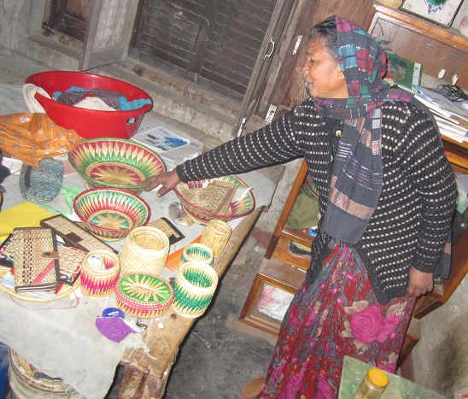

*(MED promoted women entrepreneur showing her products in Lahan, Siraha)*

GESI approach of MED model includes ensuring a minimum of 70 per cent women, 40 per cent Indigenous Nationalities (IN), 30 per cent Dalits, 30 per cent Madhesi excluded groups, and 60 per cent unemployed youths as beneficiary of the MED activities. This approach also includes the principle of ensuring two-thirds (2/3) of the position by women, Dalits and Indigenous Nationalities in all decision making positions in the organizations such as MEAs. So, the socio-political and economic changes brought by the implementation of MED model need to be evaluated for the achievements so far made from gender equality and social inclusion (GESI) persepctives.

Nepal is a signatory to various human rights instruments such as Convention on the Elimination of all   
forms Discrimination Against Women (CEDAW), Convention of the Rights of the Child (CRC), Convention on the Elimination of All Forms of Racial Discrimination (CERD) and Convention for Persons Living with Disability (CPLD). ILO Convention 169, ratified by Nepal in 2007, ensures rights of indigenous nationalities about their ownership and tenure rights to land and water resources. UN Security Council Resolutions (UNSCR) number 1325 and 1820 provide directives to address gender based violence and for protection of women rights during conflict. Thus, there exists a strong national and international policy mandate for gender equality and social inclusion in Nepal. There are some important policies and legislations that have special provisions for the socially excluded groups in Nepal. Some of the important ones are as follows.

The ***Micro Enterprise policy*** is more GESI sensitive and reinforces the strong linkage between microenterprises and livelihood improvement of the poor, women, Dalit, Indigenous Nationalities, Madhesi and other backward communities. It mandates that special priorities be provided to the targeted groups specified by GoN and their capacity strengthened.

The ***Industrial Policy*** provides special priority to women in the establishment and operation ofmicro-enterprises. It includes a section on special provisions for women which has some very progressive directives. Representation of women from different social backgrounds is made mandatory in policy formulation processes for any industrial enterprise. An exemption of 35 per cent in the registration fee is provided if an industry is registered in the name of a woman. Women are provided with an exemption of 20 per cent in the fee for patent, design and trademark and other such registrations. Special priority to women, a separate fund for women entrepreneurship, gender analysis and assessment are all provided for.

The ***monetary policy*** has provisions for women under deprived sector lending for rural areas and for branchless and mobile banking services.

The ***Technology Development Fund Guidelines, 2070 (2012-13)*** establishes a fund for new and alternate technology which can be accessed by the micro-entrepreneurs.

The **Women Entrepreneurship Development Fund Guidelines (Karyabidhi)**, 2069 (2012) provisions for collateral free loan to women with low interest rates and has ensured representation of women in the executive and management committee (GoN/MoI/UNDP, 2014, p. 11-13).

In line with the above policy provisions on GESI, implementation of MED model has also made a significant contribution in socio-political and economic changes in Nepal. The socio-political changes include improvements in different dimensions such as increased confidence, decreased caste based discrimination, strengthened capacity to put their voice, awareness on health and education, increased social network, increased participation, and increased decision making capacity. In terms of economic changes, different aspects of life, such as increased income, increased saving, improved food security and increased value of assets have been considered.

**The effectiveness of GESI target approach in MED model**

The objective of GESI target approach of MED model is to ensure that benefits of the activities reach to the target groups. As mentioned many times, that target groups of the MED model are women - 70%, Indigenous Nationalities - 40%, Dalits - 30%, and unemployed youths 60%. This target approach was primarily applied with regard to the ME created from MED model. The target also goes to the representation in different institutions promoted by MEDEP and MEDPA such as MEAs.

Table 28: Phase wise ME creation with GESI disaggregated database

|  |  |  |  |  |  |  |  |  |  |
| --- | --- | --- | --- | --- | --- | --- | --- | --- | --- |
| **Phases** | **Target** | **Progress** | **Women** | **Men** | **Dalit** | **IN** | **BCTS** | **Madheshi** | **Youths** |
| Phase I (1998 To 2003) | 6,104 | 7,418 | 3,806 | 3,612 | 1,146 | 2,302 | 3,970 | 1,415 | 4,829 |
| Phase II (2004 to 2007) | 18,125 | 21,921 | 15,637 | 6,284 | 4,949 | 8,617 | 8,355 | 4,574 | 21,921 |
| Phase III (2008 to July 2013) | 29,050 | 39,102 | 27,807 | 11,295 | 10,441 | 14,216 | 14,445 | 8,042 | 31,544 |
| Phase IV (2013 to Dec 2017) | 73,000 | 63,239 | 49,938 | 13,301 | 16,974 | 25,301 | 20,964 | 14,114 | 52,338 |
| **Total** | **126,279** | **1,316,80** | **97,188** | **34,492** | **33,510** | **50,436** | **47,734** | **28,145** | **110,632** |
| **Percentage** |  | **104** | **74** | **26** | **25** | **38** | **36** | **21** | **84** |

Source: GoN/MoI/UNDP, 2017, p. 19

The data in the above table shows that MEDEP and MEDPA intervention in terms of ME creation, as of December 2017, is close to the targets for most of the social groups. One of the interesting things seen in the above table is the number of MEs created in first three phases; in that the number is more than the targets and it is sure that the fourth phase will also be able to cross the target since ME creation for the last fiscal year (2018) of MEDPA phase is yet to come in.

*Figure 24: ME creation by target and achievements for target groups (between 1998 and Dec. 2017)*

Source: GoN/MoI/UNDP, 2017, p. 19

The figure clearly shows that ME creation in terms of GESI approach is satisfactory since the number of MEs have exceeded the target for three social groups and less for four social groups. So, it can be said that ME creation has become very effective in terms of reaching benefits to the target groups as project beneficiary. However, in many cases, GESI target approach has become problematic when the service providers focused more on the numeric targets and less on the quality of MEs.

Based on the evidences discussed above, it can be concluded that implementation of MED model has significantly contributed to the economic changes of the supported MEs. However, continuity of the economic growth of MED model supported MEs is still challenging, since most of the MED model promoted MEs belong to the hardcore poor and the development of resilient MEs from among them, as discussed somewhere else in this report, is very challenging.

**Economic changes brought by MED model through GESI approach**

It is reported, observed and found (from the studies) that the MEs promoted by MED model have become able to significantly improve their economic conditions. For example, the number of MEs supported by MED model, having cash saving status, have increased from 41.6 per cent to 58.4 per cent when MEDEP and MEDPA have supported them.

*Figure 25: Saving status of HHs before and after MEDEP by caste ethnicity and gender (in %)*

Source: GoN/MoI/UNDP, 2014, p. 227 (converted into %)

The table clearly shows that MEs having increased cash saving status increased for almost all of the GESI target groups. The number of MEs having increased cash saving status is very high for Madhesi Dalits and Tarai Indigenous Nationalities, while it is low for other groups and hill Indigenous Nationalities.

*Figure 26: MEs (in %) with profits above and below 21168 NRs*

Source: GoN/MoI/UNDP, 2014, p. 32

The data presented in the above table clearly shows that most of the GESI target groups have earned profit more than NRs. 21,168 as result of MED implementation. This impact study of MEDEP activities during 1998-2013, commissioned in 2014, has found that a total of 42.01 per cent of MEs earned the profit more than NRs. 21,168; while 48.23 per cent of them earned the profit less than this (GoN/MoI/UNDP, 2014, p. 32). Similarly, a study about economic analysis of MEs commissioned in 2018 (with sample size of 993 in 10 districts) found that a total of 13 per cent MEs supported through MED model earned annual net profits of more than NRs. 100,000 which becomes 59.7 per cent with more than NRs. 50,000 (CEDN, 2018: copied from presentation slides).

*Figure 27: Average net earnings per month from MEs (in NRs)*

Source: Source: GoN/MoI, 2014, p. 59

The above table shows that the average net earnings per months of the MEDEP supported MEs is higher for Muslim and low for Dalits in hill; while the average earning of the MEs was reported as NRs. 5965. Having this amount of monthly earning from the enterprise matters much, since the prioritized target groups of the MED model is hardcore poor.

*Figure 28: Condition of food security before and after becoming MEDEP/MEDPA supported MEs*

Source: NPC/NC, 2015, p. 39

It was found that the MEs supported through MED model have also improved the condition of food security. The above table shows that the proportion of MEs having less than 3month food sufficiency was reduced from 11.1 per cent to 9.6 per cent; while MEs having food sufficiency for more than 9 months have been increased from 54.7 per cent to 65.4 per cen t(NPC/NC, 2015 [Magh 2072 BS], pp. 37-39). This figure clearly indicates that the implementation of MED model has improved the food sufficiency of the supported MEs.

**Socio-political changes brought by MED model through GESI Approach**

The political changes of MED model target groups primarily include strengthened capacity to raise their voice through increased participation in decision making processes. The empowerment of target groups ranged from attempts to the formation of ME's association at different levels/tiers such as MEG at the community levels, MEGA at the market center levels, DMEGA at the district levels and NMEFEN/NMEGA at the national level to the changes in the leadership quality and skills of particular MEs. During the formation of MEAs at different layers, presence or participation of target groups in both executive committees and decision making positions (chair, secretary and treasurer) as mandatory steps for the empowerment could be considered as important indicators of political change.

Table 29: Representation of target groups in MEA's association (in %)

|  |  |  |  |  |
| --- | --- | --- | --- | --- |
| **Target Groups** | **DMEGA (52 Districts)** | | **NMEFEN** | |
| **Executive Committee** | **Decision making** | **Executive Committee** | **Decision making** |
| Women (%) | 60.4 | 61.5 | 42.8 | 33.33 |
| Men (%) | 39.6 | 38.5 | 57.2 | 66.67 |
| Total (%) | 100 | 100 | 100 | 100 |
| Dalit (%) | 20 | 16.6 | 19.0 | 0 |
| Indigenous Nationalities (%) | 44.8 | 40.3 | 42.8 | 66.67 |
| BCTS (%) | 35.2 | 43.10 | 38.2 | 33.33 |
| Total (%) | 100 | 100 | 100 | 100 |

Source:GoN/MoI/UNDP, 2017, p. 68

A total of 622 individuals are involved as executive committee members of the DMEGAs in 52 districts (14 MEDPA districts and 38 MEDEP districts) and 21 in NMEFEN. The capacity building of the representatives of MEAs on organizational development, MED friendly leadership development and building network have become important cross-cutting component of MED model implementation. This has developed leadership skills in many women and excluded group with strong identities of their own. But, the numbers of decision making positions of Dalit in DMEGAs are still low. Therefore, more emphasis is still needed to build capacity of under represented groups (GoN/MoI/UNDP, 2018, p. 68).

*Figure 29: Representation of target groups in DMEGA*

Source:GoN/MoI/UNDP, 2017, p. 68

The table above clearly shows the number of representation in executive committee and decision making position (president, secretary and treasurer) of target groups. Comparing between GESI targets and the representation of target groups in DMEGAs in 52 districts, it seems that women and Dalits are still below the targets. This clearly indicates that further capacity building of these groups is highly required. However, it is quit big when it is compared with the national targets.

*Figure 30: Representation of target groups in NMEFEN*

Source:GoN/MoI/UNDP, 2017, p. 68

The trend of the representation in executive committee and decision making position of target groups in NMEFEN is different than in DMEGA. The table clearly shows that representation of men is highly dominant. Similarly, representation of BCTS in executive committee and decision making position is also higher in compare to the GESI target. The increased representation of men and BCTS has minimized the representation of women and Dalits. However, it is good to see increased representation of indigenous nationalities in NMEFEN.

A total of 389 MEs, comprising of 291 females (75%) and 98 males (25%) (in 91 rural municipality, 65 municipality and 4 sub-metropolitan city), promoted by MEDEP and MEDPA have been elected in the local elections held in 2017. This is the result of civic, social and economic empowerment through MED model. The categories of empowerment activities ranged from technical and financial support for the formation of MEAs, leadership development training, facilitation for policy advocacy, and economic empowerment through enterprise development training packages (GoN/MoI/UNDP, 2017, p. 30-31).

*Figure 31: MEDEP and MEDPA supported MEs elected in the local election held in 2017*

Source: GoN/MoI/UNDP, 2017, p. 31

As these elected MEs are well versed in MED model, this has led to an opportunity of involving the elected MEs to play constructive role in the institutionalization and adaptation of MED model at LGs. MEDEP has utilized this entry point/platform to capacitate the elected MEs to play myriad roles at local level including building the capacity of LG officials in order to sustain MEDPA and MED model. The elected MEs are motivated to persuade LG representatives to allocate fund for enterprise development at local government through MED model and its sustainable implementation. So, the results of the local level general elections in 753 LGs demonstrate a trend that a process of greater inclusion is becoming gradually stronger in Nepal, and project’s efforts in GESI and economic empowerment leading to political empowerment has been visible (GoN/MoI/UNDP, 2018, p. 30-31).

Though participation of women and some of the excluded groups in the decision making positions and executive committees of MEAs is lower as compared to the GESI targets, yet the forms of presence at this level should be considered as encouraging. Their presence in the committees and decision making positions obviously have contributed to empower them in order to influence the decision making processes.

Implementation of MED model with GESI approach has become effective tool for at least in ensuring the physical presence of excluded groups in the executive committees and decision making positions of MEAs. This is a great achievement in Nepal's present socio-political and economic contexts that they are highly excluded in most of the State and non-State institutions and functionaries. Their empowerment through MEAs, therefore, is a milestone for the socio-political empowerment and changes.

Similarly, group formation and membership through establishment of cooperatives of the women and excluded groups also became one of the means of empowerment. They became capable to develop collective strengths as well as individual capacity to function their cooperatives. However, the possibility of empowerment through cross-learning and cross-sharing with other social groups has been missed out.

**Conflict transformation and peace building through MED model**

As discussed earlier that GESI approach of MED model has become effective methods of ensuring the greater reach of project benefits to the target groups. In line with this, a study commissioned by Asian Academy for Peace, Research and Development (AAPRD) in 2014 concluded that the implementation of MED model has significant continuation to the conflict transformation and peace building in Nepal. This study was carried out in four districts (Sunsari, Kathmandu, Nuwakot, Kapilvastu and Bardia districts), between December 2013 and January 2014. Sunsari and Kapilvastu were Quick Impact for Peace Support Initiative(QUIPSI) project districts, whereas Kathmandu, Nuwakot and Bardia were non-QUIPSI districts. The individual and relational/societal level changes induced by MEDEP interventions were examined; while the Reflecting on Peace Practice (RRP) method was used as an analytical framework. The study concluded that MED model focused towards addressing poverty and rural unemployment has helped addressing causes of conflict and building just and equitable society.

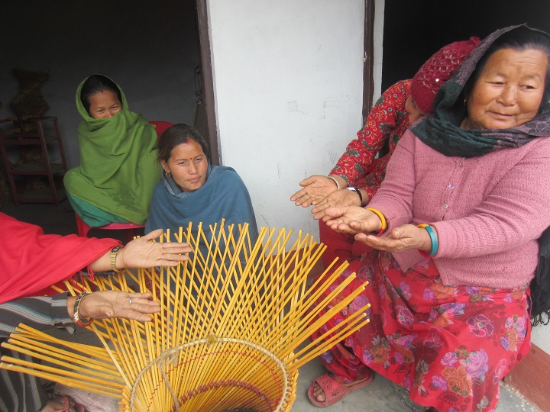

*(Women entrepreneurs in Gauridanda of Bardibas-4 in Mahottari)*

MEDEP has innovatively combined social inclusion approach in order to address socio-economic inequalities and poverty, thereby contributing to address the root causes of conflict by adopting GESI target approach. This study found that MEDEP intervention has brought about significant changes at personal and relational levels. At the personal level, an increment in the household-level income of about 66,000 entrepreneurs has enhanced their economic security, which is an integral element of human security. Similarly, there are several evidences which suggest that along with economic security, entrepreneurs fell that their identity is changed from a ‘poor’ to an ‘entrepreneur’. A sense of dignity induced by changed identity is a positive contribution to social equality and dignity. In the meantime, MEDEP and MEDPA have made remarkable changes in attitude of people towards violence: all the entrepreneurs interviewed did not believe in the use of violence for change. This study has found that MEDEP’s direct beneficiaries have received more than one training ranging from enterprise development to micro-enterprises related skill training on agro-based, forest-based, service-based, tourism-based, and artisan-based areas. These training have enhanced the human capital at the local level. In a similar vein, MEDEP has made a commendable contribution to harness leadership skill and capacity of micro-entrepreneurs which became useful to work as local peace actor in ward level and VDC level decision making processes.

The MEAs as networks of target groups have helped to connect entrepreneurs of different social, cultural, and religious backgrounds both horizontally and vertically. The extended network and trust that exist between/among entrepreneurs is a source of social capital. A major contribution of social capital is that it has increased inter-group relations, cross-cultural tolerance and social harmony. It is also found that micro-enterprises and the local markets that MEDEP has created, has functioned as a connecter between people across dividing lines.

Based on the findings and conclusion of the study by AAPRD, it can be concluded that contribution to the conflict transformation and peach building of MED model implementation is further ensured by the GESI target approach, and hence this approach has multidimensional impacts at personal and societal levels.

**Key lessons learnt from socio-political and economic changes through GESI approach**

1. ***GESI target approach has ensured the greater reach of the project benefits to hard to reach:*** As it is evidenced that greater number of socially excluded groups have become beneficiaries of MED model activities that have been summarized in the forms of the number of ME creation, economic change, social change, and political change. This has been made possible through setting GESI target. Therefore, GESI target approach is one of the unique features of MED model that has significantly contributed to ensure greater reach of the benefits to the target groups (women, Dalits, IN, Madhesi excluded groups, unemployed youths for MED model). However, GESI target as numeric outcomes sometime undermines or shadows the quality outcomes; for example, quality of MEs.
2. ***Economic changes through GESI target approach significantly contributed to the socio-political changes of hardcore poor:*** Economic growth of the hardcore poor is one of the intended goals of the implementation of MED model. In order to ensure this, MED model adopted GESI target approach. The evidences clearly showed that economic status of the project beneficiaries have been improved when they started their own micro enterprise. For example, the number of MEs having cash saving increased from 41.6 to 58.4 after becoming MED model promoted MEs. Becoming MEs did not limit just to the economic growth but it also brought changes in the social and political life of the MEs. For example, representation of excluded groups in executive committees and decision making positions have become significantly high as compared to the national ratio. Similarly, a total of 389 MEs comprising of 291 females (75%) and 98 males (25%) (in 91 rural municipality, 65 municipality and 4 sub-metropolitan city), promoted by MEDEP and MEDPA have been elected in the local elections held in 2017. However, disaggregating the contribution of other factors such as remittances, other community institutions like health, education, community organizations in bringing social changes of the MEs is still crucial but challenging.
3. ***GESI target approach of MED model has multidimensional impacts on hardcore poor:*** The narrower view on the use of GESI target limits the horizon of its repercussion into numeric achievements of the activities. But when it is looked from very societal and psychological aspects, then its effects become wider. The case of the contribution of conflict transformation and peace building through GESI approach of MED model is a relevant example that how entrepreneurship development processes and formation and capacity development of MEAs have become means to change multiple aspects of personal life on the one hand and its great effects on the societal aspects of MEs on the other.
4. ***GESI target approach sometime lead MED service providers focused more towards numeric achievements (i.e., ME creation) but focused less on quality services and this demands frequent monitoring activities:*** Numeric targets sometime become more dominant for the implementation of MED activities. In this case, there should be a frequent monitoring against the MED services delivered by the service providers.

**Conclusion of socio-political and economic changes through GESI approach**

The socio-political and economic changes brought by MED model through GESI approach has been systematically taken into account and upheld in all spheres of activities, including policies, programs and monitoring and evaluations. GESI target approach in MED model has ensured the greater reach of the project benefits to the group to whom it is hard to reach. The implementation of MED model through GESI approach not only contributed to the economic improvement of hardcore poor but it is also embedded in socio-political changes such as political empowerment and improved food security of the MEs. In addition, the service delivered through the implementation of MED model has multidimensional impacts on supported MEs that include personal capacity development (through MED components) to the societal aspects (through MEAs as collectivities of the MEs) such as increased inter-group relations, cross-cultural tolerance and social harmony between individuals of MEs. However, GESI targets sometime may lead the MED service provider to focus more towards numeric achievement (i.e., number of ME creation) instead of providing quality services for quality ME creation. This demands regular monitoring of the activities of MED service providers.

## 3.9 M&E and use of GESI-MIS in MED model

GESI-MIS is a system that contains detailed information about the MEs developed through MED model and activities/beneficiaries. This database system is developed to ease monitoring and evaluation (M & E) of the progress of MED model implementation. One of the important objectives of this system is to ease effective monitoring of the GESI targets (i.e., 70 per cent women, 40 per cent Indigenous Nationalities, 30 per cent Dalits, 60 per cent unemployed youths). The concept of this data emerged in the form of desktop based database system in order to manage project beneficiary information. It was upgraded into online system in 2010, which, in consultation with MEDEP and GoN/MOI, was planned to transfer into centralized online/web based system, known as GESI-MIS. The plan of the transfer was to start in 2013 and complete by the end of MEDPA in 2018 (Dhungana, 2073, p. 129).

GESI-MIS database is accessible for the controlled users (access through key or password). This system contains auto-updating systems that the once the data/information of the MEs is entered into the system then it automatically becomes accessible for controlled users. This means, the information entered into the system gets immediately updated to the system and can be accessed by the users.

The EDFs, responsible for the implementation of the steps of MED model, are technically responsible to collect the data and DBA are responsible to enter the information into the system. One of the interesting characteristics of this system is that the database needs to be entered in systematic processes, i.e., from one step to another step. This means, data entry in a step cannot be entered before completing the previous step. The systematization of information management has made the implementation of MED model very easier in terms of access to information and monitoring of the progress.

**Operation and transformation of GESI-MIS from MEDEP to MEDPA**

GESI-Management Information System (MIS) (GESI-MIS) is one of the peculiarities of MED model in which detailed information of the MEs including other beneficiaries are systematically managed. As discussed earlier that it is a systematized management system, which is operated and accessed through online system. It was projected that GESI-MIS has to be established in all the districts CSIDB/DCSI chapters by the end of MEDPA in 2018. However, the changing political context in Nepal (federalized government system) has created the question on the relevance of transforming the system into the districts since 753 LGs have become local governing units in the federalized system.

*Figure 32: GESI-MIS establishment projection during MEDPA period*

Source: GoN/MoI, 2013, p. 34

During the MEDPA implementation, GESI-MIS has become a means to verify progress of the performance of MEDSPs thereby taking decision for the transaction of financial installments to BDSPOs/MEDSPs. This means, the installments to the MEDSPs are provided on the basis of information entered into the GESI-MIs. For this, BDSPOs particularly the concerned EDFs, deliver the services step by step and maintain online information on their progress.

In other words, MED model had a component to support MEDPA to have access to GESI-MIS and train MIS computer officers and M&E focal person such that it becomes capable to access this facility which is available and hosted in Government Integrated Data Centre (GIDC). The Enterprise Information Centre (EIC) has been set up at MoI for MEDPA implementation with necessary hardware, software, infrastructure and equipment in order to function as GESI-MIS and knowledge-hub within the MoI (GoN/MoI/UNDP, 2018, p. 31). MoI has spared a separate room for setting up operational units of GESI-MIS. At MoI, CSIDB and DCSI, an MIS focal person has been assigned for GESI-MIS system operation.

It is frequently reported that the information entered into the system is very complex and too details and hence its management is very challenging in the sense that this system has to be managed by the concerned government agencies, namely local government units in the federalized system. During MEDEP and MEDPA implementation, this system is operated and managed by concerned MEDSPs/BDSPOs in the respective districts. Transformation of this system in concerned district CSIDB/DCSI chapters is in the process. However, it is reported that establishment of the RBM system in the district chapters of DCSI and CSIDB is very slow, which consequently may create problem for its management in future. In addition, the transformation of GESI-MIS is problematic in the present political contexts that Local Government (LG) units have to take responsibility of managing and operating this system in the federalized government system. As a result, transformation and management of GESI-MIS in and by the 753 LG units may become very challenging in terms of both human and financial resources.

**HR placement for operating GESI-MIS**

As discussed earlier, GESI-MIS contains details of MEs in a very complex system which requires technically sound human resources for its operation and management. It also discussed that all GESI-MIS at the district levels has to be transferred to the concerned districts chapters of DCSI and CSIDB (which after federalized government systems has to be transformed to the 753 LGs). It is projected that at least a Database Assistant (DBA) in each district chapter of DCSI and CSIDB has to be placed and remained to manage and operate district level GESI-MIS.

Table 30: HR targets for capacity building in order to ease MEDPA implementation

|  |  |  |  |  |  |  |  |  |
| --- | --- | --- | --- | --- | --- | --- | --- | --- |
| **SN** | **Activity** | **Baseline** | **2013/14** | **2014/15** | **2015/16** | **2016/17** | **2017/18** | **Total** |
| 1 | Total qualified and trained HR (projected) | 140 | 130 | 220 | 170 | 100 |  | **760** |
| 2 | Staffs at central level ministries and government agencies (projected) | 10 | 25 | 25 | 20 | 20 |  | **100** |
| 3 | Staffs of district offices (projected) | 90 | 120 | 200 | 150 | 100 |  | **660** |
|  | **Total** | **240** | **275** | **445** | **340** | **220** | **0** | **1520** |

Source: GoN/MoI, 2013, pp. 34-35.

The MEDPA Strategic Five Years Plan mentioned that a total of 1,520 government officials and staffs have to be trained and capacitated for the implementation of MEDPA activities. Of these, staffs at district offices may include DBA for GESI-MIS management. However, it is reported that HR placement is very slow and capacity development work of DBA where placed is still not adequate. For example, newly appointed DBA in Solukhumbu, during the field visit of this study, said that "*the orientation training for the management and operation of our GESI-MIS is not adequate as we cannot manage and operate this system with such limited training*".

The required HR placement for the GESI-MIS management and operation at the government institutions may establish institutional foundation for generating, managing and operating high quality database. However, federalized government system has created the problem of institutionalization of GESI-MIS database as the number of local government units has been increased from 75 to 753. In this context, strategic leadership of the government/MoI and further technical backstopping by MEDEP is much needed in order to transfer the existing institutional knowledge to the local government units. In addition, frequent transfer of the government staffs also affected the smooth functioning of the MED activities.

**Handling complex GESI-MIS and large number of MEs**

GESI-MIS is a complex system as it contains not only the bulk of information of the MEs but also in a complex structure that needs to be refined, filtered and revised to make it meaningful for different purposes. The key initiatives on handling GESI-MIS system undertaken in 2017 is simplification and update of GESI-MIS software.

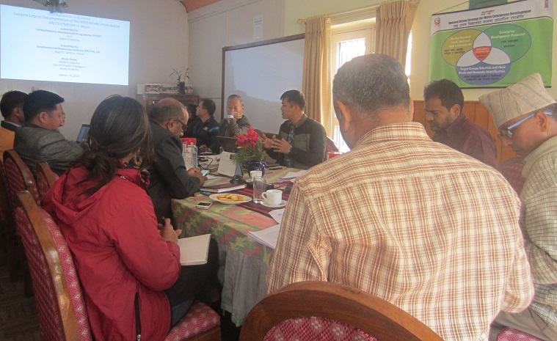

*(Discussion with MEDEP team in Kathmandu)*

GESI-MIS also contains information of the larger number of MEs, which itself is complex in terms of management, operation and transfer into simple and meaningful format. This means very high technical expertise is most required for the management, operation and use of this database system. For this a total of 144 M&E focal persons and IT staff at demo LGs have been trained and other 328 demo LGs have been provided with orientation on the use of GESI-MIS software. A total of 46 DBAs of Industry Development Section (IDS) who were also trained on GESI-MIS are mobilized for monitoring of the data collection work of the MEDSPs for quality assurance (GoN/MoI/UNDP, 2018, p. 32).

GESI-MIS is an exemplary effort in generating systematized database of the project beneficiaries and its constructive use may help very well to the planning as well and policy making in Nepal's micro enterprise sector. However, its management and operation for the government agencies may be a challenge and a burden as well. This also may create an environment that encourages the field level staffs to focus much on generation of good database rather than delivering better services to the beneficiaries.

With the realization that GESI-MIS is very complicated, a technical working group consisting of MOI, MEDEP and IT experts, has been formed for simplifying this system. The TOR of this working group is to review the contents of the data and revise it on the basis of necessity of the present political contexts so that the system of database may become manageable as well as useable in future. The lessons learned from this processes is that this system need to be revised and refined as per the needs of the time so as to make it useable and manageable.

**Reliability and use of GESI-MIS information**

Reliability of data is important as equal as availability of the data. Information systematically managed and operated into the GESI-MIS system may also have a question on its reliability. As per the practice, the information is compiled and entered into the system by respective DBAs. Conceptually, EDFs are not only the data collectors instead they are facilitators of the MEs and they know every details of the MEs. They work with the MEs sometime same like co-workers and sometime as partners. In this sense, the data generated by EDFs are much realistic and hence reliable. However, when EDFs have to deliver MED services within shorter time period then it may create trouble in data generation processes as they focus much on the technicality of the data generation rather than to reach to the realistic information. Similarly, experiences, knowledge, skills, and personal nature/characteristics of the EDFs that fits or contradicts the MEs' community are also equally important for reliability of the data. So, providing enabling environment for EDF is most required to ensure reliable information.

Many of the information generated and compiled into the GESI-MIS may not be useful or in many cases cannot be used for immediate needs of micro enterprise development. However, these data could be valuable for planning and decision making of on enterprise development in future when it is needed.

Management of skilled human resources at 753 local government units is very difficult in terms of the availability of resources and utilization of GESI-MIS information for project planning and decision making. However, this information could be baseline data for the local government units in order to develop information based planning for the promotion of micro enterprises within their constituencies. For this, effective orientation to the local government stakeholders is most required.

One of the important uses of GESI-MIS system is monitoring of the performance of BDSPOs in the field as the financial installment to the MEDSPs/BDSPOs are done on the basis of progress made so far and updated to this system. An important benefit of this mechanism, therefore, is performance based payments, according to which the MEDSPs/BDSPOs are compelled to deliver the agreed services in time to receive installments. However, most possible weakness of this system, as reported by most of the stakeholders, is that the services are much focused towards ritualistic types of service deliveries in order to fulfill numeric targets.

**Use of M&E and MIS in decision making of MEDEP and MEDPA**

In principle, the purpose of M&E and MIS would be to improve processes, methods as well as activities of the project interventions. Talking about the use of M&E and MIS during the implementation of MED model, it was reported that MIS was very instrumental for accessing the general as well as specific information of the MEs. M&E and MIS, for MED model implementation, were very useful for some of the aspects of decision making of MEDEP/MEDPA implementation, particularly in selecting the participants or beneficiaries in terms of fulfilling the GESI targets. For example, the target of the MED implementation was hardcore poor for which information systematically compiled in the MIS was very useful for taking decisions in terms of fulfilling the number of target population. In addition, M&E and MIS were very useful for accessing information on workforce diversity and taking actions for its management in terms of employing the staffs and ensuring the participation/presence of women and excluded groups in the MEAs.

**Key lessons learnt from M&E and GESI-MIS in MED model**

1. ***GESI-MIS is IT based evolving decision making tool for ME creation and promotion:*** GESI-MIS consists detail information of MEs generated by the use of information technology (IT) which is managed in a very systematic way and can be used for different purposes including monitoring and decision making. This is, therefore, a user friendly IT based solutions for decision making on ME creation and promotion. Therefore, GESI-MIS of MED model is an effective and user friendly IT based evolving decision making tools for MEDPA implementation.
2. ***GESI-MIS is gradually developing the concept of the importance of e-governance within the MEDPA lead government institution:*** GESI-MIS is a system that ensures all the data available at any time. Its proper management and operation leads the users or institutions who manage and operate towards e-governance system. Setting up this system at once begins the practice of e-governance. It makes the government efficient in managing required information, easier in decision making and effective in delivering the programs. For example, once the local governments manage and operate GESI-MIS then further activities such as preparing baseline information, preparing community profile, taking decision on any of the issues, preparing periodical planning, etc. may become easier.
3. ***Proper functioning of the GESI-MIS requires stable HR placements within the existing government institutions:*** It seems that the MoI has strong commitments thereby putting the best efforts (such as setting up required units and deploying HR) for the internalization and institutionalization of GESI-MIS into government system. However, existing traditional information management system of the government, frequent transfer of the staffs/officials, and lack of required technical skills/knowledge among traditionally trained HR needs to be changed towards IT friendly orientation.
4. ***Proper functioning of the GESI-MIS within the government institution requires user friendly systems and appropriate data variable:*** As it is discussed somewhere else in this chapter that GESI-MIS contains bulk of information and many of them may not be useable for ME related activities on the one hand, and while on the other hand it may become complex and difficult for proper and effective management and operation. For example, integrating information of other programs of implementing agencies such as regular programs of DCSI and CSIDB into GESI-MIS may be desirable for well-functioning of GESI-MIS system. Another example would be to incorporate information related to MSMEs so that the government can decide on possibilities of integrating all types of enterprises into the enterprise ecosystem framework (discussed in the conceptual framework section of this report).
5. ***A constant stakeholder discussion is highly recommended for the constructive use of GESI-MIS (such as decision making, M&E, e-governance, etc.):*** GESI-MIS contains bulk of information on MED model promoted MEs. There are great potentials of the use of GESI-MIS for the development and promotion of MEs in Nepal. However, there is also a possible risk that the collection and management of this information may be limited just to ritual fulfillment of the requirement of MEDPA activities. So, the MEDPA stakeholders should constantly discuss about the constructive use of GESI-MIS so that appropriate decisions for M&E and promoting e-governance may take place for the development and growth of MEs in Nepal.
6. ***Technically sound and committed HR placement should be done at different tiers of government institutions:*** Proper operation and management of GESI-MIS requires technically competent and committed HR at different tiers such as EDFs for data generation/entry into online system on the ground, DBA as its technical operator in the office centers (i.e., previously at CSIDB and DCSI and now it may be at IDS of LG units), and technical analysts and technical managers at LG units, providences, concerned departments and units at central levels, and ministries.

**Conclusion of the use of M&E and GESI-MIS system**

GESI-MIS is one of the unique endeavors of MED model, which has developed and transformed IT-based information management and operation system into practice thereby leading knowledge paradigms towards the realization of the importance of IT-based decision making and e-governance. Its internalization and institutionalization into government system will be a paradigm shift for improving government’s efficiency in information management and operation. For this, a substantial change in both the structure and processes of institutional governance is highly desirable to fully adopt GESI-MIS into the government system.

## 3.10 Internalization and institutionalization of MED model before federalism

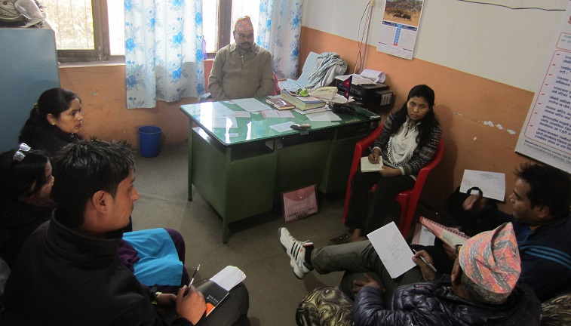MoI and UNDP/MEDEP had pushed their views since 2007 that MED model should be internalized in GoN's regular program. Internalizing MED model into government system means institutional consolidation of MED model into MEDPA. For this, it was expected that concerned ministry, department, office and local bodies implement the MED model by integrating process and system followed during MEDEP; while the GoN is expected to manage adequate resources (human and financial) for implementing this program. In terms of fundamental functions, i.e., planning, organization, control, direction, monitoring, etc., it was expected that all stakeholders including government agencies, local bodies, NGOs and MEDSPs/BDSPOs give high importance to the management of MEDPA implementation. This means, MED model's internalization has to bring managerial responsibilities to the government departments, agencies and local bodies. In addition, it was expected that the parliament, National Planning Commission (NPC), Ministry of Finance (MoF), MoFALD and local bodies allocate significant budget for the implementation of MED activities.

*(FGD in Gharelu office in Hetauda, Makawanpur)*

In accordance with the policy measures, budgetary provisions, HR placement, establishment of the MEDPA implementation procedures and the number of MEs created from the intervention, it could be claimed that MED model has been internalized into the Nepal's government system. This model is accepted as a tool for economic growth in Nepal with conceptualization that it has significantly contributed to the reduction of national poverty. Hence, the institutional set up has been in place that signifies its institutionalization as well. With this aim, the MEDPA 5-year strategic plan was prepared and implemented since 2013 with the aim that it institutionalizes MED model into the government system.

**Policy formulation for the internalization and institutionalization of MED model**

One of the major achievements of MEDEP and MEDPA implementation was formulation of the policies and legislations that provide an enabling policy environment for the implementation as well as internalization and institutionalization of MED model into the government system. MEDEP's persistent efforts and technical backstopping for almost 19 years have enabled the government to formulate a number of policies. Prior to MEDEP's efforts, the government and other agencies had their own definitions of ME. The absence of the government's formal definition gave rise to the definitional confusions in the ME sector. For this, implementation of MEDEP and MEDPA activities have significantly contributed to the formulation of a significant number of policies, both directly and by technically supporting MOI and advocacy by MEA/NMEFEN (DCC, 2016 [May], p. 25).

Table 31: Policies and regulations related to the institutionalization of MED model

|  |  |  |  |
| --- | --- | --- | --- |
| **SN** | **Year** | **Name of the policies and regulations** | **Provision related to MED model** |
|  | 2007 | Micro Enterprise Policy 2007 | Provisioned the official definition of ME |
|  | 2007 | Agri-Business Promotion Policy, 2007 | Special program for poor, Dalit and women to set up and operate agriculture enterprises |
|  | 2008 | District Enterprise Development Program Implementation Procedure, 2008 | Eased the implementation of MED model |
|  | 2008 | MED Fund Operation Guideline, 2008 | Eased the operationalization of financial resources |
|  | 2009 | Village Enterprise Plan Formulation Procedure and Implementation Guideline, 2009 | Provision for the promotion, development and expansion of micro enterprises |
|  | 2009 | Commercial Policy 2009 | Micro enterprise development as strategic focus |
|  | 2011 | Industrial Policy, 2011 | ME as one of the 5 types of industries |
|  | 2012 | District Enterprise Development Strategic Plan Preparation Guideline, 2012 | Eased local level MED activities |
|  | 2013 | Monetary Policy, 2013 | Prioritize MEDEP promoted cooperatives for providing wholesale loans (Monetary Policy 2013, clause 105) |
|  | 2014 | MEDPA Operation Guideline, 2014 | Eased the operationalization of MED model |
|  | 2015 | Forest Policy 2015 | Increase employment and income of the poor through better management and utilization of forest resources |

The persistent efforts of MEDEP have contributed significantly to nurture a number of policies that provided enabling policy environment for the internalization and institutionalization of MED model in Nepal. The MEDPA Operation Guidelines 2014 can be taken as an example of policy influence for the internalization and institutionalization of MED model into the government system. In addition, the inclusion of MED component in the Industrial Act 2069/70 has provided feedback to the Monetary Policy 2013 to prioritize MEDEP promoted cooperatives for providing wholesale loans (Monetary Policy 2013, clause 105).

Nepal government's periodic plans, policies and programs have also continued their commitments to provision MED model (NPC/NC, 2015 [Magh 2072 BS], p. 54). More than 30 policies, regulations, guidelines and programs in Nepal, directly and indirectly, have recognized the issues of ME, and of them many have recognized MED model as tools for entrepreneurship development (MEDEP, 2015 [2072 BS]).

To conclude it, MED model has gradually been recognized by many of the policy measures that have provided the enabling policy environment for entrepreneurship development of hardcore poor in Nepal. So, these policy measures are important achievements of MEDEP and MEDPA implementation in terms of internalization and institutionalizations of MED model. However, mainstreaming of these policy provisions into other ministries, line agencies, and departments are yet to be done so that MED model is replicated in the enterprise related development programs of other agencies.

**Policy advocacy for MED implementation**

During the program period, MEDEP carried out meaningful advocacy and provided various support for different policies. Special focus was given to the inclusion of provisions regarding micro enterprise in Micro Finance Policy 2008, Micro Enterprise Policy 2008, Industry Policy 2011, MEDPA Operation Guidelines 2014, and other policies, guidelines, and directives formulated during this period. As a result, Industrial Policy 2011 identified MEs as one of the 5 types of industries classified on the basis of investment and nature, and made separate provision for micro and cottage enterprise (GoN/MoI, 2013 [July], p. 3).

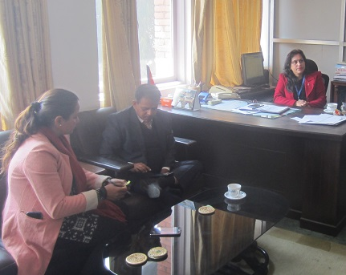

*(Interaction with officials at MoI, Singhadarbar, Kathmandu)*

Influence of the policy advocacy worked well for the inclusion of micro enterprise in the Nepal's periodic plans. Example of the achievement of policy advocacy can be taken as the formulation and enactment of Micro Enterprise Development Funds (MEDF) at the district levels. The policy provisions along with the policy advocacy in the MEDEP and MEDPA implementation created an environment for the remarkable amount of investment (30% of the annual grant) of the annual grant to the local bodies for creating income generating opportunities and micro enterprise development for targeted deprived classes. During the MEDPA period, the major expected outcomes were (GoN/MoI, 2013 [July], pp. 32-33):

1. Revise MEDPA guideline;
2. Prepare result based cub-contacting resource booklet;
3. Approval of sub-contracting policy;
4. Collaborate with concerned agencies to make harmony between sector wise policies (forest, tourism, agriculture, finance etc.); and
5. Conduct policy dialogue and interaction with stakeholders.

The last activity was important for the policy advocacy and the responsible bodies for this activity was DCSI/CSIDB; while MEAs, local civil society and MEDEP were expected to contribute as supporting agencies (GoN/MoI, 2013 [July], pp. 54-55).

MEDPA Steering committee and MEDPA Implementation Committee at the national levels, DEDC and DEDF at the district levels, and VEDC at local levels are the multi stakeholder platforms where intra and inter-ministerial as well as interdepartmental policy advocacies and lobbies took place. Annual Progress Report (APR) of MEDPA 2018 shows that a total of 24 policies, acts, regulations, and guidelines have been developed/revised to replicate MED model (GoN/MoI/UNDP, 2017, p. 86).

However, policy advocacy during the MEDPA period is carried out mostly at the central level since the policies were formulated at the national level. However, the changing political context in the country reversed the situation that local governments have constitutional rights to formulate a number of local level policies and programs on their own. This means, policy advocacies and lobby are now needed at the local levels and for these MEAs could be the most appropriate actors.

**Human resources placement for MED implementation**

For the implementation of MED model, MEDEP and MEDPA have adopted different strategies for required HR placements. At the beginning, MEDEP directly implemented, and hence the required human resources were direct employees of MEDEP. In the phase III, MEDEP adopted dual strategy that some of the activities were implemented through selected BDSPOs/MEDSPs and some were implemented by MEDEP itself. But in the phase IV (2013/14 to 2017/18), MEDEP's role got transformed into technical assistance (TA); while the government agencies became lead implementing agencies. In line with this, Nepal government has endorsed policy of recruiting required human resources at different tiers, namely, MIO, DCSI/CSIDB and their district chapters.

Table 32: Staff requirements at the government agencies for MEDPA implementation

|  |  |  |
| --- | --- | --- |
| **Agencies** | **Planned in MEDPA strategy** | **Now in practice** |
| MoI | * 1 Joint Secretary * 1 Under Secretary * 2 Section Officer * 1 Computer Operator * 1 Computer Officer | * 1 Joint secretary (as NPD) * 1 Under Secretary (as NPC) * 2 Section Officers * 1 Computer Officer * 1 Computer Operator |
| DCSI (Central) | * 1 Under Secretary (MEDPA focal person) * 1 Section Officer * 1 Computer Officer | * 1 Under Secretary (MEDPA focal person) * 1 Section Officer * 1 Computer Officer |
| CSIDB (Central) | * 1 Director/Deputy Director (MEDPA focal person) * 1 Deputy Executive Officer * 1 Senior Officer * 1 Computer Officer | * 1 Director/Deputy Director (MEDPA focal person) * 1 Deputy Executive Director * 1 Senior Officer * 1 Computer Officer |
| DCSI (District) | * 27 Officer (1 in each districts) * 27 Senior Officer (1 in each districts) * 27 Account officer (1 in each districts) * 27 EDFs/EDO (1 in each districts) * 27 Database Assistant (DBA) (1 in each districts) | * 27 Officer (1 in each districts) * 27 Senior Officer (1 in each districts) * 27 Account officer (1 in each districts) * 14 EDOs (1 in each 14 districts) (contract) * 26 EDFs (2 in each 13 districts) (contract) * 14 EDFs (1 in each 14 districts) (contract) * 27 DBA (1 in each districts) (contract) |
| CSIDB (District) | * 48 Officer (1 in each districts) * 48 Senior Officer (1 in each districts) * 48 Account officer (1 in each districts) * 48EDFs/EDO (1 in each districts) * 48 Database Assistant (1 in each districts) | * 48 Officer (1 in each 38 districts) * 48 Senior Officer (1 in each 48 districts) * 48 Account officer (1in each 48 districts) * 8 EDOs (1 in each 8 districts) (contract) * 8 EDFs (1 in each 8 districts) (contract) * 80 EDFs (2 in each 40 districts) (contract) * 48 DBA (1 in each 48 districts) (contract) |
| **Total** | **488** | **424** |

Source: GoN/MoI, 2013, pp. 61-62, Consultation with concerned stakeholders (January to March 2018)

It has been agreed that the originally foreseen full time ME section headed by a joint secretary is replaced with a 50 percent under secretary position, supported by at least two qualified officers/staffs. This under secretary becomes the National Program Coordinator to oversee the day-to-day management of MEDPA, and works closely with the MEDEP National Program Manager (Schmitt-Degenhardt et al., 2016). One of the better opportunities in terms of HR placement was that there is CSIDB and DCSI in all districts, and the Nepal government started the initiatives to HR placements in all of its constituencies to facilitate the implementation of MEDPA (Schmitt-Degenhardt et al., 2016, pp. 26-27).

Though the government policies do not allow additional incentives to the officials at DCSI and CSIDB for the implementation of MEDPA activities, placement of additional human resources to contribute in the implementation of MEDPA has expanded the outreach of the MOI/DCSI/CSIDB. One of the important examples is placement of EDFs at the district chapters of DCSI and CSIDB and their contribution in both creation and up-calling/graduation support to entrepreneurs in the district. For example, two EDFs in Khotang district, 1 EDF in Solukhumbu district, 1 EDF in Makawanpur district were employed on contract basis for the fiscal year 2017/18. In addition, placement of database assistant at district chapter of CSIDB and DCSI, and providing training to them for the use and management of GESI-MIs database of MEDPA supported entrepreneurs is speeding up.

The placement of required HR and their capacity building through orientations and training, therefore, are the efforts to institutionalize MED model within the government system (MoI at the central level and DCSI and CSIDB at the district level). However, bureaucratic processes delaying into the decision of HR placement and frequent transfer of the staffs/officials have become problematic for the implementation of MED model. Moreover, the changing political context (federal government system that have created 753 local, 7 provincial including federal government) has created great dilemmas of HR placement for MED implementation.

**Budget allocation for MED implementation**

The MEDPA Strategic Plan (FY 2070/71 - FY 2074/75) was prepared in 2013 with the total budget of NRs. 4.1 billion (approx. US$ 42.54 million). In this, GoN has allocated NRs. 1 billion in total (DCC, 2016 [May], p. 17; GoN/MoI, 2013 [July], p. 7) which is significantly high.

Table 33: Resources projection by three agencies for MEDPA implementation (in NRs '000)

|  |  |  |  |  |  |  |  |
| --- | --- | --- | --- | --- | --- | --- | --- |
| **Agencies** | **2013/2014** | **2014/2015** | **2015/2016** | **2016/17** | **2017/18** | **Total** | **%** |
| Local Body Resources | 40856 | 73914 | 80239 | 83881 | 68110 | **347000** | **8.34** |
| GoN Resources | 117776 | 213072 | 231304 | 241802 | 196339 | **1000293** | **24.04** |
| Donor Agency Resources | 327618 | 576904 | 645562 | 668332 | 594975 | **2813391** | **67.62** |
| **Total** | **486250** | **863890** | **957105** | **994015** | **859424** | **4160684** | **100.00** |
| **%** | **11.69** | **20.76** | **23.00** | **23.89** | **20.66** | **100.00** |  |

Source: GoN/MoI, 2013, pp. 6-7;

Having 24.04 per cent of budget allocation from the government's side is significantly big and its clear message is that MED model, in terms of budget allocation, is internalized into the government system. Another important evidence of MEDPA internalization into government system is the projection of resources contribution from local body. A total of 8.3 per cent of the total MEDPA budget was projected from local body.

*Figure 33: Resource projection by three agencies for MEDPA implementation (in %)*

Source: GoN/MoI, 2013, pp. 6-7;

Regarding internalization and institutionalization of MED model into government system, institutional capacity building is one of the important aspects, for which a total of 15 per cent budget was projected. This is quite a big amount and it clearly indicates a higher priority of the project to this activity.

Table 34: Resource projection for six activities of MEDPA implementation (in %)

|  |  |  |  |  |  |  |  |
| --- | --- | --- | --- | --- | --- | --- | --- |
| **SN** | **Activities** | **2013/14** | **2014/15** | **2015/16** | **2016/17** | **2017/18** | ***Total*** |
| 1 | Enabling policy environment | 0.00 | 0.09 | 0.04 | 0.06 | 0.00 | **0.04** |
| 2 | Institutional capacity strengthening | 13.19 | 13.72 | 15.22 | 14.09 | 18.13 | **15.00** |
| 3 | ME creation and scale up | 73.39 | 74.73 | 73.22 | 73.71 | 69.22 | **72.84** |
| 4 | Access to Finance | 9.72 | 8.02 | 7.90 | 8.33 | 7.85 | **8.23** |
| 5 | Market linkage | 1.85 | 2.19 | 2.30 | 2.43 | 3.05 | **2.41** |
| 6 | Environment friendly technology | 1.85 | 1.25 | 1.32 | 1.39 | 1.74 | **1.47** |
|  | ***Total*** | **100.00** | **100.00** | **100.00** | **100.00** | **100.00** | **100.00** |

Source: GoN/MoI, 2013, pp. 6-7

It could be claimed that the MED model has been well internalized and institutionalized into the government system since the government has significant amount of budgetary allocation for the implementation of MEDPA activities. However, its continuity is challenging since the top-down approach of financial allocation practiced for MEDPA implementation may not work in the changing political context (i.e., federal government system) in that the local governments have autonomous rights to plan their local budgets (primarily the budget provided under the heading of unconditional grant) on their own. For this, technical facilitating roles of the central government are highly desirable for which the central government can prepare a guideline and communicate to the local governments.

**Partnership between primary stakeholders and MEAs for MED implementation**

MEDPA envisioned the participation of various organizations in the planning and implementation processes of MEDPA activities. At the central level, MoI, DCSI, CSIDB remained as major implementing agencies, while at the district level, district chapters of DCSI and CSIDB are provided responsibility to implement MEDPA through result based subcontracting to MEDSPs. This means, partnership for project management takes place at different levels that spread from micro to macro performance such as ME creation to policy advocacy.

Partnership between MoI, CSIDB and DCSI and MEDSPs as primary stakeholders and MEAs as beneficiaries has made the implementation of MEDPA activities effective. Partnership between primary stakeholders and MEAs is one of the important components of MED model that contributes not only to the management of the MEDPA activities but also towards co-creation of institutional outreach of both the parties. Primary stakeholders and MEAs participated at the central to local levels in the planning and implementation processes of MEDPA. Their collaboration and partnership have been nurtured through institutional mechanisms. At the central level, MEDPA Steering Committee and MEDPA Implementation Committee, at the district level DEDC and DEDF, and at the local level VEDC were formed where primary stakeholders and MEs have become able to raise their voices, share their ideas and explore possible collaborations and partnerships.

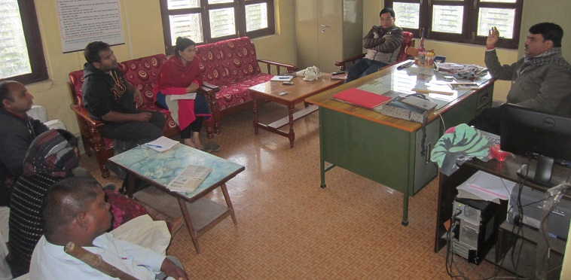

*(FGD participants in Gharelu office in Lahan, Siraha)*

Project management through different committees at different levels has some reflections in terms of internalization and institutionalization of MED model. For example, the specified roles (committees as governing body, district chapters of CSIDB/DCSI as lead institution at the district, and BDSPOs as service providers) of the stakeholders created some conflicts and confusions at the institution levels. MEDSPs are selected by national and district committees and contracted by CSIDB/DCSI accordingly. It seems that the conflicts and confusions arise when MED services are less or ineffective on the ground. It was found that CSIDB/DCSI as lead organization and BDSPOs as service providers of MED model implementation were found blaming each other as cause of the ineffectiveness of the MED services. While the primary stakeholders blame MEDSPs for not providing the service honestly, the MEDSPs blame the government institutions for delaying the selection processes, contracting and releasing the financial installments as main reasons of ineffectiveness of MED services.

The legal status of MEAs is not different than that of the NGOs, while the latent interest of MEAs was association. This has created dual roles of MEAs which resulted in the forms of confusion and conflicts that MEAs on the one hand are expected to advocate on behalf of MEs, but on the other hand they are also eligible for MED service deliveries as MEDSPs. MEAs’ dual roles is mainly due to the donors’ policy that only non-profitable organization could be MEDSPs, whereas the MEAs have registered as non-profit organizations so as to become eligible for MED implementation.

Though MEAs are less influential to the whole processes of MED model implementation, they structurally have been positioned very strongly in different tiers (MEG, MEGA/LMEGA, GMEGA, and NMEFEN). The structural positioning of MEAs from the local to national level has great potential for strong presence in future.

**Institutional development and sustainability of MEDPA for MED delivery**

Various institutions have been formed and made functional for MED deliveries. One of the important dimensions of institutional development is formation of institutions within the government system. At the central levels, MEDPA Steering Committee (comprising of the representatives of 7 ministries and 12 other organizations/institutions/departments/federations) with primary functions to facilitate in providing enabling policy environment, MEDPA Implementation Committee (comprising of the representatives of 5 ministries and 4 other institutions/departments) with the primary function to ensure program implementation, and Micro Enterprise Unit at the Ministry of Industry (MoI) have been established. At the district level, Enterprise Development Committee (EDC) (comprising of all district level stakeholders) has been formed to facilitate the implementation of MEDPA activities in the district. While, Village Enterprise Development Committee (VEDC) (comprising of village level stakeholders) has been formed to facilitate MEDPA related activities in the village levels. In addition, establishment of Enterprise Development Funds in each district is another institution for MED delivery.

Table 35: Structures of project management committees for MEDPA implementation

|  |  |  |  |  |
| --- | --- | --- | --- | --- |
| **Committees** | **Number of institutions as committee members** | **Chaired by** | **Member Secretary** | **Number of functions** |
| MEDPA Steering committee | * 7 ministries * 12 other institutions | * MoI (Secretary) | * MoI and MEDEP | 8 |
| MEDPA Implementation Committee | * 4 ministries * 5 other institutions | * MoI and MEDEP | * MEDEP and MoI | 11 |
| DEDC | * 16 members | * DDC | * DCSI/CSIDB | 15 |
| VEDC | * 12 members | * CDC | * VDC | 13 |

Source: GoN/MoI, 2013, pp. 38-44

The committees are very inclusive in terms of the inclusion of diverse stakeholders. Multiple stakeholders that include relevant ministries, departments, line agencies, federations, private sectors, and civil society groups have been included in different committees. The capacity development of the stakeholders was one of the important components of the implementation of MED model. Both institutional and individual levels of capacity development of government stakeholders were carried out. To carry out these processes, strategies like proper documentation, dissemination, and transfer of knowledge from MEDEP to MEDPA have been adopted.

Micro Enterprise Development Section at the MoI and Micro Enterprise Development Unit at the DCSI and SCIDB have been established. The efforts have been made to make MED section and MED units fully equipped with database and information system along with required number of strengthened HR through necessary training.

To conclude, the institutional development is one of the great achievements for the internalization and institutionalization of MEDPA into the government system. Methods and approaches of MED model are well institutionalized into the government system and the MoI, as lead institution of MEDPA, has strong positioning and commitments to internalize and institutionalize MEDPA into the government system.

However, the challenges for the institutionalization of MEDPA into government system have appeared in the federalized government system. The replication of the institutional setups so far made during the MEDPA period in the changing political contexts (i.e., federalization where autonomous local government is already in place) has been creating reputational risk to the MED model. This has created a question that whether the local governments would internalize and institutionalize the MEDPA institutional setups into their structure. In this context, constructive roles of the central government will be most important for proper communication and orientation of the achievements made during MEDPA implementation to the provincial and local governments.

**Institutional development and sustainability of MEDSPs/BDSPOs for MED delivery**

MEDSPs/BDSPO refers to an intermediary organization created by MEDEP in order to cater enterprise development services. It is an institutionalized form of EDFs that were instrumental for the MED service deliveries since the inception of MEDEP in 1998. The concept of MEDSP/BDSPO was developed at the end of MEDEP first phase (1998-2003). The then MEDSPs established an umbrella organization called National Enterprise Development Center (NEDC) in 2007. It now comprises of a total of 38 members and has been instituted strongly on its own (source: website of NEDC, accessed in March 2018).

The needs of MEDSPs were conceived by the MEDEP through the experiences of implementing agencies and then need for its alternatives. UNDP also drew lessons from the experience delivering services directly though government agencies, namely District Development Committees (DDCs) during MEDEP phase I. The key issue of searching for alternative to service delivery through government agencies was demand of staffs worked for the implementation of Local Development Trust Fund (LDTF) established at the DDC under the UNDP-funded Participatory District Development Program (PDDP) and the Local Governance Program. Their demand was to make their position permanent, and that was not acceptable for MEDEP as it was a threat to the sustainability of the project (NC, 2010, p. 28). In the beginning, the concept of MEDSPs was opposed by EDFs as it was seen as a direct threat to their services. The creation of MEDSPs was started at the end of MEDEP Phase I; however, the practice was started from the phase III and finally internalization and institutionalization into government system took place during phase IV.

Table 36: Number of MEDSPsfor MED delivery in two fiscal years

|  |  |  |  |
| --- | --- | --- | --- |
| **Category** | **2015/16** | **2016/17** | **2017/18** |
| Number of MEDSP bidders | 277 | 403 | 437 |
| Number of eligible MEDSPs | 162 | 284 | 285 |

Source: GoN/MoI/UNDP, 2017, p. 58

The conceptualization of MEDSPs/BDSPOs and its transformation into practice for micro enterprise creation is an exemplary initiative in Nepal's development sector. MEDPA Implementation Guidelines 2014 has institutionalized this practice into the government system. However, the contradiction between the natures of required business services to the MEs from the hardcore poor and Nepal governments' procurement policy of "no-multiyear contracting to service providers (MEDSPs/BDSPOs)" have created problems in the effectiveness of MED services (which is already discussed in this report). It has been observed as well as reported that when MEDSPs/BDSPOs are from outside district and they are new to this district, then their much effort goes in developing relation with stakeholders and coordination works. Similarly, if a MEDSP is selected for a year then its performance becomes an issue of debate since their efforts for a shorter period get into institutional ownership crisis. Such a case indicates that further innovation for the selection of MEDSPs/BDSPOs is highly required for the sustainability of MED services.

Capacity of potential local MEDSPs is another issue of debate over the MEDPA implementation. It was reported and observed that the selected MEDSPs/BDSPOs in many of the MEDEP/MEDPA districts came from other districts. This has created problem of project ownership as well as project monitoring (that the MEDSPs are not available in the district after the completion of agreed MED activities).

**Institutional development and sustainability of MEAs**

Institutional development of MEAs itself is an indicator of sustainability for the internalization and institutionalization of MED model. MEs created and supported through MEDEP and MEDPA activities have been facilitated and supported to be organized into associations from the local to the national levels. At the community levels, Micro Entrepreneurs' Groups (MEGs) are formed in every village locality where MEs are being trained. Considering up to 10 market centers in a district, MEGAs are formed as market centers. Similarly, DMEGA at the district levels and NMEFEN at the national levels are formed.

*Figure 34: Institutional structure of MEAs before federalism*

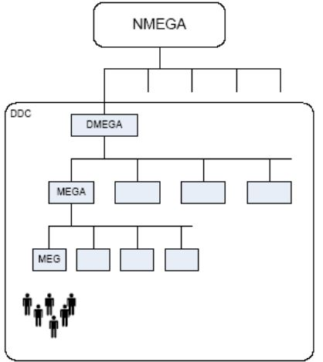

Source: NORMA Consultancy, 2010, p. 6

The objective of the institutional setups is to strengthen the capacity of MEAs so as to make them able to raise MEs' voices in the relevant forums as part of policy advocacy. They also cater a number of services required to their members in order to make them resilient.

*Figure 35: Major activities of MEAs for their members*

**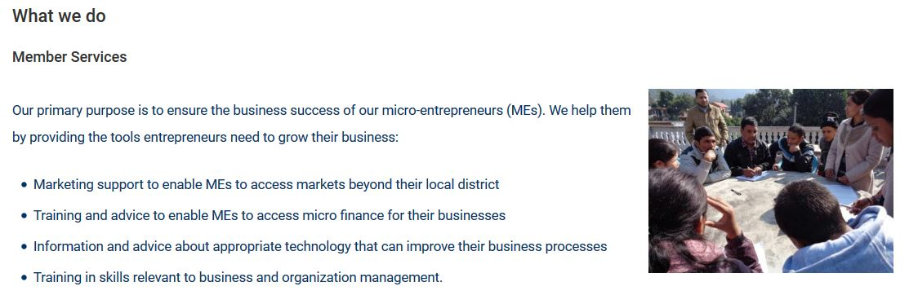**

Source: NMEFEN website, accessed on March 28, 2018

MEDPA had projected additional 52,000 MEs (32,600 MEs were associated with DEMGA before MEDPA) to be associated with DMEGAs (through MEG and MEGA) (GoN/MoI, 2013 [July], p. 75). As of December 2017, a total of 22,181 MEs (i.e. 32,600 before MEDPA minus 54,781 cumulative progresses) have been associated with DMEGA during MEDPA implementation (GoN/MoI/UNDP, 2018, p. 84).

Table 37: Number of MEs targets to be associated with MEAs during MEDPA period

|  |  |  |  |  |  |  |  |  |
| --- | --- | --- | --- | --- | --- | --- | --- | --- |
| **Category** | **Baseline data** | **2013/14** | **2014/15** | **2015/16** | **2016/17** | **2017/18** | ***Total (MEDPA)*** | ***Total*** |
| Targets (MEs associated with MEA/DMEGA) | 32600 | 2500 | 10500 | 13000 | 14000 | 12000 | 52000 | 84600 |
| Progress during MEDPA | 32600 |  |  |  |  |  |  | 54781 |

Source: GoN/MoI, 2013, p. 34; GoN/MoI/UNDP, 2017, p. 83

A total of 1,45,370 (72,370 before MEDPA and 73,000 during MEDPA) MEs is targeted to be created through MED model implementation which is quite big in terms of the number. There is a higher opportunity for the sustainability of MEAs through ensuring the affiliation of all MEs with their association (MEA). The chair of NMEFEN also showed (during the consultation meeting for this study in February 2018) his confidence of making their association self-sustained even after the end of MEDPA and the main points of his argument was the number of MEs and their efforts to make them affiliated to MEA.

MEA is an association of MEs from among the people who fall below the poverty line, and the institutional development is very challenging in terms of their comparative capacity (financial in terms of resource generation and time investment) and technical skills (management and operation). However, MEAs, with well recognized positioning in the enterprise sector, have great potentials for moving towards self-sustaining business service provisions to their members.

**Replication of MED model**

The MED model, as a flagship approach of MEDEP and MEDPA's efforts, has been partially replicated in many of the other development programs in Nepal. The MEDEP and MEDPA experts and specialists argue that enterprise related program of many development agencies such as HELVETAS Swiss Intercooperation Nepal, OXFAM Nepal, LGCDP, World Vision, Sabal Program, etc. have partially adopted six steps of MED model (as per consultation with MEDEP team, 2017). They also argue that, copied from the successful practice of MEDPA, the local government also adopted the strategy of hiring service providers for delivering the development services. However, institutionalization of the complete package of MED model into other ministries and line-agencies is still challenging.

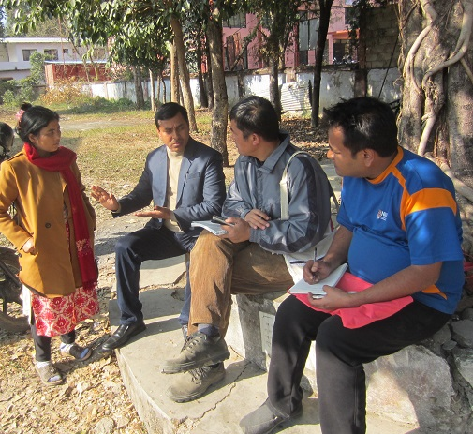

*(Interaction with official of DCC in Hetauda, Makawanpur)*

The continuity of MED model during last two decades itself is a proof of its relevance in Nepal. The six step MED strategies is a well appreciated approach to work with economically poor and socially marginalized people. However, replication of complete package may not be possible and necessary for all entrepreneurs and hence an innovation within MED model is highly desirable to ensure its relevancy for different forms of entrepreneurs.

**Key lessons learnt from the internalization and institutionalization of MED model before federalism**

1. ***MEs are well recognized in the policy frameworks which have developed the importance of promoting MEs for the better functioning of national enterprise ecosystem:*** The clear positioning of the MEs in the State's different policies and regulations is a form of State's response with respect to the importance and relevance of MEs. The relevance can be seen at the levels of its contribution to the national economy (contribution to the poverty alleviation through economic empowerment of people living below poverty line) as well as to the enterprise ecosystem (as functioning at the supply chain node to the SMEs). In addition, the MEs of MED model can also be linked with contribution to achieving the Sustainable Development Goals (SDGs) and improving Human Development Index (HDI) of the country. So, MED model has significantly contributed in establishing the positioning of the MEs and the relevance of their promotion for MEDPA and beyond.
2. ***Structural institutional set-ups envisioned for the implementation of MEDPA requires continued technical facilitation supports:*** The effort made for the structural institutional setups for the institutionalization of MED model has become crucial but challenging task for MEDPA implementation in Nepal. On the one hand, the establishment and smooth functioning of the required institutions itself was difficult within structurally bureaucratized government systems; while, on the other hand the federalized government system created reputational risk for institutional setups (as 75 districts local governing units of MEDPA has been increased to 753 LG units) where smooth functioning of the institutions became secondary. The lessons learnt is that the new structural institutional setup in the government system is time consuming process that needs continued facilitation supports by external support agencies.
3. ***Internalization and institutionalization of MED model into government system is ensured through GON's co-funding mechanism:*** The unique feature of the MED model is to reach project benefits to the hard to reach. It is ensured through three different approaches: GESI approach, demand-driven approach, and six step MED strategies. MEDPA program, based on these approaches, is very effective and contextualized in Nepal's socio-political and economic contexts. The GoN has contribution of least 24.4 per cent of the total MEDPA budget as project's co-funding which is government's commitment for the institutionalization of MEDPA program into government system. So, the internalization and institutionalization of MEDPA program into government system is an example of government's initiative to appreciate appropriate program that cater methodological appropriation (MED model) and measurable outcomes (direct contribution to poverty reduction and indirect contribution to SDG and HDI along with the development of social capital of the promoted MEs).
4. ***Internalization and institutionalization of MED model into existing government institutions in terms of HR placement and their capacity buildingrequires continuous reinforcement and orientation:*** The number of staffs/officials and their existing capacity (skills and knowledge) of existing HR in government institutions were not adequate to implement MEDPA activities. The efforts (for HR placement and capacity growth) made to address this issue had a lesson that the HR placement and their capacity building into existing government system is very challenging due to complex bureaucratic processes in decision making. Similarly, the frequent transfer of the staffs/officials is also problematic in terms of transforming knowledge and skills on MED implementation processes (such as MEDSP selection, performance based sub-contracting, GESI target, six component MED strategies, etc.). The lesson learnt is that existing government system demands continuous reinforcement to ensure HR placement and their capacity development for the implementation of MEDPA program.
5. ***MEDPA stakeholders are interconnected through MED model implementation mechanisms and this has created platform for cross-learning and cross-sharing - leading towards methodological innovations:*** MEDPA implementation has become possible through the involvement of multiple institutions with different roles/functions. The stakeholders include ministries (a total of 7 ministries) and other stakeholders (such as related departments, federations, private sectors, FIs, and civil society groups). Therefore, implementation of MEDPA has increased the interconnectedness of multiple stakeholders in Nepal. Providing a common platform to the multiple actors is a great opportunity to have cross-sharing and cross-learning for innovations. It requires constant and open discussions among the stakeholders.
6. ***Sustainability of MED model is strengthened through spectrum of contributions by MEDPA stakeholders but providing enabling environment for their proactive roles is highly desirable:*** As discussed earlier that MEDPA is a platform, where multiple institutions get opportunity to contribute in. For example, the relevant ministries and line agencies contribute in policy positioning, the private sectors for B2B partnership, MEDSPs for MED service delivery through competitive bidding process, MEAs contribute in empowering and networking of the members (MEs) as well as raising voice in the policy forums. So, the spectrum of contribution has made MEDPA program sustainable and therefore ensuring proactive contribution of all stakeholders is highly desirable for the sustainability of MEDPA program.
7. ***Wider replication of MED model is possible through providing choices in MED service provisions:*** As discussed earlier that six components of MED strategies is not required for all entrepreneurs and hence providing choices within MED components may increase the potentials of its wider replication.

**Conclusion of the internalization and institutionalization of MED model before federalism**

The internalization and institutionalization of MED model into government system, through MEDPA program, itself is a proof of the relevance of the MED approach in Nepal's socio-economic context. The realization of the relevance of MED model is reflected in the priority of ME creation, policy frameworks for the recognition of MEs as a category of enterprises, and positioning of the MEs within enterprise ecosystem framework (contributing in supply chain node of SMLEs). With this realization, the GoN has internalized and institutionalized the MED model into the government system by initiating required institutional setups, HR placement, and possible budgetary allocation (at least 24.4 % of the total budget). Implementation of MEDPA through the engagement of multiple stakeholders (7ministries and 12 other institutions) not only provided opportunities to have cross-sharing and cross-learning for effective implementation of MEDPA program but also opened up the horizon for its possible replication into other institutions/ministries/departments. However, internalization and institutionalization of MED within governance system is difficult and time consuming that needs continuous reinforcement with external facilitation supports.

## 3.11. Internalization and institutionalization of MED model after federalism

One of the important objectives of the MEDEP IV implementation was to support the government to take over the delivery of MED activities through MEDPA program. In line with this, the MED model has gradually been internalized and institutionalized into the government system. MTE reports of MEDPA state that:

*MEDPA is a unique example of GoN taking over the concept and model of donor funded project into a regular GoN funded project. Although, the history of MED type of intervention goes back to late eighties within the DCSI and CSIBD, however that was limited to a one shot short term training without any linkage to start-up enterprise by the participants. The government's strong ownership over the program is reflected not only in putting the required policy, strategies and institutional mechanisms in place at different levels,but also in its act of allocating incremental resources to the project*(DCC, 2016 [May], p. 54).

The given statement clearly states that internalization and institutionalization of MED model into government system were focused towards initiating the formulation of required policy and regulatory frameworks, setting up institutional mechanisms at different levels, and regular budgetary allocations. In addition, the efforts were also made towards capacity development of the stakeholders that primarily included the MoI and its constituent institutions, MEDSPs, and MEAs (GoN/MoI/UNDP, 2013 [July]).

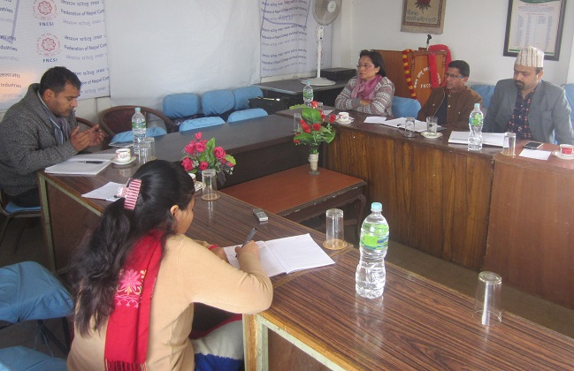

*(Interaction with representatives of FNCSI)*

Internalization and institutionalization processes of MED model into government system were right on track. However, promulgation of The Constitution of Nepal 2015, primarily the successful completion of the three tiers of election held in 2017 (local government, provincial government, and parliamentary) have dramatically changed Nepal's politics and administration. Previous municipalities and villages (3,900 in number) were restructured in a total of 753 LGs (6 Metropolitan Cities, 11 Sub-Metropolitan Cities, 276 Town Municipalities and 460 Rural Municipalities) which have affected the ongoing internalization and institutionalization processes.

Designing and implementation of MED model were practiced and experimented in the centralized government system. In this system, the policies and programs prepared at the central levels were easily implemented at the local levels by local governments. The Constitution of Nepal 2015 provisioned the rights of local governments to formulate and implement many of the policies and program on their own. Section 18 (226) of this constitution states that: "*Powers to make law: (1) A Village Assembly and a Municipal Assembly may make necessary laws on the matters set forth in the Lists contained in Schedule-8 and Schedule-9*" (GoN, 2015, p. 135). In this context, internalization and institutionalization of MED model in federalized government system have become challenging to the fact that communicating and translating MED model to administratively autonomous governments having diversity of leadership experiences and socio-political and economic background have become quite complicated, expensive and challenging. The top down approach adopted in implementing MEDPA before the federal government became incompatible.

In this context, one of the major changes adopted by the MEDPA was shifting its focus from district to Local Government (LG) units and provincial government. Before the promulgation of The Constitution of Nepal 2015, the project worked pre-dominantly with the 69 districts. But after the new Constitution came into effect, MEDPA has adapted its geographical and administrative working boundaries and aligned it into 77 districts, and 753 local governments.

**Policy provisions after federalism: continued policy advocacy and lobby**

Efforts and achievements made so far for MED friendly policy and regulatory provisions was one of the important aspects of internalization and institutionalization of MED model. One of the important policy provisions was recognition of ME as one of the 5 categories of industries in Nepal.

Table 38: Selected policies related to the institutionalization of MED model

|  |  |  |  |
| --- | --- | --- | --- |
| **SN** | **Year** | **Name of the policy** | **Provision related to MED model** |
|  | 2007 | Micro Enterprise Policy, 2007 | Provisioned the official definition of ME |
|  | 2009 | Commercial policy, 2009 | Micro enterprise development as strategic focus |
|  | 2011 | Industrial Policy, 2011 | ME as one of the 5 types of industries |
|  | 2013 | Monetary policy, 2013 | Prioritize MEDEP promoted cooperatives for providing wholesale loans (monetary policy 2013, clause 105) |

The efforts for the transformation of policy provisions were made possible through a number of regulatory frameworks. Some of the important regulatory frameworks in this line are presented in the table below.

Table 39: Selected regulations related to the institutionalization of MED model

|  |  |  |  |
| --- | --- | --- | --- |
| **SN** | **Year** | **Name of the regulations** | **Provision related to MED model** |
|  | 2008 | District Enterprise Development Program Implementation Procedure, 2008 | Eased the implementation of MED model |
|  | 2008 | MED Fund Operation Guideline, 2008 | Eased the operationalization of financial resources |
|  | 2009 | Village Enterprise Plan Formulation Procedure and Implementation Guideline, 2009 | Provision for the promotion, development and expansion of micro enterprises |
|  | 2012 | District Enterprise Development Strategic Plan Preparation Guideline, 2012 | Eased local level MED activities |
|  | 2014 | MEDPA Operation Guideline, 2014 | Eased the operationalization of MED model |

MEDPA Guidelines 2014 has been revised and implemented in order to address the changing political context for MEDPA implementation. The DEDC exists as interim committee. However, DEDC’s structure has been changed into District Coordination Committee (DCC), and in this context the DCC Coordinator instead of DDC chairperson leads the DEDC. The size of the committee has decreased from 18 to 7 members to align with district level restructuring. Similarly, VEDC also changed into Enterprise Development Committee (EDC) accordingly.

In order to institutionalize MED into the federal government, a number of policies and legislations have to be formulated and implemented by the different tiers of government (local, provincial, and federal). Many of them are in the process, while others are yet to be started. In this context, the above policies and regulations are the important institutional memory of the MED model, and they may become important references for the policy makers and legislatures to translate the achievements of the MED model. For this, policy advocacy and lobby for developing realization of the importance and relevance of promoting MEs and their creation through MED model is required. One of the important opportunities for the policy advocacy is that the MEs who have been elected in the local election as local government representatives (a total of 389) and the members of the MEAs in different positions (in executive committees) and locations (all districts and villages) are seen as most potential actors for policy advocacy. However, their capacity building through constant technical backstopping is still highly desirable.

**Institutional setups after federalism: MEDPA efforts is on track**

Establishment of a number of structural institutions was another important component of the internalization and institutionalization of MED model. They were very instrumental for the implementation of MEDPA activities.

Table 40: Institutional setups for the internalization and institutionalization of MED model

|  |  |  |  |
| --- | --- | --- | --- |
| **SN** | **Name of the institutions/committees** | **Locations** | **Possible status in federal government** |
|  | MEDPA Steering Committee | Central | May exist (with possible changes in its number of members) |
|  | Micro Enterprise Units | MoI | May exist |
|  | Micro Enterprise Section | Central (at CSIDB and DCSI) | May exist |
|  | MEDPA Implementation Committee | Central | May exist (with possible changes in its members) |
|  | DEDC | Districts | May exist under District Coordination Committee (with reduction of members from 18 to 7) but with reduced functions |
|  | DEDF | District | May exist under District Coordination Committee |
|  | VEDC |  | Will not exist but ward level committee can be formed |

The federalized government system reduced the functions of district units which by default made the district level MEDPA committees/institutions defunct from its roles, although they exist as interim provision. The efforts have been made to establish new institutions to align with federal government system in order to continue the internalization and institutionalization of MED model into this system.

Table 41: Efforts for institutionalization of MED model in demo LGs

|  |  |  |
| --- | --- | --- |
| **SN** | **Name of the institutions/committee/Plan** | **Progress as of December 2018** |
|  | Industry Development Section (IDS) | 102 |
|  | Enterprise Development Committee (EDC) | 58 |
|  | Enterprise Development Fund (EDF) | 24 |
|  | Enterprise Development Plan (EDP) | 60 |
|  | GESI-MIS |  |
|  | MED model orientation in LG units | 550 |

Source: GoN/MoI/UNDP, 2017, p. 15 and 81

A total of 154 LG units have been identified, selected and MoU signed in order to demonstrate the MED model as demo LGs for the demonstration effect and examples of best practices of MED model institutionalization at LG units (consultation with MEDEP team, 2017). IDS are emerging in the remaining LGs. DCSIs and CSIDBs in 77 districts are playing the catalytic role to establish IDS for institutionalizing MEDPA. Out of 102 IDS established so far, 37 have been established outside of demo LGs. Regarding GESI-MIS, focal person of M&E of all demo LGs have been trained. The existing MEDF at the district has become defunct owing to federal restructuring. EDF is being established at LGs in order to provide necessary support. MED model orientation program is being carried out in all 753 LGs in line with current federal structures. Out of this, MED model orientation is completed in 550 LGs. Therefore, the efforts have been made to adapt to the current situation.

**HR placement and capacity building after federalism: challenges with opportunity**

The placement of required HR and their capacity building at 753 local governments and 7 provinces is a big challenge. However, the number of EDFs (a total of 1,234 as of December 2018) including trained and capacitated other HR (a cumulative form of 1,915 MEDPA stakeholders) during the last 20 years has created a big opportunity for institutionalizing MED model. In addition, the HR trained and experienced in MEDEP are another part of potential HR for the internalization and institutionalization of MED model.

*Figure 36: GESI disaggregated information of certified EDFs*

Source: Source: NSTB and CTEVT, cited in GoN/MoI/UNDP, 2017, p. 59

It was estimated that 1,283 EDFs are required for the implementation of MEDPA during 2013 to 2018. Compared to the availability of 525 EDFs, it is sort of 708 EDFs and MEDPA had planned to collaborate with CTEVT and some other private training institute to fulfill the required EDFs for the implementation of MED model (GoN/MoI, 2013 [July], p. 24) and as a result, total of 1,234 have already been developed and available in the market. This indicates that availability of HR in terms of EDF for mainstreaming MED model in local level government units may not be a problem.

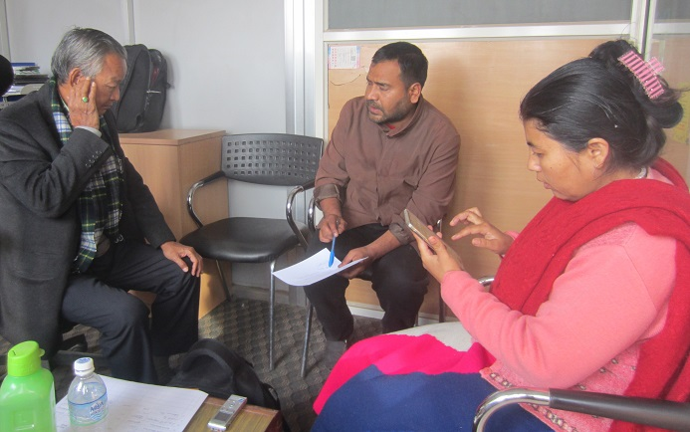

*(Interaction about MED model with Technical Advisor of MEDEPA)*

The MoU between MoI and Pokhara University for the production of undergraduate level HR is another avenue of MED model institutionalization. The human resources produced from this course will serve to mediate upper level (produced under Master in Business and Accounting-MBA) and lower level (EDFs) of human resources for enterprises development related issues. At this point, it can be claimed that the internalization and institutionalization of MED model during MEDEP and MEDPA has created an enabling environment for federalized government system.

**Budget allocation after federalism: MEDPA efforts is on track**

As discussed earlier that about 24.04 per cent of financial resources is projected to be allocated by the GoN, 8.34 per cent by local body and the rest 67.64 per cent are by donors for the MEDPA implementation. The amount projected to be allocated from local government and GoN for the implementation of MEDPA is significantly high and this would be an evidence and reference for federal government (local, provincial and federal).

In MEDEP’s technical assistance, MoI has developed a “Reference Material” encompassing MED model orientation in order to orient elected representatives of LGs and oriented in 550 LGs. This has helped to send a strong message to LGs representatives that MED sector is one of the key areas for economic and enterprise development resulting in increased income, employment and poverty reduction.

*Figure 37: MED model orientation for LG representatives*

Source: GoN/MoI/UNDP, 2017, p. 29

The primary stakeholder of MEDPA (namely the staffs of MEDEP and MEDSP/BDSPOs) and its beneficiaries (namely MEs and their associations such as MEG, MEGA/LMEGA, DEMEGA and NMEFEN) have been continuously engaging in the advocacy and lobby for the budget allocation of micro enterprise development related activities at the local government planning processes. The MED model orientation has been carried out in a total of 550 LGs (as of December 2017). It is reported that, as a result of the advocacy and lobby, many of the town/city municipalities and rural municipalities have allocated significant amount of resources for the creation and promotion of micro entrepreneurs within their governing constituencies. This has resulted in 186 LGs approving budget amounting to NRs. 398 million (out of total 186 LGs, 29 are exclusively MEDPA LGs which have allocated NRs. 70.4 million) for economic/employment generation and enterprise development activities for the poor based on GESI principles. These pledges of budget support and ownership by LGs are substantive as they represent 58 per cent of the current MEDPA budget (GoN/MoI/UNDP, 2017, p. 29).

The LGs receive two types of grant from the central government: conditional grant and unconditional grant. Budget allocation for MED model internalization and institutionalization is possible in both types of grants. The budget allocation at LGs for MED related activities depends on two things: self-realization of the importance of budget allocation for economically poor and marginalized section of society; and convincing advocacy and lobby. In the first case, prior knowledge and experiences of leaders play important role; while in the second case, capacity of the individual or institutions that engage in the advocacy and lobby may become important. In this context, internalization and institutionalization of MED model would be done through proactive roles of federal government in preparing and communicating a clear guideline for local government on budgetary allocation.

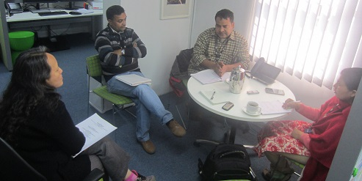

*(Interaction with DFAT team in Maharajganj, Kathmandu)*

**Subcontracting MEDSPs after federalism: possibility and challenges for alternatives**

Subcontracting MEDSPs for the delivery of MED services was one of the important innovations of MEDEP and MEDPA implementation. This practice has become means to produce required HR for the implementation of MED activities on one hand, while on the other hand, this has helped in the institutionalization of available HR. However, the services delivered through MEDSPs in the later years (particularly during MEDPA implementation) have become less effective due to the government's procurement policies (single year contracting including lengthy processes).

Municipality and rural municipality level MEDPA guideline is highly desirable in changing political context. The innovation that resolves the problem developed from delayed selection processes and single year contracting system during MEDPA implementation should be sought. For this, prior selection of MEDSPs for the implementation of MEDPA activities so that selected MEDSPs could start its work at the beginning of the fiscal year or multiyear contracting system to the MEDSPs that ensures selected MEDSP's continued engagement with the MEs for at least three years (the average cycle years of MEDEM for developing resilient MEs) are highly desirable. In addition, priority to the local MEDSPs is very important in order to increase accountability of the organization towards its beneficiaries and use of its exiting local social and political networks with local stakeholders. In addition, innovation in subcontracting MED services that fits LG context is desirable. Such as either innovations for the involvement of different community groups like local cooperatives, Mothers' group, Farmers' group, Youths' group, community groups, community associations for specific service deliveries or hiring experts for the required service deliveries.

**Effectiveness, relevance and fit of MED model after federalism: highly important**

Experiences from the implementation of MED model during 15 years of MEDEP and 5 years of MEDPA in Nepal have proven that this model is tested for further implementation. In other words, this model has been proven as a very effective approach for the economic growth of the poor and vulnerable people in countries like Nepal. MED model, therefore, is internalized and institutionalized into the government system through the implementation of MEDPA from 2013 to 2018. Question arises whether this model is effective in the context Nepal's federal government system, and if yes then how and to what extent.

One of the important characteristics of MED model is package of service deliveries to the MEs until the person becomes resilient entrepreneur (continued up to a maximum of 3 years). This means, MED model in terms of its approach is integrating six steps MED services to an entrepreneur. The second characteristic of MED model is demand driven approach, according to which beneficiaries are selected on the basis of three aspects: availability of raw materials, needs and demands of people, and market demands. This means, implementation of MED model does not go randomly, instead it goes through intensive assessment process. Third characteristic of MED model is target based approach, in which people below poverty line including socially marginalized groups, namely women, Dalits, indigenous nationalities, Madhesi, unemployed youths are made as target population. These three characteristics of MED model are very useful for Nepal's socio-economic changes in the federalized government system.

Federalism, in a simple word, is a kind of government system where the state as service providers reaches close to the people. MED model will be effective means to the state to close its distance with socially excluded groups. Therefore, this approach will be effective for the local government to deliver services related with the economic growth of the poor and socially excluded groups. This approach will also be the effective means for local government to increase government's outreach through ME creation as an economic activity, since LGs have smaller geographical territory to be covered by the interventions. MED model also helps LG to innovate for the best use of natural and human resources for economic growth of the hardcore poor.

Today, economic prosperity is one of the important agendas in Nepal and this is one of the big challenges for LGs. For this, MED model would be one of the effective approaches for LGs to reach to the hard to reach i.e., hardcore poor and socially excluded groups. In addition, implementation of MED model is much easier at the LG units since any of the policy and programmatic hurdles/problems could be resolved immediately at the local levels.

**Key lessons learnt from internalization and institutionalization of MED model after federalism**

1. ***MED model provides unique opportunity for LGs to reach hard to reach:*** MED model with unique features of intervention approaches (namely demand-driven approach, six component MED strategies, and GESI target approach) provides unique opportunity to the LGs to reach economic activities to poor and excluded groups within its constituency. This model may become an effective tool for LGs to integrate multiple actors (such as IDS, FIs, MEAs, MEDSPs, community groups, civil society groups, etc. who works in enterprise/industry related activities) in order to improve economy of the people below poverty line thereby contributing in reducing socio-economic inequality and social exclusion. For example, GESI-MIS of the MED model may provide opportunity to the LGs to collaborate with different local stakeholders for the development of periodic development plan and can incorporate enterprise development strategies. Therefore, implementation of MED model provides unique opportunities for LGs to reach to the hard to reach with their development benefits/interventions.
2. ***Furthering the effective implementation of MED model is possible through the leadership of LGs but it requires external technical facilitation supports in terms of developing policy framework, planning of the program and its proper implementation:*** MED model may provide opportunities to the LGs to further contextualize available local HR placements, utilization of available natural resources, mobilization of the capacities of local MEDSPs, and utilize innovative financial service providers and mechanism. This also provides opportunities for the mobilization of community groups, draw lessons learnt from varied development practices, and integrate various forms of local practices, mainstreaming micro enterprises into SMEs, and knowledge and skills in order to innovate effective mechanism of MED service deliveries. For all these, technical facilitation support is highly required in order to orient LGs and their leadership towards MED approaches including better transformation into local government policies, programs, plans and practices.
3. ***MED model implementation mechanisms are source of knowledge for LGs to foster partnership and collaborations among the different actors, agencies, institutions and stakeholders:*** LGs can learn a lot from the mechanisms and committees established for the implementation of MED model, such as MEDPA steering committee and MEDPA implementation committee at the central levels, DEDCs and DEDF at the district and VEDC at the VDC levels. These mechanisms have provided enabling environment for fostering collaboration and partnership among the different actors/agencies for better implementation of MED model. These mechanisms are evidences for the LGs in federal government system for fostering partnership and collaboration among local level actors, development agencies, community groups, and stakeholders.
4. ***Constant policy advocacy and lobby is highly required in order to orient LGs towards the integration of MED model into the highly demanded tangible development targets:*** In the federalized government system, the LGs have greater opportunities for developing innovative use of MED strategies as described in above points. However, the aspirations of the local leaders and people are mostly driven by the tangible development activities like road construction, electrifications, construction of the infrastructure/buildings, and quick impact livelihood improvement training. So, matching the aspirations of development target driven LGs and relevance of MED model in local context including the importance and methods of mainstreaming micro enterprises into enterprise ecosystem and wider economic frameworks requires constant technical inputs. Transformation of MED model into 753 LGs is technically a big challenge which requires a constant policy advocacy and lobby at least until MED approaches are internalized and institutionalized into all LGs.
5. ***Constant capacity building of MEAs is highly required in order to ensure effective policy lobby and advocacy from local to national levels:*** The presence of MEs all over the country is an important advantage for carrying out policy advocacy and lobby for institutionalization of MED model into LGs. Moreover, presence of MEAs from local to national level (such as MEG in the community level, MEGA/LMEGA in the market and municipality level, DMEGA at the district level, and NMEFEN at the national level) is a big opportunity for carrying out policy advocacy and lobby for the internalization and institutionalization of MED model into federalized government systems. However, MEs being promoted from among the poor and socially marginalized section of society do not have adequate skills and capacities to influence policy makers and planners. So, constant capacity building of MEAs is highly required in order to ensure effective policy advocacy and lobby.
6. ***Federalism has increased reputational risk for the internalization and institutionalization of MED model:*** The experiences and achievements gained through MED model became new in the changing political context which has unexpectedly increased the reputational risk to the progress so far made for the internalization and institutionalization of MED model in Nepal. The risks have appeared along with the changes in state governing structure (such as ministries, departments, units, sections, etc), changes in the roles of these institutions including the government officials and elected people's representatives. For example, all district units became defunct thereby creating bigger number of autonomous LGs (a total of 753 LGs), merger of the different ministries (such as environment ministry and forestry; MoFALD and General Administration), and possible collapse of many departments (such as district chapters of DCSI and CSIDB). The setting up of the governing structures at LGs are still in progress and the elected people's representatives in different government constituencies such as wards, municipalities and provinces became decisive in policy making processes and planning activities (in contrast to the bureaucracy dominated context for the last 20 years). To conclude, the restructuring of the government structures in federal context as per the Constitution of Nepal 2015 has created reputational risk to MED model internalization and institutionalization.
7. ***A technical facilitation support from external agencies is highly required at least until MED model is internalized and institutionalized into the federal government system***: Internalization and institutionalization of MED model into federalized government system is very crucial for contributing to the national poverty reduction through socio-economic empowerment of hardcore poor. But it is very challenging in terms of appropriate institutional set-ups, required HR placement, HR capacity building, adequate resource allocation, and proper implementation of MED approaches. For all this, a technical facilitation support from external agencies (such as placing the MEDEP team in the later phase of MEDPA) is highly required in order to provide technical backstopping for the internalization and institutionalization of MED model into federal government systems.

**Conclusion of the internalization and institutionalization of MED model after federalism**

The achievements so far made for the internalization and institutionalization of MED model in Nepal is facing reputational risk in federalized government system. However, MED model may provide unique opportunities to the federal government to address poverty and social exclusion through enhancing innovative use of leadership skills to integrate spectrum of knowledge and experiences of the diverse institutions and individuals. For this, a constant technical input for creating enabling environment is highly required at least until MED model get internalized and institutionalized into federal government system.

# 

# Chapter 4: Summary and conclusion

## 4.1 Introduction of the summary and conclusion

MEDEP, which later on transformed into MEDPA, continued for almost two decades, has lots of lessons to be identified and documented. One of the importance of the documentation of lessons learnt from 20 years of experiences would be to maintain its institutional memory; while another would be to draw lessons for future interventions. This study attempts to address both of these purposes.

The documentation of the lessons learnt from the implementation of MEDEP and MEDPA activities over the last two decades has been documented along 11 themes/aspects. These themes, in the study ToR, have been termed as study products, which for the LLD team is themes of MED model. So, this documentation work is an attempt to unfold multiple aspects of MED model (six step MED strategies, demand-driven approach, and target based approach) implemented during the last two decades in Nepal for the creation of MEs.

Six step MED strategies is a package of services provided to the MEs. These services are provided in a systematic process. First, social mobilization is carried out, in which target candidates are identified through PRA, groups are formed (named as MEG), and basic ideas of being entrepreneurs are given. Second, entrepreneurship development activities are carried out, in which SIYB and MECD training are provided to the selected candidates. Third is technical skills development training, in which basic technical training, according to the type of enterprise that the candidates intend to start, is provided. Forth, access to financial services, in which linkages between FIs and entrepreneurs is established to start up enterprise. Fifth is access to appropriate technology, in which low cost technology is provisioned to start a business. Sixth is related to market linkage and business counseling, in which production of MEs are consolidated and their linkages with wholesale buyers and markets are established. These steps are the key strategic service packages of MED model through which poor and vulnerable people are converted into resilient entrepreneurs.

Demand-driven approach is another important characteristics of MED model, in which three aspects of entrepreneurs are considered as important variables of potential entrepreneurs. They are: availability of the raw materials (natural resources), needs and demands of people or potential micro entrepreneurs, and market demands. Demand-driven approach, therefore, is a combination of three aspects of entrepreneurs which help diagnose the practicality of micro enterprise.

A third important characteristic of MED model is target based approach, called GESI target approach, according to which people living below poverty line are targeted beneficiaries of the MED services. For this, the MED model implementation prioritizes remote and less accessible villages or areas as working area by targeting hardcore poor, women, Dalits, indigenous nationalities, Madhesi excluded groups and unemployed youths. This means MEDEP and MEDPA activities have targeted the economically poor and socially marginalized groups. The main aim of this GESI target approach is to contribute in reducing poverty and hunger in the country through reaching the hard to reach.

## 4.2 Key thematic lessons learned

The key 11 thematic lessons learned from the implementation of MED model are summarized below.

***1) Effectiveness of MED model***

MED model, aligned with contributing to poverty reduction, is effective and proven tool for the development of MEs in Nepal is due to its unique approaches (commonly known as MED model: demand-driven service provisions, integrated service provisions [six components of MED strategies], GESI target approach, and continued supports and facilitation). A holistic service package of MED model not only orients the participants' mindsets towards becoming resilient entrepreneurs but also enhances skills for becoming innovative users of the business service provisions. Therefore, MED model being a compact of service provisions requires innovations for sequential ordering and situational choices for expanding its effectiveness. For example, the impacts of MED services to different MEs (such as successful and failures or resilient and non-resilient) demand for the situational choices of MED services. Providing enabling environment for EDFs furthers the effectiveness of the MED services.

**2) Economic empowerment of the hardcore poor through MED model**

Different activities and approaches of MED model have become means for the economic empowerment of the hardcore poor in Nepal. Targeting the hardcore poor from among socially excluded groups such as women, Dalits, indigenous nationalities, Madhesis, and unemployed youths from remote and less accessible areas is a unique approach of MED model to ensure that its benefits reach the people hard to reach (i.e., socially marginalized and hardcore poor). The number of MEs created and supported through MED model itself is an important achievement. However, ensuring the continuity of business of the created MEs is always a challenge. The important lessons learnt from the economic empowerment of hardcore poor through MED model is that the latent entrepreneur skills of the target people are triggered and actualized through a spectrum of MED services. Another lesson learnt is that economic empowerment of hardcore poor has multiple societal impacts and it can be furthered through support and skill training in timely intervals to those who are non-resilient.

**3) Economic empowerment of hardcore poor through CFC**

CFC is a platform for incubation services for the entrepreneurship development of the hardcore poor. CFC practices have also provided an enabling environment for the economic empowerment of hardcore poor. This has strong positioning in enterprise ecosystem, where MEs can work together for common learning and catering to market demand. The phases of the growth of CFC reflected in the form of legal recognition, CFC property ownership and complication in the management of internal social dynamics demands the need for the services of specialized institutions from the very beginning of the CFCs. One of the important lessons learnt is that the federal structure and present economic envisioning of the town-municipality/rural-municipality for employment and enterprise promotion can look forward for tailor-made CFC at each ward levels.

**4) Access to finance (A2F)in MED model**

Constant efforts have been made for providing A2F services to the MED model promoted MEs. A number of practices have been localized and replicated in larger scale. For example, efforts for the establishment and functioning of MEs led cooperative, MEG group level fund mobilization, buy-back guarantee, B2B partnership linkages, CFC practices and investment from community organizations can be seen in MED model implemented communities/regions. However, startup capital funding mechanism has remained an unresolved problem for most of the MED model promoted MEs. So, it is important to initiate three things at this point: 1) to devise startup capital financing from initial stage through MEDPA; 2) develop synergy between business service provider and financial service provider for joint initiation to have easy and institutional A2F for MEs from the starting of MED implementation; and 3) policy framework for coupling efforts of MED approach and financial service delivery approach.

**5) Pro-poor public private partnership (PPP) in MED model**

MEs positioning in enterprise ecosystem is well highlighted through various innovation within MEDEP and MEDPA activities. Ministry of Industry (MoI), being the lead institution for the implementation of MEDPA, is a right institution for enabling enterprise ecosystem and mainstreaming MSMEs into broader national economic ecosystem. It is right to say that MoI has played encouraging roles to establish MEs as an important component of micro enterprise ecosystem framework. It has potentials to deliver proactive roles to further its visibility. The lesson learnt from MEDPA and MEDEPs' achievements of positioning MEs as quality supply chain node is the beginning of furthering the importance of MEs to wider enterprise ecosystem in Nepal. A tailor-made program is required to work explicitly on mainstreaming MEs within enterprise ecosystem, for which predictability and regularity of the supply of goods and services is highly desired.

**6) Result based sub-contracting system (RBSC) in MED model**

RBSC approach is a paradigm shift and its application has increased programmatic outreach of the government programs. However, this approach needs to be revised so as to make it open for the competition by wider stakeholders (along with educating the possibilities) including local community groups in order to ensure sustained MED service deliveries, particularly in the context of federalized government system. The efforts made for the continuous supports to MEs for at least three years with constant engagement of EDFs is very effective which also demands provision for the engagement of multiple as well as local actors so as to ensure innovations on MED service delivery in coming times.

***7) Human resources development and capacity building of MED model stakeholders***

Human resource development and capacity building of the MEDPA stakeholders remained an important component of MED model. Regarding HR development, the number of EDFs developed until now (1,234 as of December 2017) is a big achievement that it has produced an enabling environment for sustainable business service provision for the development and growth of resilient MEs across the country. This opportunity is further ensured by the institutionalization processes (through formal courses and examination processes) and formal recognition (recognized category in the PSC). The increased number of EDFs, ensuring easy availability of EDFs in the market also opened up the opportunity to cater the required enterprise development services beyond MED model as determined by the market demands and market dynamics. A lesson learnt from the capacity building of the MED stakeholders is that the capacity building is a never ending process, which requires constant efforts at different levels to different actors at different space and time continuum.

**8) Socio-political and economic changes brought by MED model through GESI approach**

The socio-political and economic changes brought by MED model through GESI approach is systematically taken into account and upheld in all spheres of activities, including policies, programs and monitoring and evaluations. GESI target approach in MED model has ensured the greater reach of the project benefits to the group which is hard to reach. The implementation of MED model through GESI approach not only contributed to the economic improvement of hardcore poor but it also embedded with socio-political changes such as political empowerment and improved food security of the MEs. In addition, the service delivered through the implementation of MED model has multidimensional impacts on the supported MEs, for example , personal capacity development (through MED components) to the societal aspects (through MEAs as collectivities of the MEs) such as increased inter-group relations, cross-cultural tolerance and social harmony between individuals of MEs. However, GESI targets sometime may lead the focus of MED service provider more towards numeric achievement (i.e., number of ME creation) instead of providing quality services for quality ME creation. This demands regular monitoring of the activities of MED service providers.

**9) Use of M&E and GESI-MIS system in MED model**

One of the unique endeavors of MED model is GESI-MIS, which has developed and transformed IT-based information management and operation system into practice thereby leading knowledge paradigms towards the realization of the importance of IT-based decision making and e-governance. Its internalization and institutionalization into government system will be a paradigm shift for improving governments' efficiency in information management and operation. For this, a substantial change in both the structure and processes of institutional governance is highly desirable in order to fully adopt GESI-MIS into government system.

**10) Internalization and institutionalization of MED model before federalism**

The internalization and institutionalization of MED model into government system, through MEDPA program, itself is a proof of the relevance of MED approach in Nepal's socio-economic context. The realization of the relevance of MED model is reflected in the priority of ME creation, policy frameworks for the recognition of MEs as a category of enterprises, and positioning of the MEs within enterprise ecosystem framework (contributing in supply chain node of SMLEs). With this realization, the GoN has internalized and institutionalized the MED model into the government system by initiating required institutional setups, HR placement, and possible budgetary allocation (at least 24.4 % of total budget). Implementation of MEDPA through the engagement of multiple stakeholders (7ministries and 12 other institutions) not only provided opportunities to have cross-sharing and cross-learning for effective implementation of MEDPA program but also opened up the horizon for its possible replication into other institutions/ministries/departments. However, internalization and institutionalization of MED within governance system is difficult and time consuming that needs continuous reinforcement with external facilitation supports.

***11) Internalization and institutionalization of MED model after federalism***

The achievements so far made with regard to the internalization and institutionalization of MED model in Nepal is facing reputational risk in the context of federalized government system. However, MED model may provide unique opportunities to the federal governments to address poverty and social exclusion concerns through enhancing innovative use of leadership skills to integrate spectrum of knowledge and experiences of the diverse institutions and individuals. For this, a constant technical input for creating enabling environment is highly required at least until MED model get internalized and institutionalized into the federal government system.

## 4.3 Conclusion

### 4.3.1 Major lessons learned from MED model

The MED model as key tools for economic empowerment, leading towards socio-political and economic changes of hardcore poor, can also be seen from global (Sustainable Development Goal-SDG) to national (Human Development Index-HDI) conceptual framework of contribution towards humanity. Similarly, the achievements from the implementation of MED model can also be linked with some other broader national issues in Nepal such as rural-urban linkages, national economic growth through mainstreaming MEs into enterprise ecosystem, fostering collaboration and partnership between government line agencies, and contextualization of federalism. They are discussed below in points.

1. ***MED achievements, contributing towards achieving SDG targets as universal agreement to end poverty and inequality, has great potential to further the contribution:*** Of the 17 SDGs and their underlying targets, achievements so far made in poverty reduction through ME creation and employment generation and women's socio-political and economic empowerment are significant contribution to meet the SDG targets, particularly target number *SDG-1: No Poverty* (end poverty in all its forms everywhere), *SDG-5: Gender Equality* (achieve gender equality and empower all women and girls), and SDG*-8: Decent Work and Economic Growth* (promote sustained, inclusive and sustainable economic growth, full and productive employment and decent work for all) (see table 4 for details of SDG targets). Achievements of MED model activities have contributed to at least two each targets of SDG 1 (target number 1.1 and 1.2) and 5 (target number 5.1 and 5.a), and three targets of SDG 8 (target number 8.3, 8.6 and 8.10). The number of MEs creation (131,680 as of December 2017), the number of MEs operated throughout the whole year (52.4%), increased cash saving (41.6 to 58.4% MEs), the number of MEs moved out of the poverty (53.9% of the MEs households) are the examples of MED achievements towards meeting the SDG targets (DRTC, 2015). To be specific, achievements regarding socio-political empowerments (75% LG elected leaders) and access to finance (70% wholesale loan accessed by women) for women MEs are the examples of how MED achievements have contributed towards meeting the targets of SDG-5. These evidences clearly indicate that implementation of MED model has great potential to further the contribution of MED model towards achieving SDGs targets as universal agreement to poverty reduction.
2. ***MED achievements contributing towards improving HD indicators of target groups in Nepal:*** Of the three major dimensions of Human Development indicators (life expectancy-*health*; mean years of schooling-*education*; and per capita income-*economy*), achievements so far made in increasing the income of supported MEs can be linked with contribution towards economic dimensions of HD indicators in Nepal. In addition to the figures presented in the previous/above point, the example in line with the contribution to HDI is that a total of 13 per cent MEs supported through MED model earned annual net profits more than NRs. 100,000, while 59.7 per cent MEs with more than NRs. 50,000 (CEDN, 2018: copied from presentation slides). The impacts of the implementation of MED model, therefore, may have other unseen contribution to the improvement of country's HDI, such as women's socio-political empowerment leading towards access to health and education services and economic empowerment of hardcore poor leading towards improved livelihood. This clearly indicates that implementation of MED model has potential to link with furthering contribution towards the improvements of Nepal's human development indicators.
3. ***MEs positioning as important actors in enterprise ecosystem is fostering rural-urban linkages:*** The MED efforts leading towards recognition of MEs as a category of the enterprise has not only opened up the opportunity to develop Business to business linkages (B2B) between MEs and other forms of enterprises but also became means to fostering rural and urban linkages, since MEs from the rural areas positioned as supply chain node and other enterprises (namely small and medium) in urban areas as demand node actor.
4. ***Implementation of MED model has provided strategic platforms as well as opportunities to foster collaboration and partnership among multiple actors at local to national levels***: Multiple stakeholders (7 ministries and 12 other departments and institutions including MEAs, MEDSPs, private sectors, federations, FIs) have become strategic partners for MEDPA implementation. They have become part of MEDPA implementation through different mechanisms, namely the different committees. They have shared a common platform to formulate required policy and regulatory frameworks for MEDPA implementation. Similarly, the MEDPA implementation processes such as selection processes of the MEDSPs, involvements of multi-stakeholders in the monitoring activities, required institutional setups, government's regular budgetary allocation for MED implementation, MEA's positioning, and HR placements have become important platform of fostering collaboration and partnership among the stakeholders. These processes have provided ample opportunities to the MEDPA stakeholders in developing innovative use of MED model in order to ensure internalization and institutionalization of MED model. The whole of the MEDPA processes have become an example of fostering enabling environment for stakeholder's collaboration and partnership.
5. ***Opportunities for innovative contextualization of MED model into federal LGs:*** MED model as proven and tested during 20 years of experiences is a very effective tool for LGs to ensure government's reach to the hard to reach. By ensuring valuing of the principle methodological approaches namely GESI target approach, demand-driven approach, and required business services (six component MED strategies), the LGs as lead implementing agencies in federal government can innovate the use of MED model to be contextualized into the aspirations of LGs and the people within their constituencies.

### 4.3.2 Future prospects of MED model

The MED model, continued for the last two decades, has become an example in terms of projects' lengths and institutionalization process into government system in Nepal's development history. MEDEP and MEDPA genesis and ongoing knowledge clearly shows the MED model as a proven tool for transforming the hardcore poor into entrepreneurs. This requires deepening as well as broadening of the understanding of the importance of the MED model in Nepal's present socio-political context. Some of the perspectives, as potential areas for the MED model, synthesized after interacting with various stakeholders are presented below.

1. ***Mainstreaming MSMEs by conceptualizing MEs as supply chain node actor:*** Understanding the national economic contribution of MEs in isolation from SMEs is difficult and impossible. So, it requires mainstreaming of MEs within the broader enterprise ecosystem framework (discussed in this report) i.e., locating the Micro, Small and Medium Enterprises (MSMEs) within national economic ecosystem functions, in which the PPP approach comes into purview where B2B has to be further innovated in order to position MEs as quality led supply chain node actors. So, one of the potential areas of MED model is to locate MEs within the larger framework of national economic ecosystem contributed by MSMEs.
2. ***Employment opportunities beyond the livelihood improvements of the hardcore poor:*** MED model until now could not go beyond economic empowerment of the people below poverty line. So, one of the potential opportunities of MED model could be creating employment opportunities for target population through expanding the intervention areas such as supporting small and medium enterprises (SMEs).
3. ***Potential economic growth through sectoral approach of ME creation:*** The implementation of MED model, principally, is based on the portfolio approach (combination of social projection approach and market-led approach) in which capacity of the stakeholders is built in order to ensure their contribution to deliver required MED services (MoI/GoN, 2013, p. 23-24). The future intervention of MED model can expand its horizon by mainstreaming MED model in a number of potential sectors such as agriculture, forestry, tourism, handicraft making, service sectors, etc.
4. ***Expanding the use of MED model into existing informal MEs:*** As we see that thousands of informal MEs exist in different situations (progressing, declining, seeking for the service), types (women, men, youths, etc.), domains (agriculture, tourism, etc.), and places (urban, rural, etc.) in the country. Many of those MEs could have benefitted from the use of MED services. Their identification and providing MED service delivery as per their market needs could add important value to the application of the MED model and economic growth through improved enterprise.
5. ***Catering productive usage of remittances:*** The characteristic of potential MEs restricts multiple choices for enterprise promotion. The effort on productive usage of remittance and women entrepreneurship development requires a focus program so that it can speculate in future about the involvement of youths working abroad to strengthen the existing women-led businesses. This practice has been noticed in cases of MEDEP and MEDPA interventions and hence development of further specific programs could be an important opportunity of MED model.
6. ***Providing choices in six components:*** Enterprises have varied choices to access to business services which primarily depend on the existing status of the enterprises. The engagement of the youth in enterprise requires some of the MED model components to be pertinent rather than the entire component deemed as always necessary. So, the MED model has potential to expand the services to MEs and beyond as per the requirement or needs of particular entrepreneurs.
7. ***Mainstreaming climate change mitigation, green enterprises and disaster risk management:*** MED model implementation through MEDEP and MEDPA initiatives, as seen in the field, has promoted green enterprises including Rapid Enterprise and Livelihood Recovery Project (RERLP), Quick Impact for Peace Support Initiative (QIPSI) and disaster risk management by providing business solutions to the hardcore poor. However, inclusion of climate change, green enterprise and disaster risk management are found to be less documented as these have not been mainstreamed into the MED model. So, the MED model can be expanded towards these missing issues so that a variety of knowledge and experience could be gained to revise and devise the contents and strategies of the MED model.
8. ***Co-learning and bringing synergy:*** There has been a huge effort in learning from the MED model in relation to existing activities of the Department of Cottage and Small Industries (DCSI) and Cottage and Small Industries Development Board (CSIDB). Further co-learning and finding best fit in ongoing activities of CSIDB and DSCI are deemed to be of importance. There are specific learning from MEDPA and other initiatives of DCSI and CSIDB for the promotion of SMEs. A concrete understanding of SMEs is a required versatility of the MED model towards envisioning of MSMEs model through which existing learning can pave forward clarity in promiting MSMEs by related stakeholders.
9. ***Involvement of the multiple actors for commercially viable business service provision:*** Envisioning of the implementation of MEDEP and MEDPA activities is primarily based on the service procurement for MEs through MEDSPs. Definitely, subsidized services are important for transforming the hardcore poor into entrepreneurs, but the basis of business services and commercial viability is a must to be foreseen. The engagement of existing local institutions for the delivery of appropriate business services for MEs is one of the potential areas of the MED model.
10. ***Institutionalizing incubation services:*** CFC institutionalization as incubation center can be seen in many of the CFCs. The lesson learnt in CFC and its own presence/importance is very unique. Each wards' aspiration for a commercially viable CFC in federal structure is pertinent for enabling micro enterprises promotion and one-step solution for business service delivery.

### 4.3.3 Concluding remarks

The MED model for MEDEP and MEDPA in Nepal has remained to be a unique endeavor. The approaches, methods, and strategies envisioned and adopted have made it much appreciated for the enterprise stakeholders in the country. A constant adoption of this model throughout the entire MEDEP and MEDPA period has nurtured encouraging outcomes/outputs. The number of MEs created (a total of 131,680 as of December 2017 against the targeted number of 145,370 by July 2018) and their contribution to the socio-political changes (e.g., 389 MEs with 75% female emerged as victorious in the local level election held in 2017; and 64% female in MEAs executive committee and 61.5% in decision making positions in MEAs) and economic changes (e.g., family annual income increased from NRs. 86,581 to NRs. 137,161) of MEs are encouraging outcomes of the MED model.

The rationale of the continuity of MED model for almost 20 years is seen in the GoN's commitments and efforts for the internalization and institutionalization of this model into government system. However, this process is facing reputational risk after federalism, particularly after the local government election held in 2017. The risks are seen in mainly two aspects: policies; and institutional setups. At the policy level, a major risk is whether and to what extent the LGs will adopt existing policy provisions for the recognition and promotion of micro enterprises. At institutional levels, establishing required institutional setups in 753 LG units, required HR placement, their capacity building, and continue smooth functioning of the remaining committees/institutions (with necessary revision) such as MEDPA Steering Committee, MEDPA implementation Committee, MED units at CSIDB and DCSI, and MED section at MoI. However, establishment of IDS in a total of 102 LGs (as of December 2017) is a good start. In addition, the budgetary allocation, as one of the important components of MED model internalization and institutionalization, is encouraging that a total of NRs. 398 million by 186 LGs have already approved for enterprise development work.

The achievements of MED model, at the level of economic empowerment leading towards socio-political and economic changes, can be linked with 2 goals (goal number 5 and 8) of the 17 SDGs in order to link its contribution towards SDG's bold universal agreement to end poverty in all its dimensions, and HDI of Nepal in terms of two components (women's' participation and economic empowerment of hardcore poor). Therefore, the achievements so far made through/for MED model have further potentials to contribute towards SDG targets as well as for the improvements of the Nepal's HD indicators. The MED model, further, can be taken as a platform to the GoN for fostering rural-urban linkages and collaboration and partnership among/between line agencies including stakeholders. Moreover, there are great potentials for the innovative contextualization of the MED model by LGs in federalized government system for economic improvement of the hardcore poor. However, for this a continued technical input is highly required.

# References

Basnyat, Birendra, B. (2010). *Making the Difference: Micro-Enterprises Development Program: Documentation of Lessons Learned.* A report prepared by Norma Consultandy Pvt. Ltd. and submitted to GoN/MoI/UNDP: Kathmandu.

Development Consultancy Center (DCC). (2016 [May]). *Mid Term Evalution: Mocro-Enterprise Development Program (MEDEP-Phase IV).* A report prepared by Development Consultancy Center (DCC) and Submitted to Government of Nepal (GoN)/Ministry of Industry (MoI)/United Nationals Development Programme (UNDP), Nepal. Kathmandy.

Development Resource and Training Center (DRTC). (2015). *Mass Impacts on Entrepreneurs of the Selected Products and Services Promoted by Mocro Enterprise Development Program*. A report prepared by Development Resource and Training Center (DRTC) and submitted to GoN/MoI/UNDP. Kathmandu.

Dhungana, T. (2073). *Gender and Social Inclusive Management Information System.* Ministry of Industry (MOI). Kathmandu.

Digo Krishi Samstha Nepal. (2072 BS). *Laghu Udyam Bikash Sambandhi Niti, Niyam, Ain tatha Nirdesika tatha Karyabidhiharuko Sambandhit Anuchchedharuko Chanaut Gari Akikrit Gariyeko Pustika (Personal translation: A booklet Prepared Based on the Compilation Policy, Regulations, and Acts Related to Micro Enterprise Development)*. UNDP/MEDEP/MEDPA. Kathmandu.

DRS. (2017). *A Reprot on Visual Assessment of Common Facility Center (CFC).* Kathmandu: Ministry of Industry (MoI) and UNDP (report prepared by D.R.S. Developers and Designers P. Ltd.).

GoN. (2015). *The Constitution of Nepal, 2015 (english version: officially translated).* Government of Nepal (GoN). Kathmandu.

GoN. (2067 BS). *Udwog Niti 2067 (Industrial Policy 2011)*. Government of Nepal. Kathmandu.

GoN/CBS. (2011). *National Population and Housing Census 2011: National Report.* Kathmandu: Government of Nepal (GoN), Dentral Bureau of Statistics (CBS).

GoN/MoI. (2013 [July]). *Micro Enterprise Development for Poverty Alleviation (MEDPA): Five Years Srategic Plan 2070/71-2074/75.* Government of Nepal (GoN)/Ministry of Industry (MoI). Kathmandu.

GoN/MoI. (2014). *Impact Study on Empowerment of Women, Dalits, Indigenous Nationalities, and Other Hardcore Poor through Micro-Enterprise Development Program.* Kathmandu: Government of Nepal (GoN), Ministry of Industry (MoI).

GoN/MoI. (2014). *MEDPA Implementation Guideline, 2014*. Government of Nepal (GoN)/Ministry of Industry (MoI). Kathmandu.

GoN/MoI/UNDP. (2005). *Consolidated Progress Report (1998-2003).* UNDP/MEDEP. Kathmandu.

GoN/MoI/UNDP. (2013 [July]). *Micro-Enterprise Development Program Phase IV.* Kathmandu: Government of Nepal (GoN), Ministry of Industry (MoI), United Nationsl Development Programme (UNDP) .

GoN/MoI/UNDP. (2013 [July]). *Program Document of MEDEP IV.* Government of Ministry (GoN)/Ministry of Industry (MoI)/UNDP. Kathmandu.

GoN/MoI/UNDP. (2014). *Impact Study on Empowerment of Women, Dalits, Indigenous Nationalities, and Other Hardcore Poor through Micro-Enterprise Development Program.* Kathmandu: Government of Nepal (GoN)/Ministry of Industry (MoI)/UNDP. Kathmandu.

GoN/MoI/UNDP. (2016). *MEDPA: Annual Progress Report (APR) 2016.* Government of Nepal (GoN)/Ministry of Industry (MoI)/UNDP. Kathmandu.

GoN/MoI/UNDP. (2017/18). *MEDPA: Annual Progress Report (APR) 2017.* Kathmandu: Governmetn of Nepal (GoN)/Monistry of Industry (MoI)/UNDP. Kathmandu.

GoN/UNDP. (2010). *Impact Assessment of Micro-Enterprsie Development Programme (MEDEP).* Kathmandu: Govenrnment of Nepal (GoN), Ministry of Industry (MoI), United Nations Development Programme (UNDP). Kathmandu.

ILO. (2003). A Report on Micro and Small Enterprise Policy Review in Nepal: Series 7. A report prepared by Internaltion Labor Organization (ILO). Kathmandu.

MEDEP. (2015 [2072 BS]). *Laghu udhyam sambandhi bibhinna nitigat tatha kanuni prabadhanharuko sangalo (Personal translation: Compilation of policies and regulations related to micro enteprise).* Kathmandu: UNDP/Micro Enterprise Developmnet Program (MEDEP). Kathmandu.

NARMA Consultancy Pvt. Ltd. (2072). *Udhog Mantralayadwara Sanchalit Laghu-Udhem Bikas Karyakram ko Swatantra Mulayankan (personal translation: Independent evaluation of micro enterprise development program implemented by ministry of industry).* A report prepared by Norma Consultancy Pvt. Ltd and submitted to GoN/MoI/UNDP. Kathmandu.

Schmitt-Degenhardt, S., Bhatta, L. O., Kelly, L., Grigoryan, N., Dima, A., Gyawali, K., & Shrestha, N. (2016). *Narative to the Revised Results and Resoruces Framework (REF) of MEDEP IV Phase Project Document.* Kathmandu: UNDP Nepal and Micro Enteprise Development Program (MEDEP) .

Subedi, B. (2015). Gender Equality and Social Inclusion (GESI) Strategy and Action Plan for MEDP and MEDPA. A report submitted to UNDP: Kathmandu.

UNDP. (2016). *Human Development for Everyone: Briefing note for countries on the 2016 Human Development Reprot.* Kathmandy: United Nations Development Programme.

UNDP. *Sustainable Development Goals*. UNDP.

UNDP/MEDPA. (2009). C*apacity Assessment and Institutional Development Guidelines for MEDEP Supported Organizations.* UNDP/MEDPA. Kathmandu.

# Annexes

## Annex 1: Successful case stories of MED model implementation

### Case A: River-bed farming lifting people out of poverty in Nepal

Nepal's vast riverbeds, especially in the Terai area, remain submerged in muddy waters during the rainy season, and dry and desolate for the rest of the year. These unused riverbeds have huge potential to be utilized for poverty alleviation of thousands of landless families.

Currently, 1,955 landless micro entrepreneurs are turning these riverbeds into lush green vegetable fields in 9 districts of Nepal. They cultivate fresh vegetables such as cucumber, watermelon, gourd and beans that grow better in sandy soil.

This was possible with the support of Australian Department of Foreign Affairs and Trade (DFAT) funded Micro Enterprise Development Programme (MEDEP) when it entered Bhokraha and Chiknaha villages of Siraha district with the idea of helping landless people grow agro-products on the abandoned eastern side of Kamala riverbank in 2008. Initially, 84 families started riverbank farming after receiving training and start-up support from MEDEP and local bodies.

Newly elected ward member Mr. SuratiyaKamar, a financially and socially empowered riverbed farmer from Kalyanpur Municipality, who makes around Rupees 350,000 (3500 US $) profit per season from riverbed farming also serves as a Chairperson of District Micro-Enterprises Group Association (DMEGA) of Siraha. *'Riverbed farming changed my life'*, Suratiya Kumar added, -*'that all happened with the support of MEDEP*'.

Following successful piloting, many other landless farmers were trained in riverbed technology. By the end of 2016, 1,584 farmers - over 56% of them women - were trained and they have been making fortunes in the sandy riverbanks of the Kamala River. The average per capita income of the farmers has now increased to over NRs. 30,865 (US$ 300) from a meagre NRs. 4,000 (US$ 40) before.

*'MEDEP enabled me to access unused land of Kamala River for seasonal production, provided farming skills on marginal, sandy soil that helps me to gain income'* - Ms. Kusma Devi Mukhiya of Siraha Municipality said - *'I am making around 400,000 (4000 US $) per season and four members from my family are fully involved in riverbed farming*'.

The successful riverbed farming on the banks of Kamala River has now been expanded in other areas, including on the western bank of the Kamala River in Dhanusha district and also in Jhapa, Sunsari, Bardiya, Kailali, Sarlahi, Rautahat, Ramechhap and Nuwakot. With the support of MEDEP, these 1,955 landless micro-entrepreneurs are involved in riverbed farming in 9 districts of Nepal.

MEDEP, a joint initiative of UNDP and the Government of Nepal funded by DFAT, is continuously helping the farmers to innovate new, user-friendly, environment friendly and cost-effective technologies. In the beginning, diesel-operated water pumping sets were used for irrigation in the riverbed farms. The pumps cost approximately Rs. 50,000 (US $ 501) and the operating cost was so high that the family had to spend 50 per cent of the investment on irrigation alone (pump rental and diesel).

Now, manually operated, and women friendly bamboo treadle Pump, Rope and Washer Pump, Mobile Jumbo Treadle Pump and Pressure Hand Pump have replaced diesel-operated pumps. They are environment friendly, as they consume neither diesel nor electricity. Seventy per cent of the riverbed farmers have now adopted these solutions.

Source: GoN/MoI/UNDP, 2017, p. 72-73

### Case B: Kick-starting a new life - Kari Ram's story

Once a cobbler on the streets of Rajbiraj, Kari Ram now runs a successful shoe-making enterprise—a flip of the switch he says he couldn't have managed without help from UNDP’s Micro-Enterprise Development Programme. For 26 years, he had worked as a cobbler on the streets, and as much as he exerted himself, he wasn’t able to earn more than Rs. 4,000 per year, hardly enough to fulfill his daily needs. It was 2008, and after meeting and talking to a MEDEP staff, Kari Ram had decided to participate in the week-long training in entrepreneurship development. Swiftly after that, a group was formed with five members, Kari Ram among them. With business going so well, it’s not surprising that Kari Ram’s personal circumstances have improved considerably. Just last year, for instance, his earnings amounted to Rs. 720,000, a far cry from what he had once been making, and one of his top priorities has been to invest in his children’s education, and the future of the family, for which he has bought a 1.25-acre plot of land and built a house of his own in the village. “*My story is proof that a little bit of help—and a dose of confidence—can absolutely change lives*,” Kari Ram says. “*I could never have gotten where I am today if not for MEDEP’s support*.”

Source: GoN/MoI/UNDP, 2017, p. 73

### Case C: Wider horizons - a story of Sunti Purja

Ms. SuntiPurja is one of the 131,946 beneficiaries of Micro Enterprise Development Programme (MEDEP)—a joint initiative of Government of Nepal’s Ministry of Industry and UNDP. Sunti comes from a poor indigenous family of Baglung, a hilly remote district of western Nepal. She received entrepreneurship development training and access to credit by MEDEP in 2003 which helped her to establish a handicraft production company. Now her enterprise provides full time employment to 19 including her husband, and among them 80% are poor women. Sunti's handicraft company runs a sales outlet, Saugat souvenir house in Pokhara and recently in Kathmandu which plays a vital role in marketing the products of micro entrepreneurs, providing marketing linkages and selling their products from over 10 districts. Ms. SuntiPurja’s story is just one among many, in which Nepali women—many with little to no formal education—have built their own businesses, with backing from MEDEP in acquiring entrepreneurial skills, accessing funds and other forms of support.

MEDEP nominated the name of Ms. Sunti Purjafor Business for Peace Award 2018. Ms. Purja is Pokhara based one of the successful MEDEP supported entrepreneurs. Ms. Kesha Pariyar, a MEDEP assisted successful entrepreneurs and Former Chairperson of National Micro Entrepreneurs Federation (NMEFEN) was the winner of globally coveted Business for Peace Award in 2014.

Source: GoN/MoI/UNDP, 2017, p. 74

### Case D: A life sweetened with honey - a story of TikaramTimilsena

The support of UNDP’s Micro-Enterprise Development Programme offered TikaramTimilsena in Parbat options for livelihood and a way out of poverty he had never imagined possible. Tika Ram Timilsena from Modi Rural Municipality in Parbat district owns over 55 beehives, along with one orange orchard, from which he was able to earn close to Rs. 900,000 just last year. Tika Ram has also become something of a go-to man in the district insofar as beekeeping is concerned, and is a resource person for technical training in the practice. The previous year, he had received the President’s Award for excellence in farming in Parbat, along with an additional Rs. 10,000 in cash from the District Agriculture Development Office, and Rs. 25,000 from the Regional Directorate of Agriculture in Pokhara. Two decades ago, Tika Ram had been struggling to provide for his family of seven—which had included his wife, two sons and three daughters. The fog lifted somewhat when, through some Village Development Committee representatives, Tika Ram learned of the work UNDP’s Micro Enterprise Development Programme (MEDEP) was doing in the district. This was in the year 2000—Tika Ram was soon being provided training in both specific technical skills related to beekeeping, along with enterprise development overall, which served to arm him with the technical and practical skills he would need to start his own business. To this end, he first acquired a small loan of Rs. 8,000 from the Agriculture Development Bank—which he used to buy two beehives—and that, coupled with MEDEP’s technical support, was how his journey in entrepreneurship began. Tika Ram says he can scarcely believe the difference MEDEP’s assistance has made in the quality of his life and that of his family's.

Source: GoN/MoI/UNDP, 2017, p. 74

### Case E: When dreams come true

Lalo Devi Ram was a child bride. She was married at the age of 15 to Shreelal Ram a daily wage laborer. Shreelal earned NRs 3,600 a month, which was insufficient to fulfill their basic needs, especially after having three children. There was no warm clothes during winter, no sufficient beds to sleep on, no quality treatment during illness, no nutritious or enough food, and no quality education for the children. They had no assets like land or jewelry to fall back on. Owning a television set, a cell phone, a land of their own, getting sufficient food and quality education for their children was all a distant dream. Lalo, who belongs to a Dalit family, was in search of opportunities to increase her family's income so that she could fulfill basic needs for her family.

In November 2008, MEDEP selected Lalo, who is a resident of Shambhunath Municipality in Saptari, as a potential ME, as she belonged to the Dalit community and also to the ultra-poor group living below the poverty line. She upon receiving seven days entrepreneurship training, Lalo decided to pursue Basuri (flute) making as her chosen enterprise. After completing the mandatory 15-day technical skill training to make flutes, she started her enterprise. Eight years down the line, Lalo, who is 38 now, is a successful entrepreneur.

When she took the training, Lalo never thought that she would be able to sustain her family by making flutes. Surprisingly, it was not like that. She herself is surprised by the high demand for her product. Orders for flutes increased each day and now she earns NRs 37,500 in a month. She sells her flutes in the markets of Kalyanpur, Rupani, Rajbiraj, Saptari, and Kathmandu. Her husband and other family members extend their full support by collecting raw materials, producing flutes and supplying in market areas.

Initially landless, Lalo now has 650 sq. meter (2 Kattha) of land, has built a concrete house, and bought a television and cell phone. She sends her children to a good school and can afford to feed them good food. Apart from looking after her family, Lalo is an active social worker empowering other Dalit women in education, health, and sanitation. Reminiscing those days, Lalo says, "*it is because of the training from MEDEP that I am successful. MEDEP nudged me in the right direction, and now I am in a position to help other women like me*".

Source: GoN/MoI/UNDP, 2016, pp. 47-48

### Case F: Creating employment in villages

Bidur Basnet, a 25 year old youth from Boch VDC of Dolakha district was all set to go to Malaysia for work. He was fed up of looking for jobs in Nepal. He worked in Nepal electricity authority as an office assistant for some time, where he made NRs 2,000 a month. "*What could I do with that amount?"* says Bidur. It was not enough to meet even his basic needs. He was the only earning member of his family as his father was not well and therefore not working. His parents had split when he was still in school. He had wanted to specialize in agricultural development. But his dream had to bow down to the demands of family that included poor economic situation, and a sick father. Fate intervened when MEDEP with SIYB came to his village to train prospective entrepreneurs in enterprise development.

He was among the first ones to enroll in the training for entrepreneurship development. By the time he had completed his training, Bidur came up with an idea to create a business plan to farm kiwi fruit. "*Kiwi was something new in Nepal at that time, and I sensed it to be a good business prospec*t," says Bidur. He added that he sold kiwi plants in Dolakha, Sindupalchowk, and Bhaktapur and now in Balkhu, Kuleswor and Kalimati. The situation is different now. Many farmers have started cultivating kiwi given its popularity and the money it fetches. Bidur is cautious that current market values will depreciate due to oversupply. Therefore, he has plan expand his business to include a company that sells kiwi juice. Besides cultivating kiwi, Bidur has increased his business to farm cardamom in his 7.5 ropani land. He gives credit to MEDEP for giving him a chance to flourish in his own country. *"I don't think I would have been able to survive overseas for long,"* says Bidur. *"I am so happy MEDEP came to our village with the training package at the right time"*. Every year, around 500,000 youth enter the job market in a sluggish economy with insufficient job creation. MED can be solution to address this issue to some extent.

The earthquake of April 25, 2015 destroyed his home and plants that in his journey. But Bidur was willing to go to the extra mile to continue his business. Under Rapid Enterprise and Livelihood Recovery Programme (RELRP), Bidur was supported with appropriate technologies for reviving his enterprise. Last year, Bidur earned NRs 900,000 by selling fruits and plants from his nursery. The earning was used to repay his debt and reinvest in kiwi cultivation.

"*An entrepreneur should never be scared to take loan. You must trust yourself*," Bidur says. While Bidur could not continue his studies to be an agricultural expert, his profession has, nevertheless, made him one. Having grown with his enterprise, Bidur now provides business counseling and advice for planning, weeding, cutting and feeding methods to new entrepreneurs and farmers in his community.

Source: GoN/MoI/UNDP, 2016, pp. 48-49

## Annex 2: List of respondents for KII

|  |  |  |  |
| --- | --- | --- | --- |
| **SN** | **Name** | **Organization** | **Position** |
|  | Basudev Rijal | DCSI, Dang | Pramukh Udyog Adhikrit |
|  | Bijaya Kumar Chaudhari | Gharelu Office, Khotang | EDF |
|  | Bikash Shrestha | Gharelu Office, Makawanpur | EDF |
|  | Bishnu Prasad Neupane | Gharelu Office, Parbat | Officer |
|  | Bishnu Prasad Regmi | DCSI, Jajarkot | Accountant |
|  | Buddi Narayan Shrestha | DCC, Solukhumbu | Acting LDO/DEDC member |
|  | Budhi Man Gharti | Shree Mishrit Tarkari Tatha Laghu Udyam Samuha, Surkhet | Micro Enterprise |
|  | Chabi Pande | CSIDB, Tripureshwor, Kathmandu | Planning Officer |
|  | Chandani Lekhi | Gharelu Office, Khotang | EDF |
|  | Chandra Khujel | APSO, Udayapur | APSM |
|  | Chandra Kr. Amatya | Gharelu Office, Makawanpur | Officer |
|  | Chandra Prakash Gharti | Veri Municipality, Jajarkot | Nagar Pramukh |
|  | Dambar Acharya | Koreli Ghar-Diktel, Khotang | Entrepreneur |
|  | Debi Kumar Tamang | Nepal Youba Bikash Manch-BDSPO, Solukhumbu | PC |
|  | Deepak Nepali | Personal, Dolakha | Photographer |
|  | Deepak Raj Bhandari | Koseli Ghar, Solukhumbu | Entrepreneur |
|  | Dhana Bahadur Salami | Shree Mishirt Tarkari Tatha Laghu Udyam Samuha, Surkhet | Micro Enterprise |
|  | Dil Bahadur Biswokarma | APSO-Biratnagar, Morang | GSS |
|  | Dinesh Rai | Gharelu Office-Diktel, Khotang | Account |
|  | Dip Narayan Rijal | Rupakot-Majhuwagadhi Diktel Municipality, Khotang | Mayor |
|  | Dr. Laxman Pun | MoI, MEDPA, Kathmandu | CTA |
|  | Durga Bahadur Rai | DCC, Khotang | Acting LDO |
|  | Ganesh Ghimire | CSIDB, Tripureshwor, Kathmandu | Account |
|  | Ghanashyam Pandey | Tulasipur Nagarpalika, Dang | Pramukh |
|  | Gopal Shrestha | MEDEP-Supported entrepreneur, Dharan 8, sunsari | organic manure producer |
|  | Humat Oli | MEDEP, APSO Office, Dang |  |
|  | Indira Bhusal | DCSI, Jajarkot | Udyog Adhikrit |
|  | Jira Rai | DMEGA, Udayapur | EDF |
|  | Kabita Tamang | DMEGA, Solukhumbu | Chair |
|  | Kalyani Gurung | Sirjansil Laghuudemi Samuha, Dolakha | Member |
|  | Kesha Pariyar | N/DMEGA, Parbat | Chair |
|  | Krishna Dhakal | KP Bywasayik Sewa Kendra | Executive Director |
|  | Krishna Rai | MEDPA supported entrepreneur, Basantatar, Dharan, Sunsari | Organic vegetable producer |
|  | Kul Bahadur KC | Lamahi Nagarpalika, Dang | Pramukh |
|  | Lakpa Lama | NMeFEN, Lalitpur | Chair |
|  | Lila Bhujel | BDSPO, Mahottari | EDF |
|  | Man Bahadur Pun | Ward No. 3, Shivalaya Gaupalika, Jajarkot | President |
|  | Manu Baral (Chaudhary) | Bishwashilo Allo Dhago tatha Kapada Udyog , Dang | President |
|  | Megh Raj Acharya | MoI, MEDPA, Kathmandu | GS |
|  | Moti Giri | MEDEP, Mahotari | Former Staff |
|  | Nabin KC | HRDC, Jajarkot | Program Officer |
|  | Nabin Sharma | MEDEP, APSO Office, Dang | GESI/ MIS |
|  | Namgel Jangbu Sherpa | Solu-Dudhkunda Municipality, Solukhumbu | Mayor |
|  | Nepali Shah | District Forest Office, Jajarkot | AFO |
|  | Padam Bhusal | DFAT, Kathmandu | PM |
|  | Padampani Sharma | Falebas Municipality, Parbat | Mayor |
|  | Pankaja Bhandari | MEDPA supported entrepreneur, Damak, Jhapa | Entrepreneur |
|  | Parbati Chaudhari | MEDEP/MEDPA supported entrepreneur, Lahan, Siraha | Handicraft producer |
|  | Pradip Maharjan | FNCCI-AEC, Kathmandu |  |
|  | Prem Neupane | APSO-Biratnagar, Morang | APSM |
|  | Rabi Kiran Acharya | DCC, Khotang | DEDC-Focal Person |
|  | Raghunath Khanal | DCC, Makawanpur | Chair |
|  | Rajan KC | NPSO-MEDEP, Lalitpur | IM |
|  | Ram Bahadur Gurung | Ram Janaki Duna Tapari Udyog Samuha/ CFC , Surkhet |  |
|  | Ramkhrishna Thapa | DDC, Makawanpur | Officer (Samanwaya) |
|  | Ruben Rana | DMEGA, Makawanpur | Secretary |
|  | Sarmila Pariyar | CFC (Sunaulo Santi), Mahottari | Chair |
|  | Satrughna Pr. Pudasaini | CSIDB, Tripureshwor, Kathmandu | DG |
|  | Shyam Thapa | DMEGA, Dolakha | Program Coordinator |
|  | Sita Sharma | BDSPO/DMEGA, Parbat | PC |
|  | Sita Sigdel Neupane | Ghorahi Nagarpalika, Dang | Upa- Pramukh |
|  | Siva Neupane | FNCCI-Cardamom and Ginger, Kathmandu | PC |
|  | Suman Upreti | RNDC/BDSPO, Dolakha | Chairperson |
|  | Sunita Rai | DMEGA, Solukhumbu | General Secretary |
|  | Sushil Gautam | APSO-Pokhara | Admin Finance Officer |
|  | Sushma Shrestha | Personal, Dolakha | Bag maker and seller |
|  | Tara Gurung | DFAT, Kathmandu | Country Director |
|  | Udhyogmaya Moktan | DMEGA, Makawanpur | Chair |
|  | Umesh Wagle | Gharelu Office, Solukhumbu | Officer |
|  | Youbaraj Pokharel | DCC, Solukhumbu | DEDC-Focal Person |

## Annex 3: List of participants for FGD

|  |  |  |  |  |  |
| --- | --- | --- | --- | --- | --- |
| **FGD: 1**  **Date: 30 Poush, 2074 (Sunday, 14 January 2018)**  **Venue: Phalebash, Parbat (Ward no. 4)** | | | | | |
| **SN** | **Name** | **Organization** | **Position** | **Contact Number** | **Email** |
|  | Arjun Kumar Regmi |  | Teacher |  |  |
|  | Bhola Lamsal |  | Social worker |  |  |
|  | Deurupa Sunar |  | Entrepreneur |  |  |
|  | Jaaga Maya |  | Social worker |  |  |
|  | Kesa Pariyar | NMEGA | Chair |  |  |
|  | Nirmala Bhusal |  | Entrepreneur |  |  |
|  | Santu Kunber |  | Entrepreneur |  |  |
|  |  |  |  |  |  |
| **FGD: 2**  **Date: 30 Poush,2074 (Sunday, 14 January 2018)**  **Venue: DMEGA Office, Parbat (Parbat-BDSPO office)** | | | | | |
| **SN** | **Name** | **Organization** | **Position** | **Contact Number** | **Email** |
|  | Bishnu Prasad Neupane | SCIDB |  |  |  |
|  | Saraswoti Sharma | DMEGA |  |  |  |
|  | Sita Nepali | DMEGA |  |  |  |
|  | Sita Sharma | DMEGA |  |  |  |
|  |  |  |  |  |  |
| **FGD: 3**  **Date: 2 Magh, 2074 (Tuesday, 16 January 2018)**  **Venue: DCSI, Makwanpur** | | | | | |
| **SN** | **Name** | **Organization** | **Position** | **Contact Number** | **Email** |
|  | Amala Achaarya | DCSIO, Makwanpur |  |  |  |
|  | Bikash Shrestha | DCSIO, Makwanpur |  |  |  |
|  | Chandan Kumar Amatya | DCSIO, Makwanpur |  |  |  |
|  | Narayan Prasad Khanal | DCSIO, Makwanpur |  |  |  |
|  | Samir Subedi | BDSPO |  |  |  |
|  | ShyamKumar Biswokarma | BDSPO |  |  |  |
|  | Yamuna Sapkota | DCSIO, Makwanpur |  |  |  |
|  |  |  |  |  |  |
| **FGD: 4**  **Date: 3 Poush, 2074 (Wednesday, 17 January 2018)**  **Venue: Manahara (CFC), Makwanpur** | | | | | |
| **SN** | **Name** | **Organization** | **Position** | **Contact Number** | **Email** |
|  | Anita Rai | CFC | Member |  |  |
|  | Bikash Shrestha | DCSIO, Makwanpur | EDF |  |  |
|  | Bishnu Rai | CFC | Member |  |  |
|  | Laxmi Rai | CFC | Member |  |  |
|  | Panu Rai | CFC | Member |  |  |
|  | Sabina Rai | CFC | Member |  |  |
|  | Sarala Rai | CFC | Member |  |  |
|  | Shanti Rai | CFC | Member |  |  |
|  | Tara Rai | CFC | Member |  |  |
|  |  |  |  |  |  |

|  |  |  |  |  |  |
| --- | --- | --- | --- | --- | --- |
| **FGD: 5**  **Date:3 Magh, Wednesday,2074 (Wednesday, 17 January 2018)**  **Venue: Helping Organization Nepal (BDSPO), Makawanpur** | | | | | |
| **SN** | **Name** | **Organization** | **Position** | **Contact Number** | **Email** |
|  | Deependra Kumar Yadav | Helping Organization, Nepal |  |  |  |
|  | Gita Neupane | Helping Organization, Nepal |  |  |  |
|  | Samir Subedi | Helping Organization, Nepal |  |  |  |
|  | Sarita Basnet | Helping Organization, Nepal |  |  |  |
|  | ShyamKumar Biswokarma | Helping Organization, Nepal |  |  |  |
|  | Sushila Khatiwada | Helping Organization, Nepal |  |  |  |
|  |  |  |  |  |  |
| **FGD: 6**  **Date: 4 Magh 2074 (Thursday, 18 January 2018)**  **Venue: Pragati Mudha Laghu Udemi Samuha, Bardibas-4, Gauridanda, Mahottari (on 16 January), Mahottari** | | | | | |
| **SN** | **Name** | **Organization** | **Position** | **Contact Number** | **Email** |
|  | Goma Pulami | CFC | Member |  |  |
|  | Kalpana Budhathoki | CFC | Member |  |  |
|  | Lila Bujel | BDSPO | EDF |  |  |
|  | Nirmaya Rai | CFC | Member |  |  |
|  | Padam Maya Pulami | CFC | Member |  |  |
|  | Sabina Thapa | CFC | Member |  |  |
|  |  |  |  |  |  |
| **FGD: 7**  **Date: 4 Magh 2074 (Thursday, 18 January 2018)**  **Venue: Agarbatti CFC, Ramaulitar, Bateswor 2, Dhanusa** | | | | | |
| **SN** | **Name** | **Organization** | **Position** | **Contact Number** | **Email** |
|  | Bir Bahadur Samal | CFC | Member |  |  |
|  | Hema Moktan | BDSPO | EDF |  |  |
|  | Ram Bahadur Ramauli | CFC | Member |  |  |
|  | Sita Magar | CFC | Member |  |  |
|  | Tej Bahadur Ramauli | CFC | Member |  |  |
|  |  |  |  |  |  |
| **FGD: 8**  **Date: 5 Magh 2074 (Friday, 19 January 2018)**  **Venue: MEDEP-APSO, Udayapur** | | | | | |
| **SN** | **Name** | **Organization** | **Position** | **Contact Number** | **Email** |
|  | Anita Shrestha | ERI | Expert |  |  |
|  | Chandra Bhujel | APSO-Udayapur | APSM |  |  |
|  | Ishwor Paudel | APSO-Udayapur | Account |  |  |
|  | Jailab Rai | ERI | Team Leader |  |  |
|  | Suhrid Chapagain | ERI | Expert |  |  |
|  |  |  |  |  |  |

|  |  |  |  |  |  |
| --- | --- | --- | --- | --- | --- |
| **FGD: 9**  **Date: 5 Magh 2074 (Friday, 19 January 2018)**  **Venue: MEDEP Promoted Cooperative (Krishi Adhar Laghu Udham Sahakari), Udayapur** | | | | | |
| **SN** | **Name** | **Organization** | **Position** | **Contact Number** | **Email** |
|  | Chandika Rai | Cooperative | Manager |  |  |
|  | Chandra Bhujel | APSO | Manager |  |  |
|  | Chandra Bishwokarma | Cooperative | Advisor |  |  |
|  | Laxmi Rai | Cooperative | Member |  |  |
|  | Sanu Maiya Magar | Cooperative | Member |  |  |
|  | Sarita Bhujel | Cooperative | Chair |  |  |
|  | Urmila Raut | Cooperative | Treasurer |  |  |
|  |  |  |  |  |  |
| **FGD: 10**  **Date: 6 Magh 2074 (Saturday, 20 January 2018)**  **Venue: MEDEP-APSO, Biratnagar, Morang** | | | | | |
| **SN** | **Name** | **Organization** | **Position** | **Contact Number** | **Email** |
|  | Anita Shrestha | ERI | Expert |  |  |
|  | Dipak Sankar | APSO | MDS |  |  |
|  | Jailab Rai | ERI | Team Leader |  |  |
|  | Prem Neupane | APSO-Biratnagar | APSM |  |  |
|  | Sarad Singh Adhikari | APSO | Account |  |  |
|  | Suhrid Chapagain | ERI | Expert |  |  |
|  |  |  |  |  |  |
| **FGD: 11**  **Date: 7 Magh 2074 (Sunday, 21 January 2018)**  **Venue: CFC and Cooperative, Duhbi, Sunsari** | | | | | |
| **SN** | **Name** | **Organization** | **Position** | **Contact Number** | **Email** |
|  | Anita Chaudhary | Cooperative | Member |  |  |
|  | Arati Chaudhary | New-Trainee | New-Trainee |  |  |
|  | Babita Devi Khan | New-Trainee | New-Trainee |  |  |
|  | Dipesh Chaudhari | DMEGA | EDF |  |  |
|  | Hina Devi Majhi | New-Trainee | New-Trainee |  |  |
|  | Indira Rai | Cooperative | Manager |  |  |
|  | Ishworwati Chaudhary | Cooperative | Member |  |  |
|  | Janaki Kumari Uraau | New-Trainee | New-Trainee |  |  |
|  | Jayaswari Chaudhari | Cooperative | Member |  |  |
|  | Kabita Uraau | New-Trainee | New-Trainee |  |  |
|  | Pramila Lama | Cooperative | Vice-Chair |  |  |
|  | Rabina Uraau | New-Trainee | New-Trainee |  |  |
|  | Ranjita Chaudhary | Cooperative | Shareholder |  |  |
|  | Sabitri Chaudhary | CFC/DMEGA | Chair/Vice-Chair |  |  |
|  | Sakuntala Chaudhary | Cooperative | Shareholder |  |  |
|  | Sati Biswas |  | EDF |  |  |
|  | Sunita Khya | New-Trainee | New-Trainee |  |  |
|  | Tanuja Kumari Majhi | New-Trainee | New-Trainee |  |  |
|  |  |  |  |  |  |

|  |  |  |  |  |  |
| --- | --- | --- | --- | --- | --- |
| **FGD: 12**  **Date: 7 Magh 2074 (Sunday, 21 January 2018)**  **Venue: MEDPA supported entrepreneurs in Damak, Jhapa** | | | | | |
| **SN** | **Name** | **Organization** | **Position** | **Contact Number** | **Email** |
|  | Bhumika Khatiwada | Entrepreneur | Entrepreneur |  |  |
|  | Kabita Ghimire | Entrepreneur | Entrepreneur |  |  |
|  | Nira Debi Dhakal | Entrepreneur | Entrepreneur |  |  |
|  | Pankaja Bhandari | Entrepreneur | Entrepreneur |  |  |
|  | Sakuntala Ghimire | Entrepreneur | Entrepreneur |  |  |
|  | Sovadebi Pande | Entrepreneur | Entrepreneur |  |  |
|  |  |  |  |  |  |
| **FGD: 13**  **Date: 8 Magh 2074 (Monday, 22 January 2018)**  **Venue: Gharelu Office (CSIO), Lahan, Siraha** | | | | | |
| **SN** | **Name** | **Organization** | **Position** | **Contact Number** | **Email** |
|  | Baidhyanath Jha | DMEGA | EDF |  |  |
|  | Bijaya GC | APSO-Udaypur | MDS |  |  |
|  | Laan Dev Sadaya | Entrepreneur | Entrepreneur |  |  |
|  | Parbati Chaudhari | DMEGA | Member |  |  |
|  | Rajendra Kumar Lal Karna | Gharelu Office | Officer |  |  |
|  |  |  |  |  |  |
| **FGD: 14**  **Date: 13 Magh 2074 (Saturday, 27 January 2018)**  **Venue: DFNCCI, Diktel, Khotang** | | | | | |
| **SN** | **Name** | **Organization** | **Position** | **Contact Number** | **Email** |
|  | Bijaya Kumar Chaudhari | Gharelu | EDF |  |  |
|  | Chandani Lekhi | Gharelu | EDF |  |  |
|  | Rajendra Layalu | DFCCI | Chair |  |  |
|  | Sush Narayan Sainjyu | D-FNCCI | Member |  |  |
|  |  |  |  |  |  |
| **FGD: 15**  **Date: 13 Magh 2074 (Saturday, 27 January 2018)**  **Venue: Gharelu Office (CSIO), Diktel, Khotang** | | | | | |
| **SN** | **Name** | **Organization** | **Position** | **Contact Number** | **Email** |
|  | Bijaya Kumar Chaudhari | Gharelu | EDF |  |  |
|  | Chandani Lekhi | Gharelu | EDF |  |  |
|  |  |  |  |  |  |
| **FGD: 16**  **Date: 14 Magh 2074 (Sunday, 28 January 2018)**  **Venue: Bal Sewa Samaj (BSS), (BDSPO) Khotang** | | | | | |
| **SN** | **Name** | **Organization** | **Position** | **Contact Number** | **Email** |
|  | Chandrakala Bhujel | BDSPO-Khotang | Chair |  |  |
|  | Pramod Shrestha | BDSPO-Khotang | General Secretary |  |  |
|  | Youbaraj Rijal | BDSPO-Khotang | PD |  |  |
|  |  |  |  |  |  |

|  |  |  |  |  |  |
| --- | --- | --- | --- | --- | --- |
| **FGD: 17**  **Date: 14 Magh 2074 (Sunday, 28 January 2018)**  **Venue: Madhya Nepal Prabhidhik Shikshyalaya, Surkhet office (MNPS), Surkhet** | | | | | |
| **SN** | **Name** | **Organization** | **Position** | **Contact Number** | **Email** |
|  | Binod Lamsal | MNPS | Principal |  |  |
|  | Jagat Katuwal | MNPS | Executive Director |  |  |
|  | Nara Jung Rokaya | MNPS | EDF |  |  |
|  |  |  |  |  |  |
| **FGD: 18**  **Date: 14 Magh 2074 (Sunday, 28 January 2018)**  **Venue: APSO Office, Surkhet** | | | | | |
| **SN** | **Name** | **Organization** | **Position** | **Contact Number** | **Email** |
|  | Binay Shah | MEDEP APSO | Finance |  |  |
|  | Binay Shrestha | MEDEP APSO | MIS Assistance |  |  |
|  | Deepak Gyawali | MEDEP APSO | GSS/ MC |  |  |
|  | Krishna B. Chaudhary | MEDEP APSO |  |  |  |
|  | Rabindra Sriwastav | MEDEP APSO |  |  |  |
|  | Sarita Dhaudel | MEDEP APSO | APSO |  |  |
|  | Taraman Limbu | MEDEP APSO | GSS |  |  |
|  |  |  |  |  |  |
| **FGD: 19**  **Date: 14 Magh 2074 (Sunday, 28 January 2018)**  **Venue: DMEGA, Surkhet** | | | | | |
| **SN** | **Name** | **Organization** | **Position** | **Contact Number** | **Email** |
|  | Harikala Ramtel | DMEGA Surkhet | Member |  |  |
|  | Harikala Rana | DMEGA Surkhet | President |  |  |
|  | Nirendra Rana | DMEGA Surkhet | EDF |  |  |
|  | Ram Bahadur Gurung | DMEGA Surkhet | Treasurer |  |  |
|  |  |  |  |  |  |
| **FGD: 20**  **Date: 15 Magh 2074 (Monday, 29 January 2018)**  **Venue: Navajeeban Multi Education Academy (NJMA), Surkhet** | | | | | |
| **SN** | **Name** | **Organization** | **Position** | **Contact Number** | **Email** |
|  | Bhupendra Bishwakarma | NJMA | Principal |  |  |
|  | Birbal Nepali | NJMA | EDF trainer- Level 3 |  |  |
|  | Gauri B.K. | NJMA | EDF Trainer- Level 3 |  |  |
|  | Geeta Nepal | NJMA | Accountant |  |  |
|  | Mahesh Nepali | NJMA | Director |  |  |
|  | Tej B.C. | NJMA | EDF Trainer- Level 2 |  |  |
|  |  |  |  |  |  |

|  |  |  |  |  |  |
| --- | --- | --- | --- | --- | --- |
| **FGD: 21**  **Date: 17 Magh 2074 (Wednesday, 31 January 2018)**  **Venue: HRDC office, Khalanga, Jajarkot** | | | | | |
| **SN** | **Name** | **Organization** | **Position** | **Contact Number** | **Email** |
|  | Ambika Dhanamagar | HRDC | EDF |  |  |
|  | Januka Giri | HRDC | EDF |  |  |
|  | Khagendra Bohara | HRDC | MEDPA PC |  |  |
|  | Pradip Jung Shah | HRDC | President |  |  |
|  | Prakash Chanar | HRDC | EDF |  |  |
|  | Ram Bahadur Karki | HRDC | Executive Director |  |  |
|  | Saraswoti B.C. | HRDC | EDF |  |  |
|  |  |  |  |  |  |
| **FGD: 22**  **Date: 18 Magh 2074 (Thursday, 1 February 2018)**  **Venue: Gharelu Office (SCIO-Solukhumbu), Salleri, Solukhumbu** | | | | | |
| **SN** | **Name** | **Organization** | **Position** | **Contact Number** | **Email** |
|  | Debi Kumar Tamang | BDSPO | PC |  |  |
|  | Kumar Lama | SCIO-Solukhumbu | Account |  |  |
|  | Sapana Koirala | SCIO-Solukhumbu | EDF |  |  |
|  | Umesh Wagle | SCIO-Solukhumbu | Officer |  |  |
|  |  |  |  |  |  |
| **FGD: 23**  **Date: 18 Magh 2074 (Thursday, 1 February 2018)**  **Venue: Nepal Youba Bikash Manch (BDSPO-Solukhumbu), Salleri, Solukhumbu** | | | | | |
| **SN** | **Name** | **Organization** | **Position** | **Contact Number** | **Email** |
|  | Debi Kumar Tamang | BDSPO | PC |  |  |
|  | Narendra Bahadur Budha | BDSPO | EDF |  |  |
|  | Niru Mahat | BDSPO | EDF |  |  |
|  | Santosh Jethara | BDSPO | EDF |  |  |
|  | Sisir Sapkota | BDSPO | EDF |  |  |
|  | Surendra Thapa | BDSPO | EDF |  |  |
|  |  |  |  |  |  |
| **FGD: 24**  **Date: 18 Magh 2074 Thursday (1 February 2018)**  **Venue: Gharelu Office (CSIO), Dolakha, Charikot** | | | | | |
| **SN** | **Name** | **Organization** | **Position** | **Contact Number** | **Email** |
|  | Basu Prasad Sedai | Gharelu Office | EDF |  |  |
|  | Jhalak Bahadur Thapa | Gharelu Office | EDO |  |  |
|  | Laxmi Pokhrel | Gharelu Office | DBA |  |  |
|  |  |  |  |  |  |
| **FGD: 25**  **Date: 19 Magh 2074, Friday (2 February 2018)**  **Venue: Gharelu Office (CSIO), Dolkha, Charikot** | | | | | |
| **SN** | **Name** | **Organization** | **Position** | **Contact Number** | **Email** |
|  | Narayn Prasad Koirala | Gharelu Office | Chief |  |  |
|  | Rishkesh Adhikari | Gharelu Office | Na. Su |  |  |
|  |  |  |  |  |  |

|  |  |  |  |  |  |
| --- | --- | --- | --- | --- | --- |
| **FGD: 26**  **Date: 19 Magh 2074 (Friday, 2 February 2018)**  **Venue: Uddyam Bikash Shakha, Surkhet, Surkhet** | | | | | |
| **SN** | **Name** | **Organization** | **Position** | **Contact Number** | **Email** |
|  | Asha Kumari Budhamagar | DCSI | Section Officer |  |  |
|  | Bakhat Bahadur Shahi | DCSI | Trainer |  |  |
|  | Chitra Dangi | DCSI | Na. Su. |  |  |
|  | Indra Bahadur Thapa | DCSI | Section Officer |  |  |
|  | Lila Paudel | DCSI | EDF |  |  |
|  | Madhav Prasad Neupane | DCSI | Senior Accountant |  |  |
|  | Narma Jung Rokaya | DCSI | EDO |  |  |
|  | Shambhu Prasad Poudel | DCSI | Director |  |  |
|  |  |  |  |  |  |
| **FGD: 27**  **Date: 20 Magh 2074 Saturday (3 February 2018)**  **Venue: Chathali Bhume Laghu Udemi (CBLU), Chathali, Bhimeswar Municipality-3, Dolakha** | | | | | |
| **SN** | **Name** | **Organization** | **Position** | **Contact Number** | **Email** |
|  | Ranjana Thami | CBLU | Member |  |  |
|  | Seti Thami | CBLU | Worker |  |  |
|  | Sharda Thami | CBLU | Treasurer |  |  |
|  |  |  |  |  |  |
| **FGD: 28**  **Date: 20 Magh 2074, Saturday (3 February 2018)**  **Venue: Forum for Enterprise and Social Development (FEASD), Dang** | | | | | |
| **SN** | **Name** | **Organization** | **Position** | **Contact Number** | **Email** |
|  | Bhim Bahadur Basnet | FEASD | PC |  |  |
|  | Bhola Adhikari | FEASD | President |  |  |
|  | Hemanta KC | FEASD | Account |  |  |
|  | Januka KC | FEASD | EDF |  |  |
|  | Kaushilya Sunar | FEASD | EDF |  |  |
|  | Mangal Prasad Chaudhary | DMEGA | Secretary |  |  |
|  | Manju Neupane | DMEGA | President |  |  |
|  | Prakash Pandey | FEASD | Senior EDF |  |  |
|  | Rewa Adhikari | DMEGA | PC |  |  |
|  |  |  |  |  |  |
| **FGD: 29**  **Date: 20 Magh 2074, Saturday (3 February 2018)**  **Venue: Sahara Duna Tapai Udyog, Ratamata, Dang** | | | | | |
| **SN** | **Name** | **Organization** | **Position** | **Contact Number** | **Email** |
|  | Guimi Chaudhary | Entrepreneurs |  |  |  |
|  | Maya Chaudhary | Entrepreneurs | Treasurer |  |  |
|  | Ram Kumari Chaudhary | Entrepreneurs |  |  |  |
|  | Saathi Chaudhary | Entrepreneurs |  |  |  |
|  | Sarita Chaudhary | Entrepreneurs |  |  |  |
|  | Shanti Chaudhary | Entrepreneurs | President |  |  |
|  | Sita Chaudhary | Entrepreneurs |  |  |  |
|  |  |  |  |  |  |

|  |  |  |  |  |  |
| --- | --- | --- | --- | --- | --- |
| **FGD: 30**  **Date: 20 Magh 2074, Saturday (3 February 2018)**  **Venue: Saune Pani, Shantinagar Gaupalika, Dang** | | | | | |
| **SN** | **Name** | **Organization** | **Position** | **Contact Number** | **Email** |
|  | Chitra Bahadur KC | Honey Enterprise | Mes |  |  |
|  | Dammar B. Dangi | Honey Enterprise | Support to Mes |  |  |
|  | Kosh Bahadur Khatri | Honey Enterprise | MEs |  |  |
|  | Krishna Bahadur Oli | Honey Enterprise | Worker |  |  |
|  | Maya Dangi | Honey Enterprise | MEs |  |  |
|  |  |  |  |  |  |
| **FGD: 31**  **Date: 20 Magh 2074, Saturday (3 February 2018)**  **Venue: Om Shanti Langhali Masal Udhyog, Lamahi, Dang** | | | | | |
| **SN** | **Name** | **Organization** | **Position** | **Contact Number** | **Email** |
|  | Bhuwan Chaudhary | ESDF | Senior EDF |  |  |
|  | Kashiram Pun | Masal Udyog | MEs |  |  |
|  | Mangal Prasad Chaudhary | DMEGA | Secretary |  |  |
|  |  |  |  |  |  |
| **FGD: 32**  **Date: 28 Magh 2074 (Sunday, 11 February 2018)**  **Venue: MEDEP-APSO, Kathmandu** | | | | | |
| **SN** | **Name** | **Organization** | **Position** | **Contact Number** | **Email** |
|  | Bhim Moktan | APSO-Kathmandu | GSMD |  |  |
|  | Chatra Joshi | APSO-Kathmandu | Finance |  |  |
|  | Raj Kumar Rai | APSO-Kathmandu | GSMD |  |  |
|  | Twinkle Pradhananga | APSO-Kathmandu | MIS |  |  |
|  | Uttam Shrestha | APSO-Kathmandu | APSM |  |  |
|  |  |  |  |  |  |
| **FGD: 33**  **Date: 6 Fagun 2074 (Sunday, 18 February 2018)**  **Venue: MoI, Dinghadarbar, Kathmandu** | | | | | |
| **SN** | **Name** | **Organization** | **Position** | **Contact Number** | **Email** |
|  | Brinda Acharya | MoI | NPC |  |  |
|  | Dr. Gopi Khanal | MoI | NPD |  |  |
|  | Dr. Laxman Pun | MoI, MEDPA | CTA |  |  |
|  | Yam Kumari Khatiwoda | MoI | Secretary |  |  |
|  |  |  |  |  |  |
| **FGD: 34**  **Date: 8 Fagun 2074 (Sunday, 20 February 2018)**  **Venue: DCSI, Tripureshwor, Kathmandu** | | | | | |
|  | Khem Chandra Bhandari | DCSI | Officer |  |  |
|  | Nabin Kumar Jha | DCSI | DG |  |  |
|  | Surendra Thapa Magar | DCSI |  |  |  |
|  |  |  |  |  |  |
| **FGD: 35**  **Date: 9 Fagun 2074 (Sunday, 21 February 2018)**  **Venue: FNCSI, Maitighar, Kathmandu** | | | | | |
|  | Chudamani Bhattarai | FNCSI | ED |  |  |
|  | Dambar Regmi | FNCSI | Secretary |  |  |
|  | Shova Gurung | FNCSI | Vice-Chair |  |  |
|  |  |  |  |  |  |

## Annex 4: Participants in the inception and draft report sharing meeting

|  |  |  |  |  |  |
| --- | --- | --- | --- | --- | --- |
| **Name: Inception Report sharing Meeting**  **Date: 24 Paush 2074 (Monday, 8 January 2018)**  **Venue: MEDEP office, Kathmandu** | | | | | |
| **SN** | **Name** | **Organization** | **Position** | **Contact Number** | **Email** |
|  | Bhumi Bhandari | MEDEP | CDS |  |  |
|  | Bhupendra Ranamagar | MEDEP | IMC/SIC |  |  |
|  | Laxman Pun, Phd. | MEDEP | CTA |  |  |
|  | Meghraj Acharya | MEDEP | SIC |  |  |
|  | Rajan KC | MEDEP | IM |  |  |
|  | Rajesh Verma | MEDEP | IMC/SIC |  |  |
|  | Ramji Neupane, Phd. | MEDEP | NPM |  |  |
|  | Sabita Dhakhwa | MEDEP | SIDSS |  |  |
| **Name: Draft Report Sharing Meeting**  **Date: 30 Fagun 2073 (Wednesday 14 March 2018)**  **Venue: MEDEP office, Kathmandu** | | | | | |
|  | Bhumi Bhandari | MEDEP | CDS |  |  |
|  | Bhupendra Ranamagar | MEDEP | IMC/SIC |  |  |
|  | Dharmendra Shakya | MEDEP | SMES |  |  |
|  | Laxman Pun, Phd. | MEDEP | CTA |  |  |
|  | Meghraj Acharya | MEDEP | SIC |  |  |
|  | Rajesh Verma | MEDEP | IMC/SIC |  |  |
|  | Ramji Neupane, Phd. | MEDEP | NPM |  |  |
|  | Sabita Dhakhwa | MEDEP | SIDSS |  |  |
|  | Twincle Pradhananga | MEDEP | MISA |  |  |
|  | Uttam Shrestha | MEDEP | APSM-Mathmandu |  |  |

## Annex 5: Detail ToR for the lessons learnt documentation work

**Detail Scope of Work**

**Lessons Learnt Documentation**

**Topics suggested for “Lessons Learnt Documentation” by MEDEP/UNDP/DFAT Colleagues for the ToR**

**(10 September, 2017)**

**Genesis:** AWP: 1.1. 19: Support MoI to Prepare Lessons Learnt Documents

1. **Objectives:**
2. Document important lessons learnt through experience in MED model promoted by MEDEP/MEDPA.
3. Produce Lessons Learnt document as “knowledge management” and “institutional memory” of MEDEP/MEDPA in order to improve future programme implementation.
4. **Scope of Work** (indicative documentation questions in italics)

**B1. The Process**

1. During the documentation process undertake consultations with UNDP/MEDEP team and relevant stakeholders including DFAT and MoI, DCSI, CSIDB for inception-finalizing the contents and methodology, including the ones given below.
2. Prepare questionnaires/checklists for FGDs/KI in tandem with UNDP/MEDEP and relevant stakeholders consultatively.
3. Carry out desk top review of the published MEDEP/MEDPA documents, government policies and guidelines and other relevant references.
4. Carry out FGDs and KI consultations, (beneficiaries, their associations and service providers) according to the Scope of Work.
5. Obtain Inputs in the Lessons Learnt Documentation Report from the Ministry of Industry (MoI), UNDP, DFAT, DCSI and CSIDB
6. Access potential resource mobilization from local government

**B2. The Products**

1. **The Effectiveness of the MED Model and its Internalization**

(Helpful Documentation Questions: What do we want to know?)

* The effectiveness of six steps MED strategy in terms of MED Model?
* Outsourcing the MED services by GoN to the Service Providers,
* The contribution of “Graduation Support” in sustainability of MEs.
* Sustainability of MED model? Including the three stakeholders (MEAs, MEDPA, BDSPOs),
* Use of Demand driven mechanism and participant selection in MED training programs?
* How Effective has SIYB training been in the MED model?
* Lesson learnt in Project Management vis-à-vis partnership between primary stakeholders, i.e. MEDPA, BDSPOs/MED SPS (NEDC) and MEAs (Mega, DEMEGAs, NMEFEN etc)?
* Key success and challenges in implementing the MED model,
* The challenges faced by the entrepreneurs (women and excluded groups) to expand their enterprises and recommend measures to address these challenges,
* MEDEP Model in Nepal context its relevance and fit,
* The role of participatory action research (PAR) in MED mode where it existed?

**2. Internalization and Institutionalization of MED into GoN system before and after federalism**

* Policy formulation, advocacy, lobby within intra/Inter-GoN/MoI institutions,
* HR placement, placement, incentives and building capacity growth initiatives,
* Budgets in terms of financial and material resources allocation,
* Acceptance of results based sub-contracting system,
* Quality of Micro-entrepreneurs created,
* Issues related to replication, programme development and sustainability.

**3. Results based sub-contracting/MED delivery through BDSPOs**

* Effectiveness of programme implementation through BDSPOs versus direct staffing by MoI/MEDPA.
* The capacity growth of BDSPOs for MED delivery
* Subcontracting with BDSPOs in the context of federalism
* The institutional development and sustainability of BDSPOs for MED delivery.

**4. Economic empowerment of Hardcore Poor through CFC (Common Facility Center) approach**

* What lessons did we learn from the participation and contribution (of hardcore poor ?) on CFC
* What lessons did we learn from the technological inputs to MEAs/MEs.
* Lessons on CFC management?

**5) The social-political and economic changes brought by MED through GESI approach (Approach, effectiveness and end results)**

* The effectiveness of the GESI target approach of MEDEP and MEDPA,
* Use and effectiveness of Gender Equality and Social Inclusion Management Information System (GESIMIS) for monitoring system of Project implementation,
* Empowerment of Women, Dalits, Indigenous Nationalities and other Hardcore Poor through group formation and institutional development.

**6) Human Resource Development and Building Capacity of MED model stakeholders (Empowerment, Enhancement of knowledge, skills and mind-set/temperament change, networking, partnership, and collaboration towards sustainability)**

* Lessons on the use of Enterprise Development Facilitators (EDFs) for enterprise development,
* Performance of entrepreneurs having entrepreneurship development training (SIYB/MECD) in addition to direct technical skills training,
* EDF development through NSTB skill test and TSLC course under CTEVT and what are theirimpacts on the MED Model? And implication for MEDPA?
* Capacity enhancement of partners for advocacy and lobbying from local to national levels.
* Capacity growth and development of MEDPA staff?
* Capacity growth and development of MEAs?

**7) Access to Finance (A2F scenario/mapping, access, typology, transaction costs and consequences for MEs/MEAs)**

* The comparative value addition in MEDEP promoted cooperatives and general ones,
* Inaccessible areas/Cooperatives comparison with “control group”?
* What to do with non-low hanging fruits/remote isolated areas?
* Equitable accessibility of A2F for MEAs, Cooperatives, CFC etc,
* Lessons in Group Savings and mobilization,
* Partnering with financial service providers,
* Mobilisation of RSRF (Rural Self Reliant Fund) and other whole sale funding,
* Comparative access across the target groups and geographic regions of MEDEP/MEDPA MEs.

**8) M&E and GESI-MIS (Data, information, process, systems, reporting and use)**

* Operationalization of Result Based Monitoring System (RBME) of MEDEP and its transformation into MEDPA,
* A learning of the establishment and operationalization of RBME and GESIMIS system of MEDEP,
* What did we learn about HR placement and HR requirement in MEDPA for maintaining/operating GESIMIS,
* What are the lessons in handling and complex MIS system and large number of MEs,
* The reliability and confidence of using the data-set created from such a complex system?
* As a corollary what are the lessons that can be learnt in order to make a simple GESI-MIS system?
* Use of M&E and MIS system in decision making of MEDEP/MEDPA?

**9) Pro-Poor Public- Private Partnership (Empowerment, capacity, effectiveness, synergy and partnership)**

Context: Lessons identified resulting from collaborative partnership with the State (MEDPA/MoI, Training Institutions etc), Civic Society (NMEFEN, DMEGA, MEAs et al) and Private Sector (BDSPOs and other private parties within MED framework).

* Incorporation of MED policies within intra and inter ministerial policy and programmes to reflect the GO-NGO-Private Sector cooperation and collaboration,
* What are the relevant examples of MEAs (NMEFEN/DMEGA) who were able to organize MEs (not heard by GoN) to hear their voices and make them effective so they are heard by the government?
* Pro-poor public-private partnership (example veneer, juice and Nepali papers etc)
* MoUs conducted in “Buy-back-guarantee” systems,
* Sub-contracting between micro and small/medium/large enterprises (B2B Linkages,
* Partnership arrangements with Financial Institution,
* How can MEAs have sustained institution akin to BMOs in formal sector to respond to and provide quality support to the informal sector?
* The role of institutional development of Micro-Entrepreneurs' association for creation of MED friendly environment,
* Organization of MEAs in informal sector,
* Role of local government in PPP to ensure effective MED implementation.

**10) The role and effectiveness of EDF training institutes, CTEVT and NSTB for developing human resource**

**Appendix IV**

1. **Helpful Hints in Compiling Documentation Report**

Step 1: Interview and obtain relevant information from MEDEP staff at Kathmandu and field level related to the ToR.

Step 2. Provide a simple step by step method to complete the assignment by preparing an Inception Report. This will include major steps, activities, Gantt and manning chart to accomplish the Tasks laid out in the ToR.

Step 3. The Documentation team together with MEDEP/MEDPA, UNDP and DFAT staff members will review the proposals made in the Inception Report and come to consensus process and content of the Lessons Learnt Documentation exercise.

Step 4. Review literatures/documents, all project related documents such as baseline reports, proposals and log-frame, periodic/annual reports, various relevant study reports, export-import reports and any relevant or additional reports provided by the Project staff members.

Step 5: Undertake Documentation tasks through desk reviews, interviews, clarifications, meetings and FGDs at the Central level with MEDEP/MEDPA and relevant MEDEP stakeholders. This effort will take up 75 % effort of the research study team mainly in Kathmandu.

Step 6: Undertake field validation, reviews, interviews, clarifications, meetings and FGDs with 7 other out posted APSO senior staff members in the field through personal contacts, Skype meetings or any other appropriate modern ICT mediums.

Step 7: Collect, collage and document appropriate case studies, photos and other relevant evidences to shed light on important lessons learnt.

Step 8: Prepare and present the Draft Lessons Learnt Report to MEDEP/MEDPA team including relevant MEDEP stakeholders, i.e. MoI, UNDP and DFAT to collect feedback and suggestions. And,

Step9: Prepare Final Report on MEDEP’s Lessons Learnt Documentation and submit to the MEDEP/MEDPA.

1. MEDEP literature (Visual Assessment of CFC) provides Damage Grade (Normal, DG1- DG5) categorization. Out of 452 CFCs assessed; the conditions are 227 normal, 211 needs maintenance and 14 recommended to be vacated/ demolished. [↑](#footnote-ref-1)
2. Nepal Rastra Bank, NirdhanUtthan Bank, DEPROSC Bikash Bank, Civil Bank, MEGA Bank, Sanima Bank, National Cooperative Bank, Rastriya Banijya Bank and Sangrila Bank [↑](#footnote-ref-2)