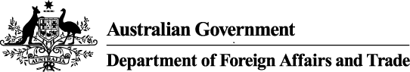

# Mekong Australia Partnership (MAP) – Call for Proposals Guidelines, Eligibility and Selection Criteria

**Instructions for Organisations:**

Please read the MAP – Call for Proposals Guidelines, Eligibility and Selection Criteria before completing the Invitation to Submit an Activity Proposal.

## Contents

Section 1 - Background

Section 2 - Eligibility Criteria

Section 3 - Selection Criteria

Section 4 - Process

Section 5 - Timeline

## Section 1 - Background

1. The second phase of MAP ($222.5 million over five years, 2024-25 to 2028-29) builds on the achievements and lessons of MAP’s first phase to progress the goal of a more resilient and inclusive Mekong subregion that pursues joint solutions to shared and transboundary challenges. The purpose of MAP is that Australia is a trusted and visible partner in supporting a resilient, inclusive and sustainable Mekong subregion. The second phase of MAP was announced at the ASEAN-Australia Special Summit on 4 March 2024.
2. This Call for Proposals focuses on four of the five MAP EOPOs, each of which align with DFAT’s forthcoming Southeast Asia Regional Development Partnership Plan:
3. Mekong subregion partners reduce vulnerability to impacts of climate change.
4. Mekong subregion partners manage water resources in a more coordinated and sustainable way.
5. Mekong subregion partners increase leadership and economic opportunities for women, people with disabilities, and other marginalised groups.
6. Mekong subregion partners enable strengthened economic resilience and subregional integration.
7. MAP will be delivered through long-term partnerships with a diverse range of partners, including with local organisations and, where possible, through locally led architecture in thematic priority areas of climate resilience, water security, economic resilience and sub-regional integration, gender equality, disability and social inclusion (GEDSI).
8. It will invest in subregional and/ or multi-country activities that respond to shared and transboundary challenges and seeks opportunities for collaboration with likeminded partners. Please refer to the MAP Portfolio Logic (Annex 1) and the [Portfolio Design Framework](https://www.dfat.gov.au/publications/countries-economies-and-regions/mekong-australia-partnership-phase-2-portfolio-design-framework) for MAP’s second phase for further information.

## Section 2 - Eligibility Criteria

### Organisations should meet the following criteria:

1. Operate as international, regional or national non-governmental organisations (NGO), civil society organisations (CSO), universities, research institutions, foundations or social enterprises.
2. Based in Australia and/ or the Mekong subregion and demonstrate an ability to operate in proposed countries of implementation through established offices, partnerships and/ or networks.
3. If shortlisted, be expected to meet [DFAT due diligence requirements](https://www.dfat.gov.au/about-us/publications/due-diligence-framework) through assessment undertaken by DFAT and/ or third-party assessor.
4. Eligible organisations may form consortia and submit proposals with two or more delivery partners.
5. All eligible organisations and consortia must demonstrate sufficient financial and organisational capacity to deliver the proposal.

### Proposals are requested that:

1. Are subregional and/ or multi-country in nature and address shared and transboundary development challenges.
2. Involve two or more countries in the Mekong subregion, including Cambodia, Lao PDR, Myanmar, Thailand, and/ or Vietnam.
3. Respond to one or more of the MAP EOPOs.
4. Focus on one or more MAP thematic areas, including climate resilience, water security, economic resilience and sub-regional integration, and GEDSI.
5. Mainstream approaches to strengthen gender equality, disability and social inclusion outcomes, outputs and activities, including indicators to measure GEDSI outcomes.
6. Require multi-year funding of between AUD 2m - 10m.
7. All proposals must have an end date no later than 30 June 2029.

### Proposals are not requested for:

1. MAP thematic areas of transnational crime, or cross cutting leadership and skills.
2. Investment values of under $2m, or bilateral (one country) in nature.
3. Implementation by managing contractors or other commercial service providers.
4. Implementation by international, regional or national governmental organisations, government aligned unions or mass organisations, or development banks.

## Section 3 - Selection Criteria

### Proposals will be assessed on:

1. Activity effectiveness:
   1. The extent the proposal demonstrates specific, measurable and achievable pathways to achieving one or more MAP EOPOs.
   2. The extent the proposal demonstrates relevant, timebound and sustainable plans, strategies, approaches to achieve intended outcomes.
   3. The extent the proposal responds to GEDSI priorities, including outcomes, approaches and reasonable accommodations.
2. Organisational Effectiveness:
   1. Extent proposal demonstrates sufficient organisational capacity and capability to efficiently implement and manage the proposal. Roles, responsibilities and resources are clearly defined.
   2. Extent the Organisation(s) have demonstrated impact in implementing similar investments in the Mekong subregion.
3. Value for Money (VfM)
   1. Extent proposal represents value for money (VfM) as assessed against [DFAT VfM principles](https://www.dfat.gov.au/aid/who-we-work-with/value-for-money-principles/Pages/value-for-money-principles).

## Section 4 - Process

### Eligible proposals:

1. Will progress to evaluation stage and be assessed by an Evaluation Committee on selection criteria outlined in Section 3.
2. That sufficiently respond to selection criteria will be considered for recommendation to the MAP Steering Committee for Endorsement.
3. If endorsed by the MAP Steering Committee, proposals may proceed to further design, quality assurance, approval and arrangement stages.
4. DFAT will notify applicants if proposals are successful, retained or unsuccessful.

## Section 5 - Timeline

1. Table 1 – Indicative Key Dates for Applicants

|  |  |
| --- | --- |
| **Date** | **Activity** |
| 06 Sept 2024 | Call for Proposals launched on DFAT Business Notifications. |
| 20 Sept 2024 | Information/ briefing session and Q&A. |
| 26 Sept 2024 | Final day for applicant questions. |
| 03 Oct 2024 | Final date for DFAT response to questions. |
| 11 Oct 2024 | Closing date for proposals. |
| Oct – Nov 2024 | Conformity checks and Evaluation Committee assessment |
| Dec 2024 | MAP Steering Committee review and endorsement. |
| Dec 2024 | Applicants notified of evaluation outcome. |
| Dec – Jan 2025 | Due diligence assessments of endorsed (as required). |
| Jan – Feb 2025 | Further design, feedback and quality assurance (as required). |
| Mar – Apr 2025 | Grant arrangement negotiations, clearances, financial approval and agreement signing. |

### Annex 1 - MAP Portfolio Logic

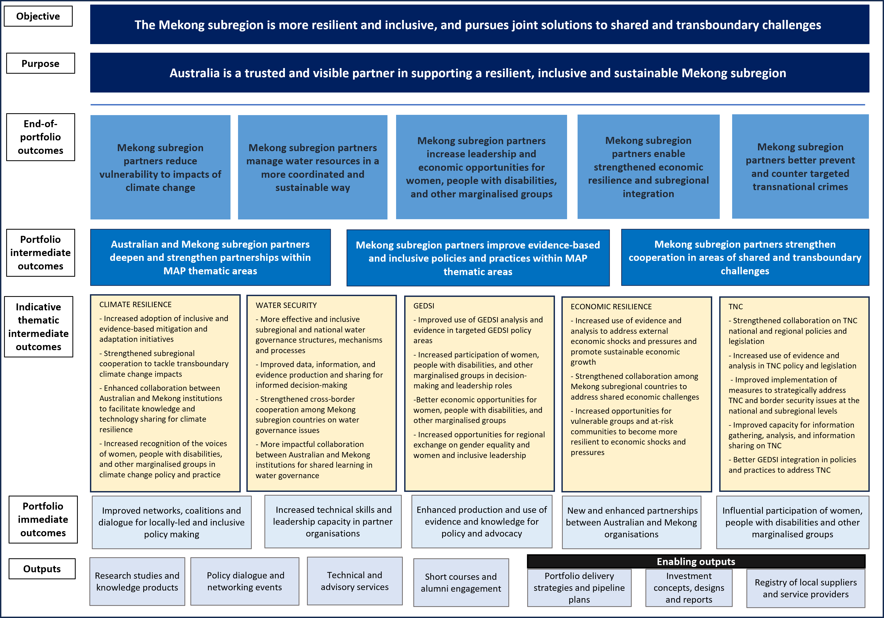

### Annex 1 - MAP Portfolio Logic (text version)

#### Objective

The Mekong subregion is more resilient and inclusive, and pursues joint solutions to shared and transboundary challenges

#### Purpose

Australia is a trusted and visible partner in supporting a resilient, inclusive and sustainable Mekong subregion

#### End-of-portfolio outcomes

* Mekong subregion partners reduce vulnerability to impacts of climate change
* Mekong subregion partners manage water resources in a more coordinated and sustainable way
* Mekong subregion partners increase leadership and economic opportunities for women, people with disabilities, and other marginalised groups
* Mekong subregion partners enable strengthened economic resilience and subregional integration
* Mekong subregion partners better prevent and counter targeted transnational crimes

#### Portfolio intermediate outcomes

* Australian and Mekong subregion partners deepen and strengthen partnerships within MAP thematic areas
* Mekong subregion partners improve evidence-based and inclusive policies and practices within MAP thematic areas
* Mekong subregion partners strengthen cooperation in areas of shared and transboundary challenges

#### Indicative thematic intermediate outcomes

##### Climate Resilience

* Increased adoption of inclusive and evidence-based mitigation and adaptation initiatives
* Strengthened subregional cooperation to tackle transboundary climate change impacts
* Enhanced collaboration between Australian and Mekong institutions to facilitate knowledge and technology sharing for climate resilience
* Increased recognition of the voices of women, people with disabilities, and other marginalised groups in climate change policy and practice

##### Water Security

* More effective and inclusive subregional and national water governance structures, mechanisms and processes
* Improved data, information, and evidence production and sharing for informed decision-making
* Strengthened cross-border cooperation among Mekong subregion countries on water governance issues
* More impactful collaboration between Australian and Mekong institutions for shared learning in water governance

##### GEDSI

* Improved use of GEDSI analysis and evidence in targeted GEDSI policy areas
* Increased participation of women, people with disabilities, and other marginalised groups in decision-making and leadership roles
* etter economic opportunities for women, people with disabilities, and other marginalised groups
* Increased opportunities for regional exchange on gender equality and women and inclusive leadership

##### ECONOMIC RESILIENCE

* Increased use of evidence and analysis to address external economic shocks and pressures and promote sustainable economic growth
* Strengthened collaboration among Mekong subregional countries to address shared economic challenges
* Increased opportunities for vulnerable groups and at-risk communities to become more resilient to economic shocks and pressures

##### TNC

* Strengthened collaboration on TNC national and regional policies and legislation
* Increased use of evidence and analysis in TNC policy and legislation
* Improved implementation of measures to strategically address TNC and border security issues at the national and subregional levels
* Improved capacity for information gathering, analysis, and information sharing on TNC
* Better GEDSI integration in policies and practices to address TNC

#### Portfolio immediate outcomes

* Improved networks, coalitions and dialogue for locally-led and inclusive policy making
* Increased technical skills and leadership capacity in partner organisations
* Enhanced production and use of evidence and knowledge for policy and advocacy
* New and enhanced partnerships between Australian and Mekong organisations
* Influential participation of women, people with disabilities and other marginalised groups

#### Outputs

* Research studies and knowledge products
* Policy dialogue and networking events
* Technical and advisory services
* Short courses and alumni engagement

##### Enabling outputs:

* Portfolio delivery strategies and pipeline plans
* Investment concepts, designs and reports
* Registry of local suppliers and service providers