**Investment Summary: MAHKOTA Indonesia**

***Menuju Masyarakat Indonesia Yang Kokoh Sejahtera***

**Towards a Strong and Prosperous Indonesian Society**

**Approximately $44 million over 4 years (July 2015­-June 2019)**

|  |
| --- |
| **OVERVIEW** |
| **Proposed start date and timeframe:** 1 July 2015 to 30 June 2019, possible extension |
| **Proposed funding allocation:** approximately $44 million |
| **Key interventions are still to be established with the incoming Government of Indonesia (GOI), but the program is likely to include:**  1. Support for policy reform of existing social protection programs   * We will focus on targeted policy advice and building on our investments using our valued position and relationships, building on work already done under the Poverty Reduction Support Facility (PRSF).   2. Support for the Unified Database (UDB) until 2016   * The Unified Database of 96 million poor beneficiaries has driven reforms to the national poverty programs and is supported by PRSF. Continued Australian support will give the GOI time to determine the UDB’s institutional home in the Indonesian system, should it change from TNP2K.   3. Support for a wider range of policy debate   * Australia has supported the World Bank to provide a think tank function to GOI on poverty and social protection. To develop indigenous capacity and diversify evidence, debate and opinion in this area MAHKOTA will support two additional national think tanks, as well the Social Protection Hub, a unit in the Australian aid program established to influence social protection policy discourse and programming.   4. Support for social security[1]   * Australia has provided small levels of assistance to social security through PRSF and the World Bank. Because of social security’s wide coverage and critical positioning in the labour market, improvements here can be transformational for the Indonesian economy and help address one of the major binding constraints to growth and competitiveness. MAHKOTA will also address the “missing middle”: the informal sector that is not covered by poverty programs but are still too poor to contribute to social security. |
| **Linkages to the new DFAT development policy and performance framework:**   * **Innovation**: MAHKOTA will support innovation, for example by improving and expanding GOI’s national conditional cash transfer (CCT) program and introducing new technologies for transferring benefits to beneficiaries that increase efficiency and promote financial inclusion. * **Social protection**: MAHKOTA directly supports improving national social protection that helps more people and communities become more resilient to shocks and stresses and to participate in their local economy. * **International competitiveness and effective governance**: MAHKOTA can support Indonesia to roll out its major employment insurance reforms; helping GOI reform rigid labour regulations that stifle investment and growth in jobs and addressing a key binding constraint to growth and competitiveness and improve labour market functions. This will lead to more investment, encourage more start-ups, and create more formal sector jobs. * **Education and health:** social protection - and CCTs in particular - is seen as one of the most effective investments to help improve neo- and ante-natal care and reduce child stunting, thereby addressing a drain of approximately 3-4% GDP on the Indonesian economy. Social protection is also proven to help families address cost constraints to sending their children to school. It helps improve demand for education and health services and promotes parents’ positive behaviour change. MAHKOTA will continue to strengthen the results DFAT’s support has already achieved in these areas. * **Gender equality and empowering women and girls:** GOI’s national CCT program is directly targeted to mothers, pregnant and lactating mothers and women carers of children. It helps them overcome financial constraints to accessing health and education services for themselves and their children, and empowers them by increasing their financial independence. MAHKOTA will continue to support the program to cover more poor women, especially in remote eastern Indonesia. MAHKOTA will also continue to improve the national scholarships for the poor program, which helps 11 million poor girls and boys enrol and stay in school. Improvements that DFAT has supported to the national targeting system helps poor girls gain equal access to scholarships. The program will support any new investments by Indonesia in social protection to be gender-sensitive and promote women’s empowerment where possible. |
| **Changes from existing support:**   * Less support for delivery systems (e.g. management information systems, complaint handling), more policy support, reflecting a smaller resource envelope than under PRSF. The budget may increase if opportunities arise in the future, but will still be subject to annual budget processes. * Support for national think tanks. * Possible increase in support for social security. |
| **Coordination and links with other approaches and sector programs:**   * **Frontline:** adopt DFAT’s Frontline approach of working cooperatively with other Australian-funded programs to mutually enhance results from Australian investments (See section 1.3.2) * **Economic governance:** on labour policies to promote flexibility for a more competitive labour market * **Education:** on private sector-led, and industry appropriate, tertiary education for a more skilled workforce * **Health:** for synergy between health insurance and employment insurance programs * **Women’s Empowerment:** on increasing women’s access to social protection and better jobs, and greater use of gendered analysis of poverty and vulnerability for more inclusive programs. |

INVESTMENT RATIONALE

## Context

**1.1.1 Background**

In 2009 the Government of Indonesia (GOI) established the National Team for the Acceleration of Poverty Reduction (TNP2K) under the office of the Vice President as a policy think tank to improve the quality and effectiveness of Indonesia’s poverty reduction programs that reach millions of poor Indonesians living below US$2 per day. Vice President Boediono requested Australia’s support for TNP2K, and Australia quickly mobilised the Poverty Reduction Support Facility (PRSF) in 2010. Australia’s support has helped GOI make its national social protection programs—which include poverty-targeted *social assistance* funded by government revenue and *social security* funded by member contributions—more efficient and effective, by increasing their coverage, accuracy, size of benefits and operational efficiency. Not least of TNP2K’s achievements was its role helping to secure $3.2 billion in savings from the fuel subsidy reduction in 2013.

PRSF will end in June 2015. With the inauguration of a new Indonesian President in October 2014, the next phase of support to social protection will need to maximise flexibility to be able to respond to the new government’s priorities. The new Indonesian Government will need to make further important reforms—including to the fuel subsidy—and our track record of support for TNP2K puts Australia (through DFAT) in a good position to continue providing technical support. But TNP2K’s role within the new administration will take time to confirm following the election outcome. Considering progress under PRSF and TNP2K, changes in the political economy of poverty reduction in Indonesia, and the country’s longer term evolution of social protection, this Investment Summary outlines the proposed approach to DFAT’s next phase of social protection support from July 2015 to June 2019. MAHKOTA Indonesia—*Menuju Masyarakat Indonesia Yang Kokoh Sejahtera* (Towards a Strong and Prosperous Indonesian Society)—aims to continue efforts begun under the current phase of Australian support to help Indonesia better reach and benefit the poorest as well as address key binding constraints to growth, competitiveness and rising inequality through ongoing labour market and social protection reforms.

Addressing the critical constraints to poverty reduction, economic growth and improved competitiveness goes beyond any single initiative. To reach these outcomes MAHKOTA will work closely with other Australian development programs including economic governance, education, health, and women’s empowerment.

**1.1.2 Key Issues**

**Falling economic growth as high levels of poverty and insecurity continue**

Over the past 25 years Indonesia has enjoyed strong economic growth accompanied by a significant reduction in extreme poverty from 23.4% in 1999 to 11.4% in 2013 (World Bank 2012; 2014a), but significant challenges remain. Continuing strong growth is not guaranteed, poverty reduction is slowing and large numbers of the population remain either poor or without income security.

While extreme poverty has fallen, a high proportion of the population remains vulnerable to falling into extreme poverty. There are still more than 28 million people below the current national poverty line of Rp302,735 per person per month (in March 2014, equating to around US$25/month). National survey data shows that around 200 million people — 80% of Indonesia’s population – experience poverty and/or insecurity and are highly vulnerable to shocks: 96 million people either live in or are vulnerable to falling into extreme poverty, while a further 106 million belong to a “emerging consumer class,” but still earn less than $3 a day (World Bank 2014a; Figure 1).

Poverty reduction has slowed in recent years and the poverty rate increased slightly in 2013 due to inflationary effects of the fuel subsidy reduction. The official poverty rate in March 2014 was 11.25%, suggesting that GOI is unlikely to achieve its goal of reducing poverty to 9-10.5% by the end of 2014. While GOI originally set its targets assuming an annual 2% reduction in poverty, actual rates over the past four years have been less than 1%.

**Figure 1: Distribution of Indonesian households by consumption**

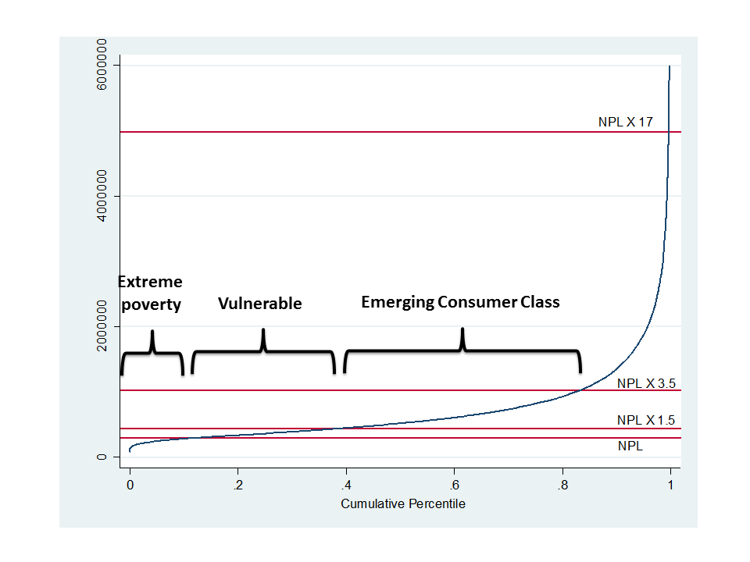

The slowing rate of poverty reduction is due to a number of reasons, but one is that the extreme poor—those in the poorest 10% segment of the population—are much further below the poverty line, and so require greater growth to get out of poverty (World Bank 2013). Another important reason is that the benefits of growth are unequally shared, and much less reaches the poorest (see below and figure 2).

**Structural weaknesses in the labour market**

Structural weaknesses in the labour market are a key risk to future economic growth. Although Indonesia enjoys abundant labour, it has not generated sufficient good jobs to fully share the benefits of growth with the working population (World Bank 2010). Too many new jobs are in the informal sector with limited expansion of employment in rural areas (World Bank 2013). Key weaknesses include low skill levels, low labour force participation by women and other key population groups, and excessively rigid regulations. This combined with the capital-intensive nature of Indonesia’s natural resource-based growth puts it on a trajectory of jobless growth (HKS 2013).

Education levels among the workforce are low and well behind regional competitors—only 25% have completed senior secondary school, and even for those who graduate the curriculum does not provide adequate skills for the labour market (World Bank 2010; 2013). Under-nutrition among young children is high and increasing, threatening future productivity – 37.2% of children under the age of five were stunted in 2013. This lost cognitive development costs Indonesia approximately 3-4% of GDP annually (Ministry of Health 2013; UNICEF 2013; World Bank 2014c).

In addition to high youth unemployment, both women and people with disabilities (PwDs) are under-represented in the labour force. Compared to regional competitors, women’s labour force participation is low and declining and is an important factor behind the country’s poor labour market performance (World Economic Forum 2014).

A major constraint to productivity is the labour market’s excessive rigidity: although Indonesia scores in the top 25% of countries in global competitiveness, it is in the bottom third for labour market efficiency (World Economic Forum 2014) with hiring and firing regulations among the most inflexible in the world (World Bank 2009). These negatively impact labour and growth: employers prefer to hire workers on informal or semi-formal terms or short contracts and are less likely to invest in skills development (World Bank 2014b); and they discourage investment by both national and international business (World Bank 2010). Ultimately this pushes new workers into the informal sector, while few workers in the formal sector benefit, as most receive little or none of their severance pay (World Bank 2010).

**Rising inequality and potential instability**

Widespread income insecurity is accompanied by growing inequality. Indonesia has had the highest sustained increase in inequality among Asia’s larger countries (World Bank 2014c). The Gini coefficient is 0.41 but the real level of inequality may be higher since the wealthiest households are under-represented in national Indonesian household surveys such as SUSENAS (World Bank 2014c). As a result, the benefits of growth have been unevenly shared: while the average annual growth in household consumption was 4.87%, it was less than 2% for the poorest half of the population versus 7% for the richest households (Figure 2).

**Figure 2: Distribution of growth benefits across population by wealth status (2008-12)**

High and growing inequality negatively impacts both economic growth and poverty reduction[2] and can also lead to political instability.

Across Indonesia’s districts high inequality correlates with conflict-related violence and deaths (World Bank 2014c), and in its recent past inequality and poverty in ethnically divided areas have been major sources of violence (HKS 2013).

**The national social protection system**

Indonesia’s national social protection system consists of several centrally-administered, poverty-targeted programs and a set of new social security programs. Although the system aims to cover all Indonesians, there are significant gaps related to children, PwDs, the unemployed and the elderly. Investment in social assistance is only 0.5% of GDP, below the developing country average of 1.5% (World Bank 2012), and coverage is limited to between 6% and 12% of poor households.[3] These factors contribute to why Indonesia was ranked 27th out of 35 Asian countries in a recent review of social protection across Asia.[4]

Indonesia’s social security schemes are still emerging and agencies to provide health and employment benefits only came into force in 2014. As of this year Indonesia has the world’s largest single payer health insurance system, and it will have the largest employment insurance scheme in 2015 when it starts to roll out coverage as mandated in Laws 40/2004 and 24/2011. GOI’s aim to cover all workers by 2019 will be difficult with only 10% of the 120 million member workforce currently contributing. To reach its targets the employment insurance agency BPJS Employment needs technical assistance to enable members wherever they live to pay regular contributions; actuarial assistance to ensure contribution rates are fiscally sound; and advice on fund investment. Poorly designed social security can negatively affect the labour market and growth. Setting employee and employer contributions too high creates incentives for avoidance, dissuades employers taking on additional employees and discourages business investment. If contributions are too low, government bailout schemes may be required.

**Moving towards comprehensive social protection**

A major challenge for Indonesia is how to align its new social security programs with social assistance to create a better-functioning social protection system. GOI’s aspirational poverty reduction strategy[5] advocates for this in the long-term, with a vision of comprehensive social protection that will address key lifecycle risks and provide protection to all Indonesians by 2025. Australia provided financial and technical support to Indonesia’s National Development Planning Agency (Bappenas) to develop its long-term poverty reduction strategy and is now supporting Bappenas to develop its next five-year plan for poverty reduction, including the role of social protection.

In the short term the policy priority has been to target programs to the poor and extreme poor. Through TNP2K’s work GOI has developed a single Unified Database (UDB) for all social assistance beneficiaries. The main national programs have adopted the database and improved their outreach to the poor, but methodological and implementation constraints place an upper boundary on the database’s accuracy (SMERU 2011). At the same time the policy focus on reaching the poorest limits the constituency for improving and expanding programs and this contributes to underinvestment, low coverage and benefit levels, and weak delivery systems. Without a change in approach it will be difficult to reach GOI’s vision for a social protection system that can address the needs of the poor, vulnerable and emerging consumer class, and effectively address inequality.

To help meet these challenges Indonesia needs creative, local solutions appropriate to its unique context. But within national think tanks there is limited capacity to generate and promote new ways of thinking in the social protection field. Aside from SMERU and a small pool of national social protection experts there is no other independent (i.e. non-government) institutional capacity. The potential for institutional growth exists but is constrained by lack of financing and (often donor-driven) competition for experts. Historically the World Bank has filled this gap, providing high-quality analysis and policy advice, but with little debate or contestability. Recently TNP2K has stepped in, and with some of the country’s best researchers and analysts it has successfully brokered a series of policy reforms, but as a GOI institution it cannot provide independent views.

**Fiscal space for expanding social protection**

One of TNP2K’s major policy achievements (with PRSF’s assistance) was design of a compensation package that enabled GOI to reduce the fuel subsidy in 2013, freeing up well over $2 billion for social protection programs. Fuel subsidy reform is a critical ongoing policy concern because it is a massive drain on the budget, crowding out other government spending, but politically is extremely difficult to remove. While the subsidy mainly benefits the better off in terms of aggregate spending, in terms of its contribution to household consumption the main beneficiaries are the emerging consumer and middle classes (figure 3). The implication is that any future cut in the subsidy without compensation to this group will be opposed, as occurred in the past.

**Figure 3: Distribution of subsidy spending across deciles and per capita expenditure (PCE)**

Reducing fuel subsidies will be a top priority for the new President’s administration. But with any plans to reduce subsidies gradually, pressure on the budget will remain strong and this will prolong any planned expansion of sustained social protection, although subsidy reform will likely be smoothed with intermittent short-term compensation programs.

## Australian support to date

Since 2010 Australia has supported GOI’s poverty reduction policy and programs through two main vehicles: the PRSF, administered by a commercial contractor, and the Partnership for Knowledge Based Poverty Reduction, a World Bank trust fund. The majority of Australian funding is channelled through PRSF for activities that allowed TNP2K to undertake research, pilots and evaluations. To date PRSF has supported TNP2K with technical assistance; operational support; commissioning and quality assuring, and implementing TNP2K activities.

In the first phase Australian funds were used to establish TNP2K; engage national and international experts to advise GOI on reforms to Indonesia’s major social assistance programs; and establish the UDB, a single registry of the poorest 40% of Indonesians (approximately 96 million individuals), now used by national programs to determine eligible beneficiaries. PRSF also assisted GOI to expand the reach of its social assistance programs, covering an additional 9.2 million poor people (more than half of whom are women). The compensation package for increased fuel prices kept 6 million people from falling into poverty in 2013.

Since 2010 Australia has invested $72 million in support of TNP2K which has leveraged over $5 billion of GOI investment in national poverty-targeted programs, benefitting up to 85 million poor individuals. For additional results and details see Annex 1.

## Future support to the new Government of Indonesia in the next phase

Australia is well positioned to build on the success of its on-going investments in social protection. It has developed an in-depth understanding of the social protection context in Indonesia, built strong partnerships across government and with other development partners, and is recognised as having expertise and a strong comparative advantage in the field. Our support for TNP2K has been successful and is highly valued, and Australia is well positioned to continue with further support to GOI’s poverty reduction and development agenda. Our support has created openings for key decisions on the fuel subsidy to be made and supported a productive partnership with high levels of the government. Further critical economic reforms (not least to the fuel subsidy) will be needed early in the new Indonesian government’s term, and Australia can constructively assist GOI to determine how to create the policy space and public support to succeed.

GOI’s long-term strategy is guided by a broad vision of comprehensive social protection for all Indonesians by 2025. It can potentially help address the challenges of reforming and strengthening the labour market, dealing with the insecurity felt by a majority of the population, and preparing the country for demographic change as it becomes an ageing society. But the strategy is less clear on the specifics of how Indonesia can reach this ambitious goal in 10 years. It also requires significant development of policy alternatives, operating systems and the capacity to implement them.

The implementation modality for MAHKOTA will be similar to the current PRSF: a flexible facility that is able to respond to GOI priorities, provide world class and top Indonesian expertise, and allow GOI to take risks with innovating policy. PRSF has delivered the right support when and where needed in a relatively fluid, difficult to predict environment. Those characteristics will continue to define the policy context in which Australia’s support will operate, particularly at the start of a new Indonesian government, and it will be important to apply an approach that maximizes flexibility and responsiveness.

This follows an evolution of support that began with a focus on poverty programs and provided intensive funding and assistance for both policy and operations, with some small, key support for GOI’s social security programs and its long-term strategy for social protection. MAHKOTA will be developed and finalised in consultation with the new government. It will continue policy-level and targeted assistance to the poverty programs, making sure GOI is able to maintain the reforms instituted under TNP2K; and provide more intensive policy and, if resources allow, operational support for social security. An economic appraisal and value for money analysis has confirmed a high return on investment for Indonesia and Australia of this approach.

Priority areas for strengthening and reforming the national social protection system include:

* Continuing support to TNP2K to operate the UDB and expand reforms to poverty-targeted programs;
* Reforming labour legislation and introducing unemployment insurance to promote greater labour market flexibility, lead to more, better jobs and improve Indonesia’s competitiveness.
* Developing mechanisms to deliver and integrate social protection services across local government, mediate central GOI processes and facilitate supply, demand and accountability;
* Strengthening human development especially for the poor by helping reduce under-nutrition and enabling more children to gain an education that prepares them for the work force;
* Ensuring social protection helps workers develop skills and enables young people, women and PwDs to engage more actively and productively in the labour market;
* Establishing an effective old age and disability pension system and ensuring BPJS Employment generates investment funds without distorting employment and productivity growth; and
* Other areas supporting emerging priorities, to be agreed with the incoming GOI.

Investment by Australia in social protection will complement and enhance the effectiveness of its support in other areas. Social protection is a key driver of the demand side for services, facilitating access and strengthening results from other sectoral interventions. This includes:

* **Economic governance:** well-designed social protection can be part of the solution to economic governance priorities and help manage difficult reforms, such as reducing the fuel subsidy or promoting more flexible markets.
* **Education:** increasing family income addresses a key reason children drop out of school. Helping tackle under-nutrition improves the cognitive development of children so they perform better at school.
* **Health:** access to social protection can improve health outcomes for both children and adults, and health insurance and social protection are both essential to help families deal with the risk and consequences of ill-health.

Gender

Gender considerations are central to MAHKOTA’s design. Strengthening Indonesia’s national social protection system provides a major opportunity to develop poverty reduction programs that will benefit a large number of women and girls. Indonesia’s policies and programs for dealing with the gender aspects of poverty reduction can still be improved to ensure women and girls have access to programs and maximise opportunities to empower women through social protection.

Australia’s support to social protection programs will operate on a principle of gender-sensitive programing, including: improving the accuracy of gender-disaggregated data wherever possible; including quantitative and qualitative analyses of gender as it is linked to poverty programming; and pioneering new program concepts or components that can address the gendered aspects of programs.

Australian support will also provide a useful mechanism to expand policy dialogue with key partners to involve women’s organisations in advisory and operational roles and draw on other development programs (such as women’s empowerment) to provide useful platforms for promoting dialogue between government and these non-traditional partners. DFAT’s ability to bring such partners to the general poverty discussion is a unique reason for Australian engagement in this area.

Frontline

DFAT has adopted as a priority an approach that supports GOI’s efforts to improve frontline service delivery in its own programs. The Frontline approach embraces the principles of local solutions for local problems, flexibility of programming, cross-sector coordination and leveraging, and strong monitoring and evaluation to inform decisions on scaling up by the Government of Indonesia. It assumes that better service delivery outcomes will only be achieved when programs cooperatively and collaboratively work together. To ensure this, DFAT has developed the following operational principles for managing contractors:

* Ensure managing contractors in a geographic co-location collaborate by:
  + working together and complementing each other based on their comparative advantage to achieve better outcomes;
  + avoiding redundancy and gaining efficiency;
  + improving coordination and communication with stakeholders representing a single DFAT position in policy dialogue with GOI; and
  + having a mechanism to resolve division of labour issues in the collaboration.
* Recognise GOI responsibility for service delivery and DFAT’s supportive role.
* Have flexibility to work together with other monitoring and evaluation support to provide independent and credible evidence on program results.
* Have flexibility to support demonstrations, experiments and explorations on innovative local solutions.

DFAT expects the MAHKOTA managing contractor to actively incorporate these principles into its own implementation approach.

INVESTMENT STRATEGY

## Australia’s social protection support portfolio

MAHKOTA and support through the World Bank are two mechanisms supporting a single, GOI-led agenda. Each will be guided by a separate Steering Committee (SC), chaired by Bappenas or another agency, with representation from other agencies supporting GOI’s social protection.

The SC’s role in guiding the DFAT social protection portfolio as well as arrangements for coordination between the multiple modalities described here are discussed further in Section 3.2.

This section focuses on the purpose and strategy for the MAHKOTA program, except where it links with other investments, including through the World Bank and other DFAT-supported programs.

As part of a small extension to our support for World Bank under this initiative, the Partnership for Knowledge Based Poverty Reduction will expand its analytical work and develop a flagship research product on a key emerging challenge, to be agreed with GOI and DFAT. The World Bank will also strengthen its coordination with partners and other research and policy users; enhance the monitoring and evaluation of its own work; and continue planned technical assistance for social security reform implementation.

## Purpose

In four years of operation PRSF has focused support on reforms to the operational elements of Indonesia’s national social assistance programs—in line with TNP2K’s mandate. In its final year PRSF will consolidate and embed those reforms and hand over to the respective implementing agencies. The next phase of support will continue improvements to social assistance programs—including a home for the UDB—and also look at how they complement GOI’s social security programs. Under MAHKOTA, DFAT takes a holistic view and aims to help establish and strengthen a social protection *system* by providing strategic support to key system elements—policies, programs and tools—and how they interact.

This rationale also recognises the need to support programs that address not only the extreme poor but the near poor and vulnerable. TNP2K has focused on improving programs that target the poorest 10% of the population. However the World Bank estimates that nearly 40% of the population live in or near poverty and another 40% just above this, surviving on less than $3/day and vulnerable to shocks even though they are considered the “emerging consumer class.” Programs targeted to the poorest 10% will not reach the majority of this group, and because of methodological limitations of the targeting process it will not fully cover the poorest 10%.[6] Also vulnerability in Indonesia is high and many people frequently fall in to poverty through everyday or catastrophic shocks, and a static database cannot capture this dynamic movement. Targeting the poorest also misses many affected by widespread stunting and poor nutrition, which cuts across income levels.

GOI’s long-term strategy is to provide protection for all Indonesians, but coverage for key vulnerable groups—e.g. elderly poor, PwDs, the working poor and unemployed—is inadequate or missing. GOI’s strategy is to cover these groups by expanding poverty programs and through participation in the new social security programs. However this creates a problem of a “missing middle”. The very poor are covered by GOI assistance, and those in formal sector or salaried jobs will benefit from social security. The vast majority in the middle — the vulnerable and emerging consumer class who don’t qualify for social assistance, and find it too difficult to contribute to social security – will be left out.

MAHKOTA will tackle these key challenges as well as some of the institutional and labour market constraints that hinder economic growth and can lead to greater instability. It will help Indonesia strengthen and expand social assistance, continuing the series of reforms begun under TNP2K; align it with social security programs; and develop policies that address both the needs of the extreme poor and the emerging but vulnerable consumer class. It responds to a clear demand by GOI (from the Ministry of Finance, the National Social Security Agency (DJSN) and Bappenas) to support implementation and rollout of BPJS Employment, a high-profile, major national initiative with important implications for several critical areas of the economy, operating under an extremely ambitious timeframe. GOI has also requested assistance to develop policy capacity for employment insurance, an area in which Australia has a comparative strength.

This is part of a long-term strategy of support that will achieve some results in the short to medium term—primarily around continued improvements to social assistance programs and better operations for BPJS Employment and DJSN—and some results in the longer term, e.g. employment insurance policy. Because of social security’s wide coverage and critical positioning in the labour market, improvements here can be transformational for the Indonesian economy. Of course these need to be complemented by addressing the other major constraints to Indonesia’s poor job growth, including a poorly skilled workforce; low infrastructure spending and poor connectivity; and counterproductive trade and investment policies. MAHKOTA will continue the provision of policy support to cover those left out of social security.

## Investment logic

Overview

In line with GOI’s long-term strategy, the program goal for MAHKOTA is “Contribute to a comprehensive and equitable social protection system[7] for the whole of Indonesia by 2025.” If this is achieved–although not by MAHKOTA alone–it will support the higher-level development goal of: “*All people are able to withstand economic, political and environmental shocks and stresses.”*

This, in turn, will contribute to the Australian aid program’s overall purpose of “Promoting Australia’s national interests by contributing to sustainable economic growth and poverty reduction*.”*[8]

Given the evolving nature of Indonesia’s social protection system and DFAT’s limited investment, by 2019 MAHKOTA will have helped to lay the groundwork for an eventual national social protection system through better policies with measurable improvements in welfare and coverage through three overlapping outcomes:

* **Outcome 1:** *Quality of the national social protection system is improved;*
* **Outcome 2:** *More comprehensive and joined up social protection and labour market policy is delivered; and*
* **Outcome 3:** *Synergies with wider social and economic policy and planning are enhanced.*

MAHKOTA could achieve these outcomes through support for the following:

* Building on the experience and relationships established under PRSF, and guided by the priorities of the new government, continue support for consolidating TNP2K’s progress with poverty targeted programs and evolution of the national targeting system; and work with GOI ministries and agencies to provide technical assistance to develop and improve their social protection programs (**Output 1**).
* Support think tanks to improve national capacity for social protection and labour market policy analysis and dialogue (**Output 2**).
* In close collaboration with the Australia-Indonesia Program for Decentralisation (AIPD) support expansion of district-level mechanisms to integrate and coordinate social protection services and manage complaints, referrals, public awareness and information management. The current PRSF is developing a pilot for this with Bappenas. This will be the entry point for integrating DFAT’s Frontline approach and principles into MAHKOTA. Social protection cuts across all aspects of the Frontline approach and the integrated referral services concept is a pragmatic way to link the two programs (**Output 3**).

With uncertainty around what the new government’s specific priorities will be, the facility approach provides the greatest flexibility and allows flexible, responsive support that can be adjusted to GOI’s needs and priorities–while the longer term GOI strategy is fairly well articulated, the incoming GOI in late 2014 may have additional related priorities that will need to be accommodated. The logic of supporting a social protection system and including social security and social assistance (i.e. current poverty-targeted programs) opens up a greater range of capacities and choices in addition to the ones currently supported by PRSF.

To date, DFAT has supported PRSF with a significant operating budget. With a smaller resource envelope from DFAT at the start of phase two we will no longer be able to provide operational support[9] in social protection programs. The focus will be narrowed and the program will provide high level policy dialogue opportunities through targeted assistance for policy advice and development. The full range of GOI partners will be determined once priorities are clear in 2015 after the new Indonesian government is in place, and work plans can be designed for priority social protection interventions. A wide range of possible partners has been included in the proposed organisational and governance structures, to illustrate the breadth of work that could be undertaken by MAHKOTA. This gives us maximum flexibility in being able to respond to new GOI priorities, within the proposed budget. If further resources become available, this model can be scaled up, or the size of investments with different partners can be designed and scaled accordingly.

Figure 4: MAHKOTA Theory of Change

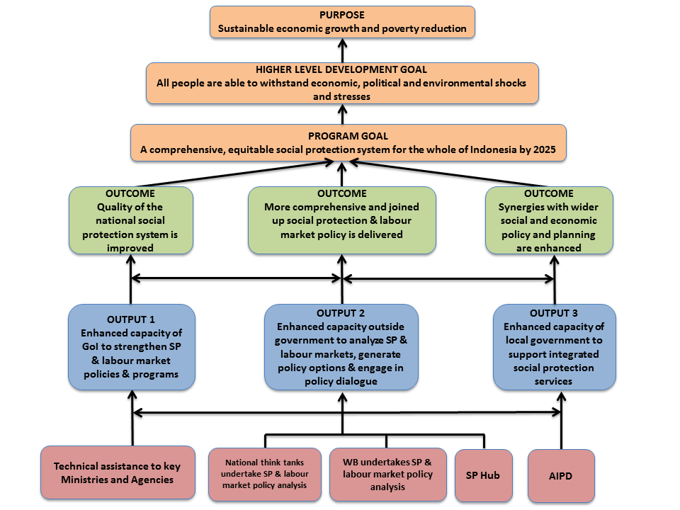

ROLES AND RESPONSIBILITIES

## Organisation

Figure 4 summarizes the overall MAHKOTA structure. DFAT will manage two contracts: one with a Managing Contractor (MC) and the other with the World Bank. The MC will be responsible for all technical assistance and other support placed within each institution, while also managing the Jakarta-based component of the Social Protection Hub (SP Hub).[10] While each institution will have indicative staff and budgets allocated to it, the MC will manage additional funds that can be allocated across institutions on an annual basis. The World Bank will manage its own funds and report directly to DFAT.

Figure 5: Example organisational structure, priorities and partners to be confirmed with next GOI

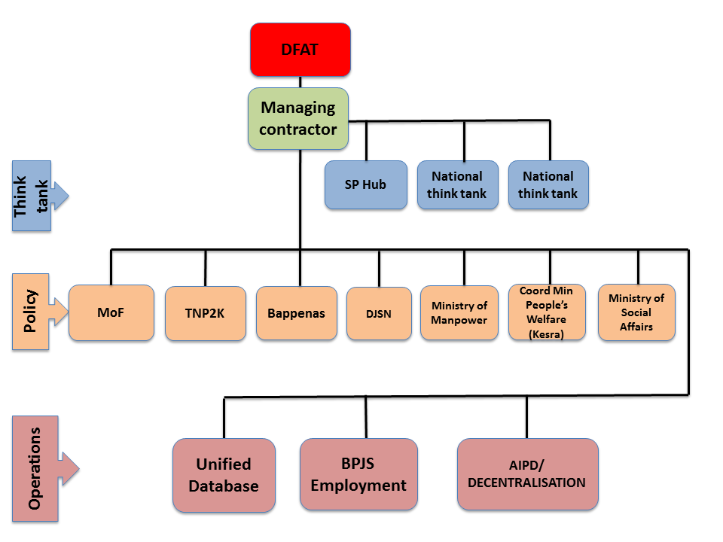

## Governance structure

The primary stakeholders of MAHKOTA are DFAT, GOI ministries and agencies involved in the program, and two national think tanks (to be identified). All organisations funded through MAHKOTA will work closely with GOI to strengthen the national social protection system.

An overview of the MAHKOTA governance and management structure is set out in Figure 6. The program will be anchored in a Steering Committee (SC) comprising senior management from DFAT, Bappenas, Ministry of Finance (MoF) and TNP2K (if it continues). Member ministries will depend on priorities supported by the Facility, to be determined in early 2015 by the new GOI. The SC will meet on a six-monthly basis, providing strategic direction to the program. It will endorse work plans and budgets, review six-monthly and annual reports, discuss progress, recommend strategic-level changes to the program and communicate the results of the program to GOI and DFAT. The MC will coordinate annual reporting and contribute secretariat support to the SC as required.

Figure 6: Example governance and management structure, if the widest range of activities is undertaken

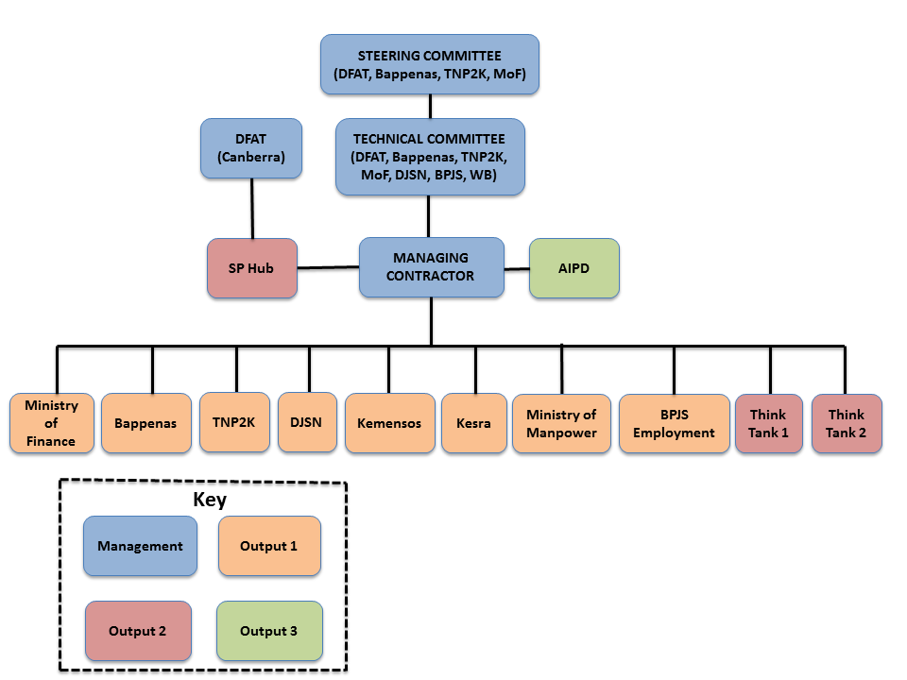

There are two branches to the program: one delivered by a MC and the other delivered through the World Bank. The governance and management of each branch is discussed below.

## Managing Contractor

A Technical Committee (TC) led by DFAT and comprising staff from Bappenas, TNP2K and other relevant ministries will meet regularly with the MC. It will review program plans, budgets and reports before they are considered by the SC and will discuss progress with the program, endorsing any changes to annual plans and budgets.

The MC will be responsible for the implementation of MAHKOTA (apart from the World Bank component). Its specific responsibilities will be set out in terms of reference and will include:

* Managing an inception phase to mobilise the facility, confirm GOI priorities and plans and produce a detailed first year work plan.
* Establishing an in-house technical and administrative team that will be responsible for the management, administration and technical oversight of the program, reporting to DFAT.
* Contracting all long-term consultants embedded within GOI ministries and agencies, ensuring their effective performance.
* Managing a pool of short-term consultants that can undertake assignments for GOI in support of the embedded engagement teams and DFAT.
* Selecting the two national think tanks and overseeing their performance.[11]
* Facilitating the operations of the SP Hub.
* Coordinating with AIPD to deliver Output 3, and coordinating with other program areas as directed.
* Facilitating the development of work plans, budgets and reports for the ministries, agencies and think tanks supported by MAHKOTA and consolidating them for the TC and SC.
* Providing effective management of all funds available to the ministries, agencies and think tanks, as well as funds directly implemented by the MC and SP Hub.
* Prepare a capacity development strategy including for think tanks.
* Quality assuring all deliverables produced by MAHKOTA, including those produced by the SP Hub if requested by DFAT.

During the MC tender process, bidders will present proposals on their ability and experience to source technical and administrative facility staff. Technical staff will have the skills to provide advice and support to the long-term consultants, quality assure all deliverables and undertake research and analysis as required by DFAT, providing advice to the DFAT social protection team and the SP Hub.

“Engagement teams” will be established within GOI ministries and agencies. They will be embedded within GOI structures, working alongside government counterparts. They will report into government management structures, which will be agreed during the Inception Phase. Combined GOI and technical assistance teams will produce regular work plans, budgets and reports provided to the MC, and will be responsible for the effective delivery of their work plans. They will also be responsible for developing more detailed proposals for specific activities, which will be reviewed by the MC and endorsed by the TC.

Each combined team within a GOI ministry or agency will be allocated an annual, minimum funding envelope. However, they will be able to access additional funds from the MC through proposals set out in their work plans, if endorsed by the TC and/or SC.

The national think tanks will be allocated funding on an annual basis, which should be used to contract specialist staff and undertake research, analysis and communications. The think tanks will produce annual work plans and budgets that will be endorsed by the SC.

The MC will contract staff to work within the SP Hub on behalf of DFAT, and SP Hub staff will report directly to a Senior Social Protection Specialist based in Canberra. Together they will produce annual work plans and budgets that will be endorsed by DFAT Canberra. Annual reports from the SP Hub will be reviewed and endorsed by DFAT Canberra.

## World Bank

The World Bank’s role under the first phase of DFAT’s social protection support was to play a think tank function, providing analysis and policy advice to GOI for poverty reduction and social protection. In addition to just-in-time policy advice, the World Bank made key contributions to the development of the UDB; produced the first public expenditure reviews of the national poverty-targeted social assistance programs; and catalysed development of GOI’s employment social security roadmap.

It will take some time before national institutions are able to deliver policy advice of the same quality and responsiveness as the World Bank, so DFAT will continue to support the World Bank in this role. We will maintain the current Trust Fund arrangements with the World Bank including the existing governance structure and reporting arrangements. The Trust Fund operates under the oversight of a Steering Committee co-chaired by DFAT, TNP2K and the World Bank that meets annually. A Technical Committee consisting of DFAT, TNP2K, World Bank and Bappenas meets quarterly to assess critical needs and recommend appropriate actions. To improve coordination with MAHKOTA and reduce transaction costs the World Bank Trust Fund and MAHKOTA Technical Committees will be merged, but the existing Trust Fund Steering Committee will be maintained.

The World Bank team provides annual plans and budgets that are approved by the Trust Fund Steering Committee. In addition to quarterly TC meetings the DFAT Jakarta social protection team program manager and adviser meet regularly with the World Bank team to review progress and expenditure. Any significant changes in plans and budgets will have to be approved by the Trust Fund Steering Committee.

## Coordination – MAHKOTA MC and World Bank

The MAHKOTA MC Team Leader and the World Bank Manager will not have any formal accountability to, or responsibility for, one another. They will coordinate over annual work planning and activity development through the TC. MC and World Bank staff will collaborate on individual activities as determined by their work plans, which will be developed in coordination with one another.

## DFAT

The DFAT Social Protection Unit and adviser in the Jakarta team will regularly engage with the MC and GOI partners to monitor the strategic direction of the program and monitor performance. They will ensure that activities are on track and deliverables are of high quality. Payment to the MC will be on a reimbursable basis and dependent on acceptable performance.

The contract and supplier performance will be managed via:

* Regular semi-annual progress reports by the MC that will be responded to by the Jakarta office social protection team.
* Independent Annual Reviews and a more comprehensive mid-term review that will inform contractor performance assessments. DFAT staff will participate in reviews where appropriate and ensure recommendations are agreed and acted upon.
* An annual audit commissioned by the MC through an independent audit firm to monitor expenditure, procurement and asset management.
* DFAT will assess progress and the MC’s performance in monthly update meetings with the facility management and consultation with MAHKOTA partners. To facilitate this, the social protection adviser will be co-located part-time in the facility offices, a practice that has worked well under PRSF.

IMPLEMENTATION ARRANGEMENTS

## Inception

Mobilisation (July-September 2015)

DFAT anticipates that management of an unspecified set of activities and personnel will move from the PRSF and any directly administered contracts to the new MC. DFAT will work with PRSF from early-2015 to identify these and develop a transfer plan, prioritising activities or support where disruption poses significant risks. The expectation is that the MC will action this plan so new contracts are processed during the mobilisation period. Not all PRSF activities will automatically move to the MC.

A small number of specific individuals may be moved to the MC from TNP2K at DFAT’s request. They will be subject to probation periods with the MC deciding whether or not to continue their contracts based on performance. Some sub-contracts may need to be novated or renewed. Activities in this category will be subject to review at a time agreed with the MC to ensure they are still contributing to the facility’s strategic direction. By the end of this period the MC will have produced a facility operations manual that will include a communication and knowledge management strategy and an easy to follow quality assurance process for individual activities and investments.

Additional outputs normally completed at the end of a mobilisation phase may be better completed during the Strategic Planning Phase, as described below.

Strategic Planning phase (July-December 2015)

Regardless of what activities transfer from PRSF to MAHKOTA, the MC will work with DFAT and other stakeholders to confirm the new Indonesian government’s direction and priorities for social protection and poverty reduction. It will take the 2013 inception strategy for PRSF’s second phase as a starting point, bearing in mind that much will have changed in the intervening two years. This strategic planning phase should also include a review of technical assistance currently provided through PRSF, and make recommendations for consolidating and adjusting technical assistance to support the directions set by the strategy. By the end of this period the MC will have produced:

* A four-year guiding strategy to be endorsed by the SC;
* A monitoring and evaluation framework and plan and value for money reporting strategy, in line with DFAT requirements for quality and results/benchmarks reporting. Program-level monitoring and evaluation will feed into Frontline sector outcomes, country level outcomes and aid benchmarks;
* A capacity development strategy;
* The first annual work plan, setting out clear deliverables, together with other partners, to be endorsed by the SC.

## Program management and delivery

Annual work plan

The MC will be responsible for resourcing an annual work planning process, which will set out priority activities for the coming year. This will be directed by the needs of GOI and prepared in consultation with key stakeholders, with an emphasis on balancing their multiple needs. The MC will prepare the work plan and present to the SC for endorsement. The annual work plan will set out tasks and deliverables for the MC that will be the basis for assessing contractor performance.

Activity development and quality assurance

The MC will be responsible for developing high quality activities as set out by the annual work plan. It will establish a simple Quality Assurance (QA) process for individual activities over a given value to ensure their quality, value for money and coherence with strategic objectives. The QA process will incorporate external review for activities over a given value, with the TC playing a role in endorsement of final technical designs.

Reporting

The MC will be responsible for preparing annual and semi-annual reports.

## Personnel

Core management team

DFAT’s approach to market will suggest five key roles, with the MC determining the actual organisational structure:

* A Team Leader, responsible for setting and maintaining MAHKOTA strategic direction, navigating multiple and sometimes competing needs for support. The Team Leader should have a good understanding of social protection and poverty reduction and excellent cross cultural and interpersonal skills.
* An Operations Manager, responsible for human resources, finance and procurement, IT services, facility logistics and other operational matters.
* A Technical Manager with primary responsibility for ensuring the overall quality of activities and outputs and systems to support that.
* A Monitoring and Evaluation Specialist, who will support M&E for individual activities, as well as developing and reporting against the MAHKOTA M&E framework.
* A Capacity Development specialist, who will be responsible for developing the facility’s capacity development strategy and coordinating needs assessments and capacity building activities.

Policy and Technical Specialist team

A small number of senior national and international policy and technical specialists may be individually specified by DFAT in the Scope of Services. All will be subject to probation periods. The policy and technical specialists will lead on discrete work areas and activities, with roles to be determined by the Team Leader. Broadly, however, individuals will have been identified for their capacity to act as brokers bringing together relevant government agencies to further policy agendas, coordinate effective technical assistance, and ensure linkages with other GOI development priorities. Specialists will be capable of providing advice to government relating to financing, technical design and implementation arrangements for the UDB and national social assistance program reform, drawing on their engagement in these areas under PRSF.

## Indicative capacities

In order to deliver the strategies set out in Section 2, the MC will be expected to be able to:

* Source and recruit high quality national and international technical assistance personnel to support GOI, as well as monitor the technical assistance provided to ensure its effectiveness and continued relevance to the MAHKOTA implementation strategy.
* Support GOI in the development of strategic policy documents and implementation plans.
* Develop and procure strategies, systems and tools to support monitoring of GOI’s program investments.
* Work flexibly, to be able to manage a potential scale up of resources to respond to emerging priorities and to be able to respond quickly when key opportunities for support to GOI arise.
* Should additional resources become available during the program, commission, design and implement pilots, for the purposes of experimentation, establishing proof of concept and practicing delivery, using a range of methodologies.
* Commission, design and implement high quality analytical work and evaluations using a range of methodologies.
* Communicate effectively with a variety of audiences and key stakeholders, including by organising and hosting visits for national and international groups.
* Support national and international knowledge exchanges, through organisation and delivery of site visits, national or international workshops and training activities.
* Provide exceptional back-office support for the facility’s management and operations, for example: procurement, IT, human resources, and strategy and work plan development and management.

## Operating principles

The MC will be guided by the following principles in its approach to supporting GOI:

* **Play a brokering and consolidating** **role**: MAHKOTA will likely work with multiple government stakeholders with various technical and capacity building needs. The MC will play a brokering role between stakeholders, most importantly for the development of a consolidated work plan as well as for activity implementation. Rapid response support may be required to take advantage of key windows of opportunity that arise in policy dialogue.
* **Take a problem-solving and hypothesis-driven approach**: Activities, especially analysis and evaluation, will be relevant to GOI’s needs and framed to answer questions it asks, starting with strong consultation, for developing annual work plans and activities.
* **Communicate well**: by keeping stakeholders regularly informed of progress, involved in activities, and presenting results in ways useful for policy making and implementation.
* **Value evidence**: The MC will invest in, and use, high quality evidence to inform effective policies and programs.
* **Complement capacity**: The MC will avoid displacing or replacing government capacity or roles. It will provide complementary capacity under GOI leadership, creating a sustainable model for sourcing high quality national and international technical expertise to complement core public service staff.
* **Create space for innovation**: The MC will take on innovative concepts while working towards take-up and mainstreaming once concepts are proven to work.
* **Remain flexible**: The MC will operate in a time of change and transition for GOI programs and policy, as well as key stakeholders. The MC may also need to manage increases to funding.

## Services

DFAT will ask MC bidders to propose long and short term staffing arrangements, structures and processes that will ensure MAHKOTA:

* mobilises, plans, manages and delivers a program as described in 4.1 and 4.2;
* has the capacities described in 4.4;
* operates according to the principles described in 4.5;
* supports GOI’s social protection agenda through strategies described in Section 2; and
* can scale up operations should additional resourcing become available.

Selected References

**ADB** (2013) *The Social Protection Index: Assessing Results for Asia and the Pacific.* Manila: Asian Development Bank.

**AusAID** (2011) *Targeting the Poorest: An assessment of the proxy means test methodology*. Canberra: AusAID. <http://aid.dfat.gov.au/Publications/Documents/targeting-poorest.pdf>.

**Bappenas/Ministry of National Development Planning RI** (2013) *Master Plan for Acceleration and Expansion of Indonesia’s Poverty Reduction (MP3KI)*. Unpublished.

**Harvard Kennedy School (HKS) ASH Center (2103)** *The sum is greater than the parts: doubling shared prosperity in Indonesia through local and global integration*. Jakarta: PT Gramedia Pustaka Utama. <http://www.ash.harvard.edu/extension/ash/docs/indonesia2013.pdf>.

**Ministry of Health RI** (2013) *Laporan hasil riset kesehatan dasar (Riskesdas)/Report on result of national basic health research*. Jakarta: Badan Penelitian dan Pengembangan Kesehatan, Departemen Kesehatan RI.

**Ostry, J. D., A. Berg and C. G. Tsangarides** (2014) *Redistribution, Inequality, and Growth.* IMF Staff Discussion Note, February 2014.

**UNICEF** (2013) *Child Poverty and Disparities in Indonesia: Challenges for Inclusive Growth.* Jakarta: UNICEF.

**World Bank** (2009) *Doing Business 2009.*  Washington, DC: World Bank Group.

**World Bank** (2010) *Indonesia Jobs Report: Towards Better Jobs and Security for All.* Jakarta: World Bank.

**World Bank** (2012) *Protecting Poor and Vulnerable Households in Indonesia.* Jakarta: World Bank.

**World Bank** (2013) *Indonesia Economic Quarterly: Slower growth; high risks (December 2013).* Jakarta: World Bank.

**World Bank** (2014a) *The Indonesian Middle Class: Evolution and Roles.* Powerpoint.

**World Bank** (2014b) *Indonesia Economic Quarterly: Investment in Flux (March 2014).*  Jakarta: World Bank.

**World Bank** (2014c) *Addressing Poverty and Inequality Throughout the Lifecycle.* Powerpoint.

**World Economic Forum** (2014) *The Global Competitiveness Report 2013 – 2014*. Geneva: World Economic Forum. <http://reports.weforum.org/the-global-competitiveness-report-2013-2014/>.

**Yusuf, A. A., A. Sumner and I. A. Rum** (2013)*The Long-run Evolution of Inequality In Indonesia, 1990-2012: New Estimates and Four Hypotheses On Drivers.* Working Paper in Economics and Development Studies No. 201314, Center for Economics and Development Studies, Department of Economics, Padjadjaran University, Indonesia.

**Annex 1. Selected PRSF outputs to date**

| **National Program** | **Selected results from TNP2K interventions (through PRSF-funded activities)** |
| --- | --- |
| 1. Scholarships for poor students (BSM) | * Program expanded from 8.7 to 16.6 million poor students—a 91% increase in coverage and a 260% increase in budget. GOI allocated an additional $697 million to program budget; this is ongoing funding. * 98% of public school student quota was disbursed for 12.3 million students. * Scholarship size increased on average by IDR 200,000 ($19), a 50% average increase, equivalent to $231 million extra for primary and lower secondary public school students. * Targeting accuracy to poorest students improved by at least 29 percentage points, or 264% improvement over previous system. * Scholarships paid directly to students (previously disbursed to schools then distributed to students) via individual bank accounts set up for 12.3 million students. |
| 2. Conditional cash transfers for health and education (PKH) | * PKH program expanded to 3.2 million poor households/15 million individuals, average additional increase in benefits equivalent to $118 million. * Average annual increase of IDR 400,000 ($37) per household for 2.4 million poor households/12 million individuals, equivalent to approximately $89 million additional funds. * Graduation strategy: following six year program term limit, 30,000 PKH 2007 cohort beneficiaries who have “graduated” from extreme poverty will be linked with Ministry of Social Affairs livelihood grants, total $5.6 million. * Transition strategy: 246,000 still-poor 2007 beneficiaries assisted for three additional years of PKH support for average 1.8 million per household, equivalent to approximately $101 million; plus skills training in health, nutrition, household economy and family development. |
| 3. Rice for the poor program (Raskin) | * Introduction of Raskin card increased average quantity of rice per person by 36% and reduced price per kilogram by for 1.3 million poor households/40 million individuals. * Through a TNP2K intervention MOHA has issued a directive to local governments to cover cost of Raskin delivery from village to distribution points. Raskin guidelines include transportation cost only up to village and most villages build delivery cost into Raskin price, on average 22% of price per kilogram. New policy will reduce cost to beneficiaries. |
| 4. Improvements to targeting and Unified Database (UDB) | * Development of database of poorest 96 million individuals/25 million households (bottom 40% of population). UDB has replaced targeting mechanisms of national social assistance programs BSM (16.6 million poor students), PKH (2.4 million poor households), Raskin (15.5 million poor households) and Jamkesmas (subsidised health insurance for 85 million poor individuals) that were inaccurate and regressive, largely not reaching the poor. * Targeting is now much more accurate and efficient, since each program uses a single system managed by TNP2K. * Effectiveness of $5.14 billion of five social assistance programs (BSM, PKH, Raskin, Jamkesmas (health fee waiver for the poor) and a temporary unconditional cash transfer) improved, since they reach the right beneficiaries. Benefits also overlap: PKH beneficiaries (extreme poor from bottom 10%) are also eligible for Raskin, BSM and Jamkesmas. |
| 5. Fuel subsidy reduction compensation program and social protection card | * TNP2K compensation package enabled fuel subsidy reduction, and from the resulting savings $2 billion was reallocated to finance a temporary unconditional cash transfer and expand Raskin, BSM and PKH reaching 65 million poor and vulnerable individuals identified through the UDB and issued with Social Protection Cards. * The compensation package prevented a 2.5% rise in the poverty rate due to inflation from the fuel price increase, and kept 6 million individuals from falling below the poverty line. |

**Annex 2. Draft Risk Matrix**

|  |  |  |  |  |  |  |  |  |  |
| --- | --- | --- | --- | --- | --- | --- | --- | --- | --- |
| # | Risk | Consequence | Likelihood | Risk Rating | Extent of influence of program | Proposed Treatment | Consequence following treatment | Likelihood following treatment | Risk Rating following treatment |
| 1 | The transition plan for the Unified Database from TNP2K is not clearly determined/adequately actioned in the first 6 months of the program due to delays in its institutional home being determined, leading to an expectation of increased financial commitment from DFAT. | Moderate | Possible | High | Moderate | Engagement from July 2014 with TNP2K and relevant institutions on development of a transition plan; advise relevant partners of planned end date of funding for the database and work to support the relevant institution to ensure it is resourced in the national budget from 2016 | Minor | Possible | Moderate |
| 2 | Politicians are resistant to changes in social protection policy due to opposition to social protection reform or other ideological reasons, or because reforms challenge long held control over program budgets. | Moderate | Possible | High | Moderate | Utilise up to date stakeholder analyses to engage actively with members of parliament, Ministers, and senior officials. Ensure designs of activities going forward take these analyses into account and that activity goals are achievable, with a credible theory of change. | Minor | Unlikely | Low |
| 3 | Civil servants that support the program interventions are replaced with people who do not understand/support social protection due to staff rotation policies, risking losses in capacity building and progress in implementation. | Minor | Possible | Moderate | High | Support for interventions from GOI partners to be sought at multiple levels, to ensure comprehensive buy-in for DFAT supported work. Where relevant, training in key technical areas is supplied for officials in order to support them to fulfil their mandates. |  |  | Risk rating accepted as Moderate |
| 4. | DFAT may not have full oversight over all initiatives due to the high reliance on implementing partners to manage a large number of activities with a wide range of partners. This could lead to activities that do not align with DFAT’s interests and poor value for money interventions. | Moderate | Unlikely | Moderate | Low | Clear parameters will be set with the implementing partners; regular communication protocols to be set up; partners to confirm their understanding of DFAT requirements and expectations from the outset of the program. | Minor | Rare | Low |

1. Member-funded insurance that provides protection against downside financial risk, managed by a not-for-profit GOI agency.
2. See, for example, Yusuf et al 2013, World Bank 2014c and Ostry *et al* 2014.
3. Source: SUSENAS September 2013 and MOEC administrative data.
4. ADB 2013. For comparison Australia’s social protection expenditure is 19.5% and the OECD average is 21.9% (<http://stats.oecd.org/Index.aspx?DataSetCode=SOCX_AGG>).
5. Bappenas 2013.
6. The methodology used to generate the UDB is more accurate at higher coverage levels. Targeting to the poorest 10% misses up to 70% of the poor, while targeting the poorest 40% misses about 30% (AusAID 2012).
7. “System” refers to the set of interacting and complementary policies, programs and tools that includes government-funded social assistance and member-funded social security.
8. See <http://aid.dfat.gov.au/Publications/Pages/australian-aid-promoting-prosperity-increasing-stability-reducing-poverty.aspx>.
9. Operational support refers to intensive support PRSF has provided to develop and/or improve operational elements and delivery systems of the major national social assistance programs, including for example management information systems, grievance and complaint handling systems, setting benefit levels, etc.
10. The Social Protection Hub is a unit within the Australian aid program compromising social protection specialists, based in Canberra and Jakarta, which focuses on adding value to the aid program’s social protection investments. Externally, the Hub looks to influence policy discourse and programming, position the Australian aid program as a leading bilateral agency in social protection, and facilitate South-South linkages.
11. In consultation with DFAT’s Knowledge Sector Initiative, which supports strengthened capacity for national research institutions.