Guiding Strategy

**Prepared for Department of Foreign Affairs and Trade**

**November 2016**

MAHKOTA is supported by the Australian Government and delivered by a consortium consisting of Cardno, Development Pathways and Monash University

  

Contact Information

Matt Greenwood

Senior Consultant

Cardno Emerging Markets – Jakarta

Level 15, International Financial Centre (IFC)

Jl. Jendral Sudirman Kav. 22–23

Jakarta 12920 Indonesia

Direct Phone: [+6221 5712430](tel:+62215712430)

Email: [matthew.greenwood@cardno.com](mailto:matthew.greenwood@cardno.com)

Document History

|  |  |  |  |  |
| --- | --- | --- | --- | --- |
| Version | Effective Date | Description of Revision | Prepared by | Reviewed by |
| 1.0 | 30 June 2016 | Guiding Strategy | Sam Muller  Team Leader | DFAT Internal Peer Review |
| 2.0 | 18 October 2016 | Interim Guiding Strategy – Draft | Ahmer Ahkter  Team Leader | Joanne Sharpe |
| 3.0 | 18 November 2016 | Guiding Strategy – Final | Héctor Salazar Salame, Acting Team Leader |  |
| 4.0 | 30 March 2018 | Guiding Strategy-edited for publication | Joanne Sharpe, First Secretary |  |

© Cardno. Copyright in the whole and every part of this document belongs to Cardno and may not be used, sold, transferred, copied or reproduced in whole or in part in any manner or form or in or on any media to any person other than by agreement with Cardno.

This document is produced by Cardno solely for the benefit and use by the client in accordance with the terms of the engagement. Cardno does not and shall not assume any responsibility or liability whatsoever to any third party arising out of any use or reliance by any third party on the content of this document.

Contents

1 Introduction 1

2 Rationale for Investment 1

2.1 Social protection as an instrument for economic growth 2

2.2 Social protection in Indonesia 2

2.3 Addressing challenges and harnessing the benefits of social protection 3

2.4 The rationale for key investments 5

3 Political Economy 5

4 Theory of Change and Key Areas of Focus 8

4.1 Contributions to MAHKOTA’s social protection goal 9

4.2 Contributions to GoI’s reduced poverty and inequality goal 11

4.3 Supporting gender and inclusive development 11

4.4 Engaging with the private sector 12

5 Ensuring Sustainability 12

5.1 Sustainable national social protection policies 13

5.2 Sustainable social protection systems 14

5.3 Institutional arrangements and the sustainability of TNP2K 14

6 Role and Ways of Working 15

6.1 Provision of technical assistance 16

6.2 Supporting streamlined TNP2K operations 18

6.3 Annual planning and prioritisation 18

6.4 Monitoring, evaluation and quality assurance 19

6.5 Flexibility 19

6.6 Linkages to other ministries and stakeholders 19

7 Collaboration Approach 20

7.1 Core partners 21

7.2 Strategic partners 21

7.3 Project-based partners 23

8 Communication and Knowledge Management Approach 23

8.1 Communications 23

8.2 Knowledge management 24

9 Client Engagement 25

9.1 Active communication 25

9.2 Responsive communication 25

9.3 Engagement with TNP2K Secretariat 25

10 Child Protection Approach 26

10.1 Child protection in program operations 26

10.2 Approach to child-sensitive social protection 26

11 References 27

Annex 1 Theory of Change 28

Tables and Figures

Table 1 Current social protection investment in Indonesia 3

Figure 1 Social protection as an instrument for economic growth 2

Figure 2 Social protection coverage of income groups in Indonesia 4

Figure 3 Theory of Change overview 9

Figure 4 Operating environment 16

Figure 5 Flow of TA between TNP2K and MAHKOTA-CT 17

Acronyms

|  |  |  |
| --- | --- | --- |
|  | **English** | **Indonesian** |
| Bappenas | Ministry of Planning and Development | Kementerian Perencanaan Pembangunan Nasional |
| DFAT | Department of Foreign Affairs and Trade |  |
| GoA | Government of Australia | Pemerintah Australia |
| GoI | Government of Indonesia | Pemerintah Indonesia |
| JKN | National Health Insurance | Jaminan Kesehatan Nasional |
| KIS | Indonesian Health Card | Kartu Indonesia Sehat |
| KOMPAK | Governance for Growth | Kolaborasi Masyarakat dan Pelayanan untuk Kesejahterran |
| KSI | Knowledge Sector Initiative |  |
| M&E | Monitoring and Evaluation |  |
| MAHKOTA | Towards a Strong and Prosperous Indonesian Society | Menuju Masyarakat Indonesia Yang Kokoh Sejahtera |
| MAHKOTA-CT | MAHKOTA Core Team |  |
| MAMPU | Empowering Indonesian Women for Poverty Reduction | Maju Perempuan Indonesia untuk Penanggulangan Kemiskinan |
| MEQA Team | Monitoring Evaluation and Quality Assurance Team |  |
| MOSA | Ministry of Social Affairs | Kemeterian Sosial |
| OECD-DAC | Organisation for Economic Cooperation and Development – Development Assistance Committee |  |
| ODI | Overseas Development Institute |  |
| PRSF | Poverty Reduction Support Facility |  |
| PSD | Poverty and Social Development Section |  |
| Raskin | Rice for the Poor | Beras untuk Rakyat Miskin |
| RPJMN | GoI’s Medium-term Development Plan |  |
| RPJPJ | GoI’s Long-term Development Plan |  |
| SLRT | Integrated Referral System | Sistem Layanan Rujukan Terpadu |
| TNP2K | National Team for the Acceleration of Poverty Reduction | Tim Nasional Percepatan Penanggulangan Kemiskinan |
| TNP2K-S | Secretariat of the National Team for the Acceleration of Poverty Reduction | Sekretariat Tim Nasional Percepatan Penanggulangan Kemiskinan |
| UDB | Unified Database | Basis Data Terpadu (BDT) |

Definitions

|  |  |  |  |
| --- | --- | --- | --- |
| Audit | | An examination carried out to provide reasonable assurance that financial statements are free of material misstatement and to provide an assessment of compliance with internal control procedures. Audits are carried out by independent auditors generally in accordance with International Standards on Auditing developed by the International Auditing and Assurance Standards Board of the International Federation of Accountants. | |
| Child | | A child is defined in accordance with the UNCRC as a person below the age of 18 (note that this is contrary to Indonesian law in some cases, where girls can legally marry at the age of 16 and are thereafter considered adults under the law). | |
| Child-Sensitive Social Protection | | ‘Child-sensitive social protection’ suggests that any social protection program, regardless of whether or not children are the intended recipients, can and should respond to children’s vulnerabilities. In the most general sense, this means that programs should aim to optimise positive effects as well as minimise potential adverse consequences for children ([Joint Statement on Advancing Child-Sensitive Social Protection 2009](http://www.unicef.org/aids/files/CSSP_joint_statement_10.16.09.pdf)). | |
| Capacity Development | | UNDP (1997) defines capacity development as ‘the process by which individuals, organisations, institutions and societies develop abilities (individually and collectively) to perform functions, solve problems and set and achieve objectives’. Thus capacity development requires a range of activities which build capacity of the individual, organisation and networks, in addition to supporting development of an enabling environment as shown below:   |  |  | | --- | --- | | **Element of Capacity Development** | **Comprises** | | Enabling environment | Legislation, policy, management and accountability perspectives, resources available | | Network | Relationships with other agencies | | Entity / Organisation | Mission, vision, strategy, culture, competencies, policies, values, structure, processes, systems, resources (human, financial, information), infrastructure | | Individual / group of people | Participates in decisions, training, access to information, understands role, adequate incentives and wage, accountability and feedback |   This report does not distinguish between the terms capacity building and capacity development. | |
| Conditional Cash-Transfer | | Cash transfer programs that makes payment conditional upon the receivers’ behaviour. Conditions may include enrolling children into public schools, getting regular check-ups at the doctor’s office, receiving vaccinations, or the like. | |
| Contribution | | The improvement or benefit a program or intervention makes to the achievement of a program outcome or goal | |
| Disability | | MAHKOTA defines disability in accordance with the Convention on the Rights of Persons with Disabilities: *‘persons with disabilities include those who have long-term physical, mental, intellectual or sensory impairments which in interaction with various barriers may hinder their full and effective participation in society on an equal basis with others.’* The Convention explicitly recognises the importance of social protection in enhancing the wellbeing of people with disabilities. In Article 28 it stipulates that states should: *‘Ensure access by persons with disabilities, in particular women and girls with disabilities and older persons with disabilities, to social protection programs and poverty reduction programs.’* | |
| Evaluation | | The process of determining the worth or significance of an activity, policy or program. An assessment, as systematic and objective as possible, of an on-going (formative evaluation) or completed intervention (ex-post evaluation). | |
| Facility | A program modality characterised by a pool of unallocated funds used to fund a series of activities that contribute to the objectives/outcomes of the program. Facilities are ‘flexible’, allowing the program to respond to emerging priorities and needs of the partner government. As such, activities are designed as they emerge. |
| Gender | | The social attributes and opportunities associated with being male and female. These attributes and opportunities are socially constructed, context- and time-specific and changeable. Gender determines what is expected, allowed and valued in a woman, man, boy or girl in a given context. | |
| Impact | | Positive and negative, primary and secondary long-term effects produced by a development intervention, directly or indirectly, intended or unintended. Impact may also be used as being analogous to the ‘goal’. | |
| Impact evaluation | | An assessment of the changes that can be attributed to a particular intervention, such as a project, program or policy, both the intended ones, as well as ideally the unintended ones. An Impact evaluation seeks to answer cause-and-effect or contribution questions, i.e. it looks for the changes in outcome that can be attributed to an intervention. | |
| Inclusive social protection | | Refers to a social protection system that provides income security for a substantial part of the population across the lifecycle, including children, the working age population, the elderly as well as people with disabilities. Stands in contrast to a system which only provides support to a small part of the population defined as poor. | |
| Indicator | | Quantitative or qualitative factor or variable that provides a valid and reliable means to measure achievement, to reflect the changes connected to an intervention, or to help assess the performance of a development actor. | |
| Initiative | | A cluster of activities focused on achieving a shared outcome. An initiative can involve multiple implementation teams, undertaking activities that contribute to the overall initiative outcome. | |
| MAHKOTA | | MAHKOTA: Towards a Strong and Prosperous Indonesian Society, is the name of DFAT’s primary social protection investment, managed by Cardno and implemented primarily with the TNP2K Secretariat. | |
| MAHKOTA Core Team | | The program and operations team representing the Cardno Consortium and headed by the MAHKOTA Team Leader. | |
| M&E Plan | | A document, often prepared during the activity’s start-up phase, dedicated to describing the theoretical and practical elements of the M&E arrangements – the entire set of processes, tools, formats and protocols that define how people, data and time interact so that the performance of initiatives can be meaningfully assessed and improved. | |
| Monitoring | | A continuing function that uses systematic collection and analysis of information on specified indicators to provide management and the main stakeholders, of an ongoing development intervention, with indications of the extent of progress and achievement of objectives and an understanding of progress in the use of allocated funds. | |
| Outcome | | The likely or achieved short-term and medium-term results of an intervention’s outputs. | |
| Output | | The tangible results (products, capital goods and services) of project implementation that are under the direct control of project managers. | |
| Program | A broad package of support comprised of sub-activities or streams of work that share a common goal or vision. MAHKOTA is described as a program that operates as a facility. |
| Quality | | Quality is a relative term indicating the level of excellence of a system or of some specific aspect of the system, as judged or perceived by various observers. | |
| Research | | Research is the systematic investigation of a particular topic to ascertain existing conditions and the reasons for such conditions. It is intended to establish facts, to help to solve new or existing problems, to prove new ideas, to develop new theories, and to demonstrate the factors that govern success. Topics of research can be ad-hoc and specific or broad-based. | |
| Social Assistance | | Social transfers, either cash or in-kind, which are one part of a comprehensive social protection system. | |
| Social Insurance | | Transfers financed by contributions from employees and employers, often complemented with government funding. Members of social insurance schemes are eligible for benefits if they experience an event against which they are insured (such as retirement, disability and unemployment). | |
| Social Protection | | MAHKOTA defines social protection as a system of regular and predictable transfers, in cash or in kind, that aim to provide people with income security. Social protection schemes are usually divided into two types: tax-financed transfers and social insurance transfers. Synonymous with Social Security (note that social protection is sometimes used by other actors as synonymously with social assistance). | |
| Social Security | | MAHKOTA defines social security as a system of regular and predictable transfers, in cash or in kind, that aim to provide people with income security. Social security schemes are usually divided into two types: tax-financed transfers and social insurance transfers. Synonymous with Social Protection (note that social security is sometimes used by other actors as synonymous with social insurance). | |
| Social Welfare | | Synonymous with Social Protection and Social Security. | |
| Sustainability | | The continuation of benefits after major assistance from a donor has been completed. | |
| TNP2K | | TNP2K, the National Team for the Acceleration of Poverty Reduction, is a coordinating body comprised of 15 line ministries headed by the Vice President. | |
| TNP2K-S | | The TNP2K Secretariat is the team of technical staff implementing initiatives, providing advice to the Government and reporting to the TNP2K Executive Secretary | |
| Unconditional Cash Transfers | | Cash transfers which, contrary to conditional cash transfers, do not require specific behaviour from beneficiaries. | |

Executive Summary

MAHKOTA (Towards a Strong and Prosperous Indonesian Society) is an AU$40 million continuation of the Government of Australia’s (GoA) investment in social protection and poverty reduction in Indonesia. Its predecessor program, the AU$120 million ‘Poverty Reduction Support Facility’ (PRSF), operated from 2010 to 2015. A consortium led by Cardno began operating MAHKOTA in November 2015. The program is slated to conclude at the end of 2019. The purpose of this Guiding Strategy is to outline the rationale, structure and approach to the implementation of MAHKOTA activities, and explain how they contribute to the program’s goals.

The rationale for investing in MAHKOTA is based on global evidence demonstrating that a developed social protection system not only serves to reduce poverty and inequality, but also to bolster economic growth by increasing the purchasing power of beneficiaries and thus stimulating demand for goods and services.

At its core, a social protection system is comprised of ‘programs that address risk, vulnerability, inequality and poverty through a system of transfers to people in cash or in kind’ (DFAT, 2015). Although Indonesia has made important strides in establishing a social protection system, its current investment is less than 0.3% of GDP, which is low by global standards and results in limited impacts. Furthermore, there is recognition (by the Government and other actors) that there is a need to shift towards a more inclusive social protection system. Currently, the Indonesian social protection system largely targets the poorest 25% of Indonesians, leaving out lower to middle classes (often referred to as ‘the missing middle’) which remain vulnerable to falling into poverty. Ultimately, in order to increase the impacts on poverty reduction and inequality, and harness its capacity to bolster economic growth, a more substantial and inclusive investment in social protection is required.

Against this backdrop, the goals of MAHKOTA are to contribute to 1) a comprehensive and equitable social protection system for the whole of Indonesia by 2025, and 2) reduced poverty and inequality. To these ends, MAHKOTA operates as a facility supporting the GoI to increase, and more effectively implement, their investments in social protection.

MAHKOTA’s partners have identified the following five outcome streams that contribute to these goals:

* Increasing access and coverage of social protection – including maintaining and dynamically updating Indonesia’s Unified Database (UDB);
* Improving social protection policies, programs and government capacity – including reforming existing programs such as Raskin and developing a social protection strategy that promotes a life-cycle approach;
* Increasing access to employment and income generation activities – including developing a productive inclusion strategy that links social protection recipients to income generation activities;
* Increasing access to health services – with a particular focus on improving the functioning and sustainability of the national health insurance system; and
* Increasing financial inclusion – including development and implementation of the National Financial Inclusion Strategy.

The first two outcome streams will form areas of core engagement through implementation of large, multi-year initiatives aligned to these outcome streams. MAHKOTA will engage flexibly across the last three outcome streams, engaging where opportunities and priorities emerge.

MAHKOTA’s support is primarily provided through the Secretariat of TNP2K. TNP2K is a coordinating body under the purview of the Vice President that coordinates poverty reduction efforts across fifteen-member line ministries. As appropriate, MAHKOTA also provides technical assistance to other core partners, including line ministries that play key roles in planning and implementing the Government of Indonesia’s (GoI) social protection programs. For example, MAHKOTA provides technical assistance directly to the Ministry of Social Affairs (MoSA) for the roll out and expansion of the MoSA-led Integrated Referral System (SLRT).

MAHKOTA’s engagement with MoSA is important, given their growing importance as the key implementers of social protection programs. MAHKOTA’s Core Team (MAHKOTA-CT) of program and operations personnel are making a concerted effort to build MoSA’s capacity to absorb TNP2K-led initiatives post 2019, such as the UDB and electronic payments transition.

Further to technical assistance, MAHKOTA-CT also provides important operational support to the TNP2K Secretariat, and engages in rigorous quality assurance through monitoring and operational oversight of activities. MAHKOTA-CT’s support includes: facilitating linkages with other relevant DFAT-funded programs including MAMPU, Peduli, KOMPAK, KSI and AIPEG; ensuring gender and social inclusion are meaningfully addressed in MAHKOTA’s investments; promoting the sustainability of investments particularly through a quality assurance process that emphasises ownership for proposed initiatives by implementing partners (typically line ministries); and lastly, building the institutional capacity of partners so that pilot initiatives can be transferred and scaled up.

# Introduction

MAHKOTA (Towards a Strong and Prosperous Indonesian Society) is a continuation of the Government of Australia’s (GoA) investment in social protection and poverty reduction in Indonesia. A previous program, the ‘Poverty Reduction Support Facility’ (PRSF) was established in 2011 and continued to 2015. Following this, the Australian Department of Foreign Affairs and Trade (DFAT) prepared a new design and selected a consortium led by Cardno to implement the next phase of the investment through MAHKOTA.

The goals of the MAHKOTA program, which operates as a facility, are to contribute to 1) a comprehensive and equitable social protection system for the whole of Indonesia by 2025, and 2) reduced poverty and inequality. The facility contributes to these goals through four pillar initiatives, as well as activities that respond to emerging GoI priorities. These range from increasing financial inclusion among social protection beneficiaries and developing a social protection strategy for Indonesia, to maintaining and ensuring the sustainability of Indonesia’s poverty targeting system – the Unified Database (UDB).

The work of MAHKOTA is critical to ensuring the sustainability of GoA’s past and current investments. Indeed, without this investment and the commitment to sustainability through MAHKOTA, Australian investments made through PRSF would likely be lost. For instance, the UDB, which was developed and is maintained with GoA funding over the past six years, needs to be carefully transitioned to MoSA, ensuring appropriate funding and capacity to manage the database over the long-term.

The purpose of this Guiding Strategy is to outline the rationale, structure and approach to the implementation of MAHKOTA activities, and explain how they contributes to the program’s goals. The document is a revision of the ‘MAHKOTA Guiding Strategy’ submitted to the Department of Foreign Affairs and Trade (DFAT) in June 2016. The modifications in this Strategy are based on discussions with DFAT and reflect changes to the political and operational context over the program’s first nine months of operation.

# Rationale for Investment

After two decades of robust economic growth and sustained poverty reduction, recent years have seen reduced growth as well as a sharp rise in inequality and a slowing of poverty reduction in Indonesia. For example, over the last seven years, the Gini coefficient, a common measure of inequality, has risen from 0.35 in 2008 to 0.41 in 2015 (World Bank, 2015). Concurrently, poverty reduction trends have slowed from 1% annually to 0.3% since 2012 (ibid). These trends put into jeopardy the Government’s targets of reducing poverty from 10% to 7% by 2019, and increasing economic security and stability for Indonesians (RPJMN, 2015).

A strong social protection system, as demonstrated by evidence from around the world, is critical to not only tackle poverty and inequality, but also to bolster economic growth. At its core, a social protection system is comprised of ‘programs that address risk, vulnerability, inequality and poverty through a system of transfers to people in cash or in kind’ (DFAT, 2015). Defining characteristics of social protection programs include being pro-poor, regular and predictable. Although Indonesia has made significant strides in establishing and evolving a social protection system, the GoI invests less than 0.3% of GDP on national social protection programs (refer to Table 1). By international standards this is a small investment. For instance, Nepal and Bangladesh invest roughly 0.8% of GDP on social protection programs. In order to see substantial positive impacts on poverty reduction and inequality, a much higher investment in social protection is required.

The remainder of this section highlights the importance of social protection for economic growth, provides an overview of the evolution and the status of social protection in Indonesia, and provides the rationale for why the GoA continues to support social protection in Indonesia through its investment in MAHKOTA.

## Social protection as an instrument for economic growth

There is a wide body of evidence demonstrating that social protection is not just a palliative instrument to address the welfare of the poor, but an economic stimulant leading to fiscal growth and increase in labour market participation; enhanced human development; and a reduction in inequality (see Figure 1).

Figure 1 Social protection as an instrument for economic growth

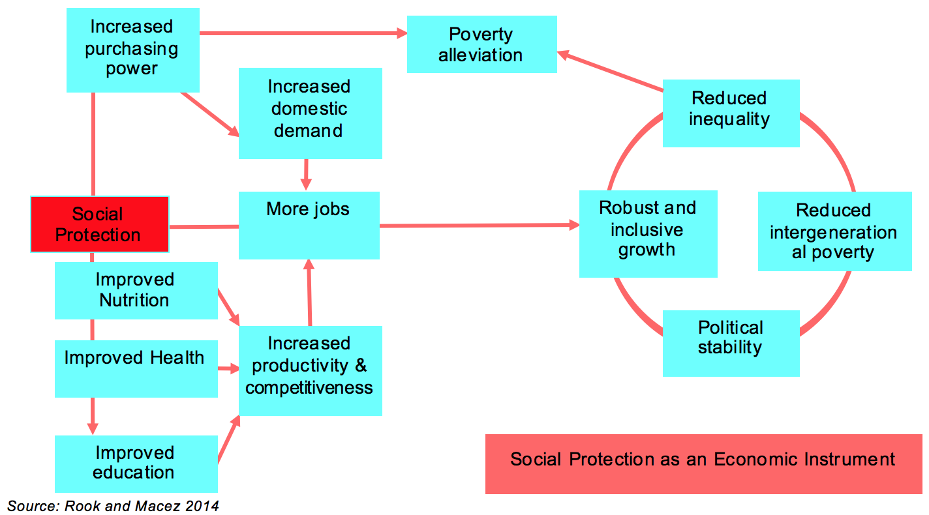

As Figure 1 shows, social protection, particularly in the form of cash transfers, increases the purchasing power of beneficiaries and stimulates demand for goods and services. This, in turn, creates more jobs and boosts economies at a local level, which benefits beneficiaries and non-beneficiaries alike. For instance, a study in Malawi, Lesotho and Ghana shows that every dollar spent on predictable payments to households generated approximately $2.50 in local communities (DFAT, 2015).

The provision of productive assets helps poor and marginalised families build resilient livelihoods, and social protection schemes globally – including in Indonesia – are increasingly connecting beneficiaries to employment opportunities. In the Philippines, 92% of conditional cash transfer beneficiaries were employed. Even where employment linkages aren’t directly formed, evidence shows that cash transfers, when set at an appropriate benefit level, facilitate entry into the labour market. For instance, households receiving South Africa’s child grant were 18% more likely to look for work than non-recipients (Samson, 2009).

## Social protection in Indonesia

Following independence in 1945, Indonesia prospered and experienced strong economic growth. In turn, the government had minimal focus on poverty reduction measures. However, in 1997, the Asian Financial Crisis contracted the economy by 13%, and the poverty rate increased from 15 to 27% over two years. Further, the crisis led to the ousting of the Suharto Regime, which governed Indonesia for over thirty years.

Responding to the economic crisis and the need to consolidate popular support, the post-Suharto government launched the first set of national social protection programs. This support, targeted to poor households, was provided largely through the IMF and included in-kind support through subsidised rice, and bursary support for health and education. To this day, these core interventions form the backbone of social assistance[1] in Indonesia.

Table 1 provides a summary of existing tax-financed transfers in Indonesia today. The main programs are: Raskin, which provides families with access to subsidised rice; the education stipend Program Indonesia Pintar (formerly BSM), that provides transfers to around 13 million school children; and the conditional cash transfer program, PKH, which targets the poorest eight percent of households. While these programs improve family incomes, and there is evidence of PKH reducing under-nutrition, the overall impacts are limited due to low transfer amounts.

Table 1 Current social protection investment in Indonesia[2]

| **Scheme** | **Targeted Number of recipients** | **Value of transfer (monthly) Rp.** | **Expenditure**  **(% of GDP)** | |
| --- | --- | --- | --- | --- |
| Raskin (Rice subsidy) * | 15,500,000 households | 15 kg. of rice | 0.18% | |
| PKH (Conditional cash transfer to poor families) ** | 3,200,000 households | 120,000 (average) | 0.05% | |
| Indonesia Pintar (formerly BSM, education stipend to poor students) | 13,000,000 children | 37,500, SMP: 62,500 SMA: 83,000 | 0.07% | |
| ASLUT (Cash transfer to poor older people) | 27,500 people | 200,000 | 0.0006% | |
| ASODKB (Cash transfer for people with disabilities) | 19,500 people | 300,000 | 0.0008% | |
| PKSA (Cash transfer for disadvantaged children) | 138,000 children | 125,000 | 0.0034% | |
| PPA-PKH (Support to child labourers) | 11,000 children | 125,000 | 0.0002% | |
| **Total spending on Social Assistance transfers** | | | | **0.31%** |

In 2010, the GoI, with support from the GoA, established the National Team for the Acceleration of Poverty Reduction (TNP2K), under the purview of the Vice President’s Office, to coordinate poverty reduction strategies, placing a strong emphasis on social protection. TNP2K tested innovative reforms to programs, such as Raskin, which had not been reviewed or reformed since their inception more than a decade prior. Importantly, TNP2K was also responsible for the development and promotion of the UDB, a world-class database consisting of the poorest 40% of households (encompassing approximately 93 million individuals) in Indonesia. Since its inception, the UDB is utilised across ministries in the GoI to target social protection programs to poor households.

## Addressing challenges and harnessing the benefits of social protection

The GoI has made strong strides in reforming and strengthening programs, but as highlighted above, the combined current level of investment in PKH, PIP and Raskin – at only 0.3% of GDP – is small and, thus, cannot have transformative impacts at a national scale. Further, programs targeted at the ‘poor’ are unlikely to gain significant popular support within a democratic environment, since most of the population will feel alienated from government assistance. Notably over 75% of the population lives on less than Rp. 32,535 per day, and would benefit from additional social protection support (see Figure 2).

Figure 2 Social protection coverage of income groups in Indonesia

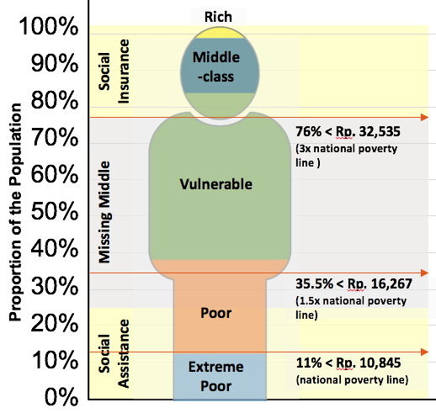

In addition to the need to increase investment in social protection, there is also a need to shift towards more inclusive and comprehensive targeting so that a greater proportion of the population can benefit from the social protection system. This requires increasing access to social protection to a broader set of the population, often referred to as ‘the missing middle,’ through a life-cycle approach, which enables vulnerable individuals to benefit from social protection at every stage of their lives. Linked to this is the realisation from the Finance Minister that Indonesia’s long history of providing fuel and electricity subsidies are inefficient, and better consolidated into providing more comprehensive and inclusive programs that produce greater economic stimulus.

The government is aware of this reality, and there is evidence that suggests that the GoI is starting to take practical measures to move towards a lifecycle-based approach. For example, GoI’s Medium Term Development Plan (RPJMN) social protection pillar states that ‘strengthening family-based social assistance along with the life-cycle approach’ is to be achieved by 2019, as is having ‘greater inclusion of people with disabilities and the elderly’ (Bappenas, 2016). We see this objective being realised towards comprehensive coverage through the expansion of PKH. Whilst conventionally focused on children, the scheme is now being extended to older people and persons with disabilities.

However, it is important to note that Indonesia’s approach is ‘poverty targeting with a life-cycle lens,’ with little evidence to suggest that this will change soon. The priority in the current RPJMN is to reduce the poverty rate from 10.8% to 7% by 2019, and GoI sees their (as well as DFAT’s) investment into the UDB as a way of ensuring that social assistance programs reach the extreme poor and poor (see Figure 2). Whilst many countries start with a targeting approach, as democracies strengthen and citizens demand access to social protection as an entitlement, many countries move away from targeting the poorest and towards more comprehensive coverage. In the short-term, however, the UDB continues to be an important investment and tool to help GoI meet its poverty reduction objectives, as stated in the RPJMN.

## The rationale for key investments

At a high level, Australia’s rationale for investing in MAHKOTA is to support the GoI to increase, and more effectively implement, their investments in social protection. To achieve this, DFAT is taking a three-pronged approach: securing critical investments, such as the UDB, so that they become sustainable; reforming existing programs so that they are more responsive to the needs of the poor; and strengthening policy so that the GoI is more knowledgeable about how to cost-effectively increase social protection spending, and more comprehensively move towards a life-cycle approach.

**Securing critical investments:** initiatives like the UDB remain critical to the Indonesian government. Although the GoI is making strides to greater inclusivity by increasing coverage from the bottom 25% to the bottom 40%, and moving more towards a lifecycle approach – the sustainability of the UDB remains pivotal to the future of social protection in Indonesia. Ensuring that the UDB is transitioned from TNP2K’s Secretariat (TNP2K-S) to MoSA[3], and that the capacity and resourcing is in place for it to be effectively utilised, remains a priority investment for DFAT and MAHKOTA.

**Reforming existing programs:**The past two decades have demonstrated GoI commitment to reforming and expanding programs as a means of addressing gaps and increasing coverage. DFAT, through MAHKOTA, is supporting the GoI to pilot cutting edge and topical reforms, including:

**Raskin:** transforming the distribution of subsidised rice by piloting the use of electronic vouchers and wallets to minimise leakages in distribution, and providing beneficiaries with opportunities for greater financial inclusion;

**On-demand Application (ODA):** dynamically updating the UDB to ensure that those excluded can access social protection programs;

**Integrated Referral System (SLRT):** enabling beneficiaries to file complaints and grievances, and linking them up to all local and national programs for which they are eligible.

Section 5 discusses the various reform initiatives, and how they contribute to the MAHKOTA Theory of Change.

**Strengthening social protection policy:**Even though there is a movement towards more inclusive coverage, the GoI remains concerned about fiscal space to increase investment in social protection. A key priority for DFAT, via MAHKOTA, is to increase GoI capacity to understand how the existing social protection framework in Indonesia could move more towards a life-cycle approach in a cost-effective and fiscally sustainable way. To support this effort, a major MAHKOTA investment is to work with TNP2K and other relevant ministries to develop Indonesia’s first social protection strategy.

# Political Economy

TNP2K-S began in 2010 during the Susilo Bambang Yudhoyono administration, when Vice-President Boediono and GoA agreed to a partnership to establish a think-tank in the Vice-President’s office to support him in taking forward his commitment to poverty reduction. Under the leadership of Dr. Bambang Widianto, a high-quality team of specialists were recruited to implement a range of innovative initiatives. Given the demands of the time, a key focus of the TNP2K-S was on reforming existing social assistance schemes. Vice-President Boediono was recognised as the champion of social protection and poverty reduction, with the TNP2K-S playing a key role in promoting and coordinating improvements to the national social assistance system.

With the election of Joko Widodo to the Presidency, the political panorama for social protection changed. Vice-President Boediono was replaced by Jusuf Kalla who has brought a different perspective on social and economic development, placing a greater emphasis on the importance of private sector development. Nonetheless, reflecting the continued importance of TNP2K, President Widodo signed a Presidential Regulation in August 2015 that extends the function of TNP2K and its secretariat under Vice President Kalla.

Although TNP2K has the backing of the Widodo administration, its coordinating role has changed. For example, whereas before the TNP2K cross-governmental coordinating body would meet as often as once a month under Vice President Boediono, since the start of the new administration it has only met once. Building from the credibility and reputation built over the past five years, TNP2K-S is still extensively sought out for advice and support from ministries and increasingly the President’s office (KSP). For example, KSP has drawn upon TNP2K-S’s expertise to advance the President’s agenda on Raskin reform and financial inclusion, including coordinating approaches across relevant ministries.

Furthermore, TNP2K-S has been encouraged to expand its horizons and incorporate some of the Vice-President’s priorities within its agenda. This has meant that TNP2K-S has had to widen the spectrum of initiatives it undertakes, including microcredit, health financing and reform to the national minimum wage policy. These issues are not strictly related to social protection, but more broadly address issues of poverty and inequality, which the Vice President deems critical. At the same time, the Vice President’s awareness of the dangers of rising inequality represent an opportunity to expand social protection to a broader set of the population. To meet the growing requests from Ministries, KSP and the Vice President’s office, TNP2K-S recognises a need to strengthen its capacity for higher-level policy analysis and policy influencing.

The adjustments in the influence of TNP2K have happened at the same time as a new Minister – Khofifah Indar Parawansa – was appointed by President Widodo to lead the Ministry of Social Affairs (MoSA). She is regarded as progressive, committed to social transformation, a supporter of expanding social protection, and having a strong interest in broadening the influence of MoSA over poverty reduction policy. She is regarded as close to the President and credited with convincing him to agree to the expansion of PKH in 2016, while broadening the focus of the program to incorporate both the elderly and people with disabilities. MoSA is now a more vocal and ambitious Ministry, when compared to its influence under the Yudhoyono administration.

The President is a strong supporter of poverty reduction, which provides an enabling environment for achieving a more equitable and comprehensive social protection system. An immediate priority of the President is to institute electronic transfers in place of food and cash transfers, which TNP2K-S has been asked to play a leading role in. The President’s broader support for social protection expansion can also be seen in his support for expansion of the PKH to six million beneficiaries. However, by and large there is no clear overarching strategic direction within the Presidency in regard to growing a more comprehensive social protection system. Indeed, social protection is significantly overshadowed by other Presidential priorities, particularly infrastructure development.

A number of other actors have an influence on future national social protection policy. Bappenas has been a close collaborator with both TNP2K-S and MoSA and has carefully tried to promote a more progressive social protection policy, while introducing reforms to the delivery of the national social assistance system. The previous Minister of Bappenas shared the Vice-President’s belief in the primacy of private sector development but the new Minister – the former Minister of Finance – is regarded as more pragmatic, although his views on expanding the national social protection system are, as of yet, untested.

The Ministry of Finance is driven primarily by fiscal concerns and fears of significant financial constraints in upcoming years, which are resulting from an expansion in the national budget driven by the Presidency and regulations that impede the annual deficit to go beyond 3% of GDP. An understanding that social protection is an essential component of a market economy – and could be an effective economic stimulus – is still not widely shared in Indonesia. However, during recent budget cuts, it is notable that the expansion of PKH was protected, and there is a general sense that the current Finance Minister, Dr. Sri Mulyani, is champion of social protection.

Other Ministries and institutions with an involvement in social protection include: the Coordinating Ministry for Human Development and Culture; the Ministry of Energy, which is seeking to reform the electricity subsidy; the Ministries of Education and Religious Affairs, which implement the education stipends (PIP) and are working to expand this program to include out of school youth; and BPJS Ketenagakerjaan, which is tasked on expanding the employment insurance scheme to 25% of the workforce by 2019 and is recognised as a strong institution, but is focused on delivering its own targets.

Local government is another important actor in the development of the national social protection system. As a result of decentralisation, some Provincial and District governments are developing their own social protection schemes, often to fill gaps in national government provision. The designs of schemes vary greatly, which can provide opportunities for learning but also generate a less coherent approach to the delivery of social protection at the ‘front-line’.

A range of development partners are active in the social protection space.

The World Bank – largely via the DFAT-funded Partnership for Knowledge-based Poverty Reduction Trust Fund – has been a key actor for many years in the field of social protection and poverty reduction, actively advocating for a targeted social protection agenda.

UNICEF is building its capacity to engage on social protection, and is focusing on promoting inclusive social protection, with a key priority on piloting universal child grants for young children. They are currently designing the implementation of a universal child grant in Papua.

GIZ has supported MoSA for a number of years and will continue their technical assistance, which is mainly focused on strengthening systems and supporting health insurance. GIZ is also actively engaging with MoSA in the expansion of PKH, developing government to people (G2P) payment systems as a part of its financial inclusion program, and in strengthening social insurance mechanisms.

The ILO is developing a new social protection program, focusing on expanding social insurance. UNDP is re-evaluating its priorities and is seeking opportunities to build its work within the poverty reduction field. USAID has engaged for many years on supporting broader social service delivery and some of its work – particularly its research on access to services – is innovative and has clear overlaps with social protection.

There are currently no mechanisms in place to promote greater coordination across development partners on social protection, which increases the likelihood of government receiving conflicting advice. This said, senior members of government have expressed a preference to receive alternative viewpoints from development partners, which they themselves can evaluate.

A number of DFAT programs are directly or indirectly engaged on social protection and the labour market and, as a result, are natural – and essential – partners for MAHKOTA (See Section 7 on Collaboration). Furthermore, the Social Protection Hub is a part of MAHKOTA, with two of its staff funded by the program, while additional funding is provided by DFAT’s social protection team in Canberra. The Social Protection Hub funds research and knowledge dissemination events on social protection, with a specific focus on south-south cooperation. Their activities bring together social protection stakeholders from around the world in Jakarta, and provide a good opportunity for complementing the capacity building and policy development activities of MAHKOTA.

# Theory of Change and Key Areas of Focus

Since April 2016, MAHKOTA-CT has consulted with over 100 individuals from TNP2K-S, DFAT, other GoI stakeholders and DFAT-funded programs to develop the program’s theory of change. The theory of change was developed to provide a:

* strategic framework to guide investments in the annual planning process;
* framework for monitoring and evaluating progress towards program outcomes; and
* platform for dialogue, shared understanding and communication.

These consultations highlighted that although MAHKOTA has a specific goal on social protection, TNP2K-S’s mandate and engagement on broader poverty reduction issues required a second program goal to capture this work. As a result, MAHKOTA’s theory of change is comprised of two goals:

* a comprehensive and equitable social protection system for the whole of Indonesia by 2025;

which contributes to GoI’s long-term goal of:

* reduced poverty and inequality by 2025.**[4]**

Five outcome streams that contribute to these two goals have been identified (described further below) as well as two categories of engagement across these outcome streams:

* core areas of engagement: for outcome streams comprised of large, multi-year initiatives (called ‘pillar initiatives’); and
* areas of flexible engagement: for outcome streams that require MAHKOTA to be flexible and responsive to priorities and opportunities where they arise.

The resulting detailed theory of change is attached as Annex 1 and is summarised in Figure 3.

Figure 3 Theory of Change overview

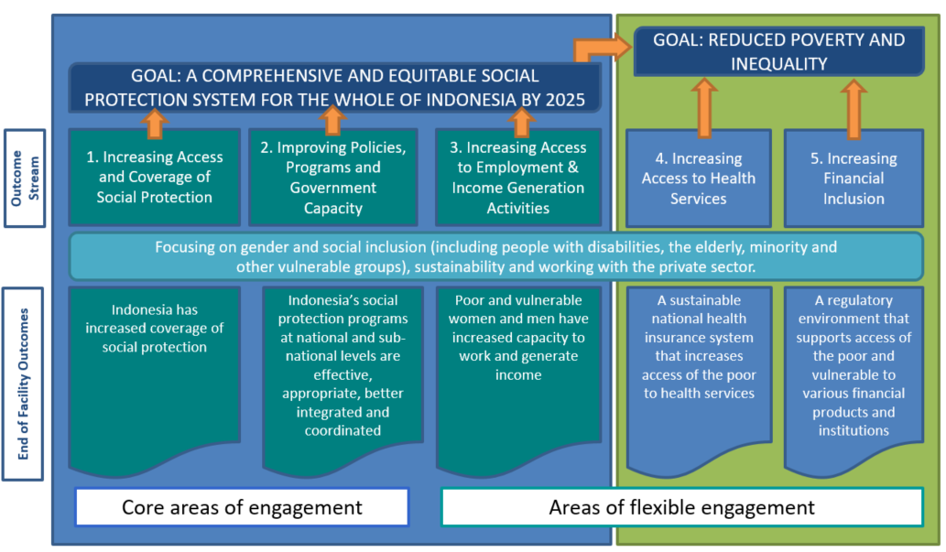

## Contributions to MAHKOTA’s social protection goal

### Outcome Stream 1: increasing access and coverage of social protection (core area of engagement)

MAHKOTA’s first end-of-facility outcome: *Indonesia has increased coverage of social protection*, will incorporate investments to: improve beneficiary access to social protection programs through improved targeting and registration procedures, dynamically update and match the UDB, and increase Government funding for the reform and expansion of existing programs and/or introduction of new programs to include more beneficiaries.

The two pillar initiatives under this outcome stream are:

1. Ongoing maintenance and matching of the UDB

TNP2K-S will be supported to maintain the UDB so it can continue informing Government targeting of ongoing social assistance programs (including the expansion of PKH), as well as new assistance packages such as the electricity subsidy. The UDB will also be matched with new surveys, such as the agricultural census used to target the fertilizer subsidy, as well as with other local and national government poverty databases.

MAHKOTA-CT will also support GoI to prepare for the transfer of the UDB from TNP2K-S to MoSA.

1. Dynamic updating of the UDB and referral to social protection programs (On Demand Application and Integrated Referral System)

This package of support will scale up an effective registration, referral and grievance system within local governments that enables on-demand applications to the UDB and entry into national and local-level social protection programs. TNP2K-S, MoSA and Bappenas will collaborate on building this system, testing a range of alternatives, and conducting a subsequent national roll out.

### Outcome Stream 2: improving policies, programs and government capacity (core area of engagement)

The second end-of-facility outcome: Indonesia’s social protection programs at national and sub-national levels are effective, appropriate, better integrated and coordinated refers to MAHKOTA’s efforts to: provide analysis and research to inform Government policy on social protection, improve benefit distribution and disbursement so programs are more effective and sustainable, as well as increase government capacity to provide social protection through trainings and technical assistance.

The two pillar initiatives under this outcome stream are:

1. Transforming social assistance**[5]** (Raskin) distribution

TNP2K-S will lead on the development and piloting of new mechanisms to disburse social assistance. This will be primarily done through the pilot of the ‘Transformation of the Food Assistance Initiative’ which aims to reform the Raskin program by disbursing non-cash transfers that can be used to redeem rice and other types of food. This pilot will inform how the Government reforms the transfers of benefits in other social assistance programs, including PKH and PIP.

1. Developing a social protection strategy for Indonesia

TNP2K-S with MAHKOTA-CT will work in collaboration with Bappenas and other relevant ministries to support the development of a strategy for social protection that will be used to inform the next RPJMN and RPJMP. The strategy will deliver on the following objectives, as suggested by TNP2K-S:

* mapping of social protection programs in Indonesia, including a survey and analysis of local government social protection initiatives;
* analysis of poverty and inequality across the lifecycle, and determining which challenges/gaps can be identified by social protection programs;
* how to reform and expand existing GoI investments in social protection; and
* simulations and value for money for future financing of social protection.

As each of the above objectives are completed, MAHKOTA-CT and TNP2K-S will share findings with MoSA and other relevant ministries through workshops, and disseminated through presentations and short briefs.

### Outcome Stream 3: increasing access to employment and income generation activities (flexible engagement)

MAHKOTA’S third-end-of facility outcome: *poor and vulnerable women and men have increased capacity to work and generate income*, refers to technical support that MAHKOTA may provide to relevant ministries to improve linkages between poor people and existing productive inclusion programs, as well as supporting a broader strategy around graduation. The latter refers to boosting the income levels of social assistance beneficiaries via various income generating activities to ensure that they sustainably ‘graduate’ out of extreme poverty.

MoSA has requested support in strengthening some of its asset transfer programs which seek to boost the income levels of PKH beneficiaries, while TNP2K-S and Bappenas have requested support in developing a strategy for strengthening poor people’s access to income generating pathways. Technical assistance in strengthening MoSA’s programs, as well as in developing a graduation strategy for beneficiaries would provide practical and tangible support in integrating social protection and income-generating opportunities.

## Contributions to GoI’s reduced poverty and inequality goal

### Outcome Stream 4: increasing access to health services (flexible engagement)

The fourth end-of-facility outcome: *A sustainable national health insurance system that increases access of the poor to health services*, could include efforts to improve the effectiveness and reach of the Indonesian Health Card (KIS), ensure that the insurance system is properly resourced/financed, and that health service providers are able to effectively treat the poor which are provided coverage for free.

The national health insurance system is a priority for the Vice President, and in 2016, TNP2K-S has already been requested to provide technical advice on how to reduce the program’s deficit. This is a high-profile issue, and as such, TNP2K-S will likely remain engaged in providing advice on the financial structuring of its health insurance scheme.

### Outcome Stream 5: increasing financial inclusion (flexible engagement)

The fifth end-of-facility outcome: *A regulatory environment that supports access of the poor and vulnerable to various financial products and institutions* is focused on MAHKOTA’s efforts to increase financial inclusion in Indonesia. This includes providing advice for the development and roll out of a National Financial Inclusion Strategy, as well as how to increase the access of poor people to savings accounts. This also includes increasing the number and types of institutions that can provide credit to micro and small enterprises.

## Supporting gender and inclusive development

As seen in Figure 3, MAHKOTA’s theory of change focuses on gender equality and social inclusion, including people with disabilities and other vulnerable groups.

To address gender quality and social inclusion, MAHKOTA-CT will implement the following key approaches:

Integrate gender and social inclusion within priority areas

Gender and social inclusion have been integrated into MAHKOTA’s initiative design and monitoring and evaluation processes. This means that all initiatives need to outline how they will implement and monitor their engagements in gender equality and social inclusion and present this to the Technical Committee as part of the initiative approval process. This has already resulted in some meaningful engagements on gender equality, including SLRT forming linkages with MAMPU partners at the local level, and the electricity for the poor initiative prioritising women-headed households. MAHKOTA-CT’s recently recruited Gender and Social Inclusion Advisor will monitor and assist with the implementation of gender interventions and assist TNP2K-S with the reporting of gender outcomes.

The social protection strategy, a pillar initiative for MAHKOTA, will be based on analysis on gender and disability. A range of analyses using Susenas and Indonesian Family Life Survey (IFLS) datasets to understand the challenges faced by women (particularly those living in poverty), people with disabilities, and their households, and ethnic groups with remote access. An objective of the strategy is to examine how social protection could address these challenges, and furthermore, how existing programs can be reformed and expanded to be more inclusive of women and socially excluded groups.

As MAHKOTA develops its work stream on access to employment and income generation activities, a potential area will be to support the development of productive inclusion strategies, with an explicit focus on engaging women in enterprise. This is a means of promoting women’s economic empowerment, which is also in line with the second priority in DFAT’s gender and economic empowerment strategy.

Build partnerships with other DFAT-funded programs to leverage the research and initiatives they have in place to address some of the gender and social inclusion issues

DFAT funded programs, such as KOMPAK, AIPEG and MAMPU, have activities related to gender and social inclusion that can potentially intersect with the social protection policy and system strengthening that MAHKOTA is undertaking. For instance, improving women’s access to social protection programs is one of five MAMPU thematic areas. MAMPU partner PEKKA, has an explicit focus on empowering female-headed households in a number of ways, including through access to social protection. It is critical that MAHKOTA builds off their initiatives and incorporates their learning into our key priority areas. We will explore ways to integrate and conduct joint policy briefs and/or trainings to key government partners, and determine ways of bringing the work that MAMPU is doing into the folds of the social protection strategy (See Section 7 on Collaboration).

In addition, AIPEG has commissioned a substantial study on reasons for low female workforce participation in partnership with Monash University, and is in the process of recruiting a labour economist. There are avenues for exploring how female labour participation and social protection can intersect. As MAHKOTA-CT delves further into analysis for the social protection strategy, there are opportunities to integrate with AIPEG to understand more about the fiscal space that’s available for social protection financing.

Lastly, it is important to leverage research and activities within KOMPAK that specifically deal with issues of access to social protection programs, and how underrepresented groups can better improve their access to existing benefits.

## Engaging with the private sector

In 2007, Indonesia became the first country to introduce mandatory legal requirements for corporate social responsibility (CSR) through Law 40/2007 on Limited Liability Companies. Due to this law, and similar laws and regulations that followed, Indonesia has seen a significant increase in private sector funding allocated to poverty reduction activities. As a result, there is great potential for MAHKOTA partners to leverage CSR funds and private-sector technical expertise and technology to deliver programs.

So far in 2016, TNP2K-S has used telco and bank technologies to trial different social assistance distribution mechanisms, and leveraged CSR funds to pay for basic infrastructure such as solar panels. These ways of engaging with the private sector have been successful, and will form models for future engagement with the private sector in MAHKOTA, particularly in pilot initiatives.

# Ensuring Sustainability

For the purpose of this strategy we use the DFAT definition of sustainability stated in Promoting Practical Sustainability, (DFAT Quality Assurance Group, 2000):

‘Sustainability is the continuation of benefits after major assistance from a donor has been completed’

As outlined in this publication, lessons learned from other DFAT programs show that the conditions below are necessary to increase the probability of sustainability. These have been adapted to fit with MAHKOTA’s operating environment:

* **Political fit**: The program should be aligned with the political aims and policy direction stated in the Government of Indonesia’s National Medium-Term Development Plan (RPJMN: 2015-2019) and National Long-Term Development Plan (RPJP: 2005-2025).
* **Policy fit**: Social protection systems strengthening should support GoI, including coordinating bodies (such as TNP2K-S) and line ministries, in meeting its policy objectives.
* **Planning horizon:** The ideal planning horizon for a systems and policy development program is five to eight years.
* **Technical value:** Technical assistance should bring added value and be demand driven.
* **Flexible and reliable financing:** Resources must be flexible to allow change and adaptation that encourage innovation. Further, program funding must be reliable over a mutually agreed period to allow the GoI to integrate the continuation of program benefits within its planning and budgeting systems.
* **Institutional arrangements and ownership:** Given that the TNP2K-S conducts its work in close collaboration with coordinating and line ministries, program benefits should be transferred and owned by the relevant line ministries.
* **Technical capacity:** Transferring of key investments will require capacity development and investment in other key ministries.
* **Securing budgets:** Program funded initiatives should ultimately be included in national and sub-national government budget.

Recognising the factors above, our sustainability approach focuses on the following three domains:

* **Political and policy domain:** sustainable national social protection policies, including ongoing political and popular support;
* **Systems Strengthening Domain:** sustainable systems established because of MAHKOTA investments; and
* **Institutional Domain:** sustainable capacity and resources within government units, including the value-added of evidence to policy functions currently provided by TNP2K-S.

## Sustainable national social protection policies

To be sustainable over the long term, social protection policies and systems require ongoing political support, as well as support from the majority of the population. Demonstrating and communicating the benefits of existing policies and programs, particularly after reforms and expansions, is essential to obtaining and maintaining this support. Also important is ensuring that the value of social protection support does not decrease over time, as it has, for example, in the PKH program, where the real value of cash transfers have consistently diminished.

MAHKOTA will take several steps to ensure sustainability of social protection policies: collaborate and provide relevant technical assistance to GoI agencies engaged in social protection; advise on the reform of existing programs, and the design of new programs (MAHKOTA’s engagement in the Social Protection Strategy is one such entry point); and disseminating evidence/lessons learnt to relevant stakeholders (through workshops, publications, and ongoing discussions). This also includes building awareness among GoI partners that increased investment in social protection not only reduce poverty, but also support economic growth and reduced inequality.

## Sustainable social protection systems

Currently, all MAHKOTA-funded activities are managed and implemented through TNP2K-S,[6] which responds to demands for new policies or policy reform from a variety of high-level government actors, including the Offices of the President and the Vice-President. Activities largely consist of pilot projects or policy analysis conducted by TNP2K-S, in close collaboration with line ministries. Line ministries then utilise the lessons learned from the pilots and analysis to inform the future direction of GoI-funded social protection systems.

MAHKOTA has put in place a rigorous process of quality assurance to ensure that all major investments can be sustained, and their quality maintained, if they are proven to be successful. The quality assurance process emphasises certain sustainability factors, for instance:

* Ensuring ownership for proposed initiatives by implementing partners (typically line ministries).
* Building the institutional capacity of implementing partners to take over and manage activities.
* Technical support for operational guidance and systems to ensure that activities can be implemented effectively and are, where appropriate, scalable.
* Establishing monitoring systems to check that there is ongoing support from, and increased capacity of, implementing partners.

### Sustainability of the UDB and SLRT

The UDB and the SLRT are two initiatives that DFAT has heavily invested in, and require ownership from MoSA to be sustainable.

While MoSA is already supporting the SLRT operations financially, the management of the initiative still rests with the DFAT-financed technical team. MAHKOTA-CT will work with the SLRT technical team and MoSA to ensure that the initiative’s management is embedded into the ministry, while continuing to offer technical assistance to strengthen its implementation.

The UDB was developed and has been housed and managed by TNP2K-S since 2010. The GoI has indicated its intention to transfer the database to MoSA by the end of the MAHKOTA program. MAHKOTA-CT will collaborate closely with TNP2K-S, MoSA, and other relevant ministries to develop a transition plan, bringing in international experts to facilitate the process. This will be accompanied by institutional capacity development within MoSA, to not only manage, but also promote UDB across the GoI as TNP2K has done to date.

We will also continue to work with the GoI to improve the effectiveness of the UDB. This includes working with the GoI to strengthen the accuracy of the database by supporting the development and testing of an on-demand application mechanism, and integrating it with the complementary SLRT initiative.

## Institutional arrangements and the sustainability of TNP2K

In an environment where reform is slowed down by bureaucratic bottlenecks, TNP2K-S represents a high-level evidence-to-policy mechanism designed to accelerate policy reform and implementation. TNP2K-S provides superior quality technical assistance and flexible financial resources that facilitate innovations in a fast-paced social policy reform context.

Sustainability of TNP2K-S should focus on how these functions and benefits are sustained, rather than on the continuation of the organisation, which is a political decision dependent on GoI/GoA resourcing, and outside the scope of MAHKOTA to influence.[7] Institutionalising TNP2K functions to ensure sustainability include:

* transferring the expertise to line ministries;
* maintaining a smaller technical unit focused on real time evidence/knowledge production for fast paced policy decision-making, directly linked to the Vice President’s office. In this scenario, line ministries and sub national partners would conduct all demonstration and policy testing;
* possible continuation of TNP2K-S as a think tank; or
* a combination of the above

MAHKOTA-CT will collaborate with DFAT, TNP2K-S, and other government actors to develop and implement a future vision for the organisation.

### Deepening new institutional arrangements

TNP2K is an ad-hoc agency dependent on a decision by each presidential administration about its continuation. As such, it is necessary to further deepen institutional relations and entry points with MoSA, which is the institutional home for social protection and poverty reduction. In addition to ongoing support to the SLRT, MAHKOTA-CT will seek to engage with MoSA as it develops a Social Protection Strategy alongside TNP2K-S, and find entry points to strengthen MoSA’s implementation capacity and ownership of initiatives such as the UDB. Through these efforts, MAHKOTA’s intention is to build a stronger institutional relationship with MoSA that contributes to building the pathways for the sustainability of MAHKOTA facility outcomes, as well as lays the foundation for potential future DFAT investments in social protection.

# Role and Ways of Working

MAHKOTA is structured as a flexible facility that supports the continuation of the partnership between the GoI and GoA to strengthen social protection and poverty reduction in Indonesia. As with its predecessor program, PRSF, MAHKOTA’s principal partner is TNP2K-S. Aside from providing the facility operational support services to TNP2K-S, MAHKOTA functions differently than PRSF, and within a context of substantially reduced funding, yet within a broader range of technical responsibilities and strategic tasks. Figure 4 below reflects the operating environment of MAHKOTA, which includes prioritisation of TNP2K-S and partner activities; a rigorous quality assurance process towards effective and sustainable investments; and more comprehensive monitoring and evaluation to measure and report on the investment of progress to DFAT.

Figure 4 Operating environment

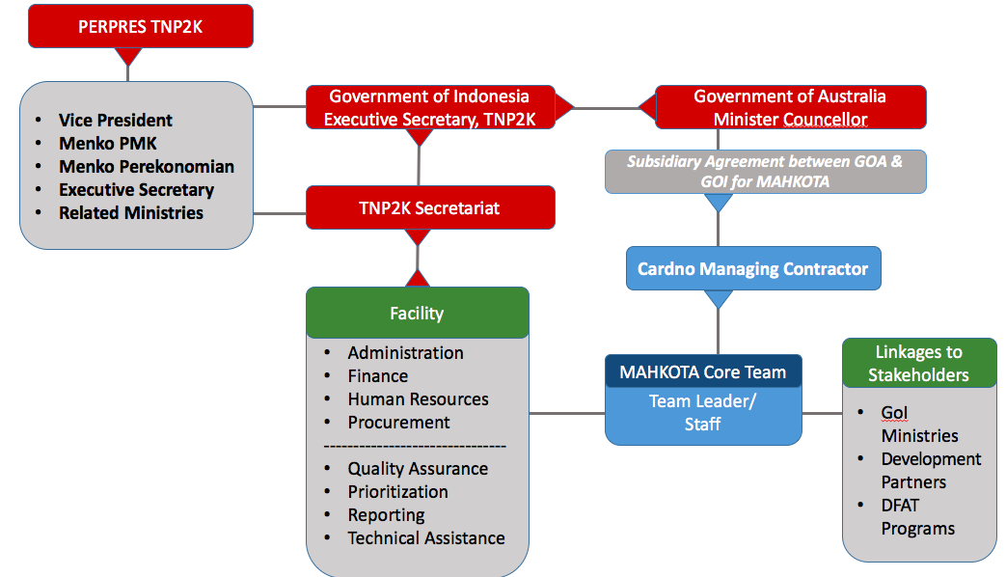

The sections below outline the key ways in which MAHKOTA works to implement the investment.

## Provision of technical assistance

MAHKOTA’s principal investment is providing technical assistance to the GoI to strengthen its social protection systems, policies and strategies. While there is an opportunity to provide greater capacity building beyond technical assistance to GoI, particularly in relation to sustaining GoA/MAHKOTA investments, a comprehensive capacity building program is currently beyond the scope of the MAHKOTA investment.[8].

Figure 5 below shows how the flow of TA is provided both through the TNP2K-S and MAHKOTA- CT.

Figure 5 Flow of TA between TNP2K and MAHKOTA-CT

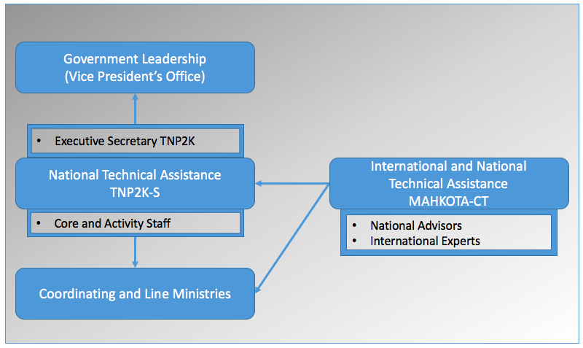

### Managing technical assistance through TNP2K-S

MAHKOTA funds core and activity staff at TNP2K-S, whose role is to conduct analysis and test innovations of social protection policies and other initiatives relating to reducing poverty and inequality. Through the Executive Secretary of TNP2K, they work closely with senior policy makers and coordinate with GoI leadership (e.g. the vice president) and line ministries. Given funding decreases, the technical assistance role of TNP2K-S has shifted to emphasising technical input and coordination over directly financing implementation costs related to pilots.[9]

This approach has reduced the overall cost of initiatives, whilst maintaining one of the biggest core components of MAHKOTA: expert national technical assistance. Notably, numerous FY17 initiatives have little funding beyond activity technical assistance. For example, with little investment beyond three core staff, the Health Working Group has provided influential policy analyses to decision makers that manage national health insurance for the poor. Similarly, in the Economic Working Group, the core staff have been producing critical analytical inputs which have directly informed the reform of national minimum-wage policies.

### National and international technical assistance through MAHKOTA-CT

MAHKOTA also provides technical assistance to GoI through the MAHKOTA-CT. The Cardno Consortium has mobilised a core team of national and international experts in social protection, social security policy and systems, gender, social inclusion and Management Information Systems (MIS). Furthermore, the Consortium provides access to expert technical advice from world-class international experts.

The MAHKOTA-CT provides technical assistance to TNP2K-S through daily engagement with its working groups, units and senior managers. This includes providing support to TNP2K-S teams on monitoring and evaluation approaches, incorporating gender dimensions into initiatives, providing analytical inputs for high level briefings government officials, and the development of a national social protection strategy. To date MAHKOTA-CT technical assistance to TNP2K-S has been instrumental in moving forward coordination across key initiatives, such as ODA and SLRT, and will continue to provide technical inputs into critical upcoming efforts such as the transition of the UDB from TNP2K to MoSA.

The MAHKOTA-CT also provides TA directly to line ministries, particularly MoSA. A key example of this is MAHKOTA’s support to the SLRT technical team, which is providing technical support for the roll out and expansion of the MoSA-led SLRT initiative. Although the MAHKOTA-CT is well positioned to field requests and provide technical assistance to line ministries as needed, there is an array of challenges associated with this approach.

## Supporting streamlined TNP2K operations

MAHKOTA-CT will ensure it maintains a streamlined and efficient program structure. An organisational review was undertaken during the inception[10], which reduced TNP2K-S core staffing from over 120 to 59 as well as disbanded two working groups (MIS and Village Law). These changes led to TNP2K-S becoming a leaner, more agile organisation. Over the course of the program, MAHKOTA will continually monitor the effectiveness of the organisational restructure and make amendments as deemed necessary.

Additionally, during the inception phase, MAHKOTA-CT restructured operational procedures maintained by PRSF that did not align with managerial best practices and government regulations. For example, MAHKOTA restructured all staff contracts to align with Indonesian manpower legislation which were not applied previously. While these amendments were challenging to implement, they have strengthened the overall administration, risk, and management integrity of the facility. As part of its ways of working, MAHKOTA-CT will continue to maintain procedures that uphold best management practices, whilst routinely reviewing in collaboration with TNP2K-S to ensure that they remain fit for purpose.

## Annual planning and prioritisation

Emphasis will be given to facilitating initiative planning and prioritisation processes, and overseeing quality assurance. This will ensure that implementation plans meet quality assurance standards, align with operational procedures, have clear technical assistance planning, and build in budgetary controls. This increased effort in supporting planning and prioritisation can make significant contributions to Value for Money (VfM) throughout the program lifecycle. In regard to prioritisation, the MAHKOTA-CT and TNP2K-S have:

Instituted an annual planning processes with TNP2K-S managers to identify and prioritise key initiatives for the next fiscal year, and to develop initiative concept and implementation plans collaboratively;

Re-energised the role of a steering committee (SC), which is to meet twice yearly, with a mandate to make strategic decisions and approve annual planning process; and

Established a technical committee to review and approve detailed initiative plans and budget revisions.

## Monitoring, evaluation and quality assurance

The MAHKOTA-CT also engages in strong quality assurance through monitoring and operational oversight of activities. The MAHKOTA-CT Monitoring, Evaluation and Quality Assurance (MEQA) team is tasked with quality assuring initiatives throughout their life cycle, including:

**Design**: Assisting TNP2K-S working groups to develop detailed implementation plans that outline key implementation arrangements for initiatives, including how gender, social inclusion and sustainability will be addressed, and whether teams are properly managing risks and resourcing. MEQA also facilitates access to technical assistance during this process, particularly in relation to gender and social inclusion, MIS and M&E. MEQA provides administrative support to the MAHKOTA Technical Committee (co-chaired by the TNP2K Chief of Policy and DFAT First Secretary), including organising independent peer review feedback on implementation plans and briefings to the Technical Committee.

**Implementation**: Facilitating and coordinating linkages with other DFAT-funded/donor programs, including MAMPU and KOMPAK; ensuring that key activities such as trainings and workshops are relevant and meeting the needs of participants; monitoring and reporting progress of initiatives through quarterly workshops, and monthly management meetings with working group and unit heads; managing technical assistance and support, particularly in relation to M&E and MIS.

**Evaluation**: Providing technical support to implementation teams undertaking evaluations; reporting on the results of each completed initiative (through completion workshops with implementation teams); ensuring that teams are collecting and storing lessons learned, as well as disseminating results to appropriate audiences.

In addition to providing the above support at the initiative-level, MEQA also monitors and evaluates MAHKOTA at the program level. The MAHKOTA M&E Plan, for instance, details the monitoring and evaluation methods for reporting to DFAT and TNP2K-S across the whole of the program.

## Flexibility

MAHKOTA-CT will maintain and continue strengthening the prioritisation and quality assurance process moving forward, while concurrently ensuring that the program remains flexible. In regard to the latter, MAHKOTA-CT will be responsive to the broader demands placed on the TNP2K-S as the national policy context changes, in particular to ensuring that it is seen as responsive to the needs of the Vice President. This holds true for engagement with, and potential support to, ministries directly. Through this approach, MAHKOTA-CT will support a range of activities that are part of wider efforts to tackle poverty and reduce inequality that do not fold neatly into the investment’s theory of change.

## Linkages to other ministries and stakeholders

Recognising that the investment will end in 2019, MAHKOTA is tasked with engaging with other GoI ministries, DFAT programs, and development partners. The objectives are to establish links across key stakeholders to progress social protection policy development, the scaling up of demonstration projects, and the sustainability of MAHKOTA-supported initiatives.

As discussed in Section 5.1, TNP2K-S regularly engages with other ministries in the design and implementation of innovative reforms. MAHKOTA-CT tries to engage sensitively with other ministries, development partners and other DFAT programs. In relation to other governmental actors, MAHKOTA-CT also seeks to build inter-governmental support and movement on collaborative strategies for social protection, such as through the social protection strategy.

A critical engagement is with MoSA which is an actor growing in importance in the social protection field. With additional financial resources, further efforts will be made to build their capacity to absorb TNP2K-S-led initiatives post 2019, such as the UDB and electronic payments transition, and to work on new initiatives, such as the development of a graduation strategy.

Specific to development partners, MAHKOTA-CT is extensively engaging with the World Bank, coordinating with them on their work with MoSA on the PKH expansion. MAHKOTA-CT is also growing relationships with other development partners and DFAT programs (See Section 6 on Collaboration).

# Collaboration Approach

This section includes a mapping of the most relevant stakeholders and the approach to prioritising the most important relationships to facilitate end of facility outcomes and sustainability. These are divided into three categories, depending on how close a relationship we expect to develop with them (see Table 2). It is important to note that these categorisations are likely to change over time, as the political context and priorities change. For example, stakeholders that have not previously engaged with the social protection agenda in Indonesia may decide to start prioritising this area, while others may phase out activities.

**Core partners**, include the TNP2K-S, MoSA and Bappenas, with our main partner being TNP2K-S. These stakeholders have a special position, as their activities are integral to the MAHKOTA theory of change, and achieving the goal of a comprehensive national social protection system. For example, the TNP2K-S’s research activities are included in MAHKOTA’s work plan as activities for achieving End of Facility Outcome 2; and, support to the UDB and the SLRT, both of which will be located within MoSA in the future, are included in the work plan as activities for achieving End of Facility Outcome 1. The core partners play a key role in determining future social protection policies. MAHKOTA-CT maintains continuous communication with these partners and provides both extensive technical support and funding for their activities.

**Strategic partners** comprise stakeholders whose activities are not integrated directly into the MAHKOTA theory of change but, nevertheless, contribute directly to achieving the MAHKOTA theory of change outcomes. The strategic partners have mandates and activities which are closely related or overlapping with the activities and mandate of MAHKOTA. We expect to prioritise frequent communication and the exploration of joint planning of activities with these organisations, for example in the form of closely coordinating research and advocacy activities.

**Project-based partners** include stakeholders which are potentially important for MAHKOTA’s work, but have a mandate and activities that are less closely related to the MAHKOTA theory of change. MAHKOTA will seek to share information with these organisations as much as possible and may enter working relationships on a project by project basis as relevant. Some of these organisations may become strategic partners in the future if it turns out that there are significant overlaps between their activities and those of MAHKOTA.

Table 2 Types of partners

| **Type** | **Criteria** | **Partners** |
| --- | --- | --- |
| Core | * Partner activities are integrated into MAHKOTA work plan. * Possibility of direct funding. * Continuous communication and joint planning of activities. | * TNP2K-S * MoSA * Bappenas |
| Strategic | * Partner activities contribute directly to MAHKOTA theory of change outcomes. * Mandates and activities closely related or overlapping with MAHKOTA. * Frequent communication and possibility of joint planning of activities. | * The World Bank * MAMPU * KOMPAK * KSI * AIPEG * Peduli * GIZ |
| Project based | * Partner activities have linkages with MAHKOTA theory of change outcomes. * Ad-hoc communication, information sharing and technical support. * Possibility of closer collaboration on a project by project basis. | * Other government ministries * Global Pulse Lab * Abdul Latif Jameel Poverty Action Lab (J-PAL) * UNDP * UNICEF * USAID * ILO |

## Core partners

Core partners are stakeholders which may receive direct funding of their activities from MAHKOTA.

The TNP2K-S will continue to be the main partner of MAHKOTA. In accordance with MAHKOTA’s Statement of Requirements, the program will provide:

* core TNP2K-S personnel, overseeing the quality of their outputs, and conducting all aspects of office and operational management, and
* supporting the TNP2K-S to achieve its goals by providing additional technical assistance to TNP2K-S to facilitate the effective delivery of its activities.

The TNP2K-S has a unique capacity for research on social protection and is well placed to influence key decision makers. The MAHKOTA theory of change provides a framework for collaboration and funding of TNP2K-S which is more focused than previously, but still allows for the necessary flexibility to pursue policy relevant research.

The Ministry of Social Affairs (MoSA) is another core partner of MAHKOTA. MoSA is an essential actor within the scope of social protection in the GoI and has requested support from MAHKOTA to expand and improve the social protection programs it manages. A key task of MAHKOTA by the end of the program is to support preparations and the actualisation of the transition of the UDB to MoSA as well as fully administer the integrated social protection referral system (SLRT), which is to be synergised with the on-demand application work that has so far taken place within the TNP2K-S. MAHKOTA will support both important processes in close cooperation with MoSA and the TNP2K-S.[11]

Bappenas is also a core partner, given its influence over social protection policy and planning. We do not envisage significant funding of Bappenas activities. Nonetheless, we will work closely with Bappenas in supporting policy development and, if appropriate, may provide technical assistance and finance small-scale activities.

## Strategic partners

Strategic partners include DFAT-funded programs, particularly those with activities linked to social protection (Please refer to Section 5.3 on the Theory of Change)

**MAMPU**is working with local civil society partners on social protection as a part of their mandate. The objective of MAMPU’s work on social protection is to increase access to social protection programs for women. The expected outcomes include: i) improved targeting systems; ii) redress and grievance mechanisms accessible to poor women; iii) eligibility awareness among beneficiaries; and iv) monitoring and feedback systems that reduce the number of poor women excluded from government social protection programs. MAMPU’s work will contribute to MAHKOTA’s objectives of increasing access to social protection programs. There are already strong synergies between SLRT, MAMPU and KOMPAK. MAMPU is operating in 16 of the 50 SLRT districts, and a work plan has been established to ensure that MAMPU and KOMPAK are able to use SLRT as a platform to link women to relevant local social protection programs. MAHKOTA envisages that this collaboration will support Outcome stream 1 in the Theory of Change

MAHKOTA has begun engagement with **PEDULI**, particularly in regards to joint research on how to incorporate marginalised communities into the UDB, and increasing their access to social protection programs. Like MAMPU their primary objective is to strengthen the capacities of Indonesian civil society organisations (CSOs) to reach and to empower marginalised communities to improve their socio-economic conditions. Enabling vulnerable households to access social assistance benefits is a part and parcel of this objective. Forging links with PEDULI would also strengthen MAHKOTA’s ability to achieve Outcome Stream 1.

Beyond the SLRT/MAMPU KOMPAK synergy described above, **several of KOMPAK’s research initiatives intersect with MAHKOTA’s Outcome Stream 3. KOMPAK is currently conducting an assessment of E-Warung, which MAHKOTA plans to incorporate and perhaps build off of into our work on graduation and productive inclusion (see Section 5.1.3). Furthermore, there are initial discussions with KOMPAK about potentially conducting a joint study on childcare, and how this facilitates re-integration into the labour force for women. Lastly,** there is a concerted effort from Bappenas to harmonise the SLRT and Sepakat, which is a government planning and budgeting tool supported by KOMPAK.

**KSI** is currently developing its strategy for a second phase of work, and there is mutual interest in collaboration at this point in time. There is a need for KSI to engage more with programs such as MAHKOTA and AIPEG to understand how they can practically support the sustainability of Indonesian think tanks. Similarly KSI can support MAHKOTA in finding pathways to make TNP2K sustainable, including securing APBN resourcing so they are no longer reliant on donor funding.

Building awareness on the role of social protection in generating economic growth and identifying sources of finance for social protection will be critical if the GoI is to increase its financing of the national social protection system. **AIPEG** is well-integrated with the Ministry of Finance and has significant capacity to work on financial issues. Therefore, we will seek to collaborate closely with AIPEG to build government commitment to an expansion of effective social protection schemes.

**The World Bank** is an influential actor on social protection. We will seek to work closely with the World Bank poverty team based in Jakarta as they further develop data and analytics on inequality. We will also seek to work closely with the World Bank social protection and labour team in its ongoing efforts to assist the GoI in moving towards a more effective and comprehensive social protection system.

**GIZ** has engaged for several years on social protection in Indonesia, focusing on health insurance, social assistance and the inclusion of people with disabilities. The main activities include:

* Supporting the National Council on Social Welfare and BPJS I to expand health insurance;
* Advising MoSA on professionalising and expanding PKH (including organisational reform of the Ministry, piloting electronic cash transfers and introducing e-learning for social workers);and
* Advising MoSA on the improved inclusion of people with disabilities. Vocational training and inclusion in the labour market are prioritised in this respect. The pensions and accident insurance institution BPJS II is also receiving advice on setting up a program to reintegrate victims of occupational accidents into the labour market.

MAHKOTA already has a good working relationship with GIZ and expects to work closely together with its social protection program to support MoSA’s efforts to strengthen and expand social assistance. GIZ will also be consulted in relation to scoping MAHKOTA’s work on people with disabilities and social insurance to explore synergies and avoid duplication.

## Project-based partners

**Other government ministries:** The Government of Indonesia is the main partner of MAHKOTA and is central to the program’s efforts to improve the coverage and quality of social protection programs. MAHKOTA will emphasise building good working relationships with all relevant government actors beyond those of our core partners, in order to support their work on social protection. These include: Ministry of Home Affairs, Ministry of Finance, Ministry of Manpower and Transmigration, Ministry of Education, Ministry of Religious Affairs, Ministry of Villages and the Coordinating Ministry for Human Development and Culture.

**Other DFAT-funded programs:**A key group of partners will be other DFAT-funded programs in Indonesia. In addition to those mentioned above, these include the Reality Check Approach, J-PAL and Pulse Lab. In particular, MAHKOTA-CT will seek opportunities to engage with these programs on designing and/or evaluating specific projects. For example, J-PAL is currently engaging closely with TNP2K-S to oversee a rigorous evaluation of the Raskin reform initiative.

**Civil society organisations:**Indonesian civil society organisations play an important role in MAHKOTA’s theory of change. They are essential actors when it comes to creating popular demand for social protection expansion at both national and local levels. They can also play an important role in engaging beneficiaries and communities in efforts to improve the operation of social protection programs at the local level, and create awareness about existing local and national programs. MAHKOTA’s main entry points to civil society organisations will be Peduli and MAMPU, and their relevant local partner organisations that are engaged in the social protection agenda. MAHKOTA will support their work on social protection through technical support to research and analysis and trainings by high level social protection experts.

**Other organisations:** As mentioned in Section 3, USAID is engaging in the provision of basic services, such as water and sanitation, which can complement social protection. UNICEF is a key player in terms of advocating and piloting a universal child grant, and MAHKOTA-CT is regularly engaging with UNICEF on updates and potential for collaboration. Other actors who are engaged in the social protection agenda in Asia include HelpAge International, Save the Children, Friedrich Ebert Stiftung and the Asian Development Bank. However, these organisations do not feature prominently in the social protection sector in Indonesia and have therefore not been included here.

# Communication and Knowledge Management Approach

The MAHKOTA Communications approach is integrated with TNP2K-S Communications team. This team already produces substantial communications materials and outputs that promote the work of TNP2K-S and the investments made by MAHKOTA.

## Communications

The overall MAHKOTA communication objectives are to:

* communicate the progress and success of MAHKOTA, TNP2K, and other partners in strengthening social protection in Indonesia;
* increase the knowledge of relevant stakeholders regarding social protection;
* expand the knowledge and visibility of MAHKOTA to a wide audience; and
* ensure consistency of messages about social protection conveyed by DFAT and MAHKOTA and TNP2K.

Specific communication outputs can include the TNP2K website, social media, intranet, media engagement, and other related communication vehicles. These types of products will be led by the TNP2K-S communications team, in close collaboration with and support from MAHKOTA-CT’s Communications and Knowledge Management manager.

MAHKOTA’s key stakeholders are defined in the Collaboration Section. Besides direct engagement with our stakeholders, MAHKOTA’s expected communication activities include:

* **Communication products:** High quality materials to reinforce key achievements. The communication products will include, among others, newsletters and one-to-two page factsheets on various initiatives
* **Op-Eds in national media:** Op-Eds are an ideal way to communicate messages to a wide audience, as they give control over content and position on specific social protection issues. TNP2K-S, already write Op-Eds for Indonesian media. The stories focus on policy reforms or new innovation launches such as the On Demand Application (ODA) based system, Corporate Social Responsibility (CSR) participation, or reforms of the Raskin program.
* **Provide DFAT with content for dissemination through social media platforms:** MAHKOTA will identify opportunities for social media coverage (e.g. events, workshops) and provide draft or proposed Facebook highlights, tweets, and photos that reflect DFAT’s support to Indonesia social protection policies.
* **Media monitoring:** MAHKOTA will routinely monitor media stories and routinely provide a digest to DFAT related to supported initiatives and social protection generally.

## Knowledge management

* The MAHOKTA-CT Communications and Knowledge Management manager will work closely with the TNP2K-S teams and MAHKOTA-CT MEQA team to capture important program progress and learning emerging from research and analyses, policy reform process and implementation of pilot projects. The focus will not be on knowledge management strategies as TNP2K-S already has these, but instead facilitating the development, production and dissemination of key knowledge management products. Typically, these will include:
* **Policy notes:** a product which summarises the key policy reform and progress, as well as potential impacts;
* **Short working papers:** summaries of evidence and research conducted by TNP2K-S Working Groups and Units;
* **Knowledge exchange forums:** specific events that share the experiences of major policy reforms and may involve international experts either from MAHKOTA CT or other development partners
* **Linking with the social protection hub:** The DFAT-funded Social Protection Hub is an excellent resource that will be used to conduct knowledge exchange through webinars and online platforms to link with the experiences and learning of social protection programs around the world.
* **Expert knowledge sharing:** MAHKOTA will convene knowledge sharing session. To date, MAHKOTA has sponsored knowledge sharing events including:
  + Reducing Inequality in Latin America: Accomplishments in the Last Decade and the Challenges Ahead (Dr Héctor Salazar Sanchez, Inter-American Development Bank);
  + The Links Between Social Protection and Labor Markets and Economic Growth (Dr Stephen Kidd, Development Pathways);
  + Key Factors to Consider When Setting Up Single Registries in Developing Countries (Mr Richard Chirchir, Development Pathways).

# Client Engagement

The key clients for MAHKOTA are DFAT and TNP2K-S. Engagement with DFAT occurs on daily basis for everyday management purposes. Overall the MAHKOTA-CT will conduct the following:

## Active communication

* **Actively provide DFAT with updates:** MAHKOTA-CT will regularly provide updates to DFAT on the latest development within social protection including; new policies by the government of Indonesia, new knowledge and innovation, high-level meetings related to social protection, and other related information of relevance to DFAT in Indonesia.
* **Provide DFAT with policy briefings, as required:** If a special event involving high-profile officers is taking place, MAHKOTA-CT will support DFAT in preparing briefings to be disseminated across its stakeholders.
* **Provide DFAT with frequent updates and routine information checks:** MAHKOTA-CT leadership will provide DFAT with frequent technical and managerial updates, including proactive communication of emerging issues, risks and strategic information. Monthly dashboards will be used to do this, as well as communication on an as-needs basis.
* **Joint Management Meetings:** Bi-weekly management meetings between the DFAT and MAHKOTA-CT team will ensure that management issues are addressed with a frequent exchange of progress information, risk review and forward planning.

## Responsive communication

* **Respond to DFAT information requests:** MAHKOTA-CT will promptly respond to any DFAT information inquiries on social protection policy, program management and implementation, as well as new upcoming meetings or policy changes planned by the GoI.
* **Inform DFAT potential high-level meetings**: MAHKOTA will inform DFAT of high-level meetings and highlight meetings and events that DFAT may opt to attend.

## Engagement with TNP2K Secretariat

Effective internal communication between MAHKOTA-CT and the TNP2K-S is essential for ensuring a good working relationship. During the inception phase it was recognised that there is a need for more frequent communication from MAHKOTA-CT to all TNP2K-S staff and management, particularly as a means to ensure that they understand the work of MAHKOTA-CT both operationally (e.g. the purpose of administrative procedures in place) and substantively (what substantive support MAHKOTA-CT provides and/or can mobilise).

Starting October 2016 MAHKOTA will implement a monitoring process consisting of quarterly monitoring workshops that will allow MAHKOTA to track and report TNP2K-S achievements and contribution towards MAHKOTA’s end of facility outcomes. This includes capturing tacit knowledge from TNP2K-S related to informal policy outreach and influence.

Finally, we will follow the formalised engagement channels between MAHKOTA-CT and TNP2K-S included in the Partnering Agreement. These include:

* **MAHKOTA update meetings:** To be held at least monthly with attendance of the MAHKOTA Team Leader and the TNP2K-S Executive Secretary to discuss progress and key issues, as well as strategy and planning;
* **TNP2K-S and MAHKOTA-CT:** Monthly management meeting with the TNP2K working group and unit heads to discuss operational, planning and management issue;
* **Partnership meetings:** Fortnightly meetings with the attendance of the First Secretary (DFAT), Chief of Policy Working Group (TNP2K), Team Leader (MAHKOTA) and others as required to discuss progress, consult each other of important higher level management issues, items requiring joints decision making, as well as having a general open forum for communication.

# Child Protection Approach

This section sets out MAHKOTA’s approach to child protection. It describes our approach in relation to the operations of the program as well as to ensuring that child protection is integrated into the social protection research and policy advice we support. MAHKOTA will comply with DFAT’s and Cardno’s Child Protection Policies. Our approach to child protection is based on the following principles:

* A commitment to protect the rights of all children from abuse and exploitation and to treat them with dignity and respect, as set out in the United Nations Convention on the Rights of the Child (UNCRC).
* The best interests of the child and the desire to secure the best outcomes for the child should always govern decisions regarding what action should be taken in response to concerns.
* Recognition that child protection is both an individual and a corporate responsibility. MAHKOTA will promote a shared commitment to take all appropriate measures to keep children safe in the delivery of our development assistance projects and programs.
* Ensure that procedures are in place which will protect both the children with whom MAHKOTA employees and associates may come into contact; and that employees and associates are not placed in a vulnerable position because of such contact.

The following sections outline our approach to child protection and to promoting child-sensitive social protection.

## Child protection in program operations

MAHKOTA has a zero-tolerance policy on child exploitation and abuse and any such actions will attract criminal, civil and disciplinary sanctions. We will not knowingly engage—directly or indirectly—anyone who poses a risk to children. We will not fund any individual or organisation that does not meet DFAT’s and Cardno’s child protection compliance standards in their operations and activities.

MAHKOTA is committed to child protection and safeguarding the welfare of children in the delivery of the program. In our commitment to protect children, all employees and associates and sub-contractors are required to sign up to and abide by the behavioural protocols outlined in Cardno’s Child Protection Code of Conduct. The code of conduct details the specific behaviour requirements of employees and associates along with what is, and is not, considered acceptable behaviour with children. Where employees and associates are considered to engage in high-risk behaviour in their professional and / or private lives, thus breaching the Code of Conduct, the code will be strictly enforced through disciplinary procedures to ensure the highest moral and ethical standards are upheld in the protection of children. We will seek an international short-term gender equality and social inclusion adviser who also has expertise in child protection, to ensure that we effectively integrated child protection principles within our work. Our approach is explained in more detail in Annex 3.

## Approach to child-sensitive social protection

MAHKOTA is committed to promoting child-sensitive social protection and we recognise that the research supported and policy advice provided by MAHKOTA could have far-reaching consequences for children in Indonesia, much beyond direct program activities. We will, therefore, ensure that we support the GoI in developing a social protection system that tackles the main challenges faced by children in Indonesia – such as the high levels of stunting, limited access to education (particularly for many teenagers) and child labour.

This will include promoting schemes that directly support children while also ensuring that other programs that indirectly benefit children are also established. We will also actively engage with the GoI to promote child-sensitivity within existing programs. Annex 4 outlines general guidelines for ensuring that MAHKOTA works towards social protection programs in Indonesia that are sensitive to the needs of children, building on the ‘Joint Statement on Advancing Child-Sensitive Social Protection’ (2009) that was agreed by a range of international organisations (and is based on the UNCRC, ratified by Indonesia in 1990).

# References

DFAT (2015) ‘Strategy for Australia’s Aid Investments in Social Protection,’ Canberra: Australian Government

Rook, J and Cioz, M (2014) ‘Developing Social Assistance in Indonesia’ (mimeo)

Samson, M (2009), ‘Social cash transfers and pro-poor growth’ in promoting pro-poor growth: social protection, Paris: OECD Publishing

Veras, F, Peres, R and R Guerreiro (2007), Evaluating local general equilibrium impacts of Lesotho’s child grants program,’ in Comparitive Politics, October 2013 (43-62)

World Bank (2015), ‘Indonesia’s Rising Divide,’ World Bank: Jakarta

1. Theory of Change

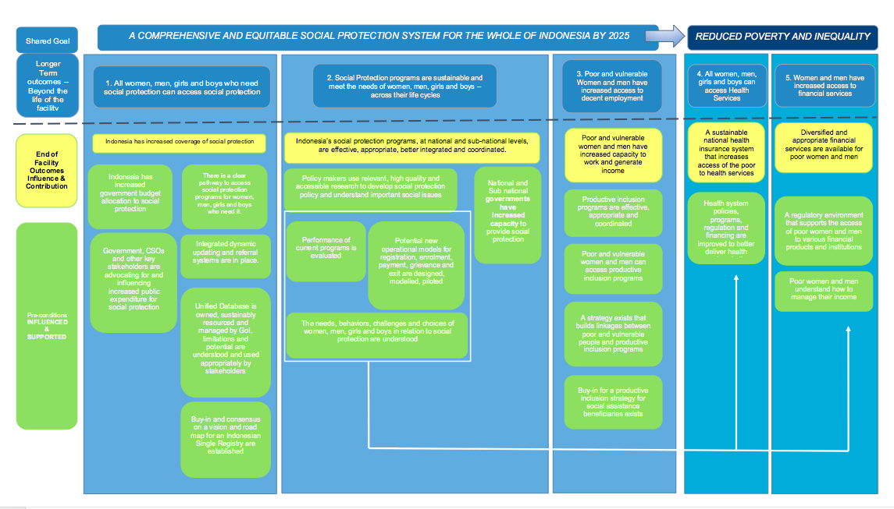

1. Social assistance, referring mainly to cash and in-kind transfers, is one part of a comprehensive social protection system. When referring to social protection in Indonesia, people are often referring to social assistance.
2. *Raskin is currently being reformed to Rastra, which provides beneficiaries with rice, milk, and eggs through e-vouchers; ** PKH is currently being expanded to cover six million households
3. Law 13/2011 gives MOSA authority over “integrated poverty data”.
4. This goal and target poverty rate of 5% are outlined in the Government’s Long Term Development Plan to 2025.
5. Social assistance refers to social transfers, either cash or in-kind. Social assistance is one part of a comprehensive social protection system.
6. SLRT is the exception this is housed outside TNP2K-S and works directly with MoSA. In addition, some demonstration projects are conducted directly by TNP2K-S using MAHKOTA which provides the flexible funding and technical assistance for rapid testing and innovation.
7. TNP2K was established by a presidential regulation, which was re-issued at the start of the current administration. The current regulation does not stipulate an end point to TNP2K. However, a re-issuing of the regulation would likely be considered at the start of a new Presidential administration in 2019. If DFAT is not in a position to continue funding TNP2K, it is likely that it will be not be continued.
8. Structural and systems capacity building would, for example, include building specific evidence to policy and technical units at MoSA to be able to undertake more sophisticated policy and systems analysis independent of TNP2K-S or MAHKOTA-CT. This is currently beyond the ability of MAHKOTA which can only identify such capacity and sustainability approaches
9. For example, between 2012 and 2014, TNP2K-S coordinated the first large-scale Raskin Reform pilot conducted by the GoI. With PRSF funding, this included directly covering the costs for the printing and distribution of the first iteration of the social protection (KPS) cards and the intensive impact evaluation conducted by J-PAL. Under MAHKOTA, TNP2K-S is currently coordinating the second generation reform to Raskin primarily through technical assistance, with minimal direct implementation costs.
10. The review was led by TNP2K-S senior managers in collaboration with MAHKOTA-CT and an independent management consultant firm.
11. A third actor who is relevant in this context is the Coordinating Ministry for Human and Cultural Development who participates in the working group for transitioning the UDB together with MoSA and TNP2K. MAHKOTA may develop a direct relationship with this ministry in the future, but so far the connection is through MoSA and TNP2K.