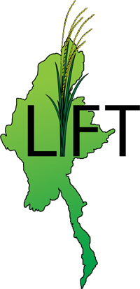

Livelihoods and Food Security Trust Fund

Annual Report 2009

A multi donor trust fund supported by Australia, European Union, United Kingdom, Netherlands, Sweden, and Switzerland.

CONTENTS

- EXECUTIVE SUMMARY I

1 FUND MANAGEMENT 1

  - Background 1
  - Coordination with the Government Ministries 3
  - Call for Proposals 4
  - Risk Management 7
  - Monitoring and Evaluation 9
  - Human Resources 10

2 FINANCIAL MANAGEMENT AND PROCUREMENT 11

2.1 Financial Status 11
  - Fund Flow Mechanism 11
  - Procurement 11

3 ANNEXURES

Annex I Organisations submitting proposals for Delta
Annex II Risk Assessment
Annex III LIFT Log Frame
Annex IV LIFT organogram and staff recruitment
Annex V Donor Contributions and Financial Statement

ABBREVIATIONS AND ACRONYMS

ACF | Action Contre La Faim
ADRA | Adventist Development and Relief Agency Myanmar
CBO | Community-Based Organization
CESVI | Cooperazione e Sviluppo (Italian NGO for cooperation and development)
DC | Donor Consortium
DCA/LWF | Dan Church Aid/The Lutheran World Federation
EU | European Union
FAO | Food and Agriculture Organization
FB | Fund Board (LIFT)
FM | Fund Manager (LIFT)
FY | Fiscal Year/Financial Year
GDP | Gross Domestic Product
GOUM | Government of the Union Of Myanmar
IOM | International Organization for Migration
IP | Implementing partner (LIFT)
ITB | Invitation to Bid
LIFT | Livelihoods and Food Security Trust Fund
MBCA | Myanmar Business Coalition on AIDS
MDG | Millennium Development Goal
MDTF | Multi Donor Trust Fund
MIDA | Myanmar Integrated Development Association
M&E  MM | Monitoring and Evaluation  Mingalar Myanmar
MMK | Myanmar Kyat (local currency)
MOA | Memorandum of Agreement
MoAI | Ministry of Agriculture and Irrigation
MoSW | Ministry of Social Welfare, Relief and Resettlement
NGO | Non Government Organization
NMTPF | National Medium Term Priority Framework
NTFP | Non Timber Forest Product
PONREPP | Post Nargis Recovery and Emergency Preparedness Plan
SC-UK | Save the Children United Kingdom
SIM | Social Impact Monitoring
TCG | Tripartite Core Group
TWA | Tun Win Aung Rural Development Services
UNDP | United Nations Development Programme
UNESCAP | United Nations Economic and Social Commission for Asia and the Pacific
UNFPA | United Nations Population Fund
UNOPS | United Nations Office for Project Services
WCM | World Concern Myanmar
WVM | World Vision Myanmar

EXECUTIVE SUMMARY

A group of donors – Australia, Denmark, European Union, France, Germany, United Kingdom, Netherlands, Sweden and Switzerland, - have come together to form a Multi Donor Trust Fund for Livelihoods and Food Security in Myanmar, known as the LIFT Fund.

The expected contribution over five years is US$100 million. The purpose of the LIFT Fund is to improve the food and livelihoods security of the poorest and most vulnerable people in Myanmar. LIFT will improve progress in Myanmar towards the Millennium Development Goal (MDG) number one: the eradication of extreme poverty and hunger.

The group of donors, the Donor Consortium (DC), has appointed a working group, the Fund Board (FB) to act on its behalf and have subcontracted UNOPS as the Fund Manager (FM) to administer the funds and provide monitoring and oversight for the LIFT Fund.

Implementation is to be undertaken through Implementing Partners (IPs) who will be selected competitively based on call for proposals. Additionally, specific Implementing Partners may be contracted to provide specialized services or for strategic purposes.

Implementing partners can consist of local organizations, national and international Non Government Organisations (NGOs) and United Nations agencies. The European Union Common Position on Burma/Myanmar has provided the framework under which the LIFT FUND will operate and the Fund Manager and Implementing Partners are expected to adhere to the EU Common Position on Myanmar.

Although the first meeting with the Ministry of Social Welfare, Relief and Rehabilitation took place on 25th December 2008, progress during 2009 was slow. The negotiations up to the release of the call for proposals in November were protracted as it took time for the various stakeholders to understand and agree on the Multi Donor Trust Fund modus operandi

With the signing of the agreement between Ministry of Social Welfare, Relief and Rehabilitation and UNOPS on 11th August, the first milestone was achieved. Following a meeting between the Minister of Social Welfare, Relief and Rehabilitation, UNOPS and the Donor Consortium members on 10 November, 2009, a Call for Proposals was issued on 11 November 2009.

The Call for Proposals requested two separate submissions with the second part being contingent upon obtaining the required authorizations for LIFT to work outside the Delta region. This was based on the request of the donors and agreed in a meeting between the European Union Ambassador and the Minister for Agriculture and Irrigation on 16 October 2009, in which the Minister requested information of possible LIFT activities outside the Delta region.

The Call for proposal was then made in two parts;
Part I. Delta Region: To provide ongoing support to the Delta region affected by Cyclone Nargis and continue the recovery effort in Food Security and Livelihoods in accordance with PONREPP and LIFT priorities.

Part II. Prioritized States/Divisions outside of Nargis-affected areas: To provide specific details to the Ministry of Agriculture and Irrigation on areas of Interest and shortlisted Implementing Partners.

The closing date for part I was 2nd December 2009 and for part II is 18th January 2010. Both rounds will be reviewed by an Independent Assessment Team and submitted to the Fund Board for consideration and final short-listing and selection.

Following the review of the delta proposals, the Fund Board, in a meeting on 16th December, approved 22 of the 36 proposals submitted. Negotiations are ongoing with the selected organizations and contracting and full implementation is expected by the end of the first quarter in 2010.

Funding and implementation of the non-delta proposals will be contingent on obtaining authorization from the Ministry of Agriculture and Irrigation to work in prioritized areas of Chin State, Rakhine State, Kachin State, Shan State and the Dry Zone.

As at 31st December 2009, US$19,863,890 of contributions had been received from the European Commission, The Netherlands, Sweden and Switzerland with additional funds expected from Australia, EC and the United Kingdom in early 2010. Disbursements for operational and overhead cost for 2009 amounted to US$273,002.

1 FUND MANAGEMENT

1.1 Background
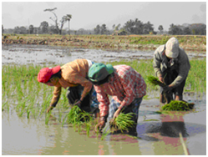
While there are variations among its sub-regions and countries, overall the Asia-Pacific region is home to the largest number of food-insecure people in the world. While significant gains have been made in the last decade, more than 64 per cent of the world’s undernourished adults and children live in Asia and the Pacific. (UNESCAP, 2009)

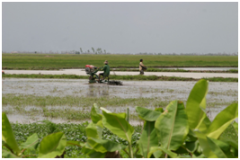
Myanmar is one of the largest and poorest countries in South East Asia, ranked 133 out of 177 countries in the 2008 Human Development Index. Ethnically diverse, with some 130 ethnic groups, its population is estimated to be between 45-54 million. Myanmar lags behind its neighbors in most socio-economic indicators and is the poorest country in Southeast Asia after East Timor in terms of Gross Domestic Product (GDP).

According to official figures, GDP growth has been over 10% annually since Fiscal Year 1999-2000. However, the true rate is likely much lower as the Economist Intelligence Unit estimated that the growth rate in 2008 was 0.9% and predicted 2009 growth to be 0.3%.

Agriculture remains the mainstay of the economy with over 50% of GDP being derived from agriculture, livestock, fisheries and forestry. Export markets include neighbors, China, India, Thailand, Bangladesh, Pakistan, Vietnam, Lao PDR and some eastern European countries.

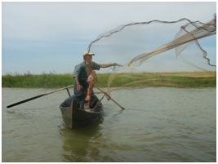
Rice is the staple crop and the second largest export commodity, after teak. Other important crops are sugar cane, groundnuts, sesame, wheat, maize, millet, jute, cotton, beans, pulses and oilseeds, vegetables, rubber, toddy palm, tobacco, spices and other edible produce.

With such a large proportion of the population relying on agriculture for livelihoods and food security, management of the agricultural sector is crucial for stability and growth. Sixty-three percent of the labor force is engaged in the agriculture sector, indicating that agriculture will be a key sector in the
economy for some time to come.

The recent global economic downturn has affected international commodity prices reducing farm-gate prices and economic returns for rural households. This general economic downturn combined with recent natural disasters and poor economic policies have resulted in poor economic growth in Myanmar.

Cyclone Nargis struck Myanmar on 2-3 May 2008, severely affecting some 2.4 million people with an estimated 140,000 people dead or missing. Cyclone Nargis simultaneously destroyed the sources of livelihoods in the region and greatly reduced the capability of people to generate income and sustain their families. Since cyclone Nargis, options for income earning in the delta areas have shrunk, sharply impacting many households ability to source capital needed for rebuilding investments. Credit is scarce and some households depend on the sale of assets, borrowing and remittances and gifts from family members. Landlessness persists, characterizing about half of all households surveyed

The recent World Bank Social Impact Monitoring (SIM) in the delta area showed that 23 percent of people still reported food as their most pressing need while another 20% reported the need for cash grants to restart livelihoods as their most pressing need.

Another recent natural disaster, referred to locally as “Mautam” (bamboo death) occurred recently in the Chin State and involved the flowering of the bamboo species, “Melocanna baccifera”, and the rat plague which is associated with heavy fruiting of the bamboo as it dies. The rats decimated crops and food reserves leaving many households in the Chin Hills without adequate food supplies.

Other food security issues exist in the Dry Zone where droughts have affected food production and the border areas where insecurity and/or armed resistance persist.

As an emerging country rich in natural and human resources, Myanmar has enormous potential for long-term economic development. In recognition of the potential as well as the need, a group of donors – the European Commission, the United Kingdom, Australia, the Netherlands, Sweden and Switzerland – established a Donor Consortium (DC) and set up a Multi Donor Trust Fund (MDTF) for Livelihoods and Food Security (LIFT). The donor consortium delegated responsibility to a Fund Board to administer the Multi Donor Trust Fund.

UNOPS was appointed as Fund Manager in order to provide management, monitoring and oversight of the LIFT Fund. The pooled funds are expected to exceed USD 100 Million over five years.

Assistance provided through the LIFT Fund will follow a community development approach and target the poorest households irrespective of gender, race, creed or sexual orientation. The use of local resources will be maximized and all efforts will be made to strengthen the capacity of the communities to self-address difficulties. LIFT FUND priorities will align with the National Medium Term Priority Framework (NMTPF) and PONREPP priorities in the delta area.

The Overall Objective of the LIFT Fund is progress towards the achievements of the United Nations Millennium Development Goal number one: the eradication of extreme poverty and hunger in Myanmar.

The Purpose of the LIFT Fund is to improve the food and livelihood security of the poorest and most vulnerable populations of Myanmar, with an initial focus on the cyclone Nargis affected areas of the Delta.

The five focus areas of intervention are;

- Increased crop and livestock production, fisheries and sustainable harvesting of non-timber forest products (NTFP)
- Diversified and increased household incomes
- Improved food nutrition and hygiene and strengthened existing mechanisms providing social protection
- Expanded local employment through business development
- Improvements in the enabling environment

Crosscutting themes include access (targeting the neediest), capacity building, strategic planning, participation and inclusion, gender, environment, coordination, risk management and sustainability.

1.2 Coordination with the Government Ministries

An initial meeting was held with the Minister of Social Welfare, Relief and Resettlement (MoSW) on 25th December 2008 in order to brief him on the proposed LIFT Fund for the cyclone Nargis affected areas of the Delta.

This was followed by other meetings on the 7th and 10th January 2009 with the MoSW and later with the Tripartite Core Group (TCG) and an AGREEMENT between MoSW and UNOPS was signed on 11th August 2009.

A separate meeting took place between the donors, EU Ambassador and the Minister of Agriculture and Irrigation (MoAI) on 16th October to discuss the possibility to launch the LIFT Fund nationally and in particular in the Chin State, Rakhine State, Kachin State, Shan State and the Dry Zone. In order to provide the Minister with the details of which organizations would be working where and doing what, it was decided to undertake the “call for proposals” in two separate parts.

Following a meeting between the Minister of Social Welfare, Relief and Rehabilitation, UNOPS and the Donor Consortium members on 10 November, 2009, the Call for Proposals was issued on 11th November 2009. A launching workshop was held on the 13th November and potential implementing partners were invited to attend. Additional to this a question and answer forum was established on the UNOPS website at www.unops.org in order to respond to any questions relating to the Call for Proposals.

The Call for Proposals was posted on the UNOPS website on 11th November requesting interested parties submit their proposals. Assessment criteria and predetermined formats were provided to guide potential implementing partners.

The Call for Proposals was divided into two separate submissions with the second part being contingent upon obtaining the required authorizations for the LIFT Fund to work outside the Delta region. The Call for Proposals was then made in two parts;

Part I. Delta Region: To provide ongoing support to the Delta region affected by Cyclone Nargis and continue the recovery effort in Food Security and Livelihoods in accordance with PONREPP and LIFT Fund priorities.

Part II. Prioritized States/Divisions outside of Nargis-affected areas: To provide specific details to the Ministry of Agriculture and Irrigation on Areas of Interest and possible Implementing Partners.

1.3 Call for proposals

1.3.1 Part I. Delta Region

The Call for Proposals for the delta region launched on November 11th 2009, consisted of two windows;
- A main window which provided grants of between US$100,000 to US$2 million over a twelve month period.
- A small window which provided grants to local organizations of between US$50-100,000 over a twelve month period.

The closing date for the delta region was 2nd December 2009 and 36 proposals were received from 31 organisations.

An Independent Assessment team was recruited by UNOPS to review the proposals based on the criteria set out in the Call for Proposals. Of the 36 proposals submitted, 24 passed the technical threshold. In a Fund Board meeting of 16th December, 2009, 22 proposals were shortlisted for funding. The criteria used for assessing the proposals included;
- Financial and operational capacity
- Relevance
- Methodology
- Sustainability
- Budget and cost effectiveness

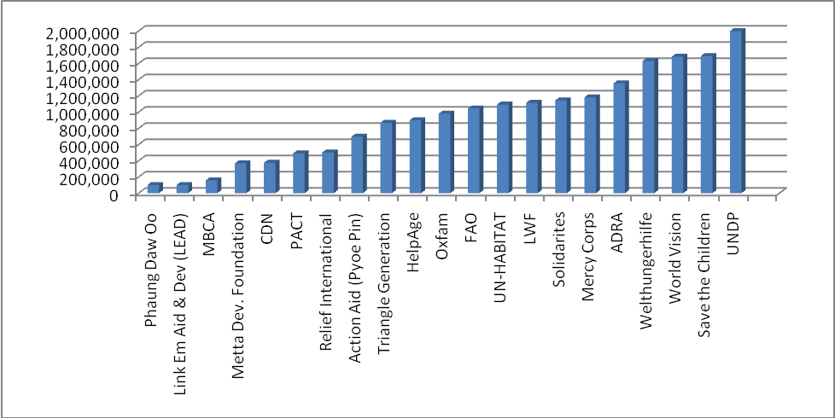
Figure 1: Fund distribution for Delta CfP

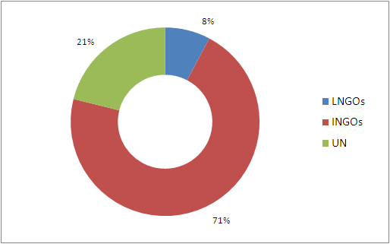
Figure 2: Distribution of fund for Delta CfP

Letters of advice were sent to all Implementing partners on 19th December, 2009 and each proposal was reviewed and negotiations undertaken with Implementing Partners for;
- Robustness of the log frame and indicators to ensure they are SMART
- Targeting and monitoring systems for all cash grants
- Indirect costs in budgets
- Disclosure of other funding sources for shared budget lines
- Ensuring that valid agreements are in place with GOUM to carry out the proposed activities in the proposed areas.
- Specific technical components of individual proposals
The payment schedule was arranged to allow frontloading of funding in order to meet expenditure requirements for the 2010 monsoon paddy crop. Negotiations are ongoing with the selected organizations and contracting and full implementation is expected by the end of the first quarter in 2010. For information on the organizations and breakdown of funding please see Annex I

1.3.2 Part II. Prioritized States/Divisions outside of Nargis-affected areas

The closing date for the non-delta areas is due on 18th January 2010. The same process will be followed as for part I. Following the assessment and short-listing of proposals, negotiations will begin with the Ministry of Agriculture and Irrigation for an AGREEMENT to operate nationally.

Funding and implementation of the non-delta proposals will be contingent on obtaining authorization from the Ministry of Agriculture and Irrigation to work in prioritized areas of Chin State, Rakhine State, Kachin State, Shan State and the Dry Zone.

1.4 Risk Management

The delivery of an aid programme is an inherently risky business involving multiple relationships, complex contractual arrangements and difficult development problems. Managing risk is an integral part of good management and is the ability to recognize and prepare for a range of possible future events.

Risk arises out of uncertainty and this has two main elements, the likelihood of something happening or not happening and the consequences if it happens or does not happen. Additional to this, risk management considers when something might happen. Risk Management is aimed at providing a structured method of identifying and analyzing potential risks and devising and implementing responses appropriate to their impact.
Risk analysis and management asks:
What might go wrong as compared with expectations?
What should/could be done about this?

The process of risk management is designed to assist planners and managers to systematically identify risks and develop measures to address them and their consequences. These responses generally draw on strategies of risk prevention, risk transfer, impact mitigation and risk acceptance.

Myanmar is a highly politicised environment within which to deliver or implement humanitarian relief and development efforts. An election is planned for 2010; the first such election since 1990 and restrictions on UN and NGO activities are expected. Visas and travel restriction of International staff is expected. The space provide to local organisations for social works, opened by cyclone Nargis is expected to shrink as donor funds are reduced and as the elections process draws closer.

Many uncertainties, delays and disruptions are expected during the first full year of operation of the LIFT FUND. Although the need is urgent and the funds significant, the election process and change in Government structure is expected to bring many challenges to the LIFT FUND in 2010 and beyond.

A risk assessment tool as seen below is used to determine risk.
Risk Assessment Tool
Impact  Likelihood | Critical (5) | High (4) | Medium (3) | Low (2) | Negligible (1)
Certain/imminent  (5) | Critical (5) | Critical (5) | High (4) | Medium (3) | Low (2)
Very Likely (4) | Critical (5) | High (4) | High (4) | Medium (3) | Low (2)
Likely (3) | High (4) | High (4) | Medium (3) | Low (2) | Negligible (1)
Moderate or Likely  (2) | Medium (3) | Medium (3) | Low (2) | Low (2) | Negligible (1)
Unlikely (1) | Low (2) | Low (2) | Negligible (1) | Negligible (1)

For full Details of the risk assessment, please see Annex II

1.5 Monitoring and Evaluation

The Fund Manager will design, develop and implement a monitoring and evaluation system to guide the FM in reaching the goals and objectives of the LIFT Fund as well as monitor the performance of implementing partners and ensure that resources are used effectively.

The M&E system will be based on a robust log-frame with SMART indicators. A baseline will be developed based on the indicators developed in the log-frame. Output tracking and outcome monitoring will be achieved through selected monitoring tools and in strong partnership and collaboration with Implementing Partners. Output and outcome indicators will be monitored and where possible standard indicators will be used by Implementing Partners.

A comprehensive baseline will need to be developed at the beginning of the project to enable evidence to be generated in support of positive (or negative) changes. Some baseline data already exists and a review of existing studies and research data will be undertaken in order to build on existing methodologies and available information. Additionally, there is the possibility to join with FAO to develop a ‘livelihoods” baseline for the Delta and learn from this methodology to develop a tool that can be used for the non-delta areas.

Some challenges exist in standardizing indicators and reporting mechanisms as many of the terms used in development have different concepts and meaning for different stakeholders. For example, there is the need define “Vulnerability” and develop an appropriate targeting tool. Additionally, as the LIFT Fund is promoting a community development approach, a common understanding of a community based organization (CBO) will need to be developed and a capacity assessment tool or score card system to measure capacity development of CBOs and local organizations will be required.

Challenges and opportunities exist for the M&E system to contribute to the understanding of poverty in Myanmar and developing strategies for intervention and generating knowledge for best practice. Stakeholder and thematic workshops will be held to share and learn from field activities and capture and promote best practices. Where possible and where credible, best practice will be disseminated to stakeholders to bring changes at the implementation, program and policy level.

Linkages with existing structures such as the Delta Livelihood Working group, Thematic Group on Food Security and Agriculture, Nutritional Technical Network, Food Security Working group and others will be developed for coordination and sharing of information.

As well as regular monitoring by the Fund Manager, an Annual and Mid-term review and end of project study will be commissioned to reputed national/international organisations.

Financial and administrative aspects of the Implementing Partners and the LIFT Fund itself will be closely monitored and tracked to measure programmatic progress including aspects such as delivery, cost effectiveness, procurement practices, financial management and reporting and overall compliance with international best practice in financial control and management.

Training will be provided to implementing partners to ensure a steady flow of adequate information/data and quality reporting. Implementing partners will be provided with feedback on performance against agreed targets when analysis of recorded data is completed. These analyses will be used by the Fund Manager to define and propose next action cycles adjusted to changing circumstances and lessons learnt, and will assist the Fund Manager in its own accountability and responsibilities. Monitoring results will be included in the Fund Manager’s reports to the Fund Board. Six-monthly narrative reports and yearly progress and financial reports will be submitted by the Fund Manger to the Fund Board.

The Log Frame which will form the backbone of the LIFT Fund is included in Annex III

1.6 Human Resource Management

Due to the long period of negotiations with donors and government, the start up of the LIFT Fund was considerably delayed. The vacancy announcements for International Staff were posted on 26th January 2009, with the first international staff starting work on 30th November 2009. The other international staff, the Livelihood and Food Security program officer, M&E program officer and Communications officer are expected to take up their positions in early January 2010.

The Fund Director and the Administration Officer who have been on board since December 2009 are waiting for visas to take up their duty station in Myanmar. An interim office was established on 15th October 2009 to handle the administration and logistics of the call for proposal and recruitment process.

Recruitment of national staff has been delayed due to the late start and recruitment of International Staff and lack of visas for entry into Myanmar.

For details of the LIFT FUND organogram and recruitment of national and international staff please see Annex IV

2. FINANCIAL MANAGEMENT AND PROCUREMENT

  - Financial Status

As 2009 is the first year of the LIFT FUND and negotiations have delayed the start of activities not many activities have taken place. LIFT FUND staff only came on board in December 2009 at the closing date for the delta proposals.

Donor contributions were received from the European Commission (€10 million), The Netherlands (USD2,950,000), Switzerland (USD379,975) and Sweden (20,000,000 SEK ) totaling US$19,863,890 with additional contributions expected from the EC, United Kingdom and Australia in early 2010.

For the 2009 financial year expenditure of US$273,002 was incurred and comprised of $753 for research and visibility, $235,757 for the operation of the Fund Managers office and $18,632 for support to the Fund Board.

For full details of the financial status and breakdown of donor contributions please see Annex V.

  - Funds Flow Mechanism

The Fund Board has the responsibility to select the Implementing Partners and directs the Fund Manager to negotiate with the IPs on their behalf. The funds flow mechanism envisioned for the LIFT FUND is through the Fund Manager to selected Implementing Partners.

A standard AGREEMENT (MOA) is reached with the implementing partners and the Description of Action, Budgets and Log Frame attached as annexures. The Implementing Partner is responsible for achievement of outputs and objectives as stated in their log frame and budgets. The Implementing Partners will be responsible for the procurement according to their proposals and no central procurement is envisaged.

The Fund Manager and Implementing Partners are expected to adhere to the EU Common Position on Myanmar.

  - Procurement

The Fund Manager’s role for procurement is limited to what is required to run the office and provide monitoring and oversight. During December 2009 the office procurement plan was revised and preparations were made for the procurement of computers, printers, mobile phones, photocopier and facsimile machine. The Invitation to Bid (ITB) was prepared and released on 4th January 2010.

Other items for procurement will depend on visas, when and where office space is selected and approval of GOUM for the importation or purchase of vehicles.

Annex I Organisations submitting proposals for Delta

SN | Organization
1 | ACF
2 | ADRA
3 | Border Area Development Association
4 | British Council
5 | Caritas Thailand
6 | Consortium Dutch NGOs
7 | DCA/LWF
8 | FAO
9 | UN-HABITAT
10 | HELPAGE
11 | IOM 1
12 | IOM 2
13 | IOM 3
14 | LINK Emergency Aid and Development
15 | Mercy Corps
16 | Metta Development Foundation
17 | Metta Mon
18 | MIDA
19 | Mingalar Myanmar
20 | Myanmar Business Coalition on AIDS
21 | MM-Thirimay-TWA Consortium
22 | NGO Consortium
23 | OXFAM
24 | PACT
25 | Phauw Daw Oo
26 | Relief International
27 | Save the Children
28 | Seventh Day Adventist
29 | Solidarites 1
30 | Solidarites 2
31 | Triangle GH
32 | UNDP
33 | UNFPA
34 | Welthungerhilfe
35 | World Concern
36 | World Vision

LEAD Organisation  Consortium  Member | ADRA | Consortium Dutch NGOs  (CDN) | Food and Agriculture Organization (FAO) | HelpAge International | Link Emergency Aid and Development (LEAD) | The Lutheran World Federation  (LWF) | Mercy Corp | Metta Development Foundation | Oxfam | PACT | Phaung Daw Oo | Relief International | Save the Children | Solidarities | Triangle Generation Humanitarie | UNDP | UN-HABITAT | Welthungerhilfe | World Vision
Karen Baptist Church (KBC)
Capacity Building Initiatives (CBI)
Metta Development Foundation
Ever Green Group
Community Development Association
Lawka Alin
Dan Church Aid
Ar Yone Oo
Network Activities Group (NAG)
Better Life
Myanmar Agricultural Service (MAS)
Mangrove Serevices Network (MSN)
Myanmar Fishery Federation (MFF)
Myanmar Nurses and Midwife Association
Thingaha
Friends of Rainforest (FORM)
Global Plain Agricultural Products Cooperatives
The Leperosy Mission International (TLMI)
AECOM International
PACT
GRET
ACTED
CESVI

Annex II: Risk Assessment

Risk | Possible effect on project | L | I | R | Risk Management | Responsibility | Timing
MoSW or MoAI do not support selected IPs | Donors will not continue to support LIFT  Donors will fund bilaterally | 4 | 5 | 5 | Select IPs carefully  Check unofficially with GOUM before submitting IPs | Fund Board | Whole project
MoAI does not support  LIFT for non-delta areas | Donors will not continue to support LIFT  Funding may be lost | 3 | 5 | 5 | Select IPs carefully  Check unofficially with GOUM before submitting IPs | Fund Board | Whole project
IPs are embroiled in political affairs | LIFT activities are put on hold by GOUM or local authorities | 4 | 5 | 5 | Carefully manage and monitor IP activities | Fund Director | Whole year
LIFT staff are unable to obtain official GOC visas | Project start up is delayed  Negotiations with IPs is delayed  Misunderstanding and poor communication affect project | 33 | 5 | 4 | Manage from UNOPS Bangkok  Appoint experienced national staff and brief/train in BKK  Invite IP to BKK for briefings | Fund Manager | January  February
MoAI does not support LIFT in certain areas | Donors will not continue to support LIFT  Funding may be lost | 4 | 4 | 4 | Build understanding with MoAI | Fund Board | Whole project
International staff (LIFT) cannot access project areas | Rely on IPs for feedback on field situation | 5 | 33 | 4 | Hire experienced national staff  Triangulate with other IPs  Prepare good monitoring feedback formats | Fund Director | July onwards
Election activities delay or interfere with LIFT implementation | Implementation is delayed or halted | 5 | 3 | 4 | Build strong understanding and partnerships with GOUM and local authorities | Fund Board  Fund Director | Election period
Post election confusion causes interference in project implementation | Implementation is delayed or halted | 4 | 3 | 4 | Keep authorities informed of project activities/ Provide regular reports and updates | Fund Director | Post election period
Poor Government policies restrict economic growth | Reduced employment and poor prices for produce  Outcome and impact of project are minimal | 3 | 3 | 3 | Promote low risk, low cost production  Study and promote market linkages | Fund Director | Whole project
Currency fluctuations impact negatively on LIFT FUND | Planned activities will be reduced with an overall reduction in outputs, outcomes and impact | 2 | 3 | 2 | Front load expenditures  Release funds on time | Fund Director | Whole project
Donors withdraw their support | LIFT fund will shrink in size and impact | 2 | 3 | 2 | Keep GOUM fully aware of the benefits of the MDTF | Fund Board and Fund Director | Years 2 & 3
Abnormal seasonal conditions wipe out any gains | Outcomes and impact negligible | 2 | 3 | 2 | Put in place DRR measures  Support village level Disaster response plans | Fund Board  Fund Director | Whole project
Strategies and activities supported by the LIFT FUND are inappropriate | Outcomes and impact will be less than expected | 1 | 1 | 1 | Work closely with other stakeholders  Openly share information and be open to feedback | Fund Director | Whole project
IP mismanage or misappropriate funds | Gives LIFT FUND a bad reputation | 1 | 1 | 1 | Carefully select and monitor IPs and their activities  Regular Auditing of IPs | Fund Director | Whole project

Annex III LIFT Logframe

PROJECT NAME | Livelihoods and Food Security Trust Fund
OVERALL OBJECTIVE/SUPER GOAL | Progress towards the achievement of Millennium Development Goal 1: the eradication of extreme poverty and hunger in Myanmar
GOAL | Indicator | Baseline | Milestone 1 (2012) | Milestone 2 (2013) | Target (2014)
To improve the food and livelihoods security of the poorest and most vulnerable people in Myanmar | Share of Food Expenditure in Overall Consumption (excluding health expenditure) in target states | 75% (2007) | n/a | n/a | 70%
 |  | Source
 |  | IHLCS 2007, 2010, 2014, FAO/WFP Crop Food Assessment 2010, 2012, 2014 and Agricultural Census 2010
 | Indicator | Baseline | Milestone 1 (2012) | Milestone 2 (2013) | Target (2014)
 | % of moderately/severely malnourished children under 5 years of age (Stunting, wasting, underweight) | 49.6% (2007) | n/a | n/a | 40%
 |  | Source
 |  | IHLCS 2007, 2010, 2014
 | Indicator | Baseline | Milestone 1 (2012) | Milestone 2 (2013) | Target (2014)
 | % increase in value of net household assets (productive/non-productive) | 0% | n/a | n/a | 10%
 |  | Source
 |  | LIFT commissioned study
PURPOSE | Indicator | Baseline | Milestone 1 | Milestone 2 | Target (2014) | Assumptions
To increase food availability, income generation opportunities and food use for 1-1.5 million target beneficiaries | % of target beneficiaries reporting new or improved income generating activities one year after assistance provided. | 0 | 10% | 45% | 60% | Fluctuating relationships between the Government and donor governments does not influence LIFT's performance and existence.  Political changes positively affect target beneficiaries capability to benefit from increase food, income and nutrition knowledge.  The election process does not adversely affect the project implementation.  There are no adverse weather conditions or natural disasters.  Economic growth is positive and markets function effectively.
 |  | Source
 |  | LIFT Annual Report, IHLCS 2010, 2014, LIFT IP household survey
 | Indicator | Baseline | Milestone 1 | Milestone 2 | Target (2014)
 | % increase in number of beneficiaries reporting an increase in food secure months | 0 | 40% | 50% | 60%
 |  | Source
 |  | LIFT Annual Report, IHLCS 2010, 2014, LIFT IP household survey
 | Indicator | Baseline | Milestone 1 | Milestone 2 | Target (2014)
 | % of targeted beneficiaries reporting an increase in dietary diversity score | 0 | 30% | 40% | 50%
 |  | Source
 |  | Survey commissioned by LIFT
INPUTS (US$) | Donors (US$) | Govt (£) | Other (£) | Total ($)
INPUTS (US$) | 100,000,000 | 0 | 0 | 100,000,000
OUTPUT 1 | Indicator | Baseline | Milestone 1 | Milestone 2 | Target (2014) | Assumption
Direct agricultural production support provided and used by targeted households | Number of targeted households provided with agricultural inputs (gender disaggregated) | 0 | 25000 | 60000 | 75000 | No political interference in funding allocations.  There are no adverse weather conditions  Policy environment (land and production rights) are not infringed.
 |  | Source
 |  | LIFT Annual Report, LIFT project monitoring data obtained through implementing partners MIS systems
 | Indicator | Baseline | Milestone 1 | Milestone 2 | Target (2014)
 | Number of targeted households provided with technical agricultural training/ information (gender disaggregated) | 0 | 25,000 | 60,000 | 75,000
 |  | Source
 |  | LIFT Annual Report, LIFT project monitoring data obtained through implementing partners MIS systems
 | Indicator | Baseline | Milestone 1 | Milestone 2 | Target (2014)
 | % of targeted households who adopt new practices for agricultural production | 0 | 50% | 60% | 65%
 |  | Source
 |  | LIFT Annual Report, LIFT project monitoring data obtained through implementing partners MIS systems
 | Indicator | Baseline | Milestone 1 | Milestone 2 | Target (2014)
 | % of targeted households reporting 5% increase in annual agricultural productivity | 0 | 50% | 60% | 75%
 |  | Source
 |  | LIFT Annual Report, FAO/WFP Crop Food Assessment 2010, 2012, 2014, LIFT IP household survey
IMPACT WEIGHTING | Indicator | Baseline | Milestone 1 | Milestone 2 | Target (2014)
20% | % of targeted households who have improved food storage capacity | 0 | 60% | 70% | 75%
20% |  | Source |  |  |  | RISK RATING
20% |  | LIFT IP household survey, Survey commissioned by LIFT |  |  |  | High
INPUTS (£) | Donors (US$) | Govt (£) | Other (£) | Total ($)
INPUTS (£) | 44,000,000 |  |  | 44,000,000
OUTPUT 2 | Indicator | Baseline | Milestone 1 | Milestone 2 | Target (2014) | Assumptions
Effective market and employment support mechanisms provided and used by targeted households | Number of targeted households that have access to credit through LIFT IPs (gender disaggregated) | 0 | 20000 | 25000 | 30,000 | No political interference in funding allocations.  Economic environment allows beneficiaries to use skills and credit.  Markets are allowed to function effectively.
 |  | Source
 |  | LIFT Annual Report, LIFT project monitoring data obtained through implementing partners MIS systems
 | Indicator | Baseline | Milestone 1 | Milestone 2 | Target (2014)
 | Number of targeted households provided with vocational & Micro/Small enterprise development training (gender disaggregated) | 0 | 6000 | 8000 | 10,000
 |  | Source
 |  | LIFT Annual Report, LIFT project monitoring data obtained through implementing partners MIS systems
 | Indicator | Baseline | Milestone 1 | Milestone 2 | Target (2014)
 | % (number) of trained households who establish enterprises using the training they received (gender disaggregated) | 0 | 50 | 60 | 75
 |  | Source
 |  | LIFT Annual Report, LIFT project monitoring data obtained through implementing partners MIS systems, Survey commissioned by LIFT
 | Indicator | Baseline | Milestone 1 | Milestone 2 | Target (2014)
 | % (number) of micro-finance groups and village savings & loan groups that are working one year after support from the project | 0 | 60 | 60 | 60
 |  | Source
 |  | LIFT Annual Report, LIFT project monitoring data obtained through implementing partners MIS systems, Survey commissioned by LIFT
 | Indicator | Baseline | Milestone 1 | Milestone 2 | Target (2014)
 | % (number) of targeted households reporting improved access to markets and market information | 0 | 30 | 40 | 50
 |  | Source
 |  | LIFT Annual Report, Survey commissioned by LIFT, LIFT project monitoring data obtained through implementing partners MIS systems
IMPACT WEIGHTING | Indicator | Baseline | Milestone 1 | Milestone 2 | Target (2014)
20% | % (number) of targeted households who report increase in income from micro-finance / savings / loans | 0 | 50 | 60 | 70
20% |  | Source |  |  |  | RISK RATING
20% |  | LIFT Annual Report, Survey commissioned by LIFT, LIFT project monitoring data obtained through implementing partners MIS systems |  |  |  | High
INPUTS (£) | Donors (US$) | Govt (£) | Other (£) | Total ($)
INPUTS (£) | 16,000,000 |  |  | 16,000,000
OUTPUT 3 | Indicator | Baseline | Milestone 1 | Milestone 2 | Target (2014) | Assumptions
Effective social protection measures provided for the chronically poor of the targeted household | Targeting methodology developed and followed | No methodology available | Methodology applied in 50% of proposals | Methodology applied in 60% of proposals | Methodology applied in 70% of proposals | No political interference in funding allocations.  Levels of support to targeted households are large enough to meet needs
 | Targeting methodology developed and followed | Source
 | Targeting methodology developed and followed | LIFT Annual Report, LIFT project monitoring data obtained through implementing partners MIS systems
 | Indicator | Baseline | Milestone 1 | Milestone 2 | Target (2014)
 | Number of targeted households receiving cash/asset transfer (gender disaggregated) | 0 | 10,000 | 20,000 | 30,000
 |  | Source
 |  | LIFT Annual Report, LIFT project monitoring data obtained through implementing partners MIS systems
 | Indicator | Baseline | Milestone 1 | Milestone 2 | Target (2014)
 | Number of targeted households accessing cash for work activities (gender disaggregated) | 0 | 10000 | 15000 | 20,000
 |  | Source
 |  | LIFT Annual Report, LIFT project monitoring data obtained through implementing partners MIS systems
IMPACT WEIGHTING | Indicator | Baseline | Milestone 1 | Milestone 2 | Target (2014)
15% | % of targeted households reporting a reduction in financial problems | 0% | 60% | 60% | 60%
15% |  | Source |  |  |  | RISK RATING
15% |  | LIFT Annual Report, LIFT project monitoring data obtained through implementing partners MIS systems |  |  |  | Medium
INPUTS (£) | Donors (US$) | Govt (£) | Other (£) | Total ($)
INPUTS (£) | 22,000,000 |  |  | 22,000,000
OUTPUT 4 | Indicator | Baseline | Milestone 1 | Milestone 2 | Target (2014) | Assumptions
Capacity of CBOs and LNGOs strengthened to support livelihoods and food security initiatives | Number of community based groups (CBOs) formed/strengthened | 0 | 1000 | 1500 | 1500 | CBOs and LNGOs are allowed to form and meet regularly and support livelihoods and food security initiatives
 | Number of community based groups (CBOs) formed/strengthened | Source
 | Number of community based groups (CBOs) formed/strengthened | LIFT project monitoring data obtained through implementing partners MIS systems
 | Indicator | Baseline | Milestone 1 | Milestone 2 | Target (2014)
 | Number of community based groups (CBOs) trained on cross cutting issues | 0 | 1000 | 1500 | 1500
 |  | Source
 |  | LIFT project monitoring data obtained through implementing partners MIS systems
IMPACT WEIGHTING | Indicator | Baseline | Milestone 1 | Milestone 2 | Target (2014)
15% | Number of CBOs have increased their capacity by 25% based on capacity assessment tool/score card | 0 |  |  | 25
15% |  | Source |  |  |  | RISK RATING
15% |  | LIFT Annual Report, LIFT commissioned studies |  |  |  | High
INPUTS (£) | Donors (US$) | Govt (£) | Other (£) | Total ($)
INPUTS (£) | 4,000,000 |  |  | 4,000,000
OUTPUT 5 | Indicator | Baseline | Milestone 1 | Milestone 2 | Target (2014) | Assumptions
Effective support provided to targeted households for nutrition and hygiene | Number of targeted households provided with nutrition education (gender disaggregated) | 0 | 10,000 (Over 75% women) | 15,000 (Over 75% women) | 20,000 (Over 75% women) | No political interference in funding allocations.  Beneficiaries have acces to and are able to afford necessary inputs for good nutrition and hygiene.
 |  | Source
 |  | LIFT Annual Report, LIFT project monitoring data obtained through implementing partners MIS systems
 | Indicator | Baseline | Milestone 1 | Milestone 2 | Target (2014)
 | Number of targeted households provided with hygiene education (gender disaggregated) | 0 | 10,000 (Over 75% women) | 15,000 (Over 75% women) | 20,000 (Over 75% women)
 |  | Source
 |  | LIFT Annual Report, LIFT project monitoring data obtained through implementing partners MIS systems
IMPACT WEIGHTING | Indicator | Baseline | Milestone 1 | Milestone 2 | Target (2014)
10% | % of targeted households using improved practices in hygiene and nutrition | 0 | 50% | 50% | 50%
10% |  | Source |  |  |  | RISK RATING
10% |  | LIFT Annual Report, LIFT project monitoring data obtained through implementing partners MIS systems, LIFT commissioned studies |  |  |  | Medium
INPUTS (£) | Donors (US$) | Govt (£) | Other (£) | Total ($)
INPUTS (£) | 1,000,000 |  |  | 1,000,000
OUTPUT 6 | Indicator | Baseline | Milestone 1 | Milestone 2 | Target (2014) | Assumptions
M&E evidence and commissioned studies are used to inform programme and policy development | % (and number) of commissioned studies that are discussed by Fund Board and lead to actioned change of strategic direction | 0 | 50% (3) | 70% (7) | 80% (10) | No political interference in funding allocations.  Activities supported by the Fund are coherent and lessons can be consolidated to have an impact on policy and implementation.  An appropriate Nationally-Owned Strategic Framework outside the Delta is developed.
 |  | Source
 |  | LIFT Annual Report, Mid-term Evaluation, Fund Board Minutes, Annual Reviews (?)
 | Indicator | Baseline | Milestone 1 | Milestone 2 | Target (2014)
 | Number of strategic issues identified through IP programme activities, discussed by Fund Board and lead to actioned change of strategic direction | 0 | 3 | 7 | 10
 |  | Source
 |  | LIFT Annual Report, Mid-term Evaluation, Fund Board Minutes
IMPACT WEIGHTING | Indicator | Baseline | Milestone 1 | Milestone 2 | Target (2014)
10%
10% |  | Source |  |  |  | RISK RATING
10% |  |  |  |  |  | High
INPUTS (£) | Donors (US$) | Govt (£) | Other (£) | Total ($)
INPUTS (£) | 5,000,000 |  |  | 5,000,000
OUTPUT 7 | Indicator | Baseline | Milestone 1 | Milestone 2 | Target (2014) | Assumptions
Funds are allocated in line with Fund Board policies and are accounted for in a transparent manner. | FB policy and strategy is clearly articulated and followed by the Fund Manager | 0% | 90% | 95% | 100% | Fund Board members allocate sufficient human resource capacity to LIFT  No political interference in funding allocations.  Fund priorities reflect international best practice and learning.  Transparent and open relationship among Fund Board, Fund Manager and Implementing Partners.  Fund Manager supportive and engaging with Fund Board policies.
 |  | Source
 |  | Fund Board Minutes of meeting, Fund Manager updates on follow-up on tasks and policies
 | Indicator | Baseline | Milestone 1 | Milestone 2 | Target (2014)
 | % of clear Fund Board recommendations implemented by the Fund Manager within given deadlines | 0% | 90% | 95% | 100%
 |  | Source
 |  | Fund Board Minutes of meeting, Fund Manager updates on recommendations
IMPACT WEIGHTING | Indicator | Baseline | Milestone 1 | Milestone 2 | Target (2014)
5% | % and number of audit areas (both FM and IPs) rate as 'high priority' by auditors | 3 (FM), 2 (per IP) | 0 for all parties | 0 for all parties | 0 for all parties
5% |  | Source |  |  |  | RISK RATING
5% |  | Fund Board Minutes of meeting, Fund Manager updates on recommendations |  |  |  | High
INPUTS (£) | Donors (US$) | Govt (£) | Other (£) | Total ($)
INPUTS (£) | 4,000,000 |  |  | 4,000,000
OUTPUT 8 | Indicator | Baseline | Milestone 1 | Milestone 2 | Target (2014) | Assumptions
Fund flow and IP performance are monitored and evaluated. | % of funds released by Fund Board is in line with the IP MoAs | 0% | 85% | 100% | 100% | Fund Manager has M&E capacity and effective M&E system in place.  Political situation does not interfere the fund flow process
Fund flow and IP performance are monitored and evaluated. |  | Source
Fund flow and IP performance are monitored and evaluated. |  | LIFT Annual Report
IMPACT WEIGHTING | Indicator | Baseline | Milestone 1 | Milestone 2 | Target (2014)
5% | % of Implementing Partners for whom the Fund Manager completes an M&E system review. | 0% | 70% | 90% | 100%
5% |  | Source |  |  |  | RISK RATING
5% |  | Fund Manager M&E review, LIFT Annual Report |  |  |  | Medium
INPUTS (£) | Donors (US$) | Govt (£) | Other (£) | Total ($)
INPUTS (£) | 4,000,000 |  |  | 4,000,000

Annex IV: LIFT organogram and staff recruitment

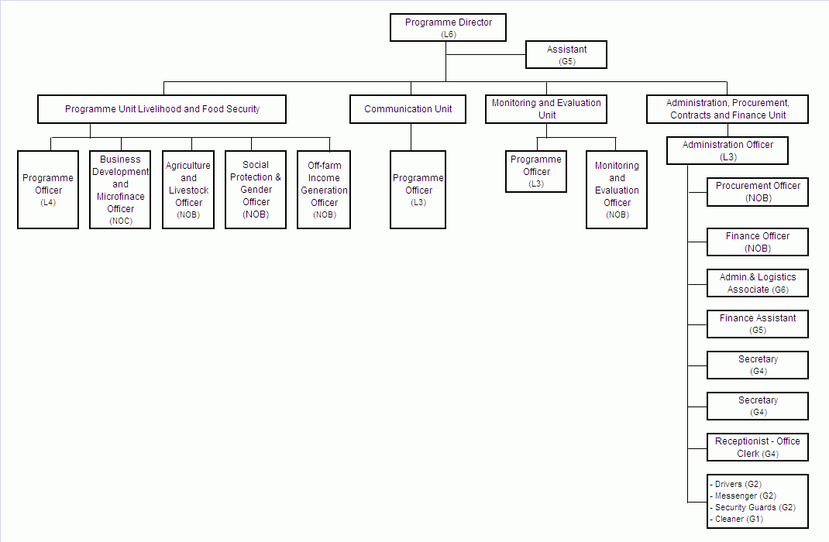

S/N | Position |  | VA posted | Interview date | Start date | Comments
1 | Fund Director | International | 26.1.09  7.8.09 | 18.3.09  25.9.09 | 30.11.09 | First candidate withdrew  On board in December 2009
2 | Program Officer (Livelihoods and Food security) | International | 26.1.09 | 6.3.09 | 11.1.10 | Expected
3 | Program Officer (Monitoring and Evaluation) | International | 26.1.09 | 27.4.09 | 25.1.10 | Expected
4 | Administration Officer | International | 26.1.09 | 3.3.09 | 30.11.09 | On board in December 2009
5 | Communications Officer | International | 26.1.09 | 20.3.09 | Vacant | Both first and second candidate withdrew
6 | Agriculture and Livestock Officer | National | 15.10.09 |  |  | Candidates are long listed and will be interviewed as soon as the internationally recruited staff are able to travel to Yangon
7 | Social Protection and Gender Officer | National | 15.10.09
8 | Off-farm income generation Officer | National | 15.10.09
9 | Business Development and Microfinance Officer | National | 15.10.09
10 | Monitoring and Evaluation Officer | National | 15.10.09
11 | Finance Officer | National | 15.10.09
12 | Procurement Officer | National | 15.10.09
13 | Administration and Logistics Associate | National | 15.10.09 | 9.12.09 | 18.1.10 | Expected
14 | Finance Assistance | National | 15.10.09
15 | Assistant to Fund Director | National
16 | Secretary (Admin Assistant) | National
17 | Secretary (HR Assistant) | National
18 | Receptionist / Office Clerk | National
19 | Driver | National |  |  |  | Drivers are not required until vehicles are purchased.
20 | Driver | National |  |  |  | Drivers are not required until vehicles are purchased.
21 | IT and database associate (short term) | National |  |  |  | Addition positions expected
22 | Communications assistant (short term) | National |  |  |  | Addition positions expected

Figure 3: Staff recruitment
Annex IV: Donor Contributions and Financial Statement

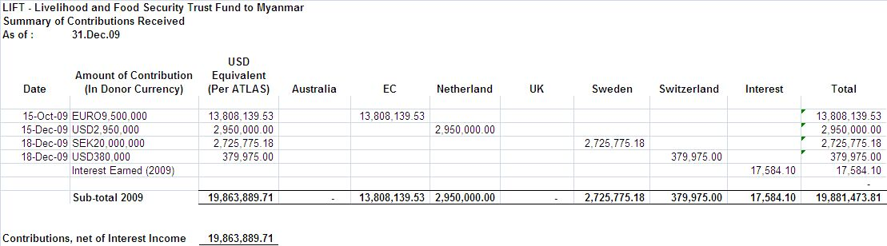

Figure 4: LIFT Donor contribution

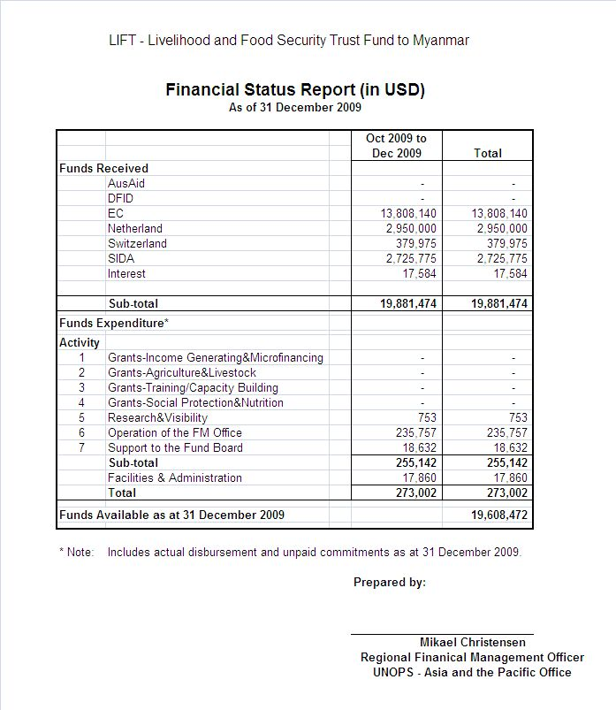
Figure 5: Financial Statement

Post Nargis Periodic Review III, page 65.
Post Nargis Periodic Review III, pg xiii
AusAID guidelines for Project Preparation, Risk Management section

