SOCIAL PROTECTION ACTIVITY DESIGN DOCUMENT

for the

Laos Australia Rural Livelihoods Program

(2012-2016)

**20 March 2013**

Table of Contents

Acronyms v

Executive Summary vii

1 INTRODUCTION 1

2 SECTOR AND PROBLEM ANALYSIS 3

2.1 Poverty in Laos 3

2.2 The role of social protection in market economies 7

2.3 Social security in Laos 8

3 RATIONALE FOR AusAID SUPPORT FOR SOCIAL PROTECTION 9

3.1 Rationale for Investing in the Resilient Livelihoods for the Poor Scheme 10

3.2 Rationale for Investing in the Senior Citizens’ Allowance 12

4 THEORY OF CHANGE 15

5 GOAL, PURPOSE AND OUTCOMES 19

6 DESCRIPTION OF THE SOCIAL PROTECTION ACTIVITY 21

6.1 Overview 21

6.2 Description of the Resilient Livelihoods for the Poor Scheme 23

6.2.1 Management and staffing of the RLP scheme 24

6.2.2 Selection of Participants 25

6.2.3 Developing micro-enterprises 25

6.2.4 Exit from the RLP scheme 27

6.2.5 Implementation schedule of the RLP scheme 28

6.3 Description of the Senior Citizens’ Allowance 30

6.3.1 Staffing of the Senior Citizens’ Allowance 30

6.3.2 The Proposed Old Age Allowance Model for Laos 31

6.3.3 Size of Senior Citizens’Allowance Benefit 32

6.3.4 Selection of Recipients 33

6.3.5 Registration of Recipients for the Senior Citizens’ Allowance 34

6.3.6 De-registration of Recipients 35

6.3.7 Senior Citizens’ Allowance implementation schedule 35

6.4 Grievance and complaints mechanisms across both social protection schemes 37

6.5 Management Information System 37

6.6 Mechanisms for Payment of Transfers 40

6.7 Financial Literacy Education 41

6.8 Monitoring of the Social Protection Activity 42

7 RELATIONSHIP OF SOCIAL PROTECTION ACTIVITY TO OTHER AusAID PROGRAMS 44

7.1 Links to Micro-Enterprise Challenge Fund 44

7.2 Links of SPA to AusAID’s Financial Inclusion Component 44

7.3 Links to AusAID’s UXO clearance component 45

7.4 Links of the SPA to AusAID’s Education Program 45

8 GEOGRAPHICAL LOCATION OF THE SPA 47

9 BUDGET AND PROCUREMENT ARRANGEMENTS 50

10 MANAGEMENT AND GOVERNANCE ARRANGEMENTS 52

10.1 The Management Role of the SPSL Managing Contractor 52

10.2 Governance arrangements for the Social Protection Activity 52

11 ROLE OF NGOS IN POLICY DIALOGUE ON SOCIAL PROTECTION 54

12 SUSTAINABILITY 55

13 EVALUATION FRAMEWORK 56

13.1 Evaluation of the Social Protection Activity outcomes 56

13.2 Social Protection Activity Process Evaluation 58

14 OVERARCHING POLICY ISSUES 60

14.1 Gender 60

14.2 Inclusive Development 60

14.3 Child Protection 61

14.4 Social Safeguards 62

14.5 Environment 62

14.6 Anti-corruption 63

15 RISK MANAGEMENT 64

Bibliography 69

Annexes 73

List of Annexes

ANNEX 1. Consultation List

ANNEX 2. Alternative approaches considered

ANNEX 3. International Experience with Allowances and Schemes similar to the RLP

ANNEX 4. Summary of Social Protection Activity evaluation tasks

ANNEX 5. Social Protection Activity Results Framework

List of Figures

Figure ES - 1: Structure of the Social Protection Activity viii

Figure 1: GDP per capita 1995-2012, current prices, US dollars 3

Figure 2: Examples of risks faced by individuals across the lifecycle 5

Figure 3: Proportion of the population over 60 years 6

Figure 4: Dependency ratios – children 0-18 and older people aged 60+ – in Laos 7

Figure 5: Spending on social security across Asia, as a per centage of GDP 8

Figure 6: Income trajectories among vulnerable families 12

Figure 7: Social Protection Activity Theory of Change 18

Figure 8: Structure of the Social Protection Activity 21

Figure 9: The NGO Team in each province 22

Figure 10: Implementation schedule for set up of the SPA 23

Figure 11: Organisational Chart showing structure and positions in each of the three NGOs (or consortia) for the RLP scheme 24

Figure 12: Transfer levels in RLP-type schemes, as a percentage of GDP per capita 27

Figure 13: Implementation Plan for the RLP scheme 29

Figure 14: The District Senior Citizens’ Allowance Team 30

Figure 15: A potential pension model for Laos 31

Figure 16: Pension model to be used in the Social Protection Activity 32

Figure 17: Pension benefit levels across developing countries, as a percentage of GDP per capita, compared to proposed benefit level for Laos 33

Figure 18: Cost of Laos Senior Citizens’ Allowance, compared to other developing countries 34

Figure 19: Implementation Plan for the Senior Citizens’ Allowance 36

Figure 20: Structure of the Management Information System 39

List of Boxes

Box 1. Commitments to social security in the Constitution of Laos 9

Box 2. Beneficiary selection steps used in other countries 25

Box 3. Potential micro-enterprises in the RLP scheme 26

List of Tables

Table 1: Basic information on the districts for the SPA activity 49

Table 2: Budget of the SPA schemes in millions of AUD 50

Table 3: Risk Management Matrix 64

Acronyms

|  |  |
| --- | --- |
| ADB | Asian Development Bank |
| ADD | Activity Design Document |
| ALF | AusAID Learning Facility |
| AM-NEP | Australia Mekong NGO Engagement Platform |
| AUD | Australian Dollar |
| AusAID | Australian Agency for International Development |
| BRAC | Bangladesh NGO |
| DFID | Department for International Development |
| DLSW | District Labour and Social Welfare |
| DoB | Date of Birth |
| ILO | International Labour Office (UN) |
| IMF | International Monetary Fund |
| GDP | Gross Domestic Product |
| GIZ | German cooperation agency - Deutsche Gesellschaft für Internationale Zusammenarbeit (GIZ) GmbH |
| GoL | Government of Laos |
| G2P | Government to person |
| LAK | Lao Kip |
| LARLP | Laos Australia Rural Livelihoods Program |
| LECS | Laos Expenditure and Consumption Survey |
| MECF | Micro-Enterprise Challenge Fund |
| MIS | Management Information System |
| MLSW | Ministry of Labour and Social Welfare |
| MoU | Memorandum of Understanding |
| NGO | Non-government organisation |
| NSO | Network Support Organisation |
| NTFP | Non-timber forest product |
| OECD | Organisation of Economic Cooperation and Development |
| PDA | Personal Digital Assistant |
| PDD | Program Design Document |
| PLSW | Provincial Labour and Social Welfare |
| PSP | Payment Service Provider |
| PwD | People with Disabilities |
| RLP | Resilient Livelihoods for the Poor |
| SCA | Senior Citizens’ Allowance |
| SPA | Social Protection Activity |
| SPSL | Social Protection and Sustainable Livelihoods |
| SSO | Social Security Organisation |
| TUP | Targeting the Ultra Poor |
| UNCDF | United Nations Capital Development Fund |
| VB | Village Bank |
| WFP | Word Food Programme |

Executive Summary

Although, in recent years, Laos has made good progress in reducing poverty, a substantial proportion of the population remain poor or vulnerable to falling into poverty. Some categories of the population appear particularly vulnerable: for example, informal systems of care and support for the elderly and people with severe disabilities seem to be weakening, young children experience high levels of under-nutrition, while many families are struggling to participate actively in markets due to limited labour capacity – such as female-headed families or families with significant care responsibilities – or an inability to access sufficient land.

Social protection schemes – often known as social security – are *publicly funded initiatives that provide regular and predictable cash or in-kind transfers to individuals, households and communities to reduce poverty and vulnerability and foster resilience and empowerment.* There is a strong international consensus that developing countries must establish effective and comprehensive social security systems if poverty is to be sustainably tackled. Social security systems are an important element of an effective and efficient market system and play a key role in generating sustainable economic growth, while ensuring that the benefits of growth are shared across the population, including with the most vulnerable. As Laos moves towards middle-income country status, it is imperative that its social security system is strengthened.

The Government of Laos is implementing initiatives to strengthen its social security system, in line with commitments in the National Constitution to provide social security and assistance to vulnerable categories of the population, in particular the elderly and people with disabilities. In 2012, AusAID approved the Laos-Australia Rural Livelihoods Program (LARLP), which commits the agency to providing the Government of Laos with support in developing its national social security policy. The program will also establish innovative social protection schemes in three provinces that will directly benefit poor families while also providing the Government of Laos with evidence on the impact and effectiveness of social protection.

In the long-term, AusAID’s engagement on social protection in Laos aims to assist the government in building a social security system that reduces poverty and inequality, strengthens the economic resilience of families, and contributes to human development and economic growth.

The **Goal** of this Social Protection Activity (SPA) is: *for the Government of Laos to begin implementation of a progressive social security policy that includes support to the elderly and other vulnerable families.*

The **Purpose** of the SPA is: *improved livelihoods, incomes and resilience for families in rural areas and the application of these results to inform government policy development in social security.*

**Description of the Social Protection Activity**

The SPA will test two alternative social protection schemes:

* The ***Resilient Livelihoods for the Poor*** (RLP) will be provided to 3,000 families, benefiting around 15,000 people in their households. The activity will build on the principles of social protection and enable vulnerable families to establish sustainable micro-enterprises. It will combine a regular cash stipend of LAK 100,000 (AUD12) per month, with a grant of an asset – to form the basis of a small business – and an intensive program of training, coaching and mentoring, including financial literacy education, over a period of two years.
* An old age allowance – known as the ***Senior Citizens’ Allowance*** (SCA) – will be provided to everyone aged 65 and above not in receipt of another form of pension. The allowance will be LAK 100,000 (AUD12) per month and will be received by around 15,500 elderly people, benefiting around 75,000 people in their households.

The SPA will be implemented in three provinces across at least six districts. The SCA and the RLP will initially be implemented in separate districts, although in Year 4 it is likely that the SCA will also be implemented in the district hosting the RLP. Depending on the number of elderly people in districts, it may be necessary in some provinces to expand to three districts for the SCA. On behalf of AusAID, a Managing Contractor will be selected by competitive tender to oversee the component on Social Protection and Sustainable Livelihoods (SPSL) as part of a broader LARLP. Separately, three NGOs – or consortia of NGOs – will be selected by open tender as the implementing partners of the SPA in each of the three provinces. Each NGO will implement both the RLP and the SCA. The overall structure of the SPA is set out in Figure ES - 1.

Figure ES - 1: Structure of the Social Protection Activity

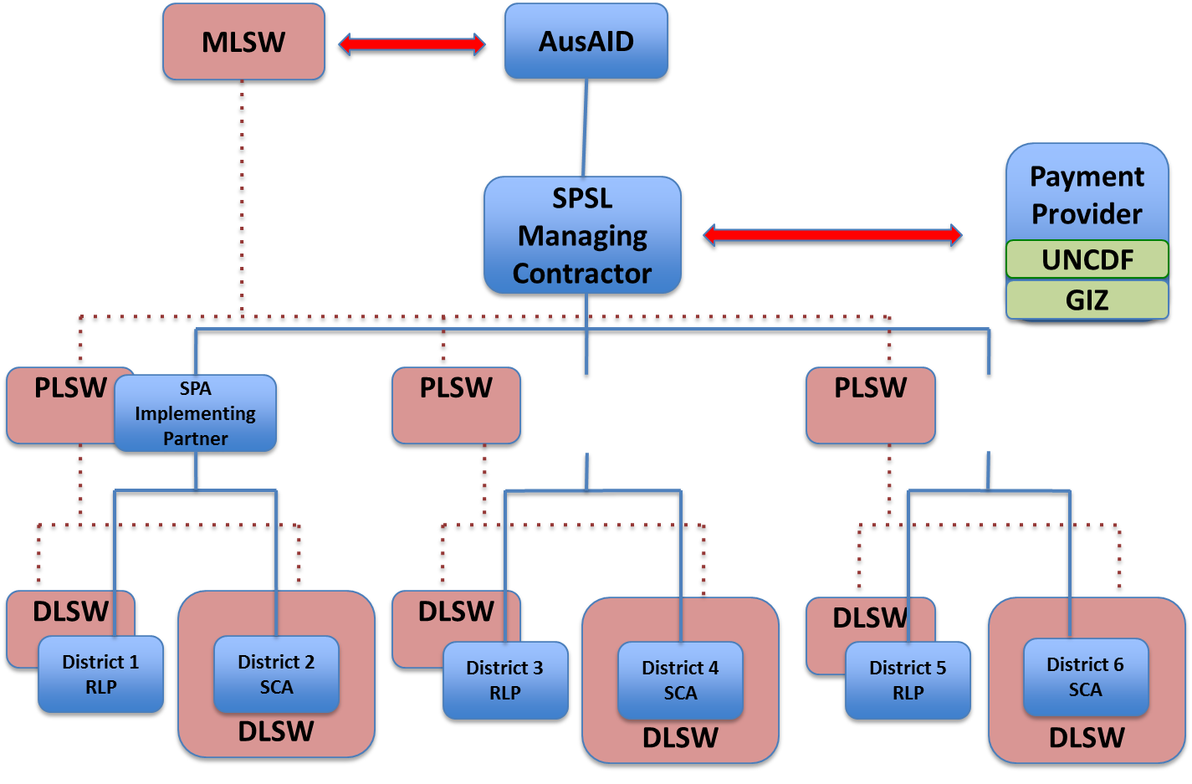

The SPSL Managing Contractor will work closely with AusAID in engaging the Ministry of Labour and Social Welfare (MLSW) at the national level, while the SPA implementing partners work will closely with the Ministry’s offices at Provincial and District levels. The NGO staff working on the SCA will be embedded within District Labour and Social Welfare (DLSW) Offices and will work in close collaboration with DLSW officers in the implementation of the scheme. The RLP scheme will be taken forward by NGOs, although they will continue to work closely with DLSW offices, which will be fully informed of progress and will, as necessary, accompany NGOs in the implementation. Provincial Labour and Social Welfare (PLSW) offices will be engaged in monitoring and evaluation of the activities. The results of both schemes will be used to inform government social security policy, and the MLSW will be fully involved in helping oversee the activity and will be fully informed of progress and the knowledge generated. A strong partnership will be created between the MLSW, AusAID, SPSL Managing Contractor and the SPA implementing NGOs.

The implementation of the SPA will be undertaken in a collaborative manner with other AusAID-supported programs in rural areas. The activity will engage with GIZ and UNCDF – which are implementing AusAID’s Financial Inclusion Program – to transfer cash to beneficiaries using innovative and technologically advanced methods. GIZ’s program to strengthen village banks will be undertaken in the same districts as the RLP scheme. GIZ will also develop financial literacy training that will be delivered jointly by GIZ and the SPA’s implementing NGOs. The SPA implementation will, whenever possible, also be closely linked to AusAID’s education program in areas such as financial literacy, establishing childcare services and evaluation. The SPSL component will also implement a Micro-Enterprise Challenge Fund (MECF) and, in those Provinces and districts where both activities are present, this will be taken forward in coordination with the SPA implementation.

**Location of the SPA**

The SPA will be implemented in three provinces: Champasak, Saravane and Savannakhet. These three provinces were selected on the basis of an analysis of quantitative data on potential districts that indicates suitability for the RLP scheme. Within each of the provinces, a number of priority districts have been identified for the RLP and SCA schemes.

**Governance of the Social Protection Activity**

AusAID will implement the SPA in close collaboration with the MLSW. An Advisory Board will be created to support the activity and will include AusAID and representation from the MLSW, the Ministry of Planning and Investment, the Ministry of Finance and the relevant Provincial governments, as well as NGOs leading the implementation of the pilot in each province. The Advisory Board will meet at least every six months (to be confirmed) to discuss progress with the activity, with the Social Protection and Sustainable Livelihoods (SPSL) Managing Contractor acting as its secretariat.

**Knowledge Generation in the Social Protection Activity**

The generation of knowledge will be a core element of the activity, which will include regular reviews and research, some of it led by AusAID’s Learning Facility. However, much of the activity’s knowledge generation will be derived from a comprehensive quantitative and qualitative evaluation that will assess the impacts of the activity and the effectiveness of its operations. The evaluation will be tendered out to a research organisation that will collaborate closely with the SPSL Managing Contractor and SPA implementing partner NGOs. The results from the evaluation will play a core role in informing government policy development. AusAID will complement lesson learning from the activity with parallel support to government policy development, including a program of capacity building on social protection across government.

**The role of NGOs in policy development**

The partner NGOs implementing the SPA will be critical to the success of the activity and should be fully committed to the social protection goals of AusAID. They will play a core role in policy dialogue with government at national, provincial and district levels, in support of AusAID. They will ensure that the lessons learnt from the social protection schemes feed into policy discussions. AusAID will engage NGOs in relevant policy fora.

**Gender and inclusive development**

The SPA has a strong commitment to promoting gender equity and women’s empowerment. The RLP scheme will mainly benefit women and support them in establishing micro-enterprises. Since the majority of older people are female, most beneficiaries of the Senior Citizens’ Allowance will be women in contrast to current pensions, which are likely to mainly benefit men. Women will also be the main recipients of financial literacy training. Incentives will be established across the activity to ensure that a commitment to gender equity is prioritised, including gender action plans and regular gender audits.

The SPA also has a strong focus on inclusive development. The elderly – many of whom are disabled – will be beneficiaries of the Senior Citizens’ Allowance. People with disabilities – as well as the elderly – who are able to work will also be a target group for the RLP scheme. Many will be very capable of running micro-enterprises if given adequate support. Families with significant care responsibilities for disabled members will also be prioritised by the RLP scheme.

The participation of all ethnic groups in the activity will be monitored. This will be particularly important in larger communities where smaller ethnic groups may have less access to land and resources, due to being later settlers in these communities. In such cases, they may well be priority beneficiaries of the RLP scheme. The SPA will also seek to ensure that local staff members are representatives of the ethnic groups that they are working with. Ensuring that local languages are used for communication will be particularly important, especially when engaging with women.

**Safeguards on resettlement**

The resettlement of rural communities is a complex and on-going development process. AusAID’s consistent approach to dealing with resettlement in Laos so as to safeguard the benefits of Australia’s aid program investment will be provided in late 2013 and applied consistently across all of AusAID’s investments.

**Budget**

The budget of the SPA schemes is set out in Table ES - 1

Table ES - 1: Budget of the SPA schemes in millions of AUD

|  |  |  |  |  |
| --- | --- | --- | --- | --- |
|  | **2013/14** | **2014/15** | **2015/16** | **Total** |
| RLP transfers and assets | 0 | 0.25m | 0.98m | **1.23m** |
| SCA transfers | 0 | 0.83m | 2.50m | **3.33m** |

# 

# INTRODUCTION

In 2012, AusAID approved its four-year Laos Rural Development Delivery Strategy, setting out the agency’s detailed plans to support the sector. AusAID plans to spend around AUD61.5 million in rural development over four years. In July 2012, AusAID further approved the Laos-Australia Rural Livelihoods Program (LARLP), which commits the agency to providing AUD43 million to support a range of areas including social protection, income generation, financial inclusion and UXO action. AusAID will also establish a Learning Facility in Laos, which will facilitate knowledge generation and lesson-learning across AusAID’s rural development portfolio and the sector more broadly.

AusAID’s support to social protection under the LARLP is within the Social Protection and Sustainable Livelihoods (SPSL) component. The SPSL has two sub-components:[1]

* A Social Protection sub-component will: a) provide support to the Government of Laos to develop its social security policy, in line with the country’s aspirations to become a middle income country; and, b) implement a Social Protection Activity (SPA) to test two social protection schemes that will bring benefits to participants while also providing evidence to inform policy development in government.
* A Micro-Enterprise Challenge Fund will be established for NGOs and social enterprises.

A Managing Contractor will be engaged by competitive tender to implement and oversee the SPSL program. However, the SPA will be directly implemented by three NGOs – or consortia of NGOs – that will be supported by the SPSL Managing Contractor. AusAID has decided to contract a Managing Contractor to reduce the administrative burden on its staff in Vientiane so that they are better able to engage meaningfully with partner NGOs on policy and learning, as well as in policy dialogue with government. A regional AusAID platform – the Australia Mekong NGO Engagement Platform (AM-NEP) – will also facilitate and support engagement of NGOs within AusAID’s rural development portfolio.

In November and December 2012, a design team visited Laos to develop the detailed Social Protection Activity’s Design Document (ADD).[2] In addition, they were tasked with developing Operations Manuals for the social protection schemes. The mission was undertaken in close collaboration with the AusAID Rural Development Team in Vientiane, who provided substantial inputs to the design. A list of consultations undertaken is in ANNEX 1.

The SPA mobilisation is expected to commence in last quarter of 2013. Selection of NGOs will be undertaken in a competitive process between May to September 2013.

During the original design of the LARLP, the PDD focused on developing a Resilient Livelihoods for the Poor (RLP) scheme, which would combine social transfers with support for income generating activities. However, during the further development of the Social Protection Activity’s design document, AusAID decided to test two social protection schemes, the RLP and an old age allowance, the latter to be called the Senior Citizens’ Allowance (SCA). The rationale for the integration of the SCA into the SPA is explained in this document.

This Activity Design Document sets out the broad parameters of the Social Protection Activity. Details on the operational aspects of the two social protection schemes are set out in accompanying Operations Manuals, to be finalised by the SPSL Managing Contractor in early 2014.[3]

# SECTOR AND PROBLEM ANALYSIS

Laos is a multi-ethnic country with a population of around 6 million.[4] Approximately 71 per cent of the population lives in rural areas, although the share of the population in urban areas is growing. Population density is low, with many communities – particularly those from smaller ethnic groups – living in relatively isolated situations. However, an expanding road network is gradually integrating communities into the market economy. In recent years, Laos has experienced strong GDP growth of around 8 per cent a year with current GDP per capita at US$1,450 (see Figure 1).

Figure 1: GDP per capita 1995-2012, current prices, US dollars*[5]*

A foundation stone for Laos’ economic growth has been its abundant natural resources. The main drivers of growth have been investments in infrastructure – in particular hydropower – agribusiness and mining. Small-scale agriculture, which employs 67 per cent of the workforce, has grown more slowly. As a result, disparities in wealth are increasing, with inequality rising and the national Gini coefficient reached 0.36 in 2007/08. If inequality becomes too high, it may limit Laos’s economic growth potential, while undermining social cohesion.

## Poverty in Laos

During the past 20 years, Laos has made good progress in reducing poverty. Overall, poverty rates fell from 46 to 28 per cent between 1992/93 and 2007/08. However, as in all countries, many people live just above the poverty line or move in and out of poverty over time: a 10 per cent increase in the poverty line would lead to a 25 per cent increase in the poverty rate. Indeed, it is evident that the number of people who are poor or vulnerable to poverty is relatively high. This is indicated by the fact that, while 13 per cent of the population is food insecure, 66 per cent face the risk of food insecurity (WFP 2007).

There are other indicators that poverty is still a challenge to be proactively addressed. Laos’s current human development index – when adjusted for inequality – places it 138th out of 187 countries, on a par with Sudan, Pakistan and Cambodia. In common with much of South-East Asia, there is also a high and persistent level of malnutrition. Around 40 per cent of young children are stunted – with higher rates among non-Lao ethnic groups – while 12 per cent of women are underweight (WFP 2011). There may be multiple explanations for high levels of under-nutrition, but poverty is almost certainly an exacerbating factor.

The distribution of poverty is uneven. Poverty is most prevalent in rural areas, where the poverty rate is 32 per cent compared to 17 per cent in urban areas. It is also highest in the northern and central regions, while non-Lao Tai ethnic groups – who often live in upland areas – experience higher levels of poverty, reaching 42 per cent in 2007/08. Nonetheless, most poor people are Lao Tai inhabiting lowland areas, although their poverty rate is around 20 per cent. There are indications that progress in reducing poverty has been uneven. In upland areas, there was almost no improvement in poverty rates between 2002/03 and 2007/08, while rice sufficiency deteriorated (Fenton et al. 2010; MPI 2010).

Economic growth in Laos, therefore, appears to be delivering uneven benefits to its citizens. While large numbers are doing well, others are falling behind. Further evidence is required on the reasons but, in part, it is likely to be the result of families having inadequate sources of income or lacking the resilience to deal with shocks.

Most rural families depend on agriculture, but often do not have sufficient land to provide both subsistence and an income. Many families are finding that access to land is reducing as the area available in which to practice swidden shrinks and soil fertility reduces or as land is used for agri-business concessions. A large proportion of the population depend on forests and rivers for subsistence and cash income but access to these resources is reducing. Alternative sources of income are being created – such as off-farm labour – but incomes can be low. Increasing numbers of people are migrating to urban areas and other countries – in particular Thailand – and while this can lead to reasonable incomes from remittances for some, others miss out.

Many of the shocks affecting families are large scale – such as typhoons Haima and Nock Ten, which affected 500,000 people in 2011, or the impacts of the global recession – while others are particular to families, such as ill-health. However, as in all countries, the vulnerability of families is related to their demographic composition and the stage of individuals across the lifecycle. As Figure 2 indicates, people face varying risks at different stages of their lives. For example, children are at risk of stunting that can harm their cognitive development, women may find it difficult to work if there is no support for care for the children (including from their kin), older people become increasingly frail and unable to work, while disability could affect anyone at any stage of their lives. When risks and changes in circumstances occur, if individuals and their families are not sufficiently resilient, this may have an impact on their wellbeing.

Figure 2: Examples of risks faced by individuals across the lifecycle

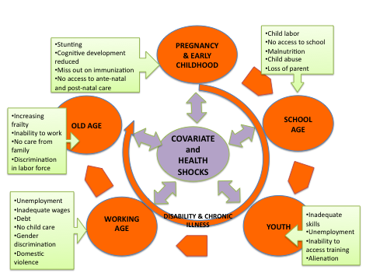

In Laos, there is insufficient evidence on the extent to which lifecycle risks are impacting on wellbeing. However, as is common to most countries as they develop, there are signs that informal care and support systems for the elderly and people with disabilities are beginning to break down, as a result of poverty, migration, resettlement and urbanisation.

Demographic changes may well exacerbate some risks over the lifecycle. In particular, the Lao population is beginning to age. As Figure 3 indicates, while around 6 per cent of today’s population is over 60 years, this will rise to 8.4 per cent by 2025 and 18.9 per cent by 2050. This will mean that a growing proportion of people will be in need of support as their ability to care for themselves and contribute to the wider community reduces. Most of these will be women since, currently, 55 per cent of older people are female.

Figure 3: Proportion of the population over 60 years*[6]*

On the other hand, there are likely to be potential benefits from future demographic transitions. The proportion of children in the population will fall while the labour force will grow. As Figure 4 indicates, this will lead to a reduction in the overall dependency ratio, when measured against both children aged 0-18 years and older people aged 60 years and over. Many countries have benefitted from this demographic dividend and, assuming that Laos can find work for its population, the growth in the working age population should translate into economic growth.

As Laos continues to develop and move to middle income country status, it is likely that informal systems of social protection will continue to weaken. As happens in all countries that develop market economies, Laos will need to establish an effective social security system to maximise efficiencies in its economy. Laos has already begun this essential process so that development is both inclusive and sustainable. The increase in tax revenues that the demographic dividend should generate will enable the country to establish an effective social security system with which to tackle poverty.

Figure 4: Dependency ratios – children 0-18 and older people aged 60+ – in Laos

## The role of social protection in market economies

Social protection is understood by AusAID as: *Publicly funded initiatives that provide regular and predictable cash or in-kind transfers to individuals, households and communities to reduce poverty and vulnerability and foster resilience and empowerment.[7]*

In many contexts – such as in Laos – social protection is also known as *social security*.[8] Examples of common social security schemes providing regular and predictable transfers include old age allowances, disability benefits, child grants, and allowances for widows and income support for poor households or the unemployed. Social security is usually funded from two main sources: either from general taxation or from the contributions of workers, when it is known as social insurance. It is most effective when complemented by active labour market strategies that help people access work.

Social security is a core component of a modern market economy. In almost all developed countries, social security is the largest area of government spending. It aims to provide income security to families and individuals who are particularly vulnerable to poverty – often due to their stage in the lifecycle (such as the elderly or young children) or disability – or to those who are living in poverty because they are missing out on the opportunities provided by the market. It ensures that prosperity is shared by all and is a key means of promoting greater social cohesion.

Well-designed social security systems contribute to wealth generation and economic growth. They can enable poor families to invest in their children so that they become significant contributors to the labour force when adults. For example, social security can help tackle under-nutrition among young children – thereby strengthening their cognitive development and protecting them from disease in later life – or enable children to both stay on at school and to perform better. Social security schemes help families overcome shocks – such as illness and unemployment – without drawing down on their assets, thereby enabling them to return to full productivity as soon as possible. Some transfers are directly linked to enabling people to enter the labour market.[9]

By providing poor and vulnerable families with regular cash, investment in social security can generate greater consumption, which will stimulate the economy and provide entrepreneurs with widespread benefits. Both China and Thailand have invested recently in extensive old age allowance schemes with the explicit purpose of generating greater spending to promote economic growth. Evidence of the positive stimulation from transfers to local economies in developing countries is becoming increasingly available.[10] However, this is not surprising, given that generating increased domestic consumption is a key driver of economic growth in many countries.

## Social security in Laos

The formal social security system in Laos is relatively underdeveloped. As Figure 5 indicates, Laos has one of the smallest social security systems in Asia, when cost is measured as a percentage of GDP. The main beneficiaries of the current system are elderly former civil servants, soldiers and veterans who receive pensions. However, in 2001, a contributory pension scheme was established for private businesses in the formal sector, which is managed by the Social Security Organisation, under the Ministry of Labour and Social Welfare.

Figure 5: Spending on social security across Asia, as a per centage of GDP*[11]*

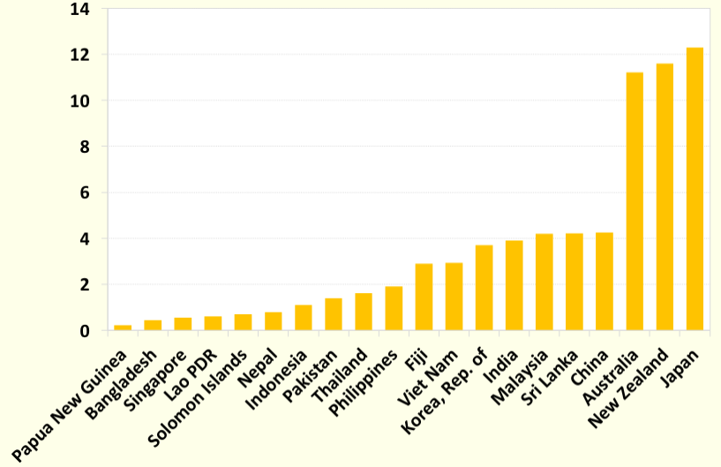

As Box 1 indicates, the national Constitution recognises the right of citizens to social security and to assistance in the case of disability or old age. Laos is also a signatory to international conventions that guarantee social security, such as the Universal Declaration of Human Rights. In June 2012, Laos also supported the ratification of the ILO’s Recommendation Concerning National Floors of Social Protection, which calls on countries to establish minimum social security benefits for vulnerable citizens, such as children, the elderly and people with disabilities (ILO 2012).

|  |
| --- |
| 1. Commitments to social security in the Constitution of Laos   **Article 28:** The State and society attend to implementing policies on ***social security,*** especially towards national heroes, soldiers, retired civil servants, disabled people, [and the] families of those who have sacrificed their lives for the revolution and who have contributed extensively to the nation.  **Article 39:** Working people have the right to rest, to receive medical treatment in times of illness, [and] ***to receive assistance in the event of incapacity or disability, in old age***, and in other cases as provided by the laws. |

Therefore, the principle of providing effective social security is well established in Laos. The challenge for government is to be able to build on its good foundations and develop a system that is compatible with the country’s ambitions to reach middle-income status based on a strong and competitive market economy.

# RATIONALE FOR AusAID SUPPORT FOR SOCIAL PROTECTION

AusAID is committed to supporting developing countries in building and improving their social protection systems. It is providing support to social protection in a range of countries including Indonesia, Cambodia, Bangladesh, Kenya and the Philippines. In 2012, with the approval of the Laos Australia Rural Livelihoods Program (LARLP), AusAID established a process that would enable it to support the government of Laos in moving towards a comprehensive social protection system, while also using Australian funds to provide direct transfers to support poor and vulnerable families.

If Laos is to build an effective and regulated market economy – as stipulated by the national Constitution – establishing an effective social security system will be essential to ensure that the economy functions effectively and that everyone can benefit from economic growth. In recent years, Laos’s neighbours have expanded their social security systems. In 1999, China established a minimum income guarantee for poor citizens in urban areas and, in 2009, set up a national rural pension pilot with the aim of achieving full coverage no later than 2013.[12] Thailand provided universal pension coverage for over-60s in 2009, while Vietnam established social pension schemes in 2000 that now provide support to those aged 60 and over. For a number of years, Cambodia has experimented with small cash transfer schemes, focused on children, and is developing a contributory pension.

There are clear indications that the Government of Laos is committed to expand its national social security system. For example, a revised Social Security Law is under development that will set out the direction of pension reform. The 2011-20 Ministry of Labour and Social Welfare’s Strategy on Social Welfare Development highlights the imperative to develop an effective social security system that includes the informal sector and rural areas, while stressing the need for additional support to people with disabilities and the elderly. The Ministry of Labour and Social Welfare has also been engaging with the World Food Programme to establish regular transfers – such as cash for work – as a response to poverty in priority areas. Laos’s engagement in international debates on building national social protection floors is also a positive sign of greater commitment.

AusAID has, therefore, agreed to support the Government of Laos as it moves towards building an effective national social security system. It is evident that social security for vulnerable families can play an important role in strengthening the government’s efforts to tackle poverty and continue on its path of economic growth while support from AusAID would be consistent with national commitments as set out in the Constitution, international agreements supported by the government, and current initiatives – such as the proposed Social Security Law and Strategy on Social Welfare Development – to extend social protection to a greater proportion of the population.

AusAID’s support will focus on two complementary areas:

* Engaging directly with government to strengthen its capacity to develop policy on social protection.
* Working with government to test innovative social protection transfers in three provinces as a means of providing evidence on the impacts of social protection. The two transfer schemes selected are an old age allowance – known as the Senior Citizens’ Allowance – and the Resilient Livelihoods for the Poor scheme, which will combine regular transfers to vulnerable families with support for the development of micro-enterprises.

There are a number of reasons for directing resources towards these two schemes. Two schemes spread risk across AusAID’s investment in case one scheme is less successful. They also provide greater potential for learning that will feed into government policy development. The rationale for the specific choice of instruments is explained below. Alternative options that were considered in the design are discussed in ANNEX 5.

## Rationale for Investing in the Resilient Livelihoods for the Poor Scheme

The Resilient Livelihoods for the Poor (RLP) Scheme is derived from BRAC’s *Challenging the Frontiers of Poverty Reduction - Targeting the Ultra Poor* (TUP) program in Bangladesh, which provides a combination of cash transfers, productive assets, financial services, health services, and personal coaching and training to many of the most vulnerable households.[13] The TUP program has been successful in increasing the incomes and assets of many vulnerable women.[14] As a result, CGAP and the Ford Foundation have adapted lessons learnt from the TUP and applied them to Haiti, Honduras, Peru, Ethiopia, Yemen, India, Pakistan and Ghana.

A number of recent evaluations have indicated the success of small NGO-led programs similar to the RLP scheme across a range of countries. In Haiti over 90 per cent of participants increased the value of their enterprises, purchased large livestock, and the proportion who were food secure increased from 1 per cent to 98 per cent. A similar intervention in West Bengal, India, also showed positive results with program participants earned significantly higher incomes, generating more savings and increasing their food security. These results were sustained for up to 2 years, following the end of the program. ANNEX 3 provides more information on the impacts of schemes similar to the RLP.

AusAID is committed to assessing whether the RLP scheme could have similar success in Laos. The RLP scheme will be directed at families with members that are able to engage in income generating activities but who are extremely vulnerable because of barriers that impede them from effectively engaging in the market. These include: losing access to cultivable land and forest; having inadequate labour supply to cultivate the remaining – and often less accessible – land; increased debt to foreign traders and money lenders as a result of insufficient financial literacy; and, deteriorating social networks as a result of migration and resettlement. Women are particularly vulnerable, as they tend to have much longer working hours than men, including both their productive activities and domestic responsibilities, and fewer market opportunities. The situation is even more challenging for many single mothers. People with disabilities are often stigmatised and given few opportunities, despite being capable of engaging in productive activities, although they may need additional support.

Insufficient development initiatives engage with this growing demographic of the extremely vulnerable in Laos. AusAID has agreed to prioritise their interests and will adopt a multi-faceted approach to enable these families to develop sustainable sources of income, mainly working with female caregivers. The Resilient Livelihoods for the Poor scheme combines social protection (regular cash transfers) and enterprise creation (productive assets and coaching), while it will also build the involvement of beneficiaries in financial services (through village banks) over a two-year period.

At the heart of the initiative is the notion that vulnerable families typically oscillate in and out of extreme poverty; and while they can build up assets, these are often depleted as they attempt to cope with unexpected shocks. Providing RLP families with the means to develop an enterprise will provide an opportunity for them to substantially increase their incomes. The regular cash transfer will enable them to dedicate time to developing enterprises, compensating them for the opportunity costs of not engaging in other activities. It will also contribute to their security, knowing that, during the time that they are building up their small business, they are assured of meeting family minimum needs as protection against shocks (see Figure 6).

Figure 6: Income trajectories among vulnerable families

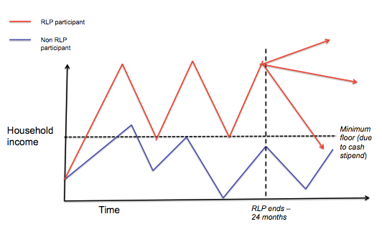

Once RLP participants leave the scheme, they will experience different trajectories. The more entrepreneurial should continue to expand their enterprises and enhance their incomes, while others may just maintain their assets and have a reasonably secure income. However, there will always be some – perhaps due to a shock such as illness – who will fall back into poverty. Such families are likely to need access to a more secure and sustainable social security system. For this reason – among others – AusAID is also engaging with government to strengthen its capacity to develop national social security policy.

It will be made clear that the RLP scheme will provide support for two years. Therefore, there will be no expectation from beneficiaries or the Government of Laos of continuing support from AusAID so no moral hazard will be created. The scheme has a strong labour and enterprise focus so beneficiaries will receive support to establish independent micro-enterprises, with a strong focus on sustainability. However, the RLP scheme has the disadvantage of being more complex and resource-intensive to deliver than conventional social security schemes such as the Senior Citizens’ Allowance. This is one reason why the community engagement skills of NGOs are very necessary in the RLP scheme.

## Rationale for Investing in the Senior Citizens’ Allowance

Old age allowances are the most common form of social security scheme in both developing and developed countries. Once established, they always have strong government commitment and are usually the largest social security programs, in terms of budget. Many developing countries have introduced extensive old age allowance schemes, financed from taxation. Indeed, there is growing government commitment across East and South-East Asia. There are, for example, extensive tax-financed old age pension schemes in Thailand, China, Vietnam and South Korea. Old age allowances have had significant impacts on poverty among older people and their households, while there are indications that such schemes can also impact on economic growth by stimulating consumption. ANNEX 3 provides more information on international experiences with old age pensions.

A key purpose of the Senior Citizens’ Allowance will be to inform government policy. It, therefore, needs to be designed as the type of scheme that could both gain political support and be scaled up by government. International experience indicates that an old age allowance is the most likely to build the necessary commitment from government. Similar pilot social protection initiatives across Africa and elsewhere have failed because they were not designed to align with the political economy of countries and promoted schemes that governments were unlikely to invest in since they were unlikely to bring them political benefits.[15]

There are indications that an old age allowance could fit well with government policy thinking. As indicated above, Laos has already established old age pensions for certain sectors of the population and is currently developing its policy on extending the old age allowance more broadly, in line with commitments to provide social security and assistance to older people and people with disabilities (as in all countries, the elderly will have significantly higher rates of disability than other sectors of the population).

In reality, most countries focus on old age allowances as their first and/or main social security instrument. Current initiatives within Laos are in line with international experience. Old age allowances feed into societal values to care for the elderly and provide those in the labour force with the assurance that they will have a measure of security in old age. It is for this reason that old age allowances have been shown to have significant impacts on behaviour among younger people, including reductions in fertility:[16] once people recognise that the state will support them in old age, they no longer have the same imperative to produce more children to ensure that they will be cared for.

Old age allowances have the advantage of being the simplest social protection scheme to deliver, if well designed. This has been a significant factor contributing to their success internationally. The Senior Citizens’ Allowance will be embedded within government and is capable of being scaled up nationally, if government decides to make this commitment.

The Senior Citizens’ Allowance will provide the government with evidence on the effectiveness of the old age allowance, which should help it in its policy deliberations. Therefore, the SPA will invest resources in ensuring comprehensive monitoring and evaluation of both the operations and impact of the allowance.

The key risk of the Senior Citizens’ Allowance is a potential moral hazard, if it is not designed well. AusAID would be investing in a transfer that may build expectations for long-term support among recipients. However, this long-term support cannot be guaranteed by AusAID, which can only commit to funding the scheme for a set period. The moral hazard challenge will, therefore, be dealt with in two ways. AusAID will engage with government to take on responsibility for the scheme by investing resources in supporting government policy development on old age allowances, while using the SCA to develop an evidence base on impact and good practice. Indeed, the SCA will be implemented in close partnership with government. It will also be made clear to recipients that they will receive support for a defined period only, unless government steps in to continue the initiative.

# THEORY OF CHANGE

In the long-term, AusAID’s engagement on social protection in Laos aims to assist the government in building a social security system that reduces poverty and inequality, strengthens the economic resilience of families, and contributes to human development and economic growth. The theory of change in AusAID’s Rural Development Delivery Strategy highlights the importance of the Government of Laos implementing social security transfers which will contribute to poverty reduction, including greater resilience among vulnerable families to cope with shocks and risks.[17]

To provide support for the longer-term process of establishing a comprehensive social security system, the **Goal** of this Social Protection Activity (SPA) is *for the Government of Laos to begin implementation of a progressive social security policy that includes support to the elderly and other vulnerable families.*

To support this medium-term objective, the **Purpose** of the SPA is: *improved livelihoods, incomes and resilience for families in rural areas and the application of these results to inform government policy development in social security.*

Thus, the purpose of the SPA is two-fold and the two social transfer schemes it utilises are different in approach: the Senior Citizens’ Allowance will provide a small, quarterly cash transfer to all citizens aged 65 and above (not in receipt of another form of pension) in the scheme’s implementation areas; the Resilient Livelihoods for the Poor scheme will specifically target particularly vulnerable families with a small allowance, a productive asset and technical training and mentoring to support development of a sustainable enterprise. The expected net effect however is similar in each case: a sustained – at least for the life of the activity – increase in income for the families included in either of the mechanisms.

Figure 7 illustrates the relationships between the goal and purpose of the Social Protection Activity and its two components. The rationale for these high-level objectives is provided elsewhere in this ADD.

With increased income from either source, the Theory of Change posits that this is likely to result in: increased savings;[18] increased consumption of goods and services (including for example, more children attending school and for longer); and/or investment in new or existing enterprises. Determining the ways in which the additional income is actually used will be a major part of the research supporting the SPA, while the existence of significant family debt is likely to limit these intended outcomes from the outset. Effects may also be manifested in changes in health and nutrition status. However these may be difficult to assess initially owing to the relatively short implementation period for the social protection schemes.[19] Analysis of the family and community changes attributable to these sustained increases in income will provide important evidence of the efficacy (or otherwise) and impact of these social protection mechanisms. However, the program does not intend to compare the mechanisms since they are very different; rather it seeks to understand their value in a Lao context, and to exploit potential complementarities between them within the context of a comprehensive national social security program.[20]

The Resilient Livelihoods for the Poor model of identifying poor individuals and families and providing closely facilitated social transfers and training to support livelihood development is untried in Laos. Consequently, there are uncertainties about whether the model – having demonstrated some success in other countries – can be effectively adapted into the unique socio-economic and cultural context of rural Laos. Related design assumptions (noted in red in Figure 7) affecting implementation include:

* The scheme can accurately select the most vulnerable families. In particular, it will need to be assessed whether methods for selection and engagement of poor families within the scheme will be socially and culturally acceptable and accurately target the most vulnerable families. Internationally, the evidence on this is variable.
* The scheme can identify and support locally viable, appropriate micro-enterprise opportunities for which an accessible market exists and that are within the capacity of the families engaged in the scheme.
* The short-term technical training and regular mentor support that is provided by the scheme will provide sufficient capacity to enable participating families to develop and manage their enterprise.
* Existing family constraints (e.g. debt, health, disability) will not markedly undermine a selected family’s ability to participate in the scheme.

Of crucial importance will be the extent to which the most vulnerable families are able to make use of opportunities to enter markets for their products that may become available as a result of market assessments associated with the RLP scheme.

The Senior Citizens’ Allowance is recognised as a relatively simple social security measure that can provide income to elderly people, their household and kinship networks. Developing a viable model in the rural Laos context will involve a number of assumptions specific to the Laos context including:

* The ability of the implementing NGOs in conjunction with their counterparts in the District Labour and Social Welfare offices to establish and maintain an accurate age register and the acceptability of the methods used to establish such a register.
* Community acceptance of the Senior Citizens’ Allowance when it is only paid to a small number of individuals and families in a community. However, the international evidence on the acceptability of this type of transfer in communities is strong.
* The likelihood that support for a Senior Citizens Allowance can be built at all levels of government.

For both of these social protection models, these assumptions will be monitored, tested, and where appropriate, implementation adjustments made as part of the regular assessment of the schemes that will take place throughout the SPA.

During the implementation of the two social protection schemes, a regular program of capacity development along with support for existing and future government social security policy development will be provided by the SPA and by other components of the Laos Australia Rural Livelihoods Program. Evidence and experience accumulating from the two SPA models will support both the capacity development of government staff and the on-going policy development work. Ultimately, achieving the SPA goal then moving substantively towards development of progressive, new government social security measures will depend on the availability within government of the requisite knowledge and the necessary capability, political will and resources.

Figure 7: Social Protection Activity Theory of Change

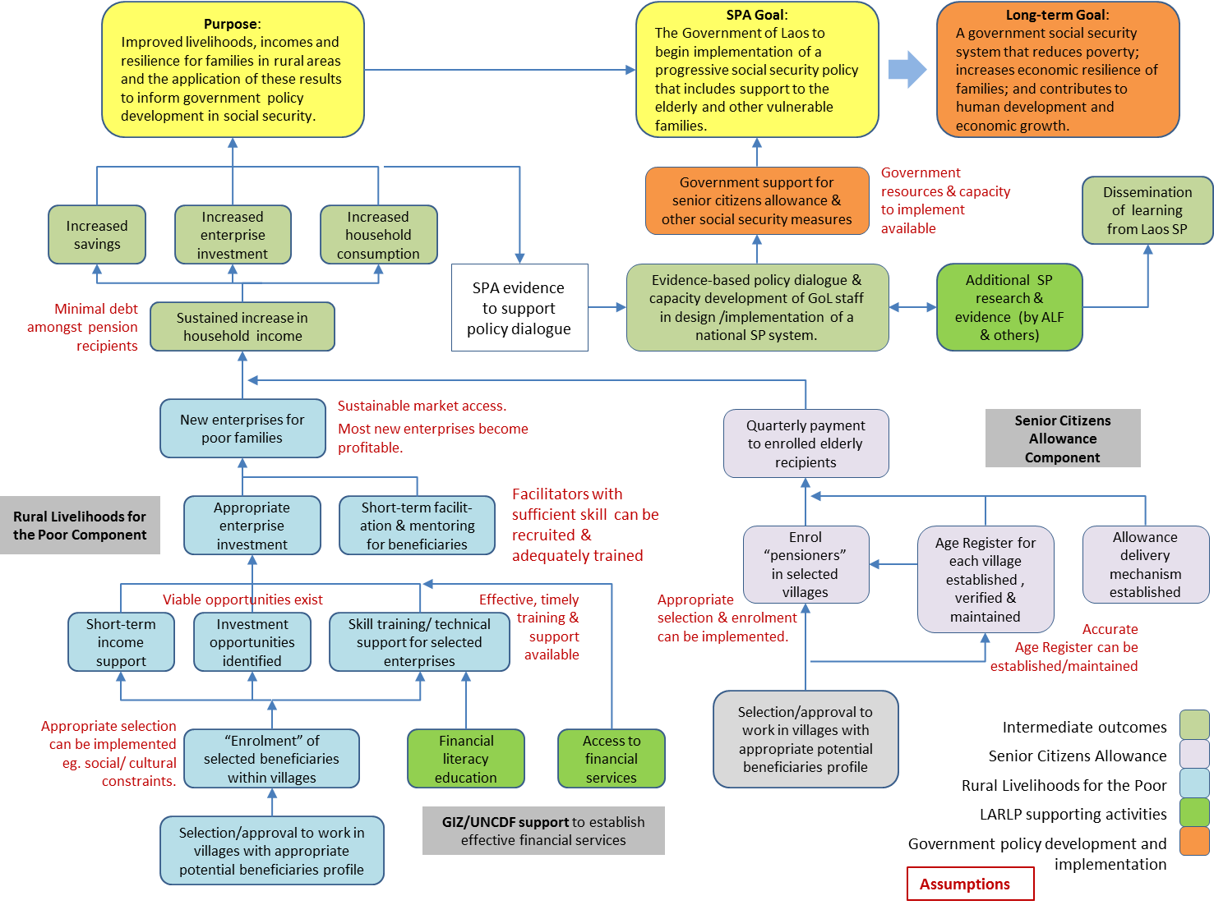

# GOAL, PURPOSE AND OUTCOMES

The ***goal*** of the Social Protection Activity is for the *Government of Laos to begin implementation of a progressive social security policy that includes support to the elderly and other vulnerable families.*

Future indicators of goal achievement will include the kind of social security measures enacted by the government; their reach and targeting; and their impact on poverty, family resilience, overall human development and economic growth, particularly as it affects poorer people in rural communities.

Indicators for the effect of the SCA and related research and evaluation work in advancing the case for a comprehensive government social security system are:

* Official government statements of intentions with respect to social security schemes;
* Government policy papers related to social security and national plans including social security commitments.

The ***purpose*** of the activity is *improved livelihoods, incomes and resilience for families in rural areas and the application of these results to inform government policy development in social security.*

Purpose level indicators are included in the Results Framework in ANNEX 5.

In addition to the SPA goal and purpose, ***intermediate outcomes*** and associated indicatorsare also set out in the Results Framework. The expected intermediate outcomes include:

* Poor households participating in the Resilient Livelihoods for the Poor scheme establish microenterprises, utilise financial services and experience changes in income and related social and economic indicators.
* Recipients of the Senior Citizens’ Allowance and their households experience changes in a range of social and economic indicators.
* Increased economic activity extends to other people in the wider communities of SPA participants.
* Evidence-based policy dialogue and capacity development of Government of Laos staff in the design and management of a national social security system.
* Progressive dissemination of learning from Lao social protection initiatives.

As part of the comprehensive monitoring and evaluation of the SPA, it will report annually on progress against a range of purpose and outcome indicators. These will include:

* The number of women and men receiving social transfers;
* The number of poor women and men who increase their access to financial services including changes in savings;
* The net increase in income of poor women and men;
* Changes in the use of income in participating families;
* The net increase in employment for poor women and men;
* The number of micro-enterprises started by SPA participants or changes in the scale of their investment in a micro-enterprise;
* Changes in trade volume in community-based businesses;
* Changes in employment and enterprise opportunities for fellow community members of SPA participants;
* Changes in stunting incidence and severity in children under 5 that can reasonably be attributed to the SPA;[21]
* Changes in food diversity and food expenditure in participating families;
* Changes in the number and duration of children attending school;
* Changes in government intentions concerning the design and implementation of comprehensive social security measures;
* Changes in government staff in their understanding and depth of analysis of the potential impact and implementation modalities of social protection, and its role in Laos;
* Assessment of the effectiveness of the AusAID Learning Facility and the SPSL Managing Contractor in their contributions to the social security policy dialogue and capacity development with government;

In reporting on these indicators and other aspects of the SPA, the activity will also collect a range of data that will enable the assessment of qualitative aspects of the changes in the lives of a sample of families and individuals who are either direct or indirect beneficiaries of the activity.

# DESCRIPTION OF THE SOCIAL PROTECTION ACTIVITY

## Overview

The Social Protection Activity will establish two types of innovative social transfer schemes across three provinces in at least six districts. One of the schemes will be a Resilient Livelihoods for the Poor scheme, an innovative micro-enterprise scheme that builds on the principles of social protection, and the other will be a Senior Citizens’ Allowance. The RLP scheme will provide 3,000 families with support to develop a micro-enterprise, also benefitting around 15,000 people in those households. They will receive a regular cash stipend for 12 months, an asset with which to start a small business, and significant training and mentoring. The Senior Citizens’ Allowance will provide around 15,500 older people aged 65 and above with a regular transfer of LAK100,000 (AUD12) per month, benefiting some 75,000 people in their households. The SCA will be aimed at everyone 65 and over in selected communities, except for those who already receive a government pension or have very recently moved into the district.[22]

As Figure 8 indicates, the SPSL Managing Contractor SPA will have oversight of the SPA and will be selected by competitive tender (see Section 10.1 for a description of the SPSL Managing Contractor). The Managing Contractor will oversee and support the work of three NGOs – or NGO consortia – that will also be selected by open tender and will deliver the activity in three provinces.

Figure 8: Structure of the Social Protection Activity



Each NGO will be responsible for delivering both social protection schemes, although they will be undertaken initially in separate districts. The NGO will have its headquarters for the SPA in the district, in which the RLP scheme is implemented, with the Senior Citizens’ Allowance implemented in another district in the first year of the transfer (in Year 3 of the SPA). However, it is likely that two more districts will be selected for the SCA in the second year of the transfer (in Year 4 of the SPA) and one is likely to be in the same district as the RLP scheme.

The proposed NGO team structure for each province is set out in Figure 9. The main team will be based in the RLP scheme district, with a smaller team working on the SCA embedded within the DLSW office within another district. In the second year of the transfer, two more SCA teams will be established in other districts, with one probably in the RLP scheme district. A Program Manager will be responsible for the activity in the province, while an Operations Manager will oversee both schemes. The Program Manager will report to his/her NGO’s headquarters while also working closely with the Managing Contractor, although the formal relationship of the Managing Contractor with the NGO will be via the NGO headquarters.

Figure 9: The proposed NGO team structure in each province

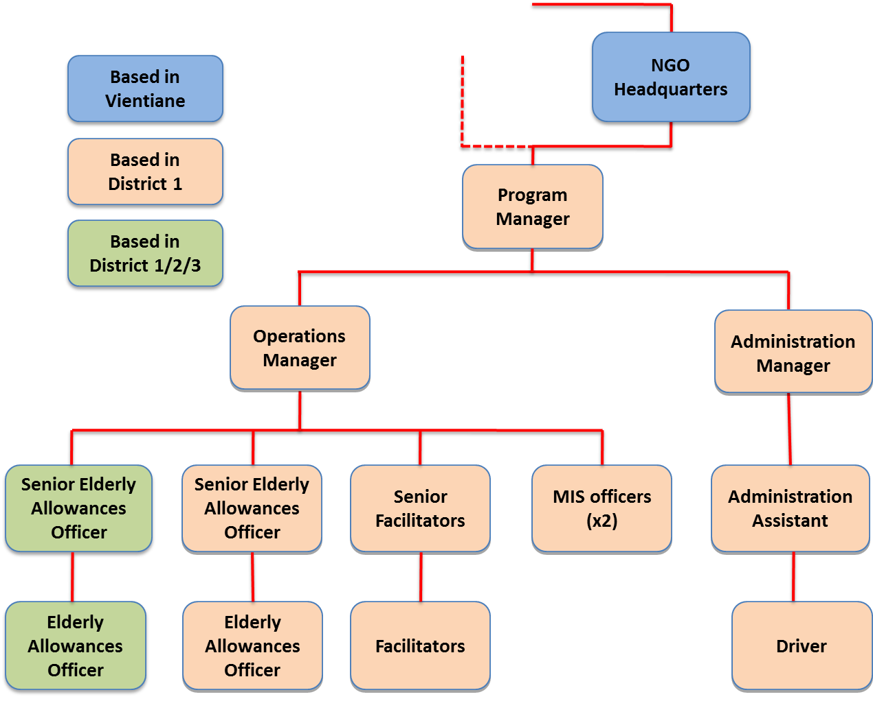

The SPA will have a close relationship with the Ministry of Labour and Social Welfare, since a key aim of the activity – in particular the Senior Citizens’ Allowance – is to inform policy development by Government. The Senior Citizens’ Allowance will be undertaken in close collaboration with the MLSW, with NGO staff responsible for the old age allowance embedded within the District Labour and Social Welfare (DLSW) office, working closely with government counterparts. The RLP scheme will be undertaken by NGOs with a less formal relationship to government although DLSW offices will be closely involved, participating in key meetings, accompanying monitoring and evaluation missions, and being regularly updated on progress.

Both the SPSL Managing Contractor and SPA implementing partner NGOs will collaborate with AusAID in supporting the government’s policy development on social protection, ensuring that it is fully informed by evidence from the SPA.[23] The SPSL Managing Contractor will ensure that government has access to the Senior Citizens’ Allowance management information system (MIS), potentially locating it within the Ministry of Labour and Social Welfare. Government staff will be trained to use the MIS in collaboration with NGO and Managing Contractor staff.

The SCA will also be implemented in collaboration with AusAID’s Financial Inclusion program, which is being delivered by GIZ and UNCDF (see Section 7.2). Both institutions will support the delivery of the cash transfers to recipients on the social protection schemes, assuming an effective solution can be found, while GIZ will be heavily involved in facilitating financial literacy education. Furthermore, there will be a close collaboration with AusAID’s Learning Facility, which will work with the SPSL Managing Contractor and SPA implementing partner NGOs to bring together learning from the social protection models. It will also undertake additional research and analysis to contribute to government-led social protection policy dialogue.

The implementation schedule for the set-up of the SPA, including the management information system and payment process can be found in Figure 10.

Figure 10: Implementation schedule for set up of the SPA

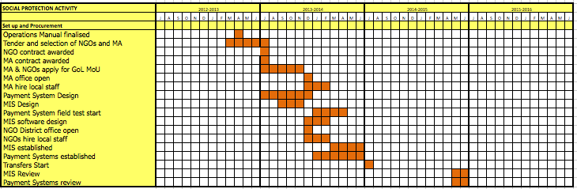

The sections below describe the two models in more detail. AusAID has comprehensive draft Operations Manuals that will provide guidance on systems and procedures for the SPA implementing NGOs to follow, allowing for consistent implementation standards. These draft Operations Manuals will be verified and finalised by the SPSL Managing Contractor.

## Description of the Resilient Livelihoods for the Poor Scheme

The Resilient Livelihoods for the Poor (RLP) scheme will provide 3,000 families with a package of a regular cash transfer, an asset with which to develop a small enterprise and intensive support and training. It will closely and actively engage with beneficiaries to enable them to access and use financial services. By providing this package of activities over a period of up to two years, it is expected that many families will develop sustainable income-generating activities.

### Management and staffing of the RLP scheme

The NGOs delivering the RLP scheme will establish an office in the district in which the scheme is to be carried out, while financial and administrative support will be located in the NGO’s Vientiane or provincial office. Indicative staffing for the RLP implementation is set out in Figure 11.

Figure 11: Organisational Chart showing structure and positions in each of the three NGOs (or consortia) for the RLP scheme

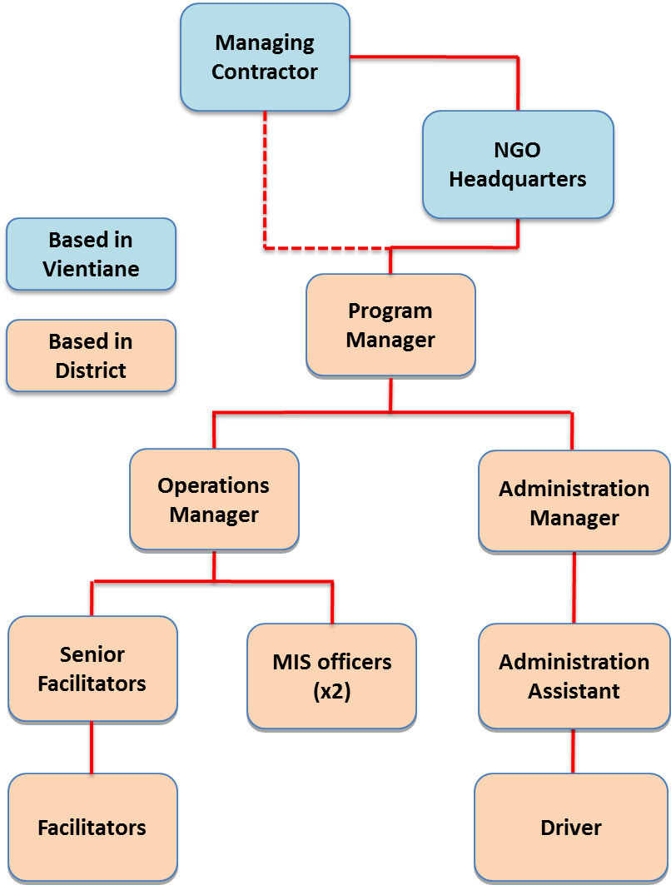

The NGO Facilitator’s role is to support each selected RLP participant to: (a) choose and manage their selected enterprise effectively; (b) improve participants' financial skills and assist them to develop a plan for their future; and (c) mentor and coach each participant, helping them identify solutions to constraints they experience.

Integral to successful implementation is strong technical assistance from experts who have practical experience in implementing similar schemes. The SPSL Managing Contractor will mobilise technical support to assist the NGOs in identifying appropriate livelihood choices for the participants. The SPSL Managing Contractor will help the NGOs access the necessary expertise, as well as provide implementation support. There will be a short-term technical assistance pool that NGOs can draw upon to assist them with implementation. In addition, the Managing Contractor will have permanent technical expertise to support NGOs, including a Social Protection Specialist and a Social Development Specialist.

All staff engaged on the scheme will receive training. Key staff will undertake a study tour to Bangladesh, either to visit BRAC’s TUP program or the Chars Livelihoods Program. Within Laos, the SPSL Managing Contractor will develop a comprehensive program of training for NGOs and government partners.

### Selection of Participants

The scheme will support vulnerable families without a viable and decent livelihood. It will incorporate families with a disabled member and single caregivers, but will develop mechanisms to identify other vulnerable families that would benefit from the scheme. The selection mechanism, described in the Operations Manual, will be facilitated by the implementing NGOs and involve communities in the selection process, building on community members’ own understandings of vulnerability and poverty.

Once the community process has identified potential beneficiaries and they have agreed to take part in the RLP, the NGOs will register each selected participant. As a learning exercise, the Managing Contractor will visit a selected number of participating families to review the targeting process undertaken. The detailed selection process will be set out in the Operations Manual, while Box 2 summarizes international practice followed by RLP-type schemes.

|  |
| --- |
| 1. Beneficiary selection steps used in other countries   BRAC’s Targeting the Ultra-Poor program and other similar programs typically utilise the following steps as part of their method to select. The beneficiary selection process will build on this process as it contextualised to the Lao context.    **Step1:** **Social mapping exercise -** the community draws a map of all the families in the local village, discusses the characteristics of extreme vulnerability that exist in the community, and wealth ranks the families according to the various poverty levels. Although there is value in gaining community insights into who is vulnerable and why, there are dangers of biased targeting and community tensions that can occur.  **Step 2:** **Develop inclusion/exclusion** **criteria** - to make the selection of participants as objective as possible. Grounds for exclusion can include having an outstanding loan, or receiving government salary or social security payment. Inclusion criteria could include owning no large livestock, selling physical labour, being a single-headed family, or having care responsibilities for a person with disability.  **Step 3:** **Visit households -** to determine who meets the criteria, and is eligible for the program. Once the staff have verified the list of potential participants, an independent verification process will take place, examining a percentage – perhaps 20 per cent – of the potential participants. However, there is evidence that this additional verification step adds little value, while being administratively costly. |

A selection mechanism acceptable to communities will be developed so that basic egalitarian values are safeguarded. The selection mechanism will be tested before becoming operational. Community reactions will be assessed and, if necessary, the selection process will be revised.

### Developing micro-enterprises

To enable families to develop a micro-enterprise, they will receive support in three areas: an asset transfer; a regular cash stipend; and a program of intensive advice, mentoring and capacity building.

*Asset transfer:* The scheme will provide a substantial asset to each participating family as a grant, which will form the basis of a micro-enterprise.[24] The SPSL Managing Contractor,– along with its technical experts, will work with the NGOs to conduct a thorough market assessment to identify enterprises that have strong market potential and are appropriate for the type of families on the scheme. Participants may select an enterprise from a list of prospective viable alternatives, up to a value of AUD250.[25] If participants do not utilise the full asset value, the remaining amount can be set aside and utilised towards their enterprise (e.g. raw material, fodder for livestock, or towards a replacement asset if required)

|  |
| --- |
| 1. Potential micro-enterprises in the RLP scheme   The RLP scheme will develop micro-enterprises based on an approach that sets out to understand and tackle systemic market constraints. Before enterprises are agreed, they will be subjected to market studies that will identify the commercial and institutional environment for products. Most enterprises are likely to be individually owned, but there may be opportunities for participants to establish joint businesses. Typical income-generating activities may include:   * Livestock and fishponds;[26] * Kitchen garden produce and mushrooms; * Non Timber Forest Products (NTFPs) such as: honey, white tea and spices * Handicrafts, such as weaving and basket making; * Small businesses such as shop keeping, providing nutritious locally grown school meals, etc. |

*Cash stipend:* Each participating family will receive a stipend of LAK100,000 (AUD12 per month) for the first 12 months of the scheme. The cash transfer is meant to give families ‘breathing space’ as they transition into a new livelihood, and help ensure that their basic needs are met during this period as they invest in their newly chosen enterprise. If families need a transfer for more than 12 months to ensure the sustainability of their enterprise, the implementing partner NGO will make a decision on whether to extend support.

The transfer is set at around half the per capita poverty line and 10 per cent of the per capita GDP. As noted in Figure 12, most countries that have implemented similar schemes have a cash transfer element that ranges from about 3 per cent to 22 per cent of GDP per capita. The transfer should be large enough to offset opportunity costs, while also giving families a chance to invest and save. The evaluation of a program in Haiti demonstrated that the large cash transfer, coupled with good financial education, was utilised by families to invest in education (school attendance increased by over 90 per cent) and to diversify into other productive activities.

Figure 12: Transfer levels in RLP-type schemes, as a percentage of GDP per capita

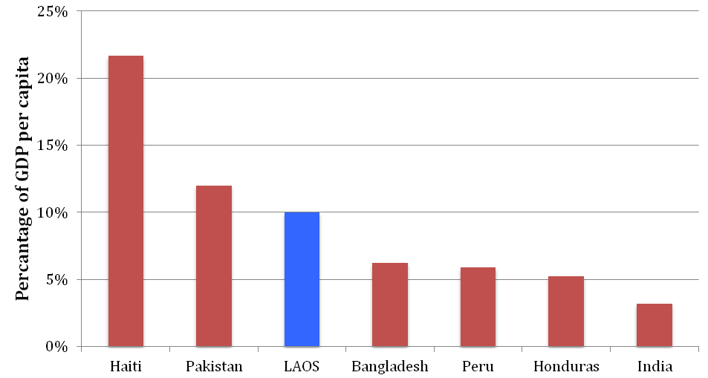

*Capacity building:* Each participant will receive technical support to gain sufficient skills and knowledge in order to establish and maintain their micro-enterprise, as well as receive financial literacy education (via curricula developed by GIZ – see Section 7.2). The NGOs will organise the required technical training, most likely with the assistance of the District Agriculture and Forestry Offices and Lao Women’s Union staff. In addition, the Facilitators will visit each participating family at least once every 2 weeks to provide them with hands-on mentoring and coaching, over a period of two years. Studies of similar interventions in other countries have shown that where there is a good facilitator-participant relationship, participants are able to plan towards their future, diversify their income sources, have better health seeking behaviour, and gain self-confidence.

Participants will also be encouraged to save regularly in local village banks that will be set up in the area by GIZ, as part of AusAID’s Financial Inclusion component. This will enable participants to smooth their consumption, build their financial competencies, and enhance their capacity to access loans in the future.

### Exit from the RLP scheme

Participants will exit the RLP scheme after two years of support. Many will be in a position to continue with their business but, as with any business, some may not be successful. The scheme will aim for 60 per cent of participants to still have functioning micro-enterprises two years after support from the scheme ceases.[27]

To strengthen the chances of long-term sustainability, participants will need to be able to access further support, if needed, once the scheme has finished. One core area of further support will be access to micro-finance to allow them to borrow and save. The NGOs will also develop plans with District Government departments to continue to provide technical assistance and advice to participants.

### Implementation schedule of the RLP scheme

The RLP scheme will initially be piloted with 600 families (200 per NGO and district) in three provinces. Upon satisfactory results from a process evaluation towards the end of the first year of field implementation, AusAID will scale-up the scheme to approximately 3,000 families. An implementation plan is set out in Figure 13, including the initial establishment of the SPSL Managing Contractor and SPA implementing NGOs.

Figure 13: Implementation Plan for the RLP scheme

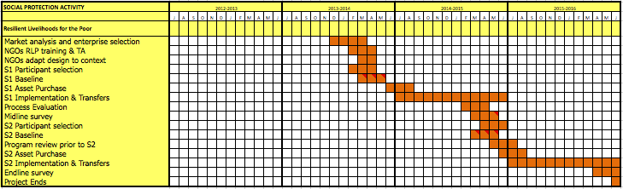

## Description of the Senior Citizens’ Allowance

The Senior Citizens’ Allowance will provide around 15,500 older people with a regular cash transfer for a specific period of time (to be determined by AusAID in 2014).[28] The key elements of the scheme are described below, alongside justifications for key design choices.

### Staffing of the Senior Citizens’ Allowance

The Senior Citizens’ Allowance will require minimal staffing levels (see Figure 14). The NGO will contract two staff – a Senior Elderly Allowances Officer and a Elderly Allowances Officer – to be placed within the local DLSW office. The NGO staff will work with DLSW officers to implement the delivery of the old age allowance, with the exact roles of the government staff to be determined by the MLSW in consultation with the Managing Contractor and NGO once the scheme is operational.

Figure 14: The District Senior Citizens’ Allowance Team

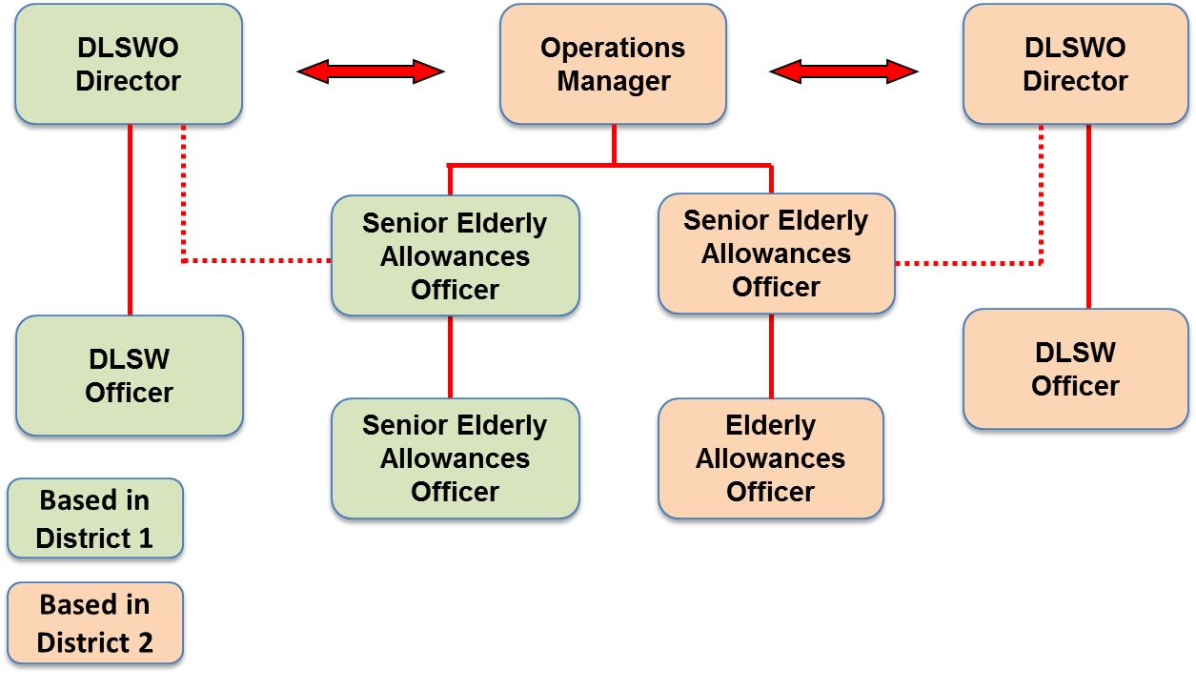

Among other tasks – which will be set out in job descriptions in the Operations Manual – the (Senior) Elderly Allowances Officers will be responsible for:

* Supporting design of the age identification process;
* Registration of recipients of the Senior Citizens’ Allowance;
* Change management of the old age allowance (such as registering deaths on the scheme’s database);
* Facilitating appeals, grievance and complaints processes;
* Managing the MIS, including – as required – inputting data and checking for quality;
* Holding regular meetings with DLSW and other local stakeholders to review progress with the Senior Citizens’ Allowance;
* Ensuring that the District population and authorities are well informed about progress with the Senior Citizens’ Allowance;
* Managing communications and expectations on the scheme at District level.

The Elderly Allowance Officers will report to the NGO Operations Manager and also to the head of the DLSW office.

### The Proposed Old Age Allowance Model for Laos

The Senior Citizens’ Allowance will align to current government pension policy, by providing an example of how a pension system could be established that would provide universal old age allowance coverage in Laos. The model used will replicate that used in Thailand – and other countries such as Nepal, Chile and Lesotho – in that those receiving a pension from government or the Social Security Organisation (SSO) will not receive the Senior Citizens’ Allowance. It is known as a Pensions-tested pension.

If the Senior Citizens’ Allowance were to be adopted nationally by Government, it is likely that tapering would be used to gradually withdraw it from those receiving another compulsory pension. When tapering is not included in pension testing, there is a danger of creating a disincentive to enter a mandatory contributory pension. The long-term aim would be to build a pension model for Laos similar to that set out in Figure 15.

Figure 15: A potential pension model for Laos

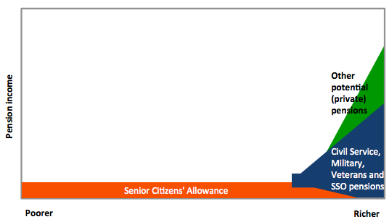

The proposed pension model would have three tiers:

* The Senior Citizens’ Allowance which would act as the Foundation Tier of the pension system;
* A mandatory pension, which would include the Civil Service, Military and Veterans’ pensions, as well as those provided by the Social Security Organisation;
* Voluntary pensions, which, in the long-term could be established by the private sector and provide those who are better-off with an option for building a higher level of pension income.

However, to ensure simplicity during the SPA, no taper will be used. A taper would require combining the management information systems of existing pensions and the Senior Citizens’ Allowance, and a common cash delivery system. In effect, the model during the SPA will be similar to that set out in Figure 16.

Figure 16: Pension model to be used in the Social Protection Activity

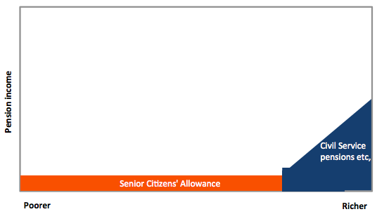

### Size of Senior Citizens’Allowance Benefit

The old age allowance benefit will be LAK100,000 per month (around AUD12) although it will be paid on a quarterly basis. This amount has been selected as it is around half the per capita poverty line.[29] It is also set at a level below current contributory pensions: the lowest government pensions are around LAK 300,000 per month (around AUD36) while the lowest pension from Social Security Organisation is around LAK110,000 per month (paid after only five years of contributions).

The SCA monthly amount is around 10 per cent of per capita GDP which, as Figure 17 indicates, is a little lower than the international norm for pensions reaching the majority of the population. It is prudent to begin a pension at a lower level, given that it will comprise a relatively significant level of government spending.

The LAK100,000 per month has been set in January 2013. It is likely that the size of the allowance will have to be adjusted by the time the scheme commences. Adjustments in the size of the benefit will be proposed by the SPSL Managing Contractor and agreed by AusAID and the MLSW. Increases should be linked to inflation.[30]

Figure 17: Pension benefit levels across developing countries, as a percentage of GDP per capita, compared to proposed benefit level for Laos

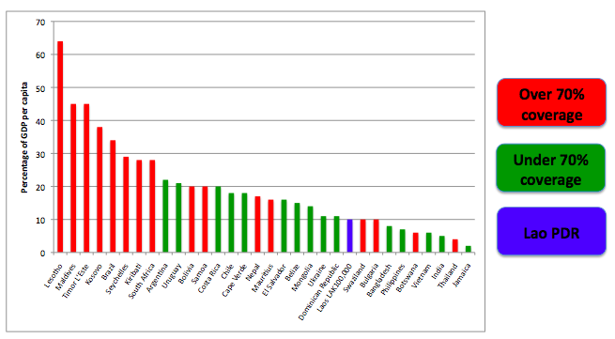

### Selection of Recipients

The old age allowance will be provided to all people aged 65 and over in selected districts, except for those already receiving a government or SSO pension. Recipients should be able to provide evidence of residency in the district for the last consecutive three years. This regulation will provide a disincentive for people to move into the district to receive the Senior Citizens’ Allowance.

While the SSO pension can be provided from age 60, beginning the Senior Citizens’ Allowance at 65 years will significantly reduce the overall cost if it is scaled up nationally.[31] A national Senior Citizens’ Allowance for all people aged 65+ years would cost around 0.39 per cent of GDP (or a little less, if other pensioners were excluded). As Figure 18 indicates, the cost of the allowance relative to other countries providing comprehensive coverage of the elderly population would be relatively low, when measured as a per centage of GDP. Therefore, it should be affordable for the Government of Laos, providing it is committed to implementing the scheme at national level.

Figure 18: Cost of Laos Senior Citizens’ Allowance, compared to other developing countries*[32]*

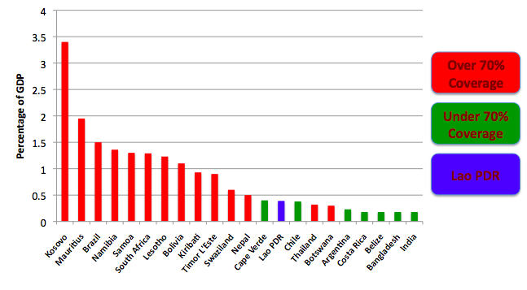

A key challenge when implementing the old age allowance will be to identify the age of potential recipients. Many developing countries have faced the same challenge when older people have no identity documents, but deal with it relatively successfully.[33] In Laos, many older people have documents that indicate their date of birth, such as a birth certificate, identity card or a Family Book. The scheme will accept birth certificates and identity cards as proof of age. However, before accepting the Family Book as proof, in each district a short study will be undertaken to test accuracy of the age on Family Books using local calendars of events.[34]

If the Family Books are proven to be reasonably accurate – to be jointly determined by the NGOs, Managing Contractor and MLSW – they will be accepted as proof of age, allowing people to appeal against their age on the document if they believe it is incorrect. If Family Books are shown to be inaccurate, then identification of age will be based on a calendar of events, with ages certified by the local community leadership. Any appeals will be against the calendar of events.

### Registration of Recipients for the Senior Citizens’ Allowance

There will be two registration processes for the Senior Citizens’ Allowance. The first will be to build the initial list of recipients, at the beginning of the scheme. The second will be an ongoing on-demand process, enabling people to register as they reach the age of eligibility.

During the initial registration process, the Elderly Allowances Officers – with staff from the DLSW and additional short-term support – will visit Kum Bans and villages to make people aware that the old age allowance will commence. Once the age identification process has been agreed, they will note all people above 60 years of age, and place them onto the scheme’s Management Information System (MIS). During a subsequent visit to the Kum Ban by the Elderly Allowances Officers and DLSW staff – accompanied by representatives of the Payment Service Provider that will deliver the cash – those aged 65 and over will be registered and noted as recipients on the Senior Citizens’ Allowance database. They will be provided with the necessary documentation to enable them to receive payment.

Following the initial registration, the Elderly Allowances Officers will visit the Kum Bans every three months to enable anyone reaching the age of 65 to register for the old age allowance. Furthermore, specific days for registration at the DLSW office will be agreed and communicated to the local population.

During registration, the recipients will be informed both verbally and in writing about the period during which they will receive the old age allowance, to avoid any moral hazard. All recipients will sign a document to provide evidence that they have understood the terms and conditions of the old age allowance.

### De-registration of Recipients

Recipients of the Senior Citizens’ Allowance will be removed from the recipients’ database upon their death. The death of an old age allowance beneficiary will be reported to the Nai Ban who will inform the Elderly Allowances Officers on their regular visits to Kum Bans. An appropriate incentive will be developed and established to encourage death registration (for example, if a recipient of the SCA dies, his/her immediate family will receive assistance with funeral expenses if the death is registered within a few days). The local community will also be compensated financially for each death registration with a small contribution to village funds. The Elderly Allowances Officer will input the information on to the scheme database.

### Senior Citizens’ Allowance implementation schedule

The first stage of the Senior Citizens’ Allowance provides transfers to around 1,700 recipients in each of three districts, or a total of 5,100. Before the end of the first year, the scheme will be reviewed and procedures revised before the registration of a further 10,300 Recipients, making a total of almost 15,500 in the second year. The Implementation Plan for the Senior Citizens’ Allowance is set out in Figure 19.

Figure 19: Implementation Plan for the Senior Citizens’ Allowance

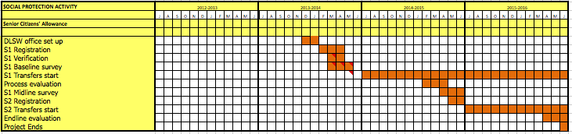

## Grievance and complaints mechanisms across both social protection schemes

Efficient consideration of appeals helps to minimise any exclusion and inclusion errors. Village residents will have an opportunity to appeal if they think believe have been wrongly excluded from the SCA. The Operations Manual sets out the proposed appeals system. Village residents will appeal either through the Nai Ban or to the DLSW. However, there will be no appeals against inclusion on the RLP scheme. The RLP scheme is not an entitlement and, given that there is likely to be minimal difference between many of those families included and excluded from the scheme – and there is a maximum number of places on the scheme – appeals will make the targeting excessively complex. For example, if anyone were successful with an appeal, then someone would have to be removed.

People can also register complaints about any issue of concern, including complaining about people who they feel have been incorrectly included onto the schemes. Again, they can complain to NGO or GoL staff, either through forms to be made available locally or at the District government or NGO office.

Details from all appeals and complaints will be entered into separate registers on the management information system (MIS), which will monitor decisions and produce consolidated reports for management response.

## Management Information System

The SPA will be an opportunity to design and test an advanced social protection management information system (MIS), using new technologies. The SPA will aim to build a prototype of a MIS that could, potentially, be adapted and used by government if it decides to scale up the Senior Citizens’ Allowance or introduce another large-scale social security scheme.

The SPSL Managing Contractor will commission a team of consultants to review options for the MIS in Laos and develop a costed plan for establishing it across the SPA. The consultants will develop software for the MIS, potentially using open source social protection software that has been developed by DFID in Kenya (for its Hunger Safety Net Programme), and which has already been successfully adapted in Uganda, Zimbabwe and across other programs in Kenya. The database will have two integrated windows, one for the RLP scheme and one for the Senior Citizens’ Allowance.

Where appropriate, the MIS will seek to use advanced technologies to establish an effective, efficient and secure system. This will include transmitting information – where possible – via the mobile phone network between communities, districts and Vientiane. The consultants will assess the potential for using new technologies – such as Personal Digital Assistants[35] (PDAs) or tablets – to capture information at community level. NGOs will probably be able to manage the database using personal computers and, within the Managing Contractor, the consultant will have to assess whether a server with greater data storage and processing capacity will be necessary.

Figure 20 sets out the potential structure of the MIS. Data will be captured at community level – such as registration, de-registration, asset training and transfers, quarterly RLP monitoring surveys, participant grievances, etc – and entered into the MIS either within communities (e.g. using PDAs) or physically recorded on paper then inputted by MIS officers by NGO staff or Elderly Allowances Officers in the DLSW and NGO office. Data from other monitoring processes and surveys will also be included in the database and linked to participant records and other components of the MIS as necessary.

Once uploaded, the data will be available to the SPSL Managing Contractor. The Managing Contractor will also enable the MLSW to have access to data on the Senior Citizens’ Allowance. Likewise, relevant MIS data will also be shared with the database of the Payment Service Provider.

The SPSL Managing Contractor will oversee the MIS and provide support to NGOs to ensure that the system works effectively. Within NGOs, data entry clerks will, if required, be employed to input data into the system. During the initial registration periods for the SCA, short-term data-entry clerks will be contracted.

The main functions of the MIS will be to:

* Record all necessary data on scheme recipients (e.g. personal registration details; payments and withdrawals; details of nominated deputy recipient; asset transfer and performance data; visits from RLP Facilitators and reports, etc);
* Facilitate payments, by providing payment schedules to the Payment Service Provider and reconciling payments once they have been made.
* Track the processing and outcomes of grievances and complaints throughout the SPA implementation.

Figure 20: Structure of the Management Information System

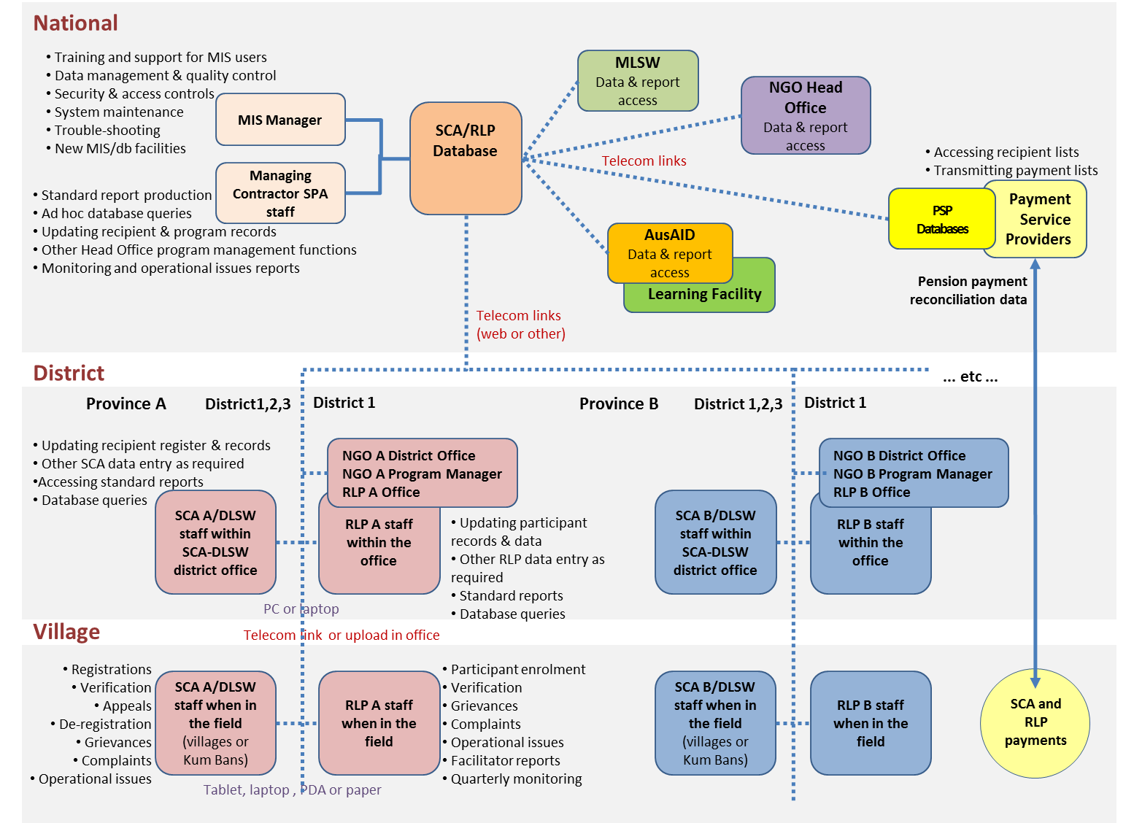

## Mechanisms for Payment of Transfers

The SPA will provide a significant level of regular stipend transfers to recipients in districts. By Year 4, the RLP is likely to transfer to recipients in each district AUD100,000 per year, while the Senior Citizens’ Allowance will provide around AUD300,000. These are significant sums and AusAID aims to use these transfers to strengthen mechanisms for financial inclusion and test innovative forms of delivering cash.

There is significant international experience on delivering cash to recipients of social security schemes, which can be built on in the SPA. It is widely recognised that simply physically handing over cash to recipients does not build on opportunities to strengthen financial systems. There is a range of experiences of delivering cash through mobile phone networks, mobile banking (e.g. mobile ATMs), branchless banking etc. and this experience can be used to inform the design of the cash delivery system in the SPA.[36] The activity will aim to demonstrate to government the value of using social security schemes to expand the inclusion of poor families into the financial system.

The LARLP’s Financial Inclusion program component offers the opportunity to develop innovative forms of government to person (G2P) transfers in Laos. Once the SPSL Managing Contractor and implementing NGOs are selected for the SPA, they will engage with GIZ and UNCDF to design and implement an effective cash delivery system that maximises the use of new technologies. GIZ will focus on developing Village Banks and their partner Network Support Organisations[37] (NSOs) as a channel for delivering cash, most likely in the districts where the RLP is operational. UNCDF will explore alternatives such as mobile banking and the Post Office, and will probably operate in those districts in which the Senior Citizens’ Allowance is active. It can potentially use the AusAID-funded Financial Inclusion Fund to support the development of alternatives.

On the assumption that effective forms of cash delivery can be developed by GIZ and UNCDF, it is likely to channel transfers via these agencies rather than through the NGOs. The SPA NGOs will be responsible for managing payment lists which will be sent to the payment service providers in advance of payments being made. However, if GIZ and UNCDF are unable to develop adequate alternatives, the SPSL Managing Contractor could decide to deliver transfers via other structures, which may, as a last resort, be the implementing NGOs.

Minimum standards will be set for Payment Service Providers to deliver transfers to recipients. These parameters will be set as procurement and monitoring requirements in the contracting of the Payment Service Providers. Meeting these standards will be monitored by the NGOs as part of ongoing monitoring, and the Payment Service Provider will issue a monthly report on payment performance. Minimum standards will probably include:

* Pay points should be sufficiently accessible to recipients, in particular those that have difficulties travelling (although recipients will be able to name proxy recipients). The level of accessibility will be agreed in the contract between the Managing Contractor and GIZ/UNCDF.
* The payment mechanism should seek to be linked to savings accounts for recipients so that they can retain funds in their accounts, if they desire, and have greater freedom to withdraw funds.
* Recipients should be able to access their funds in safety and with dignity.

The RLP scheme transfers will be delivered on a monthly basis, as families are likely to need easy access to cash for their consumption. However, the Senior Citizens’ Allowance will be delivered every three months.

## Financial Literacy Education

As with poor people in many countries, vulnerable families in Laos have complex financial circumstances. They save in various forms, often in less liquid assets that are more difficult to turn into cash (e.g. livestock) and borrow at high interest rates from moneylenders and other precarious sources. The financial climate for the poor in Laos is particularly risky, given the opening up of roads, development of markets, and prevalence of foreign traders with access to once poor, remote villages that, until recently, have had minimal engagement with cash and markets. As a result, people can take loans or agree to commercial contracts on detrimental terms.

The need for greater financial literacy is therefore essential for many rural Lao citizens, including RLP scheme participants and recipients of the Senior Citizens’ Allowance. It is particularly important for RLP scheme participants, as they must develop their knowledge of finances for their enterprise, develop savings, and learn to manage loans.

As part of AusAID’s Financial Inclusion program, GIZ will develop curricula for financial literacy that can be used across the SPA by both GIZ and NGOs. Financial literacy education will occur at four levels:

* *Community level*, through the utilization of media such as village radio or theatre. These will be messages aimed at everyone in communities, and will focus upon saving, avoiding credit traps, and making smart financial choices.
* *Village bank level*. Currently, the curriculum for village banks consists of distilling the principles and lessons that make a village bank strong (e.g. savings to build financial solvency of the bank; repaying on time; the different types of loans available). However, the curriculum requires further development and nuancing.[38] Messages for RLP participants will focus initially on saving rather than taking loans while messages for SCA recipients focus on savings.
* *Schools*: GIZ will develop financial literacy curricula in consultation with AusAID’s Education program that can be delivered to schoolchildren.
* *Household level*: RLP facilitators will deliver financial literacy education to RLP participants during household or group meetings, with messages tailored to individual aspirations and constraints. The Elderly Allowance Officers will support SCA recipients to access financial literacy and education through the village banks.

## Monitoring of the Social Protection Activity

An underlying purpose of the SPA is to test, in the Lao context, two contrasting – but potentially complementary – approaches to social protection. Consequently, comprehensive monitoring and reporting is essential to: ensure the efficacy of the scheme’s implementation and its progress; regularly monitor the progress of clients; and provide accurate information to support evaluation of the scheme’s processes and outcomes along with any additional related research.

Through the flexibility provided by the MIS, reporting will be adaptable to the diversity of different users – e.g. implementing NGOs, District Labour and Social Welfare offices, Payment Service Providers and the SPSL Managing Contractor – and their different needs for data entry and information retrieval. Thus the various users will have the facility to: define the data they want to be retained in the database; update the stored data; and define and receive regular reports as well as make *ad hoc* requests for specific information and analyses from the database.

The core of the MIS will be participant registration data for both the Resilient Livelihoods for the Poor scheme and the Senior Citizens’ Allowance components. Progressively linked to each participant record will be regular monitoring data collected by the RLP Facilitators, the Elderly Allowance Officers and PSP staff including; stipend and allowance payments; productive asset transfers; and, where a participant is part of the baseline study, a link to the data for that participant. As a check on the veracity of implementation and the MIS, the Managing Contractor in conjunction with the AusAID Learning Facility M&E Unit will conduct regular spot checks with the scheme’s participants on the circumstances and quality of their engagement with the scheme and its various processes.[39] This data will also be linked to the participants’ records in the database.

RLP Facilitators will visit participants every two weeks to provide technical support and mentoring. For each visit they will report on specific implementation issues or issues particular to the participants. This field report data will be linked into appropriate sections of the MIS including the participant records. In addition, each quarter the Facilitators will complete a short monitoring questionnaire with participants that will include, for example, questions on changes in income, assets and food consumption. This data will also be linked to the particular participant’s record in the MIS.

The District Labour and Social Welfare and the NGO-funded Elderly Allowance Officers assigned to the Senior Citizens’ Allowance component will have a major administrative role in creating and maintaining the Age Register that will form the basis of entitlement to the Senior Citizens’ Allowance as well as checking that payments are being disbursed as required. In undertaking this role in the participating villages, they will also be monitoring implementation issues, grievances or other problems and ensuring that these are included in the MIS.

Standard reporting from the MIS will focus on tracking: (a) the rollout of the RLP and SCA processes; and (b) the progress of participants within the implementation processes characteristic of each of the two components. It will also provide “frontline” information on implementation effectiveness and early warning of potential problems and the need for management action to strengthen systems or processes.[40]

# RELATIONSHIP OF SOCIAL PROTECTION ACTIVITY TO OTHER AusAID PROGRAMS

The SPA is one element of AusAID’s broader interventions in Laos. It will complement the other components of the LARLP, in particular the Financial Inclusion component, the UXO clearance component and AusAID’s Learning Facility. AusAID also has significant investment in the education sector in Laos, and will be commencing design of a future education program in 2013. The SPA will build close links with these programs, including being co-located in districts. The relationship of the SPA with these programs is described below in more detail.[41]

## Links to Micro-Enterprise Challenge Fund

As part of the broader Social Protection and Sustainable Livelihoods component of LARLP, a Micro-Enterprise Challenge Fund (MECF) will be established, under the management of the SPSL Managing Contractor. The Challenge Fund will be accessible to NGOs and social enterprises and will aim to promote micro-enterprises in more remote communities, in particular those that still have good access to natural resources. One aim of the MECF will be to demonstrate that communities can make effective and sustainable commercial use of natural resources.

It is not considered likely that MECF projects will be in the same communities as the RLP scheme, since the latter will work mainly in larger communities in which processes of social exclusion are progressing more rapidly and where access to natural resources is more limited. However, if there is overlap, the SPA and MECF implementing NGOs will be expected to coordinate closely together. This will include engaging on more crosscutting issues, such as local planning, financial literacy, promoting gender equity and inclusive development, etc. Indeed, the presence of the SCA in communities where the MECF takes place may increase the chances of success of MECF initiatives, given that there will be more cash in communities and more demand for services. The SPSL Managing Contractor will ensure coordination and synergies between the two schemes, where they are co-located.

The NGOs selected to implement the SPA will also be eligible to bid for MECF funding, and it will not be necessary for these projects to be in the same provinces.

## Links of SPA to AusAID’s Financial Inclusion Component

AusAID’s Financial Inclusion program is delivered through GIZ and UNCDF and is a component of the broader Laos Australia Rural Livelihoods Program (LARLP). The Financial Inclusion program is linked to the Social Protection Activity in three distinct ways:

* *Innovative methods for cash transfers:* Both UNCDF and GIZ will engage closely with the SPA to support the delivery of cash to the activity’s participants (see Section 6.6).
* *Platform for financial services*: The SPA participants will be able to access the financial services to be developed by GIZ and UNCDF – in particular the village banks – to save and, if necessary, take loans. This will strengthen their ability to smooth their consumption in the case of shocks, providing them with greater resilience. Both GIZ and UNCDF will examine ways of making the cash transfer mechanism financially inclusive by, if possible, providing payment recipients with access to accounts
* *Delivery of financial literacy:* As a part of their remit to strengthen financial services and understanding among RLP participants, GIZ has committed to developing curricula for financial literacy and to engage with the SPA implementing NGOs in providing financial literacy to families participating in the RLP, as well as to other community members. In districts with the SCA where GIZ supports village banks, it will also undertake financial literacy training of SCA recipients.

Each of these activities will be jointly monitored and evaluated by UNCDF, GIZ and the SPSL Managing Contractor and the implementing SPA NGOs. Any necessary adjustments to the schemes will be made from pilot to scale-up (in Year 4 of the LARLP).

## Links to AusAID’s UXO clearance component

AusAID is providing support for UXO Action through a multi-donor trust fund managed by UNDP. The multi-donor trust fund will finance the clearance activities of UXO Laos. Given that the SPA is likely to take place in districts that are contaminated by UXOs, the NGOs implementing the RLP scheme will be encouraged to engage with village and district authorities to incorporate the clearance of potential RLP sites in their priorities in UXO Laos’ clearance plan, assuming clearance is required for the proposed income generating activities.

## Links of the SPA to AusAID’s Education Program

AusAID’s education program aims to ensure all boys and girls have equitable access to quality basic education, targeting those in poor geographic areas. New program activities will be designed in 2013, after the finalisation of AusAID’s Laos Education Delivery Strategy 2012-2017.

The SPA is likely to be delivered in some of the districts and communities that will be the focus of the education program. Areas in which synergies could be strengthened between the two schemes are described below.

If the education program establishes Early Childhood Development Centres for children aged 3 and over, alongside Primary Schools in communities where the RLP scheme is active, it could provide an important opportunity to support targeted communities, particularly young mothers. There is a growing understanding internationally that childcare can have a significant impact on child poverty by providing mothers with greater opportunities to enter the labour force.[42] It may, therefore, enable mothers in the RLP scheme to have their children taken care of, while they invest in their businesses, and would reduce the risk of older children being removed from school to care for their siblings. The SPA will, however, also examine whether the Senior Citizens’ Allowance also strengthens informal systems of childcare for the benefit of young mothers.

The financial literacy component – to be developed by GIZ and delivered, in part, via the NGOs implementing the SPA – will also lead to the development of a financial literacy curriculum for schools.[43]

The education program will engage with the SPSL Managing Contractor to determine whether the delivery of school meals could be developed as a small business by RLP beneficiaries. If this is successful, good practice in locally procured nutritious school meals could be developed, which could be rolled out nationally in support of government policy to develop locally grown and managed nutritious school meals.

The education program may engage with WFP – or other agencies – to develop nutrition education in schools, which could complement nutrition education provided by the RLP facilitators.

The provision of sanitation facilities in schools is also expected to have broader health benefits for communities, including households involved in the RLP and SCA schemes, given that many of these facilities are located in schools and districts where the SPA will operate.

A joint evaluation of the education and SPA could be undertaken in selected districts (see Section 13 on evaluation for further information).

# GEOGRAPHICAL LOCATION OF THE SPA

In selecting the provinces for the SPA, AusAID has examined the available survey information to determine the most appropriate areas. The surveys used are the national population census, annual government estimates of poverty in districts and the 2010/11 Agricultural Census.[44] Geographic selection has focused first on identifying provinces that have districts that would be appropriate areas for the RLP scheme. The SCA scheme has many more districts that would be viable options, and candidates can be found in all provinces.

If the RLP scheme is to be successfully implemented, it requires districts with certain characteristics. These include:

* Sufficiently large population so that the total number of beneficiary households comprises around 15% of the total population in the district;
* Households with characteristics appropriate for selection for the RLP, such as limited labour capacity to engage in agriculture or employment, or few assets, such as land or animals; and
* Good access to communities so that Facilitators can visit participants in the RLP scheme on a regular basis throughout the year.

Other factors have been taken into account in determining the Provinces:

* The existence of sufficient *poor* households in potential districts, according to government definitions;[45]
* The district should be a priority education area, so that AusAID’s future education program will be implemented in the same locations.[46]

Therefore, in determining the selected provinces, AusAID has identified provinces with districts that have *all* of the following characteristics:

* At least 7,500 households (data from the Agricultural Census);
* Over 1,500 poor households (data from 2011 Study conducted by the National Rural Development and Poverty Eradication Committee);
* At least 400 non-farm rural households (data from the Agricultural Census);
* At least 400 female headed households (data from the Agricultural Census);
* A population density of at least 30 persons per square kilometre (data from the population census).[47]

There are three provinces with at least one district fulfilling all these characteristics. These provinces are: **Champasak, Saravane** and **Savannakhet.** The priority districts for RLP identified in each province are set out in Table 1, with key data on each.

The first batch of SCA districts are identified and have been chosen on the basis of factors such as size of accessibility (relative to the RLP district), elderly population, and poverty levels. In the first year of transfers, the SCA district will be in a separate district to the RLP. However, in the second year of transfers, two further districts will be introduced and one is likely to be the RLP district. However, a decision will be made jointly on which districts during the first year of transfers by AusAID, the SPSL Managing Contractor, the SPA implementing NGOs, the MLSW and the Provincial government.

AusAID currently funds a number of other activities in these provinces. Both the Rural Electrification and Education for All programs work in the selected RLP districts while the Poverty Reduction Fund is present in the provinces of Saravane, and Savannakhet. The LANGOCA program is in Saravane while ACIAR is in Saravane and Savannakhet. All three provinces are contaminated by UXOs and are supported by the UXO Multi-Donor Trust Fund.

Table 1: Basic information on the districts for the SPA activity*[48]*

|  |  |  |  |  |  |  |  |  |
| --- | --- | --- | --- | --- | --- | --- | --- | --- |
| **Province** | **District** | **Number of households** | **Per centage poor households** | **Number of poor households** | **Number of non-farm rural households** | **Number of female headed households 400+** | **Number of people ages 65 and above** | **Population density** |
| **Champasak** | | | | | | | | |
| RLP target | Soukhouma | 8,340 | 34.61 | 2,957 | 1,266 | 469 | 1,999 | 39 |
| SCA target | Mounlapamok | 5,128 | 20.23 | 1,114 | 964 | 274 | 1,911 | 15 |
| **Savannakhet** | | | | | | | | |
| RLP target | Phine | 8,362 | 37.27 | 3,096 | 946 | 471 | 1,732 | 13 |
| SCA target | Xepone | 8,155 | 52.92 | 4,363 | 113 | 381 | 1,779 | 18.44 |
| **Saravane** | | | | | | | | |
| RLP target | Lao Ngam | 11,371 | 21.58 | 2,583 | 395 | 946 | 1,887 | 61 |
| SCA target | Saravane | 13,016 | 10.22 | 1,482 | 462 | 1,411 | 3,186 | 37 |

# BUDGET AND PROCUREMENT ARRANGEMENTS

The budget of the SPA schemes is set out in Table 2.

Table 2: Budget of the SPA schemes in millions of AUD

|  |  |  |  |  |
| --- | --- | --- | --- | --- |
|  | **2013/14** | **2014/15** | **2015/16** | **Total** |
| RLP transfers and assets | 0 | 0.25m | 0.98m | **1.23m** |
| SCA transfers | 0 | 0.83m | 2.50m | **3.33m** |

The Social Protection and Sustainable Livelihoods Managing Contractor and the SPA NGOs will be selected by competitive tender. Both processes will take place concurrently so that there is no conflict of interest, and both the Managing Contractor and selected NGOs will be mobilised as soon as possible.

The successful tenderer, and its consortia partners, for the AusAID Learning Facility activity must be independent from the successful tenderer and its consortia partners, for the Social Protection and Sustainability Livelihoods (SPSL) activity (AusTender reference **AA1213 - 43**). Organisations may provide capacity statements in response to both requests and may progress to Step 2 if shortlisted by AusAID; however, if selected as the preferred tenderer for both activities after the assessment of Step 2 submissions, the organisation will negotiate with AusAID and can only be the successful tenderer for one of the two contracts.

The successful tenderer, and its consortia partners, for this AusAID Learning Facility will not be eligible to be an implementing organisation under the Social Protection Activity sub-component (AusTender reference AA1213 - 61) or the Micro Enterprise Challenge Fund sub-component. Organisations, and their consortium partners, may submit Capacity Statements/tender proposals/submissions for all activities. However, if selected as the preferred tenderer for the AusAID Learning Facility and as an implementing organisation under a SPSL sub-component, the organisation, including consortium partners, can only be successful for the sub-components or the AusAID Learning Facility, not both.

Tendering organisations and their consortium partners are eligible to be implementing partners under one or more Social Protection and Sustainability Livelihoods sub-components (Social Protection Activity and the Micro Enterprise Challenge Fund). These sub-components are not mutually exclusive.

Laos Australia Rural Livelihoods Program acceptable participation options are set out in the table below.

|  |  |  |  |  |
| --- | --- | --- | --- | --- |
| **Laos Australia Rural Livelihoods Program participation options** | Social Protection & Sustainable Livelihoods managing contractor | AusAID Learning Facility managing contractor | Social Protection Activity implementation partner | Micro Enterprise Challenge Fund implementation partner |
| **Option 1** | Participant | Not eligible | Not eligible | Not eligible |
| **Option 2** | Not eligible | Participant | Not eligible | Not eligible |
| **Option 3** | Not eligible | Not eligible | Participant | Participant |
| **Option 4** | Not eligible | Not eligible | Participant | Nil |
| **Option 5** | Not eligible | Not eligible | Nil | Participant |

The three cycles of SPA household surveys and analysis – baseline surveys for both interventions in the last quarter of year two, midline surveys in the last quarter of year three and the impact evaluation of the SPA at the end of year four – will be conducted by an experienced social and economic research organisation procured by the SPSL Managing Contractor. Bidders will need to demonstrate substantive evidence of their experience and the quality of their work.

All procurement undertaken within the SPA will use AusAID procurement procedures.

# MANAGEMENT AND GOVERNANCE ARRANGEMENTS

This section describes the management of the SPA by the Social Protection and Sustainable Livelihoods Managing Contractor. It will also set out the governance arrangements of the activity, and its links with the Government of Laos.

## The Management Role of the SPSL Managing Contractor

As described in Section 6, AusAID will contract a Managing Contractor to be responsible for the delivery of its Social Protection and Sustainable Livelihoods (SPSL) component. The SPSL comprises two other activities in addition to the SPA: a Micro-Enterprise Challenge Fund and support for AusAID’s policy dialogue with government on social protection. These are described further in the LARLP Program Design Document.

The SPSL Managing Contractor will support the implementation of the activity by three NGOs (or NGO consortia).

The SPA implementing partner NGOs will prepare annual plans, which will be agreed by the SPSL Managing Contractor and will also provide six-monthly up-dates. The NGOs will also provide quarterly and annual reports to the SPSL Managing Contractor in formats to be agreed once the Managing Contractor is selected. The Managing Contractor will be responsible for reporting on the SPA to AusAID.

## Governance arrangements for the Social Protection Activity

AusAID will implement the SPA in close collaboration with the Ministry of Labour and Social Welfare. An Advisory Board will be created to oversee the SPA and will include AusAID and high-level representation from Ministry of Labour and Social Welfare, the Ministry of Planning and Investment, the Ministry of Finance and the relevant Provincial governments, as well as NGOs leading the implementation of the SPA in each Province. AusAID may decide to include other representatives from government. The Advisory Board will meet at least every six months to discuss progress with the activity, with the SPSL Managing Contractor acting as its secretariat.

AusAID will also have regular meetings with the Ministry of Labour and Social Welfare to discuss progress with the activity and discuss implications for policy. AusAID will invite other relevant stakeholders to meetings, with the agreement of the Ministry of Labour and Social Welfare.

As part of its broader engagement on social protection in Laos, AusAID may support the Ministry of Labour and Social Welfare to establish a Sector Working Group on Social Protection. If this happens, the SPSL Managing Contractor – and partner NGOs – will regularly report on progress to the Sector Working Group.

Within Provinces, the SPA implementing NGO will work closely with the Provincial Labour and Social Welfare (PLSW) office, keeping it informed of progress and consulting whenever necessary. The PLSW office will also engage in monitoring missions undertake by the NGO and the SPSL Managing Contractor. The PLSW office – and the Provincial government – will participate actively in deciding on the final selection of districts.

District Labour and Social Welfare Offices will also be closely engaged in the SPA. As indicated earlier, the SCA will be embedded within the DLSW office which will be integrated into decision-making processes on the scheme; this will be agreed once the SPSL Managing Contractor and implementing NGOs are established. The implementing NGO will also keep the DLSW office informed about progress with the RLP scheme and involve it in monitoring activities. The DLSW office will also engage in decisions on the selection of communities.

# ROLE OF NGOS IN POLICY DIALOGUE ON SOCIAL PROTECTION

The NGOs selected to implement the SPA will be critical to the success of the activity and should be fully committed to the social protection goals of AusAID. They will play a core role in assisting AusAID to lead on policy dialogue with government at national, provincial and district levels. They will be expected to ensure that the lessons learnt from the social protection schemes feed into policy discussions. AusAID will ensure that NGOs involved in the delivery of the SPA are able to engage in relevant policy fora.

NGOs will be expected to actively monitor the social protection schemes, learning lessons that will be effectively communicated to the Managing Contractor, the AusAID Learning Facility and AusAID, as well as presented in relevant fora, including to government. The NGOs will proactively seek to improve the social protection schemes – in agreement with the Managing Contractor and AusAID – to ensure that good practice is developed.

AusAID will establish two mechanisms to enable SPA implementing NGOs to engage in broader learning processes. The NGOs will participate in events organised by AusAID’s Learning Facility, to ensure that they are able to regularly engage with government, development partners, research institutions and other NGOs. They will also be expected to contribute more broadly to learning from across the LARLP, generally in AusAID-led LARLP coordination meetings, which will involve all implementing partners across the program. In addition, the AusAID Mekong NGO Platform (AM-NEP) will establish mechanisms for the SPA NGOs to share lessons with other NGOs in the Mekong region.

# SUSTAINABILITY

The SPA is currently planned to finish in 2016 although AusAID may decide to extend the activity following a mid-term review. However, due to the current limit to AusAID’s formal commitment, the two social protection schemes have been designed to finish in 2016, if necessary. They could, however, both be extended.

An important objective of the Senior Citizens’ Allowance scheme is to provide evidence to government on the value of providing the elderly population of Laos with income security. AusAID’s funding of the activity will not be indefinite and its success will be judged by the extent to which it informs government policy development. To maximize the success of policy development, AusAID will provide additional support to government through the SPSL Managing Contractor, for example, through research, capacity building and the provision of technical advice. If the Government of Laos decides to scale up the Senior Citizens’ Allowance, AusAID will hand over the scheme in the implementing districts. Furthermore, AusAID will provide technical support to government in any scale-up.

As noted in Section 6, AusAID will ensure that any recipients of the Senior Citizens’ Allowance will be clearly informed that support is for a limited period only.

The Resilient Livelihoods for the Poor scheme will, in contrast, provide support to families for a maximum of 2 years. The focus of the scheme will be on families generating their own micro-enterprises, which will provide them with a sustainable source of income. The scheme, however, recognises that only a proportion of participants’ enterprises will be sustainable in the long run. Shocks – such as health shocks – could throw families back into poverty. If government were to provide more comprehensive social security, the chances of families falling back would be reduced since they would have access to a minimum income guarantee in case of difficulties.

A potential danger with micro-enterprises is that the specific activities undertaken may not have strong market prospects. The RLP scheme will enhance the sustainability of enterprises by investing in market system analysis to ensure, as far as possible, that there will be a viable and long-term market for any products. The SPSL Managing Contractor will lead this work and will engage specialist consultants as necessary. The scheme itself, with its intensive support for participants, is designed to enhance the chances of sustainability of any micro-enterprise. The investment by the SPA in financial literacy education should also provide participants with improved business skills.

# EVALUATION FRAMEWORK

There will be two components of the SPA evaluation. There will be a major impact evaluation of the entire activity commencing with a comprehensive baseline survey prior to the commencement of the first transfers. The second will be a process evaluation mainly focusing on the RLP pilot after approximately one year of implementation. The process evaluation will aim to identify challenges with the implementation of the activity so that improvements can be introduced in prior to the second year of transfers. Both are explained below while Annex 4 summarizes the evaluation activities.

## Evaluation of the Social Protection Activity outcomes

Evaluation activities will take place over the lifetime of the SPA starting with baseline surveys and analyses once initial enrolment of the first participants in each component has been completed and prior to any disbursement of Senior Citizens allowances or RLP stipends and assets. A further (midline) survey, data analysis and reporting will be completed approximately one year later and an end line study and impact evaluation of the two year implementation in 2016. If funding is available then the survey and analysis cycle should continue for one or two years after the conclusion of the activity to assess its long-term impacts. The data collection and analysis for the surveys will be conducted by an experienced social and economic research organisation, which will be selected by competitive tender.

The baseline surveys will collect a wide range of qualitative and quantitative data from samples of participants and non-participants within the pilot phase of each component. The panels of participants and non-participants will be re-interviewed for the midline and end line surveys.[49] This primary data will be augmented by monitoring data from the MIS outlined in Section 6.5 and regular small-scale data collection tasks performed by the RLP Facilitators and SCA Elderly Allowance Officers in each district if and when required. Additional research on topics of interest may also be commissioned from time to time through the resources of the AusAID Learning Facility.

Detailed design of the annual surveys and analyses will be undertaken prior to the baseline study, drawing on work done in similar kinds of activities in other countries.[50] In general, however, data will be disaggregated by gender, age, disability, female-headed households, etc. as appropriate to the analysis and more detailed qualitative data (in the form of truncated life histories) will be collected from participants in a selection of villages and also updated in subsequent survey rounds. At scale-up, a structured sample of new participants will form an additional baseline cohort. The size and structure of the sample and other details of the baseline for the scale-up phase will be determined in consultation between the SPA implementers (Managing Contractor, NGOs and government partners) and the M&E Unit of the AusAID Learning Facility.

At this stage, it is anticipated that the baseline data collection and analysis (and subsequently that of the annual follow-up studies and the impact evaluation) will incorporate at least:

* Initial demographic and family data such as: income; expenditure; assets; savings and loans; food security and sources; land access; health and nutrition; education.
* Aspects of social relations within the household and community such as: decision-making; management of income, expenditure and savings; participation in community affairs; social interactions within the community.

And, in the follow-up surveys:

* Impacts of the interventions on household and individual wellbeing (beneficiaries and non-beneficiaries) including for example, changes in: income and assets; access to financial services; diet; school attendance; enterprise development and employment; and social and gender relations.
* Impacts on the wider community of the participants including for example, changes in: community social and economic relations; informal social protection practices; prices of important commodities; perceptions of and attitudes towards the interventions.

Analysis of the survey data and preparation of the annual reports by the contractor for each intervention will be supervised by the SPSL M&E Specialist. The same survey will be used in all three districts. Where local variations in context may require collection of additional information this will be decided in consultation with the SPSL M&E Specialist. Information generated during the annual survey analysis and reporting cycle will also be used by the Managing Contractor to report to AusAID on progress against each of the outcome indicators in the SPA Results Framework. Recipients of the annual report will include the relevant government departments at district and provincial levels, the SPSL Managing Contractor, the three RLP implementing NGOs, and AusAIDLearning Facility.

The SPA will be implemented in close cooperation with GIZ and UNCDF that will have responsibility for implementing complementary work in financial literacy and financial services in the districts in which the SPA will be operating. Consequently, where appropriate, baseline and follow-up surveys and the ensuing analysis of outcomes from the various interventions will be combined. Similarly, the SPA is likely to overlap in a number of districts with AusAID’s education program and, given a number of likely areas of synergy between the schemes, combined approaches to assessing outcomes may again be of benefit.[51]

In designing these broad aspects of the outcomes evaluation processes for the SPA, consideration was given to the value of using a Randomised Control Trial (RCT) methodology. There are a number of reasons however, why a rigorous RCT approach to the SPA evaluation is considered inappropriate.[52] These include:

* The inherent complexity of the RLP intervention and the large number of variables for which it would be difficult to control;
* The difficulty (including ethical considerations) of establishing suitably comparable control groups in the highly interconnected but low population density context of rural Laos;
* To support decision-making about scaling up in the relatively short time frame of the SPA, the need for more timely and richer data from the interventions than would be available from an RCT; and,
* The relatively high cost to likely benefits of an RCT compared with the proposed mixed methods baseline/endline approach incorporating anthropological life-history data.

Instead, a modest quasi-experimental process will be established by including in the baseline and follow-up surveys a small number of villages (within both RLP and SCA districts) that are not initially included in either scheme – in the pilot stage – but are included in the later scaling-up of the two models.[53] This would provide only one or, at best, two years of comparative data but should provide important insights into the effectiveness and impact of the models.

## Social Protection Activity Process Evaluation

Since the RLP scheme is an innovative initiative in Laos, it will be introduced gradually. Initially, a small one-year pilot will be undertaken of 600 families. The pilot will be reviewed and evaluated to learn lessons and make changes to the scheme before it is scaled up in the following year.

This *developmental evaluation* *process[54]* will be managed by the SPSL M&E Specialist with assistance as required from an evaluation consultant. Broadly, it will involve the M&E Specialist engaging with the implementation managers and their teams in regular review (e.g. during monthly activity management meetings) of the implementation processes. The specific role of the M&E Specialist in these discussions and decision-making is to bring a distinctly evaluative perspective into the discussions, in particular by surfacing assumptions underpinning the work of the implementation teams, evaluating the effectiveness of each of the SPA processes, and working with the teams and management to strengthen the implementation processes.[55] It also involves conducting a sample of qualitative interviews with the RLP participants so that their perspectives provide insight for the process evaluation discussions with the management team. Process evaluations completed for other RLP-type schemes can be utilised as a guide.[56]

Towards the end of the pilot stage, an evaluation consultant will bring together the various strands of data and analysis (results of the regular process evaluation work described above, relevant evidence from the baseline and follow-up surveys, along with additional data collection and analysis to fill perceived information gaps) in a summative assessment of the scheme’s implementation along with appropriate recommendations for extending to Stage 2.

During the first year of the Senior Citizens’ Allowance a similar process will be followed to review the effectiveness of its operations so that improvements can be undertaken. A particular focus will be on the initial selection and registration process so that this can be improved prior to year four of the scheme, when a large number of additional recipients will enter it.

# OVERARCHING POLICY ISSUES

## Gender

The SPA has the promotion of gender equality and women’s empowerment at its core. The RLP scheme will mainly benefit women, and support them to establish micro-enterprises. Most recipients of the Senior Citizens’ Allowance will be female, since there are more older women than men. This contrasts with current pensions, which are likely to mainly benefit men. Women will also be the main recipients of financial literacy training given their lead role in the domestic economy. It is also expected that this training will empower them within the household and community. NGOs will also be expected to identify and address other constraints and challenges women face, such as discrimination and gender-based violence.

A Social Development Specialist will be contracted by the SPSL Managing Contractor to ensure that gender remains at the forefront of the activity. S/he will advise NGOs on gender issues and will monitor their progress in promoting gender equality and women’s empowerment. S/he will arrange gender training across the activity, if required. In the Managing Contractor and NGOs, a senior member of staff will be named as gender champion; this will not be the Social Development Specialist.

The SPSL Managing Contractor and SPA implementing partner NGOs will develop gender action plans which are drawn on sound gender analyses during the inception period of the SPA. Gender audits will also be carried out on an annual basis, led by the Social Development Specialist and supported by the AusAID Learning Facility. AusAID will approve these gender audits and, if they are not satisfactory, will ensure that a further action plan is established to address challenges. All reports to AusAID will contain sex disaggregated data and specific information on gender and women’s empowerment.

The SPSL Managing Contractor and NGOs will be expected to take gender into account when recruiting staff and should ensure that there are no gender biases. Given that women are expected to be the main participants of the RLP scheme, it would be expected that many Facilitators should be women. If this is difficult to achieve, the Managing Contractor and NGOs will devise a strategy to address this.

The SPSL Managing Contractor and the AusAID Learning Facility will ensure that evaluations and research contain a strong gender perspective and that all data is disaggregated by sex, if appropriate. The Learning Facility will commission research on gender and women’s empowerment, in collaboration with the Managing Contractor and NGOs, where possible.

## Inclusive Development

The SPA has a strong focus on inclusive development. The elderly – many of whom are disabled – will be beneficiaries of the Senior Citizens’ Allowance. By ensuring that all those over 65 years are able to receive an allowance, the high exclusion errors associated with poverty targeting will be avoided. The World Bank (1994) has recommended that universal targeting is the best means of ensuring that poor older people are reached by old age allowances.[57]

People with disabilities – as well as the elderly – will also be a target group for the RLP scheme, if they have capacity to engage in productive activities.[58] Many will be very capable of running micro-enterprises if given adequate support. The scheme will, if necessary provide assistive devices if that enables people with disabilities to be fully integrated. Families with significant care responsibilities for disabled members will also be prioritised by the scheme, if in need of options for income generation. The expectation – in any community – is that people with disabilities will be included in the scheme if they are able to actively benefit and are experiencing exclusion and discrimination that has damaged their livelihoods prospects.

Levels of poverty are higher among smaller, upland, ethnic groups and, as a result, those that live in accessible communities are likely to be a significant proportion of beneficiaries of the SPA. The participation of all ethnic groups in the activity will be monitored. This will be particularly important in larger communities where smaller ethnic groups may have less access to land and resources, due to being later settlers in these communities. In such cases, they may well be priority beneficiaries of the RLP. The SPA implementing NGOs will also seek to ensure that local staff members are representative of the ethnic groups that they are working with. Ensuring that local languages are used for communication will be particularly important, especially when engaging with women and the elderly.

The Managing Contractor’s Social Development Specialist will ensure that inclusive development is prioritised across the SPA. The SPSL Managing Contractor and NGO partners will provide annual action plans setting out how they will ensure inclusive development, which will be approved by AusAID. The activity’s evaluation and monitoring system will examine impacts on the elderly, people with disability and different ethnic groups. The Learning Facility will also undertake relevant research and learning on inclusive development.

## Child Protection

Although the SPA will not work directly with children, it will impact on children’s wellbeing. Positive impacts should include improved wellbeing among children from both the RLP scheme and Senior Citizens’ Allowance, including potential impacts on under-nutrition and school attendance and performance. However, there is a risk that families participating in the RLP may be tempted to withdraw children from school either to help in micro-enterprises or to care for younger siblings.

The Managing Contractor’s Social Development Specialist – as well as the AusAID Learning Facility – will monitor the impacts of the SPA on children and will ensure that action is taken if negative impacts are identified.

The SPA as an initiative will look into addressing the risk of families removing their children from schools to care for siblings. One option is by collaborating with the AusAID Education program to establish innovative forms of childcare in communities. These will enable women to leave their children in secure places while they dedicate themselves to developing their livelihoods. If these pilot activities are successful, they will be extended across the SPA.

To address child protection adequately, the SPSL Managing Contractor and SPA NGOs need to have in place an adequate Child Protection Policy. This will be based on AusAID’s Child Protection Policy.[59] AusAID will not work with any organisation that does not meet AusAID’s compliance standards with regard to child protection. The NGO Facilitators in the RLP scheme will have regular access to beneficiary households where children may be present. Facilitators will receive training on child protection and, as far as possible, NGOs will be expected to identify concerns with Facilitators during recruitment and monitor their behaviour. All overseas staff will be required to provide relevant police certificates.

## Social Safeguards

Resettlement of rural communities is an ongoing feature of development in developing countries like Laos. There are a variety of driving forces such as large-scale development projects (e.g. mining, hydropower, agribusiness and road construction), responses to natural disasters and local policies on village consolidation and cluster development programs. These may adversely impact on the benefits of AusAID investment in communities participating in the RLP scheme. The impacts on the recipients of the Senior Citizens’ Allowance would be different; as an entitlement, people are able to access it from wherever they are located.

AusAID social safeguards policy in relation to “Displacement and resettlement of people in development activities”[60] is guided by 3 elements: 1) avoid displacement and resettlement wherever possible by considering all viable alternative activities or design options; 2) minimise, mitigate or compensate for adverse project impacts on those affected where such impacts cannot be avoided; and 3) enhance, or at least restore, the livelihoods of affected people relative to pre-project levels, and improve standards of living for displaced poor and vulnerable groups.

In Laos, AusAID will have a consistent approach to dealing with resettlement. Local guidance on resettlement will be available by 2013 and applied consistently across all of AusAID’s investments. It may be similar to the approach used in the AusAID-funded Poverty Reduction Fund program.

The Social Development Specialist in the SPSL Managing Contractor will take a lead on monitoring safeguards within the SPA. Prior to formally agreeing to provide support to villages, the Specialist will undertake a review and ensure that any AusAID investment there will be consistent with AusAID’s guidelines.

## Environment

There are no immediate concerns that the SPA will have a significant impact on the environment but it is possible that cumulative effects arise over time as a result of the type of enterprise selected or from changes in behaviour due to increased wealth among participants.

The activity will, therefore, build processes to ensure due diligence on the environment. During the inception period of the LARLP, a consultant will be contracted to put in place an environmental screening process, including for the SPA. Short-term environmental expertise will be available to be engaged by both the Social Protection and Sustainable Livelihoods Component and the Learning Facility through their technical assistance pools. At least every two years, an environment specialist will be engaged by the Learning Facility to undertake an environmental assessment across the SPSL component, which will include the SPA. The SPSL Managing Contractor and SPA implementing NGOs will also be charged with ensuring that they identify any potential environmental risks that may arise and advise AusAID. If the potential for environmental damage is considered high enough, technical expertise will be brought in to develop a plan of action.

## Anti-corruption

The SPA will adopt a zero-tolerance approach to corruption and will ensure that it is compliant with the *Australian Financial Management and Accountability Act 1997*[61]. The SPSL Managing Contractor and SPA implementing partner NGOs will be responsible for ensuring that there are appropriate and effective safeguards in place against corruption and also guaranteeing that AusAID is informed immediately in case/s of fraud or even suspicion/s of such. The Managing Contractor and NGOs must have qualified Finance Officers in place to ensure that these safeguards are carried out and that financial procedures are consistently tested.

If funds are passed through GIZ and/or UNCDF for payment of transfers, they will be responsible for ensuring that corruption does not occur and that any Payment Service Provider has the highest standards of ethical financial practice.

Although the SPA will collaborate closely with government, it will not transfer funding through government systems. Consequently, it will not be necessary to subject government financial systems to an assessment by AusAID.

# RISK MANAGEMENT

The matrix in Table 3 sets out the key risks to the SPA and strategies to determine how they will be mitigated.

Table 3: Risk Management Matrix

|  |  |  |  |
| --- | --- | --- | --- |
| **Risk** | **Likelihood of Risk** | **Impact of Risk** | **Strategy to Mitigate Risk** |
| **Risks relevant for the overall SPA** | | | |
| No single managing contractor will have expertise in the areas of micro-enterprises, social protection and NGOs | Low | Medium | * Consortia will be encouraged to bid * A monthly re-imbursement schedule may encourage smaller companies to bid, which have greater in-house expertise |
| NGOs lack substantive experience in social protection | Medium | Medium | * AusAID will provide a significant element of capacity building for NGOs and government staff * Operations Manual will provide clear guidance on implementation of social protection activities |
| Government ownership is limited, leading to delays and limited engagement from provinces and districts | Medium | High | * AusAID will engage with government in consultations as part of design process and selection of districts to build support * AusAID will invest in building commitment of government to social protection, through its policy development support * Government will be deeply involved in delivery of the SCA |
| It will take significant time for MoUs with government to be agreed – beyond the six months set aside for this process – which could delay activities | Medium | High | * AusAID will engage with government early on in design process to build support for the activities * Relevant government agencies will be incorporated into key selection and decision-making processes to build commitment |
| Government staff in provinces and districts have limited experience with social protection, and limited staff resources to participate in activities | Medium | High | * AusAID will provide a significant element of capacity building for NGOs and government staff * The SCA will include resources for district staff participation |
| It is difficult to find local staff of sufficient capacity and experience, especially women | Medium | High | * Competitive pay will be offered across the activity * The activity will incorporate a significant element of capacity building for staff * The activity will revise its budget to bring in international technical assistance, if necessary |
| The Managing Contractor performs poorly | Low | High | * Effective performance management from AusAID – with support from the Learning Facility– will identify problems early and suggest solutions * Contracts of key personnel in the Managing Contractor will include termination clauses for poor performance * AusAID will agree key personnel |
| Gender equity and women’s empowerment is not given sufficient priority | Low | High | * Performance management from the AusAID will prioritise progress in gender equity and women’s empowerment * Incentives will be put in place to encourage a strong commitment to gender equity and women’s empowerment * The Social Development Specialist will have strong skills in gender and will be influential in the design and implementation of all interventions |
| Difficulty in identifying suitable provinces and districts can result in delays and ineffective targeting | Medium | High | * Provinces and districts will be selected in 2013, before field implementation commences, with AusAID taking an active role. |
| Resettlement and consolidation of villages in SPA areas will not enable activities to proceed and negatively impact implementation | Medium | High | * Careful selection of districts will require close consultation and agreement between AusAID and government * AusAID will establish regulations for dealing with resettlement with the Managing Contractor’s Social Development Specialist providing technical expertise, drawing on consultants as required |
| An effective Payment Service Provider and advanced payment option cannot be identified through GIZ and UNCDF | Low | Medium | * Other models will be explored using consultants contracted by the SPSL Managing Contractor. * As a last resort, the implementing NGOs will be used to deliver cash and consultants will be contracted to devise a simple payment mechanism |
| GIZ does not provide adequate support to village banks and financial literacy education | Low | Medium | * AusAID will ensure a contract with GIZ that commits it to deliver complementary services to the SPA * AusAID will monitor GIZ – including using NGOs – to ensure that it is on track * NGOs will engage actively in partnership with GIZ in specific Districts |
| **Risks specific to the Resilient Livelihoods for the Poor scheme** | | | |
| The process of selecting beneficiaries will not be done effectively and the correct households will not be identified | Medium | Medium | * The scheme’s staff will receive detailed training from the immersion visit to Bangladesh and Social Protection Specialists on how to apply methodologies that have worked elsewhere |
| The process of selecting beneficiaries will impact negatively on community cohesion as well as on the scheme | Medium | Medium | * The NGOs will spend significant time explaining the process and rationale for the project to the entire community * The targeting process will be tested before it is implemented in the initial pilot and will be modified if concerns arise |
| Participants do not earn sufficient income from the assets provided | Medium | High | * The Component Managing Contractor will ensure appropriate cost-benefit and market systems analysis on all potential livelihood activities * Facilitators will receive detailed training from sector experts so they can effectively advise participants |
| Enough local facilitators of an adequate standard cannot be employed and retained, especially women and members of some ethnic groups | High | High | * NGOs and Managing Contractor will be encouraged to engage with universities and further education colleges to identify potential staff from participating Districts * Competitive local salaries will be offered * Senior facilitators will give new facilitators continuous training to qualify them for the role |
| Community conflicts arise between participants and non-participants during implementation | Medium | Low | * Social Protection and Social Development specialists will advise on conflict mediation tactics * Wider community engagement will be actively pursued. |
| Program Managers with sufficient skills and experience are not identified | Low | High | * Competitive salary packages will be offered * Program Managers will receive in-depth training and continuous support |
| Benefits from the RLP scheme are outweighed by shocks and crises (e.g. serious illnesses, natural disasters) | Medium | High | * Income and savings from assets and cash transfers will help participants cope more effectively |
| External factors cause enterprises to become unviable (e.g. inflation, market saturation, market demand, etc) | Low | High | * The Managing Contractor will provide support to address potential enterprise bottlenecks * Detailed market analysis is undertaken to inform the appropriate choice of enterprise |
| Once the RLP scheme ends, gains will be eroded and participants will slide back | High | High | * Facilitators will work with households to put in place a clear strategy through the village banks for accessing capital, building enterprises, and saving; * NGOs will gain agreements with district government agencies to provide continuing support, once the scheme ends |
| There is limited motivation and high expectations from participants because of NGO/donor proliferation | High | High | * The scheme will avoid areas of high donor/NGO proliferation, and possibly implement in areas where there is high need but limited outreach (e.g. resettled communities in the lowlands) |
| Lack of buy-in from MLSW | Low | Medium | * AusAID’s close engagement with MLSW through policy development and the SCA will build its support |
| Support services for enterprises (e.g. vaccinations and vet support) are difficult to obtain | High | Low | * Low-risk enterprises that do not require heavy support services will be provided and relevant value chains will be analysed. |
| **Risks specific to the Senior Citizens’ Allowance** | | | |
| There is insufficient funding to reach all eligible 65 and over in districts | Low | Low | * Funding for transfers will be re-allocated across the districts participating in the SCA * AusAID will examine whether to fund any additional transfers from a contingency fund |
| Lack of buy-in from MLSW to the SCA and a lack of government commitment to scale-up | Low | High | * AusAID will engage closely with the MLSW on policy development and build an understanding that this is in line with government social security policy * Others areas of government will be included in policy dialogue, such as MPI and Ministry of Finance * An exit strategy will be developed in the inception phase of the activity, in case government does not get behind scale-up * During mid-term review, AusAID will decide whether to extend the scheme to give more time for policy dialogue |
| A moral hazard is created by building expectancy of long-term support among participants | Medium | Low | * It will be clearly explained to participants that the transfer is for a limited period |
| People under 65 years falsify their ages or residency and are enrolled on the scheme | Low | Low | * Robust processes will be put in place to assess and check ages and residency. |
| Families or carers of SCA recipients delay/withdraw care and support | Low | Low | * Robust processes will be put in place to assess SCA recipient status. |

Bibliography

**ADB** (2012) *Social Protection for Older Persons: Social Pensions in Asia.* ADB, Philippines.

**AusAID** (2012a) *AusAID Social Protection Framework,* June 2012. AusAID, Canberra.

**AusAID** (2012b) *Australia Laos Rural Development Delivery Strategy 2012-16.* AusAID, Mekong Burma and Regional Branch.

**Barrientos, A. and P. G. Lloyd-Sherlock** (2011) *Ageing, Well-Being and Development: A Comparative Study of Brazil and South Africa.* ESRC End of Award Report, RES-352-25-0028. Swindon: ESRC.

**Barrientos, A. and R. Sabates-Wheeler** (2009) *Do Transfers Generate Local Economy Effects?* Brooks World Poverty Institute Working Paper, No. 106.

**Boldrin, M., M. De Nardi and L. E. Jones** (2005) *Fertility and Social Security*. National Bureau of Economic Research (NBER), Working Paper No. 11146.

**Burgess, R., Bandiera, O., Das, N., Gulesci, S.** (2011) *Asset transfers for the Ultra Poor: A Randomized Control Trial Evaluation,* Working Paper No. 45, BRAC and Aga Khan Foundation

**Cai, F., J. Giles, P. O’Keefe and D. Wang** (2012) *The Elderly and Old Age Support in Rural China: Challenges and Prospects.* The World Bank: Washington, D.C.

**Case, A.** (2001) *Does Money Protect Health Status? Evidence from South African Pensions.* National Bureau of Economic Research, NBER Working Paper No. 8495.

**Government of China** (2012) *China’s pension insurance covers 459 million people*, media release, 13 November 2012, Xinhua, <http://english.gov.cn/2012-11/13/content_2264647.htm>

**Davies, S. and J. Davey** (2007) *A regional multiplier approach to estimating the impact of cash transfers: The case of cash aid in rural Malawi.* Unpublished. <http://mpra.ub.uni-muenchen.de/3724>

**Devereux, S.** (2001) *Social Pensions in Namibia and South Africa*, IDS Discussion Paper 379, February 2001, Brighton, IDS

**Duflo, E.** (2000) *Grandmothers and Granddaughters: Old Age Pension and Intrahousehold Allocation in South Africa*. NBER Working Paper Series; Working Paper 8061. National Bureau of Economic Research: Washington D.C.

**Ellis, F.** (2010) *Social Protection in Africa: where are we, and how did we get here?* Frontiers of Social Protection brief No: 7, September 2010, Regional Hunger and Vulnerability Programme: South Africa, Johannesburg.

**Emmett, B.** (2012) *Electronic payment for cash transfer programmes: Cutting costs and corruption or an idea ahead of its time?* Pension watch briefing no: 8, HelpAge International,UK.

**Fenton, N., J. Krahn, B. Larsen and M. Lindelow** (2010) *Background Paper Household Reliance on Natural Resources in Lao PDR: Some Evidence from LECS Surveys.* In *Lao PDR Development Report 2010: Natural Resource Management for Sustainable Development.* World Bank.

**Fiszbein A., and N. Schady** (2009) *Conditional Cash Transfers: Reducing Present and Future Poverty.* World Bank, Washington D.C.

**Galasso, V., R. Gatti and P. Profeta** (2008) *Investing for the Old Age: Allowances, Children and Savings.* Social Protection Discussion Paper No: 0838. World Bank, Washington, D. C.

**Gasparini, L., J. Alejo, F. Haimovich, S. Olivieri, and L. Tornarolli** (2007) *Poverty among the Elderly in Latin America and the Caribbean*. Background paper for the World Economic and Social Survey, 2007: The World Ageing Situation. New York: United Nations. http://www.un.org/esa/policy/wess/wess2007files/backgroundpapers/lac.pdf.

**HelpAge International** (2012), *Pension Watch Database*, version: 17 September 2012, [www.pension-watch.net](http://www.pension-watch.net/)

**Holmqvist, G.** (2010) *Fertility impact of social transfers in Sub-Saharan Africa – What about pensions?* Brooks World Poverty Institute (BWPI) Working Paper 119, The University of Manchester, UK.

**Holzmann, R., R. Hinz, H. von Gersdorff, I. Gill, G. Impavido, A. R. Musalem, R. Palacios, D. Robolino, M. Rutkowski, A. Schwarz, Y. Sin and K. Subbarao** (2005) *Old-Age Income Support in the Twenty-first Century: an International Perspective on Pension Systems and Reform.* World Bank, Washington, D.C.

**Huda, K.** (2008) *Mid-term Process Evaluation of Trickle Up’s TUP Program: A CGAP-Ford Foundation Graduation Pilot,* Dhaka: BDI

http://graduation.cgap.org/library/mid-term-12-month-trickle-up-india-tup-process-evaluation-cgap-ford-foundation-graduation-pilot-may-2009-farooq-k/

**IDL Group** (2012) *Expanding Social Protection (ESP) Programme: Mid-Term Review 2012.* Final Report for DFID (Uganda) and Irish Aid (Uganda).

**ILO** (2012) *Asia-Pacific Labour Market Update*. October 2012, ILO Regional Office for Asia and the Pacific: Thailand, Bangkok.

**Kidd, S.** (2012) *Child Poverty in OECD Countries: Lessons for Developing Countries.* Pathway’s Perspectives Issue No. 2, Development Pathways: UK.

<http://www.developmentpathways.co.uk/news/pathways%e2%80%99-perspectives-2-child-poverty-in-oecd-countries-lessons-for-developing-countries-stephen-kidd/>

**Kidd, S.** (2013) *BOLSA unFAMILIAr.* Draft paper for Developments Pathways.

**Kidd, S., N. Freeland, F. Ellis, M. Samson and R. Slater** (2010) *Issues Paper on Social Protection in Africa.* Unpublished report for AusAID, Canberra.

**Kidd, S., and R. Calder** (2011) *Conditional Cash Transfer Programmes: their relevance for Nepal*. Briefing paper published by Development Pathways (UK) and DFID (Nepal).

**Kidd, S. and E. Wylde** (2011a) *Targeting the Poorest: An assessment of the proxy means test methodology.* AusAID publication

**Kidd, S. and E. Wylde** (2011b) *Social Protection Evidence Report, Nepal.* Unpublished paper by Development Pathways.

**Kidd, S. and R. Calder** (2012) *The Zomba conditional cash transfer experiment: An assessment of its methodology.* Pathway’s Perspectives on social policy in international development, Issue No 6.

**Kidd, S. D.** (2011) *Cash in Care: An examination of a Social Cash Transfer Scheme for the elderly in rural eastern Zambia.* Undergraduate dissertation for the University of Cambridge, Anthropology Department

**Korean Ministry of Health and Welfare**,*National Pension Policy*, viewed 10 November 2012,http://english.mw.go.kr/front_eng/index.jsp

**Krishna, A., Poghosyan, M., Das, N.** (2012) *How much can asset transfers help the poorest? Evaluating the results of BRAC’s Ultra Poor Programme (2002-2008),* Journal of Development Studies, 48 (2): 254-2672012)

**McPherson, A.** (2011) *Challenges and opportunities for age verification in low- and middle-income countries.* Pension Watch briefing no: 6,HelpAge International, UK.

**Miller, C.** (2009) *Economic Impact Report of the Mchinji Social Cash Transfer Pilot.* Draft Report by the Center for Global Health and Development (CIHD) at Boston University for the Government of Malawi and USAID.

**Ministry of Planning and Investment** (2010) *Lao Expenditure and Consumption Survey 1992/03 – 2007/08: Poverty in Lao PDR 2008.* Ministry of Planning and Investment, Department of Statistics: Lao PDR.

**Murdoch and Ravi** (2011) *“Failure vs. Displacement: Why an innovative anti-poverty program showed no net impact,”* working paper (mimeo)

**Neves, D., M. Samson, I. van Niekerk, S. Hlatshwayo and A. du Toit** (2009)  *The use and effectiveness of social grants in South Africa.* Institute for Poverty and Agarian Studies, University of the Western Cape, Cape Town and Economic Policy Research Institute, Cape Town.

**Patten, M. Q.** (2011) *Developmental Evaluation: Applying Complexity Concepts to Enhance Innovation and Use.* Guildford Press.

**President’s Office** (2007) *Decree of the President of the Lao People’s Democratic Republic on the Promulgation of the Amended Labour Law, 16th January 2007.*

**Rabbani, M., Prakash, V., Sulaiman, M.** (2006), *‘Impact Assessment of CFPR/TUP: A Descriptive Analysis Based on 2002-2005 Panel Data,’* CFPR/TUP Working Paper 12, Dhaka and Ottawa: BRAC and Aga Khan Foundation

**Ruta, G.** (2010) *Background Paper: Wealth and Sustainability.* In *Lao PDR Development Report 2010: Natural Resource Management for Sustainable Development.* World Bank

**Samson, M.** (2006) *Social Pensions and Poverty Reduction.* Unpublished paper at Social Pensions Symposium at International Federation of Ageing 8th Global Conference on Ageing.

**Samson, M., U. Lee, A. Ndlebe, K. Mac Quene, I. van Niekerk, V. Gandhi, T. Harigaya and C. Abrahams** (2004) *The Social and Economic Impact of South Africa’s Social Security System.* EPRI Research Paper Number 37.

**Sridharan, V.** (2012) *Enhancing the Impact of Cash Transfers: The Latest Trends toward Savings-Linked Social Protection.* Working paper, New America Foundation, Washington D.C.

**World Food Programme** (2007) *Lao PDR: Comprehensive* *Food Security and Vulnerability Analysis (CFSVA).* United Nations World Food Programme: Italy, Rome.

**World Food Programme** (2011) Country Strategy of World Food Programme (2011-14)

Annexes

Contents

ANNEX 1. Consultation List 1

ANNEX 2. Alternative approaches considered 7

ANNEX 3. International Experience with Allowances and Schemes similar to the RLP 9

1. International experience with RLP-type schemes 9

2. International Experience with Old Age Allowances 10

ANNEX 4. Summary of Social Protection Activity evaluation tasks 14

ANNEX 5. Social Protection Activity Results Framework 15

List of Figures

Figure A - 1: Investment in social protection in a range of OECD countries (2008) 11

List of Tables

Table A - 1: Consultation Record – November 11 - November 30 1

Table A - 2: SPA Evaluation Tasks 14

Table A - 3: SPA Results Framework 15

1. Consultation List

Table A - 1: Consultation Record – November 11 - November 30

|  |  |  |  |
| --- | --- | --- | --- |
| **Date** | **Name** | **Title** | **Organisation** |
| November 12 | David Vosen | Counsellor, AusAID Vientiane | AusAID |
| Keiko Miwa | Country Manager | World Bank |
| November 13 | Emma Aguinot | Independent Consultant | Independent |
| November 14 | James Anderson | Chief Technical Adviser | UNCDF |
| Thorsten Fuchs | Team Leader, Vilabouly | GIZ |
| Bernward Rohmann | Program Director | GIZ |
| Bandith Sisoukda | National Adviser | GIZ |
| November 15  (Government meeting – Vientiane) | Dr Soubanh Sengsoulivong | Deputy Director General of Personnel and Administration | National Committee for Rural Development and Poverty Eradication, Prime Minister Office |
| November 15  (NGO Meeting) | Keoamphone Souvannaphoum | Program Manager | ChildFund |
| Phaivanh Changnakham | Head of Mission | Caritas Luxembourg |
| Marco Campisi | Country Director | CESVI |
| Rick Reese | Director | VFI |
| David Horrocks | Country Director | MAG |
| David Boisson | Head of Delegation | French Red Cross |
| Armen Harutyunyan | Program Manager | The Halo Trust |
| Bangyuan Wang | Country Director | Health Poverty Action |
| Alison Rusinow | Assistant Country Director | CARE |
| Glen Bond | Country Director | CARE |
| Mona Girgis | Country Director | Plan |
| Kampasong | Country Manager | APHEDA |
| Olive Orate | Program Manager | World Concern Laos |
| John Phillipson | Country Representative | MIVAC |
| Dominique Van der bborght | Country Director | OXFAM |
| Scott Rawson | Program Director | ADRA |
| Megan Ritchie | Country Director | SNV |
| David Hauter | Program Manager | DCA |
| Carly Mailly | Intern | World Education |
| Bounsong Phouttavong | Deputy Director | World Education |
| Anne Rowe-Khier | Country Director | Handicap International |
| Vilasack Viraphanh | Program Director | Save the Children |
| Grant Power | Operations Director | World Vision Lao |
| Fansida Sisaret | Senior Program Officer | World Vision Lao |
| Dani Wade | Head of Sector, DRR | Save the Children |
| Chris Mastaglio | Country Director | ChildFund Laos |
| Jonathan Garret | Regional Funding Adviser SE Asia | Norwegian Church Aid |
| Ranjan Shrestha | Sector Gender-Agriculture | SNV |
| Mike Carroll | Country Representative | Power International |
| Vongmany | Program Manager | Lutheran World Federation Laos |
| Eric Celiz | Regional Finance Manager | Lutheran World Federation Laos |
| Soumaly | Technical Officer | JVC |
| Quentin Rouveiroles | Head of Mission | Triangle GH |
| November 16  (Government Meetings – Vientiane) | Mr Khamkhane Phinsavanh | Chief of Cabinet | Ministry of Labour and Social Welfare |
| Mr Chomyaeng Phengthongsawat | Director of International Cooperation Division) | Ministry of Labour and Social Welfare |
| Mr Phetsamay Mangnomek | Deputy Head of International Cooperation Division | Ministry of Labour and Social Welfare |
| Mr Somchit Aminthilath | Deputy Head of Labour Management Division | Ministry of Labour and Social Welfare |
| Mr Oudone Maniboun | Deputy Director of Personnel Development Division) | Ministry of Labour and Social Welfare |
| Mr Savanh Hanephorn | Director General of Department of Planning | Ministry of Agriculture and Forestry |
| Ms Vivanh Souvannamethy | Deputy Director of Centre for Statistics and Information | Ministry of Agriculture and Forestry |
| Mr Khamkhane Phinsavanh | Chief of Cabinet | Ministry of Labour and Social Welfare |
| Mr Chomyaeng Phengthongsawat | Director of International Cooperation Division) | Ministry of Labour and Social Welfare |
| Mr Phetsamay Mangnomek | Deputy Head of International Cooperation Division | Ministry of Labour and Social Welfare |
| Mr Somchit Aminthilath | Deputy Head of Labour Management Division | Ministry of Labour and Social Welfare |
| November 18-21  (Luangnamtha field visit – Moon Sing and Nalae Districts) | Viangphon Hyyangphengoon | Deputy District Governor | Village Bank Pung (LNT district) |
| Mr Sommay Kohsada | Deputy Head of Provincial Department of Planning & Investment | Village Bank Pung (LNT district) |
| Mr Thongseuth | Head of District RDO | Village Bank Pung (LNT district) |
| Mr Kamming Lohkhamphai | Head of Village Bank | Village Bank Pung (LNT district) |
| Mr Loi | Head of Village Bank | Village Papua |
| Mr Khamphong | Nai-ban/Village Head | Village Papua |
| Mr Khamphan | Head of village bank | Village Buampiang (LNT district) |
| Mr Singkham Keopaseuth | Nai Baan / Village Head | Village Buampiang (LNT district) |
| Mr Biajoarlao | Head of village bank | Village Kangmai (LNT district) |
| Mr Tjaithong | Nai Baan / Village Head | Village Kangmai (LNT district) |
| Mr Bounleuth Duangnge | Deputy District Governor | District Government meetings in Sing |
| Mr Tjansouk Tjantasaid | Head of DPO | District Government meetings in Sing |
| Mr Khamphai Soulikan | Head of DAFO | District Government meetings in Sing |
| Mr Naankodseng | Head of Lao National Front for Reconstruction | District Government meetings in Sing |
| Mrs Khammay Maimani | Head of Lao Women’s Union | District Government meetings in Sing |
| Mrs Koantjan | Head of Village Bank | Village Mom (Sing district) |
| Mr Tkhamthaan | Nai-Ban/Village Head | Village Mom (Sing district) |
| Mr Heunpell | Head of Village Bank and Nai-Ban | Village Chapukeun (Sing district) |
| Mr Thongsone Sisoulinh | Deputy Head of Agriculture and Forestry | Provincial Meetings Luangnamtha |
| Mr Vilasonh Danhansa | Deputy Head of Rural Development Office | Provincial Meetings Luangnamtha |
| Mr Peulae Thongsavay | Deputy Head of Labour and Social Welfare Office | Provincial Meetings Luangnamtha |
| Mr Bountham Inthapaseuth | Deputy Head Planning and Investment Division | Provincial Meetings Luangnamtha |
| Mr Saysomphon Lahsoukhan | Head of International Cooperation, Planning and Investment Division | Provincial Meetings Luangnamtha |
| Mr Khamsoan | Head of Planning in Agricultural Section | Provincial Meetings Luangnamtha |
| Mrs Phonesy Phommachanh | Deputy Head of Administration, Lao Women’s Union | Provincial Meetings Luangnamtha |
| Mrs Viangphon Hyyangphengoon | Deputy District Governor | District Government Meeting - Luangnamtha |
| Mr Thongsay Akhasouk | Head of RDO | District Government Meeting - Luangnamtha |
| Mrs Chanphing Malangsy | Head of DAFO | District Government Meeting - Luangnamtha |
| Mrs Bouakham | Head of Lao Women’s Union | District Government Meeting - Luangnamtha |
| Mr. Thongseuth Manisoan | Lao Women’s Union | District Government Meeting - Luangnamtha |
| Mr Anousoan | RDO Staff | District Government Meeting - Luangnamtha |
| Mr Khouhak Viangvilay | Head of Social Welfare | District Government Meeting - Luangnamtha |
| Mr Siamphoan | Head of National Front for Reconstruction | District Government Meeting - Luangnamtha |
| Mr Khammi Deadvongsaa | Village Head/Nai-Ban | Village Hadnalaeng (Nalae district) |
| Mr Khamsaam | Head of Village Bank | Village Hadnalaeng (Nalae district) |
| Mr. Thongsai Thongsamai | Village Head/Nai-Ban | Village Nguan (Nalae district) |
| Mr Maibounsou Vongthavady | Head of Village Bank | Village Nguan (Nalae district) |
| Mr Somchit Sivansay | Village Head/Nai-Ban | Village Hadtjala (Nalae district) |
| Mr Tjae Oon | Head of Village Bank | Village Hadtjala (Nalae district) |
| Mr. Kadmanthalay | Representative of District Party | District Government Meeting (Nalae) |
| Mr Khammavong Bounthavon | Head of DPO | District Government Meeting (Nalae) |
| Mr. Thongsai Thongsamai | Deputy DPO | District Government Meeting (Nalae) |
| Mr Bounkeuab | Deputy Head of DAFO | District Government Meeting (Nalae) |
| Mr Bouathian Douangniksavong | National Front for Reconstruction | District Government Meeting (Nalae) |
| Mrs Bouaphan Tjantasy | Lao Women’s Union | District Government Meeting (Nalae) |
| November 21  (Luangnamtha NGO Meeting) | Mr Yang Yia Senyakun | Project Manager | Adra Laos |
| Dr Keopaseuth Outhagnoth | Deputy Head | Lao Red Cross – Luang Nam Tha Province |
| Mr Anongsack Chanthavong | Project Manager | Norwegian Chuch Aid |
| Dr Leila Srour | Pediatrician | Health Frontiers |
| Mr Anongsack Chanthavong | Project Manager | Norwegian Church Aid |
| November 22 | Mr Angkhansada Mouangkham | Deputy Director General External Finance Department | Ministry of Finance |
| Ms Sifong Oumavong | Public Finance Management Strengthening Program Unit , Fiscal Policy Department | Ministry of Finance |
| Oudone Maniboun | Deputy Director Personnel Development Division | Ministry of Finance |
| Saythong Itthiphonh | Deputy – Director General Personnel Department | Ministry of Finance |
| Mr Onevong Keobounnavong | Director Children Assistance Division | Ministry of Finance |
| November 26 | Boungnorth Chanthavone | Deputy Director General Social Security Organisation | Social Security Organisation |
| Sisavath Khomphonh | Deputy Director General Department of Pension, Invalid and Handicap | Department of Pension, Invalid and Handicap |
| Associate Professor Phout Simmalavong | Dean, Faculty of Social Sciences | National University of Laos |
| Associate Professor Desanourath Seneduangdeth | Vice Dean, Faculty of Social Sciences | National University of Laos |
| Mr Saychai Syladeth | Deputy Head of Research and Post Graduate Division, Faculty of Social Sciences | National University of Laos |
| Ms Chanhdy Pankeo | Director | Lao National Commission for the Advancement of Women |
| Phoutthasinh Phimmachanh | Program Coordinator | CLICK – Coalition for Lao Information, Communication and Knowledge |
| November 26-27  Savanakhet (field visit to Atsaphone and Sephone | Mr. Eddy Sianipar | Southern Zone Manager | World Vision International |
| Mr. Phonephet Chanthalangsy, | Atsaphone ADP Manager | World Vision International |
| Mr. Khamsoulith Hongsombath, | Zonal Livelihoods Coordinator | World Vision International |
| Mr. Keovilaysack Thephomma | Zonal Government Relations Advisor, WVI | World Vision International |
| Mr. Phonekham Xaynhasombath , | District Governor | District Government |
| Mr. Phoumy Laybovone, | Deputy Head | District rural development and poverty reduction office |
| Mr. Vixay Xaynhasene, | N/A | District Planning and Investment office |
| Mr. Bounma Homsivilay, | N/A | District Labor and Social Welfare officer |
| Mr. Khamma Thammavong, | District post, transport , communication officer | District Govenrment |
| Mr. Bounthiao Xayavong | Village Chief | Kout Hine Villag |
| Mr. Khamdy | Village Chief | Nanoy Village |
| Ms. Sengchanh Pouynady | Field Officer | NORMAI |
| November 27  (Meeting with NGO / NPA in Savanakhet) | Jarmo Jeonsuu | Programme Manager | Fida International |
| Glenn Hunt | Country Representative | JVC |
| Mariko Hayashi | Project Manager | JVC |
| Phou Khounphia | Director/Project Manager | Community Development Association (CODA) |
| November 28 | Meeting with the Education Delivery Strategy team | | AusAID |
| November 29  (NGO Meeting) | Ranjan Shrestha | Sector Gender-Agriculture | SNV |
| Dominique Van der Borght | Country Director | OXFAM |
| Glenn Bond | Country Director | CARE |
| Alison Rusinow | Assistant Country Director | CARE |
| David Boisson | Head of Delegation | French Red Cross |
| Anne Barohes | N/A | Triange GH |
| Quentin Rouveiroles | Head of Mission | Triange GH |
| Mark Gormon | N/A | World Education |
| Peter Kurt hansen | N/A | Luxdev |
| Khampasong | Country Manager | APHEDA |
| Zoe Roberts | N/A | APHEDA |
| Ken Davis | N/A | APHEDA |
| Inger Damlyar | N/A | HPP |
| Caroline Pinney | N/A | ChildFund |
| John Phillipson | Country Representative | MIVAC |
| Olive Orate | Program Manager | World Concern Laos |
| Rachel Stevens | N/A | World Concern Laos (Tear Fund) |
| W. Meredith Line | N/A | World Concern USA |
| Mona Girgis | Country Director | Plan |
| Tim Cook | N/A | CUSO-VSO |
| Paul Stanford | N/A | DCA Laos |
| Phillipe Sackett | N/A | Burnet Institute |
| Phaivanh Chamgnakham | Head of Mission | Caritas Luxembourg |
| Georges Gloa | N/A | Caritas Luxembourg |
| Henril Schnott | N/A | NCA |
| Marco Campisi | Country Director | CESVI |
| Lole Valentina Lucchese | N/A | CESVI |
| Fansida Sisaret | Senior Program Officer | World Vision Lao |
| Muel | N/A | World Vision Lao |
| Mike Carroll | Country Representative | Power International |
| Olivier Franchi | Country Director | Save the Children |
| November 30 | James Anderson | Chief Technical Adviser | UNCDF |
| Thorsten Fuchs | Team Leader, Vilabouly | GIZ |
| Bernward Rohmann | Program Director | GIZ |
| Bandith Sisoukda | National Adviser | GIZ |
| Feisal Hussain | Senior Regional Technical Adviser | UNCDF |
| December 4 | Mike Lally | Education Adviser | AusAID |
| Ms Kaykhoune Kounvisith | Educaiton Senior Program Officer | AusAID |
| January 15 (by email) | Chansada Souvanlasy | General Manager | Indochina Research (Laos) Ltd |

1. Alternative approaches considered

During the design of the SPA, a number of alternative designs were considered. This section sets out other feasible options and the reasons why they were not adopted.

One alternative would have been to focus on only one social protection scheme. However, this would have increased the risk of failure of the entire activity. By adopting more than one option, AusAID has spread its risk. If one scheme fails, the other may still be successful. Furthermore, two schemes provide greater opportunities for informing policy development by government. The incorporation of the SCA means that one scheme is being tested that could feasibly be scaled-up by government, as the RLP scheme is more appropriate for implementation by NGOs.

The SPA could have adopted other types of transfers, instead of the RLP scheme and SCA. Other options considered include:

* A disability benefit could have been adopted, as people with disabilities (PwD) are a government priority, alongside the elderly. However, a disability benefit is a complex scheme. The identification of disability is challenging, even in middle income and developed countries. Furthermore, the highest disability prevalence rates are among the elderly – typically, in countries, these are around 30-50 per cent compared to 3-5 per cent among younger age groups – so the SCA is an effective means of providing financial support to large numbers of PwD.
* A child grant would help tackle child poverty directly. However, it is more challenging to persuade governments to introduce child grants, as there are often concerns about increasing fertility and the costs of child grants are significantly higher than old age allowances.[62] Furthermore, it is not clear that a child grant is necessarily the best option for investing in children. Resources may be better spent on health and education. Providing free childcare may be a better use of funding since it could be an effective means of enabling mothers to enter the labour force and access higher incomes (indeed, the SPA will test childcare in collaboration with AusAID’s Education program). Tackling child undernutrition is a high priority but further analysis is required to demonstrate that a child grant would effectively achieve this outcome. It may be, for example, that investing in improving sanitation or raising the awareness of parents on nutrition may be more effective.
* A grant could have been provided to poor households, either unconditionally or made conditional on certain behaviours. However, these types of schemes do not generate significant political support when compared to old age allowances. Furthermore, poverty targeting is not possible to undertake with any degree of accuracy resulting in large numbers of poor households being excluded from social protection schemes.[63] There is little point in introducing conditions to household transfers since there is no evidence that educational conditions actually impact education.[64] They often introduce unnecessary complexity into schemes, enhancing the chances of failure.

An old age allowance is the easiest social transfer to implement. If it is successful, it is likely to generate additional support for other transfers such as child grants and disability benefits, as has happened in a number of developing countries in recent years, such as Brazil, South Africa, Namibia and Mauritius.

1. International Experience with Allowances and Schemes similar to the RLP

There is significant international experience with the type of social protection schemes that AusAID will support, and both have been shown to be successful.

* 1. International experience with RLP-type schemes

The Resilient Livelihoods for the Poor scheme will take good practices and lessons from similar programs that have been implemented in various countries and adapt them to the Lao context.[65] Most notable is BRAC’s Targeting the Ultra Poor (TUP) program in Bangladesh, which provides a combination of cash transfers, productive assets, financial services, health services, and close personal training to many of the most vulnerable households in Bangladesh. Given the overall success of BRAC’s program,[66] CGAP and the Ford Foundation have adapted lessons learnt from the TUP and applied them to Haiti, Honduras, Peru, Ethiopia, Yemen, India, Pakistan and Ghana.

The RLP approach was first implemented in Bangladesh by BRAC in 2002. An evaluation of the program indicated that per capita income of beneficiaries increased by 200 per cent between 2002 and 2008 while, over the same period, incomes among a control group increased by 114 per cent. However, between 2005-2008, 17 per cent of TUP participants – and 19 per cent of the control group – experienced a decline in income. Such results are to be expected. Since TUP participants were developing micro-enterprises, it is normal to expect a proportion to fail. The value of assets owned by TUP participants increased between 2002 and 2005 by 1,500 per cent, indicating their increased investment in personal enterprises. In contrast, those of the control group only increased by 50 per cent. However, the value of the assets held by the TUP participants fell between 2005 and 2008 by 11 per cent, while they increased by a further 40 per cent among members of the control group.[67]

However, not everyone on the program was successful. For example, single female-headed households participating on the TUP program experienced a decrease in income between 2002 and 2008. TUP participants who were literate performed better. Furthermore, larger households did less well. Shocks – such as damage to houses and illness – also set families back.

The CGAP-Ford Graduation pilots show similar types of results from around the world. The program in Haiti, for instance, showed that over 90 per cent of participants increased the values of their enterprises; purchased large livestock from their increased savings; and those who are food secure increased from 1 per cent to 98 per cent. A similar intervention in West Bengal, India, also showed positive results with program participants earned significantly higher incomes, generating more savings and increasing their food security. These results were sustained for up to 2 years, following the end of the program.

Livelihood programs such as these, however, are most effective when there is an absence, or breakdown, in formal social protection systems. In both these contexts, the states have failed to put in well-functioning social security programs that everyone (including the poor) can benefit from, enabling the Graduation programs to fill a vacuum for opportunities to increase incomes for the most vulnerable. Findings show that in Andhra Pradesh in India, where most program and control group participants availed the government National Rural Employment Guarantee Scheme, the program created little impact.[68] Both groups experienced a significant increase in income, savings and food security. This reinforces the argument that, while these programs can have significant short-term impacts that strengthen the economic capacity of many vulnerable families in Laos PDR, in the long-term, a formal social security system is the most effective way to *sustainably* increase incomes for *all* vulnerable families. It also indicates that while some families benefit from an asset transfer, others only need a regular and predictable social security transfer.

The programs also had broader impacts. In Haiti, where education is highly valued by parents, school enrolment among participants’ children significantly increased as a result of higher incomes.[69] In India, where there is a relatively widespread social protection system, participants were more aware and confident in claiming entitlements from the government than the control group. Furthermore, there were important psychological benefits, with participants in Honduras, Peru, and Pakistan, claiming to be much ‘happier.’ Female participants in Haiti also exhibited greater self-confidence, ability to plan for the future, and improved relations with their partners and decision-making power within their households.

* 1. International Experience with Old Age Allowances

As noted above, old age allowances are the most common social security scheme in both developing and developed countries. They always have strong government commitment and are usually the largest social security programs, in terms of budget. For example, Figure A - 1 indicates the distribution of investment in social security across a range of OECD countries, and it is evident that old age allowances – including survivors’ benefits – have the strongest political support.

Figure A - 1: Investment in social protection in a range of OECD countries (2008)*[70]*

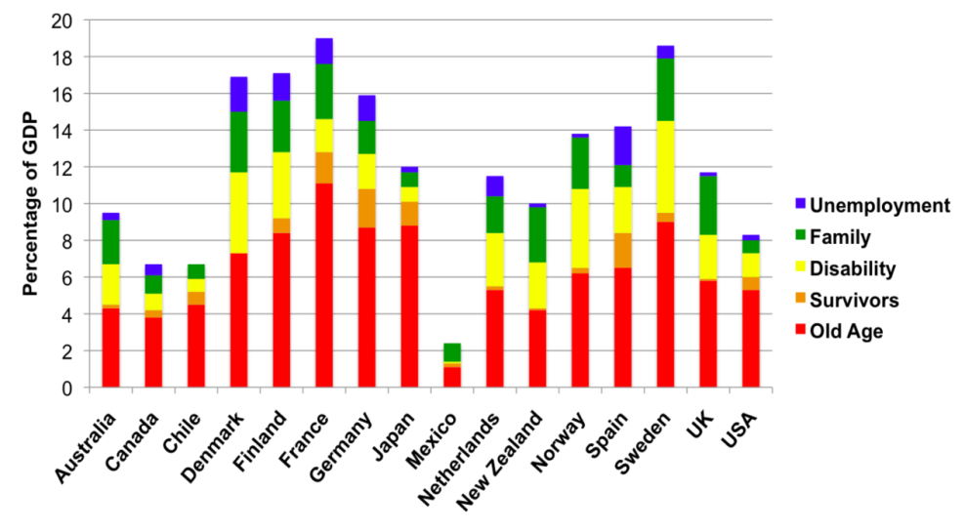

A similar picture can be found in developing countries that have more mature social security systems. For example, in southern Africa, old age allowances dominate spending on social protection in Namibia, Lesotho, Swaziland and Botswana. In South Africa – which has the most mature social security system in the region – the old age allowance costs 1.24 per cent of GDP, out of total spending on social security in 2012 of 2.91 per cent, and its success has opened the door to a significant growth in the Child Support Grant in recent years.[71] In Brazil, the government invests 1.5 per cent of GDP in old age allowances for the informal sector and poor elderly, yet only 0.4 per cent on the well known *Bolsa Familia*, a safety net for poor families.[72] In Nepal – one of the poorest countries in the region – spending on the old age allowance in 2011 was 0.5 per cent of GDP, out of a total spending on social security of 0.65 per cent.

Across Asia, governments are increasingly prioritising and investing in old age allowance schemes:

* In Thailand, the budget for the old-age allowance increased by more than 200 per cent from 2008 to 2011, and is now over 0.3 per cent of GDP;[73] there are currently 5.7 million recipients of the allowance.[74]
* In China, the government introduced a rural allowance scheme in 2009 and a new urban allowance scheme in 2011, which are now covering 459 million people with 125 million elderly people receiving a pension every month.[75]
* Vietnam provides universal allowance coverage for over-80s – with a tax-financed allowance reaching 120,000 over-80s not in receipt of another pension – and a tax-financed allowance for poor people that reaches 690,000 people over-60 years of age.[76] It is also examining how to expand its contributory pension system to the informal sector.
* Indonesia has committed to universal allowance coverage, and will begin implementation in 2015.
* In East Timor, all over-60s are provided with a state allowance at a cost of 0.62 per cent of GDP.[77] East Timor is now building on the success of its tax-financed allowance to establish a allowance that is financed through a social insurance mechanism.
* In Nepal, in 2009, the government substantially increased the coverage and benefit size of its tax-financed allowances so that they now reach around 80 per cent of over-70s – and many over-60s – at a cost of around 0.48 per cent of GDP.[78] There are 1.2 million recipients.
* South Korea complemented public and private contributory allowance schemes with a means-tested, non-contributory old-age allowance for over-65s in 2007. The social allowance covers 67 per cent of the population above the age of 65 – around 3.6 million people – costing approximately 0.32 per cent of GDP.[79]

Old age allowances have had significant impacts on poverty. In South Africa, for example, the tax-financed allowance has reduced the poverty gap among households with older people by 54 per cent (Samson 2006). In Brazil, old age allowances have reduced the poverty rate among older people from 47.9 per cent to 3.9 per cent (Gaspirini *et al*. 2007). Even in Nepal, where the allowance is only US$7 per month, the poverty gap in households with over-70s is reduced by 27 per cent (Kidd *et al.* 2012). In Thailand, the universal allowance, even with relative low benefit levels, has significantly reduced poverty among older people and assists people in meeting basic food and health needs (ADB, 2012). These impacts on poverty among beneficiary households translate into significant impacts on national poverty.

Old age allowances do not only benefit the elderly because recipients – as members of households or broader kinship networks – share their allowance income with others. Indeed, the poverty impacts noted in the previous paragraph are for all members of households, not only older people. In Namibia, for example, older people were found to spend an average of only 28 per cent of their allowance income on themselves, with most of the rest being given to children to help with schooling, food and other costs.[80] A recent study in South Africa and Brazil has indicated that almost all allowanceers share most of their allowance with others.[81] In fact, in South Africa, old age allowances have been shown to reduce stunting, with young children living with allowanceers being up to 5 centimetres taller.[82] Old age allowances also help children attend school: in South Africa, the allowance resulted in an 8 per cent increase in school attendance among the poorest quintile of the population.[83]

Old age allowances also indirectly benefit children and others by enabling families to reduce the financial support that they give to older people, which acts as a drain on resources. In effect, it helps remove a key source of informal taxation on poor families and enables them to invest in their own children and livelihoods.

Old age allowances reduce the social exclusion of older people – which is important in countries, such as Laos, where informal support for the elderly is weakening – by incorporating them more strongly into social networks. Allowances enable older people to remain as financial contributors to social networks, so they are more likely to receive support when they really need it. In a recent survey in South Africa and Brazil over 90 per cent of allowance receipient expressed satisfaction with their family relations.[84] Indeed, in South Africa, the largest households are those with allowance receipients (Neves *et al.* 2009).

Importantly, old age allowances enable the elderly to retain their dignity and self-respect. In South Africa and Brazil, over 90 per cent of older people expressed satisfaction with the respect shown to them by others,[85] with older people in South Africa investing in houses as a means of regaining their prestige[86] (Neves *et al.* 2009). In Brazil, older people have regained their role as community leaders. In Zambia, beneficiaries of an old age benefit have found that people in their community have begun to call them “bosses” (Kidd S.D. 2010).

Many of the benefits that have been seen internationally from old age allowance schemes should be expected from the pilot old age allowance in Laos. However, the key impact of AusAID investment will be seen by the influence that the pilot has on government policy.

1. Summary of Social Protection Activity evaluation tasks

The following table summarises the evaluation tasks to be completed during the Social Protection Activity. Many of the regular SPA monitoring activities will also provide data to support the various SPA evaluation processes. Details of these are set out in the Monitoring chapters of the Operations Manuals for each of the SPA components – the Senior Citizens’ Allowance scheme and the Resilient Livelihoods for the Poor scheme.

Table A - 2: SPA Evaluation Tasks

|  |  |  |  |
| --- | --- | --- | --- |
| **Evaluation Activity** | **Schedule** | **Who to manage?** | **Who to implement?** |
| 1. Baseline surveys of selected SCA and RLP participants and non-participants; basic analysis and reporting. | March-May 2014 | Managing Contractor in conjunction with the implementing NGOs in each SPA province. | Contracted social and economic research organisation chosen by competitive tender. |
| 1. Mid-term review / Independent Progress Report | February-March 2015 | AusAID Vientiane | Contracted consultant. |
| 1. Midline surveys of the same participant and non-participant panels; basic analysis and reporting. | March-April 2015 | Same as in 1. | Same organisation as in 1. |
| 1. RLP and SCA process evaluation | April-May 2015 | Managing Contractor | Contracted consultant |
| 1. Endline surveys of the same participant and non-participant panels; basic analysis and reporting. | March-April 2016 | Same as in 1. | Same organisation as in 1. |
| 1. Final outcomes evaluation of the Social Protection Activity. | May-June 2016 | Managing Contractor, and the Learning Facility. | Methodology and consultant to be chosen following completion and reporting of the midline surveys[87]. |

1. Social Protection Activity Results Framework

This annex presents a draft of the SPA results framework. This should be further developed and finalised by the SPSL Managing Contractor, once it is contracted.

Table A - 3: SPA Results Framework

|  |  |  |  |  |  |
| --- | --- | --- | --- | --- | --- |
|  | **Expected results** | **Indicators** | **Data sources** | **When** | **Responsibility** |
| **Long-term Goal** | A government social security system that reduces poverty and inequality; increases economic resilience of families; and contributes to human development and economic growth. | GoL annual data on:   * Social security implementation and reach * Changes in poverty incidence * Changes in family income * Changes in small business/ micro-enterprise development * Changes in food diversity and nutrition/malnutrition | Census  LECS  Agriculture Survey  Annual household survey |  |  |
| **SPA Goal** | The Government of Laos to begin implementation of a progressive social security policy that includes support to the elderly and other vulnerable families. | GoL annual data on:   * Social security policies * Social security implementation and reach * Statements of government intentions about social security and related policy and implementation action. |  |  |  |
| **Purpose** | Improved livelihoods, incomes and resilience for families in rural areas and the application of these results in influencing government policy development in social security. | * Changes in income of participating families * Increased access to financial services in communities of participating families. * Changes in micro-enterprise development amongst participating families and other community members. * Changes in employment or business opportunities for participating families and other community members. * Changes in school attendance * Changes in food diversity, nutrition and health * Statements of government intentions about social security and related policy and implementation action. | SPA base/mid/endline surveys and post-SPA impact study.  Minutes of Social Security WG meetings  Policy papers and other government documentation |  |  |
|  |  |  |  |  |  |
| **Intermediate outcomes** | 1. Poor households participating in Rural Livelihoods for the Poor establish micro-enterprises, utilise financial services and experience changes in income and related social and economic indicators. | * Number of people benefiting from RLP. * Number of poor women and men who have gained access to and used new agricultural technologies. * Number and % of participating families (initially 600 [200/district] enrolled, scaling to 3000 in final year) with each type of available micro-enterprise underway (current year and cumulatively). * Changes to date in social and economic variables for participating families – net income/use of income, employment, food diversity, children attending school, etc. * Value of additional agricultural production. * Value of productive assets accumulated by poor households as a result of RLP. * Number of improved value chains as a result of RLP. | Facilitator monitoring data.  SPA base/mid/endline surveys. |  |  |
|  | 2. Recipients of the Senior Citizens Allowance and their households experience changes in a range of social and economic indicators. | * Number of people benefiting from the ECA * Changes to date in social and economic variables for participating families (initially 5,100 recipients scaling to 15,500 in final year) – net income/use of income, employment, food diversity, children attending school, etc. * Number of recipients investing in new enterprises. | Elderly Allowance Officer monitoring data.  SPA base/mid/endline surveys. |  |  |
|  | 3. Increased economic activity extends to other people in the wider communities of SPA participants. | * Changes in trade volume in community-based businesses. * Changes in employment and enterprise opportunities for fellow community members of SPA participants. | SPA base/mid/endline surveys. |  |  |
|  | 4. Evidence-based policy dialogue and capacity development of Government of Laos staff in the design and management of a national social protection system. | * Statements of government intentions about social security and related policy and implementation action. * Progress in social security policy development. * Assessment of effectiveness of Learning Facility and Managing Contractor contribution to policy dialogue. * Assessed changes in government staff capacity | Minutes of Social Security WG meetings  Policy papers and other government documentation.  SPA and counterpart assessment. |  |  |
|  | 5. Progressive dissemination of learning from Laos social protection initiatives. | * Research and evaluation reports available to stakeholders. | Reports from the annual evaluation cycle (annual selective survey) and related research. |  |  |
|  |  |  |  |  |  |
| **Immediate outcomes** | 1. Rural Livelihoods for the Poor pilot established in selected districts in three provinces and progressing “on track” towards targets. | * Number (and % of target) of poor families identified, enrolled, selected asset, completed training, connected with mentor, begin to receive stipend, in each of three districts * Progress on family asset training/utilisation | Monitoring (MIS) data  Monthly mentor progress reports |  |  |
|  | 2. Senior Citizens Allowance pilot established in selected districts in three provinces and progressing “on track” towards targets. | * Progress on age register for each district/target village * Number and % of target enrolled in SCA. * Effectiveness of allowance distribution & access by recipients | Monitoring (MIS) data  Monthly Elderly Allowance Officer reports |  |  |
|  | 3. Social Protection policy dialogue (and associated capacity development) with relevant government agencies established and on track. | * Quality of capacity development outcomes (understanding/application) * Quality of government support for reforms * Quality of policy development process | SPA/AusAID assessment of progress  Government policy announcements and media releases |  |  |

1. The SPSL component also includes a Micro-Enterprise Challenge Fund.
2. The team comprised Stephen Kidd (Team Leader and Social Security Specialist), Ric Goodman (Operations Specialist), Karishma Huda (Social Protection and Financial Inclusion Specialist), Inge Stokkel (AusAID Social Protection Specialist), David Farrow (Monitoring and Evaluation Specialist), Ludmilla Kwitko (NGO Specialist/AM-NEP representative) and Jim Chamberlain (Laos Social Development Specialist).
3. The Operations Manuals will be base documents for the two social protection schemes and will be further developed as the SPA progresses.
4. There are 49 ethnic groups and 220 distinct linguistic sub-groups in Laos.
5. Source: IMF World Economic Outlook Database, at http://www.imf.org/external/pubs/ft/weo/2012/02/weodata/index.aspx
6. Source: World Population Prospects at: http://esa.un.org/unpd/wpp/index.htm
7. See AusAID (2012a).
8. In Laos, the social security system also includes elements of health financing. For example, private sector workers contribute to both health and old age pensions in the Social Security Fund, although pension contributions comprise by far the highest proportion.
9. In Bangladesh, the Targeting the Ultra-Poor program – which is the model for the Resilient Livelihoods for the Poor (RLP) scheme – provides families with a regular transfer for up to two years as well as an asset transfer and training, to help generate a micro-enterprise.
10. See, for example: Devereux (2001), Davies and Davey (2007), Neves et al. (2009), Miller (2009) and Barrientos and Sabates-Wheeler (2009)
11. Source ILO (2012), based on data from World Social Security Report, 2010/11 at: http://www.ilo.org/global/publications/ilo-bookstore/order-online/books/WCMS_146566/lang--en/index.htm
12. Cai et al. (2012)
13. RLP-type schemes have become known as “Graduation” programs, although this is a term that has caused confusion. Originally, the term was used to refer to participants “graduating” on to micro-finance programs. But, it has become increasingly associated with a view that, once the program finishes, beneficiaries should not access other forms of social security, which may undermine the gains made by participants, since many remain very vulnerable. There is good evidence that continuing access to social security benefits can enable families to better engage with markets and generate their own sources of income.
14. See: Krishna, et al (2012); Rabbani, et al (2010); Burgess, et al (2011)
15. See Kidd et al. (2010) and Ellis (2010). The main challenge in Africa is that pilot programs were implemented that targeted resources at poor households. Yet, political economy analysis would suggest that governments are unlikely to invest significant resources in social protection programs targeted at the poor. In Uganda, in 2009, an alternative approach was adopted by DFID and Irish Aid for a major pilot social transfer program, focusing on an old age allowance. A recent review by DFID has indicated that the allowance has gained significant political backing, and the chances of it being scaled up by government are good (The IDL Group 2012).
16. See, for example, Boldrin et al. (2005), Galasso et al. (2008), Holmqvist (2010)
17. See AusAID (2012b).
18. Facilitated by the concurrent LARLP activities in rural communities to expand and strengthen village banks and the availability of financial services.
19. There will need to be sufficient newborn children in participants’ households at the beginning of the transfer, to be able to measure the impact of the schemes on their nutrition in the first two years of their lives.
20. The Senior Citizens’ Allowance is capable of being scaled up nationally, while the RLP is not but it could be an important intervention for NGOs and development partners to support. It would be expected that the RLP would have larger impacts on individual households, as the cost of the intervention – and the inputs provided to families – are significantly higher than those of the Senior Citizens’ Allowance. However, the Senior Citizens’ Allowance should have smaller impacts on individual households, but is able to have these impacts over a significantly higher number of households.
21. Stunting is defined as height-for age below minus two standard deviations from the median of the WHO Child Growth Standards. Where possible, the SPA should also report the change in proportion of children who are stunted, in order to put these numbers into perspective.
22. The number of recipients of the schemes in each district and province has not yet been agreed. This will depend on the number of eligible recipients in each district. The Managing Contractor will ensure the budget for benefits is distributed between districts to ensure adequate coverage.
23. See also Section 11 for a discussion of the role of NGOs in policy dialogue on social protection.)
24. NGOs should consider and communicate to families the increased burden of managing an enterprise, particularly upon women who have domestic and childcare responsibilities. Whilst the cash transfer is meant to offset some of these opportunity costs, it may still pose too great a risk to some families.
25. Similar interventions in other countries have asset values that range from $100-$250. Given that enterprises have not yet been selected, a higher amount has been budgeted.
26. It is recognised that the livestock sector needs stronger support from government extension, including medicines and vaccines. Mitigating strategies are needed for risks related to investments in livestock and this might be outside scope of this project.
27. For similar interventions globally, 80-98% of participants still have functioning enterprises by the end of the program. BRAC in Bangladesh and SKS India have the highest numbers of successful enterprises, but market conditions and attitudes to enterprise are much more favourable than in Laos. Furthermore, it is important to measure success after two years, since this indicates sustainability. As a result, a more realistic but still ambitious estimate of likely success of enterprises will be 60 per cent after two years.
28. At present, AusAID cannot commit funding beyond 2016. At present, therefore, any commitments on the Senior Citizens’ Allowance can be for a maximum of two years. However, by 2014 – when the transfers commence – AusAID will be in a better position to determine the length of its support. Contracts for the Managing Contractor and NGOs will take into account a potential extension of the activity.
29. The poverty line was LAK142,000 in 2005 and, when adjusted for inflation, would be LAK196,000 in 2012, or around AUD24. It should provide a basket of food staples for an average family of five for one month.
30. The size of the benefit should be rounded up to three figures, to make payments simple.
31. The Civil Service pension is provided to men at age 60 and to women at age 55. See President’s Office (2007).
32. Pension Watch database, at http://www.pension-watch.net
33. See McPherson (2011).
34. Calendars of events are a normal means of assessing age of people without identity documents. See McPherson (2011) for more details.
35. A Personal Digital Assistant (PDA) is an electronic mobile hand-held device, normally with a touch screen, and connected to the internet via a SIM card or wi-fi. They can be used for data entry or data access at field level. They can be programmed with specific project software, synchronising with computers and a database such as in the main project office.  PDAs have been used by numerous government and NGOs for approaches similar to that being described in this document.
36. See Sridharan (2012) and Emmett (2012) for a review of experiences of delivering cash in social security schemes.
37. NSOs are micro-finance institutions established by GIZ to facilitate the development and functioning of village banks.
38. For instance, there should be discussion, using innovative games and techniques, about handling life cycle events, managing cash flow and debt, and dealing with financial institutions.
39. These checks are needed to confirm the accuracy of data included in the MIS, for example that participants are receiving what reports claim they are receiving, attending the meetings the reports claim they are attending, etc.
40. Specific reports from the MIS database will cover areas such as: registration, appeals, complaints, payments, asset transfers, and receipts.
41. The links of the SPA to the Learning Facility are described in the LARLP scheme Design Document. It is also possible that the Poverty Reduction Fund will take place in communities where the SPA is active; if so, NGOs will be expected to ensure that the two schemes are complementary.
42. See Kidd (2012).
43. In Fiji, AusAID has developed a financial literacy curriculum for school children, and this experience will be used to develop a similar model in Laos.
44. The analysis was unable to use LECS data as this has been designed to provide reliable information at Provincial level only.
45. Given that the number of “poor” households is important, in larger Districts poverty rates could be lower.
46. The priority education Districts have been identified by the government of Laos based on indicators such as enrolment, drop out and retention rates, etc.
47. Data found at: http://www.decide.la
48. Data is taken from the Agricultural census (2012), a 2011 survey on national poverty conducted by the National Rural Development and Poverty Eradication Committee, the national census, and AusAID’s Education program
49. Non-participant interviewees, as far as possible, will be selected from comparable villages not taking part in the pilot phases of the SCA and RLP but who will be incorporated into future scaling-up of each of each component.
50. For example, the EEP/Shiree Change Monitoring System in Bangladesh and the Uganda SAGE program.
51. See Section 7 for a discussion of the links between the SPA, AusAID’s Education Program and the financial inclusion component of LARLP.
52. An RCT may become a more effective option at a later phase in the RLP if the model is continued following the initial scale-up in Year Four.
53. Later inclusion of the initial panel of non-participants will avoid some of the potential ethical constraints often associated with RCTs in social development situations.
54. Patten (2011).
55. The Senior Citizens Allowance process is relatively simple in comparison with that for Resilient Livelihoods for the Poor. Thus, once its initial “bugs” are resolved, it is likely that the bulk of the process evaluation time will be spent in analysis of the latter activity.
56. See Huda (2008).
57. See also World Bank advice in Holzmann et al. (2005).
58. RLP-type schemes internationally often discriminate against people with disabilities and the elderly, not recognising the strong economic potential that many have.
59. http://www.ausaid.gov.au/publications/pdf/child_protection.pdf
60. www.ausaid.gov.au/aidissues/displacement/Documents/displacement-resettlement.pdf
61. www.finance.gov.au
62. There is, however, good evidence that child grants in developing countries do not increase fertility.
63. See: Kidd and Wylde (2011)
64. See: Fizsbein and Schady (2009); Kidd and Calder (2011; 2012).
65. RLP-type schemes have become known as “Graduation” programs, although this is a term that has caused confusion. Originally, the term was used to refer to participants “graduating” on to micro-finance programs. But, it has become increasingly associated with a view that, once the program finishes, beneficiaries should not access other forms of social security, which may undermine the gains made by participants, since many remain very vulnerable. There is good evidence that continuing access to social security benefits can enable families to better engage with markets and generate their own sources of income.
66. See: Krishna, et al (2012); Rabbani, et al (2010); Burgess, et al (2011)
67. The reason for the fall in the value of the assets of TUP participants is not known, but it may be that some were targeted by others and their assets were stolen or destroyed.
68. See Murdoch and Ravi (2011)
69. These results were not observed in Bangladesh or Pakistan. In India, some children were pulled out of school to support the family enterprises
70. Source: OECD Statistics Database.
71. In South Africa, in 2012, spending on social protection was (as a per centage of GDP): Old Age Pension at 1.24%; Child Support Grant at 0.95%, Disability Benefit at 0.55%, Foster Care Grant at 0.11%; Care Dependency Grant (for disabled children) at 0.05% and Grant in Aid (a poor relief safety net) at 0.01%. Until very recently, however, the proportion spent on the old age pension was significantly higher: the budget of Child Support Grant, just in 2011, was 0.61%, indicating a 50% increase in just one year. Data is taken from administrative records.
72. Spending on pensions is divided between the *Previdencia Social* program (1.3% of GDP) and the BCP, which spends around 0.2% of GDP on the elderly, and a similar amount on people with disabilities. An additional 2% of government funding is also invested in a civil service pension. See Kidd (2013)
73. According to the ADB (2012), this is equivalent to 1.65 per cent of the government budget.
74. Source: http://www.pension-watch.net/about-social-pensions/about-social-pensions/social-pensions-database/
75. Government of China, 2012
76. Source: http://www.pension-watch.net/about-social-pensions/about-social-pensions/social-pensions-database/
77. HelpAge Pension watch database, 2012
78. (Kidd et al. 2012; ADB 2012)
79. OECD, 2011; Korean Ministry of Health and Welfare website, viewed November 2012; HelpAge HelpAge Pension watch database, 2012f
80. Devereux (2001)
81. Barrientos and Lloyd-Sherlock (2011).
82. Case (2001) and Duflo (2000).
83. Samson et al. (2004).
84. Barrientos and Lloyd-Sherlock (2011)
85. Barrientos and Lloyd-Sherlock (2011).
86. The investment in households as a means of building respect was also noted in Zambia (Kidd, S.D. 2010)
87. The simplest option is to contract the same organisation to complete the whole of the outcomes evaluation process – from baseline surveys through to the final outcomes evaluation – subject to satisfactory performance at each stage. It may be more effective in the long-run however, for the main partners – AusAID, the Learning Facility and the Managing Contractor – to maintain flexibility on how, and by whom, the final outcomes evaluation will be undertaken by delaying a decision until part way through the implementation.