Australia’s aid program   
in Laos

February 2013

### Why we give aid

Australia has a strategic interest in assisting Laos to reduce poverty and become a stable, well-managed and increasingly prosperous regional neighbour. Although Laos is making steady progress in reducing poverty it remains one of the least developed countries, with an estimated two million people living under the poverty line of $1.25 a day. Laos’ location in the South East Asian region means it also has a crucial role to play in addressing important regional issues such as trafficking, pandemic diseases and water resources management.

As a regional neighbour with 60 years of bilateral relations, Australia is well placed to work with government and other partners to promote opportunities for all in education, pursue sustainable economic development through trade reform and help rural communities access services, finance and markets.

### How we give aid

Australian aid to Laos is guided by the Australia-Laos Development Cooperation Strategy 2009-15. Our aim is to assist the Lao Government address development priorities in education, rural development and trade reform. We work partnership with multilateral development agencies, other donors, the private sector and civil society and through Australian volunteers. Key multilateral partners include the World Bank, the Asian Development Bank, WFP, UNICEF and the European Union. Bilateral partners include Germany, Japan, the Republic of Korea and Switzerland.

### Improving education

While primary school net enrolment rates in Laos have risen to 94 per cent, only 64 per cent of these students complete the full five years of primary schooling, and only 88 per cent of those enter secondary school.

Supporting better education outcomes is fundamental to development in Laos. Children who stay in school longer have better prospects later in life of earning higher incomes, finding work outside farming and having better health.

Education is the flagship program of Australia–Laos development cooperation. Australia is one of the largest grant donors of education assistance in Laos, with a focus on improving access to and quality of basic education and the provision of tertiary-level scholarships. We train primary school teachers, build classrooms, provide learning resources and support the provision of school meals, water and sanitation. We are also helping improve overall management of the education sector by strengthening planning, budgeting and information systems.

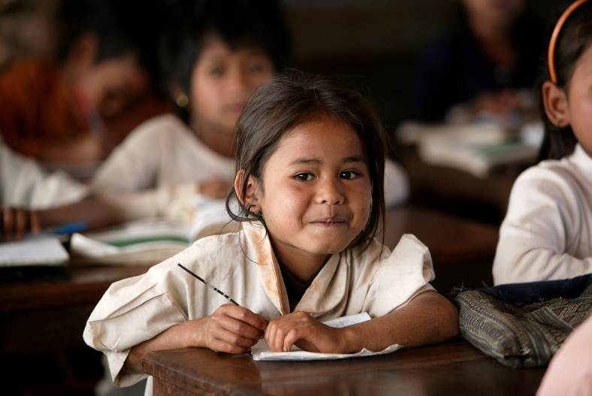

Seven year old Nang Paysaung in class in a school in Ban Dakduang, Dakcheung, near Sekong, Lao PDR, where Australia has funded training for minority group teachers. Photo: Jim Holmes for AusAID.

### Supporting trade and investment reform

Sustainable and inclusive development will require that Laos broaden its economic base beyond its booming resources sector. Improving the operating environment for non-resources sector businesses is an important element of this strategy.

Australia will continue to support the Lao Government’s trade and investment facilitation efforts to help improve incomes, employment and business opportunities. Australia is helping the Government improve regulatory simplicity and transparency for business. This has included the establishment of an electronic trade portal which is publishing in one place all government trade procedures. Future assistance will also help improve the capacity of businesses who trade to compete in and grow international markets by providing business advisory services, particularly to those that are significant employers of females such as the garments industry.

### Promoting rural development

Laos has high rates of rural poverty – 32 per cent of the rural population live in poverty. A large percentage of the rural population are also vulnerable to shocks and crises - typically droughts and floods. Food insecurity is a major challenge with 13 per cent of the population food insecure and 50 per cent of young children stunted. Australia focuses development assistance on rural areas where poverty is concentrated.

We support targeted, community-based and community-driven aid that tackles key constraints to rural development. Our programs support household-level livelihoods, micro-finance availability, and clearance of land contaminated by unexploded ordnance. We also help build and maintain rural infrastructure, particularly roads and electricity.

Image shows a girl grinding rice in Kailo Village, Sekong. AusAID, in partnership with CARE Australia, is providing income generating opportunities for people in this and other rural villages like it in Sekong Province under the Laos-Australia NGO Cooperation Agreements Program. Photo: Josh Estey/CARE 


A girl grinds rice in Kailo Village, Sekong. The Australian Government, in partnership with CARE Australia, is providing income generating opportunities for people in rural villages in Sekong Province under the Laos-Australia NGO Cooperation Agreements Program.   
Photo: Josh Estey/CARE

### More Information

More information is available at:

Laos Program: http: http://www.ausaid.gov.au/countries/eastasia/laos/Pages/home.aspx

Australia – Australia Laos Development Cooperation Strategy: http://www.ausaid.gov.au/Publications/Pages/7703_2328_9448_8983_1112.aspx