### Program Outcomes Research Report

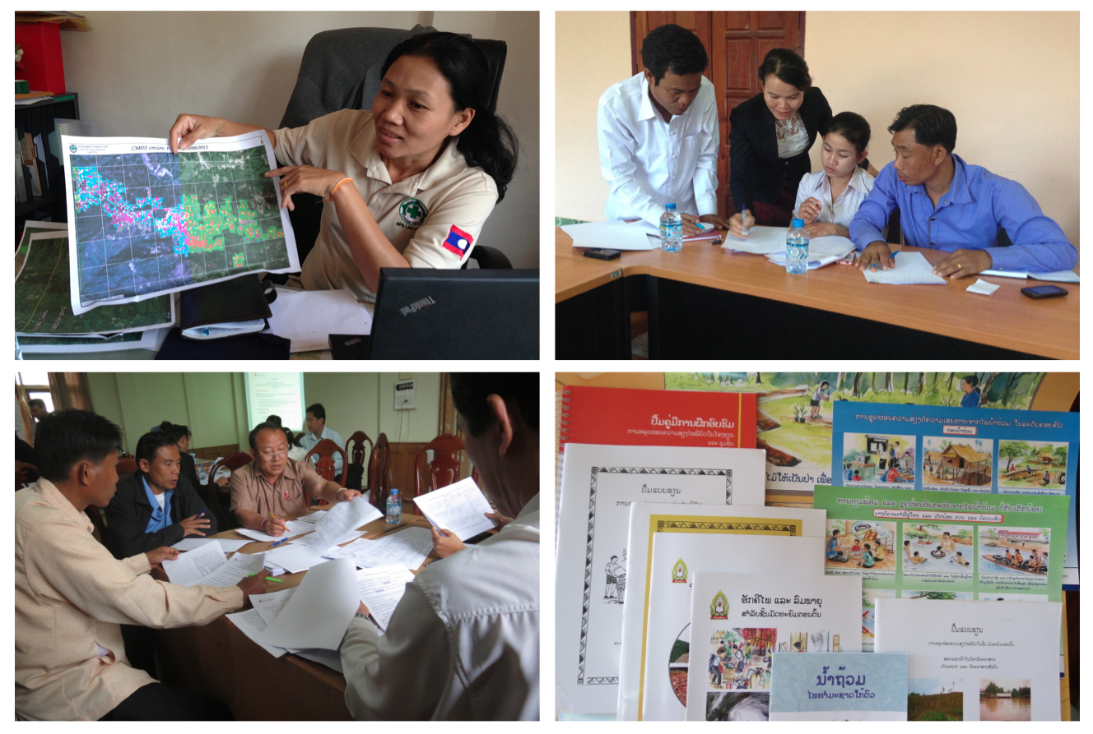

A study carried out as part of the final evaluation of the Laos- Australia NGO Cooperation Agreement (LANGOCA) Program

Andrew Bartlett

05 April 2014Table of Contents

*Executive Summary* i

*Acronyms* ii

1. Objectives and Methodology 1

1.1 Background to the study 1

1.2 Research framework and process 1

2. The Policy Context 2

2.1 Overview of development context 2

2.2 Summary of policy changes since 2007 2

3. Expected and Actual Outcomes 4

3.1 Program Design 4

3.2 Outcomes in the UXO sector 4

3.3 Outcomes related to Disaster Management 5

3.4 Livelihoods activities 6

4. Analysis of LANGOCA impact 7

4.1 Typology of program interventions 7

4.2 Mechanisms for enhancing impact 8

4.3 A success story – DRR in Sayaboury 9

4.4 Factors affecting NGO influence on policy and practice 10

5. Lessons for Policy Dialogue in Laos 13

5.1 Development narratives 13

5.2 Decision-making and decentralization 16

5.3 Evidence and ownership 17

5.4 Finding a balance between breadth and depth 18

5.5 The complex operating environment 20

Annex 1: Portfolio of LANGOCA Projects 22

#### Acknowledgements

The author would like to thank the many government officials and NGO staff interviewed during the course of this research. Special thanks also go to: Dulce Simmanivong and Rakounna Sisaleumsak at the Australian Embassy for their excellent guidance and support; David Farrow, Team Leader of the final evaluation, for his valuable suggestions, and Vilakone Chansamouth for her diligent assistance during field visits. Feedback on the draft report was provided by Dave Vosen and Mark Taylor in Vientiane, Sarah Ransom and Le Thi Quynh Nga in Hanoi, and Rob McGregor in Canberra.

The opinions expressed in this report are those of the author and do not necessarily reflect the views of the Australian aid program, the NGOs responsible for implementing LANGOCA, or those of the government partners.

#### Executive Summary

The Laos-Australia NGO Cooperation Agreement Program (LANGOCA) started in July 2007 and will end in June 2014. The goal is *to reduce the vulnerability of the poor by integrating poverty reduction and crosscutting issues with disaster management and UXO approaches in Laos.*

The program involves agreements between the Australian Department of Foreign Affairs and Trade (formerly AusAID) and four Australian NGOs: Oxfam, CARE, World Vision and Save the Children. These NGOs have implemented a portfolio of 11 projects in nine districts.

This research has been carried out as part of the final evaluation of LANGOCA. The objective of the study was to *determine the impacts of the program on policy changes and government implementation practices within the UXO and disaster management sectors.*

Two analytical frameworks have been used. Firstly, a simple typology of interventions has been proposed that distinguishes between: a) welfare and relief, b) conventional development, c) local innovation and d) best practices. This framework prompts the question: what is required to speed up local innovation and then elevate it to best practice? There are no simple answers, but the experience of LANGOCA suggests that steps can be taken to support the setting of values, the identification of new ideas, validation of innovations, cross-fertilisation and consensus-building.

Secondly, a list of factors have been identified that affect the influence NGOs can have on policy and practice. These factors have been divided into five categories: presence, partnerships, power, pragmatism and professionalism. Factors in the ‘power’ category seem to be decisive; any innovations that are contrary to government priorities are not going to be widely accepted.

The study concludes with examination of five issues, each of which provides lessons for policy dialogue in Laos:

* For NGOs to have greater influence on best practices and policy in Laos, they need to find common ground between the modernisation narrative of the Government and their own empowerment narrative.
* Policy *does* emerge from field experience in Laos, but if development programs want to influence policy they have to work with those in power, and there is considerable power in the mid-level of government in Laos.
* Policy-making in Laos is not data-driven. Field visits can play an important role in a policy-making process, and NGOs may have a comparative advantage in organising this kind of activity.
* A combination of focus *and* flexibility *and* sufficient time is needed in order to generate policy outcomes.
* NGOs in Laos are operating in a complex environment but are still able to effectively support development processes. Donors can help by playing a strong role in negotiations with government at the start of a program and subsequently provide a channel for highlighting field experience in dialogue at the national level.

#### Acronyms

ADPC Asian Disaster Preparedness Center

AEPF Asia-Europe People’s Forum

AEW Annual Evaluation Workshop

AMCDRR Asian Ministerial Conference on Disaster Risk Reduction

CMRS Cluster Munition Remnant Survey

CSO Civil Society Organisation

DAFO District Agriculture Offices

DHU District Health Office

DM Disaster Management

DREC Disaster Risk Education for Children

DFAT Department of Foreign Affairs and Trade

DRR Disaster Risk Reduction

FSD Swiss Foundation for Mine Action

GFDRR Global Facility for Disaster Risk Reduction

GoL Government of Laos

HFA Hyogo Framework for Action

HVCA Hazard and Vulnerability Capacity Assessment

INGO International Non Government Organisation

IPR Independent program Review

LANGOCA Laos-Australia NGO Cooperation Agreement Program

LARLP Lao-Australia Rural Livelihoods Program

LDPA Lao People’s Disabled Association

LECS Lao Expenditure and Consumption Survey

LPRP Lao People’s Revolutionary Party

LTA Long-Term Activity

LWU Lao Women’s Union

MAG Mines Advisory Group

MDG Millennium Development Goal

MEF Monitoring and Evaluation Framework

MoNRE Ministry of Natural Resources and the Environment

MPI Ministry of Planning and Investment

NDMC National Disaster Management Committee

NDMO National Disaster Management Office

NGO Non Government Organisation

NPA Non Profit Association

NPA Norwegian People’s Aid

NRA National Regulatory Authority

NSEDP National Socio-Economic Development Plan

ODA Official Development Assistance

PCIA Post Clearance Impact Assessment

PCL Phoenix Clearance Ltd

PDD Program Design Document

PWD People with Disabilities

SCI Save the Children International

STA Short-Term Activity

SWG Sector Working Group

TWG Technical Working Group

UXO Unexploded Ordinance

VD-CAP Vientiane Declaration - Country Action Plan

VDC Village Development Committee

Note on terminology.

For the purpose of this report, the term Disaster Management (DM) is synonymous with Disaster Risk Reduction (DRR). While much of the work carried out under the program is referred to as DRR by the cooperating NGOs, the DM designation is used in the Program Design Document.

# 1. Objectives and Methodology

## 1.1 Background to the study

The Laos-Australia NGO Cooperation Agreement Program (LANGOCA) started in July 2007 with an expected duration of five years. The goal is *to reduce the vulnerability of the poor by integrating poverty reduction and crosscutting issues with disaster management and UXO approaches in Laos.*

The program involves agreements between the Australian Department of Foreign Affairs (DFAT) (formerly AusAID) and four Australian NGOs: Oxfam, CARE, World Vision and Save the Children. The program started with a budget of $AUD 14 million. In 2011, the Australian Government approved an extension with an additional budget of $AUD 0.42 million to allow all activities to be completed by June 2014.

LANGOCA has been implemented through a portfolio of 11 projects in nine districts. The portfolio consists of five ‘Long-Term Activities’ (LTAs), designed to last the entire duration of the program, and six ‘Short-Term Activities’ (STAs). A full list of projects is given in Annex 1.

#### 1.2 Research framework and process

As part of the LANGOCA final evaluation process, the program outcome research will *determine the impacts of the LANGOCA program on policy changes and government implementation practices within the UXO and disaster management sectors.*

More specifically, this research set out to discover:

* What changes in policy and implementation practices have occurred?
* The extent and means by which LANGOCA has contributed to those changes?
* The lessons that have been learned with regard to policy and strategy development.

The study started with a review of government policy documents, NGO progress reports and media articles. Field work in Laos took place during November and December 2013. Interviews were carried out in Vientiane with representatives of the Australian aid program, relevant national agencies and NGOs. Visits were also made to Sekong, Salavan, Sayaboury and Khammouane, where meetings were held with provincial and district officials, in addition to field staff of the cooperating NGOs.

# 2. The Policy Context

#### 2.1 Overview of development context

The most important policies in place when LANGOCA was launched were as follows:

* The National Growth and Poverty Eradication Strategy (NGPES, 2004)
* The 6th National Socio-Economic Development Plan (NSEDP, 2006-2010)
* The Strategic Plan on Disaster Risk Management (2003)
* The National Strategic Plan for the UXO Programme (‘The Safe Path Forward’, 2003)

A Landscape Review prepared for LANGOCA in 2010 drew attention to a number of important trends that are adding to the vulnerability of rural people, including climate change and the commercial exploitation of natural resources. The report also noted that although overall levels of poverty were dropping, there were considerable disparities between different locations and ethnic groups.

Also relevant to this study, is the way in which policy-making is carried out in a unitary state such Laos. The limited potential for critical analysis and public debate, along with the lack of clarity in the policy-making process, is often matched by ambiguity in policy announcements and a lack of means for policy implementation.

This is not to say that donors and INGOs cannot provide useful support to policy-making in Laos, but it is clear that the process is rarely linear or predictable. While the various working groups that meet in Vientiane appear to offer a platform for systematic policy dialogue, decisions often depend on the interests of well-connected individuals and the political resonance that is achieved by relatively small ‘experiments’ in the field.

#### 2.2 Summary of policy changes since 2007

Policies enacted during the implementation of LANGOCA include the following:

The 7th National Socio-Economic Development Plan, covering the period 2011 to 2015, includes proposals for both disaster management and UXO decontamination. In total, there are 41 references to disaster management in the 7th Plan, compared to only 16 in the 6th Plan. This increase may be due to the Mekong flooding in 2008 and typhoon Ketsana in 2009, which exposed widespread weaknesses in disaster preparedness.

The implementation of the 2003 Strategic Plan on Disaster Risk Management has been influenced by a number of international agreements and networks, in particular the biannual Asian Ministerial Conference on Disaster Risk Reduction (AMCDRR) and the Hyogo Framework for Action (HFA). NDMO is the country focal point for these international agreements, and thereby acts as a link between field activities in Laos and the global community of practice.

NDMO was originally created as the Secretariat to the National Disaster Management Committee (NDMC), an inter-ministerial body chaired by Minister of Labor and Social Welfare. In 2011, as a result of Prime Ministerial decree 373/PM, NDMC was renamed the ‘National Disaster Prevention and Control Committee (NDPCC)’, which is now chaired by a Deputy Prime Minister. Subsequently, the role of Secretariat has moved to the newly created Department for Disaster Management and Climate Change at the Ministry of Natural Resources and the Environment (MoNRE).

With the support of Global Facility for Disaster Risk Reduction (GFDRR) and UNDP, the new secretariat of the NDMC has drafted a Prime Ministerial decree on disaster risk management. Approval is expected in the near future.

The Strategic Plan for the UXO sector was revised in 2009 and released under the title ‘The Safe Path Forward II’. The revised plan took account of commitments made under the Convention on Cluster Munitions in addition to NRA Decree 004 (also approved in 2009) which established a set of national standards for UXO mine action.

With the establishment of the national standards, the Government started to allow private contractors to carry out clearance operations. Accreditation is done on an annual basis. Currently 12 private operators – local and international – are accredited, plus a smaller number of NGOs.

In 2010, Laos hosted the First Meeting of States Parties to the Convention on Cluster Munitions (1MSP). As one of the parties to the convention, Laos became obliged to implement certain transparency measures, specifically, the country must report on cluster munition contaminated areas, as well as plans and progress for clearance.

In order to expedite the mapping of contaminated areas and facilitate the planning of clearance activities, Norwegian Peoples Aid (NPA) has been testing a new survey method since 2010 called Cluster Munition Remnant Survey (CMRS). A workshop was held in Pakse towards the end of 2013 at which operators and advisers discussed the details of the new method.

2010 also saw the approval of Millennium Development Goal 9, specific to Laos, which made clearing agricultural land a priority for the period 2010-2020.

In November 2012, NRA issued an Announcement on ‘UXO clearance for socio-economic development projects’ (No. 093/NRA). This states that *‘All development projects at district and provincial level that are affected by UXO must allocate sufficient budget for UXO survey, clearance and quality assurance’*. Discussion during this study suggests that while this applies to private investment projects, it does not necessarily apply to ODA and NGO projects.

The approval of the Decree on Associations (115/PM) in 2009 – the same year that Laos ratified the International Covenant on Civil and Political Rights (ICCPR) – was a cause for some optimism within civil society, but the experience of the past four years shows that registration of NPAs is a slow process. The Lao People’s Disabled Association (LDPA) is the only NPA that has benefitted from capacity-building under LANGOCA.

# 3. Expected and Actual Outcomes

#### 3.1 Program Design

LANGOCA is primarily a poverty reduction program that integrates livelihood activities with UXO clearance and disaster risk reduction. Most of these activities are carried out at the village and district level. Nevertheless, outcomes were also expected at the policy level. The 2006 Project Design Document (PDD) stated that LANGOCA would *‘maximise coordination, capacity building, best practice from community based activities, and policy dialogue, across all levels: national, provincial, district and community’*.

The actual strategy for policy dialogue is not described in any detail in the PDD, but funds were made available for research, documentation, exchanges and participation in stakeholder meetings at all levels. The indicator of success for these activities was stated as: ‘*Evidence of activities being replicated, lessons learned being applied more broadly, or specific policy recommendations being accepted as a result of LANGOCA activities’*.

In 2010, a monitoring and evaluation framework (MEF) was introduced to provide LANGOCA with a process for assessing progress of the program as a whole. As part of this framework, the participating NGOs were expected to identify *what changes are evident in the policies, capacity and practices that may be affecting the access of community members to good health & sustainable livelihoods?*

The following year, in 2011, the Independent Progress Review (IPR) identified some cases of LANGOCA contributing to policy-level impacts, but raised doubts about whether much more could be achieved in this area. In the opinion of the IPR team, weaknesses in design, particularly the lack of an over-arching narrative or ‘theory of change’, has resulted in the cooperating NGOs implementing a large portfolio of ‘disparate activities’ rather than a coherent program.

# 3.2 Outcomes in the UXO sector

In Sekong, a total of 114 ha of land was cleared in 18 villages as part of the project managed by CARE, while in Mahaxay District of Khammouane, 414 ha was cleared in 24 villages under the World Vision project. Although both NGOs have coordinated their clearance activities with the provincial and district Offices of Labour and Social Welfare, the practical arrangements have been different. The CARE project started with an agreement with the Swiss Foundation for Mine Action (FSD), an NGO that specialised in UXO clearance, but following their departure from Laos the project has contracted a private company, Phoenix Clearance Ltd (PCL). World Vision was able to complete the planned clearance activities through an agreement with the Mines Advisory Group (MAG).

The purpose of clearance activities in both Sekong and Khammouane was not simply to reduce the impact of unexploded ordnance, but to integrate clearance into poverty reduction efforts. Integration has been a challenge because normal practice in the sector is to clear large blocks of land in accordance with work plans that are prepared many months in advance. It is therefore difficult for clearance agencies to accommodate requests for clearing smaller areas – e.g. for fish ponds or boreholes – especially if these requests are made at relatively short notice. The different experiences of CARE and World Vision has led to the same conclusion, which is that the integration of UXO clearance with livelihood activities requires a dedicated clearance team; it doesn’t matter whether the team is managed by an NGO or a private company, what is important is that they are willing and able to clear small areas in a timely manner.

Both CARE and World Vision have supported Mine Risk Education (MRE). In the case of World Vision, this involved collaboration with MAG to train ‘Safer Village Volunteers’ in 24 villages. CARE has also taken a prominent role in victim assistance, specifically: strengthening the Lao Disabled People’s Association (LDPA), promoting disability rights awareness, and improving the referral system. Less successful, it seems, have been activities related to the economic inclusion of people with disabilities; the number of people involved has been relatively small and sustainability is doubtful.

In summary, it can be said that LANGOCA has been contributing to a shift in thinking about the integration of UXO clearance and other development efforts. While LANGOCA may not have directly influenced the formulation of MDG9, the program was prioritising clearance of agricultural land in advance of this announcement. Similarly, the work of CARE and World Vision to improve land utilisation in a manner that contributes to poverty reduction predates the report of the Post Clearance Impact Assessment (PCIA, 2011) that drew attention to this challenge. So, while LANGOCA may not be a leader in this field, it has been operating close to the cutting edge.

#### 3.3 Outcomes related to Disaster Management

Disaster management (DM) has been the focus of activities managed by Save the Children in two districts of Sayaboury, World Vision in Gnommalath District of Khammouane, and Oxfam in three districts scattered across the country.

Similarities between the three projects include:

* Training for DM committees at village, district and provincial levels,
* Support for the preparation of DM plans at all levels
* Introduction of DM education materials and activities
* Assistance to relief activities when flooding occurred

As with the LANGOCA activities in the UXO sector, DM activities are supposed to be integrated with other poverty reduction efforts. Examples of integration include the promotion of Job’s Tears (*Coix lacryma-jobi*) as a marketable food crop that is tolerant to both drought and storm damage; support for a local radio station that broadcasts agricultural and health messages in local languages, which is also used as part of the early warning system for severe weather; water and sanitation activities that reduces the risk of disease outbreaks following flooding.

In view of the frequency of natural disasters in Laos in recent years, and the prospect of more to come, LANGOCA’s experience in improving the resilience of rural communities merits further study and wider discussion.

In terms of policy-level impacts, the most significant activities carried out with LANGOCA funding are those in Sayaboury managed by Save the Children. Sayaboury has become a model for disaster risk reduction in Laos. Exchanges have been organised with a number of other provinces in order to extend the approaches that were developed by Save the Children, and NDMO is reporting these achievements in international meetings. This success is examined in greater depth in section 4.3.

#### 3.4 Livelihoods activities

All LANGOCA projects have implemented a range of livelihood activities in collaboration with a number of government departments, the most important being:

* Provision of advice and inputs to support the introduction of new farming techniques by the District Agriculture Offices (DAFO)
* Construction and repair of small irrigation systems, also involving DAFO
* Installing water and sanitation systems in cooperation with District Health Offices (DHO) and Nam Saat.
* Conducting gender training and women’s empowerment activities with the Lao Women’s Union (LWU)
* Conducting nutrition training in cooperation with both LWU and DHO
* Setting up rice banks, revolving funds and savings/credit groups directly with Village Development Committees (VDCs)

These livelihood activities are similar to those that have been implemented by NGOs in Laos for many years. It is not the purpose of his study to assess whether or not these activities are making a useful contribution to the livelihoods of rural people, but it can be stated that they are not having any impact on national policy.

While a number of these activities are building new capacity (for example, establishing village committees that can manage their own water supply), some are – in effect – subsidising the delivery of government services (e.g. agricultural extension), and others are simply providing charity (e.g. distribution of farming inputs).

# 4. Analysis of LANGOCA impact

#### 4.1 Typology of program interventions

LANGOCA has involved an exceptionally wide range of activities. In terms of the contribution these activities make towards generating program-level outcomes, it may be useful to distinguish between four categories of intervention, as follows:

* Welfare and relief: this includes provision of expendable resources (food, seeds, and livestock) that bring about short-term improvements in the well-being and productivity of beneficiaries, but which do not make a significant contribution to capacity-building.
* Conventional development: Unlike activities in the welfare category, development interventions are expected to bring about longer-term improvement in the capacity of communities and service providers. The term ‘conventional’ denotes *business as usual* for development organisations in Laos i.e. these activities have been carried out in much the same way by many organisations for many years.
* Local innovation: these are interventions that address new problems, or which address old problems in a new way. The interest generated by these activities, and their impact on capacity and livelihoods, is – as yet – not widespread.
* Best practices: these interventions have made an impact in more than one location, and have been accepted as a model by the Government. These practices have also been endorsed by experts from outside the program, and are being copied by other projects.

The emergence of a ‘best practise’ is a *de facto* policy outcome. Whether or not a best practice becomes the subject of an official decree, and thereby become policy *de jure*, it still represents a change in norms.

This typology should not be seen as a criticism of relief efforts or conventional development. Activities in these categories may be highly relevant and effective, they may even represent ‘good practice’, but they are not inventive or influential. It is only when projects start to do something new, when they innovate, that they create the potential for a change in policy.

Examples from each category of this typology are given in the diagram below, which also indicates the level of impact of these interventions.

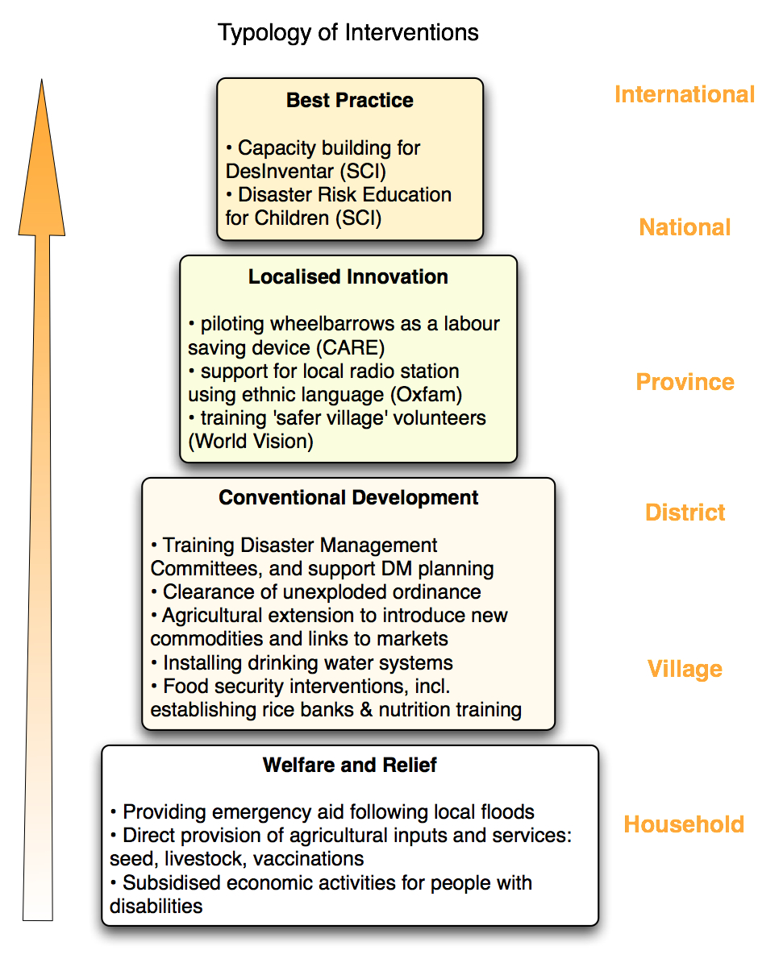

#### 4.2 Mechanisms for enhancing impact

The diagram above suggests that interventions do not suddenly become best practices; rather they start as local innovations which are subsequently scaled up. Similarly, local innovations tend to arise from conventional development; a thorough understanding of the effectiveness of existing techniques is often the basis trying something new.

This typology raises questions about how development programs such as LANGOCA can ‘up their game’ to generate policy outcomes. More specifically: what is required to speed up local innovation and then elevate it to best practice?

There are no simple answers to this question, but it is possible to make a number of observations based on the experience of LANGOCA.

Firstly, setting values may be just as important as setting goals if donors and program managers want to encourage creativity rather than mechanical implementation. The importance of innovation is often overlooked in log-frames and impact pathways.

Secondly, identification of new approaches or practices requires critical thinking and knowledge of alternatives. This does not come easy to NGO staff operating in remote locations where they may be cut off from sources of information and are understandably cautious about introducing new ideas. While foreign advisers often bring experience from other countries, it is equally important to ensure that local staff and partners have access to knowledge that will challenge their acceptance of ‘business as usual’.

Thirdly, validation must take place to prove the value of innovations. New practices should be piloted and rigorously assessed, rather than automatically accepted. Self-criticism is difficult in any organisation and special efforts may be needed to encourage open and honest reflection about what works and what doesn’t.

Fourthly, cross fertilisation is required to share lessons between organisations and locations. This is an area in which cooperating NGOs have excelled. Countless exchange visits and workshops have taken place during the past six years, which have exposed field staff and government partners to practices across the country. The importance of these visits is examined further in section 5.3.

Fifthly, consensus-building activities help bridge the gap between lesson-learning and policy-making. The most obvious channels by which NGOs can contribute to consensus-building at the national level are the NGO working groups and, to a lesser extent, the sector working groups that are organised by government and donors. CARE, Oxfam, Save the Children and World Vision are active in a number of working groups (WGs), including the Disaster Risk Management WG, the Education WG, the Land Issues WG and the INGO Network Committee.

#### 4.3 A success story – DRR in Sayaboury

The work supported by Save the Children in Sayaboury involves four successful innovations:

Methodology for risk assessment. Launched between 2007 and 2009, this was one of the earliest attempts in Laos to apply new thinking on ‘hazard and vulnerability capacity assessment’ (HVCA). The Asia Disaster Preparedness Center (ADPC) provided technical assistance for the development of methods and tools, but these would not have been widely adopted in Laos without the field testing and capacity-building carried out under LANGOCA. NDMO has confirmed that these hazard assessment procedures have provided a crucial foundation for their efforts to strengthen coping mechanisms across the country.

System for disaster data management. Between 2008 and 2011, Save the Children introduced the ‘DesInventar’ information system, which has been endorsed by the United Nations Office for Disaster Risk Reduction (UNISDR). The system is used to compile local and national databases on the damage and loss caused by disasters. NDMO has adopted DesInventar as a national standard and arranged for at least 15 exchange visits and training activities for all other provinces. The data from Laos can been seen at the [UNISDR](http://bit.ly/1kBJpzc) website[1].)

Disaster risk education in schools. Once again, Save the Children was able to build on work that was initially supported by APDC. Through a combination of field experience and national networking, the NGO has helped to develop a set of practices and procedures that have now been accepted as a model by the Ministry of Education. The activities supported by LANGOCA have reached at least 12,000 children directly and over 35,000 indirectly. Save the Children considers Laos to be a world leader in the field of Disaster Risk Education for Children (DREC) and is applying the lessons in other countries. The significance of this work has also been recognised in publications by UNESCO and UNICEF, and the Australian Government has produced a video, which highlights some of these achievements (available at [YouTube](http://bit.ly/1m6Wg87.)[2].)

Establishment of emergency response funds. This was an idea of the local partners in Sayaboury following flooding in 2010. In view of the delay in getting emergency funds from Vientiane, local funds were set up that include contributions from the salary of government officials. The practice has since been adopted by at least three other provinces after visits were made to Sayaboury. The need for these funds was acknowledged during the meeting of the National Assembly in December 2013, and NDMO reported that a decree has been drafted that is awaiting the signature of the Prime Minister.

#### 4.4 Factors affecting NGO influence on policy and practice

Based on the experience of LANGOCA it is possible to identify a number of factors that affect the extent to which NGOs are able to influence government policy and practice in Laos. In the diagram below, these factors have been grouped under five headings: presence, partnerships, power, pragmatism and professionalism.

Presence: in all locations that were visited, local government officials appreciated the assistance they received during the immediate aftermath of natural disasters. The fact that NGO staff were already in the field, and responded quickly during a time of crisis, appears to have been an important factor in building trust.

Partnerships: while not possible under this study, it would be interesting to produce social network diagrams of the different projects. It seems that the field staff of World Vision and Oxfam were relatively isolated, while those of Save and CARE were connected to a larger number of organisations at different levels.

Power: The factors in this category are decisive. Efforts to work with poor farmers are more likely to be approved and prioritised if they also help government officials achieve their personal or political objectives. Any innovations that are contrary to the modernisation priorities of the Party are unlikely to be scaled up; this issue is explored further in section 5.1 below.

Pragmatism: The ability to translate rhetoric into reality is another important element of success in Laos. Wheelbarrows are a tangible innovation, unlike the concept of women’s empowerment. Assessment forms and databases can be counted and costed, unlike the idea of vulnerability. A practical approach with visible results is highly appreciated in Laos.

Professionalism: In one location, field staff said they were working for a particular NGO because they lacked the experience and qualifications to get jobs elsewhere. This helps to explain why they were implementing agricultural activities of questionable effectiveness. Elsewhere, staff had many years of field experience and had been exposed to approaches used in other countries.

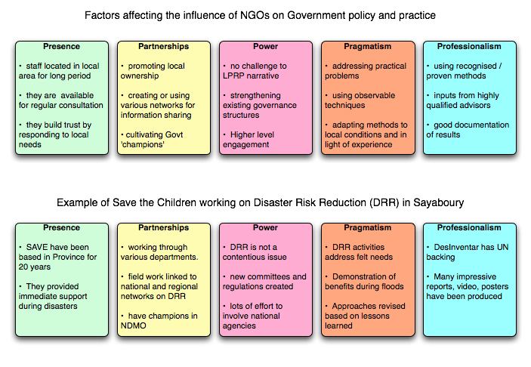

# 5. Lessons for Policy Dialogue in Laos

#### 5.1 Development narratives

The DFAT (formerly AusAID) report on ‘Thinking and Working Politically’[3] describes policy as *the expression of a set of values,* and goes on to say that *policy dialogue, therefore, is a discussion between interested parties about the relative importance of those values to each party, and about establishing a commonly agreed program of action that properly reflects those values.*

This definition raises an important question for this study: ‘what are the respective values of the Government and the development partners in Laos? And what can be done to reconcile any differences?’

A number of other studies have suggested that ‘narrative analysis’ can be helpful in answering this kind of question.[4],[5] Government policy in Laos is closely related to the *modernisation narrative* of the ruling Party. Modernisation typically involves commercial production, industrial technology and large-scale projects. This narrative is embedded in the 7th NSEDP and the Resolutions of the 9th Party Congress, and reflected in statements made by the country’s leaders almost every day as reported in the press. It can also be heard in the way that ordinary government officials talk about their work.

When asked to explain the causes of poverty, district officials reported it was because people ‘depended on nature’, they were ‘uneducated’ and practiced ‘traditional methods’ of farming. During this study, we were told that ethnic people should stop collecting produce from the forest and should start growing proper vegetables that could be eaten and sold in the market (indeed, kitchen gardens and value chains were activities under the project). In another province we heard that slash and burn farming was one of the causes of landslides and floods, and needed to be replaced by tree crops such as teak and rubber.

In summary, the Government development narrative sees progress in terms of a shift from the traditional (backward) to the modern (forward).

This is not the same narrative that has been driving LANGOCA. At the heart of the program design is a complex relationship between three concepts: poverty, risk and vulnerability. One of those concepts – vulnerability – is mentioned more than 40 times in the PDD, and yet it is hard to translate this term into Lao. The word is not mentioned at all in the 7th NESDP. It is tempting to suggest that the concept of vulnerability and its opposite – resilience – do not form part of the modernisation narrative, but it may be more accurate to say that the government and the donors are simply not speaking the same language.

When vulnerability was discussed in interviews with government officials, it was usually understood as being caused by geographical location rather than socio-economic factors. In Sekong, for example, we were told that ethnic communities are at risk from harm due to UXO contamination, or flooding because they lived along river banks. The main options for dealing with these problems were either to remove the risk (e.g. demining), or move the community (e.g. resettlement). The idea that government policy could increase vulnerability did not make sense from the perspective of those who were being interviewed, either that or it was too delicate to discuss.

The degree of congruence between the values of the development partners and the Government’s modernisation narrative varies from donor to donor. The ability to find common ground has also changed over time. For example, foreign support for village resettlement – which has played a key role in the agenda for modernising rural areas – has waned in the past decade. Some donors have also expressed concern that rapid economic growth – another policy cornerstone – may be making some people more vulnerable.[6]

The 2011 review of LANGOCA expressed concern that the program lacked an over-arching narrative. If one had to propose a narrative for the program, a strong candidate would be that of *empowerment*. Although NGOs may prefer to use the phrase ‘capacity-building’ in Laos, the concept of empowerment is consistent with much of what they are trying to achieve. This narrative sees progress in terms of ordinary people gaining greater control over their lives. This applies to students just as much as farmers, all of whom have the potential to become development actors rather than passive beneficiaries. The empowerment narrative can be contrasted with a *victim narrative*, which sees people as negatively affected by forces beyond their control.

Policy changes are reflected in a shift in the narratives used by stakeholders. During this study, an illuminating quote came from a district official in Sayaboury who said ” typhoons are not a new thing, we had floods and landslides in the past, houses were destroyed and people killed, *but we didn’t know these were disasters*”. Further discussion with this official and others made it clear that – previously – they had viewed storms and floods as acts of nature over which they had no control. But now they see a ‘disaster’ as something different; they can manage it, not just after the event but in advance.

It seems that as a result of the DRR activities supported by LANGOCA, a profound shift is taking place in the way people think about their relationship with the natural world. Hundreds of thousands of people have been empowered, from school children and villagers, district and provincial staff, up to national policy-makers.

In the UXO sector, the victim narrative has also been under attack. Mine risk education and ‘safer village’ campaigns have undoubtedly contributed to the empowerment of local people. At the national level, however, the battle between those who see themselves as victims and those who want to take greater control of the problem is still taking place. For decades, Laos has been presented as a poor country suffering from a legacy of war. A huge number of reports, press releases and speeches give prominence to the fact that Laos is the most bombed country in the world and it could take hundreds of years to clear the contamination. The CMRS methodology, while not an outcome of LANGOCA, contests this narrative. As explained by the Country Director of Norwegian People’s Aid (NPA), the methodology is ‘proactive rather than reactive’. If the methodology is adopted, it will turn an inescapable consequence of history into a manageable problem.

While it is useful to distinguish between the modernisation narrative of the Government and the empowerment narrative of NGOs, it is also important to recognise that there is – or can be – an overlap between them, as shown in the diagram below. This congruence often takes the form of new techniques. In almost every meeting with government officials to discuss the achievements of LANGOCA, the term ‘technique’ was used repeatedly. New techniques have been introduced for data collection, village planning, animal husbandry, water supply, reducing women’s labour…and so on.

Significantly, some techniques can be both modern *and* empowering.

The diagram shoes that the modernization narrative of the Lao Government, in which techniques should move from traditional to modern, can overlap with the empowerment narrative of the development partners, in which victims become actors.


The lesson is that for NGOs to have greater influence on best practices and policy in Laos, they need to find common ground between the modernisation and empowerment narratives. Interventions that involve new equipment, new procedures and new terminology, and which strengthen the capacity of Government as much as they empower local people, are more likely to be scaled up than those which can be implemented with existing resources and which only benefit the poor.

#### 5.2 Decision-making and decentralisation

The system of government in Laos is remarkably decentralised. Because the country is ruled by a single party, it is easy to assume that decentralisation takes the form of power being delegated from the centre *downward* to the provinces and districts, but in practice it often seems that the principle of subsidiarity is being applied, with most power residing at the local level and limited collective functions being assigned *upward* to the centre.

Decentralisation in Laos has its roots in a feudal system that goes back hundreds of years, some aspects of which were retained in the early years of the PDR due to national poverty and local isolation. More recently, improvements in roads and telecommunications, and an influx of foreign investment, have simultaneously created the potential for a more unified state *and* opportunities for local empire-building. This dilemma is reflected in on-going efforts to implement the policy of *Sam Sang*.

The significance for programs like LANGOCA lies in the authority of district and provincial governors. These governors can – and do – adopt different approaches to achieving national goals, and they can be quite selective in implementing decrees and strategies that have been issued by line ministries.

Of the three levels of government in Laos – national, provincial and district – some NGOs find it most difficult to work in the middle of the system. At the district level it is relatively easy to focus on the needs of local communities, while at the national level it is possible to collaborate with like-minded technical experts. By comparison, activities at the provincial level are more likely to be affected by politics and commerce.

Some project managers in Laos try to avoid capacity-building at the provincial level because this seems to have little impact on either rural livelihoods or sectoral policy. In LANGOCA, however, it is noticeable that the two NGOs with strongest presence at the provincial level – CARE and Save the Children – are the two which have achieved the most in terms of the diffusion of best practices. This suggests that if policy is to emerge from field experience, the backing of officials at the provincial level may be crucial.

It is certainly the case that policy *does* emerge from field experience in Laos, indeed this is one of the advantages of decentralisation. While the latitude granted to governors has sometimes been interpreted as sign of a weak administration, the diversity of practice can also be seen as ‘policy experiments’ that provide national leaders with the evidence they need to make decisions. The issue of evidence is examined further in the next section, but the lesson regarding decentralisation is that if development programs want to influence policy they have got to work with those in power, and there is considerable power in the mid-level of government in Laos.

#### 5.3 Evidence and ownership

Planners, academics, donors and NGOs have been debating the methods and merits of evidence-based policy-making for over a decade.[7] One point of agreement in recent literature is that different types of evidence are valued by different groups of people.[8]

The DFAT (formerly AusAID) report on ‘Thinking and Working Politically’ recommends that *Policy dialogue should be informed by evidence and that evidence should be locally owned.* This prompts the question: what types of evidence are likely to be ‘locally owed’ by policy-makers in Laos?

A number of donors have invested in data collection and analysis in Laos, in the expectation that this will improve policy-making. Surveys have been carried out, databases constructed, maps produced and interactive websites launched. The contribution of this assistance to the country’s development is questionable, at least in the short and medium term, because policy-making in Laos is not data-driven…and with good reason.

Statistics in Laos are notoriously unreliable. Not simply because of the weak capacity for data collection and analysis – something that could be corrected – but also because of the way in which information is used as a tool of government. While official reports include plenty of facts and figures, these are often an expression of how things *should be*, rather than an accurate measure of how things *really are*. The appearance of certainty is often more important than veracity, and public pronouncements that include a high level of precision need to be treated with a high level of scepticism.

Donor agencies and NGOs also add plenty of ‘spin’ to their reports. Cases are carefully selected, achievements are exaggerated, failures are overlooked, and awkward questions are left unanswered. This is not to suggest that any of the LANGOCA reports have been misleading, but it must be acknowledged that it can be difficult for government partners to distinguish between truth and hype, and between insights and delusions, when engaging with the development community.

Consequently, the facts and figures in written reports from both government departments and aid projects are unlikely to be the sole basis for making policy decisions. Indeed, this kind of evidence is sometimes completely disregarded. This is not to say that the Government does not make use of evidence in policy-making, it’s just that the decisive evidence is not in the form of data. Instead of statistics, government officials are more likely to rely on direct observation. Despite the biases inherent in ‘rural development tourism’[9], exposure to real life activities and achievements is a more trustworthy source of learning than second-hand information in Laos.

The learning process also requires interaction. Information only becomes knowledge once it is owned, and in Laos that ownership is usually achieved collectively. Observations remain tentative until they receive endorsement, and consensus often requires many rounds of discussion.

All of which helps to explain why the exchange visits organised by the cooperating NGOs under LANGOCA have been so important. Field visits involve direct observation of practical examples, and an opportunity for discussion among peers. Without these visits, it is highly unlikely that the DRR activities in Sayaboury would have generated the policy outcomes described earlier.

The challenge for any development project is to get decision-makers to participate in visits in which the object is not obscured by ceremony. But when this is achieved, the event can be of pivotal significance. So, for example, in response to questions about the achievements of LANGOCA in Sayaboury, the Provincial Director of Labour and Social Welfare spent most of the time talking about the visit of the Vice Minister to a remote ethnic community. In the mind of the Director, the details of what was seen and said during that visit were strong evidence of success, evidence that has strong local ownership.

The lesson is that field visits can play an important role in a policy-making process, and that NGOs may have a comparative advantage in organising this kind of activity. While other organisations aim to influence policy by having the biggest data sets and most powerful analytical tools, NGOs are able to create learning processes in which local innovations are observed and discussed, and decisions are made about scaling up.

#### 5.4 Finding a balance between breadth and depth

The IPR observation on the ‘disparate’ activities carried out by cooperating NGOs has been mentioned earlier in this report. The Lao-Australia Rural Livelihoods Program (LARLP) will address this issue by having NGOs focusing on a narrow set of issues, either social protection and/or income generation.

This study confirms what was found at the time of the IPR: that NGOs have been spreading their efforts over many sectors, and some of the interventions may be inefficient and ineffective. But this study also found some important benefits of supporting a wide array of interventions. More specifically, there are three interrelated arguments for taking a broad approach to improving rural livelihoods:

*Firstly,* in all four provinces visited during this study, local government officials identified the broad design of LANGOCA to be a strong point of the program, especially when compared to other projects. The fact that cooperating NGOs were able to support so many activities was greatly appreciated. Most of these activities can be categorised as ‘conventional development’, but these interventions have contributed to building trust that allowed more innovative work to be launched.

*Secondly,* LANGOCA aimed to apply an integrated approach to risk reduction while also addressing cross-cutting issues, which inevitably required diverse efforts with a range of partners. Systemic problems demand systemic solutions. It may be posited that rather than diluting of their impact, NGOs that work on many issues simultaneously are able to create synergies.

*Thirdly,* the fact that cooperating NGOs have working relationships with five or six different departments and mass organisations gives them a high degree of flexibility and responsiveness. This has obviously been important during and after natural disasters, but on a more regular basis it should allow NGOs to shift emphasis and take advantage of opportunities in order to enhance impacts.

Notwithstanding these arguments, the need for coherence remains justified. It is understandable that donors such as Australia want to ensure their funds are contributing to the achievement of strategic goals and sectoral priorities. But there is also a danger of being too prescriptive, of treating NGOs like sub-contractors who will carry out pre-determined tasks, rather than allowing them to pilot new techniques and respond to emerging needs.

Finding an effective balance between breadth and depth is never easy, but it is likely to be easier in programs that have a longer timeframe because adjustments can be made in the portfolio of interventions. Policy outcomes were only just beginning to emerge from LANGOCA at the time of the IPR, and the subsequent two years have been crucial for scaling up the use of DesInventar and the DREC curriculum.

The work of Save the Children in Sayaboury undoubtedly benefitted from the focus that was achieved through the Short-Term Activities (STA), but the NGO also needed a longer-term project in which to adapt new techniques and scale up. Everybody who was consulted in Sayaboury mentioned the significance of the flooding in 2010 and 2011, which tested their capacity and encouraged them to make improvements. Similar comments were made in other provinces, where the response to natural disasters, or to man-made problems and opportunities, has made a significant contribution to capacity-building. These specific events cannot be predicted and put into a work plan, but projects can be designed to ‘expect the unexpected’. In particular, they can have a broad enough coverage and a long enough duration, so that adjustments are possible.

The lesson from LANGOCA is that that a combination of focus *and* flexibility *and* sufficient time is needed in order to generate outcomes at the program level.

#### 5.5 The complex operating environment

As a final section to this report, it is worth understanding the operating environment affecting the effectiveness of NGOs.

Based on interviews with field staff of the four NGOs that are implementing LANGOCA, one might easily conclude that the biggest difficulties they face are practical rather than political. Field staff are far more likely to complain about road access, or the availability of certain agricultural inputs, than make any negative comments about their government partners. Similarly, there were no hints of any problems during meetings with government officials at the district level, and only one or two suggestions for improvement at the provincial level. It was only when one reached the capital that the ‘challenges’ were made explicit.

The challenges mentioned at the national level include:

* delays in approval of Memoranda of Understanding (MOU), and clearances for staff;
* close scrutiny of work plans and budgets with suggestions for changes;
* restrictions in travel, including inability to go to villages without being accompanied by district staff and a prohibition on overnight stays;
* censorship of publicity materials produced by NGOs.

While these difficulties have existed for many years, there is a general agreement that the situation has become more complex in the past 18 months. The expulsion of an INGO Country Director, the disappearance of Sombath Somphone and the revised INGO guidelines released in mid-2013 contributed to feelings of insecurity among NGOs. NGOs have also noticed that some donors have become more cautious in their support for civil society.

These recent developments have not, however, created any obvious difficulties for LANGOCA. In fact, all of the NGOs involved in the program report that they faced greater challenges during the inception phase.

Once decisions were made about *where* the cooperating NGOs should work and *what* they should be doing, the national Government has allowed them to get on with the job without major difficulties. This work has been carried out in collaboration with district and provincial officials and, consequently, there have has been plenty of suggestions and restrictions at the local level, but this is what one would expect in a similar partnership in any other country.

At the national level, NGOs and NPAs are now making a greater contribution to sectoral dialogue than was the case in 2007. As noted earlier, the LANGOCA NGOs are active in a number of WGs. Participation in the annual Round Table Meetings involves restrictions on what can be said and what materials can be distributed, but at least the NGOs have a seat at the table. If they are to have a stronger voice in some of these fora, it may need to come via statements made by donors who have greater leverage. For this to happen, there needs to be an effective dialogue between NGOs and donors, so that field experience can be given greater prominence in the observations and recommendations made by funding agencies like DFAT.

The lesson is that that NGOs are still able to effectively support development processes in Laos as long as they are consistent with the government framework. That program framework is decided at the planning and inception phases of the project cycle. If donors like Australia want to improve the impact of projects managed by NGOs, a stronger role in negotiations with government at the start of a program may be more productive than trying to tighten up monitoring later on. What is needed during implementation is an effective dialogue between the donor and NGOs that will feed into the policy dialogue with government.

#### Annex 1: Portfolio of LANGOCA Projects

| ***CARE*** | LTA: Reducing UXO Risk and Improving Livelihoods of Ethnic Communities in Sekong Province. (Dakchueng & Lamam Districts)  STA: Improving Support and Services For People with Disabilities and UXO Victims. (Lamam)  STA: Improving Socio-economic Integration Services for People with Disabilities. (Lamam) |
| --- | --- |
| ***Oxfam*** | LTA: Drought in Upland Communities: An integrated Program Response. Saravan (Ta-Oy), Sekong (Kalum) and Vientiane Provinces (Met) |
| ***Save the Children*** | LTA: Sayaboury Integrated Hazard Mitigation Project. (Sayaboury and Xieng Hone Districts)  STA: Tools for District Risk Assessment. (Sayaboury District)  STA: Disaster Information Systems. (Xieng Hone)  STA: Disaster Risk Education for Children. (Sayaboury)  STA: Disaster Risk Education for Children. (Xieng Hone) |
| ***World Vision*** | LTA: Community Based Disaster Risk Reduction. Khammouan Province (Mahaxay)  LTA: Integrated UXO Action Project. Khammouan Province (Gnommalath) |

LTA: Long Term Activity

STA: Short Term Activity

1. See http://bit.ly/1kBJpzc
2. See http://bit.ly/1m6Wg87
3. Peter Bazeley, Taylor Brown and Emily Rudland (2013) *Thinking and Working Politically: An evaluation of policy dialogue in AusAID.* The Office of Development Effectiveness, Australian Agency for International Development
4. Jones, H (2009) Policy-making as discourse: a review of recent knowledge-to-policy literature. Working Paper No. 5. IKM-ODI
5. Keely, J (2001) Influencing Policy Processes for Sustainable Livelihoods: strategies for change. Lessons for Change in Policy & Organisations, No. 2.

   IDS.
6. See, for example the EU statement at the High Level Round Table Meeting, 19 Nov 2013.
7. See, for example, this blog: http://bit.ly/1azTxlH
8. Jones, H. *et al* (2013) Knowledge, policy and power in international development: a practical framework for improving policy. ODI Background Note
9. In his 1983 seminal work ‘Rural Development: Putting the Last First’, Robert Chambers identifies a number of biases that affect the perceptions of decision-makers. These include tarmac bias, project bias, male-elite bias, dry season bias.