|  |
| --- |
| LANDSCAPE REVIEW |
| November 2010 |

Prepared for AusAID by Mr Jannie Armstrong

**Aus AID LANGOCA Landscape Review**

*Draft 23/11/2010*

**List of Acronyms:**

ADB Asian Development Bank

CFSVA Comprehensive Food Security and Vulnerability Analysis

EIU Economist Intelligence Unit

FAO Food and Agriculture Organization

FDI Foreign Direct Investment

GDP Gross Domestic Product

GoL Government of Laos

GRID Gender Resource Information and Development Centre

IASC Inter Agency Standing Committee

IFI International Financial Institutions

MoH Ministry of Health

MPI Ministry of Planning and Investment

NRA National Regulatory Authority

NTFP Non-Timber Forest Products

UNDP United Nations Development Program

UNICEF United Nations Children’s Fund

WFP World Food Programme

WHO World Health Organization

1. **Introduction:**

The Laos-Australia NGO Cooperation Agreement (LANGOCA) is one of AusAID’s mechanisms to support rural development in Lao PDR. Comprised of partnerships with four Australian NGOs (CARE, Oxfam, Save the Children and World Vision), LANGOCA is a seven year program (originally 2007-2012, extended to 2014) with a total budget of $AUD 14 million. LANGOCA funds five long term activities in five provinces across the country (Khammouan, Saravan, Sayabouli, Sekong and Vientiane) and a number of related short-term activities, with the overall goal of the program stated as: *to reduce the vulnerability of the poor (by integrating poverty reduction and crosscutting issues with disaster management and UXO approaches in Laos).*

As part of the LANGOCA monitoring and evaluation framework, in the third quarter of 2010 NGO implementing partners held program evaluation workshops (PEW). These workshops aimed to synthesize project level information into a summary evaluation of the effectiveness of the projects for individuals, households, communities and implementing partners.

The Annual Evaluation Workshop takes this process one step further, combining the information from PEW process into a program-level synthesis. The AEW provides an inclusive and dynamic forum to improve overall program implementation through shared best practice, information exchange, and renewed collaboration. Bringing together the findings of the PEWs, the direct experiences of the implementing partners, and recommendations from collaborating parties including NGO partners, and provincial and national level government counterparts, the AEW will provide the basis for evaluating the overall efficacy of LANGOCA in 2010 as a whole.

The Landscape Review forms one of a series of inputs for the AEW[1]. It summarizes developments, trends and issues in five sectors pertinent to the LANGOCA Program, viz: poverty alleviation; livelihoods; disaster management; Unexploded Ordinance (UXO) management; and gender. Program-related issues in ethnicity, the environment and climate change are also noted. A more complete picture will emerge as the AEW process evolves, as implementing partners and others accumulate examples and first-hand experience of “good” development and its relationships to the contextual factors identified in the LR process.

For this first Landscape Review, reliance has been on national data publicly available from the Government of Lao PDR, the UN, IFIs and others. Future review exercises will endeavor to incorporate more information from the province and district level for LANGOCA project areas.

This Review is not intended as a definitive statement on any of the topics discussed above and is to be treated as a working document. Suggestions for improving its content are welcome. Readers requiring more information on any of the topics contained here are referred to the Works Consulted list.

*Sources:* ADB 2010, DoS 2010, GoL/UN 2010, GRID 200, MoH 2009, MPI and UNDP 2009, NRA/UXOLao/UNDP 2009, UNDP 2010a

**Key indicators, Lao People’s Democratic Republic:**

**General:**

**HDI Index:** 122 (of 162 states)

**Life Expectancy:** 65.9 years

**Households below the poverty line:** 27 percent

**Gross National Income per Capita:** 2,321 USD (2008 Equivalents)

**Urban populations:** 31 percent

**Unemployment Rate:** 12-15 percent

**Food Security:**

**Total Rice production:** 2,468,000 metric tonnes (2009 Main harvest only)

**Malnutrition (Children under five years old):** Stunting 40 percent.

**Vitamin A**: 45 percent of children under five and 23 percent of women (ages 12-49) suffer from Vitamin A deficiency.

**Iron Deficiency and Anemia:** 41 percent of children under five and 63 percent of children under two are anemic.

**UXO:**

**Total number of Casualties:** 300perannum (approx), 2004-2007

**Total area of contaminated ground:** 2,500 villages, 80 million cluster munitions as yet unaccounted for.

**Total Cleared:** 13,700 hectares, 840,000 UXO

**Gender:**

**Political representation:** 23 percent of National Assembly, representation at ministry, provincial and district level <10 percent. (Gender Report)

**Education:** Women’s Literacy rates: 61 percent.

Number of girls enrolled in primary per 100 boys: 86.

**Participation in national labour force:** 70 percent

**Maternal Mortality:** 405 per 100,000

**Laos in 2010:**

1. **Poverty Alleviation:**

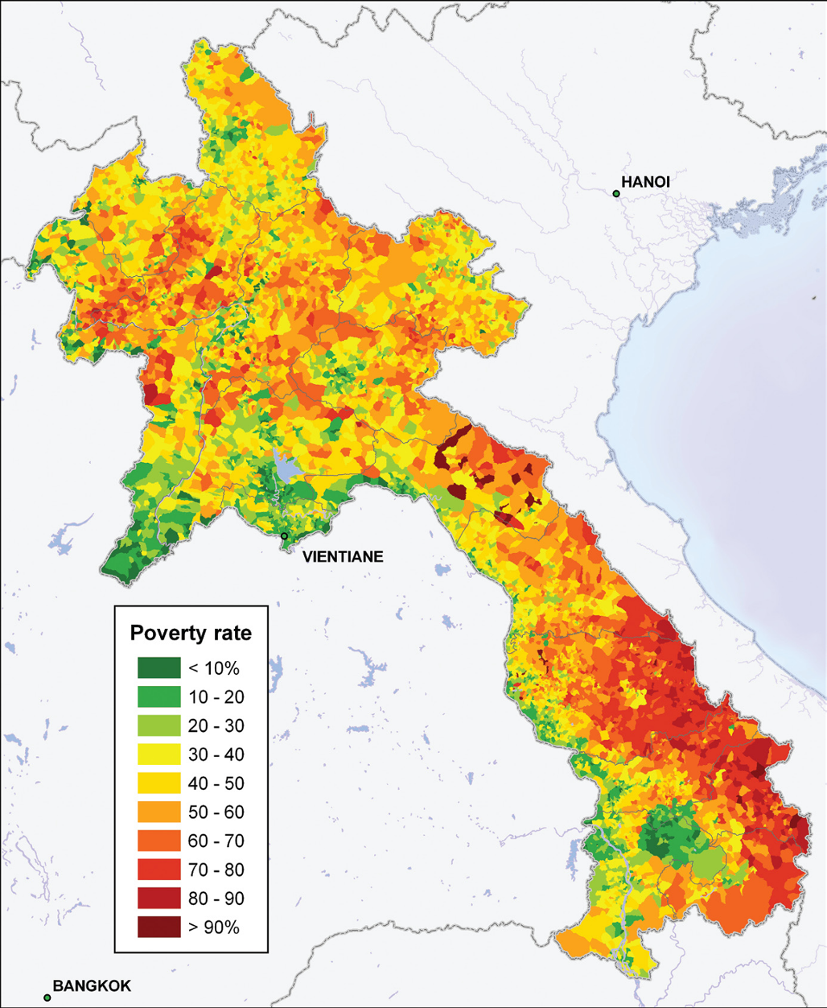

**Figure i: Map of Poverty Incidence at the Village Level: (Epprecht et al 2008, p. 30)**

Broadly speaking , there is reason for optimism in 2010 for Lao PDR. In the 2010 Human Development Report, Lao PDR is ranked 122nd, within the category of medium development, up by four places since 2009. GDP growth has been between six and eight percent per annum over the past five years(EIU 2009). The food and fuel price crises of 2006-2008 and global financial crisis of 2008 had comparatively limited impact on Lao PDR, with market fluctuations considerably lower than those experienced elsewhere in Southeast Asia (such as Vietnam and the Philippines). Net primary school enrollment has increased by more than thirty percent, while under-five and infant mortality have dropped, as have rates of malaria and tuberculosis infections (GoL/UN 2010).

Significant improvements have been made to the national transport, communications, water and education systems, and Foreign Direct Investment (FDI) continues to increase across the board (ADB 2010). Overall incidence of poverty has dropped from 46 percent (1992-3) to 28 percent (2007-8) (MPI 2010b). Poverty gap and severity data have also declined. Household asset ownership (of mobile phones, motorbikes, and other goods) has increased as poverty rates have come down.

However, pervasive poverty remains a major challenge, especially in the rural context. Poverty persists in rural areas with limited infrastructure, high altitude, difficult terrain and ethnic minority populations. Although poverty in urban areas has fallen to 17 percent, rural rates remain at 32 percent (2007-8). Given that a 71 percent of the total population live in rural areas, this indicates that a higher proportion of poor households are found in the countryside. The more distant households are from roads and district centres, the higher the rates of poverty. Among populations living at high altitudes, poverty has remained consistently high at 43 percent. Ethnicity is also an important factor in poverty incidence, with poverty all three major non Lao-Tai ethnic groups recorded at 42 percent[2].

Figure ii: Summary of poverty headcount data, (World Bank 2010, slide 22)

Lao PDR remains one of the least developed countries in Southeast Asia, and major challenges remain in chronic undernutrition and food insecurity; poor healthcare and education systems; poor access to potable water and sanitation; and increasing disparities between rural and urban populations. Equally, while overall poverty rates have decreased, the rate of food poverty has increased from 19 to 26 percent between 2003 and 2008 (FAO 2010). Malnutrition rates have been stagnant for over a decade, with chronic undernutrition (stunting) recorded at 37 percent (WFP 2008).

Development in Lao PDR is unevenly distributed socially and geographically, with isolated, poor and vulnerable populations located in remote, geographically disparate regions across the country. (MPI and UNDP 2009) Limited access to services and employment, government policy on resettlement, and the transition to commercial agriculture, forestry, hydropower and mining have contributed to renewed vulnerability at community and household levels, as traditional livelihoods are challenged by changing land use patterns and risk disruption by shock.

While recognizing the important progress that has been made in Lao PDR over the past five years, there is increasing recognition that greater efforts need to be made to ensure that development is evenly distributed, and that vulnerable populations, especially those in rural areas, are supported. The Seventh National Socio Economic Development Plan (NSEDP) (MPI 2010a) foresees continued growth rates of eight percent, and the continued conversion of land into capital through major development projects such as commercial agriculture, extractive industries, hydropower, timber and tourism. In order to attain the stated goal of graduating from least developed country status by 2002, and attaining the MGs by 2015, the 7th NSEP envisions a series of rapid advances in every major sector. In this context, ensuring that vulnerable populations are not left behind by the development process will be a key consideration for projects such as LANGOCA.

1. **Food Security and Livelihoods Development:**

*Food Security[3]:*

The core component of the Lao PDR food basket is sticky rice, the staple food across the country. In terms of overall tonnage, the country produces enough rice to meet its overall requirements in the course of a calendar year, but rice is not evenly available in all locations across the country (GoL/IASC 2009). With the bulk of production in the hands of small holders, micro level disaster events may render individual villages food-insecure even as overall production at the provincial level remains relatively constant. As a result, there is considerable variation at community level in availability of and access to rice.

According the WFP CFVSA (2008), some 84,000 households are food insecure, with a further 300,000 (one third of the total population) at risk in the event of disaster or sharp increases in food prices. Given the importance of own production and subsistence agriculture, chronic food insecurity is highly seasonal, with May-September traditionally the lean season. Households able to practice dry season cultivation may be able to meet their needs during the lean season, but this is contingent on access to reliable water supplies and/or irrigation, which are prerequisites for dry season cultivation.

Progress towards the target of reducing hunger by half, as part of attaining MDG 1, is noted as being seriously off-track (GoL/UN 2010). Districts identified as first and second priority for poverty alleviation have 53 percent of the overall population of poor population, and have recorded slow rates of reduction (MPI 2010b). The Poverty Hunger Index[4] indicates that progress on poverty overall is being undercut by persistent levels of chronic malnutrition and inequalities (Gentillini and Webb 2008). The 2010-2015 National Nutrition Strategy notes that, although GDP more than doubled between 2002-2007, levels of underweight children under five remained constant at 37 percent; 23 percent of the country’s population is undernourished(that is, does not consume enough food to meet their daily energy requirements); and there are significant levels of micronutrient deficiency.

*Livelihoods Development:*

As the map on page four illustrates, poverty in Lao PDR continues to be most pervasive and prevalent in rural areas where agriculture is the most important livelihood. Agriculture as the primary mode of existence supports between 75 and 95 percent of rural households(WFP 2008, MPI and UNDP 2009) and small holder subsistence agriculture with rice as the main crop is the prevailing mode of production.

Despite the primacy of agriculture as livelihood, rural households are routinely involved in a number of different activities at any given time, depending on seasonality, availability of labour and the local context. Keeping livestock, fishing, gathering Non Timber Forest Products (NTFP), and unskilled wage labour are common activities. Small scale handicraft production and informal income generation (though small market stalls and the like) are widely practiced by female household members (GRID 2005). Having a diversified series of household activities is a necessary strategy for households in order to meet their combined cash and non-cash requirements. Furthermore, despite the importance of own production, market purchases are also a key source of household food, consuming an average of 44 percent of monthly household expenditure (WFP 2008).

As the list of livelihood options above indicates, issues of land access, tenure and ownership are critical to rural livelihoods. As a matter of national policy, the Government of Lao PDR has proposed a transition out of shifting agriculture which, coupled with the ongoing policy of resettlement of remote villages along major access routes, has resulted in increased pressure on lands proximate to villages and main roads. As the process of human resettlement tends to precede the allocation of new land to resettled households, households may be required to commute to and from their previous location, limiting the amount of time available to cultivate. While resettled villages may have better access to services and transport links, there may be little to no land available for agriculture, especially in the case of paddy rice cultivation, which requires substantial surface area and access to water.

Unskilled wage labour on either a casual/daily or seasonal basis is a key source of cash income for rural households, but is highly contingent on seasonality and geographic location. Legal and illegal migration to Thailand for work is also a key source of income, with an estimated 240,000 labourers working over the border and sending back remittances which amount to seven percent of GDP (MPI and UNDP 2009).

Within Lao PDR, availability of wage labour (and therefore population movements in search of work) is contingent on proximity to commercial farming, industrial enterprises or urban centres. For instance, households close to the Bolaven plateau in southern Lao PDR may have one or more household members working on the tea or coffee plantations on the plateau, whereas in eastern Xieng Khouang province wage labour is virtually nonexistent. The reliability of paid employment as a livelihood is problematic, as salaries are low and variable and there is little to no job security, as an employer’s needs may vary day to day. Rates of rural unemployment or underemployment are around 12-15 percent (MPI and UNDP 2009). Wage labour also means that less manpower is available for the household’s own cultivation, making households more reliant on market purchases to meet their basic requirements.

Nevertheless, in areas of Lao PDR where concession and contract farming of cash crops (such as cassava, jatropha, maize, sugar cane and rubber) are increasingly common, wage labour represents an increasingly important rural livelihood. In a slightly different context but with similar impacts, land or natural resources allocated to hydropower and mining projects may become inaccessible to communities within the project catchment area. The more land (and the more households) that are engaged in commercial agriculture, the more reliant those households will be on market purchases.

While rural livelihoods remain heavily oriented towards agriculture and natural resources, the shift to commercial farming, cash crop production and large scale hydropower and extractive industries bears important implications for rural livelihoods across the country.



**Figure iii: Percentage Share of Difference Sources of Household Income (MPI and UNDP 2009, p.122)**

1. **Disaster Management:**

On an annual basis, Lao PDR experiences a range of natural and man-made disasters, which can occur at national, sub-national and community levels[5]. Slow onset chronic or recurrent disasters , such as drought, insect/rodent infestation, crop and animal disease are a constant challenge for vulnerable households, and compound the impact of more sudden onset events such as floods, storms or landslides.

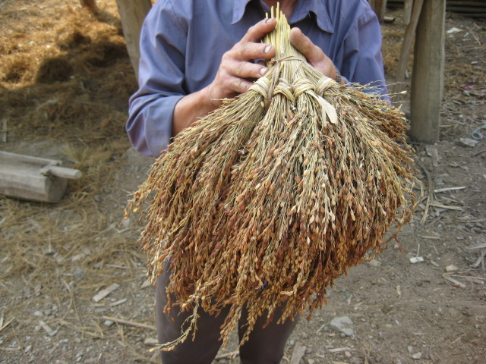

Figure iv: Rice stalks stripped of grain by rats, Xamtai district, Houaphan province, Feb 2010.

Household livelihoods and coping strategies are very limited, and in the event of individual or multiple shocks, vulnerable households are unable to deal with dramatic shifts in their living conditions. Households may face low-level chronic disasters (such as rodent or insect infestation, animal or human diseases, or UXO) on a routine basis, rendering them less able to be with sudden-onset major events when they occur. The loss of a productive asset such as a buffalo, or the death or disability of a wage earner can cause a resilient household to become vulnerable virtually overnight.

Because coping strategies are limited[6], the impact of disasters is felt long after the event itself has passed. Malnutrition resulting from livelihood compromised by Typhoon Ketsana (which occurred in late September 2009) emerged more than six months after the disaster event itself. In eastern Houaphan province, rice stocks damaged by rodent infestation resulted in less seed available for planting, hence lower overall yields and increased food insecurity in late 2010, eight to ten months after the rodents had come and gone.

In the case of larger scale disaster events, such as Typhoon Ketsana, the impact may be highly variable from one location to the next. In eastern Saravan province, Ketsana was characterized by high winds which tore up upland crops. In Sekong province, the Sekong river rose very rapidly and destroyed whole villages, but then receded almost as quickly. In Attapeu, the provincial capital and surrounding areas were submerged for days, causing high mortality amongst livestock. Although all of these impacts resulted from a single disaster level event, the impact and consequently the response required in each location will be considerably different.

Looking forward, increasing rates of investment in major projects such as mining and hydropower may increase the risk of industrial contamination or accidents, scenarios for which there are at present limited response capabilities. Given the importance of lakes, rivers and streams for Lao livelihoods, the risk of contamination for water sources may be of particular concern, notably in locations which may have water intensive extractive industries developed, such as the proposed bauxite mine in Attapeu province.

Despite continued political commitment to improving disaster management, and the increasing capacity of the National Disaster Management office, political commitment has not been matched by increased response capability on the ground. Although *After Action Reviews* were conducted following flooding in 2008 and Ketsana in 2009, recommendations coming out of the AAR process have not been acted upon, leading to a general lack of disaster preparedness. While considerable progress has been made at the national level in terms of improving coordination and information sharing, at the provincial and district level local government capability for disaster management and response is still very limited. As most disasters are highly localized, this is a significant challenge for the country.

1. **Unexploded Ordinance**

The challenge to development posed by the continuing threat of Unexploded Ordinance is a major concern for the Government of Lao PDR. More than 35 years after the last bombs fell on Lao territory, more than 300 casualties are recorded each year. Between 1964-2007, more than 50,000 people have been injured or killed by UXO (NRA/UXOLao/UNDP 2009). Poverty and UXO are correlated as the poorest districts of the country are also the most heavily contaminated with UXO. The presence of UXO also poses an impediment to agriculture as uncleared land poses a threat to farmers and their families.

The GoL has taken a proactive role on UXO both nationally and internationally with the links between UXO and overall national development underscored by the launch of MDG 9[7] , which is specific to Lao PDR and sets targets for land clearance, reductions in casualties, and care for UXO victims (UNDP 2010b)

The presence of UXO has practical implications for project implementation. as project sites must be cleared first and rendered safe. This is a painstaking, costly and time-consuming process, which can only be conducted during the dry season as the rainy season renders remote areas of the country (and thus project areas in those locations) inaccessible. As occurred after Typhoon Ketsana, major rainstorms or flooding can dislodge submerged UXO, rendering previously cleared areas unsafe once more. Given that the optimum period for UXO clearance coincides with the ideal implementation time, this represents a considerable constraint leading to delays, albeit life-saving delays, in the project cycle.

Despite continued political will and multisectoral engagement from donors, government and NGO partners alike, UXO remains a persistent impediment to development in Lao PDR.

1. **Gender**

GoL policy supports gender equity. Challenges remain however, at both operational and policy levels and substantial efforts are still required to improve access to and quality of health and education services; provide employment opportunities for women; and reinforcing legal protection and political representation. Progress on MDGs 2,3 and 5[8], all of which have important ramifications for girls and women, are all noted as being either off track or seriously off track (GoL/UN 2010). The Lao Gender Profile (GRID 2005) notes that in terms of gender equality, Lao PDR ranks last in East Asia.

25 percent of National Assembly representatives are women, but this trend is not continued at the provincial or district level (GoL/UN 2010). At the provincial and community level, progress on these issues is limited by a lack of public awareness of the rights of women and limited understanding or enforcement of legal safeguards (GRID 2005).

Substantial disparities exist between rural and urban areas, between remote and less accessible areas, and among different ethnic groups. Even so, national level data indicate the considerable shortfalls which need to be addressed if women in Lao PDR are to be supported to fully realize their potential.

In terms of livelihoods, women are estimated to make up 54 percent of all agricultural labour, in addition to household care and maintenance (including child care and all food preparation). Gathering of NTFPs (excluding hunting) is also traditionally the responsibility of female members of the household. Women’s access to land is contingent on the prevailing system of inheritance practiced by the ethnic group, which may be matrilineal (Lao-Tai) or patrilineal (Hmong-Lu Mien). In 2005, GRID noted that although 40 percent of land had been provided by the wife’s family, only 16 percent was titled in her name.

In education, illiteracy is more common among Lao women (39%) than men (23%), with higher disparities recorded among ethnic minorities. A similar gender gap in education progressively widens from primary though secondary and tertiary education as education for girls is generally less valued(GRID 2005). However, some success has been noted in the development of non-formal and adult education programs targeted at women, including both literacy and vocational training.

In the health sector, the 2010 Human Development Report’s index of births attended by skilled health personnel lists Lao PDR at 20 percent, among the lowest levels in the world, an indicator which has remained largely unchanged for more than a decade (GOL/UN 2010). This indicator is a reflection of poor health sector infrastructure (in terms of supplies, facilities and human resources), cultural preference (especially among ethnic minorities), cost barriers, and skepticism about the quality of care on offer.

Finally, as transport networks improve, the possibilities for human trafficking also increase. Laos PDR is both a transit point and a source country for trafficked persons. Given that vulnerable households, especially women and children are most likely to be trafficked, high levels of poverty may contribute to trafficking. Although numbers of recorded cases are limited and voluntary migration (notably to and from Thailand) is a frequent occurrence for many Lao citizens and a vital source of remittances, Lao PDR’s central geographic location within the region and high levels of poverty suggest that trafficking will continue to be a potential risk for the foreseeable future (Haughton).

1. **Cross Cutting Themes:**

**Ethnicity:**

Lao PDR is home to more than 49 ethnicities and sub-groups in four language groups: the Lao-Tai, the Mon Khmer, the Hmong-Mien and the Chine-Tibet (GRID 2005, RRDTC 2009). These groupings are loosely affiliated with the altitude level at which each group has traditionally lived. This ethnic diversity is accompanied by a wide diversity of culture and tradition, with the result that cultural and linguistic concerns are a major consideration in supporting development among ethnic groups (GRID 2005). This is likely to have implications for implementation of the LANGOCA projects.



**Figure v: Ethnic composition of Lao PDR population (GRID 2005, p. 19)**

Poverty tend to be more prevalent among ethnic minorities and on many human development indicators (eg. in health, education, water and sanitation), ethnic minorities tend to score lower than populations resident in the lowlands.



**Figure vi: Literacy rates among ethnic groups ages 15 and above, 2005** **(MPI and UNDP 2009, p.56)**



**Figure vii: Nutritional Status by Ethnic Group (WFP 2008, p.100)**

**Environment:**

In 2005, the IUCN reported that for Lao PDR

analysis of the full value of biodiversity shows that it contributes, directly or indirectly, three quarters of per capita GDP, more than 90% of employment, almost 60% of exports and foreign exchange earnings, just under a third of government revenues and nearly half of foreign direct investment inflows. (Emerton 2005)

Increasing commercial exploitation of Lao PDR’s natural resources through commercial agriculture, industrial timber production, mining, and hydropower combined with rural livelihoods which are heavily reliant on agriculture, as well as high incidence of natural and man-made disasters all serve to underscore the critical consideration that must be given to sustainable environmental management as Lao PDR continues to develop. As of November 2010, MDG 7[9]is recorded as being Seriously Off-Track.

Environmental considerations need to be factored in to all aspects of development support to the country, both in terms of responsible programming, and in supporting households already affected by environmental degradation. For households reliant on forests for food, fuel and cash incomes, deforestation, biodiversity loss and declines in wild foods, NTFP/fuelwood availability have immediate impacts on household well-being.

At the same time, increasing availability of employment may result in increased availability of cash incomes for households proximate to commercial sites. Increasing pressure for the commercial use of land is putting pressure on existing legal frameworks. At present, governmental oversight of environmental and land management issues is weak, and does not adequately support responsible exploitation of Lao’s resources.

**Climate Change:**

For developing countries, climate change could have impacts in the short, medium and long term and needs to be evaluated alongside population growth and the present and future needs of that population (Lefroy et al 2010). Although climate change may cause dramatic shifts in land use, the implications of climate change should be considered alongside other potential drivers of change, not in a vacuum.

The GoL has recognized the significant potential impact of climate change, and has noted the issue as a major challenge at the international and national level (specifically as it pertains to the environment) in the seventh National Socio-Economic Development Plan (2011-2015). In the first major review of climate data for Lao PDR, Lefroy et al (2010) note that temperatures are predicted to rise by two degrees Celsius by 2050 and that delays and increased variability in the rainfall patterns during the main rainy season will be increasingly likely.

The study also suggests, continuing the trend noted in the late 20th Century, that the frequency and intensity of storm events is set to rise. Crops which are susceptible to uneven weather - either too much or too little rain - are anticipated to be adversely affected by these changes. The report recommends that supporting risk reduction activities in the present context will help vulnerable communities cope better with further climate related changes as and when they happen, and may in fact have positive benefits at the micro level, for instance in terms of availability of water, or diversified crop production.

As the section on livelihoods has noted, poor households in Lao PDR are highly vulnerable to external shocks. As weather related events can have immediate and medium term impacts on the main form of rural livelihood (agriculture), projections of more unpredictable weather with greater frequency of storm level events goes to underscore the need for renewed efforts in disaster risk reduction, mitigation and adaptati**on.**

**Works Consulted:**

Asian Development Bank (2010) *Lao PDR: At the Crossroads of Change*. Manila: ADB

**Coates, J Frongillo EA****, Rogers BL, Webb P, Wilde P and Houser R. (2006)** ‘Commonalities in the Experience of Household Food Insecurity across Cultures: What Are Measures Missing?’ *Journal of Nutrition*, 136, 1438S-1448s.

Department of Statistics (2010), *Season Rice Production*, [online] Available: [http://www.nsc.gov.la/Statistics/Selected%20Statistics/Agriculture/Rice.htm [22](http://www.nsc.gov.la/Statistics/Selected%20Statistics/Agriculture/Rice.htm%20%5b22) Nov 2010]

Economist Intelligence Unit (2009) *Country Report: Laos*. London: EIU.

Emerton, L.(2005) *Making the Economic Links Between Biodiversity and Poverty Reduction: The Case of Lao PDR*. Colombo: IUCN.

Epprecht M., Minot N., Dewina R., Messerli P., Heinimann A., (2008).

*The Geography of Poverty and Inequality in the Lao PDR.* Bern: Geographica Bernensia.

FAO (2010) *Statement of the Assistant Director General of the Food and Agriculture  
Organization of the United Nations (FAO) for the 10th Round Table Meeting in  
Lao PDR*. Vientiane: 20 October 2010.

Gentillini, U and Webb, P (2008) ‘How are we doing on poverty and hunger reduction? A new measure of country performance’, *Food Policy,* 33, 521-532.

Government of Laos/UN IASC (2009) *Joint Assessment of Impact and Needs arising from the September 2009 Ketsana Typhoon*. Vientiane: UN.

Government of Laos/United Nations (2010) *Accelerating Progress*

*Towards the MDGs****.*** Vientiane: GoL/UN

Gender Resource Information and Development Centre (2005) *Lao PDR Gender Profile*. Vientiane: GRID

Haughton, J (not dated) *Situational Analysis Of Human Trafficking In The Lao PDR*. Vientiane: World Vision.

Lefroy, R**,** Collet, L and Grovermann C (2010)*Potential impacts of climate change*

*on land use in the Lao PDR*. CIAT/GTZ.

Ministry of Health (2009) *National Nutrition Strategy and Plan of Action.*  Vientiane: MoH.

Ministry of Health (2010) *Nutritional Assessment in 2008-2009 Flood and Typhoon-Ketsana Affected Provinces of Lao PDR*. Vientiane: MoH.inistry of Planning and Investment and UNDP (2009). *Employment and Livelihoods: The 4th National Human Development Report*. Vientiane: MPI/UNDP.

Ministry of Planning and Investment (2010a) *Draft Seventh National Socio-Economic Development Plan (2011-2015) Abridged Version*.Vientiane: GoL.

Minstry of Planning and Investment (2010b) *Lao Poverty Profile 2008*. Vientiane: MPI.

NRA/UXOLao/UNDP (2009) *Hazardous Ground: Cluster Munitions and UXO in the Lao PDR.* Vientiane: UNDP.

Rural Research and Development Training Center (2009), *Impacts of Land and Forest Policies on The Livelihood Of Ethnic Minorities.* Vientiane: RRDTC.

UNDP (2010a) *Human Development Report 2010*. Palgrave-Macmillan: New York, NY.

UNDP (2010b) ‘Introducing MDG 9 to reduce the impact of UXO in Laos’. 26 October 2010 [online] Available: [http://www.undplao.org/newsroom/MDG9.php [22](http://www.undplao.org/newsroom/MDG9.php%20%5b22) November 2010]

WFP (2008) *Comprehensive Food Secuirty and Vulnerability Analysis, Lao PDR.*  Rome: WFP.

1. Alongside baseline studies, monitoring data, beneficiary consultations, the PEWS, and the implementing partner annual reports.
2. All of the data in this paragraph is sourced from the Lao Poverty Profile 2008 (MPI 2010b)
3. Food Security is defined as ”Food security, at the individual, household, national, regional and

   global levels [is achieved] when all people, at all times, have physical and economic access to sufficient, safe and nutritious food to meet their dietary needs and food preferences for an active and healthy life. World Food Summit, 1996
4. A composite measurement tool of all five MDG 1 indicators.
5. In early 2010, four provinces in northern Lao PDR continued to be affected by rodent infestations which began in late 2008. In July 2010, drought conditions were recorded in central Lao PDR in Khammouan and Savannakhet provinces, followed by localized flooding. Between July and August, a Ministry of Health assessment of the nutrition situation in the south of the country was severe enough (Global Acute Malnutrition of 18.9 percent in Attapeu province) to warrant a MoH/UNICEF/WFP/WHO therapeutic feeding intervention for 5,000 mothers and children (MoH 2010).
6. Although not specific to Lao PDR, coping mechanisms include, inter alia: borrowing of food/non-food, accepting external assistance, reducing household consumption and costs, redistributing intra-household consumption, sales of productive or major assets, and migration, However, it should be noted that the viability and acceptability of these response vary greatly from one context to the next, so standardized hierarchies of responses are not possible (Coates et al 2006)
7. at the 10th high Level Roundtable Meeting in October 2010.
8. MDG 2: Achieve Universal Primary Education, MDG 3: Promote Gender Equality and Women’s Empowerment, MDG 5: Improve Maternal Health.
9. MDG 7 Target 1: Reverse Loss of Environmental Resources