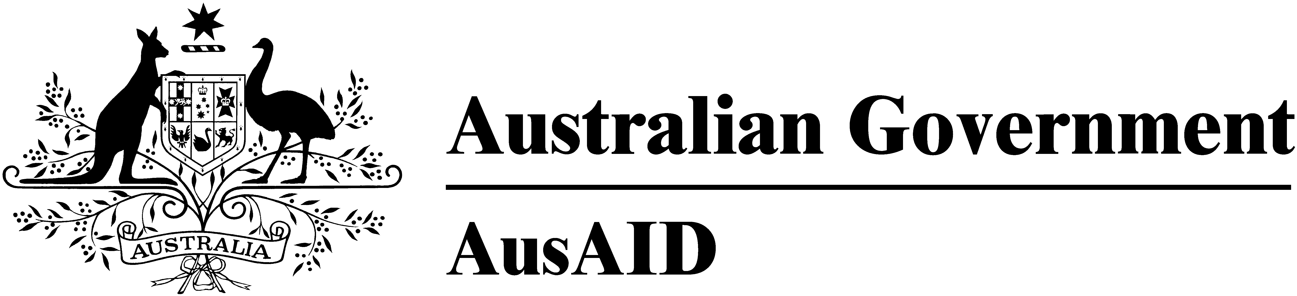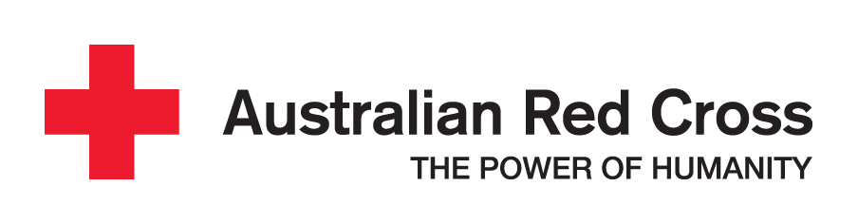

___________________________________________________________________________________
Landmine Survivor Assistance Fund 2009

_________________________________________________________________________________
Landmine Survivor Assistance Fund NGO Application Guidelines 2009

What is the Landmine Survivor Assistance Fund?
The Landmine Survivor Assistance Fund (LSAF) is a funding mechanism supported by the Australian Government through AusAID and managed by Australian Red Cross (ARC). Established in 2004, AusAID have now committed additional funds as part of their overall Landmine Survivor Assistance Program in Cambodia. This will facilitate enhanced outcomes in sector sustainability, remote access to services, and responsiveness to emerging issues and international standards.

What is the goal of the LSAF?
The goal of the LSAF is to reduce the vulnerability of persons with disability including landmine and ERW survivors, their families and affected communities in the Kingdom of Cambodia. The LSAF will support small and medium scale projects that focus on the physical, social, and economic rehabilitation and reintegration of persons with disabilities including landmine and ERW survivors.

What organisations are eligible to apply for the LSAF?
Local and international NGOs currently working in the disability sector which may have beneficiaries who are landmine or ERW survivors are eligible to apply for funding. Organisations need to demonstrate prior experience and expertise managing successful projects with cited target groups in the disability and mine action sectors in Cambodia.

Local and international NGOs must be formally registered in Cambodia. Local NGOs (LNGOs) must be registered with the Ministry of Interior (MoI) as per the NGO draft law. International NGOs (INGOs) must have a Memorandum of Understanding with the Ministry of Foreign Affairs and International Cooperation (MFAIC).

Organisations may provide a referee or partner organisation as part of their submission. The role of the referee or partner organisation is to verify the accuracy of the proposed project and budget. A referee or partner organisation may also undertake a role with the submitting organisation during the implementation of the project. This is an option available to organisations but not a requirement of the application.

NGO Certification
The Cooperation Committee for Cambodia (CCC) has commenced a voluntary certification system for NGOs working in Cambodia. The system is based on compliance with the code of Ethical Principles and Minimum Standards for NGOs in Cambodia, a code which describes minimum organisational standards for NGOs. Whilst not mandatory for funding, AusAID will look favourably upon NGOs which have applied for and/or been granted certification by CCC. AusAID refers NGOs (international and national) to the attached GPP Code of Ethical Principles and Minimum Standards of Practice as a reference for standards of organisational development and integrity, particularly LNGOs who are electing not to include a partner NGO in their proposal, and NGOs who are not current signatories to other similar codes.

For more information on the Code, please contact NGO GPP staff team at ngogpp@ccc-cambodia.org or 012 875160. Additional information is also available on the CCC website at www.ccc-cambodia.org

How much funding can an organisation apply for from LSAF?
Applications for funding can be submitted between USD20 000 and USD80 000 per year.

What is the timeline of LSAF applications?

Date | Process
Fri 16th Jan 4pm 2009 | Closing date for applications
3rd week of Feb 2009 | Notification of outcome by ARC to applicant NGOs
3rd week March 2009 | Signing of contracts with successful NGOs
3rd week March 2009 | Transfer of funds to successful NGOs
1 April 2009 | Project implementation period starts

What is the project duration and when can it start?
Funding will be made available for proposals with duration of between one to three years. For muliti-year proposals, funding will initially be made available for the first 12 months period, and funding for subsequent years will depend on:
- The submission and acceptance of project reports demonstrating satisfactory performance and budget acquittals for the initial funding allocation.

Projects will commence on 1 April 2009 subject to final approval and assessment for impact and ability to contribute to the LSAF goals

For proposals of three years duration, 5-10% of the total budget may be used to conduct an independent evaluation of the project.

Which applications will be given priority?
Support to persons with disabilities including landmine and ERW survivors is best approached through a broad development context.

Applications should include activities such as;
- Community-based social and economic rehabilitation of persons with disabilities including mine & ERW survivors, i.e. physical rehabilitation services, outreach programs, social services, and arts and sports activities,
- Improving livelihoods, i.e. vocational training, access to labour market, and income generating activities (except micro-credit activities),
- Reducing discrimination and improving acceptance of mine & ERW survivors and disabled people in society, i.e. advocacy/awareness campaigns.

Applications should address crosscutting issues such as;
- Gender, that is, how the proposal will address the differing needs of women and men, girls and boys and be able to demonstrate gender sensitivity.
- Long-term sustainability issues within the disability sector, that is how impact of projects will contribute to sustainability of the sector once they are finished
- Good Governance, that is how projects demonstrate good governance practices that are open, transparent, accountable, and equitable

Applications should include approaches to;
- Promote collaboration between different actors/service providers in the disability and mine action sectors;
- Promote the involvement of, and collaboration with, relevant bodies within the Royal Government of Cambodia;
- Incorporate disability best practice and international standards,
- Respond to the recommendations of the Physical Rehabilitation Sector Evaluation 2006.

Applications should target groups such as;
- People with disabilities and their families including landmine & ERW survivors
- Target communities which are vulnerable to or affected by disablement from landmine and ERW or other significant causes of disability
- Other mine/ERW or disabled related vulnerable groups

What activities will not be eligible for funding?
Activities not eligible for funding include;
- Overseas training, travel, and conferences,
- Activities with high administration costs,
- Activities with involve significant expatriate salary costs,
- Commercial activities and research,
- Emergency relief and welfare,
- Direct Micro-credit (Self help groups can be provided with grants which they can then use as start up for Micro-credit as part of their SHG)
- Major construction or infrastructure.

What sort of costs can be supported?
The LSAF can support;
- Direct project activity costs,
- Direct support to target groups,
- Technical assistance to support the project,
- Limited costs for per diems, travel, and accommodation,
- Limited training costs,
- Limited essential equipment,
- Project evaluations and audits.

What sort of costs will not be supported?
The LSAF cannot support;
- Office overheads, indirect or excessive administration expenses,
- Significant proportions of expatriate and non-project related staff salaries,
- Vehicle purchases,
- Recurring expenses such as spare parts, supplies, maintenance, and repairs.

What are the specific LSAF requirements organisations need to meet?
All AusAID-funded programs are required to meet Australian Government standards. Organisations must agree to the following requirements as a condition of funding.

- If the proposal includes children as part of its activities then a Child Protection Policy should be submitted within six months of contract signing; this policy will include procedures for protecting children in the project from potential abuse by staff or stakeholders associated with the project.
- Client Protection Policy: to be submitted within six months of contract signing. This policy will relate to the recommendations of the Physical Rehabilitation Sector Evaluation.
- AusAID Water and Sanitation Guidelines: organisations should ensure any proposed activities are in accordance with these guidelines (available on the AusAID website http://www.ausaid.gov.au/keyaid/envt.cfm) if proposed activities include water & sanitation.
- AusAID climate Change and Environment policy: Organisations should ensure any proposed activities are in accordance with this policy (available on the AusAID website http://www.ausaid.gov.au/keyaid/water.cfm) if proposed activities are likely to have an impact on the environment.
- Promotion of Australian government /AusAID identity: in project activities, promotional material and donor acknowledgement.

Organisations who were recipients of the LSAF in 2007 and 2008 will only be considered for funding in 2009 only if the above policies and guidelines have been submitted to AusAID. Those organisations that have previously been funded will need to submit the relevant policies at time of submission of a new proposal in order to be considered for funding.

How will LSAF applications be evaluated?
Project applications will be evaluated based on the information in the application form. ARC may request further information following submission of applications and may seek advice from independent technical experts. An Evaluation Committee formed by representatives of ARC, AusAID, MoSVY and DAC, will assess eligible applications. Evaluation will consider key criteria including;
- Meeting application requirements as outlined in the guidelines,
- Technical and management capacity of organisations,
- Project priorities alignment with LSAF goal and priorities,
- Impact and outcomes for target groups
- Quality of design,
- Cost effectiveness of budget,
- Sustainability.

How will the grant be paid to the NGO?
Funds will be transferred in one or two payments (depending on the size of the total grant) to the organisation’s nominated bank account following the signing of contracts. Proposals up to $USD20, 000 will receive one payment and those proposals of $USD20, 000 and above will receive two payments following submission of satisfactory reports. Proposals of more than one year will be assessed at 10 months for funding to continue in the second year.

How will ARC monitor projects?
Each project will be monitored closely by ARC and include;
- Assessment of project progress according to the work plan,
- Success in meeting objectives and impact of activities,
- Assessing proposed variations to project activities and associated budget implications.
- Direct contact with NGOs,
- 6 monthly reports,
- Project monitoring visits,
- An external evaluation of the overall outcomes of the LSAF.

What will happen if there is a lack of progress, or unreasonable delays, in project activities?
NGOs will be required to revise their project work plan to the satisfaction of ARC and AusAID. If there is a continued lack of progress then it may be decided to cease the project and unspent funds will be returned to AusAID.

How will inappropriate use of funds be dealt with?
If funds are used inappropriately;
- No further funding will be considered for the NGO,
- The NGO will reimburse AusAID for advanced funds,
- Accountable individuals will be held responsible.

How should applications be submitted?
Applications should be completed in English in the supplied format; applications submitted in other formats will not be considered. The application must be provided in six hard copies and one electronic copy on CD. Applications must not exceed 12 pages, including the work plan and budget but excluding the cover page.

Applications are to be submitted by 4pm Friday 16th January 2009 to:
By mail:
Australian Red Cross
c/o International Federation of Red Cross and Red Crescent Societies
Cambodia Delegation
Central Post Office P.O. Box 620
Phnom Penh, Cambodia

Or by delivery:
Australian Red Cross (Cambodian Red Cross complex)
#16, Street 652 (corner 271),
Sangkat Toek Laak 3,
Khan ToulKork,

Further information
All enquiries should be directed to:

Teresa Carney
Program coordinator
Landmine Survivor Assistance Program
Australian Red Cross

Office: +855 23 210 162/ 362 690
Fax: +855 23 210 163
Mobile: +855 92 888 956
E-mail teresa.carney@ifrc.org

