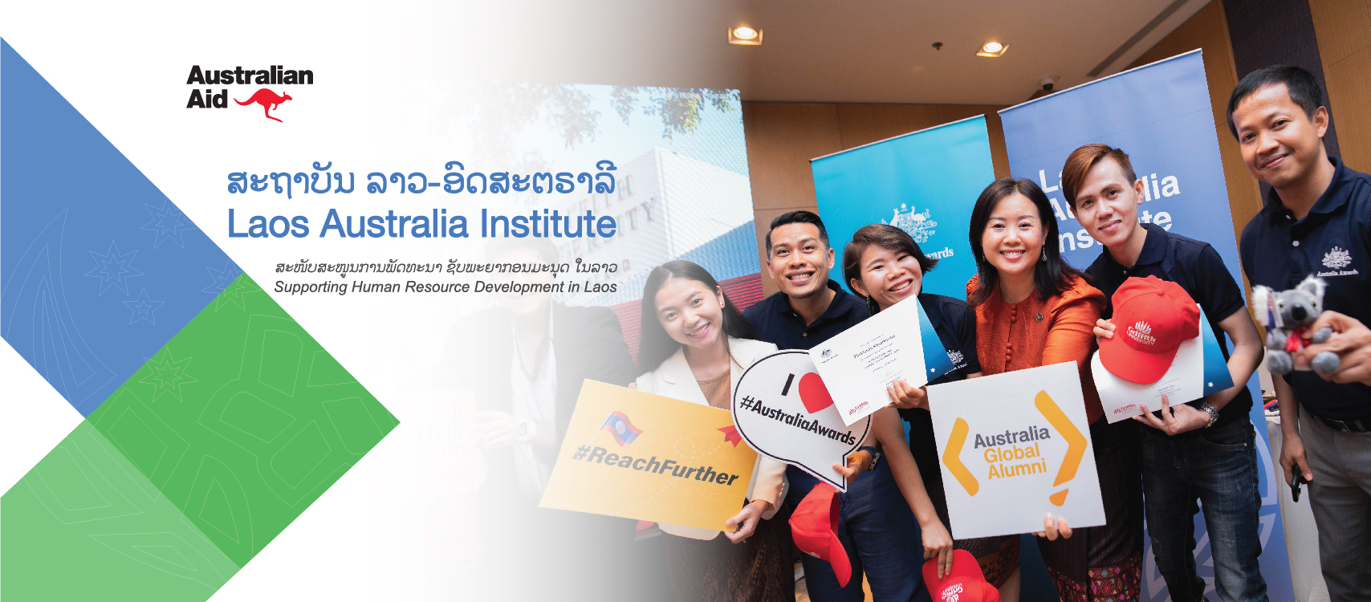
- The Independent Review of the Laos Australia Institute (LAI) Phase III
REVIEW REPORT
30 May 2025

Alinea International

Report Prepared by:
Dr Bernadette Whitelum
Dr Primatia Romana Wulandari
Siphone Phamavanh
© Cover page by LAI Phase III, taken from https://www.facebook.com/LaosAustraliaInstitute

Contents
List of acronyms 1
Executive summary 3
Purpose and scope of the review 3
Summary of key findings 3
Summary Recommendations for LAI Phase IV 6
Background and context 8
Political economy and operating environment 10
Methodology 10
Review findings 12
Relevance 12
Effectiveness 17
Efficiency 25
Monitoring and evaluation 29
Cross-cutting themes (GEDSI and Climate Change integration) 32
Learning 38
Recommendations for Phase IV 42
Sustain and enhance Phase III legacy 42
Strengthen strategic alignment between HRD and bilateral objectives 42
Refinement of program logic and priorities 43
Strategies to improve efficiency and sustainability 44
Enhancements in GEDSI and climate integration 45
Conclusion 46
Summary of overall performance 46
Areas requiring further investigation 46
Next steps for design phase 46
Annex A: Review Questions, Key Findings and Recommendations 47
Recommendations 57
Annex B: Methodology 57
Annex C: Key Documents 58
Annex D: List of consultations 60
Annex E: LAI Alumni survey result 62
Annex F: Data analysis 70
Annex G - Lao Human Resource Society (LHRS) 72
Annex H: Political Economy Analysis 74

List of acronyms
AAS Australia Awards Scholarships
AASC Australia Awards Short Courses
AIG Alumni Innovation Grant
ALFA The Australia-Laos Friendship Association (ALFA)
ASEAN Association of Southeast Asian Nations
BRI Belt and Road Initiative
CP Comprehensive Partnership
DFAT Department of Foreign Affairs and Trade
ELEP English Language Equity Program
EOPO End of Program Outcome
ESSDP Education and Sports Sector Development Plan
EU European Union
GDP Gross Domestic Product
GEDSI Gender Equality, Disability, and Social Inclusion
GoL Government of Laos
HRD Human Resource Development
HRDIS Human Resource Development Impact Survey
HRM Human Resource Management
ICT Information and Communication Technology
IELTS International English Language Testing System
JICA Japan International Cooperation Agency
KEQ Key Evaluation Questions
KPI Key Performance Indicator
LAFA The Lao-Australia Friendship Association
LAI Laos Australia Institute
LANS Laos Australia National Scholarships
LHRS Lao Human Resources Society
LPRP Lao People’s Revolutionary Party
LWU Lao Women’s Union
M&E Monitoring and Evaluation
MAP Mekong-Australia Partnership
MEL Monitoring, Evaluation and Learning
MERLA Monitoring, Evaluation, Research, Learning, and Adaptation
MOES Ministry of Education and Sports
MOHA Ministry of Home Affairs
MPI Ministry of Planning and Investment
NAPPA National Academy of Politics and Public Administration
NHRDS National Human Resource Development Strategy
NSEDP National Socio-Economic Development Plan
ODA Official Development Assistance
ORCA Organisational Rubric for Capacity Assessment
PIG Program Implementation Group
PMSC Program Management and Steering Committee
SDG Sustainable Development Goal
ToR Terms of Reference

Executive summary

Purpose and scope of the review
This report is an independent end-of-program review that examines the relevance, effectiveness, and efficiency of the Laos Australia Institute (LAI) Phase III, and assesses progress from July 2021 to December 2024. It offers key findings and provides recommendations for the remaining program period (through to 2026) as well as for the next phase (2026 to 2031). These recommendations will inform the design terms of reference (ToR) and work plan for the potential Phase IV of the LAI program.
The LAI is an 11-year initiative with a cumulative value of AUD51.2 million implemented by Tetra Tech International Development in partnership with the Governments of Australia and Laos. Since its launch in 2014, LAI has focused on developing a skilled workforce in Laos, with a particular emphasis on women, people with disability, and other targeted ‘equity’ groups . The program strengthens Laos' workforce through investments in scholarships, training, alumni engagement, and organisational capacity building, driving both economic and social development, to align with Laos’ 9th Socio-Economic Development Plan. Managed by the Ministry of Education and Sports (MOES), the Australian Embassy in Vientiane and the Department of Foreign Affairs and Trade (DFAT) in Canberra, LAI supports Laos' National Human Resource Development Strategy (NHRDS) and reinforces Australia’s role as a trusted development partner.
Phase III of the program is an AUD25.6 million investment from bilateral official development assistance (ODA), plus an additional AUD6.2 million from the regional Mekong-Australia Partnership (MAP) and approximately AUD300,000 from ASEAN regional funding. Phase III commenced in 2021 and is due for completion in September 2026.
This review provides a comprehensive assessment of the program’s effectiveness, efficiency, relevance, and sustainability. It provides evidence-based recommendations for the design and implementation of Phase IV. The evaluation focuses on the program’s alignment with Laos' human resource development (HRD) priorities and Australia’s international development goals, including the Lao-specific Development Partnership Plan (DPP). Additionally, the review examines the program’s outcomes, resource utilisation, and the integration of key themes such as gender equality, disability and social inclusion (GEDSI), and climate change.

Summary of key findings

Relevance: Overall rating: 6/6 (Very Good)
LAI Phase III is highly relevant to both Laos and Australia, aligning with the Lao-Australia Comprehensive Partnership, Laos' DPP and the National Socio-Economic Development Plan (NSEDP). The program advances shared priorities, including inclusive growth, HRD, education, skills development, and governance. Through alumni networks and institutional partnerships, it strengthens Australia’s relationship with Laos as a trusted and respected development partner.
LAI Phase III has broadened and deepened Laos-Australia people-to-people relationships. LAI III adapted its approach to support flexible training modalities, mentoring, and knowledge transfer initiatives that have built longer term relationships and gone some way to institutionalising capacity. Alumni engagement was strengthened through small grants and peer-to-peer networks, boosting their contributions to national priorities. Additionally, digital solutions facilitated ongoing communication and collaboration, ensuring alumni networks remained strong despite sectoral and geographical challenges.
LAI Phase III has solidified Australia’s position as an important bilateral development partner by leveraging Laos-Australia alumni networks, institutional partnerships, and HRD initiatives. Phase III has successfully broadened Australia’s engagement with the Lao People’s Revolutionary Party (LPRP), National Academy of Politics and Public Administration (NAPPA), Ministry of Planning and Investment (MPI), and the Lao Women’s Union (LWU). Furthermore, the establishment of the Australia-Laos Friendship Association (ALFA) and Lao Human Resource Society (LHRS) are key strategic engagements.
Regionally, LAI has positioned Australia as a key partner in trilateral cooperation with Laos and Vietnam. LAI is supporting Laos and Vietnam relationships through joint initiatives (including institutional partnerships between NAPPA, the Ho Chi Minh National Academy of Politics, and Australia). Stakeholders expressed strong appreciation for LAI as a valued and trusted partner, highlighting DFAT/Embassy’s responsive and engaged approach in collaborating on initiatives that advance local capacity and skills.

Effectiveness: Overall rating: 6/6 (Very Good)
LAI is a strong and impactful program, operating in a challenging political and economic landscape where change is often slow. Based upon the evidence collated through this review, it can be concluded that LAI III has made strong progress towards its end of program outcomes (EOPO), though success varies across outcomes areas:
- EOPO 1 is highly likely to be achieved
- EOPO 2 demonstrates moderate potential for full achievement
- EOPO 3 is likely to be achieved
Overall, LAI’s approach aligns with Laos’ political and institutional realities. While deeper systemic change will require sustained efforts beyond the program’s current scope, it is important to acknowledge the significant progress achieved in a relatively short period—particularly in strengthening partnerships and building trust with key institutions such as MPI, NAPPA, and LWU.
LAI Phase III has made significant strides in improving inclusion, with equity group participation rising from 41.44% in 2022, 62% in 2023, and ultimately reaching 66% in 2024, surpassing the 40% target. While engagement with people with disability was low from 2021 to 2024(1-3%), improvement has been measured in 2025, demonstrated by the increase of people with disability (up to 8%) applying for Australian Award Scholarship (AAS), indicating progress in outreach efforts. Women and provincial participants represent the largest share of equity groups. However, the discontinuation of Laos Australia National Scholarships (LANS) at the end of Phase II has reduced access for disadvantaged groups, limiting their ability to benefit from the program.
LAI has adopted approaches that enable individuals to see their learning manifest in the workplace and increase positive organisational change. LAI has successfully empowered alumni to apply their skills in key sectors with most (94%) reporting increased leadership and impact. Organisational impact interviews highlight meaningful organisational improvements enabled through LAI support. While LAI has intentionally focused on capacity building as a politically feasible entry point, LAI’s strategic use of human resource management (HRM) as a platform for engagement has yielded positive results. For example, the uptake of tools such as organisational rubrics for capacity assessment (ORCA) reflects meaningful, demand-driven organisational change and demonstrates partners’ increasing capacity to lead reform processes.

Efficiency: Overall Rating: 5/6 (Good)
The program’s flexible, demand-driven approach and lean management enhance cost-effectiveness, local capacity, and sustainability. LAI Phase III has ensured efficient use of funds. Compared to Phase II, Phase III has diversified investments, with increased spending on HRD support (43% in FY22-23) and scholarships and training (63% in FY23-24), aligning with Laos' workforce development needs. This has resulted in 76% of alumni mentoring others and 83% applying their skills to workplace improvements. However, limited funding for targeted GEDSI initiatives, beyond mainstreaming efforts, highlights the need for stronger investment to increase impact.
LAI has effectively balanced strategic coherence with responsiveness to partners’ needs, aligning long-term objectives with evolving stakeholder priorities. The program’s demand-driven and locally-led approach has been central to this balance, ensuring that strategic priorities are pursued while remaining flexible to emerging needs. In Laos, efficiency also requires sustained investment in relationships with partners; and transparent, consistent engagement, and active encouragement have been critical enablers.

Monitoring and evaluation: Overall rating: 5/6 (Good)
LAI Phase III’s Monitoring, Evaluation, Research, Learning, and Adaptation (MERLA) framework effectively tracks incremental improvements and supports adaptive management through robust data collection and stakeholder engagement. While it captures individual-level changes well, it has limitations in measuring broader institutional shifts and systemic change. Enhancing methodologies to assess both institutional impact and long-term change would strengthen the framework’s ability to inform strategic decisions.
The program’s MERLA mechanisms ensure continuous alignment with DFAT and Government of Laos’ (GoL) priorities through regular consultations, integrated results frameworks, and joint assessments, allowing for flexibility when adapting to shifting national goals and high-risk contexts. However, stakeholder engagement—particularly with MOES and NAPPA—could be further strengthened by enhancing dissemination strategies.

Cross-cutting issues: GEDSI and climate change integration: Overall rating: 5/6 (Good)
LAI Phase III has made significant strides in embedding GEDSI considerations, with a dedicated strategy focused on equitable opportunities for women, people with disability, and marginalised communities. Key initiatives include gender-focused leadership training, advocacy for diversity in HRD, and the use of ORCA to monitor inclusivity. While GEDSI-related initiatives receive 22-23% of the budget, there is potential for greater impact by increasing targeted support for disability inclusion.
LAI effectively integrates climate resilience into HRD by supporting scholars and Laos-Australia alumni in climate-responsive fields, with 30% of efforts focused on sustainability. Alumni-led projects, such as smart farming and sustainable agriculture, showcase practical climate adaptation, while LAI’s zero-plastic policy underscores its commitment to environmental sustainability.

Learning: Overall rating: 6/6 (Very Good)
Lessons from previous phases: LAI Phase III has effectively incorporated lessons from earlier phases by aligning more closely with GoL priorities, enhancing GEDSI integration, strengthening peer learning and mentoring, and localising training delivery to increase institutional ownership. It has also adopted a more politically informed approach, engaging influential actors like CER and NAPPA to embed HRD within government systems.
Opportunities for scaling and sustainability: LAI has delivered measurable impact across eight HRD modalities, with strong outcomes in capacity-building, alumni advancement, and GEDSI integration. The Review identifies an opportunity to build on the strong foundations laid by LAI in human resource development (HRD) to more strategically support emerging areas of national demand—particularly where the need for skilled leadership and institutional capacity is evident. While further research and engagement are needed to define priority sectors for Phase IV, LAI is well-positioned to support Laos in addressing leadership and institutional capacity gaps where national demand is already emerging. Proceeding cautiously, in close coordination with government and in line with national strategies, will ensure this evolution remains politically viable and strategically sound.

Summary Recommendations for LAI Phase IV
With an overall rating of 6/6 (Very Good), the program has demonstrated significant achievements in advancing HRD in Laos. The following recommendations seek to enhance the impact, sustainability, and relevance of LAI, ensuring alignment with both Laos' and Australia’s priorities while fostering long-term change. They are designed to provide guidance for the remainder of LAI Phase III (until June 2026) and inform the design of Phase IV. Recommendations directed at DFAT focus on strategic oversight and long-term program direction, while those for the Implementing Partner and joint DFAT-Implementing Partner efforts address immediate opportunities to enhance outcomes in the current phase.

1. Sustaining and enhancing Phase III legacy
DFAT (Phase III): Maintain DFAT’s strategic oversight on key legacy initiatives, including scholarships, Laos-Australia alumni networks, and trilateral engagement, to sustain the program’s most successful components, while looking to enhance and evolve these initiatives for continued impact.
Implementing Partner: If resources allow, enhance MERLA efforts to better capture institutional-level impact, providing evidence to strengthen the likelihood of achieving EOPOs. If full-scale enhancement is not feasible, conduct targeted ‘deep-dives’ to identify lessons for refining the MERLA system in LAI Phase IV.

2. Strategic alignment with HRD and bilateral objectives
DFAT (Phase IV design): Continue supporting the development of a long-term HRD Strategy as a strategic approach that will enable discussions on sector-specific HRD and skills development. DFAT should also consider piloting HRD initiatives beyond civil service HRM, with a focus on emerging economic sectors and professional development for strategic leaders.
Implementing Partner: Develop an options paper for professional development programs targeting senior officials, ensuring HRD planning aligns with sectoral policy needs and skills gaps in high-growth industries. The paper should identify opportunities for sector-specific policy dialogues and mechanisms to influence the NHRDS in addressing skills shortages in priority sectors.

3. Refining program logic and priorities
DFAT (Phase IV design): Consider fine-tuning the program logic to better address skills gaps in high-growth sectors and strengthen leadership development through targeted short courses for strategic leaders.

4. Improving efficiency and sustainability
DFAT (Phase IV design): Ensure a balanced approach between politically and economically relevant program components and equity-driven initiatives, such as targeted scholarships for people with disability, to enhance inclusivity while maintaining strategic impact.
Implementing Partner: While Australia’s experience-sharing remains highly valued, LAI should enhance efforts to localise training content by integrating agency-specific case studies, tailoring these to the unique challenges faced by each Ministry, Department, or Unit.
In addition, an options paper that informs Phase IV’s sustainability strategy should be developed, focussing on embedding successful Phase III training initiatives into the national curriculum. This should include integration into the training programs of NAPPA, MOES, and Ministry of Home Affairs (MOHA) training centres.

5. Enhancing GEDSI and climate integration
DFAT (Phase IV design): Assess the feasibility of reinstating LANS scholarships for individuals with disabilities.
Implementing Partner: Given the anticipated increase in participants with disabilities, LAI should strengthen targeted support for AAS applicants with disabilities.
LAI should conduct an in-depth assessment on how to support people with disability alumni following their LANS scholarship, withs focus on career advancement and increasing their participation in Laos’ socio-economic development.
If resources allow, LAI should expand Laos-Australia alumni-led projects focused on climate resilience and disability inclusion.
Both: Continue strengthening GEDSI and climate integration across all program activities, ensuring equitable access to HRD opportunities.
Relevant to all recommendations, it will be crucial for DFAT to internally test and reach consensus on the future priorities to inform planning. This will ensure a clear and unified DFAT perspective on LAI’s purpose and priorities through to 2030. The above recommendations are outlined in detail within the body of this report, and are also represented in table format at Annex A.

Background and context
The Department of Foreign Affairs and Trade at the Australian Embassy in Laos tasked Alinea International with conducting an Independent Review of LAI Phase III. This review, carried out from October 2024 to May 2025, presents Alinea International’s team’s findings and recommendations based on the program’s performance to date.
The review aims to capture key lessons from LAI’s implementation from 2021 to the present, helping DFAT shape the next phase of the program in Laos. It also holds the program accountable to stakeholders, including the Governments of Australia and Laos, LAI employees, LAI awardees and alumni, and Australian taxpayers.
The primary audience for this review is the Australian Embassy in Laos and LAI. Secondary audiences include the GoL (especially the MOES), DFAT Canberra (including the Scholarships and Alumni Branch, and relevant country Desk), and the Australian public, as the review is intended to be published on DFAT’s website.
This independent review of LAI Phase III:
- assesses the relevance of LAI support to Laos’ National Human Resource Development (HRD) objectives and Australia’s strategic priorities
- assesses the program against the below criteria, adherence to the DFAT quality and performance framework, DFAT’s Gender Equality in Monitoring and Evaluation Good Practice Note, and the OECD’s Development Assistance Committee criteria:
  - Relevance
  - Effectiveness
  - Efficiency
  - Monitoring and evaluation (M&E)
  - Cross-cutting topic of GEDSI
- provides recommendations to DFAT with respect to adjusting the current program and the implementation of the remainder of the program to 30 June 2026.
Australia has been a development partner to Laos for over 70 years, with HRD at the heart of this support. LAI is Australia’s flagship HRD initiative in Laos, combining scholarships, capacity-building programs, Laos-Australia alumni engagement, and technical assistance to support Laos' socio-economic development priorities and regional integration.

Former phases and the Laos-Australia Development Learning Facility
The first phase of LAI (2013-2017) established a strong foundation for HRD in Laos, focusing on scholarships and capacity-building for key government institutions. Phase II (2017-2021) expanded on this by offering short courses, strengthening Laos-Australia alumni engagement, and targeting institutional capacity development. Complementing LAI, the Laos-Australia Development Learning Facility (LADLF) provided research, policy analysis, and learning initiatives to both inform HRD priorities, and develop a Monitoring, Evaluating and Learning Framework for the National HRD Strategy. Together, these investments highlighted Australia’s commitment to enhancing institutional capability and developing a skilled workforce aligned with Laos’ National HRD.

LAI Phase III: Overview and investment
Launched in 2021, LAI Phase III is a four-year program (2021-2025) managed by Tetra Tech International Development, with an initial investment of AUD22.7 million. This includes AUD16 million in bilateral ODA, AUD5.7 million from the regional Mekong-Australia Partnership (MAP), and AUD30,000 from ASEAN regional funds. The program builds on previous phases by offering flexible, demand-driven support to strengthen HRD systems and capacity, aligning with Laos' NHRDS and Australia’s broader development and diplomatic goals.

Program goal, objectives, and EOPOs
LAI Phase III’s goal is to support Laos’ sustainable socio-economic development through HRD, ensuring Australia is a valued and trusted partner in Laos. Its three EOPOs are:
- EOPO 1: Strengthening dialogue and partnerships between Laos and Australia through strategic HRD investments.
- EOPO 2: Enhancing the capacity of targeted Laos organisations to deliver inclusive and systematic HRD.
- EOPO 3: Supporting alumni to leverage their skills, knowledge, and networks for inclusive and sustainable development.
These EOPOs are pursued through five intermediate outcomes, which focus on institutional HRD capacity, alumni contributions, cooperation between Laos and Australia, stakeholder perceptions, and enabling pathways for equity groups.

Program components and resource allocation
LAI Phase III delivers HRD support through eight interrelated outputs:
- Targeted Capacity-Building Initiatives: Enhancing HRD planning and implementation in key Lao organisations through training and development.
- Scholarships and Training: Offering long-term Australia Awards Scholarships, Australia Awards Short Courses (AASC), and LANS, with LANS phasing out by mid-2024.
- Alumni Engagement: Supporting alumni leadership development, fostering networking opportunities, and encouraging contributions to socio-economic progress through grants and dialogue platforms.
- Communications and Public Diplomacy: Developing and executing a strategic communications plan to support the Australian Embassy’s outreach and engagement efforts.
- GEDSI Mainstreaming and Equity Initiatives: Embedding GEDSI into HRD programming.
- Information, Research, and Learning: Strengthening evidence-based decision-making by drawing on research, M&E data, and a cloud-based Management Information System.
- Stakeholder Engagement: Strengthening governance mechanisms and building strategic partnerships with Lao government agencies and key stakeholders.
- Strategic Support to the Australian Embassy: Delivering responsive technical assistance, research, and high-level advisory support.

Governance and implementation model
LAI Phase III follows a three-tiered governance system:
- Program management and steering committee (PMSC): Aligns LAI’s priorities with Australia’s foreign policy and Laos’ NHRDS and endorses LAI’s annual plan of activities.
- Program implementation group (PIG): Reviews HRD support requests and provides technical guidance.
- Annual planning and adaptation mechanisms: Ensures strategic resource allocation and continuous learning.
Key implementing partners foster local ownership and sustainability. These include the MOES, LPRP, NAPPA, MOHA, MPI, and LWU.

Political economy and operating environment
The LAI Phase III works within Laos’ centralised governance structure, economic challenges, and regional dynamics, all of which shape its feasibility and alignment with national and international priorities.
Governance and policy environment
Laos is a one-party state led by the LPRP, with centralised decision-making. National development is guided by five-year plans, currently the 9th National Socio-Economic Development Plan (NSEDP) (2021 to 2025). Key institutions, such as the MPI and MOES, play a major role in policy and HRD. Institutional reforms, especially in HRD, need high-level political support and are rolled out gradually. LAI works strategically by aligning with national policies, fostering relationships, and supporting key institutions like NAPPA to drive HRD reforms.
Economic constraints and development pressures
Laos has transitioned from an agriculture-based economy to one driven by hydropower, mining, and services. However, economic vulnerabilities—such as high public debt, fiscal deficits, and macroeconomic instability—have continued to worsen, particularly following the COVID-19 pandemic. Laos faces growing challenges including inflation, currency depreciation, and dependence on external financing, particularly from China. To achieve sustainable growth, Laos aims to diversify into high-potential sectors like ICT, logistics, tourism, and sustainable energy, as outlined in the 9th NSEDP and World Bank strategies.
Regional and international dynamics
Laos’ development priorities are highly influenced by its political and economic ties within ASEAN, along with its reliance on China for development financing and infrastructure, particularly through the Belt and Road Initiative (BRI). Chinese investments have contributed to infrastructure improvements, they also raise concerns about debt sustainability and extraterritorial influence. Laos actively seeks to balance its international partnerships, including strengthening its relationship with Australia under the Comprehensive Partnership (CP).
LAI Phase III leverages regional initiatives, such as the MAP, to enhance HRD efforts and foster greater regional collaboration. This context underscores the need for LAI to work within Laos' political and economic realities while supporting HRD priorities through partnerships and capacity-building. A political economy analysis is included at Annex A.

Methodology
The review adopted a utilisation focused approach or dual-pathway methodology, combining a review of Phase III activities with a forward-looking approach to inform the design of Phase IV. This approach aimed to make the findings as useful as possible for future programs. The methodology included a comprehensive document review, 38 stakeholder interviews, a survey of 82 Laos-Australia alumni, and structured data analysis. Efforts were made to ensure gender balance and representation across government sectors, though potential biases, particularly in regarding the engagement levels of Laos-Australia alumni, were acknowledged.
The review also considered broader political and economic factors, such as including the impacts of COVID-19, shifts in Australia’s development policy, and Laos’ regional engagement. Findings were analysed using both qualitative and quantitative methods, with cross-checking across multiple data sources. The review focused on a forward-looking approach, and preliminary findings were shared in an Aide Memoire Briefing to align recommendations with strategic priorities for Phase IV. More details on the methodology can be found in Annex B.

Limitations of the review
While the review followed a rigorous dual-pathway methodology, the review team acknowledges several limitations:
- Time constraints and scope prioritisation: The review team was tasked with answering six Key Evaluation Questions (KEQs) and 13 sub-questions within a tight timeframe. To provide a focused and meaningful analysis, the team prioritised certain areas, particularly KEQ 1 (Relevance), KEQ 2 (Effectiveness) and KEQ 5 (GEDSI, focusing on LANS). As a result, while all KEQs were addressed, some areas were explored in greater depth than others.
- Representativeness of alumni survey data: The alumni survey received 82 responses; but response patterns varied across different support streams, sectors, and demographic groups. While the survey offers valuable insights into Laos-Australia alumni experiences, its findings may not fully represent the broader Laos-Australia alumni population. Variations in participation rates among alumni from different government sectors, regions, and gender groups may introduce a potential bias in the data.
- Potential bias in stakeholder interviews: The review included 38 interviews and four written responses from stakeholders across Laos and Australia. Although efforts were made to capture a diverse range of perspectives, participation was influenced by factors such as availability and willingness to engage. As a result, some voices, particularly from government agencies or sectors with limited involvement in LAI Phase III, may have been underrepresented.
- Limited secondary data: Analysis focused only on materials covering the 2021to 2024 program period. As a result, analysis may not fully reflect recent developments and particularly activities conducted in 2024. For insights on 2024 initiatives, the review relied mainly on interviews, focus group discussions and the review of 2024 Australia Awards Development Impact Survey (ADIS).
- Balancing retrospective and forward-looking analysis: The dual focus of reviewing past performance while generating insights for future programming required a careful balance. The team prioritized evidence-based lessons to inform the design of Phase IV, although some aspects of Phase III’s implementation, such as ORCA and LHRS, may not have been fully explored. Despite these limitations, the review offers a robust evidence base to guide decision-making for Phase IV, ensuring that the recommendations are both relevant and forward-looking.

Review findings
This section sets out how LAI Phase III has performed against the review’s KEQs. The KEQs are grouped into evaluation criteria themes: relevance, effectiveness, efficiency, monitoring and evaluation, and cross-cutting (GEDSI and Climate Change). The review has applied a rating for each. The rating scale mirrors DFAT’s rating system as applied through Investment Monitoring Reports and Evaluation Standards. The review has assigned the ratings to each evaluation criteria.
- Table 1: LAI Phase III performance rating
Criteria | Rating (out of 6)
Relevance | 6 (Very Good)
Effectiveness | 6 (Very Good)
Efficiency | 5 (Good)
Monitoring and Evaluation | 5 (Good)
GEDSI & Climate Change | 5 (Good)
Learning | 6 (Very Good)
Overall Score | 6 (Very Good)

Relevance
Overall rating: 6/6 (Very Good)
The relevance of the LAI Phase III has been rated and assessed based on its alignment with Laos' HRD priorities, integration with Australian Government objectives, and responsiveness to changing national and regional contexts.

How well does LAI Phase III align with both GoL’s HRD priorities and Australia’s development objectives in Laos?
LAI Phase III aligns closely with the GoL’s national HRD priorities, particularly the 9th NSEDP and the Education and Sports Sector Development Plan (EDDS), which focus on high-quality education, skills development, and capacity strengthening to support Laos’ transition to a knowledge-based economy. LAI Phase III has directly contributed to these goals through targeted scholarships, short courses, and institutional partnerships aimed at strengthening public sector leadership and governance.
LAI Phase III supports Australia’s development goals in Laos, as articulated in the Australia-Laos Development Partnership. The program’s focus on HRD, gender equality, and inclusive economic growth aligns with Australia’s strategy to promote Laos’ sustainable development and economic integration in ASEAN. Additionally, LAI’s efforts to provide equitable access to education and leadership opportunities supports Australia’s commitment to inclusive development, benefiting women, ethnic minorities, and people with disability.
Through its alumni networks and institutional partnerships, the program plays a pivotal role in advancing HRD priorities while strengthening Australia’s relationship with Laos as a trusted and respected development partner.
The Partnership Continuum Assessment (PCA) highlights steady progress in bilateral collaboration, with increased alignment among stakeholders in HRD execution. Notably, active engagement from Lao Government ministries, the implementation of HR Modular Training, and Australian technical assistance in the development of Laos' National HRD Strategy, all underscore Australia’s credibility as a development partner. High-level governance mechanisms, such as PSMC and PIG meetings, further reinforce strategic alignment, with key decisions being co-led by the Lao Minister of Education and Sports and the Australian Ambassador.
Alumni engagement has further deepened bilateral ties. Survey findings reveal that 73% of AASC and 63% of AAS alumni have contributed directly to Laos-Australia cooperation, while 66% of AAS alumni have advised on Australian education and business opportunities. Alumni Innovation Grants (AIGs) have further strengthened linkages, fostering knowledge exchange and collaboration.
Stakeholders interviewed commended Australia’s reliability and commitment to long-lasting institutional development, reinforcing the Australian Government’s position as a dependable partner in Laos’ development journey. Social media presence has also expanded, with LAI Facebook followers growing to 59,000 by 2024 and an increased percentage of alumni active on LAI’s 360Alumni platform.
However, while LAI Phase III does align with GoL’s HRD priorities and Australia’s development objectives, its focus on civil service HRM hasn’t yet addressed Laos’ broader skills gap. Despite strengthening public sector leadership and governance capacity, the program needs to effectively influence policy reforms to tackle pressing economic concerns, such as the financial crisis and skills shortages in sectors like energy, digital technology, and sustainable agriculture.

How responsive is the program to evolving needs within Laos, Vietnam, and regional contexts?
LAI Phase III has demonstrated strong adaptability to national and regional needs. It has adjusted its scholarship and training offerings to address skill gaps in sectors such as governance, law, education, and environmental management. The program swiftly adopted digital learning and blended models during the COVID-19 pandemic, ensuring capacity development continued despite travel and mobility restrictions.
Responding to the GoL and Australia’s shared priority of strengthening regional cooperation, the MAP—a four-year, $232 million initiative (2020/21 to 2023/24)—has supported this agenda through AUD 6.2 million in funding under its Human Capacity Pillar. In 2023, LAI collaborated with the Aus4Skills and the Australian Embassy in Hanoi to design and deliver trilateral Strategic Analysis and Analytical Writing, boosting regional cooperation. This aligns with Australia’s strategic priority to deepen Laos-Vietnam-Australia partnerships through human capacity development. The success of these efforts was acknowledged by Foreign Ministers Wong (Australia), Saluemxay (Laos), and Son (Vietnam), who endorsed the expansion of trilateral HRD cooperation. As part of MAP, the Leadership for Responsive Public Administration training program further reinforced this agenda by equipping middle-level managers at the NAPPA with essential leadership knowledge and skills, enhancing both individual and institutional performance.
During Phase III, LAI adapted its approach to ensure continued relevance, shifting from broad HRD reforms to supporting the GoL to explore alternative analytical tools for HRD planning. This shift enabled incremental progress aligned with local realities. Recognising the implications of staff mobility on institutional capacity, LAI adapted its approach to support continuity and resilience within the public sector. This has included the implementation of flexible training modalities, mentoring, and knowledge transfer initiatives aimed at institutionalising skills and reducing reliance on individual staff. Alumni engagement was also strengthened through small grants and peer-to-peer networks, enabling them to contribute more effectively to national priorities. Additionally, emerging priorities such as climate resilience and gender equality were integrated, ensuring alignment with both national and Australian development goals. Digital solutions facilitated ongoing communication and collaboration, maintaining alumni networks despite sectoral and geographical challenges. These adaptations highlight the program’s flexibility and responsiveness.
LAI’s HRD efforts have made a significant impact on key government institutions in Laos. The ORCA assessments, conducted with the MOES, the MPI, the NAPPA, and the LWU, established baseline HRD capabilities, providing valuable insights for targeted improvements. These structured assessments helped MPI develop its first-ever HRD Plan and contributed to integration of GEDSI principles into LWU’s training curriculum. Australian experts also introduced evidence-based decision-making tools, enhancing HR policies and practices through self-assessment tools like ORCA and HR modular training.
LAI Phase III has strengthened HR practices within MOHA through its competency-based training. This has improved recruitment and selection processes, job advertisements, and position descriptions. Learnings from LAI have been integrated into MOHA’s training curriculum, benefiting over 555 trainees in 2022-2023. While the expected changes come rather slow as MOHA received assistance from LAI since Phase I, maintaining MOHA as a partner has allowed for gradual, incremental changes. However, the slow pace of institutional adoptions raises questions for LAI about whether the program’s HR initiatives are sufficient to drive this type of systemic reform. This notwithstanding, the review findings reinforce the effectiveness of LAI’s adaptive approach, demonstrating how tailored, flexible interventions have enabled sustained HRD progress within Laos’ institutional landscape.
While the program has demonstrated adaptability, its support to the GoL has not yet translated into significant progress in workforce development across emerging economic sectors. This reflects the broader challenge of systemic reform, which requires sustained national leadership and coordination. While the program was not intended to directly deliver workforce development outcomes in emerging economic sectors, its support to HRD system strengthening has positioned the GoL—through the NHRDC—to better lead and prioritise workforce planning. As noted in the Rapid Review of the NHRDS implementation, the program’s contribution towards elevating HRD has influenced national strategic documents, including the Transition Out of LDC Status Plan and the 10th NSEDP. Continued progress in this area remains critical to ensure the GoL is equipped to respond to evolving workforce needs, particularly in the context of Laos’ ongoing financial and economic challenges.

To what extent has LAI Phase III contributed to political and relational outcomes, particularly in strengthening dialogue and partnership between Laos and Australia?
LAI Phase III has strengthened diplomatic and institutional ties between Laos and Australia through its alumni network, fostering long-term collaboration and policy dialogue. Many Laos-Australia alumni hold key positions in government ministries, academia, and civil society, contributing to policy reforms and governance improvements. According to the review survey, 76.8% of alumni frequently apply their skills and knowledge at work. The 2022-2024 ADIS findings show that LAI Phase III has significantly strengthened political and relational ties through alumni networks, policy engagement, and institutional collaboration:
- Strengthened bilateral links: More than 60% of alumni have actively shared information about Australian expertise, resources, and educational institutions within their networks fostering stronger connections between Laos and Australia.
- Enhanced dialogue and cooperation: Alumni engagement activities, such as professional networking events, innovation grants, and reintegration workshops, have facilitated dialogues that contribute to bilateral cooperation and the sharing of expertise.
- Institutional capacity building: Alumni have influenced workplace policies and governance practices, although the impact on systematic HRD reform remains in its early stages. The growing participation of alumni in both policy-making processes and GEDSI initiatives underscores the program’s role in shaping inclusive institutional frameworks.
- Positive perceptions of Australia: Almost all respondents across the three years expressed positive views of Australia and its institutions, reflecting the program’s role in strengthening diplomatic goodwill and mutual understanding.
Laos-Australia alumni are highly regarded in Laos for their professional skills, gained through a rigorous merit-based application process, comprehensive support, and high-quality education. They are seen as assets both in their workplaces and in advancing broader geopolitical and economic goals, offering the Australian Government and investors valuable insights into Laos' complex political and economic landscape.
Collaboration between Lao and Australian universities, training institutions, and government agencies has fostered mutual learning and capacity-building, reinforcing Australia’s reputation as a trusted development partner. The GoL’s request for Australia’s expertise in shaping its 10-year HRD Strategy (2026-2035) further underscores LAI’s ongoing relevance in policy development. This opportunity has improved policy coherence and cross-sectoral cooperation, creating pathways for future collaboration in education, research, and HRD.
LAI’s HRD initiatives have fostered strong engagement with key Government and Party officials, enhancing Australia’s ability to advance its political and strategic dialogue in Laos. Growing local ownership of the program, reflected in the increasing involvement of senior Government of Laos officials, including in the PIG and PMSC, demonstrates trust in the program.
In 2023, LAI’s targeted support to Party organisations—including English language training, International English Language Testing System (IELTS) preparation, and AASC—deepened engagement with the LPRP. The endorsement of the Laos-Australia Friendship Association by the Party highlights the value of Australia’s HRD contributions in strengthening diplomatic ties. Foreign Minister Penny Wong’s meeting with H.E. Thongsavanh Phomvihane in May 2023, saw Australia-Laos relations described as entering a “new era”, and credited Australia’s HRD support as a key enabler of political goodwill. The Laos-Australia Friendship Association agreement, signed between Foreign Minister Penny Wong and H.E. Thongsavanh Phomvihane on 16 May 2023, reflects LAI’s role in strengthening bilateral relations. Both Foreign Ministers met again on 10 February 2025, discussing measures to enhance cooperation between the two countries in key areas outlined in the Comprehensive Partnership Action Plan, including human resources development.
Beyond bilateral cooperation, LAI’s work with NAPPA, a political institution that cultivates Laos’ future leaders, has led to tangible outcomes, including the integration of human rights education into its curriculum. Additionally, LAI’s role in fostering trilateral cooperation between Laos, Vietnam, and Australia further demonstrates its strategic significance in regional diplomacy. LAI has supported the strengthening of trilateral cooperation with Laos and Vietnam—an approach that reflects both strategic opportunity and diplomatic maturity. Critically, the foundation for this cooperation lies in the strength of Australia’s bilateral partnerships—its longstanding engagement with Laos and Vietnam, underpinned by the special treaty-based relationship between Laos and Vietnam. Australia’s negotiations toward a Comprehensive Strategic Partnership with Vietnam and a Comprehensive Partnership with Laos further reinforce this momentum.
Through LAI, Australia is actively identifying synergies across these relationships to multiply the impacts of cooperation—from capacity-building for government officials to policy dialogues on attracting high-quality foreign direct investment (FDI). Opportunities are also being explored for deeper institutional collaboration, such as trilateral cooperation between Laos’ NAPPA, Vietnam’s Ho Chi Minh National Academy of Politics, and Australian partners—creating a platform for shared learning and regional leadership development. Through these contributions, LAI Phase III has not only advanced individual and institutional capacity in Laos but has also reinforced the broader strategic partnership between Laos and Australia, positioning HRD as a key pillar of bilateral relations.

Case Study: A New Era of Friendship and Cooperations
The Australia-Laos Friendship Association (ALFA) and the Lao-Australia Friendship Association (LAFA) were officially established in October 2023 to strengthen the longstanding ties between the two nations. Their creation marked a significant milestone in the 72-year diplomatic relationship between Australia and Laos, further reinforcing bilateral cooperation across various sectors, including socio-economic development, trade, and cultural exchange.
The first official meeting between ALFA and LAFA took place in Vientiane on 3 March 2025. This gathering was attended by key representatives, including Mr. Sthabandith Insixiengmay, Deputy Minister of Planning and Investment and President of LAFA, and Ms. Lynda Worthaisong, former Australian Ambassador to Laos and President of ALFA. The meeting also included vice presidents and executive committee members from both associations.
During the discussions, both sides explored strategies for deepening cooperation through structured coordination mechanisms, delegation exchanges, and joint initiatives. They also reviewed ongoing collaborative projects, such as the enhancement of the clean water system for political and national administration institutions and the organization of friendship sports events. These efforts played a crucial role in celebrating the 72nd anniversary of diplomatic relations between the two countries and the 30th anniversary of the Lao-Thai Friendship Bridge, a landmark funded by Australia.
Following the meeting, ALFA and LAFA members visited Viengxay district, Huaphan province, where they donated 75 audio headsets to the local tourism office. This initiative aimed to support the tourism sector by improving visitor experiences at historical sites, reflecting the associations’ commitment to fostering cultural ties between Australia and Laos.
Between 4 to 6 March 2025, Australian Ambassador to Laos, Megan Jones, further emphasised Australia’s commitment to strengthening socio-economic ties with Huaphan province. As part of ALFA’s initiatives, the Australian Government donated an additional 100 audio tour headsets to the Lao Leadership Caves Information Centre in Viengxay. The donation was intended to enhance educational tourism and underscore Australia’s support for preserving Laos’ historical heritage.
Ambassador Jones also met with Huaphan’s Vice Governor, Phoutphan Keovongxay, to discuss development priorities for the province. Key areas of collaboration included:
- Promoting Huaphan as a tourist destination for Australian visitors.
- Encouraging Australian investment in the province.
- Strengthening economic cooperation through trade and business expansion.
The establishment of the Laos-Australia Friendship Association marks a significant step in deepening bilateral relations. Through structured cooperation, cultural exchanges, and economic investments, both nations continue to work towards sustainable development and stronger people-to-people connections. ALFA and LAFA’s commitment to expanding joint activities ensures the continuation of a robust and mutually beneficial partnership for years to come.

Effectiveness
Overall rating: 6/6 (Very Good)
LAI Phase III has demonstrated the ability to achieve its intended outcomes, validating its program goals and theory of change. It has delivered significant capacity-building impacts at individual, institutional, and systemic levels, resulting in improved skills development, leadership, and governance. These efforts have directly contributed to the strengthening of Laos' public sector institutions, particularly by enhancing the professional capabilities of Laos equity groups, who are now better equipped to contribute to and influence national development.

How effectively does the program enhance capabilities and create enabling pathways for Laos equity groups to participate in and contribute to development?
LAI Phase III has effectively supported Laos' equity groups through its GEDSI approach, focusing on three key areas: (1) access to opportunities, (2) building capability, skills, and networks for success, and (3) fostering inclusive systems. This approach has helped to improve both immediate and long-term capabilities of equity groups to contribute to Laos’ development.
The success of LAI in promoting inclusion is reflected in its annual participation metrics. In 2022, according to the ADIS, 41.44% of participants were from equity groups, surpassing the 40% target. By 2023, 62% of participants were from equity groups, again exceeding targets. Women and provincial participants made up the largest share, though participation from people with disability remains low at 1-3% of total participants. Efforts to address this imbalance, including revising application processes, have led to some improvement, but barriers will continue to limit progress as only those with the means (resources, family networks and support) to overcome systemic hurdles are likely to succeed. For many individuals from underprivileged backgrounds, particularly those from rural or disadvantaged education systems, achieving the required IELTS score can be extremely difficult due to limited access to quality English language instruction, preparatory resources, and financial means to afford test fees and preparation courses. As a result, the IELTS requirement disproportionately excludes talented candidates from marginalised communities, undermining broader equity and inclusion goals.
In this phase, LAI commissioned a GEDSI study exploring the lived experiences of equity group members in the civil service, which confirmed that substantial structural and cultural barriers to participation persist. Importantly, the program’s facilitation of this sensitive research—and its successful presentation to the Government of Laos—represents a critical milestone. It lays the foundation for continued, culturally appropriate, and iterative advocacy on inclusion within public institutions.
The discontinuation of the LANS scholarship in 2020 (refer to Exploring Potentials to Reinstate LANS Scholarship for Individuals with Disability Case Study below), reduced opportunities for disadvantaged students—particularly those from ethnic minority groups, remote areas, and students with disability. Despite this, LAI continues to support the existing cohort of LANS scholars through professional development, including job search strategies, CV writing, and interview preparation. For LANS students living with visual impairments, specialised Non-Visual Desktop Access (NVDA) and Computer Refresher Trainings have been provided to strengthen their ICT skills, enhancing their academic success and future employment prospects. Additionally, LAI is helping to establish the Laos-Australia Inclusive Education Centre, dedicated space at the National University of Laos (NUOL), which is equipped with computers, printers, and a Braille machine to support students with disabilities.
While these ongoing efforts demonstrate LAI’s commitment to inclusion, reinstating a targeted scholarship program for underrepresented groups, particularly individuals with disability, would strengthen the sustainability of LAI’s inclusion efforts and create morel pathways for equity groups participate in Laos’ development. More discussion on LANS is Error! Reference source not found. GEDSI section below.

To what extent is LAI achieving its intended outcomes, including skills development, institutional capacity-building, and partnership enhancement with GoL?
LAI Phase III has made significant progress in achieving its intended outcomes across all three EOPOs. The program has strengthened partnerships between Laos and Australia, enhanced institutional HRD capacity, and empowered alumni to leverage their skills for inclusive and sustainable development. While challenges remain in turning individual capacity-building into systemic change, LAI’s contributions to Laos’ development highlight its long-term value and strategic importance.
EOPO 1: Strengthening dialogue and partnerships between Laos and Australia through strategic HRD investments
LAI Phase III has supported the strengthening of bilateral relations between Laos and Australia through HRD investments, collaborating with key government institutions like MOES, MPI, and MOHA to co-develop HR policies that align with Laos' national development priorities. EOPO 1 focuses on reinforcing bilateral relations between Laos and Australia through strategic investments in HRD. The rationale behind this EOPO lies in the recognition that HRD is not only a tool for individual capacity building but also a diplomatic instrument to foster enduring partnerships, knowledge exchange, and mutual development goals.
During LAI Phase III, the program collaborated closely with key Lao government institutions—including the MOES, the MPI, and the MOHA—to co-develop HRD policies and plans aligned with Laos’ evolving national development priorities. These partnerships have supported not just technical assistance but also institutional strengthening and policy coherence.
Regional and cross-border collaboration
By positioning HRD within a broader policy and diplomatic context, LAI contributes to national development in Laos while simultaneously advancing Australia's strategic interests in the region. The program has actively promoted regional partnerships, particularly with Vietnam and other ASEAN countries, through cross-country learning forums and joint initiatives. These exchanges have enhanced Laos’ ability to engage in regional policy dialogues. In addition, The LHRS was the first formal network established to promote, encourage, and facilitate the growth, visibility, effectiveness, and professionalism of the HR profession in Laos and across the Mekong region, particularly in the MAP countries (Myanmar, Laos, and Cambodia). See Annex G for detailed story on LHRS.
Monitoring progress: Partnership continuum assessment
The PCA serves as the key mechanism for tracking progress under EOPO 1. It evaluates three core dimensions of partnership:
- Shared vision for HRD,
- Senior leadership dialogue and engagement, and
- Joint ownership of planning, implementation, and evaluation.
In 2024, both MOES and LAI reported 'Good progress' in two of the three dimensions—an improvement from 2022 and 2023—signalling enhanced alignment and engagement. DFAT's self-assessment rated all three dimensions as ‘Adequate’, noting improvement in one area from the previous year. These assessments suggest steady progress, though further work is needed to embed a jointly articulated HRD vision and deepen shared ownership among all three stakeholders.
Analysis of PCA results from 2022 to 2024 indicates a clear upward trajectory in leadership engagement and joint governance. These improvements reflect a growing responsiveness to Laos’ HRD priorities and stronger institutional alignment. Complementary evidence from organisational interviews has provided qualitative validation, with senior officials citing enhanced civil service capabilities and LAI’s strategic contributions to national HRD goals. The program’s contribution to facilitating meaningful bilateral policy dialogue and bolstering Australia’s reputation as a trusted development partner have been reaffirmed through DFAT’s public statements and high-level meetings.
EOPO 2: Enhancing the capacity of targeted Lao organisations to deliver inclusive and systematic HRD
LAI Phase III has made measurable progress in building institutional capacity, especially within key ministries like MOES and MPI. The interviews with MOHA, NAPPA, MOES and LWU mentioned that LAI has supported them to embed HRD practices within their institutions. Notable achievements include:
- Institutionalising ORCA tool for evidence-based HRD planning: The HRD ORCA tool is a central mechanism for assessing and strengthening organisational capacity. Designed as a demand-driven, self-assessment tool, ORCA enables partner organisations to evaluate their current HRD capabilities, identify areas for improvement, and develop targeted action plans. It incorporates GEDSI principles to encourage inclusive HRD practices.
The baselines conducted for MOES, MPI, NAPPA and LWU have helped HR professionals within the agencies to inform the types of HRD issues that must be addressed in order to provide evidence on recommended changes to HRD resources (e.g. budget, staffing), planning (e.g. action plan, alignment with National HRD Strategy, HRD data, personnel policy and practice, as well as the identification of training and development needs).
- Embedding competency-based systems: Earlier LAI phases (I and II) introduced competency-based recruitment and merit-based performance systems in MOHA. Phase III built on this foundation by supporting short course training and reinforcing institutional practices aligned with modern HRD principles. These developments have contributed to a more structured, transparent, and performance-oriented public service culture in MOHA.
- Strengthening leadership development: LAI’s partnership with NAPPA has contributed to embedding inclusive leadership development within national training systems. The institutionalisation of inclusive leadership modules—emphasising accountability, transparency, and ethical governance—has supported a new generation of civil servants committed to reform and service delivery.
- Promoting GEDSI integration in HRD practices: Across all engagement points, LAI has mainstreamed GEDSI into its capacity-strengthening approach. This is especially evident in the LWU’s ORCA baseline, where emphasis was placed on inclusive workplace practices, gender-sensitive HRD planning, and equity in training and promotion pathways. Interviews with LWU, MOHA, and MOES stakeholders highlighted improved understanding of GEDSI as a core element of organisational development and HRD planning.
These advancements signal a growing institutional ownership of HRD practices. During review consultations, DFAT acknowledged that rather than pursuing an overarching civil service reform—which would require extensive resources and long-term commitments—LAI has taken a pragmatic approach, focusing on incremental improvements within HRD policies and supporting agencies that are open to change. The program operates within the complexities of Laos’ political economy, carefully introducing tools and perspectives that align with local structures and decision-making processes rather than imposing external frameworks. Financial constraints contribute to a ‘brain drain’ of skilled personnel, limiting the long-term impact of capacity-building efforts. Broader public sector reforms, including governance, accountability, and merit-based performance, are hindered by institutional and political realities.
EOPO 3: Supporting Alumni to leverage their skills, knowledge, and networks for inclusive and sustainable development
A core objective of LAI Phase III has been to give alumni the skills and knowledge for inclusive sustainable development.
How LAI supports Alumni to leverage their skills
LAI’s effectiveness in achieving EOPO 3 is rooted in a deliberate approach to alumni support that goes beyond the training itself. LAI invests in mechanisms that help alumni translate learning into practice, including:
- Targeted selection of participants based on their roles, potential for influence, and alignment with sectoral needs.
- Context-relevant course design, ensuring training content is closely aligned with national development priorities and institutional contexts.
- Post-training support mechanisms, such as coaching, action plan follow-ups, and workplace reintegration sessions, that reinforce application.
- Strategic alumni engagement, including knowledge-sharing events, sectoral dialogues, and leadership mentoring, to help alumni sustain momentum and build influence.
Overall progress
The LAI has effectively supported alumni in applying their knowledge and skills in professional settings, contributing to Laos’ national development goals. Evidence from the 2022–2024 ADIS and Human Resource Development Impact Survey (HRDIS) shows consistent and positive outcomes across all learning modalities—including AAS, AASC, LANS, Continuous Learning and Training (CLT), and other learning activities.
The 2024 ADIS results exceeded program targets, demonstrating strong application of skills among alumni with 100% of AAS alumni and 84% of AASC alumni reported applying their knowledge, skills, and networks "mostly" or "to a great extent" to support sustainable development in Laos. Data from previous years reinforce this trend:
- The 2023 ADIS further highlighted alumni contributions in priority areas such as climate action, health, and economic growth. Notably, 94% of AAS respondents reported feeling more empowered to lead change in their sectors, and 90% provided information or advice on connecting with Australia—strengthening bilateral professional networks.
- In 2022, 77% of AAS alumni, 100% of AASC alumni, 64% of LANS alumni, and 87% of alumni from other programs reported applying their learning. The most common forms of contribution included skills transfer (50%), direct application in practice (34%), and policy engagement (16%).
These outcomes surpass the 2024 targets of 75% (AAS) and 80% (AASC), indicating that alumni are not only well-equipped but also actively contributing to change in their sectors and communities.
Application of GEDSI knowledge was also evident, with 35% of alumni conducted GEDSI training and 17% contributed to GEDSI-related policy development or research.
While alumni demonstrated strong individual application of skills, broader institutional-level HRD improvements remain less tangible, indicating a need for continued support of systemic change alongside individual capacity development.
Findings from the 2023 HRDIS also support these outcomes, with 83% of short course alumni applied their learning, particularly to improve planning (71%) and policy development (54%). In addition, 80% reported a deeper understanding of gender equality, diversity, and inclusion in HRM.
Throughout the 2022–2024 period, the ADIS data reflects significant progress in HRD, institutional collaboration, and contributions to Laos’ socio-economic advancement. More than 70% of alumni applied their skills through practice, policy engagement, or knowledge sharing—aligning with national workforce development priorities in education, governance, and skills development.
Alumni testimonials underscore these impacts:
“I have a Master’s in human resources management, and I work as a Human Resources Officer in the Ministry, so the knowledge and skills are used in my day-to-day work to bring about better policies for human resources for the Ministry of Health.”
“I got a women leadership fellowship in 2017 in Adelaide. After learning, I applied my knowledge and experience in my association by establishing more legal aid clinics in Vientiane capital to assist vulnerable women and girls in accessing justice. In addition, after attending the police station in Australia, where there were projects training police on GBV [Gender-Based Violence], I returned to Laos and trained law enforcement officers, including male and female police, on GBV. After they understood, they cooperated with my lawyers better. This means the legal cases of GBV have been proceeding faster.”
“I was sponsored to attend a short course training on leadership in water resource management in Australia and attended women's leadership training in Laos. The lessons I have learned helped me to develop a gender-mainstreaming plan in water resource management by 2030, which is expected to be approved by the Ministry soon.”
Despite these successes, alumni still face systemic barriers that limit their impact. Interviews indicate that alumni contributions to institutional capacity are still in the early stages, with many policy improvements remaining conceptual. Most alumni hold mid-level positions, limiting their ability to influence policy decisions. Addressing these challenges requires stronger senior leadership support, targeted HRD strategies, and mechanisms to drive long-term organisational change. Broader public sector reforms in governance, accountability, and merit-based performance in civil service HRM are hindered by institutional and political constraints. The LAI Annual Report 2023 highlighted further challenges, such as hierarchical structures, limited supervisor support, competing work priorities that prevent full commitment to training, and English proficiency barriers that impede course comprehension. Additionally, administrative differences between Laos and Australia, a high level of staff turnover within ministries, and a lack of HRM expertise in MOHA, pose significant obstacles to sustainable capacity-building. Some training materials were also deemed too basic, lacking the depth necessary for effective implementation, and a lack of institutional support and socio-political constraints make it difficult to influence policy and organisational change. Despite LAI's efforts to strengthen HRD entry points, achieving systemic change in HRM remains uncertain.
To address these challenges, more effort is needed to create enabling environments where alumni can fully apply their expertise, especially by integrating them into leadership roles and providing resources for long-term impact. For example, LAI could strengthen leadership pathways by facilitating peer mentoring between senior and junior alumni to identify and nurture leadership-track opportunities, providing post-training coaching, and establishing cross-sector peer networks with clear leadership mandates. These networks could be supported through knowledge-sharing events that not only showcase alumni expertise but also highlight their leadership potential within specific sectors.
Table 2. LAI Phase III progress toward EOPOs by June 2026
EOPO | Likelihood of achievement | Brief analysis
EOPO 1: Strengthening dialogue and partnerships between Laos and Australia through strategic HRD investments | Extremely Likely | LAI Phase III has successfully strengthened bilateral relations through HRD investments, alumni engagement, and institutional collaboration. High levels of alumni involvement in fostering educational and diplomatic ties suggest that these partnerships are well-established and likely to endure.
EOPO 2: Enhancing the capacity of targeted Lao organisations to deliver inclusive and systematic HRD | Likely | LAI Phase III has made significant progress in strengthening institutional capacity for HRD within key Lao ministries and agencies, particularly MOES, MPI, MOHA, NAPPA, and LWU. While LAI’s incremental approach aligns with Laos’ political and institutional realities, challenges such as financial constraints, staff retention, and broader public sector reform limitations persist.
EOPO 3: Supporting alumni to leverage their skills, Knowledge, and Networks for Inclusive and Sustainable Development | Likely | Alumni are applying their skills across various sectors, contributing to policy, governance, and institutional reforms, and showing strong leadership. Many alumni are early-career or mid-management, with limited authority, and face institutional barriers such as funding constraints and workplace resistance that slow broader transformation. Their long-term impact is still constrained by structural limitations within their organisations and broader socio-political factors.
The Review team recognises that these recommendations may not fully address systemic barriers like limited institutional support, hierarchical decision-making, and socio-political constraints, which are difficult to overcome within the program’s timeframe. These challenges require long-term structural changes beyond individual capacity-building. Given this, future program phases should consider this when setting attainable and measurable targets.
Overall, LAI’s approach aligns with Laos’ political and institutional realities. While deeper systemic change will require sustained efforts beyond the program’s current scope, it is important to acknowledge the significant progress achieved in a relatively short period—particularly in strengthening partnerships and building trust with key institutions such as MPI, NAPPA, and LWU.

How effectively does the program foster active participation and apply learning to real workplace improvements among participants?
Organisational Impact Interviews with senior leaders further highlight meaningful organisational improvements enabled through LAI support. While systemic institutional change remains a longer-term challenge—due to factors such as financial constraints, workplace resistance, and socio-cultural barriers—the progress achieved at the organisational level despite these challenges is significant and worth recognising.
The LAI has been effective in engaging alumni and helping them apply their learning to improve workplaces. Data from the 2022, 2023, and 2024 ADIS show that alumni from programs like AAS, AASC, and LANS are actively involved in practice, policy development, and skills transfer. However, challenges remain in fully translating their learning into lasting institutional change.
As discussed under EOPO 3 achievements, the evidence shows strong alumni engagement, with most applying their skills through practice, policy and skills transfer Alumni have also helped strengthen Laos-Australia ties, with 90% providing guidance on connecting with Australia. Over 90% of AAS respondents reported increased leadership and empowerment, boosting their influence within their sectors. Stakeholders praised the program’s success in leadership development, cross-agency collaboration, and mentorship, all contributing to systemic improvements in Laos. Alumni shared examples of workplace improvements, especially in research and policy around investment and climate action. However, progress on inclusive HRD is still in the early stages, and its institutional impact is not yet clear.

Application of learning to workplace improvements
Our survey indicates that the majority of alumni (74.4%) expressed strong agreement that their training and networks were valuable in advancing their skills, knowledge and confidence in their field and allow them to apply it in their workplace (76.8%). Moreover, most of alumni indicated that they have passed on knowledge to colleagues and community members, underscoring LAI’s role in institutional learning. Our survey to alumni cited the importance of soft skills development from LAI that helps in fostering change in the workplace:
"The most valuable skills and knowledge I gained from the LAI program include teamwork, adaptability, and leadership in the workplace. The program enhanced my ability to collaborate effectively with diverse teams, adapt to changing circumstances with confidence, and lead initiatives by motivating and guiding others. Additionally, the opportunity to share experiences and gain insights from the 'big sisters' of the alumni community provided valuable perspectives that enriched my understanding and inspired my professional growth. These skills and shared experiences have significantly improved my performance and impact, enabling me to contribute more meaningfully and support my colleagues in achieving common goals.”
The 2022-2024 ADIS data consistently illustrate that alumni are leveraging their LAI-supported education to drive workplace advancements. Notable examples from 2022 ADIS report included a Ministry of Natural Resources and Environment alumnus who enhanced hydrological modelling in the Mekong River basin and a Ministry of Industry and Commerce alumnus who led the development of the Lao Industry and Handicraft Policy 2021-2025. Additionally, alumni facilitated training sessions and workshops, such as a MOHA official who introduced best practices in project governance and public service delivery.

Challenges in applying learning to the workplace
Despite high engagement and reported workplace improvements, alumni faced barriers in fully applying their learning. According to the 2022 ADIS report, the main obstacles were lack of funds and being in the wrong position or department, followed by workplace resistance and limited reference information. LANS alumni, in particular, struggled with workplace resistance and structural barriers, while AAS alumni were most affected by financial constraints. The 2023 ADIS found the biggest barriers were social, cultural, and political challenges (42%) and lack of resources (35%). The COVID-19 pandemic also hindered alumni’s ability to build and leverage networks. While workplace support was helpful, many proposed policy and practice improvements remained just ideas, as reported in the 2024 ADIS.

Effectiveness of Alumni engagement in sustaining participation
LAI’s efforts to sustain alumni engagement have been instrumental in fostering ongoing participation and workplace improvements. Through a combination of AIGs, networking dinners, and professional development events, LAI has succeeded in maintaining meaningful connections and enhancing post-award impact. These events provided opportunities for knowledge sharing, professional development, and collaboration. Furthermore, the program has fostered gender-inclusive leadership, with female alumni reporting positive outcomes in terms of empowerment and adopting inclusive decision-making practices. In our survey, participants from the women’s leadership program commented how they benefit from stronger GEDSI awareness:
"The women in leadership programme was impactful for me. I got a promotion afterward, and I used the skills learned from that programme.”
"I applied the learnings by considering equal participation and diversity of participation; management skills, research skills and knowledge, situation analysis, and inclusive consultation for decision-making.”
According to analysis from ADIS and HRDIS, alumni engagement levels and perceptions of engagement activities vary notably across alumni groups. Alumni of the AASC program demonstrate the highest levels of engagement: 76% reported attending events, and only 2% were unaware of them. This reflects the effectiveness of LAI’s communication and outreach strategies within this group. CLT alumni also reported relatively strong engagement, with 64% having attended events. However, 22% of this group were unaware of the events, indicating the need to strengthen communication efforts.
Engagement among LANS alumni is moderate, with 53% having attended alumni events and 20% reporting unawareness of such opportunities. These figures point to a communications gap that could be addressed to increase participation. The AAS alumni had the lowest attendance rate (33%) but notably, none reported being unaware of events. This suggests that while awareness is not an issue for this group, the challenge lies in motivating participation, possibly by ensuring the relevance or perceived value of alumni offerings.
In general, while awareness of alumni activities is present across all groups, the overall participation rate remains below expectations, with only 46% of alumni actively engaged. This indicates that the challenge lies not in raising awareness but in increasing motivation to attend. Factors such as timing, location, and the nature of the activities may need to be reconsidered to ensure that they better meet the needs and preferences of alumni. By addressing these factors, LAI could increase engagement and foster greater long-term participation.
In terms of perceived usefulness, the events were largely well-received. A majority of AASC (50%), CLT (57%), and LANS (57%) alumni rated the events as “greatly useful,” affirming the practical value of these engagements. However, a notable 14% of LANS alumni found the events only “somewhat useful,” signalling potential areas for improvement in content or format. Feedback from AAS alumni remains limited due to lower attendance, making it difficult to draw firm conclusions about the effectiveness of engagement activities for this group.
By December 2024, the Lao Australian Alumni network expanded to over 2,500 members, a 22% increase since 2023, according to the 360Alumni database. However, active engagement remained steady at around 30%, similar to 2023 levels. This suggests that while awareness is high, further effort is required to boost motivation and relevance, particularly for less engaged groups.
Overall, LAI’s alumni engagement initiatives have proven effective for a significant portion of the alumni network, particularly among AASC and CLT graduates. To maximise the impact and inclusivity of alumni programming, ongoing efforts should focus on refining outreach strategies, tailoring activities to alumni interests, and addressing motivational barriers to participation.

Efficiency
Overall rating: 5/6 (Good)

Are LAI resources being utilised efficiently to maximise impact across program components?
A review of program activity spending shows that LAI Phase III adopted a more diversified and balanced investment strategy toward EOPO than Phase II in 2019. The formative review noted that Phase II focussed mainly on AAS, LANS, and WIL, with insufficient funding for HRD activities, especially technical assistance to key ministries.
In LAI Phase III, an analysis of program activity spending—excluding management, personnel and operational costs—spending varied across key program components (Table 3). In FY22-23, HRD Support was the primary investment, accounting for 40% of activity spending. In FY23-24, Scholarships and Training took the lead, accounting for 63% of total activity costs. Strategic Support stayed consistent at 15 to16% of total spending each year.
With LANS discontinued, the Formative Review and the LAI Phase III Design Document recommended replacing it with a GEDSI-targeted initiative to reinforce IO4, EOPO2 and the GEDSI twin-track approach. A review of program activity expenditures indicates that spending was still limited, primarily allocated to short-term GEDSI workshops/training and GEDSI research, accounting for 3% in FY22-23 and 1% in FY23-24. Reinstating LANS would ensure a more proportionate budget allocation toward domestic scholarships, particularly benefiting individuals with disabilities. This would allow for stronger GEDSI resourcing, directly advancing equity in scholarship access and workforce participation, in alignment with the broader goals of inclusive development.
Table 2. LAI III Program activities expenditure for FY 2021-2024
Component 01 LAI III program activities | FY21-22 | FY22-23 | FY22-23 (%) | FY23-24 | FY23-24 (%)
Output 1: HRD support | Data not available - the program was in design stage. | 1,373,814 | 40% | 477,124 | 16%
Output 2: Scholarships and Training | N/A | 1,154,229 | 34% | 1,919,688 | 63%
Output 3: Scholar and Alumni Engagement | N/A | 188,120 | 6% | 117,325 | 4%
Output 4: Public Diplomacy | N/A | 11,325 | 0% | 4,226 | 0%
Output 5: GEDSI | N/A | 96,955 | 3% | 26,419 | 1%
Output 6: Information, research and learning | N/A | 17,236 | 1% | 38,896 | 1%
Output 7: Stakeholder Engagement | N/A | 29,102 | 1% | 11,998 | 0%
Output 8: Strategic Support | N/A | 536,865 | 16% | 453,630 | 15%
Subtotal LAI Funded Activity Costs | 1,459,152 | 3,407,647 |  | 3,049,307

Table 2 includes only program activities funded under LAI Phase III, excluding management, personnel and operational costs.

Strategic coherence and responsiveness
LAI Phase III has strategically adjusted its spending based on identified needs, ensuring optimal resource use. For example, as described in table 1 above, the increased allocation to HRD Support in FY22-23 (40% of total spending) addressed capacity-building priorities, including training programs and the ASEAN Support Initiative. Similarly, the rise in Scholarships and Training expenditure to 63% in FY23-24 aligned with Laos’ workforce development needs and Australia's human capital investment goals.
LAI Phase III strikes a fine balance between aligning with Laos’ long-term HRD priorities and responsiveness to emergent partner requests. This dual approach ensures resources are focused on high-impact areas while minimising unnecessary expenditure. By staying adaptable to changes in the political and development landscape, such as Laos’ role as ASEAN Chair in 2024, LAI can seize opportunities to respond to government priorities without compromising on its strategic goals. For example, LAI supported the Ministry of Foreign Affairs with the ASEAN Interpretation and Translation Program and helped the Ministry of Industry and Commerce draft the ASEAN Priority Economic Deliverables. These interventions show a successful mix of planned activities and rapid response to emerging needs.
Cost-effective interventions: LAI’s targeted short courses, focused on critical sectors, have proven to be an efficient use of resources. According to the 2023 HRDIS, 88% of alumni reported that their roles allowed them to apply the skills gained from LAI’s short courses, which directly translates into a significant return on investment. As discussed in the Effectiveness section, 2022-2024 ADIS and our survey have also confirmed that more than 70% of alumni used what they have learned from postgraduate scholarship, short courses and other capacity building supports provided by LAI, emphasising the scalability and impact of these resources. These figures suggest that LAI’s approach to resource allocation in training and capacity building is yielding measurable, long-term outcomes.

Comparative analysis of targeted short courses based on LAI HRDIS analysis report 2023
- Table 3. Table of Comparative Analysis between AASC and CLT
Criteria | Australia Award Short Courses | Complementary Learning and Training
Skill Application | 85% apply knowledge mostly/to a great extent | 63% apply knowledge mostly/to a great extent
Development Impact | Higher individual level and organisational change | Moderate Impact, mostly individual level
Promotion Rate | 15% reported promotion | 35% reported promotion
Leadership & Seniority | 69% hold management or senior roles | Mostly mid-level technical officers
Barrier to Application | Reported less barriers, 11% face frequent barriers | 55% face frequent barriers (mainly resource related)
Employer Support | Strong recognition and alignment with job roles | Limited institutional support, more peer reliance
GEDSI Understanding | 78% improved to great extent | 53% improved to great extent
Alumni Engagement | 93% aware of activities, 47% highly engaged | 68% aware of activities, 33% found engagement is useful
Bilateral Links with Australia | 70% confident in engaging with Australia related stakeholders | 40% confident, less connected
Program Scalability | Less scalable due to higher per person investment and intensive delivery, but higher impact; support systemic change | More scalable due to lower per person investment and shorter format, can reach larger, more diverse audience

The HRDIS analysis of AASC and Complementary Learning and Training (CLT) revealed that AASC alumni showed stronger knowledge application (85% to a great extent), greater integration of GEDSI principles (78%), and higher organisational recognition and leadership engagement. In contrast, CLT alumni, while demonstrating higher promotion rates (35%), faced more significant barriers to applying their skills—particularly due to lack of resources and institutional support—with only 63% reporting meaningful skill use. Moreover, AASC alumni reported stronger alumni engagement, sustained bilateral links, and greater confidence in fostering Lao-Australian cooperation. These findings suggest that, while both modalities contribute to capacity development, AASC represents a more strategic and cost-effective investment for achieving systemic and sustainable change.
Human resource utilisation: Tetra Tech’s flexible management model has enabled the program to absorb additional MAP funds while maintaining a lean operational structure.
- Table 4. MAP Funding Proportion in LAI Phase III
Financial year | MAP funded costs | Percentage against total contract costs
FY 2021-2022 | 1,515,863 | 32 %
FY 2022-2023 | 1,641,356 | 26 %
FY 2023-2024 | 2,001,764 | 27 %

The program has maximised the use of its human resources through strategic staffing decisions. Notably, 80% of LAI staff are national, with a growing proportion in leadership positions, which not only offers efficiencies but also ensures sustainability in delivery. The high proportion of local staff, supported by international expertise in key areas like HRD, GEDSI, and M&E ensures that LAI remains responsive and contextually grounded. Stakeholders interviewed expressed that LAI resourcing in terms of staffing was ‘about right’ and appreciate LAI providing quality personnel who are responsive to stakeholders’ enquiries and need.
Flexible Program Delivery: LAI has demonstrated flexibility in its approach, allowing it to respond quickly to both strategic and political objectives. The program’s ability to align with both DFAT’s political goals and Laos’ development needs is a testament to its efficiency in resource deployment. The establishment of the Laos-Australia Friendship Association to deepen political engagement with the LPRP, for example, is a direct result of LAI’s strategic use of resources through capacity building activities with LPRP to target leadership positions within the Party. This initiative reflects the program’s capacity to leverage HRD activities for broader diplomatic and strategic outcomes.

How well does the program balance strategic coherence with responsiveness to partner requests?
LAI has effectively balanced strategic coherence with responsiveness to partner needs, aligning long-term objectives with evolving stakeholder priorities. The program’s demand-driven and locally led approach has been central to this balance, ensuring that strategic priorities are pursued while remaining flexible to emerging needs.

Strategic coherence: A clear and consistent framework
The LAI has effectively balanced strategic focus with responsiveness to partner requests by aligning its long-term objectives with the evolving needs of key stakeholders. The program's direction is guided by well-defined frameworks, including the Scholar and Alumni Engagement Strategy, the GEDSI Strategy, the MERLA Plan, and Communications and Public Diplomacy Strategy, all of which support Australia’s broader development goals in Laos. LAI also follows the Australia Awards Global Strategic Framework 2021-2024.

Responsiveness to partner requests: Adaptive and demand-driven approaches
While maintaining strategic coherence, LAI has demonstrated a high level of responsiveness to the needs and priorities of its Lao partners, including government agencies, educational institutions, and civil society organisations. Several examples highlight this adaptability:
- Adjustments to HRD Activities: In response to evolving government priorities, LAI has adjusted its training programs to better meet sector-specific capacity gaps, such as expanding leadership training for women in public administration.
- GEDSI-Focused Adaptations: Recognising requests from disability organisations, LAI has enhanced accessibility measures in its programs, including sign language interpretation and targeted outreach to people with disability.
- Scholarship Policy Adjustments: Although the LANS scholarship program was discontinued due to strategic shifts, continued feedback from alumni and disability advocacy groups has led to a reconsideration of scholarship support for students with disabilities in the current phase.
- Organisational Capacity Support: The implementation of the ORCA was refined based on feedback from partner organisations, ensuring that the tool remains relevant to their evolving HRD needs.

Managing the balance: Challenges and considerations
While LAI has effectively balanced strategic direction with responsiveness, challenges persist. Some partner requests are broad or politically sensitive, requiring careful management of expectations while staying aligned with Australian development priorities. Resource constraints also mean that not all requests can be addressed right away.
During our interviews, LAI acknowledged that its focus on HRM has served as a “politically safe entry point”, enabling the program to indirectly engage with more sensitive public sector reform issues. However, significant challenges affect the long-term sustainability of these efforts:
- HRM Practices: The adoption of international HR tools has provided valuable insights and exposure to different perspectives and approaches, but concerns persist about their perceived “Western” influence and its contextualisation. Furthermore, Laos' political economy presents structural barriers to reform, particularly in areas such as compensation, grading, and HRM systems, which lack robust data and institutional support.
- Civil service brain drain: Budget constraints have contributed to the attrition of skilled personnel from the civil service to the private sector, limiting the impact of LAI’s capacity-building initiatives. Frequent staff turnover further diminishes the effectiveness of HR modular training, as trained HR specialists often leave before they can fully apply their learning gained from LAI program.
- Public Sector Constraints: While LAI offers the GoL opportunities to explore alternative HRD and HRM approaches, broader civil service reforms—such as improving governance, accountability, and merit-based performance—remain constrained by political and institutional realities.
Although LAI has successfully strengthened HRD entry points and built technical capacity within government agencies, its ability to drive transformative change in civil service management may remain limited due to its political economy challenges within the Laos’ civil service.
While deeper systemic reforms lie beyond the current scope of this phase—where Australia has purposefully focused on capacity building as a safer, politically feasible entry point—the uptake of tools like ORCA reflects meaningful, demand-driven organisational change and demonstrates partners’ growing capacity to lead their own reform processes. However, the recent GoL restructuring presents a timely opportunity to build on LAI’s 11-year foundation and explore innovative approaches to further support the government’s HRD agenda and strengthen the civil service landscape. These possibilities can be more fully explored in the design of LAI Phase IV, ensuring the program not only continues its current trajectory but also adapts to evolving priorities and reform windows.

Monitoring and evaluation
Overall rating: 5/6 (Good)
LAI Phase III has developed a robust MERLA Plan and framework designed to track progress and outcomes. These ensure that its initiatives align with the priorities of both DFAT and the GoL. The MERLA Framework is effective in capturing incremental improvements, identifying areas for adjustment, and maintaining alignment with the priorities of both DFAT and GoL, especially in high-risk contexts.

Overview of the MERLA system for the LAI program
LAI’s MERLA system ensures that monitoring, evaluation and learning are integrated into every stage of program implementation. It focuses on rigorous data collection, stakeholder engagement, and adaptive management to capture the impact and outcomes of LAI's activities. Central to this this system is a framework for collecting and analysing data that is both relevant to the context and aligned with DFAT and GoL’s priorities.
The MERLA system tracks KPIs that reflect both immediate and long-term outcomes, such as strengthening public sector capacity, enhancing governance, and promoting inclusive and sustainable development. It also emphasises cross-cutting issues such as GEDSI and climate resilience, ensuring these priorities are tracked and measured throughout the program.
The system supports both ongoing monitoring and periodic evaluations. Regular monitoring gathers data at key stages of implementation, while a combination of quantitative and qualitative methods—such as surveys, interviews, focus group discussions, and case studies—provides a comprehensive view of program impact. This approach allows LAI to track progress and respond to emerging challenges.

How effective is LAI’s MERLA framework in capturing incremental improvements and identifying areas for adaptive management?
LAI’s MERLA framework is built on principles of flexibility, adaptability, and rigorous data collection to assess program outcomes and guide decision-making. It combines quantitative and qualitative data, enabling real-time tracking of changes and progress against baseline data and expected outcomes. This approach helps identify early-stage successes and challenges, allowing for timely adjustments.
A key strength of the framework is its ability to track individual-level changes, particularly among scholarship recipients, leadership development, and alumni applying their skills in their institutions. The MERLA system effectively documents the impact of individuals on their workplaces, providing valuable insights into capacity development. For instance, the ADIS and the Human Resource Development Impact Survey (HRDIS) have significantly improved in scope, methodology, and response rates by adopting in-person and locally-led data collection approaches. These surveys captured how alumni applied their skills in the workplace, with outcome-level analysis disaggregated by equity groups, offering rich insights into gender and disability inclusion. Similarly, Organisational Impact Interviews provided qualitative evidence of individual contributions to institutional performance across key government agencies such as the MPI-led initiatives contributed to policy development and service delivery improvements but also informed capacity development plans and programmatic adjustments. The Alumni Innovation Grant (AIG) Case Study further demonstrated how individual alumni leveraged their learning and networks to implement inclusive, locally grounded projects that responded to national priorities, with findings feeding into future grant design. However, it falls short in in capturing broader institutional changes and the specific contributions of LAI to these shifts. Institutional reforms are often gradual and complex, and the current MERLA system does not fully or connect these changes to LAI interventions.
While the MERLA framework effectively communicates program outcomes, certain qualitative achievements—such as fostering soft power, goodwill, critical thinking, and the expansion of new perspectives—are not systematically measured. These significant aspects, risk being undervalued without clear methods to assess them, leaving a gap in fully recognising LAI’s broader impact on systemic change.

Identifying Areas for Adaptive Management
The capacity for adaptive management is one of the cornerstones of LAI’s MERLA framework. This is achieved through regular M&E that not only measure performance but also identify emerging risks and opportunities for improvement. By systematically gathering feedback from stakeholders, beneficiaries, and program staff, LAI is able to identify gaps, bottlenecks, and areas that require further intervention. This ongoing reflection process provides the basis for informed decision-making and timely adjustments to project strategies, objectives, and activities.
The adaptive management process is supported by a mix of real-time data collection (through regular monitoring visits, surveys, and focus group discussions) and periodic evaluations (including mid-term and final evaluations). These mechanisms enable LAI to respond to unforeseen challenges, such as political instability, natural disasters, or shifts in local governance priorities, that could impact project implementation. Furthermore, the integration of lessons learned from past phases of the program allows for continuous refinement of project strategies, ensuring that LAI is positioned to respond effectively to changes in the operational context. Importantly, the Pause, Adapt and Reflect (PAR) workshops provided structured opportunities to synthesise and reflect on MERLA findings, enabling LAI to course-correct, align with Australia's evolving development priorities, and deepen GEDSI integration in real time. Through these mechanisms, LAI has effectively embedded MERLA as a practical tool for adaptive management and accountability.
While tools such as ORCA, Organisational Impact Interviews, and the Partnership Continuum offer promising foundations, their use has not yet been consolidated into a coherent strategy for monitoring systemic change.
Recognising the challenges of capturing institutional change within a four-year timeframe, there is an opportunity to strengthen this area by building on existing tools. This could include integrating indicators that reflect incremental shifts in organisational behaviour, decision-making influence, or policy engagement. Introducing periodic institutional case studies, co-developed with partner agencies, could also provide a richer picture of change over time. In the short term, LAI might benefit in piloting a light-touch institutional outcomes tracking tool, aligned with program objectives and grounded in partner feedback, to better document emerging shifts. These enhancements would strengthen LAI’s ability to assess its long-term institutional contributions and inform both program learning and future investment design.

Are M&E mechanisms in place to ensure ongoing alignment with DFAT and GoL priorities, particularly in high-risk contexts?
Alignment with DFAT’s and GoL priorities is central to LAI design and implementation. The MERLA framework includes mechanisms for regular consultations with DFAT and GoL stakeholders, ensuring program alignment with national development plans, especially in high-risk contexts. This ensures interventions meet Laos’ evolving needs while supporting shared goals in areas such as economic growth, governance, education, and environmental sustainability.
M&E mechanisms are structured to integrate GoL development plans and DFAT priorities into the program’s results frameworks and annual plans. Regular review meetings, workshops, and joint assessments provide critical feedback from both DFAT and GoL counterparts, enabling dynamic adjustments to keep the program flexible and responsive to shifting political, economic, or emerging priorities in Laos.
In high-risk contexts, such as during periods of political or social instability, M&E mechanisms help ensure the program does not lose sight of critical issues such as human rights, safety, and the safeguarding of vulnerable populations. Regular assessments of the risks to program delivery, such as changes in government policy or security and public health challenges, help to prevent implementation disruptions and ensure prompt implementation of mitigation strategies.
Ongoing alignment with DFAT and GoL priorities is supported by performance reviews, with data informing periodic reports and recommendations for adjustments. Moreover, engagement with local stakeholders—including government officials, community representatives, and civil society actors—ensures the program remains responsive to the realities of implementation, especially in rapidly changing contexts.

Stakeholder communication and recommendations
While Embassy personnel were well-informed about program progress, some stakeholders from GoL, particularly from MOES and NAPPA, expressed interest in receiving more comprehensive MERLA information. Strengthening dissemination mechanisms can ensure broader stakeholder engagement and alignment with program objectives. Additionally, as discussed above, to enhance the effectiveness of the MERLA system, greater emphasis may need to be placed on developing methodologies to track institutional changes over time. This could include:
- Developing institutional-level indicators that go beyond individual capacity-building measures.
- Strengthening case study methodologies to systematically document institutional shifts resulting from LAI-supported initiatives.
- Incorporating tracer studies or longitudinal research to track how institutional practices evolve due to LAI-supported interventions.
Cross-cutting themes (GEDSI and Climate Change integration) Overall rating: 5/6 (Good)
LAI demonstrates a strong commitment to integrating GEDSI, and climate change considerations across its program activities and outcomes. GEDSI is embedded within the program logic, supported by a dedicated GEDSI Strategy, with annual activities addressing specific objectives.

How well is LAI incorporating Gender Equality, Disability, and Social Inclusion (GEDSI) considerations into program activities and outcomes?
LAI Phase III has made significant strides in integrating GEDSI into its program activities and outcomes. Through its comprehensive GEDSI Strategy, supported by ongoing gender analyses and disability-focused consultations, LAI strives to promote equality for all participants and beneficiaries. GEDSI mainstreaming efforts are visible across all program activities, including the use of a GEDSI checklist, the incorporation of GEDSI themes and content in AAS and HRD trainings and workshops, as well as capacity-building initiatives for LAI staff to enhance awareness and ensure the application of a GEDSI lens in all processes and activities. Targeted initiatives include a three-month ELEP, Executive Women Learning Circles, and Disability Seed Funding through the AIG. The financial review of FY 2023-2024 and FY 2024-2025 reported 23% and 22% respectively of budget allocation for GEDSI mainstreaming and allocating 18% of the total budget for targeted GEDSI activities.
LAI has committed itself to improving gender equality and empowering women, particularly in sectors where women face significant barriers, such as public administration and leadership roles. Gender Equality is embedded in the design of LAI’s programs, guided by an approach that emphasises creating equitable opportunities for women and other underrepresented groups in the Lao civil service and beyond. This approach is consistently reflected in the program’s activities and objectives.

GEDSI Strategy and Clear Objectives
LAI’s GEDSI Strategy was developed in consultation with diverse women’s and gender groups in Laos, including the Gender Development Association, Lao Disabled Women’s Association, Proud to Be Us Laos, and the LWU. These consultations have ensured that the GEDSI Strategy aligns with the specific needs and aspirations of women and other marginalised communities in the country. These organisations continue to support LAI by assisting in the dissemination of information and the delivery of activities. The involvement of these groups is a testament to the collaborative nature of LAI’s GEDSI integration, ensuring that the voices of women and gender minorities are heard at every stage of the program's development and implementation.
LAI’s GEDSI Strategy is grounded in a detailed gender analysis and contains clear objectives, including promoting:
- Access to Opportunities for Equity Groups: Ensuring that women, people with disability, and other marginalised individuals have equal access to HRD initiatives and leadership opportunities.
- Capabilities, Skills, and Networks of Equity Groups: Building the leadership skills and networks of women and marginalised groups to enhance their capabilities in contributing to the civil service and other sectors.
- Capability of Leaders to Ensure a Culture of Inclusion: Equipping leaders with the skills necessary to foster inclusive environments within the workplace, ensuring that gender equality is maintained in all organisational structures.
To ensure the achievement of these objectives, several targeted activities have been implemented:
- Inclusive Leadership Training: In 2023, LAI commissioned a six-week course on Inclusive Leadership for 27 participants, with a focus on women (77%) and one individual with a disability. This initiative aims to enhance the leadership capabilities of women in the public and private sectors. This activity directly addresses the gender leadership gap in Laos, where women are underrepresented, especially in decision-making positions.
- Advocacy for Gender Diversity: LAI has advocated for a minimum of 50% women and diverse individuals in HRD initiatives and activities, encouraging the nomination of emerging women leaders even if their current qualifications may not entirely meet the selection criteria. This approach ensures that potential women leaders are given opportunities to grow and develop.
- ORCA: LAI implemented the ORCA tool, which incorporates GEDSI indicators into its baseline assessment. This tool will help monitor and evaluate the inclusivity of HR systems within partner organisations. The analysis of the baseline data is still underway but promises to offer valuable insights into the gender dynamics of civil service organisations in Laos.
A significant step in shaping LAI’s approach was the formative research into the barriers faced by equity groups within the civil service. This research provided critical insights into the lived experiences of these groups and has informed both program investments and culturally appropriate advocacy efforts with government partners.

MERLA Framework and data collection
The MERLA framework used by LAI collects disaggregated data by sex, disability, and ethnicity, enabling the program to track its progress towards gender equality at all levels. Data from the Alumni Development Impact Survey (ADIS) and the HRDIS provides\ both qualitative and quantitative evidence on how LAI’s activities have contributed to gender equality:
- In 2023, 1,462 women participated in LAI-supported activities, making up 47% of total participants. Of these, 55% of female alumni achieved promotions and 95% reporting improved leadership capacities. While promotions are influenced by factors beyond LAI’s direct interventions, the program’s capacity building efforts—like the Executive Women Learning Circles and inclusive leadership strategies—aim to enhance women’s leadership potential and career progression. The reported improvements in leadership capacities (95% of female participants) and increased awareness of inclusive HRD strategies (80% of HRDIS survey respondents) provide demonstrate LAI’s impact.
- Survey results show strong recognition of LAI’s efforts to integrate GEDSI principles. An overwhelming majority of respondents (90.3%) believe GEDSI considerations were effectively embedded in their programs, reflecting LAI’s commitment to inclusive learning. Additionally, 86.6% found the GEDSI awareness and support provided to be both relevant and helpful, suggesting that LAI’s interventions—such as accessible learning, mentorship, and advocacy—successfully addressed the needs of diverse participants.
These results demonstrate LAI’s success in mainstreaming GEDSI and reinforcing its role in driving inclusive capacity-building in Laos. LAI’s commitment to gender equality is also reflected in its budget, with 20 to 23% of the annual budget dedicated to GEDSI mainstreaming activities. This shows a strong commitment making gender equality a central focus of the program’s operations and goals, rather than just an ancillary consideration.

Disability equity in LAI
LAI’s focus on including people living with disabilities in its activities is a key part of its GEDSI approach. Although people with disability make up a small proportion of the civil service in Laos, LAI has made considerable efforts to make its initiatives accessible and provide opportunities for individuals with disabilities to participate.

Support for persons with disability
LAI’s GEDSI Strategy includes clear objectives for disability inclusion, aiming to provide opportunities and support for individuals with disability in HRD initiatives. This includes offering sign language interpretation and accessible venues for all events. In 2023, LAI successfully implemented 15 of its 17 disability inclusion standards and plans to further improve accessibility and inclusion throughout the remainder of the program.
LAI has made significant strides in disability inclusion, such as:
- Targeted support for people with disability: LAI has worked closely with organisations that support people with disability to ensure that individuals can access information sessions and other activities. These efforts include providing one-on-one support sessions for applicants with disabilities and ensuring that venues are accessible.
- Increased applications from people with disability: From 2023 to 2024, the number of applicants with disabilities increased significantly. LAI continues to work with peak disability bodies to increase engagement and participation among people with disability, addressing barriers to access and encouraging more individuals to apply for opportunities.
- Alumni Engagement: LAI has also involved disability leaders, such as Ms. Chayphet Phanthakesone, a prominent disability rights advocate, as ambassadors to attract more applicants with disabilities and ensure their success in the program.

Future Opportunities and Inclusive Development
While LAI’s disability inclusion efforts are commendable, there is still work to be done. The program continues to refine its approach to include a wider range of disabilities and ensure that all aspects of its work are proactively inclusive. For instance, the program plans to involve disability representatives from a broader range of organisations in planning and participation in the coming years.
The LANS Scholarship program phased-out in mid-2024 could be revitalised in Phase IV to sustain progress in disability-inclusive practices in higher education.

Exploring potentials to reinstate LANS scholarship for individuals with disability
The Laos-Australia National Scholarships (LANS) program, a key initiative under LAI Phase II, played a pivotal role in advancing the inclusion of individuals with disabilities, ethnic minority groups and students from underdeveloped regions, while also enhancing Australia’s reputation as a leader in inclusive development. By offering tertiary education opportunities to disadvantaged Lao students, LANS made significant strides in promoting equity and access, particularly for those with disabilities. However, despite its positive impact, the program was discontinued in Phase III following recommendations to focus on more politically and economically relevant content. This decision was based on critiques that arose from earlier evaluations, which highlighted the program's lack of a clear Results Framework and its limited ability to fully address the complex barriers faced by students with disabilities.
About LANS
Launched in 2011, LANS was designed to provide financial aid, tuition coverage, allowances, and critical academic support for disadvantaged Lao students. It was managed by LAI starting in 2014, with full responsibility assumed in 2017. Although a 2016 evaluation recognised the educational benefits of LANS, it also pointed out significant gaps, notably the absence of a robust framework to assess its impact. Alumni consistently praised the program for enabling graduation and improving employability, particularly through enhanced CVs and specialised equipment for students with visual impairments. However, the 2020 Phase II review, spurred by these earlier evaluations, raised concerns about the program’s overall effectiveness, leading to the recommendation to discontinue it.
The 2020 formative review and its critique
The 2020 Formative Review underscored that the original LANS design lacked a comprehensive framework to assess its effectiveness and outcomes. The review raised concerns about whether the program adequately addressed the specific challenges faced by disadvantaged students, particularly those with disability. While financial support was provided, the review questioned its ability to address systemic participation barriers beyond alleviating immediate debt burdens. It also noted physical accessibility issues, such as the lack of wheelchair access in some university buildings, which LAI was unable to resolve. Moreover, while the program did offer internships for students with disabilities, the Formative Review noted that many of them struggled to secure permanent employment—although, in our analysis, it was likely premature to draw such a conclusion at that time. However, these concerns were key factors that contributed to the decision to discontinue the program. The review suggested that LANS should pivot toward more politically and economically relevant initiatives rather than continuing with this program.
Our findings from Phase III review
The Phase III Review, based on political economy context and interviews with LANS alumni, identified several structural barriers faced by LANS students, especially those with disabilities. Key issues included:
- Financial hardship: All LANS scholars come from economically disadvantaged backgrounds, making access to higher education difficult without scholarships.
- Accessibility challenges: Despite LANS support, physical barriers remain for students with disabilities, impacting their full participation.
- Geographic barriers: Scholars from rural provinces face difficulties in accessing resources and integrating into urban educational environments.
Notwithstanding these challenges, interviews with stakeholders from the National University of Laos (NUOL) and academic representatives revealed that alumni with disabilities made valuable contributions to the academic community. Their presence not only raised awareness about diversity but also enriched the learning environment by providing firsthand insights into how to engage with people with disability. These contributions had wider societal impacts, fostering inclusivity in workplaces and communities, while supporting Australia’s public diplomacy efforts in promoting disability inclusion.
Findings from 2022, 2023, and 2024 ADIS Survey on LANS alumni
Over the past three years, the ADIS surveys have highlighted a steady increase in employment among LANS alumni, rising from 70% in 2022 to 91% in 2024. While private sector employment peaked in 2023, the 2024 survey indicates a diversification of career paths, with a notable increase in self-employment and public sector roles. However, career progression remains a challenge, as the majority of alumni continue to occupy technical or junior officer positions, with minimal promotions—particularly because LANS alumni are women, individuals with disability, and from ethnic minority backgrounds. This reflects persistent structural barriers for these marginalised groups in Laos. Despite this, alumni continue to apply their skills and knowledge, though workplace constraints limit their broader contributions to national development. Persistent barriers such as work irrelevance, resource constraints, and a lack of senior leadership support further hinder their ability to maximise their impact.
Leadership development and GEDSI awareness have shown positive trends, with alumni gaining confidence with their identity and promoting inclusive practices in their communities. However, workplace influence remains limited, with few alumni successfully shaping policies or processes. Engagement in alumni activities has been consistent, though accessibility challenges persist, particularly for those with disabilities. Overall, the 2022-2024 ADIS surveys indicate that while LANS alumni are making meaningful contributions, targeted interventions—such as mentorship programs, enhanced career alignment, and leadership development initiatives—are identified by the LANS alumni as essential to unlocking their full potential.
Our recommendation
The review recommends reinstating the LANS program, with a targeted focus on supporting students with disabilities. This aligns with Australia’s new International Development Policy (2023) and the International Disability Equity and Rights Strategy (2024). Reinstating LANS would advance inclusive development goals, benefit the Lao community, and strengthen Australia’s global leadership in disability inclusion. LANS should be redesigned with a robust framework to address the specific barriers faced by students with disabilities.
Several quotes from ADIS LANS Survey qualitative responses that represent wider sentiments among the alumni group:
On Financial Support and Educational Access:
"I am extremely grateful for the LANS scholarship, as it supports individuals who lack the financial means to pursue higher education. Importantly, this scholarship opens doors for both disabled and economically disadvantaged individuals, providing them with valuable opportunities for personal and professional growth."
"Without the LANS program, I believe I would not have been able to complete my university degree. The financial support provided by LANS has significantly alleviated the burden on my family."
"Thank you, Australia, for supporting me in studying. If there was no support, I would not be able to finish my studies as my parents did not have financial support."
On the Importance of Inclusive Education and Disability Support:
"I express my heartfelt gratitude to LAI, especially for their support in enabling individuals like me, who face challenges due to disability and financial constraints, to pursue higher education."
"I would like to express my heartfelt gratitude to LANS for consistently providing me with full support. Thank you for enabling me to pursue higher education—I wouldn't have come this far without LANS."
"I am truly grateful for receiving this award. Without this support, I don't believe I would have been able to continue my studies. I sincerely hope that the LANS program continues to support individuals with disabilities."
On the Long-term Benefits and Societal Impact:
"LANS provided English courses, computer skills, and numerous other valuable skills that I had the chance to learn through this scholarship. I feel very privileged to have received this opportunity as it allowed me to enhance many skills."
"The courses provided by LANS have proven to be very helpful in my daily work, and I would like to express my gratitude to the scholarship for giving me this valuable opportunity."
"The LANS program is an excellent program as it provides support to students who lack financial resources and equips them with practical skills for post-graduation life."
On Reaching Underserved Communities:
"I wish for the continuation of this scholarship program. I believe that more information about the scholarship needs to be disseminated to people in rural areas."
"I am immensely thankful for the LANS scholarship, which has supported individuals who lack financial means to pursue higher education, and I hope it continues."
“I hope that LAI will continue to support vulnerable groups as it is crucial for improving the quality of education for our generation.”
On the Call for LANS Continuation:
"If possible, I wish LANS to continue because, on behalf of disabled persons, the majority drop out of school due to a lack of LANS support."
"I strongly advocate for LAI to continue supporting the LANS program, as there are still many individuals who are in need of its benefits."

Social Inclusion in LAI
Social inclusion encompasses the full participation of marginalised and vulnerable groups, including ethnic minorities, people with disability, and those from disadvantaged backgrounds. LAI’s social inclusion initiatives align with its overall GEDSI Strategy, which promotes diversity, equal access, and inclusion for all.
Through initiatives such as the ELEP, which supports disadvantaged individuals, including people living with disabilities, in improving their English skills, LAI aims to boost participants’ employability and educational success. Currently in its pilot phase, the success of the first two participants with disabilities will guide the future expansion of the program.
Social inclusion is also advanced through gender mainstreaming and the incorporation of inclusive practices in the delivery of HRD programs. The delivery of workshops like the Practical Inclusion Series for government officials is a key part of LAI’s efforts to foster an inclusive public sector that recognises and supports the diverse needs of all individuals.

How effectively does the program address climate resilience in its support for HRD?
LAI Phase III has integrated climate resilience into its HRD efforts by supporting scholars and alumni who engage in climate change-responsive fields and promoting environmental sustainability through community projects.
According to ADIS 2023, 30% of AAS alumni studied environment-focused or climate change-responsive fields, including one PhD. Additionally, 29% of alumni work in sectors directly related to building resilience, climate, and the environment, with 26% in agriculture, fisheries, and livelihoods. These alumni contribute to critical sectors that address climate resilience and sustainable development, with 39% working on Sustainable Development Goal (SDG) 13 (Climate Action), 26% focusing on SDG 11 (Sustainable Cities and Communities), and 19% on SDG 15 (Life on Land). These contributions demonstrate the program's alignment with global sustainability goals and its impact on promoting climate-resilient practices.
The program also ensures the inclusion of climate-responsive studies within its scholarship offerings. In 2023, for example, two scholars graduated with a Master of Environmental Management and Sustainability and a Diploma of Conservation and Ecosystem Management, contributing to the pipeline of professionals equipped to address climate challenges. Furthermore, LAI has ongoing support for three AAS scholars pursuing climate-responsive studies at the diploma and master's levels. This focus on climate education ensures that future leaders in the region are equipped with the knowledge and skills needed to navigate and address climate change impacts.
Beyond academic support, LAI strengthens climate resilience through its AIGs. These grants promote bilateral cooperation and support alumni-led community projects focused on climate resilience. Notably, between Rounds 1 and 5 of the grants, four out of 25 projects (16%) directly addressed climate resilience, focusing on smart and clean water systems, clean energy, and sustainable agriculture. These initiatives showcase the practical application of climate-responsive strategies at the community level, ensuring that environmental sustainability is embedded in local development processes.
A notable example of this integration is the Community-Based Smart Farming Project led by Vannaphone (Mee) Phetpaseuth in Vientiane province, which trained local farmers in climate-smart agricultural techniques, including mushroom plantation, greenhouse-based vegetable cultivation, organic pest control, and water-efficient irrigation systems. These efforts directly contribute to climate adaptation by reducing environmental impact and improving agricultural productivity in the face of climate variability. Furthermore, LAI has committed to reducing its environmental footprint in its operations. The office has implemented a zero-plastic policy, using water stations and encouraging suppliers to adopt sustainable practices. Publications are printed on recyclable paper, reinforcing the program’s commitment to environmental sustainability.
“GEDSI and climate change considerations were well incorporated. I was the first scholarship recipient from Laos with a declared disability to receive the scholarship. The support I received played a key role in my academic and my professional success. Many parts of LAI program have incorporated GEDSI and climate change topics. For example, the latest HR conference could well demonstrate LAI's commitment to these.”

Learning
Overall rating: 6/6 (Very Good)

What lessons from previous phases have been successfully incorporated into LAI Phase III, and what gaps remain?
Building on insights from previous phases, LAI Phase III has successfully integrated key lessons to enhance program impact and sustainability. A major success has been the shift to a more demand-driven approach, ensuring that training, scholarships, and capacity-building initiatives align with the GoL evolving priorities, particularly in civil service management and leadership development. This has led to a 40% increase in training participation from mid-level government officials compared to Phase II, reflecting stronger alignment with government workforce needs.
Participant feedback from earlier phases emphasised the need for more context-specific training with a stronger focus on applied learning. In response, LAI Phase III expanded mentorship and peer-learning networks, fostering ongoing knowledge exchange beyond formal training. Data from past evaluations indicate that alumni who engaged in structured peer-learning reported a 35% increase in confidence in applying new skills within their workplaces, with 65% of participants noting improved problem-solving capabilities due to ongoing mentorship.
GEDSI integration has also strengthened, with targeted support mechanisms for women, people with disability, and ethnic minorities. The proportion of women participating in leadership programs increased from 20% in Phase I to 45% in Phase II, yet evaluations revealed persistent structural barriers limiting their career progression. Phase III builds on this by embedding structured return-to-work support and workplace advocacy, with early data suggesting that 60% of female graduates from leadership programs have since assumed higher responsibilities within their agencies.
Another key improvement has been the transition to a more localised model, increasing engagement with Lao trainers and institutions. By the end of Phase II, 50% of training programs were co-delivered with Lao institutions; Phase III aims to increase this to 75%, enhancing local ownership and sustainability. This shift has already resulted in a 30% reduction in dependency on international trainers, fostering institutional knowledge transfer.

Remaining Gaps

Critiques from the 2020 Formative Review
The Phase II program was found to prioritise individual capacity-building over systemic and institutional change, limiting its transformational impact within GoL policy and structures. The review highlighted LAI’s insufficient engagement with the political and institutional realities of Laos, suggesting that a deeper partnership-driven approach was needed to navigate complex governance challenges. Additionally, the program theory was deemed underdeveloped, with certain investments appearing disconnected from clear objectives—most notably the LANS program. The lack of rolling outcome-level targets and reliance on DFAT-facing indicators made it difficult to assess the program’s true impact on participants. Furthermore, while Australia has strong competitive advantages in HRD, the Embassy’s strategic priorities in this space remained unclear. The review recommended a more integrated approach, balancing individual, organisational, and systemic change while ensuring investments are clearly linked to long-term development objectives.
Despite progress in Phase III, challenges discussed from the 2020 Review still limit LAI’s ability to drive lasting institutional change. However, it is important to note that the program has also built on past experience by significantly scaling up its HRD investments and adopting a more politically informed and context-responsive approach. Drawing on lessons from earlier phases, LAI has deepened engagement with influential government bodies such as the Central External Relations Department (CER) and NAPPA, enabling it to extend influence within party structures and better align HRD with national development priorities. This marks a strategic shift toward embedding HRD within government planning and decision-making processes.
LAI has refined its implementation model to operate more effectively within Laos’ political and institutional realities—delivering tailored activities that are both responsive to systemic constraints and aligned with long-term capacity development goals. These adaptations have enabled the program to achieve HRD and political gains within a complex governance context in just four years.
However, gaps remain. While MERLA systems and adaptive learning mechanisms have improved, the program still lacks a fully developed approach to systematically track institutional change or assess its contribution to broader reform outcomes. In addition, persistent structural issues—such as high staff turnover and weak retention strategies within the civil service—continue to limit the long-term sustainability of HRD gains. Addressing these gaps will be essential to strengthening LAI’s strategic influence and ensuring the durability of its outcomes in future phases.

What opportunities exist to scale or adjust LAI’s model to enhance long-term sustainability and responsiveness to evolving regional priorities?
LAI has delivered demonstrable impact through an integrated approach to HRD, leveraging eight interrelated modalities. Monitoring, evaluation, and learning (MEL) data from Phase III reveal several opportunities to scale and adjust the model to enhance long-term sustainability and responsiveness to evolving national and regional priorities.
- Targeted Capacity-Building Initiatives
LAI’s tailored HRD planning support has led to tangible improvements across ministries, with 84% of participants reporting improved capacity to integrate HRD into organisational planning. However, institutional uptake remains uneven. Deeper mentoring and closer alignment with national reforms—particularly in digital transformation and climate resilience—could strengthen systemic change.
- Scholarships and Training
Australia Awards Scholarships (AAS) and Short Courses continue to drive individual and institutional progress. A 2023 tracer study found that 78% of AAS alumni advanced to more senior roles and 68% contributed to policy or practice improvements. However, the phase-out of the Lao Australia National Scholarships (LANS) raises equity concerns. Expanding outreach and pre-scholarship preparation, especially for disadvantaged learners, will be essential to maintain inclusion.
- Alumni engagement
Alumni activities are fostering peer learning and local leadership. Dialogue participation grew by 40% between 2022 and 2024, with 52% of attendees being women or regional alumni. Alumni Grants supported over 25 grassroots initiatives. Greater focus on mentoring and aligning alumni activities with national reform efforts could deepen community and institutional impact.
- Strategic communications
A 260% increase in digital engagement since 2022 highlights the strength of LAI’s communications strategy, with GEDSI stories receiving the highest engagement. Future efforts should focus on storytelling that connects individual impact with national development goals and Australia’s broader diplomatic interests.
- GEDSI integration
By 2024, 55% of AAS recipients were women and 18% from disadvantaged backgrounds. Participation by women in non-traditional fields is rising. The GEDSI Reflection Tool is supporting inclusive practice across modalities, though consistent application across all partners remains a priority.
- Learning and adaptation
With 90% of partners now using LAI’s Management Information System (MIS), data-informed decision-making is strengthening. Learning Briefs have gained traction across ministries. Building on this, cross-modal reflection and regional peer exchange could further enhance adaptive capacity.
- Stakeholder engagement
Perceived value of LAI support among government partners has grown by 15% annually. Bilateral committees and HRD Focal Point Forums have supported strategic alignment. Expanding engagement with provincial and sub-national actors, especially in health and education, can improve equity and ownership.
- Strategic embassy support
LAI has responded to over 90 discrete requests from the Australian Embassy since 2022. While satisfaction is high, linking this support more deliberately to public diplomacy priorities and regional initiatives could amplify its strategic impact.

Institutionalising sustainable training approaches
While LAI has embedded sustainability into training delivery—particularly through HR modular training and the Practical Inclusion short course—there is potential to expand these efforts across all modalities. Greater localisation of training content, including agency-specific case studies, can improve relevance and applicability. A practical next step is to develop an options paper for Phase IV that outlines pathways to embed successful training initiatives into the national public sector training curriculum. This could be achieved through partnerships with NAPPA, MOHA, and MOES, building a system where GoL institutions are equipped to deliver the training independently. Tools like ORCA could further support this institutionalisation process.

Pathways to support high-growth sectors
Looking ahead, there is a strong case to build on the foundations laid in LAI Phase III by supporting capacity development in high-growth and priority sectors such as green energy, the digital economy, climate resilience, and public financial management. While “skills gaps” remain a politically sensitive and contested issue in Laos—and LAI Phase III did not engage directly with industry—there is a clear opportunity to strategically extend LAI’s established strengths in HRDto areas of growing national demand. In particular, the need for skilled leadership and institutional capacity within the public sector is becoming more urgent in these emerging sectors, aligning well with both national development objectives and Australia's strategic interests.
LAI can align future efforts with existing strategies, including the draft National Human Resource Development Strategy (NHRDS) and the 10-Year Development Plan (DPP). Future sectoral focus should be guided by further research and co-design with government counterparts. By proceeding in a cautious and collaborative manner, LAI can support Laos to address emerging institutional capacity needs in a way that is politically viable, strategically coherent, and aligned with both national and regional development ambitions.

Recommendations for Phase IV

Sustain and enhance Phase III legacy
This review recommends a focus on continuity of key initiatives from Phase III into Phase IV, including AAS, trilateral engagement, high-quality short courses, Lao-Australia alumni activities, and tools such as the ORCA. These initiatives have aligned with GoL priorities and strengthened the relationship between Laos and Australia. These initiatives have successfully introduced local institutions to new practices and supported systemic change. This review further recommends continuation of the key approaches deployed by LAI III to achieve outcomes, particularly its propensity for critical reflection and adaptation to continuously improve the initiatives, and its responsiveness to DFAT and GoL priorities and needs.
Phase III’s emphasis on gender equality has positioned the program as a thought-leader in promoting inclusion. But to make this effective, it is important to align approaches within the cultural framework of Laos’ hierarchical cultural norms. Cross-sector alumni networks, like the LHRS, have helped foster collaboration and provide platforms for sustained engagement, even with the challenges of centralised decision-making. Going forward, a focus on transforming institutional norms and practices in relation to disability inclusion will help strengthen outcomes.
To strengthen Phase III’s legacy, the program should focus on increasing institutional buy-in by embedding tools and training within Lao Government structures. Strengthening the MERLA system to include institutional indicators of positive change, case studies, and longitudinal research will better track the long-term impact of alumni contributions in influencing change at institutional level. Additionally, fostering local ownership of M&E mechanisms will ensure data-driven decision-making and enhance the sustainability of HRD policies.

Key recommended actions for the remainder of the program:
For DFAT: Continue providing strategic oversight for key legacy initiatives (scholarships, alumni networks, and trilateral engagement)
For the Implementing Partner: If resources permit, enhance M&E efforts to better capture institutional-level impact, providing stronger evidence to support the achievement of EOPOs. If full-scale enhancement is not feasible, conduct targeted deep dives to identify lessons for refining the M&E system in LAI Phase IV.

Strengthen strategic alignment between HRD and bilateral objectives
To better align with the Australia-Lao CP, and considering Laos’ changing political economy, the program should broaden its focus beyond civil service HRM, to include wider HRD priorities. This shift will enable LAI IV to better respond to the needs of the emerging economic transition, rising debt pressures, and the GoL’s push to diversify its economy away from resource extraction. While HRM reforms remain important, focusing on sectoral HRD—especially in areas like green growth, trade, sustainable energy, and digital transformation—will better support Laos’ economic goals and regional integration within ASEAN. Expanding short courses to include economic development, trade, and climate change topics for senior officials (e.g., Director General and Deputy Director General levels) is key to achieving long-term impact.
Expanding the program’s strategic focus must also consider the political feasibility of reforms. Short courses for senior officials delivered through bilateral, trilateral, and regional partnerships, could serve as a politically sensitive avenue to introduce new ideas and influence policy change. These courses allow participants to contextualise and adapt their learnings to Laos’ governance structures and reform priorities. Additionally, organising structured policy dialogues with smaller, focused groups offer further opportunities for Lao officials to engage with complex development challenges, while respecting the country’s preference for gradual, incremental reform.
Given Laos' centralised governance, institutional change is slow and requires high-level political support. Strengthened engagement with key policy actors such as NAPPA, LWU, and MOHA is essential for embedding HRD strategies into national and institutional frameworks.

Key recommended actions for the design of Phase IV
For DFAT: Continue supporting the long-term HRD Strategy development as a strategic approach that enables discussions on sector-specific HRD and skills development, while considering initiatives to expand HRD or skills development beyond civil service HRM, focusing on emerging economic priorities and professional development for strategic leaders. For example, facilitate structured dialogues and exchange programs between key Lao Government agencies, private sector leaders, and academia with Australian Public Service (APS) agencies and Registered Training Organisations (RTOs). These engagements could target priority sectors such as ICT, logistics, tourism, and renewable energy, for example, by:
- ICT: Establishing engagements (either through short course or knowledge exchange events) between Lao tech firms, university research centres, and Australian digital skills training providers to foster policy discussion on how to enhance digital transformation strategies and cybersecurity capabilities.
- Logistics: Connecting Laos government (MOES) with Lao transport and trade leaders and Australian TVET Colleges specialising in supply chain management, fostering policy discussion on industry-aligned TVET training to improve regional connectivity and trade efficiency.
- Tourism: Creating knowledge-sharing forums where Lao tourism authorities and business owners engage with Australian institutions on sustainable tourism management, hospitality training, and digital marketing strategies.
- Renewable Energy: Organising study tours and policy dialogues between Lao energy regulators, renewable energy entrepreneurs, and Australian experts to exchange best practices in green energy investment, workforce upskilling, and regulatory frameworks.
Such initiatives can help strengthen cross-sector collaboration and provide Lao strategic leaders with exposure to international best practices, fostering long-term capacity aligned with national economic priorities.
For the Implementing Partner: Develop an options paper for professional development programs targeting senior officials, ensuring HRD planning aligns with sectoral policy needs and skills gaps in high-growth industries. The paper should explore opportunities for sector-specific policy dialogues and mechanisms to influence the NHRDS to address skills shortages in priority sectors.

Refinement of program logic and priorities
Refining the program’s theory of change will ensure Phase IV achieves realistic, high-impact outcomes. Given Laos’ limited fiscal space and strong reliance on external development assistance, shifting towards practical workforce planning, leadership development, and sector-specific skills development may complement efforts to support long-term strategy and policy reforms. Shifting the focus slightly from HRM reforms within the civil service, to a broader HRD approach aligned with emerging economic sectors, would ensure LAI IV remains relevant to the GoL and its priorities, and facilitate skills development initiatives tailored to key growth industries.
The LHRS, a key investment from Phase III, should be leveraged to strengthen cross-sectoral HR networks. Institutionalising such networks within existing Lao professional associations or chambers of commerce will provide greater continuity and foster public-private dialogues. Structured engagement mechanisms (such as policy roundtables or sectoral HR working groups), could facilitate peer learning while providing a politically acceptable platform for discussing governance and workforce development challenges, including skills gaps.

Key recommended actions:
For DFAT: Looking forward to the design of Phase IV, DFAT could explore adjustments to program logic to address skills gaps in high-growth sectors as an economically relevant initiative and provide short courses for strategic leaders to respond to national development priorities as a politically relevant initiative.

Strategies to improve efficiency and sustainability
To ensure the long-term sustainability of program outcomes, it is crucial to strengthen local ownership of training and HRD initiatives, balancing political and economic priorities with equity considerations. One approach this review suggests is to further localise training, tailoring it to address Lao-specific challenges such as trade negotiations and governance, while ensuring that it is inclusive and equitable. Re-instituting the LANS scholarship would support the professional development of individuals from underrepresented groups, fostering greater diversity and equity in leadership roles.
Deepening the Lao-Australia Alumni engagement is crucial for sustaining the program’s impact. Structured mentorship programs that connect experienced alumni with early-career alumni professionals and scholarship recipients, particularly from marginalised communities, will foster continued capacity-building. Digital platforms can be leveraged to facilitate knowledge-sharing, ensuring that alumni remain active contributors to the program’s long-term success.
Given Laos' financial constraints, adopting blended learning models—such as modular training on emerging issues like digital governance and climate action—would increase accessibility while optimising resources. Senior leadership short courses in Australia can provide valuable exposure to international governance practices, offering a politically neutral setting for bilateral collaboration.
Expanding engagement with the private sector will enhance HRD efforts, ensuring that cross-sector collaboration extends beyond the civil service. Strengthening links between the LHRS and industry associations will institutionalise these networks, supporting both government and private sector HR development.

Key recommended actions:
For DFAT: Looking forward to the design of Phase IV, explore options to better balance existing politically and economically relevant program components with equity-driven initiatives, such as reinstating the LANS scholarship targeted for individuals with disabilities.
For the Implementing Partner:
- While Australia’s experience-sharing remains highly valued, LAI IV should enhance efforts to localise training content by incorporating agency-specific case studies. These should be tailored to the unique challenges faced by each Ministry, Department, or Unit, ensuring participants can directly apply the knowledge to their workplace and roles.
- Develop an options paper to inform Phase IV’s sustainability strategy, embedding successful Phase III training initiatives into the national curriculum for public sector officials under NAPPA, MOES, and MOHA training centres to institutionalise the program’s impact.

Enhancements in GEDSI and climate integration
The political economy of Laos requires a thoughtful and culturally sensitive approach to integrating GEDSI and climate resilience into the program. While GEDSI principles align with national development goals, promoting GEDSI among leadership roles must be approached through channels that respect local cultural and political contexts to ensure real impact. Reintroducing LANS scholarships with a focus on underrepresented groups, especially individuals with disabilities, will be a vital step in addressing systemic inequalities.
Mainstreaming climate resilience into HRD activities must be closely aligned with Laos’ economic agenda and its strategic partnerships, particularly with ASEAN and international donors. Given Laos' vulnerability to climate change, integrating climate adaptation case studies into leadership training and alumni activities will provide practical avenues for engagement. Additionally, facilitating alumni-led grants and partnerships for climate initiatives can empower alumni to contribute to national sustainability goals, while also supporting Australia’s public diplomacy objectives.

Key recommended actions:
For DFAT: for Phase IV, explore the feasibility of reinstating LANS, targeted to individuals with a disability.
For the Implementing Partner:
- Given the anticipated increase in participants with disabilities, LAI should strengthen targeted support for AAS applicants with disabilities. Notably, in the 2025 intake, 8% of AAS applicants identified as having a disability, despite the proportion of eligible applicants with disabilities remaining at just 2%.
- Conduct an in-depth assessment of how to support people with disability alumni post-LANS scholarship in advancing their careers and increasing their participation in Laos’ socio-economic development, including their role in promoting and advocating for inclusivity in society.
- If resources allow, expand Laos-Australia alumni-led projects focused on climate resilience and disability inclusion.
For Both: Continue to strengthen GEDSI and climate change integration across all program activities, ensuring equitable access to HRD opportunities.

Conclusion

Summary of overall performance
With an overall rating of 6/6 (Very Good), the program has demonstrated significant achievements in advancing HRD in Laos, aligning closely with the GoL priorities and Australia’s CP agenda. LAI Phase III has adopted effective capacity and organisational development approaches and has been one of Australia’s key drivers in strengthening the Laos-Australia relationship. To ensure the continued success and sustainability of the program, our key recommendations emphasise strategic alignment, refinement of program logic, and enhancing inclusivity.

Areas requiring further investigation
When LAI Phase III phases out and Phase IV design progresses, several areas require deeper analysis to refine the program’s strategic direction:
- LAI prioritisation: In preparation for the design of the Phase IV, it will be important to focus on reaching a unified DFAT perspective on the program's purpose and priorities, both now and through to 2030, ensuring that LAI Phase IV has a clear strategic direction and set of priorities to pursue.
- Sector-specific HRD needs: A deeper examination of workforce gaps in key sectors such as green growth, trade policy, and digital governance will help shape focused capacity-building interventions tailored to Laos' needs.
- Long-term institutional impact: Identify approaches to strengthen and track the integration of LAI-sponsored interventions into GoL institutions and explore opportunities for greater sustainability and localisation. This should include strategies for localising training programs and embedding Phase III materials into institutional frameworks.
- Scalability of GEDSI and climate integration: Consider reinstating the LANS Scholarship and strengthening efforts to mainstream climate resilience.
- Strengthening Lao-Australia alumni networks: Investigate the factors that contribute to the longevity and impact of alumni-led initiatives to guide the design of sustainable engagement strategies.

Next steps for design phase
The design phase for Phase IV should leverage lessons learned and prioritise areas with the potential for high return on investment. Key steps include:
- Continuation of legacy elements: Retain and enhance the proven components from Phase III, such as scholarships, alumni networks, and short courses, ensuring they remain relevant and impactful in the evolving context.
- Stakeholder engagement and needs assessment: Conduct consultations with GoL, alumni, and other stakeholders to identify emerging HRD priorities and refine the program’s focus. This should include assessing sector-specific workforce needs in areas like green growth, trade policy, and digital governance.
- Refinement of program logic: Revisit the Theory of Change to incorporate diversified pathways for capacity development, emphasising leadership, inclusion, and climate-resilient practices.
- Integration of cross-cutting issues: Mainstream GEDSI and climate adaptation across all program activities, with tailored interventions to address these priorities.

Annex A: Review Questions, Key Findings and Recommendations
Relevance:
Review questions | Key findings and recommendations
How well does LAI Phase III align with both GoL’s HRD priorities and Australia’s development objectives in Laos? | LAI Phase III aligns strongly with both the GoL’s HRD priorities and Australia’s development objectives. It directly supports GoL’s strategic frameworks, including the 9th NSEDP and ESSDP, by enhancing education, skills development, and governance capacity through scholarships, short courses, and institutional partnerships.  At the same time, LAI Phase III reflects Australia’s commitment to HRD, gender equality, and inclusive economic growth, reinforcing Laos’ sustainable development and regional integration. Through strong alumni networks and institutional partnerships, LAI Phase III has deepened these priorities while solidifying Australia’s position as a trusted and respected development partner.  Stakeholders commend Australia’s reliability and long-term commitment to institutional development, reinforcing its role as a dependable partner in Laos' development journey. However, while LAI Phase III has strengthened public sector leadership, it has yet to drive significant policy reforms needed to address Laos’ economic challenges and skills gap in high-growth sectors.
How responsive is the program to evolving needs within Laos, Vietnam, and regional contexts? | LAI Phase III been highly responsive to national and regional needs, adapting its scholarship and training programs to address skill gaps in governance, law, education, and environmental management. The program successfully transitioned to digital learning during the COVID-19 pandemic and strengthened regional cooperation through trilateral initiatives with Vietnam and Australia. LAI has also influenced key Lao government institutions, conducting capacity assessments and training at NAPPA, MOHA, MPI, and LWU. However, institutional adoption of reforms remains slow.  Alumni surveys indicate a high application of acquired skills, particularly in planning and policy development, aligning with Laos’ workforce development priorities. Regionally, LAI has fostered cross-country learning and policy dialogue, supporting Laos’ integration into ASEAN’s focus on green growth, climate resilience, and digital transformation. The program also shifted from broad HRD reforms to supporting the GoL explore alternative tools and practices, enabling incremental progress aligned with local realities.  LAI’s core objective has been to strengthen the human resource development (HRD) system, thereby enhancing the GoL’s capacity and capability to address structural challenges and implement long-term reforms. Nonetheless, recognising the implications of staff mobility on institutional capacity, LAI has adapted its approach to support continuity and resilience within the public sector. This has included the implementation of flexible training modalities, mentoring, and knowledge transfer initiatives aimed at institutionalising skills and reducing reliance on individual staff. Alumni engagement has been strengthened through small grants and peer-to-peer networks. Digital solutions have further enhanced communication and collaboration, maintaining alumni networks despite sectoral and geographical challenges. Additionally, emerging priorities like climate resilience and gender equality were integrated, aligning with both national and Australian development goals.  While the program has demonstrated adaptability, its support to the GoL has not yet translated into significant progress in workforce development across emerging economic sectors– an area critical to addressing Laos’ financial crisis. This reflects the broader challenge of systemic reform, which requires sustained national leadership and coordination. However, it is important to note that LAI’s support to HRD system strengthening has positioned the GoL—through the NHRDC—to better lead and prioritise workforce planning. As noted in the Rapid Review of the NHRD Strategy implementation, the program’s contribution to elevating HRD has influenced national strategic documents, including the Transition out of LDC status plan and the 10th NSEDP. Continued progress in this area remains critical for ensuring that the GoL is equipped to respond to evolving workforce needs, particularly in the context of Laos’ ongoing financial and economic challenges.
To what extent has LAI Phase III contributed to political and relational outcomes, particularly in strengthening dialogue and partnership between Laos and Australia? | LAI Phase III has strengthened Australia’s diplomatic and development presence in Laos through a robust alumni network, institutional partnerships, and HRD initiatives. Many Lao-Australia alumni, now hold key government and academic positions, playing a key part in policy dialogue, governance reforms, and cross-sectoral cooperation, thereby enhancing Australia’s diplomatic and economic influence.  Institutional collaborations have deepened bilateral ties beyond scholarships, with engagement with at senior government and Party levels ––such as LPRP training–leading to the establishment of LAFA and ALFA. LAI’s work with institutions like NAPPA has driven policy changes, including the integration of human rights education into curricula. Regionally, LAI has positioned Australia as a key partner in trilateral cooperation with Laos and Vietnam. This reflects growing commitments by the Australian and Lao governments to work with Vietnam on shared priorities such as sustainable development and economic resilience. The approach is possible due to the strength of Australia’s bilateral relationships and the special treaty-based ties between Laos and Vietnam. LAI is leveraging these foundations to support joint initiatives—from capacity building and policy exchange on quality FDI to exploring institutional partnerships between NAPPA, the Ho Chi Minh National Academy of Politics, and Australia.  DFAT’s engagement has expanded beyond traditional counterparts (MOES and MOHA) to include influential institutions such as the LPRP, NAPPA, the MPI, and the LWU. Stakeholders continue to recognise LAI”s delivery of valuable political and relational outcomes, commending DFAT’s ‘gold standard’ program management and the Managing Contractor’s effective support.

Effectiveness:
Review questions | Key findings and recommendations
How effectively does the program enhance capabilities and create enabling pathways for Laos equity groups to participate in and contribute to development? | LAI Phase III has strengthened the capabilities of Laos’ equity groups by embedding inclusion within its GEDSI objectives, increasing access to opportunities, skill-building, and supportive learning environments. The program has consistently surpassed participation targets, with equity group representation rising from 41.44% in 2022,62% in 2023, to 66% in 2024, particularly among women and provincial participants.  However, participation from people with disability remains low (1-3%), primarily due to barriers like limited access to higher education and IELTS requirements. Encouragingly, with the current proportion of AAS applicants, this figure is projected to rise to 8% by 2025. The discontinuation of the Laos LANS in 2020 further restricted access to higher education and leadership pathways for disadvantaged groups.  Despite this, LAI supports LANS scholars through professional development, ICT training for visually impaired students, and the establishment of the Laos-Australia Inclusive Education Centre at NUOL. While these efforts reflect LAI’s commitment to inclusion, reintroducing a targeted scholarship program for underrepresented groups would enhance long-term sustainability and improve their participation in Laos’ development.  In parallel, LAI commissioned a GEDSI study exploring the lived experiences of equity group members in the civil service, which confirmed that substantial structural and cultural barriers to participation persist. Importantly, the program’s facilitation of this sensitive research—and its successful presentation to the Government of Laos—represents a critical milestone. It lays the foundation for continued, culturally appropriate, and iterative advocacy on inclusion within public institutions.
To what extent is LAI achieving its intended outcomes, including skills development, institutional capacity-building, and partnership enhancement with GoL? | LAI Phase III has been highly effective in strengthening bilateral partnerships between Laos and Australia through HRD investments and alumni engagement, making the achievement of EOPO 1 extremely likely.  EOPO 2, focussed on strengthening institutional capacity for HRD within key Lao ministries and agencies–including MOES, MPI, MOHA, NAPPA, and LWU– is also likely to be achieved. However, systemic change remains slow due to financial constraints, staff retention issues, and limited authority among alumni within their workplaces.  EOPO3, which supports alumni in leveraging their skills for development, is similarly on track, with alumni actively contributing to policy and governance reforms. However, their long-term impact is constrained by workplace resistance and structural barriers.  Overall, LAI’s approach aligns with Laos’ political and institutional realities. While deeper systemic change will require sustained efforts beyond the program’s current scope, it is important to acknowledge the significant progress achieved in a relatively short period—particularly in strengthening partnerships and building trust with key institutions such as MPI, NAPPA, and LWU.
How effectively does the program foster active participation and apply learning to real workplace improvements among participants? | LAI has been highly effective in fostering alumni participation and supporting the application of learning to workplace improvements. ADIS data from 2022-2024 indicates that most alumni, particularly from AAS and AASC programs, apply their skills in professional practice, policy development, and skills transfer, with most reporting increased leadership and empowerment.  Alumni have driven workplace advancements in key sectors including trade, policy, environmental sustainability, and governance, with tangible contributions such as hydrological modelling and industry policy development. Organisational Impact Interviews with senior leaders further highlight meaningful organisational improvements enabled through LAI support. While systemic institutional change remains a longer-term challenge—due to factors such as financial constraints, workplace resistance, and socio-cultural barriers—the progress achieved at the organisational level despite these challenges is significant and worth recognising.  Alumni engagement initiatives, such as innovation grants and networking events, have played a critical role in sustaining participation. Additionally, gender-inclusive leadership programs have contributed to career enhancements, with female alumni securing promotions and influencing more inclusive decision-making processes. While LAI has supported alumni in applying their skills, further efforts are needed to enhance institutional adoption and drive long-term systemic impact.

Efficiency:
Review questions | Key findings and recommendations
Are LAI resources being utilised efficiently to maximise impact across program components? | The program’s flexible, demand-driven approach and lean management model, with 80% of staff being Lao nationals, significantly enhance cost-effectiveness, local capacity, and sustainability. LAI Phase III has effectively balanced strategic coherence with responsiveness in resource allocation, ensuring efficiency. In comparison to Phase II, the program has diversified its investments, with a notable increase in spending on HRD support (43% in FY22-23) and scholarships and training (63% in FY23-24), aligning closely with Laos' workforce development needs. However, GEDSI-focused initiatives require stronger resourcing.  Cost-effective interventions, like targeted short courses, have had a significant impact, with over 70% of alumni reporting the application of their newly acquired skills in the workplace.  LAI’s lean management model, with Laos nationals in 80% of key leadership roles, enhances efficiency and contributes to the program’s sustainability. LAI’s adaptability, demonstrated through ASEAN-focused initiatives and political engagement, ensures optimal use of available resources. To further increase impact and sustainability, there is a need to strengthen GEDSI efforts and expand technical assistance to transform knowledge into actionable policy changes.
How well does the program balance strategic coherence with responsiveness to partner requests? | LAI has effectively balanced strategic coherence with responsiveness to partner needs, aligning long-term objectives with evolving stakeholder priorities. The program’s demand-driven and locally led approach has been central to this balance, ensuring that strategic priorities are pursued while remaining flexible to emerging needs. This balance is guided by core frameworks such as the LAI Program Logic, the Scholar and Alumni Engagement Strategy, the GEDSI Strategy, the MERLA Plan, and Communications and Public Diplomacy Strategy.  Efficiency in the Lao PDR context also requires sustained investment in relationships with partners; transparent, consistent engagement and active encouragement have been critical enablers. Adjustments to HRD activities, accessibility measures, and scholarship policies illustrate how LAI’s responsive approach is grounded in ongoing dialogue and mutual trust.  However, challenges persist, including structural barriers to HRM reform, civil service attrition, and limited institutional commitment to broader governance improvements. While LAI has intentionally focused on capacity building as a politically feasible entry point, LAI’s strategic use of HRM as a platform for engagement has yielded positive results. For example, the uptake of tools such as ORCA reflects meaningful, demand-driven organisational change and demonstrates partners’ increasing capacity to lead reform processes.  Although broader systemic reforms fall outside the current phase’s scope, the recent GoL restructuring presents a timely opportunity to build on LAI’s 11-year foundation. Looking ahead, the design of LAI Phase IV offers a critical moment to explore innovative approaches that deepen Australia’s support for the GoL’s HRD agenda and strengthen the civil service landscape. This will ensure the program not only maintains its strategic trajectory but also adapts to emerging priorities and reform windows.

MERLA:
Review questions | Key findings and recommendations
How effective is LAI’s MERLA framework in capturing incremental improvements and identifying areas for adaptive management? | LAI’s MERLA framework effectively tracks individual level changes and supports adaptive management through robust data collection and stakeholder engagement. It excels in capturing scholarship outcomes and leadership development, providing valuable insights into the program’s direct impact. However, it lacks a systematic approach to tracking broader institutional shifts, which limits its ability to fully assess the program’s long-term institutional impact. While tools such as ORCA, Organisational Impact Interviews, and the Partnership Continuum offer promising foundations, their use has not yet been consolidated into a coherent strategy for monitoring systemic change.  Recognising the challenges of capturing institutional change within a four-year timeframe, there is an opportunity to strengthen this area by building on existing tools. This could include integrating indicators that reflect incremental shifts in organisational behaviour, decision-making influence, or policy engagement. Introducing periodic institutional case studies, co-developed with partner agencies, could also provide a richer picture of change over time. In the short term, LAI might benefit in piloting a light-touch institutional outcomes tracking tool, aligned with program objectives and grounded in partner feedback, to better document emerging shifts. These enhancements would strengthen LAI’s ability to assess its long-term institutional contributions and inform both program learning and future investment design.
Are M&E mechanisms in place to ensure ongoing alignment with DFAT and GoL priorities, particularly in high-risk contexts? | LAI’s M&E mechanisms ensure alignment with DFAT and GoL priorities through regular consultations, integrated frameworks, and joint assessments, allowing flexibility to adapt to changing national goals political instability or economic changes. However, engagement with GoL, especially MOES and NAPPA, could improve with better dissemination of program updates. Adding institutional-level indicators, tracer studies, and case studies would enhance LAI’s ability to measure long-term impact and sustain alignment with evolving national priorities.

GEDSI and climate change integration
Review questions | Key findings and recommendations
How well is LAI incorporating GEDSI) considerations into program activities and outcomes? | LAI has made strong progress in incorporating GEDSI into its programs, demonstrating a commitment to equitable opportunities for women, people with disability, and marginalised communities. The GEDSI Strategy, developed with input from gender and disability groups, includes key initiatives such as gender-focused leadership training, advocacy for diversity in HRD, and using the Organisational Rubric for Capacity Assessment (ORCA) to track inclusivity. A significant step in shaping LAI’s approach was the formative research into the barriers faced by equity groups within the civil service. This research provided critical insights into the lived experiences of these groups and has informed both program investments and culturally appropriate advocacy efforts with government partners.  While LAI allocates 22-23% of its budget to mainstream GEDSI, it currently only dedicates 1% to targeted initiatives. Despite this, the program has successfully boosted women's leadership roles, promoted disability inclusion, and offered accessible events and targeted support for people with disability. Social inclusion initiatives, like the English Language Equity Program (ELEP) and the Practical Inclusion Series, further support participation and success of disadvantaged groups.  Reinstating the LANS scholarship, particularly for individuals with disabilities, is crucial for sustaining inclusive development. It would improve educational access for marginalised communities and align with Australia’s commitment to disability rights. Reviving the scholarship with a robust monitoring framework would provide long-term benefits, ensuring equitable opportunities for disadvantaged Lao students and contributing to development goals of both Laos and Australia.
How effectively does the program address climate resilience in its support for HRD? | LAI Phase III boosts climate resilience by supporting for HRD in climate-responsive fields. Thirty percent of alumni focus on environmental sustainability and climate change. Through scholarships, LAI prioritises climate-resilient education, with scholars pursuing degrees in environmental management and related fields. Sixteen percent of alumni-led projects supported by the program, such as smart farming initiatives and sustainable agriculture, showcase practical climate adaptation at the community level. LAI’s also promotes sustainability in its operations, with a zero-plastic policy and sustainable practices, aligning with global sustainability goals and strengthen its climate resilience impact.

Learning
Review questions | Key findings and recommendations
What lessons from previous phases have been successfully incorporated into LAI Phase III, and what gaps remain? | LAI Phase III has applied key lessons from previous phases, aligning more closely with GoL priorities, expanding mentorship networks, and improving GEDSI integration. The demand-driven approach has boosted participation from mid-level government officials, while structured peer-learning has enhanced skills and problem-solving. GEDSI-targeted support has helped more women advance in leadership, and a localised training model has strengthened institutional ownership, reducing reliance on international trainers.  The program has also built on past experience by significantly scaling up its human resource development (HRD) investments and adopting a more politically informed and context-responsive approach. Drawing on lessons from earlier phases, LAI has deepened engagement with influential government bodies such as the Central External Relations Department (CER) and NAPPA, enabling it to extend influence within party structures and better align HRD with national development priorities. This marks a strategic shift toward embedding HRD within government planning and decision-making processes.  LAI has refined its implementation model to operate more effectively within Laos’ political and institutional realities—delivering tailored activities that are both responsive to systemic constraints and aligned with long-term capacity development goals. These adaptations have enabled the program to achieve HRD and political gains within a complex governance context in just four years.  However, gaps remain. While MERLA systems and adaptive learning mechanisms have improved, the program still lacks a fully developed approach to systematically track institutional change or assess its contribution to broader reform outcomes. In addition, persistent structural issues—such as high staff turnover and weak retention strategies within the civil service—continue to limit the long-term sustainability of HRD gains. Addressing these gaps will be essential to strengthening LAI’s strategic influence and ensuring the durability of its outcomes in future phases.
What opportunities exist to scale or adjust LAI’s model to enhance long-term sustainability and responsiveness to evolving regional priorities? | The Laos Australia Institute (LAI) has achieved demonstrable impact across eight HRD modalities. Our review findings identify opportunities to refine and scale its model for greater sustainability and alignment with regional priorities:  - Institutionalising HRD Practices: 84% of targeted agency participants reported improved HRD integration. However, institutional uptake varies. Deepening support and aligning HRD planning with national strategies—particularly in digital transformation and climate resilience—can drive systemic reform.  - Equity and Access: While 78% of AAS alumni advanced in their careers and 68% influenced policies, the phase-out of LANS risks reducing access for rural and disadvantaged learners. Strengthening outreach and pre-scholarship preparation (e.g. English skills) will safeguard inclusion.  - Alumni Engagement: Alumni dialogue participation rose by 40%, with 52% women and regional reps. Expanding peer mentoring and aligning alumni activities with government reform priorities will increase grassroots and institutional impact.  - Strategic Communications: LAI’s digital engagement rose by 260%, with GEDSI-themed stories performing best. Telling more strategic, sector-linked success stories will enhance Australia’s visibility and influence.  - GEDSI Integration: 55% of AAS recipients were women and 18% from disadvantaged groups in 2024. To maintain momentum, LAI should embed intersectional GEDSI approaches more consistently across all partners and sectors.  - Learning and Adaptation: Over 90% of partners actively use the MIS. Leveraging learning briefs for cross-modal planning and regional exchange can strengthen adaptive capacity.  - Stakeholder Engagement: LAI’s Stakeholder Engagement Index shows a 15% annual increase in perceived relevance, but sub-national engagement remains limited. Broader participation, especially in health and education, will increase relevance and ownership.  - Strategic Embassy Support: Over 90 technical support requests were fulfilled, with high satisfaction. Proactively aligning support with Australia’s regional diplomacy goals (e.g., economic governance, green growth) can enhance strategic coherence.  To enhance long-term sustainability and responsiveness, LAI should explore to scale support to high-growth and priority sectors—such as green energy, digital economy, public financial management, and climate resilience—where demand for skilled leadership is growing. These areas align with both Laos’ development ambitions and Australia’s regional strategic interests. Concurrently, LAI can sustain impact by institutionalising inclusive HRD practices, expanding alumni and provincial engagement, and using data and communications to inform policy, amplify results, and support regional positioning.

Recommendations
Recommendation | DFAT | Implementing Partner | Both (for the remainder of the program)
1. Sustaining and Enhancing Phase III Legacy | For the remainder of the program: Continue to provide strategic oversight for key legacy initiatives (scholarships, alumni networks, trilateral engagement). | If resources allow, enhance M&E efforts to better capture institutional-level impact, providing evidence to strengthen the likelihood of achieving EOPOs. If full-scale enhancement is not feasible, it would be beneficial to conduct targeted deep dives to identify lessons for refining the M&E system in LAI Phase IV. This approach would help fine-tune the framework, ensuring it is fully aligned with the program’s broader goals and more effectively measures institutional changes and sustainable outcomes. | N/A
2. Strategic Alignment with HRD and Bilateral Objectives | For Phase IV Design: Continue supporting the long-term HRD Strategy development as a strategic approach that enables discussions on sector-specific HRD and skills development, while consider piloting HRD initiatives beyond civil service HRM, targeting emerging economic sectors and professional development for strategic leaders. | Develop an options paper for professional development programs targeting senior officials, ensuring HRD planning aligns with sectoral policy needs and skills gaps in high-growth industries. The paper should explore opportunities for sector-specific policy dialogues and mechanisms to influence the NHRDS to address skills shortages in priority sectors. | N/A
3. Refining Program Logic and Priorities | For Phase IV Design: Consider adjusting the program logic to address skills gaps in high-growth sectors, aligning with economic needs. Provide short courses for strategic leaders to meet national development priorities. | Develop an options paper or strategic roadmap for private sector engagement and skills development, ensuring the program is responsive to labour market needs. This will guide HRD planning and leadership training strategies, ensuring skills development initiatives align with workforce demands. | N/A
4. Improving Efficiency and Sustainability | For Phase IV Design: Better balance politically and economically relevant program components with equity-driven initiatives, such as targeted scholarships for people with disability. | While LAI has already taken steps toward localising content—particularly through its HR modular training and Practical Inclusion course—there is a strong opportunity to expand this approach across other LAI initiatives and into future programming. Localising training content further by integrating agency-specific case studies. These case studies should be tailored to the unique challenges faced by each Ministry, Department, or Unit, ensuring participants can directly apply the knowledge to their workplace and roles.  Develop an options paper to inform Phase IV’s sustainability strategy, embedding successful Phase III training initiatives into the national curriculum for public sector officials. This can be achieved through collaboration with NAPPA, MOES, and MOHA training centres, ensuring that the program’s impact is institutionalised and sustained over time. | Integrate training insights into the Government of Laos’ (GoL) own training systems by embedding them into the national curriculum for public sector officials at NAPPA and MOHA training centres.
5. Enhancing GEDSI and Climate Integration | For Phase IV Design: Assess the feasibility of reinstating LANS scholarships for individuals with disabilities. | Given the anticipated increase in participants with disabilities, LAI should strengthen targeted support for AAS applicants with disabilities. Notably, in the 2025 intake, 8% of awardees identified as having a disability, despite the proportion of eligible applicants with disabilities remaining at just 2%. This highlights the need for more focussed efforts to ensure inclusivity in the selection process and throughout the scholarship experience.  Conduct an in-depth assessment or a deep dive of how to support people with disability alumni post-LANS scholarship in advancing their careers and increasing their participation in Laos’ socio-economic development, including their role in promoting and advocating for inclusivity in society.  If resources allow, expand alumni-led projects focused on climate resilience and disability inclusion. | Continue strengthening GEDSI and climate integration within program activities.

Annex B: Methodology

Key elements of the methodology include:
- Document Review: The Team referred to an extensive range of documents of over 43 references (listed in Annex C), to collect pre-existing data including: the LAI design; LAI Annual Plans and Annual Reports; Investment Monitoring Reports; LANs review, design, rapid review of the NHRDS; other MERLA products; and Australian policy documents.
- Stakeholder Engagement: 38 interviews were conducted with a diverse range of stakeholders and 4 participants provided their written responses (details in Annex D), including program beneficiaries, partners, and government representatives from both Laos and Australia. Care was taken to ensure representation across different streams of support and sectors within the government.
- Alumni Survey: 82 respondents have answered to survey questions on their experience engaging with the supports provided by LAI Phase III Program. The respondents were drawn from across the three main streams of alumni engagement: 51.2% from the recipients of Scholarships, 26.8% from Short Courses, and 14.6% from Training and Workshops.
The sample was assessed for representativeness concerning gender balance, geographic distribution, and sectoral affiliation. The survey included respondents from diverse government ministries, reflecting a cross-section of agencies engaged in HRD. Care was taken to ensure gender balance, with a nearly even distribution of male and female respondents. However, potential biases in the results were acknowledged, including the possibility of an overrepresentation of alumni who remained actively engaged with LAI programs. This may mean that perspectives from less-engaged alumni or those who faced barriers to participation were underrepresented, which could limit the generalisability of findings to the wider Laos-Australia alumni population. In mitigating such biases, we analyse the qualitative responses of ‘less happy respondents’, typically around 20-25% of the responses that provide insights and suggestions into potential improvements for the LAI program.
- Data Analysis: The review followed an iterative approach, incorporating continuous cycles of data collection, analysis, reflection, and validation. Both qualitative and quantitative data were analysed to assess outcomes against the review criteria. A comprehensive evidence matrix was developed to systematically organise data into key themes, facilitating triangulation across multiple sources. Further details on data processing and analysis are provided in Annex F.
- Political Economy and Contextual Considerations: The analysis incorporated an assessment of key contextual factors, including the COVID-19 pandemic, shifts in the Australian Government’s International Development Policy, and Laos’ growing regional engagement. Consideration was also given to how political and economic dynamics influenced LAI’s implementation and outcomes, ensuring that recommendations are context-responsive and adaptive to future uncertainties. Additionally, the analysis informed our recommendations.

Forward-looking approach
The review emphasised a forward-looking approach, acknowledging its role in shaping the LAI Phase IV design. Initial findings were shared in an Aide Memoire Briefing and Presentation on 29 November 2024, allowing for stakeholder feedback and alignment with strategic objectives. The review combines rigorous evaluation methods with a forward-looking approach to generate evidence-based insights that directly inform the design of Phase IV, ensuring its relevance to evolving programmatic needs.

Annex C: Key Documents
This review is informed by a range of literature and documents that complement the existing expertise of the review team members. These documents, together with the consultations in Annex B, provide the evidentiary basis for the review and review directions.
- Annual Investment Monitoring Report 2022
- Annual Investment Monitoring Report 2023
- LAI III MERLA Plan Update 2024.pdf
- LAI III GEDSI Strategy 2022-2025_final
- LAI III Communications and Public Diplomacy Strategy 2022-2025_final
- LAI III Scholar and Alumni Engagement Strategy 2022-2025_final
- LAI III_REP_ProjectInceptionReport_004_20210607_FINAL
- COZ_FMW_ProjectGovernance_001_20210215
- COZ_MAN_RiskManagementFramework_001_20210607
- COZ_TMP_ProjectRiskManagementPlan_001_20210311
- COZ_TMP_DFATRiskRegisterIncSafeguardScreeningTool_001_20210607
- COZ_MAN_QualityManual_001_20210607
- COZ_TMP_FixedAssetRegisterTemplate_001_20210312
- LAI III_REP_InceptionPeriodOrganisationalChart_004_20210607_FINAL
- LAI III_REP_InceptionPeriodHRStrategy_004_20210607_FINAL
- LAI Inception Period Workplan 2021
- LAI Annual Plan 2022
- LAI Annual Plan 2023
- LAI Annual Plan 2024
- LAI Annual Report 2022
- LAI Annual Report 2023
- LAI Annual Report 2024
- LAI Alumni Development Impact Survey (ADIS) Report 2022
- LAI Human Resource Development Impact Survey 2024 (for 2023)
- LAI Alumni Development Impact Survey (ADIS) only capturing LANS Alumni Survey responses 2023
- LAI Alumni Development Impact Survey (ADIS) only capturing LANS Alumni Survey responses 2024
- LAI Human Resource Development Organisational Rubric for Capacity Assessment (ORCA) LWU Baseline
- LAI Human Resource Development Organisational Rubric for Capacity Assessment (ORCA) MOES Baseline
- LAI Human Resource Development Organisational Rubric for Capacity Assessment (ORCA) MPI Baseline
- LAI Human Resource Development Organisational Rubric for Capacity Assessment (ORCA) MPI Midline
- LAI Human Resource Development Organisational Rubric for Capacity Assessment (ORCA) NAPPA Baseline
- LAI Phase 3 IDD_Final.
- LAI_PDD_ANNEX_1_LAIPhaseII_LADLF_FINAL.
- LAI_PDD_ANNEX_2_DesignTeamTOR.
- LAI_PDD_ANNEX_3_StakeholderConsultation_FINAL.
- LAI_PDD_ANNEX_4_DocumentList_FINAL.
- LAI_PDD_ANNEX_5_GovernanceDraftTORs_FINAL.
- LAI_PDD_ANNEX_6_OrganisationStructure_FINAL_Update20211216.
- LAI_PDD_ANNEX_7_MAPBudget_FINAL_Update20210321.
- LAI_PDD_ANNEX_8_MIS_FINAL.
- LAI_PDD_ANNEX_9_IndicativeBudget_FINAL_Update20220428.
- LAI_PDD_ANNEX_10_Indicative2022WorkPlan_Updated20220303.
- LAI_PDD_ANNEX_11_DraftMERLAFramework_Updated20220323.
- LAI_PDD_ANNEX_12_HRDInLaos_FINAL.
- LAI_PDD_ANNEX_13_GEDSI_FINAL_Update20211215.
- LAI_PDD_ANNEX_14_RiskRegister_Updated
- Formative Review of LAI Phase II
- 9th National Socio-Economic Development Plan 2021-2025
- National HRD strategy 2016 revised 2 - English language
- Australia Awards Global Strategic Framework 2021-2024
- Laos COVID-19 Development Response Plan
- Rapid Review Implementation of the National Human Resource Development Strategy (NHRD) and approach to the development of the next NHRD strategy.
- National HRD Strategy Report Annexes 1 -5
- Vision to 2030, Human Resource Development Plan for Teachers and Human Resources for Ministry of Education and Sports until 2025
- ADB Completion Report, Lao People’s Democratic Republic: Support for the Human Resource Development Strategy
- ADB Technical Assistance Consultant’s Report, Lao People’s Democratic Republic: Support for the Human Resource Development Strategy

Annex D: List of consultations
- Consultation with Ms Elizabeth Adler, Second Secretary and HRD Team, 18 November 2024
- Consultation with Key LAI Personnel, 18 November 2024
- Consultation with Ms Emily Serong, LAI Director, 18 November 2024
- Consultation with Ms Benita Sommerville, DHOM, 18 November 2024
- Consultation with Mr Cameron Allan and Economic and Trade Team, 18 November 2024
- Consultation with Ms Mali Walker, Second Secretary and Climate team, 18 November 2024
- Consultation with Mr Sithong Sikhao, Acting Director General, Planning Department MOES, 19 November 2024
- Consultation with Ms Daovieng Phongsavath, Deputy Director General, Planning Department MOES, 19 November 2024
- Consultation with Ms Dockeo Phonthachit, Director General of Student Affairs Department MOES, 19 November 2024
- Consultation with Mr Souphap Khounvixay, Deputy Director General of Cabinet MOES, 19 November 2024
- Consultation with Mr Viriyasack Sisouphanthong, Lecturer at NUOL, 19 November 2024
- Consultation with Mr Phouxay Thepphavong, Secretary General, Lao National Chamber of Commerce and Industry, 19 November 2024
- Consultation with Ms Souphaphone Khamsennam, Deputy Secretary, Lao National Chamber of Commerce and Industry, 19 November 2024
- Consultation with Mr Kouthong Sommala, Deputy Director General, Department of International Cooperation, 20 November 2024
- Consultation with Mr Nidtha Boupha, Deputy Director General and Team, Department of Personnel and Organisation, 20 November 2024
- Consultation with David Ormsby, Executive Director, AustCham Lao, 20 November 2024
- Consultation with Ms Inthana Bouphasavanh, Director of Association for Development of Women and Legal Education and Ms Chanpheng Sivila, Director of Lao Disabled Women’s Development Centre, 20 November 2024
- Online Consultation Alumni Innovation Grant (AIG) Recipients, 21 November 2024
- Online Consultation with LAI in Laos Training Alumni, 21 November 2024
- Consultation with Ms Vanesa Hegarty, First Secretary and Education Team, 22 November 2024
- Consultation with Mr Vanna Boupha, Director General, Cabinet Office, MOHA, 22 November 2024
- Consultation with Ms Sisamout Chanthavong, Director General, Department of Ethic Affairs, Mr Phosy Temmerath, Director General, Mr Arouyadeth Rasphone, Director General, Department of Administration and Protocol and other Short Course Beneficiaries at National Assembly, 22 November 2024
- Consultation with Ms Sivone Homepinkeo, Deputy Head of Student Affairs Office and Ms Ladomchanh Khantry, Head of English Department, Faculty of Letters, LANS Head Teacher, 22 November 2024
- Online Consultation with Ms Merve Hosgelen, LAI MERLA Advisor and Ms Anne Herbert, LAI HRD Advisor, 25 November 2024
- Online Consultation with Ms Vimala Dejvongsa, Tetra Tech Contractor Representative, 25 November 2024
- Online Consultation with Ms Julie Hart, First Secretary Development and Hanoi Post Team, 25 November 2024
- Consultation with Mr Tony Donovan, Senior Sectoral Adviser, LuxDev, 25 November 2024
- Online Consultation with Short Courses Alumni, 25 November 2024
- Online Consultation with Gender Mainstreaming Short Course Alumni, 25 November 2024
- Online Consultation with Mr Dan Heldon, Director of Mekong Strategy Section, Former Deputy Head of Mission at Vientiane Post and the Office of Southeast Asia team, 26 November 2024
- Online Consultation Ms Blossum Gilmour, LAI GEDSI Advisor, 26 November 2024
- Consultation with Ms Phetviengkhone Sayasane, Senior Education Specialist, and Ms Thanapha Naovalath, Education Specialist, USAID Laos, 26 November 2024
- Consultation with Mr Kerlor Yangkor, Director General of Personnel Department and team, Committee of External Relations of the Lao People’s Revolutionary Party, 26 November 2024
- Online Consultation with ASEAN Interpretation Program Alumni, 26 November 2024
- Consultation with Ms Kaysone Chansina, Chief of Cabinet and team, National Academy of Politics and Public Administration (NAPPA), 27 November 2024
- Consultation with Ms Phanthakone Champasith, Program Manager, the Operations and Budget Team and Ms Souchai, 27 November 2024
- Consultation with Ms Soukphaphone Phanit, Director General and team, Lao Women’s Union, 28 November 2024
- Online Consultation with 9 LANS Alumni, 28 November 2024
Written Responses
- Written response, Bandit Xaichalern, MAP Alumni, via email dated 20 November 2024
- Written response, Anitta, MAP Alumni, via email dated 19 November 2024
- Written response, Nalongded Luanglath, AAS Alumni, via email dated 28 November 2024
- Written response, Vannaphone Phetpaseuth, AIG Alumni, via email dated 21 November 2024

Annex E: LAI Alumni survey result

Section 1: Participant Information
1. Name (optional):
2. Current Job Title and Organization:
3. Year of LAI Program Participation:
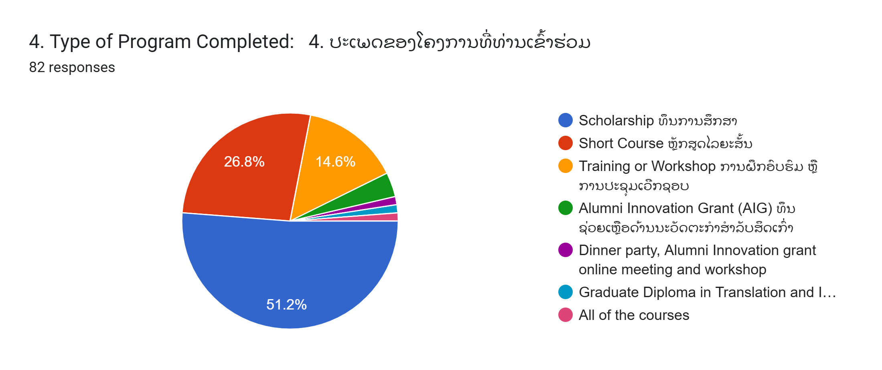
Section 2: Relevance
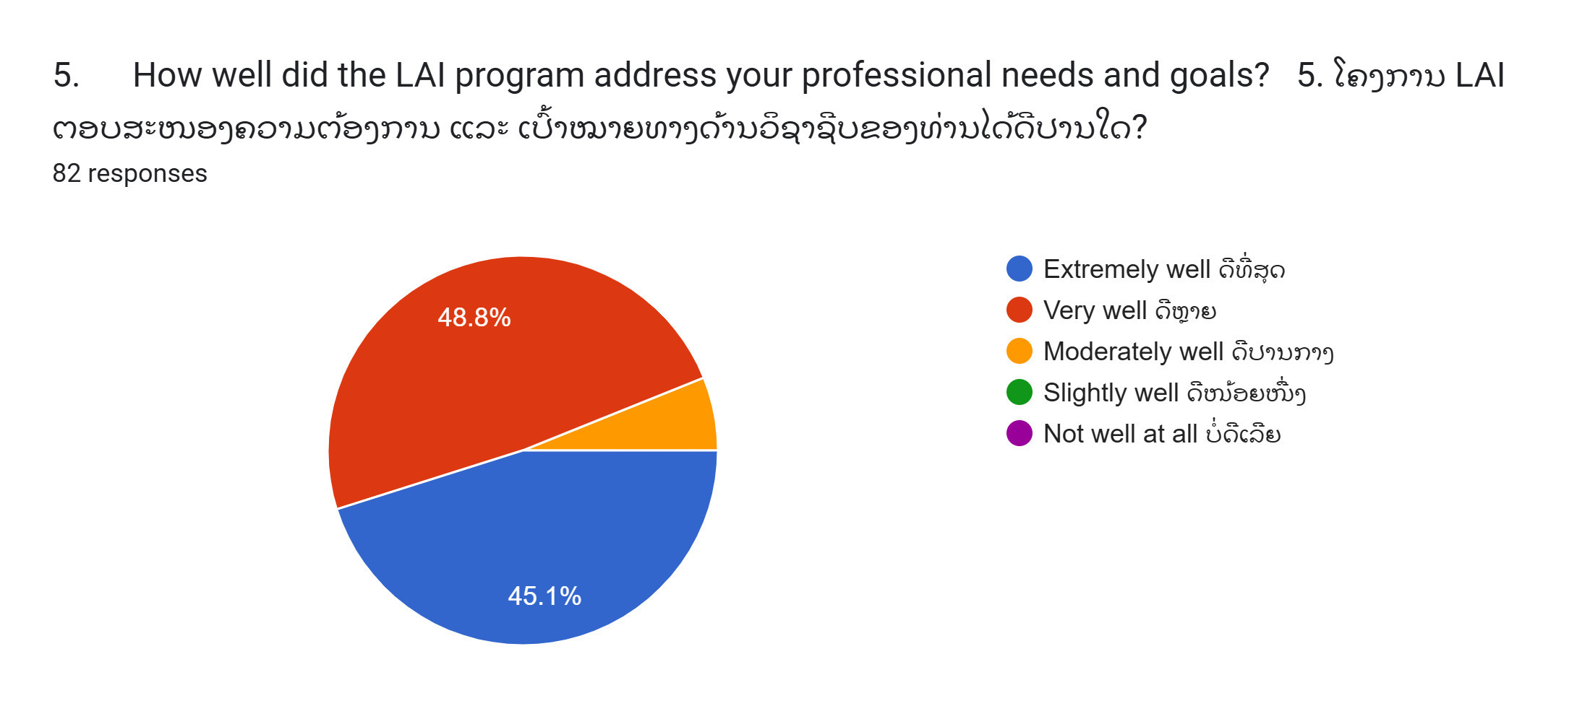
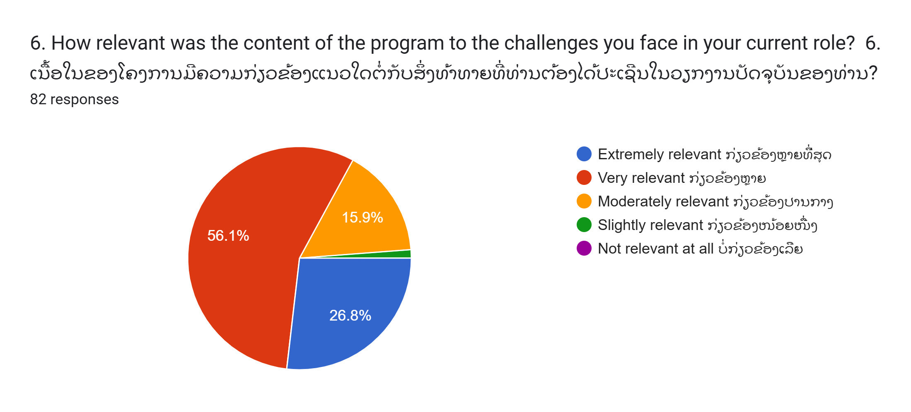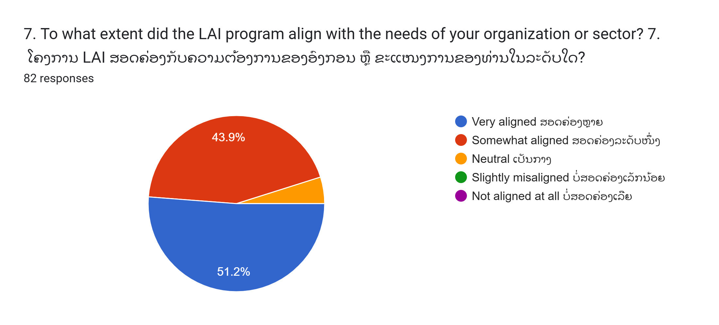
8. What could LAI improve to make its programs more relevant to your needs and career? (Open-ended)

Section 3: Effectiveness

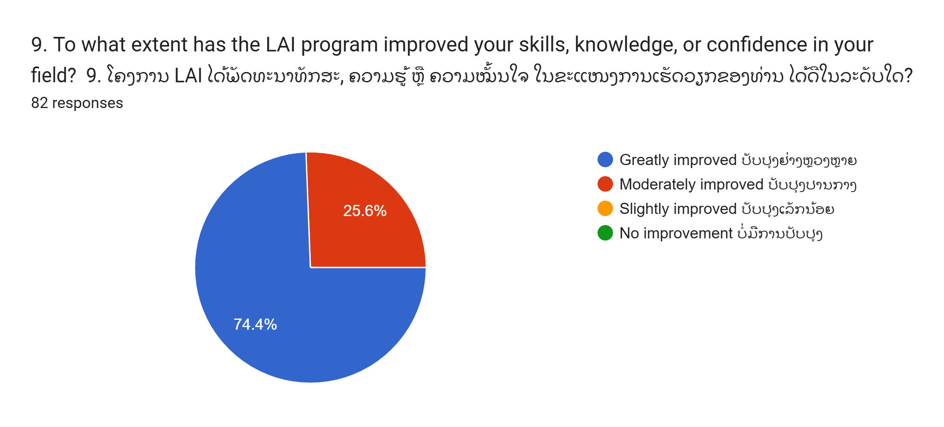
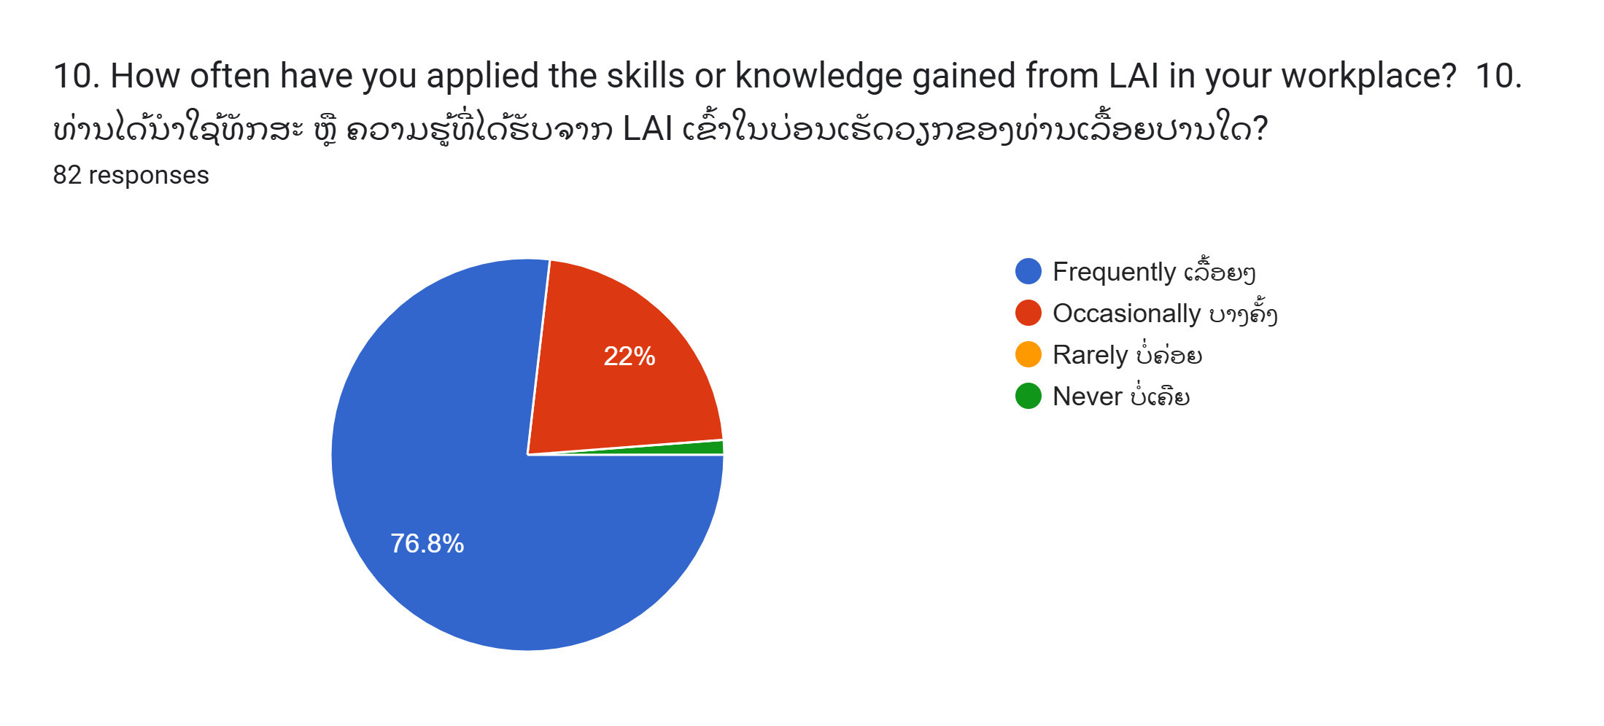

11. Please describe an example of how you have applied your LAI learnings in your workplace or community. (Open-ended)

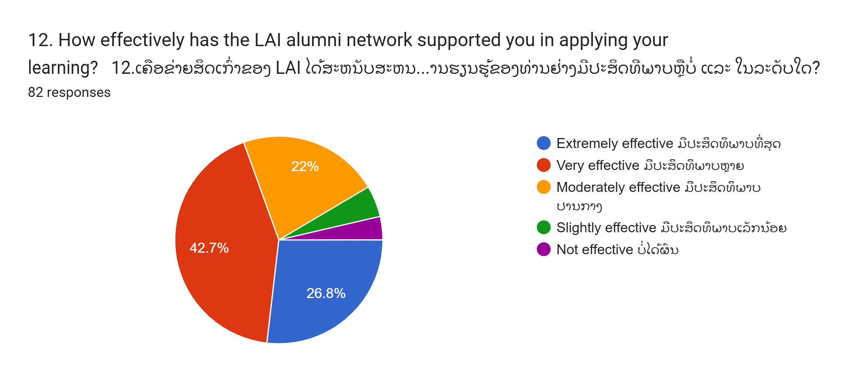
13. What could improve the support for applying learning after the program? (Open-ended)

Section 4: Efficiency
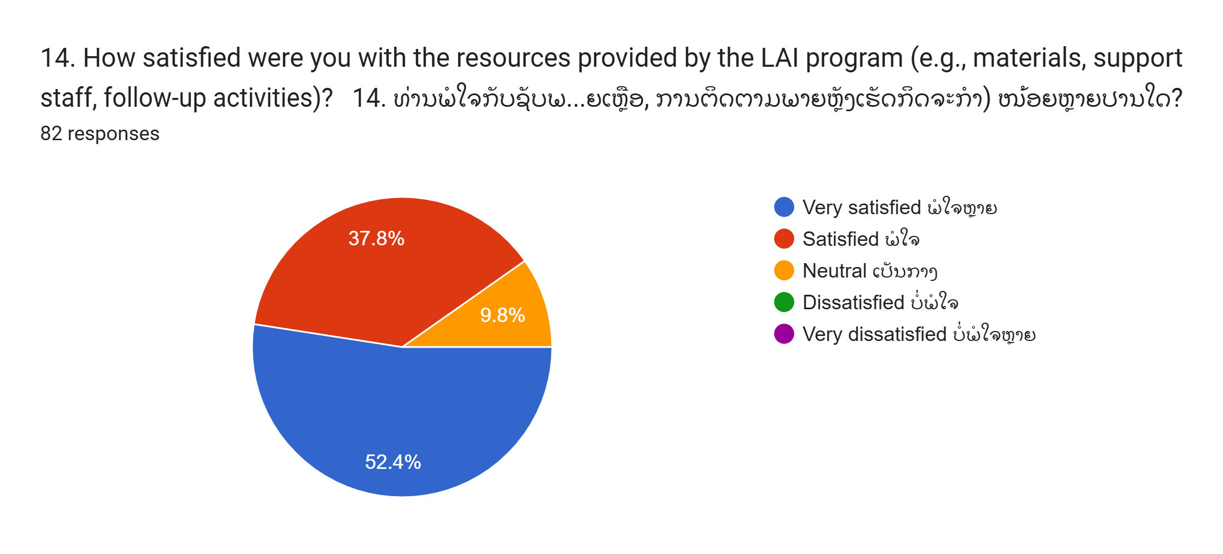

15. Did you face any challenges in accessing resources or maintaining engagement with LAI activities? (Open-ended)
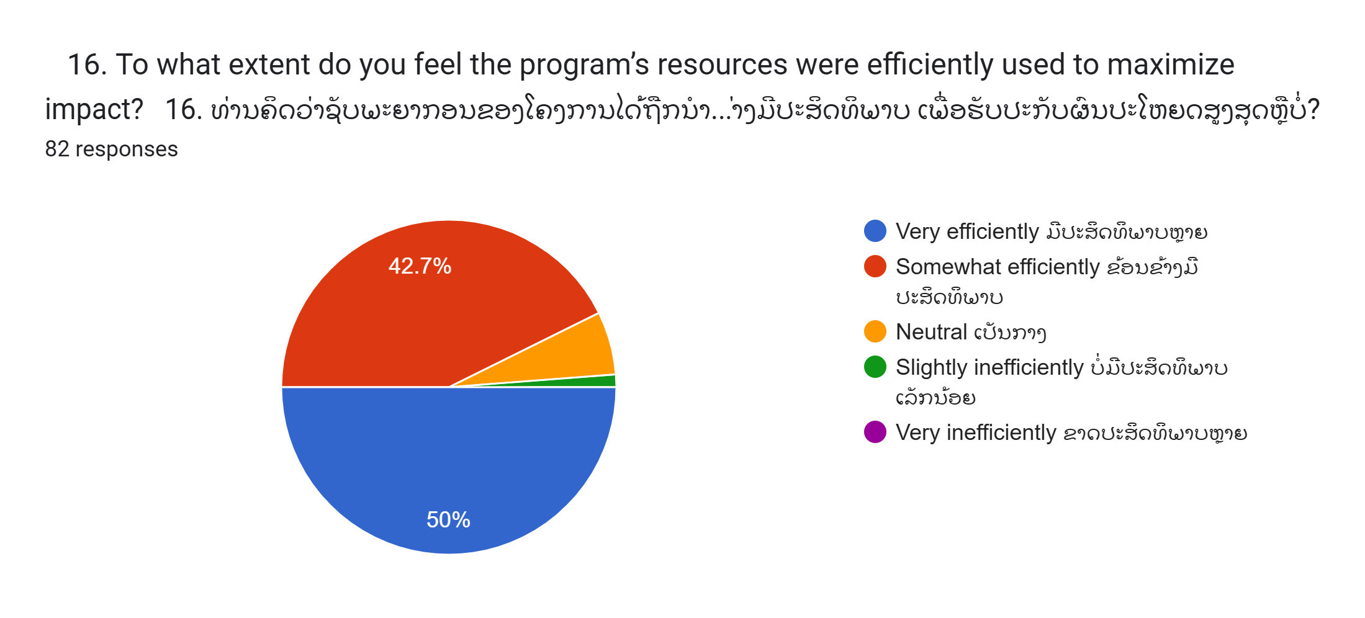
Section 5: GEDSI and Climate Change Integration
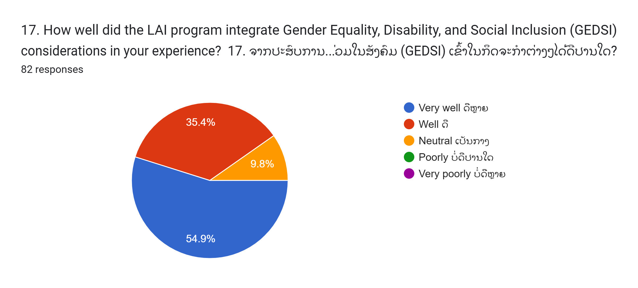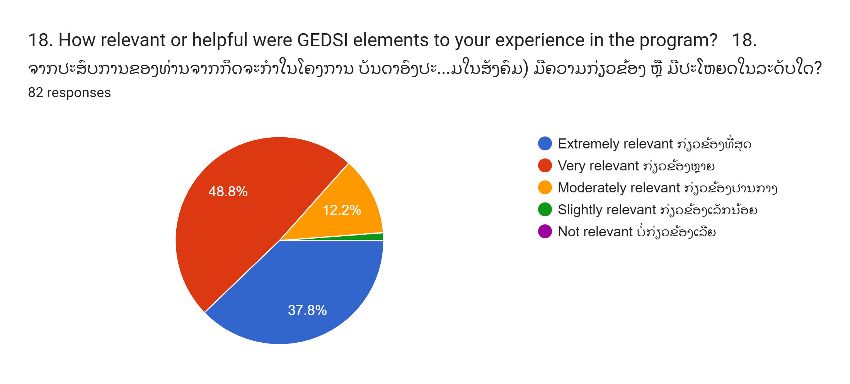
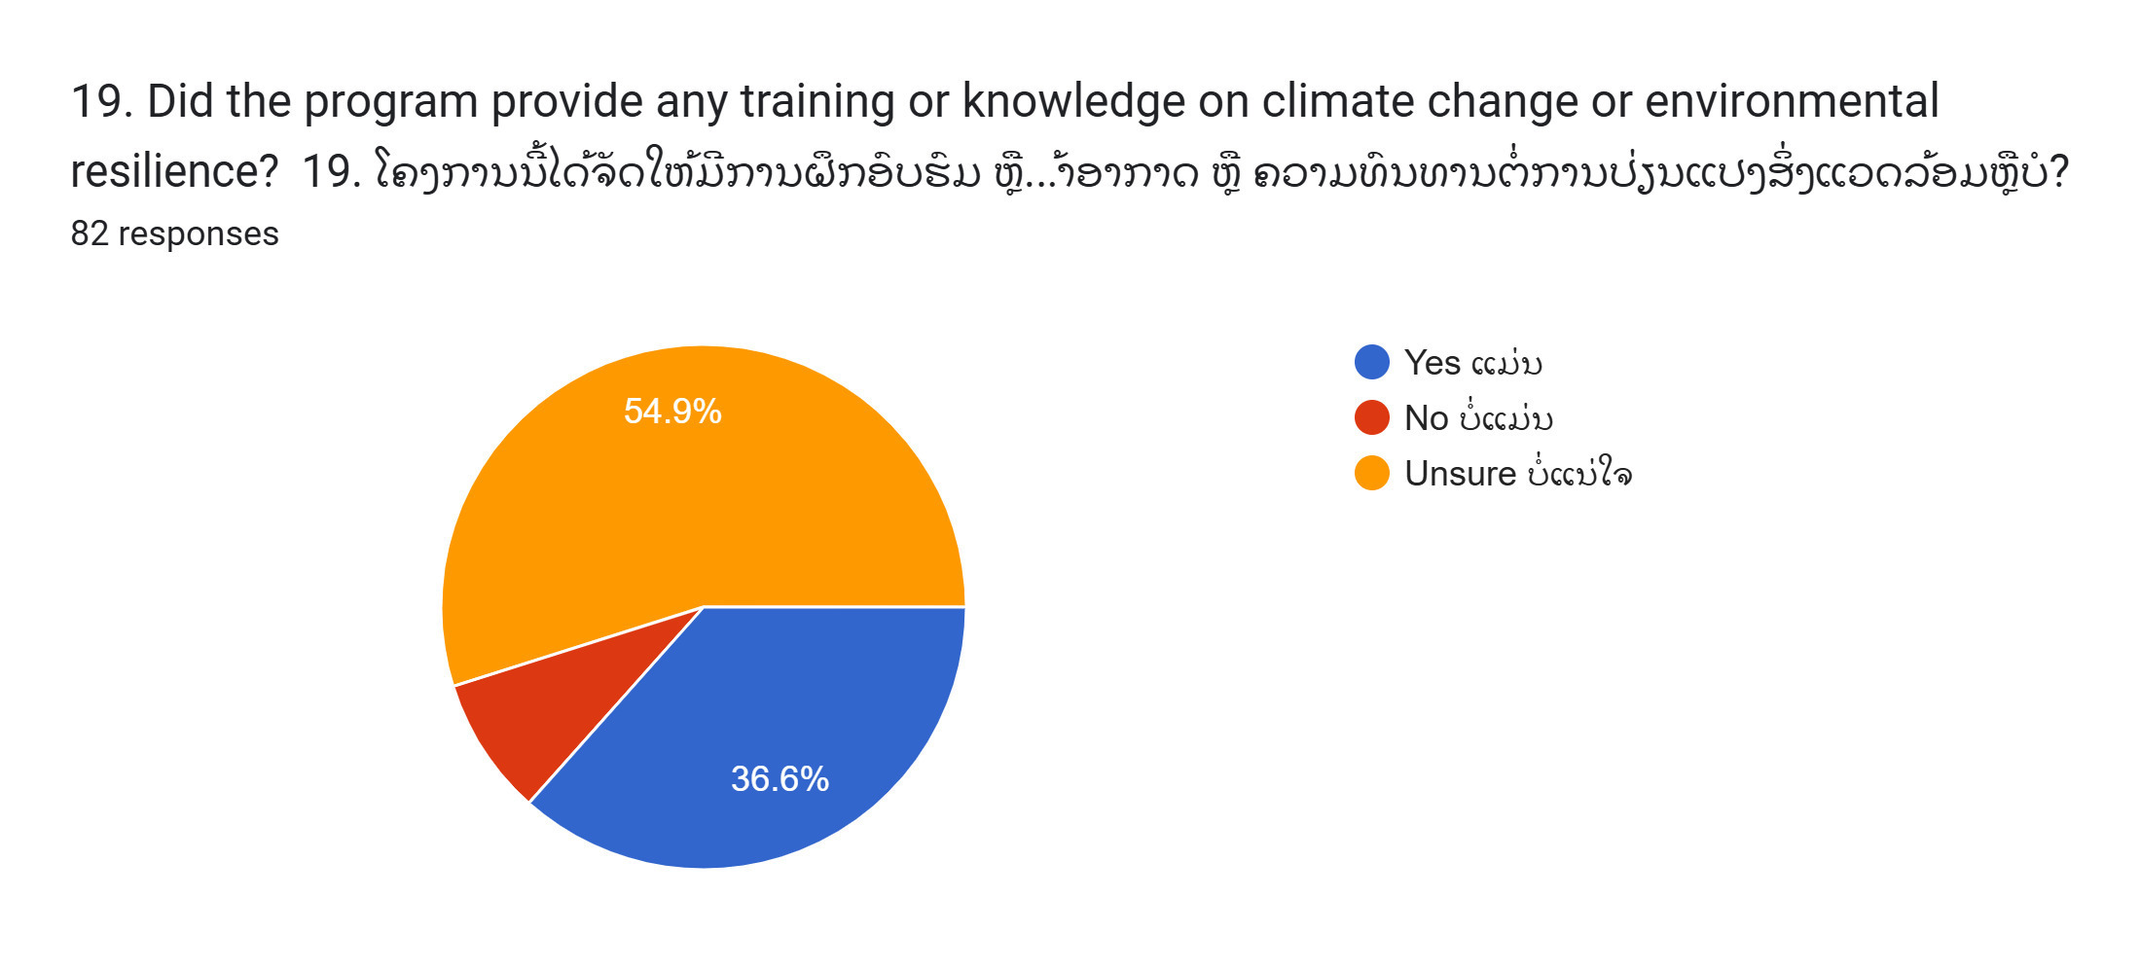
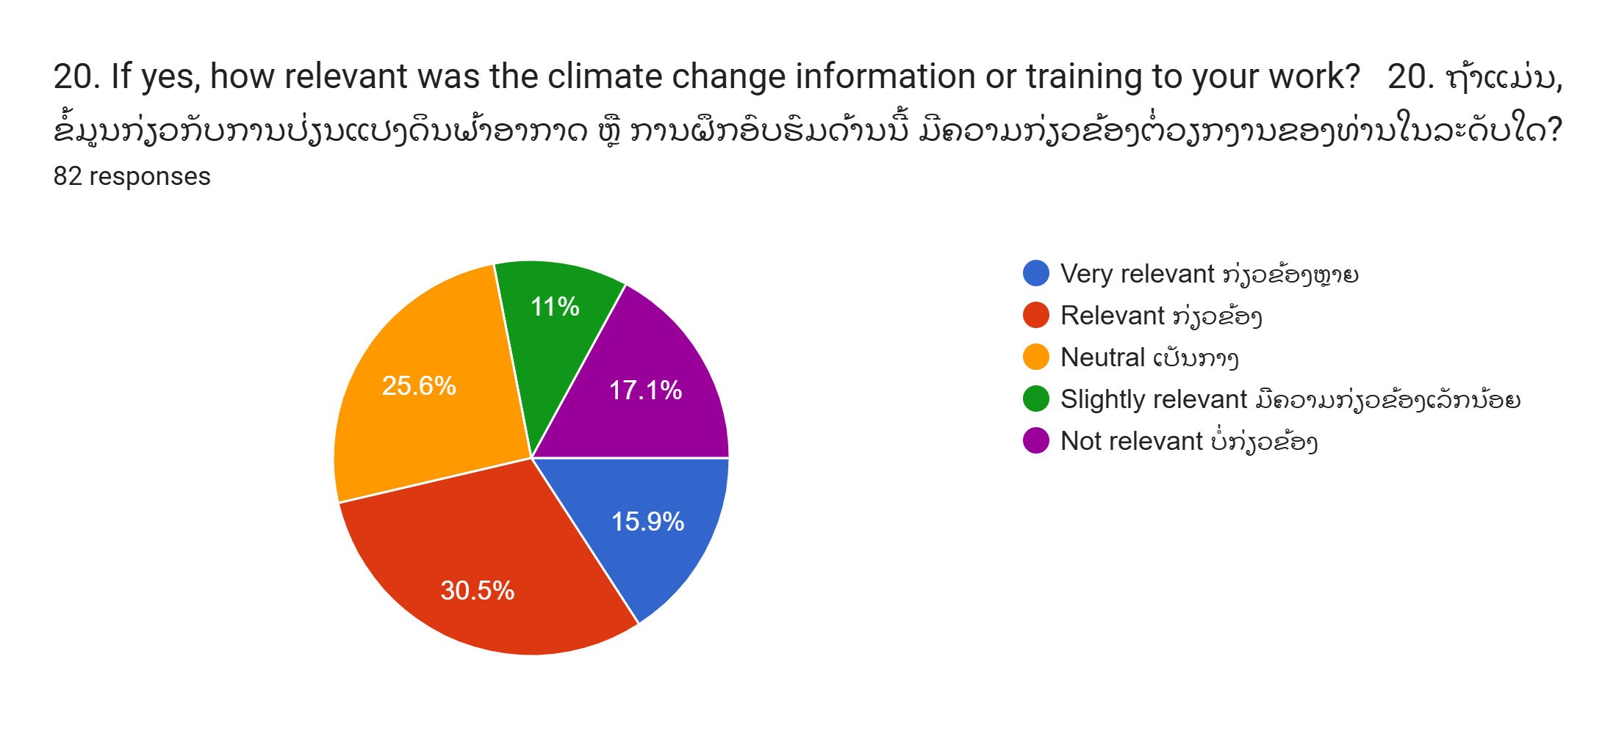
21. What additional support or topics could LAI provide related to GEDSI or climate change? (Open-ended)

Section 6: Learnings and Future Improvements
22. What are the most valuable skills or knowledge you gained from the LAI program? (Open-ended)
23. What would you like to see improved or added in future LAI programs? (Open-ended)
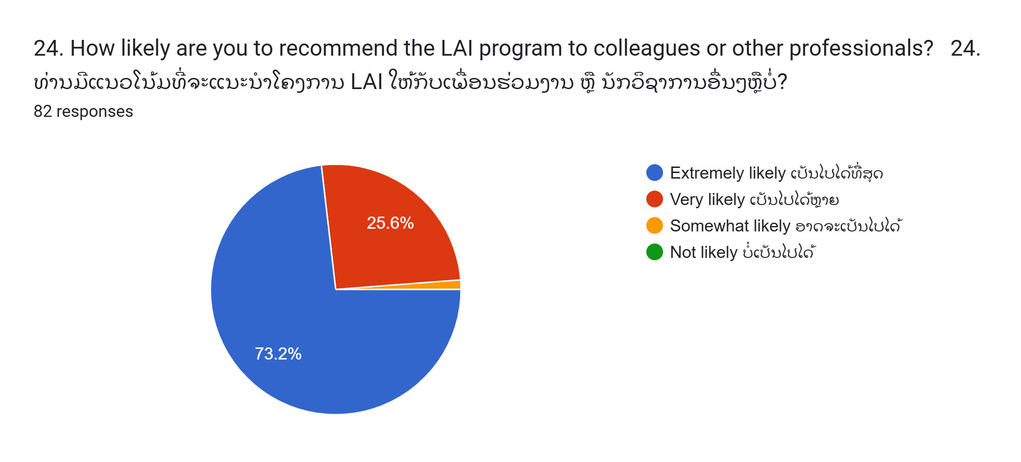

Section 7: Relevance to Laos-Australia relationship 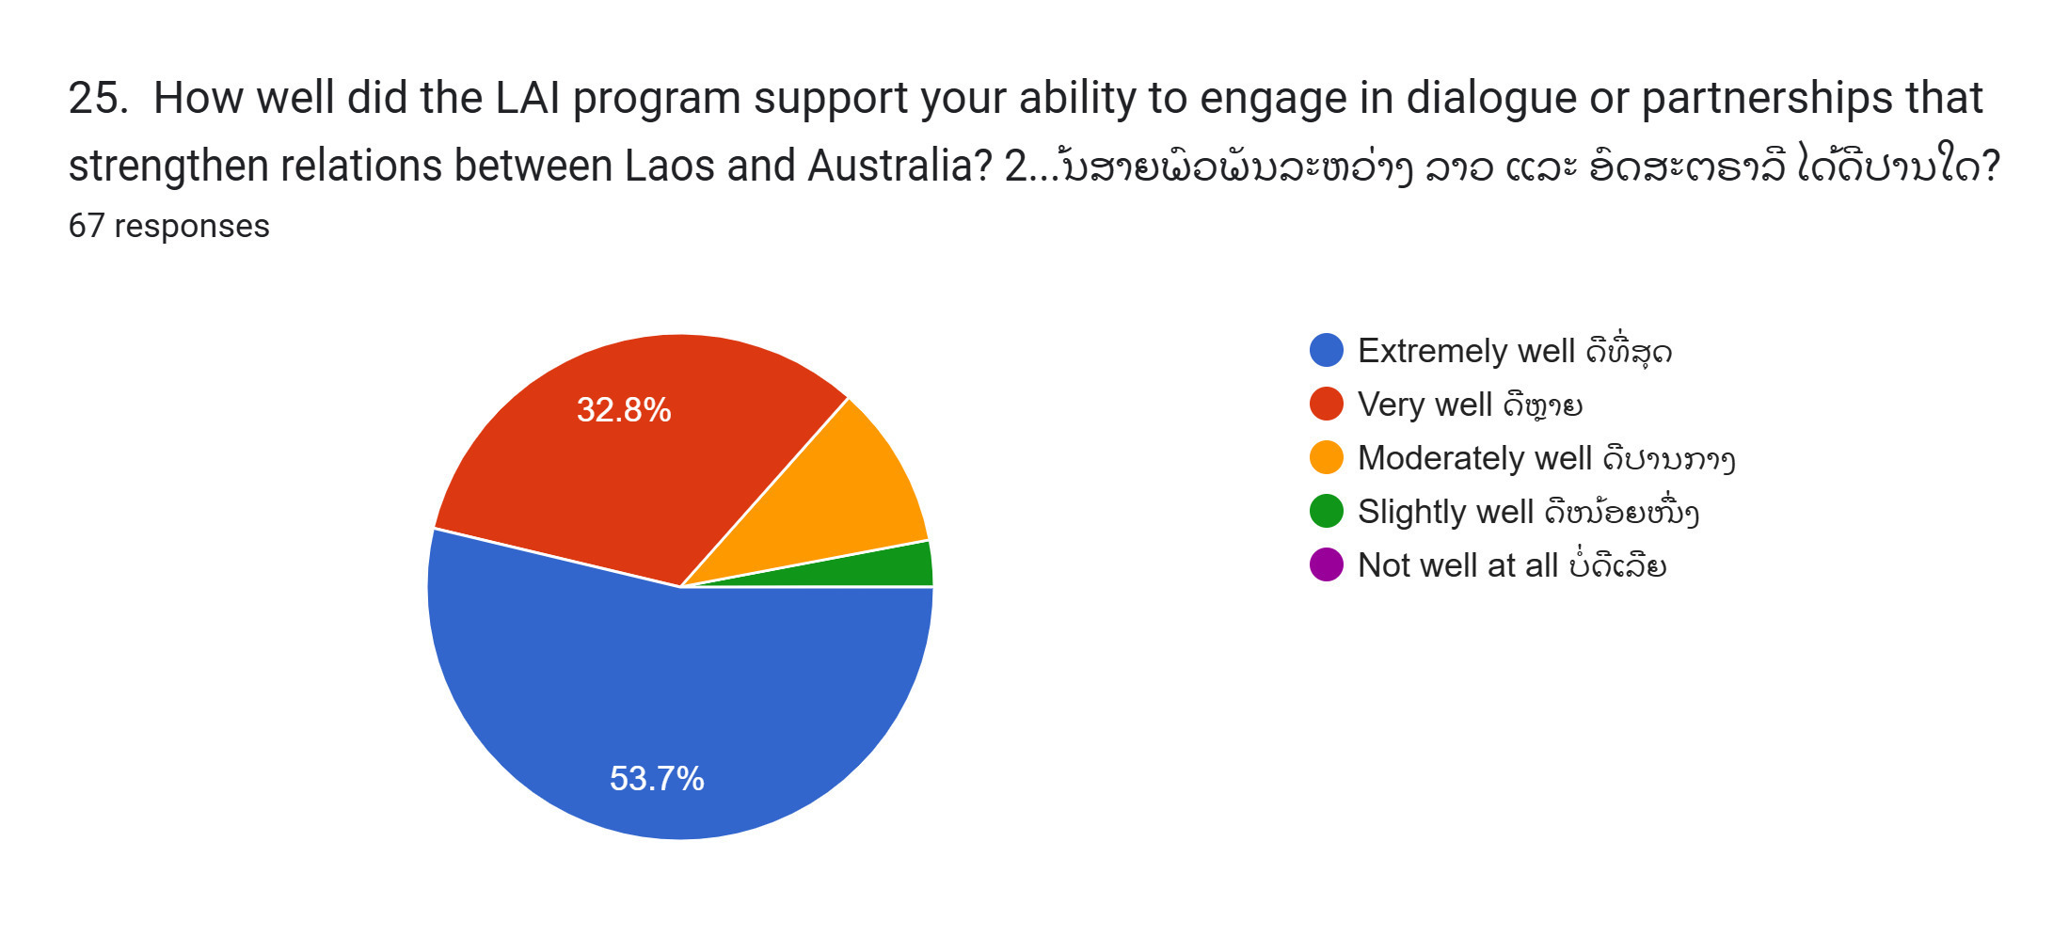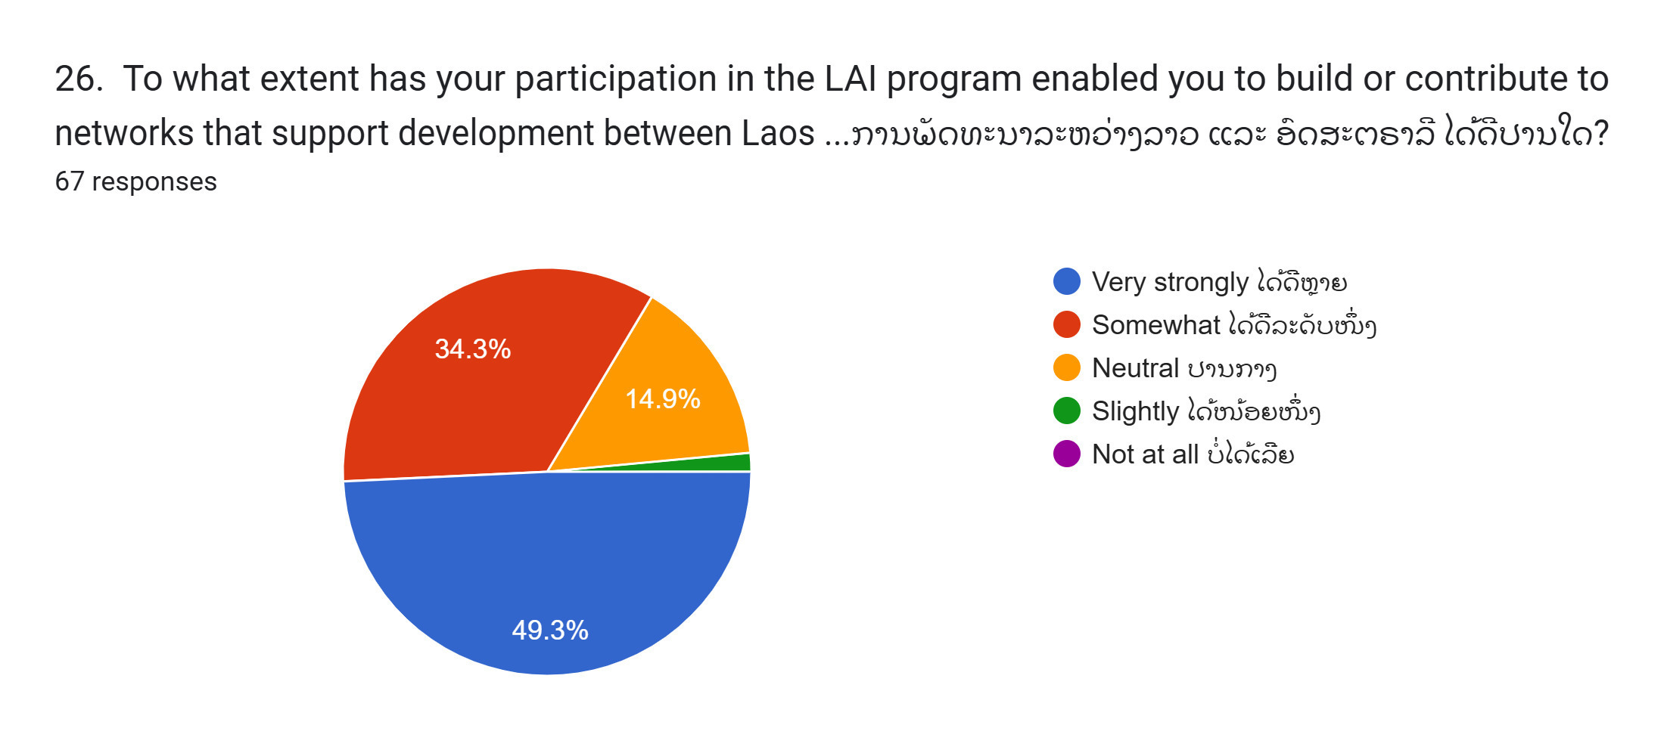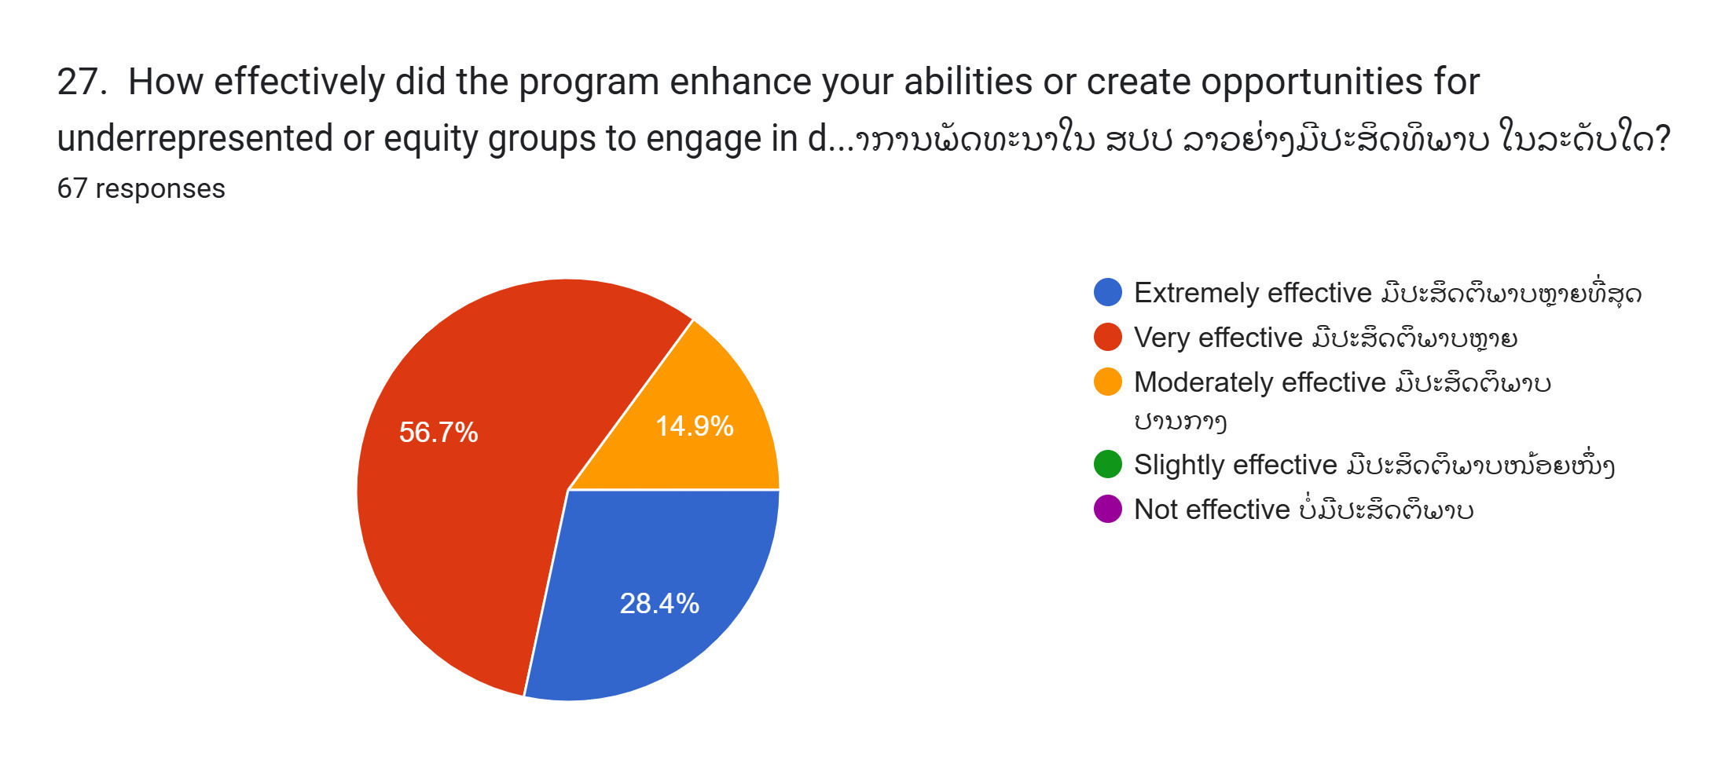

28. What additional support could LAI provide to further strengthen alumni's role in fostering cooperation between Laos and Australia? (Open-ended)
Section 8: Comments/ suggestions:
29. Please share any other comments or suggestions you have for improving the LAI program.

(End of the survey)

Annex F: Data analysis
Data collected through document review, interviews, and group discussions were systematically organised using an evidence matrix. This approach allowed for structured analysis by categorising findings under key themes aligned with the ToR and KEQs. Table 1 below illustrates the grid format used to collate and synthesise data.
- Table F.1: Data Analysis Grid Format
Data Source | Theme 1 | Theme 2 | Theme 3 | Theme 4 | etc.
1 | - | - | - | - | -
2 | - | - | - | - | -
3 | - | - | - | - | -
4 | - | - | - | - | -
etc. | - | - | - | - | -

The evaluation team identified 17 themes based on the ToR, KEQs, and initial document analysis. This thematic organisation facilitated brainstorming and report drafting, ensuring that findings were systematically presented. Memorable quotations from interviews and discussions were included to capture stakeholder perspectives and enrich the final report.
Quantitative data was primarily sourced from the document review and supplemented by discussions in the Political Economy Analysis. Data analysis utilised Excel-based tables and charts, which proved effective in visualising trends and comparisons. This approach enabled the evaluation team to identify key strengths and challenges, which were further validated through stakeholder discussions.
Findings and indicative recommendations were shared with key stakeholders through an Aide Memoire, serving as a ‘zero draft’ of this report.
- Table F.2: Themes Used in Data Analysis
Themes
- Relevance to GoL Priorities
- Alignment with Australia’s Strategic Objectives
- Scholarships and Capacity Development Outcomes
- Short Courses and Training Effectiveness
- Alumni Engagement and Contribution
- Institutional Capacity-Building
- Public Sector HRM and Leadership Development
- Partnerships and Trilateral Cooperation
- GEDSI Mainstreaming and Inclusion
- Impact of HRM and Leadership Programs
- Workplace Application and Organisational Change
- Monitoring, Evaluation, Research, Learning and Adaptation (MERLA) Effectiveness
- Sustainability and Localisation Strategies
- Policy Influence and Systemic Change
- Challenges and Barriers to Implementation
- Lessons Learned from Previous Phases
- Emerging Priorities (Climate Resilience, Digital Transformation, etc.)

This structured data analysis ensured that findings were robust, evidence-based, and directly linked to the evaluation questions, providing a strong foundation for conclusions and recommendations.

Annex G - Lao Human Resource Society (LHRS)
The Lao Human Resource Society (LHRS) was established to promote, encourage, and facilitate the growth, visibility, effectiveness, and professionalism of the HR profession in Laos and across the Mekong region, particularly in the MAP countries (Myanmar, Laos, and Cambodia). As the first formal HR professional network in Laos, LHRS provides a vital platform for collaboration, knowledge-sharing, and policy dialogue among HR practitioners across public, private, international, and non-governmental sectors.
Initiated by LAI, LHRS started with 14 core founding members and an additional 60 registered members engaging through a custom-made platform designed to foster networking and professional exchange. The Society’s inaugural HR Symposium, held on 24 November 2023, attracted approximately 110 participants and featured contributions from local, regional, and international HR experts. By 2024, LHRS membership had nearly doubled to 116 members, reflecting growing interest in HR professionalization in Laos. LAI continues to incubate and support LHRS as it progresses towards legal recognition and long-term sustainability.
Building on the success of the previous year’s symposium, the 2024 HR Conference in Vientiane on 8 November saw a significant increase in participation, with 260 attendees—53% of whom were women. The event highlighted diverse perspectives in HR, including speakers with disabilities, reinforcing LHRS’s commitment to inclusivity. Beyond large-scale conferences, LHRS initiated targeted knowledge-sharing activities, such as the June 2024 “Chat Session” on Climate Change and the Workplace, which engaged 21 participants in discussions on the intersection of environmental sustainability and HR practices.

Private sector engagement within HRD sector
The inclusion of private sector actors in HR leadership short courses and LHRS highlights their growing role in shaping HR development in Laos. Amid the current financial crisis, where skilled professionals increasingly migrate to the private sector due to higher wages and more career opportunities, the private sector is emerging as a crucial partner for HR development. HR leadership training under Phase III has not only enhanced the capacity of private sector leaders but has also created critical connections with government officials, fostering a rare space for public-private dialogue. Given Laos' centralised governance and limited public sector incentives, these relationships may be key in bridging gaps between the state’s administrative capacity and the private sector’s dynamic growth. The LHRS network could provide an important platform for future collaboration, driving innovative solutions to HR challenges and pushing for broader reforms. Engaging private sector leaders—particularly in growth sectors like tourism, logistics, and digital transformation—aligns with Laos’ economic priorities and could amplify HRD efforts, making them more responsive to the evolving needs of both public and private stakeholders. This collaboration may also offer leverage for broader policy reforms in HR management, which remain constrained by Laos' political economy, including entrenched patronage systems and limited institutional capacity.

Opportunities and challenges
LHRS has several opportunities for growth. As the first dedicated HR network in Laos, it is well-positioned as the leading authority in this field, with strong demand for up-to-date labour laws, HR best practices, and localized learning opportunities. If successfully established and self-sustaining, LHRS could serve as a lasting legacy of Australian government support for human capital development in Laos. Additionally, LHRS can play a crucial role in shaping national HR policies by providing a space for cross-sector feedback, particularly in relation to initiatives such as the National HRD Strategy and the LMIS.
However, LHRS faces several challenges. HR professionals in Laos often have demanding workloads, limiting their capacity to engage in voluntary professional networks unless there are clear, practical benefits. Moreover, professional networking is a relatively new concept in Laos, requiring targeted awareness-raising efforts to demonstrate the long-term benefits of membership. Funding and sustainability also pose concerns, as developing a monetization strategy—such as membership fees—may face resistance unless LHRS can clearly demonstrate its value proposition and offer tangible benefits to its members.
In 2024, LHRS focused on finalising a strategic work plan and determining its long-term resource requirements to ensure sustainability. Key areas of focus include expanding membership engagement through structured learning and networking opportunities, strengthening partnerships with policymakers and industry leaders, and exploring funding models that balance accessibility with financial sustainability. By leveraging its ‘first-mover’ advantage, fostering meaningful engagement, and ensuring financial sustainability, LHRS has the potential to serve as a lasting platform for HR development, policy dialogue, and workforce innovation in Laos.

Annex H: Political Economy Analysis
The LAI Phase III operates within a complex and evolving political economic landscape shaped by Laos’ centralised governance structures, economic vulnerabilities, and strategic regional positioning. Understanding these dynamics is critical for the Review to understand how the program remains politically feasible, contextually relevant, and aligned with both Laos’ national development priorities and Australia’s CP with Laos.

1. Centralised Governance and Policy Environment
Laos is a one-party state governed by the LPRP since 1975, where decision-making is centralised, and policy reforms occur gradually through high-level political consensus. The LPRP sets the strategic directions through its national congress and central committees. The government ministries are responsible for policy implementation. The government operates through a civil service of 18 national ministries and 17 provincial governments and 1 prefecture (Vientiane Capital). Ministers of the national ministries are senior party members appointed to ensure alignment of state function to the party directives. Provincial party committees replicated the national structure at provincial level and provincial governors also hold the dual role as party secretaries.
The NSEDPs is the strategic national document and the cornerstone of Laos’ national planning, outlining key development priorities in five-year cycles. The latest NSEDP is the 9th NSEDP reflecting the strategic vision of the LPRP on the five-year plan from 2021 to 2025, passed in the 11th National Congress held in 2021.The NSEDP integrates economic growth, poverty reduction, HRD, infrastructure development and other SDGs to enable Laos graduate from its status as a Least Developed Country.
The MPI is the key government body responsible for leading the formulation process. It translates the Party’s strategic directions into concrete plans and targets by coordinating and collaborating with other ministries, provincial governments, and development partners for technical assistance and funding. Key development partners that supported the 9th NSEDP include UN Joint Programs, World Bank, Global Green Growth Institute, Australia, Japan, EU, ADB, and JICA The MOES contributes to the NSEDP through the HRD framework, including the development of the NHRDS. The Australian Government, through the LAI, has provided technical assistance for implementing this strategy (Intermediate Outcome 1) and the M&E framework. MOHA plays a pivotal role in overseeing public sector HRM, including civil service management and public administration.
Any institutional reform, particularly in HRD, requires high-level political endorsement to gain traction. While there is increasing recognition of HRD’s role in economic transformation, the government favours incremental rather than sweeping reforms. Given this context, LAI has adopted a politically astute engagement approach, fostering trusted relationships, structured policy dialogues, and alignment with Laos’ national strategies, such as the 9th NSEDP (2021 to 2025).
A key institution in Laos’ HRD landscape is the NAPPA, which plays a central role in training civil servants, policymakers, and government leaders. While NAPPA is a critical entry point for HRD interventions, its curriculum, teaching methodologies, and institutional capacity remain heavily centralised and shaped by political considerations. Enhancing NAPPA’s role in sector-specific leadership training - particularly in areas such as governance, economic policy, and digital transformation—could potentially create a sustainable pathway for HRD reforms that align with national priorities. However, any capacity-building initiatives need to be designed collaboratively with MOES, MOHA, MPI, and other key ministries to ensure they are politically viable and institutionally embedded.
1. Economic Constraints and Development Pressures
In the early 1990s, Laos began transitioning from a centrally planned economy to a market-oriented system under the New Economic Mechanism introduced in 1986. These strategic reforms introduced several liberalisation policies including removing state price controls, unified exchange rates, development of market-based rules legislation and encouraging private enterprise engagement and ownership, leading to steady economic growth. The economy grew at an average annual rate of 6.3% throughout the 1990s, despite the negative impact of the Asian Financial Crisis (1997–1999), which led to temporary slowdowns. Entering the 2000s, growth accelerated further, averaging 7.5% annually from 2000 to 2018. This period was characterised by capital-intensive investments, particularly in the hydropower and mining sectors, driven by foreign direct investment and regional demand, especially from China and Thailand.
According to the 8th and 9th NSEDP, the government’s strategic direction for the Laos’ economy is to shift from an agriculture-based economy towards to industrialisation and modernisation. This shift has been evident in the progressive transformation of the economic structure, moving from agriculture to the industry and service sectors. Agriculture’s share of GDP declined from approximately 60% in 1990 to 30% by 2011 and further to 16.6% by 2020, while the share of the industry and services sectors expanded rapidly, accounting for 33% and 39.5% of GDP, respectively, in 2020. Hydropower projects, mining exports, and infrastructure development played significant roles in industrial growth, while tourism became a key contributor to the services sector.
From 2019 to 2020, Laos experienced the lowest economic growth since the 1990s with GDP growth rate of 0.5%. While this was primarily due to the global impact of the COVID-19 pandemic, it was also the result of accumulated macroeconomic vulnerabilities over the years, including debt problems, fiscal deficits and natural disasters such as typhoon Son-Tinh in 2018, several flooding and the collapse of the dam in Attapeu Province. The pandemic led to a significant decrease in tourism, disruptions in trade and investments, decline in FDI—particularly in infrastructure and natural resource projects - and reduced remittances from aboard which decreased by approximately USD97 million in 2020. Laos’ debt accumulation accelerated significantly in the 2010s due to large-scale infrastructure investments, including hydropower, road, and railway projects. The government pursued these projects as part of its strategy to become the “Battery of Southeast Asia” and to transition Laos from a "landlocked" to a "land-linked" economy.
Post COVID-19 pandemic, Laos has faced ongoing challenges characterised by macroeconomic instability and structural vulnerabilities. Despite some recovery in sectors like tourism, transport, logistics, and energy, overall economic growth remains below pre-pandemic levels. Persistent issues such as high inflation, currency depreciation, and slow growth continue to impede progress.
Building on these macroeconomic challenges, Laos now confronts mounting pressures from high public debt, currently estimated at over 100% of GDP, alongside a persistent fiscal deficit and growing reliance on external financing, particularly from China. These financial constraints not only hinder short-term economic stability but also limit the government’s ability to invest in long-term institutional development, including critical areas like public sector HRM and broader HRD initiatives.
In response to these pressures, Laos is actively pursuing strategies to diversify its economic base beyond its dependence on natural resources and hydropower. A key priority for skills development, identified based on strategic direction of the 9th NSEDP and aligned with the World Bank’s “Lao PDR Priority Skills for Growth” initiative, is addressing skills shortages in high potential sectors such as agriculture (modern farming, agribusiness etc), logistics, ICT, tourism, and sustainable energy. These sectors are crucial for enhancing workforce productivity, competitiveness, and sustainable economic growth. As part of regional integration efforts through ASEAN and the Mekong Region, Laos must also place greater emphasis on trade competitiveness, advancing digital transformation, and promoting green growth to remain regionally competitive and aligned with regional and global economic trends.

2. Regional and International Dynamics
Laos’ strategic position within ASEAN and its growing economic linkages with China, Vietnam, and Thailand shape its development choices. The BRI has deepened Laos’ economic dependence on China, with significant investments in infrastructure, energy, and transport. While these developments provide opportunities for economic growth, they also present risks related to debt sustainability and economic sovereignty.
At the same time, Laos seeks to balance its international partnerships, including strengthening ties with Australia under the CP. This presents an opportunity for LAI Phase III to position itself as a key platform for Australian expertise in HRD, governance, and public sector leadership. Trilateral and regional partnerships involving ASEAN and Australia’s regional initiatives (e.g. MAP) could further enhance the program’s impact by embedding Laos within broader regional HRD networks.

As defined in the LAI GEDSI Strategy, this term refers to all groups for whom additional effort to ensure inclusion is necessary. This is further defined as women, people with disability, ethnic minorities and those living in rural and remote areas.
Please see a speech by H.E. Paul Kelly, Australian Ambassador to Lao PDR, “Australia’s Approach to Foreign Policy and the Bilateral Relationship with Lao PDR”: https://laos.embassy.gov.au/vtan/HOM_KELLY_SPEECH_NAPPA.html
The rating is based on the following likert scale: Likert scale 1; Very Poor 2: Poor 3: Slightly Satisfactory 4: Satisfactory 5: Good 6: Very Good
In Lao, official census data from 2015—almost 10 years ago—states an overall prevalence of disability at 2.77 percent. A 2019 survey by the World Health Organization indicates that 23 percent of adults experience a severe form of disability, suggesting that Laoshas a higher-than-global-average rate of persons with disabilities (16% of the world population).
The Laos-Australia Development Learning Facility (LADLF) (2014–2020) was a DFAT-funded initiative managed by Adam Smith International to enhance the effectiveness of Australian aid in Laos. It provided contextual analysis, strategic guidance, performance assessments, and public diplomacy support across sectors like education, human rights, trade, and water resource management.
The dual-pathway methodology refers to the combined use of retrospective evaluation (to assess past performance) and forward-looking analysis (to shape future program directions).
DFAT's performance ratings are based on a 6-point scale, where ratings of 6 (very good), 5 (good), and 4 (adequate) are considered satisfactory, and ratings of 3 (less than adequate), 2 (poor), and 1 (very poor) are considered unsatisfactory
The 9th National Socio-Economic Development Plan (NSEDP) of Lao PDR (2021-2025) emphasises human resource development (HRD) as a pivotal element for the nation's socio-economic advancement to develop a competent and competitive workforce capable of driving sustainable economic growth and facilitating Laos’ integration into the regional and global economy.
The Education and Sports Sector Development Plan (ESSDP) 2021-2025 is a strategic framework developed by the Ministry of Education and Sports (MOES) Its primary objective is to enhance the education system to produce human resources equipped with knowledge, skills, ethics, and values, fostering a quality workforce that meets the demands of a growing economy.
The Australia-Laos Development Partnership is a bilateral initiative between the Australian Government and the Government of Laos aimed at fostering sustainable development, economic growth, and stability in Laos. This partnership focuses on key areas such as human resource development, gender equality, health security, economic recovery, and education. Australia plays a significant role in supporting Laos through scholarships, institutional capacity-building, and technical cooperation. In March 2024, the bilateral relationship was elevated to a Comprehensive Partnership, further deepening engagement in these sectors. (Source: Australian Government Department of Foreign Affairs and Trade (DFAT), "Development Assistance in Laos," DFAT website
As part of Mekong-Australia Partnership (MAP), an initiative launched in 2020, aimed at strengthening regional cooperation between Australia and the Mekong subregion, including Laos and Vietnam. MAP focuses on enhancing economic resilience, human capacity development, and climate adaptation. For Laos, MAP supports human resource development, governance, and sustainable energy initiatives, while in Vietnam, it bolsters trade cooperation, governance reforms, and public sector capacity-building. The trilateral collaboration among Australia, Laos, and Vietnam under MAP includes leadership training, investment policy enhancement, and institutional to promote inclusive growth and regional stability
Question 10 in LAI Alumni Survey, with total 82 respondents.
Based on 2024 ADIS, 66% of AAS alumni advising on Australian education and business opportunities, 62% of AASC alumni advising on inclusive HRM, and 68% (AASC) and 66% (AAS) informing others about Australian talents and resources
The Government of Laos (GoL), through the Ministry of Education and Sports (MOES), has sought Australia's expertise in formulating its 10-year Human Resource Development (HRD) Strategy for 2026–2035. This collaboration is facilitated through the Laos-Australia Institute (LAI).
The Laos-Australia Friendship Association was established to strengthen diplomatic, economic, and people-to-people ties between Laos and Australia. On May 16, 2023, Australia’s Foreign Minister Penny Wong and H.E. Thongsavanh Phomvihane, Head of the External Relations Committee of the Lao People's Revolutionary Party, signed a Declaration of Shared Intent to formalize the association. This initiative reflects the two nations’ commitment to enhancing bilateral relations and cooperation across multiple sectors. (Source: Australian Embassy in Laos, "Foreign Minister Wong's Visit to Lao PDR," Embassy website).
The Governments of Australia and Laos have committed to work trilaterally with Vietnam to promote sustainable development, economic resilience, and mutual understanding Please see a speech by H.E. Paul Kelly, Australian Ambassador to Lao PDR, “Australia’s Approach to Foreign Policy and the Bilateral Relationship with Lao PDR”: https://laos.embassy.gov.au/vtan/HOM_KELLY_SPEECH_NAPPA.html
The Laos Australia National Scholarships (LANS) is a scholarship program funded by the Australian Government to support young Lao men and women from economically disadvantaged backgrounds and individuals with disabilities to study at the National University of Laos (NUOL) in Vientiane Capital and at the Souphanouvong University (SU) in Luang Prabang.
ORCA baseline surveys conducted with MOES, MPI, NAPPA, and LWU, as well as midline survey with MPI.
Likert scale Extremely Likely Likely Somewhat Likely Unlikely Extremely Unlikely
Question 9 in LAI Alumni Survey, with total 82 respondents.
Question 10 in LAI Alumni Survey, with total 82 respondents.
Question 11 in LAI Alumni Survey, with total 82 respondents.
Qualitative response to question 22 in the LAI Alumni Survey
Qualitative response to question 11 in the LAI Alumni Survey
AASC includes (1) AASC HR Leadership for Future Works (2) AASC Regional Inclusive Leadership (3) AASC Strategic Analysis and Analytical Writing Course
CLT includes (1) i) Note taking and report writing (2) Effective Leadership Program (3) Project proposal formulation and drafting (4) IELTS course and general English
Interviews with LAI Management
Data from ADIS, mentioned in 2023 Annual Report
Data from the 2024 HRDIS.
Question 17 in LAI Alumni Survey, with total 82 respondents.
Question 18 in LAI Alumni Survey, with total 82 respondents.
The 2022, 2023 and 2024 ADIS LANS Alumni Surveys were analysed; however, the qualitative responses from the 2023 ADIS LANS Alumni Survey stood out more prominently, likely due to the announcement of the LANS program phase-out, which triggered strong reactions from alumni.
Written response from AA scholarship recipient with disability.
Laos continues to face significant economic challenges, which have been heightened following the pandemic, stemming from structural issues and external factors, including its high national debt, reliance on imports, and inadequate revenue collection. Despite government measures to address inflation and economic instability, results have been minimal, with inflation and the depreciation of the kip remaining high. This economic strain has led to a decline in per capita GDP, the dropping out of schooling at record rates, and the continued emigration of young people seeking work abroad. See Lao Economic Monitor, May 2023: Addressing Economic Uncertainty - Key Findings
Please see a speech by H.E. Paul Kelly, Australian Ambassador to Lao PDR, “Australia’s Approach to Foreign Policy and the Bilateral Relationship with Lao PDR”: https://laos.embassy.gov.au/vtan/HOM_KELLY_SPEECH_NAPPA.html
Recommendations are for the remainder of the program to 30 June 2026.
`Qualitative responses can be provided upon request.
Qualitative response can be provided upon request.
Qualitative response can be provided upon request.
Qualitative response can be provided upon request.
Qualitative response can be provided upon request.
Qualitative response can be provided upon request.
Qualitative response can be provided upon request.
Qualitative response can be provided upon request.
Qualitative response can be provided upon request.
United Nations in Lao PDR, Government of Lao PDR and Development Partners Validate Financing Strategy for the 9th NSEDP, accessed February 7, 2025, https://laopdr.un.org/en/201859-government-lao-pdr-and-development-partners-validate-financing-strategy-9th-nsedp.
Asian Development Bank. (2013). The Lao Economy: Capitalizing on Natural Resource Exports.
World Bank. (2022). Lao PDR Economic Monitor, October 2022. Retrieved from thedocs.worldbank.org
Asian Development Bank. (2015). The Lao Economy: Capitalizing on Natural Resource Investments and Integrating into the Global Economy.
Data from Asian Development Bank. (2013). The Lao Economy: Capitalizing on Natural Resource Exports.
The economic structure data reported in the 9th NSEDP, page 10.
World Bank. Lao PDR economic data overview (2021). Retrieved from https://thedocs.worldbank.org/en/doc/b991970a7f5096ab093720e27d5f0b68-0500012021/related/data-lao.pdf
The 9th NSEDP report, page 9
World Bank. (2021). Lao PDR economic monitor: Supporting economic recovery—Livelihoods in the time of COVID-19. Retrieved from https://pubdocs.worldbank.org/en/306131610167443727/Lao-PDR-Economic-Monitor-January-2021-Supporting-Economic-Recovery-Thematic-section-Livelihoods-in-the-Time-of-COVID-19.pdf
International Labour Organization. Labour Migration in Lao PDR: Trends and Policy Responses in the Wake of COVID-19. 2023. Available at: https://www.ilo.org/sites/default/files/wcmsp5/groups/public/%40asia/%40ro-bangkok/%40sro-bangkok/documents/publication/wcms_891143.pdf
World Bank. Lao Economic Monitor, October 2024: Reforms for Stability and Growth. World Bank, Oct. 2024, https://www.worldbank.org/en/country/lao/publication/lao-economic-monitor-october-2024-reforms-for-stability-and-growth-key-findings.
World Bank. (2022, March 3). Boosting skills for better growth in Lao PDR. Retrieved from https://www.worldbank.org/en/news/press-release/2022/03/03/boosting-skills-for-better-growth-in-lao-pdr
ASEAN, ASEAN Declaration on Human Resources Development for the Changing World of Work and Its Roadmap (Jakarta: ASEAN Secretariat, 2021)

