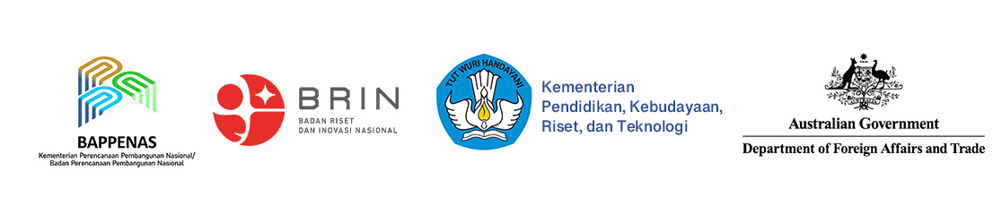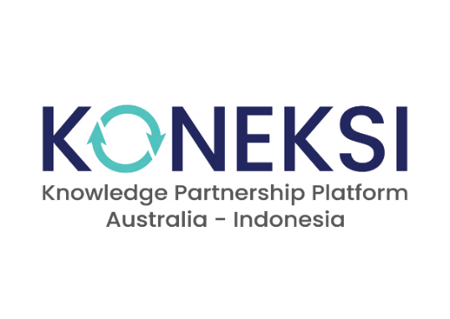

**KONEKSI**

Knowledge Partnership Platform Australia- Indonesia

**Goal**

An enduring relationship between Indonesia and Australia that advances mutual interest and supports Indonesia’s inclusive and sustainable development.

**Purpose**

Increased use of knowledge-based solutions for inclusive and sustainable policies and technologies.

*The Australia-Indonesia Knowledge Partnership Platform or KONEKSI is the Australian Government’s flagship program in the knowledge and innovation sector in Indonesia.*

KONEKSI is funded by DFAT, with a budget of up to AUD 50 million over five years (2022-27). KONEKSI will support partnerships between Australian and Indonesian knowledge organisations to carry out and disseminate high-quality, multidisciplinary, and applied research on complex socio-economic problems that reflect the mutual priorities and interests of both countries. The research themes will be agreed jointly between the Governments of Australia and Indonesia, considering Indonesia’s medium-and long-term development priorities, relevant cooperation agreements and the evolving bilateral relationship.

**End-of-Investment Outcomes (EOIOs)**

* Australian and Indonesian organisations have increased collaboration and mutual understanding through knowledge partnerships in the areas of policy and technology, in Indonesia and Australia.
* Innovative solutions for inclusive and sustainable policies and technologies are generated through new knowledge partnerships.

**Program Approaches**

Facilitating and strengthening organizational partnerships

Building partners’ capacities in relation to Gender Equality, Disability and Social Inclusion (GEDSI)

Support the enabling environment and the Indonesian knowledge and innovation ecosystem to make best use of knowledge partnerships

Key elements of the KONEKSI approach: Key elements of KONEKSI approach: i) Balance between strategic priority setting and demand-driven research; ii) Adopt a targeted, system-based approach to technical assistance; iii) Build coalitions of stakeholders from government, non-state actors, private sector, and communities; iv) Support more sustainable research and innovation funding; v) Respond to knowledge gaps in equality and inclusion.

**Knowledge to policy**



**Knowledge to innovation**

Central to KONEKSI is supporting partnerships and activities that will respond to knowledge gaps in equality and inclusion, particularly enhancing knowledge on indigenous issues and raising the profile of gender equality, disability, and social inclusion (GEDSI)-responsive interventions to support Indonesia’s economic transformation. KONEKSI includes an emphasis on combining policy and technology research to find innovative and cross-cutting solutions to complex socio-economic problems.

**KONEKSI Service Lines**

KONEKSI is operated and managed by Cowater International, based in Jakarta, and offers **four service lines:**

|  |  |
| --- | --- |
|  | **Collaborative research grants,**  that fund three types of research partnership:   * New partnerships to conduct exploratory research and just-in-time studies, * Existing partnerships to develop proof of concept, prototypes, and follow-up research, and * Well-established partnerships that demonstrate commitment to high research standards and wide-spread application |
|  | **Technical assistance,**  aiming to address capacity gaps and systemic constraints for production and dissemination of knowledge. |
|  | **Knowledge management and dissemination,**  ensuring that knowledge produced across KONEKSI is timely and effectively delivered to targeted knowledge users. |
|  | **Networking and coalition building,**  focusing on promoting and connecting services and solutions from KONEKSI partners to external stakeholders who share similar interests. |

**5 Key Principles of KONEKSI**

|  |  |
| --- | --- |
|  | **Mutual interest and application** |
|  | **Transparency and accountability** |
|  | **GEDSI-responsive** |
|  | **Problem and solution driven** |
|  | **Collaborative fit-for purpose** |

**Main Stakeholders**

* **Government of Australia**
  + Department of Foreign Affairs and Trade (DFAT)
* **Government of Indonesia**
  + National Development Planning Agency (Bappenas)
  + National Agency for Research and Innovation (BRIN)
  + Ministry of Education, Culture, Research and Technology
  + Other relevant GoI stakeholders
* **Non-government (Indonesia and Australia)**
  + Universities
  + Think Tanks
  + Private Sector
  + Civil Society Organisations
* **KONEKSI will complement and inform efforts on relevant issues and research supported by other Australian Government programs and departments.**

**Address**

Jl. Pandeglang No. 44,

Menteng, Jakarta Pusat, 10310

**Website**

koneksi-kpp.id

**E-mail**

info@koneksi-kpp.id