Iraq Emergency Medicine Care
Development Program (I-EMCD)

AidWorks Initiative Number

INDEPENDENT PROGRESS REPORT

November, 2009

Aid Activity Summary

Aid Activity Name
AidWorks initiative number
Commencement date |  | Completion date
Total Australian $
Total other $
Delivery organisation(s)
Implementing Partner(s)
Country/Region
Primary Sector

Contents
Introduction 1
Evaluation Findings 3
Evaluation Criteria Ratings 11
Conclusion 12

Introduction

Activity Background

The emergency medical service infrastructure in Iraq is very weak; there is a shortage of trained medical first responders able to provide pre-hospital life support and there are no training programs for emergency medicine technicians (EMT). Morbidity and mortality related to trauma, cardiovascular emergencies and other treatable conditions are much higher in Baghdad and other areas of Iraq than in countries with well-developed emergency medical services.

The Iraq Emergency Medicine Care Development (I-EMCD) program is a capacity-building initiative which aims to strengthen emergency medical services in Iraq.
The implementing agency is a US-based NGO, International Medical Corps (IMC) which was established in l984 by volunteer doctors and nurses and provides health care training, relief and development programs. IMC signed a Memorandum of Understanding (MoU) with the Ministry of Health (MoH) of the Government of Iraq (GoI) in June 2007. This MoU provides the umbrella under which IMC provides technical assistance and advice to the MoH in emergency medicine and primary health care.
The I-EMCD initiative aims to improve Iraq’s emergency medical services through a combination of emergency medicine training for EMTs, continuing medical education for Iraqi physicians in emergency medicine and support for national-level policy development on emergency care. AusAID first grant provided support for work in Baghdad between May 1st, 2008 and July 31st, 2009; the work carried out in respect of this grant is referred to as I-EMCD I. AusAID subsequently agreed to support the expansion of the initiative into four regions in Iraq; this work carried out in respect of this work is referred due as I-EMCD II and is due to be completed by 30th
This has apparently been the first attempt to build civilian emergency medicine infrastructure for the country.

Evaluation Objectives
This Independent Progress Review involved assessment and rating of the progress of the I-EMCD program (incorporating I-EMCD I and II) against six of AusAID seven evaluation criteria, namely relevance, effectiveness, impact, sustainability, gender equality, monitoring & evaluation and analysis and learning.
It should be noted that the efficiency criterion was not addressed because, in the opinion of the Iraq Unit, it is difficult, if not impossible to collect relevant information in the current operating context in Iraq.

Evaluation Scope and Methods
The IPR methodology included:
- Conduct of a desk review of all reports and documents produced in respect of the Iraq Emergency Medicine Care Development Program (I-EMCD), together with the Desk Review dated June 2009, with a view to assessing the degree to which the reporting emanating from the program, and the data provided, meets AusAID quality standards
- Conduct of consultations on program quality with staff at the AusAID Desk and Post and IMC officials.

Evaluation Team
The Independent Progress Review was conducted by an independent consultant, Kaye A. Bysouth.

Limitations
The conduct of the IPR was inhibited by the relative lack of information available to the reviewer. On the one hand, the written documentation was limited; on the other hand AusAID Post staff is greatly inhibited in the degree to which they are able to carry out site inspections of the work being carried out by the implementing agency.

Evaluation Findings

Relevance
Iraq shares many of the characteristics normally associated with fragile states, namely, weak governance, malfunctioning public institutions, instability and conflict. In such circumstances, Australia adopts a comprehensive approach to supporting the development of the state and nation, which incorporates attempts to strengthen good governance while maintaining delivery of basic services to minimise the impact of system failures on the poor.
This approach is enshrined in AusAID Strategic Framework: Iraq Development Program 2008-11, the goal of which, in keeping with the objective of Iraq’s National Development Strategy, is to improve the quality of life in Iraq through strengthening good governance and improving Iraqi national capacity.
The Strategic Framework identifies four medium term objectives designed to achieve the program goal: (I) supporting agriculture; (ii) improving basic service delivery; (iii) improving public sector governance; and (IV) supporting vulnerable populations.
The I-EMCD Program sits within the second pillar ‘Improving Basic Service Delivery’. Support for this program has assisted Goo to improve its services in responding to medical emergencies. Support for the program has also facilitated harmonization with other donor initiatives in Iraq. While the Japanese government provided ambulances to Iraq and the US government outfitted these vehicles, service delivery was not able to be improved until support from the Australian government made it possible to train ambulance officers to be able to respond effectively in emergency situations.
Australia’s support for this program has been an important niche initiative. While there has been a great deal of donor activity in the areas of primary health care and mother/child health care, Australia has been one of the few donors providing support for the development of the highly visible, and much needed, emergency services.

Effectiveness
  - Implementation of I-EMCD I
I-EMCD I met and exceeded its targets, as follows:
Objective 1: Design and implementation of EMT Training.
Results: All designated activities were completed and 351 first responders were trained through 11 training sessions, of which 348 were certified. With the approval of AusAID, IMC procured and delivered field equipment to each certified EMT from the program.
The level of training/certification represents 39% over-delivery compared to target. Sixty-seven percent of the trained EMTs had at least a 50% increase in theoretical test results after training compared to pre-training which exceeded the target of 50% of trainees achieving this degree of improvement.
Furthermore, a survey conducted three months after training indicated that 49% of trainees were practising at least 3 emergency medical technical skills more frequently after training.
An indication of the level of satisfaction of Mohr with the results is the fact that Mohr has accepted this program as their only certified program for EMT training.
In addition, a process of on-the-job and refresher training has been developed with the Mohr which utilizes the current cadre of trained EMTs to provide the foundation for a mentoring program that will be implemented as the next phase in EMT training.

Objective 2: Physician Training
Results: All activities were completed and 188 physicians working in Baghdad hospitals were trained through 8 training sessions. This represented a 56% over-delivery compared to target. Sixty-one percent of the trained physicians (115 of 188 trained) had at least 50% increase in test results after training compared to pre-training which exceed the target of 50% of trainees achieving this degree of improvement.
It is important to note that for every training session, trainees received two weeks on-the-job supervision as part of the clinical training, after which they are followed at their original hospitals. Trainees are evaluated on their knowledge of technical skills and their application in the clinical setting, via specialized physicians at the hospitals.

IMC has worked closely and in collaboration with the Emergency Medicine Council in the Human Resource Training and Development Centre (HRTDC) for evaluating the performance of trainees. The objective of supervision was to ensure that each trainee has sufficient skills to practice quality emergency medical care, as well as to validate the effectiveness of the training program. To date, 100% of trainees successfully passed their clinical portion and have been accepted for practice at their home hospital.

For EMCD II, IMC has additionally incorporated a more formal evaluation method for this portion of the training, in order to strengthen the monitoring and evaluation capabilities of the Ministry of Health and the Emergency Medicine Council in HRTDC at the governorate level.

Objective 3: Policy Development

As planned, IMC supported the Emergency Medicine Working Group and Mohr in designing a formal 5-year national strategy for emergency care. The National Emergency Medicine Strategy (NEMS) presented to Mohr in June 2009 emphasized:
- Identifying and involving all major stakeholders
- Community participation to guarantee program appropriateness and local applicability
- Interlinking of EM initiatives with existing primary care and public health programs.
- Local capacity building to insure program sustainability.
- Evidence based application of the medical literature and lessons learned from other emergency medicine systems.
The NEMS has not yet been adopted by MoH.
The Lessons Learned section of the Final Report notes: “Planning and implementation of the National Emergency Medicine Strategy will require continual support from international experts for the foreseeable future” and further, that “management and strategic planning expertise within the MoH is still insufficient to ensure successful implementation.”

Objective 4: Public Awareness
A baseline survey was conducted in June 2009. From the baseline survey, 47% of 350 respondents reported knowing the number to call for ambulance. The baseline data also showed that less than 50% of respondents could recognize paramedics in case of accidents. This data, together with other elements of this survey provided a clear picture of public knowledge and assisted IMC and the MOH in the design of media campaign content.
In addition to the assessment survey, IMC is currently carrying out a larger scale, population-based injury surveillance survey, coupled with another study on knowledge, attitude and practice of emergency medical system in Baghdad. The surveys will provide data on the burden of injury and needs in the population, which will then be used to target upcoming interventions.

All the surveys described above are planned to be completed by the end of November. Results will be reported to AusAID at the end of December once available.

  - Implementation of I-EMCD II
I-EMCD II, commenced ON 1ST October, 2008 and is due to be completed on 30th September 2009. This program built upon the work carried out in I-EMCD I and expanded the work to three additional provincial areas, namely, Ninewa, Anbar & Thi Qar. The program expanded the objectives to include establishment/improvement of provincial training centers; establishment of provincial-level hospital operational frameworks; design of health information systems; and implementation of a community outreach program.
With half of the program period elapsed, I-EMCD II has had mixed success in meeting targets:
Objective 1: To improve the quality of emergency care delivered by in-hospital and pre-hospital medical professionals at the provincial level
Training of emergency first responders is on target with approximately 50% of the target >500 having been certified with BLS training in the three provinces. Comparison of pre and post training test results indicate that that the knowledge of 100% of trainees improved by more than 50%.
By contrast, only 15 of the targeted 180 physicians working in emergency departments/hospitals from the three provinces have been trained; this represents approximately 17% of the mid-term target of 90 physicians trained. Although the Annual Report does not specifically state the case, it would appear that the low numbers of physicians trained resulted from the impracticality of physicians from Ninewa travelling long distances to Baghdad for training. An emergency medicine physician training center has now been established at Mosul Medical City Complex in Ninewa and the first training course is scheduled for November. Training for emergency department doctors in Anbar and Thi-Qar will still be carried out in Baghdad Al Kindi Hospital.

The implementation schedule provides for ten emergency medicine physician training programs to be held (one per month) over the ensuing ten months in order to meet the target of 180 physicians trained. The training shortfall, the changed training schedule to meet the shortfall and the realism (or otherwise) of this approach was not discussed in the Annual Report.

Objective 2: To help establish and/or improve provincial training centers for an emergency medicine and first responder training program.

Provincial training centers have been established for in all three governorates as per the program plan. The first provincial training center was set up in Anbar, with training for EMTs implemented in February, 2009. The training centers in Ninewa and Thi-Qar were set up in April, to prepare for the first EMT training courses held in June.

As indicated above, a training center for Emergency Department physicians has been recently set up in Mosul Medical City Complex in Ninewa and the first training course for physicians in Ninewa is scheduled to occur in November. However, emergency doctors from Anbar and Thi-Qar will still be trained in Baghdad.

Objective 3: To establish a provincial-level hospitals operational framework for emergency medical services.

IMC has developed a national level EM operational framework and currently modifying this framework to meet the needs of provincial level operations. IMC is also compiling an implementation tool for the technical medical directors at the provincial level to facilitate monitoring and evaluation of emergency medical services.

Objective 4: To design and establish health information systems for injury surveillance and emergency medicine at the provincial level. Are there any other reports that talk about progress in respect of these objectives?

IMC is in the process of obtaining MoH approval for the health information system implementation. To date, IMC has prepared several drafts of an Iraq-wide pre-hospital run-sheet with MoH feedback and are awaiting approval for implementation.

2.3 Effective Program Management
Neither the I-EMCD I nor I-EMCD II project designs included a Program Management Objective. A desk review carried out for AusAID in June 2009 identified a number of issues which IMC needed to address in the Final Report and Acquittal for I-EMCD I and in respect of on-going reporting and acquittals for I-EMCD II. These included the need to:
1. Clarify the roles and responsibilities of the various boards associated with the program and the costs associated with their input.
- Clarify and provide detail on funding under the “program” line item.
3. Advise if there has been discussion and or agreement reached with the MOH regarding recurrent costs associated with the program.
4. Clarify how the two programmes complement each other, and how potential for funding and staffing overlaps are managed and reported against
5. Report upon the quality of the M&E system and the usefulness of the data provided
6. Report upon the Lessons Learnt from implementing I-EMCD I
7. Provide an assessment of the process of developing the National Emergency Medicine Strategy and level of ownership of the Strategy by MoH officials, progress in implementation and next steps.
The quality of the Final Report and Acquittal for I-EMCD I and the 2008/09 Annual Report on I-EMCD II indicates that IMC has made a serious attempt to meet AusAID standards. The I-EMCD I Final Report presents results against targets, outlines the performance monitoring system which has been employed, discusses impact and includes a useful summary of lessons learned.
However, there is still room for improvement in the financial acquittals.

Impact
Using Medical City emergency records, IMC conducted a study comparing total emergency cases admitted over a 5 month period of January through May 2008 versus the same period in 2009. The 2008 data was used as a baseline for the study as no I-EMCD training was conducted until after July 2008. Cases were assessed for resultant mortality in the emergency department following arrival. The results of the study are shown in Figures 1 and 2 below.
Overall mortality during January to May 2009 decreased by 47% (from 2.8% to 1.5%, p<0.01) compared to the same period in 2008 at baseline. There was also an increase in the number of emergency visits in 2009 that is presumed to be the result of improved security and improved access to the hospital. It should also be noted that less than 5% of total emergency visits are the result of insurgent or secular violence. The vast majority of cases are trauma and injury from accidents and medical cases including cardiac arrest.
The dramatic drop in monthly mortality rate directly corresponds to the implementation of training programs for EMTs and physicians (Figure 2). While other factors may be involved, this largely reflects the integrated impact of pre-hospital and in-hospital training of medical personnel.

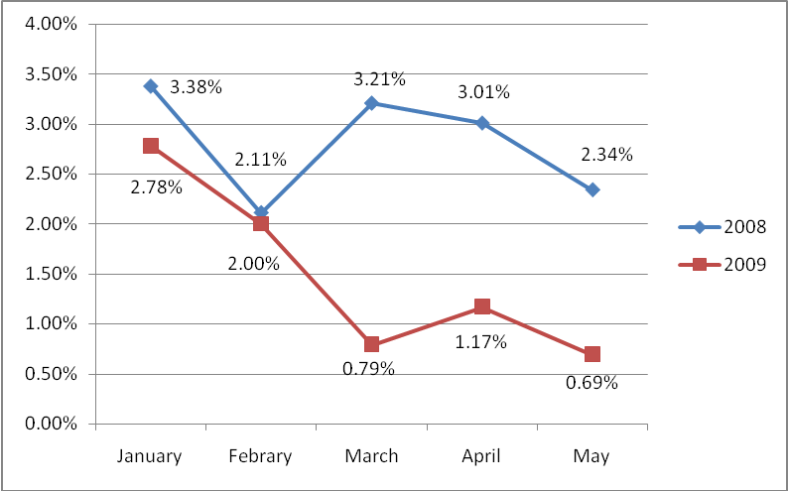

Figure 1. Emergency department mortality at Medical City Hospital.
This data is drawn from Medical City emergency department records and represents the relative mortality occuring within the department as a percent of emergency pateints.

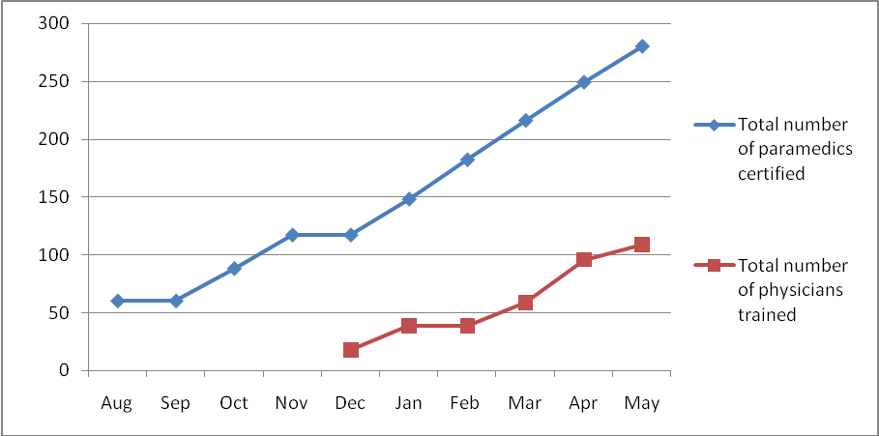

Figure 2. Total number of I-EMCD trained and certified emergency medicine professionals in Baghdad.
This is a cumulative representation of the results of I-EMCD training. EMT training started in August 2008 and physician training started in December 2008. Note the largest increase in EMTs and doctors corresponds with reduced emergency department mortality measured at Medical City from Jan – May 2009.

Sustainability
Despite a request from AusAID to IMC to provide advice on any discussion and/or agreement reached with the MOH regarding recurrent costs associated with the program, the reviewer was unable to locate any reference to this issue. This is clearly a key indicator of sustainability.
Further, while the I-EMCD I Final Report presented useful information on impact, neither this report, nor the I-EMCD II Annual Report for 2008/09 discusses sustainability. This is not surprising given that the I-EMCD I & II Performance Management Plans do not include an indicator to measure the sustainability of program achievements.
IMC clearly has a highly sophisticated vision of the way in which all of the elements of the EM system fit together, including training of EMTs and physicians, the establishment/improvement of provincial EM centers, the establishment of health information systems, the development of policy at the national level and increased community awareness. The dilemma is that, as discussed in the Lessons Learned section of the I-EMCD I Final Report, the management and strategic capacity of MoH personnel is insufficient to ensure successful implementation; very poor attention is being given to Emergency Medicine and the working environment is, to say the least, politically fraught.
It may well be that IMC is committed to maintain a permanent presence in Iraq and that this meets the needs of both this organisation and the GoI. By contrast, as a signatory to the Paris Declaration on Aid Effectiveness and the Accra Agenda for Action, the Australian Government has committed AusAID to engage in a process of capacity building of partner government systems with the ultimate intention of rendering those systems independently viable.
While the difference between the IMC position and the AusAID position may not be as stark as the above statement implies, it is imperative that a discussion be initiated around the issue of sustainability before any further grant monies are applied to support this program.

Gender Equality
IMC’s approach to gender equality appears to have many dimensions. A promotional brochure produced by IMC states that: “In a country where only 17% of women are employed, over 46% of IMC’s professional staff is female.” However, an analysis of the list of names of Key Program and Technical Advisory Personnel does not indicate the presence of a single woman. The reviewer was not able to review full staff lists for I-ECMD I and II. However, it is clear that the program does not have a gender advisor.
The Final Report on I-EMCD I notes, amongst lessons learned, that the vast majority (more than 90%) of paramedics are males. The report further notes that due to the social structure and cultural sensitivities, all women prefer a female health care provider. In the case of emergency response where the event may be less private than desired it is even more important to properly consider this cultural and social preference. In the report IMC notes that “MoH must therefore properly analyse the barriers that exist and design and implement interventions that will result in increased female participation.”
Laudable while this focus may be, it would appear that IMC lost an important opportunity to analyse the impact of the barriers faced by women when they conducted the baseline survey of community awareness of emergency medicine. While the survey sample appropriately included 50% male and 50% female respondents, the analysis of the survey results was not gender disaggregated.

Monitoring and Evaluation
IMC developed a Performance Monitoring Plan (PMP) for I-EMCD I and II and this plan has clearly evolved over time. The evolved PMP is extremely systematic in identifying quantitative measures against output and performance indicators at objective and program level.
However, some more work needs to be done to improve the Plan to facilitate quality assessments and analysis. For example, the output indicator for I-EMCD II Objective 2 is “Number of provincial training centres established or improved”. This information is not sufficient to determine the degree to which the investment in the achievement of this objective is actually contributing to the higher goal, namely, to “Enhance the capacity of the provincial Directorates of Health to deliver quality pre-hospital and hospital-based emergency medical services”. So, for example, one provincial hospital may be working more effectively than another, thereby influencing the degree to which the Program goal can be achieved, but there is no capacity within the PMP system for qualitative information to be collected to determine the reasons for shortfalls in performance. While buildings may have been constructed and equipment supplied to a common standard across the governorates performance may vary due to other factors, for example, insufficient staff, varying administrative capacity at the provincial hospitals, etc. There is no capacity to qualitatively analyse performance.

Analysis and Learning
Consequent upon the completion of I-EMCD I, IMC has identified a range of key lessons learned including:
- Significant weaknesses in management and strategic planning expertise within Iraq are clearly limiting the degree to which MoH can capitalize upon the contributions of the program in order to enhance emergency medical services.
- Very poor attention is being given to Emergency Medicine as a specialty and increased effort is required to ensure growth.
- Extra efforts are required to promote pre-hospital emergency medicine to females.
- It is critical to engage the MOH and relevant actors on a routine and detailed basis in order to build trust and to demonstrate respect for relevant authorities.
- Training programs must include mentoring or practical hands-on components for maximum results.

Evaluation Criteria Ratings

Evaluation Criteria | Rating (1-6) | Explanation
Relevance | 4 | The initiative fits within the higher order goals of both Government of Australia and Government of Iraq and responds to the needs/demands of GoI.
Effectiveness | 4 | I-EMCD I exceeded targets and was well received by GoI. I-EMCD II has fallen substantially behind in training of emergency medicine physicians. Program management and reporting is of an adequate quality but there is still room for improvement in financial acquittals.
Sustainability | 3 | I-EMCD I and II has given insufficient attention to the sustainability of program achievements. Strategies for dealing with weaknesses in GoI capacities and systems are not in evidence, nor has there been any attention to an exit plan.
Gender Equality | 3 | IMC does not have a coherent gender equality strategy nor are efforts to address gender issues evident in program documentation.
Monitoring & Evaluation | 4 | The Performance Monitoring Plan is extremely systematic in identifying quantitative measures against output and performance indicators at objective and program level. However, more work needs to be done on quality assessments and analysis.
Analysis & Learning | 4 | Efforts have been made to identify lessons from the experience of implementing I-EMCD I and to build these into the design for I-EMCD II.
Rating scale:
Satisfactory |  | Less than satisfactory
6 | Very high quality | 3 | Less than adequate quality
5 | Good quality | 2 | Poor quality
4 | Adequate quality | 1 | Very poor quality

Conclusion
The I-EMCD Program is consistent with GoA and GoI development policies, addresses a clear and present need, appears to be well regarded by GoI and has, on the whole, delivered on targets. Within a relatively short period of time the program has had a tangible impact in terms of reduced mortality in emergency departments after admission. There are serious questions as to the sustainability of achievements without continuing inputs and this issue needs to be addressed as a matter of urgency. The program does not have a coherent gender equality strategy, nor are efforts to address gender issues evident in program documentation. The Performance Monitoring Plan is extremely systematic in identifying quantitative measures against output and performance indicators at objective and program level. However, more work needs to be done on quality assessments and analysis.
While IMC has responded positively to AusAID requests for an improvement in the quality of reporting, any future contract between AusAID and IMC for implementation of I-EMCD needs to explicitly state the requirements for M&E, acquittals and reporting to meet AusAID quality standards.

Memorandum between the Iraq Ministry of Health (MOH) and International Medical Corps (IMC) on ‘Strategic and Operational Partnership in Iraq’ 21/6/2007
IMC-AusAID Agreement number 45669.
IMC-AusAID Agreement number 47912.
I-EMCD Desk Review Catherine Bennett June 2009
Evidenced by percentage differences in monthly hospital mortality amongst patients admitted through emergency departments, which is the single Program level indicator of performance.

