Iraq Humanitarian and Stabilisation Package:

Investment Design Summary

December 2017

**Executive Summary**

This document outlines the design for the AUD100 million Iraq Humanitarian and Stabilisation package (‘the package’). It is an ‘umbrella’ design that provides a framework for a series of partner-led activities over three years. The package provides the Australian Government with an aid strategy to complement its broader engagement in Iraq. Australia has major foreign policy interests in mitigating the impacts of the Iraq crisis, defeating ISIL and assisting Iraq on its path towards a sustainable peace.

The last three years of armed conflict in Iraq have increased vulnerabilities for millions of Iraqis through widespread displacement, destruction of infrastructure and decreased stability. In 2017, the UN estimated that up to 11 million Iraqis would need humanitarian assistance in 2018, including 5.1 million children[1]. As at October 2017, over 66,500 Iraqi civilians have died of war-related causes[2] since 2014. The scale of protection needs in Iraq are so great the UN has described it as a ‘protection crisis’. Since January 2014, nearly 3.2 million Iraqis[3] have been internally displaced, including some who have been displaced multiple times.

The overall objective of the package is to support international efforts to meet the humanitarian needs of the most vulnerable conflict-affected populations in Iraq, and assist communities become more resilient and stable. Activities will address short and medium-term humanitarian needs of affected populations, with a particular focus on humanitarian assistance; rapid recovery and stabilisation activities in liberated areas (including rehabilitation of essential public services and economic opportunities); and reconciliation and social cohesion. These investments will contribute to two End-Of-Package Outcomes (EOPOs):

1. Vulnerable people in Iraq affected by the crisis receive inclusive humanitarian assistance and have greater access to protection services
2. Institutions, infrastructure and social conditions improved for conflict-affected populations to recover and build resilience in a safe and stable environment.

To achieve these EOPOs, DFAT will provide predictable, flexible and largely unearmarked funding to trusted partners. This modality of aid delivery will allow gaps in response efforts to be filled rapidly and emerging priorities to be met. Funding will be channelled through UN partners, international humanitarian organisations and Australian NGOs.

Gender equality, women’s empowerment, disability inclusion and protection are key priorities for Australia’s humanitarian program as outlined in DFAT’s Humanitarian Strategy (2016)[4], and are reflected in the Iraq package. Australia championed the Charter on Inclusion of Persons with Disabilities in Humanitarian Action at the World Humanitarian Summit, and our commitment to disability-inclusive development is reflected in the package.

The package is high risk. Child protection and fraud control present as the main safeguard and risk issues. Given the context, DFAT will have limited capacity to directly monitor activities in Iraq. A full risk assessment will be conducted and risk management plan developed for each activity under this package.

# Contents

Analysis and Strategic Context 4

Investment Description 7

Implementation Arrangements 13

# Analysis and Strategic Context

### Humanitarian Overview

Iraq has a long history of conflict and instability largely driven by sectarian divides, political instability, weakened security forces and regional tensions. Most recently, the armed conflict driven by the ascent and progressive retreat of ISIL in Iraq since June 2014, has increased the vulnerability of millions of Iraqis through widespread displacement, destruction of infrastructure and decreased stability. In 2017, the UN estimated that up to 11 million Iraqis would be in need of humanitarian assistance in 2018, including 5.1 million children[5]. As at October 2017, over 66,500 Iraqi civilians had died of war-related causes[6] since 2014.

The scale of protection needs in Iraq are so great the UN has described it as a ‘protection crisis’. Since January 2014, nearly 3.2 million Iraqis[7] have been internally displaced, including some who have been displaced multiple times. Approximately 76 per cent of Internally Displaced Persons (IDP) reside outside formal camps, in host communities, shelters or informal settlements. The United Nations High Commissioner for Refugees (UNHCR) has reported that many residents of Mosul (an ISIL stronghold, liberated in July 2017) who initially fled the city and have returned to their homes after liberation, were forced back to temporary accommodation due to damaged infrastructure, unexploded ordnance and a lack of viable economic opportunities.

Governments are over-stretched, particularly in Ninewa and the Kurdistan Region of Iraq (KRI), which together host more than 57 per cent of Iraqi IDPs[8] as well as more than 240,000 Syrian refugees. Host communities, infrastructure and services are strained and unable to meet the needs of such large numbers of IDPs.

Legal assistance and support with civil documentation is a critical part of enabling IDPs to access support services as well as return home. Many IDPs have fled ISIL-held territory with few possessions and no official documentation. This impedes their ability to register with regional governments or UN agencies to receive assistance. UNHCR recently reported that close to 30 per cent of IDPs[9] in the Mosul Corridor are missing at least one key civil identification document.

Women, children and persons with disabilities are amongst the most affected by the conflict. Prior to 2003 Iraqi women enjoyed high levels of education and engagement in public life. The intervening 14 years have led to a sharp deterioration of women’s roles and status in society and increased prevalence of sexual and gender based violence (SGBV). There are significant reports of family violence amongst IDPs. Research conducted on women and girls living in ISIL-occupied territory indicates isolation from the public sphere and employment, systemic SGBV issues and limited access to reproductive health services.[10]

Iraq is one of the most landmine-affected countries in the world, with its human impact measured through its widespread need for disability support services. Reports have emerged of ISIL ‘booby-trapping’ public infrastructure and private homes to make it as difficult as possible for Iraqis to return. In Mosul, improvised explosive devices (IEDs) have been discovered at Mosul University, milling machines at cement factories, in homes, and even concealed in children’s toys. The international response is desperately underfunded for both de-mining and disability support services.

UN agencies have observed severe rates of war-related trauma and psychosocial issues (PSS) among Iraqis, which need to be addressed immediately and into the future. Persons with disabilities in Iraq face numerous societal and environmental barriers to fully and equally participate in society. Available data suggests that the number of persons with disabilities in Iraq is high and has significantly increased as a result of the ISIL conflict. At least 15 per cent[11] of the population lives with a disability and this proportion is likely to increase[12].

Achieving long-lasting stability and reconciliation in Iraq is complex. Sustainable peace in Iraq will require inclusive governance; stabilisation to reinstate basic services and re-establish confidence in Iraqi institutions; and reconciliation to restore trust between communities.

### Strategic Setting

The international humanitarian response in Iraq is coordinated under the UN’s Iraq Humanitarian Response Plan (HRP).[13] The HRP is released annually in consultation with the Government of Iraq (GOI), affected communities and humanitarian actors, and coordinates and prioritises humanitarian actions.

Stabilisation efforts in Iraq are led by GOI and implemented by the UN Development Program’s (UNDP) Financing Facility for Stabilisation (‘the Fund’). Established in May 2015, the Fund has been allocated more than USD530 million for over 1,000 stabilisation projects in newly liberated areas of Anbar, Diyala, Ninewa and Salah al-Din governorates. The UNDP has called for an additional USD874 million for stabilisation in Mosul alone, as a result of severe destruction of infrastructure during the ISIL occupation and liberation campaign.

The UN Mine Action Service (UNMAS) leads on demining and mine action activities in Iraq. Due to the severe concentration of explosive hazards [14] in newly-liberated areas, the UNDP works closely with UNMAS, who demine newly-liberated areas to reinstate access and enable populations to return.

GOI is leading on the institutional reconciliation agenda and is supported by the UN Assistance Mission for Iraq (UNAMI) and the UNDP for implementation[15]. These efforts are complemented by the many community-level activities - often funded by international NGOs or CSOs - seeking to promote social cohesion, especially as IDPs return to their communities.

### Rationale for Australian Engagement

Australia has already provided over AUD80 million in aid to Iraq since ISIL entered in June 2014. In April 2017, Prime Minister Turnbull and Foreign Minister Bishop announced a new three-year AUD100 million aid package to respond to the humanitarian crisis in Iraq. The press release announced that the package would *“…address humanitarian needs such as food, medical assistance and access to clean water. It will focus on protecting the most vulnerable, with a particular emphasis on women and girls.*”

This document outlines the design for the AUD100 million Iraq Humanitarian and Stabilisation package. It is an ‘umbrella’ design that provides a framework for a series of partner-led activities over three years. The package provides the Australian Government with an aid strategy to complement its broader engagement in Iraq. Australia has major foreign policy interests in mitigating the impacts of the Iraq crisis, defeating ISIL and assisting Iraq on its path towards a sustainable peace. The package supports Australia’s national interests in meeting humanitarian needs, limiting regional displacement and supporting GOI to stabilise and rebuild a united and peaceful Iraq.

The package maintains Australia’s position as a reliable medium-sized donor and provides an opportunity to substantively engage with GOI and other major like-minded donors. Our investment is modest relative to the scale of the need in Iraq (the 2017 HRP appeal is for USD1 billion[16]) and larger donors like the US, UK, Germany and EU (around US716 million in total as at November 2017[17]). With between AUD30-35 million each year, Australia’s assistance will be realistic and targeted to activities where we can achieve tangible outcomes.

The package is aligned with DFAT’s Foreign Policy White Paper and Humanitarian Strategy,[18] the international response to the Iraq crisis and GOI’s priorities. The package also advances commitments made under the World Humanitarian Summit’s Grand Bargain, including the provision of flexible and predictable funding for protracted crises. This package is informed by DFAT’s Syria Crisis Humanitarian and Resilience Package developed in 2016 (currently in its second year of implementation).

The strategic priorities of this package have been developed through broad consultation and address priority areas for the Australian Government (e.g. gender, women’s empowerment and disability inclusion).

The protracted nature of the crisis means our response looks beyond the immediate humanitarian situation. While immediate, life-saving assistance and protection support are still very much a necessity due to ongoing conflict, a shift towards greater support of stabilisation and reconciliation efforts over time will assist affected populations to maintain basic conditions and build self-reliance.

# Investment Description

### Thematic Overview

The overall objective of the package is to support international efforts to meet the humanitarian needs of the most vulnerable conflict-affected populations in Iraq (particularly women, children and persons with disabilities), and assist communities become more resilient and stable.

Australia’s activities will address short and medium-term humanitarian needs of affected populations; rapid recovery and stabilisation activities in liberated areas (including rehabilitation of essential public services and economic opportunities); and reconciliation and social cohesion.

Disability inclusion, protection, gender equality and women’s empowerment are areas where Australia can add value and tangibly address the needs of the Iraqi people. These priorities are central to the way Australia delivers humanitarian assistance. This is consistent with DFAT’s ‘Development for All (2015-2020)’ strategy for strengthening disability-inclusive development and will contribute to Australia’s implementation of UNSC Resolution 1325 on Women, Peace and Security. We will be looking to our partners to help us meet our obligations under the Charter on Inclusion of Persons with Disabilities in Humanitarian Action agreed at the World Humanitarian Summit and to continue our strong track record on disability-inclusive development. This package will also help Australia meet its obligation under Article 32 of the UN Convention on the Rights of Persons with Disabilities, and support the GOIs obligations under the Convention. Further, we will look to our partners to ensure DFAT’s commitments to accountability to affected populations under the Humanitarian Strategy are integrated into responses.[19]

We will require our partners to mainstream gender throughout their work. Promoting gender equality and women’s empowerment is not only a core part of DFAT’s work, but also promotes a more enduring peace by engaging all communities and their comparative advantages, driving economic growth, reducing poverty and building resilience.

Funding for reconciliation will support social cohesion activities that promote peaceful coexistence and reintegration between affected and displaced communities, and help prevent a further return to violence. Reconciliation in Iraq is aspirational and the risks associated with making gains in this area are high, given the fragile context. Women have a key role in rebuilding a sense of community. Their work at community levels is an essential part of nation building. Women have a key role in rebuilding a sense of community, decision-making, leadership, ending violence against women and girls and peace-building activities.

### Expected Outcomes

This package is structured as an ‘umbrella’ design and comprises of a series of partner-led activities. This package will contribute to twoEnd-Of-Package Outcomes:

1. Vulnerable people in Iraq affected by the crisis receive inclusive humanitarian assistance and have greater access to protection services
2. Institutions, infrastructure and social conditions improved for conflict-affected populations to recover and build resilience in a safe and stable environment

The majority of funding is allocated to humanitarian assistance, stabilisation, and reconciliation and social cohesion activities (AUD83.5 million). A smaller amount of funds (AUD14 million) is set aside to give flexibility to respond to emerging priorities, either scaling-up existing activities or investing in new ones. The remaining funds (AUD2.5 million) are allocated to monitoring, evaluation and administration requirements.

Australia’s longstanding approach is to provide flexible humanitarian funding with minimal earmarking, consistent with the World Humanitarian Summit’s Grand Bargain commitments and Good Humanitarian Donorship principles. Where we decide to earmark, it will to be ensure we are able to capture robust and attributable outcomes and direct funds in accordance with Australia’s priorities.

The Package Logic (see Table 1) ensures we can provide a coherent and compelling narrative about the impact of Australia’s support despite engaging across a range of partners and activities. Individual activities and indicators are not specified in the Package Logic but will be identified during the contracting stage.

The Package Logic is iterative. It is defined at four levels (objective, purpose, outcomes and outputs) and also includes statements of assumptions that can be regularly tested for ongoing validity. It is anticipated that the objective, purpose and outcomes will remain broadly valid throughout the duration of the investment but that some variation in the outputs may be anticipated.

The objective has been developed in line with the Prime Minister and Foreign Minister’s announcement in April 2017. The purpose is framed to reflect Australia’s contribution in the context of the broader international effort. Two outcomes (one humanitarian; one stabilisation and social cohesion) are identified to reflect the short- and longer-term deliverables we seek to address. The balance between activities across the two outcomes may shift over time but the outcomes themselves will remain broadly valid over the three years. The outputs are results-oriented and measureable. The outputs may be subject to revision,   
re-orientation or even elimination (and other outputs may be added) according to changing context. However outputs are intended to provide the primary basis for dialogue and negotiation with partners and form the basis of our agreements with partners.

**Table 1: Package Logic**

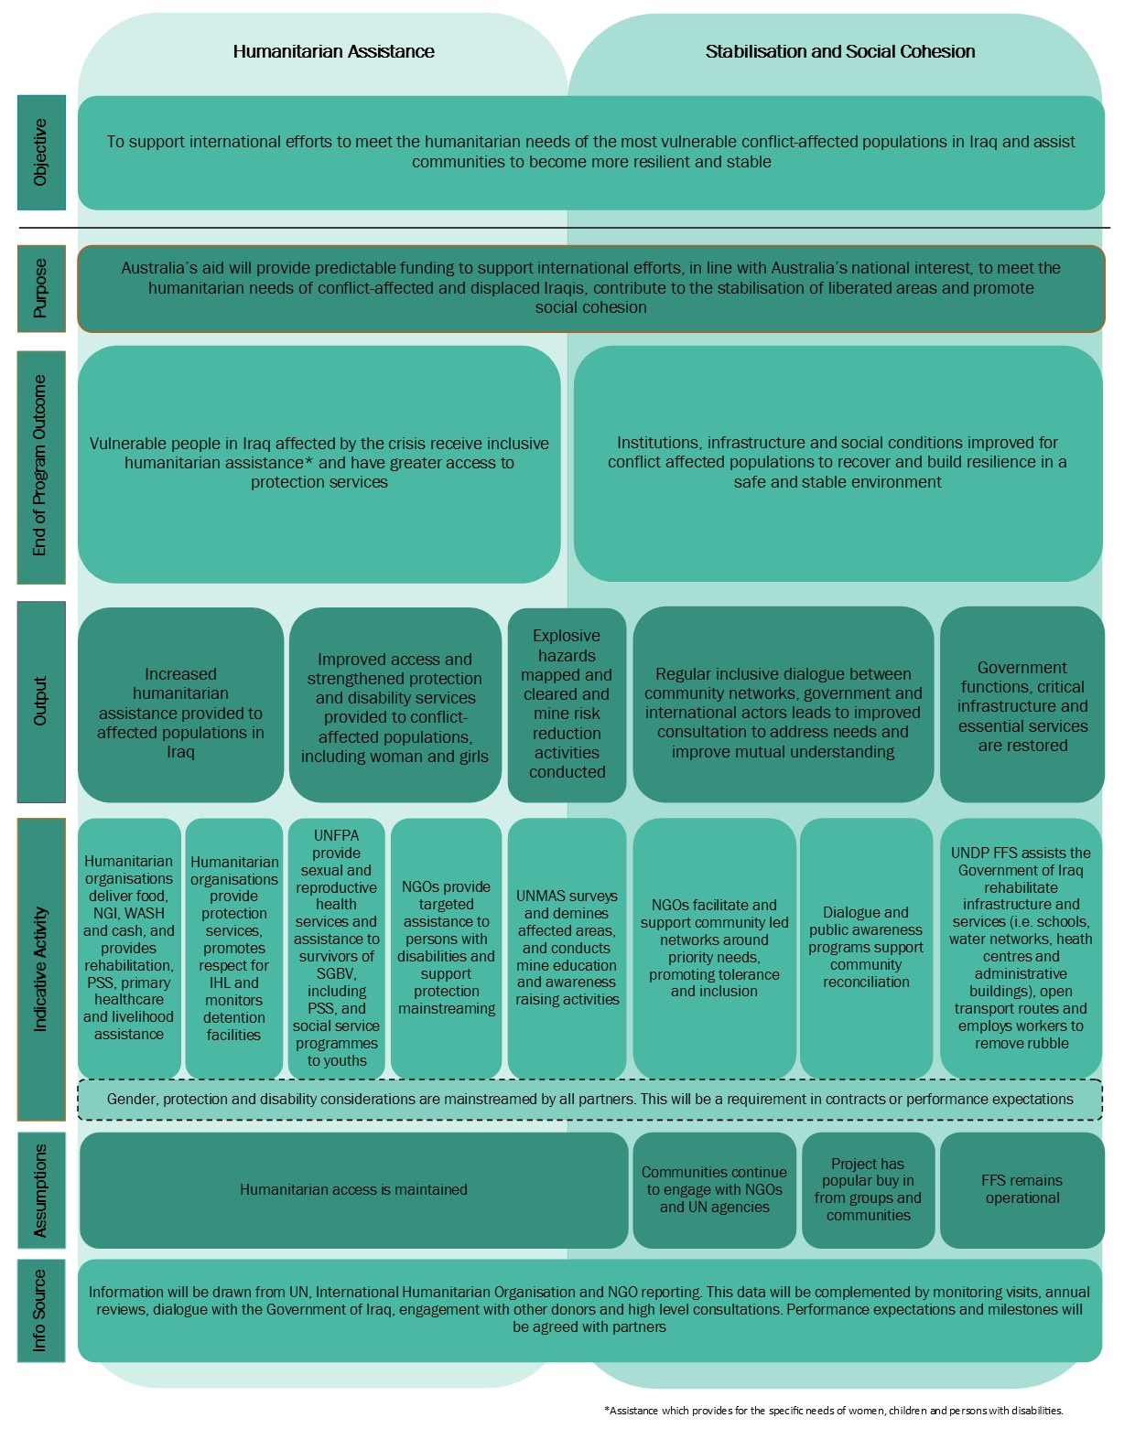

Delivery Approach

DFAT will work with existing and trusted partners. These agencies have demonstrated experience in responding to the crisis, robust security, financial and risk management systems, and child protection and environment safeguards policies we trust. These agencies have strong reputations for innovation and employing new technologies to deliver aid more efficiently.

We have limited the number of partners to avoid fragmentation, reduce the management and administrative burden and improve efficiency and effectiveness. All partners will be required to deliver assistance in line with global humanitarian principles, including the requirement to ‘Do No Harm’.

**International Humanitarian Organisations (not identified for safety reasons) - $18 million over three years**

We will provide AUD18 million over three years, earmarked to the country level, to fund international humanitarian organisations to contribute to EOPO one. These organisations will play a strong role delivering medical assistance and physical rehabilitation services (including for mine injuries); and providing water, food and essential household items to affected populations. The organisations will also play a role in repairing water and health infrastructure and protection activities such as reconnecting families.

**UNFPA - $12 million over three years**

UNFPA will receive AUD12 million over three years in Iraq to address sexual and reproductive health issues, gender equality and women’s empowerment, contributing to EOPO one and two. Since 2014, UNFPA has performed strongly in Iraq, assisting over 210,000 women and girls to access to SGBV services, and directly supporting the establishment of more than 145 reproductive health facilities. UNPFA is engaging with GOI on medical and legal policy issues associated with SGBV cases. UNFPA also has well-established youth engagement programs.

**UNDP Financing Facility for Stabilisation - $18 million over three years**

The Fund is the primary actor in the stabilisation space in Iraq. The Fund is widely respected among humanitarian actors and like-minded donors and performs strongly in a very dynamic environment. The Fund supports Iraqi authorities to restore essential public services and rehabilitate critical infrastructure within ninety days of an area being liberated. Since it commenced in 2015, two million Iraqis have returned to liberated areas where the Fund has undertaken stabilisation projects. No UN branding is attached to any Fund activities to ensure recognition for activities accrues to the regional and national governments. Support to the Fund represents a key way in which Australia will contribute to building the capacity of local and national actors for leadership and decision-making.

The Fund mainstreams gender approaches through its activities, acknowledging that effective stabilisation responses must ensure the voices of women are heard and their needs met. It does this through improving the participation of women in the design and delivery of activities and undertaking women-focussed projects to meet the needs of the most vulnerable women.[20] The Fund has also hired a gender advisor to assist in these processes and activities.

We will softly earmark AUD18 million to the country level for the Fund over three years, supporting core activities in line with EOPO two. This will likely include rehabilitation of critical infrastructure such as hospitals, schools and water supply systems; cash grants to support debris clearance (supporting livelihoods and addressing a key reason people do not return to liberated areas); and cash grants for women-headed households including access to small business grants.

**UNMAS - $11 million over three years**

UNMAS is the lead agency coordinating mine action across Iraq. De-mining in one of the most mine-affected countries in the world is so vastly challenging it is acknowledged that a ‘blended approach’ by governments, UN agencies, NGOs and the private sector is required. In such an environment, the coordination role that UNMAS plays is crucial. DFAT will provide UNMAS with AUD11 million over three years. This funding will support the stabilisation component of EOPO two, through mine mapping and clearance work, capacity building for fellow mine action actors and risk education. UNMAS also negotiates with governments on key operational impediments for mine clearing agencies, such as registration requirements. UNMAS coordinates its mine clearance work with the Fund‘s work program for maximum impact. Already an underfunded area, it is anticipated that the need for demining activities will increase as explosive hazards are identified in newly-liberated areas. Australia has a long history of leadership in mine action and arms control. Australia’s funding to UNMAS will be earmarked to the country level.

**Australian NGOs - $20 million over three years**

Up to AUD20 million over three years will be allocated to Australian NGOs through the Australian Humanitarian Partnership (AHP). The AHP provides a platform for competition for vetted, trusted and tested Australian NGOs to submit proposals that contribute to both EOPOs.

NGOs and their partners in Iraq hold deep local contextual knowledge and have an understanding of humanitarian needs, sources of community tension and drivers of conflict. NGOs are often trusted by local communities and work closely with local organisations and community partners. NGOs also play a key role implementing UN activities in Iraq.

NGOs accredited through the AHP will be invited to submit proposals focused on responding to humanitarian needs of the most vulnerable people and supporting and promoting social cohesion. Proposals will be required to have a strong focus on disability inclusion, protection mainstreaming, and to support gender equality and women’s empowerment. NGOs may form a consortium with high-performing local NGOs and/or with leading disability inclusion organisations. The AHP will be activated in December 2017 with implementation of the successful proposal/s commencing no later than April 2018.

**Reconciliation Programs - $4.5 million over three years**

Funding of AUD4.5 million will be provided over three years to reconciliation activities in Iraq, supporting EOPO two. The focus will be on institutional and community reconciliation, creating an enabling environment of mutual trust within conflict-affected populations, including, where possible, supporting and promoting leadership and engagement by women. It will be locally owned, victim focussed and include both civic led and top-down components. Partners will be selected in 2018.

**Emerging Priorities - $14 million over three years**

Unallocated funds will be set aside in each financial year to provide flexibility in programming and to address emerging priorities as the context in Iraq evolves. This may entail increased funding for re-emerging humanitarian issues or for stabilisation and reconciliation activities if the environment is permissible. This will ensure that Australia’s investment complements the activities of other donors and remains relevant to the needs throughout the duration of the package. Proposals for the use of unallocated funds will be informed by partner engagement, monitoring visits and evaluations. The Iraq Package Steering Committee will review proposals for the use of unallocated funding in line with the governance arrangements established for the package.

**Civilian specialist deployments (Australia Assists)**

The Australia Assists program will play a strategic role in supporting the package. Up to three Australian specialists will be deployed in the first year of the program in multilateral agencies and/or ANGOs and aligned with the package’s objectives. Thereafter deployees will be considered on a demand driven basis. Deployees can provide valuable field-level information to complement formal reporting from partners.

Resources

**Table 2: Indicative budget**

|  |  |  |  |  |
| --- | --- | --- | --- | --- |
|  | **Year 1**  **2017-18** | **Year 2**  **2018-19** | **Year 3**  **2019-20** | **Total** |
| **Iraq humanitarian, stabilisation and reconciliation ($83.5 million)** | | | | |
| International Humanitarian Organisations | $8 million | $5 million | $5 million | $18 million |
| UNFPA | $4 million | $4 million | $4 million | $12 million |
| Australian Humanitarian Partnership | $6.5 million | $7 million | $6.5 million | $20 million |
| UNMAS | $3 million | $4 million | $4 million | $11 million |
| UNDP Financing Facility for Stabilisation | $6 million | $6 million | $6 million | $18 million |
| Reconciliation Programs | $1.5 million | $1.5 million | $1.5 million | $4.5 million |
| **Emerging Priorities ($14 million)** | | | | |
| Emerging Priorities | $500,000 | $6.5 million | $7 million | $14 million |
| **Administration, monitoring and evaluation ($2.5 million)** | | | | |
| Administration, monitoring and evaluation | $500,000 | $1 million | $1 million | $2.5 million |
| **TOTAL** | **$30 million** | **$35 million** | **$35 million** | **$100 million** |

# Implementation Arrangements

### Implementation Plan

As an ‘umbrella’ design, this document outlines the principles governing decisions that will occur over the three years of implementation of the package. The success of the flexible approach proposed will hinge on two factors – a pool of unallocated funds that grows larger in the out-years, and the development of robust and dynamic funding agreements with partners.

Contract negotiations with partners therefore seek to strike a balance between providing surety of funding, incentivising adaptive management and allowing for new activities as required. Agreements with multilateral agencies will include performance expectations that outline the performance and requirements expected, and will be used to assess performance on an annual basis.

### Monitoring and Evaluation

Monitoring and evaluation (M&E) arrangements will be funded from the package budget with an allocation of AUD2.5 million over three years. This will support the development and implementation of the overarching package M&E framework, covering high-level program issues such as humanitarian aid policy objectives and indicators to allow DFAT to measure the success of this multi-year funding modality (as distinct from previous annual funding arrangements). The M&E framework will incorporate indicators for gender and disability, including data disaggregated by sex, disability and age where possible.

Under the overarching package M&E framework will sit partner-level performance assessment frameworks for each of the implementing partners. This will enable DFAT to implement tailored assessment metrics for each partner, taking into consideration issues such as size and duration of activities, ability to undertake direct monitoring and ‘attribution versus contribution’ issues. All M&E will need to be conducted in accordance with DFAT’s M&E standards and aggregate into the overarching M&E framework and DFAT’s Aggregate Development Results.

The overarching M&E framework will be informed by regular post monitoring, DFAT’s Investment Quality Reporting (IQR) process, partners own reporting, High-Level Consultations, annual field monitoring and annual Package Reviews. A flowchart of M&E arrangements is contained in Table 3, followed by further explanations below.

1. ***Regular Engagement***

Additional resources in Baghdad will be funded by the package budget to monitor the evolution of the humanitarian and stabilisation context in Iraq and engage with partners and like-mindeds to maximise the effectiveness of the package. This arrangement was instituted for the Syria multi-year package and has already provided dividends in terms of improved situational awareness and engagement with like-mindeds. The officer will also increase the visibility of Australian funding, monitor safeguards issues and mitigate risks. While the dangerous and highly unpredictable environment in Iraq places restrictions on field-level monitoring of activities, there may be opportunities for occasional field-level monitoring if the security environment improves.

**Table 3: Monitoring and Evaluation Flowchart**

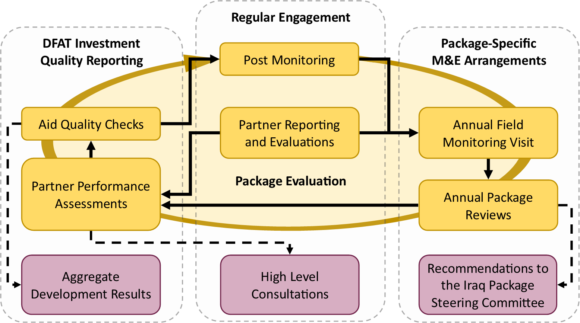

DFAT will communicate performance expectations with UN agencies through head agreements, annual High-Level Consultations (in either Canberra or relevant capitals), governing body meetings and headquarter-level dialogues. We will use these opportunities each year to evaluate progress against the performance expectations and press for changes where required. We will also use high-level visits as opportunities for senior DFAT officials to advocate to humanitarian partners on Australia’s priorities and engage on issues related to humanitarian system reform. Annual Partner Performance Assessments and Multilateral Performance Assessments will incorporate assessments related to the Iraq package, and will be used as an opportunity to rate performance and identify areas for improvement. We will engage regularly with our New York and Geneva Posts to ensure their dialogue with relevant partners furthers these efforts, and links to global dialogues on thematic issues and UN system reform.

1. ***Package-specific M&E Arrangements***

An annual field-monitoring visit will be conducted by DFAT to support oversight of the Package. Visits will be scheduled for the first half of the Australian financial year (Jan-June) to enable information to inform DFAT’s Investment Quality Reporting (IQR) process. These will provide a formal opportunity to meet with partners in the field, and, if the security situation permits, monitor projects directly. Visits provide insight into the qualitative outcomes of projects that are often difficult to capture in reports. Visits also provide an opportunity for formalised performance discussions with partners, which will inform annual package reviews. Annual field monitoring visits will also be used to consider uses for unallocated funding, and undertake exploratory discussions with prospective partners.

A formal annual package review will be conducted in October 2018 and October 2019. Annual package reviews will afford an opportunity to consider changes in the operating environment and their impact on partner programs, allowing for the adaptive management of activities. These reviews may also be used to inform views on uses for the unallocated funding.

The Iraq Humanitarian and Stabilisation Package Steering Committeewill be the primary oversight mechanism for the Package. The Steering Committee will consider issues such as monitoring and evaluation frameworks, risk management frameworks, visibility plans and the outcomes of evaluations. The outcomes of annual package reviews will be shared with the Steering Committee for comment. The Steering Committee will also make recommendations on the unallocated funding.

The Steering Committee will commission an independent evaluation of the package in February 2020. The evaluation will assess the appropriateness and relevance of the package. The evaluation will address exit and transition strategies and the development of subsequent funding options if deemed appropriate.

1. ***Investment Quality Reporting***

Activities within the package will be subject to DFAT’s annual Investment Quality Reporting (IQR) processes, including Aid Quality Checks, Partner Performance Assessments and Aggregate Development Results where relevant. This will be informed by information collected from Post and be complemented by our partners’ reporting and evaluations. We will engage with our partners to participate in at least one independent evaluation over the duration of the package, seeking to provide input into the terms of reference to ensure the evaluability of Australian contributions.

### Aid Effectiveness and Value for Money

This package represents value for money by shifting towards longer-term programming that enables greater cost efficiencies and more substantive outcomes. Further, it will be implemented by trusted partners with proven track records of aid effectiveness.

The multi-year approach builds on lessons learned from evaluations of previous aid provided to Iraq. These evaluations recommend moving away from ad-hoc, year-to-year funding for activities to provide greater consistency and reliability for partners. Multi-year packages allow partners to multiply the impact of their activities by allowing them to build on the successes of previous years and to allocate funding to achieve desired outcomes. Multi-year funding also enables the Australian Government to take a strategic approach to our engagement with host governments and partners.

This approach is aligned with DFAT’s Humanitarian Strategy and World Humanitarian Summit commitments, both of which advocate adopting new, innovative approaches to protracted crises. The package also addresses the global consensus of the need to better bridge the divide between humanitarian and ‘resilience’ or early recovery programming. We propose to earmark to partners as lightly as possible in alignment with our Grand Bargain commitments.

### Risk Management Plan

This package is high risk. A full risk assessment for the package will be conducted and risk management and safeguards plans developed in accordance with DFAT guidelines. Risks to be addressed will include programmatic, security, financial, fraud and anti-corruption, counter-terrorist financing, operational, reputational and environmental and social safeguards, including child protection.

A preliminary risk assessment notes high risks pertaining to the operating environment, results, safeguards, fraud/fiduciary management and safety of partner organisation staff. DFAT’s safeguards screening checklist identifies child protection and environment as the main safeguard issues for the package. Further analysis of child protection and environment risks will be conducted, and mitigation strategies developed, as the package is contracted, designed and implemented.

The package will fund trusted partners that have been assessed as compliant with DFAT’s risk management and due diligence policies at a global level. Multilateral partners regularly undergo performance assessments to ensure they comply with DFAT’s expectations, due diligence and risk management policies. Australian NGOs funded through AHP have similarly undergone a detailed accreditation process. The accreditation process includes a robust review and analysis of each NGO’s due diligence and risk management policies. DFAT’s multilateral and NGO partner agreements include requirements to meet DFAT’s counter terrorism, fraud, anti-corruption, child protection and risk management policies.

While partners meet DFAT policy standards at a global level, the high-risk nature of the operating environment in Iraq will necessitate partners providing a detailed country-level risk assessment to ensure risk mitigation measures are identified and ‘Do No Harm’ principles are addressed. A ‘Do No Harm’ approach in Iraq requires partners operating in this high-risk environment to understand political, security, operational and financial risks and implement effective mitigation measures to avoid, or where avoidance is not possible, minimise adverse impacts on people and the environment. Risk management strategies will be developed for multilateral partners during implementation of the package, taking into account these concerns and proposing means to mitigate them in line with DFAT’s requirements. In addition, risk management strategies will be required from Australian NGOs to assist in monitoring activity level risks.

*Personnel and physical security:* The security of personnel is of the highest priority. The safety and security of partners’ personnel is the responsibility of their agency. Multilateral agencies have robust international standard security measures in place and adopt a conservative approach to the deployment of foreign nationals. All Australian NGOs have a track record of robust safety and security processes to be eligible to receive DFAT funding and will be required to have thorough security protocols, particularly around the deployment of international staff in Iraq.

Additional resourcing at Post will increase engagement with stakeholders to ensure DFAT has a good awareness of emerging and current risks, and maintains systems to detect and address risks in a timely manner.

1. Iraq Humanitarian Response Plan 2017; UNICEF Iraq Monthly Humanitarian Situation Report, September 2017
2. Iraq Body Count Database, <https://www.iraqbodycount.org/database/>, accessed 31 October 2017
3. IOM Displacement Tracking Matrix, accessed 31 October 2017
4. See <http://dfat.gov.au/about-us/publications/Documents/dfat-humanitarian-strategy.pdf>
5. Iraq Humanitarian Response Plan 2017; UNICEF Iraq Monthly Humanitarian Situation Report, September 2017
6. Iraq Body Count Database, <https://www.iraqbodycount.org/database/>, accessed 31 October 2017
7. IOM Displacement Tracking Matrix, accessed 31 October 2017
8. IOM Displacement Tracking Matrix; KRI statistics calculated from Dahuk, Erbil and Suleymaniyah IDP populations.
9. UNHCR Mosul Weekly Protection Update – 1-7 September 2017
10. 2017 Humanitarian Needs Overview; UNFPA Concept Paper: Emergency Reproductive Health (RH) and Gender-based Violence (GBV) services for women and girls in Iraq; UNDP FFS 2nd Quarterly Progress Report 2017
11. WHO, World Report on Disability, 2011 o273 ; USAID Iraq, Iraq Access to Justice Program, Values of Access to Justice and Persons with Disabilities in Iraq, March 2014; UNAMI & UNOHCHR 2016, Report on the Rights of Persons with Disabilities in Iraq, <http://www.uniraq.org/index.php?option=com_k2&view=item&task=download&id=2118_ba29368d4a62b7b36938b845a174394d&lang=en>
12. 2016 UNAMI/OCHA report, https://reliefweb.int/report/iraq/report-rights-persons-disabilities-iraq-december-2016-enar
13. Iraq Humanitarian Response Plan 2017
14. Explosive Hazards is a term used by UNMAS for the Iraqi context to describe the proliferation of Improvised Explosive Devises, Unexploded Ordinances, Explosive Remnants of War, mines and booby-traps.
15. *Brief Concept Note: Towards a Consolidated UNDP Strategy for post-Daesh Reconciliation in Iraq 2017-2019*, 2017; UNDP, *Support to Post-Conflict Reconciliation in Iraq,* Project Document, 2017
16. Iraq Humanitarian Response Plan 2017
17. UNOCHA Financial Tracking Service - Iraq 2017; <https://fts.unocha.org/countries/106/summary/2017>
18. http://dfat.gov.au/about-us/publications/Pages/humanitarian-strategy.aspx
19. http://dfat.gov.au/about-us/publications/Pages/humanitarian-strategy.aspx
20. UNDP FFS 2nd Quarterly Progress Report 2017