|  |
| --- |
| **A: Investment Design Title: Australia Awards - Global Tracer Facility (GTF) – Phase 1** |
| **Start date: 2015 End Date: 2019** |
| **Estimated funding allocation: Up to $4 million AUD over 4 years** |

**B: Executive Summary**

The context for this investment is experience over the past decade or more in seeking efficient, effective and appropriate ways to monitor and evaluate the development contributions and the public/economic diplomacy outcomes of Australia’s investment in Australia Awards. Eliciting feedback from less recent alumni (who graduated three or more years earlier) (compared to recent alumni) is especially important because it has the potential to yield the richest insights into those contributions and outcomes. This is because less recent alumni will have progressed further in their careers and thereby potentially made more significant development or public diplomacy contributions.

The basis for key elements of this design is a rationalisation of the Tracer Study Methodology developed in 2010. This 2010 methodology has been tested in a number of country programs (including South Asia, PNG, Philippines, Solomon Islands, Tuvalu/Kiribati /Nauru [combined]), with a number of lessons learnt.

Two overarching problems affect country programs:

* Many country programs are not able to conduct research related to less recent alumni with sufficient regularity.
* Those country programs that have applied the 2010 methodology find it inefficient, labour intensive and poorly focussed on supplying sufficient high quality data to assess development contributions and public/economic diplomacy outcomes.

The Scholarships and Alumni Branch (SCB) recognise that problems remain with the 2010 methodology. Since this methodology’s first application in the Australia Awards in South Asia Program, SCB has been working jointly with that program to develop and trial an improved and rationalised approach.

A Global Tracer Facility (the Facility) will offer significant flexibility in regard to sharing of roles and responsibilities between the Facility and SCB, which has insufficient resources available to manage all of these roles in house.

Initially the Facility will be a four year initiative commencing in 2015/16 which aims to address the following main objectives:

* To assist all country programs meet the three yearly cycle of less-recent alumni monitoring agreed with the Australian National Audit Office (ANAO).
* To implement an alternate methodological approach to traditional ‘tracer studies’ that renders monitoring of less recent alumni more efficient, less labour intensive and better focussed on providing high quality data in relation to development contributions and public/economic diplomacy outcomes (the Facility is not required to develop new M&E tools).
* To compare the development contributions and public/economic diplomacy outcomes of various forms of long and short term awards.

Beyond the initial four years, if good results are achieved, it is intended that the Facility will be contracted on a rolling cycle.

The main activities of the Facility will include:

* Delivery of all routine (three year cycle) Tracing Surveys and associated Case Studies
* Delivery of *ad hoc* Tracing Surveys and associated Case Studies
* Ongoing alumni locating efforts
* Data cleansing, analysis and storage of existing and new alumni data

The logic of this investment design is based directly upon that of the Australia Awards program, complementing and elaborating its monitoring and evaluation (M&E) design at a greater level of detail. There are three main elements, relating to its set of three main functions: Twin tracer instruments (Tracing Surveys and associated Case Studies), expansion of coverage of less recent alumni, and response to specific *ad hoc* requests.

Extending the coverage of less recent alumni assumes that this group of alumni hold the key to demonstrating many of the more significant development or public diplomacy contributions made by Australia Awards. The capacity to respond to specific request for delivery of *ad hoc* Tracer Surveys and associated Case Studies assumes that important alumni-related feedback cannot all be specified *a priori,* and that priorities for information may change and evolve over time, or be driven by a contemporary expediency.

The improved survey design, locating and sampling approaches to be applied by this Tracer facility concept are based on successful outcomes and lessons learnt from the trials referenced above, including significant rationalisation of the 2010 methodology.

This investment in improving alumni tracing would amount to 0.3% of annual program budget.

**C: Analysis and Strategic Context**

A number of approaches to design and delivery of ‘Tracer Studies’ have been applied by AusAID/DFAT over many years, with varying levels of success. The most recent iteration is the 2010 Tracer Study Methodology. This 2010 methodology has now been tested in a number of country programs (including South Asia, PNG, Philippines, Solomon Islands, Tuvalu/Kiribati /Nauru [combined]), and lessons learnt from this testing form the basis for key elements of this design.

*Country/Regional and Sector Issues:*

There is varying capacity between country programs and within regional programs to undertake tracer studies. Two overarching problems are that:

* Many country programs are not able to conduct research related to less recent alumni sufficiently regularly.
* Those country programs that have applied the current methodology find it inefficient, labour intensive and poorly focussed on supplying sufficient, high quality data to assess development contributions and public/economic diplomacy outcomes.

The SCB recognise that problems remain with the current methodology. Since the methodology’s first application on the Australia Awards in South Asia Program, SCB has been working jointly with that program to develop and trial improved approaches.

*Development Problem/Issue Analysis:*

A 2014 study of evaluation methodology has identified that “of 17 AusAID [sic] post-scholarship surveys only 5 could be considered ‘high quality’ and data comparability was a serious challenge because of the differing designs of the survey tools used”[1]. The *ANAO Audit of AusAID’s [sic] Management of Tertiary Training Assistance* (May 2011) recommended involvement of DFAT’s central office in scholarship program evaluation. Accordingly, DFAT agreed to develop a standardised program of post-Award monitoring, using a ‘consistent methodology’, including interviews rather than just paper or web-based surveys, and over a three-year cycle include all geographic regions.

*Evidence-base/Lessons Learned:*

The 2010 methodology has been found to have a number of significant issues. The most important flaw is that it does not substantively address the key issue of locating a broader sample of less recent alumni. It focuses upon data collection only and its sample is often limited.

The sample is consistently skewed towards more recent returnees or those that are already involved in alumni associations. This means that the current methodology duplicates other commonly applied M&E tools. It does not increase the pool of contactable alumni who may then be targeted for other alumni initiatives. It allows little stratification of samples (e.g. along gender lines). It is the less recent alumni who are consistently missed, and these are arguably the most valuable because they will have progressed further in their careers. The issues are listed more fully in Annex 5 Problem Analysis.

*Strategic Setting and Rationale for the Investment:*

Variation in the application of the simplified methodology can be avoided and pressure on country programs can be relieved by the creation of a Global Tracer Facility. Significant flexibility is offered by the Facility model in regard to sharing of roles and responsibilities between the Facility and SCB. Currently the Branch has insufficient available resources to manage all of these roles in house.

The term ‘Facility’ is used to flag that the contractor responsible would be tasked from time to time to carry out targeted, on-demand tracer case studies, in addition to managing routine applications of simplified development impact and public/economic diplomacy assessment tools. The improved survey design, locating and sampling approaches to be applied by this Tracer Facility concept are based on successful outcomes and lessons learnt from the trials referenced above. This investment in improving alumni tracing would amount to 0.3% of annual program budget.

The facility will provide DFAT with global baseline data for alumni which country/regional program areas can access to assist with their own M&E activities.

**D: Investment Description**

Initially the Facility (Phase 1) will be a four year initiative commencing in 2015/16 which aims to address the following main objectives:

* To assist all country programs meet the three yearly cycle of less-recent alumni monitoring agreed with the ANAO
* To provide an alternate methodological approach to traditional ‘tracer studies’ that renders monitoring of less recent alumni more efficient, less labour intensive and better focussed on providing high quality data in relation to development contributions and public/economic diplomacy outcomes
* To compare the development contributions and public/economic diplomacy outcomes of long term awards on one hand and short term awards on the other

Beyond the initial four years, if good results are achieved, it is intended that the Facility will be contracted on a rolling cycle.

*Logic & Expected Outcomes:*

This investment design relates to that of the Australia Awards which it supports and for which it is an M&E tool. Its logic therefore depends upon that of the Australia Awards, complementing and elaborating its M&E design at a greater level of detail. There are three main elements to the investment logic, relating to its set of three main functions: Twin tracer instruments, extension of coverage of less recent alumni, and response to specific *ad hoc* requests.

The Tracing Survey is based on theory developed by the ‘[Tactical Conflict Assessment Planning Framework](http://www.google.com.au/url?sa=t&rct=j&q=&esrc=s&source=web&cd=2&cad=rja&uact=8&ved=0CCUQFjAB&url=http%3A%2F%2Fusacac.army.mil%2Fcac2%2Fcall%2Fdocs%2F10-41%2Fapp_a.asp&ei=dGgSVOP-KMKJuAS6sICwBw&usg=AFQjCNGRHql6VBp5A0lOP1lJSl8CEbb4ew&bvm=bv.75097201,d.c2E)’ (TCAPF/TCAF) initially used in Afghanistan. The TCAPF found that, when all things are considered (e.g. respondent fatigue, question translation errors, response categorisation errors, enumerator delivery errors, etc.), questionnaires with a few well-chosen questions provide more meaningful and usable data than longer questionnaires that attempt to be more comprehensive in scope.[2]

The Case Study methodology addresses up to 5 specific evaluative questions (redefined in each case to match the research objectives of the case study) and is based on efficiency and simple qualitative research assumptions that detailed information should only be sought when it has been identified as serving a known purpose. This pair of instruments (Tracing Survey and Case Study methodology) is based on the premise that the response rate and the quality of data will be improved by minimising the number of questions and limiting them to a few well-chosen ones. This will also result in both efficiencies and economies. It will make survey and case study results more comparable across the global spectrum of the Australia Awards, and reduce the M&E burden on the Country Programs. At the same time it will facilitate the integration of Country Program M&E into the global M&E of the Australia Awards.

These instruments are firmly focussed on collecting valid aid effectiveness data, as well as providing opportunities for public diplomacy application of such data, were appropriate. As such, they do not focus on benefits accruing to alumni, but rather impacts of alumni in their home countries. To achieve this, Case Studies also routinely seek feedback from beneficiaries of these impacts.

The richest insights into those contributions and outcomes are expected to come from the less recent alumni, and are likely to contribute most to the ability of Australia Awards to demonstrate the value and sustainability of its achievements and the return on investment.

The capacity to respond to specific requests for delivery of *ad hoc* Tracing Surveys and associated Case Studies assumes that all important alumni-related feedback cannot be specified *a priori,* and that priorities for information may change and evolve over time, or be driven by a contemporary expediency.

Such priorities might emerge from the Minister, the SCB or regional and country programs, or arise from findings of routine Tracing Surveys and associated Case Studies. Unintended consequences reported from activities and initiatives can sometimes lead to important unanticipated insights which can inform policy and practice.

*Delivery Approach:*

A flexible Global Tracer Facility model, based on recognised good practice, is deemed necessary in order to provide consistency in approach across all country programs, and to avoid variation in the application of the simplified proposed methodology. It is also designed to relieve pressure on country programs in relation to the longer term monitoring of alumni (a percentage of whom may no longer be in that country).

While the SCB does not have the resources to undertake these tasks to be performed by the Global Tracer Facility, the Branch’s M&E Manager would maintain direct oversight of any contract sourcing external provision of such services. All planned or *ad hoc* application of the two survey tools (Tracing Surveys and Case Studies), all drafts of contact approaches and protocols, and any other policy-relevant decisions would require the M&E Manager’s formal approval.

The Facility, like its parent the Australia Awards, represents an outsourcing of a function which is an Australian initiative. It will therefore not work directly within partner government systems, but will need to recognise and conform to agreements made between the Government of Australia and partner governments in relation to the operation of the Australia Awards and its alumni.

**E: Implementation Arrangements**

*Management and Governance Arrangements and Structure:*

The main activities of the Facility will include:

* Delivery of all routine (three year cycle) Tracing Surveys and associated Case Studies
* Delivery of *ad hoc* Tracing Surveys and associated Case Studies (including working with posts)
* Building and maintaining relationships with posts and alumni associations
* Ongoing alumni locating efforts
* Ensuring a focus on Gender and Disability and the relevant disaggregated data, including the routine reporting of disaggregated analyses comparable to those in Annex 2
* Data cleansing, analysis and storage of alumni data which can be uploaded to, or accessed from the Alumni Online Network (AON) or the Australian Global Alumni Network (The Network)
* Collating other studies and M&E documents from posts

The Facility will be managed by an implementing service provider on behalf of SCB, which will be recruited through open competitive tender. It may be operated as a ‘virtual office’ or by utilising contractor’s existing office space (it is not expected to require the establishment of a new or dedicated office).

The implementing service provider will employ a dedicated Facility Manager classified as C3 under the DFAT Adviser Remuneration Framework. The Facility Manager will report to the SCB through SCB’s M&E Manager who will oversight the implementation and management of the contract. The implementing service provider will provide additional staff/services as specified in the successful tender. The Facility Manager will need to be continuously accessible to DFAT. For this reason s/he will need to be located in Australia, preferably in a time zone not more than plus/minus 2 - 3 hours of Australian Capital Territory time.

The Facility will not only be required to manage routine applications of simplified development impact and public/economic diplomacy assessment tools, but will also be required to carry out more targeted, on-demand applications of such tools, when requested. Such on-demand requests may come from various DFAT sources (including country programs), and will need to identify and supply their own funding, so as not to draw down budget measures associated with routine applications of tools.

The Facility Manager will submit to the M&E Manager for formal approval proposals for all planned or *ad hoc* applications of the two survey tools (Tracing Surveys and Case Studies), all drafts of contact approaches and protocols, and any other policy-relevant decisions.

In the course of the Facility’s operation good working relationships will be developed and maintained with DFAT posts and alumni organisations in participating countries and, through the SCB, with Australian Tertiary Education Institutions.

The Facility will develop and apply a database and analysis system based on those already developed by the South Asia Program. The database that contains both raw data and analyses will not form part of the Alumni Online Network or the Australian Global Alumni Network. However it will be structured so that the post-Award data held by the Facility can be securely hyperlinked to these systems through unique identifiers (e.g. OASIS numbers, where relevant[3]). Any personal information regarding alumni on such systems will be subject to controlled access.

*Implementation Plan:*

In the inception phase the implementing service provider will recruit staff, and make sure they have appropriate working space and conditions. The inception phase will not exceed three months from contract signature. It will include clarifying communication protocols and preparation by the Facility Manager, in consultation with the M&E Manager of SCB, of the 1st Annual Plan for the three year cycle of Tracing Surveys and associated Case Studies. Standard operating procedures will be negotiated with SCB in the inception phase, and a comprehensive procedures manual prepared by the implementing service provider.

The Facility will not be required to develop new M&E instruments, but will apply the survey design approaches successfully trialled by the SCB in conjunction with the Australia Awards in South Asia. These approaches simplify the existing Tracer Study methodology and split it into two staged instruments.

The first instrument is a basic ‘Tracing Survey’, consisting of only four questions, as contained in Annex 1. It focuses specifically on development/public diplomacy contributions[4] made by alumni and the constraints/assisting factors associated with making such contributions.

Each year Routine Tracing Surveys will include a minimum sample of 1000 alumni to be surveyed each year, of which 60% will be recipients of Long Term Awards and 40% of Short Term Awards (Fellowships managed by SCB) or as advised by SCB. Where possible there will be a 50 – 50 gender split in each annual sample. The total annual sample will be drawn from approximately 20 countries, with selection of the sample negotiated with SCB each year[5]. Sampling approaches will be documented in the relevant Annual Plan.

The sample of Long Term Awardees will include alumni who graduated three or more years earlier. The sample of Short Term Awardees will mostly be drawn from those who completed their award approximately nine months earlier. Only awardees who received some form of recognised qualification as a result of their short term award will be included in the population that may be resurveyed in later years.

The Tracing Survey will be ‘enumerator delivered’ and conducted by means of Skype and telephone, and will not require in country travel. Where Skype and telephone delivery is not possible, alternative methods will be used.This method has been used satisfactorily in South Asia. The Tracing Survey data will be disaggregated by gender and disability, and will be used to generate an analytic report comparable to that contained in Annex 2.

The possibility exists to also send out tracer survey instruments to all relevant alumni not included in this ‘sample’ of 1000. However, the trial in South Asia has shown that the data quality returned from such ‘default’ email options is very low compared to sample’s enumerator delivered surveys that it often needs to be quarantined in reporting (and is therefore unusable). Hence in real terms, such ‘default’ email surveys may not be worth the effort required to analyse them.

The second instrument is a series of targeted ‘Case Studies’ which will investigate in detail any development and/or public diplomacy contributions identified in the Tracing Survey that are of particular interest to the Australian Government or the program. A sample case study report (for Bhutan) is contained in Annex 3. Each Facility Year, approximately 5 thematic Case Studies will be undertaken involving approximately 6 – 7 alumni per case study in selected geographic locations. The Case Study format is similar to a small evaluation task. It will be a small targeted exercise involving a set of 5 questions tailored to address the selected theme.

One staff member from the Facility will visit the location of study for approximately 7 days (inclusive of travel) to interview alumni face to face. (Case Study in country visits may be conducted by the Facility Manager personally, or by another appropriately qualified and experienced member of the Facility staff or by an appropriately qualified and experienced sub-contractor). The implementing service provider will ensure that the regular work of the Facility in Australia continues uninterrupted if the Facility Manager is deployed overseas for Case Study visits.

The selection of annual case studies will be made as part of the Annual Planning process. Themes for Case Studies may be determined by DFAT/SCB. The Facility may assist in identifying Case Study opportunities, but it will not be responsible for deciding which case studies are conducted. The ultimate selection will require approval by the SCB’s M&E Manager.

Both instruments also collect ‘header data’, inclusive of contact and demographic data of alumni. The regular Tracing Surveys and associated Case Studies will always need to be done in cooperation with country programs, but the level of support provided by Facility will vary from complete carriage of the exercise to nominal support only (e.g. advice, etc.).

*Ad hoc* Tracing Surveys and associated Case Studies will respond to requests from various DFAT sources, conveyed at any time through the SCB M&E Manager. The Facility Manager may invite such requests to align with the preparation of the Annual Plan, but must also provide for the contingency that requests may be made at any time. Parameters of such research are open. They may be single or multi country, or any other sampling variant that suits the research purpose. Funding for *ad hoc* applications will be external to normal Facility budgets and will be negotiated between SCB and those DFAT areas making the requests.

In addition to the administration of these two tools, the Facility will design and establish a system and processes for ongoing efforts to locate alumni, particularly less recent alumni. These would be conducted independently of application of post-Award monitoring tools, and may include all geographic areas. Such efforts will be made with due recognition of alumni privacy and of the privacy legislation in Australia and in partner countries.

Options for locating less recent alumni will include existing sources of information such as the Alumni Online Network and the Australian Global Alumni Network[6], posts and alumni associations. Consideration should also be given to utilising other potential options (where the information is in the public domain), including:

* General information registers (Marriages/Deaths/etc.) of alumni home countries
* Public service transfer/promotion/resignation records (incl. records of postings to embassies and consulates) of alumni home countries
* Employment records of multilateral agencies/International NGOs/multinational businesses
* Immigration records of alumni home countries
* “People finder websites” in third countries (US/Canada/UK/etc.) which compile and utilise all public domain records
* Australian immigration, public service or other records or registers
* Contact networks of contactable Australia Awards Alumni
* General social media and other internet searches

This data would go into the Facility’s database and also be uploaded into the Alumni Online Network and the Australian Global Alumni Network databases, where relevant.

Importantly, the Facility will be required to develop innovative solutions to locating less recent alumni. More proactive approaches should be explored that would add an incentive for re-establishment of some contacts. Such approaches could, for example, include the offering of an annual Australia Awards short course at a global level that is open exclusively to less recent alumni, or other improved alumni engagement activities.

*Procurement Arrangements:*

The routine (three year cycle) Tracing Surveys and associated Case Studies would be planned and funded from the Facility’s Annual Budget.

Funding for *ad hoc* on-demand research will be negotiated between SCB and relevant posts (or other DFAT areas making requests), and may supplement the Facility’s annual budget.

*Monitoring and Evaluation:*

The Facility is an M&E tool and an adjunct to the Australia Awards program. It is not in itself an aid activity. Therefore its M&E Framework is limited to the following:

1. An Inception Report and Procedures Manual within the first 3 months.
2. Data updates every 6 months from the start of the Annual Plan (these would present any new data collected, and identify any key issues that had arisen during the period).
3. Continuous monitoring of risks, which should be communicated to the M&E Manager by means of Exception Reports if required, and included in Annual Reports.
4. An Annual Report against Plan.
5. A Mid Term Review of efficiency and effectiveness of the Facility as an M&E tool with a view to identifying any improvements that should be introduced in Year 3. This review should take place 18 months from the start of the first Annual Plan.
6. A completion Report to be prepared 2 months prior to end of Year 4.

In addition to the above specified reporting requirements, DFAT may require additional reports or presentations on specific data analysis or selected topics arising from the survey data. These reports or presentations will be produced as agreed between DFAT and the implementing service provider.

*Sustainability:*

This activity will support the Australia Awards which are an Australian (rather than partner government) initiative. The functions of the Facility only need to be sustained for as long as the Government of Australia wishes to sustain the Australia Awards and report on the development impact and the public/economic diplomacy outcomes of the Australia Awards.

*Gender Equality and Inclusiveness:*

The Facility will address Gender Equality and Inclusiveness systemically in three main ways:

1. The Alumni Development Impact Survey form collects data on the sex of the alumni at the individual record level. This will enable sex disaggregated analyses to be made of the aggregated responses to the Tracing Survey comparable with those contained in Annex 2. These sex disaggregated analyses will be made and reported regularly. An analysis will be made of a subset of awardees relating to inclusiveness, e.g. by separately analysing responses from those alumni who had been selected under the disability category.
2. DFAT or a country program may request a case study that relates specifically to gender equality and/or inclusiveness, and the Facility would respond to that request through a dedicated case study, e.g. a case study of Gender Studies entitled ‘A Case Study of Female Masters Alumni, Focussing on Gender-related issues’, commissioned by the South Asia Program, was in progress at the time of this design, for completion by February 2015.
3. The Facility will monitor Tracing Survey responses that appear to yield potential for case studies relating to gender equality and inclusiveness, and will draw these to the attention of DFAT through SCB with a view to their potential for case study themes.

Prior to 2001 less recent alumni predated the creation of OASIS, but more recent alumni can be cross matched with OASIS for disability information.

*Risk Management Plan:*

The key risks associated with implementation of this Facility fall into two main groups:

* Risks to the Australian Government/Australia Awards Programs
* Risks to the Australia Awards Alumni

There are three main types ofRisks to the Australian Government/Australia Awards Programs:

1. There is always a risk that certain findings from M&E exercises may not reflect well on partner governments or other partners. This is vital information for successful management, but must be handled sensitively if it is not to harm relationships or reputations of the program.
2. Overly onerous survey approaches can create risks of alienating alumni from participation in ongoing monitoring. This could result in depriving the Australia Awards program of necessary effectiveness and management data.
3. Privacy legislation exists in most countries including Australia. Care will need to be taken to not contravene such external legislation when seeking to locate and contact less recent alumni.

In a relatively small number of countries, there are significant risks to alumni and their families in simply being associated with Australia Awards. This most commonly involves being targeted for kidnapping and/or physical harm as a result of being publicly identified as a recipient of an Australia Award. Both criminals and extremists may be involved (most commonly the former), but a number of examples of such targeting have already been reported by alumni.

When operating in such countries, the contractor must take their duty of care for such risks very seriously. The contractor will obtain advice from DFAT about countries that already require ‘de-branding’ of open-correspondence and/or a strict “no names, no faces” policy in publicly available information, but will also need to make their own assessments in countries where such risks are yet to be considered.

Less extreme, but also important, is the potential for other forms of possible retaliation against alumni who provide information which may reflect badly on employers or partner governments. Effective anonymity will therefore be offered to respondents, and applied to those that request it. Management of such risks and measures for handling all sensitive or personal information will be explicitly included and reported upon in annual planning.

The design of the South Asia M&E Strategy on which this design is modelled will ensure that the Tracing Survey and Case Studies are not overly onerous. Care should be taken to ensure that over time modifications to design and implementation do not result in more onerous requirements being placed on alumni, for instance through the addition of an expanded number of questions[7].

The Facility will ensure that its operations do not contravene the Australian Privacy Act, and will also make an assessment of and conform to the privacy legislation in participating countries.

A Risk Management Matrix is contained in Annex 4.

*Safeguards:*

The Tracing Study and Case Study formats clearly specify the extent of information to be collected about the past alumni and the uses to which such information will be put. They do not require working with children, with displaced or resettled populations, or of themselves pose environmental risks.

**F: Annexes**

Annex 1: Alumni Development Impact Survey (ADIS) Format

Annex 2: Outcome Summary Example (from June 2013 Australia Awards in South Asia M&E Report)

Annex 3: Sample Case Study Report (Bhutan September 2013)

Annex 4: Risk Management Matrix

Annex 5: Problem Analysis

Annex 6: Program Management & Implementation Arrangements

Annex 7: Monitoring & Evaluation Framework

Annex 8: Implementation Schedule

Annex 9: Position Descriptions  
Annex 10: Scope of Services and Basis of Payment

**ANNEX 1: Australia Awards Alumni Development Impact Survey [ADIS] Format**

**Introduction**

The purpose of the *Alumni Development Impact Survey* is to identify tasks you have achieved using the skills/knowledge or networks/connections gained from your studies in Australia and to record any constraints you faced.

**Section 1: Personal details**

|  |  |
| --- | --- |
| Family name |  |
| Given name(s) |  |
| Gender |  |
| Date of birth (dd/mm/yyyy) |  |
| Nationality |  |
| OASIS number |  |
| Completed course of study |  |
| Australian education institution attended |  |
| Telephone contact number(s) |  |
| Personal e-mail address |  |
| Name of employing agency/organisation* |  |
| Current position (full title)* |  |
| Brief description of your current role* |  |

*Complete only if currently employed.

**Section 2: Development impact**

1. List *up to 5* examples from the last X months of practical tasks in which you have used the skills/knowledge gained during your studies in Australia. Possible tasks must be related to development and must be specific. Provide *only one* example of a task on each response line.

|  |  |
| --- | --- |
|  | Examples of tasks [For example: specific policies, practices, projects, research or training you have implemented.] |
| Task 1 |  |
| Task 2 |  |
| Task 3 |  |
| Task 4 |  |
| Task 5 |  |

1. List the most significant constraints you faced in the last X months in applying the skills/knowledge or networks/connections gained during your studies in Australia (*up to 5)*. How might each constraint be addressed?

|  |  |
| --- | --- |
| Constraint  Provide *only one* example of a constraint in each response box. | Suggestions to address this constraint |
|  |  |
|  |  |
|  |  |
|  |  |
|  |  |

1. List the most significant factors that assisted you in applying your skills/knowledge or networks/connections gained during your studies in Australia (*up to 5)*.

|  |
| --- |
| Assisting factors  Provide *only one* example in each response box. |
|  |
|  |
|  |
|  |
|  |

1. Do you maintain links with anyone in Australia or anyone you met through your award? If you do, please briefly describe the most important links below (up to 5).

|  |
| --- |
| **Links**  Provide *only one* example in each response box. |
|  |
|  |
|  |

**Annex 2: Outcome Summary Example (from June 2013 Australia Awards in South Asia M&E Report)**

## Are alumni appropriately applying new knowledge and skills in their workplaces?

Indicator G2: Number or Percentage of alumni providing significant and appropriate examples of actual uses of their award skills within 2 years after return

Indicator G3: Number or Percentage of alumni providing significant and appropriate examples of usage of professional linkages with Australians within 2 years after return

The following analysis provides an in-depth assessment of outcomes data collected to inform these short to medium term indicators.

**The Sample**

The full regional sample of ADIS respondents to date is 65 alumni. The ADIS is only applied to alumni within the first two years of return. This is only the second application of the ADIS format, and the first in which a specific question was included in relation to ‘Australian Links’. This means the sample used to date for the links data reported herein is only 23 alumni (11 males and 12 females).

Sample make up:

|  |  |  |  |  |  |  |
| --- | --- | --- | --- | --- | --- | --- |
| Sex: | Male | Female |  |  |  |  |
|  | 34 | 31 |  |  |  |  |
| Employer Type: | Government | Private Enterprise | NGO/ Multilateral |  |  |  |
|  | 43 | 13 | 8 | * |  |  |

**\*Plus one unemployed alumni**

**Analysis**

**Indictor G2: Development Contributions Made by Alumni**

All but one alumni were employed. 98% of respondents were able to provide credible and relevant examples of development or linkage contributions[8]. This is impressive, given the relatively short period of time these alumni have been back.

Overall, 248 credible and realistic examples of development contributions were provided. 49% of these examples were made by females and 51% by males. Note it was possible (and common) for a single alumnus to provide more than one example. Given the relatively even representation of females and males in the sample, this suggests that both have an equal potential to deliver development contributions. Of these contribution examples, 69% were delivered by government employees, 12% by NGO employees and 19% by private sector employees. Allowing for the proportions of these groups in the sample, this represents a relatively even potential for alumni to produce development contributions across these employer types.

Of the examples of contributions made, 16% (40 examples) impacted at a national level. Of these national level examples, 40% were delivered by females and 60% by males. Of these national effects, 84% were delivered by government employees, 13% by NGO employees and 3% by private sector employees.

Of the 248 examples of development contributions provided as examples, 94% were at least partially aligned with alumnus’ field of study (and hence a country priority sector).

*Contribution Types*

In relation to the types of contributions being made by alumni, three forms were consistently identified. The proportions of examples of each type are provided in figures below:

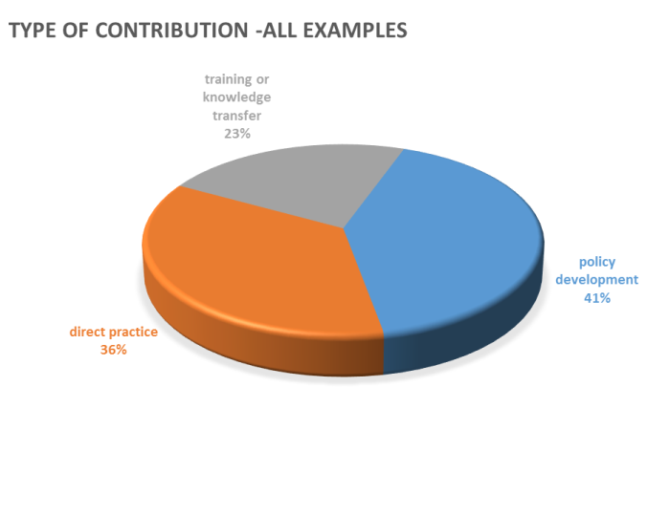

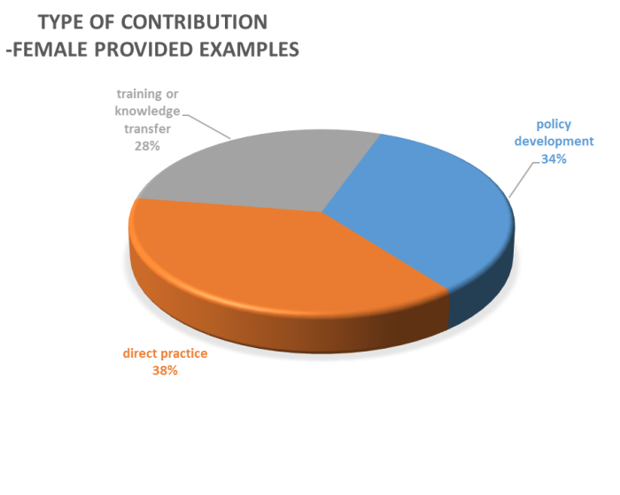

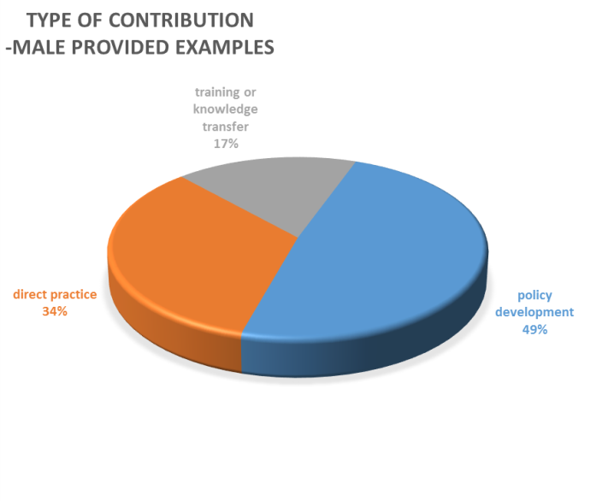

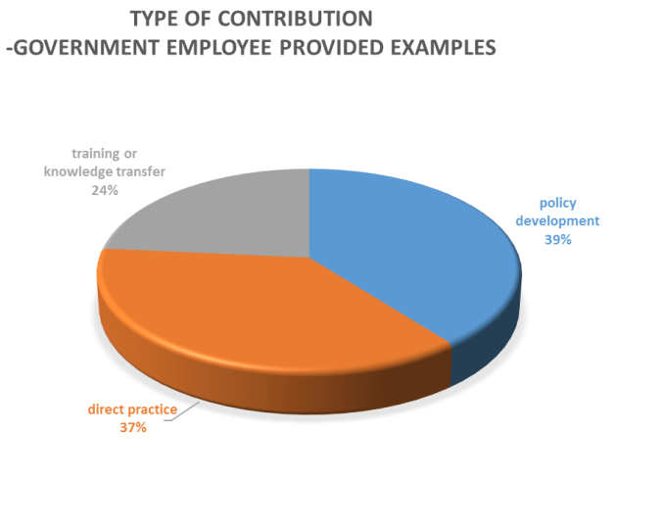

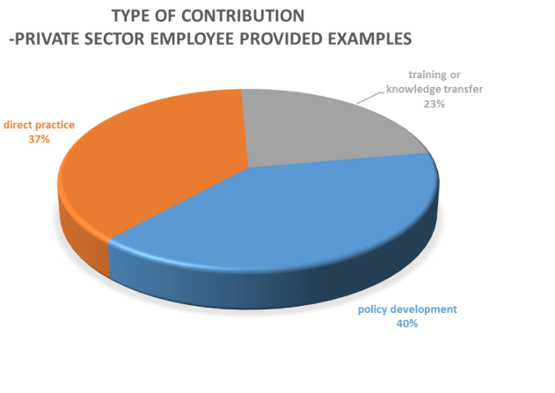

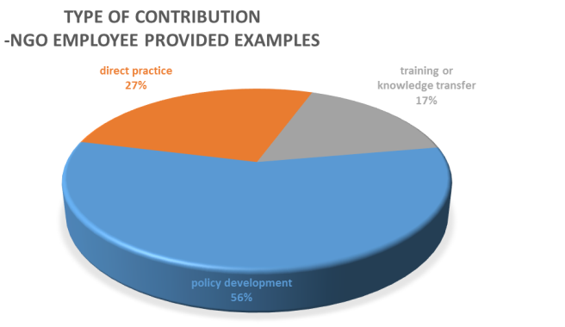

*Contribution by Sector*

Breakdowns of contributions by sectors are provided in the figures below. Note that due to the fact that this is still the early stages of application of this iterative methodology, results presented by sector need to be treated with some caution as the alumni sample is not yet effectively stratified (i.e. representative) by sector. Sector categories are inclusive of the country priority sectors where possible, but due to the non-mutually exclusive nature of the most country priority sector lists, hierarchical combinations of some sectors have been necessary to avoid miscounting inclusions.

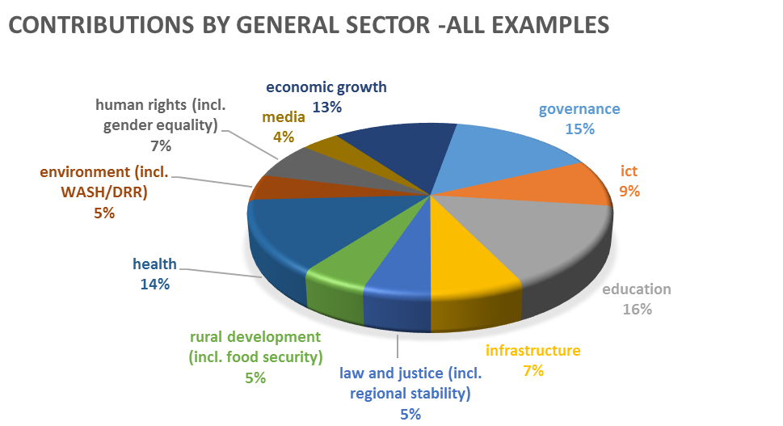

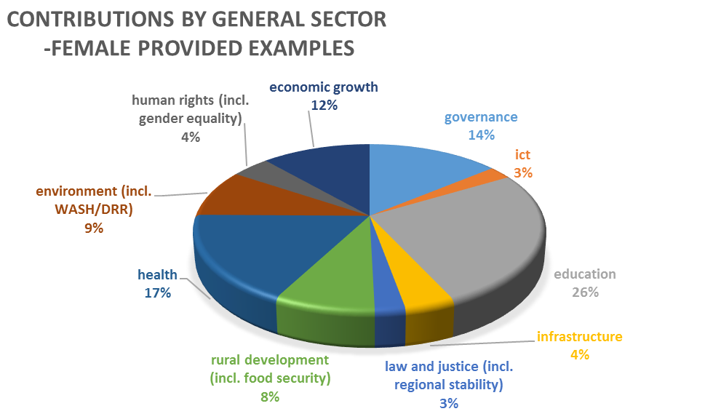

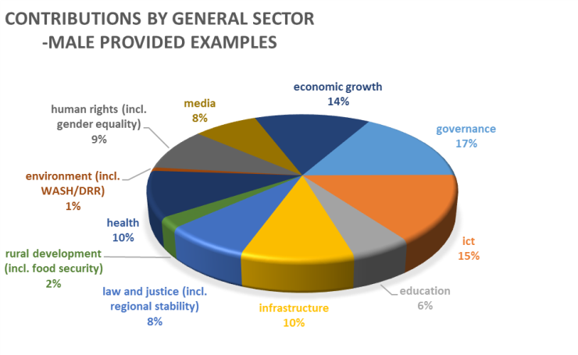

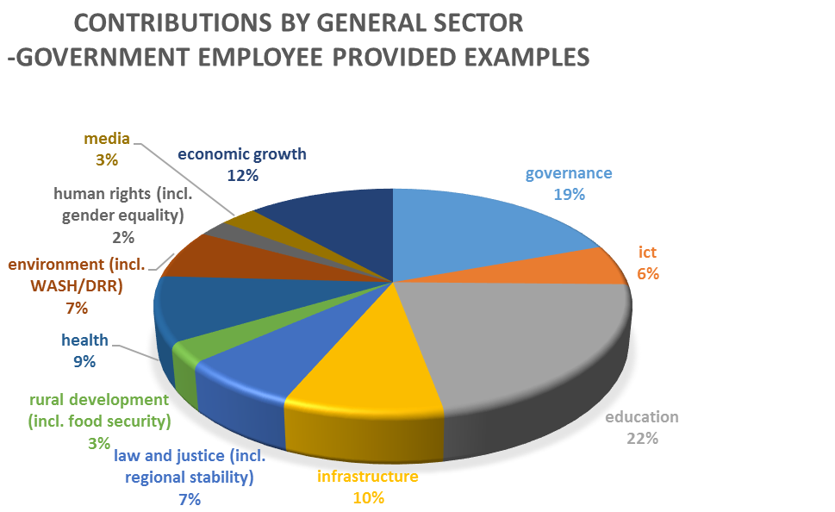

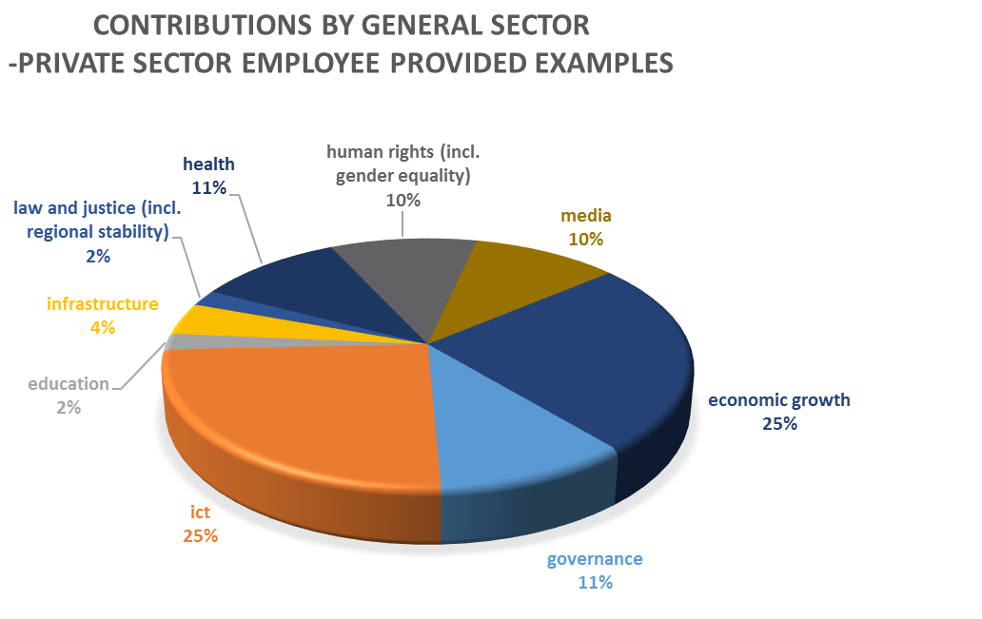

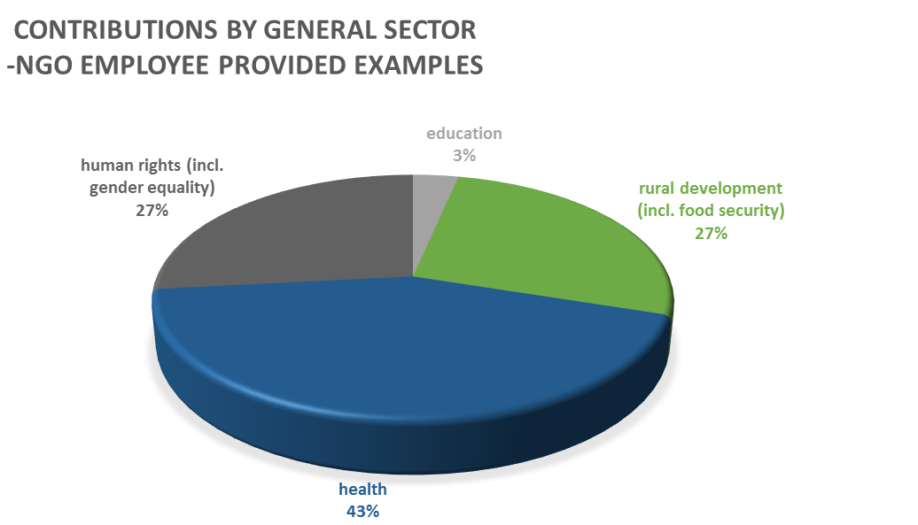

*Contribution by Millennium Development Goals (MDG)*

Breakdowns of contributions by relevant Millennium Development Goals have also been generated:

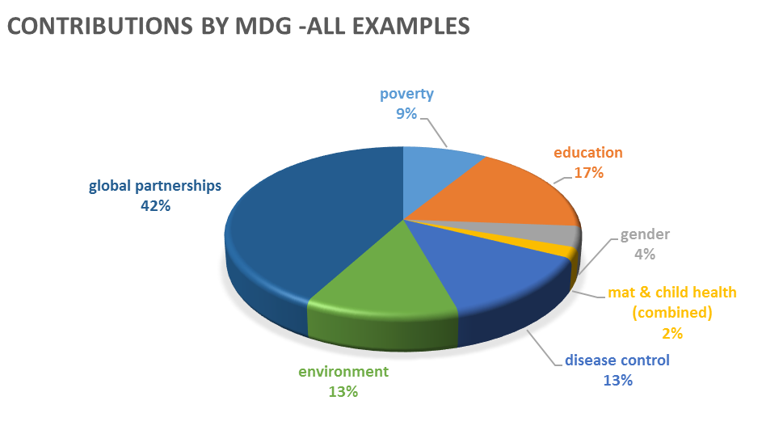

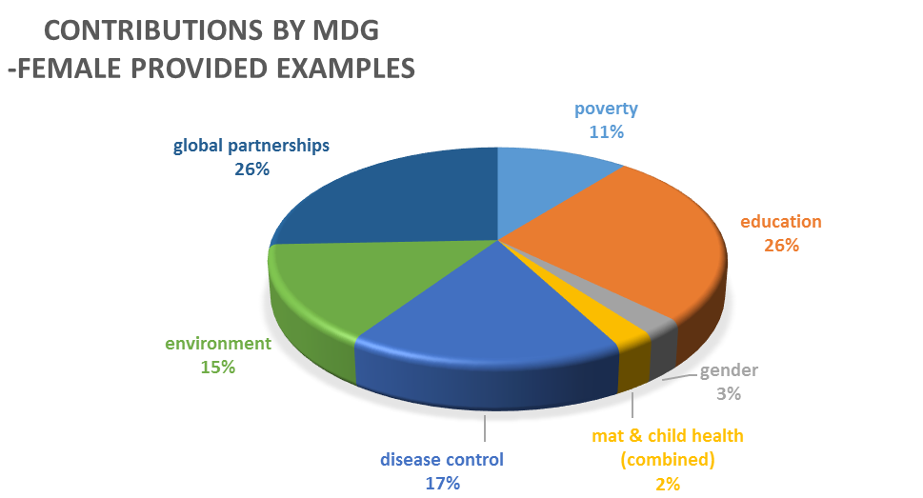

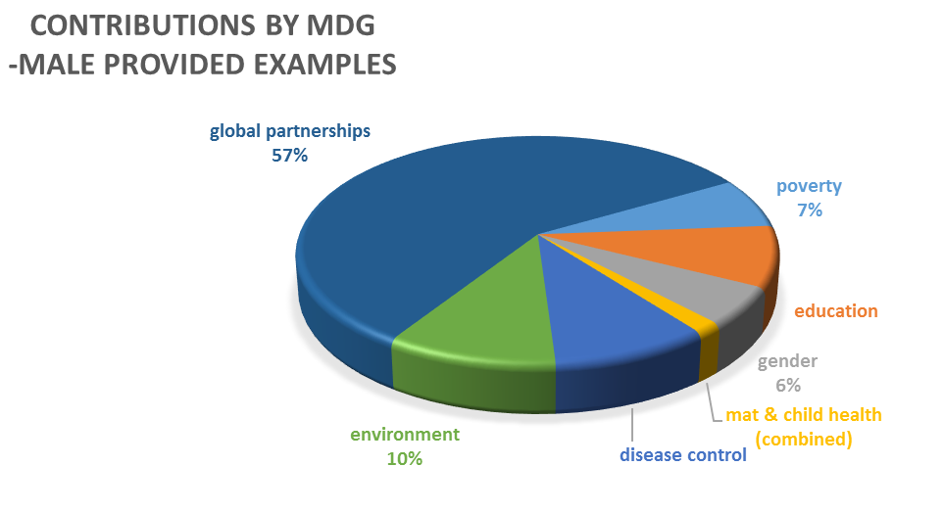

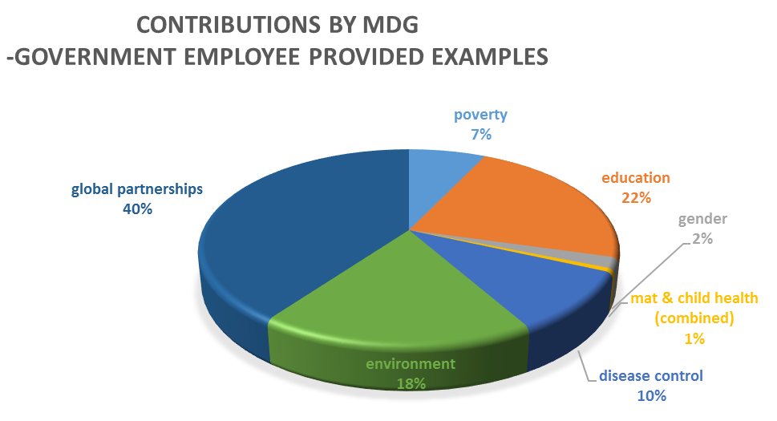

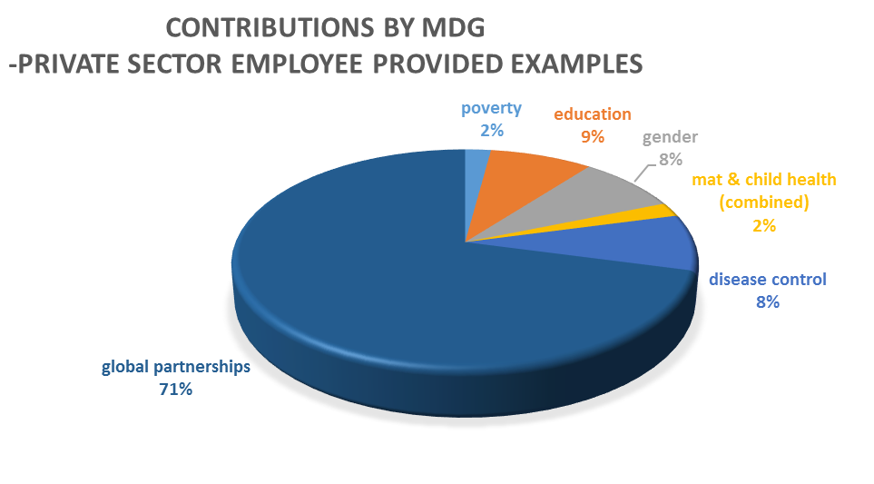

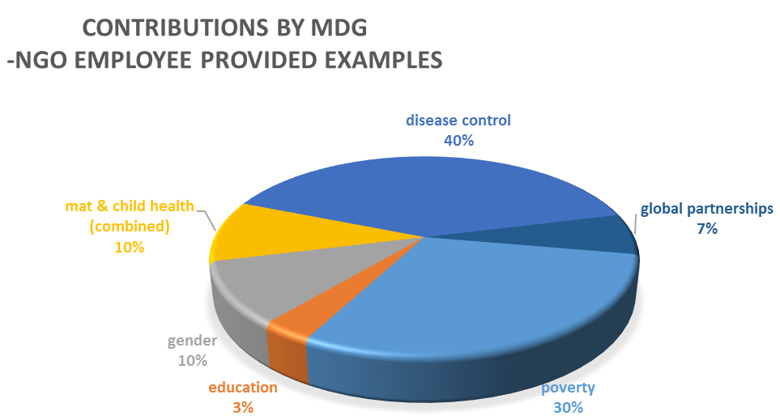

**Indictor G3: Australian Links Maintained by Alumni**

The follow-up survey also investigated the nature of Australian links that are maintained by alumni resulting from their Award (note ‘Australian Links’ includes links to classmates of any nationality made while in Australia). A total of 57 examples of such links were provided by alumni in the sample. 65% of these were provided by females and 35% by males. 70% of links were maintained by government employees, 16% by NGO employees and 14% by private enterprise employees. Of these links, 18% are stated to be maintained through social media, with females maintaining 19% of their links this way, and males 15%.

Four main forms of linkage were identified in the sample. Breakdowns of these are provided in the following figures.

**Note: ‘Aust Awards contact’ includes membership of the Australia Awards Alumni Network or similar informal network of Australia Awards alumni.**

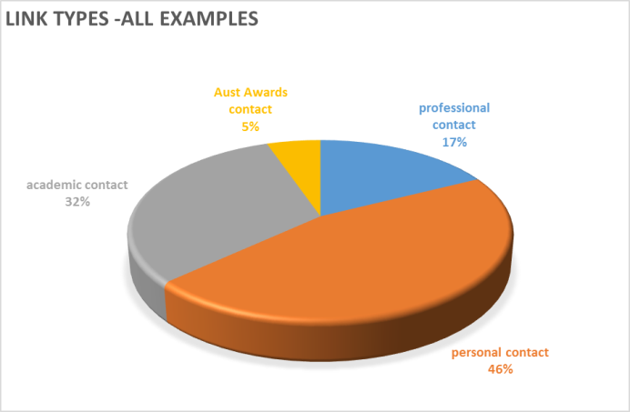

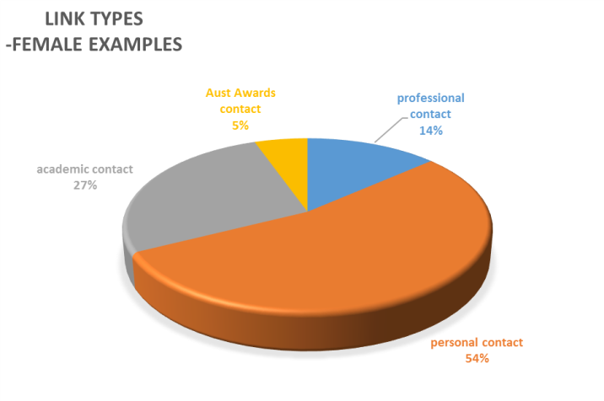

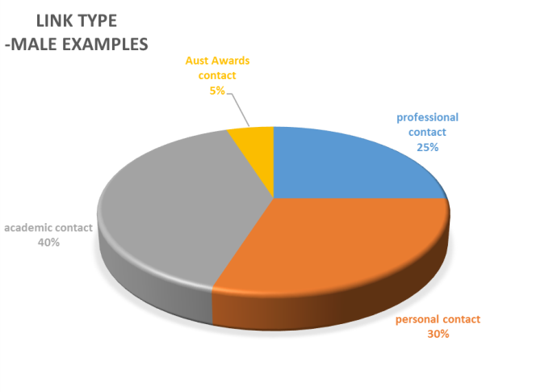

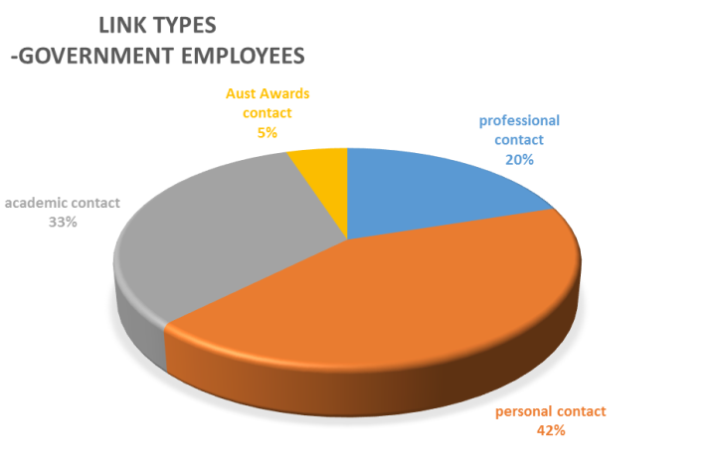

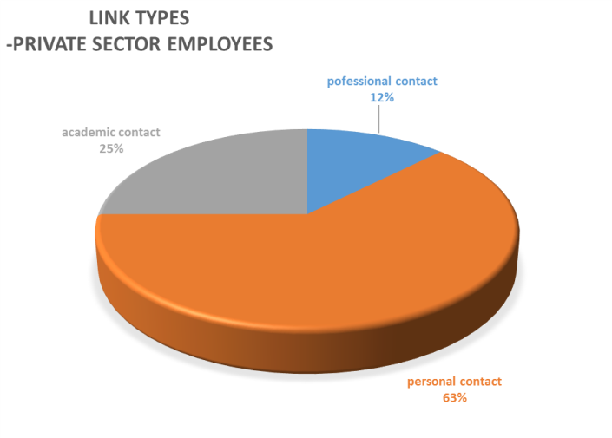

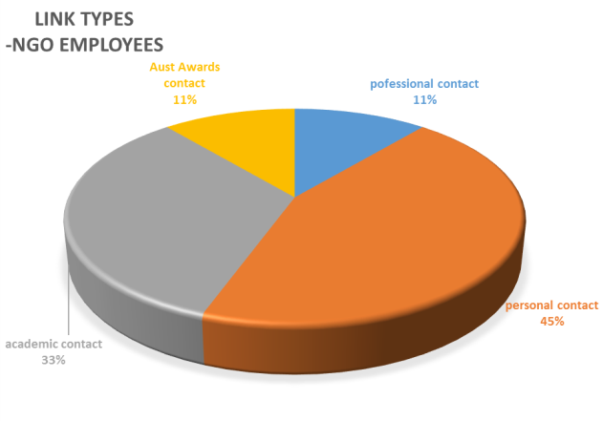

**Lessons Data: Constraints Faced by Alumni When Making Contributions or Australian Links**

The ADIS investigated the nature of constraints faced by alumni. A total of 160 examples of constraints were provided by alumni. Of these 51% were provided by females and 49% by males. From the examples given, 10 common types of constraint were reported (plus an ‘other’ category). Breakdowns of constraints according to these types are provided in the figures below.

**Note: ‘workplace resistance to change’ includes resistance from other staff (including peers and superiors) and from existing policy frameworks.**

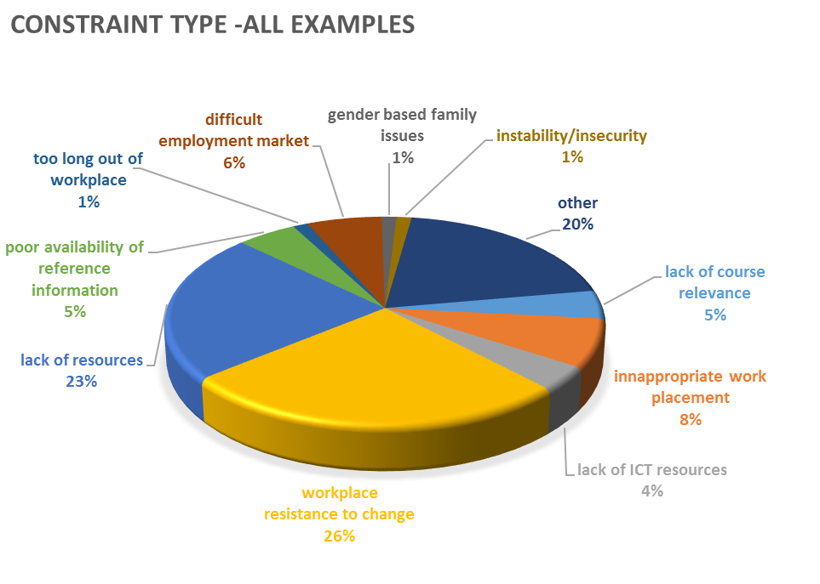

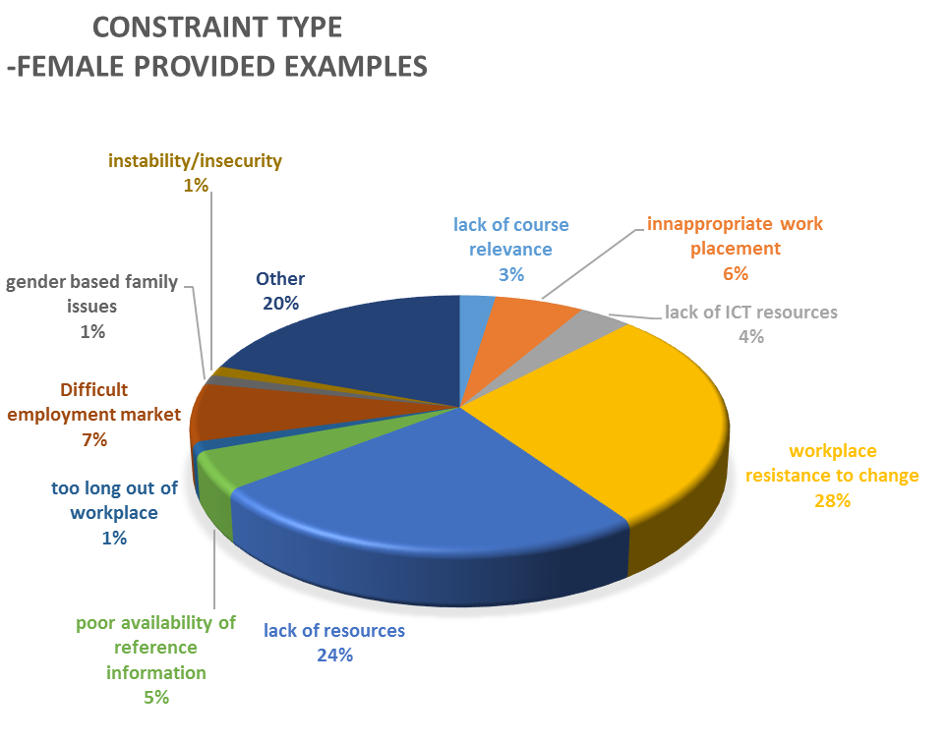

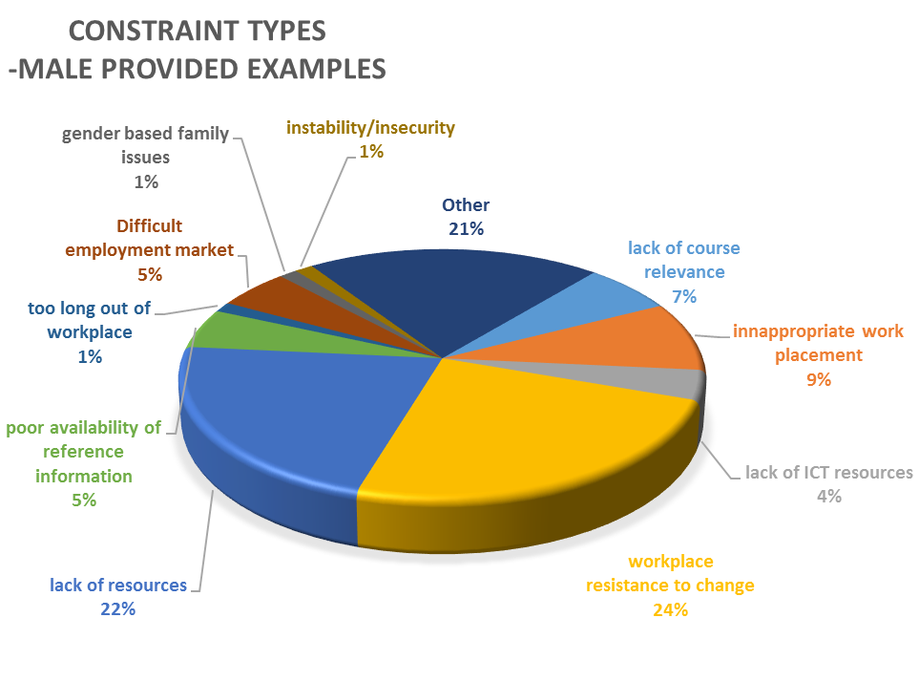

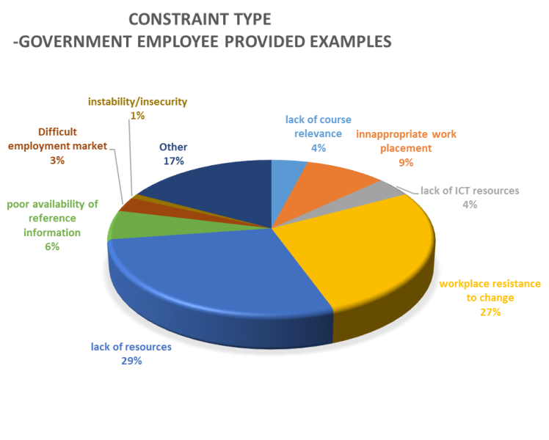

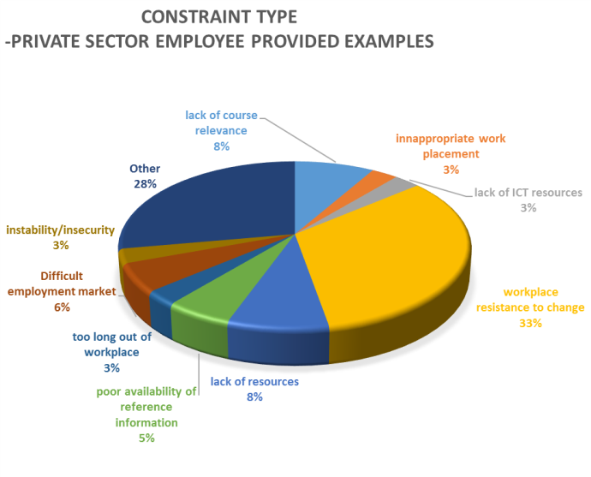

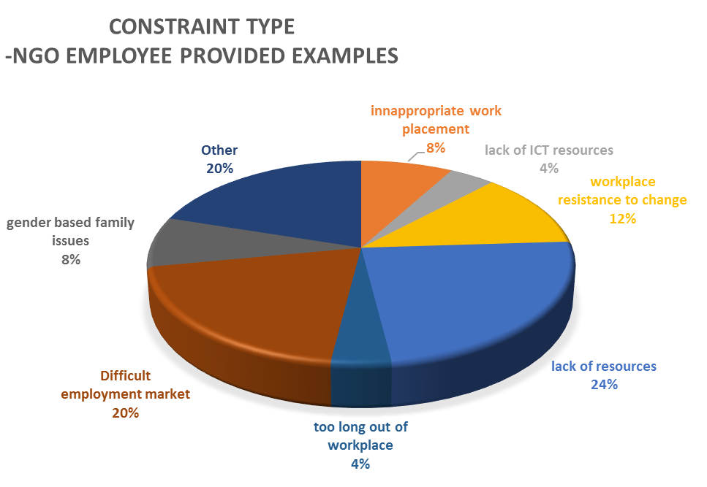

Respondents were also given the opportunity to suggest solutions to these constraints, but most solutions offered were either personally-specific or well beyond the scope of an awards program to address.

One point that was notable about suggested solutions was the encouragingly high percentage of solutions that the alumni themselves intended to implement. 41% of all solutions suggested were these ‘self-actioned’ examples, with 45% of female-offered solutions self-actioned compared to 36% of male-offered solutions.

**Lessons Data: Factors Assisting Alumni to Make Development Contributions or Australian Links**

The ADIS investigated the nature of supporting factors affecting delivery of contributions by alumni. A total of 182 examples of supporting factors were provided by alumni. Of these 53% were provided by females and 47% by males. From the examples given, 10 common types of supporting factors were reported (plus an ‘other’ category). Breakdowns of supporting factors according to these types are provided in figures below.

**Note: ‘workplace support’ includes support from other staff (including peers and superiors) and from existing policy frameworks.**

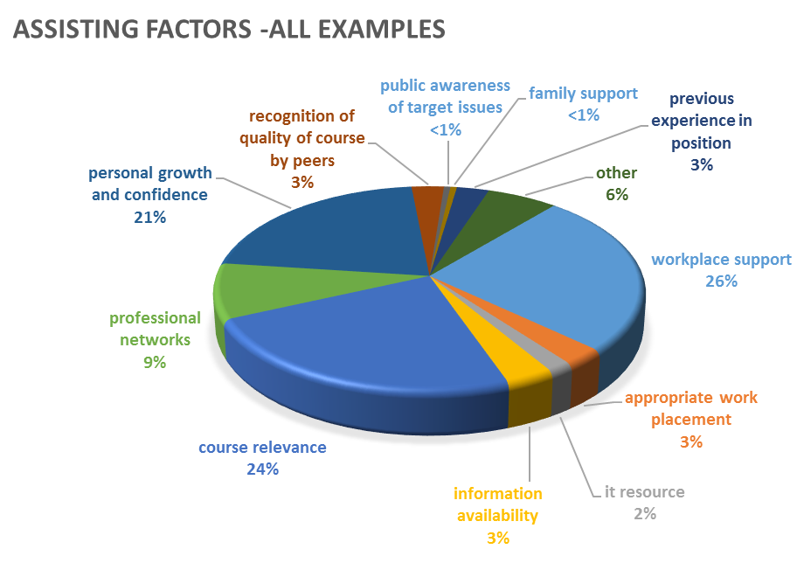

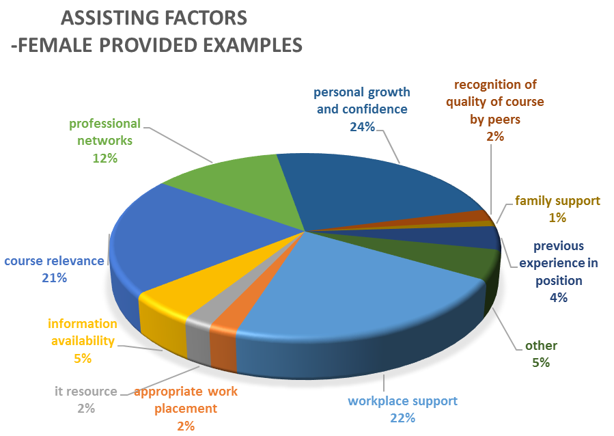

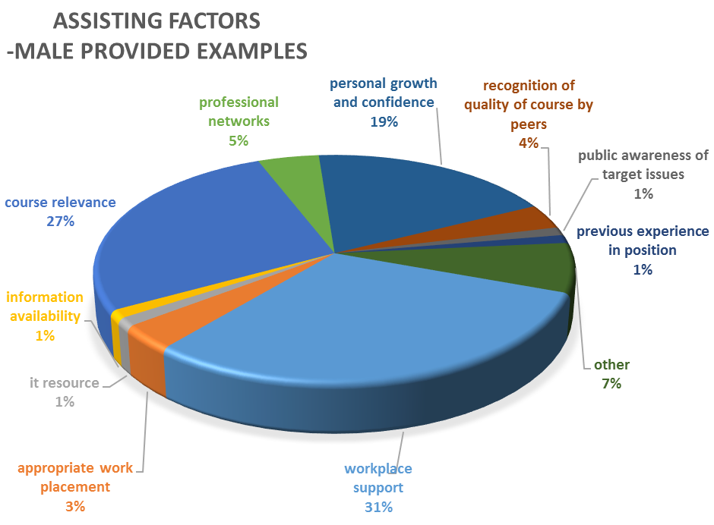

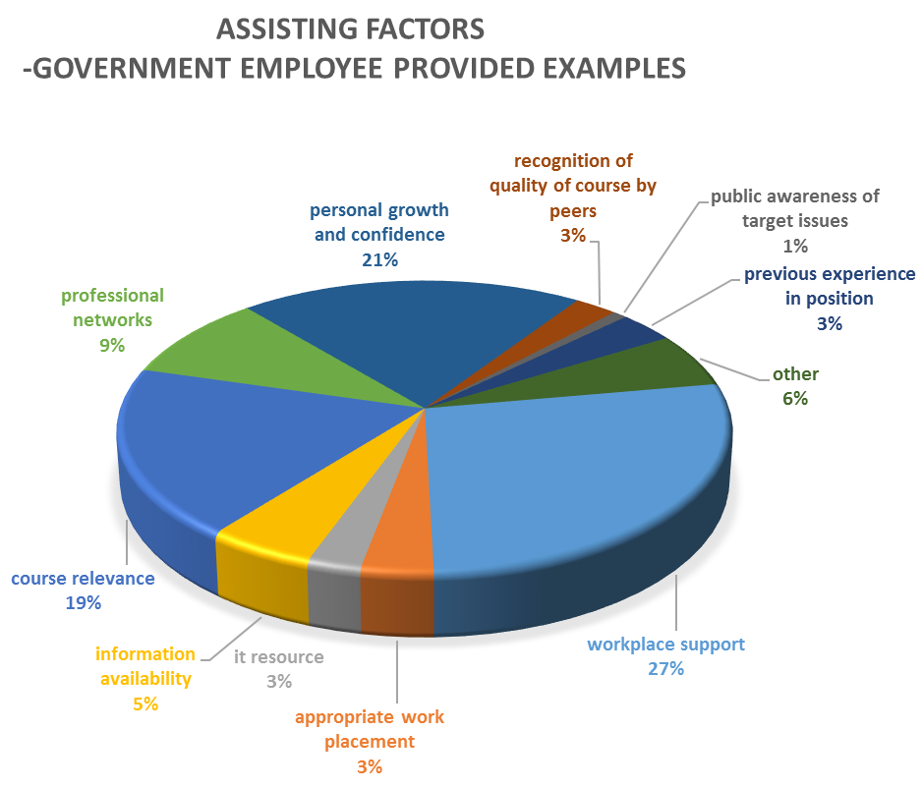

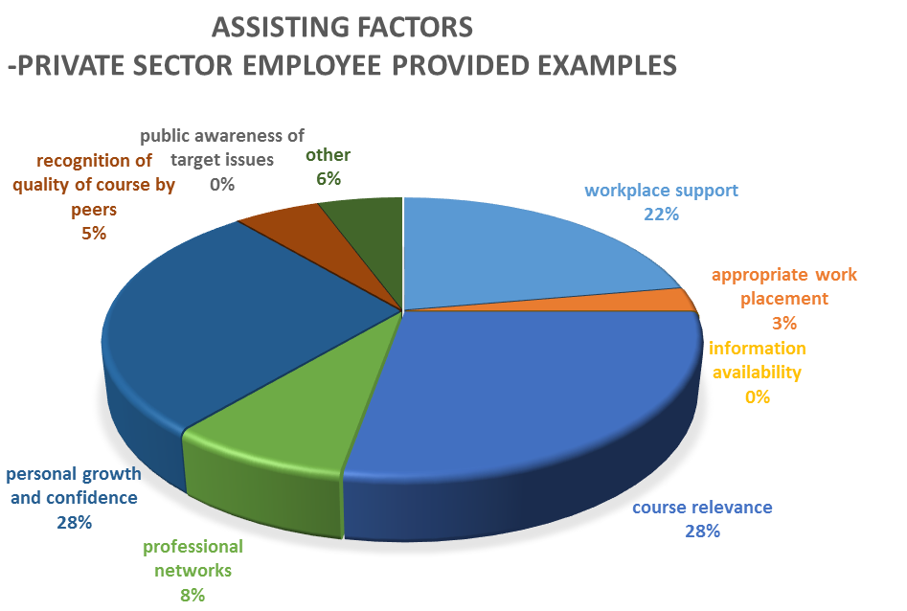

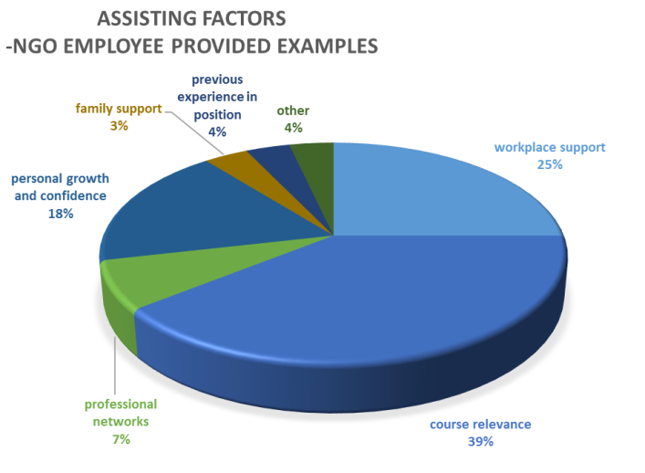

Indicator G4: Number or % alumni providing significant and appropriate examples of actual uses of their award skills 3 years or more after return

Only available when Tracing Survey and Case Studies are undertaken across all countries. So far, a case study has only been completed for Bhutan. It does demonstrate strong and sustained development contributions by alumni who have been back for 3 or more years after return.

Indicator G5: Number or Percentage of alumni reporting significant and appropriate examples of usage of professional linkages with Australians 3 or more year after return

Only available when Tracing Survey and Case Studies are undertaken across all countries. So far, a case study has only been completed for Bhutan. This case study of the impacts of pre-2010 civil service alumni was conducted in September/October 2013. The impacts of 14 alumni were examined. This case study does demonstrate some sustained professional links by alumni who have been back for 3 or more years, but these are relatively uncommon. However, caution should be taken when extrapolating from this small, focussed sample. A larger sample size is necessary to provide a quantitative result for this indicator.

**ANNEX 3: Case Study Report – Bhutan September 20123 – Australia Awards in South Asia**

**ABBREVIATIONS**

|  |  |
| --- | --- |
| **AusAID** | Australian Agency for International Development |
| **AEC** | Australian Electoral Commission |
| **BTN** | **Bhutanese** Ngultrum |
| **BRIDGE** | Building Resources in Democratic Governance and Elections [BRIDGE] Program |
| **DNA** | Deoxyribonucleic acid |
| **GNHC** | Gross National Happiness Commission |
| **GoA** | Government of Australia |
| **GEF** | Global Environment Fund |
| **IFES** | International Foundation of Electoral Systems |
| **ICT** | Information and Communications Technology |
| **M&E** | Monitoring and Evaluation |
| **MEF** | Monitoring and Evaluation Framework |
| **MoLHR** | Ministry of Labour and Human Resources (Bhutan) |
| **MIT** | Massachusetts Institute of Technology |
| **NAPA** | National Adaptation Programme of Action |
| **NGO** | Non-Government Organisation |
| **RBP** | Royal Bhutanese Police |
| **RCSC** | Royal Civil Service Commission (Bhutan) |
| **RGoB** | Royal Government of Bhutan |
| **TTI** | Technical Training Institute |
| **TVET** | Technical and Vocational Education and Training |
| **UNDP** | The United Nations Development Program |
| **UNEAD** | The United Nations Electoral Assistance Division |
| **UNFCCC** | The United Nations Framework Convention on Climate Change |
| **UNICEF** | The United Nations Children's Fund |

Contents

1. Background to Case Study 30

2. Summary Assessment Framework 30

3. Alumni and Their Development Contributions 31

4. Summary of Contributions of Civil Service Alumni (Key Evaluative Questions) 41

5. Lessons Learnt in Applying Case Study Methodology 43

# 1. Background to Case Study

In July 2012, the Australia Awards in South Asia program conducted a Tracer Study on the activities of certain of its alumni who returned between 2000 and 2010. The study indicated that alumni from the Bhutanese Civil Service appeared to be making significant development contributions, so this context was chosen as an opportunity to trial and further develop a case study methodology.

It should be noted that selection of the alumni for inclusion in the case study was based on the fact that they were making development contributions, and the desire to both verify and explore the nature of such contributions in greater detail. This means the case study sample is unavoidably positively-biased, as those alumni not making contributions were not included in the sample. This is appropriate given the aim of verifying and exploring the nature of development contributions made. Other M&E tools (e.g. reintegration plan tracking) record the proportions of alumni not reporting development contributions and this is reported for the program as a whole. In future, there may also be value in conducting a case study specifically on such non-performing alumni, and such a case study would then, appropriately, be negatively-biased.

While the sample selected was stratified across gender to ensure representation of both male and female alumni, in terms of individuals included it was effectively random (and often based on practical availability).

The case study team consisted of two parts. An M&E-focused team leader was responsible for exploring and verifying claims relating to development contributions by alumni. A three-person Communications-focused component was responsible for developing Communications products, specifically focusing on the beneficiaries of development contributions made by alumni. In practice, to avoid duplication the M&E team leader left most direct beneficiary engagement (beyond basic verification) to the Communications part of the case study team.

# 2. Summary Assessment Framework

In order to keep this report concise, a simple standardised approach to assessing alumni impact has been adopted. The impacts of development contributions generated by alumni will be assessed in relation to three sets of criteria:

 1.  Geographic Impacts

A. National level effect

B. Regional level effect

C. Local level effect

 2. Thematic Impacts

A. In line with national/AusAID priorities and targets vulnerable groups (does both)

B. In line with national/AusAID priorities or targets vulnerable groups (does only one)

C. Effects in other sectors and groups

 3. Temporal Impacts

A. Sustained General Effect (not dependent on direct alumnus involvement)

B. Sustained Personal Effect (dependent on ongoing alumnus involvement)

C. Temporary Effect

The development contributions of each alumnus will therefore be assigned a compound rating consisting of the result against each impact criteria. These ratings will therefore take the form of an ‘AAA’ impact or a ‘ACB’ impact, etc. No attempt will be made to sum the three divergent dimensions of this compound rating into a single figure, as this would hide and distort valuable insights into the real nature of the contributions.

It is recognised that many other factors could be taken into account when assessing impact, and an 'Important Comments' field accompanying the compound rating against these three prioritised factors is used to address this ‘other factors’ dimension.

One of these ‘other factors’ that deserves specific mention here is the ‘magnitude’ of the development contribution. As with any capacity development initiative, full attribution of a certain quantity of outputs and their associated outcomes to provision of a scholarship is difficult - in that provision of many other resources (e.g. funding of activities, etc.) are also necessary conditions for successful creation of these outputs and outcomes. However, in many cases it is possible to claim that the provision of the scholarship to a particular individual driving an initiative is equally a necessary condition, as without this scholarship, the impetus or know-how to implement such activities would not have existed. Hence, while the full impact of development outputs and outcomes delivered by an alumnus cannot be attributed to provision of a scholarship alone, the scholarship’s ‘contribution’ may often be regarded as reasonably on par with other, more visible, factors.

# 3. Alumni and Their Development Contributions

***Alumnus 1.***

Name: **Geley Norbu**

Sex: Male

Course: Master of Urban and Regional Planning

Year of Return: 2006

Current Position: **Chief Urban Planner, Thimphu City Corporation**

Geley Norbu worked with the National Ministry of Works and Human Settlement for approximately three years before being awarded a scholarship to study in Australia. This gave him a sound grounding in the issues and priorities faced in relation to land use planning in Bhutan. One of the reasons he and his employer chose an urban planning focus for his studies was a recognition that most land use planning to date had been rurally focussed and that increased levels of unregulated urbanization, particularly in major centres, was creating potential land use conflicts and preventing provision of appropriate service levels to urban land owners and residents.

On his return, he was placed in a new section of the Ministry, which was given a specific mandate to address urban planning issues. In his role as one of the only qualified urban planners in the Ministry, he directly and substantially contributed to the urban planning components of:

* The Land Act, 2007
* The Municipal Act 1999 (Amendments)
* The Local Government Act 2009

He also directly and substantially contributed to the revisions to the existing Planning Act, for which approval is currently pending. All of these contributions to formulation of legislation included the drafting of detailed regulations and guidelines for implementation.

In terms of implementing these pieces of legislation, Geley also spent the first 3-4 years following his return producing formal development plans for three districts of Bhutan, including the National Capital (Thimphu) District. He then voluntarily moved to a new position within the Thimphu Municipality in order to be better placed to continue implementation of the policies and legislation he had helped develop.

In his new role as the head urban planner for the Thimphu Municipality, he was responsible for developing six Local Area Plans that were specifically designed to address land use conflicts and bring appropriate services to newly expanding sections of the city. A key aspect of these local area plans is the introduction of a system of ‘land pooling’. Most blocks of land in these newly expanding areas of the city were both irregularly shaped and contiguous with each other. This leaves no opportunity for provision of basic services such as access roads, sewage, water supply lines and power lines. Impromptu roads and service lines are therefore a source of significant conflict as they commonly traverse the blocks of others. Land pooling was introduced as a means of addressing these conflicts, as well as allowing for some areas of land to be reserved as open space and parks. Under this approach, the municipality consults with all land owners in the local plan area and negotiates realignment and regularization of existing blocks to allow for a system of public roads to be introduced providing access to all blocks. In this process, all landowners agree to surrender between 20-29% of their holdings for this purpose, but overall plans are transparently provided, so that owners can clearly see how all surrendered land is used. This transparency avoids accusations of ‘land grabs’ by the Municipality. In most cases, landowner approval of the local area plans negotiated to date is close to 100%. The economic benefits to landowners has been rigorously assessed and confirmed:

“Based on the economic analysis for the Project (ADB funded, Bhutan Urban Infrastructure Development Project), the net economic benefit from the land pooling exercise was quantified for land owners as follows: without land pooling, the existing land would continue to have an economic value as agricultural land. Given the typical agricultural activities assumed for the areas, the land is valued at Nu.29,500 per ha, which is the present discounted value of net agricultural income over 30 years. With land pooling, the remaining land will be developed as urban residential areas and the main income from land will be rent from housing units. Given the typical rental value of Thimphu, the remaining land can be valued at Nu.563, 100 per ha, which is the present discounted value of net rental income over 30 years. For a typical land owner who owns 1.9 ha and contributes 29% of his land, the net economic benefit due to land pooling will be Nu.478, 000 per person, which is 15 times as large as the economic value of his/her land without land pooling”.[9]

Landowner group representatives and individual landowners themselves confirm that, while there are short term issues associated with putting plans into action, they perceive significant long term benefits in the land pooling approach and lot realignments enacted by the plans. They point to the provision of high quality roads (sealed and drained) by the Municipality at no additional cost. Likewise, City provision of water and sewage lines is likely to have obvious benefits in avoiding potential health and amenity issues. They also confirm that the municipality has taken a highly consultative approach to development of these plans, and landowners spoken to gave examples of specific issues that had been resolved for them through such consultation.

Site visits to Local Area Plan sites reveal very high levels of construction activity occurring in accordance with these plans and in anticipation of improved services. This reveals significant investment confidence, both in the longer term returns of such plans and the ability of the Municipality to eventually deliver the promised services.

Most plans address predominately greenfield sites, so the need for removal of existing structures is minimal. However, at the beginning of each local plan, the Municipality produces both a Social Assessment Report and a Resettlement Action Plan. These documents address landowners, renters of accommodation and informal occupants. They include a special focus on vulnerable groups, and such groups explicitly include those in low socio-economic brackets, female-headed households (widows, etc), the elderly and the disabled. In the Resettlement Action Plan explicit provisions are included that define the additional forms of assistance given to these vulnerable groups, including, but not limited to, payment of compensation and/or resettlement costs.

Geley has already written and published one book entitled “Thimphu, Then and Now” and is working on another on urban planning in the Bhutan context to be published through Massachusetts Institute of Technology (MIT).

Impact Rating: AAA

Other Comments: Much of the funding has come for implementation of Local Area plans has come from the Asian Development Bank and the World Bank and all work has therefore been subject to World Bank social safeguard policies.

**Alumnus 2.**

Name: **Karma**

Sex: Male

Course: Master of Public Administration

Year of Return: 2008

Current Position: **Division Chief, Vocational Education and Training Division (MoLHR)**

Karma had a civil engineering background and had been working at the Technical Training Institute (TTI) in Timphu under the Ministry of Labour and Human Resources when he was awarded a scholarship. He completed a Master of Public Administration and, on his return, was asked to produce a report into upgrading the existing TTI. This report included a range of recommendations that were accepted and resulted in the TTI being re-established as the Construction Service Centre (CSC). Karma now heads the Vocational Education and Training Division of the Ministry of Labour and Human Resources.

The redesign of this institution was aimed specifically at boosting participation of Bhutanese workers in the skilled worker section of the construction industry. This market is currently dominated by guest workers from India. The responsibility for finding work for Bhutanese Technical and Vocational Education and Training (TVET) graduates was then passed from the Department of Employment to the Centre. Programs run by the Centre included paid, on-the-job training for students in Centre managed construction projects. This program was instrumental in giving graduates the experience that they required to gain employment in the industry. One such graduate who benefited from this program was Mr Cheke, he is now a construction mason at Basochu HydroPower Project (Druk Green Power Corporation) and states that he is still using the skills he gained through the Construction Service Centre program on a daily basis.

Impact Rating: AAA

Other Comments: Some cross-alumni impact also exists with Alumnus 14, in that the CSC plays a role in teaching application of the earthquake standards identified by Karma.

***Alumnus 3.***

Name: **Kinley Wangmo**

Sex: Female

Course: Master of Journalism

Year of Return: 2009

Current Position: **Editor/Reporter K2 Magazine, Kuensel Corporation Ltd.**

Kinley was working with the Bhutanese National newspaper ‘*KUENSEL*’ when she was awarded a scholarship for further journalism studies. She was particularly interested in courses related to feature writing and while in Australia she took the initiative to use her new skills to research and write a number of feature articles on the life of Bhutanese students studying in Australia. These were sent back to her KUENSEL editor and published. On her return, her editor stated that he was impressed with her feature writing skills and wanted her to start writing such articles for the newspaper (to this point the paper had focussed primarily on short, sharp, ‘hard news’ stories). Given this task, Kinley developed a proposal to begin an insert magazine for the weekend edition of the newspaper. The proposal was successful and Kinley was appointed editor of this magazine. The magazine was initially entitled ‘City Bites’ and had a Thimphu focus. The magazine format proved very popular, but demand for stories to be published that dealt with issues and people outside of the capital resulted in the renaming of the publication to ‘K2’; with a consequent broadening of geographic focus and a more explicit editorial focus on women and youth (who had proved the key readership of the original format).

The magazine is not just known for its human interest features, but has also proved a very valuable vehicle for advancement of public service initiatives, such as school-based health and hygiene programs, Anti-smoking campaigns, AIDS awareness campaigns, discussions of electoral issues, and many others. For such inclusions, the magazine would run an independent feature article based on the personal experience of persons involved in a public service program, and the program’s sponsor (usually Government or an NGO, such as UNICEF) would purchase advertising space in the magazine to explain how to become involved and other background material.

As this opportunity has not yet been utilised by the Australia Awards program, such an approach may represent a very good means of promoting these scholarships in Bhutan.

Review of past editions of K2 confirms a strong focus on this public service provision content, and despite KUENSEL being partially state-owned, politicised content in the magazine is minimal to non-existent.

While acquisition of sufficient advertising to meet production costs remains an issue for the magazine, its popularity is evidenced by fact the weekend edition of KUENSEL has become its bestselling edition, and that the newspaper has been willing to maintain publication of the magazine despite the fact that the advertising it directly attracts does not meet the insert’s production costs.

Impact Rating: AAA

Other Comments: Nil

***Alumni 4-8 National Five Year Development Plan Group***

Name: **Thinlay Yandon**

Sex: Female

Course: Master of Finance

Year of Return: 2010

Current Position: **Chief Revenue Officer, Department of Customs and Revenue, Ministry of Finance**

Impact Rating: AAA

Other Comments: See summary below

Name: **Dorji Wangmo**

Sex: Female

Course: Master of Public Policy (Development Administration)

Year of Return: 2005

Current Position: **Senior Planning Officer, Policy and Planning Division, Ministry of Information and Communication**

Impact Rating: AAA

Other Comments: See summary below

Name: **Phuntsho Wangmo**

Sex: Female

Course: Master of International and Development Economics

Year of Return: 2010

Current Position: **Senior Program Officer, Vocational Education and Training Division, Ministry of Labour and Human Resources**

Impact Rating: AAA

Other Comments: See summary below

Name: **Phuntsho Wangyel**

Sex: Male

Course: Master of International and Development Economics

Year of Return: 2007

Current Position: **Senior Research Officer, Research and Evaluation Division, Gross National Happiness Commission**

Impact Rating: AAA

Other Comments: See summary below

These four alumni are addressed together because they were all chosen on the basis of their contributions to formal National-level development planning, namely the series of ‘National Five Year Plans’ formulated by the Government of Bhutan.

Thinlay Yandon is head of the Revenue Division of the Department of Customs and Revenue under the Ministry of Finance, and her normal duties include preparing analysis and associated forecasting of Bhutan’s revenue situation, including for state owned industries. Reports she produces on these matters are routinely provided to Cabinet. She is also a member of the National MacroEconomic Fiscal Framework Committee. She directly attributes her recognised competency in these roles to the fiscal and revenue planning subjects from her Australian course.

In her role with the Ministry of Finance, Thinlay has directly contributed to the 10th and 11th National Five Year Plans. For example, she took the lead in developing the Fiscal and Infrastructure Framework incorporated into the 10th and 11th plans and reported against targets in preceding plans. In relation to the Frameworks she has worked on (and assisted to implement), the desired targets have consistently been met.

Dorji Wangmo is now the Senior Planning Officer for the Policy and Planning Division of the Ministry of Information and Communication. She has been with this Division for almost 12 years, with ever increasing workloads and responsibilities. Since her scholarship, she has developed a number of significant policies, including the ITC sector-specific policies on Foreign Direct Investment, Economic Development and Telecommunications & Broadband Development. She has also combined these discreet policies into ITC and E-Governance Masterplans that have been incorporated into successive Five Year Plans, including the latest 11th Five Year Plan just passed on 20 September 2013.

These Master Plans require close coordination with other Ministries and address many key development issues, including; the extension of government service delivery to remote areas by creation of (182) ICT-based community centres (allowing local birth registration and other services); ICT assistance to election processes (including introduction of biometric [fingerprint registration] equipment to combat voting fraud); ICT planning for all education facilities, road transport systems, air transport systems; and specialist (ongoing) ICT planning for health and tourism services.

Dorji has also overseen the planning and installation of Bhutan’s fibre optic network, with 170 (of 205) districts now covered, as well as expansion of the country’s mobile network (in partnership with private companies), to the point where all villages in all 205 districts of Bhutan have mobile coverage. The mobile phone subscriber rate for the general population of Bhutan now stands at 72%, which is especially impressive when Bhutan’s 66% literacy rate is also considered (approximate).

Phuntsho Wangmo is Senior Program Officer with the Vocational Education and Training Division of the Department of Human Resources of the Ministry of Labour and Human Resources. In this role she has been given responsibility for developing and providing policy input on the TVET sector into the last two Five Year Plans, especially the latest 11th Five Year Plan. A key positioning of the TVET sector in this latest plan is to service the construction industry, and thereby significantly boost employment opportunities for local construction workers, as Bhutan currently uses over 60 000 Indian guest workers in this sector. Note this work aligns well with that carried out by Karma (Alumnus 2) in relation to creation to the Construction Service Centre. The TVET strategies also support a ‘Power Training Initiative’ in support of the hydropower industry, and a move to include some TVET training as optional inclusions in secondary school curricula.

Phuntsho Wangmo has also collaborated with other departments and ministries to produce the National Human Resources Masterplan for the 11th Five Year Plan. This included a great deal of specialist workforce projection analysis and resulted in development of a Human Resource Roadmap for Bhutan.

Phuntsho Wangyel is Senior Research Officer with the Research and Evaluation Division of the Gross National Happiness Commission (GNHC). His role with the Commission focuses on review of all government policy, particularly that to be incorporated into the Five Year Plans. He has been worked directly with all of the three proceeding alumni, as well as staff of other ministries in ensuring coordination and consistent quality is maintained across all inputs into the Five Year Plans. His Division’s endorsement of input is required before it may be passed on to Cabinet.

His scrutiny focuses on ensuring that all government policy retains an appropriate focus on poverty reduction targets, rural economic advancement strategies, ‘National Rehabilitation Program’ strategies (focussed on assisting landless and socio-economically disadvantaged groups), and provision of improved government services - especially in the health and income generation sectors. His GNHC role also includes ensuring that environmental, climate change, gender, and disaster risk reduction issues are mainstreamed into all policy development. He has carried out these roles for the last three Five Year Plans.

Other Comments: ***Summary***

The development contributions of these four alumni amount to an extremely broad range of sectoral impacts, initiated at the highest level of policy development. It should be noted that targets incorporated into each successive Five Year Plan are closely monitored, so those providing plans and other input are ultimately held responsible for performance against these targets on the ground. That three of the initial developers of this high level policy are women also reveals a gender-related impact in its own right. With these women all closely attributing their advancement within their workplaces to the qualifications and skills obtained through their scholarships, the Australia Awards can take some credit for giving women a strong voice at these levels.

***Alumnus 9***

Name: **Major Lobzang**

Sex: Male

Course: Graduate Diploma in Forensic Science (DNA Technology)

Year of Return: 2002

Current Position: **Head, Forensic Section, Crime Branch, Royal Bhutanese Police**

On his return to Bhutan in 2002 Lobzang was one of only two qualified forensic officers in the Royal Bhutanese Police Force (RBP) (n.b. the other was also an AusAID scholarship recipient). Lobzang’s course at Flinders University was a specially designed sandwich course which gave him a large component of on-the job training with Australian forensics laboratories and police forces. While his full course was jointly funded by both AusAID and the Royal Government of Bhutan, it was the provision of the initial scholarship that was the formative basis of this study opportunity.

The context in Bhutan in 2002 was that trials and other court matters depended heavily on testimonial evidence. Without physical evidence to corroborate such testimony, it was less easy to make assessments that were beyond reasonable doubt: either in terms of guilt or innocence. A difficult burden was thereby placed directly on judges (a jury system is not used in Bhutan) when determining cases. On his return from his studies, Lobzang was assigned the task of expanding the physical evidence base and associated forensic methods and systems employed by the RBP.

The first stage of his task included:

* Identification of priority areas of need for forensic services
* Development of appropriate systems of collection, handling and ‘chain of custody’ standards for physical evidence to ensure its admissibility in court
* Development of both Basic and Advanced forensic science courses for field officers (with associated formal certifications awarded to successful candidates)
* Development of field manuals[10] and checklists for use by field forensic specialists

Under this first stage, Forensic Units have been established within all 36 police stations in Bhutan, with each unit housing specifically trained officers and a basic kit of equipment allowing proper collection, handling and storage/transport of forensic evidence ranging from photographs and fingerprints to DNA samples. In all, approximately 60 RBP field officers have now been trained and certified as forensic specialists. While more complex testing (i.e. DNA testing) is still carried out abroad, the additional forms of evidence flowing from these Forensic Units has been welcomed by courts, and is credited for allowing clear convictions and acquittals on many occasions. In fact, demand for this type of evidence has now risen to the point that it has outstripped current ability to provide certain analyses in a timely manner. Sending material abroad for analysis necessarily incurs delays that are not easily accommodated by court proceedings.

Under the second stage of Lobzang’s work, he has developed a plan to set up a National Forensic Science Laboratory. This plan has been agreed by Government and funding of 135M (BTN) has been confirmed in the latest (11th) National Five Year Plan. The concept for this laboratory includes use by a range of public agencies, including the Police, Customs and Child Protection Services, as well as by the private sector in regard to civil cases or insurance investigations. Use by the private sector will also allow for some cost recovery on services provided, potentially allowing cross subsidization of ongoing maintenance and operational costs.

In recognition of his work in developing the forensic services within the RBP, Lobzang was awarded the Drakpoi Norbu Yoedsel Medal (for meritorious service) in February 2013. He has also written a number of standard reference materials, including National Crime Statistics and works as Project Manager on Protection of Women and Children Issues with partner organizations such as UNICEF.

It is also worth noting that due to the links he established with staff of the Adelaide Forensic Science Centre, soon after his return he was able to arrange analysis of evidence that led to a clear conviction in at least one murder case. Some external testing is still carried out in Australia.

Impact Rating: AAA

Other Comments: National Forensic Science Laboratory is referenced in the11th National Five Year Plan

***Alumnus 10***

Name: **Sonam Lhaden Khandu**

Sex: Female

Course: Master of Climate Change

Year of Return: 2010

Current Position: **Senior Environment Officer, National Environment Commission**

On return to the National Environment Commission, Sonam was placed in a newly created Climate Change Division. Bhutan had first produced a National Adaptation Programme of Action (NAPA) under the United Nations Framework Convention on Climate Change (UNFCCC) in 2006. As Sonam’s studies had included specific courses on drafting of NAPAs, she was given the task of lead author on the update due in 2012. This updated NAPA has now been completed and ratified both by the Royal Government of Bhutan and the UNFCC.

As a consequence of this completed NAPA, Bhutan has access to the Global Environment Fund (GEF) and the UN Least Developed Countries Fund. Sonam has already developed a suite of eight projects totally approximately USD11.5M which are to soon be implemented under the Bhutan NAPA. These projects cover all districts and a range of sectors, including:

* Providing better long-range weather forecasts and associated early warning systems to farmers
* Producing water resource inventories in water scarce areas
* Producing water resource projections for water scarce areas
* Developing, in association with NGOs, better water conservation measures applicable to Bhutanese contexts
* Developing improved disaster response and disaster risk management systems (including for severe weather, landslide and forest fire issues)

Sonam maintains contact with other Australian and international students she met while on her course in Australia, and uses these contacts on both a professional and personal level.

Impact Rating: AAA

Other Comments: The NAPA is referenced in the 11th National Five Year Plan

***Alumnus 11***

Name: **Sonam Pelden Thaye**

Sex: Female

Course: Master of Public Policy (Public Administration)

Year of Return: 2005

Current Position: **Senior Program Officer, Cabinet Secretariat**

Sonam’s return to her work with the Ministry of Home Affairs coincided with the announcement of Bhutan’s first open election for National Assembly members. Her Masters of Public Policy, partially specializing in electoral processes, prompted her superiors to place her as Head of the Department of Electoral Regulation. In this role she directly supervised:

* Preparation of the first National electoral role
* Development of a system of voter identity cards (to help combat electoral fraud)
* Voter registration for the entire country
* Voter awareness and educational campaigns (also supported by the Building Resources in Democratic Governance and Elections [BRIDGE] Program[11]

This work included preparation of formal policy guidelines governing future preparation of electoral rolls and voter registration procedures, and these were used successfully to conduct the recent (2013) second election.

In 2012 Sonam moved to the Prime Minister’s Office within the Cabinet Secretariat where she is Head of Good Governance Affairs. In this new role she is responsible for monitoring and evaluation of governance standards across all ministries, including review of all ‘agencification’ matters (organisation governance structures). As part of this monitoring and evaluation role she directly supervises (and drafts) the annual State of the Nation Report for presentation to Cabinet. In addition, she also has oversight of a number of projects implemented directly by the Prime Minister’s Office. This includes the Minimum Program, which is aimed at ensuring minimum standards of government service in relation to issues such as rural water supply.

Impact Rating: AAA

Other Comments: Note links to Australia via BRIDGE Program

***Alumnus 12***

Name: **Phuntsho Tobgyel Norbu**

Sex: Male

Course: Bachelor of Applied Science (Dairy Foods)

Year of Return: 2002

Current Position: **Senior Livestock Production Officer, Department of Livestock, Ministry of Agriculture**

When Phuntsho Norbu returned to work with the Ministry of Agriculture, he was reassigned to the newly established National Dairy Centre where he has since overseen the implementation of donor funded (Netherlands, India, etc.) funded projects aimed at establishing a sustainable dairy industry in Bhutan. His consistent oversight has been a clear factor in coordinating such projects into an integrated program. This program included agricultural outreach directly to small farmers, establishment of dairy cooperatives across the country, establishment of a pilot, commercial-scale processing plant in Thimphu and establishment of retail outlets.

Meetings with beneficiaries reveal Phuntsho was heavily engaged at all levels of this initiative, including training farmers in basic milk handling, creating milk collection and processing capabilities within dairy cooperatives, training workers within the pilot commercial scale processing plant and assisting retail outlets to meet regulatory requirements and acquire necessary storage and packaging equipment.

One farmer indicated his increased income due to the dairy initiative had been sufficient to fund his younger children’s education, with one of these children studying law in India and very recently being elected to the National Council (2013 National Council Elections). His family’s nutrition also benefits from household consumption of excess milk products.

One dairy cooperative consulted consists of a core of 8 families and operates a milk collection centre and mini processing plant. This cooperative reported that these additional (off-farm) activities provided employment for six people. Given that there have been approximately 30 Smallholder Dairy Farmers’ Groups (SDFGs) established across the country, such cooperatives now created across Bhutan, the multiplier benefits beyond farmers themselves are clearly considerable.

Representatives of one of the two commercial dairy processing plants now in existence in Bhutan indicated that they received the training and other assistance necessary to enable them to open their factory from their work experience at the National Dairy Centre’s pilot processing plant.

Retail outlet owners indicated that the establishment of this industry has provided significant commercial opportunities. One such outlet visited in Thimphu employs 12 people and provides an above average income for owners.

Retail outlets visited were all conducting a very brisk trade in milk products, and their commercial success reveals a significant demand for fresh dairy products within the community.

The fact that there still remains a severe skills shortage in regard to qualified dairy scientists and technicians in Bhutan means that Phuntsho is likely to continue to have significant impact in this industry for many years to come.

While it is not claimed that the success of these dairy projects in Bhutan are solely attributable to the skills Phuntsho acquired as a result of his Australia Award, it is reasonable to assert that his skills amounted to one of the necessary conditions of the success to date.

Impact Rating: AAA

Other Comments: Though funding for the dairy program itself came from other sources, the capacity building provided by Australia Awards directly facilitated this investment

***Alumnus 13***

Name: **Jigme Nidup**

Sex: Male

Course: Master of Environmental Studies

Year of Return: 2004

Current Position: **Senior Environment Officer, National Environment Commission**

After completing his studies, Jigme returned to a role as a lecturer with the University of Bhutan. In this role he initiated a number of teaching reforms, including improving approaches to research methodology and introduction of a formal system for referencing citations in research documents. He also introduced a number of new courses, including Research Methods, Climatology and Environmental Management. Prior to his input, the University had to rely on higher-level course content offered through the University of Delhi, and now they are able to design and offer this content locally. His role with the University also included conducting of research into water resource management for villages with no access to safe drinking water.

From the University he moved to the position of Senior Environment Officer with the Water Resources Conservation Division of the National Environment Commission. In this new role he is responsible for conducting numerous water resource management projects, including field research into the National Water Resources Inventory.

Impact Rating: AAA

Other Comments: Though in his first role after returning his roles and impacts were often localised, his new role has allowed him to expand his work to a national level.

***Alumnus 14.***

Name: **Karma Dupchuk**

Sex: Male

Course: Master of Engineering Studies (Structural Engineering)

Year of Return: 2006

Current Position: **Head of Urban Planning and Environment Division, Gelephu Municipality**

On return from his Award Karma was working in the North of Bhutan with some of the smaller Municipalities, and was largely involved in development of grant applications, provision of planning and structural approvals for private buildings and government structures such as schools. He also assisted in the design and construction of river training walls and other erosion protection measure. A number of earthquakes then occurred in the northern and central regions and he became involved in identifying appropriate earthquake-resistant building standards for new constructions (they eventually adopted Indian "Zone 5", or "Very High Damage Risk Zone" standards) and also carried out safety inspections on and catalogue ‘non-engineered’ (traditionally built) structures that may be at high risk of damage in future. A new permit system was then developed for earthquake prone areas.

In 2012 Karma was offered a senior position with the Gelephu Municipality (the second largest in Bhutan), and has since been working on development and implementation of local land use plans and structural development control regulations, and has developed specific planning and environmental plans for a major industrial estate. He has also assisted with identification of appropriate groundwater water supplies for urban communities around Gelephu.

Impact Rating: BAA

Other Comments: Earthquakes are only an issue for part of Bhutan, so difficult to give this impact an A for geographic component of overall rating.

# 4. Summary of Contributions of Civil Service Alumni (Key Evaluative Questions)

The Terms of Reference for this case study pose 5 key questions:

1. Are civil service employers providing opportunities for alumni to use the skills, knowledge or networks[12] gained from their award?

The clear answer to this question is that Bhutanese Civil Service employers appear to be very proactive in providing alumni with opportunities to utilize the skills obtained from their scholarships. In a number of examples identified in this case study, new sections, division or institutions were specifically created for returned alumni to use as a platform for implementation of new initiatives related to their fields of study. The Civil Service also appears to have coordinated the capacity building provided by scholarships with synergistic opportunities for resourcing of activities by Government or other donors. It is particularly interesting to note that when asked about constraints on their work, alumni consistently failed to raise the issue of unsupportive supervisors or institutions, despite this being the most commonly raised constraint by alumni worldwide. On further questioning, it appears one reason for the absence of this common global impediment may be the relatively young and well educated demographic of government workers in Bhutan, particularly those in senior posts (a direct reflection of the overall age demographics of Bhutan as a whole). This younger, well-educated demographic may therefore translate into a more progressive and less change-adverse attitude within the Bhutanese Civil Service. The fact that women are consistently among the highest achievers in this case study, also demonstrates that gender is not an impediment to success. These females also report that they suffer from no discrimination along gender lines and that the only issue they face in relation to their sex is the need to juggle looking after children and their careers, and that this may affect how much responsibility they can take on at times.

1. Are alumni using available opportunities to use the skills, knowledge or networks gained from their award to generate development impacts?

As demonstrated by the detailed examples given in the preceding section, it is clear that alumni are using their skills effectively. Use of networks is less often reported, and usually limited to networks established directly through study opportunities, rather than broader social or professional networks. Given that many of the greatest development contributions have been delivered by women, gender is clearly not an impediment to utilization of skills in the Bhutanese context.

1. What are the key constraints and enabling factors affecting provision or use of opportunities to use award skills, knowledge or networks?

The most common constraints reported were either human resource related or minor software, informational or equipment issues. In relation to human resources, this meant either supportive human resources available within work places, or the education level of those to whom assistance was targeted. A lack of supportive human resources within workplaces was usually overcome by the provision of training and other capacity-building (often by alumni themselves) to bring other staff up to a necessary standard. This was effective, but time consuming, and slowed down implementation of associated activities considerably. Low education levels in target groups was adjusted for by the use of various approaches to extension work, but remained a significant impediment in certain cases (e.g. ITC based government service delivery).

Many of the minor software, informational or equipment issues have greater potential for the Australia Awards program to address. For example, those alumni working with structural engineering matters indicated that their work would be much more effective if they had access to related engineering software packages. Other technical officers suggested provision of access to professional journals and other data systems and short course options. Small investments through a workplace-targeted, small grants program (with appropriate critical assessment of proposals) might therefore make significant improvements in alumni effectiveness at minimal cost.

Other general constraints reported include availability of appropriate budgets and difficulties in overcoming use of traditional approaches by beneficiaries.

1. Do any cross-cutting factors (e.g. gender, disability, etc.) affect provision or utilization of award skills, knowledge or networks? How?

As already stated, no evidence was obtained to suggest gender affected the provision of opportunities to alumni, or their ability to generate appropriate development outputs and outcomes. In fact many of the highest level achievers of the case study were women.

The case study also identified instances in which the needs of women and other vulnerable groups such as the disabled were explicitly considered in the development contributions delivered by alumni.

1. What awareness exists within RGoB of the Australia Awards program and its potential or existing contributions to strengthening the capacity and service delivery of the Bhutanese Civil Service?

Given the overambitious number of alumni included in the case study, rationalization of the approach has meant answering this question has relied primarily on evidence from the direct recognition from alumni themselves that their scholarships were instrumental in progressing their careers and their ability to deliver outcomes. This realization was very strong in all alumni interviewed and many of these alumni hold senior positions within the Bhutanese Civil Service.

# 5. Lessons Learnt in Applying Case Study Methodology

A very clear error made in attempting to apply this methodology for the first time was an overambitious selection of alumni to include in the study. It was originally intended to conduct interviews with a first round of 15 alumni. One of these alumni subsequently proved unavailable.

Given the richness of the impact data provided through these interviews, and the inherent difficulties in arranging reactive interviews in Bhutan[13], it rapidly became clear that following up with all relevant stakeholders was not going to be feasible. In rationalizing the approach, it was decided to focus primarily on beneficiaries (at the expense of employers) and in doing so choose the sub sample of alumni impacts with beneficiaries who were most readily available. From the M&E side of this task, the beneficiaries were contacted primarily as a means of verification of alumni claims, and research did not extend beyond this function. However, because the case study methodology also includes a public diplomacy (Communications) component, and in this case we were fortunate enough to have a separate team working on this component, more detailed presentations of effects on beneficiaries were also able to be developed in selected cases.

To avoid such overly ambitious approaches in future, it is suggested that a convention be adopted of never including more than five alumni in a case study and always choosing a more focussed area of impact (e.g. Democratic Governance, Environment, Agriculture, etc.; rather than Civil Service as a whole).

While it is recognised that it may not always be possible to include a separate communications team in carrying out a case study, it had obvious benefits in spreading of workloads. While the M&E side of the case study team was careful to verify alumni claims whenever possible (through reference to documentation or beneficiaries), much of the more detailed follow-up with beneficiaries could be left to the Communications side of the team. It should therefore be noted that the final output of the case study comprises not just this written report, but also the communications products produced in association with it.

**Annex 1 Terms of Reference**

**1.0 Background**

In July 2012, the Australia Awards in South Asia program conducted a Tracer Study on the activities of its alumni. From this study, a number of contexts worthy of further investigation were identified. Each of these will eventually become the subject of a Case Study. The Bhutanese Civil Service was one of the more general of these contexts, so it was chosen as a good opportunity to trial and develop generic Case Study methodology, before applying it to more specific areas of interest.

**2.0 Case Study Methodology**

As specified in the Australia Awards in South Asia Outcome Monitoring Strategy (Version 1.1), the important common principles of all case studies are that:

* They focus on a development contribution (including linkage establishment), not the individual alumnus
* They include at least three modalities of information gathering: document review, stakeholder interviews and direct observation
* Stakeholders interviewed must include beneficiaries of alumni development contributions
* They must also collect the ancillary information (including beneficiary quotations and photos in appropriate formats) needed to extract from the case study, relevant public diplomacy stories, if required.

This Case Study closely adheres to these principles.

* 1. **Information Gathering**

Three information gathering will be undertaken:

* Review of relevant documents

While this will include relevant overarching design documentation and associated reports, it is not entirely equivalent to an initial ‘desk study’ of the form carried out in a standard evaluation. This is because many of the relevant documents will pertain to specific development contributions made (e.g. new policies, operational manuals, specific project guidance, training materials, etc.), and will therefore only be identified through the stakeholder interviews investigating these contributions. Hence document review in the case study methodology is not an initial phase of the process, but rather an ongoing part of research. A relevant document list is therefore compiled at the end of the case study report, rather than in this Terms of Reference.

* Stakeholder Interviews

A first round of interviews will be held with alumni and their employers. These interviews will focus on identifying development contribution and linkages information, but will also be used to identify appropriate candidates for a second round of interviews focusing on the beneficiaries of development contributions/linkages. A tabulated list of the first round interviewees is provided as Annex 1. A similar table of beneficiaries interviewed will be provided in the final case study report.

Interview methodology is provided as Annex 2*(sic.)*. Respondents will be given opportunity to provide confidential (non-attributed) input, as requested.

* Site Visits

If the first or second round of interviews reveals opportunities for direct, observational information gathering, a set of site visits will be arranged, as feasible. Where possible, this will be combined with the second round of interviews to reduce logistical requirements, but if a beneficiary interview reveals an important additional observational opportunity, this will be followed whenever resources allows. The list of site visits conducted (and the rationale for each) will be provided in the case study final report.

**3.0 Focus Questions**

As this will be a generic (rather than ‘special purpose’) case study, the ‘standard’ set of questions will be applied to the Bhutanese civil service context:

1. Are civil service employers providing opportunities for alumni to use the skills, knowledge or networks[14] gained from their award? How?
2. Are alumni using available opportunities to use the skills, knowledge or networks gained from their award to generate development impacts? How?
3. What are the key constraints and enabling factors affecting provision or use of opportunities to use award skills, knowledge or networks?
4. Do any cross-cutting factors (e.g. gender, disability, etc.) affect provision or utilization of award skills, knowledge or networks? How?
5. What awareness exists within RGoB of the Australia Awards program and its potential or existing contributions to strengthening the capacity and service delivery of the Bhutanese civil service?

Note that consideration of all of the above questions will include identification of potential recommendations to improve the current situation.

**4.0 Gathering a Standard Set of Resources for Potential Use in Public Diplomacy** (Communications Functions)

This first application of this methodology will attempt to assess what is most feasible in regard to combining the M&E and Communications functions within case Studies. Generally, resources such as appropriate quotations, correctly formatted photos and pertinent background material will be incorporated into all information gathering. By the end of this pilot, a standardized set of such inclusions will be identified for use in future case studies.

**5.0 Case Study Report Format**

As this is the first application of this new case study guidance, a number of format options will be considered, and the most appropriate chosen on merit. However, any format so developed will contain:

* A summary of the development contributions (including linkages) delivered by alumni
* A summary of the impacts of the alumni on the overall capacity and service delivery of Bhutanese Civil Service organizations
* A summary of the key enabling factors and constraints faced in realizing development contributions (including linkages), at various (alumni/employer/beneficiary) levels
* A set of multi-media resources for public diplomacy use

A set of recommendations and/or lessons learnt aimed at improving future operation and effectiveness of the Australia Awards impacts on the Bhutanese Civil Service.

**ANNEX 4 RISK MANAGEMENT MATRIX**

L = Likelihood (5= almost certain, 4 = likely, 3 = Possible, 2 = Unlikely, 1 = Rare)

C = Consequence (5 = Severe, 4 = Major, 3 = Moderate, 2 = Minor, 1 = Negligible)

R = Risk Level (H = High Risk, M = Medium Risk, L = Low Risk)

|  |  |  |  |  |  |  |
| --- | --- | --- | --- | --- | --- | --- |
| **Overall Risk Area** | **Description** | **L** | **C** | **R** | **Impact** | **Risk Management Approach** |
| To the Australian Government/Australia Awards Programs | Some findings from M&E exercises may not reflect well on partner governments or other partners. | 3 | 4 | M | Harm to relationships or reputations of the Australia Awards program. | The Facility will ensure that potentially sensitive information relating to the Awards is handled sensitively at all times. The Facility will report on initiatives taken to ensure sensitive treatment of all matters undertaken by the Facility on behalf of DFAT. |
| Overly onerous survey approaches create risks of alienating alumni from participation in ongoing monitoring. | 3 | 2 | L | Reduction in effectiveness of Australia Awards program and in access to data needed for management purposes. | The Facility will conform to the Tracing Survey instrument in Annex 1 and the Sample Case Study format in Annex 3 to this document. Care will be taken to ensure that over time modifications to design and implementation do not result in more onerous requirements being placed on alumni, for instance through the addition of an expanded number of questions. |
| Failure to fully comply with privacy legislation in Australia and in participating countries. | 1 | 3 | M | Potential exposure of alumni to security and reputational risks. Legal action taken against the Facility/SCB/Australia Awards Program/DFAT. | The Facility will ensure compliance with privacy legislation as that potentially sensitive information relating to the Awards and the alumni is handled sensitively at all times. This will be reflected in the framing of the Annual Plan, and the Facility will report on initiatives taken to ensure sensitive treatment of all matters undertaken by the Facility on behalf of DFAT. |

|  |  |  |  |  |  |  |
| --- | --- | --- | --- | --- | --- | --- |
| Overall Risk Area | Description | L | C | R | Impact | Risk Management Approach |
| To individual Australia Awards Alumni | Exposure of personal identity of some alumni as being a recipient of an Australia Award and of their extended family members may result in physical harm by militant extremists and criminals. | 3 | 5 | H | Severe potential consequences for the individuals/family members (e.g. kidnapping and other forms of direct retribution). | The Facility will obtain advice from DFAT as to those countries in which the Facility must implement a strict “No names, no faces” policy and a relaxation of branding standards on correspondence and other communication. The Facility will report on measures taken to avoid any such potential retaliation. |
| Some alumni may provide information which reflects badly on employers or partner governments. | 3 | 3 | M | Retaliation by employers or partner governments against individual alumni could occur (e.g. in terms of future employment). | The Facility will ensure compliance with privacy legislation as that potentially sensitive information relating to the Awards and the alumni is handled sensitively at all times. This will be reflected in the framing of the Annual Plan, and the Facility will report on initiatives taken to ensure sensitive treatment of all matters undertaken by the Facility on behalf of DFAT. |

**Annex 5: Problem Analysis**

The Facility is an M&E tool and an adjunct to the Australia Awards program. It is not in itself an aid activity. This problem analysis therefore confines itself to the problems with previous approaches to design and delivery of ‘Tracer Studies’ which have given rise to this investment design.

Over the past decade, a number of approaches to design and delivery of ‘Tracer Studies’ have been applied, with varying levels of success. The most recent iteration of such tracer study design is the 2010 Tracer Study Methodology. This methodology has now been tested in a number of country programs (including South Asia, PNG, Philippines, Solomon Islands, Tuvalu/Kiribati /Nauru [combined]), and has been found to have a number of significant issues:

* Due to various difficulties in frequency and rigor of application of the methodology (see following issues) the standardisation of the approach is often necessarily compromised, so data sets from different tracer studies cannot be combined/databased centrally for global analyses to be conducted;
* It is long (89 multi-layered questions) and generates significant respondent fatigue that reduces data quality and generates reluctance by alumni to participate in future tracer studies;
* It is inflexible in application and sampling (i.e. it requires face-to-face interaction with each respondent and tries to capture detailed information on every traceable alumni);
* Most data collected is not relevant to development impact or public diplomacy outcomes and is unused;
* Due to the above issues the current methodology is labour intensive and inefficient in regard to how it gathers more detailed information;
* Finally, the most important flaw is that it focuses upon data collection only. It does not substantively address the key issue of locating a broader sample of less recent alumni. Its sample is often limited and is consistently skewed towards more recent returnees or those that are already involved in alumni associations. This means the current methodology is duplicative of other commonly applied M&E tools. It does not increase the pool of contactable alumni who may then be targeted for other alumni initiatives. It allows little stratification of samples (e.g. along gender lines). It is the less recent returnees who are consistently missed are arguably the most valuable because they will have progressed further in their careers and thereby made more significant development or public diplomacy contributions.

More broadly recognised issues include that “of 17 AusAID [sic] post-scholarship surveys only 5 could be considered ‘high quality’ and data comparability was a serious challenge because of the differing designs of the survey tools used”[15]. Hence, the *ANAO Audit of AusAID’s [sic] Management of Tertiary Training Assistance* (May 2011) recommended involvement of DFAT’s central office in scholarship program evaluation. Accordingly, DFAT agreed to develop a standardised program of post-Award monitoring, using a ‘consistent methodology’, including interviews rather than just paper or web based surveys, and over a three-year cycle include all geographic regions.

To summarise, given the issues outlined above in relation to the existing tracer study methodology, the two overarching **problems** with the status quo are that:

* Many country programs are not able to conduct less recent alumni-related research sufficiently regularly; and
* Those country programs that do apply the current methodology find it inefficient, labour intensive and poorly focussed on supplying sufficient, high quality data to assess development contributions and public/economic diplomacy outcomes.

The SCB recognises that problems remain with the current methodology. Since the methodology’s first application on the Australia Awards in South Asia Program, SCB has been working jointly with that program to develop and trial improved approaches. The improved survey design, locating and sampling approaches to be applied by this tracer facility concept are based on successful outcomes and lessons learnt from these trials.

This investment in improving alumni tracing would amount to 0.3% of annual program budget.

**Annex 6: Program Management & Implementation Arrangements**

The SCB M&E Manager will be responsible to the Branch for:

* Oversight of the Facility;
* Issuing Tasking Notes to the Facility for *ad hoc* tracing/case studies;
* Receiving and approving the Procedures Manual, Inception Report, Annual Plans and Reports, Exception Reports, the Mid Term Review Report and the Completion Report;
* Approving payments to the implementing service provider.

The Facility Manager will be responsible for:

* Day-to-day management of Facility staff;
* Data-to-day monitoring and reporting of risks;
* Preparation of the Procedures Manual, Inception Report, Annual Plans and Reports, Exception Reports, the Mid Term Review Report and the Completion Report;
* Responding flexibly to SCBs *ad hoc* tracing/case study requests.

Further details of the Facility Manager’s responsibilities are listed in Annex 9.

The implementing service provider will be responsible for providing corporate and administration services to the Facility such as office requirements, personnel and financial management, insurance, audits, quality management etc.

A simple organisational structure is shown diagrammatically below, in which the Facility (supported by the ISP) will report through the Facility Manager to the SCB M&E Manager, who is responsible to the SCB.

Scholarships & Alumni Branch M&E Manager

DFAT Scholarships & Alumni Branch

Implementing Service Provider

Global Tracer Facility

* Facility Manager
* Other staffing/services, as required

**ANNEX 7: MONITORING AND EVALUATION FRAMEWORK**

The M&E Framework comprises the following main elements:

1. Inception Report and Procedures Manual by the end of Quarter 1;
2. Data updates every 6 months from the start of the Annual Plan (these would present any new data collected, and identify any key issues that had arisen during the period);
3. Continuous monitoring of risks, which should be communicated to the M&E Manager by means of Exception Reports if required, and included in Annual Reports.
4. An Annual Report against Plan;
5. A Mid Term Review of efficiency and effectiveness of the Facility as an M&E tool with a view to identifying any improvements that should be introduced in Year 3. This review should take place 18 months from the start of the first Annual Plan;
6. A completion Report to be prepared 2 months prior to end of Year 4.

In addition to the above specified reporting requirements, DFAT may require additional reports or presentations on specific data analysis or selected topics arising from the survey data. These reports or presentations will be produced as agreed between DFAT and the implementing service provider.

**LOGFRAME: GLOBAL TRACER FACILITY**

| **Narrative Summary** | **Indicators** | **Means of Verification** | **Assumptions** |
| --- | --- | --- | --- |
| **Goal:** To avoid variation in the application of the simplified alumni tracing methodology and relieve pressure on country programs in relation to the longer term monitoring of alumni | Consolidated and complete analysis and reporting of feedback from alumni using a standard format.  Positive feedback from country programs regarding the burden of long term monitoring of alumni | GTF Annual Reports to SCB | The new instruments for tracing surveys and case studies to be used by the Facility are essentially capable of enabling this goal to be met, and will be revised if deemed necessary in the light of implementation |
| **Objectives:**   1. Assist all country programs meet the three yearly cycle of less-recent alumni monitoring agreed with the ANAO 2. Provide an alternate methodological approach to traditional ‘tracer studies’ that renders monitoring of less recent alumni more efficient, less labour intensive and better focussed on providing high quality data in relation to development contributions and public/economic diplomacy outcomes | All country programs have met one full iteration of the three year cycle of less-recent alumni monitoring agreed with the ANAO by the end of Facility Year 4  Methodological tracing and case study approach implemented by the Facility provides higher quality data in relation to development contributions and public/economic diplomacy outcomes more efficiently and less labour intensively than previous methodologies | Completion Report | The new instruments for tracing surveys and case studies to be used by the Facility are more efficient and less labour intensive to apply |
| **Outcome 1:** Reduced burden on Country Programs of tracing and reporting on alumni | Feedback from Country Programs on tracing and reporting on alumni | Mid Term Review Report  Completion Report |  |
| **Outcome 2:** Higher response rate from alumni and improved coverage of less recent alumni; comparability of data across the program globally achieved; development contributions and public/economic diplomacy outcomes more effectively evidenced | Alumni response rates to tracing surveys;  Expanded coverage of less recent alumni relative to more recent returned alumni;  Enhanced supply of high quality data demonstrating development contributions and public/economic diplomacy outcomes | Annual Reports of Facility  Mid Term Review Report  Completion Report |  |
| **Output 1:** Key staff recruited, office space acquired and fitted out, communication protocols clarified, standard operating procedures documented, financial management and data systems and processes established | Inception Report & Procedures Manual approved by SCB | Inception Report  Procedures Manual | Office premises will be leased, not built. Facility Office will be in a location reasonably convenient/accessible to DFAT |
| **Output 2:** 1st year of routine tracing surveys and case studies planned and documented | 1st year of routine tracing surveys and case studies approved by SCB | 1st Annual Plan |  |
| **Output 3:** Flexible plan (including innovative approaches) for locating less recent alumni prepared and documented | 1st year plan for locating less recent alumni approved by SCB | 1st Annual Plan | Innovative approaches will be trialled, evaluated and modified in implementation. |
| **Output 4:** Requests from SCB for *ad hoc*  tracing surveys/case studies actioned as required | Tasking notes from SCB M&E Manager | Reports to SCB on *ad hoc*  tracing surveys/case studies in response to tasking notes | Reports on *ad hoc*  tracing surveys/case studies will be referenced in the Annual Reports |
| **Output 5:** Alumni data updated 6 monthly, starting in late Year 1 | 6 monthly alumni data uploads resulting from Tracing Surveys/Case Studies | 6 monthly data report to SCB M&E Manager |  |

|  |  |  |  |
| --- | --- | --- | --- |
| **Output 6:** Risks monitored and emerging risks identified and managed continuously | Revisions of Risk Management Matrix made in response to ongoing and evolving risks | * Exception reports on Risks made promptly to SCB M&E Manager * Annual updates of RMM in Annual Plan | Risk identification and response is an ongoing, continuous process. |
| **Output 7:** Annual program of routine tracing surveys and case studies analysed and reported | Annual Reports of GTF approved by SCB | 1st, 2nd, 3rd Annual Reports of GTF | Annual Reports include lessons learned in implementation, and proposals for improvement to be incorporated in subsequent Annual Plan |
| **Output 8:** GTF jointly reviewed Mid Term by SCB, country programs and Facility Staff in Quarters 7 – 8. | Joint Review Report approved by SCB | Mid Term Review Report of GTF | Findings of the Mid Term Review will identify any changes or improvements that should be introduced in Year 3 |
| **Output 9:** Completion Report completed prior to end of Year 4 | Completion Report approved by SCB | Completion Report | Completion Report will be drafted by the Facility. SCB will assess whether an Independent Completion Report/Assessment should be made |

|  |  |  |  |  |  |  |  |  |  |  |  |  |  |  |  |  |
| --- | --- | --- | --- | --- | --- | --- | --- | --- | --- | --- | --- | --- | --- | --- | --- | --- |
| **ANNEX 8 IMPLEMENTATION SCHEDULE** | | | | | | | | | | | | | | | | |
|  | Year 1 | | | | Year 2 | | | | Year 3 | | | | Year 4 | | | |
| **Activity** | Q1 | Q2 | Q3 | Q4 | Q1 | Q2 | Q3 | Q4 | Q1 | Q2 | Q3 | Q4 | Q1 | Q2 | Q3 | Q4 |
| Recruitment, Mobilisation and Inception |  |  |  |  |  |  |  |  |  |  |  |  |  |  |  |  |
| Annual Plan Preparation & Approval |  |  |  |  |  |  |  |  |  |  |  |  |  |  |  |  |
| Routine Tracing Surveys |  |  |  |  |  |  |  |  |  |  |  |  |  |  |  |  |
| Routine Case Studies |  | X | X X | X X | X | X X | X | X | X | X X | X | X | X | X X | X | X |
| Ad-hoc Tracing Surveys and associated Case Studies |  |  |  |  |  |  |  |  |  |  |  |  |  |  |  |  |
| Ongoing alumni locating efforts; |  |  |  |  |  |  |  |  |  |  |  |  |  |  |  |  |
| Data analysis and interim storage of alumni data |  |  |  |  |  |  |  |  |  |  |  |  |  |  |  |  |
| Upload of new data on AON, AGAN or OASIS as appropriate |  |  |  |  |  |  |  |  |  |  |  |  |  |  |  |  |
| Monitoring of risks | |  | | --- | |  | |  |  |  |  |  |  |  |  |  |  |  |  |  |  |  |
| Annual Report Against Plan |  |  |  |  |  |  |  |  |  |  |  |  |  |  |  |  |
| Mid Term Review |  |  |  |  |  |  |  |  |  |  |  |  |  |  |  |  |
| Completion Report |  |  |  |  |  |  |  |  |  |  |  |  |  |  |  |  |

**Annex 9: Position Descriptions/DUTY STATEMENTS**

**NOTE: NO Facility personnel will be working with children in the course of their duties**

**Facility Manager**

The Facility Manager will report to the SCB through SCB’s M&E Manager who will oversight the implementation of the contract.

1. Overall management of the Facility on behalf of the Implementing Service Provider
2. Submission to the M&E Manager for formal approval all planned or *ad hoc* applications of the two survey tools (Tracing Surveys and Case Studies), all drafts of contact approaches and protocols, and any other policy-relevant decisions
3. Preparation of Annual Plan and Annual Report
4. Overall responsibility for delivery of all routine (three year cycle) Tracing Surveys and associated Case Studies
5. Overall responsibility for delivery of *ad hoc* Tracing Surveys and associated Case Studies;
6. Overall responsibility for delivery of ongoing alumni locating efforts
7. Oversight of data analysis and storage of alumni data to be uploaded to or accessed from the Alumni Online Network and/or, the Australian Global Alumni Network
8. Supervision of Facility professional and support staff
9. Travel overseas for short periods to conduct Case Studies (this duty to be shared with the Facility Research Officer with one remaining in the Facility Office while the other is overseas)
10. Other duties as required by the SCB’s M&E Manager

**Qualifications and Experience:**

* A university degree, preferably at Master’s Level
* Prior knowledge and/or work experience related to the Australia Awards Program;
* Familiarity with survey and case study research methods
* Experience in implementing international surveys
* Experience with manipulating data in electronic format and use of statistical packages to analyse and present results
* Knowledge and understanding of the concepts of development impact and Australian public/economic diplomacy

**Tenderers will be expected to specify the additional staff inputs they propose to supply to support the Facility.**

**ANNEX 10: DRAFT SCOPE OF SERVICES AND BASIS OF PAYMENTS**

**SCOPE OF SERVICES**

**Context and background**

The context for this investment is experience over the past decade or more in seeking efficient, effective and appropriate ways to monitor and evaluate the development contributions and the public/economic diplomacy outcomes of Australia’s investment in Australia Awards. Eliciting feedback from less recent alumni (compared to recent alumni) is especially important because it has the potential to yield the richest insights into those contributions and outcomes. This is because less recent alumni will have progressed further in their careers and thereby potentially made more significant development or public diplomacy contributions.

The basis for key elements of this design is lessons learnt in testing the Tracer Study Methodology developed in 2010. It has been tested in a number of country programs (including South Asia, PNG, Philippines, Solomon Islands, Tuvalu/Kiribati /Nauru [combined]). Approaches incorporating lessons learnt from this testing have been successfully trialled under the South Asia Program, in conjunction with SCB.

**Activity goal and objectives**

The goal of the Facility is to avoid variation in the application of the simplified alumni tracing methodology and relieve pressure on country programs in relation to the longer term monitoring of alumni

The main objectives of the Facility are:

* To assist all country programs meet the three yearly cycle of less-recent alumni monitoring agreed with the ANAO
* To implement an alternate methodological approach to traditional ‘tracer studies’ that renders monitoring of less recent alumni more efficient, less labour intensive and better focussed on providing high quality data in relation to development contributions and public/economic diplomacy outcomes
* To compare the development and public/economic diplomacy outcomes of various forms of short and long term awards

**Achievements over the life of the contract**

The outcomes to be achieved over the life of the contract are

1. Reduced burden on Country Programs of tracing and reporting on alumni
2. Consistency in long term monitoring approach across all country programs
3. Higher response rate from alumni and improved coverage of less recent alumni comparability of data across the program globally achieved; development contributions and public/economic diplomacy outcomes more effectively evidenced
4. A clear analysis of the awards in terms of gender and disability
5. A comparative analysis of the respective development contributions and public/economic diplomacy outcomes made by various forms of long and short term awards

These will be achieved through:

* Delivery of all routine (three year cycle) Tracing Surveys and associated Case Studies
* Delivery of *ad hoc* Tracing Surveys and associated Case Studies (including working with posts)
* Building and maintaining relationships with posts and alumni associations
* Ongoing alumni locating efforts
* Ensuring a focus on Gender and Disability and the relevant disaggregated data, including the routine reporting of disaggregated analyses comparable to those in Annex 2
* Data analysis and storage of alumni data which can be uploaded to or accessed from the Alumni Online Network (AON) or the Australian Global Alumni Network (The Network)
* Collating other studies and M&E documents from posts

Each year Routine Tracing Surveys will include a minimum sample of 1000 alumni to be surveyed each year, of which 60% will be recipients of Long Term Awards and 40% of Short Term Awards (Fellowships managed by SCB) or as advised by SCB. The total annual sample will be drawn from approximately 20 countries, with selection of the sample negotiated with SCB each year[16]. Sampling approaches will be documented in the relevant Annual Plan. The sample of Long Term Awardees will include alumni who graduated three or more years earlier. The sample of Short Term Awardees will mostly be drawn from those who completed their award approximately nine months earlier. Only awardees who received some form of recognised qualification as a result of their short term award will be included in the population that may be resurveyed in later years.

The Facility will be managed by an implementing service provider on behalf of SCB, which will be recruited through open competitive tender. It may be operated as a ‘virtual office’ or by utilising contractor’s existing office space (it is not expected to require the establishment of a new or dedicated office). The implementing service provider will employ a dedicated Facility Manager classified as C3 under the DFAT Adviser Remuneration Framework. The Facility Manager will report to the SCB through SCB’s M&E Manager who will oversight the implementation of the contract. The implementing service provider will provide additional staff/services as specified in the successful tender. The Facility Manager will need to be continuously accessible to DFAT. For this reason s/he will need to be located in Australia in a time zone not more than plus/minus one hour of Australian Capital Territory time.

The Facility will not only be required to manage routine applications of simplified development impact and public/economic diplomacy assessment tools, but will also be required to carry out more targeted, on-demand applications of such tools, when requested. Such additional requests will be self-funded, but may require recruitment of additional short term personnel.

The Facility Manager will submit to the M&E Manager for formal approval proposals for all planned or *ad hoc* applications of the two survey tools (Tracing Surveys and Case Studies), all drafts of contact approaches and protocols, and any other policy-relevant decisions.

In the course of the Facility’s operation good working relationships will be developed and maintained with DFAT posts and alumni organisations in participating countries and, through the SCB, with Australian Tertiary Education Institutions.

The Facility will develop and apply a database and analysis system based on those already developed by the South Asia Program. The database that contains both raw data and analyses will not form part of the Alumni Online Network or the Australian Global Alumni Network. However it will be structured so that the post-Award data held by the Facility can be securely hyperlinked to these systems through unique identifiers (e.g. OASIS numbers, where relevant[17]). Any personal information regarding alumni on such systems will be subject to controlled access.

The Facility will not be required to develop new M&E instruments, but will apply the survey design approaches successfully trialled by Scholarships and Alumni Branch in conjunction with the Australia Awards in South Asia program. These approaches simplify the existing Tracer Study methodology and split it into two staged instruments.

The first instrument is a basic ‘Tracing Survey’, consisting of only four questions, as contained in Annex 1 to the Request for Tender. It focuses specifically on development/public diplomacy contributions[18] made by alumni and the constraints/assisting factors associated with making such contributions. It will be a rolling annual survey applied to those alumni who graduated three or more years prior to that year (Country programs will retain responsibility for surveying newly returned alumni at 6 months and at 18 months.). The Tracing Survey will be ‘enumerator delivered’ and conducted by means of Skype and telephone, and will not require in country travel. This method has been used satisfactorily in South Asia. The Tracing Survey data will be disaggregated by gender and disability, and will be used to generate an analytic report comparable to that contained in Annex 2.

The second instrument is a series of targeted ‘Case Studies’ which will investigate in detail any development or public diplomacy contributions identified in the Tracing Survey that are of particular interest to the Australian Government or the Australia Awards program. A sample case study report (for Bhutan) is contained in Annex 3. Each Facility Year approximately 5 thematic Case Studies will be undertaken involving approximately 6 – 7 alumni in selected geographic locations. The Case Study format is similar to a small evaluation task. It will be a small targeted exercise involving a set of up to 5 questions tailored to address the selected theme. One staff member from the Facility will visit the location of study for approximately 7 days (inclusive of travel) to interview alumni face to face. (Case Study in-country visits may be conducted by the Facility Manager personally, or by another appropriately qualified and experienced member of the Facility staff or by an appropriately qualified and experienced sub-contractor). The implementing service provider will ensure that the regular work of the Facility in Australia continues uninterrupted if the Facility Manager is deployed overseas for Case Study visits.

The selection of annual case studies will be made as part of the Annual Planning process. Themes for Case Studies may be determined by DFAT/SCB. The Facility may assist in identifying Case Study opportunities, but it will not be responsible for deciding which case studies are conducted. The ultimate selection will require approval by the SCB’s M&E Manager.

Both instruments also collect ‘header data’, inclusive of contact and demographic data of alumni. The regular Tracing Surveys and associated Case Studies will always need to be done in cooperation with country programs, but the level of support provided by the Facility will vary from complete carriage of the exercise to nominal support only (e.g. advice, etc.).

*Ad hoc* Tracing Surveys and associated Case Studies will respond to requests from various DFAT sources, conveyed at any time through the M&E Manager of SCB. The Facility Manager may invite such requests to align with the preparation of the Annual Plan, but must also provide for the contingency that requests may be made at any time. Parameters of such research are open. They may be single or multi country, or any other sampling variant that suits the research purpose. Funding for *ad hoc* applications will be external to normal Facility budgets and will be negotiated between SCB and those DFAT areas making the requests.

In addition to the administration of these two tools, the Facility will design and establish a system and processes for ongoing efforts to locate alumni, particularly less recent alumni. These would be conducted independently of application of post-Award monitoring tools, and may include all geographic areas.

Options for locating less recent alumni will include existing sources of information such as the Alumni Online Network and the Australian Global Alumni Network[19], posts and alumni associations. Consideration should also be given to utilising other potential options (where the information is in the public domain), including:

* General information registers (Marriages/Deaths/etc.) of alumni home countries
* Public service transfer/promotion/resignation records (incl. records of postings to embassies and consulates) of alumni home countries
* Employment records of multilateral agencies/International NGOs/multinational businesses;
* Immigration records of alumni home countries
* “People finder websites” in third countries (US/Canada/UK/etc.) which compile and utilise all public domain records
* Australian immigration, public service or other records or registers
* Contact networks of contactable Australia Awards Alumni
* General social media and other internet searches

This data would go into the Facility’s database and also be uploaded into the Alumni Online Network and/or the Australian Global Alumni Network databases, where relevant.

Importantly, the Facility will be required to develop innovative solutions to locating less recent alumni. More proactive/innovative approaches should be explored that would add an incentive for re-establishment of some contacts. Such approaches could, for example, include the offering of an annual Australia Awards short course at a global level that is open exclusively to less recent alumni, or other improved alumni engagement activities.

**General management and coordination services**

The implementing service provider will be responsible for providing corporate, administration and support services to the Facility such as personnel and financial management, insurance, audits, quality management, and appropriate working space and conditions.

**Program governance arrangements**

The Facility (supported by the implementing service provider) will report through the Facility Manager to the SCB M&E Manager, who is responsible to DFAT.

**Reports and other deliverables required from the contractor**

The following reports and other deliverables will be made to the M&E Manager of the SCB:

1. An Inception Report and Procedures Manual not later than 3 months from contract signature
2. Data updates every 6 months from the start of the Annual Plan (these would present any new data collected, and identify any key issues that had arisen during the period)
3. Continuous monitoring of risks, which should be communicated to the M&E Manager by means of Exception Reports if required, and included in Annual Reports
4. An Annual Report against Plan
5. A Mid Term Review of efficiency and effectiveness of the Facility as an M&E tool with a view to identifying any improvements that should be introduced in Year 3. This review should take place 18 months from the start of the first Annual Plan
6. A completion Report to be prepared 2 months prior to end of Year 4

In addition to the above specified reporting requirements, DFAT may require additional reports or presentations on specific data analysis or selected topics arising from the survey data. These reports or presentations will be produced as agreed between DFAT and the implementing service provider.

DFAT retains the option to extend the contract for up to 3 years beyond the initial contract term.

1. *A study of research methodology used in evaluations of international scholarship schemes for higher education,* Commonwealth Scholarship Commission in the United Kingdom (2014)
2. www.dtic.mil/doctrine/training/.../wjtsc09_2wg_usgiag_usaid**tcapf**.ppt ;www.oss.net/.../2010-02-20%20**TCAPF**_Overview_w-notes_pages.ppt;
3. Noting that these systems do not contain Fellowships or Short Course Award (SCA) alumni as they are not managed through these systems. The AON/AGAN will have the capacity to keep alumni details for the 2 cohorts in the future but SCB executive will need to make a decision as to whether SCA alumni will be included in the GTF data gathering and AON/AGAN. Noting that SCAs are not intended to lead to an academic qualification.
4. Note that these two considerations [development contributions and public diplomacy contributions] are separated here only to provide clarity that both are explicitly addressed. In reality these are non-mutually exclusive categories, with experience to date demonstrating that development contribution examples often provide the greatest potential for public diplomacy use.
5. Sampling may be cluster-based using a rolling sample of 20 countries that ensures all Australia Awards participating countries are included within a projected timeframe of six years. Australia Awards regions will be considered in such cluster sampling, and SCB may indicate prioritisation of certain regions.
6. Although these currently only provide for approximately 90% penetration from 2001 into less recent alumni (back for 3 + years) and often contain outdated contact details.
7. See reference to TCAF/TCAFP basis of this approach above.
8. Irrelevant examples were discounted.
9. *Resettlement Action Plan (RAP) for Dechencholing LAP, Thimphu, March 2009*
10. *Guidelines on Forensic Procedures and Scene of Crime Operation, 2010*
11. The five BRIDGE partners are the Australian Electoral Commission (AEC), International IDEA, International Foundation of Electoral Systems (IFES), United Nations Development Program (UNDP) and the United Nations Electoral Assistance Division (UNEAD).
12. Note includes consideration of formal Australia Award alumni networks, as well as informal associations between civil service alumni.
13. High level approval is often required before such interviews can take place.
14. Note includes consideration of formal Australia Award alumni networks, as well as informal associations between civil service alumni.
15. *A study of research methodology used in evaluations of international scholarship schemes for higher education,* Commonwealth Scholarship Commission in the United Kingdom (2014)
16. Sampling may be cluster-based using a rolling sample of 20 countries that ensures all Australia Awards participating countries are included within a projected timeframe of six years. Australia Awards regions will be considered in such cluster sampling, and SCB may indicate prioritisation of certain regions.
17. Noting that these systems do not contain Fellowships or Short Course Award (SCA) alumni as they are not managed through these systems. The AON/AGAN will have the capacity to keep alumni details for the 2 cohorts in the future but SCB executive will need to make a decision as to whether SCA alumni will be included in the GTF data gathering and AON/AGAN. Noting that SCAs are not intended to lead to an academic qualification.
18. Note that these two considerations [development contributions and public diplomacy contributions] are separated here only to provide clarity that both are explicitly addressed. In reality these are non-mutually exclusive categories, with experience to date demonstrating that development contribution examples often provide the greatest potential for public diplomacy use.
19. Although these currently only provide very limited penetration into less recent alumni (back for 3 + years) and often contain outdated contact details.