INVESTED: MALAYSIA TO 2040 — Opportunities and Pathways for Australian Investors
Contents
Foreword 3
Malaysia at a Glance 4
Section 1 — Why Malaysia? 5
Section 2 — Malaysia’s investment landscape: growth and constraints 7
Section 3 — Sector Snapshots 14
Additional Resources 21



Foreword
I am delighted to share Invested: Malaysia to 2040 with Australian investors. This document is a guide for Australian corporate and institutional investors looking to build lasting, meaningful partnerships in one of Southeast Asia’s most resilient and forward-looking economies. As we mark the 70th anniversary of Australia's diplomatic presence in Malaysia, it is timely to take stock of our economic partnership and look ahead to the future.
Section 1 sets out Malaysia’s economic profile and growth trajectory. Section 2 explores Malaysia’s investment landscape. With a stable regulatory environment, sophisticated capital markets and strong governance, Malaysia is a mature platform for regional and global investment. Section 3 highlights key sectors where Australian capability and expertise is already deployed in Malaysia, and where there are opportunities to deepen business and investment partnerships.
Since being appointed as Australia’s Business Champion for Malaysia, I’ve been privileged to share my personal and professional journey with others looking to enter the market. Malaysia already attracts substantial foreign investment, reflecting its dynamic business environment and potential. Key sectors such as renewable energy, advanced manufacturing, digital economy, and healthcare are expanding rapidly – areas where Australian expertise and innovation can make a meaningful contribution.
Malaysia is Australia’s 11th largest trading partner and 13th largest foreign direct investor, and we are well-placed to continue this momentum. Invested: Australia’s Southeast Asia Economic Strategy to 2040 gives us the platform, tools and the market access and I strongly encourage all Australian businesses to seize the opportunities highlighted in this guide. Engage with the Australian Trade and Investment Commission (Austrade) and the Department of Foreign Affairs and Trade (DFAT) and take an active role in upcoming trade missions and investor forums to build networks, forge partnerships, and position your business for success.
I look forward to deepening our partnership and supporting the next wave of Australian businesses to invest in Malaysia.

Tony Lombardo, October 2025
Lendlease Group CEO
Australia’s Business Champion for Malaysia

Malaysia at a Glance
- Investor-ready
Malaysia has a pro-investment environment with low operational costs, generous tax incentives, and coordinated support from government agencies aimed at encouraging foreign investment.
- Rapid growth with strategic advantage
Malaysia is a rapidly growing economy in Southeast Asia, strategically positioned along key trade routes – enabling strong connectivity to regional and global markets and serving as a vital contributor to supply chain resilience across Asia.
- Diversified economic base
Malaysia has a broad-based economy anchored by a mature manufacturing sector and rapidly advancing high-value industries, including artificial intelligence (AI), digital technology and green innovation.
- Top-tier competitiveness ranking
Malaysia is the second most competitive economy in Southeast Asia in 2025.
- Business friendly landscape
Malaysia is ranked third in Fortune Southeast Asia 500, with 92 Malaysian firms generating over US$200 billion (A$308 billion) in revenue in 2025.
- Skilled and multilingual workforce
Malaysia is home to a diverse, English-speaking workforce with strong technical skills and digital capabilities – 40 per cent of people between the age 18-22 were enrolled in university or equivalent institutions in 2023.
- Integrated transport and logistics network
Malaysia has over 600 industrial estates, 21 Free Industrial Zones, seven major federal seaports and 2,000 km of rail networks.
- An emerging digital hub
Malaysia is rapidly positioning itself as a regional digital hub. Digital investment in Malaysia hit a record of RM163.6 billion (A$59 billion) in 2024.

Section 1 — Why Malaysia?
Malaysia is a mid-sized economy at the heart of Southeast Asia. Malaysia’s economy is expected to grow by 4.0-4.8 per cent in 2025, driven by sustained strength in domestic activities. Malaysia’s economy is highly trade-oriented with total goods trade exceeding RM2.8 trillion (A$1 trillion) in 2024, equivalent to around 150 per cent of gross domestic product (GDP). Key export sectors include electrical and electronic products, palm oil and petroleum.
With a stable and sophisticated economy, Malaysia has an established and growing middle class. Malaysia has the third-highest GDP per capita in Southeast Asia and is progressing towards high-income status, with per capita income of US$11,867 (A$18,500) in 2024.
The nation is an attractive destination for foreign investment in both the manufacturing and services sectors. Foreign direct investment (FDI) increased to RM379 billion (A$148 billion) in 2024 reflecting investor confidence in the economic outlook and pro-business policies. Malaysia’s credit rating is assessed as investment-grade by key rating agencies, including S&P (A-), Moody’s (A3) and Fitch (BBB+) as at August 2025.
Both Australia and Malaysia are common law countries with a relatively similar legal and regulatory system. Malaysians are well-educated and English is widely spoken. The Australian Government estimates there are approximately 500,000 Malaysian alumni from Australian institutions. In addition, four Australian universities maintain branch campuses in Malaysia, further strengthening bilateral education links.
With a stable government, highly skilled workforce and regional connectivity, Malaysia is an attractive destination for many international firms looking to establish and grow their footprint in their region.
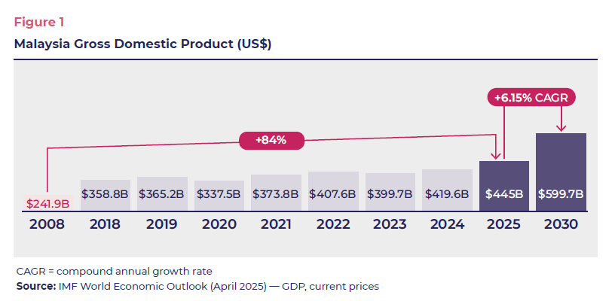

Drivers of Malaysia’s growth
Malaysia’s economic growth is driven by a robust manufacturing sector, abundant natural resources and resilient domestic consumption.
Strategically located along major maritime routes, including the Strait of Malacca, Malaysia is a key manufacturing, transshipment and logistics hub in Southeast Asia. In 2024, Malaysian ports processed over 22 million twenty-foot equivalent unit (TEUs) of container traffic. The country’s manufacturing sector, led by electrical and electronics products, accounted for over 38 per cent of total exports, while natural resources such as palm oil, petroleum, and Liquefied Natural Gas (LNG) continue to support export profits.
Malaysia’s growth is further aided by strong digital connectivity. Malaysia recorded 144.9 per cent internet banking and 106.4 per cent mobile banking penetration rate in 2024. This is underpinned by the Government’s digitalisation policy agenda which aims to enhance productivity, attract investment, and expand the digital economy’s share of GDP. Building on this foundation, Malaysia is emerging as a regional leader in data centre investment with 500MW live capacity and over 1.3GW in the pipeline. Digital investments from Australia amounted to RM2.6 billion (A$935.7 million) in 2024.
Private consumption is another key driver of Malaysia’s economy accounting for over 60 per cent of GDP in 2024. The economy is supported by a growing affluent and relatively young population as well as stable labour market conditions. Urbanisation and financial inclusion have further boosted domestic consumption with close to 80 per cent of Malaysia’s population living in urban areas in 2024. Australian products, including agriculture, food and education, are also in high demand in Malaysia.
Malaysia has a highly skilled, multicultural and multilingual workforce of over 17 million people. The domestic labour force is supplemented by an open immigration policy, including for unskilled and semi-skilled labour. As Malaysia’s population ages, with 14.5 per cent of the population projected to be over 65 years old by 2030, new opportunities in services sectors such as health and aged care are likely to materialise.
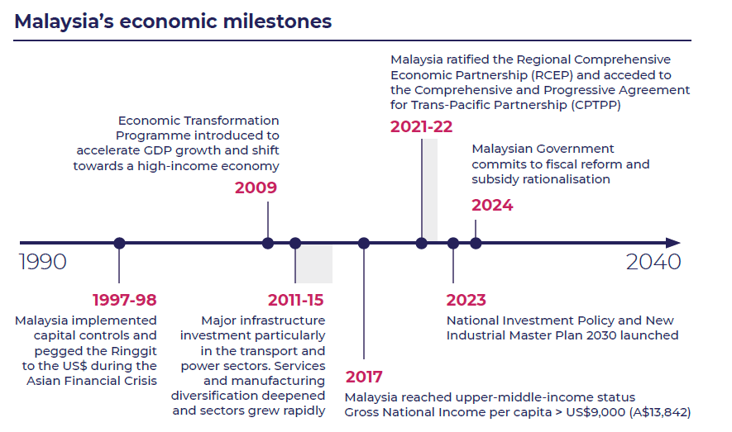

Section 2 — Malaysia’s investment landscape: growth and constraints
Entering the Malaysian market requires a thorough understanding of the unique business culture and investment landscape. While Malaysia offers commercial opportunities for informed Australian investors and business, doing business also presents varied risks and challenges, ranging from economic to geopolitical and regulatory. These risks should be identified and mitigated in advance as much as practicable – and managed carefully once business operations are established.
Malaysia maintains a relatively open investment environment, supported by various government incentives such as tax exemptions, investment allowances and targeted grants. In 2024, Malaysia received FDI into predominately the services (57 per cent) and manufacturing (42 per cent) sectors. While the country remains attractive to investors, foreign equity restrictions, local requirements, regulatory complexity, and policy uncertainty remain as challenges.
In July 2023, the incumbent Government launched ‘The Madani Economy’, which aims to restructure the economy, achieve leadership among Asian economies, and ensure equitable distribution of wealth for Malaysia’s people. The framework includes various initiatives, being the New Investment Policy (to attract high-value and sustainable investment); the New Industrial Master Plan 2030 (to upgrade manufacturing and strengthen domestic supply chains); the National Energy Transition Roadmap (to reduce reliance on fossil fuels and expand renewables); and the National Semiconductor Strategy (to secure Malaysia’s role in global chip supply chains). These initiatives signal Malaysia’s intent to reposition itself in high-value and sustainable industries.
The Government has also released its five-year blueprint, the 13th Malaysia Plan (2026–2030), which channels resources towards investment in technology adoption, green growth, and supply chain development. However, the success of these initiatives will depend on consistent implementation and the Government’s ability to navigate fiscal pressures and other challenges.
Key institutional investors and large government-linked investment companies operate in Malaysia, including the Employees Provident Fund (EPF), Permodalan Nasional Berhad (PNB) and the Retirement Fund (incorporated) (KWAP). These companies collectively manage assets worth hundreds of billions of Ringgit. Their investment strategies are often considered conservative, and private equity and venture capital markets are still developing particularly compared to regional peers. Leading financial institutions include local firms Maybank, CIMB and RHB, alongside global firms like BlackRock and Aberdeen (refer to Box 1).
The Malaysian Investment Development Authority (MIDA), Malaysia’s federal agency attracting inbound investment provides end-to-end support to investors, ranging from advice on tax incentives to regulatory approvals. State governments and investment promotion agencies provide local-level facilitation such as land approvals and access to infrastructure. Companies must navigate the state–federal divide in Malaysia, which presents both opportunities and constraints (refer to Box 2). Digital platforms such as InvestMalaysia and MYXpats Centre aim to simplify these processes. However, risks remain such as regulatory uncertainty and policy reversals especially for long-term investors.
Investment conditions are also shaped by domestic political economy considerations. Foreign investors are expected to prioritise local jobs, supply chains and Bumiputera (ethnic Malay) participation, reflecting longstanding affirmative action policies in Malaysia. Certain sectors, including telecommunications, distributive trade and licensed manufacturing, remain subject to foreign equity caps of up to 30 per cent. While these requirements can limit foreign ownership, they also encourage joint ventures and strategic partnerships with local companies facilitated by MIDA.
Malaysia has an open trade policy. It is a signatory to major regional and bilateral trade agreements, including the Comprehensive and Progressive Agreement for Trans-Pacific Partnership (CPTPP), the Regional Comprehensive Economic Partnership (RCEP), the Malaysia-Australia Free Trade Agreement (MAFTA), and the ASEAN-Australia-New Zealand Free Trade Area (AANZFTA).
Through MAFTA and AANZFTA, Australian businesses can gain improved market access, non-discriminatory treatment, and reduced barriers in key sectors such as education, financial and professional services. The CPTPP and RCEP build on these commitments by enhancing regulatory transparency, safeguarding investments, and providing recourse to international arbitration. Collectively, these agreements create a more secure environment for Australian investors in Malaysia while providing opportunities for Malaysian firms in Australia.

Box 1: Malaysia’s Government-linked companies and their role in the economy
Government-linked companies (GLCs) play a central role in Malaysia’s economy particularly in key sectors such as energy, finance, infrastructure, and plantations. GLCs are either majority-owned or significantly influenced by government-linked investment entities like Khazanah Nasional, PNB, and EPF. For example:
PETRONAS – Malaysia’s national oil and gas company is a major global energy company contributing significantly to national revenues. It dominates upstream and downstream energy segments and drives Malaysia’s push toward clean energy through its subsidiary, Gentari.
Maybank – Malaysia’s largest bank and among the leading banks in Southeast Asia by total asset value. Maybank is a dominant financial institution due to its leading digital banking facilities and regional footprint.
Tenaga Nasional Berhad (TNB) – Malaysia’s sole electricity utility managing generation, transmission, and distribution. TNB is central to Malaysia’s energy transition agenda.
Sime Darby – A diversified conglomerate active in industrial equipment, automotive, and healthcare. Its plantation arm, Sime Darby Plantation, is one of the world’s largest palm oil producers.
Telekom Malaysia – The main fixed broadband provider, with strong ties to the Government’s digitalisation agenda including 5G rollout plans.
While GLCs dominate key sectors in Malaysia, their deep local networks, familiar regulatory framework, strong capabilities and finances make them ideal strategic partners for Australian investors entering the market while minimising risks.
Most have built a strong investment footprint in Australia, spanning industrial, property, resources, renewables and healthcare. Notable investments include EPF’s investment in Australia’s real estate fund; Sime Darby’s investments in Australia’s industrial and automotive sectors; and Gentari’s investment into Australia’s renewable energy sector through the acquisition of Wirsol Energy.
By contrast, Australian investment in Malaysia is still limited. In 2024, total Australian FDI in Malaysia was A$4 billion (stock), less than half of Malaysian FDI into Australia at A$14 billion.

Box 2: Key Malaysian locations
Klang Valley, encompassing Kuala Lumpur and parts of Selangor, is Malaysia’s administrative and commercial centre. It is supported by highly skilled labour force, strong services sector, and a mature financial system. The region hosts a growing number of multinational companies and regional headquarters. In 2024, Klang Valley was Malaysia’s top investment destination, attracting RM190 billion (A$69 billion) in approved investments. RM65 billion (A$24 billion) was FDI, concentrated in digital economy and high-value business services.
Johor, located on the southern region of Peninsular Malaysia, is emerging as a major economic hub. It is directly connected to Singapore via two land crossings, benefitting from cross-border integration. A key initiative driving future growth is the Johor-Singapore Special Economic Zone (SEZ), a collaborative initiative between the governments of Malaysia and Singapore to combine Malaysia’s land and labour resources with Singapore’s financial and investment capabilities. Johor is home to two major ports (Port of Tanjung Pelepas and Johor Port) and an extensive logistics network.
Sarawak, Malaysia’s largest state, is rich in natural resources, including hydropower and natural gas reserves. The state has become increasingly appealing to foreign investors, particularly in clean energy and infrastructure. Sarawak is building a new international airport and deep seaport near its capital Kuching and has significant coastal industrial infrastructure. The state stands to benefit from its proximity and increasing interconnectedness with its neighbours on the island of Borneo, including the site of Indonesia’s future administrative capital Nusantara.
Penang, often referred to as the ‘Silicon Valley of the East,’ is a leading hub for advanced manufacturing, electronics, and semiconductors. Building on this foundation, Penang has emerged as a centre for medical device manufacturing, home to six of the world’s top 30 medical device companies by sales. In addition, Penang has cemented its position in Malaysia’s medical tourism sector, capturing 45 per cent of the national market share in 2024. This demand is driven by Indonesia, which accounts for nearly 65 per cent of Malaysia’s overall medical tourism market.

Bilateral Trade and Investment Snapshot
Australia ranked as Malaysia’s 11th largest approved FDI source in 2024, with investments totalling RM2.8 billion (A$1 billion). Some of Australia’s leading multinational companies (MNCS) maintain a significant presence in Malaysia, with one-third of Australian Fortune 2000 firms having established operations and collectively invested over RM8.5 billion (A$3.05 billion). In 2024, nearly 70 per cent of approved Australian FDI was directed to the services sector, followed by 29 per cent in manufacturing and the remainder in mining. Beyond traditional sectors, Australia has emerged as the fourth largest contributor of digital FDI in 2024, amounting to RM2.6 billion (A$935.7 million).
Bilateral trade remains robust: two-way goods trade reached A$28 billion in 2024, underpinned by MAFTA, AANZFTA, the CPTPP, and RCEP. The upgraded AANZFTA also came into effect in 2025, further strengthening economic ties.
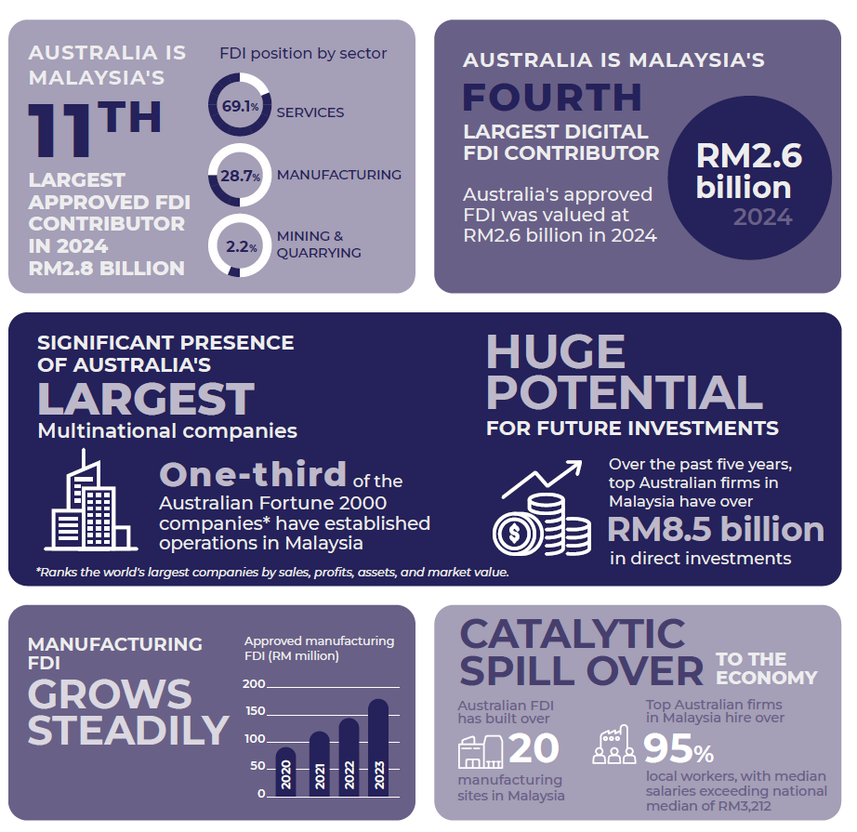

Investment Pathways
While FDI from Australia into Malaysia remains limited, corporate investment and partnerships between Australia and Malaysia are strong.
Overall FDI from Australia into Malaysia is expected to continue growing, supported by new policy initiatives aimed at enhancing Malaysia’s investment environment and improved market access through commitments under the CPTPP and the upgraded AANZFTA.
Australian corporate and institutional investors can seize this opportunity through multiple investment pathways. Invested: Australia’s Southeast Asia Economic Strategy to 2040 introduces additional government-backed initiatives designed to facilitate market entry for Australian businesses and investors.

Corporate Direct Investment
- Representative or liaison office: Often used to establish an early-stage market footprint. ANZ Bank operates a representative office in Kuala Lumpur focused on supporting Malaysian corporates and financial institutions in global trade and capital movement.
- Regional operating headquarters: Enables companies to oversee regional operations from Malaysia while retaining control and ownership. Cochlear Limited has established its regional operating headquarters and global service program in Malaysia, overseeing operations across Southeast Asia.
- Retail trade / franchising: Offers business owners retention of control while leveraging local partners’ dynamism. Boost Juice has expanded into Malaysia with over 100 outlets, surpassing its presence in Australia.
- Joint venture: Agreement between Australian and Malaysian parties used to share risk and localise operations. The Exchange TRX is a 17-acre retail-led mixed use development delivered by a joint venture between Lendlease (60%) and TRX City (40%), a wholly owned subsidiary of the Malaysian Ministry of Finance.
- Foreign-owned enterprise: Wholly foreign-owned enterprises, which can include investment companies. Harvey Norman operates wholly owned stores in Malaysia, with plans to expand from 34 to 80 outlets.
- Education and research partnerships: Australian universities establish branch campuses and partnerships in Malaysia. There are four Australian universities operating as branch campuses in Malaysia, namely Monash University Malaysia, Curtin University Malaysia, University of Wollongong Malaysia and Swinburne University of Technology Sarawak Campus.

Indirect Institutional Capital
Investing indirect institutional capital can occur through various mechanisms.
- Fund of funds: A convenient way to gain portfolio exposure to Malaysia and a diversified set of assets or asset classes.
- Asset managers / general partner: Includes the ability to allocate via a mandate and first rights to co-invest directly alongside local or international funds. Covers equities, private equity, private credit or debt and some fixed income.

Direct investment
- Corporate securities or foreign portfolio investments: Includes securities and investments in local and foreign-issued equities listed on the Malaysian Stock Exchange (Bursa Malaysia).
- Private equity: Investments in listed and non-listed Malaysian businesses.
- Fixed income instruments: Bonds / notes or similar instruments issued in the domestic market with prior approval from the Malaysian Central Bank, Bank Negara Malaysia.
- Co-investments: Alongside private equity or venture capital allocations.
- Public-Private Partnerships (PPP): Via syndicate or consortium, including corporate PPPs with either operational sector or technology specialisation. Origination and equity risk on greenfield developments with an availability payment and abatement regime.

Lendlease: Developer and Fund Manager
Lendlease has maintained a growing presence in Malaysia for nearly two decades. Its most recent project, The Exchange TRX, is a mixed-use precinct in Kuala Lumpur’s new financial district worth over A$3 billion. It marks a significant development for Australian property developers in Malaysia.
As part of its broader corporate strategy, Lendlease is diversifying beyond property construction and development and into asset management. It is exploring opportunities to invest in a range of real estate investments in Malaysia including data centres, logistics infrastructure, industrial assets, healthcare and education.
In July 2025, Lendlease announced a new partnership with key Malaysian pension fund, Kumpulan Wang Persaraan (KWAP). Lendlease has been selected as one of 12 global fund managers to manage approximately A$175 million in KWAP’s assets in real estate investments across Malaysia and Australia. The partnership marks the first step toward deepening collaboration between Australian and Malaysian institutional investors and fund managers.

Support for Australian Investors

Investment Deal Teams
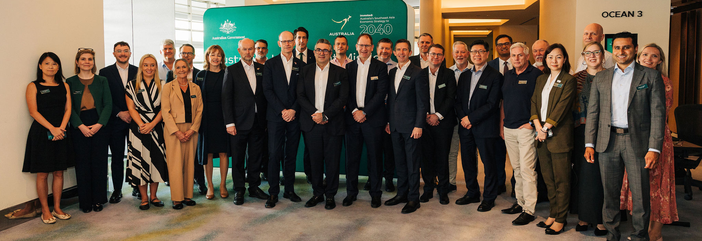
Image: Business leaders from 16 Australian companies during their visit to Johor, as part of the Deal Teams Outbound Investment Mission to Malaysia and Singapore, 24-26 June 2025.
Through Invested: Australia’s Southeast Asia Economic Strategy to 2040, the Australian Government deployed Investment Deal Teams across Southeast Asia, including in Malaysia.
Deal Teams bring together experts from DFAT, Austrade and Export Finance Australia (EFA) to provide coordinated support to Australian businesses and investors in Southeast Asia.
Each Deal Team leverages DFAT’s strong government-to-government relationships, Austrade’s deep commercial contacts and EFA’s financing expertise and tools. Together, they work with businesses and governments to identify and facilitate investment opportunities in the region.
Among EFA’s financing tools is the A$2 billion Southeast Asia Investment Financing Facility, which leverages EFA’s existing loans, bonds, guarantees, insurance and equity to catalyse Australian private sector investment and support strategically important projects in Southeast Asia, with a focus on infrastructure development and the green energy transition.
Deal Teams also facilitate targeted missions for Australian investors to the region. In June 2025, 16 Australian investors visited Malaysia to explore opportunities, including in the Singapore-Johor SEZ.
Deal Teams are focused on commercial opportunities for Australian investors across key sectors such as infrastructure, energy, healthcare, agribusiness, and digital technology. To date, the Kuala Lumpur Deal Team have identified more than 20 potential opportunities in Malaysia for Australian investment.
Additional initiatives to help Australian companies include:
- An Australian Business Champion for Malaysia, Tony Lombardo, to champion commercial links between Australia and Southeast Asia.
- The Australia-Southeast Asia Business Exchange (SEABX) which brings targeted business delegations to Malaysia.
- Market access under four free trade agreements: MAFTA, AANZFTA, RCEP and CPTPP.

Section 3 — Sector Snapshots
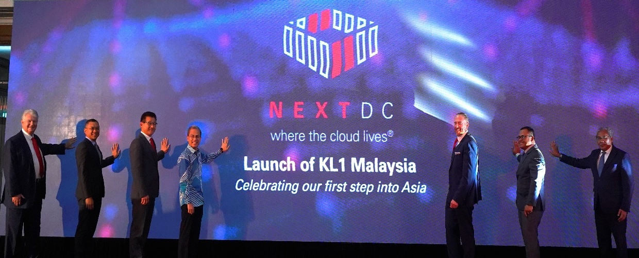
Image: Malaysia’s Minister of Communications and Digital Fahmi Fadzil with NEXTDC CEO Craig Scroggie at the official launch of NEXTDC’s KL1 data centre in Kuala Lumpur.

Digital Economy
- Digital infrastructure investment (e.g. data centres, 5G, cloud)
- AI and emerging technology development
- Tech startup platforms
- Digital talent development
- Real estate management for digital hubs

Key Australian players
- NEXTDC
- SEEK
- Employment Hero
- Symbio
- AirTrunk

Malaysia is a regional digital hub and attractive destination for significant FDI especially in high-growth sectors such as fintech, digital financial services, e-commerce, digital health, green technology, and data centres.
The digital economy now accounts for a quarter of GDP and is expanding rapidly, driven by 5G, cloud, and AI investments. Digital sector investments hit a record RM163.6 billion in 2024 (A$59 billion), with strong FDI from Australia as well as Singapore, the US, China, and India.
The Government prioritises digitalisation through targeted incentives such as the Malaysia Digital Status offering up to 10 years’ tax exemption and streamlined policies for data centres and infrastructure. Malaysia’s abundant land, energy, and water resources support growing data centre capacity, which is projected to reach 1.36GW by 2029. Key hubs for data centres include Kuala Lumpur, Johor Bahru, and Penang. Companies such as NEXTDC and AirTrunk are actively investing and expanding in the market.
Beyond infrastructure, Malaysia is fostering a vibrant AI and tech ecosystem, supporting startups, digital talent and university-industry collaboration. The National AI roadmap and 2025 budget reinforce this focus. By 2030, AI is expected to add US$115 billion (A$176 billion) in productive capacity. There are strong opportunities for Australian firms in cybersecurity, AI, and digital services, particularly in finance, manufacturing, healthcare, and smart cities.

Mining and Resources
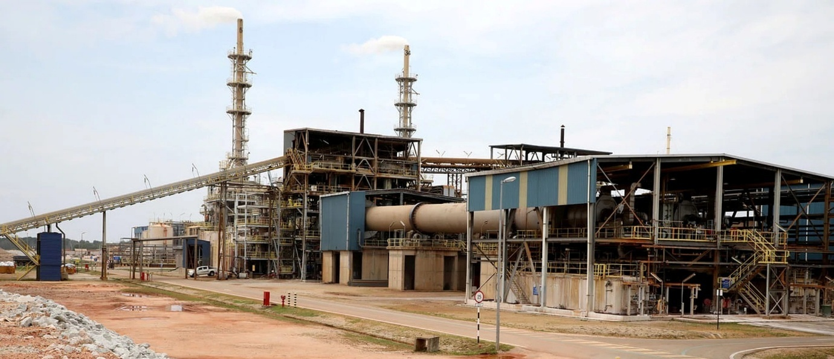
Image: Lynas Advanced Materials Plant, located in the Gebeng Industrial Park, Pahang, is the largest rare earth extraction and processing facility outside of China. Source: The Business Times

Opportunities
- Rare earth processing and separation
- Upstream exploration
- Technology and equipment supply for extraction
- Mid-stream mineral processing

Key Australian players
- Lynas Rare Earths (Lynas)
- DUG Technology
- SMEC
- Vulcanite
- Altech Chemicals
- Latrobe Magnesium

Malaysia has an emerging mining sector with most resource development historically concentrated in the oil and gas industry. However, interest in critical minerals is growing, particularly rare earth elements, which are integral to clean energy technologies, electric vehicles, and electronics.
For over a decade, Australian company, Lynas, has been operating the largest single rare earth processing facility outside of China in Pahang. In May 2025, Lynas announced it had successfully produced its first separated heavy rare earth oxide at its Pahang facility. Lynas is now the only commercial producer of separated heavy rare earth oxides outside of China.
Malaysia holds significant rare earth element deposits, especially in the states of Perak, Kelantan, and Kedah. The Government has imposed a ban on raw rare earth exports, signalling a shift toward building a full value chain domestically, from upstream exploration to mid-stream separation and downstream manufacturing.
There is also growing political and industry support for a comprehensive critical minerals strategy and mine-to-magnet ambition (outlined in Malaysia’s Natural Resources and Environmental Sustainability’s Business Model for the Development of Ion-adsorption Clay Rare Earths Industry in Malaysia). This includes amendments to key legislation such as the Mineral Development Act 1994 (MY) and incentives in the critical minerals sector, including rare earth elements. Australia and Malaysia are strongly aligned in this space with potential collaboration in exploration services, processing technology, and skills development.
Malaysia also has a range of minerals and chemicals processing facilities as inputs into its manufacturing sector. The state of Sarawak is particularly an attractive destination for investment, given its abundant land and access to competitively priced renewable energy.
There is potential to leverage Australian expertise to help grow these industries in Malaysia, including both upstream exploration and mining, and mid-stream processing and beneficiation.

Renewable Energy and Energy Transition
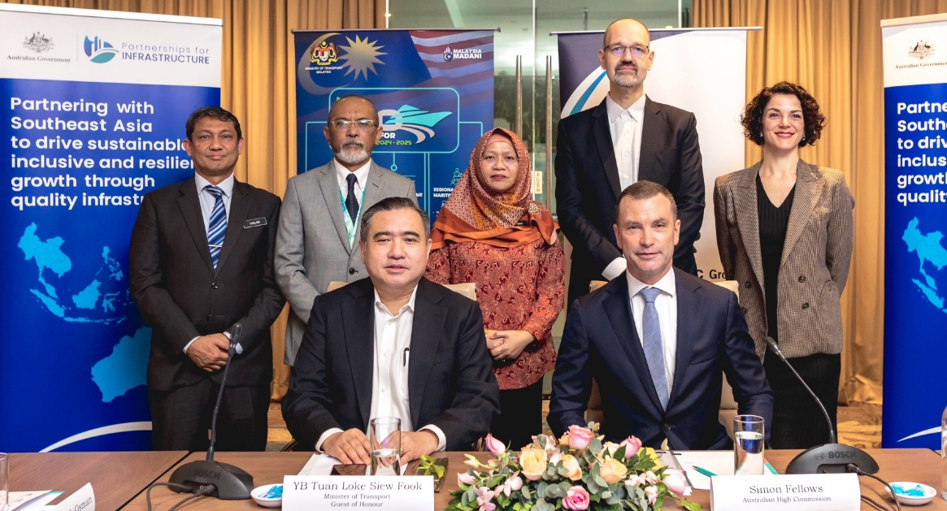
Image: Malaysia’s Transport Minister Anthony Loke and Australia’s Deputy High Commissioner Simon Fellows at a roundtable on Malaysia’s maritime decarbonisation and green shipping.

Opportunities
- Capital and equity to fund development of renewable energy projects
- Battery storage and smart grid technologies
- Blue and green hydrogen
- Waste-to-energy
- Carbon capture and storage

Key Australian players
- Blueleaf Energy
- Woodside Energy
- Cyclion

Malaysia is transitioning from fossil fuels to a low-carbon future under the National Energy Transition Roadmap, targeting 35 per cent renewable energy in the power mix by 2030. Solar and hydropower dominate renewables, accounting for nearly all installed capacity and a growing share of generation.
Traditionally led by government-linked firms like TNB and Petronas, Malaysia’s energy sector is evolving with new policies promoting decentralised power generation and third-party access to the national grid. The country is also a key player in the ASEAN Power Grid, exporting electricity to Indonesia and Singapore with plans for further regional interconnections.
Beyond solar and hydro, Malaysia is expanding into biogas, biomass, geothermal, hydrogen, and ammonia, with Sarawak spearheading hydrogen projects in partnership with Korea and Japan. Carbon capture, utilisation, and storage is advancing, led by Petronas and local partners, supported by upcoming legislation to attract private investment.
Malaysia is also developing a clean energy manufacturing hub focused on batteries, electronic vehicle (EV) components, charging infrastructure, and local EV assembly, with homegrown carmakers launching EV models in 2025. This opens opportunities for Australian firms in lithium supply and EV infrastructure. In August 2025, Blueleaf Energy, owned and managed by Macquarie Asset Management, signed a Memorandum of Understanding with Chemsain Sustainability Sdn Bhd to collaborate on the potential development of up to 3 GW of onshore utility-scale renewable energy projects in Sarawak, Malaysia.

Health and Aged Care
Image: Executives from Icon Group and Sunsuria Healthcare together with Austrade representatives at the formal launch of Icon’s first cancer care centre in Penang.

Opportunities
- Private hospital and specialist centres
- Medical tourism services
- Medical device manufacturing
- Aged care services

Key Australian players
- Icon Group
- Cochlear
- ResMed
- PPC Moulding Services

Malaysia has a dynamic and sophisticated healthcare sector, with investment opportunities across the value chain, from high-quality healthcare services to medical device manufacturing and aged care. Malaysia boasts over 150 government hospitals, 210 licensed private hospitals, nearly 10,000 private clinics and 1,100 public clinics.
Private healthcare services are growing due to higher demand for quality and specialised healthcare services, particularly in urban centres like Kuala Lumpur, Penang, and Johor. This is fuelled by rising household incomes, increased health awareness, and wider insurance uptake. Private health expenditure now makes up 48 per cent of nation’s total health spending.
Malaysia is recognised as a leading medical tourism hub in Asia. Revenues from medical tourism surpassed RM1.3 billion (A$500 million) in 2022, with growing inflows from Southeast Asia, the Middle East, and developed markets. The Government aims to double this by 2030.In 2024, Penang alone attracted 412,944 foreign patients, generating RM888.7 million (around A$324 million) in revenue.
Malaysia has strong capabilities in medical device manufacturing, particularly in areas such as surgical instruments, diagnostic equipment and single-use devices. With over 200 medical device manufacturers, Malaysia is a key export hub in the region. Australian companies have capitalised with Cochlear, PPC Moulding Services and ResMed establishing significant production facilities in Malaysia. In August 2025, Icon Group launched its cancer care centre at Island Hospital in Penang, expanding its footprint in Malaysia’s oncology landscape.
Demand is also rising in aged care, with 15 per cent of Malaysia’s population expected to be 65 years old or older by 2030. This demographic shift presents new opportunities for Australian investment in senior living facilities, including retirement housing, assisted living and geriatric care services.

Case study: PPC Moulding Services: Leveraging Malaysia’s manufacturing capabilities
Since expanding into Malaysia in 2014, PPC Moulding Services has grown rapidly, employing over 600 staff and operating more than 120 machines across its facilities in Australia and Malaysia. Its operations in Johor have been critical to the continued growth and sustainability of the overall business.
Establishing in Malaysia has enabled the company to be closer to key export markets, improving efficiency and responsiveness. With 97 per cent of what the company manufactures in the medical device sector exported around the world, Malaysia services as a strategic export hub, offering skilled talent and cost-effective operations close to Asia’s healthcare markets.
PPC is also adopting automation and robotics in its Malaysian operations to stand apart as a quality medical manufacturer. PPC currently occupies three factories in Johor with over 10,000sqm of space.
Image: Grahame Aston, CEO of PPC, briefing delegates of an Australian business mission during their visit to the company’s site in Johor, Malaysia.

Education
Monash University Malaysia, Sunway campus Source: Monash University Malaysia

Opportunities
- Transnational education focused in higher education
- Technical and vocational education training
- Private and international schools
- Ed tech and AI learning platforms

Key Australian players
- Curtin University Malaysia
- Monash University Malaysia
- Swinburne University of Technology Sarawak
- University of Wollongong (campuses across Kuala Lumpur and Penang)

Malaysia’s education sector is one of the most mature and developed in Southeast Asia, with a well-established higher education ecosystem comprising 20 public universities, 50 private universities, 36 polytechnics, and 11 branch campuses.
Malaysia’s growing middle class and rising household income is driving increased demand for quality education at the primary and secondary levels, particularly in suburban areas. More families are prioritising global exposure and international curricula, resulting in steady enrolment rates for private and international schools.
Under MAFTA, education providers are permitted to have full ownership of international branch campuses. Malaysia is now a prominent regional hub for transnational education, hosting branch campuses from leading institutions in Australia, China, the UK, and Japan. These are increasingly attracting international students, in addition to domestic enrolments.
A key goal of the Government is to increase the proportion of postgraduate international students by diversifying and raising the quality of niche programmes. Opportunities for new entrants in tertiary education are increasingly limited as the market nears saturation, however, there is potential for niche areas including biotech, environmental sciences, green skills, AI and digital sciences.
The Government emphasises technical and vocational education and training (TVET) as a priority through its national policies. It seeks to raise enrolment, industry relevance, and employability of graduates and continues to encourage public-private partnerships and facilitation of international accreditation.
However, TVET faces structural constraints due to low margins, lack of demand and fragmented governance. Underinvestment and a lack of targeted incentives, have contributed to a growing talent outflow to Singapore and beyond, particularly among STEM and high-performing graduates. This creates a valuable opportunity for Australian providers to fill the talent gap.

Case study: Monash University Malaysia: A model for transnational education success
Monash University Malaysia, the first foreign campus in the country, has grown from 417 students in 1998 to over 11,000 in 2024.
Monash forecasts increasing demand for its education offerings, driven by domestic demand and the rise of Malaysia as a regional hub for international education from across North Asia, Southeast Asia and the Middle East.
Monash’s success lies in its long-term commitment to Malaysia, strong local partnerships, and ability to offer globally recognised qualifications tailored to regional needs.

Additional Resources
Australian Government’s Advancing Implementation
dfat.gov.au/invested
Australian Government’s Invested: Australia’s Southeast Asia Economic Strategy to 2040
dfat.gov.au/southeastasiaeconomicstrategy
Asialink Business Doing Business Guide: Malaysia
asialink.unimelb.edu.au/business/publication/doing-business-guide-malaysia/
Austrade’s Go Global Toolkit
export.business.gov.au
Austrade’s Step ahead with Southeast Asia
austrade.gov.au/asea
DFAT’s Australia-Malaysia bilateral relations
dfat.gov.au/geo/malaysia
Invest Malaysia’s Investor Guide
investmalaysia.gov.my/investor-guide/
Malaysia Digital Economy Corporation
www.mdec.my
Malaysian Investment Development Authority
www.mida.gov.my
Ministry of Economy Malaysia
www.ekonomi.gov.my/en
Ministry of Investment, Trade and Industry
www.miti.gov.my
PwC’s Doing business in Malaysia 2024
pwc.com/my/en/assets/publications/2024/dbg-2024.pdf

International Monetary Fund, World Economic Outlook database: Real GDP growth–ASEAN countries, accessed July 2025.
International Institute for Management Development, ‘World competitiveness ranking’, accessed July 2025.
World Bank Data 2024, ‘School enrollment, tertiary (% gross)–Malaysia’, accessed July 2025.
Malaysia Digital Economy Corporation media release, ‘Malaysia’s digital investments hit record RM163.6 billion in 2024’, accessed July 2025.
Bank Negara Malaysia, ‘Malaysia’s GDP projection 2025’, accessed July 2025.
Ministry of Economy Malaysia, ‘Malaysia Economic and Investment Framework 224’, accessed July 2025.
World Bank Data 2024, ‘GDP per capita current US$ – Malaysia’, accessed July 2025.
Malaysian Investment Development Authority media release, ‘Malaysia Records Historic High RM378.5 billion in Investments, with 14.9% Y-O-Y Growth, Generating More Than 207,000 Jobs in 2024’, accessed July 2025.
Ministry of Transport Malaysia, ‘Annual report: official statistics’, accessed July 2025.
Department of Statistics Malaysia, ‘Official statistics’, accessed July 2025.
Bank Negara Malaysia, ‘Financial inclusion data for Malaysia’, accessed July 2025.
Knight Frank, ‘Malaysia data centre research report 2024’, accessed July 2025.
Ministry of Economy Malaysia, ‘Malaysia Economic and Investment Framework 2024’, accessed July 2025.
Ministry of Economy Malaysia, ‘Malaysia Economic and Investment Framework 2024’, accessed July 2025.
United Nations Development Programme Malaysia, ‘Navigating future care for older persons in Malaysia 2040: Community support & technological integration’, accessed July 2025.
Malaysian Investment Development Authority, ‘Investment statistics’, accessed July 2025.
Malaysian Investment Development Authority, ‘Investment statistics’, accessed July 2025.
InvestPenang, ‘Medical devices industry in Penang’, accessed July 2025.
New Straits Times, ‘Penang captures 45% of medical tourism industry’s market share’, accessed July 2025.
Malaysian Investment Development Authority, ‘Indonesia remains largest contributor to Malaysia’s medical tourism market’, accessed July 2025.
Malaysian Investment Development Authority, ‘Official website’, accessed July 2025.
Malaysian Investment Development Authority media release, ‘Malaysia Records Historic High RM378.5 billion in Investments, with 14.9% Y-O-Y Growth, Generating More Than 207,000 Jobs in 2024’, accessed July 2025.
The Star, ‘Turning data centres green’, accessed July 2025.
Malaysia Digital Economy Corporation, ‘Malaysia Digital Tech Adoption Summit: Artificial Intelligence (AI)’, accessed July 2025.
Blueleaf Energy, ‘Blueleaf Energy and Chemsain Sustainability Sign MoU to Develop Up to 3 GW of Renewable Energy Projects in Sarawak’, accessed August 2025.
MIDF Research, ‘Healthcare thematic report: Malaysia healthcare’, accessed June 2025.
Ministry of Health Malaysia, ‘Health Facts 2024’, accessed June 2025.
United Nations Development Programme Malaysia, ‘Navigating future care for older persons in Malaysia 2040: Community support & technological integration’, accessed July 2025.
StudyMalaysia.com, ‘Higher education in Malaysia: A glance at the Malaysian education system’, accessed July 2025.

