Interconnected communities
Module length: 4 × 60 minutes

Summary
This module introduces students to the idea of interconnected communities working together at a local, regional and global scale. Students will be introduced to the United Nations and explore how the UN-developed Sustainable Development Goals (SDGs) support and connect communities around the globe. Students will focus on the official development assistance Australia provides to its neighbours within the Asia-Pacific region. Economics knowledge such as types of resources, needs and wants will underpin their investigation. Students will analyse how development assistance helps those local communities most in need, creating change and working towards the SDGs.
This resource promotes student agency by fostering opportunities for students to plan a sustainable future as global citizens and make decisions weighing up the UN’s priorities. Through learning activities, students will practise social competencies such as collaboration, negotiation, critical thinking, leadership, mutual respect and problem-solving. Students are encouraged to
take action and think strategically.

Success criteria
At the end of this module, students should be able to:
- identify the SDGs and outline their purpose
- classify and explain the official development assistance Australia provides to other countries using economic concepts
- understand how communities at varying scales (global, regional and local) are interconnected in their aim to develop a sustainable future.

Organising ideas
The organising ideas are global relationships, global responsibilities and global futures. These reflect the Australian Government’s aims to build genuine partnerships to jointly tackle global challenges, protect international rules, promote Australia’s international interests, and sustain a peaceful and prosperous future that keeps our region stable.
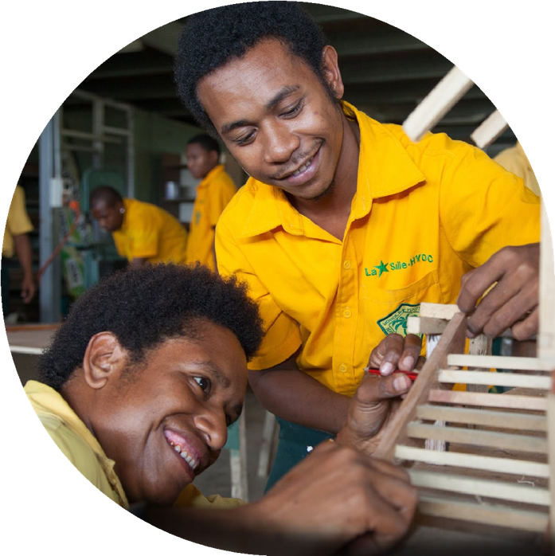
© Ness Kerton/Department of Foreign Affairs and Trade

Prior knowledge
i
n
e
r
a
p
e
/
s
m
- Geography: An understanding of the geographic concept of scale and the meaning of different levels such as local, regional and global.

Key terminology

capital resource
community
global
human resource
local
natural resource
needs
partnership
prosperity
regional
resource
sustainable development
United Nations
wants

Further resources
- Australian Government DFAT – Development cooperation fact sheets
- Sustainable foundations: A guide for teaching the Sustainable Development Goals
- Global Goals comic book or poster set
- Sustainable Development Report interactive map showing progress to achieving SDGs

Curriculum links
The table below lists the Australian Curriculum content descriptions explicitly addressed in this module.

HASS

Geography
Year 5: the influence of people, including First Nations Australians and people in other countries, on the characteristics of a place AC9HS5K04
Year 6: the geographical diversity and location of places in the Asia region, and its location in relation to Australia AC9HS6K04
Year 6: Australia’s interconnections with other countries and how these change people and places AC9HS6K05

Economics and Business
Year 5: types of resources, including natural, human and capital, and how they satisfy needs and wants AC9HS5K08

HASS skills
Year 5 and 6: evaluate information and data in a range of formats to identify and describe patterns and trends, or to infer relationships AC9HS5S03 AC9HS6S03
Year 5 and 6: develop evidence-based conclusions AC9HS5S05 AC9HS6S05
Year 5 and 6: propose actions or responses to issues or challenges and use criteria to assess the possible effects AC9HS5S06 AC9HS6S06
Year 5 and 6: present descriptions and explanations, drawing ideas, findings and viewpoints from sources, and using relevant terms and conventions AC9HS5S07 AC9HS6S07

General capabilities
Literacy: This module places emphasis on introducing and defining new vocabulary. The creation of a glossary is recommended. Students are provided with prompts to extend their written expression.
Ethical Understanding: Activities will challenge students to make decisions, considering multiple and possibly competing perspectives.
Intercultural Understanding: Students will need to consider unfamiliar cultural contexts and appreciate the values, practices and perspectives of other cultures.
Personal and Social Capability: Empathy and social management skills are vital during activities where teamwork and collaboration are necessary to make decisions.

Cross-curriculum priorities
Asia and Australia’s Engagement with Asia: As this module has a global focus, students will explore the Australian Government’s development programs that involve partners in the Asia-Pacific region. Overall, global education clearly emphasises the interdependent nature of relationships and the importance of developing mutual understanding and accepting diversity.
Sustainability: Students will gain an understanding of sustainable development. They will be challenged to consider sustainable futures that strengthen the interconnections between communities from locally to globally.

Why is a global community important?
Learning intentions | Materials
- To describe the role of the United Nations in establishing a global community.  - To outline how a global community can improve people's lives. | - Worksheet: The United Nations and the Sustainable Development Goals  - Animation: What is a partnership? (primary version 3 min)

Introduction (10 min)
Activate students’ prior knowledge and introduce the topic for these lessons. Focusing on definitions will develop students’ literacy.
- Begin a discussion based on the title of this lesson: why is a global community important? Listed below are some prompting questions. They aim to ensure students have a common understanding of key words used in this module. Literacy strategies may be employed to define words such as ‘community’, ‘sustainable’ and ‘global’.
- Who has ever participated in a community event or volunteered for the community?
- What did you do? Was it once or regularly?
- Did you form any new connections or friendships from your involvement?
- Conduct a Think-Pair-Share. Prompt students with a question such as, ‘If you think of the world as a global community, all working together, what do you think Australia might do to help other countries?’
- Follow-up question: ‘What benefits may these connections bring to Australia?’ Answers could be trade, tourism, culture, security, work or allies.
- Introduce the word ‘interconnected’ and explain the two-way relationship between countries that can build a community. The lessons will explore this concept in more detail.

Guided instruction (20 min)
- Watch the animation: What is a partnership? After watching, discuss some key features of partnerships as a class. Explain to the class that this lesson will look at global partnerships and then outline the learning intentions.
- Give each student a copy of the worksheet, The United Nations and the Sustainable Development Goals. Work through the introduction (about the United Nations) and Activity 1. Students may have many questions about the origins of the United Nations or its work. Encourage this discussion.

Independent practice (20 min)
- Set up the class to continue with Activity 2. This could be a collaborative or independent exercise. The activity covers 9 of the 17 SDGs.
- Ask students to share their responses and discuss the symbology often used to depict issues. Encourage students to explore and express a variety of interpretations. Assist student understanding with examples (‘the dove symbolises peace’) and questions (‘the gavel is used by judges in court so what might this represent’).
- Explain to students that they will learn what each icon means in the next lesson, as well as the other eight goals not covered here. Finally, students will consolidate their learning by writing their own definition of the term 'sustainable development'. They will reflect on what they have learnt about global partnerships, the United Nations and the Sustainable Development Goals.

Learning review (10 min)
Students reflect on the new knowledge they gained in this lesson about the UN and establishing a global community. They could complete the thinking routine ‘I used to think… Now I think…’ in relation to the lesson question: Why is a global community important? Responses could either be written or discussed in small groups.

The United Nations and the Sustainable Development Goals
The United Nations (UN) is the largest international organisation in the world. It was established in 1945 (after World War II) when representatives from 50 countries agreed on a set of rules they would all follow to prevent any more world wars. Today the United Nations has 193 member countries, with offices across many continents. It aims to develop friendly relations between countries. It promotes cooperation and action on issues that are important for the whole world, such as human rights, health, education and the environment. Countries that are members of the United Nations agree to work together to promote peace and security. Together they form a global community. 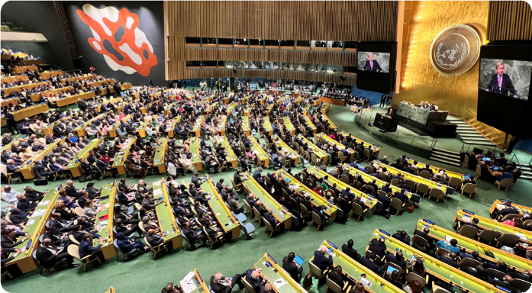
The UN headquarters are in New York City, USA. Representatives from 193 member countries discuss matters in this General Assembly building. All have equal representation.
© Gerhard Huber, CC BY-NC 4.0
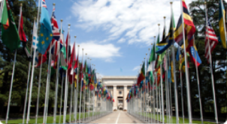
The United Nations has many offices around the world. Here is the entrance to the European headquarters in Geneva, Switzerland. All member countries are given a flagpole for their country’s flag.
© Tom Page via Wikimedia Commons, CC BY-SA 2.0

Activity 1: Sustainable development
In 2015 all UN member countries agreed to work together as one global community on 17 goals of sustainable development. They want to achieve these goals by 2030. These Sustainable Development Goals (abbreviated as SDGs) take action on areas of critical importance for the world. They are classified under the five Ps: people, planet, prosperity, peace and partnership.
- Suggest an action or goal for each P. Some examples are provided.
People
Example: All people are allowed to share their opinion.

Planet

Prosperity (this means being successful and living comfortably)
Example: People have access to work so they can earn money.

Peace

Partnership
Example: Countries can agree to share resources.

Activity 2: Introducing the Sustainable Development Goals
Take a look at the icons below. Each icon represents a Sustainable Development Goal.
Below each icon, write down:
- a few words to suggest what this icon might represent
- one or two of the five Ps that you think closely relates to the icon.
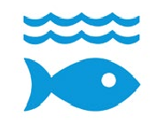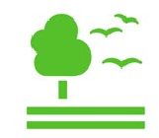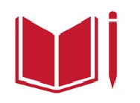
P:
P:
P:
P:
P:
P:
P:
P:
P:
P:
P:
P:
P:
P:
P:
P:
P:
P:
- What do you think is meant by ‘sustainable development’? Note down your thoughts based on these goals.

Sustainable Development Goals icons are © United Nations. https://www.un.org/sustainabledevelopment.
The content of this publication has not been approved by the United Nations and does not reflect the views of the United Nations or its officials or Member States.

What do the Sustainable Development Goals strive for?
Learning intentions | Materials
- To identify the United Nations’ Sustainable Development Goals.  - To decide which Sustainable Development Goals should be prioritised.  - . | - Worksheet: Sustainable Development Goals match-up (print one-sided)  - Class set of scissors and glue sticks  - Sticky notes

Introduction (10 min)
- Recap students’ understanding of what they learned in Lesson 1. You could use this 10-point quiz:
- Name the world’s largest international organisation. (1 point)
- Why was it established? (1 point)
- Name any two features of sustainable development. (2 points)
- Name three of the five Ps considered important by the UN. (3 points)
- Outline two goals that the UN might be working towards. (2 points)
- Name one thing that a global community can work towards. (1 point)
- Go through the answers to help recall the new terminology learned in lesson 1.
- Discuss the learning intentions for this lesson.

Match-up activity (15 min)
Remind students that in the previous lesson they saw 9 of the 17 icons for the Sustainable Development Goals. Today they will see how well they guessed what development goals the icons represent.
- Hand out the Sustainable Development Goals match-up worksheet. It must be printed on two separate A4 sheets. Students may work individually or in pairs to complete this activity.
- Students will need a pair of scissors and a glue stick. Suggest that they work on cutting out the descriptions and pairing them before they use the glue.
- Glossary: As students read and sort each description, encourage them to write on the board any words they don’t understand. These could be used to create a glossary for the class.
- Check in with students throughout this task to ensure the goals are matched correctly.

Class survey (20 min)
Preparation: Before starting this activity, place sticky notes around the classroom walls. Number the notes from 1 to 17. This task will place students in flexible groupings and build their critical thinking and decision-making skills.
- Ask students to re-read all 17 goals and decide which four they consider the highest priority.
- Now that they have narrowed down their choices, tell them to select one goal they believe the UN should try to achieve first.

- Perform a class survey where students stand with the numbered sticky note that represents the SDG goal they chose.
- Uncover why students at each goal think their chosen SDG is the most important. Discuss any trends that might appear. Are the chosen SDGs mostly health-related, environmental or perhaps political? Prompt students to help them analyse any similarities or differences.
- Based on the groupings, ask students at each number to collectively brainstorm some actions that could be taken to meet the goal. Any students by themselves could group together and help each other brainstorm. For example, the students who nominated ‘Zero Hunger’ as the most important goal could suggest ‘protecting farming land during droughts’ or ‘growing crops and maintaining soil’ as relevant actions.
- Have each group share two of their preferred strategies or actions.

Learning review (15 min)
- Congratulate students on their strategic thinking, problem-solving and decision-making in this lesson. Remind them of the challenges they faced when they could choose only one SDG and share only two actions. These challenges are similar to the difficult choices that people working for the United Nations have to make every day.
- If students are familiar with the Connect-Extend-Challenge thinking routine, this would be a suitable reflection task

Sustainable Development Goals match-up
Cut out the Sustainable Development Goal descriptions on the next page and then paste them under the correct icons.
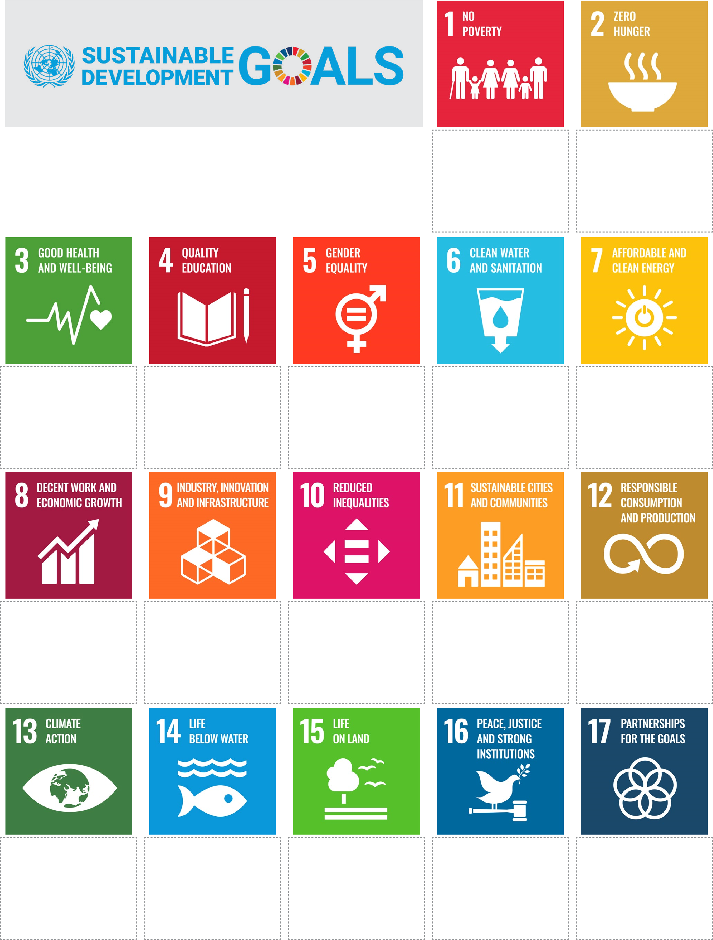
Sustainable Development Goals icons are © United Nations. https://www.un.org/sustainabledevelopment.
The content of this publication has not been approved by the United Nations and does not reflect the views of the United Nations or its officials or Member States.
Cut out the Sustainable Development Goal descriptions below and then paste them under the correct icons.
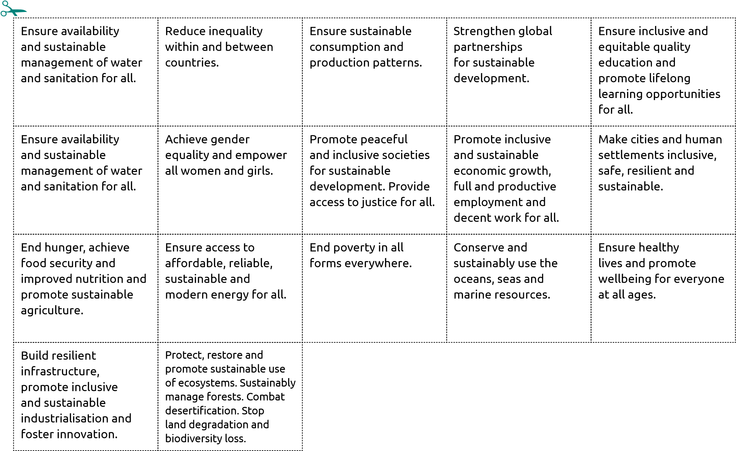

How does Australia support the Sustainable Development Goals?
Learning intentions | Materials
- To explain the different resources  that satisfy human needs and wants.  - To identify how Australia helps its  Asia-Pacific neighbours to meet the  UN Sustainable Development Goals.  - . | - PowerPoint: Interconnected communities  - Worksheet: Australia's support of sustainable development

Introduction (10 min)
Introduce students to the different types of resources – natural, capital and human – using the well-known story of the three little pigs. The video 3 types of resources: natural, human and capital (4 min 30 sec) provides an example of how to introduce these concepts.
- Ask students to help you retell the story of the three little pigs. For each house they built, focus on the materials and tools they used and discuss how each of these represents a resource that can be categorised. You could mute the sound in the video and pause it when necessary so the class can be more interactive in answering the questions on screen.
- Outline the learning intentions for the lesson (on slide 2 of the PowerPoint).
- If students have not previously studied any economic concepts, these activities are expected to take up two lessons. If students have already learned about the types of resources, needs and wants, they could move straight to the Official development assistance activity.

Scaffolding concepts: needs and wants
Students will be introduced to many terms. There are worksheet activities and discussion tasks to separate the explicit instruction into chunks.
- Ask the students, ‘At the beginning of the story when the pigs leave home and before the big bad wolf appears, what do you think the pigs needed in order to live independently?’ Students should respond with words such as food, shelter, water, heat, tools to build, a job and money to buy things.
- Follow-up question: ‘At the end of the story, what do you think two of the pigs realise they need to survive?’ Students should say bricks. Point out that the pigs’ needs changed over time in response to new pressures.
- Conduct a Think-Pair-Share asking students to consider the following three questions:
- Have you ever had specific needs in order to participate in an activity? Did you find those needs changed over time? For example, perhaps you need to upgrade your boots for sport, or a type of musical instrument, as your skills progress.
- Do you think this change was a vital need for the activity or more of a 'want'? Did you need new boots because your feet had grown or did you want a new limited edition pair?
- What do you think is the difference between a need and a want?
- Hand out the worksheet, ‘Australia’s support of sustainable development’ and ask students to fill in Activity 1 ‘Create a glossary’ by matching the key term to its definition.

Guided instruction: official development assistance
Activity 2 of the worksheet lists many examples of how Australia supports other countries to reach the United Nations’ SDGs. Students will need to refer to their completed Sustainable Development Goals match-up worksheet from Lesson 2.
- Share slides 3 to 5 of the Interconnected communities PowerPoint to introduce students to official development assistance.
- To solidify student understanding of the different resource types and to broaden their awareness of Australia’s official development assistance, students should complete Activity 2 on the worksheet.
- Once students have completed the worksheet, as a class discuss the responses for each row of the table and any examples that had alternate views. For example, ‘education’ can be viewed as both a need and a want. Ask the class, ‘Were the types of resources spread equally or did one dominate? What spread of SDGs was covered by these examples?’

Consolidation exercise: creating change through interconnection
This activity explores how interconnections established through Australia’s official development assistance can create change and influence a place or community.
- Use slide 6 of the Interconnected communities PowerPoint to show students an episode of ABC’s Beyond Awesome, Timor-Leste’s Protein Champions (7 min). Inform students this is an example of how Australia funds better health initiatives for the local community.
- Ask students to consider how this project helps Timor-Leste achieve certain SDGs and implement changes within the community. What positive influences might this have over time?
- Students will now choose one example listed in Activity 2 and complete Activity 3 ‘Creating change’.
Differentiation: Activity 3 has options for extension or extra support. An extension idea is getting students to research a specific example of a project within the Asia-Pacific region. Students who need further support could create a flow chart or visual diagram to outline how the resource assistance could improve a place or community over time.

Learning review (15 min)
Module wrap-up: The title of this module is ‘Interconnected communities’. Throughout these lessons, students have been made aware of a global community, the UN, and its aims for 2030 through the SDGs. From there, they explored Australia’s development assistance within its regional community. Finally, students considered how this regional support helps local communities. This final activity aims to meet the success criterion ‘understand how communities at varying scales (global, regional and local) are interconnected in their aim to develop a sustainable future’.
As a class, work through these connections by creating a visual flow chart together based on the prompt: ‘Outline how a global community such as the UN is connected to a small local community.’ This requires students to recall what they have learned in the module and consider the concept of interconnection between these communities and the role of Australia

Australia’s support of sustainable development

Activity 1: Create a glossary
Select the correct word from the list and write it next to the matching definition.
- capital resource
- human resource
- natural resource
- need
- want
Australia and Vanuatu have partnered to provide skills and training
to locals with the aim of building local prosperity. Prosperity is one
of the UN SDGs five Ps.
© Australian Department of Foreign Affairs and Trade
Term | Definition
 | A person who helps to create, grow, develop or sell an item or service. For example, a carpenter will build a house and a DJ will entertain people at a party.
 | Something that is necessary for survival (for example, food, water and shelter) or for performing a certain task or job.
 | A resource that comes from the earth and is useful to people. It may be limited (non-renewable) or unlimited (renewable). Examples are trees, sun, water, seeds and minerals.
 | Something that is desired to give satisfaction to someone, but is not necessary for survival or to meet the basic standard of living in a community.
 | Resources used to make or store items or services, such as equipment, machinery and buildings. It can also include a human resource such as knowledge. A doctor can use their knowledge of the lungs as well as an X-ray machine and a stethoscope to check if a person’s breathing is clear.

Activity 2: Australia’s official development assistance
- In the first column: for each example of Australia’s development assistance, say what is the main type
of resource that is provided or improved (human, capital or natural). Sometimes two types of resources
could apply. Decide which one you think is most suitable.
- In the third column: decide whether the resource is a need or want.
- In the fourth column: look at your worksheet of all 17 Sustainable Development Goals and write down
the ones that are relevant to the example.
Resource type | Examples of Australia’s official development assistance | Need or want | Relevant SDGs
Human | Training women in new job skills such as construction. | Want | 5, 8
 | Providing safer water storage by installing water tanks.
 | Funding new school supplies.
 | Planting mangroves to protect coasts from rising sea levels.
 | Building new roads and upgrading ports.
 | Awarding scholarships to university students.
 | Encouraging people to play community sport.
 | Overseeing elections and the voting process.
 | Growing crops and maintaining soil health.
 | Installing wi-fi and phone networks.
 | Protecting farmland during droughts.
 | Training nurses.
 | Installing clean energy networks like solar panel farms.
 | Constructing warehouses for emergency supplies.
 | Training a police force.
 | Improving sanitation facilities.
 | Monitoring river health and fish supplies.
 | Supplying medications and vaccines.
 | Improving disability access.
 | Replanting forests.

Activity 3: Creating change
Choose one of the examples listed in Activity 2 and write a few sentences predicting how this resource assistance from Australia could change or improve a local community in the Asia-Pacific region. Consider the following:
- How could it help to achieve the SDGs you wrote in column 4?
- Which of the five Ps (people, planet, prosperity, peace, partnership) does it address?
- What positive influences would it have on the local community?
- What would the future look like for this community or for the environment?

