The United Nations and the Sustainable Development Goals
The United Nations (UN) is the largest international organisation in the world. It was established in 1945 (after World War II) when representatives from 50 countries agreed on a set of rules they would all follow to prevent any more world wars. Today the United Nations has 193 member countries, with offices across many continents. It aims to develop friendly relations between countries. It promotes cooperation and action on issues that are important for the whole world, such as human rights, health, education and the environment. Countries that are members of the United Nations agree to work together to promote peace and security. Together they form a global community.

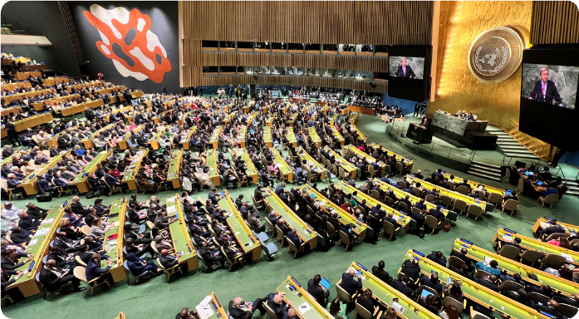
The UN headquarters are in New York City, USA. Representatives from 193 member countries discuss matters in this General Assembly building. All have equal representation.
© Gerhard Huber, CC BY-NC 4.0
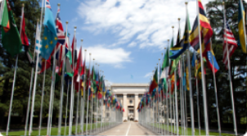
The United Nations has many offices around the world. Here is the entrance to the European headquarters in Geneva, Switzerland. All member countries are given a flagpole for their country’s flag.
© Tom Page via Wikimedia Commons, CC BY-SA 2.0

Activity 1: Sustainable development
In 2015, all UN member countries agreed to work together as one global community on 17 goals of sustainable development. They want to achieve these goals by 2030. These Sustainable Development Goals (abbreviated as SDGs) take action on areas of critical importance for the world. They are classified under the five Ps: people, planet, prosperity, peace and partnership.
- Suggest an action or goal for each P. Some examples are provided.
People
Example: All people are allowed to share their opinion.

Planet

Prosperity (this means being successful and living comfortably)
Example: People have access to work so they can earn money.

Peace

Partnership
Example: Countries can agree to share resources.

Activity 2: Introducing the Sustainable Development Goals
Take a look at the icons below. Each icon represents a Sustainable Development Goal.
Below each icon, write down:
- a few words to suggest what this icon might represent
- one or two of the five Ps that you think closely relates to the icon.
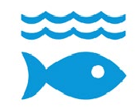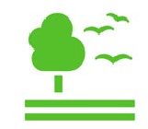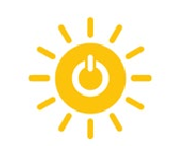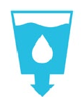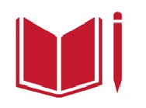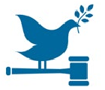
P:
P:
P:
P:
P:
P:
P:
P:
P:
P:
P:
P:
P:
P:
P:
P:
P:
P:
- What do you think is meant by ‘sustainable development’? Note down your thoughts based on these goals.

Sustainable Development Goals icons are © United Nations. https://www.un.org/sustainabledevelopment.
The content of this publication has not been approved by the United Nations and does not reflect the views of the United Nations or its officials or Member States.

Sustainable Development Goals match-up
Cut out the Sustainable Development Goal descriptions on the next page and then paste them under the correct icons.
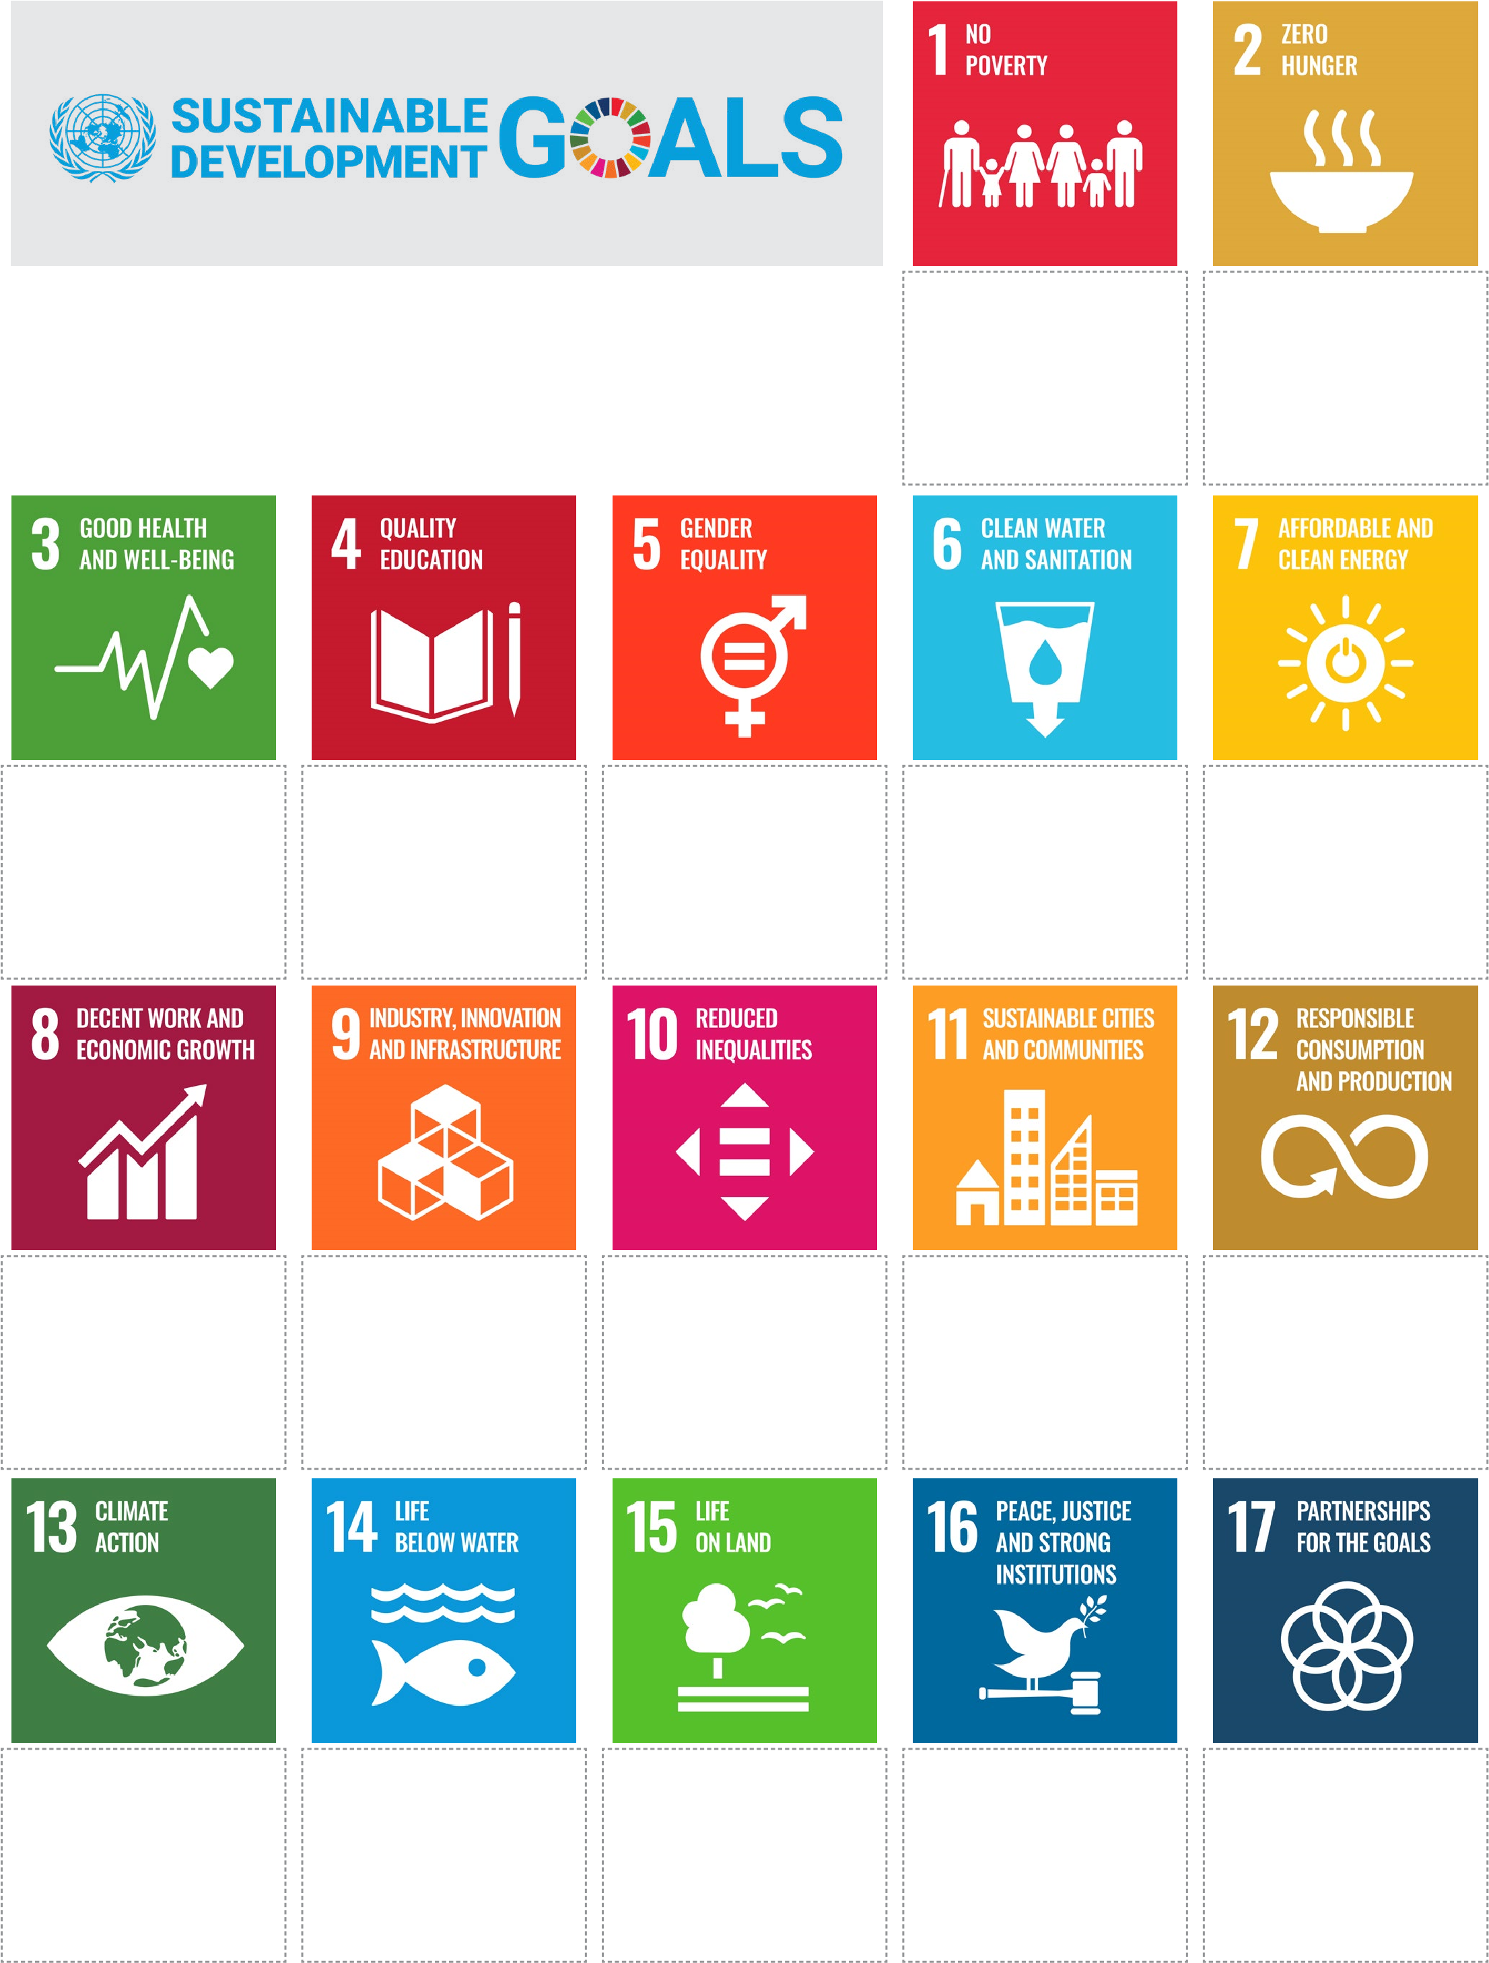
Sustainable Development Goals icons are © United Nations. https://www.un.org/sustainabledevelopment.
The content of this publication has not been approved by the United Nations and does not reflect the views of the United Nations or its officials or Member States.
Cut out the Sustainable Development Goal descriptions below and then paste them under the correct icons.
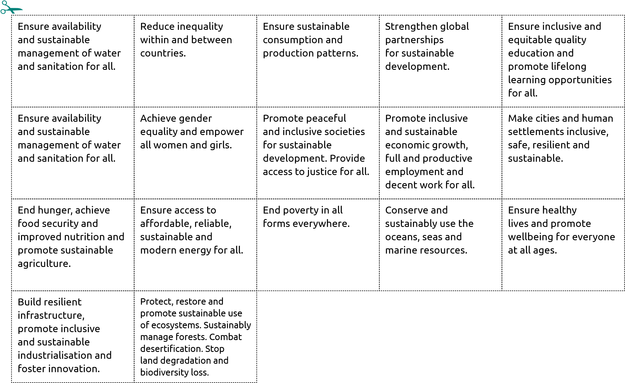
Sustainable Development Goals icons are © United Nations. https://www.un.org/sustainabledevelopment.
The content of this publication has not been approved by the United Nations and does not reflect the views of the United Nations or its officials or Member States.

Australia’s support of sustainable development

Activity 1: Create a glossary
Select the correct word from the list and write it next to the matching definition.
- capital resource
- human resource
- natural resource
- need
- want
Australia and Vanuatu have partnered to provide skills and training
to locals with the aim of building local prosperity. Prosperity is one
of the UN SDGs five Ps.
© Australian Department of Foreign Affairs and Trade
Term | Definition
 | A person who helps to create, grow, develop or sell an item or service. For example, a carpenter will build a house and a DJ will entertain people at a party.
 | Something that is necessary for survival (for example, food, water and shelter) or for performing a certain task or job.
 | A resource that comes from the earth and is useful to people. It may be limited (non-renewable) or unlimited (renewable). Examples are trees, sun, water, seeds and minerals.
 | Something that is desired to give satisfaction to someone, but is not necessary for survival or to meet the basic standard of living in a community.
 | Resources used to make or store items or services, such as equipment, machinery and buildings. It can also include a human resource such as knowledge. A doctor can use their knowledge of the lungs as well as an X-ray machine and a stethoscope to check if a person’s breathing is clear.

Activity 2: Australia’s official development assistance
- In the first column: for each example of Australia’s development assistance, say what is the main type
of resource that is provided or improved (human, capital or natural). Sometimes two types of resources
could apply. Decide which one you think is most suitable.
- In the third column: decide whether the resource is a need or want.
- In the fourth column: look at your worksheet of all 17 Sustainable Development Goals and write down
the ones that are relevant to the example.
Resource  type | Examples of Australia’s official development assistance | Need or want | Relevant SDGs
Human | Training women in new job skills such as construction. | Want | 5, 8
 | Providing safer water storage by installing water tanks.
 | Funding new school supplies.
 | Planting mangroves to protect coasts from rising sea levels.
 | Building new roads and upgrading ports.
 | Awarding scholarships to university students.
 | Encouraging people to play community sport.
 | Overseeing elections and the voting process.
 | Growing crops and maintaining soil health.
 | Installing wi-fi and phone networks.
 | Protecting farmland during droughts.
 | Training nurses.
 | Installing clean energy networks like solar panel farms.
 | Constructing warehouses for emergency supplies.
 | Training a police force.
 | Improving sanitation facilities.
 | Monitoring river health and fish supplies.
 | Supplying medications and vaccines.
 | Improving disability access.
 | Replanting forests.

Activity 3: Creating change
Choose one of the examples listed in Activity 2 and write a few sentences predicting how this resource assistance from Australia could change or improve a local community in the Asia-Pacific region. Consider the following:
- How could it help to achieve the SDGs you wrote in column 4?
- Which of the five Ps (people, planet, prosperity, peace, partnership) does it address?
- What positive influences would it have on the local community?
- What would the future look like for this community or for the environment?

