

Integrating data and   
information management   
for social protection:

Social registries and integrated beneficiary registries

#### October 2017

Valentina Barca

The principal author of this research report is Valentina Barca.

Disclaimer: The views expressed in this publication are those of the authors and not necessarily those of DFAT.

**Creative Commons**With the exception of the Commonwealth Coat of Arms and where otherwise noted, such as copyrighted images, this booklet is licensed under a Creative Commons Attribution 3.0 Australia licence http:// creativecommons.org/licenses/by/3.0/au/.

The report should be attributed as Barca V. (2017). *Integrating data and information management for social protection: social registries and integrated beneficiary registries.* Canberra: Commonwealth of Australia, Department of Foreign Affairs and Trade.

ISBN: 978-1-74322-359-8 (PDF document)  
ISBN: 978-1-74322-360-4 (Book, softcover)   
ISBN: 978-1-74322-361-1 (Word document)

**Use of the Coat of Arms**

The terms under which the Coat of Arms can be used are detailed on the ‘It’s an Honour’ website: http:// [www.itsanhonour.gov.au/coat-arms/index.cfm.](http://www.itsanhonour.gov.au/coat-arms/index.cfm)

Inquiries regarding the licence and any use of the report are welcome at:  
Department of Foreign Affairs and Trade  
R.G. Casey Building John McEwen Crescent  
Barton ACT 0221 Australia

+61 2 6261 1111  
[www.dfat.gov.au](http://www.dfat.gov.au/)

**Acknowledgments**Because of the very nature of this study – exploring a topic that is still under-documented in the literature yet widely applied in practice – a wide range of people have provided valuable contributions without which this research would not have been possible.

The author thanks Richard Chirchir for his inputs including preparing the Kenya and Indonesia country case studies. The author also thanks the DFAT Social Protection Hub team, primarily Joanna Pickles, Fazley Mahmud and Francesca Lawe-Davies, for their ongoing support over the course of the research process. Important comments and peer review were also provided by Nicholas Freeland; Thibault Van Langenhove (ILO); Kathy Lindert, Philippe George Leite, Tina George, Changqing Sun and Oleksiy Sluchynskyy (World Bank); and Tarcisio Castaneda.

We are similarly grateful to all the participants in the International Workshop on Integrated Data and Information Management for Social Protection held in Jakarta on 11–12 March 2015, who not only highlighted the need for further research on this topic but also provided fundamental inputs based on their country experiences. A special thanks to those who specifically supported the country case studies and boxes: Winnie Mwasiaji and Eva Mwangi (Kenya); Caglar Cinar and Sencer Kiremitci (Turkey); Pak Mahfudh and Julia Tobias (Indonesia); Caesar Vundule and Carin Koster (South Africa); Veronica Acha Alvarez (Chile); and Jeniffer Carla de Paula, Denise do Carmo Direito, Natalia Massaco Koga and Elaine Cristina Licio (Brazil).

**Join the community**Interested in the topic of integrated data and information management for social protection and social policy more widely? Join the [www.socialprotection.org](http://www.socialprotection.org/) online community[(http://socialprotection.org/connect/communities/](http://socialprotection.org/connect/communities/) social-registries-and-integrated-miss-social-protection).

Contents

Abbreviations 6

Executive summary 8

1. Introduction and setting the scene 11

1.1 Why is integrated information management for social protection important? 12

1.2 Three objectives for integration: integrating what? 14

1.2.1 Providing coordination and oversight 14

1.2.2 Consolidating processes for determining potential eligibility for social assistance 15

1.2.3 Integrating and coordinating operations and services 15

2. Definitions and approaches to integration 16

2.1 Background to this study: confusion in the terminology 16

2.2 Defining the underlying terminology for the study: components of a social protection information system 17

[2.3 Two main approaches to setting up a social protection data  
repository 20](#_Toc495229150)

2.3.1 Integrated beneficiary registries 20

2.3.2 Social registries 21

2.4 Comparing approaches 24

2.4.1 Evolving nature and differing operationalisation 24

2.4.2 Types of integration enabled 25

2.4.3 How country context and needs affect choices 25

2.4.4 How different solutions compare to a country’s total and ‘eligible’ population 26

2.5 Unpacking the role of the software application 27

2.5.1 Dynamic link to other databases 27

3. Brief overview of country progress 31

3.1 Comparing progress across countries 31

3.2 What factors drive country progress? 46

3.3 Typology to classify country progress 47

4. Main steps and challenges in designing and implementing social protection information systems 49

4.1 Administrative and institutional aspects 49

4.1.1 Governance and institutional arrangements 49

4.1.2 Decentralisation: an added layer of complexity? 50

4.1.3 Staff availability, capacity, training and retention 52

4.2 Operational and implementation aspects 53

4.2.1 Collecting data (intake and registration) 53

4.2.2 Updating data 57

4.2.3 Transforming data into information 58

4.2.4 Linking databases: need for a unique identifier 60

4.2.5 Integrating operations and services 64

4.2.6 Using data for determining eligibility 66

4.2.7 Using data for emergency response 67

4.3 Technological requirements 68

4.3.1 Information privacy, back-up and security 69

4.3.2 Developing and updating the tailored software application 70

4.3.3 Hardware infrastructure 71

4.3.4 Architecture and transfer of information 71

4.4 Costs, financing and political support 72

5. Lessons learned and conclusions 75

5.1 Advantages of integration and related challenges 75

5.2.1 Policy 79

5.2.2 Implementation 80

[5.3 Conclusion: factors to consider when setting up an integrated  
system for information management 81](#_Toc495229188)

6. Bibliography 85

Annex 1 Case studies 90

Case study 1: Brazil 90

Case study 2: Chile 98

Case study 3: Indonesia 104

Case study 4: Kenya 111

Case study 5: Turkey 121

Annex 2 Question checklist: needs assessment and feasibility study 128

Tables

[Table 1 What type of integration can be achieved? Comparing social  
registries and integrated beneficiary registries 9](#_Toc495233014)

Table 2 How variations in operationalisation can affect outcomes 19

[Table 3 What type of integration can be achieved? Comparing social  
registries and integrated beneficiary registries 25](#_Toc495233016)

Table 4 How context and needs affect choices 26

Table 5 Advantages of data flow from/to the social registry for selected stakeholders 28

[Table 6 List of countries that have developed or are developing ‘integrated’  
social protection information systems 32](#_Toc495233021)

Table 7 Selected country experiences, a comparison table 39

[Table 8 Relative advantages and disadvantages of survey, on-demand and  
data-sharing data collection approaches 55](#_Toc495233023)

[Table 9 The opportunities and challenges of linking a national ID number to  
social protection provision 60](#_Toc495233024)

[Table 10 Potential advantages and related challenges of integrating  
information management 75](#_Toc495233027)

[Table 11 When is the development of an integrated social protection  
information system most feasible? 81](#_Toc495233028)

Table 12 Institutional roles and responsibilities for updating the Single Registry 113

Table 13 Information kept within the Single Registry 114

Table 14 Approaches to data collection and updating 116

Table 15 Timeline for development of key ISAS modules 122

Figure

Figure 1 Visualising different approaches to data integration 24

Figure 2 How different solutions compare to a country’s total and ‘eligible’ population 27

Figure 3 Full integration of data and information management 30

Figure 4 Number of programs served, selected registries 35

Figure 5 Percentage of population covered, selected systems 36

Figure 6 Number of households registered, selected registries 37

Figure 7 Typology: breadth and depth of data and information integration 48

Figure 8 Example of Chile’s geo-referenced reporting system 59

Figure 9 Potential policy advantages and examples of necessary conditions 78

Figure 10 Potential operational advantages and examples of necessary conditions 78

Figure 11 Overall structure of Brazil’s Cadastro Único 94

Figure 12 Chile’s RSH: overall structure 101

Figure 13 Chile’s RSH, available online 102

Figure 14 Overall structure of the UDB 107

Figure 15 Sample of UDB online data 109

Figure 16 Programs that form Kenya’s Single Registry 112

Figure 17 Sample of Single Registry summary statistics 119

Figure 18 Overall structure of ISAS 125

Abbreviations

APSP Africa Platform for Social Protection

BISP Benazir Income Support Programme, Pakistan

BPS National Statistics Agency, Indonesia

Caixa Caixa Econômica Federal, Brazil (operating agent of Cadastro Único

(Unified Registry))

CD compact disk

CDCP Citizens Damage Compensation Program, Pakistan

CECAD Information Consultation, Selection and Extraction Tool, Brazil

CT-OVC Orphans and Vulnerable Children Programme, Kenya

DFAT Department of Foreign Affairs and Trade, Australia

DFID Department for International Development, United Kingdom

DSD Department of Social Development, Kenya

FPS Ficha de Protección Social (social protection form), Chile

GIS geographic information system

HSNP Hunger Safety Net Programme, Kenya

ICT information and communications technology

ID identification

ILO International Labour Organization

ISAS Integrated Social Assistance Information System, Turkey

ISMS information security management system

ISO International Organization for Standardization

IT information technology

M&E monitoring and evaluation

MDS Ministerio do Desenvolvimento Social (Ministry of Social Development

and Fight Against Hunger), Brazil

MIDEPLAN Ministerio de Planificación y Cooperación (Ministry of Planning and Cooperation), Chile

MIS management information system

MOSA Ministry of Social Affairs, Indonesia

NADRA National Database and Registration Authority, Pakistan

NGO non-government organisation

NISIS National Integrated Social Information System, South Africa

NSNP National Safety Net Programme, Kenya

ODA on-demand application

OECD Organisation for Economic Co-operation and Development

OPM Oxford Policy Management

OPTC Old Persons Cash Transfer, Kenya

OVC Orphans and Vulnerable Children Programme, Kenya

PBF Programa Bolsa Família (Bolsa Família Program), Brazil

PKH Program Keluarga Harapan (Family Hope Program), Indonesia

PPLS Pendataan Program Perlindungan Sosial (Data Collection for Social

Protection Programs), Indonesia

PUSDATIN Data Centre, Ministry of Social Affairs, Indonesia

PwSD-CT Persons with Severe Disability Programme Cash Transfer, Kenya

RASKIN Beras untuk Rumah Tangga Miskin (Rice for the Poor), Indonesia

RSH Registro Social de Hogares (Social Registry of Households), Chile

SASSA South Africa Social Security Agency

SIIAS Sistema de Información Integrada del Área Social (Social Integrated

Information System), Uruguay

SIIS Sistema Integrado de Información Social (Social Integrated Information System),  Chile

SISBEN Sistema de Identificación de Beneficiarios de Subsidios Sociales (System to Identify Beneficiaries of Social Subsidies), Colombia

SOCPEN Social Pension System, South Africa

SITA State Information Technology Agency, South Africa

TNP2K Tim National Percepatan Penanggulangan Kemiskinan (National Team for the Acceleration of Poverty Reduction), Indonesia

UDB Unified Database, Indonesia

UNICEF United Nations Children’s Fund

UPSPK Unit Penetapan Sasaran Penanggulangan Kemiskinan (Unit for Targeting and Poverty Reduction), Indonesia

WFP World Food Programme

WWP World Without Poverty

Executive summary

Given the ever-increasing focus on coordinating and harmonising social protection programs, aiming for a systems approach, countries have been exploring new ways to integrate data and better handle information, to ensure that the right people are receiving the right transfer amounts at the right time. This report attempts to address recent evolutions in this fast-paced field — including shifts in terminology and innovative best practice — and provides practical guidance for policymakers and practitioners grappling with the issue. The findings are based on a literature review of academic and grey literature on the topic; on extensive interviews and discussions with key informants; and on five in-depth case studies (Brazil, Chile, Indonesia, Kenya and Turkey). It updates the seminal publication on this topic (Barca and Chirchir, 2014). The main findings include the following:

* Developing a social protection information system — one that enables the flow and management of information within the social protection sector and sometimes beyond —   
  can ensure a more equitable, responsive and inclusive distribution of resources while also increasing efficiency and effectiveness of delivery and, most importantly, better serving citizens (see Section 1.1).
* However, several trade-offs, challenges and risks can emerge when embarking on such a process — which need to be carefully managed and addressed from the outset. These can include increasing costs and complexity, risks to data privacy and security, and risks of multiple exclusion from all social sector schemes.
* Moreover, the extent to which the benefits of information integration are felt greatly depends on the practical set-up for integration and on the ultimate use and quality of the integrated system. See Section 2.2.
* These opportunities and challenges are determined by country-specific objectives, as well as institutional, operational and technological considerations, which in turn determine the specific approach to integration. Depending on these, international best practice may not be appropriate in every instance. In fact, integrating data and information may not always be a social protection policy priority.
* Two main (and overlapping) approaches to setting up an integrated data repository for the social protection sector can be adopted by countries: integrated beneficiary registries (integrate information from existing program management information systems (MISs) to house comprehensive information on beneficiaries); and social registries (centralise collection and housing of data on potential beneficiaries to integrate the approach to registration and eligibility determination). Social registries can also be operationalised as ‘virtual’ social registries (collect data by ensuring interoperability of existing administrative databases through web service access). See Sections 2.3 and 2.4.
* Each of these approaches has advantages and disadvantages, and can help to achieve different objectives of integration depending on their ultimate set-up. Table 1 summarises these.

Table 1 What type of integration can be achieved? Comparing social registries and integrated beneficiary registries

|  |  |  |
| --- | --- | --- |
|  | **Social registries** | **Integrated beneficiary registries** |
| M&E and overview of beneficiaries across programs | Only if registry receives data from program MISs | Yes |
| Integrated process for eligibility determination across programs | Yes | No (eligibility is determined at program level, then integrated) |
| Integrating operations and services across existing programs | Only if registry receives data from program MISs | Yes (if pursued as policy objective) |
| Integrating policy across social protection sector | Only if registry is linked to all social assistance programs, social insurance etc. | Only if registry is linked to all social assistance programs, social insurance etc. |
| Integration with other sector MISs | Only if application software enables this | Only if application software enables this |

* No matter which approach to setting up the data repository is selected, its full potential as an information system is only unleashed when it is used together with a software application that links it dynamically to other databases, systematically transforms data into information, and analyses and uses the information. For example, a system that guarantees full integration within the social protection sector and beyond, in accordance with the right to privacy, would establish a direct (web service) link — e.g. using each citizen’s national ID number as a unique identifier — to (a) all social assistance program MISs; (b) social insurance MISs; (c) any other relevant government MIS. See Section 2.5.
* An ever-increasing number of low- and middle-income countries is embarking on this process of integration, with different forms of social protection information systems already fully institutionalised in 30 low- and middle-income countries worldwide. Many of these are set up as social registries. An additional 31 countries are in the process of developing such systems. These integrated systems range greatly in their set-up, size, functions and levels of cross-sectoral integration. What matters is not their official name (which varies widely), but what they are set up to do: where the data is flowing to and from. See Section 3.
* When integrating information management in practice, a wide range of aspects need to be considered in order to develop a functional system, ranging across four pillars: policy and budget (e.g. whether investments are justified); administrative and institutional aspects (e.g. ideal institutional set up); operational and implementation aspects (e.g. how data should be collected, updated, linked and used); and technological aspects (e.g. hardware, software and data transfer). See Section 4.
* Several lessons can be drawn from countries’ experience of developing social protection information systems to date. Most importantly:
* Integration is mainly a policy issue requiring political and institutional arrangements rather than technical ‘fixes’. Successfully implementing such systems requires strong political commitment to integration within the social protection sector and beyond, as well as careful assessment of the country context and possible costs and trade-offs of centralising data and information management — primarily privacy concerns
* The policy drive towards integration has been very often dominated by a focus on consolidating targeting (registration and determination of eligibility) across several programs. While pursuing these objectives has been effective in several countries, it could be important to recognise the potential downsides of this approach and shift the main focus of integration towards better serving a country’s poorest and most vulnerable citizens throughout their life cycle.

# Introduction and setting the scene

In recent years, there has been an ever-increasing focus on coordinating and harmonising social protection programs aiming for a systems approach[1]1 (World Bank and UNICEF 2013; DFAT 2015; Azevedo et al. 2011; Samson 2006). Most recently, strengthening social protection systems figures prominently among the Sustainable Development Goals:

Goal 1. End poverty in all its forms everywhere

1.3 Implement nationally appropriate social protection systems and measures for all, including (social protection) floors, and by 2030 achieve substantial coverage of the poor and vulnerable.

The number of middle and lower income countries worldwide adopting national social protection strategies and seeking to coordinate interventions from different ministries and agencies has been rapidly increasing (ILO 2015a; Garcia and Moore 2012; Honorati, Gentilini and Yemtsov 2015), leading to a growing interest in exploring ways to integrate data and better handle information management across social protection programs.

A first version of this report (*Single Registries and Integrated MISs: De-mystifying Data and Information Management Concepts*) was produced in 2014, when the literature available on this topic was scarce and country experience less evolved and mostly undocumented. At the time, any experience with integration was classified as a ‘single registry’, the terminology that was most widely used. This second edition of the report attempts to address recent evolutions in this fast-paced field — including shifts in terminology and evidence generated at the international Workshop on Integrated Data and Information Management for Social Protection hosted by the Australian Department of Foreign Affairs and Trade (DFAT) in Jakarta in March 2015[2] and shared in the Online Community on Social Registries and Integrated MISs hosted by Socialprotection.org.[3]

Specifically, by focusing on the growing evidence from low- and middle-income countries worldwide, this paper sets out to:

* discuss the advantages of integrated data and information management (Section 1.1)
* discuss different models and objectives of integration (Section 1.2)
* clarify terminology and define key terms (Section 2)
* discuss the two main practical approaches to developing a social protection data repository: social registries and integrated beneficiary registries (Section 2.3)
* review country progress on developing social protection information systems (Section 3.1) and understand what drives countries’ different trajectories in this field (Section 3.2)
* develop a typology to help categorise country experiences (Section 3.3)
* describe the main steps, challenges and risks to consider when establishing an integrated system for data and information management — using social registries as an example (Section 4), with a focus on administrative and institutional aspects (Section 4.1); operational and implementation aspects (Section 4.2); technological requirements   
  (Section 4.3); and costs, financing and political support (Section 4.4)
* provide recommendations for countries considering integration (Section 5)
* summarise the experience of establishing integrated systems in five case study countries (Brazil, Chile, Indonesia, Kenya and Turkey) (Annex 1).

## 1.1 Why is integrated information management for social protection important?

A joint 2013 note by the World Bank and UNICEF spells out that a systemic approach to data and information management for social protection can provide ‘a coordinated and harmonized response to the multi-dimensional vulnerabilities of individuals across a life-cycle’ — one that focuses on ‘exploiting interactions across programs and [is] mindful of establishing complementary incentives across programs’ (World Bank and UNICEF 2013).

The potential advantages of an integrated approach to data and information management can be analysed from policy and operational perspectives (these sometimes overlap) (Villalobos et al. 2010; Azevedo et al. 2011; Accenture 2012; Chirchir and Kidd 2011; World Bank and UNICEF 2013; OPM 2015a).

From a policy perspective, advantages can include the ability to:

* apply a potentially more equitable approach to distributing resources based on objective and comparable information, addressing the uneven and unequal provision of social protection across social groups and administrative jurisdictions
* increase responsiveness and inclusiveness of interventions to serve the chronically poor, serve those who are structurally vulnerable to poverty, and respond to individual shocks (e.g. job loss, disability, childbearing or old age) or large crises (e.g. natural disaster or conflict)
* ensure universal coverage and support implementation of the social protection floor (nationally defined sets of basic social security guarantees), potentially coordinating social assistance and social insurance
* build a stronger link to complementary institutional frameworks and wider social and economic policies[4]
* increase transparency and accountability, since program information can be more easily shared and compared
* improve the ‘image’ of the social protection system, as citizens better understand their entitlements
* increase knowledge about poverty and vulnerability based on access to the large amount of information available.

From an operational perspective, advantages can include the ability to:

* facilitate oversight of multiple schemes and reporting to policymakers
* improve budget planning and ability to model and test policy changes
* decrease the burden on staff (e.g. less paperwork, less manual reporting)
* decrease the burden on potential applicants (e.g. ability to apply for several programs at once, need for fewer documents, better / more coordinated information on entitlements)
* avoid duplication of effort (e.g. with data collection activities) and potentially establish a ‘common entry point’ for social protection
* establish common systems across all schemes (e.g. payment system, grievance mechanisms), increasing efficiency and saving money
* better manage error and fraud and monitor multiple payments (keeping track of who is receiving what)
* further digitalise service delivery, potentially reaching out to citizens in new ways (e.g. mobile phones)
* enable beneficiaries to transition between schemes as their circumstances change
* establish more effective emergency responses (e.g. by directing additional payments to social protection recipients in areas affected by an emergency for a limited period)[5] and context-based services.

Potentially, the greater the interconnectivity the greater the gains in efficiency and effectiveness of service delivery. The key issue is therefore the level of coordination and interoperability[6] achieved, not the creation of a super-sized system or database that serves all purposes.[7]

However, several challenges and risks can emerge when embarking on such a process of data integration within the social sectors. These are discussed in depth in Section 4. They include:

* increasing costs and complexity — especially at the initial development stages — call for high capacity, strong policy leadership and institutional coordination
* increasing risks to data privacy and security — misusing or losing information, potentially exposing households to further vulnerability (e.g. ‘surveillance state’)
* risks of multiple exclusion from all social sector schemes and systematic exclusion of certain types of households.

Moreover, the extent to which the benefits of information integration are felt greatly depends on the practical set-up for integration (see sections 2.3, 2.4, 2.5 and 5.1) and on the ultimate use of the integrated system (see Section 5.1).

## 1.2 Three objectives for integration: integrating what?

To conclude, it is important not to lose sight of the ultimate aim of integrating data and information management systems for social protection: collecting and sharing information to take action so as to improve the standards of life of the poorest and most vulnerable citizens.

While the potential advantages of integrating data and information management for social protection are clear (see Section 1.1), not all countries pursue integration for the same reasons.[8] This affects the ultimate choice of approach to integration (see Section 2), which in turn affects what advantages can be reaped in practice. In reviewing the literature on the topic, three main objectives for integration emerge. These are discussed below.

Consensus is that policymakers should consider all of these objectives, aiming to reap as many of the benefits of integration as possible (Section 1.1), rather than focus on one or the other.

### 1.2.1 Providing coordination and oversight

The first key objective — shared by almost all integrated systems, although to differing degrees — is to integrate existing program management information systems (MISs) and their databases to develop an overview of who is receiving what, coordinate interventions, facilitate planning and more generally combine monitoring and evaluation (M&E) across programs. An added benefit is the ability to check for multiple receipt of benefits across programs (Box 1). National governments often push for this, eager to gain increased control over their social spending and increase efficiency.

In practice, unless data flows back from program MISs to the integrated system, such an overview is not always possible (see Table 3 for example).

|  |
| --- |
| Box 1: Monitoring receipt of multiple benefits across programs |
| Reducing the chance of ‘double-dipping’ (excluding ineligible households that have ‘tricked’ the system from receiving multiple benefits they are not entitled to) is widely cited as an important benefit of integrating information management across programs.  However, it should be noted that receiving multiple benefits is not problematic per se. This is the case in an integrated vision of social protection where different programs cater for different needs of households and individuals at different stages of life, complementing each other, which is what occurs in many high-income countries and could be important to explore for countries developing social protection strategies.  The cost savings involved in preventing fraudulent double-dipping can be high, as exemplified by Iraq’s Social Safety Net Information System. By integrating beneficiary information across several programs, the system has allowed Iraq’s Ministry of Labour and Social Affairs to identify duplicate (and sometimes triplicate) beneficiaries, excluding about 57,000 households out of 120,000 in Baghdad alone and resulting in savings of about 18 million US dollars to the system’s budget (World Bank 2012a). |

Reducing the chance of ‘double-dipping’ (excluding ineligible households that have ‘tricked’ the system from receiving multiple benefits they are not entitled to) is widely cited as an important benefit of integrating information management across programs.

However, it should be noted that receiving multiple benefits is not problematic per se. This is the case in an integrated vision of social protection where different programs cater for different needs of households and individuals at different stages of life, complementing each other, which is what occurs in many high-income countries and could be important to explore for countries developing social protection strategies.

The cost savings involved in preventing fraudulent double-dipping can be high, as exemplified by Iraq’s Social Safety Net Information System. By integrating beneficiary information across several programs, the system has allowed Iraq’s Ministry of Labour and Social Affairs to identify duplicate (and sometimes triplicate) beneficiaries, excluding about 57,000 households out of 120,000 in Baghdad alone and resulting in savings of about 18 million US dollars to the system’s budget (World Bank 2012a).

### 1.2.2 Consolidating processes for determining potential eligibility for social assistance

The second key objective, which has been acquiring a great deal of weight internationally in response to fears of fragmentation across the social protection sector, focuses primarily on consolidating back-office processes for determining potential eligibility for social assistance by creating ‘unified household targeting systems’ designed to serve multiple social programs, sometimes with differing thresholds or criteria for eligibility (Castaneda and Lindert 2005). The rationale for this includes:

1. maximising coverage of the poor by minimising errors of exclusion
2. minimising leakages to the non-poor by minimising errors of inclusion, by ensuring more resources are spent on programs that use household targeting systems
3. cost efficiency through minimising the cost of interviewing families by programs or agencies while ensuring the integrity of intake efforts
4. transparency in all aspects to enhance credibility and reduce fraud.

The potential trade-offs of integrated eligibility determination processes are discussed in   
Section 4.2.6.

### 1.2.3 Integrating and coordinating operations and services

The third key objective is proposed by those advocating for integration and coordination of front-office operations and services within the social protection sector and beyond. This is strongly linked to the single- window service concept.

According to proponents, integration should be focused on:

1. user experience and ease of access to the social protection system — families should be able to register and access any relevant information in a single office at sub-national level
2. streamlining key operations across different programs, to increase efficiency and effectiveness (e.g. grievances, payments, M&E)
3. offering an integrated package of programs and services, within the social protection sector and beyond (e.g. health, education, employment), through social workers at local level who evaluate needs (case management).

Further discussion of the functionalities, operations and services that can be integrated across different social protection programs beyond initial registration is provided in Section 4.2.5.

# Definitions and approaches to integration

## 2.1 Background to this study: confusion in the terminology

Despite growing recognition that integrated data and information management plays a pivotal role in social protection, terminology used by individual countries and in the theoretical and grey literature[9] is confused. The tendency is to:

* use the same terminology when referring to systems that are radically different in objective (see Section 1.2); in focus; in functionality; in overall levels of complexity, maturity and sophistication; and in the hardware and software used. For example:
* ‘MIS’ is used for systems that integrate data across several programs, as well as for systems for individual programs
* ‘single registry’ is used for systems that integrate registration and eligibility determination and not much else (Brazil’s Cadastro Único), as well as systems that consolidate data across existing programs to ensure M&E and integrated delivery without offering integrated eligibility determination (Kenya’s Single Registry)
* use different terminology (e.g. poverty database, single registry, unified database) when referring to systems that are overall quite similar.[10] This is especially the case as almost each individual country has a different name for its system (see Section 3).

This study shows that what matters is not the name that a country calls its system, but what the system is set up to do: most importantly where the data is flowing from (e.g. where is it originally being collected and what other data sources is it drawing from) and to (e.g. who has access to the data and how).

While there is significant literature and agreement on the ideal set-up of program-level solutions (Grosh et al. 2008; Chirchir and Kidd 2011), there is still scarce systematic evidence on integrated systems for data and information management operating across different social protection programs and sectors.

There are two main reasons for this confusion, which are the consequence of historical evolution of the terminology used in this field.

* First, the terms ‘database, ‘registry’ and ‘MIS’ are often used interchangeably by social protection practitioners. However, these have different meanings and functions (see Section 2.2).
* Second, in the social protection field, the term ‘MIS’ has become synonymous with program-level solutions (e.g. a cash transfer ‘program MIS’), while the words ‘registry’ and ‘database’ are increasingly used for integrated solutions (e.g. ‘single registry’, ‘social registry’, ‘unified database’, ‘poverty database’). However, this is a misrepresentation (see Section 2.2).

Specifically, the term ‘single registry’ has gradually become the main term used by policymakers and practitioners to describe integrated approaches to data and information management in the social protection sector. This term is misleading, as Box 2 explains, and a challenge of this paper is to unpack its meaning in different contexts.

|  |
| --- |
| Box 2: ‘Single registry’ — why is the term misleading? |
| Countries’ approaches to integrated data and information management in the social protection sector have often been referred to as ‘single registries’ — including in the previous version of this report. This report explicitly choose to avoid the use of this terminology. Why?   * It was born as a literal translation of Brazil’s ‘Cadastro Único’. In recent years Cadastro Único is no longer translated as ‘Single Registry’ but as ‘Unified Registry’. * It has been used to refer to very different approaches to integration in different countries, so it does not ensure clarity. For example, Kenya’s solution is called the Single Registry but has a different set-up and functionality than Brazil’s Cadastro Único (see Annex 1, Case studies). * Key stakeholders (World Bank, ILO etc.) are rapidly moving away from the term, though it has stuck in describing country solutions to integration (e.g. Kenya). * ‘Single registries’ are not necessarily single since they often do not comprehend all social protection programs in a country and are not a substitute for individual MISs. * ‘Single registries’ do not necessarily entail a single process for targeting or unifying operations across programs. * The word ‘registry’ alone does not cover the full functionality of data and information management in the social protection sector. |

## 2.2 Defining the underlying terminology for the study: components of a social protection information system

This report starts by defining a social protection information system[11] — the broader system that enables the flow and management of information within the social protection sector, and sometimes beyond to other sectors. This is the focus of this paper, and the area of greatest confusion in the literature, primarily because such a system can be achieved and operationalised in different ways, influenced by the main objectives pursued with integration (see Section 1.2) and by a country’s context and trajectory.

The overarching social protection information system will encompass (see Box 3 for full definitions):

* a data repository, such as a registry/database for storing and retrieving data. See Section 2.3
* a software application that helps manage, link and process the data, transforming data into information and analysing/using the information (at program level these are referred to as management information systems, MISs). See Section 2.5.

It will also be sustained by a set of procedures for data sharing, most often using information and communications technology (ICT) (see Section 4.3.4) and will ultimately be managed by qualified staff (see Section 4.1.3).

|  |
| --- |
| Box 3: Key definitions |
| * **Social protection information system**[12] — the broader system that enables the flow and management of information within the social protection sector, and sometimes beyond to other sectors * **Database** — a system to organise, store and retrieve large amounts of data easily * **Registry** (a term of pre-ICT origin) — an official written record of names, events and/or transactions * In a computerised environment, ‘databases’ and ‘registries’ are overlapping concepts (effectively synonyms); both are for storing and retrieving data and therefore act as ‘data repositories’ When discussing integrated data repositories we retain the word ‘registry’ as this is most commonly used. * **MIS**[13] — a system that transforms retrieved data from a program’s database/register (or, in some cases, different databases linked to different modules) into information that can be used for efficient and effective program management. * In social protection literature, the term MIS is associated with program-level information management. When discussing integrated solutions we use the generic term ‘application software’, referring to the tailored solution that allows for the input, processing and output (e.g. display/presentation) of information. In the literature this is sometimes referred to as ‘integrated MIS’. |

The way in which these building blocks are operationalised in country will influence the system’s overall functionality, level of dynamism and level of integration, ultimately affecting the extent to which the benefits of integration discussed in Section 1.1 can be achieved in practice. Table 2 provides a few examples — which should be kept in mind throughout this report — in Table 2 below.

Table 2 How variations in operationalisation can affect outcomes

|  | **Variations in operationalisation that will affect outcomes (examples)** | **See section(s)** |
| --- | --- | --- |
| **Registry/ database** | What percentage of population is in the registry | 2.4, 3.1, 4.2.1, 4.2.7 |
| Whose data is in the registry (e.g. beneficiary vs potentially eligible) | 4.2.1 |
| What data is being collected and stored (e.g. what variables) | 4.2.1 |
| How data is being collected | 4.2.1 |
| How data is being updated | 4.2.2 |
| What data sources are being used and how | 2.5, 4.2.1 |
| **Application software (and procedures for data sharing)** | How data is being managed and used | 2.5, 4.2.3, 4.2.4, 4.2.5, 4.2.6 |
| Whether data exchange is real time or not | 2.5, 4.3.4 |
| Opportunities for data access at decentralised level and for external stakeholders (accessibility) | 4.1.1,4.1.2, 4.3.4 |
| Level of security/data privacy guaranteed | 4.3.1 |

In practice, there are two main approaches for setting up an integrated data repository (registry) for the social protection sector — namely integrated beneficiary registries and social registries, as explained in Section 2.3. These are compared and contrasted in Section 2.4. Section 2.5 then explains the complementary and essential role of the tailored software application.

## 2.3 Two main approaches to setting up a social protection data repository

### 2.3.1 Integrated beneficiary registries

Integrated beneficiary registries[14] integrate data from program MISs of several different schemes (see Figure 1). In practice, they provide a consolidated overview of data collected by different programs, focusing on beneficiaries alone (no information on potential beneficiaries is recorded).[15] This approach is mainly adopted where the main objective of integration is to provide coordination and oversight. It can also be used to integrate selected operations and services (see for example Section 1.2.1).

While this is a low-cost approach that allows building on existing systems, it is important to note that the quality of the consolidated data is only as good as the data collected and processed by the programs (each of which will have its own process for registration, eligibility determination and updating). Moreover, because of their focus on existing beneficiaries, integrated beneficiary registries cannot be used for the determination of potential eligibility for programs.

The best example of such a registry is Kenya’s Single Registry,[16] which acts as a data warehouse across the country’s five main social protection programs, as discussed in Annex 1, Case study 4.

Importantly, integrated beneficiary registries are building blocks that help achieve integration. Their full potential as ‘information systems’ is only unleashed when they are used together with a software application that links them dynamically to other databases, systematically transforms data into information, and analyses and uses the information. This is discussed in Section 2.5.

| Box 4: Integrated beneficiary registry — what it is and is not |
| --- |
| **What it is**   * It is a registry of beneficiaries across several programs * It integrates data from the MISs of several programs, adopting a ‘service integration’ approach * It supports integrated M&E and planning, and can be designed to support integration of delivery systems (e.g. payments and grievances) * It is a building block that helps achieve integration. Its full potential as an ‘information system’ is only unleashed when it is used together with a software application that enables dynamic links to other databases, systematically transforms data into information, and analyses and uses the information (see Section 2.5) |
| **What it is not**[17]  * It is not necessarily comprehensive (i.e. ensuring 100 per cent coverage of population) as it only includes existing program beneficiaries[18] * It cannot be used for ‘targeting’ or determination of (potential) eligibility for programs, because it only contains information on people or households who have already been deemed eligible by existing programs (beneficiaries and not potential beneficiaries) * It does not necessarily include data from all social assistance programs in a country (some programs may not have been integrated) * It does not necessarily include data from social insurance beneficiaries (as this data may not have been linked) * It is not necessarily highly integrated with other government databases (e.g. civil registry, tax authority) * It is not necessarily a substitute for individual program databases and MISs (unless specifically designed to do so, it cannot support program-specific delivery systems) * It is not necessarily ‘national’, since social protection programs (and data collected for registration) are sometimes targeted geographically |

### 2.3.2 Social registries

Social registries are databases of potential beneficiaries of social assistance. They differ from integrated beneficiary registries by centralising data integration up front and collecting data for a national database/ register that is then drawn upon by specific programs[19] (see Figure 1). Their primary function is to support and consolidate the initial social protection implementation phases of intake and registration. They can also support the assessment of needs and conditions for the purposes of determining potential eligibility for enrolment in selected social programs (see Section 1.2.2).

In some cases, and especially at their initial stages of development, social registries simply ‘piggyback’ on the data collection effort of the country’s flagship social protection program database, rather than start from scratch. This was the case for Bolsa Familia in Brazil.[20]

Like integrated beneficiary registries, social registries are a building block that helps achieve integration. Their full potential as information systems is only unleashed when they are used together with a software application that links them dynamically to other databases (ideally enabling a two-way data flow with program MISs), systematically transforms data into information, and analyses and uses the information (see Section 2.5).

Two of the most famous social registries worldwide are Brazil’s Cadastro Único (see Annex1, Case study1) and Indonesia’s Unified Database (see Annex1, Case study3). Box 5 further clarifies what a social registry, in its most basic formulation, is and is not. More useful information can be found in sections 3 and 4, while below also describes an advanced technical approach to developing a social registry, namely ‘virtual social registries’.

| Box 5: Social registry — what it is and is not |
| --- |
| **What it is**   * It is a registry/database of all people and households registered (the percentage of population registered will depend on the data collection approach and the user program needs) * Its primary function is to consolidate and support the initial implementation phases of intake and registration. It assesses needs and conditions for the purposes of determining potential eligibility for enrolment in selected social programs (‘targeting’) * It aims to collect, record and store updated and historical information on individual and household characteristics and circumstances, and verifies and checks information consistency * It adopts a ‘data integration’ approach (through a shared master data system) * It is a building block that helps achieve integration. Its full potential as an ‘information system’ is only unleashed when it is used together with a software application that enables dynamic links to other databases, systematically transforms data into information, and analyses and uses the information (see Section 2.5) |
| **What it is not**[21]  * It is not necessarily comprehensive (i.e. ensuring 100 per cent coverage of population) unless a national census survey is conducted covering the whole population * It is not just a list of beneficiaries (eligible people who have been selected for social protection programs) * i.e. it includes data on potential eligible households too * It does not necessarily enable an integrated overview of who is receiving what across different programs, as the main data flow is from the social registry to program MISs, not back again * It does not necessarily provide data for all social assistance programs in a country (some programs may retain their own registration and data collection) * It is not necessarily highly integrated with other government databases (e.g. civil registry, tax authority) * It does not necessarily offer a current snapshot of poverty, unless data is kept sufficiently up to date * It does not necessarily entail integrating operations across programs and is not a substitute for individual program registries and MISs * It is not necessarily ‘national’ since social protection programs (and therefore data collected by the social registry) are sometimes targeted geographically |

## ‘Virtual’ social registries

One technical approach to developing a social registry is to source data by making existing government databases interoperable — i.e. ensuring that they can ‘talk to each other’ (share data) effectively (see also Section 2.5).

This is defined here as a ‘virtual’ social registry.[22] This approach can be used by countries that have strong civil registry/ID systems and a favourable e-governance context and wish to have a comprehensive (100 per cent of population), cross-sector and proactive (linked to life-cycle events) overview of their population.

The amount of information consolidated based on this virtual integration is sufficient to determine eligibility for universal social assistance programs,[23] as for Argentina’s child allowance and Thailand’s health insurance beneficiary registry schemes (see Box 6), but not for poverty-targeted programs. When this is the case, information from several sources is consolidated and further data is then collected in order to determine (targeted) eligibility for social programs (which requires additional information that is often not available from existing databases) — as discussed in Section 4.2.1. For example, this is the case with Chile’s Registro Social de Hogares (see Annex 1, Case study 2) and with Turkey’s Integrated Social Assistance Information System (see Annex 1, Case study 5).[24]

|  |
| --- |
| Box 6: Thailand’s national health insurance registry |
| Built on a partnership between Thailand’s Ministry of Interior and social health protection schemes, the country’s national health insurance beneficiary registry facilitates access to health care for all.  Launched in 2001, the Universal Coverage Scheme (UCS) covers the 76 per cent of the population who are not covered by existing social health protection schemes. UCS beneficiaries are identified by extracting data from the national population database maintained by the Ministry of Interior and — using the country’s 13-digit national ID number[25] as a unique ID (see also Section 4.2.4) — removing individuals who already benefit from other schemes. No additional data collection is required. The National Health Security Office — an autonomous institution — was created and designated to compile and maintain the resulting registry.  Beyond helping to verify eligibility, the national ID number is also used by health-care providers to track delivered services, settle claims, and build a shared medical record for each patient.  Source: ILO (2015c).[26] |

## 2.4 Comparing approaches

### 2.4.1 Evolving nature and differing operationalisation

Importantly, these approaches to setting up a data repository for the social protection sector are not static over time and evolve as capacity, technology, and the broader governance environment matures. This complicates the classification of country experiences. For example, a country consolidating information from existing programs into an integrated beneficiary registry may decide to coordinate data collection activities to create a national social registry. This social registry may then increase its level of interoperability with other government databases (see also Section 2.5) and take on features of a virtual social registry, as has been the case in Chile (see Annex 1, Case study 2).

Similarly, no two registries developed by different countries adopting the same approach (e.g. social registry) are the same and offer the same level of functionality. This is because of the endless design and implementation variations possible when operationalising a system that affects ultimate functionality. Table 2 provides a good overview.

The basic set-ups for developing integrated beneficiary registries, social registries and virtual social registries are represented visually in Figure 1. These do not encompass any focus on potential wider interoperability managed through the registries’ tailored software application, further discussed in Section 2.5: they simply focus on where the data for the registry is being primarily sourced.

Figure 1 Visualising different approaches to data integration

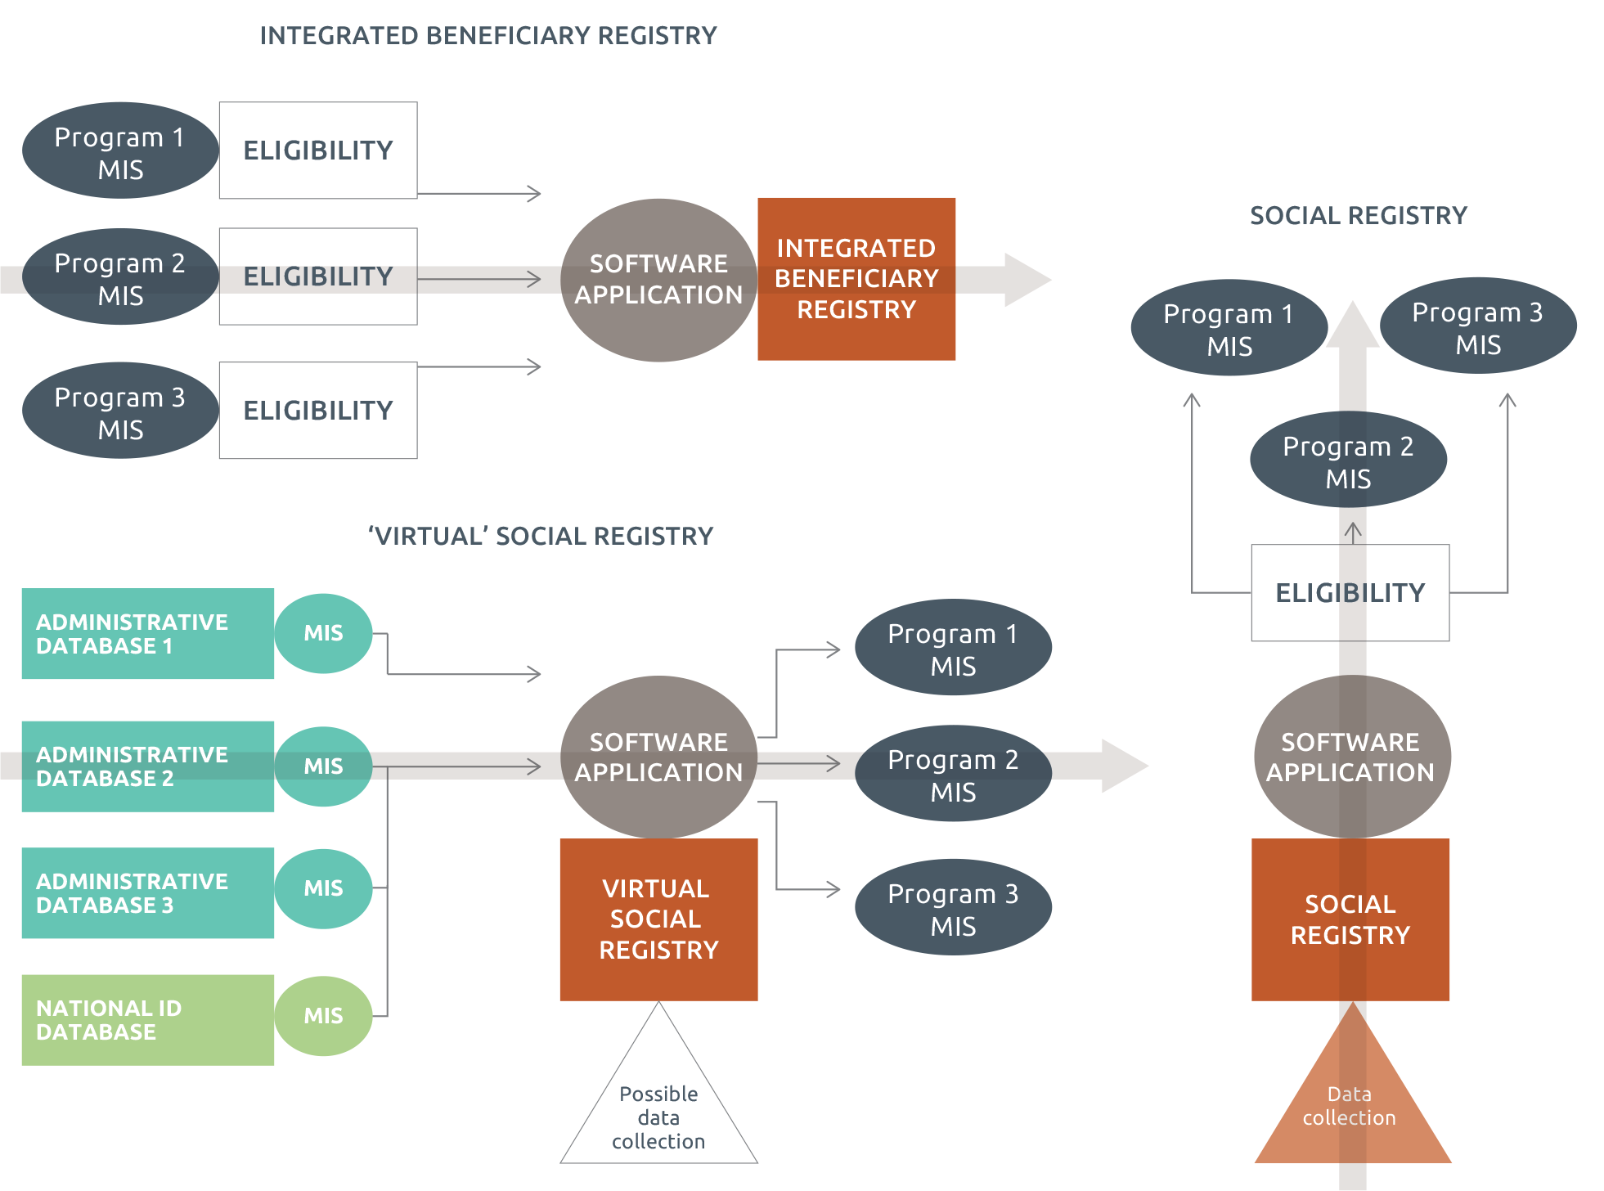

Source: Developed by the author.

Note: Boxes indicate databases; circles indicate MIS. All arrows have been portrayed as one-directional here (one-way data flow), though this is not necessarily the case. The transparent arrows behind each figure represent the direction in which it should be read.

### 2.4.2 Types of integration enabled

Social registries and integrated beneficiary registries are further classified in Table 3 based on the types of integration enabled by each in their most basic form (see also sections 1.2 and 2.5). It is clear from the table that:

* integrated beneficiary registries enable integrated M&E and potentially integration of operations and services across programs
* social registries enable an integrated process for registration and eligibility determination across programs
* virtual social registries can support registration and eligibility determination for universal programs.

The extent to which other benefits are reaped depends on the external links established through the tailored software applications (see Section 2.5).

Table 3 What type of integration can be achieved? Comparing social registries and integrated beneficiary registries

|  |  |  |
| --- | --- | --- |
|  | **Integrated beneficiary registries** | **Social registries** |
| M&E and overview of beneficiaries across programs | Yes | Only if registry receives data from program MISs (often not the case) |
| Integrated process for eligibility determination across programs | No (eligibility is determined at program level, then integrated) | Yes |
| Integrating operations and services across programs | Yes (if pursued as policy objective) | Only if registry receives data from program MISs |
| Integrating policy across social protection sector | Only if registry is linked to all social assistance programs and social insurance etc. | Only if registry is linked to all social assistance programs and social insurance etc. |
| Integration with other sector MISs | Only if application software enables this | Only if application software enables this |

### 2.4.3 How country context and needs affect choices

Ultimately, a country’s solution for integration must be strongly linked to the country context and overall objectives of the system (see Section 1.2), and is not therefore set in stone. It does not matter whether the system is initially set up as an integrated beneficiary registry, social registry or virtual social registry — what matters is that the approach chosen responds to a country’s needs, is appropriate to its context and is affordable and sustainable. Overarching considerations are presented in Table 4 below.

Table 4 How context and needs affect choices

| Approach | When most suited |
| --- | --- |
| **Integrated beneficiary registry** | * Policy objective is M&E / overview of beneficiaries, planning and integrating operations and services across programs * Existing program MISs are high quality * Existing programs have reliable/strong approaches to registration, eligibility determination and enrolment (and re-registration) |
| **Social registry** | * High capacity and commitment at central level * Policy objective is integrating the process for intake/registration (and sometimes poverty/eligibility assessment) across programs * Resources and capacity are available for frequent national census survey registration (e.g. every two years) or on-demand registration, or a combination |
| **Virtual social registry** | * High capacity and commitment at central level * Policy objectives include integrating the process for intake/registration across programs * Evolved e-government and buy-in from other ministries and stakeholders * Web service access is ensured (broadband network, data standards etc.) * National ID system has extremely high coverage |

### 2.4.4 How different solutions compare to a country’s total and ‘eligible’ population

To better understand the relationship between social registries, integrated beneficiary registries and the wider population (which can be potentially reached by virtual social registries), see Figure 2 below. In Figure 2:

* The widest **green circle** is a country’s whole population (rich and poor).
* The next **rust circle** is the population included in a country’s social registry. This is 100 per cent of the total population in a few cases (rust and green circles overlap) — notably where comprehensive census surveys are completed — but most often focuses on the sub-population of those who are potentially eligible for social assistance programs (e.g. relatively poorer). See Section 3.1.
* The smallest **blue circle** represents the population included in a country’s integrated beneficiary registry: the sum of all the beneficiaries of the social protection programs whose MISs have been integrated. This could be 100 per cent of the population if all citizens were beneficiaries of one program or another, but this is very rarely the case.
* The **grey dotted circle** represents a country’s eligible population (those who are entitled to receive some form of social assistance benefit based on the targeting criteria of any of the existing programs).[27] The area that does not overlap with the green or the blue line represents households who should be included but are not (exclusion errors). The area within the blue circle that does not overlap with the grey one represents households who are included in the social registry but not eligible based on existing eligibility criteria (they could be if these changed). All beneficiary households (green circle) are eligible (unless there are inclusion errors, not figured here).

Figure 2 How different solutions compare to a country’s total and ‘eligible’ population

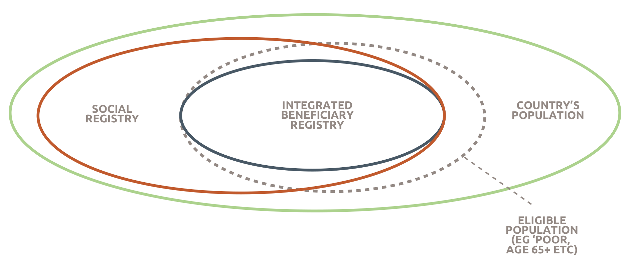

Source: Developed by the author.

## 2.5 Unpacking the role of the software application

Sections 2.3 and 2.4 mainly focus on the role of the social protection data repository: the registry/database. However no matter what approach is adopted for developing that data repository, its full potential as an information system is only unleashed when it is used together with a software application that links it dynamically to other databases, systematically transforms data into information, and analyses and uses the information.

### 2.5.1 Dynamic link to other databases

A system that guarantees full integration within the social protection sector and beyond, in accordance with the right to privacy, would establish a direct and two-way link[28] (web service — see Section 4.3.4) to:

* all social assistance program MISs and related databases — to keep track of who is receiving what, potentially integrate selected services, and enable adequate M&E and planning
* social insurance MISs and related databases — to integrate social assistance and social insurance and ensure a life-cycle and comprehensive approach to social protection
* any other relevant government MISs and related databases (e.g. civil registry, tax authority) — to collect and cross-check data, enhance accountability, and enable a comprehensive approach to social policy planning.

This can only be achieved through a purpose-designed application software, ideally using each citizen’s national ID number as a unique identifier (see Section 3.2.4 for more details and critique), allowing for instant access to up- to-date data, with information flowing in both directions — conditional on the permission level of each user. The overall solution would look something like Figure 3 below.

As an example, Table 5 focusses on social registries (see Section 2.2), to discuss the relative advantages of enabling a data flow *from* and *to* a social registry for selected stakeholders.

Table 5 Advantages of data flow from/to the social registry for selected stakeholders

| **Stakeholder** | **Advantages of data flow from social registry to (…)** | **Advantages of data flow to social registry from (…)** |
| --- | --- | --- |
| **National social protection programs** | * Programs can use data from the registry (and potentially national poverty index) to select their beneficiaries * Programs can benefit from further data integration established at national level (e.g. verifying data with civil registry) * Programs can be given access to integrated M&E information * Potential for integrating services across programs | * Registry continuously updated * Being able to keep track of who receives what * Integrated M&E across programs * Potential for integrating services across programs |
| **Civil registry and/or national ID number (see also Section 4.2.4)** | * Data collection effort for registry could help identify and register unregistered individuals | * National ID number acts as unique identifier and enables instant linkage with other government databases * Civil registry or National ID data can be used as an information base on all citizens (e.g. name, address), including notification of births and deaths * Authentication of registry data |
| **Bank or other payment institution** | * Potential for coordinating payments across different programs (economies of scale) | * Payment authentication and reconciliation across programs |
| **Tax authority** | * Tax authority could benefit from better understanding of poverty and social protection receipt | * Tax data can be cross-checked (e.g. to aid eligibility decisions and prevent fraud) |
| **Social security database** | * Better integration, coordination and planning across social protection and social insurance * Development of complementary packages targeted at social protection beneficiaries (primarily health Insurance) | * Social security data can be cross-checked (e.g. employment status and social insurance receipt to aid eligibility decisions and prevent fraud) * Better integration, coordination and planning across social protection and social insurance |
| **Health and education ministry MISs** | * Data from the registry can be used for sectorial anti-poverty policies * Better integration, coordination and planning across social sectors | * Integrated M&E across social protection and other sectorial programs (e.g. health insurance) * Health/education data could be used as information base for registry (education status, health status etc.) * Monitoring of compliance to co-responsibilities/ conditionality (if any) * Better integration, coordination and planning across social sectors |
| **Other state institutions** | * Improved transparency and accountability (e.g. monitoring government projects, open data platforms) * Planning, coordination and mainstreaming of poverty eradication strategies | * Data can be used as information base for registry (e.g. land registry) |
| **Decentralised governments** | * Data from the registry can be used for local anti-poverty programs * Local governments can be actively involved in management of social protection | * Cross-checks and eligibility assessments * Better planning, coordination and implementation of social protection programs |

Source: Developed by the author.

In reality, of course, in many countries these linkages do not exist in practice or are not developed to their full potential. This is not a problem; the ultimate set-up will depend on a country’s objectives, related needs and context. In fact, higher levels of integration and interoperability increase the risks associated with misuse and misappropriation (see Section 1.1) — which is the reason why many high-income countries have explicitly legislated against this (e.g. the United Kingdom). For example, data flows will often:

* not be bi-directional, but only one way. This is represented in Annex 1 with uni-directional arrows
* not be set up through a web service, but established on an ad hoc basis (sent in batches using CDs, email etc.).

This is represented in Annex 1 with dotted arrows (see Section 4.3.4).

* be very limited, e.g. linking to the programs they are serving and not far beyond.

Figure 3 Full integration of data and information management

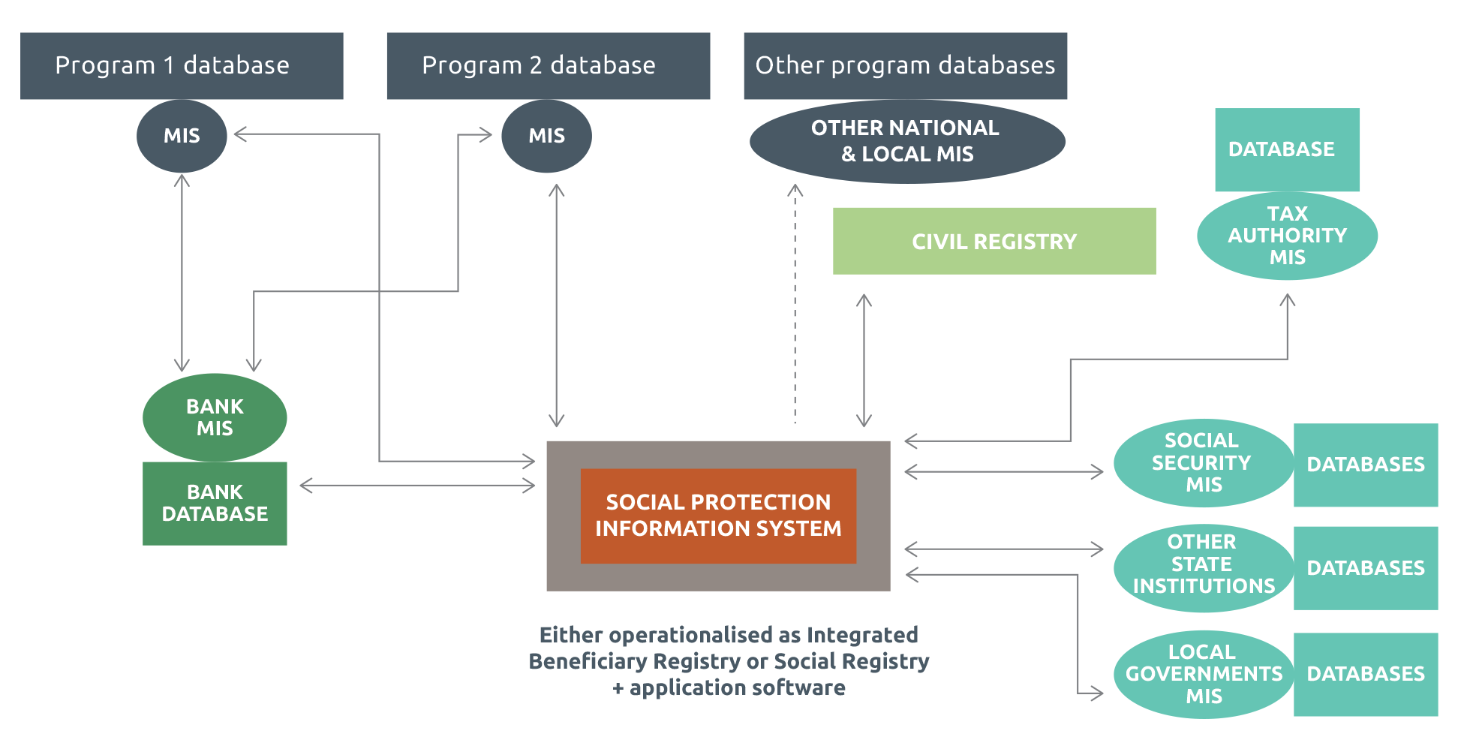

Source: Developed by the author.

Note: Boxes indicate databases; circles indicate MISs; bold lines indicate direct link (e.g. web service access); dotted lines indicate indirect link (batch process, CDs etc.); arrows indicate where information flows in one direction or two directions.

# Brief overview of country progress

As mentioned in the introduction, an ever-increasing number of low- and middle-income countries worldwide have been striving towards integration of data and information management within the social protection field in recent years. Moreover, given the evolving nature of these experiences — which are tailored to a country’s needs and priorities in any given moment — it is important to provide some form of mapping of solutions to integration to date.

This section briefly reviews key features of country experiences (Table 7 summarises information for a selected list), exploring why these differ so much and proposing a framework to analyse ‘trajectories’ of integration.

Further country-specific information is provided in Section 4 below, which discusses the main steps and challenges of designing and implementing social registries in particular.

## 3.1 Comparing progress across countries

Support for integrated data and information management for social protection has grown considerably in the last 20 years especially. The early wave goes back to the late 70s and early 80s, when Chile and South Africa were starting to set up their systems (see Box 7 for South Africa’s legacy system). Following some further experiences in Costa Rica and Argentina, since the turn of the century this process has notably accelerated — in Latin America primarily and then expanding internationally. For example, Brazil started the set-up of its systems in 2001, Uruguay in 2006, Malaysia in 2007, the Philippines in 2009, Turkey in 2010 and Indonesia and Kenya in 2011.

Each of these countries — as well as many others not listed here — has gone through several iterations during the course of this process, adjusting its system depending on the constraints and opportunities it was facing at that point in time, and on the overarching policy objectives pursued. For example, Brazil’s Cadastro Único has gone through almost 20 updates of its registry software and set-up, and — despite being a world-renowned example of best practice in this field — in 2016 started a new round of discussions to further integrate the system (WWP 2016b).

Based on data in the World Bank’s State of Social Safety Nets 2015 (Honorati, Gentilini and Yemtsov 2015) and additional assessment, some form or other of social protection information system is already fully institutionalised in 30 low- and middle-income countries worldwide (15 in Latin America, six in Africa, five in Europe and the Middle East and four in the Asia-Pacific).[29] The data repositories for many of these systems are set up as social registries. Currently an additional 31 countries — 18 of which are in Sub-Saharan Africa — are considering and developing options for integration in this sector (see Table 6).

Table 6 List of countries that have developed or are developing ‘integrated’ social protection information systems

| **Latin America** | **Africa** | **Europe and  Middle East** | **Asia-Pacific** |
| --- | --- | --- | --- |
| **Existing system** |  |  |  |
| * Argentina, Single Database for Social Security (BUSS) * Belize, Single Identification System of Beneficiaries (SISB) * Bolivia, Beneficiary Registry of Social Programs * Brazil, Cadastro Único * Chile, Social Registry of Households (RSH) * Colombia, Integrated Information System of Social Protection (SISPRO) * Costa Rica, Sistema de Identificación de la Población Objectivo (SIPO) * Dominican Republic, Sistema Único de Beneficiaros (SIUBEN) * Ecuador, Social Registry and Registry of Social Programs (RIPS) * Guatemala, Registro Único de Usuarios Nacional (RUU-N) * Honduras, Unique Registry of Participants (RUP) * Jamaica, Beneficiary Management Information System * Mexico, Cuestionario Único de Información Socioeconómica * Panama, Unified Registry of Beneficiaries (RUB) * Uruguay, Integrated Information System for the Social Area (SIIAS) | * Cabo Verde, Unique Registry * Kenya, Single Registry * Lesotho, National Information System for Social Assistance (NISSA) * Mauritius, Social Register of Mauritius (SRM) * Seychelles, IMIS * South Africa, SOCPEN | * Armenia, Family Benefit System * Azerbaijan, Ministry of Labor and Social Protection of Population MIS (MLSPP) * Macedonia, Cash Benefits Management Information System (CBM) * Romania, Integrated Information System for Administration of Social Benefits * Turkey, Social Assistance Information System (SAIS) | * Indonesia, Basis Data Terpadu (or Unified Database for Social Protection, PPLS) * Pakistan, National Socio Economic Registry * Malaysia, eKasih * Philippines, Listahanan (or National Household Targeting System for Poverty Reduction, NHTS-PR NSER) |
| **Systems that are being developed** | | | |
| * Dominica, National Beneficiary Information System (NBIS) * El Salvador, Single Registry of Beneficiaries (RUP) * Nicaragua, Unique Registry of Participants (RUP) * Paraguay, Single Registry of Beneficiaries * Peru, National Registry of Beneficiaries * St Lucia, Central Beneficiary Registry | * Benin, Unique Registry * Djibouti, Unique Register * Egypt, Unified National Registry * Ethiopia, National Household Registry (social registry) and Central Social Protection Management Information System (integrated beneficiary registry) * Ghana, Ghana National Household Registry (GNHR) * Liberia (name unknown) * Malawi, Unified Beneficiary Registry * Mali, Social Registry * Mauritania, National Social Registry * Morocco, Unified Register * Nigeria (name unknown) * Rwanda, Integrated Management Information System * Senegal, Unique Registry * Tanzania, TASAF Social Registry * Tunisia, Unified Registry and Unique Identification System * Uganda (name unknown) * Zambia, Single Registry of Beneficiaries * Zimbabwe, Integrated Social Protection Management Information System | * Georgia, System of Social Assistance * Jordan, National Unified Registry * Lebanon, National Poverty Targeting Program | * Bangladesh, Bangladesh Poverty Database * Cambodia, ID Poor * Mongolia, Intersectoral Database of Poor Households and Registry of Beneficiaries * Tajikistan, National Registry of Social Protection |

Source: Honorati, Gentilini and Yemtsov (2015) and author’s integrations.

Note: This table uses the common name of each countries integrated social protection information system.

These integrated systems range greatly in their set-up, functions and levels of cross-sectoral integration. This is exemplified by the number of social protection programs they serve, which ranges from two (Cabo Verde) to over 80 (Chile), as shown in Figure 4 below, and by the number of web service links they establish with other government databases, which ranges from zero to 43 (Chile). Of course, they also differ in their approach to setting up the underlying data repository — many are operationalised as social registries, others as integrated beneficiary registries[30] (see Section 2.3).

Figure 4 Number of programs served, selected registries

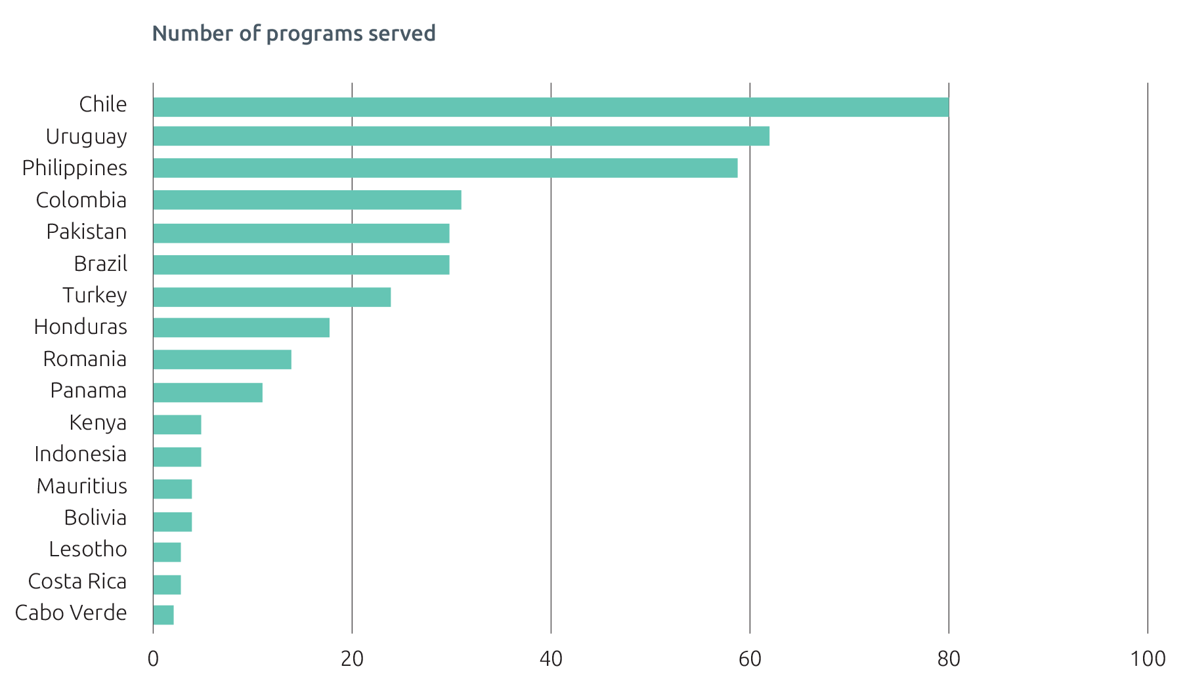

Source: Honorati, Gentilini and Yemtsov (2015) and author’s updates (online survey and recent literature).

Moreover, whether calculated as numbers of individuals or households or as a percentage of population, the size of existing systems (i.e. the total number of households and individuals they have data on) varies greatly from country to country, depending on a variety of factors.

As exemplified in Figure 5, the highest population ‘coverage’ (percentage of population registered) is reached by systems that guarantee full interoperability. For example, in Uruguay the use of data from existing administrative databases (using national ID for linking) means all citizens and residents are registered (including those who have died, those who have moved abroad and foreigners living in the country). Social registries with census survey approaches to data collection (see Section 4.2.1) that aim to survey all households in a given country follow close behind — as exemplified by Pakistan and the Philippines. Countries with social registries with on-demand data collection approaches (e.g. Brazil and South Africa) or census surveys of selected population groups (e.g. Indonesia) have marginally lower coverage rates — 40–50 per cent of the population. By definition, countries with integrated beneficiary registries have lower coverage, as only beneficiaries are included in the integrated registry (e.g. Kenya). Djibouti and Malaysia fail to hit the 5 per cent coverage mark as their systems are currently being expanded.

Figure 5 Percentage of population covered, selected systems

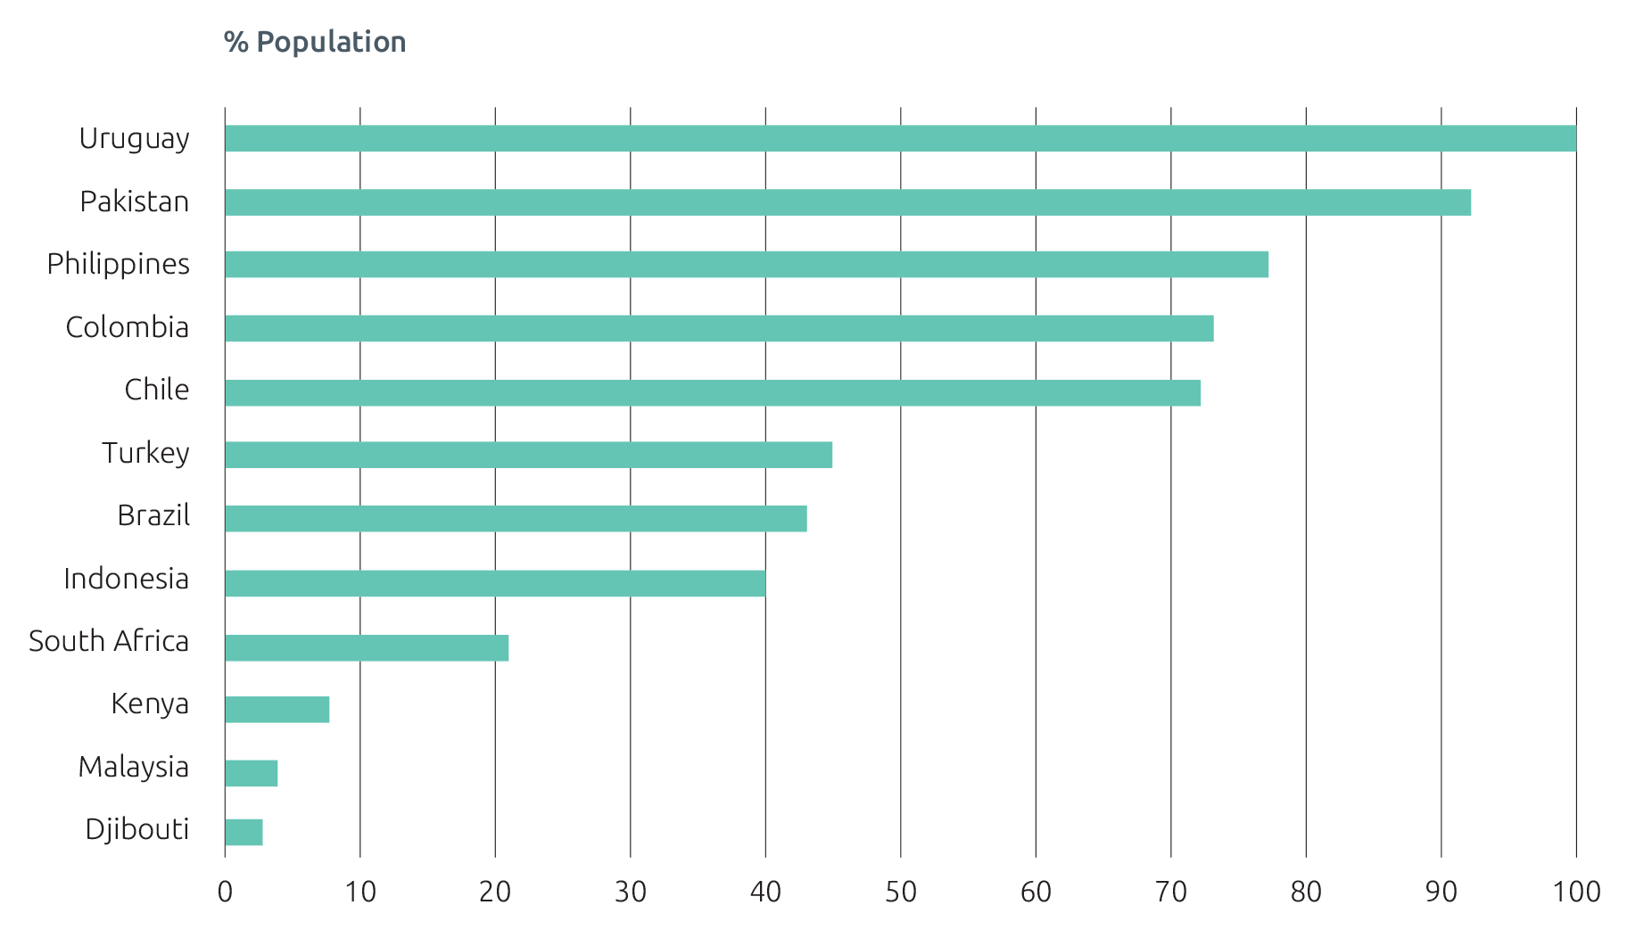

Source: Author’s analysis (online survey and recent literature).

Note: Countries and registries included are not necessarily the same as above, as some report number of households and some report number of individuals.

Less significant as a comparison (as it is strongly affected by a country’s population size), yet interesting to give a sense of the magnitude of these efforts is the number of households registered (see Figure 6). The largest of all efforts in absolute terms is Pakistan’s National Socio-Economic Registry (linked to the Benazir Income Support Programme, BISP), which contains information on 167 million individuals, equivalent to 27 million households or 92 per cent of the population (2015).[31] Far behind in terms of population coverage (43 per cent) but very close in terms of number of households (almost 27 million) is Brazil’s Cadastro Único, followed by Indonesia’s Unified Database (25 million households, 40 per cent of population)

Figure 6 Number of households registered, selected registries

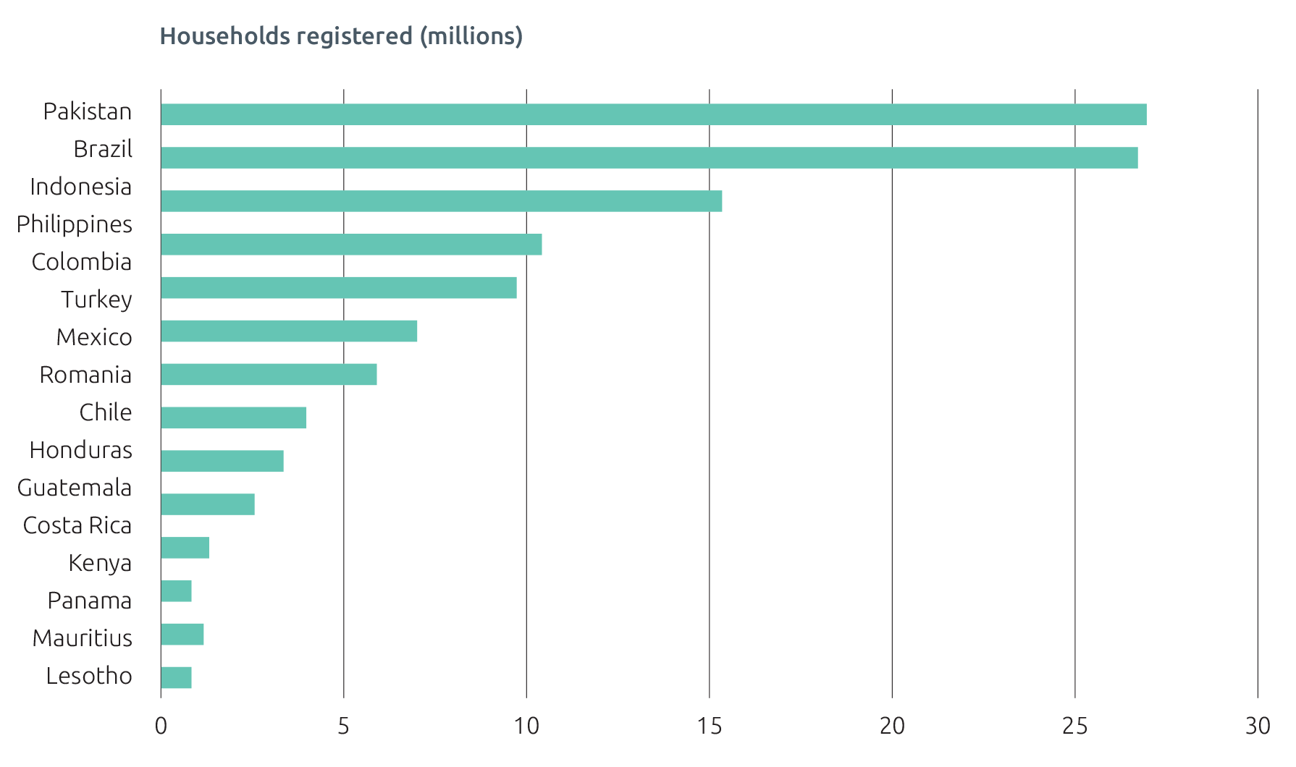

Source: Honorati, Gentilini and Yemtsov (2015) and author’s updates (online survey and recent literature). Note: Mauritius and Lesotho have registered 0.04 million beneficiaries.¬¬

The percentage of registered people or households receiving any form of social assistance (beneficiaries) also varies greatly from country to country — partly depending on the selected approach to integration. In Kenya, for example, 100 per cent of individuals registered are also beneficiaries (as this is an integrated beneficiary registry as described in Section 1.2.1). In Pakistan, the number of BISP beneficiaries was 4.8 million in 2015, equivalent to 18 per cent of the households within the national registry. In the Philippines, 5.1 million of the total 15 million registered (33 per cent) were classified as poor and therefore eligible for any benefit. In countries where data collection is primarily on demand and based on citizen applications (see Section 4.2.1 for more details), it is likely that this ratio is highest, as the households most likely to apply are those most in need (self-targeting).

|  |
| --- |
| Box 7: SOCPEN, South Africa’s legacy system |
| The Republic of South Africa’s Department of Social Development (established in 1929), together with the South Africa Social Security Agency (SASSA), runs a comprehensive system of social assistance grants and processes 16,991,634 grants monthly[32](collected by just over 11 million recipients). The grants are processed using a legacy system called SOCPEN, which started in the 1930s.  SOCPEN runs on a non-graphical user interface based on mainframes located at the State Information Technology Agency (SITA). Its legacy enterprise database, Adabas, manages more than 2300 concurrent users and has a registry of more than 16 million beneficiaries, with primary data collected through an on-demand application system. Since implementation is handled by one agency, it can be argued that South Africa operates a ‘single window’ for processing applicants.  To perform its key functions — processing applications for the country’s six social grants, determining beneficiaries from the list of applicants, maintaining the payroll for the grants,and automatically producing a list of beneficiaries to be re-assessed — SOCPEN links to a file-tracking system providing real-time information on the status of social grant applications and to Livelink, a document management system that scans and manages records of grant recipients.  SOCPEN interfaces with other government MISs, the most important of which is that of the Department of Home Affairs, and can provide real-time information from the population registry (e.g. deaths). An online interface has also been established with PERSAL (government payroll system) to cross-check income data. Other ad hoc data sources (not linked online) include the Unemployment Insurance Fund; Government Employees Pension Fund; payroll system of the Defence Force; National Treasury (to verify beneficiary banking details); Department of Basic Education learner database; and special investigations unit (to identify fraudulent grants).  While proving that legacy systems can be very effective, the system has limits:   1. reaching its ability to be customised and being overtaken by many technological changes 2. producing substantial volumes of paperwork 3. not being an organisation-wide system covering all SASSA operations, leading to duplication of data-storing and making M&E more difficult 4. linking with other MISs but not always in real time 5. focusing on managing operational processes for grant delivery rather than on policy coordination and oversight.   Moreover, approaches to further integrate SOCPEN and move towards a national integrated social information system (NISIS) have failed to date.  Source: Barca and Chirchir (2014). |

Table 7 Selected country experiences, a comparison table

| **Country, name of system and source** | **Year of creation** | **Received donor support** | **Number of individuals/ households registered (relevant year)** | **Number of individuals or households receiving benefits (relevant year)** | **Data collection and updating approach** | **Number/names of social protection programs using database** | **Linkages to other non-social protection institutions and their databases** | **Any information on costs** | **Number of staff involved at central level (full time)** |
| --- | --- | --- | --- | --- | --- | --- | --- | --- | --- |
| Brazil Cadastro Único (WWP 2016b; online survey) | 2001 | Yes | 26.8 million households (2015). Amounts to 43% of population. | 14 million Bolsa Família beneficiaries, but not currently possible to verify beneficiaries’ receipt of multiple benefits | On-demand continuous registration in 9413 centres within country, with obligation of updating every 2 years at most  Mobile units for remote locations etc. | Over 30 programs at national level, including Bolsa Família, plus several decentralised programs. Does not include social insurance or some flagship social protection programs (e.g. Bolsa Prestação Continuada) | Not linked to civil registry but shares data with education and health MISs and with land registration database | Being costed now (2016) | More than 30 staff |
| Chile Registro Social de Hogares (RSH) (Covarrubias et al. 2011; Azevedo, Bouillon and Irarrázaval 2011; Irarrázaval 2004; WWP 2016b; online survey) | 1979 (has had major changes since)  Institutionalised in 2007 and transformed again in 2016 | No | 12.4 million individuals, 4 million households (2016). Amounts to 72% of population. |  | Combination of on-demand (within municipalities and online), periodic census survey and use of existing administrative data  Continuous update | In 2016, over 80 social programs in Chile were using RSH to select their beneficiaries | Linked to civil registry, social insurance database and data from 43 state agencies and their multiple databases, including ministries such as education, health, labour and social security, housing and urban development; and the tax authority, land registration authority etc.  Also linked to 345 municipalities | In the last years, around 0.5 million US dollars annually (2016) | 16 staff |
| Colombia SISBEN (ILO 2015b;  Leite et al. 2017) | 1995 | No info | 10.4 million households (2015). Amounts to 73% of population. |  | Started as census survey sweep in geographically targeted areas; now on-demand registration and updating at local offices and census survey outreach in areas with highest levels of poverty | Now serves 31 programs (including Familias en Acción) and 8 institutions | Linked to integrated system of health insurance (SIIS), integrated contribution system of social security, information system for operation of subsidised health insurance, information system for regulation of medicines, and more | No info | No info |
| IndonesiaBasis Data Terpadu, or Unified Database (UDB) (database website and documentation, OPM 2015a, online survey) | 2011 | Yes, DFAT and World Bank | 97 million individuals registered, 25 million households (2016). Amounts to 40% of population. | Depends on the program (people can receive more than one) | Census survey  Households chosen for interview based on existing poverty data from population census, socioeconomic survey (the Survei Sosial Ekonomi, Susenas) and ‘village potential’ survey (the Potensi Desa, Podes)  Previously a new round of data collection every 3 years. Now Indonesia is developing an ‘on demand application’ to update UDB data dynamically without using large-scale census. | 5 main national programs — including Health Indonesia Program (KIS), Program Indonesia Pintar (KIP) and Program Simpanan Keluarga Sejahtera (KKS) — as well as local government programs | Yes, but only recent effort (national ID is not unique ID for database)  Also links to health MIS, education MIS, bank database | No info | 37 staff in ad hoc unit |
| Kenya Single Registry (Ministry of State Planning 2011, online survey, Chirchir and Kidd 2011, WFP and Government of Kenya 2015) | 2011 | Yes | 882,678 households. Amounts to approximately 8.4% of population | 882,678 households (all included are beneficiaries) | Data collected by individual programs (census survey) and consolidated nationally  . | Currently 5 main social protection programs in the country: CT-OVC, HNSP, OPCT, PWSD-CT and World Food Programme asset creation program | Linked to civil registry and to social security database in plan | No info | Some 20 staff in 3 ministries/agencies |
| Malaysia National Poverty Data Bank (eKasih) (ICU JPM 2013) | Created October 2007, rolled out in July 2008 | No info | 1.2 million individuals (July 2013). Amounts to 4% of population | No info | Collected from a poverty census (Banci Isi Rumah Miskin)  Online registration also available | No info | No info | No info | No info |
| Pakistan National Socio-Economic Registry (used by BISP) (registry website, BISP-SN 2016 and Malik 2014) | 2010 | Yes, World Bank and DFID | 167 million individuals, 27 million households (2015). Amounts to 92% of population. | 4.8 million households were BISP beneficiaries (2015) | Data from National Database and Registration Authority (NADRA) and BISP census survey (in the field 2016 to update previous Nationwide Poverty Scorecard Survey in 2010–11)  On-demand registration will also be tested | 30 federal and provincial social sector programs, including BISP | Links to biometric national ID database (NADRA) but not to social insurance | No info | No info |
| Philippines Listahanan (Leite et al. 2017, Listahanan official infographic) | 2008 | Yes World Bank and DFAT | 15.3 million households (2016). Amounts to 77% of population. | 5.1 million households classified as poor (2016) | Census survey  Listahanan’s first nationwide update and recertification was undertaken in 2015 | Used by 59 programs from many government agencies (including Pantawid CCT, the social pension, subsidised health insurance), as well as by local governments and other institutions | No info | No info | No info |
| South Africa SOCPEN (Social Pension System) (system database and website and online survey) | 1985 | No, national budget | 11.4 million individuals registered (‘active beneficiaries’) (January 2016). Amounts to 21% of population. | Total number of individual grants paid: 16,893,574 (January 2016) | On demand: citizens enter the system on a needs basis  Those who qualify for grants go to SASSA’s network of 366 local offices to apply  Update is continuous based on on-demand system and every contact with client | All social assistance programs: old age grants, disability grants, war veterans’ grants, care dependency grants, foster child grants and child support grants | Linked to civil registry but not to social insurance database  Also linked to national learners database and municipalities’ indigent databases | Average running cost for support and maintenance is approximately 37 million South African rand per year | 15 technical and 12 functional support resources |
| Turkey Integrated Social Assistance Information System (ministry documents and online survey) | 2010 | No, national budget | 34 million individuals registered (9.7 million households) (January 2016). Amounts to 45% of population. | Some 3 million households were recipients of any benefits in 2015 | On demand through local offices, with additional data from virtual consolidation across a wide range of government databases  Regularly as new applicants apply and change their status (on demand) plus household visits to beneficiary households by local officers at least once a year | 24 different programs, notably Conditional Cash Transfer Program, Payments for Disabled and Elderly Turkish Citizens, Food and Heating Assistance, Cash Transfers For Vulnerable Groups | Linked to civil registry, education MIS, tax system database, cadastral database, e-government portal — overall 112 web services with 22 public institutions | Approx. 10 million US dollars (amount includes software and hardware costs) | 28 software engineers, 12 expert staff  Total approx. 40 |
| UruguaySistema de Información Integrada del Área Social (SIIAS) (WWP 2016b, online survey) | 2006, operational since 2010 | Yes, World Bank | 4.3 million individuals registered. Amounts to 122% of population, as this includes those who have already died, foreigners and migrants. | 4 million individuals | Data integrated from 15 different administrative databases, including MISs of existing social protection programs | 62 programs using data | Links to civil registry and 15 different institutions providing data | To date 3,690,000, US dollars with annual costs estimated at 500,000 US dollars a year | 7 staff at national level |

## 

## 3.2 What factors drive country progress?

One important lesson emerges when analysing country experiences: no two countries take the same path towards integration of social protection data and information management. This means that the official ‘name’ of a country’s solution to integration tells us little or nothing on the way it is set up in practice: what needs to be analysed and understood when comparing countries is where data is flowing from (e.g. what are the primary data sources, where is new data being collected) and to (e.g. who has access to this data and how).

Whether gradual (setting up program MISs and then trying to integrate fragmented efforts into a wider and integrated approach within the social protection sector) or immediate (designing and implementing a social registry and its complementary software application), each country tackles internal needs based on contextual constraints, opportunities and objectives.[33]

The main factor affecting information needs and integration requirements is the core policy objective pursued by country policymakers. Is data and information integration viewed as a way to gain oversight over multiple schemes, as an efficient approach to determining program eligibility, or as a side-product of an integrated approach to service delivery (see Section 1.2 for more details)? Is social protection seen as an entitlement and conceptualised so as to address households’ life-cycle vulnerabilities? Is there a strong policy push towards integration? Is integration envisaged only within non-contributory programs, across contributory and non- contributory programs, or more widely across the social sectors?

* A second important factor is the set-up of a country’s main social protection programs. For example, are these targeted or universal? Conditional or not? Managed entirely by government or by third parties? Centralised or decentralised? Collecting data on demand or based on ad hoc censuses? Covering what percentage of population?
* A third factor relates to the enabling/constraining country context. Is there availability of funds for designing, creating and maintaining the system (from government or donors)? Is there sufficient staff capacity at all government levels? Is there possibility for technological innovation (e.g. network connection and hardware infrastructure)? Is there a national ID system in place to provide unique identifiers to readily link across different government databases? Is there a wider government focus on performance-based management and e-government? Is there a sound legal framework in place to prevent the misuse of data and protect individuals’ right to privacy?

Some of these questions are further outlined in Annex 2 as guidelines for country needs and feasibility assessments.

## 3.3 Typology to classify country progress

This section provides a typology that helps to classify country experience to date.[34] The typology combines two categories (represented as axes in Figure 7):

1. ‘Breadth’ of integration — a continuum based on the breadth of scope and level of interconnectivity of the overall system for information management, within the social protection sector (and beyond).[35] Integration can occur:
2. at program level (no integration), where information is managed through a program MIS. In its most basic construction, an MIS manages information and operations in a single social protection program. It is not connected with other systems and databases
3. within selected programs of the social assistance sector (i.e. non-contributory social protection)
4. within the whole of the social assistance sector, encompassing all government non-contributory programs (and potentially even NGO/international organisation interventions)
5. within the wider social protection sector, as above, but encompassing contributory as well as non- contributory schemes
6. across sectors within a country, whereby the interoperability of information is extended to other social sectors (for example, health and education).
7. ‘Depth’ of integration — a rough categorisation of the exchanges that operate with external (non social protection) databases[36] (linked to wider objectives of integration — see also Section 1.2).
8. No integration: no link to external (non-social protection) databases
9. Using data for verification: links to external databases, but only to verify and validate its information (either ad hoc or continuously)
10. Using data for registration/eligibility: links to external databases, but primarily to collect data used for registration (see Section 4.2.1) and determining eligibility   
    (uni-directional flow)
11. Sharing data to integrate service delivery and increase citizen focus: bi-directional links with external databases, enabling streamlining of services and/or operations within the social protection sector and beyond.

Figure 7 provides examples of countries that broadly fall into one category or the other. Note that:

* some of the categories within the typology overlap and are not entirely clear-cut or sequential, as they have been selected primarily to show increasing complexity. For example, several countries achieve integration with other social sectors without having necessarily integrated contributory and non-contributory social protection. Similarly, most countries that integrate data with other sectors to increase citizen focus and improve service delivery also use external data for verification and for registration and determination of eligibility
* a country’s positioning can and will evolve over time depending on its shifting priorities (e.g. policy objectives) and constraints/enablers (e.g. technology, staff capacity)
* countries’ shifts are not necessarily ‘linear’. Countries make constant adjustments along the way, and are not necessarily all heading in the same direction (i.e. there is no ideal trajectory or position in the matrix).

Figure 7 Typology: breadth and depth of data and information integration

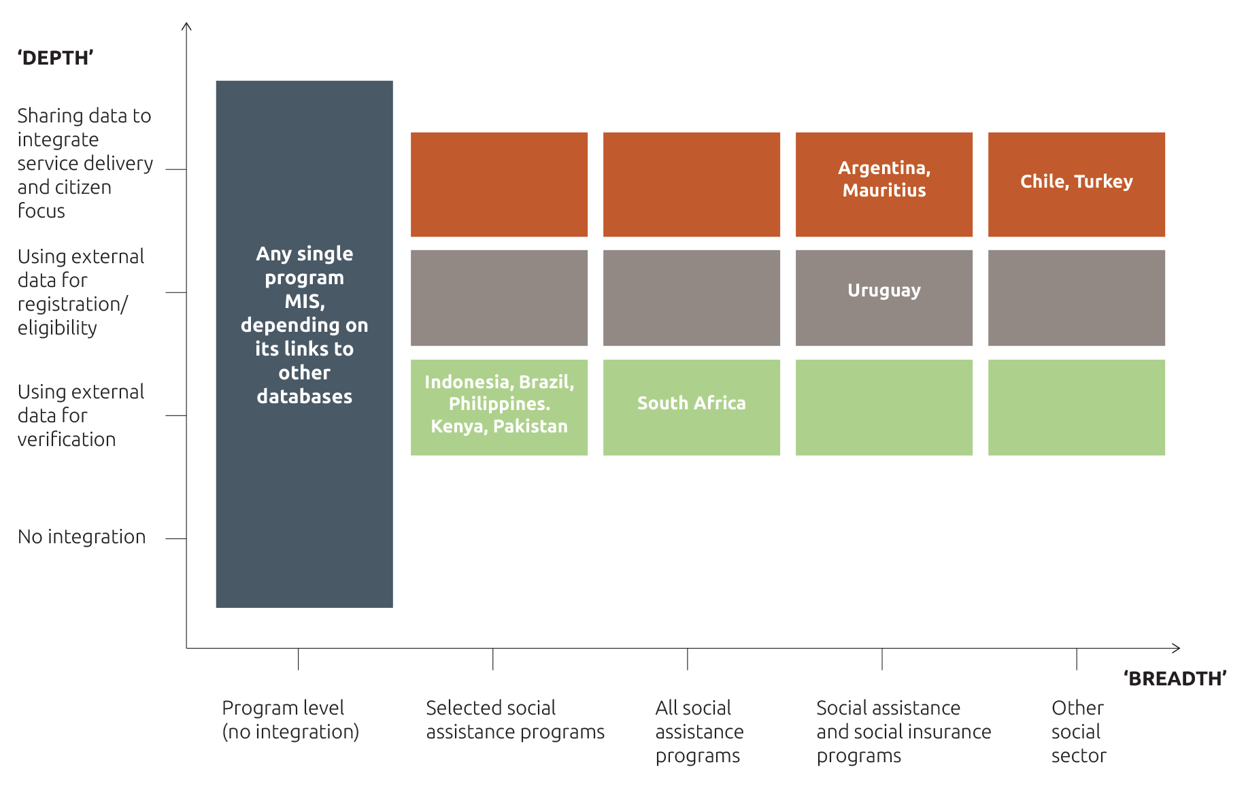

Source: Developed by the author.

# Main steps and challenges in designing and implementing social protection information systems

The more a system is integrated across several programs and databases from other government and non- government organisations, the more potential there is for complications and challenges. This section focusses on the main pillars in designing and implementing a social protection information system, outlining what these challenges are and how countries have set out to overcome them. In doing so, it focusses primarily on information systems underpinned by social registries (see Section 2.3.2) — as:

1. these are increasingly becoming the most popular approach
2. many of the lessons that apply to social registries also apply to integrated beneficiary registries (partly as these have some overlaps).

## 4.1 Administrative and institutional aspects

### 4.1.1 Governance and institutional arrangements

The more complex and interlinked the overall system for data and information management, the more difficult institutional arrangements are to establish and conform to, as there are significant transaction costs to coordination (e.g. managing complex cross-program and sector arrangements). The ultimate challenge is to get different stakeholders to share their data, especially in light of legal restrictions (e.g. data privacy) and existing power relations (information is power). Managing an integrated and centralised social registry can also lead to errors being propagated across programs that have common points of entry, and risks stifling creativity and responsiveness. There may also be fewer checks and balances as many of the core functions are centralised, as well as information asymmetries (World Bank and UNICEF 2013).

Most countries implementing integrated systems tackle these challenges by ensuring that ultimate responsibility for coordinating and managing the national registry and related software lies with an agency or unit with sufficient independence from those managing social protection programs and high enough in government to effectively coordinate with other stakeholders. Best practice has included the creation of inter-ministerial committees and ensuring regular interaction between all the stakeholders involved — ideally driven by one or two strong champions within the lead ‘social development’ ministry.

The position of the unit is vital, but so too are vertical and horizontal integration across a wide range of stakeholders. As Baldeon and Arribas-Banos (2008) warn:

… institutional arrangements across different government agencies, formal agreements between the programme and local governments, and service level agreements between the programme and service providers are essential to achieving the objectives of the [Social Safety Net] programme.

This is even more the case when integrating across programs and sectors. Best practice dictates that a clear process is needed to identify relevant stakeholders and formalise their roles and responsibilities. This could be through legally binding agreements, carefully designed incentives and mutually agreed terms of reference. It is also essential to draft legal frameworks to ensure confidentiality of data collected (a common practice across all Latin American countries — Azevedo, Bouillon and Irarrázaval 2011) and address any other legal restrictions on data-sharing.

Formal agreements are not always enough, however, and not necessarily easy to reach. Best practice dictates the need for an ongoing bargaining/negotiation process aimed at demonstrating to and clarifying to each stakeholder ‘what is in it for them’. In order to achieve this, countries have successfully implemented in-depth needs assessments (e.g. mapping information needs and synergies) and participatory planning processes (e.g. Kenya, Indonesia, Malaysia). Annex 2 provides some examples of the questions it could be useful to ask to inform design.

### 4.1.2 Decentralisation: an added layer of complexity?

Country administrative structures and levels of decentralisation affect integration of data and information management overall. The main trade-off is that, while local governments are most likely to understand the socioeconomic situation of the population they serve and best placed to collect and update data for the registry, they might have more incentive to facilitate access to social protection programs to those who are not necessarily deserving (to win votes and build contacts), given that the budget is managed centrally (Azevedo et al. 2011). Local governments in countries implementing integrated social registries have also shown resistance to change (low ownership and buy-in), feeling disempowered by the centralised process.

So how to ensure buy-in and support while maintaining consistency and control at national level?

Based on the study of six countries that had implemented a social registry in Latin America (Argentina, Brazil, Colombia, Costa Rica, Chile and Mexico), Irarrázaval (2004) notes that in no country is the design of the system[37] itself devolved to sub-national level. Several countries, such as Brazil, Chile and Colombia, devolve implementation aspects while maintaining verification and validation of data control (Azevedo et al. 2011). In Brazil, the quality of this process is guaranteed by providing financial incentives to municipalities (Box 8). In Malaysia and Indonesia, the active involvement of decentralised units of government has been considered essential to the success of the system (ensuring ownership and buy-in).

A further strategy to ensure buy-in is to provide ‘value-added’ incentives to local units of government, sharing data and tailoring reports/analysis to their needs and allowing the use of consolidated data for local programs (as in Indonesia and Brazil, for example). Countries adopt different strategies for securing access to consolidated data to decentralised levels of government. The type of strategy developed depends on consideration of factors such as established formal agreements; the sophistication of the software application granting user access; and the possibilities for transmitting data (for example, the presence of reliable internet at decentralised level).

|  |
| --- |
| Box 8: Problems with and solutions to decentralised management of a social registry — Brazil’s Cadastro Único |
| As a result of the division of tasks between municipalities, Caixa and the Ministry of Social Development, Cadastro Único offers these advantages:   * A ‘big-picture’ view of national coverage and policies, due to the ministry’s privileged position within the executive power of central government * Local accuracy for targeting, since ‘tricky’ implementation is carried out by strong and traditional structures, with fairly sound knowledge of the social needs of local people.   This decentralised system is strengthened by formal performance-based financial incentives — based on a decentralised management index (Índice de Gestão Descentralizada, or IGD) — provided to municipalities to encourage them to implement with quality. Financial incentives are regulated by law and based on set criteria, including the need to continuously update the registry.  Despite these and other advantages, the Cadastro Único’s decentralised structure faces some challenges, including:   * Difficulties in preventing influence from, and monitoring the sensitivity of the registry’s targeting to, local political disputes. To counteract this, government has: * focused on increasing public awareness of citizens’ rights to be included in the Cadastro Único and overall targeting criteria[38] * adopted a system of internal and external audit institutions from the public sector (Rede Pública de Fiscalização), and a toll-free telephone number linked to a grievance resolution mechanism that is at the public’s disposal * imposed a Cadastro Único geographical targeting limit for each municipality * Created a system for cross-checking data with other central government databases (formal labour market, social pensions and other social policy databases) and a household and personal data assessment which estimates inclusion error incidence by municipality. * Low enforcement capacity between levels of government. This challenge is partially mitigated by the ‘adherence pacts’ municipal government must sign with Cadastro Único. There are no sanctions or appeal mechanisms to resolve possible disagreements, however, so these are dealt with case by case.   Source: Mostafa and da Silva (2007).38 |

### 

### 4.1.3 Staff availability, capacity, training and retention

Staffing is particularly important for managing complex integrated systems and institutional arrangements. Issues revolve around staff availability, capacity, training and retention.[39] At central level, it can be difficult for public administration to attract and retain highly qualified staff with the right combination of strategy, management, analysis and IT skills[40] — especially as these are skills that command significantly higher salaries in the private sector. At decentralised levels, managing a national social registry can be particularly challenging in contexts where there is no established network of local staff (e.g. social assistants in each community). Moreover, it may be difficult to promote a culture of sharing and problem solving (especially where different institutions and units within each institution have different incentives and are not used to working collaboratively) and to avoid ‘overwhelming’ staff with changes linked to integration (e.g. ‘larger role’).

Different countries have strategies in place to deal with these issues (Azevedo et al. 2011; OPM 2015a; WWP 2016b), all of which centre around the idea that one-off training is never sufficient. Strategies include:

* Defining capacity as critical and budgeting for it, based on a detailed capacity assessment
* Continuous approach to training and capacity building:
* developing manuals and continuously enforcing their use (Brazil, Colombia, Costa Rica and Mexico)
* hosting capacity-building days and ongoing training (Brazil, Chile, Iraq, Lebanon, Palestine and Turkey)
* training ‘back-up officers’ for smooth change management and adopting a training of trainers approach (Malaysia)
* conducting thematic working groups (Kenya) and ‘good practice workshops’ across different locations (Moldova)
* conducting online education and online consultations (Chile)
* ensuring capacity transfer in consultant contracts (Kazakhstan) and adopting a long-term vision for capacity development and training
* Rewarding and involving staff (financially and ‘emotionally’)
* defining performance standards, monitoring compliance and rewarding good practice
* ensuring all staff are aware of the ultimate vision and benefits of an integrated system (for example, include this in training curricula)
* ensuring all staff are somehow involved in the participatory planning process and have mechanisms to provide feedback on their role (frustrations, suggestions) within the integrated system (i.e. ensuring all staff have a stake in final outcomes).

## 4.2 Operational and implementation aspects

### 4.2.1 Collecting data (intake and registration)

Systems that generate information are only as good as the data entered. Also, each piece of information collected adds an additional cost and makes information management more complicated and, potentially, less effective (Chirchir and Kidd 2011). At the same time, of course, one of social registries’ primary roles is to provide in-depth information for the purpose of determining access to social sector programs (whether means tested or categorical). So what data to collect? And how best to collect it?

#### What data to collect

Best practice is to manage the amount of data collected by keeping data focused on core objectives (e.g. for social registries: determining eligibility and program needs) and managing pressure from other institutions (e.g. during a participatory planning process, when each will be interested in different aspects). Villalobos et al. (2010) suggest:

… four key questions should be answered, preferably at design stage: (i) which data are registered? (ii) what are the data registered for? (iii) how are the registered data used? (iv) who uses the data?

The amount of data ultimately collected varies widely across countries and depends on program requirements. Universal (non means-tested) programs, for example, will have much lower data requirements, as Box 6 on Thailand’s national health insurance registry demonstrates. Data requirements of conditional programs, on the other hand, are larger. Box 9 provides some examples of the main types of data collected for social registries used for the determination of eligibility.

Importantly, certain categories of data may be more contentious than others when it comes to data privacy and security concerns (see Section 4.3.1). Whether obtained unduly by third parties or used unduly by government (e.g. ‘surveillance state’), information on citizens’ identity, address, health, asset-holding and bank accounts (among other things) could easily be abused if sufficient safeguards are not ensured, as discussed extensively in Hosein and Nyst (2013).

|  |
| --- |
| Box 9: Information typically included in a social registry |
| The exact amount and type of information collected depends on country needs and context. However, social registries typically include:   1. **information on identity and household composition** such as name, birthdate, gender, relationship with household head, marital status, unique identifiers such as a national or functional[41] ID number 2. **socioeconomic information** such as self-reported and/or verified information on incomes for each household member, education, employment and disability status of each individual 3. **information on housing and assets** such as housing characteristics (e.g. type of housing material, connection to water, electricity), self-reported and/or verified information on assets 4. **information needed for implementation of transfers** such as postal address, contact phone number, nominated recipients, bank account number (if relevant to payment modality), receipt of any further assistance 5. **other information** depending on the registry’s purpose and use, such as access to services, health, food security status, registration with employment agencies, social insurance number.   An example (in English) of Brazil’s Cadastro Único data collection form is available at socialprotection.org. Examples (in Spanish) of Chile’s Registro Unico de Hogares data collection form and manual are available on the Ministry of Social Development website.  Source: Adapted by author based on Leite et al. (2017). |

#### How to collect the data

For countries setting out to populate a social registry, three main data collection options exist, as described below. Countries with mature registries tend to combine the three approaches to varying degrees and, in doing so, reap the benefits of each (e.g. Turkey, Argentina and Chile).

The first two approaches use a questionnaire-based process (paper based or online) widely described in the literature (Grosh et al. 2008; Castaneda and Lindert 2005; Villalobos et al. 2010). On-demand registration relies on households going to a local welfare office to register and apply for benefits. Modern approaches to on-demand registration include the use of online applications or mobile phone apps (e.g. Argentina, Chile and Australia).

Census survey registration entails a labour-intensive approach by which all households in an area are interviewed at selected intervals. In some cases, as in Indonesia, only households that have been predetermined as poor (based on existing data) are interviewed.

The third approach, which is increasingly being used by mature social registries (defined in this report as virtual social registries), is the integration of data from existing databases, including — potentially — a country’s civil registry, tax registry, land registry, education and health MISs. Adequately used, such an approach can greatly reduce the need for direct data collection through the two methods described above (which remain necessary in some form or another as it is unlikely that existing administrative databases can provide the wealth and breadth of information needed for determination of eligibility, except in the case of universal transfers).

Table 8 highlights the relative advantages of the three approaches, suggesting when and where each may best be suited. It should be noted, however, that:

* several variants on these ‘pure’ categorisations exist. For example, three of the programs informing Kenya’s Single Registry’ (an integrated beneficiary registry) collect data using a ‘periodic’ on-demand approach: public meetings are scheduled yearly in each community where households can come and register (see Annex 1, Case study 4). In this case, the advantages in terms of up-to-date data may not apply. Similarly, very few countries adopt a full census sweep when collecting data for their social registry: households interviewed are only those that are predetermined as likely to be poor (based on existing data or community validations)
* costs and capacity permitting, countries often combine approaches to reap benefits of each.

Table 8 Relative advantages and disadvantages of survey, on-demand and   
data-sharing data collection approaches

|  | **Relative advantages** | **Disadvantages** | **Best suited** |
| --- | --- | --- | --- |
| **On-demand application approach** | * Lower total costs due to self-selection of non-eligible out of registry process (interviewing fewer non-eligible households) * Dynamic, ongoing entry and easier to update (including changes linked to life-cycle events) * More democratic nationally — everyone has the right to be interviewed at any time * Permanent process helps build and maintain administrative and logistical structures | * Poor may not participate because they lack information, fear stigma and face other barriers to access (illiteracy, distance, disability etc.) * Costs can be higher if social workers must verify (via home visits) information provided * Can be a slow process, involving long queues and bureaucracy * Requires large network of staff at local level * Unlikely for people to report positive changes to household conditions * Does not allow for easy collection of household’s GIS geo-referenced data | * In areas with low or moderate poverty/eligibility * In heterogeneous areas * When registry is well known or well publicised (and outreach campaigns encourage applications in poor areas) * When people have higher education levels * Where a network of social protection offices is available at local level or municipal staff are well trained to perform the registration function (to minimise travel for applicants) |
| **Census approach** | * Better chance to reach the poorest and other vulnerable groups, who are less informed and more stigmatised (less likely to apply) * Lower marginal registry costs (per household interviewed) due to economies of scale with travel * If conducted often enough, there is a higher chance of capturing positive changes to household conditions (less likely to be reported) * House check conducted during survey process (no misreporting assets etc.) | * Periodic surveys can lead to static/inflexible registries — especially if target population is linked to life-course events (pregnancy, children 0–3 etc.) * Members of eligible households may not be home or respond when the survey is conducted * Costly in areas with many non-eligible households or where households are very dispersed * Re-registration very costly and often postponed beyond recommended 2 years | * In areas with high poverty rates (more than 70%) and/or high poverty density * In homogeneous areas (rural areas and urban slums) * In areas with relatively stable poverty dynamics * With new registries (programs), particularly when a large program needs to start quickly * For registries that also want to keep a record of near-poor and non-poor households (e.g. to be targeted in case of an emergency or linked to social insurance schemes) |
| **Virtual data integration/ sharing from existing databases** | * Less burden of proof and application time for citizens * Lower data collection costs overall * Data-sharing arrangements for data collection can lead to further integration down the line * Easier to ensure information is up to date (ongoing) and linked to life-cycle events (e.g. pregnancy, birth) * Easier to prevent fraud and potentially inclusion errors (instant verification of data) | * Requires additional and complementary data collection (information from existing databases will not be sufficient) * Requires some form of unique identifier, most usefully a national ID number * Could exclude households who do not have access to national ID (poorest and most vulnerable) * Financial and transaction costs to setting up adequate integration * Risks to data privacy and of ‘surveillance state’ * Quality of other databases may not be adequate | * Where high-quality administrative data already exists * Where there is a wider shift towards  e-government * Where data can easily be linked using national ID or other unique identifier * In contexts with higher levels of formality (e.g. data describes reality) |

Source: Adapted and integrated by author from Castaneda and Lindert (2005), World Bank ‘How-To Note’ on Enrolment, and Eurofound (2015).

Note: This table focuses on registries facilitating access to social assistance programs alone (not social insurance).

Beyond considering the relative advantages of the three data collection approaches described above (or how they could usefully be combined), countries deciding to set up a new social registry should also carefully assess whether there is a need to ‘start from scratch’ or whether existing data sources — including existing program MISs — could help in the process. This depends on a country’s historical trajectory and existing administrative or program databases.

The overarching principle is to collect as much data as possible from existing databases whenever this is possible, to avoid duplication of efforts. For example, Pakistan’s Watan smartcard program successfully provided reconstruction grants to families severely affected by the 2010 flooding, based on the National Database and Registration Authority (NADRA) database (Hunt et al. 2011; Malik 2014).

### 4.2.2 Updating data

With social registries, one of the most contentious issues is updating data — especially if the registry is used for determining eligibility across programs. For a registry to be fully effective it should aim to offer:

* dynamic inclusion of newcomers (e.g. migrants, newborns)
* dynamic exclusion of those who have passed away
* dynamic management of transitory shocks (e.g. natural disaster, crop failure, unemployment, sickness, pregnancy).

Given the nature of poverty and vulnerability, any system that bases targeting on a static snapshot will likely face serious challenges in providing support to those most in need, especially when the snapshot is seriously outdated, which is the case in many countries with a social registry. For example, in countries primarily collecting data based on a census survey approach (see Section 4.2.1) scheduled updates are set far apart (e.g. two years in Costa Rica; three years in Colombia, Indonesia and Mexico) and the deadlines for updating are often not met because of budget and logistical problems.

To try to establish an ideal timing for updates, Costa Rica carried out a sample study to determine the length of validity of variables used for targeting. The conclusion was:

… the variables associated with income and occupation have a higher dynamism and ought to be updated every 1 to 1.5 years, while the variables associated with housing and ownership of goods have a lower dynamism, so that an updating every 3 to 3.5 years is recommended (Irarrázaval 2004).

These are context specific and should be considered conservative estimates in countries affected by high economic volatility. Nevertheless, it is important to acknowledge that different types of data have different time validity, meaning that during re-targeting not all indicators need to be collected (use of a reduced form).

Best practice comes from countries where technology permits online updating through integration of data from other sources. This could be done:

* from local to central level: systems that allow municipalities and lower implementation levels to update information on individual households whenever they are notified of changes (needs some level of control as this poses a risk)
* from other administrative databases: data in the social registry is linked to all its ‘feed’ databases at pre- selected intervals (ideally daily). For example, one key resource is the civil registry, which can be used to update information on household births, deaths and ages
* directly from citizens: any change to household conditions can be communicated directly by citizens either online or on mobile apps (e.g. in Chile and Australia).

These options have also been implemented using a ‘batch-sending’ approach (log of changes sent by email in batches), although this is less flexible and more labour intensive.

Countries with on-demand data collection approaches are more likely to be able to continuously update information on existing beneficiaries and enter information on potential beneficiaries. However, it is less likely that households will report a positive change to their living conditions, leading to a potential increase in inclusion errors over time. Best practice comes from South Africa, where key data are checked and updated every time a beneficiary makes contact with local SASSA offices for any reason (by phone or in person).

### 4.2.3 Transforming data into information

The characteristics of high-quality information include accuracy, correctness, currency, completeness, and relevance to the business processes it supports (Baldeon and Arribas-Banos 2008). However, ensuring data within social registries fulfil these requirements is lengthy and costly, especially if there is no unique ID (see Section 4.2.4). Moreover, even complete, high-quality data have no value unless they can be converted into information that is useful for making decisions and improving programs (Villalobos et al. 2010) and policy. The risk with social registries is that they may generate ‘data overload’: too much information that is not available at the right time and in the right format and is therefore not effectively used.

Transforming data into information — a task that is performed by the tailored software application discussed in Section 2.5— requires multiple steps and coordination at intra- and inter-institutional levels (Villalobos et al. 2010; Azevedo et al. 2011). The main steps are:

1. Verification: subjecting data to an external verification process that can be implemented in person, through a random supervision process or by comparing it to other administrative data manually or electronically. This is especially the case in countries where a national identification system provides a backbone unique ID for each citizen (e.g. data can be cross-checked with the civil registry), but is also possible where this is not the case (see Section 4.2.4)
2. Validation: checking completeness of data, applying internal consistency checks, checking for duplication, ensuring contents and formats (such as conformity of names and ID numbers to the defined data dictionary) and ensuring the length of fields and content structure for aggregation and reporting is standardised. The objective is to obtain a clean and correct dataset
3. Processing and analysis: aggregating/disaggregating, organising and analysing data so as to extract meaningful information (indicators, tables). This is linked to step 5 below and can be partly pre-coded by the social registry’s tailored software application
4. Updating: making sure the database does not present a static snapshot of household situations, thereby ensuring currency (see also Section 4.2.2)
5. Reporting and disseminating: designing and generating reports based on the data in the system, for effective decision-making and management at various levels of program administration.

The importance of adequate reporting is too often disregarded, as is the development of an overarching M&E framework to report against.[42] For example, despite its being operational since 2001, only in 2012 did Brazil start developing detailed reports for the managers of social policies, based on a new unified registry information consultation, selection and extraction tool (CECAD)[43] (WWP 2016a). Best practice to ensure reporting and use of data across government includes (OPM 2015a):

* Clearly identifying data needs and reporting requirements of each actor and catering to those (including granting relevant access)
* Developing a relevant and timely reporting system (e.g. a module within the software application), informed by constant testing by data users
* Providing adequately disaggregated data, catering to the planning needs of local governments and other data users
* Presenting reports in easy-to-read formats (e.g. dashboards, charts and graphs)
* Using GIS and geo-referenced data where possible (e.g. in Uruguay, Indonesia, Chile, Brazil)
* Publishing aggregate key data trends on a relevant institutional website, to engage citizenship more widely (e.g. Indonesia)
* Encouraging data-sharing with a wide range of actors, including research institutions and universities.

Figure 8 Example of Chile’s geo-referenced reporting system

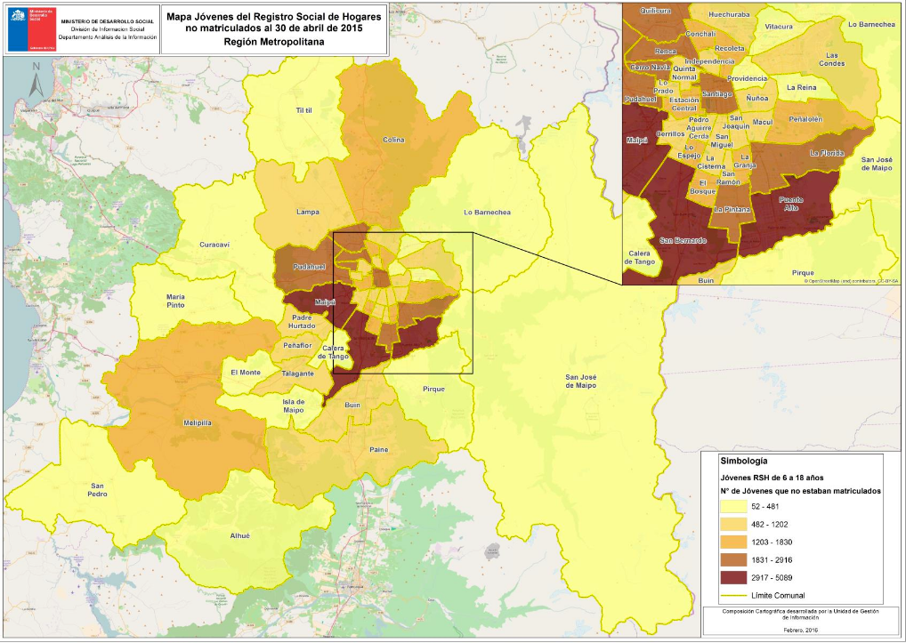

### 4.2.4 Linking databases: need for a unique identifier

Registration and eligibility processes require documenting and authenticating[44] a potential beneficiary’s identity (Samson 2006).[45] Yet ‘under-documentation is pervasive in the developing world’ due to absent or patchy civil registration systems (Gelb and Clark 2013).

When collecting information for a single social protection program, identifying beneficiaries can be approached on an ad hoc basis, using whatever documentation is available (in some cases names and surnames of household members suffice[46]). When attempting to integrate programs across and outside the social protection sector, however, a unique ID number for individuals is needed to link registry information with other systems and programs (Castaneda and Lindert 2005; Baldeon and Arribas-Banos 2008). In Latin America, for example, the absence of a unique national ID number has been a key stumbling block in the development of integrated systems, according to Castaneda and Lindert (2005). Yet the linkage of a national ID system with social protection provision is not free of controversy, as summarised in Table 9.

Table 9 The opportunities and challenges of linking a national ID number to social protection provision

| Opportunities | Challenges and risks |
| --- | --- |
| * Enables instant integration of different programs and sectorial databases (acts as unique identifier), potentially improving service delivery * Can provide online, cost-effective, ubiquitous authentication services across a country, e.g. for data verification (ensuring uniqueness — 1:n; and identity — 1:1) * Can act as a data source, with information on all citizens (e.g. names, addresses), thus helping to identify vulnerable groups or persons * Facilitates an audit trail down to the recipient of social assistance, thus increasing transparency and accountability while reducing program leakages and fraud * Can complement financial inclusion initiatives and enable access to and reduce the costs of financial services — e.g. enables e-payments to beneficiaries (fulfils know-your-customer requirements) * Can support integration of payment systems and other services across programs * Can help to ensure more integrated policy-making (cross-sectoral, with focus on the same households) and portability of benefits across the country | * Few lower and middle income countries have 100% population coverage within their National ID database * The most vulnerable and disadvantaged individuals are often those without a national ID, because of lack of information and direct (e.g. fees), indirect (e.g. transport) and opportunity (time) costs * Certain categories of populations could be systematically excluded from the national ID and therefore social protection provision, most importantly non-citizens, migrants, indigenous people and minors (e.g. street children) * Risky in contexts with no legal framework for privacy and where governance is poor — privacy concerns, while perhaps not manifested initially, will likely increase over time[47] * ID projects can have large initial capital costs that are not justified by needs in terms of social protection provision * Where biometrics are involved, requires an ad hoc approach for categories that cannot be easily registered (e.g. fingerprints for very young and very old) |

Source: Adapted by author from Gelb and Clark (2013 ) and ISPA (2016).

Note: Many of the ‘opportunities’ could also be guaranteed by other robust functional ID systems.

Unsurprisingly, those most likely not to have such ID are most often the poorest and most vulnerable. So how to ensure linkage of databases in the absence of an existing ID system and unique identifier? Country experience suggests the following avenues (Castaneda and Lindert 2005; Gelb and Clark 2013; Gelb 2014; OPM 2015a):

* Building a business case for a national ID system as an important pillar for delivery of social services, working alongside national registry offices on a common effort to register individuals, particularly in remote or poor areas where lack of identity documentation and numbers is prevalent. This could include:

1. assessing the effectiveness of a national ID system, evaluating pros and cons (see for example Table 8) and investing in a feasibility study as part of data and information integration planning.[48] Estimates on costs of large ID programs run from 3 to 15 US dollars per head[49]
2. incorporating civil registration as a key objective of a social protection program. Examples are Kenya’s Cash Transfer for Orphans and Vulnerable Children, Kenya’s Hunger Safety Net Program and Uganda’s Social Assistance Grants for Empowerment program, where beneficiary households are given easy/free access to national ID[50]
3. registering households for National ID during registration for the social registry. In Lesotho, for example, this was done during registration for the Child Grant Programme
4. incorporating social protection as a key objective of civil registration and national ID efforts. See Pakistan’s experience described in Box 11 below
5. taking advantage of national events such as elections to register all citizens. This has been done in Bangladesh, Benin and Democratic Republic of Congo, for example
6. sharing costs of setting up an ID system among government agencies to justify investment
7. linking the ID to other desirable services. For example as part of the rollout of a comprehensive ID system, Adhaar (see Box 10), India’s government is opening bank accounts. In Pakistan, NADRA achieved registration by promoting a range of wider benefits (ability to perform haj pilgrimage, access to bank accounts and other services etc.)

* Considering the relative effectiveness of other existing functional ID systems (e.g. voter registration, birth registration)
* Generating another functional ‘unique number’ to substitute a national ID number and complement existing functional IDs. The most famous is the US’s social security number, a strategy also adopted in Brazil,[51] Mauritius, and Mexico, for example. However, the common practice of assigning new numbers as people apply (a new number for each questionnaire) could lead to potential problems with duplication, as in Colombia
* Designing formulae or ‘algorithms’ that combine a number of variables to create a comparable identifier across databases in the government sector. For example, Brazil’s ‘match key’ variables consist of name, mother’s name, date of birth and codes from selected documents,[52] while in the Philippines probability models for matching data are based on birthdates and other identifying data
* Rejecting those who do not have an ID number, as Brazil did in the early phases of the Cadastro Único. However, this is not a viable strategy for an inclusive registry.

|  |
| --- |
| Box 10: India’s Aahdaar and its involvement in social protection |
| Aadhaar is a 12-digit individual identification number issued by the Unique Identification Authority of India (UIDAI) on behalf of the Indian Government, following the collection of demographic and biometric information. Any individual, irrespective of age and gender, who is a resident in India and satisfies the verification process can enrol for Aadhaar free of cost. In 2016, over 1billion people had been registered for Aadhaar (almost 80 per cent of the population).  Aadhaar serves as a proof of identity and address, anywhere in India. It also helps to provide access to basic services including banking (promoting financial inclusion) and mobile phone connections. Most importantly for social protection, Aadhaar enables a wide variety of service-enhancing functions that are slowly being rolled out by government. These include:   * removing duplicates and reducing leakages by linking beneficiary records with Aadhaar. This has reportedly already resulted in savings of 1billion US dollars per year following use for India’s fuel subsidy program (see report at livemint.com and Barnwal (2015) at www.med.uio.no). Aadhaar is also being tested to monitor attendance within the Mahatma Gandhi National Rural Employment Guarantee Scheme (MGNREGS) cash-for-work scheme and the Sarva Shiksha Abhiyan (SSA) program promoting universal primary education * better reach and targeting, ensuring inclusion of those without proof of ID * reducing cost of delivery by using direct payment to Aadhaar-linked bank accounts of beneficiaries * enhancing accountability and traceability of service delivery to beneficiaries * potentially better engagement with residents through self-service and online applications.   Recently other countries, including Russia, Morocco, Algeria and Tunisia, have shown interest in the Aadhaar model.  Source: Aadhaar website, UIDAI (2012), Barnwal (2015). |

|  |
| --- |
| Box 11: Pakistan’s NADRA and its involvement in social protection |
| The government of Pakistan started issuing national identity card (CNIC) numbers to its citizens in 1973, and the National Database and Registration Authority (NADRA) was officially instated in 2000. Rapidly increasing registration rates were achieved, in part, by incentivising women to register by making clear that if they were poor they would be eligible to receive a subsistence grant from the Benazir Income Support Programme (BISP). Similarly, citizens were told that identification could make them eligible for emergency programs and eligible to vote.[53] Registration was eventually established as a prerequisite for accessing a number of other services such as obtaining passports and utilities connections. Outreach to remote areas and mountainous regions was achieved by setting up motorcycle and man-pack (on foot) registration units. Between 2008 and 2013, approximately 30 million Pakistanis got their ID cards free of cost. To date, approximately 98 per cent of the entire population is covered in NADRA’s foundational database.  In 2010 Pakistan experienced flash floods affecting over 20 million people. NADRA set up 131 registration sites near the disaster-hit areas. If people had lost their ID cards, these were re-issued free of cost. This registration process was then used to disburse the Citizens Damage Compensation Program (CDCP), distributing 77 billion rupees to 2.84 million families. For the targeting of the BISP program, NADRA data was used as a cross-check to help verify data collected and determine eligibility, while NADRA technology and partnership is also supporting e-payments.  Source: Malik (2014); Honorati, Gentilini and Yemtsov (2015); NADRA website.53 |

### 4.2.5 Integrating operations and services

As discussed in Section 1.2.3, one of the ultimate aims of integration of data and information management should be to improve citizens’ experience of and access to social protection programs. However, integrating operations and services across the social protection spectrum requires very high levels of capacity and institutional coordination and may not always be feasible. For example, individual programs may be reluctant to relinquish control over their operations.

This section briefly discusses the key operations — beyond determination of eligibility — that could usefully be integrated and managed nationally (providing more detail is beyond the remit of this paper). Importantly, the challenge posed in order to achieve these is institutional and organisational, not technological.

#### Communications

Adopting an integrated approach to social protection entails providing clear, transparent and non-contradictory information to citizens on their rights and responsibilities in relation to the services they may or may not be entitled to. A national registry could potentially aid this process by rationalising access to and receipt of social programs, ensuring one point of contact and source of information.

#### Registration

Integrating the approach to registering potential beneficiaries of social protection programs — as is the case for social registries — can have large impacts on citizens (ensuring ease of access etc.), as discussed already in Section 1.2.3. This is in line with best practice advocated by the ILO in developing single-window services.

#### Updating registration information for ongoing assessment of eligibility

As discussed in sections 4.2.2 and 4.2.4, a key area where integration could generate benefits for the administration of social protection programs is the possibility of continuously updating citizens’ registration information. This would allow the system to continuously re-assess eligibility for a wide range of programs, especially universal categorical ones. For example, by cross-checking information from the social security system and civil registry, the system could flag households eligible for child benefits, pensions or unemployment insurance. This would enable a government to provide immediate protection when needs arise, but also to

‘exit’ households who are no longer eligible (age cut-offs, death etc.). Countries moving in this direction include Mauritius, with its twinned registry, Argentina, Chile and Uganda.

#### Payments

Integrating payments can be difficult where existing programs have different payment mechanisms and providers (e.g. banks, post offices, postal banks, private agencies and manual mechanisms such as armed vehicles). However, Brazil, Turkey and Chile (see Annex 1) show that this level of integration is possible where adequate coordination is in place and the integrated software application is linked to the payment service provider. In Kenya, such integration is also increasingly in place thanks to the role of Equity Bank and Kenya Commercial Bank, and to a 2013 presidential directive mandating the digitisation of all government payments. For example, the country’s Single Registry now supports the verification of the beneficiary list through pre-payroll and post-payroll checks (Mwasiaji 2016).

#### M&E systems

Ensuring M&E processes are integrated across the multiple schemes operating in a country ensures economies of scale and scope while also allowing for an integral vision of social protection policy, which can support planning.

A social registry can be an ideal tool to achieve this, if data from individual programs is linked back to the registry. Integrated beneficiary registries are set up with this objective, as Kenya’s experience in setting up its Single Registry has shown (see Annex 1).

#### Grievance mechanisms

Grievance mechanisms for social protection are under-used and under-perform in most countries. International best practice points to the need for an overlapping and interlinked grievance system that includes program- specific mechanisms, government or ministry-level mechanisms, independent grievance mechanisms (such as ombudsmen and public enquiries) and legal redress institutions. Moreover, it is generally accepted that it is more effective to resolve complaints at the point of service delivery where information and transaction costs are the lowest (Barca, Brook and Notosusanto 2012).

For these reasons, it is clear that integration of grievance mechanisms across programs is problematic when different programs have different structures and different capacities to respond. Nevertheless, there could still be economies of scope and scale — and benefits in terms of transparency and ease of access — from integrating the overarching grievance procedure (e.g. setting up a national hotline that redirects program-specific queries while also using a network of highly trained staff at local level as first points of access). Several countries are moving in this direction (e.g. Indonesia, Kenya), creating a module within their tailored software application focusing on grievance management; but not enough evidence is available to date.

#### Case management

Each beneficiary accessing a social protection program comes with a particular history and set of needs that are not necessarily all addressed through standard program operations. An integrated social protection case

management system would follow each individual ‘case’, ensuring that people’s needs (children, disabled people, the elderly, vulnerable households etc.) are assessed on a continuous basis and addressed (a) within existing programs (e.g. providing guidance, information and support) and (b) by linking beneficiaries to a wider set of complementary services available within the country (through some form of referral system). Integrating such a system across programs may pose challenges when case management needs differ.

#### Conditionalities

Social protection programs sometimes impose conditions on beneficiaries, such as school attendance, health check-ups and training. In theory, full integration could make it more efficient to monitor these conditions. For example, integrating the education ministry MIS could provide timely data on attendance. This is a highly complex process from an institutional and data management point of view, which is why only Turkey has succeeded in making this process entirely virtual (see Annex 1); standard practice is to adopt batch-sending processes.

**4.2.6 Using data for determining eligibility**[54]

One of the primary roles of social registries (as opposed to integrated beneficiary registries — see Section 2) is to support the gateway phases of intake/registration and determination of eligibility across social sector programs.

Many social registries[55] score or rank households registered based on their levels of poverty and vulnerability at central level, to avoid political interference. The outcome is a compiled list of potentially eligible households or a ranked list of all households. This output can then be shared with individual program implementers or decentralised counterparts, who use the national list as a basis for eligibility determination and often adapt it to their purposes by:

1. adding further criteria: for example, pregnant women or people aged 65 and over
2. validating lists provided: for example, publicising the list in the community and giving 30 days for people to object, calling a community meeting or conducting household visits
3. choosing what percentage of households ranked nationally are to be included: for example, only the poorest 10 per cent.

This two-tiered targeting approach enables a common methodology to be developed across programs while maintaining the flexibility needed by individual programs or decentralised units of government to target specific household types.

In other cases the full dataset from the social registry is shared with user programs, meaning the social registry only integrates intake/registration, not eligibility determination.

However, the risks an integrated approach to intake/registration and/or determining eligibility poses go beyond those faced by individual social protection programs, as any mistake can lead to exclusion from multiple social sector schemes.

For example, integrated intake/registration could lead to systematic exclusion of certain households because of problems with:

* data collection: e.g. low take-up for on-demand systems, biased coverage for census survey systems, political interference at local level
* data/administrative requirements: e.g. lack of an ID card

An integrated process for determining eligibility could similarly be problematic if the eligibility formula does not accurately capture those in need or if the national approach to determining eligibility does not adequately reflect local poverty profiles – a big challenge in large and diverse countries (e.g. Indonesia, Brazil).

Approaches used to mitigate these risks have included (OPM 2015a):

1. institutionalising a validation process within communities, at registration. However this is time-consuming and can be counterproductive if validation results are not integrated into the system
2. enabling two decision-making layers. In Turkey, for example, data determines eligibility but human decision (following household visit) prevails. Central level then validates local decisions, performing spot-checks on discrepancies with the central targeting index
3. having in place a functional grievance mechanism for complaints and appeals, e.g. a toll-free line (problematic if this does not translate into changes in targeting decisions)
4. ensuring, through tailored communication strategies, that people understand targeting (e.g. to increase take-up and registration).
5. including parameters relating to local context (urban/rural, services available etc.), as is done by SISBEN in Colombia.

### 4.2.7 Using data for emergency response

The literature on the topic of shock-responsive social protection clearly articulates the use of national social registries, containing information on both potential and current beneficiaries, for the scale-up of interventions in case of a humanitarian emergency (IEG 2012; Kuriakose et al. 2012; McCord 2013; Ovadiya 2014; Bastagli 2014; OPM 2015b and 2016). For example, in the aftermath of covariate shocks, a country’s social registry could be used as an immediate solution to identify households in need of assistance, enabling a combination of the following (OPM 2015b):

* Vertical expansion: Increasing the benefit value or duration of existing programs, either by adjusting transfer amounts or by introducing extraordinary payments or transfers. This assumes the target population of ordinary social protection is the same as for post-emergency transfers.
* For example, at program level, one-off ad hoc payments or temporary increases to transfer sizes have been used post-crisis in Chile, Vietnam, Brazil, Mexico, Bangladesh, Lesotho and the Philippines (OPM 2016).
* Horizontal expansion: Adding new beneficiaries to existing programs, either by extending geographical coverage, by modifying entitlement rules or by relaxing existing requirements.

For example, at program level, Bolsa Família in Brazil and Oportunidades in Mexico expanded to reach a million more beneficiaries after the Triple F[56] crisis, in Brazil’s case by relaxing the eligibility criteria (Bastagli 2014).

In Kenya, the HSNP has introduced a shock-response component that expands horizontally to an additional temporary caseload in the early stages of a food crisis as part of the national drought management response. This is done thanks to an initial exercise that census-registered all households in the HSNP counties, issuing them with bank accounts. The emergency payment was first triggered in April 2015 and has been released twice since, in May and August 2015 (OPM 2016).

* Piggybacking: Using the existing data and administrative framework, but introducing a new ad hoc intervention.

For example, in Pakistan the flood-response CDCP was in a strong position to respond to crisis thanks to NADRA’s database (Bastagli 2014; Malik 2014). Similar piggybacking approaches have been adopted in Uruguay (through Integrated Information System for the Social Area) and Lesotho (through the National Information System for Social Assistance) and are currently being discussed in Mongolia.

However important the role of social registries may be in this context, it is important to stress that they are not always fit for the role of supporting horizontal expansion or piggybacking. This is because of the very nature of emergencies, which can affect households across the social spectrum and shake up the poverty profile of affected areas.

The key factors determining usefulness of existing social registries for shock-responsive purposes include the following (bearing in mind the privacy and security concerns outlined in Section 4.3.1):

* Representing a large enough snapshot of a country’s population. This is only the case where either (a) a census survey is applied to all households (not only those who have been pre-identified as poor, as for example in Indonesia) or (b) data exchange from administrative data sources populates the registry with relevant information on all citizens
* Including information for both current beneficiaries (e.g. those who have been ranked as poor and selected as eligible for social assistance programs) and potential beneficiaries (e.g. the near-poor). This is not the case for integrated beneficiary registries, for example
* Containing data that is useful and relevant to assess contextual vulnerabilities after a shock. For example, this may not be the case for those registries that primarily aggregate data from existing administrative sources (e.g. data on consumption levels, food security, asset ownership). On the other hand, geo-referenced data could be particularly useful. Collecting relevant information may require early collaboration with the country’s disaster management authority and humanitarian agencies
* Containing up-to-date information — i.e. having a frequent, strong and valid data-updating strategy in place. As discussed in Section 4.2.2, this may be especially the case for on-demand data collection systems, which update data on an ongoing basis.

## 4.3 Technological requirements

As with program MISs, when integrating data more widely across the social protection sector (and beyond) the overall technological set-up poses risks and challenges. In an integrated environment, data and information management should therefore consider these technological requirements — while also acknowledging that technology alone does not ensure good information management.

### 4.3.1 Information privacy, back-up and security

Determining eligibility for social protection programs requires substantial amounts of personal information to be gathered from potential beneficiaries, including sensitive data on health, income, assets and housing. This poses the risk of misusing or losing such information,[57] potentially exposing households to further vulnerability (CaLP 2013; Hosein and Nyst 2013; APSP 2014). In integrated systems, this risk increases, especially as data is shared across multiple actors. Importantly, the right to information privacy is also embedded in the Universal Declaration of Human Rights, the International Covenant on Civil and Political Rights (ICCPR)[58] and ILO Social Protection Floors Recommendation 2012 (No. 202), which explicitly calls on states to ‘establish a legal framework to secure and protect private individual information in their social security data systems’ (paragraph 23).[59]

Best practice shows that, where social registries or any level of interoperability are being developed, country laws should adhere to international data transfer and information privacy protocols, which legislate the collection, transfer and storage of information. This becomes even more important where data is shared across a public network and several institutions. Key laws that should be adhered to include the Council of Europe’s Convention for the Protection of Individuals with regard to Automatic Processing of Personal Data, the United Nations Guidelines for the Regulation of Computerized Personal Data Files, and the OECD Guidelines on the Protection of Privacy and Transborder Flows of Personal Data. Such practices are common in, for example, all Latin American countries.

Some of the most important principles and actions for the secure use of personal data within social protection programs are (CaLP 2013; OPM 2015a):

* ensure informed consent of those who are sharing their data, explaining the nature of the data being collected, the purpose of collection, with whom it will be shared, and who is responsible for the secure use of their data[60]
* establish a mechanism to respond to any complaints or concerns citizens may have about the use of their personal data
* regularly undergo information system audits to analyse, document and understand the flow of data, and develop risk mitigation strategies for potential risks arising from these flows
* implement appropriate technical and operational security standards for each stage of the collection, use and transfer of beneficiary data to prevent unauthorised access, disclosure or loss
* implement appropriate mechanisms to provide individuals with the right to access their personal data and correct it
* enforce data back-up and protection protocols and guidelines, for example by
* ensuring data users are trained on and aware of these issues
* implementing user profiles on information system access, allowing for an audit trail
* sharing data in anonymised and summary format except when needed
* establish non-disclosure agreements for anyone who is granted access to data.

Specifically, back-up and security should conform to ISO 27001[61]— an approach to managing confidential or sensitive information — so that it remains secure, confidential and with its integrity intact. In some pilot transfer programs (such as the Hunger Safety Net Programme in Kenya and Social Assistance Grants for Empowerment in Uganda), back-up and security systems are hosted in physically and logically secured servers at program level. But national programs sometimes outsource this security and hosting function. In Pakistan, for example, the Benazir Income Support Programme database is hosted by the National Database and Registration Authority. In South Africa, SOCPEN is hosted by the South African State Information Technology Agency (SITA).

A trade-off emerges when the need for data privacy conflicts with transparency and accountability. Several countries have solved this by making certain aggregate and anonymised datasets and data visualisations available to the general public. In Indonesia, for example, 16 of the 40 core indicators in the social registry are available online in aggregate format.

### 4.3.2 Developing and updating the tailored software application

The classic approach to software development involves an analyst documenting requirements and then passing these to a developer to integrate them into application software. However, developing a software application that fully and flexibly responds to changes in policy and procedure is paramount in this field (Heeks 2002; Villalobos et al. 2010; Saidulloev and Dersham 2013; Browne 2014). Country solutions — implemented in Brazil, Kenya, Mauritius and Malaysia among others — to guarantee such flexibility have included:

* Conducting an in-depth needs assessment of the key software requirements based on existing business processes and projected user needs to inform the development of procurement terms of reference (aiming at a document that is not purely technical in its specifications — see also Annex 2).
* Adopting iterative prototyping,[62] whereby the system model is designed and used to customise and incorporate feedback from users. This tailors the system to suit the needs of those primarily involved in its use and enhances a sense of local ownership that is essential for success[63]
* Creating modular and incremental systems that leave space for ongoing input and changes on behalf of those responsible for managing use well beyond the design stage
* Using open-source software and applying open-design principles, acknowledging the high costs of making changes to proprietary software and the risks of vendor ‘lock-in’. For any other proprietary third-party software used, the suppliers should be asked to provide a perpetual and valid licence for a period of at least five years
* Building in-house capacity to develop and update the software application, for example by ensuring that contracts have clear provisions to allow suppliers to hand over all the source code and technical documentation of the system without any preconditions.

Trade-offs are linked to overall design complexity. The more complex the functions performed by the application software, and the more data collected and linked, the higher the overall costs (because of a host of interlinked factors, including the need for adequate servers, software, data transmission channels and training).

### 4.3.3 Hardware infrastructure

The choice of hardware depends on the software used for managing information — and, of course, on a country’s endowment. Overall, hardware should have adequate memory, disk space and processing capacity. A significant challenge many countries face is lack of availability of such infrastructure at local levels of administration. Where

it is available, the hardware is sometimes not rugged enough to withstand extreme high or low temperatures, rain, dust and/or unreliable electricity supply. Hardware specifications should therefore be carefully defined.

### 4.3.4 Architecture and transfer of information

As discussed extensively in Section 2.5, a system that guarantees full integration within the social protection sector and beyond, in accordance with the right to privacy, would establish a direct and two-way link with several external databases using the most cost-effective and appropriate information and communications technology available in country (i.e. tailored to country context). This would enable data gathering from existing administrative sources and grant data access for external actors, including sub-national level staff and possibly other government and non-government actors.

The most common approach is to guarantee ‘web-service access’ online (e.g. via a virtual private network). However, this is not always possible in contexts with low penetration of internet, or where data sharing is problematic for other reasons. Many countries adopt ‘hybrid’ approaches, sharing data online where possible and using batch-sending approaches where not.

Some countries are experimenting with newly developed hardware and telecommunication systems that increase opportunities to handle large databases and information. Others have invested in network infrastructure readiness in key locations so as to be able to operate their software application remotely, as Box 12 describes

for Malaysia. The new frontier is the use of tablets, smartphones and notebooks to access the central software application even in decentralised environments.

| Box 12: Malaysia’s eKasih social registry promotes bandwidth improvement |
| --- |
| The lack of adequate network infrastructure was one of the key obstacles faced by the Malaysian government when developing its social registry, eKasih. While waiting for the government to implement its national broadband project, the eKasih management unit (ICU JPM) initiated its own network upgrading exercise in collaboration with the Malaysian Administrative Modernisation and Management Planning Unit. Network bandwidths for eKasih sites across the nation were upgraded from 64 kbps to a minimum of 256 kbps.  Source: ICU JPM (2013). |

## 4.4 Costs, financing and political support

Building and running social registries and associated components is not cheap. In fact, evidence from Latin America indicates that ‘external financing appears to be a key element in allowing the initial disbursements needed for such systems’ (Azevedo et al. 2012). Examples from around the world support this. The World Bank has helped finance the establishment of systems (mostly through loans or technical support) in Brazil, Chile, Colombia, Uruguay, Pakistan, the Philippines (together with DFAT) and Indonesia (together with DFAT), among other countries, while Costa Rica received financing from the United Nations Development Programme and Kenya from the World Food Programme. There is a danger to such donor-driven ‘push’, as running social registries requires ongoing funding, especially to ensure adequate data updates (continuous on-demand registration or periodic census survey effort).

Overall, it is difficult to compare costs across countries, mostly because of the different ways in which costs are classified and calculated (see Box 13 for main categories), the different time reference periods and the different scope of each social registry.64 In countries where there is overall ‘kick-off’ investment, these range between 90 million US dollars in Mexico, 83 million in Argentina, 17 million in Chile, 10 million in Colombia and Turkey, 3.6 million in Uruguay and 1.7 million in Costa Rica (Azevedo et al. 2012; WWP 2016b).[64]

|  |
| --- |
| Box 13: Three main categories of social registry costs — examples from Latin America |
| 1. Implementation/running costs. Average yearly implementation costs — including support and maintenance — have been estimated at between 0.2 million US dollars in Costa Rica, 0.5 million in Uruguay and Chile, and 9 million in Brazil (Azevedo et al. 2012; Irarrázaval 2004).[65] 2. Data collection costs. The cost of interviewing households for the social registry, as a percentage of the total transfers made to beneficiaries, ranges between 0.5 per cent in Colombia and 1.6 per cent in Brazil (De la Briere and Lindert 2005). In Costa Rica, the cost of collecting and digitising data was estimated at 20 per cent of overall expenditure for the integrated system. In all countries, data collection costs varied largely between urban and rural settings. In Brazil, the average cost per application was 3.90 US dollars in urban communities and 14 US dollars in isolated communities. Costs ranged from 3.80 to 4.60 US dollars per application in Argentina; 1.80 to 2.70 US dollars in Colombia; and 2.80 to 6.90 US dollars in Chile (Azevedo et al. 2012). 3. Equipment, including hardware, software and servers. Few estimates are available for equipment, and the cost depends on initial endowment. In Argentina, equipment costs were estimated at 4.37 million US dollars between 1999 and 2006.   Source: Azevedo et al. (2012); WWP (2016b). |

How can such investments be politically justified? And how can political buy-in be fostered more widely? Country experience to date has shown the importance of (OPM 2015a):

* clearly articulating the need for integration in national development plans, national social protection policies and strategies, and other strategic documents (ideally embedded in legislation, as is the case in many Latin American countries)

fostering public debate on the benefits of integration (exposing international experience and developing research on country-specific advantages and possibilities), quantifying results where possible. This should include:

* quantifying and communicating returns on investments (efficiency gains, economies of scale, value for money). For example Turkey has estimated and widely publicised the cost savings of prevented fraud, less paperwork and de-duplication, as well as showcasing the benefits to citizens (‘time for application reduced from days to minutes, documents for application reduced from 30 to 1’)
* harnessing citizen support through active engagement, communication campaigns, media, and transparency of process
* acknowledging, researching and addressing the political economy of building social registries, for example by identifying key bureaucrats in the system and top politicians and their connections (institutional and stakeholder analysis) to know where support and resistance are likely to come from
* highlighting specific advantages/benefits for these stakeholders (e.g. data use and data-sharing potential), ensuring political buy-in and ownership across key ministries from the very start
* ensuring government is part and parcel of design, development and implementation of the information system (e.g. source codes and technical documentation should be in the custody of government)
* considering overall costs as capital or infrastructure investments, spreading them over a number of years (Turkey’s 10 million US dollar investments were spread over three years).

# Lessons learned and conclusions

## 5.1 Advantages of integration and related challenges

Section 1.1 discussed the main advantages of integrating data and information management for social protection and beyond, while the challenges and trade-offs involved in setting up such a system were discussed in depth in Section 4. Table 10 links this information, while figures 9 and 10 below discuss the conditions that need to be in place to fully reap these potential benefits.

Table 10 Potential advantages and related challenges of integrating information management

| **Potential advantages to integration** | **Extent achieved to date** | **Related challenges and risks** | **Also see section** |
| --- | --- | --- | --- |
| **Policy** |  |  |  |
| More equitable approach to the distribution of resources based on objective and comparable information, addressing the uneven and unequal provision of social protection across social groups and administrative jurisdictions |  | Integrated systems for information management that consolidate the determination of eligibility across programs can offer advantages, but there are several risks that should be carefully considered. These include:   * Systematic exclusion of certain types of households due to problems in data collection processes (e.g. remote households), in administrative requirements (e.g. lack of an ID card) or in determination of eligibility (e.g. formula not capturing all of those in need) * Multiple exclusion from all social sector schemes (in a non-integrated system, those not eligible for one scheme may be eligible for another) * Potential stigmatisation of households classified as ‘poor’ in the national data (belonging to smaller un-integrated schemes can be perceived as less stigmatising). | 4.2.6 |
| Increased responsiveness and inclusiveness of interventions, able to serve the chronic poor and those structurally vulnerable to poverty, as well as respond to individual shocks or large crises |  | This holds true when data is updated regularly and is capable of capturing dynamics around the poverty line (and transient poverty).   * Countries with the capacity to integrate data with other sectoral databases (virtual registries) are best placed for this, but do not necessarily have a policy focus on increasing responsiveness and inclusiveness of interventions (i.e. this is a policy issue). * Many countries operating census surveys as an approach to data collection struggle to update their registries more than every two or three years (or more), and may therefore not be channelling social assistance to those in need. * Countries operating on-demand data collection systems will be better placed to capture negative but not positive changes to household conditions. * Countries with low levels of population coverage within their registry (e.g. low take-up) or with information only on current beneficiaries (e.g. integrated beneficiary registries) will not be able to adequately reach this objective. | 4.2.1  4.2.2  4.2.7 |
| Ensure universal coverage and support implementation of the social protection floor, potentially coordinating social assistance and social insurance |  | Universal coverage and linkage between social assistance and social insurance is rarely on the policy agenda. Also, there is insufficient focus on smooth transition between schemes (graduating ‘out’ of social assistance ‘into’ other types of programs). |  |
| Increased linkage to the complementary institutional framework and wider social and economic policies in place[66] |  | Not the case when the focus of integration is narrowly defined to include a handful of social assistance schemes and not the wider spectrum of social protection policy (including social insurance and labour market interventions). Similarly, integration with wider government policies can be hampered by weak institutional agreements between responsible bodies (this is a policy issue). | 3.3  4.1.1 |
| Increased transparency and accountability as program information can be more easily shared and compared |  | The extent to which this is achieved strongly depends on the institutional commitment of individual stakeholders and on the overall policy context, not on the technological set-up of the system. | 4.2.3 |
| Improved ‘image’ of the social protection system as citizens better understand their entitlements |  | This holds true where citizen focus is at the heart of the integration agenda and in contexts with national on-demand application systems and integrated communication strategies. |  |
| Increased knowledge on issues around poverty and vulnerability |  | Can be hampered by lack of analytical capacity, internal incentives to focus on immediate implementation aspects rather than long-term policy aspects, and lack of coordination with institutions such as universities and research centres. Best practice has been to develop user-focused reporting systems that can be easily accessed by different audiences.  There are also large privacy and security risks to holding vast amounts of information on countries’ citizens, with the potential of that information being used to increase citizens’ vulnerability. | 4.2.3  4.3.1 |
| **Operational** |  |  |  |
| Facilitated oversight of multiple schemes and reporting to policymakers |  | Risks excessive focus on operational rather than policy aspects and insufficient effort to establish an integrated M&E system based on social registry data. | 4.2.3 |
| Improved budget planning and ability to model and test policy changes |  | Modelling and testing of policy changes should also become standard practice (building in-house capacity). | 4.4 |
| Decreased burden on staff (e.g. less paperwork, less manual reporting) |  | The additional burden posed by the maintenance and management of social registries should not be underestimated. To a lesser extent, this is also the case for integrated beneficiary registries and virtual registries. In all cases, there is need for a careful assessment of capacity at all levels of implementation. | 4.1.3 |
| Decreased burden on potential applicants and potential to establish a ‘common entry point’ for social protection |  | Not the case where this is not a policy priority. | 1.2.3  4.2.5 |
| Avoidance of duplication of effort (and cost saving), for example in data collection activities for program targeting |  | Potential concerns regarding updating of data. | 4.4 |
| Established common systems across all schemes (e.g. payment system, grievance mechanisms), increasing efficiency and saving money |  | Depending on country context and priorities, the potential for further integration is high. | 4.2.5 |
| Better manage error and fraud and monitor multiple payments (keeping track of who is receiving what) |  | Highly successful in cases where national ID or social security ID numbers can be used to cross-check databases. However, risks being used to punish ‘double-dipping’ rather than keeping track of who is receiving what across multiple programs (catered at different needs of beneficiaries). | 1.2.1 |
| Further digitalise service delivery, potentially reaching out to citizens in new ways (e.g. mobile phones) | NA | This was not a focus of this review but should be further researched. |  |
| Enabled transition of beneficiaries between schemes as their circumstances change |  | Strong focus on avoiding ‘double-dipping’ across programs rather than the adoption of a life-cycle approach to social protection provision, or linkage of social assistance and social insurance. Also, risk of insufficient updating of data to reflect ongoing changes of circumstances households face. | 4.2.2 |
| Establishment of more effective emergency responses |  | High potential, yet using existing data for emergency response may not always be appropriate because of the very nature of emergencies, which can affect households across the social spectrum and shake up the poverty profile of affected areas. Needs careful evaluation and policy direction (preparedness planning). | 4.2.7 |

Source: Developed by the author.

Figures 9 and 10 below summarise the conditions that need to be in place in order to be able to reap the policy and operational advantages of integration: these need to be explicitly pursued when setting up the system or they will compromise achievement of the potential benefits.

Figure 9 Potential policy advantages and examples of necessary conditions

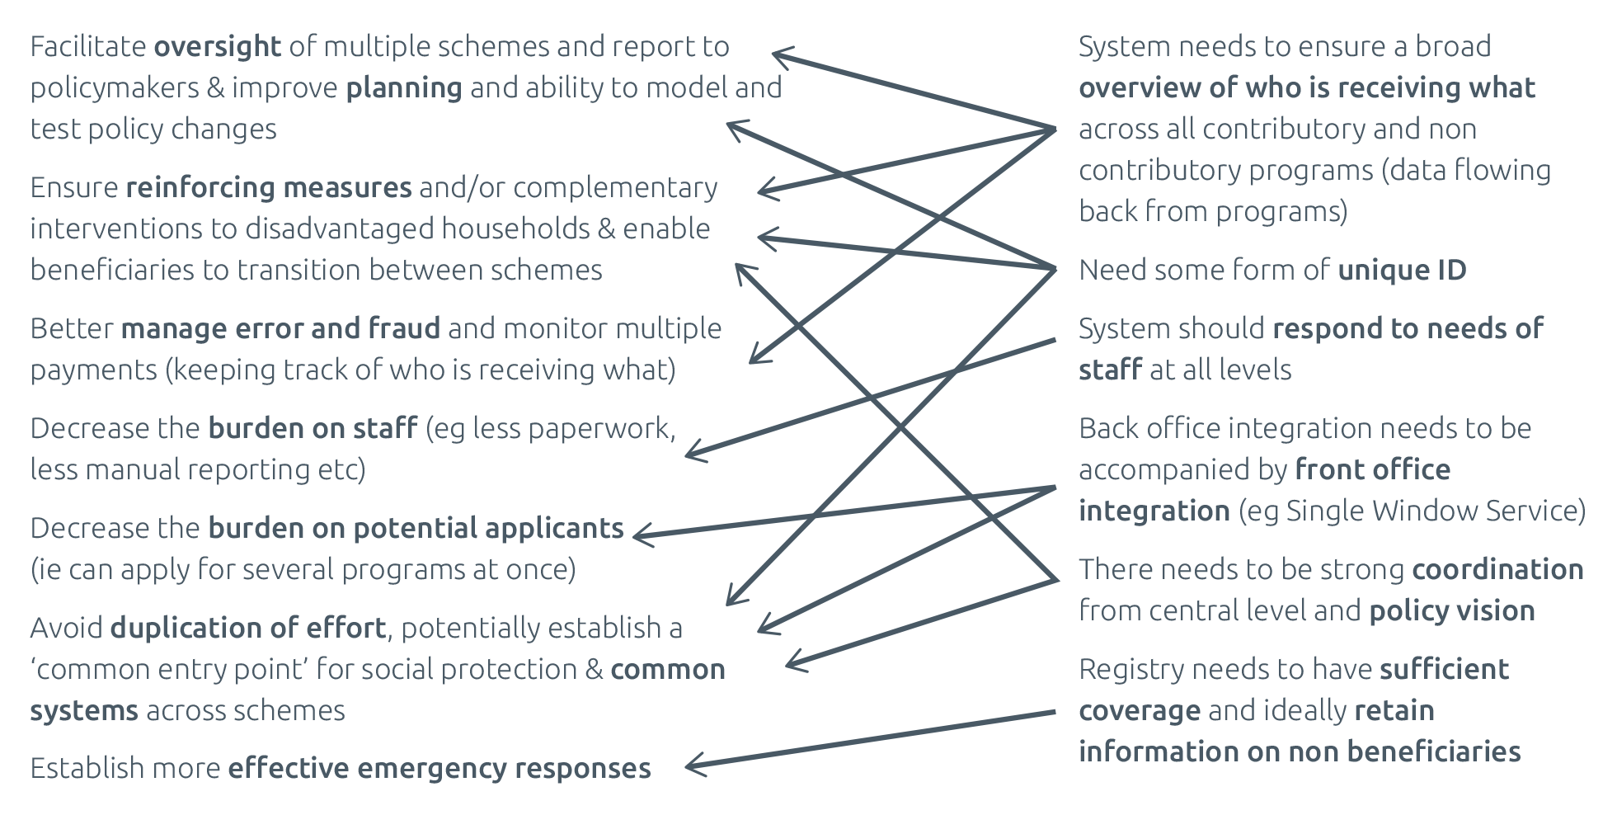

Figure 10 Potential operational advantages and examples of necessary conditions

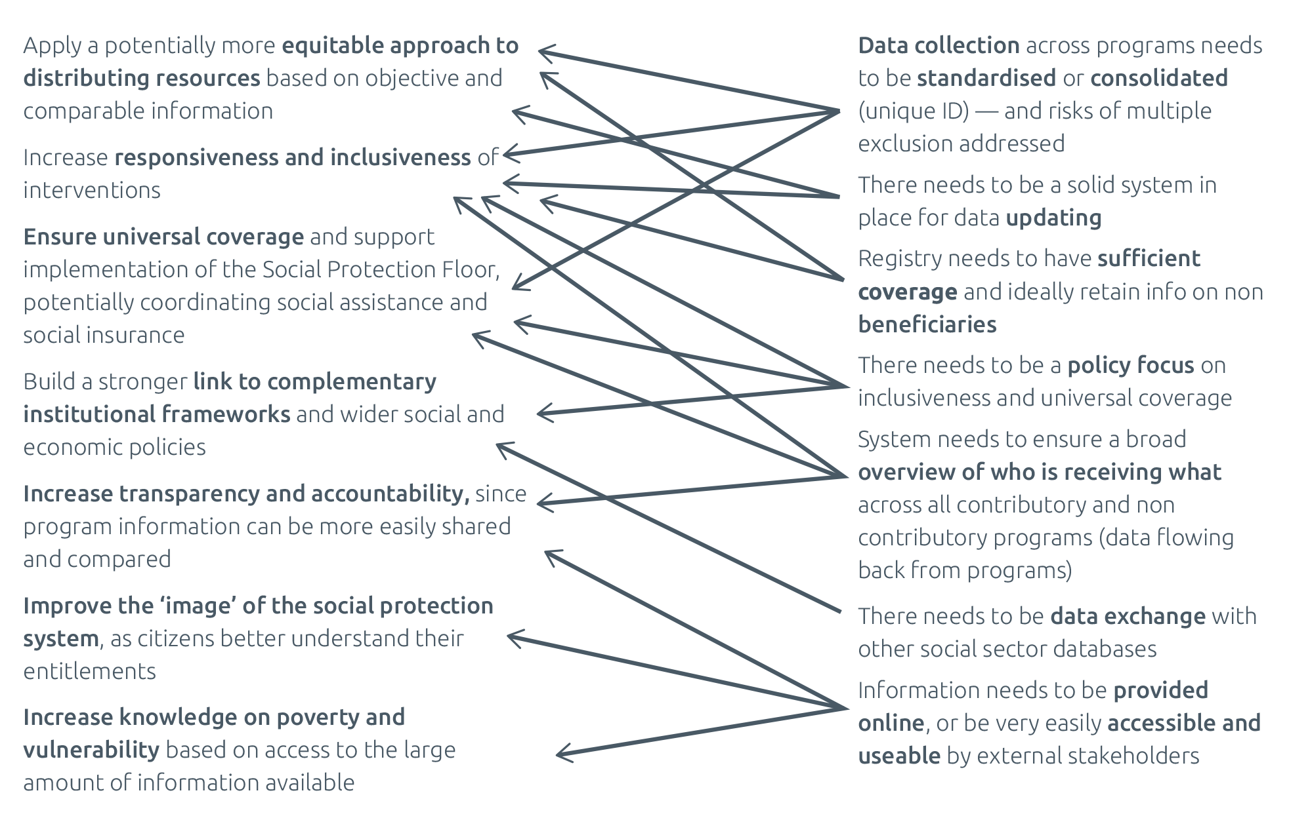

## 5.2 Key lessons emerging from the literature

### 5.2.1 Policy

From a policy perspective, several lessons emerged from the review of the scarce literature on this topic.

First and foremost, it was clear that achieving integration of data and information management in the social protection sector is mostly a result of coordination and political will, rather than a technical ‘fix’ that helps rationalise governance of social protection programs. Countries without a systems or holistic approach to social protection provision are unlikely to succeed with information integration. In fact, a critical factor appears to be the level to which the creation of a social registry was clearly articulated in national development plans, national social protection policies and strategies, and other strategic documents and legislation.

Second, the vast majority of efforts to integrate data and information management have focused on a subset of interventions aimed at providing social assistance to the poorest and most vulnerable households rather than integrating social protection as a whole (e.g. also focusing on social insurance and labour market interventions). This is not a problem per se but should be acknowledged when discussing the topic — and potentially explored as an arena for further integration. This broader integration could be instrumental in making the right to social protection a reality for all residents by ensuring universal coverage. Further, it would allow better support for individuals across their life cycle through the smooth transition from one scheme to another, and ease portability of entitlement across schemes.

Third, the policy drive towards integration has been very often dominated by a focus on consolidating registration and determination of eligibility across several programs, through social registries. The rationale for this has been strongly linked to the opportunities to maximise coverage of the poor and minimise leakages to the non-poor, to achieve cost-efficiency and transparency. While these objectives have been reached in several countries, it is important to recognise:

1. that there are other approaches to developing integrated systems for information management beyond the establishment of social registries. This includes integrated beneficiary registries and virtual registries
2. that there are potential downsides to consolidating registration and determination of eligibility, and that there is no method that allows perfect selection of those in need (the definition of poverty is subjective). Most importantly, this includes the risk of systematically excluding certain types of households from all social sector schemes (the potential beneficiary is ‘all in’ or ‘all out’).

It could therefore be important to shift the main focus of integration towards better serving a country’s poorest and most vulnerable citizens throughout their life cycle, improving access to services and increasing responsiveness and inclusiveness of social protection interventions. On one side, this could be done by simplifying registration processes and interactions with citizens (e.g. one point of contact, streamlined information flows).

On the other, the large amounts of information available within social protection information systems could more usefully be used to simulate policy shifts, understand poverty dynamics and more generally support evidence- based decision-making among policymakers. One further potential application could be the use of existing data for the delivery of additional support in the event of a humanitarian emergency.

Fourth, attempts to integrate information management could usefully go hand in hand with a policy aimed at civil registration of all households and provision of a national ID number, as only in the presence of a unique ID can true virtual integration be achieved across government sectors. For example, social protection schemes can offer a great opportunity to reach out to households least likely to have a national ID. However, there are also important privacy and security risks to the state collecting large and detailed amounts of information on its (poorest) citizens that need to be addressed at the early stages of policy development.

### 5.2.2 Implementation

Several lessons emerge from the experience of countries that have set up integrated systems for information management. With a specific focus on social registries (but with lessons that also apply to integrated beneficiary registries and virtual registries), best practice dictates the following.

With institutional arrangements, there are benefits to creating an independent unit to manage the new system at a sufficiently high government level to ensure effective coordination. This coordination is best achieved by identifying all relevant stakeholders and formalising their roles and responsibilities through legally binding agreements, carefully designed incentives and mutually agreed terms of reference, while also ensuring regular discussions (e.g. inter-ministerial meetings). Institutional ‘buy-in’ can also be achieved through an ongoing bargaining/negotiation process aimed at demonstrating and clarifying to each stakeholder ‘what is in it for them’ (e.g. through needs assessments and participatory planning processes — see also Annex 2). Importantly, vertical and horizontal coordination should focus on acquiring data and securing access to consolidated information for other stakeholders (defining user rights for each).

The administrative structure for managing an integrated system depends on country context (e.g. level of decentralisation, capacity of local structures and staff). Many countries have adopted an approach by which overall design and guidance is centralised and specific implementation — most importantly data collection — is performed locally (e.g. through municipalities). This approach has proved successful as it takes advantage of local know-how and creates buy-in from lower levels of government while guaranteeing oversight and technical uniformity. Granting access to consolidated data to local government units for their own programs has also helped ensure buy-in.

With the data collection strategy for the social registry, countries with mature registries tend to combine three different approaches — on-demand registration, census surveys and virtual integration — to varying degrees and, in doing so, reap the benefits of each. This includes managing costs and reaching the largest number of households, as well as keeping information as updated as possible. Countries deciding to set up a new social registry should also carefully assess whether there is a need to ‘start from scratch’ or whether existing data sources could help in the process. The model chosen depends on the historical trajectory of social protection

in the country and on the country’s endowments. No model is preferable to others per se. Overarching best practice has also been to manage the amount of data collected by keeping data focused on core objectives and prioritising/negotiating pressure from other institutions.

One of the most important implementation issues when discussing integrated data management is updating data. For example, a system that bases determination of eligibility on a static snapshot will likely face serious challenges in providing support to those most in need (especially given the transitory and often seasonal nature of poverty). Best practice, in this case, comes from countries that have achieved such a level of online integration between databases that updates to one immediately result in updates to the centralised system, while on- demand systems also allow for continuous updating.

Moreover, the risk with integrated systems is that they may generate ‘data overload’: too much information that is not available at the right time and in the right format and is therefore not effectively used. In order to address this gap between data and information, it is important to develop tailored reporting systems for different actors and semi-automated data extraction tools, while also offering innovative visualisation options (maps, dashboards, interactive charts etc.).

From an IT perspective, developing a tailored software application that fully and flexibly responds to changes in policy and procedure is paramount in this field. This highlights the importance of adopting a modular approach, using iterative prototyping (whereby a model of the system is designed and used to customise for and seek feedback from users) and open-source software where possible, building in-house capacity to develop and update the system. These provisions enable the system to be tailored to suit the changing needs of those primarily involved in its use and enhance a sense of local ownership that is essential for system success.

On a last note, evidence has shown that many countries have had to rely on external donor financing to cover the considerable costs of developing a social registry and its associated software application. Effective strategies for ensuring buy-in from government counterparts have included quantifying and communicating financial benefits of integration where possible (efficiency gains, economies of scale, value for money), highlighting potential benefits of data-sharing for each stakeholder and spreading capital or infrastructure investments over a number of years.

## 5.3 Conclusion: factors to consider when setting up an integrated system for information management

Overall, it is clear that what really matters when creating a social protection information system is the level of coordination and interoperability of the selected approach, not the creation of a super-sized, comprehensive social protection or government registry that encloses all others. There is no ideal model. What matters is that the system chosen responds to a country’s needs, is appropriate to its context and is affordable and sustainable.

The evidence shows that there are multiple advantages of integrating data and information management, especially if the overall policy environment is conducive to an integrated approach within the social protection sector and beyond. However, given the financial costs involved (Section 4.4), it is essential that countries weigh costs and benefits of different solutions based on an assessment of their situation. Table 11 provides some guidance on the key issues to consider and evaluate. A practical checklist of questions for a potential needs assessment and feasibility study is provided in Annex 2.

Table 11 When is the development of an integrated social protection information system most feasible?

| **Dimension** | **Key issues** |
| --- | --- |
| **Policy environment and budget** | * National policy focused on developing a systems approach to social protection (aiming to achieve coordination and harmonisation to fill coverage gaps and address the fragmentation that limits the effectiveness and impact of social protection policies and programs) * Integration of data and information management clearly articulated in national development plans, national social protection policies and strategies, and other strategic documents * Strong political leadership advocating for reform and coordinating institutional actors * Focus on ensuring political buy-in and ownership of all actors, including social partners and representatives of beneficiaries, by addressing advantages for each (e.g. through participatory planning process and stakeholder mapping) * Sufficient capacity to identify and cost policy options, assess affordability and identify available financing options * Budget availability (and policy support) to back the vision * Acceptance of slow, iterative process and failures |
| **Staff availability and capacity** | * Highly trained and qualified staff, motivated through a performance management system, and at a sufficiently high salary to guarantee retention — both at central and local level * Sufficient budget for continuous staff training and retention * Culture of sharing and problem solving, e.g. no resistance or complacency of staff wanting to keep the system as it is * Presence of ‘hybrid’ staff who understand the context, organisation and work processes of their sector and the role of information systems |
| **Governance and institutional structure** | * Existence or easy creation of an independent unit in charge of managing the new system at a sufficiently high government level to effectively coordinate with all stakeholders * Role of the integrated social protection information system and its managing unit embedded in legislation * Potential for strong institutional ties with other government bodies * Absence of parallel or competing structures for oversight of social protection policy (no power struggles) * Stakeholders clearly identified and their roles formalised through legally binding agreements, carefully designed incentives and mutually agreed terms of reference * Decentralisation approached as a resource rather than impediment, providing added value to decentralised government (tailored functionality and data sharing), involving local government and creating performance incentives |
| **Wider country context** | **Hardware (e.g. computers and server)**   * Adequate hardware available at local levels (these can be purchased, but this increases costs significantly) * Adequate servers — high-capacity computers — that can be scaled up to accommodate potential growth (e.g. a designated server room with reasonable physical and logical security that conforms to ISO 27001) * Stable provision of electricity   **Application software and database**   * (If needed) potential to create a large database that is scalable, flexible and performs well * Clarity of functional requirements and technical specifications at policy level. Key questions — such as purpose, benefits, hosting and nature of users — should be addressed at the feasibility stage and agreed by all stakeholders * Availability of capacity to support and administer the relevant software, database and network   **Transfer of data**   * Existence of a solid system for a unique ID for social protection (national ID or social security number) that can be used as a backbone to integrate data across sources * Ideally internet access at all levels of implementation, including local (to build web service access that greatly improves information flow) * Clearly documented protocols enabling quality controls on information before it is submitted over the internet or transferred by batch process * Adequate legislation and procedures ensuring data privacy and security |

Source: Developed by the author.

# Bibliography[67]

Accenture (2012). *Can Information Technology Transform the Future of Service Delivery?* Chicago: Accenture.

APSP (2014). *Privacy of Information in Social Protection, Management of Personal Information in the Older Persons Cash Transfer Programme in Kenya*. Nairobi: Africa Platform for Social Protection (APSP).

AusAID (2012). *Social Protection Framework*. Canberra: Australian Government.

Azevedo V., Bouillon C. & Irarrázaval I. (2011). *Sistemas Integrados de Informacion Social: Su Rol en la Proteccion Social*. Santiago: Centro de Politicas Publicas, Pontificia Universidad Catolica de Chile.

Baldeon C. & Arribas-Banos M. (2008). *Management information systems in social safety net programs : a look at accountability and control mechanisms*. Washington DC: World Bank.

Barca V., Brook S. and Notosusanto S. (2012). *Review of, and Recommendations for, Grievance Mechanisms for Social Protection Programmes*. Project Report. Oxford: Oxford Policy Management.

Barca V. & Chirchir R. (2014). *Single Registries and Integrated MISs: De-mystifying Data and Information Management Concepts*. Unpublished manuscript. Canberra: Department of Foreign Affairs and Trade (DFAT).

Barnwal, P. (2015). *Curbing Leakage in Public Programs with Biometric Identification Systems: Evidence from India’s Fuel Subsidies*. New York: School of International and Public Affairs, Columbia University.

Bastagli, F. (2014). *Responding to a Crisis: The Design and Delivery of Social Protection*. Overseas Development Institute (ODI) Working Paper. London: ODI.

BISP-SN (2016). *National Socio Economic Registry for the Social Protection Sector in Pakistan: BISP Data Sharing Protocol: Benazir Income Support Programme*.

Browne E. (2014). *Social Protection Management Information Systems (MIS)*. GSDRC Helpdesk Research Report. Birmingham: Governance and Social Development Resource Centre (GSDRC), University of Birmingham.

CaLP (2013). *Protecting Beneficiary Privacy: Principles and Operational Standards for the Secure Use of Personal Data in Cash and E-transfer Programmes*. Oxford: Cash Learning Partnership (CaLP).

Castaneda T. & Lindert K. (2005). *Designing and Implementing Household Targeting Systems: Lessons from Latin America and the United States*. World Bank Social Protection Discussion Paper Series No. 0526. Washington DC: World Bank.

CEPAL (2009). *Estudio económico de América Latina y el Caribe 2008–2009.* Santiago de Chile: Comisión Económica para América Latina y el Caribe (CEPAL).

CGAP (2013). *Cash for Assets: World Food Programme’s Exploration of the In-Kind to E-Payments Shift for Food Assistance in Kenya*. Washington DC: Consultative Group to Assist the Poor (CGAP) and World Bank.

Chirchir R. (2007). Towards Design of HSNP MIS: Feasibility Report. Unpublished Report. Kenya: Department for International Development (DFID).

Chirchir R. (2009). Brazilian Single Registry: Lessons Learned from the Brazilian Delegation. Unpublished Report. Kenya: DFID.

Chirchir R. & Kidd S. (2011). Good Practice in Development of Management Information Systems for SP. Briefing No.5. London: HelpAge International.

Coady D., Grosh M. & Hoddinott J. (2004). *Targeting of Transfers in Developing Countries: Review of Lessons and Experience*. Washington DC: World Bank and International Food Policy Research Institute.

Covarrubias F., Irarrázaval I. & de los Angeles M. (2011). Sistema Integrado de Información Social: Chile. In Azevedo et al. (2011). *Sistemas Integrados de Informacion Social: Su Rol en la Proteccion Social*. Santiago: Centro de Politicas Publicas, Pontificia Universidad Catolica de Chile, Ch. 4.

De la Briere B. & Lindert K (2005). *Reforming Brazil’s Cadastro Único to Improve the Targeting of the Bolsa Familia Programme.* Washington DC: Social Protection Unit, World Bank.

Direito D., Koga N., Lício E. & Chaves J. (2016). *The Single Registry as a Tool for the Coordination of Social Policies.*

Working Paper. Brasilia: United Nations Development Programme International Policy Centre (UNDP-IPC).

Eurofound (2015). *Access to Social Benefits: Reducing Non-take-up*. Luxembourg: Publications Office of the European Union.

Fenocchietto R. & Pessino C. (2011). Sistema de Identificacion Nacional Tributario y Social: Argentina. In Azevedo et al. (2011). *Sistemas Integrados de Informacion Social: Su Rol en la Proteccion Social*. Santiago: Centro de Politicas Publicas, Pontificia Universidad Catolica de Chile, Ch. 2.

Garcia M. & Moore C.M.T. (2012). *The Cash Dividend: The Rise of Cash Transfer Programs in Sub-Saharan Africa*. Washington DC: World Bank.

Gelb A. (2014). *Unique ID in Development and Social Programs*. World Bank Pensions Core Course. Washington DC: Center for Global Development.

Gelb A. & Clark J. (2013). *Identification for Development: The Biometrics Revolution*. Working Paper 315. Washington DC: Center for Global Development.

Githae R. (2012–13). *Budget Statement.* Nairobi: Government Printer.

GIZ (2012). *Technical Workshop: Developing Management Information Systems for Social Protection*. Bishkek: Deutsche Gesellschaft für Internationale Zusammenarbeit (GIZ).

Gomez Hermosillo R. (2011). Padron Único de Beneficiarios: Mexico. In Azevedo et al. (2011). *Sistemas Integrados de Informacion Social: Su Rol en la Proteccion Social*. Santiago: Centro de Politicas Publicas, Pontificia Universidad Catolica de Chile, Ch. 7.

Grosh M., del Ninno C., Tesliuc E. & Ouerghi A. (2008). *For Protection and Promotion: The Design and Implementation of Effective Safety Nets*. Washington DC: International Bank for Reconstruction and Development and World Bank.

Heeks R. (2002). Information Systems and Developing Countries: Failure, Success and Local Improvisations. *The Information Society*, 18, pp. 101–112.

Hernanz V., Malherbet F. & Pellizzari M. (2004). *Take-up of Welfare Benefits in OECD Countries: A Review of the Evidence*. OECD Social, Employment and Migration Working Papers No. 17. Paris: OECD Publishing.

Honorati M., Gentilini U. & Yemtsov R. (2015). *The State of Social Safety Nets 2015*. Washington DC: World Bank Group.

Hosein G. & Nyst C. (2013). *Aiding Surveillance: An Exploration of How Development and Humanitarian Aid Initiatives are Enabling Surveillance in Developing Countries*. London: Privacy International.

HSNP (2016). *Objectives*. A[vailable at: http://www.hsnp.or.ke/index.php/as/objectives.](http://www.hsnp.or.ke/index.php/as/objectives)

Hunt et al. (2011). *Evaluating Implementation of Pakistan’s Citizen’s Damage Compensation Program (Phase I)*. Final Report. Oxford: Oxford Policy Management.

ICU JPM (2013). *eKasih. National Databank of Poverty Malaysia*. Putrajaya: Prime Minister’s Department, Implementation Coordination Unit.

IEG (2012). The World Bank Group’s Response to the Global Economic Crisis – Phase II: 91–107. In IEG (2012).

*Support to Social Protection During the Global Financial Crisis*. Washington DC: Independent Evaluation Group, World Bank Group, Ch. 6.

ILO (2015a). *The State of Social Protection in ASEAN at the Dawn of Integration*. Bangkok: ILO Regional Office for Asia and the Pacific.

ILO (2015b). *SISBEN: A Unified Vulnerability Assessment and Identification System for Social Assistance*. Social Protection Brief. Geneva: International Labour Office.

ILO (2015c). *A National Health Insurance Beneficiary Registry Based on National Identification Numbers: Thailand*. Social Protection Brief. Geneva: International Labour Office.

ISPA (2016) Identification Systems for Social Protection. Inter Agency Social Protection Assessments Partnership. A[vailable at: http://ispatools.org/id/](http://ispatools.org/id/)

Irarrázaval I. (2004). *Sistemas únicos de información sobre beneficiarios en América Latina. Diálogo Regional de Política*. Washington DC: Estados Unidos, Banco Interamericano de Desarrollo.

Kidd S. & Hossain N. (2014). *Social Exclusion and Access to Social Protection Schemes*. Canberra: DFAT.

Kuriakose A., Heltberg R., Wiseman W., Costella C., Cipryk R. & Cornelius S. (2012). *Climate-Responsive Social Protection*. Discussion Paper No. 1210. Washington DC: World Bank.

Lecuit L. et al. (1999). *DeMIStifying MIS: Guidelines for Management Information Systems in Social Funds*. Technical Papers, Book 443. Washington DC: World Bank.

Leite, P. (2014). *Foundation of SPL System: Introducing MIS and (Social) Registries*. Presentation. Washington DC: World Bank.

Leite P., George, T., Sun C., and K. Lindert. (2017). S*ocial registries for social assistance and beyond: A guidance note and assessment tool*. Social Protection and Labour Discussion Paper no. 1704. Washington DC: World Bank.

Lindert, K. (2016). *Integrating Social Registries & Other Social Information Systems*. Presentation. Brasilia: World Without Poverty workshop.

Lindert K., Hobbs J. & de la Briere B. (2007). *The Nuts and Bolts of Brazil’s Bolsa Família Program: Implementing Conditional Cash Transfers in a Decentralized Context.* SP Discussion Paper 0709. Washington DC: World Bank.

Malik T. (2014). *Technology in the Service of Development: The NADRA Story*. Washington DC: Center for Global Development.

McCord A. (2013). *ODI Shockwatch: Review of the Literature on Social Protection Shock Responses and Readiness*. London: ODI.

MIDEPLAN (2007). *Reglamento del Registro de Información Social.* Decreto Supremo. No. 60. Santiago: Ministerio de Planificación Nacional y Política Económica.

MIDEPLAN (2008). *Guía de derechos sociales*. Santiago: Ministerio de Planificación Nacional y Política Económica.

Ministry of Gender, Children and Social Development (2012). *Kenya National Social Protection Policy*. Nairobi: Government of Kenya.

Ministry of Labour and East African Affairs (2016). *The Kenyan Single Registry: A Technical Overview*. Nairobi: Government of Kenya.

Ministry of State Planning (2011). *National Development and Vision 2030*. Nairobi: Government of Kenya.

Mostafa J. & da Silva K.C. (2007). *Brazil’s Single Registry Experience: A Tool for Pro-poor Social Policies*. Brasilia: Ministry of Social Development and Fight Against Hunger.

Mostafa J. & Safyro N. (2014). *Cadastro* Ú*nico: A Registry Supported by a National Public Bank*. Brasilia: Instituto de Pesquisa Econômica Aplicada (IPEA).

Mwasiaji W. (2016). *Strengthening the Cash Transfer Payment Systems in Kenya*. Brasilia: UNDP-IPC.

Nazara S. (2012). *Poverty Alleviation Programme Delivery: Unified Database and Programme Reforms in Indonesia*. Brasilia: National Team for the Acceleration of Poverty Reduction.

OECD (2009). *Promoting Pro-Poor Growth: Social Protection*. Paris: OECD.

Ovadiya M. (2014). *Building Flexible and Scalable Social Protection Programs That Can Respond to Disasters*. Social Protection & Labor Technical Note No. 1. Washington DC: World Bank.

Oxford Policy Management (2015a). *Workshop on Integrated Data and Information Management Systems for Social Protection: 11–12 March 2015, Jakarta, Indonesia*. Oxford: Oxford Policy Management.

Oxford Policy Management (2015b). *DFID Shock-Responsive Social Protection Systems Research: Conceptualizing Shock-Responsive Social Protection*. Working Paper No. 1. Oxford: Oxford Policy Management.

Oxford Policy Management (2016). *DFID Shock-Responsive Social Protection Systems Research: Literature Review*. Oxford: Oxford Policy Management.

Peterson S.B. (1998). Saints, Demons, Wizards and Systems: Why Information Technology Reforms Fail or Underperform in Public Bureaucracies in Africa. *Journal of Public Administration and Development*, 18, pp. 37–60*.*

Peterson V. & Appel C. (2012). *Developing Management Information Systems for Social Protection*. Workshop Proceedings. Bishkek: GIZ.

Power R., Compton M., Ratcliffe D., Robinson B., Squire G., Wise C., Dickinson J. & Knight L. (2015). Emergency Response Intelligence Capability: Improving Situation Reporting in the Australian Government Department of Human Services. *Australian Journal of Emergency Management*, 30(4).

Rao S. (2013). *National Databases of the Poor for Social Protection*. GSDRC Helpdesk Research Report. Birmingham: GSDRC, University of Birmingham.

Saidulloev F. & Dersham L. (2013). *Mastering Your Information System in a Conditional Cash Transfer Program*. Save the Children US, BOTA Foundation and IREX.

Samson M. et al. (2006). *Designing and Implementing Social Transfer Programmes*. 1st ed. Cape Town: Economic Policy Research Institute.

Samson M. et al. (2010). *Designing and Implementing Social Transfer Programmes*. 2nd ed. Cape Town: Economic Policy Research Institute.

Slater R. and Farrington J. (2009). *Targeting of Social Transfer: A Review for DFID*. London: ODI.

Sluchynsky O. (2016). *Information Systems for Social Protection and Labor Programmes: Genesis, Typology, Lexicon*. Internal Working Paper. Washington: World Bank.

Socialprotection.org (2016). Turkey’s Integrated Social Protection System Webinar. Available at: http:// socialprotection.org/turkey%E2%80%99s-integrated-social-assistance-services-system-webinar.

South Africa Information Technology Agency (2010). *Establishment of a Social Security Information Centre: The Comprehensive Social Security and Retirement Reform implications for IT*. Government of South Africa.

Taieb D. & Schmitt V. (2012). *Good Practices on Single Window Services: Research on Existing Single Window Services Around the World*. Geneva: International Labour Organization.

Tobias J. (2013). *The Development and Early Implementation of the Unified Database for Social Protection Programs*. Draft Working Paper. Jakarta: TNP2K.

TNP2K (2015). *Indonesia’s Unified Database for Social Protection Programmes: Management Standards*. Jakarta: TNP2K.

UIDAI (2012). *Aadhaar Enabled Service Delivery*. New Delhi: Unique Identification Authority of India.

United Nations (2015). *The Complementarity Initiative: Bringing Hunger Solutions to Kenya’s Safety Nets System*. New York: World Food Programme – UN.

Veras F., Peres R. & Guerreiro R. (2007). *Evaluating the Impact of Brazil’s Bolsa Família: Cash Transfer Programmes in Comparative Perspective*. IPC Evaluation Note 1. Brasilia: International Poverty Centre.

Villalobos V.S., Blanco G. & Bassett L. (2010). *Management Information Systems for Conditional Cash Transfers and Social Protection Systems in Latin America: A Tool for Improved Programme Management and Evidence Based Decision- Making*. Washington DC: Social Protection Unit, World Bank.

World Bank (2012a). *Restructuring Paper on a Proposed Restructuring of the Emergency Social Protection Project to the Ministry of Labour and Social Affairs in Iraq*. Washington DC: World Bank.

World Bank (2012b). *Protecting Poor and Vulnerable Households in Indonesia*. Jakarta: World Bank.

World Bank (2012c). *Targeting Poor and Vulnerable Households in Indonesia*. Jakarta: World Bank.

World Bank (2013a). *Proposed Credit in the Amount of SDR 331 Million to the People’s Republic of Bangladesh for a Safety Net System for the Poorest Project*. Washington DC: World Bank.

World Bank (2013b). *Kenya National Safety Net Program for Results*. Washington DC: World Bank.

World Bank (2013c). *Technical Assessment of the Kenya National Safety Net Program for Results*. Washington DC: World Bank.

World Bank (2015). *Identification for Development (ID4D) Integration Approach*. Washington DC: World Bank.

World Bank and UNICEF (2013). *Common Ground: UNICEF and World Bank Approaches to Building SP Systems*. World Bank and UNICEF.

WFP & Government of Kenya (2015). *In Focus: The Single Registry*. Briefing Note, the Complementarity Initiative. Nairobi: World Food Programme (WFP) and Government of Kenya.

World Without Poverty (2016a). *The Unified Registry Information Consultation, Selection and Extraction Tool (CECAD)*. WWP Briefing Note. WWP.

World Without Poverty (2016b). *Seminário Internacional de Integração de Base de Dados e Sistemas de Informação para Aperfeiçoamento de Políticas Públicas*. Workshop Presentations. Available at: https://wwp.org.br/pt-br/ apresentações.

World Without Poverty (2016c). Resources on Brazil’s Unified Registry. A[vailable at: https://w](http://www.wwp.org.br/en/)ww.w[wp.org.br](http://www.wwp.org.br/en/)/en/ unified-registry-0.

Annex 1  
Case studies

## Case study 1: Brazil[68]

|  |
| --- |
| **Name**: Cadastro Único (translated as Unified Registry; formerly translated as Single Registry)  **Overall classification**: social registry  **Data collection approach**: combination of on-demand registration (with home visits when needed) and occasional census surveys in selected areas  **Breadth of integration**: integrates data collection and eligibility determination across selected social assistance programs (but does not receive data back from all, so does not enable comprehensive overview of beneficiaries across programs); provides some linkage to other social sectors; does not integrate social insurance; does not have direct link to national ID system  **Depth of integration**: integration with external databases primarily used for data verification  **Number of individuals registered**: 26.8 million (43 per cent of population) |

Brazil’s Cadastro Único para Programas Sociais do Governo Federal (translated as Unified Registry for Social Programs; known as Cadastro Único) is possibly the most famous of social registries internationally, setting standards for many other countries embarking on a process of integration across the social protection sector. Cadastro Único’s main role is to support the identification and socioeconomic characterisation of low-income[69] Brazilian households in order to support the selection of beneficiaries for social assistance programs run by the federal government. Cadastro Único’s database currently contains information on 26.8 million households (2015), some 43 per cent of the country’s population, and supports over 30 programs at national level, including the flagship Bolsa Família cash transfer, as well as several decentralised programs.

## Background

Cadastro Único was established by Decree No. 3,877 in July 2001. At that time, the federal government had a diverse set of targeted cash transfer initiatives for poor families — including the Bolsa Escola (School Grant), Auxílio-Gas (Cooking Gas Aid), Bolsa Alimentação (Food Grant) and Child Labour Eradication Program (PETI) — all of which used different registries to identify and select their beneficiaries, making it difficult to coordinate initiatives and provide services.

Only in 2003, with the creation of the Bolsa Família Program (PBF), with legislation establishing Cadastro Único as the instrument for identification and selection of beneficiaries, did the registry begin to consolidate as a social inclusion tool for low-income families. Over time, an increasing number of programs started using Cadastro Único data for their selection of beneficiaries, while new decrees and ministry ordinances further regulated its functions and use.[70] Currently, Cadastro Único — which is in its v7 software iteration — has been defined as an essential tool for Brazil’s Unified Social Assistance System, and plays a strategic role in the Brazil without Extreme Poverty (Brasil Sem Miséria) Plan. Specifically, Cadastro Único has five core objectives:

* Identify and characterise the most socially vulnerable segments of the population Families that survive on a monthly income of up to one half of a minimum wage per person or on a total of three minimum wages per family.
* Foster the building of a social promotion and protection network that links existing policies
* Be used as a planning tool for public policies geared towards low-income families
* Allow for the creation of indicators that can reflect the poverty and vulnerability dimensions of the different territories
* Converge efforts in order to prioritise the offer of services to families in vulnerable situations.

### Programs supported by Cadastro Único

The federal government uses the information contained in Cadastro Único to identify and select beneficiaries for over 30 national social programs belonging to different categories. This includes:

* Benefits: Bolsa Família;[71] Auxilio Emergencial Financeiro (emergency financial aid); PETI (child labour eradication); Bolsa Verde (Green Grant); Programa de Fomento as Atividades Produtivas Rurais (support to rural productive activities)
* Discounts to taxes and contributions: Tarifa Social de Energia Elétrica (Social Tariff for Energy); Carteira do Idoso (Senior Citizen ID); fee waiver for civil service tests; Telefone Popular (Popular Telephone Program); etc.
* Discounts on credit taxes: Minha Casa Minha Vida (My House, My Life) and other housing programs (Ministry of Cities); Programa Nacional de Crédito Fundiário; etc.
* Social technology and infrastructure: Água Para Todos (Water For All); Programa Cisternas (Cistern Program); etc.
* Social services: Brasil Carinhoso (Affectionate Brazil creches); Brasil Alfabetizado (Literate Brazil); Mais Educação (More Education); National Program for Access to Vocational Training and Employment (Pronatec); etc.

The use of Cadastro Único is compulsory for all federal social programs geared to the low-income population, with the exception of social security and the Continuous Cash Benefit (BPC) program, for which use is optional. BPC and a number of other national initiatives (e.g. the national registry of people with disabilities) use data from Cadastro Único for their routine monitoring. States and municipalities are also encouraged to use the Cadastro Único database to implement local social programs.

## Institutional arrangements for Cadastro Único[72]

Given Brazil’s decentralised governance, Cadastro Único shares efforts and responsibilities between the federal government, states, federal districts and municipalities. The three levels of government work together to strengthen and consolidate the registry as the main instrument to combat poverty and social inequality.

Within the federal government, the implementation of activities related to Cadastro Único is under the responsibility of the National Secretariat of Citizenship Income (Senarc) of the Ministry of Social Development and Fight against Hunger (MDS). Its main responsibilities are to coordinate, monitor and supervise the implementation and execution of the registry, continuously assessing the quality of the information it provides and defining strategies for its improvement. MDS is also responsible for drafting regulations, rules and instructions to guide the work of states, municipalities and the Federal District. The federal government provides financial support to municipalities and the Federal District through the transfer of funds calculated via the innovative Municipal Decentralized Management Index — IGD-M (see also Box 8 in the main report). These funds are used to support ongoing registration, update existing entries and maintain the quality of the data.

Also at the federal level, Caixa Econômica Federal (Caixa), operating agent of Cadastro Único, supports its development, processes personal information and assigns a social identification number (NIS) for each registered person, and coordinates with municipalities for training and other functions. Caixa is on a performance-based contract with MDS.

State governments provide technical support to municipalities that need to manage Cadastro Único at their level. Their responsibilities include developing strategies for access to civil documentation, conducting training; supporting the improvement of municipal infrastructure; identifying, monitoring and supporting solutions to problems faced by the municipalities in the management of the registry; and supporting the identification and registration of the extremely poor under the ‘active search’ strategy.

Brazil’s 5570 municipalities are the forefront players in the management of Cadastro Único. Their main activities include identification of areas where low-income families live; collection of data from families through home visits, task forces or fixed service stations (there were 9413 centres in the country in 2016); inclusion of new families and updating of existing family data in the Cadastro Único system, as well as verification of registration inconsistencies; continuous training of interviewers, data entry technicians and all professionals involved in managing the registry (in partnership with state governments); maintenance of adequate infrastructure in their service area; and dissemination of information on social programs for low-income families. Many of these actions are managed by a municipal manager.

## How Cadastro Único is structured in practice

This section analyses how Cadastro Único is structured in practice: its data sources, how data is collected, how data is transferred, how information is used, and data security and privacy.

### Data sources and linkages

The main data source for Brazil’s Cadastro Único is the data collected by the Cadastro Único itself (see below). The registry’s data entry system (managed at municipal level) performs instant automatic validation checks (duplication, documentation, completeness, etc.). However, the Ministry of Social Development runs periodic cross-checks with other data sources to ensure accuracy of data: comparison with death certificates, formal workers’ incomes and receipt of contributory policies. This is mainly interfaced through the National Register of Social Information (CNIS),[73] managed by DATAPREV (government-owned ICT company for management of social security). Importantly, as there is no common national identification number (there are multiple sources and registries of personal data), linkages between databases are currently made through ‘match keys’ (name, mother’s name, birthdate, and codes from key documents).

Cadastro Único is also linked with the payment systems of some of its programs. Specifically, three programs have direct access to Cadastro Único data and use it for payments, through Caixa (Bolsa Família Program, Bolsa Verde Program, and Rural Productive Activities Program). Most other programs access information on demand for targeting and monitoring purposes. None of these share information (e.g. on their beneficiaries) back with Cadastro Único.

Figure 11 Overall structure of Brazil’s Cadastro Único

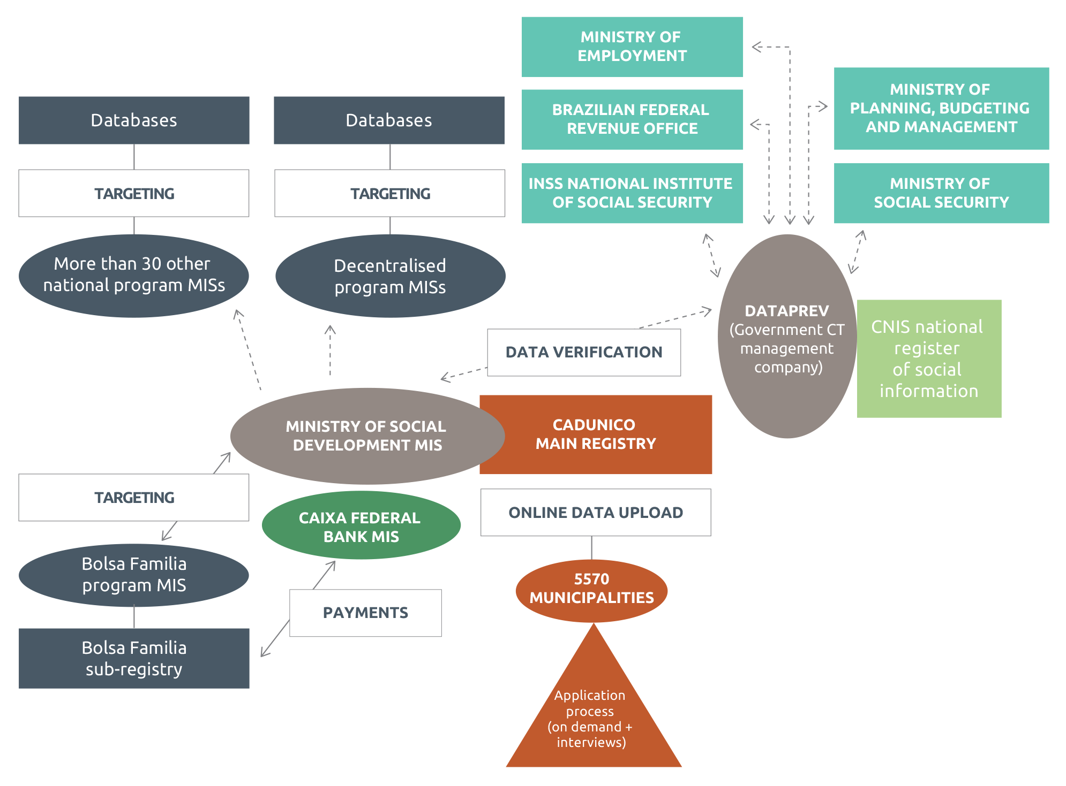

Source: Discussions with ministry staff (2016); and Oxford Policy Management Brazil poster (2015a).

Note: Boxes indicate databases; circles indicate MISs; lines indicate direct link (e.g. web service access); dotted lines indicate indirect link (batch process, CDs etc.). Arrows indicate where information flows in one direction or two directions. In Brazil, two-way flow of

information is only achieved between Cadastro Único and Bolsa Família. All other programs receive data through ad hoc links and do not share their beneficiary lists back.

### How data is collected and updated

Registration with Cadastro Único is free, and families provide the required information through an interview, using a standard Cadastro Único form.[74] Data collection is performed in any of the following ways:

* Fixed service stations: ongoing on-demand registration at any of 9413 centres across the country, many of which (5123, or 54 per cent) are Centros de Referência de Assistência Social (Social Assistance Reference Centres)
* Home visits to families
* Mobile service stations, including registration task forces (occasional census surveys in specific pre-identified areas).

By law, registered information must be updated every 24 months (from the date of last interview) or whenever there is a change in the family’s composition, address or socioeconomic conditions. Every year Cadastro Único manages some 14.4 million updates and/or new entries, equivalent to 25 per cent of the national population.

## How data is transferred

The current Cadastro Único system is 100 per cent online, and all Brazil´s municipalities have access to the internet. From the time the data is entered in the system it can be viewed in the national database by all the operators that use the system.

### How Cadastro Único information is used[75]

Cadastro Único is a powerful source of information for research and other public policies aimed at improving the quality of life of the most vulnerable segments of Brazil’s population. However, only recently have large efforts been made to ensure that Cadastro Único data can easily be consulted and used. Before 2012 it was not possible to generate detailed reports for the managers of social policies, and information could not be easily accessed by the states, municipalities and other partner agencies of the MDS.

In 2012, the MDS requested the Secretariat for Evaluation and Information Management (SAGI) to create a Cadastro Único data visualiser: the Information Consultation, Selection and Extraction Tool (CECAD). In under

a year the tool was operational, enabling managers to identify previously undetected problems resulting from unsystematic use of the database. Currently it receives around 500,000 visits and a total of over 2 million queries a month by, among others, researchers; federal, state and municipal managers; the electricity utilities; and the National Social Security Institute.

The CECAD makes it possible to tabulate the data of enrolled families based on a single variable, or by cross- referencing two variables (e.g. details of income, education, family members). CECAD data are extracted monthly from the Cadastro Único database and the PBF payroll. Access to the data is granted based on the user profile (e.g. municipal managers can only view their municipal data) and is password secured.

SAGI has also developed an application known as the Cadastro Único Data Tabulator (TabCad). This password-free application allows free access to the tabulator, the simple frequency and the summary features of CECAD.

### Data security and privacy

Considering Decree 7,724/2012, which regulates Law 12,527 of 18 November 2011 (Access to Information Act), personal information relating to intimacy, private life and the ‘honour and image’ of citizens contained in administrative records maintained by the government is restricted and can only be disclosed if there are legal provisions for doing so or with consent of the persons to whom the data refer. Thus, bodies and entities of the government must ensure the protection of personal information that is of restricted access. Different levels of access apply.

* Access is facilitated for public or private institutions legally responsible for the implementation of social programs.
* Other institutions need to submit a formal request that clearly identifies the purpose of the use of such data.
* If the request is from the judiciary or oversight bodies, it must be made by official letter, and the applicant must be informed of the restrictions and responsibilities regarding the use of the information.
* International organisations, civil society organisations and private companies may have access to information from the registry via technical cooperation agreements.
* Research institutes or autonomous researchers need to submit their research project to the institution managing Cadastro Único.
* Non-personally identifiable information from persons and families may be granted upon a formal request that identifies the purpose of using Cadastro Único data.

Budget

Funding for Cadastro Único is provided at the federal level, while municipalities and states also use their own resources for the management of Cadastro Único at the local level.[76] Between 2005 and 2010, the MDS also signed loan agreements with the World Bank and the Inter-American Development Bank.[77]

The goal of both projects was to support the MDS in strengthening its institutional activities, including strengthening the registry, developing a system for monitoring and evaluation, promoting training activities and giving support to complementary policies and programs. Currently, MDS is signing a second agreement with the World Bank for the implementation of a technical support project called ‘Consolidation of the PBF and Support to the National Commitment for Social Development’.

Main challenges and lessons learned

Over the years Cadastro Único has faced and solved several challenges, discussed in the sections above. This concluding section discusses the ongoing issues Cadastro Único is facing as it strives to increase integration across the social sectors:

* Lack of a common national identification number (Brazil currently has multiple sources and registries of personal data) limits the extent of automatic integration with external databases.
* Further development is needed to enable automatic and online database linkage with user programs (web services, database synchronisation/import). Currently Cadastro Único provides data to a wide range of programs but does not have an overview of who is receiving what as those programs do not share their beneficiary lists back (with the exception of Bolsa Família).
* Linked to the above, policy programming could be further integrated to offer single-window access to all social assistance programs through the Cadastro Único database, while also integrating key operations (most importantly M&E and planning) and services — ultimately increasing inclusiveness and responsiveness of social policy and addressing households’ changing vulnerabilities during the course of their lives.
* Connectivity and technology gaps in several regions of the country, especially in the north, have created problems given that the whole system is managed online.
* Reducing data collection efforts: the current questionnaire is very long and the burden on the individual applicant is high. Further integration with existing databases could help to streamline the process.

## Case study 2: Chile[78]

|  |
| --- |
| **Name:** Registro Social de Hogares (translated as Social Registry of Households; formerly known as Sistema Integrado de Información Social)  **Overall classification:** social registry that builds on a virtual registry  **Data collection approach:** combination of virtual data sharing from existing databases and on-demand registration (with periodic census surveys organised on an ad hoc basis)  **Breadth of integration:** integrates data collection and eligibility determination across all social assistance programs (with data flows in both directions); integrates with other sectors (health and education primarily); full integration with national ID database; some integration with social insurance  **Depth of integration:** key objective is sharing data (two-way flow) to integrate service delivery across sectors and increase citizen focus  **Number of individuals registered:** 12.4 million (72 per cent of population) |

Chile’s Registro Social de Hogares (RSH, translated as Social Registry of Households; previously, before January 2016, Sistema Integrado de Información Social (SIIS), or Integrated System for Social Information) is often cited as one of the most advanced examples of integrated data management across the social protection sector and beyond. This case study explores the key characteristics of this well-established yet continuously evolving social registry, which incorporates data on 12.4 million people, equivalent to 71.7 per cent of Chile’s population (March 2016) .

## Background

Social policy in Chile has been in constant development since the 1980s.[79] Economic prosperity in the 1990s led the government to reach out to the country’s poor in a more systemic way, leading in 2006 to the development of the Ficha de Protección Social (FPS),[80] a survey used to identify poor households to be targeted for social assistance. This approach evolved further in 2016, with a shifting focus from citizen ‘vulnerability’ to ‘rights’. In addition to the survey administered at municipal level to collect data on potential beneficiaries, the new system now incorporates large amounts of data from existing administrative databases.[81] This recent shift was endorsed by supreme decree (Decreto Supremo No. 22, 2015).

The system’s framework and technical architecture is a consequence of a concept of poverty and vulnerability encompassing all risks associated with poverty across a life cycle, including unemployment, precarious jobs, bad health and low levels of education. In this context, social protection is defined as encompassing policies and actions that help tackle these risks (Ministerio de Planificación y Cooperación (MIDEPLAN) [82] 2008). Integration (within a sector and cross-sector) is at the heart of the system.

### Programs supported by the RSH

Chile’s social protection intervention is supported by two main pillars, designed to tackle poverty and vulnerability in an integrated way at two life-cycle stages (Taieb Bono de Egreso 2012; Covarrubias et al. 2011):

1. Chile Solidario (under the umbrella of the Seguridades y Oportunidades program), established in 2002, is aimed at households in extreme poverty. Other than more traditional monetary support through cash transfers,[83] this program is innovative and personalised. Each household has a social worker assigned to it for 24 months[84] who provides information, referrals and assistance so household members can access complementary services[85] and link to employment and income-generating programs.
2. Chile Crece Contigo, developed in 2006, follows children from pregnancy to four years of age. This program is coordinated by a committee of members from different ministries. It is presided over by MIDEPLAN and involves education, health, work, social security and justice ministries that implement it at local level.

Beyond these two pillars, other programs are integrated into the overall social protection strategy through the RSH. These include one that guarantees access to health services for key illnesses,[86] universal access to education for children under 12 years of age,[87] a system of social pensions,[88] and other small programs for improving health conditions and employment opportunities and providing housing and judicial support (see Covarrubias et al. 2011 for more details). In 2016, over 80 social programs in Chile were using RSH to select their beneficiaries.[89]

The RSH is an essential part of Chile’s social protection strategy because it contains all information on the state’s provisions to beneficiary households and coordinates across ministries and levels of government. The following sections analyse how this is achieved.

## Objective and institutional arrangements for RSH

SIIS (RSH’s predecessor) was established in 2008 through Decreto Supremo No. 160, which covers how the personal data of potential and actual beneficiaries should be protected and how inter-institutional agreements should be regulated. Specifically, the decree dictates that institutions should exchange data with the:

… objective of assigning and rationalising social benefits distributed by the State, as well as researching and designing policies, plans, programs … based on the needs of those who administer such benefits, so as to promote a correct targeting of resources and the incorporation of beneficiaries in existing Social Safety Nets and ensuring access to better life conditions. (MIDEPLAN 2007, article 4)

Overall responsibility for the registry used to be with MIDEPLAN, which was then replaced by the Ministry of Social Development (MDS) through Law No. 20.530 (2011). MDS performs key management and coordination of the RSH. It determines the standards for data collection, storage, security and transmission and is responsible for coordination, control, supervision and evaluation of RSH. It underwrites legal agreements with 43 other state agencies and their multiple databases, formalising the exchange of data (including rights and obligations for use of and access to data).[90] Each institution is responsible for correct and accurate data. MDS also signs agreements with Chile’s 345 municipalities, which are primarily responsible for collecting data.

## How RSH is structured in practice

RSH is a social registry[91] that, thanks to a tailored software application (and using the national ID RUN number as a unique identifier), is linked to many databases belonging to public entities through the internet, providing up-to-date information on 12.4 million people, equivalent to 71.7 per cent of Chile’s population (April 2016). This section analyses how it is structured.

### Data sources

The key databases feeding into the RSH are:

* Data from 43 state agencies and their multiple databases, including the National Corporation for Indigenous Development, and ministries such as education, labour and social security, housing and urban development[92]
* Data collected by municipalities or collected online (using a specific form, available publicly on the Ministerio de Desarrollo Social website)
* Data from Chile Solidario and Chile Crece Contigo MISs, linked through municipalities, including information on payments
* Data from 345 municipalities
* Data from Chile’s civil registry.

RSH also keeps records of some sensitive data, such as income and taxes, which may be used only under very specific circumstances.

Figure 12 Chile’s RSH: overall structure

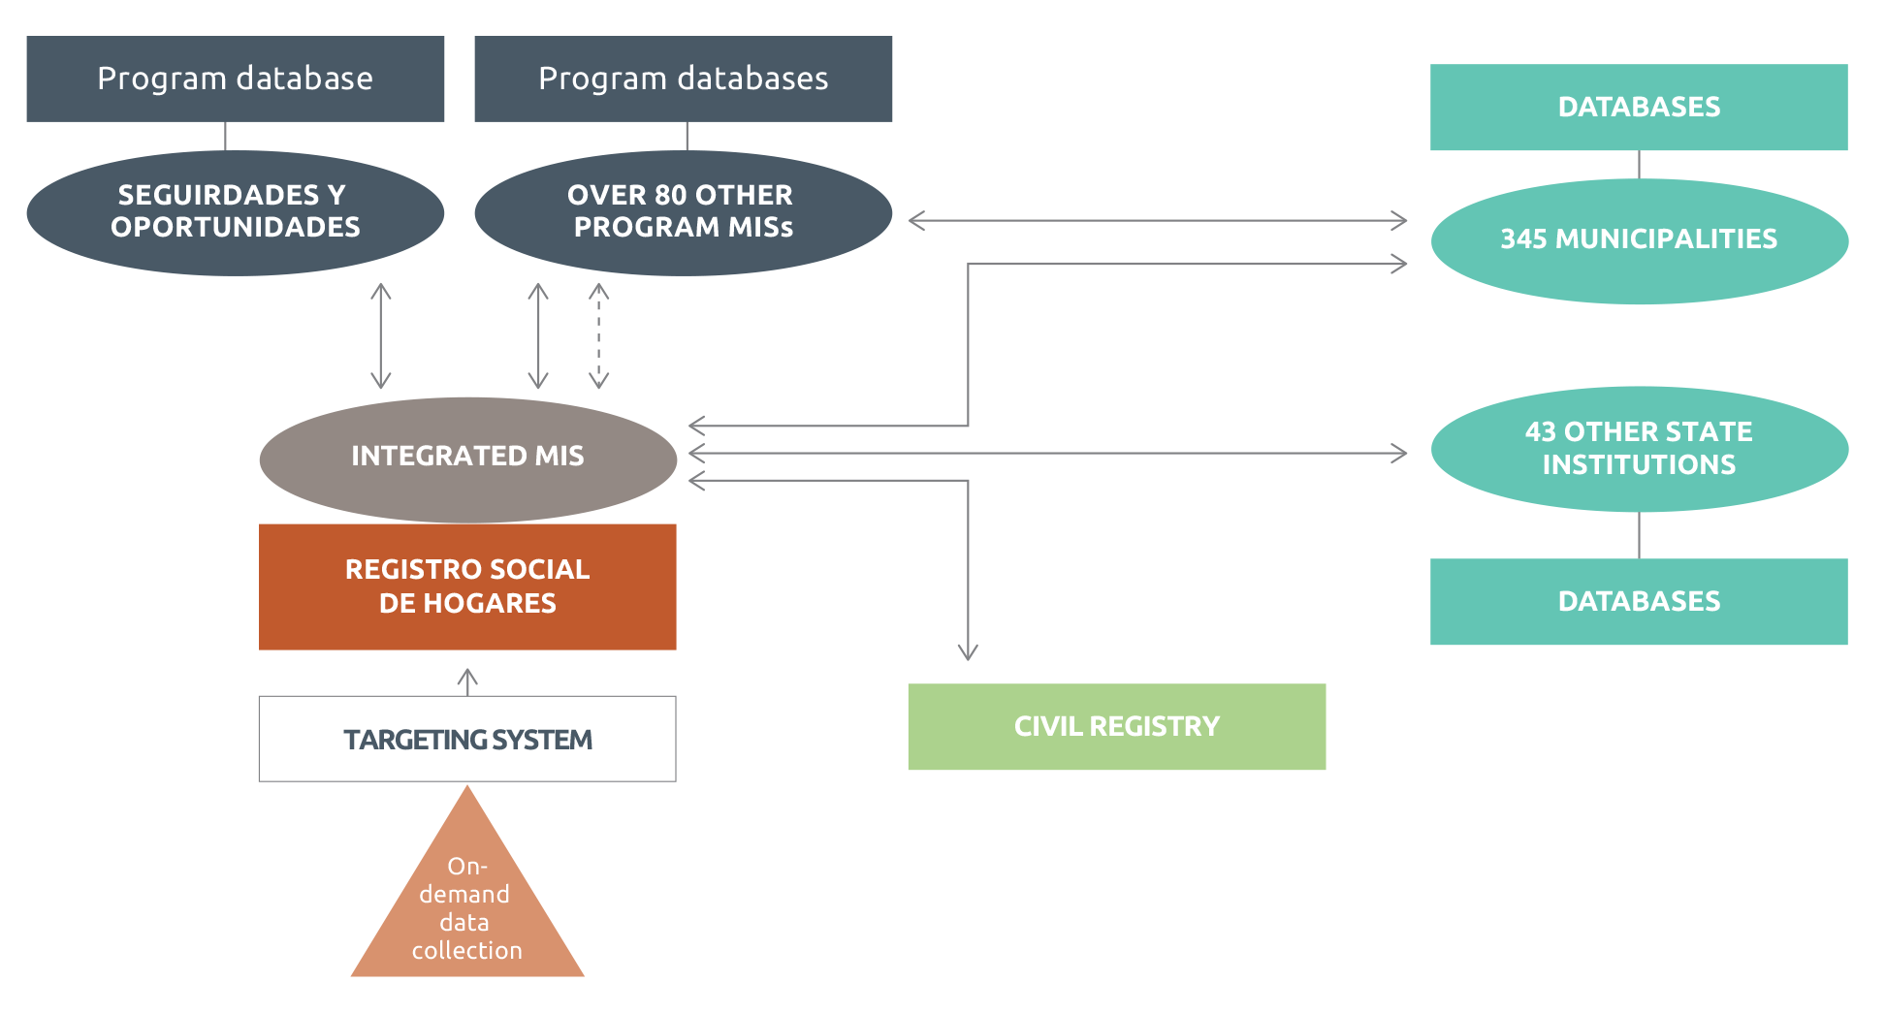

Source: Developed by author based on Covarrubias et al. (2011) and Irarrázaval (2004).

Note: Boxes indicate databases; circles indicate MISs; bold lines indicate direct link (e.g. web service access); dotted lines indicate indirect link (batch process, CDs etc.). In the case of Chile, information from the 80+ programs listed is shared on an ad hoc basis (some direct and some indirect links; some one-way and some two-way flows).

### How data is collected and updated

RSH data is collected and updated in three different ways:

1. From existing administrative databases (see above — this is why Chile’s social registry shares the characteristics of a virtual social registry)
2. Continuous access to benefits or updated information is handled on request (on demand) at municipality offices (officers are trained on this)
3. Information can be accessed and modified by citizens online. Overall, municipalities are responsible for data collection.

### Data processing and targeting

After data is entered and validated (including cross-checks with the civil registry), it is used to target at central level. It is analysed using a targeting formula (dotted rectangle in Figure 10) that calculates an overall score for each household, based on preset criteria (see more details, in Spanish, on the Registro Social website). This score, recorded in the RSH with all relevant household information, determines program eligibility. Unlike other countries in Latin America, Chile’s programs apply thresholds to eligibility based on specific objectives (for example, some focus on the most vulnerable 40 per cent and some on aspects of vulnerability such as housing).

### How data is transferred

RSH information is accessed in two ways:

* Web service[93] enables remote access by institutions with legal agreements with SIIS,[94] without the need for common software. Data is transferred using XML language and HTTP protocol. Institutions can consult integrated data, and RSH can access institution databases to update data.[95]
* Batch processes involve contacting MDS through an ad hoc website and sharing information. Institutions are given an access key — an identifier so that information and functionalities can be shared.

Because both methods depend on the internet, about 40 per cent of the 345 municipalities have faced significant access problems, despite efforts to upgrade overall infrastructure (Covarrubias et al. 2011). In fact, the lack of modernisation of many of the municipalities was listed by the ministry as one of the key challenges they faced.

### How RSH information is used

The best indicator of how well a system functions is actual use. In 2011, on average, the RSH predecessor SIIS was consulted 9800 times a day (online). Detailed reporting is available to policymakers, including geo-referenced maps (see for example Figure 10).

The RSH also has potential uses for beneficiaries. For example, municipalities can generate a document showing a household’s targeting score (including a barcode for security), which can be used to request public services.

Beneficiaries can also ask for assistance from the 15 institutions that have specific legal arrangements with the RSH without further proving eligibility. RSH personal data is also available online.

Figure 13 Chile’s RSH, available online

Figure 13 shows a sample of the Chilean RSH website.


### Data security and privacy

The information integrated by Chile’s RSH social registry is mainly personal and is regulated by Chile’s Law No.19.628 on data privacy. This means, for example, that individuals must authorise state institutions to use their personal data or transfer it to third parties. Data is also regulated based on Chile’s 2008 Transparency Law (No. 20.285), which enforces the publication of certain types of information on selected themes.

## Main challenges and lessons learned

### Keeping information updated

The main criticism around RSH’s predecessor, SIIS, was that it was more static than intended (Covarrubias et al. 2011). RSH has partly addressed this by regularly updating data from a wide range of data sources, acting as a virtual registry.

Stock data is actualised monthly by comparing it to the civil registry, and online for new users. Variables used to calculate eligibility scores (for example, administrative income and pensions) are updated monthly too.

Households are asked to inform the system, through any of the existing channels (municipalities or the website), of any updates regarding self-reported data. Since the targeting score is mainly based on administrative data, incentives to update information have changed, compared to the previous instrument (FPS).

### Risk of excluding categories of individuals

The risk of excluding categories of individuals pertains to the targeting algorithm applied, not to the RSH, but an integrated system can lead to integrated exclusion. However, some specific policies are now being designed to reach people who are out of the formal system or in special living conditions, such as homeless or institutionalised children.

### Insufficient capacity at municipal level

While an online system has many advantages for facilitating instantaneous data exchange, municipalities are often not modern enough to fully integrate. The only solution is to buy adequate equipment, improve internet access in remote areas and build staff capacity.

### Not enough focus on research and monitoring and evaluation

Overall, the RSH’s full potential to become a databank for social researchers and institutions wanting to plan social interventions is still not fully realised.

## Case study 3: Indonesia[96]

|  |
| --- |
| **Name:** Basis Data Terpadu (BDT) (translated as Unified Database, UDB).  **Overall classification: social registry**  **Data collection approach:** census survey of households pre-identified as poor (but may be moving to on- demand system)  **Breadth of integration:** integrates data collection and eligibility determination across selected social assistance programs and community health insurance scheme (but data from these schemes is not shared back with UDB, so comprehensive overview of beneficiaries across programs is not possible); increasing integration with national ID database  **Depth of integration:** integration primarily for targeting purposes; uses external data from national ID database for data verification  **Number of individuals registered:** 93 million (40 per cent of population) |

Indonesia’s Basis Data Terpadu (BDT, known as the Unified Database, or UDB) can be classified as a social registry that unifies information for poverty targeting across the country’s largest social assistance programs. The UDB database now covers 25.7million households (93million individuals) located in 82,464 villages nationwide (2016), making it one of the largest databases of its kind in the world.[97] Moreover, Indonesia’s publicly available Management Standards define international best practice for accountability in this field.

This case study provides a fascinating example of the heavy challenge that countries face when attempting to develop a new social registry. It is also a good example of how political will and flexibility in design (adopting an iterative trial-and-error approach) can drive the process of integration. This case study was drafted in 2016 and describes how Indonesia’s registry was set up at that point in time.

## Background and historical evolution

The UDB was established to unify approaches to targeting social assistance programs in Indonesia. The initial proponent of the UDB was the then Vice President, who saw it as a requirement to reach the target of reducing poverty by 8–10 per cent by 2014, as stipulated in the country’s Midterm Development Plan 2009–2014.

Specifically, the creation of a UDB was expected to:

* improve program targeting (see for example Presidential Instruction No. 1/2010 on the National Development Priority[98]), as analysis of Susenas (national socioeconomic survey) data showed that many poor families did not receive social assistance programs that they were entitled to lead to better complementarities between social assistance programs — for instance, beneficiaries of the Family Hope Program (PKH) could also receive free health services.[99]
* The UDB was officially launched in 2011. The evolution of institutional arrangements and data collection approaches for the UDB is described below.

### Programs that are supported by the UDB

Since the formulation of the UDB, at least five national programs have utilised UDB data:

* National Health Insurance–Jaminan Kesehatan Nasional (Healthy Indonesia Card–Kartu Indonesia Sehat (KIS)). Launched in November 2014, the program delivers community health insurance cards to the poorest households to receive free treatment in government hospitals. By 2016, the program is set to reach the bottom poorest 40 per cent of households.
* Cash Transfers for Poor Students–Bantuan Siswa Miskin (Smart Indonesia Card–Kartu Indonesia Pintar (KIP)).

KIP provides transfers from central education agencies directly to students or schools once enrolment, attendance and other criteria have been verified. In November 2014, KIP were launched and distributed to 160,000 children of school age.

* Family Hope Program–Program Keluarga Harapan (PKH). This is a conditional cash transfer providing direct cash benefits conditional on household participation in locally provided health and education services. It is targeted at the poorest 8 per cent of households.
* Rice for the Poor–Beras untuk Rumah Tangga Miskin (RASKIN). This is a rice subsidy program with the broad aims of strengthening food security and reducing the financial burden on poor and near-poor households.
* Temporary Unconditional Cash Transfer–Bantuan Langsung Sementara Masyarakat (BLSM) (Family Welfare Card–Kartu Keluarga Sejahtera (KKS)). This is a temporary unconditional cash transfer to compensate for the increase in fuel prices. The program is designed to protect the poor and vulnerable households from socioeconomic risks posed by the changes in national economic policies. KKS were issued to the beneficiaries of BLSM (the poorest 25 per cent of households).

Some of these programs are explicitly envisioned as complementary, with households targeted for some eligible also for others.

## Institutional arrangements for the UDB

From 2012–2015, data for the UDB was managed within the Tim National Percepatan Penanggulangan Kemiskinan, known as TNP2K (or the National Team for the Acceleration of Poverty Reduction) — a team under the office of the Vice President, established through the issuance of Presidential Decree No. 15/2010 and receiving extensive financial and technical donor support. However, over the course of 2016, the UDB

is being transitioned to PUSDATIN (Data Centre) at the Ministry of Social Affairs (MOSA). This is part of the implementation of a legislative requirement (Law No. 13) which vests in MOSA the responsibility for the collection and maintenance of data on poor households. A task force consisting of the Ministry of Human Development and Culture, TNP2K and MOSA has been established to steer the transition process.

Within TNP2K, the UDB was managed by a special unit called UPSPK (Unit Penetapan Sasaran Penanggulangan Kemiskinan or Unit for Targeting and Poverty Reduction). The functions of the TNP2K’s UDB unit were fourfold: (i) provide UDB data to line ministries, (ii) provide technical assistance on data use to local governments, (iii) generate M&E reports on data utilisation, and (iv) maintain the website portal. To deliver on these functions, UPSPK was staffed by a team consisting of one data and dissemination officer, one infrastructure and security specialist, one GIS specialist, two on-demand application officers, one administrator and two senior programmers.

* At MOSA, PUSDATIN is managed by 37 staff: nine employees, 12 staff technicians, three statisticians, one expert who handles maintenance of the data centre, and the rest general staff. MOSA plans to deploy more expertise to manage PUSDATIN. MOSA also plans to develop a comprehensive capacity development strategy to ensure that PUSDATIN has full capacity to (i) ensure the security and administration of the UDB and (ii) provide analysis of the UDB data to stakeholders.

## How the UDB is structured in practice

### Data sources and linkages

The main data source for Indonesia’s UDB is the data collected by the UDB itself (see below). This has become the only source of data for poverty targeting in the country.

Currently the UDB is not actively linked with any other government databases. However, efforts are now in place for linkage with SIAK, the national ID database at the Ministry of Home Affairs, and its national ID number (NIK). This is a process that has evolved over time.

* Only 74 per cent of the 2011 UDB data was integrated with NIK, using an algorithm consisting of names and addresses (because NIK was not collected in the 2011 round — see below).
* In the 2015 data collection round, NIK was collected as a data variable. Some 80 million individuals surveyed had a NIK.
* The entire database of 93 million records was transferred to SIAK in February 2016 and is due to be linked by August 2016.
* Going forward, further updates on the UDB database will be run using web services that will be set up between SIAK and UDB.

Currently, Indonesia is also reviewing the MISs of its core social assistance schemes with the aim of enhancing them so as to fully manage and coordinate core operational processes. The strategy will also entail integration with the UDB, given that its data will be dynamically updated in the future.

Figure 14 below summarises the key inputs and outputs of the UDB as discussed above.

Figure 14 Overall structure of the UDB

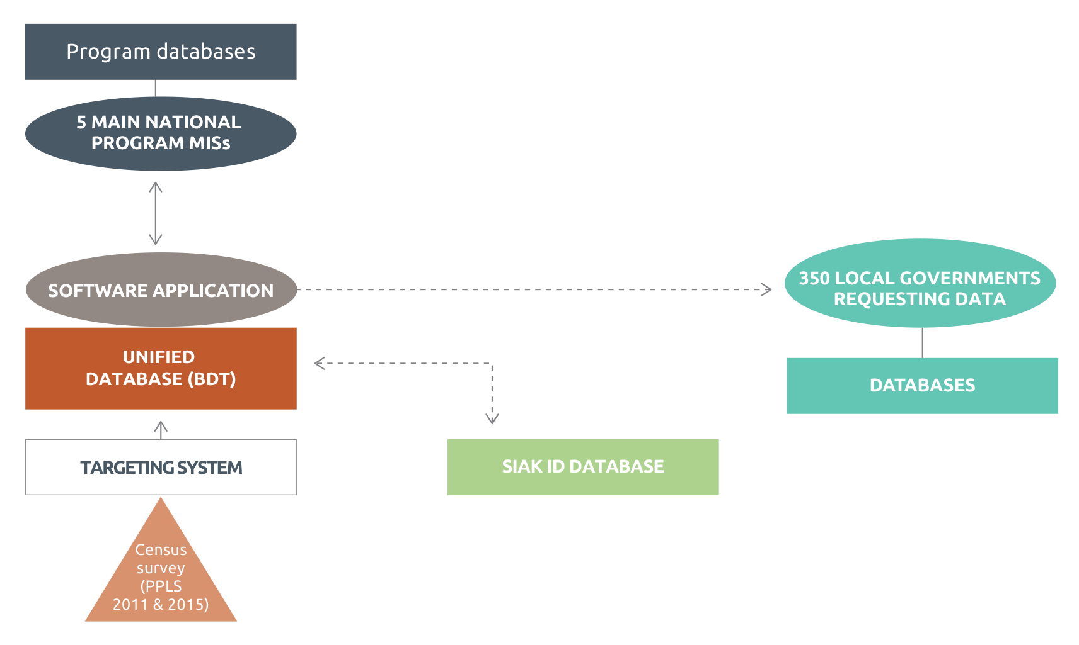

Source: Developed by authors based on discussions with the Ministry.

Note: Boxes indicate databases; circles indicate MISs; bold lines indicate direct link (e.g. web service access); dotted lines indicate indirect link (batch process, CDs etc.); arrows indicate where information flows in one direction or two directions.

### How data is collected and updated

Unlike in any other country, data for the UDB in Indonesia is currently collected by the National Statistics Agency (BPS), which regularly conducts basic statistical data collection through censuses, Susenas national surveys[100] and PODES village potential surveys.[101] Despite the potential risks of BPS taking on this role,[102] the decision was taken as no other agency or institution would have been capable of collecting data at a national scale.

The first time the BPS was explicitly tasked with systematically developing a ‘census’ of poor households (Pendataan Sosial Ekonomi) was in 2005, when the reduction of fuel subsidies led the government to develop a temporary unconditional cash transfer, the BLT, aimed at all poor households in the country. BPS conducted another large-scale survey (Pendataan Program Perlindungan Sosial, PPLS) to update the data when the government was preparing to implement a second round of the BLT program in 2008. This data collection effort verified information for the 19 million households listed in the 2005 BLT database (Tobias 2013).

The data source for the first UDB was the 2011 data collection for social protection programs, PPLS 2011, which collected data from a significantly greater number of households: 24 million (40 per cent of the population) against 19 million. Given that it would not be cost-effective to do a census of all households in the country (as the UDB focuses on the poor and vulnerable), the households interviewed were selected on the basis of the 2010 census,[103] which was triangulated with other sources including PODES 2010, Susenas 2010, the 2008 PPLS database, program listings, and local knowledge from communities.

The UDB was updated again in 2015 using a comprehensive PPLS 2015 conducted through a census process. BPS visited and collected data from 25.7 million households (old ones already in the database and new ones identified). The 2011 PPLS and PPLS 2015 survey questionnaire were designed to collect information on variables that are the strongest predictors of consumption (poverty), while maintaining brevity (two pages). Different government agencies implementing social programs were also consulted to ensure that the information collected in the database would accommodate their needs. The PPLS 2011 overall cost of about 20,000 IDR (2 US dollars) for each home interview — conducted by 120,000 BPS enumerators — is in line with international standards (Tobias 2013), as is the comparison between data collection costs and annual program costs of the three largest programs, which amount to less than 1 per cent (World Bank 2012c).

After four rounds of massive data collection (2005, 2008, 2011 and 2015), the Government of Indonesia intends to perform future updates of the UDB following a dynamic, on-demand application (ODA) process (see also Section 4.2.1). A pilot for ODA was commissioned in July 2016 to test how the dynamic update of UDB could

work in a decentralised institutional set-up where applications and inquiries are received, verified, and digitised at the local level, closer to people’s place of residence. The rationale for setting up ODA is threefold: (i) to identify any exclusion errors; (ii) to facilitate the dynamic updating of UDB data, which makes it more current; and (iii) to enhance the effectiveness of social protection program targeting.

### Data processing and targeting

To date (2011–2015), after the database is subjected to extensive validations and consistency checks, BPS transfers the dataset to TNP2K’s National Targeting Unit, where data is processed using a proxy means test (PMT) targeting index aimed at categorising households into four levels based on the PMT welfare index. These levels are then used when targeting individual programs, but combined with program-level criteria in practice. For example, RASKIN ‘validates’ lists within communities,[104] while PKH only targets extremely poor households with elementary-school-age children or pregnant mothers.

### How data is transferred

The UDB data is stored using a Microsoft SQL server but it does not currently link to other servers or web services for remote access. Up to now, transfer of data between TNP2K and other government institutions has been done manually using CDs. Ministries or local governments send written requests to MOSA detailing the type of data needed; UPSPK retrieves the data and sends it back in Excel format by email or on disk. For the new ODA system, UDB is building an ad hoc application software. The application will run on an Android platform and will operate offline and online.

### How information from the UDB is used

To promote the use of UDB data, TNP2K and MOSA have put in place an elaborate procedure for requesting, processing, extracting and use of data by stakeholders, outlined in detail in the UDB’s Management Standards (2015). Data and information available in the UDB is mostly used to determine the beneficiaries of social protection programs, both at national and local levels. However, since the inception of the UDB in March 2012, UPSPK has handled more than 700 requests for data and more than 1000 requests for technical support — including for new programs and initiatives (e.g. the Programme for Expanding and Accelerating Social Protection (Program Perluasan dan Percepatan Perlindungan Sosial, or P4S). TNP2K staff and researchers from other institutions have used the database for poverty-related research. Independent evaluations of the Unified Database’s effectiveness by other research institutions are also being encouraged.

Since January 2012, TNP2K has provided open web access to the data on national, provincial and district distributions for 16 UDB indicators. Summary reports can be downloaded from a publicly available TNP2K web portal.

Moreover, a few initiatives are now being implemented to move to using UDB as the basis for M&E and grievance mechanisms during program implementation. For example, since 2013, TNP2K has been collaborating with the Presidential Work Unit for Monitoring and Control (Unit Kerja Presiden Bidang Pengawasan dan Pengendalian, UKP4) to utilise an existing online complaint-handling website called LAPOR.

Figure 15 Sample of UDB online data

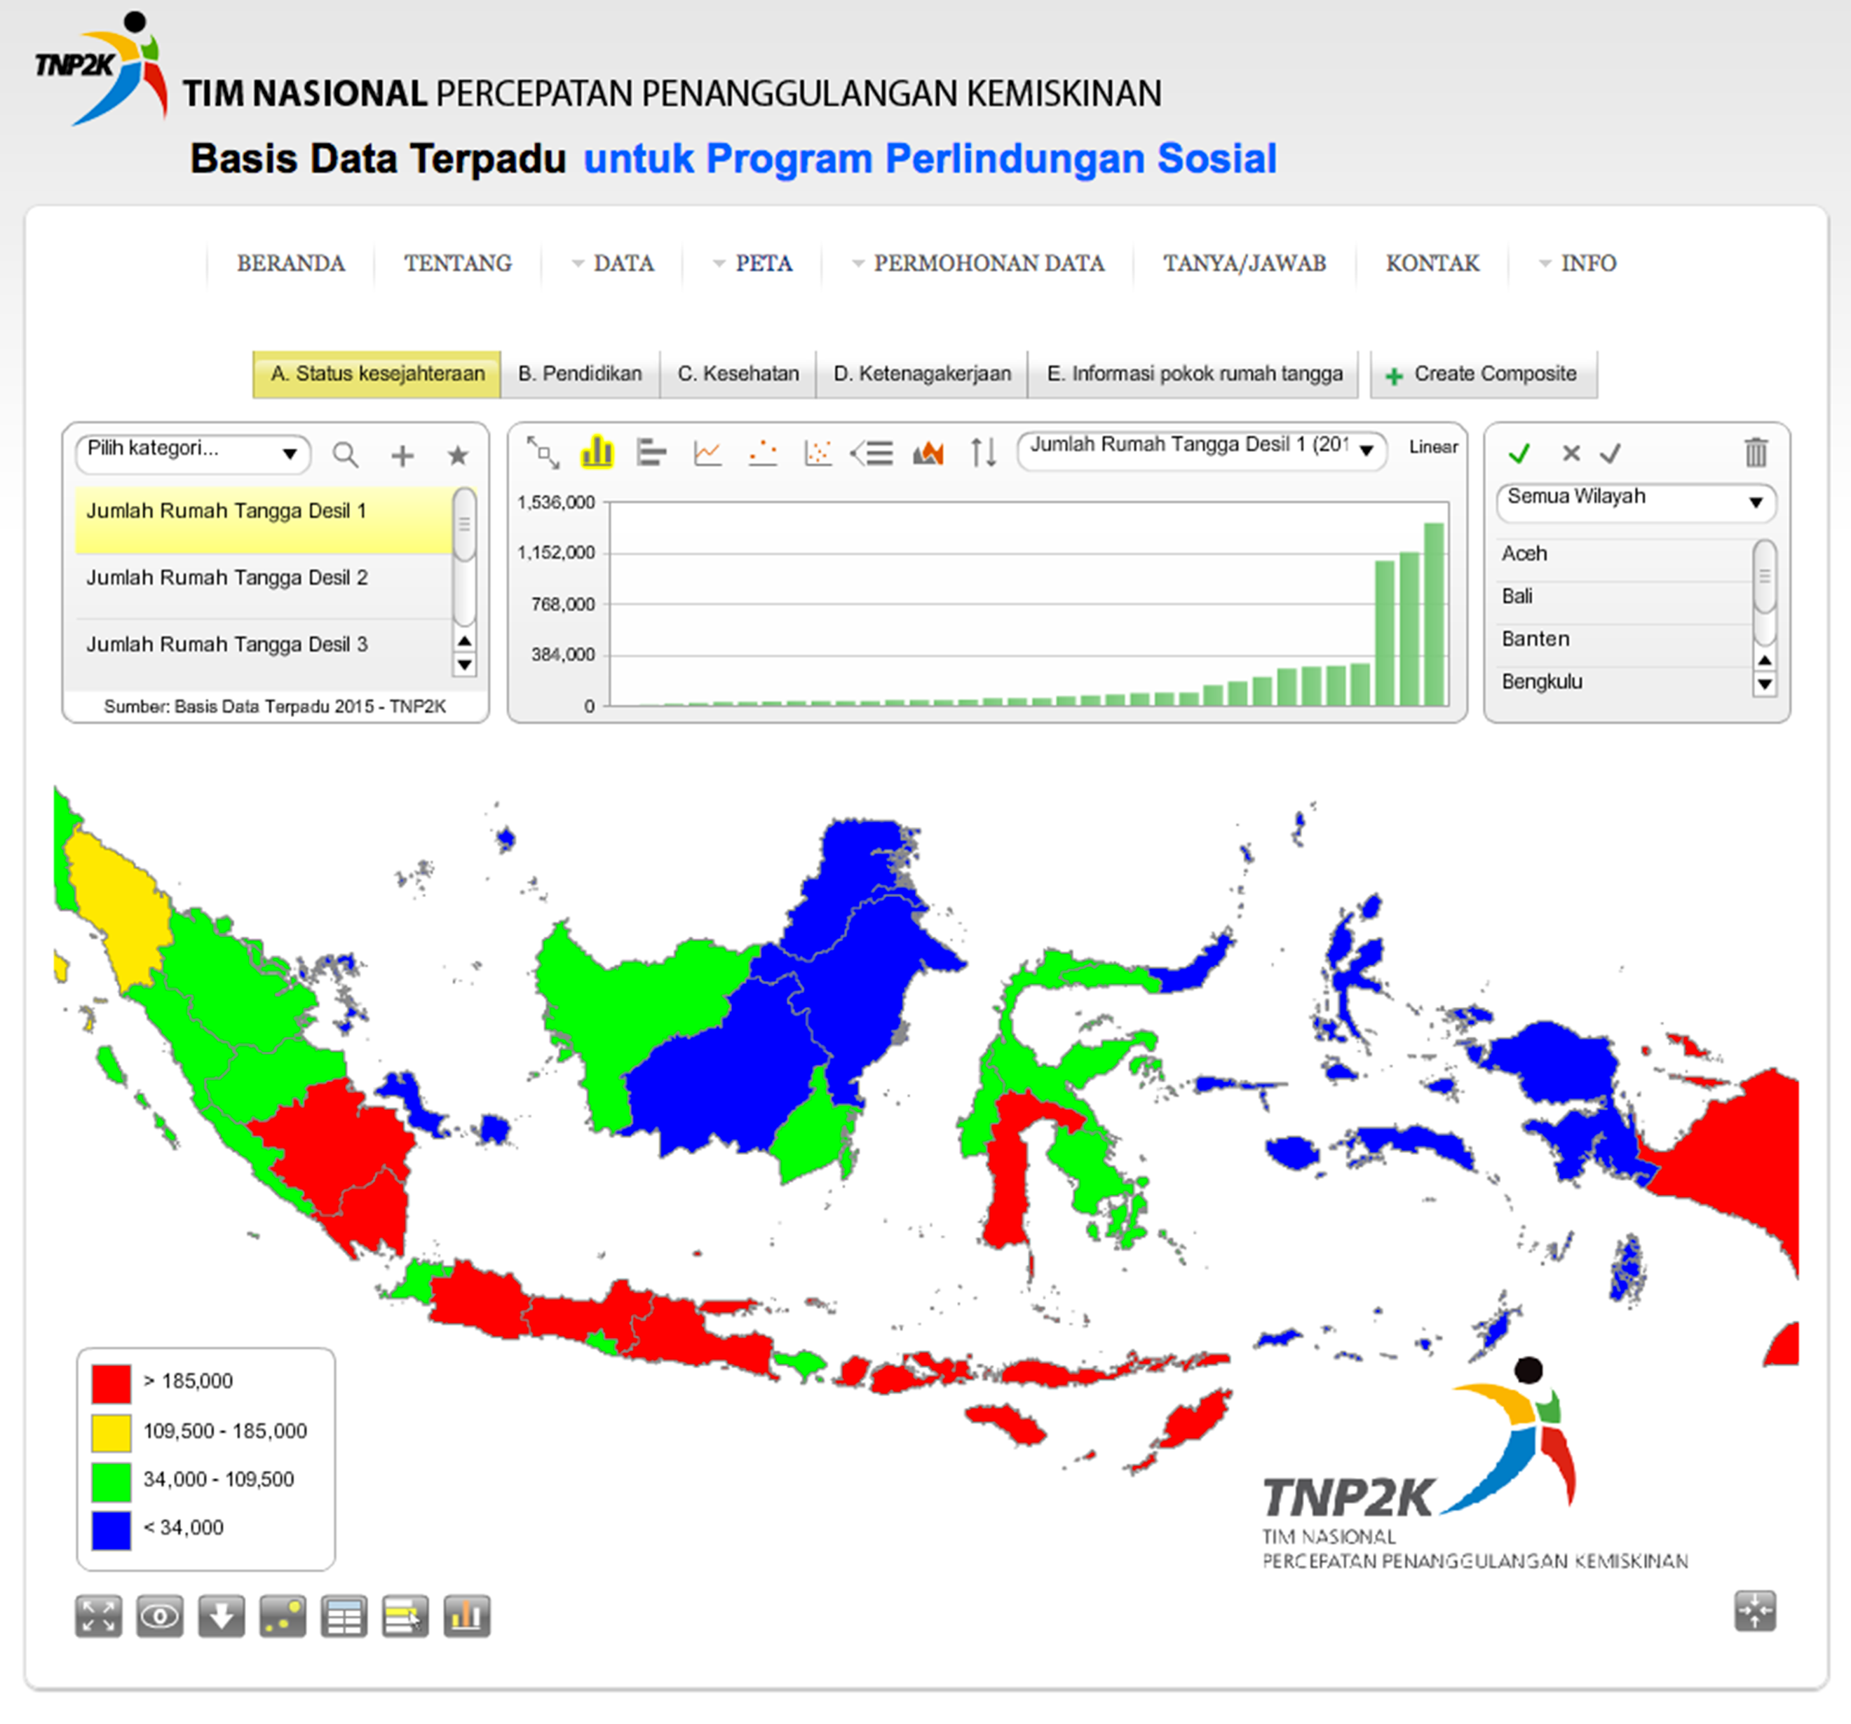

### Data security and privacy

For data requests that require personal data, an applicant is required to submit an application letter. This previously went to the head of the TNP2K. However, as of January 2016, the data requests are approved by MOSA, which conducts an interview with the applicant to clarify the details of the data requests. Data is then extracted and packaged in CD format for submission to the applicant with an accompanying cover letter. Overall, to regulate security and privacy of the data, TNP2K uses existing laws and regulations, such as Law No.11/2008 on information and electronic transaction and Law No. 14/2008 on public information disclosure. Data that is considered sensitive is only shared with other government institutions upon request.

## Main challenges and lessons learned

Indonesia’s efforts to improve and consolidate its system for managing information for poverty reduction programs through a social registry have been successful but still face various challenges, from data collection to utilisation.

With regard to data collection, Indonesia made improvements in the 2011 and 2015 data collection waves compared to those in 2005 and 2008 — most significantly increasing the overall number of households surveyed, using existing data to only survey the poorest households in each community. This approach is innovative but is not risk-free, which is why the government is now exploring ODA data collection. This new approach may also mitigate the current risks of having the BPS lead data collection for the UDB.

Data updating is possibly the biggest challenge faced by the UDB, especially for those programs that target categories or people with ‘volatile’ status, such as PKH (school-aged children and pregnant women). Even when implementing agencies at program level update their beneficiaries’ data, these changes are not fed back into the UDB. This challenge may be soon resolved with the dynamic update and ODA process.

Regarding data use, the future is still hard to predict. Although UPSPK’s activities and resources have been largely allocated to serve over 500 local (district and province) government institutions, a lack of formal institutional arrangements and memoranda of understanding with individual program implementers and other government bodies means that data exchange is managed on an ad hoc basis and is not systematic. Moreover, program managers and local governments have shown attitudes of ‘complacency’ and resistance to the changing approach to targeting in the country (Nazara 2012). Still, the 700 different requests for data from local governments and 1000 requests for technical support (TNP2K 2015) are a good indicator that there is a strong demand for such data — even if the UDB is often seen as a starting point for tailored approaches to targeting.

Interviews with staff involved in the process of creating the database revealed five key learnings based on their experience:

* Recognising that developing such a system requires an enormous amount of work and extensive capacity (technical, administrative and financial) that is not always available in a country, meaning that donor support can be essential in the development phase
* Recognising the importance of having a culture of learning that is flexible enough and open to ongoing adaptation. Piloting can take time and money, but it can be essential to creating a shared and commonly accepted approach that is effective and sustainable over time
* Not fearing, and in fact embracing, complaints and criticism, which are inherent to any system that has targeting as an ultimate goal
* Getting staffing right, including competitive salaries to attract competent staff with less incentive to move to the private sector
* Dedicating energy to communications alongside implementation, to increase ownership and transparency.

## Case study 4: Kenya[105]

|  |
| --- |
| **Name:** Single Registry  **Overall classification:** integrated beneficiary registry  **Data collection approach:** data sharing from existing program MISs (which collect data using different approaches)  **Breadth of integration:** integrates across Kenya’s five main social assistance programs and exchanges data with the national ID database  **Depth of integration:** key objective is to provide coordination, oversight and integrated monitoring and evaluation across programs; external data from the national ID database is integrated for the purposes of data verification  **Number of individuals registered:** approximately 3.7 million (8 per cent of population) |

This case study focuses on Kenya’s recently implemented Single Registry. This can be classified as an integrated beneficiary registry with a web-based reporting interface that provides a platform where common and essential information across five social assistance programs is stored, analysed and reported. In detail, the Single Registry enables the government of Kenya to link together the management information systems (MISs) of its five major social protection schemes: the Old Age Grant, Disability Benefit, Orphans and Vulnerable Children’s Cash Transfer, Hunger Safety Net Programme, and World Food Programme (WFP) Cash for Assets scheme.

Kenya’s Single Registry is very different in design compared to attempts in other countries to develop social registries. Kenya’s system is essentially an integrated beneficiary registry (‘data warehouse’) holding information on all the beneficiaries of the national social protection system, and is continuously and automatically updated as individual program MISs update their information on beneficiaries. The Single Registry — which offers a publicly available online version sharing aggregate data trends — acts as a single point of reference to give an overview of who is receiving, what type of assistance (and how much), where the assistance is received, and when the assistance is transferred. In May 2016, the Single Registry was populated with information on 883,000 beneficiary households (approximately 3.7 million individuals) out of a population of 44 million, equivalent to 8 per cent of the national population.

## Background and historical evolution

Historically, social protection programs in Kenya were not well coordinated. They were fragmented, presenting duplications and inconsistencies, and were led by different agencies, resulting in a lack of efficiency (World Bank 2012c). Over time, there was growing recognition that there should be a systematic approach to data and information management across the sector.

Kenya’s Social Protection Policy, which was gazetted in 2012, comprehensively addressed policy coordination, including the institutional framework and management information systems needed to make it happen. The policy also envisioned the country’s Single Registry as playing a central role in establishing a coherent and scalable approach to social protection: ‘The Government recognizes the need to establish a management information system (MIS) for social protection in Kenya’.[106] This vision was also reflected in the medium-term plan of Kenya’s Vision 2030 and was strongly led by the National Social Protection Secretariat.

In 2011, the process to achieve such integration was not clear. Some of the programs that were going to be integrated did not have an electronic database or related MIS, while none of the existing databases could speak to each other and no standardisation of data existed across databases (e.g. there was no use of standard geographic locations across programs). To tackle these problems, in 2011 a working group was established with members from the country’s five core programs to start discussing standardisation. Recommendations developed on the basis of ongoing assessments led to a first achievement, with government-led cash transfer MISs harmonised in 2013. With technical assistance from WFP, full integration across programs was achieved in 2014–2015, including integration with the country’s civil registration authority. The system went into full use by April 2015, when linkage to civil registration was established.

### Programs supported by Kenya’s Single Registry

As illustrated in Figure 16, the Kenyan Single Registry consolidates information from five of its main schemes’ MISs into an integrated beneficiary registry. Information on non-beneficiaries is kept by individual program MISs and their databases.[107] The programs are (i) the Hunger Safety Net Programme, (ii) the Persons with Severe Disability Programme, (iii) the Older Persons Cash Transfer, (iv) the Orphans and Vulnerable Children Programme, and (v) the WFP Jenga Jamii Programme.

Figure 16 Programs that form Kenya’s Single Registry

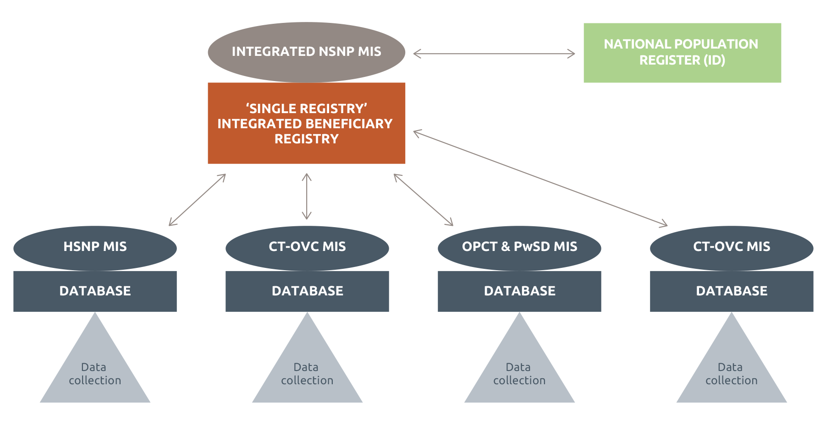

Source: Developed by authors based on discussions with the Ministry.

Note: Boxes indicate databases; circles indicate MISs; bold lines indicate direct link (e.g. web service access); arrows indicate information flowing in both directions. In the case of Kenya, information flowing from the integrated beneficiary registry to the programs is on duplicate beneficiaries across programs (data is collected by individual programs, then shared and cross-checked against the ‘Single Registry’.

* Hunger Safety Net Programme (HSNP). This is an unconditional cash transfer designed to respond to the growing levels of chronic food insecurity in Kenya’s arid lands and reduce poverty in northern Kenya.
* Orphans and Vulnerable Children Programme (CT-OVC). This is a program with the objective of improving the welfare of poor households with orphans and vulnerable children and retention of children within these households, to mitigate the impacts of HIV/AIDS. OVCs are defined as children who have lost one or both parents, are chronically ill or have a caregiver who is chronically ill, and/or live in child-headed households as orphans.
* Older Persons Cash Transfer (OPCT). The program targets extremely poor households that include a person aged 65 or older who is not already receiving a pension. Designed in recognition of the fact that older persons constitute a sizeable poor population, the program aims to strengthen the capacities of older persons and improve their livelihood.
* Persons with Severe Disability Programme Cash Transfer (PwSD-CT). The program was created to provide immediate relief from extreme poverty for people with severe disabilities who are unable to look after themselves and require permanent care.
* WFP Jenga Jamii Programme. This is a large-scale unconditional cash transfer program implemented across Kenya’s arid and semi-arid lands.

## Institutional arrangements

The National Social Protection Policy vests in the National Council for Social Protection[108] the overall strategic direction for social protection. Support and coordination is provided by the Social Protection Secretariat, located within the Ministry of Labour and East African Affairs (MoLEAA). Since Kenya’s Single Registry is essentially a warehouse, holding information on all the beneficiaries of the national social protection system, data collection and updating is undertaken by individual program MISs. Therefore, the individual programs play an important role in the collection and updating of data of the overarching integrated beneficiary registry. Table 12 below lists the institutions that are responsible for managing the existing social assistance programs, all of which have been configured to automatically populate Kenya’s Single Registry.

Table 12 Institutional roles and responsibilities for updating the Single Registry

| **Institution** | **Function** | **Programs** |
| --- | --- | --- |
| MoLEAA – Department of Social Development (DSD) | Data collection  Data updating | Older Persons Cash Transfer Programme  Persons with Severe Disability Programme |
| MoLEAA – Department of Children Services | Data collection  Data updating | Orphans and Vulnerable Children Programme |
| National Drought Management Authority | Data collection  Data updating | Hunger Safety Net Programme |
| World Food Programme (WFP) | Data collection  Data updating | Cash Transfer Module Programme |
| MoLEAA – Social Protection Secretariat | Data consolidation  Data warehousing  Reporting;  Data sharing | National Safety Net Programme |

The head of the Social Protection Secretariat is fully responsible for the overall management of the Single Registry. Technical administration (data back-up and ensuring that the system is up and running) is undertaken by an MIS coordinator supported by two assistants. Since effective functionality of individual program MISs is important to ensure update of the Single Registry, an MIS working group was created to bring together MIS specialists from individual programs, coordinated by the MIS Coordinator at the Secretariat. This group leads in providing technical oversight of Single Registry development. An external consultancy firm, Development

Pathways, was contracted initially by the UK Department for International Development (DFID) and more recently by the WFP to build and maintain the Single Registry.

At the program level, the staff responsible for administration of the individual program MISs are:

* one MIS Coordinator and one assistant at the DSD
* one MIS Coordinator and two assistants at the Department of Children Services
* three MIS officers at the National Drought Management Authority.

## How Kenya’s Single Registry is structured in practice

### Data sources and linkages

As discussed above, the main sources of data for the Single Registry are the country’s five social protection program databases. The broad range of data available within the Single Registry is set out in Table 13 below.

Table 13 Information kept within the Single Registry

| **Registration** | **Members** | **Characteristics** | **Payments** | **Complaints** |
| --- | --- | --- | --- | --- |
| County  District  Division  Location  Ward  Sub-location  Village  Physical address  Landmark  GPS coordinates | ID number  Names  Sex  Relationship to head of household  Birth certificate  Age  Orphanhood  School attendance  Grade  Disability  Chronic illness  Occupation  Marital status | Dwelling characteristics  Assets  Flag whether household benefits from other programs  Type of program  Real estate ownership  Employment terms  Business ownership  Income  Expenditure  Meals | Transfer amount  Frequency of payment  Dates of actual payment  Amount paid | Date of submission of complaint  Reasons for complaint  Stage in process (and date)  Confirmation of action taken  Date of resolution |

To ensure that data on the Single Registry and program MISs is verified (i.e. accurate), the Single Registry is also linked to Integrated Population Registration Systems (IPRS) — a department in the Ministry of Interior and Coordination that maintains the 30 million plus National Population Register — and to other government and private sector providers using an automated software mechanism (web services). It is worth emphasising that the registration of potential beneficiaries for safety net programs in Kenya was historically conducted by recording personal information from formal types of identification, including national identity cards and passports. The integration of the Single Registry and IPRS enables the National Safety Net Programme (NSNP) to verify details of its beneficiaries and authenticity of potential beneficiaries before enrolling them.

### How data is collected and updated

Data collection and updating for Kenya’s Single Registry is undertaken by individual programs. Owing to the fact that these programs have been set up for different purposes, their registration (data collection) approaches and data needs are different. There are plans currently to standardise information collection.

In terms of registration, except for HSNP (which followed a ‘pure’ census approach for its second-phase registration), other social assistance programs in Kenya undertake a ‘push’ registration on an annual basis. For the purposes of this case study, push registration is defined as a process whereby government purposely and periodically goes to communities to register a set number of beneficiaries through ad hoc committees and with help of local administrators, without resorting to a door-to-door census (Kidd and Hossain 2014). Table 14 describes the historical data collection process by each individual program in the Single Registry.

Table 14 Approaches to data collection and updating

|  |  |  |
| --- | --- | --- |
| **Program** | **Data collection method approach** | **Data collection and updating process** |
| OPCT/ PwSD-CT | Push registration (variant on census survey approach) | Geographic-based registration is undertaken by social development officers and location OVC committees. The numbers of registered applicants are based on quotas set by the expansion plan and government annual budget allocations. Besides regular updates to remove deceased beneficiaries, OPCT undertook a recertification process in 2015 with the aim of updating its list of beneficiaries and excluding households that are no longer eligible. |
| CT-OVC | Push registration (variant on census survey approach) | Geographic-based registration is undertaken by child welfare officers and location OVC committees. The numbers are based on quotas set by the expansion plan and government annual budget allocations. Besides regular updates, CT-OVC planned to pilot recertification during the 2015–16 financial year. |
| HSNP | Census survey | Registration is undertaken with support of contracted NGOs. HSNP is in the process of a re-registration process (2016). Once undertaken (registration and targeting), this will lead to an update of the Single Registry by providing a new set of beneficiaries. |
| WFP Jenga Jamii Programme | Push registration (variant on census survey approach) | Registration is undertaken with support of contracted cooperating partners based on program targets. |

Except for HSNP and the WFP’s Cash Transfer Module Programme, which have electronic data collection systems, all the other NSNP programs (CT-OVC, OPCT, PwSD-CT and UFSP-CT) register households manually (first data capture). The paperwork is then transported from the field to the national office for transcription into the program MIS. Recently the DSD decentralised the transcription process from the national to the county level. So far, there has been an indication of a general improvement in the quality of data captured and the timeliness of the registration process, attributed to nearness to the data source.

Each program has specific operational guidelines to ensure currency of its data based on its targeting approaches. For example, three programs (OPCT, PwSD-CT and CT-OVC) are categorical schemes that are poverty targeted.

These programs continuously update their data to exit beneficiaries who are no longer eligible. For instance, a senior citizen who has died or an orphan who has turned 23 are exited from OPCT and CT-OVC respectively.

When this happens, the Single Registry is automatically updated. The Single Registry is also updated to bring in replacements for beneficiaries who have been exited. This is very common with OPCT. Finally, as discussed above, large enrolments of new beneficiaries are normally undertaken annually based on government budget allocations and in line with expansion plans.

### How data is transferred

Until early 2015, the transfer of data from program MISs to the Single Registry was not automatic. This meant that data had to be moved manually and the process did not guarantee up-to-date data at the Single Registry. As a result, two methodologies for automatic transfer of data between individual MISs and the Single Registry were tested: (i) data exchange using web services, and (ii) automatic replication using Microsoft SQL tools. A technical assessment of the two showed that the latter was appropriate for the Kenyan context because (i) all the program databases were set up with a Microsoft SQL server, (ii) technically it was possible to configure a homogenous replication mechanism, and (iii) using the web service option would have required more programming time.

Therefore, an automatic replication of data from the CT-OVC, joint OPCT/PwSD-CT and HSNP MISs to the Single Registry was configured using an SQL server, giving each program database a mirror copy on the Single Registry server (thus acting as a real-time back-up).

Apart from sending data to the Single Registry, each program MIS can connect to the Single Registry and access its data using a web service (Bio Data Verification). The web service link enables programs (through their MISs) to access data on beneficiaries for the purposes of verification of potential beneficiaries before they are enrolled. This web service specifically ensures that adult members (with national IDs) of potential beneficiary households are (i) authenticated against the IPRS Population Register, and (ii) checked against the Single Registry to determine whether one member benefits from one or multiple programs.

The Single Registry currently works as a tool to support program monitoring and coordination of the social protection sector. As such, its primary users are program staff at the national and sub-national levels. Therefore, program staff working in national as well as decentralised units of government (counties and sub-counties) are also provided access to the Single Registry. In fact, the Single Registry ‘enquiries module’ has become an effective tool to respond to program queries, as it accessible over the internet. The enquiries module is used to check whether beneficiaries have been enrolled by programs or whether payments have been delivered to beneficiaries. Going forward, there are plans to deepen the use of Single Registry data by targeting other government entities — e.g. other ministries and counties — at both national and local levels as well as providing an access portal to beneficiaries using national ID as search parameter.

Data from the Single Registry to external stakeholders is transferred in Excel format by email or on disk. The Social Protection Secretariat has developed and signed off data-sharing protocols that define procedures for (i) application for use of Single Registry data, (ii) assessing the application, (iii) approval sharing, and (iv) disposal of data. Examples of institutions that have requested data based on the protocols are other social protection programs; other national government institutions (e.g. parliament); implementation partners (e.g. payment service providers); donor organisations (i.e. DFID, DFAT, World Bank, UNICEF, WFP); and international and national NGOs.

### How data is processed and used for targeting

After data is captured on program MISs, each undergoes a validation based on the procedures defined in program operations manuals. Each core step (registration, determination of eligibility and enrolment) is supported by individual program MISs. The data that is consolidated in the Single Registry is only from program beneficiaries.

Importantly, however, the overarching integration has added value to the verification phase for each program in two ways: (i) by enabling a check of potential beneficiaries against the Single Registry to determine households that could be benefiting from more than one program, and (ii) by comparison with IPRS’s national population registry to determine accuracy of the information collected on potential beneficiaries (especially ID numbers, names, dates of birth and sex). The potential beneficiaries who do not meet the criteria (i.e. are already enrolled in another program) are de-registered.

### How information is used

The Single Registry through its MIS platform is used for organising and managing the data for social protection programs in Kenya. It enables the flow and management of information within and between social protection programs and, in some instances, other sectors. The information is utilised by local and national government, policymakers, and social safety net program designers and managers. Kenya’s Single Registry responds to the following stakeholder issues:

* Prevention of error/fraud. Information in the Single Registry is run against data on the IPRS National Population Register (30 million individuals), allowing program managers to be sure that beneficiaries’ details are accurate/verified
* Program efficiency and effectiveness. Cross-checking is carried out on whether beneficiaries enrolled in a program are on the payroll, and whether the number of beneficiaries scheduled to be paid equals those actually paid
* Monitoring program implementation. The Single Registry supports program monitoring and has a specific report that allows monitoring of the selected indicators across programs
* Planning expansion of social protection programs. The expansion plan of the NSNP has been integrated with the Single Registry so that users can cross-reference attainment against objective for any program
* Foundation for establishment of common delivery systems. With a consolidated payroll of beneficiaries from existing cash transfer schemes, the Single Registry is a key resource for creating other common delivery systems, including payment systems, which will reduce the costs associated with delivering benefits
* Basis for emergency response. HSNP sub-registry contains bank account details for households in the four poorest counties (Turkana, Wajir, Mandera and Marsabit), enabling emergency response in case of drought.

Since February 2016, the Social Protection Secretariat also provides open web access to the data on key performance indicators of the NSNP.

Figure 17 Sample of Single Registry summary statistics

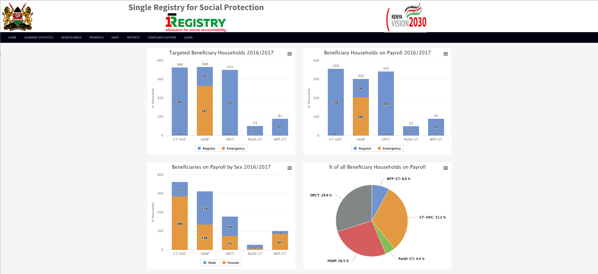

### Data security and privacy

The Social Protection Secretariat has developed comprehensive data protection and sharing protocols. The NSNP data-sharing protocols have five purposes: (i) provide a framework for the secure and confidential sharing of information, (ii) ensure personal information is handled in a sensitive manner and only disclosed on a need-to- know and need-to-use basis, (iii) provide a basis for sharing anonymised data about an individual beneficiary or member without consent in a form where the identity cannot be recognised, (iv) create a transparent procedure to increase usage of the NSNP data to layer additional services to cash transfer beneficiaries, and (v) ensure that the rights of program beneficiaries, especially their privacy rights, are not infringed, as enshrined in the Kenyan Constitution and other international conventions. The data-sharing protocols are based on the Kenyan Constitution; Kenya’s Data Protection Act 2013; and other international conventions such as the Council of Europe Convention for the Protection of Individuals with regard to Automatic Processing of Personal Data, United Nations Guidelines Concerning Computerized Personal Data Files, OECD Guidelines on the Protection of Privacy and Trans-Border Flows of Personal Data, and Universal Declaration of Human Rights.

Summary and aggregated data on the programs that form the Single Registry can be accessed through a public portal. However, personal data and data on beneficiary household listing are accessed on a need-to-know and need-to-use basis. For all data requests, the applicants must assent to data confidentiality agreements that have specific guidelines on use and disposal of the data.

## Main challenges and lessons learned

The management of information for the different social protection programs in Kenya has been significantly improved since the inception of the Single Registry. Social protection programs in Kenya are better managed and operated, while the coordination, oversight and monitoring of the social assistance sector is made possible by the Single Registry. The Single Registry has enabled the government and other key stakeholders to conceptualise the programs in a clear and coordinated manner.

Key lessons from the implementation of Kenya’s Single Registry include the following:

* Approaches to developing integrated systems for information management should be construed more broadly as a policy tool. Kenya’s social protection policy underscored the need for the Single Registry and envisioned the set-up of individual programs with functional MISs populating the Single Registry
* Adequate investment should be made to deliver quality single registry design, based on needs assessments and feasibility studies (see also Annex 2) — both important for long-term sustainability
* The development of a single registry should be phased. Phasing helps ensure:
* ease of managing project sub-components
* incorporating lessons from previous phases in next phases
* less risk of failure and risk of overwhelming existing capacity
* ad hoc strengthening of business processes and systems.

The key challenges that have been experienced during the set-up include:

* Conceptualisation: at first, it was difficult to technically conceptualise how social assistance programs could be coordinated. Now the model is clear and logical, but it took a lot of assessment and thinking to get there
* Coordination: the Social Protection Secretariat had to undertake a massive task to actually coordinate individual programs to invest time and resources in an MIS. Now each social assistance program owns its own MIS and is a core part of the Single Registry. It works for all the actors involved
* Resources: in order to save time and money in the future, an up-front investment is needed. Over the years, various development partners have stepped in to support the government in making this happen.

The next stage in the development of the Single Registry will be to ensure that all program MISs can be managed at district level — through a web-based system — and that information on beneficiaries can be updated as close to real time as possible. The broader plan is to also bring on board other components of the social protection system such as the National Social Health Insurance scheme and the National Social Security Fund.

Case study 5: Turkey[109]

|  |
| --- |
| **Name:** Butunlesic (translated as Integrated Social Assistance System, ISAS)  **Overall classification:** social registry building on a virtual registry  **Data collection strategy:** combination of virtual data sharing from existing databases and on-demand registration (including home visits)  **Breadth of integration:** integrates data collection, eligibility determination and core services (e.g. payments, grievances, case management) across all social assistance programs (with data flows in both directions); integrates with other sectors (health and education primarily, including monitoring conditionalities); full integration with national ID database; some integration with social insurance (data acquired for eligibility determination)  **Depth of integration:** key objective is sharing data (two-way flow) to integrate service delivery across sectors and increase citizen focus  **Number of individuals registered:** 34 million (45 per cent of population, though access to selected data from any ID holder in Turkey is possible) |

Turkey’s Integrated Social Assistance System (ISAS) was launched in 2009 and finalised in December 2015. It is now in its ‘implementation and maintenance phase’. ISAS enables all social assistance processes (application, decision-making, payments, monitoring, accounting, case management etc.) to be carried out in an electronic platform. It is integrated with 22 public institutions via web service — meaning it shares many of the connotations of a virtual social registry — and incorporates further information from 1000 local social assistance offices, thus serving as a ‘poverty inventory’ (social registry), with socioeconomic data of approximately 34 million citizens.

Since its creation, several benefits have already emerged.

* For citizens
* Social assistance application process simplified: documents needed decreased from 30 to 1 (only identity card with Turkish ID number)
* Period for accessing assistance was reduced: time for application decreased from days to minutes; processing reduced from months to days
* Citizens can easily reach the latest information about their application (thanks to e-gov integration and SMS delivery service)
* Full automation of payments: direct and integrated transfer to bank accounts across programs using Social Assistance Card
* For the state
* Savings on time and resources in delivery of social assistance
* ‘Neediness situation inspection’ (eligibility determination) decreased from 15–20 days to approximately 1 minute
* Integrated processes/services: payments, case management etc. (economies of scale)
* Disbursement time shortened (time from application to payment)
* Other government institutions’ workload decreased (web access)
* Bureaucracy minimised and paperwork reduced: electronic record-keeping through ISAS saves the Turkish Government from processing approximately 5 million paper documents per month
* Efficient control and auditing mechanisms
* Misuses blocked and duplications avoided
* Reliable statistical information gathered

## Background

ISAS was launched in 2009 and was finalised in December 2015. It was created with the objectives of transferring all social assistance processes to an electronic platform; establishing a ‘social welfare’ and ‘poverty’ inventory (social registry); and establishing efficient control and monitoring mechanisms to ensure fair distribution of resources.

The development of the ISAS modules was slow and iterative, involving extensive user testing. In 2010 work started on the Conditional Cash Transfer Module. Two further modules were developed in 2011, four in 2012, four in 2013, two in 2014 and a final four in 2015. Overall, the program-specific modules were developed first and the integrated functionalities (e.g. External User and Communication Module for link to the e-government portal; Central Risk Assessment and Inspection Module; Decision Support System Module) were developed subsequently. This is shown in Table 15.

Table 15 Timeline for development of key ISAS modules

| **ISAS modules** | **In service** |
| --- | --- |
| Conditional Cash Transfer Module | 2010 |
| Social Assistance Module (Temporary Assistance Module) | 2011 |
| Accounting and Resource Management Module | 2011 |
| Human Resources Module | 2012 |
| General Health Insurance Module | 2012 |
| Cash Assistance for Widowed Women | 2012 |
| Disabled and Elderly Salaries Module | 2012 |
| Home Care Module | 2013 |
| Cash Assistance for Needy Military Families | 2013 |
| Project Assistance Module (Income Generating and Social Service Projects) | 2013 |
| Fund Committee and Directorate Module | 2013 |
| Employment Aid Module | 2014 |
| Inventory Stock Management and In-Kind Aid (for Disasters) Module | 2014 |
| External User and Communication Module (e-government portal integration) | 2015 |
| Central Risk Assessment and Inspection Module | 2015 |
| Decision Support System Module | 2015 |
| Case Management Module | 2015 |

### Programs supported

Turkey’s social expenditure as a percentage of GDP was 1.46 per cent in 2016. The main social assistance programs supported and managed through ISAS are:

* Conditional Cash Transfer Services: Aims to reduce poverty by making welfare programs conditional upon the receivers’ actions. The system only transfers the money to persons who meet certain criteria
* Social Assistance and Solidarity Foundation Services: Aims to help needy citizens with in-cash and in-kind assistance for food, clothing, shelter etc.
* General Health Insurance Income Test Service: Aims to determine the income level of households to provide health insurance to those who need it
* Widow Assistance Service: Aims to help widowed citizens with cash support
* Disabled and Elderly Assistance Services: Aims to help disabled and elderly citizens with cash support
* Soldier Families Assistance Service: Aims to help soldiers’ families with cash support
* Solidarity Foundation Project Services: Aims to support citizens to start businesses so that their need for social assistance is prevented.

## Institutional arrangements

Unlike many other experiences internationally, where the development of a solution for integration is outsourced to a provider company, in Turkey the full development of ISAS was undertaken by a project team within the Ministry of Family and Social Policy and by expert staff from the Research and Development Department of the General Directorate of Social Assistance and from the Scientific and Technological Research Council of Turkey.

During the project phase, 28 software engineers were contracted on a full-time basis, while 12 administrative staff supported implementation at central level. For the ongoing maintenance period six software engineers are still contracted by the ministry, with an additional four in house, supported by five administrative staff.

Institutional arrangements with a wide variety of other institutional actors across government (see below) were slowly negotiated over time, facilitated by the country’s overarching e-government framework. This was

achieved through extensive face-to-face meetings where project staff explained win–win aspects of data-sharing. Moreover, the project’s IT department gave support to other institutions’ IT departments. Following this process, official protocols and memoranda of understanding were signed.

## How ISAS is structured in practice

### Data sources and linkages

The primary data source for Turkey’s ISAS is the data obtained from 22 different public institutions through 111 different web services. Further data collection is then carried out by local offices responsible for social assistance administration. ISAS is therefore a virtual social registry (with information potentially available on all citizens) that performs additional data collection activities within social assistance applicant households in order to determine eligibility (becoming therefore a social registry). External stakeholders that share data with ISAS include:

* Ministry of Interior, Directorate of Civil Registration and Nationality (civil registry): addresses, copies of civil family registration
* Ministry of Labor and Social Security, Social Security Institution: employment status, short-term working allowance and job-loss compensation
* Ministry of Labor and Social Security, Public Employment Services: unemployment insurance
* Ministry of Finance, Turkish Revenue Administration: registration to tax system and running a business; owning a motor vehicle
* Ministry of Family and Social Policies, Social Services and Child Protection Agency; Directorate-General of Foundations: receipt of other social services
* Ministry of Education, E-schools: student enrolment and attendance information
* »Institution of Scholarship and Dormitories: scholarships
* Ministry of Health, Family Medicine Information System: examination tracking; benefit from health services
* Ministry of Defence and Ministry of Interior: information on soldiers and village guards
* Ministry of Environmental and Urban Planning: land registry and cadastre information (owning property)
* Ministry of Agriculture and Rural Affairs: plantation ownership information
* PTT Bank, Ziraat Bank: payment information and payment synchronisation for delivery of payments.

It should be noted that this level of virtual integration could be achieved in Turkey because of two important preconditions: first, the existence of a strong government focus on e-government; and second, the fact that each Turkish citizen has a national ID number assigned at birth — meaning this number can be used as a unique identifier to share information across databases. Importantly, this ID number is assigned to both nationals and foreigners and is essential for accessing any government service or exercising citizenship rights. For example, without an ID number it is not possible to go to school, access health services, work, own a house or car, vote or receive water or electricity.

### How data is collected and updated

As discussed above, the primary approach for data collection and updating is through virtual integration (interoperability) of existing administrative databases. However, this information is not sufficient for the purposes of determining means-tested eligibility for social assistance programs. For this reason, additional data is collected as a side-product of the social assistance application and registration process (through home visits and on- demand visits to local offices).

There are approximately 4000 social assistance inspection officers dedicated to household visits across Turkey. These officers work within the Ministry’s 1000 local branches, making approximately 3 million household visits per year. During these visits a paper-based household visit form is completed, and this is subsequently entered into the ISAS system by local office staff.

### How data is transferred

Data is transferred exclusively using web services. For example, data transferals between local branches and the ministry are made via a ‘secure tunnel’ and virtual private network.

### How data is processed and used for targeting

Each local branch has a decision body called a board of trustees. This board decides whether a household is eligible or not, based on the ministry-set eligibility criteria and the data collected. Grievances can also be made to this board or to a free-call centre. To control this process, local branches are audited by three different

institutions acting as inspectors. The ISAS system also automatically detects suspicious cases (e.g. households that have been deemed as eligible but do not fulfil the required criteria) and generates flags for ministry inspectors via a specially designed Risk Assessment Module.

Figure 18 Overall structure of ISAS



Source: Developed by author based on discussions with the Ministry.

Note: Boxes indicate databases; circles indicate MISs; bold lines indicate direct link (e.g. web service access); dotted lines indicate indirect link (batch process, CDs etc.); arrows indicate where information flows in one direction or two directions.

### How information is used

Data from ISAS is not only used for registration into and determination of eligibility for social assistance programs. A wide variety of other functions can also be carried out through ISAS, a characteristic that is rare in other social registries. These include:

1. Programme payments: ISAS has online integration with four different banks that carry out all the social assistance payments. For example, the standard payment process is as follows:
   1. Eligibility is decided by the local branch
   2. Eligible households are automatically added to payment lists
   3. Before payment, regular administrative queries are automatically processed by an ISAS batch process to control the updated status of each beneficiary
   4. A payment list is verified and closed by the system
   5. Each payment is calculated by ISAS and automatically transferred to the beneficiaries’ bank accounts
   6. ISAS regularly monitors delivery and payment status from each financial partner’s system, with status changes recorded to the ISAS database automatically
2. Case management: ISAS enables social assistants at local level to flag any issue that requires ad hoc case management — for example if there is violence against a woman in the household. The system automatically creates a ‘case’ and reports to the local foundation manager. The manager redirects the cases to the relevant institutions, and each institution can see its redirected cases through an e-government portal and make its own operations. When an institution makes an operation, this operation is synchronised to ISAS and foundation officers can see any changes on the case
3. Monitoring of conditionalities: ongoing monitoring of conditionalities is achieved by integrating ISAS with the health and education ministry MISs. This process is entirely electronic. For example, school teachers record their information on a daily basis. Each month’s total absences are then collected by ISAS before payment. If there is an absence above the predefined limit then that month’s payment is automatically cut off by the system.

Information collected by ISAS is also used for research and policy design purposes (using ad hoc pre-designed reports, a GIS visualisation system and simple business intelligence) and is further shared with citizens and other relevant institutions through an ad hoc e-government portal. ISAS has supported up to 4500 concurrent users and enables access to 10,600 users in total, including staff within 1000 local branches.

### Data security and privacy

A wide variety of strategies are used to ensure data privacy and security for ISAS. This is fundamental given the vast amount of information available through the system. User privacy is guaranteed through two-factor authentication via one-time password devices.[110] Communication security (discussed above) is ensured via the setting of a virtual private network among system users. System room security is guaranteed in several ways, including restricted access, retina scans and storing of devices in locked cabinets that open using fingerprints. To add to this, each operation within the system is logged on a system database and on a second database.

## Main challenges and lessons learned

Turkey’s ISAS is a great example of how building a social protection information system does not imply one ‘super system’ but creating an integrated framework: the key issue is to build databases that effectively ‘talk’ to each other (are interoperable). Of course, this achievement has been possible in a context that was ‘ripe’ and ready to accommodate such a virtual system:

* ISAS integration to 22 public institution databases via web service is a testament to the functionality of other government databases
* Turkey has an existing e-government platform, an important enabler of effective integration (though it has risks). For example, integration of ISAS with the e-government portal allows for exchange of data directly with citizens (by web and SMS), municipalities (pilot) and the Turkish Red Crescent (testing)
* Turkey’s comprehensive national ID system has provided a strong unique ID for integration.

ISAS is also testament to the important role played by political will in shaping the design of solutions for integration. From the very start, ISAS was intended as a tool to improve the active management, monitoring and control of 11 different social assistance services throughout their delivery cycle — empowering local actors while also maintaining a strong role at central level.

Importantly, this shared vision and strong leadership meant that the project for the creation of the ISAS system was also managed in an effective way:

* It had had a long-term perspective (five years) and a clear objective
* It chose to invest in in-house resources (capacity building and fewer risks, costs and time loss associated with tendering)
* It adopted an incremental, iterative and modular approach to development (meaning that any glitches could be addressed on an ongoing and user-tested basis)
* It built a community of practice that had a stake in the project through ongoing negotiations and face-to-face time spent with other contributing institutions.

Annex 2  
Question checklist: needs assessment and feasibility study

## Needs assessment — informing design

| **Component** | **Example questions (underlying question for each: How does this affect design choices?)** |
| --- | --- |
| **Broad social protection context[111] (policy and legislation)** | What is the national social protection policy? Priorities? Does this reflect plans for integration? How? What are the policy priorities in terms of integration (see Section 1.2)?  (Stakeholder mapping) Who is in charge of delivering social assistance and social security in country, at both central and decentralised level (primary users)? What other stakeholders are involved (secondary users)? Which further actors may have a stake (tertiary users)? What are these actors’ interests? What are their (information and management) needs that integration can help address? What resistance could be encountered?  What are the legislative foundations for social protection and for integration? What are the gaps?  What is the current degree of fragmentation or integration within social assistance and between social assistance and social insurance? What are the existing mechanisms for horizontal and vertical coordination?  What is the level of decentralisation? What capacity is there at local level? |
| **Broad e-governance context[112]** | Does a broader e-governance platform exist? Status? Institutional arrangements? Is there a government framework for ICT and interoperability? What is the main government ICT infrastructure?  What are the existing legal and regulatory provisions for information access, cyber security, data security, data confidentiality, privacy standards, personal data protection etc.? Are these sufficient?  What other government information systems could usefully share data (depending on objectives)? E.g. national ID, civil registry, employment and labour, tax system, social security, health, education, land titling, housing and other property etc. Are links with each desirable, and why?  Can the national ID be used as a unique identifier? E.g. what percentage of population has national ID; what information is collected; characteristics of those with no ID; other forms of ID; most common ID for low-income households; charges or fees for ID; accessibility of registry etc.? Advantages and disadvantages? If not, what alternative solution? |
| **Existing programs and their business processes** | What programs exist in country (objectives, budget, implementing agency, targeting criteria, coverage and plans for scaling up, benefits, key features, business processes, information management approach)?  Which of these can usefully be integrated? Along which dimensions (e.g. integration of registration / data collection, eligibility determination; or other systems too — payments, grievances etc.)?  Do programs’ current business processes need redesigning and integrating? How? |
| **Information requirements** | What are the specific information needs of all key actors (primary, secondary and tertiary — national and local, government and civil society, implementation and policy etc.)? Why are these needs important? How will this information be used? What is the order in terms of priority?  What data will be needed to feed into the core business processes supported?  Has the amount of data collected been limited by keeping data focused on core objectives and processes? |

## Needs assessment — informing design

| **Component** | **Question** |
| --- | --- |
| **Institutional capacity** | * Does existing legislation and policy adequately reflect the rationale and main objective pursued? If not, is there space for shifting policy in this direction? How? * Is there strong enough political leadership advocating for reform and coordinating institutional actors across the board? If not, how can this be garnered? * What other institutions will back the process? Who will oppose? How can each be influenced and brought on board? * Is there sufficient capacity to identify and cost potential options for integration, assess affordability and identify available financing options? If not, how could this technical support be achieved? * Is the existing governance structure strong enough to ensure vertical and horizontal coordination and lead development and management phases? If not, how could this be strengthened? |
| **Implementation capacity** | * What capacity is there at all levels of social protection governance to implement such a project? What are the gaps that need addressing (number and qualifications of staff)? * Is there in-house IT capacity that can be leveraged? If so, how will this be used? If not, how will external providers be managed? * Is there a network of staff at local level (e.g. social assistants) that can be called upon? How can these most effectively be used? * Overall, what are the proposed roles and responsibilities of various actors involved in setting up, managing and using the system? |
| **Infrastructure requirements** | * What are the hardware requirements of the proposed model? Do these respond to country constraints (durability etc.). Are these already available at all levels of governance or will they need to be procured? If so, how? Expected costs? * What are the telecommunication systems/network requirements? Do these respond to country constraints (availability of internet, power etc.)? What back-up options exist? |
| **Financial costs and sustainability** | * What are the estimated start-up costs of the proposed model (including hardware and training costs)? * What are the estimated costs of operating the proposed model (including staff requirements)? * Is an adequate source of funding guaranteed and sustainable over time? |
| **Intended users** | * How will the system ultimately be used? How can use be most effectively enhanced? |
| **Potential positive impacts** | * What are the expected positive impacts of the proposed system? How could these best be achieved? See list in Section 1.1 as an example. |
| **Potential negative impacts** | * What are the negative impacts and how can these be mitigated? E.g. privacy and security risks, excessive costs, unsustainability. |
| **Conclusions and recommendations** | * What are conclusions? * What are key recommendations? |

1. 1. In this paper, social protection includes non-contributory social assistance and contributory social insurance. However, evidence shows that many solutions for integration are mostly used to manage information for non-contributory social assistance.

  
2. 1. [See www.opml.co.uk/publications/news/workshop-integrated-data-and-information-management-social-protection-bridging](http://www.opml.co.uk/publications/news/workshop-integrated-data-and-information-management-social-protection-bridging) for more details and workshop materials.

  
3. 1. [The online community www.socialprotection.org/connect/communities/social-registries-and-integrated-miss-social-protection](http://www.socialprotection.org/connect/communities/social-registries-and-integrated-miss-social-protection) provides a platform for members to learn from each other’s experiences of designing and implementing social registries and integrated management information systems that support the delivery of social protection programs.

  
4. 1. SP systems have the potential for maximizing outcomes and impacts if they are conceived as integral components of national development and poverty reduction strategies, linked with complementary programs (e.g.: livelihood promotion, labour market and intermediation programs, food security programs, etc.) and macro policy determinants (macroeconomic stability, economic growth, etc.).’ Organisation for Economic Co-operation and Development (OECD) 2009.

  
5. 1. For example, see Kenya’s Hunger Safety Net Programme (HSNP) Phase 2 and Pakistan’s CDCP program. For more discussion on this topic see the comprehensive literature review at socialprotection.org/connect/communities/social-registries-and-integrated-miss- social-protection (Oxford Policy Management 2016). See also Section 4.2.7 and Box 11 on Pakistan

  
6. 1. Interoperability is a characteristic of a product or system whose interfaces are completely understood, enabling it to work with other products or systems, present or future, in either implementation or access, without any restrictions.

  
7. 1. A large whole-of-government information and communications technology system is unrealistic and risks being too complex to be useful. Instead e-government, for the purposes of this paper, means a set of policies and frameworks that ensure interoperability of multiple government sector systems and use of IT to provide services to citizens.

  
8. 1. This does not imply that other objectives are not valued by the proponents of one or the other; they may simply be given less priority.

  
9. 1. Literature describing individual country experience with integrating social protection information

  
10. 1. For example, Samson’s seminal manual on designing and implementing social transfer programs (2006) points to the advantages of a ‘single national registry’ such as Brazil’s Cadastro Único without questioning whether it is really single (it is not in the strict sense of the term, as it is not the only registry in Brazil) or which objectives such a registry can achieve. Castaneda and Lindert (2005) talk about a ‘unified household information registry’ (or ‘cadastre’), which includes all interviewed households. However, the word ‘unified’ can be misleading in this context: what is being unified and what is not? Villalobos, Blanco and Bassett (2010) discuss the benefits of ‘sophisticated MISs’ that can ‘integrate the management of social protection systems’, while Azevedo, Buillon and Irarrázaval (2011) — in the most comprehensive publication on the topic available in Spanish – talk about ‘integrated systems for social information’ (sistemas integrados de información social).

   
11. 1. This terminology is preferred as it ensures clarity and consistency with IT parlance. Another potential choice and effective synonym is ‘integrated system for social protection information management’.

   
12. 1. See footnote 11.

   
13. 1. This term has been borrowed from the business world, where it is defined as a ‘system that provides information that organisations require to manage themselves efficiently and effectively’.

   
14. 1. This is in line with recent practice within the World Bank’s Social Protection and Labour Delivery Systems Group. The author thanks the group, and in particular Kathy Lindert, for inputs into this report update. In the previous version of this report, this was called a ‘consolidated model’ (Barca and Chirchir, 2014). Other terminology used to discuss such models includes ‘central beneficiary database’ and ‘common beneficiary system’.

   
15. 1. When consolidating data from several existing programs, data on non-beneficiaries could also be consolidated. However, to date this has never been the case in countries following this approach to integration.

   
16. 1. Single Registry is the official name.

   
17. 1. In all the statements below the terms ‘not necessarily’ mean this can be achieved if explicitly pursued.
    2. It could be if 100 per cent of the population were beneficiaries (e.g. universal guaranteed minimum income).

   
18. 1. In Barca and Chirchir 2014 this was discussed this in Section 2.3.2 as the ‘centralised model’.
    2. In Barca and Chirchir 2014 this was discussed in Section 2.3.2 as the ‘program-centred model.’

   
19.
20.
21. 1. In all the statements below the terms ‘not necessarily’ mean that this can be achieved if explicitly pursued.

   
22. 1. Others have defined these as ‘federated databases’ or ‘co-databases’. Barca and Chirchir 2014 called this a ‘virtual consolidated model’.

   
23. 1. Universal programs are those that target anybody within a given demographic category (e.g. old age social pensions). These require less information as they do not require data for poverty targeting.

   
24. 1. It is important to note that in Turkey’s system the name itself reveals the importance of the software application component (it is primarily an information system, not a ‘registry’).

   
25. 1. This unique 13-digit identification number is generated for each Thai citizen when their birth is registered in the national civil registration database. National ID cards are issued to citizens when they reach seven years of age. Non-Thai residents and foreigners can be issued with ad hoc ID numbers.

   
26. 1. Available at socialprotection.org

   
27. 1. In cases of universal coverage, this grey dotted line would correspond to the outer green circle.

   
28. 1. In Section 2.3.2 discusses how virtual social registries source their data from existing administrative databases. This section discusses linkages beyond the simple sourcing of data to be used for targeting purposes (two-way flows; use of data for validation, accountability and planning).

   
29. 1. The World Bank’s full list includes 21 countries. This report also provides additional countries based on the author’s own assessments

   
30. 1. The amount of information available on each country’s experience was not sufficient to classify these explicitly.

   
31. 1. Interestingly, this is far lower than the number of beneficiaries registered for China’s Dibao program registry of beneficiaries, which comprehends 78 million households (Honorati, Gentilini and Yemtsov 2015) — representing, however, only 6 per cent of China’s population.

   
32. 1. Source: Interviews with Caesar Vundule and Carin Koster. The current estimate of South Africa’s population is 54 million.

   
33. 1. This is inherent in the design of all MISs, even in the business sector, where, by its very nature, information management is designed to meet the unique needs of individual institutions.

   
34. 1. This typology has evolved compared to the first version of this report, based on useful discussions and inputs from Kathy Lindert (World Bank) and workshop participants in Jakarta.

   
35. 1. This continuum, in practice, represents the natural trajectory that many MISs follow over the years due to increasing program demands (complexity of management), increasing external pressure to share data (given the high costs of collection) and political economy considerations. However, some countries may ‘skip a step’ in the process, for example consolidating social assistance programs with other sectorial databases without achieving full integration within the social protection sector.

   
36. 1. Databases here refers to databases that are not program MISs. These could include a country’s civil registry, tax registry, land registry etc.

   
37. 1. This includes defining information requirements for the social registry (and related questionnaire) and formalising the main procedures to establish the registry (Irarrázaval 2004).

   
38. 1. For example, the simple selection criteria for Cadastro Único and Bolsa Família (its main user) have greatly increased the transparency and therefore accountability of the registry process. The more complex the targeting criteria, the less easy the process.

   
39. 1. In Malaysia, the high turnover rate among officers involved in eKasih implementation was considered one of the biggest implementation challenges. Among the main reasons were promotion, relocation and retirement.

   
40. 1. For example, the literature studying failure of information systems in developing countries discusses how the success of data integration processes can be bolstered by ‘hybrid’ figures at central level who ‘understand both context, organization, and work processes of their sector and the role of information systems. As such, they can bridge the contexts and assumptions of both technical designer and business-oriented user’ (Heeks 2002). This hints at the important fact that creating a social registry is not a task that can be solely led by IT consultants specifically contracted for the task.

   
41. 1. A functional ID number is one that covers population subsets and is introduced in response to a demand for a particular service or transaction (such as voter registration) (Gelb and Clark 2013).

   
42. 1. This topic would require additional research.

   
43. 1. Since its launch in 2012, the CECAD has been upgraded several times. Currently (2016) it receives around 500,000 visits and a total of over 2 million queries a month.

   
44. 1. Providing identification responds to the question ‘Who are you?’. Providing authentication responds to the question ‘Are you who you claim to be?’.

   
45. 1. See also validation discussion in Section 2.4.3.

   
46. 1. Note that this does not provide authentication, unless biometric data is collected too.

   
47. 1. It should be noted in this context that several high-income countries, most recently France, have not allowed for integration across their civil registry and social protection system because of privacy concerns.

   
48. 1. Such a study would clarify objectives, benefits, costs and contextual constraints and set out a clear road map.

   
49. 1. See Gelb 2014 for more details.

   
50. 1. A controversial example comes from the Dominican Republic, where a program aiming to register poor citizens de facto stripped citizenship rights from many residents of Haitian extraction — see the International Justice Resource Center website.

   
51. 1. See for example Brazil’s ‘social identification number’ (unique number for each registered person).

   
52. 1. Note that cross-checks across databases using these algorithms as a unique ID are not 100 per cent accurate.

   
53. 1. When data from NADRA was cross-checked with the voter roll, it was found that this ‘included 15 million voters without identities; 9 million duplicates (some individuals had registered more than 23 times!); and 13 million invalid identities. These 37 million voters — nearly 45 per cent of the voter roll — were expunged from the system, with the aid of the Supreme Court to ensure that this was done in accordance with legal procedures. The voter lists were augmented with 36 million missing ID cardholders who became new eligible voters. These voters had received their ID cards in the last three years or had possessed ID cards earlier but were missing from the previous electoral rolls’ (Malik 2014).

   
54. 1. A full discussion on targeting is beyond the scope of this paper. It is treated extensively in the literature (Coady, Grosh and Hoddinott 2004; Castaneda and Lindert 2005; Slater and Farrington 2009). This paragraph is a brief overview of how integrated targeting is used in practice for individual programs.

   
55. 1. In some cases, the full dataset from the social registry is shared with user programs.

   
56. 1. The food, fuel and finance crisis that began in 2008.

   
57. 1. For example, data could be illicitly used for blackmail, identity theft, or marketing purposes.
    2. Article 17 of the ICCPR, which reinforces Article 12 of the Universal Declaration of Human Rights, provides that ‘no one shall be subjected to arbitrary or unlawful interference with his privacy, family, home or correspondence, nor to unlawful attacks on his honour and reputation’.

   
58. 1. States that are parties to other United Nations or regional instruments such as the ICCPR, the American Convention on Human Rights and the African Union Principles on Freedom of Expression should also take into account their international obligations in the implementation of their national social protection floor

   
59. 1. Recent research in Kenya showed that this was often not the case (APSP 2015).

   
60. 1. ISO/IEC 27001:2013 is an information security standard published in September 2013 by the International Organization for Standardization (ISO) and the International Electrotechnical Commission (IEC). Organisations that meet the standard may be certified compliant by an independent and accredited certification body on successful completion of a formal compliance audit.

   
61.
62. 1. Based on the design divisibility concept, meaning staff can learn from early, relatively small failures and not be overwhelmed by a single, whole-system design. ‘Where design comes as this single whole, “big bang” implementation, opportunities for local improvisation are reduced and risks of failure correspondingly increase’ (Heeks 2002).

   
63. 1. This is not only functional but also helps reduce design—actuality gaps (whereby the designer believes they know what is best without understanding the user context) and hard–soft gaps (between rationality of information system design and political and behavioural actualities of developing-country organisations) (Heeks 2002). According to Peterson (1998), this can be particularly important in weak African bureaucracies characterised by personal and not procedural authority, in which information systems fail primarily because they outstrip government staff capacity to manage and exercise their power. Moreover, it is particularly important to follow the iterative prototyping approach in lower income countries because (a) individual social protection policy and programs are still at a relatively early stage of development and are still evolving; (b) individual social protection programs require significant strengthening of business processes, financial management and M&E systems; and (c) social protection institutions have differing capacity to engage in the development, implementation and maintenance of sector-wide systems.

   
64. 1. This results in different sources citing different figures, showing the need for a costing study to systematise information on this topic.

   
65. 1. Estimated yearly running cost for support and maintenance for South Africa’s SOCPEN is approximately 37 million rand per year (2 million US dollars).

   
66. 1. ‘SP systems have the potential for maximizing outcomes and impacts if they are conceived as integral components of national development and poverty reduction strategies, linked with complementary programs (e.g.: livelihood promotion, labour market and intermediation programs, food security programs, etc.) and macro policy determinants (macroeconomic stability, economic growth, etc.).’ (OECD 2009).

   
67. 1. Note that most of these papers and report are available within the www.socialprotection.org online community of practice on integrated data and information management for social protection.

   
68. 1. The main sources for the information provided are the comprehensive World Without Poverty (WWP) series on Cadastro Único, available on the WWP website, together with the conference proceedings from Brazil’s 2016 international workshop on integrated data and information management (WWP 2016), and the UNDP-IPC 2016 paper on Cadastro Único (Direito et al. 2016). Much of the information used for this case study is also based on discussions and inputs from Jeniffer Carla de Paula, Denise do Carmo Direito, Natalia Massaco Koga and Elaine Cristina Licio, whom I warmly thank for their collaboration.

   
69. 1. Families that survive on a monthly income of up to one half of a minimum wage per person or on a total of three minimum wages per family.

   
70. 1. See for example Decree 6,135/2007 (regulates the Unified Registry); MDS Ordinance 177/2011 (defines procedures for the management of the Unified Registry; MDS Ordinance 10/2012 (disciplines the criteria and procedures for the provision and use of information contained in the Unified Registry).

   
71. 1. Now almost 14 million beneficiary households.

   
72. 1. This section is primarily based on the World Without Poverty publication ‘Stakeholders Responsible for Managing the Unified Registry’ (WWP 2016c).

   
73. 1. This database contains more than 230 million records of individuals and over 35 million legal entities (companies or institutions), documenting the development of employment contracts, payroll, and contribution amounts for each registered individual. It is the main registry that allows Brazilians to receive pensions, social insurance in cases of illness or disability, and several other types of pensions and social benefits.

   
74. 1. An example of the 2016 data collection form is available at wwp.org.br.

   
75. 1. For detailed information on CECAD, see wwp.org.br, the main source for this section.

   
76. 1. To fund activities related to the Unified Registry at the federal level, there is Budget Provision 6414. The purpose of this provision is to fund the planning, coordination, monitoring, support and maintenance of the registration of families in Cadastro Único, ensuring the quality of information and the uniqueness of records. In addition, Budget Provision 6414 aims to support the collection, updating and maintenance of the information that makes up the Unified Registry; achieve integration with other registration databases; and encourage the use of the Unified Registry by social programs of the federal government. There are two other budgetary provisions directly related to the Unified Registry: Provision 6524, ‘Concession, Arrangement, Maintenance, Payment and Termination Services for Direct Cash Transfer Benefits’, which comprises the services agreement with Caixa; and Provision 8446, ‘Support for the Decentralized Management of the Bolsa Família Program’, which is to strengthen shared management with states and municipalities through the transfer of financial resources based on quality indicators for municipal and state management.

   
77. 1. World Bank agreement ‘Bolsa Família Program’ and Inter-American Development Bank agreement ‘Social Protection System Support Program’.

   
78. 1. Much of the information used for this case study is based on discussions with Luis Alejandro Díaz and Verónica Achá from the Ministerio de Desarrollo Social and on a phone interview with Ignacio Irarrázaval, Head of the Public Policy Centre at the Pontifical Catholic University of Chile. Other resources include a book chapter co-authored by Irarrázaval with Francisco Covarrubias and M. de los Angeles Morande, ‘La efectividad de las redes de protección social: El rol de los sistemas integrados de información social en Chile’; a presentation by Chile’s ministry in April 2016 (see below); and the ministry website ‘documents’ section.

   
79. 1. The first version of the CAS was already developed in the 1980s.

   
80. 1. Translated, the first is ‘Form for Socio-economic Characterisation’ and the current version is ‘Social Protection Form’.

   
81. 1. See April 2016 ministry presentation from Brazil conference on integrated data and information management for the social sector.

   
82. 1. Planning ministry of the Government of Chile.

   
83. 1. The program also offers conditional cash transfers (Bono de Protección Familiar) for up to two years, an unconditional exit transfer (Bono de Egreso) for an additional three years, and more subsidies for particular categories of people within the household (for example, those under 18 years of age, those over 65 years of age and those with disability).

   
84. 1. Twenty-one home visit sessions are organised, with decreasing intensity after the first six months. The social worker and family members develop a strategy (‘contract’) based on a methodology that requires the family to meet 53 minimum conditions. These are grouped into seven pillars — health, work, education, family dynamics, housing, identification documentation and income (Taieb and Schmitt 2012).

   
85. 1. Social assistance, health, education, housing, family support services, drug prevention and rehabilitation, technical help for people with disability, and support for violent situations.

   
86. 1. The prioritised list includes 56 pathologies (see Covarrubias et al. 2011 for more details).

   
87. 1. This includes a system of scholarships and other support, such as for buying school materials and school meals.

   
88. 1. Created in 2008, these pensions are for those who are without a formal pension and belong to the poorest 40 per cent of the population. They cover both citizens 65 years of age and older and invalid citizens between the ages of 18 and 65 years.

   
89. 1. See ministry presentation from Brazil conference on integrated data and information management for the social sector.

   
90. 1. Includes methods for access and data transferral, level of access, obligations on how data is used, content and schedule of reporting.

   
91. 1. The definition of RSH provided by the ministry is: ‘RSH is a 4-part system consisting of (1) a functional data base and its platform, (2) support for the selection of beneficiaries of social benefits created by law, (3) technical assistance to the programmatic supply, and (4) control and monitoring processes’.

   
92. 1. Each of these institutions integrates multiple databases to the SIIS, depending on the key services they provide. For example, the National Corporation for Indigenous Development integrates nine databases and the National Agency for Schooling Support and Scholarships integrates 12 databases. For further details see pp. 27–28 in Covarrubias et al 2011. See also Oxford Policy Management’s poster from its 2015 Indonesia workshop (OPM 2015a).

   
93. 1. A web service is a method of communication between two electronic devices over the Internet. It is a software system designed to support interoperable machine-to-machine interaction over a network.

   
94. 1. Only nine of the 15 institutions access the SIIS through the internet.

   
95. 1. Covarrubias et al. (2011) note that ‘definition and design of the software and hardware components that are needed to implement and fully exploit such a system is not a minor task, not only because of the size of the system in terms of number of databases linked, number of users and types of transactions, but also because of the strategic importance of this information’.

   
96. 1. Information for the Indonesia case study was collected through (i) key informant interviews with staff at TNP2K, including a phone interview with Julia Tobias, who was formerly involved in setting up the country’s UDB (we thank all who participated in the study for their help); (ii) in-country mission by Richard Chirchir between 17 and 30 April 2016; (iii) a review of the relevant literature, including the TNP2K (2015) Unified Data Base Management Standards, available at www.socialprotection.org. The case study was primarily authored by Richard Chirchir.

   
97. 1. BISP’s poverty database in Pakistan includes information on 27 million households and 108 million individuals.

   
98. 1. ‘By using the updated data [of UDB], our poverty program can choose the right target with minimum data error and maximum benefit’ (Vice President Boediono in the opening ceremony of the Regional Development Planning Meeting).

   
99. 1. These objectives were also fully in line with World Bank recommendations: ‘the current non-unified collection of initiatives may not be the most effective way to protect households’ (World Bank 2012b).

   
100. 1. The National Socioeconomic Survey (Susenas) is conducted every two years.

    
101. 1. The Village Potential Statistics (PODES) provide information about village characteristics for all of Indonesia.

    
102. 1. For example, collecting data for the purpose of social protection provision could undermine the statistics agency’s perceived independence. Moreover BPS taking on additional data collection responsibilities presents a risk to the quality of core collections due to constraints on resources (e.g. overburdening of the BPS permanent and temporary field force).

    
103. 1. This is of course a controversial decision and Indonesia is the only country in the world where such an approach has been taken.

    
104. 1. This process, in practice, often results in distribution of less rice to a much higher number of households. For example, around 55 per cent of all Indonesians report receiving RASKIN rice, even though it is targeted at the poorest 25 per cent (see World Bank 2012c).

    
105. 1. The main sources for the information provided in this case study are WFP’s Complementary Initiative June 2015 ‘In Focus’ on the Single Registry; and a DFAT-promoted webinar hosted by socialprotection.org (and related presentation). The case study, which was authored primarily by Richard Chirchir, also greatly benefited from extensive inputs from Winnie Mwasiaji and Eva Mwangi from Kenya’s Social Protection Secretariat.

    
106. 1. National Social Protection Policy, p. 22.

    
107. 1. For OCPT, PwSD and CT-OVC (see below) ineligible households do not receive any other form of support. For HSNP, out of 374,000 registered in the program’s second phase, 100,000 are provided with regular and predictable payments, while 274,000 receive support during emergencies. There are plans to scope out how the Single Registry will report on both regular transfers and emergency transfers.

    
108. 1. Bill soon to be passed.

    
109. 1. This case study is based on discussions with Mehmet Çağlar Çinar and Mustafa Sencer Kiremitci from Turkey’s Ministry of Family and Social Policy and on materials presented during socialprotection.org’s webinar on Turkey’s ISAS and accompanying materials.

    
110. 1. USB-based tokens that generate new passwords each time they are clicked (based on a crypto algorithm and device and user-specific information).

    
111. 1. Primarily drawn from Leite et al. (2017).

    
112. 1. Primarily drawn from Leite et al. (2017).

    