

**Briefing**

Integrating data and   
information management   
for social protection:

Definitions, trends and best practice

#### Valentina Barca, October 2017

Given the ever-increasing focus on coordinating and harmonising social protection programs, aiming for a systems approach, countries have been exploring new ways to integrate data and better handle information to ensure that the right people are receiving the right transfer amounts at the right time. This briefing note summarises evolutions in this fast-paced field – including shifts in terminology and innovative best practice – and provides practical guidance for policymakers and practitioners grappling with the issue. The main findings are:

* Developing a social protection information system — one that enables the flow and management of information within the social protection sector and sometimes beyond – can ensure a more equitable, responsive and inclusive distribution of resources while also increasing efficiency and effectiveness of delivery and, most importantly, better serving citizens.
* However, several trade-offs, challenges and risks can emerge when embarking on such a process – which need to be carefully managed and addressed from the outset. These can include increasing costs and complexity, risks to data privacy and security, and risks of multiple exclusion from all social sector schemes.
* Moreover, the extent to which the benefits of information integration are felt greatly depends on the practical set-up for integration and on the ultimate use and quality of the integrated system.
* These opportunities and challenges are determined by country-specific objectives, as well as institutional, operational and technological considerations, which in turn determine the specific approach to integration. Depending on these, international best practice may not be appropriate in every instance. In fact, integrating data and information may not always be a social protection policy priority.
* Two main (and overlapping) approaches to setting up an integrated data repository for the social protection sector can be adopted by countries: **integrated beneficiary registries** (integrate information from existing program management information systems (MISs) to house comprehensive information on beneficiaries); and **social registries** (centralise collection and housing of data on potential beneficiaries to integrate the approach to registration and eligibility determination across programs). Social registries can also be operationalised as **‘virtual’ social registries** (these collect data primarily by ensuring interoperability of existing administrative databases through web service access).

Table 1  What type of integration can be achieved? Comparing social registries and integrated beneficiary registries

|  |  |  |
| --- | --- | --- |
|  | **Social registries** | **Integrated beneficiary registries** |
| **M&E and overview of beneficiaries across programs** | Only if registry receives data from program MISs | Yes |
| **Integrated process for eligibility determination across programs** | Yes | No (eligibility is determined at program level, then integrated) |
| **Integrating operations and services across existing programs** | Only if registry receives data from program MISs | Yes (if pursued as policy objective) |
| **Integrating policy across social protection sector** | Only if registry is linked to all social assistance programs, social insurance etc. | Only if registry is linked to all social assistance programs, social insurance etc. |
| **Integration with other sector MISs** | Only if application software enables this | Only if application software enables this |

* Each of these approaches has advantages and disadvantages, and can help to achieve different objectives of integration depending on their ultimate set-up. Table 1 summarises these.
* No matter which approach to setting up the data repository is selected, its full potential as an information system is only unleashed when it is used together with a software application that links it dynamically to other databases, systematically transforms data into information, and analyses and uses the information. For example, a system that guarantees full integration within the social protection sector and beyond, in accordance with the right to privacy, would establish a direct (web service) link – e.g. using each citizen’s national ID number as a unique identifier – to (a) all social assistance program MISs; (b) social insurance MISs; (c) any other relevant government MIS.
* An ever-increasing number of low- and middle-income countries is embarking on this process of integration, with different forms of social protection information systems already fully institutionalised in 30 low- and middle-income countries worldwide. Many of these are set up as social registries. An additional 31 countries are in the process of developing such systems. These integrated systems range greatly in their set-up, size, functions and levels of cross-sectoral integration. What matters is not their official name (which varies widely), but what they are set up to do: where the data is flowing to and from.
* When integrating information management in practice, a wide range of aspects need to be considered in order to develop a functional system, ranging across four pillars: policy and budget (e.g. whether investments are justified); administrative and institutional aspects (e.g. ideal institutional set up); operational and implementation aspects (e.g. how data should be collected, updated, linked and used); and technological aspects (e.g. hardware, software and data transfer).
* Several lessons can be drawn from countries’ experience of developing social protection information systems to date. Most importantly:
* Integration is mainly a policy issue requiring political and institutional arrangements rather than technical ‘fixes’. Successfully implementing such systems requires strong political commitment to integration within the social protection sector and beyond, as well as careful assessment of the country context and possible costs and trade-offs of centralising data and information management – primarily privacy concerns
* The policy drive towards integration has been very often dominated by a focus on consolidating targeting (registration and determination of eligibility) across several programs. While pursuing these objectives has been effective in several countries, it could be important to shift the main focus of integration towards better serving a country’s poorest and most vulnerable citizens throughout their life cycle.

## What is integration of data and information management in the social protection sector and why is it important?

Despite growing recognition that using data more systematically across social protection programmes can have extensive policy and operational advantages (See Box 1), the terminology used by individual countries and in the theoretical and grey literature on the topic is confused. The tendency is to use the same terminology (eg. ‘single registry’ – which has become a catch-all concept in this sector) when referring to systems that are radically different or to use different terminology when referring to systems that are overall quite similar. Whereas in fact what matters is not the name that a country calls its system, but what the system is set up to do: most importantly where the data is flowing from (e.g. where is it originally being collected and what other data sources is it drawing from) and to (e.g. who has access to the data and how).

In this note a social protection information system is the broader system that enables the flow and management of information within the social protection sector and sometimes beyond to other sectors. It is made up of:

* a data repository, such as a registry/database for storing and retrieving data.
* a software application that helps manage, link and process the data, transforming data into information and analysing/using the information (at program level these are referred to as management information systems, MISs).

It will also be sustained by a set of procedures for data sharing, most often using information and communications technology (ICT) and will ultimately be managed by qualified staff.

Each of these components can be operationalised in very different ways and the extent to which each of the benefits of information integration are felt greatly depends on this practical set-up for integration and on the ultimate use of the integrated system. For example, if data is not flowing back from individual programmes to an integrated data repository, an overview of who is receiving what will not be possible. Table 2 provides more examples.

It is evident that integration is mainly a policy issue requiring political and institutional arrangements rather than technical ‘fixes’, meaning that effective systems for data and information management cannot operate in a policy vacuum. In fact, the practical set-up of an integrated system depends on a country’s historical trajectory, context and key objectives being pursued through social protection policy in-country.

| **Box 1 Advantages and risks of data and information integration** |
| --- |
| Developing an integrated social protection information system serving the social protection sector has policy and operational advantages:   * Policy advantages can include a more equitable approach to distributing resources based on objective and comparable information; increased responsiveness and inclusiveness of interventions (potentially ensuring universal coverage), increased transparency and accountability (and improved ‘image’ of the Social Protection system); increased links to complementary services and sectors, and; increased knowledge on issues around poverty and vulnerability. * Operational advantages can include facilitated oversight of multiple schemes, reporting to policymakers, and ability to plan, model and test policy changes; decreased burden on staff (e.g. less paperwork) and on potential applicants (e.g. streamlined access to services); increased efficiency of delivery by avoiding duplication of efforts, enabling economies of scale, and ensuring better management of error and fraud, and; improved management, for example enabling beneficiaries to transition between schemes as their circumstances change and establishing more effective emergency responses.   However, several trade-offs, challenges and risks can emerge when embarking on such a process – which need to be managed. These can include:   * increasing costs and complexity (especially at the initial development stages) – calling for high capacity, strong policy leadership and institutional coordination * increasing risks to data privacy and security – misusing or losing information, potentially exposing households to further vulnerability * risks of multiple exclusion from all social sector schemes and systematic exclusion of certain types of households. |

## Two main approaches

### Integrated beneficiary registries

Integrated beneficiary registries integrate data from program MISs of several different schemes (see Figure 1). In practice, they provide a consolidated overview of data collected by different programs, focusing on beneficiaries alone (no information on potential beneficiaries is recorded). This approach is mainly adopted where the main objective of integration is to provide coordination and oversight. It can also be used to integrate selected operations and services.

While this is a low-cost approach that allows building on existing systems, it is important to note that the quality of the consolidated data is only as good as the data collected and processed by the programs (each of which will have its own process for registration, eligibility determination and updating). Moreover, because of their focus on existing beneficiaries, integrated beneficiary registries cannot be used for the determination of potential eligibility for programs. The best example of such a registry is Kenya’s Single Registry.

### Social registries

Social registries are databases of potential beneficiaries of social assistance. They differ from integrated beneficiary registries by centralising data integration up front and collecting data for a national database/register that is then drawn upon by specific programs (see Figure 1). Their primary function is to support and consolidate the initial social protection implementation phases of intake and registration. They can also support the assessment of needs and conditions for the purposes of determining potential eligibility for enrolment in selected social programs.

In some cases, and especially at their initial stages of development, social registries simply ‘piggyback’ on the data collection effort of the country’s flagship social protection program database, rather than start from scratch. Two of the most famous social registries worldwide are Brazil’s Cadastro Único and Indonesia’s Unified Database.

An advanced technical approach to developing a social registry is to source data by making existing government databases interoperable – i.e. ensuring that they can ‘talk to each other’ (share data) effectively. This is described in this briefing as a ‘virtual’ social registry, an approach that can be used by countries that have strong civil registry/ID systems and a favourable e-governance context and wish to have a comprehensive (100 per cent of population), cross-sector and proactive (linked to life-cycle events) overview of their population.

The amount of information consolidated based on this virtual integration is sufficient to determine eligibility for universal social assistance programs, as for Argentina’s child allowance and Thailand’s health insurance beneficiary registry schemes, but not for poverty-targeted programs. When this is the case, information from several sources is consolidated and further data is then collected in order to determine (targeted) eligibility for social programs (which requires additional information that is often not available from existing databases). For example, this is the case with Chile’s Registro Social de Hogares and with Turkey’s Integrated Social Assistance Information System.

Ultimately, a country’s solution for integration must be strongly linked to the country context. It does not matter whether the system is initially set up in one way or another – what matters is that the approach chosen responds to a country’s needs, is appropriate to its context and is affordable and sustainable. Table 3 presents some overarching considerations.

Table 2 How variations in operationalisation can affect outcome

|  | **Example variations in operationalisation** | **Examples of how outcomes may be affected** |
| --- | --- | --- |
| **Registry/ database (data repository)** | What percentage of population is in the registry | Affects: potential for targeting and for shock-responsiveness; use-cases for other sectors, etc |
|  | Whose data is in the registry (e.g. beneficiary vs potentially eligible) |  |
|  | What data is being collected and stored (e.g. what variables) |  |
|  | How data is being collected | Affects: exclusion and inclusion errors, ease of access, data quality, etc |
|  | How data is being updated | Affects: up-to-dateness and usability of data |
|  | What data sources are being used and how | Affects: data quality, cost/time of data collection, type of data available, etc |
| **Application software  (and procedures for data sharing)** | How data is managed | Affects: data quality, transformation of data into information and its ultimate use/usefulness |
|  | Whether data exchange is real time or not |  |
|  | Opportunities for data access at decentralised level and for external stakeholders (accessibility) |  |
|  | Level of security / data privacy guaranteed | Affects: overall accountability |
|  | How data is managed |  |
|  | Whether data exchange is real time or not |  |

## Unpacking the role of the software application

Moreover, integrated data repositories are just building blocks that help achieve integration. Their full potential as ‘information systems’ is only unleashed when they are used together with a software application that links them dynamically to other databases, systematically transforms data into information, and analyses and uses the information. This is sometimes forgotten. Table 4 outlines the advantages of data flow.

A system that guarantees full integration within the social protection sector and beyond, in accordance with the right to privacy, would establish a direct and two-way link to:

* all social assistance program MISs and related databases – to keep track of who is receiving what, potentially integrate selected services, and enable adequate M&E and planning
* social insurance MISs and related databases – to ensure a life-cycle and comprehensive approach to social protection
* any other relevant government MISs and related databases (e.g. civil registry, tax authority) – to collect and cross-check data, enhance accountability, and enable a comprehensive approach to social policy planning.

This can only be achieved through a purpose-designed application software, ideally using each citizen’s national ID number as a unique identifier (though integration is also possible without, as several countries have shown), allowing for instant access to up-to-date data, with information flowing in both directions — conditional on the permission level of each user. The overall solution would look like Figure 2.

Figure 1 Visualising different approaches to data integration

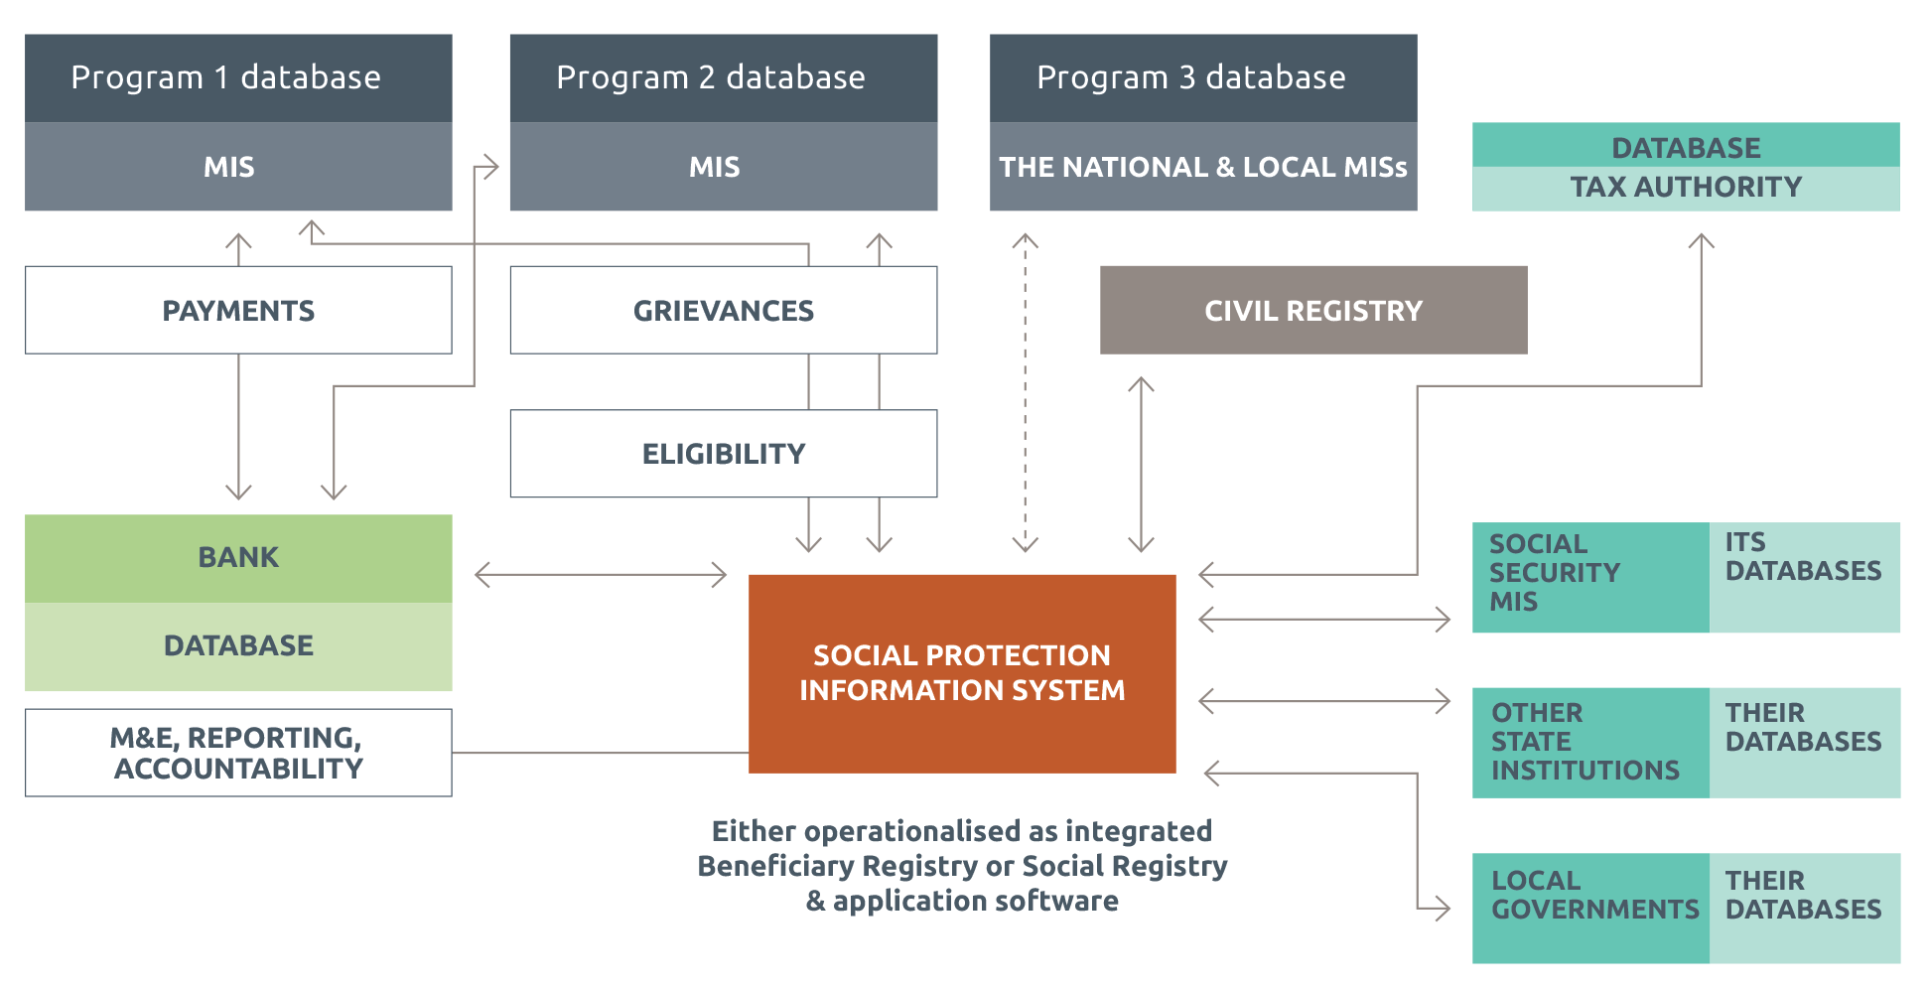

Source: Developed by the author.

Note: Boxes indicate databases; circles indicate MIS. All arrows have been portrayed as one-directional here (one-way data flow), though this is not necessarily the case. The transparent arrows behind each figure represent the direction in which it should be read.

Table 3 How context and needs affect choices

|  |  |
| --- | --- |
| **Approach** | **When most suited** |
| **Integrated beneficiary registry** | * Policy objective is M&E / overview of beneficiaries, planning and integrating operations and services across programs * Existing program MISs are high quality * Existing programs have reliable/strong approaches to registration, eligibility determination and enrolment (and re-registration) |
| **Social registry** | * High capacity and commitment at central level * Policy objective is integrating the process for intake/registration (and sometimes poverty/eligibility assessment) across programs * Resources and capacity are available for frequent national census survey registration (e.g. every two years) or on-demand registration, or a combination |
| **Virtual social registry** | * High capacity and commitment at central level * Policy objectives include integrating the process for intake/registration across programs * Evolved e-government and buy-in from other ministries and stakeholders * Web service access is ensured (broadband network, data standards etc.) * National ID system has extremely high coverage |

Source: Developed by the author.

## Conclusion

Overall, it is clear that what really matters when creating a social protection information system is the level of coordination and interoperability of the selected approach, not the creation of a super-sized, comprehensive social protection or government registry that encloses all others. There is no ideal model. What matters is that the system chosen responds to a country’s needs, is appropriate to its context and is affordable and sustainable.

The evidence shows that there are multiple advantages of integrating data and information management, especially if the overall policy environment is conducive to an integrated approach within the social protection sector and beyond. However, given the financial costs involved, it is essential that countries weigh costs and benefits of different solutions based on an assessment of their situation. Table 5 provides some guidance on the key issues to consider and evaluate.

Figure 2 Full integration of data and information management

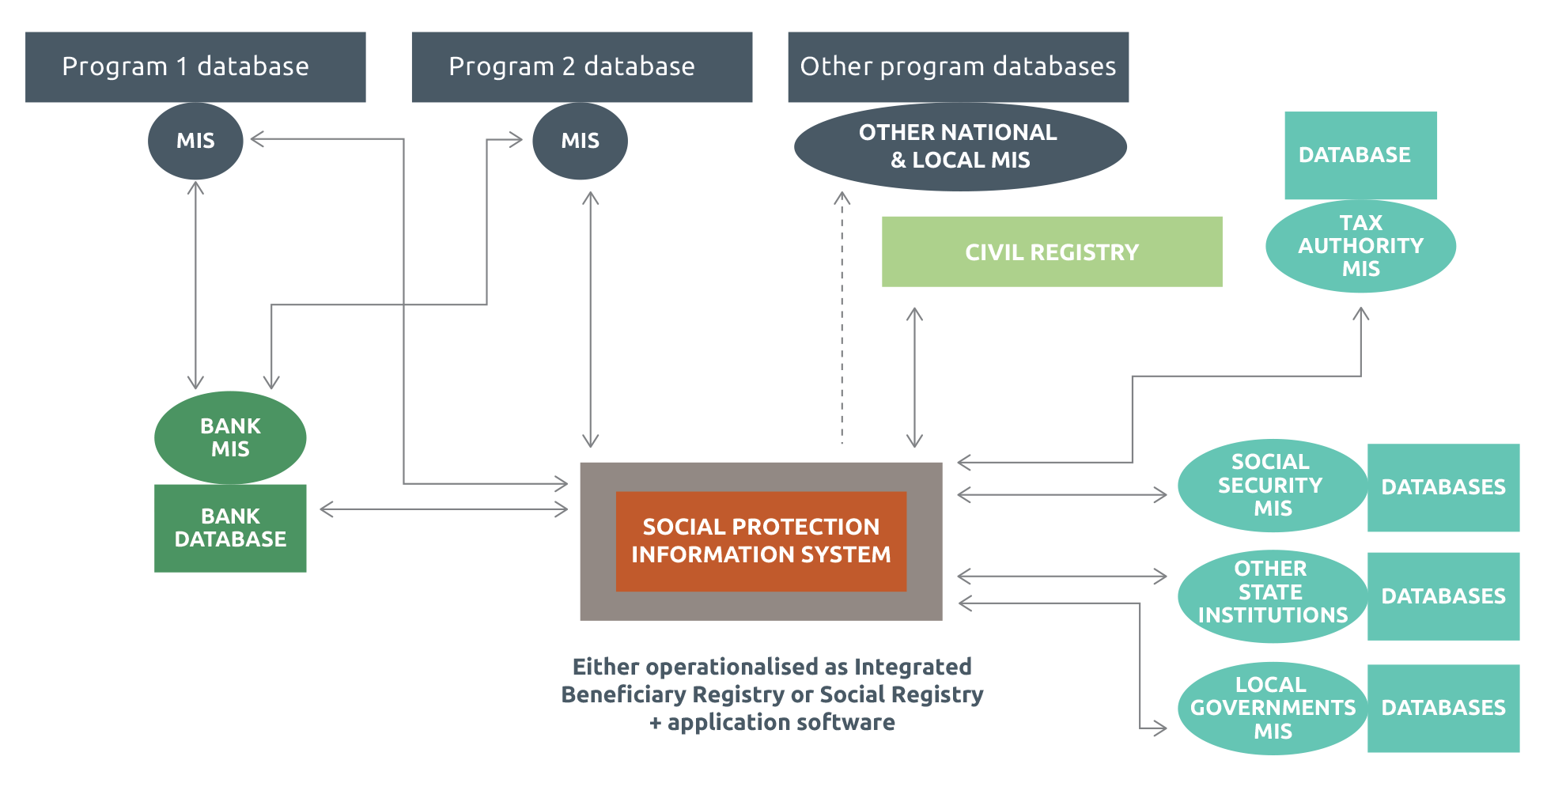

Source: Developed by the author.

Note: Boxes indicate databases; circles indicate MISs; bold lines indicate direct link (e.g. web service access); dotted lines indicate indirect link (batch process, CDs etc.); arrows indicate where information flows in one direction or two directions.

Table 4 Advantages of data flow from/to the social registry for selected stakeholders

|  |  |  |
| --- | --- | --- |
| **Stakeholder** | **Advantages of data flow from social registry to (…)** | **Advantages of data flow to social registry from (…)** |
| **National social protection programs** | * Programs can use data from the registry (and potentially national poverty index) to select their beneficiaries * Programs can benefit from further data integration established at national level (e.g. verifying data with civil registry) * Programs can be given access to integrated M&E information * Potential for integrating services across programs | * Registry continuously updated * Being able to keep track of who receives what * Integrated M&E across programs * Potential for integrating services across programs |
| **Civil registry and/or national ID number** | * Data collection effort for registry could help identify and register unregistered individuals | * National ID number acts as unique identifier and enables instant linkage with other government databases * Civil registry or National ID data can be used as an information base on all citizens (e.g. name, address), including notification of births and deaths * Authentication of registry data |
| **Bank or other payment institution** | * Potential for coordinating payments across different programs (economies of scale) | * Payment authentication and reconciliation across programs |
| **Tax authority** | * Tax authority could benefit from better understanding of poverty and social protection receipt | * Tax data can be cross-checked (e.g. to aid eligibility decisions and prevent fraud) |
| **Social security database** | * Better integration, coordination and planning across social protection and social insurance * Development of complementary packages targeted at social protection beneficiaries (primarily health Insurance) | * Social security data can be cross-checked (e.g. employment status and social insurance receipt to aid eligibility decisions and prevent fraud) * Better integration, coordination and planning across social protection and social insurance |
| **Health and education ministry MISs** | * Data from the registry can be used for sectorial anti-poverty policies * Better integration, coordination and planning across social sectors | * Integrated M&E across social protection and other sectorial programs (e.g. health insurance) * Health/education data could be used as information base for registry (education status, health status etc.) * Monitoring of compliance to co-responsibilities/conditionality (if any) * Better integration, coordination and planning across social sectors |
| **Other state institutions** | * Improved transparency and accountability (e.g. monitoring government projects, open data platforms) * Planning, coordination and mainstreaming of poverty eradication strategies | * Data can be used as information base for registry (e.g. land registry) |
| **Decentralised governments** | * Data from the registry can be used for local anti-poverty programs * Local governments can be actively involved in management of social protection | * Cross-checks and eligibility assessments * Better planning, coordination and implementation of social protection programs |

Source: Developed by the author.

Table 5 When is the development of an integrated social protection information system most feasible

| **Dimension** | **Key issues** |
| --- | --- |
| **Policy environment and budget** | * National policy focused on developing a systems approach to social protection (aiming to achieve coordination and harmonisation to fill coverage gaps and address the fragmentation that limits the effectiveness and impact of social protection policies and programs) * Integration of data and information management clearly articulated in national development plans, national social protection policies and strategies, and other strategic documents * Strong political leadership advocating for reform and coordinating institutional actors * Focus on ensuring political buy-in and ownership of all actors, including social partners and representatives of beneficiaries, by addressing advantages for each (e.g. through participatory planning process and stakeholder mapping) * Sufficient capacity to identify and cost policy options, assess affordability and identify available financing options * Budget availability (and policy support) to back the vision * Acceptance of slow, iterative process and failures |
| **Staff availability and capacity** | * Highly trained and qualified staff, motivated through a performance management system, and at a sufficiently high salary to guarantee retention — both at central and local level * Sufficient budget for continuous staff training and retention * Culture of sharing and problem solving, e.g. no resistance or complacency of staff wanting to keep the system as it is * Presence of ‘hybrid’ staff who understand the context, organisation and work processes of their sector and the role of information systems |
| **Governance and institutional structure** | * Existence or easy creation of an independent unit in charge of managing the new system at a sufficiently high government level to effectively coordinate with all stakeholders * Role of the integrated social protection information system and its managing unit embedded in legislation * Potential for strong institutional ties with other government bodies * Absence of parallel or competing structures for oversight of social protection policy (no power struggles) * Stakeholders clearly identified and their roles formalised through legally binding agreements, carefully designed incentives and mutually agreed terms of reference * Decentralisation approached as a resource rather than impediment, providing added value to decentralised government (tailored functionality and data sharing), involving local government and creating performance incentives |
| **Wider country context** | **Hardware (e.g. computers and server)**   * Adequate hardware available at local levels (these can be purchased, but this increases costs significantly) * Adequate servers — high-capacity computers — that can be scaled up to accommodate potential growth (e.g. a designated server room with reasonable physical and logical security that conforms to ISO 27001) * Stable provision of electricity   **Application software and database**   * (If needed) potential to create a large database that is scalable, flexible and performs well * Clarity of functional requirements and technical specifications at policy level. Key questions — such as purpose, benefits, hosting and nature of users — should be addressed at the feasibility stage and agreed by all stakeholders * Availability of capacity to support and administer the relevant software, database and network   **Transfer of data**   * Existence of a solid system for a unique ID for social protection (national ID or social security number) that can be used as a backbone to integrate data across sources * Ideally internet access at all levels of implementation, including local (to build web service access that greatly improves information flow) * Clearly documented protocols enabling quality controls on information before it is submitted over the internet or transferred by batch process * Adequate legislation and procedures ensuring data privacy and security |

Source: Developed by the author.