# technical assistance for education system strengthening (TASS), indonesia - SUMMARY document

**Investment Name: Technical Assistance for Education System Strengthening (TASS) – Indonesia**

**Start date:** *16 January 2017* **End date:** *15 January 2020*

**Total DFAT funding:** *AUD 11.98m* **Total funding from all donor/s:** *AUD 11.98m*

**Current program fund annual allocation:** *AUD3 million* **AidWorks investment number:** *70774/29*

**Overall Risk Profile**: *Low* **Risk** *Low* **Value** *AUD11.98 m*

**Concept approved by:** *Fleur Davies, Minister Counsellor* **Concept endorsed by AGB:** *FAS ACD*

**Quality Assurance completed:** *Appraisal by DFAT Education Adviser*

**Approval: Delegate at Post:** *Fleur Davies, Minister Counsellor***Delegate in Canberra:** *FAS ACD and CFO*

1. **Executive Summary**

Indonesia’s education system has made remarkable progress in recent years. Increased spending and a range of policy reforms have led to gender-balanced, near-universal school enrolment. Yet significant challenges remain. National test results and comparative international assessments of scholastic performance point to weak learning outcomes, the ramifications are which are felt by learners, households and ultimately the national economy. The impacts are shared unequally: the ‘learning deficit’ has a disproportionate effect on disadvantaged households and learners, including those with a disability and those living in frontier, outermost and remote regions.

The Governments of Indonesia and Australia are keen to facilitate incremental change by tackling the deep-seated policy, political and institutional constraints to improved learning for all. The three-year TASS facility represents a strategic investment in better state capability; one that supports domestic efforts to ‘nudge’ the sector towards improved policy and practice. By working with national-level policy-makers to support the emergence of a systems-focused approach to improving learning outcomes *for all*, the Governments of Indonesia and Australia wish to

* + improve the quality of teaching and learning in classrooms and schools (Goal 1); and
  + reduce the impact of regional, socio-economic, gender and disability-related disparities on teaching and student learning outcomes (Goal 2).

Guided by those high-level ambitions, TASS delivers low-cost, short-term catalytic assistance to key decision-makers. This extends from the provision of technical advice and trusted, yet independent support, peer review, and encouragement, to the the brokering of dialogue and collaborative engagement between sector stakeholders. Such support is intended to *contribute* to two changes in the sector landscape:

* + participating decision-makers within the Indonesian Government apply the policies, systems, processes, and programs needed to affect education reform (End of Facility Outcome 1); and
  + participating decision-makers within the Indonesian Government implement processes that help bridge the divide between policy and implementation (End of Facility Outcome 2).

While the EOFOs frame investment choices and ways of working, they are beyond the control or even direct influence of TASS. TASS is therefore expected to make a *significant contribution* to the attainment of three intermediate outcomes:

* + Participating decision-makers within the Indonesian Government draw on TASS support to improve the feasibility of policy implementation (Intermediate Outcome 1).
  + Participating decision-makers within the Indonesian Government make *conceptual use* of TASS-facilitated products and services (Intermediate Outcome 2).
  + Participating decision-makers within the Indonesian Government make *instrumental use* of TASS-facilitated products and services (Intermediate Outcome 3).

TASS is an *active participant* in the Indonesian education sector: it is variously a broker, a shaper, a disrupter and supporter of locally-led reform agendas. The flexible, agile and politically-smart facility enables the two governments to pursue their shared ambition to improve teaching and learning outcomes for all (the destination) while maintaining an open mind about the most appropriate reform pathways and the strategies (the route). This emphasis on partner ownership and leadership, flexibility, and thinking and working politically means that TASS should have an enduring influence on the thinking of its Indonesian partners and, where possible, on their organisational practices, ultimately increasing the impact of Indonesia’s public spending. TASS is therefore aligned with and is expected to make a meaningful contribution to the Australian Government’s *Strategy for Australia’s Aid Investments in Education, 2015-2020*, Australia’s *Aid Investment Plan – Indonesia, 2015/16 – 2018/19, DFAT’s Gender Equality and Women’s Empowerment Strategy,* and DFAT’s *Development for All 2015-20 Strategy.*

The facility is delivered by a commercial contractor (Palladium) appointed by way of a procurement agreement. It is governed by a Steering Committee that includes senior representatives of relevant Indonesian ministries, DFAT, TASS and TASS’s sister program, INOVASI. The Australian Embassy’s Human Development team, and specifically its Counsellor and the Manager of the Basic Education Unit, oversee the strategic and operational performance of TASS. They also lead strategic engagement, direction setting and policy dialogue with the Indonesian Government, supported both formally and informally by TASS.

TASS is implemented over a three-year period from January 2017 and is subject to a mid-point evaluation in 2018 and an end-point evaluation in 2019. DFAT reserves the right to extend TASS for a further two years (subject to demand, resource availability and performance). The budget for the first three years is A$11.98m

1. **Development Context**

Indonesia’s education system – the fourth largest in the world – has made remarkable progress in recent years. From an access perspective, net enrolment rates are over 80 percent in junior secondary schools and are near-universal and gender-balanced in primary schools. From a quality perspective, Indonesia has established minimum service standards and national education standards; introduced procedures for school and madrasah accreditation; established a system for school quality assurance; introduced continuous professional development for teachers, principals and supervisors; supported teacher up-grading and certification; and, most recently, introduced a curriculum that emphasizes “21st century skills”[1].

Yet **significant challenges remain**. Results from Indonesia’s *Asesmen Kompetensi Siswa Indonesia* (AKSI or Progressive Assessment of Student Achievement) show that about 75% of Grade 4 students perform poorly in mathematics and science[2]. While the literacy picture is comparatively positive, students in half of the provinces fail to achieve the minimum level of competency (see figure in Annex A). AKSI results are broadly consistent with the picture painted by the Programme of International Student Assessment conducted by the OECD. Compared to other countries (including Vietnam and Thailand), the quality of learning in Indonesia remains stubbornly low. Inevitably this has a knock-on effect on both secondary school exam results and the extent to which school graduates are equipped to participate in the labour market.

The **‘learning deficit’** has a disproportionate effect on disadvantaged households. The poor and marginalised typically receive an inferior education, reinforcing socio-economic disadvantage and restricting inter-generational social mobility. Only 31% of children with disabilities are enrolled in formal education across the country and when they do attend, most teachers and administrators lack the knowledge, skills, and facilities to support their learning[3]. More broadly, second graders in the eastern provinces of Nusa Tenggara, Maluku, and Papua are four times less likely to be able to read than the national average[4], and less than 1% of fourth grade students in West Papua have “good” competency in mathematics[5].

Indonesia’s upcoming *National Medium Term Development Plan for Education* (RPJMN, 2020-24) is expected to emphasize the role of “quality and competitive human resources” in driving national economic development. The Indonesian Government is therefore keen to explore **opportunities to** **address the drivers of poor performance** in the basic education sector[6]. These are many and complex but often manifest themselves in the variable quality of teaching in many classrooms, the complexities of planning, resourcing and delivering services in a decentralised environment, and the performance or otherwise of accountability and quality assurance mechanisms.

TASS works with national-level policy-makers to support the emergence of a **systems-focused approach to quality teaching and learning *for all***. Its investments are expected to generate particular benefit for primary and junior-secondary schooling (“basic education”) because of the pivotal role it plays in delivering downstream results in senior secondary education and beyond. However, as a systems-focused facility that operates within a complex and integrated education sector, some activities will necessarily have a sector-wide focus (e.g. support to the upcoming RPJMN) or will have bearing on other sub-sectors (e.g. early childhood, senior secondary).

TASS will be deemed a **success** when:

* + It is considered by the Ministry of Education and Culture (MoEC), the Ministry of Religious Affairs (MoRA), and the Ministry of National Development Planning (BAPPENAS) to be a valuable and respected source of technical assistance, knowledge and support.
  + It is trusted by the Indonesian Government to provide essential support to key national initiatives, including assessment reforms; curriculum reviews and improvements; education standards and quality assurance mechanisms; systems for improved teacher quality; and development of strategies for inclusive and equitable schooling.
  + Indonesian Government partners make use of TASS-facilitated products and services to develop and enact more effective policies, systems and/or practices that improve the quality of teaching and learning, and reduce the impact of disparities on learning outcomes.
  + It provides the Australian Government with regular access to senior government officials and advances Australia’s reputation as a trusted, long-term development partner.

TASS (A$11.98m, 2017-20) is one of four Australian Government-financed investments in Indonesia’s education sector. It works alongside:

* + The Palladium-managed,[*Innovation for Indonesia’s School Children*](http://www.inovasi.or.id/id/) (INOVASI, first phase, A$49m, 2016-19), which works in partnership with sub-national partners (e.g. schools, districts) to pilot school-level approaches to strengthen the quality of teaching and learning, particularly in early grades.
  + The World Bank-managed Trust Fund, [*Improving Dimensions of Teaching, Education Management, and Learning Environment*](https://www.worldbank.org/en/country/indonesia/brief/improving-teaching-and-learning-in-indonesia) (ID-Teman, A$9m, 2016-19), which provides research, analytical and advisory support to reforms in MoEC, MORA, and the Ministry of Research, Technology and Higher Education that will lead to more effective teaching and learning processes and the improved delivery of education for all.
  + The UNICEF-managed [*Rural and Remote Education Initiative for Papuan Provinces*](https://unicef-my.sharepoint.com/:w:/r/personal/krose_unicef_org/_layouts/15/Doc.aspx?sourcedoc=%7B73d643d7-1606-4c4b-965d-71624d0304f9%7D&action=default&gad=1221) (“The Papua program”, A$16.8m, 2014-19), which seeks to identify effective and sustainable approaches to improved learning outcomes in early literacy (grades 1-3) in marginalised and remote districts in Papua and West Papua.

TASS, INOVASI, ID-Teman and the Papua program assist the Indonesian Government to deliver national, sub-national and school/madrasah-level education policies, practices and systems that are more effective, inclusive and contextually relevant. Guided by DFAT’s active management, oversight and strategic shaping of its education portfolio, TASS liaises with its sister programs on both strategic and operational matters. It offers partners a vehicle to address missing links and opportunities across the Australian portfolio (subject to resource availability); pools resources, expertise and/or procurement channels with INOVASI; and elevates issues, lessons and successes emanating from INOVASI to a national level (where relevant). By **working in a coherent and complementary way**, TASS, INOVASI, ID-Teman and the Papua program seek to increase the effectiveness of sector expenditure and improve learning outcomes for all.

1. **Strategic Intent and Rationale (Why?)**

Australia’s *Foreign Policy White Paper* identifies Indonesia as a key partner within its immediate Indo-Pacific neighbourhood. As a long-standing bilateral partner and dynamic member of the G20, Australia supports Indonesia's efforts to tackle inequality and maintain social stability, promote tolerance and pluralism, and counter violent extremism. As Indonesia’s economy has evolved, so has Australia’s aid policy. In line with the Government’s *Strategy for Australia’s Aid Investments in Education, 2015–2020* and Australia’s *Aid Investment Plan – Indonesia, 2015/16-2018/19,* DFAT recognises that responsibility for improving education outcomes resides with the Indonesian Government. By delivering **catalytic assistance within a systems-focused approach**, TASS helps the Indonesian Government to tackle the stubborn and complex barriers to unlocking improved learning for all.

The TASS investment is aligned with, and is a key component part of, the *Indonesia-Australia Education Partnership – Sector Investment Plan, 2016-2020*. As a **strategic investment in better state capability**, it is regarded by both countries as an important enabler of Indonesia’s continued pursuit of quality education (SDG Goal 4), reduced inequalities (SDG Goal 10), gender equality (SDG Goal 5) and, ultimately, decent work and economic growth (SDG Goal 8).

The TASS investment, and the *Indonesia-Australia Education Partnership – Sector Investment Plan* more broadly, passes the **four aid tests**. A more prosperous and stable Indonesia is in **Australia’s strategic, security and economic interests**. However, this ambition will only be realised if the necessary human capital foundations are in place. International evidence shows that education is an important driver of increased household earnings, employment, and **inclusive growth and poverty reduction[7]**. TASS activities seek to **leverage** and ultimately strengthen the impact of the Indonesian Government’s public spending, while DFAT’s close cooperation with senior ministry-level officials further strengthens Australia’s reputation as a long-standing and valued partner in the education sector. As a ‘smart facility’ (see below), TASS embodies Australia’s commitment to the delivery of effective development assistance. It delivers **results and value for money** by adopting a strategic and politically savvy approach to planning and implementation. Its *modus operandi* is founded on thinking and working politically, and that allows it to invest in activities as targeted ‘small bets’, to adapt to changes in context, and to build on success while responding to areas of under-performance.

1. **Proposed Outcomes (What?)**

TASS supports the Indonesian Government to:

* + improve the quality of teaching and learning in classrooms and schools (**Goal 1**); and
  + reduce the impact of disparities on teaching and student learning outcomes (**Goal 2**).

Guided by those high-level ambitions, TASS wishes to *contribute* to two changes in the sector landscape. It wishes to see:

* + participating decision-makers within the Indonesian Government apply the policies, systems, processes, and programs needed to affect education reform (**End of Facility Outcome 1**); and
  + participating decision-makers within the Indonesian Government implement processes that help bridge the divide between policy and implementation (**End of Facility Outcome 2**, see the logic diagram in Annex B).

TASS undertakes a range of **activities** in the pursuit of the End of Facility Outcomes. Activities include:

* + delivering technical advice to key policy-makers, with a view to improving their understanding, navigation or resolution of issues of significance or emerging importance;
  + rapidly analysing issues of significance, with a view to informing and advancing policy dialogue;
  + brokering dialogue and collaborative engagement between ministries, departments and levels of government, with a view to nurturing ‘tailwinds’ for reform;
  + providing trusted, yet independent support, peer review, and encouragement to key decision-makers within the Indonesian Government, with a view to offering the necessary understanding, courage, credibility and/or legitimacy to pursue reform;
  + providing informal, on-the-job competency development to key decision-makers within the Indonesian Government, with a view to enhancing the capability – the ability – of the government to deliver its commitments; and
  + supporting the Indonesian Government to pilot activities that test new strategies for improved quality of schooling.

The activities result in a suite of tailored, context-specific **outputs** - knowledge, skills, products, and options - that are both politically informed and technically sound, and which ultimately better enable the Indonesian Government to address the:

* + drivers of poor teaching and learning (**Focal Area 1**); and/or
  + disparities in teaching and learning outcomes (**Focal Area 2**).

The outputs, when coupled with the effects of TASS’s ongoing policy engagement, are expected to lead to three **intermediate outcomes**:

* + Participating decision-makers within the Indonesian Government draw on TASS support to improve the feasibility of policy implementation **(Intermediate Outcome 1)**, by, for example, supporting ‘reform tailwinds’, creating space for new perspectives, and brokering dialogue and collaboration among relevant actors.
  + Participating decision-makers within the Indonesian Government make *conceptual use* of TASS-facilitated products and services **(Intermediate Outcome 2)**, such as when they table new ideas for discussion or seek to examine an old problem in a new way.
  + Participating decision-makers within the Indonesian Government make *instrumental use* of TASS-facilitated products and services **(Intermediate Outcome 3)**, such as when they argue for a particular course of action, including changes to policy, plan, budget or established practice.

Beyond its support to the Indonesian Government, TASS may be tasked to offer *ad hoc* support to the Australian Embassy as it coordinates and oversights its education sector portfolio. Subject to resource availability, support may include (but not be limited to) the contracting of TA and the organisation and management of seminars, workshops, conferences and capacity building activities.

TASS is delivered by a commercial contractor (Palladium) appointed by way of a procurement agreement. The facility-based delivery arrangement offers two advantages over other delivery approaches:

* + For the comparatively small **DFAT-facing component** of its work, a facility constitutes a responsive service delivery mechanism that enables DFAT to meet its administrative, procurement and capacity-related needs in a timely and efficient manner.
  + For the significantly larger **Indonesian Government-facing element** of its operation, a flexible, agile and politically-smart facility enables the two governments to pursue their shared ambition to improve teaching and learning outcomes for all (the destination) while maintaining an open mind about the most appropriate reform pathways and strategies (the route).

TASS’s ‘**value proposition**’ is reflected in its **way of working**. By having ‘tight ends but loose means’ – retaining line of sight on its ambition but being flexible in terms of what it does – TASS positions itself as **a ‘smart facility’**. It seeks to **think *and* work politically** (TWP) by:

* + Recognising that reform processes are inherently political, necessitating a focus on changes that are *desirable*, technically *feasible*, and politically and institutionally *viable*.
  + Seeking to understand and navigate individual and institutional values, interests, motivations and incentives.
  + Investing in ‘small bets’ – short activities with a low financial value – that serve to test and explore opportunities for reform[8].
  + Employing an evidence-informed and adaptive approach that is shaped by rapid learning and feedback.
  + Looking to identify and engage supporters and coalitions within the Indonesian Government, while collaborating with other DFAT-funded programs and development partners where there is merit.

In doing so, TASS supports domestic efforts to ‘nudge’ the sector towards improved policy and practice. From a DFAT-facing perspective, the delivery arrangements offer **value for money** because they are aligned with DFAT’s eight principles (e.g. see the emphasis placed on evidence-informed decision-making and experimentation in a complex political and institutional environment). From a Indonesian Government-facing perspective, the ‘smart facility’ arrangement and its focus on TWP permits delivery of support that is deemed by partners to have:

* + **Merit**, i.e. of having attractive qualities or attributes (e.g. because TASS delivers skills, expertise and experience that is otherwise unobtainable to the ministries).
  + **Worth**, i.e. of generating potential upsides that more than offset the time or money required of participating decision-makers before, during and after an activity.
  + **Significance**, i.e. of having importance (e.g. because TASS focuses on areas that attract greatest Indonesian Government expenditure or provides further momentum to ‘reform tailwinds’ or acts as a ‘disrupter’, creating space for and interest in new understandings of old or emerging challenges).

This emphasis on **partner ownership and leadership** means that TASS should have an **enduring influence** on the thinking of its Indonesian Government partners and, where possible, on their organisational practices[9]. By thinking and working politically and by building individual competencies and organisational capabilities, participating ministries should have improved adaptive capacity to navigate and adapt to shocks, stresses and opportunities in the political and institutional environment as they occur. This should mean that the policies, systems and processes supported by TASS will continue to deliver benefits once Australian funding finishes.

1. **Implementation Arrangements (How will DFAT engage in the partnership?)**

Governance and management arrangements

TASS and its sister investment, INOVASI, are framed by a Subsidiary Arrangement between the Governments of Australia and Indonesia. The Facility is governed by a joint **INOVASI-TASS Steering Committee:** an arrangement conceived to promote coherence and coordination of DFAT investments and the exchange of insights between participating decision-makers. The Committee provides strategic direction to TASS and is co-chaired by MoEC’s Secretary General and the Head of MoEC’s Board of Research and Development (or their delegates). Members include senior representatives of MoEC, MoRA, Bappenas, DFAT, INOVASI and TASS. The Committee meets six-monthly to set the course of direction and review progress (see Annex C for further description of roles and responsibilities).

A **managing contractor**, Palladium, was appointed to manage TASS following a competitive tender process in 2016. Palladium has responsibility for the day-to-day management of TASS, including the delivery of activities and the establishment and implementation of a monitoring and evaluation system. The Australian Embassy’s **Human Development team**, and specifically its Counsellor and the Manager of the Basic Education Unit, oversee the strategic and operational performance of TASS. They also lead strategic engagement, direction setting and policy dialogue with the Indonesian Government, supported both formally and informally by TASS. The **Indonesian Government**, and specifically participating decision-makers in MoEC, MoRA and Bappenas, are responsible for leading reform efforts with the active support of TASS and DFAT.

Senior DFAT and TASS staff (e.g. the Counsellor and Unit Manager, and Facility Director respectively) hold regular senior management meetings to discuss the TASS workplan, the status of current activities, and opportunities for future activities and strategic positioning. Insofar as possible, DFAT seeks to prioritise strategic management, policy engagement and flexibility over activity implementation and prescriptive contract management, while delegating an appropriate degree of responsibility for operational matters to TASS. DFAT and TASS both seek to navigate DFAT’s policies and processes such that they *enable*, not *constrain*, timely, flexible and adaptive programming.

While the INOVASI-TASS Steering Committee is responsible for setting the overall strategic direction, the TASS team has significant authority to determine how best to operationalise the strategy. The TASS team works with the Steering Committee, participating decision-makers within the Indonesian Government and DFAT to co-identify and develop new opportunities and, if agreed, to design, manage and administer activities that meet Australia’s quality requirements and the Indonesian Government’s expectations. In line with **DFAT’s *Public Diplomacy Strategy*** and TASS’s *Communications Plan,* DFAT and TASS actively look to inform and, where relevant, shape the understanding of reform-minded ‘policy entrepreneurs’ whose interests are aligned with the End-of-Facility-Outcomes and, more broadly, to inform the wider population about TASS and Australian development assistance more generally.

Identification, appraisal and implementation of activities

TASS is not a ‘responsive, demand-driven’ facility *per se* - it is not a passive recipient of requests or a sector-wide ‘enabling facility’ conceived to process activities and deliver efficiency gains. Rather as a ‘smart facility’ that seeks to think and work politically, **TASS is an active participant in the Indonesian education sector**: it is variously a broker, a shaper, a disrupter and supporter of locally-led reform agendas. As such, TASS seeks to apply processes that are fit for purpose and which meet the processual requirements of the Australian Government. Insofar as there is a typical activity, they are first screened and scoped, then designed, prepared and approved, and then implemented and followed-up (i.e. reviewed and assessed for necessary actions) (see Annexes D and E). Where potential activities first appear to be unstrategic in nature, TASS may have discussions with the requesting agency to better refine or reshape the request so that it becomes more transformative in nature. Funding decisions are taken by DFAT (in collaboration with TASS and within the parameters agreed by the INOVASI-TASS Steering Committee).

For DFAT-generated tasking notes, TASS develops an activity package that contains a Tasking Note and/or Terms of Reference for approval and, where relevant, a budget and/or procurement proposal.

Issues that may affect investment sustainability, i.e. the pursuit of ‘enduring influence’ .

The pursuit of systems strengthening is complicated and frequently complex. The [*Independent Completion Report of the Australia-Indonesia Education Partnership*](https://dfat.gov.au/about-us/publications/Pages/indonesia-education-partnership-completion-report.aspx) (2011-16) and a World Bank-funded *Review of Reforms/Projects in Basic Education in Indonesia, 1975-2015* found that capacity and technical knowledge are insufficient to tackle stubborn challenges. They also suggested that the relevance of inflexible and expensive programs can wane as priorities and policies evolve over time. By thinking and working politically, TASS moves political and institutional considerations from the risk matrix to centre stage. While vested interests, divergent needs and motivations, and changes in policy priorities may all affect the prospects of TASS having an ‘enduring influence’, the application of partner-led ‘small bets’, the appointment of well networked personnel, and the continued implementation of horizon scanning, rapid feedback and structured reflection points creates the optimal conditions for success.

1. **Monitoring and Evaluation (How will DFAT measure performance?)**

TASS’s approach to monitoring and evaluation is informed by DFAT’s *Monitoring and Evaluation Standards* and is aligned with the reporting expectations outlined in the Performance Assessment Framework of Australia’s *Aid Investment Plan (AIP) – Indonesia, 2015/16-2018/19*’s and, by extension, the *Indonesia-Australia Education Partnership – Sector Investment Plan, 2016-2020*.

The TASS M&E system seeks to generate timely, informative and practicable insights and recommendations (see Annex F for further details). Its primary intent is to capture and understand the **results stemming from individual activities** and the **aggregated effect of TASS’s activities and its engagement with government**. By doing so during the course of TASS implementation and at its end, key questions can be considered in a timely manner: *What happened? What does this mean? What now?* Given these ambitions and the very short duration of some activities, the M&E system monitors the performance of a *sample* ofIndonesian Government-facing investments (whereas TASS staff seek to track and interpret the performance of *all* individual activities in real time such that corrective action and informed decision-making may occur in timely fashion).

The EOFO-focused evaluative component – the mid-term evaluation in 2018, the end-point evaluation in 2019, and the periodic structured reflections from 2017 to 2020 – allows TASS and its partners to make *judgements* about the merit, worth or significance of TASS’s work. These judgements feed into discussions about strategic direction while meeting DFAT’s accountability-related reporting needs.

While all TASS staff have some responsibility for the quality and relevance of M&E outputs, responsibility ultimately resides with the TASS Facility Director and, for technical direction, TASS’s International M&E Specialist. Evaluations are led by the same International M&E Specialist: an ‘insider-outsider arrangement’ that offers some detachment and independence from the individual activities, while providing conditions for capacity building and the application of insights. The monitoring activities and evaluative studies employ **mixed-method approaches**.

TASS’s M&E activities have a dedicated budget of just over A$220,000. This covers the International and National M&E Specialists and their activities. The allocation represents less than 1.9% of the total facility value, although the real cost is slightly higher given that participation in M&E is built into all positions, from the Facility Director, Activity Managers, and Planning and Quality Assurance Manager to the STA.

1. **Gender, Disability and Other Cross Cutting Issues**

The *TASS Gender and Disability Inclusion Plan* (updated annually) is framed by DFAT’s *Gender Equality and Women’s Empowerment Strategy*, DFAT’s *Development for All 2015-2020* Strategy, and DFAT’s Education Sector Investment Plan’s *Gender Action Plan*. TASS is actively committed to:

* + supporting the Indonesian Government to enhance women’s voices in leadership and decision-making, and advancing outcomes for girls and women as actors and participants in education;
  + supporting the Indonesian Government to promote the needs of boys;
  + supporting the Indonesian Government to enhance the voices of people with disability in leadership and decision-making; and
  + supporting the Indonesian Government to identify and address barriers that prevent people with disabilities participating in and benefiting from education.

Its pursuit of these ambitions is framed by both its resource envelope (a constraining factor) and its sphere of influence within policy-making circles (a potential opportunity). TASS therefore seeks to:

* + mainstream **gender and disability inclusion** in each activity (e.g. at the screening stage and during implementation);
  + include gender and disability-related recommendations in each activity output (as appropriate); and
  + adopt an **advocacy and, where possible, data-led approach** to increasing interest in gender and disability inclusion, with a view to shaping understanding and attitudes, and ultimately to increase the likelihood that future changes in policies, systems and practices will benefit all.

Where feasible and should resourcing allow, TASS will undertake specific studies that address issues related to gender and disability in education (involving people with disability and disabled people’s organisations in the activity cycle wherever possible).

1. **Budget and Resourcing (What will it cost?)**

TASS commenced in January 2017 and will be implemented over a **three-year period**. The *Strategic Review of DFAT’s Education Sector investments (TASS, INOVASI, ID-Teman)* in late 2018 will, in part, inform DFAT’s decision as to whether or not to exercise the option of continuing the Facility for a further two years.

The budget for the first three years is **A$11.98m**. This includes program and facility costs, and management fees (see Annex G for more detail). The entire amount will be financed from DFAT’s own budget. DFAT’s budget will not finance physical infrastructure. The Indonesian Government contributes in kind through the provision of office space, personnel for participation in TASS activities, and co-funding of activities and events.

TASS’s way of working, coupled with the fluid political-institutional environment within which it works, means that budget planning and management is dynamic and complicated. TASS, DFAT and the Indonesian Government will regularly review the facility’s budget and expenditure position (e.g. in the Steering Committee and in ‘bilateral’ meetings). Insofar as possible, partners will seek to keep a proportion of TASS’s annual budget unallocated so that the facility can remain opportunistic and responsive.

In accordance with its head contract with DFAT, Palladium is required to recruit and manage both long-term personnel (e.g. Facility Director, Activity Managers, program management and administrative staff) and short-term advisors. The latter includes those on draw-down contracts (e.g. the Education Specialists) and those appointed for specific activities. To meet its obligations, DFAT requires a blend of technical, management and administrative staff to variously engage in policy dialogue, to manage the facility, administer contracts and agreements, and to monitor TASS’s performance.

Every six-months DFAT undertakes an Partner Performance Assessment of TASS. The results are used as the basis for contractor performance payments, with the six-monthly performance-related fee adjusted to reflect performance during the preceding six-month period.

1. **Risk Management and Safeguards (What might go wrong?)**

All parties recognise that reform processes are inherently political. By extension, development assistance that seeks to support changes to policy and practice carries some degree of risk, particularly where partners are seeking to engage in a catalytic and ultimately transformative manner.

As the guardian of taxpayers’ funds, DFAT’s Counsellor for Human Development (or his/her delegate) has overall responsibility for the performance of TASS. That includes the timely mitigation, management and resolution of facility-level risks and matters pertaining to the relationship between DFAT and its Indonesian Government partners. Notwithstanding, all three partners – DFAT, the Indonesian Government, and the TASS team – will actively identify, monitor and review risks on an ongoing basis and in line with their roles and responsibilities for the governance, management and implementation of the facility and its activities[10].

All activities implemented by TASS are required to meet **DFAT’s quality and risk management requirements**. TASS maintains a Risk Management Plan that draws on *DFAT’s Risk and Safeguards Assessment Tool* (see Annex H for headline risks as of early 2019). The Plan captures risks[11] - not just headline risks – pertaining to the operating environment, anticipated results (i.e. developmental risks), ‘sustainability’ (i.e. as they may affect the anticipated *enduring influence*), task implementation (i.e. delivery-related risks), safeguards (and specifically children, vulnerable and disadvantaged groups), and fraud and/or fiduciary risks. In addition, TASS remains cognisant of possible reputational risks to DFAT (and the Indonesian Government), escalating these where required.

TASS and DFAT share and update their respective risk registers at least quarterly, allowing for coordinated implementation of controls and treatments. Emergent risks are reported to DFAT as they arise and a management plan is agreed where appropriate. Risks are proactively managed through inclusion of controls and treatments in TASS procedures, templates, tools and practices. TASS formally reviews risks and the effectiveness of control measures as part of routine reporting, and it updates procedures, templates, and practices accordingly.

TASS activities may involve contact with **children and vulnerable and disadvantage groups**. In line with DFAT’s ***Child Protection Policy***, TASS has conducted a facility-level assessment of child protection-related risks. Mitigation measures are applied where necessary and all new staff and/or STA are required to complete child protection training as part of their inception program.

**Annex A: Snapshot of the Learning Challenge**

**Percentage of Children in Grade 4 Achieving at Least a Minimum Proficiency in Reading and Mathematics, 2016**

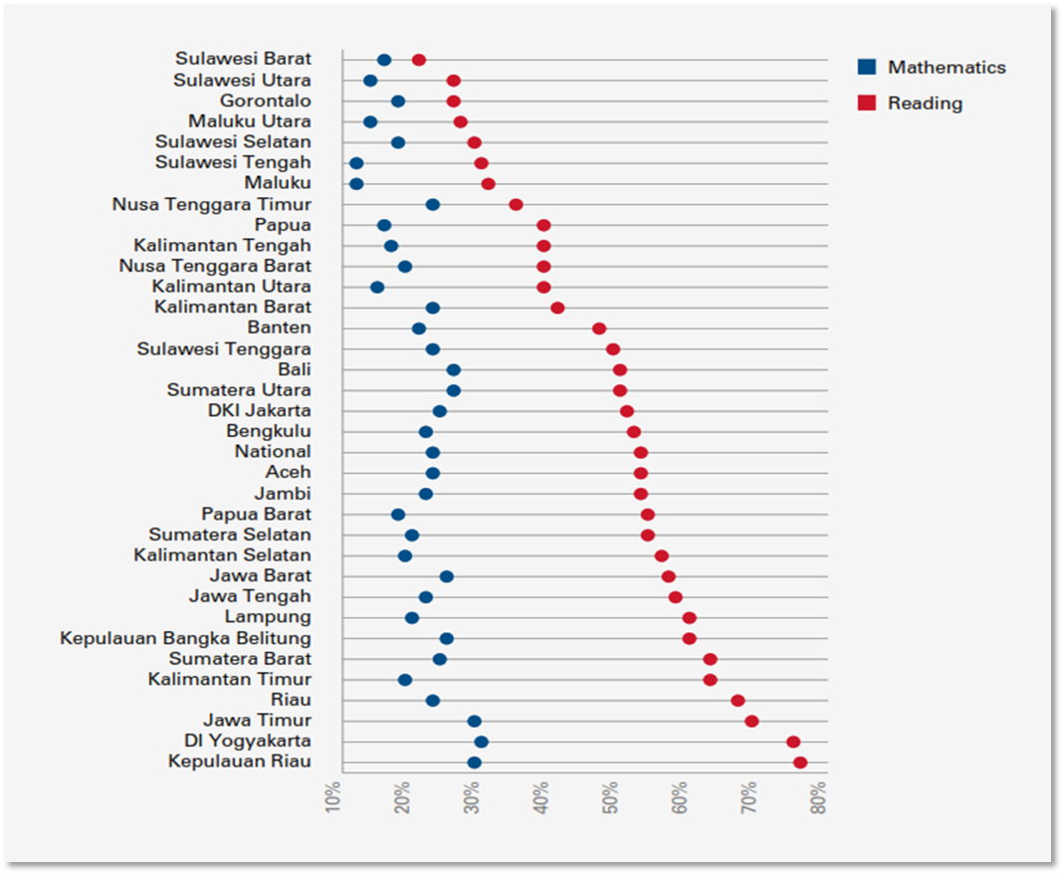

*Source: BAPPENAS/UNICEF. 2017. SDG Baseline Report on Children in Indonesia. BAPPENAS/UNICEF.*

**Annex B: TASS Logic Model**

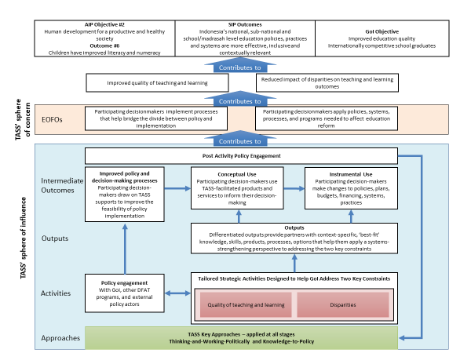

**Annex C: Roles and Responsibilities**

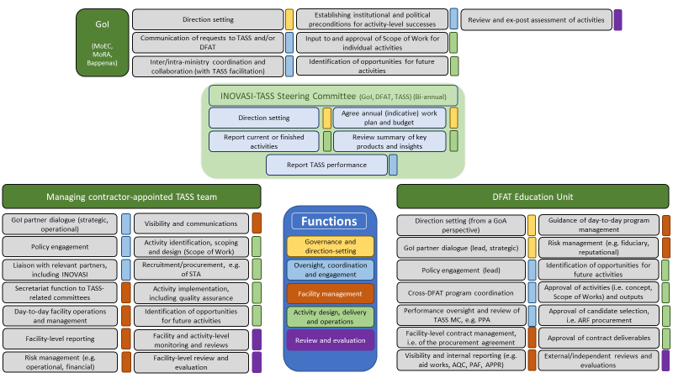

**Annex D: Activity Design and Implementation**

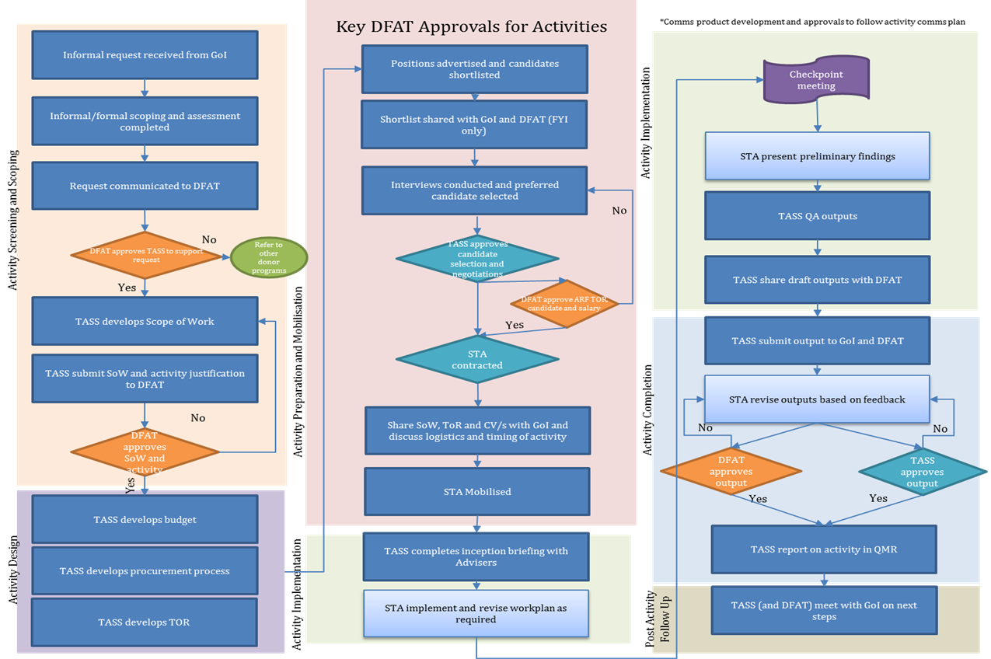

**Annex E: Activity Screening Matrix**

| **Factor** | **Indicators of low viability** | **Rating** | | | **Indicators of high viability** | **Justification for rating** |
| --- | --- | --- | --- | --- | --- | --- |
| **Low** | **Med** | **Hi** |
| **Area 1: THE PROBLEM to be addressed** | | | | | | |
| *Alignment* | *The thematic focus and/or requested activity/TA is outside the scope of TASS; the thematic focus and/or requested activity/TA is not in an area of DFAT/Australian comparative advantage[12]; the requested activity/TA has weak line of sight to TASS outcomes and objective; other partners or programs are better placed to assist the requesting agency* |  | ***x*** |  | *Fully consistent with the focal areas (constraints) identified for TASS; the requested activity/TA allows DFAT to draw on and showcase DFAT and Australian experience and expertise; the requested activity/TA has strong line of sight to TASS outcomes and objective; the request is consistent with the competitive and comparative advantages of TASS vis-à-vis other programs and partners; enables consideration of gender and disability-inclusion issues.* | [free text cell] |
| *The focal problem* | *The request lacks a clear problem focus; the problem analysis is shallow, e.g. it fails to uncover root causes or it mistakes symptoms for causes.* |  |  | ***x*** | *The problem is readily apparent and well-articulated; the problem is deconstructed to reveal its causes; the proposal does not conflate symptoms with root causes; the problem represents a performance shortcoming; the problem is penetrable, i.e. the nature of the problem allows real, sequenced, strategic responses by TASS and others - it can be broken down into manageable parts.* | [free text cell] |
| *Local ownership* | *The problem has been identified by an outsider; the performance shortcoming is frequently denied or ignored by key local actors; the problem is routinely accepted as normal and unavoidable or too difficult or risky to address.* |  |  |  | *The problem has been identified and defined by local actors; there is a specific problem that has grabbed the attention of key policy-makers; the existence of the performance shortcoming is widely accepted by local actors; the resolution of the problem inspires and encourages vision and action.* | Etc. |
| **Area 2: THE CONTEXT, i.e. the space for change** | | | | | | |
| *The political feasibility* | *No explicit consideration is given to the context within which the problem occurs; the extent to which the problem and its solution will have bearing on prevailing interests and incentives is overlooked; the problem feels too big and too thorny to make sense of; power structures (e.g. as manifested through resourcing decisions) are such that change will not occur.* |  |  |  | *Those who will be affected by reform or change accept the need for change and the implications of change; the problem matters to key change agents; there is robust evidence that they are actively searching for solutions; there is a clear sense of who cares about the problem AND who needs to care more AND how the activity will give the problem the attention it requires, paving the way for probable change.* |  |
| *The support base* | *Local actors show limited enthusiasm for the proposed activity; limited breadth of support; powerful agitators will probably disrupt to such an extent that progress will be stifled, with no feasible risk management/mitigation strategy open to TASS/GoI.* |  |  |  | *The network of stakeholders involved is well understood; the support base extends beyond the immediate proposer; coalitions of interested parties exist; the activity will engage with leaders and coalitions that have the interest, power and ability to influence change.* |  |
| **Area 3: THE TECHNICAL VIABILITY of the proposed activity/TA input** | | | | | | |
| *Quality of activity design* | *The request speaks to a solution, without paying adequate attention to the problem and its root causes; the proposed approach is inflexible, e.g. it does not easily permit timely withdrawal or scaling back if need arises; the request tackles symptoms or superficial causes, not root causes; more cost-effective measures exist.* |  |  |  | *The requested activity/TA offers a tailored response to a specific problem; the activity/TA represents one or more small experimental or incremental steps; the proposed approach is flexible, e.g. it easily permits timely withdrawal or scaling back if need arises, or modified, expanded or extended where there is merit; it is easy to routinely appraise progress and context; the proposed approach reflects the experience of positive deviants that are already working in the local environment.* |  |
| **Area 4: THE OUTLOOK, i.e. the prospects for change once the proposed activity/TA input is completed** | | | | | | |
| *Clarity of vision* | *No clear articulation of what will stem from the activity/TA (e.g. in terms of tangible behavioural change); the expected results are unrealistic, e.g. in terms of reach/scale, timeframe* |  |  |  | *Clear sense of the change that will occur because of the activity/TA and over an agreed timeframe, e.g. six months; the role of the activity/TA input within broader change processes is understood and is defensible, both technically and politically; the activity/TA input represents a progressive approach to tackling a performance problem; the expected results are realistic.* |  |
| *Dependency on other factors* | *Other activities must take place or changes must occur (e.g. to the regulatory environment) before the proposed activity is undertaken and for it to be successful.* |  |  |  | *There are no insurmountable ‘killer factors’ in the short- to medium-term that are needed to effect reform or policy change (legal, organisational…) and upon which the success of this activity/TA input is dependent; critical, practical building blocks and resources (e.g. time, money, skills) to deliver reform or change are present or in motion.* |  |
|  | *Overall rating (select one cell)* |  |  |  |  |  |
|  |  |  |  |  |  | Tick one |
|  | *Recommended action* | | | | *Recommend for support* |  |
|  | *Reshape request and reconsider* |  |
|  | *Refer to other support mechanisms (e.g. ID-Teman)* |  |
|  | *Recommend reject* |  |

**Annex F: A Summary of the M&E Approach**

Intent and focus

TASS distinguishes between those things it can control (i.e. its inputs, activities and outputs), those it can influence (i.e. the Intermediate Outcomes) and those it is interested in or motivated by (i.e. the End-of-Facility-Outcomes and the longer-term objectives) (see Figure 1). These distinctions are critically important because TASS cannot offer a suite of comprehensive activities that are sufficient to achieve the EOFOs; its mandate and footprint are too small to control or even *directly influence* the political-institutional trajectories of those Indonesian Government partners with whom it engages. Rather, TASS seeks to nurture the emergence of the necessary *preconditions* for meaningful change to occur.

*Figure 1: Line of Sight and Degrees of Accountability*

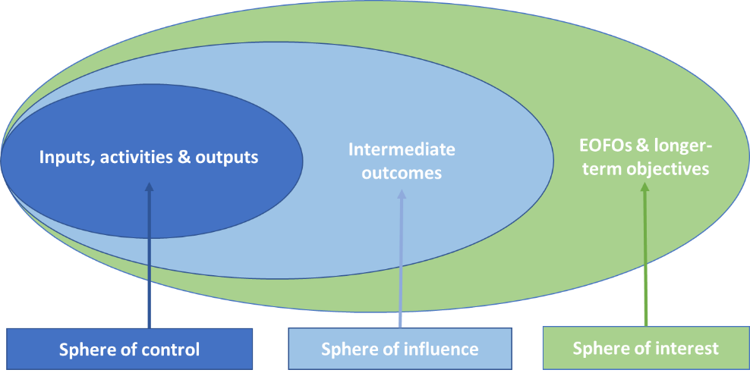

TASS’s M&E activities are intended to support and track the achievement of the facility’s Intermediate Outcomes and TASS’s contribution to the emergence of the two EOFOs. In some cases the cause-effect relationship will be known, though multiple interventions may be required by TASS and others to ‘nudge’ the system towards the desired ends. In other cases, a number of interconnected and interdependent variables will be at play, the drivers and trajectories of change will be uncertain, and a degree of experimentation will be required.

Performance monitoring and evaluation

TASS’s annual M&E Plan describes, *inter alia*, its Results Framework (including EOFO-level indicators, targets and means of verification), monitoring and evaluation plans, learning processes, and communication and dissemination strategies. TASS uses a mix of methods and tools to triangulate and interpret data, such as impact logs, tailored rubrics, and semi-structured interviews.

Activity-level monitoring has two distinct elements:

* + Routine *performance monitoring* by TASS staff to appraise the ongoing relevance, quality, timeliness, effectiveness, risk profile and future trajectory of individual investments, with a view to informing tactical and operational decisions as implementation proceeds.
  + *Evaluative monitoring* of a sample of activities by TASS’s M&E Specialists, to capture individual activity results and with a view to providing the building blocks necessary for the mid-point and end-point evaluations in 2018 and 2019 respectively.

The mid-term and end-point evaluations are framed by a set of key evaluation questions (see Table 1). The evaluations also appraise TASS’s Value for Money proposition in terms of its economy (or cost), efficiency, effectiveness and equity.

*Table 1: Framing Questions*

|  |  |
| --- | --- |
| Focus Area | KEQs |
| Impact | To what extent did TASS contribute to the reduction of the two key constraints?[13] Why or why not? |
| Effectiveness | To what extent is TASS achieving the desired outcomes (i.e. its intermediate outcomes and EOFOs)? Why or why not? |
| Relevance | How well are TASS activities and outputs meeting needs and priorities, and responding to changing circumstances? |
| Efficiency | To what extent is TASS targeting investments to activities that are likely to make the greatest impact? |
| Learning | What lessons can be drawn from the TASS experience? |

The mid-point and end-point evaluation studies draw on a modified success case method in which the evaluation deliberately examines the most and least successful activities in terms of the application of TASS’s expected ways of working. The two evaluations are led by TASS’s International M&E Specialist and National M&E Specialist (both of whom are on draw-down STA contracts for the duration of TASS). They are not involved in the design or implementation of the activities but their long-term involvement in the TASS facility provides a cost-effective approach to internal learning[14].

Beyond the evaluation studies, TASS nurtures evaluation-thinking culture by using and critically appraising program theory (e.g. in annual reviews), undertaking periodic reviews and reflective thinking after the completion of key activities, and sharing the learning that arises from the various M&E activities.

Given the complicated, often complex, nature of the change processes TASS supports, TASS does not collect baseline data in a manner akin to simple interventions where there are direct causal links. TASS’s mapping of sectoral priorities in 2017 and the scoping exercises for specific investments provide general descriptions of the ‘state of play’ in particular contexts. These can be used for comparative before-and-after purposes and are supplemented by theory-based (i.e. forward-looking) and/or case-centric (i.e. backward-looking) measures to understand the direction, extent and drivers of travel, particularly during the mid-point and end-point evaluations.

TASS M&E as an evolving practice

The TASS M&E Plan is a living document. The annual plans are adapted to reflect the evolving nature of the facility and the lessons learned through ongoing monitoring of activities and outcomes, and periodic reflection. Updates are captured and submitted to DFAT alongside the Annual Work Plan and are discussed with TASS stakeholders as and when required.

Standards

TASS’s M&E activities are guided by DFAT’s *Monitoring and Evaluation Standards* and the Australian Evaluation Society’s *Guidelines for the Ethical Conduct of Evaluations*.

**Annex G: Budget Summary**

|  |  |  |
| --- | --- | --- |
| Item | Maximum Amount Payable (AUD) | Notes |
| Management fees | 1,739,179 | Including monthly payments and provision for six-monthly performance-related payments. |
| Personnel | 2,621,532 | Includes long-term advisors (e.g. the Facility Director, Facility Manager, Planning and Quality Assurance Manager), short-term advisors on draw-down contracts, and staff undertaking financial and administrative functions. |
| Advisor Support Costs | 787,063 | Costs associated with the deployment of long-term advisors (e.g. mobilisation, demobilisation) and short-term advisors (e.g. airfares, hotel accommodation). |
| Operational Costs | 466,400 | Includes (but is not limited to) office rental and utilities, office maintenance costs, and IT equipment. |
| Program Activity Costs | 6,367,778 | Can only be used for implementation of activities approved by DFAT. Items include (but are not limited to) activity-specific short-term advisors, their support costs, and the holding of conferences and seminars. |
| Total Payment Summary  (excluding GST) | 11,981,953 |  |

**Annex H: Headline Risks (i.e. pre-control and treatment risk rating of *Moderate*, *High* or *Very High*)**

|  |  |  |  |  |  |  |  |  |
| --- | --- | --- | --- | --- | --- | --- | --- | --- |
| Risk event | Risk rating (pre-controls & treatments) | | | Headline controls & treatments | Responsibility (timetable) | Adjusted risk rating | | |
| Likelihood | Conseq. | Risk rating | Likelihood | Conseq. | Risk rating |
| Results-related risks | | | | | | | | |
| The broad emphasis on systems strengthening, coupled with any desire to generate benefits for all Director-Generals, leads to a portfolio of activities that lacks ‘shape’, focus and/or depth | Possible | Minor | Moderate | (1) The Steering Committee, DFAT and TASS to regularly review the current portfolio and pipeline for its strategic merit and direction; (2) TASS to regularly review the political-institutional landscape for opportunities and consider its portfolio and pipeline in light of any changes; (3) TASS to promote the merits of a structured work plan that focuses on areas where reform is most likely. | Steering Committee, DFAT & TASS FD  (Ongoing) | Unlikely | Minor | Low |
| Sensitivities within the Indonesian Government mean that DFAT is unable to publicly announce its contribution to reform processes, including policy change | Possible | Minor | Moderate | (1) DFAT and TASS to utilise their networks/relationships to identify any sensitivities and to discuss permissible framing; (2) TASS to identify innovative ways to increase understanding/awareness/visibility. | DFAT with TASS FD  (As required) | Possible | Minor | Moderate |
| Implementation-related risks | | | | | | | | |
| Opportunities to support reforms are missed due to budget limitations within TASS, i.e. demand outstrips supply | Likely | Moderate | High | (1) TASS, DFAT and the Steering Committee to regularly track and/or review expenditure patterns and budget availability; (2) TASS to apply screening guidelines to ensure, insofar as possible, that the most strategic activities are supported; (3) TASS, DFAT and the Steering Committee to review overall resource envelope as and when required; (4) DFAT, TASS, and GoI to maintain continuous dialogue about the most strategic activities within the budget availability | TASS FD/CR, DFAT & Steering Committee  (Ongoing) | Unlikely | Moderate | Moderate |
| DFAT lacks the necessary human resources to successfully fulfil its strategic engagement, policy dialogue and direction-setting roles | Possible | Moderate | High | (1) DFAT to actively delegate an appropriate degree of responsibility for operational matters to TASS, thereby freeing up resources to focus on strategic matters; (2) DFAT to appoint an in-house Education Advisor to the Embassy from Q1 2019 to undertake or assist with the undertaking of strategic matters. | DFAT Counsellor/ Unit Manager  (Ongoing) | Unlikely | Moderate | Moderate |
| TASS is unable to recruit suitable TA to meet GoI/DFAT needs | Possible | Minor | Moderate | (1) All parties to build in sufficient time for recruitment (where possible); (2) TASS to establish and maintain a pool of STA with relevant skills and experience; (3) TASS and the Indonesian Government to invest in task scoping, the identification of clear TA specification and realistic ToR; (4) TASS to provide early warning to DFAT and Indonesian Government where challenging recruitment is anticipated so that alternative routes can be explored and negotiated; (5) TASS to share vacancy announcements with INOVASI, the Palladium Education Practice Area, DFAT and relevant DFAT programs; (6) Advertisements to be placed on the DFAT AusConnect portal. | TASS FD /FM/TASM and Education Specialists with DFAT and the Indonesian Government  (Ongoing) | Possible | Neg. | Low |
| TASS cannot mobilise TA quickly enough to meet GoI/GoA timeframes and needs. | Possible | Major | High | (1) TASS to highlight the need for rapid TA mobilisation when submitting Tasking Notes, with TASS and DFAT to negotiate alternative recruitment processes where required; (2) TASS to draw TA down from its pool of pre-qualified STA; (3) TASS to inform and update the Indonesian Government about expected timeframes for TA mobilisation; (4) TASS to regularly check the availability of its pool of pre-qualified STA and refresh the list of experts as required; (5) TASS to identify potential TA candidates during task scoping such that candidates can be contacted and encouraged to apply when advertisements are placed. | TASS FD / AM /PQAM / TASM and Education Specialists  (Ongoing) | Possible | Negligible | Low |
| Operating environment-related risks | | | | | | | | |
| Indonesian elections and associated changes in personnel slow momentum and create delays | Possible | Minor | Moderate | (1) TASS and its partners to plan and schedule activities while remaining cognisant of likely changes and uncertainty. | TASS FD/CR & DFAT  (Ongoing) | Possible | Neg. | Low |
| Safeguard-related risks | | | | | | | | |
| Subcontracted institutions, NGOs, or other partners do not comply with DFAT Child Protection Policy. | Unlikely | Major | Moderate | (1) TASS to routinely review compliance with controls and update procedures and processes as appropriate; (2) DFAT to advise the Managing Contractor of any changes in its policy. | TASS FD/PM with DFAT  (Ongoing) | Rare | Major | Moderate |
| Fraud/fiduciary-related risks | | | | | | | | |
| Funds are not used for intended purposes. | Possible | Minor | Moderate | (1) Palladium to apply its policies and procedures: Code of Conduct, Whistle-blower Protection Policy, OHS Policy, Privacy Policy, Good Fame and Character Declaration; (2) TASS to apply its Fraud and Risk Control Policy (a part of the TASS Operations and Financial Procedures Manual); (3) TASS to apply appropriate checks and balances for procurement and financial management approvals as mandated by Palladium policy and guidelines and the TASS Operations and Financial Procedures Manual; (4) All TASS team members and contracted TA to read and sign the Palladium code of conduct, and to be trained in fraud, anti-corruption and Whistle-blower policies at induction and at least annually; (5) TASS senior managers to attend DFAT fraud control training whenever delivered in-country. | TASS FD, with PM and CR  (Ongoing) | Rare | Minor | Low |

Notes: FD = TASS Facility Director; FM = TASS Facility Manager; PQAM = TASS Planning and Quality Assurance Manager; CR = TASS Contractor Representative (i.e. within Palladium); PM = TASS Program Manager; TASM = Technical and Advisory Services Manager; AM –TASS Activity Manager

1. Which include, for example, literacy and numeracy, critical thinking, communication, and life skills.
2. 2016 figures. AKSI was previously called INAP or Indonesian National Assessment Program. The AKSI draws on the Trends in International Mathematics and Science Study (TIMSS) and Progress in International Reading Literacy Study (PIRLS) international assessment tools. It also draws on Australia’s National Assessment Program – Literacy and Numeracy (NAPLAN) tests but while NAPLAN is a census test (i.e. ‘whole of population’) AKSI is only a sample survey at this stage. In 2016 AKSI was administered to a nationally representative sample of 48,682 students in 1,941 schools from 216 districts/cities across Indonesia. AKSI is administered in Grade 4 and, more recently, Grade 8. The assessment includes three separate tests: Mathematics, Reading and Science. See Cislowski, H. 2018. *Situation Analysis Paper: Review of the System for* *Assessment of Student Learning and a Report of Learning Outcomes*. TASS; OECD. 2016. *PISA 2015 Results (Volume 1): Excellence and Equity in Education*, *PISA*. OCED; OECD. *Programme for International Assessment (PISA). Results from PISA 2015. Country Note. Indonesia*
3. DFAT. *Australia-Indonesia Education Partnership – Sector Investment Plan (ESIP, 2016-2020)*. (Draft v3.0).
4. <https://www.riseprogramme.org/news/evaluating-how-teacher-reforms-decentralised-indonesia-can-promote-learning-gains-rise> (accessed 25 February 2019).
5. <https://puspendik.kemdikbud.go.id/inap-sd/kategori> (accessed 25 February 2019).
6. See TASS. 2017. *Mapping Education Sector Priorities. Final.* (06 June 2017).
7. See Hanushek, E.A., Wößmann, L. 2007. “The role of education quality in economic growth”, *Policy Research Working Paper 4122*. World Bank; Klump, R., Cabrera, C.A.M. 2007. “How can education contribute to pro-poor growth? Policy implications for financial cooperation”, *KFW Discussion Paper 49*. KFW; World Bank. 2018. *World Development Report 2018: Learning to Realise Education’s Promise*. World Bank.
8. As or if some of the small bets gain traction TASS may support supplementary activities that assist the Indonesian Government to take the necessary next steps. Such activities are also short-term (e.g. up to six-months) but where they are slightly longer term (i.e. up to 12 months) TASS undertakes periodic informal and formal monitoring and evaluation to continually revise and sharpen the activity and mitigate risk of substitution.
9. TASS uses the term “enduring influence” rather than “sustainability”.
10. DFAT, for example, will proactively address any risks that might inhibit the timely approval and implementation of activities.
11. Where possible, TASS, DFAT and the Indonesian Government will apply a principle of proportionality, i.e. the investment of time and effort will be proportional to the degree of risk in play relative to the potential upside of the investment. Headline risks are therefore those that require careful and ongoing management.
12. A request that falls outside DFAT/Australian comparative advantage will not be eliminated if it rates poorly against this factor.
13. i.e. the drivers of poor teaching and learning (Focal Area 1) and/or the disparities in teaching and learning outcomes (Focal Area 2).
14. DFAT has recourse to its Office for Development Effectiveness and an in-house M&E adviser as part of its quality assurance system. It can also outsource independent reviews and evaluations to external contractors.