2019-20 INDONESIA development program progress report

|  |  |
| --- | --- |
| **Program Budget** | **2019-20 Budget Estimate ($m)\*** |
| Bilateral | 255.7 |
| Regional | 25.3 |
| Global | 12.8 |
| Other Government Departments | 4.7 |
| **Total Australian ODA to Indonesia** | **298.5** |

* Actual expenditure is expected to be available in December 2020

Infrastructure and trade – 25%
Agriculture, fisheries and water – 10%
Governance – 25%
Education – 27%
Health – 3%
Building resilience – 7%
General development support – 3%
Due to rounding total percentage may not add up to 100 per cent


**COVID-19 Development Response**

* COVID-19 has been having a significant impact on the lives and livelihoods of Indonesians, especially the most vulnerable. After a decade of solid growth, Indonesia has been experiencing negative growth in 2020. The World Bank estimates a further 8 million people are likely to fall back into poverty. With health resources diverted to COVID-19, existing health challenges could deepen.
* Australia has been supporting Indonesia with its immediate response, providing AUD 79 million through the pivot of existing activities and a number of new initiatives to support Indonesia’s immediate health, humanitarian and economic response.
* Through policy advice, Australia has been supporting Indonesia manage the economic response to the crisis. This included advice on stimulus measures, budget prioritisation, debt management, addressing revenue shortfalls and financial stability.
* Australia has also provided specialist advice to Indonesia’s National COVID-19 Management Taskforce to support its work overseeing the pandemic response.
* Australia has supported Indonesia to build stronger systems to respond to public health threats, promote vaccine development, and provide essential medical equipment to frontline community health services.
* Australia supported Indonesia to expand its social safety net, which includes rapid financial and food assistance, and subsidised electricity to vulnerable communities.
* Australian assistance for women - who represent the bulk of healthcare workers, and have experienced an increase in domestic violence – has supported access to essential health and reproductive services, social assistance and alternative livelihoods, and justice and domestic violence support. Australia has also been supporting data collection and analysis to help better understand the gendered impact of the pandemic, particularly on women's ability to participate in the economy.
* Australian support has been helping Indonesia’s economy to move safely. To ensure the infrastructure and transport sectors can continue to employ workers and move people safely, Australia has helped develop COVID-safe guidelines for public works and public transport.

**Other program highlights**

* A state visit to Australia by President Joko Widodo in February 2020 underscored our strong relationship as neighbours, friends and strategic partners. The Indonesia-Australia Comprehensive Economic Partnership Agreement (IA‑CEPA) entered into force on 5 July 2020 and is supported by a comprehensive Economic Cooperation Program to help take advantage of the agreement.
* Australia helped cushion the economic impact of COVID-19 on Indonesia’s small businesses and households through policy advice on how to target newly vulnerable groups.
* Australia supported Indonesia to strengthen infrastructure planning and delivery, which resulted in the Indonesian government committing its own state budget to scale up the successful use of performance-based funding for water infrastructure to cover road improvements in strategic tourism areas.
* Indonesia has been taking steps to boost employment and attract investment through a draft *Omnibus Bill on Job Creation* (targeted to be enacted in 2020). Australia has been providing advice on the legislation and helped Indonesia with complementary reforms including streamlining business licencing.
* Australia supported Indonesia to provide healthy food to families through an expansion of its Basic Foods Program to over 15 million households by December 2019 and a more nutritious food menu. Australia also supported Indonesia with innovative cash transfers to improve nutrition outcomes of indigenous Papuan children under four. Our nutrition investments have assisted in reducing stunting of adolescent girls.
* Australia supported Indonesia to deliver quality education and improved student learning outcomes. Our support contributed to the inclusion of student-learning targets in Indonesia’s national medium-term development plan 2020-2024, for the first time.
* Australia and Indonesia continued to work together to combat shared regional security threats, including counterterrorism. Working through civil society organisations, Australia assisted Indonesia with the *Government Regulation on Prevention of Terrorism Acts*, signed by President Widodo in November 2019. The Regulation enables national authorities and non-state actors to work hand in hand on terrorism prevention efforts to address national security and human rights concerns.
* Australia supported the amendment of the Marriage Law to increase the legal age of marriage for girls from 16 to 19 (in line with the age for boys), and development of *Indonesia’s National Strategy for Child Marriage Prevention.*
* Australia worked with Indonesia to develop regulations so that people with disability have access to social protection and the rehabilitation services that they need. We fostered increased policy dialogue on the need for social pensions for the elderly and people with disability.

## Progress against 2019-20 performance indicators

| **strategic OBJECTIVE** | **Performance assessment framework indicator/ benchmark** | **Brief summary of progress against indicator/benchmark** |
| --- | --- | --- |
| Objective 1. Effective Economic Institutions and Infrastructure | * 1. indonesia’s second tax expenditure report expands in coverage and improves in examining tax exemptions.   2. 1.2 aud 1.5 billion in additional financing is leveraged.   3. 1.3 Over 373,000 cumulative smallholder farming households can access markets and increase their incomes by 30 per cent. | ~ Australia’s technical support helped Indonesia to expand the coverage of the report, including examining the impact of exempting luxury goods from the value added tax. Australia also advised on the improved approach to estimating tax exemptions in the report, with new datasets and better modelling techniques. Expanding the coverage of the tax expenditure report improves transparency and accountability, and provides the evidence-base to inform future tax policy reform.  ~ Australia’s support to the Government of Indonesia helped leverage more than AUD 2.1 billion in additional financing. This includes AUD 326 million in World Bank funding for the government’s waste management program and AUD 575 million for social assistance. This additional financing is providing crucial budget support to fund economic stimulus, and safety net support during the COVID-19 pandemic.  ~ From 2013 to 2019, Australia helped to increase the incomes of 385,976 smallholder households by 239 per cent. Australia partnered with private and public organisations to co-fund interventions that improved access to agricultural inputs, knowledge, technology and markets. In addition to raising agricultural productivity and household incomes, these partnerships also benefited 10,472 small and medium enterprises (5,063 female and 3,467 male-owned providers and 1,942 owned by both husband and wife) as intermediary service providers across six provinces in eastern Indonesia. |
| Objective 2. Human Development for a Productive and Healthy Society | 2.1 Indonesia improves the coverage and/or quality of national social protection programs.  2.2 150,000 women and men have improved access to basic sanitation.  2.3 Literacy and numeracy scores increase for girls and boys in partner schools across four provinces | ~ Australia’s technical assistance supported Indonesia to expand the coverage, increase the allowance, and improve the delivery of its Basic Foods Program. This included the development of a new phase of the Program, which Australia supported through expert technical assistance to the drafting of legislation and implementing guidelines. Australia also supported Indonesia’s further expansion of the Program as a critical element of its COVID-19 response. In addition, Australia supported Indonesia to evaluate the impact of reforms to the Program to inform government policy development.  ~ With Australian support, over 380,000 people were provided access to improved basic sanitation - 335,000 (169,813 male and 165,187 female) were provided with affordable toilets, and 46,166 (23,545 male and 22,621 female) were connected to their local sanitation system.  ~ Australian-facilitated pilots with local partners and schools to improve teaching practices and learning environments, achieved an increase in literacy and numeracy scores. 78 per cent of students (41 per cent female, 37 per cent male) passed the pilots basic literacy end line test (compared to 58 per cent before-31 per cent female, 27 per cent male) and 69 per cent passed the numeracy test (compared to 55 per cent before). Results showed that girls consistently outperformed boys, but lower-achieving boys had the most marked improvement. The pilots therefore contributed to improved gender equality in student learning outcomes. |
| Objective 3.  An Inclusive Society Through Effective Governance | 3.1 100 districts have increased coverage of birth certificates through DFAT supported technical assistance and outreach services.  3.2 A year on year increase in the number of policy decisions influenced by organisations and networks supported by Australia that improved women’s access to jobs and services.  3.3 Four implementing regulations (RPP) of the disability law (access to justice, social welfare, rehabilitation, and planning and budgeting) are adopted and a plan to monitor and evaluate their implementation is finalised | ~ Australia worked with local government and civil society partners to increase coverage of birth certificates in 62 Districts. A range of approaches were piloted with local partners, designed to strengthen local government systems and community support for inclusive delivery of birth certificate services, especially to the poor and marginalised. The annual milestone was partially met due to the demand-driven nature of some community support approaches and shifting community level priorities during the COVID-19 pandemic. DFAT will review activity levels and targets for the next period.  ~While the annual target was partially met, Australia’s goal of supporting service delivery reform through pilots was achieved. Australia’s pilot of village-based civil registry and vital statistics (CRVS) services, in partnership with local government and the University of Indonesia’s Centre on Child Protection and Wellbeing, provided an evidence-based model that informed the Government of Indonesia’s reform in the 2019 Presidential Regulation on CRVS. Australia also provided technical support to the Indonesian Ministry of Planning to draft the accompanying *National Strategy for CRVS*.  ~Australia worked with Indonesian civil society partners to increase women’s participation in village-level decision making. With this support, local women’s groups influenced 156 village-level policy decisions across 42 districts, more than triple the number achieved in the preceding 12-months (50 policy decisions across 24 districts). These decisions addressed a wide variety of issues that matter to women, including better handling of cases of violence against women, more inclusive decision-making processes, and access to legal identity and social protection.  ~Australia, in partnership with disabled persons’ organisations (DPOs), worked closely with the Government of Indonesia to support the approval of two regulations of the disability law - social welfare and planning, implementation and evaluation. Regulations on access to justice and rehabilitation are expected to be approved by the end of 2020. Australia provided technical support to the development of disability rights indicators in the Government’s monitoring and evaluation plan, which was adopted in October 2019. Australia’s support in tracking and informing the implementation of all Disability Law regulations will help bring about positive change for people with disabilities. |

ANNEX A: Program Quality

### Investment Monitoring Report ratings

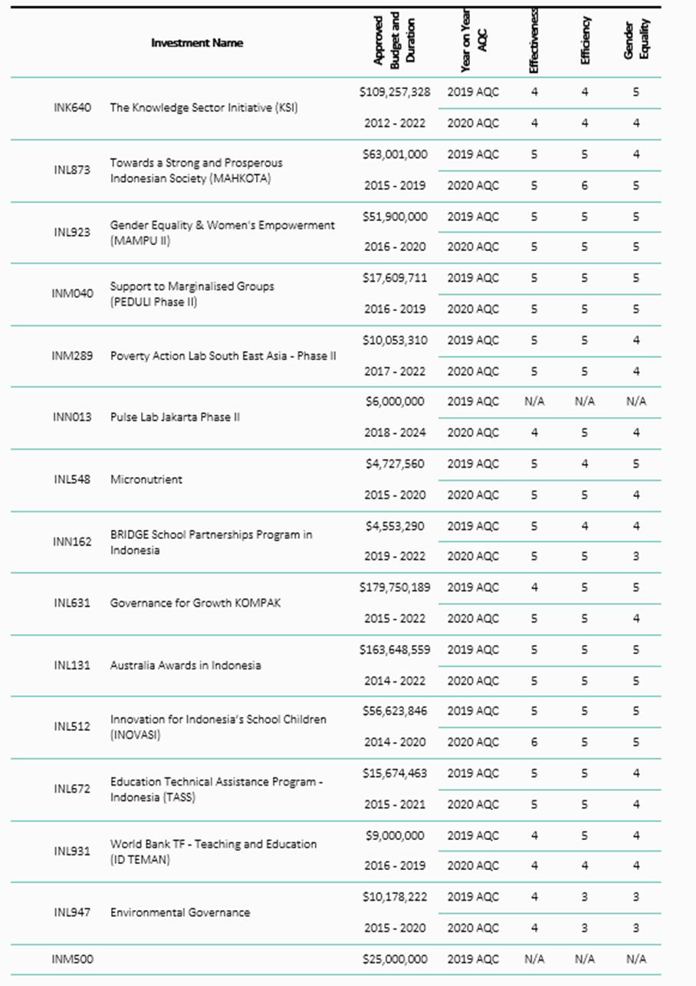

### 2019-20 Investment Monitoring Report ratings

### Humanitarian Investment Monitoring Report ratings

### Humanitarian Investment Monitoring Report ratings

### Final Investment Monitoring Report ratings

