Improving water utility performance to better serve consumers
With increasing urbanisation, demand for water connections has risen. To achieve universal access to water, water utilities are looking for ways to better manage their water resources and improve overall service delivery to their customers.

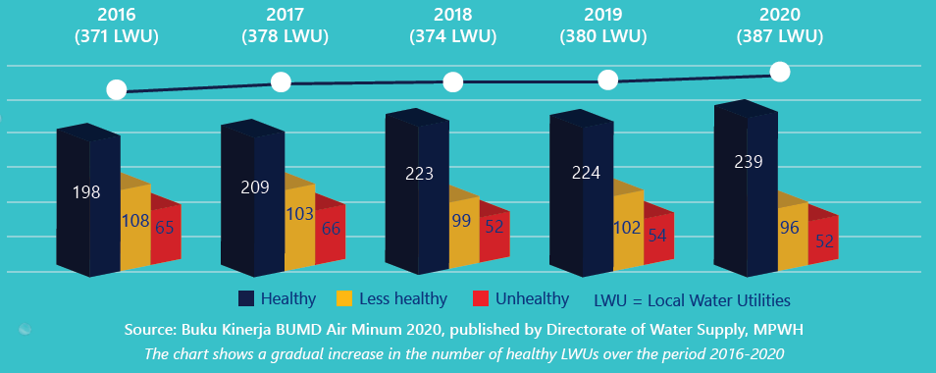

Important factors in improving water utility performance
The water utilities have progressively improved their performance through attention to:
- Strengthening organisational capacity to manage constantly expanding water networks
- Increasing water supply to meet the increasing demands on the expanding water network
- Improving the quality and safety of piped water for drinking
- Providing training and capacity building for water personnel

Australia is supporting Indonesia to improve the performance of its water utilities
Australian grants incentivise participating local government to improve the performance and management of their water utilities. Performance improvements enable utilities to provide better and more sustainable water supply services for all. Through KIAT, Australia also provides technical assistance to the central government and participating local governments to help implement the program, measure its achievements and ensure improved water services benefit all people, including women and people with disability.

How the Grants Work?
Grants totalling up to AUD 15 million will be disbursed through the Ministry of Finance to eligible local governments upon recommendation from the Ministry of Public Works and Housing. Local governments will need to demonstrate that their utilities have achieved performance targets across 4 key areas to be eligible for grants: Governance, Financial Sustainability, Operation Efficiency and Service Quality.

- Governance – The water utility’s business proposal must ensure that plans and budgeting are up-to-date, implementable and meet the needs of the local government where it operates
- Financial Sustainability – The water utility’s operating ratio must ensure that revenue covers all operating costs, and that efficient billing collection is in place to ensure cashflow for daily operations
- Operation Efficiency – The water utility should reduce non-revenue water and implement energy efficiency measures to help boost the utility’s performance
- Service Quality – The water utility must be able to provide its customers with piped clean water 24 hours a day that meets the water quality standards set by the Ministry of Health

In response to COVID-19, an additional component has been included in the grant program to help PDAMs improve the reliability and safety of their water supply through improved chlorination. Chlorination is a low cost but effective process for the disinfection of drinking water, which can help limit the spread of COVID-19.

Making sure infrastructure benefits everyone
Everyone has the right to water. This grant program will promote Gender Equality and Social Inclusion (GESI) to help contribute to increasing access to water for all, especially women, people with disability and vulnerable groups.

