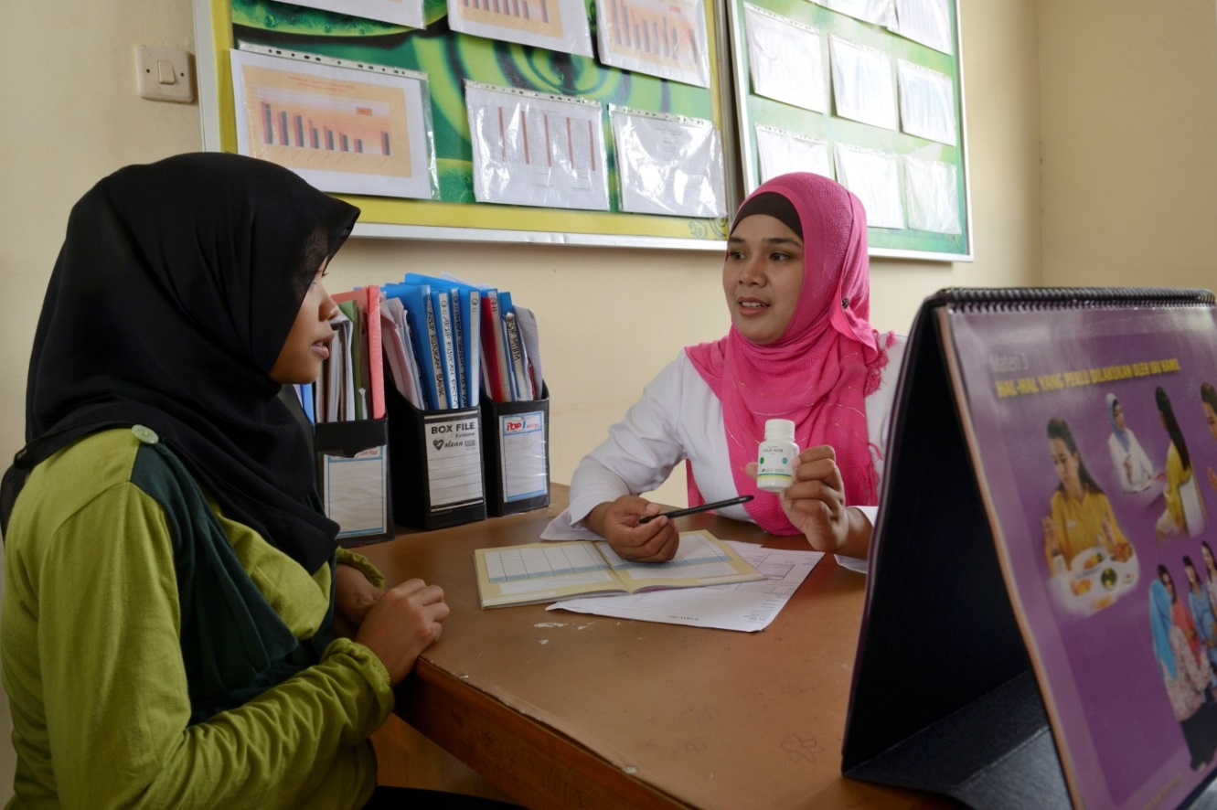

Reducing Iron Deficiency Anaemia in pregnant women and reducing mortality and morbidity in children under five, in

two provinces of Indonesia:

East Java and East Nusa Tenggara

Micronutrient Initiative/Nutrition International

Contents

Abbreviations 2

Executive Summary 3

1. Introduction 4

*1.1.* *Background* 4

*1.2.* *Contribution to Australian-Canadian-MOH-Indonesia collaboration on MNCH* 4

*1.3.* *Geographic scope of the project* 5

2. Situational Analysis - Overview 5

*2.1.* *Anaemia and Iron and Folic Acid (IFA) supplementation for pregnant women* 5

*2.2.* *Zinc supplementation and ORS in the treatment of childhood diarrhoea* 6

*2.3.* *Vitamin A supplementation among children 6-59 months* 6

3. Work undertaken by the MI in micronutrient programming in Indonesia 8

*3.1.* *Iron and Folic Acid (IFA) supplementation program for pregnant women* 9

*3.2.* *Zinc supplementation and ORS in the treatment of childhood diarrhoea* 9

*3.3.* *Vitamin A supplementation (VAS) among children 6-59 months* 10

4. Rationale and Proposed Program Strategy 11

*4.1.* *Enabling Environment* 12

4.1.1. Strengthening government commitment for micronutrients and integration with other programs 12

4.1.2. National technical assistance on improving the quality of supplements, HMIS and revision of national guidelines 13

*4.2.* *Provision of services* 13

4.2.1. Streamlining the supply chain, forecasting for supplies at district, province and national levels 13

4.2.2. Needs-based capacity building of health staff, midwives and cadres 14

4.2.3. Streamlining program monitoring and supervision from national to district levels 14

4.2.4. Partnership with the private sector 15

*4.3.* *Uptake of interventions* 15

4.3.1. Behaviour Change Strategy and Interventions for creating awareness 15

5. Roles of Each Partner 15

*5.1.* *Role of Ministry of Health (MoH)* 15

*5.2.* *Role of MI* 16

*5.3.* *Role of UNICEF* 16

6. Risk assessment framework 16

7. Project Management Arrangements 17

8. Performance Measurement Framework 17

9. Project Evaluation 18

Annex 1: Project Logic Model 20

Annex 2: Project Monitoring Framework 22

Annex 3 : Project Implementation Plan 28

# Abbreviations

|  |  |
| --- | --- |
| BCI | Behaviour Change Interventions |
| CD&EH | Communicable Diseases and Environmental Health |
| DFAT | Department of Foreign Affairs and Trade |
| DFATD | Department of Foreign Affairs, Trade and Development |
| DHO | District Health Office |
| DHO | District Health Office |
| GAPPD | Integrated Global Action Plan for the Prevention and Control of Pneumonia and Diarrhoea |
| GMP | Good Manufacturing Practices |
| GoI | Government of Indonesia |
| HQ | Head Quarter |
| IDHS | Indonesia Demographic Health Survey |
| IFA | Iron and Folic Acid |
| IMCI | Integrated Management of Childhood Illness |
| MI | Micronutrient Initiative |
| MNCH | Maternal and Child Health |
| MoH | Ministry of Health |
| MoU | Memorandum of Understanding |
| NDDCP | National Diarrhoea Disease Control Program |
| NGO | Non Government organisation |
| ORS | Oral Rehydration Salt |
| PERMATA | Primary Health Care Strengthening and Maternal New Born Health |
| PHO | Provincial Health Office |
| *Poskesdes* | Pos Kesehatan Desa *-*Village Health Post |
| *Pustu* | Puskesmas Pembantu *-* Auxiliary Puskesmas |
| *Posyandu* | Pos Pelayanan Terpadu - Integrated Health Post for MCH |
| Puskesmas | Pusat Kesehatan Masyarakat - Community Health Centre at the sub-district level |
| RO | Regional Office |
| SUN | Scaling Up Nutrition |
| ToT | Training of Trainers |
| UNICEF | United Nations Children’s Fund |
| VAC | Vitamin A Capsule |
| VAS | Vitamin A Supplementation |

# Executive Summary

Building on the Micronutrient Initiative’s 10 years of experience in Indonesia, and its success in designing and demonstrating processes that have enhanced micronutrient coverage and adherence, the following proposal to the Department of Foreign Affairs and Trade, Australia (DFAT) outlines a plan to replicate these processes in 6 high mortality provinces, to improve survival and wellbeing of women and children by addressing iron deficiency anaemia, diarrhoea, and providing Vitamin A to boost immunity. The proposal relates directly to helping the Government of Indonesia (GoI) achieve the nutrition priorities of the RPJMN (2015-19) and aligns with DFAT’s ODE Review of Child Under-nutrition “A window of opportunity” that DFAT shall increase its investment in nutrition (ODE ”A window of opportunity”, April2015).

The plan will leverage existing investments in Indonesia by the Government of Canada, and harness MI’s strong relationship with the GoI, established through close collaboration and a track record of success, which is now providing an enabling environment for the scale up of these proven approaches. It will also help to ensure the success and sustainability of Australia’s complementary investment in Indonesia through the PERMATA[1] program, by helping to guide Government of Indonesia investments in program activities over the long term.

This proposal offers a unique opportunity in the region for Australian-Canadian collaboration in a key development area in a country of common interest, in line with the aspirations captured in the 2011 Memorandum of Understanding between both countries. The combined investments from Australian Government and Canadian Government, in six provinces outlined below will mean that an additional:

* 0.2 million pregnant women will receive at least 90 Iron and Folic Acid (IFA) supplements
* 1.22 million children will be reached with two doses of Vitamin A Supplementation (VAS) and
* 1.47 million children will receive zinc and oral rehydration salts (ORS) for treating diarrhoea.

**Proposed Investments (2015-2018)**

|  |  |  |
| --- | --- | --- |
| **Target geographies** | **Australian funding** | **Canadian funding** |
| East Nusa Tenggara  East Java | $ 1.44 million AUD | $ 0.38 million AUD |
| West Nusa Tenggara  West Java  Banten  Riau | N/A | $ 2.80 million AUD |

**The rest of the document focuses on the components to be implemented in two provinces namely East Nusa Tenggara and East Java primarily with Australian funding.**

**Interventions**

|  |  |  |  |  |
| --- | --- | --- | --- | --- |
| **Type** | **Impact** | **Burden** | **Approach** | **Delivery** |
| Iron and folic acid (IFA) for pregnant women | Reduced incidence of iron deficiency anaemia | 37% of pregnant women are anaemic  33% adherence rate to 90+ IFA tablets during pregnancy | Test and scale to improve adherence and coverage | Public Sector |
| Zinc and Oral Rehydration Salts (ORS) – targeted at children under 5 | Treat diarrhea and reduce mortality | 83% of children with diarrhea are not receiving zinc  53% of children are not receiving ORS | Test and scale to improve adherence and coverage | Public Sector  Private Sector |
| Vitamin A – targeted at children aged 6-59 months | Improve immunity and reduce mortality | Range in rates of coverage nationally (45%-99%)  Inadequate availability of VACs  Poor quality of VACs  Lack of proper recording and reporting system | Scale and maintain coverage | Public Sector |

Introduction

## *Background*

MI has been present in Indonesia for 10 years working closely with the Government of Indonesia (GoI) to advocate for both greater attention and resources for micronutrient programming, while providing funding and techno-management support to the GoI in designing and implementing such programs, seeking to make them more efficient, integrated within the health system, sustainable and have greater reach and impact.

This proposed program seeks to expand this work with regard to four micronutrients – Vitamin A, Zinc, Iron and Folic Acid - with a focus on their key role in improving Maternal, Newborn and Child Health (MNCH). From 2011 – 2014, with financial support from the Government of Canada MI worked with the GoI at central, provincial and district levels to undertake pilot programs that aimed to increase the coverage and appropriate consumption of IFA supplementation by pregnant women and the coverage and appropriate consumption of Zinc supplements with ORS, by children in the treatment of diarrhoea. Formative research was carried out and barriers identified and addressed with the result that the programs for these interventions showed significant improvement prompting the GoI to seek MI’s support in scaling them up in selected provinces where their impact on MNCH would be most felt. Three-year programs beginning in 2015 were designed in collaboration with provincial governments and funding made available from Canadian Government’s grant to MI. Similarly, MI has been supporting the GoI to scale up VAS in children aged 6-59 months for several years at the national level and in 6 high mortality provinces, in collaboration with UNICEF.

* 1. *Contribution to Australian-Canadian-MOH-Indonesia collaboration on MNCH*

In 2011, the Department of Foreign Affairs and Trade of the Government of Australia (then AusAID: Australian Agency for International Development) and the Department of Foreign Affairs, Trade and Development of the Government of Canada (then CIDA: Canadian International Development Agency) signed a memorandum of understanding (MoU) to commit to closer collaboration in international development, drawing on the comparative advantage and areas of common interest of both countries. While this program will not fall formally within the framework of this MoU, in terms of adhering to its internal management processes (primarily because it is being facilitated by MI, an NGO), in spirit and practice it will certainly do so, for example:

1. The vision of the MoU is that by working together Australia and Canada can help people living in poverty and assist developing countries achieve the MDGs;
2. Two common areas of interest identified in the MoU are: Maternal and Child Health; and Food and Nutrition Security;
3. This proposal shares key principles captured in the MoU including:

* an emphasis on pursuing cooperation opportunities of mutual benefit to both Australia and Canada to bring about positive outcomes that could not have been achieved by either party working alone
* a shared commitment to achieving results that reduce poverty, take into account the perspective of the poor and are consistent with international human rights standards.
* a commitment to open communication at all levels and to create professional relationships characterized by respect honesty and trust
* a shared commitment to increasing transparency and accountability by making information available to the public
* focus on countries based on their alignment with Australian and Canadian national interests
* efficient and effective use of resources

While this document focuses on the components to be implemented in two provinces with Australian funding (East Nusa Tenggara; East Java), complementary activities will take place concurrently in four other provinces (West Nusa Tenggara; West Java; Banten; Riau) using Canadian funding. The program as a whole will thus cover six provinces as follows.

* The primary implementers of the program in all provinces will be Ministry of Health (MoH) staff at both levels with support from the central level.
* There will be a single Jakarta-based MI management team for the whole program that will guide and support all proposed work, with technical and monitoring and evaluation support from senior MI subject matter specialists in our Regional Office in Delhi and in our HQ in Ottawa Canada.
* The management team will comprise the Country Director and two program managers - one who will be the focal point for the two Australian funded provinces and the other for the Canadian funded provinces; each province will have dedicated Provincial Coordinators with ‘roving’ coordinators who follow up at district level.
* The Jakarta management team will use common approaches, methodologies and human resource frameworks that will
  + Achieve efficiencies from a joint approach by using impact measures from just 2 (Australian funded) provinces to estimate the impact of comparable inputs in 4 other (Canadian funded ) provinces
  + Leverage opportunities for cross-learning between provinces and developing a broader greater evidence base on which to draw when advocating to GoI for sustaining the gains of the overall program all of which would not have otherwise been possible.
  + Provide a single point of engagement with GoI at central level relating to work in all six provinces.
  + Enable the Australian funded component to benefit from the wider Canadian funded MI program in Indonesia and globally; and the Canadian funded MI program to benefit from more extensive contact with the Australian funded programs and PERMATA in particular
  + Allow the Australian funded component to leverage MI staff costs for technical and managerial support, including travel, office premises etc that will be covered from MI’s existing Canadian funded grant thus being a direct contribution by Canada to the work in the two Australian funded provinces.
  1. *Geographic scope of the project*

The geographical scope and implementation methodology are elaborated in the pages that follow with particular focus on the two provinces that Australia Funding Agency is interested to support, namely: East Java and East Nusa Tenggara. The goals of this proposal align very closely with those of PERMATA to support the GoI to improve health system performance at central, provincial and district levels to reduce maternal and newborn mortality and stunting.

1. **Situational Analysis - Overview**

The Republic of Indonesia comprises 17,000 islands with an estimated population of about 250 million spread over 33 provinces. While the Indonesia economy has grown impressively in recent years, prevalence of maternal and child malnutrition remains high. A serious impact of maternal undernutrition is that children are stunted. Stunting is widely accepted as one of the best predictors of the quality of human capital, influencing potential academic performance and future earning capability of a nation. Based on the Indonesia Demographic Heath Survey (IDHS), 2012 findings of the under-5 mortality at 40 deaths per 1,000 live births[2] and infant mortality at 32 deaths per 1,000 live births1, the MDG goal of reducing the infant mortality rate to 23/1000 by 2015 will probably not be achieved[3]. Many factors must be addressed, such as availability of, and access to, effective health facilities and services, and improving the quantity and quality of health providers. The section below describes the specific scenarios for key micronutrients and related program gaps and needs.

* 1. *Anaemia and Iron and Folic Acid (IFA) supplementation for pregnant women*

Iron-deficiency anaemia is an underlying cause of up to an estimated 115,000 maternal deaths per year[4]. Consequences of iron deficiency and moderate or severe anaemia during pregnancy have been associated with increased risk of premature delivery, maternal and child mortality and infectious diseases[5]. Pregnant women are recommended to start IFA supplementation as soon as possible to reduce the risk of low birth weight and anaemia at term. The impact of IFA supplementation on anaemia and low birth weight is dependent on having a sufficient intake of supplements. Women need to consume at least 90 IFA supplements containing the recommended dose over the course of the pregnancy to reduce anaemia at term. The benefits of IFA supplementation may be extended to the postnatal period as it has been reported that being born small for gestational age and/or premature increases children’s risk of being stunted at two years of age[6].

37% of pregnant women in Indonesia are anaemic, with a similar proportion among rural (36.4%) and urban (37.8%) women[7]. The rate has decreased from 44% in 2008[8] .

Antenatal care (ANC) attendance rates in Indonesia are relatively high and provide a solid platform for distribution of IFA supplementation. The Indonesian maternal health program recommends that pregnant women receive at least four ANC visits, with at least one in the first trimester and with 30 IFA tablets dispensed at each visit. 88% of women make four or more ANC visits during their pregnancy1 and 98% make at least one visit *1.* The timing of the first visit is relatively early. 80% of pregnant women have their initial ANC visit during the first trimester 1, an increase from 70% in 2007[9]. The median number of months pregnant at the first ANC visit is 2.4 months. While the provision of IFA is integrated into the ANC visits, in reality the full amount of tablets (at least 90) is rarely dispensed, highlighting the missed opportunity for this intervention.

IFA supplementation has been operational in Indonesia since the 1970s and has resulted in impressive coverage as the percentage of women taking IFA supplements during their last pregnancy increased from 57%[10] to 76% 1. However, although reported consumption of at least 90 IFA tablets has increased to 33% 3*,* compared to 18% in 2010 3, this is still well below the coverage of ANC. The key reasons reported for low IFA consumption are: (a) low acceptability of the product due to poor quality of the supplements dispensed through the public sector and; (b) lack of adequate counselling by health workers[11] to the women to adhere to the recommended dose and manage side effects.

The government has demonstrated its commitment towards strengthening program implementation in 2013 through its decision to follow new WHO recommendations namely: (i) increase the dose of folic acid to 400µg from 250 µg; (ii) change the elemental iron of 60 mg from ferrous sulphate to ferrous fumarate, and (iii) change the packaging from sachet to blister pack. These steps will improve the quality of IFA tablets provided through public sector. The process of re-formulation was initiated in 2014. MoH has also committed to an increased budget allocation for procurement of IFA tablets and to training of health staff for more effective program implementation to improve availability of supplies as well as improved counseling skills of the health workers on benefits and management of side effects. This proposed project will support the Government to strengthen the implementation of the proposed strategies to improve the uptake and consumption of IFA tablets by pregnant women.

* 1. *Zinc supplementation and ORS in the treatment of childhood diarrhoea*

As per the IDHS, 2012 data, prevalence of diarrhoea among children under 5 was 14% while overall, 65% of children under 5 suffering from diarrhoea received treatment from a health facility or health provider.At the national level, 47% of children with diarrhoea received oral rehydration solution (ORS)[12] *,* while only 16.9% received zinc supplements[13]. It should be noted that neither of these surveys included information on adherence to the recommended combined treatment of both zinc and ORS. The National Diarrhoea Disease Control Program (NDDCP) in Indonesia which includes zinc and ORS as adjunct treatment remains only partially implemented according to the national guidelines.

The reasons for low national coverage and utilization of zinc and ORS for treatment of diarrhoea in children under 5 [14] include: (a) poor supply chain management, resulting from a lack of commodity forecasting and inadequate distribution due to limitation of operational budget, (b) poor knowledge and skills of health staff on program planning, delivery and monitoring which results in inadequate provision of zinc and ORS and lack of proper counselling of caregivers; (c) gaps in the HMIS system for recording use of zinc and ORS in treatment; and excessive use of antibiotics.

* 1. *Vitamin A supplementation among children 6-59 months*

Vitamin A deficiency remains a moderate public health problem among children 6-59 months in Indonesia. Under-5 mortality has decreased from an estimated 44/1000 in 2007 to the recent *State of the World’s Children 2*015 estimate of 29/1000. The national average two-dose VAS coverage is regularly quite high, however with much variability among the 33 provinces. In 2013, the official national average was estimated at 84%[15], but continues to range from 99% in Yogyakarta to 45% in Papua. It is plausible that the high and sustained VAS coverage has contributed to this decrease in under-5 mortality over time. The strategy for delivering two doses of VAS to children 6-59 months of age in Indonesia continues to be through the biannual distribution of vitamin A capsules (VACs) through the national network of integrated health posts, called *Posyandu*, during the months of February and August.

The key gaps in the VAS program identified by MI during their course of program implementation are:

* *Inadequate availability of VACs:* Since 2009, the Government of Indonesia has procured 100% supply of VA Capsules (VACs) as per the national requirement, but due to decentralization, budget allocation is varied. Usually, the Central Government provides about 50% of total district needs, while provincial government provides 30% and district government is expected to provide 20%. This decentralized policy places most of the responsibility for planning and implementation of vitamin A campaigns on the district governments. While facilitating good ownership of the program, there have been challenges with this practice, since the districts have inadequate capacity at various levels to efficiently plan, implement, and monitor the program. Nor do the districts always have sufficient budget to procure their needs and so with delays in receiving additional funds from central or provincial levels, stock outs occur.
* *Poor quality of VACs*: MI staff during their field visits observed that the VACs procured by the government of Indonesia are of poor quality, particularly after the Government has supplied VACs through a Semi-Government Company (*Kimia Farma*) which is not Good Manufacturing Practice (GMP) certified and the capsules they produce are of variable quality - some have different shades of blue and red, the gelatin layer is thin which causes leakage before the expiry date, and the shape of capsules is also different.
* *Lack of proper recording and reporting system:* The Government of Indonesia has a Vitamin A monitoring system that records infants and children who received vitamin A capsule at the health post *(Posyandu)*. From the *Posyandu* the report is rolled up to health facility (*Puskesmas*), from the health facility to District Health Office, District Health Office (DHO) to Provincial Health Office (PHO) and Ministry of Health through the Nutrition Information System *(Sistem Informasi Gizi*). Although on paper, the information system is robust, in reality there are problems which affect the timeliness and accuracy of the reporting system. According to the routine annual report from MoH, the coverage of the VAS program has increased from 79% in 2007 to 83% in 2010. However, according to Basic Health Research RISKESDAS data, the coverage of Vitamin A program decreased from 71.5% in 2007 to 69.8% in 2010.The difference between the two sources of data is due to the poor quality of routine monitoring data generated. Therefore, the coverage is still far from the national target of 85% that is planned to be achieved by 2015 by the National Plan of Action on Food and Nutrition of the Ministry of Development Planning Indonesia, 2010.

# Work undertaken by the MI in micronutrient programming in Indonesia

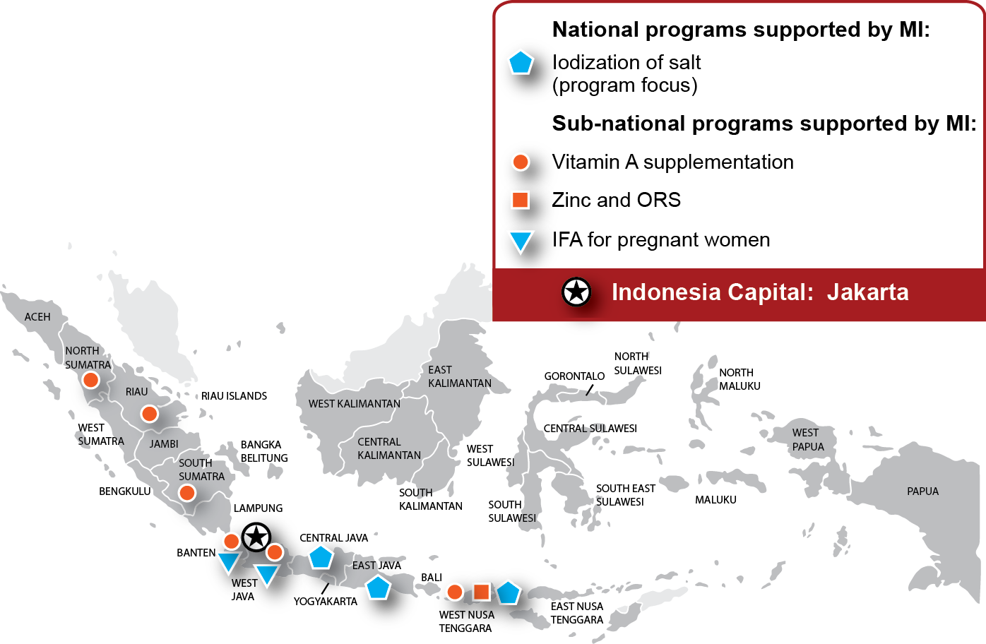

As a response to the situation described above, MI has supported the Government of Indonesia to demonstrate program models within the public health delivery system as follows:

1. For increasing coverage and adherence of IFA supplements among pregnant women to reduce iron deficiency and iron deficiency anaemia among pregnant women, in one district each of Banten (Lebak) and West Java (Purwakarta) provinces (2011-2014).
2. For increasing coverage and adherence of zinc and ORS among children under 5 suffering from diarrhoea in East Lombok and West Lombok districts in West Nusa Tenggara province (2011-2014)
3. For increasing coverage of VAS among all children under 5 in in six high mortality provinces of Banten, West Java, West Nusa Tenggara, North Sumatera, Riau and South Sumatera from 2010-2014.

MI collaborated with the implementers of these programs - Directorate General of Community Nutrition (MoH), Directorate General Communicable Disease and Environment Health (CD&EH) of the Diarrhea Subdivision within the MoH and the District Health Offices who facilitated the implementation of these models through placements of MI Districts Extenders and national level coordinators to play a “catalyst role”.

These demonstration projects focused on:

* Strengthening government commitment towards these programs through highlighting their benefits.
* Strengthening the supply chain and forecasting of the IFA, Zinc and ORS and VA supplements.
* Building capacity and skills of health staff and frontline workers on planning, delivery mechanisms and monitoring.
* Supporting standardization of target population estimations and micro-planning.
* Facilitating behaviour change Interventions for increasing adherence to IFA, and zinc and ORS, with a focus on Interpersonal and Group counselling.
* Working with the District Health Offices (DHO) to improve delivery mechanisms for supplements, utilising all opportunities to deliver interventions and counsel through ANC contacts, immunisation, health facility contacts, group sessions and home visits.
* Modifying the monitoring system to track stocks and coverage and strengthening supportive supervision.

The details and the results of these projects are presented below.

* 1. *Iron and Folic Acid (IFA) supplementation program for pregnant women*

MI in partnership with the DHOs of Lebak and Purwakarta, demonstrated a model for strengthening the existing IFA supplementation programs to improve coverage and utilization rates among pregnant women (July 2011-September 2014). This demonstration project focused on improving the following on the basis of gaps that were identified by MI prior to program strategy development:

1. Quality and availability of IFA supplements
2. Government commitment to the program.
3. Capacity of service providers including health centre staff, village midwives and health cadres to provide and advise pregnant women appropriately.
4. Regular supportive supervision.
5. The use of behaviour change interventions (BCI) that focus more on effective interpersonal communication (IPC) and group counselling
6. Strengthen Health Monitoring Information system (HMIS) to track coverage and stocks.

In June 2014,a post intervention survey in two intervention districts (Lebak and Purwakarta) and two comparison districts (Pandeglang and Subang) was conducted to evaluate the impact of program activities on coverage and compliance of IFA and other process indicators amongst recently delivered women (although no baseline survey had been conducted prior to program initiation). Overall the program evaluation indicated that Lebak and its comparison district Pandeglang showed comparable results for key coverage and utilization indicators, however, Purwakarta showed better results than Subang. .

The overall findings of the post intervention survey were as follows:

* 74% and 92% of pregnant mothers received 90+ IFA in Lebak and Purwakarta districts compared to 81% and 61% in Pandeglang and Subang, respectively [figure 1].
* In Purwakarta, utilization of 90+ IFA tablets was more than double its comparison district. Utilization was comparable in Lebak (56%) and its comparison district Pandeglang (56%) [Figure 2].
* Coverage of 180 IFA tablets was significantly higher in Purwakarta than in its comparison district. 46% and 68% of women in Lebak and Purwakarta, respectively, reported to have received at least 180 IFA tablets among those who received any IFA tablet from the public sector compared to 55% and 21% in Pandeglang and Subang, respectively.

Purwakarta showed overall higher coverage and utilization of IFA tablets as compared to Lebak in the demonstration project. Further, analysis of some of the process indicators showed that stock-outs reported by health workers and reported side effects in Lebak could be possible reasons for low coverage and utilization.

* A quarter of mid-wives in Lebak reported stock-out of IFA tablets while none reported any stock out in Purwakarta district.
* 77% pregnant women in Purwakarta as compared to 64% in Lebak reported to have been counselled by health workers on IFA supplementation.
* 51% of the pregnant women in Lebak, as compared to 29% in Purwakarta, reported side effects after consuming IFA tablets received.

In addition, lower level of DHO commitment to the IFA supplementation program and frequent turnover of health staff, including the Head of Sub-division of Nutrition, (which led to sub-optimal availability of staff for project activities) were two other possible reasons,

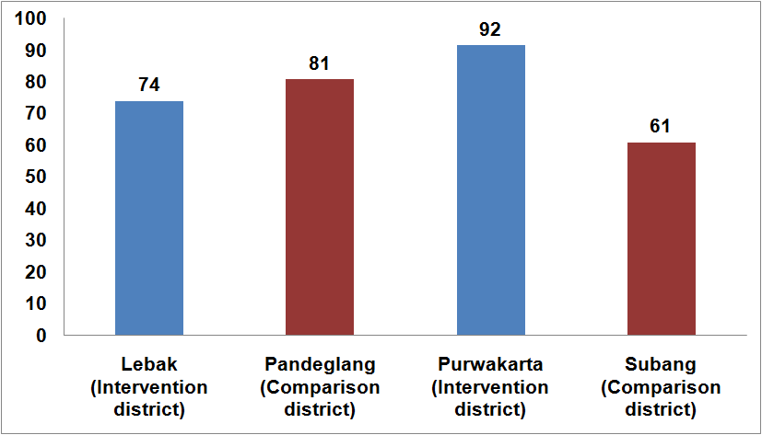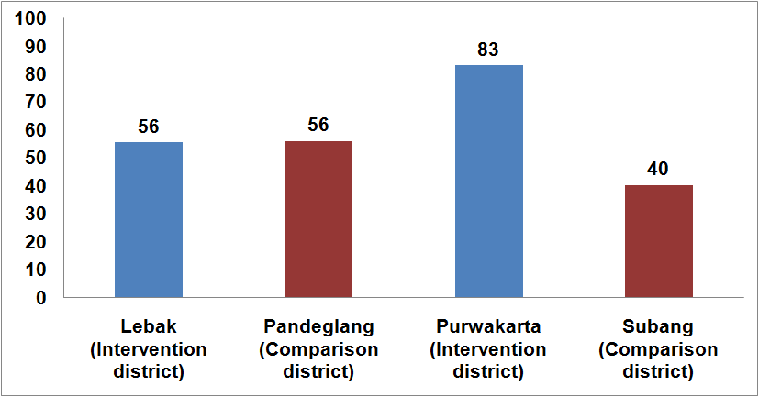

Figure 2 : Percentage of pregnant women who consumed 90+ IFA tablets

Figure 1 : Percentage of pregnant women who received 90+IFA tablets

* 1. *Zinc supplementation and ORS in the treatment of childhood diarrhoea*

MI demonstrated the use of zinc and ORS in the treatment of diarrhoea among children 6–59 months in two districts of East and West Lombok in the province West Nusa Tenggara. MI collaborated with the Directorate General Communicable Disease and Environment Health (CD&EH) of the Diarrhoea Subdivision within the MoH and the DHOs in West Lombok and East Lombok who are the implementers of the IMCI program. The key focus areas were:

1. Strengthening the supply chain from district to the health centre;
2. Building capacity of the health system functionaries on treatment of diarrhoea;
3. Use BCI interventions based on formative research which focused on IPC
4. Modifying the monitoring system to include indicators to track coverage;
5. Undertake supportive supervision.

A post intervention survey was carried out in June-August 2014 in two intervention districts. The key findings were as follows:

* Increased care seeking in the public sector for childhood diarrhoeal management. 62% of caregivers sought treatment from the public sector health facilities. These results are substantially higher than the 13% in these districts reported through the HMIS at the start of the program in 2011.
* Nearly 30% more caregivers who went to the public sector for diarrhoeal treatment received both zinc and ORS. This is a remarkable increase in service delivery from nearly zero at the start of the program in 2011. As per the IDHS 2012, the coverage of zinc supplements in the province of West Nusa Tenggara, where East and West Lombok are situated was only 3.8%. The proportion of caregivers who reported to have received both zinc and ORS from among those who sought treatment in the public sector was 26% in East Lombok and 43% in West Lombok [figure 3].
* Among those who sought treatment in the public sector, adherence to recommended zinc treatment course duration increased from ~0% (on the basis of field observations in 2011 prior to start of the program) to 23% in East Lombok and to 30% West Lombok (figure 4). Adherence remains low however, necessitating the focus in future programs. This will be addressed in the scale up phase through a focus on counselling on the benefits of zinc, dosage and management of side effects.
* Nearly all caregivers had heard about ORS but far fewer knew of zinc, only 38% and 50% in East and West Lombok, respectively.

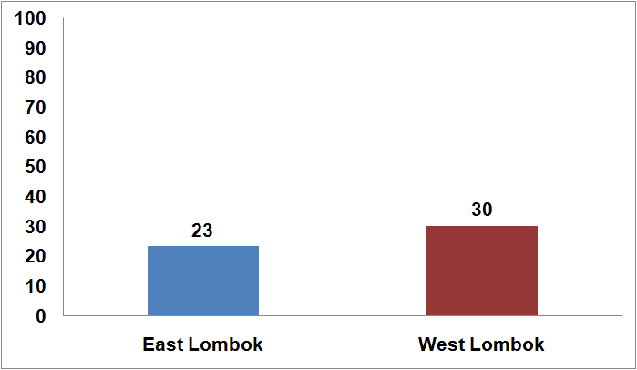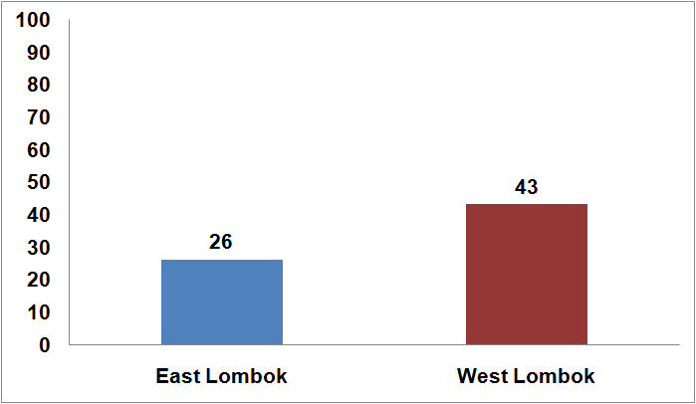

Figure 4 : Percentage of caregivers of children under 5 with diarrhoea who sought care in public sector and consumed full course of zinc

Figure 3: Percentage of caregivers of children under 5 with diarrhoea who sought care in public sector and received both zinc and ORS

* 1. *Vitamin A supplementation (VAS) among children 6-59 months*

The scale of MI’s support to the VAS program is sub-national, supporting the six high-mortality provinces of Banten, West Java, West Nusa Tenggara, North Sumatra, Riau, and South Sumatra since 2007. MI’s technical support to the VASprogram in 2013 was provided in the form of six MI Extenders, positioned tosupport the provincial level. This is a change from the previous strategy of providing intensified technical assistance at the district level in low performing districts. This shift isintended to scale-up the lessons learned from the previous district-level support, expand thereach of the technical assistance and gradually increase capacity at the provincial level forprogram management.

The MI extenders supported provincial-level healthofficials to replicate processes across other districts that were proven to be effective in the12 MI demonstration districts of previous years – including budgeting for supplies, micro-planning,streamlining the supply chain within the province, monitoring and reporting. As a result of MI’s active engagement in these six provinces since 2007 improvements in following components have been observed:

* *No stock outs in MI districts:* there have been no stock outs in any of the 12 MI districts since 2010, because MI extenders facilitated the provision of adequate vitamin A supply.
* *Coverage*: Nearly 6 million children 6-59 months were reached with 2 doses of VAS in these 6 provinces during 2014 in part due to MI support.
* *Improved recording and reporting system for VAS:* MI worked with the DHOs and designed a system to improve the accuracy of vitamin A reporting and recording at all levels through better processes and tools. The four major tools developed by the MI supported project were:
  1. vitamin A recording form for p*osyandu*
  2. vitamin A reporting form for Health Centre
  3. vitamin A data quality checklist and reporting form
  4. qualitative vitamin A reporting form

The MoH agreed that the tools will be used in the six MI-supported provinces. Based on experiences with the system in the MI-supported provinces, the MoH is seeking MI’s technical assistance to implement the tools in other provinces and plans to integrate them fully into the current reporting system.

Further, MI along with UNICEF will continue advocacy with MoH to improve quality of VACs. MI and UNICEF will provide support to the CentralMoH to ensure better quality of VACs by advocating to change the current procurementpractice to use better specifications and an improved quality assurance process in line with global standards.

# Rationale and Proposed Program Strategy

Based on the findings of the demonstration projects described in section 2, MI has identified processes which have worked to improve the coverage and adherence of IFA supplements among pregnant mothers for reducing iron deficiency anaemia, and improving coverage and adherence of zinc and ORS and Vitamin A supplements among children under 5 years of age to reduce mortality and morbidity. MI proposes to replicate these processes in high mortality provinces of West Nusa Tenggara, West Java, Banten and Riau which are being supported by funding from Canadian Government .

MI has undertaken a series of consultations with the Micronutrient Subdivision, Directorate of Nutrition, Directorate General of Community Nutrition (MoH), on the progress of key micronutrient programs including IFA supplements for pregnant women, VAS program and use of zinc and ORS in treatment of childhood diarrhea for children under 5 and how to improve the coverage and adherence of these programs, thereby making them more effective. The Government of Indonesia has expressed keen interest in utilising the lessons learnt from the MI demonstration projects to improve these programs. They have proposed that MI support key micronutrient interventions in high mortality geographies.

MI proposes to replicate these processes in the two provinces of East Java and East Nusa Tenggara where the Australian government will be targeting in the design of its next MNCH program called PERMATA. It is expected that in the 2 provinces to be supported by Australian funding through MI an additional 73,500 pregnant women will receive at least 90 IFA tablets and 60,000 will consume at least 90 IFA tablets and among children 6-59 months an additional 240,000 children 6-59 months are expected to be reached with two doses of VAS every year and 365,000 children 6-59 months will be treated with both zinc and ORS for childhood diarrhoea.

Overall, the program is expected to reach nearly 250,000 pregnant women with IFA supplements along with counselling of which 190,000 will consume at least 90 IFA tablets and, 1.1 million children 6-59 months are expected to be reached with two doses of VAS every year and 0.5 million children 6-59 months will be treated with both zinc and ORS for childhood diarrhoea.

The overall approach is innovative as it is about integrating the delivery of critical micronutrients using cost effective approaches for capacity building, communication and program monitoring to strengthen the coverage and adherence of these interventions within the existing system. During the life of the program the PHO’s will be capacitated to replicate the program package to the remaining districts with minimal external resources.

An added benefit of this integrated approach is to bring into play the inter program/sectoral collaborations from the primary health care level to the national level

The program strategy components have been organized under the enabling environment, provision and consumption headings (Figure 5) and include:

* Strengthening government commitment to reduce micronutrient deficiencies and integrate such programs within the health system.
* National technical assistance on improving the quality of key MN[16] supplements, HMIS and revision of national guidelines.
* Streamlining the supply chain and improving forecasting for supplies at the district, province and national levels.
* Needs based capacity building of health staff, midwives and cadres.
* Streamlining program monitoring and supervision from national to district levels.
* Exploring support through private sector.
* The use of an appropriate BCI strategy and supporting BCI interventions for creating awareness on the benefits of these interventions to care givers and consumers on the one hand and to health workers on the other including the need for effective counselling to caregivers and proper administration of the interventions.

The program will contribute to the achievement of two of the proposed SDGs as follows:

*Goal 2 End hunger, achieve food security and improved nutrition and promote sustainable agriculture.* 2.1: by 2030, end hunger and ensure access by all people, in particular the poor and people in vulnerable situations including infants, to safe, nutritious and sufficient food all year round and,

2.2: by 2030, end all forms of malnutrition, including achieving by 2025 the internationally agreed targets on stunting and wasting in children under five years of age, and address the nutritional needs of adolescent girls, pregnant and lactating women, and older persons.

The proposed project is also relevant to GoI RPJMN (2015-2019) as nutrition is one of the priority programs, and aligns with Australain aid program recommendation 2 to address child undernutrition (ODE Brief;2015): “DFAT should ensure that the proportion of Official Development Assistance (ODA) invested in partner countries to address child undernutrition is appropriate to the country context”.

Figure 5: Program strategy components

***Provision***

***Need based capacity building of health staff, midwives and cadres***

***Streamlining* *program monitoring and supervision from national until district levels***

***Streamlining the supply chain, forecasting for supplies at the district, province and national levels***

***Enabling Environment***

***National technical assistance on improving the quality of supplements, HMIS and revision of national guidelines***

***Strengthening government commitment for micronutrients and integration with other programs***

***Consumption***

***Supporting BCI interventions and use of appropriate BCI strategy for creating awareness***

**Reduction of anaemia among pregnant women and reducing mortality and morbidity in children under five in two provinces of Indonesia**

***Partnership with private sector***

## *Enabling Environment*

* + 1. Strengthening government commitment for micronutrients and integration with other programs

The commitment of the GoI to micronutrient programs has been inadequate in terms of allocation of budgets and prioritisation. Therefore, advocacy meetings at national, and province levels will be undertaken to strengthen and integrate these programs with the Maternal Health Program, IMCI, Child Health Division within MoH while collaborating with other programs which include Health Promotion, Surveillance, Pharmaceutical Service, Family Welfare, Environmental Health, and Sanitation for stronger implementation on the ground.

MI is also actively participating in the Mother and Child Forum and SUN movement National Task group and these can serve as channels for MI to strengthen Government commitment. UNICEF and WHO are advocating for implementation of the Integrated Global Action Plan for control of Pneumonia and Diarrhoea (GAPPD), and this would also be one of the channels for MI to strengthen Government’s commitment.

Advocacy will focus on ensuring adequate budget allocation for procurement and supply of IFA, zinc and ORS and VAS, delivery of timely and recommended quantities of these at health facilities, provision of communication materials and assuring an operational budget for monitoring and supervision.

In collaboration with MoH at central level, MI will conduct meetings and visits to the demonstration districts to advocate for expansion of identified program processes which have worked in other districts/provinces using their local district budget which would benefit both PERMATA and provinces supported by Canadian funding.

* + 1. National technical assistance on improving the quality of supplements, HMIS and revision of national guidelines

MI will provide technical assistance for the revision of national guidelines of these programs and streamlining HMIS to include essential indicators at the national level.

MI has actively participated in a series of meetings for discussing the re-formulation of IFA supplements according to the latest WHO recommendation. These meetings were supported by UNICEF and organized by the MoH at the national level during 2014. MI will provide technical assistance in the re-formulation process including packaging, dosage, and form of iron formula.

Meetings with national level stakeholders for incorporation of best practice in the VAS guidelines and revision of VAS guidelines will also be facilitated.

These activities would benefit both PERMATA and provinces supported by Canadian funding.

* 1. *Provision of services*
     1. Streamlining the supply chain, forecasting for supplies at district, province and national levels

Currently, the Central Government provides 80-100% of total IFA supplements, but only 10-20% of total zinc requirements. However, if the supplies are not adequate at the district level, PHO and Central MoH can provide buffer stock.

As already noted, the Government of Indonesia procures 100% VACs for the national need, but due to the decentralization, budget allocation is varied. Usually, the Central Government provides about 50% of total district needs, while provincial government provides 30% and district government is expected to provide 20%. However, the districts do not always have sufficient budget to procure all of their needs and with delays in receiving additional funds from Central or Provincial levels, stock-outs occur.

MI will support the PHO and DHO by providing: technical specifications of the supplements; capacity building of health staff on forecasting and indenting for supplies, and in developing a mechanism for identifying health facilities with stock-outs in order to facilitate appropriate corrective actions.

Supply bottlenecks and gaps will be identified through using the modified HMIS and will be streamlined in consultation with the local district staff. The MI District Extender will advocate with the DHO and the district pharmacy to ensure adequate and timely supply of supplements to the district and further to the Puskesmas, Pustu and Poskesdes. The MI Provincial Extender, in coordination with the District Extender, will communicate supply chain issues to the PHO to resolve them. In case of inadequate availability of supplies at the central pharmacy, the Provincial Extender will catalyze distribution of supplements from the buffer stock maintained at the province.

As a long term objective, capacity will be built at the health facility level to demand for adequate stocks. The health staff will be capacitated to establish a mechanism to flag stock-outs to the DHO using mobile technology.

As a pre-requisite to the streamlining of supply chain, advocacy will be undertaken with the Diarrhoea Program and Pharmaceutical division to negotiate for a clear definition of stock-out at the health facility and the DHO levels.

MI will coordinate with MCAI in East Java and East Nusa Tenggara to align with the MCAI program in strengthening the district procurement unit and ensuring that stocks of micronutrients (VAS, Zinc and IFA supplements) are available.

Monitoring the quality of VACs in the district/province by checking at health centres and district warehouses and providing feedback to MoH and Food and Drug Administration will be undertaken.

* + 1. Needs-based capacity building of health staff, midwives and cadres

Tailored capacity building through the Training of Trainers (ToT) of DHO and PHO and the Indonesia Midwives Association (IBI), will be conducted at the provincial, district and health centre levels. The training will involve the health staff, midwives and cadres to improve their knowledge and skills for effective planning, delivery, monitoring and management of these programs. On the job capacity building utilising existing review and planning platforms will be conducted at the province and district levels and at health centres.

Training will focus on providing interpersonal counselling during ANC contacts using communication materials on IFA supplementation and more specifically on overcoming side effects of consuming IFA tablets, to ensure use of zinc and ORS as first line of treatment in uncomplicated diarrhoea during health facility contacts and improve adherence to full course. Other components of training will be supply chain management and streamlining reporting and recording systems. Revision of communication materials according to local context will be undertaken and used for the capacity building.

The focus will be on ensuring that health service providers can effectively plan, implement, monitor and supervise the on-going VAS program with special emphasis on micro-planning and needs assessment prior to the VAS rounds to facilitate that the hard to reach children are reached.

* + 1. Streamlining program monitoring and supervision from national to district levels

MI has supported modification of the HMIS for micronutrients at the district level, and it will strongly advocate for these modifications to be incorporated at the Central MoH. These modifications have included:

* addition of a column for ‘stock of IFA supplements’ at the health centre level
* reporting on Fe 1 (30 tablets), Fe 2 (60 tablets) and Fe 3 (90 tablets)
* another column to track the private IFA tablets needs to be included
* addition of a column to track zinc and ORS provision to children under 5
* disaggregation of treatment by age at national level
* expected number of cases for each intervention

MI has already conducted an assessment of the existing vitamin A reporting system from Posyandu to MoH level and identified the following gaps:

* Lack of standard recording system for infant, children and post partum women who received vitamin A at health posts (posyandu)
* Lack of standard reporting system from health posts (Posyandu) to health centres (Puskesmas)
* The denominator for vitamin A coverage calculation was not standard, some Puskesmas used projected number of infants/children for denominator, and some used real number infants/children for denominators
* Lack of mechanism to assure the accuracy of vitamin A reporting from Posyandu, Puskesmas and District Health Office

On the basis of these monitoring and reporting gaps identified in the VAS program a Quality Recording System (QRS) was designed in consultation with MoH to improve the quality and accuracy of vitamin A reporting and recording at all levels through better processes and tools. The four major tools developed were:

* Vitamin A recording form for *posyandu*
* Vitamin A reporting form for Health Centre
* Vitamin A data quality checklist and reporting form
* Qualitative vitamin A reporting form

The Vitamin A reporting and recording system has been introduced and used in some districts in the 6 provinces supported by Canadian funding including capacity building of MoH to PHO to use the accuracy tools; enrolment for all districts will be started in 2015. This QRS will be implemented at wider scale in the project areas by providing training and other capacity building support through MI’s District and Provincial Coordinators.

Attention will be given to district and sub-district level health officials using the modified MIS, improving recording and reporting and use of the data for corrective actions and decision making. Monitoring and supervision by the health staff through home visits will be improved with the available budget within the districts.

The objective of improving the HMIS is to track critical indicators which are simple yet very relevant for tracking, and the health system finds this valuable as seen in the demonstration and scale-up phases, hence in all likelihood will get incorporated in the central HMIS facilitated by planned negotiation and advocacy.

Joint reviews of challenges encountered, progress made and lessons learned in both PERMATA and Canadian funded provinces will be actively facilitated to promote cross learning, problem solving and course correction for the program work. Consultation and collaboration with other relevant Australian funded program will be undertaken as appropriate during the planning and implementation phases.

* + 1. Partnership with the private sector

Analysis of MI’s work conducted during the demonstration phase suggests that midwives working in the public sector also provide service as private service providers. Similarly, the evaluation of MI’s demonstration program revealed that care-seeking for diarrhoea through the private sector is at 40%10. Therefore we will seek to engage with private sector to increase coverage and utilization of these key micronutrient programs through advocacy with the professional organizations such as the midwives associations and private service providers such as doctors and pharmacists.

The key strategies proposed are:

* sensitization of professional organizations of medical doctors including paediatricians and midwives
* sensitization of the pharmaceutical representatives to promote zinc supplementation so that they recommend zinc and ORS for uncomplicated diarrhoea.

## *Uptake of interventions*

* + 1. Behaviour Change Strategy and Interventions for creating awareness

Based on MI’s experience in the demonstration districts a BCI plan will be developed and appropriate messages and channels identified for creating awareness amongst pregnant mothers and caregivers. In consultation with MoH and other stakeholders the development/modification of communication materials will be undertaken that can be used by the health service providers for counseling and problem solving. Focus will remain on group meetings and interpersonal counseling and regular follow up through home visits to ensure adherence. Intensive engagement of village midwives and frontline workers with social influencers such as local community leaders, family members etc. during group meetings, community platforms such as Posyandus etc. will also be promoted to inform them on benefits and use of key micronutrient supplementation programs.

1. **Roles of Each Partner**
   1. *Role of Ministry of Health (MoH)*

MI’s approach to public health and nutrition interventions is anchored in both the Paris Principles and the guiding principles of the Scaling-Up Nutrition (SUN) movement which emphasize the importance of country ownership and leadership of its own policies and strategies. MI will coordinate regularly and effectively with MoH so that all external assistance to improve nutrition outcomes are aligned with GoI strategies and priorities while selection of program locations appropriately take into account other GoI/development partners’ program e.g. MCAI. The MOH is thus positioned as the main lead on the project overall with the following responsibilities:

* Program planning and coordination at the national level within the Directorate General of Community Nutrition, MoH.
* Ensure the timely and adequate procurement of key micronutrient supplements in consultation with the DHOs to ensure availability at frontline distribution points.
* Support the capacity building of health workers, midwives and cadres to be provided under this program by conducting regular meetings and on the job training at district and province levels to strengthen the service delivery of key micronutrient programs.
* Facilitate the strengthening of monitoring and supervision on the part of health service providers in support of the initiatives introduced by this project.
* Undertake monthly and quarterly review of stocks and coverage of these key micronutrients at district pharmacies.

## *Role of MI*

* Provide financial support for advocacy meetings and trainings at provincial and district levels, provisional and district coordinators, program monitoring and program evaluation.
* Provide MI field staff (Provincial and District level coordinators) who will each provide technical assistance in the form of: advocacy; facilitation of training events and the development of tools and materials at provincial and district levels for building the capacity of field functionaries; providing advice and input to relevant officials on how to streamline, monitor and improve their planning and forecasting as well as distribution management of relevant supplies; provide catalytic support more generally for removing bottlenecks in program implementation.
* Provide financial and technical (review and development of training materials) support to training for the health staff, cadres and midwives to build their capacity for effective implementation, monitoring and supervision of the program.
* Provide technical advice and recommendations for appropriate revisions of the HMIS at the national level to include relevant indicators and assist in analysis of the HMIS reports and support in identifying corrective actions.
* Provide technical and financial support for the design and conduct of a program evaluation through an appropriate research agency.
* Facilitate meetings to review and revise the existing national guidelines of IFA, Diarrheal Disease Control Program (DDCP) and VAS program.
* Provide technical assistance in the re-formulation process including its packaging, dosage, form of iron formula) and revision of national guidelines as per the recent recommendations of GoI which are in line with the new WHO guidelines.

Engagement with the Private Sector

All the supplies including IFA supplements, zinc and ORS and VAS are provided by the Government. However, the pharmaceutical component will entail conducting of sensitization meetings with pharmaceutical representatives to promote zinc supplementation at the provincial level. Another priority activity is with the government pharmaceutical company *Kimia Pha*r*ma* to provide technical specifications for improved quality of Vitamin A capsules and support the reformulation of IFA supplements.

## *Role of UNICEF*

Relationships with UNICEF will be forged in order that UNICEF will support the policy and advocacy of these programs.

* Facilitate a series of meetings with government officials and *Kimia Pharma* which is responsible for production of public sector micronutrient supplements including IFA and VACs for problem solving and guidance on formulation, dosage, and packaging etc. In line with recent Government of Indonesia recommendations.
* Facilitate meeting to review and revise the existing national guidelines of IFA, Diarrheal Disease Control Program (DDCP) and VAS program.

MI will coordinate with Australian funding agency /GOI including donor programs such as AIPHHS and PERMATA for overall programming and in particular programs engaged in malaria prevention/treatment in a malaria endemic area such as East Nusa Tenggara to promote a coordinate approach to addressing anaemia.

Gender and Women’s empowerment

Special attention will be given during formal and on the job training and in communications aspects of the project to ensure that any potential gender bias, relating to seeking diarrhoea treatment and vitamin A supplementation for young girls, is minimised.

According to the IDHS, 2012, 10% (increased from 9% during IDHS 2007) of adolescent girls (15-19 years) had started child bearing of which 7% had had a live birth and 3% were currently pregnant with their first child at the time of the survey. Hence, in the proposed program, adolescents who are pregnant will also be covered for IFA supplementation and counselling among the total universe of pregnant women (15-49 years).

The proposal is designed to improve access of health services both by pregnant women and women with young children for better health outcomes which contributes to empowerment of women in general. The project also builds capacity of health staff and cadres about 90% of which are women.

1. **Risk assessment framework**

| **Key Risks** | **Likelihood** | **Mitigation strategy** |
| --- | --- | --- |
| Low commitment of local government for these programs | Low | Systematic engagement with local health staff. |
| High turnover of health staff who have been trained | High | Embed improved training designs into the curricula and materials and training of trainers (TOT) used routinely by the GOI and embed improved components in the supportive supervision undertaken by DHO staff |
| Inadequate supply of IFA supplements, zinc supplements and ORS and VACs, at the health centre/ health post | Low | Regular advocacy with the district and provincial governments for adequate allocation of budget for procurement of commodities. |
| Stock outs of commodities at delivery points | Medium | Strengthen the supply chain through capacity building of local district government and the local health staff on estimation of requirement and forecasting. |
| Poor adherence to IFA supplements and zinc and ORS in diarrhoea treatment among pregnant women and caregivers | Medium | Intensive interpersonal and group counselling and the involvement of the local informal and community leaders to improve adherence. |
| Remote locations of unreached children affects provision of vitamin A | Medium | Engage and coordinate with local health staff to undertake home visits and ‘mop-up’ rounds to reach the unreached children. |

# Project Management Arrangements

There will be a single Jakarta-based MI management team for the program that will guide and support all proposed work, with technical and monitoring and evaluation support from senior MI specialists in our Regional Office in Delhi and in our HQ in Ottawa Canada. The management team will comprise the MI Country Director, Indonesia and one Senior Program Officer (who will be the focal point for the 4 Canadian funded provinces) and a Project Coordinator, contracted for the life of the program, who will be responsible for the two Australian funded provinces; each province will have dedicated Provincial Coordinators with ‘roving’ district coordinators who follow up at district level.

* The Provincial Coordinator will closely work with the Provincial Health Office and monitor the implementation of the program within the province.
* The District coordinators will be mobile and work closely with the DHOs and health officer in the health centre*/posyandu* of the districts and will be supervised by the Provincial Coordinator to streamline bottlenecks in program implementation.

The Project Coordinator will supervise and monitor the two Provincial Coordinators for Australian funded provinces. The Australian funded project coordinator will work closely with the Senior Program Officer based at the Jakarta office responsible for managing the four Canadian funded provinces to leverage the benefits of cross learning and joint problem solving. The Project Coordinator, supported by Australian funding and the MI Country Director will liaise with Australian funding agency and national government and other stakeholders to keep them informed of progress and any issues arising.

MI field staff will provide catalytic support e.g. promoting the right set of tools for problem analysis, asking the right questions etc. These roles will be absorbed within the current job descriptions of key staff and therefore additional staff will not be required. The program underscores building health systems capacity and skills. For example under the VAS program the MI extender will transfer knowledge to use the accuracy tools to the PHO and DHO officers.

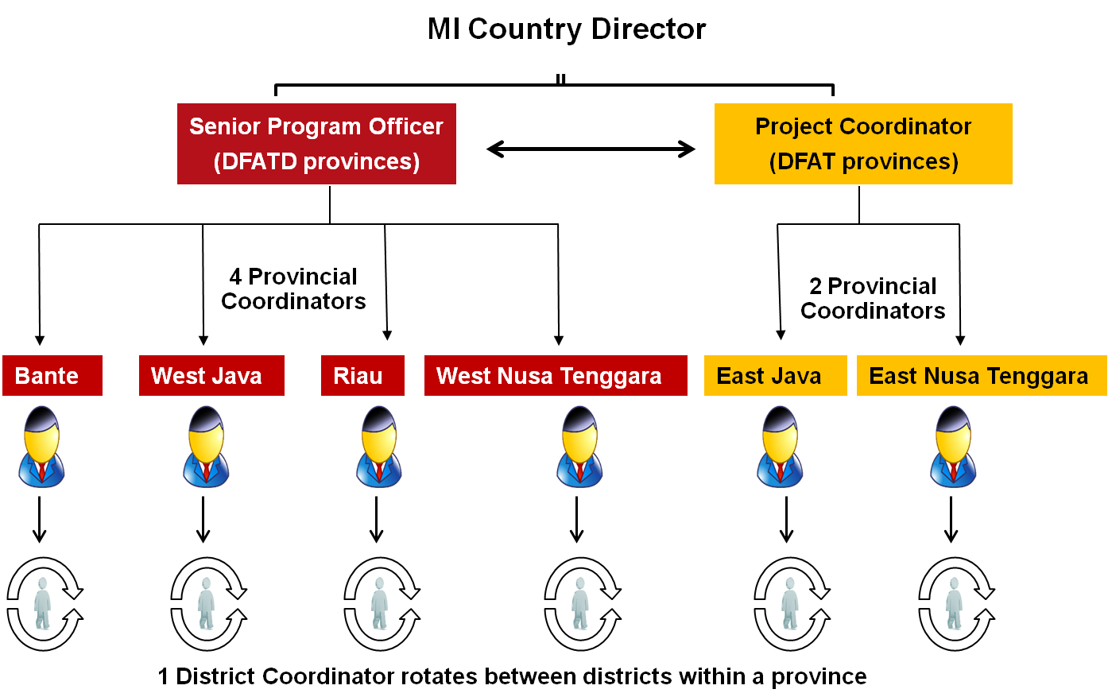

# Performance Measurement Framework

An identified set of indicators will be measured and tracked through a project monitoring system which essentially will be informed by the HMIS, extender reports and a program evaluation.

The indicators that will be tracked on a monthly and quarterly basis will provide information for program management and decision making. For details see the Performance Measurement Framework below.

# Project Evaluation

The overall objective of the project evaluation will be to (a) assess any changes in anaemia prevalence, in coverage and in adherence of key micronutrients; (b) evaluate the extent to which these are plausibly due to the program interventions and (c) provide this information to the national and provincial governments to inform their further planning and scale-up of these programs.

Technical guidance and support for the evaluation will be provided by the Research and Evaluation team at the Asia Regional Office and Headquarters of the Micronutrient Initiative. The ethical clearance for the study will be obtained from the appropriate accredited authorities.

The program will be evaluated using a quasi-experimental pre and post intervention survey design. The sample size will be powered to provide project area level estimates combined for the two program provinces considering them as a single domain. Cross-sectional surveys will be conducted prior to the program roll out (baseline) and at the end of the program exposure period (end line) in the two program provinces and in similar comparison provinces among the following four groups of respondents:

* *Recently delivered women to measure changes in coverage and utilization* of IFA supplements during their last pregnancy as well as knowledge and practices related to iron deficiency anaemia and IFA supplementation. We will be considering recently delivered women to allow for a period of complete exposure to the entire duration of the pregnancy to be able to effectively assess levels of complete coverage and utilization of IFA during the entire duration of the last pregnancy. In addition, knowledge about the causes, symptoms and consequences of anaemia, ways to prevent anaemia, the possible reasons for non-compliance of IFA, knowledge of IFA dose, duration and benefits, methods to overcome side effects of IFA consumption, counselling provided and use of behaviour change communication materials by health workers will also be assessed. Health worker and cadres knowledge and practices about causes, symptoms and consequences of anaemia, ways to prevent anaemia, IFA supplementation, dosage, duration and benefits of IFA utilization, supplies of IFA tablets, counselling provided and use of behaviour change communication materials by the health workers will also be assessed.
* *Pregnant women (pregnant at the time of survey), to measure the prevalence of any anaemia among pregnant women.* Currently, anaemia prevalence among pregnant women has been assumed to be 37% as per the RISKESDAS 2013 in the Performance Measurement Framework. To measure change in haemoglobin levels more precisely, we will be drawing blood samples from currently pregnant women during the baseline and end line surveys. In these surveys, samples will be drawn from pregnant women in all the three trimesters of pregnancy since the levels of anaemia may differ by gestational age, as reported in some studies. Further, during the end line survey, pregnant women who have been staying in the program area since the beginning of the program will be selected assuming that they have been exposed to the program interventions during the course of their pregnancy, and those who have migrated in and out of the program area during the program exposure period will be excluded. In addition, we will assess the coverage and utilization of IFA supplementation during the current and last pregnancy retrospectively as well as their knowledge and practices related to anaemia and IFA supplementation will also be assessed through a questionnaire so that we can analyze the association between the coverage and utilization of IFA and haemoglobin levels.
* *Caregivers of children in the age group of 6-59 months with an episode of diarrhoea* to measure the knowledge of zinc and ORS and use of zinc and ORS for diarrhoea management. In addition, the source of diarrhoea treatment whether in the public or private sector, source of zinc and ORS, possible reasons for non-compliance of zinc, use of antibiotics will also be explored. We will also assess the health worker and cadres’ knowledge about zinc and ORS for diarrhoea management, supplies of zinc and ORS at frontline distribution points, and monitoring of stock levels.
* *Caregivers of children in the age group of 6-59 months to measure coverage of vitamin A* supplementation. In addition, the knowledge of benefits of VAS and the barriers and bottlenecks in achieving high coverage will also be assessed. We will also assess the health worker and cadres’ knowledge of VAS, method of estimation of target group, forecasting of supplies of Vitamin A at the frontline distribution points and recording, reporting and compilation of VAS data.

The evaluation design will detect provincial level differences. To have estimates of anaemia prevalence for the two program provinces and two comparison provinces separately in the baseline and end-line, we would need a total of ~13,100 blood samples for Hb level measurement (based on the baseline and expected end-line values of the indicator proposed in the Performance Measurement Framework of the proposal)

The results of the evaluation will be disseminated in a workshop with the various stakeholders from the GoI, civil society organizations, private sector, academia, UN and donor agencies.

# Annex 1: Project Logic Model

|  |  |  |  |  |  |  |  |
| --- | --- | --- | --- | --- | --- | --- | --- |
| **Title** | Reducing Iron deficiency Anaemia in pregnant women and reducing mortality and morbidity in children under five, in two provinces of Indonesia: East Java and East Nusa Tenggara | | | | | Team Leader |  |
| Country | Indonesia | | | | | Duration | August 2015- September 2019 |
| **ULTIMATE OUTCOME** | 1000 **Impact**: Reduced iron deficiency anaemia in pregnant women and reduced mortality and morbidity among children under five years of age. | | | | | | |
| 🡹 |  | |  | | 🡹 | | |
| **INTERMEDIATE OUTCOMES** | 1100: **Enabling environment:** public sector policy makers renew leadership of and commitment to more effective implementation of key Micronutrients (MN)[17] programs to provide iron and folic acid (IFA) supplements to pregnant women, linked to antenatal care services (ANC), zinc and ORS to children under five who suffer from diarrhoea and Vitamin A supplements (VAS)to all under five children including improved policies, guidelines, product standards and increased budget allocations | | 1200: **Provision:** improvements in the extent to which front-line health workers, supervisors and health service managers, prioritize the timely provision of IFA supplements to pregnant women, zinc and ORS for children under 5 suffering from diarrhoea and VAS for all under five children and are capacitated for effective planning, monitoring, management, and appropriate counselling to pregnant women and caregivers of children under five | | 1300: **Consumption**: pregnant women and caregivers of children under five have improved receipt and adherence of key MN supplements | | |
| 🡹 | 🡹 | 🡹 | 🡹 | 🡹 | | 🡹 | 🡹 |
| **IMMEDIATE OUTCOMES** | 1110 **Knowledge, Skills and Capacity**: policy makers have committed to revitalizing and strengthening key MN programs through changes in policy instruments[18], and to increase budgets to effectively plan, implement and monitor these programs. | | 1210: **Knowledge, Skills and Capacity**: front-line health workers, supervisors and managers, have recognized the importance of prioritizing key MN programs through improved capacity for timely provision of adequate amounts of supplements and effective planning, monitoring, management and appropriate counselling. | | 1310: **Knowledge,** **Skills and** **Capacity**: pregnant women and caregivers of children under five have improved knowledge and skills on benefits, when and where to seek key MN supplements, method of administration, including the correct frequency and duration and managing side effects to ensure adherence. | | |
| 🡹 | 🡹 | 🡹 | 🡹 | 🡹 | | 🡹 | 🡹 |
| **OUTPUTS** | 1111 **Key information received**: policy makers have received information about gaps in key MN programs (including product re-formulation; packaging; dosage, service quality etc); and on the scope for improvement based on the results from the MI demonstration projects  1112 **Tools** **received**: policy makers have received updated guidelines and approaches to monitoring to help them plan and implement these programs effectively  1113: **Learning completed:** policy makers have received briefing on the above | | 1211: **Supplies ensured:** bottlenecks and gaps in supply chains identified and streamlined in consultation with local district staff through provision of tools and checklists for planning and forecasting  1212: **Tools received**: front-line health workers, supervisors and managers, have effective systems e.g. modified HMIS, training curricula for improving service delivery in provision of supplements and improved skills for appropriate counselling  1213: **Learning completed:** front-line health workers, supervisors and managers have completed training on modified tools for forecasting, monitoring recording and reporting use of job aids for appropriate counselling | | 1311: **Evidence-informed BCI approaches** **uptake and use :** BCI plan developed with appropriate messages and channels identified for improving knowledge and skills of pregnant mothers and caregivers of children under five on benefits and use of key MN supplements in consultation with key stakeholders  1312: **Messages received on correct use:** pregnant women and caregivers of children under five have received guidance on how to administer key MN supplements at the appropriate time, with the correct frequency and duration and how to manage side effects to ensure adherence | | |

# Annex 2: Project Monitoring Framework

|  |  |  |  |  |  |  |  |
| --- | --- | --- | --- | --- | --- | --- | --- |
| Title | Reducing Iron Deficiency Anaemia in pregnant women and reducing mortality and morbidity in children under five, in two provinces of Indonesia: East Java and East Nusa Tenggara | | | | Team Leader | |  |
| **Result statements** | **Indicators** | **Baseline** | **Target** | **Data sources** | **Data collection methods** | **Frequency** | **Responsibility** |
| **Ultimate outcome** |  |  |  |  |  |  |  |
| 1000 **Impact**: Reduced iron deficiency anaemia in pregnant women and reduced mortality and morbidity among children under five years of age. | % of pregnant women with haemoglobin below 110 g/L | 37% (Riskesdas, 2013) | 30%[19] | Evaluation | Baseline and end line survey | Once | MI/ Independent agency |
| # of deaths averted of children under 5 (VAS and zinc + LO ORS). | Number of child deaths in project areas | TBD | Modelling | Modelling | Once | MI RO/MI HQ |
| **Enabling environment- Intermediate outcome** |  |  |  |  |  |  |  |
| 1100: **Enabling environment:** Public sector policy makers renew leadership of and commitment to more effective implementation of key Micronutrients (MN)[20] programs. Specifically to provide iron and folic acid (IFA) supplements to pregnant women, linked to antenatal care services (ANC), zinc and ORS to children under five who suffer from diarrhea and Vitamin A supplements (VAS) to all under five children including improved policies, guidelines, product standards and increased budget allocations | **Standards and Guidelines:** % of districts that are implementing programs with   1. product standards consistent with international norms for each MN 2. guidelines that are consistent with the WHO recommendations for each MN program   **Budget allocation:** # of districts where there is an increase in budget allocation (supplies/training /operational cost) for the MN programs. | For IFA and Vitamin A 0%[21]  For  IFA 0%[22]  0 | 80%  80%  15 of 20 districts | Policy documents  - Policy documents  - District Development Planning Board documents | Review of documents and policy statements  District program action plans | Once  Annual | MI/ DHO  MI/ DHO |
| **Enabling environment – Immediate outcome** |  |  |  |  |  |  |  |
| 1110 **Knowledge, Skills and Capacity**: Policy makers have committed to revitalizing and strengthening key MN programs through changes in policy instruments[23], and to increase budgets to effectively plan, implement and monitor these programs. | **Plan and implement:** # of districts with policy makers who know how to plan and budget appropriately for   1. national procurement of key MN supplies (e-procurement) 2. improving service delivery to increase coverage of MN programs   **Monitoring:** # of districts that have modified HMIS to track key coverage and stock indicators. | 0  0 | 20 districts  15 of 20 districts | FGDs with policy makers  Revised HMIS | Analysis of FGDs  Modified HMIS tools | Once  Once | MI  MI/ DHO |
| **Enabling environment – outputs** |  |  |  |  |  |  |  |
| 1111 **Key information received**: Policy makers have received information about gaps in key MN programs (including product re-formulation; packaging; dosage, service quality etc); and on the scope for improvement based on the results from the MI demonstration projects | # of dissemination meetings organized to inform policy makers and influencers | 0 | 1 national level advocacy workshop | Advocacy meeting minutes | Review of minutes of the meeting | Once | MI/ MoH |
| 1112 **Tools** **received**: policy makers have received updated guidelines and approaches to monitoring to help them plan and implement these programs effectively | # of districts in which key policy makers and influencers received relevant tools | 0 | All 20 districts | Distribution records | Review of distribution records | Once | MI/ MoH/ PHO/DHO |
| 1113: **Learning completed:** Policy makers have received briefing on the above | # of workshops conducted for policy makers at national level  # of workshops conducted for policy makers at provincial level  # of workshops conducted for policy makers at district level | 0  0  0 | 2 (1 per year )  2 (1 per year )  2 (1 per year ) | Minutes of the meeting | Review of minutes of the meeting | Annual | MI/ MoH/ PHO/DHO |
| **Provision – Intermediate outcome** |  |  |  |  |  |  |  |
| 1200: **Provision:** improvements in the extent to which front-line health workers, supervisors and health service managers, prioritize the timely provision of IFA supplements to pregnant women, zinc and ORS for children under 5 suffering from diarrhoea and VAS for all under five children and are capacitated for effective planning, monitoring, management, and appropriate counselling to pregnant women and caregivers of children under five | **Capacity for monitoring**:  # of districts that actively compile HMIS data on  Stock and Coverage  of MN supplements | 0 | 15 of 20 districts | Revised HMIS | Modified HMIS tools/ directives from DHO | Once | MI |
| **Adequacy of supplies:**  % of districts with adequate supplies of each MN available at the DHOs  a. IFA supplements  b. zinc and ORS  c. VAS | 0 | 100% (all 20 districts) | District procurement records | District procurement offices/ District Pharmacies | Annual update | MI |
| **Planning and monitoring**: % of districts conducting annual planning and quarterly program review meetings on these micronutrient programs to identify gaps and potential solutions | 0 | 100% (all 20 districts) | Minutes of meetings | Review of minutes of meetings | Annual update | MI |
| **Provision – Immediate outcome** |  |  |  |  |  |  |  |
| 1210: **Knowledge, Skills and Capacity**: Front-line health workers, supervisors and managers, have recognized the importance of prioritizing key MN programs through improved capacity for timely provision of adequate amounts of supplements and effective planning, monitoring, management and appropriate counselling. | % of frontline workers who can correctly describe dosage, duration, benefits and side effects of each MN  a. IFA supplements  b. zinc and ORS  c. VAS | TBD from baseline survey | Increase by 50% | Program evaluation | Baseline and end line surveys | Once | MI/ Independent agency |
| **Provision – Outputs** |  |  |  |  |  |  |  |
| 1211: **Supplies ensured:** bottlenecks and gaps in supply chain identified and streamlined in consultation with local district staff through provision of tools and checklists for planning and forecasting | **Stock outs:** % of districts with stock out of  a. IFA supplements  b. Zinc supplements  c. ORS  d. VAS  at frontline distribution points | TBD | 20%  20%  20%  20% | HMIS data | Review of HMIS data | Annual update | MI and DHO |
| 1212: **Tools received**: front-line health workers, supervisors and managers, have effective systems e.g. modified HMIS, training curricula for improving service delivery in provision of supplements and improved skills for appropriate counselling | % of managers, supervisors frontline health workers who receive an improved package of tools | 0 | 80% | Dissemination records/ training reports | Review of dissemination records or estimates | Annual update | MI and DHOs |
| 1213: **Learning completed:** front-line health workers, supervisors and managers have completed training on modified tools for forecasting, monitoring recording and reporting use of job aids for appropriate counselling | a. formal training  # or % of managers and supervisors trained on improved package of tools  # or % of frontline health workers trained on improved package of tools  b. on the job training  % of manager, supervisors frontline health workers provided on the job training during program review meetings | 0  0  0 | 128 (80% of the 160)  512 (80% of the 640)  60% | Training reports  Project Monitoring reports | Review of training reports  Review of project MIS | Annual update  Quarterly | MI and DHOs  MI |
| **Consumption – Intermediate outcome** |  |  |  |  |  |  |  |
| 1300: **Consumption**: Pregnant women and caregivers of children under five have improved receipt and adherence of key MN supplements | **IFA Coverage:** % of women who have been pregnant in the past year who received   1. any iron tablets 2. at least 90 3. at least 180   IFA supplements during pregnancy  **Utilization:** % of women who have been pregnant in the past year reporting consumption of at least 90 IFA supplements | 88%[24]  TBD from baseline survey  TBD from baseline survey  56%[25] | Increased by 5%  Increased by 25%  Increased by 15%  Increased by 20% | Program evaluation | Baseline and end line surveys | Once | MI/ Independent agency |
| **Zinc and ORS Coverage:** % of children aged 1-59 mo presenting with diarrhoea whose caregivers received the recommended course[26] of zinc and lo-ORS supplements from any sector (public-private both)  **Utilization:**% of children aged 1-59 mo presenting with diarrhoea whose caregivers administered the full course of zinc and lo-ORS supplements as per recommendation | 15%[27]  TBD from baseline survey | Increased by 30%  Increased by 20% | Program evaluation | Baseline and end line surveys | Once | MI/ Independent agency |
| **VAS Coverage:** % of children 6-59 months of age who are fully protected with two annual doses of VAS | 82%[28] | 90% | Program evaluation | Baseline and end line surveys | Once | MI/ Independent agency |
| **Consumption – Immediate outcome** |  |  |  |  |  |  |  |
| 1310: **Knowledge,** **Skills and** **Capacity**: pregnant women and caregivers of children under five have improved knowledge and skills on benefits, when and where to seek key MN supplements, method of administration, including the correct frequency and duration and managing side effects to ensure adherence. | % of end users who can describe one benefit to seek each MN supplement  a. IFA (among pregnant women)  among caregivers of children under 5  b. Zinc and ORS  c. VAS  % of all pregnant women who can explain how to overcome at least one typical barrier/side effect to IFA consumption | TBD from baseline survey  TBD from baseline survey | Increased by 40%  Increased by 40% | Program evaluation | Baseline and end line surveys | Once | MI/ Independent agency |
| **Consumption – Output** |  |  |  |  |  |  |  |
| 1311: **Evidence-informed BCI approaches** **uptake and use :** BCI plan developed with appropriate messages and channels identified for improving knowledge and skills of pregnant mothers and caregivers of children under five on benefits and use of key MN supplements in consultation with key stakeholders | BCI plan developed | No plan | BCI plan developed and finalized | - | - | Once | MI/ MoH/ DHO |
| 1312: **Messages received on correct use:** pregnant women and caregivers of children under five have received guidance on how to administer key MN supplements at the appropriate time, with the correct frequency and duration and how to manage side effects to ensure adherence | % of pregnant women who received correct messages on benefits and mitigation of side effects for IFA supplementation  % of caregivers of children under 5 who received correct messages on benefits, dosage and use of zinc in diarrhea and VAS | TBD from baseline survey  TBD from baseline survey | Increased by 60%  Increased by 60% | Program evaluation | Baseline and end line surveys | Once | MI/ Independent agency |

# Annex 3: Project Implementation Plan (PIP)

|  |  |  |  |  |  |  |  |  |  |  |  |  |  |  |  |
| --- | --- | --- | --- | --- | --- | --- | --- | --- | --- | --- | --- | --- | --- | --- | --- |
| **Project Title** | **Reducing Iron Deficiency Anaemia in pregnant women and reducing mortality and morbidity in children under five, in two provinces of Indonesia: East Java and East Nusa Tenggara** | **Responsible party** | **Preparatory phase** | | **2 provinces [20 districts]** | | | | **2 provinces [20 districts]** | | | | **2 provinces [20 districts]** | | **BUDGET (AUD)** |
| **Start date** | **1-Aug-15** |  |  | |  | | | |  | | | |  | |  |
| **End date** | **30 September, 2018** |  | 2015-16 | | 2016-17 | | | | 2017-18 | | | | 2018-19 | |  |
|  | **Outputs + Activities** |  | Aug-Dec | 4 | 1 | 2 | 3 | 4 | 1 | 2 | 3 | 4 | 1 | 2 |  |
|  | **1111 Key information received: Policy makers have received information about gaps in key MN programs (including product re-formulation; packaging; dosage, service quality etc); and on the scope for improvement based on the results from MI demonstration programs** |  |  |  |  |  |  |  |  |  |  |  |  |  |  |
|  | Conduct dissemination workshops to share findings from the micronutrient programs implemented by MI in recent years. | MI, MoH | X |  |  |  |  |  |  |  |  |  |  |  |  |
|  | Conduct advocacy meetings with MoH officials at central level to ensure adequate allocation of budget for procurement and supply of IFA, zinc and ORS and VAS supplements, delivery of timely and recommended quantities of these at health facilities, provision of communication materials and operational budget for monitoring and supervision. | MI, MoH | X |  | X |  |  |  | X |  |  |  | X |  |  |
|  | Strengthen government commitment through MI and DFAT participation in meetings such as Mother and Child Forum and SUN movement National Task group and GAPPD | MI, MoH |  |  | X |  |  |  |  |  |  |  |  |  |  |
|  | **1112 Tools received: policy makers have received updated guidelines and approaches to monitoring to help them plan and implement these programs effectively** |  |  |  |  |  |  |  |  |  |  |  |  |  |  |
|  | Facilitate meetings and discussions for modifications/updating existing IFA guidelines for pregnant mothers | MI, MoH, PHO |  | X |  |  |  |  |  |  |  |  |  |  |  |
|  | Facilitate meetings and discussions for modifications/updating existing guidelines for use of zinc and ORS in treatment of childhood diarrhea | MI, MoH, PHO |  | X |  |  |  |  |  |  |  |  |  |  |  |
|  | Facilitate meetings and discussions for modifications/updating existing guidelines for VAS program | MI, MoH, PHO |  | X |  |  |  |  |  |  |  |  |  |  |  |
|  | Facilitate review and modifications in existing HMIS to strengthen and streamline monitoring of these MN programs | MI, MoH, PHO |  | X | X |  |  |  |  |  |  |  |  |  |  |
|  | **1113: Learning completed: Policy makers have received briefing on the above** |  |  |  |  |  |  |  |  |  |  |  |  |  |  |
|  | Conduct advocacy meeting with MoH at the central level to facilitate for procurement of IFA supplements, Zinc and ORS and Vitamin A capsules complying with WHO recommendations and integration with other existing maternal and child health programs | MI, MoH |  | X |  |  |  | X |  |  |  | X |  |  |  |
|  | Conduct advocacy meeting with PHO at the provincial level to faciliitate integration with other existing maternal and child health programs | MI, MoH, PHO |  |  | X |  |  |  | X |  |  |  | X |  |  |
|  | Conduct advocacy meeting with DHO at the district level to faciliitate integration with other existing maternal and child health programs | MI, MoH, PHO, DHO |  |  | X |  |  |  |  |  |  |  |  |  |  |
|  | **1211: Supplies ensured: bottlenecks and gaps in supply chain identified and streamlined in consultation with local district staff through provision of tools and checklists for planning and forecasting** |  |  |  |  |  |  |  |  |  |  |  |  |  |  |
|  | Supporting PHO and DHO staff in estimating requirements of IFA supplements, Zinc and ORS and VAS using appropriate methodology to facilitate provision of adequate IFA supplements, Zinc and ORS and Vitamin A capsules at the health centres | MI, PHO, DHO |  | X |  |  |  | X |  |  |  | X |  |  |  |
|  | Advocate with the DHO and the pharmacy at the district level through the district extender to facilitate adequate and timely supply of MN supplements at the district level and further to the puskesmas and posyandu at village level | MI, PHO, DHO |  | X |  |  |  | X |  |  |  | X |  |  |  |
|  | Support development of micro plans for distribution of IFA supplements, Zinc and ORS and VAS at district level to puskesmas/posyandu | DHO |  | X | X |  |  |  | X |  |  |  | X |  |  |
|  | Facilitate provincial and district level project progress reviews to troubleshoot problems in supply chain for eg facilitate pharmaceutical district manager to check stocks of MN supplements on a regular basis to ensure uninterrupted services to the health facility and catalyze distribution of MN supplements from the buffer stock maintained at the province in case of inadequate availability of supplies at the central pharmacy | MI, PHO, DHO |  | X | X | X | X | X | X | X | X | X | X | X |  |
|  | Facilitate DHOs to use mobile technology to flag stock outs. | MI, PHO, DHO |  |  | X | X | X | X | X | X | X | X | X | X |  |
|  | **1212: Tools received: front-line health workers, supervisors and managers, have effective systems e.g modified HMIS, training curricula for improving service delivery in provision of supplements and improved skills for appropriate counselling** |  |  |  |  |  |  |  |  |  |  |  |  |  |  |
|  | Review and modify the existing training manual to focus on use and importance of IFA supplements for pregnant women, Zinc and ORS and VAS for children under five, estimation of supplies, provision of MN supplements, dose, benefits, how to handle side effects and effective counselling for better compliance, program monitoring and reporting. | MI, MoH, PHO | X | X |  |  |  |  |  |  |  |  |  |  |  |
|  | Review and modify the existing HMIS system to include indicators on coverage and stock of key MNs. | MI, MoH, PHO |  | X |  |  |  |  |  |  |  |  |  |  |  |
|  | Printing of training and communication materials to the district health office and health centre | MI, MoH |  |  | X |  |  |  |  |  |  |  |  |  |  |
|  | Facilitate provision of modified BCI materials to frontline workers | MoH, DHO |  |  | X |  |  |  |  |  |  |  |  |  |  |
|  | **1213: Learning completed: front-line health workers, supervisors and managers have completed training on modified tools for forecasting, monitoring recording and reporting use of job aids for appropriate counselling** |  |  |  |  |  |  |  |  |  |  |  |  |  |  |
|  | Conduct national level ToT on systems, tools and product specifications for planning, delivery and monitoring of the program | MI, MoH |  | X |  |  |  |  | X |  |  |  |  |  |  |
|  | Training of PHO, DHO officials and IBI on systems, tools and product specifications for planning, delivery and monitoring of the program including QRS for VAS | MI, MoH |  |  | X | X |  |  |  |  |  |  |  |  |  |
|  | Training on supply chain management for district level officials at province | MI, MoH |  |  |  |  |  |  | X |  |  |  |  |  |  |
|  | Training of health staff, midwives, cadres and their supervisors to effectively plan, implement, monitor and supervise the key MN programs. | PHO, DHO |  |  |  | X |  |  |  | X |  |  |  | X |  |
|  | Regular on job training and capacity building at monthly coordination meeting at the province, district and puskesmas levels | PHO, DHO |  |  |  | X | X | X | X | X | X | X | X | X |  |
|  | Provision of supportive supervision during field visits to the frontline workers to register pregnant women and children under five, provision of recommended number of IFA supplements, Zinc and ORS, VAS, and use of communication materials for counselling | PHO, DHO |  |  |  | X | X | X | X | X | X | X | X | X |  |
|  | Ensure that the HMIS data is regularly collected and compiled at the district levels and sent to the province (PHO) for feedback and necessary action. | DHO |  |  |  | X | X | X | X | X | X | X | X | X |  |
|  | Facilitate use of the modified MIS , improved recording and reporting systems and use of the data for corrective actions and decision making | MI, PHO, DHO |  |  |  | X | X | X | X | X | X | X | X | X |  |
|  | Facilitate DHOs and PHOs staff in monitoring the quality of VACs in the district/province by checking at health centres and district warehouses and providing feedback to MoH and Food and Drug Administration | MI, PHO, DHO |  |  |  | X | X | X | X | X | X | X | X | X |  |
|  | Conduct joint review meeting between PERMATA and DFATD provinces at provincial level. |  |  |  |  |  |  |  | X |  |  |  |  |  |  |
|  | ***Private sector -*** Undertake sensitization meeting with professional organizations of medical doctors, pediatricians and midwives from districts and province to promote zinc supplementation for treatment of uncomplicated diarrhea | MI |  | X |  |  |  |  | X |  |  |  |  |  |  |
|  | ***Private sector -*** Conduct sensitization meeting among the pharmaceutical representatives to promote zinc supplementation at the province level | MI |  | X |  |  |  |  | X |  |  |  |  |  |  |
|  | **1311: Evidence-informed BCI approaches uptake and use : BCI plan developed with appropriate messages and channels identified for improving knowledge and skills of pregnant mothers and caregivers of children under five on benefits and use of key MN supplements in consultation with key stakeholders** |  |  |  |  |  |  |  |  |  |  |  |  |  |  |
|  | Undertake review of existing BCI plan developed for the demonstration phase and modify on the basis of recommendations | MI, MoH, PHO, DHO |  | X |  |  |  |  |  |  |  |  |  |  |  |
|  | Identify appropriate channels, messages and communication materials | MI, MoH |  | X |  |  |  |  |  |  |  |  |  |  |  |
|  | Utilisation of BCI materials by health staff, midwives, frontline workers during facility contacts and home visits | DHO |  |  |  | X | X | X | X | X | X | X | X | X |  |
|  | **1312: Messages received on correct use: pregnant women and caregivers of children under five have received guidance on how to administer key MN supplements at the appropriate time, with the correct frequency and duration and how to manage side effects to ensure adherence** |  |  |  |  |  |  |  |  |  |  |  |  |  |  |
|  | Enlisting of all the pregnant women and children under five in the catchment area by the health workers. | DHO |  |  |  | X | X | X | X | X | X | X | X | X |  |
|  | Village midwives and frontline workers provide IPC to pregnant women on benefits and use (dosage, frequency, appropriate time of consumption) of IFA supplements and methods to overcome side effects. | DHO |  |  |  | X | X | X | X | X | X | X | X | X |  |
|  | Village midwives and frontline workers engage with social influencers such as local community leaders, family members etc during group meetings, community platforms such as Posyandus etc to inform them on benefits and use of key MN supplementation programs. | DHO |  |  |  | X | X | X | X | X | X | X | X | X |  |
|  | Frontline health workers provide IPC to caregivers of children under 5 on benefits and use (dosage, frequency, appropriate time of consumption) of Zinc and ORS and VAS. | DHO |  |  |  | X | X | X | X | X | X | X | X | X |  |
|  | Facilitate provision of pink book for recording of health services provided to pregnant women and children | DHO |  |  |  | X | X | X | X | X | X | X | X | X |  |
|  | Frontline health workers (health staff) provide information to pregnant women to take IFA supplements during pregnancy, Zinc and ORS and VAS for children under five through group meetings at the community level | DHO |  |  |  | X | X | X | X | X | X | X | X | X |  |
|  | **Program evaluation** |  |  |  |  |  |  |  |  |  |  |  |  |  |  |
|  | Conduct baseline and end line survey in the 2 provinces |  |  | X |  |  |  |  |  |  |  |  | X |  |  |
|  | Results of the program evaluation are disseminated to policy makers |  |  |  |  |  |  |  |  |  |  |  |  | X |  |
|  | Advertisement vacancy for extenders |  |  |  |  |  |  |  |  |  |  |  |  |  |  |
|  | EXTENDER COSTS & PROJECT COORDINATOR |  |  |  |  |  |  |  |  |  |  |  |  |  |  |
|  | Indirect Cost (10%) |  |  |  |  |  |  |  |  |  |  |  |  |  |  |
|  | DFAT BUDGET TOTAL |  |  |  |  |  |  |  |  |  |  |  |  |  |  |

1. The Permata program did not proceed due to budget cuts
2. Indonesia Demographic and Health Survey, 2012
3. Report on the achievement of the Millennium Development Goals, Indonesia, UNDP, 2010
4. Sanghvi TG, Harvey PW, Wainwright E. Maternal folic acid supplementation programs: evidence of impact and implementation. Food Nutr Bul, 2010 Jun; 31 (2 Suppl): P 100-7.
5. WHO, Guideline: Daily iron and folic acid supplementation in pregnant women. Geneva, World Health Organization, 2012.
6. Christian P. Fetal growth restriction and preterm as determinants of child growth in the first two years and potential interventions. Nestle Nutr Inst Workshop Ser. 2014;78:81-91. doi: 10.1159/000354943. Epub 2014 Jan 27.  
7. Basic Health Research, *Riskesdas, 2013*
8. Worldwide prevalence of anaemia 1993–2005,WHO, 2008
9. Indonesia Demographic and Health Survey, 2007
10. Ministry of Health data, 2009
11. Program evaluation of the MI demonstration program “Strengthening the IFA supplementation program for pregnant women in Indonesia: Results from the demonstration project in Lebak and Purwakarta“ in 2014
12. Indonesia Demographic and Health Survey, 2012
13. Basic Health Research, *Riskesdas, 2013*
14. Program evaluation of the MI demonstration program “Zinc and ORS in the treatment of childhood diarrhoea in Indonesia through the public health system: Results from the demonstration project in East and West Lombok“ in 2014
15. The endorsement of national coverage for 2014 is not available yet. Usually, the data is published in the middle of the year after i.e. (mid 2015).
16. Key MN supplements/programs in the proposal from henceforth will refer to distribution of iron and folic acid (IFA) supplements for pregnant women, zinc supplements and ORS to treat children under five who suffer from diarrhea and administration of Vitamin A supplements (VAS) to all children under five bi-annually
17. Key MN supplements/programs in the proposal from henceforth will refer to distribution of iron and folic acid (IFA) supplements for pregnant women, zinc supplements and ORS to treat children under five who suffer from diarrhea and administration of Vitamin A supplements (VAS) to all children under five bi-annually
18. Can include: Guidelines on counselling, product standards, approaches to monitoring, distribution policies; BCI policy/strategy
19. The global trends of reduction in anaemia prevalence from 1995 to 2011 shows a reduction of 43% to 38% among pregnant women, an absolute reduction of 5% during this time (<1% per year)* and 9% in the East and South-east Asia region (includes Indonesia in the analysis) about 1.5% per year. In the proposed project, in a 3 year period, if we assume with additional intensified efforts, we may expect to see a reduction of about 2% absolute reduction per year. So, after 3 years, it could be pegged at about 30%.*\*source: Gretchen A Stevens, Mariel M Finucane, Luz Maria De-Regil, Christopher J Paciorek, Seth R Flaxman, Francesco Branca, Juan Pablo Peña-Rosas, Zulfi qar A Bhutta, Majid Ezzati, on behalf of Nutrition Impact Model Study Group (Anaemia).  Global, regional, and national trends in haemoglobin concentration and prevalence of total and severe anaemia in children and pregnant and non-pregnant women for 1995–2011: a systematic analysis of population-representative data, Lancet 2013.*
20. Key MN supplements/programs in the proposal from henceforth will refer to distribution of iron and folic acid (IFA) supplements for pregnant women, zinc supplements and ORS to treat children under five who suffer from diarrhea and administration of Vitamin A supplements (VAS) to all children under five bi-annually
21. The quality of zinc and ORS are in line with the international standards, hence, not included.
22. The guidelines for implementation of VAS and use of zinc and ORS in childhood diarrhea programs are consistent with the WHO guidelines, hence not included.
23. Can include: Guidelines on counselling, product standards, approaches to monitoring, distribution policies; BCI policy/strategy
24. East Nusa Tenggara (ENT): 86.9%, and East Java: 88.0%. Source: IDHS, 2012
25. ENT: 62.1%, and East Java: 49.2%. Source: IDHS, 2012
26. Zinc: at least 10 zinc and 2 LO-ORS for children aged 1-59m presenting with diarrhoea;
27. ENT: 15.8%, and East Java: 13.9%. Source: RISKESDAS, 2013
28. MoH administrative data for 2014