# 

[This page intentionally left blank]

# Table of Contents

Acronyms and Abbreviations 1

1.0 Introduction 1

1.1 Why do we need a Monitoring and Evaluation Plan? 1

1.2 Who is this M&E Plan for? 1

1.3 Principles underlying MAMPU M&E 1

1.4 Organisation of this document 2

2.0 What does MAMPU aim to achieve and how? 3

3.0 How will MAMPU be monitored? 7

3.1 Partner Quarterly Progress Reporting 7

3.2 MAMPU Secretariat field monitoring and verification 8

3.3 Routine reflection by Partners and the MAMPU Secretariat 9

3.4 Monitoring performance against annual Thematic Roadmap Targets 9

4.0 How will MAMPU be evaluated? 11

4.1 Key Evaluation Questions (KEQs) 11

4.2 Key Evaluation Question 1: How and to what extent has MAMPU affected the partners and networks’ capacity to influence government reform? 12

4.3 Key Evaluation Question 2: How and to what extent have the partners and networks influenced government reform in relation to the needs and priorities of poor women? 14

4.4 Key Evaluation Question 3: How and to what extent has MAMPU contributed to improved access to essential government services and programs? 16

4.5 Key Evaluation Question 4: What changed in the context and how did MAMPU respond? 19

4.6 Key Evaluation Question 5: To what extent has MAMPU delivered sound VfM? 20

4.7 Making ‘summative’ judgements of Thematic Roadmap Targets 21

4.8 Types of evaluation 22

5.0 Managing and reporting M&E information 23

5.1 Routine reporting products 23

5.2 Program Completion Reporting 24

5.3 MAMPU National Information System (MANIS) 24

6.0 Operationalising the M&E Plan 26

6.1 Resources required 26

6.2 Data Quality 27

6.3 Implementation schedule 27

Annex 1: Partner Quarterly Report (PQR) A1-1

Annex 2: Back-To-Office-Record (BTOR) A2-1

Annex 3: Participatory Analysis and Reflection (PAR) A3-1

Annex 4: Most Significant Change (MSC) A4-1

Annex 5: Combined Tool for Process Tracing and Contribution Analysis A5-1

Annex 6: Longitudinal Study of Access to Services and Livelihoods A6-1

Annex 7: Process for Value for Money Assessment A7-1

Annex 8: MAMPU Value for Money Principles A8-1

**List of Figures**

Figure 1: Outcomes and timeframes 4

Figure 2: Using data from Quarterly Progress Reports to monitor performance by partner, theme, or portfolio 8

Figure 3: Field trip coverage dashboard, MAMPU National Information System 8

Figure 4: Scale for monitoring performance aginst roadmap targets 10

Figure 5: Domains of organisational capacity assessed through the OCPAT 12

Figure 6: Number of policies at each stage of progress, MANIS policy tracking dashboard 14

Figure 7: Identifying quantitative indicators of access to services 17

Figure 8: Timeline of evaluations over Phase II 22

**List of Tables**

Table 1: Summary program logic for MAMPU 6

Table 2: Draft rubric to assess the strength of the case for MAMPU contribution to capacity change 13

Table 3: Draft evaluative criteria to assess changes in capacity, readiness, voice and influence among women at the village level 15

Table 4: Draft rubric scale to assess capacity, readiness, voice and influence at the village level 16

Table 5: Quantitative indicators to measure changes in access to services 16

Table 6: ‘Draft rubric to assess the strength of the case for MAMPU contribution to improved access to services 18

Table 7: Combining sub-questions to assess EOPO achievement in target districts and municipalities 19

Table 8: Targets for MAMPU achievement by 2020, by theme **Error! Bookmark not defined.**

Table 9: Key reporting and information products, audience, content and timing 24

# Acronyms and Abbreviations

|  |  |
| --- | --- |
| BAPPENAS | National Planning and Development Ministry of the Government of Indonesia |
| BAST | Berita Acara Serah Terima / Financial reporting obligations to Government of Indonesia |
| BPJS | Badan Penyelenggaraan Jaminan Sosial / Social Insurance Administration Agency |
| BPS | Badan Pusat Statistik / Statistics Indonesia |
| BTOR | Back-To-Office-Record |
| CA | Contribution Analysis |
| COR | Collaborative Outcomes Reporting |
| CSOs | Civil Society Organizations |
| DFAT | Department of Foreign Affairs and Trade |
| EOPO | End of Program Outcome |
| GoA | Government of Australia |
| GoI | Government of Indonesia |
| JKN | Jaminan Kesehatan Nasional / National Insurance System |
| KEQ | Key Evaluation Question |
| M&E | Monitoring and Evaluation |
| MAMPU | Australia-Indonesia Partnership for Gender Equality and Women’s Empowerment |
| MANIS | MAMPU National Information System |
| MEO | Monitoring and Evaluation Officer |
| MEISO | Monitoring and Evaluation Information Systems Officer |
| MES | Monitoring and Evaluation Specialist |
| MSC | Most Significant Change (monitoring tool) |
| OCPAT | Organisational Capacity and Performance Assessment Tool |
| PAR | Participatory Analysis and Reflection |
| P2TP2A | Integrated Services Center for Women and Children’s Empowerment |
| PQR | Partner Quarterly Report |
| PT | Process Tracing |
| RPJMN | Medium-Term Development Plan of the Government of Indonesia |
| SA | Subsidiary Agreement |
| SC | Steering Committee |
| SIMFONI | National information system for cases of Violence Against Women and Children |
| SOPs | Standard Operating Procedures |
| SPC | Significant Policy Change |
| SUSENAS | National Socio-Economic Survey |
| TC | Technical Committee |
| ToC | Theory of Change |
| VAW | Violence Against Women |
| VfM | Value for Money |
| VIA | Visual Inspection with Acetic Acid /Inspeksi Visual Asam Asetat |
| WCA | Women’s Collective Action |

# 1.0 Introduction

### 1.1 Why do we need a Monitoring and Evaluation Plan?

This document describes the Monitoring and Evaluation (M&E) system for the second phase of the Australia-Indonesia Partnership for Gender Equality and Women’s Empowerment (MAMPU). The Plan expands on the information contained in the M&E Framework developed in March 2017 and formally endorsed by the Steering Committee in December 2018. It contains greater operational detail on tools, resources and implementation of the concepts contained in the earlier document. Both this Plan and the M&E Framework for Phase II draw heavily on the M&E system developed during the first phase of the MAMPU (2013-2016).

The M&E system for MAMPU addresses three interrelated purposes. Firstly, it supports partners, stakeholders, and policy audiences to learn from change. This includes the important contribution of robust and persuasive evidence on specific interventions to policy formulation and implementation. Secondly, this M&E system serves the accountability needs of key stakeholders, especially the partners, the MAMPU Team, and Department of Foreign Affairs and Trade (DFAT), by documenting and demonstrating how MAMPU has contributed to its intended outcomes in the short, medium and long-term. Thirdly, and of no less importance, is the critical transformative role of M&E in MAMPU. MAMPU is explicitly designed to contribute to the empowerment of Indonesian women. This strongly implies a participatory orientation that provides the space for women to decide which change is important and to be actively involved in monitoring, reflecting on, and taking action on the basis of such change.

### 1.2 Who is this M&E Plan for?

The MAMPU M&E system described in this document aims to address the main information needs of key stakeholders involved in MAMPU.

Key audiences of the information gathered through the M&E system are the MAMPU team, partners, Australian Embassy, Thematic Working Groups (‘Pokja’), Technical Committee (TC), and Steering Committee (SC). These different stakeholders play key roles within the governance structure for MAMPU. The right information will need to reach these stakeholders at the right time and in the appropriate format to support effective decision-making.

The information needs of key audiences and how these will be met with M&E ‘products’ is analysed in section 5 of this document.

### 1.3 Principles underlying MAMPU M&E

The M&E system described in this document has been developed to be consistent with the principles that have underpinned MAMPU from the outset in 2012:

**Outcomes and process focused:** M&E focuses on the quality of implementation processes carried out, and equally on what outcomes have occurred as a result of these activities. Outcomes can be positive or negative, expected or unexpected.

**Gives voice to those most marginalised:** The M&E system will actively create opportunities for the perspective of the most marginalised (e.g. women, the elderly and people with disabilities) to be communicated directly to both internal and external decision makers. This has been addressed though the inclusion of participatory monitoring techniques.

**Look for the unexpected as well as expected outcomes:** Changes in the partners' design and implementation of its activities are expected as they learn about what works and does not work, and as changes occur in the context. The M&E should be sufficiently flexible to adapt to these changes.

**Strengthens partners’ M&E systems:** Specific approaches have been put forward to support partners to use and strengthen their own M&E systems.

In addition, the system continues to be guided by the following principles that have guided MAMPU’s approach to M&E since 2013:

**A user-focused orientation:** The M&E system has been structured to provide the right information in the right format to key stakeholders when they need it.

**Learning-by-doing:** Consistent with the approach to capacity development described in the MAMPU Capacity Development Strategy, this M&E Plan takes a practical ‘learning-by-doing’ approach to supporting partners.

**A strengths-based approach:** that builds on what the partners already do. Such an approach begins from the partners’ existing systems and processes.

### 1.4 Organisation of this document

This document is structured in five sections. In section 2, the ‘change process’ that needs to be monitored and evaluated is explained, alongside a summary of what MAMPU expects to achieve. Section 3 outlines how MAMPU will routinely monitor implementation progress. Section 4 sets out arrangements for evaluation, including Key Evaluation Questions (KEQs), data to address these, and the basis for judging success. Section 5 describes mechanisms for collating, managing and ensuring that findings from these M&E processes reach key decision-makers in the MAMPU governance structure. Finally, in section 6 we outline the resources – including the timeframe – needed to implement the system.

Descriptions of key M&E tools and processes referred to throughout the document can be found in annexes 1-8.

## 2.0 What does MAMPU aim to achieve and how?

The Subsidiary Agreement (SA) between the Governments of Indonesia and Australia notes that the ultimate goal of MAMPU is to contribute to “gender equality and women's empowerment in selected areas in Indonesia.” Achieving this high level goal will be the result of the complex interaction of wider socio-cultural, political and economic forces, many of which lie outside the direct influence of MAMPU.

Nevertheless, by 2020 MAMPU will make a contribution towards this goal in two ways. Firstly, MAMPU expects to have “improved access to essential government services and programs for poor women in target locations”. The ‘*essential government services and programs*’ referred to in this statement reflect the five MAMPU themes described in the SA:

* Social protection programs, particularly publically-funded health insurance provided through the National Health Insurance Scheme (*Jaminan Kesehatan Nasional*) administered by BPJS (theme 1);
* Workplace protections, particularly health insurance for women homeworkers (theme 2);
* Services that improve migration conditions for women migrant workers (theme 3);
* Services that address women’s sexual, reproductive health, and nutritional needs (theme 4); and
* Counselling and support services that address the needs women victims and survivors of violence (theme 5).

Secondly, by 2020 MAMPU expects to see positive change in the ‘voice’ and ‘influence’ of women at multiple levels. In villages, women will working collectively, expressing their views in public and private (‘voice’), shaping decision-making and influencing the allocation of state resources (‘influence’) for wider benefit, including improved access to services. By doing so they will be challenging norms that constrain what is socially acceptable for women and girls to do. These changes in ‘voice’ and ‘influence’ are a *process* as well as an expected *outcome*. As a ‘process’ they describe a pathway through which MAMPU improves women’s access to services. They are an ‘outcome’ of MAMPU in that they describe an expected end state that in itself has intrinsic value. Critical to both is a view of poor women as *agents*, not only *users* of services provided by others. This is the empowerment agenda that is central to MAMPU.

**How does capacity increase ‘voice’ at the grassroots?**

In 2017 a qualitative study of eight local women’s groups established by MAMPU partners explored the effects of membership. The analytical framework centred on five types of empowerment ‘assets’. Applying this framework to women’s experiences as members shed light on how and in what circumstances individual and collective capacity leads to increased ‘voice’: “In terms of an empowerment pathway development of human assets, particularly confidence, self-belief, and as called by many interviewees, ‘courage’, appears to be a pre-requisite for other forms of empowerment. Members of each example of collective action studied reported a progression from growing confidence and knowledge (changes in human or individual assets), to speaking out and participating in or presenting to community forums (agency assets), and then some expectation that this will lead to either finance and resource assets or enabling assets, and these will reinforce each other.” These findings are consistent with a wide variety of evidence about women’s empowerment drawn from other contexts.

(MAMPU, (2017) *Women’s Collective Action for Empowerment in Indonesia: A study of collective action initiated by partners of the MAMPU program*. Yogyakarta: Migunani and MAMPU)

MAMPU is based on the idea that networks of selected civil society organisations – the MAMPU partners – can play a pivotal role in shaping government reform to benefit poor women on a significant scale. The program has elected to build on the work of organisations with an established track record of influencing reform in Indonesia. The theory is that with the right kind of support at the right time, these organisations will act more collectively, and increasingly in concert with allies in government, parliament, and private sector. At the same time, partners will work with and draw from the priorities and experiences of poor women in villages across Indonesia. By supporting these multilevel processes, MAMPU expects momentum for change to grow, influencing how the government makes and carries out policies, improving women’s access to essential services on a wide scale.

By the conclusion of 2018 MAMPU expects the results of this process to be visible in increased ‘voice’ and ‘influence’. In the villages where MAMPU works, women will be more involved in decision-making and their ongoing participation will be acknowledged and enshrined in formal village regulations. At the district, provincial and national levels, MAMPU’s contribution will be reflected in policy decisions that can plausibly contribute to improving women’s access to services on a wide scale by 2020. This is the expected medium-term outcome of MAMPU.

Figure 1: Outcomes and timeframes

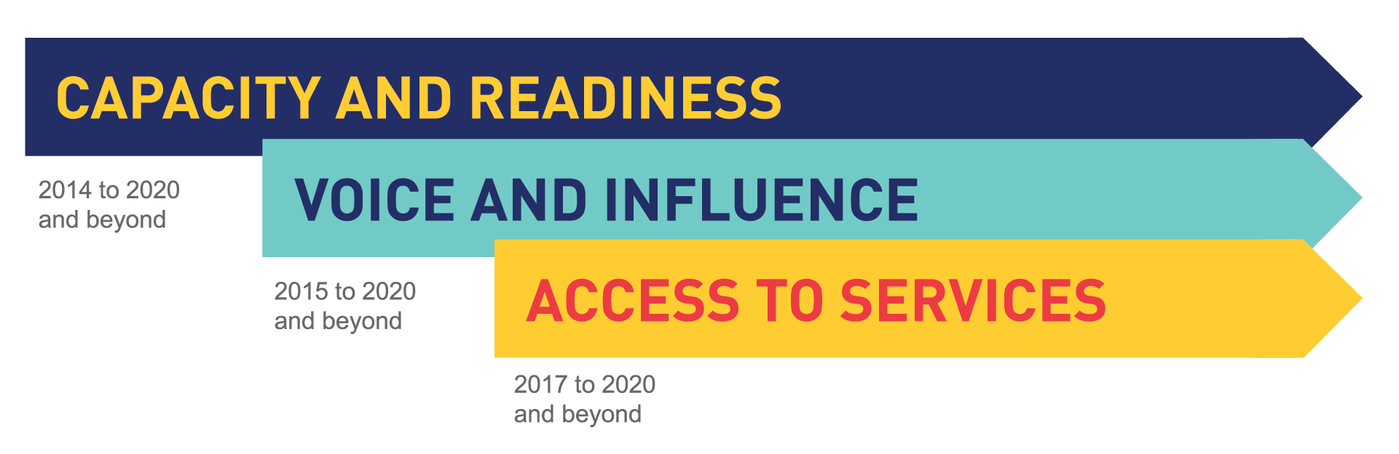However, a series of preconditions are needed if these outcomes are to contribute to better service delivery, improved access to services, and empowerment by 2020. Firstly, they must be accompanied by positive changes in the self-belief, knowledge and confidence of women with whom MAMPU works at the village level. Evidence from MAMPU as well as internationally, suggests that these are important prerequisites for voice and empowerment (see text box previous page). Secondly, the authorizing regulations and policies for reforms that address women’s priorities need to be in place at the national, provincial, and district or municipality levels. Without these, further action such as allocating budgets to women’s priorities is difficult. Thirdly, resources (financial and human) need to be mobilized and allocated towards the particular service-related issue addressed in the policy. Fourthly, government service providers need sufficient capacity to deliver the policy intent at the service level. These four preconditions are not enough in the absence of a fifth: evident commitment and support from a critical mass of leaders – inside government and parliament as well as in communities.

MAMPU is cautious about generalizing across the diversity of contexts where the program aims for change. The opportunities and constraints will depend to a great extent on the unique social, political and cultural dynamics in each village, district and province. Nonetheless, together these five preconditions – in varying configurations – represent the ‘causal package’ that MAMPU believes is required for policy influence to lead to improved access to services and empowerment.

Increasing the capacity and readiness of partners for collective action – including their links with government and private sector – lays the foundation for achieving medium-term and End-Of-Program-Outcomes (EOPOs). MAMPU helps to accelerate this by developing partner organisational capacity, bolstering the focus and intensity of collective action, and enabling them to expand their reach among women at the grassroots. The program incentivizes partners to work in networks that link up local and national organisations and provides them with grant funds to test ideas in selected locations across Indonesia. Alongside this, MAMPU links partners to technical expertise, high quality evidence, and resources, to enable them to better seize opportunities that emerge in the context.

Since 2017 MAMPU’s role as an active ‘connector’ and ‘bridge builder’ between partners, government agencies, and other strategically significant actors has grown. The governance structure for MAMPU – which opens space for routine partner-national government interaction – is critical to this. The increased involvement of Bappenas in a guiding and facilitating role boosts the program’s capacity to link with wider reforms across the government.

Table 1: Summary program logic for MAMPU

|  |  |  |  |  |
| --- | --- | --- | --- | --- |
| **GOAL** | **Gender Equality and Women’s Empowerment** | | | |
| **End-of-Program-Outcome**  (2017-20 and beyond) | **“Improved Access to Essential Services”**  **Improved access:** Poor women have improved access to essential government services and programs in target areas  **Responsive service delivery:** Government providers deliver higher quality and more accessible services in target areas in response to influence from poor women at village, district, and national level | | * Social protection programs * Workplace protections * Services supporting migration for employment * Services that address reproductive health and nutritional needs * Services for women victims and survivors of violence | |
| **Medium-Term Outcomes**  (2015-20 and beyond) | **“Increased Voice and Influence”**  **Critical external factor:** Local government service providers have sufficient capacity to carry out the intent of policy decisions  **Changes to resource allocation:** Governments and parliaments (local and national) allocate the resources (human and financial) needed to implement policy decisions  **Regulatory and policy decisions:** Government and parliaments (local and national) make policy and regulatory decisions that reflect the needs and priorities of poor women in the five thematic areas  **Commitment to reform:** National and local leaders, government policy-makers, and parliamentarians increasingly reflect the needs of poor women in decision-making agendas  **Strengthened demand for reform through grassroots ‘voice’:** Poor women in target locations increasingly advocate for their needs and priorities at village, district, and national levels | | | |
| **Short-term Outcomes**  (2014-20 and beyond) | **“Increased Capacity and Readiness for Collective Action”**  **Build coalitions to advocate for change:** Partners increasingly using evidence to advocate, engage and build alliances with government, parliamentarians, the media, and the private sector  **Develop solutions:** Partners and their networks trial and refine solutions to service delivery issues that affect poor women in target locations  **Organise at the grassroots:** Partners organize women and men at the grassroots and develop women’s critical awareness, knowledge, and self-belief  **National-to-local linkages:** Increasingly effective communication between partners at national and local levels and branches | | | |
| **Support from MAMPU** | **FUND**: Multi-year grants to partner networks to enable them to test and refine their ideas and advocate for change  **ADVISE and ASSIST**: Technical advice and expertise that is strategic while being responsive to emerging needs | **CONVENE:** Bring the network together regularly to identify, discuss, and strategise  **BUILD EVIDENCE:** Collect, analyse, synthesize, and communicate evidence | | **COORDINATE and BRIDGE:** Link partners with Government of Indonesia, media, private sector, and other DFAT- and donor-funded initiatives |

## 3.0 How will MAMPU be monitored?

The path from influencing government policy to improved access to services is neither straight nor predictable. In such contexts it is especially important that implementation teams have rapid feedback to gauge progress and make timely adjustments. MAMPU’s monitoring system will address this need.

Broadly, there will be four complementary components: (i) quarterly progress reporting and analysis; (ii) field monitoring and verification; (iii) regular opportunities for structured reflection and adaptation; (iv) and monitoring performance across MAMPU’s five themes against annual roadmap targets.

### 3.1 Partner Quarterly Progress Reporting

The work of partners is at the heart of MAMPU’s change process and frequent feedback on their performance is essential for responsive and adaptive management.

Every 3 months, each partner will submit a short, structured report to MAMPU through the online reporting system, ‘MANIS Kita’. The quarterly progress report (see Annex 1 for a description of the quarterly reporting tool) will contain information and data so that partners and the MAMPU Secretariat can answer 5 key monitoring questions:

1. **Did we do what we expected to do?** Applies a ‘traffic light’ scale and brief narrative to produce a snapshot of performance against annual workplan over the previous 3 months. The existing template will be modified to ensure alignment with the Government of Indonesia’s BAST financial reporting obligations.
2. **Were the costs in line with what we expected?**Provides a summarized picture of expenditure against budget for each immediate outcome in the annual workplan.
3. **What challenges and risks are affecting progress?** Provides information to explain divergence between planned and actual implementation, and identifies risks that have emerged in the context during the previous 3 months.
4. **Are we reaching and engaging the right people and groups in sufficient numbers?** Qualitative and quantitative data – including sex-disaggregated statistics – enabling a rapid assessment of whom and where partners are engaging, including other organisations, men and women at the village level, religious and community leaders and policy makers at multiple levels of government.
5. **What changes and benefits are being experienced by direct participants and stakeholders?** Information on outcomes including short narrative of progress towards partner End-of-Project-Outcomes, progress towards policy influence, and quantitative data on selected indicators.

Taken together, this information is designed to generate a picture of performance across key dimensions of a stylized program logic, as illustrated in figure 2 overleaf.

Key data in each report are visualized automatically in a series of interactive ‘dashboards’ which are accessible to partners and the MAMPU Secretariat through the online MANIS Kita system. This assists analysis and helps to monitor trends in key indicators at the thematic level, or across the whole-of-MAMPU portfolio.

Figure 2: Using data from Partner Quarterly Reports to monitor performance by partner, theme, or portfolio

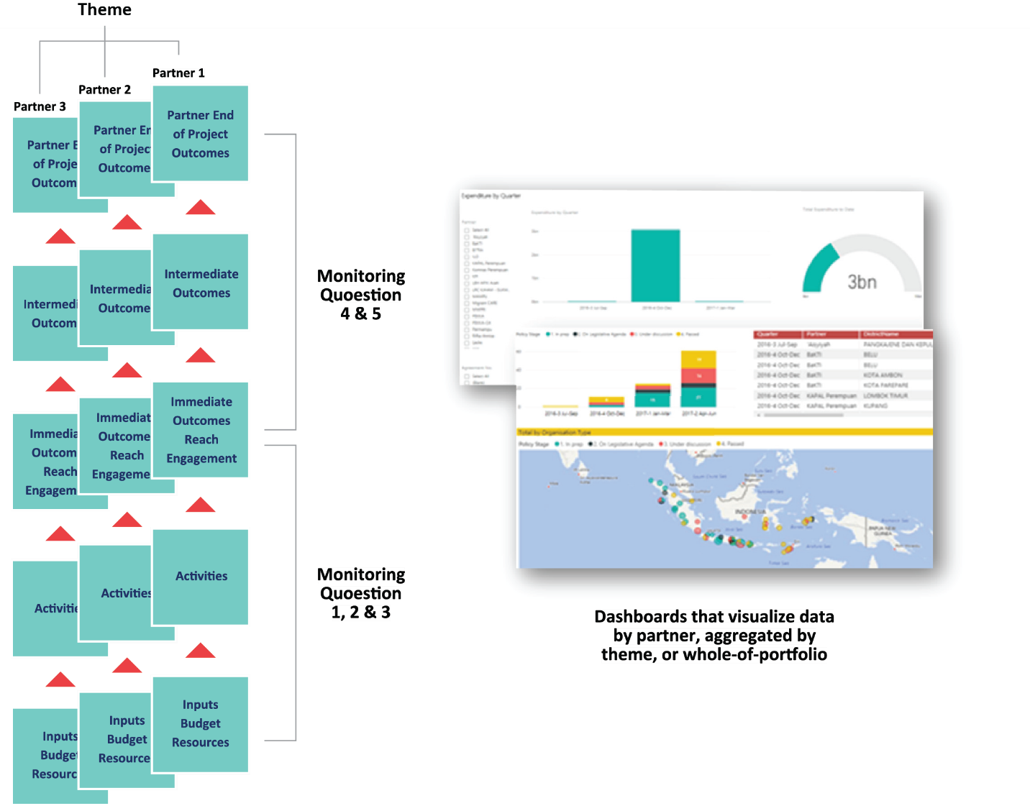

### 3.2 MAMPU Secretariat field monitoring and verification

Field monitoring and verification will be an important complement to the formal quarterly progress reporting system. For MAMPU, ‘field monitoring’ is defined by contact with activities at the *desa* or *kelurahan* level. In conjunction with partners, the MAMPU Secretariat undertakes on average 10 such field monitoring visits per quarter to observe activity implementation, hear directly from men and women involved at the grassroots, and engage with local leaders and government actors. An important purpose of field monitoring is to triangulate and verify outcomes and issues in quarterly progress reports. Highlights from all field monitoring, as well as key data are logged in a Back-To-Office-Record (see Annex 2) on the MAMPU National Information System (MANIS). This will assist regular analysis of findings by M&E staff, strengthen confidence in reported outcomes, and enable the MAMPU Secretariat to track the frequency and coverage of field monitoring across the portfolio.

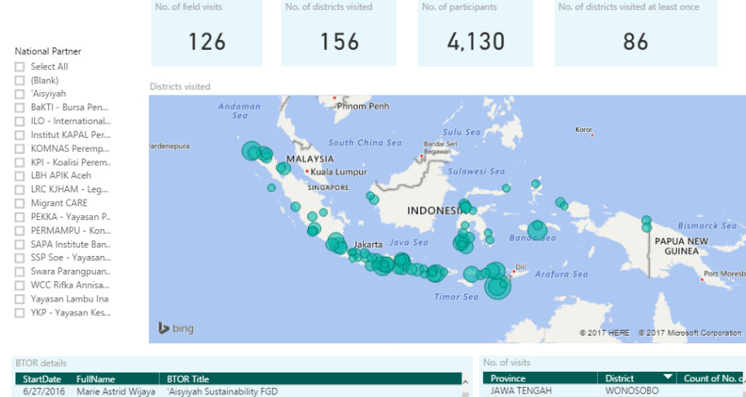

Figure 3: Field trip coverage dashboard, MAMPU National Information System

### 3.3 Routine reflection by Partners and the MAMPU Secretariat

Opportunities to make sense of monitoring information and plan follow up actions will be essential to MAMPU’s approach. The MAMPU Secretariat will facilitate two types of regular structured reflection process during Phase II.

Firstly, the MAMPU Secretariat will facilitate regular 6-monthly reflection sessions (Participatory Analysis and Reflection) with each partner covering what worked well, what was challenging, and what action needs to be taken – by both the partner and the MAMPU Secretariat (see Annex 3 for a more detailed description of the process). These half to full day sessions are designed to be simple, interactive exercises that are open and flexible. Facilitation will make use of a variety of participatory techniques including ranking, voting, and World Café to elicit reflection and encourage discussion. This approach acknowledges that written reporting following a structured template can miss interesting and valuable information. Highlights, key findings and agreed actions from each 6-monthly reflection are recorded on MAMPU’s internal Management Information System where the process and follow up can be monitored.

A second type of routine reflection will take place every 3 months within the MAMPU Secretariat. Facilitated by internal M&E staff, this will bring together findings from a rapid analysis of quarterly progress reports, field monitoring, and financial monitoring to consider progress in each of MAMPU’s five thematic ‘hubs’. Using a mix of presentations and interactive discussion, these will aim to foster greater strategic coherence within and between hubs and ensure MAMPU is responsive to emerging developments.

### 3.4 Monitoring performance against annual Thematic Roadmap Targets

MAMPU monitors overall performance of the network against a set of annual Thematic Roadmap Targets. These targets identify areas of collective achievement in each MAMPU thematic area – results to which several partners contribute. First drafted in 2017, Roadmap Targets are reviewed by partners over August to September each year, prior to development of workplans for the following 12 month period. Each year a total of 25-30 targets are defined across 5 thematic areas, to which 150-200 immediate outcomes contribute. Roadmap Targets are crafted to align with goals and objectives in the Government of Indonesia’s 2015-2019 Medium-Term Development Plan (RPJMN) and are of significant interest to Bappenas.

MAMPU tracks performance against immediate outcomes and aggregates this to provide a snapshot of progress towards roadmap targets. As described above in section 3.1, performance against immediate outcomes is captured through a ‘traffic light’ scale updated by partners through the online quarterly progress reporting system (MANIS Kita). The MANIS system automatically aggregates this information to generate a percentage score against each annual target. This enables MAMPU to aggregate performance information drawn from a large number of organisations to generate an overall picture of performance.

Figure 4: Example of Roadmap targets ranked by % ‘on track’ (source: MANIS)



MAMPU and partners will apply this approach to rapidly identify where progress may be less than expected and drill down to which immediate outcome is delayed. Organising monitoring data in this way allows more timely strategic monitoring of performance across the network and enables adaptive management.

The rubric scale defined in figure 5 below indicates how scores will be interpreted.

Figure 5: Interpreting % scores against Roadmap Targets

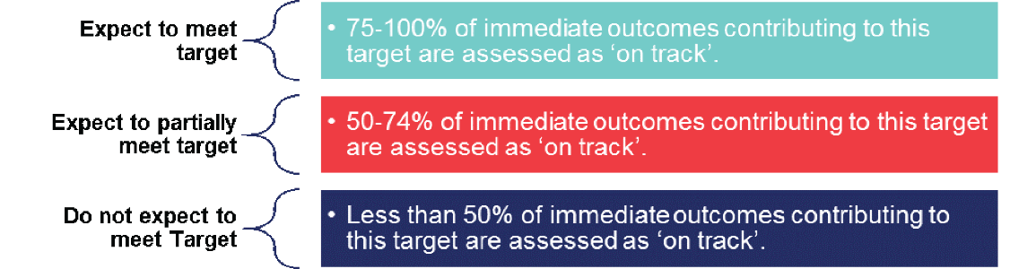

During 2019, the final year of MAMPU implementation, this formative approach will be complemented with a ‘summative’ assessment of the achievement roadmap targets. This is further discussed below in section 4.6 below.

## 4.0 How will MAMPU be evaluated?

This section explains how MAMPU will be evaluated at key points over Phase II. It describes the Key Evaluation Questions (KEQs) that need to be answered, which data and information will be used, how judgements will be made, and what types of evaluation exercise will be undertaken.

### 4.1 Key Evaluation Questions (KEQs)

All evaluative activity will address a set of 4 Key Evaluation Questions (KEQs) that link to the outcomes expected at key times in the program life. Proposed KEQs for MAMPU set in the design are:

**KEQ 1:** How and to what extent has MAMPU affected the capacity of partners and networks to influence government reform?

**KEQ 2:** How and to what extent have partners and networks influenced government reform in relation to the needs and priorities of poor women?

**KEQ 3:** How and to what extent has MAMPU contributed to improved access for poor women to essential government services and programs?

**KEQ 4:** What changed in the context and how did MAMPU respond?

In addition, this M&E plan proposes an additional fifth KEQ to address the Value for Money (VfM):

**KEQ 5:** To what extent has MAMPU delivered sound VfM?

All KEQs will be addressed between 2018 and 2020 to generate a complete picture of MAMPU’s contribution to outcomes.

**Contribution Analysis (CA):** MAMPU’s approach to addressing KEQs 1, 2 and 3 will draw from ‘contribution analysis’ (CA). CA can be distinguished from traditional approaches to evaluation which typically attempt to *attribute* an outcome to a particular intervention. This often involves isolating (using statistical techniques) the role of the intervention from other factors that could be responsible for causing the outcome. By doing this it is possible to say unequivocally whether or not X intervention ‘caused’ Y outcome. Such an approach is well suited to highly defined interventions with largely predictable types of effect.

MAMPU will need a different approach. Influencing policy, fostering empowerment in a dynamic political, economic and social context is complex and non-linear and it is widely acknowledged that the outcomes of interventions in this space are more challenging to predict. Generally MAMPU will be only one of many factors that contribute to an observed change. In this situation it is more reasonable to establish a *credible case that MAMPU contributed* rather than attempt to tease out the effects of large numbers of variables that are often interdependently related.

CA is well suited to this task. This approach boils down to four ingredients. First, set out the ‘logic’ or ‘theory’ that shows how an intervention is expected to work. Secondly establish whether or not the expected outcomes have happened. Thirdly, map out the contribution by an intervention to that outcome using the theory or logic to structure the evidence. Fourthly, acknowledge and account for the relative contributions of *other factors*. This approach is reflected in the sections below addressing KEQs 1, 2 and 3.

### 4.2 Key Evaluation Question 1: How and to what extent has MAMPU affected the partners and networks’ capacity to influence government reform?

KEQ 1 addresses the short-term outcome of MAMPU that is expected to emerge within years 2 to 3 of the program life: positive changes in the capacity and readiness of partners and networks. To answer this MAMPU must first establish if capacity is changing and in what ways. As such, the first sub-question is**: How and to what degree has the capacity of MAMPU partners changed?**

Figure 6: Domains of organisational capacity assessed through the OCPAT

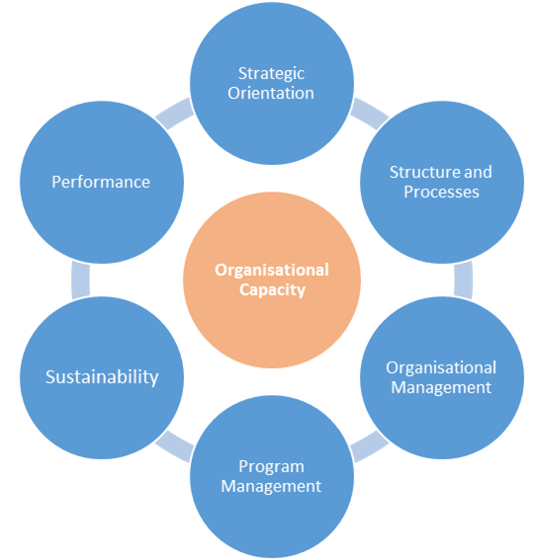

Data to address sub-question 1 will draw from two sources: (i) longitudinal capacity assessments of MAMPU national partner organisations; and (ii) monitoring data on partner collaboration with other organisations.

Longitudinal assessments apply a structured methodology called the ‘Organisational Capacity and Performance Assessment Tool’ (OCPAT) developed by Indonesian CSO YAPPIKA. The OCPAT is based on existing evidence of how capacity develops in organisations, including the experience of other CSO programs in Indonesia.[1] The tool assesses capacity in six ‘domains’ (see figure 6). The process takes two days with each organization and combines a highly participatory approach with specific measures to bolster validity and reliability. The assessment is conducted by independent facilitators and MAMPU’s role is limited to observing, and only with the approval of the partner.

A ‘baseline’ OCPAT was facilitated with MAMPU partners in late 2012/2013, a second round in 2015, and a third round in 2017. At each round, the assessment method applied a mixture of scoring, ranking and discussion to identify which domains of capacity had changed, to what extent, and what needs to be done differently. A final round of OCPAT assessments will be completed in 2019.

**Scale for tracking level of collaboration between partners and other types of organisations**

1 – Indirect communication

2 – Sporadic communication

3 – Frequent collaboration

4 – Sustained collaboration

Aside from the OCPAT, additional data will be needed to assess the strength of the networks among partners and between partners and other types of organisations. This will draw from MAMPU’s quarterly reporting system. Each three months, partner’s provide data on (i) organisations with which they had most contact during the reporting period; (ii) describe what they collaborated on; and (iii) uses a simple scale (see text box on the right) to assess the level of collaboration. These data will be analysed to draw out which types of organisations partners developed links with, what types of activity they worked together on, and how this changed over time.

Specifically, this analysis will address two indicators:

* Number of instances of increased partner communication with government organisations or other policy making actors;
* Number of instances of increased partner collaboration with other organisations outside of government, specifically for advocacy purposes.

An increase in both will be considered evidence of increased network capacity to influence government reform.

While this analysis will show capacity change among partners and their networks it will not directly assess the extent to which MAMPU contributed to such changes. To fully address KEQ 1, MAMPU must address a second subquestion: **To what extent did MAMPU’s contribute to changes in capacity and in what ways?**

There will not be a single answer to this question. Rather, it is likely that MAMPU’s contribution will be more evident in some aspects of capacity change than in others. It is also likely that MAMPU will make a stronger contribution to some partners than others. This will require a nuanced approach.

This analysis will use internally held data on key functions of the MAMPU Secretariat: (i) grant funding; (ii) technical assistance and advice; (iii) convening the MAMPU network; (iv) building and communicating evidence; and (v) bridging and linking partners. These data will be brought together to assess the case that MAMPU made a contribution to changes in capacity of partners and networks. A qualitative scale (or ‘rubric’) will be used to enable clear judgements about MAMPU’s contribution to capacity change. Table 2 below outlines a draft scale, which will need to be further refined before being applied.

Table 2: Draft rubric to assess the strength of the case for MAMPU contribution to capacity change

|  |  |
| --- | --- |
| Weak | The OCPAT may show positive change in one or more of the six domains assessed. However the OCPAT report does not identify a MAMPU contribution to this change. Other than grant funding, there may be evidence that the partner has accessed support from MAMPU (technical, network participation, bridging). However there is no evidence that the learning from this has been applied by the partner. |
| Moderate | The OCPAT shows positive change in at least one of the six domains assessed. However, the OCPAT report does not identify a MAMPU contribution to this change. There is verifiable evidence that in addition to grant funding the partner has accessed support in some form (technical, network participation, bridging) from MAMPU and this can be linked to the positive capacity change. There is also evidence that the partner has in some way applied the learning from this to their work. |
| Strong | The OCPAT shows positive change in at least one of the six domains assessed. The OCPAT report identifies that MAMPU has contributed to change in at least one domain. There is verifiable evidence that in addition to grant funding, the partner has accessed support in some form (technical, network participation, bridging) from MAMPU and this can be linked to the positive capacity change. There is evidence clearly showing that the partner has in some way applied the learning from this to their work. |

### 4.3 Key Evaluation Question 2: How and to what extent have the partners and networks influenced government reform in relation to the needs and priorities of poor women?

While KEQ 1 addresses capacity change, KEQ 2 focuses on the application of this capacity to influence government reform. There are two interrelated facets to this. Firstly, partners work directly to form networks and coalitions (including with allies in government and private sector) to influence government decision-making (formal and informal) at multiple levels. Alongside this, partners organise women at local level (village and district) and support them to express their views (‘voice’) with the expectation that this will influence change that benefits poor women and their families. Both of these ‘pathways’ to achieving influence will be assessed under KEQ 2.

Subquestion 1 will focus on influence on formal government policies: **How and what extent have MAMPU partners and networks influenced formal government policies?**

Data to assess this will draw from MAMPU’s monitoring system, particularly data (qualitative and quantitative) on engagement between partners and policy makers, and policy changes. The data on MANIS enables MAMPU to:

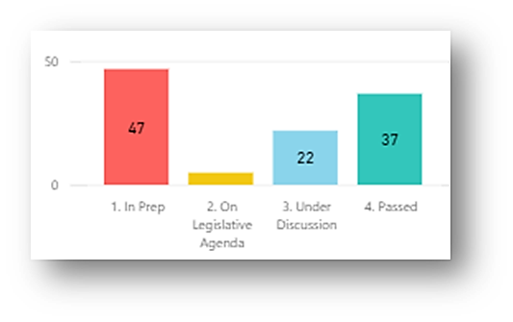

Figure 7: Number of policies at each stage of progress, MANIS policy tracking dashboard

* Track the progress of decision-making on regulations and formal policies from planning to agenda setting, formal debate, through to formal ratification;
* Monitor levels of engagement between partners, policy makers, the media and other influential stakeholders including religious and community leaders.

This enables MAMPU to identify instances where there is a plausible contribution claim to different types of policy change, from national laws to village regulations. Minimum criteria for inferring a claim for contribution to policy influence are:

1. There has been partner engagement with the policy maker over at least two quarters prior to the decision, as evidenced in quantitative data on engagement; and
2. Prior engagement has addressed the substance of the decision taken by the policy maker as evidenced through narrative material in partner reporting and/or monitoring records.

Once potential claims meet these criteria, MAMPU follows up to critically review the ‘influence story’ in a purposive sample of cases, interviewing partners to clarify details and seek additional evidence where required. MAMPU has developed a process that combines Contribution Analysis (CA) with Process Tracing (PT). The procedure is described more fully in Annex 5. Using this process MAMPU maintains a list of instances of policy influence at multiple levels, backed by verifiable evidence.

A second set of subquestions will address the critical grassroots voice and influence that MAMPU seeks to develop: **How and to what extent have partners contributed to the capacity of women at the village level to project ‘voice’? To what extent has this translated to influence on decision-making at the household, village, and beyond?**

These are complex questions. To address them MAMPU will synthesize data from a range of sources against a set of ‘evaluative criteria’. These identify the types of changes that will be valued and taken to indicate capacity, readiness, voice and influence among women at the village level. Table 3 contains a draft list, developed with partners.

Table 3: Draft evaluative criteria to assess changes in capacity, readiness, voice and influence among women at the village level*[2]*

|  |  |
| --- | --- |
| Outcome | Evaluative Criteria |
| Capacity and Readiness | * Women demonstrate a critical awareness of power, gender, culture and society * Women demonstrate an ability to analyze village regulations and formulate regulations in line with their aspirations * Women demonstrate an ability to manage conflict at the village level * Women are organised around key priorities of concern * Women demonstrate confidence and capability to express their ideas |
| Voice and Influence | * Women occupy leadership roles including as religious leaders, community leaders * Meaningful participation in village deliberative processes * Village level policies, regulations, and resource allocation addresses women’s needs and protects their ongoing participation |

The data on these criteria will draw from several sources. Quantitative and qualitative data in Quarterly Progress Reports will be complemented by a qualitative monitoring tool already in use by MAMPU – the Most Significant Change (MSC) technique. Based on first-person narratives about changes (positive or negative), MSC involves the collection of stories from women at the village across MAMPU which are then systematically selected by partners and MAMPU (see Annex 4 for a description of this tool). Stories are uploaded by partners into a custom-designed database (‘MAMPU Storybook’) where MAMPU conducts secondary analysis of their content. An open-ended monitoring tool, MSC is well suited to capturing complex social changes that are often intangible and hard to observe directly.[3] MAMPU’s own field monitoring records will be used to verify and triangulate these data with direct observation of village-level processes. In addition, MAMPU will need to draw upon a range of research studies for further evidence. These will include the MAMPU longitudinal survey, which examines changes in access to services in 1500 women- and male-headed households in 15 villages over 3 waves: 2014 (baseline), 2017 (midline), and 2019 (endline) (see Annex 6 for a more detailed description of this study). It will also include a further study of local level voice and influence, designed to build on the findings of the 2017 Women’s Collective Action (WCA) Study.

These data will be brought together against a rubric scale – drafted in table 4 below – that distinguishes between different levels of achievement against each of the evaluative criterion contained in table 3 above. It is proposed that this rubric is applied on a partner-by-partner basis. However, it will be essential that this is first refined with partners and adapted to suit their diverse circumstances. Nevertheless, the use of the scale will enable some consistency in the synthesis of evidence.

Table 4: Draft rubric scale to assess capacity, readiness, voice and influence at the village level

|  |  |
| --- | --- |
| No change | There is no evidence that this criterion has been met. |
| Adequate | The available evidence is inconsistent. There are some indications that this criterion has been met but some serious gaps and weaknesses are apparent. |
| Good/Developing | The available evidence suggests that this criterion has generally been met. There remain some gaps and weaknesses but none serious. |
| Very Good/ Consolidating | The available evidence suggests that this criterion has been strongly achieved. Most gaps and weaknesses are being addressed and managed. |
| Excellent/Significant change | The available evidence suggests exemplary or outstanding achievement of this criterion. Gaps and weaknesses if any, are being effectively managed. |

### 4.4 Key Evaluation Question 3: How and to what extent has MAMPU contributed to improved access to essential government services and programs?

Put simply, two distinct but linked pieces of analysis will be needed to assess MAMPU’s contribution to improved access to essential services. First, it must be clear *if* more poor women have access to essential services in MAMPU locations. Secondly, there must be an assessment of *the MAMPU contribution* to such increases. These analytical points will addressed through two sub-questions.

The first sub-question concerns the *extent and scale* of change: **Has access to services increased for women who are poor and if so, where and by how much?** This will require the collection and analysis of quantitative data. Table 4 proposes a set of 8 quantitative indicators for this purpose.

Table 5: Quantitative indicators to measure changes in access to services

|  |  |  |
| --- | --- | --- |
| Sub-question 1: Has access to services increased for poor women and if so, where and by how much? | | |
| Theme | **Quantitative Indicators** | **Source and timing** |
| THEME 1: Improving access to social protection programs | 1. No. of women/men who report membership of BPJS PBI in MAMPU districts/municipalities 2. No. of women/men who report possession of a valid form of legal identity in MAMPU districts/municipalities | * Direct: Partner indicator data reported quarterly * Indirect: SUSENAS 2015 (baseline), 2016, 2017, 2018, 2019 (endline) |
| THEME 2: Improving employment conditions and removing workplace conditions | 1. No. of women members of homeworker groups established by MAMPU with access to BPJS Ketenagakerjaan | * Direct: Partner indicator data reported quarterly |
| THEME 3: Improving conditions for women’s overseas labour migration | 1. No. of women departing districts/ municipalities as documented migrant workers after district-wide adoption of DESBUMI policy reforms | * Direct: Partner indicator data reported quarterly * Indirect: Ministry of Labour data 2015 (Baseline), 2016, 2017, 2018, 2019 (Endline) |
| THEME 4: Improving women’s health and nutritional status | 1. No. of women who report access to family planning services in MAMPU districts/ municipalities 2. No. of women who report accessing VIA and Papsmear tests in MAMPU districts/municipalities 3. No. of women in MAMPU districts/ municipalities who report accessing at least one antenatal check | * Direct: Partner indicator data reported quarterly * Indirect: Ministry of Health administrative data published annually 2015 (Baseline), 2016, 2017, 2018, 2019 (Endline) |
| THEME 5: Reducing Violence Against Women | 1. No. of cases handled by Integrated Service Centre for Women’s Empowerment and Children (P2TP2A) in MAMPU target districts/municipalities | * Direct: Partner indicator on cases referred to P2TP2A * Indirect: SIMFONI database of P2TP2A cases handled 2015 (Baseline), 2016, 2017, 2018, 2019 (Endline) |

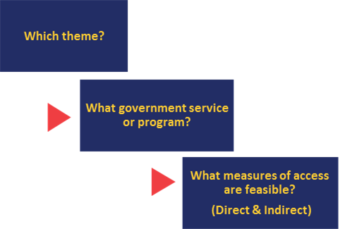Indicators in table 2 have been identified through a cascading process starting with the theme, and then confirming the service or program addressed by the relevant partners. MAMPU then identified indicators of access to the service or program. To be feasible for MAMPU, these indicators need to be sex-disaggregated, representative at the district or municipality level, sufficiently linked with partner activity, and for which data are available at baseline (2015/2016) and endline (2019/2020). Assessing changes in these indicators across different target areas should enable a sufficiently nuanced picture of changes in access to services across the diversity of MAMPU contexts.

Figure 8: Identifying quantitative indicators of access to services

Quantitative indicators in table 2 measure two categories of access:

1. **DIRECT** support by MAMPU: where women have been directly supported by partners to access a government service or program. This data will be collected and reported by partners through a specific module in the quarterly progress reporting template. The magnitude of increase that is achievable over the life of MAMPU is *expected to be in the order of 10-15,000 women across all five themes.*
2. **INDIRECT** benefit through policy implementation: Where women gain increased access to services through implementation of government policy decisions. Data to measure this will come from selected Government of Indonesia datasets that are representative at the district/municipality level and sex-disaggregated. These include SUSENAS (annual ‘core’ survey) as well as administrative data published routinely by line agencies including the Ministry of Labour and the Ministry of Women’s Empowerment. Given the coverage and scale of MAMPU, the *number of women who could gain access to services indirectly is in the millions.*

Clearly, MAMPU’s influence on policy development and implementation is critical for wide scale improvements in access (i.e. category 2 above). However, MAMPU’s contribution must be shown for this outcome to be claimed. This is the focus of the second sub-question under KEQ 3: **How strong is the case that MAMPU contributed to observed increases in access to government services and programs?**

Data to answer this will draw primarily from MAMPU’s monitoring system including the quarterly progress reports and field monitoring, supplemented with case studies and where available, other qualitative material such as Most Significant Change narratives and research studies. This data will be drawn together to assess the strength of the case for MAMPU’s contribution against a 5-point ‘rubric’ (described in table 6).

Table 6: Draft rubric to assess the strength of the case for MAMPU contribution to improved access to services

|  |  |
| --- | --- |
| Non-existent | There is verifiable evidence of partner activity but no evidence of engagement with government authorities and local leaders and decision makers in relation to the thematic issue of focus. |
| Weak | There is verifiable evidence of partner engagement with policy makers/local leaders on the thematic issue but no evidence that this has influenced regulatory, policy and/or budgetary decision-making. |
| Moderate | There is verifiable evidence of partner engagement and influence on regulatory and policy decisions of local leaders/policy makers in relation to the MAMPU theme. There is no evidence of substantial budgetary or resource allocation decisions reflecting this. Significant capacity gaps between policy intent and service improvement may remain unaddressed. |
| Strong | There is verifiable evidence of partner engagement and influence on regulatory and policy decisions of local leaders/policy makers in relation to the MAMPU theme. There has been an allocation of budget and resources in line with these decisions. Some capacity gaps between policy intent and services may exist and there is no evidence that regulatory and policy decisions are reflected in service delivery. |
| Very Strong | There is verifiable evidence of partner engagement and influence on regulatory and policy decisions of local leaders/policy makers in relation to the MAMPU theme. There has been a significant allocation of budget and resources in line with these decisions. Some evidence exists suggesting that these decisions are reflected in service delivery. |

Combining an assessment of contribution (sub-question 2) and quantitative analysis of changes in access (sub-question 1) will enable MAMPU to answer KEQ 3 clearly, but also in a nuanced way that reflects the diversity across target areas. Using this approach MAMPU will distinguish between four possible types of scenario, as listed in table 7.

Table 7: Combining sub-questions to address KEQ 3 in target districts and municipalities

|  |  |  |  |  |  |
| --- | --- | --- | --- | --- | --- |
| **Type** | Sub-question 1 |  | Sub-question 2 |  | KEQ |
| **Where women’s access to basic government services and programs…** |  | **…and the case for MAMPU’s contribution is assessed as…** |  | **…wide scale improvement in access to services is…** |
| 1 | stayed the same or decreased between 2016 and 2019/2020 | + | Non-existent/Weak/Moderate | = | **Not achieved** |
| 2 | increased between 2016 and 2019/2020 | + | Non-existent/Weak/Moderate | = | **Not achieved** |
| 3 | stayed the same or decreased between 2016 and 2019/2020 | + | Strong or Very Strong | = | **Largely achieved** |
| 4 | increased between 2016 and 2019/2020 | + | Strong or Very Strong | = | **Fully achieved** |

It is important to differentiate between these. Target areas where types 3 or 4 have occurred will be regarded as having achieved the. However, only type 4 will be counted as an actual increase in the number of women with access to services within the MAMPU timeframe. Further analysis of the quantitative data will be done where such cases are identified. This will include attention to the relative differences in access to services experienced by women and men in the target area to draw tentative conclusions about effects on gender equality beyond the life of MAMPU.

Although MAMPU aims for widespread improvements in access, the links between policy influence – even at local levels – and service delivery are undeniably complex. To account for this, MAMPU considers it to be inappropriate to set targets for the number of women who gain access to services indirectly through MAMPU. To do so will inevitably understate the instances where MAMPU’s contribution is ‘strong’ or ‘very strong’ but not yet reflected at the service level. MAMPU will track quantitative changes in women’s access to services, but ultimately success will be judged on the basis of contribution to government decision-making that has already led to or is likely to lead to an increase in access. This is consistent with the intent of Key Evaluation Question 3.

### 4.5 Key Evaluation Question 4: What changed in the context and how did MAMPU respond?

The MAMPU design emphasizes the importance of adapting to changes in the social, political and economic context to seize opportunities for influence that could emerge unexpectedly. For initiatives that seek to influence unpredictable processes such as policy decision-making, the capacity to first spot contextual changes, and then move quickly to adjust, is likely to be key to effectiveness.

MAMPU will use data from several sources to assess adaptiveness. Firstly, data on partner responses to challenges affecting progress will be analysed to show how have adapted. This draws on information entered online as part of the quarterly reporting process. As shown in figure 9, this can illustrate patterns in adaptive practice across partners over a particular timeframe.

Data from quarterly reports will be supplemented with records from six-monthly Participatory Analysis and Reflection (PAR) sessions, which systematically collect information on challenges and follow-up actions – by partners and MAMPU. A variety of structured qualitative and quantitative data from PARs can be extracted from MANIS.

Figure 9: Ways in which partners adapted to challenges, based on data from October 2017 to March 2018 (Source: MANIS Kita)

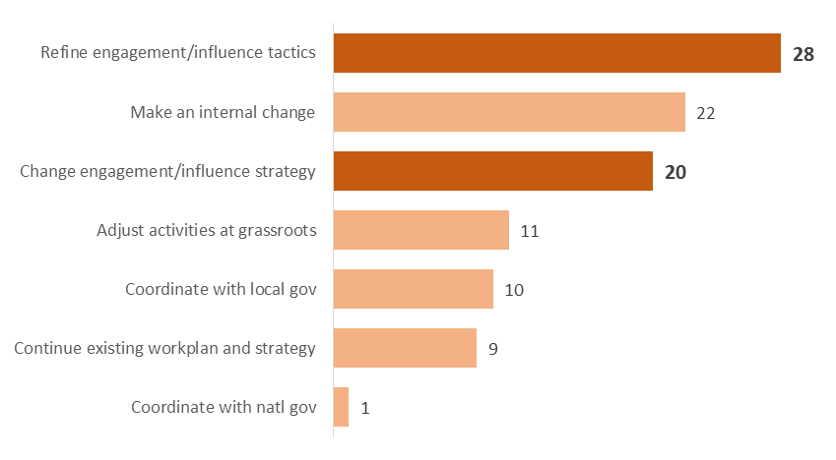

A further source of important information are **media monitoring records** from an online dashboard maintained by Explicar – an external provider engaged by MAMPU to monitor and distribute detailed quantitative and qualitative information on a range of relevant topics. Quantitative metrics on the number of articles can be grouped by thematic area on the dashboard and tracked over time. Spikes and troughs in media coverage in each thematic area or MAMPU topic provide an indication of the changing context, including opportunities for influence. This can highlight major events that have occurred over the timeframe of Phase II and help to identify public statements and responses by MAMPU and partners.

### 4.6 Key Evaluation Question 5: To what extent has MAMPU delivered sound VfM?

Given the complex and diverse nature of MAMPU, demonstrating VfM at the overall program level in any coherent way is highly challenging and open to significant interpretation and contestation. To address this issue, MAMPU’s approach will be based on a set of agreed principles that underpin sound VfM. That is, if there is sufficient evidence showing that practice reflects these principles, then a credible case can be made that MAMPU is delivering sound VfM.

The basis for this approach is fully elaborated in the MAMPU VfM Framework developed in 2018. As outlined in the VfM Framework, 8 global DFAT VfM principles have been translated into 13 principles that reflect MAMPU’s specific approach and intended outcomes. The complete list of DFAT and the MAMPU VfM principles that derive from these is set out in Annex 8.

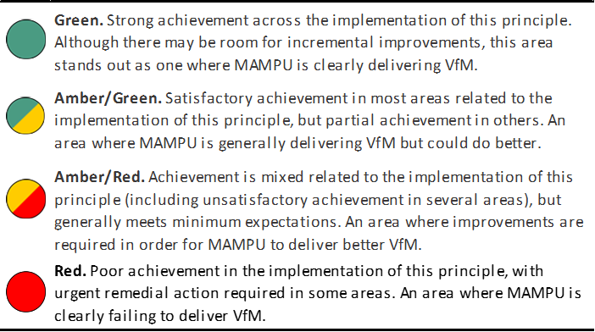

Figure 10: Rubric for assessing MAMPU adherence to VfM principles

MAMPU will undertake a 5-step process to assess the extent to which these VfM principles are reflected in actual practice (see detailed description of the methodology in Annex 7). Using a collaborative approach, this will involve working with relevant sections of the MAMPU team to assemble an evidence-based case against each principle. A 5-point rubric (see figure 10) will then be applied to make transparent judgements against each principle.

The full 5-step process also includes an additional step for review and verification of the VfM case assembled by an external party. This step helps to enhance the credibility of the analysis produced.

The final step of the process involves uptake of the lessons and planning purposeful action to respond to the findings of the VfM exercise.

### 4.7 Making ‘summative’ judgements of Thematic Roadmap Targets

In 2019, partners will commence the final 12 month period of implementation with funding from MAMPU. As such, ‘summative’ judgements of the achievement of roadmap targets will be needed to complement the performance monitoring approach described in section 3.4. Partners will help make these judgements, consistent with the participatory and collaborative approach that underpins MAMPU.

During the first quarter of 2019, MAMPU will work with partners in each thematic area to generate a simple rubric scale to assess achievement of each of the 25 roadmap targets. In a workshop facilitated by MAMPU, partners in each thematic area will define three levels of achievement for each roadmap target:

**Above expectations:** This will identify ‘observable signs’ that achievement in relation to the roadmap target has been beyond what was expected within the timeframe. This is the scenario considered *less likely* at the outset of 2019.

**In line with expectations:** This is a scenario considered *most likely* or ‘what we expect to see’. For example, if the roadmap target is “Policy recommendations for the implementation of safe migration governance services”, the workshop will identify what is reasonable to expect in terms of how many recommendations, pitched at what level of government (or parliament), and in which locations this is expected to happen.

**Below expectations:** Partners will be assisted to identify signs that indicate that achievement has been less than expected. This scenario should be *less likely* to occur based on the expectations of partners.

This scale will enable MAMPU and partners to make collective judgements in each thematic area on the basis of a wide range of data collected during 2019. Together with data on implementation of Immediate Outcomes, this will enable a summative assessment of all 26 Roadmap Targets for 2019.

### 4.8 Types of evaluation

Two types of evaluation will be undertaken over Phase II of MAMPU: (i) two internal evaluations based on the Collaborative Outcomes Reporting (COR) technique[4]; (ii) and an independent mid-term evaluation commissioned by DFAT.

**Internal evaluations** addressing all five KEQs will be undertaken at two points: during the first half of 2018; and in late 2019/early 2020. Facilitated by the MAMPU M&E Specialist, these will draw together data collected through the M&E system to assess the strength of MAMPU’s contribution to short-, medium-term outcomes, and examine progress towards the long-term outcome. The second internal evaluation will make a summative assessment of program achievement of all outcomes, applying the methodology outlined above, along with data available from other sources.

While the M&E Specialist will lead the process, the COR technique works best as participatory exercise that involves different stakeholders in data collection and analysis. Consistent with the COR methodology, all claims of contribution will transparently reference the source of evidence that can be verified by an independent party. MAMPU will ensure an independent perspective to assess the strength of the case for contribution for outcomes. The findings, evidence, and recommendations will be documented in a short readable report called a ‘Performance Story’.

DFAT in consultation with Bappenas will be responsible for commissioning an **independent evaluation** of progress over Phase II. The exact scope and timing of this evaluative exercise will be determined by DFAT but it has been tentatively scheduled to take place in the second half of 2018.

## 

Figure 11: Timeline of evaluations over Phase II

## 5.0 Managing and reporting M&E information

This section describes how the information collected through the various monitoring and evaluation processes will be brought together for reporting to key audiences. This section also describes how data will be entered, stored, and managed in a program database.

### 5.1 Routine reporting products

This section briefly describes the different reporting and information products that contain findings and recommendations from the M&E processes described in the preceding sections. It explains how these will reach key audiences to support decision-making about the program.

Key audiences of the information gathered through the M&E system are the MAMPU Secretariat, partners, Australian Embassy, Thematic Working Groups (Pokja), Technical Committee (TC), and Steering Committee (SC). These different stakeholders play key roles within the governance structure for MAMPU outlined in the SOPs. The right information will need to reach these stakeholders at the right time and in the appropriate format to support decision-making.

The **MAMPU Secretariat** (or the MAMPU team) will need frequent feedback on performance at the partner level, across a thematic ‘hub’, as well as for the program overall. Of particular importance will be rapid feedback, early warning signs, and risks that enable the Secretariat staff to take action. This needs to be allied to more ‘strategic’ and long-term considerations that enable the Secretariat to see how immediate concerns affect the likelihood of achieving the EOPO.

As the donor, the **Australian Embassy** needs information to assess progress towards short-, medium- and long-term outcomes, as well as summarized information on implementation of the annual workplan and budgetary performance. This information should enable Embassy staff to meet internal accountability and compliance requirements but also make decisions concerning risks and strategic opportunities that would benefit from official government-to-government involvement.

The 5 **Thematic Working Groups** (Pokjas) are venues for partner-government interaction and coordination, not decision-making. To support these functions, information is needed on policies targeted in each theme, progress and obstacles, and highlights and lessons from work ‘on the ground’ where partners are attempting to solve policy issues in practical ways.

The **Technical Committee** (TC) requires summarized information on program performance against outcomes, particularly progress towards the EOPO. The information should be sufficiently detailed to enable members to judge the adequacy of overall performance, consider relative progress across themes, and assess the appropriateness of the Annual Workplan and budget proposed by the MAMPU Secretariat.

The **Steering Committee** (SC) needs high level synthesized information on performance, sufficient to approve the annual workplan and budget. A key consideration for the SC will be the ongoing relevance and alignment of MAMPU’s portfolio with strategic priorities of both governments.

Table 8: Key reporting and information products, audience, content and timing

|  |  |  |  |
| --- | --- | --- | --- |
| **Reporting or information product** | **Key audiences** | **Content highlights** | **Timing** |
| Internal Presentations for reflection | MAMPU Secretariat | * Progress at partner and theme level * Key risks and challenges * Key trends in reach and influence by theme and overall | 3 monthly |
| Partners Forum Presentations | Partners | * Overall progress towards the EOPO * Key trends in the past 12 months * Recurring challenges and risks impacting on multiple partners * Narratives and accounts of change from women at the village level | Annual |
| Progress Reports | Australian Embassy  Bappenas  TC  SC | * Progress towards the MAMPU outcomes, overall, and by theme * Implementation of annual workplan and expenditure vs budget * Proposed changes to annual workplan * Key risks, challenges and lessons identified | 6-monthly  (Nov/May) |
| Pokja Presentation | Pokja members | * Policies targeted, geographic reach per theme * Challenges impeding progress per theme * Highlights from ‘on the ground’ | Twice per year |
| Internal Evaluation Reports (Performance Story) | MAMPU Secretariat  Partners | * Short, readable, evidence-based ‘story’ of MAMPU performance against each level of the theory of change * Answers all four Key Evaluation Questions set for MAMPU * Recommendations for future | 2018, 2019/20 |
| Independent Evaluation Report | MAMPU Secretariat | * TBD | 2018 |

### 5.2 Program Completion Reporting

MAMPU is scheduled for completion in June 2020. A comprehensive Program Completion Report will be prepared prior to completion, conforming to the requirements of the contract and DFAT’s aid programming guidelines. This report will incorporate the results of the final Collaborative Outcomes Reporting exercise (as described above) as well the findings of a range of research reports and analysis undertaken during MAMPU’s lifetime.

### 5.3 MAMPU National Information System (MANIS)

The analysis contained in M&E reporting products will be based on data stored and managed in the Management Information System – known ‘MANIS’ (MAMPU National Information System).

First developed in 2014, MANIS is a comprehensive system that integrates financial information on MAMPU’s grants with an array of qualitative and quantitative performance data drawn from Back-To-Office-Reporting (including field monitoring and training reports), partner quarterly reporting, ‘Most Significant Change’ stories, and large socio-economic datasets from the Government of Indonesia. Data are brought together and visualized in a series of interactive dashboards that enable the team to monitor key trends and analyse relationships between different sets of information. Data can be extracted in pre-formatted reports for distribution to stakeholders, or exported into other software packages for more in depth analysis. By November 2018 more than 1,500 Back-To-Office-Reports including 218 field monitoring records, and 27 Participatory Analysis and Reflection reports are stored on MANIS. In 2019 MAMPU plans to assess the possibility of continuing all or part of MANIS following completion in addition to making appropriate arrangements for transfer of the data to DFAT.

**Online data capture through ‘MANIS Kita’ and ‘Storybook’**

MANIS was adapted in 2016 to include an online quarterly reporting module (called ‘MANIS Kita’), which replaced a previous off-line reporting system. Partners enter Quarterly Progress Reports online and can view a suite of dashboards, maps and other visualisations of their data online. Partners can upload documents and files in a range of formats for sharing and. Feedback from MAMPU on the draft report, and partner responses, are all done through the online system. At the conclusion of 2018, 213 quarterly reports from partners were entered on the system.

Partners also use MANIS for storage of their Most Significant Change stories. They directly enter, store and retrieve stories through the MANIS ‘Storybook’. To date more than 570 such narrative accounts of change have been uploaded by partners describing women’s (and some men’s) experiences.

**Grants and Financial Information**

MAMPU’s grants management team use a specially designed module within MANIS to store and track grants information. Data input to the system includes total grant amounts, annual budgets, core funding, and expenditure acquittals. This information is routinely updated by four grants officers, enabling the grants manager to track financial performance across more than 120 national and local partner organisations. This enables MAMPU and partners to track workplan implementation as well as expenditure against budget.

## 6.0 Operationalising the M&E Plan

This section describes how the processes described in this M&E Plan will be operationalised. It identifies the key resources and expertise required, and summarises how these will be deployed over the remaining 2 years of the program life. MAMPU has allocated approximately 6.5 per cent of annual budget to M&E.

### 6.1 Resources required

A Monitoring, Evaluation and Research (MER) unit within the MAMPU team will be primarily responsible for driving the implementation of the M&E Plan. They will draw on the skills and expertise of contracted individuals and organisations who will undertake assessments and research studies needed to comprehensively address the Key Evaluative Questions. Table 1 below illustrates the key resource requirements associated with each key aspect of the M&E system, as described in previous sections of this document.

Table 9: Resources required to implement the M&E Plan

|  |  |
| --- | --- |
| M&E system process | Resources required |
| Routine capture, storage and analysis of partner quarterly reporting (3 monthly) | 3 x M&E Officers, 1 x M&E Information System Officer |
| Management Information System maintenance and adjustment (ongoing) | 1 x M&E Information System Officer, 1 x Information Management Specialist (Part-Time) |
| Participatory Analysis and Reflection (partner level) including MSC selection (6 monthly) | 3 x M&E Officers |
| Most Significant Change story verification, troubleshooting, storage, secondary coding and analysis | 1 x M&E Officer, M&E Information Systems Officer |
| Participatory Analysis and Reflection (MAMPU level) (3 monthly) | M&E Specialist, 3 x M&E Officers |
| Field monitoring (ongoing) | 3 x M&E Officers, M&E Specialist |
| Organisational Capacity and Performance Assessment Tool (OCPAT) of 7 partners (2017, 2019) | Contracted provider with expertise in participatory organizational assessment, 1 x Research Officer |
| Evaluation using Collaborative Outcomes Reporting (COR) Technique (2018, 2020) | M&E Specialist, 3 x M&E Officers, 2 x Research Officers, M&E Information Systems Officer, contracted Outcomes Panel members (at least 2 external members) |
| Longitudinal Study of Access to Services and Livelihoods (Mid-line 2017, End-line 2019) | Contracted Research Organisation (SMERU Institute), 1 x Research Officer (Full-Time Coordination role), 1 x Senior Research Adviser (Part-Time QA role) |
| Other analytical work including research studies and case studies | Contracted Research Organisations and Individuals, 1 x Research Officer, 2 x Research Officers (Full-Time Coordination role), 1 x Senior Research Adviser (Part-Time QA role) |

The MER unit comprises 6 full-time staff under the overall direction of the M&E Specialist (reporting to the Team Leader). Within the unit, 3 M&E Officers (MEOs) have been assigned to each of MAMPU’s five Thematic Areas and Cross-Cutting area. Working closely with each Thematic Coordinator (TC), they have a significant partner liaison role on matters relating to M&E. Key areas of responsibility include timely capture of data through the online reporting system (MANIS Kita), ensuring data completeness, and analysis of key issues emerging from these regular reports. M&E Officers also work with TCs to plan and undertake field monitoring to verify reported information and facilitate 6-monthly Participatory Analysis and Reflection exercises with partners (see section 3.3 above).

A wide range of additional research and analytical work is required on a program of the complexity of MAMPU. 2 Research Officers (ROs) play a key role in coordinating this work. With the M&E Specialist, they draft Terms of Reference and engage suitably qualified research organisations or individuals. Research Officers are supported by a part-time Senior Research Adviser with expertise in a wide range of quantitative and qualitative methods and experience in Indonesia. This position will take a Quality Assurance (QA) role in significant research activities, including technical reviews of research designs and key outputs.

MAMPU’s information systems are vital to its capacity to report on program outcomes. The MER unit includes a full-time M&E Information Systems Officer (MEISO) who ensures system functionality and integrity. The MEISO is supported by an experienced part-time Information Management Specialist who will regularly review MANIS, undertake major upgrades of the system, and advise on database strategy.

### 6.2 Data Quality

The monitoring system will depend to a great extent on the quality of data collected and reported by partners. A major proportion of the work of Monitoring and Evaluation Officers is to undertake field monitoring including verifying reported information. Preparation for each field visit will involve preparing a short list of key developments and results reported from the location and partner. These issues are then probed and explored in the field visit with the results noted in the BTOR recorded on MANIS.

Since ‘quality’ in participatory data is closely related to the process of facilitating the use of a tool, this will involve observing the way tools such as MSC are applied in a range of locations. Other methods and practices that will be used to encourage data quality include:

* + - Regular refresher training for field staff in the participatory monitoring tools adopted;
    - Feeding back data collected through participatory methods to participants as a routine practice;
    - Encouraging where possible partners and sub-partners to use local staff who are familiar with the locale where the participatory tool is being applied.

### 6.3 Implementation schedule

An overarching 2-year schedule for implementation of the M&E Plan is depicted below from July 2018 through to June 2020. This provides an indicative timeline for key monitoring and evaluation activities and reporting events as MAMPU approaches completion in mid-2020. Routine monitoring and analysis activities will continue through to the conclusion of MAMPU grants to partners in December 2019. Alongside this, a number of major research activities will continue, as well as preparations for completion and potentially transfer of database systems to new arrangements. The aim will be to ensure a comprehensive basis of information and analysis is available for the final six-month period. From January to June 2020, this will involve MAMPU in intensive analysis and synthesis to prepare the Program Completion Report – the final reporting deliverable under MAMPU’s contract.

**Monitoring and Evaluation Implementation Schedule (indicative)**

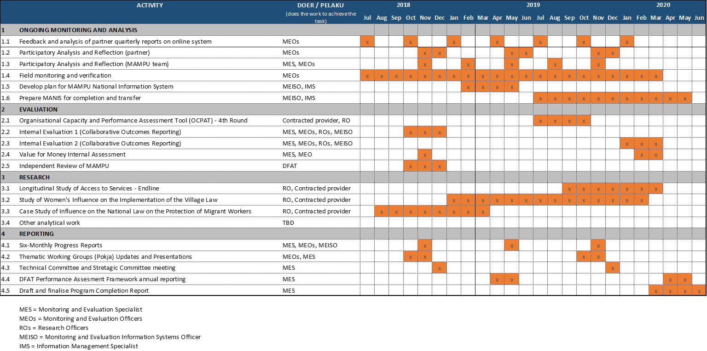

# Annex 1: Partner Quarterly Report (PQR)

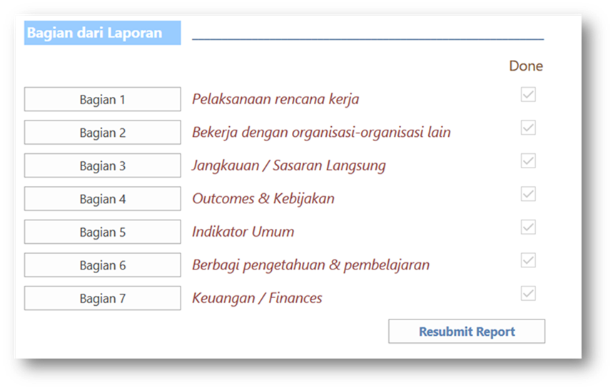

Figure 12 Online view of the PQR sections completed by partner on the MANIS Kita system

**Overview of tool**

Partner Quarterly Reports (PQRs) are a structured report from each of partners (direct grantees) to MAMPU. Each partner submits the PQR through a web-based system called ‘MANIS Kita’ covering each 3 month period. Key sections completed with narrative and quantitative data are:

* + - Section 1: Implementation of Annual Workplan
    - Section 2: Collaborative work with other organisations;
    - Section 3: ‘Reach’ and engagement with different categories of actor
    - Section 4: Outcomes (including data on PAF indicators on policy influence and funding leveraged)
    - Section 5: Indicators (including access to services)
    - Section 6: Information for learning and sharing
    - Section 7: Budget update

As described in the M&E Plan, the information in the PQR is designed to enable MAMPU and each partner answer 5 Monitoring Questions. At June 2018, MANIS Kita contained 213 reports uploaded since July 2014.

**Partner Quarterly Reporting Process**

Step 1 Set up. The PQR process for each partner is based on the design of their MAMPU-funded project and their annual workplan. The End-of-Project-Outcomes and intermediate outcomes expected from each partners work are first entered into MANIS Kita. Once these details are entered into the online system consistent with the content of the Grant Agreement, partners are assisted to enter the annual workplan and corresponding budget into the system. The annual workplan consists of Immediate Outcomes expected to be achieved (typically 20-30 immediate outcomes per partner each year) and the anticipated timing of implementation.

Step 2 Report preparation and submission by partner. Partners prepare and submit their report in the online system. There are four quarterly reports to be submitted each year by partners according to the following schedule (also contained in the Grant Agreement):

Quarter 1 (January-March), due in 15 April;

Quarter 2 (April-June), due 15 July;

Quarter 3 (July-September), due 15 October;

Quarter 4 (October-December), due 15 January.

Many partners work offline to collect and synthesize information and data from their networks, before uploading to the system. Once ready, the partners submit the completed report by pressing on the ‘submit report’ button.

Step 3 Review and Feedback by MAMPU. Once the draft report has been submitted, Thematic Coordinators and Monitoring and Evaluation Officers are responsible for reviewing the completeness of the information and providing feedback to the partners within a 2-week period. Feedback is communicated through an online window alongside the PQR.

Step 4 Resubmission and Acceptance. Partners respond to the feedback and the Thematic Coordinator accepts the revised report by clicking ‘Accept’. This locks the report for editing and confirms it as a record of progress. PDF versions of the report for printing are uploaded by MAMPU for further distribution.

**Use of the data in the PQR**

The data collected through the online PQR are visualized automatically in a series of online dashboards. In addition, all narrative data and text fields can be searched using

* + - Section 1 of the PQRs describes how partners have carried out the activities they planned in their annual workplans including establishing components of their models and approaches. A narrative within this section explains the highlights from the 3 months reporting period. Together this information shows how partners such as KAPAL Perempuan, Migrant CARE, Pekka, and BaKTI progressively trial their approaches. These data are used for KEQ 1 and the PAF pilot-to-scale tool.
    - Challenges and proposed responses of partners are entered in section 1. These data contribute to addressing KEQ 4 on context and adaptation.
    - Collated data from section 2 tracks changes in the quantity and intensity of collaborative activities between partners and a range of other actors including other CSOs, the government, and private sector. These data are used to addressing KEQ 2.
    - Data on a range of indicators including access to services and the number of new village-level women’s groups established each 3 months. These data are used to address KEQ 3 and PAF indicators, including the pilot-to-scale tool.
    - Sections 4 and 5 of the PQRs present much of the data related to influence on formal decision-making. Partners enter information on the title of the policy or 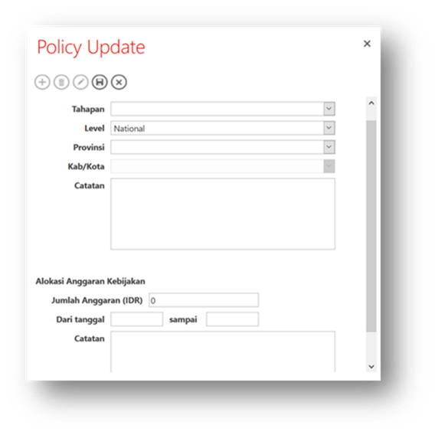decision, the location, the stage (in preparation, on the agenda, under discussion, passed/ formalised) and brief notes. A new field to capture funding leveraged was introduced in 2018. These data are used for KEQ 2 and PAF indicators on district level improvements.

Figure 13: Screen capture of policy influence and budget leverage fields in MANIS Kita online PQR

# Annex 2: Back-To-Office-Record (BTOR)

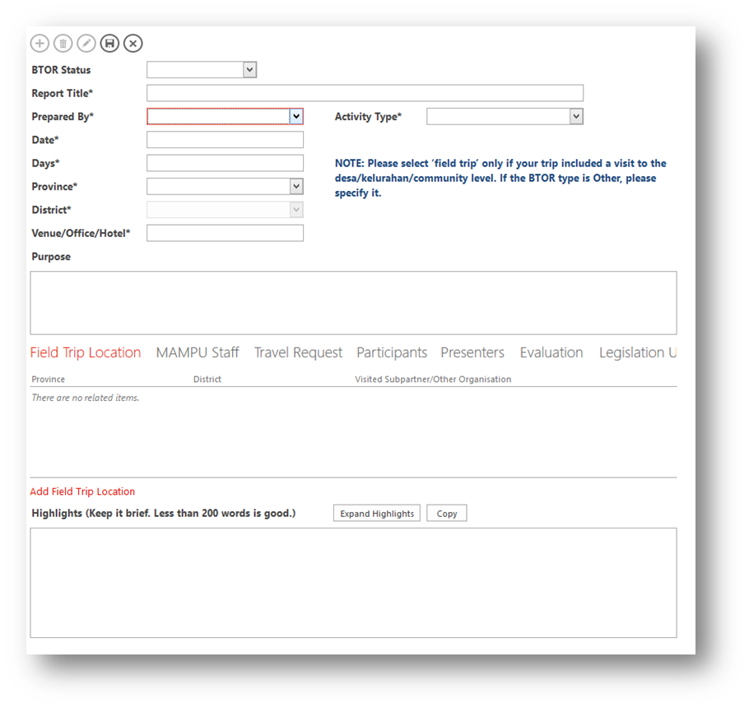

Figure 14: BTOR interface on MANIS

**Overview of the reporting tool**

Back-To-Office-Records (BTORs) are the backbone of the internal MAMPU office reporting system. They are designed to capture key qualitative and quantitative information about engagement between MAMPU and other actors. It is an expectation that all staff members complete a BTOR for meetings, field trips, workshops, training activities, and seminars. BTORs are entered into an online system (MANIS) directly by staff. Standard fields that must be entered for every BTOR are:

* Basic information including: Title, date/time/duration, district, province, the type of engagement, which MAMPU staff members were present;
* Brief narrative of the highlights of the meeting or other type of engagement;
* Participants (non-MAMPU) in the activity: by organization and sex, names are not needed;
* Any key points needing follow-up.

For **field monitoring**, defined as trips involving contact with MAMPU activities at the village level (*desa*/*kelurahan*), additional information is required:

* Locations visited, partners and local partners, administrative travel requests;
* A field monitoring tool (introduced in February 2018) with questions and observational points for focus group discussions with women members of local groups. This is designed to verify activities reported through other channels and probe changes experienced by women including confidence, awareness, and leadership. Completed forms are uploaded to the system.

For **training or workshop** activities provided by MAMPU, evaluation forms collected from participants (using a workshop evaluation tool) must be entered into the system enabling summarised information on training quality.

The data show a total of 1,597 BTORs have been recorded by MAMPU staff between December 2013 and June 2018. Of these, 218 relate to field monitoring trips covering 115 districts across Indonesia. Evaluations from 962 individuals who attended 69 training and workshops provided by MAMPU activities are captured.

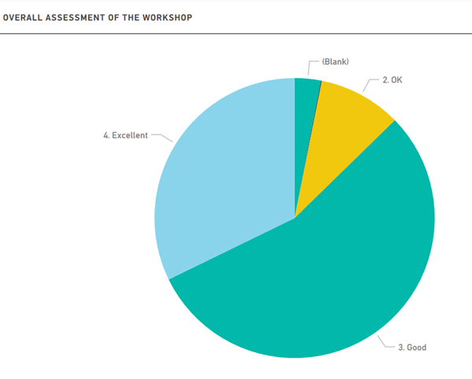

Figure 15 Chart from MANIS showing aggregate responses on overall assessment of 69 workshops (n=962

The BTOR dataset can be interrogated in a variety of ways including by text searching, filtering by staff name, by activity type or date. Quantitative data can be visualized automatically on a series of dashboards.

**Use of data from BTORs**

BTORs are used to corroborate and triangulate other sources of information behind claims of achievement. Information from training and workshop evaluations illustrate the wide range of topics covered and help to monitor quality. The 218 field monitoring BTORs help to establish quality of community organizing processes that are the bedrock of MAMPU.

Quantitative data from BTOR participants is monitored through a dashboard and tracks patterns of MAMPU’s engagement with a wide variety of actors including partners, other DFAT programs, the media, local government, parliamentarians, as well as national government agencies. Analyzing the qualitative narratives from these BTORs can be used to show *how* MAMPU has developed relationships and corroborate program contribution to wider outcomes.

BTORs outside Jakarta – whether to the village, district or province – have been used to triangulate information from partner reporting about their activities, especially the development of models and approaches to improving access to services. For example, a BTOR from June 2016 in Demak in Central Java documents a MAMPU staff member observing an influence process playing out. A DPRD member worked with ‘Aisyiyah to convince the district health office and BPJS to allocate funding for training health staff to provide reproductive health services. Other BTORs document, for example, discussions with District Women’s Empowerment and Child Protection office in South Sulawesi to explore if changes in service delivery have happened as reported and if so, how they happened. In this way, BTORs strengthen confidence in reported partner influence.

# Annex 3: Participatory Analysis and Reflection (PAR)

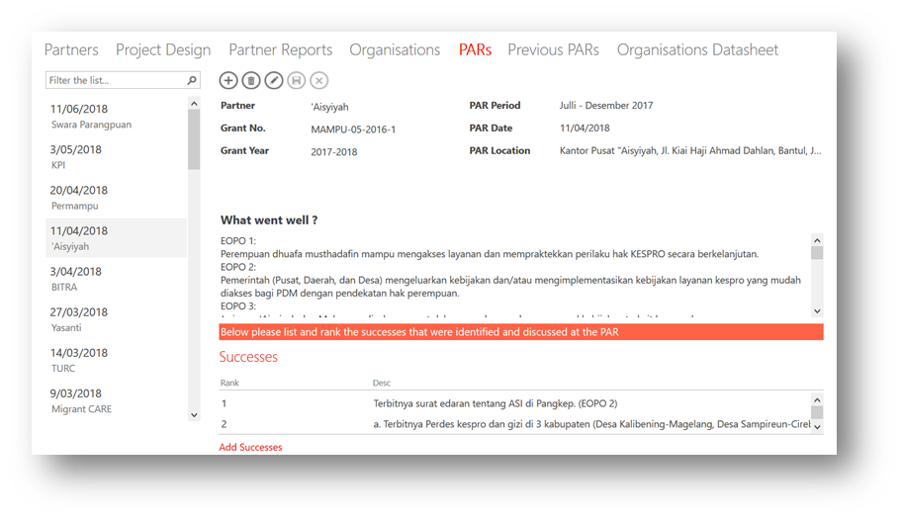

Figure 16: Screenshot of searchable PAR records stored on MANIS

**General overview of tool:**

MAMPU facilitates regular 6-monthly reflection sessions (Participatory Analysis and Reflection) with each of the 14 direct partners covering what worked well, what was challenging, and what action needs to be taken – both by the partner and by MAMPU Secretariat. These half to full day sessions are designed to be simple, interactive exercises that are open and flexible. Facilitation makes use of a variety of participatory techniques including ranking, voting, and World Café to elicit reflection and encourage learning. This approach also acknowledges that written reporting following a structured template (PQR) can miss interesting and valuable information. Highlights, key findings and agreed actions from each 6-monthly reflection are recorded on MAMPU’s Management Information System (MANIS) where the process and follow up can be monitored.

Between October 2014 and July 2018 MAMPU facilitated 27 PAR exercises with partners involving 212 women and 48 men.

**Outline of process:**

Monitoring and Evaluation Officers (MEOs) play the lead role in facilitating each PAR session. They work in close conjunction with the Thematic Coordinators and occasionally with the support of the Research Officer or other members of the team. Thematic Coordinators take the lead in discussing with partners the timing and attendance. The attendance of the relevant MAMPU Grant Officer and/or the Senior Grants Manager is encouraged so that discussions can also incorporate any salient financial management matters.

Table 10: Sessions typically run in a six-monthly PAR exercise

|  |  |
| --- | --- |
| Session | Content and Process |
| 1. What went well? | Group brainstorming of what has gone well in last 6 months, followed by ranking to identify most significant. Facilitated in depth discussion of top ranked achievements or areas of progress. |
| 2. What was challenging? | Group brainstorming of the challenges and difficulties in last 6 months, followed by ranking to identify most significant. Facilitated in depth discussion of top ranked challenges or areas of difficulty. |
| 3. What do we need to do differently? | World Café exercise to identify responses to challenges identified. Joint follow-up plan agreed between MAMPU and the partner. |
| 4. MSC selection | Facilitated process to discuss stories of change submitted during the last 6 month period and select those considered ‘most significant’. |
| 5. Finance/grant expenditure | Specific session with Grants Officer and/or Senior Grants Manager focusing on grants management issues. |

**Use of the data:**

A major aspect of the value of the PAR is in the process of MAMPU reflecting together with partners and deciding jointly on follow up actions. This helps to build and strengthen relationships of trust.

The notes from PARs provide additional corroborating evidence that partners recognize and adapt to the external challenges they confront. For instance, during a PAR with ‘Aisyiyah in 2018, participants identified that religious leaders were continuing to oppose their efforts at the grassroots to raise public awareness and discussion of reproductive health issues. The workshop identified the need for further efforts to link with local leaders. Similarly, a PAR with SAPA Institute in 2017 identified that in some areas they were suspected of ‘Christianizing’, making it difficult to build relationships with potential allies. To find ways of addressing this they planned to work with Parahyangan Catholic University and the local government.

PARs have also been used to bolster other sources and increase confidence that women at the grassroots level are applying capacity to express voice and apply influence. Where partners identifies local level influence in a PAR, MAMPU records it as supplementary evidence that these changes are taking place.

# Annex 4: Most Significant Change (MSC)

**General overview of tool:**

The Most Significant Change (MSC) technique is a monitoring and evaluation tool (M&E) based on the systematic collection and selection of narrative accounts of change. The method was identified in the M&E Plan to discover, value and learn from change experienced by women (and men) at the village level.

In 2014 MAMPU and trained over 100 staff from selected partners through multiple waves of training. MSC stories are collected and documented by field staff or sometimes by the woman herself with the help of partners. Stories describe an experience of change with a beginning, a middle, and an end.

**Outline of the process:**

On MAMPU, the focus of story collection is women and men at the village level. The choice of a story ‘worth’ collecting is purposive. Through the course of their work, field staff from partners (usually facilitators or community organisers) notice individuals who may be experiencing a change – whether negative or positive. Field staff capture the account of change from the story-teller using a simple tool introduced at MSC training as a guide. The questions are designed to encourage the storyteller to identify the ‘most significant change’ from several changes that she may have experienced. The MSC training emphasized the importance of adopting an informal conversational style and avoiding the appearance of a formal ‘interview’. This often means avoiding the use of the MSC form during the discussion and instead recording details of the story afterwards.

Once recorded, the details of the story are entered in an online database (‘Storybook’) with shared password access by MAMPU and partners.

Figure 17: Screen capture of Storybook MSC database

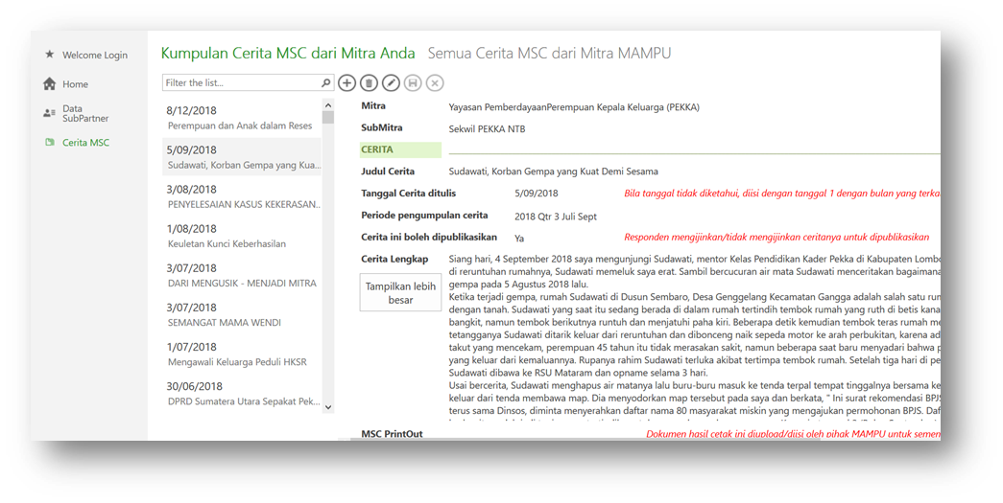

Stories are entered directly by partners, who can decide the level of visibility and whether permission has been given for publication. MAMPU reviews and codes the stories against four broad types of change:

* a change experienced by an individual;
* in addition to the above, some indication of influence on immediate circle (*kommunitas*);
* in addition to the above, some indication that the change involved influencing decision-making at the village level;
* 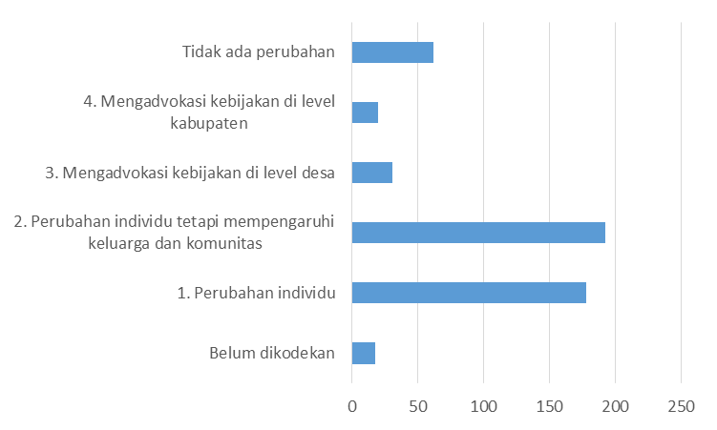in addition to the above, some indication that the change involved influencing beyond the village level (e.g. another village or a district).

Figure 18: Number of stories coded to 4 levels of change, June 2018 (Source: MANIS Storybook)

To ensure quality, MAMPU also identifies stories that do not sufficiently describe change.

As of July 2018, 500 stories of change from 92 districts across 24 provinces had been entered on the Storybook database from 19 partners. 402 described changes experienced by women (80%), 11 by men (8%), while this information was not entered for the remaining 56 (11%). Thematically, the greatest proportion of stories have been submitted by partners working on VAW (31%), homeworker (27%), women’s health and nutrition (23%). The remainder have been collected by social protection (13%) and women’s migration (6%). Partners indicated that 10 of these stories were not for publication, although in 88 stories this field was blank.

Selection of stories by staff and partners is an important aspect of the technique. Selection is intended to encourage dialogue about which types of change are considered ‘significant’. MAMPU facilitates selection of the stories as part of the six-monthly Participatory Analysis and Reflection sessions facilitated with partners (See Annex 3).

**Use of the data:**

The *process* of narrating a story of change is in itself an important purpose of the MSC tool. This reflects the principle that M&E for MAMPU should create space for women’s voices to be captured and heard. The selection of these stories and feedback from MAMPU to partners and from partners to grassroots is a further important use of the stories.

Secondary analysis of the stories captured in the database will be used in several aspects of the monitoring and evaluation process. In particular, MSC is an important a source of evidence about the types of change experienced by women at the grassroots. To understand how these rich data illustrate changes in capacity, readiness, voice and influence, MAMPU analyses stories against a set of criteria, outlined in the table below. These criteria were developed through a workshop with MAMPU partners in August 2017. This analysis is completed as part of the Collaborative Outcomes Reporting to be conducted twice in the 2018 to 2020 period.

**Table 11:** Criteria for assess changes in capacity, readiness, voice and influence at the village level

|  |  |
| --- | --- |
| Outcome | Evaluative Criteria |
| Capacity and Readiness | * Women demonstrate a critical awareness of power, gender, culture and society * Women demonstrate an ability to analyze village regulations and formulate regulations in line with their aspirations * Women demonstrate an ability to manage conflict at the village level * Women are organised around key priorities of concern * Women demonstrate confidence and capability to express their ideas |
| Voice and Influence | * Women occupy leadership roles including as religious leaders, community leaders * Meaningful participation in village deliberative processes * Village level policies, regulations, and resource allocation addresses women’s needs and protects their ongoing participation |

**Limitations:**

MSC stories cannot be used to establish the *prevalence* of changes in capacity, readiness, voice and influence across all women involved in collective processes at the village level. The selection of a story ‘worth’ capturing is purposive and these cannot be generalized across all women. However, the geographic dispersal can indicate that these changes are happening in many diverse contexts through different partners and in relation to different themes. This increases *confidence* that the changes described are not isolated cases.

**Format Pengumpulan Cerita**

**Kerahasiaan**

Kami mungkin akan menggunakan cerita Anda sebagai bahan laporan atau untuk berbagi dengan orang lain, melalui Newsletter maupun Brosur.

Apakah Anda, (sebagai pencerita):

* Bersedia nama Anda disebutkan di dalam cerita (pilih satu) Ya 0 Tidak 0
* Memberi izin kepada kami untuk mempublikasikan (pilih satu) Ya 0 Tidak 0

Tanda tangan pencerita

(-------------------------------)

**Rincian Kontak[5]**

Nama pencerita :

Hubungan dengan program :

Telepon :

Jenis kelamin :

Usia :

--------------------------------------------------------------------------------------------------------------------

Nama orang yang mencatat cerita :

Hubungan dengan program :

Telepon :

Jenis kelamin :

-------------------------------------------------------------------------------------------------------------------------------

Lokasi :

(nama desa/kelurahan, kecamatan, kabupaten/kota, propinsi)

Tanggal pencatatan :

-------------------------------------------------------------------------------------------------------------------------------

**Pertanyaan**

1. Ceritakan bagaimana Anda (pencerita) dapat terlibat dalam program / proyek ini.
2. Menengok ..................... (satu tahun / 6 bulan / 3 bulan / .... ) ke belakang, perubahan-perubahan apa yang sudah terjadi pada Anda atau komunitas Anda dengan adanya program ini?
3. Di antara perubahan-perubahan itu, mana yang menurut Anda paling penting?

Mengapa hal itu penting?

1. Bagaimana perubahan tersebut terjadi?

Faktor-faktor apa yang menyebabkan terjadinya perubahan itu?

1. Menurut Anda, bagaimana perubahan itu akan bermanfaat bagi pekerjaan / peran Anda di masa yang akan datang?

# Annex 5: Combined Tool for Process Tracing and Contribution Analysis

**General overview of tool:**

Each six-month period, MAMPU explores the process of influence on policy decision-making on a small sample of purposively selected cases. The method applied by MAMPU to do this is inspired by Contribution Analysis (CA) and Process Tracing (PT). This method has been used by MAMPU since November 2016.

While CA is often referenced in monitoring and evaluation literature, PT is emerging as a qualitative method for developing and testing causal claims that is uniquely suited to complex emergent outcomes like policy influence. PT employs four types of probative test to assess the strength of each piece of evidence, and applies Bayesian statistical theory to make an overall assessment of a claim for contribution. Drawing on these techniques, MAMPU reconstructs the steps towards influence, drawing on available evidence collected available through the M&E system. Gaps are then addressed with follow up interviews of key partner staff, who also review the draft ‘process steps’. However, MAMPU has yet to apply the probative tests demanded in a full application of PT.[6]

**Outline of the process:**

As described in section 4.3 of this M&E Plan, MAMPU routinely monitors engagement with policymakers and policy change. Where contribution to a policy decision has been reported, MAMPU checks that two basic conditions (‘minimum criteria’) are satisfied:

1. There has been partner engagement with the policy maker over at least two quarters prior to the decision, as evidenced in quantitative data on engagement; and
2. Prior engagement has addressed the substance of the decision taken by the policy maker as evidenced through narrative material in partner reporting and/or monitoring records.

Each six-month period, MAMPU compiles cases of influence that satisfy these two conditions into a list of policy influence, classified by partner, type (e.g. village or district regulation), and substantive focus. From this ‘long list’, MAMPU selects a small purposive sample of cases of influence for more detailed application of the CA and PT process, applying a 5-step process.

Step 1: Assemble the basic influence story from MAMPU records. In this initial step, MAMPU staff (MEO and MES) trawl records stored on MANIS or the Media Monitoring online dashboard for relevant information on the influence process. It is particularly important to establish *when* the first recorded influence activities were undertaken. The result is an account of the ‘process steps’ linking influence activities carried out by MAMPU partners to the decision by a particular policymaker. There should be *at least one* source of evidence on MAMPU’s records establishing that the step occurred.

Step 2: Identify gaps and alternative contributing factors. Typically, step 1 unearths gaps and unanswered questions in the influence process. For example, it may not be clear why a policymaker chose to adopt a recommended clause in a regulation after resisting it. Other explanations and contributing factors also need to be identified. For example, it may be known that there were already champions of a particular policy reform within government. These various other factors and gaps should be listed.

Step 3: Collect additional evidence. MAMPU undertakes interviews with partners and/or other actors to fill out these gaps and address questions. This may also involve additional analysis of documentary evidence including the clauses or passages of a regulation or law. For example, MAMPU may conduct a detailed analysis of an advocacy position paper of a partner and the provisions in a law. If there other contributing factors, information on how these may have contributed needs to be collected through documents or interviews.

Step 4: Complete the process tracing steps. Revisit the initial table of ‘process steps’ (generated in step 1) and incorporate any additional steps and evidence into the table. The ‘mechanism’ through which the outcome was generated should be sufficiently clear without major ‘leaps’ between process steps.

Step 5: Conclude the analysis of program contribution. Once the process steps are complete, develop a short narrative about how MAMPU contributed to the policy decision. Using additional evidence from step 3, either (a) discount any alternative explanations or factors; or (b) incorporate them into the narrative taking care to set out MAMPU’s contribution from these.

**Use of the data/findings:**

The aim of this process is to explore and document *how* influence plays out in a variety of contexts, and tease out the extent to which MAMPU contributed amidst a range of other actors and factors. This is directly relevant to KEQ 2.

The process is also applied to assemble evidence required for any national level changes considered to be potential Significant Policy Change (SPC).

**Limitations:**

CA and PT are intensive to apply and can only be applied to a small sample of cases of influence. MAMPU’s monitoring processes show that the total number of instances of influence is in the range of 20-50 each 3-month. It is not possible to apply CA and PT this method to all cases of influence.

Given this, the criteria for drawing a small sample need to be transparent. The selection of the sample will be driven by the following needs:

* Ensure a mix of cases that explore how influence happens at different levels of government i.e. village, district and national;
* Ensure a mix between different channels of influence i.e. through the legislature (DPRD and DPR RI) and executive branches (district government or national ministries);
* Show rich potential to generate learning relevant to MAMPU themes or issues of focus.

# Annex 6: Longitudinal Study of Access to Services and Livelihoods

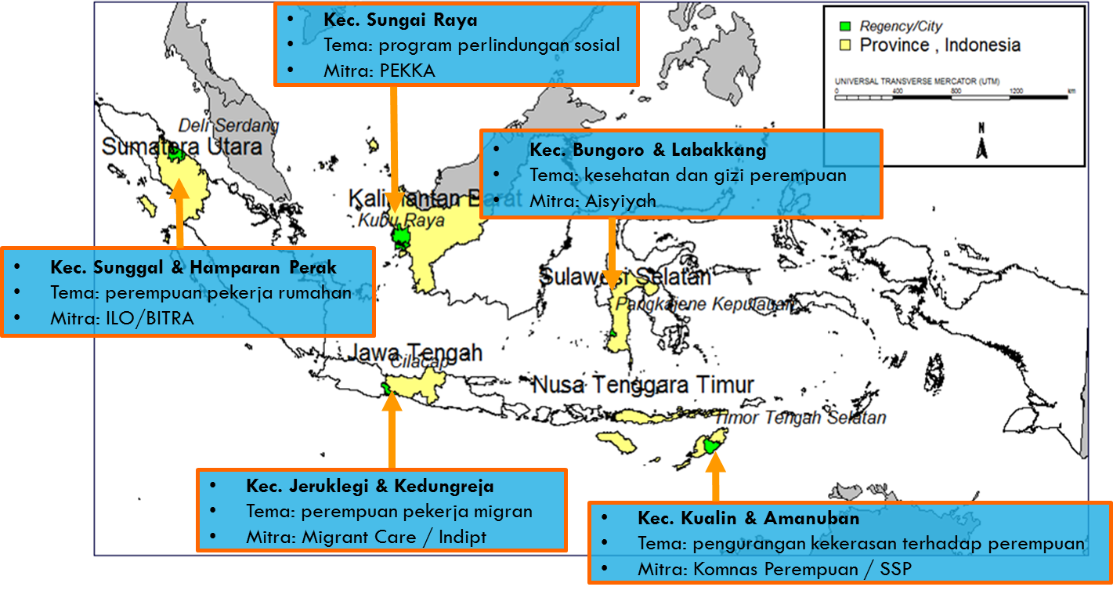

Figure 19: Districts sampled in the MAMPU Longitudinal Study

**General overview of study:**

The Longitudinal Study of Access to Services and Livelihoods (‘Longitudinal Study’) was initiated by MAMPU in 2014 to understand changes in access to services in the 5 thematic areas. The study targeted 1,500 poor households (headed by women and men) in a sample of 10 MAMPU and 5 comparable non-MAMPU villages in 5 districts across Indonesia: Deli Serdang (North Sumatra); Cilacap (Central Java); Pangkajene Islands (South Sulawesi); Kubu Raya (West Kalimantan); and Timor Tengah Selatan (East Nusa Tenggara). The study returns to the same households over 3 ‘waves’: in 2014 (baseline); in 2017 (midline); and a final planned for late 2019 (endline).

Quantitative and qualitative instruments were developed and field-tested in 2014 in advance of baseline data collection. These were modified in consultation with MAMPU in preparation for data collection in October 2017. Broadly, the quantitative instruments measure changes in access to services across 5 thematic areas:

* A range of social protection and welfare programs including (but not limited to) JKN-KIS, Raskin/Rastra, PKH, Bantuan Langsung Sementara Masyarakat (BLSM), Simpan Pinjam Perempuan (SPP), Kredit Usaha Rakyat (KUR);
* Workplace-provided social protection for workers (BPJS-TK);
* Migration for employment-related services including pre-departure training, use of agents and sponsors, communication with family members overseas as migrant workers, financial support and remittances;
* A wide variety of reproductive health services including cervical cancer testing, prenatal and antenatal services, and family planning and contraception;

After difficulties assessing access to services associated with VAW in the baseline, the instrument applied in the midline was extensively revised to reflect international approaches (e.g. WHO). Further changes at the midline stage involved the addition of modules on involvement in village collective activities, and nutrition, reflecting increased interest in this from the Government of Indonesia.

The actual coverage by the quantitative survey at the midline was 1,661 households including 6,052 individuals across the study sites. Over 90% of households interviewed at the baseline were successfully followed up in the midline (i.e. the ‘tracking rate’).

The qualitative component of the study involved observations, as well as 60 key informant interviews and focus group discussions with households, community/village, sub-district and district levels. At the household-level interviews followed up the same families interviewed at the baseline stage. FGDs were of two types: mini FGDs; and village FGDs. Mini-FGDs were small group discussions attended by five poor women, who are all members of a local collective action group established by MAMPU.

The baseline study report was published by MAMPU in July 2015, while 5 thematic reports and 1 synthesis report from the midline are currently in the final stages of publication. All study instruments, draft findings, and analysis have been subject to internal review by MAMPU staff plus one peer review by an external researcher with expertise in quantitative and qualitative methods,

**Use of the data/findings:**

The Longitudinal Study provides clear evidence of increases in access to services and provides indications of the mechanisms through which MAMPU works to improve access to services. For example, the mid-line illustrates how collective action by MAMPU partners at the village level acts with concerted government initiatives (local and national) to improve access to services for poor women.

**Limitations:**

The Longitudinal Study employs purposive sampling methods and therefore the findings cannot be taken as representative of all MAMPU locations. However, credible arguments based on evidence from this and other studies can still be made about the applicability of findings on a wider scale.

Challenges assessing access to services related to migration and VAW make it difficult for the midline to detect change in these areas at the midline. The instruments were modified and improved for the mid-line which should address this issue at the end-line stage in 2019/2020.

# Annex 7: Process for Value for Money Assessment

In 2018 MAMPU, with assistance from Jakarta-based evaluation consultancy Solidaritas, developed a VfM framework. The VfM framework includes a tool for assessment, described in further detail in this annex.

As part of the Collaborative Outcomes Reporting process (internal evaluation) MAMPU will undertake a five-step process to assess VfM at the program level. The process will be led by the MES with the assistance of at least one MEO. The key steps are outlined below:

**Step 1: Collaborative discussion and agreement of MAMPU’s VfM principles**

This is a preliminary step to collaboratively review MAMPU’s “Overarching Principles” for VfM together with program staff and representatives of CSO partners, to consult these with representatives of DFAT and GoI as relevant, and then to revise or update these as necessary to reflect the shared values of the stakeholders and/or the changing circumstances of the program. In addition to the practical purpose of agreeing the set of “overarching principles”, this step also serves the purpose of socializing the both the DFAT principles and their contextual application within MAMPU. To facilitate a more concrete understanding among program staff, this step may also include the identification of “operating principles” that provide more specific, actionable guidance on how the “overarching principles” will be applied within certain aspects of the program.

The relationship between the DFAT principles, MAMPU “Overarching Principles”, and potential “Operating Principles” is presented below.

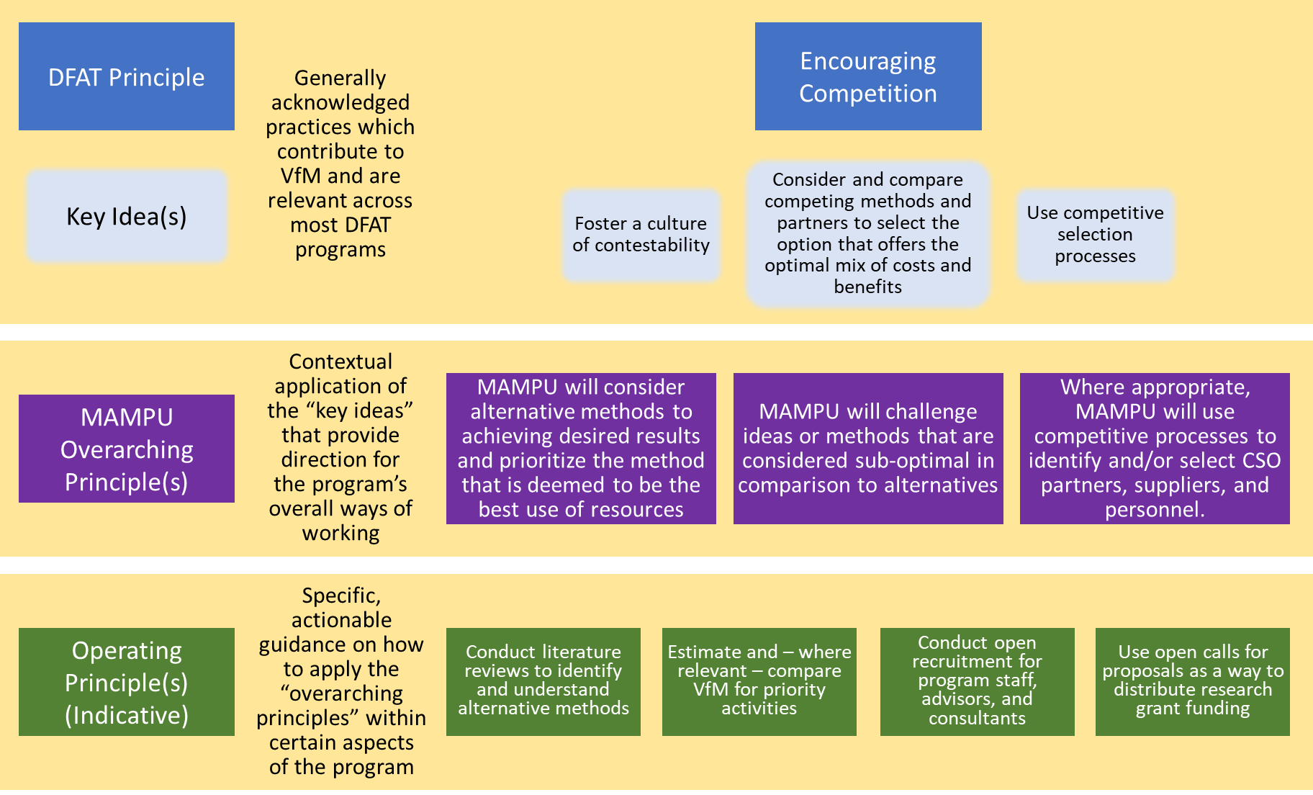

This step may also entail the weighting of the overarching principles in terms of their centrality to providing VfM in the context of MAMPU, and/or the designation of a PIC and/or “working group” for each overarching principle or groups of working principles.

**Step 2: Internal assessment against a Generic Rubric**

Following the general agreement of the “Overarching Principles” in Step 1, MAMPU will implement an internal assessment against the following generic rubric[7]:



This assessment will entail gathering and analysing relevant evidence – quantitative, qualitative, or both – related to each of the principles in question, and synthesizing an argument for why a particular level of performance has been selected.[8] The synthesis process can be quite streamlined, in the form of a small workshop with key staff to discuss evidence and make reasoned judgements against the standards (see King and OPM, 2018).

Thus the output of this step for each principle is the selected level, as well as an explanation (citing key pieces of evidence) as to why that level was considered most appropriate. To enhance the usefulness of the exercise in improving VfM within MAMPU, potential priority areas for improvement should also be highlighted.

**Step 3: Validation through external review**

In line with the principle of transparency and contestability, where agreed between MAMPU and DFAT, the results of the internal program-level VfM assessment should be validated by an external reviewer. This validation is not intended as an in-depth review of the assessment or an audit of the evidence cited, but rather should provide a “second set of eyes” and an objective professional judgment as to the credibility of the argument that MAMPU is (or is not) working in ways which are likely to produce value for money. It is therefore critically important that the reviewer have a background in program management, ideally for complex programs similar to MAMPU.

In reviewing the credibility of the argument presented by MAMPU, the external reviewer can be guided by the following rubric:

|  |  |
| --- | --- |
| **Highly Credible** | MAMPU’s argument is well-reasoned and supported with convincing evidence. There are no significant “gaps” in the argument or evidence. |
| **Generally Credible** | MAMPU’s argument is acceptable and supported with sufficient evidence. There are some minor evidence gaps, but not enough to trigger significant questions or doubts about the overall argument. |
| **Somewhat Credible** | MAMPU’s argument is debatable, and supported by weak or limited evidence. Significant evidence gaps contribute to meaningful doubts. |
| **Highly Suspect** | MAMPU’s arguments include unsubstantiated claims or contradictory and/or clearly exaggerated information. There are major evidence gaps. |

As with the results of the assessment in Step 2, the external reviewer should document (1) the level of the credibility of evidence, and (2) a brief explanation of the selected level, including any areas of concern or suggestions for strengthening the argument.

This review can be conducted during a VfM “summit”, where MAMPU presents the results of the internal assessment conducted in Step 2, and the reviewer (potentially together with other stakeholders) provides feedback.[9] This has the advantage of enabling a two-way discussion about each of the criteria, including the collaborative agreement of key action points to be taken to strengthen VfM and/or the results of the internal assessment. Alternatively, MAMPU could send the results of the internal assessment to be reviewed remotely as desk-based work. This “lighter touch” approach may be more efficient, especially where the reviewer is already familiar with the MAMPU program and MAMPU’s approach to VfM.

**Step 4: Management response and action planning**

In response to the results of the internal self-assessment (Step 2) and the validation through external review (Step 3), MAMPU senior management will prepare a brief management response, including identifying high-priority areas which should be a focus for improvement prior to the next program-level VfM assessment. These areas for improvement can be the basis for more detailed action planning and/or target setting by MAMPU program units and/or CSO partners, including who will do what by when.

Where the validation process (Step 3) occurs during a “VfM summit”, the management response and action planning can be conducted as the last stage of the workshop.

**Step 5: Communication of results**

To facilitate transparency and broader accountability, MAMPU should prepare a summary of the VfM Assessment per principle, for example using the proposed format in Annex 3. The format should be intentionally brief (maximum one page per principle), visual (using the traffic light system above), and action-oriented (for key tasks, describing who will do what by when).

# Annex 8: MAMPU Value for Money Principles

(From the MAMPU VfM Framework)

|  |  |  |
| --- | --- | --- |
| **DFAT “Principle”** | **Key Ideas[10]** | **Proposed Overarching Principles for MAMPU** |
| Cost-consciousness | * “seek reasonable opportunities to reduce costs at every level of operations”, but not “without consideration of the impact on effectiveness or efficiency” | * MAMPU will scrutinize program costs and seek reasonable opportunities to reduce costs without compromising the potential to achieve desired results. |
| Encouraging competition | * “consider and compare competing methods and partners to select the option that offers the optimal mix of costs and benefits”; * Foster a “culture of contestability”; * use “competitive selection processes” | * MAMPU will consider alternative methods to achieving desired results and prioritize the method that is deemed to be the best use of resources * MAMPU will challenge ideas or methods that are considered sub-optimal in comparison to alternatives * Where appropriate, MAMPU will use competitive processes to identify and/or select CSO partners, suppliers, and personnel. |
| Evidence-based decision-making | * Use “systematic, structured and rational approaches to decision making”; * Consider “logical arguments informed by accurate analysis”; * Incorporate “learning from past experience” | * MAMPU will use information, including lessons from past experience, when making decisions about program management and strategy. |
| Proportionality | * Ensure “organisational systems are proportional to the capacity and need to manage results and/or deliver better outcomes” | * MAMPU will prioritize the development or strengthening of processes/systems which are considered most relevant for delivering better outcomes and/or maximizing efficiency. * MAMPU will work together with CSO partners to strengthen their own management systems rather than consolidating all management functions in MAMPU |
| Performance and Risk Management | * continuous review “quality”; * employ “robust approaches to risk management”; * prevent of “fraud and corruption” | * MAMPU will review the extent to which CSO partners, sub-contractors, and consultants are achieving expected results, and take corrective action to address any concerns as necessary. * MAMPU will work with CSO partners to prevent fraud and corruption throughout the program. |
| Results Focus | * Ensure “effective contract, investment and program design”; * Develop “clearly identified objectives and performance targets”; * Allow for “flexibility” “to ensure approaches can be adapted”   Note: results-focus also means being clear about the issues of “whose results” and “results for whom”[11] | * MAMPU will work together with CSO partners to define the results that are important to them, and to develop and iteratively adapt strategies to achieve those results. * MAMPU will work closely with CSO partners to ensure sufficient flexibility to work toward agreed upon results |
| Experimentation and Innovation | * “trialling of experimental and innovative mechanisms”; * “well-managed risk-taking”[12] | * MAMPU will work together with CSO partners to identify and trial experimental approaches where there are reasons to believe that they may produce better outcomes |
| Accountability and Transparency | * “appropriate incentives for optimal performance”; * “honest dialogue about the overall impact of investments” | * MAMPU and CSO partners will share and discuss important results and challenges with DFAT, GoI, and one another * MAMPU and CSO partners will actively facilitate and respond to third party oversight from highly qualified external advisors |

1. In particular, the OCPAT is influenced by a major study on capacity development by the European Centre for Development Policy Management (ECDPM) in 2008. See Baser, H. and P. Morgan (2008), Capacity, Change and Performance Study Report. (ECDPM Discussion Paper 59B). Maastricht: ECDPM.
2. These criteria were identified by partners during a workshop facilitated by the M&E Specialist as part of the MAMPU Partner’s Forum in Jakarta in July 2017.
3. Kloosterman J. (2012), ‘Measuring the unmeasurable’: gender mainstreaming and cultural change, in *Gender and Development*, Vol. 20, 2012, Issue 3
4. <http://www.betterevaluation.org/en/plan/approach/cort>
5. Jika mereka tidak ingin diketahui namanya, jangan mencatat nama ataupun rincian kontak mereka. Cukup tuliskan “anggota kelompok”, “warga masyarakat”, atau deskripsi serupa.
6. See: Befani B. and J. Mayne (2014), “Process Tracing and Contribution Analysis: A Combined Approach to Generative Causal Inference for Impact Evaluation”, IDS Bulletin Volume 45 Number 6, November 2014. For a brief explanation, see http://betterevaluation.org/en/evaluation-options/processtracing
7. The use of a VfM rubric reflects emerging approaches to assessing VfM, including by Harrison, et. al (2017) and King and OPM (2017). The four-level color system (Green, Green/Amber, Amber/Red, Red) follows the Independent Commission on Aid Impact’s overall approach.
8. To paraphrase King and OPM (2018): for any particular principle, it is entirely possible that different lines of evidence may point to different levels of performance on the rubric. The overall judgment should ask where the overall “centre of gravity” sits. If doubt remains, the lower of the two performance levels can be selected, with a qualifying statement as to why the higher level was not selected.
9. Such a “summit” could also be combined with larger evaluations / reviews of MAMPU, including the Independent Review planned for late 2018.
10. These key ideas are taken primarily from the explanation of DFAT’s Value for Money principles on the DFAT website (<http://dfat.gov.au/aid/who-we-work-with/value-for-money-principles/Pages/value-for-money-principles.aspx>), but also incorporate some additional concepts taken from the Independent Commission on Aid Impact’s Approach to Effectiveness and Value for Money (2011).
11. See the first principle of The Independent Commission for Aid Impact (2011)’s reviews, as outlined in their Approach to Effectiveness and Value for Money: “The intended beneficiaries come first: our focus will always be on assessing results for the people that aid is intended to help. Only if programmes are truly ‘owned’ by the beneficiaries will they realise long-term benefits... In our reviews, we will want to ascertain whether the intended beneficiaries are being involved in programme planning, roll-out and monitoring.” (p 10)
12. See The Independent Commission for Aid Impact (2011), p 11.