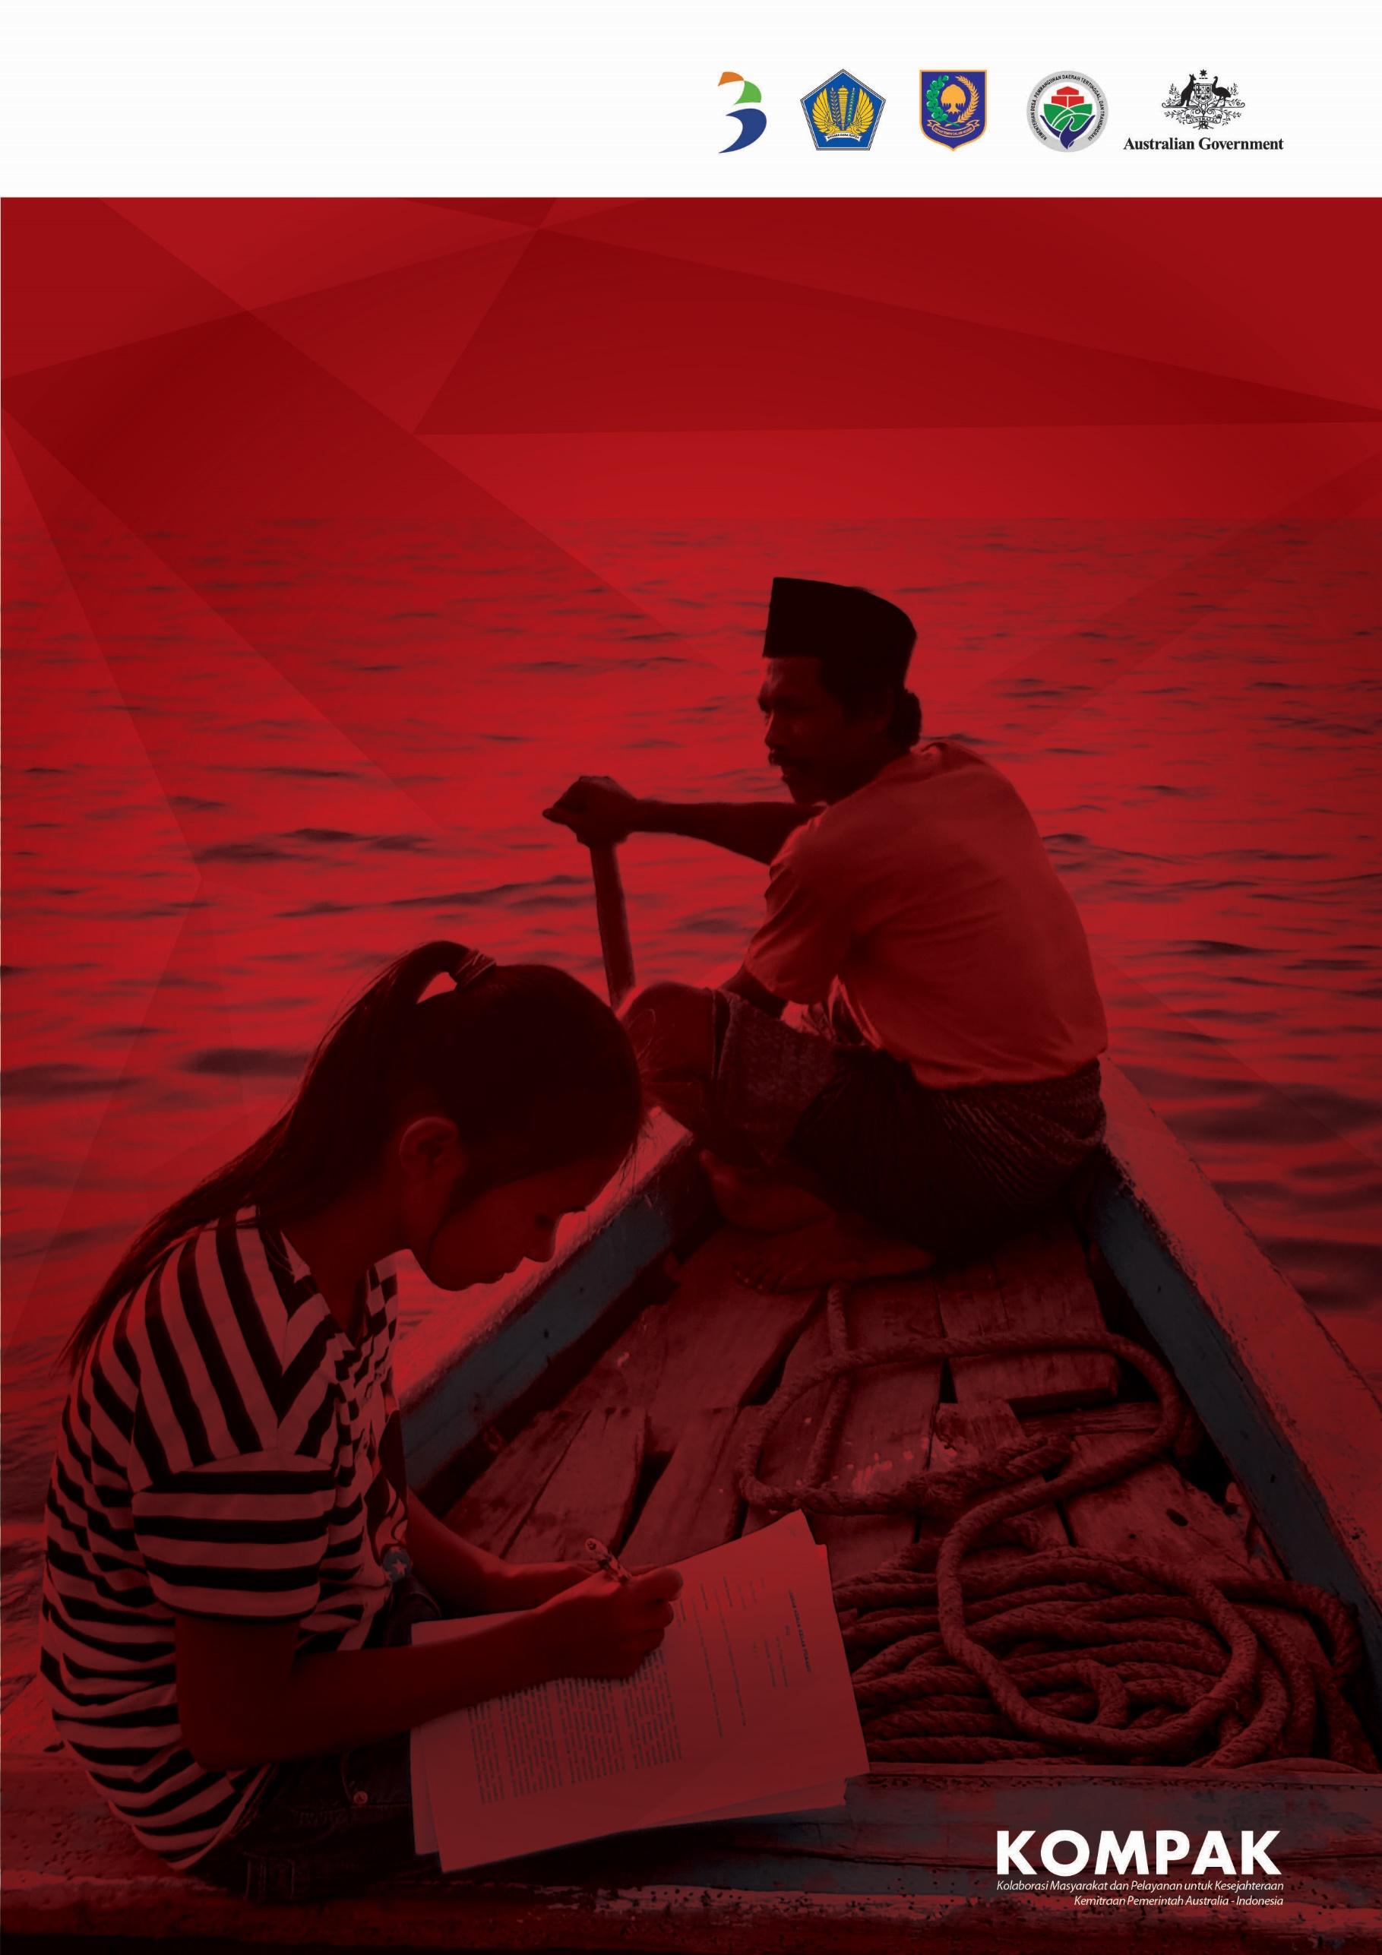

**KOMPAK**

**SIX-MONTHLY REPORT**

January - June 2019

**KOMPAK SIX-MONTHLY REPORT**

January - June 2019

##### KOMPAK

Jalan Diponegoro No. 72, Jakarta 10320 Indonesia

T: +62 21 8067 5000

F: +62 21 3190 3090

E: [communications@kompak.or.id](mailto:communications@kompak.or.id) [www.kompak.or.id](http://www.kompak.or.id/)

## Contents

OVERVIEW 1

About KOMPAK 2

Map of KOMPAK Locations 3

How KOMPAK Transforms Local Governments and Creates Economic Opportunities 4

Partners 5

PERFORMANCE: JANUARY-JUNE 2019 7

Executive Summary 8

KOMPAK Progress against Workplan 12

DEVELOPMENT IMPACT 13

Introduction 14

Results Mapping: KOMPAK Governance Program 16

Strategic Development Planning and Coordination 17

Inform medium-term development planning 18

Strengthen planning and implementation of the minimum service standards for

basic services 19

Support development coordination, research and innovation initiatives 21

Kecamatan and Village Strengthening 22

Strengthen the sub-district as the centre for village governance and technical assistance 23

Establish and strengthen integrated village and sub-district information systems 27

Strengthen community engagement and social accountability mechanisms 29

Strengthen women’s involvement in village governance 30

Strengthen village planning and budgeting 33

Public Financial Management 36

Improve national fund allocation mechanisms supporting sub-national basic

service delivery 37

Strengthen public financial management at the district-level 41

Strengthen the use of Special Autonomy Funds 42

Civil Registration and Vital Statistics 44

Strengthen national CRVS policies and regulations 45

Strengthen provincial and district CRVS policies, planning and information systems 46

Strengthen sub-district and village CRVS initiatives 48

Education 50

Strengthen early childhood education and development 50

Support initiatives to reach out-of-school children 51

Health 53

Develop and test health innovations and strengthen district health and nutrition policies 53

Local Economic Development 55

Pilot market linkage models to strengthen sustainable livelihoods 55

Research and Evaluations 57

Gender Equality and Social Inclusion 59

FINANCIAL REPORT 63

Financial Report 64

Program implementation costs (Activity, Personnel and Operations) 64

ii

KOMPAK Six-Monthly Report

*Commonly Used Acronyms*

## Commonly Used Acronyms

CRVS Civil registration and vital statistics

ECED Early childhood education and development GESI Gender equality and social inclusion

MSE Micro and small enterprise MSS Minimum service standards

NTB Nusa Tenggara Barat (West Nusa Tenggara)

PTPD *Pembina Teknis Pemerintahan Desa* (Village Governance Facilitator)

RPJMN *Pembangunan Jangka Panjang Nasional* (National Medium-Term Development Plan)

RPJMD *Rencana Pembangunan Jangka Menengah Daerah* (Regional Medium-Term Development Plan)

RPJMDes *Rencana Pembangunan Jangka Menengah Desa* (Village Medium-Term Development Plan) SID *Sistem Informasi Desa* (Village Information System)

TA Technical assistance

UMD *Universitas Membangun Desa* (University Strengthening Villages program)

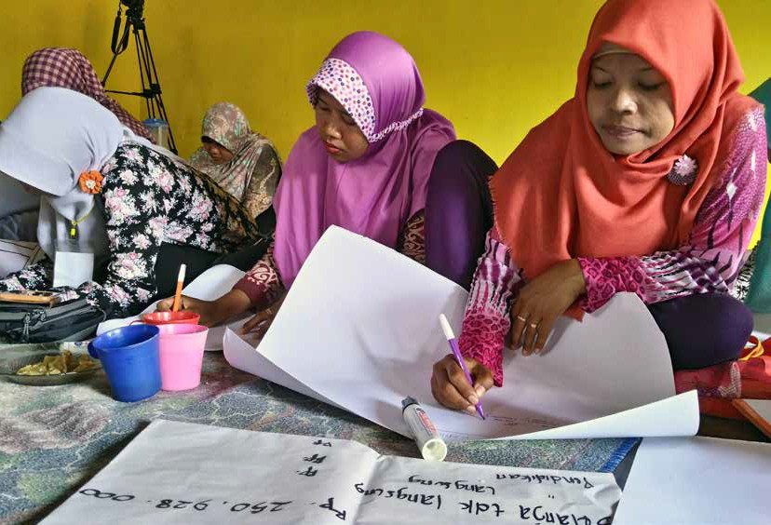



# OVERVIEW

## About KOMPAK

KOMPAK (Governance for Growth) is a facility funded by the Government of Australia to support the Government of Indonesia in achieving its poverty reduction targets and addressing inequality. KOMPAK started in January 2015 with the first phase running until June 2018. DFAT approved the continuation phase for KOMPAK for the period of 2019 to 2022. Its current end date is 30 June 2022 with a total commitment of up to A$178 million.

KOMPAK is committed to working at all levels of government to find solutions for the most important challenges faced in delivering basic services and promoting livelihoods for the people of Indonesia. Our network of expertise stretches to seven provinces and the central ministries where we identify constraints, pilot and test innovative approaches, and provide expert advice, research and support to government partners to shape direction, build capabilities, and support execution for sustainable results.

KOMPAK’s goal is to help the poor and vulnerable benefit from improved delivery of basic services and economic opportunities. To achieve this, we support initiatives that will improve the capabilities of the government – at the national, provincial, district, sub-district and village levels – to manage and deliver basic civil registration, health and education services and create an enabling environment for local economic development. Integral to this is strong development planning and coordination, effective and inclusive local governments, and performance-oriented and efficient public financial management systems.



January-June 2019 3

##### MAP OF KOMPAK LOCATIONS

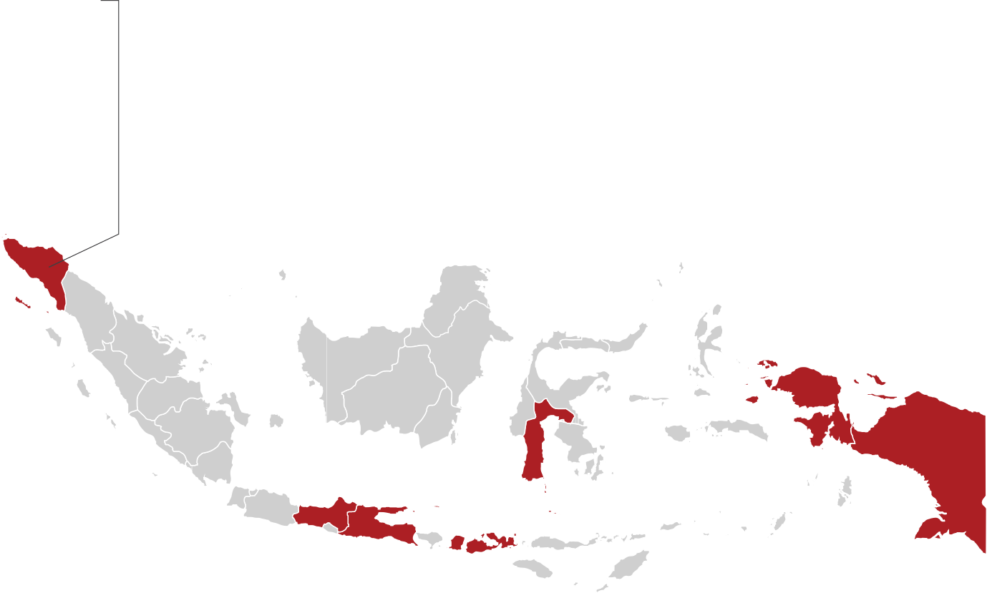

Sectors:

* Kecamatan and Village Strengthening and Social Accountability
* Fiscal Decentralisation and Public Financial Management
* Civil Registration and Vital Statistics
* Health and Nutrition
* Education

Districts:

* Lanny Jaya • Jayapura • Asmat • Waropen •
  + Boven Digul • Nabire •

**PAPUA**

Sectors:

* Kecamatan and Village Strengthening and Social Accountability
* Fiscal Decentralisation and Public Financial Management
* Civil Registration and Vital Statistics
* Health and Nutrition
* Education
* Local Economic Development

Districts:

* Bantaeng • Pangkajene dan Kepulauan •

**SOUTH SULAWESI**

Sectors:

* Kecamatan and Village Strengthening and Social Accountability
* Fiscal Decentralisation and Public Financial Management
* Civil Registration and Vital Statistics
* Education
* Local Economic Development

Districts:

* Pekalongan • Brebes • Pemalang •

**CENTRAL JAVA**

Sectors:

* Kecamatan and Village Strengthening and Social Accountability
* Fiscal Decentralisation and Public Financial Management
* Civil Registration and Vital Statistics
* Health and Nutrition
* Local Economic Development

Districts:

* Aceh Barat • Bireuen • Bener Meriah •

**ACEH**

*About KOMPAK*

|  |
| --- |
| **EAST JAVA** |
| Districts:   * Lumajang • Bondowoso • Pacitan • Trenggalek • |
| Sectors:   * Kecamatan and Village Strengthening and Social Accountability * Fiscal Decentralisation and Public Financial Management * Civil Registration and Vital Statistics * Health and Nutrition * Local Economic Development |

|  |
| --- |
| **WEST NUSA TENGGARA** |
| Districts:   * Lombok Timur • Sumbawa • Lombok Utara • Bima • |
| Sectors:   * Kecamatan and Village Strengthening and Social Accountability * Fiscal Decentralisation and Public Financial Management * Civil Registration and Vital Statistics * Health and Nutrition * Education * Local Economic Development |

|  |
| --- |
| **PAPUA BARAT** |
| Districts:   * Kaimana • Fakfak • South Manokwari • Sorong • Waropen* • |
| Sectors:   * Kecamatan and Village Strengthening and Social Accountability * Fiscal Decentralisation and Public Financial Management * Civil Registration and Vital Statistics * Health and Nutrition * Education   *\* No activities were delivered in Waropen District in 2019 due to lack of political support* |

How KOMPAK Transforms Local Governments and Creates Economic Opportunities

**MODALITY DESCRIPTION KOMPAK EXAMPLES**

Piloting and testing By trialling different models,

KOMPAK can test what works

best and provide options to the government for potential scale-up

Scaling and replication For proven models, KOMPAK

assists the government to bring

the model to scale, including developing the trainings, guidelines, regulations and securing funding

Technical assistance KOMPAK leverages its specialist

expertise and networks to help

the government solve problems and make systems work more efficiently and effectively

Research and analytics KOMPAK or partner research

institutions undertake studies

and analytics to provide the government with evidence to make better decisions

Market linkage model

Village registration officer

model

Mobile application for midwives to support pregnant women (PWS+ Apps)

BANGGA Papua Universal Child Grant Program

Village information systems

Sub-district and village strengthening (PTPD) model

Inputs to national medium- term development plan (RPJMN 2020-2024)

Improving fiscal transfers from central to district and village governments

Costing study on implementation of the minimum service standards

Constraints (poverty) analysis of district funding

Coordination and facilitation

With so many stakeholders, KOMPAK is able to help the government to coordinate and share best practices and lessons learned

*Universitas Membangun Desa* (UMD) with universities, government agencies and the private sector

INSPIRASI Conference

## Partners

#### GOVERNMENT PARTNERS





Ministry of National Development Planning/ National Development Planning Agency (Bappenas)

Ministry of Home Affairs

Ministry of Finance

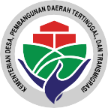

Ministry of Villages, Development of Disadvantaged Regions and Transmigration

**KOMPAK also partners with provincial, district, sub-district and village governments, community groups and civil society organisations**

#### CIVIL SOCIETY PARTNERS





Yayasan Bursa Pengetahuan Kawasan Timur Indonesia

Sekretariat Nasional Forum Indonesia untuk Transparansi Anggaran



Pemberdayaan Perempuan Kepala Keluarga

 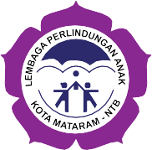

Pusat Kajian Perlindungan Anak Universitas Indonesia

LPA NTB - Lembaga Perlindungan Anak Nusa Tenggara Barat

 5

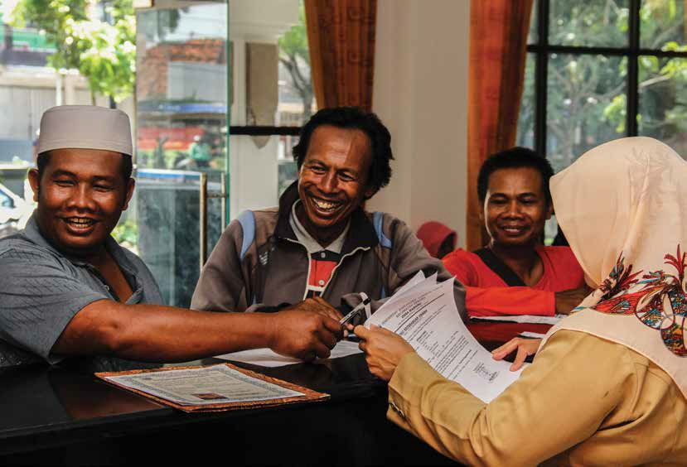



# PERFORMANCE:

### JANUARY-JUNE 2019

## Executive Summary

As KOMPAK enters its second phase starting from January 2019, it is well positioned to build on the development achievements and successful models piloted since its inception in 2015. This report outlines KOMPAK’s development progress from January to June 2019 as well as highlighting key challenges and areas to focus on as implementation and handover continues towards 2022.

From January to June 2019, KOMPAK delivered programs across seven provinces and 25 districts. Due to lack of political support, KOMPAK did not deliver programs in Waropen District, Papua, during the reporting period and this was excluded from the reporting and data collection.

The results in this report are based on program reports and surveys of KOMPAK villages, sub-districts and districts (see Introduction section for overview of survey approach). All percentages for village level data – unless otherwise indicated – are based on 424 villages surveyed (there are 441 villages in KOMPAK locations, but 17 villages were not accessible during the survey period). All districts and sub-districts in KOMPAK locations were surveyed. This data serves as an important mid-line for KOMPAK and will be used to inform work-planning for 2020.

##### LIST OF KOMPAK LOCATIONS AND VILLAGE SURVEY RESPONSE RATE

**VILLAGE SURVEY**

|  |  |  |  |  |
| --- | --- | --- | --- | --- |
| **PROVINCE** | **DISTRICT** | **# OF SUB-DISTRICT** | **# OF VILLAGES** | **RESPONSE RATE** |
| ACEH | Aceh Barat | 1 | 8 | 100% |
|  | Bener Meriah | 1 | 9 | 100% |
|  | Bireuen | 1 | 6 | 100% |
| JAWA TENGAH | Brebes | 1 | 12 | 100% |
|  | Pekalongan | 1 | 9 | 100% |
|  | Pemalang | 1 | 12 | 100% |
| JAWA TIMUR | Bondowoso | 2 | 28 | 100% |
|  | Lumajang | 2 | 20 | 70% |
|  | Pacitan | 2 | 27 | 100% |
|  | Trenggalek | 2 | 20 | 100% |
| NTB | Bima | 2 | 29 | 100% |
|  | Lombok Timur | 2 | 40 | 100% |
|  | Lombok Utara | 2 | 13 | 100% |
|  | Sumbawa | 2 | 20 | 100% |
| PAPUA | Asmat | 2 | 23 | 100% |
|  | Boven Digoel | 2 | 9 | 100% |
|  | Jayapura | 3 | 19 | 100% |
|  | Lanny Jaya | 2 | 15 | 100% |
|  | Nabire | 3 | 16 | 100% |

 8 KOMPAK Six-Monthly Report

|  |  |  |  |  |
| --- | --- | --- | --- | --- |
| **PROVINCE DISTRICT # OF SUB-DISTRICT** | | | **# OF VILLAGES VILLAGE SURVEY**  **RESPONSE RATE** | |
| PAPUA BARAT | Fakfak | 2 | 15 | 93% |
|  | Kaimana | 1 | 17 | 41% |
|  | Manokwari Selatan | 3 | 34 | 100% |
|  | Sorong | 2 | 23 | 100% |
| SULAWESI | Bantaeng | 1 | 10 | 100% |
| SELATAN | Pangkajene Kepulauan | 1 | 7 | 100% |
| **TOTAL** |  | **44** | **441** | **96%** |

Note: Waropen District (2 sub-districts, 19 villages) has been excluded from this table. From January to June 2019, KOMPAK has not delivered activities in Waropen due to lack of political support. KOMPAK will propose exiting this district at the next Steering Committee. For district and sub-district surveys, the response rate - excluding Waropen - was 100%.

**KOMPAK SUCCESS 2022 KEY ACHIEVEMENTS AND STATUS BY JUNE 2019**

An increased number of women have assumed higher roles of formal responsibility in their village in KOMPAK targeted provinces

Village governments have the skills and mechanisms (including data) to improve basic services at the village and inter-village levels

Communities - especially women, the poor and vulnerable - take action to push government and services units to improve

the accessibility and quality of services

* 400 women graduated from the Paradigta Academy, adding to the more than 2,500 alumni supporting village development initiatives in over 400 villages across 10 provinces.
* More than 467 women were supported to form women’s groups to promote collective advocacy in nine villages across six districts.
* In KOMPAK-surveyed villages, only 16% (598/3,753) of village council members were women, while 62% (261/424) of villages had a female appointed as head, treasurer or secretary.
* All 44 KOMPAK sub-districts have village governance (PTPD) facilitators providing assistance to villages, and almost all (97%, 257/264) villages outside Papua and Papua Barat reported receiving technical assistance from sub- districts in the past 6 months.
* 77% (326/424) of KOMPAK villages had a village information system, and there is evidence the systems are being replicated, with the Provincial Government of Papua Barat signing an MoU with KOMPAK indicating their commitment to implement in all 1,742 villages in the province.
* 98% (258/264) of KOMPAK villages outside Papua and Papua Barat were using Siskuedes, the village financial management system. Support is needed for Papua and Papua Barat where only 57% (91/160) of KOMPAK villages are using the system.
* 59% (249/424) of KOMPAK villages including women and people with disabilities in development planning forums (*Musrenbang*) and 19% had a specific women’s planning forum (*Musrena*) – KOMPAK is integrating modules on social accountability into PTPD trainings, setting up women’s groups, and advocating to local governments to prioritise these inclusive forums.
* A model promoting transparency in village budgets was piloted in five provinces – 306 community members were trained and women’s groups and community feedback mechanisms were established in 18 villages.

**KOMPAK SUCCESS 2022 KEY ACHIEVEMENTS AND STATUS BY JUNE 2019**

Local governments provide effective support to villages and service units (health clinics and schools) to improve basic services

Local governments have increased allocations and quality of spending to improve access and quality of basic services

Local governments and service units have improved the accessibility and quality of CRVS services

* The village governance (PTPD) facilitator model – based at the sub-district – is being expanded nationally from all KOMPAK supported districts to 350 districts. The World Bank is finalising a US$300 million project to scale up the program, adapted from the KOMPAK model.
* 15 of 25 (60%) KOMPAK-surveyed districts have incorporated the minimum service standards for health and education into their medium-term development plans and have allocated funds accordingly.
* KOMPAK facilitated workshops for 51 district governments to improve the quality of Special Allocation Fund (DAK) physical proposals using KRISNA, a work-planning and budgeting software. KOMPAK will assess the effectiveness of these trainings based on the proposal approval ratio and alignment with minimum service standard objectives using the 2020 DAK physical allocations which will be released in late 2019.
* 86% (4/5 provinces, 14/16 districts) of KOMPAK-supported provinces and districts outside Papua and Papua Barat received 2019 Regional Incentive Funds (DID), higher than the national average of 57%.
* An e-planning and budgeting application was launched in Aceh –integrating work planning and budgeting for all provincial government agencies and initially one district. In 2020, the system will be expanded to 22 other districts in Aceh.
* A model for kecamatan and village performance funding is being piloted in 191 villages in NTB – this is linking funding with performance on village financial management and basic service delivery.
* Evaluations of Otsus Fund expenditure and performance have been completed in Aceh and Papua/Papua Barat. KOMPAK is supporting implementation of the recommendations.
* 20,356 children were registered under the BANGGA Papua Universal Child Grant Program in Papua, with their guardians receiving a A$300 per year unconditional cash transfer. KOMPAK has also initiated a study to explore blockchain as a delivery mechanism to improve the efficiency and security of the system.
* In KOMPAK districts, excluding Waropen, coverage of birth certificates for 0-17 year olds increased by 5.3 percentage points on average from 2015 to 2018, according to SUSENAS data. This is above the national average increase of

3.6 percentage points. While ten districts increased coverage more than 10 percentage points, six districts had worse coverage. The CRVS research study aims to best practices and ongoing challenges.

* There remain gaps in CRVS coverage – 14 KOMPAK districts had birth certificate coverage less than 85% in 2018, leaving an estimated 595,000 children without a birth certificate.
* National guidelines and trainings are under development for CRVS services

– firstly for village governments, adopting lessons learned from pilots, and secondly, on post-disaster response drawing on lessons from KOMPAK’s assistance after the 2018 NTB earthquake.

* The village registration officer model, developed by KOMPAK and funded by village governments, was active in 34% of KOMPAK’s villages. The model is part of the proposed national guidelines.

10

KOMPAK Six-Monthly Report

**KOMPAK SUCCESS 2022 KEY ACHIEVEMENTS AND STATUS BY JUNE 2019**

Local governments and service units have

developed and tested local innovations to improve the accessibility and quality of education services

Local governments and service units have

developed and tested local innovations to improve the accessibility and quality

of health and nutrition services

An increased number of MSMEs, especially those involving the poor and vulnerable, have increased their productivity and market access

* + A pilot for out-of-school children in South Sulawesi, known as the ‘boat class’ initiative, was gaining traction with KOMPAK supporting guideline development and replication to add to the current 26 participating schools in Pangkep District.
  + To support the National Action Plan for Early Childhood Education and Development, KOMPAK supported Bappenas and the National ECED Coalition to develop indicators for the plan’s monitoring framework.
  + A study was completed on the feasibility of using drones for the distribution of drugs and medical supplies in remote areas of South Sulawesi. A cost-benefit analysis is to follow.
  + A mobile application was piloted in Bener Meriah District, Aceh, to support midwives to better monitor and track pregnant women under their care. 231 pregnant women are registered, and the application is to be piloted in two more districts in late 2019.
  + The market linkages program was being piloted in seven provinces with 12 business groups registered, such as a coffee group in South Sulawesi with 2,000 members. KOMPAK is developing a mobile application to better capture data and assess its reach, cost-benefit and impact. The lessons learned will be used to inform the next medium-term development plan.

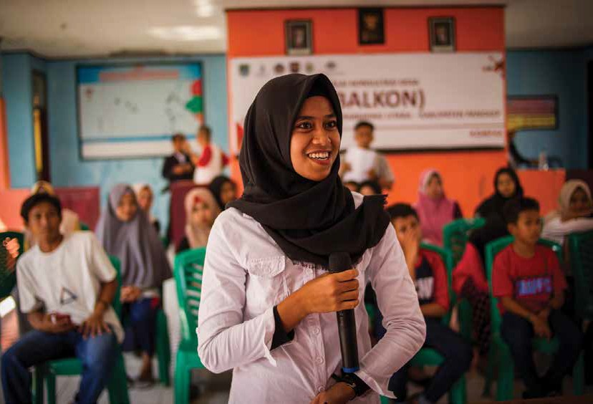



# DEVELOPMENT IMPACT

*Development Impact*

## Introduction

KOMPAK works in seven key areas at the national and sub-national levels. These areas – adapted from KOMPAK’s multi-year workplan 2019-2022 – are in the diagram on the next page. This report is structured based on this results mapping, which shows the key sectors and objectives in which KOMPAK targets its efforts. Underpinning these services is a focus on gender equality and social inclusion, so that the poorest and most vulnerable have a say in how government operates and is provided with the essential services they need.

KOMPAK works to strengthen the enabling environment for basic services to be delivered more effectively and efficiently by local governments. This means strengthening strategic planning and coordination, kecamatan (sub-district) and village governance, and public financial management.

KOMPAK also aims to deliver changes in basic service delivery specifically for civil registration, health and education. KOMPAK leverages its work with national and local governments and civil society organizations and ability to pilot and scale-up innovative approaches to benefit these sectors. This includes advocacy for greater funding allocation to these sectors, supporting the implementation of the minimum service standards, and implementing innovative models to improve service delivery.

KOMPAK also contributes to the national agenda on local economic development. KOMPAK is piloting new approaches to connect micro and small enterprises (MSEs) with market actors, so these MSEs can better respond to market needs and increase their productivity. In doing so, KOMPAK is helping to inform national policies to create more income generating opportunities for the poor.

 14

KOMPAK Six-Monthly Report

##### KOMPAK SURVEYS AT THE DISTRICT, SUB-DISTRICT AND VILLAGE LEVELS

In July 2019, KOMPAK conducted a survey of all districts, sub-districts and villages in its target locations. This aimed to provide a snapshot of the current situation on the areas outlined in the results mapping.

The surveys were collected by KOMPAK monitoring and evaluation officers visiting or calling a village representative and collecting data using a structured questionnaire. The questionnaires aimed to collect information on the status of a specific issue – whether or not KOMPAK had an impact. For example, villages were asked if an official had been trained on planning and budgeting in the last six months – this could be from KOMPAK or another development or government agency.

The survey will serve as a baseline for the second phase of KOMPAK, providing information for program managers to better target their interventions and assess progress over the next one to two years.

|  |  |  |  |
| --- | --- | --- | --- |
|  | **COLLECTED** | **TARGET** | **RESPONSE RATE** |
| District survey | 25 | 25 | 100% |
| Sub-district survey | 44 | 44 | 100% |
| Village survey | 424 | 441 | 96%a |

a Missing 17 villages: (a) 11 villages in Papua Barat not collected due to political and weather conditions limiting access; and (b) 6 villages in East Java not contactable. Data was not collected in Warpoen district in Papua due to no activities implemented in 2019 and lack of poltical support.



LEGEND

Higher-level goals Sectors

Key result areas

KOMPAK 2022 Indicators of Success

Local governments provide effective support to villages and service units (clinics and schools) to improve basic services

Village governments have the skills and mechanisms (including data) to improve basic services at village & inter-village levels

Local governments and service units have

improved the accessibility and quality of CRVS services

Local governments have increased allocations and quality of spending to improve access and quality of basic services

Strengthen women’s involvement in village governance

An increased number of MSMEs, especially those involving the poor and vulnerable, have increased their productivity and market access

Local governments and service units have developed and tested local innovations to improve the accessibility and quality of health and

nutrition services

Local governments and service units have developed and tested local innovations to improve the accessibility and quality of education

services

Pilot market linkage models to strengthen sustainable livelihoods

Develop and test health innovations

Strengthen early childhood education and development planning

Strengthen national CRVS policies, laws and regulations

Strengthen public financial management at the district-level

Strengthen the sub- district as the centre for village governance and technical assistance

Inform medium-term development planning

*Development Impact*

#### RESULTS MAPPING: KOMPAK GOVERNANCE PROGRAM

**GOAL**

**END-OF-FACILITY** 1) Local government and service units better address the needs of basic service users

**OUTCOMES** 2) The poor and vulnerable benefit from improved village governance

3) The poor and vulnerable benefit from increased opportunities for economic development

**GOAL** The poor and vulnerable benefit from improved basic services and

greater economic opportunities

Local economic development

Health

Education

Civil registration and vital statistics

Public financial

management

Kecamatan and village strengthening

Strategic development planning and coordination

16

KOMPAK Six-Monthly Report

Strengthen planning and implementation of the minimum service standards for basic services

Establish and strengthen integrated village and sub-district information systems

Improve national fund allocation mechanisms supporting subnational basic service delivery

Strengthen district CRVS information systems, policies and planning

Support initiatives to reach out-of-school children

Strengthen district health and nutrition policies

Strengthen national policies, guidelines and regulations using market linkage approaches

Support development coordination, research and innovation initiatives

Strengthen community engagement and accountability mechanisms

Strengthen the use of Special Autonomy Funds

Strengthen sub-district and village CRVS initiatives

Strengthen village budgeting and planning

An increased number of women have assumed higher roles of formal responsibility in their village in KOMPAK targeted provinces

Communities - especially women, the poor and vulnerable - take action to push government and services units to improve the accessibility and quality of services

Strategic Development Planning and Coordination

Planning is a key element of good management and governance. Planning helps governments to identify and meet the needs of their constituents and provides the basis for implementation, monitoring progress and assessing results and impact. For these reasons, KOMPAK provides assistance at both the national level in the development of the next medium-term development plan (RPJMN 2020-2024) and at the sub- national level for annual and medium-term development and poverty alleviation plans and strategies.

A core component of this is also integrating the minimum service standards (MSS) into planning documents. The MSS are a set of indicator targets for priority sectors which identify the minimum level of achievement all districts and provinces should attain. KOMPAK has been working with Bappenas, the Ministry of Home Affairs and other stakeholders to determine the additional funding that will be required to meet the minimum standards and the best approach for tracking progress.

KOMPAK also provides support for a wide range of other development coordination, research and innovation initiatives. In 2019, this included promoting greater uptake of the *Universitas Membangun Desa* (UMD) model among government institutions, especially the Ministry of Villages, Ministry of Research, Technology and Higher Education, and university networks.

Inform medium-term development planning

Strengthen planning and implementation of the minimum service standards for health, education and other basic services

Support development coordination, research and innovation initiatives

TA on the development of the national medium-term development plan (RPJMN 2020-2024)

Study on MSS Costing for Health, Education and Public Housing

TA on Universitas Membangun Desa (UMD) development and implementation

TA on provincial and district annual and medium-term development plans

TA to develop M&E framework for MSS

TA on indicators for Ease of Being Indonesian study

TA to district governments to integrate MSS in planning documents

#### INFORM MEDIUM-TERM DEVELOPMENT PLANNING

The Government of Indonesia’s medium-term development plan (RPJMN) outlines the government’s five-year priorities, serving as the basis for all ministries and government agencies in formulating their respective strategic plans.

Bappenas is overseeing the development of the next national medium-term development plan (RPJMN 2020-2024). KOMPAK has been assisting Bappenas and its partner ministries to identify priority issues and incorporate lessons learned from pilots, technical assistance and research to support this process.

KOMPAK has also been supporting provincial and district governments to better align their annual and medium-term plans with national government priorities, particularly on incorporating the minimum service standards for health, education and other basic services.

Support to the development of the national medium- term development plan (RPJMN 2020-2024)

Support to provincial and district annual and medium- term development plans

KOMPAK is providing assistance to Bappenas to develop the RPJMN 2020-2024 with a focus on village governance, the sub-district role in providing village assistance and supervision, and the One Index

policy. This has included developing policy input briefings, facilitating

workshops and other initiatives to support discussions.

In partnership with the Institute for Research and Empowerment (IRE), KOMPAK provided policy inputs from the civil society perspective on strengthening implementation of village law. This included input to the development of a Background Study on Village Authority to inform the RPJMN 2020-2024. The paper provided a series of recommendations, including the need to undertake an audit of village boundaries and associated terminology, harmonising and simplifying regulations on the implementation of village law, and strengthening community voice to influence village government. In partnership with IRE, KOMPAK will be providing support to harmonise and simplify the regulations.

KOMPAK provided technical assistance to provincial governments to support the development of annual work plans (RKPD), poverty alleviation strategies (*Renstra Kemiskinan*), and provincial medium- term development plans (RPJMD). A key focus of this assistance was

integrating the minimum service standards (MSS) in health, education and other basic services into the plan so that there are a common set of indicators and baseline activities.

In Aceh, KOMPAK supported its three districts to develop costed annual workplans based on investments needed to achieve the MSS, and in Papua KOMPAK helped to integrate the standards with the RPJMD and sectoral plans (*Renstra Perangkat Daerah*). KOMPAK also supported the district government of Lumajang to hold a district planning forum (*Musrenbang Inspirasi*). This was an innovative approach that brought together 120 stakeholders to jointly agree on development priorities for 2020.

#### STRENGTHEN PLANNING AND IMPLEMENTATION OF THE MINIMUM SERVICE STANDARDS FOR BASIC SERVICES

In 2014, the Government of Indonesia passed Law (UU) No. 23/2014 (regional autonomy) from which regulations (PP and Permen) were developed on minimum service standards (MSS) for health, education and other basic services. The Law and its PP on MSS divided the responsibilities and mandated various levels of government (central, province and district) to deliver key services on health, education, infrastructure, housing, and other areas.

The MSS sets targets for the quality of basic public services that districts should achieve, such as immunisation coverage or school enrolment benchmarks. KOMPAK is providing support to Bappenas and the Ministry of Home Affairs to assess the additional investment needed to achieve these standards and to assist districts integrate the MSS in their planning documents.

MSS Costing on Health, Education and Public Housing

KOMPAK is conducting a study on the investment needed to achieve the MSS in all districts for health, education and water and sanitation.

Initial estimates are that an additional approximately IDR 12.4 trillion (A$1.2 billion) will need to be allocated through district and city governments to achieve the MSS targets in the health sector by

2020. While for the water and sanitation sector, about IDR 159 trillion (A$15.9 billion) is needed to achieve the MSS by 2024. Estimates for education are not yet available. The final study is set to be published in November 2019.

District performance on MSS KOMPAK has been advocating for districts to incorporate MSS targets

into their planning documents and to allocate specific funds toward achieving the MSS, with 15 of 25 (60%) KOMPAK-surveyed districts having achieved this (Waropen was not surveyed due to limited activity by KOMPAK in 2019).

##### DISTRICT IMPLEMENTATION OF MINIMUM SERVICE STANDARDS

|  |  |  |  |  |
| --- | --- | --- | --- | --- |
| **Province** | **District** | **Medium-term development plan (RPJMD) includes MSS targets** | **Annual Work (RKPD) includes MSS targets** | **Funds allocated for MSS achievement** |
| Aceh | Aceh Barat Bener Meriah  Bireuen |  | | |
|  | | |
|  | | |
| Central Java | Brebes  Pekalongan Pemalang |  | | |
|  | | |
|  |  |  |
| East Java | Bondowoso |  | |  |
|  | Lumajang |  | | |
|  | Pacitan |  | | |
|  | Trenggalek |  | | |
| NTB | Bima |  |  |  |
|  | East Lombok |  |  |  |
|  | North Lombok |  |  |  |
|  | Sumbawa |  |  |  |
| Papua | Asmat |  | | |
|  | Digoel |  | | |
|  | Jayapura |  | |  |
|  | Lanny Jaya |  | | |
|  | Nabire |  | | |
| South Sulawesi | Bantaeng  Pangkajene Islands |  | | |
|  | | |
| Papua Barat | Fakfak |  | |  |
|  | Kaimana |  | | |
|  | Sorong |  |  | |
|  | South Manokwari |  |  | |

Yes No

#### SUPPORT DEVELOPMENT COORDINATION, RESEARCH AND INNOVATION INITIATIVES

KOMPAK provides assistance on a range of development coordination, research and innovation initiatives. In early 2019, one notable area of support included the replication of the *Universitas Membangun Desa* – or Universities Building Villages Program – approach.

Universitas Membangun Desa (UMD)

Students at Indonesian universities usually undertake community service projects as part of their undergraduate studies, known as the *Kuliah Kerja Nyata* (KKN). This community service program – involving about 3,000 universities annually – has the potential to contribute significantly to village development.

The UMD – initiated by KOMPAK – aims to mobilise the KKN community service program to be better coordinated and focused on supporting local government priorities. KOMPAK has served as a facilitator in bringing universities, ministries, the private sector and sub-national governments – from provincial to district levels – together to identify better ways of working. A successful model of

UMD is being delivered in Pangkep District, South Sulawesi, where 17 universities have signed on to support the District Poverty Reduction Program, targeted initially in 23 villages. The approach is also being used in NTB and East and Central Java.

KOMPAK is also supporting the development of Platform Inspirasi- UMD (https://inspirasi-umd.id). The website is active with 12 universities and 13 villages currently signed up to the site. The platform enables villages to post problems or projects requesting assistance. Universities and companies can view these projects to identify areas to support the KKN program.

Kecamatan and Village Strengthening

Over the past 20 years, Indonesia has increasingly decentralised financing and public services from the national to district and village governments. This has led to the district and village governments having substantial financial resources and authority to oversee and deliver basic services. The sub-district – or *kecamatan* – occupies a strategic position between these two levels of government and in overseeing frontline basic services, such as schools, community health centres, and civil registry processes. To support the villages and sub-districts, KOMPAK is prioritising five key result areas:

Strengthen the sub-district as the centre for village governance and technical assistance

Establish and strengthen integrated village and sub-district information system

Strengthen community engagement and accountability mechanisms

Strengthen women’s involvement in village governance

Strengthen village budgeting and planning

Training of PTPD facilitators and establishment of Klinik Desa

Village Information Systems (SID and SAIK)

Women’s groups (PEKKA)

Women’s Village Governance Academy - Paradigta Akademi (PEKKA)

TA on village budgeting, planning and ﬁnancial systems (Siskeudes)

TA to change district policies on

sub-district powers and funding allocations

Kecamatan Information Systems (Kecamatan Dashboard and SAID)

Training for community members and women’s group on planning and budgeting (Seknas Fitra)

Trainings for heads of sub-districts (Camat)

**PILOTS-TO-SCALE: LEVERAGING AUSTRALIAN-FUNDING TO SCALE UP SUCCESSFUL MODELS**

KOMPAK is partnering with the Government of Indonesia to pilot models that have the potential for national scale up. KOMPAK’s flexibility, expertise and linkages at the national and sub-national levels position it uniquely to pilot and test innovative models and advise the government on bringing the ideas to scale.

Notable successes of transitioning from pilots to scale include the village governance (PTPD) model and village information systems. KOMPAK was a key stakeholder in the development of the model of using PTPD facilitators at the sub-district to provide technical support to villages. This model is now being adapted by the World Bank and Government of Indonesia as part of a US$300 million project

– known as P3PD – to develop the capacity of village apparatus in 350 of 416 districts that received

*Dana Desa.*

In addition, the pilot on village and sub-district information systems, piloted by KOMPAK, is getting more buy-in from government stakeholders. In Papua Barat, the provincial government has indicated its strong support for replication, including signing a Memorandum of Understanding with KOMPAK to support implementation of the system in all 1,742 villages.

For all of these and other pilots, KOMPAK provides support in developing national and local policies and regulations, securing funding, and designing training and standard operating procedure packages to assist replication and promote the sustainability of these initiatives.

#### STRENGTHEN THE SUB-DISTRICT AS THE CENTRE FOR VILLAGE GOVERNANCE AND TECHNICAL ASSISTANCE

A flagship initiative of KOMPAK is the strengthening of the sub-district as the centre for village governance and technical assistance. KOMPAK was a leading provider of technical assistance to the Ministry of Home Affairs in the development of the National Strategy on Strengthening the Capacity of Village Governments, known as *Penguatan Kapasitas Pemerintahan Desa* (PKAD).

In support of this strategy, KOMPAK and the Ministry of Home Affairs designed a capacity building program to support sub-district governments to establish a team of ‘technical village government facilitators’ – known as *Pembina Teknis Pemerintahan Desa* (PTPD) facilitators – who provide trainings and technical assistance to village governments. The PTPD facilitators have a specific room (known as *Klinik Desa*) at the sub-district government office, where they provide outreach and on-location consultancy services for village governments.

##### COMMON ACRONYMS AND TERMS ON SUB-DISTRICT STRENGTHENING

**PKAD**

*Penguatan Kapasitas Pemerintahan Desa*

**PbMAD**

*Pembelajaran Mandiri Aparatur Desa*

**PTPD facilitators**

*Pembina Teknis Pemerintahan Desa*

The Ministry of Home Affairs National Strategy on Strengthening the

Capacity of Village Governments

The independent learning modules developed to support village governments. Village governments identify their training needs based on a self-assessment tool developed by the Ministry of Home Affairs. Village governments then use village funds to pay for the relevant trainings or support.

Sub-district officers known as ‘technical village government facilitators’ – or PTPD facilitators – who provide trainings and technical assistance to village governments.

**Klinik Desa** At the sub-district office, a village governance clinic assisted by about

3-10 PTPD facilitators supports village officials through training, coaching, and consulting support. Village officials can either visit the clinic to access resources, or alternatively can pay for PTPD facilitators to visit their village and provide hands-on trainings and support using village funds.

Delegating authority and funding to sub- districts

As of June 2019, 21 of 25 KOMPAK-surveyed districts had regulations in place delegating authority from the district to the sub-district, and 13 of these also had regulations to allocate funds to sub-districts (see table below). The four districts with no regulations are in Papua and Papua Barat. The regulations are important in giving the head of the sub-district – the *Camat* – the legal authority to make decisions, spend funds and to ensure funding and decision-making powers continue even in the event of a change in government.

KOMPAK has been supporting the Ministry of Home Affairs – which oversees these regulations – to develop national regulations on district delegation of authorities, a framework to assess the performance of *Camat*, and the incorporation of new budget line items in the district annual budget (APBD) to better integrate this policy in the planning and budgeting cycle.

##### STATUS OF DISTRICT REGULATIONS DELEGATING AUTHORITY AND FUNDING TO SUB-DISTRICTS

|  |  |  |  |  |  |
| --- | --- | --- | --- | --- | --- |
| **Province** | **District** | **# of sub-**  **districts** | **Ave 2019 funding allocation per sub-district (IDR)** | **Regulation on delegating authority to sub-districts** | **Regulation on allocating funds to sub-districts** |
| Aceh | Aceh Barat  Bener Meriah Bireuen | 12  10  17 | 0.00B  0.00B  0.00B |  |  |
|  |  |
|  |  |
| Central Java | Brebes Pekalongan  Pemalang | 17  19  14 | 3.80B  1.52B  2.76 |  |  |
|  |  |
|  |  |
| East Java | Bondowoso | 23 | 0.85B |  |  |
|  | Lumajang | 21 | 3.01B |  |  |
|  | Pacitan | 12 | 2.67B |  |  |
|  | Trenggalek | 25 | 3.31B |  |  |
| NTB | Bima | 18 | 0.34B |  |  |
|  | East Lombok | 21 | 3.27B |  |  |
|  | North Lombok | 5 | 3.80B |  |  |
|  | Sumbawa | 24 | 1.06B |  |  |
| Papua | Asmat | 23 | 2.86B |  | |
|  | Digoel | 20 | 3.38B |  | |
|  | Jayapura | 19 | 3.00B |  | |
|  | Lanny Jaya | 39 | 1.92B |  | |
|  | Nabire | 15 | 0.00B |  |  |
| Papua Barat | Fakfak | 32 | No data |  |  |
|  | Kaimana | 6 | 2.57B |  |  |
|  | Sorong | 8 | No data |  |  |
|  | South Manokwari | 13 | 1.37B |  |  |
| South Sulawesi | Bantaeng  Pangkajene Islands | 17  7 | 5.27B  0.02B |  |  |
|  |  |

Yes No

PTPD facilitators and Village Governance Clinics

KOMPAK has supported the establishment of the PTPD facilitator model in all 44 KOMPAK-surveyed sub-districts. Of these, 20 have an active village governance clinic (*Klinik Desa*) and a further 13 sub-districts are in the process of setting one up. NTB has the highest coverage of *Klinik Desa*, while the Papua region has the lowest coverage.

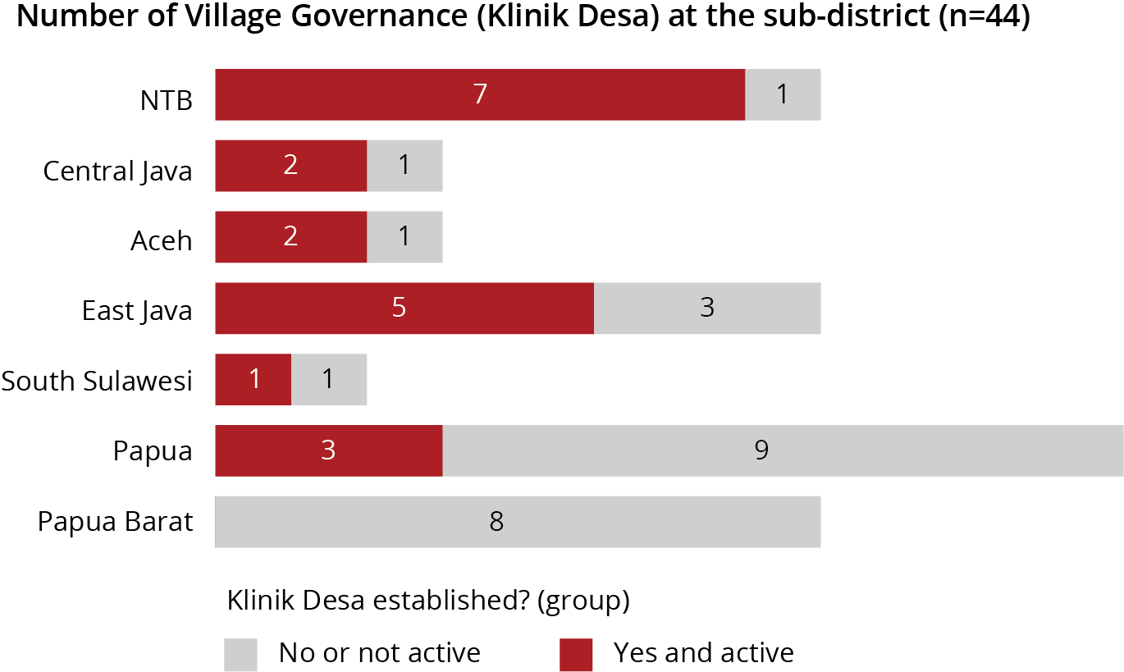

Most of the PTPD training was conducted in 2018, except in Central Java where KOMPAK trained 22 PTPD facilitators (6 women) from three districts. In most provinces, KOMPAK supported provincial and district

governments to institutionalise and replicate the works of PTPD. This was achieved through developing new district regulations in Central and East Java, strengthening sub-district village governance clinics across KOMPAK locations – which included developing standard operating procedures, decree letters and *kecamatan* dashboards.

The KOMPAK village survey found that PTPD facilitators have been providing regular and effective technical assistance. Almost all villages (97%) outside Papua and Papua Barat indicated that villages had received technical support from PTPD facilitators in the past six months. Technical support included facilitating development planning forums, specifically the *musrenbangdes*, or special *musrenbangdes* for women and people with disabilities. In Papua and Papua Barat, the PTPD model has not been as effective although those that did receive assistance gave the same average score of 4.3 out of 5 as those in other KOMPAK target locations.

**Percentage of villages receiving technical assistance from PTPD facilitators in past 6 months**

Yes

97%

Other KOMPAK

provinces

**Ave score (out of 5) from villages on helpfulness of**

No

Papua & Papua Barat

3%

**sub-district and PTPD facilitators**

4.3

Yes

No

79%

21%

The main services provided, as indicated by sub-districts, is support for planning and budgeting, followed by technical assistance on civil

registration services, and village law and regulations. The PTPD facilitators provided less support on village information systems or site visits to schools and health centres. Each sub-district had an average of five PTPD facilitators supporting village governments, ranging from 0 to 17.

**Type of services that PTPD facilitators provide to villages during outreach visits**

(Percentage of sub-districts)

Planning and budgeting Civil registration services Village law and regulations

30%

28%

40%

14%

35%

23%

23%

33%

14%

30%

30%

12%

37%

14%

9%

28%

Village information systems (SID)

Visit to health centres to check

42%

40%

9%

9%

performance

Visit to schools to check

7%

44%

42%

7%

performance

Frequency of services:

Never

Rarely

Sometimes

Routinely

**Each sub-district has 5.3 PTPD facilitators, on average, supporting village governments**

**Province**

**# of**

**sub-districts**

**# of PTPD**

**facilitators**

**Average PTPD facilitators per sub-district**

3

34

Central Java

Aceh

3

33

|  |  |  |  |  |  |
| --- | --- | --- | --- | --- | --- |
| South Sulawesi | 2 | 21 |  | | |
| East Java | 8 | 51 | Average = 5.3 |  |  |

0 2 4 6 8 10 12

|  |  |  |  |  |
| --- | --- | --- | --- | --- |
| NTB | 8 | 36 |  | |
| Papua  Papua Barat | 12  8 | 35  21 | |  |

Trainings for heads of sub-districts (*Camat*)

To complement the strengthening role of the sub-district, KOMPAK worked with the Ministry of Home Affairs to develop a training of trainers (ToT) on *Camat* (sub-district head) leadership, based on a model previously piloted by KOMPAK. The Ministry of Home Affairs has agreed to issue a circular institutionalising the *Camat* training package, and KOMPAK will continue to support its implementation.

Based on KOMPAK’s survey of sub-districts, 39% of *Camat’s* had received some training, but most had received no training in the past six months. Most of KOMPAK’s training for *Camat’s* had been undertaken in prior years, which will not be reflected in the below graph.

**Percentage of Heads of Sub-district (*Camat*) trained on village support and oversight**

Trainings provided

39%

No trainings provided

61%

Average number of days trained

1-4 days

5-9 days

10 days or more Never

#### ESTABLISH AND STRENGTHEN INTEGRATED VILLAGE AND SUB-DISTRICT INFORMATION SYSTEMS

KOMPAK provides technical assistance to expand coverage of village information systems – known as *sistem informasi desa* (SID) – and to increase use of the system for village planning and development, civil registration, monitoring of basic services, and other functions. There are 326 village information systems operational, based on the village survey (76% of KOMPAK-surveyed villages).

**BASED SYSTEM**

|  |  |  |  |  |
| --- | --- | --- | --- | --- |
|  | **MANUAL PAPER-** | **OFFLINE SID** | **ONLINE SID** | **GRAND TOTAL** |
| Aceh | 6 |  | 17 | **23** |
| Central Java | 4 | 13 | 16 | **33** |
| East Java | 14 | 22 | 53 | **89** |
| NTB | 7 | 51 | 44 | **102** |
| Papua | 47 | 26 | 9 | **82** |
| South Sulawesi | 10 | 4 | 3 | **17** |
| Papua Barat | 10 | 47 | 21 | **78** |
| **Grand Total** | **98** | **163** | **163** | **424** |

In KOMPAK locations, about 38% of villages have an online information system. The benefits of being online are that the system can link with other online systems to aggregate datasets, such as the *kecamatan* dashboard – an information system that pulls together data from all villages in a sub-district – and the civil registration database (known as SIAK). Being online will also assist with enabling better standardisation and updating of forms, formulas or reporting procedures. Having a standardised and connected village information system – that is updated regularly and integrated with other databases – will give all levels of government a stronger ability to understand how villages are performing and where assistance is needed.

**Villages with information system (SID)**

|  |  |  |  |
| --- | --- | --- | --- |
| Manual, paper-based system |  | 23% |  |
|  |  |  |
| Oﬄine SID |  |  | 38% |
|  |  |  |  |
| Online SID |  |  | 38% |

There remain challenges, however, in standardising and connecting all systems. There exist multiple versions of the SID, and almost one in four (23%) villages in KOMPAK-locations still rely on paper-based systems. In Papua and Papua Barat, KOMPAK has shown some success in establishing village information systems in challenging locations and getting strong buy-in from provincial and local governments. A key success in this region is the Provincial Government of Papua Barat’s support for further expansion of the village information system to all villages. KOMPAK has signed a Memorandum of Understanding with the Governor of Papua Barat for replication; however, funding has not yet been allocated.

The most common reported use for the online village information system by two in three (68%) villages was to support civil registration services, followed by reporting to the district and sub-district (60%) and for planning and budgeting (54%). Even with the online systems – which have higher usage for these activities than offline or paper-based systems – there remains considerable scope for greater use of the data available for managing village services.

**Uses of the online village information system**

(Percentage of villages, n=163)

|  |  |  |
| --- | --- | --- |
| 17% 14% 40%  25% 14% 37%  20% 25% 34% | | |
| 35% | 18% | 25% |

Support civil registration services

28%

Support reporting to the district/sub-district

23%

Support planning and budgeting

20%

village

Support veriﬁcation on poverty and

22%

special needs database (BDT)

Frequency of services:

Never

Rarely

Sometimes

Routinely

To expand coverage of village information systems and improve their utilisation, each KOMPAK Provincial Office provides support based on joint agreement with the district government. Some examples of activities to support SID improvements include:

* In Central Java, KOMPAK supported the government to develop technical guidelines on using and administering the SID as well as drafting a local regulation (*Perdes*) to support implementation.
* In Aceh, KOMPAK provided workshops for operators and advocated to the district government to allocate funding for SID in future budgets.
* In East Java, KOMPAK supported district governments to establish the integrated data system (SAID)

linked to poverty reduction programs managed directly by the District Planning Office (Bappeda).

* In NTB, KOMPAK is supporting the replication of OpenSID to all KOMPAK districts and improving

the system to interconnect with the civil registration (SIAK) and unified database on poverty (BDT).

#### STRENGTHEN COMMUNITY ENGAGEMENT AND SOCIAL ACCOUNTABILITY MECHANISMS

In Indonesia, public consultation at the district, sub-district and village levels is a compulsory part of the planning process through the ‘*musrenbang*’, an annual community forum that aims to reach an agreement on program priorities for local governments. About half of KOMPAK villages (54%) reported including women and people with disabilities in the annual *musrenbang*.

However, marginalised groups – including the poor, women and people with disabilities – are not contributing actively in many of these forums. To strengthen social accountability, KOMPAK is:

* Developing the confidence, skills and knowledge of female community members through the

Paradigta Academy to take a more active role in the community, particularly in leadership positions;

* Supporting villages to establish groups for marginalised groups – particularly women – so that they can collectively discuss and raise issues with their local governments;
* Using PTPD facilitators to promote community participation in villages. Participatory planning and monitoring approaches have been integrated into PTPD modules for village governance so that PTPD facilitators promote good practices for *musrenbang*, *musrena* (community forums for women) and other community forums; and
* Providing facilitation and training to community members – particularly those from marginalised groups – on village budgeting and planning so that they better understand the process and have the skills and knowledge to more effectively contribute to planning and budgeting discussions.



Happier, more

satisﬁed electorate

Take collective action to

advocate or ﬁnd solutions

Money not reaching communities

Improve monitoring and oversight of services

Share ﬁndings

Children not being vaccinated

Better target resources

Identify problems

Teachers not turning up for school

**CONTRIBUTE TO BETTER GOVERNMENT SPENDING AND SERVICES**

**MORE INFORMED AND ENGAGED CITIZENS**

**WHEN ISSUES ARISE**

**HOW SOCIAL ACCOUNTABILITY APPROACHES WORK**

#### STRENGTHEN WOMEN’S INVOLVEMENT IN VILLAGE GOVERNANCE

Women can face significant barriers that limit access to and participation in decision-making forums in local government and other community groups. This includes lacking the confidence, knowledge and skills to contribute, lacking the opportunity or willingness to be involved, and many cultural factors around the roles of men and women.

KOMPAK’s village survey found that 57% of villages had a woman in a senior village government position, but there was wide disparity between provinces. In NTB, a policy mandating female participation in village government appears to have been a key driver in achieving coverage of 91%, compared to Aceh with just 17% coverage. This is supported by reporting from the field which noted: “Some village still hold strong traditions where public affairs are men’s business, so women’s involvement is not important or mandatory. Aceh Barat is one of the regions that holds the tradition firmly.”

**Percentage of villages with at least one female in position of village apparatus head, secretary or treasurer**

|  |  |  |  |  |  |  |
| --- | --- | --- | --- | --- | --- | --- |
| NTB |  |  |  |  |  | 91% |
|  |  |  |  |  |  |  |
| Central Java |  |  |  |  | 79% |  |
|  |  |  |  |  |  |  |
| East Java |  |  |  | 67% |  |  |
| South Sulawesi |  |  | 59% |  |  |  |
| Papua Barat |  |  | 53% |  |  |  |
| Papua |  | 33% |  |  |  |  |

17%

Aceh

Average (all villages) = 57%

KOMPAK and its partner PEKKA are addressing these barriers by providing women opportunities to learn about village government and supporting them to take a more active role and working with local governments and communities to establish and integrate women’s groups in village decision-making.

**THE PARADIGTA ACADEMY: EMPOWERING WOMEN TO LEAD AND CONTRIBUTE TO VILLAGE DEVELOPMENT**

The Paradigta Academy training program provides a one-year course of study to prepare women from rural villages to engage more effectively with their local governments and communities. Women – usually female heads of households or members of women’s groups – are equipped with the knowledge, skills, confidence, and tools to be more active members in their village governments.

The Academy adopts a mentoring system where female instructors – mostly from villages – are trained to become facilitators and accompany participants in their learning processes. This helps to promote a sustainable education process capable of strengthening the capacity of the students as community organisers and local leaders. The Women-Headed Household Empowerment Program – known by its Bahasa acronym PEKKA – developed this initiative to strengthen female leaders at the grassroots-level.

Paradigta Academy The Paradigta Academy graduated 400 women in 2019, all funded by

village funds. This was achieved from previously trained Paradigta alumni – that were sponsored by KOMPAK – advocating to their local governments to pay for other women to join the program.

KOMPAK funding for the Paradigta Academy has been focused on establishing new operations in 11 KOMPAK-target districts, including setting up women’s groups to select future students and getting local government support. The majority of costs associated with Paradigta classes since July 2018 have been funded by village governments, demonstrating the potential sustainability of this model. However,

a new batch of Paradigta students are scheduled to be enrolled in September 2019 with these classes funded through KOMPAK.

Of the 2,478 alumni, 398 women have taken on higher roles of leadership as village government (apparatus), village council and village-owned enterprise officials and members. In 2019, Paradigta alumni also influenced the development of 11 local regulations (village regulations, Bupati regulations, Surat Keputusan, and MoUs) focused on pro-poor and gender-inclusive development. This includes village fund allocations to sponsor women to join Paradigta classes and regulations on women’s engagement in *Musrenbangdes.*

KOMPAK and PEKKA are working with the Ministry of Villages to develop strategies for scaling and handover. In April 2019, officials from the Ministry of Villages visited Paradigta Academy in West Kalimantan to see the results, and to support the development of a government-funded documentary on the academy.

KOMPAK is developing technical facilitation guidelines on women’s empowerment and social accountability at the village level. These draw on lessons learned from the programs and will provide a replicable model for the Ministry of Villages. The MoV has stated they are committed to replicating the Paradigta Academy program in 2020.

Women’s groups PEKKA has also been establishing women’s groups in villages

which are the basis for collective action and advocacy. PEKKA aims to establish women’s groups – known as *Serikat* PEKKA (literal translation is PEKKA Union) – in all KOMPAK-targeted locations.

In 2019, PEKKA established 24 women’s groups with 467 members in nine villages across six districts. These groups help to give women a collective voice in raising issues and holding their local governments accountable.

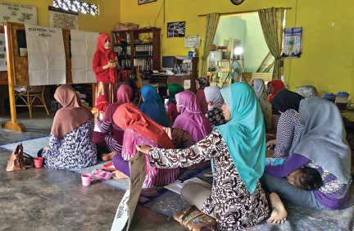

“I believe that women’s lives will only get better if we are not just involved, but lead and influence the decision-making process, especially on issues that affect our welfare”

Tika, a Paradigta Academy mentor and alumni of class 2016

#### STRENGTHEN VILLAGE PLANNING AND BUDGETING

KOMPAK provides assistance to improve village planning and budgeting through: 1) strengthening the capacity and resources of the sub-district to provide trainings and technical support to village governments; 2) advocating for the installation of Siskeudes, the village financial management system; and 3) improving community members – particularly women and people with disabilities – understanding of village planning and budgeting approaches and the mechanisms through which they can influence resource allocation and hold village governments accountable.

Village government and council members

KOMPAK provides training to village governance (PTPD) facilitators from sub-district governments, who then provide trainings or technical assistance to village governments on request.

KOMPAK’s village survey found about half (48%) of villages in KOMPAK areas reported that at least one member of the village government or council received one or more days training in the past six months on planning and budgeting.

**Percentage of villages with at least one person trained on planning and budgeting in last 6 months**

52%

|  |  |  |
| --- | --- | --- |
| No training |  | |
|  | |
|  | |
| At least one person trained |
|  |  |
|  | |

48%

The PTPD facilitators are the main mechanism used to train village government and council members, and 63% (27/43) of sub-districts reported their PTPD facilitators providing outreach visits to villages on budgeting and planning sometimes or routinely.

**Percentage of sub-districts (through PTPD facilitators) providing outreach visits to villages on planning and budgeting**

|  |  |  |  |
| --- | --- | --- | --- |
| Routinely 28% | Sometimes 35% | Rarely 14% | Never 23% |

Village financial management system (Siskeudes)

There is almost universal coverage of *Siskeudes*, the village financial management system, in KOMPAK locations outside Papua and Papua Barat.

In Papua and Papua Barat, there remains a major gap with about 43% (69/160) of villages not using *Siskeudes* in KOMPAK locations. Further work will be needed to bridge this gap.

**Percentage of villages using Siskeudes (village ﬁnancial management system)**

Papua & Papua Barat

No

43%

Yes

Other KOMPAK

provinces

57%

No

2%

98%

Yes

Community members and women’s groups

In partnership with Seknas FITRA, KOMPAK is piloting a model to promote transparency in village budgets in five provinces. The model combines trainings for community members on village budgets (*Sekolah Anggaran*) with the establishment of women’s groups and community feedback mechanisms (*Posko Aspirasi*).

From January to June 2019, 306 community members (40% women) from 18 villages were provided training on village budgets. The series of 8-day trainings cover village law, improving the performance of the village council (BPD), basic concepts of village planning and budgeting,

and analysing the rural development plan for gender responsiveness and inclusiveness.

**Number of community members trained on village planning and budgeting**

Aceh

86

Central Java

75

East Java

70

NTB

75

Female Male

A challenge has been to increase women’s involvement in budgeting discussions, particularly in more conservative regions such as Aceh Barat. Lessons learned have demonstrated the importance of including senior government officials in the development of the program. To achieve

this, Seknas FITRA arranged launch events in three provinces with senior district and village officials, the media and community members to promote the key messages of this pilot. These events were attended by about 150 people and resulted in over 25 news articles.

**What does an average village budget look like?**

Average village revenue and expenditure for one village (AUD)

General Government: 50,700

Public Works: 49,530

Housing & Sanitation: 6,760

Health: 4,160

Education: 3,120

Village Economy: 3,120

Agriculture: 2,080 Youth & Sports: 1,300 Community Empowerment: 1,170

Environment: 260

Other Expenditures: 130

Social & Culture: 7,540

|  |  |
| --- | --- |
| Block Grant from Central Govt (DD): 66,300 |  |
|  | **Village** |
|  | **Revenue and** |
|  | **Expenditure:** |
|  |
|  | **130,000** |
| Block Grant from District Govt (ADD): 48,490 |  |

Village Own Source Revenue: 7,540

Financial Assistance (from Central/Province/District): 4,550

Shared Tax & Levies from District Govt (BH-PHRD): 2,730 Other Revenues (incl. Grant/Third Party Contribution): 390

**KOMPAK**

**target areas to increase budget allocation**

Source: World Bank (20019)). Village Public Expenditure Analysis (ViPER) 2017

## Public Financial Management

KOMPAK’s technical assistance on public financial management has a two-fold objective. Firstly, it aims to improve how the national government allocates funding to sub-national governments. And secondly, KOMPAK supports local governments to increase their funding allocations and improve the quality of spending towards basic services. KOMPAK’s strength is in working at multiple levels of government and harnessing the lessons learned to improve national policies and funding mechanisms. This is demonstrated by initiatives to strengthen performance-based funding allocations where KOMPAK is working with government partners to both refine indicators and test the approaches at the district and village levels.

KOMPAK is also piloting new financial planning and budgeting tools to simplify and consolidate the process and strengthen the analytical tools available for planners and decision-makers. For the special autonomous regions, which have some of the greatest development needs, KOMPAK is providing support through both evaluations, implementation of the corresponding recommendations, and in providing joint technical support with the Australian-funded MAHKOTA program for the piloting of a new social protection program, the BANGGA Papua Universal Child Grants. The initiatives that KOMPAK is supporting have the potential to assist sub-national governments across Indonesia by making sure limited funds are spent most effectively where they are most needed.

Strengthen public ﬁnancial management at the district-level

Improve national fund allocation policies and mechanisms supporting sub-national basic service delivery

Strengthen the use of Special Autonomy Funds

Capacity building to districts for Special Allocation Fund (DAK) proposals through KRISNA

Evaluation of Regional Incentive Fund (DID) indicators

TA on use of Special Autonomy (Otsus) Funds in Aceh

e-Planning and Budgeting Application (Aceh)

Kecamatan and Village Performance Incentives Approach

TA on use of Special Autonomy (Otsus) Funds in Papua and Papua Barat

Technical assistance to districts on Regional Incentive Funds (DID)

Constraint analysis on district budget and sectoral perfomance

Support BANGGA Papua child cash grant transfer pilot

e-Course on public ﬁnancial management

SEPAKAT poverty analysis and planning tool

#### IMPROVE NATIONAL FUND ALLOCATION MECHANISMS SUPPORTING SUB- NATIONAL BASIC SERVICE DELIVERY

KOMPAK provides a range of technical assistance to multiple ministries to improve the way national funds are allocated to sub-national governments. The aim is to better target funding to provinces, districts and villages by linking performance and needs.

To achieve this, KOMPAK is developing ways to better link central and district funding with sub-national government performance, particularly on performance-based allocations to and from the Regional Incentive Fund (which districts receive). KOMPAK is also leading the development of new poverty analysis and targeting tools. The piloting of SEPAKAT – a poverty analysis and planning tool – and an analysis on district budget constraints is providing district and provincial governments with better information from which to inform planning and budgeting.

Regional Incentive Funds (DID)

At the national level, KOMPAK is supporting an evaluation of Regional Incentive Fund (DID) indicators and policy to make them better representative of district performance in improving basic services for the poor and vulnerable. DID funds are allocated as a reward to provincial and district governments that perform well on indicators related to fiscal and regional financial management, public and general government services, and social and community welfare.

Based on 2019 funding allocations through DID funds (see table below), 86% (18/21) of KOMPAK-supported districts and provinces outside Papua and Papua Barat received funding compared to the national average of 57% (336/594).

The funding through DID also continues to vary significantly between years. Between 2018 and 2019, six districts increased their allocations while nine districts received reductions in funding with the percentage change ranging from +418% to -100%. KOMPAK’s support to review indicators aims to make funding more consistent and better reflective of development progress and good governance.

**18 out of 21 districts and provinces supported by KOMPAK received 2019 Regional Incentive Funds (DID)**

District DID allocations



|  |  |  |  |  |  |  |  |
| --- | --- | --- | --- | --- | --- | --- | --- |
| **Province** | **District** |  | | | | | |
| ACEH | Kab. Bireuen |  | IDR 22.7M |  |  | 159% |  |
|  |  |  |  |  |  |  |  |
|  |  |  |  |  |  |  |  |
|  | Kab. Aceh Barat |  | IDR 12.1M | -66% |  |  |  |
|  |  |  |  |  |  |  |  |
|  | Kab. Bener Meriah |  | IDR 11.2M | -69% |  |  |  |
|  |  |  |  |  |  |  |  |
|  |  |  |  |  |  |  |  |
| CENTRAL JAVA | Kab. Pemalang |  | IDR 46.6M |  |  |  | 418% |
|  |  |  |  |  |  |  |  |
|  | Kab. Pekalongan |  | IDR 35.2M |  |  |  | 340% |
|  | Kab. Brebes |  | IDR 0.0M |  | 0% |  |  |
|  |  |  |  |  |  |  |  |
| EAST JAVA | Kab. Trenggalek |  | IDR 44.4M |  |  | 160% |  |
|  |  |  |  |  |  |  |  |
|  | Kab. Pacitan |  | IDR 35.8M | -3% |  |  |  |
|  |  |  |  |  |  |  |  |
|  | Kab. Bondowoso |  | IDR 35.8M | -63% |  |  |  |
|  |  |  |  |  |  |  |  |
|  |  |  |  |  |  |  |  |
|  | Kab. Lumajang |  | IDR 0.0M | -100% |  |  |  |
|  |  |  |  |  |  |  |  |
| NTB | Kab. Lombok Utara |  | IDR 29.8M | -17% |  |  |  |
|  | Kab. Sumbawa |  | IDR 23.4M | -16% |  |  |  |
|  |  |  |  |  |  |  |  |
|  | Kab. Bima |  | IDR 12.2M | -52% |  |  |  |
|  |  |  |  |  |  |  |  |
|  | Kab. Lombok Timur |  | IDR 9.5M | -74% |  |  |  |
|  |  |  |  |  |  |  |  |
| SOUTH SULAWESI | Kab. Pangkajene & Kep. |  | IDR 22.0M |  |  | 175% |  |
|  |  |  |  |  |  |  |  |
|  |  |  |  |  |  |  |  |
|  | Kab. Bantaeng |  | IDR 18.7M |  |  | 108% |  |
|  |  |  |  |  |  |  |  |
|  |  | 0M | 20M 40M 60M | 200% | 0% | 200% | 400% 600% |

**DID allocations for 2019 Percentage change (2018-2019)**

Provincial DID allocations

100%

50%

0%

80M

60M

40M

20M

0M

-5%

IDR 73.8M

0%

**Province**

86%

IDR 62.4M

CENTRAL JAVA

SOUTH SULAWESI

NTB

ACEH

EAST JAVA

81%

IDR 28.9M

33%

IDR 36.3M

IDR 0.0M

Note: Analysis only includes districts that KOMPAK has provided technical assistance to improve performance to be able to access DID fund allocations. This excludes districts in Papua and Papua Barat provinces.

Kecamatan and Village Performance Incentives Approach

Constraint analysis on district budget and sectoral performance

KOMPAK has been providing assistance to the Ministry of Finance – and in partnership with BAPPENAS, the Ministry of Home Affairs, and Ministry of Villages – in the development of a *kecamatan* and village performance incentive approach that is linked to the distribution of funds from the central government.

The first component of this initiative is to link Regional Incentive Funds (DID) at the district level to *kecamatan* and village indicators. This aims to better link the performance of the three levels of local government so that their priorities reinforce each other. KOMPAK has developed a basic framework for a Local Performance Incentive System and aims to pilot

the approach over a three year period, which will include developing and passing relevant national and local regulations.

The second component is the KOMPAK-led pilot on village performance incentives in five districts. Since early 2018, KOMPAK has been piloting the approach in 191 villages in Bima, creating a village incentive fund

* known as DINDA – from part of the district’s village fund allocation (ADD). Villages are being assessed on performance against 25 indicators
* developed in partnership with local governments – which cover village financial management (such as budgets submitted on time, in the correct format), basic service delivery (such as malnutrition rates, birth certificate coverage), and village economy (such as revenue from village-owned enterprises (BUMDES)). In Bantaeng, Lombok Timur, Sumbawa and Aceh Barat piloting with a different set of indicators is planned for early 2020 with preparations and regulatory approvals ongoing.

In June 2019, KOMPAK published the results of a study examining district budget and sectoral performance in Bener Meriah, Pemalang, Pacitan and Pangkep districts.

The study found that district governments generate about 12% of their own revenues, meaning they are highly dependent on central

government transfers. As a result, the authors recommended increasing district taxes (PAD) and optimising alternate funding sources – such as Regional Incentive Funds (DID) and Special Autonomy Funds (Otsus) –

to boost district revenues. However, the study also noted that budget increases did not always result in increased sectoral performance. Using the example of Bener Meriah, they found that while expenditure on civil registration doubled over the past five years, coverage of legal identity documents declined.

To better address this, there is scope for districts to improve the link between planning and implementation. District governments raised more revenue than planned, and underspent budgets, meaning available funds were not getting invested in the services that needed them. There were also inconsistent relationships between the programs and activities defined in the Regional Medium-Term Development Plan (RPJMD)

and outputs and outcomes reported. The report recommended that improvements were needed in developing synergies between planning, budgeting and monitoring and evaluation approaches.

SEPAKAT poverty analysis and planning tool

Since May 2019, KOMPAK and Bappenas have been undertaking a poverty analysis using data from the SEPAKAT analysis software for 15 high poverty-prevalence districts in East Java. Based on the analysis, Bappenas published a ‘State of Poverty in East Java’ policy brief which identified areas and drivers of poverty, gaps in services and government resources to address them, and provided recommendations on how to better target pro-poor programming.

As of June 2019, SEPAKAT was available for use in 10 KOMPAK-supported districts. Nationally, the system was available in nine provinces and 208 districts.

**Number of districts with SEPAKAT poverty analysis tool installed and available for use (n=25)**

Yes No

Not speciﬁed

10

11

4

**WHAT IS SEPAKAT?**

SEPAKAT is an integrated analysis system developed by Bappenas. The system integrates datasets from Susenas (the social economic survey), Sakernas (labour/employment survey), Sensus (national census), Podes (village survey), and the Unified Database for Social Protection Programs (BDT). SEPAKAT has several modules to help local governments (provinces and districts) with poverty analysis, poverty mapping, budget analysis, and the design and prioritisation of interventions.

A key priority for KOMPAK is for SEPAKAT to be used as a tool to assist regional medium-term planning across Indonesia and in integrating SEPAKAT with other information and e-planning and budgeting systems, such as using SEPAKAT as a required tool for developing provincial and district poverty alleviation strategies or to assist preparing DAK physical proposals from district governments before they are submitted via KRISNA.

#### STRENGTHEN PUBLIC FINANCIAL MANAGEMENT AT THE DISTRICT-LEVEL

KOMPAK is providing technical assistance to district governments to increase their revenues and more strategically allocate funding to improve civil registration, health and education services. A key area of assistance has been improving the quality of proposals to access Special Allocation Funds (DAK physical) and piloting an e-planning and budgeting application to consolidate planning and budgeting across provincial and district government agencies.

Capacity building to districts for Special Allocation Fund (DAK) proposals through KRISNA

e-Planning and Budgeting Application (Aceh)

Up to June 2019, KOMPAK facilitated workshops and trainings on public financial management in East and Central Java, NTB, Aceh and South Sulawesi (no support was provided in Papua and Papua Barat). The workshops, many co-funded, were held for 51 district governments (including 21 in KOMPAK locations) to improve the quality of DAK physical proposals submitted through KRISNA, a system that helps integrate work- planning and budgeting with the central government.

KOMPAK will be able to assess the quality of proposals based on the 2020 DAK physical allocation, planned for late 2019. Quality will be measured by the ratio of proposals approved compared with the number submitted, the total funding allocated for each district and whether this has increased, and the alignment of proposals with the minimum service standard objectives.

In Aceh, KOMPAK supported the development and launching of the

e-planning and budgeting application. This involved six workshops and advocacy events with more than 400 participants. The improved system integrates planning and budgeting for all provincial government offices in Aceh and initially in one district (Bener Meriah).

The new system improves the quality of the planning process by linking the outputs and activities from the provincial master plan into the government’s other planning and budgeting processes at the provincial and district levels. In 2020, the system will be expanded to 22 other districts in Aceh province. The approach also has potential applicability to other provinces and districts in Indonesia.

#### STRENGTHEN THE USE OF SPECIAL AUTONOMY FUNDS

KOMPAK provides technical assistance to the special autonomous regions in Aceh, Papua and Papua Barat to strengthen their use of Special Autonomy Funds (Otsus). These funds contribute to about 60% of provincial budgets and are provided by the central government to help close the gap in health, education and other development outcomes. In 2018, KOMPAK conducted reviews of Otsus Fund utilisation in Aceh and the Papua region and in 2019 has been working to implement the recommendations in partnership with the relevant provincial governments, Ministry of Home Affairs, Ministry of Finance and Bappenas. This is part of the ongoing discussion on the future of Otsus policy.

Implementation of recommendations from the 2018 evaluation of Otsus Funds in Aceh

Based on the recommendations from the report, KOMPAK provided technical assistance to support the Aceh Government to revise the Aceh Autonomy Master Plan for the next ten-year period (2018-2027). The report recommended a need to better integrate existing e-planning

by the Provincial Planning Agency (Bappeda) and e budgeting by the Provincial Financial Management Office (DPKA). This includes upgrading planning and budgeting with additional software modules, and creating better linkages between provincial and district government offices. The implementation of the e-planning and budgeting system in Aceh is an outcome of this process.

**ACEH PROVINCE: SPECIAL AUTONOMY FUND AND DEVELOPMENT PROGRESS**

Between 2008 and 2017, Aceh Province received about A$5.7 billion (IDR 57 trillion, ~A$570m per year) in Special Autonomy Funds from the central government, making up about 60% of its budget. The funds are being transferred over a 20-year period and are scheduled to finish in 2027.

Economic and community development in Aceh has made relatively slow progress over this period, despite the Aceh Provincial Government managing funds (per capita) far greater than the national average. The special autonomy funds have not resulted in significant improvements in the welfare of the population. Aceh’s economic growth averaged only

2.7 percent per year between 2012 and 2017, which was the second lowest rate in Sumatra, and Aceh’s poverty rate (16.0%) remains well above the national average (9.8%).

Rapid review of Otsus Funds in Papua and Papua Barat

The review has been completed, but the final report is awaiting approval from the Ministry of Finance. The review concluded that to overcome the main geographical challenges in both provinces, the government should focus on ways to improve basic services through outreach activities and meeting the minimum service standards, particularly for health and education.

The review noted that provincial governments will also need to reduce the high dependency of the basic service sectors on special autonomy funds. The fund allocations for basic service provisions needs to be prioritised from other sources aside from the special autonomy fund. This could include additional infrastructure funds, district/city and provincial APBD funds, APBN funds from ministries and agencies, special allocation funds (DAK), and village funds.

With the increasing type and amount of funding sources, each district and city government will need to work closely with the relevant provincial government to coordinate a regional approach.

**PAPUA AND PAPUA BARAT PROVINCES: SPECIAL AUTONOMY FUND AND DEVELOPMENT PROGRESS**

Between 2002 and 2017, Papua Province received about A$6.6 billion (IDR 66 trillion, ~A$390m per year) from special autonomy funds, while Papua Barat received around A$2.2 billion (IDR 22 trillion, ~A$240m per year) over a nine-year period (2009-2017).

With special autonomy funds, the Papua and Papua Barat Provinces have shown significant improvement. In general, special autonomy funds have played a role in accelerating the decline in poverty in Papua, from 42% in 2002 to 28% in 2018. While in Papua Barat, the poverty rate decreased from 36% to 23% in 2018. Although the special autonomy fund has demonstrated its contribution in reducing poverty, both provinces still have the highest poverty rates in Indonesia (Susenas, 2018).

BANGGA Papua Universal Child Grant Pilot

As of June 2019, there were 20,356 children (45% girls) registered under the BANGGA Papua program and 16,027 guardians receiving the cash grant (98.5% of recipients are mothers). Guardians receive an unconditional cash transfer of about IDR 3 million (A$300) per year for each child under the age of four (households receive less cash for each subsequent child).

The pilot and its operational cost is fully funded by the Papua Provincial Government while KOMPAK and MAHKOTA, another Australian-funded program, provided technical assistance on how to enact new provincial regulations, register and open bank accounts for all eligible families, and education on how to improve children’s nutrition status.

By June 2019, the program had leveraged more than IDR 50 billion (A$5m) in Otsus Funds. The program is being piloted in Asmat, Lanny Jaya and Paniai districts, which have some of the highest poverty rates in Indonesia, and is due to be scaled out to an additional two districts in 2020.

Civil Registration and Vital Statistics

Civil registration is the critical act of recording important events in people’s lives – such as births, marriages, divorces and deaths. It provides individuals with the official documentation necessary to establish legal identity, and in many cases is needed to access essential services, such as health, education and social protection.

Vital statistics generated from effective civil registration services enables the production of timely and accurate population estimates and other demographic and health statistics. These contribute to more effective planning, efficient resource allocation and accurate monitoring and evaluation.

KOMPAK provides considerable support to the national and sub-national governments to strengthen their CRVS services. In some locations, there has been considerable progress – seven districts increased birth certificate coverage more than 10% over the past three years. However, there remain major gaps in civil registration – 14 of KOMPAK’s 25 districts have coverage of birth certificates for children below 85% and an estimated 595,000 children in KOMPAK locations do not have a birth certificate, based on Susenas 2018 data.

The lessons learned from the most successful models – such as using village registration officers to actively find people without legal identity documents and help them to register – and the integration of these in national policies will contribute to the goal of universal legal identity document coverage.

Strengthen national CRVS policies, laws and regulations

Strengthen district CRVS policies, planning and information systems

Strengthen sub-district and village CRVS initiatives

TA on national guidelines for implementation of CRVS services under village authority

TA to Dukcapil (Civil Registration Oﬃce at District) on policies and planning

TA to sub-district and village governments to engage, train, and support village registration oﬃcers

TA on national guidelines for implementation of CRVS services in post-disaster situations

TA to sub-districts and villages on CRVS regulations

Research study on the eﬀectiveness of CRVS interventions by local governments

#### STRENGTHEN NATIONAL CRVS POLICIES, LAWS AND REGULATIONS

KOMPAK and its partner PUSKAPA are working at the national level to improve policy frameworks and standardise guidelines and trainings incorporating comprehensive civil registration services across Indonesia. This aims to capture the lessons learned from well-performing districts and villages, and package these approaches in a way that districts and villages can more easily implement. A strength of KOMPAK is its ability to utilise lessons from the field – such as the response to the earthquake in NTB or piloting of the village registration officer models – and integrate these into national policies, thereby having a significantly larger reach and impact.

National guidelines for implementation of CRVS services under village authority

National guidelines for implementation of CRVS services in post-disaster situations

Research study on the effectiveness of CRVS interventions by local governments

In collaboration with Bappenas, KOMPAK and PUSKAPA developed guidelines, manuals and a training of trainer package on the implementation of CRVS services under village law. In early 2019, KOMPAK tested the guidelines and trainings in Aceh and South Sulawesi, with the lessons learned incorporated into the documents. The guidelines and associated materials are expected to be finalised in late 2019.

Some of the challenges in developing and implementing these guidelines include institutionalising the outreach model with village registration officers and developing a better evidence base for the outreach models that are being piloted.

Indonesia is one of the most disaster-prone countries in the world, and yet it currently lacks effective guidelines on the provision of legal identity documents in post-disaster situations. Quick access to legal identity documents – such as birth certificates – makes it easier for people affected by disasters to access services and rebuild their lives.

Following the 2018 earthquake in Lombok, KOMPAK and PUSKAPA supported local governments to re-establish civil registration services. KOMPAK is currently leading a study of this response to document lessons learned and identify best practices that can be incorporated into national guidelines. The draft guidelines are expected to be submitted to the Bappenas in late 2019.

This study aims to assess CRVS-related changes between 2015 and 2019 and examine the contribution of KOMPAK-supported interventions. It will also explore linkages, opportunities and challenges related to health, education and social protection services and KOMPAK’s work in sub- district and village strengthening.

The design of the qualitative and quantitative study has been finalised, and data collection is planned for late 2019. A report will follow in early 2020.

#### STRENGTHEN PROVINCIAL AND DISTRICT CRVS POLICIES, PLANNING AND INFORMATION SYSTEMS

KOMPAK has supported 25 district governments to institute effective regulations, guidelines and processes, and set up outreach service models using village registration officers. KOMPAK is assessing coverage of legal identity documents using Susenas data from 2015 to 2018 for 0-17 year olds, which uses a sampling model to estimate coverage. Some discrepancies were found between district records and Susenas data, which will be further research as part of the CRVS study planned for late 2019.

Birth certificate coverage based on Susenas survey

The Susenas dataset showed that 11 of 25 KOMPAK districts achieved birth certificate coverage for 0-17 year olds greater than 85%. It also highlighted some very underperforming regions in Papua, with three districts having coverage less than 50%. When population is considered, there are an estimated 595,000 children in KOMPAK locations without birth certificates, and 60% of these live in only six districts.

Between 2015 and 2018, KOMPAK locations increased coverage by an average of 5.3 percentage points, compared with the national average of

3.6 percentage points. The best performing district was Lombok Timur, increasing coverage by 17.9 percentage points, while six districts declined in coverage.

The Susenas survey uses a 2018 dataset, and therefore interventions by KOMPAK in 2018 and 2019 will not be reflected in the coverage changes. During this period, KOMPAK provided substantial support to sub-national governments in institutionalising the village registration officer model and strengthening CRVS regulations and procedures – and it is expected these will lead to greater improvements in future years. KOMPAK has

not yet started providing technical assistance on CRVS services in Papua and Papua Barat, but these regions – notably Lanny Jaya, Asmat and Monokwari Selatan – have very low birth certificate coverage and will receive support in future years.

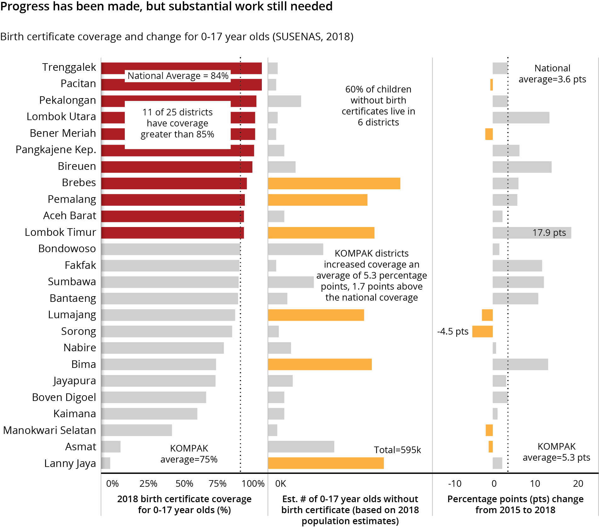

#### STRENGTHEN SUB-DISTRICT AND VILLAGE CRVS INITIATIVES

KOMPAK provided assistance to sub-district and village governments to improve legal identity services, particularly through assistance on CRVS regulations, establishing and training village registration officers, and incorporating systems to collect information on people with disabilities.

Village regulations By June 2019, 87 out of KOMPAK’s 424 villages (21%) had issued village regulations related to CRVS. This assists to institutionalise the village role in delivering civil registry services.

Establishing and training village registration officers

KOMPAK has also been supporting villages to assign dedicated officers to

oversee civil registry services. Two provinces – South Sulawesi and Aceh

* had village registration officers in all KOMPAK locations, while in Papua

and Papua Barat there were very few.

**Percentage of villages with a Village Registration Oﬃcer**

|  |  |  |  |  |  |  |
| --- | --- | --- | --- | --- | --- | --- |
| South Sulawesi |  |  |  |  |  | 100% |
|  |  |  |  |  |  |  |
| Aceh |  |  |  |  |  | 100% |
|  |  |  |  |  |  |  |
| Central Java |  |  |  |  | 69% |  |
|  |  |  |  |  |  |  |
| East Java |  |  |  | 49% |  |  |
|  |  |  |  |  |  |  |
| NTB |  |  | 37% |  |  |  |
| Papua Barat |  | 6% |  |  |  |  |

Papua 3%

Civil registration services for people with disabilities

Overall, about one in three villages in KOMPAK locations (144/424, 34%) had at least one designated village registration officer, including 10% (46/424) with a female officer. And three in four villages (313/424, 74%) indicated they had an officer – whether a village registration officer, government official or village cadre – assigned to civil registry services.

To complement these efforts, KOMPAK and PUSKAPA developed national guidelines and a training of trainers (ToT) package for local civil registration facilitators (refer to national CRVS section of report). This has been tested by KOMPAK in Aceh and South Sulawesi, with the training

of 43 facilitators who in turn have trained an additional 100 plus village

registration officers.

There remain gaps in the provision of CRVS services to people with disabilities. Only 19% of villages (82/424) reported that they assisted people with disabilities in the past six months. The best villages provided services to about 20 to 50 persons with disabilities over the past six months. There will need to be ongoing focus on better utilising village registration officers to conduct outreach service to people with disabilities and other marginalised groups.

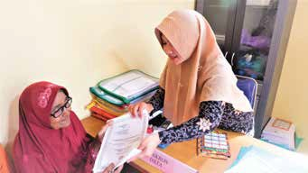

**BRINGING CIVIL REGISTRATION SERVICES CLOSER TO COMMUNITIES**

Legal identity documents are the key to accessing basic government services, such as education, health and social protection programs aimed at poverty alleviation.

KOMPAK – together with the Bireuen District Government in Aceh Province – have engaged and trained village registration officers to accelerate ownership of legal identity documents. These officers provide a door-to-door service, working with the local community identify vulnerable people without appropriate documentation and helping them to manage the process of obtaining birth certificates and other legal identify documents.

“I have not taken care of my documents and lost my ID. I’m older now, so am no longer able to go to the District Office of Population and Civil Registration. The village registration officer helped me to apply for a new ID card and navigate the complicated process. Within two weeks my ID card has been completed, “explained Kasmiati, a 62 year-old resident of Blang Kuta Dua Meunasah.

The use of village registration officers has been a catalyst in increasing the coverage of birth certificates

for children aged 0-17 years in Bireuen district from 77 percent in 2015 to 91 percent in 2018.

## Education

KOMPAK’s support for education focuses on supporting local governments to better fund and manage education services, particularly through initiatives to address out-of-school children and early childhood education and development (ECED).

Strengthen early childhood education and development (ECED)

Support initiatives to reach out out-of-school children

TA on indicators for the National Action Plan for ECED

Input to National Strategy for out-of-school children

TA to district governments on ECED Task Forces and Action Plans

Support for the replication of the ‘boat class’ approach in South Sulawesi

Support for ‘go-back-to-school’ initiatives in Central Java

#### STRENGTHEN EARLY CHILDHOOD EDUCATION AND DEVELOPMENT

Inputs on indicators for the National Action

Plan for Early Childhood Education and Development (ECED)

At the national level, KOMPAK has been supporting Bappenas to conduct a background study on potential indicators for the National Action Plan for ECED. ECED has been identified as one of the National Program Priorities for the new national medium-term development strategy (RPJMN 2020-2024).

In partnership with the National ECED Coalition, KOMPAK developed a monitoring framework that includes indicators on education, health and nutrition, and child protection, care and welfare. KOMPAK is supporting Bappenas to get agreement among government ministries and civil society groups on the proposed framework. The next step will involve working with district governments to develop tools for collecting and monitoring the indicators.

Support to district governments on ECED initiatives

KOMPAK is assisting district governments in Central Java and NTB to establish ECED Joint Task Forces to oversee implementation of the ECED activities in their respective districts. This includes preparing or revising district regulations (Perbup) and decrees (SK) to formally

establish the task force, technical assistance to develop a multi-sector ECED District Action Plan, and training to develop the capacity of Joint Task Force members to operationalise, implement, and monitor the ECED Action Plan. The ECED approach advocated by KOMPAK combines both educational elements with civil registration (specifically for birth certificates) and health services, such as immunisation. KOMPAK also advocates to use village funds to provide education kits (including books, games and other materials), renovate ECED centres, and provide incentives for community volunteer teachers.

In Central Java, KOMPAK assisted in the development of Regional Action Plans for ECED in Pemalang and Brebes districts. These are expected to be finalised by the end of 2019.

In NTB, the Provincial Government has expressed a strong interest in expanding ECED services, with initial progress starting in Sumbawa district where KOMPAK supported the development of district regulations and an official launch of the district’s ECED program.

#### SUPPORT INITIATIVES TO REACH OUT-OF-SCHOOL CHILDREN

Inputs to the National Strategy for Addressing Out-of-School Children

Support for the replication of the ‘boat class’ approach in South Sulawesi

KOMPAK is documenting lessons learned from local government pilots on out-of-school children in South Sulawesi and Central Java (see below). These are aimed as inputs to Bappenas in the development of the National Strategy for Addressing Out-of-School Children.

In South Sulawesi, KOMPAK has supported the Pangkep District Government to expand the ‘boat class’ (*Kelas Perahu*) initiative. This has been achieved through development of implementation guidelines, a handbook on replication of the classes, and workshops for implementers. KOMPAK has started engaging with the Ministry of Education to use lessons from this pilot for potential broader replication in Indonesia.

The ‘boat class’ initiative enables children to continue their education while at sea. Students are provided with worksheets as learning materials while going to sea and get support from teachers when back on land. The boat classes are being implemented in 19 elementary schools and seven junior high schools, and the district government estimated that it has reduced drop-outs to 2-3% of students (KOMPAK is not yet able to verify education outcomes).

The ‘boat class’ initiative was acknowledged by the Ministry of Bureaucratic Reform and State Apparatus’s SINOVIK awards program as one of the top 20 public service innovations in Indonesia. The district

government has confirmed plans to roll out the approach to an additional

four sub-districts.

Support for ‘go-back- to-school’ initiative in Central Java

In Central Java, KOMPAK provided technical assistance in the development of a ‘go back to school’ initiative in Pekalongan and Brebes districts. KOMPAK supported the district governments to undertake data collection – using household surveys – to identify out-of-school children for follow up. This was complemented with advocacy by KOMPAK on

a district regulation (*Perbup*) in Pekalongan to mandate 12-years of schooling for all children.

##### LANDASAN HEALTH AND EDUCATION PROGRAM

LANDASAN is an approximately A$2.5 million per annum program implemented by BaKTI, a KOMPAK partner, designed to address gaps in the capacity of service units (health centres and schools) and village governments to help improve access to and quality of frontline services in the Papua and Papua Barat provinces. Nine districts are prioritised for assistance, and within these districts a further 20 sub-districts covering 171 villages are supported. The tenth district, Waropen, was not supported in 2019 due to lack of political support with future activities to be determined at the next KOMPAK Steering Committee meeting.

The focus for LANDASAN in 2019 is to further expand and institutionalise village information systems

– particularly in finalising capacity building packages (training materials, manuals, standard operation procedures and the like) – and supporting local governments and service units in planning, budgeting and the implementation of the minimum service standards (MSS) for health and education.

**Village and sub-district information systems**

The pilot on village and sub-district information systems – known as SAIK and SAID in the Papua region – has been getting more buy-in from government stakeholders. In Papua Barat, the provincial government has allocated IDR 127 billion (A$127 million) to implement the system in all 1,742 villages. KOMPAK is also advocating to provincial and district governments in Papua to fund the initiative.

SAIK is piloted in 205 villages in Papua and Papua Barat Provinces, according to BaKTI. SAIK and SAID have dedicated officers/cadres who manage these information systems. The operators are trained by BaKTI and they work with village government to support planning and decision-making. To date, there are 425 SAIK cadres (112 are female) in Papua and Papua Barat.

**Integration of MSS into local government and service unit planning**

As a result of KOMPAK and BaKTI’s technical assistance, five out of ten KOMPAK districts in the Papua Region have integrated the MSS into their medium-term development plans (RPJMD), annual workplans, and allocated funding specifically for MSS achievement (refer to MSS section of this report). A further nine out of 24 KOMPAK sub-districts have been supported to conduct visits to health centres and schools. The KOMPAK sub-district survey found that three out of the 24 sub- districts reported conducting site visits ‘routinely’ or ‘sometimes’.

KOMPAK and BaKTI also supported service units. Of the 217 primary schools supported, 67 have developed profiles based on the MSS and corresponding workplans and standard operating procedures (SOPs) to improve performance in this area. These schools have also formed committees to oversee progress towards the MSS. In addition, 31 *Puskesmas*/health centres were supported to strengthen their work-planning and SOPs to achieve the MSS. This has led to improvements in overall management, patient safety and community participation in the planning and monitoring process.

KOMPAK also provided support to the Papua Barat Health Office to draft the Provincial Regulation overseeing the health system (*Raperdasi*). The regulation provides guidance on implementation across the seven pillars of the health system: service delivery; drugs and medical supplies; human resources for health; health information systems; community participation; healthcare financing, and, leadership and governance. The regulation is expected to come into law in October 2019.

## Health

#### DEVELOP AND TEST HEALTH INNOVATIONS AND STRENGTHEN DISTRICT HEALTH AND NUTRITION POLICIES

KOMPAK provides assistance to pilot innovative ways to deliver health services more efficiently and effectively and to strengthen health and nutrition policies, regulations and systems for district governments. The main areas of assistance were in conducting a study to assess the feasibility of using drones for remote area medical supply distribution, the piloting of a mobile application to support midwives provide services to pregnant women, and technical assistance to districts to help implement the National Strategy to Accelerate Stunting Prevention.

Develop and test innovative health initiatives

Strengthen district health and nutrition policies

Conduct feasibility study on drones for drugs and medical supplies

TA to districts to support implementation of the National Strategy to Accelerate Stunting Prevention

Mobile application for midwives (PWS+)

Feasibility study on use of drones for drugs and medical supplies distribution

In early 2019, KOMPAK completed a feasibility study which explored the potential use of drones to deliver drugs and medical supplies to island communities and other remote areas in South Sulawesi.

This involved a literature review and interviews with stakeholders. The study concluded that the use of drones could be an effective mechanism in reducing the gap in access and quality of health services for remote islands and difficult to reach areas, particularly for vaccines, blood products and other difficult-to-transport and/or time-sensitive drugs and medical supplies.

While the literature review showed that sending essential medical commodities using drones can be more effective and efficient than transporting by land, a more in-depth cost-benefit analysis should be undertaken to get a better understanding of the longer-term feasibility of using drones to support medical supply distribution.

Bappenas is using the report to inform discussions with the Ministry of Health and other relevant aviation and maritime agencies on whether to proceed or not.

Mobile application and dashboard to support health services for pregnant women

District regulations for stunting prevention

In Bener Meriah District, Aceh, KOMPAK has been piloting a mobile application (PWS+) and dashboard to assist midwives and health centres to better manage health services for pregnant women. There are plans to expand to other provinces – with initial results expected in late 2019.

In 2018, the Government of Indonesia released its National Strategy to Accelerate Stunting Prevention. This commits 22 ministries and an

estimated US$14.6 billion to converge priority nutrition interventions. The strategy targets 160 districts and cities with high stunting rates in 2019 and will be scaled up to all 514 districts and cities by 2021.

To support this government priority, KOMPAK is providing assistance to district governments in the development of action plans to address stunting. In 2019, KOMPAK assisted Bima and Lombok districts in NTB,

Pangkep in South Sulawesi and the Provincial Government of Aceh to develop integrated stunting prevention plans through technical

assistance and workshops. This support is complemented by KOMPAK’s assistance on early childhood education and development and increasing birth certificate coverage for young children, which were both identified as priorities in the National Strategy.

## Local Economic Development

Enhancing the livelihoods of poor and near-poor households is critical to Indonesia’s poverty reduction efforts. As a first step, the government is expanding the reach of social protection and basic services to reduce vulnerabilities among the poor and protect them from shocks. Meanwhile, they aim to promote sustainable livelihoods to increase incomes and pull poor households out of poverty.

In rural Indonesia, most of the poor and near-poor are self-employed in either agriculture or micro and small enterprises (MSEs), or both. However, generally MSEs fail to grow and generate sufficient income. Therefore, improving the productivity of MSEs is critical to improving the livelihoods of the poor – a core area of KOMPAK’s work to supporting local economic development.

Since 2017, KOMPAK has been partnering with local governments, start-ups and local producers – in this case, MSEs – to pilot an approach to enhance their ability to market and sell their products and services. This ‘market linkages’ approach assists MSEs to assess market opportunities and then design viable business options to respond.

KOMPAK is also working with Bappenas to integrate the lessons learned from these pilots to strengthen the local economic development components of the next national medium-term development plan (RPJMN 2020-2024). To support the national roll out of this policy, KOMPAK has developed a mobile application and website to connect local business groups with buyers, and has also drafted national market linkage guidelines to assist the government replicate the approach in new areas.

**DEFINITION OF MSE**

Micro and small enterprises (MSEs) are productive entities owned by an individual or individual business unit, with assets of less than IDR 500m (A$50,000) and an annual turnover of less than IDR 2.5b (A$250,000). KOMPAK’s work is mostly focused on micro enterprises which have assets of less than IDR 50m (A$5,000) and an annual turnover of less than IDR 300m (A$30,000).

#### PILOT MARKET LINKAGE MODELS TO STRENGTHEN SUSTAINABLE LIVELIHOODS

KOMPAK is piloting the market linkages approach in seven districts: Trenggalek and Pacitan (East Java), Bantaeng (South Sulawesi), Aceh Barat (Aceh), Lombok Utara (NTB), and Pemalang and Pekalongan (Central Java). In 2019, KOMPAK set up 12 new business groups in five of these districts (Pacitan and Lombok Utara were established in 2017/18). While accurate numbers of total membership are not yet available, an example of a business group is a coffee cooperative in Bantaeng with about 2,000 members. These business groups, based in villages, are helping to ‘link’ local goods with market actors (intermediate and ultimate buyers).

KOMPAK has been assisting in facilitating connections between the business groups and local businesses

– including start-ups – to support business group members (beneficiaries) to process, package, market and sell the goods. By pooling resources, village members can sell larger quantities at a higher level on the value chain to intermediary and ultimate buyers.

KOMPAK is developing an online platform for local producers and buyers, including a mobile application which is planned for testing in October 2019, to link these groups and to better capture data and assess its reach, cost-benefit and impact. The lessons learned will be used to inform the next medium-term development plan. In addition, an evaluation of the income and productivity benefits for business group members is planned for late 2019. This will help to better quantify the cost benefits of the market linkages approach. As of June 2019, there are case study examples of significant income and productivity improvements, but no data available for the approach overall.

KOMPAK’s role is to connect the producer to a market actor, as well as assist local governments in designing viable business options for the producer and establishing other enabling environments



PRODUCT

Coﬀee

Coconut husks

Seaweed

Water hyachinth



PROCESSING

Coﬀee

beans

Coco bristle, coco ﬁber, cocopeat

Incorporated into beauty and food products

Handicrafts



MARKET ACTORS

Negeri Kebun Kopi

Ultimate buyer

Nusa Berdaya

Intermediary buyer

Ultimate buyer for beauty products, Intermediary buyer for food products

Intermediary buyer



FINAL PRODUCT

Market actors are responsible for providing technical assistance in the production and access to markets

## Research and Evaluations

For KOMPAK’s next phase, there is an increasing need to capture results to provide evidence to demonstrate the effectiveness of models piloted and technical assistance provided. This will provide KOMPAK and partners with evidence to inform development planning and sustainability, advocate for scaling and replication, and to assist in the development of documentation for handover of programs to government partners. The following is a list of major research and evaluation studies – in addition to ongoing technical assistance and analytical support being provided by KOMPAK teams.

##### LIST OF MAJOR RESEARCH AND EVALUATION STUDIES

**CRVS Study**

Aug-Dec 2019

##### Village Budget Analysis

Jul-Oct 2019

##### Local Economic Development (LED) Approach Evaluation

Sep-Dec 2019

**Objectives**: (i) to assess CRVS-related changes between 2015 and 2019 and whether these changes were aligned with the desired outcomes; (ii) to examine the contribution, if any, of KOMPAK-supported intervention or activities to those changes; (iii) to investigate the state of and linkages between health, education, and social protection aspects and CRVS; and

(iv) to explore the opportunities and challenges related to health and education services strengthening as well as village strengthening, budget transparency, and social accountability in supporting CRVS.

**Main method**: Quantitative, with additional qualitative modules to understand the process and roles of KOMPAK/partners

**Coverage**: 5 provinces, 10 districts

**Objectives**: (i) to analyse village expenditure in KOMPAK-targeted locations where there is increased budget allocation towards basic services (education and health); and (ii) to explore factors that influence and incentivise shifts in spending at the village level.

**Main method**: quantitative, analysis of village budget and related district regulations

**Coverage**: All KOMPAK villages

**Objectives**: (i) to analyse the business model of KOMPAK’s LED approach;

(ii) to provide path to scale up; and to (iii) measure potential impact beyond the monetary measure.

**Main method**: Mixed-methods approach, SLA and more to capture social impact indicators

**Coverage**: Bantaeng, Trenggalek, Pemalang, Pekalongan

##### Village Governance (PTPD) Facilitator Model Review

Sep-Dec 2019

##### BANGGA Papua Process Evaluation

Jan-Dec 2019

##### Health Services in Remote Island Areas (Drone Study)

Mar-Jul 2019

##### Paradigta Academy Women’s Leadership Training (PEKKA) Analysis

Jul-Nov 219

**Objectives**: (i) to document PTPD-related process and results; (ii) to understand what a functional PTPD looks like and key factors/elements to support functionality; and (iii) provide lessons-learned to help replication/ scaling

**Main method**: Qualitative (in-depth interview), analysis of project’s data

**Coverage**: All districts for documentation, selected districts (two or three) for in-depth analysis.

**Objectives**: to assess three domains of program implementation

(i) the enabling environment (policies, regulations, governance arrangements, institutional buy-in, staff capacity and knowledge); (ii) Key business processes (registration, enrolment, payments, grievances, communications and management information systems); and (iii) The quality of implementation, as well as the intended and unintended consequences of the program experienced the community level

**Main method**: Qualitative, analysis of project’s data, interview

**Coverage**: Three districts in Papua

**Objectives**: identify important factors and challenges related to drone utilisation for the vaccines, blood and essential drugs delivery in South Sulawesi Province.

**Main method**: Feasibility Study, Quantitative (Cost and Benefit Analysis)

**Coverage**: South-Sulawesi

**Objectives**: (i) to gather and analyse best practices from the PEKKA’s Paradigta Academy implementation; (ii) to identify opportunities to accelerate the implementation of the Paradigta Academy in KOMPAK locations (Aceh, Central Java, East Java, NTB); (iii) to provide input for the Ministry of Village.

**Main method**: Quantitative and qualitative through survey and FGD/in- depth interviews.

**Coverage**: Brebes (Central Java) and Lombok (NTB)

Gender Equality and Social Inclusion

KOMPAK’s Gender Equality and Social Inclusion (GESI) Strategy 2018-2022 outlines the changes KOMPAK is seeking for poor women, persons with disabilities, and disadvantaged and marginalised groups. The strategy has two components: mainstreaming gender in all activities, and gender-focused activities.

The best performing districts on GESI, based on selected indicators from the village and sub-district surveys, were in Bantaeng (South Sulawesi) and Trenggalek (East Java). However, most districts had significant areas where they can focus on improving, such as increasing the number of female village council members or institutionalising more inclusive village development planning forums (*Musrenbang* and *Musrena*). The *Musrenbang* is a process during which residents meet together to discuss issues facing their communities and decide upon priorities. The *Musrena* is held before the Musrenbang and is for women in the community to agree on priorities and to enable them to share these collectively during the formal *Musrenbang* process.

##### Performance on selected gender and social inclusion indicators for KOMPAK districts

|  |  |  |  |  |  |
| --- | --- | --- | --- | --- | --- |
| **District** | **Province** | **% villages and sub-districts with female in leadership role** | **% village gov. and council officials that are female** | **% villages with inclusive Musrenbang and Musrena** | **Ranked performance on averaged GESI indicators** |
| Bantaeng Bireuen  Trenggalek | South Sulawesi Aceh  East Java |  |  |  | |
|  |  |  |  |
|  |  |  |  |
| East Lombok Pangkajene Islands  Kaimana | NTB  South Sulawesi Papua Barat |  |  |  |  |
|  |  |  |  |
|  |  |  |  |
| Pacitan | East Java |  |  |  |  |
| Sumbawa | NTB |  |  |  |  |
| Sorong | Papua Barat |  |  |  | |
| Nabire | Papua |  |  |  |  |
| Lumajang | East Java |  |  |  |  |
| Jayapura | Papua |  |  |  |  |
| Fakfak | Papua Barat |  |  |  |  |
| Pemalang | Central Java |  |  |  |  |
| Bima | NTB |  |  |  |  |
| Brebes | Central Java |  |  |  |  |
| Aceh Barat | Aceh |  |  |  |  |
| Bondowoso | East Java |  |  |  |  |
| Pekalongan | Central Java |  |  |  |  |
| North Lombok | NTB |  |  | | |
| Bener Meriah | Aceh |  | |  |  |
| South Manokwari | Papua Barat |  | | | |
| Lanny Jaya | Papua |  |  |  | |
| Digoel  Asmat | Papua  Papua |  | No data |  | No data |
|  | No data |  | No data |

Best performing district

(Max rank 1)

Note: Dataset available on page 62 and based on KOMPAK-surveyed locations. In Aceh, only 21 villages were surveyed in KOMPAK locations. The district-wide performance

may differ significantly from this data as KOMPAK is only active in selected sub-districts within each district.

KOMPAK is working to improve GESI outcomes by developing and supporting women leadership, developing women’s groups and ‘coalitions for change’, strengthening affirmative action for women and people with disabilities in village planning forums, developing gender and disability responsive village budgets, and establishing civil registration services that reach marginalised groups.

Building local women leadership

Local women’s coalitions for change

Affirmative action for women and persons with disabilities in local planning

KOMPAK’s survey of village and sub-district governments showed that in many districts there is relatively good representation of women in leadership roles, with 62% of villages reporting they had a female in the

position of head, treasurer or secretary. Some areas – such as NTB – had very high rates due to regulations mandating female appointments while other areas – such as Aceh – had few villages with a senior village female appointee.

Village governments and village councils are overwhelmingly male- dominated, with about 14% female representation on average. Just one district – Pangkep – had 50% or more female village government officials, but even this district had low representation of women in village councils (11%). Sub-districts had better female representation overall, making up about one in four officials.

Ongoing efforts are needed to continue to give women the confidence, skills and knowledge to take on these positions, as well as advocacy for local governments to engage more women and, if needed, develop affirmative action regulations.

In KOMPAK locations, women’s representation in village councils remains low. Just 16% of village council members are women, and even in areas with higher representation of women in leadership roles – such as NTB – this did not appear to translate into higher female membership of village councils.

Overall, 62% of villages reported involving women and people with disabilities in the *Musrenbang* forums. While only 19% indicated specific *Musrena* forums were active in the past six months.

KOMPAK is promoting multiple initiatives to strengthen social accountability. A key priority is improving the inclusiveness of the *Musrenbang*, the annual village planning and development forum. In three districts – Pacitan, North Lombok and Trenggalek – KOMPAK is piloting approaches to integrate specific female planning and development forums – known as *Musrena* – before the *Musrenbang* process to collate ideas and better inform the *Musrenbang* process.

In Trenggalek, East Java, KOMPAK has had notable success through the initiation of *Sepeda Keren*, a program involving women and people with disabilities that provides trainings to these vulnerable groups

on identifying issues and solutions, organises discussion forums and involves district and other local government officials. This initiative may have contributed to Trenggalek being ranked the best performing

KOMPAK district for inclusive *Musrena* and *Musrenbang* forums, based on village and sub-district surveys.

Gender and Disabilities Budget Statements

CRVS for Women and Persons with Disabilities

KOMPAK has not undertaken an analysis of village budgets to assess gender and disability responsiveness. In late 2019, KOMPAK plans to conduct a village budget analysis which will examine funding allocations for initiatives supporting these cross-cutting issues.

Village registration officers have been engaged in villages to provide outreach services, particularly for the most vulnerable. From January to June 2019, 19% of villages reported providing civil registration

services to 568 people with disabilities. This leaves substantial room for improvement, as many of these villages also reported assisting less than five people with disabilities over this period.

There does not appear to be a major gender gap in the issuance of birth certificates. In the past six months, 49% of birth certificates were issued to women. Birth certificate coverage for women was not available.



*Development Impact*

##### GENDER AND SOCIAL INCLUSION PERFORMANCE IN KOMPAK-SURVEYED LOCATIONS

62

KOMPAK Six-Monthly Report

|  |  |  |  |  |  |  |  |  |  |  |
| --- | --- | --- | --- | --- | --- | --- | --- | --- | --- | --- |
| **District** | **Province** | **% female sub-district gov officials** | **% female village council members** | **% female village gov officials** | **% sub-districts with female leadership appointee** | **% villages with female leadership appointee** | **% female PTPD facilitators** | **% villages held Musrenbang with women and PWDs** | **% villages held women’s planning forum (Musrena)** | **Ranked performance on averaged GESI indicators** |
| Bantaeng | South Sulawesi | 46% | 26% | 37% | 100% | 50% | 25% | 80% | 70% | 1 |
| Bireuen | Aceh | 75% | 3% | 5% | 100% | 50% | 27% | 83% | 50% | 2 |
| Trenggalek | East Java | 22% | 11% | 7% | 100% | 70% | 11% | 70% | 80% | 3 |
| East Lombok | NTB | 31% | 7% | 16% | 100% | 85% | 38% | 63% | 23% | 4 |
| Pangkajene Islands | South Sulawesi | 56% | 11% | 52% | 0% | 71% | 54% | 100% | 0% | 5 |
| Kaimana | Papua Barat | 42% | 25% | 9% | 100% | 57% | 50% | 29% | 29% | 6 |
| Pacitan | East Java | 24% | 9% | 9% | 100% | 74% | 25% | 89% | 4% | 7 |
| Sumbawa | NTB | 30% | 15% | 26% | 0% | 100% | 50% | 85% | 10% | 8 |
| Sorong | Papua Barat | 32% | 10% | 18% | 50% | 83% | 20% | 96% | 0% | 9 |
| Nabire | Papua | 27% | 36% | 26% | 100% | 44% | 35% | 6% | 25% | 10 |
| Lumajang | East Java | 25% | 22% | 14% | 50% | 79% | 40% | 43% | 21% | 11 |
| Jayapura | Papua | 37% | 14% | 10% | 33% | 58% | 36% | 84% | 11% | 12 |
| Fakfak | Papua Barat | 31% | 13% | 15% | 50% | 57% | 0% | 93% | 21% | 13 |
| Pemalang | Central Java | 18% | 27% | 18% | 0% | 100% | 24% | 92% | 0% | 14 |
| Bima | NTB | 22% | 11% | 12% | 50% | 93% | 0% | 69% | 10% | 15 |
| Brebes | Central Java | 24% | 18% | 11% | 0% | 67% | 17% | 100% | 0% | 16 |
| Aceh Barat | Aceh | 26% | 17% | 0% | 0% | 0% | 33% | 75% | 63% | 17 |
| Bondowoso | East Java | 11% | 10% | 6% | 50% | 54% | 0% | 64% | 18% | 18 |
| Pekalongan | Central Java | 16% | 19% | 8% | 0% | 67% | 9% | 89% | 0% | 19 |
| North Lombok | NTB | 13% | 2% | 25% | 0% | 92% | 0% | 38% | 0% | 20 |
| Bener Meriah | Aceh | 13% | 4% | 1% | 0% | 11% | 0% | 89% | 33% | 21 |
| South Manokwari | Papua Barat | 19% | 6% | 6% | 33% | 29% | 0% | 3% | 0% | 22 |
| Lanny Jaya | Papua | 25% | 11% | 11% | 0% | 7% | 0% | 0% | 0% | 23 |
| Digoel | Papua | 18% | 12% | 12% | 50% | 67% |  | 0% | 0% |  |
| Asmat | Papua | 26% | 1% | 1% | 50% | 9% |  | 0% | 0% |  |
| GRAND TOTAL |  | 28% | 16% | 14% | 45% | 59% | 21% | 62% | 19% | 1 |

January-June 2019 63



# FINANCIAL REPORT

*FINANCIAL REPORT*

## Financial Report

As of June 2019, KOMPAK had disbursed A$101.8 million over the life of the facility. Future budgets are allocated annually.

KOMPAK’s Financial year (FY) 2018/2019 budget allocation was initially A$25 million; however, this was revised to A$24 million earlier in 2019. KOMPAK disbursed A$11.1 million during the July to December 2018 period and a further A$12.9 million during the current reporting period (January – June 2019). This resulted in the FY expenditure amounting to A$24.0 million. This is the fourth FY year in a row that KOMPAK actuals have been within less than 1% of its FY budget allocation.

#### PROGRAM IMPLEMENTATION COSTS (ACTIVITY, PERSONNEL AND OPERATIONS)

KOMPAK’s total expenditure for activity, personnel and operations during FY 2018/19 amounted for A$20.5 million of which 50% being directed towards activity costs, 39% towards personnel costs and the remaining 11% for operational costs. Funding at the sub-national offices is about half of KOMPAK’s expenditures, with the program becoming more decentralised since the end of 2016.

**Percentage costs by type (FY 2018/2019)**

(total = A$20.5M)

Activity Costs

$10.3M 50%

Total Expenditure

**$20,475,287**

Personnel Costs

$8.0M 39%

Operation Costs

$2.2M 11%

Percentage of national and subnational expenditure (Jan 2015 to Jun 2019)

80%

% of 6 monthly expenditure

60%

40%

20%

KOMPAK began with operations mostly at the national level

But over time, programming at the subnational level has increased to about 50% of expenditure

National

Sub-national

0%

2015 Q4

2016 Q2 2016 Q4 2017 Q2 2017 Q4 2018 Q2

2018 Q4

64

KOMPAK Six-Monthly Report

*Financial Report*

While national expenditure is a bit higher than the sub-national expenditure, this reflects some of the cross-cutting support (Executive team, Performance team, and some parts of the Operations team) allocated to national cost but providing benefits to both national and provincial activities. For the seven sub-national regions, 64% of expenditure was for activity costs reflecting their focus on implementation.

Papua received the largest portion of funding, with A$2.9 million. The other provinces spent between A$0.9 to A$1.2 million. Papua Barat had minimal operations costs as provincial activities are managed out of Papua.

**National and sub-national expenditure (FY 2018/2019)**

(total = A$20.5M)

**Sub-national expenditure (FY 2018/2019)**

(total = A$9.1M)

National

Sub-national

Type

Activity Costs Personnel Costs Operational Costs

$11.4M

$9.1M

51%

39%



64%

25%

Papua PapuaBarat East Java

NTB



$1.2M

$1.1M

$1.1M

$1.0M

$0.9M

$0.9M

Aceh Central Java South Sulawesi

$2.9M



January-June 2019 65

66

KOMPAK Six-Monthly Report



January-June 2019 67



*Kolaborasi Masyarakat dan Pelayanan untuk Kesejahteraan Kemitraan Pemerintah Australia - Indonesia*