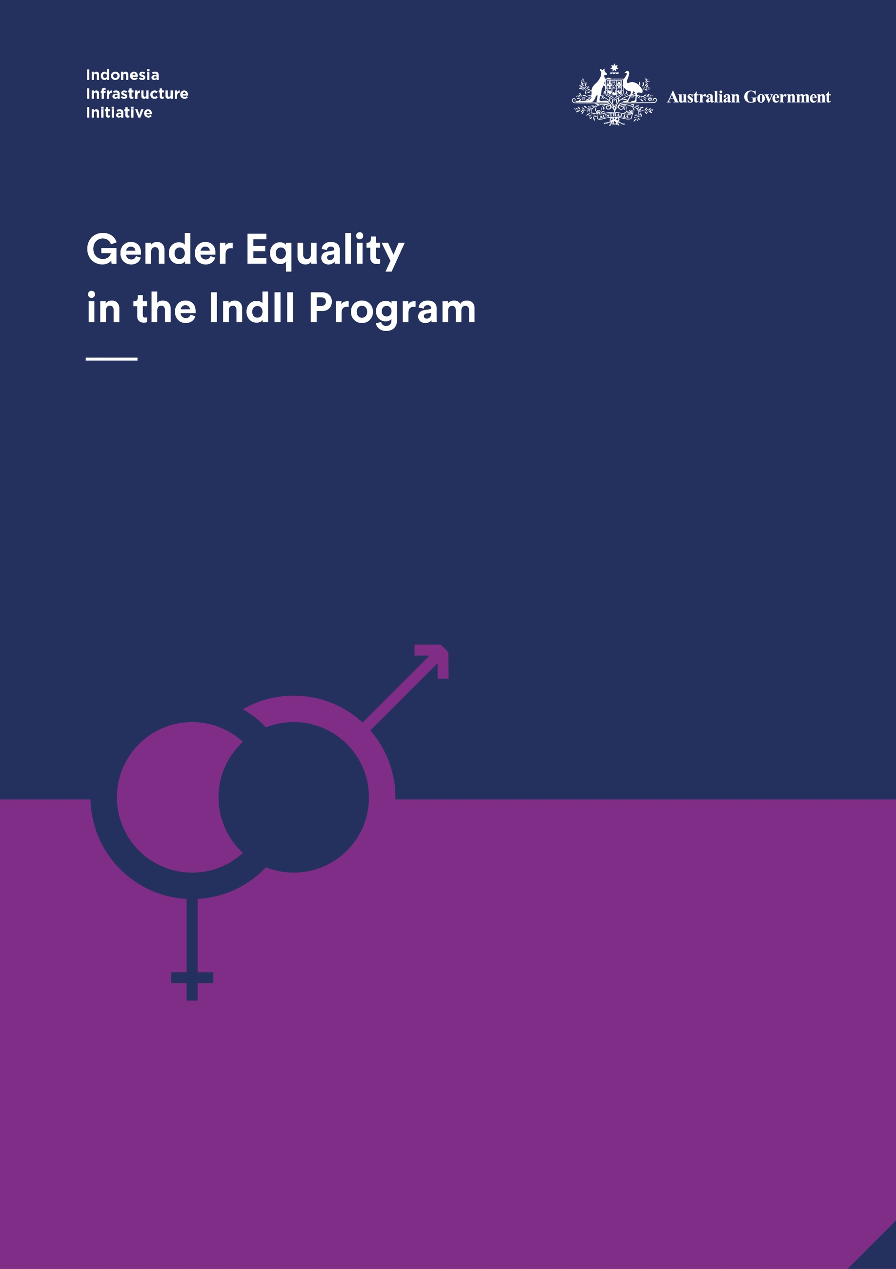

Indonesia Infrastructure Initiative

This document has been published by the Indonesia Infrastructure Initiative (IndII), an Australian Government supported project designed to promote economic growth in Indonesia by enhancing the relevance, quality and quantum of infrastructure investment.

The views expressed in this report do not necessarily reflect the views of the Australia Indonesia Partnership or the Australian Government. Please direct any comments or questions to the IndII Director, tel. +62 (21) 7278-0538, fax +62 (21) 7278-0539. Website: www.indii.co.id.

ACKNOWLEDGEMENTS

Thanks to Mr Jeff Bost, Deputy Director IndII; Ms Arya Geikie, Water and Sanitation Operations Advisor IndII; and Mr Eko Utomo, Gender Officer IndII, for their valuable suggestions and support throughout this review of IndII’s gender equality efforts.

Gaynor Dawson, IndII International Gender Advisor

© IndII 2016

All original intellectual property contained within this document is the property of the Indonesia Infrastructure Initiative (IndII). It can be used freely without attribution by consultants and IndII partners in preparing IndII documents, reports designs and plans; it can also be used freely by other agencies or organisations, provided attribution is given.

Every attempt has been made to ensure that referenced documents within this publication have been correctly attributed. However, IndII would value being advised of any corrections required, or advice concerning source documents and/ or updated data.

Indonesia Infrastructure Initiative

This document has been published by the Indonesia Infrastructure Initiative (IndII), an Australian Government supported project designed to promote economic growth in Indonesia by enhancing the relevance, quality and quantum of infrastructure investment.

The views expressed in this report do not necessarily reflect the views of the Australia Indonesia Partnership or the Australian Government. Please direct any comments or questions to enquiries@indii.co.id. Website: [www.indii.co.id](http://www.indii.co.id/index.php/en/).

ACKNOWLEDGEMENTS

Thanks to Mr Jeff Bost, Deputy Director IndII; Ms Arya Geikie, Water and Sanitation Operations Advisor IndII; and Mr Eko Utomo, Gender Officer IndII, for their valuable suggestions and support throughout this review of IndII’s gender equality efforts.

**Dr Gaynor Dawson**   
IndII International Gender Advisor

© IndII 2016

All original intellectual property contained within this document is the property of the Indonesia Infrastructure Initiative (IndII). It can be used freely without attribution by consultants and IndII partners in preparing IndII documents, reports designs and plans; it can also be used freely by other agencies or organisations, provided attribution is given.

Every attempt has been made to ensure that referenced documents within this publication have been correctly attributed. However, IndII would value being advised of any corrections required, or advice concerning source documents and/ or updated data.

CONTENTS

Program Overview i

Acronyms and Terminology ii

1. Objectives 1

2. Methodology 1

3. Strengths and Achievements 2

4. Strengths and Achievements - Selected activities 3

5. Main areas for improvement 5

6. Lessons Learnt 6

7. Recommendations 8

8. Conclusion 11

Annex 1 - Document Review II

Annex 2 - Interview analysis: experiences, observations, perspectives III

Annex 3 - Workshop Report IV

Program Overview

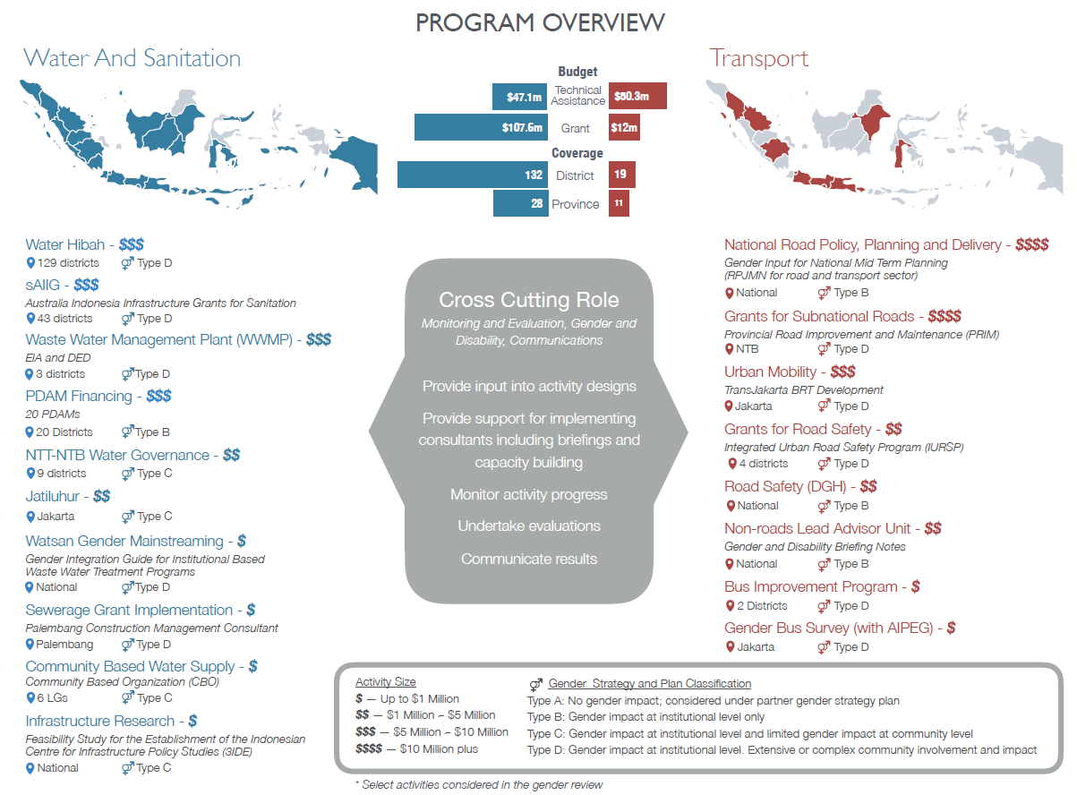

Acronyms and Terminology

|  |  |
| --- | --- |
| AIPEG | Australia Indonesia Partnership for Economic Governance |
| AQC | Aid Quality Check |
| BAPPENAS | Badan Perencanaan Pembangunan Nasional (National Development Planning Board) |
| BRT | Bus Rapid Transit |
| CBO | Community Based Organisation |
| CPMU | Central Project Management Unit |
| DFAT | Department of Foreign Affairs and Trade |
| DGHS | Directorate General for Human Settlement |
| GoI | Government of Indonesia |
| *Hibah* | Grant/s |
| HR | Human Resources |
| IndII | Indonesia Infrastructure Initiative |
| IURSP | Indonesian Urban Road Safety Program |
| KIAT | *Kemitraan Indonesia Australia Untuk Infrastruktur* (Indonesia Australia Partnership for Infrastructure) |
| KUAT | *Komite Advokasi untuk Aksesibilitas* (Advocates for Accessible Transportation) |
| LG | Local Government |
| MAMPU | Empowering Women for Poverty Reduction Program |
| NTB | Nusa Tenggara Barat province |
| PAF | Performance Assessment Framework |
| PAO | Preparation Appraisal and Oversight consultants |
| PKK | *Pemberdayaan Kesejahteraan Keluarga* (Family Welfare Empowerment movement) |
| PMM | Program/Project Management Manual |
| PRIM | Provincial Roads Improvement and Maintenance |
| RPJMN | *Rencana Pembangunan Jangka Menengah Nasional* (National Medium Term Development Plan) |
| RTTF | Road Traffic and Transport Forum |
| sAIIG | Australia Indonesia Infrastructure Grants for Sanitation |

1. Objectives

The Indonesia Infrastructure Initiative (IndII) is coming to a close and a new infrastructure facility is being designed. The overall purpose of this gender review is to provide a final evaluation of the effectiveness of IndII’s approach to addressing gender equality and women’s empowerment in Phase II and to reflect on achievements, challenges and opportunities. Recommendations and lessons learnt are to provide ideas about how to better integrate gender equality in the design and implementation of the new facility, *Kemitraan Indonesia Australia Untuk Infrastruktur* (KIAT), and for other infrastructure programs in the future.

The objectives of the review were to:

* Assess the implementation of the Gender Strategy and Plan and evaluate how effective it is in achieving gender outcomes for the program. The focus is on assessing the effectiveness of the strategy overall as well as program and activity level strategic objectives;
* Assess and examine the impacts of gender activities within IndII activities, with specific focus on the grant programs (Australia Indonesia Infrastructure Grants for Sanitation- sAIIG, Water and Sanitation Hibah and Provincial Roads Improvement and Maintenance- PRIM). This includes an assessment of how this is being implemented and key methods to improve implementation.
* Identify challenges and opportunities to address gender issues within IndII and with other stakeholders (consultants, GoI, Local Government/ LG, community etc).
* Understand and address barriers to integrating gender issues within infrastructure related institutions and programs.
* Identify strategies and key actions to strengthen effective objectives and initiatives and to address barriers and weaknesses within infrastructure related institutions and programs.
* Analyse and review gender documents and initiatives to improve and strengthen the approach going forward.
* Review and assess internal gender equality and diversity mechanisms (such as HR, recruitment, and training).

This report brings together the approach and findings of the three detailed review reports found in Annexes 1, 2 and 3.

1. Methodology

The review process comprised three interlinked stages, each with its own method. These are described below.

2.1 Document review (see Annex 1 for the Document Review Report)

A range of documents from IndII Phase II were provided, including design documents, technical reports, manuals, case study gender evaluations, routine activity reporting documents, on-line communications materials and the 2014 evaluation of the implementation of the Gender Strategy and Plan (from here in referred to as the Gender Strategy). The total number of documents reviewed was 55. Comments from IndII personnel provided context where necessary.

The review assessed the documents for the strengths and weaknesses they showed in how IndII’s facility and program level gender strategy objectives were addressed. The findings provided in depth material on IndII’s programs and activities and gave the background for questions to ask in the series of interviews which followed.

2.2 Interviews (see Annex 2 for the Interview Analysis Report)

Twenty-nine interviews[1] and two site visits were conducted over 12 days between 29 August and 9 September 2016. Persons interviewed in Jakarta were IndII facility personnel, consultants on IndII activities, Government of Indonesia officers, DFAT representatives and representatives of the KUAT advocacy group. Site visits were conducted in Bandung, West Java (Sanitation Hibah program) and Nusa Tenggara Barat (PRIM). During the site visits, meetings and interviews were held with representatives of local communities, local government, implementing consultants, road maintenance contractors, members of the Road Traffic and Transport Forum (RTTF) and women working in road maintenance.

The interview responses were analysed to identify respondents’ perceptions and experiences about how gender equality was being integrated into IndII programs, its strengths, areas where there could be improvement, lessons learnt and recommendations.

2.3 Workshop (see Annex 3 for Workshop Report)

A workshop was held as the final stage of the review. The main findings of the document review and interview analysis were presented to participants. This was followed by group discussions of eight key topics which had emerged from the document analysis and interviews and were expected to be included as recommendations for the new facility.

Forty people participated in the workshop representing IndII, IndII’s implementing consultants, DFAT, GoI, the design team for the new facility, and representatives of other DFAT programs. [2]

1. Strengths and Achievements

The key strengths and achievements identified during the process of reviewing IndII’s gender equality efforts are summarised below. Detailed descriptions of these strengths and achievements are found in Annex 1 and Annex 2.

* The joint efforts and motivation of many facility personnel to address gender equality in their work across the extensive program was important to IndII’s gender achievements. In each sectoral program (water and sanitation and transport) Program Officers were appointed as gender focal points and championed gender in their sectors. A full-time national gender officer was in place, working closely with key personnel and providing continuous support and ideas. An international specialist provided intermittent inputs with feedback and guidance. She also facilitated participatory workshops which motivated personnel by enabling them to analyse what they were doing successfully in their work and what they could do to improve. In addition, senior management gave encouragement. While not all personnel had the same level of commitment and interest, a critical mass of support to improve gender equality in IndII’s activities was gained within the facility. This was especially important in providing backup and support in cases where handovers to new IndII staff did not give adequate information about what was required for gender equality.
* IndII’s Gender Strategy document provided an effective umbrella strategy and direction for the facility and its activities. It includes five gender equality objectives for the overall IndII program and six for activities. Each objective was followed by potential actions to be taken to achieve the objectives. Indicators to monitor the implementation of the strategy were incorporated within the document (see Annex 1, sub Annex 3). The gender screening tool, which was included within the Gender Strategy, provided a method for identifying those activities with higher gender implications and suggested appropriate measures which could be integrated into designs.
* A series of activity case study evaluations and facility reviews provided lessons learnt and recommendations for improvement. These findings were presented and discussed with technical directors and relevant personnel within the sectors.
* Some of the activities reviewed incorporated substantial consultation with women and men and data collection about gender issues which informed activity planning and approaches, although this was not consistent across all activities where it might have been expected. Significant activities where there was data collection to identify gender issues include the Jatiluhur to Jakarta Pipeline and Water Treatment Plant Stage 2 where a Social, Gender and Environmental Impact report collected qualitative data for recommendations to avoid or mitigate potential gender impacts; the Urban Mobility - Transjakarta Improvement program where qualitative data was collected from women and men to identify the improvements they needed; the IURSP where gender data was used for planning pilot projects in each district.
* IndII’s communications program promoted gender equality, for example, through its inspiring stories series and on the gender section of the IndII website. Some Prakarsa editions also highlighted gender equality issues.
* Encouragement and support was provided to women as gender champions and as inspirational role models in leadership positions, including promoting their stories through IndII’s communication activities. Gender champions in LGs were given targeted support and, in the sAIIG program, some were given opportunities to share their experiences with each other.
* Women were given equal opportunities to participate in capacity building training and workshops, overseas fact finding missions and comparative study tours. While many of these opportunities were for women in government, increased opportunities were also given to women in the community to participate and develop their leadership, skills and self-confidence in the Community Based Organisation Piped Water activity.
* Headway was made in increasing women’s representation on committees and organisations, for example in the Community Based Organisation Piped Water activity and the PRIM program’s RTTF. However, where efforts to ensure better gender balance were made after organisations had been formed, rather than in the initial stages of their formation, it was more difficult to get higher women’s representation.

1. Strengths and Achievements - Selected activities

4.1 Grant activities

* PRIM has integrated gender equality throughout its implementation, in a Governor’s Decree, membership and operation of the RTTF, local government and road contractors’ awareness and willingness to give non-traditional work opportunities to women, and a number of women taking work opportunities offered in road maintenance. The commitment of a number of the consultants working on this activity contributed to its success in improving gender equality.
* By providing piped water to the house, the Water Hibah activity has reduced women’s daily concern with ensuring water is available for the household and the time and energy they spend in water collection. This is particularly the case for women whose main source of water was previously far from the house and in some places difficult to access. For example, in Manggarai NTT, women collected water from rivers and springs located far from their homes and sometimes in valleys. This was particularly onerous and dangerous for pregnant and elderly women and those who were ill or had disabilities. Several women said that previously they had been half dead (setengah mati) from having to carry water up to their homes, particularly in the rainy season. Others had to go out late at night to wait for closer, frequently used water sources to replenish before they could collect water.
* The sAIIG Program Management Manual (PMM) has gender equality requirements for LGs to implement and examples of formats to use. These are: (a) a statement of commitment by LG that they will undertake a gender equality approach in implementing sAIIG; (b) LG to develop gender action plans for public consultation during the planning stage, socialisation and public awareness campaigns during implementation, and women’s representation in implementing organisations; (c) monitoring of women and men’s participation. A self-monitoring questionnaire was developed by the Preparation, Appraisal and Oversight (PAO) consultant. This simple but effective tool enables LGs to see the actions they have completed and what they need to achieve in regard to the PMM requirements, and has given LGs focus and direction.
* A Guide to Integrate Gender into Institution-Based Waste Water Treatment Programs was produced at the request of the Ministry of Public Works (DG Cipta Karya) to support IndII’s institutional-based sanitation efforts in sAIIG and the Sanitation Hibah activity. The State Ministry for Women’s Empowerment and Child Protection was involved in and supported its development. The guide was initially socialised to LGs and NGOs in workshops in Batam and Riau and piloted in Balikpapan. Nine LGs in the sAIIG program have had the guide introduced to them during Training of Trainer activities. The sAIIG PAO consultant has also integrated many of the ideas and materials from the guide into the completion reports they are preparing for each LG to use as a reference to manage their waste water efforts after the program finishes. DGHS is currently examining how it may be integrated into a legal framework. When the guide has been distributed more widely, it would be useful to have an assessment of its use.

4.2 Other activities

* The Indonesia Urban Road Safety Program (IURSP) had gender equality objectives in the design. In 2015, a gender responsive community consultation guide was produced. This gives LGs information and a checklist about how to develop and implement effective community consultation programs with attention to gender equality in the consultation process. The community consultation guideline is being incorporated in the Road Safety and Monitoring and Evaluation Guideline. The draft Road Safety Standard, which was also developed in the IURSP activity in 2015, requires sex disaggregated data to be collected for gender analysis of road accidents in the future. This has the potential to be a useful tool in designing and targeting road safety measures more effectively. The draft Road Safety Standard is yet to be implemented by government.
* The Urban Mobility program incorporates an analysis of gender issues to guide bus service planning for improved safe, secure and accessible transport for women. The Transjakarta BRT minimum service standards which were developed under the program and were regulated in 2014 included aspects addressing women’s concerns and those of social inclusion: reliability and regularity, security and safety, affordability, comfort and ease of use, and equity. Community engagement efforts have included workshops about gender and disability issues and community consultations with women’s and people with disability’ groups. A community based advocacy group, KUAT, was formed in 2015 to advocate for the transport needs of people with disability and women. A video and leaflets highlighting gender and disability concerns with transport have been produced and distributed.
* IndII is working jointly with Australia Indonesia Partnership for Economic Governance (AIPEG) on a research project to analyse and identify ways to address transport issues which restrict women’s participation in the workforce. It will collect sex disaggregated quantitative and qualitative data on women’s transport access issues which affect their workforce participation and assess interventions.
* IndII has provided gender equality inputs for The National Medium Term Development Plan (RPJMN) of Directorate General of Highways 2015 – 2019 and the Transport Sector Medium Term Development Plan 2015 – 2019. Inputs include analysis of gender and social inclusion issues in transport development and the road sector, and a gender action plan. The action plan includes research, policy development, capacity building, community education, developing a pilot project, an information system and monitoring and evaluation.

1. Main areas for improvement

Key weaknesses and/or areas for improvement for integrating gender equality into infrastructure programs are summarised below. Detailed descriptions are provided in Annex 1 and Annex 2.

* While the Gender Strategy provided a general guide and objectives across the IndII program, there was a need for sectoral objectives and targets to give greater direction and outcomes to aim for. Yearly work plans needed to tie into the sectoral work plans to ensure better linkage and coordination of technical and gender aspects. Careful monitoring of achievements and timely intervention for non-performance were needed.
* While there were some gender capacity building workshops within the facility which focused on staff application of the Gender Strategy and screening tool, there was a demand for more systematic needs analysis and capacity building to support personnel to integrate gender in their work.
* There needed to be a stronger effort to ensure that implementing consultants understood what they were expected to do with regard to gender equality with clear briefings, discussions about the consultants’ gender approach, and opportunities for their questions to be answered. There also needed to be greater monitoring of consultants’ gender equality achievements and the timeliness of gender specialist inputs during implementation with further opportunities for discussion and support. The capacity of gender specialists nominated on consultant teams to undertake tasks, such as gender analysis, needed to be better assessed in some cases.
* When there were changes in facility personnel, new consultants, or changes in government, briefings and hand-overs sometimes focused on technical issues and lacked adequate information about gender equality approaches and initiatives. There needed to be more attention paid to ensuring all new personnel were aware of, and understood, IndII’s gender equality requirements and measures from the beginning of their work.
* Gender equality was often confined to a particular section of documents, including designs and technical reports. There was a need to integrate gender throughout and to show how gender equality measures link to technical issues and the impact and wider benefits that could be achieved in the activity by improving gender equality.
* The wording about gender equality in activity designs was sometimes very general and was frequently based on common knowledge about gender issues which might be faced rather than the particular insights which site visits and discussion with people can give. Sometimes cut and paste of text about gender equality was taken from other designs and at times was not relevant to the particular design it was inserted in. Designs needed to have more detailed and specific steps clearly stated for implementers to follow, particularly where there were significant gender implications.
* The review of selected documents found that while some activities had strong data collection and gender analysis elements, it was limited in others. Survey questionnaires did not always clearly collect valuable gender data, such as household headship or the household’s main water collector for in the case of the Water Hibah Socio-economic surveys. In some instances, sex disaggregated data was collected but was not analysed by consultants to identify those gender differences which could be used to improve planning and implementation (for example, some socioeconomic surveys for the Water Hibah). Where issues were identified, they were not always followed-up. Data in the sAIIG Socioeconomic Survey reports for Balikpapan, Kotamogabu, Medan, Tebing Tinggi pointed to a lack of women’s participation in meetings but there was no apparent response to encourage greater participation. The Feasibility Study for the Establishment of the Indonesian Centre for Infrastructure Policy Studies (3IDE) did not incorporate any data collection to identify the gender issues which might have been relevant for consideration in the creation of the Centre.
* Reporting by consultants frequently lacked specific information which would have been provided by better gender data collection and analysis. Capacity to undertake useful gender data collection and analysis about key issues was sometimes limited when it should have been a strength and, in some cases, it was not seen as a priority by team leaders and team members.
* Both central and local governments were not made sufficiently aware of IndII’s gender equality approach and efforts in ways which would encourage their greater interest, involvement and support to achieve gender objectives. Where efforts were made, they were often not at the commencement of an activity or program, were not strong or consistent enough, or at high levels.
* Reporting from implementing consultants to IndII did not give sufficient detail about the efforts being made and the achievements. Reporting from IndII to DFAT also did not provide adequate information to meet DFAT Aid Quality Check (AQC) reporting requirements.

1. Lessons Learnt

There were many lessons learnt. The main ones are:

* Considerable time and effort is needed to bring about changes to social norms and the entrenched attitudes and practices found in institutions and communities which are barriers to improving gender equality. While this is a general problem, it is particularly the case for infrastructure programs where a focus is on construction and there is less appreciation of related social aspects, including gender equality. For instance, women are often not seen as having a role in road works. It has taken time and persistence on behalf of the consultants and IndII to open more opportunities for women to be employed in road maintenance work on the PRIM activity.
* Technical issues will always predominate in infrastructure programs if there is not a concerted effort to ensure that the importance of addressing gender issues is clear to all stakeholders. The lack of a facility gender objective hampered efforts to gain a focus and a target to work towards in the facility. Because of a lack of a gender objective, efforts to improve gender equality in the facility were sometimes viewed as not having a basis and as being imposed. Having the Gender Strategy and screening tool for the facility was a counter to this to some degree. They provided useful overall guidance which highlighted areas to aim for to improve gender equality and support for IndII personnel to integrate gender in the activities they were involved with.
* Though there were no specific incentives or disincentives applied, IndII’s personnel were generally willing and motivated to integrate gender equality in their work. This was mainly achieved by discussion and inputs provided by the IndII gender officer during the activity design process and, afterwards, in his consistent encouragement to national staff that gender equality was something which was valuable. Personnel were also motivated by participatory workshops facilitated by the international gender specialist where they were able to assess what they were doing well and how they could improve. Feedback about achievements and difficulties in the field was also important to interest and motivate personnel. The results of the gender case studies were fed back to technical directors and relevant members of the sectoral teams. Gender focal points were appointed in each sector to give more attention and strengthen efforts where necessary. Senior management, in particular IndII’s Deputy Director who was the cross-cutting team manager, also provided encouragement across the facility. If gender performance assessments had been in place, such as ensuring that gender equality impacts were monitored and reported, they may have assisted in further increasing staff attention to gender equality.
* Overall, IndII senior management supported efforts to improve gender equality, in particular the Deputy Director, who was the cross-cutting team manager. However, timeliness, effectiveness and strategic attention could have been improved with the appointment of a person specifically responsible for gender equality and social inclusion impact, whose position was full-time or near full-time, who held a high level of authority and influence across the program and who could oversee the implementation of yearly workplans linked to the sectoral workplans.
* The benefits for program/activity success of addressing gender equality needs to be well-defined and understood right from the beginning to get better buy-in from stakeholders. A focus on gender equality cannot be introduced ‘later’ because of an initial priority on sorting out technical problems. It needs to be explained, advocated and prioritised from the start, otherwise it is often considered an ‘add on’ and not having much importance. The PAO consultant, in particular, noted this as a problem in gaining traction with LGs involved in the sAIIG program.
* One-off capacity building and strengthening about gender equality issues is seldom sufficient. It needs to be developed incrementally with analysis of what strengths can be strengthened and what understanding and practice limitations should be improved. In the case of PRIM, an initial workshop to raise awareness of gender issues was followed up with a workshop targeted at increasing opportunities for women’s employment in road maintenance by changes to contract wording. Respondents noted that capacity building is more effective if it is based on practical experience, application, observation and exchanges of ideas.
* Impact in the field is often less than that promised in designs because: (a) consultants are not clear about the importance of gender equality in the activity, know what to do, or have the required capacity or gender resourcing to implement what is required; (b) local government often have limited capacity and lack ownership and understanding of the value of gender equality for success; (c) the central government has uneven capacity and commitment and the CPMU prioritises technical issues; (d) activities often lack gender objectives and indicators to monitor progress and enable interventions to be identified as necessary.
* The need for gender equality resourcing is often underestimated, with the notion that ‘anyone can do it’. However, where non-gender specialists are responsible for analysis, planning and decision making, results can sometimes be unsatisfactory. Limited gender specialist resourcing risks restricting the amount of drive and effort that is put into achieving gender equality outcomes.
* Sex disaggregated data is important to enable gender issues to be identified. There is a general lack of sex disaggregated data available for planning. However, even where it is available, it is not always analysed or the analysis does not identify important gender issues. This may be because the key variables are not identified for data collection and so the appropriate data is not collected to enable the issues to be analysed, or because the key variables are not identified when the analysis is done, such as in the analysis of the Cimahi socio-economic survey in the Water Hibah program. Gender analysis capacity is important both for the development of questionnaires and for analysis.
* When a common approach is adopted and applied over several large programs, such as what happened in IndII’s Water Hibah, sAIIG and PRIM grant programs, it would be prudent to conduct a focused evaluation across those programs to identify where they are successfully addressing gender equality and if there are shared challenges and weaknesses. Any existing gender policy, strategy or monitoring framework needs to be adjusted to address concerns identified by an evaluation.
* It is difficult to increase women’s numbers in organisations and committees once membership is established, so the process must start at their inception. Men need to be convinced of the benefits of having different perspectives, skills and ideas from women which will contribute to the success of the organisation or committee.
* Some manuals have been produced which are valuable to strengthen capacity and guide gender action. However, there need to be written agreed plans for their testing, distribution and capacity building in their application before they are developed, to ensure that their use is maximised.
* A two-track approach was implemented with gender integrated widely throughout activities and, on the other hand, a limited number of gender and women’s empowerment specific efforts. The second approach included the development of a gender guide for institutional-based waste water treatment programs, collaboration with AIPEG on a research project about transport and women’s participation in the workforce, and the promotion of inspiring women’s achievements. While being limited, the gender/women focused initiatives had the benefit of being very clearly targeted and having focused efforts and, in the case of the sanitation and transport gender activities, are valuable to assist other activities’ progress and success. The integration of gender was important to gain wider gender equality impact throughout all aspects of activities across the program, apart from where there were no gender implications. PRIM and IURSP are examples where gender equality has been well integrated across all aspects of the programs.
* It is more difficult to satisfy women’s strategic and empowering needs compared with their practical demands. However, addressing women’s practical needs, such as providing water to the house in the Water Hibah activity, can sometimes lead to support for women’s empowerment by giving them more freedom for other activities and interests, as discussed in the Inspiring Story *Promoting Women’s Empowerment through the Provision of Clean Water.*
* Small, simple, practical measures can be effective in getting focus, direction and the required gender equality action. For example, in sAIIG, a consultant developed a self-monitoring gender questionnaire for local government which enabled them to see what needed to be done, what they had achieved and what still needed to be done. In another case, the simple requirement in a letter to a decision-maker that women as well as men be considered for an overseas fact finding mission resulted in women being chosen when they expected they might not have been otherwise.

1. Recommendations

This section presents key recommendations for the new facility and DFAT to better integrate gender equality and women’s empowerment across the program and achieve improved gender equality impacts. Some of these recommendations reflect the results of group discussions during the workshop (see Annex 3).

**A. The Facility**

***Management***

1. A more strategic approach should be developed for the facility with a stated gender objective/sub objective and clear gender equality targets and indicators for the program overall and also for the sectors. Gender work plans should be tied to sectoral workplans. Systematic monitoring of achievements should be integrated into the facility’s M&E framework with timely responses to address issues where necessary. A gender strategy, or something similar, should be developed for support and to provide overall guidance.
2. Gender resourcing should be boosted for the facility, including a senior gender, or gender and social inclusion team leader position at a level comparable to technical directors to emphasise the importance of gender equality and to enable that person to be involved in senior management decisions and have more status in interaction with government. The team leader would be responsible for managing a team of gender and social inclusion specialists, and short-term national and international support. Budgeting should allow for capacity building within the facility, field visits for activity designs, and for activity needs. Gender resourcing was one of the areas which was felt should be prioritised by workshop participants.
3. Gender equality should be included as an important item in the managing contractor’s staff TORs. Performance assessments should be made of how well staff are achieving what is required of them with appropriate interventions for non-performance and encouragement where there are genuine efforts and achievements.
4. A system should be initiated so that changes in facility personnel, consultants, or government officers will trigger briefings by the gender specialists about the facility’s gender equality approaches and initiatives and their relevance for the new personnel’s role.
5. The new facility’s communications team should promote gender equality and what the facility is doing to improve gender equality to the wider audience and package the information as a record of what has been achieved.
6. In technical team meetings, facility representatives should routinely raise and advocate the benefit of addressing gender issues relevant to the activities being discussed.

***Activities***

1. Clear gender objectives and indicators should be identified for activities with high gender implications and adequate budgets provided to achieve gender objectives and to monitor progress towards objectives. Research and site visits should be enabled to identify key gender issues and entry points which can be integrated in the activity designs.
2. Gender should not be confined to particular sections of documents. Gender equality analysis and measures should be required to be integrated throughout documents, such as designs, project management manuals and technical reports, and the value to overall activity impact clearly defined.

***Consultants***

1. Briefings and other communications with consultants should highlight the importance and value of gender equality achievements for overall activity impact from the commencement of the activity, not be delayed until after technical issues are resolved.
2. TORs for consultants engaged on activities with gender implications should include gender equality as an important element where relevant. Consultants’ performance should be assessed against their gender equality achievements and they should be aware that this aspect will be taken into account for their performance assessments.
3. Where activities have important gender equality implications, the quality of the gender expertise on consultant teams which are bidding for the work should be assessed and given a weighting to be taken into account in appointing the successful company. Whilst this is currently done for some activities, it needs to be more consistent across all activities.
4. The facility’s gender specialists and technical team members should ensure that consultants are clear about their obligations with regard to improving gender equality in the activity they are implementing. This includes providing briefings, asking consultants to explain the approaches they will take, giving spaces for consultants to ask questions and providing responses, monitoring consultants’ efforts and giving support where necessary.
5. A system of incentives and sanctions should be in place to encourage consultants to achieve required gender targets, for example through performance based contracts. Careful consideration of objectives and indicators and how to monitor achievements will be required. Workshop participants considered this issue.
6. Report formats should be developed to enable clear reporting to the facility of the specific efforts and achievements of consultants. Report formats should be in line with the AQC (including detailed gender requirements) and Indonesian Performance Assessment Framework (PAF) requirements. The facility should report the efforts and achievements made to DFAT on a regular basis and with detail.

***Gender champions and women achievers***

1. There has been some success in identifying gender champions and women with inspirational stories. The new facility through its activities and with DFAT support should make further efforts to identify women and men in government and civil society who can champion gender equality, bring them together for mutual support, and encourage the development of gender networks which can further the work of the facility. The capacity of gender champions and potential gender champions to understand how they can improve gender equality may need fostering. Some champions may already have a good grasp of gender inequalities and have ideas for gender initiatives which can be discussed, supported and promoted by the facility and DFAT. Others may be interested but not have a clear enough understanding of how to identify gender equality issues or what to do about them. Providing opportunities for widening of understanding and experiences, for example by supporting attendance at conferences or short courses is important. Giving such opportunities to gender champions also signals to their colleagues that gender equality is valued. Facilitating occasions for meeting, sharing and development of ideas of what is possible between gender champions is also essential to enable mutual support and increase confidence and commitment. At an individual level, leadership and speaking opportunities, and opportunities to express in writing what they believe should be done or have achieved, can assist a champion’s personal development and confidence.
2. Women achievers should be identified for support. This could be via recognition of their achievements and by providing opportunities for them to expand and demonstrate their capacities through encouraging their involvement in activities such as symposiums and conventions and, where relevant, mentoring. Networks for women with common interests and skills such as engineering should be supported. For example, the Feasibility Study for the Establishment of an Indonesian Centre for Infrastructure Policy Studies suggested that a network for women in infrastructure be established. Measures which address policies, attitudes and practices within the bureaucracy which inhibit women achievers’ development and promotion should also be integrated into programs/activities.

***Government of Indonesia***

1. Formal and informal approaches should be made to the central government from the beginning of the new facility’s work. Relationships should be developed with government to ensure greater appreciation of the facility’s gender equality objectives and priorities, and optimise government ‘buy-in’.
2. The gender and social inclusion aspects of activities should be highlighted and explained to the central government from the beginning of the activity. This should include the benefit for activity impact in order to gain higher level attention to the wider advantages of the activity and gain stronger direction within the government to the achievement of gender equality outcomes.
3. The Project Management Units should be made clear about both the facility’s objectives and activities’ gender equality requirements. They should be prepared and supported to be capable of following them up.
4. A more consistent relationship should be developed between the facility and the State Ministry for Women’s Empowerment and Child Protection, in particular the persons concerned with gender and infrastructure.

***Local government***

1. Briefings and other communications with local governments should highlight the importance and value of gender equality achievements for overall activity impact from the commencement of the activity, not be delayed until after technical issues are resolved.
2. The awareness and capacity of local governments to address gender issues was limited. Where activities that have gender implications require local governments to implement them, their relevant gender capacity building needs should be identified and integrated into activity designs, ToRs and budgets. Participatory planning and monitoring methods should be incorporated where possible to encourage government ownership of gender efforts. Monitoring of local government’s efforts should be undertaken with follow-up capacity building and support provided where necessary.

***Community engagement***

1. Activity design and implementation should have greater engagement with community groups, including women’s groups, to give women’s voices and needs greater expression. This was identified as a priority in the workshop. Other programs which work at local level, such as MAMPU, have links to extensive gender networks which could be utilized. Local governments, including the Women’s Empowerment units, and local PKK, also often have knowledge of active women’s organisations and individuals in their areas who could be engaged. Workshops could be held to bring together groups and individuals to discuss gender issues relevant to an activity and explore the potential for coalitions, and obtain follow-up support in implementing those activities which directly involve communities.

***Engagement with other programs***

1. Efforts should be made to identify areas for collaboration with other programs on gender activities. Some current programs which could be engaged for possible joint activities are MAMPU, MAHKOTA and IUWASH. However, this review was not aimed at exploring these possibilities and the new facility should endeavor to identify further potential partners. DFAT should play a role in facilitating engagement between programs. BAPPENAS may also have a role.

**B. DFAT**

1. DFAT should adopt a higher profile in engaging with GoI in gender and social inclusion (GESI) in order to support the new facility’s gender equality and social inclusion aims. This could either be informally or in regular bilateral discussions; or periodic engagement together with the facility GESI Director or by inviting GoI counterparts to DFAT gender events. Gender equality should be a standing item on the agenda for discussions with government, including at Steering Committee and Technical Team meetings, in order to highlight the importance that the Australian government places on this issue. DFAT should play a lead role in this.
2. It would be useful for DFAT to play a role in facilitating and supporting the development of a relationship between the new facility and the State Ministry for Women’s Empowerment and Children’s Protection to strengthen and widen the facility’s gender equality and women’s empowerment impact.
3. DFAT should play a key role in coordinating opportunities for Australian government funded programs to discuss and collaborate on potential joint activities. Efforts should commence as soon as possible to enable sufficient time to develop and undertake joint projects fully.
4. Gender champions and high achievers should have DFAT, as well as the facility’s, support. See recommendations 15,16 above.
5. Conclusion

This review has been broad ranging and has involved a wide group of stakeholders involved in implementing IndII. Some of the successes identified have been small and some have had greater impact. Some are likely to be more sustainable than others. There have been a number of areas where improvements could be made to gain better outcomes. Challenges have been identified in the review including different priorities and understandings of stakeholders, the lack of capacity of key implementers, the time needed in many cases to achieve gender objectives, the lack of appreciation of the difficulty and skills needed to integrate gender into an infrastructure program, and changing personnel in stakeholder organisations. Successfully integrating gender into an infrastructure program and achieving changes in long-established attitudes and practices needs determination and consistent application. There is a need for strong, strategic and continued efforts in order to achieve gender equality objectives and to bring about sustained change.

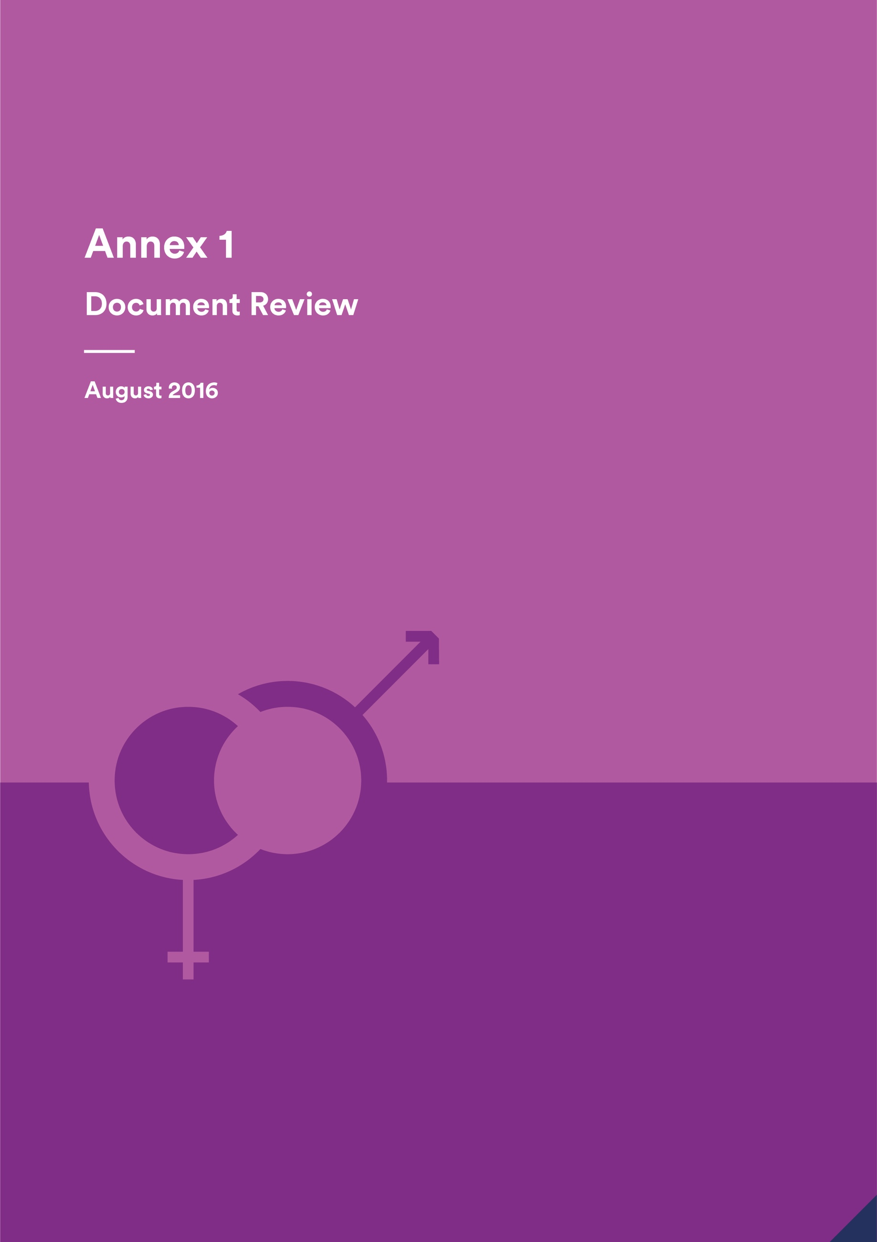

Annex 1 - Document Review

**August 2016**

Indonesia Infrastructure Initiative

This document has been published by the Indonesia Infrastructure Initiative (IndII), an Australian Government supported project designed to promote economic growth in Indonesia by enhancing the relevance, quality and quantum of infrastructure investment.

The views expressed in this report do not necessarily reflect the views of the Australia Indonesia Partnership or the Australian Government. Please direct any comments or questions to the IndII Director, tel. +62 (21) 7278-0538, fax +62 (21) 7278-0539. Website: www.indii.co.id.

© IndII 2016

All original intellectual property contained within this document is the property of the Indonesia Infrastructure Initiative (IndII). It can be used freely without attribution by consultants and IndII partners in preparing IndII documents, reports designs and plans; it can also be used freely by other agencies or organisations, provided attribution is given.

Every attempt has been made to ensure that referenced documents within this publication have been correctly attributed. However, IndII would value being advised of any corrections required, or advice concerning source documents and/ or updated data.

CONTENTS

Acronyms and Terminology i

Executive Summary iii

1 Introduction 1

2 Strengths and weaknesses in achieving Gender Strategy and Plan objectives 1

2.1 Facility Level 1

2.2 Activity Level 5

3 Preliminary lessons learnt 10

From sAIIG 10

From PRIM 11

From the Water Hibah 11

4 Preliminary recommendations 11

5 Recommendations relating to Government 12

6 Effective design example 12

Sub-Annex 1: Gender Strategy and Plan - Program Level and Activity Level Strategic Objectives 14

Sub-Annex 2: Documents Reviewed 15

Sub-Annex 3: Gender Strategy and Plan - Key Performance Indicators 18

Acronyms and Terminology

|  |  |
| --- | --- |
| ACR | Activity Completion Report |
| ADB | Asian Development Bank |
| ADD | Activity Design Document |
| AMR | Activity Monthly Report |
| AusAID | Australian Agency for International Development |
| BIP | Bus Infrastructure Program |
| CBO | Community Based Organisation |
| DFAT | Department of Foreign Affairs and Trade |
| EIA | Environmental Impact Assessment |
| EOI | Expression of Interest |
| *Hibah* | Grant/s |
| IAR | Initial Activity Request |
| IndII | Indonesia Infrastructure Initiative |
| IURSP | Indonesian Urban Road Safety Program |
| Kopaja | *Koperasi Angkutan Jakarta* (Jakarta Transport Cooperative) |
| KUAT | *Komite Advokasi untuk Aksesibilitas* (Advocates for Accessible Transportation) |
| LG | Local Government |
| M&E | Monitoring and Evaluation |
| MEF | Monitoring and Evaluation Framework |
| NPMP | National Port Master Plan |
| NTB | Nusa Tenggara Barat province |
| PDD | Program Design Document |
| PIU | Project Implementation Unit in government |
| PKK | *Pemberdayaan Kesejahteraan Keluarga* (Family Welfare Empowerment movement) |
| PMM | Program/Project Management Manual |
| PAO | Preparation, Appraisal and Oversight consultant |
| PRIM | Provincial Road Improvement Program |
| RENSTRA | *Rencana Strategis* (Strategic Plan) |
| RKL | *Rencana Pengelolaan Lingkungan* (Environmental Management Plan) |
| RPJMN | *Rencana Pembangunan Jangka Menengah Nasional* (National Medium Term Development Plan) |
| RPL | *Rencana Pemantauan Lingkungan* (Environmental Monitoring Plan) |
| RT | *Rukun Tetangga* (Neighbourhood) |
| RTTF | Road Traffic and Transport Forum |
| RW | *Rukun Warga* (Hamlet) |
| sAIIG | Australia Indonesia Infrastructure Grants for Sanitation |
| TD | Technical Director |
| ToR | Terms of Reference |

Executive Summary

This document review is the first stage in an evaluation of how IndII has performed in its gender equality efforts. Lessons learnt and ideas to improve gender equality will be identified through the final evaluation to assist in the *Kemitraan Indonesia Australia Untuk Infrastruktur* (KIAT) design.

Documents were reviewed and evaluated for strengths and weaknesses against IndII’s Gender Strategy objectives at the facility and activity levels. A number of preliminary recommendations and lessons learnt for the future were identified.

Preliminary recommendations identified included:

* A system of incentives and sanctions for achieving gender equality outcomes;
* Gender equality measures be integrated throughout designs, ToR, PMM and other documents rather than being confined to a particular section;
* Gender objectives are always included in activities/program designs which have a high likelihood of gender issues in order to emphasise the gender equality measures and help ensure outcomes are monitored;
* Attention to adequate and timely activity gender specialist resourcing;
* Improvements to reporting on gender issues, efforts to address issues, and the provision of evidence of improved gender equality in activities and programs;
* Greater emphasis and clarifications to LGs and central government from the beginning of activities/programs about gender equality objectives, not allowing technical and financial issues to predominate;
* Assessment of LG gender understanding and capacity by consultants with a sustained program of support designed to strengthen strengths and address weaknesses;
* When new programs with common characteristics such as the grant programs are developed, an evaluation is conducted across them to identify common challenges and strengths with regard to gender equality and to improve efforts;
* Appropriate resourcing of other concerns, such as disability, so they are not conflated with gender.

Preliminary lessons learnt identified included:

* Technical issues will always predominate in infrastructure programs if there is not a concerted effort to ensure the importance and value of addressing gender issues;
* It is difficult to increase women’s numbers in organisations and committees once membership is established, so the process must start at the inception;
* Australia Indonesia Infrastructure Grants for Sanitation (sAIIG):
  + gender equality measures need to be socialised from the beginning;
  + sustained gender support is needed for LGs because of their limited gender equality capability;
  + implementing consultants have valuable ideas to contribute about gender equality because of their first-hand understanding of the situation.
* Provincial Road Improvement Program (PRIM):
  + a series of workshops which build on and strengthen commitments made in earlier workshops is more effective than one-off workshops, especially where there is low capacity.

The document review suggests that the design of IURSP provides a good model with key attributes for achieving gender equality outcomes and evaluation should be made of its implementation.

1. Introduction

The overall purpose of this activity is to provide a final evaluation of the effectiveness of IndII’s approach to addressing gender equality and women’s empowerment in Phase II and to reflect on achievements, challenges and opportunities. Recommendations and lessons learnt and how these may be carried forward in the new infrastructure facility are to be identified. This document review is the initial step of the activity.

The objective of the document review is to assess the documents made available to the consultant to provide an initial idea of how IndII has performed in implementing and achieving the objectives of the IndII Gender Strategy and Plan:

* what worked well and why
* what didn’t work well and why not
* recommendations as to what improvements could be made
* preliminary lessons learnt.

This document review will also be used to assist in the identification of areas for further investigation through interviews with key stakeholders and for the development of open ended questions.

The document review is the first stage of the overall evaluation activity. Interviews with key stakeholders and a workshop to discuss findings and to plan what can be done better to improve gender equality in the new infrastructure facility will follow. The results of these activities will be brought together in the Gender Equality in the IndII Program – Executive Summary Report. A summary of findings and recommendations from this document review will also be incorporated in the Executive Summary Report.

A range of IndII produced documents from IndII Phase II were provided for the review, including design documents, technical reports, manuals, case study gender evaluations, routine activity reporting documents, communications materials and the 2014 evaluation of the implementation of the Gender Strategy and Plan (see Annex 2 for the full list of documents). Comments from IndII personnel provided further context. External documents were not reviewed.

The review assesses strengths and weaknesses in achieving the IndII Gender Strategy and Plan objectives at facility and program levels as revealed in the documents and provides preliminary recommendations and lessons learnt.

1. Strengths and weaknesses in achieving Gender Strategy and Plan objectives

The IndII Gender Strategy and Plan (from here referred to as Gender Strategy) provides a framework for improving gender equality across the IndII program. It has sets of objectives for the facility and activity levels and actions designed to achieve each objective. This section identifies strengths and weaknesses in fulfilling actions and achieving the respective objectives.

* 1. Facility Level
     1. Resourcing and support

**Strengths**

* A Gender Strategy, which includes a screening tool was produced to provide overall guidance and objectives and actions for activity design and implementation. It has been revised twice since it was originally created in 2009, most recently in early 2016. Amongst improvements, the 2016 document has incorporated Department of Foreign Affairs and Trade’s (DFAT’s) 2016 Gender and Women’s Empowerment Strategy. It has added a section on human resources which was missing from earlier versions. This applies to IndII’s employees and links to SMEC’s corporate human resources policy which includes gender equality measures in recruitment, increasing women’s representation in senior leadership, equal opportunities for capacity building and intolerance of sexual harassment.
* Workshops were held with IndII personnel to increase understanding of gender equality and the use of the Gender Strategy in their work in Phase II in 2011 and 2014. Personnel have remained fairly consistent during this time.
* Resourcing for a national gender officer was increased from part-time to full-time in IndII Phase II. This provided a valuable and continuous resource and support for gender equality efforts in the facility including inputs to designs, data collection, workshops, video production; communication with consultants; and a channel for interaction with governments and community organisations about gender equality.
* An international gender specialist provided support with core and non-core inputs from 2009-14 including developing the Gender Strategy, designs, capacity building, evaluations of the implementation of the Gender Strategy, case study evaluations of activities in line with the Monitoring and Evaluation Framework (MEF), reporting to AusAID on achievements and challenges, and support to the national gender officers. In 2016 the international specialist provided inputs for this gender review.
* Diversity in perspectives and ways of operating are important for an organisation’s effectiveness. Data from the Gender Strategy (2016) shows that women form 30% of IndII’s senior management, 61% of professional/program officers, and 70% of finance and administrative support. The number and proportion of women in senior management has increased since 2014 when it was 20% due to the addition of two positions which have been filled by women. However, the most senior managers are men.

**Weaknesses**

* The Gender Strategy lacks sufficient detail on important issues which might arise in IndII’s interactions with government in implementing activities.
* The Gender Strategy was written before the grants process was identified as an important approach to implement programs at district level. It does not specifically target the gender issues which arise in grants programs implemented at district level.
* Activity evaluations from a gender perspective, including that of Australia Indonesia Infrastructure Grants for Sanitation (sAIIG) and other grant programs, have not been conducted since 2014. However, the national gender officer has provided a focus for gender efforts including outreach.
* While the international gender specialist and national gender officers were originally responsible only for gender equality, other social issues such as disability and child protection were subsequently added to their responsibilities, without any additional input time.
  + 1. Gender responsive design

**Strengths**

* The Gender Strategy’s screening tool is being used to assess the degree of gender implications and to guide gender equality responses which are included in designs for activities categorised as Type B,C and D.
* Gender specific activities have been designed to complement IndII’s gender mainstreaming efforts and to support gender equality achievements in activities/programs eg The Guide to Integrate Gender in Institution-Based Waste Water Treatment Programs. A video’ Nothing about us without us’ was developed to support gender and disability aspects of the Urban Mobility activity and follow-up workshops resulted in an advocacy group (KUAT) being formed in 2015.

**Weaknesses**

* Gender equality is usually isolated in the Policy Compliance/Cross cutting issues sections of designs and activity Terms of Reference (ToRs) and is not integrated throughout documents. While being restricted to one section does give a focus to addressing gender issues, it separates gender equality measures from the mainstream technical elements of the activity.
* The Gender Strategy requires that gender equality objectives be in place for activities categorised as Types C and D. Even though gender equality is highlighted in the text of designs such as the sAIIG and Urban Mobility programs, there was a lack of gender equality objectives in most activities in the documents reviewed. The Indonesian Urban Road Safety Program (IURSP) was an exception. Having a gender equality objective increases focus on the issue and forces monitoring and reporting of outcomes relating to the objective. A related issue was that gender equality outcomes did not usually appear in activity logic models.
* While design documents are mostly subject to a gender review with recommendations, some designs were developed from very brief versions such as Initial Activity Request (IAR) and did not allow for adequate gender input.
* Design documents sometimes require that reporting is ‘compliant’ with IndII’s Gender Strategy. However, being ‘compliant’ does not encourage consideration of the real needs for improving gender equality. Focusing on ‘being compliant’ encourages a ‘box ticking’ response rather than a response which is thoughtful and meaningful.
* The monitoring and evaluation sections of design documents typically don’t discuss reporting on gender outcomes, even when they are important to the activity eg Bus Improvement Project (BIP) design document.
* Risk matrixes do not include the risk of failure in achieving gender equality requirements of a design eg sAIIG.
  + 1. Gender disaggregated data for planning, analysis and reporting

**Strengths**

* IndII’s M&E team frequently review consultants’ gender data and, where needed, have provided input and briefings to support them to improve the quality and usefulness of the data submitted.
* Tools have been provided to consultants to assist in the collection of sex disaggregated data such as participation of women and men, and to program officers to assist in the gender performance review. Support has been provided for survey questionnaire design to improve the collection of gender disaggregated data.
* Qualitative case study gender evaluations of selected activities were implemented in line with the MEF. These used secondary quantitative data and primary qualitative data from observations and interviews with stakeholders. The case studies give a human face to the outcomes and impact of activities for women and men. They also provide a deeper explanation and understanding of the reasons for particular outcomes than can be provided by quantitative data. Other data collection, analysis and reporting was undertaken, such as the series of Inspiring Stories which canvases a number of gender topics.
* Lessons learnt, inspiring stories and activity updates from the gender case studies and workshops have been documented on the website.

**Weaknesses**

* The Activity Completion Report (ACR) templates give consultants little opportunity to report much information about gender issues faced and the efforts they have made to address challenges. While the Activity Progress Reports(APR)/monthly report allows more opportunity for reporting of achievements and problems, if there is poor reporting in this, the facility has limited understanding of what has been achieved at the completion of the activity.
* The sAIIG Project Design Document (PDD) mentions that there will be a series of evaluations of gender impact of the program. This did not happen. Nevertheless, the gender officer has had regular meetings with the consultants to monitor progress. A workshop with GoI and LGs was held in August 2016 to assess problems and lessons learnt with regard to the use of the Gender Integration Guide for Institution Based Waste Water Treatment Programs.
  + 1. Consultants and contractors understand and have capacity to implement IndII’s gender equality requirements

**Strengths**

* The national gender officer and M&E team have held discussions with implementing consultants about gender equality requirements at activity mobilisation and during implementation, for example, in supporting the improvement of consultant gender data analysis and reporting.
* The respective program officers have provided information to consultant teams and supported them to fulfil gender equality initiatives.
* The capacity and commitment of consultants varies widely. Some consultants are capable and show initiative and ideas to deal with problems (eg the consultants involved in the Finalisation of the National Port Master Plan (NPMP) decree; IURSP consultant; sAIIG Preparation, Appraisal and Oversight consultants), others are not.

**Weaknesses**

* There has sometimes been a lack of insistence from IndII that gender equality is prioritised in the implementation of activities and effective efforts to explain what is needed to be done. This is critical, especially when there is a lack of commitment or understanding by some consultants and, in particular, when activities are Type C or D. Gender equality is sometimes considered a burden by consultants and unimportant, especially when technical problems are faced. Previous evaluations indicate that gender equality efforts should have been raised in more meetings and discussions with implementing consultant teams. Team leaders, particularly, need to be more aware of gender equality expectations that they and their team face and to give more thought to what actions are needed, including the timing of gender specialist mobilisation.
* The IndII gender officer was expected to meet with teams on mobilisation but this was not always possible. On some occasions he was only able to meet with the gender specialist on the implementing team which limited his influence.
* From the documents available for the review it is unknown whether gender responsiveness was used as one of the assessable criteria in proposals for activities, especially Type D activities, (as required in the Gender Strategy and Plan actions for this objective) or whether contractors submitting EOI for these activities included their experience with regard to gender equality. These are requirements of the Gender Strategy.
* Gender equality is not something which is easily achieved. Changing attitudes and perspectives usually takes time and effort at institutional, community and individual levels to bring about improved understanding, commitment and capacity to go about improving gender equality. Some activities with significant gender implications showed weaknesses in providing adequate, timely and quality gender specialist support. This included activities where capacity building with government and community organisations was required. For example, there is no gender specialist in the sAIIG PAO extension, though the consultant has appointed the assistant Institutional Development specialist/community development specialist to champion gender equality and provide a focus. The length of input and timing of implementing consultant gender specialist inputs was not always optimal, for example, in the Community Based Organisation Piped Water activity the gender specialist finished before some of the community facilitators were mobilised and they received no gender support. Local governments (LGs) sometimes indicated that they wanted more information than they had been able to get from the brief visits from the activity’s gender specialist eg BIP.
  + 1. Promotion of gender equality in IndII through communication to a wider audience

**Strengths**

* Communications material such as *Prakarsa*, *Policy Briefings*, the *Inspiring Stories* series, *Gender Briefing Note* and communication platforms such as the IndII website, including the attractive Gender Infographics page, give excellent promotion and awareness for gender equality and effectively explain the various aspects of IndII’s gender efforts. Pre and post event tweets, which reflect gender equality values in text and pictures were provided for DFAT.
* The communications team worked closely with the national gender officer and international gender specialist to ensure that opportunities to raise awareness and understanding of gender and infrastructure in communications were taken advantage of.

**Weaknesses**

* No documents were available to indicate how many users these communications materials have, nor how effective the gender content has been. No user surveys have been undertaken. The program has not developed a specific target audience matrix with regards to gender, rather communication materials are developed in line with program needs. Nevertheless, Google searches for the term ‘*gender dan disabilitas Indonesia*’ reveal that the link to the IndII website’s Indonesian language gender and disability page is top of the first search page, indicating that a high number of people are accessing it.
  1. Activity Level
     1. Collect and analyse data to inform approaches

**Strengths**

* Some activities had strong data collection and gender analysis to better direct approaches. Detailed data collection of the Kopaja S66 route with analysis of the transport issues which affect women, the elderly and people with disabilities informed the Urban Mobility activity. The BIP activity implementation was also preceded by extensive data collection in the field to provide guidelines for the design of bus stops. The Social, Gender and Environmental Impact Report for the Jatiluhur to Jakarta Pipeline and Water Treatment Plant Stage 2a activity also had detailed data collection and analysis on gender and other social impacts.

**Weaknesses**

* Consultants often lack adequate capacity in gender analysis. Some surveys collect sex disaggregated data but do not identify important gender issues or explanations about why there were differences between women and men which could be valuable to improve the gender responsiveness of implementation, for example, analysis in the Socioeconomic surveys for Cimahi and Banjarmasin in the Water Hibah activity.
* Consultants’ monitoring and reporting is often poor and lacking useful detail. In one case, women’s low participation in meetings was identified as an issue but was explained as being a ‘cultural’ problem without any explanation about what needed to be done by the consultants to address it (sAIIG Socioeconomic Survey report for Balikpapan, Kotamogabu, Medan, Tebing Tinggi). There were few explanations of what the consultants did to address gender challenges in the documents reviewed, or whether consultants thought there were things that could be done better another time. The sAIIG Eastern and Western monthly activity report for April 2016 appears to be an exception, reporting in reasonable detail the difficulties faced and efforts made by the implementing consultant. Consultant’s reports may omit achievements. For example, early in the NTT Water Governance activity, the consultants managed to increase women’s representation on a committee but this was not formally reported and was only discovered by chance through discussion with a team member later.
  + 1. Project preparation activities (eg scoping, feasibility) build in gender initiatives

**Strengths**

* The Feasibility Study for the Establishment of an Indonesian Centre for Infrastructure Policy Studies suggested that a gender program be proposed to members and that a ‘women’s infrastructure network’ be considered.
* The Jatiluhur to Jakarta Pipeline and Water Treatment Plant Stage 2a Social, Gender and Environmental Impact Report had a good analysis of likely gender impacts, a gender action plan, and gender sensitive indicators to monitor gender impact and the involvement of women.

**Weaknesses**

* The Feasibility Study for the Establishment of an Indonesian Centre for Infrastructure Policy Studies does not mention whether universal access was raised and discussed as part of the workshops or other discussions. While not strictly a gender issue, it is related to inclusion and human rights and is an important infrastructure design consideration which is not well dealt with in Indonesia. Furthermore, more women than men have a disability in Indonesia.
* The gender analysis, action plan and gender sensitive indicators in the Jatiluhur to Jakarta Pipeline and Water Treatment Plant Stage 2a Social, Gender and Environmental Impact Report were largely confined to Appendix C. Gender impact was minimally integrated into the main text in comparison with social impact. This points to a lack of serious concern with gender issues.
  + 1. Ensure that needs and priorities of women and men are identified and addressed in the activity

**Strengths**

* Efforts were made to consult directly with women and men to identify their different needs and priorities in a wide range of activities. For example, the BIP activity consulted with women and men who used bus shelters to determine their priorities for the design. The baseline and endline surveys for BIP Phase 2, were also required to obtain the opinions of both women and men and to consult with women’s organisations. Women and men were consulted for the development of the Guide to Integrate Gender into Institution-based Waste Water Treatment programs. There was a series of consultations conducted with women’s groups and people with disability in Jakarta for the urban mobility program (pilot corridor). An advocacy working group (KUAT) was established in 2015 which represents and advocates for the different needs of women and men and people with disabilities in urban transport. During PRIM gender training, women’s needs and priorities have been discussed and recommendations made for inclusion in the amended contracts between the Project Implementation Unit (PIU) and contractors. Women’s groups and people with disability were included in the planning consultations for IURSP in Bandung, Bali and Medan and the community consultation guide which has been developed for LGs included a checklist for consultation with men and women. The series of case study gender evaluations also consulted with women and men and provided recommendations to better address their particular needs in the activities evaluated.
* The BIP gender evaluation found that in Surakarta, as a result of the efforts to highlight gender differences in the activity, the LG had resolved to specifically consult with women to gain their opinions in the future.

**Weaknesses**

* Surveys do not always seek or analyse the key gender differences in needs and priorities which are relevant and useful to implementation of the activity. There is indication of a lack of gender analysis capacity in implementing consultants. An example is the Socioeconomic survey Cimahi Water Hibah in which the analysis focused on differences in education and occupations of women and men rather than other differences, such as contrasts in how women and men prefer to access information which could have been used to guide socialisation design and implementation (use of media was reported without any gender disaggregation). The survey did not look at gender differences in priorities to obtain a connection or willingness to pay which would also have been useful for better targeting customers.
  + 1. Socialisation and communications are able to be accessed by women and men

**Strengths**

* There is wide variation in the understanding of the importance of differences in access to information and communications by women and men. Efforts are being made by the PAO consultants working with the sAIIG LGs to support them to develop gender action plans and socialisation strategies to reach both women and men. Similarly, PRIM gender and disability workshops with consultants, government, contractors and community representatives have stressed the need to ensure that different media are used to advertise road maintenance work so that both women and men can access it.

**Weaknesses**

* A consistent weakness at community level is the routine way in which dissemination of information and socialisation is conducted which fails to allow equal access by women and men, and the prevailing socialisation practices which privilege household heads, usually men, and restrict or eliminate women’s opportunities to express opinions and be involved in community decision making. LGs and village government usually have long standing strategies for dissemination of information through local leaders at hamlet (RW) and neighbourhood (RT) levels to household heads who are then expected to convey the information to household members. Because most household heads are men, women are often excluded from information and are not usually invited to meetings where decisions are made unless they are heads of household. Overcoming the prevailing practice of only involving household heads in community information sharing and decision making is a challenge which requires increased and sustained efforts, such as is occurring in sAIIG where reports show that LGs, with the consultant’s support, are encouraging greater women’s participation in meetings. Care must be taken, however, not only to involve women’s organisations, such as PKK which may represent only certain sections of the community, but women more generally, through formal and informal activities such as *pengaijan* (prayer group meetings).
  + 1. Give equal opportunities for the participation of women and men in non-traditional and leadership roles

**Strengths**

* IndII has supported the efforts of a number of strong women who have been gender champions at national and LG levels and who have gone on to become leaders eg the Secretary General in Cipta Karya.
* IndII has documented both personal and professional achievements of women as leaders and advocates in its ‘Inspiring Stories’ and ‘Latest Interview’ column on the website. Highlighting their achievements has promoted their efforts and made them role models in their professions and institutions.
* IndII has made requirements for women’s equal participation in opportunities such as training and study tours. A woman’s comment from a Road Safety overseas fact finding mission was that, if there had not been a requirement from IndII that women were given the same opportunity as men, the decision makers were not likely to have chosen any women to go. The women who were selected went on to take lead roles in the fact finding mission and made considerable contributions.
* PRIM is making determined efforts to ensure opportunities for women to work in road maintenance which is a non-traditional type of work for many women in Lombok.

**Weaknesses**

* + Turning around men’s perspectives about what they consider are the appropriate roles for women and the fact that women should be given equal opportunity to participate in whatever they wish, needed more attention from the beginning of activities eg the CBO piped water activity where, especially in the men-only organisations, there was resistance to women’s participation because it was not seen by them as a role women should take up.
  + There also needs to be more focus on building women’s confidence to take on non-traditional roles and leadership.
  + Checks were not made to documents to ensure that women were not being excluded from non-traditional work. For example, the environmental impact assessment (EIA) report prepared for a sewerage activity in Palembang provided a list of potential work positions during construction and operation. These positions indicated the gender of the person who should perform the work eg during the construction phase the manager should be a man; site engineer, man; administration, men and women; machine operator, man. This goes entirely against the Gender Strategy’s concern with giving opportunities for women (and men) to undertake non-traditional roles. While the ADD for the EIA makes general reference to IndII’s Gender Strategy in the cross-cutting Issues section, it does not give specific emphasis to issues such as this.
    1. Equal opportunities for women to participate in committees, groups, government bodies established as part of IndII activities especially as decision makers

**Strengths**

* Overcoming assumptions about who should represent communities and households in public is a challenge but IndII has made headway. A 2014 workshop resulted in commitments being made to increase women’s representation on the Road Traffic and Transport Forum (RTTF) in NTB. The organisation includes two women, one of whom is the working group (pokja) adviser, and also has a women’s NGO representative. Previously there were no women members and no thought of ensuring women’s perspectives were necessary to be included. While this may seem a small number, the achievement of having some women who can show the way for more, should not be underestimated.
* Women’s representation in CBOs in the CBO Piped Water activity increased as a result of the implementing consultants’ efforts. This made a significant difference to those women’s lives. Some women said that they had become more capable because of the training they received. Others explained that, before they became committee members, they lacked confidence but now they were able to talk in formal situations and they were proud of the social contributions they were making. They had also had the experience of networking with stakeholders such as local government and participating in CBO competitions which put them in contact with people from other communities. Also importantly, some men’s perspectives about the value of equal opportunity for women were strengthened. Men in one CBO spoke about how they had seen how women were empowered and their potential realised. The head of another CBO said that women could do whatever men could, so that in his view they should have the same opportunity.

**Weaknesses**

* The proportion of women involved in infrastructure generally is low and their background and capacity is also often limited. The DFAT sAIIG review suggests that greater effort could be made with regard to capacity building and leadership opportunities for women through sAIIG because of the comparatively larger number of women involved in environmental sanitation: ‘*This makes it a useful pathway for capacity building and implementation of sAIIG programs to support expanded roles for women in management, technical design, operations and support and community consultation’.*
* Gender is often seen as a ‘women’s issue’ when it needs to be seen as an issue for both women and men. Men should be encouraged to be allies and champions in supporting equality for women and women being leaders and decision makers. This sends a powerful message to other men and also to women about the fact that women can take on leadership positions despite traditional gender roles and values. While efforts to change men’s attitudes have been successful in some cases, there needs to be greater efforts across the board.
  + 1. Other issues

**Limited capacity of local governments**

There is a range of LG capacity with regard to understanding and identification of gender equality issues and responding to them. It may be the first time that some LGs have been required to implement gender responsive action while others have had some experience. Support has usually been provided by implementing consultants but is usually very limited in the resourcing and time provided. LGs have sometimes expressed a need for more capacity building, indicating their willingness to learn and a concern about their capability to be gender responsive. Greater effort needs to be given to ensuring that consultants, LGs and the relevant sections or units of the central government are clear about the requirements for gender equality, not just technical and financial aspects, from the beginning. Effort needs to be put into assessing strengths and weaknesses in LGs and providing appropriately designed, resourced and sustained capacity building.

**Application of the Guide to Integrate Gender into Institution-based Waste Water Treatment Programs**

This guide was produced at the request of a government officer who championed gender in sanitation and considered that it was a necessary support for sAIIG and similar institutional-based programs implemented through the Ministry of Public Works. She also mentioned that other organisations such as the Asian Development Bank (ADB) always produced gender guidelines in support of their programs. The manual was presented to LGs, NGOs facilitators and engineers at a Cipta Karya workshop in Batam and Riau Islands and was also supported and trialled by the Ministry of Women’s Empowerment. The Guide is currently being examined by DGHS to see how it can be integrated into a legal framework. Nevertheless, the guideline is being introduced directly to some LGs by IndII as part of the sAIIG implementation process which was the original intention.

1. Preliminary lessons learnt
2. Technical issues will always predominate unless concerted and sustained efforts are made by Technical Directors, program officers, and all others concerned, to ensure from the beginning that equal attention is directed to identifying how gender equality can be improved in the activity (see also Lesson Learnt from sAIIG below). The will and commitment of senior decision makers is critical. In addition, more effort needs to be made before activities commence to ensure that all main decision makers in government will support the gender aspects of the activity.
3. Once committees and other bodies are formed, often the only opportunity to increase the proportion of women is if someone leaves or, sometimes, if there is a change of leadership. It is imperative to ensure that men understand the benefits of a diversity of viewpoints and skills in organisations and that women are equitably represented in committees and other organisations right from the beginning. A token one woman representative in an organisation is unsatisfactory from many points of view. The CBO activity shows that women are more likely to take positions on committees if there are other women involved.
4. More efforts should have been put into discussing what is required in activities with regard to gender equality, asking implementing consultant teams how they were going to go about it and discussing their responses with them before mobilisation. This approach enables a better assessment of their strengths and weaknesses at the beginning of an activity and identification of where support may be needed. The need for implementing consultants to report achievements in detail, the difficulties faced so that they could be discussed and resolutions identified, and also the efforts made which addressed problems should have been emphasised to improve gender equality reporting. Monitoring of implementing consultants’ gender equality efforts in the field needed to be stronger.

From sAIIG

1. There is a need to ensure understanding and commitment of government concerning the importance of achieving gender equality from the very beginning and for gender and other social inclusiveness issues to be given equal prominence and value compared with the technical aspects of the program/activity. A Monthly Report from the implementing consultant for Eastern sAIIG (April 2016) notes that most local governments are not aware of the gender requirements. The importance of insisting that gender equality is a central aspect of activities at the beginning of an activity and the difficulties of bringing it in later is conveyed in this paragraph from the report:

*Without continual badgering, the progress is slow or none at all with the preparation of the plans and any implementation - to some extent this is due to the fact that (i) the importance of gender and inclusivity was not established at program launch – despite being covered well in Appendix 3 of the PMM, and (ii) the UPTDs have not yet been fully established in all of the 21 LGs in the program.*

1. Working with Local Governments, who often have limited gender equality background and capability and who are more focused on engineering and financial aspects than gender and social concerns, needs sustained resourcing by gender specialists to provide the LGs with sufficient support to maximise the possibility of achieving desired outcomes
2. Implementing consultants may have constructive ideas to increase the potential for improving gender equality because of their first-hand understanding and experience of the situation and they should be encouraged and supported to explore ideas.
3. Gender evaluations conducted from early in the process would have been useful to identify where there were problems and to provide recommendations. Gender evaluations also serve to provide an encouragement and incentive for government and implementing consultants to do better, especially when it is known that there will be follow ups and that reporting is to donors. A lesson learnt is that where there are major programs with expected gender equality concerns, designated gender monitoring or evaluations should be planned and implemented throughout implementation to identify issues and provide recommendations commencing early in the process.

From PRIM

1. Improving gender equality and social inclusiveness understanding and practices is not easy and requires considerable time and effort. Some workshops conducted by consultants as part of activities with government and civil society appear to be one-off without any follow-up. This partly relates to the question of limited gender resourcing within consultant teams. Workshop outcomes need to be monitored afterwards to make sure that the understandings gained and decisions made are put into practice so that the workshop achieves what is intended. Follow up workshops, mentoring, and meetings may need to be conducted. The PRIM gender workshops show a lesson learnt and good practice in that problems in achieving commitments from an earlier workshop were identified and following up with a second workshop to address them. The second workshop secured amendments to contracts to support greater employment of women and reporting of numbers.

From the Water Hibah

1. Overall, it is more difficult to fulfil women’s strategic and empowering needs compared with the achievement of practical needs because addressing women’s strategic needs often requires shifts in power relations, men’s willingness to give support, as well as women’s confidence to take opportunities. However, satisfaction of practical needs can also lead to support for women’s empowerment, such as giving women greater freedom for other activities including income earning as discussed in the Inspiring Story *Promoting Women’s Empowerment Through the Provision of Clean Water*.
2. Preliminary recommendations
3. There are no particular incentives or sanctions for governments, managing contractors, consultants or others who do not commit to, or achieve, what is required as far as gender equality. A system of incentives and sanctions is recommended.
4. Significant attention should be paid by both the facility and implementing consultants to identify in a realistic way where gender support is needed and what is required in order to provide timely and adequate resources for activities. The facility needs to be proactive in ensuring that contracts provide for sufficient, quality gender resourcing and to stress with implementing consultants the need for timeliness in mobilising gender specialists.
5. Gender equality should be integrated across design, ToR, PMM and other documents, rather than being merely confined to a particular section, in order to give a sense of greater importance to gender equality throughout and to link to the specific areas in activity implementation where gender equality measures will be applied.
6. Activities and programs with high likelihood of gender equality issues, such as sAIIG, should have gender objectives (such as in IURSP). This will to give higher priority to gender equality in implementation and ensuring that there are gender sensitive indicators for monitoring the achievement of those objectives.
7. Survey questionnaire design should be paid particular attention to make sure questions are asked which elicit the gender information needed by the activity. Questions should be selected which provide relevant and useful information to identify differences between women and men’s opinions, experiences, and behaviours which will assist activity design or implementation to improve targeting, participation, and access. It would be useful for a tool to be developed to assist in the development of survey questionnaires to ensure that more valuable information is collected.
8. Reporting of gender equality efforts and outcomes to the facility is limited. Effort needs to be given to both enabling and insisting that implementing consultants and governments report in detail on gender issues, how they have addressed challenges, and specific evidence of changes that have been made.
9. When a common approach is adopted and applied over several large programs, such as happened in IndII’s Water Hibah, sAIIG and PRIM grant programs, it would be prudent to conduct a careful evaluation across the programs to identify where they are successfully addressing gender equality and where there are shared challenges and weaknesses. The results of the evaluation of programs which use similar approaches should be applied to strengthen any strategy or tool which is already in existence.
10. While there is some overlap, gender equality should not be conflated with other important issues such as disability. There should be clear specialist resourcing of the different areas.
11. Recommendations relating to Government

The Gender Strategy does not deal particularly with government and has a greater focus on consultants’ roles and responsibilities. These recommendations relate specifically to government, especially LGs.

1. The follow on infrastructure facility should be vocal and clear in discussions and socialisation with government at both central and local levels from the beginning about its overall gender equality objectives, the gender equality initiatives which are incorporated in activities, and what is expected to be achieved.
2. The gender support for LGs requires a strong and sustained effort to identify how LGs will go about satisfying gender requirements. It should be a requirement of activities that consultants assess LG understanding and capacity to implement what is required with regard to gender equality early in implementation, include their findings in their reports, and be resourced to provide appropriate support.
3. PMM need to be up-to-date with gender requirements in the main text. Gender equality measures were confined almost completely to Annexes in the PMM for the Water Hibah and sAIIG. The sAIIG PAO mentions that there was little realisation that there were gender equality requirements in the PMM. This could be because they were only found in an Annex. It could also be that LGs are sometimes not issued with up to date PMM which include specifications for gender equality, as was identified as a problem in the 2013 Gender Evaluation of the Water Hibah.
4. Effective design example

There is often a gap between an activity’s design and implementation with regard to gender equality. Designs can be quite gender responsive but implementation is disappointing. The reasons for this gap need to be further explored. An example of successful design appears to be IURSP. IURSP is categorised as Type D with significant gender implications. Although it is an on-going project, it has characteristics which suggest there should be successful outcomes. The design integrated gender throughout and included a specific gender objective which ensured that attention would be paid to gender equality in resourcing, implementation and reporting. The logic model incorporated gender equality and M&E indicators were gender responsive. A gender specialist was on the team and workshops and consultations involved representatives of women’s groups. The implementing consultants brought local governments along with the idea that women and men might have different risks and needs with regard to road safety and sex disaggregated data on road accidents is expected to be collected. A guide for local governments concerning community consultation with regard to road safety has been created which pays attention to gender differences and has a useful checklist tool. Further investigation should be made of this activity to identify how successful it has been in implementation.

Sub-Annex 1: Gender Strategy and Plan - Program Level and Activity Level Strategic Objectives

|  |  |
| --- | --- |
| **No** | **Program Level** |
| ***1*** | ***Strategic objective 1*** |
|  | *Provide sufficient gender specialist support to improve and maintain awareness within IndII of the value of integrating gender for increased effectiveness, to increase the capacity of personnel and implementing consultants to improve gender equality and to monitor and provide recommendations for improvement* |
| ***2*** | ***Strategic objective 2*** |
|  | *Develop activity designs which are gender responsive* |
| ***3*** | ***Strategic objective 3*** |
|  | *Collect data to inform planning, analysis and reporting of gender impacts* |
| ***4*** | ***Strategic objective 4*** |
|  | *Ensure that consultants and contractors to IndII understand the gender equality issues in the activity they are implementing, and have the capacity to address gender equality* |
| ***5*** | ***Strategic objective 5*** |
|  | *Promote gender equality and the importance of gender equality in IndII activities through communication to a wider audience* |
| **No** | **Activity level strategic objectives** |
| ***1*** | ***Strategic objective 1*** |
|  | *Collect and analyse data to inform approaches to improving gender equality* |
| ***2*** | ***Strategic objective 2*** |
|  | *Ensure project preparation activities, such as scoping, feasibility and design, build in gender equality initiatives where relevant* |
| ***3*** | ***Strategic objective 3*** |
|  | *Ensure that the needs and priorities of women as well as men are identified and addressed in the activity* |
| ***4*** | ***Strategic objective 4*** |
|  | *Ensure that all socialisation and communication undertaken as part of IndII activities are able to be equally accessed by women and men* |
| ***5*** | ***Strategic objective 5*** |
|  | *Increase the knowledge, understanding and practical capacity of both women and men in both traditional and non-traditional roles, by giving equal opportunities for their participation in capacity building - including leadership roles.* |
| ***6*** | ***Strategic objective 6*** |
|  | *Provide equal opportunities for women to participate in committees, groups and government bodies which are established as part of IndII activities, especially as decision makers.* |

Sub-Annex 2: Documents Reviewed

Cardno Emerging Market. (2015). *Social Economic Survey Report Activity W267.03 Water Hibah: Banjarmasin City*. Jakarta: Indonesia Infrastructure Initiative.

Direktorat Jenderal Cipta Karya (Kementerian Pekerjaan Umum). (2013). *Pedoman Pengelolaan Program Hibah Air Minum*. Jakarta.

Direktorat Jenderal Cipta Karya (Kementerian Pekerjaan Umum). (2013). *Lampiran Pedoman Pengelolaan Program Hibah Air Minum*. Jakarta.

Direktorat Jenderal Cipta Karya (Kementerian Pekerjaan Umum). (2014). *Pedoman Pengelolaan program Hibah Australia – Indonesia untuk Pembangunan Sanitasi (Edisi Ke-2)*. Jakarta.

Elliot, Tom. (2013). *PT TransJakarta Minimum Service Standard (MSS) 2014-2018*. Jakarta: Indonesia Infrastructure Initiative.

Eveline, Ruth. (2015). *Improving Transport Accessibility For All: Bus Reforms In a DKI Jakarta Pilot Corridor*. Jakarta: Indonesia Infrastructure Initiative.

Indonesia Infrastructure Initiative. (2010). *Activity Design Document Bus Improvement Project Phase II (2010-2011)*. Jakarta.

Indonesia Infrastructure Initiative. (2011). *Project Design Document Australia Indonesia Infrastructure Grants for Municipal Sanitation*. Jakarta.

Indonesia Infrastructure Initiative. (2011). Annexes of *Project Design Document Australia Indonesia Infrastructure Grants for Municipal Sanitation*. Jakarta.

Indonesia Infrastructure Initiative. (2012). *Activity Design Document W254.1, W254.2, W254.3, W254.4 and W254.6 Australia Indonesia Infrastructure Grants for Sanitation: Technical Assistance for Implementation of Municipal Sanitation Program*. Jakarta.

Indonesia Infrastructure Initiative. (2012). *Activity Design Document W267.01 Baseline Survey and Verification For The Water and Sanitation Hibah (All Local Governments)*. Jakarta.

Indonesia Infrastructure Initiative. (2012). *Activity Design Document W275.01 Oversight of Upgrading Community-Based Piped Water Services Pilot with Private Sector Support (CBO)*. Jakarta.

Indonesia Infrastructure Initiative. (2012). *Activity Design Document T246.03 TransJakarta Improvement Program*. Jakarta.

Indonesia Infrastructure Initiative. (2012). *Disability and Gender Report: Evaluation of the Bus Improvement Project in Surakarta and Palembang from Disability and Gender Perspectives*. Jakarta.

Indonesia Infrastructure Initiative. (2013). *Activity Design Document W268.02 Preparation of the Environmental Impact Assessment for Sewerage in Palembang, Cimahi and Makassar*. Jakarta.

Indonesia Infrastructure Initiative. (2013). *Activity Design Document T252.03 Technical Support for Implementation of the Pilot Program for Provincial Road Improvement & Maintenance (PRIM)*. Jakarta.

Indonesia Infrastructure Initiative. (2013). *Success Story and Lesson Learnt of CBOs in Activity W275.01 (version: Bahasa Indonesia)*. Jakarta.

Indonesia Infrastructure Initiative. (2013). *Gender Integration Guide in Institution-Based Waste Water Treatment Programs*. Jakarta.

Indonesia Infrastructure Initiative. (2013). *Program Design Document: Pilot Program for Provincial Road Improvement and Maintenance (PRIM) (Version: June 2013)*. Jakarta.

Indonesia Infrastructure Initiative. (2013). *Briefing Note February 2013: Improving Transport Services by Paying Attention to Gender Differences: Why, What and How*. Jakarta.

Indonesia Infrastructure Initiative. (2013). *Briefing Note May 2013: Accessible Transport for People with Disability: Why and How*. Jakarta.

Indonesia Infrastructure Initiative. (2014). *Activity Design Document T281.02 Integrated Urban Road Safety Program (IURSP)*. Jakarta.

Indonesia Infrastructure Initiative. (2014). *Laporan Kegiatan: Workshop Sosialisasi Gender dan Disabilitas Dalam Transportasi Perkotaan Bagi Pemangku Kepentingan di DKI Jakarta*. Jakarta.

Indonesia Infrastructure Initiative. (2014). *Naskah Teknokratik Renstra Perhubungan: Isu Gender Dalam Transportasi*. Jakarta: Kementerian Perhubungan.

Indonesia Infrastructure Initiative. (2014). *Naskah Teknokratik Renstra Bina Marga: Pengintegrasian Kesetaraan Gender and Sosial*. Jakarta: Kementerian Pekerjaan Umum.

Indonesia Infrastructure Initiative. (2014). *Report of Workshop to Increase Gender Equality in PRIM (June 27, 2014)*. Jakarta.

Indonesia Infrastructure Initiative. (2014). *Activity Update: Workshop Highlights Gender and Disability Concenrs in Jakarta’s Public Transport*. Jakarta.

Indonesia Infrastructure Initiative. (2014). *Gender Report: Evaluation of CBO Piped Water Activity Phase II from Gender Perspective*. Jakarta.

Indonesia Infrastructure Initiative. (2015). *Inspiring Stories: Promoting Women’s Empowerment through the Provision of Clean Water.* July, 2016. http://www.indii.co.id/index.php/en/indii-en/inspiring-stories/promoting-women-s-empowerment-through-the-provision-of-clean-water-en.

Indonesia Infrastructure Initiative. (2015). *Term of References Gender Specialist In Activity T246.09 DKI Jakarta Assistance*. Jakarta.

Indonesia Infrastructure Initiative. (2015). *Scope of program of the Sub Consultancy Services In Activity T246.08 Assistance to BLU TransJakarta*. Jakarta.

Indonesia Infrastructure Initiative. (2015). *Activity Update: Advocacy Working Group Established to Tackle Gender and Disability Concerns in Jakarta’s Transport*. Jakarta.

Indonesia Infrastructure Initiative. (2015). *Inspiring Stories: Beyond Box Ticking – Taking the Gender Manual to Neighbourhood and Dangdut*. July, 2016. http://www.indii.co.id/index.php/en/indii-en/inspiring-stories/beyond-box-ticking-taking-the-gender-manual-to-neighbourhood-and-dangdut-en.

Indonesia Infrastructure Initiative. (2015). *Activity Completion Report P255.02: Feasibility Study for the Establishment of the Indonesian Centre for Infrastructure Policy Studies (3IDE)*. Jakarta.

Indonesia Infrastructure Initiative. (2016). *Minutes of Meeting for Advocacy Accessibility of Revitalization Bus Program In Jakarta*. Jakarta.

Indonesia Infrastructure Initiative. (2016). *Gender Strategy and Plan (Version: May 2016)*. Jakarta.

Indonesia Infrastructure Initiative. (2016). *Report Workshop On Gender and Disability For PRIM Stakeholders (April 27-28, 2016)*. Jakarta.

Indonesia Infrastructure Initiative. (2016*). IndII Events: Women and Men in Banjarmasin Working Together to Enhance Sanitation Awareness (May 24, 2016).* July, 2016. http://www.indii.co.id/index.php/en/events/women-and-men-in-banjarmasin-working-together-to-enhance-sanitation-awareness.

Indonesia Infrastructure Initiative. (2016*). IndII Events: Gender Disability Workshops for the Provincial Road Improvement and Maintenance Program Stakeholders (April 27, 2016)*. July, 2016. http://www.indii.co.id/index.php/en/events/gender-and-disability-workshops-for-the-provincial-road-improvement-and-maintenance-stakeholders.

Indonesia Infrastructure Initiative. (2016). *Activity Update: Addressing Gender and Disability Concerns in the Provincial Road Improvement and Maintenance Program in Lombok*. Jakarta.

Indonesia Infrastructure Initiative. (2016). *Infographics: Integrating Gender in IndII Activities*. July, 2016. http://www.indii.co.id/index.php/en/publications/integrating-gender-in-indii-activities.

Indonesia Infrastructure Initiative. (2016). *Inspiring Stories: Women’s Leadership – Advocating for Community Sanitation*. July, 2016. http://www.indii.co.id/index.php/en/indii-en/inspiring-stories/women-s-leadership-advocating-for-community-sanitation.

Lo, Steve. (2015). *Socio Social Economic Survey Report Activity W254.02 sAIIG: Balikpapan, Kotamobagu, Medan, Tebing Tinggi*. Jakarta: Indonesia Infrastructure Initiative.

Mott MacDonald. (2011). *Jatiluhur to Jakarta Pipeline and Water Treatment Plant Stage 2a: social, gender and environmental impact report*. June. Jakarta: Indonesia Infrastructure Initiative.

NORC (University of Chicago). (2015). *Impact Evaluation Report of Water Hibah Phase I (Activity W267.09)*. Jakarta: Indonesia Infrastructure Initiative.

Pemerintah Kota Cimahi, Dinas Kebersihan dan Pertamanan (2016) *Upaya Pengelolaan Lingkungan (UKL) dan Upaya Pemantauan Lingkungan (UPL)*. *Pembangunan Jaringan Perpipaan Air Limbah Domestik Kota Cimahi Daerah Layanan: Kelurahan Cimahi, Kelurahan Karangmekar, dan Kelurahan Baros (Kecamatan Cimahi Tengah) serta Kelurahan Citeureup (Kecamatan Cimahi Utara).* January.Cimahi.

Pemerintah Kota Palembang, Dinas PU Cipta Karya dan Perumahan. (2016). *Analisis Dampak Lingkungan (ANDAL) Pembangunan Instalasi Pengolahan Air Limbah (IPAL) Domestik Beserta Jaringan Perpipaan Kota Palembang Daerah Layanan : Kecamatan Ilir Timur I, Ilir Timur II dan Kalidoni*. April. Palembang.

Pemerintah Kota Palembang, Dinas PU Cipta Karya dan Perumahan. (2016). *Rencana Pengelolaan dan Pemantauan Lingkungan (RKL dan RPL) Pembangunan Instalasi Pengolahan Air Limbah (IPAL) Domestik Beserta Jaringan Perpipaan Kota Palembang Daerah Layanan : Kecamatan Ilir Timur I, Ilir Timur II dan Kalidoni.* April. Palembang

PT Aurecon Indonesia & PT Infratama Yakti. (2015). *Monthly Progress Report December 2015: Activity W254.01 sAIIG Package A1 – PAO Consultant Eastern Region*. Jakarta: Indonesia Infrastructure Initiative.

PT Aurecon Indonesia & PT Infratama Yakti. (2015). *Monthly Progress Report December 2015: Activity W254.01 sAIIG Package A2 – PAO Consultant Western Region*. Jakarta: Indonesia Infrastructure Initiative.

PT Aurecon Indonesia & PT Infratama Yakti. (2016). *Monthly Progress Report April 2016: Activity W254.01 sAIIG Package A1 – PAO Consultant Eastern Region*. Jakarta: Indonesia Infrastructure Initiative.

PT Aurecon Indonesia & PT Infratama Yakti. (2016). *Monthly Progress Report April 2016: Activity W254.01 sAIIG Package A1 – PAO Consultant Western Region*. Jakarta: Indonesia Infrastructure Initiative.

PT Mitra Lingkungan Dutaconsult. (2015). *Social Economic Survey Report Activity W267.03 Water Hibah: Kabupaten Ciamis*. Jakarta: Indonesia Infrastructure Initiative.

Rowe, Greg. (2015). *Integrated Urban Road Safety Program (IURSP): Community Consultation Report Component B, Milestone Report No.1*. Jakarta: Indonesia Infrastructure Initiative.

VicRoads. (2015). *Integrated Urban Road Safety Program (IURSP): Final Consolidation Report Activity T281.02 Components A and B*. Jakarta: Indonesia Infrastructure Initiative.

Sub-Annex 3: Gender Strategy and Plan - Key Performance Indicators

| **Objective** | **Key Performance Indicator** | **Verification** | **Evidence** |
| --- | --- | --- | --- |
| Improve gender equality in participation, access, leadership, decision-making, control of resources, and development benefits at government and community levels - through the implementation of gender responsive activities. | * Data shows improved gender equality in participation, access, leadership, decision making, control of resources, benefits | * Quantitative and qualitative data in activity and case study reports | Through a review of quantitative and qualitative data in activity and case study reports, there is evidence that there has been increased gender equality in participation, access, leadership, decision making, control of resources, benefits during Phase II of the IndII program, for example:  *Participation, leadership and decision making:*   * An advocacy working group for transport accessibility named KUAT (Komite Untuk Advokasi Aksesibilitas) was established in 2015 following a number of workshops for the Urban Mobility activity (activity T246.07 and T246.09 – Jakarta BRT Development). 2 women (25%) from Indonesian’s Women Coalition (KPI) and Association of Indonesian’s Women with Disability (HWDI) are represented in the working group; the other 6 members are male (75%). This group will have an active role in advocating universal design application in Jakarta public transport facility. * The community based organisation (CBO) activity (W275) contributed to a 42% improvement in women’s involvement in the daily operations of CBOs. 11 CBOs (9 CBOs in East Java and 2 CBOs in West Java) have assigned women in core functions such as treasurer and administrators. Female representatives increased from 24 to 34 women. * 3 of 46 members of the Road Transport and Traffic Forum (RTTF), for PRIM, are women including representation from women’s NGO (Annisa). This group has an active role in providing input for planning and programming in the road, traffic and transport sector and participating in Provincial Roads Improvement and Maintenance (PRIM) in NTB. * The PRIM evaluation in February 2015 found that Involvement of PKK (women’s group) in public consultation led to greater involvement of women in the road sector; women were also employed as field workers for simple maintenance works.   *Access, resources and benefits*   * Quantitative disaggregated data on access to basic sanitation, through sanitation hibah, reveals that in 2014, 16,716 male (51%) and 16,061 female (49%) have increased access to basic sanitation. While in 2015 the figures are 5,499 male (47%) and 6,201 female (53%). Data from sAIIG reported that 7,197 male (51%) and 6,914 female (49%) and 269 people with disability (2%) have increased access to basic sanitation. * Quantitative disaggregated data on access to safe water has been collected from the water hibah and CBO program. This information reveals that in 2014, 408,644 (52%) male and 272,429 female (48%), 432 (1,7%) people with disability gained access to safe water through water hibah and 979 (52%) male and 886 (48%) female gained access through the CBO program. In 2015, 124,285 male (52%), 116,443 female (48%) and 2,708 (1%) people with disability have access to safe water. * A joint IndII and AIPEG study -Baseline Survey to Assess Bus-Related Policy Interventions to Improve Female Labour Force Participation in Jakarta- is being implemented in 2016 and will yield disaggregated statistical information and qualitative data about access and benefits. |
| **Program level** | | | |
| *Strategic Objective 1:* Provide sufficient gender specialist support | * A full-time national gender specialist is in place. * A part-time international gender specialist has a minimum of two months input/year on the core program. | * Policies and tools * Contracts | * A full time national gender specialist has been in place since 2011 to integrate gender and social inclusiveness in IndII’s activities. * An international gender specialist provided support with core and non-core inputs from 2009-2014 and in 2016. Support includes developing and evaluating the Gender Strategy, activity designs, capacity building, case study evaluations of activities in line with the Monitoring and Evaluation Framework (MEF), reporting to AusAID/DFAT on achievements and challenges, and provision of support to the national gender officer. * Workshops on gender held with IndII personnel to increase understanding of gender equality and use of the Gender Strategy in their work in Phase II in 2011 and 2014. Personnel have remained fairly consistent during this time. |
| *Strategic Objective 2:* Develop activity designs which are gender responsive | * % designs showing the gender category of the activity and integrating gender responsive measures using the Screening tool * # gender focused activities designed | * Review of activity designs | * All activity design documents have been reviewed by national gender specialist and categorised using gender screening tool. As at August 2016, based on the gender screening tool, 16.67% categorised as type A, 51.67% type B, 21.67% type C and 10.0% type D; gender action plans developed for activities categorised as B, C or D. * In Phase II gender specific activities have been developed and delivered for water and sanitation in W.322.01 Watsan Gender Mainstreaming and as a part of W254 Australia-Indonesia Initiative Grant for Sanitation (sAIIG) through the development of the Gender Integration Guide for Institutional Based Waste Water Treatment Programs. Gender issues have been addressed specifically through transport as a part of act T.246.07 Urban Mobility – TransJakarta BRT Development: Component B: DKI Policy and Planning, including film on gender and disability development “Nothing About Us Without Us” and T246.09 Urban Mobility – TransJakarta BRT Development: Component B: Implementation for gender assessment in pilot corridor S66 Blok M - Manggarai. A joint study supported by IndII and AIPEG is being undertaken in 2016. This study is “Baseline Survey to Assess Bus-Related Policy Interventions to Improve Female Labour Force Participation in Jakarta” |
| *Strategic Objective 3:* Collect data in a form which can be analysed to inform planning, analysis and reporting of gender impacts | * Indicators are gender sensitive as relevant. * Reports provide sex-disaggregated quantitative and qualitative data. * Reports include lessons learned and success stories on gender equality. | * Activity reports * Program level reports including MEF. | * The M&E team and gender specialist develop and include gender sensitive indicators in project design and activity design documents for activities. The IndII program officers report on these and other indicators in 6 monthly activity progress reports and activity completion reports. This includes quantitative data, qualitative data and lessons learned. * Qualitative gender evaluations of selected activities have been completed in line with the MEF. These used secondary quantitative data and primary qualitative data from observations and interviews with stakeholders. * Qualitative data is also presented through a series of inspiring stories which also cover gender topics. * Disaggregated data for attendance at IndII organised meetings, workshops, events is captured through IndII’s MIS. |
| *Strategic Objective 4*: Ensure that consultants and contractors to IndII understand and have the capacity to address gender equality | * % activities which are categorised as C or D which have gender specialists on the implementing team. * % activities where implementing consultants are given a briefing by the national gender consultant. | * Review of activity designs * National gender specialist’s records | * 100% (4) activities that are categorised type D had a gender specialist on the implementing consultant’s team, this includes Integrated Urban Road Safety (IURSP), sAIIG, CBO and EIA (Environmental Impact Assessment) of City Sewerage. Note in 2016, the gender specialist for sAIIGs role also included institutional development. * In type C activity, 57% (4 of 7) activities have or have had a specific gender specialist on the team, these are: Bus Improvement Project (BIP), Water Hibah and NTT/NTB Water Governance program. The consultant’s gender specialist has been briefed by the IndII national gender specialist either at activity commencement or during implementation. The 3 type C activities with no gender specialist --Activity: 194 Road Safety program Stage 2a (complete), P247 Jatiluhur-Jakarta Pipeline and Water Treatment Plant (complete) and P260.02 Financial Reform of 20 PDAMs (ongoing)- are monitored by the IndII national gender specialist and project officers to ensure progress towards delivering against the gender action plan. * For Type A and B activities, the IndII project officers have been briefed by the national gender specialist. |
| *Strategic Objective* 5: Promote gender equality, and the importance of gender equality for IndII activities, through communication to a wider audience | * IndII Gender Strategy on website in English and Indonesian. * Communications material promotes gender equality and does not reinforce gender stereotypes. | * Review of website * Review of gender materials in collaboration with Communications Team | * IndII Gender Strategy is accessible on the website in both English and Indonesian. Other IndII produced gender specific material- such as case study evaluations, the gender integration manual are also available on the website; wherever possible materials are available in English and Indonesian. * Gender equality and social inclusiveness are promoted and communicated regularly through Prakarsa, inspiring stories, tweets and news updates. By end of 2016 gender documents will be collated in one place using a uniform design. |
| **Activity level** | | |  |
| *Strategic Objective 1*:Collect and analyse data at activity level to inform approaches to improving gender equality | * Sex disaggregated quantitative and qualitative data about activities are collected and reported. * Activity indicators are gender sensitive. | * Baseline survey questions and database * M&E framework and database | * Quantitative and qualitative sex disaggregated data is collected about activities wherever relevant, for example: * Water and sanitation hibah and sAIIG programs were data is collected on aspects such as household water expenditure, monthly household income, time spent for water collection, male and female participation in community meetings. Qualitative data is collected through consultant reports. * The diagnostic assessment under T.246.09 Transjakarta BRT development has included the concerns and recommendation on gender and disability in Jakarta urban transport particularly with regard to Kopaja S66. * Activity indicators are gender sensitive and are integrated into activity output and outcomes. Examples of indicators include number of workshop participants (disaggregated by male/female), whether designs address the different needs of men and women, people with disability, elderly and children. |
| *Strategic Objective 2:* Ensure scoping, design and other preparation activities build in gender equality initiatives where relevant | * Gender responsive initiatives are integrated into all scoping, feasibility, design and any other implementation preparation activities which are identified as having potential gender impact using the gender screening tool. | * Review of scoping, feasibility and design documents | * Gender responsive initiatives are integrated into scoping, feasibility, design and other implementation preparation activities which are identified as having a gender impact, particularly activities categorised as C and D. * In Phase II only a select number of activities have involved scoping, feasibility or design and gender responsive design has been included where applicable, including: * C248.02 Gender Mainstreaming in MoT - Scoping study report * P255.02 – Feasibility Study for the Establishment of the 3IDE. * Gender and social inclusiveness issues are integrated in technical design/standard in Urban Mobility (Act T.246.08 and T246.09). * New activity- a scoping study U100.02 Developing Effective Governance in Community Sanitation considers gender in design. |
| *Strategic Objective 3:* Ensure that the needs and priorities of women as well as men are identified and addressed in the activity | * Activity documents identify the different needs of women and men relevant to that specific activity and how they will be, or are being, addressed. | * Review of activity documents | * All activity documents identify the different needs of men and women relevant to the activity, including they how will be or are addressed. Key documents include: * Minimum Service Standard TransJakarta includes gender and disability considerations. * Project Management Manual of Water Hibah and sAIIG has included gender aspects and a detailed gender action plan. * Gender Integration Guide in Institution Based – Waste Water Treatment Program has been developed to assist the implementation of waste water programs particularly sAIIG implementation. * The BIP gender evaluation report documented that in Surakarta, as a result of the efforts to highlight gender differences in the activity, the LG had resolved to specifically consult with women in the future to gain their opinions. * Amended contracts between the PIU and contractors as a result of PRIM gender training, which covered women’s needs, priorities and made recommendations. * Community consultation guide and checklist for consultation developed, in conjunction with women and persons with a disability, for IURSP. * Baseline and endline surveys for BIP Phase 2, obtained the opinions of both women and men and consulted with women’s organisations. * Diagnostic Report & Need Assessment Gender Disability report “Improving Transport Accessibility for All: Bus Reforms in a DKI Jakarta Pilot Corridor” identified issues and approaches to addressing gender and disability issue in Jakarta urban mobility program T.246.09 TransJakarta BRT Development. * A report on gender and disability workshops in the bus revitalisation program which summarised the consultations conducted with women’s groups and people with disability in Jakarta for the urban mobility program (pilot corridor S66 Blok M - Manggarai). An advocacy working group (KUAT) was established in 2016 following these workshops; this group advocates for the different needs of women and men and people with disabilities in urban transport. * Naskah Teknokratik Rencana Strategis Bina Marga 2015 – 2019 (Technocratic Paper of Strategic Plan of Directorate General of Highway 2015 – 2019) and Naskah Teknokratik Penyusunan Rencana Pembangunan Jangka Menengah 2015 – 2019 Sektor Transportasi (Technocratic Paper of Transport Sector Mid-term Development Plan 2015 – 2019) provides a gender action plan and how this will be considered in activities. * Gender case study evaluations and briefing notes also document how gender issues will be or have been address through activities. |
| *Strategic Objective 4*: Ensure that all socialisation and communication undertaken as part of IndII activities are able to be equally accessed by women and men | * Plans clearly indicate how socialisation and communications will be equally accessed by women and men. | * Review of socialisation/ communication plans | * As a part of implementing an activity, consultants are required to include measures to ensure that socialisation and communication activities are able to be equally accessed by men and women; the IndII gender specialist works with the consultant teams to achieve this. Activities include: * The SAIIG PAO consultant team working with LGs to develop gender action plans and socialisation activities to reach men and women. * PRIM gender and disability workshops seek equal participation and to use different media for men and women to access. |
| *Strategic Objective 5*: Increase the knowledge, understanding and practical capacity of both women and men, in traditional and non-traditional roles by giving equal opportunity for their participation - including in leadership roles | * Reports show (quantitatively and qualitatively) that women are participating in capacity building activities including in non-traditional activities. * Reports show (quantitatively and qualitatively) that women are taking leading roles during capacity building and in tasks/activities which follow the capacity building. | * Review of activity Interim and Completion Reports | * A review of activity interim and completion reports show that there has been increased knowledge, understanding and practical capacity of women and men in traditional and non-traditional roles by providing equal opportunity. Examples include: * IndII support for gender champion and leader within Cipatakarya, who is now a secretary general. * Support for the appointment of women as heads of the Local Integrated Service Unit for Sanitation programs in Makassar, Maros and Ambon has been strongly supported by IndII. * IndII has made requirements for women’s equal participation in opportunities such as training and study tours. The women who were selected went on to take lead roles in the fact finding mission and made considerable contributions. * PRIM is making determined efforts to ensure opportunities for women to work in road maintenance which is a non-traditional type of work for many women in Lombok. |
| *Strategic Objective 6*: Provide equal opportunities for women to participate in committees, groups and government bodies established, especially as decision makers | * Reports show (quantitatively and qualitatively) that women are participating as members/staff and in decision making positions in committees, groups and other bodies established under IndII. | * Review of activity Interim and Completion Reports | * Reports document how women are participating as members and/or staff in decision making, including: * 3 female representatives on the RTTF. * 42% increase in women’s involvement in the daily operations of CBOs (increasing from 24 to 34 representatives. 11 CBOs (9 CBOs in East Java and 2 CBOs in West Java) have assigned women for core functions such as treasurer and administrators. * 3 Local Sanitation Integrated Implementing Units (UPTDs) -Makassar, Maros and Ambon are led by women. |

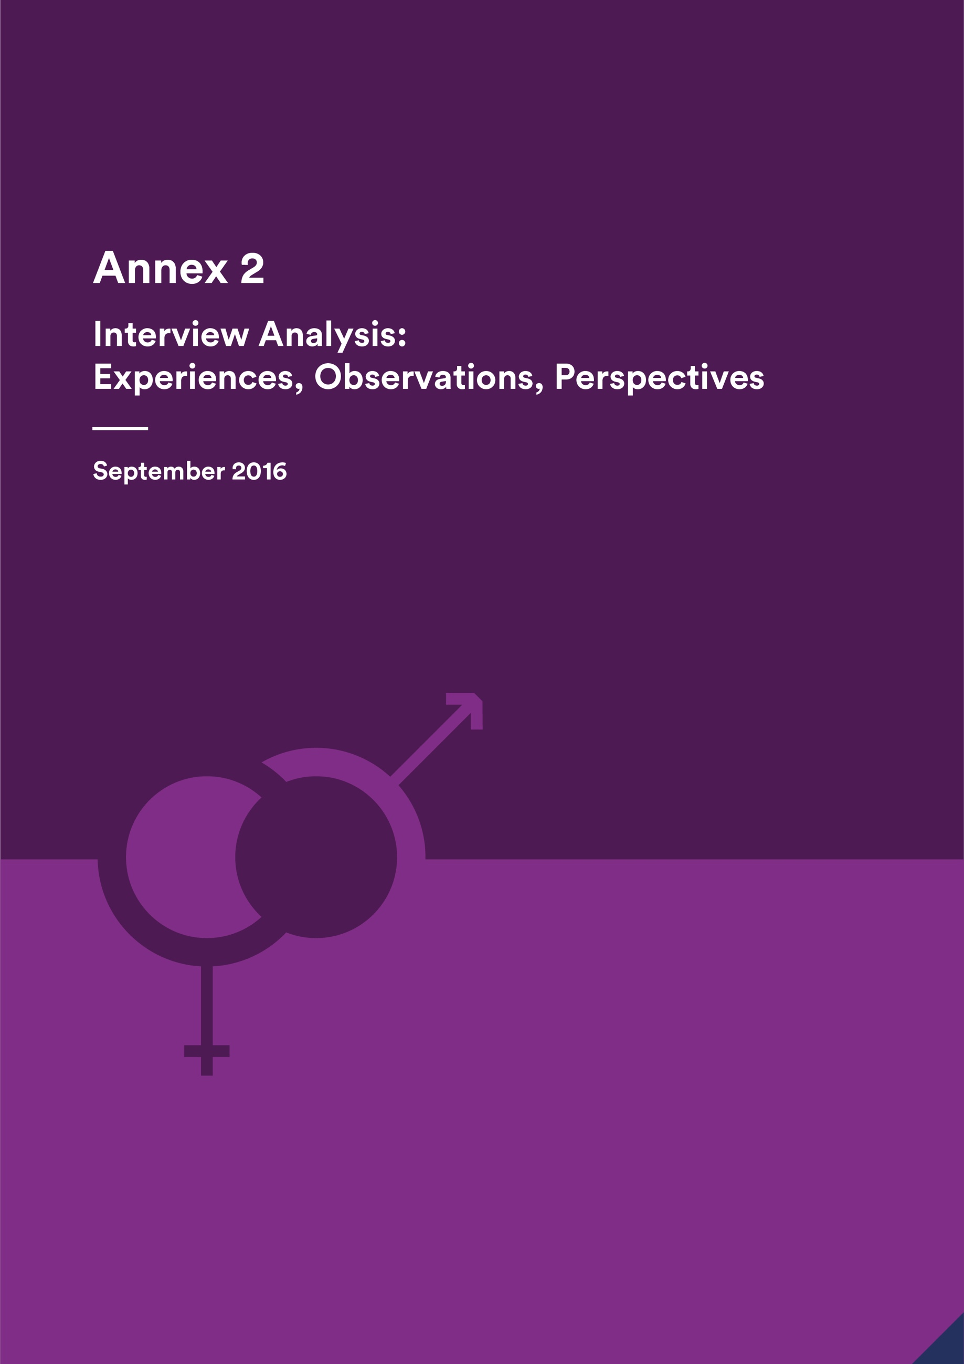

Annex 2 - Interview analysis: experiences, observations, perspectives

September 2016

Indonesia Infrastructure Initiative

This document has been published by the Indonesia Infrastructure Initiative (IndII), an Australian Government supported project designed to promote economic growth in Indonesia by enhancing the relevance, quality and quantum of infrastructure investment.

The views expressed in this report do not necessarily reflect the views of the Australia Indonesia Partnership or the Australian Government. Please direct any comments or questions to the IndII Director, tel. +62 (21) 7278-0538, fax +62 (21) 7278-0539. Website: www.indii.co.id.

ACKNOWLEDGEMENTS

Thanks go to all the persons who participated in the interviews or provided their written responses to the questions. Thanks also go to the people involved in organising the site visits and to the community members who participated. The interview section of this study could not have benefited from such a wide range of ideas without the cooperation of everyone. Comments from IndII personnel on the text of the report were also invaluable.

© IndII 2016

All original intellectual property contained within this document is the property of the Indonesia Infrastructure Initiative (IndII). It can be used freely without attribution by consultants and IndII partners in preparing IndII documents, reports designs and plans; it can also be used freely by other agencies or organisations, provided attribution is given.

Every attempt has been made to ensure that referenced documents within this publication have been correctly attributed. However, IndII would value being advised of any corrections required, or advice concerning source documents and/ or updated data.

CONTENTS

Acronyms and terminology i

Executive summary iii

1. Introduction 1

2. Respondents’ overall comments 1

3. Strengths, achievements and unexpected outcomes 2

3.1 Factors Internal to the Facility 2

3.2 Champions 2

3.3 Increased Government Awareness and Capacity 3

3.4 Recognition of Women Achievers 3

3.5 Activity Achievements 3

4. Areas for improvement 4

4.1 Technical Issues Often Predominate 4

4.2 Lack of Appreciation of the Benefits of Improving Gender Equality 5

4.3 Lack of Strategic Direction 5

4.4 Resourcing and the Belief that ‘Anyone Can Do It’ 5

4.5 Designs Need Improvement 6

4.6 Lack of Information for Consultants 6

4.7 Lack of Gender Dedicated Activities 6

4.8 The Usefulness of PMMs 6

4.9 Lack of Cross Engagement with Other Programs 7

4.10 Limited Attention to Policy Level Change 7

4.11 Human resource concerns 7

5. External challenges faced in implementing gender equality 7

5.1 Capacity and Commitment of Consultants 7

5.2 Capacity of Local Government 7

5.3 Limited Engagement with Women in the Community 8

5.4 Changes of Personnel in Government 8

5.5 A General Lack of Sex Disaggregated Data 8

5.6 DFAT Focus and Resourcing 8

5.7 Changing Social Norms Takes Time 9

6. Lessons learnt and recommendations for the new facility design 9

6.1 Facility Direction 9

6.2 Improved Understanding from The Beginning 9

6.3 Government Capacity 10

6.4 Sanctions and Incentives 10

6.5 Resourcing 10

6.6 Sex Disaggregated Data 11

6.7 Gender Champions and Higher Level Initiatives 11

6.8 The Application and Use of Manuals 11

6.9 Empowering Women in Organisations and as Workers 11

6.10 Communication and Knowledge Sharing 12

6.11 Human Resources Complaints Mechanism 12

Sub- Annex 1: Interview Questions 13

Acronyms and terminology

|  |  |
| --- | --- |
| ACR | Activity Completion Report |
| ADB | Asian Development Bank |
| ADD | Activity Design Document |
| ANDAL | Analisis Dampak Lingkungan |
| AMR | Activity Monthly Report |
| AQC | Aid Quality Check |
| AusAID | Australian Agency for International Development |
| BIP | Bus Infrastructure Program |
| CBO | Community Based Organisation |
| DFAT | Department of Foreign Affairs and Trade |
| EIA | Environmental Impact Assessment |
| EOI | Expression of Interest |
| *Hibah* | Grant/s |
| IAR | Initial Activity Request |
| IndII | Indonesia Infrastructure Initiative |
| IURSP | Indonesian Urban Road Safety Program |
| KIAT | *Kemitraan Indonesia Australia Untuk Infrastruktur* (Indonesia Australia Partnership for Infrastructure) |
| Kopaja | *Koperasi Angkutan Jakarta* (Jakarta Transport Cooperative) |
| KUAT | *Komite Advokasi untuk Aksesibilitas* (Advocates for Accessible Transportation) |
| LG | Local Government |
| M&E | Monitoring and Evaluation |
| MEF | Monitoring and Evaluation Framework |
| NPMP | National Port Master Plan |
| NTB | Nusa Tenggara Barat province |
| PAO | Preparation, Appraisal and Oversight consultant |
| PDD | Program Design Document |
| PIU | Project Implementation Unit in government |
| PKK | *Pemberdayaan Kesejahteraan Keluarga* (Family Welfare Empowerment movement) |
| PMM | Program/Project Management Manual |
| PMU | Project/program Management Unit |
| PRIM | Provincial Road Improvement Program |
| RENSTRA | *Rencana Strategis* (Strategic Plan) |
| RPJMN | *Rencana Pembangunan Jangka Menengah Nasional* (National Medium Term Development Plan) |
| RT | *Rukun Tetangga* (Neighbourhood) |
| RTTF | Road Traffic and Transport Forum |
| RW | *Rukun Warga* (Hamlet) |
| sAIIG | Australia Indonesia Infrastructure Grants for Sanitation |
| TD | Technical Director |
| ToR | Terms of Reference |

Executive summary

Fifty-one people were interviewed (29 women and 22 men) and two site visits were made to collect the qualitative data for this analysis.

IndII’s approach to gender integration was regarded as ‘sound’ and ‘structured and comprehensive’. Most people new to the facility were surprised at the emphasis paid to gender equality and the range of achievements. This was all the more so given its design objective of economic growth through infrastructure provision without reference to gender equality. Strengths included the overall efforts of IndII personnel to integrate gender in their work and the support given by the gender officer; work with women at national, local government and community levels; and achievements in activities such as Provincial Road Improvement Program (PRIM), Indonesian Urban Road Safety Program (IURSP), Australia Indonesia Infrastructure Grants for Sanitation (sAIIG), water hibah and the urban mobility activity.

Areas for improvement included the need for more attention to gender and social issues to counter the predominance of technical and engineering concerns; greater appreciation of gender equality as a factor to improve activity success; improved strategic direction within the facility; attention to resourcing at facility and activity levels; improving activity designs; ensuring that new personnel are briefed and that consultants are clear about what is required; increasing the number of gender dedicated activities; improving Project Management Manuals (PMMs) with regard to gender equality requirements; increased cross engagement with other programs; increased consideration of policy and strategic level initiatives; and attention to some human resources issues. The significant achievements by IndII in promoting gender equality were not always communicated effectively to the Department of Foreign Affairs and Trade (DFAT). Routine reporting and website features were not sufficient. Using Embassy social media in the final year has helped to improve this.

External challenges comprised the capacity and commitment of consultants and local governments (LGs); engaging with women in the community to gain their particular perspectives; changing personnel in government; lack of sex disaggregated data for planning; DFAT resourcing; and the time required and need for consistent efforts to change entrenched attitudes and practices.

Lessons learnt and recommendations for the new facility design included: increasing strategic direction for gender equality in the new facility; efforts to ensure that gender equality initiatives and their value and importance are clearly understood by all stakeholders from the very beginning; efforts to increase LG capacity; having a system of incentives and penalties; improved resourcing at facility and activity levels; allowing for research to increase the availability of sex disaggregated data for planning; identifying more champions and implementing more policy level and strategic approaches to increase gender equality in institutions; improving the application and use of any manuals produced; capacity building and empowering women workers in government and private sectors; increased communication and knowledge sharing; and having a human resources complaints mechanism that women are comfortable with.

A question raised for the new facility was where should gender and disability and other social inclusion issues fit structurally and what is the appropriate term to cover them all?

2. Introduction

The AusAID gender stocktake was undertaken by the gender unit and gender coordinators of AusAID Indonesia to map ways in which gender equality was being integrated in the Australia-Indonesia Partnership. In its first rapid assessment stage, IndII was given a category C rating. This meant that IndII included ‘some elements of gender integration’. In comparison, A was given to initiatives with a ‘gender equality theme’, B to those with ‘effective gender integration’ and D for ‘no gender elements in the initiative’. While being given an original score of C, the second stage of the 2012 stocktake, which was a more detailed survey, found that during operations, IndII’s rating had improved to B for ‘effective gender integration’.[3] This reflects the efforts and commitment of IndII personnel in moving from a design which paid little attention to gender issues in infrastructure, to a program which was successfully integrating gender.

This 2016 evaluation of gender equality in IndII, seeks to identify some of the strengths and weaknesses in IndII’s work and to give lessons learnt and recommendations for the design of the new infrastructure facility. Two approaches have been used to collect information: a review of selected documents which has been completed and this series of interviews.

Twenty-nine interviews with 29 women and 22 men, and two site visits were conducted over 12 days between 29 August and 9 September 2016. This report reflects the experiences, observations and perspectives of the people interviewed. Respondents included IndII facility personnel, consultants on IndII activities, Government of Indonesia (GoI) officers, and DFAT representatives. Site visits were made to a sanitation grant (sanitation *hibah*) location in Bandung, West Java, and the Nusa Tenggara Barat (NTB) Provincial Road Improvement Program (PRIM). During the site visits, meetings and interviews were conducted with representatives of the Antapani community group in Bandung who are beneficiaries of the sanitation *hibah* activity (11 women and 3 men); and in NTB, meetings and discussions were held with consultants, LG representatives, private sector contractors, and members of the road traffic and transport forum on PRIM (4 women and 9 men). In addition, 3 women road maintenance workers and 1 male sub-contractor were interviewed.

A set of key questions were used to guide interviews (see Sub-Annex 1). The questions were adapted as necessary to the context of the interview. The following provides a summary of respondents’ overall impression of IndII’s approach to gender equality, strengths and achievements, areas for improvement, and external challenges. Lessons learnt and recommendations based on the interviews are then provided.

1. Respondents’ overall comments

Respondents were generally positive about IndII’s overall approach to integrate gender. It was regarded as ‘sound, ‘structured and comprehensive’ and as being integrated throughout program implementation. The Gender Strategy and Plan (from here referred to as the Gender Strategy), and its screening tool, provided guidance across the program. Many activity designs for activities which were likely to encounter significant gender issues included relevant gender equality measures. Monitoring and evaluation was conducted for gender differences and outcomes and a gender officer was employed full-time for support.

Some people external to IndII, or who were newcomers to the facility, were surprised at the emphasis on gender equality and also at the facility’s achievements. One respondent thought that IndII was ‘advanced’ in gender equality in comparison with other programs she had worked on. Another person with experience on other programs remarked how ‘consistent’ IndII was with regard to mainstreaming gender. An external consultant said that what was being achieved was ‘incredible’ and another respondent commented that what IndII was doing should be ‘a benchmark’ for infrastructure programs.

However, a number of weaknesses in the overall approach were also noted by respondents. An inherent weakness was the fact that gender equality and women’s empowerment had never been a central part of the IndII program from the design stage – the design was based on improving economic growth through infrastructure, while social and gender issues were not high priorities.

There was also a lack of effective and regular communication with DFAT to successfully get ‘the story across’ about what was being done to strengthen gender equality in the facility and activities. Gender achievements were said to be ‘buried in progress reports’. They needed to be conveyed more clearly and consistently because ‘while it looks like IndII is not doing much, actually some things are being done really well’. More information about gender equality achievements needed to be given in AQCs, including integrating them across other sections of the AQC.

An IndII program officer felt that there was ‘a failure to fully embrace the process of gender integration’ within the facility, indicating a concern that superficial attention was paid, especially in comparison with other issues. It also suggests a lack of capacity and resourcing to give a more focused and effective effort.

Some respondents felt that there was little influence by IndII on government with regard to raising awareness of gender equality issues. On the other hand, others thought that there was some impact. The difference in responses is likely dependent on the activity that the respondents were engaged in.

One respondent thought that there was too much focus on gender equality in the facility, spending time on it when it was not a core activity and losing time and effort when other key IndII objectives, such as the economy, poverty alleviation or improving industry, did not get the same attention. The respondent, along with a number of others, also thought that gender equality was sometimes ‘overplayed’ and ‘like ticking boxes’. These thoughtful and honest comments reflect the lack of a gender equality objective in IndII’s original design and the gradual evolution of a greater emphasis both within the facility and DFAT on efforts to improve gender equality and women’s empowerment. It also reveals the dilemma faced when difficult and complex technical and management issues which are seen as central concerns need a response, while a gender equality response to something which may not be fully explained or understood, or may indeed be less critical but still important to the activity’s success, is called for.

1. Strengths, achievements and unexpected outcomes

3.1 Factors Internal to the Facility

The support provided by the cross-cutting team, especially for designs, was appreciated by the sectoral and communications teams. Having a dedicated gender officer has enabled IndII to push through with workshops and liaise with consultants. Gender capacity building workshops and planning opportunities and the gender strategy as a guide were also commented on favourably.

3.2 Champions

The identification of, and working with, gender champions for leverage within government has been something which has emerged as really important, even though it has been limited. Having gender champions helps to integrate and embed gender equality in the partner institution, as well as helping to smooth over any potential cultural differences to do with the emphasis on gender equality. At local government level, an unexpected achievement was identifying the Bupati’s wife as a champion for sanitation (Australia Indonesia Infrastructure Grants for Sanitation (sAIIG) Palembang). This helped to link sanitation cadres, many of whom were women, with decision makers and gave them feelings of empowerment and enthusiasm.

3.3 Increased Government Awareness and Capacity

Three respondents noted in their comments that they had observed an increased gender awareness in national government as the result of IndII’s persistent work in encouraging change. A Government of Indonesia (GoI) respondent stated that IndII’s support had encouraged gender equality efforts within government. These effects are restricted and likely to be dependent on the activity being implemented and the relationships developed between government personnel and the implementing consultants but are, nevertheless, important to note.

3.4 Recognition of Women Achievers

The inspiring stories series which highlight women’s achievements, often in the face of adversity within their organisations and from other stakeholders, have supported and promoted the work of women leaders within government and the community, giving them recognition and publicity.

3.5 Activity Achievements

3.5.1 The depth of gender integration in PRIM

The PRIM program for road maintenance in NTB has resulted in gender equality being integrated at many levels. A requirement for gender equality to be considered has been inserted in the Governor’s Decree[4] regarding the Adviser Team for Accelerating Provincial Road Maintenance. The Road Transport and Traffic Forum (RTTF) has been reformed under PRIM and more women are involved, including the adviser to the working group and a representative of a women’s non-government organisation (NGO). The idea to involve an NGO to give women’s perspectives came from RTTF members themselves. Public consultations endeavour to include women so that they can express their concerns and there is a quota of 30% women. The process is not particularly successful in reaching women in the community and could be improved. Nevertheless, it has been noticed that where women do attend public consultation meetings they sometimes express different concerns than men with regard to road conditions. This is also the case in RTTF meetings and has highlighted to these observers the benefits of having the contribution of women who might have different opinions than men. In road maintenance works, there have been efforts made to encourage contractors to employ women and a clause is being inserted in their contracts so that they are required to open up job opportunities for women. Women are already employed, often in routine and unskilled work, but some women are hired for skilled work positions where they have the required experience. A barrier to employing women is that, unlike men, they need to return home every evening and cannot remain overnight at the location where the road maintenance is being done.

3.5.2 Increasing safety for women through the urban mobility program

In the Urban Mobility program, particularly for TransJakarta Bus Rapid Transit development, much of the focus has been on universal access, with a focus on people with disability. However, there is also concern for safe, secure and accessible transport for women and other vulnerable groups. The joint research which is commencing with the Australia Indonesia Partnership for Economic Governance (AIPEG) will highlight barriers to women’s use of public transport affecting their participation in the work force and suggest ways to address problems.

3.5.3 Sex disaggregated data about road accidents

Respondents noted that in the Indonesian Urban Road Safety Program (IURSP), the road safety standards insist that the local government identifies differences in women and men’s road accidents. This has the potential to lead to better targeting of road safety efforts. IURSP’s community consultation guideline for government also emphasise gender and disability inclusive approaches to community consultation and a checklist provides a useful tool for local government to follow.

3.5.4 Higher level policy and planning in transport

Inputs about gender equality have been provided to higher level transport documents such as the Rencana Pembangunan Jangka Menengah Nasional (National Medium Term Development Plan) (RPJMN). Gender sections which include gender and social inclusion issues in transport development and the road sector and a gender action plan for government have been provided to the technocratic paper of the Strategic Plan of Directorate General of Highways 2015 – 2019 and the Transport Sector Medium Term Development Plan 2015 – 2019. The action plan includes research, policy development, capacity building, community education, developing a pilot project, an information system and monitoring and evaluation.

3.5.5 The Gender Integration Guide in Institution Based Waste Water Treatment Programs activity

*The Gender Integration Guide in Institution Based Waste Water Treatment Programs* was produced in response to demand for such a manual from the Ministry of Public Works. While community based sanitation programs have often had gender equality measures integrated into their implementation guidelines by donors, there had not been a manual which could be applied by the government to implementing institutional based programs, such as sAIIG. The gender integration guide provides a very comprehensive reference document with practical examples for institutionally delivered sanitation programs. Efforts to formalise it within the Ministry of Public Works are being explored. It is unclear exactly how wide its distribution and application is at LG level.

3.5.6 Encouraging Local Government action through a self-monitoring questionnaire

The sAIIG PMM has a number of gender equality requirements for LGs. A short self-monitoring questionnaire was developed by the sAIIG Preparation Appraisal and Oversight (PAO) consultant to enable LGs to monitor their own progress in implementing PMM requirements. This simple tool has given LGs guidance about what they need to do and has increased their focus on completing the gender equality measures. It has also enabled the PAO consultant to track LGs’ headway and give further encouragement where necessary.

3.5.7 Reducing the burden of water collection through the water *hibah*

The water *hibah* has successfully brought water to the house, addressing women’s practical needs. For women whose water source was previously far from the house, there have been significant savings in time and energy for themselves and those family members who help. Even where water sources are closer to the house and time saved is less, small savings in time over a day accumulate over weeks and months.

1. Areas for improvement

4.1 Technical Issues Often Predominate

Gender integration is not viewed by everyone associated with IndII as being a priority. This may be attributed in part to its original design priorities and ‘because of the ways programs are managed and structured around engineering and technical issues’. The notion that gender equality is expected to be improved was often not introduced at the beginning of activities because of the focus on technical issues. It was frequently raised part way through implementation, even where it was identified as important in the activity design document. This sometimes resulted in it being considered an ‘add-on’ and a ‘burden’.

It was noted by a number of respondents that ‘activities are not very effective unless, from the very beginning of the design, there is recognition of gender interventions – it is difficult to introduce in the implementation stage’. There also needs to be regular follow-up to ensure that it remains a priority.

New personnel in the facility and amongst consultant teams needed better briefing on the importance placed on IndII’s gender equality approach (and other policies such as disability and child protection) and what it meant to their work. While some respondents did use the website to find out information about gender equality in IndII, more attention was needed to systematically meet new personnel and provide information and answer questions about the facility’s gender equality approach and how it applied to their work.

Lack of a clear understanding of gender equality also contributes to a lack of focus and importance. People within government, consultants and some within the facility, still have different understandings about what gender is about. Gender has often been understood merely as ‘women’s business’ and that all that is needed is to have a number of women involved. This is often seen as all that is required without analysing whether or not women actually have influence on decision making or benefit strategically. More effort could have been given to ensuring common understandings across stakeholders to increase the priority given to gender equality in the program.

4.2 Lack of Appreciation of the Benefits of Improving Gender Equality

It was felt by some respondents that gender equality was something which was being implemented in IndII because it was pushed by the donor rather than being seen as ‘a success factor’ which could improve a program’s social and economic impact. A number of respondents raised the need for more efforts to ensure that people understand the reason why gender equality is so important - its value, including the improved targeting of initiatives; support for the rights of women; and the substantial social and economic benefits which can be obtained which contribute to activity and overall program impact and success.

4.3 Lack of Strategic Direction

Concern was expressed about the rather *ad hoc* arrangements for implementing the gender equality approach at facility level. The approach lacked strategic direction and objectives of what was hoped to be achieved including yearly work plans linked to program targets. While routine work was undertaken, such as inputs into activity designs, there was not a clear program of work which linked directly to IndII’s water and sanitation, transport and policy and investment programs. In concert with this, there was not a clear list of outcomes, targets and key performance indicators to be achieved in implementing the workplan. A lack of key objectives meant that monitoring of efforts and follow up for non-performance in implementing activities has not been as effective as it could be.

Although there is a national gender specialist, it was thought that more support was required at a strategic level to drive the direction of the facility’s initiatives, help leverage opportunities with GoI and LGs, and monitor follow-up. Counterparts needed to be more aware of activities’ gender equality objectives and initiatives and what was required. Better resourcing and an approach which was strongly linked to objectives and targets was required. This is particularly critical given the size and range of the IndII program.

4.4 Resourcing and the Belief that ‘Anyone Can Do It’

Gender and social measures were sometimes viewed at facility level as being easy to implement and as something anyone could do effectively. One person remarked, ‘there is probably a tendency to think that anyone can do it’. Another commented, ‘There is a view that engineers can do everything but they really can’t.’ There was also some concern expressed about the ability to identify good gender specialists to work on activities and whether some gender consultants who were appointed to activities really had sufficient background and experience for the position because it was not seen as key.

4.5 Designs Need Improvement

Gender needed to be integrated into activity design documents in greater depth and detail, and with greater consistency. While some designs were felt to be good, there was sometimes a lack of effective identification of the key gender equality issues to be addressed and the measures required. Some designs for activities which had significant gender equality issues lacked gender objectives, outputs and outcomes which were clearly defined and would enable monitoring. This reflects a number of difficulties, including the time available for gender input into design and the lack of opportunity for a gender analysis in the field to identify issues and the potential ways to address them, especially for large programs. The gender issues identified in activity designs were usually from common knowledge rather than being verified in the field. There was concern that in the management of activity designs, the cross-cutting team was sometimes omitted from providing inputs. There was also concern expressed that from time to time there was a lack of thought and examination of the specific needs of the activity with ‘cut and paste’ of wording from previous activities being re-applied, even when it was not exactly relevant to the activity.

4.6 Lack of Information for Consultants

As well as information about IndII’s gender equality focus generally, a number of implementing contractors said that they needed gender briefings specific to their activity so that they had a better understanding of what was really required. There was concern expressed that there needed to be more information provided about what to do in ways which translated generic statements about obligations to more specific and practical actions. This was particularly the case when there was no gender specialist position on the team but there was still a need to achieve significant gender equality outcomes (eg PRIM). Teams with no gender equality background found that this was a considerable burden to them on top of their other responsibilities. Some consultants asked for gender manuals specific to the sector they were working in to support them. More thought needs to be given to what support is required and what resources are available for consultants so that they can better perform.

4.7 Lack of Gender Dedicated Activities

In Phase II, attempts were made to implement gender dedicated activities which would support existing programs. The respective technical director was to be responsible for their management. However, while it had been hoped to have a number of these type of activities, the only one which succeeded in being implemented was the Gender Integration Guide in Institutional Based Waste Water Treatment Programs. A number of factors contributed to the lack of gender dedicated activities, including that amongst IndII facility management it was thought at that time that it might be difficult to get DFAT approval for an activity in an infrastructure program which was specifically dedicated to encouraging gender equality.

4.8 The Usefulness of PMMs

PMMs need to be used to clearly articulate what needs to be done with regard to gender equality, especially in programs with substantial gender issues. This is not always the case. For example, the PRIM program has a number of gender equality issues but a PRIM consultant noted that the PMM did not include specifications about what was to be done.

On the other hand, the sAIIG PMM has practical and clear guidelines to support governments to implement gender equality measures. However, ensuring that government reads and follows the guidelines about gender equality is also needed. The self-monitoring questionnaire which has recently been introduced by the new PAO (see 3.5.6 above) has assisted. Nevertheless, there needed to be more support from the commencement of the program to ensure that government and consultants understood and implemented what was required in the PMM.

4.9 Lack of Cross Engagement with Other Programs

A lost opportunity observed by respondents was to work with other DFAT programs such as MAMPU or KSI on gender activities which bridge IndII and the other program’s focus.

4.10 Limited Attention to Policy Level Change

A lost opportunity was seen to be the possibility of working more strongly and effectively at higher levels within government and influencing how gender issues were addressed in different aspects of infrastructure policy and planning. Associated with this is the disappointment that not more gender champions were identified at policy level, including male champions. A missed opportunity observed by a GoI respondent was for greater cooperation with the Ministry of Women’s Empowerment and Children at national and local government levels. There was some concern expressed by a GoI respondent about the level of coordination between the facility and GoI regarding the implementation of gender equality initiatives. This included ensuring that the Project Management Unit (PMU) was clear about the gender objectives of an activity, the benefits to the program, and what was expected to be achieved.

4.11 Human resource concerns

Within the facility some female national staff raised concerns about perceived gender inequalities in the facility’s human resources policy. The human resources policy for national personnel is based on Indonesian Labour law, and may reflect gender assumptions and possible biases. For example, health insurance is provided for men as heads of households and for their families, while for women employees, the same is not given unless they are heads of household. On the other hand, while women receive parental leave, men do not. These issues are being investigated further by SMEC. Some staff may not be aware of existing channels to address these types of concerns in the facility or may feel reluctant to raise concerns with management.

1. External challenges faced in implementing gender equality

5.1 Capacity and Commitment of Consultants

Lack of commitment and limited gender capacity of some consultants with regard to the implementation of gender equality measures is seen as a challenge. Technical people on consultant teams are focused on how to achieve technical impact and often think of gender as something further to do and a compliance issue. There is not a clear understanding that gender equality will contribute to overall activity success. Within contractor teams, team leaders and engineers were often asked to convey information about the gender measures expected to be implemented to other team members and this is not always done well. Consultants did not always report in detail what was being done about gender equality and what was being achieved. Reporting was often very general, which may indicate that it is merely a ‘box ticking’ exercise, or perhaps, that the consultants do not have sufficient gender capacity to be able to report in detail. Contractors did not always pay sufficient attention to the qualifications and standard of gender specialists that they recruited and, in some cases there was poor gender analysis of data. It was noted by several respondents that there is no penalty applied for failure to perform what is required with regard to gender equality at any level.

5.2 Capacity of Local Government

Local government priorities, capacity and commitment to do with gender equality was viewed as a significant challenge by many respondents, although this varied by location with some local governments regarded as having greater capacity than others. There was also concern about the need for a stronger focus on, and resourcing for, practical approaches to building capacity with local government and the need for strengthening gender equality understanding in communities. Decentralisation, and limited GoI and LG capacity in some cases, means that even if there are efforts by the national government with regard to increasing gender equality in activity implementation, it may not be effective.

5.3 Limited Engagement with Women in the Community

The opportunity for women to express their needs and ideas was seen as something which was valuable but was a challenge to achieve. Gender equality issues which are inherent in community engagement such as socialisation, marketing, customer service or public consultation by local government organisations, and some consultants, are poorly dealt with. This is partly because of the focus on infrastructure construction and technical matters in activity designs coupled with the assumption that LG already has effective community engagement practices in which women have equal opportunity to express their opinions. However, this is often not the case.

An example of gender inequality provided in the interviews was that women were often excluded from *Analisis Dampak Lingkungan* (ANDAL) or Environmental Impact Assessment (EIA) meetings which were usually held at night and where only one person from the household is invited to attend. A lack of community engagement was also found during the site visit to the Antapani community group in Bandung. Although they were eventually beneficiaries of the sanitation *hibah* program, the group, whose majority membership were women cadres, saw the need for sanitation improvements in their neighbourhoods. However, the sanitation unit (PDAM) did not engage with them initially and they were the primary instigators in obtaining the service.

A comment with regard to the Urban Mobility program’s impact was that it was ‘good getting community involvement’ in lobbying for safe, secure, universal access for women and people with disability. This was also the case in PRIM’s Road Traffic and Transport Forum (RTTF) where women’s NGO representatives have raised different issues for consideration than were expressed by male members. These examples point to the benefits of having a greater focus on engaging with communities and ensuring that those with particular needs, such as women and people with disability, are able to express them.

5.4 Changes of Personnel in Government

Changing personnel within GOI or at LG level meant that someone with capacity and interest in improving gender equality may be lost when there is a change of staff, or a gender champion might not have the same ability to influence after being reassigned to a different position.

5.5 A General Lack of Sex Disaggregated Data

Some respondents observed that there was generally a lack of data available to identify important gender issues which need to be addressed. The water and sanitation socio-economic surveys are providing some useful sex disaggregated data. However, it was noted by respondents that unfortunately the results of these were not available early enough for the local government to apply in the socialisation for the water *hiba*h.

5.6 DFAT Focus and Resourcing

While there has always been concern with gender and social equality within DFAT and, in recent years this has increased in importance, historical priorities within the infrastructure section were considered by some respondents as being focused on economic growth and building infrastructure. There is a perception that some personnel within the section might still not support gender dedicated activities or particular efforts to integrate gender equality. DFAT itself recognises that they have limitations because of limited resourcing and no dedicated gender adviser for Indonesia. Without this, there is a gap in assessing the quality of program gender equality efforts.

5.7 Changing Social Norms Takes Time

Gender equality often means changes to social norms and practices in communities and households, for example, in getting more women routinely employed in road maintenance work on PRIM. Changing entrenched attitudes and practices is a slow process which needs time and consistent effort to produce. There needs to be frequent assessment of what changes have been achieved, what is necessary to improve outcomes and the best strategy to use. Small improvements need to be appreciated because changing attitudes and values is not an easy task.

1. Lessons learnt and recommendations for the new facility design

This section presents lessons learnt and recommendations based on an analysis of respondents’ comments in the interviews.

1. Facility Direction

Issues were raised by a number respondents indicating a lack of direction in the facility. This affected gender equality targeting, outcomes and impact. Recommendations resulting from analysis of responses is as follows:

IndII lacks a gender equality objective and this means that gender is sometimes seen as something being imposed on personnel to perform without real basis in the facility’s design. Gender equality and women’s empowerment should be included in the new facility’s objectives to provide focus and as an overall statement of intention for the facility.

A respondent suggested that a framework with objectives and indicators to guide gender and social inclusion efforts by the facility should be created in line with DFAT priorities. This could build on a reframed gender strategy and be directed to the achievement of the overall facility gender equality/women’s empowerment objective. Gender workplans should be integrated into sectoral program workplans to be strategically actioned where they can be most effective, instead of being *ad hoc*. An international specialist – gender/and or M&E - should be resourced and responsible for developing a strategic plan and working with the technical teams to achieve it.

It was suggested in the interviews that a gender equality and social inclusion team should be positioned within the new facility’s structure with its own management and authority and greater ability to link to and be included in the sectoral programs.

More effective key performance indicators need to be identified, including for sub-projects, and stronger efforts need to be put into monitoring the progress of implementation, addressing problems quickly and reporting what is achieved in detail. This would also assist in AQC reporting.

1. Improved Understanding from The Beginning

Many respondents pointed to the fact that, from the beginning, all stakeholders should be aware of program and activity gender objectives and clear about what was required to be done in order to ensure that gender was given adequate priority.

It was recommended by respondents that more time and resources should be provided in the early stages of implementation to ensure that all stakeholders, including government partners, knew what was expected and that priority was to be given to gender equality. This needed reiterating and reinforcing throughout implementation.

In the interviews, a number of implementing consultants asked for more detailed guidance about what they needed to do, especially when their team did not include a gender specialist. Activity designs with important gender implications need to be clearer and more specific, including having gender objectives, clearly defined gender indicators, and adequate gender resourcing of the team. Developing designs needs more time and resources to identify the gender needs of the activity. This may include field visits to collect relevant data.

Briefings and discussions about gender issues need to be held regularly with all stakeholders throughout activity implementation. Manuals or Standard Operating Procedures for gender equality in the various sectors were also suggested in the interviews. In addition, some respondents noted that when there were changes of facility or government personnel, or of contractors, comprehensive gender briefings should be given as a matter of course to ensure that the new personnel knew what was necessary.

Several respondents noted that an understanding of the value of gender equality for increased overall activity/program impact was lacking and that this influenced the willingness and commitment to implement gender measures or address gender equality issues. From the initial stage of an activity, gender equality needs to be highlighted as a practical means of improving its social and economic benefits and the ‘how, why and where’ these would contribute to success made clear.

1. Government Capacity

A common comment was that local government often had very limited capacity as far as gender equality was concerned and that this affected the implementation of gender responsive initiatives. Both government and consultant comments recommended that capacity building was required but that it needed to be well resourced, as practical and ‘hands on’ as possible, and based on real experience. It was observed that ‘one-off’ efforts were often insufficient and that there needed to be assessments of where follow-up capacity building with government was needed to get better outcomes.

Self-monitoring questionnaires for LGs in sAIIG are showing to be quite useful in providing guidance and focus for government and something similar could be designed and used to direct efforts in other programs.

A government respondent noted that discussions and meetings with PMU should not just focus on technical issues but stress what is required in activities/programs as far as gender equality is concerned.

Other comments indicate that there should be better use of PMMs to clearly specify gender initiatives for implementation by government partners. The documentation about gender initiatives should not just be confined to an annex but be integrated in the PMM’s main text with clear pointers to guide readers to gender equality actions.

1. Sanctions and Incentives

It was noted by some respondents that contractors do not always do what is expected of them with regard to implementing what is required regarding gender equality in the activity design or their TOR but there are usually no penalties or incentives applied.

It was recommended that a system of performance based sanctions and incentives for the achievement of gender outcomes be put in place. With regard to government performance, it was specifically recommended by a contractor engaged on a grant program, that MoF should be involved in applying sanctions and incentives for LGs implementing grant programs.

1. Resourcing

The negative impact of inadequate gender resourcing for both the overall program and individual activity implementation was a frequent observation of respondents interviewed.

At facility level, it was recommended by respondents that there should be sufficient dedicated gender resourcing to provide direction and drive gender equality in the facility; to engage with governments at different levels; to monitor contractor’s work; and also to manage any gender dedicated activities which were identified. An engineer remarked that this ‘cannot be farmed out to non-gender specialists who have their own tasks and focus’. Ideally, a gender specialist should be part of each sectoral team.

In activity designs, positions for gender specialists need to be included in all activities which have significant gender implications. Adequate length of input should be allowed. This has not always been the case. The background and quality of gender specialists put forward for the contractor teams need to be assessed by gender specialists in the facility, rather than being left to non-gender specialists. The timing of their inputs in activities also needs to be monitored. Too often, short gender inputs have been completed before they can be used to optimal effect.

1. Sex Disaggregated Data

A few respondents remarked on the limited amount of sex disaggregated data available for planning. In one case, it was noted that a survey had been conducted but its analysis was completed too late to assist LGs to better design their socialisation activities.

It is recommended that research activities be identified to collect and analyse sex disaggregated (quantitative and qualitative) data in order to identify gender issues which will assist planning the new facility’s activities and for government implementation, and which will also provide benchmarks for measuring gender benefits.

1. Gender Champions and Higher Level Initiatives

A number of respondents felt that identifying more gender champions within GoI is important to drive the agenda within government and strengthen gender initiative implementation. It is important to look for men as well as women as champions, in order to reduce the tendency for gender to be seen as a woman’s issue and to gain greater leverage amongst men.

Government and a number of consultant respondents recommended that there should be more efforts to engage with the State Ministry of Women’s Empowerment and Children. This would provide more support for gender initiatives at ministerial level and also at local level through the local government women’s empowerment units (*Badan Pemberdayaan Perempuan*).

Some respondents recommended analysis of infrastructure policies and strategic planning be conducted to identify where it would be beneficial for gender equality to be integrated and what is required.

1. The Application and Use of Manuals

Guides for government which integrate gender equality into institutional-based sanitation and public consultation procedures for road safety have been produced by IndII. As yet they are not in general use or formalised by government. Unlike technical manuals, gender manuals are often not viewed as essential tools by the people who it is hoped will use them.

It is recommended that attention should be paid to obtaining stakeholder agreement and documentation of the plan for any manual’s application before it is produced – for example, how will it be tested and piloted, how will it be distributed, how will capacity building be provided for its application, how will it be institutionalised, and how will the manual’s use be monitored and evaluated.

1. Empowering Women in Organisations and as Workers

A number of respondents who worked at local government level noted that more support could be given to empower women in operating organisations, for example sanitation units, where there are larger numbers of women personnel. It was suggested by one respondent that this could involve providing greater opportunities for networking between these women; identifying what is needed to improve their capacity; mentoring; and other person to person approaches which give guidance and training and opportunities to develop their capacity.

Consideration should also be given to identifying other opportunities to encourage women outside government to gain better skills so that they can gain employment in activities, for example training to enable women to be employed in higher paid work on the PRIM road maintenance activity was suggested by a LG respondent.

1. Communication and Knowledge Sharing

Several respondents noted that there are many benefits to be gained from communicating about, and promoting, gender equality to a wider audience through a range of communication channels.

A recommendation was made that within the facility there should be more opportunities for knowledge sharing about gender equality initiatives, the challenges faced and what is successful. For example, meetings and discussions could be held about gender in selected activities. A similar recommendation from a consultant was that consideration be given to providing opportunities for more sharing of ideas between implementing consultants from various activities and IndII personnel about the gender issues that they are facing and the approaches which are being taken. It was also suggested that these knowledge sharing opportunities could be integrated into the monitoring and evaluation process by assessing strengths, weaknesses, lessons learnt and follow up and incorporating them into M&E reports.

It was recommended that there should be knowledge management with the packaging of information about gender issues and gender equality impacts. This was seen as important to show consistency and to leave a legacy of institutional memory with well documented activities so that, both internally and externally, people knew what was being done about gender equality through the facility and why.

Some respondents noted a lack of knowledge sharing with other programs about gender equality. There was a recommendation that there should be more cross-engagement with other programs, such as MAMPU and AIPEG, about what each is doing so people can learn from each other’s experiences. This could also assist in initiating joint projects between programs. A question raised was, does DFAT have a role to play in initiating this engagement between programs?

A further recommendation was that systematic, explanatory and detailed reporting be provided from the facility to DFAT about what is being achieved with regard to gender equality to ensure that the full story, both positive and negative, is clear to the donor.

1. Human Resources Complaints Mechanism

Some women respondents expressed concerns about human resources issues.

A recommendation is that a complaints mechanism which staff are comfortable with should be identified to deal with personnel issues in the new facility. Whilst there is a complaints mechanism in place, it should be ensured that all personnel know about the mechanism and are clear about how to access it, and that new personnel are briefed. It is recommended that a woman be included as one of the persons to whom grievances can be made.

Sub- Annex 1: Interview Questions

1. **Key Evaluation Questions (KEQs)**
2. This review is guided by four key evaluation questions: Were the strategic objectives of the IndII Gender and Strategy and Plan achieved? (If so, what is the evidence? If not, which ones – and why not?)
3. What worked well and should be repeated (why)?
4. What didn’t work well? (Why not?)
5. Based on 1,2 and 3 above, how can gender objectives be best achieved in the new facility? (What are the specific, practical design recommendations?)
6. **Interview Question**

|  |  |  |
| --- | --- | --- |
|  | **Question** | **Informs KEQ** |
| 1. | What is your role (or involvement) in promoting IndII’s gender objectives? | Respondent capacity to respond (KEQ 1–4) |
| 2. | What is your overall impression of IndII’s approach to gender? | 1 |
| 3. | Do you (did you) have any concerns about the way gender equality has been implemented by IndII? (Strategically? Operationally? Culturally?) | 3 |
| 4. | What do you think are the main achievements (if any?) Please provide an example. What were the reasons for this achievement? | 1, 2 |
| 5. | Have there been any disappointments or missed opportunities? What were the reasons for this do you think? | 1, 3 |
| 6. | Have there been any unexpected outcomes or surprises? What were the reasons for this? | 1, 2, 3 |
| 7. | What internal factors (positive and negative) have impacted on the ability/capacity to meet gender outcomes? What external factors (positive and negative) have impacted on the ability/capacity to meet gender outcomes? | 2, 3 |
| 8. | What would you see as being the most significant change to do with gender equality as a result of IndII? | 2 |
| 9. | What lessons can be learned from IndII’s gender integration process (positive and negative)? | 2, 3, 4 |
| 10. | Based on your experience, is there anything you would do differently (if so, what would that be)? | 3, 4 |
| 11. | If the design team for the new IndII (KIAT) asked you for advice, what would be the 3 things you would tell them to do? What are the 3 things you would tell them not to do? | 4 |
| 12. | Is there anything else you’d like to say to us? | 4 |

Specific questions will get responses that only the interviewee can provide.  The questions depend on the person/institution being interviewed and their program knowledge, role or expertise.  Some have detailed knowledge of IndII, others have less. The specific questions are based on the domain eg – policy level, program level, activity level, implementing level, receiving (benefiting) level.

The interview questions by category of respondent are summarized in below table.

| **Interviewee Category** | **Interview Questions** |
| --- | --- |
| DFAT | * What is your overall impression of IndII’s approach to gender? * What do you think are the main achievements (if any)? Please provide an example. Have there been any disappointments or missed opportunities? What do you think is necessary to do it better another time? * Were there opportunities for DFAT to highlight IndII’s gender concerns more forcefully to stakeholders? Where? * From your observations, could IndII have been more proactive about its gender equality objectives in meetings with key stakeholders? * Was there anything you were surprised about (positives/negatives)? * What do you see as being the most significant change in gender equality as a result of IndII? * Can you give your opinion on these three issues (if not raised previously): * How could IndII have done better to show gender equality achievements in its reporting? * Do you think you have been able to give as much guidance to IndII as you would have liked on what is required by DFAT with regard to gender equality? Why/why not? What would help to improve the situation? |
| IndII (Management, POs, Comms and M&E team) | * What is your overall impression of IndII’s approach to gender? * Do you (did you) have any concerns about the way gender equity has been implemented by IndII? (Strategically? Operationally? Culturally?) * How effective was the gender integration process under your activity in delivering the task? What were the main challenges faced? * Is there any significant effort made to strengthen gender equality in the activity? * What do you think are the main achievements (if any)? Please provide an example. What were the main reasons for being successful in these achievements do you think? * Have there been any disappointments or missed opportunities? What were the reasons for the disappointments or missed opportunities? * Have there been any unexpected outcomes or surprises? What were the reasons? * What internal factors (positive and negative) have impacted on the ability to meet gender outcomes? * What external factors (positive and negative), have impacted on the ability/ capacity to meet gender outcomes (eg.: barriers/opportunities within government setting/ infrastructure programs, etc). * What would you see as being the most significant gender change (eg in government, civil society, other) as a result of IndII? * What lessons can be learned from the gender integration process (positive and negative)? * Based on your experience, is there anything you would do differently with regard to gender (if so, what would that be)? * If the design team for the new IndII (KIAT) asked for you advice, what would be the 3 things you would tell them to do? And what are the 3 things you would say not to do? * Is there anything else you’d like to say to us? |
| IndII’s gender officer | **Additional questions to the generic questions above**:   * You have mentioned a gender performance review. What was it and what were the results? * IURSP appears in the documents to be very successful at integrating gender throughout. What have been its strengths and weaknesses if you look at the gender outcomes? From your perspective as IndII’s gender officer, what have been the key elements which have enabled this to happen? * What have you found out from the sAIIG workshop about applying the Guide to Integrate Gender in Institution Based Sanitation? * Can you talk about workshops that were more successful and what made them so? What is necessary so that workshops are more effective in bringing about changes in attitudes and behaviour towards gender equality? |
| Implementing consultant team leaders and members/Gender experts | **Generic questions**   * What is your overall impression of IndII’s approach to gender equality? * Do you (did you) have any concerns about the way gender equity has been implemented by IndII? (Strategically? Operationally? Culturally?) * What has been done to improve gender equality through the activity? * What do you think are the main gender equality achievements (if any) in the activity/program you have been implementing? Please provide an example. What were the main reasons for being able to obtain successful outcomes do you think? * Have there been any disappointments or missed opportunities? What were the reasons for the disappointments or missed opportunities? * Have there been any unexpected outcomes or surprises? What were the reasons? * What internal factors (positive and negative) have impacted on the ability to meet gender outcomes? * What external factors (positive and negative), have impacted on the ability/ capacity to meet gender outcomes (eg.: barriers/opportunities within government setting/ infrastructure programs, etc). * **INSERT THE SPECIFIC QUESTIONS BELOW AS THEY ARE RELEVANT TO RESPONDENTS** * What lessons can be learned from the gender integration processes (positive and negative) that you have experienced? * Based on your experience, is there anything you would do differently with regard to gender (if so, what would that be)?   **QUESTIONS RELATING TO SPECIFIC ELEMENTS OF THE PROGRAMS FOR INSERTION IN THE GENERIC QUESTIONS ABOVE**  **Transport**  PRIM   * Were there any changes in practices in the implementation of public consultation to improve gender equality? What were they? How effective has it been? What have been the benefits for women? How have men reacted? How can they be sustained? * What was needed to involve more women in the RTTF? How are women participating in the functions of the RTTF (consider quality of participation)? Another time, what is to make it easier to ensure more women are involved and are able to participate equally with men in an organization such as the RTTF? How can this be sustained? * How are women being employed in road maintenance? What are the main challenges to getting women employed in road maintenance? How is the program responding? * IURSP * IURSP has assisted LGs in developing planning process and universal design for integrated urban road safety, could you explain how gender integration is applied in the activity? * What have been the key elements in ensuring gender equality has been prioritised? * What has been the LG reaction to the gender equality aspects of the program? How have you encouraged LGs to recognize and embrace the gender inclusive aspects of the program? * How effective is the participation of men and women within the activity such as public consultations, access to the program which has been developed, and the benefits of the program to men and women including design for all (children, women, older people, PwD, etc) What improvements could have been made to obtain greater participation and benefits? * Has the gender responsive consultation manual for LGs been applied by government and what has been the response? What is being done to sustain its use after the program? * Urban Mobility * What are the gender issues in urban mobility? How does the activity respond? * How effective is the gender integration process under your activity in delivering the task? For the example: the series of Gender Workshops, video development, accessible bus testing and the advocacy activity done by KUAT (advocacy working group)? * What has been successful and not so successful about the workshops? How would you do the workshops better another time? * Of the gender equality activities in the program what do you see as the most effective in bringing about change? * RPJMN/ Renstra MoT * What is the key message of the integration of gender in the formulation of RPJMN as well as Renstra DGH and MoT? * Were there any changes in the policy and strategy in the transport program regarding gender and integration issues as a result of the inputs? * Was there anything that could have been done to make them more effective in bringing about change (eg was the content useful, how were they socialized, what follow up was required, other)?   Water and Sanitation   * Water and Sanitation Hibah * There are a lot of gender and social inclusiveness issues included in the socio-economic survey questionnaire, how do you use all of these data in addressing and analyze gender issues in safe water sector? * What use has been the information for improving the implementation of the program? * What could have improved the data collection and analysis process to make it more useful? * sAIIG * IndII and MPW have developed a Gender Integration Guide for Institution-Based Wastewater Treatment, what is your opinion about the guideline? * Is it currently being used? Who is using it? How? * How effective is the manual in improving gender integration within activity? * What could improve its use into the future? * NTT/NTB Water Governance * What is the progress of establishing the Forum Pelanggan PDAM in each district/LG? * How are women being involved in the Forum Pelanggan? * How are women being involved at community level? * What obstacles are faced to their involvement in the forum and at community level? * What is necessary to encourage their greater participation in (1) the forum and (2) at community level? |
| GoI (Central Policy Makers and counterpart implementing agencies, incl. PDAMs) | * What is your role (or involvement) in promoting IndII gender objectives? * What is your overall impression of IndII’s approach to gender equality? * Do you (did you) have any concerns about the way gender equity has been implemented by IndII? (Strategically? Operationally? Culturally?) * What would you see as being the most significant change as a result of IndII? What are the main achievements? * Have there been disappointments or missed opportunities? * Are there some areas which are particularly weak? Why? * How have women in your organization benefited from IndII’s support? Has this improved gender equality within your organization do you think? * What are the barriers to implementing gender initiatives in infrastructure programs? * What are the barriers/ challenges to sustaining successful gender initiatives? * What opportunities exist which can be leverages to implement and sustain gender initiatives in infrastructure programs/ departments? * What lessons can be learned from IndII’s gender integration process (positive and negative)? * Based on your experience, is there anything you think should be done differently to improve gender equality outcomes (if so, what would that be)? * Is there anything else you’d like to say to us? |
| Women beneficiaries | * Did you participate in the sanitation program? Please explain how you participated and why? * What were its successes? * What were its problems? * Did you benefit from this activity? If yes, how (consider physical benefits such as provision of water, sanitation as well as personal such as skills, confidence, participation in organisations etc)? * How did you hear about the program? From whom? Did a facilitator or the Local Government approach you directly? * Did you feel women were invited to participate as well as men in all aspects of the program, or did you think only men could participate? Why? * What are the obstacles for women to participate in programs like … (name of program)? * What do you think could have been done better to encourage more women to participate? * Were there some things where you think women could have been involved but were not (eg committees, meetings, …)? * How do you think men benefited? Do you think that women and men benefited fairly or unequally? Why? * What would you see as being the most significant change for you as a woman as a result of the IndII activity? |
| Men beneficiaries | * How did you participate in the sanitation program? * What did you think was successful about the …? * What was unsuccessful? * How were men involved in the program? How were women involved? * How could women have been encouraged to be more involved? * How could men help women to participate more another time? * What did you learn about the need to involve women equitably with men from the ….. (program name) |

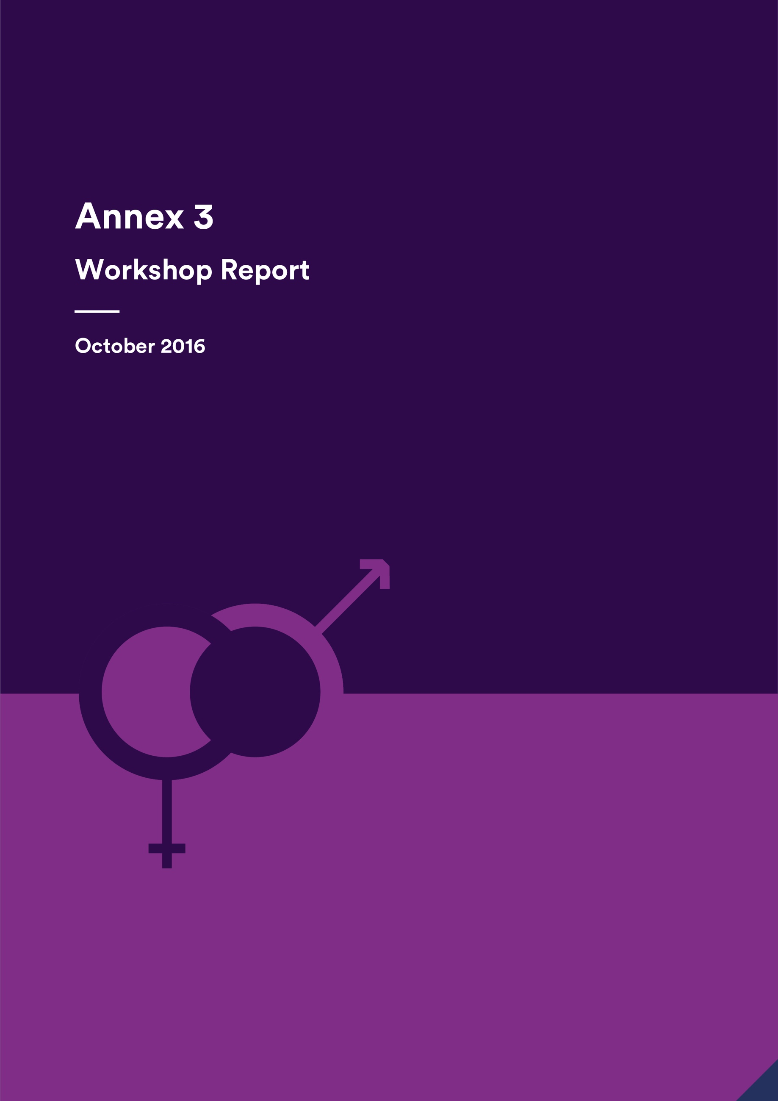

Annex 3 - Workshop Report

October 2016

Indonesia Infrastructure Initiative

This document has been published by the Indonesia Infrastructure Initiative (IndII), an Australian Government supported project designed to promote economic growth in Indonesia by enhancing the relevance, quality and quantum of infrastructure investment.

The views expressed in this report do not necessarily reflect the views of the Australia Indonesia Partnership or the Australian Government. Please direct any comments or questions to the IndII Director, tel. +62 (21) 7278-0538, fax +62 (21) 7278-0539. Website: www.indii.co.id.

ACKNOWLEDGEMENTS

Thanks go to all those people involved in organising and running the workshop, especially Mr Eko Utomo and Ms Arya Geikie whose notes were invaluable, and to those who participated and engaged in the discussions so enthusiastically.

© IndII 2016

All original intellectual property contained within this document is the property of the Indonesia Infrastructure Initiative (IndII). It can be used freely without attribution by consultants and IndII partners in preparing IndII documents, reports designs and plans; it can also be used freely by other agencies or organisations, provided attribution is given.

Every attempt has been made to ensure that referenced documents within this publication have been correctly attributed. However, IndII would value being advised of any corrections required, or advice concerning source documents and/ or updated data.

CONTENTS

Acronyms and terminology i

Executive Summary ii

1. Introduction 1

2. Workshop summary 1

3. Key points from the questions and answers 1

4. Discussion Summary 2

4.1 Topic 1 - Objectives 2

4.2 Topic 2 - Focus 2

4.3 Topic 3 - Resourcing 3

4.4 Topic 4 - Community Engagement 3

4.5 Topic 5 – Incentives and Sanctions 3

4.6 Topic 6 - Leveraging Opportunities at GoI Policy and Strategic Levels 4

4.7 Topic 7 - Joint projects with Other Programs 4

4.8 Topic 8 - Empowering Women at Local Government Level 4

5. Groups’ prioritisation of discussion topics 5

Sub-Annex 1: Workshop Terms of Reference 6

Sub-Annex 2: Slide Presentation 9

Sub-Annex 3: Summary of Questions and Answers 18

Sub-Annex 4: Group Discussion Points 19

Acronyms and terminology

|  |  |
| --- | --- |
| AIPEG | Australia Indonesia Partnership for Economic Governance |
| Bappenas | *Badan Perencanaan Pembangunan Nasional* (National Development Planning Body) |
| CBO | Community Based Organisation |
| CSO | Civil Society Organisation |
| DFAT | Department of Foreign Affairs and Trade |
| GESI | Gender Equality and Social Inclusion |
| GoI | Government of Indonesia |
| ICT | Information and Communications Technology |
| IndII | Indonesia Infrastructure Initiative |
| KIAT | *Kemitraan Indonesia Australia Untuk Infrastruktur* (Indonesia Australia Partnership for Infrastructure) |
| KOMPAK | Indonesia Governance for Growth |
| KSI | Knowledge Sharing Initiative |
| LG | Local Government |
| MAMPU | Empowering Women for Poverty Reduction Program |
| M&E | Monitoring and Evaluation |
| MIS | Management Information System |
| POKJA | *Kelompok Kerja* (Working Group) |
| PRIM | Provincial Road Improvement Program |
| PUG | *Pengarusutamaan Gender* (Gender Mainstreaming) |
| RPJMN | *Rencana Pembangunan Jangka Menengah Nasional* (National Medium Term Development Plan) |
| sAIIG | Australia Indonesia Infrastructure Grants for Sanitation |
| ToR | Terms of Reference |

Executive Summary

A workshop to present the main findings from the analysis of the document review and interviews and to discuss key topics to sharpen recommendations for the new facility was held on 12 October. Participants represented IndII, the design team for the new facility, consultants on IndII activities, DFAT, GoI and representatives of other DFAT programs.

Following the slide presentation of main findings, participants broke into four discussion groups. Each group discussed two allocated topics in detail and considered other topics briefly. They also chose two topics which they thought were most important for the new facility design.

**Results of discussions**

**1. Objectives:** The group agreed that objectives were sufficient at a higher level but they needed to be contextualised within a framework to provide direction. Gender equality objectives and outcomes identified at facility and design levels needed to be monitored and evaluated. Definitions needed to be articulated and gender issues identified for each of the facility’s outcome areas. Activity level objectives needed to be clearly linked to the facility level objectives. There was agreement from other discussion groups that there needed to be gender equality and social inclusion (GESI) objectives.

**2. Obtaining greater focus on gender issues in the facility:** The group found that at facility level there needs to be more structure and integration into the monitoring and evaluation framework with greater accountability at management level. Resourcing, design and reviewing achievements were important. There needed to be higher level interactions with government which drew attention to gender equality, including in management team meetings, and support for gender equality networks within government.

**3. Resourcing:** The group decided that there should be a senior full time national specialist with a GESI program officer under that person. Short term specialists should provide inputs as necessary. There needed to be a specific GESI budget for the facility and activity designs should also include GESI budgets.

**4. Community engagement:** While it is difficult to find women’s CSOs working on infrastructure issues, efforts can be made to identify existing networks and build on them. Working with other DFAT programs would be useful. There could be more use of information and communications technology (ICTs) and social media to engage with women’s groups. Other ideas included supporting communities to engage with local governments to hold them accountable and linking to ‘good governance’.

**5. Incentives and sanctions:** Incentives and sanctions could be useful but there would need to be indicators identified first. These could be qualitative or quantitative. Monitoring and evaluation tools would need to be strong. There could be financial or non-financial sanctions and applied. Other points included that the output/milestone/deliverable that was to be measured needed to be clearly stated and be in the contract. Rewards should be given for positive achievement. There could also be a risk of ‘perverse’ incentives if there was merely an emphasis on ‘counting’.

**6. Leveraging opportunities at GoI and strategic levels:** There needs to be clear communication with GoI about the scope of the new facility, including gender equality and women’s empowerment. Department of Foreign Affairs and Trade (DFAT) and Government of Indonesia (GoI) need to agree within the steering and technical committees on gender issues and priorities. Both informal and formal meetings which raise gender and women’s empowerment issues are important for all parties. Other groups made the point that there need to be champions for many different social inclusion issues, not just gender. Besides individual persons networks and institutional champions are important.

**7. Joint projects:** There is little contact between programs and there is a problem of coordination. Staff don’t know each other or what other programs are doing, however there has been recent progress on this. There are different program objectives. DFAT has a role to play in encouraging collaboration but programs should also make an effort informally and formally. Both DFAT and Bappenas could assist. There could be sharing of both financial and human resources for joint activities. There also needs to be consideration of time needed to be spent by personnel on the respective programs. There is potential for work in locations in which both programs are working and with other donor programs.

**8. Empowering women at local government level:** There needs to be identification of opportunities to work with CBOs and consideration of cross cultural differences. At institutional level, there needs to be consideration of all the opportunities available to empower women, including working with provincial and district/municipal level women’s empowerment bodies and the family welfare movement, and assessment of what local policies and regulations can support women’s empowerment. Other groups mentioned the importance of consulting with local governments about gender mainstreaming; ensuring that programs are assessed for how useful they are to address women’s needs; and coordination with other programs working at community level.

**Prioritisation**

The three main priorities identified by the groups were improving the focus on gender equality in the new facility; resourcing; and community engagement, including with women’s groups and women’s representatives.

1. Introduction

The third and final stage of the review of gender equality efforts and achievements in the IndII program was a workshop (see Sub-Annex 1 for Workshop Terms of Reference). This followed a document review and analysis of a series of interviews about gender equality in IndII. The workshop was held at the Gran Mahakam Hotel on 12 October 2016 and was facilitated by Dr Gaynor Dawson, IndII’s international gender specialist.

The aims of the workshop were to:

* Present key findings, lessons learnt and initial recommendations from the document review and interviews.
* Discuss key questions based on the findings to sharpen the lessons learnt and recommendations for gender integration in the next infrastructure program.

1. Workshop summary

Forty participants (26 women and 14 men) attended the workshop. They represented IndII personnel, members of the design team for the new program, consultants working on IndII activities, DFAT, GoI and other DFAT programs. In addition, there were three support personnel.

After registration, IndII’s Director, David Ray welcomed participants to the workshop and explained its objective of discussing some of the main review findings and giving more detail to recommendations for the design of the new infrastructure program.

Dr Gaynor Dawson presented the key findings from the document review and analysis of interviews (see Sub-Annex 2 for slide presentation). This was followed by a brief question and answer session (see Sub-Annex 3 for summary of questions and answers).

The participants broke into four discussion groups of between six and nine persons. Groups were allocated a support person from IndII to help them keep focused on discussing the topics in a timely manner.

The groups selected a presenter and a note taker. Each group discussed two allocated topics in detail. After discussing the two topics, the groups moved on to discuss other topics more briefly in order to be able to provide inputs to the other groups’ presentations. Finally, each group was expected to select any two topics as the ones they thought were most important for the new facility.

Groups presented the results of their discussions and the topics which they thought were most important and other participants provided additional comments (see Sub-Annex 4 for points made by groups in their discussions).

Eko Utomo, IndII’s national gender officer, thanked participants and wrapped up the workshop in *Bahasa Indonesia* and Arya Geikie, IndII’s water and sanitation operations advisor, made a final wrap up of the workshop’s main themes. Jeff Bost, IndII’s Deputy Director, closed the workshop.

1. Key points from the questions and answers

This section summarises the main points from responses to questions raised by participants following the slide presentation.

*The new facility’s high level goal is for inclusive growth and women’s economic empowerment. How can the new facility be best directed to women’s empowerment and economic growth?*

Enabling the new facility to be more directed to women’s empowerment and economic growth could be supported by collaboration with other programs which have women’s economic empowerment goals; ensuring the government is brought along with the new gender equality goals and approaches from the beginning; engaging with women in the community to ensure that their economic needs are identified with regard to infrastructure; and ensuring that there is monitoring and evaluation of the economic benefits for women to show the facility’s impact and where improvements need to be made.

*What are the challenges and lessons learnt about linking with other programs in joint gender activities?*

There are difficulties in getting programs discussing common areas and concerns. DFAT has a role in coordinating its programs to gain more collaboration and has taken a strong role in that, particularly over the last six months. There is a new DFAT gender strategy and action plan so there is a need to have a stronger narrative for gender across the whole of the program. IndII and AIPEG have successfully worked together to identify a common area in transport and are working together on a research project.

*Please unpack the findings about champions in government because there appears to be only one. What is DFAT’s role?*

There is only one main champion working with IndII at central government level, but there are others at local government and district level whose stories are told in the Inspiring Stories series. DFAT can assist by promoting the idea of gender champions. Networks of gender champions are important. There is a need to build leadership in the sector itself and also to support the building of networks across sectors, including between private and government sectors.

*Consultants are not clear about their role? What is necessary for the TA and also the facility?*

Better briefings, designs (and TOR) being more specific with regard to what is required, better gender resourcing of activities, and simple gender manuals being produced for activities with important gender implications would assist.

1. Discussion Summary

This section presents the topics discussed and a summary of the group discussions. The approach to the group discussions, is described above.

* 1. Topic 1 - Objectives

*Currently, IndII’s objectives are concerned with economic development through infrastructure. There is no highlighting of gender equality and women’s empowerment in statements about what IndII is aiming to do. To give greater attention to and also encourage more effective monitoring of outcomes against a stated objective, should the next facility have an objective, or sub – objective, about improving gender equality and women’s empowerment which is aligned with the DFAT policy and strategy? Why or why not? If it is a good idea, what might a gender and women’s empowerment objective for the new facility resemble?*

Discussion summary: The group agreed that objectives were sufficient at a higher level but they needed to be contextualised within a framework to provide direction. Gender equality objectives and outcomes identified at facility and design levels needed to be monitored and evaluated. Definitions needed to be articulated and gender issues identified for each of the facility’s outcome areas. Activity level objectives needed to be clearly linked to the facility level objectives. There was agreement from other discussion groups that there needed to be GESI objectives. Another group noted that brainstorming GESI objectives could assist with developing an enabling environment, assist with project preparation and with sector wide monitoring.

* 1. Topic 2 - Focus

*IndII made achievements in gender equality but technical issues tended to predominate at the expense of ‘soft’ social issues, as is frequently the case in infrastructure programs generally. To strengthen gender equality outcomes in the future, what more could be done (a) in the facility, (b) in activities and (c) with government to highlight and give focus to the importance of gender equality and women’s empowerment in the new infrastructure facility’s work?*

Discussion summary: At facility level there needs to be more structure and integration into the monitoring and evaluation framework, with greater accountability at management level. Resourcing, the design process and reviewing achievements are seen as important for activities. There needs to be higher level interactions between the facility and government which draw attention to gender equality, including in management team meetings, as well as support for any existing gender equality networks within government.

* 1. Topic 3 - Resourcing

*To achieve gender equality and women’s empowerment outcomes there needs to be adequate resourcing to drive momentum, identify opportunities and monitor processes and outcomes. How can the new facility be best resourced to ensure that gender equality and women’s empowerment is visible and seen as important, and to give direction? Could there be a technical director for gender equality and other social inclusion issues? If not, who should have responsibility? In IndII, the gender officer’s duties have expanded to a wider responsibility for social inclusion such as disability and vulnerable groups generally. While there is overlap between gender and other concerns, should there be separate resourcing of each to ensure that DFAT’s interest in addressing these issues is met?*

Discussion summary**:** The group decided that there should be a senior full time national specialist with a GESI program officer under that person. Short term specialists should provide inputs as necessary. There needed to be a specific GESI budget for the facility for advocacy, networking, capacity building, research and analysis. Activity designs should also include GESI budgets as necessary, for example for capacity building and monitoring. The question was asked, what is the balance for budgeting between the big picture items and activities?

* 1. Topic 4 - Community Engagement

*Community engagement strategies and practices which enable the voices of women in the community to be heard can enable them to gain greater self-esteem and confidence, as well as ensuring that their needs and opinions are aired. Community engagement can also be designed to support women to be leaders and decision-makers. Many organisations that IndII has been working with at local government level are weak with regard to community engagement, even though for their existence they require a good relationship with community members and consumers. IndII has focused on technical issues in working with organisations while, in comparison, strengthening their capacity for community engagement and other social issues is generally touched on lightly. Should the new facility have a greater concern at local government level with community engagement with a strong emphasis on women’s empowerment? Why/Why not? Workshops might not always be the best way to increase capacity in areas such as community engagement and women’s empowerment. What other approaches might be more effective to increase capacity?*

Discussion summary**:** While it is difficult to find women’s CSOs working on infrastructure issues, efforts can be made to identify existing networks and build on them. Working with other DFAT programs would be useful. There could be more use of information and communication technologies (ICTs) and social media including the facility’s communications activities in engaging with women’s groups and capacity building. Other ideas included enabling communities to engage with local governments to hold them accountable and linking to ‘good governance’.

* 1. Topic 5 – Incentives and Sanctions

There is no real incentive to achieve gender equality outcomes at facility level. Neither are there *penalties for managing contractors, consultants or government if they ignore or superficially deal with requirements for gender equality such as in strategies, activity designs, terms of reference or project management manuals. This means that gender equality and women’s empowerment can be treated as something which is not serious. In the new facility, should easily trackable gender equality and women’s empowerment indicators be identified and incentives/sanctions applied to their achievement in order to strengthen implementation? What system of incentives/sanctions could be used?*

Discussion summary**:** Incentives and sanctions could be useful but there would need to be indicators clearly identified first. These could be qualitative or quantitative but monitoring and evaluation tools would need to be strong. Gender mainstreaming working groups across ministries could be involved. There could be financial or non-financial sanctions which would be applied to either organisations or individuals. Other points included that the output/milestone/deliverable that was to be measured needed to be clearly stated and to be in the contract. Rewards should be given for positive achievement. There could also be a risk of ‘perverse’ incentives if there was merely an emphasis on ‘counting’. The issue of contractor gender capacity was raised. The question was asked about why talk about incentives and sanctions to do with gender and we don’t talk about it to do with other issues. The response was that contractors are not often subject to gender milestones or performance payments in contrast to other requirements, but maybe they should be. It would also increase accountability. DFAT noted that there was a trend towards more performance based contracts which forces the drive for monitoring and evaluation of the whole program.

* 1. Topic 6 - Leveraging Opportunities at GoI Policy and Strategic Levels

*IndII has identified and supported some gender champions within government and has had some gender equality inputs at a strategic and policy level, especially in the last few years. How can the new facility make more ground at policy and strategic levels with regard to gender equality and women’s empowerment? What is needed? What might DFAT’s role be?*

Discussion summary**:** There needs to be clear communication with GoI about the scope of the new facility, including gender equality and women’s empowerment. DFAT and GoI need to agree within the steering and technical committees on gender issues and priorities. Both informal and formal meetings which raise gender and women’s empowerment issues and gain agreement are important for all parties. Other groups made the point that there need to be champions for many different social inclusion issues and that, besides individual persons as champions, there should be institutional champions.

* 1. Topic 7 - Joint projects with Other Programs

*Working with other programs in joint activities, such as the research project on transport and women’s participation in the workforce between IndII and AIPEG, is often touted in program designs as something which should be aimed for. But it is often easier to say than to bring about. What are the barriers to identifying joint projects and working together to implement them? How can these barriers be addressed by the new facility?*

Discussion summary**:** There is little contact between programs and consequently a problem of coordination. Staff don’t know each other or what other programs are doing. There are different program objectives. DFAT has a role to play in encouraging collaboration but programs should also make an effort informally and formally. Both DFAT and Bappenas could assist. There could be cost and resources sharing for joint activities. There also needs to be consideration of the time needed to be spent by personnel on respective programs. There could be potential for work in geographic locations in which both programs are working and for the possible collaboration with other donor programs, such as between IWASH and sAIIG during preparation. A suggestion was made that an indicator for the new facility could be collaboration with other programs on joint activities.

* 1. Topic 8 - Empowering Women at Local Government Level

*A comment on a sAIIG (sanitation grant program) review was that there are many women working in local sanitation organisations and that more effort needs to be made to support and strengthen them. What are some ideas about how the new facility could ensure that this focus on women is done effectively and sensitively?*

Summary**:** There needs to be identification of opportunities to work with CBOs but working with local government institutions is also important. This should include Women’s Empowerment Bodies (Badan Pemberdayaan Perempuan) in provincial and district/municipal governments and the organisation, the Family Welfare Movement (Pembinaan Kesejahteraan Keluarga). Within institutions there needs to be consideration of what opportunities exist to empower women and also what are the local gender equality and women’s empowerment policies and regulations which efforts should be aligned with for sustainability. There needs to consideration of cultural differences in the various regions. Other groups mentioned the importance of consulting with local governments about gender mainstreaming and ensuring that programs are assessed for how useful they are in regard to addressing women’s needs. They also noted that local governments need to be clear about the expected non-technical as well as technical targets. Coordination with other programs working at community level was also viewed as important to maximise gender impact.

1. Groups’ prioritisation of discussion topics

Each group was asked to prioritise what they considered the most important aspects to be considered in the new program design, results are as below:

**Group 1:** Priority was given to resourcing and community engagement. In addition, one person voted for the gender equality objective and having more of a focus on gender equality.

**Group 2:** All were felt to be important but with a slight preference for improving the focus on gender equality and for community engagement.

**Group 3:** All discussion topics were seen as interlinked and important. In addition, leadership was very important, even though it wasn’t included in the discussion topics.

**Group 4:** Most people voted for having more of a focus on gender equality and resourcing. In addition, there was one vote for the importance of having an objective and two votes for leveraging opportunities at GoI and strategic levels.

**Summary**: Improving the focus on gender equality in the new facility; resourcing; and community engagement were the three main priorities identified by the groups. Other priorities identified by individuals were: having a gender equality objective and leveraging opportunities at GoI and strategic levels.

Sub-Annex 1: Workshop Terms of Reference

**Terms of Reference**

**Integrating Gender Equality in the IndII Program**

**Lessons Learnt Workshop**

1. **Overview**

It is often assumed that women and men will benefit equally from infrastructure construction and service provision. However, research shows that women and men may have different needs and priorities relating to infrastructure and that unequal gender relations in society often constrain women from accessing and benefiting from facilities and services provided. Determined efforts need to be made to ensure that both women and men are able to participate and benefit equally. This is essential for progressing women’s human rights, as well as for effective and sustainable development. Both Government of Australia (GoA) and Government of Indonesia (GoI) policies emphasise the need to take gender equality into account in development initiatives.

The Indonesia Infrastructure Initiative (IndII) supports infrastructure and service provision by assisting improvements to Indonesian Government systems and processes, and by responding to proposals from government agencies to help them plan, implement and manage infrastructure investments. IndII focuses primarily on water and sanitation issues, and on transport (with particular attention to roads, ports, urban mobility, and multimodal connectivity), as well as a number of cross-sectoral policy issues.

Throughout the implementation of IndII, gender equality has been considered and assessed in activities from the design stage through to implementation and evaluation. This has been guided by a dedicated *Gender Strategy and Plan* which frames IndII’s approach to addressing gender in its work. This has led to the development and implementation of key initiatives to address gender issues. It has also guided how gender issues are addressed within program implementation, monitoring and evaluation. For further information please visit our website <http://www.indii.co.id/index.php/en/program/gender-and-disability-en>.

As the end of IndII draws to a close and the design of the new infrastructure facility commences, it is an opportune time to evaluate and learn from IndII’s approach and progress in order to identify next steps for effectively addressing gender issues in infrastructure in the future.

As a part of this process, IndII is conducting a final review to identify lessons learnt and recommendations for integrating gender within infrastructure programs. This has included a review of IndII documents and interviews with key stakeholders.

Draft findings and recommendations are being prepared for discussion at this Lessons Learnt Workshop on 12 October 2016.

1. **Objectives**

The objectives of the workshop will be to:

* Present key findings, lessons learnt and initial recommendations from the document review and interviews.
* Discuss key questions based on the findings to sharpen the lessons learnt and recommendations for gender integration in the next infrastructure program.

1. **Time and Venue**

The workshop will be held on Wednesday, 12 October 2016 at the Hotel Gran Mahakam, Jalan Mahakam I No.8, Blok M, Jakarta 12130. Phone: +6221 720 9966.

1. **Facilitator**

Gaynor Dawson, the Gender Specialist leading the review, will present the key findings, lead the discussion and wrap up the recommendations from the workshop.

1. **Agenda**

|  |  |  |  |
| --- | --- | --- | --- |
| **No** | **Time** | **Agenda** | **Remarks** |
|  | 08.00 – 08.30 | Registration | IndII |
|  | 08.30 – 08.40 | Introduction | David Ray, Director IndII |
|  | 08.40 – 09.30 | Overview of workshop program, main findings of the review, and question and answers | Gaynor Dawson, Gender Specialist |
|  | 09.30 – 11.30 | Group Discussion |  |
|  | 11.30 – 12.30 | Lunch |  |
|  | 12.30 – 14.00 | Groups report back and wrap up | Gaynor Dawson, Gender Specialist |
|  | 14.00 – 14.15 | Closing | Jeff Bost, Deputy Director IndII |

1. **Participants**

Stakeholders from various backgrounds and organisations will be invited to participate in the workshop including representatives from Government of Indonesia (including Ministry of Public Works, Bappenas, Ministry of Transport and TransJakarta), DFAT, IndII, the new infrastructure facility design team, consultants and representatives from other DFAT programs such as MAMPU, AIPEG and MAHKOTA.

1. **Key Questions**

The workshop will discuss a number of key questions:

1. **Objectives**: Currently, IndII’s objectives are concerned with economic development through infrastructure. There is no highlighting of gender equality and women’s empowerment in statements about what IndII is aiming to do. To give greater attention to and also encourage more effective monitoring of outcomes against a stated objective, should the next facility have an objective, or sub – objective, about improving gender equality and women’s empowerment which is aligned with the DFAT policy and strategy? Why or why not? If it is a good idea, what might a gender and women’s empowerment objective for the new facility resemble?
2. **Focus**: IndII made achievements in gender equality but technical issues tended to predominate at the expense of ‘soft’ social issues, as is frequently the case in infrastructure programs generally. To strengthen gender equality outcomes in the future, what more could be done (a) in the facility, (b) in activities and (c) with government to highlight and give focus to the importance of gender equality and women’s empowerment in the new infrastructure facility’s work?
3. **Resourcing**: To achieve gender equality and women’s empowerment outcomes there needs to be adequate resourcing to drive momentum, identify opportunities and monitor processes and outcomes. How can the new facility be best resourced to ensure that gender equality and women’s empowerment is visible and seen as important, and to give direction? Could there be a technical director for gender equality and other social inclusion issues? If not, who should have responsibility? In IndII, the gender officer’s duties have expanded to a wider responsibility for social inclusion such as disability and vulnerable groups generally. While there is overlap between gender and other concerns, should there be separate resourcing of each to ensure that DFAT’s interest in addressing these issues is met?
4. **Community engagement:** Community engagement strategies and practices which allow the voices of women in the community to be heard can enable them to gain greater self-esteem and confidence, as well as ensuring that their needs and opinions are aired. Community engagement can also be designed to support women to be leaders and decision-makers. Many organisations that IndII has been working with at local government level are weak with regard to community engagement, even though for their existence they require a good relationship with community members and consumers. IndII has focused on technical issues in working with organisations while, in comparison, strengthening their capacity for community engagement and other social issues is generally touched on lightly. Should the new facility have a greater concern at local government level with community engagement with a strong emphasis on women’s empowerment? Why or why not? Workshops might not always be the best way to increase capacity in areas such as community engagement and women’s empowerment. What other approaches might be more effective to increase capacity?
5. **Incentives and sanctions:** There is no real incentive to achieve gender equality outcomes at facility level. Neither are there penalties for managing contractors, consultants or government if they ignore or superficially deal with requirements for gender equality such as in strategies, activity designs, terms of reference or project management manuals. This means that gender equality and women’s empowerment can be treated as something which is not serious. In the new facility, should easily trackable gender equality and women’s empowerment indicators be identified and incentives/sanctions applied to their achievement in order to strengthen implementation? What system of incentives/sanctions could be used?
6. **Leveraging opportunities at GoI policy and strategic levels and with other programs:**
7. IndII has identified and supported some gender champions within government and has had some gender equality inputs at a strategic and policy level, especially in the last few years. How can the new facility make more ground at policy and strategic levels with regard to gender equality and women’s empowerment? What is needed? What might DFAT’s role be?
8. Working with other programs in joint activities, such as the research project on transport and women’s participation in the workforce between IndII and AIPEG, is often touted in program designs as something which should be aimed for. But it is often easier to say than to bring about. What are the barriers to identifying joint projects and working together to implement them? How can these barriers be addressed by the new facility?
9. **Empowering women at local government level:** A comment on a sAIIG (sanitation grant program) review was that there are many women working in local sanitation organisations and that more effort needs to be made to support and strengthen them. What are some ideas about how the new facility could ensure that this is done effectively and sensitively?

Sub-Annex 2: Slide Presentation

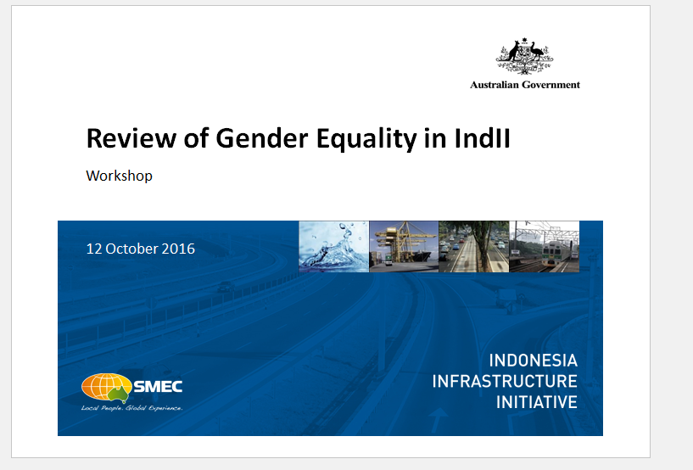

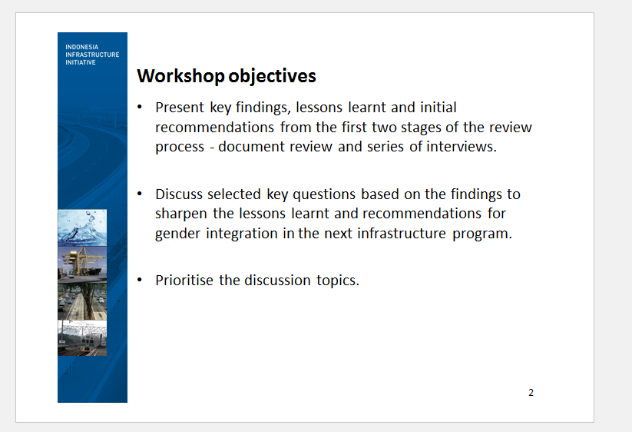

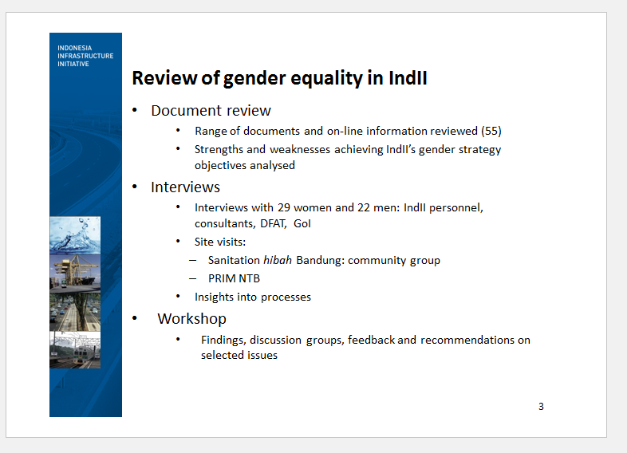

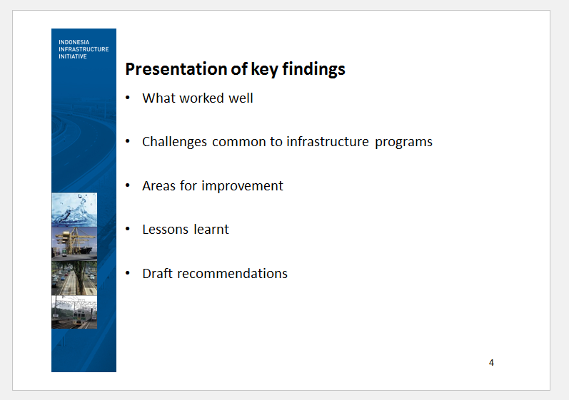

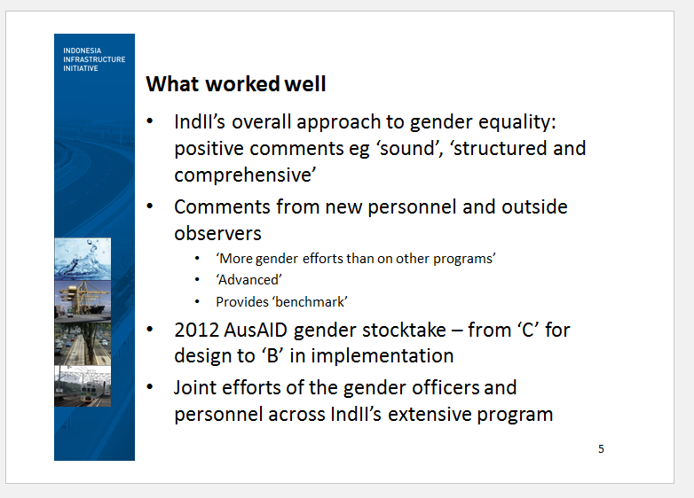

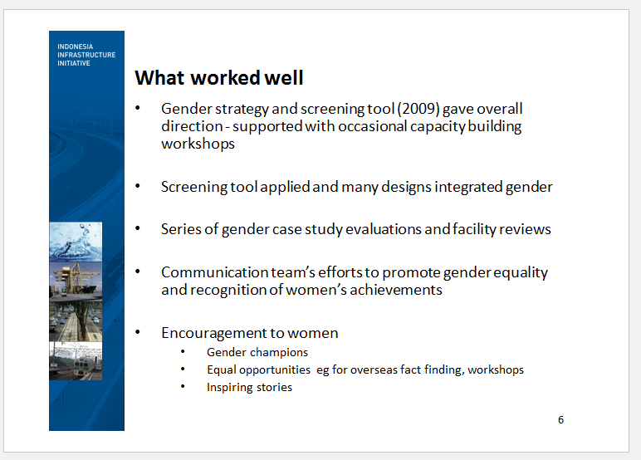

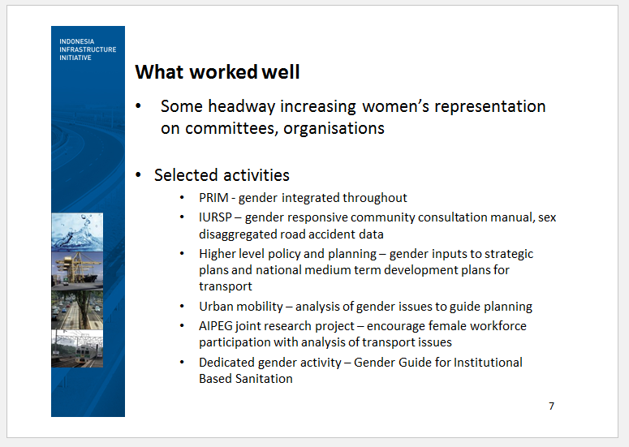

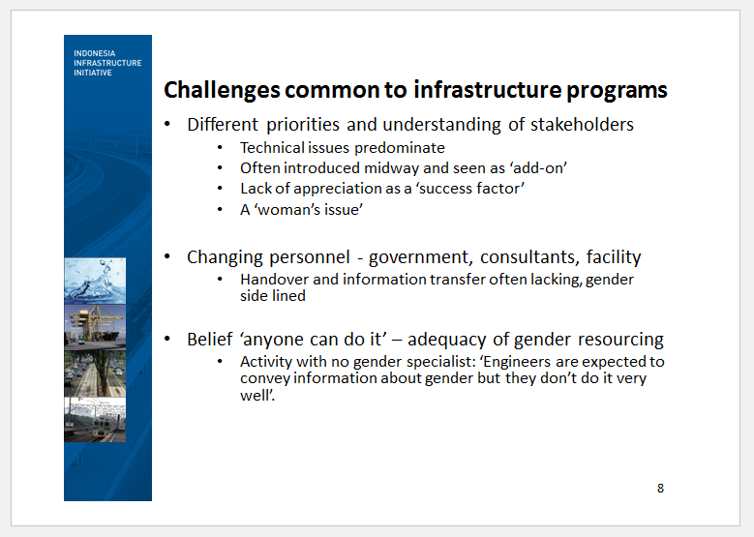

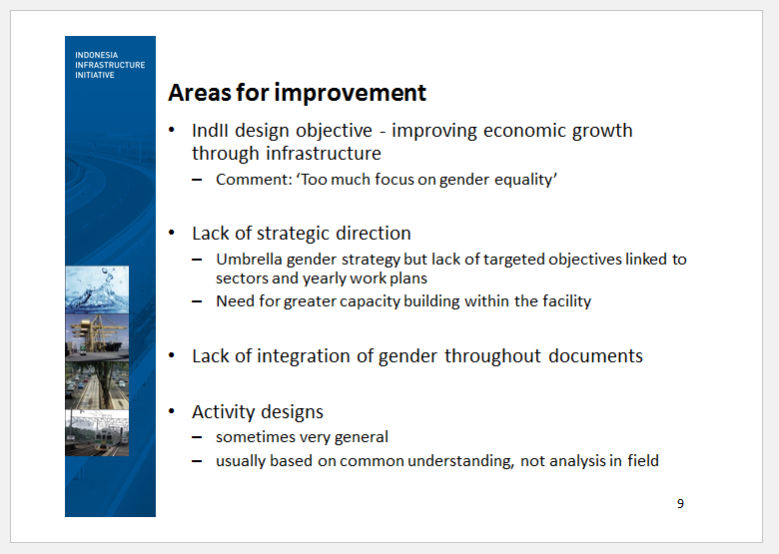

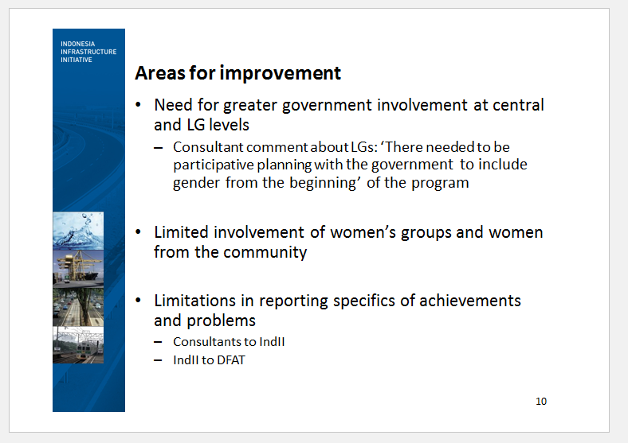

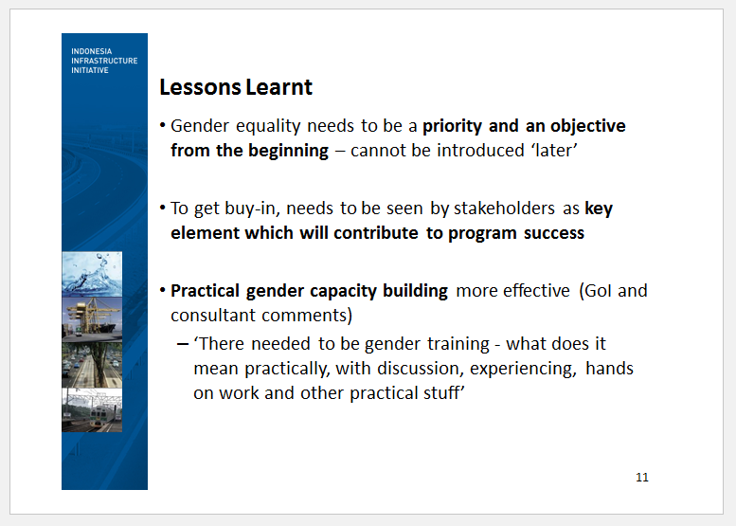

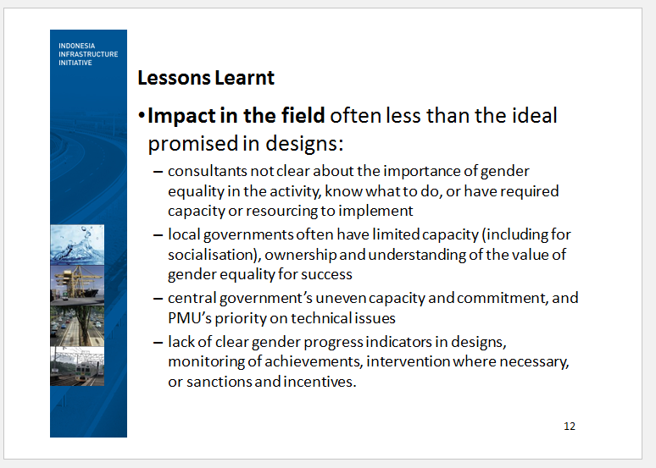

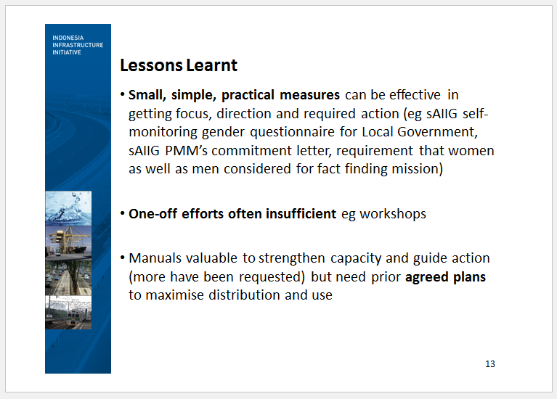

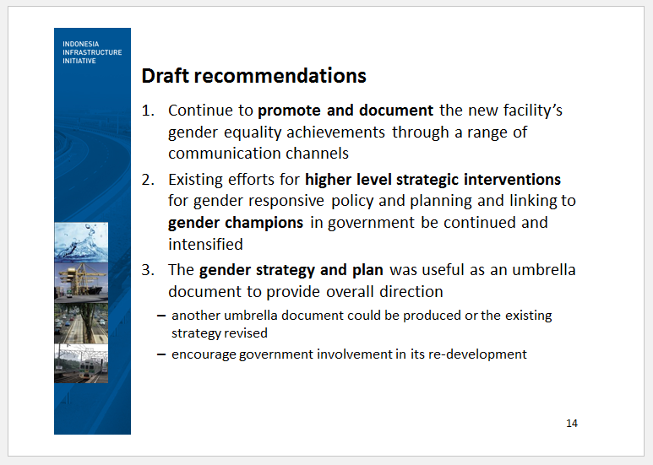

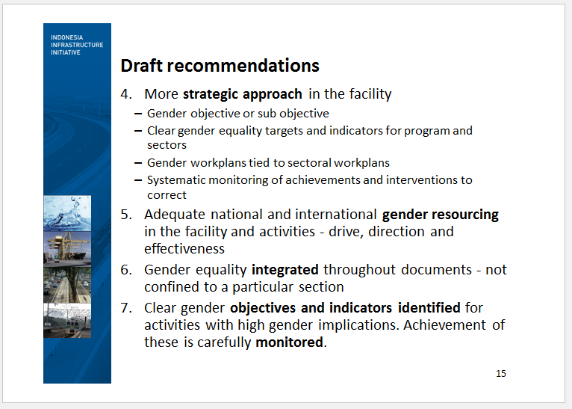

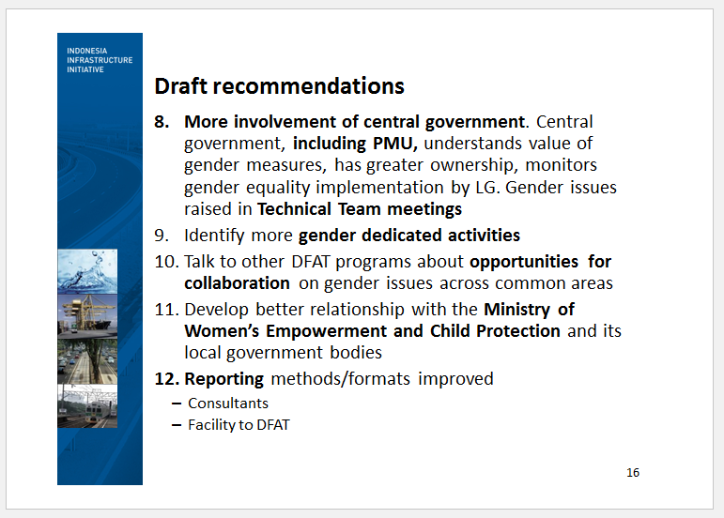

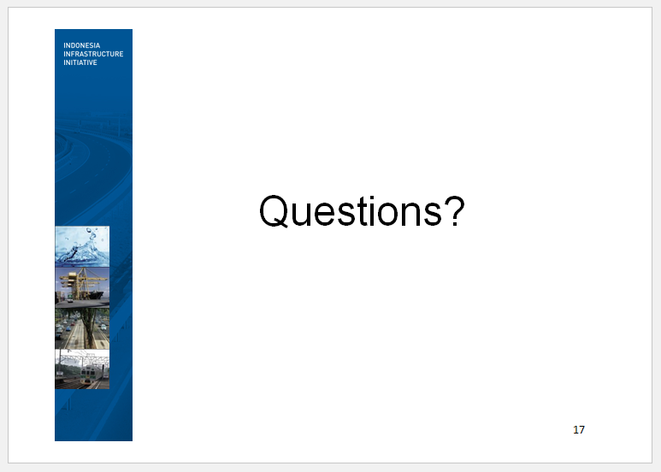

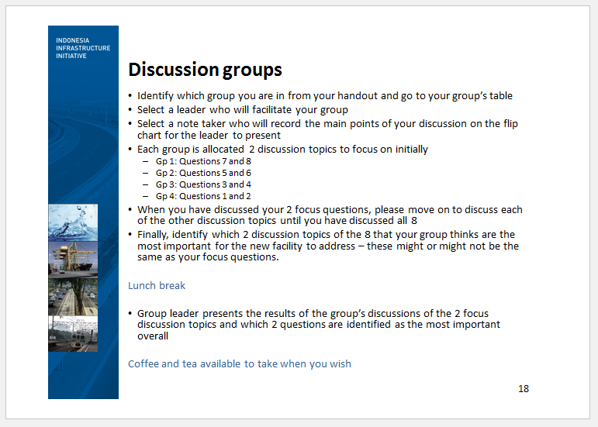

Sub-Annex 3: Summary of Questions and Answers

**Summary of questions and answers**

|  |  |
| --- | --- |
| **Questions** | **Responses** |
| Qn.1 The new facility has a high level goal of inclusive growth and women’s economic empowerment. How could the new facility be more directed to women’s empowerment and economic growth? | * Work with other programs that have women’s economic empowerment goals eg MAMPU * Bring government along with the new approach and objectives from the beginning * Community engagement as well as higher level interaction is important * Ensure monitoring and evaluation of women’s economic benefits is effective |
| Qn.2 What are the challenges and lessons learnt about linking with other programs in joint activities? | * DFAT response: DFAT has a role and they recognise this role. In the last 6 months, there have been concerted efforts to bring together programs to try and overcome this. DFAT have a new Gender Action Plan and Gender Strategy and are trying to create a stronger narrative for gender across the whole Indonesia program. DFAT need all program managers to be conscious of this point. * The IndII Deputy Director, noted that IndII and AIPEG had successfully collaborated on a joint gender initiative |
| Qn.3 Could you please unpack the finding about champions at government-only aware of one?  How do you see DFATs role in helping this? | * Agree there is there is currently only one Central government champion, although there are other champions at local levels whose stories are told in the Inspiring Stories series. * DFAT can help –through encouraging women and facilitating the idea of gender champions and that this is something that would be useful. * The KIAT design team gender and social inclusion specialist commented that rather than looking for individual champions in one department there is a need to recognise that there are champions across departments- The question is how do we build leadership in the sector itself? Global programs have good examples. Sectors have networks themselves and they have equity networks that go across sectors. There is a need to look across the resources that are there and to integrate these. |
| Qn. 4 You found consultants are not clear about their role. What you recommend across the TA and facility? | * IndII has undertaken briefings for consultants, and this can be effective if everybody gets a good briefing. Sometimes designs are not specific enough and they need to have greater detail. There also needs to be briefing on design improvements. Manuals could be developed to support consultants in the work they do and this has been requested by consultants. Better gender resourcing on activities would also assist. |
| Qn.5 What would you suggest about how a program can have community engagements to reach women and men | * LG has standard ways they go about socialisation. Information is always to the village head and then to neighbourhood groups. This results in information going to household heads and women are not included. There needs to be more work with LGs to ensure that they have socialisation methods to reach both women and men. |

Sub-Annex 4: Group Discussion Points

**Topic 1 - Objectives**: Currently, IndII’s objectives are concerned with economic development through infrastructure. There is no highlighting of gender equality and women’s empowerment in statements about what IndII is aiming to do. To give greater attention to and also encourage more effective monitoring of outcomes against a stated objective, should the next facility have an objective, or sub – objective, about improving gender equality and women’s empowerment which is aligned with the DFAT policy and strategy? Why or why not? If it is a good idea, what might a gender and women’s empowerment objective for the new facility resemble?

**Group discussion points:**

There needs to be contextualisation of any gender objective. Three areas where outcomes for the new facility are envisaged are in:

1. Policy and regulatory environment
2. Project delivery, management, maintenance
3. Project preparation and delivery

For this to occur there needs to be rapid, sustainable and inclusive:

* Economic growth
* Access to services These need robust descriptions.
* Women’s participation & empowerment
* Poverty alleviation

For gender equality and women’s empowerment objectives to be determined and achieved there should be:

* Testing of the assumptions of gender benefits
* Categorization of the intensiveness of gender issues
* Linking activity designs with overall objectives:
* With consideration of the importance of time and resources for initial assessments
* Linking deliverables/ milestones to gender issues (providing incentives)
* M&E designs which link to the overall objectivity
* Clearly articulated ‘definitions’ about gender and women’s empowerment in the context of KIAT’s work
* ‘Targets’ identified for resource allocation on specific issues
* Both gender considerations/objectives and potential challenges in activity designs need to be expressed
* There needs to be importance put on expertise in contextualization/applying gender equality concepts
* There needs to be identification of ‘indicators’ of actual practice, not only regulation
* Gender equality needs to be placed more ‘front and centre’ (not only as a cross cutting issue)
* Tracking of gender champions and gender networks in the sectors is needed
* Specific policy issues which will promote gender equality and women’s empowerment need identifying
* To get gender on the table with GoI there could be ‘two track targets’
* ‘Appropriate consideration’ (gender mainstreaming)
* ‘Focused’ (targeted or gender dedicated)
* The ‘default position’ is that activity designs should have clearly defined gender objectives
* There also needs to be a description/contextualization of gender issues for each facility outcome area.

**Points from other groups**:

* Approaches to identifying objectives should be from both institutional and community based.
* Objectives should be in line with GoI policy/RPJMN/RPJMI
* Yes, absolutely, the new facility should have clear objectives on gender equality and social inclusion
* There should be brainstorming of possible key GESI objectives to:

1. Generate learning amongst all stakeholders on how to better integrate GESI in infrastructure projects development/ policy development

* Create an enabling environment (policy, regulatory) OA#1

1. Help GoI to prioritise infrastructure development that will deliver intermediate (5 years) inclusive growth and women’s economic empowerment

* Project preparation OA#2

1. Institutionalise good practices for GESI into project preparation/ design/ management/ delivery

* Sector wide monitoring for GESI OA#3

**Topic 2 - Focus**: IndII made achievements in gender equality but technical issues tended to predominate at the expense of ‘soft’ social issues, as is frequently the case in infrastructure programs generally. To strengthen gender equality outcomes in the future, what more could be done (a) in the facility, (b) in activities and (c) with government to highlight and give focus to the importance of gender equality and women’s empowerment in the new infrastructure facility’s work?

**Group discussion points:**

Facility level

* There needs to be a framework/checklist/process for activity design
* Integration with the M&E and strategy
* Clearer indicators/ways of viewing performance
* Understanding of opportunities for cross program collaboration
* Shared accountability at management level
* Management attention
* Replication of capacity building for contractual/sub consultants
* Communication outreach through the Communications team

Activity level

* Earlier inputs in the design process
* Specific gender expertise used
* Involvement of gender support in the implementation process
* Inclusion of gender expertise in design/implementation teams
* Reviews of gender equality achievements and issues in carried over activities

With Government

* High level interaction/relationship and “liaison”
* Need to ‘reintroduce’ gender at management meetings
* Leveraging external pressure
* Support POKJA PUG and gender focal points
* Identify and network with gender champions
* Leverage DFAT with regard to relationships with other programs

**Topic 3 - Resourcing**: To achieve gender equality and women’s empowerment outcomes there needs to be adequate resourcing to drive momentum, identify opportunities and monitor processes and outcomes. How can the new facility be best resourced to ensure that gender equality and women’s empowerment is visible and seen as important, and to give direction? Could there be a technical director for gender equality and other social inclusion issues? If not, who should have responsibility? In IndII, the gender officer’s duties have expanded to a wider responsibility for social inclusion such as disability and vulnerable groups generally. While there is overlap between gender and other concerns, should there be separate resourcing of each to ensure that DFAT’s interest in addressing these issues is met?

**Group discussion points:**

Human resources

* Need a senior level expert (national, fulltime)
* Gender and social inclusiveness (GESI) Program Officer to work with the sectoral POs to implement the GESI strategy
* Short-term experts on specific issues (eg disability, urban poor, resettlement, remote areas and indigenous people)
* One short-term international (gender, social inclusion and infrastructure with a background in Indonesia)
* Individual activities may need to engage their own GESI expertise as needed
* Key responsibilities (accountabilities) lies with the Facility Director and Managing Contractor
* The sectoral Team Leader and Program Officers should also be responsible

Budget

* Activity design should include a GESI budget, including for capacity building and monitoring
* Facility should have a budget allocation for GESI advocacy, networking, capacity building of staff and GOI, study/analysis/research
* What is the balance for supporting big picture items and at activity level?
* Resourcing is also needed for workshops and coordination.

**Topic 4 - Community engagement:** Community engagement strategies and practices which enable the voices of women in the community to be heard can enable them to gain greater self-esteem and confidence, as well as ensuring that their needs and opinions are aired. Community engagement can also be designed to support women to be leaders and decision-makers. Many organisations that IndII has been working with at local government level are weak with regard to community engagement, even though for their existence they require a good relationship with community members and consumers. IndII has focused on technical issues in working with organisations while, in comparison, strengthening their capacity for community engagement and other social issues is generally touched on lightly. Should the new facility have a greater concern at local government level with community engagement with a strong emphasis on women’s empowerment? Why/Why not? Workshops might not always be the best way to increase capacity in areas such as community engagement and women’s empowerment. What other approaches might be more effective to increase capacity?

**Group discussion points:**

Issues

* Challenge to find women’s groups/CSOs working on infrastructure issues
* How the new facility can work with community:
* Build on existing networks to develop their interest and capacities in infrastructure issues (including in GoI programs)
* Work with other DFAT programs (eg MAMPU, KSI, KOMPAK) to identify these actors at national & local level
* GoI current focus is on infrastructure at a national scale and subnational (even to village level) which is sometimes translated well to the community
* Develop Apps, use ICT more to engage the community

**Points from other groups**:

* The facility’s communications and social media should be used for community engagement
* There should be strategies for specific gender oriented activities in communities
* Existing community groups should be identified
* Should involve the community in planning with wider social inclusion, not just gender equality as a focus
* Link into broader “good governance” discourse and enable communities to engage with local governments to hold them accountable (eg PRIM)
* Sustain more coordination/relationships (mentoring, etc)
* Ensure communities have a ‘correct’ understanding about gender quality.

**Topic 5 – Incentives and sanctions:** There is no real incentive to achieve gender equality outcomes at facility level. Neither are there penalties for managing contractors, consultants or government if they ignore or superficially deal with requirements for gender equality such as in strategies, activity designs, terms of reference or project management manuals. This means that gender equality and women’s empowerment can be treated as something which is not serious. In the new facility, should easily trackable gender equality and women’s empowerment indicators be identified and incentives/sanctions applied to their achievement in order to strengthen implementation? What system of incentives/sanctions could be used?

**Group discussion points:**

* There would need to be indicators to allow incentives and sanctions to be given
* GoI, DFAT, Implementing partners.
* Qualitative and Quantitative indicators.
* Monitoring and Evaluations tools – need to be stronger
* Gender indicators
* MIS (monitoring information system)
* Consider using established forum, body etc like POKJA PUG which are active across ministries.
* Stronger linkage with other DFAT program/activity(s).
* Incentives and sanctions
* Sanctions are easy but incentives are more difficult
* To appreciate gender achievement and gender champions is easy but programs themselves need more consideration.
* To adopt and improve the incentive system.
* To develop – financial incentive/sanction, - non financial incentive/sanction.
* Sanction: - organizational, personal.

**Points from other groups:**

* Need to have a measure of the indicator of ‘success’ and this needs to be clear from the beginning
* Should be stated in the output to be measured (and in the contract).
* Rewards should be given for positive achievement.
* Sanctions should be given based on performance evaluation
* Should be based on deliverables and milestones (as appropriate)
* There is a risk of perverse incentives if there is an over-emphasis on “counting”
* 2 targets at facility level
* There should be consideration of gender in performance-based payments programs (as appropriate)
* Incentives and sanctions need to be at both activity and facility level but how do you manage contractors when they don’t have capacity
* Sanctions can be for DFAT but not GoI programs
* The question was asked about why do we talk about incentives when we talk about gender – not other parts of programs – why are we talking about incentives and sanctions?
  + Accountability is important
  + Managing contractors don’t have gender milestones or performance payment on deliverables so maybe this could be considered
* DFAT noted that there is a trend towards more performance based contractors and that one good thing about performance payments is that it forces the drive for M&E for the whole program.

**Topic 6 - Leveraging opportunities at GoI policy and strategic levels:** IndII has identified and supported some gender champions within government and has had some gender equality inputs at a strategic and policy level, especially in the last few years. How can the new facility make more ground at policy and strategic levels with regard to gender equality and women’s empowerment? What is needed? What might DFAT’s role be?

**Group discussion points:**

* Engage/communicate with GoI on the next facility’s scope in general including gender equality/women’s empowerment.
* There should be agreement between DFAT and GoI (in the steering and technical committees) about gender issues and priorities.
* DFAT should have both formal and informal ‘pre steering’ committee meeting(s).
* DFAT and KIAT Managing Contractor and GoI should coordinate to do formal and informal meetings as well to identify how a synergy can be formed for mutual benefit.
* Team leaders’ meetings between programs should be more routine and also include gender specialists and M&E personnel to bring programs together and help collaboration.

**Points from other groups**:

* Should not only be individual champions but also institutions.
* Need champions of different categories:
  + Disability
  + Children
  + Indigenous people
  + Gender balance

**Topic 7 - Joint projects with other programs:** Working with other programs in joint activities, such as the research project on transport and women’s participation in the workforce between IndII and AIPEG, is often touted in program designs as something which should be aimed for. But it is often easier to say than to bring about. What are the barriers to identifying joint projects and working together to implement them? How can these barriers be addressed by the new facility?

**Group discussion points:**

Barriers:

* Program staff don’t know each other.
* Program people are not aware of each other activities.
* Problem of coordination.
* Programs have different program objectives.

How to address:

* DFAT should encourage collaboration.
* Program should make effort to coordinate and build relationship.
* DFAT and Bappenas to help assist programs to identify common objectives.

Other considerations:

* Resourcing is always an issue: time and money.
* Collaboration: Both formal – informal collaboration is important.
* Locations: Overlapping locations could be useful.

**Points from other groups**

* We should be looking at ways to move forward on this and there are lots of opportunities to collaborate with other programs.
* An idea for KIAT was to have an indicator as to the degree to which it can identify ways to collaborate and the performance on collaboration with other programs
* There also needs to be coordination with other organisations and GoI.

**Topic 8 - Empowering women at local government level:** A comment on a sAIIG (sanitation grant program) review was that there are many women working in local sanitation organisations and that more effort needs to be made to support and strengthen them. What are some ideas about how the new facility could ensure that this focus on women is done effectively and sensitively?

**Group discussion points:**

* Look for more opportunities to work with CBOS particularly in sanitation:
* To build demand for sanitation services.
* Go help with education and socialization of programs.
* Recognize cultural differences which our program will encounter in different part of the country – there is no cookie-cutter approach.
* Look for more opportunities to work with institutions to empower women and mainstream gender, not just with CBOs.
* Assess local resolutions and policies to look for empowerment of women and gender mainstreaming.
* For sustainability: should in line with the government policy and programs at both local and national levels.

**Points from other groups**:

* There is a need for consultation with LG about gender mainstreaming at the LG level.
* Programs need to be assessed for how they can be effective and useful based on women’s needs.
* There is a need to get GoI buy-in.
* There is a need to put in program outputs that we require both technical and non technical outputs and to inform LGs that this is what is needed, not just technical outputs. Outputs could include cross cutting issues, governance, social welfare.
* At village level to improve the development of infrastructure projects by empowerment and other resources to have good coordination using APB-Desa, for example working with MAMPU & PEDULI and other relevant DFAT programs, to help identify the needs at the village level.

1. Interviews were held with 29 women and 22 men.
2. 26 women and 14 men
3. AusAID Indonesia *Gender Stocktake Report* January 2012 p10
4. Governor’s Decree No.620-742/2016