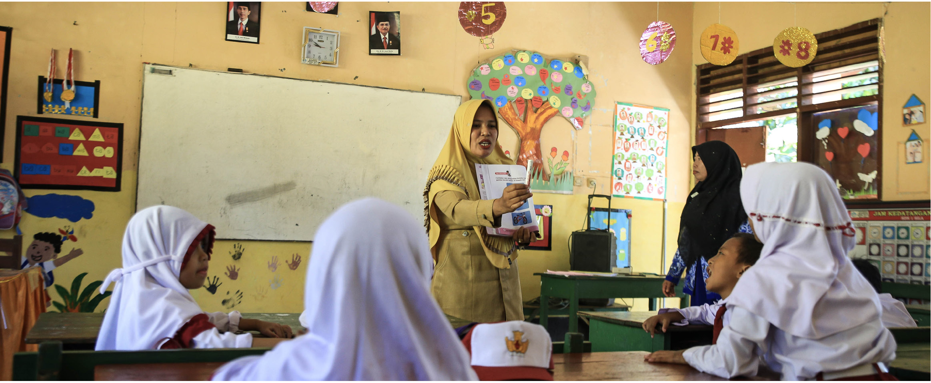

**In the past decade Indonesia has made very significant gains in expanding access to education and providing a more qualified and professional workforce in education across the country.** These gains however have not yet translated into improved student learning outcomes and it is clear that the education systems which support quality teaching and learning at both national and regional levels need further development and support. This has been identified as an area where a strategic partnership between the Australian and Indonesian Government can be established.

Photo: INOVASI

What is TASS? TASS is a flexible, agile and politically-smart facility funded by the Australian Government. Since January 2017, the

program has been working with the Indonesian Ministry

of Education and Culture, the Ministry of Religious Affairs and the National Development Planning Ministry (Bappenas) to contribute to a stronger education system in Indonesia. It does this by working with the Government of Indonesia to bring about sustainable changes in education systems, policies and practice.

What does TASS support?

TASS provides short-term catalytic assistance to key decision-makers. that responds to needs identified by the Indonesian Government.

Assistance provided through TASS is designed to strengthen and add value to the Indonesian Government’s own systems, policies and programs. Assistance may take the form of:

Research and analyses, designed to contribute to ongoing education policy dialogue

Short-term technical assistance to support the Indonesian Government in areas where it requires technical support

Brokering dialogue and facilitating collaboration

Support provided to date has included technical assistance to assessment reform, piloting of a continuous professional development system for madrasah teachers, evaluating basic and secondary education quality assurance systems, and provision of technical assistance, research and analysis in support of the Indonesian Government’s five- yearly review of education planning and strategies.

TASS also provides broader support to the Australian Government in the coordination and delivery of its Education Sector Investment Program.

You are free to copy, distribute and transmit this work, for non-commercial purposes. To request copies or for more information, please contact [info@tass.or.id](mailto:info@tass.or.id)

**Ratu Plaza Office Tower 19th floor**

Jl. Jend. Sudirman Kav. 9, Jakarta Pusat 1027, Indonesia

**Kementerian Pendidikan dan Kebudayaan**

Gedung C Lantai 7, Jl. Jend. Sudirman Senayan, Jakarta Pusat 10270

**Kementerian Agama**

Jl. Lapangan Banteng, Direktorat KSKK Lantai 6, Jakarta Pusat