Annex 1  
Summary of the MTR approach and KIAT Logic Model

## Assumptions, limitations and risk mitigation for the KIAT MTR process

The review team is making the following assumptions regarding the evaluation process:

* DFAT will, where necessary, facilitate introductions to stakeholders and partners taking part in the review and will, where relevant, join with the review team for consultations (DFAT has indicated it will join all GOI consultations).
* A sufficient proportion of stakeholders will make themselves available to participate in the review in a timely way and provide the contact information of other potential interviewees, if relevant.
* DFAT, the managing contractor and other stakeholders (if relevant) will provide timely access to all pertinent documents to assist the review (noting that a substantial, wide range of documents has already been provided by DFAT during the preparatory stage).
* DFAT and other relevant parties will provide feedback on deliverables based on the agreed schedule and document structure.

The review team envisages the limitations below and proposes the following adaptive strategies to ensure that the review is completed on time, is robust, consultative and meets the expectations of DFAT.

| **Limitation** | **Mitigation and adaptive strategies** |
| --- | --- |
| **Tight timeframe** | Due to the review schedule, the review team will have approximately three weeks to conduct consultations prior to the delivery of the Aide Memoire. Strategies to ensure a complete range of stakeholders are covered will include: 1) identify which stakeholders to engage initially, 2) conduct group interviews where practical, particularly within specific agencies or work groups, and 3) review team members may conduct consultations separately to enable more than one discussion to take place at a specific time. The volume of documents to be reviewed will need to be managed carefully to ensure completeness, but in a timely manner. A document tracker spreadsheet is being used to support the identification and review of documents. |
| **Language barrier** | Data collection tools and consultations will be designed and conducted in English. This may result in challenges caused by a language barrier when communicating with Indonesian interviewees. To minimise this challenge, a translator will be present when participants may not be comfortable communicating in English. We will actively seek the opinions of interviewees in group situations where their English may not be as strong as other group members. |
| **Inability to travel** | Due to the COVID-19 pandemic and associated travel restrictions, it is not possible for the review team to travel to Indonesia. This prevents in-person discussions and field visits to infrastructure sites or data gathering with infrastructure users. All discussions will take place via video or teleconference and Tetra Tech has engaged a national coordinator in Indonesia to facilitate any arrangements required for these. |
| **GESI restructure** | As DFAT has recognised, budgetary limitations and the decision to focus on gender and social inclusion mainstreaming curtails the Facility’s ability to achieve some of the aims of its GESI and civil society organisation (CSO) engagement strategy. This may present added complexity when assessing Facility performance in this area. The review team will seek to build an accurate picture of the changes made and consider their implications going forward. |
| **Evolving context** | Changes to the budget and scope of KIAT occurred during the first phase. This includes adaptions required to the impacts of COVID-19, which also resulted in a new Australian aid strategy and reporting requirements for KIAT. The review team will need to look beyond the timeframe of the current Partnerships for Recovery strategy (which concludes in June 2022) to a recovery phase that will be covered by a new and as-yet undeveloped strategic framework. The review team will remain cognisant of these factors when considering the review data, findings and recommendations. |
| **Remote consultations** | We are aware of the difficulties of conducting some remote consultations, which can be challenging due to the lack of face-to-face interaction, especially in cross-cultural contexts. The review team will try as much as possible to build rapport with respondent(s), starting with a clear introduction of themselves and the review. The discussions will be informal and semi-structured to ensure that the atmosphere and conversation is open. This will allow the review team to probe the respondents more and seek further clarity on some of their perspectives. |

## Safety and ethical practice

### Travel risks and restrictions

The review team will manage travel risks through the adoption of a remote format for those based in Indonesia. Stakeholders and partners based there will not be expected to travel in order to participate in the review. Opportunities may arise for the review team to meet and consult Australian-based stakeholders and partners.

### Voluntarism, confidentiality and anonymity

All participation in consultations will be voluntary. The review team will take all practical steps to protect the confidentiality and anonymity of respondents. We will not directly attribute any quotes in the report, although due to the specific nature of the roles and responsibilities of interviewees, there may be cases where it is not possible to completely safeguard their identity. The review team will consider any such instances on a case-by-case basis to ensure that these circumstances do not present risks for any individual involved.

## Overview of the methodological approach

The review will adopt **qualitative and quantitative** approaches to answering the review questions. We will be informed by enquiry through **two principle methods**:

1. A **Document Review** focussing largely on documents provided by DFAT and the KIAT managing contractor, supplemented where possible with third party sources.
2. **Consultations with key stakeholders and partners,** in individual or group settings, with people who have been purposively selected due to the nature of their professional role and relationship to KIAT.

The review will test the **program theory of the Facility**. The basis of this will be the Facility Logic from the 2019 KIAT Monitoring and Evaluation Framework (MEF) and the theory of change in the Gender Equality, Social Inclusion and Civil Society Engagement Strategy 2018-2021. This will provide the team with the core understanding of what the Facility is seeking to achieve and how. The program logic was important in refining the analytical framework below, especially in assessing how KIAT activities may be contributing to the achievement of the EOFOs.

The **limitations discussed above** **have informed** the review method focussing on document review and consultations. In the current environment, it is not possible to visit infrastructure sites, commission technical audits or conduct on-the-ground research among beneficiary communities in Indonesia. The approach is also informed by the mid-term nature of the review, owing to which the Facility may be expected to have made progress toward the achievement of the end-of-facility outcomes, but it may be too soon to produce independent analysis or quantitative social or economic data about program impacts. KIAT does not have specific mid-term targets against which to assess performance.

**Figure 1** provides a simplified overview of the review process, with a focus on the sequencing of analysis to take place and the contextual factors that will need to be considered.

Figure 1 Simplified overview of the KIAT mid-term review

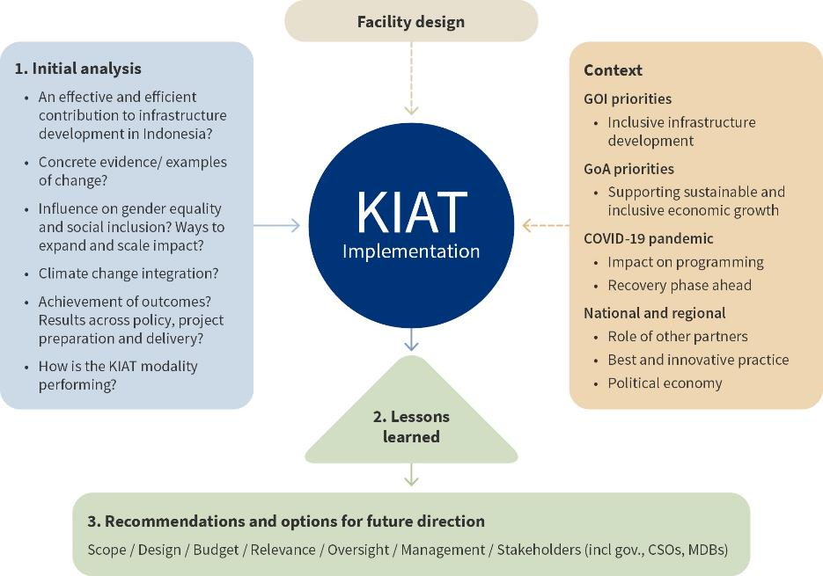

## Summary of data sources

The review will primarily use the following data sources.

| **Data source** | **Description** |
| --- | --- |
| **GOI staff - national** | Senior staff from national ministries and agencies, including the Coordinating Ministry for Economy Affairs, Coordinating Ministry of Maritime Affairs and Investment, Ministry of Finance, Bappenas (the Ministry of National Development Planning), and the Ministry of Public Works and Housing. Staff from other agencies engaged may include from TransJakarta, state-owned and private infrastructure companies, and the Indonesian National Public Procurement Agency. |
| **GOI staff - provincial** | As sites of KIAT sub-national activity, staff from the city governments of Palembang, Semarang and Makassar and the Regency Government of Probolinggo, and representatives from their relevant water utilities. |
| **DFAT staff** | Staff from Post and Canberra, including staff with program management and supervisory responsibility for KIAT, sectoral focal points for economic governance, infrastructure, water, gender and climate change, and senior staff responsible for aid program oversight and strategic direction. |
| **Multilateral development partner staff** | Staff from the Asian Development Bank, the World Bank, and potentially the Islamic Development Bank. |
| **Managing Contractor staff** | Staff from Cardno, the Managing Contractor responsible for KIAT implementation. This will include the Facility Director, the deputy directors responsible for Transport, and Water and Sanitation, and Strategic Planning and Performance (now including GESI responsibilities). |
| **CSO staff** | Civil society staff (or representatives) from Himpunan Wanita Disabilitas Indonesia (an association for women with disabilities) and Ikatan Wanita Pengusaha Indonesia (Indonesian Business Women Association). |
| **DFAT documents** | Including relevant aid program strategies and plans, KIAT activity approvals, Partner Performance Assessments and Aid Quality Checks, and the COVID-19 Development Response Plan and associated Performance Assessment Framework for Indonesia. |
| **KIAT documents** | Including the Design Document, GESI and CSE Strategy, MEF and the Communications and Engagement Strategy; workplans and activity, progress and performance reports; contract documents; Risk Management Plan and Register; and Indonesia Infrastructure Issues Briefs. |
| **ITSAP documents and staff** | The team will also review documents related to ITSAP. Targeted consultations will be considered with ITSAP staff and stakeholders on an as-needed basis. |

## Summary of the analytical framework

With reference to the KIAT Logic Model (see below), the analysis will focus initially on whether:

* The activities selected and implemented by KIAT are leading to the improved policy environment and enhanced human capacities and motivation envisaged by the design
* The approach taken to GESI is influencing the conduct and nature of KIAT activities
* Evidence exists that the changes resulting from KIAT activities are leading to the achievement—or likely achievement by the 2026—of the EOFOs.

The review is pitched at this activity-outcome level in recognition of the mid-term nature of the exercise. It will require analysis of:

* The substantive outputs of the Facility, be it evidence generated to inform decision-making, new policies or practices adopted by GOI partners, or physical infrastructure developed: these are represented by the **PURPLE BOXES** on the Logic Model
* The knowledge, attitude, and practice of partner GOI agencies to determine if they are both motivated and capable of using these outputs to deliver high quality infrastructure and if this is occurring in practice: these are represented by the **ORANGE BOXES** on the Logic Model.

Based upon the results of these enquiries, the review will seek to draw lessons learned that can then be used to develop recommendations or options for the future direction of the Facility. When developing recommendations or options for the future, the review team will have consideration of:

* The evolving context in which the KIAT Facility is operating
* Evolving and emerging innovative global practice on infrastructure
* The current and anticipated priorities and incentives of the governments of Indonesia and Australia.

## **KIAT Logic Model**

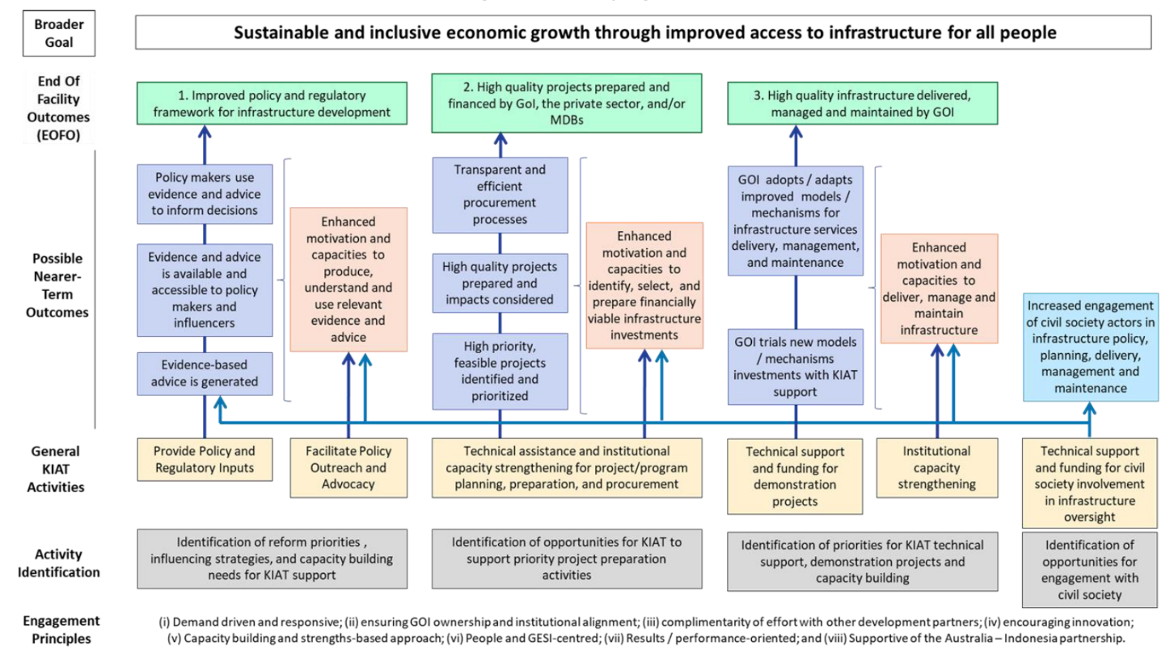

Annex 2  
Key stakeholders consulted

Key stakeholders consulted

| **No** | **Counterpart** | **Name and Title/Position** | **Sector (Role)** |
| --- | --- | --- | --- |
|  |  | **Government of Indonesia** |  |
| 1 | Coordinating Ministry | Dr. Ir. Wahyu Utomo, MS Deputy for Spatial and Regional Development  Coordinating Ministry for Economy Affairs/Head of KPPIP | IFF (LCS and Waste to Energy Semarang) |
| 2 | Ministry of Finance | Dr. Farid Arif Wibowo, S.E., Ak. MID. Ec  Head of Sub-directorate for Regulation and Development of Infrastructure Financing Policies | IFF (key contact on IFF and PPP within MOF) |
| 3 | Bappenas | Ir. Josaphat Rizal Primana, MSc Deputy Minister for Infrastructure | Lead GOI counterpart and Co-chair KIAT of Management Committee |
| 4 | Bappenas | Drs. Sri Bagus Guritno, AK, M.Sc  Director for Development Funding System and Procedure/PPP Unit consultation | IFF/PPP |
| 5 | Bappenas | Novie Andriana  Deputy Director for Development Funding System and Procedure/PPP Unit | IFF/PPP |
| 6 | Bappenas | Tri Dewi Virgiyanti, ST MEM  Director for Urban, Housing and Settlement Areas | WatSan and GESI |
| 7 | Bappenas | Ikhwan Hakim, ST MSc, Ph.D  Director for Transport | Transport |
| 8 | MPWH | Ir. Rachman Arief Dienaputra, M.Eng. Director for Bureau of Budget Planning and International Cooperation (Head of the MPWH Gender Mainstreaming Implementation Team)  Secretariat General - MPWH | Crosscutting  (GESI-CSE, Grant Administration, Transport) |
| 9 | MPWH | Riono Suprapto, SE, ST, MT Director for Centre of Facilitation of Regional Infrastructure  Secretariat General - MPWH | Transport (PHJD and PRIM) |
| 10 | MPWH | Dian Suci Hastuti  Chair of Central Project Management Unit (CPMU)  Program Hibah Air Minum | WatSan |
| 11 | MPWH | Ir. Miftachul Munir, MT Director for Road and Bridge Management System and Strategy  Bina Marga - MPWH | Transport  (IRAMS-DC and IPD) |
| 12 | MPWH | Dr. Ir. Hedy Rahardian  Director General of Highways  Bina Marga | Road Management, VicRoads |
| 13 | PT SMI | Darwin Trisna Djajawinata, M.Sc. Director for Operation and Finance  PT Sarana Multi Infrastructure (PTSMI) | IFF (Lead on IFF; Waste to Energy Semarang Project & for future engagement; ADB Green Financing Pipeline) |
| 14 | PT SMI | Fakhrul Aufa  Team Leader, Business Development and Strategic Partnerships | IFF (Lead on IFF; Waste to Energy Semarang Project & for future engagement; ADB Green Financing Pipeline) |
| 15 | LKPP | Rusli Maryadi, Ak.M.M  Head of Sub-directorate of Specific Procurement Policy Development | IFF (Solo Street lighting Model Bidding Documents Pilot) |
| 16 | LKPP | Ilvia Restu Utami, SE  Head of Section of Specific Procurement Policy Development II | IFF (Solo Street lighting Model Bidding Documents Pilot) |
| 17 | Local Government | Ir. Akhmad Bastari, MT., IPM Head of Public Works Agency of Palembang City | Water and Sanitation - Palembang City Sewerage Project (PCSP) |
| 18 | Local Government | Eka Gustini, S.T., M.Si., M.Sc  Head of the technical implementation Unit of Wastewater Treatment | Water and Sanitation - PCSP |
| 19 | Local Government | Adhe Abdilah, S.T.  Committed Officer (PPK) PCSP | Water and Sanitation - PCSP |
| 20 | Local Government | Ir. R.A. Marlina Sylvia, S.T., M.Si., M.Sc., IPM  Head of Irrigation and Waste | Water and Sanitation - PCSP |
| 21 | Local Government | Dr. Bunyamin, M. PD  Head of Bappeda | IFF - Waste to Energy (WtE) Project |
| 22 | Local Government | Drs. Sapto Adi Sugihartono, MM  Head of Agency for Environment | IFF - WtE Project |
| 23 | Local Government | Drs. Satrio Imam Poetranto  Head of Legal Department | IFF - WtE Project |
| 24 | Local Government | Arwita Mawarti, ST, MT  Head of Infrastructure Planning and Regional Development, Development Planning Agency at sub-national level | IFF - WtE Project |
|  |  | **Multilateral Development Banks** |  |
| 25 | ADB | Amr J. Qari Principal Infrastructure Specialist  Indonesian Residence Mission | ADB lead on infrastructure |
| 26 | World Bank | Alessandra Campanaro Program Leader for Sustainable Development and Infrastructure in Indonesia and Timor Leste | World Bank Country TF lead on infrastructure |
| 27 | World Bank | Jeffrey Delmon  Senior Infrastructure Finance Specialist | Key KIAT contact on Limited Concession Scheme |
| 28 | World Bank | Elena Y. Chesheva  Senior Transport Specialist | Transport |
| 29 | World Bank | Irma Magdalena Setiono  Senior Water Supply and Sanitation Specialist | WatSan |
|  |  | **Department of Foreign Affairs and Trade** |  |
| 30 | Jakarta Post | Allaster Cox, Chargé d'Affaires/Deputy Head of Mission | Development agenda & KIAT |
| 31 | Jakarta Post | Anna McNicol - Acting Minister Counsellor EII | KIAT MTR SES |
| 32 | Jakarta Post | James Gilbert - Acting Counsellor IEG | PROSPERA (ITSAP) |
| 33 | Jakarta Post | Esther Ewagata - First Secretary, Infrastructure | Transport and MDBs |
| 34 | Jakarta Post | Jason Court - First Secretary, Infrastructure | Watsan, IFF and Ops |
| 35 | Jakarta Post | Piter Edward – Unit Manager, Infrastructure | Infrastructure |
| 36 | Jakarta Post | Widya Setyowati – Unit Manager, Water and Sanitation | Watsan |
| 37 | Canberra | Tim Gill – Manager, Infrastructure and Climate Branch | DFAT climate change |
| 38 | Canberra | Annemarie Reerink – Senior Gender Adviser, Gender Equality Branch (GEB) | GESI |
| 39 | Canberra | Philip Martin – Director, Gender, Inclusion & Social Safeguards, AIFFP | GESI and Safeguarding |
| 40 | Canberra | Dan Heldon – Director, Indonesia Human Development Section | Human development |
| 41 | Canberra | Lachlan McCall – Economist | Economics |
| 42 | Austrade | Sally Deane – Minister | Bilateral trade/investment |
| 43 | Canberra | Ben Williams | P4I & KIAT |
| 44 | Canberra | Justin Baguley | Development agenda |
| 45 | Canberra | Peter Kelly – Infrastructure Specialist, Climate Integration and Programming Branch | Technical Advisory Groups |
| 46 | Canberra | Kirsten Hawke – Lead Design Specialist | Technical Advisory Groups |
| 47 | ITSAP/DITRC | Charlie Brister - Counsellor for Transport | ITSAP |
| 48 | ITSAP/DITRC | Steve Shaw - Director for International Programs, Aviation Group, Department of Infrastructure | ITSAP |
|  |  | **Private Sector** |  |
| 49 | PwC | Julian Smith - Infrastructure Finance Adviser PwC | IFF (WtE project OBC and FBC; Transaction Advisor Solo Street Lighting) |
|  |  | **Civil Society Organisations** |  |
| 50 | CSO | Sri Sukarni  Himpunan Wanita Disabilitas Indonesia – Provinsi NTB Indonesian Association of Women with Disabilities – NTB | GESI-CSE and Transport (PRIM/PHJD) focus on disability |
| 51 | CSO | Dr. Rita Siswati  Ikatan Wanita Pengusaha Indonesia/IWAPI (Indonesian Business Women Association) NTB | GESI-CSE and Transport (PRIM/PHJD) focus on women’s economic empowerment |
|  |  | **Project Staff** |  |
| 52 | KIAT | Steven Chaytor – Facility Director and A/g Deputy Director Infrastructure Financing | Leadership team |
| 53 | KIAT | Paul Wright – Deputy Director, Strategic Planning and Performance | Leadership team |
| 54 | KIAT | Shamas Bajwa – Deputy Director Transport | Leadership team |
| 55 | KIAT | Jim Coucouvinis – Deputy Director Watsan | Leadership team |
| 56 | KIAT | Daniel Brown – Facility Operations Manager | Leadership Team |
| 57 | KIAT | Arlan Rahman – Senior Project Manager | Infrastructure Financing |
| 58 | KIAT | Endah Trista Agustiana - Gender Adviser | GESI |
| 59 | KIAT | Felicity Pascoe – Senior GESI/CSE Adviser | GESI |

Annex 3  
List of documents reviewed

List of documents reviewed

Australian Department of Foreign Affairs and Trade (DFAT) Documents

|  |  |  |
| --- | --- | --- |
| 1 | Approval Documents | * Email #1 |
| 2 | Approval Documents | * Email #2 |
| 3 | Approval Documents | * Email #3 |
| 4 | Approval Documents | * Email #4 |
| 5 | Approval Documents | * Email #5 |
| 6 | Approval Documents | * Email #6 |
| 7 | Approval Documents | * Email #7 |
| 8 | Approval Documents | * Email #8 |
| 9 | Approval Documents | * Email #9 |
| 10 | Approval Documents | * Email #10 |
| 11 | COVID-19 Response and Recovery | * DFAT Partnerships for Recovery: Australia’s COVID-19 Development Response |
| 12 | COVID-19 Response and Recovery | * Indonesia COVID-19 Development Response Plan |
| 13 | DFAT Performance Assessment Framework (PAF) | * DFAT PAF 2019-2020 |
| 14 | DFAT PAF | * DFAT PAF 2020-2021 |
| 15 | Facility investments | * Guidance note: Facility investments |

Kemitraan Indonesia Australia untuk Infrastruktur (KIAT) Documents

|  |  |  |
| --- | --- | --- |
| 16 | Design Documents | * KIAT Facility Design Document |
| 17 | Design Documents | * Project design document: Palembang City Sewerage Project |
| 18 | Contracts and Amendments | * Subsidiary Arrangement |
| 19 | Contracts and Amendments | * Deed of Amendment 1 |
| 20 | Contracts and Amendments | * Deed of Amendment 2 |
| 21 | Contracts and Amendments | * Deed of Amendment 3 |
| 22 | Contracts and Amendments | * Deed of Amendment 4 |
| 23 | Contracts and Amendments | * Deed of Amendment 5 |
| 24 | Contracts and Amendments | * KIAT Contract |
| 25 | Facility Operations Manual (FOM) and Standard Operating Procedures (SOP) | * FOM |
| 26 | FOM and SOP | * SOP 2019 |
| 27 | FOM and SOP | * SOP 2020 |
| 28 | Monitoring and Evaluation Framework | * Performance System Guidance |
| 29 | Monitoring and Evaluation Framework | * Performance System PowerPoint Presentation |
| 30 | Monitoring and Evaluation Framework | * Independent Reviewer Summaries from Performance Review sessions |
| 31 | Facility and Activity based Milestones | * KIAT Transition Activity Report 2018 |
| 32 | Facility and Activity based Milestones | * Facility and Activity FY20-21 |
| 33 | Facility and Activity based Milestones | * Facility Milestones FY19-20 |
| 34 | Facility and Activity based Milestones | * Activity Milestones FY18-19 |
| 35 | Facility and Activity based Milestones | * Performance System Report |
| 36 | Facility and Activity based Milestones | * Inception Report – Developing Sustainable Urban Mobility Plans for Two Cities |
| 37 | Facility and Activity based Milestones | * Inception Report - TransJakarta |
| 38 | Facility and Activity based Milestones | * Palembang City Sanitation Project Communications Strategy and Workplan |
| 39 | Bimonthly Program and Performance Reports (BPPRs) | * BPPR April-Dec 2017 |
| 40 | BPPR | * BPPR Jan-June 2018 |
| 41 | BPPR | * BPPR July-Dec 2018 |
| 42 | BPPR | * BPPR Jan-June 2019 |
| 43 | BPPR | * BPPR July-Dec 2019 |
| 44 | BPPR | * BPPR Jan-June 2020 |
| 45 | BPPR | * BPPR June – December 2020 |
| 46 | Technical Committee (TC) and Management Committee (MC) meeting | * MC Meeting Minutes #1 Nov 2017 |
| 47 | TC and MC meeting | * MC Meeting Minutes #2 May 2018 |
| 48 | TC and MC meeting | * MC Meeting Minutes #3 Nov 2018 |
| 49 | TC and MC meeting | * MC Meeting Minutes #4 May 2019 |
| 50 | TC and MC meeting | * MC Meeting Minutes #5 Jan 2020 |
| 51 | TC and MC meeting | * MC Meeting Minutes #6 Oct 2020 |
| 52 | TC and MC meeting | * TC Meeting Minutes Transport Sept 2020 |
| 53 | TC and MC meeting | * TC Meeting Minutes Transport Nov 2019 |
| 54 | TC and MC meeting | * TC Meeting Minutes Transport Oct 2019 |
| 55 | TC and MC meeting | * TC Meeting Minutes Transport May 2019 |
| 56 | TC and MC meeting | * TC Meeting Minutes Water and Sanitation (WatSan) Sept 2020 |
| 57 | TC and MC meeting | * TC Meeting Minutes WatSan May 2019 |
| 58 | TC and MC meeting | * TC Meeting Minutes Infrastructure Funding and Financing Sept 2020 |
| 59 | TC and MC meeting | * TC Meeting Minutes GESI-CSE May 2019 |
| 60 | TC and MC meeting | * MC Meeting powerpoint presentation March 2021 |
| 61 | Partner Performance Assessments (PPAs) and Aid Quality Checks (AQCs) | * AQC 2018 |
| 62 | PPAs and AQCs | * AQC 2019 |
| 63 | PPAs and AQCs | * AQC 2020 |
| 64 | PPAs and AQCs | * PPA 2018 |
| 65 | PPAs and AQCs | * PPA 2019 |
| 66 | PPAs and AQCs | * PPA 2020 |
| 67 | Risk Management Plan and Register | * KIAT Risk Management Plan |
| 68 | Risk Management Plan and Register | * KIAT Risk Register 2019-2020 |
| 69 | Risk Management Plan and Register | * KIAT Risk Register 2016 and 2018 |
| 70 | PAF | * PAF Milestone Reporting for KIAT |
| 71 | PAF | * Relevant Significant Policy Change (SPC) submissions National Roads Improvement |
| 72 | PAF | * Relevant SPC submissions Program Hibah Jalan Daerah (PHJD) |
| 73 | PAF | * Relevant SPC Evidence Base |
| 74 | PAF | * Potential SPCs 2020 |
| 75 | PAF | * Summary of examples of change |
| 76 | PAF | * Performance planning workbook PHJD |
| 77 | PAF | * Performance review workbook: improving project delivery |
| 78 | Stakeholders | * List of Key Counterparts |
| 79 | Strategies | * KIAT Mini-Strategies (GESI/Transport/Infrastructure Funding and Financing/ WaSH) |
| 80 | Strategies | * GESI-CSE Mini Strategy |
| 81 | Strategies | * KIAT Communications Strategy |
| 82 | Strategies | * KIAT GESI-CSE Strategy 2018-2021 |
| 83 | Indonesia Infrastructure Issues Briefs | * Brief #1 Private Participation in Infrastructure |
| 84 | Indonesia Infrastructure Issues Briefs | * Brief #2 National State-owned Enterprises |
| 85 | Indonesia Infrastructure Issues Briefs | * Brief #3 Sub-national Roads Maintenance |
| 86 | Indonesia Infrastructure Issues Briefs | * Brief #4 CSO engagement |
| 87 | Indonesia Infrastructure Issues Briefs | * Brief #5 Water Utility Performance |
| 88 | Indonesia Infrastructure Issues Briefs | * Brief #6 Renewable Energy |
| 89 | Indonesia Infrastructure Issues Briefs | * Brief #7 Regional and City-owned Enterprises in Infrastructure |
| 90 | Indonesia Infrastructure Issues Briefs | * Brief #8 Urban Mobility and Connectivity |
| 91 | Indonesia Infrastructure Issues Briefs | * Brief #9 Donor Financing for Infrastructure Development |
| 92 | Indonesia Infrastructure Issues Briefs | * Brief #10 The New Water Law: State Control and Private Investment |
| 93 | Indonesia Infrastructure Issues Briefs | * Brief #11 Sustainable Urban Mobility Planning |
| 94 | Indonesia Infrastructure Issues Briefs | * Brief #12 The Role of Infrastructure in COVID-19 Response and Recovery |
| 95 | Indonesia Infrastructure Issues Briefs | * Brief #13 COVID-19 Detection in Wastewater |
| 96 | Facility and Activity based Milestones | * GAP Implementation Report |
| 97 | Gender Equality and Social Inclusion (GESI) | * PHJD activity level GAP |
| 98 | Gender Equality and Social Inclusion (GESI) | * PHJD local government GAP |
| 99 | Gender Equality and Social Inclusion (GESI) | * Performance-based grant project implementation consultant monthly snapshot |
| 100 | Gender Equality and Social Inclusion (GESI) | * PHJD project implementation consultant monthly snapshot |
| 101 | Gender Equality and Social Inclusion (GESI) | * PHJD six-monthly progress report |

**Indonesia Transport Safety Assistance Package (ITSAP) Documents**

|  |  |  |
| --- | --- | --- |
| 102 | Reviews | * ITSAP Review Report (2015) |
| 103 | Reviews | * Prospera Formative Review |
| 104 | Reviews | * DFAT Management Response to Prospera Formative Review Recommendation |
| 105 | Annual Reports | * 2018-19: Australian Maritime Safety Authority (AMSA) |
| 106 | Annual Reports | * 2018-19: Australian Transport Safety Bureau (ATSB) |
| 107 | Annual Reports | * 2018-19: Civil Aviation Safety Authority (CASA) |
| 108 | Annual Reports | * 2018-19: Infrastructure |
| 109 | Annual Reports | * 2019-20: AMSA |
| 110 | Annual Reports | * 2019-20: Air services |
| 111 | Annual Reports | * 2019-20: ATSB |
| 112 | Annual Reports | * 2019-20: CASA |
| 113 | Annual Reports | * 2019-20: Infrastructure |
| 114 | Annual Reports | * Prospera Annual Report and Workplan 2020 |
| 115 | Health Check Notes | * Air services |
| 116 | Health Check Notes | * AMSA |
| 117 | Health Check Notes | * ATSB |
| 118 | Health Check Notes | * CASA |
| 119 | Health Check Notes | * Department of Infrastructure |
| 120 | Prospera Newsletters | * An inspector calls |
| 121 | Prospera Newsletters | * Slick response |
| 122 | Prospera Newsletters | * Testing the water |
| 123 | Workplans | * ITSAP 2020 Extension Workplan |
| 124 | Workplans | * ITSAP 2020 |
| 125 | Workplans | * ITSAP Jun-19 |
| 126 | Workplans | * ITSAP Jun-18 |

**Government of Indonesia Documents**

|  |  |  |
| --- | --- | --- |
| 127 | Ministerial document | * Ministry of Finance Coordination Forum slideshow |

Annex 4  
Stories of change

**Palembang City Sanitation Project**

|  |  |
| --- | --- |
| **Activity Stream** | Urban Sanitation |
| **Duration** | 2017-present |
| **Location** | Palembang City, South Sumatra |
| **Reach** | The project will connect 12,000 households and businesses with sewerage services and directly benefit about 60,000 people in Palembang City. In coming years, a planned expansion would connect an additional 40,000 people. |
| **Value** | Approximately AUD6 million in KIAT technical support, complementing an Australian grant of AUD45 million for the treatment plant, pumping station and earthworks. Indonesian central and local governments contributed AUD64m to the overall project. |
| **EOFO(s)** | 1. Improved policies and regulations for infrastructure development  2. High quality projects prepared for financing by Government of Indonesia (GoI), multilateral development banks (MDBs) or the private sector  3. High quality infrastructure delivery, management and maintenance by GoI. |

Situation

Less than one per cent (1%) of Indonesians are connected to a piped sanitation system, which undermines household and public health. An example of this problem can be found in Palembang, where septic tanks leak and raw sewerage enters the river, endangering the health of the city’s population. The GoI wants to see 90% access to ‘feasible and safe’ sanitation by the end of 2024.

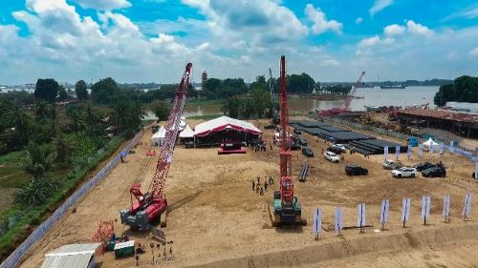

Figure 1: The Palembang wastewater treatment plant under construction in January 2021

Palembang has become the site of new approach to high quality infrastructure development with a city government in the lead. This will create a new waste water treatment plant and sewerage system for the city while also modelling a new approach to infrastructure development in Indonesia, which could unlock more much-needed investment in other cities.

Response

KIAT has been involved in the Palembang City Sanitation Project (PCSP) from the very beginning, helping to scope and structure the approach. Once agreement was reached between the GoI agencies involved, KIAT put in place a single Construction Management Consultant who performed tasks such as:

* conducted a socio-economic survey of affected households and a baseline survey of the project to allow the evaluation of project impacts (with a control area outside the plant catchment); and
* prepared documentation for tendering and contract award of the treatment plant and pumping station, and provided support for the local government of Palembang in the review of the project contractor’s detailed workplan and procedures.

This has enabled the GoI to implement a new model of infrastructure development, different from the traditional approach whereby the central government leads on tendering and construction and then hands over to a local government to run. This approach can result in unsustainable infrastructure projects that are beyond the capacity of provincial and local government to manage effectively. With the provincial government now involved every step of the way, the infrastructure will be sustainable and fit for purpose. According to GoI officials consulted by the MTR, “this is the way forward for Indonesia.”

More directly, KIAT helped set up important project approaches including:

* the local government tendered and awarded contracts using an international competitive bidding process;
* a Project Administration Manual guiding the implementation of the project was agreed between the central GoI agencies, the local government and DFAT; and
* project plans were updated to meet revised effluent standards announced by the Ministry of Environment.

Results

A ground-breaking event on the site of the waste water treatment plant was held on 4 November 2020 and construction is progressing well. A Communications Strategy has been developed by KIAT to highlight achievements as the project achieves progress milestones and household begin to connect.

The PCSP also presented an opportunity to develop commercial links between Australia and Indonesia. The project is a consortium between Australian company McConnell Dowell and Indonesia’s PT Pembangunan Perumahan. KIAT staff believe the status as an official Australian project helped foster interest by the private sector.

The PCSP incorporates a Gender Action Plan with four focus areas: women’s empowerment; social development, laws and regulations; and institutional strengthening.

However, the COVID-19 pandemic has placed new demands on the Palembang City budget while also reducing revenues. This means that the city is struggling to fund the socialisation strategy developed for the PCSP, which is needed to explain the purpose of the works in progress and encourage households to connect to the system.

Sustainability

The waste water plant and sewerage system has been designed to be affordable to run. KIAT will provide a package of technical assistance for the water utility that will operate the finished works, including advice on tariff setting and billing of customers

The Palembang city officials say the project has been a big learning experience from them, taking them from where they could not envision what such buildings and systems would look like to a place where they will soon be able to offer safe sanitation connections for their citizens.

Central agencies have learned a lot too, particularly when it comes to developing infrastructure projects that draw on multiple budgets. During the MTR consultations they recognized that this approach will be needed in many other cities in Indonesia, which makes the experience and demonstration project very important.

Challenges

A project modelling a new approach such as this encounters a variety of challenges. These have included:

* bureaucratic hurdles in securing the multi-year budgets required
* insufficient responses to the initial works tender
* construction delays due to COVID-19 and now the challenge of funding socialisation activities.

The testing of the approach with KIAT support and development of attendant systems should help alleviate or avoid similar problems in future. Nevertheless, a careful balance will always be required to ensure infrastructure projects are manageable within local capacities while also meeting required national and international standards.

**Attracting private financing for a Waste-to-Energy Plant in Semarang City**

|  |  |
| --- | --- |
| **Activity Stream** | Infrastructure Financing (Stream 7) |
| **Duration** | Jan 2019 – Present |
| **Location** | Semarang City, Central Java |
| **Reach** | If developed, the plant will reduce landfill requirements by 80% |
| **Value** | Approximately AUD1.5 million (KIAT component) |
| **EOFO(s)** | 2. High quality projects prepared for financing by GoI, MDBs or the private sector |

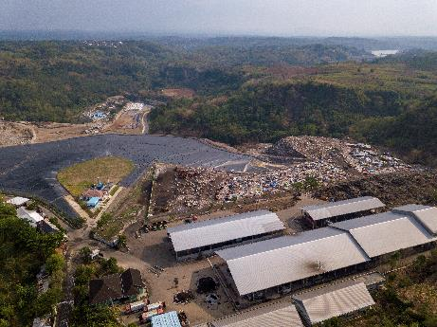

Figure 2: The Waste-to-Energy plant will enable Semarang to manage its waste more effectively

Situation

The City of Semarang has a population of 1.8 million with economic growth above 5 per cent pa in recent years. Total waste generated by the city was estimated at around 1,227 tonnes per day (tpd). At this rate, the Jatibarang landfill was due to be full in the next two to three years, leaving Semarang with serious waste disposal challenges.

Response

In response, KIAT supported the City of Semarang in the preparation of a Waste-to-Energy (WTE) project, critical to addressing the future of the city’s solid waste management. By installing and operating a WTE plant to divert and use waste in electric power generation, it is estimated that the landfilling void requirement would be reduced by around 80% (and generate 17MW of electricity enough to power 17,000 homes).

KIAT assistance initially included an Outline Business Case (OBC), or pre-feasibility study, to consider key technical and financial aspects of the project and to look at the feasibility of using a Private Public Partnership (PPP) scheme. The findings of the OBC were that operating the project as a PPP would provide a positive contribution to the economy measured by:

* economic net present value (value of all future cash flows over the entire life of an investment) estimated at around IDR1,106 billion (AUD101 million)
* favourable economic return on government spending (16%)
* a beneficial contribution to the economy as measured by the benefit cost ratio of 1.42.

KIAT has supported the preparation of a Final Business Case and PPP bidding documents to enable the City Semarang to enter the transaction stage and tender the project. The Ministry of Finance has formally appointed PT SMI to be the transaction adviser for the project and KIAT will provide support on clarifications regarding the project feasibility (including the financial modelling and alternative simulations requested).

Separate from the procurement documents, KIAT has prepared a discussion paper on opportunities for the integration of GESI and CSE in PPP procurement processes and is working to progress this. KIAT’s consideration of GESI in the Business Case process thus far was noted by the City of Semarang has being exceptionally effective and detailed. A Gender Action Plan is being finalised in conjunction with the completion of the Final Business Case, with the aim of considering GESI issues and opportunities for mainstreaming at the preparation, transaction and operations phases.

Results

KIAT’s support for the project has been designed to demonstrate to other Indonesian cities confronting similar waste management concerns the suitability and replicability of the PPP model for infrastructure. The consultation process with the City of Semarang verified how useful KIAT’s support had been in building local capabilities, with their conduct being “professional and procedural.”

As Semarang and other cities in Indonesia look to explore the feasibility of developing and implementing other renewable energy projects in coming years, KIAT’s support for this process will be used as a marker of good practice going forward, and also as a benchmark for the “type of problems that need to be considered during the development process.”

**Civil society engagement for GESI under the Provincial Roads Improvement and Maintenance Program (PRIM)**

|  |  |
| --- | --- |
| **Activity Stream** | Gender Equality and Social Inclusion (GESI) – Civil Society Engagement (CSE) |
| **Duration** | 2017- April 2019 |
| **Location** | Nusa Tenggara Barat (NTB) Province |
| **Reach** | KIAT provided grants and capacity strengthening to four organisations in NTB Province |
| **Value** | Approximately AUD80,000 in grant funding |
| **EOFO(s)** | 1. Improved policies and regulations for infrastructure development  3. High quality infrastructure delivery, management and maintenance by GoI. |

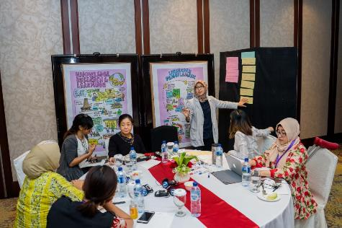

Figure 3: Attendees at a Road Traffic and Transport Forum

Situation

In NTB Province women’s voices have traditionally been marginalised from public policy and leadership roles. This is particularly the case in the construction sector, which is known to be a male-dominated sector. Further, while laws and standards on accessibility in infrastructure exist, they are not consistently complied with.[1]

The civil society sector is well placed to drive accessible and inclusive infrastructure development. Civil society organisations (CSOs) are strong in advocating on issues and mobilising communities. However, CSOs commonly face funding issues and lack organisation capability, therefore requiring capacity strengthening and funding support to work more effectively.[2]

Response

Through the GESI-CSE Strategy, KIAT engaged with civil society to increase the participation of women and other vulnerable groups across the whole project cycle of infrastructure activities over the longer term.

Following preliminary discussions with local governments and CSOs to identify areas of interest, and technical and financial capacity, KIAT designed and implemented a program of capacity building activities in areas such as workplans, budgeting and financial reports, complimented by a series of grants.

The program provided grants to four CSOs in NTB to strengthen GESI and CSE in the Provincial Roads Improvement and Maintenance (PRIM) program. Delivered by KIAT’s GESI-CSE Unit, the grants provided capacity strengthening for the organisations and support to implement activities for improved transportation for women, disabled and members of other vulnerable groups through Road Traffic and Transport Forum (RTTF) model. Two CSOs, the Indonesian Women in Business Association (IWAPI), and the Indonesian Association for Women with Disabilities (HWDI), were also chosen to receive support to carry out their activities.

Results

The grants to CSOs increased representation of women and disability groups in RTTF [3], improved capacity among the local women’s business association, improved networks among women sub-contractors and government and improved the flow of information and data on road maintenance tenders.

The support provided to HWDI was a particular success. With their grant funding and the support provided by KIAT to conduct action research, HWDI successfully petitioned the local government to build accessible walkways in the Cakra Business Zone and equip several buses with hydraulic lifts. In April 2018, the Governor of West Nusa Tenggara Province issued Decree No 551.1.2/353/2018 which formalised the inclusion of HWDI as a representative on the RTTF. This representation on the RTTF has seen non-government representatives on the forum increase from 10 per cent in 2014 to over 50 per cent in 2018.

HWDI representative: “We were hesitant to do any engagement with local government because we were afraid that we would not be heard [and] that they would not listen to us. But after we gained more confidence, we learned ways to conduct advocacy from our cooperation with KIAT. In the Cakra business zone, we have roads that can be accessed by the disabled, that's based on the action research that we've done. And we shared the results with the local government from that action research. This will enhance the human capacity, the human resources from disabled women, it also gives us better understanding for our organisation. Our organisation is now much better after having the [Memorandum of Understanding] with KIAT.”

In addition, HWDI now benefits from the provision of a free office by the Vice Governor for a period of two years and was invited by the Provincial Government to provide inputs into the drafting of the Provincial Regulation on People with Disabilities.

KIAT also supported IWAPI to convene two workshops targeting women's participation in infrastructure, and helped the organisation build capacity among women contractors in competing for tenders. Senior staff from the organisation noted change on both an organisational and individual level following the grants program, with the experience leading to shifts in their mindset around wider inclusion issues, such as disability, as well as developing their financial management and advocacy skills.

Both HWDI and IWAPI expressed a clear interest in working with KIAT again on a similar initiative, and agreed that the model is well positioned for scaling up.

Annex 5  
List of programmed and over-programmed activities (as of December 2020)

**KIAT list of programmed and overprogrammed activities (as of December 2020)**

|  |  |  |
| --- | --- | --- |
| Activity stream | Status | Activity |
| Urban Water Supply | Programmed | Performance Based Grant for Water Utilities |
|  |  | Technical Assistance to Bappenas |
|  |  | National Water Agency |
|  |  | Regional Water Supply Systems (formerly Regional Water Utilities) |
|  |  | Review of the GOI-funded Water Hibah |
|  | Overprogrammed | Water Supply and Sanitation Index (WSSI) |
|  |  | Eastern Islands Water Governance (formerly titled NTT NTB Water Governance) |
|  |  | Water Resource Allocation for Urban and Non-urban Use |
|  |  | Institutional Review of BPPSPAM |
| Urban Sanitation | Programmed | Palembang City Sewerage Project |
|  |  | sAIIG and Sanitation Hibah |
|  |  | DKI Jakarta: Improvements to Sanitation Services to Zone 5 and Capacity Development |
|  | Overprogrammed | National Sanitation Platform |
|  |  | Palembang PDAM Capacity Development |
| Urban Solid Waste Management | Programmed | DKI Jakarta: Upgrade of Waste Collection and Transportation System |
|  | Overprogrammed | DKI Jakarta: ITF (Waste to Energy) Project Preparation |
| National Road Network Development and Management | Programmed | Road Preservation Fund |
|  |  | Road Network Planning and Programming |
|  |  | Improving Project Delivery |
|  |  | Integrated Road Asset Management Systems and Data Collection |
|  | Overprogrammed | Road Development Strategic Assessment |
|  |  | Competency Based Training System for Road Construction Workers |
|  |  | Network Monitoring and Citizen Feedback App (JAKI) |
| Sub-National Road Network Development and Management | Programmed | Program Hibah Jalan Daerah |
|  |  | PRIM (Probolinggo) |
|  | Overprogrammed | - |
| Urban Mobility and Road Safety | Programmed | Crisis/Pandemic Management Framework (TransJakarta) |
|  |  | Sustainable Urban Mobility Plans (Semarang / Makassar) |
|  |  | Jakarta Transit Oriented Development and Pedestrian Oriented Design – Pilot Project and Capacity Building |
|  |  | Developing a Performance Benchmarking Mechanism for Public Transport Jakarta |
|  | Overprogrammed | Road Safety Masterplan |
| Infrastructure Funding and Financing | Programmed | Strengthening the functioning of the PPP Joint Office |
|  |  | Strengthening procurement documentation (Model Bidding Documents (MBDs)); policy, regulations and guidance material on Preparatory Agency and Probity requirements for PPP schemes |
|  |  | Preparation of Semarang PPP Waste to Energy Project |
|  | Overprogrammed | Support to DGH – Availability Payments |
|  |  | LRT Semarang |
|  |  | Technical Assistance to Yogyakarta Waste to Energy (WtE) Solid Waste Management Project |
|  |  | Valuation of Assets for concessions – social and environmental valuation |
|  |  | Ciptutat Markets PPP |
|  |  | MOHA – Availability Payments |
|  |  | Market Sounding Standard Operating Procedures |
|  |  | PTSMI – prefeasibility, financial instruments, transactions and capacity building |
| GESI-CSE | Programmed | Civil Society Engagement – GESIT |
|  |  | Inclusive Economic Empowerment – PERINTIS |
|  |  | GESI-CSE Adviser position: MPWH |
|  | Overprogrammed | Research, Knowledge and Learning |
|  |  | Enabling Employment of Vulnerable Groups |

Source: BPPR 31 December 2020, Page 43-44.

1. Japan International Cooperation Agency, 2015, ‘Data collection survey on disability and development in Indonesia’, <https://openjicareport.jica.go.jp/pdf/12245775.pdf>.
2. Management Systems International, 2018, ‘Assessment report: civil society organisations in Indonesia’, United States Agency for International Development, <https://pdf.usaid.gov/pdf_docs/PA00T6KQ.pdf>.
3. The RTTF aims to improve road safety and the representation of women and people with disabilities, as well as to improve the implementation of relevant regulations on roads, strategic planning and M&E. It plays a key role in overseeing PRIM and helping to resolve the concerns of all road users in NTB Province.