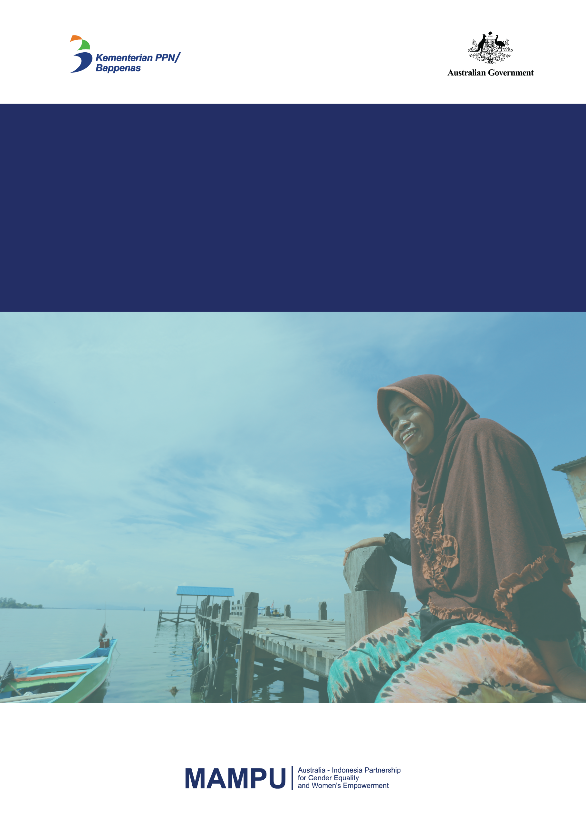

MAMPU is implemented by Cowater International Inc. on behalf of the Australian Government

**Strategic Plan**

**2017 – 2020**

**DFAT ‒ BAPPENAS**

**Australia-Indonesia Partnership**

**for Gender Equality**

**and Women’s Empowerment**



**MAMPU Strategic Plan**

**2017 - 2020**

Table of Contents

INTRODUCTION 3

GOAL AND THEORY OF CHANGE 3

COALITIONS, NETWORKS, AND COLLECTIVE ACTION 5

VOICE AND INFLUENCE 6

ALIGNMENT 9

LOOKING AHEAD 10

ROLE OF THE MAMPU PROGRAM TEAM 10

ANNEX 1: MAMPU Partners and Sub-Partners 12

ANNEX 2: MAMPU Program Theory of Change 21

ANNEX 3: MAMPU Five Thematic Area Road Maps 22

ANNEX 4: MAMPU Program Governance Structure 27

**Figure 1: MAMPU Program Outcomes and timeframes 4**

**Figure 2: The MAMPU Empowerment Framework 7**

# INTRODUCTION

Women in Indonesia continue to be more vulnerable to poverty and to lag behind in workforce participation, their access to services and in their levels of wellbeing. Underpinned by social norms and reinforced by institutions, social and political structures, gender inequality is persistent. Despite significant reforms, critical public services do not always reflect the needs of poor women, nor are they accessible to poor women.

Now in its sixth year, the Australian-Indonesia Partnership for Gender Equality and Women’s Empowerment (MAMPU) is working to address these issues. Commencing in 2012, MAMPU has worked to strengthen broad-based coalitions, led by civil society organisations (CSOs), to influence government policies, empower poor women and improve their access to essential services. MAMPU directly supports 17 national partner organisations (see Annex 1) and their 93 local partners. Working collectively, these networks are achieving significant results through their activities in local communities throughout the country. MAMPU partners currently work in just over 900 villages, across 27 of the country’s 34 provinces. More than 2,200 local community

groups have been established with a membership of more than 50,000 women. MAMPU partners work to empower their members to advocate for change within their local contexts and to influence how government policies are made and delivered ‘on the ground’.

During the first five years MAMPU developed a number of conceptual frameworks – on empowerment, on policy influence, on pathways of change in different sectoral areas – that supported activity choices by the program team, partners and other stakeholders. This Strategic Plan brings those frameworks together into one narrative, linked to the goal of the program and its theory of change. This will help to inform work planning through to 2020, to ensure that MAMPU makes a positive contribution to the goal. In addition to the annexes, it is complemented by the MAMPU M&E Framework (September 2017).

# GOAL AND THEORY OF CHANGE

MAMPU’s goal statement was revised in 2017 following discussion between the Governments of Indonesia (GoI) and Australia (GoA) on a new Subsidiary Agreement for MAMPU between 2017 and 2020. The revisions explicitly capture MAMPU’s contribution to GoI priorities of gender equality, women’s empowerment and the Sustainable Development Goals (SDGs).

**Table 1:** Changes to the MAMPU goal, 2012 to 2017

|  |  |
| --- | --- |
| **Original goal (2012 MAMPU Design Document):** | **Revised goal (2017 Subsidiary Agreement):** |
| “Improved **access and livelihoods** for poor women in Indonesia in selected geographic areas within the targeted themes.” | “…to improve the **access of poor women in Indonesia to essential services** and other government programs in order to **achieve gender equality and women’s empowerment** and support the achievement of relevant Government of Indonesia SDG targets.” |

While the goal statement has evolved, the Theory of Change (outlined in Figure 1 below and in further detail in Annex 2) that describes the pathway to the goal remains the same.

This is critical. There is little evidence that in isolation, improved access to services empowers women, as implied by the revised goal. However, improved access to services that comes about *through the voice and influence of women themselves (and organisations who work with and for them) can contribute to their empowerment and foster greater gender equality*.[1] This is the basis for MAMPU’s Theory of Change, which supports the goal.

That theory can be loosely arranged in three levels of outcomes over the 8-year MAMPU lifespan. From 2014 (year 2) onwards, MAMPU expected to see increased ‘**Capacity and Readiness for Collective Action**’ among partners (the Short-Term Outcome). This reflected MAMPU’s initial focus on supporting the development of partner internal administrative systems, their ability to build and sustain networks of sub-partner organisations, and their ability to communicate and collaborate with external partners including government and media. Evidence of positive changes in capacity and readiness has been documented in the Performance Story and Mid-Term Review in 2015, progress reports, and three capacity assessments of MAMPU partners in 2012/13, 2015, and 2017.

**Figure 1: MAMPU Program** Theory of Change Outcomes and timeframes

MAMPU’s current work builds on these gains. From 2015 (year 3) onwards MAMPU expected to see increasing ‘**Voice and Influence**’ among women (Medium-Term Outcome) at multiple levels. In the villages where MAMPU works, women are more involved in decision-making and their ongoing participation is starting to be acknowledged in formal village regulations. At the district, provincial and national levels, MAMPU’s contribution is reflected in policy decisions that contribute to improving women’s access to services.

Over the longer-term (from 2017 to 2020 and beyond), MAMPU expects these changes to contribute to improved ‘**Access to Essential Services**’ for poor women on a significant scale, as decisions and policies are implemented.

By 2020, these three levels of outcomes (increased capacity and readiness, increased voice and influence, improved access to services) act together to contribute to gender equality and women’s empowerment.

While this process appears linear, experience to date shows it to be highly complex and variable across the many different contexts where MAMPU is active. For example, ‘*Aisyiyah*’s work in Central Java and South Sulawesi first demonstrated how access to reproductive health services could be effectively increased for thousands of women by working with selected Community Health Centres. These early results were the basis for advocacy to district governments and parliaments, which have responded by allocating budgets and issuing administrative directives that enable the same approach to be applied to all Community Health Centres across target districts. This differs from Migrant CARE for example, who have leveraged their extensive networks at national level to influence the design of a national trial of decentralised service-delivery being implemented by the national Ministry of Labour.

This complexity and diversity reflects the extensive influence that MAMPU’s networks have developed. This is a tremendous source of strength while also challenging for conventional reporting systems.

# COALITIONS, NETWORKS, AND COLLECTIVE ACTION

In line with the original design, MAMPU continues to be underpinned by the idea that collective, evidence-informed advocacy, by strong CSOs and their allies in parliament and government can catalyse widespread positive change in the lives of poor women by influencing key government policies. Organisations advocating for improved gender equality and outcomes for women are more effective when they act in broad-based coalitions that include supporters within as well as outside the state.

MAMPU currently engages with the following networks of influence:

**Women’s Movement: National, Regional and Global Networks** – At a national level, MAMPU partners have worked together with other national organisations in the women’s movement to develop national level networks such as *Indonesia Beragam* which successfully advocated on key gender issues in the lead up to the 2014 Presidential Election. MAMPU Partners have also coordinated coalitions to respond to other gender issues. MAMPU Partners have identified three areas for focussed action in 2018, these include: women’s access to the National Health Insurance scheme (*Jaminan Kesehatan Nasional* (JKN), the Elimination of Violence Against Women (EVAW), and a consolidated movement to target elections as a platform for building momentum and commitment to women’s empowerment (including strategic campaigns for Presidential, Legislative and Local elections). There is also potential for an expansion of these coalitions outside Indonesia.

**MAMPU Partners and Sub Partners** – 17 MAMPU partners and their networks have come together and successfully advocated on a range of policy reforms. One example is the growing collaboration between partners on the issue of Child Marriage in Indonesia. Similarly within the partners themselves there is also significant scope for reform.

**Local Women’s Groups –** Organising at the grassroots level is a critical plank of partner strategies. Since 2014 MAMPU has established over 2,200 groups with a total membership over 50,000. Working collectively, women members engage with other strategic actors including religious and customary leaders to articulate their priorities and influence decisions that affect their lives. Tools and forums such as gender audits, *Sekolah Perempuan* (informal women’s schools), and *Balai Perempuan* (women’s meeting place) empower women to engage with and address gender equality and women’s empowerment issues themselves and through these, also to build their linkages to sub national governments, parliaments, and services providers.

**Government and Parliaments** – MAMPU will continue to build and strengthen broad horizontal and political networks, as well as inclusive coalitions, in order to influence government policies, regulations and service provision that improve the access of poor women to important services. MAMPU will continue to nurture deeper engagement with government at the national level, particularly with BAPPENAS through the Phase II governance arrangements. The five working groups (*Pokja*) are convened by BAPPENAS and bring together relevant ministries and partners, providing opportunity for advocacy and joint efforts between government and civil society.

As results to date have demonstrated, networks of selected civil society organisations – in some cases comprised of poor women themselves – can play a pivotal role in shaping government reforms at local and national levels. Critically, this agenda builds from work with women at the grassroots level across Indonesia to empower them and to support them to apply influence within their local contexts. Future refinements to the approach will focus on forming coalitions with male and female leaders; building horizontal linkages and networks across communities; and expanding vertical linkages to government officers, service providers, and other stakeholders.

# VOICE AND INFLUENCE

At this stage of MAMPU, the Theory of Change anticipates increasing women’s voice and influence at multiple levels, from their local communities, to formal policy-making arenas at the local and national levels.

Through the **breadth** of its networks of women’s groups, MAMPU has **empowered thousands of poor women**, often in isolated, rural parts of the country. Recognising that as an important outcome led to the development of an ‘Empowerment Framework’ in 2014, in order to map out the different assets that individuals acquire when they are ‘empowered’. Under the framework, MAMPU defines women’s empowerment as a process whereby women’s lives are transformed from a situation in which they have limited power and access assets, to a situation in which their power and agency is enhanced.

MAMPU’s Empowerment Framework identifies five types of assets, combinations of which individuals gain through an empowerment process:

* **human assets**, or ‘power within’: personal health and education, knowledge and skills;
* **social assets** or ‘power with’: friends, relatives, social networks, gaining inspiration and support from others, and having access to people of influence;
* **financial and resource assets**, or ‘power over’: increased income and savings ability to borrow, access to markets and inputs;
* **enabling assets:** access to administrative or legal documents, information, legal protection of rights etc, and;
* **agency assets** or ‘power to’: increased participation and influence in the family and community, access to better work, services and/or government programs.

At the individual level, empowerment involves changes in capability, knowledge and self-esteem. Through their involvement in local women’s groups, poor women have been provided by MAMPU with access to the first three of these – human, social and (in some cases) resource assets. As such they have a stronger **voice**; they are more confident to express their views in public and private spheres. That is an outcome in and of itself.

**Figure 2:** The MAMPU Empowerment Framework

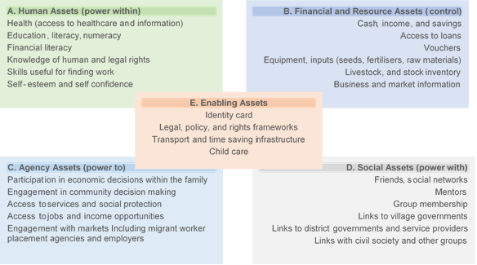

The Empowerment Framework also recognises that women’s empowerment has the potential to facilitate change beyond the individual; in communities and institutions, in markets and value-chains; and in the wider political and legal environment. Empowered women – particularly those with increased agency or resource assets, in addition to human and social – have the potential to contribute to the economy, and help to improve the efficiency and effectiveness with which resources are allocated to deliver essential services. MAMPU’s experience has shown this to be the case.

Decentralisation has presented challenges for the delivery of good quality basic services in Indonesia: where budgets are allocated for those services locally this also presents an opportunity for local women’s groups to advocate for improved quality of those services within communities. Where they have achieved a critical mass in their local communities and the context has been conducive to change, poor women – supported by MAMPU partner organisations – have also been empowered to **act collectively** and to **influence local decision-making** and advocate for the better allocation of local resources for basic services.

Where MAMPU partners are influencing government policies, they are working to improve the access of poor women to services and benefits in five areas:

* Social protection
* Employment and workplace discrimination
* Overseas labour migration
* Maternal and reproductive health
* Violence against women.

These five areas were chosen during the original design of the program, based on their alignment to priority policy areas for both Government of Australia (GoA) and Government of Indonesia (GoI) as well as areas of work relevant to the MAMPU partner organisations. To ensure focussed interventions within these areas, the MAMPU Program together with Partners and the GoI have developed thematic road maps for each of the five thematic areas. The road maps were developed to i) help define the policy focus within a given sector and ii) develop the appropriate strategies and targets to complement the GoI’s efforts within the relevant area (Annex 3).

MAMPU’s work in these policy areas takes a ‘dual-track’ approach. By engaging directly with poor women in local communities, MAMPU works to increase the demand for better basic services, while through its advocacy efforts, with and on behalf of poor women, MAMPU influences changes in policies to improve the supply of those services. Over the past five years, MAMPU has achieved results in each: MAMPU-facilitated coalitions of partner organisations supported greater access to publically-funded health insurance; improved access to health insurance for women homeworkers; supported local governments to provide better information to prospective and returning women migrant workers; delivered services addressing women’s sexual, reproductive and nutritional needs; and supported local authorities to provide counselling and support services to women survivors of domestic violence.

MAMPU’s partner network cascades from national-level organisations through to local branches and sub-partner organisations in districts and villages throughout the 27 provinces in which it operates. As such, the network also has **depth:** strong vertical linkages between organisations at the sub-national and national levels.

To achieve increased voice and influence, MAMPU leverages both the breadth and depth of its networks to:

* Enrich the lives of poor women by empowering them with social, human and resource assets;
* Empower poor women with agency and enabling assets to act collectively and enable their greater participation, leadership and influence in decision-making;
* Strengthen partner organisations’ ability to influence better and more accessible public services in the five sectoral areas on behalf of poor women; and
* Strengthen partner organisations’ ability to influence national-level policies that reduce gender inequalities and facilitate the empowerment of women.

# ALIGNMENT

The Indonesian President, Joko Widowo, committed the Government to these goals in the Nawacita: The Nine Point National Priority Agenda, which was the foundation for the 2015-2019 National Mid-Term Development Plan (or RPJMN). Through the RJPMN, GoI has nominated three main priorities for gender equality and women’s empowerment,

1. Increasing the participation of women in politics and development;
2. Mainstreaming gender in development planning and programs;
3. Protection of women and children.

MAMPU continues to contribute to each of the three priorities above.

With the shift to the Directorate of Human Development, Society and Culture in BAPPENAS in early 2017, much effort has gone into strengthening MAMPU’s alignment with other key Government of Indonesia agendas related to women’s empowerment and gender equality. In particular, with guidance from the Steering Committee and the Partners, MAMPU is much more closely aligned to the SDG agenda and positioned to help GoI deliver on some of its SDG goals. Now afforded regular engagement with the Director for Gender Equality, Children and Sport, MAMPU has also increased its alignment to other relevant UN programs, under the director’s supervision. As a result, MAMPU is now more closely aligned to GoI programs and priorities and is well-positioned to support the approach to gender equality and women’s empowerment in the next iteration of the RPJMN, starting in 2018.

# LOOKING AHEAD

By the conclusion of 2018, MAMPU expects there to be more visible results in increased ‘voice’ and ‘influence’. In the villages where MAMPU works, women will be more involved in decision-making and their ongoing participation will be acknowledged and enshrined in formal village regulations.

At the district, provincial and national levels, MAMPU’s contribution will be reflected in policy decisions that can plausibly contribute to improving women’s access to services on a wide scale by 2020. This is the expected medium-term outcome of MAMPU.

However, a series of preconditions are necessary if these outcomes are to contribute to better service delivery, improved access to services and greater levels of empowerment by 2020:

* Ongoing positive changes in the self-belief, knowledge and confidence of women with whom MAMPU works in villages;
* Authorising regulations and policies for reforms that address women’s priorities in place at the national, provincial and district or municipality level (without which budget allocations for priority areas will not be possible);
* Resources (financial and human) mobilised and allocated towards the particular service addressed in the policy;
* Capacities of government service providers sufficient to deliver the policy intent at the service level;
* Evident commitment and support from a critical mass of those in positions of power – within government, parliament and communities.

Together, these five preconditions represent the ‘causal package’ that MAMPU believes is required for policy influence to lead to improved access to services and greater empowerment. Increasing the capacity and readiness of partners for collective action has laid the foundations for achieving that outcome and MAMPU has helped to accelerate that process by developing organisational capacity, bolstering the focus and intensity of collective action and enabling partners to expand their reach both horizontally among local communities and vertically from local to the national levels of government.

# ROLE OF THE MAMPU PROGRAM TEAM

At this stage of the program, MAMPU’s role is as a connector and bridge builder between partners, government agencies and other strategically significant actors will increase. The new governance structure for MAMPU (Annex 4) opens space for routine partner-national government interaction. This is critical as it provides more (and arguably more powerful) avenues for civil society to influence positive policy change. With continued MAMPU support, partners will be encouraged to increasingly work collectively and in concert with allies in government, parliament, and the private sector to pursue their goals.

As MAMPU partners have recognised, the increased acknowledgement of their work at the national level, and the opportunities to showcase models, activities and achievements, is overwhelmingly beneficial. The increased involvement of BAPPENAS in guiding and facilitating these engagements will boost MAMPU’s capacity to link with wider reforms across government, and increase impact.

While MAMPU has performed positively so far, the program is now entering a critical phase. Ensuring the sustainability of the gains that MAMPU has enabled so far will be crucial to long-term change. Even so, it must be acknowledged that social changes as complex as progress on gender equality and women’s empowerment can take decades or longer in any context. Progress is rarely linear and it is likely that the real significance of MAMPU’s work on these issues will emerge well after 2020.

***

# ANNEX 1: MAMPU Partners and Sub-Partners

MAMPU provides grants to 17 selected main partners and through these organisations on-grants to local organisations who implement MAMPU activities across Indonesia. In total, 110 organisations are engaged in activities that contribute towards MAMPU’s outcomes. These organisations work in three broad types of network: (a) in a ‘vertical’ structure within the organisation, involving a national headquarters, and a mix of provincial, district, and sub-district ‘chapters’ or ‘branches’; (b) in a formal partnership with other autonomous CSOs at different levels working on similar issues; or (c) in a looser form of coordinated network relationship with other autonomous CSOs[2].

**Thematic Area 1 – Improving access to government of Indonesia’s social protection programs**

**1. PEKKA – *Yayasan Pemberdayaan Perempuan Kepala Keluarga /* Foundation for the Empowerment of Female Headed Households**

PEKKA or ‘Foundation for the Empowerment of Women Headed Households’ commenced its work in Aceh in 2000 to assist widows who were the victims of conflict in Aceh. Today it has grown to be a mass membership-based organisation empowering female heads of households to secure their livelihoods, participate in social and political life, and improve their standard of living. Today, PEKKA is the largest organisation representing women-headed households in Indonesia, organized in groups known as Pekka unions. They are active in 20 provinces, 65 districts, 220 sub-districts and 850 villages.

Through MAMPU, PEKKA focuses on improving women’s access to government and community social protection programs. They empower their members by building leadership and organizing capacity, providing literacy training, forming savings and loans groups and supporting small business. Their ‘KLIK PEKKA’ innovation is a mobile service which takes government to the people. This has enabled PEKKA to capture women-headed households in national data systems, and improve their access to social protection programs. MAMPU supports PEKKA branches in 99 villages spread across 20 districts in 14 provinces.

[pekka.or.id](http://pekka.or.id/)

**2. Institut KAPAL Perempuan – *Lingkaran Pendidikan Alternatif Perempuan* / Alternative Education Circle for Women**

KAPAL Perempuan was formed in 2000 to build a women's and social movement to realise social justice, gender equality and peace. The organization was established on 8 March 2000 – International Women’s Day – to address ethnic and religious identity-based conflict and violence occurring in various regions in Indonesia.

With MAMPU support, KAPAL Perempuan and their partners support women to gain to access to and influence the delivery of government social protection programs through *Gender Watch* and *Sekolah Perempuan. Sekolah Perempuan*, or informal women’s circles, provide community based education and training to develop local women leaders that can advocate for change at village and district levels. KAPAL Perempuan’s *Gender Watch* initiative enables joint monitoring of social protection programs by women, CSOs, academics, and government officials at village, district and provincial levels. This approach enables inaccuracies in beneficiary data to be identified and advocated to improve access to the National Health Insurance (JKN). As a largely urban based organization, MAMPU support has enabled KAPAL Perempuan to expand their network through partnerships with 6 local organisations working in 24 villages in 9 districts of DKI Jakarta, West Sumatra, East Java, South Sulawesi, as well as West and East Nusa Tenggara.

[www.kapalperempuan.org](http://www.kapalperempuan.org/)

**3. KPI - *Koalisi Perempuan Indonesia untuk Keadilan dan Demokrasi* / The Indonesian Women's Coalition for Justice and** **Democracy**

KPI was established in 1998 to promote gender equality and justice to support the development of a democratic and prosperous Indonesia. KPI has a national coordinating secretariat and secretariats in more than 110 cities/regencies in Indonesia. It has around 38,000 members and reaches around 900 villages in 24 provinces. KPI advocates for poor and marginalized groups of women through laws on disability, the protection of fisher women, and the Draft Law on Gender Equality and Justice (RUU-KKG).

Through MAMPU, KPI has strengthened community organizing and women’s leadership by establishing women’s groups called ***Balai Peremuan*.** By developing women leaders and cadre in these groups, KPI have developed an initiative called **PIPA-JKN** (*Pusat Informasi, Pengaduan dan Advokasi Jaminan Kesehatan Nasional).* The Center for Information, Complaints and Advocacy for National Health Insurance Program monitors the access by women to the National Health Insurance (JK) and other social protection programs. KPI are trialing the PIPA-JKN technique in 73 villages, and 37 districts across 8 provinces.

[koalisiperempuan.or.id](http://koalisiperempuan.or.id/)

**Thematic Area 2 - Improving conditions of employment and removing workplace discrimination**

The four organisations under Thematic Area 2 do not work through a local network. They are national organisations, with local branches, directly implementing activities in areas where they represent female homeworkers. Indonesian Homeworkers, or home-based workers produce, assemble, or finish products on a piece rate basis such as footwear, clothing, embroidery, cooking products and rattan products for domestic and international markets.

**1. BITRA - *Yayasan Bina Keterampilan Pedesaan Indonesia* / BITRA Indonesia Foundation / Foundation for Rural Capacity Building**

Established in 1986, BITRA works with poor and marginalized communities in rural areas to provide education and training opportunities to increase human capacity and community empowerment. They advocate for policies that support marginalised people, build strategic alliances to promote human development policies, and raise public awareness on matters of policy advocacy and economic empowerment.

BITRA’s work with MAMPU began in 2014. Since commencing they have organized over 500 poor women into ‘Homeworker Groups’ in 28 villages across 5 regencies of North Sumatra. BITRA have developed the capacity of members through training and awareness-raising in their rights, and supported income generation by forming credit unions. BITRA work closely with homeworkers to support them in their discussions and negotiations with employers and businesses. Policy advocacy is key to their work and they have worked with government and parliaments to develop draft provincial regulations recognising homeworkers.

[bitra](http://bitra.or.id/2012/tag/bitra/)

**2. MWPRI – *Mitra Wanita Pekerja Rumahan Indonesia / Indonesian National Network of Women Homeworkers***

MWPRI was founded in 1996 and is a network organisation dedicated to empowering women homeworkers. It does this by advocating for social protection for women home-based workers; ratification of ILO C177 - Home Work Convention, 1996 (No. 177) and the empowerment and strengthening of women workers organizations. Based in Malang, East Java, it has approximately 2,000 members. As a member of HomeNet South East Asia, MWPRI also collaborates with other networks of home-based workers in the region.

Since commencing their MAMPU-funded work in 2014, MWPRI has organized over 1,000 women homeworkers in 30 villages across 8 districts of East Java. They develop the capacity of women members to understand their rights and negotiate with employers. In close contact with the other 4 organisations in theme 2, MWPRI works on two key issues: continued strengthening of local homeworker groups, and influencing district and provincial government regulations covering the rights of homeworkers in the workplace. In 2016, MWPRI successfully contributed to placing a proposed regulation on the provincial legislative agenda.

**3. TURC – Trade Union Rights Centre**

The Trade Union Rights Centre (TURC) was established in 2003 and supports the development of an independent trade union movement in Indonesia. It represents workers by advocating for reforms to national and local labour laws and build workers capacity to organize.

Since joining MAMPU in 2014 TURC has worked with other NGOs and Trade Unions, organizing almost 300 women homeworkers in 22 villages in Solo and Sukoharjo districts (Central Java), completing research on homeworkers, and using the findings to develop a policy position paper. TURC advocacy activities focuses on homeworkers supplying national and international companies with branded products. This strategy will support stronger organizing and advocacy to benefit these homeworkers

[**http://www.turc.or.id/pub/**](http://www.turc.or.id/pub/)

**4. YASANTI – Yayasan Anisa Swasti**

Founded in 1982, Yasanti is a non-governmental women's organisation based in Yogyakarta. Yasanti empowers home-based workers through community organising, education, advocacy, and strengthening women’s economic independence.

Since 2014, Yasanti’s MAMPU-funded activities have involved organizing over 900 women homeworkers in 44 groups in 28 villages in 5 districts of DI Yogyakarta and Central Java. By forming credit unions, training and supporting members to negotiate with employers, Yasanti have steadily developed the capacity of women homeworkers. Their strategy will increasingly take a more strategic approach that recognizes that homeworkers occupy different positions across the ‘supply chain’. Yasanti also combine this grassroots work with advocacy to ensure that regulations provide better protection for homeworkers.

[**http://yasanti.or.id/**](http://yasanti.or.id/)

**Thematic Area 3 - Improving conditions for women's overseas labour migration**

**1. Migrant CARE**

Migrant CARE and its sub-partners advocate to increase female migrant workers rights and ensure they are free from exploitation and discrimination. Established in 2004, Migrant CARE focuses on strengthening the protection and services provided by government institutions to migrant works.

With MAMPU support, Migrant CARE has extended their extensive network at the national level to encompass partners at the district and local levels in 9 migrant-sending districts, in 5 provinces across Java, East and West Nusa Tenggara. In collaboration with their local partners, Migrant CARE has developed and is trialling a model for community-based service provision for migrant workers (pre-departure training, financial literacy, case handling) in 47 villages. This experience has informed their campaign to advocate for changes to the National Law on the Placement and Protection of Migrant Workers as well as for changes to the service delivery from key government agencies. As a result their **DESBUMI** model (Village that Cares for Migrant Workers) has influenced the national government **DESMIGRATIF** scheme (Productive Migrant Village), which is currently being trialed in 140 villages in 50 districts.

[migrantcare.net](http://migrantcare.net/)

**Thematic Area 4 - Improving women's health and nutritional status**

**1. ‘Aisyiyah**

‘Aisyiyah, was established in 1917 as an Islamic faith-based women’s organisation under Muhammadiyah, one of the two largest Islamic organisations in Indonesia. An autonomous women’s organization, ‘Aisyiyah contributes to women’s empowerment by strengthening women’s participation in all aspects of social and economic life. In operation for a century, ‘Aisyiyah has a large membership base of 10-15 million women with branches and activities across Indonesia, supporting women’s education, health and livelihoods.

MAMPU supports ‘Aisyiyah to improve access to reproductive health services. At the national level ‘Aisyiyah works with the Ministry of Health to improve their Minimum Service Standards (MSS). At the local level, ‘Aisyiyah’s work centres on the establishment of ***Balai Sakinah ‘Aisyiyah* (BSA)**, local women’s groups. ‘Aisyiyah have devised a ‘Service Model’ concept that works on the demand side to increase women’s knowledge and awareness of reproductive health issues and their right to access services including cervical and breast cancer screening. Alongside this, they work on the supply side to develop the skills of health workers, and advocate for the necessary budgets to enable service provision. ‘Aisyiyah is currently implementing these activities in 97 villages, across 16 districts, in 6 provinces.

BSA leaders are active in village and district government development planning forums, where they can now deploy evidence based advocacy to improve government funding for reproductive health services.

[www.aisyiyah.or.id](http://aisyiyah.or.id/)

**2. PERMAMPU – *Konsorsium Perempuan Sumatera MAMPU* / PERMAMPU Consortium**

PERMAMPU is a consortium of eight women’s organisations from across Sumtra. Established in 2012, it is made up of Flower Aceh (Aceh), Perkumpulan Sada Ahmo (PESADA) (North Sumatra), Organisasi Pengkajian dan Pemberdayaan Masyarakat (LP2M) (West Sumatra), Pusat Pengembangan Sumberdaya Wanita Sumatera (PPSW) (Riau), Aliansi Perempuan Merangin (APM) (Jambi), WCC Cahaya Perempuan (Bengkulu), WCC Palembang (South Sumatra), and DAMAR (Lampung).

Through MAMPU, PERMAMPU works to influence strategic actors including religious and cultural leaders, health service providers, schools and local governments. Since 2015, PERMAMPU have established a significant grassroots network of over 788 women’s groups in 214 villages, in 33 districts across 8 provinces of Sumatra. They work closely to enable women members of these groups to claim their sexual and reproductive health rights (SRHR). PERMAMPU’s strategy seeks to develop their economic and collective capacity at the grassroots, improve government service delivery, and ensure that improvements are anchored in policy, regulations, and budgetary allocations. Especially critical, is the role of religious and customary leaders who can influence the social and cultural norms that constrain women from accessing sexual and reproductive health services.

[**http://permampu.org/**](http://permampu.org/)

**3. YKP – Yayasan Kesehatan Perempuan / Women’s Health Foundation**

YKP (Yayasan Kesehatan Perempuan) or Women’s Health Foundation, is a small advocacy organization formed in 2001 working in the reproductive health space.

With MAMPU funding they formed a network with 15 like-minded organisations to implement multi-wave longitudinal (non-panel) surveys assessing delivery of the National Health Insurance, the JKN(Jaminan Kesehatan Nasional),in each of their 15 assigned provinces. The first two waves of the survey were conducted between June-August 2015 and repeated in February-June 2016. The third wave commenced in September 2017. In each district around 200 respondents are surveyed including users and providers of JKN funded services (medical and administrative staff in hospitals, *puskesmas* and private clinics). Results are used to advocate to government for increased funding to improve access and quality of services.

[www.ykp2015.org](http://www.ykp2015.com/)

**Thematic Area 5 - Reducing violence against women.**

**1. Komnas Perempuan –** ***Komisi Nasional Anti Kekerasan Terhadap Perempuan /* National Commission on the Elimination of Violence against Women**

Indonesia’s National Commission on the Elimination of Violence against Women (Komnas Perempuan) was established in 1998 as an independent national institution to protect women’s rights including preventing and reducing violence against women. It does so through increasing public awareness, monitoring, fact-finding and reporting violence against women, reviewing state policy, conducting research, and facilitating cooperation. The organisation works with close to 400 partners among national and local civil society organisations (CSOs) working on violence against women and gender equality, including maintaining and updating its database on violence against women cases in Indonesia. Through their collective advocacy efforts Komnas Perempuan were instrumental in the passing of Law No. 23/2004 on domestic violence.

[komnasperempuan.go.id](http://komnasperempuan.or.id/)

**2. FPL - Forum Pengada Layanan / Service Provision Forum.**

Initiated by Komnas Perempuan, Forum Pengada Layanan (FPL) was established in 2001. FPL is a network of over 100 service providers that provide frontline services (case handling, referral and legal assistance, crisis centres) to women victims of violence throughout Indonesia. It provides a forum for learning for these service providers to share experiences, resources and knowledge in case handling.

Through MAMPU, Komnas Perempuan partners with 24 FPL. Four of these have been selected as FPL host organisations which cooperate with 20 other FPL organisations operating in MAMPU sites to implement MAMPU funded activities. Together they work to improve the functioning (regulatory frameworks, budget support, referral mechanisms) of the governments Integrated Criminal Justice System for Handling Cases of Violence Against Women (SPPT-PKKTP).

http://fpl-region.blogspot.co.id

**3. Yayasan BAKTI - *Bursa Pengetahuan Kawasan Timur Indonesia /* The Eastern Indonesia Knowledge Exchange Foundation**

BaKTI Foundation was established in 2009 in Makassar, and grew out of its initial beginnings as the World Bank’s Support Office for Eastern Indonesia (SofEI) in Makassar. BaKTI collects and distributes information on development programs and assistance available for the development of Eastern Indonesia and supports local development actors to collaborate and harmonise different initiatives. BaKTI is also the Secretariat for *Forum KTI* (the Eastern Indonesia Forum). Established in 2004, the spans 12 provinces in Eastern Indonesia, its members are local government officials, legislature, academics, as well as representatives of civil society organisations and the private sector.

Through MAMPU, BaKTI’s work focuses on ending violence against women. They do this through grassroots community organizing by establishing *Kelompok Konstituen* (Constituent Groups); and bringing these constituent groups together in public consultation with their local parliamentarian leaders through their initiative ‘**Reses Participatif’** (Participatory Recess). BaKTI work in 85 villages, 6 districts, across 5 provinces of eastern Indonesia.

[bakti.or.id](http://www.bakti.or.id/)

MAMPU Partners and Sub-Partners

|  |  |  |  |  |  |  |  |  |  |  |  |
| --- | --- | --- | --- | --- | --- | --- | --- | --- | --- | --- | --- |
| **Theme 1: Increasing women’s access to social protection programs** | | | | | | | | | | | |
| **Mitra Nasional** | | | | | | | | | | | |
| 1. **KAPAL Perempuan** | | 1. **KPI** | | | | | 1. **PEKKA** | | | | |
| **Sub Mitra / Cabang** | | | | | | | | | | | |
| 1. KPS2K 2. LPSDM 3. Pambangkik Batang Tarandam 4. YAO 5. YKPM | | 1. Sekwil KPI Aceh 2. Sekwil KPI Bengkulu 3. Sekwil KPI DI Yogyakarta 4. Sekwil KPI Jambi 5. Sekwil KPI Jawa Timur 6. Sekwil KPI Sulawesi Selatan 7. Sekwil KPI Sulawesi Tengah 8. Sekwil KPI Sumatera Barat | | | | | 1. Seknas PEKKA 2. Serikat PEKKA Bali 3. Serikat PEKKA Bangkalan 4. Serikat PEKKA Banten 5. Serikat PEKKA Bantul 6. Serikat PEKKA Hulu Sungai Utara 7. Serikat PEKKA Kab HALUT - Maluku Utara 8. Serikat PEKKA Kab. Asahan 9. Serikat PEKKA Kab. Bantul 10. Serikat PEKKA Kab. Sijunjung 11. Serikat PEKKA Mamasa 12. Serikat PEKKA Ogan Komering Ilir 13. Serikat PEKKA Prop. Maluku Utara 14. Serikat PEKKA Sijunjung 15. Serikat PEKKA Sukabumi | | | | |
| **Theme 2: Improving conditions of employment and removing workplace discrimination** | | | | | | | | | | | |
| **Mitra Nasional** | | | | | | | | | | | |
| 1. **BITRA** | | 1. **MWPRI** | | | | 1. **TURC** | | | | 1. **Yasanti** | |
| **Theme 3: Improving conditions for women’s overseas migration** | | | | | | | | | | | |
| 1. **Migrant CARE** | | | | | | | | | | | |
| **Sub Mitra** | | | | | | | | | | | |
| 1. MC Banyuwangi 2. Perkumpulan Panca Karsa (PPK) 3. SARI Solo 4. YKS | | | | | | | | | | | |
| **Theme 4: Improving women’s health and nutritional status** | | | | | | | | | | | |
| **Mitra Nasional** | | | | | | | | | | | |
| 1. **‘Aisyiyah** | | | 1. **Permampu (Konsorsium)** | | | | | | 1. **YKP** | | |
| **Sub Mitra / Cabang** | | | | | | | | | | | |
| 1. PDA Kab. Bantaeng 2. PDA Kab. Blitar 3. PDA Kab. Cianjur 4. PDA Kab. Cilacap 5. PDA Kab. Cirebon 6. PDA Kab. Demak 7. PDA Kab. Lamongan 8. PDA Kab. Mamuju 9. PDA Kab. Mempawah 10. PDA Kab. Ngawi 11. PDA Kab. Pangkep 12. PDA Kab. Sambas 13. PDA Kab. Sumedang 14. PDA Kab. Takalar 15. PDA Kota Tegal 16. PDA Magelang | | | 1. APM Jambi 2. Flower Aceh 3. Lembaga Advokasi Damar Lampung 4. LP2M Padang 5. PESADA 6. PPSW Sumatera 7. WCC Cahaya Perempuan Bengkulu 8. WCC Palembang | | | | | | 1. Cakrawala Timur 2. FPMP Makassar 3. Lembaga Advokasi Damar Lampung 4. LP2M Padang 5. LPSDM 6. MAHA BHOGA MARGA 7. Mitra Aksi Jambi 8. PESADA 9. PIAR 10. PKBI Aceh 11. RAHIMA 12. SPEK HAM 13. Swara Parangpuan 14. Yayasan GASIRA Ambon 15. YLK YOGYAKARTA | | |
| **Theme 5: Reducing violence against women** | | | | | | | | | | | |
| **Mitra** | | | | | | | | | | | |
| 1. **Komnas Perempuan** | 1. **Forum Pengada Layanan (FPL) Hosts** | | | | | | | | | | 1. **BaKTI** |
| **2.1 LBH APIK Aceh** | | **2.2 LRC KJHAM – SUKMA** | | **2.3 SAPA** | | | **2.4 Swara Parangpuan** | | |
| **Sub Mitra / Cabang** | | | | | | | | | | | |
|  | 1. HAPSARI 2. LBH APIK Aceh 3. SPI Labuhan Batu 4. WCC Nurani Perempuan Padang 5. Yayasan PUPA Bengkulu | | 1. CIQAL 2. LRC KJHAM - SUKMA 3. SPEK HAM 4. WCC Jombang 5. WCC Savy Amira Surabaya | 1. Embun Pelangi Batam 2. LBH APIK Bali 3. LBH APIK Jakarta 4. SAPA 5. WCC Mawar Balqis | | | | 1. SSP Soe 2. Swara Parangpuan 3. YABIKU TTU 4. Yayasan GASIRA Ambon 5. YLI | | | 1. Arika Mahina Ambon 2. BaKTI 3. PPSE-KA Atambua 4. Rumpun Perempuan Sultra 5. Yayasan Kombongan Situru 6. YLP2EM Parepare |
| **Cross-cutting Support** | | | | | | | | | | | |
| **INFID** | | | | **Walang Perempuan** | | | | | | | |

Source: MAMPU National Information System (MANIS), October 2017

# ANNEX 2: MAMPU Program Theory of Change

|  |  |  |  |  |
| --- | --- | --- | --- | --- |
| **GOAL** | **Gender Equality and Women’s Empowerment** | | | |
| **End-of-Program-Outcome**  (2017-20 and beyond) | **“Improved Access to Services”**  **Improved access:** Poor women have improved access to basic government services and programs in target areas  **Better service delivery:** Government service providers deliver better more accessible services in target areas | | * Social protection programs * Workplace protections * Services supporting migration for employment * Services that address reproductive health and nutritional needs * Services for women victims and survivors of violence | |
| **Medium-Term Outcomes**  (2015-20 and beyond) | **“Increased Voice and Influence”**  **Critical external factor:** Local government service providers have sufficient capacity to carry out the intent of policy decisions  **Changes to resource allocation:** Governments and parliaments (local and national) allocate the resources (human and financial) needed to implement policy decisions  **Regulatory and policy decisions:** Government and parliaments (local and national) make policy and regulatory decisions that reflect the needs and priorities of poor women in the five thematic areas  **Commitment to reform:** The needs and priorities of poor women are increasingly reflected in the decision-making agendas of national and local leaders, government policy-makers, and parliamentarians  **Strengthened demand for reform through grassroots ‘voice’:** Poor women in target locations increasingly advocating for their needs and priorities at village and district levels | | | |
| **Short-term Outcomes**  (2014-20 and beyond) | **“Increased Capacity and Readiness for Collective Action”**  **Build coalitions to advocate for change:** Partners increasingly using evidence to advocate, engage and build alliances with government, parliamentarians, and the private sector  **Develop solutions:** Partners and their networks trial and refine solutions to service delivery issues that affect poor women in target locations  **Organise at the grassroots:** Partners organize women and men at the grassroots, campaign to generate public concern, and work with the media  **National-to-local linkages:** Increasingly effective communication between partners at national and local levels and branches | | | |
| **Support from MAMPU** | **FUND**: Multi-year grants to partner networks to enable them to test and refine their ideas and advocate for change  **ADVISE and ASSIST**: Technical advice and expertise that is strategic while being responsive to emerging needs | **CONVENE:** Bring the network together regularly to identify, discuss, and strategise  **BUILD EVIDENCE:** Collect, analyse, synthesize, and communicate evidence | | **COORDINATE and BRIDGE:** Link partners with Government of Indonesia, media, private sector, and other DFAT- and donor-funded initiatives |

# ANNEX 3: MAMPU Five Thematic Area Road Maps

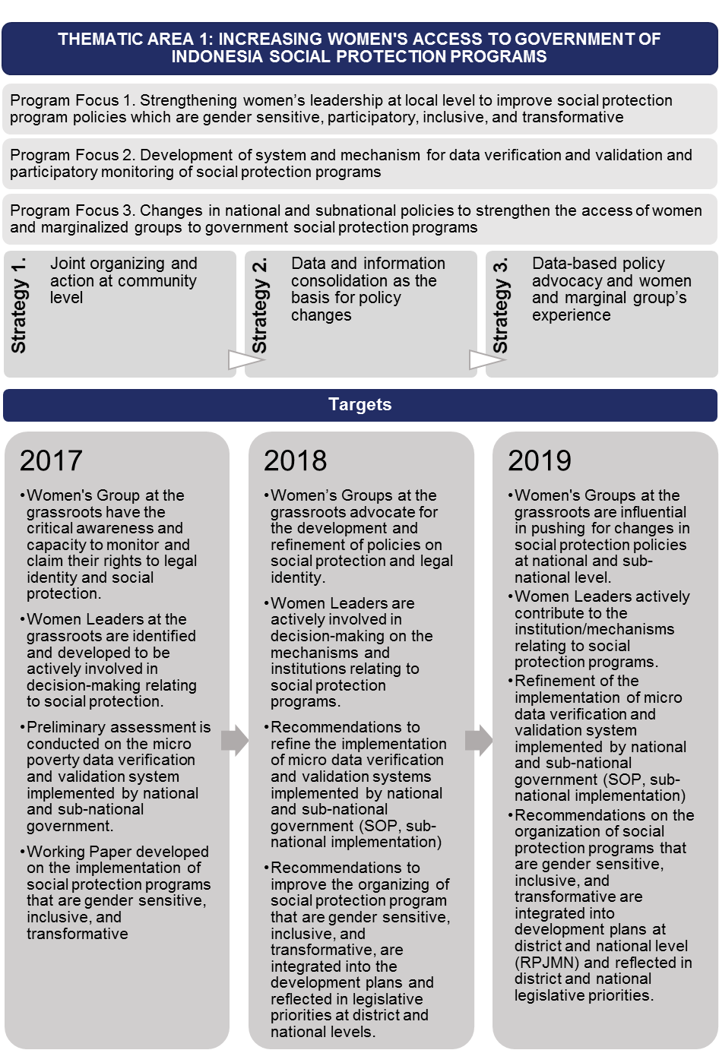

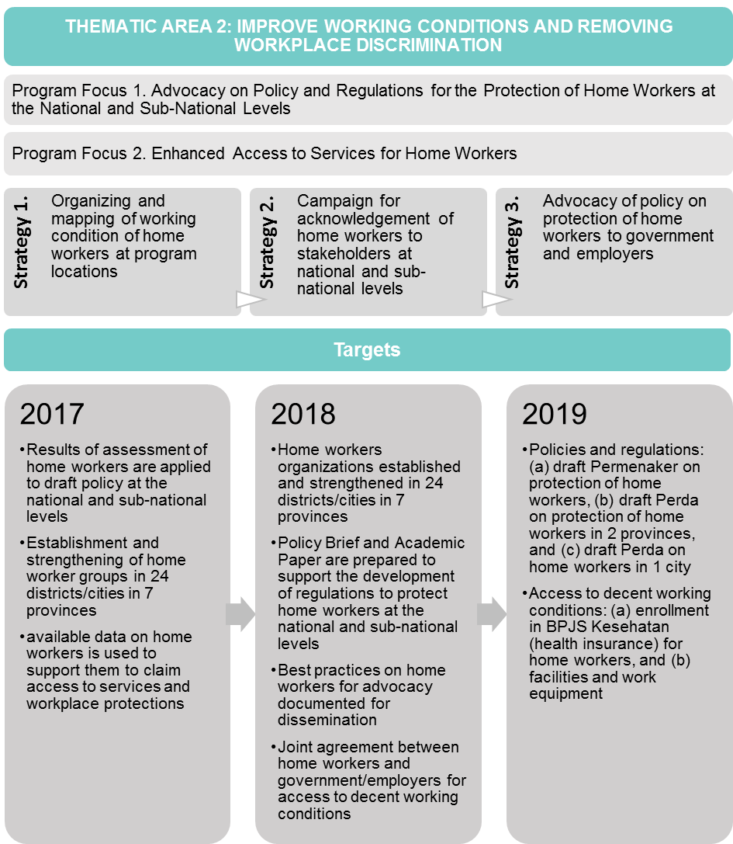

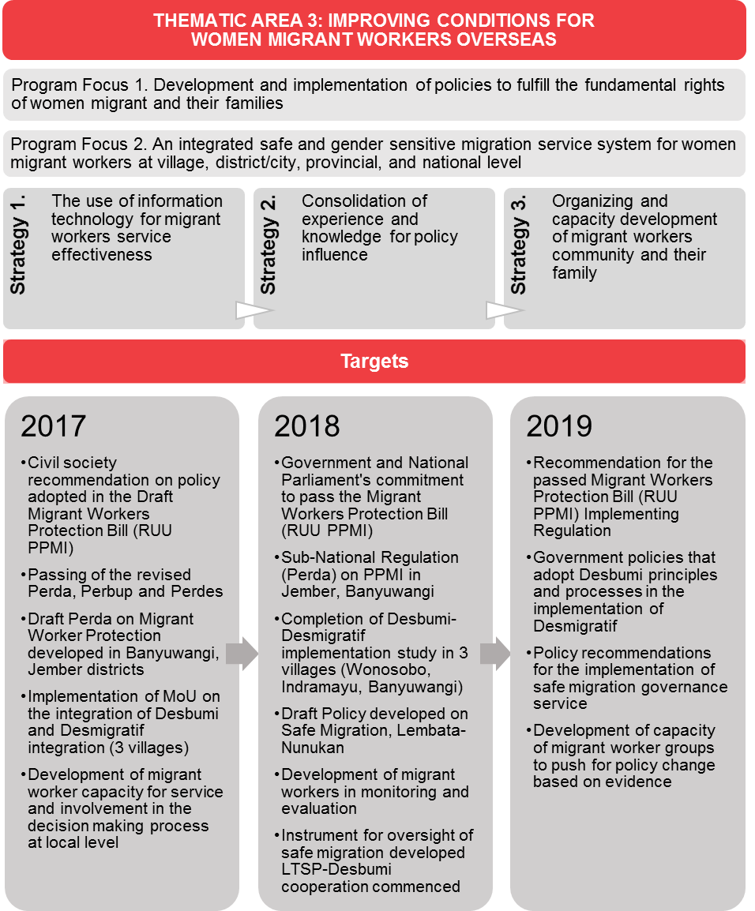

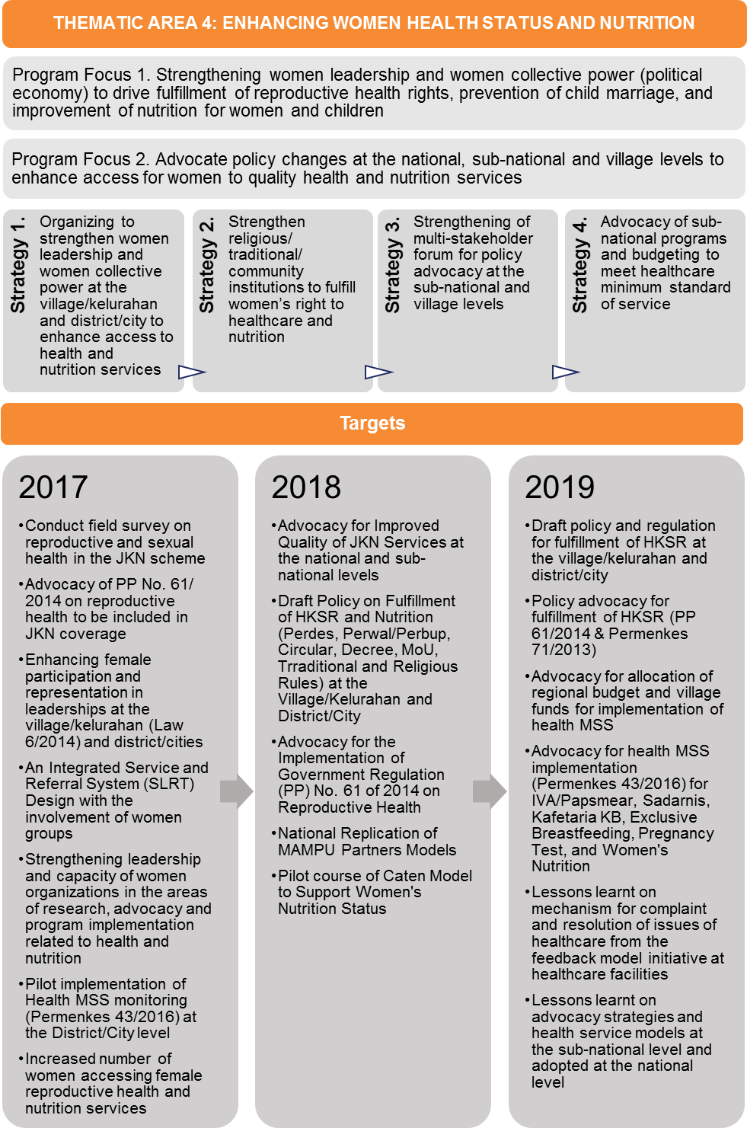

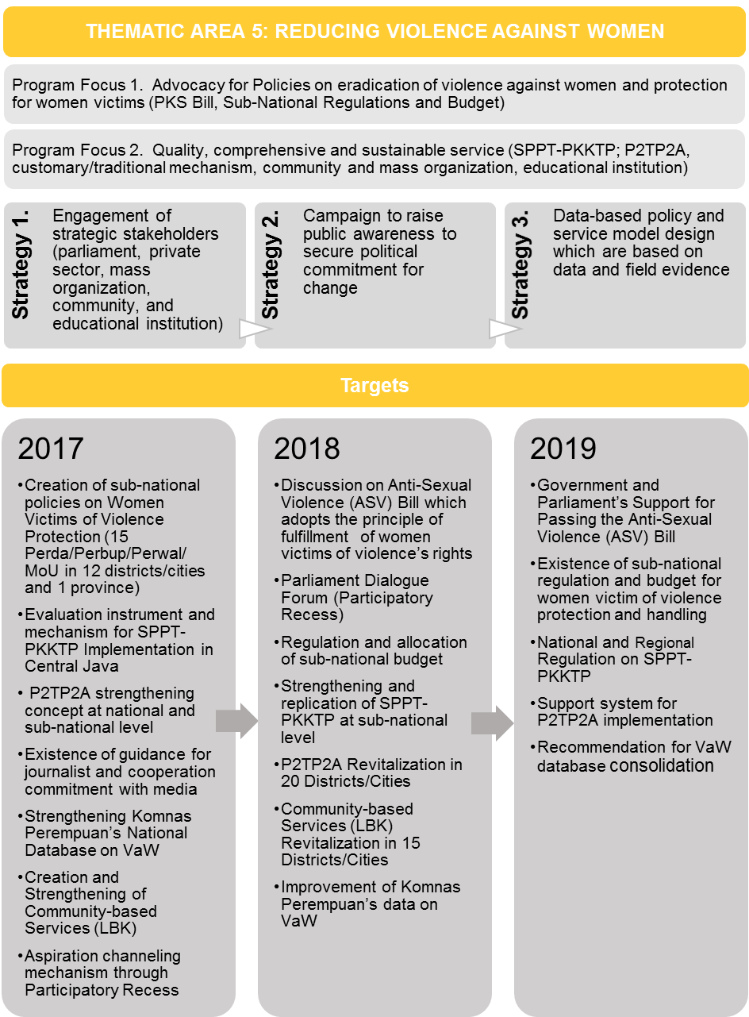

# ANNEX 4: MAMPU Program Governance Structure

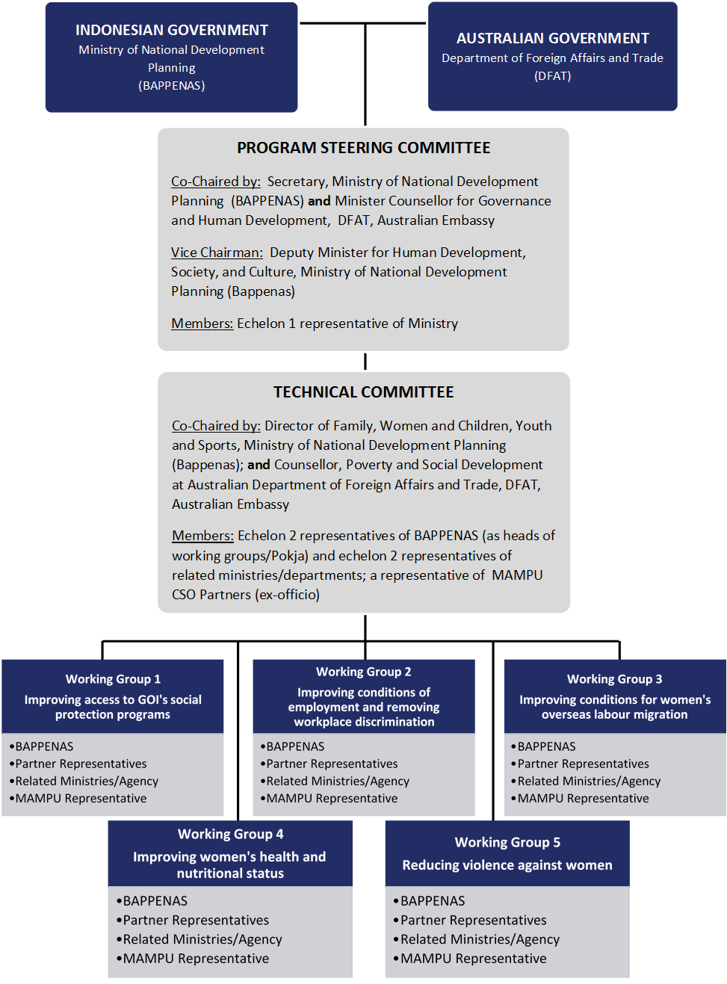

1. Although women’s empowerment has many definitions, women’s ‘agency’ is fundamental in all of them.
2. Data on Partners from partner website. Data on Partners areas of working in Indonesia from MAMPU National Information System (MANIS), current at October 2017.