  
**Commonwealth of Australia**

**Approach to Market (ATM)**

**Reference No: Regional Health Security Risk Report**

Statement of Requirement (SOR)

**This SOR is for the provision of:** A report on current risks to health security in the Indo-Pacific region.

The Commonwealth as represented by Department of Foreign Affairs and Trade (the Customer) is seeking tenders for the provision of the services (Services) described in this SOR.

In submitting a response, Potential Suppliers are required to comply with all requirements set out in both the:

* [Commonwealth Approach to Market Terms](https://www.finance.gov.au/sites/default/files/Commonwealth_Approach_to_Market_Terms_v5_July_2018_0.pdf), and
* [Commonwealth Contract Terms](http://www.finance.gov.au/sites/default/files/TERMS%20-%20Contract%20v2%20IPP%20link%20update.pdf)

Statement of Requirement

**A.A.1 Key Dates and Times**

|  |  |  |  |
| --- | --- | --- | --- |
| **Event** | **Date** | **Time** | **Location** |
| **ATM Closing Time:** | 21 February 2019 | 1700 | Canberra |
| **Question closing time:** | 2 business days before ATM Closing Time | | |
| **Expected Contract execution date:** | 1 March 2019 | | |
| **Services to be completed on or before:** | 30 April 2019 | | |
| **Term:** | Contract will terminate Tuesday 30 April 2019 | | |
| **Extension Option:** | Contract may be extended by ONE WEEK. | | |

**A.A.2 Mandatory Conditions of Participation**

The Customer will exclude from consideration any Response that does not meet the following Mandatory Conditions of Participation:

* Shows required level of skill in:
  + Report drafting and writing
  + Quantitative and qualitative analysis
* Has knowledge of the Indo-Pacific region including its:
  + health systems, including animal and environmental health systems as relevant to health security
  + health risks, especially relating to infectious disease detection, prevention and control
  + international relations, including international development assistance arrangements
  + regional institutions and architecture, including current programs and initiatives.

**A.A.3 The Requirement**

# Background

The Indo-Pacific Centre for Health Security within the Department of Foreign Affairs and Trade (‘The Centre’) administers the Government’s Indo-Pacific Health Security Initiative, which is a $300m program over 2017-2022 working to improve health security in the Indo-Pacific region (‘the region’) and more broadly. This includes investing in health systems research, product development, workforce and laboratory capacity building, disease surveillance and working with country partners on particular health security threats. The Initiative takes a One Health approach, acknowledging the interconnected nature of human, animal and environmental health.

# Purpose

The Centre is seeking to publish a baseline report on overall risks to health security in the region.

The Centre uses a definition of health security as “the avoidance and containment of infectious disease threats with the potential to cause social and economic harms on a national, regional or global scale.”

In 2018, the Centre has invested in high-level scoping missions conducted by international experts in human and animal health. The scoping teams prepared detailed reports summarising the findings and providing recommendations for improving health security at the country and regional level for on individual countries and on the Pacific and Southeast Asia areas of the region.

Many countries in the region have also completed external assessments of their pandemic preparedness levels and capacities, through the WHO Joint External Evaluation and OIE Performance of Veterinary Services tools.

It is envisioned that a similar report will be commissioned towards the end of the five-year initiative.

The report and its subsequent publication aim to:

* Outline and demonstrate a sophisticated understanding of the Indo-Pacific region’s

(1) Infectious disease threats;

(2) State of preparedness for health emergencies, particularly infectious disease outbreaks; and

(3) Its current trajectories for reducing key risks and implementing the International Health Regulations (IHR).

* Demonstrate the trans-boundary nature of heath security risks
* Provide an evidence base for domestic (within regional partner countries), regional and global action in support of IHR implementation
* Facilitate cross-sectoral communication on health security threats and responses
* Provide a significant number of high quality data visualisations accessible to non-technical audiences.
* Function as a flagship publication to inform health security policies and programs and maintain momentum for regional action to reduce health security risks.

# Location

Work under this project will be performed remotely at the supplier’s offices and/or at the offices of the Indo-Pacific Centre for Health Security.

# Key Personnel and special requirements

The project will require at least one lead with the following qualifications:

* A post-graduate degree in public health, medicine, epidemiology or a related field including One Health, Veterinary Medicine, Anthropology and Gender
* Demonstrated outstanding competence and academic leadership in research, and/or international public health and outbreak response
* Demonstrated experience in coordinating research and reporting projects accessible to a general audience, including clear science communication
* A solid understanding and demonstrated history of applying One Health approaches, and incorporating cross-sectoral perspectives.

The project lead will be responsible for procuring relevant additional expertise from personnel with more specialised backgrounds, including but not limited to the following areas:

* International Health Regulations
* Specific infectious disease threats as reflected in surveillance data and/or credible disease modelling
* Zoonoses
* Regional health systems, including workforce, laboratory and vector control capacities.

Proposals should also strongly consider the use of an advisory panel for rapid review of material at key stages.

Proposals should strongly consider the diversity of their personnel.

# Pricing

Responses should include a budget proposal, which clearly defines a pricing structure in one of two ways, as defined in [5.1-2].

## By Personnel

* + Responses from sole traders or individuals may outline the number of days expected for each deliverable and the relevant personnel and levels required.
  + Responses under this structure should be outlined with reference to DFAT’s [Aid Remuneration Framework](https://dfat.gov.au/about-us/publications/Pages/adviser-remuneration-framework.aspx) (ARF), under Discipline Category Group C.

## By Deliverable

* + Responses under this structure should be outlined with reference to pricing by milestones or deliverables.
  + Responses under this structure may consider the ARF or the Supplier’s own pricing structure where this is sufficiently clear and not comparable to the ARF.

# Scope and Deliverables

## Scope

### Geographic Scope

The report should principally cover ODA-eligible countries in Southeast Asia and the Pacific, as listed below, while also including selective coverage of threats across the wider Indo-Pacific:

**South East Asia**

Cambodia

Indonesia

Laos

Myanmar

Philippines

Timor-Leste

Vietnam

**Pacific**

Cook Islands

Federated States of Micronesia

Fiji

Kiribati

Nauru

Niue

Papua New Guinea

Republic of Palau

Republic of the Marshall Islands

Samoa

Solomon Islands

Tokelau

Tonga

Tuvalu

Vanuatu

### Thematic Scope

The report should have a strong focus on quantitative analysis, drawing on current literature and publicly available assessments of Indo-Pacific countries’ capacity to respond to a disease outbreak. It is not intended to require new research. It would ideally cover:

* Pathogens or pathogen types that impose the highest burdens on the region, or pose the highest risks, with a focus on both endemic and emerging/re-emerging pathogens
* The current state of national and regional preparedness as particularly reflected in the findings and recommendations of Joint External Evaluations, where completed, or other comparable assessments
* Estimates of the potential impacts of various forms of health emergency in the Indo-Pacific or subregions thereof, including economic costs and mortality/morbidity.
* Specific social, political, economic and geographic qualities of the Indo-Pacific, or subregions thereof, and their impacts on health security risks.

#### Cross cutting issues

The report should include a discussion of how health security risks and responses might be affected or amplified by factors relating to gender, climate change, or disability, in keeping with DFAT’s commitments under the department’s [*Disability Action Strategy 2017-2020*](https://dfat.gov.au/about-us/publications/Pages/disability-action-strategy-2017-2020.aspx)*,* the [*2017 Foreign Policy White Paper*](https://www.fpwhitepaper.gov.au/foreign-policy-white-paper/chapter-six-global-cooperation/climate-change)on Climate Change and[*Gender equality and women’s empowerment strategy*](https://dfat.gov.au/about-us/publications/Pages/gender-equality-and-womens-empowerment-strategy.aspx).

The report should include dedicated sections addressing these themes, including consideration of, but not limited to, the below:

##### ****Gender****

Sex and gender differences have a major impact on women’s, men’s, girls’ and boys’ exposure, vulnerabilities and behaviours in response to public health emergencies. This matters for the effectiveness of interventions. Disease outbreaks affect men and women differently, and it has been argued that international and regional health security frameworks inadequately address gender. This means that Australia has an opportunity and responsibility to make a difference in how gender is incorporated into health security, by actively promoting gender equity perspectives in policy dialogue, partnerships, research, and people-to-people links.

##### Disability

People with disabilities, who account for about 15 per cent of the global population, are disproportionately more likely to be marginalised and at risk of being left behind in health security prevention, response and recovery efforts. Disability is frequently a result of infections, often avoidable. Disability-inclusive health security frameworks that include people with disabilities as both beneficiaries and participants enhance effectiveness by increasing reach to all members of at-risk communities.

##### Climate Change

Human health is directly and indirectly affected by changing environmental factors linked to climate change. Increasing temperatures, changing rainfall patterns, rising sea levels and increasing frequency and severity of extreme weather events amplify risks for infectious disease, contributing to the increased frequency and spread of vector-borne diseases such as malaria, dengue and Zika virus disease. The Indo-Pacific region is particularly vulnerable to the health impacts of climate change, including from extreme weather events and rising sea levels.

## Deliverables

### Publication Outline

A publication outline including a proposed table of contents, to no more than three heading levels, and a 1-2 page accompanying rationalisation for the proposed structure.

Acceptance upon written agreement from the Customer.

### Draft Bibliography

Initial list of proposed sources cross-referenced with publication outline, demonstrating thorough coverage of key issues

Acceptance upon written agreement from the customer.

### First Draft

First draft of the report, which should include:

* At least 70% of expected final content, edited for spelling, grammar and clarity
* At least 50% of expected final tables and figures (data visualisations).

Acceptance on written agreement from customer. This may be after the incorporation of some initial feedback.

### Second Draft

Second draft of the report, which should be a complete draft with all intended content (including figures and tables), fully edited for spelling, grammar, structure, clarity and accessibility.

Acceptance on written agreement from customer. This may be after the incorporation of some initial feedback.

### Final Report

The final report must meet the aims of the project laid out in section A.A.3. It will be at least 50 pages in length, but not more than 100 pages, not including source list/bibliography but including data visualisations. It should include a clear executive summary of no more than three pages.

Acceptance on written agreement from the Customer.

# Audience

Likely users include foreign and international civil servants from organisations such as partner country governments, regional and international organisations.

|  |  |  |
| --- | --- | --- |
| **Partner Type** | **Profile** | **Examples** |
| Regional and international organisations, and other donor governments | International or regional civil servants, interested in pursuing aligned goals and collaboration | ASEAN Secretariat, Pacific Community (SPC), World Health Organisation, United Nations agencies, World Bank, Asian Development Bank, Product Development Partnerships, multiple donor government agencies |
| Whole-of- Australian Government | Medical, veterinary, or health system specialists from partner agencies | Department of Health, Department of Agriculture and Water Resources, CSIRO, Australian Centre for International Agricultural Research, Department of Defence |
| Research institutions | University departments, standalone medical and health research institutions | Multiple universities and research institutes, some focused on fundamental or translational medical research, others on health systems or other social science research |
| Partner governments, philanthropic organisations and NGOs | Nationals and representatives of countries in the Indo-Pacific, and non-government financing and delivery organisations working in those countries or globally | Multiple Indo-Pacific governments, multiple health-oriented NGOs, Bill and Melinda Gates Foundation, Wellcome Trust |

# Relevant examples

Some reports within or relevant to the interests to the Foreign Affairs and Trade portfolio that meet broadly similar requirements in health and other fields include:

[World Health Organisation Global Health Risks Report](https://www.who.int/healthinfo/global_burden_disease/GlobalHealthRisks_report_full.pdf?ua=1&ua=1)

[Institute for Economics and Peace Global Peace Index](http://visionofhumanity.org/app/uploads/2018/06/Global-Peace-Index-2018-2.pdf)

Institute for Economics and Peace Measuring Peace in the Pacific (attached)

[Department of Foreign Affairs and Trade Consular State of Play](https://dfat.gov.au/about-us/our-services/consular-services/Documents/consular-state-of-play-2016-17.pdf)

**A.A.3 (b) Security Requirements**

None Specified

**A.A.3(c) Workplace Health and Safety**

Prior to commencement of the Contract, the Customer’s Contract Manager and the Supplier’s Contract Manager will identify any potential workplace health and safety issues and assign management of each issue identified to the party best able to manage it.

**A.A.3 (d) Delivery and Acceptance**

The Customer may accept or reject any deliverables under the Contract in accordance with the Commonwealth Contract Terms [Clause C.C.10].

**A.A.3 (e) Facilities and assistance offered by the Customer**

No assistance will be provided beyond access to the Centre. Within the Centre, no access to corporate IT systems can be provided. Desk space, printing/copying facilities and wi-fi may be available.

**A.A.4 Approach to Market (ATM) Distribution**

**Distribution**

This SOR and any updates will be distributed via the DFAT Business Opportunities webpage and the Centre for Health Security Website and social media channels. Any questions relating to this SOR must be directed to the *Customer’s Contact Officer* at A.A.6.

**A.A.5 Assessment of Proposals**

Proposals received by the closing date will be assessed on the following criteria:

* Evidence of ability to meet requirement
* Appropriateness and strength of methodology to meet the requirement
* Qualifications of proposed personnel and/or institutions
* Value for money

**A.A.6 Lodgement Method**

Before lodging a response, please notify us of your interest.

EOIs and Responses should be lodged via Email to:

|  |  |
| --- | --- |
| **Email Address:** | [caitlyn.mckenzie@dfat.gov.au](mailto:caitlyn.mckenzie@dfat.gov.au) CC chs@dfat.gov.au |
| **Reference:** | State of Regional Health Security Report |

by the closing time specified above.

The Customer will accept Responses lodged in Word Doc (.docx) and/or PDF (.pdf).

Response files should/must not exceed a combined file size of 20 megabytes per upload.

**A.A.7 Customer's Contact Officer**

For all matters relating to this ATM, the Customer’s Contact Officer will be:

|  |  |
| --- | --- |
| **Name:** | Caitlyn McKenzie |
| **Email:**  **Phone:** | caitlyn.mckenzie@dfat.gov.au  CC: chs@dfat.gov.au  (02) 6261 3508 |

**Additional Contract Terms**

An executed contract will incorporate the Commonwealth Contract Terms and the following Additional Contract Terms:

**A.C.1 Intellectual Property**

The Supplier hereby assigns to the Customer all rights and interests in the intellectual property rights in the Material provided under the Contract. The Supplier agrees to create, execute or sign any document, which may be necessary to transfer those rights to the Customer.

The Customer grants to the Supplier a fee free, non-assignable, irrevocable, licence to exercise the intellectual property rights in the Material for the sole purpose of fulfilling its obligations under the Contract.

The Supplier warrants that it has full legal authority to assign the rights in the Contract; and that the provision of the Goods and/or Services and any Material under the Contract, and its use by the Customer in accordance with the Contract, will not infringe any third Party’s intellectual property rights.

**A.C.2 Special Conditions**

Further to Commonwealth Contract Term C.C.14 [*Specified Personnel*],the Supplier must not engage any current employee of the Customer or Former Employee of the Customer as Specified Personnel.

Further to Commonwealth Contract Term C.C.20 [*Compliance with Commonwealth Laws and Policies*],the Supplier must comply with, and ensure its officers, employees, agents and subcontractors comply with the following clauses:

**Child protection:**

The Supplier must, and must ensure that its Subcontractors and Personnel comply with all Customer safeguard policies as listed on the Customer’s website <http://dfat.gov.au/childprotection>.

The Customer may conduct a review of the Supplier’s compliance with the Customer’s Child Protection Policy. The Customer will give reasonable notice to the Customer. The Supplier must participate cooperatively in any such review.

If the Customer finds that the Supplier has failed to comply with the Customer’s Child Protection Policy, the Supplier must promptly, and at the cost of the Supplier, take such actions as are required to ensure compliance with the Customer’s Child Protection Policy compliance standards.

**Sanctions and Counter-Terrorism:**

The Supplier (and where appropriate, the Suppliers’ subcontractors) will ensure that no funds are provided, directly or indirectly, to, or otherwise used to provide assistance or support to, persons or entities designated for targeted financial sanctions by the United Nations Security Council or under Australian law, or to terrorists or terrorist organisations. The Supplier must inform the Customer immediately if, during the course of the Contract, the Supplier determines that any such funds have been so provided or used. Information on Australian sanction laws, including the Customer’s Consolidated List of persons and entities subject to targeted financial sanctions, is available at [www.dfat.gov.au/sanctions](http://www.dfat.gov.au/sanctions). Information on terrorist organisations for the purposes of the *Criminal Code Act 1995*, including those organisations specifically listed as terrorist organisations, is available at [www.nationalsecurity.gov.au](http://www.nationalsecurity.gov.au).

**Anti-Corruption:**

The Supplier warrants that neither it nor its Personnel will make or cause to be made, receive or seek to receive any offer, gift or payment or benefit of any kind, which could be construed as an illegal or corrupt act, either directly or indirectly to any individual or organisation in relation to the execution of the Contract. Any breach of this clause will entitle the Customer to issue a notice under Commonwealth Contract Term Clause C.C.11 [*Termination for Cause*] to terminate the Contract immediately.

**Fraud:**

The Supplier is responsible for preventing and detecting suspected, alleged or attempted Fraud in delivering the goods or services under the Contract.

If the Supplier becomes aware of any suspected or detected Fraud in delivering the goods or services under the Contract, it must report the matter to the Customer in writing within five (5) business days. The Supplier must investigate the Fraud at the Supplier’s expense and in accordance with any directions or standards required by the Customer.

After the investigation is finished, the Supplier must promptly report full details of any Fraud to the local police and any other appropriate law enforcement agency in the country where the incident occurred, unless the Customer agrees otherwise in writing.

If the investigation finds Fraudulent Activity in delivering the goods or services under the Contract, the Supplier must promptly:

Pay to the Customer the full value of any Customer funds that have been misappropriated; and

Either return any misappropriated property to the Customer or, if the property cannot be recovered or has been damaged so that it is no longer usable, replace the property with property of equal quality.

For the purposes of this clause:

‘Former Employee of the Customer’ means a person who was previously employed by the Customer, whose employment ceased within the last nine (9) months and who was substantially involved in the design, preparation, appraisal, review, and or daily management of the Contract.

‘Fraud’ or ‘Fraudulent Activity’, means dishonestly obtaining a benefit, or causing a loss, by deception or other means.

‘Personnel’ means the Supplier’s officers, employees, agents, advisers, Suppliers and Subcontractors (including their respective personnel), and includes Specified Personnel and associates.

**A.C.3 Meetings**

The Supplier must ensure that its personnel and subcontractors (where applicable), attend meetings with the Customer to discuss the Goods and/or Services as required for fulfilment of the supplier’s obligations, at no additional cost to the Customer. All meetings with the Customer will be held at Canberra or at a location which provides best value for money as determined by the Customer.

**A.C.4 Travel**

The Supplier must ensure that its personnel and subcontractors (where applicable), make travel arrangements in consultation with the Customer, if the Customer requires the Supplier or its personnel to undertake travel to perform any part of this Contract.

**A.C.5 Supplier Performance**

In accordance with the Customer’s performance policy *Making Performance Count*, available at: <http://dfat.gov.au/aid/Pages/australias-aid-program.aspx>, the Customer recognises that Supplier performance contributes to aid policy outcomes. Therefore, the Customer may conduct an assessment of the Supplier’s performance at any time in a form that the Customer deems appropriate.

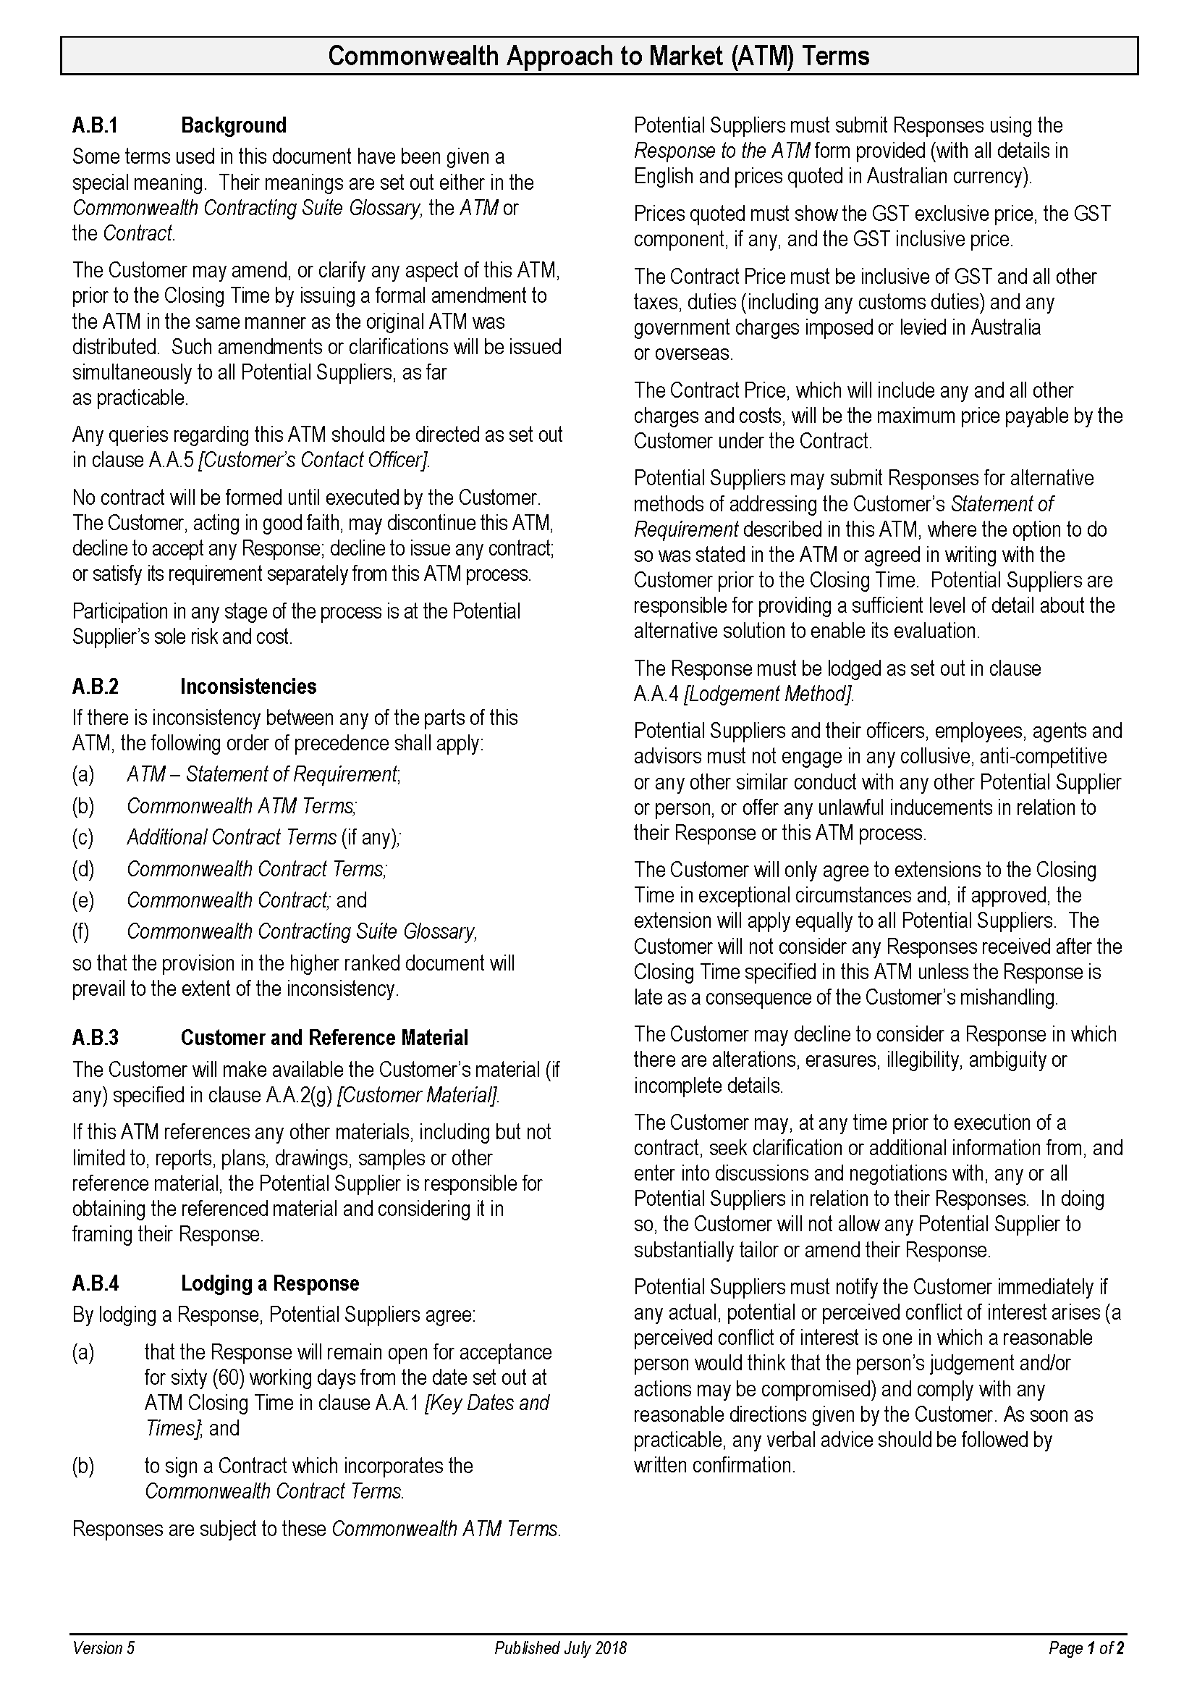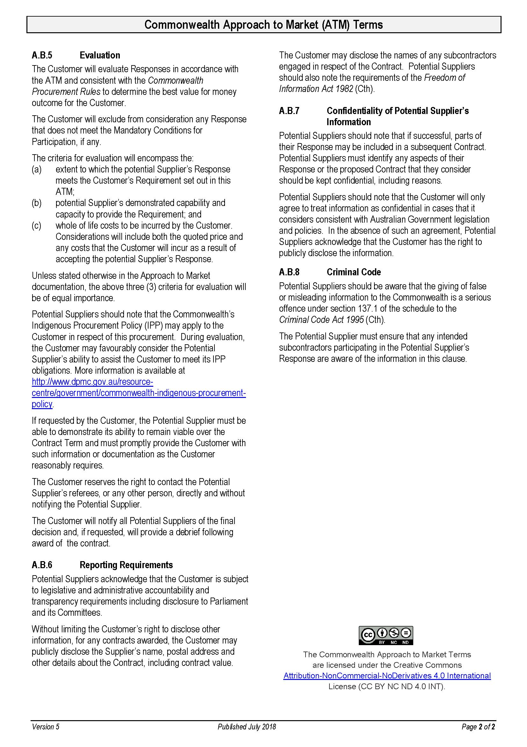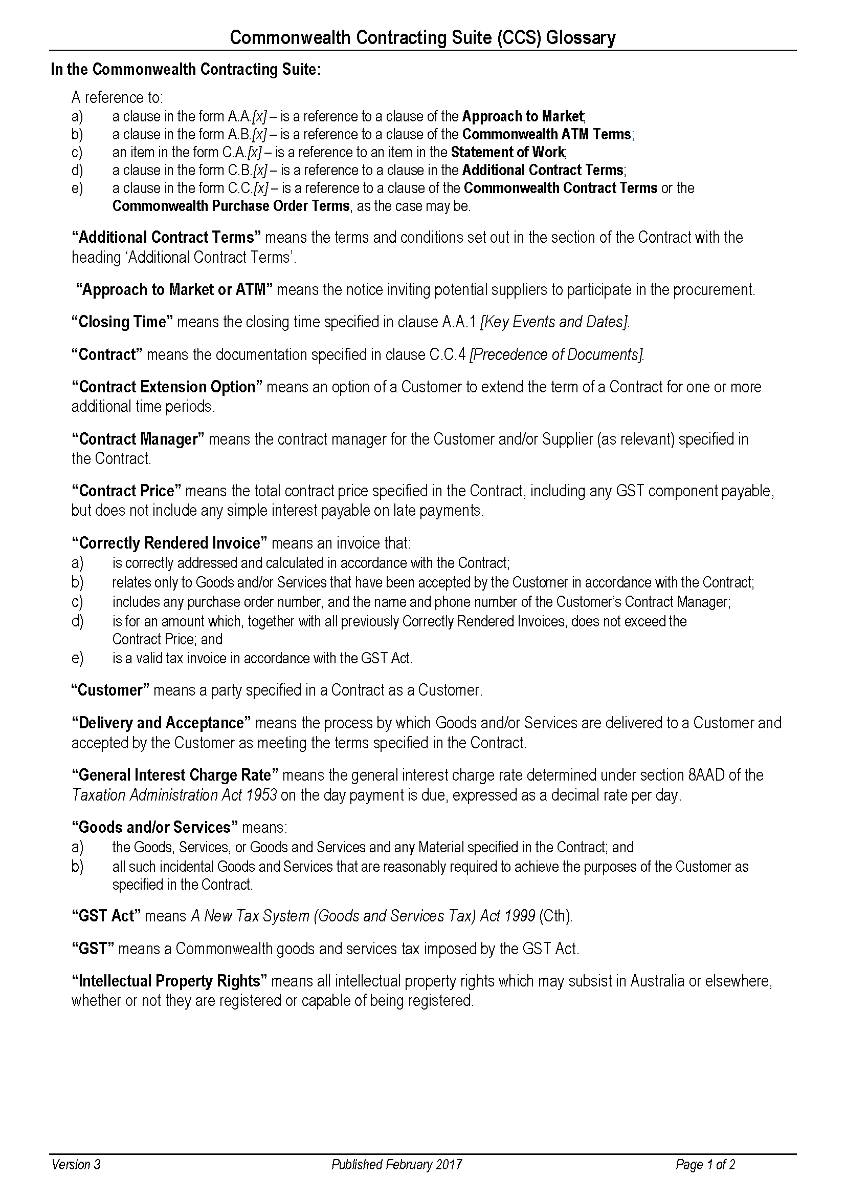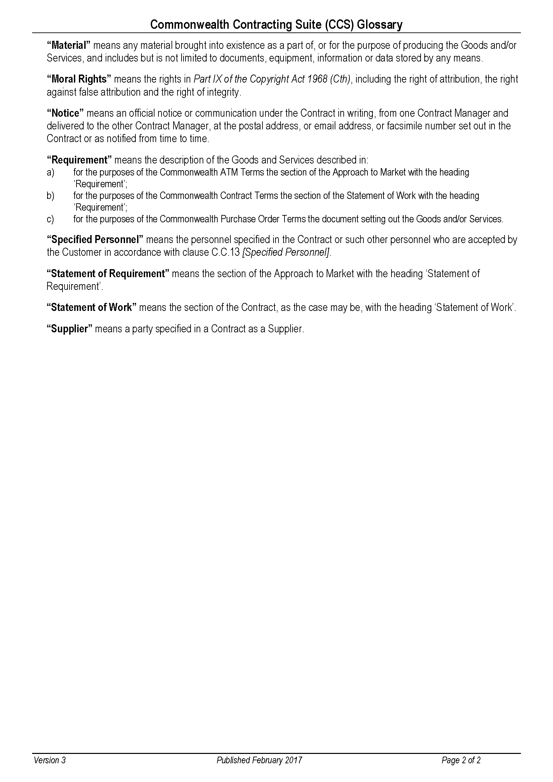**Before completing this form read the information below:**

**Note:**

The Supplier is the business entity who will contract with the Customer if their Response is successful. If you are the preferred Supplier and are an individual without an ABN, and do not meet the Australian Taxation Office’s (ATO) definition of an independent contractor, you may be offered a different form of contract OR we may not be able to contract with you. Before completing this Response Form, notify the Nominated Contact Officer to enable them to seek advice.

For further guidance refer to the ATO website at:

<http://calculators.ato.gov.au/scripts/axos/axos.asp?CONTEXT=&KBS=GEC.xr4&go=ok>

Instructions to assist Potential Suppliers to complete their Responsehave been included throughout this form.

**Prior to submitting your response, you should remove all Instructions and Handy Hints.**

**Handy Hints** appear in shaded boxes.

Specific questions on this procurement should be directed to the Contact Officer nominated in the *Commonwealth ATM* [Clause A.A.6] distributed with this Response to ATM form.

**Instruction to Potential Suppliers:**

You must use this form to submit your Response, which must comply with the *Commonwealth ATM Terms*, which are available at <http://www.finance.gov.au/sites/default/files/ATM%20Terms%20v1_0.pdf>.  
Before completing this Response read the Customer’s Approach to Market (ATM) distributed with this Response to ATM form and decide whether your organisation has the necessary skills and experience to meet the Customer’s requirement set out in that ATM.

In this Response, be as concise as possible while including any and all information that your organisation wants the evaluation panel to consider. Do not assume that the evaluation panel has any knowledge of your organisation’s abilities or personnel.

Your organisation’s participation is at your sole risk and cost. This is a competitive process, and you should note that your organisation may incur costs in participating, and if not successful be unable to recoup those costs.

**Handy Hints**

When completing this form, provide all information requested and submit the form as required in *Lodgement Method* [Clause A.A.5]*.*  Demonstrate that your organisation meets the *Mandatory Conditions of Participation* [Clause A.A.2] if any, as failure to do so will result in your response being excluded from consideration.

The Customer will assess all Responses received by the *Closing Time* [Clause A.A.1] which meet any *Mandatory Conditions of Participation* [Clause A.A.2] and compare them to determine which Potential Supplier has proposed the best value for money outcome for the Customer. In making this decision, a panel will consider:

(a) which Response best meets the Customer’s requirement set out in the *ATM*;

(b) whether the Potential Supplier has proven capacity to provide the Customer’s requirement; and

(c) the total cost the Customer will incur in accepting the Potential Supplier’s proposal.

The successful Potential Supplier will have demonstrated its ability to provide the best value for the Customer. This will not necessarily be the lowest price.

If your organisation is unsuccessful with this submission, request a debrief to assist with future submissions. The *Customer’s Contact Officer* [Clause A.A.6] can arrange this for you.

**Part 1 - Potential Supplier’s Details**

**Instruction to Potential Suppliers:**

Provide the following organisational details which will appear in any contract with the Customer. These details should be for the legal entity that would be the Supplier under a Contract.

Full legal business name:

Registered business address:

ACN/ARBN (if applicable):

ABN (if applicable):

Web address:

What is the entity’s legal status (double click a box below to select):

|  |  |  |  |  |
| --- | --- | --- | --- | --- |
| Company | Partnership | Sole Trader | Sole Director Company | *Other |

If none of the above apply, please state entity type:

Is the above entity a non-government employer with more than 100 employees? Yes No

Is the above entity an Indigenous owned (50% or more) business? Yes No

***Contact Officer***

For all matters relating to this Response, the Potential Supplier’s Contact Officer will be:

Name:

Position title:

Telephone:

Mobile:

Email:

Postal Address:

***Address for Notices*** (if different from the Contact Officer)***:***

Name:

Position title:

Email:

Postal Address:

***Contract Manager*** (if different from the Contact Officer)

**Instruction to Potential Suppliers:**

Potential Suppliers should provide the requested details of the person they propose to be their Contract Manager if a contract is awarded. That person will be responsible for general liaison with the Customer and accepting and issuing any written notices for that Contract.

Name:

Position title:

Telephone:

Mobile:

Email:

Postal Address:

(if different from above)

**Part 2 - Executive Summary**

**Instruction to Potential Suppliers:**

Provide a brief (less than 1 page) Executive Summary of your proposal highlighting any key aspects, including how you (and any subcontractors) propose to comply with the Commonwealth Government’s Indigenous Procurement Policy (available at <http://www.dpmc.gov.au/resource-centre/government/commonwealth-indigenous-procurement-policy>).

**Handy Hint:**

You may find it useful to complete this Executive Summary last so that it is easier to summarise your proposal’s key features.

**Part 3 – Ability to meet the requirement**

***Mandatory Conditions of Participation***

**Instruction to Potential Suppliers:**

If there are any *Mandatory Conditions of Participation* [Clause A.A.2], specifically respond to them here.

*Please Note: If you are unable to meet any Mandatory Conditions of Participation your response will be excluded from consideration.*

***Detailed proposal to meet the Customer’s requirement***

**Instruction to Potential Suppliers:**

The information you provide in this section will be considered in evaluating the extent to which this Response meets the Customer’s requirement, be as concise as possible. Do not provide general marketing material that does not relate to the specific requirement.

Provide a detailed description of your proposal to supply the Customer’s requirement, including any delivery methodology.

If there are any *Mandatory Conditions of Participation* [Clause A.A.2] you should specifically respond to them here.

**Handy Hint**

This is your organisation’s opportunity to convince the evaluation panel that your organisation understands the Customer’s requirement and can deliver it to a high standard.

This is the place to highlight your competitive advantage as well as any special or unique features of your proposal. Depending on the requirement, your organisation’s response could propose a detailed project plan including project milestones and completion dates; timeframes; quality standards or performance indicators which demonstrate success or progress. It could also detail any critical issues or key delivery risks of which the Customer should be aware.

Do not rely solely on your organisation’s reputation as the evaluation panel can only consider information you provide in this submission – this *Response to ATM* is the opportunity to promote your organisation.

**Part 4 - Potential Supplier’s Proven Capacity**

***Statement of Skills and Experience***

**Instruction to Potential Suppliers:**

The information you provide in this section will be considered in evaluating your organisation’s proven capacity to meet the Customer’s requirement.

Provide clear, concise details of your relevant abilities to deliver what you have proposed above.

This is your opportunity to prove to the evaluation panel that you can meet the Customer’s requirement to a high standard.

**Handy Hint**

This is your opportunity to highlight any unique capabilities.

Depending on the requirement, this could include a detailed description of your recent experience in successfully supplying a similar requirement for Consultancy Services It could also include your organisation’s expertise in this field, brief information about your personnel (highlighting relevant expertise and experience), details of relevant intellectual property or unique products used.

You may also attach brief supporting information specific to this procurement including tailored CVs for Specified Personnel, where relevant.

***Specified Personnel***

**Instruction to Potential Suppliers:**

Usually it will not be necessary to include Specified Personnel for Consultancy Services contracts. However, if your proposal has referenced the skills of specific personnel provide details in the table below. Include their role, the percentage of the project that they will complete (the total of all specified personnel will add to not more than 100% of the project) and if relevant, their current Commonwealth Government security clearance. Only propose Specified Personnel where you can reasonably expect them to perform the roles nominated.

Also include the same details for any subcontractor personnel, if applicable.

Add extra lines to the table if required. If no Specified Personnel are proposed insert “Not Applicable” in the table.

Potential Suppliers must work within the Aid Adviser Remuneration Framework (ARF), as amended from time to time. It is available on the Customer’s website at <http://dfat.gov.au/about-us/publications/Pages/adviser-remuneration-framework.aspx>.

**Handy Hint**

Where the person proposed is a recognised expert in their field and the quality of your proposal relies on their expertise, they must be specified in the table below. Only include names for Specified Personnel where their unique skills are relevant or a security clearance is required to perform a particular role.

However, where you have a number of staff who could perform a particular role, include details of the position/role, and the % of the project time which this role will perform. In these circumstances it would not be necessary to name the person.

The % Time column is the % of the total project time each specified person/role will provide.

Include subcontractor personnel in this table, if applicable.

Further information on Management Fees, Personnel Fees and Adviser Support Costs is included at Annexes 1, 2 and 3.

|  |  |  |  |  |  |
| --- | --- | --- | --- | --- | --- |
| ***Position/Role*** | ***% Time*** | ***Name*** | ***Current level of Security Clearance***  ***(if requested at A.A.3(b))*** | ***ARF Job Level*** | ***ARF Job Category*** |
|  |  |  |  |  |  |
|  |  |  |  |  |  |
|  |  |  |  |  |  |
| **Total all project personnel** | **100%** |  |  |  | |

***Subcontractors***

**Instruction to Potential Suppliers:**

Provide details of each subcontractor organisation you will use below. If no subcontractors are proposed write “Not Applicable”.

Note that the Customer is required to publicly disclose information about subcontractors.

Full legal name:

Postal address:

ACN/ARBN (if applicable):

ABN (if applicable):

***Scope of works to be subcontracted***

**Instruction to Potential Suppliers:**

Potential Suppliers must identify the roles or the specific parts of the contract each subcontractor will perform. If no subcontractors are proposed write “Not Applicable”.

**Handy Hint**

The Supplier remains solely responsible to the Customer for all obligations under the Contract and therefore is responsible for subcontractor performance and management. The Supplier must ensure that any subcontract the Supplier enters into for the purpose of fulfilling their obligations under the Contract imposes any necessary obligations on the subcontractor (including this requirement in relation to subcontracts).

If you are intending to include subcontractors read and understand what your obligations would be under the *Commonwealth Contract Terms*; including in particular the obligations set out in *Subcontracting* [Clause C.C.10]; *Relationship of the Parties*; [Clause C.C.2]; *Compliance with Laws* [Clause C.C.21] and *Compliance with Commonwealth Laws and Policies* [Clause C.C.22].

***Conflict of Interest***

**Instruction to Potential Suppliers:**

Would a real or perceived conflict of interest exist, or a potential conflict arise, if the Potential Supplier, or where applicable the subcontractor, entered into a contract with the Customer? If so, include full details and strategies to manage the conflict here.

Has this Response been prepared with any assistance from a current or former employee of the Customer? If so, include full details here.

If none, write “Nil”.

**Handy Hint**

A perceived *Conflict of Interest* is one in which a reasonable person would think that the person’s judgement and/or actions may be compromised.

It is important that the Potential Supplier notify the Customer immediately if an actual, perceived or potential conflict of interest arises or may arise after the Response has been submitted or during the Contract period.

***Referees***

**Instruction to Potential Suppliers:**

Provide daytime contact details for three (3) referees who can attest to your capacity to meet the Customer’s requirement. Note that the Customer reserves the right to contact the Potential Supplier’s referees, or any other person, directly and without notifying the Potential Supplier as set out in Clause A.B.5 *[Evaluation]*.

**Handy Hint**

A reference is stronger if your organisation and/or specified personnel has recently provided the referee with similar Consultancy Services.

It is also good practice to make sure that any referees nominated are aware they might be contacted.

|  |  |  |  |
| --- | --- | --- | --- |
| ***Referee Name*** | ***Position/Company*** | ***Phone No*** | ***Email Address*** |
|  |  |  |  |
|  |  |  |  |
|  |  |  |  |

***Additional Information***

**Instruction to Potential Suppliers:**

Are there additional details relevant to this proposal that you have not already included but want the Customer to consider? Any information included here should be relevant to this proposal and be as concise as possible.

**Handy Hint**

Potential Suppliers may use this opportunity to identify any pre‑existing intellectual property or unique methodology. This section should not be used to include generic marketing information that is not specific to the Requirement. Be as concise as possible.

***Confidentiality of Potential Supplier’s Information***

**Instruction to Potential Suppliers:**

Potential Suppliers must identify, in the table below, any aspects of their Response or any aspect of the proposed Contract that they consider should be kept confidential, with reason. If none, complete the table with “Not Applicable”.

The Customer will only agree to treat information as confidential in cases that meet the Commonwealth’s guidelines and which the Customer considers appropriate. In the absence of the Customer’s agreement, the Customer has the right to disclose any information contained in the Contract.

Add extra lines to the table as required.

**Handy Hint**

Information to assist you to assess whether the Customer is able to treat particular information as confidential is available at <http://www.finance.gov.au/procurement/procurement-policy-and-guidance/buying/contract-issues/confidentiality-procurement-cycle/principles.html>.

|  |  |
| --- | --- |
| ***Information in the Contract considered necessary to be confidential*** | ***Reasons for requesting confidentiality*** |
|  |  |
|  |  |

|  |
| --- |
| **Part 5 – Total Costs to be incurred by the Customer** |

**Instruction to Potential Suppliers:**

The information you provide in this section will be considered in assessing the total costs the Customer will incur if it accepts your Response.

**Pricing**

***Fixed Fees and Charges***

**Instruction to Potential Suppliers:**

Fill out the table below including fixed prices for each item. These fixed prices must include any taxes, duties and any other government charges which may be imposed or levied in Australia or overseas. Add extra rows to the table if required.

**Handy Hint**

Include in the table below all the known costs for the Consultancy Services on a fixed price basis.

Fixed Fee items may include operational costs or supplies (as specified in the Requirement).

|  |  |  |  |  |
| --- | --- | --- | --- | --- |
| ***Due Date*** | ***Milestone Description*** | ***Price (GST Exclusive)*** | ***GST component*** | ***Total Price  (GST Inclusive)*** |
|  |  | $ | $ | $ |
|  |  | $ | $ | $ |
|  |  | $ | $ | $ |
|  |  | $ | $ | $ |
|  |  | $ | $ | $ |
| **Total Fixed Price for Consultancy Services** | | | | **$** |

**Instruction to Potential Suppliers:**

In the space below, explain how the above prices would be adjusted, if at all, if a contract variation (for either an increase or a decrease for the Consultancy Services) or if an extension is awarded.

**Handy Hint**  
Some examples of information which could be included for pricing contract extensions are: for variations, a cost per unit for additional goods; for extensions, unit prices will remain the same or unit prices will be adjusted in line with an appropriate (specified) pricing index.

***Variable Fees and Charges***

|  |
| --- |
| **Instruction to Potential Suppliers:**  Include only those variable charges which are not included in the prices quoted above. An example of a variable charge could be a delivery fee for split deliveries where the total number of deliveries are not able to be calculated in advance. Add extra rows to the table if required.  If none, the Potential Suppliers should complete the table with “Not Applicable”. |

|  |  |  |  |
| --- | --- | --- | --- |
| ***Description / Comments*** | ***Cost (GST Exclusive)*** | ***GST component*** | ***Total Cost (GST Inclusive)*** |
| Maximum Management Fee for a detailed breakdown refer to **Annex 1 – Management Fees** | $ | $ | $ |
| Maximum Personnel Fees – for a detailed breakdown refer to **Annex 2 – Personnel Fees** | $ | $ | $ |
| Maximum Adviser Support Costs – for a detailed breakdown refer to **Annex 3 – Adviser Support Costs** | $ | $ | $ |
|  | $ | $ | $ |
|  | $ | $ | $ |
| **Total Maximum Variable Costs (in addition to the fixed costs in the table above)** | | | **$** |

**Instruction to Potential Suppliers:**

In the space below, explain how the above *Variable Fees and Charges* would be adjusted, if at all, if a contract variation (for either an increase or a decrease for the Consultancy Services) or if an extension is awarded.

**Handy Hint**

Some examples of information to be included for pricing contract extensions are: for variations, a cost per unit for additional goods; for extensions, the unit prices will remain the same or unit prices will be adjusted in line with an appropriate (specified) pricing index.

***Proposed Payment Schedule***

**Instruction to Potential Suppliers:**

Only complete this table if you are proposing that progress payments be made. If there are no progress payments, leave this table blank.

Do not propose a payment schedule that reflects more than the value of the milestones or deliverables achieved at any stage.

Add extra lines to the table if necessary.

Payment schedules for Management Fees, Personnel Fees and Adviser Support Costs are included in Annexes 1, 2 and 3.

**Handy Hint**

The total payment amount is the Total Fixed Price excluding any variable costs. If *Variable Costs* have been proposed the *Total Payment Amount* percentage will be less than 100%.

|  |  |  |  |
| --- | --- | --- | --- |
| ***Estimated Date*** | ***Milestone*** | ***Payment amount GST Inclusive*** | ***% of Maximum Contract Price*** |
|  |  | $ | % |
|  |  | $ | % |
|  |  | $ | % |
| **Total Payment Amount** | | **$** | **100%** |

Payment schedules for Management Fees, Personnel Fees and Adviser Support Costs are included in **Annexes 1, 2 and 3**.

***Additional Facilities and Assistance***

**Instruction to Potential Suppliers:**

Any requirement is set out in *Facilities and Assistance offered by the Customer* [Clause A.A.3(e)].

If only the *Facilities and Assistance* offered by the Customer are required, insert “No additional facilities and assistance required” in the space below.

If no *Facilities and Assistance* are offered by the Customer and none required by the Potential Supplier, insert “Not Applicable” in the space below.

If the Potential Supplier’s proposal and pricing is based on the Customer providing any *Additional* *Facilities and Assistance* these should be stated here.

**Handy Hint**

Any costs the Customer would incur in providing any *Additional* *Facilities and Assistance* will be included in the costs assessment.

***Non-Compliance***

**Instruction to Potential Suppliers:**

If your proposal is successful you will be offered the opportunity to enter into a contract which incorporates the *Commonwealth Contract Terms* available at <http://www.finance.gov.au/procurement/commonwealth-contracting-suite/>. These terms have been designed to enable Commonwealth officials to comply with their legislated responsibilities and are therefore not negotiable.

If you have reasons why any of the *Additional Contract Terms* should be changed*,* fill in the table below as these may be negotiable.

Add extra lines to the table if necessary.

**Handy Hint**

Any costs the Customer would incur in obtaining legal advice (including in‑house legal advisors) or negotiating the Customer’s *Additional Contract Terms* will be included in the Customer’s total costs assessment.

|  |  |  |
| --- | --- | --- |
| ***Clause*** | ***Reason for non-Compliance*** | ***Proposed new wording*** |
|  |  |  |
|  |  |  |

**Response to Approach to Market Annex 1 – Management Fees (if applicable)**

**Instruction to Potential Suppliers:**

Delete the components below that are not applicable.

The maximum amount payable to the Supplier in management fees must not exceed **$0.00** (inclusive of GST and all taxes and charges).

**Managing Contractor or Company**

The Supplier’s management fee is comprised of the following:

* + 1. profits, including commercial margins and mark-up for personnel and project management;
    2. financial management costs; including the cost of financial charges;
    3. costs of Supplier administrative and head office staff if any;
    4. insurance costs as required by this Contract, but exclusive of medical insurance costs for personnel;
    5. taxation, as applicable;
    6. costs of complying with the Supplier’s reporting and liaison obligations under this Contract;
    7. costs associated with all personnel briefings in Australia or in-country;
    8. costs associated with any subcontracting and procurement of goods and services,
    9. costs, including domestic and international travel, accommodation, per diems and local transport costs where required for Supplier head office personnel;
    10. any other overheads required to perform the Services in accordance with this Contract;
    11. all escalators for the management fees for the term of this Contract; and
    12. any allowance for risks and contingencies.

**OR**

**Handy Hint: Management Fee for Individuals or Sole Traders**

Use this option if you are an individual or sole trader (not engaged through a company, partnership or trust). Note: The Customer will only pay a management fee to individuals/sole traders up to 10 per cent and where there is a clear justification provided in accordance with the Aid Adviser Remuneration Framework available at <http://dfat.gov.au/about-us/publications/Pages/adviser-remuneration-framework.aspx>.

**Individuals or Sole Traders**

The Supplier’s management fee is comprised of the following:

* + 1. financial management costs, including the cost of financial charges;
    2. insurance costs as required by this Contract, but exclusive of medical insurance costs for personnel;
    3. taxation, as applicable;
    4. costs of complying with the Supplier’s reporting and liaison obligations under this Contract;
    5. costs associated with all personnel briefings in Australia or in-country;
    6. costs associated with procurement of goods and services;
    7. any other overheads required to perform the Services in accordance with this Contract;
    8. all escalators for the term of this Contract; and
    9. any allowance for risks and contingencies.

***Management Fees Payment Schedule (if applicable)***

**Instruction to Potential Suppliers:**

Select your preferred payment schedule by deleting the non-preferred options, noting the Customer has the right to propose an alternative schedule.

In accordance with its performance policy “Making Performance Count”, the Customer shall pay the Supplier’s management fees subject to receipt of a Correctly Rendered Invoice and subject to the Supplier’s satisfactory achievement of the relevant milestone(s) based on verifiable indicators as follows:

|  |  |  |  |  |
| --- | --- | --- | --- | --- |
| ***Due Date*** | ***Milestone*** | ***Description*** | ***Verifiable indicator*** | ***Total Amount Payable (GST Inclusive)*** |
|  |  |  |  | $ |
|  |  |  |  | $ |
| **Total Management Fee** | | | | **$** |

**OR**

The Customer will pay the Supplier’s management fees upon completion of the Services subject to receipt of a Correctly Rendered Invoice and the Customer’s confirmation that the Services have been provided as required by this Contract.

**OR**

The Customer will pay the Supplier’s management fees in accordance with the table below at the end of each four (4) week period in arrears subject to receipt of a Correctly Rendered Invoice and the Customer’s confirmation that the Services have been provided as required by this Contract.

| ***Date*** | ***Management Fee (GST Inclusive)*** |
| --- | --- |
|  | $ |
| **Total Management Fee:** | **$** |

**Response to Approach to Market Annex 2 – Personnel Fees (if applicable)**

**Instruction to Potential Suppliers:**

Ascertain whether Personnel Fees are payable and complete the table(s) below as required. If none, complete the table with ‘not applicable’.

Personnel fee costs areinclusive of GST and all taxes and charges and include:

* + 1. Long Term Adviser Costs as specified in Table 1 below and inclusive of:
       1. the Monthly Remuneration Rate in accordance with the Job Level and Professional Discipline Category specified in the position Terms of Reference and calculated in accordance with the [Aid Adviser Remuneration Framework](http://dfat.gov.au/about-us/publications/Pages/adviser-remuneration-framework.aspx) (ARF). The Monthly Remuneration Rate will be inclusive of base salary; Superannuation Guarantee Contribution, if any; paid annual leave allowances as specified in the ARF.
       2. Mobility Allowance, where eligible;
       3. Mobility Allowance Supplement, where eligible; and
       4. Special Location Allowance, where eligible.
    2. Short Term Adviser Costs as specified in Table 2 below and inclusive of the Daily Remuneration Rate in accordance with the Job Level and Professional Discipline Category specified in the position Terms of Reference and calculated in accordance with the ARF. The Daily Remuneration Rate will be inclusive of base salary and Superannuation Guarantee Contribution, if any.

The Remuneration Rates for all Supplier personnel must be exclusive of any profit, overheads, administration or management fee, or any other mark-up/margins on the part of the Supplier.

Leave accrued by Supplier personnel during the assignment must be deemed to be taken in the twelve (12) month period it falls due and cannot be accumulated or paid out.

Remuneration Rates are based on a working day of at least eight (8) hours. The Supplier is not entitled to claim for additional personnel fees if they work more than eight (8) hours per working day.

The Customer will pay the Supplier for the lesser of actual number of days/months’ work undertaken or the maximum values specified in Tables 1 and 2 below. The Supplier must keep verifiable records to enable verification of actual time spent undertaking the Services.

**Table 3: Long Term Personnel Fees (GST Inclusive)**

|  |  |  |  |  |  |  |  |  |  |
| --- | --- | --- | --- | --- | --- | --- | --- | --- | --- |
| ***Adviser Name*** | ***Position Title*** | ***ARF Job Level*** | ***ARFJob Category*** | ***Monthly Remuneration Rate*** | ***Monthly Mobility Allowance*** | ***Monthly Mobility Supplement*** | ***Total Monthly Remuneration*** | ***Maximum Number of Months Payable*** | ***Total*** |
|  |  |  |  | $ | $ | $ | $ |  | $ |
|  |  |  |  | $ | $ | $ | $ |  | $ |
|  |  |  |  | $ | $ | $ | $ |  | $ |
| **Total Personnel Fees** | | | | | | | | | **$** |

**Table 4: Short Term Personnel Fees (GST Inclusive)**

|  |  |  |  |  |  |  |
| --- | --- | --- | --- | --- | --- | --- |
| ***Adviser Name*** | ***Position Title*** | ***ARF Job Level*** | ***ARF Job Category*** | ***Daily Remuneration Rate*** | ***Maximum Number of Days Payable*** | ***Total*** |
|  |  |  | $ |  |  | $ |
|  |  |  | $ |  |  | $ |
|  |  |  | $ |  |  | $ |
| **Total Personnel Fees** | | | | | | **$** |

***Personnel Fees Payment Schedule (if applicable)***

**Instruction to Potential Suppliers:**

Select your preferred payment schedule by deleting the non-preferred options, noting the Customer has the right to propose an alternative schedule.

The Customer will pay the Supplier for personnel fees incurred, subject to receipt of a Correctly Rendered Invoice, on the completion of each milestone in the same invoice as the management fees.

**OR**

The Customer will pay the Supplier for personnel fees upon completion of the Services subject to receipt of a Correctly Rendered Invoice and the Customer’s confirmation that the Services have been provided as required by this Contract.

**OR**

The Customer will pay the Supplier for personnel fees at the end of each four (4) week period on a reimbursable basis in arrears subject to receipt of a Correctly Rendered Invoice.

**Response to Approach to Market Annex 3 – Adviser Support Costs (if applicable)**

**Handy Hint:**

Ascertain whether Adviser Support costs are payable and complete the table below as required. If none, complete the table with ‘not applicable’.

Potential Suppliers must work within the ARF, as amended from time to time. It is available on the Customer’s website at <http://dfat.gov.au/about-us/publications/Pages/adviser-remuneration-framework.aspx>

**Note:** Hotel accommodation and travel allowances must be negotiated within the Customer’s Reimbursable Rates for Contractors as specified in the requirement.

**Table 5: Adviser Support Costs**

|  |  |
| --- | --- |
| ***Description*** | ***Maximum Cost*** |
| Housing Costs | $ |
| Mobilisation Costs | $ |
| Demobilisation Costs | $ |
| Airfares | $ |
| Hotel Accommodation | $ |
| Travelling Allowance | $ |
| Compulsory Arrival and Departure Taxes and Travel to and from Airport (e.g. taxis) | $ |
| Transport Costs | $ |
| Medical Insurance | $ |
| **Total Adviser Support Costs** | **AUD$** |

The conditions of payment by the Customer to the Supplier of its Adviser Support Costs are as follows:

1. Mobilisation/Demobilisation costs: for Long Term Advisers/Personnel including all reasonable one-off costs associated with mobilisation and demobilisation including: any necessary medical clearances and inoculations; uplift of effects; storage; and the cost of one return international flight from home location for the Long Term Adviser/Personnel and dependents.
2. Airfares: reimbursed at economy class for all domestic flights, and for international flights less than two (2) hours continuous flight time; and business class for international flights over two (2) hours continuous flight time. Any travel undertaken at cheaper rates (e.g. discount fares) does not entitle the Supplier to reimbursement of the cost of any higher class of travel. Travel must be via the most direct and cost effective route.
3. Compulsory arrival and departure taxes and travel to and from Airport: reimbursed at reasonable cost.
4. Transport costs: which includes reasonable costs directly relating to the Services and for overseas project purposes only.
5. Medical Insurance: reimbursed at reasonable cost.

***Adviser Support Costs Payment Schedule (if applicable)***

**Instruction to Potential Suppliers:**

Select your preferred payment schedule by deleting the non-preferred options, the Customer has the right to propose an alternative schedule.

The Customer will pay the Supplier for Adviser Support Costs incurred, subject to receipt of a Correctly Rendered Invoice, on the completion of each milestone in the same invoice as the management fees.

**OR**

The Customer will pay the Supplier for Adviser Support Costs upon completion of the Services subject to receipt of a Correctly Rendered Invoice and the customer’s confirmation that the Services have been provided as required by this Contract.

**OR**

The Customer will pay the Supplier for Adviser Support Costs incurred at the end of each four (4) week period on a reimbursable basis in arrears subject to receipt of a Correctly Rendered Invoice.