 

Accelerating our economic integration

An update to   
An India Economic Strategy to 2035:   
Navigating from potential to delivery

## Creative Commons

The material in this publication is licensed under a Creative Commons Attribution 4.0 International Licence ([creativecommons.org/licenses/by/4.0/](http://creativecommons.org/licenses/by/4.0/)), with the exception of:

* the Commonwealth Coat of Arms
* the Department of Foreign Affairs and Trade logo, and any other material protected by a trademark
* any image where credit is not directly provided to the Department of Foreign Affairs and Trade.

Creative Commons Attribution 4.0 International Licence is a standard form license agreement that allows you to copy, distribute, transmit and adapt this publication provided that you attribute the work.

## Third party copyright

Some material in this report, made available under the Creative Commons Licence framework, may be derived from mate rial supplied by third parties. In these instances, the work will be clearly labelled with the source of the original material. If a third party holds copyright in materials in the report, the copyright remains with that party and their permission may be required to use the material.

## Use of the Coat of Arms

The terms under which the Coat of Arms can be used are detailed on the website of the Department of the Prime Minister and Cabinet: [pmc.gov.au/resource-centre/government/commonwealth-coat-arms-information-and-guidelines](https://www.pmc.gov.au/resource-centre/government/commonwealth-coat-arms-information-and-guidelines)

## Website

[dfat.gov.au/IESUpdate](http://dfat.gov.au/IESUpdate)

## Contact

Enquiries about the report are welcome and should be directed to:

[India75@dfat.gov.au](mailto:India75%40dfat.gov.au?subject=)

# Minister’s Foreword

Australia’s relationship with India continues to gain ground strategically and economically. The *Comprehensive Strategic Partnership* agreed by Prime Ministers Morrison and Modi in June 2020 underscores the ambition, trust and energy that characterise our contemporary ties.

Since endorsing *An India Economic Strategy to 2035: Navigating from potential to delivery* (IES), the Australian Government has invested substantially in laying the ground for deeper economic links. Despite the setbacks of COVID-19, we remain confident of realising the IES’s long-term ambition through sustained, strategic investments in the economic relationship.

This *Update* is part of the Government’s plan to build a stronger, more dynamic and competitive economy in the wake of COVID-19 and as we confront a more challenging international environment. The *Update* will support Australian businesses and industries to diversify and adapt to this new environment.

Australia’s partnership with India is vital to this plan as we both strive for stronger, sustainable economic growth and more secure and diversified trade and investment patterns and supply chains. The trust and reliability of our partnership will help drive deeper economic engagement. Our stronger economic ties will benefit the region and contribute to a more open, inclusive and resilient Indo-Pacific.

I am confident the new initiatives within this *Update* will deliver fresh vigour and focus to our economic ties, including greater two-way trade and investment. We will grow Australia’s traditional strengths in the Indian market and leverage our natural complementarities to position us both for the future. Our high-quality goods and services — from minerals to world-class education and technology — will help support India’s fast-growing economy.

Targeted initiatives will harness the energy and expertise of Australia’s deeply valued Indian Australian community. These initiatives will also drive closer cooperation in the strategically significant sectors of science, space, technology, health and critical minerals. And they will build new partnerships to support the new energy economy through accelerating low emissions technologies. We will continue to update the IES to ensure we are positioned for success.



**The Hon Dan Tehan MP**

Contents

Minister’s Foreword 3

Executive Summary 5

Action plan 7

Introduction 11

Technology partners: from cyberspace to outer space 15

India’s dynamic south 21

Science and Innovation 22

Resources and METS sectors 23

Energy 25

Health 29

Investment: improving conditions 31

Infrastructure: strengthened architecture for deeper partnerships 34

Financial services 37

Growing community ties 39

Education 41

Tourism 44

Cultural and creative industries 45

Sport 46

Agribusiness 47

Defence 49

Global partners 50

Business literacy and the commercial environment 51

India’s dynamic neighbourhood 53

# Executive Summary

*An* *India Economic Strategy to 2035: Navigating from Potential to Delivery* (IES) was presented as an independent report to the Australian Government in 2018 as a roadmap to deepen economic integration with India. The IES persuasively argued that no country would offer more growth opportunities for Australian businesses than India over the coming decades.

The Government endorsed the IES in 2018 and has since implemented practical initiatives to deliver on its ambition. The Comprehensive Strategic Partnership (CSP) announced by Prime Ministers Morrison and Modi in June 2020 represented another step forward in realising the potential of these ties, including work towards a Comprehensive Economic Cooperation Agreement (box). This *Update* accelerates the efforts across the Australian Government to build and deepen economic linkages in support of both countries’ prosperity.

This *Update* represents a five-year action plan for the Australian Government that responds to the evolving opportunities for both countries, changed global circumstances, the growing strength of the bilateral relationship, and key economic reforms in India.

This *Update* outlines practical initiatives focused on building our traditional strengths and forging new partnerships for emerging areas of cooperation. Itaddresses the priority sectors identified by the IES, in addition to a sharpened focus on the roles of technology, space and creative industries. The *Update* is geared to support businesses in practical ways to make the most of new and existing opportunities.

## Priority sectors

The Government will support greater two-way **investment** flows to grow both economies and help businesses expand. India’s reform agenda will improve conditions for Australian investors. We will help realise greater potential in the **infrastructure** sector.

The Government will help our **education** ties with India recover from the impact of border closures. We will build on longstanding ties and help position our world-class providers as partners of choice for India’s education, skills and research needs now and into the future.

The Government will work with industry and state and territory governments to regain the strong growth from the Indian **tourism** market. Australia still aims to achieve 1.2 million Indian arrivals by 2035, likely to be worth over A$9 billion a year to the Australian economy.

The Government is working to position Australia as India’s primary **agribusiness** partner, a key supplier of agricultural commodities and partner in technical knowledge. We will pursue greater market access as a first order priority.

**Resources** will remain central to our economic relationship. We will work with industry to maintain our position as a reliable and competitive supplier of minerals and mining equipment, technology and services. We will facilitate partnerships in critical minerals.

The Government will work to grow our **energy** ties with India — the world’s fastest growing energy market. We will cooperate with India on cutting edge technologies, especially renewables and hydrogen.

The Government will work with Australian **technology** firms to capitalise on India’s emergence as a technology powerhouse and source of trusted technical talent globally. By 2025, India is set to have 900 million internet users.[1] We will deepen cooperation on the **critical and emerging technologies** that will underpin our future prosperity.

A growing **space** relationship will yield commercial and strategic dividends. We will work with business to leverage our growing complementarities and strategic ties, including to help Australian **defence** firms find further niche opportunities in India.

Australia-India collaboration in the **health** sector is highly prospective. COVID−19 drove the uptake of digital health services in India, supercharged a focus on manufacturing medical devices and pharmaceuticals, and reinforced India’s importance in global supply chains, including for vaccines.

India is seeing rapid growth in **financial services** and **technology** sectors. India’s bid to become Asia’s top fintech hub will present opportunities for Australian business.

The Government will foster the community and commercial benefits of Australia and India’s shared passion for **sport** and our burgeoning ties in the **cultural and creative** industries.

Across all sectors our deep **people-to-people links** will help drive economic engagement. The vibrant Indian Australian community is central to this story and the Government will support its role as a source of advice, networks and partnerships.

As part of our efforts to broaden and deepen economic ties with India, the Government will also help grow Australia’s trade and investment ties in India’s neighbourhood — particularly with **Bangladesh, Sri Lanka, Maldives** and **Nepal.**

Australia and India have formally relaunched negotiations for a **Comprehensive Economic Cooperation Agreement** (CECA). Both countries are working toward an early agreement to deepen bilateral trade in goods and services, with the aim of concluding a full CECA by the end of 2022.

Australia is seeking a comprehensive and balanced trade agreement that will encourage expanded trade and investment flows to the benefit of both economies. The CECA should deliver improved goods market access across resources and energy, agriculture, processed food and beverages, and industrial products. Australia will also seek improved access for service suppliers, and modern investor protections to increase investor confidence and drive investment, with appropriate safeguards for governments’ rights to regulate. An agreement could facilitate digital trade by including modern and forward-looking rules which support the use of digital tools to enable trade.

The *Update* complements these efforts and will help lay the ground for businesses on both sides to realise the potential of our economic partnership.

# Action plan

This *Update* provides a focused plan to deliver on the IES’s ambition over the next five years.

## Expanding our diplomatic footprint and technology sector cooperation

* An **Australian Consulate-General in Bengaluru** will help plug Australian businesses into India’s booming digital economy and innovation ecosystem, and reinforce our growing links in the space sector
* An **Australia-India Innovation Network** will help Australian and Indian firms commercialise critical technologies and services, access investment, and encourage the development of deeper supply chains
* An **Australia-India Centre of Excellence for Critical and Emerging Technology Policy** will build our shared capacity to influence global technology standards and settings and help ensure that technology continues to make us safer, healthier, wealthier and freer.

## Enabling our vibrant diaspora community and businesses

* The **Centre for Australia-India Relations** will grow our community and cultural links, work in practical ways to help businesses succeed in the Indian market, and channel the expertise of the Indian-Australian community
* The newly formed **Business Champions** grouping will accelerate commercial engagement and provide an avenue to work with governments on improving the business environment
* A **diaspora mapping report** will highlight key networks such as Australian company directors, professionals, academics, and entrepreneurs of Indian ancestry. This research will underpin a diaspora engagement strategy to better target our engagement and grow ties between Australia and India.

## Strengthening our education and research links

* The **Australia-India Maitri (Friendship) Scholars Program** will support some of the best and brightest Indian students to study in Australia, and the **Maitri Grants and Fellowships** program will build links between our future leaders
* An industry-led **Australia-India Future Skills Initiative** will position Australia as a skills provider of choice for India to meet critical and emerging labour force requirements
* The **Australia-India Research Student Fellowship Pilot program** and the **Australian Researcher Cooperation Hub – India** will continue to strengthen bilateral research collaboration and showcase the research excellence of both countries.

## Accelerating the new energy economy

* The **Australia-India Clean Technology and Critical Minerals Package** will share world-leading innovations as Australia and India transition to the new energy economy, and jointly take advantage of commercial opportunities to deliver jobs and growth
* The **India-Australia Green Steel partnership** will support innovative technologies that will deliver jobs of the future to the resources sector in the transition to a low emissions economy
* Australia and India will work in **partnership on New and Renewable Energy Technology** to drive down the cost and scale up deployment of low and zero emissions technologies.

## Broadening our resources and METS relationship

* An **India-Australia Critical Minerals Research partnership** and an **Australia-India Critical Minerals Investment partnership** will strengthen supply chains, add value to Australian exports, and work with India to commercialise technology
* A **Resources and METS Industry Market Access and Preparedness Program** will help resources and METS companies better understand how to do business in South Asia
* A **Global Mining Challenge - India** will connect Indian miners facing major technical and operational challenges with world-leading Australian solutions.

## Building our science and innovation ties

* The **India-Australia Innovation and Technology Challenge** will support entrepreneurs and small businesses to scale-up for market around 20 cutting edge Australian and Indian innovations a year
* Ongoing funding for the **Australia-India Strategic Research Fund** will ensure a dedicated stream of research with India, supporting a science and innovation relationship that drives growth and increases productivity
* Expanding **International Space Investment Initiative** funding to support collaboration on satellite communications, navigation systems, earth observation and its applications, and big data analytics to support mutual policy priorities.

## Laying the ground for greater trade

* A **Standards and Conformance Trade Enabling Program** will help ease behind-the-border barriers to trade and simplify the export of goods and services in both directions
* The **India-Australia grains partnership** will continue to strengthen logistics and supply chains and support agricultural trade
* A **strengthened partnership on economic policy and regulation** will build public sector institutional ties and knowledge exchange.

## Realising potential in infrastructure

* The **Australia-India Infrastructure Forum** will smooth the path for Australian firms to engage with India’s vast infrastructure plans and prospects.

## Boosting the creative and cultural industries

* The **Maitri Cultural Partnership** will support projects, events, exhibitions and professional exchanges in the visual and performing arts, literature, film, and music sectors.

## Expanding our regional presence

* An Australian **High Commission in Malé** will deepen our education, tourism and broader economic linkages in the Maldives
* The **Bay of Bengal Trade and Energy Partnership** will provide greater export opportunities and support energy security in India, Bangladesh and Sri Lanka
* The **Bay of Bengal Connectivity Partnership** will expand the commercially-focused Australia-India Infrastructure Forum (AIIF) to a regional initiative covering other South Asian countries from 2024-25.

### Ministerial Champions

The Australian Government’s *India Economic Ministerial Champions* are driving action in Australia and engagement with their Indian counterparts. The grouping was formed in 2018 in response to an IES recommendation and expanded in 2020. It ensures strategic oversight, coordination, and the highest level of political attention to our economic ties with India.

### Members

Minister for Trade, Tourism and Investment (Chair)

Minister for Industry, Energy and Emissions Reduction

Minister for Resources and Water

Minister for Agriculture and Northern Australia

Minister for Education and Youth

Minister for Science and Technology

Minister for Immigration, Citizenship, Migrant Services and Multicultural Affairs

### Observers

Minister for Foreign Affairs and Minister for Women

Minister Assisting the Minister for Trade and Investment

Chair, Parliamentary Friends of India





# Introduction

The Australian Government is building strong trade and investment relationships to bolster our economic recovery and enhance the prosperity and security of Australians.

Australia and India have highly complementary economies. The sustained growth of both economies will continue to enhance opportunities for businesses. The economic relationship will continue to be buttressed by deep community links and our shared values.

To help realise the economic potential of our relationship, the Government committed in 2018 to the IES as our long-term framework to 2035 (see inset). Under this strategy, the Government is helping Australian firms succeed and prosper in the Indian market, engaging on policy and regulatory settings, enhancing understanding of Australia in India and India in Australia.

This *Update* sets out where the Government will focus over the next five years to realise the IES’s ambition for India as a top tier economic partner. It maintains the momentum built since the launch of the IES and Prime Minister Morrison and Prime Minister Modi’s announcement of a *Comprehensive Strategic Partnership* (CSP) in June 2020. It responds to evolving opportunities.

This *Update* supports thetraditional strengths — education, resources, agribusiness, tourism and information technology — that will remain central to our economic ties with India. It also positions us to expand investment and cooperation in emerging sectors, such as low emissions technologies, cyber and critical technologies, and space, that will underpin both countries’ future prosperity. It will help drive science and innovation partnerships, complementing our engagement in the Quad (Australia-India-Japan-US) on these issues.

This *Update* takes a national focus but we continue to endorse the value to Australian companies of knowing the diversity in India’s market and considering a focus on particular states or regions.

The *Update* values the *Australia Economic Strategy* (AES) presented by Ambassador Anil Wadhwa, former Secretary (East) of India’s Ministry of External Affairs, and the Confederation of Indian Industries, as a complementary strategy demonstrating the spirit of our partnership.

Share of World GDP Projections (PPP)

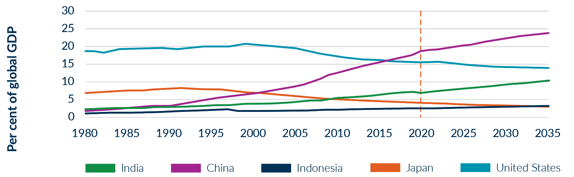

Source: IMF World Economic Outlook - October 2021, and the Australian Department of the Treasury, 2021

An India Economic Strategy to 2035: Navigating from Potential to Delivery (IES)

In 2017, the Australian Government commissioned Mr Peter Varghese AO, former Australian High Commissioner to India and former Secretary of the Department of Foreign Affairs and Trade, to provide a roadmap for Australia to deepen its economic partnership with India.

The IES was released and endorsed by the Government in 2018. While the IES was directed at the Australian Government, it also outlined the essential roles of Australian state and territory governments and the private sector.

The IES remains the most detailed analysis of the complementarities of the Australian and Indian economies into the future. Central to the IES are ambitions to make India a top three export destination and top three outbound investment destination in Asia by 2035.

Key progress in the initial phase of implementation included:

* opening a Consulate-General in Kolkata
* launching ‘India-ready’ training for the tourism sector
* extending the Australia-India Strategic Research Fund with A$15 million for four years
* establishing an air services agreement to enable more direct flights
* improving forecasting of India’s agricultural demand for Australian exporters.

In addition, the Government has established a State Education Forum on India; held a bilateral International Education and Research Workshop showcasing Australia’s education system; and delivered biosecurity training to facilitate Australian fruit exports.

The IES remains the framework guiding our policy for the economic relationship. To support its implementation and keep momentum, the Government will continue to deliver periodic, action-oriented updates. Finalising a commercially meaningful *Comprehensive Economic Cooperation Agreement* will be a vital adjunct to these efforts.

The IES as released in 2018 is accessible here: [indiaeconomicstrategy.dfat.gov.au](http://indiaeconomicstrategy.dfat.gov.au/)

This *Update* is accessible here: [dfat.gov.au/IESUpdate](http://www.dfat.gov.au/IESUpdate)

In the process of drafting this report the Australian Government has consulted over 600 stakeholders across government and industry in Australia and India. The Government has sought to reflect their views in preparing this *Update*. Ongoing engagement with businesses, state and territory governments, diaspora communities, and other organisations will be vital to the Government’s work to deepen economic integration with India.

This *Update* is grounded in the principles of gender equality, inclusion, diversity and equity, which will be integrated into the implementation of this five-year plan of action.

## India’s economy: growth, reform and opportunity

By 2024, India is forecast to become the world’s most populous country.[2] A young demographic, burgeoning consumer class, more people employed in formal work, mass uptake of technology, significant infrastructure investment and rapid urbanisation will drive growth over the period of this *Update*.

India’s economy is recovering from COVID-19. Rapid mass vaccination is restoring confidence. To 2026, the IMF forecasts India’s GDP to expand by 53 per cent from 2019 levels.[3]

There is significant potential for reforms to create even stronger growth. Planned reforms include policies to improve banking sector resilience, privatise underperforming public assets, open the tertiary education sector, leverage special economic zones and improve taxation. Fiscal transparency and a greener economy are on the agenda. Energy reforms are set to deliver cleaner, more reliable and lower cost power. Measures to lift female workforce participation would improve productivity and unlock untapped potential.

Reforms may face headwinds and be slower to implement than industry would prefer. Still, the broad growth trajectory and pro-investment policies will enhance opportunities. In addition to the structural complementarities set out in the IES, the closer government to government relationship will open new commercial opportunities in sectors such as critical and emerging technologies, space and critical minerals.

Rising wages elsewhere in Asia, trade tensions, and efforts to diversify business risk will likely play to India’s advantage as a place to relocate parts of global supply chains. If India can boost its manufacturing sector, it could offer new opportunities for Australian agriculture and resource commodities, including critical minerals.

The services sector will increasingly generate high value jobs. An educated workforce and more openness to competition are attracting foreign investment to the services sector. Investments by technology firms contributed to India becoming a top global destination for FDI in 2020, underscoring India’s status as source of trusted technical talent globally.[4]

The pandemic has accelerated India’s digital transformation. According to one estimate, India’s e-commerce market will grow to A$150 billion by 2025.[5]

India’s fast-growing economy will create more trade and investment opportunities

The IMF projects India’s GDP will grow at a similar rate to ASEAN – and by 2026 India’s GDP could be 91% of ASEAN’s.

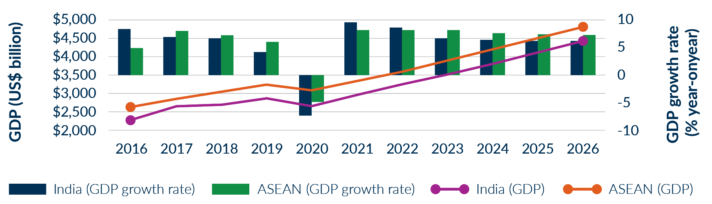

Source: IMF World Economic Outlook: GDP (current prices) October 2021

India’s growing population underpins strong economic growth projections

India’s population is projected to grow by 77 million from 2020 to 2026 – more than Thailand’s entire 2020 population.

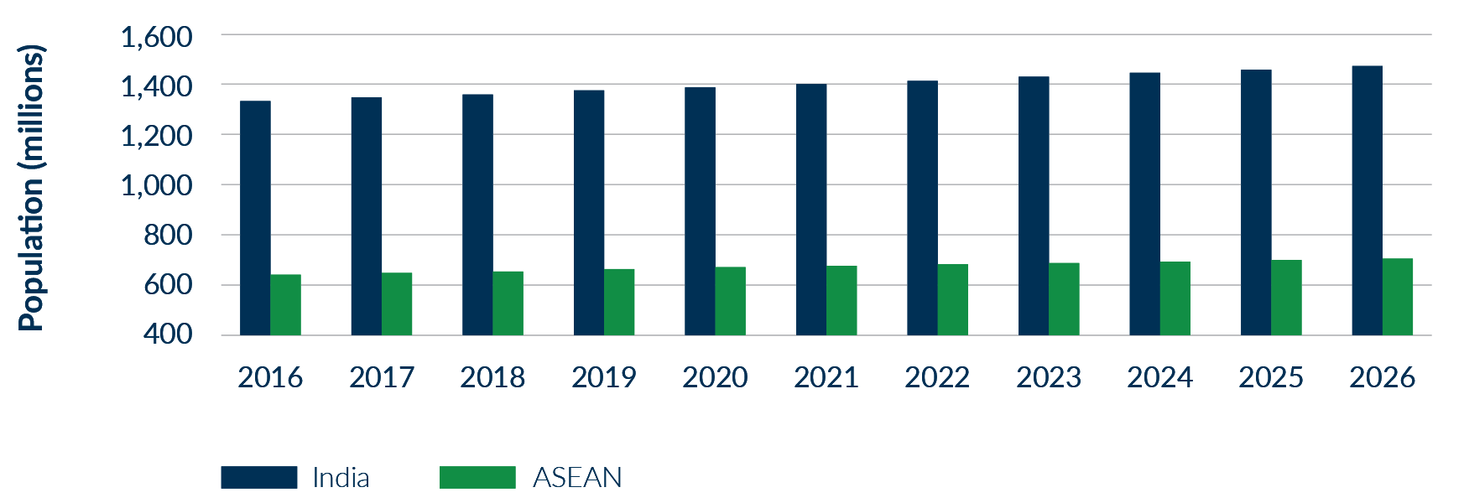

Source: IMF World Economic Outlook: GDP (current prices) October 2021

India’s educated workforce will grow demand for Australian education exports

India’s educated workforce has continued to grow, with almost 30% of secondary school graduates enrolling in tertiary institutions.

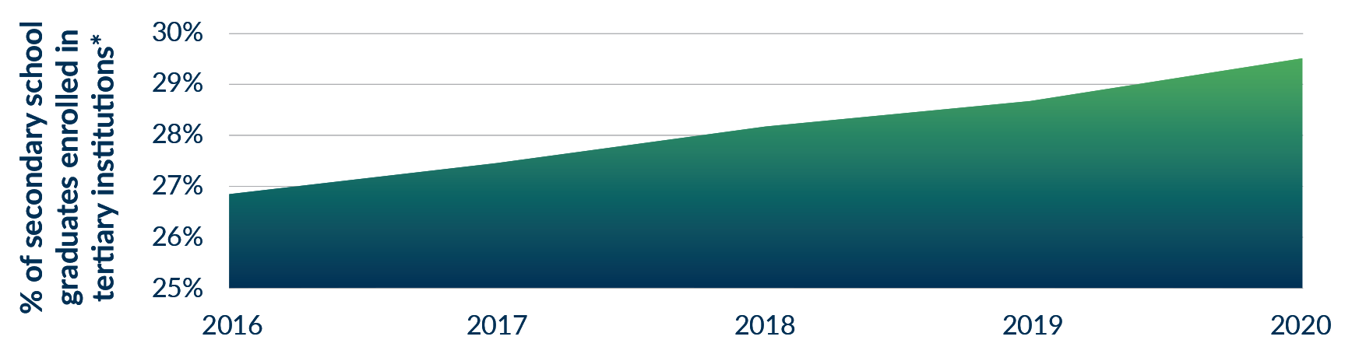

Source: UNESCO: India – Education and Literacy, 2021

*universities and vocational training

To support greater linkages in the technology sector, the Government is:

* supporting Australian and Indian research collaboration on critical and emerging technology standards, ethical frameworks and best practices through future grants under the *Australia-India Cyber and Critical Technology partnership*
* exploring ways to facilitate easier movement of skilled tech workers between the two countries including via the Skilled Migration Program, the *Global Talent Program* and the *Migration and Mobility Partnership Arrangement*
* building on existing cyber security operational engagement, bilaterally and through multilateral Computer Emergency Response Team (CERT) communities to achieve mutually beneficial cyber security information sharing with India bilaterally and through minilateral groups such as the Quad.

# Technology partners: from cyberspace to outer space

India is one of the world’s largest and most dynamic technology and innovation ecosystems. By 2025, India is set to have 900 million internet users and is striving for a A$1.35 trillion digital economy.[6]

It is increasingly important to the global technology economy. India now hosts over 80 ‘unicorns’ — startups with a market value of over US$1 billion - more than half of which were added in 2021 alone. Computer and information services are India’s top services exports, worth almost A$130 billion in 2019.[7]

To position Australia as a preferred technology partner, the Government will step-up to assist Australian technology businesses to break into India and ensure that Australia is a ‘must consider’ source of leading-edge technologies and game-changing products. International competitors are actively supporting their businesses to capture opportunities in India through an enhanced diplomatic presence in South India.

The Government will expand support for Australian technology firms looking to access India’s rapidly growing innovation ecosystem and forge stronger links with partners, customers and investors in India. India’s manufacturing base offers potential for mutually beneficial partnerships to deliver Australian innovations to the world.

The Government will foster Australia’s trade in innovative technologies and services and encourage partnerships with Indian industry, including in digital health, financial technology (fintech), smart infrastructure, agricultural technology (agritech), cybersecurity, artificial intelligence, energy efficiency, environmental technology, and space technology. Trade in this sector is already strong: IT services were India’s second-largest export to Australia in 2019-20.

The Government will support Australian firms to leverage Indian expertise through talent attraction and better mobility for technology workers. Few countries rival the competitiveness and scale of India’s increasingly well-educated technology workforce. In addition to business process outsourcing, companies are looking to India for product development and innovation. Several major Australian firms have already established global capability centres in India to partner with local engineering and R&D talent.

The Government will promote further Indian investment in Australia. Indian technology giants such as TCS, Infosys, HCL, Wipro and Tech Mahindra already have large operations in Australia, employing primarily Australian citizens and driving improvements in Australian productivity. The Government will continue to work to attract expanded and new FDI from India to support further growth in Australia’s technology sectors.

New and emerging technologies — such as 5G/6G, artificial intelligence, quantum computing, blockchain and synthetic biology — are opening-up exciting new possibilities but also represent vectors of strategic competition and risk. The Government will expand our close engagement with India to advance our shared interest in secure and trusted technology.

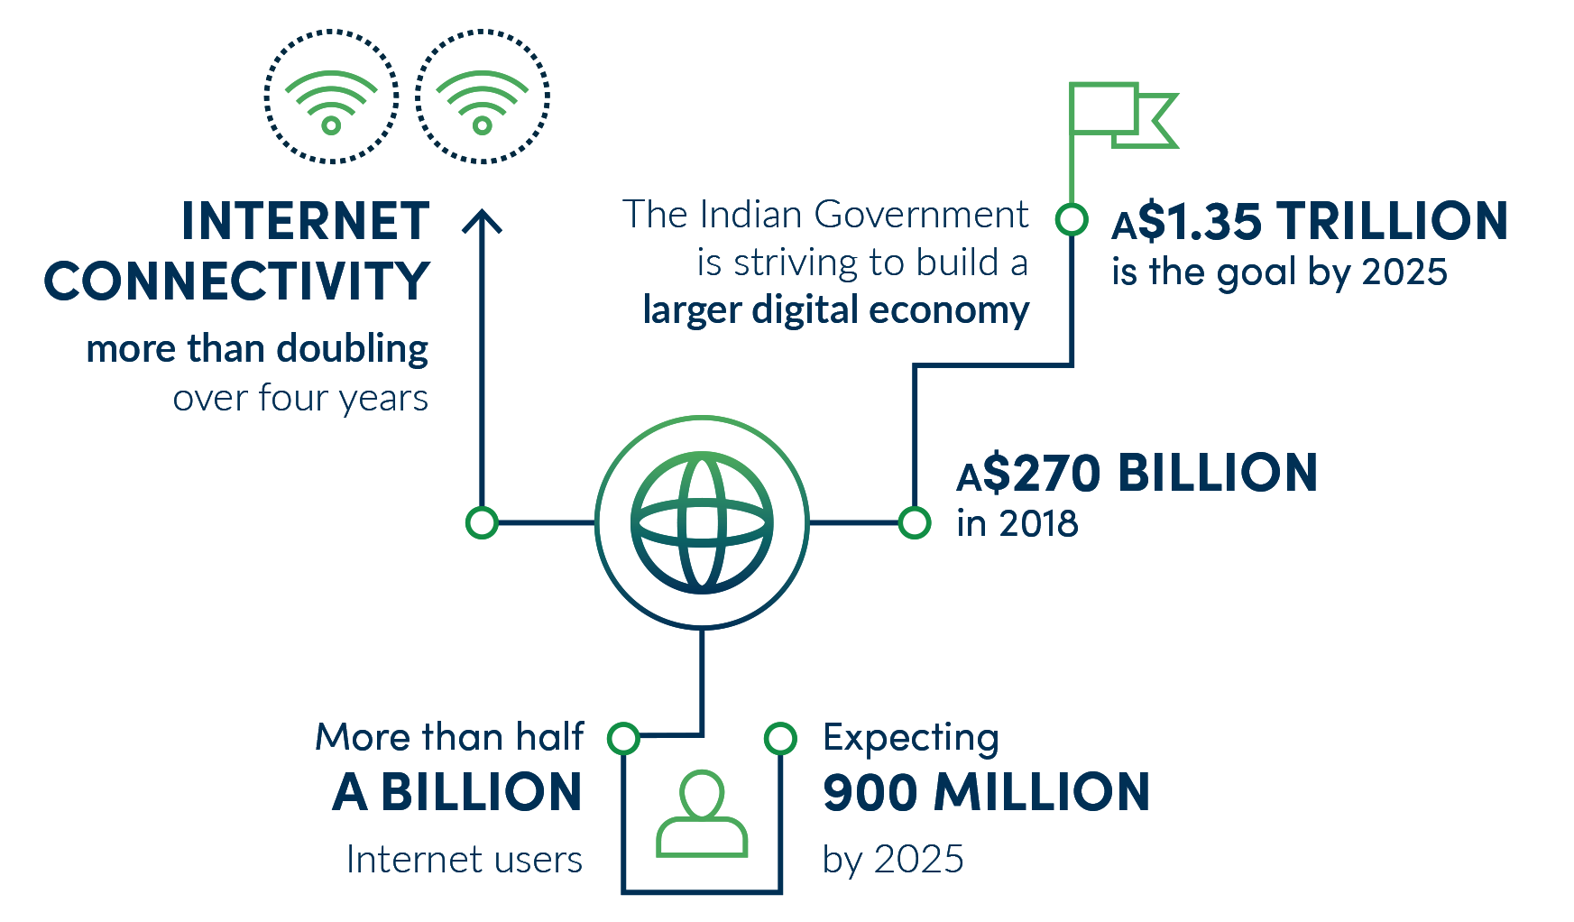

ACTION PLAN

The new **Consulate-General in Bengaluru** will be Australia’s fifth diplomatic post in India. It completes the IES’s recommendations for an Australian presence in India fit for our level of ambition, and brings the size of our India network in line with our highest global priorities.

Bengaluru — Asia’s Silicon Valley — is the world’s fastest growing tech hub and hosts the Indian national space program. The Consulate-General, which builds on an Austrade office, will join a growing international diplomatic community and a sizeable Australian business presence.

The Consulate-General will build official, commercial and research links. Government to government engagement has an important role in the Indian market. The Consulate-General will help Australian researchers and innovators navigate India’s dynamic technology, space and science sectors and commercialise innovations.

Around the world, technology is evolving faster than the rules and norms which govern its use. The **Australia-India Centre of Excellence for Critical and Emerging Technology Policy** will bridge the gap between policy and technology development and contribute to an open, multi-stakeholder model of technology governance, bringing together government, academia and industry. The Centre will support greater commercial ties, and harness the opportunities of critical technology while mitigating the risks. It will be a leading voice in global debates on cyber and emerging critical technologies and issues related to information operations and disinformation, and help to deliver Australia’s *International* *Cyber and Critical Technology Engagement Strategy*.

The Centre complements Australia and India’s collaboration under the bilateral *Framework Arrangement on Cyber and Cyber‑Enabled Critical Technology Cooperation*, signed in June 2020. We are working to shape an open, free, safe, and secure internet, including through bilateral Cyber Dialogues and the *Australia-India Cyber and Critical Technology Partnership Grants Program*.

ACTION PLAN

The Government will establish the **Australia-India Innovation Network** to support Australian technology firms looking to access India’s rapidly growing innovation ecosystem and forge stronger links with partners, customers and investors in India.

In India, the Innovation Network will foster partnerships among innovation centres, incubators, and accelerators providing soft landings for Australian technology firms in India. The Innovation Network will deliver showcase events, support cohort visits to market, undertake pitching sessions and boot camps for Australian technology firms. The Innovation Network will also work with Indian technology firms and investors to match them with Australian businesses with relevant capabilities. It will be able to engage with pre-commercial innovators as well as scale-ups and more established firms.

In Australia, the Innovation Network will provide India-specific market orientation programs, including boot camps and pitching sessions, to ensure a pipeline of businesses that have the capacity to successfully engage with India’s technology businesses and investors to build productive commercial partnerships. The program will leverage existing government commercialisation programs, such as the *Accelerating Commercialisation Grants Program*.

Case Study: Atlassian

For tech company **Atlassian**, opening a world-class R&D centre in Bengaluru, India was a no brainer. With the tech talent in the region, the company knew that it would be a place that aligned with its long-term company goals. Starting with just over 60 employees in 2018, the company now has over 900 employees in India with aggressive plans to hire over 300 engineers in the next year, making it the business’ fastest-growing talent location.

Today, big parts of its products for the IT Service Management market are built out of India, as well as large parts of its cloud platform and infrastructure. Atlassian Co-CEO and Co-Founder, Mike Cannon-Brookes says, “we want to do really meaningful work in India and it’s had a truly global impact on our business. It’s an essential part of our global R&D force.”

This year also saw Atlassian place in the top 20 Best Workplaces in India by Great Place to Work Institute. Atlassian believes that by empowering its employees to unleash their potential, it will fulfil its mission of helping its customers around the world unleash their potential too.

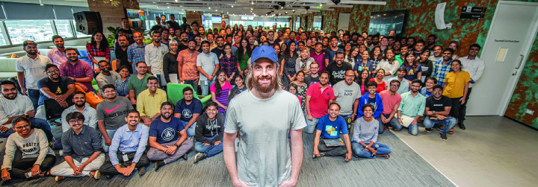

Case Study: Tata Consultancy Services

Global Indian tech giant **Tata Consultancy Services (TCS)** has a significant Australian client base including most of the top 10 companies on the Australian Stock Exchange.  “Our strategic intent is to be part of the Australian growth story,” says TCS Country Head Vikram Singh, “we’ve been here for over three decades - we’re here for the long haul.”

In Australia, as in India, TCS has invested heavily in products and people. TCS BaNCS, a flagship finance software product for clients globally, was developed in Australia.  The company has recruited over 100 graduates this year and hosted 58 New Colombo Plan students to date.

TCS cyber and critical-technology capability in Australia includes a cyber threat-management centre for clients and future-proofing research projects with Australia’s Cyber Security Cooperative Research Centre.  Multiple Australian university partnerships support the company’s broader R&D competitiveness.

With community initiatives - such as TCS GOIT/GOIT Girls STEM programs and a partnership with the Indigenous Marathon Foundation - underpinning a broader Australian vision, TCS is upbeat about its Australian future.

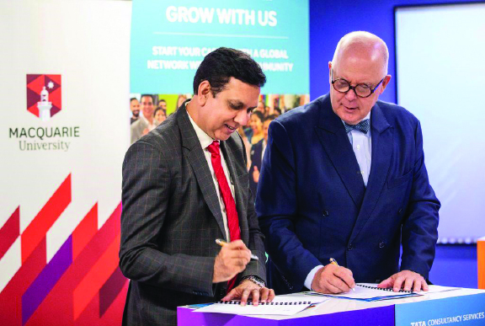

## Space

Space-sourced data and space-enabled technology will increasingly permeate our lives and economy, with applications from agriculture and resources management to insurance and finance. At the same time, the emergence of commercial space operators alongside traditional government players is offering unprecedented opportunities for Australian firms to develop products based on space technology and data.

Australia’s geography gives us advantages in many aspects of the space economy, including in launch services, ground station services, communications and satellite tracking. Companies in Australia’s startup dominated space sector have traditionally developed innovative solutions using space-sourced data, and are increasingly developing the technology and supporting services to access space as well.

India is becoming a major player in space. Prime Minister Modi — also India’s Space Minister — is leading an ambitious national space program and industry reform. India’s national space program is now open to private sector involvement – opening opportunities for Australian space companies. Planned revisions to FDI restrictions and a new Indian National Space Promotion and Authorisation Centre (IN-SPACe) will further commercial opportunities. Australian Government facilitated industry participation at the International Space Conference and Expo – India’s premier space summit - has led to increased interest in the Australian space industry and tangible agreements between companies to advance two-way commercial collaboration.

Relations are strong at a government-to- government level. Under an updated Memorandum of Understanding (MoU), the Australian Space Agency and the Indian Space Research Organisation are working on practical initiatives to enhance space science, R&D and technology collaboration. Building on Australia’s support for India’s *Gaganyaan* human space flight missions, including a temporary tracking station on Australian territory, an even deeper space relationship will yield commercial and strategic dividends.

The new Consulate-General in Bengaluru — where much of India’s space industry and research program is based —will grow Australia’s reputation as a space and technology partner and facilitate burgeoning space cooperation. We will continue to maintain a presence at India’s premier international space expo.

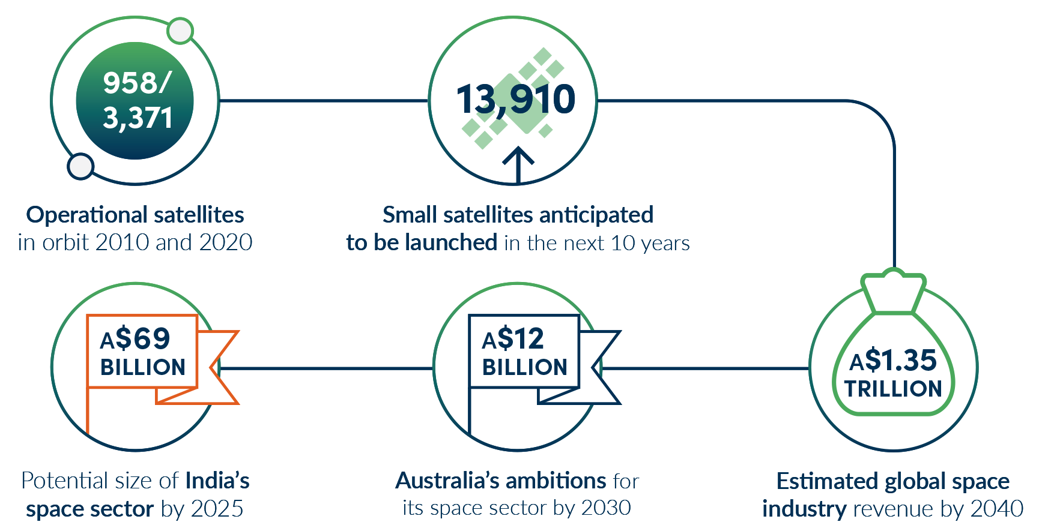

ACTION PLAN

The Australian Space Agency’s **International Space Investment Initiative** supports strategic space projects that build relationships with international space agencies. Its purpose is to grow Australia’s space industry capability.

An expanded stream will focus on building cooperation with India. It will support Australian companies to grow expertise and develop new products, services and technologies leveraging both countries’ space capabilities, such as satellite communication and Earth Observation (EO) technologies. This will support mutual priorities — such as water management, drought resilience planning and agricultural resource management — and deliver commercial benefits. The funding will have an open and competitive element for Australian businesses and researchers, as well as supporting joint projects between the Indian and Australian space organisations, such as the Australian Space Agency and the Indian Space Research Organisation.

Case Study: Space Machines Company

Sydney-based **Space Machines Company** is developing innovative technology to deliver small commercial satellites to their final orbit after launch – a kind of space taxi service. According to CEO Rajat Kulshrestha, Northern Sky Research (NSR) has forecast annual smallsat orders will expand nearly 30-fold by 2023 as compared to the pre-2020 historical average, representing a significant global opportunity. Through their R&D centre in Bengaluru, Space Machines Company is developing connections within India’s commercial space sector, which has a growing need for the space transport services Space Machines Company can provide.



Case Study: Venture Catalyst Space Program

Indian space startups Astrogate Labs, Digantara and 114ai have found early successes participating in the **Venture Catalyst Space Program**, an incubation and acceleration program run by the University of South Australia’s Innovation and Collaboration Centre. Acceptance into the program is one of the fastest ways for Indian startups to access the Australian space ecosystem, test products and services, and build confidence before expanding into larger western markets. The support provided has also assisted these startups to secure seed-funding from investors, grow their teams and secure partnerships with research academic institutions in Australia.



# India’s dynamic south

Our Consulate-General in Chennai and new Consulate-General in Bengaluru will help Australian firms further capitalise on opportunities in India’s south. India’s southern states — Tamil Nadu, Karnataka, Andhra Pradesh, Telangana and Kerala — represent 20 per cent of India’s population and contribute 30 per cent to India’s GDP.

The region has sustained high growth for the past five years (averaging 8.1 per cent per year). It boasts well-established industries, including automotive manufacturing and pharmaceuticals, and competes globally in high-tech manufacturing including growing aerospace and bio-technology sectors.

It has strong service sectors and dominates India’s information technology market. Chennai, Bengaluru and Hyderabad embody India’s new modern, tech-driven economy and compete as hubs for science, innovation, technology and startups.

India’s south has favourable operating environments, strong global connectivity, skilled workforces and attracts relatively high levels of foreign investment. A history of investment in health, education, and social welfare has resulted in medium to high human development and GDP per capita 50 per cent higher than India’s national average.

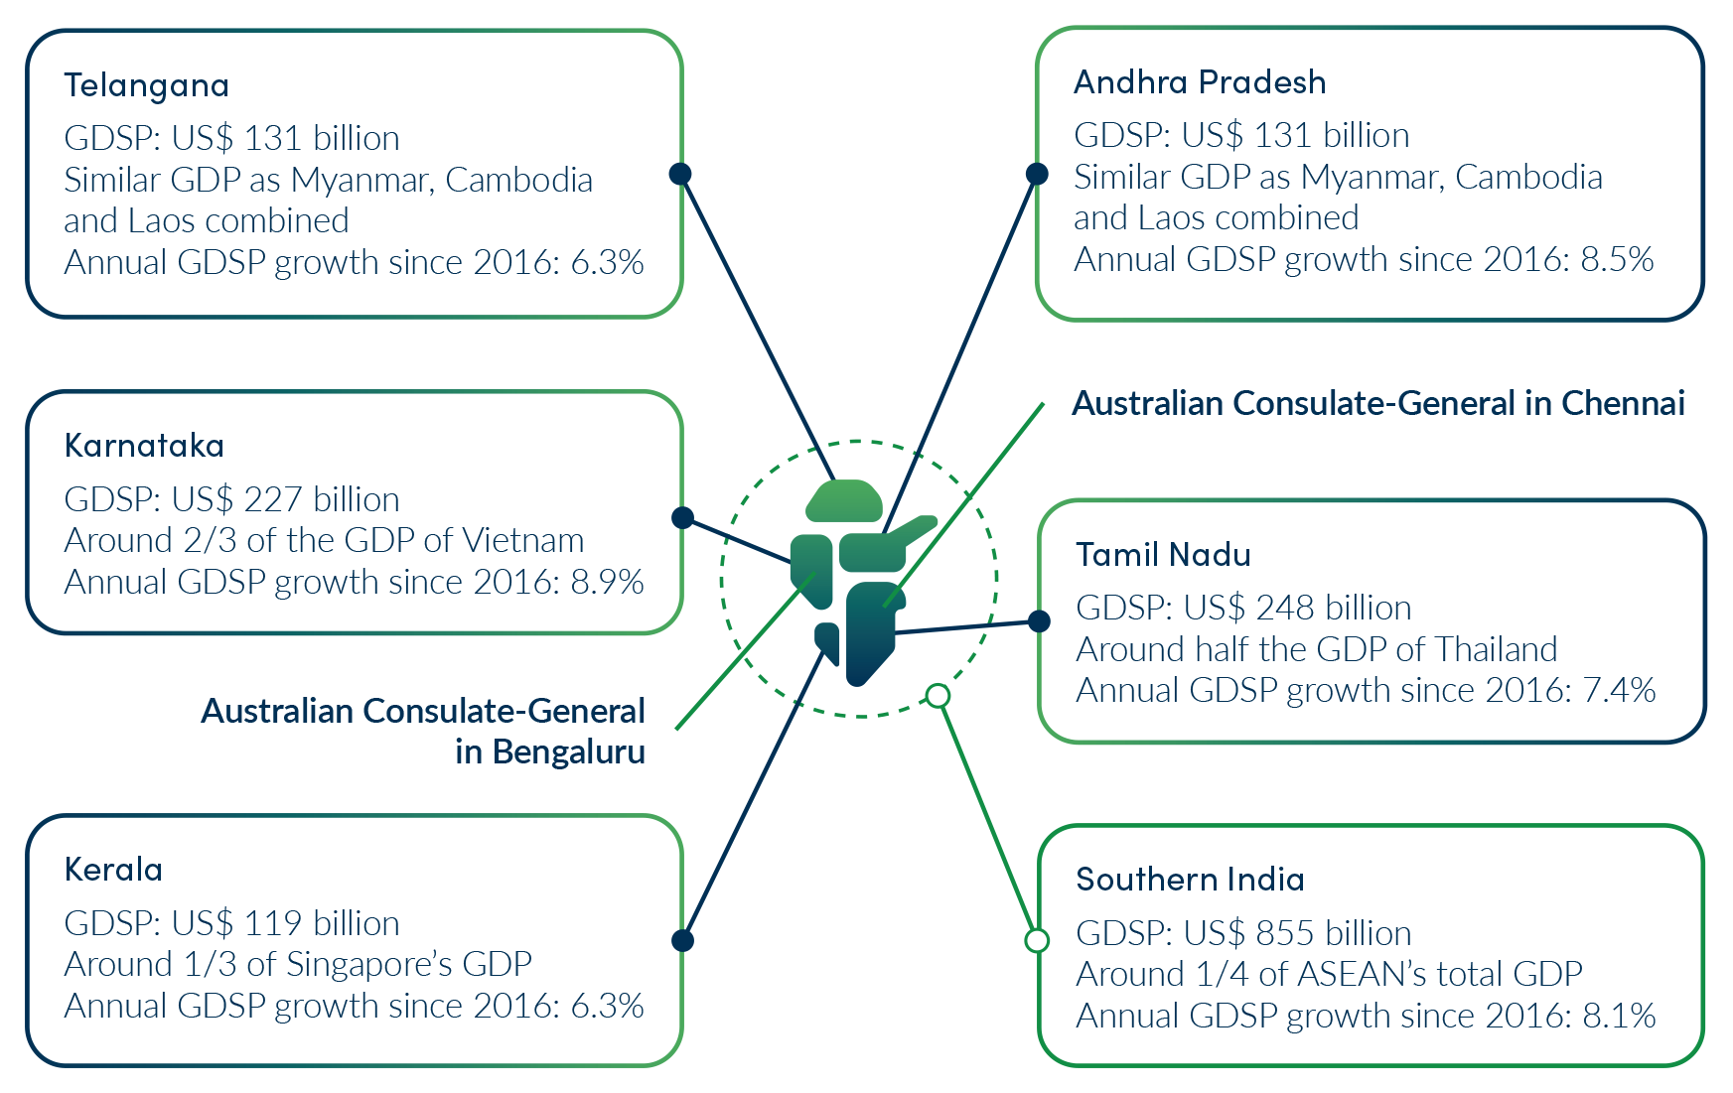

GDSP: Gross Domestic State Product

# Science and Innovation

As the IES outlined, sustained scientific and technological innovation will be a fundamental component of Australia and India’s prosperity to 2035 and beyond.

Deeper research and development collaboration will benefit both sides. Global companies and research institutions are increasingly interested in India’s large talent pool and world-standard technology clusters. Australia - which has at times lagged in commercialising pure research breakthroughs – stands to gain from deeper connections with India’s innovation ecosystems.

Our bilateral research ties are on a good footing. Australian and Indian researchers are producing around 2,130 co-publications annually. And Australia was India’s seventh-largest scientific publication partner between 2016-2020.

But room for growth remains. The Government will take steps to lift the standing in India of Australia’s world-class universities — making sure we attract the best and brightest — and use our local presence to help Australian researchers and firms access India’s talent pool and market opportunities.

The primary mechanism for the Government’s support for science and innovation cooperation remains the Australia-India Strategic Research Fund. Australia and India co-fund the initiative and jointly agree on research priorities.

ACTION PLAN

Ongoing funding for the **Australia-India Strategic Research Fund** (A$3.8 million per annum after 2024-25) will ensure a dedicated stream of research with India under the broader Global Science and Technology Diplomacy Fund.

The **India-Australia Innovation and Technology Challenge** will tackle complex environmental and economic challenges (such as waste reduction, water security and food system resilience) by supporting small businesses, start-ups and entrepreneurs to launch innovative technology solutions. Building on CSIRO’s innovation accelerator program and the successful 2021 *India-Australia Circular Economy Hackathon* delivered by India’s Atal Innovation Mission and CSIRO in 2021, this partnership will help scale-up for market around 20 cutting edge Australian and Indian innovations each year. Working with industry to turn deep-tech innovations into real world solutions.

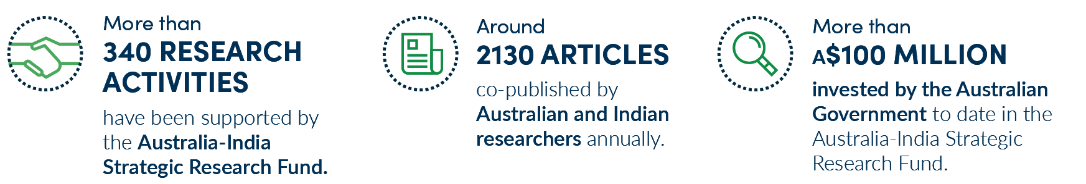

# Resources and METS sectors

Resources will remain at the centre of the Australia–India economic relationship. The Government will continue to work with industry to grow Australia’s position as a secure, reliable and high-quality minerals supplier. We will help our world-class Mining Equipment, Technology and Services (METS) sector expand in the South Asian market, developing mutually beneficial partnerships.

Metallurgical coal for steel production dominates our merchandise trade with India, worth A$7.7 billion in 2020-21 — high-quality thermal coal, copper, gold, silver and platinum are also ‘top ten’ goods exports. Indian demand for resources to fuel construction, manufacturing and electricity generation, transmission and storage is set to grow over the course of India’s sustained, long term economic development.

Critical minerals and commodities such as copper will form an increasingly important part of this picture. Underpinned by growing industry interest and ambitious government targets, India’s push to roll-out renewables and grid-scale battery storage and advanced manufacturing in electric vehicles, solar panels, computers and smartphones is set to generate considerable demand.

Australia, a Comprehensive Strategic Partner with vast quantities of development ready and diverse critical minerals, is a logical choice as India looks to secure its supply chains. Austrade’s 2021 report *Unlocking Australia-India Critical Minerals Partnership Potential* outlines a pathway to greater cooperation.

Australian firms are well-placed to meet growing demand for METS and have a competitive edge in mining consultancy; exploration technologies; mining software; processing components and systems; environmental and mineral quality technologies and safety equipment; and mining education and skills. Sharing of best practice between governments and involving the regulatory technology (regtech) sector offers the opportunity to increase mine productivity, safety and environmental compliance, and open commercial opportunities. The METS relationship has also seen Indian firms investing in the Australian mining sector.

The Australian Consulate-General in Kolkata – opened in 2019 following an IES recommendation – has amplified Australia’s commercial and economic diplomacy in resources and METS in eastern India.

To support greater engagement in the resources and METS sector, the Government is:

* supporting the development of critical minerals projects through the A$2 billion Critical Minerals Facility administered by the Export Finance Agency
* coordinating closely through the Business Champions group which will include a major Indian client for Australian resources.

ACTION PLAN

A **METS Industry Market Access and Preparedness Program** will help resources companies better understand how to do business with India, Bangladesh and South Asia.

Indian miners facing technical and operational challenges will be connected with Australian solutions through a **Global Mining Challenge – India**.

ACTION PLAN

The **India-Australia Critical Minerals Research partnership**, a collaboration between Indian and Australian science institutions, industry and government partners and the Critical Energy Metals Mission currently being developed by CSIRO, will tackle the challenge of resourcing the renewable energy transition and help to unlock the commercial benefits of integrating Indian and Australian critical minerals value chains.

The **India-Australia Green Steel partnership** will build on CSIRO’s relationships with Australian steel and iron ore producers and Indian Government and industry to support commercialisation of innovative Australian and Indian technology to improve efficiencies and environmental outcomes in steel production.

An **Australia-India Critical Minerals Investment partnership** will support ongoing engagement between Australian and Indian officials and accelerate the growth of Australia-India critical minerals supply chains.

India’s push to manufacture electric vehicles is set to generate considerable demand for resource commodities

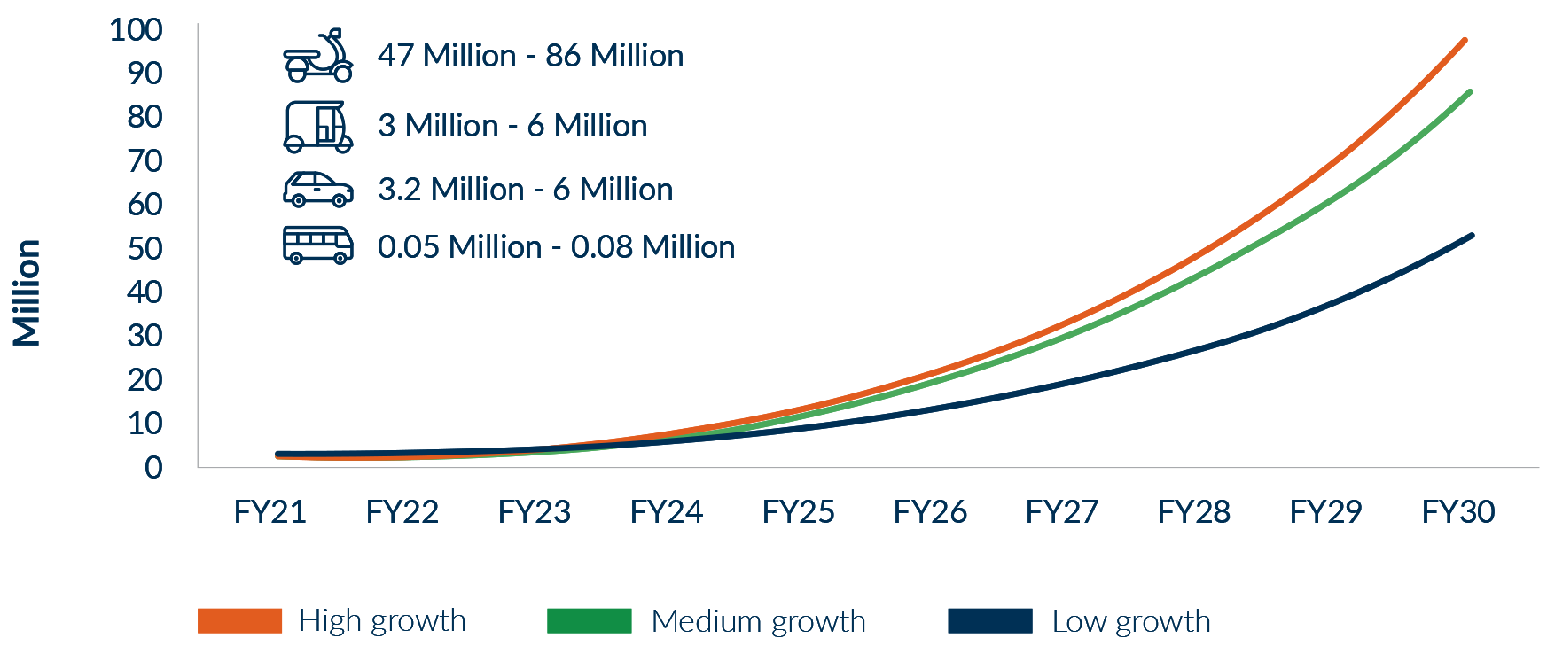

Source: Austrade, Unlocking Australia-India Critical Minerals Partnership Potential

# Energy

The International Energy Agency (IEA) forecasts Indian energy demand to increase by almost 70 per cent by 2040, based on current national policies, and to have the largest increase of any country globally across all IEA forecasting scenarios. Australia — with abundant energy resources, experience delivering large energy projects and deep technological know-how — is well-placed to help India meet its energy needs.

Given the price sensitivity and competitive nature of Indian energy markets, the Australian Government and industry will need to work hard to be a substantive traditional energy partner. Thermal coal will remain dominant in India’s energy mix over the period of this *Update*, according to the IEA, and India will present an opportunity for Australian suppliers of high-quality thermal coal as the global coal trade responds to external factors. The Indian Government is supporting increased usage of LNG as a transition fuel, and Australian producers have had some recent successes selling into India.

Australia and India are likeminded in our technology-based approach to emissions reductions, and the commercial opportunities in renewables and the hydrogen economy are significant. Recently reaching 100 GW of renewables capacity, the Indian Government has set a target of 500 GW installed by 2030 to meet growing energy demand and support decarbonisation efforts. To achieve this, the Indian Government will look to the private sector; Australian companies with expertise in renewables development and grid management will be well placed to engage.

India released the first part of its Hydrogen Plan on 17 February 2022. The Plan will help set parameters for cooperation between Australia and India on developing a hydrogen economy. Australian and Indian companies are already forging partnerships, such as the 2021 framework agreement between Fortescue Future Industries and JSW Future Energy on green hydrogen projects in India. As the world’s second largest producer of steel, India will need new technologies to decarbonise its industry. Close coordination on standards-setting for low emissions technology will also be important.

To support Australia’s continued role in meeting India’s energy needs and support India’s leadership on energy security, the Government is:

* building cooperation and encourage commercial outcomes on new and renewable energy, power, coal and mines, petroleum and gas, under the India-Australia Ministerial Energy Dialogue
* supporting India’s leadership of the International Solar Alliance to increase global uptake of solar energy through an A$1 million contribution
* working with India to support regional energy connectivity and governance, including working with multilateral development funds, and through the Australia’s South Asia Regional Infrastructure Connectivity program.

The Australian Government will harness the region’s economic potential through targeted regional initiatives. These include:

* an aid for trade partnership to support the *Bay of Bengal Initiative for Multi-Sectoral Technical and Economic Cooperation (BIMSTEC)*, a regional organisation of seven South Asian and Southeast Asian nations
* a data and digital based government service delivery project in Bangladesh, assisting the government to capture and digitise life events and census data to improve service delivery, boost the use of technology by government and private sector to promote financial inclusion and innovative financial products, drawing on Australian and South Asian IT expertise
* a study of Bangladesh market opportunities and trade barriers to provide policy recommendations to increase trade and investment under the newly established Australia-Bangladesh Trade and Investment Framework Arrangement.

ACTION PLAN

The Government will launch the **Bay of Bengal Trade and Energy Partnership** to harness the region’s economic potential with a LNG partnership for South Asia, to facilitate access to fast growing South Asian energy markets, particularly India and Bangladesh.

India’s demand for energy is projected to grow

Under the current settings or more ambitious implementation of sustainable energy policies, India’s energy demand is projected to grow

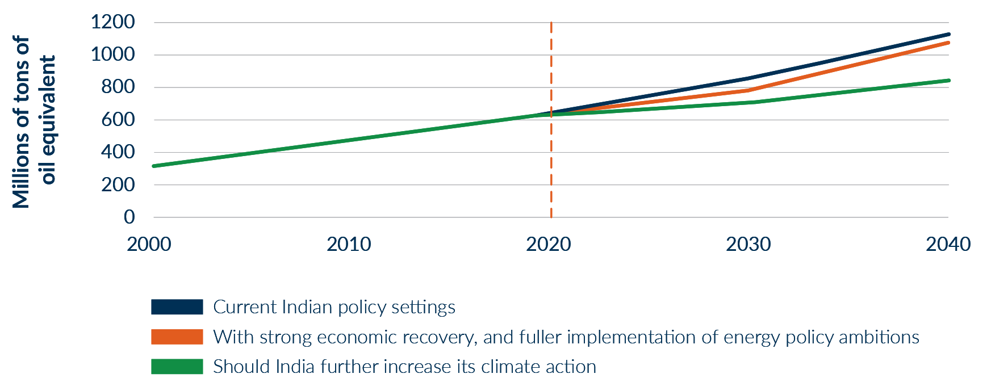

Source: International Energy Agency, India Energy Outlook, February 2021

Case Study: Village Energy

Perth-based **Village Energy** has developed low-cost technology to manage grids with intermittent power sources, such as rooftop solar. Using Artificial Intelligence, Village Energy manages energy flows in the network to respond to the needs of consumers, allowing individual customers to adjust their usage to match their budget and needs.

This ground-breaking technology has had a real impact at Village Energy’s flagship project in Pagidiroy village, Andhra Pradesh. Energy costs have fallen at the same time as consumption has risen. There has been a large reduction in power outages accompanied by a big fall in damage to household and small business appliances from power surges. Village Energy technology is improving the efficiency of last mile energy transmission for big power utilities. And it is helping local villagers and micro SMEs take advantage of new opportunities that flow from better quality and more reliable services at a lower cost – a real catalyst for change.







# Health

Australia-India collaboration in the health sector is highly prospective. COVID−19 drove the uptake of digital health services in India, supercharged a focus on manufacturing medical devices and pharmaceuticals, and reinforced India’s importance in global supply chains, including vaccines.

The scale of the Indian market provides major opportunities to commercialise Australian innovations in medical devices and digital health in niche areas, export nutraceuticals and vitamins, and work together on training for health professionals. At the same time, India has the capacity to enhance Australia’s pharmaceuticals security and supply chain resilience.

Increased government-to-government collaboration would support these objectives. Cooperation on regulatory and data standards and universal health practices in multilateral forums would drive efficiencies, help unlock investment, and facilitate trade in pharmaceuticals and medical devices. Bilateral collaboration will also resolve common challenges, connecting technical knowledge with need in complementary areas.

These private sector and government efforts should be supported by a step-up in bilateral medical research cooperation to support commercialisation.

Australia and India are also cooperating through theQuad vaccine partnership. The partnership is expanding COVID-19 vaccine manufacturing in India, including supporting a boost in production by at least one billion doses by the end of 2022.

To support greater health cooperation the Government is:

* supporting high-quality brand positioning for Australian health products
* building greater Australian MedTech awareness of Indian market opportunities by stepping-up efforts to commercialise Australian research and set up production hubs in India
* finalising the MoU between Australia’s Therapeutic Goods Administration and India’s Central Drugs Standard Control Organisation to facilitate information exchange and confidence building activities
* undertaking an Australia India digital health standard and harmonisation gap analysis – to identify opportunities for harmonisation, data privacy settings, clinical language, regulatory coherence and technical alignment
* continuing to pursue technical exchanges, including using working groups under existing agreements, to troubleshoot regulatory and policy issues.

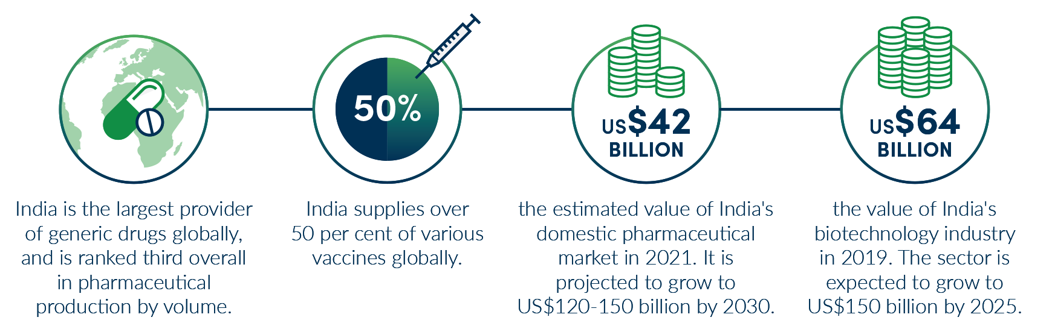

Source: India Brand Equity Foundation

Case Study: Cochlear

Australian company **Cochlear** has been restoring hearing in India since 1998 where its world-leading technology has helped more than 20,000 children hear better, unlock their potential and pursue their passions.

Today, Cochlear’s technology can help even more people with hearing loss in India. Cochlear is ready to work even more closely with governments to address barriers including raising awareness about hearing loss, promoting early detection through universal newborn hearing screening and access to the most advanced treatments and technologies. Cochlear’s team has introduced educational initiatives and works closely with health professionals in India.



# Investment: improving conditions

The IES highlighted India’s positive investment fundamentals. These have further improved since the launch of the IES and opportunities for Australian investment in India are significant.

COVID-19 impacted Australian investment into India to a degree consistent with trends elsewhere in Asia. Still, the total Australian investment stock in 2020 was comparable to 2018 levels, and over the five years to 2019 had a trend of 15.1 per cent growth.

Indian Government policies to attract foreign investment include: a privatisation agenda valued at over A$30 billion; continued rollout of major infrastructure; asset monetisation; scrapping retrospective tax laws; and lifting of some investment caps. India’s state governments are using liberalising reforms to compete for foreign investment, as well as other incentives such as land concessions and other subsidies.

Australia remains an attractive investment destination for India. Major Indian companies across a range of industries, including advanced tech, healthcare, resources, and energy already have significant investment in Australia.

These investments strengthen Australia’s capabilities in R&D and commercialisation and improve the economic infrastructure that underpins growth and productivity in key industries and regions.

To strengthen the overall investment relationship, the Government is:

* expanding understanding of India and investment opportunities for Australian portfolio investors, particularly superannuation funds
* continuing efforts to attract Indian investment in areas of strategic priority to support Australia’s economic growth
* seeking to renew the MoU between Austrade and Invest India to facilitate investment flows
* negotiating a reciprocal solution to the issue of cross-border taxation of fees for technical services under the *India-Australia Double Taxation Agreement*
* negotiating on investment protection rules to provide greater certainty and legal protections for investors.

ACTION PLAN

A **strengthened partnership on economic policy and regulation** will expand institutional engagement with India, build capacity and Australian understanding of the Indian regulatory environment.

The program will include programs for Australian and Indian civil service leaders to share and build expertise in regulation, taxation and trade; a reciprocal secondment program across Australian and Indian economic agencies; and a tailored engagement and exchange program delivered by the Australian Public Service Commission to foster stronger institutional links with India.

Australia’s investment relationships: total stock of investment as at 2019 (A$ billion)

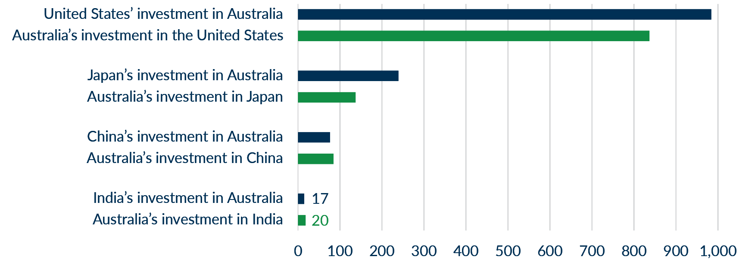

Source: Based on ABS catalogue 5352.0

Case Study: Australian Super

In 2019 **AustralianSuper** committed US$1 billion to India’s National Investment and Infrastructure Fund’s (NIIF) Master Fund and acquired a stake in the manager NIIF Limited. AustralianSuper noted that during the years leading up to its investment decision, the Indian Government had proactively made structural changes to make India more attractive for foreign investment, especially in the infrastructure sector.

While AustralianSuper’s investment is still in its early stages, making it hard to assess returns, it notes that activity on infrastructure assets has recovered strongly from the second wave of COVID-19 in India.

Traffic on roads and at airports, throughput at ports, and electricity consumption have recovered to near pre-COVID levels.

One challenge observed by AustralianSuper is the ability to get its investment deployed quickly in India. AustralianSuper attributes this in part to the timing of its investment and COVID-19 but also due to the high levels of competition for assets in the attractive sectors of the Indian infrastructure sector. However, with the recently released National Infrastructure Pipeline and Masterplan, AustralianSuper is confident that there will be sufficient opportunity to invest in the near future.



# Infrastructure: strengthened architecture for deeper partnerships

The Government will strengthen connections and facilitate business outcomes in the infrastructure sector. Australia and India have robust infrastructure agendas to drive economic development and deliver world-class connectivity to their populations and the Indo-Pacific region.

India is pursuing high levels of investment in infrastructure to support economic growth, job creation and recovery from COVID-19. There is scope to grow Australia’s engagement in India’s infrastructure sector. There is also room for Indian investment in Australia’s infrastructure sector.

India’s infrastructure agenda presents opportunities for Australian investors and infrastructure service providers, especially in transport infrastructure (rail, roads and ports), urban development (buildings and water) and logistics. There is also potential for engagement with India’s energy and agriculture agenda, including decarbonisation.

Australian businesses see challenges to understanding and entering the Indian market. Despite these challenges, Australian success stories underscore the advantage of being an early mover that engages with risk. The Government is committed to playing its role in building confidence and the official relationships to support greater commercial partnerships.

Since the release of the IES, India has accelerated efforts to facilitate infrastructure development by announcing ambitious plans: the *National Monetisation Pipeline* (over A$100 billion of ‘derisked’ brownfield assets); the *National Infrastructure Pipeline* (over 8,000 infrastructure projects worth around A$2.6 trillion); the A$1.8 trillion *National Infrastructure Master Plan;* and reforms allowing 100 per cent FDI in the infrastructure sector. It has also improved its rankings on most aspects of infrastructure development according to the Global Infrastructure Hub’s InfraCompass(see chart).

To support further investment and commercial activity in the infrastructure sector, the Government is:

* continuing an infrastructure focus in the Australia-India Business Exchange, including initiatives to showcase Australian capability and connect businesses
* cooperating on regulatory frameworks and standards to improve the interoperability of Australian and Indian infrastructure sectors.

ACTION PLAN

The **Australia-India Infrastructure Forum (AIIF)** — a key recommendation of the IES — will smooth the path for Australian businesses to benefit from India’s vast infrastructure plans and prospects. The Forum will draw together policy, corporate and regulatory expertise, strengthen business ties and create awareness of opportunities, including for Australian investors and exporters of niche services and technology. The Forum will support greater Australian involvement in Indian infrastructure projects and greater diversification of Australia’s trade and investment. The Forum will commence its activities in the first half of 2022 and run until June 2024.

India’s infrastructure enabling environment has improved

According to InfraCompass, India has risen on six of eight key drivers of infrastructure quality from 2017 to 2020.

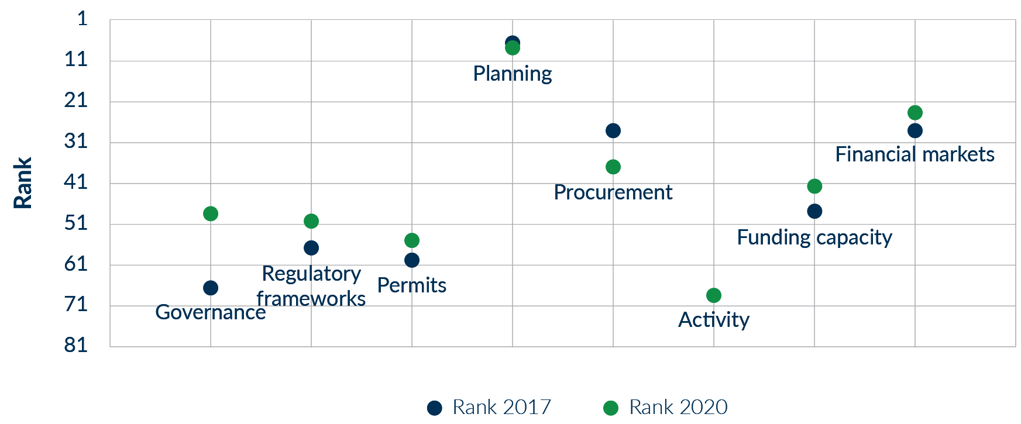

Source: Global Infrastructure Hub

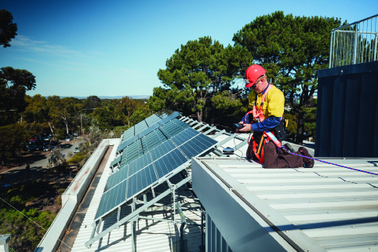



# Financial services

India’s financial services sector continues to offer significant opportunities for partnership. Reflecting the accelerating pace of digital innovation, India is seeing rapid growth in the banking and financial technology (fintech) sectors, including mobile payments applications and other personal financial information tools. India’s bid to become Asia’s top fintech hub will present opportunities for Australian business into the future.

Attracting foreign investment in financial services is a priority for the Indian Government. India is focused on the health of its banking sector, giving priority to capital investment growth, strong corporate governance and public sector divestment. It is also implementing a data portability regime to empower consumers to better access and share their data.

As the regulatory certainty for potential investors increases, Australian and Indian businesses will benefit from harmonised systems and standards, inter-operability and greater information sharing.

Australia’s banking system, while well-integrated with the global financial system, continues to have very limited exposure to India. Around a quarter of Australian bank assets are located offshore, but less than 1 per cent of this is in India.

Increased investment in India’s credit markets represents a strong near-term opportunity, providing an avenue to establish new investment mandates, and promote further knowledge of the Indian market.

To help deepen engagement in financial services, the Government is:

* utilising annual dialogues conducted by the Australian Treasury with NITI Aayog, as well as with India’s Ministry of Finance, to deepen bilateral ties and collaboration in the financial sector, including by re-establishing an MoU between Treasury and India’s Ministry of Finance
* continuing engagement on inter-operable consumer data portability frameworks with India, to enable data-driven tech companies to scale up internationally and allow consumers to access products and services across markets.

Global Fintech Adoption Index, 2019

87% India
64% Global Average
58% Australia

Fintech adoption in India is well above the global average, according to EY’s Global Fintech Adoption Index 2019. This chart shows the percentage of the population using FinTech Services.

Source: [EY Global FinTech Adoption Index 2019](https://assets.ey.com/content/dam/ey-sites/ey-com/en_gl/topics/banking-and-capital-markets/ey-global-fintech-adoption-index.pdf)





# Growing community ties

Over 700,000 strong, Australians with Indian heritage represent one of the most dynamic and successful communities in Australia. The community has grown five-fold in 20 years and in 2020 those born in India became Australia’s second-largest group of overseas born residents (see chart). This community’s cherished role in Australia’s economy and society will continue to grow across business, politics, the arts, science and civil society.

Many members of this community make a valuable contribution to the Australia-India economic relationship. They facilitate trade and investment, help build cultural understanding, promote Australia’s attractiveness as a destination for students, skilled migrants and tourists, and influence how Australia is perceived in India, and how India is perceived in Australia.

ACTION PLAN

The **Centre for Australia-India Relations** will drive and coordinate business and community engagement between India and Australia, and with Australia’s vibrant Indian diaspora. It will complement the Australia India Business Exchange (AIBX) in building Australian business “Indian literacy” and linkages to help navigate the Indian market. The Centre will support a more accurate understanding of globally leading quality Australian tertiary institutions, and amplify people-to-people ties, understanding and exchange through events and cultural exchange.

ACTION PLAN

The Government will support the Indian diaspora’s readiness to use its networks and expertise to further support the economic relationship. A **diaspora mapping report** will highlight key networks such as Australian company directors, professionals, academics, and entrepreneurs of Indian ancestry. This research will underpin a diaspora engagement strategy to better target our engagement and grow ties between Australia and India.

Community connections to India continue to grow

Indian-born Australian residents and Australians of Indian ancestry, 2000-20

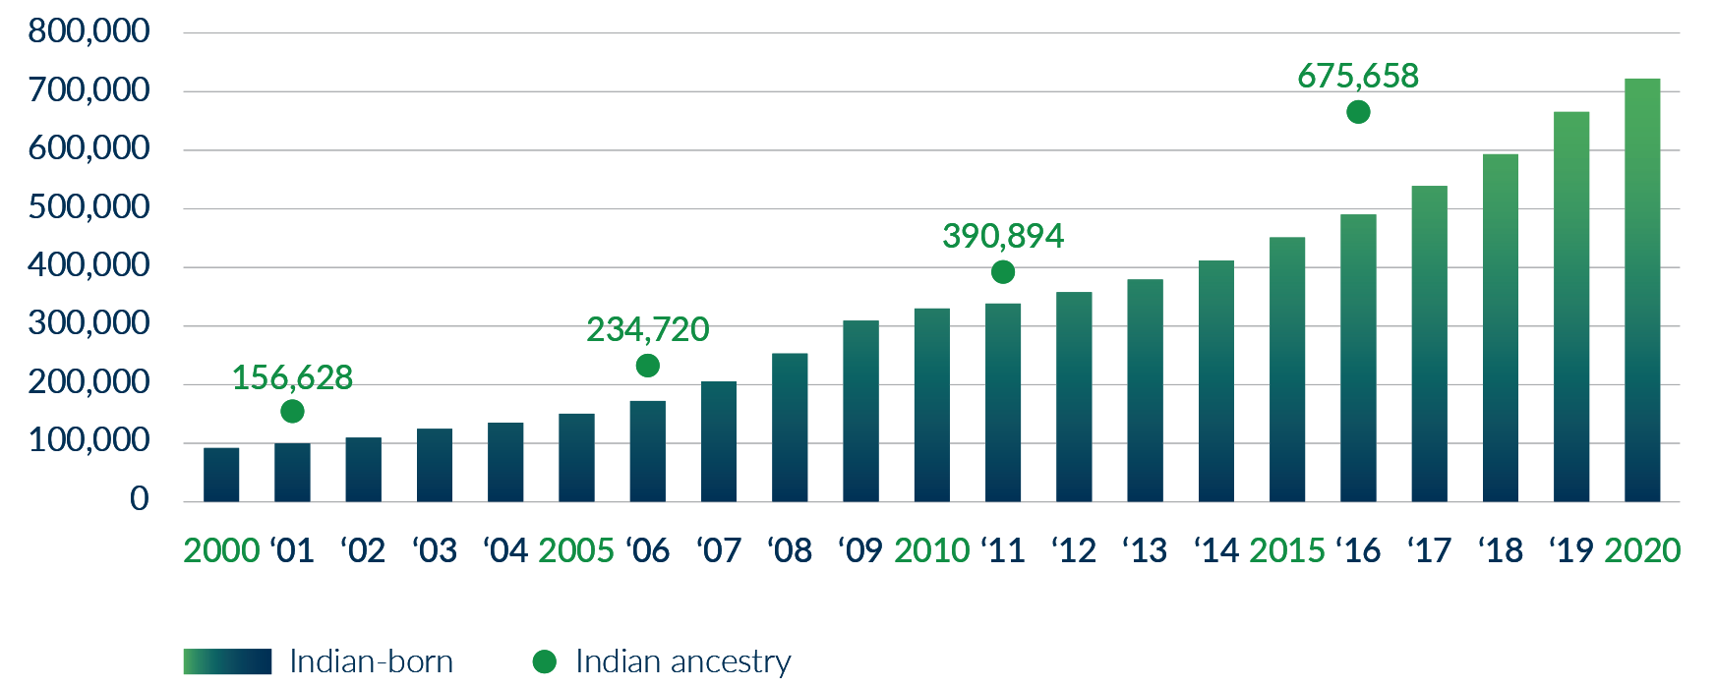

Source: ABS census and migration data (Indian ancestry data is drawn from Australian census data across 5-year increments)



# Education

The Australia-India education relationship is strong. Australia is a world-class provider of education and training in secondary, university and vocational sectors with longstanding connections to Indian students, institutions, the Indian diaspora and the Indian Government. An even deeper education relationship will bring benefits to both countries.

The Government has worked to bolster education ties despite the challenges of COVID-19. Australia and India elevated cooperation on vocational education and training (VET) under an MoU signed in 2020. Australia has cooperated with India on the transition to digital delivery, such as sharing expertise in quality assurance across the sector. Many Australian institutions have continued to conclude cooperative agreements with Indian counterparts, including for joint research, degree twinning programs, and the exchange of students, faculty and expertise.

As we move beyond the challenges of border closures, the Government will continue to position Australia as a high-quality education provider and partner, supporting our respective education, skills and research needs now and into the future.

Continued official engagement on regulatory settings will support Australian providers to grow cooperation in India and the links that may support an in-country presence. It will also support opportunities in India for Australian students and joint degree programs. The Government will commission a scoping exercise to explore work integrated learning opportunities in India for Australian VET students with Australian and Indian business organisations.

The Government will work with providers to encourage Indian students to study in a wider variety of courses, including through digital and blended modes of delivery that utilise advances in EdTech. Innovative models of education delivery will help facilitate the skilling of diverse students and ready mobility to meet future skills needs.

The *Australian Strategy for International Education 2021-2030 (ASIE)* will further guide the future of Australia’s international education sector and will focus on supporting the recovery of the sector from the pandemic. Australia will also continue to support opportunities to share best practice in the recognition of qualifications, including in relation to blended, online, and offshore delivery, where more complementary approaches would be of mutual benefit.

To strengthen ties across the education sector, the Government is:

* working with Australian universities to establish Study Australia Centres to support India’s international education agenda, institutional partnerships, and students in India
* launching *the Australia India Skills Summit* to strengthen linkages in VET, inform future skills engagement and support the Australia India Education Council (AIEC) skills agenda
* launching an *Australia India Skills Portal* to foster greater collaboration between the skills sectors with a grants program supporting engagement in areas of mutual interest
* delivering on Austrade’s *India Digital Education Hub*, including employability programs for Indian students and graduates, to improve student experience and build Australia’s position as a holistic education partner
* showcasing Australian capabilities and attract new students and partners through events such as the *Study in Australia Masterclass* *Series* and *Virtual Education Showcase.*

ACTION PLAN

A new **Maitri Scholars** initiative will bring top performing Indian graduate students to Australia’s world-leading universities. The Centre for Australia-India Relations will administer the initiative, which will include a focus on Science, Technology, Engineering and Mathematics (STEM) and health.

The Government will work with industry to establish an **Australia-India Future Skills Initiative** to give Australian education, skills and edtech providers access to the India market, showcase Australian capabilities, and position Australia as an education partner of choice. The Future Skills Initiative would open significant opportunities for Australian skills providers to deliver at scale in India. Australia’s strength in digital health; transport and logistics; advanced manufacturing; and data analytics and cybersecurity matches to India’s skills demand. Using an industry-led approach to meet business training needs will ensure more Indian workers have the skills to support India’s economic growth.

The Government is supporting two-way student and researcher exchange through the **Australia-India Research Student Fellowship Pilot Program** and supporting Australian and Indian researchers to connect and collaborate through the **Australia Research Cooperation Hub - India**.

Case Study: Deakin University and O.P. Jindal Global University

In October 2021, **Deakin University** and **O.P. Jindal Global University** launched the Jindal and Deakin Education partnership in New Delhi. The partnership illustrates new models for transnational education, employability, research and innovation partnerships for Australian institutions in India.

The launch celebrates the two universities’ commitment to develop innovative and hybrid models of teaching and learning for students to have an international campus experience while commencing studies within India and subsequently transferring credit.



Indian student enrolment 2012-2020

Indian student enrolment has grown rapidly since 2012, with a slowdown in 2020 due to the COVID-19 pandemic.

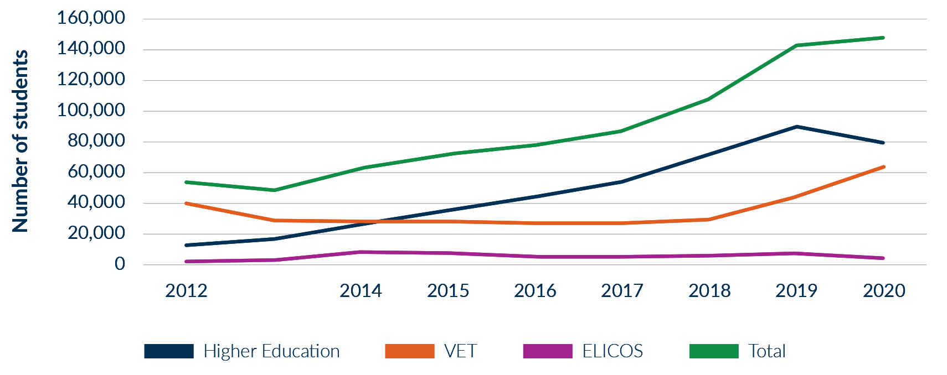

*Enrolment data does not represent the number of overseas students in Australia, but counts actual course enrolments

Source: Department of Education, Skills and Employment

Almost 1 in 5 overseas students in Australia are from India

As at December 2021, Indian international students made up the largest group of overseas students in Australia.

19% India
17% China
11% Nepal
5% Vietnam
4% Colombia

Source: Australian Government

# Tourism

India will be important to the recovery of Australia’s tourism industry. Pre-COVID-19, India was our fastest growing tourism market by number of visitors. Australia still aims to achieve 1.2 million Indian arrivals by 2035, potentially worth over A$9 billion a year to the Australian economy.

The Government has committed to work with industry and state bodies to address short to medium-term challenges and realise the long-term potential of the Indian market. Aviation access, targeted marketing, industry collaboration and strong government-to-government ties will be crucial to position Australia as a top destination for Indian visitors. Indian students will also be a key component of our international visitor economy.

The Government will continue to enhance the Australian sector’s understanding of outbound Indian tourism, by updating Tourism Australia’s *India Strategic Tourism Plan out to* *2035*, commissioning research to inform our priorities, and cooperating with India under a renewed MoU on tourism and Joint Working Group. The Government will work under the *One Voice* initiative with states and territories to avoid brand dilution.

To grow demand and improve offerings to Indian tourists, the Government is:

* boosting aviation connectivity and capacity on Australia-India routes through engagement with Indian and Australian airlines, airports, CAPA, state and territory governments and tourism bodies
* growing our share of the luxury leisure segment by leveraging celebrity endorsements and promoting the *Signature Experiences of Australia* program
* expanding Tourism Australia’s footprint in India and leverage new funding for additional marketing activities, such as the T20 World Cup 2022 promotion
* supporting an ‘India ready’ tourism workforce through education initiatives under the Australian Tourism Export Council’s *India* *Host* program.

Indian visitors to Australia

In 2019, almost 400,000 Indians visited Australia and spent A$1.8 billion, making India our seventh-largest market by short-term visitor arrivals and our sixth-largest market by spend

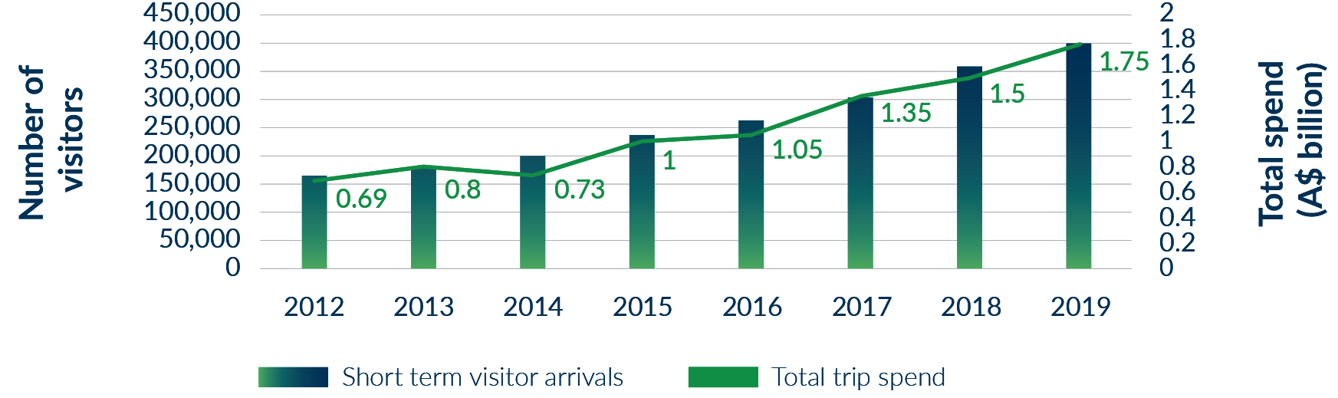

Source: Tourism Australia

# Cultural and creative industries

Arts experiences and cultural exchanges between India and Australia support our economies, drive tourism and build community links. Australia and India have vibrant cultural sectors that underscore the value we place on ideas and creativity.

Encouraging collaboration between India and Australia’s screen industries will shape Indian perceptions of Australia’s rich cultural fabric and natural beauty. Closer cooperation in cultural festivals, from literature to visual and performing arts, offers benefits in both directions.

Fashion and textiles are highly prospective, and as the AES highlights Australia and India have complementary strengths in design, manufacturing and production of raw inputs. In the animation and gaming sector, partnerships in India offer vast potential for Australia’s growing industry.

The Government is committed to supporting stronger ties across the arts. Strong opportunity exists through the Australian Performing Arts Market, which is a strategic initiative of the Australia Council for the Arts, designed to showcase Australian and New Zealand contemporary dance, theatre, emerging and experimental arts nationally and internationally.

To date, the Government has supported presentations at high-profile Indian festivals and biennales, particularly in literature and the visual arts. This has also enabled reciprocal relationships and exchanges in the performing arts.

ACTION PLAN

The Government will establish the **Maitri Cultural Partnership** to boost the important role of creative industries in our economic and people-to-people links. The Fund will support projects, events, exhibitions and professional exchanges in the visual and performing arts, literature, film, and music sectors. The fund will help develop collaborative cultural projects and increase cultural tourism in both directions.

# Sport

Australia and India share a longstanding passion for sport, particularly cricket, but also football, swimming, hockey and a range of Olympic sports.

Sports participation in India is growing, including by women and girls. Indian Government policies to support elite sport are showing success, with recent achievements at the Tokyo Olympic and Paralympic Games.

Like Australia, India sees the value of sports not only as a big business but a way to bolster its global standing. India is looking to develop infrastructure and its capacity to host more global sporting events. Australia’s hosting of the 2023 FIFA Women’s World Cup and the Brisbane 2032 Olympic and Paralympic Games will offer opportunities for partnerships and to share lessons learned.

Australian sport and sportspeople enjoy a strong standing in India. This reputation is advantageous to Australia’s world-leading sports service providers looking to meet India’s growing demand for expertise in facilities, training and event management. Over the years, Australian and Indian firms in India have successfully engaged high profile Australian sportspeople as brand ambassadors.

The Government will continue to raise awareness of the sporting expertise behind Australia’s sporting achievements and look for opportunities to open doors for Australian sports services providers in India. The Government will continue to maintain close official engagement with India including through MoUs on sports cooperation, and anti-doping and sport integrity. The ABC’s Women in News and Sports initiative will continue to be a valuable program to support diversity and inclusion in sports media.



# Agribusiness

India continues to represent a potential source of growth for the Australian agribusiness sector. Despite India’s focus on domestic production, demand for raw commodities and value-added products (such as wine, processed food and nutraceuticals) will continue to grow. Australian expertise can also provide a platform for mutually beneficial partnerships to drive productivity.

The Government is working to position Australia as India’s primary partner in agribusiness, key supplier of agricultural commodities and critical partner in technical knowledge. The Government recognises that customs duties and import tariffs remain key issues for our industries and will continue to seek tariff reduction in negotiations towards the *Comprehensive Economic Cooperation Agreement* (CECA). Progress on technical market access issues in both markets helped two-way agricultural trade exceed A$1 billion in 2020.

Commodities such as nuts, pulses, grains, oilseeds, cotton and wool remain among Australia’s priorities. In addition, we are also working to expand market opportunities for Australian exporters beyond our traditional export strengths, including in horticultural products, packaged food and beverages. The Government will continue to help industry navigate fluctuating import demand and policy changes, such as through the *Agribusiness Expansion Initiative* and the *Agriculture Trade and Market Access Cooperation* grants. We will also support the industry-led *India-Australia grains partnership* to deepen business to business relationships.

The Government will look to increase opportunities for Australian agricultural commodities which contribute to Indian manufacturing — such as Australian wool and cotton for India’s textile producers. The Government will refresh the Australia-India Wool MoU to further these efforts.

The Government will also look to India as a source of agricultural chemical and fertiliser imports, as part of our broader efforts to diversify supply chains for key agricultural inputs.

India is also a growing market for Australian agricultural technologies, including in water management. Some companies have found success launching joint ventures in India — such as manufacturing products using Australian intellectual property or partnering in food processing.

Australia will continue to work with India on food security and climate resilient agriculture. A 2020 MoU on Water Resource Management will strengthen policy, technical and research collaboration on water resource management.

To support sustained growth in the agribusiness sector, the Government is:

* finalising a mutual recognition arrangement for organic products to support trade
* increasing awareness among domestic importers of India’s ability to supply critical agricultural chemicals and identify opportunities to connect Indian exporters with Australian importers
* engaging in technical knowledge exchange to support India’s regulatory capacity and evidence-based controls, particularly through food standards administered by the Food Safety and Standards Authority of India (FSSAI).

ACTION PLAN

Under the **Australia-India grains partnership** and the Agribusiness Expansion Initiative (ABEI) the Government is funding the Australian grains industry to develop a strategic framework for engagement with India to build a platform for future trade in grain and grain products.

This follows a series of government-to-government exchanges to build confidence and a pilot study into grains storage to help improve infrastructure and reduce post-harvest losses in India.

India’s agrifood consumption and imports are projected to grow substantially by 2050

Driven by India’s growing population, wealth and urbanisation, this presents an opportunity for Australian agricultural and agribusiness exports

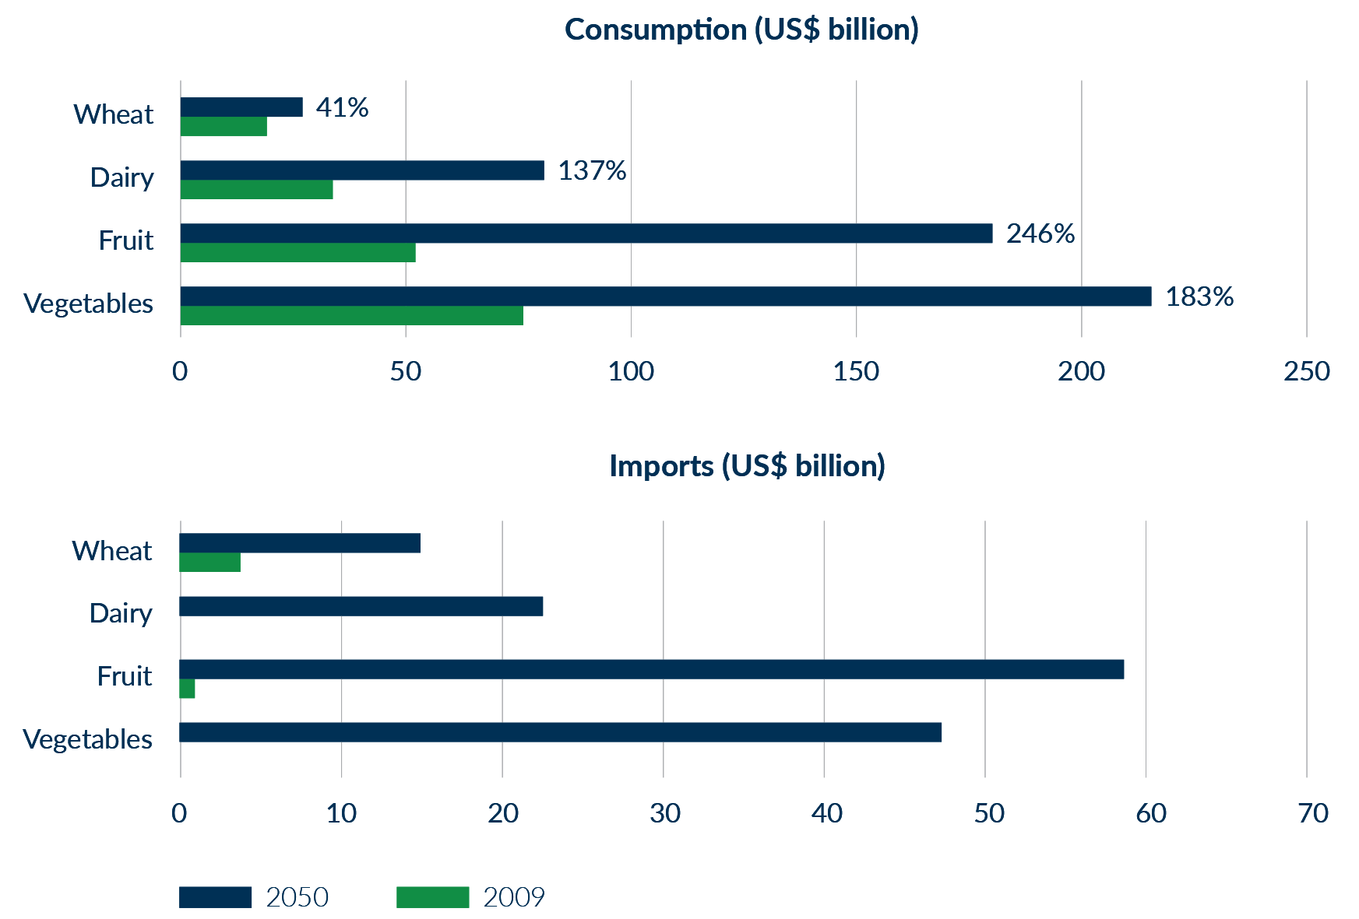

Source: Australian Bureau of Agricultural and Resource Economics and Sciences

# Defence

Australian and Indian firms can find further niche opportunities in each other’s significant procurement agendas. Our *Comprehensive Strategic Partnership* and *Defence* *Science and Technology Implementing Arrangement*, alongside other defence related initiatives, are building greater levels of trust with India, which supports commercial interests. Australia and India also benefit from a growing number of shared platforms, including key transport and surveillance systems, increasing opportunities for industry involvement.

Areas for collaboration include cyber security, space, integrated intelligence, surveillance and reconnaissance, maritime warfare, unmanned vehicles, soldier equipment and the provision of services and training. Growing US–India defence ties may also offer opportunities for Australian firms involved in the global supply chains of major US defence firms working in India.

To support sustained growth in the defence industry relationship, the Government is:

* convening with India the inaugural meeting of the Defence Science and Technology steering committee
* supporting Australian industry participation in future defence and security trade shows in India, including DEFEXPO
* supporting industry involvement in bilateral and multilateral defence exercises with India where appropriate.

India’s military expenditure from 2000 to 2020

India’s military expenditure has grown rapidly over the past two decades, with a further nominal increase in 2021-22 of 1.5 per cent over 2020-21

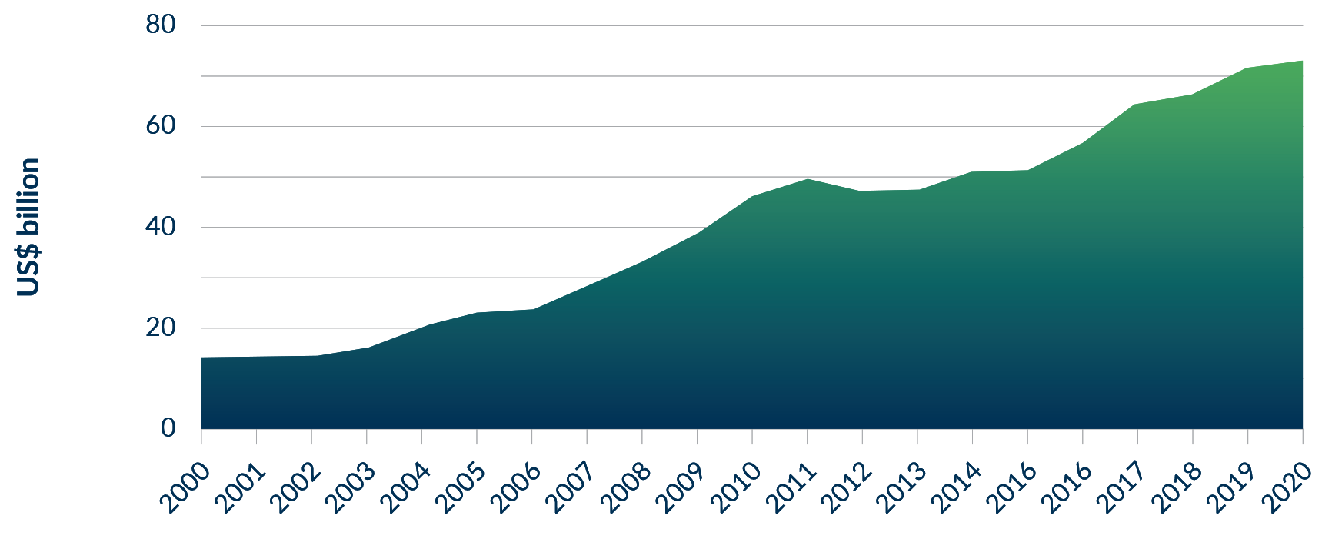

Source: Stockholm International Peace Institute

# Global partners

Australia and India share a commitment to transparent and effective multilateral bodies, and India will remain an important partner in setting the global norms and standards that underpin the rules-based order.

Australia will support India’s G20 host year in 2023. Australia and India share many priorities and will look to harness the opportunities of India’s G20 presidency for the region.

Australia will continue working with India and the OECD across several key streams of work, including energy, critical minerals, responsible business conduct, supply chain resilience and trade and investment*.* India is a Key Partner of the OECD and Australia chairs the OECD’s Informal Reflection Group on India. The OECD’s standards and toolkits bolster global transparency and good governance.

Australia will support India’s strategic partnership with the International Energy Agency (IEA), and continue to work with other IEA member countries to identify a pathway to membership for India.

In any future consideration of expanded membership in APEC, where decisions require consensus, Australia remains committed to working with other members to bring India into this key regional forum. India has substantial economic links with APEC members and would make a significant contribution to the organisation.

Australia will continue working with India in the WTO – including on reforming the institution - to ensure it can continue to deliver a stable and open rules-based global trading system.

Australia is working with India in the Quad (Australia-India-Japan-United States) on critical and emerging technology, supply chain resilience (including in relation to clean energy and semiconductors and their vital components), cyber security, infrastructure, combating climate change, the sustainable use of space, and next-generation STEM talent. The Quad has a positive, practical agenda to contribute to the region’s prosperity, stability and resilience.

# Business literacy and the commercial environment

The IES’s advice to Australian firms on the Indian business environment remains relevant. Investing in understanding the market — either through internally-developed expertise or local representation — is key. Success stories often cite the benefit of an Indian partner or representative, a long-term view and an on-the-ground presence. India’s scale and diversity often necessitates a targeted and localised approach.

This Update reiterates the Government’s commitment to providing practical assistance to Australian firms operating in India.

Our network of officials on the ground – including an extensive Austrade presence – has a strong record. Practical new initiatives include:

* the Centre for Australia India Relations
* the Australia India Infrastructure Forum (AIIF)
* the Australia India Business Champions

These initiatives will build off the existing work undertaken, including by:

* the Australia India Business Exchange
* the Australia India CEO Forum

The **Australia India Business Exchange** (AIBX) is the Australian Government’s flagship program to advance trade and investment partnerships with India. An initiative under the Comprehensive Strategic Partnership, AIBX connects business, industry and government leaders to advance commercial and economic links.

Led by Austrade, the AIBX program aims to grow Australian exports to India, increase two-way investment, and improve business literacy in both directions.

The program includes industry events to connect Australian and Indian businesses, market insights to equip business for success, and tailored support for individual companies to capture export and investment opportunities across the two markets.

To find out more about AIBX and upcoming events, visit: [austrade.gov.au/AIBX](http://austrade.gov.au/AIBX).

The Business Champions group will engage through our flagship trade and investment program in India, the AIBX, and operate alongside *the CEO Forum* — a high-level body that meets parallel to leader-level meetings.

The two-way movement of professionals and professional servicesbetween Australia and India helps facilitate bilateral trade and investment. This is best achieved through collaboration between Australian and Indian professions and will also contribute to increasing the two-way trade in professional services.

In 2019-20, other business services (which includes most professional services) accounted for 13 per cent of Australia’s services exports globally, but less than one per cent of Australia’s services exports to India.

Professionals — like lawyers, accountants, and engineers — often need to meet additional business requirements under local rules and regulations when providing services outside their home jurisdiction. As these rules and regulations help protect the public and the environment, their application must be focussed on maintaining appropriate standards without unnecessarily hindering the two-way movement of professionals between Australia and India.

To better facilitate the two-way movement of professionals and professional services, the Government will work with Australian professional services regulatory and accreditation bodies in pursuing mutual recognition and similar arrangements with counterparts in India.

ACTION PLAN

To strengthen the architecture underpinning bilateral business engagement at the highest levels, the Government has established a **Business Champions**group. The group consists of four senior businesspeople from each country to bolster business engagement. Supported by a Secretariat, this group will advise Government, including in the formulation of economic policy, and promote trade and investment.

The Government will establish an **Australian Standards and Conformance Trade Enabling Program.** The program will deploy Australia’s national standards and conformance (testing) bodies to forge partnerships with Indian counterpart organisations, boosting trade and investment opportunities with India. This multi-year program will identify and overcome barriers to trade and build sustainable industry partnerships, including by identifying business opportunities where standards, conformance and certification processes are aligned. This approach towards harmonisation is essential as standards cannot be utilised by businesses unless each economy’s conformance and testing regimes have the capability to deliver accurate and trustworthy results to markets and consumers.

# India’s dynamic neighbourhood

Bangladesh, Sri Lanka, Nepal and Maldives offer complementary opportunities for Australian companies engaged in the Indian market, including education, tourism, resources, energy and agricultural products.

Bangladesh is the world’s eighth largest country by population and continues to record strong economic growth. The Australia-Bangladesh Trade and Investment Framework Arrangement, which came into force in September 2021, has laid the ground for deeper economic ties. Bangladesh is pursuing reforms ahead of its graduation from Least Developed Country status in 2026. Deepening India-Bangladesh connectivity — including major transport corridors coming online in the next several years — will open opportunities for Australian firms already in India.

Sri Lanka boasts a growing skilled workforce, deep water ports and direct air links to Australia. Direct shipping from Australian ports to Sri Lanka and beyond has the potential to unlock real efficiencies. Sri Lanka could also serve as a hub to process and re-export Australian commodities, including agricultural goods. Subject to rules of origin conditions, this may allow firms to take advantage of the zero-duty market access under Sri Lanka’s trade agreement with India. Over 28 Australian education institutions have a presence in Sri Lanka, underscoring its prospects as a regional education hub.

Nepal offers opportunities for firms with a foothold in India. Its growing middle class is a market for education and premium foods. Renewable energy and agricultural technology are also prospective.

ACTION PLAN

The new **Australian High Commission in Malé** will deepen our education, tourism and broader economic linkages with Maldives. The Maldives’ luxury tourism sector presents opportunities for suppliers of high-quality food and beverage exports.

The **Bay of Bengal Connectivity Partnership** will expand the commercially-focused Australia-India Infrastructure Forum (AIIF) to a regional initiative covering other South Asian countries from 2024-25.

1. India’s Trillion Dollar Digital Opportunity, Government of India, 2021
2. World Economic Outlook, IMF, October 2021
3. World Economic Outlook, IMF, October 2021
4. World Investment Report, UNCTAD, 2021.
5. E-Commerce in India, India Brand Equity Foundation, 2021
6. India’s Trillion Dollar Digital Opportunity, Government of India, 2021
7. The Observatory of Economic Complexity, 2021.