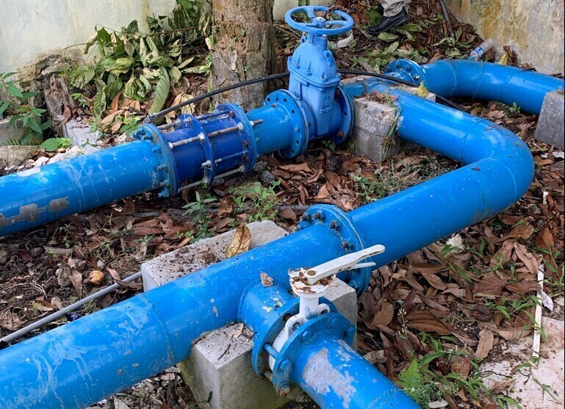

Independent Review of Performance-Based Grants to Water Utilities
  - Final report
  - 18 December 2024

Acknowledgements
The Independent Review of the Performance-Based Grants for Water Utilities demonstration activity was commissioned by the Australian Department of Foreign Affairs and Trade (DFAT) and conducted by Sustineo Pty Ltd. This report was developed by Nicky Thatcher, Dean Taylor and Kate Walton.
The review team extends its sincere gratitude to the numerous stakeholders across Indonesia who generously contributed their time, insights, and expertise. Their valuable input has been instrumental in shaping our understanding and analysis of the Performance-Based Grants demonstration activity.
Special recognition is due to Widya Setyowati, Fenni Rum, Gerard Cheong, Poppy Lestari and Benedictus Dwiagus Stepantoro for their invaluable field support and contributions to the review process. Their local knowledge, facilitation skills, and dedication helped ensure the success of our in-country consultations and data collection efforts.
The collaborative spirit and openness of all participants, from government officials to PDAM representatives and local community members, have greatly enriched this review, providing a comprehensive and nuanced perspective on the activity’s implementation and outcomes within the Indonesian context.
This report was funded by DFAT. The views expressed in this publication are the authors’ alone and are not necessarily the views of DFAT.
Reference
This paper can be referenced as:
Sustineo (2024) Independent Review of Performance-Based Grants to Water Utilities: Final report, report to DFAT, Sustineo.
Contents
List of tables 4
List of figures 5
List of acronyms and abbreviations 7
Activity Summary 9
Executive summary 10
Key Findings 10
Effectiveness 10
Efficiency 11
GEDSI 11
Sustainability 12
Key Recommendations 12
1 Introduction 13
1.1 Background to the review 13
1.2 Review purpose and approach 14
1.3 Key Review Questions 14
1.4 Methodology 15
1.5 Limitations 16
2 Performance-Based Grants for Water Utilities 18
2.1 PBG design overview and timeline 19
2.2 Concurrent activities 22
3 Findings and Considerations 23
3.1 Effectiveness of the PBG activity 23
3.2 Efficiency of the PBG activity 33
3.3 Gender equality, disability, and social inclusion in the PBG activity 41
3.4 Sustainability of the PBG activity 45
4 Lessons Learned 47
5 Conclusions and Recommendations 50
5.1 Conclusion 50
5.2 Recommendations 51
Support Wider Industry Capacity Development 51
Implement Initial Diagnostic Assessments 52
Prioritise Business Plan Development 53
Refine Performance Indicators 54
Mainstream GEDSI Principles 55
Enhance PDAM Performance Monitoring Systems 56
Appendix A. Analytical and Evaluation Framework 57
Review Questions 57
Efficiency 57
Effectiveness 57
Sustainability 58
Evaluation Framework 58
Appendix B. PBG indicator introduction, eligibility criteria and participant PDAMs 60
Appendix C. Original Program Logic 65
Appendix D. LG investment in PDAM as compared to grant allocation 66
Appendix E. Disbursement results for each indicator, by LG/PDAM, with percentage 68
Appendix F. Disbursement results for each PDAM, by indicator 74
Appendix G. Description of Figure 3-5 91
Appendix H. Description of Figure 3-6 92

List of tables
Table 1-1: Consulted stakeholder groups 15
Table 2-1: Indicator introduction timeline 20
Table 3-1: Performance achievement against agreed targets 28
Table 3-2: Summary of verifications by location and indicator 35
Table A-1: Review questions 58
Table C-1: Indicator introduction timeline, eligibility criteria and participant PDAMs 60
Table E-1: LG Equity Investment and SPPh amounts 66
Table G-1: Disbursement results for Bandung 74
Table G-2: Disbursement results for Banyumas 75
Table G-3: Disbursement results for Banyuwangi 76
Table G-4: Disbursement results for Cirebon 77
Table G-5: Disbursement results for Gianyar 78
Table G-6: Disbursement results for Palangkaraya 79
Table G-7: Disbursement results for PPU 80
Table G-8: Disbursement results for Pesisir Selatan 81
Table G-9: Disbursement results for Sleman 82
Table G-10: Disbursement results for Sumedang 83
Table G-11: Disbursement results for Tegal 84
Table G-12: Disbursement results for Wonosobo 85
Table G-13: Disbursement results for Brebes 86
Table G-14: Disbursement results for Kebumen 87
Table G-15: Disbursement results for Lebak 88
Table G-16: Disbursement results for Magetan 89
Table G-17: Disbursement results for Purworejo 90

List of figures
Figure 2-1: PDAM performance categorisation for the period 2016 to 2022 18
Figure 3-1: Final PMPD Transferred to PDAM Compared with Grant Allocation (IDR Billions) 27
Figure 3-2: Final available SPPh grant and amount disbursement by MoF per indicator 28
Figure 3-3: Disbursement results for NRW, by LG/PDAM. 29
Figure 3-4: Final available SPPh grant and amount disbursement by MoF per PDAM 30
Figure 3-5: Mechanism of Implementation of the PBG 34
Figure 3-6: Mechanism for PBG Verification Surveys 35
Figure 3-7: Amount of funds disbursed compared to the no. of verification activities by MoF per indicator 37
Figure 3-8: Amount of funds disbursed compared to the no. of verification activities by MoF per PDAM 37
Figure 5-1: Whole of business NRW focus 55
Figure F-1: Disbursement results for BP, by LG/PDAM. 68
Figure F-2: Disbursement results for OR, by LG/PDAM. 69
Figure F-3: Disbursement results for BCE, by LG/PDAM. 69
Figure F-4: Disbursement results for NRW, by LG/PDAM. 70
Figure F-5: Disbursement results for EE, by LG/PDAM. 70
Figure F-6: Disbursement results for CoS, by LG/PDAM. 71
Figure F-7: Disbursement results for WQ, by LG/PDAM. 71
Figure F-8: Disbursement results for IEC, by LG/PDAM. 72
Figure F-9: Disbursement results for SOPs, by LG/PDAM. 72
Figure F-10: Disbursement results for ICPS, by LG/PDAM. 72
Figure F-11: Disbursement results for WSP, by LG/PDAM. 73
Figure F-12: Disbursement results for CC, by LG/PDAM. 73
Figure F-13: Disbursement results for MWH, by LG/PDAM. 73
Figure G-1: Disbursement results for Bandung, by indicator. 74
Figure G-2: Disbursement results for Banyumas, by indicator. 75
Figure G-3: Disbursement results for Banyuwangi, by indicator. 76
Figure G-4: Disbursement results for Cirebon, by indicator. 77
Figure G-5: Disbursement results for Gianyar, by indicator. 78
Figure G-6: Disbursement results for Palangkaraya, by indicator. 79
Figure G-7: Disbursement results for PPU, by indicator. 80
Figure G-8: Disbursement results for Pesisir Selatan, by indicator. 81
Figure G-9: Disbursement results for Sleman, by indicator. 82
Figure G-10: Disbursement results for Sumedang, by indicator. 83
Figure G-11: Disbursement results for Tegal, by indicator. 84
Figure G-12: Disbursement results for Wonosobo, by indicator. 85
Figure G-13: Disbursement results for Brebes, by indicator. 86
Figure G-14: Disbursement results for Kebumen, by indicator. 87
Figure G-15: Disbursement results for Lebak, by indicator. 88
Figure G-16: Disbursement results for Magetan, by indicator. 89
Figure G-17: Disbursement results for Purworejo, by indicator. 90

List of acronyms and abbreviations
Acronym | Description
ACR | Activity Completion Report
AO | Activity Outcome
BAPPENAS | Badan Perencanaan Pembangunan National (Ministry of National Development Planning)
BAPPEDA | Badan Perencanaan Pembangunan Daerah (Provincial Development Planning Agency)
BCE | Billing Collection Efficiency (Financial Sustainability indicator)
BP | Business Plan (Governance indicator)
BPKP | Badan Pengawasan Keuangan dan Pembangunan (Finance and Development Supervisory Agency)
BPPSPAM | Badan Peningkatan Penyelenggaraan Sistem Penyediaan Air Minum (Drinking Water Service System Provision Improvement Agency)
CC | Climate Resilience (Climate Change indicator)
CoS | Continuity of Service (Quality of Service indicator)
CPMU | Central Project Management Unit
DFAT | Australian Government Department of Foreign Affairs and Trade
EE | Energy Efficiency (Operational Efficiency indicator)
EoAO | End of Activity Outcome
FERSIA | Forum GEDSI Perusahaan Air Minum Seluruh Indonesia (Indonesian Water Utility GEDSI Forum)
GAP | Gender Action Plan
GEDSI | Gender Equality, Disability and Social Inclusion
GOA | Government of Australia
GOI | Government of Indonesia
ICPS | Improved Chlorination & Safety Performance (COVID-19 Response indicator)
IEC | Communication, Information & Education (COVID-19 Response indicator)
KIAT | Kemitraan Indonesia Australia untuk Infrastruktur (Indonesia Australia Partnership for Infrastructure)
LG | Local Government
MHR | Ministry of Human Resources
MOF | Ministry of Finance
MOH | Ministry of Health
MOHA | Ministry of Home Affairs
MPWH | Ministry of Public Works and Housing
MWH | Accelerating Access to Drinking Water (Increased Coverage indicator)
NRW | Non-Revenue Water (Operational Efficiency indicator)
NUWSP | National Urban Water Supply Project (World Bank funded initiative)
OECD–DAC | Organisation for Economic Co-operation and Development's Development Assistance Committee
OR | Operating Ratio (Financial Sustainability indicator)
PBG | Performance-Based Grant to Water Utilities
PDAM | Perusahaan Daerah Air Minum (Local Water Utility)
PERPAMSI | Persatuan Perusahaan Air Minum Seluruh Indonesia (Indonesian Association of Water Utilities)
PIC | Project Implementation Consultant contractor (Cowater International in association with PT Infratama Yakti)
PMM | Program Management Manual
PMPD | Penyertaan Modal Pemerintah Daerah (LG equity investment)
PPU | Penajem Pasir Utara
SOPs | Compliance with Regulations, Guidelines & SOPs (COVID-19 Response indicator)
SPPh | Surat Persetujuan Penerusan Hibah (MOF Grant Forwarding Approval Letter)
TA | Technical Assistance
WPS | Drinking Water Safety Plan (Public Health indicator)
WQ | Water Quality
* Note: Italics used throughout report to indicate Indonesian language/ terminology

Activity Summary
Summary | Description
Aid Investment Name | Water and Sanitation Hibah Phase 2 & PBG
Activity Name | Performance-Based Grants for Water Utilities
Activity Grant Allocation (AUD) | $15 million, with $12.6 million disbursed
Grant Budget (AUD) | FY20/21 $3,318,312.34  FY 21/22 $3,218,052.43  FY 22/23 $3,085,063.41  FY 24/25 $2,730,053.53
Technical Assistance contract (AUD) | Contract $12,351,481.71, with $10,785,588.18 expended as at July 2024
TA Activity Budget (AUD) | FY20/21 $2,237,706.17  FY 21/22 $2,771,883.90  FY 22/23 $3,041,860.51  FY 24/25 $2,734,137.60
Delivery organisations | KIAT Facility, administered by DT Global  PIC organisation, Cowater International

Executive summary
The Performance-Based Grants (PBG) demonstration activity was a pilot program implemented from 2020-2024 to improve the performance of local water utilities (PDAMs) in Indonesia through targeted technical assistance (TA) and grant funding.
The PBG was established in 2020 as a continuation of the long-standing partnership between the Australian and Indonesian governments to improve water supply services. Building on the success of the Water Hibah initiative, which used an output-based grant funding model, the PBG aimed to incentivise Local Government (LG) investment in water utilities (PDAMs) and enhance their performance. With AUD 15 million in grant support available, the program worked with 17 PDAMs across Western and Central Indonesia, requiring each associated LG to co-invest an average of AUD 1 million over at least two years.
The PBG faced two significant challenges during its implementation. First, the COVID-19 pandemic emerged shortly after the activity’s launch, necessitating adaptations to the original design. In response, additional indicators related to COVID-19 responses were incorporated into the pilot. Second, the dismantling of BPPSPAM (Drinking Water Service System Provision Improvement Agency) during the course of the activity posed a challenge, as BPPSPAM had been responsible for monitoring PDAM performance and providing crucial data for the PBG's design and implementation. Despite these obstacles, the pilot continued, with adjustments made to accommodate the changing circumstances.
This independent review assessed the effectiveness, efficiency, sustainability, and gender equality, disability, and social inclusion (GEDSI) outcomes of the PBG pilot in order to inform the future water sector programming of the Government of Indonesia (GOI), Australia’s Department of Foreign Affairs and Trade (DFAT) and other development partners.

Key Findings

Effectiveness
The PBG demonstration activity was moderately effective in improving PDAM performance, although broader outcomes were shaped by program design limitations, contextual challenges, and shifting national policies.
The program aimed to encourage Local Government (LG) equity investments to complement grant allocations. However, meeting eligibility criteria for additional grant funding was the only mandatory requirement for increased LG investment. Among the 17 participating PDAMs, investment patterns varied significantly:
- Seven LGs exceeded grant allocation in equity investments
- Six LGs matched grant allocation
- Four LGs invested less than grant amounts.
Total LG investment reached IDR 180.583 billion, exceeding the overall grant allocation of IDR 146.180 billion (124%). The results varied considerably across participants due to diverse local circumstances such as political priorities, financial capacity, and development initiatives.
At the program level, significant progress was achieved against most performance indicators, particularly for the six later-introduced public health-focused indicators. The improvements against initial operational indicators such as Billing Collection Efficiency (BCE), Non-Revenue Water (NRW), Energy Efficiency (EE), and Continuity of Supply (CoS) proved more variable. For instance, EE recorded only 30% of available grant funding disbursed, while NRW, despite achieving 100% disbursed funding at the program level, showed variable results by PDAMs.
Extrapolating zone-specific gains achieved under the NRW, CoS and EE to the overall performance of participating PDAMs is not possible, unless the PDAM and local government intentionally allocate resources for replication in other zones.
Twelve of the 17 PDAMs accessed between 94% and 100% of their expected grants, while the remaining five accessed between 54% and 83%. This did not necessarily mean that most or all targets were achieved within individual PDAMs; rather, underachievement in some areas was offset by overachievement in others.
The integration of TA across the pilot and installation of specialist water management infrastructure played a crucial role in enabling improvements.

Efficiency
The PBG demonstration activity involved a complex implementation mechanism requiring significant resources beyond the nominal AUD 27 million activity cost (AUD 15 million in grant funding and AUD 12 million in TA support). The level of Program Implementation Consultant (PIC) support to government ministries and PDAMs was considerably resource-intensive compared to the capital grant funding distributed and the previous Water Hibah output-funding model.
The process of setting baselines and conducting verifications was more extensive than anticipated, necessitating additional PIC staffing and resources. Unlike the Water Hibah model, the PBG activity required establishing robust baselines for each indicator before demonstrating performance changes. This process was time-consuming and impacted the ability to distribute grant funds.
The verification process was particularly resource-intensive, with 291 verification minutes prepared by PIC, not always proportional to the grant funding available or disbursed. This extensive verification, coupled with BPKP's review, contributed to the time lag between performance achievements and grant disbursement.
The pilot demonstrated that these relatively healthy participant PDAMs required considerable TA support to participate effectively, suggesting that less developed PDAMs would need equal or greater support in a mainstreamed version.

GEDSI
GEDSI was not integrated as a core component of the PBG activity nor linked to accessing PBG funding. Instead, it required participating PDAMs to develop annual GEDSI Action Plans (GAPs), which were ideally (but not always) incorporated into PDAM business plans. GEDSI support was largely delivered as request-based capacity building and mentoring, allowing PDAMs to choose their level of involvement. This approach effectively made GEDSI initiatives optional in nature.
Despite these limitations, the PBG pilot brought about significant improvements through enhanced understanding and support for GEDSI among PDAM directors, managers, and staff. However, limited achievement was achieved against actual GEDSI program targets over the life of the pilot due to time constraints and varying leadership commitment to GEDSI (LG and PDAM level); resource requirements; and the limited sphere of program influence (sustainable mindset change takes time and must reach a broad audience).

Sustainability
At the time of the review, it was too early to determine the sustainability of achieved PDAM performance improvements through the pilot. PERPAMSI remains the primary avenue (along with its subgroup, FERSIA) for continuing professional development and technical support following the end of the PBG demonstration activity. The level of influence the demonstration activity has had or will have on informing policy and practice to invest in and improve water supply services is likely complicated by the change of government at both national and local levels in October 2024.

Key Recommendations
The report made six high level recommendations for possible future water sector programming consideration.
- Support sector-wide capacity building and leverage existing initiatives for sustainable, industry-wide improvements
- Consider a program that helps PDAMs conduct comprehensive initial diagnostic assessments to prioritise interventions effectively
- Prioritise development of strong PDAM business plans integrating GEDSI and climate resilience principles
- Simplify and refine performance indicators for grant funding, focusing on overall performance measures like non-revenue water that reflect holistic improvements
- Mainstream GEDSI principles throughout all activities rather than as standalone initiatives
- Enhance PDAM performance monitoring systems and capabilities through targeted readiness support and equipment investments
Overall, the PBG demonstration activity provided valuable insights for improving PDAM performance, but substantial modifications are needed to create a more sustainable, scalable model for sector-wide impact. Future initiatives should build on lessons learned while addressing identified limitations to support broader improvements across Indonesia's water utility sector.

Introduction
The Australian Department of Foreign Affairs and Trade (DFAT) engaged Sustineo to conduct the Independent Review of Performance-Based Grants to Water Utilities (PBG) demonstration activity in 2024.

Background to the review
The PBG demonstration activity continues a long association and partnership between the Government of Australia (GOA) and the Government of Indonesia (GOI) to provide cost effective, efficient and stable water supply. The PBG demonstration activity built on the success of the Water Hibah initiative which used an output-based grant funding model to support water providers in expanding their networks. Specifically, the Water Hibah initiative sought to encourage local government (LG) investment in their local LG-owned water utility (Perusahaan Daerah Air Minum – PDAM) in order to increase connections in predetermined areas of low-income households.
The PBG demonstration activity was established in 2020. Through this performance-based grant funding mechanism, AUD 15 million in grant program support was available for LGs and PDAMs to improve the quality and sustainability of water services. The combined approach of infrastructure investment, grant funding and targeted technical assistance (TA) across multiple sectors of government aimed to enhance the governance, sustainability, operational efficiency, and the quality of water service delivery of the local water utilities. The expectation was that by investing in and providing TA to PDAMs, PDAM performance would improve, and, in time, a corresponding improvement in the quality of service to customers would occur. As a pilot program, the PBG activity sought to trial an approach which incentivised LG investment (Penyertaan Modal Pemerintah Daerah – PMPD) and support for PDAMs to improve performance and subsequently inform future GOI programming.
The PBG demonstration activity worked with 17 PDAMs and their associated LGs, each of which were required to co-invest in their PDAMs to achieve improvements against four performance areas: Governance, Financial Sustainability, Operational Efficiency and Quality of Service. The level of co-investment by an LG into their PDAM was to be equal to or greater than the anticipated level of grant funding. The PBG demonstration activity had three explicit development objectives:
- LGs are actively engaged with their PDAMs
- Improved PDAM performance
- Improved national monitoring of PDAM performance and classification of PDAMs.
The activity was implemented through the Indonesia Australia Partnership for Infrastructure (Kemitraan Indonesia Australia untuk Infrastruktur – KIAT) under an AUD 12 million Project Implementation Consultant (PIC) contract. The activity involved active engagement and support from GOI ministries and the KIAT Water and Sanitation team.

Review purpose and approach
The purpose of the review is to assess the effectiveness of the PBG demonstration activity to inform future programming in water supply provision for the GOI, DFAT and other development partners. It seeks to understand the mechanisms by which performance-based grant programs can produce the expected outcomes or may create adverse effects, especially in the context of grant provision to PDAMs in Indonesia.
The review considers the identification of achievements and lessons learned on designing and implementing performance-based incentives, including in selecting appropriate indicators and verification methods that would yield most performance improvement.

Key Review Questions
The following key review questions provide the focus for the review.
- To what extent has the investment achieved the end-of-activity outcomes? (Effectiveness)
- To what extent has the investment brought about change in implementing partners commitment to gender equality and disability inclusion within their institutions? To what extent has the investment influence the institution to address all potential opportunity for integrating Gender Equality, Disability and Social Inclusion (GEDSI) in their community outreach/service provision? (GEDSI, Sustainability)
- To what extent has the investment made appropriate and efficient use of Australia's and our partners' time and resources to achieve the end-of-activity outcomes? (Efficiency)
- To what extent has the program influenced GOI policy and practice to invest in and improve water services? (Sustainability)
- What lessons have been identified regarding the factors which increase or inhibit commitment and demand of Local Government (LG) in providing sustainable water supply, and whether the activity used appropriate incentives to influence change? (Effectiveness, Sustainability).
The analytical and evaluation framework for investigating these questions (see Appendix A) was informed by DFAT’s Design and Monitoring, Evaluation and Learning Standards and its International Development Programming Guide. The standards are informed by the Organisation for Economic Co-operation and Development's Development Assistance Committee (OECD–DAC) evaluation criteria. Where suitable the reviews findings are presented against the identified criteria of efficiency, effectiveness and sustainability.

Methodology
The review utilises a mixed methods approach comprised a variety of data collection methods. This included:
- review of relevant literature and program documentation and data, including records maintained by the PDAMs
- consultation with key stakeholders (see Consulted stakeholder groups) conducted as part of a comprehensive in-country visit to Jakarta, Palangkaraya, Bandung and Sleman between 22 July to 7 August 2024
- an online survey issued to the 14 PDAMs not visited by the review team but who participated in the PBG activity.
Data collection and analysis was guided by the key review questions, refined in consultation with DFAT.
Consulted stakeholder groups
Level | Agencies
Central governments | Ministry of Public Works and Housing (MPWP), including Central Project Management Unit (CPMU), Ministry of Finance (MOF), Badan Perencanaan Pembangunan National (Ministry of National Development Planning – BAPPENAS), Badan Pengawasan Keuangan dan Pembangunan (Finance and Development Supervisory Agency – BPKP), Ministry of Health (MOH), Ministry of Home Affairs (MOHA)
Provincial governments | Central Kalimantan BPKP auditors; West Java BPKP auditors  Yogyakarta BPKP auditors
Local governments in Palangka raya, Bandung and Sleman | Mayor’s/District Head’s Office, Badan Perencanaan Pembangunan Daerah (Provincial Development Planning Agency – BAPPEDA), Project Implementation Unit, Relevant local government agencies, including Local Public Works and Housing Office, Local Finance Office, and Local Health Office
Water utilities | PDAM Directors, managers, and staff , Persatuan Perusahaan Air Minum Seluruh Indonesia (Indonesian Association of Water Utilities – PERPAMSI), Forum GEDSI Perusahaan Air Minum Seluruh Indonesia (Indonesian Water Utility GEDSI Forum – FERSIA)
Community members in PDAM service areas | PDAM Customer Forums, Community members with PDAM connections
Implementing partners | DFAT, KIAT, PIC (Cowater International)

Limitations
There are a number of limitations that should be considered in interpreting the review. These are detailed below, along with how they were managed.
- Time and resources: The rigour of the data gathering and analysis processes for the review was constrained by the time available. To mitigate this, the review used the extensive program reporting material prepared by the PIC and KIAT and built on existing information where possible rather than duplicate it. Review methodologies were targeted and aligned to the components of support provided under the Activity. To mitigate duplication, a key source of information was the Activity Completion Report (ACR), alongside other KIAT and PIC published knowledge products.
- Access: While the demonstration program covered 17 LGs, the review team was only exposed to perspectives from a subset of stakeholders/locations. The selection of PDAMs examined by this review was purposeful and considered various criteria including initial performance conditions and performance improvements; reported challenges faced by PDAMs; primary types of water sources; the size of the PDAM (based on number of household connections); and geographic location. The three consultation sites provided a good cross-section of PBG participants. An additional online survey was circulated to the remaining 14 PDAMs to provide them an opportunity to share their experiences with the review team.
- Measurement: The review was reliant on the presentation of quantitative data within PBG activity reporting, including the verification reports and recommendations supporting the drawn-down/ release of grant funding. The review did not independently verify or re-calculate reported results across the 17 PDAMs.
- Attribution: PBG activities are implemented within ‘open systems’ where multiple factors contribute to and/or detract from the anticipated changes. As a result, definitive attribution of changes to particular interventions can be challenging. Where possible, key informant interviews sought to draw out examples where grantees identified that the PBG has impacted on institutional change.
- Language: PBG activity documentation is in both English and Indonesian. One member of the review team had significant experience living and working in Indonesia and is proficient in Indonesian. They ensured that a culturally appropriate approach to engagement was applied, that documents available only in Indonesian contributed to the review, and that potential misunderstandings due to language barriers did not impact the review. To ensure effective stakeholder engagement during field work, KIAT-facilitated translator services supported the team to ensure all members could undertake their work.

Performance-Based Grants for Water Utilities
As set out in the PBG Activity Design Document, at the time of design (2018) there were 374 PDAMs in Indonesia, each owned by their LG. PDAMs were monitored through a national system administered by the then-Badan Peningkatan Penyelenggaraan Sistem Penyediaan Air Minum (Drinking Water Service System Provision Improvement Agency – BPPSPAM). At that time PDAMs provided piped water supply to some 18% of the then Indonesian population.
Through the national system for monitoring PDAM performance, each year BPPSPAM allocated a performance categorisation of ‘healthy’ (sehat), ‘unhealthy’ (kurang sehat) or ‘sick’ (sakit) to PDAMs through BPPSPAM’s PDAM Performance Evaluation Report. This classification was based on BPKP annual assessment of individual PDAM performance. The classification system was structured around four weighted aspects of performance: financial, service, operations, and human resources, and allowed for tracking performance trends and comparing PDAMs across regions. Figure 2-1 illustrates the proportion of all PDAMs across Indonesia split by their official categorisation for the period 2016 to 2022. The categorisation of PDAMs can change from year to year. The proportion of those categorised as ‘healthy’ ranged from 53% in 2016 to as high as 65% in 2022.
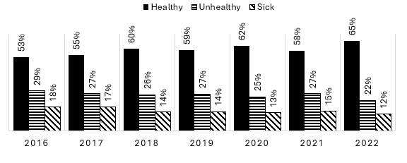
Figure 2-1: PDAM performance categorisation for the period 2016 to 2022
Source: https://data.pu.go.id/visualisasi/kinerja-bumd-air-minum
The design of the PBG demonstration activity explained that, even though some 60% of PDAMs were assessed as healthy in 2018, this categorisation masked the fact that many of these PDAMs were performing poorly in terms of the efficiency, quality of service and service coverage within their localities.
The PBG demonstration activity sought to trial the move from an output-based grant funding model, as used under the Water Hibah, to a performance-based grant funding model. The PBG’s Activity Design Document stated:
Developing a Performance Based Grant requires a monitoring framework for performance. Fortunately, GoI has a well-established basic framework for measuring water utility performance through the Water Utility Improvement Agency of MPWH, BPPSPAM, which has been reporting on water utility performance since 2005. This activity has used the performance data of the BPPSPAM to develop the design of the PBG pilot and proposes that the BPPSPAM data be used in the implementation of the PBG. This will both facilitate the mainstreaming of the PBG by GoI and help to improve the quality and timely reporting of BPPSPAM data. Strengthening the capacity and role of BPPSPAM will provide a sound platform for the implementation of the PBG nationally.
The entry criteria for a PDAM to participate in the demonstration activity was that the PDAM needed to be categorised as unhealthy or above. At the start of the activity,
15 out of 17 (88%) participating PDAMs were classified as 'healthy' and two out of 17 (12%) were classified as unhealthy. By the end of 2023, all 17 (100%) participant PDAMs achieved healthy status. Based on the most recent data available in 2024, 16 out of 17 (94%) maintained their healthy status.

PBG design overview and timeline
The key components of the PBG demonstration activity included:
- Investment in PDAM infrastructure, provided by the LG to improve PDAM performance to an agreed target. The grants provided by GOA’s DFAT would be disbursed upon verification that PDAM achieved the target.
- A range of TA services provided through a separately DFAT-funded PIC contract. The TA expertise covered areas such as:
- Baseline and verification support
- Capacity development and knowledge sharing (including for example business planning, engineering and financial management)
- GEDSI oversight and reporting
- Monitoring and evaluation.
The PBG demonstration activity uses a series of 13 performance indicators to measure and incentivise improvements in PDAM performance. Initially performance was tracked and rewarded against an initial series of seven indicators grouped under the four performance areas:
- Governance: One indicator – Business Plan
- Financial Sustainability: Two indicators – Operating Ratio and Billing Collection Effectiveness
- Operational Efficiency: Two indicators – Non-Revenue Water (NRW) and Energy Efficiency (EE)
- Quality of Service: Two indicators – Continuity of Supply (CoS) and Water Quality (WQ).
As a program trialling new approaches to measure water utility performance improvements, it was understood that adjustments may be needed during program implementation. Additional indicators were added to the PBG activity after commencement. These related to COVID-19 responses; climate change adaptation action plans; water safety plans; and a modified water hibah (grant) for increasing household connections. The governing Program Management Manual (PMM) was amended each time additional indicators were added to the program. Any changes or adjustments to the program were discussed and agreed by both GOA and GOI.
The timeline for the introduction of the indicators is shown in Table 2-1. The eligibility to participate against the initial seven indicators was based on satisfying performance eligibility criteria. Eligibility to access grant funding allocations on the additional six indicators introduced later in the PBG related to an LG’s ability to provide additional investment funding to their PDAM. Appendix C sets out more comprehensive eligibility criteria, basis of grant payment and participant PDAMs against each indicator.
Table 2-1: Indicator introduction timeline
Component | Indicator Type | Date included in the PMM
Business Plan (BP) | Governance | Feb 2020
Operating Ratio (OR) | Financial Sustainability | Feb 2020
Billing Collection Efficiency (BCE) | Financial Sustainability | Feb 2020
Non-Revenue Water (NRW) | Operational Efficiency | Feb 2020
Energy Efficiency (EE) | Operational Efficiency | Feb 2020
Continuity of Supply (CoS) | Quality of Service | Feb 2020
Water Quality (WQ) | Quality of Service | Feb 2020
Communication, Information & Education (IEC) | COVID-19 Response | Aug 2021
Compliance with Regulations, Guidelines & SOPs (SOPs) | COVID-19 Response | Aug 2021
Improved Chlorination & Safety Performance (ICPS) | COVID-19 Response | Aug 2021
Accelerating Access to Drinking Water (MWH) | Increased Coverage | Aug 2023
Drinking Water Safety Plan (WSP) | Public Health | Aug 2023
Climate Resilience (CC) | Climate Change | Aug 2023
Source: Document review
During the course of the pilot, a number of a significant changes occurred to the operating context.
The commencement of the PBG coincided with the global COVID-19 pandemic. As a result, the inception phase of the program was significantly adjusted in response to the inability of specialist advisors to travel and have in-person engagement with participating PDAMs. For example, as noted in the ACR:
For the first 18 months of program implementation, COVID-19 constraints meant that all meetings and discussions at the national level were on-line via Zoom and no field visits could be made by PIC.
This also impacted on the time taken to establish robust baselines necessary for measuring performance improvements against. Additional indicators were added to the PBG program to support LGs respond to COVID by improving the disinfection of the water supply. GOI budgets more broadly became constrained, and structural changes across government were made to support economic recovery actions. It is also considered that COVID-related budget constraints may have impacted on an LG’s ability to provide previously-agreed equity investments to their PDAMs within agreed timeframes. In light of these various issues, the PBG pilot period was extended to June 2024.
In addition to the impact of COVID-19 on the initial years of the activity, there were two significant issues at the national level impacting on the pilot and next steps. Specifically, the dismantling of BPPSPAM and the enactment of Law 1 of 2022 (UU HKPD) concerning Financial Relations between the Central Government and Regional Government.
The assessment of PDAM performance had until 2020 been the responsibility of BPPSPAM. Considerable use was made of BPPSPAM reports in the original design and framing of the PBG, and through the assessment of PDAMs to join the pilot. In July 2020, the President of Indonesia disbanded BPPSPAM by Presidential Decree 82 as part of a wider whole of government agency reform initiative as part of the COVID-19 economic recovery actions. The responsibilities held by BPPSPAM, including the monitoring and reporting of PDAM annual performance, were effectively halted. Minor functions of the defunct BPPSPAM continue in part through transfer on a temporary basis to the Directorate for Water Supply within the Directorate General of Human Settlements, Ministry of Public Works and Housing (MPWH). The annual classification of PDAMs has continued. The dismantling of BPPSPAM had specific, unanticipated impacts on the assumptions underpinning the PBG program design as well as the planned activities associated with PBG End of Activity Outcome (EoAO) 3. In addition, and to reduce challenges during implementation, the PIC contract was amended and the TA team increased to incorporate some of the roles previously being undertaken by BPPSPAM.
The Long Term Outcome 1 for the PBG was ‘GOI has a proven method of encouraging LG to achieve policy objectives, in this case to actively manage, invest in, and improve the performance of their water companies’. The introduction of Law 1 of 2022 resulted in a fundamental change in the regime for subnational fiscal transfers and was designed to significantly impact how LGs use their budget. The law governs the full range of fiscal decentralisation issues, including intergovernmental transfers and subnational taxation, finance, spending and service delivery, among others. The new law came into effect in early 2023 so has had minimal impact to date, though it is expected to heavily impact LG investment (through PMPD) and PDAM funding arrangements into the future.

Concurrent activities
The World Bank-funded National Urban Water Supply Project (NUWSP) and the PBG demonstration activity were related initiatives aimed at improving water supply services in Indonesia. NUWSP was developed at the same time as the PBG, mirrored many aspects and has run in parallel to the program. While both programs emphasised improving the performance of PDAMs, they used different delivery approaches in the provision of grant funding and technical support.
While the PBG provided technical support and access to grant funding for improving performance against 13 indicators, NUWSP pursued just two indicators: the operational efficiency indicators of NRW and EE. Further, while the PBG was underpinned by a comprehensive TA support program, the NUWSP did not provide dedicated TA support to participant PDAMs.

Findings and Considerations
The key findings are discussed below in relation to each review question.

Effectiveness of the PBG activity
Summary of findings – Effectiveness
The PBG demonstration activity was moderately effective in improving PDAM performance, although the achievement of broader outcomes was shaped by program design limitations, contextual challenges, and shifting national policies.
The PBG aimed to improve PDAM performance by encouraging LGs to provide equity investments complementing the grant allocations. While LG engagement and investment in PDAMs were an intended outcome, meeting eligibility criteria for additional grant funding was the only mandatory requirement for increased LG investment. This meant that beyond initial commitments, LGs were not obligated to significantly increase their investment unless they sought to access further grants. Of the 17 participating PDAMs:
- 7 LGs made total equity investments into their PDAM exceeding the grant allocation in their final Surat Persetujuan Penerusan Hibah (SPPh, MOF Grant Forwarding Approval Letter)
- 6 LGs made total equity investments into their PDAM matching the grant allocation in their final SPPh
- 4 LGs made total equity investments into their PDAM that were less than the grant amounts allocated in their final SPPh.

Total LG investment across the pilot amounted to IDR 180.583 billion, exceeding the overall grant allocation of IDR 146.180 billion (124%). The results varied significantly across LG/PDAM participants, reflecting diverse local circumstances such as political priorities, financial capacity, and development initiatives.

At the program level, significant progress was achieved against most performance indicators, particularly for the six later-introduced public health-focused indicators (e.g., IEC, WSP, and CC). By contrast, achieving meaningful improvements in each PDAMs for many of the seven initial operational indicators, particularly OR, BCE, NRW, EE and CoS, proved more variable, with results constrained by local contexts, competing priorities, and specific operational zones. For instance, EE recorded only 30% of available grant funding disbursed, while NRW, although achieving 100% disbursed funding at the program level, showed variable results by PDAM, with outcomes in target zones not necessarily reflective of broader utility performance. The level of funding availability also varied across indicators.

Extrapolating zone-specific gains achieved under the NRW, CoS and EE is not possible, unless the PDAM and LG intentionally allocate resources for replication in other zones. Also, external factors, such as weather impacts or infrastructure failures, highlighted the fragility of performance improvements against certain indicators. In relation to overall program grant funding, 12 of the 17 PDAMs accessed 94% or more of their expected grants. The remaining five accessed between 54% and 83% of available funding. This did not mean that most or all targets were achieved within a PDAM, rather that underachievement in some areas was offset by overachievement in others.
The integration of TA across the pilot, and the installation of specialist water management infrastructure, played an essential role in enabling improvements in areas like service continuity and data-driven monitoring.

The PBG’s inability to support improved national monitoring and PDAM classification due to the dismantling of BPPSPAM further constrained progress toward enhanced institutional oversight, as originally envisioned under EoAO3. While this shift was beyond the program’s control, it underscored the importance of a robust institutional framework for scaling and sustaining performance-based funding systems.

This section reports on findings aligned to Key Review Question 1: To what extent has the investment achieved the end-of-activity outcomes?

Findings
The PBG demonstration activity was designed to achieve three EoAOs. These were:
- EoAO1: Local Governments actively engaged with their PDAM
- EoAO2: Improved PDAM Performance
- EoAO3: Improved National Monitoring of PDAM Performance and Classification of PDAMs
The original program logic to achieve these EoAOs is shown at Appendix D. As set out in the PBG ACR, these high-level outcome statements were underpinned by several key assumptions, including:
- LGs and PDAMs recognise the importance of sound business planning and the focus on key performance indicators to increase efficiency and effectiveness.
- BPPSPAM and BPKP recognise the importance of robust and accurate data collection, monitoring, and reporting to provide high confidence in data and information and inform decision-making.
- The Directorate General of Human Settlements and LGs recognise that improved PDAM performance requires strategic leadership, management, resources, and robust data and information.
- Long-term sustainability is only achievable if improved systems and processes are embedded and institutionalised for the longer term (e.g., a national monitoring system).
The logic underpinning the PBG demonstration activity was sound. Specific elements such as LGs and PDAMs recognising the importance of sound business planning were embedded and tested throughout the life of the activity. Similarly, having broader GOI agreement and recognition of attributions to support PDAM performance was demonstrated over the activity. A key challenge for the implementation of the activity was, however, that the core building blocks to support the collection of robust and accurate PDAM performance data, such as specialist water management infrastructure (bulk water meters, pressure sensor devices and data logging equipment) were less than expected. The initial phase of the PBG activity was extended to support the installation of such equipment and ensure robust baselines could be established within each participant PDAM to measure subsequent performance improvements. This was an important and positive outcome of the activity but came at a time-impost on the implementation timeline. Concurrently, the dismantling of BPPSPAM in the initial phase of the activity’s implementation reduced the opportunity to build on long-standing monitoring activities and the ability to embed and institutionalise the new performance-based grant systems and processes being piloted through the PBG activity.
Over the life of the PBG activity, these three EoAOs evolved into 4 Activity Outcomes (AOs). In November 2022, the following set of outcome statements were agreed by PIC, KIAT and GOI stakeholders:
- Activity Outcome 1 (AO1): GOI (MPWH-Cipta Karya, MOF-DJPK, BAPPENAS, and BPKP) provide support to LG and PDAM for PBG program implementation
- Activity Outcome 2 (AO2): Local Governments (Provincial & Municipality) actively manage, engage and support PDAMs for implementing the program
- Activity Outcome 3 (AO3): By June 2024, all participating PDAMs have demonstrated improved performance
- Activity Outcome 4 (AO4): By June 2024, key GOI Agencies accepted a variety of documented evidence and learning about the effectiveness of the program, as the basis for supporting PDAMs going forward.
The anticipated contribution of the PBG demonstration activity to EoAO3 was removed due to significant changes in the national context including the dismantling of BPPSPAM in July 2020. The importance of robust and accurate national monitoring of PDAM performance and associated classification was a key pillar of work necessary to support the mainstreaming of a performance-based funding system for PDAMs across Indonesia. This strategic change in policy direction, and the associated absence of this component running in parallel to the demonstration activity, has meant that PBG-related verification activities are separate to the broader annual PDAM performance progress monitoring reports and associated BPKP audit activities. Similarly, the institutional strengthening of a GOI entity responsible for the strategic oversight of ongoing PDAM performance was not able to occur to the same extent as envisaged by the program design. It is recognised that these circumstances/results were outside the control of the demonstration activity.

Achievement against the EoAOs
The conditions of participation into the demonstration program required an existing commitment by the LG to provide funding investment/support equal to or greater than the anticipated level of grant funding being accessed through the PBG. The original EoAO1 (and subsequent AO2) referred to active engagement between an LG and its PDAM, however, there was no requirement under the program for participant LGs to increase the level of engagement or support. Similarly, although the activity sought to incentivise LG investment, there was no requirement to make any adjustments to existing or future plans unless this was a specific eligibility requirement to access additional available funding (see Appendix D for eligibility requirements). This general increase in funded support by the LG to its PDAM over and above the grant amounts was an intended outcome but not an obligation.
During interviews conducted in the field, LG and PDAM representatives identified a variety of factors which influenced LG investment in PDAMs. Key factors included the local political priorities across competing demands; the financial capacity of the LG to fund increased equity investment; and examples of the broader development initiatives (such as new housing developments) and the ability to partner with housing developers to increase the water distribution network and associated number of household connections.

EOAO 1
Overall, the ACR reported that of the 17 participating PDAMs:
- 7 LGs made total equity investments exceeding the grant allocation in their final SPPh
- 6 LGs made total equity investments matching the grant allocation in their final SPPh
- 4 LGs made total equity investments that were less than the grant amounts allocated in their final SPPh. In one of these locations (Penajem Pasir Utara – PPU), this had the effect of limiting the total grant amount the LG could receive.
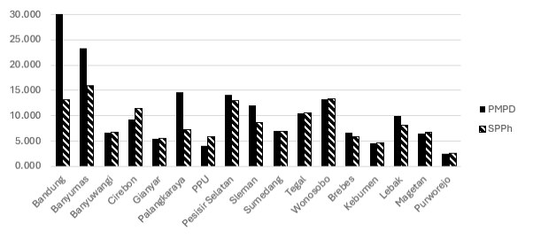
The final total amount of LG equity (PMPD) transferred for PBG over the period of the program was IDR 180.583 billion. This compares with an overall grant allocation of IDR 146.180 billion. While the aggregate total of LG investment is a positive achievement for the PBG (at 124% compared to disbursed grant funding), the detail underpinning this result shows a varying level of overall achievement for each participant LG. The detail of each LG’s total equity investment and their overall grant allocation of the PBG demonstration activity is shown diagrammatically in and in detailed table form in Figure 3-1 Appendix E.

Figure 3-1: Final PMPD Transferred to PDAM Compared with Grant Allocation (IDR Billions)
(Source: Figure based on Annex 5: Equity investment by LG, ACR PBG for Water Supply, KIAT, 17 July 2024, p. 194.)
As Figure 3-1 shows, two LGs (Bandung and Banyumas) invested considerably more into their PDAMs during the pilot compared to their grant allocation (SPPh). In addition to accessing the initial indicators they were eligible for, these two LGs were two of three PDAMs who signed up to improving performance against all six additional performance indicators where eligibility to participate for each was an increased LG investment. The other PDAM participating in all six additional indicators was Wonosobo, whose LG overall invested slightly less into its PDAM compared to the grant allocation. The other standout LG investing into its PDAM an amount greater than the grant funding amount was Palangkaraya. Palangkaraya only participated in one of the additional six indicators requiring additional investment by the LG yet increased its originally planned investment in its PDAM (IDR 4.5 billion) to IDR 14.585 billion, an increase in investment of IDR 10.085 billion (224%). Of those seven LGs who invested more than their grant allocation, Lebak was the only LG which did not participate in the additional indicators.

Participation in different indicators for the PBG may have directly influenced the increase in LG investment in their PDAM. It is important to note that the highly variable results across participants are also impacted by a diverse range of local circumstances such as political priorities, financial capacity, and development initiatives.

EOAO2
The PBG tracked and rewarded performance against a series of 13 key performance measures. An initial series of seven indicators grouped under four performance areas were introduced at the beginning of the demonstration activity, with additional indicators introduced early in the program’s life to support the GOI response to COVID-19. Noting the limited timeline of the demonstration activity, subsequent indicators were introduced to provide additional avenues for strengthening PDAM performance and enabling available funds to be accessed. PDAM performance achievement against accessing agreed grant funding was higher for these later indicators as compared to the achievements against grant allocations set for the initial seven indicators (Table 3-1).
Table 3-1: Performance achievement against agreed targets
Component | Indicator Type | Date included in the PBG PMM | % Achievement against target
Business Plan (BP) | Governance | Feb 2020 | 91%
Operating Ratio (OR) | Financial Sustainability | Feb 2020 | 114%
Billing Collection Efficiency (BCE) | Financial Sustainability | Feb 2020 | 78%
Non-Revenue Water (NRW) | Operational Efficiency | Feb 2020 | 100%
Energy Efficiency (EE) | Operational Efficiency | Feb 2020 | 30%
Continuity of Supply (CoS) | Quality of Service | Feb 2020 | 67%
Water Quality (WQ) | Quality of Service | Feb 2020 | 80%
Communication, Information & Education (IEC) | COVID-19 Response | Aug 2021 | 100%
Compliance with Regulations, Guidelines & SOPs (SOPs) | COVID-19 Response | Aug 2021 | 100%
Improved Chlorination & Safety Performance (ICPS) | COVID-19 Response | Aug 2021 | 88%
Accelerating Access to Drinking Water (MWH) | Increased Coverage | Aug 2023 | 100%
Drinking Water Safety Plan (WSP) | Public Health | Aug 2023 | 100%
Climate Resilience (CC) | Climate Change | Aug 2023 | 100%
Source: Document review and results from Annex 6, ACR PBG for Water Supply, KIAT, 17 July 2024, p. 195.
As shown in Table 3-1, the release of funding for performance improvements in one indicator (OR) was able to exceed agreed funding amounts at 114% disbursed. The performance improvements more difficult to achieve compared to target grant funding levels (in order) were EE (30% of funds disbursed) and CoS (at 67%), BCE (at 78%), WQ (at 80%) and ICPS (88%). Figure 3-2 presents the same percentage of achievement in Table 3-1 but shows the actual amount disbursed by MoF as compared to the overall level of grant funding available for each indicator. Each SPPh figure is the agreed 2023 grant amount.
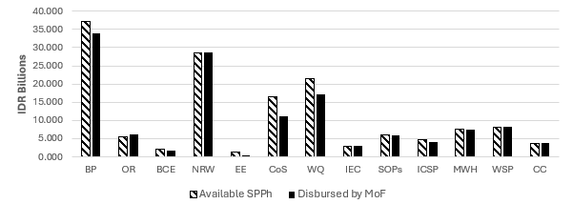
Figure 3-2: Final available SPPh grant and amount disbursement by MoF per indicator
(Source: Visual presentation of data in Annex 6 Table A, ACR PBG for Water Supply, KIAT, 17 July 2024, p. 195.)
Figure 3-2 highlights that the PBG activity provided different emphases on performance improvements across the program. Also, while the percentages presented in Table 3-1 indicate very positive achievement against an indicator, specific results by PDAM for that indicator show a variable result particularly for OR, NRW and CoS. As an example, the overall results for NRW shows that 100% of available funding was disbursed by MoF. The results by PDAM (see Figure 3-3) show a very different picture. The available SPPh for each LG/ PDAM for this indicator varied between IDR 0.030 billion and IDR 4.674 billion, and the amount disbursed per LG/PDAM varies between IDR 0.230 billion and IDR 5.374 billion. The range of disbursement as compared to the final grant amount went from as low as 23% for Cirebon to as high as 3000% for Purworejo.
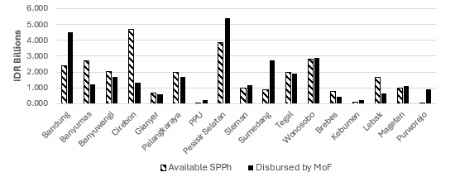
Figure 3-3: Disbursement results for NRW, by LG/PDAM.
Source: Based on Annex 6, Table E, ACR PBG for Water Supply, KIAT, 17 July 2024, p. 199.

Figure 3-4 below illustrates the agreed level of SPPh grant funding by PDAM, compared to amount of funding as disbursed by MoF for that PDAM. It also shows the overall percentage of grant funding accessed by that PDAM. Overall, six of the 17 PDAMs were able to access 100% of their available PBG grant funding. A further six PDAMs were able access between 94% and 99% of their available grant funding. The ability to access available grant funding for the remaining five PDAMs was more difficult and ranged between 54% and 83% of available funding.
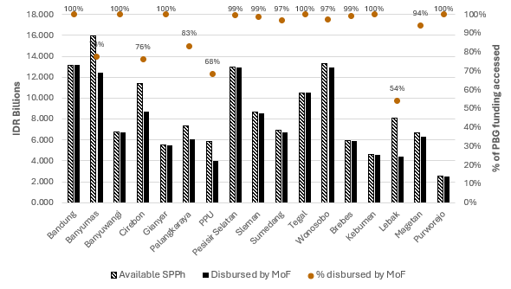

Figure 3-4: Final available SPPh grant and amount disbursement by MoF per PDAM
(Source: Visual presentation of data in Annex 7 Table A, ACR PBG for Water Supply, KIAT, 17 July 2024, p. 209.)
These overall results of accessing grant funding are positive yet, like the percentage achievements for each indicator, the actual overall performance achievement requires careful analysis (see Appendix G). The results do not mean that of these PDAMs who achieved 100% of grant funding performance satisfied all their grant conditions and achieved against all of their performance targets. Rather, adjustments were made against available funding not able to be achieved on one indicator against increased performance able to be achieved against another.
For example, in the case of Bandung, only 24% of available grant funding was disbursed for CoS, and 50% for WQ; yet 189% of grant funding for NRW was disbursed, and 150% for OR (see Table F-1 and Figure F-1). Similarly, for Gianyar, only 2% of available funding was disbursed for EE, 80% for WQ and 88% for NRW; yet 132% was disbursed for CoS and 200% for OR (see Table F-5 and Figure F-5). While Purworejo was disbursed 100% of its grant funding, no indicator received 100% of its agreed amount. Rather, only 50% was disbursed for BP, yet 3000% of NRW funding was disbursed, 205% of OR funding, 110% against EE funding and 104% of WQ (see Table F-17 and Figure F-17).

Performance targets and associated grant amounts, specifically for OR, NRW, EE, CoS, WQ, varied by PDAM. In the case of NRW, EE and CoS, these targets and measured improvements were confined to a dedicated ‘zone’ as identified by the PDAM and isolated from the rest of the service network. From a coverage perspective, NRW, EE and CoS indicators were all measured within the same defined zone, whereas WQ monitoring covered the entire PDAM service area. This is an important consideration when reflecting on the overall performance achievements achieved from the PBG investment.
While the program design expected each LG’s PDAM to implement a program to improve their performance under all sub-indicators (except for EE if their energy cost was below Rp 300/m³) this did not ultimately occur. Rather, the implementation of the PBG demonstration activity enabled participants some flexibility in which indicators they choose to participate in. There was no evidence in the program design of consideration of the potential interactions between indicators, such as how positive improvements in one indicator may have a negative impact on another. Evidence of the interactions between indicators did occur during the program for example, in Banyumas initial energy savings were mitigated by the installation of a booster pump which positively impacted on the PDAMs NRW and CoS:
during the second year of the program, the PDAM installed a major booster pumping installation. This new booster installation was a project which provided a positive impact on the CoS and NRW indicators but a negative impact on the EE indicator.
…
Energy savings were obtained initially from the VSDs [variable speed drives] on pumps and motor replacements. In 2022 the PDAM commissioned a booster pump on the Purwokerto system which caused electricity consumption to increase greatly. The new booster provided a positive impact on the CoS and NRW.
Another example was in Penajam Paser Utara (PPU) where achievements in NRW were negated by actions to increase the CoS:
Following the setting of the baseline for NRW in PPU there was some water saving; however, in order to boost continuity of supply, a major booster pump was installed on the Sepaku system in early 2022. This had the effect of increasing leakage in the system.
…
Initially there was a significant Increase continuity as WTP operation was increased from 12 hours to 24 hours. Unfortunately negated initial savings on NRW as pressure in the pipes and night leakage increased.
Stakeholder consultations confirmed that each performance result against the target and subsequent drawdown of grant money was considered in isolation of other results. Overall assessment of specific results for each PDAM shows that in some instances, such as the example of Bandung (see Table F-1), great emphasis was put on improving NRW results, yet the target for CoS was not able to be achieved.
The performance indicators selected covered important issues for utilities though they were not necessarily indicative of the main issues facing each PDAM at a point in time. The PBG pilot highlighted the importance of undertaking an initial diagnostic report to help focus a PDAM’s emphasis on relevant indicators. In the absence of an initial diagnostic report and considered PDAM business plan, there was the potential for the performance-based grant funding mechanism (with a defined group of indicators) distracting time and funding from other issues facing a PDAM. Even within the indicators included in the PBG demonstration activity, there was the potential for conflicting demands in resources as noted in the ACR for water safety plans (WSP):
the WSP team members were members of other activity teams such as other PBG indicators or the NUWSP team. Therefore, they were very busy and found it difficult to carry out discussions and prepare documents.
There was evidence provided of external factors impacting on performance of some PDAMs against targets such as EE and NRW. This has the potential to disadvantage PDAMs who make investments in time and assets and are then not able to receive the full grant available.
The provision of comprehensive TA and specialist water management infrastructure (bulk water meters, pressure sensor devices and data logging equipment) were key enabling activities necessary to underpin the demonstrated improvements in participant PDAM performance. As advised by a respondent to the online survey, having such equipment installed on the PDAM network allows the monitoring of disruptions and handling of service disruptions to be faster so that continuity is maintained:
With the PBG program, the zones included in the program are equipped with direct and online service monitoring tools (data loggers installed) on the input and output flow systems, making it easier to monitor, evaluate and quickly identify and follow up activities.
An important caveat under the PBG activity is that performance improvements within participant PDAMs related to changes in results against selected performance indicators applicable to targeted zones. Even within one PDAM, the level of performance improvements cannot be extrapolated and reported as overall PDAM improved performance, as the improvements only occurred within one sub-area.
It is important to note that overall performance of the PBG activity, as set out in the ACR, reports that substantial amounts of water have been saved as compared to the NRW target. However, the English terminology used to refer to NRW achievements under the PBG is potentially misleading, as the language across program documentation switches between volume of water saved and volume of NRW recovered. Recovered NRW can relate to either physical and/or commercial reductions whereas water saved implies a reduction in physical water losses. In Indonesian language documentation, the Indonesian phrase for NRW – air yang diselamatkan – was consistently used.

Efficiency of the PBG activity

Summary of findings – Efficiency
The PBG demonstration activity involved a complex implementation mechanism with numerous stakeholders and steps, requiring significant resources beyond the nominal AUD 27 million activity cost. The level of PIC support to GOI ministries and PDAMs was considerably resource-intensive when compared to the capital grant funding distributed and the previous Water Hibah output-funding model.
Comprehensive TA support and specialist water management infrastructure (bulk water meters, pressure sensor devices and data logging equipment) were crucial enabling activities for improving PDAM performance. The process of setting baselines and conducting verifications was more extensive than anticipated, necessitating additional PIC staffing and resources.
Unlike the Water Hibah model, the PBG activity required establishing robust baselines for each indicator before demonstrating performance changes. This process was time-consuming and impacted the timely distribution of grant funds. For instance, NRW baselines for Phase 1 locations spanned from December 2021 to June 2022, while Phase 2 extended to July 2023, just six months before implementation completion.
The verification process was particularly resource-intensive, with 291 verification minutes prepared by PIC, not always proportional to the grant funding available or disbursed. This extensive verification, coupled with BPKP's review, contributed to the time lag between performance achievements and grant disbursement.
The PBG activity also revealed that even relatively healthy PDAMs required considerable TA to participate effectively, suggesting that less developed PDAMs would need equal or greater support in a mainstreamed version.

This section reports on findings aligned to Key Review Question 3: To what extent has the investment made appropriate and efficient use of Australia's and our partners' time and resources to achieve the end-of-activity outcomes?

Findings
The PBG demonstration activity involves many stakeholders across the GOI. As highlighted earlier, many stakeholder groups contributed to the pilot either indirectly from a policy position or more specifically being involved in the implementation of the activity. There are also many steps involved in the overall grant mechanism as summarised in Figure 3-5 below.
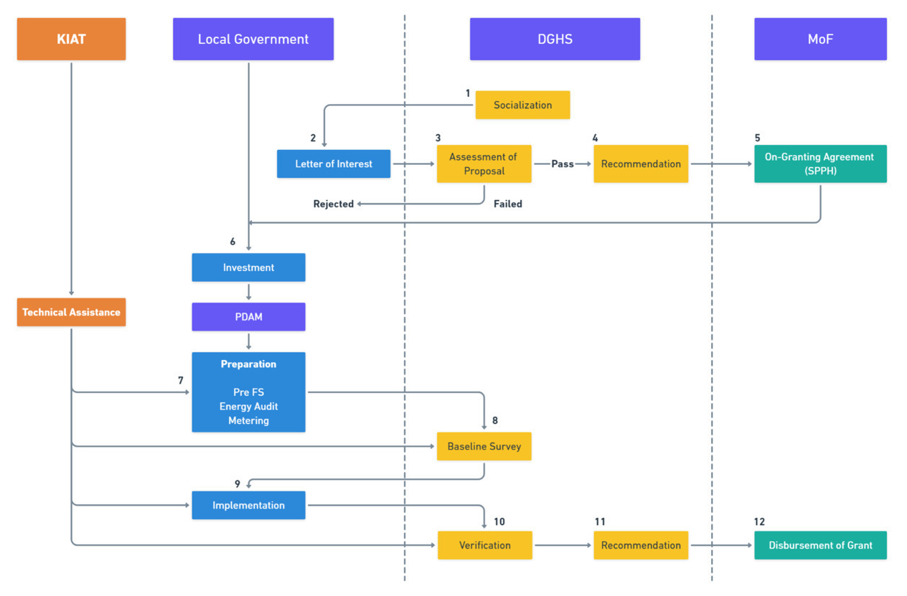
Figure 3-5: Mechanism of Implementation of the PBG
(Source: ACR PBG for Water Supply, KIAT, 17 July 2024, p. 26.)
The funding-level of some AUD 27 million (AUD 15 million grant funding and approximately AUD 12 million for PIC) for the PBG demonstration activity cost was the nominal activity cost to the GOA. It excludes resources within KIAT for managing the activity and resources from GOI ministries involved in administering the PBG.
While not illustrated by Figure 3-5, considerable work and effort was expended against item 8 (Baseline survey) and item 10 (Verification) by multiple parties. The original PIC contract provided only one specialist to oversee both the Baseline and Verification work. As the program’s implementation progressed, the extent of the baseline and verification workload became more apparent. At the request of CPMU, a separate branch was set up within PIC, including the addition of a separate Baseline/Verification Deputy Team Leader. An underpinning reason for the increase in staff for this work related to the GOI’s importance of a separation between implementation support and verification activities, particularly noting the need for a level of impartiality in verifying grants.
The scope of work involved in setting the baselines and subsequent verifications was extensive. During the life of the activity, a total of 144 baseline minutes were prepared. This included 4 re-baselines where the original baseline had lapsed due to the failure of implementation works to proceed. In relation to verification activities, BP and OR verifications were completed on-line. The verification of other indicators was completed in a combination of on-line and off-line participation from the relevant parties. The mechanism for PBG Verification Surveys is shown in Figure 3-6.
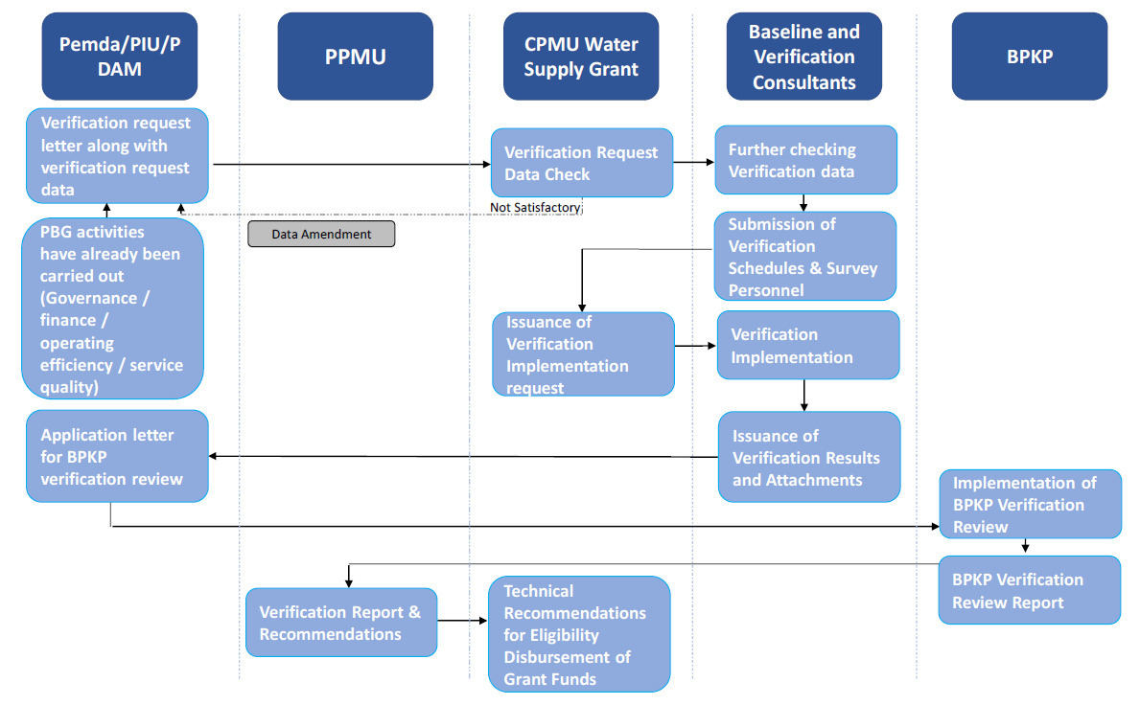
Figure 3-6: Mechanism for PBG Verification Surveys
(Source: ACR PBG for Water Supply, KIAT, 17 July 2024, p. 63.)

Level of effort
In addition to the 144 baselines, a total of 291 verification minutes had been prepared by PIC. The breakdown of the number of verifications, by PDAM and by indicator is shown in Table 3-2. Of the 291 verifications, 24 resulted in zero grant being recommended and were therefore not recommended for review to BPKP.
Table 3-2: Summary of verifications by location and indicator
Phase 1
Location | BP | OR | BCE | NRW | EE | CoS | WQ | C-19* | MWH | WSP | CC | Total
Bandung | 2 | 4 | 0 | 4 | 0 | 2 | 2 | 3 | 1 | 1 | 1 | 20
Banyumas | 2 | 3 | 0 | 3 | 5 | 2 | 5 | 3 | 1 | 1 | 1 | 26
Banyuwangi | 2 | 0 | 0 | 2 | 0 | 2 | 4 | 0 | 0 | 0 | 0 | 10
Cirebon | 2 | 4 | 0 | 3 | 0 | 4 | 4 | 0 | 0 | 1 | 0 | 18
Gianyar | 2 | 3 | 0 | 2 | 2 | 2 | 3 | 0 | 0 | 1 | 0 | 15
Palangka Raya | 2 | 2 | 2 | 3 | 3 | 0 | 3 | 0 | 0 | 1 | 0 | 16
PPU | 2 | 2 | 0 | 3 | 3 | 3 | 4 | 2 | 0 | 0 | 0 | 19
Pesisir Selatan | 2 | 4 | 2 | 3 | 0 | 4 | 4 | 3 | 0 | 1 | 1 | 24
Sleman | 2 | 3 | 0 | 2 | 3 | 4 | 4 | 3 | 0 | 1 | 0 | 22
Sumedang | 2 | 3 | 0 | 3 | 4 | 4 | 4 | 2 | 0 | 1 | 0 | 23
Tegal | 2 | 0 | 0 | 2 | 0 | 4 | 4 | 3 | 1 | 0 | 0 | 16
Wonosobo | 2 | 4 | 0 | 2 | 0 | 2 | 5 | 3 | 1 | 1 | 1 | 21
Sub Total | 24 | 32 | 4 | 32 | 20 | 33 | 46 | 22 | 4 | 9 | 4 | 230
Phase 2
Location | BP | OR | BCE | NRW | EE | CoS | WQ | C-19* | MWH | WSP | CC | Total
Brebes | 2 | 3 | 0 | 1 | 0 | 2 | 4 | 3 | 0 | 0 | 0 | 15
Kebumen | 2 | 2 | 0 | 2 | 1 | 2 | 3 | 0 | 0 | 1 | 0 | 13
Lebak | 2 | 2 | 1 | 1 | 1 | 2 | 3 | 0 | 0 | 0 | 0 | 12
Magetan | 2 | 3 | 0 | 2 | 0 | 0 | 0 | 2 | 0 | 1 | 1 | 11
Purworejo | 2 | 2 | 0 | 2 | 1 | 0 | 3 | 0 | 0 | 0 | 0 | 10
SubTotal | 10 | 12 | 1 | 8 | 3 | 6 | 13 | 5 | 0 | 2 | 1 | 61
Total Phase 1 and Phase 2
Location | BP | OR | BCE | NRW | EE | CoS | WQ | C-19* | MWH | WSP | CC | Total
TOTAL | 34 | 44 | 5 | 40 | 23 | 39 | 59 | 27 | 4 | 11 | 5 | 291
Source: ACR PBG for Water Supply, KIAT, 17 July 2024, pp. 63-64. Note: * The 3 COVID-19 indicators are jointly presented in this data rather than separately presented as IEC, SOPs and ICPS,
When you consider the total number of verification activities per indicator as shown in the above table to the level of grant funds being distributed by indicator as shown in Figure 3-2 (above in Section 3.1), considerable effort was expended by PIC and GOI stakeholders on some indicators more than others, notwithstanding the level of funding available to be disbursed had the performance target been achieved.
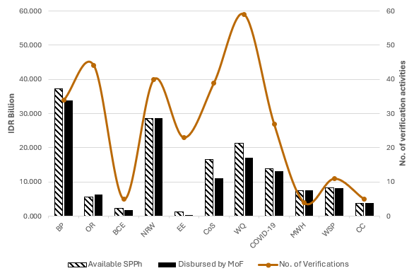

Figure 3-7: Amount of funds disbursed compared to the no. of verification activities by MoF per indicator
(Source: Amalgamated results as presented in Figure 3-2 compared to total verifications per indicator in Table 3-2.)
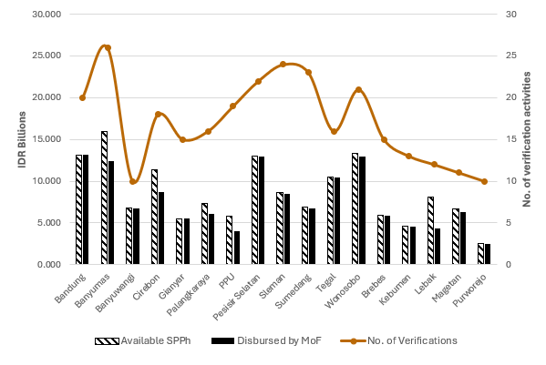
Similarly, comparing the level of grant funding disbursed to each PDAM compared to the number of verification minutes required to be completed is shown in Figure 3-8. This diagram uses the same comparative visual scale as Figure 3-7 with one verification activity as compared to the provision of IDR 1 billion.

Figure 3-8: Amount of funds disbursed compared to the no. of verification activities by MoF per PDAM
(Source: Amalgamated results as presented in Figure 3-4 compared to total verifications per indicator in Table 3-2.)
Determining the level of resources needed to be expended to verify each of the indicators was an important aspect of the PBG demonstration program. This is an important sustainability consideration in any future design or mainstreaming of the PBG. The results from the pilot also highlighted that the number of verification activities necessary across participant PDAMs is not consistent across the number of indicators being involved with nor when compared to the level of grant funding available for distribution.

Time impact
The PBG activity built on the content of the BPPSPAM Annual PDAM Performance Evaluation Report indicators and activities, but with the initial addition of EE and BP indicators. The underpinning evidence-base of indicators included in the annual BPPSPAM performance reports became more apparent once the PBG demonstration activity commenced. For example, while NRW had been reported on for a considerable period in BPPSPAM’s performance reports, in many instances it was based on an estimate rather than through robust data collection and existent monitoring systems. The PBG demonstration activity provided considerable TA effort supporting PDAMs to strengthen the underpinning basis of reporting for the zones to be covered by the grant arrangement. This preparatory work took considerable time and impacted on the ability for grant funding to be approved and released in the initial years of the PBG demonstration activity timeline.
Stakeholder consultations and program reporting highlighted that considerable TA was provided to support PDAMs respond to and track performance against agreed targets. This included initial assistance to each PDAM to assess which PBG indicators they could best participate in. The approach to these initial assessments evolved during the PBG implementation due to the ongoing impacts of COVID-19 on planned initiatives. Notwithstanding, initial support for targeting priority areas for support was an important element of the PBG. This assistance, combined with the provision and help to install additional key water utility infrastructure, was crucial in prioritising support and determining PBG performance targets aligned to a PDAM’s specific circumstances. The pilot did however highlight that this initial work took considerable time to complete and, until it and subsequent performance baselines were determined, available grant funds were underutilised. The considerable problems experienced in setting the baselines was compounded by the additional bulk water meters, data loggers and valves requiring months for procurement, installation, and commissioning. For example, the first NRW baseline for the Phase 1 locations was done in Palangkaraya on 2 December 2021 and the last in Gianyar on 29 June 2022. In the Phase 2 locations the first NRW baseline was done in Brebes on 1 November 2022 and the last in Kebumen on 14 July 2023, 6 months before implementation period completion. The impact of COVID-19 on the initial assistance is captured well in the following extract from the PBG demonstration activity Mid-Term Review Report:
It is important to note that the baselines for BP, OR, BCE and WQ were able to be set on-line while the pandemic was at its peak in January and February 2021. The major cause of delays in the technical indicators has been due to the need to set these baselines off-line or with field support. Fieldwork did not commence in earnest until late September 2021. Work on improvement in technical indicators (NRW, EE and CoS) then focused on completion of baselines prior to moving to implementing system improvements. The incremental feed of LG equity has meant that in some locations, delays have been experienced in the procurement of materials, equipment and contracts needed to implement improvements in services. Much preparatory work has been done but significant effort and technical input and support will be required to achieve agreed targets. All PDAMs have indicated that NRW and EE are the two most difficult indicators to address and reach.
Should a future performance-based grant funding initiative be considered, there would be considerable value in a ‘preparation’ phase where support is provided to potential participant PDAMs to undertake an initial overarching assessment to tailor support and prioritise interventions effectively.
The role of BKPK as the reviewer of PDAM performance is a long-standing activity feeding into the annual PDAM reporting/classification framework. To align with the requirements of the PMM, rather than supporting and/or strengthening existing PDAM performance reporting processes, a standalone reporting and verification process was established for the PBG to satisfy anticipated fiduciary risks. The necessary PIC verification activities, and the subsequent BPKP assurance review (and adjustment) of performance results, contributed to the elapsed time between results and the release of grant monies. It required, at times, additional involvement of various stakeholders undertaking pre-verification work so that a PDAM could obtain the maximum grant amount. As identified in the ACR, this process was time-consuming and sometimes repetitive. In addition, PIC staff allocations had to be significantly increased to allow for the pre-verification work.
The pilot enabled a greater understanding on the level of effort needed to verify performance claims under a performance-based model. It also enabled key stakeholders to better understand the time it takes between program establishment and actual release of monies. These learnings are important to reflect in any future program design.
The efficiency of the PBG demonstration activity and its potential for broader mainstreaming must be considered in the context of its target audience. Initially, the activity aimed to include PDAMs classified as 'unhealthy' or above at the time of application. In practice, the demonstration activity primarily involved PDAMs that were already at the healthier end of the spectrum. Despite this, these more developed PDAMs still required considerable TA to effectively participate. This suggests that less developed PDAMs would likely require an equal or greater level of support to participate effectively in a mainstreamed version of the activity. This factor is crucial when considering the feasibility and resource requirements for any broader implementation of the approach across a wider range of PDAMs.

Gender equality, disability, and social inclusion in the PBG activity

Summary of findings – GEDSI
GEDSI was not integrated as a core component of the PBG activity. It was not mainstreamed across the technical indicators nor linked to accessing PBG funding. Rather, it required participating PDAMs to develop annual Gender Action Plans (GAPs), which were ideally (but not always) also incorporated into PDAM business plans. GEDSI support was largely delivered as request-based capacity building and mentoring, enabling PDAMs to choose their level of involvement and effectively making GEDSI initiatives optional in nature.
Nevertheless, the PBG pilot brought about significant improvements through enhanced understanding and support for GEDSI among PDAM directors, managers, and staff, primarily as a result of increased awareness of GEDSI principles within participating PDAMs. Despite these positive changes, limited achievement against GEDSI PBG targets was reached over the life of the pilot due to:
- Time constraints and leadership commitment: GEDSI changes require substantial time and leadership commitment to become embedded in organisational culture.
- Resource requirements: Meaningful achievements in GEDSI implementation necessitate sufficient TA support.
Limited sphere of influence: Some GEDSI-related indicators and targets, while important, were outside the pilot's immediate control due to its time- and resource-bound nature and the positioning of GEDSI as a non-central component.
This section reports on findings aligned to Key Review Question 2: To what extent has the investment brought about change in implementing partners commitment to gender equality and disability inclusion within their institutions? To what extent has the investment influence the institution to address all potential opportunity for integrating GEDSI in their community outreach/service provision?

Findings
The PBG pilot aimed to enhance awareness of and commitment to GEDSI within PDAMs. The initiative focused on improving PDAM workplace culture and attitudes towards gender and disability diversity, improve the proportion of women employed by PDAM (especially in management), and enhance physical accessibility in PDAM offices.
The PBG demonstration activity brought about some important changes with regards to GEDSI in participating PDAMs. Particularly crucial was the improved understanding of and support for GEDSI principles from PDAM directors, managers, and staff. Qualitative
studies conducted during the activity, the ACR, stakeholder interviews, and the online survey conducted for the review all demonstrated that the PBG achieved meaningful changes in how PDAM representatives understood and supported key GEDSI principles. During stakeholder interviews, several directors admitted that they did not understand GEDSI prior to the PBG activity, but are now committed to integrating GEDSI approaches in their PDAM. The inclusion of a national disability expert in the PIC team was a notable step taken to ensure disability inclusion received sufficient attention; their work was well-recognised by PDAM representatives, many of whom informed the review team that their attitudes towards people with disabilities have completely shifted from a negative one to a positive one.
With regards to GEDSI-responsive infrastructure, major improvements were made at the PDAM level during the PBG demonstration activity. For example, 88% of participating PDAMs improved physical accessibility and 59% improved the workplace by providing gender-responsive facilities such as lactation rooms, gender-segregated toilets, and children’s play areas. Physical improvements enabled the recruitment of four staff with disabilities across the 17 PDAMs. Several PDAM representatives noted that these physical improvements were more beneficial than they had anticipated, such as when one PDAM staff member had an accident and needed to use assistive devices to move around the building while they recovered. Female staff with babies greatly appreciated having lactation rooms to safely and comfortably express and store breastmilk, as it enables them to continue working.
The program had a positive impact on the integration of GEDSI into PDAM planning, budgeting, and policymaking. All participating PDAMs developed GAPs for the years 2021–2023, and most developed GAPs for 2024, even though this was not a program requirement. In addition, the PIC assisted PDAMs to develop GEDSI profiles (identifying the strengths and weaknesses of PDAMs), with 30% of PDAMs integrating GEDSI into their business plans, and 71% drafting GEDSI-related policies. However, the sustainability of these initiatives is uncertain, as they largely depend on PDAM directors’ commitment. For example, during interviews with stakeholders, one PDAM’s GEDSI focal point noted that although they and other staff had put forward several GEDSI-related proposals to the director, none had been actioned; they also noted that the director’s limited interest in GEDSI meant that it was unclear if the PDAM would continue to develop new GAPs in the future.
On PDAM-level policy, although 71% of PDAMs drafted GEDSI-related policies, just 25% of those PDAMs (18% of all participating PDAMs) had formalised the policies. Without support (such as from the PBG activity or other form of TA), it is unlikely these drafts will be implemented; this is a significant missed opportunity and reduces the likelihood of GEDSI achievements being sustained at the PDAM level. Only 18% of PDAMs produced draft policies on the prevention of sexual harassment and violence, none of which were formalised as official policy. More consideration needed to be given to supporting PDAMs to approve and operationalise policies, Standard Operating Procedures and guidelines to ensure implementation and sustainability. As noted in the KIAT report Integrating GEDSI Initiatives in the PBG Activity (March 2024, p. 45):
While developing the draft documents provided a good learning experience for [PDAM] staff that were involved to learn about relevant GEDSI concepts, regulations and actions, in many cases, the draft documents’ impacts were no greater than that initial effort.
One additional (non-targeted) achievement of the PBG activity was the establishment of Forum GEDSI Perusahaan Air Minum Seluruh Indonesia (FERSIA, or the Indonesian Water Utility GEDSI Forum). FERSIA was established under the umbrella of PERPAMSI and intends to support the sustainability of the PBG activity’s GEDSI achievements by enabling discussion, exchange of ideas, and mutual support for PDAMs. FERSIA was launched in December 2023 and formally registered with the Ministry of Law and Human Rights in May 2024. Although the Forum’s establishment is a positive development, it cannot yet be said to have had an impact, nor can its likelihood for sustainability be judged at this early stage. As noted in the ACR, further support will be required for the sustainable operation of FERSIA.
Notwithstanding significant efforts by PIC and participant PDAMs, the program was unable to achieve against several targeted GEDSI outcomes, particularly those on increased proportion of women in the organisation and in managerial positions. Only 24% of PDAMs saw a greater than two percentage point increase in the overall proportion of women, and just one PDAM experienced an improvement in the proportion of women at the senior management level. This is largely the result of inappropriate indicator selection: 1) PDAM directors are appointed approximately every five years by the District Head/Mayor (not from within the PDAM), meaning the PBG activity was unable to influence change; and 2) it is extremely challenging to bring about significant increases in female employment in such a short time frame. Structural transformation requires sustained long-term efforts to be achieved, and is easier to achieve at ‘lower’ levels, as demonstrated by how a much higher percentage of PDAMs (77%) saw an increased proportion of women in entry-level management. Challenges in recruiting and promoting women for technical and operational roles were among the reasons for this, due to few women applying for such roles and some PDAM managers’ beliefs that women are not suitable for physical labour. The lack of financial incentive (in the form of a grant) for GEDSI was also potentially a reason for low achievement, as there was little external motivation for directors to pursue structural change. While an additional GEDSI indicator and incentive was proposed for the pilot mid-way through the program, the design team and GOI partners were unable to identify an appropriate indicator, thus the proposal was dropped.
Although quantitative inclusive socialisation targets were largely achieved – such as through holding inclusive socialisation activities that specifically included women and at-risk groups (59% of PDAMs) – the meaningful impact of these achievements is likely limited. The target stated that each PDAM should implement inclusive socialisation activities ‘at least once’ during the program. This is a low target, as PDAMs can simply hold a single activity and deem that indicator achieved without making genuine efforts to ensure socialisation activities are truly inclusive and will remain so in the future. While partners stated in interviews that they understood the importance of inclusive socialisation, especially on reaching women (as household managers of water), there was limited concrete evidence of this being put into practice on a routine basis. Several PDAMs developed Standard Operating Procedures/ guidelines on inclusive socialisation during the PBG activity, but interviews with stakeholders found that the additional effort and resources (time, money, networks) required for inclusive socialisation meant that it was not often implemented.
Despite significant improvements in PDAM directors’, managers’, and staff understanding of and support for GEDSI, the program's request-based GEDSI capacity building approach for PDAMs was inappropriate given the low starting point of partners’ knowledge. While the review team notes that GEDSI was not a core component of the PBG activity and included no incentive indicators, and that building commitment to GEDSI is often a lengthy process, this does not lessen the importance of providing GEDSI capacity building at an appropriate level for participants. PBG’s request-based capacity building approach for GEDSI enabled PDAMs to choose their level of involvement, effectively placing GEDSI as an optional add-on to the program and to water service provision as a whole. Some PDAMs requested multiple capacity building activities from the PIC, while others only completed introductory activities. The situation was exacerbated by insufficient PIC resources allocated to GEDSI (as stated by PIC representatives themselves), resulting in limitations being placed on the TA provided to partners, as well as limited resources at the PDAM and LG levels.

Sustainability of the PBG activity

Summary of findings – Sustainability
At the time of the review, it is too early to know the extent of sustainability associated with achieved PDAM performance improvements from the demonstration activity.
PERPAMSI (and FERSIA) through their ongoing sectoral support activities for PDAMs remain the primary avenue for continuing professional development and technical support following the end of the PBG demonstration activity.
The level of influence the demonstration activity has had or will have to inform policy and practice to invest in and improve water supply services is likely complicated by the change of government at both the national and local level in October 2024.
This section reports on findings aligned to Key Review Question 4: To what extent has the program influenced GOI policy and practice to invest in and improve water services? What is the likelihood this will continue beyond PBG?

Findings
The sustainability of PDAM performance improvements achieved through the demonstration activity will only become apparent in coming years when gains made have additional time to be embedded or subsequently diminish. There is currently uncertainty of sustainability outside of pilot zones due to potential lack of funding to continue initiatives and the potential need for ongoing TA support. At the time of this review, the provision of support for the pilot zones is not guaranteed to be provided by LGs to continue from where the pilot was able to achieve. With the PBG demonstration activity coming to a hard close in June 2024, the primary avenue for continuing professional development and technical support for PDAM staff is through PERPAMSI (and FERSIA) through their ongoing, business as usual sectoral support activities.
Minimal evidence was observed in relation to the PBG activity having influenced GOI policy and practice to invest in and improve water services. As explained in the ACR:
Policy discussions have been hampered/influenced by GOI desire to see the results of the PBG pilot first before engaging in PBG mainstreaming discussions. Ideally the PBG program would run for an additional period of time to allow further bedding down of results and space for GOI to prepare a pathway to continue/mainstream the program (ie a ‘seamless’ transition). Change in GOI management are resulting in loss of institutional drive and visioning.
It is evident that PDAM annual performance results, as previously managed by BPPSPAM, continue to be important in supporting and informing the formulation of drinking water supply system development policies and strategies. The continuing administration of this national reporting system is being considered as part of the ongoing KIAT Performance Benchmarking and Institutional Strengthening project.
The future shape of the water sector in Indonesia is expected to be further influenced by the change of government at the national level to take effect in October 2024.

Lessons Learned
This section reports on findings aligned to Key Review Question 4: What lessons have been identified regarding the factors which increase or inhibit commitment and demand of LG in providing sustainable water supply, and whether the activity used appropriate incentives to influence change?

Lessons regarding effectiveness
If a performance-based program is intended to influence the level of engagement between an LG and their PDAM (outside of the equity investment), this needs to be more clearly defined in governing program documentation. There would also be benefit in having related outcomes linked to accessing grant funding.
Investing efforts into improving one performance indicator can have unintended but direct negative impacts on other indicators, while also being affected by factors outside of the control of a PDAM. Considering performance improvements of a PDAM as a whole system rather than indicators in isolation will better support overall PDAM improvements in quality and efficiency of water services provided to customers.
Greater clarification is needed to accurately communicate what is to be achieved in relation to reducing NRW. This is particularly important if there is a desire to access ‘idle capacity’ within the system and the need to understand the amount of physical water (water saved) available for increased household connections.

Lessons regarding efficiency
The complexity of performance reporting and verification processes in order to access grants are important elements to streamline before future performance-based funding mainstreaming activities occur. Where possible, building on and strengthening existing PDAM performance reporting requirements should be encouraged.
A performance-based grant funding program and the ability to fund changes in a PDAM’s performance is reliant on a robust performance monitoring system being in place. Where a potential participant does not have a system in place, targeted readiness support, involving both time and financial investment in appropriate measuring equipment, is necessary to establish a robust baseline.
If such measuring equipment is installed and available in a PDAM, additional TA support would be beneficial to assist sustainable changes in performance to be realised. For example, helping a PDAM to calculate their water balance, CoS levels and energy efficiency etc and determine priorities and best approaches, such as priority locations for NRW reduction areas, would be of value. As the pilot highlighted there can be considerable time between when equipment is installed and a robust baseline determined. Providing separate support to PDAMs to undertake such activities outside of a specific performance-based grant program would set up future participants for success.

Lessons regarding GEDSI
Future programs to support PDAMs would be wise to mainstream GEDSI throughout activities, rather than having standalone initiatives. For example, where the PBG activity assisted PDAMs to develop and implement business plans, future programs should target GEDSI-responsive business plans. This would simultaneously ensure multiple other PBG initiatives are included, for example increased recruitment and promotion of women (especially in technical and management roles), GEDSI-responsive policies (such as on sexual harassment), internal capacity building, and inclusive socialisation. In addition, this would negate a need for GEDSI-focused financial incentive (as a grant indicator), as PDAMs would already have sufficient incentive to enact GEDSI principles.
In addition to PDAM GEDSI profiles, which were appropriately developed at the outset of the PBG activity, future projects should assess the baseline awareness, knowledge, and commitment of PDAMs and relevant LG agencies (e.g. BAPPEDA and District Public Works Office) towards GEDSI principles. This can be done as part of a stakeholder needs assessment process during project development or as part of the initial implementation stage. This would ensure the right level of GEDSI capacity building support can be provided to participating PDAMs and LG agencies.
Selection of monitoring and evaluation framework components (such as indicators and targets) should be based on context and what can be influenced through the activity. For example, as PDAM directors are appointed by District Heads/Mayors, program efforts should not be directed towards increasing the proportion of women at senior management but towards an area where efforts can more easily achieve an impact, such as increasing the proportion of women at lower- and middle-management levels, among technical staff, or through work placement/internship programs.

Lessons regarding sustainability
The issuance of Presidential Instruction no. 1 of 2024 on Acceleration of Drinking Water Supply and Domestic Wastewater Management Services and its emphasis to coordinate and integrate actions in accelerating the provision of water supply and domestic wastewater services highlights the ongoing importance to support and strengthen the Indonesian water and sanitation sector. The PBG demonstration activity has helped identify some key learnings to consider as next steps prior to rolling out a national wide approach to PDAM performance improvement. The ongoing KIAT Performance Benchmarking and Institutional Strengthening project (established to response to changes to the PBG activity’s EoAO3) will be key to support next steps and building on existing GOI systems.
The developments in establishing a supervisory water authority will also go some way to ensuring that existing PDAM regulatory requirements are enforced.
PERPAMSI has a potentially significant role in the future strengthening of PDAM capacity. For example, and as outlined in the ACR, when supporting PDAMs to revise their Business Plans, participants wanted to conform to not only to government regulations (such as Permendagri 118/2018) but also to the business plan module being socialised by PERPAMSI. In a similar way, advanced PDAMs such as Bandung, who are currently delivering training to 28 other PDAMs, have the potential to be supported to build the overall capacity of the Indonesian water industry. The establishment of FERSIA as a PERPAMSI-associated organisation with a focus on GEDSI also has potential for strengthening PDAM capacity, although as noted in Section 3.4, FERSIA is new and its impact will depend heavily on its leaders and resources.
As noted earlier in this report, the PBG built on the experiences from the earlier Water Hibah which was then subsequently mainstreamed into GOI funding. Anecdotal evidence from the field interviews noted that State Government Budget allocations for the Water Hibah ceased in 2024 based on possible control issues in relation to grant funding. Should this prove to be true, there would be value in better understanding the circumstances associated with the change in funding to minimise such outcomes in the future.
At an individual PDAM level, interviews highlighted the potential difficulty faced by some PDAMs in replicating the results of the pilot studies in individual zones to the remainder of their networks, replace failed equipment as noted earlier or are abandoned as in the case of billing collection improvements in Palangkaraya and Pesisir Selatan. The sustainability of results will only become apparent in coming years when gains made during the pilot program have additional time to be embedded or otherwise.

Conclusions and Recommendations
This section reports on findings aligned to Key Review Question 4: What lessons have been identified regarding the factors which increase or inhibit commitment and demand of LG in providing sustainable water supply, and whether the activity used appropriate incentives to influence change?

Conclusion
The PBG demonstration activity showcased a comprehensive approach to improving PDAM performance through targeted TA and performance-based incentives. This pilot program yielded valuable insights into the potential and challenges of implementing such a model on a broader scale in Indonesia's water utility sector.

Key Successes
Effective Technical Assistance: The provision of extensive TA was crucial in helping PDAMs design and implement initiatives to meet performance targets. PDAMs consistently identified this support as a critical factor in the pilot's success.
Improved Monitoring Capabilities: The installation of monitoring equipment significantly enhanced PDAMs' ability to provide accurate and verifiable data, moving away from estimated performance metrics to more reliable measurements.

Challenges and Limitations
Mixed Results in LG Engagement: While the pilot aimed to incentivise increased LG investment and engagement with PDAMs, the outcomes were varied. External factors, including local political priorities, financial constraints, and competing development demands, influenced LG decision-making.
Misunderstandings About Grant Funding: Some misconceptions arose regarding the nature of the PBG grant funding, with some viewing it as a reimbursement for investment expenditure rather than a performance-based incentive. The time taken between initial investment and release of grant funding also affected additional investment decisions.

Implications for Future Programs
Time Lag in Grant Disbursement: The pilot highlighted the practical limitations and time involved between initial investments and the subsequent verification and release of grant funding. Important for GOI when considering budget allocations for any future programming.
High Support Requirements: The pilot revealed that even 'healthy' PDAMs required significant tools and support to achieve demonstrable performance improvements. This suggests that 'unhealthy' and 'sick' PDAMs would require even more intensive support in a mainstreamed program.
Need for Capacity Building: The varying levels of institutional capacity and infrastructure maturity across PDAMs highlight the need for a broader sector-wide approach to strengthening PDAM capacity. Without such strengthening, a future performance-based grant model will struggle to achieve desired results.
Importance of Accurate Data: The existence of embedded monitoring equipment within a PDAM proved essential for demonstrating reliable baselines and measuring performance improvements. PDAMs without such systems in place would struggle to participate in any mainstreamed performance-based grant program.

Looking Forward
The lessons learned from this pilot are invaluable for designing future programs aimed at improving PDAM performance. Any mainstreamed performance-based grant model will need to address the challenges identified, particularly in terms of LG engagement, grant funding clarity, and the high level of support required across PDAMs of varying health statuses. Future initiatives should build on the successes of the TA and monitoring improvements while addressing the limitations and challenges encountered during the pilot.
The experiences from this demonstration activity provide a solid foundation for refining and scaling up performance-based approaches to water utility improvement in Indonesia, with potential for significant positive impacts on the sector's overall performance and sustainability.

Recommendations
The following sections provides six recommendations under thematic areas for future consideration. These recommendations aim to address the key challenges identified in the PBG demonstration activity while leveraging existing strengths and initiatives in the Indonesian water sector. They focus on creating sustainable, industry-wide improvements that can benefit PDAMs of all sizes and capacities.

Support Wider Industry Capacity Development
Recommendation 1: Support sector-wide capacity building and leverage existing initiatives for sustainable, industry-wide improvements.
The current PBG model, while effective for demonstration purposes, faces challenges in achieving cost-effective and rapid scalability across Indonesia's water sector. The resource-intensive nature of baseline development and verification processes, and extensive individual PDAM support, limits its potential for widespread impact. This is particularly significant given the large number of PDAMs in Indonesia, each with varying capacities and performance levels.
A shift towards industry-wide capacity building, potentially led by a professional body, offers the opportunity for more sustainable and far-reaching improvements. This approach focuses on addressing systemic challenges—such as NRW management, operational efficiency, and financial sustainability—through regulatory reforms, standardisation of practices, and coordinated efforts. By elevating the entire water utility landscape, this strategy ensures that even smaller or underperforming PDAMs benefit from shared resources, best practices, and knowledge platforms.
Several existing programs and networks provide a strong foundation for scaling up sector-wide improvements:
- PERPAMSI: As the national association of PDAMs, PERPAMSI already delivers training and support to member utilities. Empowering PERPAMSI to expand its technical assistance can enhance its impact.
- KIAT Performance Benchmarking and Institutional Strengthening Project: This initiative is developing a roadmap for national regulation, standardisation of practices, and improved reporting. Aligning future efforts with the outcomes of this KIAT Activity can accelerate progress and ensure complementarity.
- Presidential Instruction No. 1 of 2024: Recent government directives prioritising water and sanitation services create a supportive policy environment for aligning sector initiatives with national priorities.
By building on these programs, future support efforts can avoid duplication while ensuring alignment with ongoing work.
In relation to strengthening regulation and peer learning, the establishment of a supervisory water authority presents an opportunity to enforce compliance with PDAM performance standards and reporting requirements. Strengthened regulation can promote accountability and transparency across the sector. Additionally, advanced PDAMs like Bandung—which currently provide training to other utilities—can play a pivotal role in peer-to-peer learning initiatives. This cost-effective approach leverages local expertise to disseminate best practices across the sector.
The newly established FERSIA (a PERPAMSI-associated organisation focused on Gender Equality, Disability, and Social Inclusion) offers a promising avenue for integrating GEDSI principles into PDAM capacity-building efforts. While FERSIA's impact will depend on its leadership and resources, it represents an important step toward inclusive development in the water utility sector.
By leveraging these existing initiatives and structures, future support programs for PDAMs can build on established foundations, avoid duplication of efforts, and create more sustainable, sector-wide improvements in the Indonesian water utility landscape.

Implement Initial Diagnostic Assessments
Recommendation 2: Consider a program that helps PDAMs to conduct comprehensive initial diagnostic assessments to prioritise interventions effectively.
Each PDAM faces unique challenges based on its specific location, water sources, and size. Indonesia's geographic diversity results in vastly different water quality issues, from saltwater intrusion in coastal areas to high turbidity in mountainous regions. Operational scales vary significantly, with some PDAMs serving millions of customers in urban areas while others cater to small rural communities. These differences necessitate tailored approaches to improvement, as solutions effective in one context may be inappropriate or ineffective in another.
As the pilot highlighted, understanding the specific needs of each PDAM allows for the identification of broader support requirements and prioritisation of interventions. A comprehensive diagnostic assessment can reveal critical issues that may not be immediately apparent, such as hidden infrastructure problems, inefficient management practices, or financial vulnerabilities. This detailed understanding enables the development of targeted improvement plans that address the most pressing issues first, ensuring efficient use of limited resources. For example, a PDAM struggling with high NRW might need to focus on leak detection and repair, while another with financial difficulties might require support in tariff setting and revenue collection.
Initial diagnostics are particularly crucial for unhealthy and/or smaller PDAMs to participate effectively in any future performance improvement programs. These utilities often lack the internal capacity to identify and articulate their needs accurately. They may also face more severe challenges that require immediate attention before they can benefit from performance-based programs. A thorough diagnostic can help these PDAMs establish a clear baseline, identify quick wins, and develop a realistic improvement roadmap. This approach ensures that even the most challenged PDAMs have a fair opportunity to participate in and benefit from sector-wide improvement initiatives.

Prioritise Business Plan Development
Recommendation 3: Prioritise development of strong PDAM business plans integrating GEDSI and climate resilience principles.
Business plans provide a clear strategy and resource allocation framework for PDAMs. They serve as comprehensive roadmaps for improvement, helping utilities to set clear targets, allocate resources effectively, and track progress over time. A well-developed business plan typically includes financial projections, operational targets, and investment plans, providing a holistic view of the PDAM's future direction. This structured approach is fundamental to sustainable performance enhancement as it aligns all aspects of the utility's operations towards common goals.
Well-developed business plans offer an opportunity to mainstream GEDSI principles and climate resilience strategies. By integrating these crucial elements into the core planning document, PDAMs can ensure that these considerations are not treated as afterthoughts but are central to their operations and development. For instance, a business plan could include targets for increasing female representation in technical roles, strategies for making water services more accessible to people with disabilities, or plans for adapting infrastructure to climate change impacts. This integration ensures that GEDSI and climate resilience are considered in all aspects of PDAM operations, from human resources to infrastructure development.
Strong business plans can be directly linked to key performance indicators, providing a clear connection between strategic planning and operational outcomes. This linkage allows for more effective monitoring and evaluation of PDAM performance, facilitating targeted improvements and accountability. For example, if a business plan sets a target to reduce NRW by 10% over three years, this can be broken down into annual targets and linked to specific operational improvements and investments. Regular monitoring against these targets can help PDAMs identify areas where they are falling short and adjust their strategies accordingly. Furthermore, linking business plans to performance indicators can provide a more objective basis for performance-based funding, ensuring that grants are aligned with strategic priorities and long-term sustainability goals.

Refine Performance Indicators
Recommendation 4: Simplify and refine performance indicators for grant funding, focusing on overall performance measures like non-revenue water that reflect holistic improvements.
The PBG demonstration activity highlighted that while all indicators under the PBG were important, they were not equally relevant for all PDAMs. This variability in relevance can lead to inefficient resource allocation, as PDAMs might divert attention from their most pressing issues to pursue available grant funding. For instance, a PDAM with severe infrastructure problems might focus on easier-to-achieve administrative targets at the expense of addressing critical operational issues.
The complexity and extended time required to establish baseline data and subsequent verification emerged as a significant challenge during the pilot. This process was resource-intensive for all stakeholders involved, potentially detracting from actual improvement efforts. Simplifying the number and range of indicators could streamline this process, making it more manageable and cost-effective for both PDAMs and program administrators.
The potential interaction between indicators needs to be fully considered when designing the grant allocation mechanism. There is a risk of perverse outcomes if PDAMs seek to maximise grant payments by focusing on some indicators at the detriment of others, which may impact overall service standards. For example, a PDAM might prioritise expanding its service area to meet connection targets while neglecting water quality improvements.
External factors that can impact performance against agreed targets need to be accounted for in any future program. PDAMs and LGs may be encouraged to invest in initiatives with the expectation of a performance grant, which is then denied or diminished by circumstances outside of their control, such as extreme weather events or unexpected changes in water source quality.
A focus on overall performance indicators, like NRW, can better reflect PDAM capacity and encourage holistic improvements. NRW is a good proxy for overall performance as it requires a whole-of-business focus to make and sustain improvements over time (see Figure 5-1). Good NRW management can indicate progress in areas such as operational efficiency, financial management, and customer service, making it a valuable indicator for assessing overall PDAM performance.

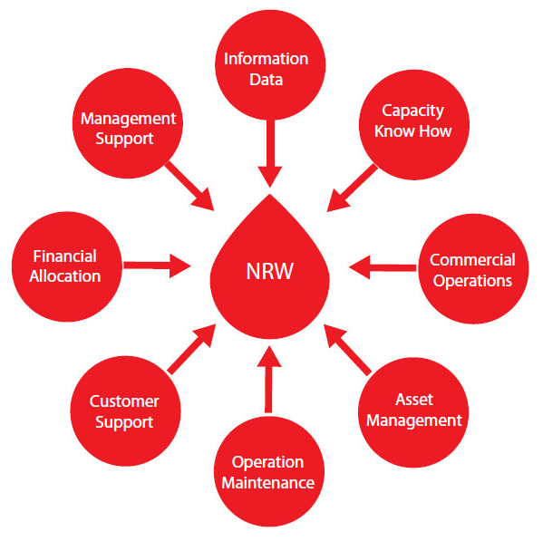
Figure 5-1: Whole of business NRW focus
Source: The Manager’s Non-Revenue Water Handbook, Ranhill Utilities Berhad and the United States Agency for International Development (USAID), 2008, p.6.

Mainstream GEDSI Principles
Recommendation 5: Mainstream GEDSI principles throughout all activities rather than as standalone initiatives.
Mainstreaming ensures GEDSI is not sidelined and is sufficiently resourced and supported. By integrating these principles throughout all activities, rather than treating them as standalone initiatives, PDAMs can ensure that gender equality, disability inclusion, and social inclusion are considered in every aspect of their operations. This approach prevents GEDSI from being treated as an afterthought or a separate, underfunded initiative.
GEDSI-responsive business plans can embed principles across all PDAM activities, both internally and in terms of service provision. This comprehensive integration ensures that GEDSI considerations are factored into strategic planning, resource allocation, and operational decision-making. For example, it can lead to increased recruitment and promotion of women in technical and management roles, development of GEDSI-responsive policies (such as on sexual harassment), internal capacity building, and inclusive customer engagement strategies.
Implementing partners and government agencies should be supported to ensure all team members understand GEDSI and can integrate foundational GEDSI principles into their support to PDAMs. This capacity building across all levels of the organisation creates a more inclusive and equitable work environment and ensures that GEDSI principles are consistently applied in all aspects of PDAM operations and customer service.
Baseline assessments of GEDSI awareness, knowledge, and commitment within PDAMs and relevant LG agencies (e.g., BAPPEDA and District Public Works Office) are crucial. These assessments allow for the development of targeted training and support programs, maximising the impact of GEDSI initiatives and ensuring that capacity-building efforts are tailored to the specific needs and contexts of each organisation.

Enhance PDAM Performance Monitoring Systems
Recommendation 6: Enhance PDAM performance monitoring systems and capabilities through targeted readiness support and equipment investments.
A performance-based grant funding program and the ability to fund changes in a PDAM's performance is reliant on a robust performance monitoring system being in place. Without accurate and reliable data, it becomes challenging to establish baselines, track progress, and verify improvements, which are all crucial elements of a performance-based funding mechanism.
The pilot demonstrated that PDAMs did not have the underpinning instrumentation embedded within their operational networks to effectively monitor their performance across a range of indicators. This was a necessary step of the program’s design.
More broadly, many PDAMs lack proper monitoring equipment and systems, which will hamper their ability to participate effectively in a performance-based program. This deficiency can lead to inaccurate reporting, difficulties in establishing reliable baselines, and challenges in verifying performance improvements. Addressing this gap is crucial for the success of any future performance-based funding initiatives.
Where a potential participant does not have a system in place, targeted readiness support, involving both time and financial investment in appropriate measuring equipment, is necessary to establish a robust baseline. This preparatory phase is crucial for ensuring that all participating PDAMs have the necessary tools and capabilities to accurately measure and report their performance.
Additional TA can help PDAMs sustainably improve performance by leveraging the data from their monitoring systems. For example, helping a PDAM to calculate their water balance, continuity of service levels, and energy efficiency can provide valuable insights for operational improvements. Similarly, assistance in determining priorities and best approaches, such as identifying priority locations for NRW reduction, can help PDAMs make more informed decisions and target their improvement efforts more effectively.
The installation of monitoring equipment and the provision of related TA can have a time lag between initial support and subsequent performance changes being identified. This delay needs to be factored into program design and expectations, ensuring that PDAMs have sufficient time to implement changes and demonstrate improvements. It is also an important element in program design when considering budget forecasting for any grant program.

Analytical and Evaluation Framework
This appendix sets out the analytical and evaluation framework underpinning the key deliverables for the project.

Review Questions
As outlined in the TOR, there are 5 broad questions that provide the focus for the review.
- To what extent has the investment achieved the end-of-activity outcomes? (Effectiveness)
- To what extent has the investment brought about change in implementing partners commitment to gender equality and disability inclusion within their institutions? To what extent has the investment influence the institution to address all potential opportunity for integrating GEDSI in their community outreach/service provision? (GEDSI, Sustainability)
- To what extent has the investment made appropriate and efficient use of Australia's and our partners' time and resources to achieve the end-of-activity outcomes? (Efficiency)
- To what extent has the program influenced GOI policy and practice to invest in and improve water services? (Sustainability)
  - What is the likelihood this will continue beyond PBG?
- What lessons have been identified regarding the factors which increase or inhibit commitment and demand of LG in providing sustainable water supply, and whether the activity used appropriate incentives to influence change? (Effectiveness, Sustainability)
The analytical framework for investigating these questions is informed by DFAT’s Design and Monitoring, Evaluation and Learning Standards and its International Development Programming Guide. The standards are informed by the OECD-DAC’s evaluation criteria. The section below gives a brief explanation of how the identified criteria of efficiency, effectiveness and sustainability will be considered in the review.

Efficiency
Efficiency is a measure of how well resources (for example, funds, expertise and time) are minimised for a given level of activity outputs, or the extent to which outputs are maximised for a given level of inputs. Efficiency considerations must be balanced with whether the use of Commonwealth resources will also be effective, economical and ethical. Consideration of efficiency will have regard (where possible) to whether the PBG influenced the timing and the amount of support provided by participant LGs to their PDAMs.

Effectiveness
Effectiveness is the measure of the extent to which activities/ subprojects of the program have attained their objectives. This will include assessing whether the objectives TA assistance and grant funding through the PBG have supported the improvement of PDAM performance and the identification of factors that enabled or inhibited the achievement of those objectives.

Sustainability
Sustainability is extent to which current project outputs, outcomes and benefits will continue after GOA’s funding has ceased, with due account of partner government systems, stakeholder ownership and the phase-out strategy. This will include considering whether current activities and processes implemented through the PBG and TA support would be continued without the current funding arrangements within participant LGs/PDAMs and whether the PBG-model is suitable for application more broadly going forward.

Evaluation Framework
Table A-1 sets out the expected key data sources available. The table also provides supporting sub questions which were used to guide the desk review, analysis, key informant interviews and final report.
Table A-1: Review questions
Primary review question | Guiding sub questions | Key data source | DFAT Quality Criteria
To what extent has the investment achieved the end-of-activity outcomes? | To what extent did the PBG activity support PDAMs to improve their performance?  To what extent did the PBG activity influence LGs to actively manage, invest in, and support their PDAMs?  To what extent did the PBG activity influence GOI to provide support to LGs and PDAMs?  Did the performance improvements achieved through the PBG activity lead to expansion of services? | Program governance and management documentation  KIAT activity reporting  DFAT Investment Monitoring Reports (IMRs)  Activity Completion Report  Interviews with stakeholders | Effectiveness
To what extent has the investment brought about change in implementing partners commitment to gender equality and disability inclusion within their institutions?  To what extent has the investment influence the institution to address all potential opportunity for integrating GEDSI in their community outreach/service provision? | To what extent did the PBG activity lead to GEDSI-related institutional changes within LGs and PDAMs?  To what extent did the PBG activity lead to increased consideration of GEDSI in PDAM service provision and community outreach? | PDAM management reporting  DFAT Gender Branch reviews/evaluation  DFAT IMRs  Interviews with stakeholders | Gender Equality  Disability Equality
To what extent has the investment made appropriate and efficient use of Australia's and our partners' time and resources to achieve the end-of-activity outcomes? | How efficient was the PBG activity implementation?  How critical was the provision of technical assistance provided by the PIC in enabling PDAMs to make performance improvements?  What were the major factors supporting and obstructing efficient use of PBG activity resources? | Program governance and management documentation  PDAM/ MOF reporting on release of grant funding  Interviews with stakeholders  KIAT / GOI Special Account Financial Data  DFAT IMRs | Efficiency
To what extent has the program influenced GOI policy and practice in water supply investments? | What changes, if any, have been made in GOI policy and practice in water supply investments as a result of the PBG activity?  What changes, if any, have been made in LG policy and practice in water supply investments as a result of the PBG activity? | Interviews with stakeholders  KIAT activity reporting  KIAT Baseline data  KIAT Media Monitoring  DFAT Media Monitoring | Sustainability
What lessons have been identified regarding the factors which increase or inhibit commitment and demand of LG in providing sustainable water supply, and whether the activity used appropriate incentives to influence change? | To what extent did the PBG incentive funding influence the level and timing of LG support to the PDAM?  Were the chosen PBG activity indicators/ incentives appropriate? Are there other indicators/ incentives that would be appropriate for future water supply activities?  What factors beyond the PBG activity affected LG investment in PDAMs and PDAM performance?  How important was the interaction between the PBG incentive mechanism and the provision of technical assistance?  What are the main lessons of relevance for the future mainstreaming of the PBG incentive mechanism and provision of technical assistance? | Program governance and management documentation  Interviews with stakeholders  Field Visits  DFAT IMRs | Effectiveness  Sustainability

PBG indicator introduction, eligibility criteria and participant PDAMs
Table B-1: Indicator introduction timeline, eligibility criteria and participant PDAMs
Component | Indicator Type | Date included in the PBG PMM | Eligibility criteria | Calculation of grant payment | Participant PDAMs
Business Plan (BP) | Governance | Feb 2020 | PDAM to have a Business Plan valid until at least 2018 | The Grant Fund will be given for the achieved improvement and implementation of BP of PDAM. The amount of grant fund is calculated with the following provisions:  BP includes PBG for Water Supply (NRW, EE, OR, BCE, CoS, WQ), Standard Operating Procedure (SOP), timeline, implementing team, as well as financing plan. BP has been implemented and updated BP of PDAM has been approved by the Regional Head. | All participant PDAMs
Operating Ratio (OR) | Financial Sustainability | Feb 2020 | PDAM/Perumda Water Supply BUMD with an operating ratio > 0.85 based on BPPSPAM's Performance Evaluation Report to be prioritised | Reduction in OR up to 0.05 per year, the obtained grant amount is 30% of the determined grant value  Reduction in OR of >0.05 up to 0.075 per year, the obtained grant amount is 70% of the determined grant value  Reduction in OR of >0.075 per year, the obtained grant amount is 100% of the determined grant value | 15 PDAMs: Banyumas, Lebak, Sleman, PPU, Palangka Raya, Gianyar, Sumedang, Kebumen, Purworejo, Cirebon, Wonosobo, Pesisir Selatan, Brebes, Magetan and Bandung. Banyuwangi and Tegal could not participate since their OR was below the threshold.
Billing Collection Efficiency (BCE) | Financial Sustainability | Feb 2020 | PDAM/Perumda Water Supply BUMD with collection efficiencies < 90% based on BPPSPAM's Annual Performance Evaluation Report to be prioritised | For improvement in BCE up to 2% per year, the obtained grant amount is 30% of the determined grant value  For improvement in BCE of 2% up to 5% per year, the obtained grant amount is 70% of the determined grant value  For improvement in BCE of >5% per year, the obtained grant amount is 100% of the determined grant value. | 3 PDAMs: Palangka Raya, Pesisir Selatan and Lebak
Non-Revenue Water (NRW) | Operational Efficiency | Feb 2020 | PDAM/Perumda Water Supply BUMD with NRW level > 25% based on BPPSPAM's Annual Performance Evaluation Report to be prioritised, provided the water supply agency is in possession of a complete plan of their water supply system that has been, or can be digitised. | The water volume managed to be recovered is calculated for each month based on the difference between NRW figure (m3) at the time of baseline and NRW figure (m3) during the month. The amount of grant fund is calculated from the cumulative NRW volume managed to be recovered multiplied by the grant amount unit of IDR 3,000 per m3. The maximum grant for a PDAM with over 45,000 connections is IDR2.4 M. For those with less than 45,000 connections it is IDR2.0 M. | 17 PDAMs: Banyumas, Lebak, Sleman. PPU, Palangka Raya, Gianyar, Sumedang, Kebumen, Purworejo, Cirebon, Wonosobo, Pesisir Selatan, Banyuwangi, Tegal, Brebes, Magetan and Bandung
Energy Efficiency (EE) | Operational Efficiency | Feb 2020 | PDAM/Perumda Water Supply BUMD energy costs higher than 15% of total annual operating costs or higher than Rp 300/m3 based on BPPSPAM report. | The amount of grant fund is calculated from the amount of energy managed to be reduced/saved multiplied by the grant amount unit of every kWh of energy reduced/saved (subject to an agreed cap) | 9 PDAMs: Banyumas, Lebak, Sleman, Penajam Paser Utara, Palangka Raya, Gianyar, Sumedang, Kebumen and Purworejo
Continuity of Supply (CoS) | Quality of Service | Feb 2020 | PDAM/Perumda Water Supply BUMD with service hours of less than 24 hours per day based on BPPSPAM’s Annual Performance Evaluation Report to be prioritised, provided the water supply agency has a complete plan of its water supply system which has been, or can be, digitised | The amount of grant fund of the indicator is calculated from the percentage of calculation result multiplied by the determined grant value allocated for the indicator of Flow Continuity. | 14 PDAMs: Bandung, Banyumas, Banyuwangi, Sleman, Penajam Paser Utara, Sumedang, Cirebon, Pesisir Selatan, Tegal, Palangka Raya, Wonosobo, Brebes, Kebumen and Lebak.
Water Quality (WQ) | Quality of Service | Feb 2020 | PDAM/Perumda Water Supply BUMD supplying customer water with quality indicators of less than 100%, based on BPPSPAM’s Annual Performance Evaluation Report (2018/19), to be prioritised | Calculated from the percentage of samples passing water quality multiplied by 70% of the determined value of grant; and fund allocation 30% based on compliance with testing procedures. | 16 PDAMs: Bandung, Banyumas, Banyuwangi, Cirebon, Gianyar, Palangka Raya, PPU, Pesisir Selatan, Sleman, Sumedang, Tegal, Wonosobo, Brebes, Kebumen, Lebak, Purworejo
Communication, Information & Education (IEC) | COVID-19 Response | Aug 2021 | Participation in the PBG program.  Willing to provide additional funding to PDAM, subject to the provisions of the PMM | The maximum Grant provided is IDR 300 million provided for successful implementation of IEC programs | 10 PDAMs: A, B and C participation: Banyumas, Bandung, Tegal, Wonosobo, Sleman, Penajam Paser Utara, Sumedang, Brebes, Pesisir Selatan and Magetan
Compliance with Regulations, Guidelines & SOPs (SOPs) | COVID-19 Response | Aug 2021 | Participation in the PBG program.  Willing to provide additional funding to PDAM, subject to the provisions of the PMM | The maximum Grant provided is IDR 600 million will be awarded for the implementation of 3 intervention actions. For the implementation of at least 2 of the 3 intervention actions IDR 300 million will be awarded | 10 PDAMs: A, B and C participation: Banyumas, Bandung, Tegal, Wonosobo, Sleman, Penajam Paser Utara, Sumedang, Brebes, Pesisir Selatan and Magetan
Improved Chlorination & Safety Performance (ICPS) | COVID-19 Response | Aug 2021 | Participation in the PBG program.  Willing to provide additional funding to PDAM, subject to the provisions of the PMM. | The maximum Grant provided is IDR 600 million if at least 2 (two) of the 4 (four) efforts stipulated in PMM are implemented. | 9 PDAMs: A, B and C participation: Banyumas, Bandung, Tegal, Wonosobo, Sleman (added C later), Penajam Paser Utara, Sumedang, Brebes and (late in joining) Pesisir Selatan.
Drinking Water Safety Plan (WSP) | Public Health | Aug 2023 | Participation in the PBG program.  Willing to allocate additional funds to Drinking Water BUMD, with the following conditions in accordance with the provisions stipulated in the PMM. | The Grant provided for WSP component is IDR 750 million for each Local Government.  The Grant amount is calculated based on the aggregate value of all the achievements of each indicator in accordance with the provisions stipulated in the PMM. | 11 PDAMs: Bandung, Banyumas, Cirebon, Gianyar, Kebumen, Magetan, Palangka Raya, Pesisir Selatan, Sleman, Sumedang and Wonosobo
Climate Resilience (CC) | Climate Change | Aug 2023 | Participation in the PBG program. Willing to provide additional funding to PDAM, subject to the provisions of the PMM. | The maximum Grant provided for Climate Resilience component is IDR 750 million for each Regional Government. | 5 PDAMs: Bandung, Banyumas, Magetan, Pesisir Selatan and Wonosobo
Accelerating Access to Drinking Water (Modified Water Hibah – MWH) | Increased Coverage | Aug 2023 | Participation in the PBG program.  Willing to allocate additional funds to Drinking Water BUMD, with the following conditions in accordance with the provisions stipulated in the PMM | The government will pay a grant to LGs with the amount of IDR 3 million for each new connection that has been verified and meets the PMM requirements.  All connections from all categories of domestic customers who have met the requirements are entitled to be considered for a grant of the same amount | 4 PDAMs: Bandung, Banyumas, Tegal and Wonosobo
Source: Document review, most specifically Section 2.6 of the ACR (pp. 38 – 50.)

Original Program Logic
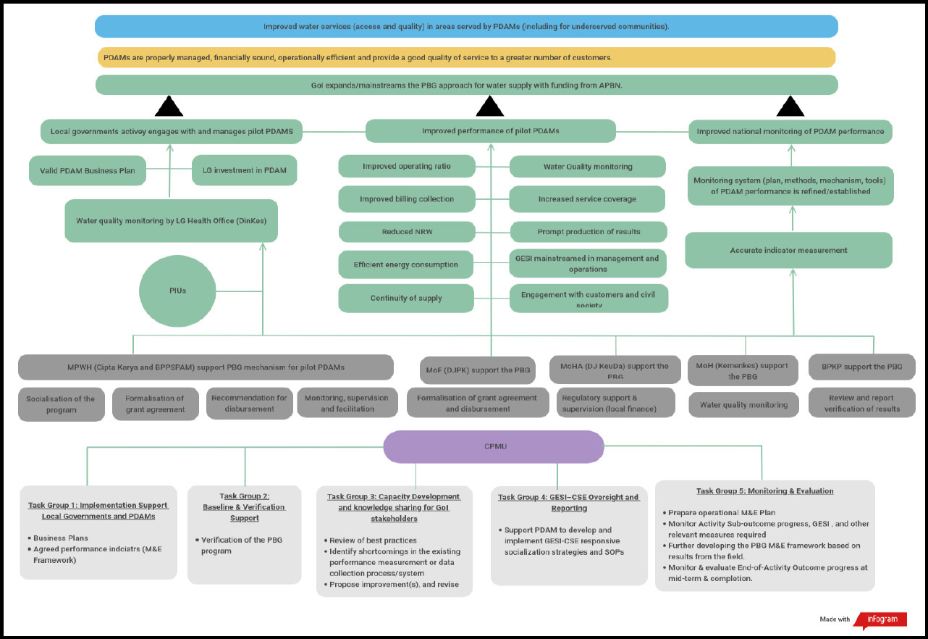
Program Logic as presented in the July 2020 MEL Framework report

LG investment in PDAM as compared to grant allocation
Table D-1: LG Equity Investment and SPPh amounts
Location | Grant | Amount | (IDR) | (IDR) | (IDR) | Equity | Investment | (IDR | billions) | Period | Period | Period | Period | Period | Total Equity
Period | SPPh Oct 2020 | SPPh Dec 2021 | SPPh Dec 2022 | SPPh Nov 2023 | Total SPPh | Jan-Jun 2020 | Jul-Dec 2020 | Jan-Jun 2021 | Jul-Dec 2021 | Jan-Jun 2022 | Jul-Dec 2022 | Jan-Jun 2023 | Jul-Dec 2023 | Jan-Jun 2024 | Investment (IDR billions)
1. Bandung | 3.256 | 4.756 | 10.170 | 13.170 | 13.170 | N/A | N/A | N/A | 7.157 | 3.000 | N/A | N/A | 20.000 | N/A | 30.157
2. Banyumas | 9.973 | 11.473 | N/A | 15.973 | 15.973 | N/A | N/A | N/A | 6.896 | N/A | 12.004 | 4.500 | N/A | N/A | 23.400
3. Banyuwangi | 5.000 | N/A | 5.000 | 6.742 | 6.742 | N/A | 0.600 | N/A | 4.400 | N/A | N/A | N/A | 1.742 | N/A | 6.742
4. Cirebon | 10.674 | 10.674 | N/A | 11.424 | 11.424 | N/A | N/A | 2.500 | N/A | 2.500 | N/A | 2.265 | N/A | 2.000 | 9.265
5. Gianyar | 4.500 | N/A | 4.500 | 5.500 | 5.500 | 4.500 | N/A | N/A | N/A | N/A | 1.000 | N/A | N/A | N/A | 5.500
6. Palangka Raya | 4.500 | N/A | 6.557 | 7.307 | 7.307 | N/A | N/A | 4.500 | N/A | 2.410 | 7.675 | N/A | N/A | N/A | 14.585
7. PPU | 4.952 | 5.852 | N/A | N/A | 5.852 | N/A | N/A | N/A | 1.500 | 2.500 | N/A | N/A | N/A | N/A | 4.000
8. Pesisir Selatan | 6.000 | N/A | 8.499 | 13.000 | 13.000 | N/A | N/A | N/A | 2.133 | N/A | 2.000 | N/A | 2.926 | 7.063 | 14.122
9. Sleman | 6.069 | 6.996 | 7.657 | 8.657 | 8.657 | N/A | N/A | 2.000 | 4.096 | 0.900 | 3.000 | 1.000 | 1.000 | N/A | 11.996
10. Sumedang | 3.200 | 4.700 | 6.200 | 6.950 | 6.950 | N/A | 3.200 | N/A | 2.100 | 1.500 | N/A | N/A | 0.150 | N/A | 6.950
11. Tegal | 5.000 | 6.500 | 8.000 | 10.500 | 10.500 | N/A | 5.000 | N/A | N/A | N/A | 1.500 | N/A | 1.500 | 2.500 | 10.500
12. Wonosobo | 9.028 | 10.528 | 9.763 | 13.300 | 13.300 | N/A | N/A | N/A | 1.159 | N/A | 2.877 | N/A | 2.070 | 7.080 | 13.186
Sub-Total Phase 1 | 72.179 | 61.479 | 66.346 | 112.523 | 118.375 | 4.500 | 8.800 | 12.000 | 35.285 | 25.177 | 33.056 | 15.775 | 29.388 | 18.643 | 150.402
Phase 2
Location | Grant | Amount | (IDR) | (IDR) | (IDR) | Equity | Investment | (IDR) | (IDR) | Period | Period | Period | Period | Period | Total Equity
13. Brebes | N/A | 5.900 | N/A | N/A | 5.900 | N/A | N/A | 4.325 | N/A | 1.500 | N/A | N/A | 0.75 | N/A | 6.575
14. Kebumen | N/A | 3.000 | N/A | 4.605 | 4.605 | N/A | N/A | N/A | N/A | N/A | 3.000 | 1.605 | N/A | N/A | 4.605
15. Lebak | N/A | 7.359 | 8.110 | N/A | 8.110 | N/A | N/A | N/A | N/A | 5.000 | 5.000 | N/A | N/A | N/A | 10.000
16. Magetan | N/A | 5.190 | N/A | 6.690 | 6.690 | N/A | N/A | N/A | N/A | N/A | 5.000 | N/A | N/A | 1.500 | 6.500
17. Purworejo | N/A | 2.500 | N/A | N/A | 2.500 | N/A | N/A | N/A | N/A | 2.500 | N/A | N/A | N/A | N/A | 2.500
Sub-Total Phase 2 | 0.000 | 23.949 | 8.110 | 11.295 | 27.805 | 0.000 | 0.000 | 12.500 | 0.000 | 23.000 | 14.000 | 12.000 | 6.500 | 1.500 | 30.180

Total Phase 1 and Phase 2

Location | Grant | Amount | (IDR) | (IDR) | (IDR) | Equity | Investment | (IDR) | (IDR) | Period | Period | Period | Period | Period | Total Equity
Total (all) | 72.083 | 85.428 | 74.456 | 123.818 | 146.180 | 4.500 | 8.800 | 24.500 | 35.285 | 48.177 | 47.056 | 27.775 | 35.888 | 20.143 | 180.583
The table above is a duplication of the content of Annex 5: Equity Investment by LG, from the PBG ACR (p. 194).

Disbursement results for each indicator, by LG/PDAM, with percentage
This annex presents the detailed breakdown of disbursement results by indicator, across each PDAM building on data as presented in table form in Annex 6: Grant Performance by Component of the ACR. The percentage of PBG funding disbursed is included in each graph.
As Figure E-1 shows, all PDAMs participated in the BP indicator. Three PDAMS were not able to achieve all performance requirements and therefore were not able to access all available funds for this indicator. 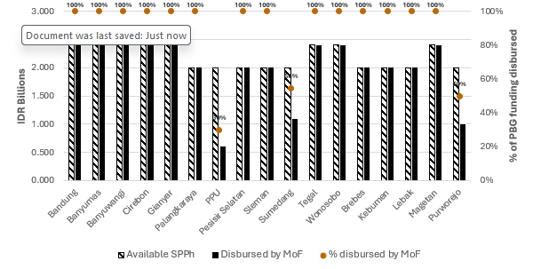

Figure E-1: Disbursement results for BP, by LG/PDAM.
Source: Based on Annex 6, Table B, ACR PBG for Water Supply, KIAT, 17 July 2024, p. 196.
Achievement against OR was much more variable, with some LGs/PDAMs significantly exceeding their target performance improvements and receiving more funding than in the agreed SPPh. There were only three instances where a PDAM was not able to meet or exceed their OR performance target and access all available funding for this indicator. In this instance, Banyumas was able to access 30% of available funding, Megetan accessed 45% of available funding and PPU accessed 71% of available funding. This is illustrated in Figure E-2.

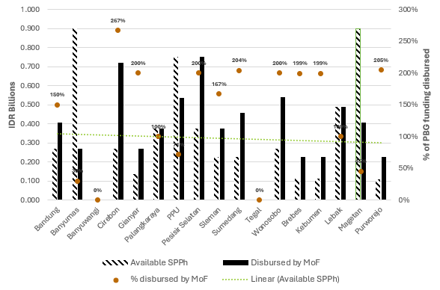
Figure E-2: Disbursement results for OR, by LG/PDAM.
Source: Based on Annex 6, Table C, ACR PBG for Water Supply, KIAT, 17 July 2024, p. 197.
Three PDAMs participated in the BCE indicator. As shown in Figure E-3 below, performance across the three was variable, with one accessing all funds, one accessing 85% of funding and one accessing 50% of available funding.
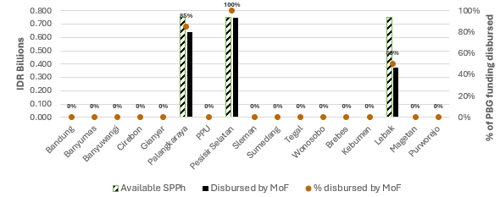
Figure E-3: Disbursement results for BCE, by LG/PDAM.
Source: Based on Annex 6, Table D, ACR PBG for Water Supply, KIAT, 17 July 2024, p. 198.
The NRW indicator released the second highest amount of overall grant funding at IDR 28.657 billion. As Figure E-4 below shows, notwithstanding the NRW result of achieving 100% of disbursement against the overall grant amount for this indicator, the results for NRW are extremely variable between LGs/PDAMs. The available SPPh for each LG/ PDAM for this indicator varies between IDR 0.030 billion and IDR 4.674 billion, and the amount disbursed per LG/PDAM varies between IDR 0.230 billion and IDR 5.374 billion. The range of disbursement as compared to the final nominated grant amount went from as low as 23% for Cirebon to as high as 3000% of the grant amount for Purworejo.

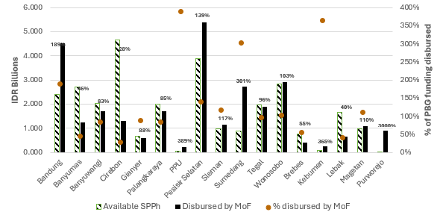
3000%
Figure E-4: Disbursement results for NRW, by LG/PDAM.
Source: Based on Annex 6, Table E, ACR PBG for Water Supply, KIAT, 17 July 2024, p. 199. Note to graph: Scale for percentage is limited to 400% so as to not distort level of disbursed funds. The variability in data points and data tags makes it difficult to show them together. Data tag is above funding results. The data point for the 3000% of funding disbursed for Purworejo is therefore excluded from the image due to the scale.
Achieving results and accessing grant funding under the EE indicator was the most difficult as shown in Figure E-5. Grant funding amounts were low and only two PDAMs were able to reach their EE targets and access more than their available share of funding.
`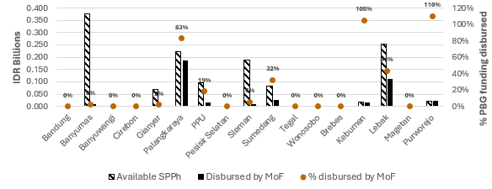Figure E-5: Disbursement results for EE, by LG/PDAM.
Source: Based on Annex 6, Table F, ACR PBG for Water Supply, KIAT, 17 July 2024, p. 200.
Overall 67% of CoS grant funding was disbursed. As Figure E-6 shows, four PDAMs were able to achieve the CoS targets and receive greater than 100% of their agreed funding against this indicator. A further four PDAMs received between 70% and 96% of their expected funds. The remaining six PDAMs had less positive results and received between 4% and 54% percent of their available SPPh.

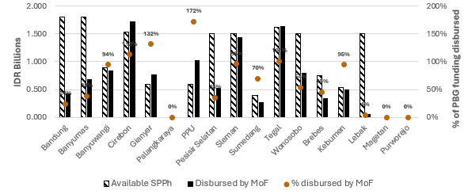Figure E-6: Disbursement results for CoS, by LG/PDAM.
Source: Based on Annex 6, Table G, ACR PBG for Water Supply, KIAT, 17 July 2024, p. 201.
Of the available SPPh funding for WQ, 80% of it was disbursed. As Figure E-7 shows nine of the 16 participant PDAMs received 80% or more of their available SPPh, with one PDAM receiving 180% of funding. The remaining seven PDAMs had mixed results with results ranging from 34% to 77% of their available funds having been disbursed to them.

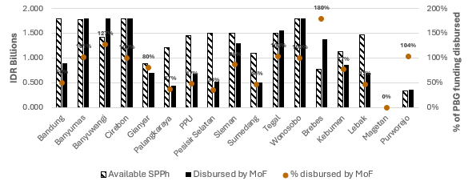Figure E-7: Disbursement results for WQ, by LG/PDAM.
Source: Based on Annex 6, Table H, ACR PBG for Water Supply, KIAT, 17 July 2024, p. 202.
For the three indicators associated with COVID-19, performance results were relatively consistent across participants. For the IEC indicator, as Figure E-8 shows, all participants received 100% of allocated SPPh funding for that indicator. The same result was shown for participant with the SOPs indicator (see Figure E-9). A minor difference for the ICPS indicator (see Figure E-10) was where one PDAM received 0% of agreed funding. 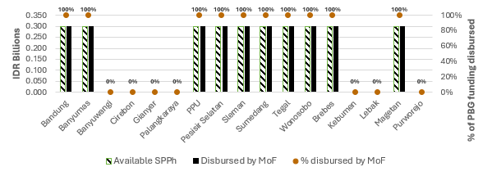
Figure E-8: Disbursement results for IEC, by LG/PDAM.
Source: Based on Annex 6, Table I, ACR PBG for Water Supply, KIAT, 17 July 2024, p. 203.

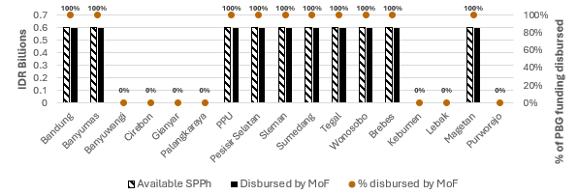
Figure E-9: Disbursement results for SOPs, by LG/PDAM.
Source: Based on Annex 6, Table J, ACR PBG for Water Supply, KIAT, 17 July 2024, p. 204.
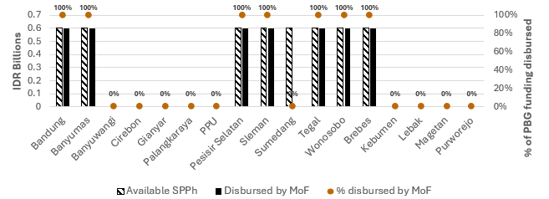Figure E-10: Disbursement results for ICPS, by LG/PDAM.
Source: Based on Annex 6, Table K, ACR PBG for Water Supply, KIAT, 17 July 2024, p. 205.
A similar result was seen for the final three indicators introduced in August 2023. Each PDAM who participated with the indicators each received 100% of their available grant funding. This is shown in figures Figure E-11, Figure E-12 and Figure E-13.

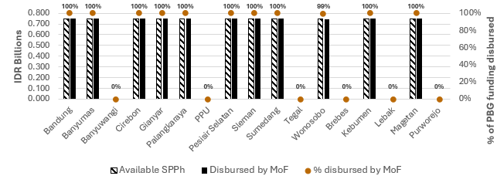Figure E-11: Disbursement results for WSP, by LG/PDAM.
Source: Based on Annex 6, Table L, ACR PBG for Water Supply, KIAT, 17 July 2024, p. 206.
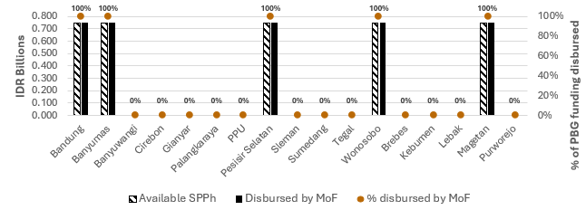Figure E-12: Disbursement results for CC, by LG/PDAM.
Source: Based on Annex 6, Table M, ACR PBG for Water Supply, KIAT, 17 July 2024, p. 207.
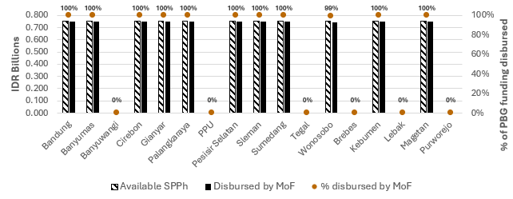Figure E-13: Disbursement results for MWH, by LG/PDAM.
Source: Based on Annex 6, Table N, ACR PBG for Water Supply, KIAT, 17 July 2024, p. 208.

Disbursement results for each PDAM, by indicator
Table F-1: Disbursement results for Bandung
Component | Grant Amount - SPPh (IDR billions) | Disbursed by MoF | % Achievement  (disbursed by MoF)
Business Plan (BP) | 2.400 | 2.400 | 100%
Operating Ratio (OR) | 0.270 | 0.405 | 150%
Billing Collection Efficiency (BCE) | N/A | N/A | N/A
Non-Revenue Water (NRW) | 2.400 | 4.530 | 189%
Energy Efficiency (EE) | N/A | N/A | N/A
Continuity of Supply (CoS) | 1.800 | 0.434 | 24%
Water Quality (WQ) | 1.800 | 0.900 | 50%
Communication, Information & Education (IEC) | 0.300 | 0.300 | 100%
Compliance with Regulations, Guidelines & SOPs (SOPs) | 0.600 | 0.600 | 100%
Improved Chlorination & Safety Performance (ICPS) | 0.600 | 0.600 | 100%
Accelerating Access to Drinking Water (MWH) | 1.500 | 1.500 | 100%
Drinking Water Safety Plan (WSP) | 0.750 | 0.750 | 100%
Climate Resilience (CC) | 0.750 | 0.750 | 100%
Total Grant Amount | 13.170 | 13.169 | 100%
Source: Based on Annex 7: Grant Performance by LG, Table B, ACR PBG for Water Supply, KIAT, 17 July 2024, p. 210.
As Table F-1 shows, in total Bandung received 100% of available SPPh grant funding, with this being the case for most indicators they participated in. They did however receive significantly more (189%) grant funding for NRW than expected, and 150% of expected OR funding. Performance results for CoS and WQ meant that they only received 24% and 50% of available funding respectively. This is presented visually below in Figure F-1.
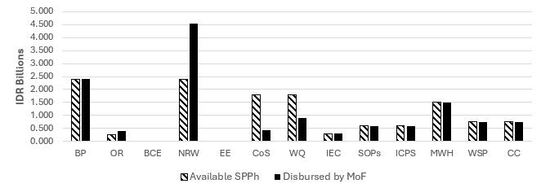Figure F-1: Disbursement results for Bandung, by indicator.
Table F-2: Disbursement results for Banyumas
Component | Grant Amount - SPPh (IDR billions) | Disbursed by MoF | % Achievement  (disbursed by MoF)
Business Plan (BP) | 2.400 | 2.400 | 100%
Operating Ratio (OR) | 0.900 | 0.270 | 30%
Billing Collection Efficiency (BCE) | N/A | N/A | N/A
Non-Revenue Water (NRW) | 2.720 | 1.240 | 46%
Energy Efficiency (EE) | 0.378 | 0.010 | 3%
Continuity of Supply (CoS) | 1.800 | 0.684 | 38%
Water Quality (WQ) | 1.775 | 1.800 | 101%
Communication, Information & Education (IEC) | 0.300 | 0.300 | 100%
Compliance with Regulations, Guidelines & SOPs (SOPs) | 0.600 | 0.600 | 100%
Improved Chlorination & Safety Performance (ICPS) | 0.600 | 0.600 | 100%
Accelerating Access to Drinking Water (MWH) | 3.000 | 3.000 | 100%
Drinking Water Safety Plan (WSP) | 0.750 | 0.750 | 100%
Climate Resilience (CC) | 0.750 | 0.750 | 100%
Total Grant Amount | 15.973 | 12.404 | 78%
Source: Based on Annex 7: Grant Performance by LG, Table C, ACR PBG for Water Supply, KIAT, 17 July 2024, p. 211.
As Table F-2 shows, overall Banyumas received 78% of available SPPh grant funding, with 100% achieved for many indicators they participated in. One indicator (WQ) received slightly more grant funding (101%) than expected. Performance results against agreed targets for 4 indicators resulted however in receiving less grant funding than agreed. Of these, they accessed only 3% of available EE funding, 30% of OR funding, 38% of CoS funding and 46% of NRW funding. This is presented visually below in Figure F-2.
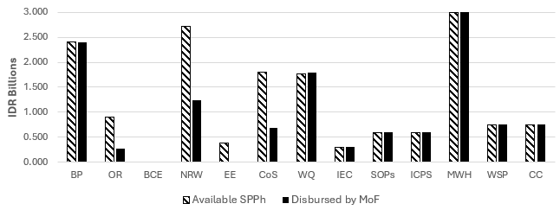
Figure F-2: Disbursement results for Banyumas, by indicator.

Table F-3: Disbursement results for Banyuwangi
Component | Grant Amount - SPPh (IDR billions) | Disbursed by MoF | % Achievement  (disbursed by MoF)
Business Plan (BP) | 2.400 | 2.400 | 100%
Operating Ratio (OR) | N/A | N/A | N/A
Billing Collection Efficiency (BCE) | N/A | N/A | N/A
Non-Revenue Water (NRW) | 2.030 | 1.693 | 83%
Energy Efficiency (EE) | N/A | N/A | N/A
Continuity of Supply (CoS) | 0.900 | 0.849 | 94%
Water Quality (WQ) | 1.412 | 1.800 | 127%
Communication, Information & Education (IEC) | N/A | N/A | N/A
Compliance with Regulations, Guidelines & SOPs (SOPs) | N/A | N/A | N/A
Improved Chlorination & Safety Performance (ICPS) | N/A | N/A | N/A
Accelerating Access to Drinking Water (MWH) | N/A | N/A | N/A
Drinking Water Safety Plan (WSP) | N/A | N/A | N/A
Climate Resilience (CC) | N/A | N/A | N/A
Total Grant Amount | 6.742 | 6.742 | 100%
Source: Based on Annex 7: Grant Performance by LG, Table D, ACR PBG for Water Supply, KIAT, 17 July 2024, p. 212.
As Table F-3 shows, Banyuwangi only participated in 4 indicators. In total they received 100% of their available grant funding. However, this was not the same across each indicator. Of these, they received 100% of available SPPh grant funding for BP, and 127% of grant funding for WQ. Performance results against agreed targets for 2 indicators resulted in receiving less grant funding than agreed. These were NRW, where they received 83% of available funding, and CoS where they received 94% of available funding. This is presented visually below in Figure F-3.
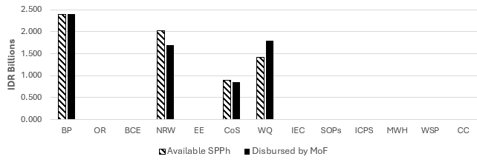
Figure F-3: Disbursement results for Banyuwangi, by indicator.
Table F-4: Disbursement results for Cirebon
Component | Grant Amount - SPPh (IDR billions) | Disbursed by MoF | % Achievement  (disbursed by MoF)
Business Plan (BP) | 2.400 | 2.400 | 100%
Operating Ratio (OR) | 0.270 | 0.720 | 267%
Billing Collection Efficiency (BCE) | N/A | N/A | N/A
Non-Revenue Water (NRW) | 4.674 | 1.310 | 28%
Energy Efficiency (EE) | N/A | N/A | N/A
Continuity of Supply (CoS) | 1.530 | 1.731 | 113%
Water Quality (WQ) | 1.800 | 1.800 | 100%
Communication, Information & Education (IEC) | N/A | N/A | N/A
Compliance with Regulations, Guidelines & SOPs (SOPs) | N/A | N/A | N/A
Improved Chlorination & Safety Performance (ICPS) | N/A | N/A | N/A
Accelerating Access to Drinking Water (MWH) | N/A | N/A | N/A
Drinking Water Safety Plan (WSP) | 0.750 | 0.750 | 100%
Climate Resilience (CC) | N/A | N/A | N/A
Total Grant Amount | 11.424 | 8.711 | 76%
Source: Based on Annex 7: Grant Performance by LG, Table E, ACR PBG for Water Supply, KIAT, 17 July 2024, p. 213.
As Table F-4 shows, Cirebon participated in 6 indicators and was able to receive 76% of available SPPh grant funding. Three indicators (BP, WQ and WSP) were able to achieve 100% of available funding. Of the remaining 3, 2 indicators received more funding than expected with 267% of grant funding disbursed against OR and 113% against CoS results. The proposed performance target for NRW was not able to be achieved, with 28% of this indicator’s funding being accessed. This is presented visually below in
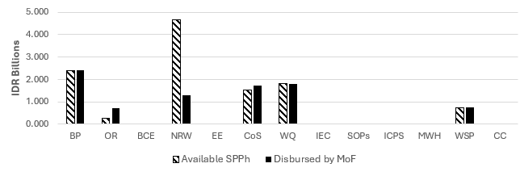
Figure F-4.
Figure F-4: Disbursement results for Cirebon, by indicator.

Table F-5: Disbursement results for Gianyar
Component | Grant Amount - SPPh (IDR billions) | Disbursed by MoF | % Achievement  (disbursed by MoF)
Business Plan (BP) | 2.400 | 2.400 | 100%
Operating Ratio (OR) | 0.135 | 0.270 | 200%
Billing Collection Efficiency (BCE) | N/A | N/A | N/A
Non-Revenue Water (NRW) | 0.681 | 0.598 | 88%
Energy Efficiency (EE) | 0.068 | 0.001 | 2%
Continuity of Supply (CoS) | 0.588 | 0.775 | 132%
Water Quality (WQ) | 0.878 | 0.705 | 80%
Communication, Information & Education (IEC) | N/A | N/A | N/A
Compliance with Regulations, Guidelines & SOPs (SOPs) | N/A | N/A | N/A
Improved Chlorination & Safety Performance (ICPS) | N/A | N/A | N/A
Accelerating Access to Drinking Water (MWH) | N/A | N/A | N/A
Drinking Water Safety Plan (WSP) | 0.750 | 0.750 | 100%
Climate Resilience (CC) | N/A | N/A | N/A
Total Grant Amount | 5.500 | 5.499 | 100%
Source: Based on Annex 7: Grant Performance by LG, Table F, ACR PBG for Water Supply, KIAT, 17 July 2024, p. 214.
As Table F-5 shows, Gianyar participated in 7 indicators and nominally received 100% of available SPPh grant funding. Two indicators (BP and WSP) were able to achieve 100% of available funding. Of the remaining 5, 2 indicators received more funding than expected with 200% of grant funding disbursed against OR and 132% against CoS results. The proposed performance target for NRW was not quite able to be achieved, with 88% of this indicator’s funding being accessed. Performance against EE was more difficult, with only 2% of agreed funding disbursed. This is presented visually below in Figure F-5.
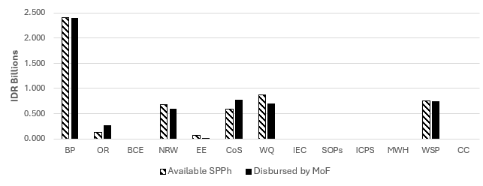
Figure F-5: Disbursement results for Gianyar, by indicator.

Table F-6: Disbursement results for Palangkaraya
Component | Grant Amount - SPPh (IDR billions) | Disbursed by MoF | % Achievement  (disbursed by MoF)
Business Plan (BP) | 2.000 | 2.000 | 100%
Operating Ratio (OR) | 0.375 | 0.375 | 100%
Billing Collection Efficiency (BCE) | 0.750 | 0.638 | 85%
Non-Revenue Water (NRW) | 2.000 | 1.691 | 85%
Energy Efficiency (EE) | 0.224 | 0.186 | 83%
Continuity of Supply (CoS) | N/A | N/A | N/A
Water Quality (WQ) | 1.208 | 0.445 | 37%
Communication, Information & Education (IEC) | N/A | N/A | N/A
Compliance with Regulations, Guidelines & SOPs (SOPs) | N/A | N/A | N/A
Improved Chlorination & Safety Performance (ICPS) | N/A | N/A | N/A
Accelerating Access to Drinking Water (MWH) | N/A | N/A | N/A
Drinking Water Safety Plan (WSP) | 0.750 | 0.750 | 100%
Climate Resilience (CC) | N/A | N/A | N/A
Total Grant Amount | 7.307 | 6.085 | 83%
Source: Based on Annex 7: Grant Performance by LG, Table G, ACR PBG for Water Supply, KIAT, 17 July 2024, p. 215.
As Table F-6 shows, overall Palangkaraya received 83% of available SPPh grant funding, with 100% achieved for 3 of these indicators (BP, OR and WSP). No indicators received more grant funding than expected. Performance results against agreed targets resulted in 4 indicators receiving less grant funding than agreed. Of these, only 37% of WQ funding was accessed, 83% of available EE funding and 85% of funding for both BCE and NRW. This is presented visually below in Figure F-6.

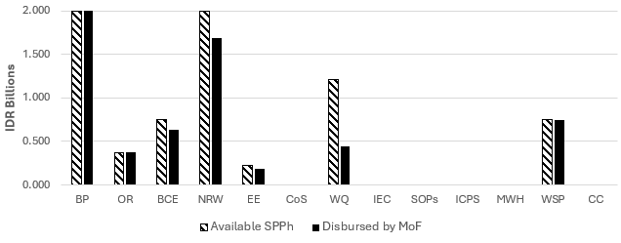Figure F-6: Disbursement results for Palangkaraya, by indicator.

Table F-7: Disbursement results for PPU
Component | Grant Amount - SPPh (IDR billions) | Disbursed by MoF | % Achievement  (disbursed by MoF)
Business Plan (BP) | 2.000 | 0.600 | 30%
Operating Ratio (OR) | 0.750 | 0.535 | 71%
Billing Collection Efficiency (BCE) | N/A | N/A | N/A
Non-Revenue Water (NRW) | 0.059 | 0.230 | 389%
Energy Efficiency (EE) | 0.095 | 0.018 | 19%
Continuity of Supply (CoS) | 0.600 | 1.031 | 172%
Water Quality (WQ) | 1.448 | 0.686 | 47%
Communication, Information & Education (IEC) | 0.300 | 0.300 | 100%
Compliance with Regulations, Guidelines & SOPs (SOPs) | 0.600 | 0.600 | 100%
Improved Chlorination & Safety Performance (ICPS) | N/A | N/A | N/A
Accelerating Access to Drinking Water (MWH) | N/A | N/A | N/A
Drinking Water Safety Plan (WSP) | N/A | N/A | N/A
Climate Resilience (CC) | N/A | N/A | N/A
Total Grant Amount | 5.852 | 4.000 | 68%
Source: Based on Annex 7: Grant Performance by LG, Table H, ACR PBG for Water Supply, KIAT, 17 July 2024, p. 216.
As Table F-7 shows, PPU participated in 8 indicators and received 680% of available SPPh grant funding. Two indicators (IEC and SOPs) were able to achieve 100% of available funding. Of the remaining 6, 2 indicators received more funding than expected with 389% of grant funding disbursed against NRW and 172% against CoS results. Performance results against agreed targets resulted in 4 indicators receiving less grant funding than agreed. Of these, only 19% of EE funding was accessed, 30% of available BP funding, 47% of WQ funding and 71% of OR funding. This is presented visually below in Figure F-7.

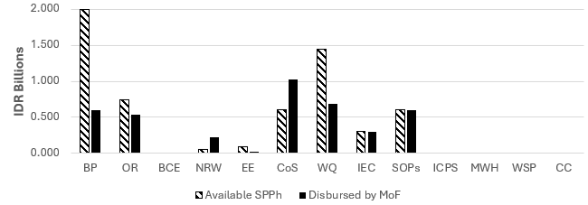Figure F-7: Disbursement results for PPU, by indicator.
Table F-8: Disbursement results for Pesisir Selatan
Component | Grant Amount - SPPh (IDR billions) | Disbursed by MoF | % Achievement  (disbursed by MoF)
Business Plan (BP) | 2.000 | 2.000 | 100%
Operating Ratio (OR) | 0.375 | 0.750 | 200%
Billing Collection Efficiency (BCE) | 0.750 | 0.750 | 100%
Non-Revenue Water (NRW) | 3.875 | 5.374 | 139%
Energy Efficiency (EE) | N/A | N/A | N/A
Continuity of Supply (CoS) | 1.500 | 0.532 | 35%
Water Quality (WQ) | 1.500 | 0.514 | 34%
Communication, Information & Education (IEC) | 0.300 | 0.300 | 100%
Compliance with Regulations, Guidelines & SOPs (SOPs) | 0.600 | 0.600 | 100%
Improved Chlorination & Safety Performance (ICPS) | 0.600 | 0.600 | 100%
Accelerating Access to Drinking Water (MWH) | N/A | N/A | N/A
Drinking Water Safety Plan (WSP) | 0.75 | 0.750 | 100%
Climate Resilience (CC) | 0.75 | 0.750 | 100%
Total Grant Amount | 13.000 | 12.921 | 99%
Source: Based on Annex 7: Grant Performance by LG, Table I, ACR PBG for Water Supply, KIAT, 17 July 2024, p. 217.
As Table F-8 shows, Pesisir Selatan participated in most indicators and received 99% of available SPPh grant funding. Many indicators were able to achieve 100% of available funding. Of the remaining 4, 2 indicators received more funding than expected with 200% of grant funding disbursed against OR and 139% against NRW results. Performance results against agreed targets resulted in 2 indicators receiving less grant funding than agreed. Of these, 34% of WQ funding was accessed and 35% of available CoS funding. This is presented visually below in Figure F-8.
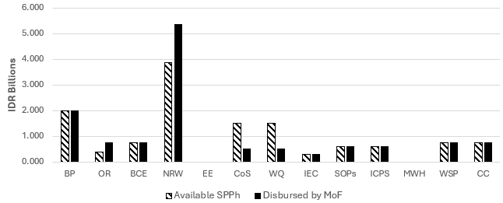Figure F-8: Disbursement results for Pesisir Selatan, by indicator.

Table F-9: Disbursement results for Sleman
Component | Grant Amount - SPPh (IDR billions) | Disbursed by MoF | % Achievement  (disbursed by MoF)
Business Plan (BP) | 2.000 | 2.000 | 100%
Operating Ratio (OR) | 0.225 | 0.375 | 167%
Billing Collection Efficiency (BCE) | N/A | N/A | N/A
Non-Revenue Water (NRW) | 0.992 | 1.160 | 117%
Energy Efficiency (EE) | 0.190 | 0.011 | 6%
Continuity of Supply (CoS) | 1.500 | 1.441 | 96%
Water Quality (WQ) | 1.500 | 1.292 | 86%
Communication, Information & Education (IEC) | 0.300 | 0.300 | 100%
Compliance with Regulations, Guidelines & SOPs (SOPs) | 0.600 | 0.600 | 100%
Improved Chlorination & Safety Performance (ICPS) | 0.600 | 0.600 | 100%
Accelerating Access to Drinking Water (MWH) | N/A | N/A | N/A
Drinking Water Safety Plan (WSP) | 0.750 | 0.750 | 100%
Climate Resilience (CC) | N/A | N/A | N/A
Total Grant Amount | 8.657 | 8.529 | 99%
Source: Based on Annex 7: Grant Performance by LG, Table J, ACR PBG for Water Supply, KIAT, 17 July 2024, p. 218.
As Table F-9 shows, Sleman participated in most indicators and received 99% of available SPPh grant funding. Of the 10 indicators, 5 were able to achieve 100% of available funding. Of the remaining 5, 2 indicators received more funding than expected with 167% of grant funding disbursed against OR and 117% against NRW results. Performance results against agreed targets resulted in 3 indicators receiving less grant funding than agreed. Of these, only 6% of EE funding was accessed, 86% of available WQ funding and 96% of CoS funding. This is presented visually below in Figure F-9.

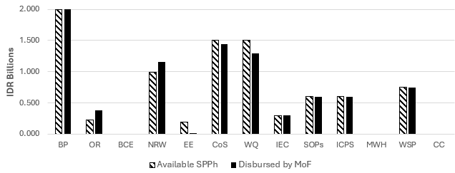Figure F-9: Disbursement results for Sleman, by indicator.
Table F-10: Disbursement results for Sumedang
Component | Grant Amount - SPPh (IDR billions) | Disbursed by MoF | % Achievement  (disbursed by MoF)
Business Plan (BP) | 2.000 | 1.092 | 55%
Operating Ratio (OR) | 0.225 | 0.459 | 204%
Billing Collection Efficiency (BCE) | N/A | N/A | N/A
Non-Revenue Water (NRW) | 0.900 | 2.713 | 301%
Energy Efficiency (EE) | 0.084 | 0.027 | 32%
Continuity of Supply (CoS) | 0.400 | 0.278 | 70%
Water Quality (WQ) | 1.091 | 0.507 | 46%
Communication, Information & Education (IEC) | 0.300 | 0.300 | 100%
Compliance with Regulations, Guidelines & SOPs (SOPs) | 0.600 | 0.600 | 100%
Improved Chlorination & Safety Performance (ICPS) | 0.600 | 0.000 | 0%
Accelerating Access to Drinking Water (MWH) | N/A | N/A | N/A
Drinking Water Safety Plan (WSP) | 0.750 | 0.750 | 100%
Climate Resilience (CC) | N/A | N/A | N/A
Total Grant Amount | 6.950 | 6.727 | 97%
Source: Based on Annex 7: Grant Performance by LG, Table K, ACR PBG for Water Supply, KIAT, 17 July 2024, p. 219.
As Table F-10 shows, Sumedang participated in 10 indicators and received 97% of available SPPh grant funding. Three indicators were able to achieve 100% of available funding. Of the remaining 7, 2 indicators received more funding than expected with 204% of grant funding disbursed against OR and 301% against NRW results. Performance results against agreed targets resulted in 5 indicators receiving less grant funding than agreed. Of these, 0% of funding was provided for ICSP, 32% of EE funding and 46% of WQ funding was accessed, 55% of BP funding was disbursed and 70% of the available CoS funding. This is presented visually below in Figure F-10.
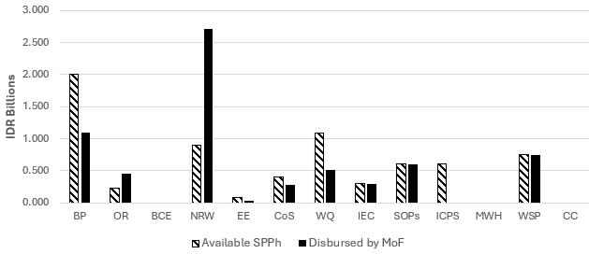Figure F-10: Disbursement results for Sumedang, by indicator.
Table F-11: Disbursement results for Tegal
Component | Grant Amount - SPPh (IDR billions) | Disbursed by MoF | % Achievement  (disbursed by MoF)
Business Plan (BP) | 2.400 | 2.400 | 100%
Operating Ratio (OR) | N/A | N/A | N/A
Billing Collection Efficiency (BCE) | N/A | N/A | N/A
Non-Revenue Water (NRW) | 1.974 | 1.900 | 96%
Energy Efficiency (EE) | N/A | N/A | N/A
Continuity of Supply (CoS) | 1.620 | 1.642 | 101%
Water Quality (WQ) | 1.506 | 1.557 | 103%
Communication, Information & Education (IEC) | 0.300 | 0.300 | 100%
Compliance with Regulations, Guidelines & SOPs (SOPs) | 0.600 | 0.600 | 100%
Improved Chlorination & Safety Performance (ICPS) | 0.600 | 0.600 | 100%
Accelerating Access to Drinking Water (MWH) | 1.500 | 1.500 | 100%
Drinking Water Safety Plan (WSP) | N/A | N/A | N/A
Climate Resilience (CC) | N/A | N/A | N/A
Total Grant Amount | 10.500 | 10.499 | 100%
Source: Based on Annex 7: Grant Performance by LG, Table L, ACR PBG for Water Supply, KIAT, 17 July 2024, p. 220.
As Table F-11 shows, Tegal participated in 8 indicators and received 100% of available SPPh grant funding. Five indicators were able to achieve 100% of available funding. Of the remaining 3, 2 indicators received more funding than expected with 101% of grant funding disbursed against CoS and 103% against NRW results. Performance results against agreed targets resulted in 1 indicator receiving less grant funding than agreed, with NRW receiving 96% of available funding. This is presented visually below in Figure F-11.

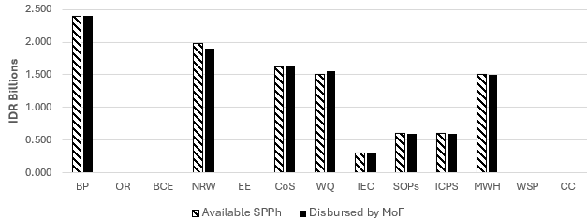Figure F-11: Disbursement results for Tegal, by indicator.

Table F-12: Disbursement results for Wonosobo
Component | Grant Amount - SPPh (IDR billions) | Disbursed by MoF | % Achievement  (disbursed by MoF)
Business Plan (BP) | 2.400 | 2.400 | 100%
Operating Ratio (OR) | 0.270 | 0.540 | 200%
Billing Collection Efficiency (BCE) | N/A | N/A | N/A
Non-Revenue Water (NRW) | 2.830 | 2.901 | 103%
Energy Efficiency (EE) | N/A | N/A | N/A
Continuity of Supply (CoS) | 1.500 | 0.808 | 54%
Water Quality (WQ) | 1.800 | 1.800 | 100%
Communication, Information & Education (IEC) | 0.300 | 0.300 | 100%
Compliance with Regulations, Guidelines & SOPs (SOPs) | 0.600 | 0.600 | 100%
Improved Chlorination & Safety Performance (ICPS) | 0.600 | 0.600 | 100%
Accelerating Access to Drinking Water (MWH) | 1.500 | 1.485 | 99%
Drinking Water Safety Plan (WSP) | 0.750 | 0.743 | 99%
Climate Resilience (CC) | 0.750 | 0.750 | 100%
Total Grant Amount | 13.300 | 12.927 | 97%
Source: Based on Annex 7: Grant Performance by LG, Table M, ACR PBG for Water Supply, KIAT, 17 July 2024, p. 221.
As Table F-12 shows, Wonosobo participated in most indicators and received 99% of available SPPh grant funding. Many indicators were able to achieve 100% of available funding. Of the remaining 4, 2 indicators received more funding than expected with 200% of grant funding disbursed against OR and 139% against NRW results. Performance results against agreed targets resulted in 2 indicators receiving less grant funding than agreed. Of these, 34% of WQ funding was accessed and 35% of available CoS funding. This is presented visually below in
Figure F-12.
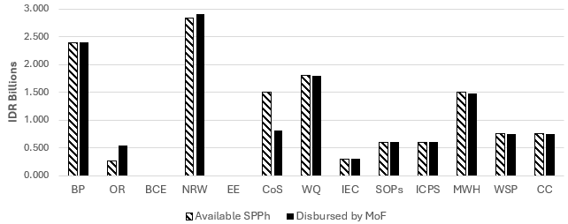
Figure F-12: Disbursement results for Wonosobo, by indicator.

Table F-13: Disbursement results for Brebes
Component | Grant Amount - SPPh (IDR billions) | Disbursed by MoF | % Achievement  (disbursed by MoF)
Business Plan (BP) | 2.000 | 2.000 | 100%
Operating Ratio (OR) | 0.113 | 0.225 | 199%
Billing Collection Efficiency (BCE) | N/A | N/A | N/A
Non-Revenue Water (NRW) | 0.772 | 0.421 | 55%
Energy Efficiency (EE) | N/A | N/A | N/A
Continuity of Supply (CoS) | 0.750 | 0.340 | 45%
Water Quality (WQ) | 0.765 | 1.375 | 180%
Communication, Information & Education (IEC) | 0.300 | 0.300 | 100%
Compliance with Regulations, Guidelines & SOPs (SOPs) | 0.600 | 0.600 | 100%
Improved Chlorination & Safety Performance (ICPS) | 0.600 | 0.600 | 100%
Accelerating Access to Drinking Water (MWH) | N/A | N/A | N/A
Drinking Water Safety Plan (WSP) | N/A | N/A | N/A
Climate Resilience (CC) | N/A | N/A | N/A
Total Grant Amount | 5.900 | 5.862 | 99%
Source: Based on Annex 7: Grant Performance by LG, Table N, ACR PBG for Water Supply, KIAT, 17 July 2024, p. 222.
As Table F-13 shows, Brebes participated in 8 indicators and received 99% of available SPPh grant funding. Four indicators were able to achieve 100% of available funding. Of the remaining 4, 2 indicators received more funding than expected with 199% of grant funding disbursed against OR and 180% against WQ results. Performance results against agreed targets resulted in 2 indicators receiving less grant funding than agreed. Of these, 45% of CoS funding was accessed and 55% of available NRW funding. This is presented visually below in Figure F-13.
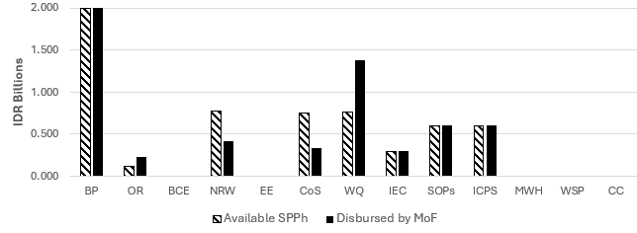
Figure F-13: Disbursement results for Brebes, by indicator.

Table F-14: Disbursement results for Kebumen
Component | Grant Amount - SPPh (IDR billions) | Disbursed by MoF | % Achievement  (disbursed by MoF)
Business Plan (BP) | 2.000 | 2.000 | 100%
Operating Ratio (OR) | 0.113 | 0.225 | 199%
Billing Collection Efficiency (BCE) | N/A | N/A | N/A
Non-Revenue Water (NRW) | 0.067 | 0.245 | 365%
Energy Efficiency (EE) | 0.017 | 0.018 | 105%
Continuity of Supply (CoS) | 0.533 | 0.505 | 95%
Water Quality (WQ) | 1.125 | 0.863 | 77%
Communication, Information & Education (IEC) | N/A | N/A | N/A
Compliance with Regulations, Guidelines & SOPs (SOPs) | N/A | N/A | N/A
Improved Chlorination & Safety Performance (ICPS) | N/A | N/A | N/A
Accelerating Access to Drinking Water (MWH) | N/A | N/A | N/A
Drinking Water Safety Plan (WSP) | 0.750 | 0.750 | 100%
Climate Resilience (CC) | N/A | N/A | N/A
Total Grant Amount | 4.605 | 4.605 | 100%
Source: Based on Annex 7: Grant Performance by LG, Table M, ACR PBG for Water Supply, KIAT, 17 July 2024, p. 223.
As Table F-14 shows, Kebumen participated in 7 indicators and received 100% of available SPPh grant funding. Two indicators were able to achieve 100% of available funding. Of the remaining 5, 3 indicators received more funding than expected with 365% of NRW funding be accessed, 199% of OR funding and 105% of EE funding. Performance results against agreed targets resulted in 2 indicators receiving less than the agreed grant funding for that indicator. For WQ, 77% of available funding was disbursed, and 95% of available CoS funding. This is presented visually below in Figure F-14.
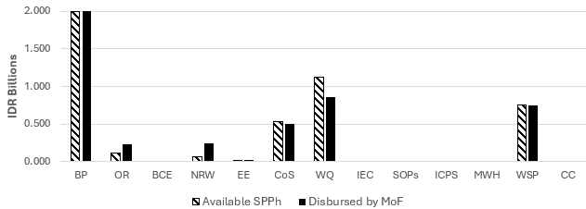Figure F-14: Disbursement results for Kebumen, by indicator.

Table F-15: Disbursement results for Lebak
Component | Grant Amount - SPPh (IDR billions) | Disbursed by MoF | % Achievement  (disbursed by MoF)
Business Plan (BP) | 2.000 | 2.000 | 100%
Operating Ratio (OR) | 0.488 | 0.488 | 100%
Billing Collection Efficiency (BCE) | 0.750 | 0.375 | 50%
Non-Revenue Water (NRW) | 1.650 | 0.661 | 40%
Energy Efficiency (EE) | 0.253 | 0.111 | 44%
Continuity of Supply (CoS) | 1.500 | 0.060 | 4%
Water Quality (WQ) | 1.469 | 0.691 | 47%
Communication, Information & Education (IEC) | N/A | N/A | N/A
Compliance with Regulations, Guidelines & SOPs (SOPs) | N/A | N/A | N/A
Improved Chlorination & Safety Performance (ICPS) | N/A | N/A | N/A
Accelerating Access to Drinking Water (MWH) | N/A | N/A | N/A
Drinking Water Safety Plan (WSP) | N/A | N/A | N/A
Climate Resilience (CC) | N/A | N/A | N/A
Total Grant Amount | 8.110 | 4.386 | 54%
Source: Based on Annex 7: Grant Performance by LG, Table O, ACR PBG for Water Supply, KIAT, 17 July 2024, p. 224.
As Table F-15 shows, Lebak participated in 7 indicators and received 54% of available SPPh grant funding. Two indicators were able to achieve 100% of available funding. Of the remaining 5, no indicators received more funding than expected. Performance results against agreed targets resulted in these 5 indicators receiving 50% or less of agreed grant funding for that indicator. Only 4% of CoS funding was accessed, 40% of NRW funding, 44% of EE funding, 47% of WQ funding and 50% of available BCE funding. Notwithstanding these more negative performance results compared to other participants, Lebak had the highest level of LG equity funding and demonstrated their desire to improve the PDAM’s technical performance. This is presented visually below in Figure F-15.
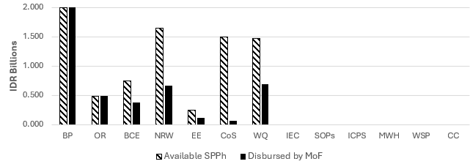
Figure F-15: Disbursement results for Lebak, by indicator.
Table F-16: Disbursement results for Magetan
Component | Grant Amount - SPPh (IDR billions) | Disbursed by MoF | % Achievement  (disbursed by MoF)
Business Plan (BP) | 2.400 | 2.400 | 100%
Operating Ratio (OR) | 0.900 | 0.405 | 45%
Billing Collection Efficiency (BCE) | N/A | N/A | N/A
Non-Revenue Water (NRW) | 0.990 | 1.091 | 110%
Energy Efficiency (EE) | N/A | N/A | N/A
Continuity of Supply (CoS) | N/A | N/A | N/A
Water Quality (WQ) | N/A | N/A | N/A
Communication, Information & Education (IEC) | 0.300 | 0.300 | 100%
Compliance with Regulations, Guidelines & SOPs (SOPs) | 0.600 | 0.600 | 100%
Improved Chlorination & Safety Performance (ICPS) | N/A | N/A | N/A
Accelerating Access to Drinking Water (MWH) | N/A | N/A | N/A
Drinking Water Safety Plan (WSP) | 0.750 | 0.750 | 100%
Climate Resilience (CC) | 0.75 | 0.750 | 100%
Total Grant Amount | 6.690 | 6.296 | 94%
Source: Based on Annex 7: Grant Performance by LG, Table P, ACR PBG for Water Supply, KIAT, 17 July 2024, p. 225.
As Table F-16 shows, Magetan participated in 7 indicators and received 94% of available SPPh grant funding. Five indicators were able to achieve 100% of available funding. Of the remaining 2, 1 indicator received more funding than expected with 110% of grant funding disbursed against NRW results. Performance results against agreed targets resulted in 1 indicator receiving less grant funding than agreed, with 45% of available OR funding. This is presented visually below in Figure F-16.
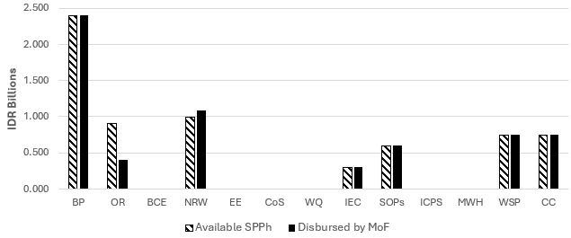
Figure F-16: Disbursement results for Magetan, by indicator.

Table F-17: Disbursement results for Purworejo
Component | Grant Amount - SPPh (IDR billions) | Disbursed by MoF | % Achievement  (disbursed by MoF)
Business Plan (BP) | 2.000 | 1.000 | 50%
Operating Ratio (OR) | 0.110 | 0.225 | 205%
Billing Collection Efficiency (BCE) | N/A | N/A | N/A
Non-Revenue Water (NRW) | 0.030 | 0.900 | 3000%
Energy Efficiency (EE) | 0.020 | 0.022 | 110%
Continuity of Supply (CoS) | N/A | N/A | N/A
Water Quality (WQ) | 0.340 | 0.353 | 104%
Communication, Information & Education (IEC) | N/A | N/A | N/A
Compliance with Regulations, Guidelines & SOPs (SOPs) | N/A | N/A | N/A
Improved Chlorination & Safety Performance (ICPS) | N/A | N/A | N/A
Accelerating Access to Drinking Water (MWH) | N/A | N/A | N/A
Drinking Water Safety Plan (WSP) | N/A | N/A | N/A
Climate Resilience (CC) | N/A | N/A | N/A
Total Grant Amount | 2.500 | 2.500 | 100%
Source: Based on Annex 7: Grant Performance by LG, Table Q, ACR PBG for Water Supply, KIAT, 17 July 2024, p. 226.
As Table F-17 shows, Purworejo participated in 5 indicators and received 100% of available SPPh grant funding. No indicators were able to achieve 100% of available funding however 4 of the indicators received more or significantly more funding than agreed by indicator, with 3000% of NRW funding, 205% of OR funding, 110% against the EE funding and 104% against WQ funding. Performance results against agreed targets resulted in 1 indicator receiving less grant funding than agreed, with 50% of BP funding accessed. This is presented visually below in
Figure F-17.
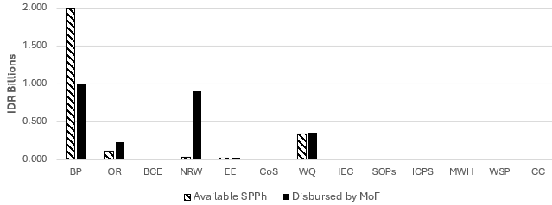
Figure F-17: Disbursement results for Purworejo, by indicator.

Description of Figure 3-5 , page 34

This flowchart illustrates the grant mechanism process involving four entities: KIAT, Local Government, DGHS, and MoF.
KIAT provides technical assistance to the Local Government. The process begins with Socialization (1) by DGHS, followed by the Letter of Interest (2) submitted by the Local Government. DGHS conducts an Assessment of Proposal (3), which may result in either a pass or fail. If passed, DGHS issues a Recommendation (4) to MoF for an On-Granting Agreement (SPPH) (5). Upon receiving investment and support from KIAT (6), the Local Government proceeds with Preparation (7), which includes Pre-Feasibility Study, Energy Audit, and Metering.
DGHS performs a Baseline Survey (8), and the Local Government carries out Implementation (9). DGHS then conducts Verification (10) and provides a final Recommendation (11). Based on this, MoF proceeds with the Disbursement of Grant (12).

Description of Figure 3-6, page 35
This flowchart outlines the verification and review process for a water supply grant, involving five key entities:
- Local Government (Pemda/PIU/PDAM)
  - Sends a verification request letter with supporting data.
  - Confirms that PBG activities (governance, finance, operational efficiency, service quality) have been completed.
  - Submits an application letter for BPKP verification review.
- PPMU (Provincial Project Management Unit)
  - Handles data amendments.
- CPMU Water Supply Grant (Central Project Management Unit)
  - Checks the verification request data.
  - If data is unsatisfactory, issues a request for verification implementation.
- Baseline and Verification Consultants
  - Conduct further checks on verification data.
  - Submit verification schedules and survey personnel.
  - Carry out the verification process.
  - Issue verification results and attachments.
  - Provide technical recommendations for grant fund eligibility to PPMU.
  - Submit verification report and recommendations to the Local Government.
- BPKP (Financial and Development Supervisory Agency)
  - Conducts the BPKP verification review.
  - Issues the BPKP verification review report.
Sustineo Pty Ltd
490 Northbourne Ave, Dickson ACT 2602 Australia
GPO Box 591 Canberra ACT 2601 Australia
E: enquiries@sustineo.com.au
© Sustineo Pty Ltd, 2024
This document is and shall remain the property of Sustineo. The document may only be used for the purpose for which it was prepared.
Unauthorised use of this document in any form whatsoever is prohibited.

In Indonesian the state-owned water utilities are known as either Perusahaan Daerah Air Minum (PDAM) or Badan Usaha Milik Daerah Air Minum (BUMD AM). The review uses the term PDAM for consistency.
All PBG locations were in Western and Central Indonesia: Kabupaten Pesisir Selatan (West Sumatera Province); Kabupaten Penajam Paser Utara (East Kalimantan Province); Kota Palangkaraya (Central Kalimantan Province); Kabupaten Lebak (Banten Province); Kabupaten Bandung, Kabupaten Sumedang, and Kota Cirebon (West Java Province); Kabupaten Brebes, Kabupaten Tegal, Kabupaten Kebumen, Kabupaten Banyumas, Kabupaten Wonosobo, and Kabupaten Purworejo (Central Java Province); Kabupaten Sleman (Yogyakarta Special Region); Kabupaten Magetan and Kabupaten Banyuwangi (East Java Province); and Kabupaten Gianyar (Bali Province).
KIAT, Water Hibah – Design of a Performance-Based Grant for Water Supply: Final Activity Design Document, December 2019, Section D.1., pp. 28–31.
The original description of service for the Activity referred to Gender Equality and Social Inclusion (GESI) oversight and reporting. Over the life of the pilot this term changed across the Australian Aid Program to include disability and become Gender Equality, Disability, and Social Inclusion (GEDSI). For consistency, the latter term (GEDSI) is used throughout the report.
BPPSPAM (the Drinking Water Service System Provision Improvement Agency) was an agency regulated by Presidential Decree (PerPres) No 90/2016, which reported to the Ministry of Public Works and Housing (MPWH). Its functions in terms of the PBG were: (a) performance evaluation of the implementation of drinking water supply systems operated by state-owned enterprises in terms of fulfilling quality, quantity and continuity requirements; (b) facilitation of improved performance in administering drinking water supply systems, (c) advice to Central and Regional Government in terms of implementing the requirements of (b), and (d) recommendations to Central and Regional Governments for safeguarding a balance of interests between service provider and customer.
KIAT, Water Hibah – Design of a Performance-Based Grant for Water Supply: Final Activity Design Document, December 2019, Section C.1.2., p. 19.
KIAT, Water Hibah – Design of a Performance-Based Grant for Water Supply: Final Activity Design Document, December 2019, Section C.1.2., p. 19.
KIAT, Water Hibah – Design of a Performance-Based Grant for Water Supply: Final Activity Design Document, December 2019, Section B.1.5., p. 12.
KIAT, ACR PBG for Water Supply, 17 July 2024, Section 5.2.13. p. 122.
PDAM performance categorisation data obtained from https://data.pu.go.id/visualisasi/kinerja-bumd-air-minum.
The PBG is not a reimbursement program, and the level of available grant funding is not influenced by the amount of investment necessary to improve PDAM performance. Rather, the available grant payment varies depending on the verified level of PDAM performance improvement as compared to the applicable indicator’s baseline.
ACR PBG for Water Supply, KIAT, 17 July 2024, p. 59.
ACR PBG for Water Supply, KIAT, 17 July 2024, p. 71.
KIAT, Description of Services, Program Implementation Consultant, Performance Based Grant for Water Supply (June 2022), Section 3.2, p. 22.
ACR PBG for Water Supply, KIAT, 17 July 2024, p. 50.
The work originally envisaged to be undertaken to support EoAO3 is now being delivered under the separate KIAT Performance Benchmarking and Institutional Strengthening project.
ACR PBG for Water Supply, KIAT, 17 July 2024, p. 71.
ACR PBG for Water Supply, KIAT, 17 July 2024, p. 13, and Annex 5, p. 194.
See Appendix E of this report for agreed grant amounts (SPPh) and actual amounts disbursed (by MoF) presented by indicator for each PDAM; and Appendix F for each PDAM, by indicator.
KIAT, Water Hibah – Design of a Performance-Based Grant for Water Supply: Final Activity Design Document, December 2019, Annex 6.3, p. 99.
ACR PBG for Water Supply, KIAT, 17 July 2024, pp. 91 and 195.
ACR PBG for Water Supply, KIAT, 17 July 2024, p. 195.
ACR PBG for Water Supply, KIAT, 17 July 2024, pp. 99 and 173.
ACR PBG for Water Supply, KIAT, 17 July 2024, p. 173.
ACR PBG for Water Supply, KIAT, 17 July 2024, p. 115.
Damage to variable speed drives in Lebak damaged by lightning and not repaired due to lack of funds – ACR PBG for Water Supply, KIAT, 17 July 2024, p. 91.
A period of dry weather in Bandung in 2023 resulted in lower production and therefore increased NRW as a percentage – ACR PBG for Water Supply, KIAT, 17 July 2024, p. 241.
These annual reports provide aggregated data from 18 performance indications and supplementary data on 31 additional indicators.
The intention of the program was to undertake an initial ‘diagnostic visit’ by a technical specialist to help calculate a water balance and identify the specific circumstances and gaps within the PDAM that could best benefit from assistance against each of the intended indicators. The review team recognises the timing of COVID-19 movement restrictions and the impact this had on such activities required changes to the planned approach.
ACR PBG for Water Supply, KIAT, 17 July 2024, p. 10.
Project Implementation Consultant, Mid-Term Review Report (W-1-01-03), September 2022, KIAT, September 2022, p. 44.
ACR PBG for Water Supply, KIAT, 17 July 2024, p. 66.
Three GEDSI-focused studies were published by KIAT in 2024: 1) The Benefits to BUMD-AM of Integrating GEDSI During the PBG Activity; 2) The Recruitment and Retention of Persons with Disabilities in BUMD-AM; and 3) The Enabling and Challenging Factors Affecting the Promotion of BUMD-AM’s Female Staff.
The ACR incorrectly reports these targets and results as a “2% increase”. The correct phrase is a “2 percentage point increase”, as the measurements were presented in percentages, not raw numbers.
The topic of promoting women within PDAMs was also explored in depth for the 2024 KIAT report entitled The Enabling and Challenging Factors Affecting the Promotion of BUMD-AM’s Female Staff. Please refer to this report for further analysis.
Notwithstanding LG investment and TA support, individual PDAM results by indicator, year on year varied. It is only over time that a stronger pattern of sustainable performance improvement will become evident.
ACR PBG for Water Supply, KIAT, 17 July 2024, p. 126.
For example, a MOU has been drawn up between the Ministry of Human Resources (MHR) and BPKP No. 09/MCC/M/2020 and MoU-10/K/D1/2020 on the Organization of Intern Supervision in the MHR dated December 22, 2020. (Source: https://data.pu.go.id/visualisasi/kinerja-bumd-air-minum)
Ideally, they should also be climate-resilient: ‘GEDSI-responsive and climate-resilient business plans’.
Relevant LG agencies interviewed for this review indicated they did not receive any capacity building on GEDSI, unlike the PDAMs. This is an unfortunate oversight, as LG agencies’ roles are crucial in ensuring GEDSI-related activities are sufficiently resourced and supported.
ACR PBG for Water Supply, KIAT, 17 July 2024, p. 72.
As an example, Sleman indicated during site visits that they require more than 100 additional flow meters for their system for NRW management but do not have a budget going forward.
ACR PBG for Water Supply, KIAT, 17 July 2024, p. 78.

