Water and Sanitation Hibah

Independent Review

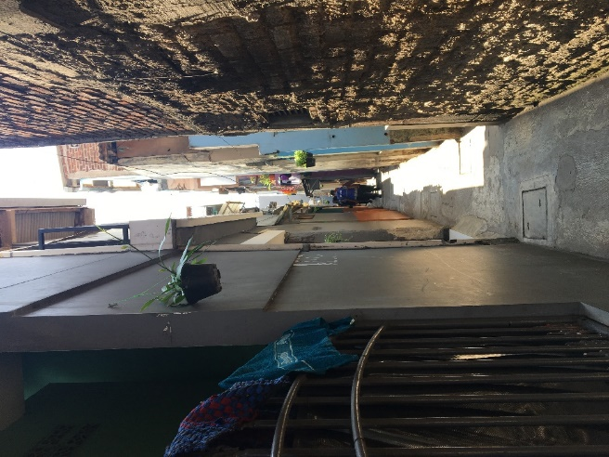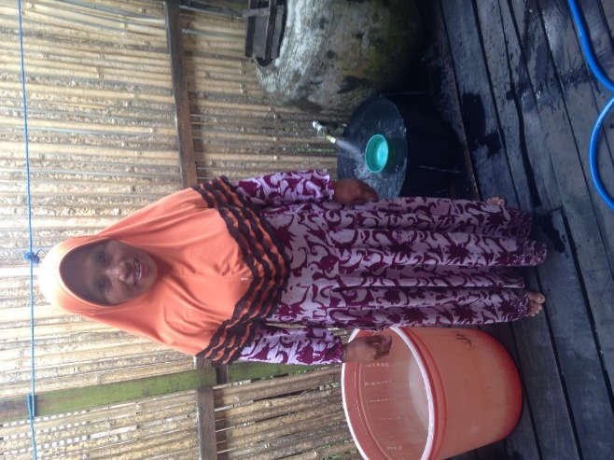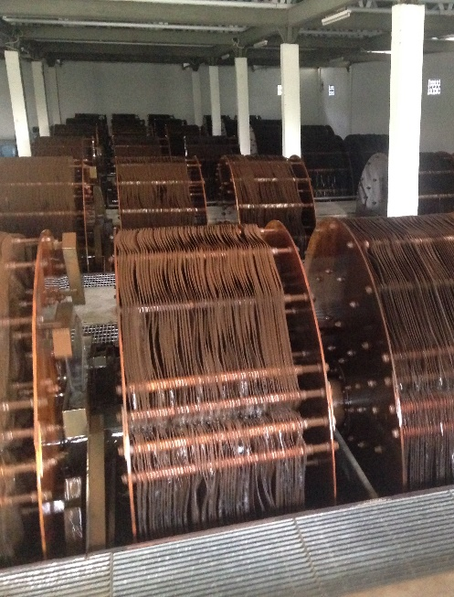

December 2017

Document: | Independent Review
Version: | 2.1 Final
Initiative: | Water and Sanitation Hibah
Donor: | Australian Department of Foreign Affairs and Trade (DFAT)
Implementers: | Indonesia Infrastructure Facility (IndII) to 2016,  Kemitraan Indonesia Australia untuk Infrastruktur (KIAT) from 2017
Evaluators: | Juliet Willetts  Marcus Howard  Jan Edwards  Nikhilesh Bhattacharyya
Date: | 14 December 2017

This document is the property of DFAT.
It is permissible to copy and use any of the material in this report provided that the source is appropriately acknowledged. Further information is available from:
Widya Setyowati
Unit Manager, Infrastructure (Development Cooperation), DFAT Australian Embassy Jakarta
Email: Widya.Setyowati@dfat.gov.au
Tel: +62 21 2922 6859

© DFAT 2017

Aid Activity Summary

Aid Activity Name | Water and Sanitation Hibah – Phase 2
Commencement date | June 2012 | Completion date | Water: Dec 2016  Sanitation: Dec 2019
Total Australian $ | $85m
Total other $ | USAID: US$10m
Delivery organisation(s) | Indonesia Infrastructure Facility (IndII) to 2016  Kemitraan Indonesia Australia untuk Infrastruktur (KIAT) from 2017
Country/Region | Indonesia
Primary Sector | Water and Sanitation Infrastructure

Author AND TEAM Details
Professor Juliet Willetts (Institute for Sustainable Futures, University of Technology Sydney) is a consultant and researcher in the areas of monitoring and evaluation; water, sanitation and hygiene; gender equality and development effectiveness. Juliet.Willetts@uts.edu.au
Marcus Howard is Senior Infrastructure Specialist – Water in the Department of Foreign Affairs and Trade (DFAT) Marcus.Howard@dfat.gov.au
Other evaluation team members and Government of Indonesia participating partners:
Jan Edwards is Deputy Director, Gender Equality, Social Inclusion and Civil Society Engagement, KIAT
Nikhilesh Bhattacharyya is Second Secretary, Economic Governance, DFAT, Australian Embassy Jakarta
Aisyah Nasution and Tyo Pramadana (Bappenas) and Chandra Situmorang and Catur Elkana (Central Project Management Unit, Directorate General Housing and Settlements)

Acknowledgements
The review team would like to thank Widya Setyowati for managing and supporting this review, as well as Nura Ghaeni and Prisca Seridanta. The support of Catur Elkana in organising field visits is also gratefully acknowledged. We would also like to acknowledge the cooperation and contributions from Jim Coucouvinis (formerly IndII and currently KIAT Deputy Director Water and Sanitation) and former IndII staff Martinus Warsono and Sumingin Kismoyo. The local governments and respective utilities in Kota Bandung, Kabupaten Garut, Kota Banjarmasin, Kabupaten Kapuas, Kota Surakarta and Kabupaten Boyolali are all thanked for their time and contributions. Finally, and most importantly, the community members, government staff and program staff who generously shared their time and views are thanked for their valuable contributions.

Executive Summary
This document is an independent review of the Water and Sanitation Hibah.
The purpose of the review was to inform Department of Foreign Affairs and Trade (DFAT) and Government of Indonesia (GoI)’s continued implementation of performance-based financing mechanisms to improve water services and effective completion of the Sanitation Hibah. The specific objectives were as follows:
- Water Hibah:
- Assessment of effectiveness and sustainability
- Assessment of replicability at scale, with a view to informing GoI implementation of the approach
- Sanitation Hibah:
- Assessment of implementation progress, enablers and inhibitors
- Assessment of existing and potential approaches to gender
- Assessment of potential approaches to increase commitment and demand
Fieldwork for this evaluation was carried out in the period 2 -11 October 2017 and involved interviews or discussions with more than 200 people; 132 institutional stakeholders (27% female) and 74 beneficiaries (54% female). The evaluation also drew on wider sector literature and undertook document review and analysis.
The Hibah is an initiative of the Australian aid program of the DFAT, implemented in partnership with the Indonesian Ministry of National Development and Planning (Bappenas), Ministry of Public Works and Housing and Ministry of Finance across approximately 124 district governments (Water Hibah) and 4 district governments (Sanitation Hibah). DFAT provided technical assistance through the Indonesia Infrastructure Facility (IndII).
The review findings are summarised below against each of the evaluation questions.
Water Hibah
Assessment of effectiveness and sustainability: Overall, this evaluation judged that the Hibah was ‘good’ (5/6 - satisfied merit criteria in almost all areas). The key strengths were the policy influence, strong participation of local governments, and achievement of a significant increase in access to services (250,000 households). Whilst overall, the roles of all GoI partners at national and local levels were functional, several areas for improvements were identified, and typical challenges faced at local level help explain why targets to date have been only about 85% achieved. Increased local government investment directly leveraged through their participation was observed, and Hibah participants tended to already have higher rates of increasing coverage than non-participants, though this may represent a selection bias rather than the result of the Hibah. Beneficiary satisfaction with new services was high in all locations visited.

This review found that sustainability was ‘good’ (5/6 - satisfied merit criteria in almost all areas). The reasons being the A$369m continued investment in the GoI-led Anggaran Pendapatan dan Biaya Negara (APBN or State Budget) Hibah over five years, the evidence of complementary investment through Anggaran Pendapatan dan Biaya Daerah (APBD or local government budget) in at least some locations, and evidence of improved governance and capacity of Perusahaan Daerah Air Minum (PDAMs or Water Utility Company) at local level. However, lower than expected disbursement of the APBN Hibah points to the need for ongoing refinement of respective roles amongst Ministry of Finance (MoF), Directorate General Housing and Settlements (DGHS), local governments and PDAMs, and there did not currently exist definitive evidence that across Hibah participant local governments were prioritising and sustaining water investments or equity investments in PDAMs beyond those required by the grant.

Assessment of replicability at scale, with a view to informing GoI implementation of the approach: The review judged the replicability to be ‘good’ (5/6 - satisfied merit criteria in almost all areas), as the Hibah was highly replicable. This was due to various characteristics, including the full use of GoI systems and the scale of its implementation to ‘prove’ the approach. There do remain different views concerning the appropriateness of the verification process, and this needs ongoing attention and discussion, both in the context of the APBN Hibah, but also for future performance-based financing approaches that utilise the Hibah grant mechanism. The minor differences in the GoI replication of the Hibah, namely inclusion of a verification audit mechanism by Badan Pengawasan Keuangan dan Pembangunan (BPKP, or Agency for Oversight of Finance and Development) and use of annual rather than multi-year budget appeared to be workable.

Sanitation Hibah
Assessment of implementation progress, enablers and inhibitors: Overall, this review found that progress for the Sanitation Hibah was mixed, but had improved over time. In three of the four locations progress was now on-track or completed which is positive. In only one location were there remaining challenges and delays. In two locations, Bandung and Surakarta, some initial barriers had been overcome, implementation was working well and there was appetite to use the remaining (or even additional) funds to expand connections.

Enablers and inhibitors varied between locations. In Bandung, progress was enabled by free connections and strong partnership with the health agency in behaviour change communication. In Surakarta visible environmental benefits and reduced odour was recognised, and strong leadership and commitment had secured good progress. In Banjarmasin, significant challenges were met in lack of community interest or acceptance to connect, due to the flat terrain, and due to an ineffective tariff structure and patchy sewerage coverage that limited the possible benefits. Improved M&E and other strategies discussed below will likely be required to ensure ongoing progress in Banjarmasin.

Various political economy factors had also influenced progress and uptake of the Sanitation Hibah. These were typical of sanitation programs globally, so should not be considered unique to this program or to Indonesia, or be assumed to be a necessarily a negative reflection on the program itself. These included lower prioritisation of sanitation at both national and local levels (as compared to water) and institutional fragmentation (in this case concerning limited involvement of the wastewater directorate in Cipta Karya). Local level budget allocations for sanitation were low and there existed a potentially unrealistic expectation that sanitation services be a for-profit enterprise, which reduced their focus as an essential public service.

There were mixed responses about the potential for scale-up of the concept to other cities. This should be interrogated further and a closer assessment made of the realistic potential to extend or replicate the Sanitation Hibah in the same or other locations with idle wastewater treatment capacity. The program concept remains worthwhile, in its innovative approach to incentivising optimisation of use of existing infrastructure, but has been shown to require conducive city contexts (in terms of political will and community demand) to be successful.

A longer-term question raised by this evaluation is how the Sanitation Hibah (or a revision thereof that still uses performance-based financing) can operate in a more strategic way, given the breadth of sanitation sector governance challenges that need to be addressed at city-level. There appeared to be deficiencies in its narrow design focus (replicating the Water Hibah) that do not match the complexity of the sanitation sector. Complementary technical assistance is likely needed to address the broader governance challenges that surface, as is building in other measureable outcomes attached to payments to incentivise required governance changes.

Assessment of existing and potential approaches to gender: This review found that there was significant room for improvement in how women (and other disadvantaged groups) were engaged in socialisation and consultation. The review documented a number of positive and negative gender outcomes, pointing to the need for greater attention to this area. Analysis of current engagement processes demonstrated that in none of the locations was there a clear strategy to integrate gender and inclusion in socialisation or consultation, and in all locations there was limited attention to, or understanding of people living with a disability (PLWD) or their needs. Potential strategies were suggested that could improve both program effectiveness as well as enable explicit intentional gender outcomes. These included: identifying and communicating the key gender issues; upskilling PDAM/PDPAL community engagement staff or promoting appropriate partnerships; facilitating formal involvement of Women’s empowerment movement (Pembinaan Kesejahteraan Keluarga- PKK) or other local civil society groups; explicitly planning for and monitoring gender outcomes through M&E; improving local regulations for involvement of women in consultation and planning; involving groups that represent diverse voices of women, especially those that are disadvantaged, and other marginalised groups. In the short-term, more formally involving women’s groups in consultation and building gender into M&E are recommended.
Assessment of potential approaches to increase commitment and demand: Commitment and demand varied across locations. This review found that a range of approaches that have been developed and used elsewhere to support urban sanitation could be applicable and useful to increase political will and community demand. Applicable approaches to increase political will included: tapping local drivers, particularly environmental amenity; use of rewards and recognition; benchmarking performance; evidence-based advocacy drawing on local evidence, Shit-Flow-Diagrams, water quality data, economic cost data and links to stunting; cross-city engagement; and media and social media campaigns. Key approaches to increase community demand included building from Sanitasi Total Berbasis Masyarakat (STBM- community-based total sanitation) behaviour change approaches, and mobilising and supporting the Pokja sanitasi, to promote cross-sectoral engagement, amongst others.

Consolidated lessons and recommendations
As the Water Hibah is completed, and Sanitation Hibah is ongoing, below we provide key messages and lessons only for the Water Hibah, and key recommendations for the Sanitation Hibah.

Key messages and lessons concerning the Water Hibah

- The Water Hibah’s clear design to meet a gap to increase services for low-income households and trial a performance-based financing approach has worked well and resulted in strong participation of local governments and demonstration that the Hibah grant mechanism ‘works’. It is now widely viewed as more effective than other intergovernmental transfers for achieving results, and as a consequence, is being taken up inother sectors by GoI (septic tanks, roads etc.) and for upcoming urban water programming by GoI and World Bank
- Strategic level monitoring could have been improved and the program objective to increase LG investment in water services was only partially met. The required metrics and methods to judge the latter had not been set and operationalised. This has potentially resulted in a missed opportunity to support learning from the program. There remains continued opportunity to monitor and analyse patterns in local government and PDAM performance and investment to refine the mechanism and identify levers to increase program effectiveness.
- Socialisation processes and attention to gender and inclusion could have been improved, however in general the impacts on beneficiaries documented to date are positive. The pro-poor targeting could usefully be refined in the future to align with use of the unified database, as electricity becomes a less appropriate measure to identify poor households.
- Both the DFAT-funded Hibah and APBN Hibah have demonstrated slower than predicted disbursement. Whilst this is partially accounted for by the ‘learning curve’ of all parties in using the mechanism, there is an on-going need to review and improve the respective roles, timing, communications and mutual expectations of MoF, DGHS, LGs and PDAMs. As part of this, it may important to consider the role and placement of the Central Project Management Unit (CPMU) in DGHS (within technical sectoral areas or outside of them), to ensure appropriate technical input is provided, given minor concerns raised in the technical quality of construction in some locations and that the technical sectoral areas are currently not formally involved in the verification process.
- The investment in PDAMs (through local government equity investment) to use idle capacity and increase tertiary network (household connections) was complementary to APBD investment in public works managed capital works and network extensions. It also improved linkages and communication between PDAMs, LGs and parliament as regards the need for, and improvements in, water services. It also has achieved improvements in governance and capacity in water service delivery at local level.
- The high replicability of the mechanism was achieved through several factors. These include: full use of GoI public finance mechanisms; demonstrated success at sufficient scale across diverse geographical locations; clear technical guidelines; alignment to a national (and global) policy mandate 100-0-100; visibility of the outputs, including for political purposes at local level; and available technical capacity (within PDAMs, CPMU and MoF) for implementation
- There were mixed views about the appropriateness of the verification process established by DFAT and replicated in the APBN Hibah in terms of its complexity and cost-effectiveness. It will be important to review this verification process (suggested for 2018-19) and consider alternatives that could simplify the process whilst maintaining the required rigour and transparency
- Key lessons from Water Hibah for design of an envisaged outcome-focused Hibah to be piloted by KIAT are:
- requirement for simplicity of implementation to enable clear mutual understanding of expectations by stakeholders involved;
- importance of ‘predictability’ of time and human and financial resources required to meet a particular performance measure;
- piloting robust scalable verification approaches;
- ensure targeting of the poor and disadvantaged using standardised approaches (eg Unified Database Measure );
- include a robust approach to addressing gender
- importance of well-conceived strategic approaches to monitoring and evaluation

Recommendations concerning the Sanitation Hibah

- DFAT/KIAT should improve the M&E system to capture and address challenges faced in real-time, allocating sufficient responsive resources to assist in addressing context-specific challenges (technical and institutional support, advocacy and socialisation activities as required). This should include facilitating regular DFAT/Bappenas joint monitoring, ensuring monitoring against strategic objectives, and improving the methodological approach and analysis of the baseline-endline surveys.
- Optimise GoI roles going forward, including greater involvement of DGHS PPLP directorate in implementation (through potentially shifting the CPMU to PPLP) and consideration of an increased role for MoHA that leverages their position in relation to local governments.
- DFAT and GoI to take actions to improve sustainability of the Sanitation Hibah, including to review potential (or not) for its extension to conducive contexts by either GoI or with DFAT support. This should comprise undertaking an assessment of all cities with idle wastewater treatment capacity to understand if there are cities with both strong political will and strong community demand where it could be implemented in its current form (or with some minor additional community engagement) and/or consider extension in any of the current participating cities that have additional demand.
- DFAT in consultation with GoI should implement short-term efforts to address the poor integration of gender equality and inclusion into the Sanitation Hibah, in ways that are complementary to chosen approaches to improving community socialisation, and including monitoring of gender outcomes in the revised M&E system.
- In the short-term, DFAT/KIAT should use improved M&E system to identify issues (see Recommendation 1) and building from this, as relevant, adopt targeted strategies to increase political will and increase community demand and improve the program socialisation approach, following the recommended options presented in this report, and including attention to gender and PLWD in such approaches.
- In the longer term, GoI and DFAT should take on board the lessons arising from the Sanitation Hibah and the breadth of required sanitation sector governance reforms into the design of future performance-based financing programs towards achieving 100-0-100 and SDG targets. This includes how to use performance-based financing to incentivise local level regulatory and tariff reform, ways to revise and evolve the program design so in future it can reach a greater breadth of cities, and concurrently taking steps to address national regulatory reforms.
- DFAT and Bappenas should support efforts towards greater coordination of development partners in sanitation through the Sanitation Donor Working Group, given the scale of the issues to be addressed in the sanitation sector and the ambitions of the 100-0-100 and SDG targets.

Table of Contents
Aid Activity Summary ii
Author and Team Details ii
Acknowledgements ii
Executive Summary iii
Table of Contents viii
Table of Figures viii
List of Acronyms ix

1. Introduction 1
1.1 Document purpose 1
1.2 Background 1
1.3 Design overview 1
1.4 Review purpose and objectives 2
2. Methodology 3
2.1 Methods 3
2.2 Limitations 4
3. Findings 5
3.1 Effectiveness of the Water Hibah 5
3.2 Sustainability of the Water Hibah 11
3.3 Replicability of the Water Hibah 14
3.4 Implementation progress, enablers and inhibitors of Sanitation Hibah 17
3.5 Gender in the Sanitation Hibah 23
3.6 Approaches to increase commitment to and demand for sanitation services 26

Appendix A: Evaluation Terms of Reference AI
Appendix B: Stakeholders consulted BI
Appendix C: Question guide CI
Appendix D: Site location findings DI
Appendix E: Gender in the Water Hibah E1

Table of Figures
Figure 1: Evaluation approaches for each corresponding evaluation focus 3
Figure 2: Review process 4
Figure 3: Water Hibah progress and achievements 7
Figure 4: Hibah progress and explanations 7
Figure 5: Annual growth rate in household connections across regions 11
Figure 6: Spending on the APBN Water Hibah 2015-2019 13
Figure 7: Insecure piping crossing waterway 15
Figure 8: Verification costs for the Water Hibah 17
Figure 9: Progress and key enablers and reasons for delays for Sanitation Hibah 20
Figure 10: Detailed factors affecting progress of the Sanitation Hibah 22
Figure 11: Approaches to increase political will for sanitation 29
Figure 12: Methods to increase community demand for services 31

List of Acronyms
APBD | Local government budget (Anggaran Pendapatan dan Belanja Daerah)
AKKOPSI | Alliance of Cities and Districts Concerned about Sanitation (Aliansi Kabupaten/Kota Peduli Sanitasi)
APBN | National Government budget (Anggaran Pendapatan dan Belanja Nasional)
Bappeda | Local Government Development Planning Agency (Badan Perencanaan Pembangunan Daerah)
Bappenas | National Development Planning Agency (Badan Perencanaan Pembangunan Nasional)
BPS | Statistics agency
BPKP | Non-ministerial government agency responsible for internal financial and development oversight reporting directly to the President (Badan Pengawasan Keuangan dan Pembangunan)
BPPSPAM | Agency for Improving the Implementation of Water Supply System directly responsible to Ministry of Public Works and Housing (Badan Peningkatan Penyelenggaraan Sistem Penyediaan Air Minum)
Bupati | Regent (head of regency/kabupaten)
CBO | Community-Based Organisation
DGHS | Directorate General of Human Settlements at Ministry of Public Works and Housing (Direktorat Jendral Cipta Karya)
CPMU | Central Project Management Unit (for Hibah)
DFID | Department for International Development, UK
DAK | Special allocation fund (Dana Alokasi Khusus)
DFAT | Department of Foreign Affairs and Trade
DGHS | Directorate General of Human Settlements
DPO | Disabled people’s organisation
FGD | Focus Group Discussion
GoA | Government of Australia
GoI | Government of Indonesia
Hibah | Grant
IDR | Indonesian Rupiah
IndII | Indonesia Infrastructure Facility
Inpres | GoI Presidential Instruction
IPAL | Wastewater Treatment Plant (Instalasi Pengelolaan Air Limbah)
ISF | Institute for Sustainable Futures
IU WASH | Indonesia Urban Water, Sanitation and Hygiene Program
Kabupaten | Regency
Kelurahan | An equivalent of a village (within a city)
KIAT | Kemitraan Indonesia Australia untuk Infrastruktur
KII | Key Informant Interviews
Kota | City
LG | Local government at city/regency level (kota/kabupaten level)
MBR | Masyarakat Berpenghasilan Rendah (Low-income community)
M&E | Monitoring & Evaluation
MoHA | Ministry of Home Affairs
MoF | Ministry of Finance
MoPWH | Ministry of Public Works and Housing
NUWAS | National Urban Water supply Program
O&M | Operation & Maintenance
ODF | Open Defecation-Free
PD-PAL | Local Government Wastewater Management Enterprise (Perusahaan Daerah Pengelolaan Air Limbah)
PDAM | Local Government Drinking Water Enterprise (Perusahaan Daerah Air Minum)
Perpres | Presidential decree
Perda | Local Government Regulation/Decree (Peraturan Daerah)
PERPAMSI | Association of Water Utility companies in Indonesia (Persatuan Perusahaan Air Minum Seluruh Indonesia)
PKK | Women Empowerment movement (Pembinaan Kesejahteraan Keluarga)
PLWD | People living with a disability
PMD | Village and Community Empowerment (Pemberdayaan Masyarakat Desa)
Pokja sanitasi | Working Group (Kelompok Kerja) for sanitation
PPLP | Environmental Sanitation directorate within Directorate General Housing and Settlements
PPSP | Accelerated Development of Urban Sanitation (Percepatan Pembangunan Sanitasi Perkotaan)
KemenPUPR | Ministry of Public Works and Housing (Kementrian Pekerjaan Umum dan Perumahan Rakyat)
Puskesmas | Community Health Centre (Pusat Kesehatan Masyarakat)
RPJMN | National Medium Term Development Plan (Rencana Pembangunan Jangka Menengah Nasional)
RPJMD | Local Government Medium-Term Development Plan (Rencana Pembangunan Jangka Menengah Daerah)
RT/RW | Community units
SAIIG | Australia-Indonesia Infrastructure Grants for Municipal Sanitation Programme
Sanimas | Community-Based Sanitation (Sanitasi Berbasis Masyarakat)
SDG | Sustainable Development Goals
Sekda | Regional Secretary (Sekretaris Daerah)
SKPD | Local Government Work Unit (Satuan Kerja Perangkat Daerah)
SPPH | Grant agreement letter (Surat Persetujuan Penerusan Hibah)
SSK | City Sanitation Strategy (Strategi Sanitasi Kota/Kabupaten)
STBM | Community-Based Total Sanitation (Sanitasi Total Berbasis Masyarakat)
STEEP | Social, technical, economic, environmental, political factors
UPTD | Local Government Technical Implementation Unit (Unit Pelaksana Teknis Daerah)
USAID | US Government Aid Agency

- Introduction
  - Document purpose
This document is a review of the Water and Sanitation Hibah programs, which provided piped water and sewerage connections to low-income households through an output-based grants mechanism.
Fieldwork for this evaluation was carried out from 2 - 11 October 2017 and involved interviews or discussions with 36 national stakeholders (78% men, 22% women), 96 local institutional stakeholders (72% men, 28% women) and 74 beneficiaries (46% men, 54% women). The evaluation also drew on sector literature and undertook document review and analysis. A list of stakeholders consulted is provided in Appendix B.
  - Background
Access to water and sanitation in Indonesia remain important areas in need of attention. The baseline report for the Sustainable Development Goals (SDGs) in 2015 indicates that only 33% of the urban population have piped water access on the premises. In addition, there are only 13 cities in Indonesia that have sewerage systems, serving less than 2% of the urban population, one of the lowest access rates in Asia. Most households use on-site sanitation systems in the form of septic tanks and previous research has found these are often leaching systems, close to domestic water wells and not regularly emptied. Some toilets also discharge directly to drains. The Government of Indonesia (GoI) aims to achieve 100% coverage of improved water and sanitation services by 2019, supported by the priorities of the Medium-Term Development Plan (2015-2019).
Department of Foreign Affairs and Trade (DFAT) has provided support to the Water and Sanitation Hibah since 2009. An independent evaluation of the Hibah in 2011 confirmed its effectiveness and sustainability, and as a result, further investments were made of $85m in a second phase, which started in June 2012. The water component was completed in December 2016, and remaining funds are to be allocated to a new pilot. The pilot involves maintaining a performance-based financing approach, but shifting from an output (household connections) basis of the current Water Hibah to an outcome (improved utility performance) basis. The sanitation component is still underway and is expected to be completed by December 2019.
The Hibah was designed to take advantage of idle capacity in water production and wastewater treatment, and uses the ‘Hibah’ grant mechanism for intergovernmental transfer. It was one of the first large-scale programs to make use of this performance-based mechanism. In the context of decentralisation, it is an important mechanism as it promotes accountable investment towards mutually agreed priorities of central and local government.
In the water and sanitation sector, the mechanism provides a pathway to address the national policy imperative of ‘100-0-100’ by 2019 and the global SDGs of universal access to water and sanitation by 2030. Given the increased ambition of ‘safely managed’ access to services of the SDGs, the Water and Sanitation Hibah is particularly relevant, since it promotes increased access to water ‘’on premises” and it involves safe treatment and disposal of wastewater.
  - Design overview
The Hibah was implemented through the Indonesia Infrastructure Facility (IndII) by SMEC—a managing contractor—in partnership with the Indonesian Ministry of National Development and Planning (Bappenas), Ministry of Public Works and Housing (MoPWH) and Ministry of Finance (MoF) across approximately 124 district governments (Water Hibah) and 4 district governments (Sanitation Hibah).
The Water and Sanitation Hibah is an output-based approach for central government to make financial transfers to local governments and to increase local government investment in water and/or sanitation utilities (PDAMs/PDPALs) to increase the number of urban poor households with access to piped water and off-site sewerage.
The Water Hibah has the following development objectives:
- Increase local government investment in water infrastructure towards meeting the GoI and Millenium Development Goal (MDG) water service targets.
- Improve governance of the water sector at LG by increasing the accountability of LG to adhere to an agreed water investment program and to a level of incremental improvements to services.
The Sanitation Hibah has the following development objectives:
- Increase LG investment in sanitation infrastructure towards meeting the GoI and MDG sanitation service targets. Specifically, to provide access to sewerage and on site sanitation to an additional 7,000 poor and low income households (in addition to the 2,500 achieved during phase 1)
- Improve governance of the sanitation sector at LG by increasing the accountability of LG to adhere to an agreed sanitation investment program and to a level of incremental improvements to sanitation services
The Water Hibah program approach was mainstreamed into centre-regional fiscal transfer arrangements using $1 billion in APBN (GoI) funds from 2015-2019. DFAT has supported GoI with preparation and implementation of its Hibah program including strategic advice to Bappenas and PU to modify the program to suit Indonesia's context to increase cost efficiency and manage risks.
  - Review purpose and objectives
The purpose of the review was to inform DFAT and GoI’s continued implementation of performance-based financing mechanisms to improve water and sanitation services. The Terms of Reference (ToR) for the evaluation (see Appendix A) defined the primary purpose of the evaluation of Water Hibah as a final ‘assessment of achievements and lessons learnt’ and for the Sanitation Hibah as ‘program improvement’—to inform implementation scheduled to continue until December 2019.
The specific objectives were as follows:
- Water Hibah:
- Assessment of effectiveness and sustainability
- Assessment of replicability at scale, with a view to informing GoI implementation
- Sanitation Hibah:
- Assessment of implementation progress, enablers and inhibitors
- Assessment of existing and potential approaches to gender
- Assessment of potential approaches to increase commitment and demand
Expected primary users of the evaluation report were:
- DFAT infrastructure team in Indonesia to inform decisions about implementation of Sanitation Hibah and proposed outcome-based pilot with PDAMs;
- GoI partners, particularly the Bappenas, Ministry of Public Works and Ministry of Finance in implementation of the Hibah through APBN; and
- KIAT in the continued implementation of the program.
- Methodology
The evaluation was conducted during October 2017. The team adopted a collaborative, ‘utilisation focussed approach’. The broad methodology was qualitative and ‘agile’, using new insights to progressively refine evaluation questioning. Where relevant, sector literature was consulted to inform development approaches. The approach for each evaluation focus is presented in Figure 1.
Evaluation focus | Approach
Water Hibah
Assessment of effectiveness and sustainability | Secondary data triangulated with stakeholder perspectives and evidence from field visits informed assessment of achievement of outputs and outcomes and sustaining benefits. Merit criteria (based on evaluation questions) used to judge the investment.
Assessment of replicability at scale, with a view to informing GoI implementation of the Hibah | Replicability at scale considered national and local stakeholder lessons arising from implementation of the performance-based approach, with particular attention to the verification process.
Sanitation Hibah
Assessment of implementation progress, enablers and inhibitors | Implementation progress was assessed against plans, identifying enablers and inhibitors using STEEP framework (social, technical, economic, environmental, political factors) and how drivers and incentives shaped stakeholder attitudes and roles.
Assessment of existing and potential approaches to gender | Existing and potential approaches to gender were assessed with reference to practical and strategic gender outcomes, including consideration of voice and decision-making at household, community and institutional levels.
Assessment of potential approaches to increase commitment and demand | Successful mechanisms used elsewhere to (i) increase political will and (ii) increase community demand for sanitation services, were tested with stakeholder groups and their applicability considered against identified enablers and inhibitors of progress.
Figure 1: Evaluation approaches for each corresponding evaluation focus
  - Methods
The review involved a range of primarily qualitative research methods and six fieldwork locations:
- Document reviews: a comprehensive review of key documents produced by the program and relevant sector literature identifed key issues for further investigation in the field
- Key informant interviews (KII): purposively selected informed individuals provided the backbone of the fieldwork since these interviews enabled probing and triangulation of stakeholder issues and perspectives concerning the program.
- Stakeholder mapping and power analysis: enabled the evaluation team to have an informed understanding of the positioning, alignment, power and influence of relevant stakeholders
- Targeted analysis of secondary data: including program reporting information and secondary data on gendered impacts informed specific review questions
- Focus group discussions (FGD): FGDs with beneficiaries and with LG/PDAM staff enabled the evaluation team to rapidly develop a sense of the diversity of views about the program, and also supported exchange of views between different stakeholder groups.
- Observation: general observations during the fieldwork was used to confirm or challenge preliminary conclusions arising from the other methods; for example, the interactions and relationships between classes of stakeholder, professionalism of implementation etc.
Gender was mainstreamed in the evaluation by: providing and reporting on a gender balanced sample of respondents; ensuring that women’s and men’s voices were heard through appropriate arrangements such as separate meetings; and using a relevant conceptual framework to identify intended and unintended gender outcomes from program implementation.

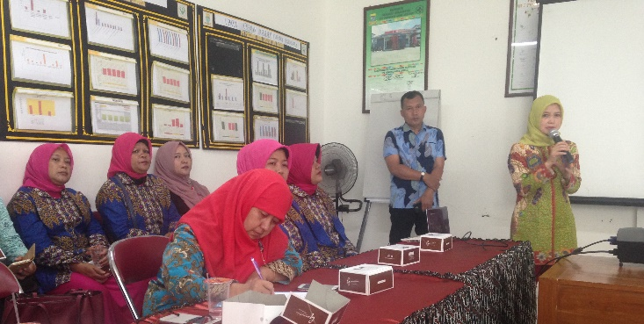 | 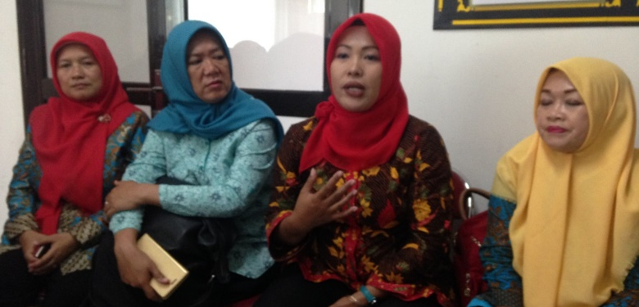
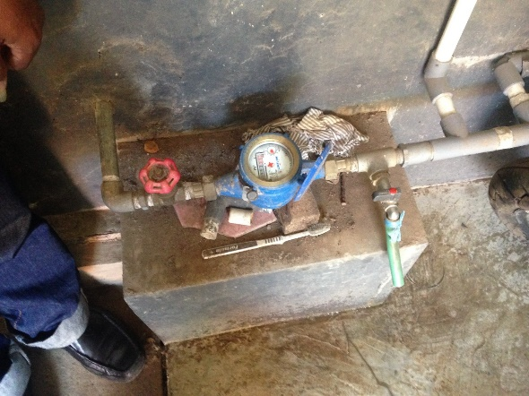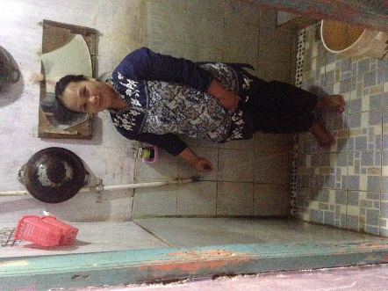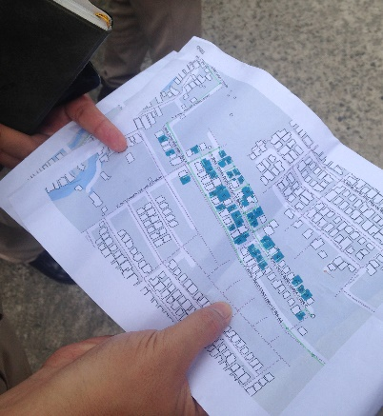
Figure 2: Review process. Top left to right- Presentation by Kota Bandung PDAM Head of Wastewater division, Women at focus group discussion in Antapani. Below left to right: Water meter in Kabupaten Garut, female beneficiary in Garut and map of household sewerage connections in Sungai Andai, Banjarmasin
A question guide (Appendix C) was used in a semi-structured way to triangulate views across program stakeholders, and to ensure consistency of approach across the evaluation team. The purposive sample of interviewees considered logistical constraints and selected relatively strong and weak performing districts to examine the spectrum of achievements and a realistic view of challenges. The review sought verbal consent and ensured participants were adequately informed of the review purpose and type of information sought. Throughout this report quotes have been used, with names omitted to preserve privacy. Detailed site location findings are provided in Appendix D.

  - Limitations
The following limitations are important to take into account in considering review findings:
- Time and resources: the rigour of the data gathering and analysis processes for this review was constrained by the time available- eight days were allocated for the fieldwork.
- Access: the program covers a large geographic area, however the evaluation team was only exposed to a limited range of stakeholders/locations. Limitations in available data to inform choices and logistics, meant the three Water Hibah sites were all better performing sites
- Measurement: social changes are multi-faceted and difficult to measure. Systematic analysis of quantitative and qualitative data, including direct quotes, mitigated this limitation.
- Attribution: initiatives such as the Hibah are implemented within ‘open systems’ such that multiple factors contribute to and/or detract from the anticipated changes.
- People living with a disability (PLWD): Direct involvement of PLWD or related groups was beyond the evaluation scope.
- Findings
  - Effectiveness of the Water Hibah
This section addresses the key evaluation question: “How effective was the Water Hibah program in achieving increased LG investment in water services”. Overall, this evaluation judged that the Hibah was ‘good’ (5/6 - satisfied merit criteria in almost all areas). The key strengths were the policy influence, strong participation of local governments, and achievement of a significant increase in access to services (250,000 households). Whilst overall, the roles of all GoI partners at national and local levels were functional, several areas for improvements were identified, and typical challenges faced at local level help explain why targets to date have been only about 85% achieved. Increased local government investment directly leveraged through their participation was observed, and Hibah participants tended to already have higher rates of increasing coverage than non-participants, though this may represent a selection bias rather than the result of the Hibah. Beneficiary satisfaction with new services was high in all three locations visited.
Policy influence
An important starting point when considering effectiveness is to recognise the Hibah from a broad perspective, and how it has shifted perceptions about the potential for the Hibah grant mechanism to drive accountable investment and efficient intergovernmental transfer from central to local level.

Strong messages were heard from all national ministries in support of DFAT’s successful trialling of the Hibah grant mechanism, as well as from sector stakeholders including the World Bank and Indonesian Water utilities association (PERPAMSI). Bappenas felt the program had been effective in demonstrating the mechanism and that “everyone is now eager to do it [use the mechanism]”. ’MoF emphasised its importance as a means to increase accountability of local governments. This contrasts with other financing mechanisms that involve upfront payments that are perceived to be entitlements, whereas:
“This is on the contrary with the Hibah. Local government are not entitled, instead they receive an obligation. Why an obligation? Because it is output-based- if they don’t meet the target they will never receive the funds.” (MoF)
They and other stakeholders also reported on the adoption of the grant mechanism, “Now government of Indonesia has also been triggered to develop our own programs. We replicate water” (MoF). MoPWH also emphasised the importance of the Hibah mechanism at local level: “the Hibah created a new spirit for local government to invest their money to the PDAM”. Finally, the World Bank noted:
“[Water Hibah is] one of the most successful program from the Australian Aid in Indonesia. It’s true that the government [of Indonesia] is good at picking up good ideas. But, there are not many. At the nuts and bolts there is room for improvements. But the big picture is … this is a successful program” (World Bank staff member)

Achievement of outputs
The Water Hibah originally expected to achieve 346,000 household connections in total. At the end of 2016, 250,000 were built through this program. This is an impressive result that reflects the overall effectiveness of the mechanism. However, it is also important to consider that there have been several downward revisions of the targets during Phase 2, each with relevant explanations. The original target set out in the DFA in June 2012 was 346,000 households. This was revised downwards to 324,000 households, and subsequently lowered to approximately 300,000 households, in part due to participation of local governments in the APBN Hibah which started in 2015. Data provided by CPMU during the evaluation noted a final target of 298,000 households. The overall progress is shown in Figure 3.

Figure 3: Water Hibah progress and achievements (Source: IndII/KIAT)
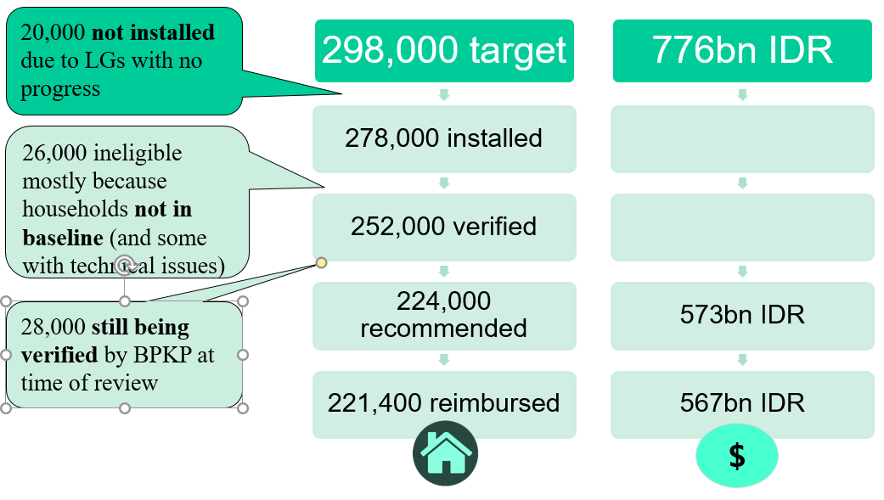
The gap between the target of 298,000 households and 250,000 households is explained by a range of different factors. Each gives some insight into the ongoing areas for improvement in the mechanism and associated processes: namely local government adherence to their commitment, quality of construction and matching of baseline and endline households, and time taken for the BPKP audit process (Figure 4).
Figure 4: Hibah progress and explanations (Source: CMPU and authors)
Local government adherence to commitment: Some local governments made commitments (including receiving the letter from MoF confirming funds were available (SPPH) but subsequently did not make any progress. This contributed to 20,000 expected connections that were not installed, or 7% of target connections. Common reasons included Parliament not passing the equity regulation or lack of availability of financial resources in the PDAM to build the connections.

Baseline-endline alignment and technical issues: 278,000 connections were installed, however only 252,000 connections were verified. This was because some 26,000 of these connections were not in the baseline (or a smaller number had technical issues and therefore did not pass verification). This represented 9% of the 298,000 target connections. When new local governments join the scheme, there was often limited understanding of the importance of adhering to households covered in baseline and poorly managed customer databases. However, there were repeated reports that in subsequent years local governments improved their performance and PDAMs adopted better customer database software.

Verification audit process: At the time of writing this report, only 224,000 connections had been recommended for disbursement (and 221,400 disbursed to date), since BPKP was still auditing the work of the verification consultants. This audit process was introduced in line with the approach used in APBN and due to concerns in the quality of the work of some of the verification consultants contracted by IndII.

Other challenges noted during the site visits that affected either progress in installing connections or ability to claim the agreed reimbursement were as follows:
- Challenges convincing parliament to pass the local regulation to give equity to the PDAM was reported to require significant explanation and MoPWH reported it may be influenced by local politics: “When the head of LG comes from the same party as the majority of local parliamentary members, usually you will see more progress and achievements”.
- Unable to make the full equity payment within the timeframe due to fiscal capacity (e.g. in Garut and Kuala Kapuas), hence although connections were built, not all were reimbursed.
- PDAMs required to prefinance the investment: This issue was reported by many stakeholders, and whether it became a problem for implementation was context dependent as some PDAMs had capacity to do so with minimal issue, and for others it was a burden.
- Households impatient to connect: The time lag between offering and providing a connection means that some households elect to proceed earlier (through regular registration mechanism), however this means such households included in the baseline cannot be included in the verification: “[We face the] constraint of the baseline survey and waiting for the work order. Sometimes the community are not patient. For 2017, we got data in 2016, and they were installed in May 2017- this is a 6-month delay and sometimes causes a problem.”

Implementation quality
In this section we provide a brief overview of performance against the roles laid out for GoI partners and DFAT/IndII in the direct funding agreement of 2012 based on national and local level stakeholder interviews. Overall, all parties have adequately played the agreed roles, and as observed by MoF, the mechanism relies strongly on mutual trust between each agency that the others will play their part.

Bappenas monitoring of program implementation: It was observed that Bappenas had engaged proactively in Phase 1 and analysed the relative effectiveness of the Hibah mechanism as compared with DAK (pointing to a favourable result that it was more effective), and examining patterns of participation and performance against local government fiscal capacity, demonstrating that regions with lower fiscal capacity were performing better. In Phase 2 there did not appear to have been further analysis of this type, however there was interest to examine the situation further.

MoF management of on-granting mechanism: In general MoF’s role was viewed as functional, though comments from other stakeholders indicated that at times there were delays which slowed down the functioning of the system. It appeared that the delays may have stemmed from the division of responsibilities between MoF and DGHS.

Directorate General Housing and Settlements (DGHS) executing agency provision of technical advice, technical and operational guidance and monitoring activity implementation: Most national stakeholders felt that in general DGHS’s role was effective and the DGHS Hibah technical guidelines were described as being clear and robust. However, there were some concerns put forward of negotiations with local governments to participate in other DGHS programs, and that this may lead to delays in the program. It was also observed that rather than setting up a significant number of agreements with local governments upfront, these were staggered over time, which slowed the overall process of disbursement of DFAT funds affecting program performance. It also reduced the opportunity for local governments to plan ahead and also concurrently increase their available water supply capacity. There appeared to be potential for more systematic and strategic monitoring and analysis to be conducted concerning local government participant performance.

Local government implementing agencies: As described above in achievements against outputs, the performance of participating local governments is varied, affected by local politics and local capacity, and over time those that have participated in previous years gradually learn about the approach and are able to more predictably follow through on their commitments. At times local governments reported they were ready for either baseline or verification however in reality they were not, and this has led to some level of wasted resources re-doing these surveys. MoF also reported that many local governments struggle to meet the documentation requirements for grant disbursement.

IndII support implementation, technical assistance, baseline-verification, PDAM assessments and socio-economic surveys: Some national stakeholders believed that IndII’s focus was too technical and did not stay sufficiently focused on the higher-level strategic goals. IndII did during the course of the program address some key strategic issues, including the full allocation of the grant, selection processes for LG/PDAMs and the baseline/verification methodology. There were both positive and negative reports of performance of IndII and IndII consultants, however the positive generally outweighed the negative. On the positive side, IndII was reported to have built capacity of the CPMU, and shared strategies for effective management of the verification process and consultants. The PDAM assessments met challenges due to poor quality data from many PDAMs, and do not appear to have been used for a higher-level strategic purpose. The socio-economic surveys equally appear to be potentially mechanically undertaken and of mixed quality, and perhaps unclear purpose and audience, as they do not appear well-designed for informing implementation, and suffered from gender imbalances amongst survey participants. Their intended use as a tool for measuring success in subsequent evaluations was also unclear.

Evidence of increased local government investment
The development objectives for the Hibah include a focus on increasing local government investment in water services. This area was highly contested in terms of the diversity of stakeholder responses as to whether it had been achieved, and was not comprehensively monitored by IndII, despite plans being in place to do so in the IndII Phase 2 M&E Plan developed in 2012. In this report we discuss local government investment within the context of the Hibah (in terms of matching funds, and relative performance in achieving household connections) in this section on effectiveness. Under sustainability, we discuss further the extent to which the Hibah also mobilised additional funds.

The participation of local governments in the DFAT Hibah program is one form of demonstration of local government investment in increasing services, since the program only provided approximately 40% of the connection cost, though it is the PDAM that commonly pre-finances the connection and pays the remaining gap. IndII reported the average connection to cost approximately 5m IDR and that the grant reimbursed only 2-3m IDR. This already represents a leverage factor of more than 100%.

In terms of the equity investments to PDAMs, analysis conducted during Phase 1 made two tentative conclusions- that the water Hibah had a significant and large impact on equity investments to PDAMs, and that equity investments were positively associated with household water connections since investments made by Hibah participants were significantly more efficient than those for non-Hibah local governments. No similar analysis has been undertaken during Phase 2 to ascertain if this trend has continued, however it could be presumed to be likely, given the model is the same.

Another way to consider local government investment towards improved service coverage is to look at trends in increasing household connections. Available data from the Agency for Improving the Implementation of Water Supply System (BPPSPAM) (up to 2014) demonstrates that Hibah participants had a higher rate of increasing service coverage than non-participants (except for in Eastern Indonesia), and that in general the Hibah connections were additional to already higher rates of increasing access amongst participants (again, except for Eastern Indonesia) to their annual growth rate in connections (see Figure 5). What is not possible to ascertain, is whether there is any causal effect between participating in the Hibah and higher rates of increasing coverage amongst this group, as there is an inherent selection bias. That is, it appears that participants were already more strongly focused on expanding services than non-participants. Without further data and analysis, it is not possible to draw firm conclusions about the importance of the Hibah itself in increasing local government investment (see further discussion of this area under sustainability).

Figure 5: Annual growth rate in household connections across regions (Source: BPSPAM data; IndII)

Impacts on low-income households, women and disadvantaged
This evaluation reviewed documentation on impacts, particularly from a gender perspective, as well as conducted focus group discussions with women and men at three sites. A high level of satisfaction was visible in all locations. Both women and men reported that services are reliable, affordable, and of improved water quality. Our findings also mirrored key documented impacts on the Water Hibah including: access to better quality and cheaper water;improved health; time savings in accessing and treating water; and increased cleanliness and bathing. As one women from Garut reported:
“in the past we often get stomach aches and our clothes were yellow. Now when we’re thirsty we just drink. And our skin is less itchy.”
For women, according to this evaluation and from previous studies, in some cases the practical benefits had flow-on gender outcomes of increased discretionary time, greater energy for work and leisure, and greater privacy to bathe at home, as well as opportunity for employment (ice production and vegetable growing). These qualitative examples contrast with the impact evaluation report of Phase 1 that did not find any statistical effect on health outcomes, school attendance or employment, which may signify that these examples are not necessarily representative.

In general none of the reports identified changes in women’s strategic gender interests (in terms of changed power dynamics at household or community level), which may either be due to their methodology, or due to the limited focus on empowering women in the design of the program. This evaluation indeed confirmed that there had been limited effort to directly involve women in socialisation, which left them somewhat excluded, and reduced in their ability to participate in household decisions about connecting (“[it’s] difficult if you don’t have the information”). Female participants noted the need for explicit effort to involve them and to socialise the program with women and men separately because “then the aspiration of women will be voiced. Otherwise men tend to dominate”. In addition, in all locations there was limited understanding of people living with a disability (PLWD) and their needs, and PDAMs did not have data about them, however acknowledged that this could be possible to collect through community leaders.

One strength of the approach was the targeting of low-income households, which also increased the political imperatives to support the program at local level. However, questions were raised about the use of electricity service to target low-income households, including the current phasing out of the lower rated power connections and related electricity subsidy. Concurrently, through other programming, DFAT have been supporting the development of the unified database to identify the poorest 40% of households for poverty reduction and social assistance programs. This information is available to government ministries and local governments and soon will be updated dynamically, hence could form the basis in the future for targeting in the Water Hibah.
Key messages and lessons
- The Water Hibah’s clear design to meet a gap to increase services for low-income households and trial a performance-based financing approach has worked well and resulted in strong participation of local governments and demonstration that the Hibah grant mechanism ‘works’. It is now widely viewed as more effective than other intergovernmental transfers, and as a result, is being taken up in other sectors by GoI (septic tanks, roads etc.) and for upcoming urban water programming by GoI and World Bank
- Strategic level monitoring could have been improved and the program objective to increase LG investment in water services was only partially met. The required metrics and methods to judge the latter had not been set and operationalised. This has potentially resulted in a missed opportunity to support learning from the program. There remains continued opportunity to monitor and analyse patterns in local government and PDAM performance and investment to refine the mechanism and identify levers to increase program effectiveness.
- Socialisation processes and attention to gender and inclusion could have been improved, however in general the impacts on beneficiaries documented to date are positive. The pro-poor targeting could usefully be refined in the future to align with use of the unified database, as electricity becomes a less appropriate measure to identify poor households.
  - Sustainability of the Water Hibah

This section addresses the key evaluation question: “To what extent are the outcomes of the Water Hibah program being actively sustained, in terms of continued national and LG investments and on-going service quality?”. Overall, this review found that sustainability was ‘good’ (5/6 - satisfied merit criteria in almost all areas). The reasons being the A$369m continued investment in the GoI-led APBN Hibah over five years, the evidence of complementary investment through APBD in at least some locations, and evidence of improved governance and capacity of PDAMs at local level. However, lower than expected disbursement of the APBN Hibah points to the need for ongoing refinement of respective roles amongst MoF, DGHS, local governments and PDAMs, and there did not exist definitive evidence that across Hibah participants local governments were prioritising and sustaining water investments or equity investments in PDAMs beyond those required by the grant.

Sustained use of the Hibah mechanism and national investment

The uptake of the Hibah mechanism by GoI in the form of the APBN Hibah is a strong sign of sustainability and continued investment by national government. The agreed investment up until 2019 totals A$369m, which is 4.6 times the original investment made by DFAT (see Figure 6). There were some concerns voiced, however that the current level of expenditure and disbursement of the grants needs to be improved. In essence, good predictability amongst all parties of the funds that are to able to be spent, is an important aspect of an effective preformance-based financing system. In this case it appears that the various implementation issues and delays described earlier under ‘effectiveness’ contribute to reduced expenditure, and hence the imperative to refine those roles and in particular, to ensure that local governments and PDAMs are able to reliably predict their achievements. MoF in particular voiced concern, noting that:

“Before we develop it further we need to develop the institutions, we need to provide assurance there will not be obstacles. I would prefer that the [funding allocation to the] Hibah is not too big, and not too small. We need to maintain credibility of the mechanism, that it is robust and can be replicated”.

Year | Allocated (APBN) AUD | Allocated (APBN) IDR | Expended (IDR) | Expended (%)
2015 | 48m | 500,000,000,000 | 309,878,000,000 | 62%
2016 | 77m | 800,000,000,000 | 466,410,082,000 | 58%
2017 | 82m | 850,000,000,000 | -
2018 | 77m | 800,000,000,000 | -
2019 | 86m | 890,000,000,000 | -
Total | 369m | 3,840,000,000,000
Figure 6: Spending on the APBN Water Hibah 2015-2019
Sustained local government investment in water services
A large proportion of local governments that participated in the DFAT-funded Hibah have continued to participate in the APBN Hibah, which is another sign of strong sustainability. Of the 138 local governments participating in the DFAT and USAID funded Hibahs, 97 have continued to participate in either APBN 2015 or APBN 2016 or both, which represents 70% of local governments.

In terms of ongoing local government investment in water services by local governments, as described earlier under ‘effectiveness’, data has not been systematically collected to support this analysis. It is therefore not possible to determine whether local government investments in water services are being prioritised and sustained. A range of possible analyses could be undertaken in the future, and should be selected on the basis to enable strongest learning about the dynamics of local government investment in water services; they include examining APBD budgets, equity allocations, increasing household connection rates and PDAM capital investments (of Hibah participants and non-participants and/or time series data to consider before and after participating in the Hibah).

In the absence of factual data to answer this question, it is also useful to document the varied stakeholder views. Bappenas were unconvinced that local government investment had increased, and reported their observation that the reimbursement of the Hibah was directed to other sectors rather than reinvested in the water sector. MoF reported that they consider that the Hibah had encouraged local governments to invest in their PDAM, whether they had debts or not, and the expectation that this would lead to other investments. DGHS noted the challenges of local governments allocated the necessary equity, due to insufficient APBD allocation, and that there were only a few known cases where equity was allocated above and beyond that expected by the grant. In addition, the attempt through the re-design fo the Hibah in 2013 to incentivise PDAMs borrowing (through Perpres 29 or other means), demonstrated that there was not yet appetite for this amongst local governments and PDAMs. PERPAMSI have a global perspective of PDAMs and noted that there was high variability in terms of whether PDAMs were increasing their production capacity or not and that changes in local government leadership meant that on-going support through equity to PDAM couldn’t be assumed.

The field visits provided positive evidence that at least some local governments and PDAMs were prioritising investment in sustaining and expanding services, however it should be noted that those visited were higher performers. In both Boyolali and Kapuas, there appeared to be coordinated investment between public works (in networks and new supply) through APBD and the Hibah grants to support PDAMs in tertiary networks and household connections:
“we coordinate using the masterplan and use APBD for expanding the network and distribution installed by public works, and match this with Hibah household connections by the PDAM” (Kapuas)
This scenario combats concerns voiced by a number of stakeholders that idle capacity limitations would be met and reduce the relevance of the APBN Hibah, since if local governments continue to plan new investments in supply, there is opportunity, ongoing, to continue to support household connections through the Hibah.

Field visits also, however, confirmed the challenges in allocating equity (Garut and Kapuas) and the poor likelihood that any additional equity beyond that required by the grant mechanism would be allocated, though in Boyolali there was no issue in allocating the equity payment. In Kapuas the current regulation (until 2019) also fixes the equity payment at a certain level and although interested, they cannot increase the level of their participation (e.g upwards from 1000 households annually):
“The 1000 households is locked in to the Perda for 2016-2019, but after that yes, we plan to revise the Perda. It is a challenging discussion. I think it’s their understanding, but we have to reassure them – they want to have confidence, surety.”
Sustainability of service delivery
Sustainability of the service supplied through new household connections relies on improving governance and capacity to support ongoing service delivery. The evaluation therefore sought evidence to understand if and how PDAM performance and management had improved levels of customer satisfaction with the ongoing quality of service. The evidence provided below is positive, however it should be placed in the context that the PDAM visited were higher performers, and hence not representative. PERPAMSI noted the large variability in PDAM performance across the country, in terms of financial management, implementation of cost-recovery tariffs and attention to asset management, and hence it could be expected that in some Hibah locations, PDAMs will likely experience challenges in sustaining quality services to the household connections made. It was also reported that in the aim to increase connections, in some locations water pressure has dropped. These will be important aspects to monitor into the future. Equally, in the future it will also be important to consider the implementation of recent MOHA regulations concerning the cost-recovery tariff and the imperative for local governments to meet any gap if tariffs are below this level.

In all three locations improvements had been made in governance and capacity, including as a result of participating in the Hibah. In Garut the Bupati reported restructuring the PDAM, new online payment systems and customer databases and efforts to address non-revenue water though new meter installation. In Kuala Kapuas, the PDAM performance has improved since participating in the Hibah- it was categorised as ‘sick’ and then ‘not healthy’ in 2012, but is now deemed healthy. The PDAM remains unprofitable however, due to the high cost of providing services in a semi-rural area and the low tariffs due to affordability. The Hibah verification process appeared to have instigated improvements in the customer database management, and non-revenue water was reduced from 36% to 28%. The regional Finance Ministry official did not view unprofitability of the PDAM as problematic, given it needed to service poor households in remote and arid areas. In Boyolali, the PDAM stated that in line with their increase customers from 10,000 to 50,000, they had increased O&M budgets and employed staff to work in the new service areas on maintenance, meter reading and customer billing. There was a greater focus on service delivery, and customer satisfaction is now an important indicator of sustainability.

One concern raised in Kuala Kapuas was the technical standards of the system built and possible implications for sustainability. At the site visited, PVC pipes (used because nearby water was corrosive) were not properly secured in multiple crossings of a small local waterway (see Figure 7). This pointed to the issue that the Hibah PMM Guidelines, in their effort to remain simple, only include technical verification of the water meter itself, rather than the overall piped system. Lower technical standards compromise the potential sustainability of the connections made and hence this issue would benefit from attention by DGHS. It also points to concerns raised by stakeholders about the absence of sufficient dedicated role for the DGHS water directorate. | 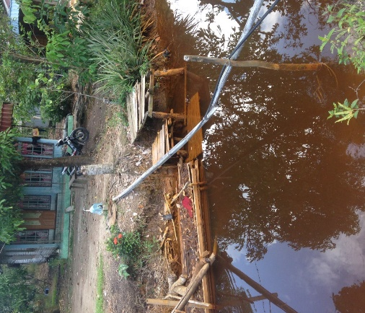  Figure 7: Insecure piping crossing waterway
Community satisfaction with connections to date was high and bodes well for sustainability. In Garut, both women and men described their ongoing need for the service since alternative sources were of much lower water quality, its ongoing affordability, the high service quality and their strong satisfaction with the service. In Kuala Kapuas, similarly, community members confirmed their ability to afford their bills and appreciated the high quality of the service. Their service was 12 hours per day, from 6am-6pm, and only stopped due to cleaning of the tank. In Boyolali, results were also positive; community members participating in FGDs stated that the water connection was reliable, provided good quality water at adequate pressure. The men’s FGD reported that the PDAM was responsive. Some affordability concerns were raised by women, who noted that their water bill was twice their electricity bill and “what we pay is too high” but that “after having the PDAM life was much easier”.

Key messages and lessons
- Both the DFAT-funded Hibah and APBN Hibah have demonstrated slower than predicted disbursement. Whilst this is partially accounted for by the ‘learning curve’ of all parties in using the mechanism, there is an on-going need to review and improve the respective roles, timing, communications and mutual expectations of MoF, DGHS, LGs and PDAMs. As part of this, it may important to consider the role and placement of the Central Project Management Unit (CPMU) in DGHS (within technical sectoral areas or outside of them), to ensure appropriate technical input is provided, given minor concerns raised in the technical quality of construction in some locations and that the technical sectoral areas are currently not formally involved in the verification process.
- The investment in PDAMs (through local government equity investment) to use idle capacity and increase tertiary network (household connections) was complementary to APBD investment in public works managed capital works and network extensions. It also improved linkages and communication between PDAMs, LGs and parliament as regards the need for, and improvements in, water services. It also has achieved improvements in governance and capacity in water service delivery at local level
  - Replicability of the Water Hibah

This section addresses the key evaluation question: “: To what extent did the Water Hibah program demonstrate a scalable model and relevant lessons to enable effective replication at scale”. The review judged replicability to be ‘good’ (5/6 - satisfied merit criteria in almost all areas) as it was highly replicable. This was due to various characteristics, including the use of GoI systems and the scale of its implementation to ‘prove’ the approach.There does remain controversy concerning the appropriateness of the verification process, and this needs ongoing attention and discussion, both in the context of the APBN Hibah, but also for future performance-based financing approaches that utilise the Hibah grant mechanism. The minor differences in the GoI replication of the Hibah, namely inclusion of a verification audit mechanism by BPKP and use of annual rather than multi-year budget appeared to be workable.

Almost all aspects of the DFAT-funded Hibah were successfully translated directly into the APBN Hibah. Across all stakeholders interviewed at local and national level, the response when asked about the differences in the schemes, was that there wasn’t any difference, only the source of the funds. For example, Bupati in Garut noted that “from our perspective, it’s the same.”; Sekda Kapuas explained “when we implement it from the state budget, there are no changes”. Equally, MoF noted:
“In our opinion the best Hibah is for Water supply. Because we can replicate Water Hibah using APBN. Many parties said there are several transfers to LG but the best is the Water Hibah funded by Australia”.
These findings reflect the full use of GoI systems in the design of the Water Hibah program, a point also noted by the World Bank: “it was designed with full understanding of the budget cycle and designed based on existing GoI systems.” Several national stakeholders identified that it was the scale of the DFAT investment that led to replication, since the program was demonstrated to work throughout the country with a large number of local governments.

That said, it is likely that continued improvements in each partner’s role could improve the overall efficiency and effectiveness of the Water Hibah program (see suggestions made under ‘Effectiveness’). It was also reported by several stakeholders that there is a need to constantly re-socialise the concept of the Hibah, whether that be to new staff at national level, or to new local governments who join the program, since it represents a new way of working.

Appropriateness of the verification process
Census versus sampling approach: The verification approach instituted by the DFAT funded Hibah was a census approach, in which all households verified must also be included in the baseline. Over the last years there have been ongoing discussions about the importance, or not, of this approach to ensure robust and transparent verification of outputs, with widely diverging views. Those stakeholders arguing for continuation of the approach were concerned about the imperative to avoid corruption cases and misuse of funds if a sampling method were employed. Those arguing against the current process see it as cumbersome and complex, causing challenges and delays at the local level, and easily replaceable with a system that relies on PDAM customer databases. Other output-based aid initiatives approach this area in different ways. It is normal practice to employ independent consultants to enhance transparency, and it is acknowledged that, “while the verification process should be kept simple where possible, more complex system may be needed to measure access to services". In a recent UKAID funded WASH initiative in South Asia and Africa, their experience in their first phase has also led to reconsideration of the payment by results mechanism for every output to avoid verification inefficiencies and to look at increasing implementer roles. Overall, the evaluation concluded that the verification process could usefully undergo a formal review process in 2018-2019 to consider how and where efficiencies could be made, without loss in transparency and robustness.

Cost of verification: Connected with the complexity of the verification process is the cost. The evaluation found that the cost for verification were relatively high, but that within the APBN Hibah, they appeared to be manageable. DGHS reported these to be 2.8% (including socialisation, baseline and verification, or 1.9% for baseline and verification only). Unit costs for the verification consultants for the DFAT Hibah were higher than for APBN (see Figure 8), and the BPKP component is particularly high. MoF suggested that looking for efficiencies in the verification process such that the cost for monitoring the outputs could be minimised would be desirable.

Description |  | Water Hibah
 |  | # hc | Amount (A$) | Unit Cost (IDR/hc)
1. DFAT Project (PT Mitra Lingkungan Dutaconsult MLD) | Baseline | 177,205 | 1,840,458 | 5.23
 | Verification | 174,994 | 1,840,458 | 5.23
2. DFAT Project (Cardno) | Baseline | 141,931 | 2,111,210 | 5.08
 | Verification | 273,440 | 2,111,210 | 5.08
3. DFAT Project (BPKP) | Baseline | - | 70,000 | 2.69
 | Verification | sample of 26,000 | 70,000 | 2.69
4. APBN Support (MLD) | Baseline | 212,276 | 2,065,567 | 5.51
 | Verification | 162,770 | 2,065,567 | 5.51
5. APBN Support (Cardno) | Baseline | 138,655 | 2,076,676 | 7.85
 | Verification | 126,050 | 2,076,676 | 7.85
6. APBN Project West (CPMU) | Baseline | 160,000 | 912,276 | 2.85
 | Verification | 160,000 | 912,276 | 2.85
7. APBN Project East (CPMU) | Baseline | 130,000 | 804,139 | 3.09
 | Verification | 130,000 | 804,139 | 3.09
Figure 8: Verification costs for the Water Hibah (Source: IndII)
BPKP audit of verification consultant results: The APBN Hibah added spot checks by BPKP through random/sampling checks to give confidence to DGHS in making recommendations for payments of the grants to MoF. According to CK CPMU: “The value of the Hibah lies in the baseline and verification process to ensure accurate targeting and verify LG claims of performance”. Bappenas noted their agreement with this approach and that it was in line with following existing accountability mechanisms in GoI. At local level in sites visited, the process was working well and local governments were at ease with the process, for instance in Garut, it was noted: “for us it [the BPKP audit] is no issue, it just takes a little longer, but that’s fine”. In Kuala Kapuas, there was also support:
“I think it’s a good initiative- the BPKP goes to the field directly and they ask proof of payment and check against the identity card. They truly do check in the field…[…]..BPKP go there and we provide a list- they choose randomly. I’m open to this verification- let the community say what they have to say. I give the full list.”
It was noted however, that the spot check process may have some inconsistencies, in that only those households found not to comply are removed from the list of ‘recommended’ households, rather than a proportion of households in line with the proportion of unverified connections. It was also noted that sometimes BPKP might be a bottleneck (e.g. in West Java) due to limited human resources and many Hibah participants, causing delays to the grant reimbursement process.

Use of an annual budget cycle
The APBN Hibah uses an annual budget cycle rather than the multi-year approach implemented through the DFAT Hibah. The DFAT Hibah, in developing the approach, very much required that longer time-frame to support all actors to understand and implement the mechanism, and it was also intended that longer time-frames could support planned expansion of supply works that could match the household connections reimbursed through the grant. GoI have decided to employ an annual cycle and this has brought both advantages and disadvantages, voiced by national stakeholders and visible in the field. The short timeframe places pressure on all actors and has led to significant unexpended budget allocation. In Garut for example, the timeframe meant that the full equity payment was not able to be paid and therefore although connections were built, the reimbursement was not achieved in full. Equally, the short timeframe supports intense action (particularly in the field by PDAMs, who must construct connections within a few months mid-year) and was reported to ensure the program didn’t become drawn out. For instance, in Kuala Kapuas, the PDAM reported both the challenge: “we feel like we’re being chased by the state budget” and the positives “I think it’s good, if we prolong it, our potential customers might resign”, and in Boyolali there was acceptance of the short timeframe.

Analysis of local government and PDAM capacity
Several national stakeholders noted that one aspect that was missing from the Water Hibah was a nuanced understanding of different local government contexts and variability of PDAM capacity. Its ‘one size fits all’ design benefited scalability through its simplicity, but may be resulting in exclusion of local governments with limited fiscal capacity, and/or low performing PDAMs that could not meet expected requirements, or weren’t trusted by local governments to do so. The data presented earlier (Figure 5) on rates of increasing household connections across regions demonstrates that there are significant numbers of PDAMs with low rates of increasing connections that are not participating in the Hibah. To advance the sector overall, this area requires attention, and new thinking on the National Urban Water Supply Program (NUWAS) appears to be responding to this imperative.

Key messages and lessons
- The high replicability of the mechanism was achieved through several factors. These include: full use of GoI public finance mechanisms; demonstrated success at sufficient scale across diverse geographical locations; clear technical guidelines; alignment to a national (and global) policy mandate 100-0-100; visibility of the outputs, including for political purposes at local level; and available technical capacity (within PDAMs, CPMU and MoF) for implementation
- There were mixed views about the appropriateness of the verification process established by DFAT and replicated in the APBN Hibah in terms of its complexity and cost-effectiveness. It will be important for GoI to review this verification process (suggested for 2018-19) and consider alternatives that could simplify the process whilst maintaining the required rigour and transparency
- Key lessons from Water Hibah in design of an envisaged outcome-focused Hibah to be piloted by KIAT are: (i) requirement for simplicity of implementation to enable clear mutual understanding of expectations by stakeholders involved; (ii) importance of ‘predictability’ of time and human and financial resources required to meet a particular performance measure; (iii) piloting robust scalable verification approaches; (iv) ensure targeting of the poor and disadvantaged using standardised approaches (eg unified database measure); (v) include a robust approach to address gender; (vi) importance of well-conceived strategic approaches to monitoring and evaluation
  - Implementation progress, enablers and inhibitors of Sanitation Hibah

This section addresses the key evaluation question: “To what extent is the Sanitation Hibah progress on-track, and what enablers and inhibitors explain progress in specific locations?”. Overall, this review found that progress for the Sanitation Hibah was mixed, but had improved over time. In three of the four locations progress was now on-track and completed. In only one location was there remaining challenges and delays. In two locations, Bandung and Surakarta, some initial barriers had been overcome, implementation was working well and there was appetite to use the remaining (or even additional) funds to expand connections. Support will likely be required to ensure ongoing progress in Banjarmasin. The key longer term question is how the Sanitation Hibah can operate in a more strategic way, given sanitation governance challenges that need to be addressed at city-level.

Explanations of implementation progress
On overview of progress on outputs in the four Sanitation Hibah locations, including key enablers and reasons for delays is shown in Figure 9. Against the expected outcome of local government investment, it was confirmed that all four local governments provided the required equity to PDAM/PDPADL legalised with the local Parliament Decree (Perda) and that IDR 45,000mllion had been listed in the local government’s APBD/DPA. Overall, KIAT/IndII reported that to date the program has connected 7,187 households (79% of target), of which 6,991 were verified and 5,213 reimbursed, such that total grant disbursement is A$2.57m to date.

In Bandung and Surakarta, current progress is positive, and demonstrates that the Hibah mechanism for sanitation can work in conducive environments. In Banjarmasin and DKI Jakarta, various challenges have been faced which will continue to require oversight and engagement.

Location | Expected household connections | Expected Hibah | Progress to date | Key enablers | Key reasons for delays or challenges
Bandung | 5,100hh (revised upwards from 3,100 in June 2016) | 25.5 Billion IDR | 4,086hh installed (3,100hh recommended and 15.5 Billion IDR disbursed to date) | - Free connection and wastewater charge already incorporated  - Reduced odour benefits  - Partnership with health agency | - Parliament passing equity regulation  - Under-prioritisation of sanitiation as compared with water  - Road access challenges and disruption during construction
Banjarmasin | 1,000hh (revised down from 2,900 originally) | 5 Billion IDR | 305hh installed (none yet recommended or disbursed) | - New road associated with sewerage connection construction  - Significant treatment capacity available | - Lack of community interest or acceptance to connect  - Technical challenges due to flat terrain  - Tariff structure ineffective  - Patchy coverage hence no visible benefits  - Insufficient political support to PDPAL
Surakarta | 2,500hh | 12.5 Billion IDR | 2,113hh recommended (10.6 billion IDR) | - Involvement of health agency and PKK  - Visible environmental/odour benefits  - Strong political leadership from Bupati | - Insufficient socialisation of non-health benefits  - Poor socialisation among women
DKI Jakarta | 500hh |  | 500hh | - Area included shops etc. with sufficient ability to pay | - Little interest from leadership/ PDPAL since Hibah investment is small-scale
Figure 9: Progress and key enablers and reasons for delays for Sanitation Hibah
Key factors affecting implementation progress are summarised below against social, technical, economic, environmental and political and institutional factors (see Figure 10). This demonstrates the complexity of increasing sewerage coverage and that the Sanitation Hibah mechanism is affected by broader systemic challenges that the program design does not address.

Factor | Enablers | Inhibitors
Social factors | - Engagement between PDAM and Puskesmas to support socialisation and behaviour change communication based on STBM (Bandung, Surakarta)  - Involvement of women who have intrinsic motivation concerning sanitation, including PKK (Bandung, Surakarta)  - Offer of to improveand re-surface the local road whilst undertaking sewerage construction was a strong motivator to community (Banjarmasin) | - Low income communities with low awareness and not interested to connect (Bandung, Banjarmasin)  - Inadequate approaches to socialisation, only comprising meeting with males and no behaviour change strategies (Banjarmasin, Surakarta)  - Hygiene promotion aspects of socialisation inadequate (Bandung, Banjarmasin, Surakarta)  - No involvement of PLWD or DPOs in planning or consultation (Bandung, Banjarmasin, Surakarta)  - Household decisions to connect generally made by men (Banjarmasin, Surakarta)
Technical factors | - Existing infrastructure conducive to adding tertiary connections e.g. deep pipes (Bandung)  - Readily available technical skills and responsive maintenance by service provider (Bandung)  - Use of open-source GIS mapping of infrastructure and customers to aid planning and management (Banjarmasin)  - Small lot-size did not have room for septic tank so households willing to connect (Surakarta) | - Lack of available quality data in PDAM/PDPAL and poor coordination delayed baseline survey actvities, household installation and verification activities  - Poor quality work by verification consultants affects results  - Road access in dense areas makes construction challenging (Bandung, Banjarmasin, Surakarta)  - Disruption during construction undesired (Surakarta, Bandung, Banjarmasin) and long term dissatisfaction when reinstatement is not done well.  - Treatment plant performance inadequate (Bandung)  - Inadequate technical skills in construction and maintenance, particularly in the face of difficult flat terrain (Banjarmasin)  - Households not in the baseline were connected but not eligible (Banjarmasin)  - Households already with a septic tank uninterested to connect (Surakarta, Banjarmasin)
Economic factors | - Wastewater integrated as 30% addition to wastewater bill (Bandung)  - Wastewater as additional minimal monthly fee (5000IDR) (Surakarta)  - Connections provided for free (Bandung, Banjarmasin, Surakarta- for MBR only) | - Budget of service provider constrained (Bandung wastewater division of PDAM, Banjarmasin PDPAL)  - Tariff structure (25% addition to water bill only to those connected) that penalises sewerage customers (since no charge for onsite even if substandard) who are mostly MBR (Banjarmasin)  - Many households already connected refuse to pay (Banjarmasin and Surakarta)  - Some treatment plan assets haven’t yet been handed over to local government and hence no budget allowable for O&M (Banjarmasin)  - Wish to increased tariff (from 5,000- 13,500 IDR but not yet achieved (Surakarta)
Environmental factors | - Vision and desire to improve river quality (Bandung, Banjarmasin, Surakarta)  - Improvements in environmental amenity and reduction in odour (Bandung, Surakarta)  - Engagement of schools and universities to educate and promote sanitation (Banjarmasin) | - Patchy coverage (due to households refusing to connect and no authority to mandate) led to no improvement in living environment despite connecting (Banjarmasin)  - No enforcement of regulations concerning onsite systems (Banjarmasin)
Political and institutional factors | - Political will to improve city environment (Bandung, Banjarmasin, Surakarta)  - Active, broad-based Pokja-Sanitasi supported cross-sectoral engagemen, including with civil society organisations (Surakarta)  - Policy commitment to 100% sanitation coverage by 2019 (Surakarta)  - City sanitation strategy supported planning and budget allocation to sanitation (Surakarta) | - Parliament difficult to convince to provide equity (Bandung)  - Even with political will, infrastructure budgets are limited (Bandung)  - PDPDAL facing human resource challenges (overstaffed but underskilled) but without authority to address the situation (Banjarmasin)  - Challenges coordinating with public works concerning drainage and roads (Bandung, Banjarmasin)  - Having a separate commercial entity for wastewater (rather than integrated with PDAM supporting cross-subsidisation) ineffective (Banjarmasin)  - Limited proactive activity of the Pokja Sanitasi (Banjarmasin)  - Poor consultation and communication skills of PDPAL/PDAMs concerning participation and construction activities puts customers offside
Figure 10: Detailed factors affecting progress of the Sanitation Hibah

Incentive structures and their implications for the Sanitation Hibah
Beyond the above technical analysis, the following section describes political economy aspects of decision-making and behaviour, shaped by incentives and disincentives of key stakeholders (national government, local government, PDAMs/PDPAL, community leaders) which have also affected the progress to date of the Sanitation Hibah. Many of these political economy factors are typical of sanitation programs globally, so should not be considered unique to this program or to Indonesia, or be assumed to be a necessarily a negative reflection on the program itself. The recent World Bank report that reviewed the potential for connecting households to sewers in Indonesia and Vietnam also points out many of these factors, particularly with regards to community attitudes and willingness to pay etc.

National government: Given DFAT’s multi-year budgets, there has not been strong pressure to disburse the allocated funds (by MoF and DGHS) to help act as an incentive to problem-solve challenges met at local level. In addition, there appeared to be insufficient available technical and human resources in DGHS to address the breadth of issues faced during implementation, and stakeholders reported an increase in administrative requirements during the second phase which had delayed progress. Finally, within DGHS, the PPLP did not appear to be strongly engaged in the program nor have a formal role as regards the verification process and management of consultants since it is handled by the CPMU (which has a dominant focus on water, given the different scale of activity). Yet PPLP carry the relevant mandate and sectoral technical skills: “PPLP thinks this program is managed by CPMU so this is not their mandate any more …[..].. but PPLP have understanding of sanitation”.

Bappenas were aware of the issues but had not been proactive in troubleshooting and promoting solutions as this is one amongst numerous sector initiatives, and they viewed the initiative as potentially too ‘top-down’ in orientation (conceived of at national level rather than demanded from local level). There appeared to be room to enhance Bappenas’ role to support, learn from and leverage the Sanitation Hibah, potentially facilitated through better operationalising the envisaged role in GoI-GoA agreement of monitoring the program. MoHA have been relatively uninvolved in the initiative and appear to have few incentives to do so, and yet their power and authority as regards local government could be an important point of leverage to overcome some challenges faced.

There is currently no strong incentive to support direct replication beyond the DFAT-funding. In fact, whilst not strictly the case, replication is partly considered infeasible (by DGHS and also somewhat by MoF) since only a small number of local governments are eligible for the Sanitation Hibah (in that they have idle wastewater treatment capacity and have an enterprise- such as a PDAM or PDPAL- able to receive equity and to build new connections). It could, however, be possible to replicate the Sanitation Hibah in other cities with sewerage including those with other forms of local government management unit (besides an enterprise) if the Sanitation Hibah program guidelines were adjusted. And there may be demand for replication, for instance it was mentioned that Denpasar had voiced interest in the program. Further discussion with DGHS PPLP on this matter is warranted, as is an assessment of the other cities with sewerage to ascertain their potential interest and readiness to participate in such a program, including gauging community demand. Beyond this, it should not be considered a ‘failure’ if the sanitation Hibah in its current form is not replicated, as the program has still ‘proved’ that the concept of output-based aid can work in the sanitation sector (indeed it has been replicated, in a sense, by DGHS through the septic tank Hibah), and based on learning from the Sanitation Hibah, there are variations and extensions of the existing program that can be considered for the future that would allow a greater number of local governments to be eligible.

Local political leadership: Local political leadership demonstrated awareness and interest to address sanitation issues in field locations, particularly in Surakarta and Bandung, and less so in Banjarmasin. They are accountable, however, to their citizens’ interests and focus. In Bandung, this meant that if communities did not choose to prioritise sanitation (particularly, in comparison with water), then the resultant situation was reduced attention to and budget for sanitation. The greatest driver for local political leadership across all locations appeared to be environmental factors rather than health, since the immediacy of changes or improvements to environmental amenity through improved sanitation. AKKOPSI and its strong links to local leaders was a potentially under-utilised resource as regards promoting the Hibah program, and how to incentivise increased investment in sanitation.

Local government: Budget allocations to sanitation were limited, and gaining understanding from local Parliaments to support the equity payment has proved challenging in some locations (Bandung) but feasible in others (Banjarmasin and Surakarta). In addition, the idea within local government that sanitation should be a profitable enterprise was observed, and yet it is extremely challenging (and potentially unrealistic), and sanitation is likely more usefully be viewed as an essential public service that may require cross-subsidisation from other sources.

PDAM/PDPAL: The relatively low status and authority of either wastewater division in PDAMs, or, as an independent PDPAL in Banjarmasin, affects their ability to negotiate for necessary resources and to progress the Sanitation Hibah in a timely manner. The wastewater division is much smaller than the PDAM for both Bandung and Surakarta. Whilst in Bandung there is an effective approach to charging for wastewater (30% charge for all PDAM customers), it appeared that the revenue associated with this 30% was not necessarily directed back to the wastewater division. The political pressure for the PDAM to increase access to water first appeared to lead to its prioritisation over sanitation. In Banjarmasin, the PDPAL faced a wide range of challenges, and although a review two years ago suggested amalgamation with the PDAM, this was not followed through. The current customer base of primarily MBR customers with low ability to pay, and tariff structure that only charges sewerage customers the additional tariff means that the PDPAL is not financially viable. However, the PDPAL was also not a sufficiently powerful entity to secure decisions that would increase their viability, such as connecting the central commercial district of the city. The PDPAL also pointed out the need for conducive policies to support connections: “if government comes up with a policy that requires people to connect, that you have to become a customer, that would be better.”

Community leaders: Community leaders were generally allies to promote improved sanitation and facilitate socialisation, however they are traditionally men, and following only existing lines of authority and communications is likely to exclude women from planning, consultation and decision-making. In locations where Puskesmas was involved, engagement through both RT/RW as well as Posyandu occurred, providing multiple lines of communication. In some cases, relative authority of community leaders was insufficient to convince whole communities to join the sewerage network (Banjarmasin) resulting in patchy coverage and underachievement of the potential benefits.

Approaches to monitor the Sanitation Hibah
The current M&E system and reporting at the activity level on the Sanitation Hibah is partially fit for purpose, but may not be ensuring the most important strategic issues are noticed and addressed in a timely way. The M&E system defines the development objectives, outcomes, short-term outcomes and outputs. What appears to be most missing is the metrics and methodology for measurement at outcome level (LG investment and gender-sensitive socialisation and benefits). It would appear from this evaluation that neither of these outcomes is being fully achieved, nor adequately monitored.

Similarly, one of the development objectives noted is to: “make sanitation services more sustainable by supporting sector reform and capacity building” (one of IndII’s water and sanitation sector ‘End Outcomes’), however the progress report also notes the absence of “a benchmark of PDPAL of PDPAL/PDAM customers to evaluate the PDPAL/PDAM performance”. As noted by the report, this data is needed if institutional changes in the service provider are to be assessed. During the evaluation there appeared to be a paucity of available information about the wastewater division of PDAMs and the PDPAL. Given there are only four locations, this should be feasible to rectify.

Concerning short-term outcomes and outputs, there generally appeared to be sufficient appropriate methods and report to capture these in the Activity Progress Report, however it is not clear if key challenges experienced at local level that require attention from national GoI (particularly CK and Bappenas) were being documented and raised sufficiently and responded to in a timely manner. Secondly, and as discussed further below, that gender aspects of both design and M&E were not strategically oriented (focused around the methodology of the socio-economic survey, and only to a minor extent on involvement of women in socialisation). The socio-economic survey itself also appeared to suffer from methodological issues (conclusions drawn that did not fit the data, and lack of gender balance in participants across many locations), and did not appear to have been used to inform implementation at either national or local level.
Revised approaches to monitor the Sanitation Hibah should be aligned to the proposed Monitoring and Evaluation framework in the KIAT design, which includes two relevant End of Facility Outcomes. These are an improved policy and regulatory framework for infrastructure provision (in relation to financing specifically) and GoI delivery, management and maintenance of high quality infrastructure.

Recommendations
- DFAT/KIAT should improve the M&E system to capture and address challenges faced in real-time, allocating sufficient responsive resources to assist in addressing context-specific challenges (technical and institutional support, advocacy and socialisation activities as required). This should include facilitating regular DFAT/Bappenas joint monitoring, ensuring monitoring against strategic objectives and improving the methodological approach and analysis of the baseline-endline surveys.
- Optimise GoI roles going forward, including greater involvement of DGHS PPLP directorate in implementation (through potentially shifting the CPMU to PPLP) and consideration of an increased role for MoHA that leverages their position in relation to local governments.
- DFAT and GoI to take actions to improve sustainability of the Sanitation Hibah, including to review potential (or not) for its extension to conducive contexts by either GoI or with DFAT support. This should comprise undertaking an assessment of all cities with idle wastewater treatment capacity to understand if there are cities with both strong political will and strong community demand where it could be implemented in its current form (or with some minor additional community engagement) and/or consider extension in any of the current participating cities that have voiced additional demand.
  - Gender in the Sanitation Hibah
This section addresses the key evaluation question: “How might incorporation of additional gender aspects in design and implementation achieve greater practical and strategic gender outcomes in the Sanitation Hibah?”. Overall, this review found that there was significant room for improvement in how women (and other disadvantaged groups) were engaged in socialisation and consultation. Below we document a limited number of gender outcomes achieved to date, followed by analysis of current engagement processes and presentation of potential strategies that would improve both program effectiveness as well as enable explicit intentional gender outcomes.

Evidence of the potential for (positive and negative) gender outcomes
A limited number of gender-related outcomes are documented below based on evaluation fieldwork. Amongst program documents provided, gender outcomes were only reported in relation to the Water Hibah and not in relation to the Sanitation Hibah. Minor mention was made in Activity progress reporting of its importance and relevance, but without referring to any evidence of impact. The main focus appeared to be the socio-economic survey, in which there were reported attempts to ensure gender and inclusiveness in the survey with disaggregation by sex, age group and disability, and examining expenditure on sanitation, disease rates and education impacts on females and children.

Household level: At household level in some cases women had voice in decisions to connect to the sewerage system and female-headed households and widows were given opportunity to decide to connect (Bandung), however this was not always the case, with men at times making household decisions without discussing with their wives (Surakarta, Banjarmasin). A key problem is that invitations to socialisation meetings go to the head of family names on the ‘family card’, which are in most cases the male.

Men in Bandung also reported a practical benefit for women, in that women no longer had to defecate in the open as a result of the new connections. School girls in the FGD in Surakarta noted improved privacy relating to menstrual hygiene, and one woman reported that it was easier to toilet train young children. Other women appreciated that the household connection allowed more privacy, including for menstruation, greater comfort and convenience compared to using a public toilet.

Negative gender outcomes were also identified. One female FGD participant from Banjarmasin showed significant personal stress from the burden of the tariffs imposed:
“Yes, [I could not pay] when I had to pay for school fees. And I had to plead with the PDAM, I’ll pay tomorrow. If I haven’t paid two months then they will cut off my water”
Another negative outcome reported by women was the requirement to use additional water (which must be paid for) and effort to ensure the toilet flushed properly since the pipes had little elevation. Finally, the cost of the tariff (25% in addition to water bill) was felt to be a burden for the household and a dis-benefit (particularly in the face of not feeling an obvious service improvement benefit). Household bills for water and sewerage were reported to be high (150,000-400,000 IDR/month, with minimum fee for 10m³/month or 125,000 IDR/month).
Community-level: In general no impact, or a negative impact, on women’s position in the community was noted across all locations. The negative impact constituted the perpetuation of gendered norms of involving only men in community meetings and decisions, and women feeling that they would have liked to be involved, but weren’t. On the positive side, there was one case of an opportunity to build the skills and confidence of a female volunteer health worker in Bandung had been realised through her engagement in the socialisation:
“I am a ‘posyandu’ representative for Antapani. I was the first batch- training for socialisation and changed my practices… can’t just dump waste. The skills gained in communicating to the community are very useful. I gained much information on health and used it for myself also.”
It was clear that women, including a PKK group in Bandung, had intrinsic motivation to socialise the program and its benefits:
“We [PKK] have done socialisation now also outside RW9, we often go around- it’s a word of mouth thing. We promote the program, and are convincing other communities.”
In terms of practical benefits, In Banjarmasin women reported that the new road provided in association with sewerage connections greatly improved liveability, but there was no benefit of the sewerage system itself due to patchy coverage and despite the need to pay ongoing for the service: “I have seen my neighbour’s [septic] tank and it leaks. I can see it from my kitchen.” and “If everyone has to install it is better. Otherwise the environment is still not clean”. In Surakarta and Bandung both women and men noted positive environmental benefits from the scheme with less odours, cleaner waterways and a cleaner neighbourhood.
Institutional level: 10% of the PDAM staff in Bandung were women, a very low proportion, however at least two women were in senior positions. This demonstrates the potential for institutional engagement to increase the gender balance, with potential flow-on effects in how the PDAM operates. In Surakarta, a senior woman was employed by Bappeda and had input into the local level planning and decision-making. Surakarta has an operational Pokja Sanitasi and this group was reported to be effective, however there is no representation of women’s and PLWD groups.

Current approaches to consultation and engagement
In all three locations visited there was no explicit strategy to integrate gender and inclusion in the socialisation and consultation process. The Public Works guide (Guide to Integrate Gender into Institution-Based Waste Water Treatment Programs) did not appear to be in active use (as reported by local officials), which might have informed a more gender-balanced approach to engagement. In two cities (Surakarta and Banjarmasin) the socialisation process comprised only a meeting with men held through the RT/RW, with no formal line of engagement to enable participation by women, and also resulting in male-led decisions at household level. In Bandung, the engagement from the PDAM was both through RT/RW and directly to households, which resulted in a mix of women and men who engaged, depending on who was at home at the time. In Bandung and Surakarta, the explicit involvement of the Puskesmas and Posyandu had resulted in involvement of women in socialisation, including the PKK, who were enthusiastic and supportive. Overall it appeared that the relevant skillset to sensitively engage both women and men in socialisation was not a strength of the PDAM/PDPALs and that there was significant room to improve the approach.
In all locations there also appeared to be limited attention to or understanding of or data on PLWD and their needs. There did not appear to be an understanding of differential impacts of services (or lack of specific groups, such as women or PLWD) in any of the three locations. And whilst ‘bottom-up’ development processes were described by the Mayor in Bandung, it was not clear whether these processes would naturally be inclusive.

Potential strategies going forward
The above evidence concerning the gendered outcomes (positive and negative) make clear the imperative to address the issue of gender in community engagement in the Hibah in the short term. It is expected that this would be done in relation to chosen options as regards improving the overall approach to community demand and behaviour change (see next section).

A range of potential strategies were mentioned by evaluation participants which should be given due consideration. These included:
- Identifying and communicating the key gender issues that relate to sanitation to ensure they are addressed (some are mentioned in this report- gendered needs of women in terms of menstrual hygiene and privacy; opportunity to shift gendered norms in community decision-making processes; needs of specific groups such as widows/female-headed households etc.)
- Upskilling PDAM/PDPAL community engagement staff with relevant skills for effective engagement, or promoting appropriate partnerships between PDAM/PDPALs to ensure access to this skill-set (potentially through Puskesmas/posyandu or other group)
- Formal involvement of PKK groups or other women’s and civil society groups, given women’s instrinsic imotivations to improve sanitation, however with attention to avoiding adding to women’s unpaid workloads
- Explicitly plan for and monitor gender equality outcomes, rather than assuming outcomes will eventuate, only capturing examples of unintentional outcomes.
- Better incorporate gender and inclusion in M&E such that disaggregated data is collected and analysed, and through undertaking gender-focused case studies and evaluations
- Improved local regulations for involvement of women in consultation and planning, building from the national policy commitments to gender mainstreaming in GoI Presidential Instruction (INPRES) No.9/2000 and the Medium Term National Development Plan 2015-2019
- Involvement of groups representing women and PLWD to improve socialisation processes to reach these groups
Of these options, it is recommended that in the short term more formal involvement of women’s groups is sought as well as incorporation of gender into the M&E system.

Recommendation
- DFAT in consultation with GoI should implement short-term efforts to address the poor integration of gender equality and inclusion into the Sanitation Hibah, in ways that are complementary to chosen approaches to improving community socialisation, and including monitoring of gender outcomes in the revised M&E system.
  - Approaches to increase commitment to and demand for sanitation services
This section addresses the key evaluation question: “How might greater commitment, ownership and demand of the Sanitation Hibah be engendered, in particular by drawing on the experience of successful cases (in Indonesia and elsewhere) and based on responses to key enablers and inhibitors of progress?”. Overall, this review found that a range of approaches that have been developed and used elsewhere to support urban sanitation could be applicable and useful. However, several of these would require larger-scale changes to the program design than are deemed appropriate at this stage in the program (with 2 years to complete, and 80% progress to date), and hence these have been translated into short-term recommendations to improve the current program and longer-term recommendations for DFAT’s work in the sanitation sector.

The following approaches have been employed to generate political will and interest in sanitation services in other country and city contexts and many have potential applicability to solve issues arising in the Sanitation Hibah due to low ownership, commitment and political will (see Figure 11). Of these, this review suggests that the most practical, feasible steps in the short-term to improve progress (particularly in Banjarmasin where this is needed) involves developing a communications and advocacy approach that taps local drivers to engage high-level city leadership, and alerts them to the issues faced.

Approach to increasing political will and commitment to sanitation | Potential applicability
Understand and tap local drivers, particularly environmental amenity and odour and visions of prosperous, clean city | Highly applicable, since this evaluation identified these common drivers across all field sites, and yet they did not seem central to communications and promotion of the program.
Rewards and recognition | This could be a feasible approach in the short-term to recognise and affirm achievements in Bandung (particularly partnership with Puskesmas) and Surakarta. It could also be a potential strategy to facilitate buy-in in locations with low progress by offering rewards or recognition (e.g. through AKKOPSI) on achievement of improved progress.
Benchmarking cities performance | This type of exercise has been undertaken in countries such as India to help apply pressure to city governments to act. Cooperation with AKKOPSI and other development actors could provide a means to address this area.
Advocacy based on evidence from:  - Local evidence of benefits of sewerage, for instance Hibah socio-economic surveys  - Shit Flow Diagrams  - Water quality data (including raw and piped drinking water quality)  - Economic costs of poor sanitation  - Links to stunting and nutrition | Short-term actions are feasible using the evidence base that already exists to undertake advocacy strategies, and could be employed in contexts with poor progress. It was also observed in field visits that communities who felt they had benefited were able to talk convincingly to other communities about the benefits.  Longer-term it is possible to commission studies alongside implementation that could capture evidence of environmental and health improvements. However, these require rigourous design and significant resources to provide reliable evidence, and hence conducting advocacy using existing available evidence may be a more cost-effective approach. The current socio-economic surveys may contribute at least some evidence of this type, but their design and methodology may limit their usefulness for this purpose, and self-reported health data has been found to generally be insufficient for linking WASH to health outcomes. It is also possible that the ‘reality check approach’ could be utilised.
Cross-city engagement and learning, or exposure to cities in other country contexts | AKKOPSI has a leading role in this area (domestically) and hence could potentially be engaged to assist.
Media and social media campaigns, potentially in partnership with (environmental) civil society organisations | The use of social media appears to be used partially used in relevant cities for sanitation (for instance in Banjarmasin and Bandung). A dedicated campaign with other aligned actors could provide a means to apply political pressure. Mayors such as in Bandung appear responsive to perceived community demands. The communications for development (C4D) approach could be valuable for ensuring that messaging targets the full range of potential service users.
Figure 11: Approaches to increase political will for sanitation
The importance of strong political will is critical because there are a range of required governance reforms (identified through the evaluation’s focus on enablers and inhibitors) that require strong leadership and commitment to address. These included the following:
- Ensuring connection to sewerage is a value-proposition for a customer: At the moment in most cities the ‘do nothing’ scenario has no cost attached. That is, there is no mandated upgrade and maintenance of household septic tanks.
- Equitable tariff collection: It is normal practice globally that sewerage costs are subsidised from water revenue, and also that low-income customers are subsidised with the tariffs from high-income and commerical customers. At present in some cities the current tariff structure puts a burden on low income customers (particularly Banjarmasin), in part because of the above point, that onsite sanitation services are not properly enforced or paid for, but also due to the tariff structure. The approach in Bandung of a global charge across all water customers is an approach that should be replicated elsewhere.
- Clarifying service commitments: It appeared that customer service contracts might not be in proper use in terms of expected service levels, and in some cases customers were paying additional costs (eg transport fees) to the service provider to come and unblock pipes (eg Banjarmasin). To promote reliable service and clear community expectations, service contracts with agreed levels of responsiveness to technical problems etc. would be beneficial.
- Implementation of ‘area-wide’ approaches to achieve full sewerage coverage in a given location: It was clear that patchy coverage of sewerage connections is both economically inefficient for the service provider, and also limits the benefits felt by the user. Hence policies and regulations to ensure area-wide coverage where sewerage networks exist is a critical area for development.
- Regulatory improvements and smart enforcement: It was clear that appropriate technical standards for both sewerage construction (for example supporting of pipes underneath elevated houses) and for septic tanks
- Zonification and coordination of off-site and on-site planning and implementation through the SSK: It appeared that the SSK was not providing the necessary overarching strategy to ensure that efforts undertaken within the Sanitation Hibah were coordinated with city-wide sanitation development. Only in Surakarta was it mentioned as an active planning document that helps individual initiatives such as the Sanitation Hibah to fit wihtin a wider coherent strategy to improve coverage in the city.
Given the breadth of the challenges, the need for greater collaboration and coordination between development agencies working in the sanitation sector is paramount. It appeared through this evaluation that efforts by DFAT (through IndII/KIAT), USAID (through IU WASH), Dutch Embassy (through PPSP), and AKKOPSI could benefit from being better coordinated. Since 2018 is an election year, efforts should be focused on 2019 and working with new leaders in advocacy efforts, building on known motivations: clean, green cities; economic costs of poor sanitation; opportunity for publicity and profile; and links to stunting and nutrition, and building on existing local institutional structures, the Pokja sanitasi.

Building community demand
There are a range of methods that can be used to increase community demand for services, and the use of STBM through the local health agency and Puskesmas is deemed the most appropriate pathway for supporting the Sanitation Hibah, with a view to longer-term engagement with MoH in future programming. Other complementary approaches could be utilised, in either the short or long term, to improve progress in achieving Sanitation Hibah connections (see Figure 12).

Across any of the approaches, efforts to integrate the needs of disadvantaged groups, including PLWD is explicitly needed. Such approaches could be achieved through:
- Direct engagement with and support to Pokja sanitasi to enable cross-sectoral engagement, particuarly in cities where its performance is weaker
- Partnership with international non-governmental organisations that have knowledge and skills in urban sanitation baheviour change programming (eg Plan Indonesia and SNV)
- Partnership with local civil society organisations based in the relevant cities, including DPOs or other groups representing disadvantaged people.
Amongst these choices, as a pragmatic way forward in the short-term for the current program, this review recommends the use of urban STBM approaches involving Puskemas and sanitarians, supported through either international or local civil society organisations. The full range of options described below should be considered in the longer-term in design of future sanitation programs.

Approaches to increase community demand | Potential applicability
Urban STBM – which uses ‘triggering’ of disgust (in addition to health messages) as a mechanism to support behaviour change | STBM is used in efforts to address rural sanitation behaviour change throughout Indonesia and has been successfully adopted in urban situations, including in Bandung and Surakarta through collaboration with the Puskesmas. It is highly applicable but requires sufficient coordination and cross-sectoral engagement at local level, ideally through the Pokja sanitasi, to support coordinated efforts in locations where Sanitation Hibah progress is slow.
Public information campaigns which could include community engagement through community leaders, including through local cultural events, Friday prayers and other community forums. | An activity of this nature conducted in Surakarta and Banjarmasin in 2016, including a journalist workshop, journalist writing competition, Radio and TV Talk show at local level and Sanitation School Awareness Day. Such activities are feasible, but may require a sustained engagement and ongoing communications strategy rather than once-off efforts. Such campaigns could be led by any of Pokja sanitasi, PDAM/PDPAL themselves or may require external development partners to help drive action in the short-term.
Sanitation marketing and social marketing approaches | These approaches have been successfully used in achieving behaviour change in relation to sanitation. They are built on formative research concerning consumer aspirations and user-centred design. These principles could be applied together with STBM behaviour change approaches.
Associated benefits (e.g. roads or other infrastructure) | The Sanitation Hibah achieved interest from some communities through the promise of improved road infrastructure. Given the need to disrupt roads and footpaths to construct connections, it is a conducive pathway to ensure community benefit. It requires coordination with Public Works agencies, which has shown to be achievable.
Nurture sanitation champions at city level, including working with ‘would-be’ heroes that have intrinsic interest to address this area | Beyond political leaders, within the executive and relevant agencies there are likely to be individuals who are committed to sanitation. Explicit identification and support for these individuals can be a strategy to build collective action.
Leverage opportunities in general citizen meetings and forums for planning | Examining points of possible intervention in existing planning process and points of leverage can serve to focus communication and advocacy efforts. For instance working through the musrembang processes to support sanitation plans.
Involve civil society in Pokja sanitasi activities (including former Pokja members) and PKK | This practice was observed in Surakarta, and could be a mechanism to promote improved cross-sectoral engagement as well as citizen-state accountability. Regulations that specify membership (national MOHA SE660 regulation or local level) could be usefully updated to ensure participation of women’s groups and PLWD.
Education through schools and universities | Several evaluation participants suggested that long-term strategies such as working through schools could support wider behaviour change. Partnership with universities can provide technical expertise and another avenue for engagement.
Figure 12: Methods to increase community demand for services and their applicability
Addressing broader sanitation sector reforms
As discussed earlier, the Sanitation Hibah has been shown to work in conducive environments where political will and community demand are already present at sufficient level. The concept, to increase coverage and reduce idle capacity, is a valuable one, and future DFAT and GoI programming can usefully build on this and the lessons arising to date from the Sanitation Hibah. In particular, looking forward beyond the current Sanitation Hibah, GoI and DFAT should consider the following:
- How to incentivise the breadth of required reforms (tariffs, local regulations and technical capacity) tailored to specific city contexts
- How to use performance based financing approaches to strengthen, and not undermine, a city-wide inclusive approach based on strategic sector planning and an active Pokja Sanitasi
- Options to extend the Sanitation Hibah concept – increasing connections to idle wastewater treatment capacity – to a more cities by including sewerage systems managed by BLUD or UPTD, and also community-scale systems (SANIMAS) (which also have significant idle capacity) and in doing so incentivise relevant governance and management reform
- National regulatory reforms (eg equivalent regulation for sanitation concerning cost-recovery and local government responsibility to meet gaps, removing the tax on wastewater tariffs).
Recommendation
- In the short-term, DFAT/KIAT should use improved M&E system to identify issues (see Recommendation 1) and building from this, as relevant, adopt targeted strategies to increase political will and increase community demand and improve the program socialisation approach, following the recommended options presented in this report, and including attention to gender and PLWD in such approaches.
- In the longer term, GoI and DFAT should take on board the lessons arising from the Sanitation Hibah and the breadth of required sanitation sector governance reforms into the design of future performance-based financing programs towards achieving 100-0-100 and SDG targets. This includes how to use performance-based financing to incentivise local level regulatory and tariff reform, ways to revise and evolve the program design so in future it can reach a greater breadth of cities, and concurrently taking steps to address national regulatory reforms.
- DFAT and Bappenas should support efforts towards greater coordination of development partners in sanitation through the Sanitation Donor Working Group, given the scale of the issues and the ambitions of the 100-0-100 and SDG targets.

Appendix A: Evaluation Terms of Reference
Introduction
The A$120 million Water and Sanitation Hibah program (2009-2017) was developed and has been implemented in partnership with the Indonesian Ministries of National Development and Planning (Bappenas), Public Works and Housing, and Finance with technical support from the Indonesia Infrastructure Initiative (IndII) facility. USAID also contributed approximately US$10 million into this program. It uses a performance-based approach, where a grant is provided to local governments after independent verification shows that the new piped water or sanitation connections have functioned for at least three months.
After eight years of implementation the construction of new water connections to households under the DFAT-funded Water Hibah program ceased as of January 2017, with A$5 million in grant funds remaining (to be used for a new pilot program). The Sanitation Hibah component will continue to December 2019. Jakarta Post (Infrastructure Section, the Department of Foreign Affairs and Trade (DFAT)) seeks to complete an independent review of Water and Sanitation Hibah program in order to assess performance and document achievements and lessons learned.
Evaluation Purpose
The evaluation will have two main priorities: first to assess the achievement of the Water Hibah program and summarise lessons learnt; and second to assess factors inhibiting progress of the Sanitation Hibah program and to recommend measures for improvement.

The evaluation report and recommendations will be used to inform a new pilot program and improve the implementation of the Sanitation Hibah program.
Background and context
The objective of the Hibah program is to demonstrate a new method for central government to make financial transfers to Local Governments (LG's) and to increase local government investment in water and/or sanitation utilities to increase the number of urban poor households with access to piped water and off-site sewerage.
The development objective for Water Hibah as stated in the Water and Sanitation Hibah Phase 2 Concept Note dated September 2011 are:
- Increase LG investment on water infrastructure towards meeting the GoI and MDG water service targets.
The development objectives for Sanitation Hibah are:
- Increase LG investment in sanitation infrastructure towards meeting the GoI and MDG sanitation service targets. Specifically, to provide access to sewerage and on site sanitation to an additional 7,000 poor and low income households (in addition to the 5,000 achieved during phase 1)
- Improve governance of the sanitation sector at LG by increasing the accountability of LG to adhere to an agreed sanitation investment program and to a level of incremental improvements to sanitation services.
The Water Hibah program has leveraged GOI investment as evidenced by the GOI’s replication of the program nation-wide using national budget funds (APBN). Approximately A$1 billion has been allocated from the national budget between 2015 – 2019. During 2015 and 2016, the absorption of Australian Water Hibah grants has decreased as, understandably, GOI and LGs are keen to prioritise spending on the APBN Hibah. As a result, the Ministry of Finance special account has A$5 million in Australian grant funding remaining unallocated, which GOI proposes to be used to pilot a performance based grant program which shifts the focus from an output-based program (indicated by the number of household water connections) to outcome-based (using PDAM/Water utilities performance as an indicator to pay the grant).
Since 2009, the Sanitation Hibah program has disbursed half of its allocation and will continue until December 2019. Thus far, the factors inhibiting progress of the sanitation component include: complaints surrounding tariffs and beneficiaries not wanting to pay; the disruption during construction of necessary infrastructure for a sewerage connection; and the availability of easier (and cheaper) options such as the on-site (septic tank) system. This disparity between the two elements of the Hibah program is to be expected, given the generally slow uptake of sanitation services versus the overwhelmingly high demand for water, in communities throughout the world. In Indonesia in particular - sanitation is considered a private matter, and is not one which communities will necessarily advocate for. Nevertheless sanitation education and hygiene awareness programs (which emphasise the health and environmental benefits of offsite-sewerage) could turn this around, and will be an area DFAT will be focussing on in the remaining months of the program. For example, complimentary work from the health sector at the LG level boosted demand for sanitation connections under the Sanitation Hibah program, in Bandung (according to the IndII Gender Review).
Evaluation scope
The evaluation will provide a summative assessment on the performance of the Water Hibah program at completion. It will draw upon previous studies including: the Impact Assessment Team reviews of the IndII program, IndII gender study, Independent review of Water Hibah Phase 1, IndII six monthly progress reports on Water Hibah, IndII consultants’ reports and the analysis of cost, technical and socio-economic data gathered under the program M&E system. The evaluation will utilise a series of targeted semi-structured interviews to help assess the effectiveness and sustainability of the program.

For both components, the evaluation team will spend up to 8 working days in Indonesia to meet with key DFAT staff at post, key stakeholders at Ministry of Finance, Bappenas, and Ministry of Public Works. Field work to selected Water and Sanitation Hibah locations will be undertaken to verify information from interviews and documentary sources and obtain beneficiaries perceptions.

For the Water Hibah component this will be a completion review of the output-based grants and the team will focus on the identification of achievements and lessons learned rather than providing specific targeted recommendations. For the Sanitation Hibah component this will be a mid-term review which assesses the progress of the implementation at this point in time, identifies gaps and recommends improvement measures (which are practical and tangible).
Audience
The primary intended users of this review are the DFAT infrastructure team at post, the DFAT staff working in partner systems section (Canberra), and DFAT health and water branch (Canberra). It is also expected that GOI partners including Ministry of Finance, Bappenas, and Ministry of Public Works will find the evaluation useful as will the multilateral development banks in country.
Key evaluation questions
- How effective and sustainable was the Water Hibah program?
Taking into consideration the following sub-questions:
        - To what extent were program outputs and end of program outcomes met?
        - To what extent has the program influenced Government of Indonesia policy and practice?
        - To what extent did the Water Hibah incentivise Local Governments’ (LG) investment in water infrastructure (for example did the LG’s budget more funds for construction of water infrastructure)?
        - Has the (performance based) modality worked?
        - What are the program impacts on gender and disability?

- What were the key lessons from the design and implementation of the Water Hibah for future programming?

Taking into consideration the following sub-questions:
        - How could the program have taken a more strategic approach on gender and disability?
        - What factors need to be considered when designing a pilot for performance-based financing which is envisaged to be taken to scale?
        - Was the Technical Assistance provided by IndII adequate to assist implementation and replication?

- To what extent is the Sanitation Hibah program on track to achieve its end of program outcomes by December 2019?

Taking into consideration the following sub-questions:
  - To what extent are outputs and outcomes being achieved as expected at this time?
  - What are the factors affecting performance?
  - To what degree are LGs taking up the responsibility to provide sanitation services?
- What can be done under the Sanitation Hibah to accelerate implementation progress?
Taking into consideration the following sub-questions:
  - How can the program take a more strategic approach to gender?
  - Would collaboration with the health sector increase demand for sanitation services? If so, how?
  - How can DFAT influence program ownership and commitment?
  - How can the programs’ M&E system be improved?
  - How can the program encourage community demand for sanitation services?
  - How can the Sanitation Hibah program be tweaked to be able to report on contributions to health outcomes (such as reduction of faecal-borne diseases) and environmental outcomes?
Evaluation methodology
The evaluation methodology will be developed in consultation with the DFAT Indonesia program and outlined in an evaluation plan. It is likely that the evaluation process will include:
- Initial team briefing provided by DFAT Indonesia (by phone) to the evaluation team to highlight key priorities and expectations of the evaluation team and provide relevant documentation.
- Desktop review of documentation related to Water and Sanitation Hibah programs, the Australian aid program to Indonesia and the infrastructure sector. The evaluation team may identify documents additional to those provided by DFAT for inclusion in the desktop review.
- In-country DFAT briefing session in Jakarta at the start of the in-country field visit.
- Internal and external stakeholder reviews including relevant DFAT staff, key staff in DGHS, Bappenas, MOF and relevant consultants and contractors. DFAT Indonesia will provide the evaluation team with the names, positions, and contact details of all key stakeholders.
- Field visit to a selected number of (1-2) project sites according to criteria outlined in the evaluation plan
- Aide memoire outlining the evaluation team’s initial impressions and highlighting key lessons idenfitied.
Key deliverables
The evaluation team will provide DFAT with the following reports:
- Evaluation plan – articulating key evaluation questions, methodologies to collect data, a timeline linked to key milestones, identification of key evaluation informants, proposed schedule for in-country field work and a detailed breakdown of responsibilities between team members. The evaluation plan should meet DFAT standards and be submitted at least 14 days prior to the in-country visit for stakeholder consideration (10 pages).
- Aide Memoire – the initial findings to be presented to DFAT and to key GoI stakeholders at the completion of the in-country mission (2 – 4 pages).
- Draft report – includes an executive summary (4 pages) that summarises findings of the evaluation; explores key issues arising from the project, and highlights critical lessons which can help improve the effectiveness of Australia’s ongoing support for infrastructure in Indonesia. The report is to be submitted to DFAT within 14 days of completing the field visit (approx. 24 pages plus annexes).
- Final completion report – incorporating any agreed changes to be submitted within 7 days of receipt of feedback. The final report should provide a succinct and clear presentation of key findings and lessons learned. The report should meet DFAT’s accessibility guidelines and be fit for publication (approx. 24 pages plus annexes).

Appendix B: Stakeholders consulted

Organisation/group | Location | Male | Female
National level
Previous IndII Implementation team | Jakarta | 6 | 2
Bappenas | Jakarta | 3 | 2
David Hawes | Jakarta | 1
World Bank | Jakarta | 4 | 2
Public Works (plus observers) | Jakarta | 4 | 2
MoF | Jakarta | 2
MOHA | Jakarta | 3
Perpamsi | Jakarta | 2
AKKOPSI | Jakarta | 3
Bandung (sanitation)
Mayor | Bandung | 1
PDAM | Bandung | 2 | 1
Subdistrict head | Bandung | 1
Kelurahan | Bandung |  | 4
Posyandu | Bandung |  | 1
Puskesmas | Bandung |  | 5
Community members | Antapani |  | 5
Community members | Antapani | 6
Garut (water)
Bupati | Garut | 1
Bappeda | Garut | 1
PDAM | Garut | 1 | 3
BPKAD | Garut | 1
Community members | Ciwalen |  | 10
Community member | Ciwalen | 7
Other community members (household observation) | Ciwalen |  | 1
Banjarmasin (sanitation)
Institutional | Banjarmasin | 7 | 3
Community members | Sungai Andai
Community member | Sungai Andai |  | 8
PDPAL | Banjarmasin | 3 | 3
Kuala Kapuas (water)
Institutional | Kuala Kapuas | 9 | 3
Community members | Anjir Serapat | 10
Community member | Anjir Serapat |  | 10
Surakarta (sanitation)
Institutional | Surakarta | 22 | 5
Community members | Semangi | 7
Community member | Semangi |  | 11
Boyolali (water)
Institutional | Boyolali | 23 | 3
Community members | Ngargorejo | 5
Community member | Ngargorejo |  | 7

Appendix C: Question guide
The questions below were prepared for fieldwork to ensure a consistent approach to questioning by different members of the evaluation team.

Water Hibah
Assessment of effectiveness and sustainability:
- Key evaluation question: How effective was the Water Hibah program in achieving increased LG investment in water services as compared to the counterfactual?
  - To what extent were expected program activities completed in a timely manner and of appropriate quality (technical assistance, verification, PDAM assessments etc.)?
  - To what extent were expected numbers of new household connections met?
  - What were the reasons for any variations in PDAM performance to achieve required connections?
  - Is the level of equity investments in PDAMs amongst Hibah recipients higher than other non-participating LGs?
  - Do Hibah recipients demonstrate a higher rate of increasing service coverage (particularly for low-income households) than other non-participating LGs?
  - What were the key documented impacts on low-income households, including with regard to gender and disability? To what extent are beneficiaries of the investment satisfied?
- Key evaluation question: To what extent are the outcomes of the Water Hibah program are being actively sustained, in terms of continued national and LG investments and on-going service quality?
  - Beyond the DFAT Hibah (and its associated investments), what has been the additional further investment by both national and local governments?
  - What proportion of LGs participating in DFAT-funded Hibah have continued to access funds from APBN?
  - Is the level of LG investment in water services (including new capital investments etc.) amongst Hibah recipients higher than other LGs? If not, are the reasonable explanations for this (eg. constraints to allocate additional budget)
  - What changes in LG/PDAM water governance and capacity have occurred as a result of the Water Hibah?
  - What evidence suggests robustness of on-going management and service delivery arrangements for Hibah-implemented water systems?
  - What evidence suggests that Hibah outcomes (particularly service quality) are (or will be) sustained 3-5 years beyond implementation?
Assessment of replicability at scale:
- Key evaluation question: To what extent did the Water Hibah program demonstrate a scalable model and relevant lessons to enable effective replication at scale?
  - In what ways has the program influenced Government of Indonesia policy and practice?
  - What aspects of the Hibah have successfully translated to scale in its mainstreaming using APBN? What aspects have presented challenges and why?
  - What are stakeholder views on if and how the verification process be further streamlined?
  - If and how are other sector stakeholders building on the approach to adopt performance-based modalities (eg World Bank etc.)

Sanitation Hibah
Assessment of implementation progress, enablers and inhibitors:
- Key evaluation question: To what extent the Sanitation Hibah progress on-track, and what enablers and inhibitors explain progress in specific locations?
  - What is the current progress on outputs and outcomes in each of the four locations?
  - What social, technical, economic, environmental and political factors are supporting or impeding progress?
  - How are formal and informal institutions, decision-making processes and incentives and disincentives of key stakeholders (national government, local government, PDAMs, community leaders) affecting progress?
  - To what extent does the program M&E framework contribute to timely analysis of progress in outputs and outcomes for program improvement?
Assessment of existing and potential approaches to gender
- Key evaluation question: How might incorporation of additional gender aspects in design and implementation achieve greater practical and strategic gender outcomes in the Sanitation Hibah?
  - What were the practical gender outcomes (meeting direct material needs, including for menstrual hygiene) fulfilled by the Hibah? Were there different levels of satisfaction amongst women and men and people living with a disability?
  - If and how did women, men and any disadvantaged groups have a voice in consultations and decision-making in households (eg decision to connect/not) and community (eg. participation in socialisation or consultation processes)?
  - How is the following guide being used- Guide to Integrate Gender into Institution-Based Waste Water Treatment Programs (produced at the request of the Ministry of Public Works)?
  - What additional strategies would promote gender equality at the household level?
  - What additional strategies would promote gender equality at the community level?
  - What additional strategies could promote gender equality within the relevant organisations, including PDAMs, local governments and national government?
Assessment of potential approaches to increase commitment, ownership and demand
- Key evaluation question: How might greater commitment, ownership and demand of the Sanitation Hibah be engendered, in particular by drawing on the experience of successful cases (in Indonesia and elsewhere) and based on responses to key enablers and inhibitors of progress?
  - How applicable are the methods to generate political will and interest in sanitation services in other country and city contexts to the Sanitation Hibah context?
  - How applicable are the methods to generate increased demand by communities or households for sanitation services in other country and city contexts to the Sanitation Hibah context?
  - How might analysis of health and environmental improvements and risk reduction be used to drive greater recognition of the benefits of sanitation?
  - How could linkages with other actors and programs (AKKOPSI, urban STBM, PPSP-USDP, IU WASH) improve ownership and uptake of the Sanitation Hibah?

Appendix D: Site location findings
KABUPATEN GARUT

Background
Kabupaten Garut is located in West Java and was chosen as a high-performing participant in the Hibah program. The district has a total population of just over 2.5 million, (though reported by the Bupati to be 3.2 million) and the area includes 42 subdistricts, 442 kelurahan and desa. Access to drinking water was 51.55% and access to sanitation was 33.87% in 2014 (BPS, 2014). The poverty level is 9.3% and it was reported that 30% of PDAM customers are MBR. The district was reported by the Bupati to have experienced strong economic growth in recent year.

PDAM profile
PDAM "Tirta Intan" Kabupaten Garut | 2013 | 2014
Date established
Number of customers (household connections) | 40,060 | 44,268
Total number of employees | 386 | 389
Ratio employee/connection | 9.1 | 8.1
Production capacity | 687 | 687
Idle capacity | na | na
Non-revenue water (%) | 32 | 37
Reliability 24h/day (%) | 24 | 24
Coverage (cakupan) (%) | 45 | 49
Healthy/not | Healthy | Healthy
Water tariff (social general) (IDR) |  | 1,755
Water tariff (household) (IDR) |  | 4,362
Water tariff (commercial) (IDR) |  | 8,811
Proportion of MBR customers | 1,000 | 3,000
Proportion of customers paying reduced tariff
Source : BPS 2014

Financials
PDAM "Tirta Intan" Kabupaten Garut | 2013 (IDR)
Figures
Asset | 64,623,435,950.89
Liabilities | 12,834,126,154.02
Equity | 51,789,309,796.87
Working Capital | 51,789,309,796.87
Cash & Equivalent | 6,800,394,799.71
Inventory | na
Current Ratio | 0.78
Debt Equity Ratio | 0.25
Profit/Loss | 517,754,316.29
ROE | 1.00%
Source: IndII Water Hibah (PCP Report), BPPSPAM Data

Participation in the Water Hibah
Kabupaten Garut participated in the DFAT Water Hibah, and also in all three years of the APBN funded Hibah. As evident from the table below, Kab Garut did not provide the full equity payment to the PDAM for each year in 2015 and 2016 APBN, and hence although all household connections were built, the local government did not receive the full reimbursement from central government.

Subject | DFAT | 2015 APBN | 2016 APBN | 2017 APBN | Total
SPPH House Connection (HC) | 4,000 | 3,000 | 3,000 | 3,000 | 13,000
Installed HC | 4,000 | 3,000 | 2,971 | 2,109 | 12,080
Recommended HC | 4,000 | 1,898 | 1,697 |  | 7,595
Total Hibah | 11 Billion | 9 Billion | 9 Billion | 9 Billion | 38 Billion
Recommendation | 11 Billion | 5.7 Billion | 5.1 Billion | - | 21.8 Billion
Hibah disbursed | 11 Billion | 5.7 Billion | 5.1 Billion | - | 21.8 Billion
Source: Cipta Karya CPMU

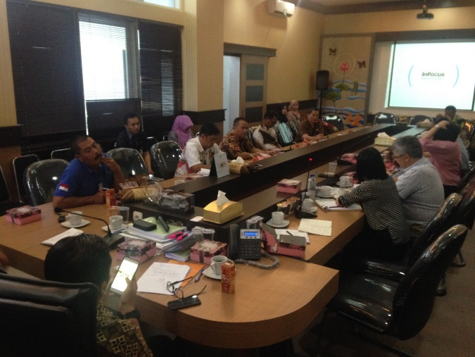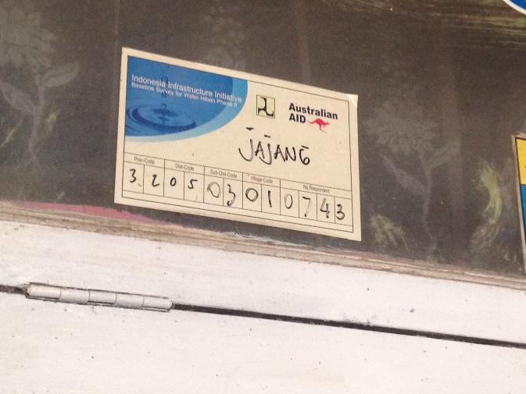
Effectiveness of the Water Hibah
Strong political commitment was demonstrated from the Bupati to provide water throughout urban rural areas, and the Hibah was reported to have “greatly helped us to expand our services in order to reach 100% coverage”. Also that “it accelerated our achievements, and also encouraged us to be accountable, because this is a national government program, especially Jokowi, he would like all to have basic access to services by 2019” (Bupati Garut). An increase from 22,000 connections in 2012 to some 55,000 connections in 2017 was reported. Local government invested some 22 Miliyar in 2012-2016 through the local budget.

The PDAM also reported the importance of the Hibah: “it we don’t receive the Hibah, we would have to charge the normal price to MBR- with the Hibah we can expand the connections”. It also provided us budget to expand the network and sources and add pumps and increase capacity. The only reported issue was impatience by households to connect and the need to communicate that the Hibah worked in stages and the need to wait. A second reported issue was the need to convince the local parliament, particularly some members, to accept the local regulation for equity, and provide explanation, including that MBR would receive benefits. The PDAM reported they were able to bear the cost of the new connections made but not reimbursed (due to insufficient equity).

Beneficiaries viewed the program positively, and both women and men felt that the connection was affordable (450,000 IDR which could be made by three payments. The first payment was 250,000 IDR and then next two payments were included in the water bill.

Sustainability
The Bupati reported on the continuing re-structuring of the PDAM to improve governance. In addition, The PDAM Director reported various improvements in operation in terms of an online customer database and cooperation with the post-office to promote ease of payments. The PDAM did not seem concerned about having many MBR customers, and mentioned ability to cross-subsidise. Efforts to address non-revenue water were underway, both to follow-up on customers in arrears, fix meters and address leakage (including coordinating with public works agency that sometimes broke PDAM pipes).

From the perspective of community, both women and men described their need for the service, its ongoing affordability, the high service quality and their strong satisfaction with the service. In terms of need for the service, alternative sources were yellow and contaminated. The tariff was reported to be affordable (in the range of 20,000IDR/month and 40,000-100,000/month for households with 2-3 families). The service was reliable, with only a few occasions when it was not available. Men reported complaints could be made through the meter reader PDAM staff, however the women were not aware of how to complain or that there was a call centre, and instead contacted a ‘friend’ who worked in the PDAM. Men reported were occasional traces of chlorine or solids, and suggested communication from the PDAM on this would be welcome. Overall, the community were satisfied, as the women reported: “sangat, sangat puas- [very, very satisfied]”.

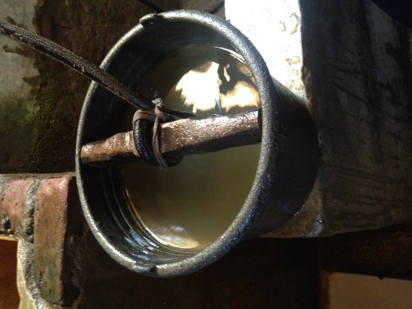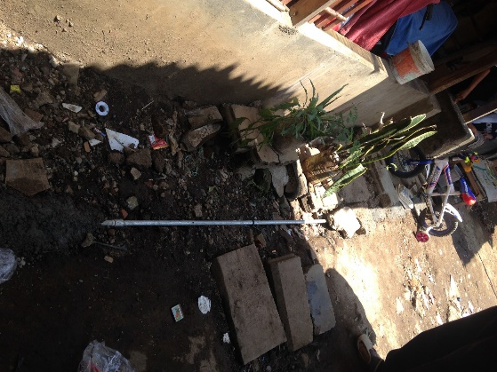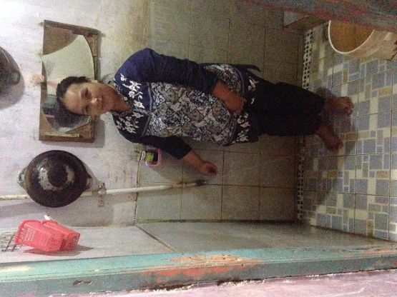

Replicability
In general, the grant mechanism was viewed as completely the same: “From our perspective, it’s the same. We carry out the activity first, and we require finance for that. After that, we seek reimbursement. It’s gone well”. However, it was mentioned that the longer time-frame for DFAT allowed for full equity payment and reimbursement. The annual budget cycle of APBN Hibah did appear to have contributed to challenges. The regulation issued for equity payment was only for 3 billion IDR, rather than the 9 billion requested from central government (for 3000 connections) and also the finance agency reported they could not pay more than this due to limited fiscal capacity and dependency on changeable central government allocations. The verification process was understood to have changed and now include a BPKP audit, which was welcomed since everything was in good order: “for us it [the BPKP audit] is no issue, it just takes a little longer, but that’s fine”.

Impact, gender and inclusion aspects
The PDAM reported not to have any data on people living with a disability, but agreed that it could be possible to address this through communication with community leaders (RT), as well as improved approaches to ensuring involvement of women and men in consultation and planning. Whilst there was clear improvements in quality of life as a result of the water connections, sanitation and hygiene has not been addressed, and most households had toilets connected directly to drains and waterways, no doubt contaminating the shallow groundwater that was still in use for some domestic purposes in some households. The table below documents gender aspects of socialisation, decisions and benefits.

Aspect | Women (n = 10) | Men (n= 7)
Socialisation (gender and inclusion aspects) | Program was only partially socialised with women, who only recalled socialisation when prompted by PDAM staff, and who suggested it would be good to socialise with women and men separately because “then the aspiration of women will be voiced. Otherwise men tend to dominate” | Men had been involved in proactively seeking connection to PDAM water due to poor water quality.
Gender balance in household decision to connect | Women important in this decision, and “women pay the bills” | Joint decision and both realized need to connect to access higher quality water
Perceived benefits | The program has addressed women’s practical gender needs (reduced time burdens etc. however this time was then used for shopping and other household tasks) and reduced tiredness. Noticeable improvements to clothing (no longer stained yellow), improved taste of food and drinking water and health benefits, ‘feeling’ cleaner. | The water connection saves time previously spent collecting water (reported to be undertaken by both women and men) and provided better quality water than the well for drinking, cooking and washing.
Changed gender dynamics at household level | None noted | None noted
Changed gender dynamics at community level | None noted | None noted, however community committee met regularly to discuss issues could include women and men but generally comprised men, and no women had ever been a community head.

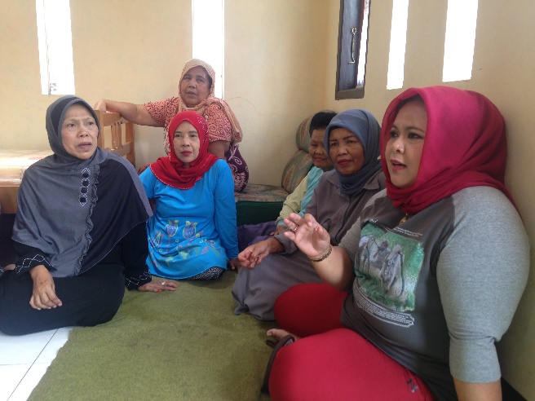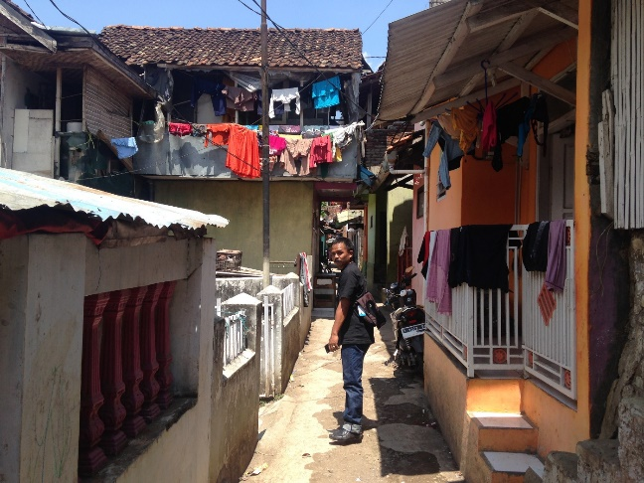

KABUPATEN KUALA KAPUAS

Background
Kabupaten Kuala Kapuas is located in South Kalimantan and was chosen to ensure geographic diversity higher levels of poverty, and a PDAM that was a poor-mid performer (in terms of overall health). The district has a total population of just over 350,000 people, and the area includes 17 subdistricts, 231 kelurahan and desa. Access to drinking water was 41.35% and access to sanitation was only 6.04% in 2014. The poverty level is 18.9% and it was reported that 30% of PDAM customers are MBR. There were reported challenges concerning water availability in the dry season.

PDAM profile
Kuala Kapuas PDAM | 2012 | 2013 | 2014 | 2015 | 2016
Water sources/points | 12 | 11 | 10 | 10 | 10
Installed Capacity (l/dt) | 192,5 | 192,5 | 367,5 | 367,5 | 387,5
Water Loss (%) | 36,2 | 34,1 | 32,8 | 31,5 | 28,8
24 Hour Service Hour / hr (%) | 75 | 80 | 80 | 85 | 85
Service Unit (Unit) | 12 | 11 | 10 | 10 | 10
Customer (SR) | 13.484 | 14.814 | 16.996 | 19.076 | 20.247
PDAM Service Coverage (%) | 63,8 | 68,7 | 77,8 | 86,6 | 95,4
Number of employees (persons) | 150 | 148 | 145 | 145 | 150
Source: PDAM Kuala Kapuas

Financials
 | 2012 | 2013 | 2014 | 2015 | 2016
Income | 11.265.714.637 | 13.208.813.446 | 16.795.779.316 | 19.290.037.055 | 19.649.276.376
Cost | 17.453.916.145 | 17.760.421.848 | 21.398.031.383 | 33.625.137.211 | 34.476.934.846
Net income / loss | (6.188.201.508) | (4.551.608.402) | (4.602.252.067) | (14.335.100.156) | (14.827.658.469)
Billing Efficiency | 90,88 % | 95,63% | 94,85 % | 94,87 % | 95,01 %
Equity capital | 22.573.649.044 | 15.677.649.257 | 11.615.763.080 | - | 3.000.000.000
Accountant's opinion | WDP | WDP | WTP | WTP | WTP
Performance of PDAM (BPKP) | Cukup | Cukup | Baik | Cukup | Cukup
Performance of PDAM (BPPSPAM) | Kurang Sehat | Kurang Sehat | Sehat | Sehat | Kurang Sehat
Source: PDAM Kuala Kapuas

Participation in the Water Hibah
Kabupaten Kuala Kapuas participated in the DFAT Water Hibah (including the USAID funded component), and also in 2016 and 2017 APBN funded Hibah. As evident from the table below, Kabupaten Kuala Kapuas achieved almost all connections. However, a reduced disbursement was paid for the US AID-funded portion due to insufficient equity payment to the PDAM in the timeframe) for the DFAT-funded portion, some households connections were found not be in line with the baseline, but instead instalments had been made in other areas and hence only 3373 of the 3500 were recommended, which then reduced the DFAT disbursement from 9.5billion to 9.1 Billion.
Subject | USAID | DFAT | 2015 APBN | 2016 APBN | 2017 APBN | Total
SPPH House Connection (HC) | 650 | 3500 | - | 1000 | 1000 | 6150
Installed HC | 650 | 3500 | - | 1000 | 1000 | 6150
Recommended HC | 650 | 3373 |  | 1000 |  | 5023
Total Hibah | 1.950 Billion | 9.5 Billion | - | 3 Billion | 3 Billion | 17.45 Billion
Recommendation | 1.950 Billion | 9.119 Billion |  | 3 Billion |  | 14.069 billion
Disbursed | 1.50 Billion | 9.119 Billion |  | 3 Billion |  | 14.069 billion

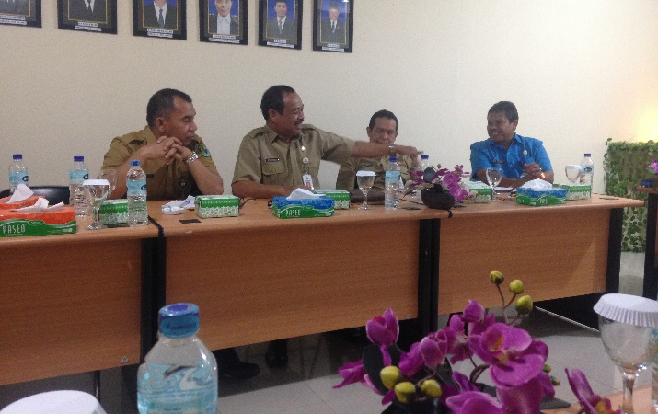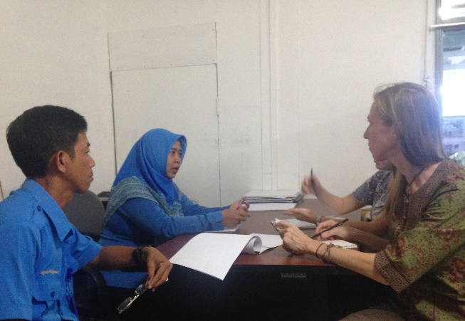
Effectiveness of the Water Hibah
Sekda expressed support for the Hibah noting that it “our coverage increased- this is something very visible, this is the impact of the program- household access has increased and will continue to increase”. However, it was also made clear that the pre-financing and payment on completion was not their desired approach and there was a preference to receive the funding on commencement. It was suggested that providing budget from local government was not an issue, but that there was a preference that budget from central level was allocated directly. The representative from the finance agency clarified that the challenge with the equity payment was convincing parliament of its importance, and gain understanding concerning the output-based payment arrangement. The PDAM Director reiterated the challenges of the regulation for equity payment which reduced the funds received whilst all target household connections were built. It therefore appeared that the local politics were a key barrier in providing this or other equity payments to the PDAM.

In terms of whether the Hibah had increased LG interest and motivation to invest in the PDAM or water sector, this was not so clear. When asked about increasing investment, the response was wholly focused on the required equity payment (not anything beyond this) and a sentiment that ‘we were forced to pay it’, at the same time as making clear that the local government had access to surplus funds from a forestry rehabilitation project that has had low funds disbursement. When asked whether the PDAM routinely receives equity, it was reported that this would need to be on the basis of a proposal.

PDAM reported the cost of connection for MBR households was 240,000 IDR in kotas and 130,000 in other areas, whereas the full connection price is 560,000. Beneficiaries in the community of Anjir Sarapat viewed the program positively, and both women and men felt that the connection was affordable and reported the connection fee of IDR 130,000. These connection fees were reported to be much less than the real cost to connect (reported to be approximately 1.25m IDR). This was assisted by the fact reported by PDAM planning staff that they were often able to target new MBR and non-MBR customers together using the Hibah grant. The only challenge faced was the “constraint of the baseline survey and waiting for the work order. Sometimes the community are not patient. For 2017, we got data in 2016, and they were installed in May 2017- this is a 6-month delay and sometimes cases a problem.” Another issue was customers that did not request a service at time of baseline, but later decided they wanted one, were then upset if they could not be included for that year.

Sustainability
The Sekda was supportive of continuing participation in the program, “Should we continue this program? I would say, yes, we only have 20,000 customers, and have a big gap to the large population who need services.” PDAM planning staff confirmed this also, and noted that they would be prepared to build even more connections and apply for additional funds, but were constrained by the current regulation that was passed on equity, which stipulates an amount of only 3 Billion IDR (for 1000 connections) annually until 2019. After that time, there was interest from the PDAM to increase the amount.

The governance and capacity of the PDAM appears to have improved since participating in the Hibah. In 2010-2011, the PDAM was categorised as ‘sick’ and then ‘not healthy’ in 2012. It was also reported by the finance official that the Kapuas PDAM is not profitable, requires a regular subsidy from the Local Government. However, the subsidy has been decreasing over time as the number of connections has increased and reduced losses. This lack of profitability was not perceived as a problem, said it was justified given the PDAM’s mission and remote location of connections.

The verification process appeared to have instigated improvements in the customer database management, and the current Director reported participation of staff in BPSPAM training in both technical and administrative areas. The non-revenue water was reported to have been reduced from 36% to 28% in recent years, through a process of replacing water meters, noting that leaking systems still require attention and modernised equipment is needed to detect leaks. In addition, the payment system is automatised (since 2014) and letters are issued for non-payment and after two-three months non-payment the water is cut. There was no concern about taking on many MRB customers as they pay the same tariff as other customers- only 0.04% of customers were reported to pay the social tariff.

There appeared to be useful complementary budgeting and programming with public works in terms of extending the pipe networks, with the ‘Action Plan for Water’ / Water-supply Masterplan and the Regional Medium Term Development Plan providing the basis for coordination between the PDAM and Public Works. Public Works reported that their APBD budget was 1-3% annually for water and sanitation. As the planning staff mentioned: “we coordinate using the masterplan and use APBD for expanding the network and distribution installed by public works, and match this with Hibah household connections by the PDAM”. There was also a sense that the PDAM was planning ahead for continuing the program: “In future, we continue to update the proposal and already starting to scope houses for the Hibah next year and already have 800 houses”. And, “the 1000 households is locked in to the Perda for 2016-2019, but after that yes, we plan to revise the Perda. It is a challenging discussion. I think it’s their understanding, but we have to reassure them – they want to have confidence, surety.” There were also plans to socialised the benefits with members of parliament.

Sustainability factors relevant to the community perspective confirmed that people were able to afford their bills, strongly appreciated the quality of the service (and didn’t have ready alternatives). Larger households reported by women as paying 50,000-80,000 IDR per month, and the men reported average of 35,000-60,000 IDR per month, and whilst they reported this as affordable, the women also said that they were careful and tended to conserve water to avoid high bills. The service was 12 hours, from 6am-6pm, and was only stopped due to cleaning of the tank. Alternative sources were highly acid, sour water from shallow wells, a small waterway running through the centre of the community (with corrosive water), or paying for bottled water refills (as was previously done before the piped water. The community indicated they could “now drink directly from the tap!”.

The only negative technical aspect concerning sustainability was observation during the field visit of pipes that were not secured. As there was a waterway through the centre of the community, every household connection on one side of the waterway involved a PVC pipe crossing the river, and many of these were poorly secured. The current technical specification for the Hibah is only the water meter and it’s mounting on a block, however these poorly secured pipes raise a question as to whether other criteria might also be important to ensure ongoing sustainability of services.

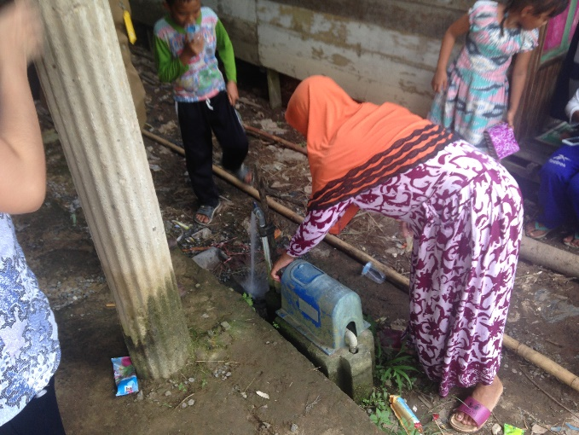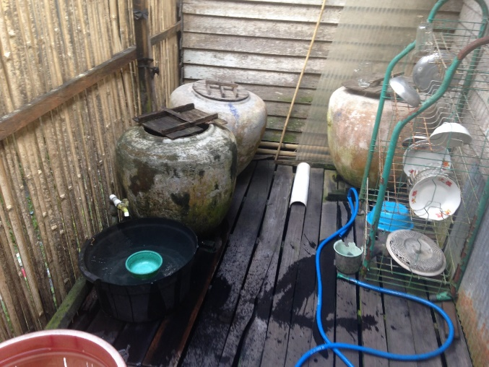
Replicability
A first when reporting on any changes between the DFAT funded Hibah and APBN the response was that “When we implement it from the state budget, there are no changes”. However further questioning revealed a sense of pressure created by the annual budget “we feel like we’re being chased by the state budget” and in fact a positive response concerning this: “I think it’s good, if we prolong it, our potential customers might resign”. There was also support for the BPKP verification spot-check process:
“I think it’s a good initiative- the BKP goes to the field directly and they ask proof of payment and check against the identity card. They truly do check in the field…[…]..BPKP go there and we provide a list- they choose randomly. I’m open to this verification- let the community say what they have to say. I give the full list.”
At times verification consultants found technical issues, which were then improved. As mentioned under ‘effectiveness’ above, the Hibah mechanism, whether DFAT or APBN, is not a significant problem, but difficulties were faced with local parliamentary approval.

Impact, gender and inclusion aspects
The PDAM reported not to have any data on people living with a disability, but agreed that it could be possible to address this through communication with community leaders (RT), as well as improved approaches to ensuring involvement of women and men in consultation and planning. Whilst there was clear improvements in quality of life as a result of the water connections, sanitation and hygiene has not been addressed, and most households had toilets connected directly to drains and waterways, no doubt contaminating the shallow groundwater that was still in use for some domestic purposes in some households. The table below documents gender aspects of socialisation, decisions and benefits.

Aspect | Women (n = 10 with 15 additional observers) | Men (n= 10)
Socialisation (gender and inclusion aspects) | Every house was visited by the PDAM staff, sometimes male or sometimes females were home. | Someone came to their houses and told them about the Hibah program.  Whoever was home when the staff / person who told them about the hibah program came to their houses.
Gender balance in household decision to connect | Decisions were made together, some women were concerned about being able to pay the on-going tariffs. | Everyone in the house eager to connect as the water from the river and well is of poor quality (acidic, yellowish).
Perceived benefits | For women, they felt better able to meet household needs for drinking water (could drink the water directly), reduced labour of collecting water, made toilets easier to clean. Clothes are cleaner. There are less bacteria, “in the past we often get stomach aches and our clothes were yellow. Now when we’re thirsty we just drink. And skin is less itchy.”  For an elderly woman, she reported that: “I am more comfortable, it is easier to cook, and when I want to pray, I do not need to leave the house to wash in the river”  The posyandu reported reduced diarrhoea and itchiness but did not have any records of this and reported that these were kept at the Puskesmas (she would just convey people there by motorcycle). She also reported improvements for birth delivery in having ready access to water. | Reduced burden to the wife as they don’t need to fetch water anymore.
Changed gender dynamics at household level | None noted | None noted
Changed gender dynamics at community level | None noted | None noted.

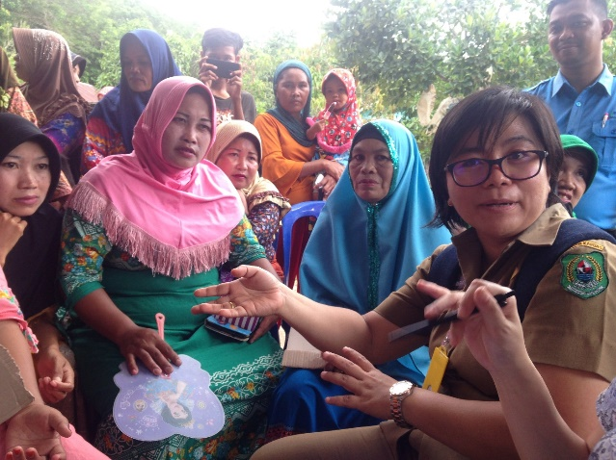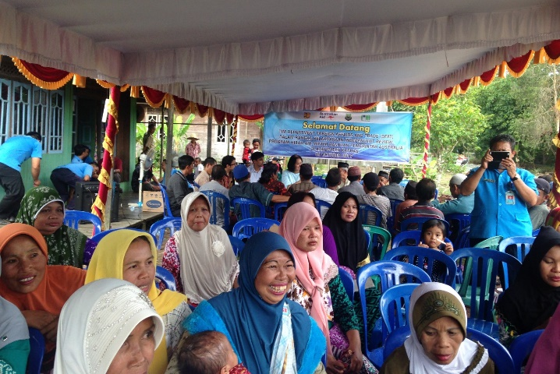

KABUPATEN BOYOLALI

Background
Kabupaten Boyolali is located in West Java and was chosen because of its proximity to Surakarta and as a participant in the Hibah program. The district has a total population of just over 930,531, and the area includes 15 subdistricts, 4 kelurahan and 267 desa. Access to safe drinking water was 66.05 % and access to sanitation was 61.65 % in 2015 (BPS, 2015). The poverty level is 26.6 %. The Deputy Bupati stated the District was committed to improving water supply coverage with a particular focus in rural areas suffering from poor level of access. By 2017 the PDAM provided services to 50,000 households and through the additional Hibah and APBN funded connections and was more financially viable.

PDAM profile

PDAM Kabupaten Boyolali | 2011 | 2012
Date established
Number of customers (household connections) | 26,706 | 29,875
Total number of employees | 154 | 154
Ratio employee/connection | 5.89 | 5.26
Production capacity | 222 | 120
Idle capacity | na | Na
Non-revenue water (%) | 29 | 26
Reliability 24h/day (%) | 18 | 20
Coverage (cakupan) (%) | 65 | 70
Healthy/not | Healthy | Healthy
Water tariff (social general) (IDR) |  | 1,475
Water tariff (household) (IDR) |  | 4,006
Water tariff (commercial) (IDR) |  | 6,733
Proportion of MBR customers | 500 | 1,756
Proportion of customers paying reduced tariff
Source: IndII

Financials
PDAM Kabupaten Boyolali | 2012 (IDR.000)
Figures
Asset | 82,967,666.63
Liabilities | 435,863.16
Equity | 82,531,803.47
Working Capital | 82,531,803.47
Cash & Equivalent | 4,784,351.35
Inventory | na
Current Ratio | 0.03
Debt Equity Ratio | 0.01
Profit/Loss | 2,260,078.82
ROE | 2.74%
Source: IndII Water Hibah (PCP Report), BPPSPAM Data

Participation in the Water Hibah
Kabupaten Boyolali participated in the DFAT Water Hibah, and also in three years of the APBN funded Hibah. As evident from the table below, Boyolali did not receive full payment to the PDAM for one year in 2015 APBN. While 7,000 household connections were built, the local government did not receive the full reimbursement from central government. While verification was generally not a problem, the PDAM had issues in providing accurate information on property addresses. Through use of GIS and updated customer billing software the process was now improved.

Subject | DFAT | 2015 APBN | 2016 APBN | 2017 APBN | Total
SPPH House Connection (HC) | 4,000 | 7,000 | 5,000 | 6,000 | 22,000
Installed HC | 4,000 | 7,000 | 5,000 | 3,829 | 19,829
Recommended HC | 4,000 | 6,737 | 5,000 | - | 15,737
Total Hibah | 11 Billion | 21 Billion | 15 Billion | 18 Billion | 65 Billion
Recommendation | 11 Billion | 20.211 Billion | 15 Billion | - | 46.211 Billion
Hibah disbursed | 11 Billion | 20.211 Billion | 15 Billion | - | 46.211 Billion

Effectiveness of the Water Hibah
Strong political commitment to increasing water supply coverage was demonstrated by the District. It has a perda and investment plans to provide water throughout urban and rural areas. The Hibah was reported by the Deputy Bupati as contributing to the Bupati’s policy commitment of scaling up water supply. Boyolali has an investment plan of IDR 55 billion for water supply over the 2016-2020 period under the perda. The Deputy Bupati reinforced that Hibah payments were reinvested in the PDAM and reported plans for another 10,000 connections.

The PDAM reported that the Water Hibah helped the District meet its investment target and that funds were targeted to scaling up access to water supply in villages not just in urban areas. PDAM Boyolali has scaled up service delivery from servicing 80 sub-districts in 2015 to 154 sub-districts in 2017. They estimated an increase from 10,000 to 50,000 household customers from 2015 to 2017 has also increased the financial viability of the PDAM. Connections in rural villages require greater investment, averaging IDR 8 million per connection due to larger lot sizes.

Beneficiaries considered participation in the program good value as households had few affordable alternatives for a safe water supply. Alternatives included accessing groundwater which required a well or bore over 10 metres depth which could cost over IDR 12 million and a monthly electricity charge of IDR- 20-30,000 or walking a kilometre to collect water in a container. The connection fee of IDR 800,000 was considered affordable and the PDAM had a flexible payment plan which allowed for an initial payment of IDR 200,000 and then the remainder paid as a monthly payment over 20 months on their water bill.

Sustainability
The Deputy Bupati advised that he valued the Hibah scheme and the local government was continuing to participate in the Government funded APBN program that used a similar funding mechanism. Boyolali was able to make necessary equity investments and could meet the requirement for local equity investment as focused their funds on source development and transmission lines. The PDAM stated that following the Hibah program they had increased O&M budgets and employed staff to work in the new service areas to undertake maintenance, meter reading and customer billing. There was a greater focus on service delivery and customer satisfaction was now an important indicator of sustainability. Implementation of the IDR 55 billion investment plan would allow further growth of the PDAM and allow an additional 15,000 household connections.

For implementation of the Hibah the PDAM followed a socialisation plan and was continuing to use the methodology for the APBN funded program. The PDAM does not contact the household directly but works through community and local government management at sub-district level. Materials provided by the PDAM included how the process worked, including agreements and billing, and costs of connection which outlined household responsibility for funding their site costs beyond the standard connection of 6 metres. Following socialisation the PDAM workers then verified interest with individual households who would become customers.

Community members participating in focus group discussions stated that the water connection was reliable, and the service provided good quality water at adequate pressure. The men’s focus group reported that the PDAM was responsive if there were any issues and they were able to contact the local PDAM manager directly while the women’s focus group were not aware of the contact details of the PDAM manager or the telephone number.

Monthly water bills for households in the FGD ranged from IDR 40,000 to IDR 120,000 for a small business with an average households water bill on IDR 50,000 to 60,000 per month. Of the 9 participants in the men’s FGD 8 out 9 household only used the piped water supply as the quality of water was better and was more available than use of the river or well. The women’s group noted a higher household usage of well water. The women’s group noted the water bill was twice as expensive as the electricity bill and “what we pay is too high” but “having the PDAM life was much easier”.

Replicability
The Deputy Bupati advised that are still areas in Boyolali that lack access to safe water supply and the District has an investment plan under Law 25 which includes a budget and the PDAM works with the DINAS to ensure coordination including ensuring adequate budget allocation. The only significant difference between Hibah and APBN was that the Hibah enabled multi-year investment and reimbursement while the APBN required it to be operationalised and payment made in the one financial year. The District reported that they were able to work with either scheme. Following implementation of the DFAT-Hibah program they had learned how to manage the process and was able to schedule budgeting, approvals, implementation and payments required by the APBN process.

The district was comfortable with meeting the Hibah targets, the required equity investment and compliance with the verification process. The District had made it easier for poor and rural households to participate by matching payments with seasonal worker incomes, which fluctuated during the year.
Cross-sectoral engagement through a Pokja was recognised as important for achieving health and other benefits from improved water supply. This included water for industry, which is a relatively small volume but important customer in PDAM Boyolali.

Impact, gender and inclusion aspects
The Deputy Bupati spoke on issues of gender and social inclusion noting that the District was following government policy on involvement of disadvantaged persons including for local companies to employ PLWD. However, an absence of regulations at local level to implement national policy means that there has not been any tangible action aimed at implementation. No mention was made about the role of women or of actions on gender equality. The main mechanism used to socialise messages to women is the PKK and there was no mention of strategies aimed at empowering women at local level.

Main benefits to the community was in time saved in collecting water from the river and “children were healthier”. The piped water supply was very considered as very reliable and water was much better quality than the well water which had a strong odour. Household wells while available often ran dry and collecting water from a well, which even if 15-20 metres away still took more time than using the tap. The men in the focus group stated that before the water supply connection they generally collected the water while the women said they collected the water and described how they either used the well or collected water from the river which required carrying two buckets. The river was located around 1 km from the main group of houses so the time commitment was significant as were the loads that needed to be carried.

Men’s and women’s FGD both included examples of small businesses using the piped water supply and they were very reliant on the PDAM supply. The table below documents gender aspects of socialisation, decisions and benefits.

Aspect | Women (n = 7) | Men (n= 9)
Socialisation (gender and inclusion aspects) | Women heard about the Hibah program from neighbouring villages but were not included in the PDAM or community socialisation process. Women would have very much liked to be involved in discussions with the PDAM and did not even have PDAM telephone numbers to call if there was a problem. A key problem is that the ‘family card’ is in the name of the male and information is provided and issued to the person named on the family card. | Men became aware of the program after the PDAM, who were aware of local water supply issues, contacted the RT head. The RT organised a community meeting involving about 35 people, mostly men, because it was held in the evening. The PDAM shared information on the Hibah and about 50% of HOUSEHOLD agreed to connect.
Gender balance in household decision to connect | Women from the village said that it was mostly a decision made by the man. 1 out of the 7 women felt that they had a say. While women felt they could make a decision without asking their husband but it was “difficult if you don’t have the information”. | Men who participated in the meeting shared information with their wives but felt it was the men’s role to make a decision “ the wife agrees with the husband”.
Perceived benefits | The program has addressed women’s practical gender needs (reduced time burden of collecting water, feeling less tired and life was healthier). The water “tastes better” and does not smell. One woman was involved in production and sale of snacks and reduced time burden allows her more time for economic activity. Elderly people were no longer seen collecting water from the river | The water connection saves time previously spent collecting water (both women and men said they were the main water collectors) and water was more available including for food preparation and washing motor bikes.
Changed gender dynamics at household level | None noted | None noted
Changed gender dynamics at community level | None noted | None noted, however there were separate men’s and women’s monthly community meeting that discussed issues. Men’s meeting were held 7pm in the evening while women’s meetings were at 2pm in the afternoon.

KOTA BANDUNG

Background
Kota Bandung is located in West Java and was chosen as a high-performing participant in the Sanitation Hibah program. The city has a total population of just over 2.3 million, and the area includes 30 subdistricts, 151 kelurahan and desa. Access to drinking water was 89.52% and access to sanitation was 39.50% (BPS, 2015).

PDAM profile (Wastewater division)
The wastewater treatment capacity (currently at capacity) was 80.835m³/day, with staffing and described in the tables below for a total of 250,960 household connections
Staffing | Number of staff
General wastewater services | 28
Wastewater technical planning | 12
Wastewater operation | 34
Wastewater treatment | 45
Total | 119
Source: PDAM Bandung

Financials
Financials – Annual budget wastewater division (IDR) | 2014 | 2015 | 2016
Revenue
Water sales | 282,413,186,000 | 284,879,301,000 | 302,403,763,000
Non-water revenue | 31,670,255,000 | 43,188,811,000 | 55,309,144,000
TOTAL |  | 328,068,112,000 | 357,712,907,000
Direct operating cost
Raw water sources | 16,536,941,000 | 25,215,094,000 | 27,810,395,000
Water treatment | 36,519,757,000 | 27,374,790,000 | 26,807,287,000
Transmission and distribution | 53,615,205,000 | 50,949,346,000 | 48,201,914,000
Wastewater operation | 26,619,110,000 | 23,724,577,000 | 20,175,307,000
Non-water activities | 11,073,698,000 | 12,535,003,000 | 21,328,971,000
Total |  | 139,798,810,000 | 144,323,874,000
Gross income | 169,718,730,000 | 188,269,302,000 | 213,389,033,000
Source: PDAM Bandung

Participation in the Sanitation Hibah
Kota Bandung participated in the DFAT Sanitation Hibah (and more recently the APBN Water Hibah). As evident from the table below, Kota Bandung to date has built approximately 80% of the expected connections, and so far been reimbursed for 3,100household connections that were part of the grant agreement made in 2016.

Subject | DFAT Sanitation Hibah
SPPH House Connection (HC) prior to the Amendment of June 2016 | 3,100
SPPH House Connection (HC) after the Amendment of June 2016 | 5,100
Installed HC to date | 4,086 (80.1%)
Recommended (HC) | 3,100
Hibah disbursed (in 2015) | 3,100
Total Hibah prior to the Amendment | 15.5 Billion
Total Hibah after the Amendment | 25.5 Billion
Recommendation | 15.5 Billion
Hibah disbursed to date (in 2015) | 15.5 Billion
Source: Cipta Karya CPMU

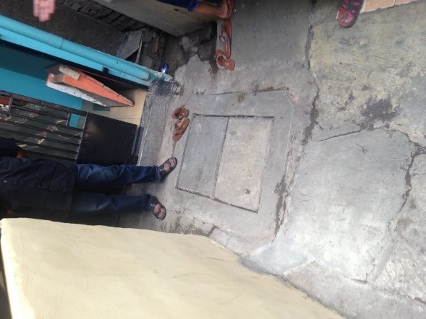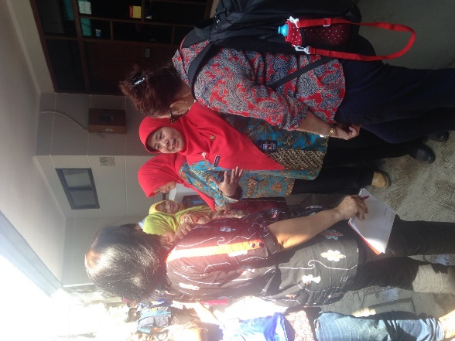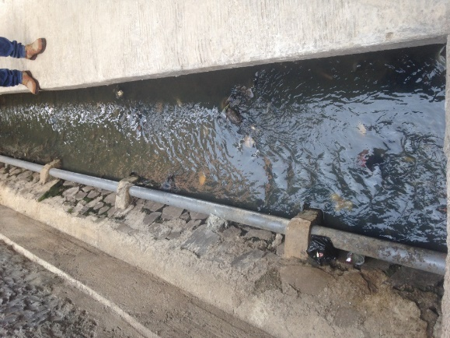
Implementation progress, enablers and inhibitors
Progress: Progress was initially held up by the passing of the regulation concerning equity to the PDAM, which was reported to take several years. Subsequent to that, progress was reported to be good, with 80% of planned connections completed.

Enablers
S | - A partnership between the PDAM and the Puskesmas has greatly facilitated socialisation of the program and the benefits of sewerage- with a focus on a ‘healthy lifestyle’, and drawing on MoH STBM approaches and resources. A flow-on enabler from this partnership was strong engagement and involvement of women who have intrinsic interest in improving sanitation
T | - Main pipe is available in areas with interest to connect (since sewerage system only covers 40% of the city) and significant proportion of MBR households (though noting that the requirement for MBR only has bene removed in this phase of the Sanitation Hibah)  - Cooperation between PDAM and public works agency  - Dense housing, so once decide to connect an area, many connections can be made in a small area  - Depth of main pipe has made adding the secondary and tertiary network easier  - Sufficient technical skills were available to ensure good design- for example regular inspection holes, careful phasing of construction to minimise disruption  - From community perspective minor blockages had occurred and were cleared by the community but major problems were fixed by the PDAM on the same day. They noted that it would be good to have cleaning equipment in the area for clearing blockages. Blockages were infrequent (3-4 times since connections were made) but occurred after rain
E | - Wastewater charge is integrated with the water tariff (30%) based on a regulation in 2009, amended in 2012 here it is no longer explicitly stated to be for wastewater (creates a tax issue)  - Connections were provided for free to households- this was reported to be important by women from the community, who thought otherwise their husbands would not agree  - Equity funds through the Hibah grant considered essential for building the connections- “the PDAM doesn’t have the funds to fully fund new connections, only sufficient funds for operation and maintenance”.
E | - Before sewerage, many areas dispose from toilets direct to drains or rivers causing odour- hence the desire amongst community members to improve systems and readiness to join the sewer network.  - General desire to improve the quality of the river-water and river banks in the city, as well as improve the raw water quality for drinking water plant.
P | - Political will in terms of a focus on improving the riverways, and also attention to slums  - Outcome of evaluation meeting was for Mayor to review his budget and to ensure equity payment reaches the wastewater division of the PDAM.

Inhibitors
S | - In slum areas, some people are supportive and others not at all interested to connect to sewer, requires significant efforts in socialisation
T | - Road access in slums is challenging, very small- hence drilling and digging significantly impacts on household activities  - Wastewater treatment capacity- design was 80m3/day but operating at 85m3/day  - Performance evaluation reported to be required concerning the treatment plant since the quality of the effluent is not currently meeting the standards (particularly the new more stringent standards)- a feasibility study is planned to evaluate all components
E | - Actual cost of connections was 10m IDR however only 5m IDR was reimbursed  - Budget of the wastewater division is constrained, since “there is higher need for water, and it is higher priority”  - It did not appear to date that the 30% addition to the water bill is provided directly to the wastewater division “there is more prioritisation to water”  - Mayor made clear that “there is a problem in budgeting, to have sufficient funds for all the infrastructure that is needed”
E | - None noted
P | - Political focus is on providing funds to communities, youth and women’s groups and their decision on how to spend funds, and this pathway is not likely to yield a focus on sanitation in the short-term. In addition a focus on public private partnerships is not likely to address the need for a public service such as sanitation in the short-term.  - There was a delay of several years in setting the equity regulation in place

Gender and inclusion strategies
There was no explicit gender and inclusion strategy implemented, however the involvement of the Puskesmas had led to involvement of women both in socialisation and in terms of reaching households. This demonstrated the benefits observed elsewhere when women are involved in sanitation issues, since women were intrinsically motivated on the issue and were able to successfully socialise the program. In addition, the Mayor demonstrated support for women’s groups (PKK) as one of the targets of his funding allocations (also to youth and to each RT/RW). It is possible that more explicit planning of socialisation with involvement from PKK groups could be a useful strategy going forward, both towards gender equality as well as sanitation outcomes. In addition, the consultation process in the community visited had involved at least women, but it was not intentionally ‘designed in’, and indeed the men reported that the meetings held had mostly involved men.
There appeared to be limited attention, understanding or data on PLWD and their needs. Hence, whilst ‘bottom-up’ processes were described by the Mayor and other actors, it was not clear whether these processes would naturally be inclusive. There did not appear to be an understanding of differential impacts of services (or lack of specific groups, such as women or PLWD).

At the institutional level in the PDAM there had not been a specific focus on women’s roles. Only 10% of PDAM staff were reported to be women (attributed to the technical nature of the work), though there were at least two women in leadership positions, including leading the wastewater division.
The table below documents gender aspects of socialisation, decisions and benefits, from the perspective of women and men in the community. Interestingly, both women and men noted that more of their own sex was present at the socialisation meeting.

Aspect | Women (n = 5) | Men (n= 6)
Socialisation (gender and inclusion aspects) | “First we heard of it as from the Puskesmas. They held a meeting- it’s called a triggering- if we dump waste directly to the drains it’s not healthy and create odour- during the dry season you can small the waste”.  Both women and men heard about the program as there was a meeting at RT house comprising mostly women as men were at work. | The local Puskesmas contacted the environmental health group in the RW/RT and community leaders to assess interest in the sanitation scheme. A community meeting involving about 45household representatives attended and while it was a combined meeting it was mostly men. Content included health, CLTS concepts, healthy living, women’s empowerment and role of the Puskesmas.
Gender balance in household decision to connect | Wives who attended the meeting relayed information to their husbands, and noted that “The meeting was held during the day and there were more women because the men were at work…[…]…we told our husbands. If we had to pay it would have been harder to convince them - because we are mostly low income households, most are construction workers.” | Both men and women were interested in better sanitation and the CLTS process encouraged community decisions. Head of the household is the man who decided but did ask the wives’ opinion. There are some female-headed households (widows and divorced women) who were asked. Key issues were odour and environment rather than health.
Perceived benefits | There was a reported reduction in the smell and amenity of the immediate living environment. | Household’s experienced local improvements in sanitation including a cleaner environment, less odour was a major benefit, better groundwater quality and cleaner waterways. Overall, the local area had healthier conditions which was safer for infants. The community was now considered cleaner and ODF.
Changed gender dynamics at household level | None noted | Benefits varied depending on the HOUSEHOLD makeup. Some women no longer had to defecate in the open.
Changed gender dynamics at community level | In general no impact on women’s position in the community was noted. However, an opportunity to build the skills and confidence of a female volunteer health worker had been realised through engagement in the socialisation: “I am a ‘posyandu’ representative for Antopani. I was the first batch- training for socialisation and changed my practices, can’t just dump waste. The skills gained in communicating to the community are very useful. I gained much information on health and used it for myself also” | No change in gender issues noted at community level as women did not participate in consultation or decision making.

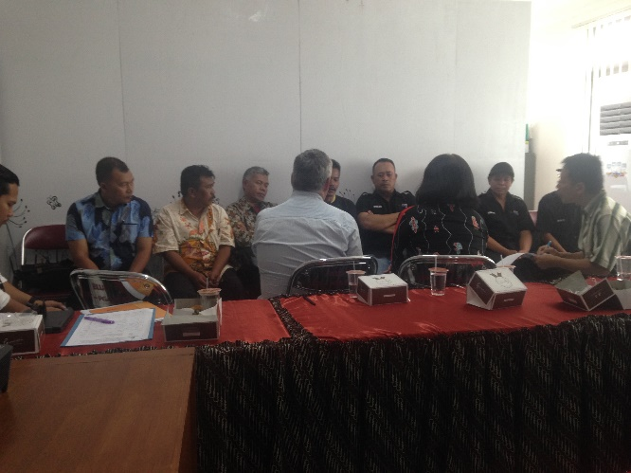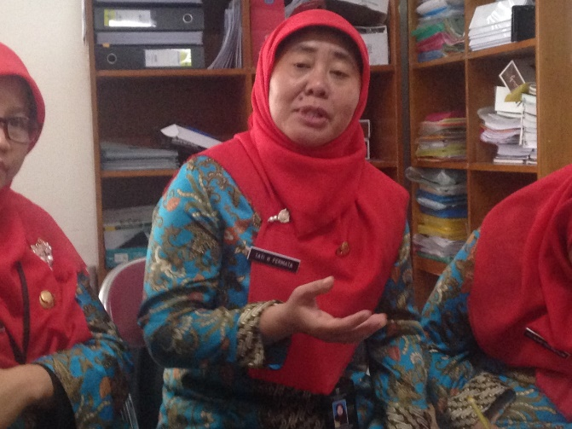
Political will and community demand
Political will:
Given the Mayor’s strong focus on bottom-up empowerment and provision of funds- there is opportunity to put greater emphasis on communications and engagement to foster community level interest and focus on sanitation, which could include engagement with environmental or related groups in civil society. In addition, build from the Mayor’s interest in cleaning and greening the city, efforts could be made to support the case for the need for improved sanitation to reach this vision, given current access is only 39.5% and many toilets discharge directly into open drains and waterways.

There could be potential to use social media as part of the strategy to generate political will, since that is a medium utilised by the current leader. The men’s focus group suggested that other local governments should be invited to visit the community, who are now advocates for better sanitation. Good experiences are also already being shared by the community group on facebook and you tube, and this could be capitalised upon.
Community demand:
The men’s focus group discussion pointed to households’ interest in the sewerage connection because of cleaner environment and health issues. The group suggested sharing better information on the benefits of the piped sanitation system which as well as health included less odour, cleaner waterways and less groundwater pollution which affected local wells.
Building from the approach used in Bandung in other locations could be possible, as well as strengthening it further in Bandung itself. Some features described by an official from the Puskesmas: “We mapped the areas that were ODF and not, and we did triggering for the cadres (volunteer health workers). We also invited the community leaders, and make agreement to carry out this program”. The involvement of the posyandu (volunteer health workers) had been both positive for those involved, as well as led to on-going socalisation. As reported in the women’s focus group discussion: “we have done socialisation now also outside RW9, we often go around- it a word of mouth things. We promote the program, and are convincing other communities. The head of RT and RW are also involved”. The men also reported that taking STBM approach was very influential in convincing the community to connect to the sanitation system.

There could be value in developing a case study of Bandung to help show other locations how cross-sectoral partnership for sanitation can work to build community demand- need to sell to both technical agencies and organisations (public works and PDAMs) as well as health departments that there are benefits in cooperating and reaching joint outcomes.

KOTA BANJARMASIN

Background
Kota Banjarmasin is located in South Kalimantan and was chosen as a low-performing participant in the Sanitation Hibah program (in its second phase, as performance in the first phase was high). The city has a total population of 636,000, and the area includes 5 subdistricts, 52 kelurahan and desa. Access to drinking water was 99.40% and access to sanitation was 85.96% (BPS, 2015).

PDAM profile
Capacity of the IPALs is shown below.
Area | Capacity (m3/day) | Year built | Household connections
IPAL Lampung Mangkurat | 1000 | 2000 | 1502
IPAL Pekapuran Raya 2500 | 2500 | 2007 | 1802
IPAL HKSN | 5000 | 2009 | 1699
IPAL Nasirih | 2000 | 2010 | 457
IPAL Tanjung Pagar | 2000 | 2012 | 855
IPAL Sungai Andai | 3000 | 2013 | 607
IPAL Sultan Adam | 2000 | 2014 | -
IPDAL Sultna Adam | 17500 |  | 6922
Source: Presentation by PDPAL
Participation in the Sanitation Hibah
Kota Banjarmasin participated in the DFAT Sanitation Hibah. As evident from the table below, kota Baanjarmasin to date has built approximately 30% of the expected connections, and have not yet been reimbursed. The targeted household connections was revised downwards due to challenges met in identifying suitable areas with interested households to connect.

Subject | DFAT Sanitation Hibah
SPPH House Connection (HC) prior to the Amendment | 2,900
SPPH House Connection (HC) after the Amendment | 1,000
Installed HC to date | 305 (30%)
Recommended (HC) | -
Hibah disbursed (in 2015) | -
Total Hibah prior to the Amendment | 14.5 Billion
Total Hibah after the Amendment | 5 Billion
Recommendation | -
Hibah disbursed to date (in 2015) | -

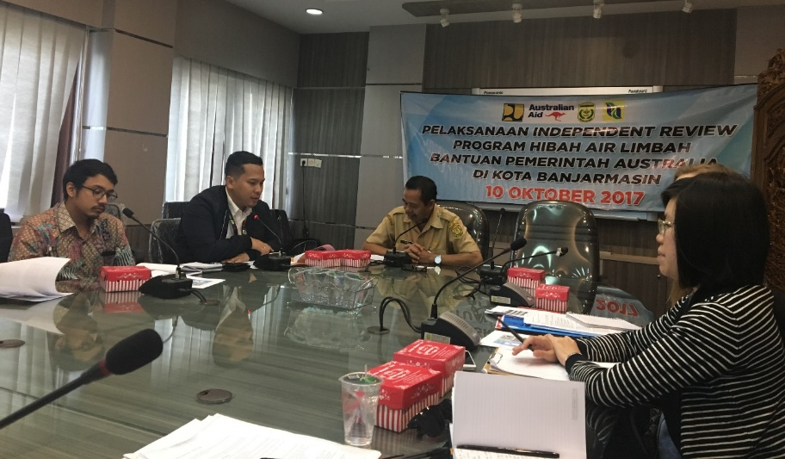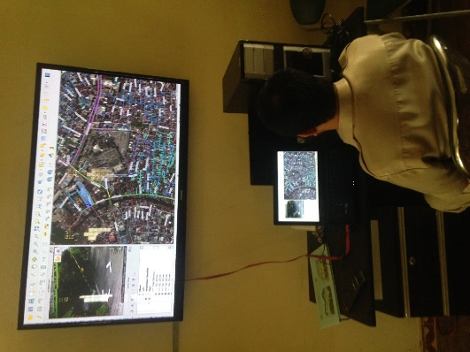

Implementation progress, enablers and inhibitors
Progress: Progress has been held up by a wide range of factors, despite the plentiful treatment capacity available across the city. The reasons are outlined in terms of enablers and inhibitors below. The PDPAL reported that 133 connections to date had been verified. The original target of 2,900 households was revised downwards to 1,000 households as ‘the implementation was very hard to achieve’.

Enablers
S | - In community visited, being promised a road and a free connection were motivators for households to connect  - A vision and a motto to make the city and river the most beautiful in Indonesia – lots of the community reported to have concern for the river
T | - Significant available treatment capacity across 7 different treatment systems (for varying capacity) across the city  - Cooperation with Public Works agency to build road in community where installing wastewater tertiary network.  - Community visited reported that blockages rarely happen  - Women reported that there was no damage to the house as the pipe could be attached to the outside of the house (which is on stilts in water)  - PDPAL had set up a self-funded open-source GIS system to map their networks and customers- will be useful from both customer management and technical management perspectives
E | - A Mayor’s regulation passed in 2015 supports 25% addition to PDAM water bills for those connected to the sewerage network (however see inhibitors below, as this is insufficient for cost-recovery)  - Potential in future for PDPAL to link to commercial area to sewerage, which would increase financial viability
E | - Heavily and visibly polluted river a source of interest and energy to prompt action, including very high levels of Ecoli.
P | - Passing of Regulation 7 (2010) and Regulation 5 (2014), including follow-up campaign- these regulations mandate that each household and business must manage their waste.  - There is a target for 15% access to offsite systems, which provides an agreed goal to get to from current 5% coverage.

Inhibitors:
S | - Low levels of community understanding of wastewater, and ‘community want it for free’  - Only some members of a community willing to connect (leads to slow progress and patchy coverage). Observation from one woman: “I have seen my neighbour’s tank and it leaks. I can see it from my kitchen. Yes, there was leakage onto the ground.”  - Socialisation process at community visited was minimal and involved only a meeting attended by men only (and many men were not present and hence didn’t connect) and content presented at the meeting wasn’t considered clear  - In community visited only some household connected yet all gained benefit of the road- this was seen as an injustice (particularly since connecting being paying ongoing) by those who connected. They felt that it should have been mandated for everyone.  - PDPAL noted that there are concerns that those who don’t connect will still have to pay  - Tariffs for wastewater services are considered too expensive, and in community visited, they assumed everyone would have to pay (however only those connected pay)  - A focus on MBR as a starting point (rather than middle class customers who may have higher awareness and higher ability to pay) may be increasing the difficulties faced.
T | - Requirement to install sewerage pipes both disruptive and may reduce quality of road, or perceptions and fears of this by community  - Technical competency in terms of human resources within the PD PAL are not optimal  - Flat terrain  - Complexity as regards interaction with roads- technical standards for these and being able to meet them  - Community visited was not satisfied with the quality of construction. The construction of the pipe holder was using below standard materials (according to community, it should be ulin wood to cope with the swamp water). Sometimes the pipe connections are broken and they have to call PD PAL to fix it (reported by both women and men), with women reporting long response times from PDPAL to fix leaks of at least 2-3 days. Men suggested that they would like PD PAL to do regular monitoring (3 monthly interval) to check on the pipes. When the connections are broken, they can smell the odour. Another household experienced odour coming out of a damaged septic tank behind their neighbour house, as the septic tank was broken when PD PAL installed the sewerage connections. Remaining sludge was not removed and PD PAL and the neighbour never resealed the septic tank. Finally, the pipe construction were not steep enough and require them to flush with more water or the sludge will dried up inside the pipes – and later on produce smell.  - Only blackwater had been connected (confirmed by both PDAM and community), with PDPAL reporting that the wastewater treatment plant was suited to that. Adding greywater to the connection may have contributed to better flow in the sewerage pipes.  - Misunderstanding concerning the program and the baseline process meant that some household connections were built that were not (to date) counted.  - The PDPAL does not manage drainage as well as the wastewater service, and the drainage is an area where there is a lot of criticism, which is directed at PDPAL, but is not under their authority  - Some of the wastewater assets haven’t been handed over from the provincial satker to the local government, and as a result operation and maintenance cannot be budgeted for legitimately in the APBD budget.
E | - The additional 25% wastewater charge is only applicable to customers connected to the wastewater system (as compared with Bandung where all PDAM customers pay it regardless)- this provides a disincentive for households to connect. It also means low revenue, since only 5% of the city is connected. More recently this was adjusted to 12.5% for MBR households. However, the community visited reported paying 25%- they felt this is a burden since the water supply cost is increasing and there is a minimum charge of 10m³ usage (equal to IDR100,000) for the water bill and therefore they will have to pay at least IDR125,000. They suggested that removing the minimum use tariff for PDAM would help.  - Women mentioned also being asked to pay transport costs (variable amounts) of PDPAL officers when they were called to come fix a leak  - Women reported times when they were not able to pay, for instance at the time of the children’s school fees: “Yes, when I had to pay for school fee. And I had to plead with the PDAM, I’ll pay tomorrow. If I haven’t paid two months then they will cut off my water”  - The equity payment was made, but appears to have been used for connecting households that may not have been in baseline (or other purposes- it wasn’t quite clear), hence posing a difficulty to complete the remaining committed connections.  - Customers who were added during the first phase were promised they would not have to pay, and some 2,000 customers were therefore reported not to be paying for the service, and this creates a financial burden for the PDPAL: “At the time the policy was to get the community to connect, so there was 6 months free. However, the reality they want it to be free forever. It is different from water, can stop water. Then the community feel they need to pay. But if we stop the connection, they will just continue to dump the waste.”  - PDPAL had also inherited a SANIMAS system for which customers did not want to pay  - The additional tax payable for wastewater (10-11%) was viewed as unfair and difficult: “We’re already struggling and then the product is taxed. The deficit is 120ID/month due to this””
E | - None noted
P | - Regulation 7 (2010) and Regulation 5 (2014) implementation is not optimal, since although they place responsibility with households and businesses to manage their waste, they are not enforced- it was reported that they needed strengthening in terms of fines  - It appeared that some of the staff in the PDPAL may not have the requisite skill-set for their position, however the PDPAL itself does not have full authority to address this situation and requires political support to resolve it. In addition the ratio of staff to number of connections is high (require only 25 staff for current number of connections rather than 50 staff), and a request has been made to the Mayor to reduce the number.  - Complaints come to PDPAL for things that are outside of their control or authority: “I think we need a policy from government so when community complain they complain to local government, not to PDPAL. We do coordination with public works but sometimes it ends in a quarrel”  - There appears to be potential need for a regulation to mandate connection, however this would need significant political will to accomplish: “if government comes up with a policy that requires people to connect, that you have to become a customer, that would be better”  - The separation of the PDPAL from the PDAM may not be the best arrangement, and although a review two years ago recommended combining them, the Mayor was not ready to do so (on the basis that it was ‘going back in time’ to a previous arrangement, and because Jakarta also had a separate PDPAL).  - There is a perception that the PDPAL should be profit-making, rather than a service provider: “the government sometimes have the profit-loss mentality- they see PDAM as profitable and they see PDPAL ration of revenue and operational still at a deficit. They lack confidence whether the PDPAL can succeed”  - It appeared that strengthened leadership would be needed to ensure functionality and effectiveness of the Pokja Sanitasi. Mention was made of the Pokja Sanitasi, however it didn’t appear to be functioning well: “the Pokja Sanitasi, there is the same policy for all Indonesia, however the expectation is that the Pokja will solve issues, but in reality everyone is busy with their own things so often things are not followed up”

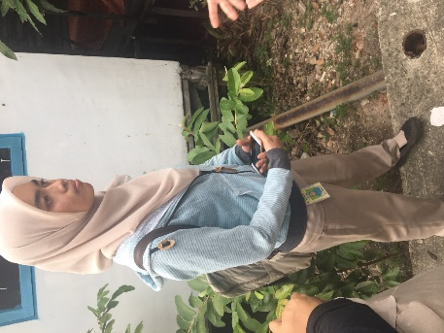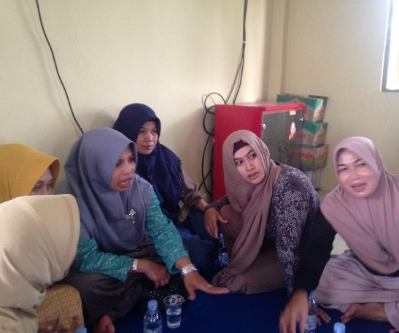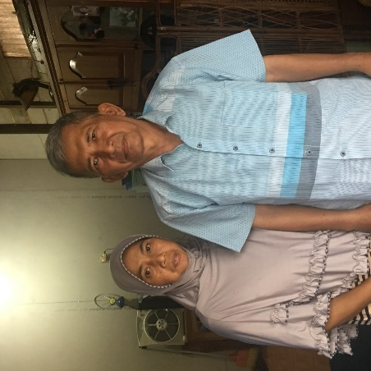
Gender and inclusion strategies
There was no explicit gender and inclusion strategy implemented, and at the community visited women had been excluded from the socialisation process. We also did not hear of any efforts to consider the needs of particular disadvantaged groups in the consultation or planning processes. The table below documents gender aspects of socialisation, decisions and benefits, from the perspective of women and men in the community.
Aspect | Women (n = 5) | Men (n= 6)
Socialisation (gender and inclusion aspects) | The head of RT invited others to a meeting attended only by males- the women only heard about it through their husbands, and said that things ‘didn’t seem clear- kurang jelas’ and that some men did not attend (contributing to partial coverage with about 30% who did not connect). Road was promised and ‘that was why we connected’. No involvement of health agency, Puskesmas, musholla etc.) | PD PAL staff approached the RW and then the head of households (men only) were invited to a community meeting at a Musholla. Community responded they would connect only if they were built a road. The PDPAL made a requirement that 90% of the household connect to go ahead.
Gender balance in household decision to connect | Husband made the decision. | The men consulted the wives but this was a quick process as they want the road
Perceived benefits | The road was seen as a benefit (resulting from the program) but injustice felt since some were benefiting but not paying.  Some households had already upgraded their septic tank and therefore felt no benefit. For those with leaking or substandard septic tanks (wood and open at bottom) there was also no benefit since nearby households were not connected and pollution from them continued.  Women perceived the cost as a disbenefit, and household bills for water and sewerage were reported to be 150,000-400,00 IDR/month, with minimum fee of 10m3, or 125,000IDR/month.  Another perceived disbenefit noted was the requirement for additional water to ensure that the toilet flushed (due to pipes with insufficient incline). | No observed or felt benefit/changes from the connection. It creates a burden of paying tariff. Previously, they had never had to empty the septic tank when they were not yet connected.  Some participants mentioned that odour had decreased, and others felt that the odour remained. Some participants mentioned a cleaner environment – however they were mainly referring to the concrete road built by the PDPAL/ LG rather than the sanitation situation.
Changed gender dynamics at household level | None noted | None noted
Changed gender dynamics at community level | None noted. Women suggested that as a minimum ideally they should have attended the original socialisation meeting | None noted

Political will and community demand
Political will:
There were mixed views about the level of political will amongst local government leaders. Stakeholders at national level noted greater political will during Phase 1 of the sanitation Hibah and that leadership and commitment had been reduced during Phase 2. As described above under inhibitors, there were a large number of sanitation governance issues that need attention, and require significant high-level commitment to address. These include improved enforcement of regulations to manage sanitation overall (including onsite systems), since this would remove the no-cost option for households to ‘do nothing’, which currently competes with joining the sewerage system. Regulations to support all members of a community to connect in locations where there is a sewerage main is another key area for policy development. A third area is the institutional arrangements and considering the potential merits of recombining the PDPAL and PDAM into a single enterprise, and reducing the expectation that the PDPAL operate on a for-profit basis, particularly with a significant proportion of MBR households as the customer base.

To increase both political will and community demand, local stakeholders suggested to find ways to make clearer the terrible state of the water quality in the river, as due to fluctuating water levels and unsealed tanks Ecoli levels are extremely high:
“We need to use a microscope- no one would want to touch that water. And yet people take bath, and brush teeth- they don’t know what is contained in that water.”
The strong voiced driver to beautify the river could be capitalised upon in advocacy and communications efforts. It appeared that high-level engagement with the Mayor and Sekda (as leader of the Pokja Sanitasi) was needed and could be instrumental in improving progress on the sanitation Hibah and the wider sanitation governance challenges.
Community demand:
Building community demand has been extremely challenging in the Banjarmasin context. Several local stakeholders proposed that there was a need to mandate and install 100% coverage in an area, such that the results and benefits will be more obvious to households: “If everyone has to install it is better. Otherwise the environment is still not clean”. They also felt that this would reduce would injustice concerning payment: “if others were willing to pay, then it would be cheaper. We are subsidising others. That isn’t fair”. Some FGD participants felt that socialisation would be insufficient and that mandating connection was essential: “they [non-connected community members] have tough temperaments….[..]…it would be better if they were forced to connect. I don’t think socialisation will be useful- the people are too difficult.”
FGD participants also gave suggestions to reduce the tariffs associated with sewerage so as to make the connection more attractive. Women suggested to reduce the additional fee (from 25% to 10% additional to the water tariff), and men suggested removing the minimum volume used (10m³ = 125,000IDR), which would allow poorer households to be careful in their usage and manage lower bills.
There was a missed opportunity to date to involve the health agency, Puskesmas and Posyandu in efforts to address sanitation behaviour change. It was reported that the current focus of Posyandu is on immunisation, pregnant women, breastfeeding and hygiene. To date there had been no training in STBM either for the sanitarian or the posyandu. It was reported by the PDPAL that although their formal lines of engagement were not with women, they had done so in some locations and found that this was a useful strategy: “Yes, we sometimes socialise with the women because the women tend to dominate in the households. And also it is easier to explain and easier to comply”
To date some efforts had been undertaken through the education system as a way to build engagement on sanitation. Involvement of schools (sanitation ambassadors) and universities (doing internships at PDPAL) in health and environmental promotion was mentioned by the PDPAL as a strategy to assist with socialisation and communications.
Finally, local stakeholders also felt that use of media and social media were also important communications strategies. In the ‘information era’ it was suggested that u-tube can and is being used to share information about the dangers of poor sanitation.
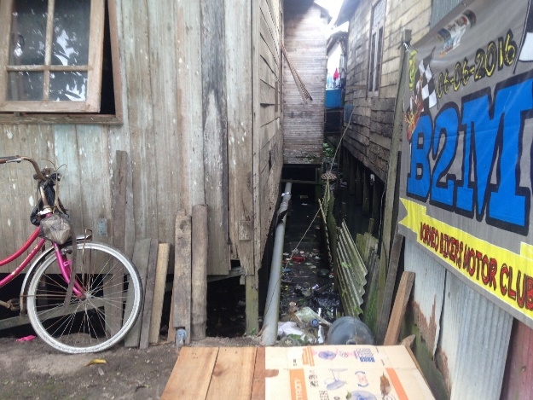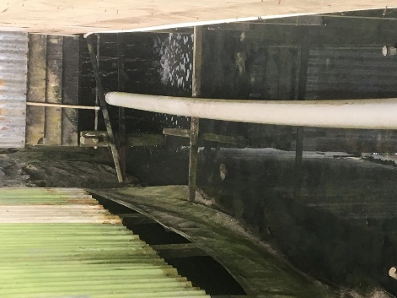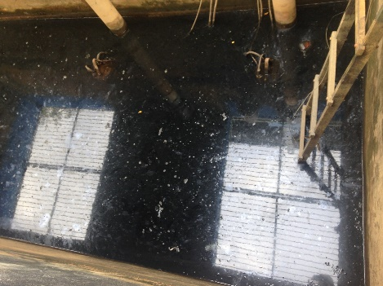

KOTA SURAKARTA

Background
Kota Surakarta is located in West Java and was chosen as a participant in the Sanitation Hibah program. The city has a total population of just over 552,650 people, and the area includes 5 subdistricts, 51 kelurahan. Access to drinking water was 83.88% and access to sanitation was 34.26% in 2015 (BPS, 2015). The poverty level is 10.87% and PDAM Surakarta reported that 4.88 % of PDAM customers are MBR.

PDAM profile
Surakarta has been involved in national sanitation programs including ISSDP, WASAP-D, DFAT Hibah, ADB twinning, IUWASH sanitation and faecal sludge management. In 2015 around 15% of the population were connected to three wastewater treatment systems, with the remainder of the population using on-site sanitation. Home industry, including cloth dying and soy products, result in industrial/commercial wastewater discharge from residential areas. PDAM Surakarta is the water and wastewater enterprise that owns and operates three sewerage treatment plants and one sludge treatment plant. The PDAM is responsible for charging and collecting tariffs from sewerage system customers.
PDAM "" Kota Surakarta | 2012 | 2013 | June 2014
Date established
Number of customers (household connections) | 55,709 | 58,231 | 60,678
Total number of employees | 394 | 360 | 368
Ratio employee/connection | 6.95 | 6.18 | 6.06
Production capacity | 772 | 752 | 746
Idle capacity
Non-revenue water (%) | 35.96 | 33.15 | 33.71
Reliability 24h/day (%) | 22 | 22 | 23
Coverage (cakupan) (%) | 78.44 | 79.65 | 82.07
Healthy/not | Healthy | Healthy | Healthy
Water tariff (social general) (IDR) |  |  | 650
Water tariff (household) (IDR) |  |  | 3,663
Water tariff (commercial) (IDR) |  |  | 7,600
MBR customers |  | 1,042 | 2,958

Financials
PDAM Kota Surakarta | 2013
Figures
Asset | 129,780.22
Liabilities | 57,058.49
Equity | 72,721.73
Working Capital | 72,711.73
Cash & Equivalent | 3,350.40
Inventory | na
Current Ratio | 0.45
Debt Equity Ratio | 0.78
Profit/Loss | 4,550.82
ROE | 6.26%
Source: IndII Water Hibah (PCP Report), BPPSPAM Data
Participation in the Sanitation Hibah
Kota Surakarta participated in the DFAT Sanitation Hibah, and in DFAT’s SAIIG program. The Sanitation Hibah Agreement dated 20 June 2013 had an approved allocation of 2500 HC with a budget of IDR 12.5 billion. 2,113 HC were installed which was an efficiency ratio of 85% and IDR 10.565 billion recommended for payment. Hibah disbursement of IDR 10.565 billion was made in 2014. Surakarta made an agreement under SAIIG for an additional 1500 HC. The SAIIG connection target of 1,500 was amended and 1,141 household connections, or 76%, of the target completed although only 466 have been recommended for disbursement to date.
Subject | DFAT(AL) | DFAT (sAIIG) | Total
SPPH House Connection (HC) prior to amendment | 2,500 | 1,500 | 4,000
SPPH House Connection (HC) after amendment |  | 1,500 | 1,500
Installed HC | 2,113 | 1,141 | 3,254
Recommended HC | 2,113 | 466 | 2,579
Total Hibah | 12.5 Billion | 4.5 Billion | 17 Billion
Recommendation | 10.565 Billion | 3.186 Billion | 13.751 Billion
Hibah disbursed | 10.565 Billion | 1.398 Billion | 11.963 Billion

Implementation progress/enablers/inhibitors Sanitation Hibah
Progress: Progress of the Sanitation Hibah was good with Surakarta reaching 85% of the target. There is strong political leadership from the Bupati to achieve national sanitation targets and recognition of city-wide benefits of an improved environment especially for riverfront areas.

Enablers
S | - Involvement of the Puskesmas and PKK allowed for effective socialisation.  - Health workers know the local community and improved communications with the PDAM.  - Earlier involvement in IUWASH had also built local capacity for socialisation.  - Benefits of a household sanitation connection including privacy and improved health from greater handwashing.
T | - Sewerage system design was appropriate to the urban situation in Surakarta.  - PDAM partnership with a local Puskesmas, familiar with the STBM approach.  - Health workers first socialised key messages with the community, which allowed the PDAM to approach household on connections.
E | - Environmental benefits from the scheme including less odour, cleaner waterways and few blockages contributed to local higher local satisfaction.  - The PDAM made use of narrow spaces between building which minimised household disruption compared to other locations.  - HOUSEHOLD were willing to connect as for most resident the small lot size did not allow a septic tank.
E | - The city has the financial capacity to make equity investment and has an IDR 15 billion investment program which supports water and sanitation programs.  - No connection fee for MBR customers so 90% of the community agreed to participate. While non MBR HOUSEHOLD were willing to pay connection fees of IDR 800,000 to IDR 3,000,000.  - A PDAM responsible for water and sanitation allowed monthly fee of IDR 5,000 to be included in the water bill.
P | - There was strong evidence of political will. The Bupati confirmed that the National policy targets for water and sanitation under 100-0-100 strategy are a key driver for the city’s engagement in sanitation programs. Surakarta has an ambitious goal of reaching its local targets by 2019.  - The broad based Pokja Sanitasi supported better socialisation including involvement of a local community-based sanitation group

Inhibitors
S | - Local community considered that hygiene promotion in the socialisation was inadequate.  - PDAM officials are not well equipped to undertake socialisation.  - No one in the women’ focus group attended meetings to discuss the Hibah program. As a result they were no involved in decision making at household level.  - PDAM socialisation process only involved the men.
T | - Household’s that invested in a septic tank did not want to participate as they already had a service.  - Households did not want the disruption that went with sewer and toilet installation.
E | - While the community was generally happy with the sanitation service rehabilitation of the roadway, which is a community asset, was done poorly and lowered community satisfaction.  - Not enough socialisation of the non-health benefits of the scheme.
E | - Some poor households could not afford the monthly fee so were reluctant to connect even for free.  - MBR household along the riverfront would benefit but did not participate as they did not have secure land title.
P | - This was the location with the Pokja Sanitasi that included NGO’s, Bappeda and other agencies. However, the group could be strengthened through the inclusion of representatives of disabled people’s organisations and women’s groups. There was no evidence of a strong working relationship with Ministry of Women’s Empowerment at sub-national level and Bappeda does not have current links with disabled people’s organisations.

Gender and inclusion
Formal socialisation of the sanitation Hibah in Surakarta was conducted by the PDAM through RT/RW leadership rather than the PDAM working directly with the community. The consultation process, which included a community meeting of about 20 household representatives, only had involved men.

From a gender perspective there was little engagement with women, some men in the focus group discussion did discuss the scheme with their wives before agreeing to participate. But there was limited opportunity for contact with the PDAM by women unless the husband was away when they came to visit the house. The women’s and men’s group both agreed that men were the main decision makers in participating in the Hibah. This group included some school-aged girls who confirmed that household decision were made by the men. There were no formal mechanisms for engagement of women and people with disabilities. Engagement with women took place through the PKK, but this did not represent a formal engagement.

Both men and women noted similar environmental benefits from the scheme with less odours, cleaner waterways and generally there were benefits in a cleaner neighbourhood. While the men saw little difference in gender dynamics in the home the women appreciated that the household connection allowed more privacy, including for menstruation management, greater comfort and convenience compared to using a public toilet. The FGD included a group of school aged girls who were especially appreciative of the household connections, in particular the privacy aspects relating to menstrual hygiene. One woman mentioned that the household connection made it easier to toilet train young children. Women in the focus group thought that to encourage greater involvement of women the mayor should issue a regulation supporting this aim.

When asked local officials were not aware of the IndII developed gender responsive guidelines and confirmed they had not been used in the socialisation process.

The table below documents gender aspects of socialisation, decisions and benefits.

Aspect | Women (n = 6) | Men (n= 7)
Socialisation (gender and inclusion aspects) | The program was not formally socialised with women in the community and there was little direct contact with the PDAM. The PKK was used as an informal mechanism for information sharing. | Only men had been involved in socialisation through the PDAM contacting the RT/RW leaders. They organised a community meeting of 20 households which included only men. Over 90% of those who attended agreed to participate.
Gender balance in household decision to connect | Women said that the men usually made the decision, but they were aware of the issues. | Men said that the husband made the decisions, but some men reported discussing the issue with their wife.
Perceived benefits | Women recognised there were personal benefits as a household connection allowed for improved health, privacy, greater comfort and convenience, including during menstruation, and that socialisation had improved hygiene behaviours including handwashing. They were more concerned than the men about affordability | Men noted the similar benefits in cleaner toilets, cleaner environment, less odour, time saved compared to using public toilets. There was no need for cleaning of the septic tank, which could cost IDR 300,000.
Changed gender dynamics at household level | Yes there was more privacy for sanitation. | None noted
Changed gender dynamics at community level | None noted, but a number of youth present noted involvement of PKK (NGO) and youth organisation would be valuable for future programs. Involvement of women’s and people with disabilities representatives could improve socialisations | None noted.

Approaches to increase commitment, ownership and community demand
Leadership from the Bupati was a major enabling factor in increasing commitment from the Local Government and PDAM. In Surakarta this included making a policy commitment for 100% sanitation and water coverage by 2019. Sanitation was seen as contributing to city-wide campaigns for improved health, clean city and waterways especially along river frontages which greatly improved the amenity of public areas.

It seemed that greater understanding was needed about the drivers of change for sanitation in the local context. Health based campaigns are valuable but the community appeared to give greater recognition of other benefits including cleaner environment, reduced odour and the greater amenity of a household toilet. The city health office noted that during a recent dengue outbreak a health campaign focused on water borne diseases had increased awareness of the impact of poor water quality in the local area. The women’s focus groups thought more could be done by the Mayor to encourage involvement of women while the men’s group considered that there could be greater socialisation of health benefits.

A current city sanitation strategy was a key enabler as it allowed for planning and budget preparation. In Surakarta the city sanitation strategy was being updated by the Pokja Sanitasi. This group did not currently include representation of women and people with disabilities, but this could be usefully considered in the future.

The PDAM appeared to be technically focused and while technically competent in delivering appropriate sanitation systems they did not demonstrate strong capacity in socialisation. This points to the need for PDAM’s to work in partnership with planning, health, local Puskesmas and NGO’s in the socialisation process to create local demand.

To promote city sanitation there appeared to be a need for DFAT/IndII/KIAT to build partnerships with other programs, which have much longer experience in socialisation and behaviour change, including IUWASH and PAMSIMAS.
Appendix E: Gender in the Water Hibah
Background to gender in the Water and Sanitation Hibah
This program incorporated performance targets and governance milestones to improve household water supply. Socio-economic baseline surveys, which included a number of gender and social inclusiveness-sensitive indicators such as household composition of beneficiaries by gender and age groups, income, health, primary water source conditions, sanitation facilities and other community activities or issues were conducted as a part of this activity. However it appears that these may have suffered from some methodological weaknesses and not always targeted sufficient female respondents or examined the most important gender dimensions.

A related activity relevant to the Sanitation Hibah was the development of the Gender Integration Guide in Institution-Based Waste Water Treatment Program. This Guide was initiated by Directorate General of Human Settlements (DGHS) and developed by IndII and DGHS in 2013 to assist local governments and relevant stakeholders with the integration of gender into institution-based waste water treatment programs. The Guide has been socialised with national and local level stakeholders, presented at a Ministry of Public Works and Public Housing (MPWPH) workshop and piloted in one location, Balikpapan with the intention to apply it on a wider basis. It is being examined by DGHS to see how it can be integrated into a legal framework. The Guide was designed to be applied to support all sanitation programs, such as Australian Indonesia Infrastructure Grants for Sanitation (sAIIG) and the Sanitation Hibah.

Previous reviews of the Water and Sanitation Hibah from a gender perspective
The Water Hibah has been reviewed from a gender perspective and there have also been overall general assessments. There have been no previous evaluations to date of the Sanitation Hibah from a gender perspective. Differing methodological approaches have been used in the various reviews and evaluations. Overall, studies such as the Impact Evaluation Report completed by NORC (which used a quantitative approach and draw on the first set of socio-economic surveys from Phase 1) provide little evidence of gender impacts in contrast to qualitative based studies. Reports examined for this review are summarised in the Table 1 below. A number of shorter articles summarising the key findings of the above reports were published in Prakarsa, however they focus on reporting key findings from the above evaluations.

Table 1: Summary of evaluations of hibah activity in IndII.
Date | Study | Methodological approach
2011 | Case Study Evaluation from a Gender Perspective: Water Hibah and Public Diplomacy Community Outreach Activities (Phase 1) | Mixed methods (QUAL & QUANT)  Document review  Stakeholder workshop  Interviews  Observation  Thematic analysis  Locations: Serang and Palembang
2013 | Evaluation of Selected Water Hibah Activities from a Gender Perspective. | Mixed methods (QUAL & QUANT)  Document review  Interviews  Observations  Thematic analysis  Locations: Malang and Manggarai
2015 | Impact Evaluation Report of Water Hibah Program Phase 1. | Quantitative  Large household survey  Statistical analysis

The following framework of analysis was developed by ISF-UTS and published in a paper that synthesised gender outcomes related to water and sanitation that have been documented in the literature. The paper draws the thinking of Caroline Moser and is based on an understanding of women’s practical and strategic gender needs and interests. Practical gender needs are those that do not challenge women’s socially accepted roles, while strategic gender interests are transformative and reflect the demands for improved gender equality. This thinking begins from the assumption that women are subordinate to men as a result of discriminatory social and institutional practices. In order to transform gender relations and improve gender equality, attention must be directed at changing relations at the household level and in the public arena.

Table 2: Exploring gender equality through roles and relationships in private and public arenas
Types of changes | Household sphere:  Household and family networks | Public sphere
Types of changes | Household sphere:  Household and family networks | Local: social and community networks | Broader: governance institutions and beyond
Changes in self/individuals  (includes changes for women or men, and changes relating to roles as well as self-perception and attitudes) | Changes in roles, self-perceptions, and attitudes within the household sphere, related to family networks and household roles and responsibilities | Changes in roles, self-perceptions, and attitudes within the local public arena including social networks, community and local institutions | Changes in roles, self-perceptions, and attitudes within the broader public arena including sub-national and government institutions, medium to large scale private sector actors
Changes in relationships  (includes changes in relationships between women/men and within gender groups) | Changes in relationships within household sphere, related to family networks and household roles and responsibilities | Changes in relationships within the local public arena including social networks, community and local institutions. | Changes in relationships within the broader public arena including sub-national and government institutions, medium to large scale private sector actors

The above framework goes beyond thinking about women’s participation in decision-making and reduction of time burdens and provides a framework for thinking about higher-level outcomes that may be sustainable in the long terms such as changes in attitudes, behaviours, beliefs, roles and responsibilities beyond the home. These address the strategic gender needs of women and are transformative.

This evaluation uses the Gender Outcomes conceptual framework to identify the key gender outcomes achieved as documented in the above reports. The domains in the above conceptual framework were identified from a review of the literature (academic and grey) and from research examining WASH programs in Fiji and Vanuatu. Whilst not all changes referred to in the literature examined can be attributed to WASH programs, the authors note that there is a ‘significant body of evidence on the strong relationship between WASH and gender, and the reality that all development interventions including WASH have gendered outcomes.’ A number of other caveats are noted such as the limited coverage in the literature of issues relating to menstrual hygiene, outcomes for older and pregnant women, female-headed households and other layers of difference and discrimination such as socio-economic status, disability and ethnicity.

This Annex identifies key outcomes as reported in the previous evaluations and reviews of the water hibah against the domains described in the above conceptual framework.

Reported outcomes in the household sphere: changes in self/individuals
Changes in self/individuals can occur at the household level and in the public sphere (social and community networks and governance institutions and beyond). It is at this level that the literature reports the most changes. It is important to note that within the sub-dimensions below, there are overlaps.

Changes in self-awareness
Positive outcomes were noted as a result of participation in community outreach programs and other education and information dissemination activities. Together with improved understanding of the role gender plays in water and sanitation activities, there was reported to be ‘improved understanding of, and interest in, gender issues more generally by participants.’

Changes in access and usage of water
The independent evaluation of phase 1 conducted in 2011 found a number of benefits to women. This document notes: ‘access to better quality and cheaper water, substantial time savings in accessing and treating water, and health improvements… households reported a reduction in odours and less pooling of stagnant water, which should reduce the incidence of vector-borne diseases. While women and the disabled were found to be significant beneficiaries of the program, this finding is not quantified.’ The impact evaluation by NORC was not able to find any such links. A key barrier to identifying gender impacts by the NORC study is that a statistical survey is unlikely to be able to identify the kinds if benefits important to women due to its methodology and design.

The 2013 gender study by IndII reports that ‘the provision of piped water at the house has had an amazing impact on the lives of women and children.’ These effects were felt by men as well as women, who reported greater time and energy for work and leisure activities. Labour savings were reported for the elderly, but it is not clear if the time saved was by family members with care responsibilities or the elderly themselves.

Changes in self- confidence, particularly for women
The ability to bathe at home which is linked to linked to privacy was important for women as was the access to clean water for bathing children at home and reported benefits to health. The IndII 2013 evaluation reports that families built bathrooms after the piped water was connected, health had improved and some people had increased the levels of bathing. This contrasts with the report provided by NORC in 2015 that did not find any effect on health outcomes, school attendance or employment. However, they did find evidence of improvements to water quality.

There were differing impacts between poor households were not able to substitute bathing water for piped water and the improvements noted were not as significant as in other households. One woman reported increased independence as she previously used water from the next-door house of her parents in law. Having her own connection meant she was able to use water more freely.

Outcomes relating to increasing and/or diversifying income opportunities and skills
IndII reports that women have ‘greater time and energy for their multiple productive, income earning and domestic work and for their social activities and leisure.’ One family had started ice production with the clean water, others were planting vegetables that could now be watered during the dry season. The excess produce was reported to be sold at market. One interviewee described lower costs for micro business because of piped water, others indicated a have more time to explore income generating opportunities.

Reported changes in relationships as household level
The report provides some evidence of changes in status within relationships at household level. As noted in the 2013 report, even though there were cost implications, 11 of the 24 interviewed report that they would stay connected despite the financial burden. It is not clear if the above respondents were female or male. Piped water connections had eliminated the need to purchase bottled water so while there were increased costs, there were also increased savings that offset the extra expense. The above example shows some evidence of changes in relationships within households. Women appear to be using their negotiating power in household relationships, and taking charge over one household expense (resources and assets). Other changes at this level for which there was no clear evidence may include changes to communication between husbands and wives, levels of respect between women and men in the household, levels of conflict and harmony (including gender based violence within households).

Women’s strategic gender needs
It was not possible to identify any changes in women’s strategic gender needs (Local: Social and community networks: at individual level). Based on the gender outcomes framework, such changes might have included:
- changes in self-confidence particularly for women, educational outcomes relating to girls’ education and literacy
- awareness of women’s rights by men and women
- number of women occupying public and potentially influential roles in their community, changes to the extent to which women are voicing their expectations and demands relating to community governance
- levels of mobility and seclusion for women, personal safety for women, outcomes relating to increasing and diversifying income opportunities and skills for women and men including opportunities to take up non-traditional roles.
There were no changes reported in the Public arena (broader government institutions and beyond at individual level). Based on the gender outcomes framework, such changes might have included:
- numbers of women occupying public and potentially influential roles in government and private sector institutions;
- numbers of women occupying technical roles in government and private sector institutions, changes in the extent to which women are voicing their expectations and exerting influence within higher levels of government (e.g. provincial, national),
- changes in women’s leadership on WASH issues at a larger scale (beyond their local community).
In the Public arena (broader government institutions and beyond in relationships) there were no reported changes. Based on the gender outcomes framework, such changes might have included:
- changes in the status of women in public life, shifting of traditional social norms, including the diversity of roles available and acceptable for women in the public and private sectors,
- changes in the level of trust and respect afforded to women in influential and technical roles in government and private sector institutions,
- changes in policies and programs that support equal participation of women and men in influential and or technical roles in government and private sector institutions,
- outcomes relating to women and men becoming positive gender role models in their province, district or nation, changes to priority given to WASH investments relevant to advancing gender equality, as reflected in budget allocations at this scale,
- changes in media and public debate about WASH investments and gender equality,
- changes in the representation of female and male water users on consultative bodies, advisory groups and boards established by water utilities,
- changes in national, regional or international WASH commitments relevant to gender equality (e.g. recognition of the right to sanitation, policy commitments about provisioning for separate facilities for girls in schools).

Ministry of Finance Regulation No. 188/PMK.07/2012, with subsequent amendments in 2015 and 2016
100-0-100 refers to a national policy commitment towards 100% access to water, 0% slums and 100% access to sanitation by 2019.
IndII 2011 Project concept
Please note that we have modified the wording from the Concept Note section on Water Hibah (changing ‘sanitation’ to ‘water’) based on discussion between DFAT and Jim Coucouvinis
IndII 2011 Project concept
Note this output was revised to 9,100 households due to a miscalculation in the original design (Pers. Comm, J. Coucouvinis)
The original plan was 5000 households, however some funds were transferred to the Water Hibah
Utilisation focused evaluation prioritises strong stakeholder engagement and a focus on servicing the practical information needs of intended users (Patton, 2008, Utilization Focused Evaluation, Sage Publications)
Based on Moser, C., (1989) Gender Planning in the Third World: Meeting Practical and Strategic Gender Needs. In World Development, Vol. 17. pp 1799 – 1825.
The evaluation employed DFAT’s 6 point scale to assess the three criteria: effectiveness, sustainability and replicability, based on the views of the two independent evaluation team members
As reported in IndII Activity Progress Report December 2016
The revisions to the final target was due to exchange rates, which varied during the course of the project, and were set once a year by DGHS, which meant that towards the end of the program whilst IndII predicted 307,000 households, DGHS expected 298,000 households
Note that it is in fact difficult to make a direct comparison between Hibah achievements in terms of the unit cost of household connections and those achieved by DAK, since DAK funding is also used for network extension, rehabilitation, water supply units etc., and Hibah commonly includes household connections and related tertiary network. However, several stakeholders noted the importance of the accountability provided by the Hibah mechanism as compared with other intergovernmental transfer mechanisms.
Presentation developed by Pak Nugroho, Bappenas, 2012, Performa Hibah Kapasitas Fiscal
As an example, the Local Government and Decentralization Project (LGDP), an output-based program focused on DAK, undertook rigourous analysis of how local governments participated and used this information to refine the program and identify broader sector issues
The IndII M&E Plan lays out the following performance questions and related measures, however these do not appear to have been monitored during Phase 2: (i) How has the priority for and investment in water and sanitation services changed? ($ increase in investment flows to LGs for water and sanitation investment. (ii) How have the financing arrangements supported LGs to improve water and sanitation investments? Have these been sufficient and effective? ($ increase in investment flows from LGs to PDAM/PDPAL). The M&E Plan also mentions: “At district level – Local Government (LG) investment data on water and sanitation sector is required to identify trends over time in order to determine whether IndII has contributed to improve the investment situation. Baseline data collection at this level might also include service provider performance to enable assessment on improvement around this aspect.”
IndII internal report of Blaine Lewis conducted in October 2013
Averill, K, Scally-Irvine, K, Nordiawan, D, Howard, M, Gouy, J (2011) Independent evaluation of the water and sanitation hibah program Indonesia: Draft Final Evaluation Report; NORC at the University of Chicago. (2015). Impact Evaluation Report of Water Hibah Program Phase 1. Jakarta, Indonesia Infrastructure Initiative.
IndII (2013: v)
Averill et al (2011)
See Office of the Vice President of Indonesia, TNP2K, Indonesia’s Unified Database for Social Protection Programmes Management Standards, www.tnp2k.go.id and also Adama Bah Suahasil Nazara and Elan Satriawan, 2015, Indonesia’s Single Registry for Social Protection Programmes, Research Policy Brief
MoF also voiced concern about the need for concurrent mandatory spending (20% for education and 5% for health) associated with national government spending on initiatives such as the Hibah.
Only 5-6 PDAMs were reported to have borrowed money under Perpres 29 or other means
This is significant also in relation to disadvantage groups, since improved databases can better capture PLWD or other groups
GPOBA 2016 Getting Results: Independent Verification in Output-Based Aid
Please see https://washresultsmve.wordpress.com/2016/02/05/what-have-we-learned-about-payment-by-results-pbr-programmes-from-verifying-one/ for further information
Note this overall unit cost is lower than others as a sampling method was used for the 26,000hc’s rather than census method (as is true for others described in this table). In this case, 3,273 connections were verified as a sample of a total of 26,000 connections. The individual unit cost for each of these 3,273 connections is relatively high due to higher logistics costs associated with only a small number of connections per local government, however since a sampling method was used, the overall unit cost is lower.
NUWAS is the proposed upcoming loan program of the World Bank to Government of Indonesia
There appear to be deficiences in its narrow design focus (replicating the Water Hibah) that do not match the complexity of engaging in the sanitation sector- hence the inclusion of longer-term recommendations for DFAT’s programming in the sanitation sector going forward.
See IndII Activity Progress Report, Sanitation Hibah, December 2016
Based on IndII Activity Progress Report, December 2016
Noted in IndII Activity progress report, December 2016
Noted in IndII Activity progress report, December 2016
Noted in Draft WB WSP Improving On-site sanitation and Connections to Sewers in Southeast Asia, Surakarta Report, May 2015
Noted in IndII Activity progress report, December 2016
World Bank (2015) Improving On-site Sanitation and Connections to Sewers in Southeast Asia – Insights from Indonesia and Vietnam
Direct Funding Agreement (DFA) June 2012 between Government of Australia and Government of Indonesia
As part of the World Bank (2015) Upgrading Onsite Sanitation and Connecting to Sewers in Southeast Asia - Insights from Indonesia and Vietnam, research was done in six cities (Banjarmasin, Bandung, Denpasar, Yogyakarta, Surakarta and Jakarta) which may including useful evidence to inform such assessments.
Stakeholders reported that CK promotes at least 2% of LG budget for sanitation, however in reality many LG only allocate less than 1%, and only a few LG allocate 3-5%
Reports that there were issues with the performance of the treatment system and insufficient funds to extend the sewerage network are all signs that the wastewater division may not be receiving adequate priority
The two outcomes described in IndII Activity progress report, December 2016 are: (i) The participating LGs increase their overall sanitation expenditure significantly above nonparticipating LGs, and where most of that increase is directed to fixed infrastructure investments resulting in increased access to efficient and sustainable sanitation services; (ii) Public health and social welfare have improved, and that a socially inclusive approach has been taken. Women, the poor, people with disabilities and other disadvantaged groups, will have equitably participated, including in decision making, and will have enjoyed equitable access to resources and benefits.
See IndII (2012) M&E Plan
See Annex 11 Monitoring and evaluation framework, KIAT design: p6
IndII Sanitation Hibah Activity Progress Report December 2016 (Section addressing gender)
Both of these were already committed to in IndII (2010) M&E Plan
The socio-economic surveys undertaken by IndII at present appear to be potentially under-used in terms of drawing on evidence to assist in communications and advocacy
Shit Flow Diagrams (SFDs) have been developed for several Indonesian cities by the World Bank, including development of a process to streamline their development (Fecal Waste Flow Diagram (SFD) for City Wide Inclusive Sanitation in Indonesia, presentation by Maraita Listyasari, Water and Sanitation Specialist at Water Week 2017). The SFD template and manual are available at www.susana.org
Recent evidence From BPS/UNICEF for Yogyakarta confirms high levels of contamination of drinking water, including from poor sanitation.
The World Bank Economics of Sanitation Initiative (ESI) documented the economic costs, including in the capital, Jakarta, where poor sanitation costs Jakarta about IDR 16.2 Trillion (USD 1.4 billion) per year.
Recent World Bank studies on Poverty Diagnostics released in 2017 demonstrates that an estimated 9 million children (37 percent) under five are stunted in Indonesia, and that children in the lowest quintile (49 percent) are more likely to be stunted than children in the highest (29 percent), and in lowest quintile stunting is just as likely in urban as in rural areas. Owning a toilet and having access to clean drinking water supply, and living in a community where most of one’s neighbours own a toilet, are important drivers of child growth and cognitive development. See World Bank (2017) Improving Service Levels and Impact on the Poor, A Diagnostic of WASH and Poverty in Indonesia).
See http://www.reality-check-approach.com/
In Banjarmasin Pokja Sanitasi appeared to need support: “the pokja sanitasi, there is the same policy for all Indonesia, however the expectation is that the pokja will solve issues, but in reality everyone is busy with their own things so often things are not followed up”
Plan Indonesia recently completed urban STBM work in Duri Utara, West Jakarta
SNV Development Organisation Indonesia have been working on urban sanitation behaviour change programs in Lampung Selatan
Identified in previous research, practice or by evaluation participants
A key strategy identified by a rigourous study examining three cities and the Winters et al. 2014, Public Service Provision under Conditions of Insufficient Citizen Demand: Insights from the Urban Sanitation Sector in Indonesia World Development Vol. 60, pp. 31–42, 2014
See ISF-UTS (2015) Strengthening governance arrangements for small city and town sanitation. Report prepared by the Institute for Sustainable Futures, University of Technology Sydney, Kemitraan Partnership for Governance Reform and SNV Indonesia for the Australian Aid Indonesia Infrastructure Initiative (IndII).
WaterAid, 2017 A Tale of Clean Cities
See http://www.righttowater.info/making-rights-real/
See ISF-UTS (2015) Ibid
See ISF-UTS (2015) Ibid
See Mitchell, C, Ross, K, and Abeysuriya, K. 2015. An analysis of performance data for local scale wastewater services in Indonesia. Prepared by the ISF-UTS, http://communitysanitationgovernance.info/
https://garutkab.bps.go.id/new/website/pdf_publikasi/Kabupaten-Garut-Dalam-Angka-2016.pdf
https://garutkab.bps.go.id/new/website/pdf_publikasi/Kabupaten-Garut-Dalam-Angka-2016.pdf
https://kapuaskab.bps.go.id/ 2017
BPS, 2015
https://kapuaskab.bps.go.id/ 2017
Non-water revenue refers to bottled water, laboratorium testing for industry
https://garutkab.bps.go.id/new/website/pdf_publikasi/Kabupaten-Garut-Dalam-Angka-2016.pdf
https://garutkab.bps.go.id/new/website/pdf_publikasi/Kabupaten-Garut-Dalam-Angka-2016.pdf
World Bank Improving On-site sanitation and Connections to Sewers in SE Asia –Insights from Indonesia and Vietnam Appendix 5 – Surakarta Report
This comment may have been in relation to a community-based sanitation program rather than the sanitation Hibah.
Carrard, N. Crawford, J. Halcrow, G. Rowland, C and Willetts, J (2013) A framework for exploring gender equality outcomes from WASH programmes. Waterlines V 32, (4) pp315-333.
Moser, C (1989) Gender planning in the third world: meeting practical and strategic gender needs. World Development. 17. 11.
Source: Carrard, N. Crawford, J. Halcrow, G. Rowland, C and Willetts, J (2013) A framework for exploring gender equality outcomes from WASH programmes. Waterlines V 32, (4) pp315-333.
Carrard et al (2013: 316).
NORC (2015: 21).
Averill, K, Scally-Irvine, K, Nordiawan, D, Howard, M, Gouy, J (2011) Independent evaluation of the water and sanitation hibah program Indonesia: Darft Final Evaluation Report. NORC at the University of Chicago. (2015). Impact Evaluation Report of Water Hibah Program Phase 1. Jakarta, Indonesia Infrastructure Initiative.
NORC (2015).
IndII (2013: v)
Averill et at (2011).
Averill et al (2011).
NORC 2015: 15
NORC 2015: vii
IndII (2013: 9).
IndII (2013: v).
IndII (2013: v).
Averill et al (2011).
Averill et al (2011).
IndII (2013: 5).

