

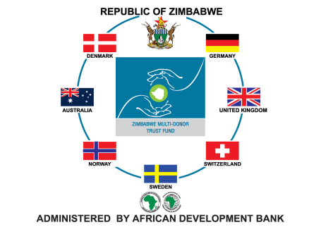

**EVALUATION OF OUTCOMES AND IMPACT OF ZIMFUND PHASE I URGENT WATER SUPPLY AND SANITATION REHABILITATION PROJECT (UWSSRP) and EMERGENCY POWER INFRASTRUCTURE REHABILITATION PROJECT (EPIRP)**

**Final Report: February 2017**

**List of Abbreviations**

AfDB African Development Bank

EPIRP Emergency Power Infrastructure Rehabilitation Project

FGD Focus Group Discussion

HH Household

HPS Hwange Power Station

KII Key Informant Interview

KM&E Knowledge, Monitoring and Evaluation

NGO Non-Governmental Organisation

OECD Organisation for Economic Cooperation and Development

PAR Project Appraisal Reports

PHHE Primary Health Hygiene Education

PLWHIVA People Living with HIV and Aids

POC Programme Oversight Committee

SAIDI System Average Interruption Duration Index

SLB Service Level Benchmarking

ToRs Terms of Reference

UWSSRP Urgent Water Supply Sanitation Rehabilitation Project

VfM Value for Money

WASH Water, Sanitation and Hygiene

WSS Water Sanitation Services

ZETDC Zimbabwe Electricity Transmission and Distribution Company

ZESA Zimbabwe Electricity Supply Authority

ZimFund Zimbabwe Multi Donor Trust Fund

Contents

1. Introduction 5

1.1 Background 5

2. ZimFund Achievements 6

3. Objectives of the Evaluation 12

3.1 Phases of the Evaluation 12

3.2 Understanding of the Terms of Reference (ToRs) 12

3.3 Methodology for the Evaluation 13

3.4 Limitations of the evaluation 13

4. Study Methodology 13

**1.** **Inception Phase** 13

**2.** **Preparation Phase** 14

3. **Demographics of the Sample** 16

4. **Findings from the Study** 17

4.1 Diarrhoea Amongst young Children 17

4.2 Hygiene Training 18

4.3 Access to Municipal Water 19

4.4 Reliable and Stable Water Production 21

4.5 Quality of Water 24

4.6 Household Water Hygiene Practices 26

4.7 Sanitation and Waste Water 26

4.8 Evaluation of the PHHE Component 29

Household Sanitation Hygiene Practices 29

4.9 Reduction in Non-revenue Water 32

4.10 Gender and Water Collection 33

**5.** **Constraints and Opportunities Impacting the Project** 36

**6.** **Access to Electricity** 36

7. Conclusions 43

8. Recommendations 43

**Annexes** 44

**Annex 1 : Workplan** 44

**Annex 2 : Notes on Terms of Reference** 47

**Annex 3 : Team members** 49

Annex 4 Documents Reviewed 51

**Annex 5 : Inception Report** 52

**Annex 6 : The Social Evaluation Survey for the UWSSRP FIELD PLAN** 53

Annex 7 : Impact and Outcome Indicators for UWSSRP 1 from Project Appraisal Reports (PAR) 55

Annex 8: Impact and Outcome Indicators for EPIRP 1 from Project Appraisal Reports (PAR) 57

**Annex 9: Household Survey Tool** 59

**Annex 10: Key Informant Interview Water Tool** 69

**Annex 11: Key Informant Interviews Waste Water Tool** 83

**Annex 12: Household Focus Group Discussion Tool** 86

Figure 1 : Age of Household Head 16

Figure 2 : Household Size 16

**Figure 3 : Percent of Households with Occurrence of Diarrhoea amongst Children 0-4 years past 30 days** 17

**Figure 4 : Number of Children with Diarrhoea in Households with Occurrence of Diarrhoea amongst Children 0-4 years past 30 days** 17

Figure 5 : Number of Diarrhoea Cases 2015-16 from Clinic Records 18

Figure 6 : Place of treatment of Children 0-4 years with Diarrhoea 18

Figure 7 Household Members with Hygiene Training or Health Club Membership 19

Figure 8 : Children in Households with Hygiene Training or Health Club Membership 19

Figure 9 : Household Primary Water Source 20

Figure 10 : Household Secondary Water Source 20

Figure 11 : Distances to Household Water Sources 21

Figure 12 : Frequency of Water Cuts During the Past 7 Days 22

Figure 13 : Length of Water Cuts During the Past 7 Days 23

Figure 14 : Continuity of Water Support 2014-16 23

Figure 15 : Perceptions as to whether Water is Safe for Drinking 25

Figure 16 : Basis of Perceptions for Residents Feeling Water is Not Safe for Drinking 25

Figure 17 : Cleanliness of Water Storage Containers 26

Figure 18 : Access to Sanitation 27

**Figure 19 : Presence of Sewage in Vicinity** 28

Figure 20 : Extent of Sewage Flows 28

Figure 21 : Cleanliness of Toilets 29

Figure 22 : Anal Cleansing Materials 30

Figure 23 : Presence of Handwashing Facility 30

Figure 24 : Presence of Soap at Handwashing Facility 31

Figure 25 : Means of Garbage Disposal 31

**Figure 26 : Functionality of Water Meters** 32

Figure 27 : Frequency of Reading of Municipal Water Meters 33

**Figure 28 : Reason for Not Paying Service Bills** 33

**Figure 29 : Household Members who Collect Water** 34

Figure 30 : Domestic (Household) customers supplied from a ZimFund Transformer. 37

Figure 31 : Extent of household Access to Electricity 38

Figure 32 : Status of Electrical Connection 38

Figure 33 : Households Currently with Power Supply 41

Figure 34 : Extent of Load Shedding 41

**Figure 35 : Length of Load Shedding** 42

**Figure 36 : Comparison with Previous Supply from ZESA** 42

# Introduction

In October 2016 the Zimbabwe Multi Donor Trust Fund (ZimFund), managed by the African Development Bank (ADB), contracted GRM International Zimbabwe (Pvt) Ltd to conduct an evaluation of Outcomes and Impact of the Urgent Water Supply and Sanitation Rehabilitation Project Phase 1 (UWSSRP 1) and the Emergency Power Infrastructure Rehabilitation Project Phase 1 (EPIRP 1). The evaluation was conducted from 24th October to 24th December 2016, including an Inception period of 2 weeks. This report presents the key findings of the evaluation.

## 1.1 Background

In 2010, the government of Zimbabwe enlisted help from seven donors (Australia, Denmark, Germany, Norway, Switzerland, Sweden and United Kingdom) to address the challenges the country was facing in its water and sanitation services and unreliable power supply. The infrastructure was in a state of disrepair due to lack of proper maintenance and also as a result of vandalism. Limited resources due to the prevailing socio economic challenges, also contributed to the deterioration of service delivery. Many parts of the country have been grappling with reticulation issues, bringing to the fore threats of water borne diseases as experienced with the 2008 – 2009 cholera outbreaks.

Reliable and consistent power supply is integral to the provision of services such as water supply and related sanitation services and a substantial number of people had been disconnected from the power supply due to obsolete infrastructure. The prime need was to improve the health and social well-being of the general populace, especially women, who shoulder the burden of fetching water from long distances as well as trying to keep children from playing in raw sewage. Productive time is lost in this way and some people also resort to using water from unhygienic sources, further exposing them to diseases.

In a bid to address this situation, the ZimFund was set up to address the supply challenges in both the water and the power sectors, and two parallel projects were commissioned to achieve this goal, namely

* The Emergency Power Infrastructure Rehabilitation Project (EPIRP 1), to provide adequate and reliable electricity in an environmentally sound manner, including rehabilitation works namely the rehabilitation of sub-transmission substations and distribution transformers throughout the country, and
* The Water Supply and Sanitation Rehabilitation Project (UWSSRP 1), to augment the provision of adequate water and sanitation services, implemented in Harare, Chitungwiza, Mutare, Chegutu, Kwekwe and Masvingo.

The key activities undertaken under EPIRP 1 included

* Rehabilitation of the Ash Plant at Hwange power station,
* Reinforced distribution networks and sub-transmission networks throughout the country.

The key activities undertaken under UWSSRP I in the six towns listed above, included

* Rehabilitation of the water treatment and sewage treatment infrastructure,
* Promotion of improved sanitation and hygiene practices, and
* Institutional support to service providers.

## ZimFund Achievements

Consultations with ZimFund clarified that the evaluation should focus on the output indicators from the Baseline studies (table 1), as those in the PAR had been covered by ZimFund’s project Completion Reports. The data in table 1 derives from secondary data found in the Project Completion Reports which was confirmed through field visit checks by the Evaluators. Major findings from these outputs are as follows:

**Water supply & Sanitation Infrastructure**

Although all targeted water treatment plants were rehabilitated during the project, water pumps in Harare were not providing clean water during the time of the survey due to mechanical faults. In Chegutu the installation of raw water pumps significantly increased the volume of raw water delivered but, due to other technical factors, there has not been an increase in clean water to benefit the whole town. See further discussions later.

The water reservoir built in Mutare has significantly benefited the Southern Suburbs of Mutare as residents in Hobhouse who did not have access to water before the intervention are now receiving water for almost 24 hours per day – see further discussions later under access to safe water (*Primary water source).*

**Sanitation and Hygiene promotion**

The project successfully delivered the training in all the towns, but from the findings we conclude that this component did not result in the desired expected changes. The intended behaviours should be nurtured throughout the project rather than a once-off training; key health extension staff should have taken on this role and promote further group formations until these WASH groups are mature.

**Institutional Capacity Building**

The visits made to the local authorities testifies that indeed the trainings were carried out but due to the prevailing economic hardships and low revenue collection by the local authorities the results are yet to be realised .

Table 1 : Output Indicators for UWSSRP 1 and EPIRP 1

| Output Indicators | Achievement | Target | Progress | Comments |
| --- | --- | --- | --- | --- |
| Component 1 Water Supply and Sanitation Infrastructure | | | | |
| Number of water treatment works rehabilitated | 6 | 6 | 100% | All targeted water treatment plants were rehabilitated under the project. |
| Number of clean water pump units replaced (to distribution system) | 12 | 12 | 100% | All targeted clean water pump units were replaced under the project. |
| Number of raw water pumping units replaced | 4 | 4 | 100% | All targeted raw water pumping units were replaced under the project. |
| Number of water reservoirs built | 1 | 1 | 100% | The target Mutare 10Ml reservoir was completed |
| Number of waste water treatment works rehabilitated/ replaced | 9 | 9 | 100% | All targeted waste water treatment plants were successfully rehabilitated under the project. |
| Number of waste water effluent Pumping units rehabilitated/replaced | 13 | 13 | 100% | All targeted waste water effluent pumping units were rehabilitated under the project. |
| Number of raw sewage pumping units rehabilitated/replaced | 13 | 13 | 100% | All targeted raw sewage pumping units were rehabilitated under the project. |
| Km of rehabilitated sewer line | 5 | 5.16 | 103% | A total of 5.16km of pipe was rehabilitated at Firle, Marimba, ZMDC, other parts of Chegutu, Kwekwe, and Gimboki. This assured that waste water would reach the rehabilitated sewer treatment plants. |
| km of new trunk sewer constructed | 12.5 | 12.5 | 100% | A sewer line in Mutare was abandoned in the previous project financed by another development partner. ZimFund completed the remaining 12.5km of that trunk sewer line. |
| Number of sewer cleaning equipment handed over to municipalities | 6 | 6 | 100% | All the 6 municipalities received the specific sewer cleaning equipment. |
| Component 2 Sanitation and Hygiene Promotion | | | | |
| Number of community WASH groups trained | 80 | 120 | 67% | Due to budgetary and time constraints, the project managed to achieve 67% of the targeted 120 community groups. |
| Proportion of women in Community WASH Groups | 97% | 60% | 162% | The target was surpassed given that most WASH issues in the country have been culturally assigned to women/girls. |
| Number of school WASH groups trained | 116 | 60 | 193% | The project achieved more than the targeted number of school groups as there was a great eagerness on the part of schools as well as ease of mobilisation as school pupils are more than willing to learn new ideas. |
| Proportion of Girls in School WASH Groups | 57% | 60% | 95% | The project nearly managed to reach the target but missed the target by 5% due to school enrolment which had more boys than girls. |
| Number of people trained | 9,916 (79% women) | 6,000 (60%  Trainees women) | 100% | The project exceeded the targeted number of trainees as well as proportion of female trainees. |
| Number of people reached through the project | 2.4 million (52% women) | 2.4 million (52% women) | 100% | While the number of direct beneficiaries of the project was estimated at 122,465, it is considered that the total population of 2.4million was reached through improved water supply and reduced pollution of the environment and river courses in all the six towns |
| Component 3 Institutional Capacity Building | | | | |
| Number of Municipal Operations & Maintenance staff trained | 190 | 120 | 158% | The project reached more that the targeted municipal O&M staff. This will facilitate sustainability of municipal facilities and services. |
| Number of municipal revenue and cost recovery strategies prepared | 6 | 6 | 100% | All 6 municipalities had revenue and cost recovery strategies prepared. |
| Number of Municipal medium and long term investment plans prepared. | 6 | 6 | 100% | All 6 municipalities prepared medium and long term investment plans prepared. |

From the Baseline Reports for both UWSSRP 1 and EPIRP 1 the Team identified the higher level indicators for the projects which are detailed in Table 2 below. Project appraisal reports (PAR) identified impact and outcome indicators for UWSSRP 1 and EPIRP 1 which are detailed in Annexes 6 and 7, noting that these indicators are not precisely the same as those provided in table 2.

The data contained in table 2 derives from secondary data from the Project documents, and will be discussed further as evaluation results. A summary follows:

**Outcome Indicators for UWSSRP**

Even though water supply has improved (compared to the period before the ZimFund intervention as will be seen later, it appears other basic causes of Child diarrhoea still need to be attended to. In addition, although water borne disease incidence (diarrhoeal) have comparatively decreased in 2016 compared to 2015, which is most probably attributable to both the water interventions and to other interventions such the Rota virus vaccinations which were on-going in the Country.

Access to clean water has improved in all the towns save for Chegutu Town and Chitungwiza town. The survey coincided with the El NINO induced drought with major dams being very low in holding capacity.

**Outcome Indicators for EPIRP**

The project ensured that there is improved reliability of power supply services as well as improved access to power as is seen by reductions in power outages and load shedding in all the areas under study. This resulted from the installation of seven (7) transmission transformers as outlined in table 1 above. Populations residing in the areas covered by each transformer are now no longer being subjected to long periods of power outages due to transformer faults or to maintenance, as the alternative transformer can take over customer supply.

It is also important to note that these same transformers provided by ZimFund are supplying electricity for a whole range of other services in addition to domestic users, ranging from Primary and Secondary schools, Water and Sanitation facilities, to Health providers across the country, as will be discussed later.

Table 2 : Impact and Outcome Indicators for UWSSRP 1 and EPIRP 1 from Baseline Reports

| Level | Statements | Indicators | Baseline | | Milestone 2015 | | Target 2016 |
| --- | --- | --- | --- | --- | --- | --- | --- |
| *Impact* | ***Improved health and social well-being of the population*** | Diarrhoea morbidity amongst children aged 0-4 years | 6/1000 (2010) | |  | | < 5 (2020) |
| Proportion of people with access to quality municipal water | 39% | | 42% | | 45% |
|  |  | **Baseline 2012** | | **Milestone 2015** | | **Target 2016** |
| *Outcomes for UWSSRP 1* | ***Stabilised and restored water and sanitation services*** | |  |  | | |  |
| ***Improved sanitation security*** | Quality of sewage treatment | 9% | | 15% | | 20% |
| Proportion of wastewater treated | 36% | | 50% | | 60% |
| Sewer blockages per 1,000 people per year | 26 | | <24 | | <20 |
| ***Improved water security*** | Water treatment works production capacity | 78% | | 82% | | 86% |
| Quality of water supplied (bacteriological tests only) | 93% | | 95% | | 97% |
| Access to clean water |  | |  | |  |
| ***Improved service delivery*** | |  | | |  | |
| ***Sustainable WSS[1] system*** | Cost recovery in WSS services | +$31 | | +$37 | | +$45 |
| Efficiency in collection of WSS charges | 74% | | 80% | | 84% |
|  |  |  | **Baseline 2013** | |  | | **Target 2016** |
| *Outcomes for EPIRP 1* | **Improved energy generation at HPS[2]** | Electrical energy production at HPS | 3,133 GWh | | N/A | | 3,850 GWh |
| **Improved access to power** | Number of customers restored to the network, by type of customer | 0 | | N/A | | 11,632 |
| Number of additional customers added to the network | 0 | | N/A | | 11,097 |
| Population guaranteed supply of water due to reliable power supply to water (production) source | 0 | | N/A | | 2,920,738 |
|  | **Baseline 2013** | | N/A | | **Target 2016** |
| Population guaranteed of sewage reticulation due to reliable power supply to sewer pump stations/ sewer treatment plants | 0 | | N/A | | 1,969,683 |
| ***Improved reliability of power supply services*** | Customers with continuous power supply due to firm capacity | 0 | | N/A | | 49,605 |
| Total Outages per 10,000 customers per year | 2 | | N/A | | 1 |
| System average interruption duration index (SAIDI) | 222 minutes | |  | | 30 minutes |

## Objectives of the Evaluation

The ZimFund envisaged that, in terms of the evaluation of the UWSSRP I project in the 6 towns, focus would be on aspects such as

* The reliability of the water supply on a daily basis, in terms of both quantity and quality of water supplied to all end users,
* The levels of knowledge and practice of improved sanitation and hygiene amongst end-users,
* Incidence of water borne disease amongst end-users,
* The on-going capacity building of the recipient Institutions to continue to provide robust water supplies and to efficiently manage wastewater.

For the evaluation of the EPIRP project ZimFund anticipated that the focus would lie in assessing the extent of

* Improved access to, availability and reliability of electricity supply primarily for disadvantaged residents, schools, health centres, WASH related facilities, and
* Increased generation output of the Hwange power plant.

## 3.1 Phases of the Evaluation

The evaluation was conducted over a period of 10 weeks in four phases, equating to four deliverables, namely

* Inception including production of Inception Report
* Preparations for field work including production of field documentation
* Field work including production of a fieldwork report
* Data entry, analysis and production of final report.

A work-plan for the evaluation can be found in Annex 1.

## 3.2 Understanding of the Terms of Reference (ToRs)

The ToRs were discussed with ZimFund before and after contract signature and clarifications made in terms of the scope of the evaluation and what was expected from the evaluation. Details of these discussions are provided in Annex 2 of this report.

1. The ToRs refer to the ‘evaluation of outcomes and impact’ focusing on target groups and beneficiaries, including women and marginalized groups, and recognize that “the impact on the end-beneficiaries had not been well documented.”
2. The ZimFund Knowledge Management Monitoring and Evaluation (K, M&E) Expert’s briefing, and the meeting with the Co-Chair of the Programme Oversight Committee (POC), Christina Landsberg, both clearly spelt out that previous evaluations had focused on technical aspects, and, to a large extent, ignored the impact on people.
3. Taking the above points into consideration, the focus of this evaluation was therefore specifically **’people oriented’**, focusing on the social outcomes and impact of the projects, rather than focusing heavily on technical and financial issues.

## 3.3 Methodology for the Evaluation

The study used both quantitative and qualitative data collection approaches, using a participatory approach, where feasible, and involving the Implementing Entity staff as part of the learning experience. In order to facilitate the participation of a wide range of stakeholders, household surveys, focus group discussions and semi structured interviews were used to gather data, views, opinions and perspectives and details of programme outcomes from key informants.

In line with anticipated donor needs the ZimFund’s Theory of Change was reviewed. Relevant aspects of the Organisation for Economic Cooperation and Development (OECD) criteria were adopted for evaluation of the projects, by considering the project achievements in terms of:

* Relevance – the extent to which the project addressed the priorities of citizens
* Effectiveness – the extent to which the outputs delivered the outcomes and impact
* Impact – identifying both positive and negative, intended and unintended, changes and
* Sustainability – the possible levels of continuity of the benefits.

## 3.4 Limitations of the evaluation

* Low response rate from municipalities of Harare and Kwekwe
* Difficulties in identifying ZimFund-specific activities by some communities as there were other stakeholders also involved in similar activities.
* Evaluators had to make reference to project equipment such as sewerage trucks and council trucks with donor logs as markers of the ZimFund programme and its related activities.

# Study Methodology

## **Inception Phase**

A team of expert consultants was mobilised for the study. Details of members’ names and expertise can be found in Annex 2. The size of the team was decreased from that originally proposed after clarification of the terms of reference, specifically in regard to the scope of work required for the EPIRP 1 evaluation, and the need to focus on the impact on intended beneficiaries.

The team conducted preliminary interviews and undertook a literature review (see Annex 3) during the Inception phase of the evaluation and submitted an Inception report which can be found in Annex 4 of this report. A field plan for implementation of the evaluation was put in place (annex 5).

Tools for use during the evaluation were designed and are detailed in annexes 8-11 covering

* Household survey tool
* Key informant water and waste water check lists
* Household focus group discussions check list.

The team noted that it would be unable to collect information on the final UWSSRP 1 outcome indicators, namely *Sustainable WSS[3] system*, due to the limited scope of the study. Updated information on all other outcome indicators was sourced from the individual municipalities and, in the case of diarrhoeal morbidity, from local health facilities, and from ZETDC[4] as applicable.

The team noted also that the range of values of each indicator, across the 6 urban centres which benefitted from the UWSSRP 1 project, is quite substantial.

## **Preparation Phase**

**Methodology for the Evaluation**

The Social outcome Evaluation used detailed pre-defined tools to gather information from 3 sources, namely

* Focus Group Discussions (FGD) with representatives from the six towns
* Community Leaders, Residents Associations, community groups (youth, elderly, men, women)
* Key Informant Interviews (KII) with
* Service providers (clinics, social authority staff, councillors and representatives of the residents)
* Household interviews.

In each city the samples were primarily drawn from the high density suburbs with size of sample depending on total housing units in each suburb. Sampling intervals were used to select at least 100 households for interview in each city. A total of 723 households were interviewed in the 16 sites, see table 3 below. In more than half of the households the respondent was the head of household, whilst in the remaining households the respondent was a spouse or a relative of the household head.

**Characteristics of the Sample**

The sampled suburbs had similar levels of provision of social services, with most households accessing their water directly from the municipal supply and with their sewerage directly connected to the main municipal sewer. Electricity was also available in all the suburbs. However, the presence of these services - electricity, piped water, sewage - in no way equates with functionality, the levels of which will become apparent in the findings section.

Table 3 Details of Sample in the six Cities

|  |  |  |  |  |
| --- | --- | --- | --- | --- |
| City | Suburb | Type of suburb | Total number of HH | No. of HH sampled |
| Chitungwiza | Zengeza 1 | Fully developed, high density | 2,786 | 47 |
| Unit A | Fully developed, high density | 2,001 | 52 |
| Unit C | Fully developed, high density | 1,030 | 55 |
| Chegutu | Kaguvi 1 | Fully developed, high density | 2,786 | 47 |
| Kaguvi 2 (DRC) | Fully developed, high density | 2,001 | 27 |
| Umvovo | Fully developed, high density | 1,030 | 26 |
| Harare | Kuwadzana Extension | Fully developed, high density | 5100 | 137 |
| Granary | Fully developed, high density | 1800 | 5 |
| Herbert Chitepo | Fully developed, high density | 680 | 7 |
| Kwekwe | Amaveni | Fully developed, high density | 2,062 | 49 |
| Mbizo | Fully developed, high density | 12,474 | 59 |
| Masvingo | Mucheke – Roma | Fully developed, high density | 110 | 35 |
| Mucheke – Dikwindi | Fully developed, high density | 104 | 29 |
| Mucheke - Old Railways | Fully developed, high density | 102 | 36 |
| Mutare | Hobhouse | Fully developed, high density | 8,610 | 104 |
| Natview | Fully developed, high density | 3,794 | 16 |

## 3. **Demographics of the Sample**

The majority (75%) of respondents were males and these were almost always being supported by their respective spouses during the interviews. Close to half of all households (44%) had no children less than 5 years of age currently living in the household. Just over one third (37%) of households had one child aged 0-4 years whilst a few (12%) had 2, and 3% had 3, young children resident in the household.

The age of the household head ranged from 18 to above 65 years, with oldest heads most commonly found in Masvingo and youngest most commonly in Mutare and Kwekwe. Figure 1 illustrates the range of age groups of household heads across the 6 towns.

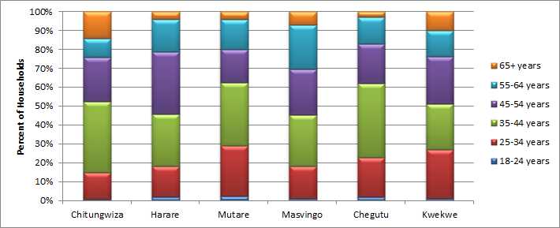Figure 1 : Age of Household Head

.

Household size also showed variations across towns with Harare and Mutare most likely to have households of size 5-6 persons, whilst Masvingo and Chegutu are most likely to have those of size 3-4 persons, as seen in figure 2 below.

Figure 2 : Household Size

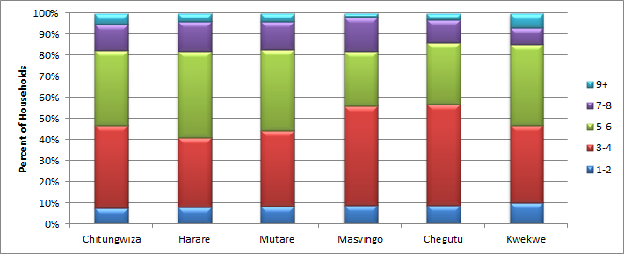

## 4. **Findings from the Study**

### 4.1 Diarrhoea Amongst young Children

Diarrhoea incidence amongst children aged 0-4 years, during the past 30 days, was most common amongst children in Chitungwiza (48%) with all other towns having rates of less than 30%, as shown in figure 3. Masvingo was most likely to have more than one child in a household affected, more so (24%) than in other towns, as shown in figure 4.

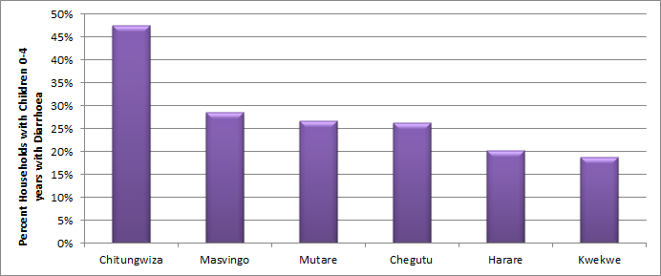**Figure 3 : Percent of Households with Occurrence of Diarrhoea amongst Children 0-4 years past 30 days**

**Figure 4 : Number of Children with Diarrhoea in Households with Occurrence of Diarrhoea amongst Children 0-4 years past 30 days**

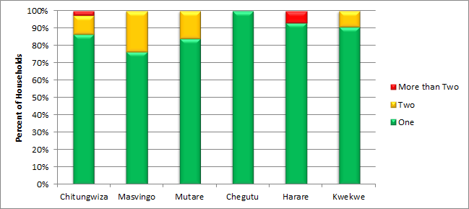

Figure 5 below provides details of diarrhoea cases recorded at local clinics on a month to month basis during the past 2 years (2015-16) and Chitungwiza again has the highest figures amongst the 6 towns. Within Chitungwiza, St. Mary's suburb is hardest hit and we note that many of these households are able to access municipal water for only two days a week and, for those in the higher lying areas, access is restricted to only a few hours at a time. Even though water supply has improved (as will be seen later), it appears other basic causes of Child diarrhoea still need to be attended to. Figure 5 also shows that water borne diseases (diarrhoeal) have comparatively decreased in 2016 when compared to 2015. This is most probably attributable to both the water interventions and the Rota virus vaccinations that are on-going country wide.

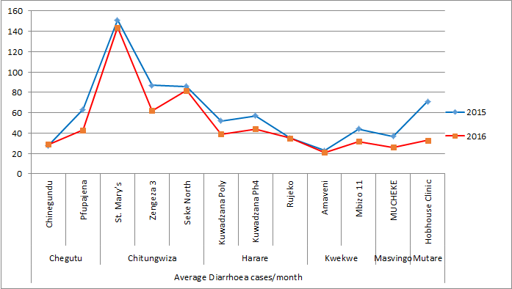Figure 5 : Number of Diarrhoea Cases 2015-16 from Clinic Records

From figure 5 we find that child diarrhoea cases in Mutare were most likely to be treated at home (67%) whilst those in Kwekwe were most likely to have been treated at a health centre (60%). Very few children were taken to traditional healers, 10% in Kwekwe and 7% in Harare, whilst 7% of children in each of Masvingo and Harare were considered not to be in need of treatment.

Figure 6 : Place of treatment of Children 0-4 years with Diarrhoea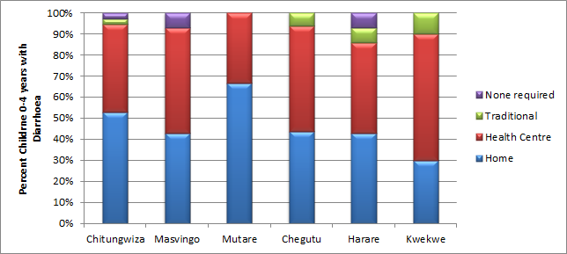

### 4.2 Hygiene Training

When considering the household members, the extent to which hygiene training has been rolled out appears low with at most only 22% of households in Chitungwiza having a member who has received training in the past 5 years (figure 7). Similarly current membership of health clubs is extremely low with Masvingo having the highest figure, but still with only 9% of households with a member who is currently a member of a health club (figure 7).

Figure 7 Household Members with Hygiene Training or Health Club Membership

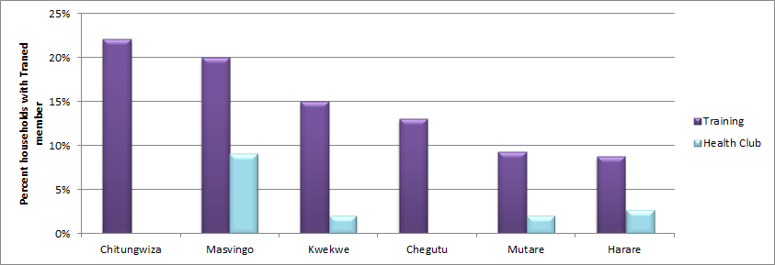

Respondents were asked if any child in the household had received hygiene training and/or belonged to a school Health club. Whilst Chitungwiza again has the highest figure (21%), we note that of these, a quarter was trained elsewhere and not locally. We also note that most respondents did not have good knowledge about their children’s activities at school, so that the figures for membership in health clubs by their children may therefore be inaccurate – recorded as 2% in Chegutu and less than that in each of the other towns. This apparently means that even though the ZimFund had a PHHE component, more could have been done with School Health Teachers and there was need for follow up and continuous engagement which may have resulted in the formation of school health club. The training did not apparently lead to an active engagement of pupils to form school health clubs.

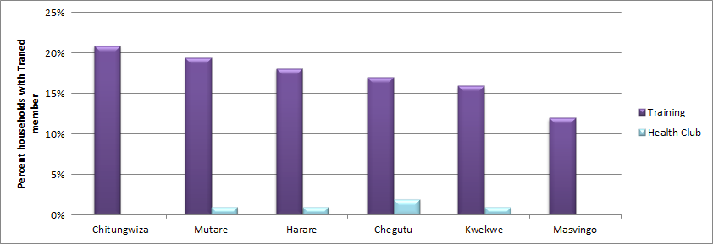Figure 8 : Children in Households with Hygiene Training or Health Club Membership

### 4.3 Access to Municipal Water

This section examines the extent and reach of water from local authorities to its residents. It also highlights the different water sources from which household’s access water for domestic use on an everyday basis (primary water sources) as well as alternative water sources when this primary source is unavailable. Figure 9 below indicates the different types of water source in each town, showing a combined figure of piped water into the house as well as water piped into the yard.. We find that the local authority water is the primary water source in all the towns, and with boreholes most common as an alternative primary source in Harare and protected wells in Chitungwiza. Overall 75% of households cited piped water into the house as their primary source, with the highest number of households in each of Mutare and Kwekwe (100%) and the least number (86%) in Chitungwiza.

Figure 9 : Household Primary Water Source

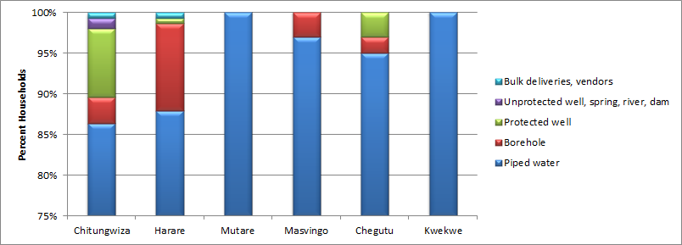

Even though reticulation/connectivity is that high, the use of boreholes and hand pumps was still very high in Harare (11%) whilst the reliance on protected wells, either in the yard or elsewhere, was highest in Chitungwiza (8%). Just 1% of households in each of Chitungwiza and Harare rely on bulk deliveries as their primary source of water.

We note that even though the ZimFund project had improved water production, the evaluation was carried out during a year when sources for raw water to the ZimFund rehabilitated water treatment plants had significantly dwindled. Prince Edward water works were virtually out of production and yet this is the plant that supplies water to Chitungwiza as a whole. Hence households had to rely on non-municipal sources even though some households (as will be noted later on) have now grown to dislike municipal water.

Figure 10 : Household Secondary Water Source

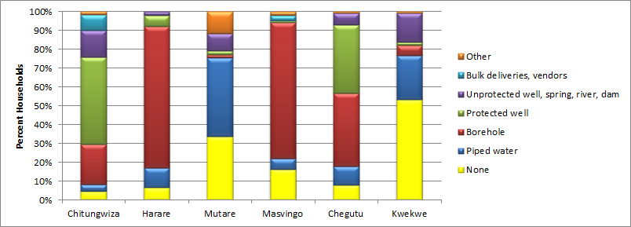

For reasons already cited above, all towns indicated a high use of secondary water sources (80%) although only half (47%) of those in Kwekwe. Sources ranged from boreholes as the most favoured, especially in Harare and Masvingo (75%, 72%) to unprotected shallow wells, mostly in Chitungwiza (14%) and Kwekwe (15%).The many varied sources of water are reflective of the water supply patterns in the towns. This is notably a very worrisome scenario as, apart from the challenged PHHE component, there will always be no guarantee that water from secondary sources will be safe; pollutants are bound to be introduced in such sources in the absence of proper water handling practises as shall be discussed under PHHE Component.

Distance to primary source of water was in most cases insignificant with the primary source being most often within the house or yard. A fraction of residents in all towns reported travelling more than a kilometre to a secondary source of water, with Chitungwiza recording the highest incidence (14%) of long distances travelled, followed by Mutare (8%). The most common situation for secondary water source appeared to be distances of 101-500m, whilst Chitungwiza and Harare have the highest percentages (18%, 17%) of households reporting traveling between 501-1,000m to the secondary source. The ZimFund had tried to avert this undesirable situation by boosting production at each of the (6) Local Authorities through refurbishment of water treatment plants, but other challenges such old reticulation infrastructure has prevented this from satisfying the water gap.

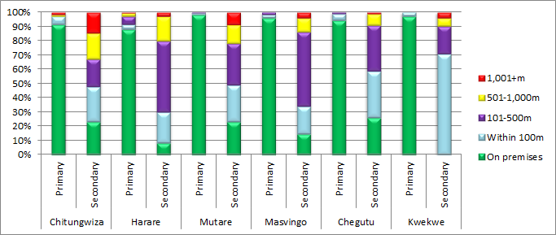Figure 11 : Distances to Household Water Sources

### 4.4 Reliable and Stable Water Production

This section highlights the reliability of, and stability in, the Local Authorities’ water supply to residents. It looks at the frequency of water cuts as well as the length of time (days) for which residents go without water supplied from the local authorities.

The extent of municipal water connections to households in the six towns was high with only three towns recording rates of less than 100%, namely Chitungwiza (99%), Masvingo (98%) and Chegutu (99%). One household remarked that it was pointless to spend money on a connection and plumbing since there was no water in his area. We note again that the presence of a connection is not reflective of the availability of water, from those connections, to the households.

In Mutare, residents noted that they used to get water around 11 pm in the evenings only and the water would at most run for about an hour. People in the community used to fetch water from a municipal “stand pipe” located at the foot of a mountain near a railway track. The stand pipe was erected on a private pipeline owned by the Prison Services Department and it services households as far as 5km away.

To establish reliability and stability in water supply, respondents were asked to indicate the frequency of water cuts in the last 7 days, as shown in figure 12. Chitungwiza is the only town in which 100% of households reported water cuts, with the vast majority (98%) of 5 or more days. Less than a quarter of households in Chegutu (18%), Masvingo (23%) and Mutare (23%) reported a continuous supply of water in the past 7 days and Harare had fewest incidences of water cuts with 77% of households not experiencing any water cuts in the last seven days, and in fact in Kuwadzana the water situation was said to be almost normal. Kwekwe also had a fairly stable water supply with more than half (58%) of households receiving water without any interruptions during the past 7 days. This was partly attributed to the general improvements in water production capacities of the municipalities.

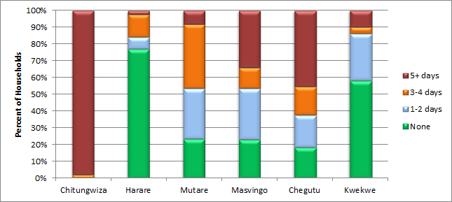Figure 12 : Frequency of Water Cuts During the Past 7 Days

The length of the water cuts ranged from less than 4 hours to 12 or more hours on any given day during the last 7 days, with all towns experiencing some long cuts of 12+ hours. Chitungwiza had the highest number of households who were without municipal water for 12+ hours (94%), followed by Mutare (75%) and Chegutu (74%), as shown in figure 13.

Since the upgrade of the water systems in all towns we however see an increase, from the baseline period in 2014, in the number of hours with municipal water supply, despite periodic water rationing in Chitungwiza, Harare and Masvingo which were caused mainly by shortage of raw water to the treatment plants as already noted above. This is well illustrated in figure 14, the data for which was gathered through the Key Informant interviews.

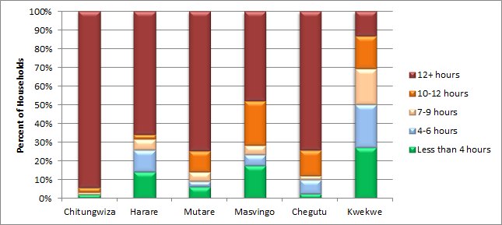Figure 13 : Length of Water Cuts During the Past 7 Days

Figure 14 shows that there are notable improvements in the 2016 figures across all towns except Kwekwe, (post intervention period) compared to the pre-intervention period of 2014.

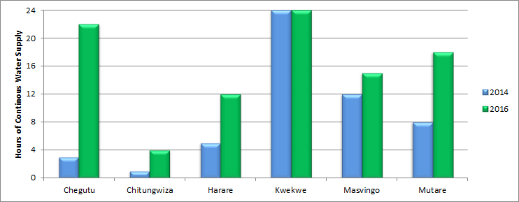Figure 14 : Continuity of Water Support 2014-16

Key challenges associated with of the acute shortage of water in all the towns, as identified during focus group discussions (FGD) included items noted in Box 1 Below.

**BOX 1: Challenges faced by vulnerable groups in search of water – Before ZimFund Interventions**

* Women and children (who bear the main responsibility for fetching water) had to travel long distances to access water and in the process could be exposed to risks of attacks by criminals or of sexual abuse. A case was noted in Mutare where one woman was raped at night on her way to the stand pipe to collect water.
* Some households have had their homesteads broken into while away looking for water – burglars knew when people are not indoors because of domestic water issues.
* Women and children also had to endure long queueing periods at water points waiting for their turn. In Mutare, it would at times take as long as 5 hours for one to eventually access water because of the long queues, while in Masvingo, Kwekwe and Chitungwiza, it took an average of between 3 to 6 hours. These long waiting periods resulted in less time being available for other family income generating activities, thus negatively affecting the livelihoods of the families.
* Women and children were also exposed to violence at the water points particularly in Chitungwiza, Mutare and Chegutu. Gangs of young men in these towns derisively called “water barons “or “*makoronyera*” (unscrupulous people/thugs) monopolized the water points as they were collecting water for sale. They threatened women and children and at times assaulted them when they demanded their rights to access water. The water barons would come with as many as 40 containers for filling, meaning it took a long time to fill their containers, prolonging the time which women and children had to wait in the queue. Some water barons were also reported to have been demanding sex in exchange for water, which made women and female children particularly vulnerable.

### 

### 4.5 Quality of Water

This section highlights the *perception* of water users have in regards to the quality of the water they receive from the local authorities. These perceptions have a direct implication on their acceptance of primary water sources and usage of water, which ultimately may lead to unwillingness to pay for the water, due to challenges with water quality. Results from the evaluation indicate that a large proportion of residents feel that the water they receive from the Municipalities is “unsafe”.

In both Harare and Chitungwiza 89% of residents consider that municipal water is unsafe to drink, with fewer such perceptions in other towns. In Chegutu and Masvingo the majority (69%, 55%) of the residents believe the water is safe and drink that water straight from the tap with the remainder believing the water is unsafe. The municipalities of Mutare and Kwekwe were the only ones deemed to provide safe drinking water as evidenced by affirmations from their residents, 89% and 88% respectively.

Figure 15 : Perceptions as to whether Water is Safe for Drinking

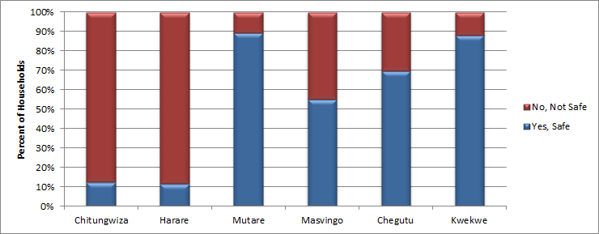

The major reasons cited by the residents for believing that the water is not safe for drinking include the water being smelly or having visible suspended particles or being green in colour. Figure 16 compares perceptions across towns.

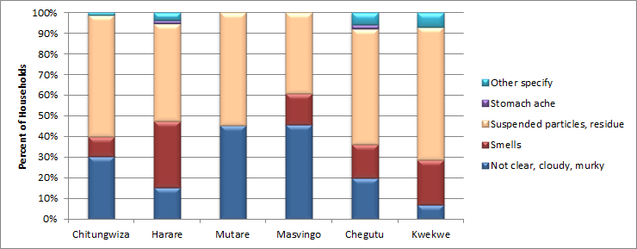Figure 16 : Basis of Perceptions for Residents Feeling Water is Not Safe for Drinking

The most common reason (51%) for not considering the water to be safe for drinking was that the municipal water contains suspended particles and after a while of its standing one can observe collected residue at the bottom of the container. Residents were quick to bring out containers and demonstrate the evidence of their claims. Many claimed to feel sick after drinking tap water. The water was also said to be cloudy or murky and with a certain smell (15%). Residents felt the need to substitute the water with a preferred secondary source and where possible to further treat the water at home before using for drinking or cooking, although this was a small proportion of households (see below). The above perceptions by the municipality consumers highlighted issues related to” turbidity”. In as much as ZimFund assisted municipalities in improving water production capacity and improved water quality at treatment plants, acceptable turbidity level of water is not guaranteed beyond the treatment station as the water then travels through old piping systems and it is possible that additional pollutants are introduced in the piping systems. A separate intervention beyond rehabilitation of water treatment plants would be required to ensure acceptable turbidity at the furthest point of the distribution network. The six (6) local authorities confirmed that their water (at the treatment plants outlet) is of very acceptable standards in terms of turbidity after the ZimFund interventions and that the challenge now lies in the distribution network.

### 4.6 Household Water Hygiene Practices

As a result of intermittent water supply, households resort to storing water in varying containers. Most households (94%) were observed to store water in covered closed containers, with the containers usually stored inside the house except for those containers which are set aside for bathing, laundry or ablution purposes.

In most households (80%) water containers for storing water for cooking or drinking were observed to be clean with proper covers, whilst 17% had traces of dirt and 3% were dirty or very dirty, as shown in figure 17. Masvingo had the highest proportions of households (5%) with containers with traces of dirt or outright dirty.

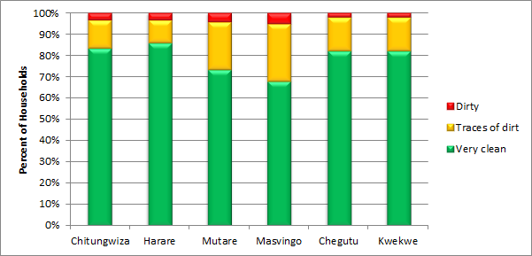Figure 17 : Cleanliness of Water Storage Containers

Such basic hygiene practices seem to have been only remotely supported by the ZimFund PHHE intervention. As already noted previously (Figure 7), less than 25% of households had a member who had actually participated in PHHE training and those which had participated were most likely to have been trained elsewhere and not under the ZimFund.

Treatment of water before use was not common across the towns with only 14% of households overall noting that they treat water, from any source, before usage. Such treatment was most common in Chitungwiza (33%) followed by Chegutu and Harare (13%, 12%).

### 4.7 Sanitation and Waste Water

This section considers sanitation coverage as well as connectivity of households to municipality sewer services. It also looks at sewer blockages or bursts and the Local Authorities’ response to these.

Households were asked whether they had a toilet within the premises, inside the house or in the yard. Results showed that 99% responded positively, as shown in figure 18. In old locations such as Mucheke in Masvingo, all detached toilets were considered to be outside the house, and hence we classify toilets as being in the yard, if they are within 10 metres from, or adjacent to, the living quarters. Two thirds (65%) of households had toilets inside the house, whilst one third (35%) had toilets within the yard and less than 1% had no toilets. This minority (1%) were mostly from among those staying in “in-fills” or new houses that were as yet incomplete.

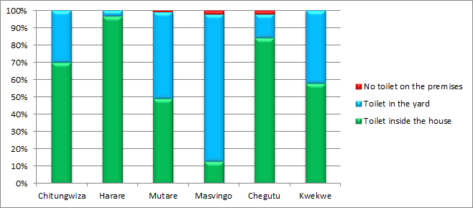Figure 18 : Access to Sanitation

Where a homestead had a toilet, virtually all (99%) of the toilets were functional flush toilets, although one suburb (Hobhouse in Mutare) commonly had toilets with no squat-pans but still connected to the council sewer system and 3% of households in Masvingo reported non-functional flush toilets.

Whilst we were aware that the ZimFund did not have an intervention to provide sanitation facilities at household level, the above estimates of sanitation coverage provide a proxy for the proportion of households which would require ZimFund sanitation interventions. ZImFund sanitation interventions focussed on un-choking or unblocking sewers and manholes.

Households were asked whether they had observed sewage flowing in the vicinity of their house within the past 7 days. The vacuum tankers and such related sewer cleaning equipment provided under the ZimFund were supposed to ensure quick responses to blockages on the part of municipalities. This had become a common phenomenon in all the municipalities prior to the ZimFund interventions. Chegutu had the highest cited sewage reported to flow from respondents’ houses themselves at 8% followed by Chitungwiza at 5%, whilst Chitungwiza recorded the highest proportion of sewage flowing from neighbours’ houses (27%), followed by Mutare (15%). Figure 19 illustrates these results.

In a couple of cases the flowing sewage was reported as having been there for long periods of time. In Chitungwiza Unit C, sewage could be observed flowing outside houses as well as inside houses. At one house the sewage was observed flowing next to an “protected well” which the household use as its primary source of water. The residents regard this sewage flow as a source of water borne diseases as they and their children have to walk around this flowing sewage every day. In Zengeza flowing sewage was reported to have been reduced, and men at work could be seen attending to one of the blocked stations in the area. In all the local authorities, there was a general consensus that free flowing sewer has reduced significantly as municipality waste water team quickly responds to sewer bursts.

**Figure 19 : Presence of Sewage in Vicinity**

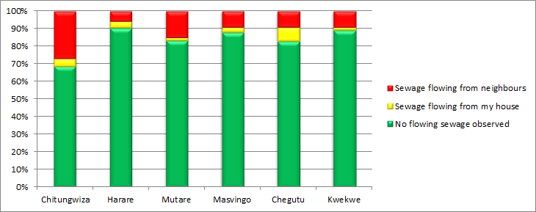

Figure 20 illustrates the extent of the sewage flows, with 9% of households claiming this has been the case for 5 or more days, most commonly in Chitungwiza (20%) and with some households reporting the flow as perennial though this is confined to areas in low lying areas.

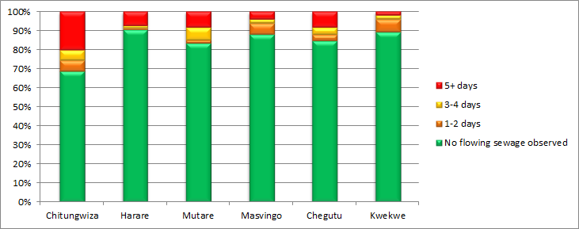Figure 20 : Extent of Sewage Flows

Residents in Chegutu blamed the blockages on the pipes, which they say were not laid properly. One resident claimed that the pipes coming from the houses were the same diameter as the main sewer pipes, causing serious cases of back flow. Municipal officials explained that where sewage spillages have become a permanent eyesore in residential areas, the main issue was due to collapsed sewers or the very design of the sewer system in a given area. It was pointed out that the ZimFund phase I interventions could not resolve such challenges as these were outside the scope of the interventions. However, municipalities pointed out that another ZimFund intervention (either Phase II or some Consolidation Works intervention) was going to deal with these recurrent blockages. It therefore appears that where the blockages were primarily due to choked sewers, the ZimFund has successfully resolved the challenges but failed to provide solutions where the main issue arose from the original sewer design or collapsed sewers.

FGDs revealed that during the water crisis periods, sanitation was a big challenge. Toilets were constantly blocked because there was no water to move the sewage. This situation proved particularly difficult for women, who unlike men, could not easily resort to open defecation. The FGD in Kwekwe revealed that because of the blockages, some women and children resorted to “flying toilets” where they defecated in paper bags and then threw away these bags (away from their homesteads). This was particularly dehumanizing to women who resorted to this method in the dead of night to avoid detection by the public. The practice of flying toilets posed serious health risks to the respective communities as did practices of open defecation.

However sanitation scenarios were noted to have improved significantly in Mutare, Masvingo and Chitungwiza with the improvement in the water supply situation although incidences of sewer blockages still exist due to challenges already stated above (collapsed sewers and design issues). In Chegutu, low lying areas such as Umvovo, experienced backflow on sewage when the motors at the sewage treatment plant had broken down. It had not been expected by residents, and neither by municipal officials, that the sewage pump stations would break down so early. Areas in Chegutu continue to experience perennial sewage flows in the streets, although the intensity has reduced. Again, the main challenge in such areas was outside the scope of the ZimFund interventions, arising as they do from a design issue.

FGDs in Mutare, Masvingo and Chitungwiza revealed that communities were generally happy with the current response from council when they report sewage bursts whereas in Kwekwe and Chegutu residents expressed disappointment with the response rate by their councils. They complained that raw sewage was allowed to flow in the streets for weeks without being attended to by their councils.

### 4.8 Evaluation of the PHHE Component

### Household Sanitation Hygiene Practices

The levels of cleanliness of the toilets used by households were observed and are illustrated in figure 21. Toilets were observed to be fairly clean in most of the households visited. All towns presented with more than 70% having clean toilets, with the exception of Masvingo with 61%. The highest number of toilets observed with faeces and urine was in Chitungwiza (6%), which can be generally attributed to the reportedly poor supplies of running water to the household toilets.

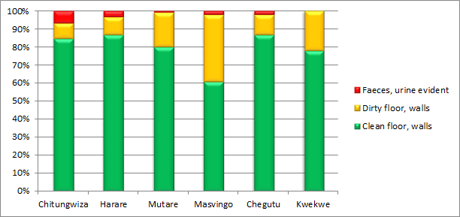Figure 21 : Cleanliness of Toilets

Lack of proper anal cleansing materials can contribute to high toilet blockages, and the survey sought to find out what kind of cleansing materials were commonly used by households in their toilets. Tissue paper was most commonly used (78%) with Masvingo the lowest at 59% and all towns reporting more than 70% usage, as shown in figure 22. Other cleansing materials (16%) observed to be in use in by households were mainly newspapers, and 6% of households either had no cleansing materials or no toilet close by. We note that some households keep the cleansing materials in the house and take it to the toilet during their visits. Use of water as a cleansing practice was not common with only one respondent alluding to this practice.

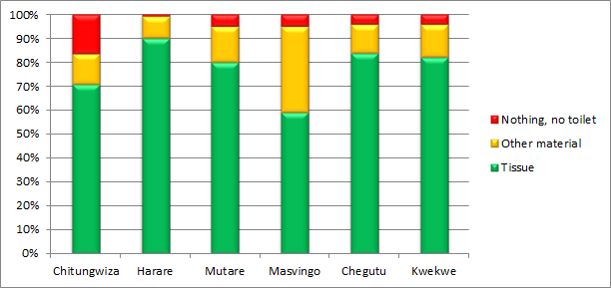Figure 22 : Anal Cleansing Materials

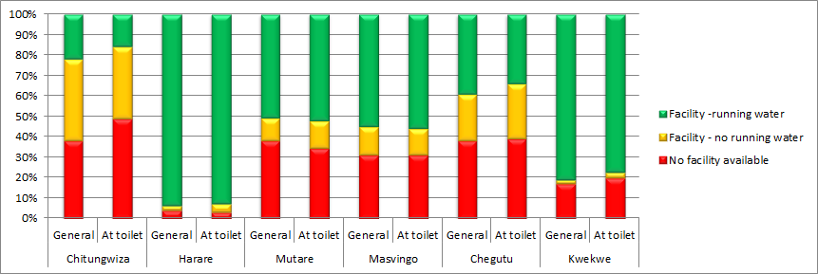Figure 23 : Presence of Handwashing Facility

Hand washing after toilet use is critical in preventing the spread of diseases such as diarrhoea. The survey sought to establish the handwashing practices after using the toilet in relation to the prevalence of diarrhoea cases in the towns. As illustrated in figure 23 above, in all cities there were households without handwashing facilities either close to the toilet itself, or even a general purpose facility. Chitungwiza has the least proportion of households with proper facilities with running water whilst Harare has the highest proportion of households with handwashing facilities with running water.

Good handwashing practice requires not only running water but also the use of soap to reduce germs. However the survey established that 58% of households had no facility or no soap at the handwashing facility close to the toilet. Harare exhibited a general alertness to good hygiene practises in terms of having facilities with running water and soap. Figure 24 indicates an alarming culture of poor hygienic practices among households.

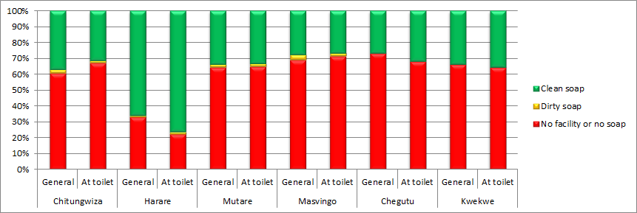Figure 24 : Presence of Soap at Handwashing Facility

Garbage disposal in the householdswas mostly characterised by filledup or uncovered bins or bags found within the yard as evident in figure 23 below. A significant number of households (11%) had no bin or bags at all, with some reporting that they had dug pits within their yards. In Kwekwe 21% , compared to 3% in Chitungwiza, of households did not have a bin or bag.

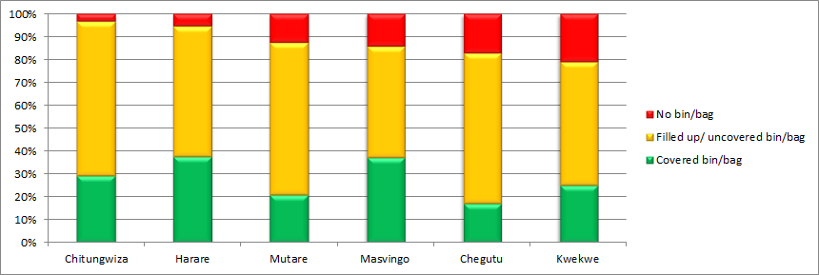Figure 25 : Means of Garbage Disposal

All in all the poor hygiene practices by households, in all aspects of water, sanitation and solid waste disposal, provide good evidence towards insufficient training in PHHE, coupled with a probable lack of follow up to permanently instil notions of good hygiene amongst all household members, including school children.

### 4.9 Reduction in Non-revenue Water

This section considers the extent of water metering by the municipalities as well as the functionality of meters at property level and the frequency of meter reading by the municipalities. The section also makes an attempt to quantify revenue collection by looking at the debts of the ratepayers at the time of the evaluation.

**Figure 26 : Functionality of Water Meters**

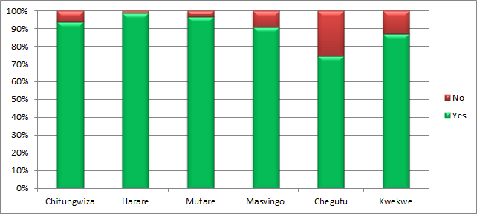

Revenue collection for water hinges on the on the installation of meters at household level, and whilst 92% of the households reported that they were connected to the municipal meter system, 8% of these reported that their meters were not working and thus for these households no meter readings are conducted and these households will be billed based on estimates

Amongst those with water meters, more than 90% of households in Chitungwiza, Harare, Mutare, and Masvingo reported functioning meters, whilst in Kwekwe 87%, and in Chegutu 75%, of households so reported, as shown in figure 26.

Reasons for meters not working included

* Meter is broken – 40% of households and most commonly in Kwekwe;
* Meter has been vandalised or stolen – 24% of households and most commonly in Harare;
* Do not know or other unspecified reasons – 35% of households and most common in Masvingo and Harare.

Masvingo (99%) emerged as the best in terms of monthly meter reading, followed by Kwekwe (94%), Mutare (92%) and down to Chegutu (31%) where meter reading is not common, as shown in figure 27. In Chitungwiza, 23% of households indicated that their meter readings were conducted less often than every 3 months, whilst in Chegutu 42% were not aware of any meter readings taking place and 19% reported the frequency as less often than 3 months. Households in Chegutu agreed that the municipality frequently estimates their charges (*on a fixed charges billing system).*

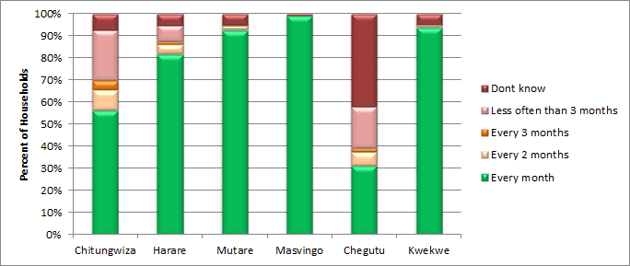Figure 27 : Frequency of Reading of Municipal Water Meters

Households, when asked why they were not up to date in their payments for services, provided reasons as shown in Figure 28, which reflects poor customer support for service delivery in all cities, the most critical situation being the inability to pay, notably in Harare, where 77% of households indicated that they cannot afford to pay their bills, followed by Masvingo (69%) and Chitungwiza (68%). Chegutu was different in that 11% of households didn’t make payments because they claimed they did not receive any services. Many households (21%) were not themselves responsible for paying the bills and clearly at times the landlords were not remitting the money which had been collected for bills. Other respondents argued that they had started accruing the debts even before they had built their homes, and hence the difficulties in clearing their debts. In Chitungwiza, residents said they were not happy with the bills they received from council as a result of the erratic meter reading and poor service delivery. Other reasons offered for not keeping up to date with payments included those who were expecting bill to be once again written off, those who claimed they were instead owed money, and other reasons which were not specified.

**Figure 28 : Reason for Not Paying Service Bills**

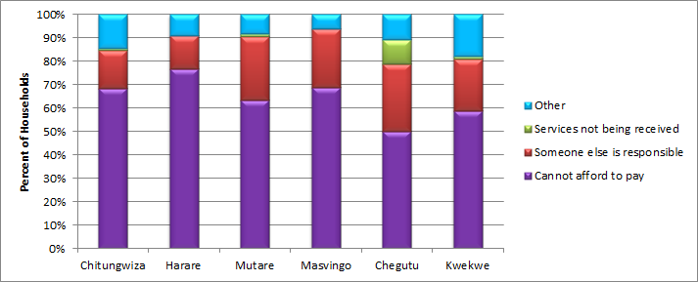

### 4.10 Gender and Water

The household component of the social outcome evaluation attempted to collect information relating to collection of water from the primary or secondary water sources, where the water source is not piped into the household or yard.Figure 29 illustrates the results which arise from multiple responses from each household.

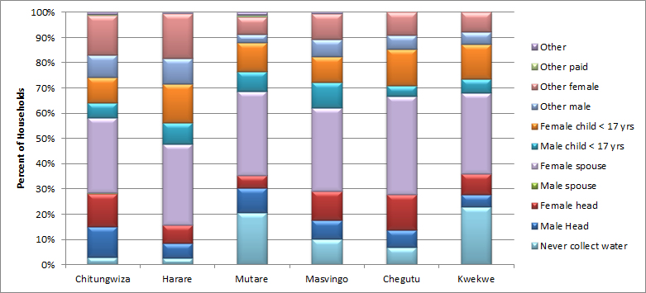**Figure 29 : Household Members who Collect Water**

Water collection tends to be gender specific according to occasions or events in the family. This responsibility seems to fall primarily on the female spouse of the head of household (33%). The male head of household was also reported to share the responsibility for collecting water (8%), while 10% of female household heads were responsible for water collection. Female children aged less than 17 years were also key water collectors (13%) and 7% of male children less than 17 years. Other males and females in the households also shared collection duties (7%, 12%) whilst 10% of households claimed never to have to collect water.

The pattern of collecting water on special occasions is similar to that above although on such occasions neighbours and friends also step in to assist.

Hygienic practices were compromised by lack of water in all the towns as communities reported that they were using less water to bath and at times had to endure the whole days without taking a bath because of the critical shortage of water. Most affected were women, particularly those on their menstruation cycles as they felt “dirty and humiliated” after failing to bath. Women reported during FGDs that failing to bath as a result of water shortages eroded their confidence because they would feel unclean.

In critical situations, women and children also had to buy water from the water barons thus spending from the little available income on water. They also had to pay for transport to carry clothes for washing to get to the water points. This compromised household income status.

FGDs revealed that children were negatively affected by the shortage of water as they had to spend long hours in queues and would get home exhausted. Some would also go to school late after spending time at the water points. Some children would go to school without having taken a bath, thereby compromising their personal hygiene.

There were cases of domestic violence reported in Chitungwiza (2 cases) and Mutare (3 cases) which were attributed to shortages of water, with men accusing their wives of having extra marital affairs whilst they spent long hours, sometimes during the night, queuing for water.

At water points, it was a disaster. Sometimes unwashed menstrual pads were thrown everywhere and some “flying toilets “were also scattered in the vicinity. You wouldn’t know where to put your foot on and I felt pity for some of the children who came to the boreholes bare footed because they risked contracting diseases.

FGD, Mutare

Environmental pollution was noted to be a serious challenge at the overcrowded water points. Women and children would wash their clothes at the water points and in some cases menstrual pads and dirty water flooded the environment resulting in high risks of disease outbreaks.

Diarrhoea outbreaks were noted to have been high during the water shortage periods although outbreaks decreased after water availability was improved. People Living With HIV and AIDS (PLWHIVA) as well as the elderly and People Living With Disability were groups noted to have been severely affected by the water shortages as they could not travel long distances to access the water points, nor could they withstand the physical hassles that one had to go through at the water points. Community members at times helped these especially vulnerable groups, but generally they were the worst affected, the FGDs revealed.

The FGDs reported several positive changes arising from the improved water supply situation and partly as a result of ZimFund interventions. These included the following:

Community members were now spending less time looking for water as the water was now readily available particularly in Mutare and Chitungwiza. The improvement in the water supply situation has enabled women in particular to have more time to concentrate on Income Generation Activities. Children now attend school on time as they do not need to spend their study and school time in water queues.

Before our water problems were rectified, we never used to have nutrition gardens in our yards because there was no water. Now that we have running water, I now have a flourishing garden of vegetables. I have two kids who used to go to school on foot because I had no money for transport. I am now able to pay for my kids ‘transport with proceeds from selling my vegetables. I no longer have to buy vegetables and I am saving money in the process. Now I eat fresh vegetables which is good for the family nutrition and the income I realise (of about USD200 a month) makes me able to contribute to household income, which has eased the burden on my husband, who really appreciates my garden project.

(Natview, Mutare)

The availability of water has enabled households to establish nutrition gardens, which they never used to have as the testimony below from one of the FGD participants reveals:

* FGD participants noted that incidences of diarrhoea outbreaks had decreased significantly after the improvement in the water supply situation. This was corroborated by the City Health Departments in Masvingo and Mutare.
* Although the water situation has greatly improved, there are some households particularly in high level areas that are not getting regular water supply in Mutare, Masvingo and Chitungwiza. The situation was however not described as a crisis during the FGDs as these households now have reasonable access to water compared to the water crisis period.

## **Constraints Impacting the Project**

Key informant interviews revealed a number of final points as follows:

* There are high debts for water by the users which affect the operation and maintenance of the existing infrastructure;
* Chitungwiza is unable to supply water 24/7 as the supply from Harare dwindles every year and Chitungwiza is without an independent water supply meaning that some sections access water rarely;
* Metering is the major challenge in most cities especially in Chitungwiza, Masvingo and Chegutu - where there are meters many are not functioning and bills are mostly based on estimates;
* Residents perceive that the water which they access from local authorities is unsafe and local authorities should be put in place measures to clear users’ perceptions which have a detrimental effect on their willingness to pay for the services;
* Recurrent breakdowns of the sewerage systems arise from poor quality infrastructure installed by the project especially in Chegutu (sewage treatment plant) and Harare (water supply);
* Lack of instruments to measure bulk water delivered in different locations mean that bulk data is based on estimates.

## **Access to Electricity**

The EPIRP project’s main outcome is improved (i) access to, (ii) availability of, and (ii) reliability of, power supply services. In order to assess

* Availability of supply, we considered *households connected to the power supply*,
* Reliability, we posed questions on frequency and length of load shedding in a week.

Several EPIRP outcomes indicators were verified via case studies with beneficiaries to assess the impact of EPIRP, including that of a Clinic in Chitungwiza which benefitted asitssupply points were uprated under the distribution transformer project, and that of a community in Mutare where new customers could now be fed from supply points upgraded under the distribution transformer project.

**EPIRP output Section**

This section highlights an analysis of output results from the ZimFund project as reported at the end of the Project as a well as extracts from monthly reports and key I formants Interviews. It is also important to note that the same ZimFund provided transformers are supplying electricity for a whole range of other services in addition to domestic users. Figure 30 shows Domestic (Household) customers, supplied from ZimFund Transformers, who owe their supply to combined efforts from ZimFund and other players.

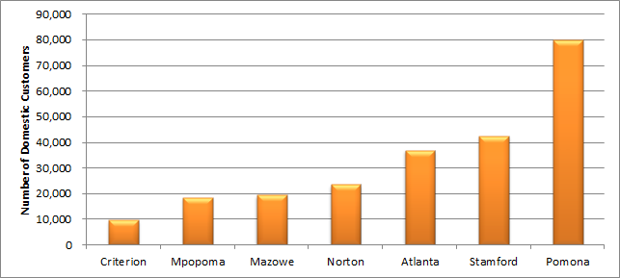Figure 30 : Domestic (Household) customers supplied from a ZimFund Transformer.

The fund also necessitated improvement and new connections to power to critical institutions such Primary schools, Water and Sanitation facilities, and Health providers across the country. This was recorded as stories of change in this document in boxes 2 and 3. Table 4 gives an overall picture of all the institutions which ZEDTC and ZimFund jointly assisted in accessing power.

Table 4 : Institutions Supplied with Electricity from a ZimFund Transformer

|  |  |  |  |  |  |
| --- | --- | --- | --- | --- | --- |
|  | **Numbers of** | | | | |
| **Primary schools** | **Secondary Schools** | **Other education facilities** | **Water & sanitation facilities** | **Health facilities** |
| **Mpopoma** | 1 | 2 | 0 | 2 | 2 |
| **Criterion** | 20 | 8 | 1 | 15 | 6 |
| **Norton** | 18 | 11 | 2 | 2 | 13 |
| **Stamford** | 125 | 23 | 2 | 5 | 9 |
| **Pomona** | 13 | 9 | 2 | 1 | 3 |
| **Atlanta** | 20 | 15 | 1 | 9 | 63 |
| **Mazowe** | 24 | 19 | 1 | 5 | 23 |
| **Total** | **221** | **87** | **9** | **39** | **119** |

**Connections to ZETDC**

The suburbs in which interviews were conducted in the 6 towns were fully developed high density areas which received a full social services package, including power supply. From figure 31 we see that Harare had the greatest proportion of households connected (97%), followed by Chitungwiza and Masvingo, and with Mutare the lowest at only 55% as the sampled area is largely still under construction and hence yet to receive electricity services.

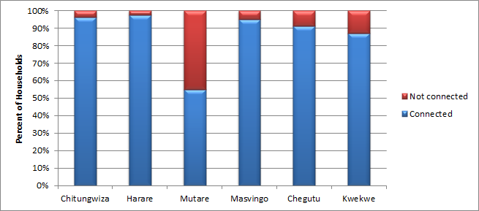Figure 31 : Extent of household Access to Electricity

Although most suburbs in the towns were fully developed, Mutare had a fairly new area in Natview, which had no electricity connections as yet, although poles were in place indicating connection intentions. The survey team also encountered households in Kwekwe’s Amaveni old suburbs which have never been connected, with residents now being pensioners who cannot afford electrification costs. Figure 32 provides an overview of the two main reasons behind the lack of access to power by 13% of residents in the towns.

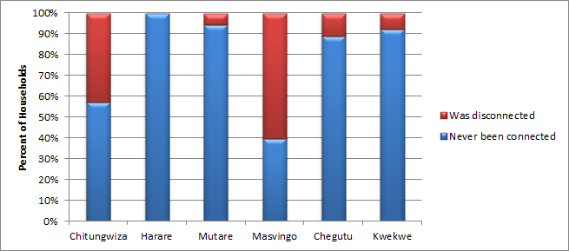Figure 32 : Status of Electrical Connection

Amongst those who had no access to power 88% had never been connected to the power grid with the remaining 12% having been disconnected for one reason or another. Households who have never been connected are those on properties which are newly or still not fully developed. Only in Masvingo and Chitungwiza were there significant proportions of households which had been disconnected (60%, 43%).

Key informant interviews conducted in Masvingo, Kwekwe and Chitungwiza revealed that electricity connections to institutions and households which previously had none or had interrupted supplies, due to infrastructural constraints (shortage of distribution transformers) brought relief to these institutions and households. The ZimFund then became a timely intervention by providing over 500 distribution transformers country wide. A household interviewed in Masvingo described changes that occurred to the family’s livelihood after being connected to the grid as described in box 2 below.

In Masvingo, ZimFund supported the installation of a transformer at Mundondo Secondary School whose transformer had been struck by lightning. The school has 388 full time students and 30 part time students and a total of 20 teachers. Although the school was previously connected to the national grid, it had gone for 6 months without electricity. Challenges were faced by the school during the 6 month period including

* students writing their examinations could not study at night
* An electrically powered water system could not function to capacity resulting in water shortages and affecting teachers, students and the school’s garden project
* Little access to internet meaning students were unable to conduct research in preparation for their examinations.

When the school was eventually connected after the installation of the transformer, all the above challenges were eased. The headmaster was thankful to ZimFund for having installed the transformer as the school could not afford to buy a new one. The headmaster claimed that the high pass rates at Advanced Level and Ordinary level were partly to the availability of electricity which enabled students to study at night and to conduct research using the internet.

**BOX 2:Power improves Household income diversity in Masvingo**

I was connected to the ZESA grid in 2014 after having failed to get connected before because of lack of funds. After being connected, my life and that of my family greatly improved. We now use electrical appliances such as stoves and fridges and this has improved our lives in a number of ways. I no longer need to spend my time looking for firewood which is a time consuming and environmentally unfriendly process. I now take less time to prepare meals for the family and I use the extra time to concentrate on my chicken rearing business which I started after being connected to ZESA. I can slaughter my chickens and preserve them in the fridge for a long time while looking for customers. Without refrigeration you can’t slaughter the chickens before you find a buyer and what this means is that if you do not find a market quickly, the chickens will start to eat into you profits because you have to continue feeding them. I now stock drinks in the refrigerator which I also sell to the community.

On average I get between USD$40 to USD80 per week in sales and this enables me to sustain my family. Having electricity in the house has been a game changer for my family.

(Masvingo)

In Chitungwiza, Population Services International in Zimbabwe has benefited from the installation of a transformer through ZimFund. Below in box 3 is an excerpt with the PSZ Team Leader in Chitungwiza.

**Box 3: Power Reliability restores normalcy at Health institutions in Chitungwiza**

We are an institution that offers family planning services to the community in Chitungwiza. This clinic relies so much on water and electricity supply for it to function. When we lost electricity after the transformer that feeds us developed a fault, we found it extremely difficult to function normally. Because we have a borehole that is electrically powered, we could not have water and as a result we had to turn away some of our patients or alternatively asked them to bring their own water. This was very risk because the water that they brought could have been contaminated thereby posing a health risk to the patients themselves. We also have various drugs that need refrigeration and we had to improvise and keep these drugs in cooler boxes, which again was not an effective was of storing them as some of the drugs could potentially end up losing their efficacy.

Normally we open up to 7 in the evening but we were forced to close early because of lack of electricity. On a normal day we see between 60 and 80 patients but we had to cut this down to around 40 a day because of electricity. This means that we were depriving our patients of critical services that they needed because of lack of electricity. When electricity was finally restored, we resorted to our normal schedule. We would like to than ZimFund for their support, now that we know that they are the one that restored electricity for us as previously we did not know.

Team Leader, PSI Clinic, Chitungwiza

Residents were asked whether there was electricity at the time of interview and 97% of the respondents replied in the affirmative. As figure 33 shows only in Chitungwiza were there significant proportions of households without power on the day of interview (13%), this being attributed to a fault arising from recent rains. We note that overall 5% of households had no supply because of non-purchase of tokens as payment for supply. It could be noted therefore that by and large, availability of electricity supply is apparently guaranteed as the distribution network is now in good shape. Never the less, distribution transformers alone would not explain this availability as generation and purchases from other countries (areas where the ZimFund had no influence) also play significant roles in access to electricity.

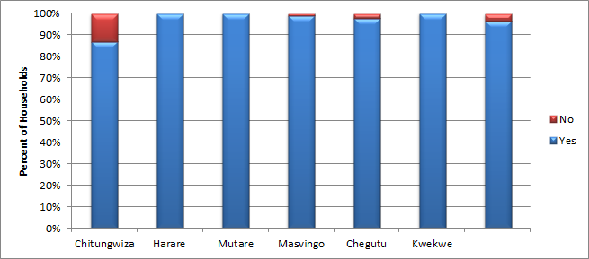Figure 33 : Households Currently with Power Supply

Households were then asked about the extent of power load shedding during the past 7 days with overall 91% reporting none at all during the past month and only Mutare and Chitungwiza showing significant levels (25%, 16%) during the past month.

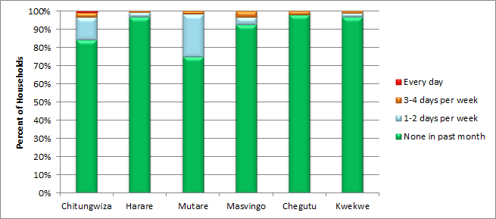Figure 34 : Extent of Load Shedding

For load shedding of 1-2 days per week we find highest reported incidence in Mutare and Chitungwiza (23%, 12%) and lowest in Chegutu (0%). Shedding of 3-4 days per week was highest in Masvingo (3%) and lowest in Harare (0.7%) and that of every day was only recorded by 1 household in Chitungwiza. Close to half of all households (44%) noted that the current load shedding pattern had been occurring over the past year, since December 2015 whilst 15% considered the pattern to be of 6 months duration.

Respondents were asked to estimate the duration, number of hours, of each load shedding incident as summarised in figure 35. Most commonly report were durations of 1-3 hours (61%), most commonly in Chitungwiza, followed by durations of 4-6 hours (20%) most commonly in Chegutu. Extended durations of 10-12 hours were reported by 13% of households and most commonly in Kwekwe (75%) and that of 13 or more hours was reported only by 1 household in Harare.

**Figure 35 : Length of Load Shedding**

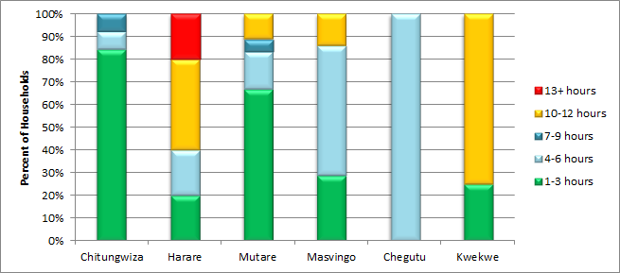

In terms of number of hours of power during a normal day 97% of households reported continuous supply for 24 hours as the current norm. Finally households were asked to compare their levels of access to electrical power today with that of previously, before the current load shedding patterns. Just over half of the households (55%) thought that access to power had previously been worse whilst 42% thought it had previously been better. Figure 36 shows levels, with little variation across towns.

**Figure 36 : Comparison with Previous Supply from ZESA**

### 

# Conclusions

* Since the upgrade of the water systems in all towns we see an increase, from the baseline period in 2014, in the number of hours with water supply despite on-going periodic water rationing in Chitungwiza, Harare and Masvingo.
* The study found that household connections to piped water is high, above 90%, but use of secondary water sources also remains high (80%), due to residents perceiving piped water to be unsafe.
* 18% of the population are still walking up to a km to fetch water when there is no water, and possible further strengthening of households in PHHE might bridge the gap in water handling and transportation to minimise contamination.
* Stability and reliability of water supply has improved across all cities, municipalities and towns due to restoration and improvement in treatment plant capacities.
* Key challenges of water supply and sanitation to women and children have been improved with the elimination of the communal water point in Mutare and Masvingo but remain high in Chitungwiza and Chegutu.
* Water quality remains a challenge in Chitungwiza and Harare despite efforts by the local authorities to supply clean water to residents.
* Chegutu remains with most seen challenges amongst the 6 towns in terms of both water supply and sanitation.
* ZETDC was cited to have improved immensely and its availability at user level was now largely dependent on affordability.

# Recommendations

* Although the Local Authorities revealed that they are supplying water of acceptable quality to residents, the households’ perceptions highlighted that they consider that the water they access is of poor quality, and it is recommended that the Municipalities consider all quality parameters, including turbidity, when monitoring water quality.
* Replacement of worn out non-functional water meters would reduce the extent of Non-Revenue Water.
* Strengthening of Community support for Service delivery to close the gap on households’ unwillingness to pay. This can be achieved through projects which instil good customer care and good citizen relations, which, it is assumed, would, in the long term, increase willingness to pay for the services. Non-payment of bills by residents threatens the sustainability of the installed infrastructure since it results in allocation of low budgets for operations and maintenance in the towns
* In the wake of continued water rationing in towns, it is advisable to strengthen Health promotion activities to activate best practices in household water and sanitation usage by all people. The evaluation noted that practices such as handwashing with soap at household level as well as water storage are very weak. It is highly recommended to invest in behaviour change WASH programmes such as Participatory Health and hygiene programmes (PHHE) to complement the hardware component.
* Consolidation works under preparation address some of the issues in water quality and sanitation in Chegutu.

# **Annexes**

## **Annex 1 : Workplan**

| **N°** | **Deliverables** 1 **(D1-4)** |
| --- | --- |
| **WEEKS** | | | | | | | | | |  |
| **1** | **2** | **3** | **4** | **5** | **6** | **7** | **8** | **9** | **10** | **TOTAL MAN DAYS** |
| **D-1** | Deliverable #1: Inception report |  |  |  |  |  |  |  |  |  |  |  |
|  | 1) Briefing with ZimFund |  |  |  |  |  |  |  |  |  |  | 2 |
|  | 2) Literature review |  |  |  |  |  |  |  |  |  |  | 4 |
|  | 3) Production of sampling framework |  |  |  |  |  |  |  |  |  |  | 1 |
|  | 4) Production of Review framework |  |  |  |  |  |  |  |  |  |  | 0.5 |
|  | 5) Report preparation |  |  |  |  |  |  |  |  |  |  | 3 |
|  | 6) Final report |  |  |  |  |  |  |  |  |  |  | 1 |
| **D-2** | Deliverable #2: Fieldwork documentation |  |  |  |  |  |  |  |  |  |  |  |
|  | 1) Sampling |  |  |  |  |  |  |  |  |  |  | 0.5 |
|  | 2) Preparation of tools |  |  |  |  |  |  |  |  |  |  | 2 |
|  | 3) Final sample and tools shared |  |  |  |  |  |  |  |  |  |  | 1 |
| **D-3** | Deliverable #3: Fieldwork report |  |  |  |  |  |  |  |  |  |  |  |
|  | 1) Train team leaders & pilot tools |  |  |  |  |  |  |  |  |  |  | 22 |
|  | 2) Finalise tools |  |  |  |  |  |  |  |  |  |  | 2 |
|  | 3) Train team members |  |  |  |  |  |  |  |  |  |  | 51 |
|  | 4) Collect data including FGD, KIIs |  |  |  |  |  |  |  |  |  |  | 130 |
|  | 5) Fieldwork report |  |  |  |  |  |  |  |  |  |  | 2 |
| **D-4** | Deliverable #4: Report |  |  |  |  |  |  |  |  |  |  |  |
|  | 1) Preparations for data entry |  |  |  |  |  |  |  |  |  |  | 2 |
|  | 2) Data entry |  |  |  |  |  |  |  |  |  |  | 6 |
|  | 3) Data cleaning & management |  |  |  |  |  |  |  |  |  |  | 6 |
|  | 4) Production of draft report |  |  |  |  |  |  |  |  |  |  | 5 |
|  | 5) Validation workshop |  |  |  |  |  |  |  |  |  |  | 4 |
|  | 6) Production of final report |  |  |  |  |  |  |  |  |  |  | 4 |
|  | 7) Submission of final report |  |  |  |  |  |  |  |  |  |  | 1.5 |

## **Annex 2 : Notes on Terms of Reference**

A first briefing was held prior to contract signature on 18th October in order to clarify specific issues from both parties, including

* Outcomes of EPIRP 1
  + Regular customers are unlikely to be aware of the rehabilitation of distribution transformers since ZETDC applies switching processes which, in the event of a transformer failure, most of the time in urban areas move customers from one transformer to another without noticeable interruption of supply;
  + On the other hand customers who had been without supply due to vandalism or transformer fault for some time before the intervention should now be experiencing continuous supply and would therefore be aware of the improvement.
  + Specific institutions in rural areas will also now have improved uninterrupted power.
* Approaches for UWSSRP 1 evaluation
  + All other proposed approaches are acceptable but it will be important to take note of issues raised in the next bullet points;
  + The roll out of hygiene training amongst targeted populations did not proceed as expected and little impact of that training is likely to exist;
  + ZimFund does not therefore recommend the use of the PHHE index since attribution to UWSSRP 1 will be difficult if not impossible;
  + Correlation of occurrence of diarrhoeal disease with household hygiene practices may be difficult and is unlikely to yield clear results due to sample size and reliance on recall of past events;
* Value for Money (VfM)
  + VfM will be extremely difficult to ascertain since interventions took place on functioning systems and hence attribution will not be possible;
* Methodology
  + At most one focus group discussion per residential area is recommended.
  + The team will try to access municipal water quality test results over time in order to be able to discuss issues of water quality
  + The size of the enumeration team will be trimmed since interviews at household level for the EPIRP 1 evaluation will not be required;
  + The team will be streamlined with additional days allocated to the team leader and the social scientist and fewer days allocated at technical engineer level

A second briefing with ZimFund was held on 8th November in which the results of a mini-survey of UWSSRP, conducted by ZimFund earlier in the year, were presented for comments and discussions. Highlights of the discussions included

* ZimFund appears to have achieved most of its intended outputs
* Households are still having to use alternative water sources, not all of which are safe with some in fact being extremely unsafe
* Sewer leaks and overflows continue in some areas
* Customers, whilst generally willing to pay, do not always have the capacity to pay
* Municipalities have not followed through on the ZimFund investment in UWSSRP 1, leakages and reticulation challenges that were outside the scope of UWSSRP I persisted, leaving households with erratic supplies and vulnerable to disease.

## **Annex 3 : Team members**

|  |  |  |
| --- | --- | --- |
| Position | Name | Experience |
| Team Leader | Erica Keogh | Erica has more than 25 years experience in developing and implementing a wide variety of M&E approaches for projects in Zimbabwe including development of effective innovative tools and approaches in respect of WASH. |
| Social Development expert | George Zimbizi | George has a wealth of experience in evaluations including approaches using the OECD criteria. In addition, his gender expertise will enable him to perform a key role in assessing the effectiveness of improved WASH and electrical services to communities, commerce and industry in the targeted urban areas. |
| Water resources engineer | Shepherd Ngwenya | Shepherd brings his engineering expertise to the team in terms of water resource management, water supply design, effectiveness of water supplies |
| Monitoring & Evaluation expert & field team leader | Tafadzwa Shumba | Tafadzwa has been closely involved in the monitoring of WASH projects in a number of projects and brings to the team his specific skills in assessing the effectiveness of WASH provision to rural and urban communities. |
| Electrician | Paul Wilson | Paul’s experience in working as an electrician for ZETDC places him in an excellent position to advise on the on-going electrical requirements and needs of residents, commerce and industry, approaches to the assessment of the reinforced distribution and sub-transmission networks, and functioning of the ZETDC National Control Centre. |
| Community Facilitation expert and field team leader | Duduzile Moyo | Dudu has extensive work and practical experience in tool development, conducting evaluations and strong community facilitation skills |
| Data Manager | Norian Chindowa | Norian has robust experience in the development of tools and in designing data entry programmes, then managing and monitoring data entry, data cleaning and analysis. |
| Enumerators | Getrude Fani  Linia Bayayi  Munyaradzi Zibaruwa  Masimba Nyaminhinde  Sandisiwe Mlotshwa | All the selected enumerators have good experience in data collection at community and household level and in managing focus group discussions and conducting key informant interviews. Before final selection, each was screened for ability and capacity during training. |
| Drivers | Clayton Maponga  Elijah Makoto | Both Clayton and Elijah have many years of experience in working with field teams, including considerations of security and safety. |

## Annex 4 Documents Reviewed

| Title | Date |
| --- | --- |
| ZimFund annual reports 2011-15 | 2011-15 |
| ZimFund half yearly reports 2013-15 | 2013-15 |
| ZimFund monthly reports 2013-16 | 2013-16 |
| ZimFund reports or POC meetings Sept 2013, July 2014 | September 2013, July 2014 |
| Joint Review by Angelique International, ZETDC, Kotson of transformers – Southern region | None given |
| UWSSRP 1 Project Appraisal Report | October 2010 |
| EPIRP1 Project appraisal report | February 2011 |
| UWSSRP 1 Proposal for supplementary grant | June 2013 |
| EPIRP 1 Proposal for supplementary grant | August 2013 |
| ZimFund UWSSRP 1 baseline report | January 2014 |
| ZimFund EPIRP 1 baseline report | March 2014 |
| Review Aide Memoire Danish Zimbabwe development partnership 2013-15 | May 2014 |
| Joint Donor Review | 2014 |
| ZimFund 3rd quarterly report | September 2015 |
| ZimFund Project Completion Report Aide Memoire | October 2015 |
| UWSSRP 1 Project Completion Report | November 2015 |
| Identified issues in the Draft Denmark ZimFund Technical Review Report | December 2015 |
| Denmark ZimFund Technical Review | December 2015 |
| Project Completion Report EPIRP 1 | April 2016 |
| Testimonials from UWSSRP 1 customers | July 2016 |
| Chegutu, Chitungwiza – What was done? (presentations) | July 2016 |
| Western Region Report verified by ZETDC | September 2016 |
| UWSSRP 1 Mini Survey Results | October 2016 |

## **Annex 5 : Inception Report**



**Annex 6 : The Social Evaluation Survey for the UWSSRP FIELD PLAN**

|  |  |  |  |  |
| --- | --- | --- | --- | --- |
| **Day** | **Date** | **Activity** | **Place** | **Where sleep** |
| **Monday** | **14-Nov** | Training and HH tool familiarisation | Harare | Harare |
| **Tuesday** | **15-Nov** | Pre-test - HH Social Evaluation Survey & Feedback | Chitungwiza | Harare |
| **Wednesday** | **16-Nov** | Feedback and Finalisation of HH Social Survey Tools | Harare | Harare |
| **Thursday** | **17-Nov** | HH Data Collection, KII interviews, FGDs, Clinic Checklists | Chitungwiza | Harare |
| **Friday** | **18-Nov** | HH Data Collection, KII interviews, FGDs, Clinic Checklists | Chitungwiza | Harare |
| **Saturday** | **19-Nov** |  |  |  |
| **Sunday** | **20-Nov** | Travel Mutare | Mutare | Mutare |
| **Monday** | **21-Nov** | HH Data Collection, KII interviews, FGDs, Clinic Checklists | Mutare | Mutare |
| **Tuesday** | **22-Nov** | HH Data Collection, KII interviews, FGDs, Clinic Checklists - Afternoon travel Masvingo | Mutare &Masvingo | Masvingo |
| **Wednesday** | **23-Nov** | HH Data Collection, KII interviews, FGDs, Clinic Checklists | Masvingo | Masvingo |
| **Thursday** | **24-Nov** | HH Data Collection, KII interviews, FGDs, Clinic Checklists - Afternoon travel Kwekwe | Masvingo & Kwekwe | Kwekwe |
| **Friday** | **25-Nov** | HH Data Collection, KII interviews, FGDs, Clinic Checklists | Kwekwe | Kwekwe |
| **Saturday** | **26-Nov** | HH Data Collection, KII interviews, FGDs, Clinic Checklists - Afternoon travel Harare | Kwekwe | Harare |
| **Sunday** | **27-Nov** | Sunday- travel Chegutu | Chegutu | Kadoma |
| **Monday** | **28-Nov** | HH Data Collection , KII interviews, FGDs, Clinic Checklists | Chegutu | Kadoma |
| **Tuesday** | **29-Nov** | HH Data Collection , KII interviews, FGDs, Clinic Checklists - Afternoon travel Harare | Chegutu | Harare |
| **Wednesday** | **30-Nov** | HH Data Collection, KII interviews, FGDs, Clinic Checklists | Harare | Harare |
| **Thursday** | **01-Dec** | HH Data Collection , KII interviews, FGDs, Clinic Checklists | Harare | Harare |
| **Friday** | **02-Dec** | HH Data Collection , KII interviews, FGDs, Clinic Checklists and Mop up Chitungwiza if necessary | Harare/ Chitungwiza | Harare |

## Annex 7 : Impact and Outcome Indicators for UWSSRP 1 from Project Appraisal Reports (PAR)

| **HIERARCHY OF OBJECTIVES** | **EXPECTED RESULTS** | **REACH BENEFICIARIES** | **PERFORMANCE INDICATORS, SOURCE, PERIODICITY** | **INDICATIVE TARGETS, TIMEFRAME** | **RISKS, MITIGATING MEASURES** |
| --- | --- | --- | --- | --- | --- |
| **Goal:**  To improve the health and social well being of the population through equitable provision of adequate water supply and sanitation services; | **Impact:**  Increased access to improved water supply and sanitation services;  Improved public health | The entire national population. | **Impact Indicators**  Coverage of safe drinking water and adequate sanitation;  Incidence of water related diseases  **Source:** National Statistical Report, Baseline data collected under the studies and Government statistical bulletins and economic report | The entire population having access to adequate water supply and improved sanitation by 2030.  All wastewater treated by 2020  Outbreaks of water related diseases eliminated by 2015 | Country’s political situation continues to improve to allow proper sector planning and development to take place;  Continued sector development support by GOZ and development partners; |
| **Purpose:**  1. To provide urgent support for restoration and stabilization of water supply and sanitation services in the Municipalities of Harare, Chitungwiza, Mutare, Chegutu, Masvingo and Kwekwe.  2. To improve service delivery in the project areas. | **Outcomes:**  Increased reliability, quality and availability of water supply in the project areas;  Wastewater treatment capacity restored  Reduced incidence of cholera and other water related diseases.  Improved operational performance and efficiency | A total population of approximately 4.15 million people living in the six cities covered by the project;  The transit population of nearly 0.75 million using the cities as nodal transportation points. | **Outcome Indicators:**  Production of potable water ;  Treated wastewater;  Incidence of cholera and other water borne diseases  Revenue collection, efficiency and reduction of non revenue water  No. of Staff trained (disaggregated by sex)   * Sources * Performance reports of each of the individual treatment works; * Quarterly Reports by the municipalities; * Works Commissioning Reports and Project Completion Report. | Total water production stabilized and increased to806,000 m3/d from 775,000 m3/d by Sept. 2012.  A total wastewater treatment capacity of 184,325 m3/d restored for all the urban areas from 76,325 m3/d by Sept 2012;  Cholera case fatality reduced to less than 1% by Sept. 2012.  Revenue collection increased by 20%  Non revenue water decreased by about 10% from estimated 50% presently. | Risk of weak project implementing institutions will be mitigated by engaging a project management agent who will assist in critical public sector functions such as procurement.  Municipalities continue to improve institutionally and technically;  Risk of failure to operate, and maintain the rehabilitated facilities. This will be mitigated through training of staff and provision of essential O&M supplies;  More resources are made available to continue with the rehabilitation of the water supply and sewerage infrastructure in the project areas;  Risk of power insecurity  MDTF power project and other planned investment to improve the security and other options of ensuring security being taken by Municipalities |

## Annex 8: Impact and Outcome Indicators for EPIRP 1 from Project Appraisal Reports (PAR)

|  |  |  |  |  |  |
| --- | --- | --- | --- | --- | --- |
| **HIERARCHY OF OBJECTIVES** | **EXPECTED**  **RESULTS** | **PROJECT**  **BENEFICIARIES** | **PERFORMANCE**  **INDICATORS, SOURCE, PERIODICITY** | **INDICATIVE**  **TARGETS, TIMEFRAME** | **RISKS, MITIGATING**  **MEASURES** |
| **Goal:**  To support the implementation of the Government’s Short Term Emergency Recovery Program (STERP) by assisting implementation of the emergency power infrastructure rehabilitation program to increase access to affordable and reliable electricity supply at competitive prices | **Impact:**  Increased access to affordable and reliable electricity supply at competitive prices. | The Electricity Consuming public in Zimbabwean | **Impact Indicators**  Access to reliable electricity;  **Source:**  ZESA demand and supply statistics  ZETDC customer Accounts | The Electricity consuming public having access to reliable electricity by 2012.  **Source:**  ZESA demand and supply statistics  ZETDC Customer Accounts | Continued improvements and stabilization in the political and socio-economic conditions in the Country.  Continued injection of investment capital by GOZ and ZESA into the Zimbabwean Power Sector, especially into ongoing Hwange rehabilitation |

|  |  |  |  |  |  |
| --- | --- | --- | --- | --- | --- |
| **HIERARCHY OF OBJECTIVES** | **EXPECTED**  **RESULTS** | **PROJECT**  **BENEFICIARIES** | **PERFORMANCE**  **INDICATORS, SOURCE, PERIODICITY** | **INDICATIVE**  **TARGETS, TIMEFRAME** | **RISKS, MITIGATING**  **MEASURES** |
| **Purpose:**  1. To improve the reliability of power supply in an environmentally sound manner through the rehabilitation of the Ash Plant at Hwange Power Station (HPS) and the sub-transmission and distribution facilities in the country. | **Outcomes:**  Improved Ash handling at  HPS  Improved reliability of sub-transmission and distribution networks  Improved electricity supply to the treatment plant of Harare City and other urban water supply systems.  Improved environmental management at HPS | The entire electricity consuming public in Zimbabwe  Population of Greater Harare Metropolitan and other municipalities  HPS staff and impacted surrounding communities | **Outcome Indicators:**  Increased generation output.  No of customers to whom service is restored  Reduction in number of system outages due to incidents in T&D network  Sources  • Operational reports of HPS and  ZETDC;  • Environmental & Safeguards  Reports of HPS | Electricity supply services restored to about 22,000 customers in various neighborhoods across the country by end of 2012. | Efficiency of Procurement Agent and Implementing Entity to mitigate implementation risk.  .  Effective involvement of  Project Management Teams s to contribute to implementation success;  Adequate measures designed to control vandalism of T&D network to ensure network integrity and security  Improvements in institutional setup for environmental management both at HPS and ZESA to ensure effective implementation of ESMP |

## **Annex 9: Household Survey Tool**

|  |  |  |  |
| --- | --- | --- | --- |
| The Social Evaluation Survey HOUSEHOLD TOOL - ZIMFUND | | | |
| Introduction: (Greetings……..). My name is ………………………………………………. I am working on behalf of ZimFund stakeholders who include the Municipality of …... the project manager (GKW Consult), the African Development Bank, Gov. of Zimbabwe, and the ZimFund Donors. I am here to discuss with you the experiences you are having with Water and Sanitation Services provision by the municipality of ………………., and access to electricity services provided by ZETDC. The discussions are confidential, your household has been randomly selected, and please feel free to give me your genuine views which will only ever be used to help ZimFund to understand the general status of Water, Sanitation and Electricity Services provision in this town. I would also like to take photos, with your permission, if you can identify anything of interest in respect of these services. Please be assured that I am NOT in any way concerned with your payments for these services i.e. I am NOT a debt collector | | | |
|  | | | |
| Enumerator Name |  | HH Status  1. Owner  2. Main tenant  3. Sub-tenant |  |
| Position in HH of Respondent  1=Head of HH 2=Spouse of head of HH  3=Son/Daughter 4=Other |  | Sex of Respondent  1=Male  2=Female |  |
| SECTION A : HOUSEHOLD DEMOGRAPHIC INFORMATION | | | |
| A1 : Name of Town or City |  | A2 : Residential area or suburb name |  |
| A3 : Type of Residential area  1. High density  2. Medium density  3. Low density |  | A4 : Type of services in residential area  1. New unserviced area with no designated developer  2. New are under formal development  3. Established area |  |
| A5 : Sex of head of Household  1. Male  2. Female |  | A6 : Age of head of Household  1. Less than 18 years  2. 18-24 years  3. 25-34 years  4. 35-44 years  5. 45-54 years  6. 55-64 years  7. 65+ years |  |
| A7 : Size of Household |  | A8 : How many children living in your household are aged 0-4 years (state the number ) |  |
| A9: IF 1+ child aged 0-4 years - has any of these children had diarrhoea in the past 30 days?  1. Yes 2. No |  | A10 : IF YES - how many of your 0-4 year old children had diarrhoea in the past 30 days (state number) |  |

|  |  |  |  |
| --- | --- | --- | --- |
| A11 : IF 1+ diarrhoea incidences - where were these children treated? (Please answer separately for each child)  1. Treated at home  2. Treated at a health centre  3. Traditional treatment or with Faith healer  4. No treatment necessary | A: Child 1  Age  Place of treatment | B: Child 2  Age  Place of treatment | C: Child 3  Age  Place of treatment |
| A12 : During the past 5 years has any household member been trained on hygiene practices or PHHE or similar, by an NGO, Municipality, local health providers or any other?  1. Yes  2.Yes else  3. No |  | A13 : During the past 5 years has any adult household member been a member of a community health club?  1. Yes  2. No, SKIP to A15 |  |
| A14 : IF YES in A13, Is any adult household member currently a member of a community health club?  1. Yes  2. No |  | A15 : During the past 5 years has any child living in the household been trained at school, on hygiene practices or PHHE or similar, by an NGO, Municipality, local health providers or any other?  1. Yes  2.Yes else  3. Don't know  4. No |  |
| A16 : During the past 5 years has any child in the household been a member of a school health club? (PROBE)  1. Yes  2. Don't know  3. No, SKIP to Section B |  | A17 : IF YES in A16, is any child in the household currently a member of a school health club? (PROBE)  1. Yes  2. Don't know  3. No |  |

|  |  |  |  |
| --- | --- | --- | --- |
| SECTION B : WATER PROVISION | | | |
| B1 : What is this household's primary water source for drinking, cooking, bathing?  1. Piped water into the house  2. Piped water into the yard  3. Piped water into another place  4. Borehole in this household's yard  5. Borehole elsewhere  6. Protected well in this household's yard  7. Protected well elsewhere  8.Unprotected well in the yard  9 .Unprotected wel else  10. Shallow well in this household's yard  11. Shallow well elsewhere  12. Bulk water deliveries  13. Rainwater harvesting  14. Spring  15. Municipal valve or hydrant  16. River or dam  17. No secondary source  18. Other specify |  | B2 : What is this household's secondary water source for drinking, cooking, bathing?  Multiple response  1. Piped water into the house  2. Piped water into the yard  3. Piped water into another place  4. Borehole in this household's yard  5. Borehole elsewhere  6. Protected well in this household's yard  7. Protected well elsewhere  8.Unprotected well in the yard  9 .Unprotected wel else  10. Shallow well in this household's yard  11. Shallow well elsewhere  12. Bulk water deliveries  13. Rainwater harvesting  14. Spring  15. Municipal valve or hydrant  16. River or dam  17. No secondary source  18. Other specify |  |
| B3 : Distance in metres to primary water source?  0 if on premises |  | B4 : Distance in metres to secondary water source?  0 if on premiseS, 99 if no secondary source |  |
| B5 : How does the household transport water from the primary source?  1.No transport, piped into house  2. Covered, closed container  3. Narrow mouth container with no lid  4. Wide mouth container with no lid |  | B6 : How does the household transport water from the secondary source?  1. Covered, closed container  2. Narrow mouth container with no lid  3. Wide mouth container with no lid  4. No transport, no secondary source |  |
| B7 : Does the household treat their water before using it (water from any source)?  1. Yes  2. No SKIP to B9 |  | B8 : IF YES, What methods do you use for treating your water ? Multiple response  1. Boiling  2. Use of chemicals  3. Use of filter (proper)  4. Sieving  5. Other specify |  |
| B9 : How does this household store water?  1. Covered closed container  2. Narrow mouth container with no lid  3. Wide mouth container with no lid  4. Other specify |  | B10 : Observe Cleanliness of storage containers  1. Very clean  2. Traces of dirt  3. Dirty  4. Very dirty, filthy |  |

|  |  |  |  |
| --- | --- | --- | --- |
| SECTION C : SANITATION SERVICES | | | |
| C1 : Does this household have a toilet on the premises? (even if non- functional)  1. Yes, inside the house  2. Yes, in the yard  3. No toilet on the premises SKIP to C3 |  | C2 : What type of toilet is it?  1. Functional flush or pour flush  2. Non-functional flush  3. Functional BVIP  4. Functional pit latrine  5. Non functional pit latrine or BVIP |  |
| C3 : What toilet is used on a daily basis by household members?  1. Flush toilet (including pour flush)  2. BVIP  3. Functional/upgradeable pit latrine  4. No toilet, bush (SKIP to C15) |  | C4 : Is this toilet on the household premises?  1. Yes inside the house  2. Yes in the yard  3. No, neighbour's toilet SKIP TO C7  4. No, public toilet SKIP TO C7 |  |
| C5 : Observe cleanliness of this toilet  1. Faeces &/or urine on the floor/walls  2. Dirty floor/walls but no faeces & no urine  3. Clean floor and walls |  | C6 : Observe, is anal cleansing material present? (tissue,NOT plant material, newspaper, magazines)  1. Tissue paper present.  2. No tissue/wiping material/non-functional toilet/bush  3.Other wiping material |  |
| C7 : IF 1 in C3  To what system is this flush toilet, used by the HH, connected?  1. Sewage system  2. Septic tank |  | C8 : IF 1 in C3  Please tell me about the current functionality of this flush toilet, used by the  HH?  1. Functional during the entire past week  2. Not functional during some of the past week  3. Not functional for more than 7 days but less than a month  4. Not functional for more than a month |  |
| C9 : IF 2-4 in C8  Please tell me why this flush toilet has been non-functional at any time  1. Septic tank is full  2. No water at all  3. Blockages  4. Water has been disconnected  5. Other specify |  | C10 : If 2-4 in C8  Have you reported the fault?  1. Yes  2. No |  |

|  |  |  |  |
| --- | --- | --- | --- |
| C11: If 1 in C10  To whom did you report?  1. Municipality  2. Local Councillor  3. Local MP  4. Landlord  5. Owner of property  6. Plumber  7. Other specify |  | C12: If 1 in C10  Have you had a response?  1. Yes  2. No |  |
| C13 : If 1 in C12  How many days did it take to get a response? (State number of days) |  | C14 : If 2 in C10  Why did you NOT report the fault?  1. Reports don't yield results  2. No money to pay for plumber  3. No money to pay for Municipal repair  4. It is not my property  5. My HH members can repair  6. Other specify |  |
| C15 : Have you observed sewage flowing in the streets around your house  (within 1 block) at any time during the past 7 days?  Multiple response  1. Sewage flowing from my house  2. Sewage flowing from neighbours houses  3. No flowing sewage observed SKIP TO SECTION D |  | C16 : IF 1-2 in C16  For how long has this sewage been flowing?  1. 1-2 days  2. 3-4 days  3. 5+ days |  |
| SECTION D : HOUSEHOLD HYGIENE | | | |
| D1 : Does this household have a handwashing facility for general household use?  1. No facility or non functional facility  2. Facility without running water  3. Facility with running water |  | D2 : Is there some handwasing agent available at this general handwashing facility?  1. No soap nor ash  2. Dirty soap, or ash, at the facility  3. Clean soap or soapy water (NOT ASH) at the facility |  |
| D3 : Does this household have a handwashing facility close by to the toilet?  1. No facility or non functional facility  2. Facility without running water  3. Facility with running water |  | D4 : Is there some handwashing agent available at this handwashing facility close to the toilet?  1. No soap nor ash  2. Dirty soap, or ash, at the facility  3. Clean soap or soapy water (NOT ASH) at the facility |  |
| D5 : Observe Is the environment around the household faecal free?  1. Faeces in or around the homestead  2. No faeces around the homestead |  | D6 : How does the household dispose of its rubbish?  1. No bin or bag evident  2. Filled up or uncovered bin or bag  3. Covered bin or bag |  |

|  |  |  |  |
| --- | --- | --- | --- |
| D7 : Does this household have a dedicated sink for dish washing?  1. YES 2.NO |  | D8 : What does this household use for washing its dishes, utensils, etc  1. Nothing  2. Only sand  3. Ash or scouring powder  4. Soap |  |
| SECTION E: HOUSEHOLD DUTIES AND GeSI | | | |
| E1 : On accasions when water has to be collected, who in the household usually participates in collecting water from the primary or secondary source? Multiple response  1. Head of household  2. Spouse of head of household  3. Male child < 17 years  4. Female child < 17 years  5. Other male in the household (17+ years)  6. Other female in the household (17+ years)  7. Other specify  8. Never collect water |  | E2 : On special occasions when extra water has to be collected, who in the household participates in collecting water from the primary or secondary source? Multiple response  1. Head of household  2. Spouse of head of household  3. Male child < 17 years  4. Female child < 17 years  5. Other male in the household (17+ years)  6. Other female in the household (17+ years)  7. Other specify  8. Never collect water on special occasions |  |
| SECTION F : POWER SUPPLY | | | |
| F1 : Are you currently connected to the ZESA electricity supply?  1. Yes  2. No |  | F2 : If 2 in F1  Why are you not currently connected?  1. Never been connected  2. Was disconnected  3. Other specify |  |
| F3 : If 1 in F1  Is the power supply currently (now, today) supplying you with electricity?  1. Yes  2. No |  | F4 : If 2 in F3  Do you know why there is currently no power?  1. Load shedding  2. Fault  3. Other specify  4. Don't know |  |
| F5 : If 1 in F1  How often do you experience load shedding in a normal week?  1. No load shedding in the past month  2. 1-2 days per week  3. 3-4 days per week  4. 5-6 days per week  5. Every day |  | F6 : IF 2-5 IN F5  Can you estimate the number of hours of load shedding on each occasion?  1. 1-3 hours  2. 4-6 hours  3. 7-9 hours  4. 10-12 hours  5. 13+ hours |  |

|  |  |  |  |
| --- | --- | --- | --- |
| F7 : If 1 in F1  Please estimate the number of hours per day when you have electricity during a normal 24 hour period  1. 3 or less hours per day  2. 4-7 hours per day  3. 8-11 hours per day  4. 12-15 hours per day  5. 16-23 hours per day  6. 24 hours |  | F8 : For how long would you say this estimate in F5 has been the norm?  1. Less than 6 months.  2. Past year (December 2015)  3. Past 18 months (June 2015)  4. Past 2 years (December 2014)  5. Past 2.5 years (June 2014)  6. Past 3 years (December 2013)  7. Longer than 3 years (before December 2013)  8. Can't remember at all |  |
| F9 : Prior to the time frame given in F8, i.e. before that time, was the electricity supply better or worse than it had been in the past?  1. Better  2. Worse  3. No difference |  |  |  |
| SECTION G : MUNICIPAL WATER SUPPLY | | | |
| PLEASE REFER BACK TO SECTION B, SPECIFICALLY QUESTION B1=1 OR 2  FOR ALL HOUSEHOLDS WHERE B1 WAS NOT EQUAL TO 1 OR 2 I.E. PIPED WATER ONTO THE PROPERTY, THE INTERVIEW IS NOW COMPLETED | | | |
| G1 : Is your piped water connected to the municipal water supply?  1. Yes  2. No |  | G2 : IF 2 in G1  From where does your piped water originate?  1. Borehole piped in  2. Bulk water delivered into reservoir and piped in  3. Well water piped in  4. Other specify  INTERVIEW COMPLETE FOR ALL RESPONSES |  |
| G3 : IF 1 in G1  Please estimate how often you have had water cuts during the past 7 days  1. No water cuts in past 7 days  2. 1-2 days  3. 3-4 days  4. 5 or more days |  | G4 : If 2-4 in G3, please estimate the average duration of these water cuts in the past 7 days  1. Less than 4 hours  2. 4-6 hours  3. 7-9 hours  4. 10-12 hours  5. More than 12 hours |  |
| G5 : For how long would you say these estimates in G3 and G4 have been the norm?  1. Past 6 months (June 2016)  2. Past year (December 2015)  3. Past 18 months (June 2015)  4. Past 2 years (December 2014)  5. Past 2.5 years (June 2014)  6. Past 3 years (December 2013)  7. Longer than 3 years (before December 2013)  8. Can't remember at all |  | G6 : IF 1 in G1  Is there a water meter on your premises?  1. Yes  2. No |  |

|  |  |  |  |
| --- | --- | --- | --- |
| G7 : IF 2 in G6  Why do you not have a water meter?  1. Never installed although we get piped water  2. Stolen although we get piped water  3. Removed by owner although we get piped water  4. Removed by Municipality although we get piped water  5. Other specify |  | G8 : IF 1 in G6  Is the meter currently working?  1. Yes  2. No |  |
| G9 : If 2 in G8  Why is your meter not currently working?  1. Vandalised  2. Broken  3. Don't know  4. Other specify |  | G10 : IF 1 in G6  How often do municipal meter readers visit you to take a reading?  1. Every month 2. Every 2 months  3. Every 3 months 4. Less often than 3 months  5. Don't know |  |
| G11 : Please assist me by giving me the details of the most recent charges to your HH for water, sanitation and sewage | A. Date of the bill (i.e. date paymet due) | |  |
| B. Balance brought forward (BF) | |  |
| B. Water charges for the month | |  |
| C. Rates charges for the month | |  |
| D. Sewage charges for the month | |  |
| E. Total bill for the month including balance C/F | |  |
| F. Total paid in the month | |  |
| G12 : Please can I look at your most recent bill for rates, water, sewage EMPHASISE we are not debt collectors, just interested in confirming charges | Circle the appropriate response:  1. Bill provided 2. Bill not provided | | |
| G13 : Please can you give me the main reason for not being up to date in your payments  1. Bills not reflective of true consumption  2. Not my bill, belongs to previous tenant  3. Council owes me money which should be deducted from by bill  4. Waiting for bills to be scrapped  5. Don't get solid waste collection  6. Landlord's responsibility  7. Sewage flowing in streets  8. Can't afford to pay  9. Other specify |  | G14 : In general, how does your water supply during January 2016-June 2016 compare with the supply before August 2014 ?  1. Improved  2. Worse  3. Same, no difference  4. Don't know was not staying here then  5. Don't know can't remember |  |
| G15 : Do you consider that the Municipal water is safe to drink?  1. Yes  2. No |  | G16 : If NO in G14, why not?  1. Not clear, cloudy, murky 2. Smells  3. Suspended particles or residue visible  4. Other specify |  |
| THANK YOU VERY MUCH FOR YOUR ASSISTANCE IN COMPLETING THIS INTERVIEW | | | |

## **Annex 10: Key Informant Interview Water Tool**

The Social Evaluation Survey KII WATER TOOL - ZIMFUND

|  |  |  |  |  |  |  |
| --- | --- | --- | --- | --- | --- | --- |
| Suggested Best Source of Data | | Water Works superintendent(s) | Treasury department | Water superintendent(s) | Treasury department | |
| Year | Month | Total volume of Clean Water released from PE (cubic meters) | Total volume of water billed to customers (cubic meters) | Water supplied to residents (cubic meters) | Domestic water Billed (cubic meters) to area of interest | Commercial water Billed (cubic meters) |
| 2009 | January |  |  |  |  |  |
| February |  |  |  |  |  |
| March |  |  |  |  |  |
| April |  |  |  |  |  |
| May |  |  |  |  |  |
| June |  |  |  |  |  |
| July |  |  |  |  |  |
| August |  |  |  |  |  |
| September |  |  |  |  |  |
| October |  |  |  |  |  |
| November |  |  |  |  |  |
| December |  |  |  |  |  |
| 2010 | January |  |  |  |  |  |
| February |  |  |  |  |  |
| March |  |  |  |  |  |
| April |  |  |  |  |  |
| May |  |  |  |  |  |
| June |  |  |  |  |  |
| July |  |  |  |  |  |
| August |  |  |  |  |  |
| September |  |  |  |  |  |
| October |  |  |  |  |  |
| November |  |  |  |  |  |
| December |  |  |  |  |  |
| 2011 | January |  |  |  |  |  |
| February |  |  |  |  |  |
| March |  |  |  |  |  |
| April |  |  |  |  |  |
| May |  |  |  |  |  |
| June |  |  |  |  |  |
| July |  |  |  |  |  |
| August |  |  |  |  |  |
| September |  |  |  |  |  |
| October |  |  |  |  |  |
| November |  |  |  |  |  |
| December |  |  |  |  |  |
| 2012 | January |  |  |  |  |  |
| February |  |  |  |  |  |
| March |  |  |  |  |  |
| April |  |  |  |  |  |
| May |  |  |  |  |  |
| June |  |  |  |  |  |
| July |  |  |  |  |  |
| August |  |  |  |  |  |
| September |  |  |  |  |  |
| October |  |  |  |  |  |
| 2013 | November |  |  |  |  |  |
| December |  |  |  |  |  |
| January |  |  |  |  |  |
| February |  |  |  |  |  |
| March |  |  |  |  |  |
| April |  |  |  |  |  |
| May |  |  |  |  |  |
| June |  |  |  |  |  |
| July |  |  |  |  |  |
| August |  |  |  |  |  |
| September |  |  |  |  |  |
| October |  |  |  |  |  |
|  | November |  |  |  |  |  |
|  | December |  |  |  |  |  |

**Other Water related data –** *Water Zones/Districts and hours of supply.*

|  |  |  |  |  |  |
| --- | --- | --- | --- | --- | --- |
| **Metering Zone/ District** | **Residential Areas covered (list all)** | **Total Number of occupied properties under that zone** *(kindly ask for this data from housing department)* | **Total number of properties that have direct water connection** | **Total number of properties that are metered** | **Total number of properties that are have *functional meters*** |
|  |  |  |  |  |  |
|  |  |  |  |  |  |
|  |  |  |  |  |  |
|  |  |  |  |  |  |

|  |  |  |  |  |  |  |  |  |  |
| --- | --- | --- | --- | --- | --- | --- | --- | --- | --- |
| **Total Hours of pressurized water supply per day** | | | | | | | | | |
| **Metering Zone/ District** | **Residential Areas covered (list all)** | **2009** | **2010** | **2011** | **2012** | **2013** | **2014** | **2015** | **2016** |
|  |  |  |  |  |  |  |  |  |  |
|  |  |  |  |  |  |  |  |  |  |
|  |  |  |  |  |  |  |  |  |  |
|  |  |  |  |  |  |  |  |  |  |

**Quality of Water Supplied**

|  |  |  |  |  |  |  |  |  |  |  |  |
| --- | --- | --- | --- | --- | --- | --- | --- | --- | --- | --- | --- |
| **Metering Zone/ District** | **Residential Areas covered (list all)** | **N# of samples taken at intermediate points** | **N# of samples taken at consumer end** | **Total samples for residual Chlorine test** | | **Total samples for Bacteriology** | | **Chemical/Physical** | | **Turbidity** | |
| **N# taken** | **Passed** | **N# taken** | **Passed** | **N# taken** | **Passed** | **N# taken** | **Passed** |
|  |  |  |  |  |  |  |  |  |  |  |  |
|  |  |  |  |  |  |  |  |  |  |  |  |
|  |  |  |  |  |  |  |  |  |  |  |  |
|  |  |  |  |  |  |  |  |  |  |  |  |

**Apart from the above mentioned test, kindly indicate other tests that are done at each designated site e.g PH, Conductivity etc. You can insert more columns to accommodate other tests**

**Further Data from Treasury Department**

|  |  |  |  |
| --- | --- | --- | --- |
| **Residential area** | **Number of Paid up Water Accounts (No water arrears)** | **Number of accounts with Water Arrears** | **Total Debts owed to municipality by residents in residential area (USD)** |
|  |  |  |  |
|  |  |  |  |
|  |  |  |  |

**Further Data from Housing/Planning Department**

|  |  |
| --- | --- |
| **Name of residential area as targeted by the Survey (***e.g. Area between Rimuka and Musasa streets***. Or** *Makusha High density***)** | **Number of occupied housing units in the area** |
|  |  |
|  |  |
|  |  |
|  |  |

**Further Data from Housing/Planning Department – Schools Data** *(if there is a school within the area etc.)*

|  |  |  |  |  |  |
| --- | --- | --- | --- | --- | --- |
| **Name of Pri./Sec. School in the residential area targeted by the Survey.** | Total Boys (including ECD) | Total Girls (including ECD) | Total Male Teachers (including student teachers) | Total Female Teachers (including student teachers) | Total support staff (total males in brackets) |
|  |  |  |  |  | …….. (………. ) |
|  |  |  |  |  | …….. (………. ) |
|  |  |  |  |  | …….. (………. ) |

**DATA FROM THE MUNICIPAL HEALTH *– DIARRHEAL MORBIDITY (Data should be collected and consolidated from municipal health facilities in the whole town/ city***

|  |  |
| --- | --- |
|  | **C1-Considering only the period June 2015 to May 2016, kindly share with us the Diarrheal morbidity for each month as captured by the Municipal health systems.** |

| **Year** | **Month** | **Municipal Consolidated Data** *(Total cases recorded during the month as captured from the Municipal Health Systems including data from municipalities within survey area)* | **Data from Municipal Clinic(s) in targeted area(s)** *(Total cases recorded at all clinics within the Survey targeted areas during the month as captured from the Municipal Health Systems)* |
| --- | --- | --- | --- |
| 2009 | Month |  |  |
| January |  |  |
| February |  |  |
| March |  |  |
| April |  |  |
| May |  |  |
| June |  |  |
| July |  |  |
| August |  |  |
| September |  |  |
| October |  |  |
| November |  |  |
| December |  |  |
| 2010 | January |  |  |
| February |  |  |
| March |  |  |
| April |  |  |
| May |  |  |
| June |  |  |
| July |  |  |
| August |  |  |
| September |  |  |
| October |  |  |
| November |  |  |
| December |  |  |
| January |  |  |
| February |  |  |
| March |  |  |
| April |  |  |
| May |  |  |
| June |  |  |
| July |  |  |
| August |  |  |
| September |  |  |
| October |  |  |
| November |  |  |
| December |  |  |
| 2012 | January |  |  |
| February |  |  |
| March |  |  |
| April |  |  |
| May |  |  |
| June |  |  |
| July |  |  |
| August |  |  |
| September |  |  |
| October |  |  |
| November |  |  |
| December |  |  |
| 2013 | January |  |  |
| February |  |  |
| March |  |  |
| April |  |  |
| May |  |  |
| June |  |  |
| July |  |  |
| August |  |  |
| September |  |  |
| October |  |  |
| November |  |  |
| December |  |  |

## **Annex 11: Key Informant Interviews Waste Water Tool**

***Departments covered by this tool: Waste Water, Health* Waste Water Department Data**

***(This questions is ONLY for pipes sections or manholes that were worked on under ZimFund either through replacements or the use of the equipment supplied under the project).***

***Before the ZimFund interventions, which sections of the Collector, Outfall sewer or Trunk Sewer were you experiencing sewer challenges? It is expected that the Vacuum tanker, rods, utility vehicle availability, and perhaps training and other works under the UWSSRP I helped to alleviate these challenges.***

***Complete the table below for the sections, average number of bursts per month, number of housing units affected (add rows as needed).***

|  |  |  |  |  |  |
| --- | --- | --- | --- | --- | --- |
| ***1. Sewer Section (state the name that your department usually uses to refer to the area you were experiencing challenges)*** | ***2. Average bursts per month before ZimFund*** *(if always in a state of perpetual bursting, please indicate this)* | ***3. Total Housing units affected in those days*** | ***4. List residential sections affected.*** | ***5. Average bursts per month after ZimFund*** | ***6. Total Housing units affected in the post ZimFund days*** *(if a school was also affected, please insert the name of school here and ensure that the housing department provides school data in their respective data sheet****)*** |
|  |  |  |  |  |  |
|  |  |  |  |  |  |
|  |  |  |  |  |  |

***WASTE-WATER TREATMENT (Source: Town Engineer – Waste-Water department).***

|  |  |  |  |  |
| --- | --- | --- | --- | --- |
| ***7. Name of STP*** | ***8. Types of Sewer Treatment Plant*** | ***9. Design capacity per day*** | ***10. Total waste water treated per day before ZimFund*** | ***11. Total waste water treated per day After ZimFund*** |
|  |  |  |  |  |
|  |  |  |  |  |

12-Is there a river/stream near or passing through any of the residential areas under this town/city? (NOTE: “Near” means at most within 1km, whereby it can become a source of water for domestic use or

children play) 1 = YES, 2 = NO **Response:………………..**

If **YES** in F6, please complete the following Table:

|  |  |  |  |
| --- | --- | --- | --- |
| **F8. River/Stream Name** | **F9. Residential Sections touched or crossed by stream/river** | **F10. Before the ZimFund, was raw sewage sometimes flowing into that water body** | **F11. After the ZimFund, is raw sewage sometimes flowing into that water body** |
|  |  |  |  |
|  |  |  |  |
|  |  |  |  |

## **Annex 12: Household Focus Group Discussion Tool**

***Departments covered by this tool: Waste Water, Health* Waste Water Department Data**

***(This questions is ONLY for pipes sections or manholes that were worked on under ZimFund either through replacements or the use of the equipment supplied under the project).***

***Before the ZimFund interventions, which sections of the Collector, Outfall sewer or Trunk Sewer were you experiencing sewer challenges? It is expected that the Vacuum tanker, rods, utility vehicle availability, and perhaps training and other works under the UWSSRP I helped to alleviate these challenges.***

***Complete the table below for the sections, average number of bursts per month, number of housing units affected (add rows as needed).***

|  |  |  |  |  |  |
| --- | --- | --- | --- | --- | --- |
| ***1. Sewer Section (state the name that your department usually uses to refer to the area you were experiencing challenges)*** | ***2. Average bursts per month before ZimFund*** *(if always in a state of perpetual bursting, please indicate this)* | ***3. Total Housing units affected in those days*** | ***4. List residential sections affected.*** | ***5. Average bursts per month after ZimFund*** | ***6. Total Housing units affected in the post ZimFund days*** *(if a school was also affected, please insert the name of school here and ensure that the housing department provides school data in their respective data sheet****)*** |
|  |  |  |  |  |  |
|  |  |  |  |  |  |

***WASTE-WATER TREATMENT (Source: Town Engineer – Waste-Water department).***

|  |  |  |  |  |
| --- | --- | --- | --- | --- |
| ***7. Name of STP*** | ***8. Types of Sewer Treatment Plant*** | ***9. Design capacity per day*** | ***10. Total waste water treated per day before ZimFund*** | ***11. Total waste water treated per day After ZimFund*** |
|  |  |  |  |  |
|  |  |  |  |  |

12-Is there a river/stream near or passing through any of the residential areas under this town/city? (NOTE: “Near” means at most within 1km, whereby it can become a source of water for domestic use or

children play) 1 = YES, 2 = NO **Response:………………..**

If **YES** in F6, please complete the following Table:

|  |  |  |  |
| --- | --- | --- | --- |
| **F8. River/Stream Name** | **F9. Residential Sections touched or crossed by stream/river** | **F10. Before the ZimFund, was raw sewage sometimes flowing into that water body** | **F11. After the ZimFund, is raw sewage sometimes flowing into that water body** |
|  |  |  |  |
|  |  |  |  |
|  |  |  |  |

1. Water and sanitation services
2. Hwange power station
3. Water and sanitation services
4. Zimbabwe Electricity Transmission and Distribution Company