Document cover: Independent Evaluation of the Australian Volunteers Program
Evaluation Report 
25 February 2025.
Logo: Tetra Tech: International Development


Independent Evaluation of the Australian Volunteers Program

Evaluation Report

25 February 2025

Independent Evaluation of the Australian Volunteers Program

Evaluation Report

25 February 2025



Contents

Executive Summary iv

Methodology iv

Findings v

Recommendations vii

1. Introduction 1

1.1 About the program 1

1.2 About the evaluation 1

2. Findings 4

2.1 How to read this section 4

2.2 Effectiveness 4

2.3 Coherence and strategic alignment 11

2.4 Efficiency and effectiveness 13

2.5 Efficiency and risk 18

2.6 Partnership 19

3. Lessons and recommendations 21

Annexes

Annex 1: AVP Program Logic 24

Annex 2: Stakeholders consulted 25

Annex 3: Key evaluation questions (KEQ) 26

Annex 4: AVP Evaluation Partner Organisation Survey Summary 27

Annex 5: Reference list 32

Annex 6: Figure alt text list 34

List of figures

Figure 1: Data collection methods 3

Figure 2: AVP support for PO capacity organisational capacity development (Evaluation Partner Survey, 2024) 5

Figure 3: AVP partner organisations inform the design of volunteer assignments (Evaluation Partner Survey, 2024) 5

Figure 4: AVP is responsive to partner organisations’ needs, objectives, and goals (Evaluation Partner Survey, 2024) 6

Figure 5: AVP partner organisations value the contribution volunteers make to development (Evaluation Partner Survey, 2024) 6

Figure 6: AVP partner organisations consider that AVP has strengthened their relationship with Australia (Evaluation Partner Survey, 2024) 7

Figure 7: Percent of AVP volunteers who identify as Aboriginal or Torres Strait Islanders 8

Figure 8: Percentage of AVP volunteers who identify as having a disability 9

Figure 9: AVP engagement with Indigenous suppliers (Source: AVP progress reports) 9

Figure 10: Overview of the AVP operational model 14

Figure 11: Costs of volunteer deployment by year 15

Figure 12: AVP Program Logic 24

Figure 13: Percent of AVP partner organisations who responded by region 27

Figure 14: Percentage of respondents and the year their last volunteer assignment was completed (Evaluation Partner Survey, 2024) 28

Figure 15: Percentage of respondents and the number of volunteers their organisations have received through the AVP (Evaluation Partner Survey, 2024) 28

Figure 16: To what extent has the partnership with the AVP delivered on your organisation's expectations and requirements (Evaluation Partner Survey, 2024) 29

Figure 17: To what extent has the AVP supported your organisation to strengthen its capacity to progress its development objective / organisational mission (Evaluation Partner Survey, 2024) 30

Figure 18: Volunteer contribution to country socio-economic development (Evaluation Partner Survey, 2024) 30

Figure 19: The program has strengthened my organisation’s relationship with Australia (Evaluation Partner Survey, 2024) 31

Abbreviations

**AHC** Australian High Commission

**AIP** Aid Investment Plan

**AVI** Australian Volunteers International

**AVID** Australian Volunteers for International Development

**AVP** Australian Volunteers Program

**AYAD** Australian Youth Ambassadors for Development

**CMG** Contract Management Group

**CPP** Country Program Plan

**DFAT** Department of Foreign Affairs and Trade

**DPP** Development Partnership Plan

**EoPO** End-of-program outcomes

**FLEX** Flexible Learning Exchange

**HDS** Humanitarian and Development Deployments Section

**ICMT** AVP's in-country management team

**IDD** Investment Design Document

**INGO** International non-governmental organisation

**KEQ** Key evaluation questions

**LGBTQI+** Lesbian, gay, bisexual, transexual, queer, intersex, or people otherwise diverse in gender, sexual orientation and/or innate variations of sex characteristics

**MEL** Monitoring, evaluation, and learning

**NGO** Non-governmental organisation

**OPD** Organisations of people with disabilities

**PMG** Program Management Group

**PNG** Papua New Guinea

**PO** AVP partner organisation

**PSEAH** Prevention of Sexual Exploitation and Harassment

**RMG** Risk Management Group

**SDG** Sustainable Development Goals

**UN** United Nations

**WHS** Work health and safety

Acknowledgements

The evaluation team wishes to thank all those who contributed to this evaluation and acknowledge the time committed by all those who participated. This includes the Humanitarian and Development Deployments Section (HDS) team at the Department of Foreign Affairs and Trade (DFAT) and the representatives of AVP program staff in Melbourne, regional offices and country teams who generously shared their time and insights in interviews and discussions. In particular, the AVP Monitoring, Evaluation and Learning Manager provided considerable support to coordinate and facilitate data collection. The evaluation team is especially appreciative of the responsive, constructive and open way in which all concerned participated in the evaluation process.

The evaluation team also wishes to pay respects to Indigenous Elders, past and present, of the lands on which this evaluation was undertaken. Tetra Tech International Development recognises the traditional custodians of country, and their unique connection to their lands and waters, language, law, kinship and ceremony. Through this acknowledgement we commit to ongoing learning and understanding on our journey to reconciliation.

**Cover photo:** Australian volunteer Sally Jesmille Molero Obregon volunteers at Vietnam National University of Agriculture (VNUA), Hanoi, Vietnam as a Research and Network Development Officer. VNUA has a collaborative program with Australian partner organisation, the Crawford Fund. In this photo Sally Jesmille Molero Obregon is with her counterpart Ha Hai Yen preparing for the presentation at VNUA.

Region: Vietnam. Creator/Photographer: Ho Thanh Dat (TAJ Media Vietnam)

Source: Australian Volunteers Program

# Executive Summary

This report presents findings and recommendations from the independent final evaluation of the *Australian Volunteers Program (AVP),* funded by the Australian Department of Foreign Affairs and Trade (DFAT)*.* The program is one of Australia’s flagship people-to-people programs, which continues Australia’s long and proud history of international volunteering.

Since the 1960s, Australia has been sending Australian volunteers internationally, supporting development outcomes of partner countries and organisations. Over this time, Australia has deployed over 17,000 Australian volunteers to more than 50 countries. There have been many iterations and versions of Australia’s volunteer program with predecessor programs such as the Australian Youth Ambassadors for Development (AYAD) and the Australian Volunteers for International Development (AVID) (2011-2017). The current iteration of Australia’s international volunteering program, the AVP, is a ten-year, global program delivered over two five-year terms (from January 2018 to 30 June 2027) with a total value of up to $264 million. AVP (the program) is delivered by the Australian Volunteers International (AVI), in consortium with DT Global and Alinea International.

The program’s overall goal is ‘global volunteering supports locally led change and the realisation of the Sustainable Development Goals’. It achieves this by matching skilled volunteers with partner organisation in 25 countries across the Pacific, Asia and Africa to support partners organisations to achieve their development objectives, to strengthen appreciation of the partner of volunteering in Australia and in partner countries, and to facilitate greater cultural awareness and connections across countries between program participants.

Tetra Tech International Development was commissioned by DFAT to deliver the evaluation from August 2024 to February 2025. The evaluation purpose was to explore efficiency, effectiveness, sustainability, relevance and coherence of AVP. Findings and recommendations from the evaluation will inform delivery of the current phase of the program, as well as the procurement process and future design of the program, due to be undertaken in 2025/2026.

## Methodology

The evaluation drew on primary and secondary data to respond to the key evaluation questions (KEQ) and develop insights and recommendations to inform implementation of the current phase and the design of the next phase of the AVP. The evaluation team worked closely with DFAT Humanitarian and Development Deployments Section (HDS) and a Guidance Group comprising representatives of HDS and AVP to test and review enquiry and findings across the four phases of the evaluation. The evaluation is guided by its commitment to ethics in research and evaluation, in line with the Australian Evaluation Society Code of Ethics, which commits evaluators to principles including quality work, integrity and truthfulness.[1]

Program data from the AVP monitoring, evaluation, and learning (MEL) system and management documentation, including annual reports, internal evaluations, and volunteer and partner organisation surveys, were key sources of information, triangulated against stakeholder interviews and focus group discussions, three workshops and a survey with 181 partner organisations. Purposive sampling was used to identify stakeholders for interview, in order to collect views from different locations and experiences of the program. The evaluation analysed data using qualitative data analysis methods to code data according to themes, and triangulate across data types (eg project reports and stakeholder interviews). In presenting findings, the evaluation has used direct quotations from stakeholders to illustrate and add depth to significant themes emerging from data collection.

DFAT and the evaluation team worked together to review the four key evaluation questions (KEQs) below (for the full list of sub-questions see Annex 3), which focused primarily on the contractual model and delivery of the program, rather than testing program achievements or validating the significance of Australia’s volunteering program. These elements are well recognized. In line with this approach and given the large amount of program data already available to represent the experience and perspectives of volunteers, the evaluation did not collect data directly from volunteers.

DFAT and AVP input and feedback informed the evaluative approach and its ongoing refinement throughout the Evaluation, especially through data collection and workshops to test emerging findings and recommendations with both DFAT and the Guidance Group. In order to explore the partnership elements of the program, the evaluation team included a Partnership Specialist who provided technical expertise and supported the analysis of the state of the program’s partnership and potential improvements.

Table 1: Key evaluation questions

| **Key evaluation question (KEQs)** |
| --- |
| 1. To what extent is AVP’s operational model fit for purpose for the management of the program? |
| 1. To what extent have robust and appropriate AVP processes and systems supported DFAT, volunteers and partners? |
| 1. To what extent has the program been supporting ‘… locally led change and the realisation of the Sustainable Development Goals’ (SDGs)? |
| 1. To what extent has the program supported the achievement of Australia’s strategic objectives and commitments – i.e. International Development Policy/ Partnerships for Recovery, and DPPs/ AIPs? |

## Findings

The evaluation confirmed that the AVP is an effective and strategically important program for DFAT, building on Australia’s history of global volunteering to build relationships, contribute to development outcomes and strengthen recognition for volunteering. Despite significant shifts in operating context that have emerged through and following the pandemic, AVP has been able to maintain a consistent focus on delivering effective partnerships and volunteer assignments. This is a significant achievement.

As a global program deploying many hundreds of volunteers across 25-26 countries, AVP is complex, and by its nature high-risk. AVP is being implemented through a contract, rather than through a grant modality, as was the case for previous iterations of the program. In this context, resourcing challenges and changing government requirements have presented particular challenges that have created pressure on relationships between DFAT and the implementer, the consortium led by AVI. There is a need to refresh the partnership approach and ways of working, to rebuild confidence in some areas, to work through challenges and set the program up for success to deliver on the contract. A summary of all key findings is presented here.

Effectiveness

1. AVP is delivering effectively on its end of program outcomes, and its goal of contributing to locally led change and the realization of SDGs. This is a significant achievement given the complexity and scale of the program. There is evidence that AVP is supporting partner organisations’ capacity, enhancing the value and appreciation of volunteering and supporting disability and inclusion.
2. The program has utilized an array of tools to strengthen the quality of volunteering and outcomes for volunteers and the program. These amplify outcomes from volunteer placements (impact grants), assist the program to innovate and adapt to the changing context and opportunities for volunteering (innovation fund/hub) and deepen sustainability of relationships between volunteers and countries (returned volunteers support). These have been utilized and appreciated, and in some cases made a significant contribution to supporting the achievement of program outcomes. For example, The Innovation Fund (now closed) played a critical role in AVP’s achievement of program outcomes, by assisting the program to develop the hybrid and remote volunteering modalities required during the pandemic. However, given resource constraints, there may be value in exploring ways to simplify and integrate approaches to achieve the benefits offered by these tools.
3. The Indigenous Pathways Program (IPP) has pioneered an approach to inclusion for First Nations participants that is a significant contribution to Australia’s policy goals in this space. While relatively small numbers of volunteers have participated through the IPP, it is appreciated by stakeholders and is one of the only initiatives of its kind in DFAT programs. It therefore offers unique and important potential for learning in this emerging area of the aid policy.
4. The MEL system captures substantial evidence to support performance management and program reporting, but there is potential to further strengthen its utility through more specific country-level reporting.
5. There is a disconnect between the current program logic and the program’s strategic intentions, as they have evolved for DFAT, especially at country level. This creates sometimes unfair expectations of the results reported through the MEL system, which is aligned with the program logic and meets DFAT M&E Standards.

Strategic alignment with the Australian aid program priorities

1. AVP is designed and delivering important elements of Australia’s strategic objectives and commitments, particularly at a global level. Australian strategic objectives have evolved, and the program has adapted effectively to shifts in development priorities and themes, such as climate change and Indigenous pathways.
2. There are different perspectives across DFAT on the extent to which AVP aligns to DFAT strategic intentions in-country. It is apparent that DFAT expects a stronger focus on diplomatic and soft power outcomes, linked to public diplomacy, from the large number of Australian volunteers deployed through the program, particularly at country level. However, these expectations are not well articulated or understood.
3. Volunteer allocation is driven by both supply and demand, but operational factors (recruitment cycle; volunteer interest; need to recruit new partner organisations) can cause delays in meeting Post requests and this varies across countries. In some countries, the same partner organisations are drawn on repeatedly, and this use of long-term or repeat volunteers feed into concerns that the program is not “working strategically”.
4. The relationships, roles and responsibilities between Posts, the program and HDS in strategic decision-making remain blurred, and Post’s role is not clear or, potentially, not accepted. This is a familiar challenge for a global program, and it causes challenges between stakeholders. DFAT Canberra has little opportunity for face-to-face discussions with the program and Posts, to identify and work through emerging issues together.

The AVP operational model and operations

1. Broadly, the operational model is well set up to deliver on the contract and against the program logic, but reduced staffing in DFAT and other contextual shifts have changed the assumptions on which the contract was originally developed. This has increased pressure on the program, leading to some tensions between AVP and DFAT.
2. The program has responded well to multiple significant shifts in context, some of which have fundamentally affected its operations.
3. Costs and requirements related to volunteer deployment and support have increased. The program adjusted in response, but volunteer numbers were reduced (now climbing again). Areas where costs and requirements have increased include: 1) the level of onboarding, training and preparation for partner organisations; 2) financial costs of deployment including insurance; 3) level of support that is provided on assignment and after assignment (making sure return is smooth).
4. Elements of AVP operations were questioned by some respondents and should be flagged for management attention to consider the need to make changes.
5. In-country program staff are required to cover all areas of the program, which is a heavy and complex workload, requiring significant resourcing and support.

Processes and systems for managing risk and security

1. AVP has detailed risk and security processes and systems in place which have been positively assessed through independent audits and continue to develop, with noted recent improvements in incident reporting. However, DFAT is not fully assured that the program is able to manage and respond to all risks or incidences in line with DFAT risk management standards and policies. To overcome DFAT’s concerns, the program will need to strengthen visibility of efforts around risk monitoring and analysis, and incident management, and show how Australia’s standards and policies underpin operations at all levels.
2. Despite significant efforts from AVP, some in-country partner organisations have not understood the need for Prevention of Sexual Exploitation and Harassment (PSEAH) policies and see them as culturally inappropriate, while others appreciate developing policies as an element of organisational strengthening. This challenge is not unique to AVP.

Building stronger partnership and collaboration

1. While there are areas for improvement in the delivery of any program, this evaluation has found that it is the partnership between the managing contractor AVI and DFAT that is creating tension and warrants attention. The contract outlines roles and responsibilities, but there have been some differences in interpretation and implementation, and changes in resourcing and context that have led to frustrations on both sides.
2. The objectives of AVI and DFAT in delivering AVP are sometimes at odds, with different pressures to deliver results in terms of risk assurance and policy compliance, diplomatic and soft power objectives, and volunteering effectiveness outcomes. All are part of the contract and are important to balance, but trust and collaboration is needed to work through tensions and context-specific issues. Both parties feel their needs are deprioritised by the other at times.
3. There is a need to improve ways of communicating between AVP and DFAT to articulate expectations clearly, and for AVP to demonstrate responsiveness. There is currently no agreed process for raising, prioritising and responding to management challenges.

## Recommendations

The following recommendations have been identified to take up opportunities for change and improvement in the delivery of AVP. Recommendations will require further consultation and design processes on behalf of the program and DFAT, separately and collectively, to take recommendations forward as actions.

**Recommendation #1: Clarify the links between AVP and DFAT’s country level strategic objectives, and consider how to reflect this in the Program Logic and outcomes framework**

Noting that the program logic was reviewed in 2022, AVP and DFAT should consider whether and how to review the program logic or introduce additional data that will meet DFAT’s needs for information about the partner organisations engaged with the program and the fit with Post strategic interests.

In reviewing the public diplomacy strategy, AVP should take this into account, to ensure public diplomacy is clearly defined and understood across all stakeholders. Ensure that efforts are then resourced appropriately at regional and country level. The program’s definition of public diplomacy should differentiate between Australian and country-facing objectives, and between public diplomacy related to awareness-raising and recruitment of partner organisations/ volunteers, and public diplomacy to strengthen support for the Australian aid program and bilateral relationships. Other diplomatic interests and pursuits favoured by Posts should also be considered here and clearly articulated as reasonable expectations within a future public diplomacy strategy, or not. The process should be developed to assist in building shared understandings between AVP, Posts and Canberra of objectives, roles and operational factors (time, capacity, resources) needed to build new (strategic) relationships and establish volunteer placements. Where possible, these discussions would benefit from external facilitation and brokering; outcomes to ‘agree to disagree’ with regard to various issues will continue to undermine good working relationships and effectiveness.

**Recommendation #2: Elevate visibility of policy compliance and risk management to better reflect AVP efforts, and clarify implications for partner organisation capacity development and engagement outcomes**

AVP should work to strengthen visibility of policy compliance and risk assurance, so that it is elevated to the same level as program effectiveness in management, communications with staff and DFAT, program reporting and updates to Posts. Noting sensitivities, AVP should consider providing more detailed reporting on changes in country risks identified, and numbers of incidences / country over a reporting period. Similarly, country-level reports on progress towards policy compliance could be included.

The time and effort taken to bring partners up to speed for due diligence purposes may have implications for AVP’s ability to bring new partners on board, in turn affecting targets for number and type of partner organisations engaged at country level. AVP could consider how these factors could be reflected in CPP targets, indicators and strategies for partner organisation engagement and capacity development. Collaboratively working through any changes with DFAT would strengthen visibility and understanding of how risk assurance and policy compliance requirements are impacting program delivery. There is also potential to document and share learning around this sensitive area of work for other development programs who may be experiencing similar challenges.

DFAT should clearly articulate priority concerns with specificity and agree with AVP on timed targets for resolving key issues to be referred to in management meetings. This will assist AVP to respond and prioritise in line with DFAT concerns. DFAT monitoring visits should be resumed, with assessment of risk processes as a key agenda item.

**Recommendation #3: Strengthen coherence by creating a stronger and more explicit connection between Posts, HDS and AVP**

As a global program, AVP depends on strong collaboration between Posts, HDS and AVP (at country and central level) to ensure strategic alignment, realistic expectations of the program and clarity around roles and responsibilities. It is noted that strong relationships between partner organisations and AVP are vital to the delivery of an effective program, though it is the collaboration between the three partners mentioned that this evaluation has found to be in need of attention. Current tools (CPPs) are helpful but not sufficient to ensure coherence and shared understandings. AVP is responsible for delivering the program and managing relationships at country level, but Posts are communicating concerns about the program back to HDS, that have often already been raised with the program. DFAT HDS should convene regular joint meetings to discuss annual plans and strategies, ideally face to face as part of monitoring visits.

**Recommendation #4: Ensure learnings and impact of the AVP tools such as Innovation Fund/Hub and impacts grants, and the Indigenous Pathways Program are documented and presented to allow for learning and adaptation in the future**

Noting that program tools and initiatives including the Innovation Hub have been revised and scaled down during the 2024 change process, there is value in documenting and summarising the value add and achievements of these tools to ensure their objectives and potential future contributions are not lost.

As part of this, undertake a close-out review of the Innovation Hub/Fund, recognizing the contribution the fund made to improving volunteering processes, and utilizing these findings to strengthen messaging and offerings that will attract volunteers and partner organisations to apply.

Continue to document insights and lessons from the Indigenous Pathways program to share for other DFAT development programs.

**Recommendation #5: Refresh MEL system and tools to strengthen utility and engagement with data within DFAT**

The program should identify ways to integrate data linking annual reporting more directly to CPPs with targets to strengthen the country level story of change and reflect country strategic alignment.

Review current monitoring and reporting tools to explore how to appropriately capture and reflect negative or challenging experiences expressed by volunteers and partner organisations. Currently, outliers providing negative or critical feedback in surveys or informal feedback (e.g. in conversation with Posts), are treated as such and DFAT have expressed concern that there is little visibility of how this feedback is dealt with and actions taken to resolve issues. Some of the current MEL tools (e.g. volunteer survey) are useful for understanding aggregate trends, while others (e.g. partner organisation survey) are administered by the program and are arguably positively biased. The evaluation heard from partner organisations, Posts and AVP staff that partner organisations (though aware that their participation in feedback is anonymous) are keen to present a positive image of their experience as they do not want any element of the program to be cut. This is not a unique problem for AVP, but it limits the utility of MEL for learning and improvement. Therefore, consider whether additional tools or processes are needed (e.g. independent evaluation, key informant interviews), or whether this could be achieved through greater visibility of existing processes.

Reporting should provide greater detail on risk management and policy compliance in annual reporting to strengthen visibility and accountability, commensurate with the high priority and resources utilized for this area of work.

Strengthen country volunteer case studies linked to CPPsto show strategic contribution and include quotes from host organisations*.* Ensure the program has adequate resources at regional level to craft these stories for publication on relevant platforms that will reach Post audience, partner organisations and DFAT in Australia.

**Recommendation #6: Articulate country-level strategies for partner organisation engagement**

AVP should articulate context-specific partner organisation engagement strategies that clarify goals and targets for recruitment, to match country strategies, long-term capacity development aims, regulatory contexts, due diligence and other factors that affect the development and maintenance of relationships with long-term and newer partner organisations. This could be integrated into CPPs. The process should ensure space for local partners to influence the country-level strategy in line with AVP commitment to locally led development and good partnership. Pending resources, progress could be monitored, used for AVP’s in-country management team (ICMT) management and included in reporting. Note that there is no one-size-fits-all approach, given different restrictions and potential in each country.

**Recommendation #7: Review management support for ICMTs to ensure clear targets and sufficient resourcing and support to meet the program’s demands**

To address concerns from DFAT that some country teams are not adequately responsive to DFAT requests at Post, AVP should assess the value of reviewing and clarifying ICMT performance targets to build ownership and accountability at country level. Noting ongoing resourcing discussions, since ICMTs and regional teams must meet the program’s wide range of complex requirements, this evaluation underlines the importance of adequate resources, training and mentoring to deliver on these targets and objectives including public diplomacy, risk and compliance, supporting volunteers, building and maintaining relationships with and onboarding partner organisations.

AVP should also share more detail of regional and country implementation and support in DFAT meetings and reporting, to generate greater awareness of different contexts and progress.

**Recommendation #8: Refresh the partnership between AVP and DFAT to improve the process for resolving challenges and create opportunities to document lessons and insights**

Undertake a collaborative review of partner (DFAT and AVI) objectives, ways of working and communications to complement the contract and clarify processes and timeframes for sharing and resolving specific issues, such as the long-standing questions over the strategic approach; partner organisation recruitment and risk assurance. AVI is responsible for delivering the contract, but complex international development programs require DFAT to play an active role throughout the program to ensure that the contractor is set up for success. This creates a difficult balancing act, particularly in the context of shrinking resources and increasing complexity. It would be valuable for DFAT and AVI to surface this issue, and agree on expectations for the management of challenging issues. This includes identifying what information and support DFAT needs to provide to enable AVI to deliver on the contract, and when the program is expected to step up and deliver. It is recommended that independent facilitation from a partnership broker or practitioner would be useful in alleviating inherent power dynamics between parties. DFAT in-person monitoring visits would also strengthen relationships.

# Introduction

## About the program

**Background**

Since the 1960s, Australia has been sending Australian volunteers internationally, supporting development outcomes of partner countries and organisations. Over this time, Australia has deployed over 17,000 Australian volunteers to more than 50 countries. There have been many iterations and versions of Australia’s volunteer program with predecessor programs such as the Australian Youth Ambassadors for Development (AYAD) and the Australian Volunteers for International Development (AVID) (2011-2017). The current iteration of Australia’s international volunteering program, the Australian Volunteers Program (AVP), is a ten-year, global program delivered over two five-year terms (from January 2018 to 30 June 2027) with a total value of up to $264 million. AVP (the program) is delivered by the Australian Volunteers International (AVI), in consortium with DT Global and Alinea International.

The program was designed based on lessons learned from six decades of implementing Australia’s international volunteer programs and aligned to Australia’s aid policy and priorities. In recent years, the program has been guided by the International Development Policy, which was launched in 2023. AVP is one of DFAT’s flagship people-to-people programs, promoting relationships and providing opportunities for Australians to share their skills and work alongside local people and organisations through volunteering.

**AVP objectives and outcomes**

The overarching goal of the program is that ‘global volunteering supports locally led change and the realisation of the Sustainable Development Goals’. The program’s objective is for Australia to form strong, mutual relationships with people and communities across the Pacific, Asia, and Africa that contribute to achieving equitable development outcomes. To this end, AVP aims to achieve three end-of-program outcomes (EoPOs):

EoPO 1: Partner organisations are supported to progress their development objectives

EoPO 2: Key stakeholders in Australia and partner countries appreciate the value of volunteering

EoPO 3: Program participants gain greater cultural awareness and build stronger connections across countries

The program is guided by a set of Guiding Principles:

* Grow strong relationships and partners
* Support locally led change
* Value volunteering
* Evolve good practice and embrace innovation
* Enhance diversity and inclusion
* Ensure accountability and value learning.

For the full program logic, see Annex 1.

## About the evaluation

### Purpose and scope

In August 2024, Australia’s Department of Foreign Affairs and Trade (DFAT) commissioned Tetra Tech International Development (‘Tetra Tech’) to undertake an independent final evaluation of the AVP. This evaluation considered the investment program period from 2018 – the present.

The purpose of this evaluation was to explore efficiency, effectiveness, sustainability, relevance and coherence of AVP. Findings and recommendations from the evaluation will inform the procurement process and future design of the program, due to be undertaken in 2025/2026. This final evaluation was conducted in the eighth year of implementation, and 2.5 years prior to the end of the investment period (2027).

### Methodology

The evaluation drew on primary and secondary data to respond to the key evaluation questions (KEQ) and develop insights and recommendations to inform implementation of the current phase and the design of the next phase of the AVP. The evaluation team worked closely with DFAT Humanitarian and Development Deployments Section (HDS) and a Guidance Group comprising representatives of HDS and AVP to test and review enquiry and findings across the four phases of the evaluation: Inception; Consultation; Analysis; and Reporting. The evaluation is guided by its commitment to ethics in research and evaluation, in line with the Australian Evaluation Society Code of Ethics, which commits evaluators to principles including quality work, integrity and truthfulness.[2]

Program data from the AVP monitoring, evaluation, and learning (MEL) system and management documentation, including annual reports, internal evaluations, and volunteer and partner organisation surveys, were key sources of information, triangulated against stakeholder interviews and focus group discussions, three workshops and a survey with 181 partner organisations. Purposive sampling was used to identify participants across the identified stakeholder groups for interview, in order to collect views from different locations and experiences of the program. The evaluation analysed data using qualitative data analysis methods to code data according to themes, and triangulate across data types (eg project reports and stakeholder interviews). In presenting findings, the evaluation has used direct quotations from stakeholders to illustrate and add depth to significant themes emerging from data collection.

DFAT and AVP input and feedback informed the evaluative approach and its ongoing refinement throughout the Evaluation. In order to examine the partnership elements of the program, the evaluation team included a Partnership Specialist who provided technical expertise and supported the analysis of the state of the program’s partnership and insights to strengthen it in future.

DFAT and the evaluation team worked together to refine the four key evaluation questions (KEQs) in line with DFAT’s priority areas for learning. These focused primarily on the contractual model and delivery of the program, rather than testing program achievements or validating the significance of Australia’s volunteering program. These elements are well recognized and appreciated across DFAT. In line with this approach and given the large amount of program data already available to represent the experience and perspectives of volunteers, the evaluation did not collect data directly from volunteers.

Program data from the AVP MEL system and management documentation, including annual reports, internal evaluations, and volunteer and partner organisation surveys, were key sources of information, triangulated against 24 group and individual stakeholder consultations, 3 workshops and a survey with in-country partner organisations. The evaluation team did not travel to partner countries for data collection, and most interviews conducted were online.

The evaluation report refers both to DFAT and DFAT Posts. The evaluation notes DFAT Posts are part of DFAT, but at times it was relevant to distinguish Posts from DFAT at large, to reflect different perspectives with relevant strategic or operational implications.

The evaluation was conducted in four phases: Inception; Consultation; Analysis; and Reporting. The methods used are as follows:

Table **2**: Evaluation methods and tools

|  |  |
| --- | --- |
| Method | Purpose and application |
| Document review | The AVP Evaluation team reviewed relevant program documents provided by DFAT and AVP, which included Annual Reports, Annual Plans, meeting minutes, evaluations and research summaries, and country program plans. These provided critical contextual information and evidence of results. They used extensive existing data to gain insights into the perspectives and experiences of current and former volunteers and partners. The documents included the AVP MEL plan, Investment Design Document, contract, governance arrangements, progress and annual reports, financial acquittals, meeting minutes, surveys, standard operation procedures, and position descriptions. These were reviewed and analysed in alignment with the KEQs and triangulated with data from interviews and surveys. |
| Face-to-face stakeholder interviews and workshops | The Evaluation Team conducted workshops in Melbourne with 10 AVP staff to gain insights into managing and implementing the program. The first face-to-face workshop, lasting 3-4 hours, covered various topics in line with the KEQs and allowed senior AVP leadership team members to share comments in a group setting, generating rich data. A second face-to-face workshop was held on the same day for AVP mid-level managers. The proposed agenda for both these workshops was shared with DFAT for review and approval before sharing with workshop participants. Facilitated by the Team Leader and Partnership Specialist on the 17th of October, it included seven (7) senior leadership team members and three (3) members of the mid-level management. |
| Remote stakeholder consultations | The Evaluation Team conducted interviews and focus group discussions, agreed and identified by DFAT and AVP using agreed purposive sampling criteria. Conducted remotely by two team members in each consultation, these interviews collected in-depth qualitative data from significant stakeholders, including 15 staff members across 8 DFAT Posts, 4 DFAT stakeholders from Canberra, 19 AVP staff from head office, regional and in-country management teams, and 3 focus group discussions with 10 Australian and in-country partner organisations. Interviews lasted 60 to 90 minutes, with tailored guides developed beforehand. Communications shared with participants included an evaluation overview, information usage, and ways to share additional information post-interview. |
| Survey | The Evaluation Team used an online survey to broaden stakeholder representation across 25 countries. The team designed a simple, quantitative survey for AVP partner organisations, open for two weeks and consisting of 11 questions. The survey used nine questions from AVP’s existing partner organisation survey and were complemented by two additional questions to respond to the KEQs. Responses provided findings to assess against data from workshops, KIIs, and desk reviews. The survey included stakeholders not identified as key informants or unable to interview during the consultation period and was managed through Microsoft Forms, adhering to DFAT’s security requirements. |
| Guidance Group | As part of the governance of the evaluation, the evaluation team set up a Guidance Group that included DFAT Canberra and AVP program staff. The purpose of the Guidance Group was to help to inform the overall Evaluation design, implementation and results. The evaluation team and the Guidance Group held three meetings: to set up the evaluation and discuss scope, to share interim insights, and one 3-hour Guidance Group Findings and Recommendations Testing workshop to test findings and feasibility of recommendations for the current phase of the program. |
| Sensemaking workshop | After completing the data collection phases, the Evaluation Team held a 3-hour workshop in Canberra with DFAT to present and discuss initial findings. Led by the Team Leader, the workshop systematically covered key themes and emerging recommendations. This session allowed both teams to test and develop findings and recommendations, including internal recommendations for DFAT. |

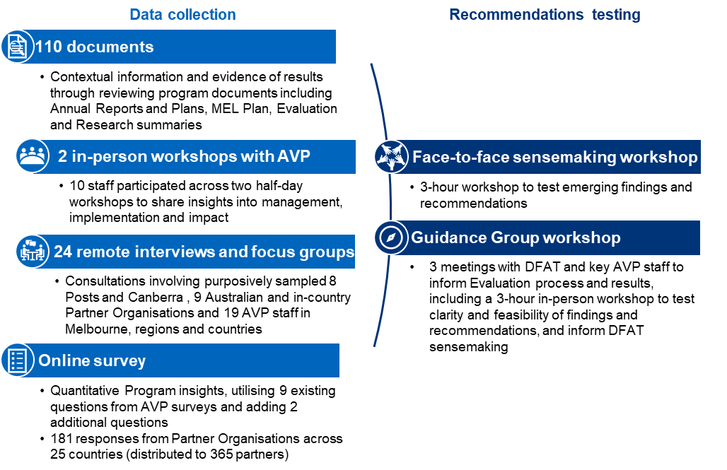

Figure 1: Data collection methods

### Limitations

Given the evaluation scope and scale of the AVP, the evaluation concentrated on collecting qualitative data from key stakeholders that could be assessed for significant insights and drew on existing data to triangulate and validate analysis, rather than comprehensive, wide-ranging primary data collection in-country. The key limitations identified were:

**Scope and timing:** This final evaluation was conducted in the eighth year of implementation, and 2.5 years prior to the end of the investment period. As such, this evaluation is not able to definitively assess the entire AVP investment period and is instead focused on evaluating the information available from 2018-2024. This means that questions relating to the achievement of EoPOs will be indicative only.

**Volunteer voice:** AVP data on volunteers was reviewed and included as a key source for the evaluation, including the recent internal evaluation into the value of volunteering[3]. Further primary data in the form of interviews or a further survey with volunteers was not collected, in line with DFAT’s objectives for the evaluation.

**Significant perspectives:** In line with qualitative data collection approaches, the evaluation conducted purposive sampling to seek significant perspectives able to test and add value to desktop data through different perspectives. Data collection from interviews is not necessarily representative of all countries/stakeholders or levels within DFAT.

# Findings

## How to read this section

This report presents findings from the evaluation against the Key Evaluation Questions, which are presented at the top of each section. Overarching findings are presented in **bold type**, followed by further details, supporting evidence and analysis.

The program has consistently collected and reported on program effectiveness and the value of volunteering for volunteers and partner organisations. These perspectives are routinely collected through the delivery of the program and demonstrate strong evidence the program is effective and that volunteering is an important modality. In this final evaluation, DFAT’s focus was on operational and management factors, to examine the extent to which the program design is meeting multiple stakeholder needs. While the discussion of AVP’s effectiveness presents some of the program’s achievements, the emphasis is on technical and relational aspects of the program, with insights and lessons for both DFAT and AVP.

## Effectiveness

To what extent has the program been supporting ‘… locally led change and the realisation of the SDGs’?

* To what extent have the end of program outcomes been achieved?
* To what extent have the program’s tools (i.e. different components and offerings e.g. small grants; support to returned volunteers; partner organisation attendance at conferences) been necessary to achieving program outcomes?
* What adaptations/ changes were made to the program’s delivery or design, and why?
* How has the MEL system generated rigorous data to improve and adapt the program (including risk and financial management)?

**Finding #1: AVP is delivering effectively on its end of program outcomes, and its goal of contributing to locally led change and the realisation of SDGs. This is a significant achievement given the complexity and scale of the program. There is evidence that AVP is supporting partner organisations’ capacity, enhancing the value and appreciation of volunteering and supporting disability and inclusion.**

The program is on track to achieve EoPOs, with 376 volunteers and 299 partner organisations (POs) engaged as reported in 2023-2024[4]. Volunteer numbers are again on the increase after a drop due to COVID-19, and resourcing challenges. The program has restructured to respond to these challenges and maintain effective delivery of volunteering assignments. There is evidence through reporting, surveys and interviews of the program supporting partner organisations’ capacity, enhancing appreciation of volunteering, strengthening cultural awareness and connections between program participants and countries. The program also supports diversity and inclusion objectives through increasing awareness of these elements within partner organisations and intentionally broadening volunteer and partner organisation recruitment.

The program works with a range of partner organisations to achieve its objectives. Since 2019, the program has worked with over 500 partner organisations across 25-26 countries and completed over 2000 volunteer assignments. Partner organisations range from national and local NGOs, INGOs, government departments, academic and or research institutions, UN agencies and the private sector. Support to partner organisations is delivered through modalities including, but not limited to, volunteer assignments conducted in-country and remotely, small grants, and brokering new partnerships and networks with partner organisations in-country. The program supports capacity development of partner organisations that explores, respects and builds on partners’ existing capacity and works with them to identify the best ways and mechanisms that the program can support them achieve their objectives (see Figure 2).

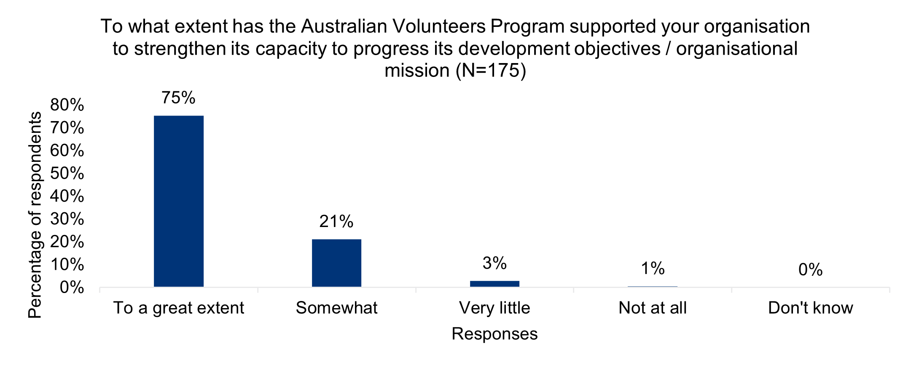

Figure 2: AVP support for PO capacity organisational capacity development (Evaluation Partner Survey, 2024)

These sentiments were confirmed through the survey conducted with partner organisations, with 72 per cent of respondents agreeing strongly that their organisations decide on the type of assignments and volunteers they need (see Figure 3). Furthermore, 98 per cent agreed or strongly agreed that the program responds to their needs and priorities (see Figure 4). In doing so the program enables partners to strengthen their capacity to better progress their development objectives. The evaluation found evidence that partners’ capacities were enhanced through the program in the areas of staff leadership, organisational governance, strategic planning, fundraising, networking and communication as a result of the program’s volunteer assignments.

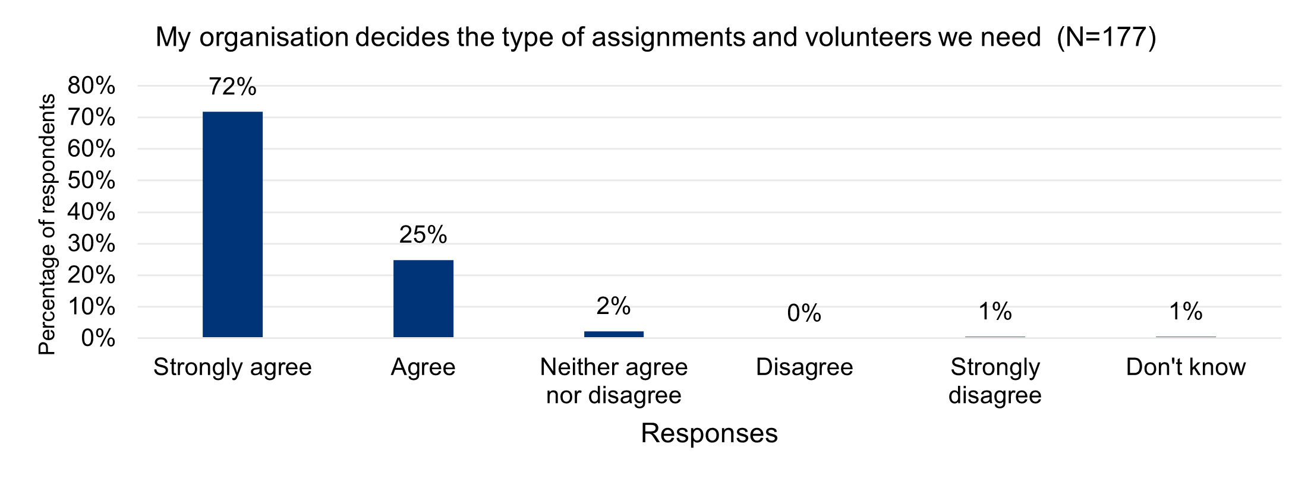

Figure 3: AVP partner organisations inform the design of volunteer assignments (Evaluation Partner Survey, 2024)

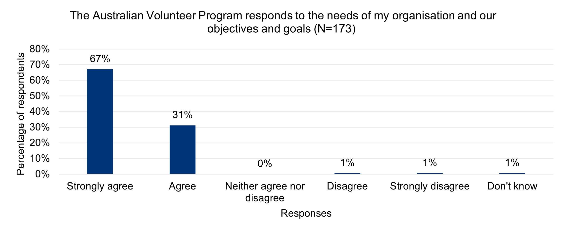

Figure 4: AVP is responsive to partner organisations’ needs, objectives, and goals (Evaluation Partner Survey, 2024)

In 2022-23, the program supported 206 in-country assignments, 195 remote assignments and 16 hybrid assignments.There was consensus among all stakeholders interviewed that AVP provides critical support to partner organisations. This stands out as the greatest achievement of the program. Some examples of support to partners include, but are not limited to, support during the COVID-19 response to address critical local needs (Vanuatu), support for gender equality, disability and social inclusion (South Africa, Samoa, Vanuatu), strengthening skills of individuals across sectors through training and mentorship (Papua New Guinea (PNG), South Africa, Vietnam) and enhancing partner organisations’ communication skills and visibility (Sri Lanka). Other examples include strengthening partner operational systems and processes (Cambodia and PNG) as well as effective training and support mechanisms for volunteers and partner organisations to become trainers and focus on mental health and wellbeing (PNG). The evaluation’s partner organisation survey found that 75 per cent of partner organisations reported the program has strengthened their capacity to progress with their development objectives to a great extent (Figure 3).

**Building appreciation of volunteering in Australia and overseas**

The program continues to deliver a range of initiatives that contribute to increasing the appreciation of volunteering in Australia and with partners overseas. 2022-2023 was the first year that the program reported on the value of volunteering after the 2021 program logic refresh, which included ‘enhancing appreciation of volunteering’ as EoPO 2. This is also understood as the ‘public diplomacy’ outcome, which generates visibility for the contribution Australian volunteers’ make overseas, and recognition in Australia and globally.

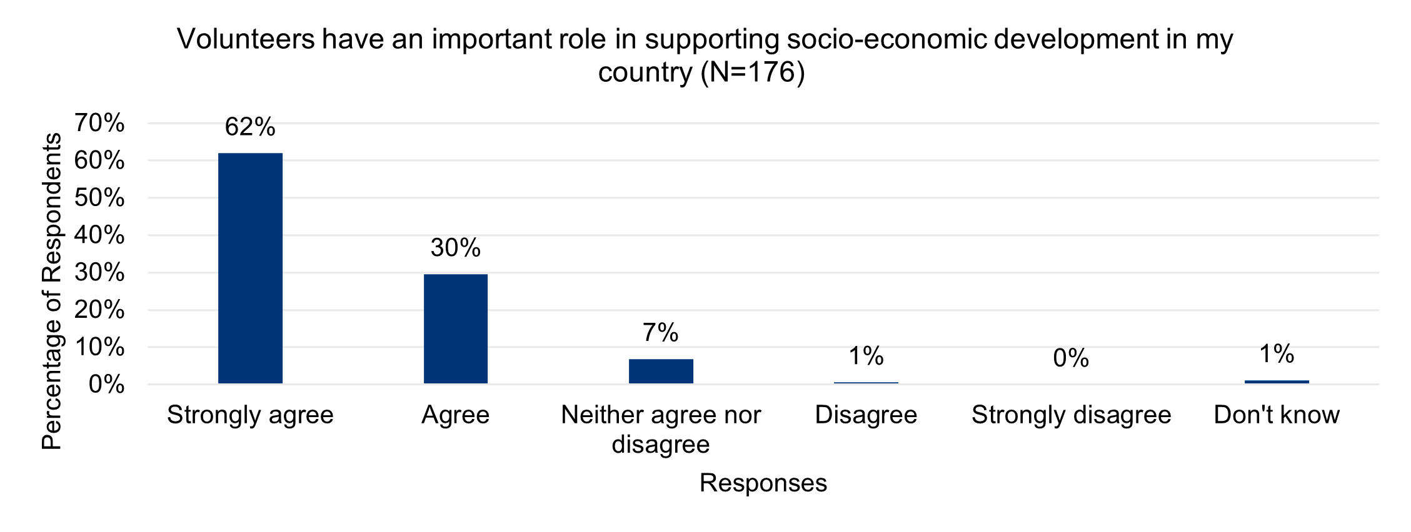

Figure 5: AVP partner organisations value the contribution volunteers make to development (Evaluation Partner Survey, 2024)

The evaluation found evidence of the program’s continued support for recognition and appreciation of volunteering through stories that demonstrate the value of volunteering, participation in international and national volunteer days, supporting partner organisations’ attendance in international conferences and knowledge sharing and dissemination. Interviews and online surveys with partner organisations (see Figure 5) and DFAT Posts, highlighted the high level of technical skills and experiences volunteers offer, enhancing local capacities and fostering sustainable development.

From 2017- 2024, the program embraced innovation through the Innovation Hub which was initially known as the Innovation Fund. The Innovation Hub’s aim was to create a portfolio of innovation activities that enhanced international volunteering and in doing so increase the impact of the program. Through the Hub, the program created avenues to experiment, design, test and scale new ideas and initiatives that continue to bring new knowledge to the program. Ideas tested include hybrid/open volunteering, optimising remote volunteering, locally led volunteering through Volunteering For Development (Vol4Dev), Global Volunteering Accelerator and Growing Community Volunteering, and supporting families and partners of volunteers. With host government support, the program is supporting the creation of national volunteering programs in the Philippines and supporting research on volunteering in Indonesia and Timor-Leste as a means of enhancing appreciation and growth of volunteering. All these spaces and experiments continue to provide the program with lessons and insights on volunteering which are integrated into the program and with partner organisations to support effective volunteering. Enhanced recognition of volunteering also has strategic benefits and enhances strong relationships between Australia and partner organisations (see Figure 6).

**Lasting relationships and personal development for volunteers**

AVP’s third EoPO supports placements of skilled volunteers with partner organisations to build stronger and long-lasting connections. Mutual reciprocity is at the core of this outcome. The objective is not only for the volunteers to support partner organisations (EoPO 1) but also for them to learn from partner organisations and grow personally in the process. To achieve this, the program is inclusive of and attracts a diverse range of participants who are supported by the program during and after assignments to build stronger connections. For instance, in the 2022/2023 annual report, the program supported 388 program participants, 362, individual volunteers and 26 accompanying dependents. According to the 2023 Alumni survey conducted by the program, 78 per cent of respondents reported still being in contact with their partner organisations while 80 per cent of past volunteers who completed their assignments reported that they felt they had grown professionally or personally as a result of their assignment.

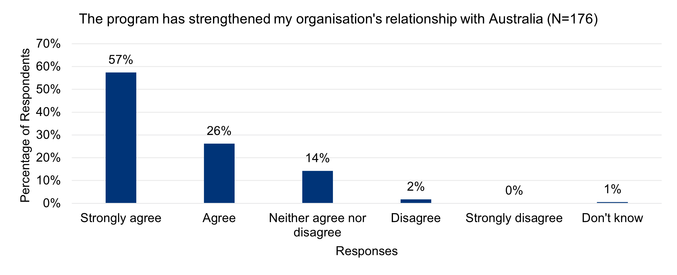

Figure 6: AVP partner organisations consider that AVP has strengthened their relationship with Australia (Evaluation Partner Survey, 2024)

**Finding #2: The program has utilized an array of tools to strengthen the quality of volunteering and outcomes for volunteers and the program. These amplify outcomes from volunteer placements (impact grants), assist the program to innovate and adapt to the changing context and opportunities for volunteering (innovation fund/hub) and deepen sustainability of relationships between volunteers and countries (returned volunteers support). These have been utilized and appreciated, and in some cases made a significant contribution to supporting the achievement of program outcomes. For example, The Innovation Fund (now closed) played a critical role in AVP’s achievement of program outcomes, by assisting the program to develop the hybrid and remote volunteering modalities required during the pandemic. However, given resource constraints, there may be value in exploring ways to simplify and integrate approaches to achieve the benefits offered by these tools.**

In addition to volunteer assignments, the program supports partner organisations through tools such as impact funds, knowledge transfer, learning opportunities and partners' participation in conferences. The impact fund provided 23 small grants (of up to AUD 10,000) across nine countries to support climate action projects in 2022 and 10 grants across 10 countries in 2023 to support gender equality projects. Discussions with partner organisations through this evaluation noted the importance of the impact fund in supporting their community development initiatives. In Vietnam, through the fund, a partner organisation was able to implement environmental protection and energy saving activities in community, while in Tanzania, a partner organisation noted that through the impact funds, the organisation was able to strengthen their systems and process which has helped them attract funds from other donors. Through the Flexible Learning Exchange (FLEX) the program has provided opportunities for shared learning for the program staff and partner organisations. FLEX continues to provide spaces and avenues for sharing through formats such as networking forums, events, communities of practice, resource sharing and global webinar series among others. In 2023, through FLEX, the program hosted 17 global webinar events that brought together participants, partner organisations, program staff and relevant stakeholders to share, learn and connect. Participants reported that the webinars were impactful, inspirational and enhanced their connection to the program.

Following the forced opportunity for remote volunteering that grew from COVID-19, as noted above, the Innovation Fund enabled the development and trialling of several different volunteering models, including remote volunteering, open volunteering and local volunteering. In 2020 the Innovation Fund led efforts to establish remote volunteering for repatriated volunteers, generating or supporting 104 assignments. The 2021 evaluation found the fund to be an effective adaptation mechanism. Additionally, other activities and models have been investigated, such as ways to bring partners together for shared learning, and making volunteering more attractive for partners and families.[5]

Several tools, such as the Innovation Hub, have been wound up as part of the 2024 financial review of the program. This was a response to shifts in context which saw the program’s annual allocation reduced to $21m/$23m (from $40m), reduced numbers of volunteers deployed in-country and skyrocketing costs of deployment (flights, insurance, and living allowances to support increased living costs). DFAT asked the program to review its activities and structure, including ceasing new innovation activities. Existing activities were consolidated and completed.

Figure 7 is a graph showing the percentage of AVP volunteers who identify as Aboriginal or Torres Strait Islanders. Full alt text in Annex 6


Figure 7: Percent of AVP volunteers who identify as Aboriginal or Torres Strait Islanders

**Finding #3: The Indigenous Pathways Program (IPP) has pioneered an approach to inclusion for First Nations participants that is a significant contribution to Australia’s policy goals in this space. While relatively small numbers of volunteers have participated through the IPP, it is appreciated by stakeholders and is one of the only initiatives of its kind in DFAT programs. It therefore offers unique and important potential for learning in this emerging area of the aid policy.**

The program’s focus on inclusion is through support for gender equality, disability, and Indigenous inclusion. This is reflected in the diverse range of participants that the program works with alongside targeted efforts to attract Aboriginal and Torres Strait Islander (Figure 7) volunteers and people with a disability (Figure 8).

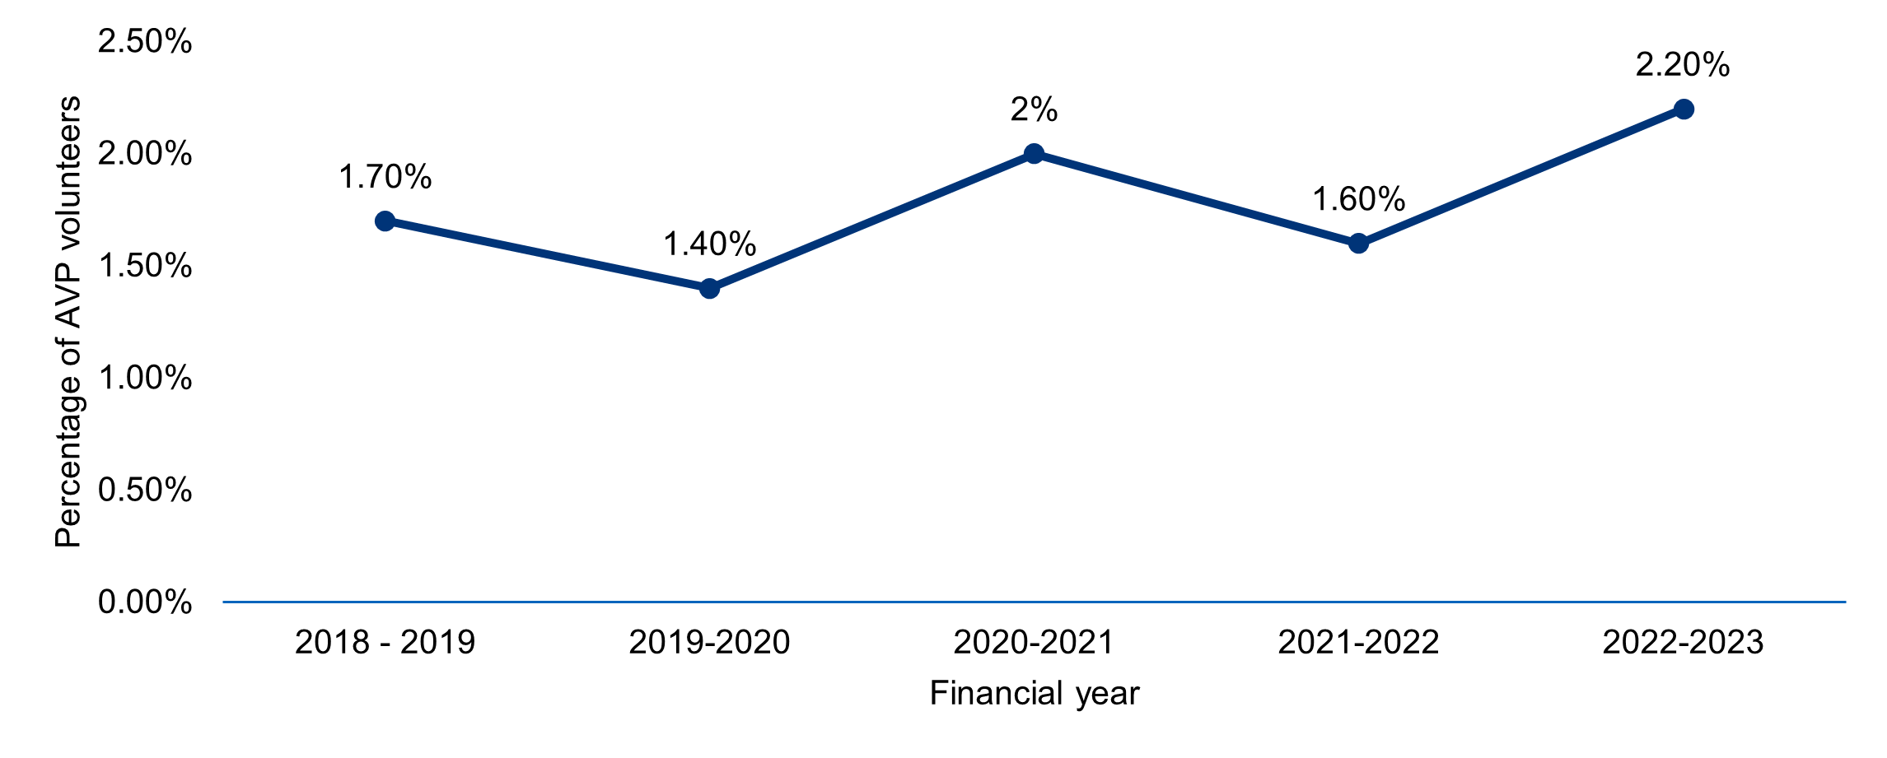

Figure 8: Percentage of AVP volunteers who identify as having a disability

Through IPP, the program is building strong relationships and connections with First Nations people, championing culturally safe approaches, adapting internal systems and processes to remove barriers to entry for First Nations people and brokering relationships, partnerships and cultural connections between Indigenous staff from Australia and some Pacific Islands countries (Fiji and the Solomon Islands).

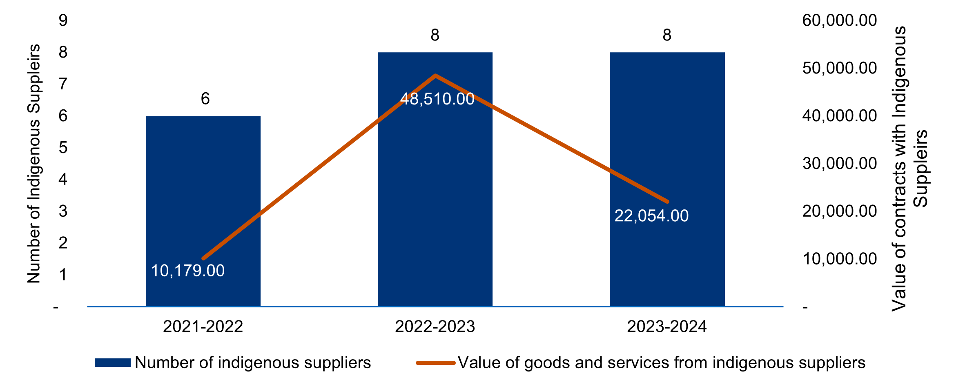

Figure 9: AVP engagement with Indigenous suppliers (Source: AVP progress reports)

The program also engages Indigenous-led suppliers to provide services and tracks evidence that indicates a steady increase in the number of suppliers and the value of contracts awarded (see Figure 9). Program staff consulted and DFAT in Canberra reported much pride in the Indigenous Pathway approach and hailed it as one of the key innovations of the program’s targeted inclusion approaches worth emulating in the future and across other initiatives. Outside the program and DFAT, the evaluation found no evidence of the knowledge of Indigenous Pathways. Beyond a diverse workforce, the evaluation found examples of the program advocating for gender equality, disability and social inclusion in the volunteer assignments with partner organisations. Examples include volunteers supporting women and LGBTQI+ organisations through skills training in Vanuatu, support for organisations of people with disabilities (OPDs) in Samoa and supporting disability inclusion in South Africa.

Overall, the program's commitment to gender equality, disability and social inclusion is strong through its volunteer selection, advocacy efforts with partner organisations and targeted Indigenous-inclusion approach. Inclusion is considered and is a key feature of the program. Additionally, reporting to DFAT includes disaggregated data which shows the scale and diversity of the volunteers, their assignments and the partner organisations supported.

**Finding #4: The MEL system captures substantial evidence to support performance management and program reporting, but there is potential to further strengthen its utility through more specific country-level reporting.**

Analysis of the program’s MEL documentation, system, processes and products highlights a well-designed system that supports program monitoring needs, research, evaluation, learning and reporting in line with the program logic. Reporting to DFAT is well-written and captures the program's progress in achieving its EoPOs. Through a range of MEL products, AVP communicates partner organisations’ reach, partner support, research and innovation and achievement of development outcomes in different contexts. It also includes information for learning through deep dives and internal reviews. At an aggregate level, these show that the program is making an impressive contribution to countries’ development goals.

Despite this, the evaluation found that some DFAT Post staff wanted more from the MEL products developed, noting that in some instances, the information they are currently receiving does not suit their needs and does not provide them with relevant and strategic information that they are seeking to support relationships in-country. For example, one Post noted that they don’t receive reports and would like more regular reporting so that they have greater understanding of volunteer activities, stating: “We don’t receive it (AVP reporting); unless we’re finding our own time to meet them, we really don’t know what they’re doing here”.

Furthermore, some DFAT Post and partner organisations raised concerns about the program’s reliance on surveys administered by the program as the primary monitoring and reporting tool that they are aware of. Consistently positive findings do not always align with anecdotal information heard by Posts, and over time this has raised questions about how the program surfaces concerns or negative feedback, and the lack of opportunity for independent data collection. This theme, drawn from several respondents, is captured in the questions raised by one: “Surveys find that it’s all very good; no one’s being honest…they don’t want to jeopardize the future?” The evaluation heard that the program does use other tools to capture these concerns, many of which are internal, and therefore not visible to Posts.

AVP acknowledged DFAT Post concerns about country-level reporting provided and noted that Post reporting needs by nature will always vary, and need to be balanced with MEL resources available within the program. This mismatch of views around country reporting does not necessarily suggest a weakness on the program’s side, but points to a lack of shared understanding and communication of what the MEL system has been designed for and therefore what it can produce. It also points to a lack of clarity on what constitutes fit-for-purpose MEL products at the country level to support DFAT Post needs and the feasibility of the program delivering on these varying requests from Post.

It also reflects differing expectations about the program’s strategic intentions. The evaluation found that DFAT’s strategic intentions in-country are not represented in the program logic (discussed further below), despite the collaborative review of the program logic in 2021. This means that the MEL system is not set up to collect data and report stories on some areas that are of significant interest to DFAT, particularly at Post.

The evaluation also found that DFAT regard reporting on policy compliance and responses to risk incidences as too high-level and therefore, of little use. This is discussed in detail below, at section 3.5. While risk and compliance are discussed in management meetings, including data in annual reporting (noting sensitivities), and elevating it to a more prominent position in reporting, would demonstrate the high priority already placed on these issues by AVP.

**Finding #5: There is a disconnect between the current program logic and the program’s strategic intentions, as they have evolved for DFAT, especially at country level. This creates sometimes unfair expectations of the results reported through the MEL system, which is aligned with the program logic and meets DFAT M&E Standards.**

The program's strategic focus is anchored in its Global Program Strategy (GPS), which aligns with Australia's development/aid policy. As a global program, AVP is a mechanism for Australia and its partner countries to contribute to the SDGs. Interviews with DFAT noted the value and importance of the program in not only supporting the achievement of development outcomes but also in advancing Australia's strategic interests in partner countries overseas. Ideally, at a high level, the strategic intentions of the program should be well captured in the program logic to measure progress and guide reporting of these intentions to DFAT. Some elements of the strategic intentions of the program are captured in EoPO2 (key stakeholders in Australia and partner countries appreciate the value of volunteering), but the program logic is strongly designed and focused on development outcomes. There is less articulation of the strategic intentions and benefits of the program in strengthening country-to-country relationships and diplomatic pursuits. The evaluation found a strong desire from DFAT for the strategic intentions and benefits of the program to be emphasised and reported more fully. Though interviews with the program staff echoed the understanding of these benefits, this remains a gap for the program. It is recognised that the responsibility for articulating these strategic intentions is shared between AVP and DFAT. If not clearly articulated in the program logic, the strategic intentions of the program will remain assumed rather than clearly articulated and therefore not planned for, reported against and well communicated. Program respondents also indicated that the reduction in DFAT staffing allocated to the program meant there was little time available for HDS to work strategically, including linking between the program and Post to highlight how upcoming priorities at country level might relate to the program’s overall global strategy.

## Coherence and strategic alignment

To what extent has the program supported the achievement of Australia’s strategic objectives and commitments – i.e. International Development Policy/ Partnerships for Recovery, and DPPs/ AIPs?

* To what extent has the program demonstrated coherence and alignment with Australia’s public diplomacy objectives?
* To what extent has partner organisation selection, and the range of program partners aligned with International Development Policy/ Partnerships for Recovery, and DPPs/ AIPs?
* To what extent has the program been supporting Australia’s soft power objectives and the networking aims of its foreign policy? To what extent has the program’s public diplomacy, advocacy and branding played a role in this?
* To what extent is the program delivery model driven by supply and/ or demand (supply – driven by AVI volunteer talent pool; demand driven by partners/ government/ Posts)?

**Finding #6: AVP is designed and delivering important elements of Australia’s strategic objectives and commitments, particularly at a global level. Australian strategic objectives have evolved, and the program has adapted effectively to shifts in development priorities and themes, such as climate change and Indigenous Pathways.**

Public diplomacy is the diplomacy Australia engages in beyond traditional government-to-government engagement. It is about building people-to-people links and sustaining an extensive network of relationships with other countries. It advances Australia’s interests through strengthening our influence and reputation.

DFAT website, [Public diplomacy | Australian Government Department of Foreign Affairs and Trade](https://www.dfat.gov.au/people-to-people/public-diplomacy), accessed 26 Nov 2024.

Against a range of measures, AVP has made and continues to make significant contributions to the achievement of key elements of Australia’s International Development Policy (2023), its predecessors and country-level strategies. The program’s recently released Global Program Strategy 2024-2027[6] includes thematic areas aligned to Australian Government priorities and cross-cutting issues, and increases the program’s emphasis on gender, disability and climate change. It also provides a focus on culturally appropriate opportunities for First Nations perspectives.[7] A number of Postshighlighted that the program enables them to provide support to meet development needs and to engage with organisations they would not be able to support through other aid programs or modalities. The Strategy provides a framework that guides partner organisation selection and volunteer recruitment, progress reporting, reviews and research. As one interviewee at Post explained: “A great strength of the program is it helps to align to the policy [particularly related to locally led development and climate change]”.

DFAT defines public diplomacy as part of its people-to-people approach, and DFAT’s website includes AVP as one of its flagship people-to-people programs. AVP is recognized by Australians for making critical contributions alongside local people, to partner countries. The 2023 International Aid Policy is illustrated with four photographs from AVP, including one on the cover. One Post interviewee stated: “The volunteers are the face of Australia on the ground and in community”.

The program adapted admirably to Partnerships for Recovery during COVID-19, adjusting country strategies and volunteering modalities, which was a major shift. As mentioned already, AVP is recognized by DFAT through the Indigenous Pathways program to engage First Nations communities as volunteers, which aligns with the intention for DFAT’s First Nations approach to Foreign Policy and is one of only a few initiatives developing this area of work. The First Nations approach aims at “better reflecting Australia’s shared and full identity, our modern diversity and the rich heritage of First Nations People”[8]. The design of the Indigenous Pathways program was Indigenous-led, and the IPP has further contributed to DFAT guidance around implementation for those delivering Australian aid. This is recognized as high-cost, long term work that is important for the Australian aid program.

AVP operates largely within DFAT’s primary area of geographic focus (Indo-Pacific), but also extends Australia’s reach into countries such as Nepal and South Africa. More than one Post also referred to the value of the program for adding value, with one stating “(It) gives depth to bilateral engagements and priorities”. This is particularly relevant in countries where there is less substantial engagement with the Australian aid program.

**Finding #7: There are different perspectives across DFAT on the extent to which AVP aligns to DFAT strategic intentions in-country. It is apparent that DFAT expects a stronger focus on diplomatic and soft power outcomes, linked to public diplomacy, from the large number of Australian volunteers deployed through the program, particularly at country level. However, these expectations are not well articulated or understood.**

As a people-to-people program, AVP is valued for demonstrating and building strong relationships between countries. In 2023-24, the program considered withdrawing from a number of its locations to reduce its high operating costs. In one of these locations, the High Commission intervened and successfully advocated to retain the program on the basis of its strategic and development value to the country and Australian aid program. However, the evaluation found that some Posts’ expectations that the program should ‘be strategic’ go beyond the program’s design. Posts interviewed were unanimous in appreciating the value of being able to place volunteers within local organisations, and particularly welcomed being able to respond to requests for support from local organisations and thus help build relationships; this was seen as an important and strategic role for the program. Posts also expected more ‘public diplomacy’ that would promote the program’s contribution to the country, and the strong relationship between countries. However, this emphasis does not fully align with AVP’s program logic, which guides implementation and reporting. One interviewee at Post explained, “It’s (AVP is) a really great, juicy orange, but we could squeeze it so much more.”

AVP’s program logic emphasises the value of volunteering as a modality to contribute to development outcomes. EoPO2 reflects the importance of volunteering to Australia as a way of building relationships, providing support and achieving development outcomes, and leverages AVP’s organisational strategy and expertise[9]. The updated program logic was released following the Phase I 2021 evaluation, based on consultations including with Posts. At that time, it was agreed that the program should maintain a focus on development outcomes over in-country relationship building. The change in emphasis heard through this evaluation since then could reflect the increased focus on the geostrategic significance of country partnerships, particularly in a number of Pacific Island Countries.

A significant proportion of Posts expressed dissatisfaction with the program’s ability to support the delivery of their strategic agenda and questioned why the program was failing to respond more proactively or quickly to shifts in strategy at country level. Practically, these issues seemed to be grounded in Posts’ involvement in partner organisation selection. Comments included that the program ‘pushed back’ on Post requests related to prioritizing or expanding to new partners, including those identified by Posts as high strategic priorities. These issues were not understood the same way by program teams, who referred to the value of CPP (developed together with Australian High Commission (AHC) staff to align with local development priorities and DFAT’s in-country strategy) and cited regular meetings and close working relationships with Posts.

Given the strong feedback received from many Posts, there is a clear opportunity to balance the strategic and public diplomacy goals for the program (including at country level), noting differences between Australia-facing and country-facing objectives; and the need to generate recruitment for the program and contribute to relationship-building and development results for DFAT. This also raises the important question about the extent to which AVP shouldbe viewed as a tool to advance soft power objectives in countries, given the risks associated with placing volunteers in potentially sensitive political roles.

This disconnect also indicates the need for clearer coherence across DFAT to ensure expectations of the program are shared across the many different countries where it operates. These differences in understanding reflect the complexity of relationships across global programs, which work across Canberra-based teams and Posts (more than 20 for AVP). High Commission staff allocated to AVP manage multiple programs, and may have development, diplomatic or other backgrounds. They change frequently. DFAT Posts do not always appreciate the challenges of delivering a development program, including program timeframes, recruitment of volunteers and DFAT staff turnover. This fluidity makes it important for DFAT in Canberra to be able to engage actively with Posts and AVP, to ensure coherence and shared understanding across stakeholders.

**Finding #8: Volunteer allocation is driven by both supply and demand, but operational factors (recruitment cycle; volunteer interest; need to recruit new partner organisations) can cause delays in meeting Post requests and this varies across countries. In some countries, the same partner organisations are drawn on repeatedly, and this use of long-term or repeat volunteers feeds into concerns that the program is not “working strategically”.**

The evaluation heard from some DFAT respondents that the program was not meeting expectations in terms of engaging new partner organisations, or placing volunteers in partner organisations requested by Post, including government agencies. CPPs are developed with Posts to guide partner organisation and volunteer selection. However, the slow speed of partner organisation relationship-building and volunteer recruitment creates tensions between Post and AVP in the face of other pressures. CPPs were first developed in 2018 and some were revisited in 2020 to respond to Partnership to Recovery plans. HDS requested further updates in 2023, and the program moved to refresh these in 2024. Updated CPPs are now pending or approved for all AVP countries. Respondents noted that budget constraints played a significant role in restricting expansion to new areas or partnerships but felt that other issues were also at play. Comments included: “If there is no incentive, they [AVP] stick to their bread and butter… We’ve always wanted new people but if there’s no incentive they’ll play to their more conservative approach”. Another interviewee noted: “We want them to critically engage and suggest. That’s what’s missing in the current model.”

AVP respondents highlighted the importance of working with long-term partners to build capacity sustainably, the time it takes to bring new POs up to standard in terms of risk assurance, challenges around identifying appropriate volunteers and high turnover of staff within Posts.

**Finding #9: The relationships, roles and responsibilities between Posts, the program and HDS in strategic decision-making remain blurred, and Post’s role is not clear or, potentially, not accepted. This is a familiar challenge for a global program, and it causes challenges between stakeholders. DFAT Canberra has little opportunity for face-to-face discussions with the program and Posts, to identify and work through emerging issues together.**

As noted above, at an operational level, the evaluation found that there is a disconnect between DFAT and AVP over who is responsible for strategic decision-making and at what level. In evaluation interviews, AVP and DFAT looked to each other to take responsibility to address this perceived lack of strategic engagement and referred to the contract to clarify roles and responsibilities. Differing expectations are a source of tension at various levels of the relationship between AVP and DFAT.

DFAT’s strategic goals for the program vary depending on the Post country strategy, immediate relationship-building priorities and even Post staffing. Reductions in DFAT staffing noted above have had made it difficult to invest the time needed to facilitate the relationship between Posts, the program and DFAT in Canberra, to ensure clear understandings and coherence, and resolve challenges.

## Efficiency and effectiveness

1. To what extent is AVP’s operational model fit for purpose for the management of the program?

1.1 What are the key elements of the operational model and how well has the model supported delivery against the program logic?

1.2 How are international operations meeting the needs and requirements for volunteers, partner organisations and DFAT?

1.3 What are the in-kind supports and volunteer deployment costs and how do they contribute to program outcomes?

1.4 How has AVP been affected by shifts in its operating context (internal and external – budget, personnel, partnerships, COVID, travel restrictions, partner country instability) and how has it responded?

**Finding #10: Broadly, the operational model is well set up to deliver on the contract and against the program logic, but reduced staffing in DFAT and other contextual shifts have changed the assumptions on which the contract was originally developed. This has increased pressure on the program, leading to some tensions between AVP and DFAT.**

In the current phase, DFAT moved from a grant modality to a contract for the volunteering program, at the same time as consolidating volunteer programs under the AVP banner. As outlined in the AVP Investment Design Document (IDD), DFAT expected the contract would provide for greater efficiency and cost-effectiveness in operations, and a more cohesive, better articulated strategic direction for the program. It was expected that the arrangement would allow DFAT staff to focus more on strategic direction, with implementation outsourced to a single specialist service provider (in consortium with technical advisers). During interviews, the evaluation heard that a contract should provide DFAT with assurance that the program is delivering on current government policies and legislation, noting that they change over time. This was and continues to be critical for AVP given the large amount of money involved and the complexity of the program deploying Australians across more than 20 countries.

Stakeholders agreed that the consolidation of the different Australian volunteering programs into one has provided greater coherence and simplicity in the current phase, although there is shared recognition of the scope and complexity of the program due to budget size, number and type of stakeholders, and geographic range.

AVP contract governance is appropriately supported by the Program Management Group (PMG) which meets six-monthly, the Contract Management Group (CMG) and Risk Management Group (RMG), which meets quarterly. The contract also includes details of the Delivery Model for the program, as well as the Program Logic and EoPOs (see annex 1). These frameworks are operationalised through the organisational structure developed by the Contractor, which operates at 3 levels and includes positions based at AVP head office, 5 Regional Directors and in-country teams. Figure 10 illustrates the core elements and relationships that make up the AVP Operational Model, based on the contract and supporting documents.

The contract provides a clear framework to guide delivery of the program, but reductions in resources to support contract oversight and implementation has contributed to some issues (including related to risk assurance, partner organisation selection, and reporting) arising remaining unresolved (see Figure 10 below). The Program Logic, Delivery Model diagram and Roles and Responsibilities paper are useful documents, but relationships and processes for resolving challenges are not fully supported through the current contract and systems, with potential to strengthen the approach to partnership.

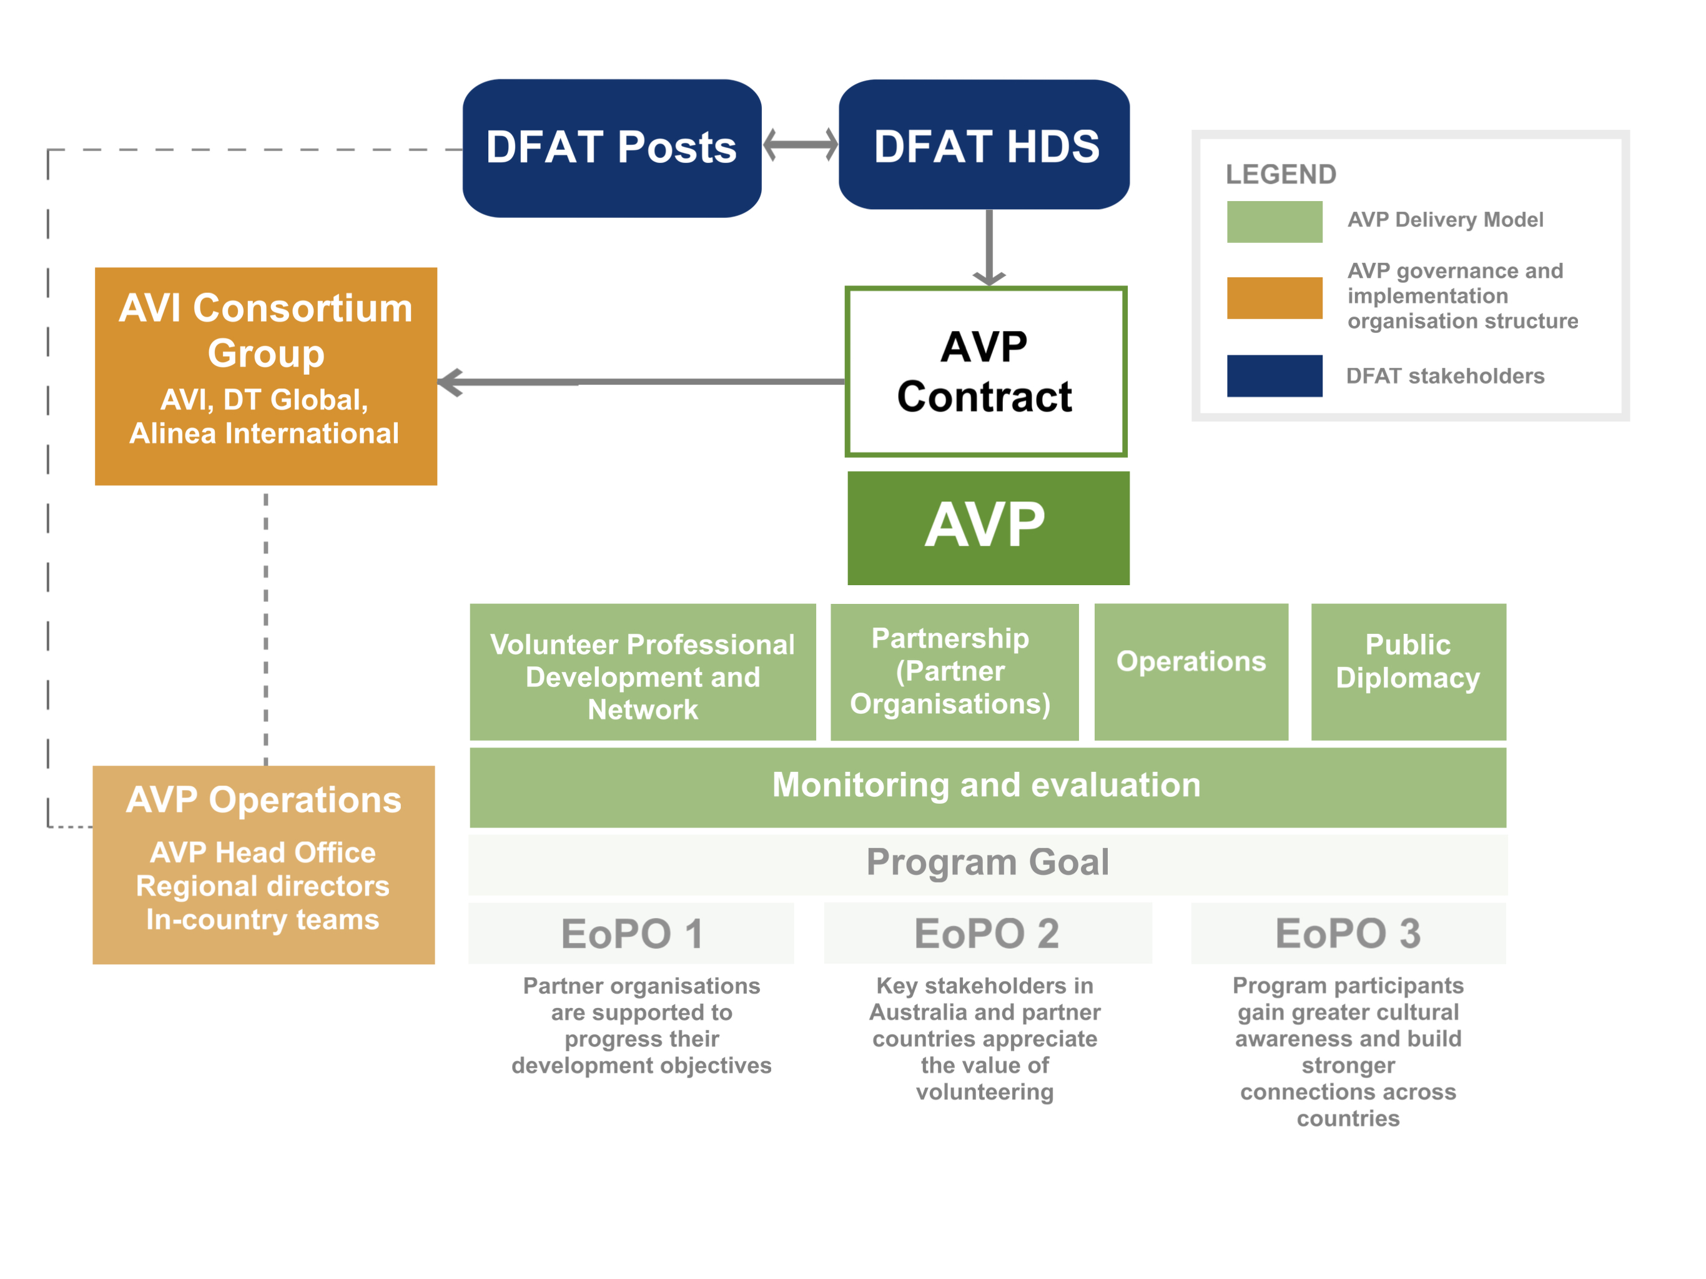

Figure 10: Overview of the AVP operational model

**Finding #11: The program has responded well to multiple significant shifts in context, some of which have fundamentally affected its operations.**

There have been numerous major shifts in context since the contract was put in place that have made it difficult to realise some of the expected efficiencies and play into the recurring tensions noted above. These are:

* COVID-19 and introduction of hybrid and remote volunteering (hybrid volunteering is to be evaluated by AVP in 2025)
* Changes to DFAT structure and reduced staffing, with reduction in allocation of staff from 8 to 2.1
* Changes to DFAT policy requirements, including WHS and PSEAH (note this is discussed more below)
* Country-specific disasters, policy shifts or unrest
* Changes to proposed budget allocations
* Increase in costs of volunteer deployment, and decrease in volunteer numbers following COVID-19

DFAT’s reduced allocation of staffing in Canberra was noted across multiple stakeholder consultations with DFAT and AVP, and is seen to have had a significant impact on the Program. The contract specifies that DFAT Canberra will be responsible for “advising the program on strategic policy direction for alignment with DFAT’s global aid program priorities”, while Posts will work with AVP at country level. Administration and desk-based compliance monitoring takes up the majority of DFAT staff time and there is no available time to undertake monitoring visits. At the same time that DFAT resourcing to the program changed, the program was moved into the Humanitarian and Development Deployments Section (HDS), as the Australian Volunteers Section and NGOs and Volunteers Branch were restructured.

The costs of volunteer deployment following COVID-19 increased significantly (see Figure 1111**Error! Reference source not found.**), and changes in legislation following the change in government in 2018 have demanded more rigorous monitoring and assurance of the program from DFAT. Escalating costs for insurance, program requests for unanticipated security costs, and regular fraud reporting (a sign of policy compliance rather than a concern around the level of fraud per se) have all been areas of concern, as noted in meeting minutes reviewed for the evaluation and evaluation consultations.

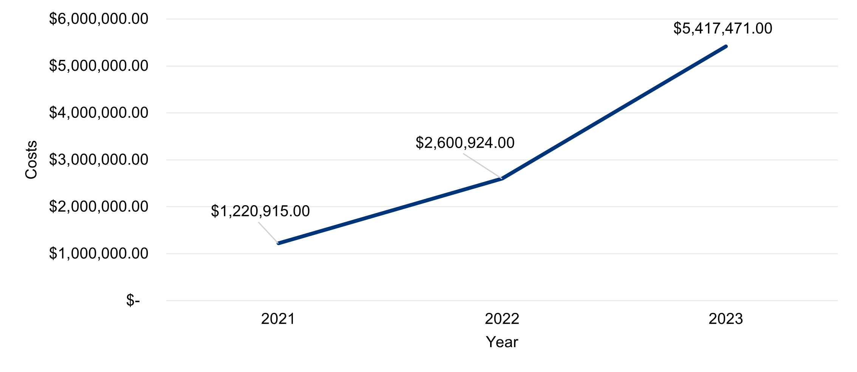

Figure 11: Costs of volunteer deployment by year

Nevertheless, the evaluation found evidence that the program has responded and adapted to shifts in context, with the goal of meeting contractual requirements and delivering an effective program. The significant work to reshape the program in response to budget pressures in 2023/2024 is a strong example. During 2023, AVP undertook reviews in order to ‘reshape the program’ and reduce costs, whilst continuing to meet DFAT priorities. In early 2024, the Program Mid-Year Report noted that DFAT had little appetite to reduce geographic footprint and wished to continue to prioritise in-country volunteers. AVP reported that they had cut 21 roles from the program, ranging across functions including global security, partnerships and innovation, program managers and recruitment officers in Australia and overseas. Following presentation of the Aide Memoire for this evaluation, the program noted that budget pressures during 2023/24 led to reduced volunteer numbers, but that this is changing during 2024/25. As noted in an evaluation workshop, the Program anticipates a 68% increase in the number of in-country assignments during the year.

**Finding #12: Costs and requirements related to volunteer deployment and support have increased. The program adjusted in response, but volunteer numbers were reduced (now climbing again). Areas where costs and requirements have increased include: 1) the level of onboarding, training and preparation for partner organisations; 2) financial costs of deployment including insurance; 3) level of support that is provided on assignment and after assignment (making sure return is smooth).**

International skilled volunteering has long been known to create value far beyond the financial resources provided for the deployment of volunteers and includes the program outcomes reflected in the program logic, as well as public diplomacy outcomes. In recent years, and during the lifespan of the program, a range of factors have contributed to rising costs – from partner organisation engagement and onboarding, to volunteer training needs, to accommodation availability in country, and global rises in the costs of living. At the same time, COVID-19 and its aftermath has contributed to changes in how volunteer assignments are established, as well as the risk and security procedures that have shifted and expanded. Pre-deployment efforts have grown (i.e. risk and security procedures, recruitment processes, volunteer onboarding, partner organisation onboarding) and expectations of volunteers for different types of assignments (i.e. flexible time frames, hybrid) have had impacts on the types of in-kind support the program needs to draw from, as well as the costs of deployment. Most respondents acknowledged these changes as welcome, and supportive of improving the volunteer experience, oversight of risk assurance, and partner organisation capacity outcomes.

Australian volunteer sending organisations have been long time partners of the program, often engaged in a longer and deeper capacity with supporting the program to bring particular skills to assignments (e.g. paramedics, emergency nursing). This evaluation found that their experiences of engaging with the program differed from those at Post. Australian organisations in a focus group discussion shared particular gratitude towards local teams for AVP making the deployment process “really amazing”. Specifically, they noted the in-kind and wrap around support AVP provided, in terms of offering a single point of contact from submission of application, through interviews, and into deployment. Ongoing support was referenced by Australian volunteer sending organisations as “responsive and supportive”.

Local partner organisations told the evaluation of their experiences of working with the program. They described “helpful” local coordinators who were facing numerous challenges to find “highly skilled and specific” volunteers for assignments. The partner organisations acknowledged the difficulties of finding highly skilled candidates for these roles, and the contribution this makes to inefficiencies and delays in placing volunteers. Frustrations in the time taken for “the turnaround time from completing forms and having volunteers in country” were expressed, as well as an acknowledgment that some requests are complicated to make.

The evaluation found that the costs of deployment (including pre, during and post) have changed, and in many cases expanded for the program. However, financial investment in the program has not grown in line with these increased pressures, and as outlined, there have been challenges in expectations being met within existing resource constraints. The evaluation found that while in-kind supports are present within the program, they have largely been secured through deep and deliberate engagement with in-country partners and volunteer sending organisations. The ability of the program to draw from these supports is directly related to its ability to build these long-term trusting relationships. Often, the evaluation heard frustration from Posts related to responsiveness and efficiencies in the program dealing with requests for changes or increased in-kind supports, with little appreciation for the required efforts from the program to deliver these.

**Finding #13: Elements of AVP operations were questioned by some respondents and should be flagged for management attention to consider the need to make changes.**

The following issues were raised multiple times by DFAT and at times Program respondents, so are flagged for further attention.

1. **Partner selection, responsiveness and flexibility**

A major focus of the program in some countries is matching specialist skilled volunteers to settings whereby organisations can benefit from deep training and capacity support. For example, in PNG where there is a shortage of trained nurses and other medical staff as well as a shortage of training available, volunteers have brought their specialist skills to share and tailor their support to the contexts they are working in. In Nepal, it took two years to match and deploy specialist volunteers skilled in managing forest fires, though this was appreciated and commended by DFAT and the partner organisation. Long lead times were noted as complicated to navigate in keeping partner organisations or host governments up to date, and equally that changes in volunteer interests and requirements for assignments all have contributed to a complex process. This could potentially be improved with more efficient forms and processes for raising volunteer requests, approving volunteers, and onboarding partner organisations.

There is a desire from DFAT, partner organisations and the program to continue to innovate within the program. The evaluation heard that DFAT are trying to influence and shift the program to adapt, with one respondent saying: “I’d expect more ideas, advice, innovation rather than just this is the way we’ve done it.”From AVP colleagues, this was experienced slightly differently, as demonstrated in this comment from an AVP team member: “It’s hard. We have to be reactive and proactive dynamic as well. Logistically it’s hard to manage. It takes time to onboard new partners as well. And sometimes those new partners are not as interested as DFAT might think they are. The skill of our in-country team is to navigate that.”

At Post, the evaluation heard from numerous countries of a different situation. DFAT’s needs for flexibility are not consistently being met, and colleagues described the program as “not open to innovation and flexibility to address what we see as emerging issues.” Similarly, program staff acknowledged that shifting focus, priorities or responding to ‘strategic guidance’ can be difficult, “if we want to do anything different or plan ahead or manage issues – because of the constraints, the decision making is slower in DFAT.” The evaluation heard from all sources, a desire for increased flexibility and proactive adaptation, and an acknowledgment that all parties have concessions to make in order to meet these competing needs and interests.

1. **Pre-departure training and context-specific cultural awareness among volunteers**

The program looks to ensure that volunteers and partner organisations are well prepared and equipped with training, education and information to navigate their time together. Program staff described that in-country context training was offered at predeparture, and throughout the assignment. Support may take the form of online webinars or discussions on certain topics to keep volunteers connected to learning. However, noted by multiple Posts and a program team member, the evaluation heard some lack confidence in the pre-departure training and onboarding provided to volunteers. Specifically, concerns were raised that volunteers do not have sufficient basic language training or awareness when they are deployed. This, alongside a perception that volunteers are not aware of the “cultural context” in which they are operating, and that this training is not delivered by partner organisations, is adding to concerns from some Posts and even program staff that cultural sensitivity is at risk, and therefore that efforts to build relationships could be compromised. The evaluation notes that pre-departure training is not the only tool used to prepare volunteers.

1. **Risk management and security**

AVP stakeholders – volunteers, Posts, HDS, management teams - have different and sometimes contradictory responses to issues of risk management and security, though it is recognised as being of critical importance by all of them.

Importantly, the needs expressed by DFAT for risk assurance and policy compliance, are not positioned in the same way by AVP staff in-country. Security practices and procedures at Post differ depending on a range of contextual - including live - factors. The evaluation found that in-country AVP teams had varying degrees of tolerance, appetite and interest in risk and security concerns. Concerns (from DFAT) ranged from a perceived lack of incident reporting and communication, through to a lack of proactive risk management and mitigation. One Post explained, “risk and security need to be brought up. Talk to us when nothing is happening. These should be ongoing discussions. We want to understand patterns.” In PNG, Vietnam and Vanuatu, for example, security and risk management processes have fluctuated over the course of the program, relative to contextual changes as well as the nature of volunteer assignments. Posts noted that they have received feedback from volunteers raising concerns that their needs are not being attended to, despite being raised to country teams of the program.

For volunteers, personal security concerns and risk comfortability differs among individuals. They are wanting to maintain autonomy and independence, at the same time as wanting freedom from surveillance while on assignment. One Post noted that volunteers say they “feel quite restricted” by the various instruments (e.g. curfews, tracking, reporting) and all volunteers “want more freedom of movement”.

**Finding #14: In-country program staff are required to cover all areas of the program, which is a heavy and complex workload, requiring significant resourcing and support.**

In-country, the practical implementation of the program involves many stakeholders, within vastly different organisations, in highly diverse contexts. Key actors include volunteers on assignment, partner organisations, and DFAT personnel at Post or in Canberra. In the middle of these partners are local and global AVP colleagues, navigating the many strands of the program while attempting to keep clear communication channels open, information sharing transparent and open, and meeting myriad needs and requirements from stakeholders.

The demands on Posts, and thus for in-country teams, are significant, and constantly evolving. For example, the evaluation heard from some Posts that a focus on forward planning and priorities is front of mind, and that this has implications for working with the program. It was noted, “we want them to wait until the DPP (development partnership plan) to put forward a plan” and that staff within the High Commission are necessarily navigating competing priorities and interests. In some places (as noted above), Posts were frustrated with the time taken by ICMT to identify new partner organisations, while program teams noted the challenges involved with developing these new partnerships. One Post indicated that there was little incentive for long-established country teams to make these changes (see above). Many staff in in-country management teams (ICMT) have been in the role for many years. This expertise is highly valued, but there may be a need to support them to refresh their approaches and relationships to be responsive to DFAT needs and changes.

All stakeholders across the evaluation noted the complexities of working within a global program, where Posts are bringing bilateral interests, and often limited experience of the program. Teams are oscillating between developing and implementing plans, while remaining completely flexible. As one program colleague noted, “Navigating expectations can be challenging. It takes time. We are small teams who are also managing medical evacuations and then sorting out developing assignments and then orienting new volunteers.” Support is provided by Regional Directors, who play a critical role in management and connecting ICMT with head office and Posts.

## Efficiency and risk

2.2. To what extent has the program demonstrated ‘fit for purpose’ risk and security processes and systems for all partners involved – including DFAT Canberra, DFAT Posts, partner organisations and volunteers?

**Finding #15: AVP has detailed risk and security processes and systems in place which have been positively assessed through independent audits and continue to develop, with noted recent improvements in incident reporting. However, DFAT is not fully assured that the program is able to manage and respond to all risks or incidences in line with DFAT risk management standards and policies. To overcome DFAT’s concerns, the program will need to strengthen visibility of efforts around risk monitoring and analysis, and incident management, and show how Australia’s standards and policies underpin operations at all levels.**

DFAT at Post, HDS and AVP all bear responsibility for risk, adding to the complexity of this high priority issue. AVP is an inherently challenging, high-risk program. It faces the additional challenge of ‘retrofitting’ new policies, such as PSEAH, with existing partners, some of which have been initially resistant, and new and nascent partners. This takes time and, in some cases, DFAT has perceived these delays as resistance by the program.

Under the contract, as outlined in Attachment C Roles and Responsibilities, AVI is responsible for the “health, welfare, safety and security of its staff, the volunteers and their approved accompanying dependents. As such, AVI is responsible for threat and risk analysis, management and mitigation across the operations and delivery of the program and responding to concerns or feedback from DFAT.”

In response, the program has a Global Risk Management Plan in place, convenes quarterly AVP Risk Management meetings with HDS and provides quarterly risk reports to DFAT. Incident reporting is managed in accordance with the Incident Management Flowchart, which includes requirements to share information with Posts. AVP also has long-standing relationships with recognized and trusted security, insurance and mental health service providers. The previous evaluation (2021) identified certain types of risk that were not captured in the program’s Global Risk Management Plan, but program reporting indicates that this is considered to have been addressed, with greater integration of risk within the MEL framework and reporting and a risk assurance framework developed in 2021. The program was praised by a range of respondents for its risk-informed response to COVID-19. Recently, the 2023-2024 independent Due Diligence audit of AVI noted that AVI: “demonstrated a strong risk-based approach to the implementation and management of its projects and specifically the Australian Volunteers Program”.

Nevertheless, DFAT is concerned that some key needs are not being met, despite positive independent reviews and regular Risk Management Meetings. The evaluation finds that concerns are rooted in delays in communication, leading to anxiety about perceived lack of information or transparency, rather than specific incidents (which have not happened yet), which the evaluation sees as related to trust between partners, the high level of risk inherent in the program, concerns over rapidly changing country contexts and challenges around reduced resourcing. This is less about the program’s operational model or systems, and more about communications and relationships between partners.

As noted above, responses in interviews with Posts to questions on risk and security varied, ranging from a sense that risk is managed adequately, to concerns that information is not shared quickly or comprehensively enough with Posts when incidents arise.The evaluation was not directed to examples of critical incidences or failings, but a number of DFAT respondents in different contexts described that the program was not quick enough to prioritise and respond to concerns or changing Australian government requirements for WHS, PSEAH and / or country level risk monitoring. Several Posts indicated that they have had to push to get the program to respond to security concerns at country level. One Post interviewee shared frustration, saying: “We can say we’ve resolved that [security] challenge, but I wouldn’t say it wasn’t without a lot of to-ing and fro-ing from us.” In early 2024, HDS instructed the program to provide investigation reports for Level 3-5 incidents in order to identify and rectify risks. These have now been introduced.

Nevertheless, the evaluation found that program management is highly committed to maintaining its duty of care to staff and volunteers and continues to work to evolve in line with changing requirements.

**Finding #16: Some in-country partner organisations have not understood the need for PSEAH policies and see them as culturally inappropriate, while others appreciate developing policies as an element of organisational strengthening.**

The evaluation found that management and AVP staff are deeply committed to ensuring the safety of staff and volunteers, and considerable effort and resources goes towards this goal. Both DFAT and the program noted that policy requirements have increased significantly since program start, creating additional demands for DFAT, the program at central and country level, and partner organisations.

In 2024, the program placed greater emphasis on compliance with DFAT policies for risk and security, particularly with regards to PSEAH for downstream partners. The program also sought to strengthen risk and security processes in-country. A country risk assessment framework template remained outstanding in February 2024 but has since been completed. Several Country Security Plans were finalized in 2024, including PNG, Nepal, Solomon Islands and Vanuatu. Additional program resources were provided to support PSEAH assessments for partner organisations, which is a significant task. AVP reported assessing 487 active partner organisations in July 2024. By Q4, 15 policies were approved. Some DFAT respondents in interviews and sense-making sessions reiterated that they considered the response to PSEAH too slow.

The evaluation found that requests from DFAT on risk assurance such as PSEAH are not well understood by all country team staff, though they are clear that they are non-negotiable. Although AVP has put considerable effort, resources and time into rolling PSEAH policies out to local partners, some ICMT staff indicated the need for further support to take PSEAH into their local context. Evaluation discussion with staff indicated that PSEAH was understood as high priority but were unsure how to progress PSEAH in conservative local cultures and would benefit from additional support from head office.

While it does not affect the program’s requirement to deliver on the contract, it is relevant to acknowledge the challenges of supporting policy compliance with small or nascent organisations, and with the sensitive policy area of PSEAH in some contexts. In evaluation interviews, the program acknowledged that small or new organisations may be unable to meet standards for compliance, and they work to assist them to develop these competencies where possible. One country staff member in a country known for challenging attitudes towards gender equality shared that she did not feel sufficiently supported with knowledge and skills to assist partner organisations, who are sometimes resistant, to develop PSEAH-compliant policies. The evaluation also found contrasting examples of partner organisations who consider they have benefited from training in DFAT policies, including PSEAH. Long-term partner organisations in an evaluation focus group discussion indicated that they consider this as part of the capacity they develop through the program, which they value. One partner organisation with a long relationship with the program explained: “When the government requests (information), we already have it. Thanks to AVP for always pushing us to be aware of these policies.”

## Partnership

**Finding #17: While there are areas for improvement in the delivery of any program, this evaluation has found that it is the partnership between AVI and DFAT that is creating tension and warrants attention. The contract outlines roles and responsibilities, but there have been some differences in interpretation and implementation, and changes in resourcing and context that have led to frustrations on both sides.**

**Finding #18: The objectives of AVI and DFAT in delivering AVP are sometimes at odds, with different pressures to deliver results in terms of risk assurance and policy compliance, diplomatic and soft power objectives, and volunteering effectiveness outcomes. All are part of the contract and are important to balance, but trust and collaboration is needed to work through tensions and context-specific issues. Both parties feel their needs are deprioritised by the other at times.**

**Finding #19: There is a need to improve ways of communicating between AVP and DFAT to articulate expectations clearly, and for AVP to demonstrate responsiveness. There is currently no agreed process for raising, prioritising and responding to management challenges.**

The evaluation found that the operational model is fit-for-purpose for delivering the EoPOs. However, this finding does not address DFAT’s concerns that the program is not adequately responding to requests from the client, and that the requirements of the contract (i.e. “The Contractor is expected to be creative and flexible in generating innovative ways to support the Australian Volunteers program”) are therefore not being adequately addressed. The move to a contract from previous granting processes has enabled new ways of working and has taken some adjustment for all parties. A contract in and of itself does not necessarily create the conditions needed for an effective partnership between parties; often though, the instrument is documentation of how facets of the relationship will operate, including shared and individual objectives, roles and responsibilities and ways of working. As this is a new way of delivering AVP, a thorough review of how the partnership has operated within the boundaries of the contract is provided here.

There are many references to ‘partnership’ within the governance documents, contractual obligations and terms of reference guiding the program; partnerships with partner organisations, Australian volunteer sending organisations and Posts are described with varying levels of specificity. These examples range from partnerships with a focus on people-to-people relationships with local organisations in long-term and sustained relationships to enable development outcomes and capacity strengthening, through to details of partnerships with Posts approving assignments and providing technical advice for country plans. The evaluation found within the design documents, clear commitment to partnership at various levels: with DFAT, with partner organisations, with Australian Volunteer Sending Organisations, and with consortium partners. There are limited references to how the partnership might operate between DFAT and the Contractor (beyond contractual obligations and controls). The lack of detail about these different types of partnerships is important, because there are a variety of assumptions underpinning how relationships between parties will operate, ranging from deep collaboration and co-working, through to one party contracting services from the other. The evaluation heard from all stakeholders interviewed, an express desire for improved ways of working, an increase in openness, trust and transparency, and a perception from all that purposes and intentions for the program are not currently completely aligned.

**Transparency and trust**

At several junctures through this evaluation, there were discussions about the evaluation scope, with the program seeking to reorient the evaluation away from some questions and lines of inquiry posited by the client (DFAT). DFAT colleagues expressed a pattern of behaviour in their interactions with the program: “We do get pushback to say, ‘why do you need to know that?’”. Through the course of the evaluation, DFAT and the program team were able to have constructive conversations, and DFAT expressed that they recognised positive shifts in behaviour.

Not having available information to answer a partner’s question or one partner seeking clarity from another partner are not indicators of problems in and of themselves. However, when principles of transparency and trust are present within a partnership, expressions of pushback or blocking information flows are often less present. A practical example that was cited by DFAT colleagues at Post and in Canberra throughout this evaluation was a desire to be better informed about how partner organisations were selected, and the rationale for certain selections. The evaluation heard that the reason DFAT have for seeking this information was to better prepare the HDS team to navigate conversations in Canberra and at Posts.

The terms of the agreement outline that Posts will be involved in approving and endorsing volunteer assignments, and that they may make suggestions. If partnership is of interest to all parties, then it would be important to clarify how such decisions are made, how partners can raise new ideas, how information can be shared transparently (including being transparent about what cannot be shared). Without these critical elements in place, the evaluation found that partners had different expectations about the scope and boundaries of their relationship.

**Shared purpose and clear responsibilities**

Partnerships thrive when partners are positioned to bring complementary sets of skills and expertise to fulfil shared purposes; they can achieve more together than they can separately. The evaluation heard that DFAT are aware of their changing contexts and needs, and that they appreciate the complexities of their requests to the program in Australia and in countries of operation. Several DFAT colleagues expressed they had questions over the flexibility and adaptability of the program to change in line with external context shifts. One respondent noted, “there is an expectation over the contract of ten years that they [AVI] would move with the times. I don’t know they’ve got the flexibility to move with changing times or philosophy. They haven’t taken changes in policy on board.”. Across the program, colleagues described their own experiences of these relationships, citing attempting to meet changing and competing demands, and often juggling where to channel finite resources (e.g. into finding new partner organisations, maintaining relationships with existing partners, focusing on collecting stories for purposes of communications and public diplomacy). The evaluation found that there is a strong desire from DFAT and the Contractor to re-establish and align on purposes and responsibilities within the partnership.

**Mutual benefit**

In a contractual partnership, such as AVP, it is common to find partners navigating obligations, requests, and ad-hoc conversations. Often partners, as individuals, respond in ways that can seem to the other partner to not meet the context of the interaction. The evaluation heard from multiple Posts that country teams, when interacting with Posts in recent months, have been sharing the Roles and Reference documents that explains expectations and boundaries. At the same time, the evaluation heard from in-country teams and from the Australian team of the program, that these instruments had been re-introduced in response to a perception of scope creep, and requests from DFAT that they felt could not be met with shrunken resources. On the one hand, one colleague at Post described the interaction leaving them to believe that “the partnership approach to managing the program here, is not there”. On the other hand, in-country Program teams are attempting to meet these requests while maintaining relationships with existing partner organisations. One colleague recalled going out to the “province and reaching out to many partners. It’s many compliance lists. It’s a challenge to help potential POs fill the compliance lists. All POs have to do work health and safety (WHS) as well and so we have to physically go inspect their buildings.” While there are not necessarily competing priorities between partners, there are significant differences in how, why and where attention is placed on different elements.

**Optimism and courage**

Throughout the evaluation, there were consistent messages from program team members and DFAT colleagues conveying deep respect for one another’s positions and pressures. There was also acknowledgment of the difficulties of working in a partnership of this scale and complexity; with many different countries, cultures and needs. All stakeholders acknowledged shrinking resources, increasing risk and compliance procedures, and complicated environments for assignments. At the same token, and as mentioned above, some of the critical ingredients needed for a successful partnership – openness, transparency and trust, shared purpose and responsibilities, mutual benefit – were under pressure in different ways, for different stakeholders. There were small examples cited, of DFAT noticing that they are deprioritised as key stakeholders in communications with AVP, of Posts being shown the Roles and Responsibilities document rather than conversing, and of the program dealing with requests to diversify partner organisations often with unreasonable expectations of time. These seemingly small examples are manifesting in stakeholders feeling frustrated, pushed back against, and mistrusting of the information being shared between partners. The evaluation heard a willingness from all stakeholders to embrace courageous conversations about how the partnership might be strengthened, beyond rhythms of communication and structural changes, to ways that partners might show up and work together in this complex environment.

# Lessons and recommendations

The evaluation has identified a series of recommendations to take up opportunities for change and improvement in the delivery of AVP. These recommendations were drafted and tested with the Guidance Group on 22 January 2025, with further feedback provided and taken into consideration with a view to achieving clear and feasible proposals for action. These will require further consultation and design processes on behalf of the program and DFAT, separately and collectively, to develop a Management Response, agree on and prioritise recommendations, and take them forward.

**Recommendation #1: Clarify the links between AVP and DFAT’s country level strategic objectives, and consider how to reflect this in the Program Logic and outcomes framework**

Noting that the program logic was reviewed in 2022, AVP and DFAT should consider whether and how to review the program logic or introduce additional data that will meet DFAT’s needs for information about the partner organisations engaged with the program and the fit with Post strategic interests.

In reviewing the public diplomacy strategy (planned for 2025), AVP should take this into account, to ensure public diplomacy is clearly defined and understood across all stakeholders. Ensure that efforts are then resourced appropriately at regional and country level. The program’s definition of public diplomacy should differentiate between Australian and country-facing objectives, and between public diplomacy related to awareness-raising and recruitment of partner organisations/ volunteers, and public diplomacy to strengthen support for the Australian aid program and bilateral relationships. Other diplomatic interests and pursuits favoured by Posts should also be considered here and clearly articulated as reasonable expectations within a future public diplomacy strategy, or not. The process should be developed to assist in building shared understandings between AVP, Posts and Canberra of objectives, roles and operational factors (time, capacity, resources) needed to build new (strategic) relationships and establish volunteer placements. Where possible, these discussions would benefit from external facilitation and brokering; outcomes to ‘agree to disagree’ with regard to various issues will continue to undermine good working relationships and effectiveness.

**Recommendation #2: Elevate visibility of policy compliance and risk management to better reflect AVP efforts, and clarify implications for PO capacity development and engagement outcomes**

AVP should work to strengthen visibility of policy compliance and risk assurance, so that it is elevated to the same level as program effectiveness in management, communications with staff and DFAT, program reporting and updates to Posts. Noting sensitivities, AVP should consider providing more detailed reporting on changes in country risks identified, and numbers of incidences / country over a reporting period. Similarly, country-level reports on progress towards policy compliance could be included.

The time and effort taken to bring partners up to speed for due diligence purposes may have implications for AVP’s ability to bring new partners on board, in turn affecting targets for number and type of partner organisations engaged at country level. AVP should consider how these factors could be reflected in CPP targets, indicators and strategies for partner organisation engagement and capacity development. Collaboratively working through any changes with DFAT would strengthen visibility and understanding of how risk assurance and policy compliance requirements are impacting program delivery. There is also potential to document and share learning around this sensitive area of work for other development programs who may be experiencing similar challenges.

DFAT should clearly articulate priority concerns with specificity and agree with AVP on timed targets for resolving key issues to be referred to in management meetings. This will assist AVP to respond and prioritise in line with DFAT concerns. DFAT monitoring visits should be resumed, with assessment of risk processes as a key agenda item.

**Recommendation #3: Strengthen coherence by creating a stronger and more explicit connection between Posts, HDS and AVP**

As a global program, AVP depends on strong collaboration between Posts, HDS and AVP (at country and central level) to ensure strategic alignment, realistic expectations of the program and clarity around roles and responsibilities. It is noted that strong relationships between partner organisations and AVP are vital to the delivery of an effective program, though it is the collaboration between the three partners mentioned that this evaluation has found to be in need of attention. Current tools (CPPs) are helpful but not sufficient to ensure coherence and shared understandings. AVP is responsible for delivering the program and managing relationships at country level, but Posts are communicating concerns about the program back to HDS, that have often already been raised with the program. DFAT HDS should convene regular joint meetings to discuss annual plans and strategies, ideally face to face as part of monitoring visits.

**Recommendation #4: Ensure learnings and impact of the AVP tools such as Innovation Fund/Hub and impacts grants, and the Indigenous Pathways Program are documented and presented to allow for learning and adaptation in the future**

Noting that program tools and initiatives including the Innovation Hub have been revised and scaled down during the 2024 change process, there is value in documenting and summarising the value add and achievements of these tools to ensure their objectives and potential future contributions are not lost.

As part of this, undertake a close-out review of the Innovation Hub/Fund, recognizing the contribution the fund made to improving volunteering processes, and utilizing these findings to strengthen messaging and offerings that will attract volunteers and partner organisations to apply.

Continue to document insights and lessons from the Indigenous Pathways program to share for other DFAT development programs.

**Recommendation #5: Refresh MEL system and tools to strengthen utility and engagement with data within DFAT**

The program should identify ways to integrate data linking annual reporting more directly to CPPs with targets to strengthen the country level story of change and reflect country strategic alignment.

Review current monitoring and reporting tools to explore how to appropriately capture and reflect negative or challenging experiences expressed by volunteers and partner organisations. Currently, outliers providing negative or critical feedback in surveys or informal feedback (e.g. in conversation with Posts), are treated as such and DFAT have expressed concern that there is little visibility of how this feedback is dealt with and actions taken to resolve issues. Some of the current MEL tools (e.g. volunteer survey) are useful for understanding aggregate trends, while others (e.g. partner organisation survey) are administered by the program and are arguably positively biased. The evaluation heard from partner organisations, Posts and AVP staff that partner organisations (though aware that their participation in feedback is anonymous) are keen to present a positive image of their experience as they do not want any element of the program to be cut. This is not a unique problem for AVP, but it limits the utility of MEL for learning and improvement. Therefore, consider whether additional tools or processes are needed (e.g. independent evaluation, key informant interviews), or whether this could be achieved through greater visibility of existing processes.

Reporting should provide greater detail on risk management and policy compliance in annual reporting to strengthen visibility and accountability, commensurate with the high priority and resources utilized for this area of work.

Strengthen country volunteer case studies linked to CPPsto show strategic contribution and include quotes from host organisations*.* Ensure the program has adequate resources at regional level to craft these stories for publication on relevant platforms that will reach Post audience, partner organisations and DFAT in Australia.

**Recommendation #6: Articulate country-level strategies for partner organisation engagement**

AVP should articulate context-specific partner organisation engagement strategies that clarify goals and targets for recruitment, to match country strategies, long-term capacity development aims, regulatory contexts, due diligence and other factors that affect the development and maintenance of relationships with long-term and newer partner organisations. This could be integrated into CPPs. The process should ensure space for local partners to influence the country-level strategy in line with AVP commitment to locally led development and good partnership. Pending resources, progress could be monitored, used for ICMT management and included in reporting. Note that there is no one-size-fits-all approach, given different restrictions and potential in each country.

**Recommendation #7: Review management support for ICMTs to ensure clear targets and sufficient resourcing and support to meet the program’s demands**

To address concerns from DFAT that some country teams are not adequately responsive to DFAT requests at Post, AVP should assess the value of reviewing and clarifying ICMT performance targets to build ownership and accountability at country level. Noting ongoing resourcing discussions, since ICMTs and regional teams must meet the program’s wide range of complex requirements, this evaluation underlines the importance of adequate resources, training and mentoring to deliver on these targets and objectives including public diplomacy, risk and compliance, supporting volunteers, building and maintaining relationships with and onboarding partner organisations.

AVP should also share more detail of regional and country implementation and support in DFAT meetings and reporting, to generate greater awareness of different contexts and progress.

**Recommendation #8: Refresh the partnership between AVP and DFAT to improve the process for resolving challenges and create opportunities to document lessons and insights**

Undertake a collaborative review of partner (DFAT and AVI) objectives, ways of working and communications to complement the contract and clarify processes and timeframes for sharing and resolving specific issues, such as the long-standing questions over the strategic approach; partner organisation recruitment and risk assurance. AVI is responsible for delivering the contract, but complex international development programs require DFAT to play an active role throughout the program to ensure that the contractor is set up for success. This creates a difficult balancing act, particularly in the context of shrinking resources and increasing complexity. It would be valuable for DFAT and AVI to surface this issue and agree on expectations for the management of challenging issues. This includes identifying what information and support DFAT needs to provide to enable AVI to deliver on the contract, and when AVI is expected to step up and deliver. It is recommended that independent facilitation from a partnership broker or practitioner would be useful in alleviating inherent power dynamics between parties. DFAT in-person monitoring visits would also strengthen relationships.

Annex 1: AVP Program Logic

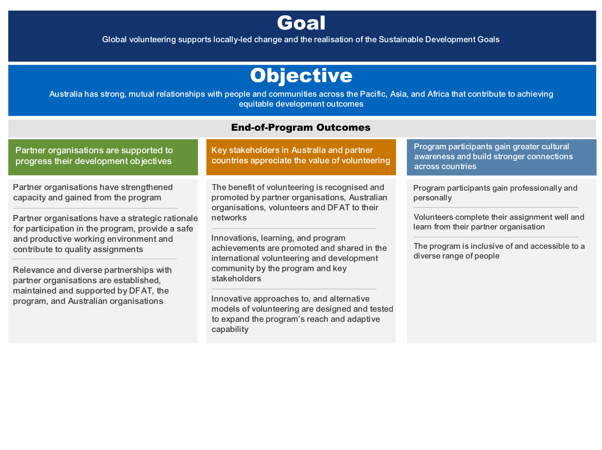

Figure 12: AVP Program Logic

Annex 2: Stakeholders consulted

|  |  |  |
| --- | --- | --- |
| Stakeholder Type | Stakeholder Name | Number of participants |
| Lead Contractor | AVI Global Team | 6 |
| Lead Contractor | AVI In-country team | 5 |
| Lead Contractor | AVI Regional Director | 6 |
| DFAT Canberra | DFAT HDS | 2 |
| Australian High Commissions | DFAT Post | 15 |
| Implementing Partner | DT Global | 1 |
| Implementing Partner | Alinea International | 1 |
| Australian Partner Organisation | ACEM | 1 |
| Australian Partner Organisation | CUFA Australia | 1 |
| Australian Partner Organisation | Planning Institute of Australia | 1 |
| AVP Partner Organisation | Center for Knowledge Co-Creation and Development Research | 1 |
| AVP Partner Organisation | Tonga Fire and Emergency Services | 1 |
| AVP Partner Organisation | Ministry of Environment, Lands, and Agricultural Development | 1 |
| AVP Partner Organisation | Msichana Imara Foundation - MIF | 1 |
| AVP Partner Organisation | St Johns Ambulance | 1 |
| AVP Partner Organisation | Stepping Stone Foundation Inc | 1 |
| AVP Partner Organisation | Vanuatu Society for People with Disability | 1 |

Annex 3: Key evaluation questions (KEQ)

| **Key evaluation question (KEQs)** | **Sub questions** |
| --- | --- |
| 1. To what extent is AVP’s operational model fit for purpose for the management of the program?   *OECD DAC Criteria: Efficiency and effectiveness* | 1. What are the key elements of the operational model and how well has the model supported delivery against the program logic? 2. How are international operations meeting the needs and requirements for volunteers, partner organisations and DFAT? 3. What are the in-kind supports and volunteer deployment costs and how do they contribute to program outcomes? 4. How has AVP been affected by shifts in its operating context (internal and external – budget, personnel, partnerships, COVID, travel restrictions, partner country instability) and how has it responded? |
| 1. To what extent have robust and appropriate AVP processes and systems supported DFAT, volunteers and partners?   *OECD DAC Criteria: Efficiency* | 1. How has the MEL system generated rigorous data to improve and adapt the program (including risk and financial management)? 2. To what extent has the program demonstrated ‘fit for purpose’ risk and security processes and systems for all partners involved – including DFAT Canberra, DFAT Posts, partner organisations and volunteers? |
| 1. To what extent has the program been supporting ‘… locally led change and the realisation of the SDGs’?   *OECD DAC Criteria: Effectiveness and sustainability* | 1. To what extent have the end of program outcomes been achieved? 2. To what extent have the program’s tools (i.e. different components and offerings e.g. small grants; support to returned volunteers; partner organisation attendance at conferences) been necessary to achieving program outcomes? 3. What adaptations/ changes were made to the program’s delivery or design, and why? |
| 1. To what extent has the program supported the achievement of Australia’s strategic objectives and commitments – i.e. International Development Policy/ Partnerships for Recovery, and DPPs/ AIPs?   *OECD DAC Criteria: Relevance and coherence* | 1. To what extent has the program demonstrated coherence and alignment with Australia’s public diplomacy objectives? 2. To what extent has partner organisation selection, and the range of program partners aligned with International Development Policy/ Partnerships for Recovery, and DPPs/ AIPs? 3. To what extent has the program been supporting Australia’s soft power objectives and the networking aims of its foreign policy? To what extent has the program’s public diplomacy, advocacy and branding played a role in this? 4. To what extent is the program delivery model driven by supply and/ or demand (supply – driven by AVI volunteer talent pool; demand- driven by partners/ government/ Posts)? |

Annex 4: AVP Evaluation Partner Organisation Survey Summary

Introduction

As part of the independent evaluation of the Australian Volunteers Program (AVP), the evaluation team developed and disseminated an evaluation survey to 365 partner organisations through the support of the AVP team. The survey was developed based on the four key evaluation questions (KEQ) relating to effectiveness, efficiency, sustainability, coherence, and relevance. This document provides a summary of the survey findings which then informs the key findings and recommendations presented in the 2025 AVP Evaluation Report.

It is important to note that the AVP team administers a similar Partner Organisation Survey every year for monitoring purposes. This summary report provides a comparison with 2023’s PO Survey only where the difference appears significant. However, the Evaluation team have found that the difference is not significant overall – i.e. differences between one to four percentage points generally. There were two questions with more significant difference, an increase by seven percent and 11 percent. These will be discussed in their respective sections below. Another note to consider as one reads this document is that the respondents may or may not be the same ones from the previous years.

Purpose

The purpose of this survey was to ensure the insights and experiences of AVP partner organisations were considered and informed the overall findings and recommendations of the AVP evaluation.

Response demographic and implications

In Phase 2 of the AVP evaluation, the evaluation team worked together to develop the survey questionnaire using Microsoft Forms. The survey developed for this evaluation was based closely on the AVP Partner Organisation Survey that is administered yearly. During this time, the team worked closely with the AVP program team to ensure clear roles and responsibilities and a smooth process in the dissemination of the survey questionnaire. Once ready, the AVP team disseminated the survey to 365 partner organisations. The survey went to all POs that had an assignment in the last 2 ½ years. The survey was opened between the 25th of October 2024 to 15th November 2024 (a duration of 23 days) and received 49% response (178 responses), a response rate similar to AVP Partner Organisation surveys in previous years.

In terms of response rate by the regions, representation by region were similar when comparing the proportion of total sampled against its response share, with the exception of East Asia which received the highest representation of partner organisations. This means that the data collected has relatively equal inference across the regions with greater inference on East Asia.

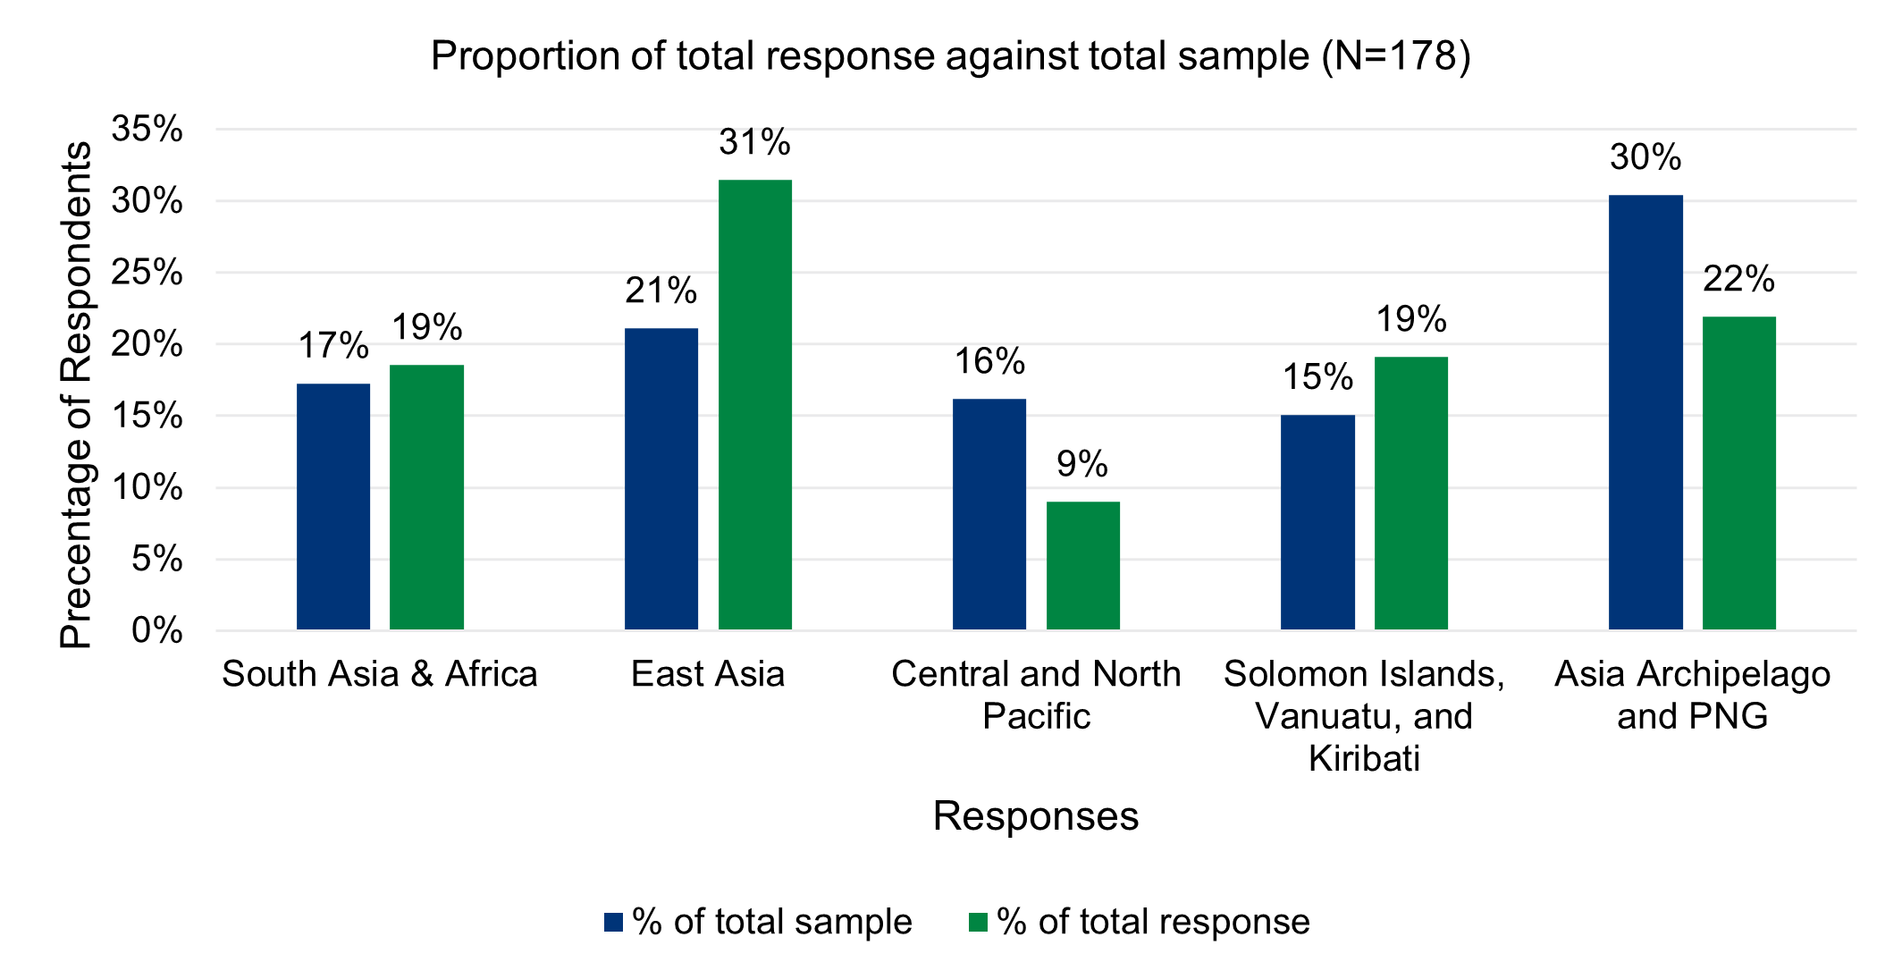

Figure 13: Percent of AVP partner organisations who responded by region

**Forty-two percent of respondents (n=75) identified as representing a national or local non-government organisation (NGO). The second highest organisation type represented were government agencies (20%; n=36) followed by international NGO (16%; n=28), then academic/research institute (14%; n=25). Representation from the private sector, UN agency, or other made up the remaining types.**

**Majority of the survey respondents had their last completed volunteer in 2024 (61%; n=109) and 45 percent of respondents (n=80) reported that their organisations had hosted 2 to 3 volunteer assignments since 2018. Thirty-one percent (n=55) reported that their organisations had hosted one volunteer.** Figure 14 **and** Figure 15 **present the percentage of respondents whose partner organisations completed from 2018 to 2024 as well as those who were unsure and the percentage of respondents who have received volunteer assignments through the AVP.**

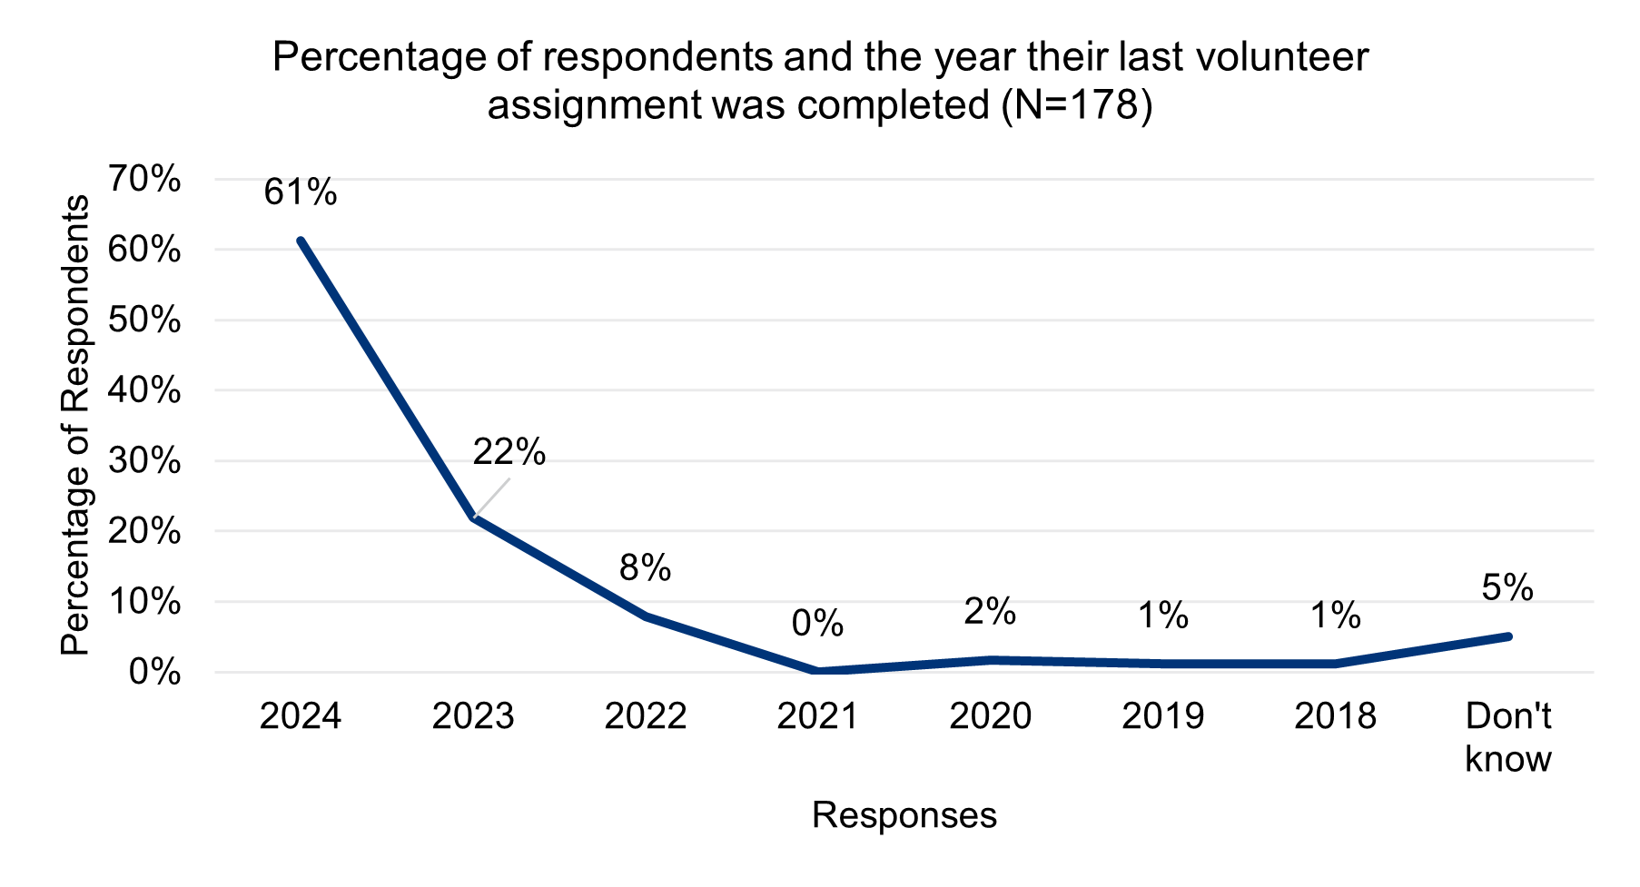

Figure 14: Percentage of respondents and the year their last volunteer assignment was completed (Evaluation Partner Survey, 2024)

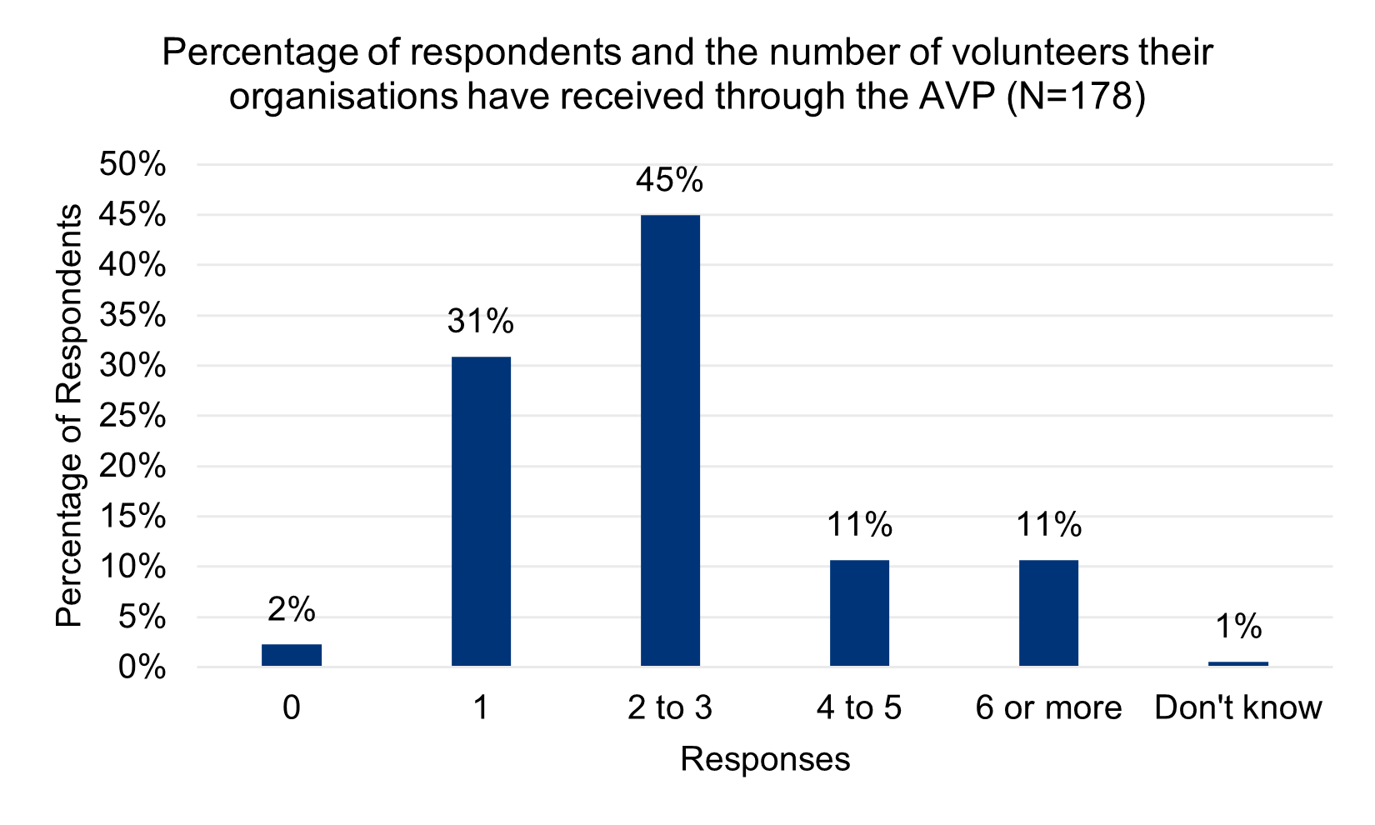

Figure 15: Percentage of respondents and the number of volunteers their organisations have received through the AVP (Evaluation Partner Survey, 2024)

This means that majority of survey respondents have recent experience (i.e. 2023 and 2024) with the program and have at least hosted one volunteer since 2018.

Key findings

**Partnership**

This section of the survey sought to understand the partner organisation’s perception of the partnership with AVP, particularly in the areas of support, communication, conflict management, autonomy in deciding volunteer assignments, compliance, and feedback mechanism. Responses in this section were strongly positive.

* Ninety-eight percent of 173 responses strongly agree (67%) or agree (31%) that the AVP responds to the needs of their organisation and their objectives and goals. This is an increase from the previous year’s AVP PO Survey (91%)
* Ninety-four percent of 177 responses strongly agree (62%) or agree (32%) that communication from the AVP is relevant, timely, and useful
* Ninety-seven percent of 177 responses strongly agree (72%) and agree (25%) that their organisations decide the type of assignments and volunteer they need

While responses to the statements were strongly positive, there were several statements with outlier responses, such as when the ‘neither agree nor disagree’ received 10 or more responses or when the ‘disagree’ and ‘strongly disagree’ responses were received more than one response.

* While ninety-three percent of 177 responses strongly agree (62%) or agree (31%) that they are satisfied with the level of engagement from the AVP when their organisation hosts a volunteer, 6 percent (n=10) neither agree nor disagree with the statement.
* While 86 percent of 176 responses strongly agree (47%) or agree (39%) that it is easy to meet the program requirements for Partner Organisations, 12 percent (n=21) neither agree nor disagree.
* While 89 percent of 177 responses strongly agree (52%) or agree (37%) that if there was a challenge or conflict with the AVP or volunteer, the program would manage it fairly and effectively, seven percent (n=12) neither agree nor disagree. Additionally, five responses disagree (1%; n=2) and strongly disagree (2%; n=3). Three responses indicated that they were unsure.
* While 92 percent of 176 responses strongly agree (53%) or agree (39%) that there is a clear process to provide feedback and raise any issues or concerns their organisation has with a volunteer and/or the AVP, six percent (n=11) neither agree nor disagree with this statement.

These responses indicate that, while partner organisations’ perceptions are largely positive, there are several areas where improvements can be made to be further enhanced. The above responses relate to the level of engagement AVP provides to partners when they host a volunteer, compliance requirements for partner organisations, conflict management, and feedback mechanisms.

**Impact**

Responses in this section indicate that the volunteer assignments and the volunteers through the AVP are contributing significantly to partner organisations’ expectations as well as strengthening their capacity to progress its development objectives. Figure 16 and Figure 17 present the findings from this section of the survey.

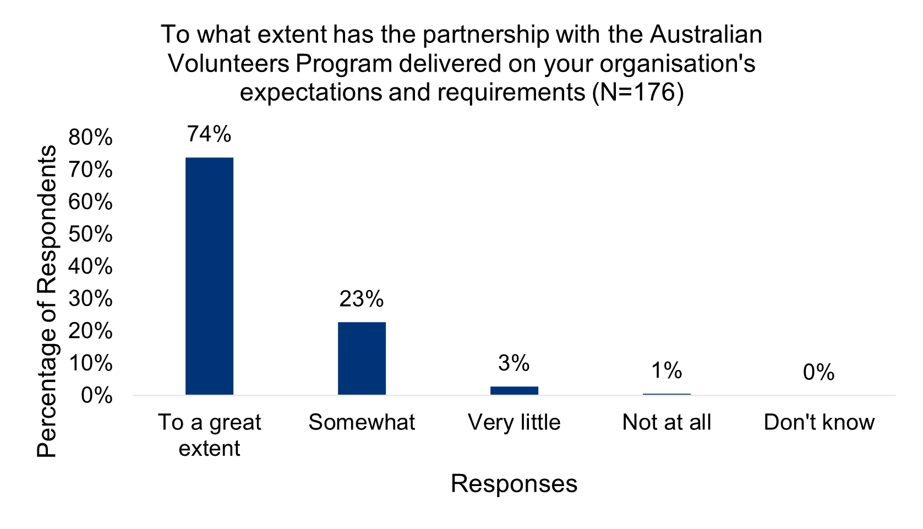

Figure 16: To what extent has the partnership with the AVP delivered on your organisation's expectations and requirements (Evaluation Partner Survey, 2024)

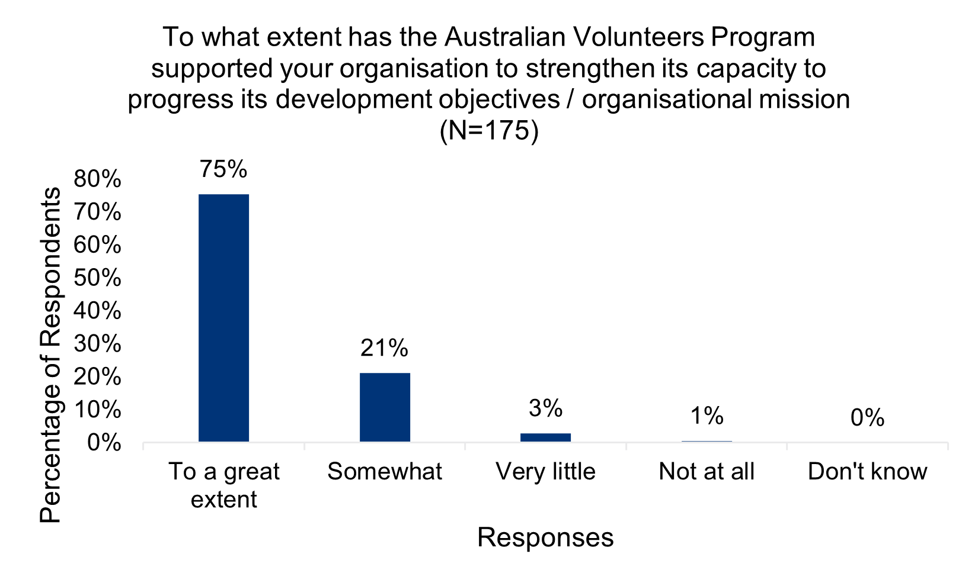

Figure 17: To what extent has the AVP supported your organisation to strengthen its capacity to progress its development objective / organisational mission (Evaluation Partner Survey, 2024)

As the figures above indicate, there are no notable differences or outliers in the responses. However, it remains relevant to note that six respondents responded ‘very little’ (n=5) and ‘not at all’ (n=1).

**Value of volunteering**

This section sought to understand partner organisations’ level of value for volunteering, particularly in the importance of volunteering to support socio-economic development in their country as well as the extent the AVP has strengthened its relationship with Australia. Figures below present results from the survey relating to these statements.

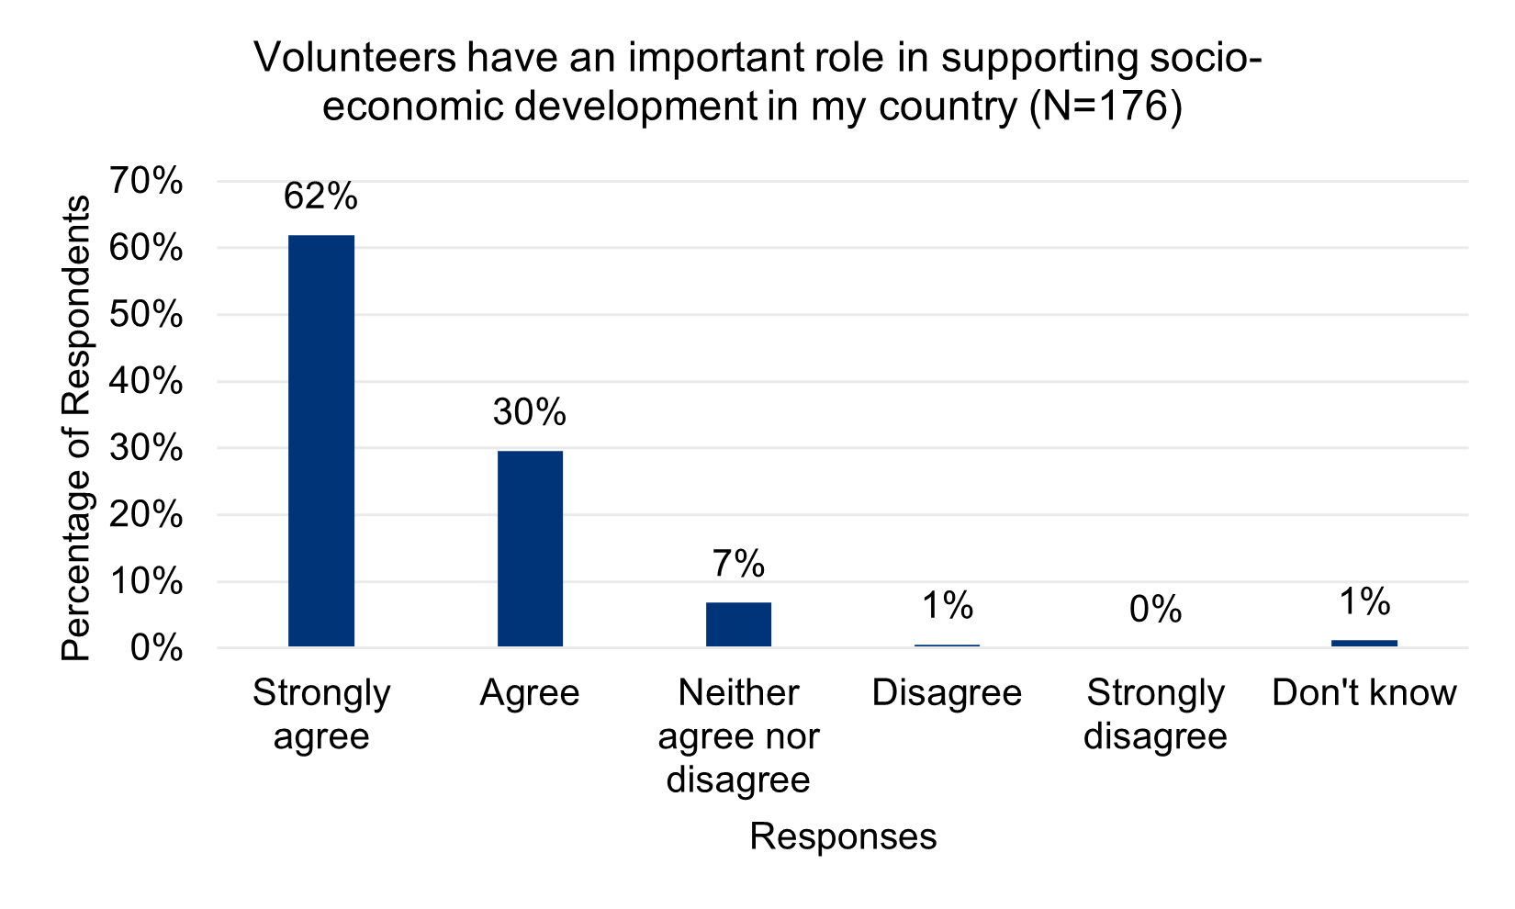

Figure 18: Volunteer contribution to country socio-economic development (Evaluation Partner Survey, 2024)

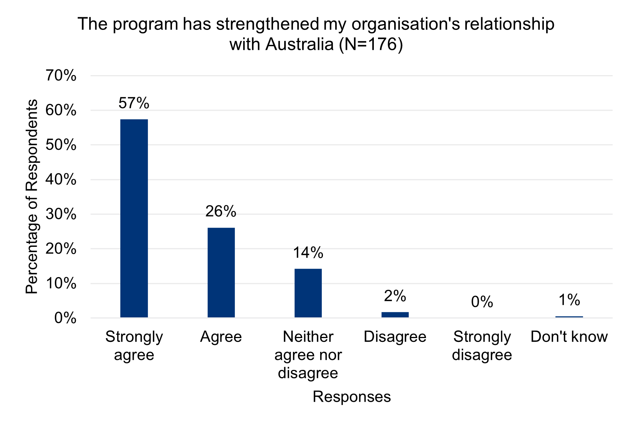

Figure 19: The program has strengthened my organisation’s relationship with Australia (Evaluation Partner Survey, 2024)

Applying a similar lens to the Partnerships section assessing outlier responses where overall response are largely positive, the above figures indicate that there may be room for further investigation and improvements needed to strengthen the AVP’s perceptions in these areas.

* Seven percent (n=12) neither agree nor disagree that volunteers have an important role in supporting socio-economic development in their country. However, the proportion of responses that strongly agree or agree with this statement is an increase of 11 percent when compared to the 2022/23 AVP Partner Organisation Survey, that is from 81 percent (n=166) to 92 percent (n=161).
* Fourteen percent (n=25) neither agree nor disagree that the AVP has strengthened their organisation’s relationship with Australia. This question was introduced in this AVP Evaluation Survey, and so was not included in previous iterations of AVP’s Partner Organisation Survey. Therefore, no comparison is possible.

**Conclusion**

**The survey indicates that while the perceptions and experiences of AVP partner organisations have been largely positive, there are several areas that the program could look into to further assess, investigate, and improve.**

Annex 5: Reference list

Over the course of the evaluation period, the evaluation team referenced and reviewed a total of 125 documents.

| **Document number** | **Name** |
| --- | --- |
|  | Aid Works: Annual Investment Monitoring Reports 2021-2023 |
|  | Aid Works: Partner Performance Assessments 2021-2024 |
|  | Australian Department of Foreign Affairs and Trade: Australian Volunteers Program Official Development Assistance, Partner, Country by number of countries (2022-2023) |
|  | Australian Department of Foreign Affairs and Trade, Office of Development Effectiveness (2014). Evaluation of the Australian Volunteers for International Development (AVID) program |
|  | Australian Department of Foreign Affairs and Trade: Goods and Services Contract 2017 |
|  | Australian Department of Foreign Affairs and Trade (2024). Performance of Australian Development Cooperation Report 2022-2024 |
|  | Australian Volunteers Program: Alignment of the AVP to *Partnerships for Recovery* and the new Performance Assessment Framework (Draft) 2020 |
|  | Australian Volunteers Program: Approved accompanying dependents (AADS) on the Australian Volunteers Program |
|  | Australian Volunteers Program: Annual Plans 2019 to 2025 |
|  | Australian Volunteers Program: Annual Plan 2025 – Annex 3: Organisational Charts |
|  | Australian Volunteers Program: Annual Reports 2018 to 2024 |
|  | Australian Volunteers Program: Australian Public Opinion of International Volunteering 2021 |
|  | Australian Volunteers Program: Deep dive evaluation of climate change, disaster resilience and food security in the Pacific |
|  | Australian Volunteers Program: Design Document 2017-2022 |
|  | Australian Volunteers Program: Documenting Australian volunteers’ contributions to advancing gender equality |
|  | Australian Volunteers Program: Global Program Strategy 2018-2022 |
|  | Australian Volunteers Program: Global Program Strategy 2024-2027 |
|  | Australian Volunteers Program: Guide for Partner Organisations. Working with Australian Volunteers 2024 |
|  | Australian Volunteers Program: How Diverse are our volunteers? |
|  | Australian Volunteers Program: How Inclusive is our Program for LGBT+ Persons? |
|  | Australian Volunteers Program: Impact Fund Research Summary |
|  | Australian Volunteers Program: Incident Management Flow Charts 2024 |
|  | Australian Volunteers Program: Indigenous Pathways |
|  | Australian Volunteers Program: Learning Journey (2018-2022) |
|  | Australian Volunteers Program: Mid-Year Progress Reports 2022-2024 |
|  | Australian Volunteers Program: Monitoring, Evaluation and Learning Framework 2022 |
|  | Australian Volunteers Program: Monitoring, Evaluation and Learning Framework 2022 – Annex 2: Detailed M&E Framework |
|  | Australian Volunteers Program: Parter organisation feedback survey 2023 |
|  | Australian Volunteers Program: Partnerships, power and supporting locally led change |
|  | Australian Volunteers Program: Phase 1 – Longitudinal Study of Australian Volunteers 2019-2020 |
|  | Australian Volunteers Program: Our Program Logic 2022 |
|  | Australian Volunteers Program: Program Management Group meeting agenda and minutes 2017-2024 |
|  | Australian Volunteers Program: Program Management Group Terms of Reference 2017 |
|  | Australian Volunteers Program: Program Management Group Terms of Reference 2022 |
|  | Australian Volunteers Program: Public Diplomacy and Communications Strategy 2017 |
|  | Australian Volunteers Program: Quarterly Contract Management Group Meeting Notes 2018-2024 |
|  | Australian Volunteers Program: Quarterly Risk Management Report Q4 2020-2024 |
|  | Australian Volunteers Program: Refreshed Program logic 2021 |
|  | Australian Volunteers Program: Review of remote volunteering |
|  | Australian Volunteers Program: Roles and Responsibilities 2024 |
|  | Australian Volunteers Program: Schedule 1B Statements of Requirements Term two final |
|  | Australian Volunteers Program: Supporting partners in the Health Sector: documenting contributions to SDG 3 2024 |
|  | Australian Volunteers Program: Survey Report 2023 |
|  | Australian Volunteers Program: Volunteer’s contribution to achieving disability inclusion in programs implemented by partner organisations 2022 |
|  | Australian Volunteers Program Volunteer Impact Survey 2024 |
|  | Australian Volunteers Program: What is the long-term impact of volunteering on volunteers’ lives? A longitudinal study of Australian Volunteers (2019-2022) |
|  | Australian Volunteers Program: What is the long-term impact of volunteering on volunteers’ lives? A longitudinal study of Australian Volunteers |
|  | Australian Volunteers Program: What is the long-term impact of volunteering on volunteers’ lives? A longitudinal study of Australian Volunteers – Phase 2 |
|  | Bhutan Country Program Plan 2024-2027 |
|  | Day Four Projects (2024). Australian Volunteers Program: Value of Volunteering Short Report. |
|  | Day Four Projects (2022). Partnership Review |
|  | Independent Evaluation of the Australian Volunteers Program Management Response 2021 |
|  | Independent Evaluation of the Australian Volunteers Program Management Response – Progress Report 2022 |
|  | Independent Evaluation of the Australian Volunteers Program Management Response – Progress Report 2024 |
|  | Innovation Hub (2017-2022). Innovation Engagement Journey |
|  | Institute for Sustainable Futures (2021). Deep Dive Evaluation of Climate Change, Disaster Resilience and Food Security in the Pacific: Final Report |
|  | Institute for Sustainable Futures (2021). Deep Dive Evaluation of Human Rights in southern Africa Final Report |
|  | Institute for Sustainable Futures (2020). Deep Drive Evaluation of Inclusive Economic Growth in Indonesia Final Report |
|  | Institute for Sustainable Futures (2007). Final Report: Formative evaluation of the Australian Volunteers Program’s thematic ‘impact areas’ |
|  | Jo Ronalds (2024). 2024 Tier 2 Indicator Results – Tier 2 Indicator Results – 2024. Application No. Tier 2-24-00116 |
|  | Kiribati Country Program Plan 2024-2027 |
|  | Nepal Country Security Plan 2024 |
|  | Papua New Guina Country Program Plan 2024-2027 |
|  | Papua New Guina Country Security Plan 2024 |
|  | Solomon Islands Country Security Plan 2024 |
|  | Tetra Tech International Development (2021). Independent Evaluation of the Australian Volunteers Program Final Report |
|  | Tetra Tech International Development (2021). International volunteer programs in Australia, Canada, New Zealand, Norway and United Kingdom. Comparative analysis and future directions. |
|  | University of Technology Sydney (2024). Longitudinal Study of Australian Volunteers (2019-2026) Phase Three-Interim Report |
|  | Vanuatu Country Program Plan 2024-207 |
|  | Vanuatu Country Security Plan 2024 |
|  | Whitelum Group (2021). Synthesis report: Australian Volunteers Program COVID-19 Review Final Report. |

Annex 6: Figure alt text list

**Alt text for Figure 1: Data collection methods**

The AVP evaluation team have collected data through the following methods:

Reviewed 110 relevant AVP documents - contextual information and evidence of results through reviewing program documents including Annual Reports and Plans, MEL Plan, Evaluation and Research summaries.

Two in-person workshops with AVP - 10 staff participated across two half-day workshops to share insights into management, implementation and impact.

24 remote interviews and focus groups - consultations involving purposively sampled 8 Posts and Canberra, 9 Australian and in-country Partner Organisations, and 19 AVP staff in Melbourne, regions and countries.

Online survey with partner organisations - quantitative program insights, utilising 9 existing questions from AVP surveys and adding two additional questions. Received 181 responses from Partner Organisations across 25 countries. The survey was distributed to 365 partners.

To test the recommendations, the evaluation team conducted a (1) 3-hour face-to-face sensemaking workshop to test emerging findings and recommendations; and (2) 3 Guidance Group meetings with DFAT and key AVP staff to inform evaluation process and results, including a 3-hour in-person workshop to test clarity and feasibility of findings and recommendations, and inform DFAT sensemaking

**Alt text for Figure 2: AVP support for PO capacity organisational capacity development (Evaluation Partner Survey, 2024)**

Figure 2 contains data collected through the AVP Evaluation Partner Survey in 2024 where 175 responses were received to the question "To what extent has the Australian Volunteers Program supported your organisation to strengthen its capacity to progress its development objectives/organisational mission?".

The following are the results:

* 75 percent reported 'to a great extent'
* 21 percent reported 'somewhat'
* 3 percent reported 'very little'
* 1 percent reported 'not at all'
* 0 percent reported 'don't know'

**Alt text for Figure 3: AVP partner organisations inform the design of volunteer assignments (Evaluation Partner Survey, 2024)**

Figure 3 presents data from the AVP Evaluation Partner Survey in 2024. 177 partner organisations responded to the question 'My organisation decides the type of assignments and volunteers we need'.

The results were as follows:

* 72 percent reported 'strongly agree'
* 25 percent reported 'agree'
* 2 percent reported 'neither agree nor disagree'
* 0 percent reported 'disagree'
* 1 percent reported 'strongly disagree'
* 1 percent reported 'don't know'

**Alt text for Figure 4: AVP is responsive to partner organisations’ needs, objectives, and goals (Evaluation Partner Survey, 2024)**

Figure 4 presents data from the AVP Evaluation Partner Survey conducted in 2024. 173 AVP partner organisations responded to the question "The Australian Volunteers Program responds to the needs of my organisation and our objectives and goals".

The results are as follows:

* 67 percent reported 'strongly agree'
* 31 percent reported 'agree'
* 0 percent reported 'neither agree nor disagree'
* 1 percent reported 'disagree'
* 1 percent reported 'strongly disagree'
* 1 percent reported 'don't know'

**Alt text for Figure 5: AVP partner organisations value the contribution volunteers make to development (Evaluation Partner Survey, 2024)**

Figure 5 presents data from the AVP Evaluation Partner Survey conducted in 2024. 176 AVP partner organisations responded to the statement "Volunteers have an important role in supporting socio-economic development in my country".

The results were as follows:

* 62 percent reported 'strongly agree'
* 30 percent reported 'agree'
* 7 percent reported 'neither agree nor disagree'
* 1 percent reported 'disagree'
* 0 percent reported 'strongly disagree'
* 1 percent reported 'don't know'

**Alt text for Figure 6: AVP partner organisations consider that AVP has strengthened their relationship with Australia (Evaluation Partner Survey, 2024)**

Figure 6 presents data from the AVP Evaluation Partner Survey conducted in 2024. 176 AVP partner organisations responded to the statement "The program has strengthened my organisation's relationship with Australia".

The results are as follows:

* 57 percent reported 'strongly agree'
* 26 percent reported 'agree'
* 14 percent reported 'neither agree nor disagree'
* 2 percent reported 'disagree'
* 0 percent reported 'strongly disagree'
* 1 percent reported 'dont' know'

**Alt text for Figure 7: Percent of AVP volunteers who identify as Aboriginal or Torres Strait IslandersFigure 7 presents data from AVP's reports on the percentage of Aboriginal or Torres Strait Islander volunteers participating in the program.**

* In 2018-2019, 3.5 percent participated in the program.
* In 2019-2020, 1.4 percent participated in the program.
* In 2020-2021, 1 percent participated in the program.
* In 2021-2022, 0.3 percent participated in the program.
* In 2022-2023, 0.8 percent participated in the program.

**Alt text for Figure 8: Percentage of AVP volunteers who identify as having a disability**

Figure 8 presents data from the AVP reporting documents on the percentage of AVP volunteers who identify as having a disability.

* In 2018-2019, 1.7 percent reported having a disability
* In 2019-2020, 1.4 percent reported having a disability
* In 2020-2021, 2 percent reported having a disability
* In 2021-2022, 1.6 percent reported having a disability
* In 2022-2023, 2.2 percent reported having a disability

**Alt text for Figure 9: AVP engagement with Indigenous suppliers (Source: AVP progress reports)**

Figure 9 presents data from AVP reporting documents on the percentage of AVP volunteers who identify as having a disability.

* In 2018-2019, 1.7 percent identify as having a disability
* In 2019-2020, 1.4 percent identify as having a disability
* In 2020-2021, 2 percent identify as having a disability
* In 2021-2022, 1.6 percent identify as having a disability
* In 2022-2023, 2.2 percent identify as having a disability

**Alt text for Figure 10: Overview of the AVP operational model**

Figure 10 is a flowchart of an overview of the AVP operational model. On the right side of the flowchart is a grey box with a Legend. Green boxes refer to AVP delivery model. Orange boxes refer to AVP governance and implementation organisation structure. Blue boxes refer to DFAT stakeholders.

At the top are two blue boxes. DFAT Posts and DFAT HDS with a two-way arrow linking both boxes. DFAT HDS has a downward arrow linking it to the AVP Contract. AVP Contract (green box) has an arrow to the left, linking it to the AVI Consortium Group (orange box). The AVI Consortium Group is linked to the AVP Operations (AVP Head Office, Regional Directors, and In-country teams) (orange box) beneath it with a dotted line. This box is also linked to the DFAT Posts (blue box) at the top of the chart. Under the AVP Contract (green box) is the AVP (green box). Under the AVP box are four green boxes - Volunteer Professional Development and Network, Partnership (Partner Organisation), Operations, and Public Diplomacy. Underneath these four boxes is a green box that runs from the left to the right of the horizontally-laid boxes which is labelled Monitoring and Evaluation.

Under the Monitoring and Evaluation box is a grey box labelled "Program Goal". Under the program goal box are three boxes and accompanying descriptions:

Box 1: EoPO 1 - Partner organisations are supported to progress their development objectives.

Box 2: EoPO 2 - Key stakeholders in Australia and partner countries appreciate the value of volunteering

Box 3: EoPO 3 - Program participants gain greater cultural awareness and build stronger connections across countries.

**Alt text for Figure 11: Costs of volunteer deployment by year**

Figure 11 presents data from AVP reporting on the costs of volunteer deployment per year. In 2021, it was $1,220,915.00. In 2022, it was $2,600,924.00. In 2023, it was $5,417,471.00.

**Alt text for Figure 12: AVP Program Logic**

This is a chart of the AVP Program Logic.

At the top is the Program Goal - Global volunteering supports locally-led change and the realisation of the Sustainable Development Goals. Below it is the Objective of the Program - Australia has strong, mutual relationships with people and communities across the Pacific, Asia, and Africa that contribute to achieving equitable development outcomes. Underneath it is the three end-of-program outcomes that contribute to the overall objective and goal.

Box 1 (from the left) - Partner organisations are supported to progress their development objectives. Underneath are its intermediate outcomes - (1) Partner organisations have strengthened capacity and gained from the program; (2) Partner organisations have a strategic rationale for participation in the program, provide a safe and productive working environment and contribute to quality assignments; (3) Relevance and diverse partnerships with partner organisations are established, maintained and supported by DFAT, the program, and Australian organisations.

Box 2 (middle box) - Key stakeholders in Australia and partner countries appreciate the value of volunteering. Underneath this box are three intermediate outcomes - (1) The benefit of volunteering is recognised and promoted by partner organisations, Australia organisations, volutneers and DFAT to their networks; (2) innovations, learning, and program achievements are promoted and shared in the international volunteering and development community by the program and key stakeholders; (3) Innovative approaches to, and alternative models of volunteering are designed and tested to expand the program's reach and adaptive capaibility.

Box 3 (box to the right) - Program participants gain greater cultural awreness and build stronger connections across countries. Underneath this box are three intermediate outcomes that contribute to it - (1) Program participants gain professionally and personally; (2) Volunteers complete their assignment well and learn from their partner organisation; (3) the program is inclusive of and access to a diverse range of people.

**Alt text for Figure 13: Percent of AVP partner organisations who responded by region**

Figure 13 presents the proportion of total response against total sampled by the region the respondents operate from.

* From South Asia and Africa, 17 percent of total sample and 19 percent of total response.
* From East Asia, 21 percent of total sample and 31 percent of total response.
* From Central and North Pacific, 16 percent of total sample and 9 percent of total response.
* From Solomon Islands, Vanuatu, and Kiribati, 15 percent of total sample and 19 percent of total response.
* From Asia Archipelago and PNG, 30 percent of total sample and 22 percent of total response.

**Alt text for Figure 14: Percentage of respondents and the year their last volunteer assignment was completed (Evaluation Partner Survey, 2024)**

Figure 14 presents survey data from the AVP Evaluation Partner Survey conducted in 2024. It presents responses from 178 AVP partner organisations and the percentage of respondents and the year their last volunteer assignment was completed.

* 2024 - 61 percent
* 2023 - 22 percent
* 2022 - 8 percent
* 2021 - 0 percent
* 2020 - 2 percent
* 2019 - 1 percent
* 2018 - 1 percent
* Don't know - 5 percent

**Alt text for Figure 15: Percentage of respondents and the number of volunteers their organisations have received through the AVP (Evaluation Partner Survey, 2024)**

Figure 15 presents survey data from the AVP Evaluation Partner Survey conducted in 2024 with responses from 178 AVP partner organisations on the number of volunteers their organisations have received through the AVP.

* 0 volunteers - 2 percent of respondents
* 1 volunteer - 31 percent of respondents
* 2 to 3 volunteers - 45 percent of respondents
* 4 to 5 volunteers - 11 percent of respondents
* 6 or more volunteers - 11 percent of respondents
* Don't know - 1 percent of respondents

**Alt text for Figure 16: To what extent has the partnership with the AVP delivered on your organisation's expectations and requirements (Evaluation Partner Survey, 2024)**

Figure 16 presents survey data from the AVP Evaluation Partner Survey in 2024. 176 AVP partner organisations responded to the question "To what extent has the partnership with the Australian Volunteers Program delivered on your organisation's expectations and requirements?".

* "To a great extent" - 74 percent
* "Somewhat" - 23 percent
* "Very little" - 3 percent
* "Not at all" - 1 percent
* "Don't know" - 0 percent

**Alt text for Figure 17: To what extent has the AVP supported your organisation to strengthen its capacity to progress its development objective / organisational mission (Evaluation Partner Survey, 2024)**

Figure 17 presents data from the AVP Evaluation Partner Survey conducted in 2024. 175 AVP Partner Organisations responded to the question "To what extent has the Australian Volunteers Program supported your organisation to strengthen its capacity to progress its development objectives/organisational mission?"

* "To a great extent" - 75 percent
* "Somewhat" - 21 percent
* "Very little" - 3 percent
* "Not at all" - 1 percent
* "Don't know" - 0 percent

**Alt text for Figure 18: Volunteer contribution to country socio-economic development (Evaluation Partner Survey, 2024)**

Figure 18 presents data from the AVP Evaluation Partner Survey conducted in 2024. 176 AVP partner organisations responded to the statement "volunteers have an important role in supporting socio-economic development in my country".

* "Strongly agree" - 62 percent
* "Agree" - 30 percent
* "Neither agree nor disagree" - 7 percent
* "Disagree" - 1 percent
* "Strongly disagree" - 0 percent
* "Don't know" - 1 percent

**Alt text for Figure 19: The program has strengthened my organisation’s relationship with Australia (Evaluation Partner Survey, 2024)**

Figure 19 presents survey data from the AVP Evaluation Partner Survey conducted in 2024. 176 AVP partner organisations responded to the statement "The program has strengthened my organisation's relationship with Australia".

* "Strongly agree" - 57 percent
* "Agree" - 26 percent
* "Neither agree nor disagree" - 14 percent
* "Disagree" - 2 percent
* "Strongly disagree" - 0 percent
* "Don't know" - 1 percent

1. Australian Evaluation Society, *Code of Ethics,* July 2013.
2. Australian Evaluation Society, *Code of Ethics,* July 2013.
3. Day Four Projects, Austra*lian Volunteers Program: Value of volunteering,* April 2024
4. AVP Annual report, 2023-2024
5. AVP Annual Report 2018-2019
6. AVP Global Program Strategy 2024-2027, November 2024
7. AVP Annual report 2019-2020
8. [Indigenous Peoples | Australian Government Department of Foreign Affairs and Trade](https://www.dfat.gov.au/international-relations/themes/indigenous-peoples#:~:text=A%20First%20Nations%20approach%20to%20foreign%20policy%20is,play%20in%20projecting%20Australia%E2%80%99s%20identity%20to%20the%20world.), accessed 28 November 2024.
9. AVI,[*Sustainable Change through the power of people_final approved*](https://www.avi.org.au/wp-content/uploads/2023/09/Sustainable-Change-through-the-power-of-people_final-approved-1.pdf)*,* accessed 26 November 2024