
Impact Evaluation of the Market Development Facility in Timor-Leste

Final Report
Submitted to the
Department of Foreign Affairs and Trade
by Bluebird Consultants
8 MAY 2025
Enquiries:
Jessica Kenway, Director
M: 0425 878 368
E: jess@bluebirdconsultants.com.au
www.bluebirdconsultants.com.au

Acknowledgements
Bluebird Consultants MDF Impact Evaluation team was composed of Mr Bob Warner, Dr Farida Fleming, Mr Alberto Correia and Ms Zenny Correia. We would like to express our sincere appreciation for the valuable support and advice provided by the Government of Timor-Leste, particularly the Ministry of Agriculture, Livestock, Fisheries, and Forestry; the Ministry of Tourism and Environment; and the municipal authorities in Dili, Aileu, Ainaro, Ermera, and Manufahi.
The evaluation team has also greatly benefited from the guidance of the dedicated staff at the Australian Department of Foreign Affairs and Trade (DFAT) and the Market Development Facility (MDF). Thanks to the MDF team members who helped to facilitate meetings with partners and plan an effective field visit schedule.
We extend our deep gratitude to the numerous individual farmers and partners who generously shared their time and insights to assist with this impact evaluation process. We are especially thankful to the 164 respondents from various stakeholder groups, including government representatives, DFAT, MDF and its partners, private sector entities, other donors, investment partners, and farmers in Dili and the municipalities.
Their willingness to welcome our evaluation teams into their offices, villages, and homes for Key Informant Interviews and Focus Group Discussions has been essential to this study. The respondents not only shared their views and perceptions but also their personal life stories and aspirations, patiently responding to our inquiries.
This impact evaluation would not have been possible without the openness, honesty, and collaborative spirit of the participants. Their contributions have been invaluable in shaping the findings of this report.
DISCLAIMER: This evaluation does not reflect the views of DFAT or the Australian Government.

Contents
List of Abbreviations 4
Executive Summary 6
Recommendations 9
Background 11
Introduction 11
Methodology and limitations 13
KEQ1: What impact has MDF achieved in Timor-Leste? 15
Coffee Market System 15
The historical coffee market system and how it has changed 15
How MDF and others contributed to the changes in the coffee market system 17
Impacts from changes in the coffee market system 20
What else could have brought about these changes? 23
Pig Market System 24
The historical pig market system and how it has changed 24
How MDF and others contributed to the changes in the pig market system 25
Impacts from changes in the pig market system 26
What else could have brought about these changes? 29
Tourism Market System 29
MDF’s engagement with tourism 29
Indications of impact 31
Limits to impact in some market systems 32
KEQ2: What are the key lessons from MDF? 32
Recommendations for the future phase of private sector engagement in Timor-Leste 34
Conclusion 35
Annex 1 – How MDF works 37
Annex 2 — Context of Timor-Leste 41
Annex 3 – Methodology 43
Annex 4 – Rubric findings 53
Annex 5 – Accessible Figure Data 68

List of Abbreviations

Acronym | Meaning
ACT | Associação Café Timor/ Timorese Coffee Association
ADB | Asian Development Bank
ANZ | Australia and New Zealand Banking Group Limited
APEP | The Australia-Papua New Guinea Economic Partnership
AUD | Australian Dollar
ASF | African Swine Fever
ASOP | Annual Strategic and Operational Plan
ATM-TL | Assosiasaun Turizmu Maritima Timor-Leste/ Timor-Leste Maritime Tourism Association
CAPRED | Cambodia Australia Partnership for Resilient Economic Development
CBS | Café Brisa Serena
CCAT | Cooperativa Comercio Agrikultura Timor-Leste
CCITL | Chamber of Commerce and Industry in Timor-Leste
CCT | Cooperativa Café Timor
CHKO | Cooperative Haburas Kafe Organica/ Organic Coffee Growing Cooperative
COVID | Coronavirus Disease
DFAT | Department of Foreign Affairs and Trade
DOWG | Dive Operators Working Group
EOPO | End of Program Outcome
EVS | Evaluation and Assurance Section
FGD | Focus Group Discussion
GDP | Gross Domestic Product
GEDSI | Gender Equality Disability Social Inclusion
GoA | Government of Australia
GoTL | Government of Timor-Leste
IFC | International Finance Corporation
ILO | International Labour Organisation
IT | Information Technology
KEQ | Key Evaluation Question
KII | Key Informant Interview
MALFF | Minister of Agriculture, Livestock, Fisheries, and Forestry
MAF | Mission Aviation Fellowship
MDF | Market Development Facility
MELF | Monitoring, Evaluation and Learning Framework
M&E | Monitoring and Evaluation
MSD | Market Systems Development
NCBA | National Cooperative Business Association
NGO | Non-Government Organisation
PHD | Partnership for Human Development
PNG | Papua New Guinea
PROSIVU | Parseria ba Prosperidade Inklusivu/ Partnership for Inclusive Prosperity
PWD | People with Disabilities
SMS | Short Messages
TAF | The Asia Foundation
TAG | Technical Advisory Group
TOMAK | To'os ba Moris Di'ak/ Farming for Prosperity
USAID | United State Agency for International Development
USD | United States Dollars
VAMT | Value of Additional Market Transactions
WEE | Women’s Economic Empowerment
WFP | World Food Programme

Executive Summary
Market systems development (MSD) programs are ambitious. They aim to change the way a market works for the benefit of poor people. That can mean changing the ways businesses operate and interact with each other, the way business associations function, or the way government interacts with businesses. MSD programs aim to change market systems in a sustainable way to positively impact poor people at scale. Conducting an MSD program in a country like Timor-Leste is difficult as it is a ‘thin’ market with few businesses, little access to finance, and an economy dominated by government revenues from offshore oil and gas resources.
This report provides findings from the second phase of an impact evaluation of the Market Development Facility (MDF) in Timor-Leste. MDF in Timor-Leste is an AUD 29m Australian government investment which is part of a larger multi-country program. MDF started operations in Timor Leste in 2012 and will close in 2027. The Australian Department of Foreign Affairs and Trade wanted to know (1) the impact of MDF in Timor-Leste and the (2) key lessons from MDF to help plan for the next phase of its programming.
The evaluation team found MDF had positively impacted the market systems examined, including the participating businesses and individuals. As the program has made most of its investment in agriculture, we looked at the two market systems where the program has focused most effort: coffee and pigs. In the coffee market system, MDF’s work with private sector partners has been a catalyst for the development of Timor-Leste's premium and speciality coffee markets. MDF has supported partners to introduce farmers to practices required to achieve premium and specialty coffee standards. Through relatively small funding allocations (between $5,000-$75,000), and co-investment by partners, MDF has been able to bring coffee processors closer to farmers, sometimes to locations processors had not previously accessed. MDF partners purchased pulpers and constructed wet mills, enabling local processing of selectively picked coffee cherries. This increased the grade of the final coffee bean, which increases sales value for partner businesses. As a result, partners began paying farmers 30-40% more for the coffee. Partners also worked with farmers to increase the productivity and yield of their trees through farm rehabilitation, pruning and stumping trees. This work is only beginning to show results as it takes 1-2 years for the trees to start to produce coffee cherries again. However, early improvements in yield are substantial. MDF monitoring shows an increased average yield from 0.73 to 2.27kg of coffee cherries per tree. This benefits farmers through increased income and partners through the increased volume sought by local and international buyers.
There are positive economic, cultural, and environmental impacts for 10,141 smallholder coffee farmers most of whom were poor. Economically, smallholder farmers confirmed they have increased their incomes during interviews. MDF monitoring data shows additional annual income of between $20 and $226 for farmers due to the price premiums for premium and specialty coffee. The significance of this increase in income can be seen when compared to the average annual rural income of $600. Farmers have spent some of their new income on improving their homes, children’s education, cultural ceremonies and reinvesting in coffee production or other businesses. Coffee farmers also now have more choice in who they sell their coffee to, given an increased number of buyers in the market. While producing premium or speciality coffee is economically advantageous, farmers can easily move back to producing commercial-grade coffee if the prices change. That is, farmers are not locked into the production of premium coffee by expensive investments. Culturally, farmers expressed satisfaction at being able to continue culturally significant farming practices passed down from their ancestors. Environmentally, the rehabilitation efforts of farmers are resulting in more productive and resilient trees.
There are positive gender equality impacts for the smallholder coffee farmers noted above. The positive impacts are shared across both males and females in the farming households. MDF monitoring data shows that 4,996 male and 5,145 female farmers, most of whom were poor, benefitted. Both male and female smallholder farmers confirmed they have increased their incomes during interviews. Female smallholder coffee farmers reported spending additional income on household expenses and community development. Importantly, the evaluation team found no signs of any negative consequences or harm to female smallholder coffee farmers due earning additional income. Women coffee farmers benefited from rehabilitation as the shorter coffee trees are easier to harvest.
Changes in global markets have exposed the lack of financial depth of some MDF partners, leading to some negative social and economic consequences for some farmers, lead farmers and middlemen/women. This is due to delayed payments to farmers from two partners facing credit shortages. Threefold increases in the global price of coffee and delays in processing due to the lack of dry mills in the country are the cause of partner credit shortages. One lead farmer and one middleman noted they faced community pressure and in one instance, threats from supplying farmers. These negative consequences are not directly related to MDF’s support nor would be confined to MDF partners. However, it is important to note these consequences as part of considering MDF’s current and future work supporting the financial ecosystem of the coffee value chain.
There have been positive impacts for coffee processing and exporting businesses through greater access to premium and speciality coffee and greater yields for those partners who began supporting farm rehabilitation in 2021. Most of the 13 partners MDF has supported report an intention to continue in the production of premium and speciality coffee, providing ongoing opportunities for coffee farmers. One partner, Olam, is one of the largest coffee exporters in Timor-Leste, meaning there is the potential for positive impacts to scale to larger numbers of coffee farmers in the future.
The team examined other potential explanations for the Timor-Leste coffee market changes. Other actors played important roles such as Peace-Winds, a Japanese NGO, that worked in Letefoho for over 20 years with the community to produce specialty coffee and Oxfam who supported the development of a coffee farmers’ cooperative. However, the evaluation team found that there was no actor other than MDF who had supported businesses to make links to farmers to source high quality coffee cherries. As such, MDF’s role in these changes has been unique. Equally, increases in global coffee prices are partly responsible for the higher incomes coffee farmers receive for premium and speciality coffee. However, global coffee prices only increased in earnest from 2024 onwards, while coffee farmers have benefitted from MDF initiatives since 2015.
In the pig market system, MDF’s work had most impact by helping male and female smallholder farmers prevent the spread of lethal African Swine Fever (ASF) to their pigs. This virus can kill up to 100% of the pigs it infects and has no vaccine. MDF’s ASF campaign, in partnership with the Ministry of Agriculture and Fisheries, reached and benefited pig farming households across the country, with positive impact to over 60,000 pig farmers. Systemically, this campaign sped up the move from traditional free-roaming farming methods to penned farming. This was an important way for farmers to prevent disease, as their pigs could no longer encounter diseased animals. Penning pigs and other biosecurity measures such as washing and cleaning hands and clothes are the only ways to stop the spread of this disease. Penning pigs also served as the beginning of more intensive and commercial farming for some farmers. MDF supported the restocking of the depleted national pig herd after the major 2019-2020 ASF outbreak and worked with partners to bring in more productive exotic breeds (including supporting the introduction of artificial insemination as a way of improving pig genetics in the country). MDF supported the import and local production of commercial feed to help pigs gain weight more rapidly. MDF is supporting the beginning of a commercial abattoir system linked to the formal sale of locally produced pork.
There are positive economic, cultural, and social impacts for 64,845 smallholder pig farmers. As with the coffee market system, MDF mostly benefitted poor pig farmers. The major economic impact was to reduce the loss of pigs from ASF and thus avoid major economic losses. Smallholder farmers reached by the MDF ASF campaign took action such as penning their pigs and not feeding their pigs leftovers, which reduced losses from the virus. Some farmers have increased their incomes by breeding exotic pigs and piglets and using commercial feed. However, commercial feed remains expensive for many farmers. In some cases, farmers choose to provide commercial feed only at specific points in the breeding cycle such as when sows are pregnant or when boars are breeding. Culturally, MDF support for pig restocking means that pigs are more readily available and can be used in significant ceremonies. Socially, use of commercial feed reduces the time impost of feeding.
There are positive gender equality impacts for the 64,845 smallholder pig farmers. There is equality of benefit with 32,753 male and 32,092 female smallholder pig farmers positively impacted. The reduction in time when using commercial feed especially benefitted women given cooking local feed is a task which often falls to them.
Businesses have increased revenues and profits from the sale of commercial feed, piglets and pork. W-Four, a major supermarket in Timor-Leste, now stocks and regularly sells out of commercial feed and locally bred exotic pork. W-Four expects further growth from the addition of business partners in each municipality. The large Indonesian agricultural feed company Sreeya first started exporting feed to Timor-Leste in 2022 and saw initial profits. There has since been a decline in profits linked to limitations of raw materials, but the company foresees future growth. Not all businesses have benefited, however. MDF partnered with Reyivita in 2020 to establish a commercial abattoir and butchery, but this failed due to an inability to compete with lower cost frozen pork imports. In 2024, MDF partnered again in this area given the population of pigs was increasing. One of the partners, the W-Four supermarket chain, has existing customers who are demonstrating demand for local pork at higher prices than imported frozen pork, potentially addressing the previous issue.
Other important actors have contributed to changes in the Timor-Leste pig market. However, MDF’s role has been unique. The Government of Timor-Leste and the Government of Australia, through the Australian and Victorian Departments of Agriculture, as well as DFAT’s TOMAK (To’os ba Moris Di’ak or Farming for Prosperity) agriculture livelihoods program all provided important support in immediately responding to African Swine Fever. MDF drew from some of TOMAK’s technical content and worked alongside immediate response work to deliver the ASF campaign. Equally, GoTL provides funding for pig farming groups and there is a working model of intensive pig farming in Fatumaca, Baucau. These provide useful foundations for MDF’s work.
MDF activities have brought benefit to men and women with disability. While MDF does not specifically target people with disabilities, there is data to show that the program is bringing benefit to this group. Data from two assessments shows there was a 10% rate of disability amongst the smallholder farmers interviewed. Actual rates of participation of people with disabilities is likely higher than 10%, as many farmers may not have been comfortable identifying as such.
At DFAT’s request, lessons from MDF’s support to the tourism sector were identified to inform future support. Tourism is a small and relatively new sector in Timor-Leste, hindered by large barriers which market operators cannot easily address themselves such as the high cost of airline tickets to the country and poor infrastructure. MDF’s work in the sector has changed and grown over time, from early support to guesthouses to building demand and focusing on marine tourism. There are early signs of impact with reach to over 1,053 people, net additional income of $335,171 and value of additional market transactions of partner businesses at $991,979. There are a range of factors that mean it will take time and effort before tourism initiatives reach scale and benefit large numbers of poor people.
Key lessons from MDF are:
- An MSD approach can and does work in Timor-Leste. The impact of the program addresses prior concerns that this type of approach could not work in a thin market. However, the scope for continued expansion is limited by the pervasive constraints inherent in the country’s economic structure, resources and human endowments and in the institutions of government and a market economy. Looking forward, MDF or its successor may need to focus more strongly on incentivising and facilitating actions to address these constraints. This is particularly apparent in the tourism sector.
- An iterative and adaptive way of working was central to impact. Achieving results related to the program’s ability to update strategies based on monitoring data and to changes in the external context. These mechanisms enabled the team to adapt its approach to chosen market systems.
- MDF adopted tailored approaches to engagement in each sector and market system. The team developed specific strategies in each market system that related to unique issues and opportunities. The market functions and points of entry where MDF has chosen to engage are very different, and very little replication across sectors is feasible.
- Government engagement can change how market systems function in Timor-Leste, and that presence informs how MDF can engage in targeted sectors. Government may take a more coordinating role in some sectors and a more interventionist role in others, for example. Any successor MSD program, or component, would need to establish the role of government in targeted sectors and engage at key points.
- MDF’s partnerships with small and larger businesses supported different outcomes. Small businesses provided important room to support innovation. Small businesses are focused on growing and wanting to trial new approaches. However, these small businesses can face constraints to scaling due to limited access to finance. A number of smaller businesses noted the difficulty they faced in accessing working capital and loans. For purposes of scaling, MDF’s partnerships with larger businesses were key. MDF’s partnerships with key large-scale coffee processing and exporting and animal feed importing companies, increased the numbers of farmers reached markedly. Any future MSD program, or program component, should consider the relevant scale of business to partner with depending on the outcome sought.
- MDF also played an important role in market systems development through developing valuable public goods. For example, MDF instigated and undertook important research on common problems such as climate change Any future MSD program, or program component, should consider the important public good contributions to be made over and above contributions that individual businesses can make towards pro-poor change.
- There has been mixed success with import substitution. A key approach used in some of MDF’s work is developing local production to substitute imports. However, there has been mixed success with this approach, with earlier work on rice and cattle reaching limits to scale due to the limited number of private firms in these sectors. Future MSD programs or with MSD components, need to carefully consider the evidence on import substitution in Timor-Leste noting the limited number of private firms to support this in certain sectors (e.g. rice and cattle).
- Sustainability of changes facilitated by MDF’s work will vary across the sectors of engagement and will be determined, to some extent, by external factors and ongoing government action. Sustainability strategies of any future MSD program, or program component, will need to bear in mind external factors that would likely have significant impact on long term benefits.

Recommendations
The evaluation is intended to inform design of a successor development investment by the Australian Embassy in Dili. As such, the team developed the following set of recommendations:
- DFAT to consider continuing MSD engagements in agriculture and tourism in the new design.However, the Australian Embassy should be prepared for limited results relative to effort required to generate systemic change.
- DFAT to clarify for stakeholders how MSD work will impact gender equality and poverty. An MSD program, or program component, would work in parts of the economy where large numbers of poor people operate or where women play a significant role rather than directly targeting the extremely poor.
- DFAT to develop a stronger and more explicit focus on climate adaptation in the design of the next phase.
- DFAT to ensure the future MEL system and Performance Assessment Framework enables stakeholders to assess progress on systemic change as well as the direct benefits from individual activities. This would involve constructing end-of-program outcomes more closely aligned with the kind of changes the program will try to bring about.
- DFAT to note that an MSD program staff are central to the value the program delivers through market analysis, systematic learning and adaptation, mentoring, networking and problem solving with partners, and public good research accompanying the program’s co-investment with market actors. This means staff costs should not be seen as an overhead.
- DFAT to consider expanding work on access to finance issues, including access to credit. Focus in this area can facilitate greater inclusion in access to finance, or development of financial tools to assist in the improvement of market systems.
- DFAT to consider ways to replicate the benefits that MDF’s program in Timor-Leste received from access to experience of MDF in other countries. The design team, Canberra and the Australian Embassy to consider ways to make sure knowledge is not lost with the end of MDF, with perhaps a central part of DFAT playing a stronger coordinating and learning role across MSD programs.
- DFAT to consider the implications of the transition from a multi-country to a single country program. There is a need to provide for the investment review committee role the MDF leadership team provides. Given the adaptive approach embedded in an MSD program, there is a real need for strategies and activities to be subject to a thoughtful interrogation by people who operate at some distance from the program team.
- MDF to prepare for closure or transition to new phase. If a new phase, signal early intentions so good staff are not lost. Consider novation of contracts for staff and interventions if that would be appropriate.

Background
DFAT’s Development Evaluation and Assurance Section and Dili Post commissioned an impact evaluation of MDF in Timor-Leste, to assess the impact of MDF from 2012 to 2025, and to inform the design of a new private sector development program. The impact evaluation builds on the recommendations of an evaluability assessment conducted in September 2024 that found an impact evaluation would be plausible, feasible, and have utility. The impact evaluation also builds on a rapid impact assessment conducted over September-November 2024 that provided key findings and lessons from a desk review.
The overall impact evaluation uses the following three-phased approach:
- Phase 1: A rapid impact assessment (September-November 2024). This phase provided preliminary findings and key lessons based on desk review and a small number of interviews.
- Phase 2: Fieldwork and synthesis (January-May 2025). This phase further tests and expands preliminary findings. The focus of this phase is the examination of impact.
- Phase 3: A post implementation impact assessment (2027). This phase will focus on testing impact after the program has closed.
Phase 1 addressed the evaluation sub-questions in Table 2 below, predominantly by desk review. With the benefit of field work Phase 2 is ground truthing the Phase 1 findings and addressing the key evaluation questions (column 1 in Table 1).
Table 1 Key evaluation questions
Key question | Sub-questions
- What impact has MDF achieved in in Timor-Leste? | - What are the longer-term changes in the target markets that have been observed and how does this compare to the intended EOPOs?  - Did MDF make a significant contribution to changes in the target market systems, at each expected level?  - Were there any key modalities or market systems that achieved better than expected results? Why?  - What aspects were most significant in contributing to the intended impacts?
- What are the key lessons from MDF? | - How did MDF achieve key changes in targeted market systems?  - What are the options for incorporating the MDF approach into a new private sector development program that has a bigger budget envelope?  - What would be the challenges/opportunities of incorporating the MDF approach or program?
This report has been prepared as a short and easy-to-read document based on the request from post.

Introduction
MDF is a multi-country program operating in 6 countries: Fiji, Samoa, Sri Lanka, Timor-Leste, Tonga and Vanuatu. The operations in Fiji, Sri Lanka and Timor-Leste are delivered wholly by an in-country team. In contrast, Samoa, Tonga and Vanuatu are delivered by some locally based personnel and supported by a regional team based in Fiji. MDF was also previously implemented in Pakistan (2013-2020) and Papua New Guinea (2015-2023).
The program intended to improve employment and income of poor women and men. MDF developed estimates of the additional income and jobs it aimed to facilitate through market systems development. To achieve these impacts, the program aimed to achieve the following end of program outcomes (EOPOs) by 2027: 1) improved service delivery to rural and urban growth sectors and 2) improved access to end markets.
MDF uses a market systems development (MSD) approach which seeks to transform priority market systems to deliver sustained benefits to the poor and marginalised. MSD programs ‘develop market systems so that they function more effectively, sustainably and beneficially for poor people, building their capacities and offering them the opportunity to enhance their lives’. MSD programs are expected to identify and target the underlying reasons why existing market systems keep people poor. Annex 1 presents more information on how MDF implements the MSD approach.
The program was established in Timor-Leste in 2012 and has had an overall budget of AUD $29m to 2027. MDF currently operates in Timor-Leste with a total of 22 staff (full-time equivalent). Business advisors, of which MDF currently has 6, play a key role in implementing the MSD approach. The business advisors are supported by field officers (4), Results Impact Measurement and Inclusion (2), communications (1), and operations staff (7). The team is overseen by 2 managers. The Timor-Leste operations are supported by a shared set of staff resources and common operational systems at the Facility level.
MDF business advisors and management staff work to identify key market systems able to benefit the poor in Timor-Leste. They isolate market functions which can be improved and engage in partnerships with businesses or other market actors willing to trial innovations to address the problems or opportunities that these market functions provide. MDF then engages in partnerships to co-fund innovations. Sometimes, MDF takes the lead role in implementing important activities (such as the ASF campaign that it implemented in coordination with MALFF) or identifies and conducts important research that would not otherwise be done (such as the ‘Rehabilitation of coffee trees in Timor-Leste’ research paper). The context of Timor-Leste, described further in Annex 2, determines possible interventions.
MDF in Timor-Leste is currently focused on market systems in agriculture, tourism and renewable energy. It has previously had engagements in manufacturing. As the table below shows, two thirds of its partnerships have been in agriculture, and 22 per cent in tourism. The average size of these partnerships is just under US$9,400. While this is quite small, it is important to recognise co-investment through partner grants are just one aspect of an intervention, given the analytical, market linkage and technical support the MDF team contributes. In addition to its work to promote systemic change through partnerships, MDF has a significant market intelligence function, which was particularly important during the COVID-19 pandemic.
Table 2 MDF Sector/ Market System and Partnership at end 2023
Sector/Market System | Active partnerships | Closed partnerships | Total partnerships
Agriculture total | 24 | 69 | 109
Agri-inputs | 4 | 9 | 16
Chicken | 1 | 0 | 2
Coffee | 5 | 15 | 26
Early-stage exports | 3 | 0 | 5
Pigs | 8 | 10 | 22
Other | 3 | 35 | 38
Tourism total | 6 | 21 | 36
Destination marketing | 4 | 7 | 18
Marine tourism | 1 | 3 | 6
Other | 1 | 11 | 12
Other total | 2 | 17 | 19
Renewable energy | 2 | 1 | 3
Manufacturing and other | 0 | 16 | 16
All Sectors/Market Systems | 32 | 107 | 164

Methodology and limitations
This is the second phase of the larger impact evaluation of MDF and addresses the key evaluation questions on impact and lessons. In response to the first question, “What impact has MDF achieved in Timor-Leste?”, we look at the two market systems where MDF has had most reach – coffee and pigs. We consider how these market systems have changed, who has benefitted and how from these changes, and how (if at all) MDF contributed. We examine impact at three levels: market system, business, and individual. In response to the second question, we look at what can be learned from the overall program, in the context of MDF’s planned closure in 2027 and to inform post’s design of a new private sector program in Timor-Leste.
The team employed a theory-based approach to evaluate the impact and lessons of the MDF program, collecting qualitative and quantitative data to test the theories of change. The qualitative approach involved data collection across multiple municipalities, including Aileu, Ainaro, Ermera, Manufahi and Dili shown in the map below.
Figure 1 Geographical coverage and number of interviewees
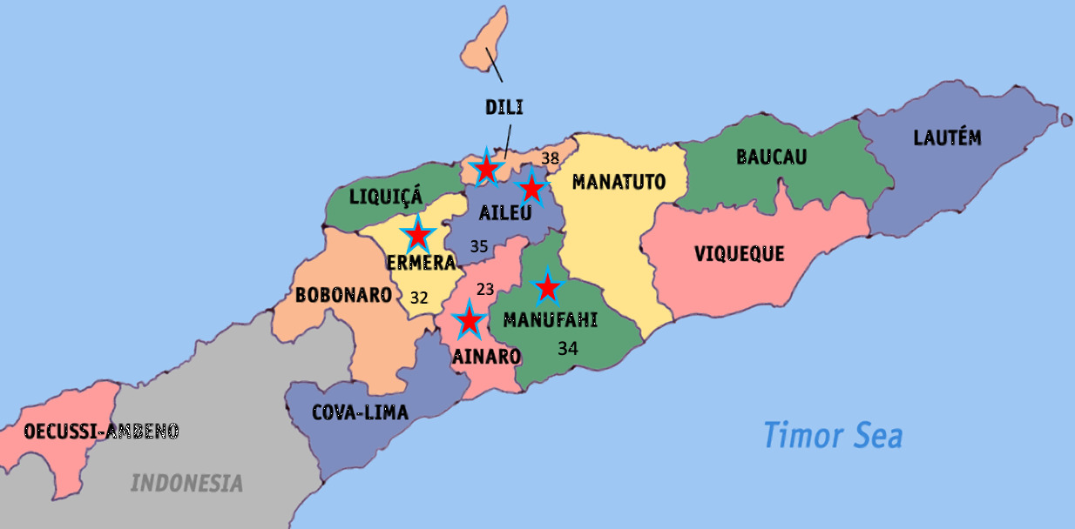
34
At these sites, the team conducted Key Informant Interviews (KIIs) with different stakeholders (government at national, municipal and village levels, DFAT, MDF team, partners and farmers), Focus Group Discussions (FGDs) with farmers and observations. The team conducted nine FGDs, including three sessions exclusively with women and 47 KIIs. In total, the team interviewed 164 people (40% female and 60% male) through the FGDs and KIIs (see Tables 3-4). Detailed disaggregated breakdown by stakeholder type, municipality, gender, and disability status is in Annex 3.
Table 3 Total Respondents
Organisation | Female | Male | Total
Government (National and Municipal) | 5 | 12 | 17
DFAT, MDF and Other Donors/ Investment Partners | 4 | 12 | 16
Partners / Business Actors | 3 | 19 | 22
Farmers | 53 | 55 | 108
TOTAL | 65 | 99 | 163

Table 4 Respondents by Municipality
Municipality | Female | Male | Total
Dili | 8 | 35 | 43
Aileu | 21 | 13 | 34
Ainaro | 8 | 14 | 22
Ermera | 12 | 18 | 30
Manufahi | 16 | 18 | 34
TOTAL | 65 | 99 | 164
The sampling strategy was developed in close consultation with MDF and the DFAT team to ensure representation across key variables, including geography, gender, and rural versus urban residence. Participant recruitment efforts were strengthened by close collaboration with MDF partners, using purposeful and snowball sampling approaches to identify participants, particularly those who engage and don’t engage with the coffee and pig farming intervention.
In this phase, the 4-person team undertook primary data collection in Timor-Leste over a 2.5-week period. The fieldwork was an opportunity to explore data on impact against theories of change for the program overall and the coffee and pigs target market systems. The team examined issues not addressed in MDF’s reporting, for example impacts beyond income change and indications of negative effects. Similarly, the team examined time lags between interventions and outcomes, the effects of other programs, the consequences of unexpected shocks and market cycles, and the various ways systemic change occurred.
The team examined several areas where data was not available in Phase 1. For example, in relation to farming practices we explored the effect of partial adoption – for example, a partial switch to commercial feed for pigs. The team examined time frame for productivity increases – for example, stumping coffee trees to improve productivity initially leads to a farmer missing one or two harvest seasons as trees typically start producing after two years after stumping. We explored factors affecting income, such as understanding changes in coffee quality, quantity, price, and costs, including the additional costs of using selective picking rather than strip picking of coffee cherries, as well as changes in prices offered when more produce is available. The team considered differential changes in practices and income for poor people – for example, whether the changes in practices and increased incomes have been mostly among farmers with higher levels of resources to support increased costs.
During data collection, comprehensive notes were taken, including verbatim quotes, and consent was obtained for recording interviews. Daily debrief meetings among the evaluation team ensured alignment and addressed immediate concerns. Preliminary findings were presented to DFAT on February 25, 2025.
The team used contribution analysis and process tracing to analyse the data in examining impact. This involved checking evidence against the theories of change for the program and each market system to see where progress and impact aligned with or diverged from what was expected. We examined alternative explanations for results and compared this to the data aligning with MDF’s theories of change. The team identified gaps and undertook further data collection when testing the theories so as to map how actual practice occurred and identify what the program was and was not responsible for. The team used a rubric to test the adequacy of the program’s progress in achieving systemic change in target market systems based on the Springfield Centre’s Adopt/Adapt/Expand/Respond framing of systemic change. See Annex 3 for further details on the methodology.
This phase had several limitations. The team visited only 4 of the 14 municipalities of Timor-Leste (Aileu, Ainaro, Ermera, and Manufahi) in addition to Dili given time and budget constraints. Findings from these sites provide useful learnings, especially as they are the main areas for coffee production. However, the data from these municipalities cannot simply be extrapolated across the country. Similarly, the team was only able to engage with 108 farmers (49% female and 51% of male as shown in Figure 2) or approximately 0.01 per cent of farmers MDF partners have engaged with. However, the team interviewed 10 of the 13 coffee partners and cross-checked findings from farmers through these sessions. Even so, findings should be considered exploratory rather than taken to apply to all participants. The team engaged three translators to work with the two international team members and one international observer who did not speak Tetum.
Figure 2 Coffee and Pig Farmers
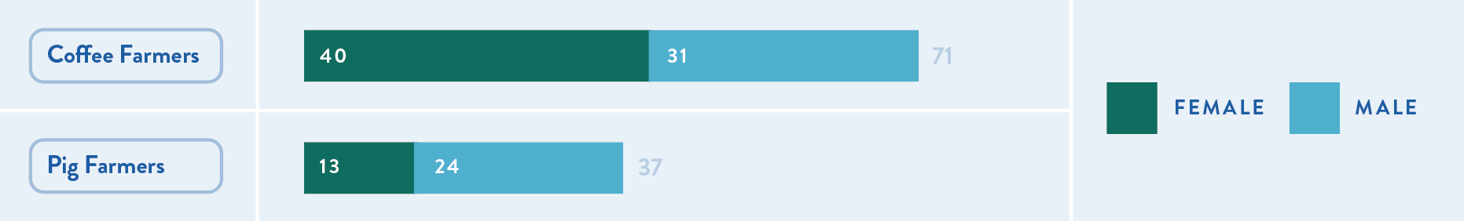

KEQ1: What impact has MDF achieved in Timor-Leste?

Coffee Market System

The historical coffee market system and how it has changed
Coffee production was historically plantation-based in Timor-Leste and has shifted to a smallholder production model over the long term. Coffee was first planted in Timor-Leste in the 1860s under the Portuguese colonial administration. During the Indonesian occupation these plantations became owned and operated by Indonesian military-backed companies. Local farmers worked as labourers with little or no pay under these models, rather than as independent coffee producers. With the deregulation of the coffee market in the 1990s and collapse of the coffee plantation system, there was a shift to smallholder production.
Most smallholder farmers previously produced commercial-grade coffee destined for export. Farmers had little choice for the last three decades but to sell coffee to commercial coffee buyers – dominated by Cooperativa Café Timor (CCT) – given there were no other markets. CCT bought coffee cherries in cash at the farm gate. There was no incentive for farmers to focus on quality production. The focus instead was on volume, as farmers were paid by weight. Coffee farmers were paid a low rate for commercial grade coffee for decades (20 to 32 cents USD per kg of cherry).
Coffee productivity is in decline, resulting in a reduction in the volume of Timorese coffee exported. Coffee tree productivity has declined because of a lack of maintenance, the age of the trees and the weather. The declines in volume have resulted in reductions in the volume of coffee exported by an average of 11 per cent over the period of 2021-2023 as shown in the table below.

Table 5 Decline in coffee export volumes 2021-2023
Year | Volume | % change
2021 | 7,507,388 | NA
2022 | 6,078,335 | -19%
2023 | 5,880,926 | -3%
The reduction in coffee productivity has been a long-term concern and the Government of Timor-Leste (GoTL) and donors have responded with large-scale efforts to rejuvenate coffee farms, rehabilitate coffee trees, and expand coffee plantations through new plantings. The Asian Development Bank’s (ADB) USD 3.2m Coffee and Livelihood Improvement Project (2020-2024) has undertaken research into coffee varieties, trained farmers and distributed seedlings. The Portuguese government funds Quinta Portugal (USD 111,000 over 2020-2023), an agroforestry research centre, which also conducts research on coffee varieties and works with farmers to improve farm management and distribute seedlings. The Chinese Embassy recently provided a USD 70,000 grant to the Timorese Coffee Association, Asosiasaun Café Timor or ACT, focusing on increasing market access and linking with Chinese buyers.
A good news story is the increased recognition and demand for Timorese premium and speciality coffee both locally and internationally. Local demand for premium and specialty coffee is seen through the proliferation of high quality and well frequented coffee shops. Additionally, Timorese premium and specialty coffee is exported around the world. The largest international buyers, in order, are Japan, the United States, Australia, the United Kingdom and Belgium. Additionally, several other countries also buy speciality coffee from Timor-Leste: China, Germany, Hong Kong, Indonesia, the Netherlands, New Zealand, South Africa and Taiwan.
Smallholder farmers are producing more premium and speciality coffee in Timor-Leste, based on increased demand from international and local buyers. Figure 4 drawn from Customs data shows the growth in exports of premium and specialty grade coffee over time. Exports of commercial grade coffee were previously dominant, but this has begun to change. Premium grade coffee and speciality grade coffee rose from a combined figure of 24 per cent of the total volume of coffee exported in 2017 to 48 per cent in 2022 as shown in the following figure.
Figure 3 Changes to grade of coffee export (by volume) over the 2017-2022 period
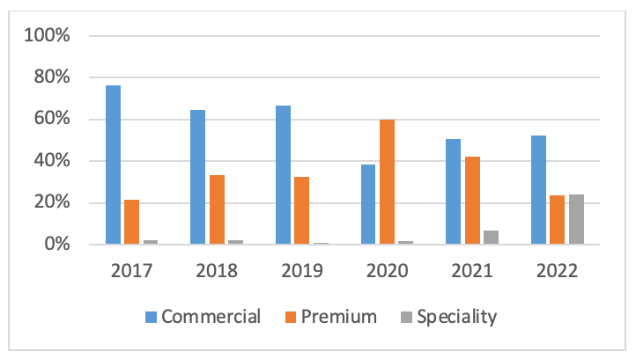
Smallholder farmers now have more choice in how they produce coffee and who they sell to. There are now more companies buying premium and specialty coffee in Timor-Leste. Coffee processors and exporters are now able to grade coffee at new coffee cupping laboratories. Internationally standardised grading measures are now being used in Timor-Leste to negotiate prices and contracts. As a result, international buyers have a better understanding and appreciation for Timorese coffee. In fact, demand for premium and specialty Timorese coffee is larger than supply. Farmers are being paid more for selling their coffee cherries or parchment to premium and specialty buyers than commercial grade buyers. Buyers expect a level of quality and pay differently at each of the three different grades.

How MDF and others contributed to the changes in the coffee market system
MDF has made a substantial contribution to the growth of premium and speciality coffee production in Timor-Leste. MDF worked in three main areas to increase specialty coffee production and exports: marketing, quality processing and rehabilitation as shown in the theory of change in Annex 3.
MDF first began by building demand through its support to marketing. In 2015, the program began at the sector level by contributing to the National Coffee Strategy and supporting the establishment of the national coffee association (Asosiasaun Café Timor or ACT). MDF then supported key partners, Café Brisa Serena (2015) and ACT (2017) to build cupping laboratories and the underpinning quality management systems. With technical assistance, ACT was able to strengthen its own and its 31 coffee producing members’ understanding of the dimensions of coffee quality through grading specialty coffee. This provided feedback to coffee farmers to improve specific practices and address quality related issues. Local production is now informed by this improved understanding enabled by cupping labs and trained personnel – including Q-graders. From 2020 onwards, MDF support was focused on building the international market for Timorese coffee. This included funding for international assessment of coffee samples and travel for international judges to Timor-Leste. Funding to ACT has meant it could usefully facilitate a continued focus on quality through the annual national coffee festival and national coffee awards, which includes an award for coffee quality and farm management. All these efforts build international recognition and demand for Timorese premium and specialty coffee.
MDF then shifted to supporting the improvement in coffee quality. From 2020, MDF worked with 3 partners to provide farmers with training and equipment to selectively pick and process coffee. Farmers used knowledge from training to picking only red, ripe coffee cherries. Farmers then separated out lower quality cherries after picking, again using techniques outlined in training. Farmers were able to process their cherries using pulpers and wet mills closer to their locations, supported by MDF funding. Having this infrastructure more accessible to farmers meant that cherries could be processed and milled more quickly after being picked, improving quality. Farmers then used drying racks provided by partners to dry the green beans to the requisite level. Figure 5 shows the steps between the farmer picking the cherry off the tree and the bean sold to exporters.
MDF then moved to supporting rehabilitation given increasing production volumes are critical to smallholder income growth and ongoing exports. MDF commissioned research on coffee tree rehabilitation in 2021 and then started to support partners in this area. It first engaged with ACT and MALFF in the same year to develop technical materials that could be used by all members. MDF also engaged with nine other partners to pilot extension services to supplier farmers. Extension services included knowing how to rehabilitate trees (which trees to cut, where on the trees to cut, how long before grow back), providing equipment to do so (chainsaws and petrol, handsaws, hoes for replanting), establishing local nurseries and selling trees to farmers. MDF then commissioned research into the impacts of climate change on coffee plantations in 2023.
Figure 4 Steps between the coffee cherry to roasted bean
MDF also supported partners to continue to export during COVID-19. It worked with 4 partners to ensure ongoing exports, to maintain the livelihoods of coffee farmers. MDF supported one partner, CBS, to procure and build storage facilities for coffee that needed to be stored appropriately given the slowdown in trade. It also worked with 3 partners to facilitate access on World Food Programme (WFP) flights into the country when other international flights were no longer available.
Figure 6 shows the progression of MDF’s coffee activities over time across the areas of marketing, quality, COVID-19 response, and rehabilitation.
Figure 5 MDF coffee activities
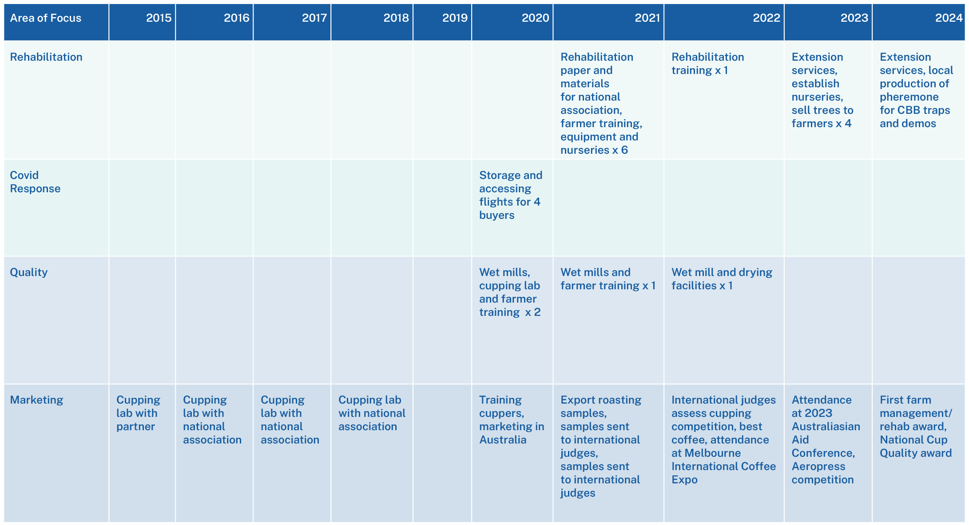
The review team identified other important contributors to the development of the speciality coffee sector but found MDF played a unique role. Peace-Winds, a Japanese NGO, started working with coffee farmers in Letefoho in 2003 on speciality coffee. They developed the social enterprise, CBS, to trade the coffee produced in Letefoho locally and internationally while improving the lives of coffee farmers. CBS delivers training to farmers, supports farmers in undertaking coffee tree rehabilitation, farm productivity improvements and nursery development. CBS has agreements with a specific set of farmers who are all organically certified. Farmer numbers have grown from 10 to 600 over 20 years. Additionally, in 2004 Oxfam and ANZ supported the establishment of C-CAT, a cooperative of coffee farmers. C-CAT became fairtrade and organically certified in 2017. C-CAT exported fairtrade and organic coffee themselves in 2018 and since then supply to OLAM for export. These partners have supported farmers to produce premium coffee and built international demand for this coffee. MDF’s efforts have built on this base and expanded international demand and local scale of production.

Impacts from changes in the coffee market system

For individuals
The evaluation team found economic, social, cultural, and environmental impacts because of MDF and partner efforts.
Poor farmers benefitted from MDF and partner efforts. Data from four assessments shows that MDF works mostly with smallholder farmers. For example, the Coffee Rehabilitation assessment shows that 99% of farmers surveyed had land holding of less than 5 ha. MDF’s targeting of smallholder farmers accords with the broader population profile where most farmers in Timor-Leste (95%) are smallholders, with land sizes of less than 4 ha. Smallholder farmers are generally poor given the majority of the poor (83 percent in 2007, 63 percent in 2014) depend on agriculture for their livelihood.
MDF benefitted both male and female smallholder coffee farmers. Of the 10,141 farmers who have benefitted from MDF’s work, 4,996 are men and 5,145 are women. These statistics are based on MDF’s research-based assumption that rural households are an economic unit where money from various productive activities is pooled, and financial decision making is usually jointly made by male and female heads of the household. These assumptions were further tested through MDF’s monitoring assessments where it asks detailed questions of male and female beneficiaries on the involvement of women in production and benefits from MDF and partner interventions. Equally, the evaluation team validated these assumptions through fieldwork. Coffee smallholders noted women benefitted from training and applying learned skills effectively (e.g., women applying biosecurity techniques in pig farming and engaging more in technical aspects of coffee production). However, some women coffee farmers in Ermera and Aileu reported men dominating training sessions, which limited the opportunity for women to actively participate.

Farmer interviews: Coffee middle-woman
One interviewee was a female farmer who had previously operated a public transport business before moving into the coffee industry as a middle-woman. This shift is an example of a change in the more traditional gender roles in the coffee sector, where women are typically involved in cleaning and picking activities in the coffee value chain, and less in sales and marketing. By entering the coffee sector as a trader, the woman not only diversified her income but also gained access to less common roles for women, especially in rural areas. (Female FGD participant in Aileu, 13 February 2025)
Male smallholder coffee farmer
A male coffee farmer had abandoned coffee farming for seven years in favor of horticultural production through a USAID program. After observing the benefits experienced by other coffee farmers, he decided to return to specialty coffee production in 2020/2021. As a result of his increased income from the sale of specialty coffee cherries, he was able to build a new house. (FGD participant in Aileu, 13 February 2025)
Figure 6 Picture of interviewee’s new house – coffee farmer in Aileu
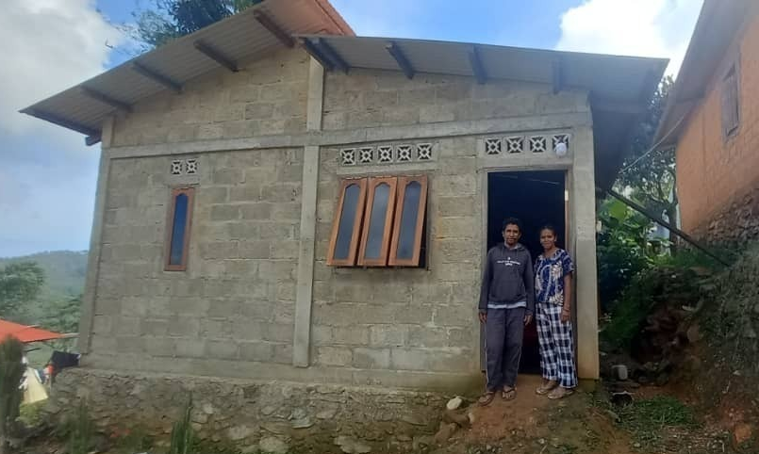
Positive economic impacts: Male and female smallholder coffee farmers working with MDF partners have improved their financial situation. Male and female smallholder farmers reported receiving more income from producing premium and specialty grade coffee. MDF’s 2023 quality assessment showed farmers earnt an additional USD 0.11 (AUD 0.16) per kg on average when selling premium and specialty grade coffee. This represents a 20 to 30% increase. The team confirmed the higher prices compared to commercial grade coffee during fieldwork as well as farmer satisfaction with the increased income. While this percentage improvement is significant, the overall per-farmer annual increase in income received from coffee remains on the low side – between $20 and $226 per year. However, this additional income compares well against the mean monthly rural income of $600 and is gained with minimal additional investment in time. Farmers interviewed described valuing this additional income and using it for essential expenses (home and farm); improving their homes; children’s education; cultural ceremonies; and reinvesting in coffee production or other business. Some farmers (including group leaders) interviewed are now acting as middlemen/women (firms) who purchase coffee cherries and parchment from their members and other farmers and sell to larger buyers. Women smallholder coffee farmers reported using additional income to support household expenses and invest in community development. There were no signs of negative consequences (e.g. domestic violence) due to women earning additional income and no woman reported any harm from additional income earned.
Male and female smallholder coffee farmers working with MDF partners expressed satisfaction at having greater choice in how they sell their coffee. Farmers interviewed expressed satisfaction at having greater choice in how they produce and sell coffee. They noted how previously they only were able to sell their coffee to CCT at the set commercial grade price. Now they have several different buyers to choose from and the price for premium and speciality grade coffee is higher than the price for commercial grade coffee. The introduction of farming technologies (e.g. coffee pulping machines) has reduced the time-consuming nature of tasks and eased the workload for women in households overall, though quality picking techniques do take more time. Women farmers noted that they were involved in decision-making, especially regarding increased income from speciality coffee sales.
Importantly, smallholder farmers retain the possibility of selling commercial grade to CCT and other traders so they are not locked into a new way of producing coffee. Additionally, most changes farmers have made to produce higher quality coffee has not involved much in the way of investment. The major change is in selective picking of coffee cherries. The introduction of farmer level equipment has been minor – buckets, hoes, drying racks. Larger scale machinery or equipment, such as pulpers and wet mills, have been provided by business partners. As such, farmers can relatively easily move back to commercial grade with little lost. Farmers who engage in coffee tree rehabilitation do, however, lose income from the pruned trees for one to two years. This factor acts as an impediment to widespread adoption of the practice, despite productivity gains noted below.
Figure 7 Coffee drying rack
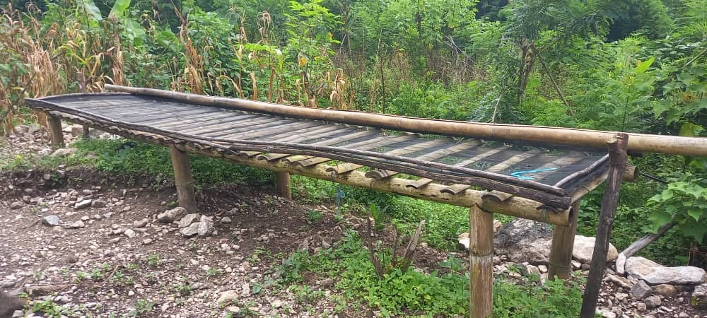
Positive cultural impact: Male and female smallholder coffee farmers working with MDF partners are satisfied that they can continue coffee production which is a culturally significant practice. Some farmers were also satisfied that they could continue producing coffee, a culturally important practice handed down from their ancestors. They felt more assured of being able to continue producing coffee and that their children and future generations might continue the practice, given the increased prices offered by producing premium and speciality coffee. Farmer interviewees talked of the opportunities coming with speciality coffee production, especially with further moves up the value chain. They see future employment opportunities as a possible way to counter the well documented movement of people from rural to urban areas, even as many farmers noted that their children were in Dili to study.
Positive environmental impact: Male and female smallholder coffee farmers who rehabilitated their trees in 2021 now have more productive and resilient trees. MDF impact assessments in 2024 found farmers who rehabilitated their trees in 2021 have increased their harvest from 0.73kg to 2.27kg of coffee cherry per tree. This means each farmer harvested an additional 289 kg of coffee cherry due to rehabilitation, given the average farm size of 292 trees. Research shows shorter, rehabilitated trees are more resilient to increased winds and rains associated with climate change. Women coffee farmers have also benefited as the rehabilitated shorter coffee trees are easier to harvest. For example, one farmer reported during fieldwork:
In 2024 we were able to produce 856 kg of parchment x $3.4 = $2,996.00. This was higher than the previous year’s productions. I believe that this year (2025) the production will be much higher than 2024. Female farmer, Aileu Municipality
Negative social and economic developments: In the aftermath of the large increase in global coffee prices and as a consequence of the lack of financial depth in parts of the value chain, some farmers have faced delayed payments from MDF partners and lead coffee farmers and middlemen/ women have faced community pressure as a result. The team found two instances of this, related to two different partners, which occurred in 2024. Large rises in coffee prices reduced the working capital of partners and there is also an absence of pre-harvest financing in the under-developed financial system in Timor-Leste. All of this meant some farmers had to wait up to two to three months for payment. This is significant given income from coffee is the only income for some families. The situation became dangerous for representatives of those partners, facing threats from supplying farmers and a loss of trust. The evaluation team does not find that the delayed payments were a direct consequence of MDF support. In fact, many other businesses would also have faced the sharp increases in coffee prices and lack of working capital. However, it is important to note this issue and to keep working on improving the financial ecosystem surrounding the coffee value chain.

For businesses
MDF partners have access to more coffee cherry and parchment at higher quality that they produce into premium and specialty grade coffee. This is evidenced by the increases in export volumes for premium and speciality coffee over the period of 2017-2022 as shown in Figure 4. Farmers are providing coffee producers with more higher-grade cherries and parchment. However overall coffee production volumes have declined so there is increased competition for the high-grade coffee that is available. Coffee processors are also focused on initiatives to improve production.
Partners working with MDF are starting to see production improvements. Low levels of production is the major concern for coffee producers sourcing product from Timor-Leste. Partners have trialed business-led extension services through MDF which are providing successful. Olam and CBS were the first partners to work with MDF in 2021 and the farmers who supply to these companies have started to see positive results in yields. This improvement in production is important given Olam, for example, aims to double the production of premium and specialty grade coffee from Timor-Leste in the next 3 years.
MDF partners have broadly improved their financial situation through MDF-enabled marketing, quality and rehabilitation. Partners the team interviewed reported an overall trend of increased revenue and profit from exports of premium and speciality coffee. For example, CBS’s ability to communicate the high quality of its coffee through grading and marketing resulted in new buyers and increased sales of USD 1,527,694 between 2015 and 2018. COVID-19 support provided by MDF also benefitted partner businesses with additional market transactions for Timor Global in 2020-21 at USD 1,245,800. Importantly, MDF’s focus is not in achieving returns for partners as an end in itself. Rather, these profits should guarantee these businesses continue to produce premium and speciality coffee thereby providing ongoing benefits to smallholder farmers.
Increased income is not the only factor in deciding whether partners and others will continue to produce premium and speciality coffee. A few partners reported reductions in revenue over the Covid-19 period and working capital stresses related to large price increases in 2024. Equally, a few partners noted the lack of predictability in volume and timing of coffee from Timor-Leste. For these reasons, not all partners plan to continue to produce premium and specialty coffee.

What else could have brought about these changes?
Other government and donor coffee programs have been important in the development of the coffee sector, but MDF played a unique role. As noted previously, Peace Winds was an important pioneer in working with smallholder farmers and local capacity development in the areas of speciality coffee production. And the government has undertaken nationwide efforts to improve coffee productivity, such as the national rehabilitation program. CCT has been active in promoting rehabilitation, and ADB has delivered large-scale coffee rehabilitation programs, using the materials MDF developed in coordination with MALFF and ACT and partnering with government. The ADB also supported the establishment of ACT alongside The Asia Foundation. ADB also provided a $100m loan to Olam for midstream processing assets and permanent working capital for smallholder farmer supply in Timor-Leste, as well as in other countries in the region - Papua New Guinea (PNG), Viet Nam, and Indonesia. However, on closer analysis these investments largely complement what MDF has been doing. That is, government and ADB’s efforts contribute to the volume of coffee produced in Timor-Leste, while Peace Winds and the ADB loan to Olam contribute to speciality coffee production. MDF is the only actor working to broaden the production of premium and speciality coffee through linking partner businesses directly to coffee smallholder farmers.
Large scale increases in global coffee prices explain part of the higher prices received by producers of premium and speciality coffee. Commercial coffee prices are now at peaks not seen since 1977, due to droughts cutting supply in Brazil and Vietnam, the world’s largest coffee producers. These higher prices account for at least part of the additional income received by smallholder coffee farmers producing premium and speciality coffee, since the prices of premium and specialty coffee have risen in line with increases in prices for commodity grade coffee. However, these price rises only occurred in 2024 and there is evidence of Timorese smallholder coffee farmers increasing income since 2015 due to MDF and partner efforts. Whilst global price increases have contributed to increased incomes since 2024, there is also evidence that MDF and partner efforts have increased smallholder farmer incomes since 2015.
The evaluation finds that much of the measured impact is directly attributable to MDF activities. The coffee market system is clearly changing, and MDF played a significant role in making the changes come about. While there are signs that systemic change is occurring, there is some way to go for such change to be robustly established. As the rubric analysis of systemic change in Annex 4 shows, the evaluation assesses that adoption of practice changes promoted by MDF activities in coffee has been adequate to good, adaptation to the changes has been adequate, expansion has been adequate to good, but the response of market actors to the changes is assessed as inadequate, affected in part by incomplete delivery of government interventions in the sector specifically payments related to coffee tree rehabilitation.

Pig Market System

The historical pig market system and how it has changed
The pig market in Timor-Leste is largely informal and primarily serves subsistence and cultural needs. Pigs are an integral part of Timorese culture, used in cultural ceremonies and considered a store of wealth. Most Timorese households raise pigs, for these reasons. Households generally feed their pigs with scraps and leftovers, rather than buying feed, and local pigs have traditionally been left to roam and find food. Commercial pig feed has only started to become available since 2018. Prior to this point there was limited use given the lack of available commercial feed throughout the country. People commonly buy pigs, piglets and pork through local markets. Formal supermarkets have tended to only carry imported, frozen pork given the lack of slaughterhouses in Timor-Leste.
The pig market system changed markedly with the African Swine Fever (ASF) outbreak of 2019. The ASF outbreak decimated the national pig herd in Timor, with more than half of the national pig herd dying. Pig rearing changed markedly because of the 2019-2020 ASF outbreak and response and follow up smaller outbreaks and farmer responses. MDF assessments conducted in 2021, 2022, 2023 and 2024 show that the majority of farmers surveyed are penning their pigs and remaining disease free as a result. The majority of farmers interviewed and observations in the four provinces showed that most pigs were penned so that they do not mix with other potentially infectious pigs. Isolation is an important preventative measure given there is no vaccine for the disease. Government has prohibited pig rearing in Dili, encouraging pig production in rural areas. However, some farms and households in Dili have exemptions to the pig rearing prohibition and some others continue to rear pigs in secret. The Ministry of Agriculture, Livestock, Fisheries, and Forestry (MALFF), supported by donors including Australia, continues to monitor for the disease and has successfully contained a few localised outbreaks. There is now a nationwide focus on restocking, and an introduction of exotic pigs as part of this restocking effort. There is now increased availability of commercial pig feed (see Figure 8 drawn from Customs data) and exotic pigs and piglets are sold in urban and rural locations across the country. Agri-input suppliers who sell commercial pig feed are now also providing advice to farmers on better animal husbandry.

Figure 8 Increased availability of commercial pig feed in Timor-Leste over time
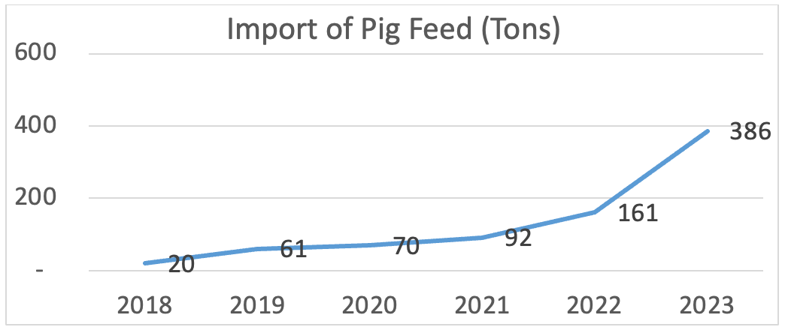
Herd restocking efforts have triggered a shift to a more formalised pig market, with more commercially focused rearing of pigs. Farmers have bought new piglets to rebuild their herds after ASF. They now have greater choice about whether to buy local or exotic breeds, given increased availability of exotic breeds in Timor-Leste. Exotic breeds fare better on commercial feed and farmers now have more access to commercial feed. One of the major supermarkets, W-Four, now sells commercial feed and sells out quickly. Sreeya, a large-scale Indonesian agri-input supplier is now exporting commercial feed to Timor-Leste and projects a growing market for its produce. Other companies are also considering entering the market. There is greater openness to buying commercial feed, given pigs are now mostly penned and require feeding rather than relying on them to scavenge for themselves. Farmers are either collecting and cooking food for the pigs, buying commercial feed, or mixing commercial and local feed. There is also now availability of local pork in the formal market. W-Four stocks local pork weekly, sells out quickly, and is looking to expand production of local pork.

How MDF and others contributed to the changes in the pig market system
MDF first focused on building access to commercial feed. The program partnered with four companies from 2014 to 2020 on feed initiatives. MDF partnered with Kmanek Supermarket Trading in 2014 to undertake a feasibility study for the first industrial scale fish and chicken feed manufacturing facility in the country. It then partnered with Manu Fahi Lui in 2019 on the local production of pig feed, with RN Agri in 2020 on the importation of soymeal as a feed supplement, and with Casa Agricultor in 2019 to import complete feed from Indonesia and increase the availability of this feed in rural areas through sales agents. RN Agri, Manu Fahi Lui and Casa Agricultor built understanding by using demonstration plots. Farmers could see the weight gain of exotic pigs using commercial feed at these sites. MDF also brokered Sreeya’s entry to Timor-Leste in 2022. MDF undertook a survey of the business opportunity for the company and introduced them to multiple buyers. Sreeya then formed a partnership with W-Four. W-Four now carries pig feed through its supermarkets across the country and supplies through other retailers.
MDF rapidly shifted to biosecurity and improved animal husbandry messaging with the 2019 outbreak of ASF. MALFF requested MDF’s support to contain the ASF outbreak given the importance of pigs to Timorese culture and economy and DFAT directed MDF to provide this support. MDF developed a communications campaign designed to reach households in Timor-Leste with pigs. It was designed as a short-term (3-month) campaign early in 2020 to quickly increase knowledge about how to reduce the spread of the disease. The focus of the campaign was on transmitting key behaviour change messages to people: how to pen their pigs, wash hands and change clothes before being in contact with pigs, not feeding pigs leftover food and burying dead and diseased pigs rather than eating them. The national MDF ASF campaign used messaging via TV, SMS and in-person sessions using a prepared flipchart by MALFF extension staff. It reached farmers across the country and led to large-scale behaviour change. Also, in 2020 MDF engaged a specialist to provide training and advice to pig farmers and businesses on best practices in pig farming and biosecurity. MALFF and MDF then collaborated on a second campaign in 2022 after ASF incidents in Dili, Aileu and Baucau. This campaign focused on the importance of biosecurity practices to prevent a second outbreak.
MDF then turned to a focus on restocking after the devastation of ASF, which provided an opportunity to make exotic and hybrid pigs more available. MDF worked with 9 partners between 2021-2023 to develop commercial pig farms around the country producing piglets in Atsabe, Baucau, Bobonaro, Manatuto, Metinaro, Oe-cusse and Viqueque. These activities all had a similar focus of developing a model farm to provide information to other farmers on improved farm management practices and biosecurity. Each farm established a biosecurity system, upgraded the farm to support the piglet breeding business model, built capacity of staff, and promoted the sale of piglets. In 2023, MDF assisted the piloting of artificial insemination (AI) at the Metinaro Pig Breeding Centre to encourage introduction of improved genetics and to assist farmers reduce costs by not having to raise boars. By the end of 2024, the Centre had provided over 160 AI services to 77 farmers. Informed by the potential for AI, and the success of the Metinaro initiative, another firm has invested in an AI facility.
Figure 9 Hybrid pig in pen
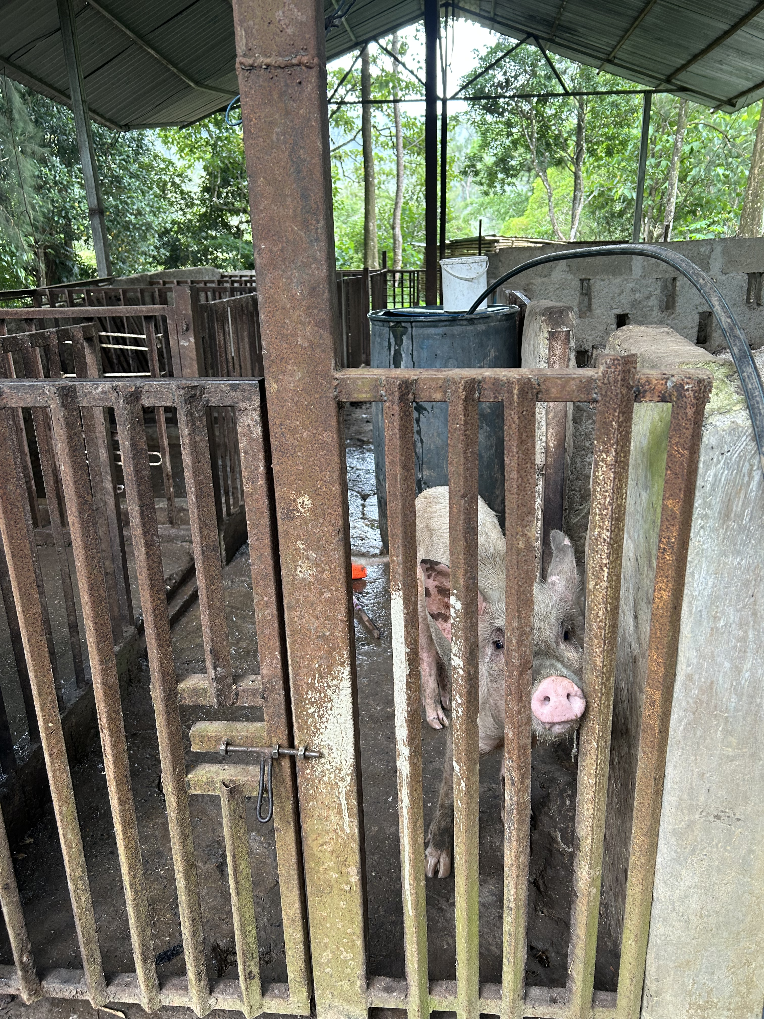
MDF then worked with W-Four, a major supermarket in Timor-Leste, from 2021-2023 to test an outgrower model for safe and hygienic local pork. W-Four intended to produce piglets, establish contract farming for fattening of pigs, and buy back fattened adult pigs from contract farmers. W-Four then intended to sell pork from fattened pigs through its supermarket outlets. While its contract farming model is still in development, W-Four stocks local pork produced through its own farms and network farms one day a week and the pork is always sold out.
MDF worked with three partners to develop slaughterhouses and link with smallholder farmers to provide supply. The first partnership, with Reyivita in 2020, was to develop Timor-Leste’s first modern, commercial abattoir and butchery for pigs and pork meat and outgrower farming model. It was ultimately unsuccessful given the increased price of production of local pork due to reduced availability and increased costs of pigs after ASF, making local pork uncompetitive with cheaper-priced imported, frozen pork. MDF then partnered with W-Four and ASUL in 2024 to establish abattoirs and strengthen links to supplying farmers.
Annex 3 provides a diagram of the theory of change for the pig market.

Impacts from changes in the pig market system

For individuals
The evaluation team found economic, cultural, and social impacts due to MDF and partner efforts.
As with the coffee market system, poor farmers were the main beneficiaries of MDF and partner efforts in the pig market system. MDF partners worked mostly with smallholder farmers with land holdings of less than 5 ha. As noted previously, this cohort of farmers are generally poor.
Economic impact: Male and female smallholder pig farmers benefitted by avoiding the loss of pigs based on improved animal husbandry practices outlined in MDF’s ASF campaign. Of the 64,845 farmers who benefitted from ASF awareness activities, 32,753 are men and 32,092 are women. MDF’s 2021 survey of 200 households across 13 municipalities found that most farmers interviewed were aware of the ASF campaign (79 per cent) and implemented at least one improved practice, such as building a pen and cleaning the pen regularly, because of the campaign (74 per cent) . Similarly, most evaluation fieldwork interviewees confirmed seeing the campaign and understanding and using key elements of good animal husbandry practice. This response was not consistent, however. Not all farmers knew of the campaign or could recall or had used required practice. For some, this was due to the time elapsing between the ASF outbreak and the present day. Others may have never properly understood the required changes. However, it is notable that there has been no large-scale outbreak of ASF since 2020 and minor outbreaks have been isolated and contained.
Economic impact: Some male and female smallholder farmers interviewed reported higher incomes from exotic-breed piglets, which fetch higher prices than local breeds. This extra income was highly valued.
This provides income that I can use to send my children to school and use the leftover for fertiliser (manure). Female smallholder pig farmer.
I follow the guideline. I got the result. My income comes from raising pigs... A good income is from raising pig. Coffee is not enough for me that is why I am focused on raising pigs. This generates income for me. That is why I prefer to focus on this. This provides income for my household and my children’s education. Female smallholder pig farmer with a disability.
These farmers get maximum value when switching to exotic breeds and using commercial feed and biosecurity practices. However, during fieldwork there was a clear distinction between commercial farmers raising piglets for sale and smaller scale operations. The larger, commercial farmers noted increased income from sale of exotic piglets and use of commercial feed. Smaller scale operators were more focused on weight gain, intermittent sale of piglets and pigs and use of pigs for cultural ceremonies. As such, there is variation in income gains across farmer types. As with the coffee market system, there were no signs of negative consequences to female smallholder pig farmers earning additional income.
However, not all male and female smallholder farmers can afford commercial feed. In some cases, farmers are using feed at specific points of the cycle if they cannot afford to use commercial feed all of the time. Feed is provided, for example to piglets, pregnant sows and mating boars. And farmers also noted that they mixed commercial with local feed if they cannot afford enough commercial feed.
Increased income needs to be considered after the costs of building pens and using commercial feed have been taken into account. As noted in the Phase 1 report most farmers were not reporting increased income in the MDF’s 2023 Pig Breed assessment. MDF assumed this was because of the costs incurred in setting up commercial pens and using commercial feed. MDF’s own costing tables for breeding and fattening businesses show returns for farmers, over and above investment, after the second cycle of sales for breeding businesses and after the first cycle of sales for fattening businesses.
Cultural impact: MDF-supported restocking efforts have made pigs and piglets more available in the market. Interviewees consistently noted the importance of pigs to culture in Timor-Leste. The loss of more than half of the pigs in the country due to ASF meant a dearth of pigs. The price of pigs went up markedly, as people need to have live pigs for slaughter as part of cultural ceremonies and this is not substitutable by cash or other items. MDF’s support to restocking pigs through pig farms across the country serves an important cultural need.
Social impact: Commercial feed requires less preparation time, positively impacting women and people with disabilities. Commercial feed can be given directly to pigs in contrast to local food which needs to be cooked and takes time. Women were often responsible for collecting and cooking local pig feed and have benefited from being able to use commercial pig feed. The three farmers with disabilities that the evaluation team interviewed from the Ahisaun Disability Foundation, an MDF partner, also noted that commercial feed requires less preparation. However, they are unable to buy commercial feed in Railaco, Ermera, requiring transport and time to travel to Dili.
Figure 10 Local pig food being cooked
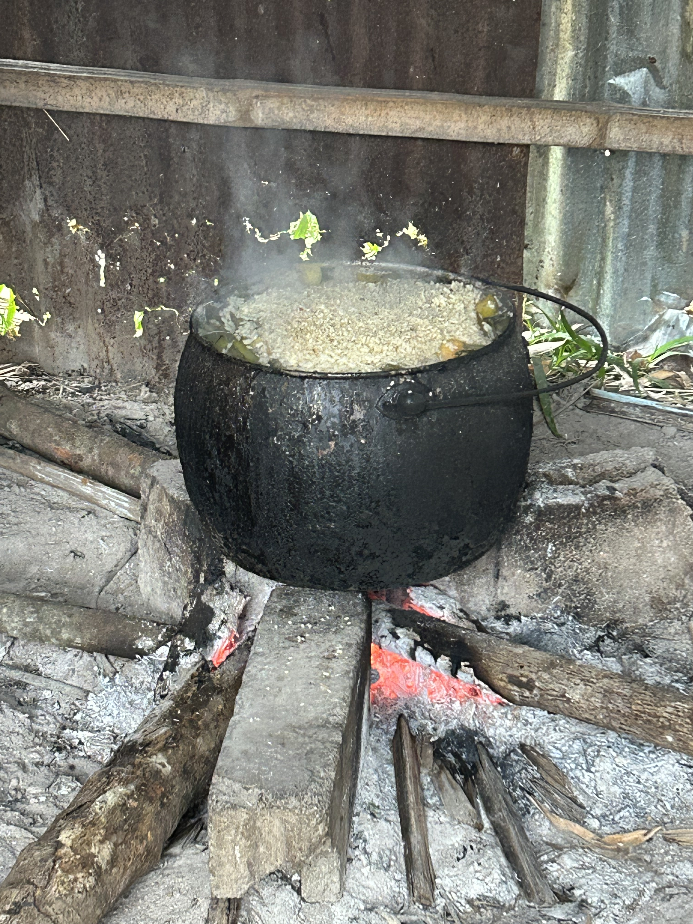

For businesses
Partners noted increased revenue and profit from selling commercial feed, piglets and pork. For example, W-Four has seen the demand for exotic pigs increase across the country, leading to growth in the market. W-Four notes an increasing number of small to medium-sized entrepreneurs in the pig sector, who sell agricultural inputs and piglets. W-Four’s total revenue and net profit from selling pig feed and pork has significantly increased over the last few years. The supermarket is making between $8,600-$14,700 in additional revenue per month due to commercial pig feed and pork sales. With the addition of new business partners in each municipality, W-Four expects further growth in revenue and profit.
Sreeya has seen revenue and profit from sale of pig feed to Timor-Leste increase initially when they began to export to W-Four in 2022. However, in 2024 the company faced limitations in raw materials, which led to higher prices and decreases in profits. Despite this, they continued to produce and sell feed to both Indonesia and Timor-Leste. Sreeya has found that farmers in Timor-Leste are somewhat reluctant to buy commercial feed, similar to some regions of Indonesia. However, their experience in Kupang, Indonesia over 10 years shows that it takes time to convince people to transition from traditional methods to using commercial feed.
Casa Agricultor highlighted a notable increase in the pig farming market, largely attributed to enhanced knowledge on proper pig raising practices, which have been supported by initiatives from MDF. Casa Agricultor has significantly expanded its retail operations, particularly in locations such as Baucau, Lospalos, Manufahi, Suai, Loes, and Liquica. The business has seen significant growth in revenue and profit over recent years. However, delays in importing inputs (such as feed and others) caused by government or the companies themselves have hindered potential additional growth.
Micro businesses have expanded by selling commercial feed and piglets to groups in other municipalities. One owner selling commercial feed sourced from Casa Agricultor in Aileu noted this provided income to his business. However, demand for commercial feed was severely affected by ASF. Before ASF he would sell 30 sacks of feed a month and currently he only sells 6 sacks of feed a month.
Not all businesses have benefitted. MDF partnered with Reyivita in 2022 to develop a commercial abattoir and butchery for pigs. However, the business was not able to survive given the surge in prices for local pigs after ASF making the business model uncompetitive with frozen imported pork. Commercial abattoirs and butcheries are necessary for further development and commercialisation of the pig market system, so MDF reimbarked on supporting pig processing in 2024. MDF partnered with W-Four and ASUL using slightly different models from its original partnership with Reyivita. W-Four for example, as a supermarket, has a guaranteed market and has been able to establish the demand for pork over time.

What else could have brought about these changes?
Other actors contributed to the ASF response but MDF’s role was still unique. MALFF originally identified the disease and worked with the Australian Department of Agriculture to confirm the outbreak. DFAT then provided important immediate support. The materials that MDF developed drew from knowledge on good animal husbandry practice documented by TOMAK in a Pig Husbandry Manual. All these efforts complement MDF’s unique action in designing and running the ASF campaign.
There are several other actors working to support more intensive, commercial pig rearing in Timor-Leste, but these efforts complement MDF’s actions. Government provides support to pig farming groups. Secretary of State for Cooperative (SECOP) gives funding of $10,000 for pig farming groups. This funding complements MDF’s efforts in making exotic pigs and commercial feed available. There is large scale intensive pig farming in Fatumaca, Baucau, which has been operating for several decades. However, this is not a commercial model and has largely been used in the faith community. Commercial farmers have, however, sourced pigs from Fatumaca when trying to improve their pig breed. Additionally, a few interviewees reported individually importing feed and piglets from Indonesia. However, on further investigation many of the initial links were brokered through MDF facilitated visits to Indonesia.
Much of the measured impact is directly attributable to MDF activities. MDF has played a significant role in supporting changes to the pig market system come about but it is still too early to conclude that systemic change is fully established. As the rubric analysis in Annex 4 shows, the evaluation assesses that adoption of practice changes promoted by MDF activities in pigs has been adequate to good (although it will be important to test the extent and durability of adoption of new husbandry practices), adaptation to the changes has been adequate to good, expansion has been adequate, but the response of market actors to the changes is assessed as inadequate to adequate, affected by the ongoing uncertainty created by ASF.

Tourism Market System
Timor-Leste has a small and relatively new tourism sector. Timor-Leste is one of the smallest tourism players in the Asia Pacific Region, and one of the least visited countries in the world. The industry in its modern form only began with the establishment of the UN Mission in 1999 and suffered a significant contraction when that mission was withdrawn and with the onset of the 2006 crisis. While visitor arrivals have been growing, reaching some 81,000 tourists in 2023, the expatriate community has continued to be a major consumer of tourism services. Timor-Leste’s attraction as a tourism destination is based on its marine, coastal, mountain forest, cultural and heritage assets.
Development of tourism is hindered by several major constraints which market operators cannot themselves readily address. These include but are not limited to an overwhelming lack of knowledge about the country as a potential tourist destination, combined with intense and sophisticated competition for other well-developed destinations, serious problems with external and internal connectivity, and low-cost competitiveness linked to the use of the US dollar. Timor-Leste’s tourism sector also suffers from the ‘Dutch disease’ effects of the relatively large inflows of foreign revenues to the Government from sales of oil and gas and the way those revenues are spent, the high cost (and limited provision outside of Dili) of utilities, and limited infrastructure constraining access to many parts of the country.

MDF’s engagement with tourism
MDF has been working in the tourism sector for over 10 years. The engagement has escalated during the second phase of the program and the extension of that phase to 2027. Its two earliest partnerships, which commenced in 2013, were establishing a boutique hotel (partner Balibo House Trust) and upgrading a guesthouse (partner Posada Alecrim). By the end of the first phase (2017), MDF reported 7 partnerships, of which 2 had been completed. At the end of 2023, MDF had had 36 partnerships in the sector of which 21 were closed, 9 were in the monitoring phase, and 6 were active. These partnerships accounted for 22 percent of all MDF’s partnerships since the program began, and 24 per cent of total partnership investments.
MDF’s strategy for engaging with tourism has evolved over time. In the early stages of the program, tourism was seen as one of several ‘greenfield’ industries, to be investigated with a number of probing activities with a selection of tourism operators. By 2017, tourism had been identified as a stand-alone Strategic Engagement Area. MDF made a decision to shift its focus to the demand side, especially to destination marketing and attracting new types of tourists, in recognition of the very low levels of tourism activity in the country. In 2019, MDF structured its engagement around four market systems: destination marketing, dive tourism, cruise tourism and adventure tourism. It continued monitoring work on several legacy partnerships, bundled under an ‘other tourism’ heading. By 2020, MDF had sharpened its strategic engagement to the destination marketing and marine (including dive) tourism market systems. The COVID-19 pandemic, and responses made by the Government, led to an almost complete shutdown of tourism, and MDF pivoted towards activities designed to maintain market linkages for local operators, and build preparedness for an expected post pandemic recovery in activity. With borders re-opening in early 2022, MDF restarted growth-oriented work, continuing and refining its work on destination marketing and marine tourism. In its 2023 Annual Strategy and Operational Plan, MDF indicated that it would no longer engage with on-the-ground service delivery related to cruise tourism, judging that such work was neither sustainable nor scalable.
Figure 11 Atauro Island a major tourist destination in Timor-Leste

Key elements of the MDF’s work in destination marketing and marine tourism are:
- Concentrating on Timor-Leste’s potential for niche/high end tourism. MDF and partners focused on niche tourism, specialised travel experiences catering to specific interests, activities, or demographic groups. Unlike mass tourism, which targets mainstream attractions, niche tourism focuses on the needs and interests of a smaller group of travellers.
- Focusing on the demand side of the market. MDF has targeted its work on marketing and travel-trade connections to build an understanding of Timor-Leste’s offer, in contrast to most other partners who have focused more on the supply side.
- A focus on the coordination and collective action challenges facing the industry and the Government’s attempts to achieve its objectives for the sector. MDF had assisted the formation of the Dive Operators Working Group to address issues but found that members could not reach agreement on collective actions and decided to work with a subset of the Group’s membership. However, MDF’s work with the Hospitality Operators of Timor-Leste (formerly the Hotel Operators of Timor-Leste) has been more effective, as there appears to be more capacity and interest in marketing among its members. MDF has assisted members to engage much more effectively with digital marketing platforms and the travel trade.
- Continued awareness of the need for collaboration with other development partners working in a quite crowded space with a very small number of market participants. MDF collaborates closely with The Asia Foundation, whose work focuses more on tourism in inland and mountainous areas (including coffee tourism).
- Continued awareness of the challenge of engaging with the government and helping reach agreement on the most effective - and largely complementary - role for government to play in the sector. The Tourism Authority is not perceived to be helpful, and greater diversity in its board would be useful. Interviewees noted the need to include greater representation of the private sector from the industry alongside government officials. Consultation between the government and the tourism sector is very limited. PROSIVU has now placed an advisor in the Ministry of Tourism and Environment, which may enable better interaction with between MDF and the government over time.

Indications of impact
The COVID-19 pandemic, and recent disruptions to the global economy have limited the impact of MDF’s work in tourism. The program’s reporting indicates no change in the key indicators of achieved impact, and forward indicators of potential impact barely changed between 2019 and end 2023. While tourism accounted for over 20 percent of total partnerships and investment by end 2023, it only accounted for 1.2 percent of effective outreach for the whole program, 2.5 percent of additional income and 8.8 percent of the value of additional market transactions at the end of 2023.
MDF’s latest Annual Report indicates some pick up in the value of indicators in 2024, with cumulative effective outreach increasing by just over 6 percent (compared to 2023) to 1,053 beneficiaries, cumulative net additional income increasing by just over 18 percent to US$ 335,171, and the cumulative value of additional market transactions increasing by just under 38 percent in 2024 to $US991,979.
There are a range of factors at work that suggest that it will take considerable time and effort for MDF’s tourism efforts to reach any kind of scale. Programs aiming to facilitate growth of tourism in Timor-Leste are working from an exceptionally small point of departure (very different, for example, from the situation facing MDF in countries like Fiji, Sri Lanka, Samoa, Tonga and Vanuatu). While the hotel section of the industry is organised and able to collaborate on collective actions to promote the sector, this is less true of other operators, so that helping the industry engage better with the travel trade and carry out destination marketing may continue to be challenging. It is also clear from consultations that the government has yet to develop an appropriate role for engagement in the sector and find ways to prioritise provision of the public goods and services needed for expansion and realisation of the country’s potential.
MDF has now chosen to work on market systems and functions that are some distance from the tourism operations that generate direct and indirect income and employment benefits, after working directly with individual tourism operators in the early stage of its engagement. This seems like a sensible approach given the nascent state of the industry and the nature of underlying constraints that stand in the way of expansion in levels of activity and employment. But it does mean that the engagement may not be delivering attributable impact at scale in the immediate future. The choice of market functions appears consistent with an approach targeting some of the underlying impediments to expansion of the sector: but that expansion may also depend on other constraints (connectivity, supporting infrastructure, human resource development) being addressed contemporaneously. And those constraints may not be amenable to quick fixes.
It is not likely that expansion of the industry in the immediate future will be particularly pro-poor given the nature and prevalence of poverty in Timor-Leste and low educational attainment of many poor people, and the type of tourist activities with the best opportunities in the country. However, tourism is the only industry in Timor-Leste dominated by women (accounting for 60 percent of the workforce). So, increasing arrivals can increase job opportunities for women, although effort is required to expand opportunities beyond the lower income informal or entry level jobs they currently tend to fill.

Limits to impact in some market systems
MDF has chosen to terminate engagement in market systems when it has become clear that the limits to impact have been reached. Among the challenges that MDF faces in Timor-Leste are the macroeconomic constraints to competitiveness of import substitution (as well as exporting) activities and the limited size of the domestic market. The market size constraints are a function of the overall size of the population, and the very limited purchasing power of most rural households, which account for over 60 percent of that population. In addition, the quasi-subsistence farmers who make up most of the rural population tend to have deeply embedded practices and an aversion to new methods.
The limits for activities targeting the domestic market are exemplified by MDF’s experience in the rice and beef market systems, where relatively successful partnerships leading to changes in market functions and systems led to rather limited impacts on rural incomes.
In the case of rice, MDF ceased its work after stimulating an important change in the value chain for locally produced rice. In the case of beef, MDF found limited farmer appetite for fostering improved productivity in the cattle sector.

KEQ2: What are the key lessons from MDF?
This section focuses on the key evaluation question related to the lessons learned from MDF. This section builds on the response to this question as well as the evaluation sub-questions in the Phase 1 report.
An MSD approach can and does work in Timor-Leste, despite all the constraints inherent in the country’s economic structure, resource and human endowments and in the institutions of government and a market economy. Working with market actors to address underlying causes of market system underperformance, particularly in the rural areas of Timor-Leste has resulted in positive benefits for individuals and businesses. It has also built very effective relationships and reputational capital. It has also offered post a degree of separation from the problems associated with being seen to preference particular businesses with the deployment of Australian aid. Over time, the business community has come to appreciate that MDF is not a conventional business grant program or undirected source of grant finance. However, the scope for continued expansion is limited by the pervasive constraints discussed in Annex 2 inherent in the country’s economic structure, resources and human endowments and in the institutions of government and a market economy. Looking forward, MDF or its successor may need to focus more strongly on incentivising and facilitating actions to address these constraints, This is particularly apparent in the tourism sector.
An iterative and adaptive way of working was central to impact. While MDF identifies a particular vision for each market system its strategy and way of execution is heavily dependent on the availability and interest of partners and external circumstances as the coffee and pig cases show. MDF began in the coffee market system by building demand and moved over time to supporting enhanced quality of coffee production and then to improving productivity. Supporting market system change depended on each of these elements that unfolded over time. In the case of pigs, circumstance played a major role. The outbreak of ASF provided a massive incentive for pig farmers to pen their pigs. Once penned, there was then a clearer rationale for farmers to consider using commercial feed given they now had to directly feed their pigs rather than leaving them to roam. MDF continuously monitors its activities, through regular engagements with partners as well as structured annual monitoring of impacts. Additionally, the team engages in six-monthly strategic portfolio reviews . These mechanisms enable the team to adapt its approach to chosen market systems and to iterate strategy implementation.
MDF adopted tailored approaches to engagement in each sector and market systems. The two main systems where impact is being achieved are very different in structure: final demand for coffee lies in the highly commercial export market, where expanded Timorese supply has limited impact on price, whereas pigs are sold to a limited domestic market where customary practices still shape demand and household approaches to pig-rearing. The market functions and points of entry where MDF has chosen to engage are very different, and very little replication across sectors is feasible. This once again points to the importance of MDF’s investigative research, piloting and learning approach to engagement.
Government engagement can change how market systems function in Timor-Leste, and that presence informs how MDF can engage in targeted sectors. MDF collaborated quite closely with the government on a communication response to the ASF outbreak, but interactions on coffee and tourism have had to been more selective given the more direct role that the government appears to play in those sectors, and the lower priority it appears to place on addressing some of the regulatory, infrastructural and other constraints that the public sector might be expected to focus on. Any successor MSD program, or component, would need to establish the role of government in targeted sectors and engage at key points.
MDF’s partnerships with small and larger businesses supported different outcomes. Small businesses provided important room to support innovation. For example, CBS and Karst demonstrated deep engagement with coffee farmers through intensive training and hands-on quality control. These methods ensured high quality coffee production that drove increased international demand for coffee. The focus of these companies is primarily on quality driven growth. Expansion of their innovations requires capital and staffing and the growth of these partners may be limited by these factors. However, these small businesses can face constraints to scaling due to limited access to finance. MDF’s partnership with MMC involved using similar approaches to quality coffee production as CBS and Karst. MMC is locally owned by an entrepreneur who grew the business from small savings. MMC has limited access to finance, despite a number of efforts. These efforts include applying and being awarded a government loan which never materialised despite much follow up. The lack of working capital constrained the company’s ability to pay coffee farmers immediately, as noted previously in the report. For purposes of scaling, MDF’s partnerships with larger businesses were key. MDF’s partnerships with larger, more established market actors supported delivery of innovations at scale. For example, Timor Global and Olam have applied approaches trialed by smaller players, such as community-based location of medium-scale coffee processing infrastructure (pulpers and wet mills). MDF was able to broaden impact through partnering with these companies as they already have large scale reach to smallholder farmers, established markets, and existing capital. The same approach applies in the pigs market system. MDF originally partnered with Casa Agricultor to import pig feed into Timor-Leste, but the amounts imported were small (under 100 tons a year). Over time, MDF was able to demonstrate the likely market to a much larger Indonesian feed export company and link them to a large supermarket chain in Timor-Leste. Since that time, imports of pig feed have increased more than threefold and reach more customers through W-Four’s existing supermarket platform and distribution system. Any future MSD program, or program component, should consider the relevant scale of business to partner with depending on the outcome sought.
MDF also played an important role in market systems development through developing valuable public goods. Business instigated innovations are required but not sufficient for market systems development. There are initiatives which are above the level of individual business interests which need to be undertaken for systems change. MDF has taken the lead several times to deliver public goods processes and outputs while still partnering with relevant actors. For example, MDF undertook research on rehabilitation practices and then partnered with MALFF and CALIP in the development of rehabilitation materials. Its response to ASF in the pigs market system and current work on developing a farmer manual and videos also benefit the sector more broadly than just businesses. These types of actions are required in undertaking market systems development work. These actions ideally are undertaken by a business association or other local actors and MDF works to ensure that local actors take the lead. But MDF has taken on these types of initiatives where a business association does not exist (as is the case in the pigs market system) or is new (as is the case in the coffee market system). Any future MSD program, or program component, should consider the important public good contributions to be made over and above contributions that individual businesses can make towards pro-poor change.
There has been mixed success with import substitution. MDF’s earlier interventions in rice and cattle, while useful and successful at small scale, were unable to generate significant expansion by substituting imports with local production. This reflects in part the relatively small size of the urban markets, and the degree of self-sufficiency of the quasi-subsistence livelihoods pursued by many rural households. Similarly, MDF’s work in pigs appears to be predicated on an expectation that there will be growing local demand for local pig production once the overall herd has recovered from the losses caused by ASF. So far, the evidence shows that this is the case, but production is still at small scale. There is a question of whether this can continue to grow and to substitute for cheap imported pork as well as meeting continued demands for cultural practices. Future MSD programs or with MSD components, need to carefully consider the evidence on import substitution in Timor-Leste noting the limited number of private firms to support this in certain sectors (e.g. rice and cattle).
Sustainability of changes facilitated by MDF’s work will vary across the sectors of engagement. External factors, such as climate change and developments in other parts of the global market may impact on the switch to specialty coffee and implementation of rehabilitation practices to increase yields, and government policies towards the sector (including state driven coffee growing) may undermine incentives for smallholder coffee farmers to invest in upgrading. Pig farmers may need continued prodding to persist with changed husbandry practices and combined use of exotic breeds and complete feeds. Sustainability strategies of any future MSD program, or program component, will need to bear in mind external factors that would likely have significant impact on long term benefits.

Recommendations for the future phase of private sector engagement in Timor-Leste
The Australian Embassy in Dili is in the process of designing a new private sector development investment to replace MDF’s engagement in Timor-Leste when that program ends. It is expected to use a market systems development approach, and apply lesson learned form and build on the successes of MDF. Recommendations from this evaluation are:
- DFAT to consider continuing MSD engagements in agriculture and tourism in the new design. There is still progress to be made in transforming the pro-poor nature of the coffee and pigs market systems. Equally, tourism may be one of the only other export activities that can be internationally competitive given the dominant role that oil and gas play in Timor Leste’s economy. However, the Australian Embassy should be prepared for limited results relative to effort required to generate systemic change.
- DFAT to clarify for stakeholders how MSD work will impact gender equality and poverty. An MSD program, or program component, would work in parts of the economy where large numbers of poor people operate or where women play a significant role rather than directly targeting the extreme poor. It will be important to clearly present the theory of impact on the poor. This presentation needs also to help stakeholders understand the adaptive nature of the program.
- DFAT to develop a stronger and more explicit focus on climate adaptation in the design of the next phase. Future efforts can build on the useful work MDF has conducted to date on climate change. Developing a stronger and more explicit focus on climate adaptation is important given the effects of climate change on government of Timor-Leste and Australia policy commitments.
- DFAT to ensure the future MEL system and Performance Assessment Framework enables stakeholders to assess progress on systemic change as well as the direct benefits from individual activities, since this is the raison-d’être of the MSD approach. This would involve constructing end-of-program outcomes that are more closely aligned with the kind of changes that the program will try to bring about, such as better functioning market systems that can deliver inclusive and environmentally sustainable growth.
- DFAT to note that an MSD program staff are central to the value the program delivers through market analysis, systematic learning and adaptation, mentoring, networking and problem solving with partners, and public good research accompanying the program’s co-investment with market actors. This means that the staff costs should not be seen as an overhead to be endured to deliver co-investments: and in effective MSD programs, staff costs will account for significant share of total program outlays.
- DFAT to consider expanding work on access to finance issues, including access to credit – MDF has successfully done this in other countries where it has operated (Pakistan, for example), and MDF is currently looking at working with banks to provide credit to pig and coffee farmers. A larger effort may need to be complemented with other approaches, given that there are several factors that might make it hard for an MSD program to bring about change, including the risk aversion of most rural households and the difficulty in providing collateral. Over time, and as improvements are made in the overall financial system, a new program may find ways to facilitate greater inclusion in access to finance, or development of financial tools to assist in the improvement of market systems.
- DFAT to consider ways to replicate the benefits that MDF’s program in Timor-Leste received from access to experience of MDF in other countries: what works, how to focus on specific market functions, what kind of networks can be tapped into, MDF’s reputation with key players in relevant export markets (e.g. tourism, coffee). The design team and the Australian Embassy to consider ways to make sure this is not all lost with the end of MDF, with perhaps a central part of DFAT playing a stronger coordinating and learning role across MSD programs.
- DFAT to consider the implications of the transition from a multi-country to a single country program. There is a need to provide for the investment review role that the MDF leadership team provides. Given the adaptive approach embedded in an MSD program, there is a real need for strategies and activities to be subject to a thoughtful interrogation by people who operate at some distance from the program team. One option would be a TAG, charged with engaging on strategy and portfolio reviews, and regular reviews of performance, recognising as this evaluation has shown, that such reviews involve much more than checking progress on a static statement of outcomes presented in a design document.
- MDF to prepare for closure or transition to new phase, whether or not a new Managing Contractor is contracted. If a new phase, signal early intentions so that good staff are not lost. Consider novation of contracts for staff and interventions if that would be appropriate.

Conclusion
The team assessed MDF against its original expectations to understand impact. The program’s intended impacts were additional income and jobs. And to achieve these impacts, the outcomes the program aims to achieve by 2027 are: 1) improved service delivery to rural and urban growth sectors and 2) improved access to end markets. The program takes a market systems development approach to attain these impacts and outcomes. That is, the program starts by identifying gaps and opportunities in market systems that could better serve poor people. MDF then engages with businesses or other actors (government, business associations) to trial innovations. These innovations aim to benefit both the partner, to ensure sustainability, and the poor. Over time, these innovations should be adapted further and scaled up given they produce mutual benefit. Other actors, such as government and development partners, should then also act to sustain these innovations and the market system more broadly.
The team identified positive impact at the market system, business, and individual level for the coffee and pig market systems. We examined these two market systems in depth as these were the systems where the program had most impact. MDF has assisted in making improvements in these market systems to the benefit of smallholder farmers. MDF supported coffee processors and exporters meet the international demand for speciality coffee. This has resulted in increased revenue and profits for MDF partners and an uptake in premium and speciality coffee more broadly. MDF partners equipped coffee farmers, through training and materials, to produce premium and speciality grade coffee cherries and parchment and rehabilitate their coffee trees. These efforts mean that nearly all interviewed coffee farmers are making more, up to 40% more, by producing speciality coffee than they were producing commercial grade coffee. And there are signs of increases in the amounts of coffee produced because farmers are using rehabilitation techniques.
The coffee market in Timor-Leste now has a new and growing segment of premium and specialty coffee, to the benefit of smallholder farmers. Previously Timor-Leste produced commercial grade coffee almost exclusively. Connecting premium and speciality grade processors and exporters to over 10,000 smallholder coffee farmers is providing benefit to these farmers.
There is the potential for further growth. Interviews with several companies shows that they are committed to ongoing production and export of premium and speciality grades of coffee, Karst, Café Brisa Serena (CBS) and OLAM for example. Other companies may revert to commercial grade coffee production given current profits available with largescale rises in the global commercial coffee price. Timor Global is an example of a company that has decided to switch back to commercial grade coffee production in 2025. And other companies may not be able to persist with buying premium and speciality grade coffee from Timor-Leste given inconsistent quality, unpredictable volume and limits to working capital and dry mills. Raw Material is an example of this type of company. Overall, however, there are enough buyers to ensure better livelihoods for many coffee farmers. OLAM for example plans to double its specialty coffee production over the next 2 to 3 years through improved production based on rehabilitation. As one of the largest commercial grade exporters, an increase of this scale in premium and speciality grade coffee production is significant.
MDF’s impact in the pig market system increased exponentially with its support to the ASF response. The public campaign that the program ran helped some 64,000 famers to save their pigs, a substantial economic impact. This public campaign drew importantly from other technical work on appropriate animal husbandry methods and was conducted in close coordination with MALFF. However, the reach and effectiveness of action taken as a result of the messaging would not have been achieved without MDF.
There has been take up of exotic breeds and commercial feed in Timor-Leste as a result of MDF and partner efforts. Growth rates are high, although from a low base. For example, imports of pig feed have increased from 20 to 386 tonnes over the 2017-2023 period. The availability of piglets has had an important cultural impact, ensuring they are available for cultural ceremonies. And socially, use of commercial feed reduces the workload especially for women farmers. Businesses selling commercial feed, piglets and pork noted increased revenues and profits and are committed to continuing.
MDF’s efforts in tourism identify lessons for the future. Any future endeavour can usefully continue the focus on niche tourism and Timor-Leste’s unique story and selling points. The constraints to the sector can only be addressed collectively and in some instances require government intervention. MDF’s support for collective efforts have been important, although not always successful. The Government of Timor-Leste has identified Tourism as an area of focus for economic diversification, which the Government of Australia also supports. The sector offers potential for formal employment, in a way that Agriculture does not, although potential job numbers may remain low and jobs at entry level and poorly remunerated.
The way MDF has worked also offers lessons for the future. The program has shown that an MSD approach can work in Timor-Leste to deliver pro-poor impact. To deliver results, the program has iterated and adapted its strategy over time. It has responded to specific issues and events in each market system and partnered with government depending on the government’s approach by sector. Small business partners provide useful room for innovation but can remain constrained by finance. This may be an important area for a future program to provide support so that scaling does not only rely on larger businesses. Importantly, there is a role in market systems change for the development of public goods which benefit a whole sector. This role can be played by a program in the early stages and can change to business associations or businesses over time. There are signs of benefits of MDF’s work persisting over time, but sustainability is also dependent on external factors and the role of government.

Annex 1 – How MDF works
MDF uses a market systems development (MSD) approach that seeks to transform priority market systems to deliver sustained benefits to the poor and marginalised. MSD programs ‘develop market systems so that they function more effectively, sustainably and beneficially for poor people, building their capacities and offering them the opportunity to enhance their lives’. MSD programs are expected to identify and target the underlying reasons why market systems keep people poor².
MSD is a well-recognised international approach that is part of broader effort to employ markets and the private sector in reducing poverty. MSD programs focus on facilitating change that improves the way markets work so that there is benefit for the poor. MSD programs are not designed to directly deliver solutions.
MDF assesses the sectors and sub-sectors that have potential to realise benefits for poor people. MDF then assesses the performance of the various market functions within the focus sub-sectors and looks for ways to improve the performance of these functions. MDF designs interventions and seeks to garner interest from market actors in implementing them, using a piloting approach.⁴ The aim is to support change processes that trigger more widespread adoption and other market responses to improve the overall market system. MDF may work with several actors in a particular market function, and in several market functions that underpin a chosen market system. The core expectation is that system level changes will lead to impact at a scale that exceeds the immediate impacts of individual interventions.
MDF develops market system strategies (MSS) to show how MDF will engage with a chosen system, based on market analysis and investigation. The MSS lays out which market functions are to be targeted, and interventions developed to promote change in those functions. But the choice of functions, and selection of market actors may change over time informed by monitoring information about how change is occurring, and whether more interventions, or additional functions may need to be considered. Like other MSD programs, MDF is managed adaptively with a strong focus on learning from its actions.
MDF changes the way it engages in a market system over time as the market system matures.
- starting with a ‘micro’ focus which provides the entry point, aimed at changing firm-level market access, productivity, jobs, income etc. Introducing, testing and demonstrating business innovation, and developing on-the-ground learning, evidence and connections.
- Moving to a ‘meso‘ level, which is the principal focus, aimed at changing industry behaviour, structure, performance and strengthening functions (beyond the firm) with an intentional pursuit of scale and sustainability and engagement with key industry stakeholders to stimulate industry response and building critical mass for change.
- Over time operating at the ‘macro’ level as an influencer, using insights, evidence and networks to influence higher-level change, and influencing influencers.
The program tracks progress of change at three levels: 1) the partnership; 2) the intervention/function; and 3: system level. While information is collected systematically at the first two levels, MDF examines impacts at the market system level when the change process reaches a level of maturity. MDF is currently examining market system changes in the pigs and coffee market systems for example. MDF’s program logic, shown below, illustrates this change pathway.

Figure 1 MDF’s program logic
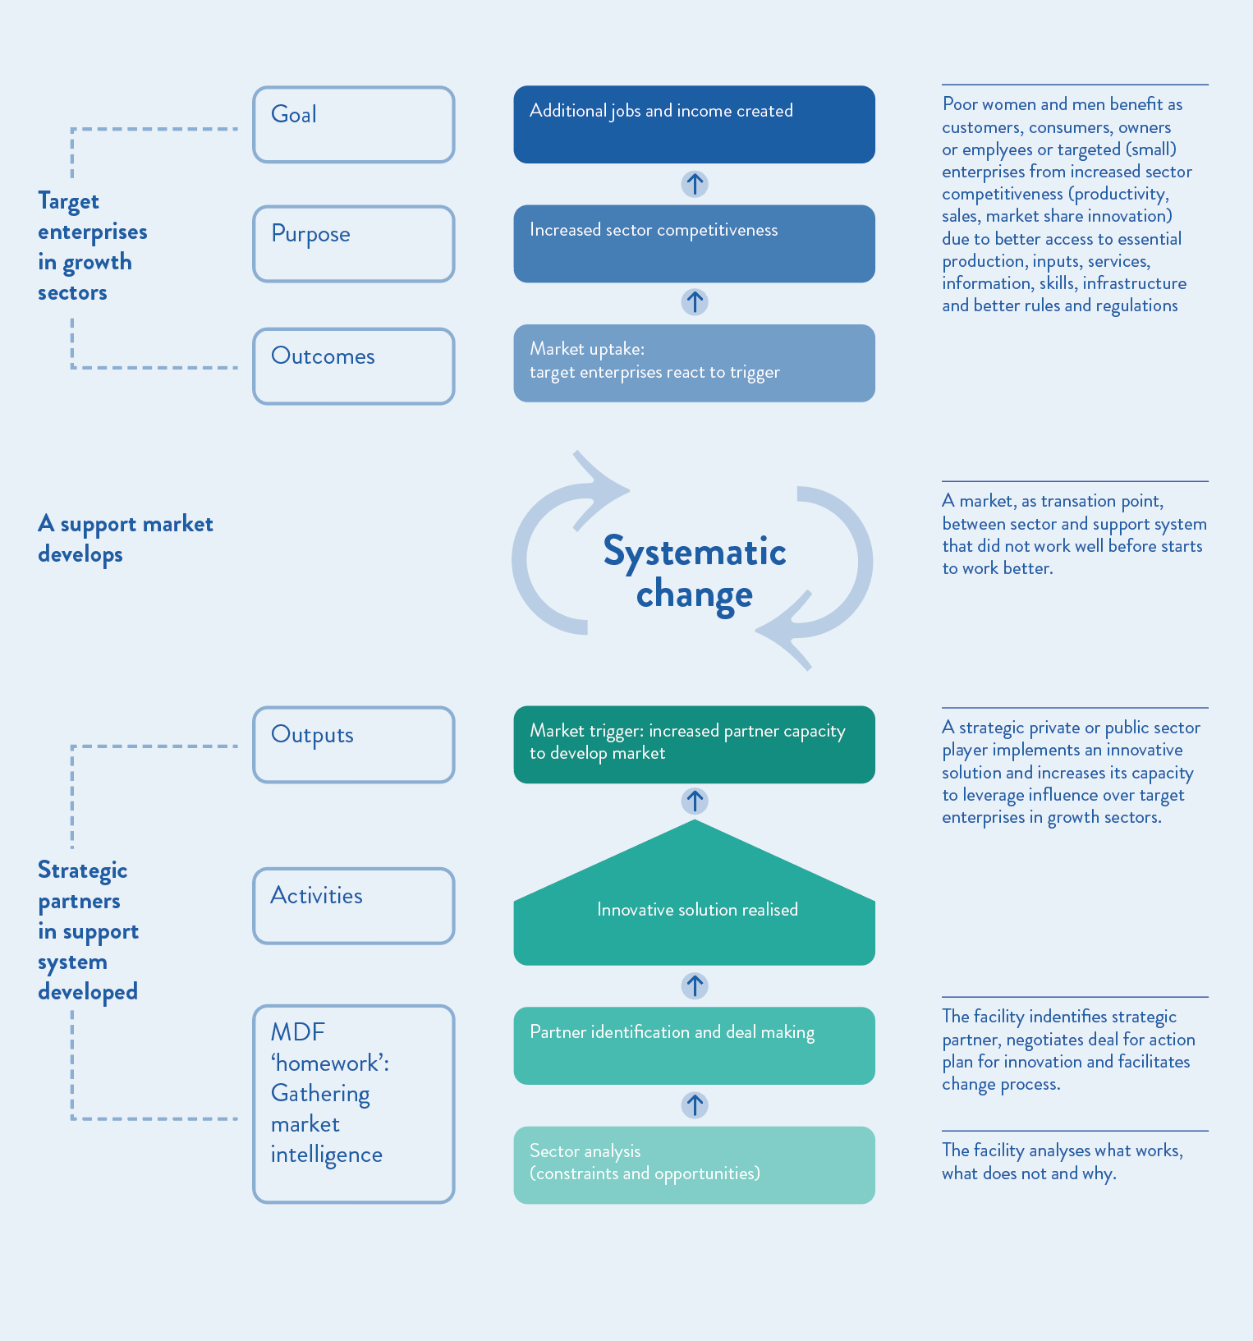
The program logic does not identify specific outcomes and pathways, while serving as a useful overview diagram. As such, the evaluation team developed a more detailed program logic shown in Figure 2.

Figure 2 Theory of change for MDF program developed by the evaluation team

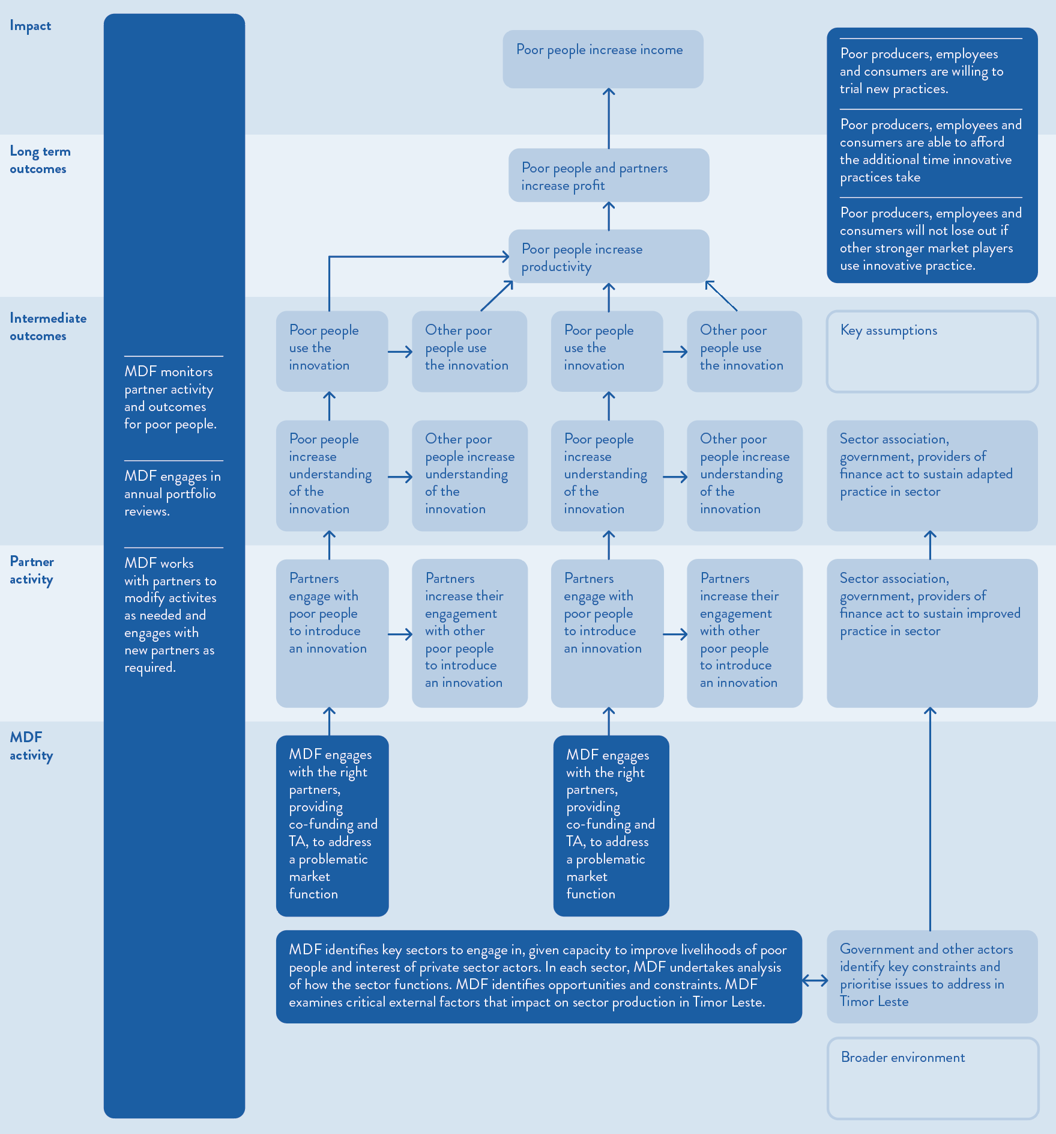
MDF uses the Adopt-Adapt-Expand-Respond model to frame how the program will improve the market system. Figure 3 shows the framework which conceives systemic change as a process of piloting which, if successful, is adopted more broadly and institutionalised.
Figure 3 Adopt-Adapt-Expand-Respond model
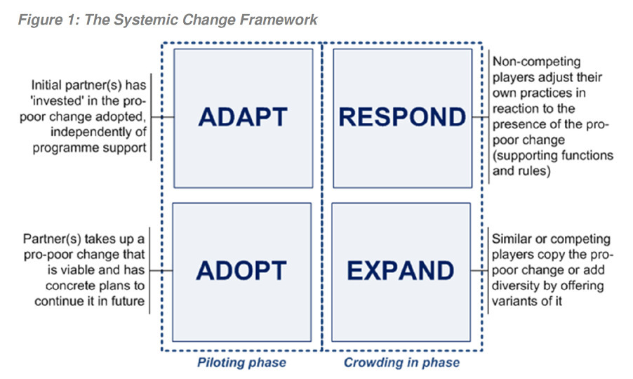

Annex 2 — Context of Timor-Leste

Context of Timor-Leste
Timor-Leste is a new nation formed after a violent separation from Indonesia and a long period of non-developmental colonisation by Portugal. Access to earnings from offshore oil resources has created a paradoxical situation of a nation that has levels of per capita income (and government revenue) that are at variance with the human development status of most of its population. The legacy of neglect and occupation are reflected in the struggle that the country has undergone to rapidly create the institutions of national government, and to build an entrepreneurial base to drive private sector development beyond that linked to use of oil revenues. Government spending on wages and salaries, goods and services and construction drives most economic expansion.
Demographics and poverty: The population in Timor-Leste is currently estimated to be just over 1.3 million with 57% of people below the age of 25. The human capital base for the country is quite limited: only 68% of the adult population is literate (64% of the adult female population), and 26% of the population over 25 has had no formal education. Poverty and deprivation are at high levels in Timor-Leste. Data from 2021 estimates that 55% of people experience multi-dimensional poverty. Timor-Leste is considered a food-deficit country, importing 60% of its food, given low levels of agricultural productivity. The are high rates of stunting with 47% of children under five years stunted.
Livelihoods: Only 30% of the working age population (just over 809,000 thousand people) is in the labour force (working or looking for work), and informal employment accounts for some 77% of those who are in employment. A further 20% of the working age population is engaged in subsistence farming.
Overall, some two-thirds of households depend on agriculture for their livelihoods. However, the total area of land under cultivation is falling (35% less in 2020 than in 2005). Rural-urban and external migration (driven by urban-rural wage disparities underpinned by expansion of the public sector and growing opportunities for temporary work overseas) is leading to labour shortages for agriculture, even as agricultural productivity is stagnant or falling. In addition, alternative income sources linked to expansion of access to veterans’ and other pensions and remittances appear to be diminishing incentive for farmers to invest in low-income and low-return agricultural activities.
Oil dependency and its implications: Timor-Leste is perhaps the most oil-dependent economy in the world, with offshore oil and gas exports at their peak in 2012 accounting for around 80% of GDP. The Government’s oil and gas revenues currently derive from Timor-Leste’s share of proceeds from the Bayu Undan and Kitan offshore fields. These revenues flow into a ‘state of the art’ Petroleum Fund, from which the Government makes withdrawals to fund its spending. The Government consistently withdraws more than the amounts that are consistent with sustaining the viability of the Fund, and its spending dominates the economy. This level and composition of externally financed government spending severely skews incentives towards non-tradables. Current Government of Timor-Leste projections suggest that the Fund will could be exhausted in the early-mid 2030s, highlighting the urgency of making good use of the remaining funds, and of promoting economic diversification.
Vulnerability to shocks: Timor-Leste’s economy has proved vulnerable to internal disruptions, external shocks and natural disasters. The COVID-19 pandemic and associated responses severely impacted the economy, and recovery suffered a severe setback when Tropical Cyclone Seroja caused widespread flooding and damage to infrastructure and agriculture. Timor-Leste’s rural economy is also very exposed to the effects of climate change.
Shallow markets and under-developed institutions: An important feature of Timor-Leste’s economy for MDF is the extreme shallowness of its markets, the nascent state of market enabling institutions (both formal and informal), and the limited engagement with formal market exchange of significant parts of the population. Combined with the small size of the population and the disincentives for development of export and import competing activities resulting from the inflows and uses of foreign exchange revenues by the government, the prospects for rapid expansion of new or existing market systems and sectors is quite limited, and engagement with the formal and informal private sector will take significant time to yield strong impacts on incomes of men and women not engaged in the oil-related economy.
Implications: Together these features of Timor-Leste pose daunting challenges for programs trying to facilitate inclusive market-based growth. Viable opportunities for expanding income opportunities for the poor are hard to identify, and impediments are all-pervasive and inter-locking. Inclusive and sustainable diversification is thwarted by how the Government uses its oil and gas revenues, and the legacy of neglect and conflict mean that informal institutions supporting the trust needed to underpin market exchanges are poorly developed. A program like MDF may have to experiment with many strategies to find viable ways forward to achieve improvements in the well-being of poor people.
Priorities of the Government of Timor-Leste and the Government of Australia
MDF aligns with the priorities of the Government of Timor-Leste. GoTL prioritises economic diversification by boosting the productive sectors such as agriculture, tourism.
For agriculture, the Government has stated that it aims to improve national food security, reduce rural poverty, support the transition from subsistence farming to business production of agricultural, livestock, fisheries and forestry products, and promote environmental sustainability and conservation of Timor-Leste's natural resources. And with respect to tourism, the Government is focusing on niche opportunities such as community and ecological tourism, adventure, religious, historical, cultural, and ethnographic tourism rather than mass tourism. This said, the Government also identifies the future development of the petroleum and mineral resources sector as one of the cornerstones of the country’s future development, including the Tasi Mane project, which aims to create two industrial hubs on the south coast. The success of this strategy depends on if and how the Greater Sunrise oil and gas fields are developed.
The Government of Australia is Timor-Leste’s largest development partner, with official development assistance to Timor-Leste in 2022-23 reaching AUD136.6m. Australia and Timor-Leste bilateral development priorities are set out in the recently launched Australia-Timor-Leste Development Partnership Plan 2025-2030. Priorities of the GoA are working with the GoTL on long-term human development outcomes, supporting the growth and diversification of the economy, and supporting the resilience of institutions and communities. Australia’s official development assistance to Timor-Leste in 2022-23 was $136.6m. DFAT is currently developing a new development partnership plan for Timor-Leste, including a new private sector development program as noted previously.

Annex 3 – Methodology

Overall design and methodology
The evaluation used a theory-based approach to examine impact. This approach involved looking at the evidence that confirmed or contradicted the program theories of change. That is, we used the theory to structure our examination of evidence to see how MDF has (or has not) contributed to intended changes. The theory-based approach was the most appropriate way to examine impact given MDF is a long-term intervention operating in an exploratory manner. Additionally, the program is conducted in a highly changeable context alongside other actors contributing to the same changes. These program characteristics and the context means that neither an experimental nor quasi-experimental approach is suitable.
The evaluation focused on the coffee and pig market systems. The Evaluability Assessment showed that MDF had most impact in these two systems of its overall portfolio, using MDF’s two key impact indicators of increased beneficiary income and partner revenue. For this reason, the evaluation examined these two market systems. The team also gathered learnings from marine tourism and destination marketing within the tourism sector. The tourism sector is prioritised for growth by the Government of Timor-Leste and has the potential to deliver impact in the future. The evaluation did not, however, examine impact in the tourism sector given there is only limited outreach and impact so far.
The evaluation used contribution analysis to analyse how the program works and who it benefits. This involved setting out the contribution problem: to identify the impact that MDF had in the coffee and pig market systems. We collected data to test the causal links in the theories of change and the extent to which MDF has been responsible for changes. Up to 72,823, male and female coffee and pig farmers, including those with disabilities, reported they had benefitted from MDF interventions. In Phase 2 we gathered data from farmers to verify MDF’s reported results, determined whether positive changes have persisted, and whether other farmers have adopted similar practices. We also spoke with the businesses that MDF partnered with to see whether they had increased their profits (not just turnover), whether any profit increases persisted or changed, and whether other companies had taken on similar or related changes. We were looking for evidence that confirmed or contradicted the theories of change and testing alternative theories for why changes have occurred.
The team examined MDF’s contribution alongside the efforts of the government and other major actors in each market system. That is, we were not expecting that MDF was solely responsible for changes. Rather, we mapped the larger context of change in each market system and the key contributing actors. As noted above, this approach was the most appropriate given MDF’s complicated causal pathways that were influenced by the activities of other key actors. For example, activities in the pig market system are impacted by the policies and extension activities of Ministry of Agriculture and Fisheries, animal husbandry programming and knowledge generation of ACIAR, and availability of commercial feed and exotic pig breeds through private sector partners in Timor-Leste and overseas.
The evaluation used a rubric to understand MDF’s contribution to systems change. The rubric was based on the Adopt-Adapt-Expand-Respond Framework which was developed for managing and measuring systemic change processes. The framework is well recognised across market systems development programmes. MDF uses it to understand and analyse changes they have contributed to at each level: intervention, market function and market system levels, as shown below.

Figure 1 Adopt-Adapt-Expand-Respond model
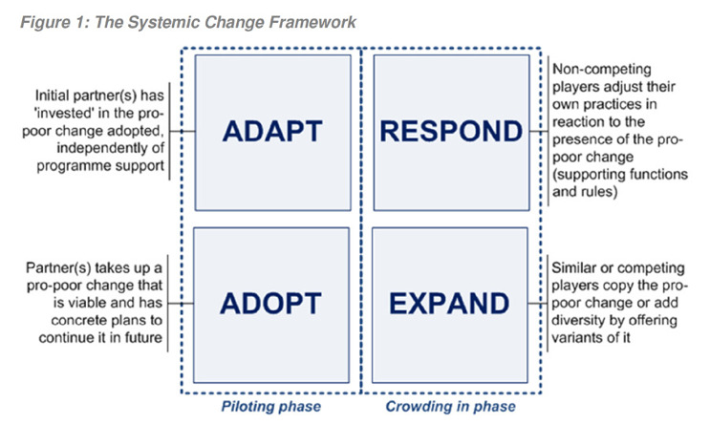
We used the indicators proposed by the Springfield Centre for each quadrant to develop the rubric. This allowed us to transparently evaluate MDF’s progress in catalysing pro-poor positive coffee and pig market systems changes.
The focus of Phase 2 was to gather primary data from key stakeholders. This supplemented the analysis of key quantitative data at the intervention and market function level undertaken in Phase 1. Quantitative data included changes in income and additional sales for partners and their beneficiaries. This data was collected by MDF monitoring activities, such as collecting operational data from businesses, or through specific research studies.

Limitations of the evaluation and risks
The evaluation team identified limitations and risks to the success of the evaluation and mitigation measures to address them, as described below.
- Limited timeframe of the field visit. There were limited resources available for the fieldwork meaning that the visit could only be two and a half weeks in duration. The team carefully identified the most important sites to visit and stakeholders to interview in relation to the two focus market systems of the impact evaluation.
- Limited baseline data. The evaluation had limited access to consistent baseline data on partners’ turnover, profits, or farmers’ incomes. This meant that we couldn’t easily compare current turnover, profit and incomes to baselines. Rather, we asked people to recall details that could result in inaccuracies given the length of time that has passed. To address this issue, we used other points of comparison that MDF has developed. For partners, we compared income and profits of selling different products (speciality grade coffee beans to commercial grade coffee beans and commercial feed to not selling commercial feed). For farmers, we compared income and profits of selling speciality grade coffee beans to selling commercial grade coffee beans and the same for pig farmers who feed their pigs commercial feed and those who do not.
- Response Bias. The participants could have had political or personal motives to provide responses that may be inaccurate (e.g. attitudes towards the MDF team personnel etc.). As a mitigation measure, the team used a range of probing questions and interactive methods to ascertain accuracy and relevance of information. Additionally, the team triangulated data from multiple sources and across multiple data collection methods.
- Selection Bias. We purposefully selected the market systems that have had most impact for this evaluation. We were careful communicating findings to link these specifically to the market systems of focus. Findings are not extrapolated to other market systems. Another element of selection bias was that farmers selected by partners that are most successful. We cross-checked findings with other key stakeholders, such as Municipal Authorities, to ensure we were not reporting overly optimistic results.
- Risks to confidentiality of information and identity of participants and respondents. The interviews were voluntary and the evaluation team explained this and the methodology before initiating any consultation. Respondents were not named in the report. Permission was sought for any views attributed in this report.

Key evaluation questions (KEQs) and sub-questions
Phase 2 of the evaluation addresses the key evaluation questions and sub-questions below.
- What impact has MDF achieved in in Timor-Leste?
  - What are the longer-term changes in the target markets that have been observed and how does this compare to the intended EOPOs?
  - Did MDF make a significant contribution to changes in the target market systems, at each expected level?
  - Were there any key modalities or market systems that achieved better than expected results? Why?
  - What aspects were most significant in contributing to the intended impacts?
- What are the key lessons from MDF?
  - How did MDF achieve key changes in targeted market systems?
  - What are the options for incorporating the MDF approach into a new private sector development program that has a bigger budget envelope?
  - What would be the challenges/opportunities of incorporating the MDF approach or program?
To investigate market systems change we have developed a rubric with criteria related to the Adopt-Adapt-Expand-Respond model as noted earlier. The sub-criteria are essentially another set of sub-questions to answer Question 1b (Did MDF make a significant contribution to changes in the target market systems, at each expected level?).
Data collection and analysis methods
The team collected primary data through interview and focus group discussions. The team conducted interviews and focus group discussions with: DFAT; MDF team; MDF partners; farmers who supply these partners; and other key stakeholders in each of the two market systems such as other companies, MALFF staff; Ministry of Tourism and Environment; business associations and other donor partners. This data supplemented the qualitative and quantitative data gathered through desk review during Phase 1.
The data collection methods are described below.
- Desk Review. The team completed the desk review in Phase 1. The key documents reviewed included MDF monitoring and evaluation data and project documents; evaluations and analysis of other MSD and other related programs; and Timor-Leste census and population data, and other relevant documents. The desk review helped the team to identify, select, and refine the methodology and the interviews, as well as developed data collection tools.
- Key Informant Interviews (KIIs). We conducted approximately 47 KIIs with key stakeholders involved in managing and implementing MDF program, including DFAT and MDF staff, coffee stakeholders, pig stakeholders, tourism stakeholders, and development partners. Focus Group Discussions were held with farmers (see below).
The evaluation used semi-structured interviews, derived from the evaluation questions. The interviews were conducted through a mix of online and face-to-face meetings.
Consistent with DFAT evaluation policy and that the success of the program might vary across gender, we ensured adequate representation of male and female participants. The interview guides included questions to assess the extent to which women and people with disability have benefited from, and been empowered by, the intervention.
Interview guides were used to guide the discussions. The approach of using the same or similar questions with each of these partners allowed the evaluation team to reliably identify consistent themes or perspectives in the responses of different partners.
The KII questions were coded against the key evaluation questions. This facilitated subsequent analysis of responses and linkages to the document review. We put special attention to the views of women or people with disability and planned data collection to minimise any obstacles that would prevent people from taking part in key informant interviews and focus group discussions.
Prior to the commencement of any interview, the interviewer outlined the purpose of the evaluation, how the information would be used, and steps that would be taken to maintain confidentiality of responses (such as non-attribution of quotes). The evaluators gained formal consent from the interviewee.
Each evaluator was responsible for taking comprehensive notes in real-time including verbatim quotes during interviews. In addition, interviews were recorded if consent was acquired. Each evaluator was responsible for typing up notes. Interview notes were only available to people who had a direct role in the evaluation and notes were destroyed after the publication of the evaluation to ensure confidentiality and data security.
- Focus Group Discussions (FGDs). We undertook nine FGDs (3 of them were women only) across 4 different municipalities where key partners have been most active. We prioritised these areas for focus group discussions with farmers. We ensured that we had adequate representation of men, women and farmers with disabilities at these focus group discussions.
The team conducted 1 pig and 2 coffee FGDs in each of the 4 selected Municipalities for male and female farmers. The team also conducted individual interviews with 1 to 2 pig farmers and at least 1 pig non-participant farmers in each of the Municipality. The reason for this approach was to compare the experience of participating and non-participating farmers. For coffee, we did not require a comparison group as farmers who produce speciality coffee also produce commercial grade coffee. The coffee FGDs included 10 or more male and female farmers who compared their experiences selling specialty and commercial grade coffee. For pig farmers we conducted 1 FGD with 10 or more male and female farmers who use commercial feed and 1 or more male or female farmers who do not use commercial feed. In 2 of the municipalities, we conducted 1 female-only focus group, composed of coffee farmers. Here, we tested the findings from the mixed-group FGDs.
The FGDs focused on the evaluation questions. To keep the FGDs focused and comparable, all FGDs followed a common format:
    - Introduction and explanation by FGD moderator (10 min)
    - FGD moderator engaged in focused and guided discussion in Tetum with an audio recording. The moderator was charged with keeping the discussion on track to answer the questions, and probing the participants for more details if necessary (60-90 min)
- Observations. We concluded the KII and / or FGD activities with field observations of implementation of MDF program activities as needed in the respondent groups’ work area (geographical location, etc). The evaluators took notes of their observations and sought consent for photos (using DFAT’s Video, audio, photograph and story – Privacy notice and Consent form).
The team identified the sample of stakeholders through desk review and consultation with MDF. The team identified the partners from the interventions in the market systems where MDF had most impact. We examined the results from these key interventions during the desk review and consulted further with MDF. We collectively agreed on the final list of key partners, stakeholders and beneficiaries for interview during the fieldwork. The snapshot of MDF’s market systems strategy for coffee is below.

Figure 2 MDF interventions and targeted market functions in the coffee market system
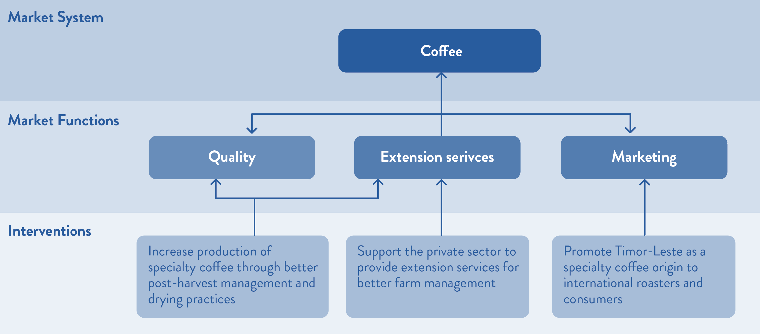
In the coffee market system, the team focused on the quality interventions given these had most impact. There was useful data available through MDF’s 2023 Coffee Processing assessment. MDF collected data from 3 partners (Karst, Mara Mresa and Timor Global) as well as farmers who supply to these partners regarding quality picking, pulping, washing, and drying of coffee beans. The team followed up with these 3 partners and supplying farmers to test the extent to which they continue to implement improved practices, adapt these practices and whether they have seen any adoption by other companies. We also sought to find out why people continued or didn’t continue (either fully or partially). Similarly, we engaged with farmers to better understand differences that have resulted from their move to producing quality coffee beans and what these differences mean to them and their families.
The team took the same approach to identify the sample of pig stakeholders to consult. The snapshot of MDF’s market systems strategy for pigs is below.
Figure 3 MDF interventions and targeted market functions in the pig market system
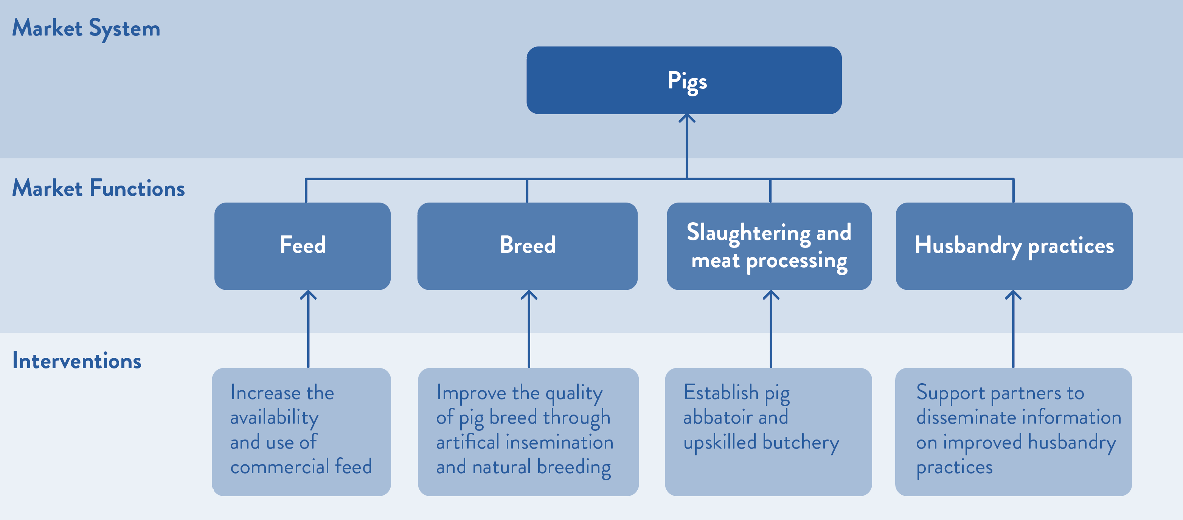

In the pig market system, changes to husbandry practices resulted in the most historical impact and changes to feed will likely have impact into the future. MDF has collected comprehensive data on the husbandry interventions, so the evaluation focused on the feed interventions and partners.
In the tourism market system, we engaged with stakeholders primarily to gain advice on potential future investments.
Our sampling strategy was based on first identifying the key partners to interview, as outlined above. We then identified the municipalities where these partners were most active and prioritised these areas for focus group discussions (FGDs) with farmers. We worked with selected partners to identify farmer groups that they have and have not worked with. We ensured that we have adequate representation of men, women and farmers with disabilities at these focus group discussions.
The focus of Phase 2 was on the collection of both qualitative and quantitative data to examine MDF’s impact. Important sets of quantitative data were:
Coffee
- Prices of premium and commercial grade coffee over time
- Farmer outlay and incomes for premium and commercial grade coffee beans over time
- Differences in increases/ decreases in male and female farmer incomes
- Partner turnover and profit over time
Pigs
- Prices for local and exotic pork over time
- Prices for commercial feed in different municipalities
- Farmer incomes for local and exotic pork and piglets over time
- Differences in increases/ decreases in male and female farmer incomes
- Partner turnover and profit over time
Important sets of qualitative data were:
- Extent to which farmers and partners had embedded new practices
- Extent to which other farmers and companies had taken on new practices
- Extent to which farmers and partners attributed changes to MDF’s interventions
- How farmers valued any increases/ decreases in their incomes relative to any increases/ decreases in outlay
- How partners valued any increases/ decreases in turnover and profit
- Partner plans for the future
We triangulated data collected from different sources and across different collection methods and cross-check against the desk review data collected in Phase 1. The final report prioritised findings which are backed by a range of sources, as this denotes stronger evidence. The data analysis methods are described below.
- Realtime sensemaking. The evaluation team engaged in regular meetings during the fieldwork to make sense of initial findings. Team members discussed key findings and initial interpretations. These sessions were important for drawing out lessons.
- Thematic coding of interview and FGD data. Each evaluator wrote up notes at the end of each day. At the end of the fieldwork the team coded transcripts by theme. This involved a microanalysis (reading several times) for appropriate coding of notes. Sufficient flexibility was given to the researcher in altering and expanding the number of themes depending on the emergent findings in each interview. As part of coding the team considered:
  - Differential benefits (or lack of benefits) for women and people with disabilities.
  - How the interventions removed any constraints to women’s participation.
All data collected during the evaluation was disaggregated by gender and ability status and analysed for its effects on women beneficiaries and people with disability.
- Testing findings against the theories of change. We tested whether there was evidence of change along the predicted pathway of change for both coffee and pigs, see the theories of change on pages 52 and 53, resulting in intended impact. We also tested any disconfirming evidence and alternate theories for the identified impact.
- Testing findings against the rubrics. We examined change at the 4 levels of the rubric: adapt, adopt, expand and respond. The analysed findings were compared to the descriptions in the rubric to determine which was the best fit description of market systems changes to determine how much change happened and the extent to which MDF contributed.
- Development of overall findings. The team reviewed all data to examine consistency of themes. The most cited findings were collated into overall findings and findings that contest majority views were also collated.
- Triangulation. The team reviewed interview and FGD findings against findings from the desk review. The team priortised findings that were supported across several sources.
- Report drafting. The team drafted the report against the key questions drawing on the findings supported across several sources.
- Review. We submitted a draft report to DFAT. The draft report provided key findings against the KEQs and initial recommendations.
- Report finalisation. Following feedback, we finalised the evaluation report.

Ethical issues
The review applied the standards outlined in DFAT’s Ethical Research and Evaluation Guidance. This included the principles of respect for human beings, beneficence, research merit and integrity, and justice. The team also abided by the Australian Evaluation Society guidelines for the ethical conduct of evaluations. The key principles that we used, and related actions are noted below.
Respecting the rights, privacy, dignity and entitlements of those affected by and contributing to the evaluation: We identified ourselves as evaluators, outlined the purpose of the evaluation and how it would be used, and identified the evaluation commissioners in all interactions with interviewees. We obtained informed consent before proceeding with interviews. We ensured no individual could be identified through reporting and checked references and quotes with interviewees. We had male and female evaluation team members. Specific focus groups with female farmers were conducted. We considered the potential harm especially for those who were most at risk (poor farmers) and developed strategies to address.
Reciprocity. We took time from interviewees, and this is especially an issue for poor farmers who are time poor and may miss income generating activities for discussions. We ensured focus group discussions were catered and transportation costs were covered.
Judgements and any related actions are based on sound and complete information. We developed a rigorous method of design, data collection and analysis and outlined the limitations. We engaged in a process of feedback and review to ensure the quality, usability and accuracy of our findings.
Ensuring the safety and protection of all people engaged in this process is paramount: Consultations did not proceed if they were likely to place anyone at risk. The evaluation team implemented robust safeguarding policies, including on child protection and on preventing sexual abuse, exploitation, and harassment, aligned with industry best practice and that exceed DFAT requirements. We conducted rigorous due diligence for all personnel delivering our work and implemented a risk-based approach to manage and mitigate safeguarding risks. Our team was responsible for implementing and adhering to all required safeguarding measures.
Report in a way that audiences are provided with a fair and balanced response to the terms of reference for the evaluation. We developed a clear and simple final report. We ensured the report was fair, accurate and comprehensive. We identified and acknowledged sources.

Schedule
We developed a draft schedule that allowed the team to interview key stakeholders in Dili and in the municipalities of Ermera, Aileu, Ainaro and Manufahi.
The team worked closely with MDF team to organise the logistics in mid-January 2025 prior to the field work in February 2025. This included the list of stakeholders with their contact details, arrangement of invitations to participants to be interviewed and focus group discussions, printing of materials, and other operational logistics (car rental, accommodation, etc).
During the first week of fieldwork, the team conducted initial meetings in Dili with DFAT, MDF and key Ministry staff. The team then split into two and conducted the first regional visit to Ermera and Aileu. The two teams interviewed coffee and pig stakeholders in each location before returning to Dili to debrief. The second week involved travel to the more remote municipalities of Ainaro and Manufahi. The team leader stayed in Dili in the second week to meet with Dili-based stakeholders. Both teams returned on the Friday of the second week arriving with sufficient time for a team debrief and meeting with DFAT. The detailed schedule was provided to DFAT.
The team undertook analysis during and after the completion of fieldwork. The team prepared the draft report by the end of March. DFAT had 3 weeks for review in early April, with the team finalising the document by early May 2025.
Theory of change for MDF’s work in the coffee market system

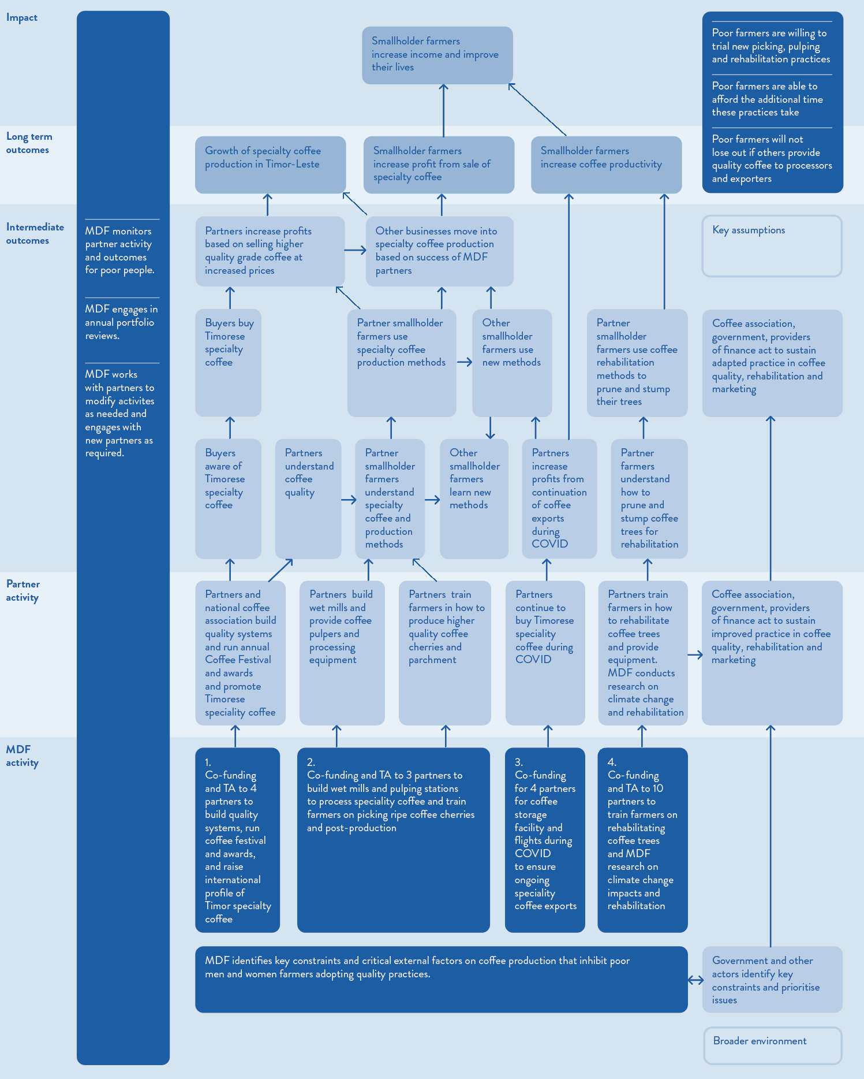
Theory of change for MDF’s work in the pig market system

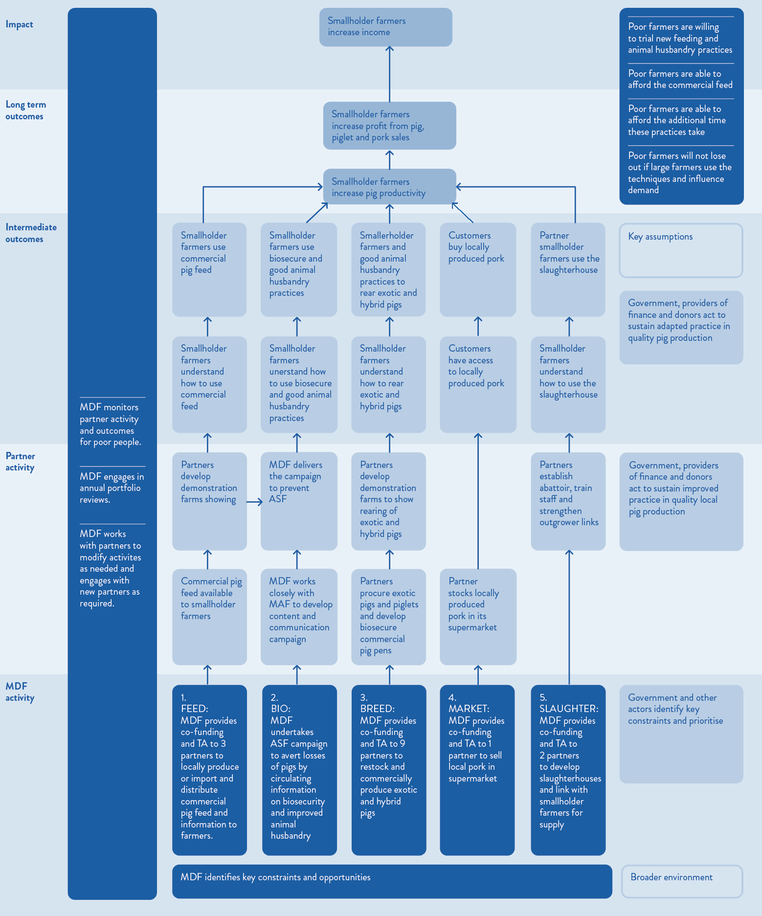

Annex 4 – Rubric findings

Coffee rubric

Rubric for Adoption
The rubric for adoption shows good progress in relation to partner contribution to the pilot, long-term viability of practice changes and partner satisfaction and intention to continue. Progress is adequate for partner ability to continue and target group’s satisfaction and benefit. Further details are in the table below. Progress indicator per criteria is marked by shading and the word ‘selected’ for screen reader users.
Criteria | Poor | Inadequate | Adequate | Good | Comments
Partner contribution to the pilot | Partners do not invest financially and non-financially | Partners invest financially or non-financially | Partners invest financially and non-financially | [Selected] Partners invest significantly, including both financially and non-financially | MDF has engaged in 28 interventions with partners across the 3 market functions (Quality, Extension/ Rehabilitation, Marketing). Evidence of partner investment is that they have spent $137,835.50 to date. This is approximately 50% of MDF’s cash contribution of $275,754.67.  Partners have also contributed significant time and attention to the productivity and quality activities. The 2023 Coffee Processing assessment shows 3 partners (Karst, Mara Mresa and Timor Global) spent time training farmers in techniques for quality picking, pulping, washing, and drying. The 2023 Coffee Rehabilitation assessment shows that 2 partners (CBS and OLAM) provided training to farmers on rehabilitation practices.
Long-term viability/ benefit of practice changes | The partner sees no long-term viability in the practice changes. | Practice changes introduced are not commercially viable and/ or competitive and/ or position the partner well for longer-term benefits. | Practice changes introduced are commercially viable and/ or competitive and/ or position the partner well for longer-term benefits. | [Selected] Practice changes introduced are commercially viable, competitive and position the partner well for longer-term benefits. | Practice changes of producing speciality coffee are commercially viable for partners. These practices have been supported through MDF’s Quality and Extension/ Rehabilitation market function activities (the Marketing market function serves to build the overall profile of Timorese coffee but does not directly lead to partner practice change). Commercial viability of speciality coffee exports can be seen in the increase in VAMT for partners. Over the period of 2015-2023 there has been $4,218,119 in VAMT generated through the Coffee Quality interventions. Coffee rehabilitation practices are yet to result in VAMT given pruned coffee trees take 2 years to recuperate. MDF will report on rehabilitation results later in 2024.  Coffee quality practices position partners well for future benefits. MDF documentation and the ACT interview note the large capacity for future growth of the speciality coffee export market, with demand for speciality coffee from Timor-Leste far outstripping supply.  There are, however, ongoing risks to production of speciality coffee due to climate change. MDF data shows that 50% of coffee plantations in Timor-Leste will not be viable by 2050. MDF documentation (The business case for investing in climate change adaptation and mitigation in agriculture) and interview with ACT noted that the practices introduced as part of quality production are also those that mitigate the effects of climate change. Specifically, “Shorter trees are less vulnerable to high winds and use water more effectively, building resilience to droughts. Coffee trees that are correctly stumped and pruned also provide space for intercropping with shade trees that act as windbreakers and protect coffee trees from intense sunlight and high temperatures.” Pg. 21. The 2023 Coffee Rehabilitation assessment shows that most farmers (24 of 33) interviewed continued to rehabilitate their trees. Those who did not either lacked equipment, resources (petrol for chainsaws), planned to conduct more rehabilitation in following years or were monitoring the effects of previous rehabilitation.
Partner satisfaction and intent to continue | Partners are unsatisfied with the pilot and do not intend to continue. | Partners are satisfied with the pilot but do not intend to continue. | Partners are satisfied with the pilot, intends to continue but no concrete plans to absorb related costs for continuation yet. | [Selected] Partners are satisfied with the pilot, intends to continue and have concrete plans to absorb related costs for continuation. | Interview with most partners showed satisfaction in rehabilitation and quality pilots and intension to continue. ACT for example noted that across the association members are focused on continuing to produce speciality coffee given the additional income received from this higher value export. Producing speciality coffee requires partners to absorb costs of mill maintenance, ongoing training for farmers on quality production and coffee tree rehabilitation.
Partner ability to continue | Partners do not possess the organisational and human resources to uphold the practice changes. | Partners currently possess the organisational or human resources to uphold the practice changes but this capacity is very vulnerable to changes such as staff turnover. | [Selected] Partners currently possess some depth of the organisational and human resources to uphold the practice changes but remain quite vulnerable to changes such as staff turnover. | Partners currently possess deep organisational and human resources to uphold and progress the practice changes and strategies to retain this in the future (e.g. succession planning, training programs). | Partners as well as the farmers that supply to them need to be able to retain the practice changes. Partners have sufficient expertise to be able to train their farmer suppliers, indicating some depth in organisational and human resources. Fieldwork interviews showed ongoing commitment of partners to training international and local staff.  The 2023 Coffee Rehabilitation assessment showed some variability in the success of farmers rehabilitation efforts. Success rates of tree rehabilitation varied from 50-100% across the 4 farmer groups according to the Group Heads interviewed. Interviewed farmers report high levels of satisfaction however and almost all (37 of 39) report their trees have grown back. Rates of regrowth are mostly over 90% (30 of 37).
Target group’s satisfaction and benefit | Beneficiary groups are being harmed from the practice changes. | Beneficiary groups are unsatisfied with or not benefitting from the practice changes. | [Selected] Beneficiary groups are satisfied with and benefitting from the practice changes. | Beneficiary groups are very satisfied with and significantly benefitting from the practice changes. | Farmers benefit from increased income for selling quality coffee cherries and parchment to processors and exporters. MDF’s 2023 Coffee Quality assessment shows farmers earn an additional USD0.11 (AUD0.16) per kg on average for their cherries (20-30 per cent more) due to adopting the improved practices. While price per kilo increased most farmers in 2023 experienced lower income due reduction in coffee produced due to weather. Farmers reported satisfaction during fieldwork with the improved choice they had to sell their coffee cherries, increased income, and their ability to invest and spend on prioritised areas based on the increased income.  There is time required for picking of only ripe cherries, and returning to pick other cherries when they ripen, and also pruning trees for rehabilitation. However, farmers do not report the selective picking as requiring additional time.  There are costs also associated with rehabilitation given trees don’t produce for 2 years. The 2023 Coffee Rehabilitation assessment shows that farmers have managed this risk by only pruning and stumping a proportion of their trees. There are also risks of incorrectly pruning trees. As noted above, company assessments showed a range from 50-100% survival rate of trees post pruning. Farmer assessments, however, show higher rates of success with most farmers reporting trees grew back. The 2024 impact assessment shows high rates of regrowth and improved income for farmers.  Fieldwork showed there were some instances of delayed payment to farmers and agents in 2024 due to largescale price rises in coffee that reduced partner working capital. This had a negative effect on the affected farmers, lead farmers and agents.

Rubric for Adaptation
The rubric for adaption shows good progress in relation to competitors or similar types of organisations “crowding-in”. Progress is adequate for independent investment, target group benefits sustaining and ability to accommodate competition or collaboration. Further details are in the table below. Progress indicator per criteria is marked by shading and the word ‘selected’ for screen reader users.
Criteria | Poor | Inadequate | Adequate | Good | Comments
Independent investment | There is no evidence that original changes have been sustained | Pilot partners only sustain original changes | [Selected] Pilot partners improve original changes or take changes to new locations | Pilot partners improve original changes and take changes to new locations | The 2022 MDF Annual Report notes that KARST planned to establish another wet mill and Timor Global planned to expand its pulping stations in 2023. KARST decided not to establish another wet mill as some farmers were choosing to only produce cherries rather than parchment so the existing wet mill was sufficient. Timor Global’s additional pulping stations were confirmed during fieldwork. Timor Global had developed a model where agents would purchase the pulpers over a 3-year period to address earlier issues of lack of maintenance when the pulper was bought by the company.
Target group benefits sustain | There is evidence of loss to beneficiaries after the pilot ends. | Beneficiaries do not continue to benefit after the pilot ends. | [Selected] Beneficiaries continue to benefit after the pilot ends. | Beneficiaries have improved benefit after the pilot ends through ongoing partner pro-poor innovation. | Farmers supplying to CBS continued to earn increased income for quality coffee over 2015-2018. The number of farmers supplying to Timor Global reduced in 2023 from 2022. So, there was reduced benefit to beneficiaries from this partner. The team will investigate the reason for the reduction during field work. Pruned trees are more productive and easier to pick given reduced height of trees. However, there is some risk of incorrect pruning as noted above. Additionally, MDF’s 2022 annual report notes that most farmers lack sufficient knowledge and inputs to manage harvest and post-handling during bad weather and that companies face issues in drying due to the longer wet seasons.

Rubric for Expansion
The rubric for expansion shows good progress in relation to competitors or similar types of organisations “crowding-in”. Progress is adequate for partner ability to accommodate competition or collaboration. Further details are in the table below. Progress indicator per criteria is marked by shading and the word ‘selected’ for screen reader users.
Criteria | Poor | Inadequate | Adequate | Good | Comments
Competitors or similar types of organisations “crowd-in” | There is evidence that competitors do not see value in pilot practices or influential stakeholders advocate against changed practices | There is no evidence that competitors have adopted the pilot practices or that influential stakeholders advocate for the changed practices | Competitors adopt pilot practices or influential stakeholders advocate for the changed practices | [Selected] Competitors adopt pilot practices and influential stakeholders advocate for the changed practices | The 2022 MDF Annual Report notes that Alter Trade Timor, FarmPro, Kape Diem and PARCIC have started exporting high-quality coffee. Other companies show interest in establishing drying racks. However, there is no evidence of crowding-in in coffee with MDF not observing and reporting indirect VAMT in coffee so far. Interview with ACT shows that they are a strong advocate for quality coffee production and there is strong government support as documented in the National Coffee Sector Development Plan 2019-2030 (pgs. 32-34).
Ability to accommodate competition or collaboration | There are increased barriers to entry of new players and competitors and the industry organisation does not support expansion | There is no reduction in barriers to entry of new players and competitors and the industry organisation does not support expansion | [Selected] There are reduced barriers to entry of new players and competitors or the industry organisation supports expansion | There are reduced barriers to entry of new players and competitors and the industry organisation supports expansion | ACT provides technical support and internationally certified cupping lab to support farmers in their transition to quality coffee production. ACT is actively working towards expansion by advocating to government and promoting Timor-Leste coffee to export markets and managing a portion of the GoTL rehabilitation program.

Rubric for Response
The rubric for response shows adequate progress in relation to ability of ‘adopters’ to cope with shocks. Progress is inadequate for system responsiveness and receptiveness. Further details are in the table below. Progress indicator per criteria is marked by shading and the word ‘selected’ for screen reader users.
Criteria | Poor | Inadequate | Adequate | Good | Comments
System responsiveness and receptiveness | There is no evidence that actors in supporting functions change their practices enabling early and late ‘adopters to operate more effectively and further improve their performance | [Selected] Some actors in supporting functions (not enough to make a significant difference) change their practices enabling early and late adopters to operate more effectively and further improve their performance | Some actors in supporting functions (enough to make a significant difference) change their practices enabling early and late adopters to operate more effectively and further improve their performance | Many and significant actors in supporting functions change their practices enabling early and late adopters to operate more effectively and further improve their performance | The GoTL committed to 2 payments to farmers who agreed to rehabilitate their trees – 40% up front and 60% on completion. However, the Government has only paid the first tranche to all farmers. It has undertaken monitoring and has now released another 16% to some farmers. The Government states it is committed to funding the remainder and has transferred funds to ACT and CCT. However, the unpredictable action of government to date has negatively affected the market for private businesses offered embedded extension services, including support for rehabilitation.  ACT provides important support to systems change as noted above.  There has been a buyer response to date with increasing quality of coffee being exported from Timor-Leste. MDF’s 2022 annual report notes that more small-scale roasters in Australia, the EU and the UK are selling Timorese Coffee.
Ability of ‘adopters’ to cope with shocks | There is no evidence that practice changes can persist | There is no evidence that practice changes can withstand adverse events and negative reactions from supporting systems | [Selected] Evidence that practice changes can withstand adverse events or negative reactions from supporting systems | Evidence that practice changes can withstand adverse events and negative reactions from Supporting systems | MDF’s research (Climate change and the competitiveness of Timor-Leste’s coffee, pg. 6) shows that the land suitable for cultivating arabica coffee will likely halve by 2050. Climate change and increased extreme weather events have the potential to adversely affect production. However, rehabilitation activities improve soil quality and tree resilience.

Pig rubric

Rubric for Adoption
The rubric for adoption shows good progress in relation to partner contribution to the pilot and partner satisfaction and intention to continue. Progress is adequate for partner contribution to the pilot, partner ability to continue and target group’s satisfaction and benefit. Further details are in the table below. Progress indicator per criteria is marked by shading and the word ‘selected’ for screen reader users.
Criteria | Poor | Inadequate | Adequate | Good | Comments
Partner contribution to the pilot | Partners do not invest financially and non-financially | Partners invest financially or non-financially | Partners invest financially and non-financially | [Selected] Partners invest significantly, including both financially and non-financially | Partners in 2 of the 4 market functions (Feed and Piglets and Breeds) have contributed approximately 36% of MDF’s cash contribution of $253,269. The 2022 Pig feed assessment shows partners have all contributed significant time and attention to the activities through establishment of demonstration plots (Casa Agri established 15 plots, RN Agri established 1 plot, W4 established 2 plots), conducting farmer training, and conducting other awareness activities. The 2023 Pig breeding & feed assessment shows partners have contributed time and attention by constructing piglet pens, sourcing feed for sows, boars and piglets.  There was no co-funding for ASF campaign which was the key cost component of the Animal Health and husbandry market function however MDF worked closely with MAF on the campaign. There is no spending to date in the Slaughter and meat processing market function.
Long-term viability/ benefit of practice changes | The partner sees no long-term viability in the practice changes. | There is no evidence that practice changes introduced are commercially viable and/ or competitive and/ or position the partner well for longer-term benefits. | [Selected] Practice changes introduced are commercially viable and/ or competitive and/ or position the partner well for longer-term benefits. | Practice changes introduced are commercially viable, competitive and position the partner well for longer-term benefits. | There is data from monitoring showing partners taking on feed, breeding and animal health practice have increased income and engaged additional employees. For example, the 2023 Pig Breed Assessment shows 3 pig breeders took on 10 new employees (all male). There are some issues, however, noted in 2023 monitoring showing loss of exotic piglets due to cold weather and lack of electricity and FGD with the MDF team noted further incursions of ASF resulting in loss of stock.
Partner satisfaction and intent to continue | Partners are unsatisfied with the pilot and do not intend to continue. | Partners are satisfied with the pilot but do not intend to continue. | Partners are satisfied with the pilot, intends to continue but no concrete plans to absorb related costs for continuation yet. | [Selected] Partners are satisfied with the pilot, intends to continue and have concrete plans to absorb related costs for continuation. | Partners have continued with selling commercial feed, breeding exotic pigs, and using recommended practices to ensure health of animals. The 2023 Pig Breed Assessment showed breeders had spent on average $10,000 in making changes related to more intensive breeding of exotic pigs.
Partner ability to continue | Partners do not possess the organisational and human resources to uphold the practice changes. | Partners currently possess the organisational or human resources to uphold the practice changes but this capacity is very vulnerable to changes such as staff turnover. | [Selected] Partners currently possess some depth of the organisational and human resources to uphold the practice changes but remain quite vulnerable to changes such as staff turnover. | Partners currently possess deep organisational and human resources to uphold and progress the practice changes and strategies to retain this in the future (e.g. succession planning, training programs). | The 2023 Pig Breed Assessment showed partners continuing to breed exotic piglets and farmers buying these piglets, indicating sufficient organisational and human resources to uphold practice changes. The 2022 Pig Feed Assessment interviewed 2 main partners supplying complete feed. One partner indicated no challenges in selling pig feed. One partner noted that transport out of Dili was very expensive.
Target group’s satisfaction and benefit | Beneficiary groups are being harmed from the practice changes. | Beneficiary groups are unsatisfied with or not benefitting from the practice changes. | [Selected] Beneficiary groups are satisfied with and benefitting from the practice changes. | Beneficiary groups are very satisfied with and significantly benefitting from the practice changes. | The 2022 Pig Feed Assessment showed positive benefit for farmers with larger litter size, shorter breed cycles, higher growth rate and weight gain than farmers who did not use commercial feed. Interestingly however, most farmers reported that there was no additional income from sales in the last 1-2 years. The rationale provided by the MDF team during the FGD is that farmers may be considering the totality of their investment (for example, building pens as well as buying commercial feed) when answering this question rather than only looking at how much use of commercial feed increased their income from pig sales.

Rubric for Adaptation
The rubric for adaption shows good progress in relation to independent investment. Progress is adequate for target group benefits sustaining, competitors or similar types of organisations “crowding-in” and ability to accommodate competition or collaboration. Further details are in the table below. Progress indicator per criteria is marked by shading and the word ‘selected’ for screen reader users.
Criteria | Poor | Inadequate | Adequate | Good | Comments
Independent investment | There is no evidence that original changes have been sustained | Pilot partners only sustain original changes | Pilot partners improve original changes or take changes to new locations | [Selected] Pilot partners improve original changes and take changes to new locations | MDF 2022 annual report notes existing pig breeders expanded their production scale. MDF Pig Feed monitoring data shows the two main partners, Casa Agricultor and RN Agri, have continued to expand supply of complete feed to rural locations. Casa Agricultor added agreements with rural retailers each year (2020-4, 2021 -3, 2022-4). And RN Agri increased the number of retailers it stocked with pig feed (2021-5, 2022-3. 2023-5). Interviews and MDF monitoring data show Casa Agricultor and RN Agri have expanded the sites where they sell complete feed.
Target group benefits sustain | There is evidence of loss to beneficiaries after the pilot ends. | Beneficiaries do not continue to benefit after the pilot ends. | [Selected] Beneficiaries continue to benefit after the pilot ends. | Beneficiaries have improved benefit after the pilot ends through ongoing partner pro-poor innovation. | Poor farmers continue to benefit through access to complete feed and exotic piglets in more rural locations than before the pilot as noted above.

Rubric for Expansion

Criteria | Poor | Inadequate | Adequate | Good | Comments
Competitors or similar types of organisations “crowd-in” | There is evidence that competitors do not see value in pilot practices or influential stakeholders advocate against changed practices | There is no evidence that competitors have adopted the pilot practices or that influential stakeholders advocate for the changed practices | [Selected] Competitors adopt pilot practices or influential stakeholders advocate for the changed practices | Competitors adopt pilot practices and influential stakeholders advocate for the changed practices | MDF’s monitoring shows there has been $120,000 worth of additional market transactions for other providers who have crowded in. MDF’s 2023 annual report shows commercial pig feed imports doubled to 322 tons in 2023 compared to 169 tons in 2022. The 2022 annual report shows that the number of complete feed importers tripled between 2019 and 2021. The team will collect data during fieldwork on the overall size of market transactions by MDF partners and total size of the market. MDF’s 2021 annual report showed partners in one market function taking on practices related to pilots in another market function. For example, Saknuka Unipessoal Lda, one of the pig-feed demo-plots set up by MDF under Casa Agricultura, expanded into breeding pigs and sold more than 100 piglets in various municipalities. Tito dos Santos Costa, an MDF-supported demo plot farmer, established his own commercial pig feed and breeding company, Maucali Metin Unipessoal Lda. Gregorio da Silva, an MDF-supported demo-plot farmer, expanded his operation to sell piglets and commercial feed and share information on ideal rearing practices with farmers. The team will follow up with these companies and farmers during fieldwork. MDF’s 2022 annual report notes other farmers copied good breeding practices.
Ability to accommodate competition or collaboration | There are increased barriers to entry of new players and competitors and the industry organisation does not support expansion | There is no reduction in barriers to entry of new players and competitors and the industry organisation does not support expansion | [Selected] There are reduced barriers to entry of new players and competitors or the industry organisation supports expansion | There are reduced barriers to entry of new players and competitors and the industry organisation supports expansion | Increased availability of complete feed and exotic piglets reduces the barriers to entry of new farmers aiming to fatten local pigs or take on rearing of exotic pigs. There is no industry organisation to support expansion.

Rubric for Response
The rubric for response shows adequate progress in relation to ability of ‘adopters’ to cope with shocks. Progress is inadequate for system responsiveness and receptiveness. Further details are in the table below. Progress indicator per criteria is marked by shading and the word ‘selected’ for screen reader users.
Criteria | Poor | Inadequate | Adequate | Good | Comments
System responsiveness and receptiveness | There is no evidence that actors in supporting functions change their practices enabling early and late adopters to operate more effectively and further improve their performance | [Selected] Some actors in supporting functions (not enough to make a significant difference) change their practices enabling early and late adopters to operate more effectively and further improve their performance | Some actors in supporting functions (enough to make a significant difference) change their practices enabling early and late adopters to operate more effectively and further improve their performance | Many and significant actors in supporting functions change their practices enabling early and late adopters to operate more effectively and further improve their performance | Sreeya, the Indonesian animal feed exporter, included animal health and bio-security messages on its feed sacks via QR code. This is the direction that MDF is planning to support further in the future, bringing private sector players into addressing ASF rather than the responsibility for this problem left to the government and MDF. MDF is currently in discussions with a micro-finance institution about developing loan packages for pig farming groups. If successful, this will be an important practice change that will support expansion of commercial pig production.
Ability of ‘adopters’ to cope with shocks | There is no evidence that practice changes can persist | There is no evidence that practice changes can withstand adverse events and negative reactions from supporting systems | [Selected] Evidence that practice changes can withstand adverse events or negative reactions from supporting systems | Evidence that practice changes can withstand adverse events and negative reactions from supporting systems | The FGD with MDF staff noted the ongoing issue of ASF which has the potential to wipe out gains of pig breed and feed practice changes. Adopters require further information and support to undertake and maintain behaviours and processes to ensure the health of their pigs. MDF supported MAF in a second ASF campaign, with MDF focused training MDF trainers within MAF. The two further ASF outbreaks have both been quickly contained.

Annex 5 – Accessible Figure Data

Data for Figure 3 – Changes to grade of coffee export (by volume in kilograms per year) over the 2017-2022 period
Year | Commercial | Premium | Speciality | Total
2017 | 4,125,605 | 1,173,900 | 108,913 | 5,408,418
2018 | 4,979,158 | 2,588,100 | 151,366 | 7,718,624
2019 | 4,696,697 | 2,281,633 | 53,323 | 7,031,653
2020 | 1,426,637 | 2,242,503 | 67,115 | 3,736,255
2021 | 3,805,841 | 3,177,877 | 522,878 | 7,506,596
2022 | 3,232,979 | 1,475,849 | 1,499,120 | 6,207,948
2023 | 4,294,105 | 1,296,133 | 231,870 | 5,822,108

Data for Figure 4 – Steps between the coffee cherry to roasted bean
To produce speciality or commercial grade coffee the farmer selectively picks the red, ripe coffee cherries. Then, the farmer submerses cherries in water and defect, unripe or poorly developed cherries float to the top. These defective cherries are separated from the red, ripe cherries. At this stage, there are three options. Firstly, the farmer can sell the low-grade cherries to a commercial buyer or trader at a low price. Secondly, the farmer can sell the red, ripe cherries at a higher price. To do this, the farmer can sell to a processor or exporter focused on quality. The processor or exporter will process the cherries in a dry mill and then export to the domestic or international market. Thirdly, the farmer can undertake some of the processing themselves. They can either produce wet parchment, by removing the cherry skins, or they can produce dry parchment, with the cherry skins removed, fermented, washed and dried. The farmer then sells to a processor or exporter who processes the coffee in dry mills and exports to the domestic or international market.

Data for Figure 5 – MDF coffee activities
Rehabilitation activities
- 2021 - Rehabilitation paper and materials for national assoc., farmer training, equipment and nurseries x 6
- 2022 - Rehabilitation training x 1
- 2023 - Extension services, establish nurseries, sell trees to farmers x 4
- 2024 - Extension services, local production of pheromone for CBB traps and demos
COVID Response activities
- 2020 - Storage and accessing flights for 4 buyers
Quality activities
- 2020- Wet mills, cupping lab and farmer training x 2
- 2021 - Wet mills and farmer training x 1
- 2022 - Wet mill and drying facilities x 1
Marketing activities
- 2015 - Cupping lab with partner
- 2016 - Cupping lab with national association
- 2017 - Cupping lab with national association
- 2018 - Cupping lab with national association
- 2020 - Training cuppers, marketing in Australia
- 2021 - Export roasting samples, samples sent to international judges
- 2022 - International judges assess cupping competition, best coffee, attendance at Melbourne International Coffee Expo
- 2023 - Attendance at 2023 Australasian Aid Conference, Aeropress competition
- 2024 - First farm management/ rehab award, National Cup Quality award

Data for Figure 8 – Increased availability of commercial pig feed in Timor-Leste over time
Year | Tons
2018 | 20
2019 | 61
2020 | 70
2021 | 92
2022 | 161
2023 | 386

Annex 1: Data for Figure 1 – MDF’s program logic
MDF begins by gathering market intelligence, identifying constraints and opportunities in each sector. MDF examines what works, what does not work and why. The facility then identifies strategic partners and negotiates action plans for innovation and facilitates the change process. At the activity level, MDF supports innovative solutions to be realised through its technical assistance and grants. This leads to the output of the partner increasing its capacity to leverage influence over target enterprises in growth sectors and acts as a market trigger. This leads to the outcome of other target enterprises react to the trigger by adopting, adapting, and scaling the innovation and conducting their own innovations. As a result, the sector becomes more competitive. This supports MDF to reach its goal that poor women and men benefit as customers, consumers, owners or employees of targeted (small) enterprises from increased sector competitiveness (productivity, sales, market share innovation) due to better access to essential production, inputs, services, information, skills, infrastructure and better rules and regulations.

Annex 1: Data for Figure 2 – Theory of change for MDF program developed by the evaluation team
MDF identifies key sectors to engage in, given capacity to improve livelihoods of poor people and interest of private sector actors. In each sector, MDF undertakes analysis of how the sector functions. MDF identifies opportunities and constraints. MDF examines critical external factors that impact on sector production in Timor-Leste. MDF engages with the right partners, providing co-funding and technical assistance, to address problematic market function. MDF supports partners in multiple sectors. In the broader environment, government and other actors identify key constraints and prioritise issues to address in Timor-Leste.
Partners engage in activity, drawing on MDF’s support. They engage with poor people directly to introduce an innovation. Over time, if successful, they increase their engagement with other poor people to introduce the innovation. Sector associations, government and providers of finance act to sustain improved practice in the sector.
Changes in the medium term are that poor people increase their understanding of the innovation and use the innovation. Over time, if successful, more poor people will increase their understanding of the innovation and use the innovation.
Changes over the long term are that poor people will increase their productivity and income. Partners also increase their profit over the long term.
The theory of change depends on several assumptions. Firstly, poor producers, employees and consumers are willing to trial new practices. Secondly, poor producers, employees and consumers can afford the additional time innovative practices take. Thirdly, poor producers, employees and consumers will not lose out if other stronger market players use innovative practices.

Annex 1: Data for Figure 3 – Adopt-Adapt-Expand-Respond Model
- Adopt: During the piloting phase, partners take up a pro-poor change that is viable and have concrete plans to continue in the future.
- Adapt: The partner invests further in the pro-poor change independently of programme support
- Expand: Similar or competing players copy the pro-poor change or add diversity by offering variants of it
- Respond: Non-competing players adjust their own practices (supporting functions and rules) in reaction to the presence of the pro-poor change

Annex 3: Data for Figure 1 – Adopt-Adapt-Expand-Respond Model
- Adopt: During the piloting phase, partners take up a pro-poor change that is viable and have concrete plans to continue in the future.
- Adapt: The partner invests further in the pro-poor change independently of programme support
- Expand: Similar or competing players copy the pro-poor change or add diversity by offering variants of it
- Respond: Non-competing players adjust their own practices (supporting functions and rules) in reaction to the presence of the pro-poor change

Annex 3: Data for Figure 2 – MDF interventions and targeted market functions in the coffee market system
MDF undertakes coffee interventions in three areas: quality, extension services, and marketing. In the area of quality, MDF aims to increase the production of specialty coffee through better post-harvest management and drying practices. In the area of extension services, MDF aims to support the private sector to provide extension services for better farm management. In the area of marketing, MDF aims to support partner promote Timor-Leste as a specialty coffee origin to international roasters and consumers.

Annex 3: Data for Figure 3 – MDF interventions and targeted market functions in the pig market system
MDF undertakes pig interventions in four areas: Feed, breed, slaughtering and meat processing and husbandry practice. In the area of feed, MDF aims to increase the availability and use of commercial feed. In the area of breed, MDF aims to support the quality of pig breed through artificial insemination and natural breeding. In the area of slaughtering and meat processing, MDF aims to support partners establish pig abattoirs and upskill butcheries. In the area of husbandry practices, MDF aims to support partners to disseminate information on improved husbandry practices.

Annex 3: Data for Theory of change for MDF’s work in the coffee market system
MDF identifies key constraints and critical external factors on coffee production that inhibit poor men and women farmers adopting quality practices. Government and other actors identify key constraints and prioritise issues. MDF undertakes activities in four areas. Firstly, it provided co-funding and TA to 4 partners to build quality systems, run coffee festival and awards, and raise international profile of Timor specialty coffee. Secondly, it provided co-funding and TA to 3 partners to build wet mills and pulping stations to process speciality coffee and train farmers on picking ripe coffee cherries and post-production. Thirdly, it provided co-funding for 4 partners for coffee storage facility and flights during COVID to ensure ongoing speciality coffee exports. Fourthly, it provided Co-funding and TA to 10 partners to train farmers on rehabilitating coffee trees and MDF research on climate change impacts and rehabilitation.
MDF activities are assumed to lead to the following partner activities. In the area of marketing, partners and the national coffee association build quality systems and ran the annual Coffee Festival and awards and promoted Timorese speciality coffee. In the area of quality, partners build wet mills and provide coffee pulpers and processing equipment. Partners also train farmers in how to produce higher quality coffee cherries and parchment. In relation to COVID, partners will continue to buy Timorese speciality coffee during COVID. In the area of rehabilitation, partners train farmers in how to rehabilitate coffee trees and provide equipment. MDF conducts research on climate change and rehabilitation. In the broader environment, the coffee association, government, and providers of finance act to sustain improved practice in coffee quality, rehabilitation and marketing.
In the medium term, these activities lead to the following changes. Due to the marketing activities, buyers become more aware of Timorese specialty coffee, buy more coffee, and partners increase profits. Due to the support for awareness of coffee quality activities, partners better understand coffee quality. Due to the quality activities, partner smallholder farmers understand and use specialty coffee production methods and other smallholder farmers learn and use new methods. This means that other businesses move into specialty coffee production based on the success of MDF partners and drawing from farmers who understand this type of production. COVID activities ensure smallholder farmers can continue to earn income. Rehabilitation activities lead to partner farmers understanding and using methods to prune and stump their trees. The coffee association, government, and providers of finance act to sustain adapted practice in coffee quality, rehabilitation and marketing
Over the long term, all these medium-term changes lead to the growth of speciality coffee production in Timor-Leste, smallholder famers increasing profits from the sale of specialty coffee and increasing productivity. Ultimately, this leads to smallholder farmers increasing income and improving their lives.
The theory of change makes a few assumptions. These are that poor farmers are willing to trial new picking, pulping and rehabilitation practices; poor farmers can afford the additional time these practices take; and poor farmers will not lose out if others provide quality coffee to processors and exporters.

Annex 3: Data for Theory of change for MDF’s work in the pig market system
MDF identifies key constraints and critical external factors on pig production that inhibit poor men and women farmers adopting quality practices. Government and other actors identify key constraints and prioritise issues. MDF undertakes activities in five areas. Firstly, in feed, MDF provides co-funding and TA to 3 partners to locally produce or import and distribute commercial pig feed and information to farmers. Secondly in biosecurity, MDF undertakes ASF campaign to avert losses of pigs by circulating information on biosecurity and improved animal husbandry. Thirdly in breed, MDF provides co-funding and TA to 9 partners to restock and commercially produce exotic and hybrid pigs. Fourthly in marketing, MDF provides co-funding and TA to 1 partner to sell local pork in supermarket. Fifthly in slaughter, MDF provides co-funding and TA to 2 partners to develop slaughterhouses and link with smallholder farmers for supply. In the broader environment, government and other actors identify key constraints and prioritise issues.
MDF activities are assumed to lead to the following partner activities. In the area of feed, partners make commercial pig feed available and show farmers how to use this feed at demonstration farms. In the area of biosecurity, MDF works closely with MAR to develop content and a communication campaign to prevent ASF. In relation to breed, partners procure exotic pigs and piglets and develop bio-secure pig enclosures and develop demonstration farms to show how to rear exotic and hybrid pigs. In the area of marketing, the partner stocks locally produced pork in its supermarket. In the area of slaughter, partners establish abattoirs, train staff and strengthen out grower links. In the broader environment, government, providers of finance and donors act to sustain improved practice in quality local pig production.
In the medium term, these activities lead to the following changes. Due to the feed activities, smallholder farmers understand and start to use commercial feed. Due to the bio-security activities, smallholder farmers know how and use bio secure and good animal husbandry practices. Due to the breed activities, smallholder farmers understand how and start to rear exotic and hybrid pigs. Due to the marketing activities, customers have access to and buy locally produced pork. Due to the slaughter activities, smallholder farmers understand how and use the slaughterhouses. Government, providers of finance and donors act to sustain adapted practice in quality pig production.
Over the long term, all these medium-term changes lead to smallholder farmers increasing pig productivity. This in turn leads these farmers to increase their profit from pig, piglet and pork sales. Finally, this means that smallholder farmers increase their income.
The theory of change makes several assumptions. These are that poor farmers are willing to trial new feeding and animal husbandry practices; poor farmers can afford the commercial feed; poor farmers are able to afford the additional time these practices take; and poor farmers will not lose out if large farmers use the techniques and influence demand for exotic pigs over local.

A coffee pulper removes the soft pulp from the ripe red cherries before the next processing stages or fermentation and drying.
A coffee wet mill is a processing facility where coffee cherries are processed using water to remove the outer layers and prepare the beans for drying and further milling.
A coffee dry mill is a facility where dried coffee beans are hulled (removing the parchment), graded, and sorted to ensure quality and uniformity.
Based on a proxy of landholding size
MDF provided useful updates to DFAT on the functionality of markets during the COVID-19 pandemic.
Damian Grenfell, D., (2005), Reconstructing the Coffee Republic: Development and Colonialism in Timor-Leste, Development Bulletin, No. 68, October 2005, pp. 83-86.
Henriques, P. D, Lucas, M. R., da Silva Carvalho, M. L., da Conceição de Deus, C., Coffee value chain in Timor-Leste
The National Cooperative Business Association (NCBA) began work in Timor-Leste in 1994 and was part of US backed efforts to deregulate the coffee market in Timor-Leste. NCBA helped to form CCT which has been the dominant player in the coffee market in Timor-Leste since that time, producing primarily commercial grade coffee for export.
Coffee farmer interview cross checked with purchase price data from CCT over 2017-2023
GoTL, ADB, ACT, and Coffee Quality Institute, National Coffee Sector Development Plan Timor-Leste 2019-2030, pg. 1
See https://www.adb.org/projects/51396-001/main for further details
See https://www.instituto-camoes.pt/activity/o-que-fazemos/cooperacao/cooperacao-na-pratica/todos-os-projetos/quinta-portugal for more detail
See https://en.tatoli.tl/2022/09/19/china-donates-us70-000-to-assist-coffee-farmers-in-boosting-coffee-bean-yield/20/#:~:text=DILI%2C%2019%20september%202022%20(TATOLI,in%20boosting%20coffee%20bean%20yield.
Specialty Coffee Association (SCA), the largest global coffee trade association, defines speciality and premium coffee in the following way: Grade 1 – Specialty Coffee green coffee beans have no more than 5 full defects in 300 grams of coffee. The greens should have a moisture content of 9-13%. No primary defects are allowed. The roasted coffee must have at least one distinctive attribute in the aroma, acidity, or mouthfeel. There should be no quakers. Grade 2 – Premium Coffee must have a max of 8 full defects in 300 grams. Some primary defects are allowed. These greens should also have a moisture content between 9-13%. Just like Grade 1 (Specialty Coffee), the roasted coffee should have at least one distinctive attribute for aroma, acidity, or mouthfeel. There should only be 3 quakers at most.
Timor-Leste customs data, 2017-2023
There are coffee cupping laboratories at CBS and ACT.
Interview with CBS.
CBS, Karst and Raw Material all noted that demand exceeded supply.
For example, MDF monitoring data shows coffee farmers supplying to Karst in 2023 were paid 15 cents more/ 35% more at 58c per kilo than selling coffee cherry to CCT at commercial grade price of 43c.
MMC – 2020, Timor Global – 2020, Karst - 2021
Olam – 2021, CBS – 2021, Karpediem – 2021, ATT – 2021, Karst – 2022, C-CAT – 2023, AFES – 2023, TMMC – 2023, CHKO - 2023
CCT has also been promoting rehabilitation among its members, with NZ support.
CBS, Karts, Olam, Timor Global
Interview with CBS
Coffee Rehabilitation assessment 2023, Pig feed assessment 2022, Pig breeder assessment 2023, ASF assessment 2021
It may be useful for MDF to consider slight modifications to its cut off points for proxy poverty measures given research on poverty levels in Timor-Leste. WB research shows that average landholding size is 4ha and GoTL census data shows average household pig holdings are 3. These numbers are slightly lower than the numbers MDF uses.
Timor-Leste Agriculture Census 2019 – National Report on Final Census Results, General Directorate of Statistics, Ministry of Finance and the Ministry of Agriculture and Fisheries, pg. 27
World Bank, (2019), Making Agriculture Work for the Poor in Timor-Leste, World Bank
MDF, (2015), Women’s Economic Empowerment - How Women Contribute to and Benefit from Growth, Strategic Guidance Note 4
Akter, S., Erskine, W., Branco, L.V, Agostinho, O.F, Imron, J., Spyckerelle, L., (2016), Gender in crop production in Timor-Leste in Food security in Timor-Leste through crop production, ACIAR
Timor-Leste Household Income and Expenditure Survey 2011, pg. 7
MDF 2021 ASF assessment, MDF 2022 Pig Feed assessment, MDF 2023 Pig Breed assessment, MDF 2024 Pig Breed impact assessment. MDF asked questions on penning practices in each of these surveys related to the ASF campaign: Did you receive information on ASF in the last 2-3 years? Have you changed any practices after receiving the information? If yes, what practices changed?
MDF (2021). Survey of pig farmers across the country
MDF, RoI for Pig Farming
MDF. 2024. Annual Report
Noting that a direct flight to China has recently begun operation
MDF. 2014. Annual Aggregation of Results
MDF. 2017. Annual Aggregation of Results
MDF. 2024. Portfolio Review (unpublished)
MDF. 2018. Annual Report
MDF had, however, in collaboration with the Ministry of Tourism, Commerce and Industry, produced a detailed manual on standard operating procedures for cruise tourism detailing roles and responsibilities for all stakeholders.
MDF. 2024. Annual Report
MDF. 2024. Annual Report
MDF implemented rolling, rather than six-monthly, reviews during COVID given these were more feasible to implement than in-person or online workshops.
The program had only a schematic program logic in the design, so the team developed a more detailed theory of change to assist in understanding what the program has done and achieved.
MDF Coffee Quality monitoring data
The model is well recognised in the MSD field and used by many programs.
https://hdr.undp.org/sites/default/files/Country-Profiles/MPI/TLS.pdf
See World Food Program Timor-Leste Country Profile, https://www.wfp.org/countries/timor-leste
General Department of Statistics, Labour Force Survey Summary Report. Timor-Leste Labour Force Survey 2021 SUMMARY REPORT - INETL, I.P (inetl-ip.gov.tl)
World Bank. 2023. Ways to Harvest Prosperity: Timor-Leste Economic Report
World Bank. 2023. Ways to Harvest Prosperity: Timor-Leste Economic Report
Summary of the Program of the IX Constitutional Government, https://timor-leste.gov.tl/?p=32819&lang=en&n=1#:~:text=The%20Programme%20of%20the%209th,for%20Sustainable%20Development%20and%20the
Ibid
https://www.dfat.gov.au/geo/timor-leste/development-assistance/development-partnership-with-timor-leste
https://www.dfat.gov.au/publications/development/australia-timor-leste-development-partnership-plan-2025-2030
https://www.dfat.gov.au/geo/timor-leste/development-assistance/development-partnership-with-timor-leste
See https://www.betterevaluation.org/methods-approaches/approaches/contribution-analysis for more details.
See Hills, D. and Junge, K. (2010). Guidance for transport impact evaluations: Choosing an evaluation approach to achieve better attribution. The Tavistock Institute in consultation with AECOM.

