# Voices from the Region

Easy Read

This paper was written by:

CBM’s Inclusion Advisory Group

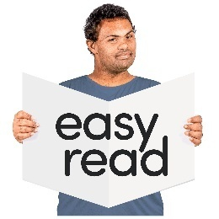

The first time we write a hard word we will write:

* the word in **bold**
* what the hard word means.

## Introduction

This document shares what people with disability said they want to be in DFAT’s Disability Strategy.

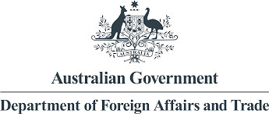The Department of Foreign Affairs and Trade is also called **DFAT**.

**DFAT** is a part of the Australian Government.

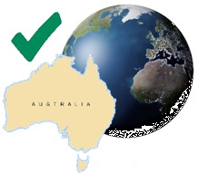DFAT’s job is to help:

* Australia work with other countries and help people and communities who need assistance
* Australia to be safe when working with other countries
* Australians who are in other countries if they need help.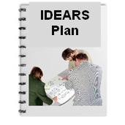

DFAT has made a new plan called Australia’s International Disability **Equity** and **Rights** **Strategy**.

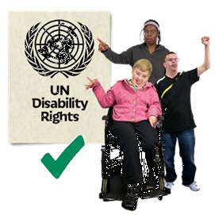**Equity** means everyone gets what they need to succeed.

**Rights** are things every person should have like:

* food and clean water
* being treated in a way that is fair and equal
* 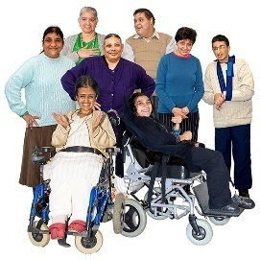a place to live
* being able to make your own decisions.

**Strategy** means to make a plan to do things in the best way to get things done.

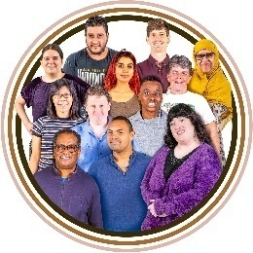Australia’s International Disability Equity and Rights Strategy is also called the **Disability Strategy.**   
The **Disability Strategy** will say how Australia will work to support people with disability overseas.

The Disability Strategy has been published on DFAT’s website. You can find it by typing in this web address on the internet:



**WWW.**

<https://www.dfat.gov.au/publications/publications/australias-international-disability-equity-and-rights-strategy-advancing-equity-transform-lives>

## What happened

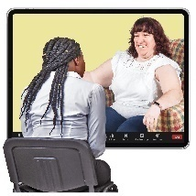From October 2023 to March 2024, DFAT asked almost 400 people what they want to be included in the Disability Strategy.

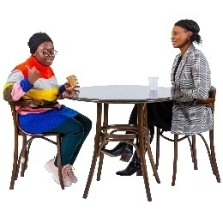DFAT spoke to these people in person and on video meetings on the computer.

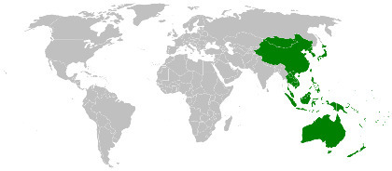Most of the people DFAT spoke to said they have a disability and were from places around the world, like:

* the Pacific area
* Southeast Asia.

There were more people with physical disability than other types of disability.

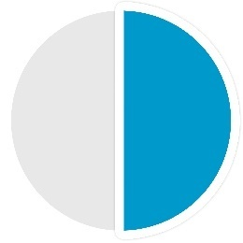

Almost half of the people with disability said they have a physical disability.

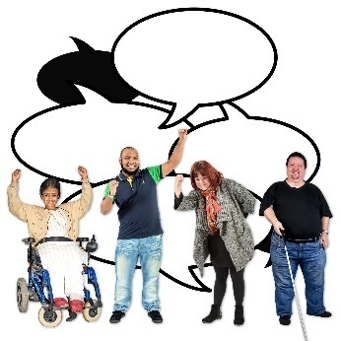DFAT also talked to people from **Organisations of Persons with Disabilities**.

We call these **OPDs**.

**OPDs** are organisations that:

* are run by people with disability
* have members who are mostly people with disability
* 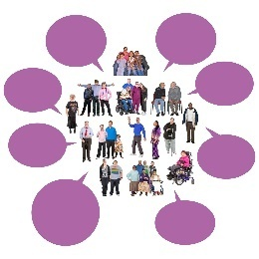work on disability rights issues.

DFAT also asked everyone that wanted to share their ideas, to send them to DFAT to be part of the Disability Strategy.

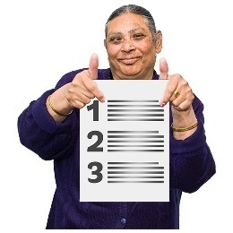Almost 100 people or organisations wrote to DFAT to share their ideas.

This document is a summary of some of the main ideas shared by people with disability and OPDs.

## **Australia’s role**

### Australia works to make sure people with disability get their rights. Some of the ways Australia does their work, is to:

* support people with disability around the world
* 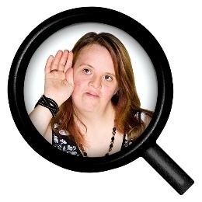make sure people with disability get their rights and are treated the same as everyone
* make sure DFAT listens to OPDs around the world
* 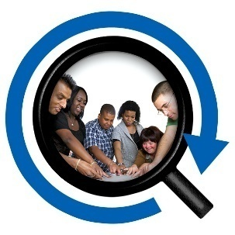help people with disability go to meetings and make sure they are listened to.

OPDs said Australia should keep working hard to do this.

OPDs want Australia to work with others around the world to help follow the **commitments** made in the **United Nations Convention on the Rights of Persons with Disabilities**.



**Commitments**

**Commitments** are things people say they are going to do.

These commitments are also called the **UN CRPD.**

The **UN CRPD** are commitments that governments around the world have made to make sure people with disability get their rights and are treated fairly.

OPDs want Australia to help them work with other

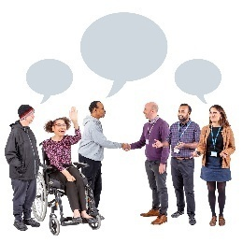governments to support people with disability to be part of things like:

* important meetings with governments and people from around the world



* talks about **climate change.**

**Climate change** means the Earth’s weather is changing. This makes some bad things happen. Like more and bigger natural disasters like:

* storms
* floods
* **droughts**. This means it does not rain for a long time.
* 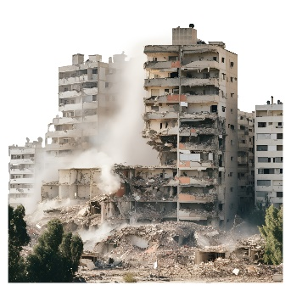talks about helping people in **humanitarian crises.**

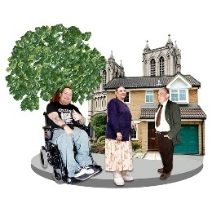**Humanitarian crises** are very bad things that can hurt lots of people. Like when there is a natural disaster or war.

Many OPDs said they want Australia to give them better support to help them make changes in **local** places.

**Local** means the place people live.

## **Support Australia gives**

Australia gives support to:

* + the **Pacific Disability Forum**.

This is a group of OPDs in the Pacific that speak up for people with disability.

* + 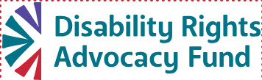the **Disability Rights Advocacy Fund**.

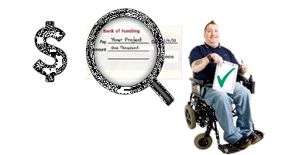This organisation gives money to OPDs to help make sure people with disability are treated fairly and the same as everyone else.

They also support OPDs and people with disability to get help from programs like:

* 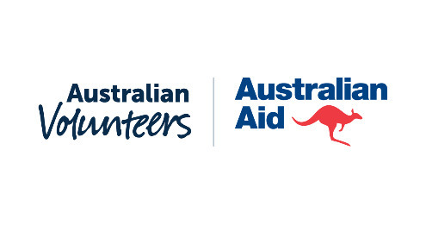the **Australian Volunteers Program**.

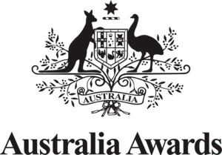This Program helps Australians go to other countries and help with important projects to make good changes.

* the **Australia Awards Scholarships**.

This is a way for people from other countries to study and learn in Australia for free or at a cheaper cost.

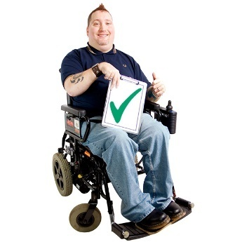OPDs said these types of supports are very important and should keep going so they can help more people.

OPDs said:

* 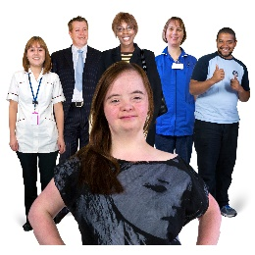Australia should help people with disability in other countries to be part of things like:
  + health care
  + 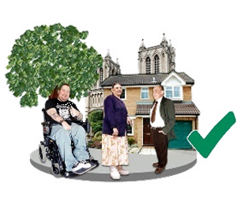education
  + work
  + living in the community
  + closing **institutions**.



**Institution** means a place where people live with lots of other people and do not get to choose things like what they do, eat or when they sleep.

* 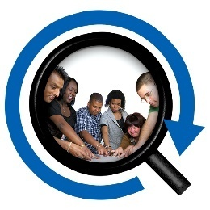Australia should be using information about their work in other countries to make sure people with disability are:

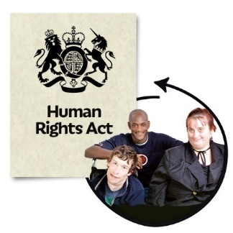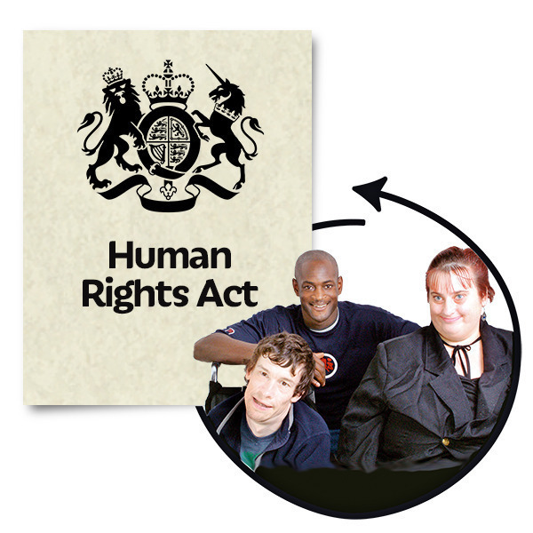

* + part of things
  + 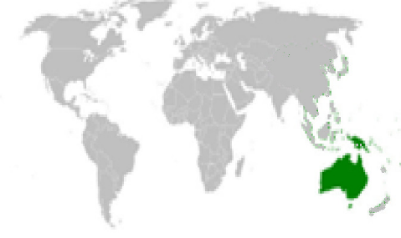can do the same things as other people.
* OPDs from the Pacific asked Australia to help them to get money to spend on disability when they need it.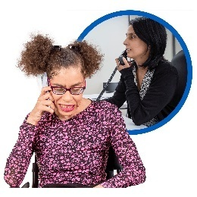

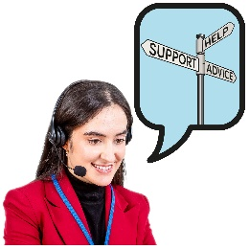They said they need the money for things like a **help desk** for governments and disability groups.

A **help desk** is a support team to help fix problems.

## Working with OPDs

OPDs said:

* they liked that Australia is working better with other OPDs and wanted more contact with DFAT
* they need more support to fund the work they do.

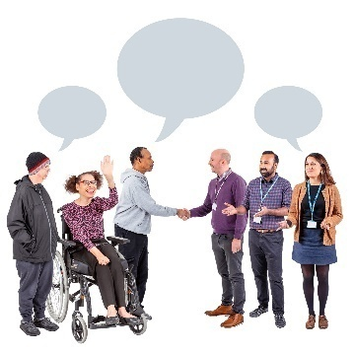OPDs said people with disability should have:

* a say in decisions just like anyone else
* lead and be part of things like **co-design**.

**Co-design** means working together to make

something.

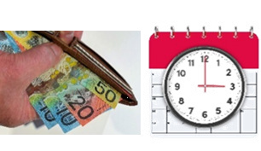OPDs should be paid when they take time to support DFAT’s work.

Working with OPDs will make sure people with disability can:

* get information in the way they need it and can understand it

speak up and be part of things the same as everyone else.

* Australia was asked to keep helping OPDs to give:
* 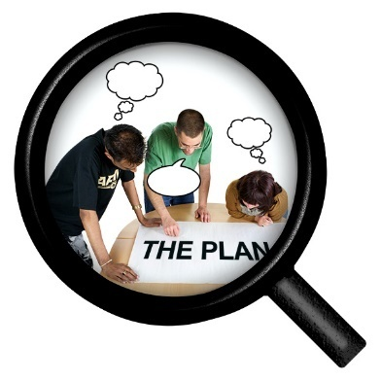advice and support to DFAT programs
* support to collect data and share what they learn
* support to plan and do projects
* 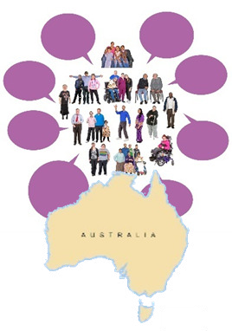support to understand how climate change and disasters can change the work OPDs do.

Australia should make sure they work with people with disability who are not always included or who are treated unfairly in the community.

These are people who are:

* 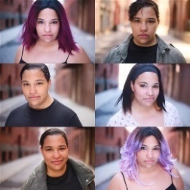**Gender diverse.** This is how a person sees themself, like woman, man, or non-binary.
  + **Non-binary** is when a person identifies as not being a man or a woman.



* + 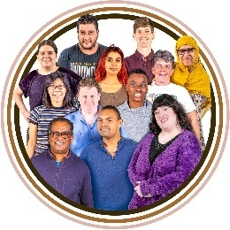**Culturally diverse.** These are people who might be born in another country.

This means they might have:

* other languages
* religions
* celebrations.

## Priority areas

OPDs said there are things that need to be done first to make sure all people have access and can participate in their communities.

They are:

### Being treated as equals and having laws that follow the UN CRPD

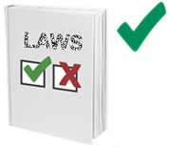OPDs said they want Australia to:

* help other countries make sure that laws and rules say what the CRPD says they should
* 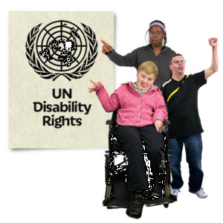make sure everyone has the right to have a say and make choices about their own lives
* help support other governments to learn about the rights of people with disability
* help translate the CRPD into the words used by people in other countries
* 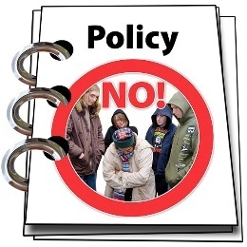teach people with disability about their rights.

OPDs said things need to change to stop:

* 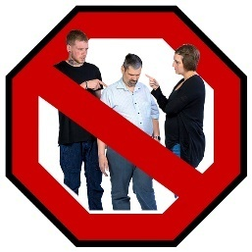**discrimination**. This is when people with disability are treated in an unfair way
* **stigma**. This is when people have wrong ideas about someone and treat them badly because of something that is different about them.

### Assistive technology and disability support services

**Assistive technology** means things people use to help them

access information, move around and to be included in the

community.

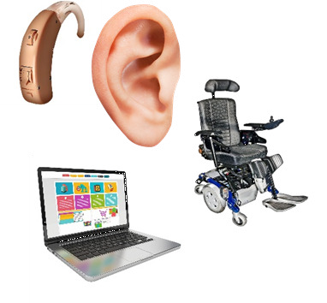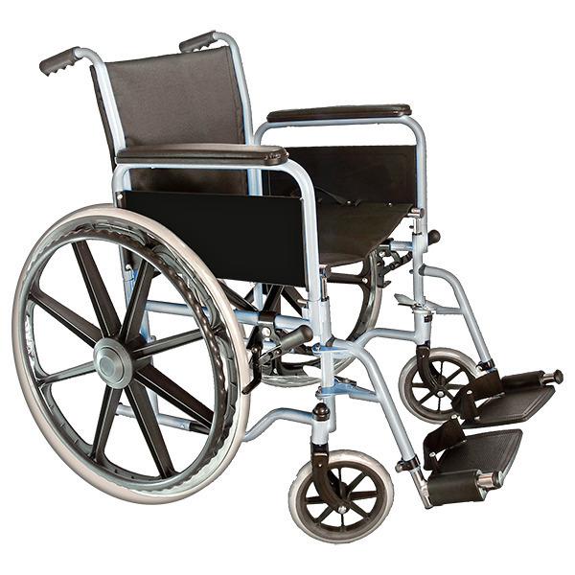

These are things like:

* hearing aids, to help people hear better
* wheelchairs, to help people get around
* screen readers, to read out loud words on a phone or computer.

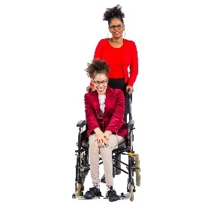**Disability support services** help people with disability with everyday tasks and activities.

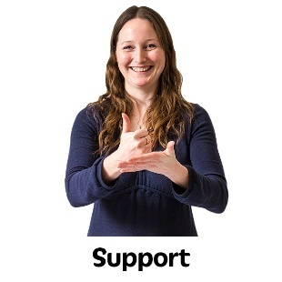This means having someone to help you:

* go to work or school
* go to a meeting
* 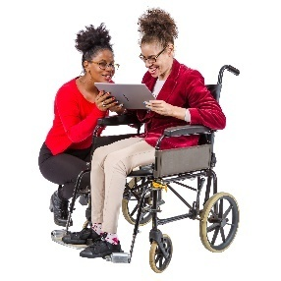shower and eat.

OPDs said it is important for Australia to support assistive technology to help people with disability in their communities.



OPDs said that it should be easy to get assistive technology and not cost too much.

OPDs said that:

* 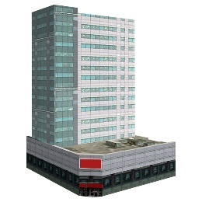their governments do not know much about support services for people with disability
* they want more money spent on support services and the people who work for the services
* 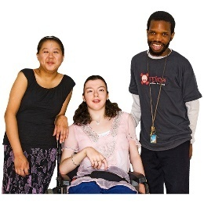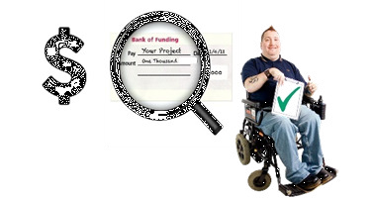money should be spent on support services in the community, so that people with disability can stay in the community while getting them
* OPDs talked about how important family, friends, and the community are in supporting people with disability.

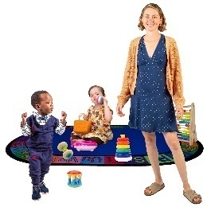OPDs said there are three areas that need more disability support services.

These are:

1. **early childhood development and intervention**, means providing support for young children with disability to learn and grow
2. 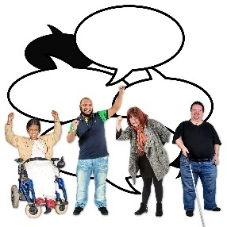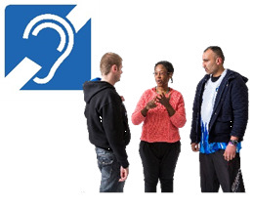**sign language,** whichis a way for people who are Deaf to communicate using their hands.

Not all countries have a shared sign language.

It is important for countries to make their sign language so people who are Deaf can communicate with each other.

It is also important for the government to have laws to make their sign language **official**.

**Official** means a thing that is done or decided by an important person, like someone from the Government.

1. 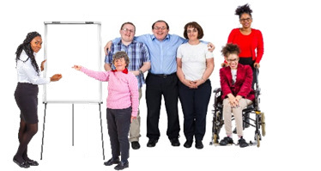making training and qualifications for caregivers and service providers. This means making sure that people who support people with disability have the right skills and know how to care for and keep people with disability safe.

### Accessibility

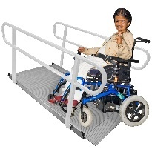**Accessibility** means that everyone can use or understand something, including people with disability.

Accessibility is a human right and not having access can be a problem for people with disability around the world.

OPDs said:

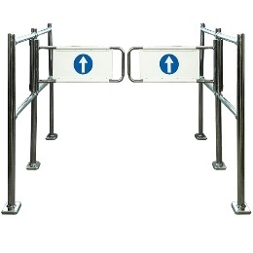

* they know there are lots of things that get in the way or stop people accessing things
* Australia should support other countries to make things accessible for everyone
  + 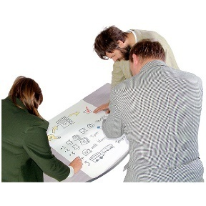this can be done through **universal design**. This is when things are made, or changed, to make sure that everyone can access them.
* 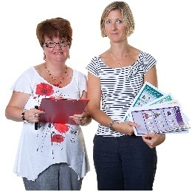Australia should make sure that they use information that everyone can understand and access when they meet with OPDs.

This can be done by using more than one way to share information with people, like:

* + plain words
  + Easy Read
  + 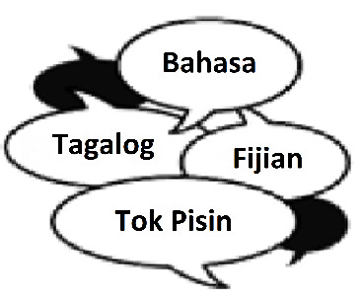the language people use
  + ways that people with blindness or low vision or who are Deaf can also access.

### Social protection

**Social protection** means things the governments pay for to help people who might need extra support.

This includes money and services to make sure everyone can lead a safe and good life.

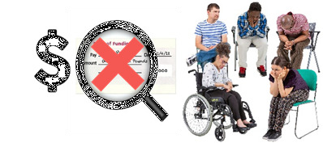OPDs said:

* people with disability are not getting the right amount of support from their governments to pay for things they need to help with their disability
* 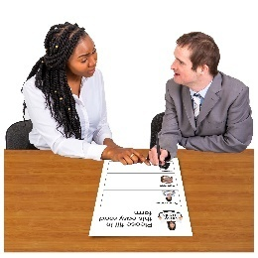it is important to help people with disability get the support they need, like making it easier for them to access help
* we also need to listen to OPDs about what needs to change so people with disability can access social protection.

### Doing things in and with the community

OPDs said there need to be:

* programs Australia funds to help communities to:
  + know about disability rights
  + know about **barriers**. This means things that stop people from being included or part of a community
  + include people with disability.
* 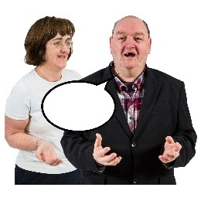more support for OPDs to **advocate** for people with disability and people who are left out.  
  **Advocate** means to speak up for or support a person to speak up about what they want
* more work to stop people with disability being hurt or injured by other people. This is even more important for women and children

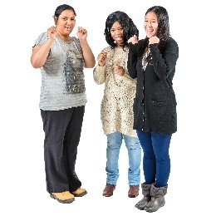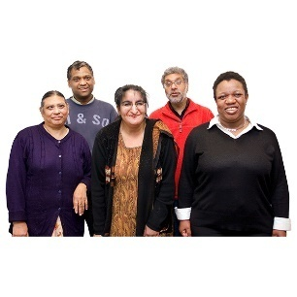

* 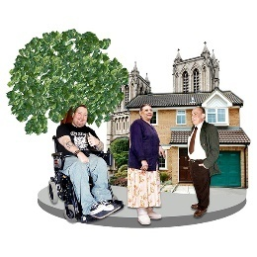more support to help people with disability be part of their communities.

### Other important things

OPDs said:

* Australia’s support has helped make some rights better for people with disability.

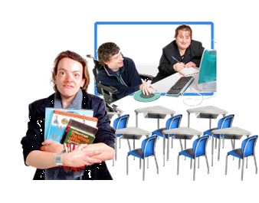There needs to be more support for:

* 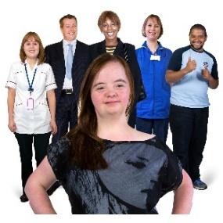**Inclusive education**. This means everyone can learn together, and teachers and students with disabilities can get supports they need
* **Inclusive health and rehabilitation**. This means everyone, including people with disabilities, can get the health care they need
* 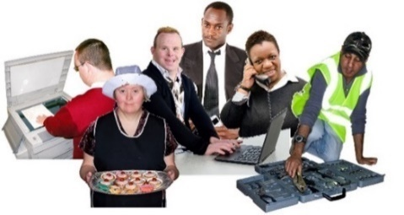**Employment opportunities.** This means more jobs for people with disability, like:
  + help to start up their own small business
  + training in new skills.

Australia should do more work to support people with disability when there is a **disaster**.

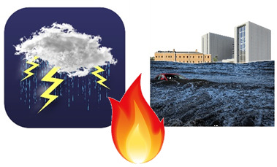A **disaster** is when things go very wrong, like:

* floods
* fires
* big storms.

## How things will be done

### Including people who are not always included

OPDs said:

* it is important to know that people with disability are not all the same, they have different needs because of their disability and their:
  + age
  + gender
  + culture
  + **LGBTQIA+** identity. Each letter of **LGBTQIA+** stands for a different way people can feel about who they love or how they see themselves.
* 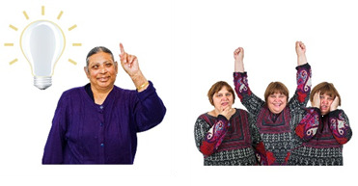they are worried that it is not well known what people with **psychosocial** disability or **cognitive** disability need.

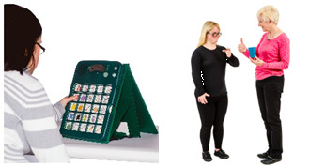**Psychosocial disability** means how some people have different ways of thinking, feeling, or saying how they feel.

**Cognitive disability** means how some people have different ways of communicating, remembering, understanding new things, or thinking about one thing at a time.

* 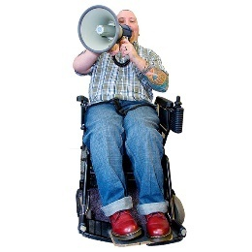that Australia can support people in these groups to speak up for themselves and become leaders
* 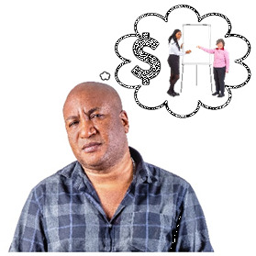they are worried that disability will not be as important when it is grouped together with other things like gender
* they said it is important to have **experts** and money

to support the needs of people with disability.

An **expert** is a person who knows a lot about

something. This could be people with

disability or OPDs.

### Information that supports rights and helps people with disability having the same chance do the same things as other people.

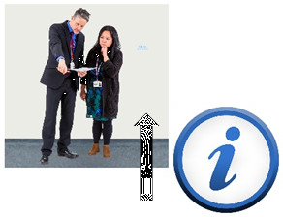OPDs said that:

* more work needs to be done to get and share information about disability
* Australia needs to get better at checking how well their programs include people with disability
* more needs to be done to find the best ways to work on how communities can support disability rights and inclusion of people with disability.

### Greater support needed to follow the rules of the CRPD

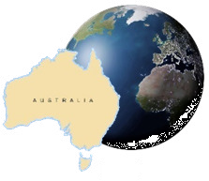OPDs said:

* they want Australia to help other governments put money and do more work towards disability. They want Australia to speak up with people with disability to make sure they get their rights, like:
  + making sure there is money to help other governments include people with disability
  + supporting OPDs that advocate for people with disability.

### Invest in DFAT’s capability

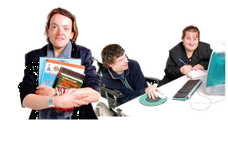**Invest** means to spend time and money to make things better.

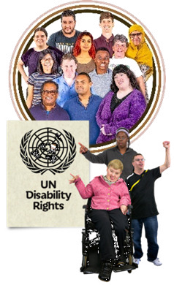**Capability** means things you can do, like learn new skills.   
  
OPDs said:

* DFAT needs to get better at helping people with disability be included more in their country
* they want DFAT to get better at knowing about disability equity and rights
* 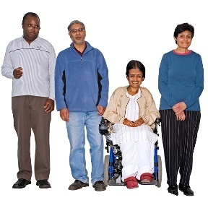a local Disability Advisor could be employed in countries that DFAT works in, to help people with disability to be included in their communities better
* people with disability should be included in:
  + **mainstream** programs. These are activities that help everyone together, like people with and without disabilities
  + 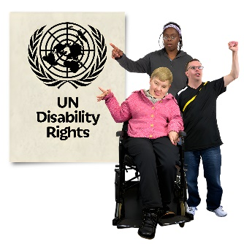**disability-specific** programs. These are things done just for people with disability.

Like stopping things that make it hard for people with disability to be part of their communities.

* 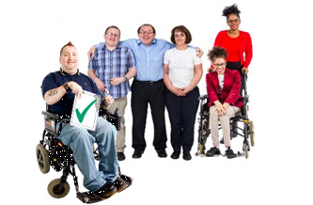Australia should make sure more people with disability are part of things within DFAT, like:
  + being part of important meetings and decisions
  + getting jobs at DFAT.

This will make more ways for people with disability to work with and give feedback to DFAT.

