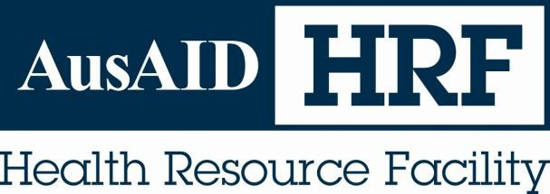

Technical Report

Reporting Period: 22nd July 2011 – 21st January 2012

Date submitted: 20th February 2012

AusAID HRF
HLSP in association with IDSS GPO BOX 320
15 Barry Drive
Canberra City ACT 2601
Tel: +61 (2) 6198 4100
Fax: +61 (2) 6112 0106 www.ausaidhrf.com.au

Table of Contents

Acronyms ................................................................................................................. i

HRF at a glance ....................................................................................................... 1

HRF headlines: July 22nd 2011 – January 21st 2012............................................ 2

Examples of HRF Assignments.............................................................................. 5

Annex 1: Sourcing of Technical Assistance ....................................................... 16

Annex 2: Communication Activities, including web site .................................... 27

Annex 3: Plaudits .................................................................................................. 30

Annex 4: HRF Non-Core Activities delivered in the reporting period ................ 33

Annex 5: HRF Core Knowledge and Information Activities ............................... 39

Annex 6: Analysis of Contractor Performance Assessment Received Jan 2009 to January 2012 ..................................................................................................... 41

Annex 7: Knowledge Requests Feedback ........................................................... 43

List of Tables

Table 1: Proportion of potential commissioners that have contracted the HRF Jan
2009 to January 2012.............................................................................................. 24

Table 2: Knowledge Requests Feedback (formally known as Help Desk Feedback)
– July 2011 to January 2012 ................................................................................... 43

Table 3: Cumulative Knowledge Requests Feedback (formally known as Help Desk
Feedback) - Sept 2009 to January 2012.................................................................. 43

List of Figures

Figure 1: Contracted days vs. Billed days – Jan 2009 – Jan 2012............................ 2

Figure 2: Active Days Carried to Following Period.................................................... 3

Figure 3: Service orders by services type - Jan 2009 to Jan 2012 .......................... 17

Figure 4: Service orders by services type – Jul 2011 to Jan 2012 .......................... 17

Figure 5: Source of nominated and contracted consultants – July 2011 to January
2012 ........................................................................................................................ 18

Figure 6: Nationality of nominated and contracted consultants – July 2011 to
January 2012 .......................................................................................................... 19

Figure 7: Proportion of Australian versus Non-Australian and new to AusAID
consultants used by HRF Jan 2009 to Jan 2012 ..................................................... 20

Figure 8: Origin of requests (requesting AusAID section) – July 2011 to January
2012 ........................................................................................................................ 21

Figure 9: Geographic distribution of assignments – July 2011 to January 2012...... 22

Figure 10: Days contracted by commissioning section, July 2011 to January 2012 22
Figure 11: Origin of requests (requesting AusAID section) – Jan 2009 to January
2012 ........................................................................................................................ 23

Figure 12: Topics of assignments according to the categories of expertise in scope of services – July 2011 to January 2012.................................................................. 25

Figure 13: Types of assignments – July 2011 to January 2012 .............................. 25

Figure 14: Hits on the website, by month – May 2009 to Jan 2012......................... 28

Figure 15: Website membership by country (AusAID staff) – Jan 2012 .................. 28

Figure 16: Downloaded Files by Visitors – July 2011 to Jan 2012 .......................... 29
HRF Technical Report Submitted xx February 2012
Period Offer Deed 48511

Acronyms

AusAID Australian Agency for International Development

CD Communicable Diseases

CPA Contractor Performance Assessment

ERF Education Resource Facility

FAQ Frequently asked Questions

GIPA Greater Involvement of People living with HIV/AIDS HRF Health Resource Facility
HHTG Health and HIV Thematic Group HIV Human Immunodeficiency Virus HRH Human Resources for Health HSS Health System Strengthening
IDSS International Development Support Services

NCD Non-communicable diseases

MoH Ministry of Health

MSM Men who have sex with men

PAEP Performance Assessment and Evaluation Plan

PDS Professional Development Services

PICs Pacific Island Countries

SO Service Order

SPMF Specified Personnel Management Fee

TOR Terms of Reference

QA Quality Assurance

HRF Technical Report
Period Offer Deed 48511

HRF at a glance
Submitted 20 February 2012

HRF goal

To contribute to improvements in the performance of Australia's international development activities in the health sector in partner countries, including through contributions to health policy and strategic planning processes, and health programming. Thereby contributing to improving the health of citizens in Australia's partner countries

HRF objective
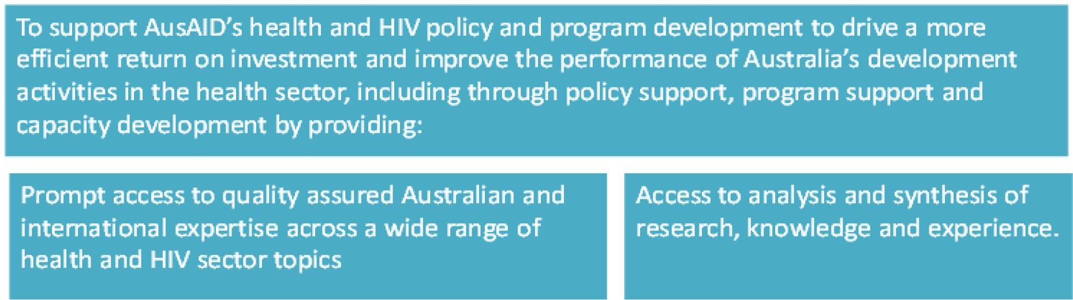

AusAlD Health Resource Facility
Managed by HLSP in association with lOSS

HRF headlines: July 22nd 2011 – January 21st 2012

Demand. Demand for HRF services has consistently increased year on year over the last three years. Since January 2009, 129 Service Orders have been agreed for a total of 5451.5 consulting days. During this six month reporting period the HRF agreed a total of 30 separate Service Orders, and five amendments for pre-existing SOs, for a total of 1511.5 consulting days (see Annex 4). The Help Desk knowledge
services continue to be well used during this period with demand averaging at around three days a week, and 2.4 days per request. Thirty-one requests have been responded to, 70% of these from HHTG and the remainder from posts and desks
(see Annex 5).

In year three we have been contracted for a total of 3038.5 consulting days, around a third of these in the last quarter (especially the first few weeks of January). This means we have entered year four with a very high number of ongoing Service Orders to be delivered in year four. Since the 22nd January (ie in the last three weeks at the time of writing) we have been contracted for an additional 670 consulting days. This is the same as for the entire same quarter in year 2. There are 200+ days in the active pipeline.

Contracting

Figure 1: Contracted days vs. Billed days – Jan 2009 – Jan 2012

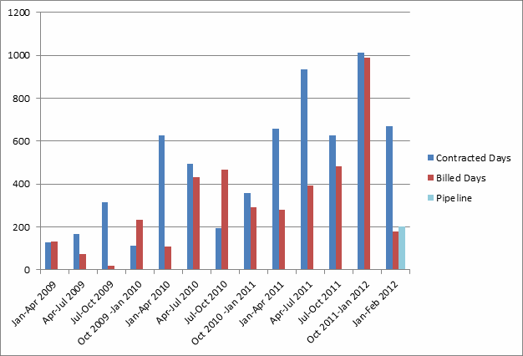

When looking at non-billed days carried forward to the following reporting period (Figure 2) the trend is evident. The number of active days at the end of this reporting period is almost 3 times the level that it was at this time last year. There was a similarly high level at the last 6 month report (July 2011) suggesting that the trend isn’t just a knock-on effect of the delays associated with the contract amendment.

Figure 2: Active Days Carried to Following Period

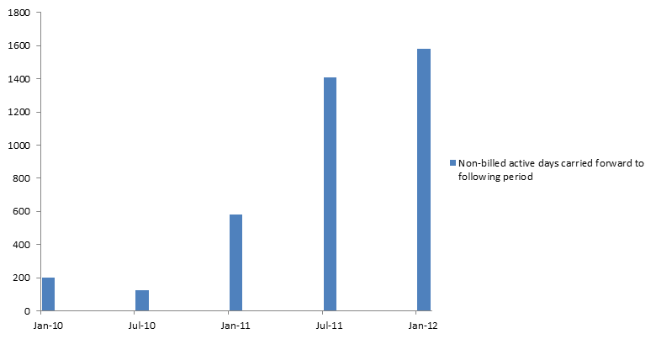

Resourcing. Amendment two is based on a ceiling of 2200 consulting days in year four (+10% in year five), 300 Specialist pool days and up to three days Help Desk knowledge time a week where capacity allows. This was calculated in late September 2011 as a working figure for discussions based on demand at the time and assuming demand between Oct 2011 and Jan 2012 would be the same as year two (ie around 300 days). However demand between Oct 2011 and Jan 2012 has
exceeded expectations, with a clear trend of increasing demand. In addition we have entered year four with a much higher than anticipated active work portfolio.

We would like to discuss this item at the Steering Committee. We do not want any decrease in quality (indeed our aim is to continually improve). Nor do we want a higher than planned for demand for assignments to compromise the high value strategic and analytical work in years four and five. Our assessment is that the high demand for HRF services in year three will continue into years four and five and that there is a need to plan now how to manage. We see three options:

1 HRF to work with HHTG using the workplan process to prioritise HRF capacity with lower priority requests to be managed through alternative mechanisms.

2 HRF to work with HHTG to phase requests, perhaps through a waiting list system.

3 Consider additional resources now to respond to additional demand as and when it arises.

Clients. A good range of fifteen different posts and sections contracted the HRF

during this reporting period, with HHTG and East Timor being the biggest users of

the HRF in terms of number of days contracted. Of the 24 different posts / sections identified as potential clients of the HRF, 20 have now contracted the HRF. Of these
20, 17 (or 85%) have contracted us more than once. This is up from 70% in the last reporting period with more users being repeat users.

Feedback. Annex 6 analyses all the completed CPAs received. This analysis covers a 36-month period since the beginning of the HRF (Jan 2009 to Jan 2012). Overall the average score for all assessment criteria was 3.91 (just below highly satisfied) with the Help Desk continuing to score 4.2. Scores have been reasonably consistent over the last two years. The average score for the last six months was 3.81, slightly below the previous reporting period. We are missing 5 CPAs (SO92, SO95, SO111, SO115, and SO125).

Overall the average score for client feedback for core knowledge requests under the Help Desk has remained at 3.6 (between Good and Excellent) in this reporting period. This is slightly higher than the overall average score of 3.5 for all feedback received to date (Table 3 in Annex 7).

Operational Issues. The HRF continues to experience ongoing issues with commissioners that undermine good practice to engage with and get maximum value from the HRF. These include direct communication between client and consultants on TORs, scope of work, feedback on reports etc.
HRF Technical Report Submitted 20 February 2012
Period Offer Deed 48511





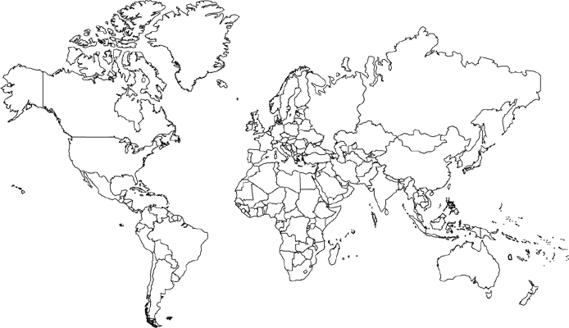
Examples of HRF Assignments

Mekong, November 2011: Preparatory support to Mekong team meeting to develop a health framework


Vanuatu, 2011: Joint Partnership Agreement for Health

Vanuatu, July – November 2011:
Public Expenditure Review

Tonga, 2011-2012:
Capacity building support for in- country partners of the Australian Sports Outreach Program in Tonga


South Sudan, August 2011:
Draft social appraisal in support of the development of the Business Case of the Health Pooled Fund (HPF) for AusAID, DFID and joint donor support to the health sector.

Central support, July 2011
Review of World Food
Programme concept notes

Papua New Guinea, 2011
Evaluation of the Australian Aid Program’s Contribution to the HIV Response in Papua New Guinea


AusAID Health Resource Facility 5
Managed by HLSP in association with IDSS

Examples of HRF Assignments

The new AusAID health strategic framework has six pillars for investment. Through its consultancy, knowledge and professional development services, the HRF has provided support to AusAID staff across all six interlinking areas.

Australia six pillars for health:

1. Supporting partner countries to deliver more and better-quality health services for poor and vulnerable people

2. Closing the funding gap to provide essential health services for all

3. Empowering poor and vulnerable people to improve their health

4. Working with other sectors, such as education, water and sanitation, and rural development, to address the causes of poor health

5. Reducing the impact of global and regional health threats, particularly in Asia and the Pacific

6. Maximising the impact of Australia’s total health ODA investment in partner countries

1 Supporting partner countries to deliver more and better-quality health services for poor and vulnerable people

AusAID is committed to supporting its partner countries to deliver equitable,

affordable and quality health services. The HRF has provided consultants to carry out several program designs to ensure that services provided are both evidence-based and responsive to partner countries’ needs. In East Timor, HRF consultants are designing a program to support the continuation of specialist medical services to respond to the country’s need for surgical capacity. The HRF also provided inputs into the preparation of a detailed design, implementation and M&E plan of the second round of support to the National Health Sector Strategic Plan (2012-15). In Indonesia, the HRF supported the AusAID country post to finalise the design of the Health Systems Strengthening project and to ensure buy in from the Government of Indonesia. In the Solomon Islands, the HRF has provided senior advisory support to develop a concept document for AusAID’s contribution to the Health Sector Support Program 2012-2016.

In many AusAID partner countries, insufficient human resources pose a key challenge for the health sector. The HRF supplied HHTG with a part-time senior human resources for health (HRH) adviser to provide policy advice on HR and related sectoral issues. The HRF review of the Pacific Regional Health Systems

AusAID Health Resource Facility 6
Managed by HLSP in association with IDSS

Strengthening Initiative reviewed a number of AusAID funded initiatives related to HRH in the Pacific. In addition, the HRF Help Desk reviewed the Nepal Human Resources for Health Strategic Plan 2011-2015 with reference to international best practice.

At a national and regional level, the HRF provided a consultant to assess the capacity of Papua New Guinea’s National Department of Health to deliver its mandate and to identify possible approaches and incentives to support it to carry out its specified functions. The Help Desk reviewed an independent report which assessed China’s health reforms to identify key areas of progress and critical constraints to achieving the country’s long term 2020 health goal. The HRF was tasked with a formative evaluation of the Pacific Senior Health Officials Network, which aims to facilitate communication between senior health officials in the Pacific
and Australia in order to strengthen health systems governance and the development and implementation of effective health policies.

Identifying emerging health issues in the Mekong

In November 2011, AusAID held a meeting for its Mekong team to develop a health policy framework and identify priorities for future programming.

The HRF Help Desk was tasked to carry out a ‘horizon scan’ of key emerging health issues in the region, specifically Burma, Cambodia, China, Laos, Thailand and Vietnam. The final output was a
20-30 minute power point presentation, which was used at the Mekong Health meeting. The presentation covered key statistics, sub-regional health issues and identified long term and short term priorities. The presentation concluded with suggested bilateral and multilateral approaches to health issues in the region and formed a key input to the regional meeting. This was followed up
with a briefing note on health in the Greater Mekong Sub region.

2 Closing the funding gap to provide essential health services for all

Pooled funding arrangements have been a recurrent theme in the HRF’s recent work. The HRF was commissioned to produce a guide to enable AusAID staff to better understand and implement a Sector Wide Approach (SWAp), this includes SWAps in fragile states and practical advice on harmonising and aligning donor support.

At country level, the HRF carried out a number of consultancies to strengthen pooled funding arrangements and joint donor programs in the health sector. The HRF finalised the design for the successor to Myanmar’s Three Diseases Fund, which was set up to finance HIV, TB and malaria interventions after the Global Fund pulled out
in 2005. In Papua New Guinea (PNG), the HRF assisted the Government and

AusAID to strengthen health partnerships to facilitate improved health service

delivery within the context of a SWAp. Following a review of the Solomon Islands health SWAp, the HRF provided recommendations for future sector engagement and ongoing quality dialogue among SWAp partners. The HRF conducted a short desk review and made recommendations on the health SWAp in Samoa.

In Vanuatu, the HRF provided a Strategic Budget Adviser to support the Ministry of Health to develop a more strategic approach to allocating government and donor resources, and to engage with AusAID’s transition to program-based funding. This work was followed by an independent assessment of Vanuatu’s health sector spending to help refine the Ministry of Health Corporate Plan and identify expenditure priorities (see text box below).

Supporting health sector spend in Vanuatu

In 2011, the Government of Vanuatu conducted a health public expenditure review (PER) to complement the Treasury’s analysis of the effective and efficient use of public monies. A small team of HRF consultants carried out the PER with the aim of assessing current health sector spending to inform the Ministry of Health (MOH) Corporate Plan, and to identify expenditure priorities and adjustments required to translate this sector strategy into reality. Of particular importance was an integrated analysis of recurrent and development budgets in the sector, and similarly, integrated analysis of Government-funded programs and donor-funded projects. The review was also supported by MOH management who wanted to be able to apply the output from the analysis to be able to improve their internal resource allocation.

The HRF consultant was physically located in the Ministry of Finance and Economic Management (MFEM) alongside the key government sector analysts and provided with full access to budget and expenditure information for the health sector. Health performance data (where available) was provided by the MOH. Early analysis was presented to government officials from the Prime Minister’s office, MFEM and MOH in order and comments received along with requests for additional information from interested participants. The MFEM were very clear that they did not want the output to be a consultant report sponsored by a donor – this was very much a
government output. The consultant’s draft report and analysis was not circulated, but instead was handed to the MFEM to be formatted as a Treasury report before passing to the MOH for comment.

The final report included recommendations on how to improve the efficiency of public expenditure in health and how to build capacity for internal monitoring in the Ministry of Health. The recommendations are now under consideration by the Vanuatu Government.

AusAID continues to play an active role in supporting major international health financing organisations. This is reflected in recent HRF assignments including a review of the draft GAVI supply and procurement strategy and a substantive mapping exercise of all the Global Fund’s grants in Asia Pacific. The HRF also produced a paper summarising the implications of the Global Fund financial squeeze as well as providing a short analysis on the impact of the global financial crisis – looking at the

effect previous crises have had on health spend, the impact of the current crisis and

implications for donors in Asia Pacific.

The Help Desk also provided a summary of the global experience of separating medical procurement functions from the Ministry of Health (MoH) to see what had worked best in terms of driving down drug prices and maximising efficiency.

3 Empowering poor and vulnerable people to improve their health

Australia’s latest health strategic framework will continue to support poor and vulnerable people to demand and access affordable, quality health services and interventions. The HRF’s assistance to the aforementioned PNG partnership project (see section 2) included support to three pilot provincial health authorities (PHAs). These PHAs have been set up in order to better unify provincial hospital services (managed nationally) and rural health services (managed provincially). Similarly, in Nepal the HRF has been reviewing two AusAID-funded UNICEF programs to assess their contribution to maternal, neonatal and child health services for the disadvantaged.

Social appraisal in South Sudan

In support of the development of the South Sudan Health Pooled Fund, the HRF was commissioned to conduct a social appraisal to provide a detailed social and gender analysis of areas in which the health pooled fund would work.

The Health Pooled Fund is planned to run from mid 2012 to mid 2015 and comprises AusAID, DFID and joint donor support to the health sector. The HPF will fund primary and essential health service delivery in 6 of the 10 states of South Sudan. The social appraisal represents AusAID’s significant input into the fund’s design and has been incorporated by DFID into the design.

The work involved extensive consultation with key relevant stakeholders, including citizens, government, civil society, donors, local and international NGOs, and UN agencies. The appraisal looked at poverty and gender issues, as well as examining the impact of conflict on access to
health services and health-seeking behaviour.

Civil society plays a critical role in advocating for health services. In 2011, the HRF provided a team to put together a program design for a new grants facility to support civil society organisations in the Asia Pacific region to be effective advocates for, and contributors to, inclusive evidence-informed HIV responses which meet Australian aid quality criteria. The design, however, was not completed as AusAID decided not to finalise the facility.

The Help Desk carried out an appraisal of two proposals seeking support for the introduction of gender-based violence (GBV) screening and counselling referral into antenatal care services within Fifi and the broader region.

4 Working with other sectors, such as education, water and sanitation, and rural development, to address the causes of poor health

The scope of the HRF’s assignments has extended beyond health and HIV to include

other related sectors and multisectoral work.

One key example is the HRF’s work on non-communicable diseases (NCDs). The

HRF carried out an independent completion review of the Pacific Regional NCD 2-1-

22 Program and recommended how AusAID support for NCDs in the Pacific should be delivered beyond 2011. Ahead of the UN High Level Meeting on NCDs in September 2011, an HRF consultant provided high-level policy advice to guide Australia’s input into the high-level event and its follow up, through a round table discussion of key issues. In Tonga, HRF consultants helped build the capacity of project partners the Ministry of Health and the Ministry of Training, Employment, Youth and Sport in order to design, implement and evaluate a Strategic Health Communication Plan for the ‘Sport for Health’ program that aims to combat NCDs (see text box below).

The HRF provided a health sector note as part of an integrated strategy to strengthen the capacity of the Pacific’s post-secondary education and skills development institutions to produce quality graduates who can contribute to their nation’s
economic and social development. The note looked at skill gaps in medicine, medical services, nursing and dentistry.

Two knowledge requests through the Help Desk reviewed the economic and epidemiological validity of a recent paper on the prevention of childhood drowning in low and middle income Asian countries. While an evaluation of the Mekong HIV Prevention and Mitigation program assessed projects to mitigate the spread of HIV associated with construction work.

Linking sports and health in Tonga

This assignment was initially conceived as a short term TA input to the Tongan Ministry of Health (MoH) to support the roll out of a Strategic Health Communication Approach (SHC). All four NCDs subcommittees (tobacco, alcohol, healthy eating, physical exercise) had been mandated to implement this approach – but with little training or understanding of what it entailed.

The HRF identified a consultant to carry out mentoring and training, a role which has now been extended to include a fully documented pilot program to demonstrate effectiveness and help build an evidence base for this approach. Uniquely, this assignment has brought together and built a stronger relationship between the Ministry of Health and the Ministry of Sport in Tonga and will provide robust evidence of the potential to use sport as an intervention in managing / mitigating NCDs in the Pacific. The assignment will have significant impact on NCD social marketing in Tonga – and ultimately across the Pacific. A significant next step will be the focus of a Healthy Islands meeting of Ministers of Health and Sport in March 2012, which will examine the link between sport and health.

Partner Australian Sports Commission (Sports Outreach Program or ASOP) have secured agreement from the consultant to continue working with them beyond this contract as the programme expands; ultimately rolling out to other ASP countries, Samoa, Vanuatu, Nauru,
Kiribati. AusAID have committed funding for this expansion of the program.

5 Reducing the impact of global and regional health threats, particularly in Asia and the Pacific

Emerging infectious diseases and drug resistance pose a serious threat in Asia and the Pacific. On the issue of drug resistance, the help desk prepared a technical briefing on multi-drug resistant tuberculosis in Asia and malaria drug resistance in the Mekong. In addition, the HRF is in the process of undertaking an analysis of the current strategic frameworks, epidemiological data, technical and program responses to artemisinin resistant malaria in the Mekong. This consultancy will inform countries and international agencies of opportunities to advocate for political commitment to address this issue.

The HRF has also been involved in broader malaria advisory support. An HRF technical issues paper provided a synthesis of the current evidence base for investing in malaria control and elimination, made policy recommendations for
Australia’s aid program as well as engaging with Australian universities and research organisations to look at the implications of the research agenda for malaria. The HRF carried out a progress review of the Asia Pacific Malaria Elimination Network (APMEN) Establishment Support Program, which aims to work collaboratively to address the regional challenges of malaria elimination. The HRF prepared a final concept design note which provides the basis for the next phase of Australia’s
support for malaria in the Solomon Islands and Vanuatu.

A large proportion of the HRF’s advisory work relates to HIV issues and in particular evaluations of HIV programs. The HRF provided a consultant to carry out a mid-term review of the Australia–Indonesia Partnership for HIV (AIPH). In PNG, the HRF managed the strategic evaluation of Australia’s support to PNG’s national HIV response, including assessing the effectiveness and appropriateness of support (see bix). Also in PNG the HRF evaluated the effectiveness of existing ‘promising’ HIV prevention activities. In addition, the HRF is providing ongoing strategic advice to donors, governments and their partners on options for addressing HIV epidemics in Asia.

A strategic approach to HIV in Papua New Guinea

Papua New Guinea’s HIV epidemic is at a critical point – with new cases outstripping prevention and treatment efforts. If growth continues at this rate it threatens to reverse development gains made by the country, in particular placing added burden on the health system.

In 2009, the Independent Review Group on HIV/AIDS noted the lack of reliable information on both the nature of the epidemic and which interventions are having an impact. AusAID commissioned the HRF to run the first evaluation of Australia’s HIV programs in PNG. The evaluation, which covers the period 2006-2010, assessed whether the aid program's approach to supporting the national HIV response was effective for the context, and of a scale appropriate to the needs.

The evaluation team agreed with the consensus that, without AusAID support, PNG’s HIV response would be considerably less advanced. However, the team did note that by acting as a stand-alone program, the HIV response had missed some opportunities for addressing wider development issues. It was recommended that AusAID invests resources in expanding community based, integrated sexual health prevention and promotion services. The evaluation also found that AusAID can be credited with success in improving processes and increasing access to HIV services. That said there is little evidence that this process support has had an impact on reducing the spread of HIV.

The existing management arrangements of the HIV program were found to place a great burden on AusAID staff. As such, the evaluation recommended a move to a program management model that combines strategic technical HIV capacity within AusAID and implementation through a managing contractor (international non-governmental organisation, national organisation or private sector). AusAID has now tendered for an Implementing Service Provider (ISP), a step that will bring together the implementing agency contracts for health and HIV. While the evaluation cannot be directly credited with this outcome, it is in line with the team’s recommendations to rationalise management arrangements and integrate HIV and health interventions.

The scoping for the ISP tender was done in March/April last year, around the same time as the peer review of the strategic evaluation. The recommendations in the scoping report are consistent with the evaluation and it could be fair to say the evaluation had an influence on the broad changes in direction around the health/HIV teams.

6 Maximising the impact of Australia’s total health official development assistance (ODA) investment in partner countries

A significant number of HRF requests are aimed at helping AusAID to maximise the impact of its international health program, this includes advisory support, work on harmonising donor support, operational research and impact evaluations, and support to build the evidence-base for cost-effective interventions.

The HRF has sourced a number of technical advisors to work across AusAID’s health

program, this has included:

• Interim Health Advisors in Bangladesh, Cambodia and East Timor

• Part time Advisors to support the Health and HIV Thematic Group

• A Strategic Health Advisor supporting the Human Development Pacific Team to identify priority health interventions and design, implement and evaluate health investments in the Pacific region.

• Support to recruit a new Maternal and Child Health Advisor for Ethiopia

• Policy advice on NCDs

As well as providing consultants to take up specialist posts across Australia’s health program, the HRF has also focused support on AusAID’s organisational structure and workforce in order to help it undertake its expanded aid program. One such consultancy was the review of the role and functions of AusAID’s sector policy division to identify how it can effectively support program development and delivery. Requested by the Director General, this work also took into account the outcomes of the 2011 Independent Review of Aid Effectiveness.

With workforce issues posing a key challenge to the scale up of Australia’s aid program, the HRF has provided phased support to help AusAID ensure it has the staff resources to deliver on its strategy. As a first step in integrating workforce planning into AusAID’s corporate reform agenda, the HRF facilitated a workshop to identify and agree a vision. An HRF consultant has since been supporting the development of a workforce plan, which includes work environment, demand and supply forecasts, and prioritised strategies to address gaps in critical job roles.

Support has also been provided to the Health and HIV Thematic Group (HHTG) to develop a knowledge and capability framework for the health sector, and input into the capability framework for aid management.

The HRF’s assistance in helping AusAID address its resourcing challenges was complemented by work to support the professional development of staff members in the health program. New health posts come from a variety of different backgrounds. The HRF has been finalising accessible and concise predeployment briefings covering a range of health topics in order to strengthen the capacity of such staff.

The HRF has been supporting AusAID’s need to demonstrate the results of its health program. In the context, the Help Desk reviewed and commented on versions of HHTG’s new strategic health framework. Evaluation plays an important role in ensuring the effectiveness and results of AusAID’s health program. Alongside the HIV evaluations mentioned above, the HRF has implemented a number of other program reviews. In the Pacific, the HRF managed a mid-term review of the
Regional HIV/STI Response Fund, an independent completion review of the Regional NCD Program and a review of initiatives under the Pacific Regional Health Systems Strengthening Initiative.

Value Add of HRF’s Continuing Engagement

Supporting AusAID decision-making on the World Food Programme

In 2011, AusAID received two unsolicited concept notes for World Food Programme (WFP) projects. The HRF was commissioned to provide an independent nutrition specialist to offer an informed opinion on the concepts notes and assist AusAID decision-making around whether or how to take them forward.

Seeing an opportunity to” join the dots” with existing knowledge hub work, HRF contacted Heather Grieve a nutritionist working on the Women and Children’s health hub. Having just developed a nutrition critical appraisal tool (NCAT) with hubs funds, Grieve instantly saw the value she could add to this work and juggled existing work to meet the timeframe.

The NCAT is a practical, interactive guide to assist prioritising and planning evidence-based, multistakeholder, integrated and comprehensive approaches to improve the nutrition of women and children appropriate to their local context. Grieve used the tool to assess the two concept notes: the first was a School Feeding M&E Systems Strengthening Initiative and the second a Nutrition, new nutritious food product development, & food quality points proposal. The review found that both concept notes contained inadequate detail for AusAID to make an informed funding decision, and the final report indicated information gaps in the two proposals.

The HRF has also been involved in strengthen Australia’s research capability. As AusAID considers the appropriateness of expanding support to global health product research and development (R&D), a team of two consultants reviewed publicly available information and interviewed key informants to assess and recommend the best opportunities for AusAID funding.

The help desk also carried out a literature review of capacity building methods in research as well as reviewing the health and HIV proposals for the Australia Research Development Research Awards (ADRAs).

Better coordinating health in Vanuatu

In January 2011, Vanuatu signed a Joint Partnership Agreement (JPA) for health with the Australian Government, WHO, UNICEF, UNFPA and the Secretariat of the Pacific Community (SPC). The JPA marks Vanuatu’s commitment to its health sector as well as one of the first stages in building a sectoral approach.

Between September 2010 and January 2011, the HRF contracted an international consultant to support the Ministry of Health and its development partners to draft the JPA. The Agreement is structured to allow partners to pass funds through the government’s financial systems incrementally. This arrangement aims to facilitate better alignment of health partners’ assistance with the priorities set out in Vanuatu’s Health Sector Strategy 2010-2016.

In addition to the key donors involved in the JPA a number of other health partners have signed up as ‘non-funding partners’ to demonstrate commitment to supporting Vanuatu’s health strategy. Following the signing of the JPA, the consultant supported the Government-led JPA Working Group to draft a protocol for coordinating technical assistance to support the national health
programme.

AusAID Health Resource Facility 15
Managed by HLSP in association with IDSS

Annex 1: Sourcing of Technical Assistance

Consulting days contracted and invoiced

During the six month period the HRF agreed a total of 30 separate Service Orders (SOs), and five amendments for pre-existing SOs, for a total of 1511.5 consulting days. The 30 Service Orders covered 50 different consultants and nine consultants were contracted more than once. All Service Orders were from AusAID. Of the 30
Service Orders, eight were complete at the end of the reporting period. Annex 4 provides key information related to the SOs.

Since January 2009, 129 Service Orders have been agreed for a total of 5451.5 consulting days. This includes the three month establishment phase.

Service Order Type

Of the 30 Service Orders during this reporting period, two were for analytical services, none for information and knowledge, none for professional development and 28 for advisory services (Figure 4). A similar pattern is evident when all 129
Services Orders are categorised by services type – 86% are advisory (Figure 3). Knowledge and information requests have been managed under the Help Desk function. Seminars delivered during this period include:

• Aid Effectiveness and Health: Where is the aid effectiveness agenda going –

lessons from health

Jackie Mundy (AusAID HRF Director)

29 November 2011

• Technical Assistance in Health

Pete Thompson and Ken Grant (Health Specialist and Technical Director, HRF)

08 September 2011

Figure 3: Service orders by services type - Jan 2009 to Jan 2012

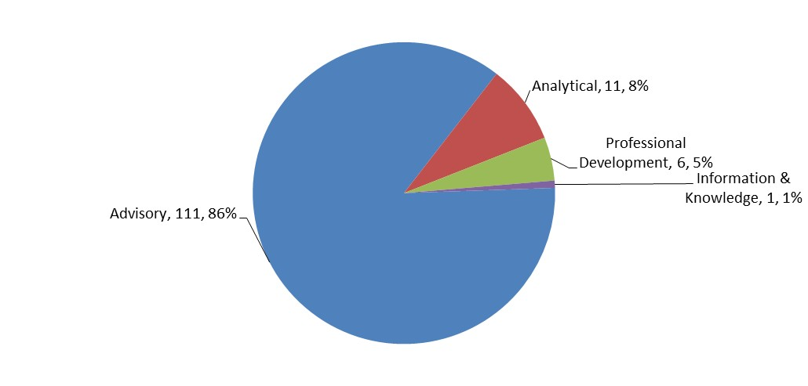

Figure 4: Service orders by services type – Jul 2011 to Jan 2012

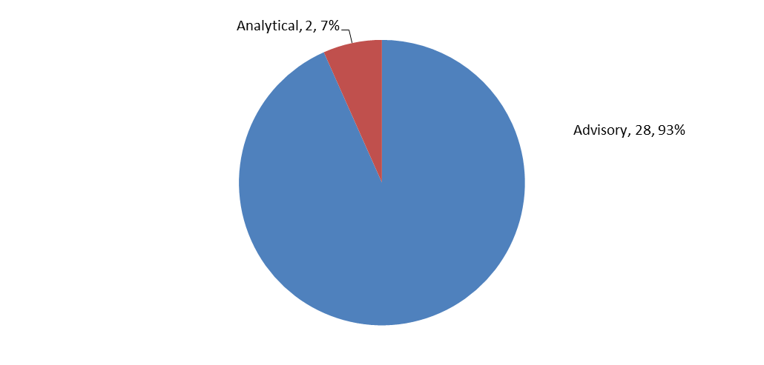

Nominated versus Contracted

One hundred and nineteen consultants were nominated during this period from which

59 consultants were selected. Seven consultants were selected twice and one was selected three times. The slightly high number of HLSP consultants includes the two teams from HLSP’s Consultancy Services Team contracted under two separate SOs for the Ethiopia adviser recruitment.

Figure 5: Source of nominated and contracted consultants – July 2011 to January

2012

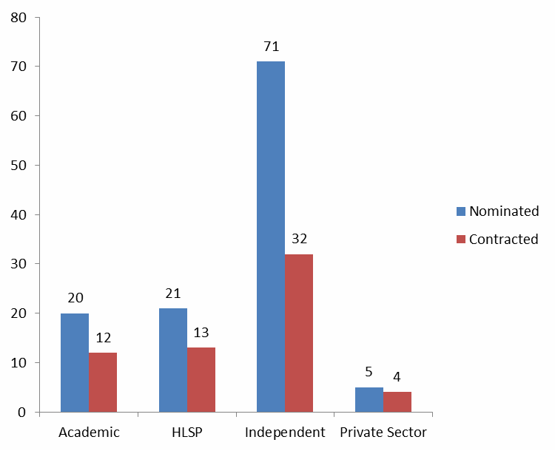

Source and Characteristics of Consultants

During this period all nominated and contracted consultants are categorised as international. This reflects the nature of the requests received.

During the period the majority of consultants nominated and contracted were independent. Of the 119 nominated consultants, 44, or about 37%, were women. Of the 59 contracted consultants, 23, or 39%, were women.

In this reporting period more non-Australian consultants were nominated and contracted (Figure 6) than Australian consultants. During this period 34% of the 119 nominated consultants were new to AusAID. Of these 40 consultants, 16 were selected for work. This proportion of nominated consultants new to AusAID is expected to reduce during the operation of the HRF as new consultants are contracted more than once.

Figure 6: Nationality of nominated and contracted consultants – July 2011 to

January 2012

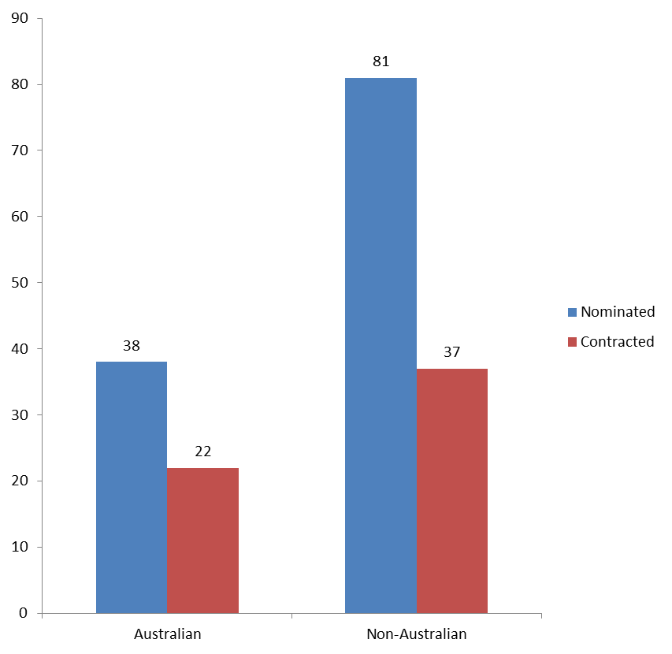

Since January 2009, the HRF has contracted 257 consultants. About 35 per cent of these were Australian and about 26 per cent were new to AusAID (indicator 1.3
PAEP). See Figure 7.

Figure 7: Proportion of Australian versus Non-Australian and new to AusAID

consultants used by HRF Jan 2009 to Jan 2012

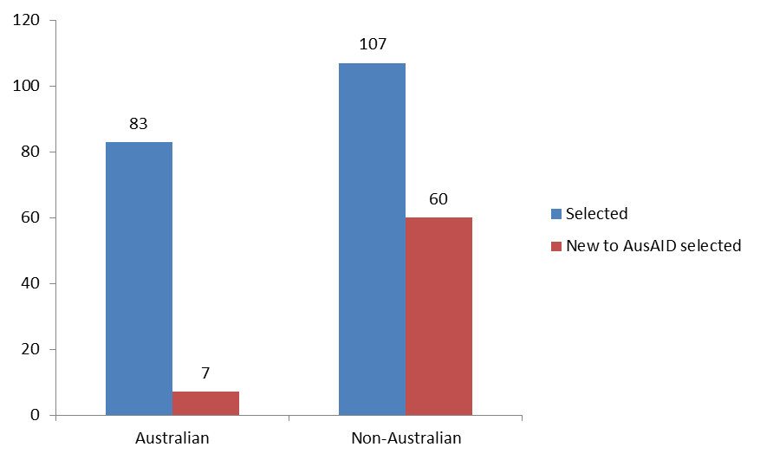

Geographic Distribution and Origin of Requests

In this reporting period the 30 agreed Service Orders were requested by a good range of 15 different posts / sections (Figure 8). This was a wider range of commissioners than in the previous reporting period (when 12 different posts and sections contracted us).

All of these posts / sections had previously contracted the HRF.

Twenty seven of the 30 SOs involved country or regional focused assignments, with the remaining three being global or agency focused (Figure 9). The 26 Service Orders agreed during the previous reporting period (Jan 2011 to July 2011) were issued from 12 different posts / sections. Figure 10 shows that in terms of number of days contracted that HHTG and East Timor Branch were the biggest users of the
HRF between July 2011 and January 2012.

Figure 8: Origin of requests (requesting AusAID section) – July 2011 to January

2012

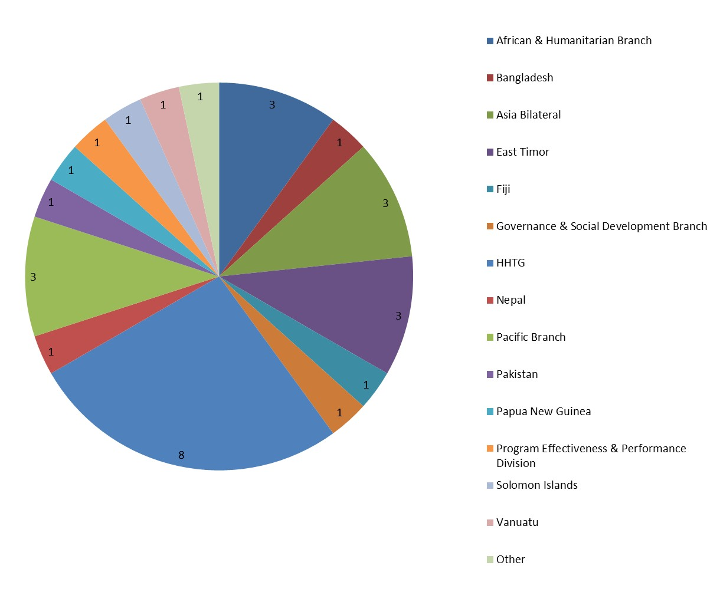

Figure 11 and Table 1 show the 20 different posts / sections that have contracted the HRF over the last 36 months. Twenty, or 83%, of the 24 potential HRF clients (i.e. posts / sections with a health and HIV program) have made at least one request to the HRF since January 2009 (indicator 1.1 PAEP).

Of the 20 posts/sections who have made at least one request to the HRF, 17, or

85%, have made repeat requests (indicator 1.2 PAEP). See Table 1 – this has increased from 70% in the last reporting period. There are four potential commissioners who have not yet contracted the HRF. Of these, two have requested services via the Help Desk.

Figure 9: Geographic distribution of assignments – July 2011 to January 2012

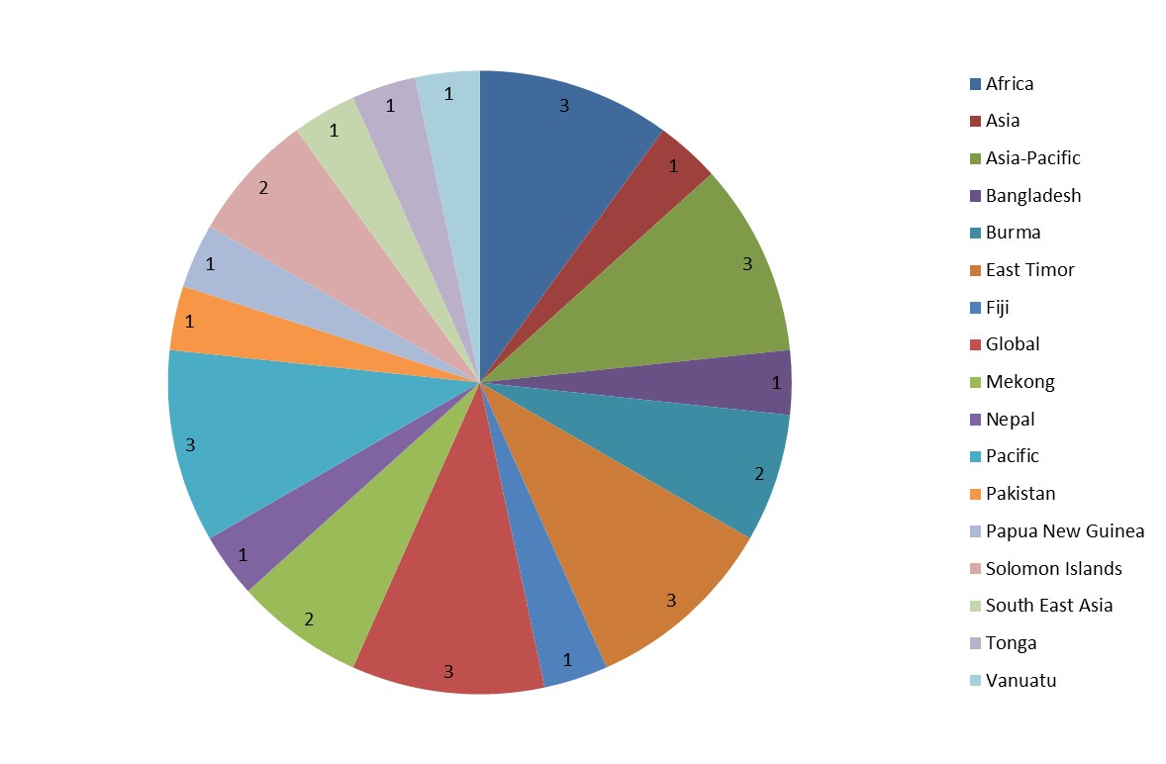

Figure 10: Days contracted by commissioning section, July 2011 to January 2012

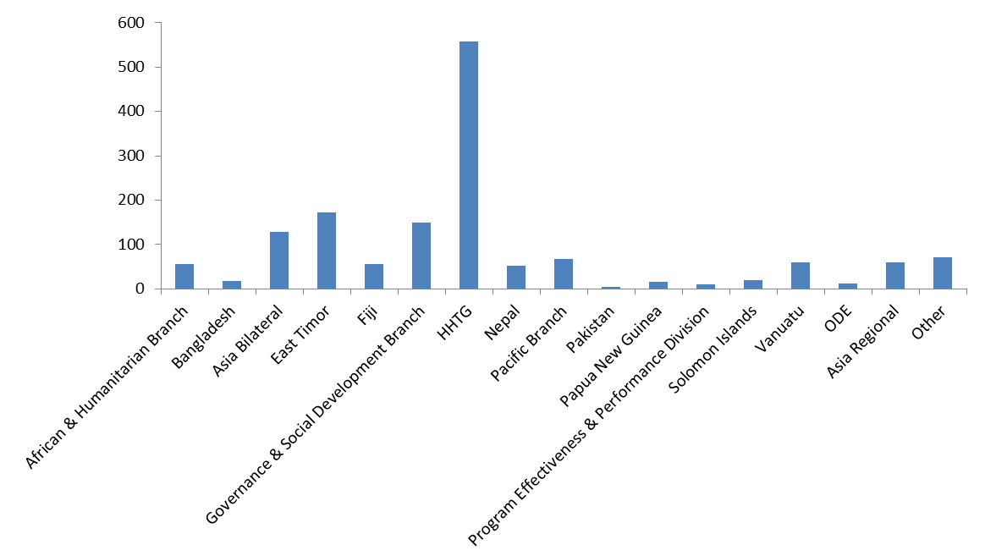

Figure 11: Origin of requests (requesting AusAlD section) -Jan 2009 to January

2012

•Asia Bilateral

•Asia Regional
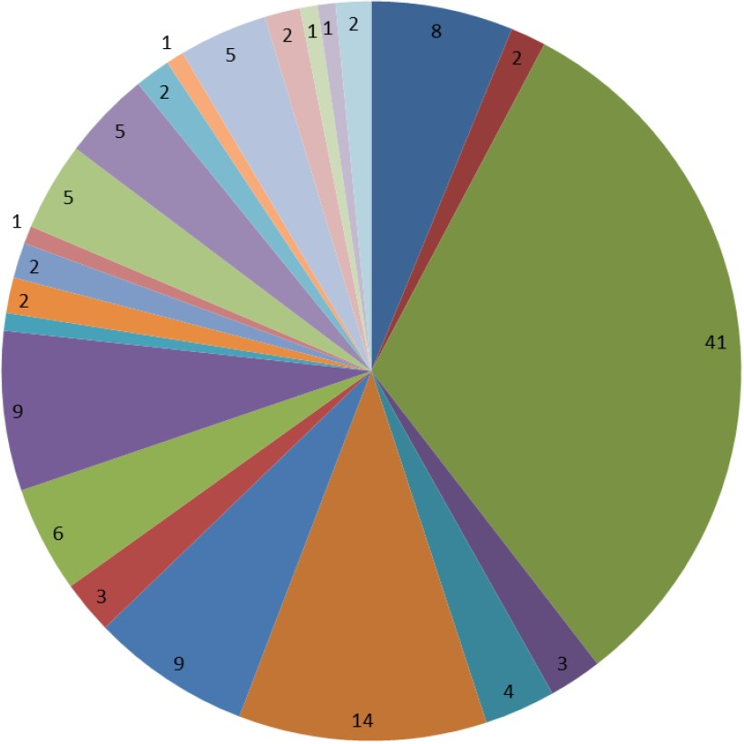

•HHTG

•Office of Development Effectiveness (ODE )

•OPS

•Pacific Branch

•Papua New Guinea

•Solomon Islands

•Vanuatu

•Fiji
1 •Kiribati

•Nepal

•China

•Nauru

•African and Humanitarian Branch

•Indonesia

•Bangladesh Cambodia East Timor Pakistan
Governance & Social Development Branch Program Strategies and Design Branch other
Period Offer Deed 48511

Table 1: Proportion of potential commissioners that have contracted the HRF Jan

2009 to January 2012

Commissioning post/section |  | Contracted  HRF |  | Contracted more than  once
HHTG |  | YES |  | YES
Program Effectiveness & Performance  Division |  | YES |  | YES
Pacific Branch |  | YES |  | YES
Asia Bilateral |  | YES |  | YES
Fiji |  | YES |  | YES
Vanuatu |  | YES |  | YES
China |  | YES |  | YES
Indonesia |  | YES |  | YES
PNG |  | YES |  | YES
Office of Development Effectiveness |  | YES |  | YES
Asia Regional |  | YES |  | YES
Solomon Islands |  | YES |  | YES
Africa & Humanitarian Branch |  | YES |  | YES
East Timor |  | YES |  | YES
Nepal |  | YES |  | YES
Pakistan |  | YES |  | YES
Bangladesh |  | YES |  | YES
Nauru |  | YES |  | NO
Kiribati |  | YES |  | NO
Cambodia |  | YES |  | NO
Middle East & West Asia Branch |  | NO |  | Help Desk only
Samoa |  | NO |  | Help Desk only
Philippines |  | NO
Vietnam |  | NO

Topics of Assignments

Figures 12 and 13 provide an overview of the topics and types of HRF assignments during this reporting period. There is a reasonable spread across the topics (Figure
12) and types (Figure 13). Of the 30 Service Orders in this period, six were for evaluation and reviews, 16 for policy and strategy development and one for scoping/assessment/design.

Figure 12: Topics of assignments according to the categories of expertise in scope of services – July 2011 to January 2012
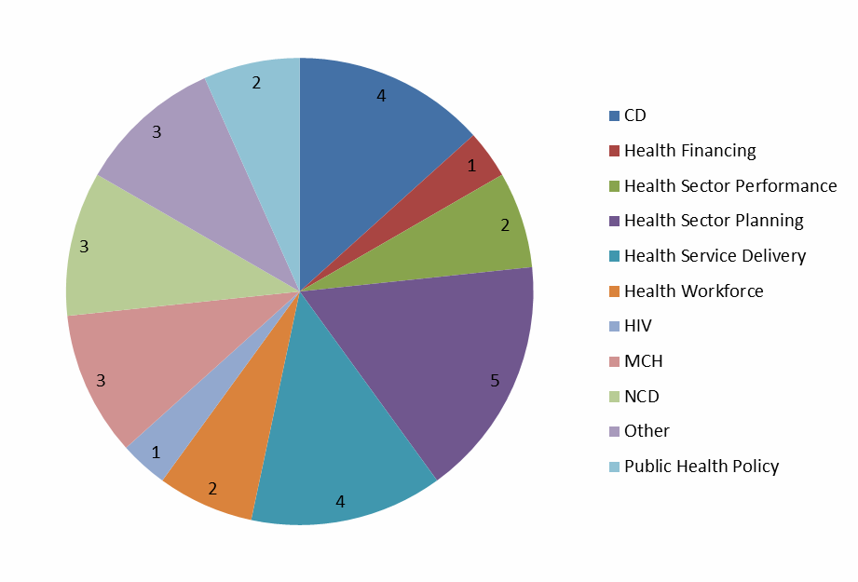

Figure 13: Types of assignments – July 2011 to January 2012

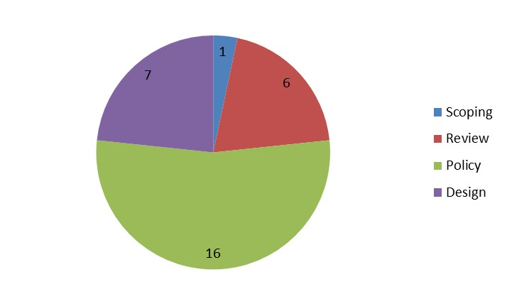

Cancelled Assignments

Given their impact on core resources, cancelled requests need to be kept under review. In a proportion of consultancy requests, an AusAID client contacts the HRF with a request and the HRF begins the process of clarifying the ToR and searching for consultants, but, for one reason or another, the assignment is cancelled.

In this reporting period the HRF put considerable effort into TOR support and consultant sourcing for four separate assignments that were all cancalled after CVs were submitted:

• Infrastructure, Water and Sanitation Section requested consultants for the design of a new Civil Society Water, Sanitation and Hygiene Fund. Consultants were sourced elsewhere.

• Kiribati post sought the services of a short-term adviser to critically review the design brief, specifications, draft plans and initial costing estimates for the Refurbishment of the Kiribati School of Nursing and construction of the Betio Maternity Facility. The HRF submitted a choice of consultants. The selected consultant was subsequently contracted directly under an existing Period Offer.

• Indonesia post requested short term M&E and Gender advisers to assist the Ministry in the critical inception phase of the Australia-Indonesia Partnership for Health System Strengthening program.. HRF sourced and submitted CVs. Consultants were sourced elsewhere.

• Indonesia post requested a Program Logic / M&E team member for the CHAI III design. After HRF had done considerable work and submitted CVs, post decided not to engage the position externally, but to maximize work with Procurement and Quality Unit for their role as design facilitator.

Annex 2: Communication Activities, including web site

Communication Activities

Activities to deliver the HRF Communications Strategy

In addition to using professional development activities to build AusAID awareness about the HRF, communication activities undertaken in the reporting period include:

• An update and content review of the HRF website, including the following improvements:

- Fine-tuning of the search function in the Document Library.

• Distribution of Compass newsletter at presentations to AusAID staff.

• Approval and distribution of two knowledge round-ups through HHTG – one in

August 2011 and the other in November 2011.

• Ongoing introduction of the HRF to AusAID staff – including attendance at O

based staff events and opportunistic meetings.

Website – www.ausaidhrf.com.au

The HRF has continued to add content to the AusAID password protected area, including the building of the reports database and a searchable record of Help Desk requests. All HRF outputs are available on the website.

Figure 14 below shows the hits on the site by month since the launch. The average is 4,817 hits per month. This is slightly higher than the average for the same time last year– which was around 4,328 hits per month.

In the last reporting period there were 118 approved members of the website. In this reporting period there are 151. Figure 15 shows the distribution of all members by country. Twenty-four country posts are represented.

Figure 14: Hits on the website, by month – May 2009 to Jan 2012

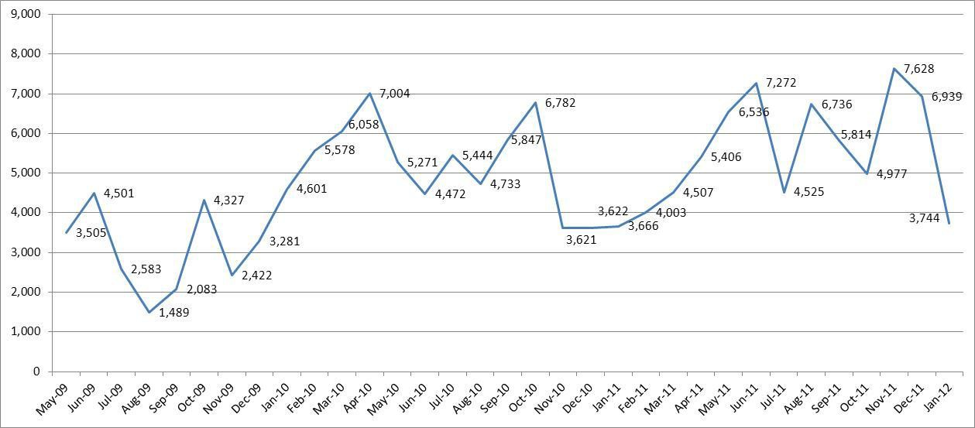

Figure 15: Website membership by country (AusAID staff) – Jan 2012

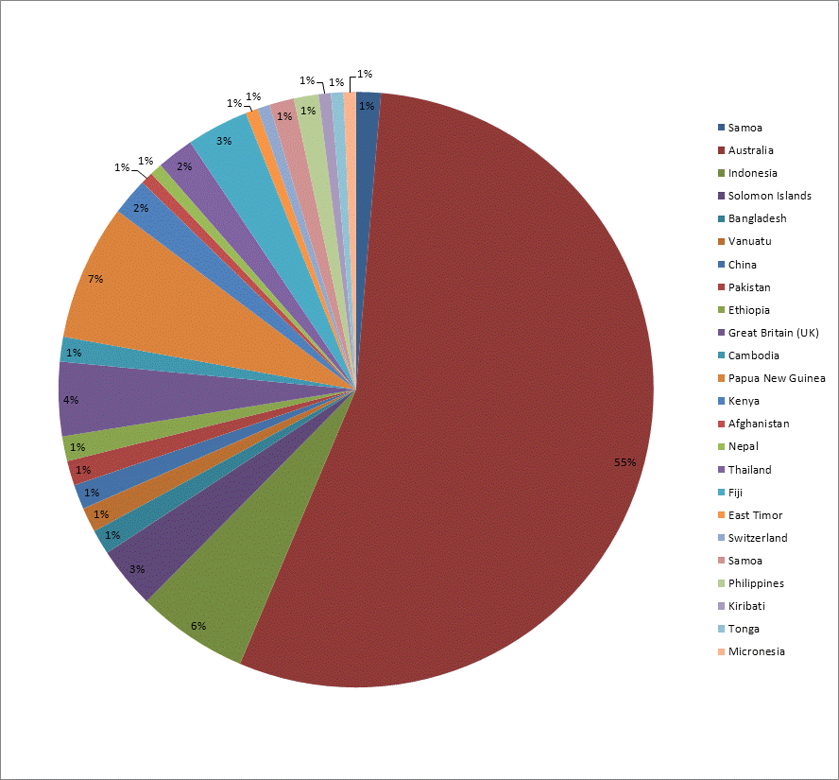

Figure 16 shows the number of times visitors have downloaded particular reports from the web site. The HIV scoping reports are public documents so it is expected that they would have been highly downloaded.

Reports on the AusAID only part of the site are still not being downloaded regularly. AusAID staff are still not downloading reports and Help Desk requests – reinforcing the continued need to communicate these options.

Figure 16: Downloaded Files by Visitors – July 2011 to Jan 2012

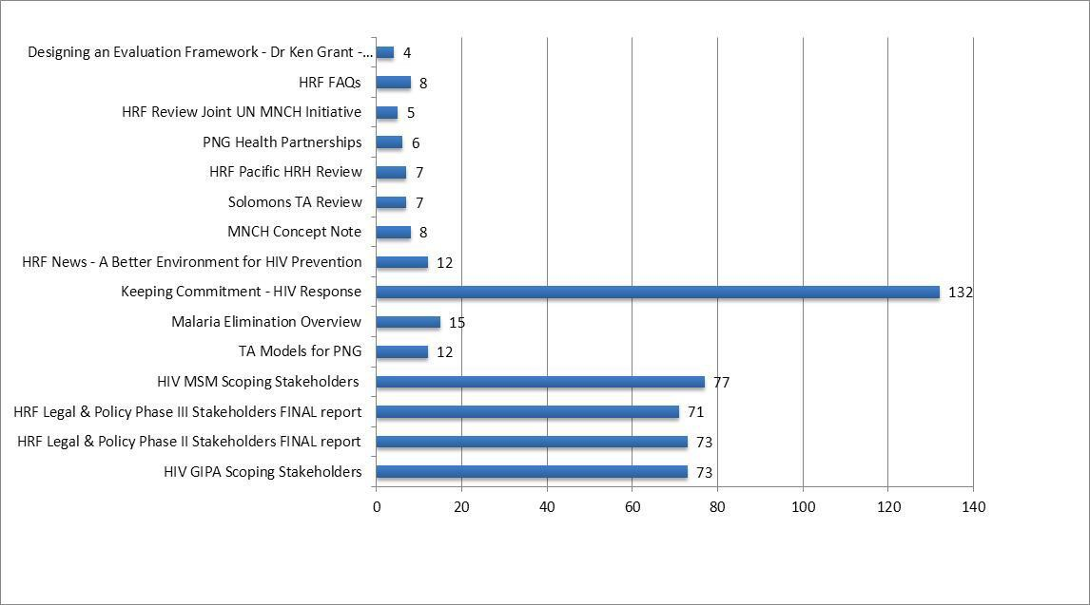

Annex 3: Plaudits

Positive written feedback

The following plaudits were received during this reporting period. These have been lifted from email correspondence between the HRF team and the named AusAID advisers, and also from the verbatim responses received on completed CPA forms.

Paula Henriksen, Senior Development Program Specialist, Solomon Islands, AusAID
Re: Development of Concept Document for AusAID contribution to the Health

Sector Support Program (HSSP) in the Solomon Islands 2012-2016

The Concept is an excellent basis for our second phase so comments are few and focussed.

Stephanie Kimber, Policy Officer, East Africa, AusAID

Re: Ethiopia Health Adviser Recruitment Support (Phase I & II)

We were very happy with the service provided by both the HRF and the consultants from HLSP. Prompt, responsive and flexible.

Emily Rudland, Evaluation Group, Office of Development Effectiveness, AusAID
Re: PNG HIV Evaluation – HRF Management

Much thanks and congratulations for coming to the end of all your hard work

on this project; it’s much appreciated.

Deepa Gajjar, Policy and Program Officer, Health Thematic Group, AusAID Re: Totally drug resistant TB
The writing style was easy to understand and explained technical issues clearly. We appreciated the quick turnaround.

Renee Martin, Health and HIV Thematic Group, AusAID Re: Maternal Health Seminar/Presenter – Lucy Palmer
Very appropriate format for the group and its learning needs – great to have some questions in advance that provided focus for the discussion.
Clearly a very thorough understanding of the subject matter as well as practical realities associated with implementing complex programs

Joanne Greenfield, Health and HIV thematic Group, AusAID

Re: Greater Mekong/East Asia presentation and briefing document

Just to say your presentation went down very well. ….

Thanks so much for this and all your work on this meeting- which was way beyond a help desk request!

Emily Fisher, Director, Workforce Planning & Design, AusAID Re: Workforce Planning Project
Thanks very much. We are absolutely stoked with all the work Carolyn (Peterken) has done for us and I wouldn’t hesitate in recommending her to others or engaging her again.

Beth Slatyer, Health and HIV Thematic Group, AusAID

Re: AusAID Health Resource Facility - Knowledge Round-up – August 2011

This is useful - and just the right length

Meria Russell, Program Manager, Health, Gender and Disability, AusAID Re: Pacific Health Adviser – Rob Condon
Thank you very much for what you have done and greatly appreciate your time for doing this. Wishing you all the best in your next tasks but I know we all do look forward to working with you again sometime very soon.

Barbara Tu’ipulotu, Program Manager, Tonga, AusAID

Re: Six month review of the Tonga Health System Support Program

The contractor’s response to AusAID Post’s requests and needs was very good and we will not hesitate to use their services again. The adviser sourced by the contractor had the expertise required and demonstrated clear knowledge and understanding…Overall the adviser worked very well in the circumstances and was a very good team member.

Fiona McAlister, Effectiveness & Program Performance, Mekong Subregion, AusAID
Re: Mid Term Review of the Regional Technical Assistance project for HIV Prevention and Infrastructure: Mitigating Risk in the Greater Mekong Subregion
Thanks very much to the HRF – the vetting of consultants was particularly challenging and the HRF did a fantastic job throughout the process. The

consultant’s performance was of very high quality and we are very happy with

the results.

Sue Elliot, Health and HIV Thematic Group, AusAID

Re: Research and Development in Health: Scoping Review for AusAID Health

Thematic Group

This piece of work was excellent, and will certainly assist with future program development.

Annex 4: HRF Non-Core Activities delivered in the reporting period

Service  Type | Requesting Client and AusAID Section | Title / Short  Description | Consultant(s) Nominated | Consultant(s) Selected | Key Deliverables | Status (Cancelled, Inactive, Completed, Ongoing) | Deliverables  submitted in timeframe  agreed with client (Y/N)* | Expenditure  / Forecast** (AUD ex. GST)
Advisory | HHTG | 101 Tonga Sports Outreach | Turk/ Finchley | Turk | Final report | Ongoing | N/A | $135,300.00
 | HHTG | 110 NCD Analysis | Robinson/Moodie | Robinson/Moodie | Various AusAID- Nossal Institute stakeholder roundtable outputs/ Briefing notes on specific topics as agreed/ Final Report | Ongoing | Yes so far | $43,072.00
 | Vanuatu | 111 Vanuata  PER | Northway / Bartholomew / Rannan-Eliya / Wheeler | Northway | Provide input to aide memoire and report. | Completed | Yes | $75,175.48
 | HHTG | 112 MNCH Investment Case | Anderson | Anderson | Written reports as agreed between parties for activities as they arise | Ongoing | Yes so far | $38,500.00
 | East Timor | 114 East Timor Spec Med Services | James / Condon  / Cripwell | Condon | Consultantion plan/ Aide memoir/ Draft  Design Document and Final Design Document | Ongoing | Yes | $44,316.05

Service  Type | Requesting Client and AusAID Section | Title / Short  Description | Consultant(s) Nominated | Consultant(s) Selected | Key Deliverables | Status (Cancelled, Inactive, Completed, Ongoing) | Deliverables submitted  in timeframe agreed with client (Y/N)* | Expenditure  / Forecast** (AUD ex. GST)
 | African & Humanitarian branch | 115 South Sudan Social Appraisal | Esser/ Maguire | Maguire | Final report | Completed | Yes | $31,799.51
 | Burma | 116 Burma  3MDG Fund  DoA | Pederson / Kramer / Attawell  / Christensen / Reed / Thornton / Foot / Cook / Horsey | Pedersen / Attawell / Christensen | Program of work outline/ Detailed presentation and discussion of preliminary findings and  recommendations/  revised Description of Action/ Stand alone papers as annexes | Ongoing | Yes | $112,463.00
 | Pacific Branch | 117 Pacific Health Adviser RC | Condon | Condon | Comments, reports, presentations and other documents as agreed. | Completed | Yes | $10,100.70
 | HHTG | 118 APMEN IPR | Martinez / Stevenson / Cornish | Stevenson | Independent Progress Review report. | Ongoing | Yes | $29,198.82
 | HHTG | 119 Malaria Drug Resistance In The Mekong | Tulloch | Tulloch | Final report/ Policy briefing note | Ongoing | Yes so far | $174,479.00

Service  Type | Requesting Client and AusAID Section | Title / Short  Description | Consultant(s) Nominated | Consultant(s) Selected | Key Deliverables | Status (Cancelled, Inactive, Completed, Ongoing) | Deliverables submitted  in timeframe agreed with client (Y/N)* | Expenditure  / Forecast** (AUD ex. GST)
J.T.
 | Bangladesh | 120 Bangladesh ICDDRB Organisational Assessment | Northway | Northway | Provide input to final report. | Completed | Yes | $18,614.03
 | HHTG | 121 Malaria Drug resistance in the Mekong S.E. | Ezard / Burns / Tulloch / Miller / Reeder / Toole / Ear / Meek / Ear/ Lynch | Ear | Provide inputs into the main report for SO119 | Ongoing | Yes so far | $80,031.00
 | Nepal | 122 Nepal MNH UNICEF  Review | Devkota / Singh Rana / James / Tyson / Middleton / Thompson | Devkota / Middleton / Thompson | Inception report/ Presentation on preliminary findings/ Final report | Ongoing | Yes so far | $45,418.00
 | Pacific Branch | 123 Brisbane  NCD Facilitation | Davies / Campbell | Davies / Campbell | Final report on outcomes of the NCD workshop(s) and meetings | Completed | Yes | $7,223.51
 | PNG | 125 PNG Capacity Diagnostic | Brown / James / Simmonds / Vermeulen / Jensen | Vermeulen | Overall diagnostic report and  working papers | Completed | Yes | $16,087.03
 | Pacific Branch | 127 Cuban  Doctors Pacific | Campbell / Hearn | Campbell / Hearn | Methodology/ Aide memoire/ Final Concept | Ongoing | N/A | $125,117.10

Service  Type | Requesting Client and AusAID Section | Title / Short  Description | Consultant(s) Nominated | Consultant(s) Selected | Key Deliverables | Status (Cancelled, Inactive, Completed, Ongoing) | Deliverables submitted  in timeframe agreed with client (Y/N)* | Expenditure  / Forecast** (AUD ex. GST)
Note
 | HHTG | 128 HIV SE Asia Strategic Options | Godwin / Attawell  / Carael / Mundy  / Dickinson / Lowe / Wheeler / Collins / Murphy / Chanlivong / de Lind van Wijngaarden / Fowler / Kumar / Loo / Uhring / Bennoun / Salas  / Collins / Thomson / Sambo / Poblete  / Lyttleton / Mahomet | Godwin / Dickinson / Wheeler / Collins  / Murphy / de Lind van Wijngaarden / Fowler / Kumar / Sambo / Poblete  / Lyttleton / Mahomet/ Loo | 10 x country situation analyses/ Strategic advice report | Ongoing | Yes so far | $276,396.00
 | Solomon Islands | 129 Solomons Health Deliv Strat Concept Note | Tyson | Tyson | Concept document | Ongoing | Yes | $21,360.00
 | East Timor | 130 East Timor Temp Health Adviser | Middleton/ Simmonds/ Anzia/ Cazottes/ Naylor/ Stevenson/ | Marion Kelly | Various as agreed | Ongoing | N/A | $219,478.00

Service  Type | Requesting Client and AusAID Section | Title / Short  Description | Consultant(s) Nominated | Consultant(s) Selected | Key Deliverables | Status (Cancelled, Inactive, Completed, Ongoing) | Deliverables submitted  in timeframe agreed with client (Y/N)* | Expenditure  / Forecast** (AUD ex. GST)
Chattoe-Brown/ Smet/ Lloyd/ Alonsoa/ Kelly
 | HHTG | 131 Malaria  Issues Paper | Kelley / Palmer / Hewitt / Lynch / Burns | Kelley / Palmer / Hewitt | Two reports | Ongoing | N/A | $20,566.00
 | Burma | 132 Burma  3MDG Fund  Appraisal | Anderson | Anderson | Quality at Entry report | Ongoing | Yes | $4,950.00
 | East Timor | 133 East Timor Independent Appraisal | Attawell/ Anderson/ Tyson | Tyson | Independent Appraisal report/ Quality at Entry report | Ongoing | Yes | $5,808.00
 | Pakistan | 134 Pakistan MNCH Appraisal | Thompson / Wright / Duby | Duby | Appraisal and Quality at Entry report | Ongoing | Yes so far | $4,040.00
 | Fiji | 135 Fiji Bilateral  Health Support | Wilkinson / Keane / Bellew | Wilkinson / Keane | TAG Report on Mobilisation Phase and QAI Report/ Appraisal Note of the Concept Paper from FHSSP | Ongoing | N/A | $47,100.00
 | Other | D08 Workforce  Planning CP | Peterken | Peterken | Workforce Plan and various others as agreed. | Ongoing | Yes so far | $159,870.00

Service  Type | Requesting Client and AusAID Section | Title / Short  Description | Consultant(s) Nominated | Consultant(s) Selected | Key Deliverables | Status (Cancelled, Inactive, Completed, Ongoing) | Deliverables submitted  in timeframe agreed with client (Y/N)* | Expenditure  / Forecast** (AUD ex. GST)
 | Africa & Humanitarian branch | D09 Ethiopia MCH Adviser Recruitment One | Young / Pitts  /Angus |  | Faciliation of the recruitment process. | Completed | Yes | $10,272.00
 | Africa & Humanitarian Branch | D10 Ethiopia MCH Adviser Recruitment Two | Young / Pitts / MacMillan Douglas / Angus |  | Faciliation of the recruitment process. | Completed | Yes | $10,272.00
 | Program Strategies and Design Branch | D12 SWAps Guidance Development | Waddington / Sambo | Waddington / Sambo | Written SWAps guidance | Ongoing | Yes so far | $6,826.00
Analytical | Solomon Islands | 108 Solomon Islands Sector Review | Grant/ Tyson/ Wikman/ Drexler | Tyson | Interim report/ Mid-term report | Completed | Yes | $73,153.64
 | Governance & Social Development branch | 137 UQ Drowning Prevention Analysis | Lopez / Vos / Blore / Higashi | Lopez / Vos / Blore / Higashi | Two reports | Ongoing | N/A | $65,863.00

Annex 5: HRF Core Knowledge and Information Activities

Initial
Request Project Name Type of Output Status Requested By Region/Country Time
Date Taken
5/08/2011 Summary of M&E and coordination issues Summary Paper Complete Mia Thornton East Timor 1.5 paper in East Timor
18/08/2011 | Support to ToR development Documents Complete Robyn Biti HHTG 0.25
18/08/2011  22/08/2011  23/08/2011 | Definitions / scope of Medical Research Summary paper Complete Sue Elliott HHTG 3
18/08/2011  22/08/2011  23/08/2011 | Review of Document - health reforms in Review Complete Ben David HHTG 4  China
18/08/2011  22/08/2011  23/08/2011 | Delegated Cooperation Agreements Definitions and DP Complete Joanne HHTG 3 examples Greenfield
22/09/2011  22/09/2011  29/09/2011  30/09/2011 | Review of revised GAVI strategy Comments on Strategy Complete Dom Vigie HHTG 1.5
22/09/2011  22/09/2011  29/09/2011  30/09/2011 | Review of Childhood Drowning Paper -  Assessment of Ecomonic and Review document Complete Joanne HHTG 3  Epidemiological Validity Greenfield
22/09/2011  22/09/2011  29/09/2011  30/09/2011 | Burma - consistency of UN proposal and Short paper Complete Shaanti Sekhon Burma 3  3MDG fund design
22/09/2011  22/09/2011  29/09/2011  30/09/2011 | Burma - QAE UN Proposal QAE report Complete Shaanti Sekhon Burma 3
30/09/2011 Editorial and format document - Health Final Report Complete Ben David HHTG 1 reforms in China
11/10/2011 Medical Procurement - Sep from MOH - Short report Complete Ben David HHTG 3
Global Experience
12/10/2011 Avoidable Blindness Initiative - Review of Short Review Complete Renata Zanetti ABI 3
Proposals
2/11/2011  2/11/2011  3/11/2011 | Health Priorities East Asia Power Point and Reading Complete Joanne HHTG 6  List Greenfield
2/11/2011  2/11/2011  3/11/2011 | Review of WHO Cambodia Proposal Short Review Complete Jennifer Lean Cambodia 2
2/11/2011  2/11/2011  3/11/2011 | Capacity building methods in Research Brief literature analysis Complete Maddie Smith HHTG 2

17/11/2011 | ADRAs Review four final reports Complete Maddie Smith HHTG 2
23/11/2011  23/11/2011  23/11/2011  23/11/2011  21/11/2011 | Nepal HRH Strategy Short Review Complete Latika Pradhan Nepal 3
23/11/2011  23/11/2011  23/11/2011  23/11/2011  21/11/2011 | Global Fund Round 11 Regional Overview Table Complete Dom Vigie HHTG 7  Applications
23/11/2011  23/11/2011  23/11/2011  23/11/2011  21/11/2011 | Fiji PCSS Proposal Short Review Complete Nilesh Goundar Fiji 3
23/11/2011  23/11/2011  23/11/2011  23/11/2011  21/11/2011 | HRF Support to East Asia Summary Table Complete Joanne HHTG 0.5  Greenfield
23/11/2011  23/11/2011  23/11/2011  23/11/2011  21/11/2011 | Samoa SWAp Analysis Short review and Complete Erica Reeve Samoa 3 recommendations
11/2011  11/2011  1/12/2011  23/12/2011 | Aust Civilian Corps Tech Assessment CVs Ongoing Lauren Gee Rec & P-ments 1.5
11/2011  11/2011  1/12/2011  23/12/2011 | Greater Mekong / East Asia Briefing Document Complete Joanne HHTG 3  Greenfield
11/2011  11/2011  1/12/2011  23/12/2011 | Health Pre-deployment Briefings Revision of Documents Ongoing Sue Elliott HHTG 2
11/2011  11/2011  1/12/2011  23/12/2011 | Reading list for AusAID Bangladesh Joanne  Reading List Complete HHTG 0.5  Health Retreat Greenfield
Public health impact of WASH Joanne
6/01/2012 Short report Complete HHTG 2.5 interventions Greenfield
Impact of global economic crisis on health Joanne
14/01/2012 Short report Complete HHTG 3
ODA Greenfield

14/01/2012 Briefing Seminar - maternal health Seminar Complete Robyn Biti HHTG 1

14/01/2012 Briefing Seminar - M&E Seminar Complete Robyn Biti HHTG 1

14/01/2012 Briefing Seminar - health financing Seminar Ongoing Robyn Biti HHTG 1

Synthesis of key
16/01/2012 Bibliography of Results Based Financing Complete Ben David HHTG 0.5 documents

Annex 6: Analysis of Contractor Performance

Assessment Received Jan 2009 to January 2012

Assessment Criteria Number of Average**
ratings*
Management and Administrative Logistics
Was the logistical support provided adequate for the assignment (including security briefings,
inoculations, travel details and accommodation for 48 3.9
the consultant?)
Were management issues dealt with in a timely
and professional manner (including accurate 67 3.8 invoicing)?
Were management, administrative and logistical 65 3.9 arrangements communicated effectively to you?
Was the assignment completed in accordance 70 4.0 with the agreed budget and timing?
Average Management and Administrative 3.9
Logistics
Performance of Personnel
Did the consultant demonstrate an understanding
of the requirements of the ToR or Scope of 73 3.9
Services?
Did the performance of the Consultant meet with
the requirements as outlined in the ToR/ Scope of 73 3.9
Services?
Was the Consultant responsive to AusAID’s 73 3.8 requests and instructions?
Was the Consultant aware of/ highlight risks, issues and problems associated with the
assignment and did they respond to them 65 3.7
appropriately?
Did the Consultant work and communicate with
AusAID and other counterparts and stakeholders 72 4.0 in a professional and appropriate manner
(including cultural sensitivity)?
Average Performance of Personnel 3.9
Quality of Deliverables
Were deliverables of good quality in terms of 72 3.8 content?
Were deliverables communicated clearly,
accurately and in an appropriate format? 72 3.7
Average Quality of Deliverables 3.8
Resource Facility
How easy were the services of the Resource 69 4.0
Facility to access and use?
Help Desk Services

Did the Help-Desk respond to your request in a
timely manner? 53 4.1
How satisfied were you with the quality of service
delivered directly by the Help Desk (e.g. literature 31 4.2 and data searches and compiling information)?
How satisfied were you with the service provided by the Help Desk in sourcing technical expertise
(including assistance with drafting ToR and 54 4.1
sourcing suitable consultants)?
Average Help Desk Services 4.2
Overall average score |  | 3.91
* Not all questions were applicable to all the rated projects, hence the number of
ratings vary
** 1=Weak 2=Marginally Satisfactory 3=Satisfactory 4=Highly Satisfactory 5=Best
Practice

Annex 7: Knowledge Requests Feedback

Table 2: Knowledge Requests Feedback (formally known as Help Desk
Feedback) – July 2011 to January 2012

Assessment Criteria Number Average of
ratings*
How helpful was the Help Desk in clarifying your tasks and responding to your requests in a timely manner?  How satisfied were you with the expertise of the HRF team to respond in an appropriate manner to complete your request? | 8 3.6
 | 8 3.6
How satisfied were you with the quality of the final product or outcome? | 8 3.5
Overall |  | 3.6
1=Unsatisfactory 2= Satisfactory 3=Good 4=Excellent

Table 3: Cumulative Knowledge Requests Feedback (formally known as Help
Desk Feedback) - Sept 2009 to January 2012

Assessment Criteria Number Average of
ratings*
How helpful was the Help Desk in clarifying your tasks 32 3.7 and responding to your requests in a timely manner?
How satisfied were you with the expertise of the HRF
team to respond in an appropriate manner to 32 3.4 complete your request?
How satisfied were you with the quality of the final 32 3.3 product or outcome?
Overall |  | 3.5

