

Technical Report

Reporting Period: 22nd January to 21st July 2011

Date submitted: 9th August 2011

AusAID HRF
HLSP in association with IDSS GPO BOX 320
15 Barry Drive
Canberra City ACT 2601
Tel: +61 (2) 6198 4100
Fax: +61 (2) 6112 0106 www.ausaidhrf.com.au

Table of Contents

Executive Summary ................................................................................................................ 1

1. Sourcing of Technical Assistance ................................................................................. 5

2. Help Desk ....................................................................................................................... 15

3. Knowledge and Information and Professional Development Services ................... 17

4. Communication Activities ............................................................................................ 17

5. Performance Management and Feedback .................................................................. 20

6. Other Issues and Discussion ....................................................................................... 25

Annex 1: HRF Non-Core Activities delivered in the reporting period .............................. 32

Annex 2: HRF Core Activities ............................................................................................... 36

Annex 3: Analysis of Contractor Performance Assessment Received…………………...39

List of Tables

Table 1: Proportion of potential commissioners that have contracted the HRF ..................... 13

Table 2: Knowledge Requests Feedback – July 2010 to Jan 2011....................................... 21

Table 3: Cumulative Knowledge Requests Feedback - Sept 2009 to Jan 2011 .................... 21

List of Figures

Figure 1: Service orders by services type - Jan 2009 to Jan 2011 .......................................... 6

Figure 2: Service orders by services type - July 2010 to Jan 2011.......................................... 6

Figure 3: Source of nominated and contracted consultants – July 2010 to Jan 2011 ............. 7

Figure 4: Nationality of nominated and contracted consultants – July 2010 to Jan 2011 ........ 8

Figure 5: Proportion of Australian versus Non-Australian and new to AusAID consultants

used by HRF Jan 2009 to Jan 2011 .......................................................................................... 9

Figure 6: Origin of requests (requesting AusAID section) – July 2010 to Jan 2011............... 10

Figure 7: Geographic distribution of assignments – July 2010 to Jan 2011 .......................... 11

Figure 8: Origin of requests (requesting AusAID section) – Jan 2009 to Jan 2011 ............... 12

Figure 9: Topics of assignments according to the categories of expertise in scope of services

– July 2010 to Jan 2011 .......................................................................................................... 14

Figure 10: Types of assignments – July 2010 to Jan 2011 .................................................... 14

Figure 11: Hits on the website, by month – May 2009 to Jan 2011 ....................................... 19

Figure 12: Website membership by country (AusAID staff) – Jan 2011 ................................ 19

Figure 13: Downloaded Files by Visitors – July 2010 to Jan 2011......................................... 20
Acronyms

AusAID Australian Agency for International Development

CD Communicable Diseases

CPA Contractor Performance Assessment

ERF Education Resource Facility

FAQ Frequently asked Questions

GIPA Greater Involvement of People living with HIV/AIDS HRF Health Resource Facility
HHTG Health and HIV Thematic Group HIV Human Immunodeficiency Virus HRH Human Resources for Health HSS Health System Strengthening
IDSS International Development Support Services

NCD Non-communicable diseases

MoH Ministry of Health

MSM Men who have sex with men

PAEP Performance Assessment and Evaluation Plan

PDS Professional Development Services

PICs Pacific Island Countries

SO Service Order

SPMF Specified Personnel Management Fee

TOR Terms of Reference

QA Quality Assurance

Executive Summary

This report describes progress of the AusAID Health Resource Facility (HRF) for the period from 22nd January to 21st July 2011. Achievements include:

• Demand for HRF services continues to be buoyant. Since January 2009, 99

Service Orders have been agreed for a total of 3940 consulting days.

• During this 6 month reporting period the HRF agreed a total of 26 separate Service Orders, and 6 amendments for pre-existing SOs, for a total of 1527 consulting days. Since then (between 22nd July and 5th August 2011) we have been contracted for an additional 332 days bringing the total to 1859.

• In year 3 we have exceeded the 1600 consulting days on which resourcing levels were based (following the contract amendment signed in September 2010). We conservatively anticipate a total of around 2300 days contracted for year.

• The Pacific and HHTG were the biggest users of the HRF in terms of number of days contracted. Of the 24 different posts / sections identified as potential clients of the HRF, 20 have now contracted the HRF. Of these 20, 14 have contracted us more than once.

• The remuneration framework has had a positive impact on our work with regards to supporting our work to lower fee rates.

• We have experienced some challenges in achieving client agreement on the remuneration framework category and level prior to sourcing and submitting CVs. Some clients wish to finalise this agreement once reviewing CVs which can lead to the HRF spending time sourcing consultants which are not affordable under
the framework.

• The average Contractor Performance Assessment (CPA) Score has slightly increased during this period. Overall the average score for all assessment criteria was 4.03 (between highly satisfactory and best practice). This is higher than the

average score of 3.91 reported in the last 6 month period and the overall average score of 3.94 reported since the inception of the HRF.

• The Help Desk has continued to be well utilised during this reporting period with users reporting that the service is easily accessible and responsive. The average CPA score for the Help Desk Services for this reporting period remained high at
3.95 (very slightly below highly satisfactory) with the average since inception of the HRF being 4.2 (highly satisfactory).

• Demand for the Help Desk’s core services (policy advice, literature searches and knowledge analysis / synthesis) remains very strong. The HRF has been operating at full capacity (even with capacity increased for up to 3 days per for these types of requests following the contract amendment). Forty-two knowledge requests have been delivered during the reporting period. Twenty-nine of these requests came from HHTG with the remaining generated from country posts.
This is a very similar pattern to the last reporting period. The inputs required have varied widely from a few hours to a number of days. There is often a demand for complex and specialised inputs within tight timeframes. HRF has been able to respond flexibly and appropriately using the pool of subcontracted expertise.

• The HRF uses a short form for written client feedback for core knowledge requests under the Help Desk. Overall the average score was 3.6 (between Good and Excellent) in this reporting period. This is slightly higher than the overall average score of 3.5 for all feedback received to date and indicates a slight increase in quality.

• The part of the HRF web site which is accessible only to AusAID staff via a password is not being well used. AusAID staff are still not downloading reports and Help Desk requests. This highlights that more communication and socialisation of this feature is needed now that a review of the site has been concluded.

Staffing and Capacity Issues

• Given the number of days we have contracted already in Year 3, we are projecting around 2300 days contracted by the end of the current contract period.

• The core services under the Help Desk (knowledge and information) are operating at around the guideline of ‘up to 3 days a week’. The increase in use and the range / type of request under the Help Desk has meant that more Help Desk Manager time has been needed for the sourcing, technical management and QA of these requests.

• In view of this volume we are discussing with HHTG staffing for the remainder of the existing contract period in order to maintain quality. Andrea Neale will not be remaining with the HRF team beyond the end of the current contract and we are actively recruiting. We will be seeking AusAID approval for Becky Dodd to join the HRF team as a Health Specialist from mid December 2011. In addition we will be advertising shortly for a new Help Desk Manager and are hopeful that the successful candidate (with AusAID approval) will be in post from October 2011. Following this recruitment, we will be requesting that Andrea Neale remains working part-time with the HRF as a Health Specialist – both to support the new Help Desk Manager settle in and to and undertake technical management of
assignments.

• We note in the recent HRF Independent Progress Review that the reviewers recommended that the HRF needed more technical standing capacity to undertake more strategic and analytical work. An option could be for AusAID to consider varying the sums assigned under line items in the Reimbursable cost budget and allocate additional sums to the final category (Sub-contracted expertise for knowledge and information services). If this was considered, the HRF would like to work closely with HHTG to create a pool of agreed specialists that would meet the requirements (eg health economists / financing; monitoring and evaluation; health systems and sector reform; programme based approaches and sector working).

Engagement Issues

• The HRF is appreciative of the ongoing opportunities to engage with HHTG at a managerial and technical level. We are looking forward to further discussions in the context of the findings of the recent Independent Program Review and working in partnership with HHTG to ensure that we are providing services which add value and meet need.

• In particular we are looking forward to working with HHTG and the Steering Committee to review the Performance Assessment Evaluation Plan at objective level to ensure that we are capturing value add.

Operational Issues

• The HRF continues to experience ongoing issues in order to support good practice among commissioners to engage with and utilise the HRF. We will continue to work with HHTG to address and respond to these.

1. Sourcing of Technical Assistance

This report describes progress of the AusAID Health Resource Facility (HRF) for the period from 22nd January to 21st July 2011. This is the fifth report of HRF activity and the third which responds to the Steering Committee’s agreement to move to a six month reporting period.

AusAID requires the HRF to provide country and HQ staff with timely and quality- assured expertise on priority health-related topics. This section describes how the HRF has contributed to that objective over the reporting period.

Consulting days contracted and invoiced

During the 6 month period the HRF agreed a total of 26 separate Service Orders (SOs), and 6 amendments for pre-existing SOs, for a total of 1527 consulting days. The 26 Service Orders covered 30 different consultants and 3 consultants were contracted more than once. All Service Orders were from AusAID. Of the 26 Service Orders, 4 were complete at the end of the reporting period. Annex 1 provides key information related to the SOs.

Since January 2009, 99 Service Orders have been agreed for a total of 3940 consulting days. This includes the 3 month establishment phase. Following the contract amendment signed in September 2010, the maximum amount payable is based on the level of resourcing expected to be required for 1600 consulting days per year which was exceeded for 2011 and will be exceeded for 2012.

Service Order Type

Of the 26 Service Orders during this reporting period, three were for analytical services, one for information and knowledge, none for professional development and
22 for advisory services (Figure 2). A similar pattern is evident when all 99 Services Orders are categorised by services type – 84% are advisory (Figure 1). The vast majority of knowledge and information requests have been managed under the Help Desk function (see Section 2). The one request which did require a Service Order was the production of a publication to highlight Australia’s strong commitment to HIV internationally at the United Nations HIV/AIDS High Level Review Meeting held in New York from 8-10 June 2011.

Figure 1: Service orders by services type - Jan 2009 to Jul 2011

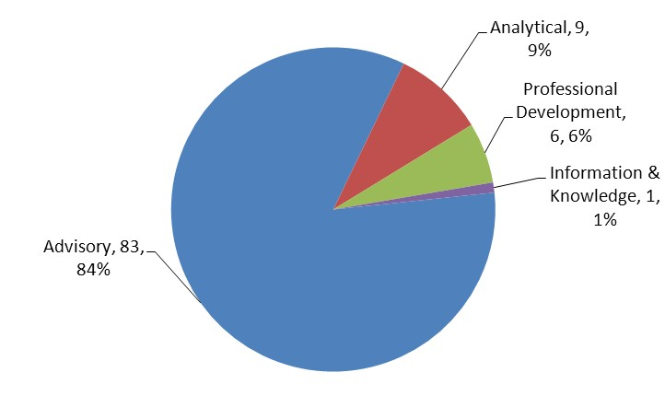

Figure 2: Service orders by services type – Jan to Jul 2011

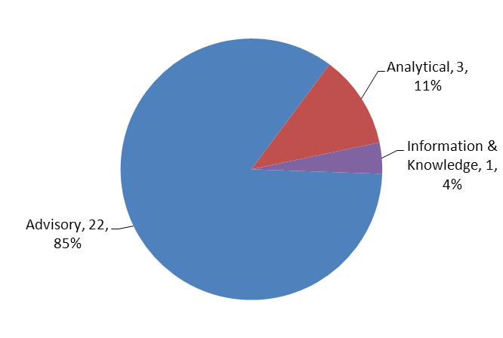

Nominated versus Contracted

The HRF aims to offer a choice of up to 3 consultants for each position. During this reporting period, out of the 26 Service Orders, there were 9 exceptions. In all of these exceptions the client agreed to one prequalified consultant per position and requested the HRF to source no further.

The exceptions were for three reasons. In five cases the HRF was asked to consider a named consultant for the assignment. After full investigation and discussion the

HRF agreed that the named consultant was well qualified for the work. In three
other cases the HRF proposed two, rather than three, CVs (SO 87, 104 and 109). In the final situation the consultants were so clearly the most appropriate for the work that it was agreed with the client further sourcing was not required (SO90).

Figure 3: Source of nominated and contracted consultants – January to

July 2011

70 65

60

50

40
Nominate d
29
30 Cont racted

20 17
13

10 6 7
2 1
0
Aca demic HLSP Independent Private Sector

Ninety-seven consultants were nominated during this period from which 30 consultants were selected. Two consultants were selected twice and one was selected three times. In all cases selection was made from the HRF submission.

Source and Characteristics of Consultants

During this period all nominated and contracted consultants are categorised as international – by definition having experience of providing consulting services internationally. This reflects the nature of the requests received.

During the period the majority of consultants nominated and contracted were independent. Of the 97 nominated consultants, 49, or about 50%, were women. Of the 30 contracted consultants, 16, or 53%, were women.

In this reporting period more non-Australian consultants were nominated and contracted (Figure 4) than Australian consultants. During this period 39% of the 97 nominated consultants were new to AusAID. Of these 38 consultants, 17 were

selected for work. This proportion of nominated consultants new to AusAID is expected to reduce during the operation of the HRF as new consultants are contracted more than once.

Figure 4: Nationality of nominated and contracted consultants – January to July 2011
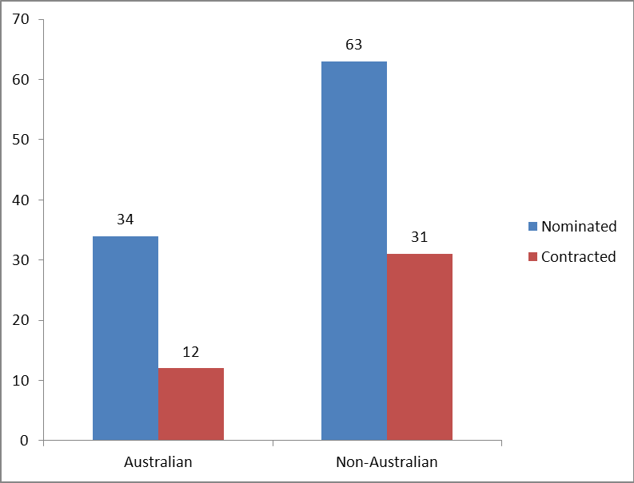

Since January 2009, the HRF has contracted 179 consultants. About 37 per cent of these were Australian and about 27 per cent were new to AusAID (indicator 1.3
PAEP). See Figure 5.

Figure 5: Proportion of Australian versus Non-Australian and new to

AusAID consultants used by HRF Jan 2009 to July 2011

120

100

43

80

5
60 New to AusAID sele cted
Selected

40
69
62

20

0
Australi an Non-Aus tralia n

Geographic Distribution and Origin of Requests

In this reporting period the 26 agreed Service Orders were requested by a good range of 12 different posts / sections (Figure 6). All of these posts / sections had previously contracted the HRF. Twenty of the 26 SOs involved country or regional focused assignments, with the remaining six being global or agency focused (Figure
7). The 18 Service Orders agreed during the previous reporting period (July 2010 to Jan 2011) were issued from 9 different posts / sections. Figure 8 shows that in terms of number of days contracted that HHTG and Pacific Branch were the biggest users of the HRF between January and July 2011.

Figure 6: Origin of requests (requesting AusAID section) – January to

July 2011

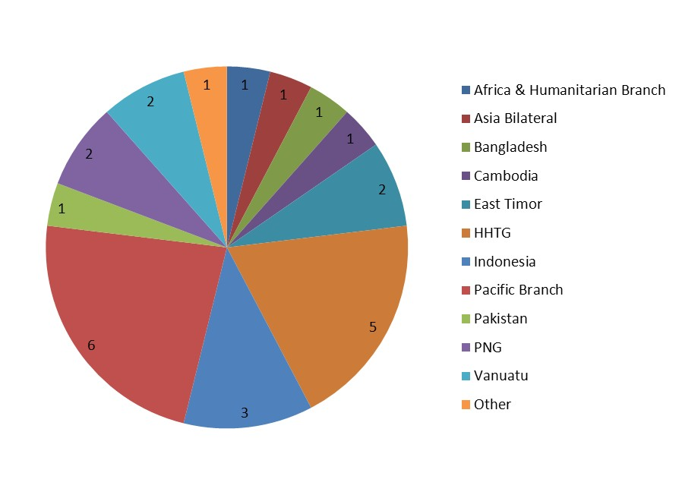

Figure 9 and Table 1 show the 20 different posts / sections that have contracted the HRF over the last 30 months. Twenty, or 83%, of the 24 potential HRF clients (ie posts / sections with a health and HIV program) have made at least one request to the HRF since January 2009 (indicator 1.1 PAEP). This has increased from 67% of all potential clients in the last reporting period.

Of the twenty posts/sections who have made at least one request to the HRF, 14, or

70%, have made repeat requests (indicator 1.2 PAEP). See Table 1. There are 4 potential commissioners who have not yet contracted the HRF. Of these, two have requested services via the Help Desk.

Figure 7: Geographic distribution of assignments – January to July

2011

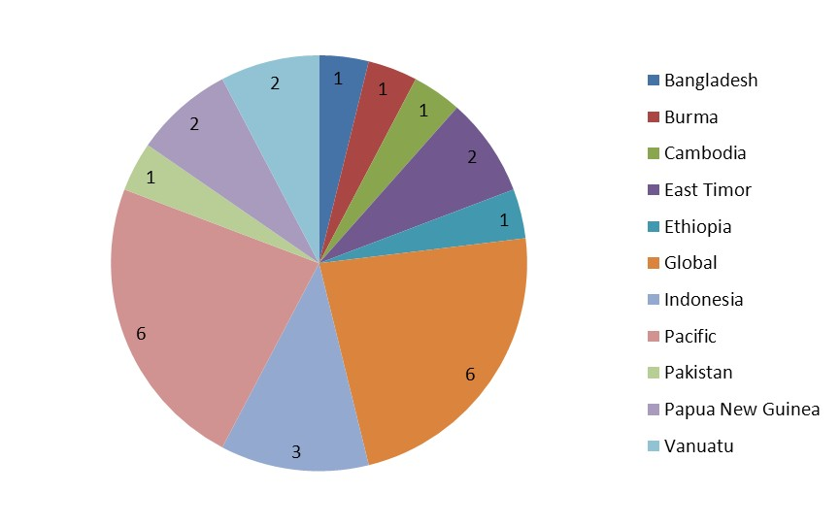

Figure 8: Days contracted by commissioning section, Jan to July 2011

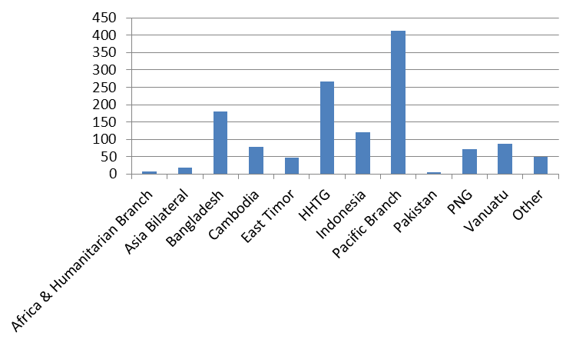

Figure 9: Origin of requests (requesting AusAID section)- Jan 2009 to

July 2011

•Asia Bilateral

•Asia Regional

•Office of Development
Effectiveness (ODE)

•OPS
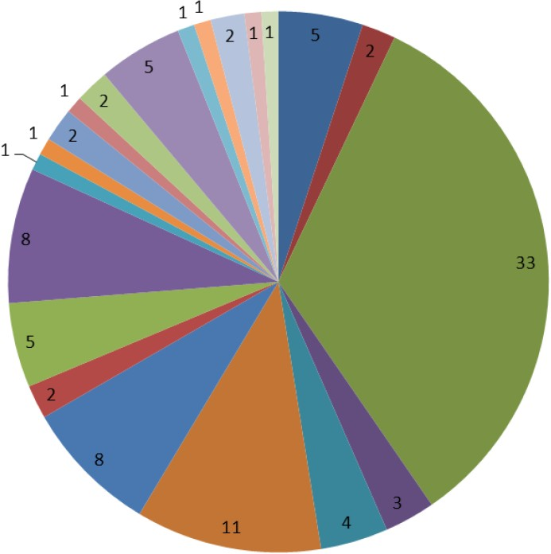

•Pacific Branch

•Papua New Guinea

•Solomon Islands

•vanuatu

•Fiji

•Kiribati

•Nepal

•China

•Nauru

•African and Humanitarian
Emergency Response

•Indonesia

•Bangladesh

Cambodia

Table 1: Proportion of potential commissioners that have contracted the HRF Jan

2009 to July 2011

Commissioning post/section |  | Contracted HRF |  | Contracted more than once
HHTG |  | YES |  | YES
Operations Policy and Support Branch |  | YES |  | YES
Pacific Branch |  | YES |  | YES
Asia Bilateral |  | YES |  | YES
Fiji |  | YES |  | YES
Vanuatu |  | YES |  | YES
China |  | YES |  | YES
Indonesia |  | YES |  | YES
PNG |  | YES |  | YES
Office of Development Effectiveness |  | YES |  | YES
Asia Regional |  | YES |  | YES
Solomon Islands |  | YES |  | YES
Africa & Humanitarian Branch |  | YES |  | YES
East Timor |  | YES |  | YES
Nauru |  | YES |  | NO
Kiribati |  | YES |  | NO
Nepal |  | YES |  | NO
Cambodia |  | YES |  | NO
Pakistan |  | YES |  | NO
Bangladesh |  | YES |  | NO
Middle East & West Asia Branch |  | NO |  | Help Desk only
Samoa |  | NO |  | Help Desk only
Philippines |  | NO
Vietnam |  | NO

Topics of Assignments

Figures 10 and 11 provide an overview of the topics and types of HRF assignments during this reporting period. There is a reasonable spread across the topics (Figure 10) and types (Figure 11). Of the 26 Service Orders in this period, 9 were for evaluation and reviews, 8 for policy and strategy development, 8 for scoping/assessment/design and one for other.

Figure 10: Topics of assignments according to the categories of expertise in scope of services – January to July 2011
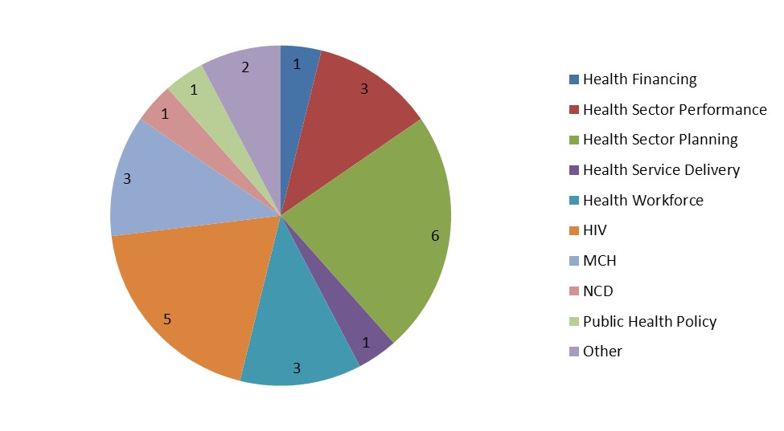

Figure 11: Types of assignments – January to July 2011

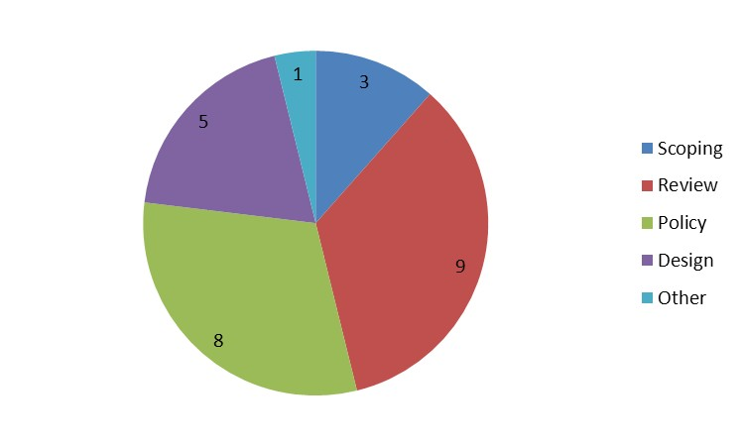

Cancelled Assignments

Given their impact on core resources, cancelled requests need to be kept under review. In a proportion of consultancy requests, an AusAID client contacts the HRF with a request and the HRF begins the process of clarifying the ToR and searching for consultants, but, for one reason or another, the assignment is cancelled.

In February the HRF put considerable effort into sourcing for a Procurement Specialist

Adviser for the Solomon Islands. However, the role was subsequently changed to a long

term position and the HRF request cancelled. One cancelled assignment in six months is an improvement on previous reporting periods.

2. Help Desk

The Help Desk has continued to be well utilised during this reporting period with users reporting that the service is easily accessible and responsive. The average CPA score for the Help Desk Services for this reporting period was 3.95 (just under highly satisfactory) with the average since inception of the HRF being 4.2 (highly satisfactory).

As in the last reporting period all requests have had TORs agreed and consultants sourced within the time agreed with the commissioning AusAID staff member (indicator 1.4 PAEP).

Contact remains separated into two categories:

1. Enquiries and requests relating to Non-Core activities which will lead to a future Service Order. This includes requests for consultants and requests for comments on Terms of Reference.
2. Requests under Core activities – policy advice, literature searches and knowledge analysis / synthesis. HRF capacity has increased for these types of requests since the signing of the Amendment to Services Order 1 in September 2010. The HRF is now able to respond to knowledge requests for up to 3 days per week and is operating at full capacity. Annex 2 is a summary of the requests that have been
responded to under this Core knowledge time, and a sample of selected assignments

is in the box below.

Selected Help Desk Assignments, January to July 2011

Global Policy brief on HIV and Children
Overview of key issues, progress and policy directions with regard to 1) preventing HIV transmission to children 2) providing treatment and care to both children and their HIV-positive mothers, and 3) providing care and support to children affected by AIDS through the death or illness of one or both parents.

Review on the first Update of the Medium Term Expenditure Framework (MTEF) for the Health Sector report - Samoa
Independent review of the above report and the provision of comments on: what a health sector MTEF is in the context of a SWAp; whether or not the MTEF is the right tool to provide the information needed and; the quality of this MTEF.

Malaria Drug Resistance in the Mekong Region
The paper sought to provide answers to the following questions:
• Is there scope for malaria drug resistance in the Mekong region to be declared a “public health emergency of international concern” under the International Health Regulations (IHR)?
• If not, is there another specific term under the IHRs that could be used to describe malaria drug resistance in the Mekong region?

A rapid review of Drug Resistant Tuberculosis in nine high-burden Asian countries
A technical briefing including: epidemiological overview; global policies guidelines and best practise in addressing TB/DR-TB and; global level initiatives/programs/partnerships to address MDR TB.

Review of the report on Health Financing Options for Samoa
Independent assessment of the quality of the report on Health Financing Options for Samoa against the Terms of Reference.

Solomon Islands – Joint Annual Programme Review
An initial briefing to provide assistance with planning for the Joint Annual Performance Review of the Health
Sector Support Program.

Forty-two core knowledge requests were completed during the reporting period. Twenty-nine of these requests came from HHTG with the remaining generated from country posts. The inputs required have varied widely from a few hours to a number of days with often a

demand for complex and specialised inputs with tight timeframes for which the HRF has been able to respond flexibly and appropriately

3. Knowledge and Information and Professional Development Services

The HRF continues to deliver a Seminar Program and looks forward to developing this program further with HHTG for 2011. All presentations are available on the HRF website. Seminars delivered during this period include:

• Dr Ken Grant (HRF Technical Director and Director of the HLSP Institute), “Monitoring and Evaluation in Health” Thursday, 10 March 2011

• Henrietta Wells (HRF Health Specialist) “Sector Wide Approaches in Health (SWAps): some lessons learned, issues and opportunities” Tuesday, 31 May 2011

As a part of the HRF Knowledge and Professional Development Plan February 2010, HHTG commissioned the HRF to develop a series of pre-deployment briefings in international health for staff taking up posts in Health and HIV. These final draft briefs were submitted to HHTG in March 2011 and the HRF is awaiting final comments from HHTG so that we can finalise and disseminate.

Many of the Help Desk requests in this period were knowledge and professional

development activities. For example preparation of a short paper on the Global Fund and in- country coordination for the health leads teleconference.

The HRF has had a number of discussions with HHTG about possible follow on Knowledge and Professional Development activities and has provided a list of topics for professional development activities and seminars to HHTG. A Knowledge and Professional Development Plan for the remainder of the current HRF contract has been submitted and we look forward to discussing it at the next Steering Committee meeting.

4. Communication Activities

Activities to deliver the HRF Communications Strategy and 2011 Action Plan

In addition to using professional development activities to build AusAID awareness about the

HRF, communication activities undertaken in the reporting period include:

• An update and content review of the HRF website, including the following improvements:

- Update and consolidation of all AusAID HRF pages

- Streamlining of site map

- Consolidation of all HRF documents into a central document library, with the introduction of a central search function to allow search by document type (presentations, knowledge requests, consultancy reports, operational documents) as well as search by keyword/title.

- Modification of log-in area to encourage users to access the members-only area of the site, in which the majority of the key documents are located.

- Addition of graphics to improve the general aesthetics of the home page

• Preparation and submission of the Communications Plan 2011

• Drafting of an e letter and knowledge round up which was submitted to HHTG in May

2011 and approved in August.

• Ongoing introduction of the HRF to AusAID staff – including attendance at O based staff events and opportunistic meetings.

• Preparation of case studies and facilitation of small groups at O-based training sessions

(March and May 2011) and a new starters training event (April)

Website – www.ausaidhrf.com.au

The HRF has continued to add content to the AusAID password protected area, including the building of the reports database and a searchable record of Help Desk requests. All HRF outputs are available on the website (PAEP Indicator 2.4).

Figure 12 below shows the hits on the site by month since the launch. The average is 5,864 hits per month. This is higher than the average for the same time last year– which was around 4,100 hits per month.

In the last reporting period there were 91 approved members of the website. In this reporting period there are 118. Figure 13 shows the distribution of all members by country. Twenty- three country posts are represented.

Figure 12: Hits on the website, by month – May 2009 to July 2011

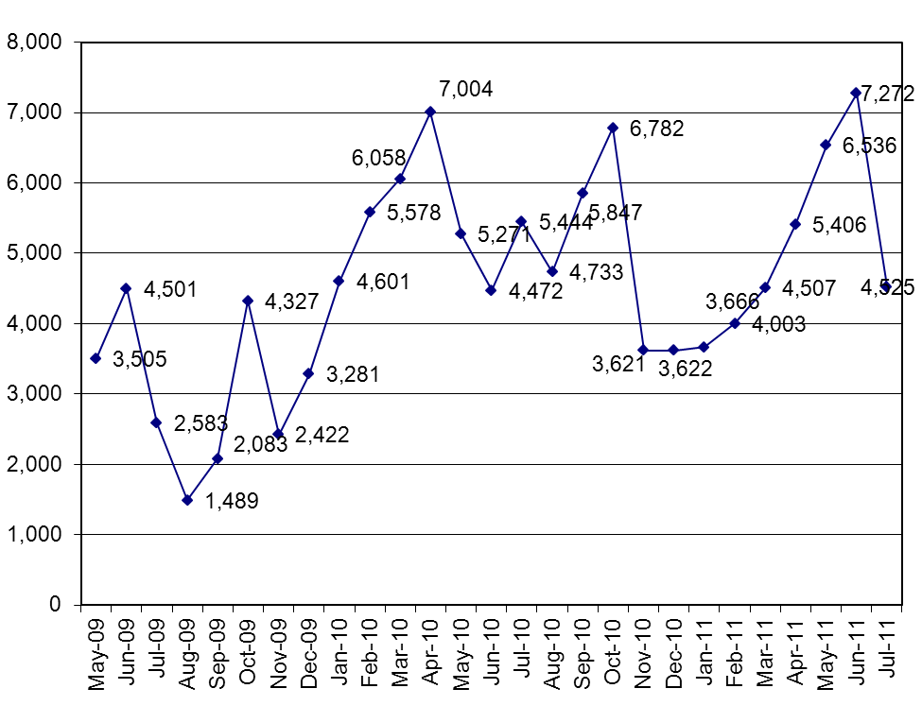

Figure 13: Website membership by country (AusAID staff) – July 2011

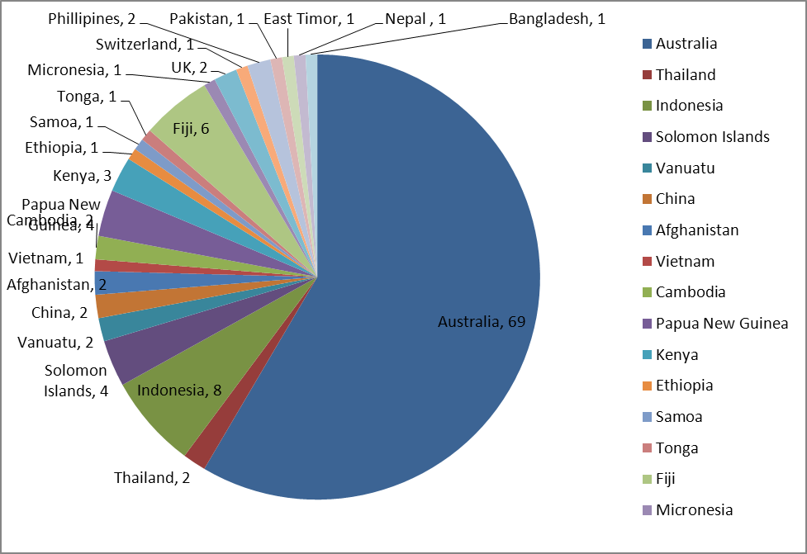

Figure 14 shows the number of times visitors have downloaded particular reports from the web site. The HIV scoping reports are public documents so it is expected that they would have been downloaded the most.

Reports on the AusAID only part of the site are still not being downloaded regularly. AusAID staff are still not downloading reports and Help Desk requests – reinforcing the continued need to communicate these options.

Figure 14: Downloaded Files by Visitors – January to July 2011

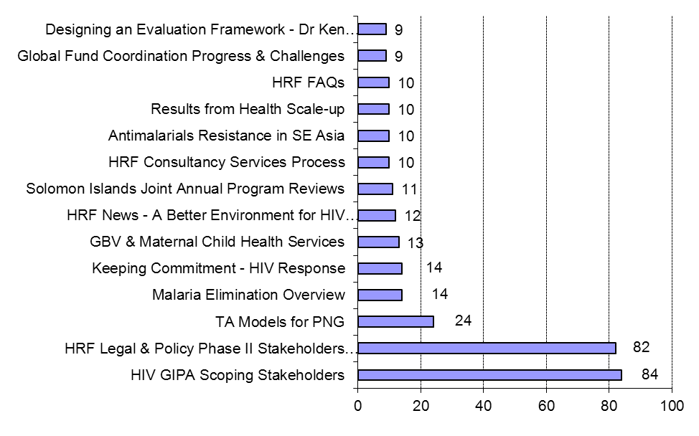

5. Performance Management and Feedback

Contractor Performance Assessments (CPAs)

Annex 3 analyses all the completed CPAs received. This analysis covers a 30-month period since the beginning of the establishment phase of the HRF (Jan 2009 to July 2011). Overall the average score for all assessment criteria was 3.94 (just below highly satisfied). This is higher than the average score of 3.91 reported in the last period. Scores have been reasonably consistent over the last 2 years.

Scores for the last 6 months have slightly increased with an average at 4.03 (between highly satisfactory and best practice) being reported. We are missing only two CPAs (SOs 91 and
92).

We look forward to further discussion about the CPAs and their use following the

Independent Progress Review.

Other Feedback

Knowledge and Information

The HRF uses a short form for written client feedback for core knowledge requests under the Help Desk. The return rate is about 25 per cent and analysis of feedback can be found below. It has been broadly extremely positive confirming the outputs have fulfilled the requests and are of value to AusAID staff. Overall the average score was 3.6 (between
Good and Excellent) in this reporting period (Table 2). This is the same as the overall average score of 3.6 for all feedback received to date (Table 3).

Table 2: Knowledge Requests Feedback (formally known as Help Desk Feedback) – Jan to July 2011

Assessment Criteria Number of ratings

Average*

How helpful was the Help Desk in clarifying your tasks and responding to your requests in a timely manner?
How satisfied were you with the expertise of the
HRF team to respond in an appropriate manner to

13 3.7

complete your request? 13 3.6

How satisfied were you with the quality of the final product or outcome?

13 3.5

Overall average score 3.6
1=Unsatisfactory 2= Satisfactory 3=Good 4=Excellent

Table 3: Cumulative Knowledge Requests Feedback (formally known as Help Desk
Feedback) - Sept 2009 to July 2011

Assessment Criteria Number of ratings

Average*

How helpful was the Help Desk in clarifying your tasks and responding to your requests in a
timely manner? 36 3.7
How satisfied were you with the expertise of the
HRF team to respond in an appropriate manner
to complete your request? 36 3.6
How satisfied were you with the quality of the
final product or outcome? 36 3.4
Overall average score 3.6

Positive written feedback

The following plaudits were received during this reporting period. These have been lifted from email correspondence between the HRF team and the named AusAID advisers, and also from the verbatim responses received on completed CPA forms.

Jill Bell, Manager, South Asia Section, AusAID

Re: Draft Zero Background Doc for Nepal Health Care Financing Strategy

Sophie’s feedback is very incisive and useful to encourage a better quality product than it currently is. Could you please thank Sophie (Witter) for this work and also for her quick turnaround…Many thanks to you Chris for organising this. Much appreciated.

Mia Thornton, East Timor AusAID Re: East Timor Design
Please thank Javier (Martinez) for providing this detailed and frank assessment of his participation in the joint health design mission – it is hugely appreciated.

Robyn Biti, HIV Advisor, Health & HIV Section, AusAID Re: Policy Briefing on HIV and Children
This is excellent – just what we were looking for. I love it! I think you’ve done a very complex job incredibly well…Thanks for all your hard work

Margot Morris, Australian HIV Ambassador, AusAID Re: Results from scaling up AusAID spending
Thanks again for the paper on estimating results … A very good summary of the available tools (including their data requirements and limitations). We’ll be doing a lot of thinking about how we measure and communicate our results over the coming months, so the paper is a very helpful guide for what’s feasible and what’s not.

Zoe Mander-Jones, Director, Evaluation, Office of Development Effectiveness, AusAID Re: PNG HIV Evaluation - Peer Review Comments
Thank you for attending the peer review meeting/s last week…I often feel that we (ie. the peer reviewers) don’t praise enough during these meetings. I wanted to let you know that there were a number of comments from people of congratulations for the body of evidence that had been drawn on during the process and for the final product. I hope you recognise that in these processes, often the praise is left unsaid with

people tending to strongly focus on what needs to change as opposed to what is good. But we all recognise we are dealing with a very good product.

Zoe Mander-Jones, Director, Evaluation, Office of Development Effectiveness, AusAID Re: SO40 PNG HIV Evaluation - Main Report Draft
We are very pleased with how this draft is looking…we know it has been a huge effort to get to this stage. However, from ODE’s perspective, all the efforts have been very worthwhile. We have a high quality product to go out to peer review…I look forward to continuing to work with you all as we progress through peer review consultations and move towards finalisation of the report.

Jennifer Lean, Cambodia, AusAID

Re: Temporary Health Adviser, Cambodia

Marion (Kelly) is fantastic…Fiona's (Duby) appraisal was also very good. Thanks to all of you.

Marion (Kelly) and Marilyn (McDonagh) worked seamlessly as a team, such that it made the shared consultancy much more effective... There was a 1+1 = 3 synergy – of great value to me.

Robyn Biti, HIV Advisor, Health & HIV Section, AusAID Re: HIV Publication
Corrie (Mills) – I love it! I think you’ve done a very complex job incredibly well. Thanks for all your hard work – hope you have a good rest over the weekend!

Lucy Phillips, Pacific Division, AusAID

Re: Appraisal of the proposal to AusAID by the Royal Australasian College of

Surgeons (RACS)

What we needed, when we needed it, and high quality. Thanks again.

Ainsley Hemming, Health Systems Strengthening, AusAID Indonesia

Re: Indonesia HSS Design

Many thanks for your ongoing help - it is greatly appreciated at this end.

Edwina Chinn, Program Officer, Health & HIV Section, AusAID Re: NCDs Briefing Note
Thanks again for the NCDs briefing note – it has been very useful so far.

Lucy Phillips, Human Development Section, Pacific Division, AusAID

Re: AusAID Support to Tertiary Health Care and Medical equipment

Maintenance in the Pacific

It was great to get Jim Buchan at such short notice and fantastic that he was able to produce the quality of report that he did, in the few days that we had available for the work.

6. Other Issues and Discussion

Capacity issues

In September 2010 the Amendment to Services Order 1 was signed. This provides for increased staffing capacity based on an agreed volume of 1600 consulting days per year under Service Orders, an additional 600 days per year over the original contract.

Between January and July 2011 we have been contracted for nearly as many days under Service Orders as we did in 12 months last year (1695.5 days in year 2 and 1527 days in the last 6 months). Since then (between 22nd July and 5th August 2011) we have been contracted for an additional 332 days bringing the total to 1859.

A number of the SOs from 2010 are ongoing and delivery continues into 2011. We have an active pipeline. In the second six months of year 2 we were contracted for around 500 days and are expecting at least this volume of demand this year. Under such a scenario we can project to around 2300 days contracted by end of Year 3.

In view of this volume we are currently discussing with HHTG staffing for the remaining time of the existing contract period in order to maintain quality. See next section on staffing for discussion.

The type of demand on core HRF technical and operational resources varies to a certain extent with the type of assignment. However, it is not always true that the more ‘adviser’ or call down type assignments demand less input. Assignments which can appear more straightforward can require significant staff time to keep on track. Also during any one reporting period there are a number of ongoing assignments contracted during the previous period requiring significant input. Examples include ODE’s PNG HIV evaluation, Pacific regional malaria concept design, Indonesia design and East Timor design. Some illustrative examples included below.

Table 2: Illustrative examples of different types of HRF assignments with comments on inputs
Assignment | Comments
Eg Adviser assignments
D03 Cambodia Temporary  Health Adviser | Marilyn MacDonagh and Marion Kelly for a total of 79 days.  Significant HRF time to coordinate their inputs and overcoming availability constraints. HRF QA of key milestones, including Health Delivery Strategy. CPA mostly 5s.
SO94 Bangladesh Health  Adviser | Jan Borg contracted for 180 days from 1 May. Milestone  deliverables (including Health sector analysis, delivery strategy) to be QAed by the HRF over the next months. Significant operational support on contracting and mobilisation issues.
Eg Assignments with different QA arrangements
SO 84 and 97 Indonesia Health  Design | Conflict of interest issues addressed by using a non-staff HRF  Health Specialist (Pete Thompson) to provide QA inputs and technical management support to the design team. This remains core HRF time.
D07 Review of the Sector Policy  Division | Team of 3 consultants with Carolyn Peterken and Michael  Pilbrow providing 45 days plus Jim Tulloch under SO 76. Due to the sensitive nature, HRF exempt from QA. HRF inputs focused on sourcing, comments on the TORs, contracting and logistics.
Eg Ongoing assignments requiring significant input
SO 40 Evaluation of the  Australian program’s  contribution to the HIV response in Papua New Guinea | HRF contracted for 212 days with start date March 2010. Six SO  amendments. ODE is happy with the quality of draft reports (with 29 annexes, 15 of which stand alone). New ODE Director has led to further comments. HRF has provided technical, operational management has been very significant and ongoing.
SO 75 Next phase of support  for malaria programs in  Solomon Islands and Vanuatu | HRF has supported new concept design (132 days for 3  consultants) since November 2010. The dates for Phase 2 shifted so needed to replace the team leader and ensure a smooth transition. Significant HRF technical management inputs. Peer review planned for September 2011.
SO 108 Support to the MoH in  the Solomon Islands for the Joint Performance review and MTR of the health SWAp | SO for Stewart Tyson signed late July 2011. Stewart mobilised  early August after seven versions of TORs over three months and more than 50 emails stretching back to December 2011. Significant HRF technical input and support to get to this point.
Pacific reviews – SOs 89, 100  and 95 | 355 days over three reviews. Extensive travel and logistical  issues, including several major re-organisations of multiple country visits at last minute.

The remuneration framework has had a positive impact on our work with regards to lowering fee rates. We have also noticed an increase in the proportion of consultants selected that are new to AusAID. A number of consultants who have a track record of working with AusAID have informed us that the new remuneration framework has resulted in them prioritising work with higher paying clients. In particular we are working with design teams who are new to AusAID and necessarily need additional HRF staff input for both briefing and ongoing support on AusAID requirements. This pattern is not unique to the HRF.

The core services under the Help Desk (knowledge and information) continue to be well used and are operating at around the enhanced capacity levels following the contract amendment. With the new ‘up to 3 days a week’ guideline there has been an increase in both use and the range and type of request. We are needing to source specialist expertise
outside of the core team (eg health financing, disease specialists) to meet the need.

The increase in use and the range / type of request under the Help Desk has also meant that more Help Desk Manager time has been needed for the sourcing and technical management of these requests.

Staffing issues

The HRF needs to ensure that quality is maintained with this volume of demand and has been considering staffing issues accordingly.

Charley Barber assumed the role of Operations Manager in April 2011. Megan McKeough was appointed as Operations Officer in June 2011 and Kathryn Pachnatz will be joining the team at the end of August.

We are very grateful to Chris McLanachan in her flexibility to relocate from the DFID Human Development Resource Centre to work with the HRF from May to August to cover Andrea Neale’s leave and return to work. Chris will be returning to the UK at the end of August. Andrea Neale (Help Desk Manager) returned to work 4 days a week in early July. We have informed HHTG that Andrea will not be remaining with the HRF team beyond the end of the current contract.

Henrietta Wells has needed to reconsider her work priorities and will no longer be available to provide health specialist inputs to the HRF. Pete Thompson has been providing invaluable additional Health Specialist support over the last few months and we would like him to continue to do so in the short term. Debra Hartley remains working 50% time as a Health Specialist

The HRF is actively recruiting in close liaison with HHTG. We will be seeking AusAID approval for Becky Dodd to join the HRF team from WPRO as a Health Specialist from mid December 2011. In addition we will be advertising shortly for a new Help Desk Manager and are hopeful that the successful candidate (with AusAID approval) will be in post from October 2011. Following recruitment of the new Help Desk Manager, we will be requesting that Andrea Neale remains working part-time with the HRF as a Health Specialist until the end of the contract – both to support the new Help Desk Manager settle in and to and undertake technical management of assignments.

We also look forward to working with the Steering Committee and HHTG on future staffing scenarios. We envisage that one of these could involve the recruitment of a junior health specialist. We are not proposing to proceed with this during the current contract term, but would like to consider this option if workload remains at a level where additional support is required. In addition, if the recruitment of the Help Desk Manager is delayed for any reason, we would be looking for additional Help Desk / Health Specialist support and a more junior
person could be considered.

We note in the recent HRF Independent Progress Review that the reviewers recommended that the HRF needed more technical standing capacity to undertake more strategic and analytical work. The proposed staffing has been considered to meet existing requirements under the contract. This has been based on the anticipated volume of consulting days (more than 1600 and up to 2300 days) and Help Desk requests (up to 3 days
a week).

If HHTG would like to ensure that the HRF has additional technical capacity at this time, an option could be for AusAID to consider varying the sums assigned under line items in the Reimbursable cost budget and allocating additional sums to the final category (Sub-
contracted expertise for knowledge and information services.

If this was considered, the HRF would like to work closely with HHTG to create a pool of agreed specialists that would meet the requirements (e.g. health economists / financing; monitoring and evaluation; health systems and sector reform; programme based approaches and sector working). For each specialism we would recommend having up to 3 CVs
approved so that we could ensure that we could meet demand for rapid response given availability constraints.

HRF Technical Report
Period Offer Deed 48511
Submitted 4 February 2011

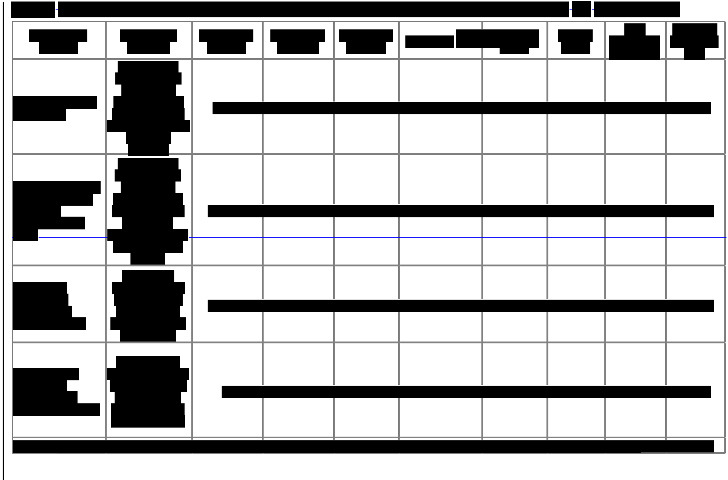

AusAlD Health Resource Facility 30
Managed by HLSP in association with lOSS

Engagement Issues

The HRF is appreciative of the ongoing opportunities to engage with HHTG at a managerial and technical level. We are looking forward to further discussions in the context of the findings of the recent Independent Program Review and working in partnership with HHTG to ensure that we are providing services which add value and meet need.

In particular we are looking forward to working with HHTG and the Steering Committee to review the Performance Assessment Evaluation Plan at objective level to ensure that we are capturing value add.

Operational Issues

The HRF continues to experience ongoing issues related to supporting good practice among commissioners to engage with and utilise the HRF. We will continue to work with HHTG to address and respond to these.

Annex 1: HRF Non-Core Activities delivered in the reporting period

Title / Short
Description

D03 Cambodia
Temporary Health
Consultant(s) Nominated

McDonagh / Kelly / Duby / Cosgrove / Donoghue /
Consultant(s) Selected
Key
Deliverables
Status (Cancelled, Inactive, Completed, Ongoing)
Deliverables submitted in timeframe agreed with client (Y/N)*
Expenditure / Forecast** (AUD ex. GST)

Adviser
McLanachan McDonagh / Kelly Ongoing $100,950.00

D04 Pakistan MNH D05 Workforce
Planning Phase II
Austin / Duby / Middleton
/ Barker Duby Completed $3,650.00

HHTG Ollier Ollier Ongoing $92,840.00

D06 Workforce
Planning Phase II HR Flynn Flynn Ongoing $94,400.00

SO82 Vanuatu
Medical Specialist
Buchan / Smith /
Peterken / Davies Buchan Completed $36,363.02

SO84 Indonesia HSS Design
Taylor / Buchan / Walford
/ Ensor / Kraushaar
Taylor / Buchan /
Walford / Ensor Ongoing $59,828.00

SO86 MNCH Burma
UN Proposal James James Ongoing $19,088.00

SO87 Vanuatu
Finance Support Northway / Keane Keane Ongoing $82,300.00

Title / Short | Consultant(s) | Consultant(s) | Key | Status | Deliverables | Expenditure /
Description | Nominated | Selected | Deliverables | (Cancelled, | submitted in | Forecast**
 |  |  |  | Inactive, | timeframe agreed | (AUD ex. GST)
 |  |  |  | Completed, | with client (Y/N)*
 |  |  |  | Ongoing)

SO88 Ethiopia MCH Proposal Review
Gruber / Duby /
McLanachan Duby Completed $5,110.00

SO89 ICR PacNCD Review
SO90 Research & Development in Health
Sancho / Snowdon /
Moodie / Kanungo Sancho / Moodie Ongoing $107,611.00

- Scoping Review Grace / Sambo Grace / Sambo Ongoing $22,190.00

SO91 East Timor  Paper | Sancho / Allison / Simmonds / Lloyd | Simmonds | Completed | $28,499.88
 | Thompson / Heijkoop /
 | Northway / Cosgrove /
SO92 East Timor | James / Martinez /
Design | Crawford | Martinez | Ongoing | $45,350.00
 | Adair / McLanachan /
 | Dastgeer / Ghosh /
SO93 HIV Civil | Mundy / Lowe / Heijkoop / | Adair / Dastgeer /
Society | Haggarty / Doust | Ghosh / | Ongoing | $151,245.00



SO94 Bangladesh
Health Adviser
Borg / Foster / Wikman / Cornish / Northway /
Thompson Borg Ongoing $161,250.24

Title / Short Consultant(s) Consultant(s) Key Status Deliverables Expenditure / Description Nominated Selected Deliverables (Cancelled, submitted in Forecast**
Inactive, timeframe agreed (AUD ex. GST) Completed, with client (Y/N)*
Ongoing)
Gelmon / Struwig / Struwig / Godwin / SO95 Pacific HIV Godwin / Godwin / Garcia Garcia / Sa'aga-
Fund / Sa'aga-Banuve Banuve Ongoing $91,875.85

SO96 PNG Provincial
Health Authorities Sorenson Sorenson Ongoing $78,057.50

SO97 Indonesia HSS
Design Part II Taylor Taylor Ongoing $31,930.00
Buchan / Braithwaite /
SO100 Pacific Buchan / Braithwaite / McKimm /
Regional HSS Review McKimm / Campbell Campbell Ongoing $257,744.05

SO103 IPR of England / Austin / Thapa /
Indonesia HIV Lowe Lowe Ongoing $49,027.00
SO104 Evaluation of the Pacific Senior Health Officials
Network Lower / Nesbit Lower Ongoing $46,007.00
SO105 Post secondary Strategy: Sectoral Note  D07 Review of the  Sector Policy Division | Braithwaite / McKimm /  Kafoa Kafoa Ongoing $8,990.00  Tulloch / Peterken /  Pilbrow Peterken / Pilbrow Ongoing $100,585.50

Title / Short  Description | Consultant(s) Nominated | Consultant(s) Selected | Key  Deliverables | Status  (Cancelled, Inactive,  Completed,  Ongoing) | Deliverables submitted in  timeframe agreed with client (Y/N)* | Expenditure / Forecast**  (AUD ex. GST)
SO85 PNG HIV Prevention Programs Impact Evaluation: Feasibility Study | Loo / Plowman / Schierhout / Wilson / Lowe / Butcher / Chevalier / Gordon / Slavin | Schierhout / Lowe  / |  | Ongoing |  | $39,598.00
SO109 Tonga Health System Support Program - 6 month Review | Waliji / Urbano | Urbano |  | Ongoing |  | $17,900.00
SO83 HIV Publication | Mills / Wilson / Doust | Mills |  | Completed |  | $10,272.00
*N/A recorded for deliverables related to assignments for which no deliverables due within the reporting period
**Figures for “Completed” projects are actual expenditure. Figures for “Ongoing” projects are as per budgets

Annex 2: HRF Core Activities (knowledge and information) delivered in the reporting period


Initial Request Date | Project Name | Type of Output | Status | Requested By | Region/Country | Time  Taken
24/01/2011 | Comments on Indonesia Diagnostic  Related Groups proposal | Short comments | Complete | Helen  McFarlane | Indonesia | 1
25/01/2011 | Comments on UNICEF proposal | Short comments | Complete | Nilesh Goundar | Fiji | 2
3/02/2011 | Fragile States and Sector Wide  Approaches | Key Documents | Complete | Sue Elliott | HHTG | 0.5
17/02/2011 | Performance framework for health  Indicators | Examples | Complete | Ben David | HHTG | 3
14/02/2011 | Lancet Series Health South East Asia | Summary paper | Complete | Joanne  Greenfield | HHTG | 2
14/02/2011 | Lancet Series Health India | Summary paper | Complete | Joanne  Greenfield | HHTG | 2
11/02/2011 | Global Fund and in-country coordination | Overview + Key papers | Complete | Sue Elliott | HHTG | 4
2/03/2011 | Request for Human Resources for Health  articles | PDFs of articles | Complete | Tiroam Neeri | Kiribati | 0.2
1/03/2011 | Cambodia Independent Appraisal  Reduction Maternal Mortality Project | Review of Proposal | Complete | Jennifer Lean | Cambodia | 4
7/03/2011 | Royal Australasian College of Surgeons proposal | Review of Proposal | Complete | Lucy Phillips | Pacific | 2
15/03/2011 | AusAID possible results and Scale Up -  Phase One | Analysis of models | Complete | Ben David | HHTG | 4
1/03/2011 | Joint annual program review Solomon  Islands | Initial concept advice | Complete | Paula  Henriksen | Solomon Islands | 2
25/02/2011 | Independent Progress Review of China  Australia Health and HIV/AIDS Facility | Initial sourcing of Health  Specialist | Complete | Chen Wei | China | 1.5
10/03/2011 | Professional Development  Seminar | Monitoring &Evaluation  Frameworks | Complete | Tamara Khosla | HHTG | 2
21/03/2011 | Examples of good National Health  Strategic Plans | Documents | Complete | Beth Slatyer | HHTG | 0.1

23/03/2011 | Fiji UNICEF Proposal Two | Quality at Entry report | Complete | Nilesh Goundar | Fiji | 3
22/03/2011 | AusAID Overseas Based Training | Case Studies | Complete | Tamara Khosla | HHTG | 0.6
1/04/2011 | WHO Non-Communicable Diseases  Proposal | General comments on proposal | Complete | Paulini Sesevu | Fiji | 1.5
 |  |  |  | Peter | Middle East & West Asia
7/04/2011 | UNWRA proposal | Draft note | Complete | Lindenmayer | Branch | 0.6
3/05/2011 | Communications for development | Advice of relevance for health | Complete | Tamara Khosla | HHTG | 0.4
5/05/2011 | UNICEF Social protection proposal | QAE appraisal | Complete | Nilesh Goundar | Fiji | 3
13/05/2011 | Australian Development Research  Awards (ADRA) 24 | Mini review | Complete | Sue Elliott | HHTG | 0.3
20/05/2011 | Australian Development Research  Awards (ADRA) 252 | Mini review | Complete | Sue Elliot | HHTG | 0.3
11/05/2011 | HIV and Children | Policy brief - HIV Children | Complete | Robyn Biti | HHTG | 3.5
17/05/2011 | China health reform | Documents search | Complete | Ben David | HHTG | 0.5
20/05/2011 | Avoidable Blindness Initiative | Review of Annual report  2010 | Complete | Anne Rigby | HHTG | 2.25
2/06/2011 | Polio eradication | Briefing note | Complete | Joanne  Greenfield | HHTG | 3.5
3/06/2011 | Australian Development Research  Awards (ADRA) 52 | Mini review | Complete | Sue Elliot | HHTG | 0.3
3/06/2011 | Australian Development Research  Awards (ADRA) 148 | Mini review | Complete | Sue Elliot | HHTG | 0.3
6/06/2011 | Nutrition proposals review | Review of two World  Food Program proposals | Complete | Joanne  Greenfield | HHTG | 3.5
8/06/2011 | IPPF funding proposal | Quality at Entry report | Complete | Nilesh Goundar | Fiji | 2
9/06/2011 | Health Financing Samoa (1) | Review of Medium Term Expenditure Framework report | Complete | Beth Slatyer | HHTG | 1.25

9/06/2011 | Health Financing Samoa (2) | Review of Health  Financing Options report | Complete | Beth Slatyer | HHTG | 1
20/06/2011 | Public private partnerships in health sector | Briefing paper on experience & lessons | On going | Ben David | HHTG | 3
22/06/2011 | Nepal Review of Health Financing report | Technical Review - | Complete | Jill Bell | South Asia | 1.75
28/06/2011 | Non-Communicable Diseases Statistics analysis | Technical note | Complete | Edwina Chin | HHTG | 1.5
28/06/2011 | Malaria Drug Resistance in the Mekong | Technical note | Complete | Edwina Chin | HHTG | 1.25
30/06/2011 | AusAID draft strategic framework for health | Review | Complete | Ben David | HHTG | 0.75
7/07/2011 | Multi-drug resistant Tuberculosis in Asia | Technical briefing | Complete | Roger Nixon | HHTG | 3.5
12/07/2011 | Sector Wide Approach information for  AusAID Ethiopia | Key documents | On going | Joanne  Greenfield | HHTG | 0.5
 | Global Alliance for Vaccines and  Immunisation (GAVI) supply and |  |  | Dominique
14/07/2011 | procurement strategy | Commentary on draft | Complete | Vigie | HHTG | 1.25
4/07/2011 | Economic & Health Data Malaria Drug  Resistance Mekong | Technical note | On going | Edwina Chin | HHTG | 0.5

Annex 3: Analysis of Contractor Performance Assessment Received Jan 2009

to July 2011

Assessment Criteria Number of ratings*
Average**

Management and Administrative Logistics
Was the logistical support provided adequate for the assignment (including security briefings, inoculations, travel details and accommodation for the consultant?)
Were management issues dealt with in a timely and professional manner (including accurate invoicing)?
Were management, administrative and logistical

38 4

55 3.8

arrangements communicated effectively to you? 52 3.9

Was the assignment completed in accordance with the agreed budget and timing?
Average Management and Administrative

58 3.9

Logistics 3.9
Performance of Personnel
Did the consultant demonstrate an understanding

of the requirements of the ToR or Scope of
Services?
Did the performance of the Consultant meet with the requirements as outlined in the ToR/ Scope of Services?
Was the Consultant responsive to AusAID’s
60 4

60 3.9

requests and instructions? 60 3.9
Was the Consultant aware of/ highlight risks,

issues and problems associated with the assignment and did they respond to them appropriately?
Did the Consultant work and communicate with AusAID and other counterparts and stakeholders in a professional and appropriate manner (including cultural sensitivity)?

52 3.8

59 4.0

Average Performance of Personnel 3.9
Quality of Deliverables

Were deliverables of good quality in terms of content?
Were deliverables communicated clearly,

59 3.8

accurately and in an appropriate format? 59 3.8
Average Quality of Deliverables 3.8
Resource Facility

How easy were the services of the Resource
Facility to access and use? 58 4

Help Desk Services
Did the Help-Desk respond to your request in a
timely manner? 45 4.1

How satisfied were you with the quality of service
delivered directly by the Help Desk (e.g. literature 26 4.3 and data searches and compiling information)?
How satisfied were you with the service provided
by the Help Desk in sourcing technical expertise 46 4.2 (including assistance with drafting ToR and
sourcing suitable consultants)?
Average Help Desk Services 4.2
Overall average score |  | 3.94
* Not all questions were applicable to all the rated projects, hence the number of
ratings vary
** 1=Weak 2=Marginally Satisfactory 3=Satisfactory 4=Highly Satisfactory 5=Best
Practice

