. .

DEED OF AMENDMENT

BETWEEN

COMMONWEALTH OF AUSTRALIA

represented by the Australian Agency for International Development
(AusAID)

ABN 62 921 558 838

and

THE AUSTRALIAN INTERNATIONAL HEALTH INSTITUTE (THE UNIVERSITY OF MELBOURNE) LTD FOR AND BEHALF OF THE NOSSAL INSTITUTE FOR GLOBAL HEALTH

ABN 18 084 268 655

FOR

KNOWLEDGE HUB FOR HEALTH POLICY AND HEALTH FINANCE AUSAID AGREEMENT 44911

THIS DEED OF AMENDMENT is made this 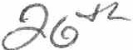
Amendment No. 1
N o-re r
day of 0·2010

BETWEEN:

The COMMONWEALTH OF AUSTRALIA, represented by the AUSTRALIAN AGENCY FOR INTERNATIONAL DEVELOPMENT, ABN 62 921 558 838 ("the Commonwealth") ofthe one part

AND

The Australian International Health Institute (The University of Melbourne) Ltd for and
on behalf of the Nossal Institute for Global Health, ABN 18 084 268 655 of 161 Barry Street, The University ofMelboume, Carlton VIC 3010 (the "Organisation").

WHEREAS:

A. On 7 April 2008 the Commonwealth and the Organisation entered into Funding Agreement 44911 in wr iting for the prov ision of the Activity described in the Agreement.

B. The Parties have now agreed to alter the Funding Agreement as set out herein.

NOW THEREFORE THIS DEED WITNESSETH as follows:

1 . In this Deed unless the contrary intention appears, a reference to the "Agreement" is to the

Agreement referred to in Recital A.

2. Subject to Clause 3 herein the Agreement is amended as set out below:

Clause 4.2 Delete existing Clause 4.2 and replace with new Clause 4.2 as follows: The organisation must commence the Initiative on the date of its
acceptance of this Agreement ("Initiative Start Date") and conclude the
Initiative by 31 December 2011.

3. In all other respects the parties confirm the Agreement.

Amendment No. I

IN WITNESS whereof this Deed has been executed by the Commonwealth, by an authorised officer, and has been executed by the Organisation by its authorised officer.

SIGNED for and on behalf of the COMMONWEALTH OF AUSTRALIA represented by the Australian Agency for International Development by:

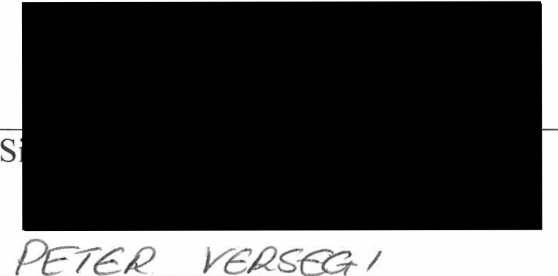
in the presence of:

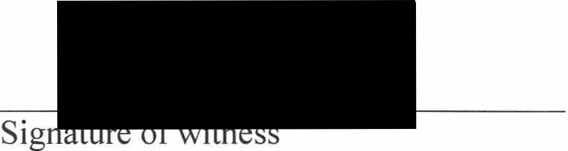

Name
(Print)

.11ca . 11r2r
Position, Settion
l:frt a.-"'7 a Do /II'MCJc..J'LP\_
Name ofwitness
(Print)

SIGNED for and on behalf of
The Australian International Health Institute (The University of Melbourne) Ltd for and on behalf of the Nossal Institute for Global Health by

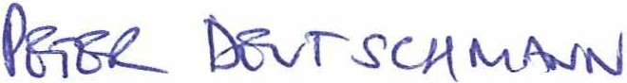
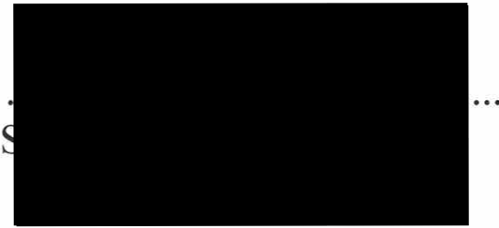

Name and Position .e
(Print) . .

By executing this Deea of Amendment the signatory warrants that the signatory is duly authorised to execute this Deed of Amendment on behalf of the Organisation.

in the presence of -


d!.
......... : . :<-·.:7.......

Name of Witness
(Print)
Sig

' I

AMENDMENT SUMMARY SHEET
Agreement 44911
Amendment No. 1

The Funding Agreement has been varied in accordance with the clause headed Agreement
Amendments of the Funding Agreement on the following dates relating to:

Amendment  # | Date | Very Brief Summary of amendment | Increase/Decrease in financial limit | Adjusted Financial Limit
1 | 20/09/10 | Extension of the completion date of the  Agreement to 31 December 2011 | Nil | A$6,000,000

