HUMANITARIAN LOGISTICS

CAPABILITY

ANNUAL REPORT 2023-2024

October 2024

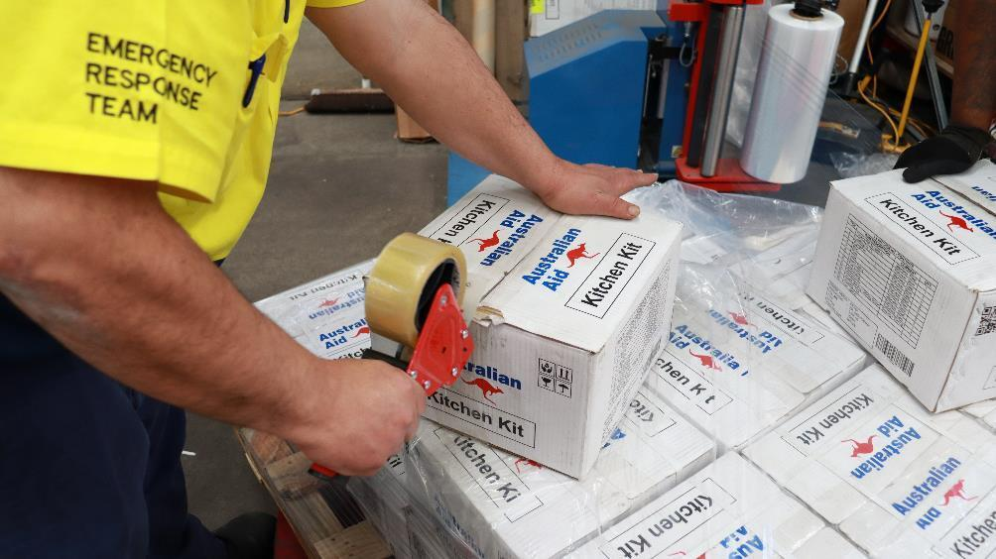

*Brad Bell, Senior Storeperson for Humanitarian Logistics Capability prepares Kitchen Kits for distribution (Source: Reginald Ramos, HLC).*

ACKNOWLEDGEMENT

The Humanitarian Logistics Capability team acknowledges the Aboriginal and Torres Strait Islander people as the traditional custodians of the lands on which we live and work, and pays our respects to Elders past, present, and emerging. The Humanitarian Logistics Capability team works across Turrbal and Jagera (Brisbane), Gadigal (Sydney) and Ngunnawal (Canberra) Countries.

Disclaimer

This publication has been funded by the Australian Government through The Department of Foreign Affairs and Trade. The views expressed in this publication are the author’s alone and are not necessarily the views of the Australian Government.

The Humanitarian Logistics Capability is an Australian Aid investment managed by the Department of Foreign Affairs and Trade and implemented by Palladium International Pty Ltd.

Table of Contents

ACKNOWLEDGEMENT 2

Disclaimer 2

1. INTRODUCTION 5

1.1. PURPOSE 5

2. WHAT WE DO 5

3. KEY DOMAINS 6

4. PACIFIC SUPPORT 7

4.1. OTHER KEY STATISTICS 7

5. OUR WORK 8

5.1. PROCURING AUSTRALIA’S HUMANITARIAN SUPPLIES 8

5.1.1. Procurement Breakdown 8

5.2. PREPARING FOR DISASTERS IN THE INDO-PACIFIC 10

5.2.1. Warehouse Breakdown 11

5.2.2. Stock Governance 11

5.2.3. Inventory Control 11

5.2.4. Warehouse Partners 12

5.2.5. Port Moresby Warehouse 12

5.3. PREPARING FOR RAPID DISPATCH 13

5.3.1. Pre-Positioning 13

5.3.2. Impact: Freight and Transport – Fiji Airways Embargo and Tuvalu’s COVID-19 Response 14

5.3.3. Reaching the Pacific 14

5.4. RESPONSE AND LOGISTICS 15

5.4.1. Response Talent and Expertise 15

5.4.2. Formalising Knowledge and Practice 15

5.4.3. Embedding in Canberra 16

5.4.4. In-Country Specialist Support 16

5.4.5. Response Breakdown (2023/2024) 16

6. OUR KEY RESPONSES 17

6.1. MOUNT BAGANA VOLCANIC ERUPTION - JULY 2023 17

6.1.1. Quick Facts 17

6.1.2. Background 17

6.1.3. Our Response 17

6.2. TROPICAL CYCLONE LOLA - OCTOBER 2023 19

6.2.1. Quick Facts 19

6.2.2. Background 19

6.2.3. Our Response 19

6.3. MOUNT ULUWAN VOLCANIC ERUPTION - NOVEMBER 2023 20

6.3.1. Quick Facts 20

6.3.2. Background 20

6.3.3. Our Response 21

6.4. ENGA LANDSLIDE - MAY 2024 21

6.4.1. Quick Facts 21

6.4.2. Background 22

6.4.3. Our Response 22

7. DEEPENING OUR IMPACT 23

7.1. GENDER, EQUALITY, DISABILITY AND SOCIAL INCLUSION 23

7.1.1. Embedding GEDSI 23

7.1.2. Internal GEDSI Consultations 23

7.1.3. Disability Inclusion Pilot 23

7.2. GREENING 25

7.2.1. Waste Removal 25

7.2.2. Donations 25

7.3. CONNECTEDNESS, PARTNERSHIPS AND COLLABORATION 27

7.3.1. Working with the Pacific 27

7.3.2. Successful Collaborations 27

7.3.3. Whole of DFAT Collaboration 27

7.3.4. Integrating with the Humanitarian System 28

7.4. MONITORING, EVALUATION AND LEARNING 28

7.5. TELLING OUR STORY 29

7.6. PUBLIC DIPLOMACY 29

7.6.1. Team Australia Open Day 30

7.7. LEARNING JOURNEY 30

7.7.1. Learning Loop 30

7.7.2. Formalising and Retaining Knowledge 30

7.7.3. Strengthening Foundations 30

7.7.4. Data Integrity and Accuracy 30

8. RISK MANAGEMENT 30

8.1. RISK MITIGATION 30

8.2. SAFEGUARDING 31

8.2.1. Pre-Deployment Briefings 31

9. Contact Details 32

A group of people walking through a warehouse containing large racks of humanitarian supplies. The view is from the pack of the group of people with movement of the people slightly blurred

 *Humanitarian Partners Open Day, May 2024 (Source: Reginald Ramos, HLC).*

1. INTRODUCTION

The Humanitarian Logistics Capability (HLC) facilitates the timely, effective, and flexible delivery of the Australian Government’s humanitarian assistance and emergency relief program around the world, providing high quality, multifaceted, flexible and responsive project management and humanitarian supply chain solutions in support of the Commonwealth of Australia’s Department of Foreign Affairs and Trade (DFAT) Humanitarian Emergency Relief activities.

* 1. PURPOSE

This report is intended to provide an overview of the HLC program and the achievements between 1 July 2023 through to 30 June 2024. It also describes the progress made towards HLC’s end of program Outcomes and lessons learnt, which inform our future work.

1. WHAT WE DO

The Humanitarian Logistics Capability supports the Australian Government to respond to a variety of humanitarian challenges, upon the request of a country affected by a disaster or crisis. We’re committed to supporting Australia’s humanitarian action to save lives, alleviate suffering and maintain dignity of people affected by crisis.

Since 2018, HLC has supported the Australian Government to respond to over 50 disasters. This year, we supported 26 requests for assistance across 8 countries in the Indo-Pacific with a strong focus on the South Pacific region (87.5%).

* **Humanitarian disaster response**: We respond to disasters and crises, such as tropical cyclones, earthquakes and volcanic eruptions. No disaster is the same and we remain committed to being adaptable, fit-for-purpose, while also informed by a country’s humanitarian needs.
* **Strategic pre-positioning**: We ensure Australia’s humanitarian supplies are ready to enable rapid access in the event of a disaster. This has included strategic pre-positioning at our humanitarian warehouse (Brisbane), in Papua New Guinea and on a variety of Defence assets across the Indo-Pacific.
* **Country and specialist support**: We provide ad hoc support to country partners during long-term (protracted) crises, such as droughts. This also includes providing specialist logistics support across transport, logistics and warehousing upon request from a partner country.

1. KEY DOMAINS

* **Warehouse storage and handling**
* **Freight and transport logistics**
* **Specialist logistics personnel and expertise**
* **Procurement**
* **Deployment support**
* **Consular crises\***

*\*Consular Crises capability has only been activated once since 2018 and not within the reporting period.*

GEDSI Gender equality, disability and social inclusion sits across all that we do in the above domains.

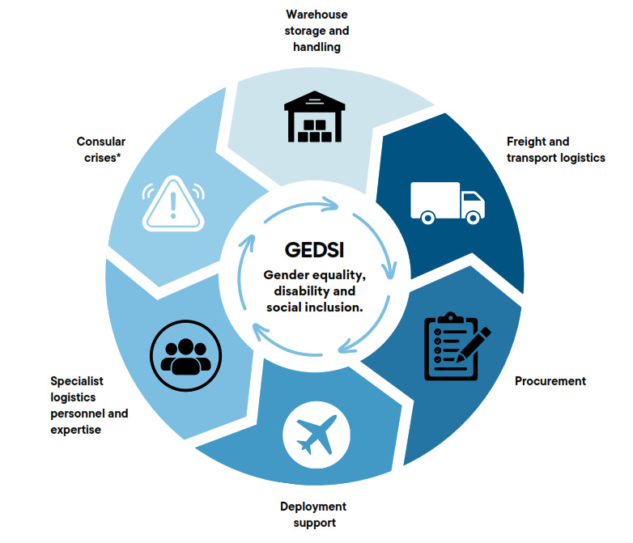

1. PACIFIC SUPPORT

This year we have supported **8 countries** across **26 requests for assistance**.

|  |  |
| --- | --- |
| Type of Assistance | Number of Taskings |
| Preparing for disasters | 10 |
| Disaster responses | 4 |
| COVID 19 and medical | 4 |
| Drought response | 2 |
| Other* | 6 |

*Other taskings included supporting election logistics and ad-hoc requests from DFAT

* 1. OTHER KEY STATISTICS
* 846, 998 Humanitarian supplies dispatched.
* 51 Dispatches coordinated across air, sea and road (65% Air, 26% Sea and 10% Road).
* 78% Humanitarian supplies dispatched.
* 22% Specialty procured items.
* Time for fastest dispatch was 4hrs.
* 8,000 kg of near-expired items donated to local community organisations, avoiding landfill.
* 19% of stock movements used ADF transport assets.
* 81% of stock movements used Commercial transport assets.
* 36 consultations with disability and health stakeholders across Australia, Pacific and Timor-Leste.
* 9 Humanitarian Partners including Australian NGOs, Red Cross and UN agencies.

1. OUR WORK
   1. PROCURING AUSTRALIA’S HUMANITARIAN SUPPLIES

The procurement of Australia’s humanitarian supplies is a critical component to ensure we can rapidly respond in times of disaster. This is increasingly challenging as global supply chains are facing increased pressure with emerging disasters, conflict and growing humanitarian needs.

Each disaster is unique and the importance of sourcing the right type of humanitarian supplies to address humanitarian needs is critical, while also balancing timeliness and value for money.

The HLC procures humanitarian supplies to ensure the Australian Government can deliver the widest possible range of rapid response options. These standard humanitarian supplies are designed to address immediate needs, such as water, sanitation, and hygiene (WASH), shelter and GEDSI kits.

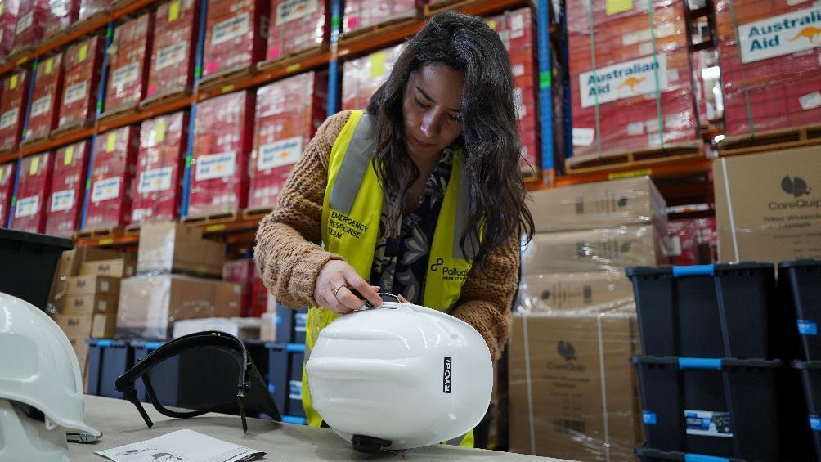*Andrea Juvera Brooks, Program and Operations Administrator puts together a helmet for a Chainsaw Kit. (Source: Reginald Ramos, HLC)*

* + 1. Procurement Breakdown
* 64,424 Humanitarian supplies were dispatched this year.
* 78% were Australia's standard humanitarian supplies.
* 22% of supplies were specialist procurement.
  + - 1. DIFFERENT COUNTRIES, DIFFERENT NEEDS

Upon the request of a country affected by disaster, we also fast-track specialty procurement humanitarian supplies. This year, HLC procured 64,424 humanitarian supplies with 78% being Australia’s standard humanitarian supplies and 22% being specialist procured items.

Generally, specialty procurement often supports a country’s preparedness, ahead of a disaster or crisis. It also supports a country-specific need, usually as part of a large disaster response (such as the COVID 19 pandemic).

While specialty procurement has decreased since the global pandemic, this year HLC has procured and delivered a range of items, such as medical technology and equipment for Tuvalu and Kiribati and pharmaceuticals for Kiribati.

* + - 1. REMAINING RESPONSIVE AND READY

This year, the critical function of procurement was moved from the warehouse to the broader, cross- functional operations team. This was to ensure procurement was not an isolated business area, but instead fully integrated into a whole-of-investment humanitarian approach.

* + - 1. REPLENISHMENT OF HUMANITARIAN STOCKPILE

Every year in the Pacific, adverse weather conditions and cyclones are at a higher risk between November –April (commonly known as ‘Pacific Cyclone Season’). However, tropical storms and cyclones can occur at other times. In November 2023, the Pacific Cyclone Season was predicted to be more severe than normal. Procurement is a key function to our readiness, and we ensured our humanitarian supplies were adequately stocked.

For more information, see – ‘Preparing for disasters in the Indo-Pacific’.

STAFF SPOTLIGHT: MEG DODDS

Meg Dodds is a Logistics and Procurement Administrator. Meg helps organise the sourcing and purchasing of Australia’s humanitarian supplies, and manages relationships with the suppliers, while also providing logistics and information management support to Response Leads during times of disaster.

Meg has learnt that communication and collaboration is key in procurement: “It’s being able to deal with emerging priorities, while also supporting various people requesting different things. You have to be flexible and be able to communicate and negotiate effectively with numerous people.”

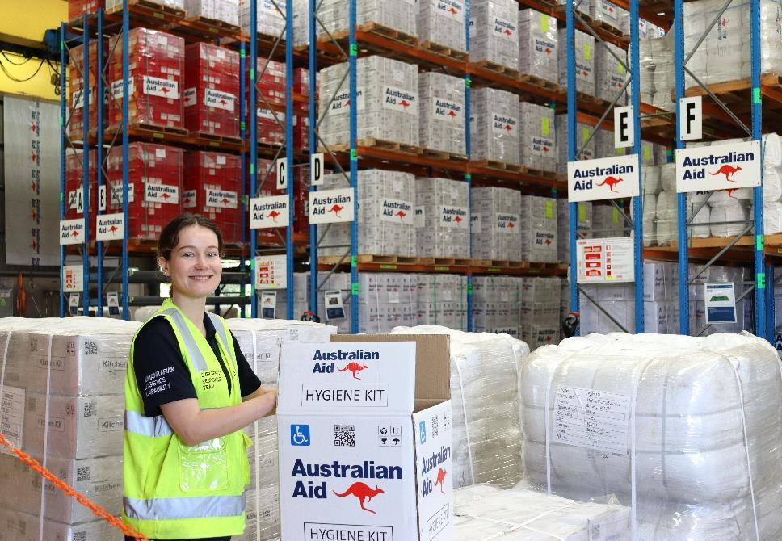 *Logistics and Procurement Administrator, Meg Dodds, holds an open Hygiene Kit (Source: Reginald Ramos, HLC).*

* + - 1. FIT FOR PURPOSE SUPPLIES: VANUATU

The Humanitarian Advisory Group (HAG) worked with ni-Vanuatu consultants to conduct an evaluation on the relevance and appropriateness of Australian humanitarian supplies in August-September 2023, following the impact of Tropical Cyclones Judy and Kevin in Vanuatu (March 2023). They visited communities in affected provinces such as Tafea and Shefa.

Overall, Australia’s humanitarian supplies were reported by community members to be very relevant and useful; 98% of surveyed people reported using all or some of the items received. There was also strong evidence that items were being used for their intended purposes (96% of people self-reported), while 91% reported that the Australian humanitarian supplies made a difference for their household.

The items frequently reported as most useful were Tarpaulins, Solar Lights, Shelter Tool Kits, Solar Lights, Chainsaws, Hygiene Kits and Water Containers. The findings also identified that items and packaging were generally reused. 51% of people surveyed had not thrown their items away and 43% said they were still using them (3-6 months after receiving them).

Tarpaulins were also used for other purposes – such as protecting boat motors, generators and reused as bags to help carry thatch, while Shelter Tool Kits were shared with other people who may have missed out.

VOICES FROM VANUATU

* “All the items I received have made a big difference to me and my family since we lost everything during the cyclones.” (Survey respondent, Tanna)
* “The shelter toolkit and tarps are still very much being used and shared between five families. Tarps are used as mats after they tear apart.” (Survey respondent, Futuna)
* “Tarp bag repurposed as bag for transporting thatch for repair. Solar light box used as storage for booklets and pens.’ (Survey respondent, Erromango)
  1. PREPARING FOR DISASTERS IN THE INDO-PACIFIC

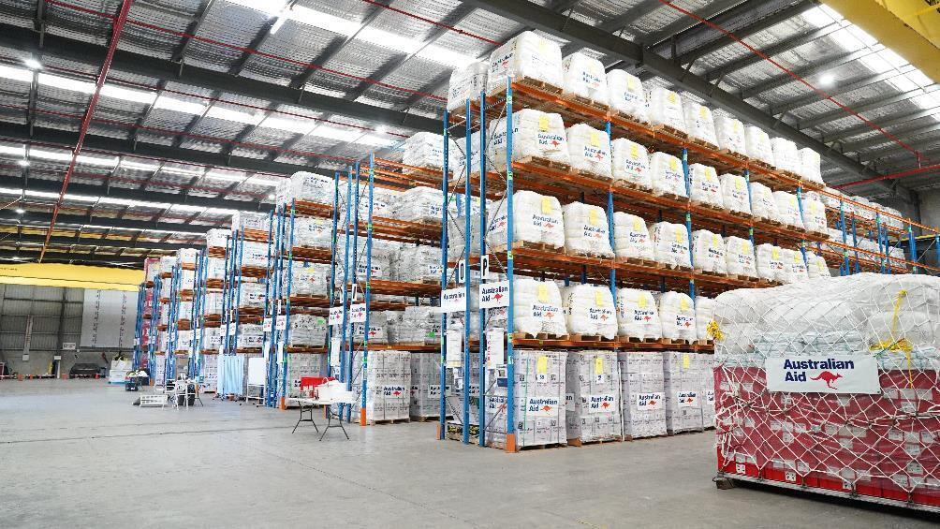 *The Humanitarian Logistics Capability warehouse located in Brisbane, Queensland (Source: Reginald Ramos, HLC).*

The HLC manages Australia’s largest humanitarian warehouse (10,000m2), capable of supporting 11,000 families at any given time. This year, the Pacific Cyclone Season was forecasted to be more ‘severe than normal’. To remain prepared in the event of a disaster during the predicted season, HLC ensured stockholdings were at maximum capacity to ensure rapid response.

Following recent years of heightened activity surrounding the global pandemic, we began the process of optimising warehouse storage space and reducing excess supplies (especially health-related items). This included a strong focus on inventory control, restructuring of warehouse staffing and revising our work health and safety processes and protocols.

* + 1. Warehouse Breakdown
* Total storage is 10,000 m.
* 3,500 pallet spaces.
* Capacity to support 11,000 families.
  + 1. Stock Governance

1. Weekly cycle counts
2. ‘Stock on Hand’ reports
3. Capacity percentage reports
4. Expiration reports
5. 4 stocktakes annually
   * 1. Inventory Control

STAFF SPOTLIGHT: BRAD BELL

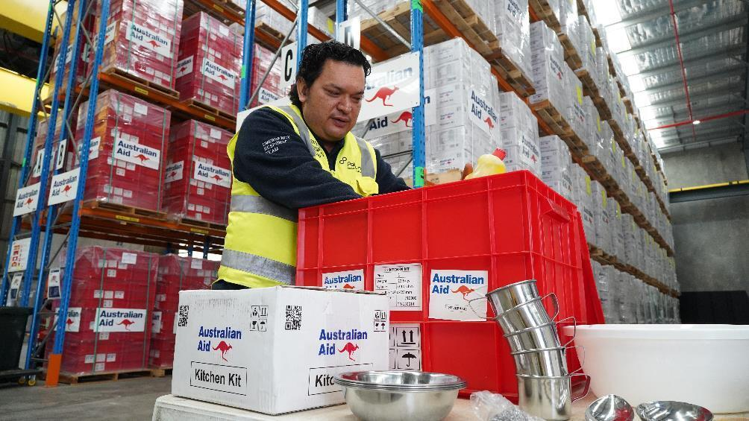 *Inventory Controller, Brad Bell packs items into a red Kitchen Kit. (Source: Reginald Ramos, HLC).*

The sheer size and ability to respond rapidly to disasters has always presented challenges, in terms of stock accuracy and inventory control. This year focused strongly on improving consolidation of warehouse stock, identification of obsolete items and optimising warehouse space to reduce the risk of overcrowding and improving efficiency in times of disaster. Importantly, a newly created Inventory Controller role was introduced to strengthen this area of warehousing.

The Inventory Controller maintains a strong focus on weight and dimension quality control, enhancing and ensuring accurate stock through regular counting cycles and capacity planning. Being a key part of Australia’s humanitarian action, Brad recognises the importance of his role in saving lives, alleviating suffering and maintaining human dignity. “Every single minute that we don’t get our humanitarian supplies out the door is a minute longer that a fellow human being is suffering.”

* + 1. Warehouse Partners

As part of DFAT’s partnership with humanitarian organisations, HLC also provide a shared warehousing arrangement with Australian NGOs, the Red Cross Movement and the United Nations as part of Australia’s commitment to humanitarian action. This year, as part of responding to disaster, we dispatched 3,946kg of partner humanitarian supplies. These humanitarian supplies included reproductive kits and tarpaulins within the Health and Shelter clusters.

AUSTRALIAN HUMANITARIAN PARTNERS

* Care International
* World Vision
* Oxfam Australia
* Save The Children

RED CROSS MOVEMENT

* Australian Red Cross
* International Federation for Red Cross and Red Crescent Societies

UNITED NATIONS

* United Nations Children’s Fund (UNICEF)
* United Nations Population Fund (UNFPA)
* World Food Programme (WFP)
  + 1. Port Moresby Warehouse

The Australian Government also prepositions humanitarian supplies in the Port Moresby warehouse, Papua New Guinea. To ensure the management and preparedness of this rapid response capability, we engage directly with Express Freight Management (EFM).

The HLC Warehouse Manager visited the Port Moresby warehouse in June 2024 to understand our current pre-positioned humanitarian supply stock while also identify any opportunities to optimise our operations. This also led to key relationship building with EFM which will help to strengthen the existing partnership and network.

This critical logistics partnership has ensured the rapid deployment of Australian humanitarian supplies across Papua New Guinea. The Port Moresby warehouse has helped support people affected by the Mount Ulawun volcano eruption (5,595 humanitarian supplies) and the catastrophic Enga landslide (26,725 humanitarian supplies).

A group of people in Papua New Guinea wearing high visibility vests unloading humanitarian supplies from an Australian Defence Force plane
 *Locals help unload Australian Aid supplies from a Royal Australian Air Force C-130J Hercules at Hoskins Airport, Papua New Guinea. (Source: LACW Maddison Scott, Department of Defence)*

* 1. PREPARING FOR RAPID DISPATCH

Effective freight and transport management and coordination ensure Australia’s humanitarian supplies arrive in a timely and efficient manner, while also balancing value for money and compliance with the respective rules and regulations of each country that we are supporting. In the humanitarian response sector, every second counts. We measure timeliness through our ability to dispatch humanitarian supplies within 48 hours of tasking received from DFAT.

This year 100% of our humanitarian supplies were dispatched within 48 hours of tasking.

* + 1. Pre-Positioning

Our ability to rapidly dispatch humanitarian supplies within the 48 hours timeframe is made possible by the effective prepositioning of humanitarian supplies, commonly in the form of pre-built ‘LPallets’. These are built to the specification of the Australian Defence Force (ADF), enabling them to be rapidly loaded on to a range of Australian Defence aircraft assets at short notice.

HLC hold L-Pallets within the Brisbane warehouse and Royal Australian Air Force (RAAF) Amberley, while also prepositioning a range of humanitarian supplies in Papua New Guinea and onboard ADF naval vessels, such as the ADV Reliant, in the IndoPacific region.

These L-Pallets, also known as ‘No Regrets’ pallets, are a collection of humanitarian supplies that provide initial relief to men, women and children affected by a disaster or humanitarian crisis until an on-ground assessment can be undertaken.

HLC currently hold two different types:

**DFAT 0900 (Family Kits)** – these pallets can support up to 40 families and include Kitchen Kits, Hygiene Kits, Shelter Tool Kits, sleeping mats and mosquito nets.

**DFAT 0903 (Hygiene and Shelter Kits)** – these pallets can support up to 72 families and include Hygiene Kits, Shelter Tool Kits and tarpaulins.

* + 1. Impact: Freight and Transport – Fiji Airways Embargo and Tuvalu’s COVID-19 Response

The Government of Tuvalu had approached Australia to assist them in responding to the COVID-19 crisis, by procuring laboratory testing items. This was challenging as Fiji Airways placed an embargo on freight being carried through to Tuvalu in late 2023 – early 2024. In response to Tuvalu’s request, HLC procured specialised laboratory equipment and various consumables that included cold chain, ultra-cold chain and ambient shipping requirements.

To ensure the integrity of the cold chain items, and to comply with the imposed limits of 40kg per shipment via Fiji, HLC planned and coordinated 13 dispatches that included air freight for cold chain and high priority items. Dispatches could not exceed 40kg per shipment, and sea freight was used for ambient and low priority items.

* + 1. Reaching the Pacific

The ADV Reliant is an ADF asset crewed by civilian sailors with taskings in consultation with DFAT. HLC has a strong working relationship with the ADV Reliant, which has helped leverage existing shipping routes and to send humanitarian supplies through prepositioning.

When Tropical Cyclone Lola struck the outer remote islands of Tikopia, Solomon Islands in October 2023, the ADV Reliant was nearby and was able to deliver 3,613kg Australian humanitarian supplies to Solomon Islands Red Cross Society for distribution, which helped support the Solomon Islands National Disaster Management Office’s early recovery efforts in Tikopia.

STAFF SPOTLIGHT: LEAH MCDONALD

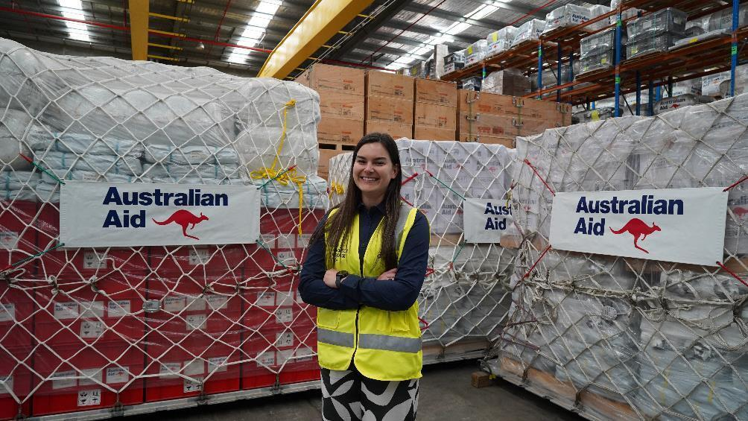 *Leah McDonald, Logistics Liaison Officer (Source: Reginald Ramos, HLC)*

When the catastrophic landslide occurred in Enga, Papua New Guinea in May 2024, Leah McDonald was at RAAF Amberley overseeing the dispatch of 52,000kg of Australia’s humanitarian supplies in just over four days. As the Logistics Liaison Officer, Leah’s ability to work in partnership with Defence is critical.

“There are always different priorities. It’s always changing... You don’t always get all the information, and you’ve just got to roll with it. I communicate with Defence on what the Department of Foreign Affairs and Trade needs to send in.”

* 1. RESPONSE AND LOGISTICS
     1. Response Talent and Expertise

Our fully integrated humanitarian team brings their diverse expertise, skillsets and knowledge to collaborate successfully with DFAT and to support Australia’s humanitarian action.

In preparation for high-risk weather season members of the team undertook a variety of training, which included RedR’s Essentials of Humanitarian Practice (EHP) and Hostile Environment Awareness Training (HEAT). This was also supplemented by internal practical scenario workshops, exploring past responses to preserve historical knowledge.

* + 1. Formalising Knowledge and Practice

There was a focus this year to update and retain institutional knowledge through strengthening documentation. A new response checklist was developed to support DFAT’s decision-making and early disaster response planning, while also ensuring adequate response planning and key considerations within our team. There were sustained efforts to ensure standard operating procedures (SOPs) were updated and fully reflective of lessons learned, while improved harmonisation of SOPs with DFAT’s Humanitarian Response Operations Section (HOS) was achieved through regular visits between Brisbane and Canberra. A modular costing guide was also created to provide DFAT a quick reference sheet for pricing humanitarian logistics and supplies.

STAFF SPOTLIGHT: EBONY LAURIE

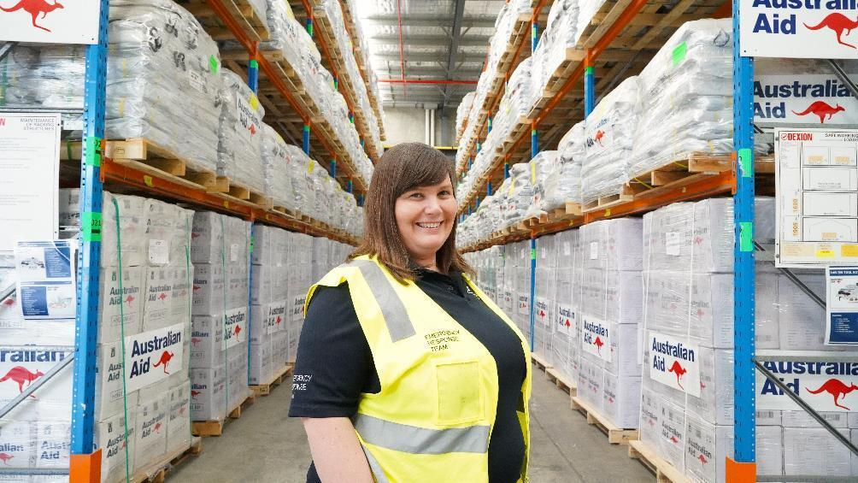 *Ebony Laurie, Senior Response Lead (Source: Reginald Ramos, HLC)*

Ebony Laurie is a Senior Response Lead who has supported Australia’s responses to the Pacific including to Papua New Guinea, Vanuatu, Solomon Islands, Fiji, Tonga and Kiribati.

“Ultimately, in logistics, you’re a problem solver. Finding creative and efficient solutions to problems is what I really like about this role. I feel like logistics is the glue that holds everything together, in terms of being able to respond effectively, timely and efficiently. Nothing can happen without good logistics.”

* + 1. Embedding in Canberra

The Senior Logistics Officer embedded in Canberra departed in October 2023. After a formal revision of the Senior Logistics Officer’s role and function by DFAT, we onboarded a new Senior Logistics Officer in April 2024.

The revised iteration of the Senior Logistics Officer was designed to provide specialist technical and logistics expertise and advice directly to DFAT, ahead of any formal disaster response planning. A greater coordination and synchronicity with DFAT also ensured that DFAT could task and delegate the Senior Logistics Officer, as part of their own response team during a crisis. This provides our team a direct link into DFAT when needed.

There is an ongoing effort to further refine the functionality and capabilities of the Senior Logistics Officer, with current work focusing on broadening out DFAT’s commercial disaster response capabilities and closer integration with the Department of Defence’s logistics capabilities.

* + 1. In-Country Specialist Support

Responding to disaster can also include the deployment of humanitarian logisticians, commonly known as ‘In-Country Management Teams’ (ICMT). The ICMTs generally oversee and support the delivery of Australia’s humanitarian supplies but can also be specifically tasked by DFAT as required.

This year, we had 15 people deploy across 9 deployments, providing expert technical advice to local stakeholders, government and national disaster management authorities. These deployments have also occurred alongside existing Australian disaster response capabilities, such as the Disaster Assistance Response Team (DART), Australian Medical Assistance Team (AUSMAT) and PowerOn.

* + 1. Response Breakdown (2023/2024)
* Preparing for disasters: 10
* Disaster Responses: 4
* Drought responses: 2
* Covid-19/Medical: 4
* Other: 6

1. OUR KEY RESPONSES
   1. MOUNT BAGANA VOLCANIC ERUPTION - JULY 2023
      1. Quick Facts

* Location - Papua New Guinea (Autonomous Region of Bougainville)
* Type - Volcanic eruption
* Number of affected - 8,111 people, as estimated by the Autonomous Bougainville Government, excluding flood estimates
* Items sent - Shelter, Health, WASH (water, sanitation and hygiene)
* Deployment – Two-person In-country management team
  + 1. Background

On 7 July 2023 Mount Bagana erupted and caused significant ashfall in the Torokina district of the Autonomous Region of Bougainville. The ABG (Autonomous Bougainville Government) coordinated the evacuation of affected people and at-risk communities living nearby. They established evacuation centres at Wakunai station in Central Bougainville and Piva station (Torokina) in South Bougainville. Additionally, heavy rainfall and flooding on 13 August 2023 in southern Bougainville impacted communities, contributing to the rising humanitarian need in the region.

* + 1. Our Response
       1. Facilitation of humanitarian supplies:

On 29 July, our team facilitated the deployment of 10,008 items of humanitarian supplies from Brisbane warehouse and RAAF Amberley. Humanitarian supplies were prepared and dispatched from the Brisbane warehouse to RAAF Amberley within a four-hour period. They subsequently departed Australia on 31 July with support from the ADF. Through a combination of in-country commercial and military logistics support, they reached the Wakunai and Torokina Districts on 12 and 14 August.

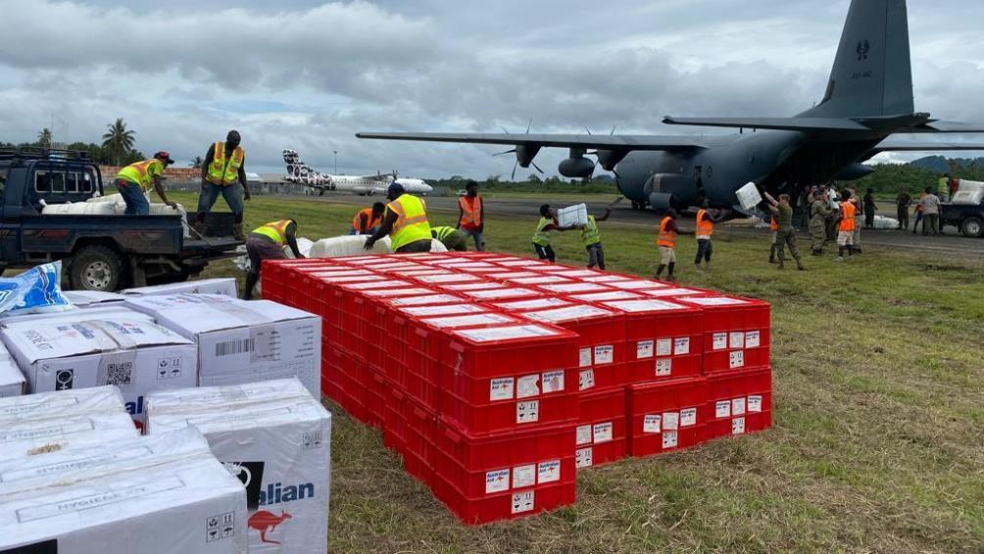 *Humanitarian items being unloaded in PNG (Source: Shaun Thomas, HLC).*

GUIDED BY LOCAL NEEDS

Consultation between Australia’s High Commission in Papua New Guinea and the Autonomous Region of Bougainville informed the choice of humanitarian supplies, including priority clusters such as Shelter, Health and WASH.

* + - 1. Support to the Autonomous Bougainville Government:

On 11 August, we were tasked to activate an ICMT with specialist expertise in logistics and humanitarian response. HLC ICMT included two logisticians with expertise in the Pacific context, as well as Pidgin language capability. Due to visa delays, our ICMT deployed on 25 August.

The Australian High Commission in Papua New Guinea tasked our ICMT to embed within the Autonomous Bougainville Government SOECC (State of Emergency Control Centre). This was to provide expert specialist support to the SOECC, while also providing advice to the Australian Government on the current situation.

When heavy rainfall and flooding also impacted southern Bougainville communities in mid August, our ICMT pivoted and provided logistics support to locally led disaster response efforts, led by the SOECC.

The ICMT was able to support the Autonomous Region of Bougainville’s SOECC, while also supporting notable sites including the Wakunai and Torokina Internally Displaced Peoples Camps. They provided training, advice and mentoring to the SOECC, informed logistics planning, while also reported their observations to help inform the Australian Government on the humanitarian needs within the Autonomous Region of Bougainville.

STAFF SPOTLIGHT: KENNEDY FOLASI

Kennedy Folasi is a Humanitarian Logistician and was deployed to Papua New Guinea, as part of the Mt. Bagana response to provide support to the Autonomous Bougainville Government. Kennedy played an integral role in supporting the Autonomous Bougainville Government State of Emergency Control Centre (SOECC). He provided technical advice on the transportation and storage of Australia’s humanitarian supplies, shaped and informed SOECC’s logistics planning, while also supporting the negotiation of Aropa Airport as a key staging location for humanitarian supplies before it reached communities affected by the disasters. For Kennedy, supporting a locally led response to disasters requires a specific skillset: “Good logistics planning, understanding the local context and being able to build strong relationships with people on the ground is important.”

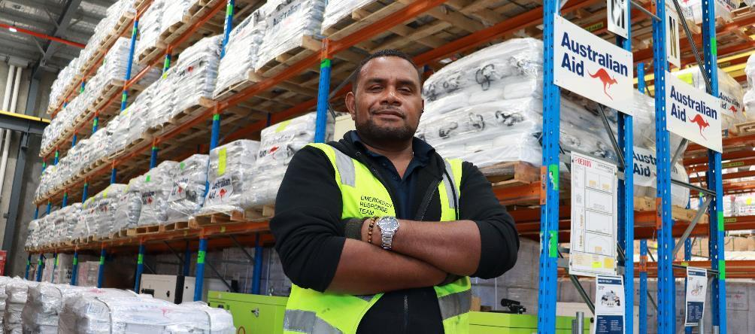*Response team member Kennedy Folasi (Source: Reginald Ramos, HLC).*

* 1. TROPICAL CYCLONE LOLA - OCTOBER 2023
     1. Quick Facts
* Location - Solomon Islands and Vanuatu
* Type - Tropical Cyclone
* Number of affected people: Vanuatu 110,748 people (estimate from Vanuatu National Disaster Management Office) and Solomon Islands 580 people (estimate from Solomon Islands Disaster Management Office)
* Items sent - Shelter, Health, WASH (water, sanitation and hygiene)
* Mode of delivery - 2 x flights (ADF), 1 x sea shipment (ADV Reliant)
* Deployment - 3 person in-country management team
  + 1. Background

Tropical Cyclone Lola emerged as an off-season cyclone in the Pacific, reaching winds of 205 kilometres per hour as a Category 5 tropical cyclone. Initially, Lola impacted the Solomon Islands (Category 3) outer island of Tikopia. On 22 October, Lola made landfall in Vanuatu (Category 5), primarily impacting Pentecost, Maewo, Ambrym and Malekula Islands.

This was the third severe tropical cyclone to impact Vanuatu, after Tropical Cyclones Judy and Kevin in March 2023. On 27 October, the Government of Vanuatu declared a six-month state of emergency for Torba, Penama, Malampa, Shefa and Sanma provinces. The Government of Vanuatu issued an official request for assistance, as early needs-assessments began to be undertaken.

* + 1. Our Response
       1. Facilitation of humanitarian supplies:

Before an official request for assistance was received by the Australian Government, preparation was well underway to ensure HLC responded in a timely manner. Within 48 hours of being tasked, the HLC team facilitated the delivery of 3,562 humanitarian supplies between 29-30 October across two ADF flights. This was accompanied by three logisticians to ensure successful delivery to Port Vila, Vanuatu.

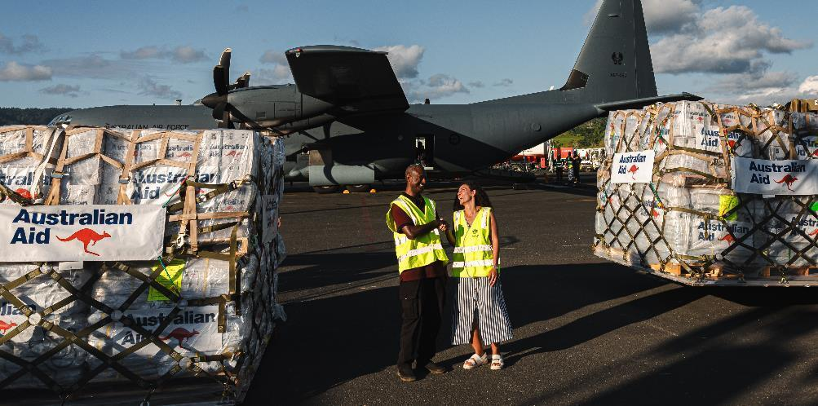 *Director National Disaster Management Office Mr Abraham Nasak (left) and Australian Deputy High Commissioner, Ms Suzanne Akila, with Australian Aid humanitarian supplies in support of Tropical Cyclone Lola at Port Vila Airport, Vanuatu. (Source: LAC Adam Abela, Department of Defence).*

HLC also supported the Department of Foreign Affairs and Trade to facilitate delivery of Australian humanitarian supplies to Solomon Islands Red Cross Society for distribution in Tikopia, via Australian Defence Vessel ‘Reliant’ on 4 November.

STAFF SPOTLIGHT: SKYE OUT

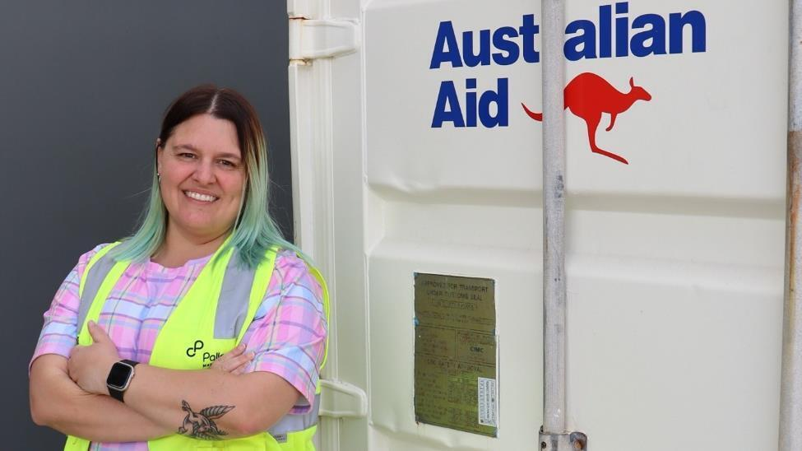 *Response Lead, Skye Out (Source: Reginald Ramos, HLC).*

Skye Out is a Response Lead, who supported Australia’s response to Tropical Cyclone Lola: “In the days after Tropical Cyclone Lola, Vanuatu was getting a better picture of the situation and how they were able to respond to the disaster. We were able to appropriately support them with humanitarian supplies.”

Working in the disaster response sector, Skye knows the importance of taking care of yourself: “It’s important to remain flexible to the situation, the affected community’s needs and to communicate with your team. You also need to take care of yourself, because you can’t support people affected by crisis if you’re burnt out.”

* 1. MOUNT ULUWAN VOLCANIC ERUPTION - NOVEMBER 2023
     1. Quick Facts
* Location - Papua New Guinea
* Type - Volcanic eruption
* Estimated total number of affected people - 26,000. Estimated number of displaced people – 9,000 (estimates from Australian High Commission, Papua New Guinea)
* Items sent - Shelter, Health, WASH (water, sanitation and hygiene)
* Mode of delivery - 1 x flight (ADF), 1 x sea shipment
* Deployment - Nil
  + 1. Background

On 20 November 2023, the Mount Ulawun volcano on the border of West New Britain and East New Britain provinces erupted, spewing ash plumes and causing mass displacement of local communities in the affected areas. The ‘Tracking Matrix’ site assessment tool, used by the International Organisation for Migration Displacement, reported an estimated 8,565 people displaced in West New Britain and East New Britain.

* + 1. Our Response
       1. Facilitation of humanitarian supplies:

At the request of the Government of Papua New Guinea, Australia provided humanitarian supplies into Kimbe, West New Britain. Across 7-8 December 2023, HLC facilitated the transport of humanitarian supplies from RAAF Amberley (2,160 items) and Port Moresby Warehouse (5,590 items).

A few months later in April 2024, a sea shipment was requested and transported from Brisbane to Port Moresby which consisted of 19,461 items to assist with this response. These humanitarian supplies had a strong focus on addressing shelter and water, sanitation and hygiene needs.

A group of local men unloading a plane
of Australian Aid humanitarian supplies at an airport in Papua New Guinea  *Locals of the Kimbe region unloading Australian Aid humanitarian supplies at Hoskins airport, Papua New Guinea (Source: LACW Maddison Scott, Department of Defence)*

* 1. ENGA LANDSLIDE - MAY 2024
     1. Quick Facts
* Location - Papua New Guinea
* Type - Landslide
* Estimated total number of affected people - 26,000. Estimated number of displaced people – 9,952 (estimates from International Organisation for Migration)
* Items sent - Shelter, Health, WASH (water, sanitation and hygiene) and Protection
* Mode of delivery - 3 x flights (ADF)
* Deployment - 2 person in-country management team
  + 1. Background

On 24 May 2024, a catastrophic landslide buried villages in the Maip-Mulitaka area in Papua New Guinea’s Enga province. It was estimated to be roughly 8m deep, causing an unknown number of lives lost (estimates ranged from 100 to 2,000). The catastrophic landslide also contaminated sources of drinking water.

First responders had difficulty getting to the site as roads and power was cut. Safe access to the affected site was also difficult, due to heightened tensions across local communities in the area.

The heavy rain also meant that the ground was increasingly unstable, risking the threat of further landslides which could affect early recovery efforts.

* + 1. Our Response
       1. Deployment of technical assistance:

On 28 May 2024, we deployed a 2-person ICMT to Papua New Guinea. This deployment provided support to the administrative and logistical arrangements for 12 members of the Disaster Assistance Response Team (DART), 1 x DFAT Liaison Officer and 1 x National Emergency Management Agency of Australia (NEMA) Liaison Officer to support the country’s initial recovery efforts.

* + - 1. Facilitation of humanitarian supplies:

Australia dispatched a total of 26,725 items of humanitarian supplies from the Port Moresby warehouse, along with 7,758 items of humanitarian supplies, over a 72-hour period, from RAAF Amberley and the Brisbane warehouse. This included humanitarian supplies from World Vision, Save the Children, UNFPA and UNICEF.

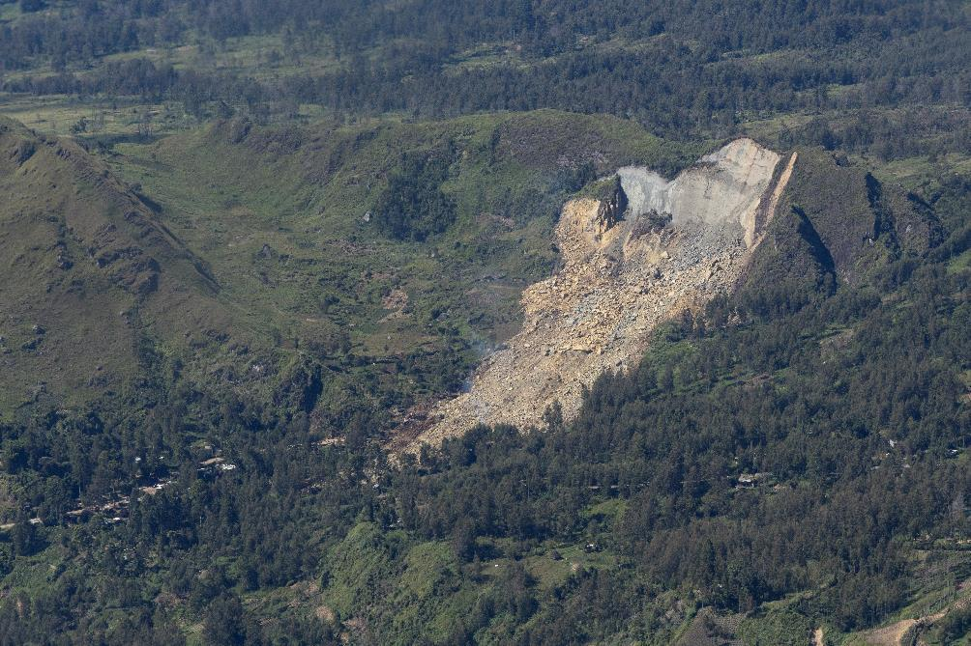 *Aerial view of the Maip Mulitaka landslide in Enga Province, Papua New Guinea (Source: LACW Maddison Scott, Department of Defence)*

1. DEEPENING OUR IMPACT
   1. GENDER, EQUALITY, DISABILITY AND SOCIAL INCLUSION

Gender equality, disability and social inclusion (GEDSI) remains an integral part of Australia’s humanitarian action and our investment. We continued to implement our GEDSI Strategy to mainstream GEDSI and pilot work on disability inclusion in the humanitarian response space.

* + 1. Embedding GEDSI

This year presented exciting opportunities to integrate GEDSI into the dynamic environment of humanitarian response. While the complexity of disaster response and a fluctuating team structure posed some challenges, these also prompted a focused and proactive approach to educating our team on the significance of GEDSI and included refreshing the GEDSI Strategy and GEDSI-relevant Monitoring and Evaluation indicators.

The GEDSI strategy also relates to our onboarding, and this year our team represents a varied gender balance across all roles. As of 30 June 2024, our staff disaggregation is 61% female and 39% male.

Our management team consists of 50% split and 100% female at the executive level (Team Leader). Our deployments, related to disaster response, have seen 37.5% female deployment. This remains an area of opportunity for our investment.

* + 1. Internal GEDSI Consultations

The HLC GEDSI team applies several approaches to ensure GEDSI is a whole-of-investment consideration. This includes across our operations, disaster responses and for building staff awareness on GEDSI issues and opportunities.

One of these approaches includes GEDSI briefings that are conducted at the request for assistance (such as responding to disasters). It is embedded within our SOPs to ensure GEDSI is integrated into our approach as soon as possible.

Pre-deployment GEDSI briefings are also conducted for each deployee, unless a rapid response makes this impossible. The briefing session provides the opportunity for the GEDSI team to sit down with the ICMT before deployment and to discuss what country-specific, GEDSI-related issues or concerns could arise during their deployment.

This is also an opportunity to discuss potential opportunities that contribute to GEDSI’s objectives, including identifying stakeholders and supporting GEDSI initiatives in-country.

Despite rapid deployments (sometimes, a matter of hours), our GEDSI team aims to meet with most ICMT members before they depart. This year, we conducted 7 GEDSI briefings for a total of 9 deployments (77.8%). This is also complemented by the presence of one or both GEDSI Advisers during new employee inductions to provide introductions into the current GEDSI priorities and how their role may intersect with those priorities.

* + 1. Disability Inclusion Pilot

Disability inclusion in the humanitarian sector is a critical part of Australian humanitarian action. People at risk, such as those with disabilities, are disproportionately affected by the effects of disaster and natural hazards. In the Pacific region, at least 15% of people in Pacific Island countries live with disability.

* + - 1. RELEVANT AND APPROPRIATE PRODUCTS

In the last reporting period, DFAT requested Christian Blind Mission’s (CBM) Global Disability consulting services to begin desktop research on appropriate humanitarian supplies to support people with disabilities in the Pacific. In addition to this, we also conducted our own review of current inclusions of disability-specific items being sent overseas from our warehouse.

To form an initial list of disability assistive items to pre-position for the first time, we began consultations within DFAT’s Global Health Division, the Pacific Disability Forum (through CBM), and multiple other GEDSI and allied health stakeholders in non-government organisations.

This led to the recommendation to pilot a range of disability assistive products, specifically in the format of an ‘Assistive Product Brick’ and a ‘Community Support Brick’.

**Assistive Product Brick:** This includes disability assistive products that can support a range of needs including mobility, neurodivergent, elderly, child-specific and complex needs such as wheelchairs, communications boards, noise-cancelling headphones and earplugs and more. These items are in line with the World Health Organisation AT6 and AT10 priority assistive product lists.

**Community Support Brick:** This includes disability assistive products that can support evacuation centres or community-settings following a disaster. This includes way-finding signage, portable wheelchair ramp, moveable whiteboards and privacy screens.

* + - 1. IN COUNTRY CONSULTATIONS

In June 2023, we commenced the procurement of disability assistive products. This was followed by an in-country consultation with people with disabilities and disability and disaster sector stakeholders in Fiji (which included a sample Assistive Product Brick) in December 2023. In addition to this, we also conducted a series of virtual consultations with Vanuatu, Papua New Guinea, Solomon Islands and Timor-Leste in partnership with CBM Australia and Nossal Institute through to March 2024.

The consultations across the Pacific were an opportunity for people with lived experiences to help shape and inform Australia’s humanitarian action, particularly with disability inclusion. It also provided an opportunity for GEDSI stakeholders to provide feedback on the relevance and appropriateness of the assistive products and how they can be delivered in an inclusive and equitable way. The next phase of the disability inclusion pilot will focus on preparedness planning and will be explored in the next reporting period.

DISABILITY STAKEHOLDERS CONSULTED

|  |  |
| --- | --- |
| Country | Number of Stakeholders |
| Fiji | 9 |
| Vanuatu | 6 |
| Papua New Guinea | 8 |
| Solomon Islands | 1 |
| Timor-Leste | 2 |

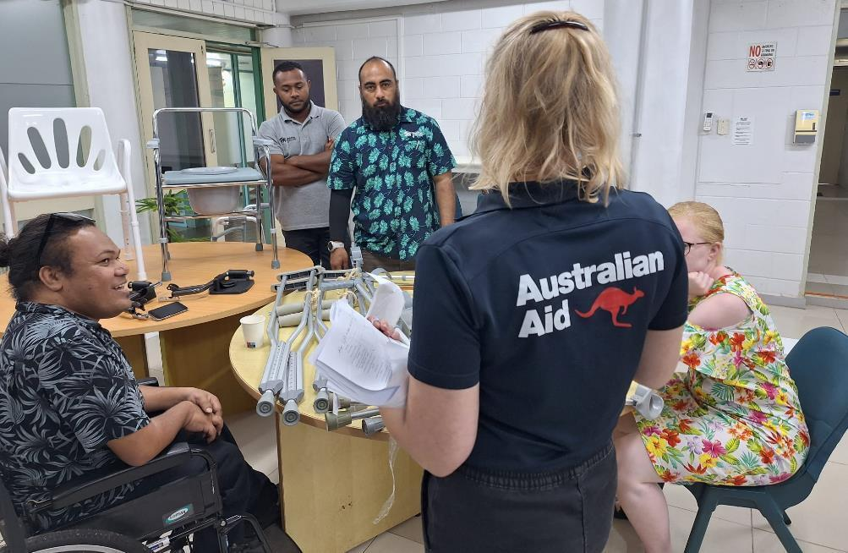 *Penelope Holder, GEDSI Adviser, consulting with people with disabilities and other stakeholders on the relevant and appropriateness of the disability assistive products in Fiji (Source: Skye Out, HLC)*

* 1. GREENING

In recent years, we’ve embarked on a transformative process in our approach to environmental sustainability and greening. Our existing Greening Strategy and Action Plan has continued to make progress – with a key focus on reducing waste and carbon emissions. We continued working collaboratively with relevant stakeholders within the humanitarian response sector, such as the Humanitarian Advisory Group. This year, our work was highlighted in their ‘Framework for Greening Humanitarian Action in the Pacific’ as case studies.

* + 1. Waste Removal

HLC’s efforts towards greener humanitarian action, in accordance with our Greening Strategy and Action Plan, led to a review and expansion of the warehouse’s disposal process. Upon receiving humanitarian supplies, the HLC warehouse team conducts inspection and removal of unnecessary plastic and packaging before consolidating items into humanitarian kits.

Some statistics of how much waste has been removed:

* 1.7kg of waste removed per Chainsaw Kit
* 4.2kg of waste per Light Tower Kit
* 20kg of waste per Assistive Product Brick
  + 1. Donations

Pre-positioned humanitarian supplies often contain items, with expiry dates, which occasionally are not used before items expire. When these supplies expire, they are discarded. HLC discerned a positive, no-cost, solution to this issue by identifying and donating the near expired items to organisations which are committed to distributing the items to those in need, for use before expiry, avoiding unnecessary landfill.

This process change led to more than 8,000kg of humanitarian supplies nearing expiry being donated to local community organisations. One example is the successful donation of 1,997 packs of near-expired menstrual pads to Share the Dignity, a Brisbane based not-for-profit organisation dedicated to free access to period care for people in need.

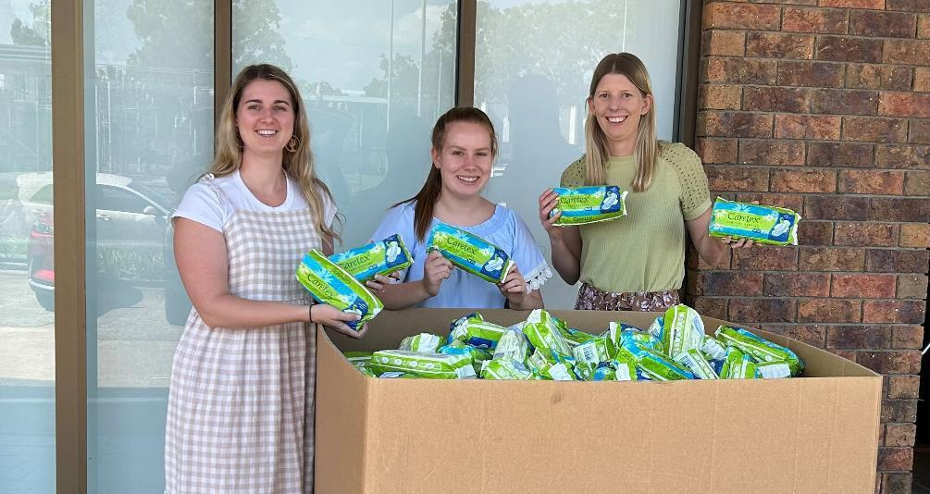 *Share The Dignity staff receiving donated menstrual pads (Source: Penelope Holder, HLC)*

STAFF SPOTLIGHT: SILIAKO ‘LUX’ ANAE

Siliako ‘Lux’ Anae is the Warehouse Second in Command for the Humanitarian Logistics Capability. Lux supports the leadership and oversight of warehouse operations, while his passion for innovation has helped champion the cause for greener humanitarian action.

“Climate change is affecting everyone around the world. The fact that we can reduce some of the waste in our humanitarian supplies is helpful. It gives me a sense of relief to know that countries affected by disaster won’t be needing to deal with so much unnecessary waste. We’ve got to keep our high standard [in Australia] and constantly remember the communities who are receiving our humanitarian supplies.”

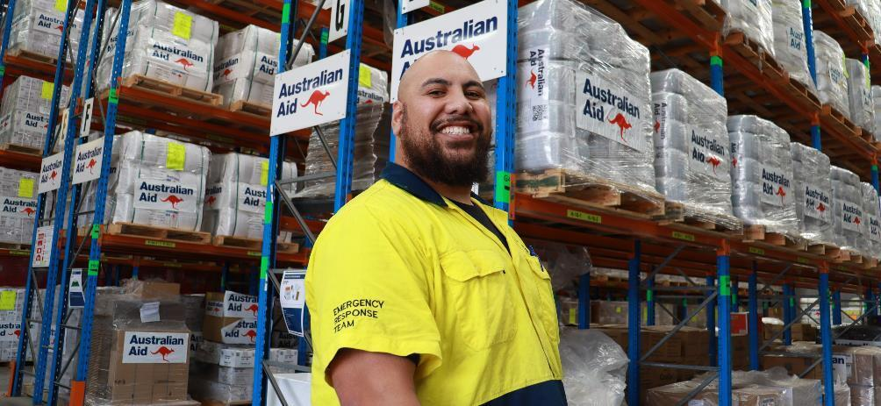*Warehouse 2IC Siliako Anae (Source: Reginald Ramos, HLC)*

Lux’s Pacific heritage (Samoan and Tongan) has also resonated strongly, igniting his sense of purpose and his upbringing of being there for people, no matter what. Most importantly, it’s an opportunity to be there for Pacific communities in times of need.

“There aren’t many jobs out there that can provide me with the opportunity to give back to the Pacific community. The fact that I’ve been able to do that, it means the world to me.”

* 1. CONNECTEDNESS, PARTNERSHIPS AND COLLABORATION

The Humanitarian Logistics Capability is a critical component within Australia’s suite of humanitarian response capabilities. In a rapidly evolving and increasingly challenging humanitarian landscape, our ability to collaborate and work effectively with different partners is critical to our success.

* + 1. Working with the Pacific

The Pacific is unlike any other region in the world. Its sheer vastness in size, remoteness and geographic complexity means working in partnership is critical. This year, we collaborated closely with a variety of national disaster management authorities and local government agencies across the Pacific region.

**Papua New Guinea**: We embedded directly in the Autonomous Bougainville Government State of Emergency Control Centre (SOECC), as part of the Mt. Bagana volcano response. This included the provision of expert specialist support to the SOECC, while also provided advice to the Australian Government on the post-disaster situation on-the-ground.

**Fiji**: We worked with DFAT Post, the Fiji National Disaster Management Office (NDMO) and local organisation in Fiji to support the local prepositioning of humanitarian supplies, while also strengthened the capacity of Fiji NDMO to respond locally to disasters.

**Solomon Islands:** We supported the Government of Solomon Islands to procure medical supplies to address the critical shortage in their national medical stockpile.

**Kiribati**: To support Kiribati’s prolonged drought, we collaborated with DFAT Post, New Zealand’s Ministry of Foreign Affairs and Trade (MFAT) and the Kiribati Public Utilities Board to arrange logistics for a desalination plant and associated equipment to improve Kiribati’s access to clean, safe drinking water.

* + 1. Successful Collaborations
* Commercial and military logistics providers
* Local disaster management and government agencies across the Pacific
* Whole-of-DFAT collaboration (Desk, Post and Divisions)
* Australian Humanitarian Partners, Red Cross Movement and the United Nations
* Humanitarian experts (including humanitarian logistics and disability inclusion)
  + 1. Whole of DFAT Collaboration

HLC worked effectively across DFAT, coordinated through the Humanitarian Response Operations Section (HOS) in the Humanitarian Division (HPD). This year, our work included logistics requests from different Desks and Posts and outside of HPD, including the Global Health Division (GHD) and the Office of the Pacific (OTP) – from supporting the procurement of election materials for Vanuatu and Tuvalu, the procurement and delivery of medical supplies, to the prepositioning of humanitarian supplies across a variety of Pacific countries.

* + 1. Integrating with the Humanitarian System

The HLC manages a Warehouse Sharing Arrangement with Australian Humanitarian Partners (AHP) non-governmental organisations, the Red Cross Movement and the United Nations (United Nations Children’s Fund, United Nations Population Fund and World Food Programme).

Each warehouse sharing partner provides a wide range of humanitarian supplies that supplement Australia’s existing humanitarian offering. There is, however, a greater need for Australia’s humanitarian response to be increasingly coordinated, efficient and integrated within the existing humanitarian response architecture.

This year, the HLC took steps towards improving coordination and efficiency through the inaugural Team Australia Open Day. In partnership with DFAT, HLC welcomed Defence and Australia’s humanitarian response partners for a full day to learn more about our humanitarian logistics capability, as well as the strengths, challenges and opportunities in humanitarian disaster response. Team Australia partners also had the opportunity to engage directly with DFAT to understand the strategic landscape for the future.

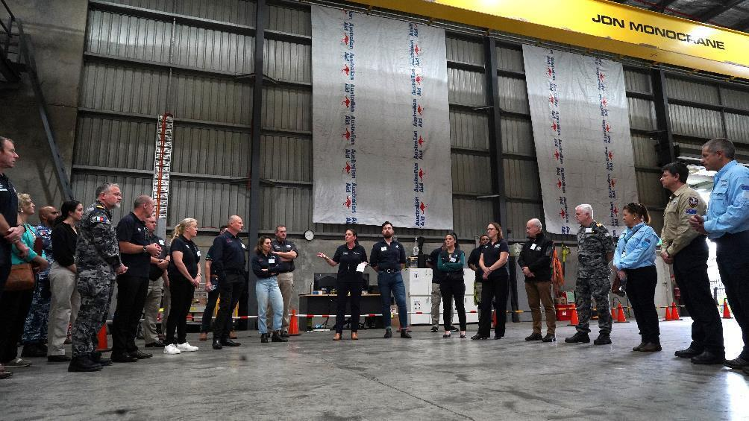 *Shelley Thomas, Response Director, welcomes Australia’s deployable capabilities to the Humanitarian Logistics Capability warehouse on 16 May 2024. (Source: Reginald Ramos, HLC)*

* 1. MONITORING, EVALUATION AND LEARNING

HLC is committed to maintaining a robust Monitoring, Evaluation and Learning (MEL) approach to ensure our work is monitored and evaluated against its intended goal and objectives.

In December 2023, the HLC commenced an evidence-based refresh of the MEL Framework, strengthening the focus on program effectiveness (measuring success, results, challenges and learnings) and alignment with ongoing DFAT requirements. This involved creation of an updated and refined list of program indicators, realignment of key operational areas (and their associated indicators) into key domains, and ongoing consultation with operational program pillars.

We closely engaged with DFAT’s Humanitarian Division’s Monitoring and Evaluation Technical Specialist to strengthen our M&E approach, to more accurately measure our outcomes. This approach was approved in April 2024. We also developed a new reporting format that further aligns with DFAT information requirements.

* 1. TELLING OUR STORY

Our strategic communications and storytelling were guided by a Communications Strategy and annual work plan, in close consultation with DFAT’s HPD and emerging priorities.

This year marked the first time Humanitarian Logistics Capability content was part of DFAT’s social media channels, following the recruitment of a Senior Communications Advisor embedded in DFAT HPD in the last reporting period.

The primary broadcast channel was DFAT’s @AusHumanitarian X (Twitter) account. This included content surrounding World Humanitarian Day, Team Australian Open Day, greening humanitarian action and disaster responses such as Tropical Cyclones Judy, Kevin and Lola in Vanuatu. This also led to the revitalisation of the DFAT webpage on humanitarian logistics and contribution to the DFAT Crisis Hub.

To support our storytelling, there was a focus on building the quantity of high-quality assets on DFAT’s Media Library. This year saw 100+ images and dozens of case studies being hosted on the DFAT Media Library, with content being used in the DFAT Corporate Plan (2023-24) and within internal DFAT publication.

The Senior Communications Adviser also co-delivered an ‘iPhone photography’ workshop for DFAT HPD, and also developed a Guidance Note – Photographing Australia’s Humanitarian Emergency Relief Supplies which informed DFAT’s multimedia training to Public Diplomacy Officers.

* 1. PUBLIC DIPLOMACY

The Humanitarian Logistics Capability warehouse in Brisbane, Queensland continues to serve as a symbolic and practical embodiment of Australia’s commitment to the Indo-Pacific when disasters strike. HLC has been focused on reforming our public diplomacy approach to streamline our internal processes to maximise the delivery and public diplomacy value.

This year HLC hosted a range of warehouse tours and events. This year we welcomed The Hon Jeremiah Manele, Prime Minister of Solomon Islands, as well as the United Kingdom’s Foreign, Commonwealth and Development Office.

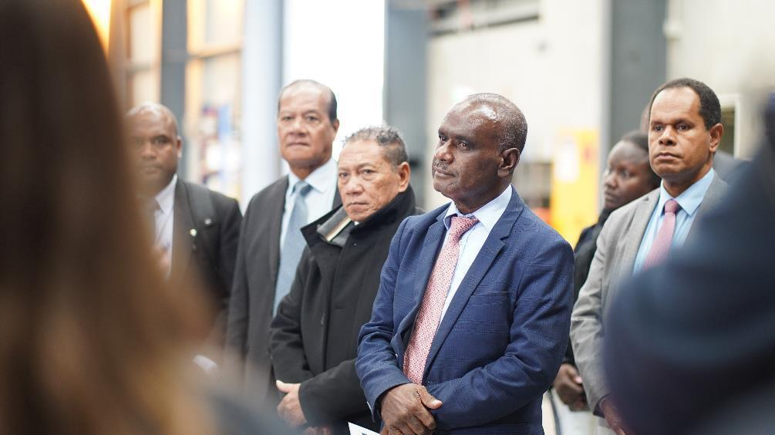*The Prime Minister of Solomon Islands, The Hon Jeremiah Manele MP toured the Humanitarian Logistics Capability warehouse in Brisbane on 25 June 2024, as part of his official visit to Australia. (Source: Reginald Ramos, HLC)*

* + 1. Team Australia Open Day

HLC hosted the inaugural Open Day for ‘Team Australia’, which included the Disaster Assistance Response Team (DART), Australian Medical Assistance Team (AUSMAT) and Australia Assists; as well as Australian Government agencies such as the Department of Defence, Civil Aviation Safety Authority (CASA), and the National Emergency Management Agency (NEMA).

* 1. LEARNING JOURNEY

Each crisis offers a new opportunity to learn and improve our humanitarian action. After every disaster response, our Response Team facilitates the capturing of lessons and information from a whole-of-investment perspective. These are known as ‘After Action Reviews’ (AAR) and are supported by the Monitoring, Evaluation and Learning (MEL) team and the Senior Logistics Officer (embedded in Canberra). Some of the lessons the HLC observed this year are detailed below.

* + 1. Learning Loop

HLC strengthened the learning loop through the standardisation of our AAR process, aligning it closely with DFAT’s AAR process. We also introduced a ‘Lessons Register’. The Lessons Register is a ‘live’ document – in which lessons, recommendations and related follow-through activities are captured and updated in real-time to ensure consistency and accountability. There is also additional work being undertaken to fully integrate other areas of business within the post-disaster learning environment which will be explored in the next reporting period.

* + 1. Formalising and Retaining Knowledge

There has been a focus this year on formalizing and strengthening our institutional knowledge. Establishing, testing and reviewing Standard Operating Procedures (SOPs), formal documentation and information management and introducing quick-access checklists and cheat- sheets to ensure high-quality implementation of program activities.

* + 1. Strengthening Foundations

The program also invested significantly in the team’s humanitarian knowledge to ensure we are aligned with international best practice. This is especially important, given the diversity of backgrounds within our team – from government, defence and humanitarian and international development. Staff attended RedR Australia’s training courses, such as Essentials of Humanitarian Practice (Fiji, Melbourne) and Hostile Environmental Awareness Training (HEAT). These were also supplemented by regular internal training sessions, including the Sphere Handbook.

* + 1. Data Integrity and Accuracy

As part of efforts to strengthen warehouse inventory control and reporting our operating system was upgraded and a new Inventory Controller role created. The current development of the Management Information System will also streamline and support the whole-of-investment’s information management, stakeholder engagement, transparency and reporting.

1. RISK MANAGEMENT
   1. RISK MITIGATION

As one of Australia’s critical humanitarian response mechanisms, the identification and mitigation of risk remains a high priority. Our leadership team has continued to coordinate with DFAT closely on managing our risk management system and risk mitigation processes. Risks were discussed fortnightly with DFAT through our biweekly Governance meetings, with one Governance meeting each quarter dedicated entirely to risk.

This risk management approach was further strengthened by the development of a response-specific risk matrix. This was maintained for all responses undertaken by HLC. The risk matrix is shared with DFAT’s Humanitarian Response Operations Section and DFAT Post, when relevant.

This has led to a standardized approach to risk identification and management across all work undertaken by HLC and links to the existing risk management architecture currently in place.

* 1. SAFEGUARDING

As a humanitarian program, HLC has a duty of care to prevent and respond to safeguarding for both the members of our team and the people we work with disaster response. Successful safeguarding prevents adults and children from the risk of harm of abuse or exploitation, particularly those that are made more vulnerable in times of disaster.

HLC continued to apply an established approach to environmental and social safeguarding. Our environmental safeguarding approach, contained within the Greening and Sustainability Strategy, was created in direct alignment with DFAT’s environmental and social safeguard policy.

The program’s Safeguarding Strategy includes the following measures: a trained Safeguarding Focal Point, thorough human resources/recruitment screening processes, mandatory training of all staff and contractors, a range of corporate Palladium safeguarding policies including (but not limited to) preventing and responding to bullying, harassment and discrimination within the workplace, child protection and the protection of vulnerable adults and communities.

We also make certain our activities do not contribute to modern slavery (including trafficking) and that we ensure the prevention of sexual exploitation, abuse and harassment (PSEAH) of beneficiaries and within all international communities.

* + 1. Pre-Deployment Briefings

Before deploying anyone into a host country, a safeguarding process is followed. This includes: the development of a Safety and Security Plan, registering the team’s itinerary with Palladium’s Global Security Team, registering for and issuing of traveller’s insurance certificates, receiving a pre and post GEDSI briefing with particular attention to cultural sensitivities, customs and traditions, as well as whistleblower hotlines and information about employee assistance services, the completion of a bespoke risk assessment and the undertaking of any required training such as Hostile Environmental Awareness Training (HEAT).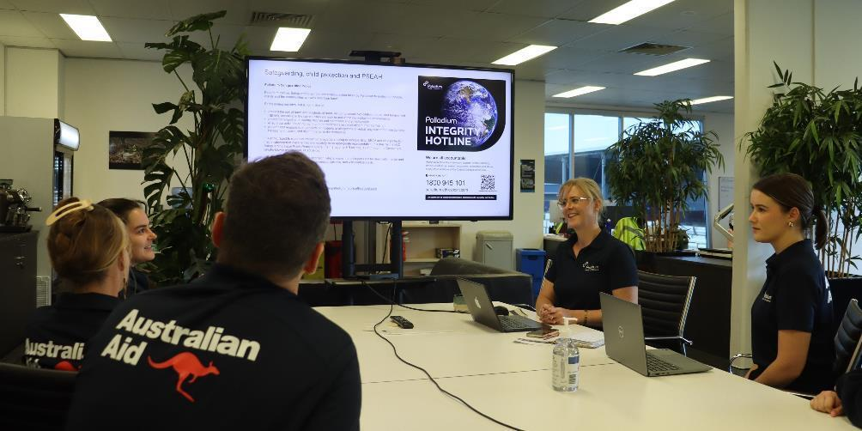*Penelope Holder, Safeguarding Focal Point and GEDSI Adviser, conducting a safeguarding briefing with the team. (Source: Teresa Putri Sari Prabono, HLC)*

1. Contact Details

Email: HLC@thepalladiumgroup.com

Address: 113 Bancroft Road, Pinkenba,

Brisbane, AUSTRALIA 4008