## Factsheet 1 of 4



**Demographics and Disability**

Disability is deﬁned as interactions between personal and environmental factors. It is measured by the level of functioning of a person in various areas of daily activities (called “domains”) regardless of impairments, using the Washington Group tools.

**Total sample size**

**Persons with disabilities**

**Coverage**

1,665

8,876

1,903

**Jordan Lebanon**

among 8,341 persons aged 2+

**DISABILITY PREVALENCE**

aged 2+ with disabilities

Syrian refugees, all age groups

Households

*GPS random sampling*

Lebanon

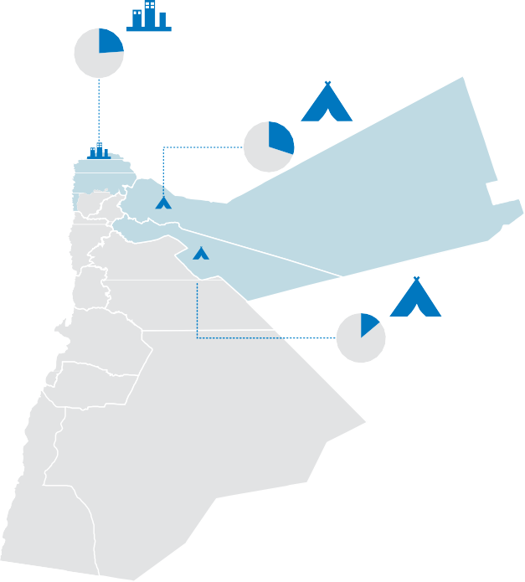

**23.5%**

Jordan

Irbid

Zaatari

**30.5%**

Mafraq

Azraq Zarka

**13.8%**

**21.0%**

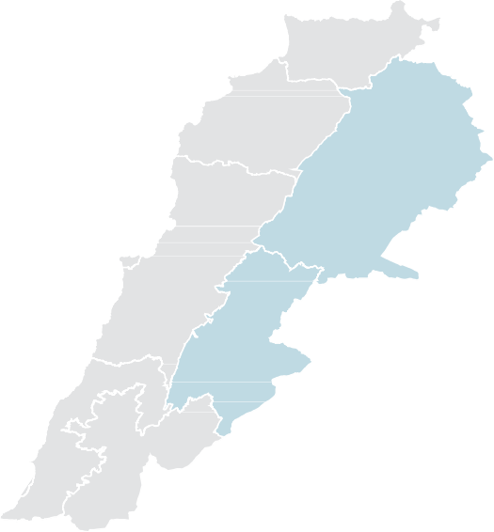

Bar Elias

Bekaa

Baalbek El Hermel

Arsal

**24.9%**

1,374

**Jordan**

6,003

8,341

Total Population *aged 2+*

## 1,903

Total persons with

**Lebanon**

2,338

529

Host communities Camps

Informal settlements (ITS)

22.8%

**of the surveyed Syrian refugees (aged 2+) in Jordan and Lebanon have disabilities**

Zaatari Irbid Azraq

30.5%

23.5%

13.8%

22.9

%

4,629

77.1%

disabilities

*aged 2+*

persons without disabilities

*aged 2+*

#### 22.6

%

1,809

77.4%

21.0%

24.9%

Bar Elias ITS

**FACTSHEET 1: DEMOGRAPHICS & DISABILITY**

**1**/3

**Disability Assessment among Syrian Refugees in Jordan and Lebanon**



**(HI & iMMAP, 2018)**

**DISABILITY PREVALENCE BY AGE AND GENDER**

Disability prevalence is higher in young males than females in age groups 2-34 years, and in older females than males in age groups 35 years and above

**2 - 4 5 - 17 18 - 34 35 - 65+**

**Disability prevalence**

**Jordan**

Without disabilities

With disabilities

Age distribution in

the surveyed population aged 2+ *

With disabilities Without disabilities

(18.1%) 13

2.4%

5.7%

16.4%

65+

51-64

35-50

18-34

(81.8%) 1125

(18.2%) 250

25.2%

2.2%

5.0%

(56.2%) 82

(43.8%) 64

(31.8%) 21

(68.2%) 45

13.1%

(69.8%) 270

(30.2%) 117

20.8%

(23.9%) 147

(76.1%) 467

**23.9%**

39.9%

|  |  |  |  |  |
| --- | --- | --- | --- | --- |
|  | (81.9%) 59 | | | |
| (31.2%) 54 | | (68.8%) 119 | | |
| (56.9%) 285 | | | (43.1%) 216 | |
| (81.6%) 628 (18.4%) 142 | | | |  |
| (85.2%) 1038 (14.8%) 180 | | | |  |
| (96.0%) 309 (4.0%) 13 | | | | |

5-17 46.7%

##### 21.9%

###### Lebanon

(31.0%) 9

10.5%

2.4%

(69.0%) 20

5.7%

(49.3%) 34

2-4

65+

51-64

12.2%

2.8%

(37.5%) 12

(62.5%) 20

(93.9%) 337

(6.1%) 22

4.6%

(53.8%) 28

(46.2%) 24

13.7% 35-50 15.8%

(24.2%) 62

(69.8%) 125

(30.2%) 54

23.2%) 82

(30.3%) 50

(69.7%) 115

(50.7%) 35

##### 21.4%

(76.9%) 273

(85.7%) 397

( (14.3%) 66

29.4% 18-34

38.4% 5-17

22.6%

40.6%

(75.8%) 194

##### 23.9%

(78.0%) 359

(95.2%) 119

(22.0%) 101

(4.8%) 6

10.4%

2-4

13.5%

*Percentages may not add up to 100% due to rounding

(93.5%) 143

(6.5%) 10

### DISABILITY AT HOUSEHOLD LEVEL

*Percentage of households with at least one member with disabilities*

61.4%

**of households in**

0% 100%

**Jordan**

62.0%

|  |  |  |  |
| --- | --- | --- | --- |
|  | **Azraq** | 47.9% |  |
| **Irbid** | 67.2% |
| **Zaatari** | 68.3% |  |
|  |  |  |  |





0%

**Bar Elias ITS**

**Lebanon**

59.9%

58.5%

67.7%

100%

**Jordan and Lebanon have at least one member**

**with disabilities**



**CAUSES OF DISABILITIY**

**Jordan Lebanon**

Related to Syria Conﬂict

**Yes**

86 (38.9%)

**No / Don’t know**

135 (61.1%)

Related to Syria Conﬂict

**Yes**

140 (24.7%)

**No / Don’t know**

426 (75.3%)

Illness or disease

Injury Malnutrition

(29.9%) 411

(10.7%) 147

(0.58%) 8

Illness or disease

Injury Malnutrition

(26.8%) 142

(13.6%) 72

(1.3%) 7

**Almost one in three disabilities**

**Rates of conﬂict-related disability:**

**were acquired as a result of illness or disease**

%

Jordan

%

**Lebanon**

**FACTSHEET 1: DEMOGRAPHICS & DISABILITY**

24.7

38.9

**2**/3

**Disability Assessment among Syrian Refugees in Jordan and Lebanon**

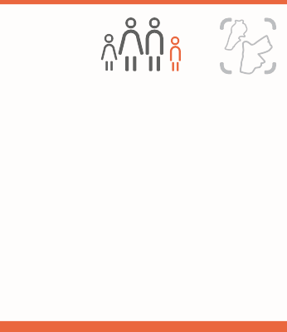

**(HI & iMMAP, 2018)**

### DISABILITY DOMAINS

*Domains mean different activity areas for which the functioning of a person was measured by the Washington Group tools.*

*Surveyed domains differ for age groups*

**Children aged 2 - 4 years**

**Children aged 5 - 17 years**

**Adults aged 18+**

**Jordan**

Communication

Controlling behavior

2.8%

1.5%

Anxiety

Depression

9.7%

5.9%

Walking Anxiety Fatigue

14.4%

# 11.4%

10.9%

**Children aged 2 - 4 years**

**Children aged 5 - 17 years**

**Adults aged 18+**

**Lebanon**

Communication

4.7%

Anxiety

10.3%

Anxiety Fatigue

13.0%

# 12.5%

Playing

2.5%

Depression

6.8%

Upper body 1*

10.4%

* Upper body 1: Difﬁculty raising 2 liter of water from waist to eye level.

### DISABILITY AND ASSISTIVE DEVICES

*Of persons aged* **2***+*

**Glasses Hearing aid Mobility aids**

**Of surveyed populations aged 2 +…**

**Jordan**

8.8%

**Wear glasses**

22.6%

0.7%

**Use a hearing aid**

**Of those using assistive devices ...**

19.0%

2.8%

**Use mobility aids**

or receive assistance with walking

71.0%

**High rates of**

**of persons who wear glasses still experience difﬁculty in seeing**

**of persons who use hearing aids still experience difﬁculty**

**in hearing**

**of persons who use mobility aids still experience difﬁculty**

**in walking**

persons who use assistive devices still

**Glasses Hearing aid Mobility aids**

**Of surveyed populations aged 2 +…**

**experience ongoing difﬁculty = having**

**Lebanon**

7.0%

**Wear glasses**

18.9%

**of persons who wear glasses still experience difﬁculty in seeing**

0.9%

**Use a hearing aid**

**Of those using assistive devices ...**

35.0%

**of persons who use hearing aids still experience difﬁculty**

**in hearing**

3.3%

**Use mobility aids**

or receive assistance with walking

65.4%

**of persons who use mobility aids still experience difﬁculty**

**in walking**

disabilities

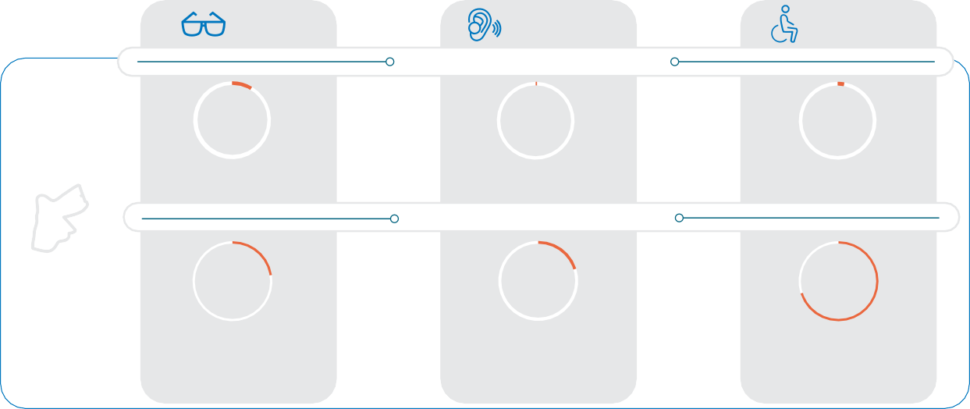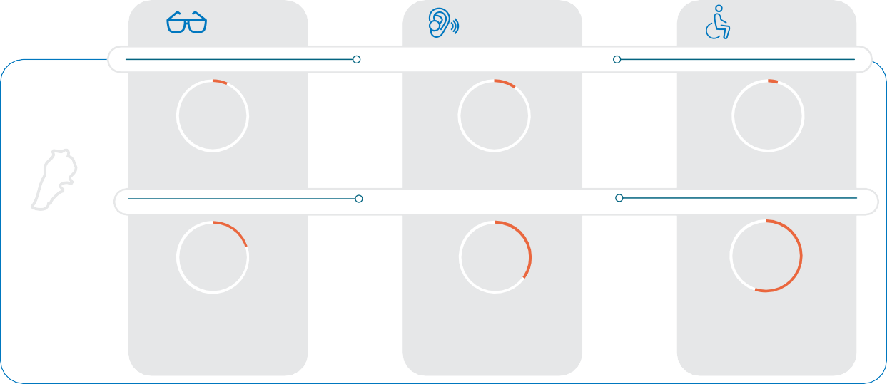

**FACTSHEET 1: DEMOGRAPHICS & DISABILITY**

**Disability Assessment among Syrian Refugees in Jordan and Lebanon**

**(HI & iMMAP, 2018)**

For further information [J.McGeown@hi.org](mailto:J.McGeown@hi.org)

[**info-mena@immap.org**](mailto:info-mena@immap.org)

**3**/3