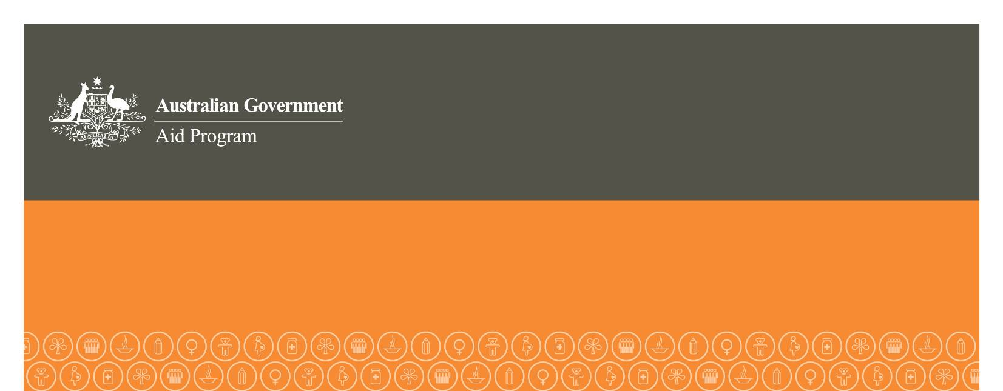

Human Rights Grants Scheme
Attachment B: Full Application

Instructions
This form is to be completed by the applicant organisation upon request of the relevant Australian diplomatic mission. The form must be typed and in English. The form must be submitted to the mission by 4pm (local time) 1 October 2012. Late applications will not be accepted without prior agreement from the mission.

APPLICANT ORGANISATION AND CONTACT DETAILS
Name of organisation
Organisation goal or purpose
Street address
City
Country
Postcode
Name of contact person
Honorific (tick one) | Mr Ms Mrs Miss Other
Position
Contact numbers | Work Mobile
Email address

PROJECT DETAILS (maximum 4 pages)
Name of project
Amount of funding being sought from HRGS (maximum AUD100,000)
Total cost of project in AUD
Project start and end date
Country in which project will be implemented
Briefly describe the project and why it is needed
Which of the following are objectives of this project? (Please tick one or more)

- Prevent or end gross human rights violations

- Promote positive change in policies or actions of government or relevant non-state actors in the area of human rights

- Monitor, seek redress for and/or report on human rights violations, including supporting victims of human rights abuses

- Educate and/or train human rights victims, workers or defenders

- Promote observance and implementation of international human rights standards

- Promote and strengthen national or regional human rights institutions or mechanisms
What are the specific anticipated outcomes of this project?
How will those outcomes be achieved?
How will you promote the project and its Australian Government funding?
What partners, if any, are involved in the project? What is their role and relationship to your organisation?
Does the project have any other sources of funding? If so, please indicate the source and amount.
Does this project involve participation by both men and women?
Does the project involve the participation of marginalized groups? For example, people with disability.
Has the organisation previously received HRGS funding? If YES, has a Project Completion Report (including full acquittal) been submitted?
Has the organisation previously received any other Australian Government funding? If YES, which Australian government agency, what project and how much?
Does the project involve working with children? If YES, the organisation must have a current Child Protection Policy to be eligible for funding.
Are there any real or potential risks associated with the project? (please tick one or more)
Physical risks Child related risks Environmental risks
Political risks Economic risks Social risks
If YES, please briefly outline how you will manage those risks (maximum 300 words).

PROJECT BUDGET (maximum 2 pages)
Expenditure (must be in Australian dollars) | HRGS funding | Implementing organisation | Other
Personnel costs
Salaries
Per diems for travel/activities
Support costs (costs directly related to the successful management of the project)
Communications
Training materials
report preparation
vehicle/transport costs
Equipment*
Freight*
Buildings*
Travel costs**
International travel
Local transportation
Audit costs***
Miscellaneous costs
TOTAL
* must not amount to more than 10% of the total project cost
** must not amount to more than 20% of the total project cost
*** the organisation must undertake an independent audit of the project and attach it to the Project Completion Report before sending the report to the Australian diplomatic post. Costs of audits must be reasonable.

