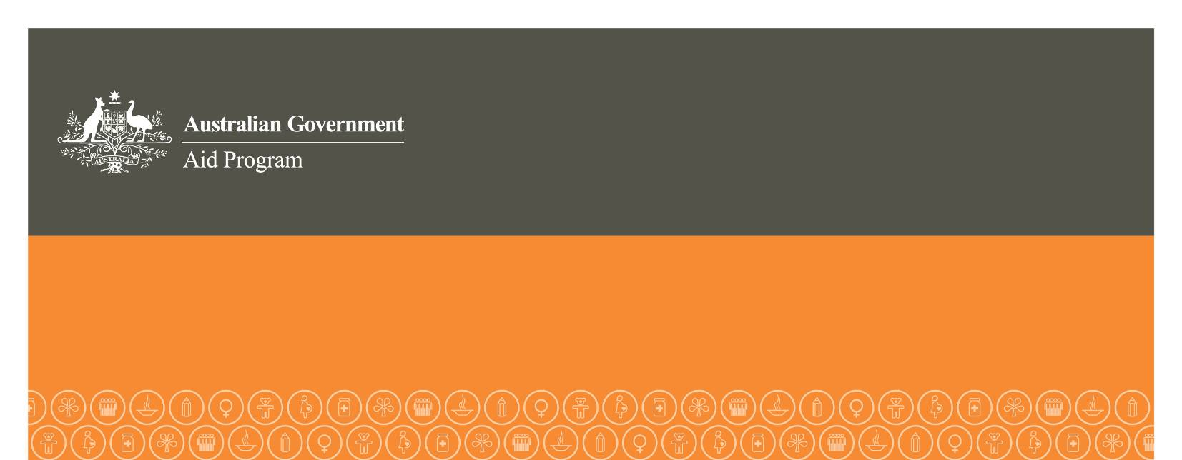
Human Rights Grants Scheme
Application Guidelines
2012-2013

The Human Rights Grants Scheme provides short-term funding to support non-government organisations and human rights institutions to implement projects that help to enhance human rights.

Stage 1: 2012-2013 Human Rights Grants Scheme commences 17 July 2012.
Stage 2: Expressions of Interest must be lodged with the relevant Australian diplomatic mission by 4pm (local time) 17 August 2012.
Stage 3: Australian diplomatic missions will notify successful Expression of Interest applicants to proceed with a Full Application by 1 September 2012.
Stage 4: Full Applications must be lodged with the relevant Australian diplomatic mission by 4pm (local time) 1 October 2012.
Step 5: Recipient organisations will be announced on Human Rights Day, 10 December 2012.

Overview of the Human Rights Grants Scheme (HRGS)

The objective of the HRGS is to enhance human rights in developing countries.

The HRGS helps to achieve this objective by providing short-term funding to support non-government organisations and human rights institutions to implement projects that help to enhance human rights.

The HRGS is managed by the Australian Agency for International Development (AusAID) in consultation with:

- Australian human rights experts;

- Australia’s network of diplomatic missions; and

- Department of Foreign Affairs and Trade (DFAT).

Which organisations can apply?

To be eligible for funding in 2012-2013, organisations must be operating in one or more of the following countries:

- Africa: Burkina Faso, Burundi, Cape Verde, Côte d’Ivoire, Democratic Republic of Congo, Egypt, Eritrea, Ethiopia, Malawi, Morocco, Somalia, South Sudan, Tanzania, Tunisia, Uganda, Zimbabwe

- Middle East: Iraq, Jordan, Lebanon, Palestinian Territories

- Asia Pacific : Afghanistan, Bangladesh, Burma, Cambodia, China, East Timor, Indonesia, Laos, Nepal, Pakistan, Philippines, Sri Lanka, Thailand, Vietnam, Fiji, Solomon Islands, Vanuatu

- Latin America and Caribbean: Bolivia, Brazil, Colombia, Guatemala, Honduras, Nicaragua, Paraguay, Cuba, Haiti

In addition, organisations must:

- be involved in promoting and protecting human rights;

- have an established and sustainable track record in the type of activity the organisation wants funded and/or experience in the country in which the project will take place; and

- be a non-government organisation or a national/regional human rights institution.

Examples of organisations and projects that have been funded previously under the HRGS are at: www.ausaid.gov.au/business/other_opps/humanrights_scheme.cfm

Proposals from individuals are not eligible.

What types of projects can receive funding?

Projects eligible for funding must:

- Be based in one or more of the eligible countries.

- Aim to achieve one or more of the following objectives:

- prevent or end gross human rights violations such as (but not restricted to) extra-judicial and arbitrary killings; torture; human trafficking; restrictions on freedoms of thought/expression/association; abuses in the judicial system; systemic discrimination; mass evictions; forced displacement; denial of the right to education for girls; denial of the right to economic livelihoods for particular groups; or forced labour;

- promote positive change in policies or actions of government or relevant non-state actors (including corporations, international institutions, non-government organisations) in the area of human rights;

- monitor, seek redress for and/or report on human rights violations, including supporting victims of human rights abuses;

- educate and/or train human rights victims, workers or defenders;

- promote observance and implementation of international human rights standards, including through treaty ratification, domestic legislation and/or effective engagement with international and/or regional human rights institutions or mechanisms; and

- promote and strengthen national or regional human rights institutions or mechanisms;

- demonstrate that the equal rights of women and men and girls and boys, underpin the project, in line with AusAID’s gender equality policy (see below);

- be designed and delivered in accordance with human rights principles; and

- include a budget that represents value for money as determined by AusAID.

Where relevant, projects should also:

- involve the active participation of marginalised groups such as people with disability, women, children, youth, the elderly, people living with HIV/AIDS, prisoners, homeless people, refugees, internally displaced persons, indigenous peoples, ethnic and religious minorities, gay, lesbian, bisexual, transsexual and intersex persons;

- encourage self-help and self-reliance by involving communities in developing, implementing and managing project activities and by using community structures and systems;

- strengthen the ability of countries to meet their obligations and requirements to report on their performance to international or regional human rights institutions and/or mechanisms; and

- promote collaboration in funding and networking to optimise the impacts of activities.

Applications for joint or partial funding of a larger project with other contributors will be considered.

Applications from multiple organisations will be considered provided there is a clear lead organisation which is based in an eligible country.

Applications extending across multiple countries will be considered provided they are all eligible countries, although there may be some flexibility in cases where the project is heavily concentrated in, but not entirely limited to, eligible countries.

Applications for funding project activities that have previously received a HRGS grant will be considered. However, new funds will not be released until previous HRGS funding has been acquitted and an Project Completion Report (as per the 2011-12 template) is submitted and accepted by AusAID.

Dependant on the scope of the project, applications should adhere to the following
Australian Government policies:

- Gender Equality in Australia’s Aid Program—Why and How http://www.ausaid.gov.au/publications/pubout.cfm?Id=39_3102_3439_6270_8533 (for guidance on implementing the gender policy see AusAID’s Gender Equality Guidelines http://www.ausaid.gov.au/keyaid/gender.cfm)
- Environmental Management Guide for Australia’s Aid Program http://www.ausaid.gov.au/publications/pubout.cfm?ID=2297_1393_1917_9648_6600
- Development for All – Towards a disability inclusive Australian aid program 2009-2014 http://www.ausaid.gov.au/keyaid/pdf/FINAL%20AusAID_Development%20for%20All.pdf
- Safeguarding your organisation against terrorism financing http://www.nationalsecurity.gov.au/
- Family Planning and the Aid Program: Guiding Principles http://www.ausaid.gov.au/publications/pdf/GuidingPrinciples.pdf
- Child Protection Policy http://www.ausaid.gov.au/publications/pdf/child_protection.pdf

What types of projects can’t receive funding?

Funding will not be provided for:

- projects that support independence movements
- evangelism or missionary outreach activities
- political party campaign activities
- projects which are contrary to Australia’s interests as determined by AusAID
- emergency relief activities
- retrospective activities
- activities that already receive significant funding through other Australian Government programs
- individuals
- recurrent costs
- welfare and service delivery activities
- academic research

Amount and duration of funding

Grants will be awarded as a single payment valued between
AUD20,000 – AUD100,000.

Project activities may take place over maximum of two years. All 1 year projects must be completed by May 2014. All two year projects must be completed by May 2015.

Funding will not be provided for travel expenses exceeding 20 per cent of total project costs. Likewise the provision of equipment, freight or buildings, may not exceed 10 per cent of the total project cost. Costs associated with the required certified statement of expenditure must be reasonable and in accordance with project activity and budget.

Application process

Organisations should submit an Expression of Interest (Attachment A) to the relevant Australian diplomatic mission by 4pm (local time) 17 August 2012. This form must be no longer than 2 pages.
By 1 September 2012, Australian diplomatic missions will review, on a competitive basis, Expressions of Interest and will invite up to 2 organisations per eligible country to submit a
Full Application (Attachment B).
Organisations requested to do so should submit a Full Application to the relevant Australian diplomatic mission by 4pm (local time) 1 October 2012.
A list of relevant Australian diplomatic missions and addresses is at Attachment C.
Late applications will not be accepted, except where the applicant organisation has negotiated a late submission with the relevant Australian diplomatic mission prior to the closing date.

All applications must be submitted in hardcopy by mail or delivered in person to the relevant Australian diplomatic mission. Envelopes should be clearly labelled ‘Human Rights Grants Scheme’.

All applications must be typed and in English.

All applications must be represented in Australian dollars.

All queries should be directed to the relevant Australian diplomatic mission.

Selection process

Australian diplomatic missions will assess Expressions of Interest against the following criteria:

- Does the organisation meet eligibility criteria as per page 2?
- Does the project meet eligibility criteria as per page 3?
- To what extent does the project address a need to enhance human rights within an eligible country (rated 1 - 10)?

An independent panel of human rights experts will assess Full Applications against the following criteria:

- Does the organisation meet eligibility criteria as per page 2?
- Does the project meet eligibility criteria as per page 3?
- Does the budget represent value for money?
- If the project involves working with children, does the organisation have a current Child Protection Policy?
- To what extent will the project address a need to enhance human rights within an eligible country (rated 1 - 10)?
- To what extent will the organisation promote the project and Australian Government funding (rated 1 - 10)?
- To what extent will the project involve participation by both men and women
(rated 1 - 10)?
- To what extent will the project involve participation by marginalised groups
(rated 1 - 10)?
- If the project involves potential risk, to what extent will the organisation manage those risks well (rated 1 - 10)?

Additional documentation

If requested to submit a Full Application and the organisation has not previously received funding support from the Australian Government (under the HRGS or otherwise), the organisation will be required to provide the following documentation:

- a copy of the organisation’s constitution or articles of association;
- an audited annual financial statement certified by a public accountant who is not a member of the organisation;
- a copy of the organisation’s annual report, or an equivalent document; and
- an outline of the organisation’s annual plan or program of work activities.

If the organisation is unable to provide any of these documents a written explanation must be provided within the Expression of Interest.

Funding and reporting requirements for recipient organisations

Organisations awarded a grant must enter into a funding agreement with AusAID. The funding agreement will set out all terms and conditions relating to the grant, including implementation of project activities, accountability, outcomes required, funding arrangements and project reporting.

Within 6 weeks of the completion of the project the organisation must provide:

- 100% acquittal for funds provided under the HRGS via a certified statement of expenditure

- A case study depicting outcomes of the project (maximum 2 pages)

Templates for both will be provided at a later date.

The Australian Government will, from time-to-time and at its own expense, monitor, review and/or evaluate the project in consultation with the successful organisation.
Human Rights G

